Volume 13. Future of Physical AI and Civilization

Chapter 00. Introduction

00.01. Why Physical AI May Transform Civilization
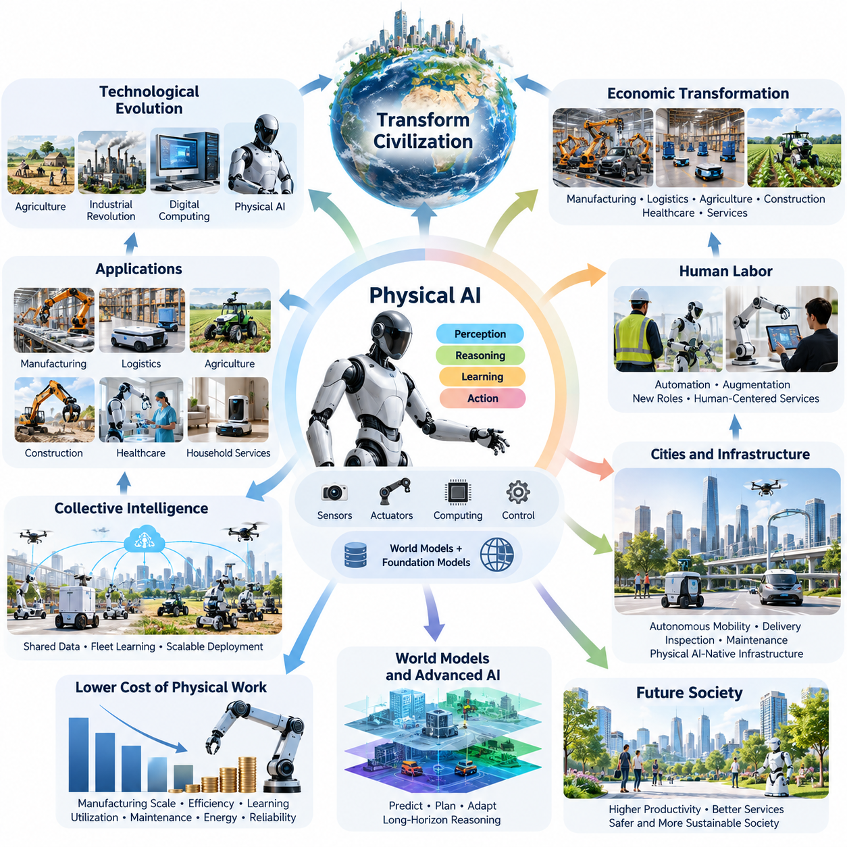
Physical AI represents a potentially transformative stage in technological evolution because it extends artificial intelligence beyond digital information processing into direct interaction with the physical world. Unlike conventional AI systems that primarily generate information, analyze data, or support decisions, Physical AI integrates perception, reasoning, learning, and action to influence material environments through autonomous machines.
Throughout history, major technological revolutions have transformed civilization by changing how humans produce goods, organize labor, distribute resources, and construct infrastructure. Agriculture enabled permanent settlements, industrial machinery expanded production capacity, and digital computing accelerated information processing. Physical AI may represent another transition by making increasingly complex physical activities programmable, adaptable, and partially autonomous.
The distinguishing characteristic of Physical AI is its ability to connect intelligence with physical agency. A system must interpret sensory information, understand environmental conditions, predict the consequences of actions, and execute movements under real-world constraints. This requires the integration of artificial intelligence algorithms with sensors, actuators, mechanical structures, computing platforms, and reliable control systems.
Traditional automation has generally depended on predefined operating conditions and carefully engineered sequences of actions. Industrial robots perform repetitive tasks with exceptional consistency when their environments remain predictable. Physical AI seeks to expand these capabilities by enabling machines to adapt to changing circumstances, recognize unfamiliar situations, and select appropriate actions without requiring every possible condition to be explicitly programmed.
This transition could significantly expand the range of economically useful machine activities. Manufacturing, logistics, agriculture, construction, healthcare, infrastructure maintenance, and household services contain numerous tasks that require physical interaction with unpredictable environments. As autonomous systems become more capable, some activities previously dependent on continuous human intervention may become increasingly suitable for intelligent machine assistance.
The economic implications extend beyond replacing individual tasks with automated equipment. Physical AI could become a new form of productive capital capable of performing diverse activities across multiple operating environments. When machines can be reconfigured through software and learning rather than extensive mechanical redesign, the relationship between capital investment, production flexibility, and operational productivity may change substantially.
One important possibility is a gradual reduction in the effective cost of certain forms of physical work. Improvements in robot manufacturing, actuator efficiency, computational hardware, and autonomous learning could make machine labor more economically attractive. However, actual cost reductions will depend on utilization rates, maintenance requirements, energy consumption, safety obligations, deployment complexity, and the reliability of autonomous operation.
The relationship between Physical AI and human labor will be particularly important for civilization. Some repetitive, dangerous, and physically demanding tasks may become increasingly automated, while other occupations may evolve toward supervision, coordination, creative problem solving, and human-centered services. The resulting transformation will depend on whether organizations use intelligent machines primarily to augment workers or substitute for particular categories of labor.
Physical AI may also influence how cities and infrastructure are designed. Autonomous mobility platforms, delivery robots, intelligent inspection systems, and automated maintenance equipment could become integrated into urban operations. Buildings, transportation networks, communication systems, and public facilities may gradually incorporate features that support machine navigation, shared environmental understanding, coordinated operations, and safe human-robot interaction.
Such developments could encourage the emergence of Physical AI-native infrastructure rather than simply introducing robots into environments designed exclusively for humans. Standardized interfaces, machine-readable maps, connected facilities, and coordinated fleet management systems may reduce operational complexity. Nevertheless, infrastructure transformation will require long-term investment, interoperability standards, cybersecurity protection, and public acceptance.
The development of Physical AI is closely connected to advances in world models, which represent environmental states and predict how those states may change over time. By learning relationships among objects, actions, physical constraints, and future outcomes, autonomous machines may become better equipped to plan beyond immediate reactions. Reliable world models could support long-horizon reasoning, uncertainty estimation, and adaptive decision-making.
The integration of world models with robot foundation models and vision-language-action architectures could further expand machine capabilities. Foundation models may provide transferable representations and general knowledge, while action-oriented models connect perception and instructions with physical behavior. Combining these approaches with predictive dynamics, memory, and feedback control may support more flexible and increasingly general-purpose autonomous systems.
Another potential transformation involves collective machine intelligence. Large fleets of robots may generate operational experience across factories, warehouses, cities, and other environments. When appropriately governed, selected experiences can contribute to shared learning systems, enabling improvements discovered by one machine to benefit others. Such data-driven learning cycles could accelerate capability development beyond what isolated robots can achieve.
Physical AI may become especially valuable in societies experiencing demographic aging and labor shortages. Autonomous assistance could support material handling, transportation, facility maintenance, and selected caregiving activities. These technologies might help sustain essential services where human resources are limited. Their success, however, will depend on affordability, reliability, accessibility, and the preservation of human dignity and meaningful personal relationships.
The potential consequences extend to environmental sustainability and resource management. Intelligent machines could improve precision agriculture, monitor infrastructure deterioration, inspect renewable energy facilities, and support more efficient material utilization. At the same time, widespread robotic deployment would increase demand for computing hardware, batteries, electricity, and industrial materials, making lifecycle efficiency and responsible resource management essential considerations.
Physical AI could also expand humanity's capacity to operate in environments that are dangerous, inaccessible, or unsuitable for continuous human presence. Disaster zones, deep oceans, remote industrial facilities, and extraterrestrial environments present significant operational challenges. Autonomous machines capable of local reasoning and adaptation may support exploration, scientific investigation, infrastructure construction, and resource utilization under difficult conditions.
Space exploration illustrates the importance of physical autonomy particularly clearly. Communication delays and uncertain environmental conditions limit continuous remote control of planetary machines. More capable Physical AI could allow robotic explorers to navigate unfamiliar terrain, manipulate scientific instruments, respond to unexpected events, and coordinate operations with reduced dependence on immediate instructions from Earth.
The convergence of Physical AI with artificial general intelligence introduces deeper questions about the nature of machine intelligence. General intelligence operating through physical embodiments would require more than language understanding or abstract reasoning. It would also require grounded perception, causal understanding, temporal memory, physical planning, and the ability to manage uncertainty while acting within environments where mistakes can produce irreversible consequences.
Nevertheless, increasing robotic capability does not automatically imply the emergence of artificial general intelligence. Physical competence may remain specialized across tasks, environments, and mechanical embodiments. Achieving broad generalization requires progress in transfer learning, continual adaptation, common-sense physical reasoning, efficient exploration, and robust performance under unfamiliar conditions. These remain substantial scientific and engineering challenges.
The civilizational significance of Physical AI will therefore depend on more than technological performance. Autonomous systems capable of influencing the physical world introduce questions concerning responsibility, liability, privacy, security, and human control. Unlike errors in purely informational systems, failures involving physical machines may damage infrastructure, disrupt essential services, or directly threaten human safety.
Economic distribution will present another major challenge. Organizations and countries possessing advanced robotics platforms, computational infrastructure, high-quality operational datasets, and manufacturing capabilities may gain disproportionate advantages. Without appropriate institutions and policies, productivity improvements could coexist with increased concentration of economic power, unequal technology access, and significant disruption in labor markets.
The long-term trajectory of Physical AI remains uncertain because technological progress interacts with economic incentives, social institutions, regulatory frameworks, and physical limitations. Advances in algorithms alone cannot guarantee successful deployment. Mechanical reliability, energy efficiency, safety certification, maintenance infrastructure, and the cost of operating machines in unstructured environments may determine whether promising demonstrations become scalable commercial systems.
Civilizational transformation should consequently be understood as a gradual process involving multiple possible development pathways rather than an inevitable technological outcome. Some industries may adopt autonomous physical systems rapidly because tasks are structured and economic benefits are measurable. Other environments, especially those involving vulnerable people, unpredictable conditions, or complex social interactions, may require considerably longer development and validation periods.
Looking toward the 2030–2040 period, plausible scenarios range from the widespread deployment of specialized autonomous machines to the emergence of increasingly general-purpose robotic platforms. More ambitious scenarios envision coordinated fleets, self-improving physical intelligence, and infrastructure designed around autonomous operation. These possibilities should be evaluated through explicit assumptions, measurable milestones, technical dependencies, and alternative rates of progress.
Ultimately, Physical AI may transform civilization by changing the relationship between intelligence, physical labor, productive capital, and human agency. Its greatest significance may not be the creation of individual intelligent robots, but the emergence of interconnected systems capable of performing useful physical work at scale. Whether this transformation produces broadly shared prosperity will depend on how effectively technological innovation is aligned with human needs, institutional responsibility, and long-term societal well-being.

00.02. From Digital Intelligence to Machine Agency
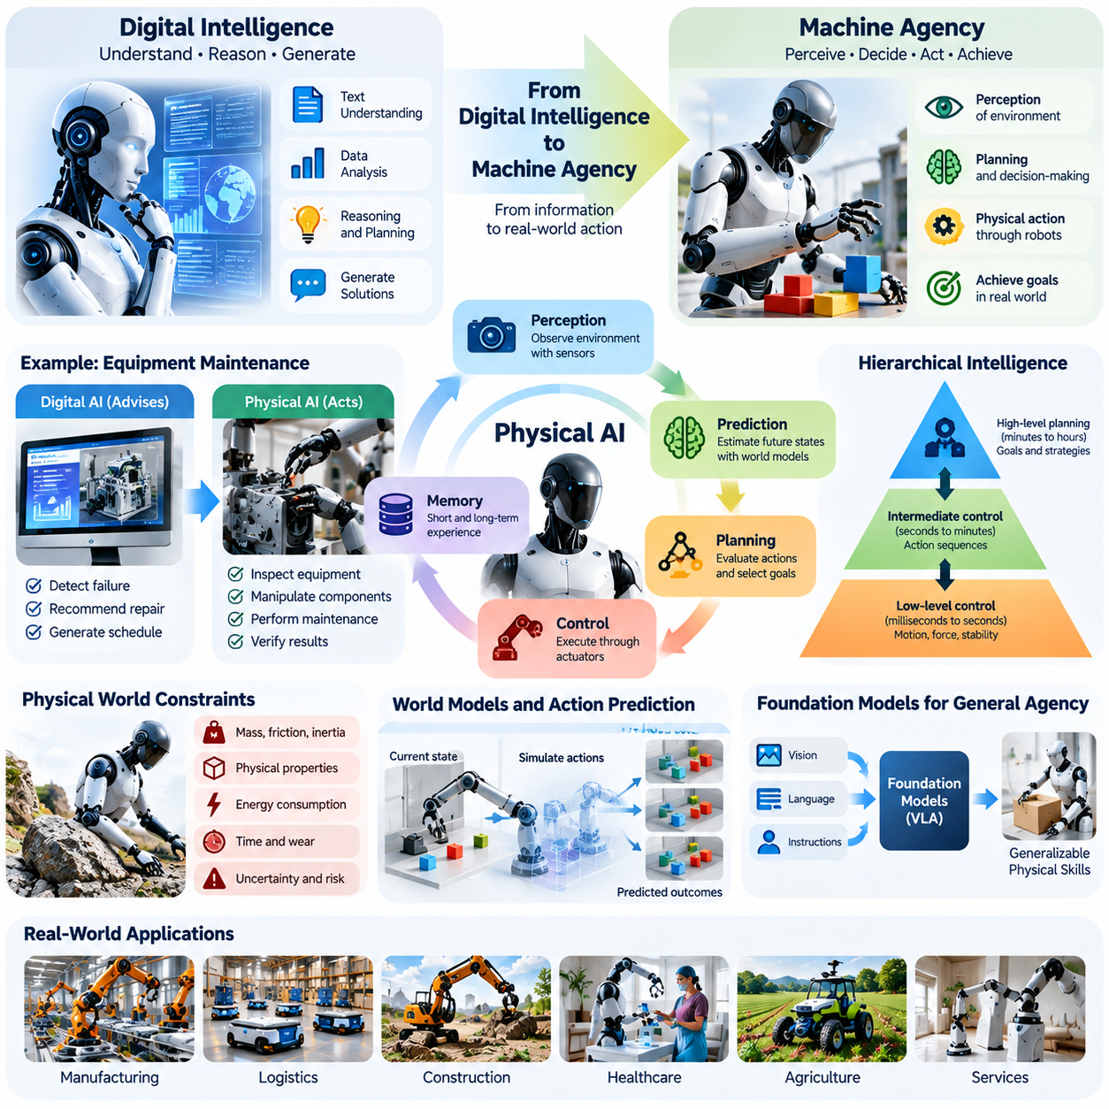
Digital intelligence has transformed the way humans create knowledge, process information, and make decisions. Machine learning, large language models, and advanced reasoning systems can interpret complex data, generate solutions, and support intellectual activities. However, these capabilities have largely operated within digital environments, where intelligence influences the physical world indirectly through human decisions and actions.
Machine agency represents a fundamental extension of digital intelligence into autonomous physical action. Rather than merely recommending what should happen, an intelligent machine can perceive its surroundings, establish operational goals, select actions, and execute them through physical mechanisms. This transition introduces a new relationship between computation, decision-making, and the material environment.
The distinction between intelligence and agency is essential for understanding this transformation. Intelligence concerns the ability to represent information, recognize patterns, reason about relationships, and solve problems. Agency concerns the capacity to initiate actions that influence an environment in pursuit of defined objectives. Physical AI combines these capabilities within systems that operate under real-world constraints.
A digital AI system may identify an equipment failure, recommend a repair procedure, or generate an optimized production schedule. A physically capable autonomous system could additionally inspect the equipment, manipulate components, perform authorized maintenance operations, and verify the resulting conditions. The difference lies not simply in intelligence quality but in the ability to translate decisions into consequential physical actions.
Machine agency requires continuous interaction between perception, prediction, planning, and control. Sensors provide observations of the surrounding environment, while internal representations estimate relevant physical states. Planning mechanisms evaluate possible actions, and control systems translate selected decisions into actuator commands. Feedback from the environment allows the machine to detect deviations and adjust its behavior.
Unlike digital environments, the physical world imposes constraints that cannot be ignored or easily reversed. Objects possess mass, friction, inertia, and geometric properties, while actions consume energy and require time. Sensor measurements contain uncertainty, mechanical components experience wear, and unexpected interactions may produce damage. Consequently, physical agency requires intelligence grounded in dynamics, safety, and operational reliability.
World models provide an important foundation for connecting digital reasoning with physical action. A world model represents environmental states and estimates how those states may evolve under different actions. By combining sensory observations with learned physical relationships, autonomous machines can anticipate consequences, evaluate alternatives, and construct plans that extend beyond immediate reactive behavior.
Action-conditioned prediction is particularly important because autonomous machines must distinguish between changes occurring naturally and changes caused by their own interventions. A robot moving an object must anticipate its displacement, potential collisions, and effects on surrounding structures. Such predictions support causal reasoning and allow planning systems to compare possible actions before committing to physical execution.
The transition toward machine agency also changes the role of artificial intelligence architectures. Traditional digital models primarily transform input information into output information. Physical AI architectures must additionally maintain operational state, coordinate multiple temporal processes, and connect high-level reasoning with low-level control. These requirements encourage hierarchical systems that combine perception, memory, planning, and real-time execution.
Hierarchical intelligence allows machines to operate across different time horizons. High-level planning may establish objectives extending over minutes or hours, while intermediate controllers coordinate sequences of actions. Low-level control mechanisms regulate motion, force, and stability at much shorter intervals. Successful physical agency depends on maintaining consistency across these temporal layers while responding to unexpected environmental changes.
Memory becomes increasingly important when machines perform extended tasks in changing environments. Short-term memory supports immediate context and recent observations, while long-term memory preserves environmental knowledge, operational experience, and learned procedures. Multi-horizon memory systems may allow autonomous agents to maintain task continuity, recognize recurring conditions, and improve decisions through accumulated experience.
Foundation models and multimodal learning provide another pathway toward more general machine agency. Vision-language models can associate visual observations with semantic concepts and instructions, while vision-language-action models extend these relationships toward executable behavior. When combined with world models and reliable controllers, these architectures may support machines that interpret human objectives and translate them into context-sensitive physical operations.
However, generating an action prediction does not guarantee successful physical execution. A robot must account for embodiment, actuator limits, contact dynamics, localization uncertainty, and changing environmental conditions. A policy that performs effectively in simulation may fail when transferred to unfamiliar hardware or real environments. Physical agency therefore requires continual validation through feedback, testing, and robust control mechanisms.
Embodiment determines how intelligence can influence the physical world. A mobile robot, industrial manipulator, humanoid, quadruped, and aerial vehicle possess different movement capabilities, sensing configurations, and mechanical constraints. Although some knowledge may transfer across platforms, practical autonomy requires adapting decisions to each machine's physical structure and available actions.
The emergence of machine agency also introduces the possibility of distributed and collective autonomy. Multiple robots may coordinate activities, share environmental representations, and exchange operational experience. Fleet-level systems can allocate tasks, manage resources, and optimize collective behavior. Such coordination transforms autonomous machines from isolated devices into interconnected participants within larger physical infrastructures.
Increasing autonomy changes the relationship between humans and machines. Traditional tools depend on direct human operation, while automated systems follow predefined instructions. Autonomous agents may independently select intermediate actions within authorized objectives and operational boundaries. Human involvement consequently shifts toward defining goals, establishing constraints, supervising performance, and intervening when necessary.
This shift does not imply that machines possess independent moral authority or unrestricted decision-making rights. Machine agency is an engineering concept describing operational autonomy rather than consciousness, personhood, or legal responsibility. Human institutions remain responsible for defining acceptable behavior, assigning accountability, and ensuring that autonomous systems operate within established safety and ethical boundaries.
Safety becomes more demanding as machine agency increases because autonomous decisions can directly affect people, property, and infrastructure. Systems must recognize hazardous conditions, estimate uncertainty, respect operational limits, and enter safe states when necessary. Runtime monitoring, independent safety controllers, emergency intervention mechanisms, and verifiable operating constraints become essential elements of trustworthy physical autonomy.
The economic significance of machine agency arises from its potential to reduce the need for continuous human intervention in complex physical processes. Machines capable of independently handling routine variations may operate across longer periods and more diverse environments. Nevertheless, economic viability depends on reliability, maintenance costs, deployment complexity, energy efficiency, and the frequency of situations requiring human assistance.
Machine agency may gradually transform manufacturing, logistics, construction, agriculture, healthcare, and urban services. Autonomous systems could coordinate material movement, inspect infrastructure, manipulate equipment, and support human workers in demanding environments. The pace of adoption will differ across industries because physical complexity, safety requirements, regulation, and economic incentives vary substantially.
A major unresolved challenge is the development of machines that can generalize beyond narrowly defined tasks. Digital intelligence can often transfer knowledge between informational domains, but physical generalization requires understanding geometry, dynamics, causality, and embodiment. Reliable adaptation to unfamiliar objects, environments, and operational conditions remains a central obstacle to broadly capable autonomous systems.
The convergence of digital intelligence and machine agency may ultimately establish a new technological paradigm in which computation becomes an active component of physical production and infrastructure. Intelligence would no longer be limited to analyzing the world or advising human operators. Instead, appropriately governed autonomous systems could perceive, predict, decide, act, and learn through continuous interaction with material reality.
The long-term importance of this transition lies in the emergence of scalable physical intelligence rather than the development of any single robotic platform. As perception, world modeling, reasoning, memory, and control become more tightly integrated, machines may acquire increasingly flexible operational capabilities. Whether this evolution transforms civilization will depend on technical progress, economic accessibility, institutional governance, and the preservation of meaningful human control.

00.03. From Automation to Autonomous Physical Systems
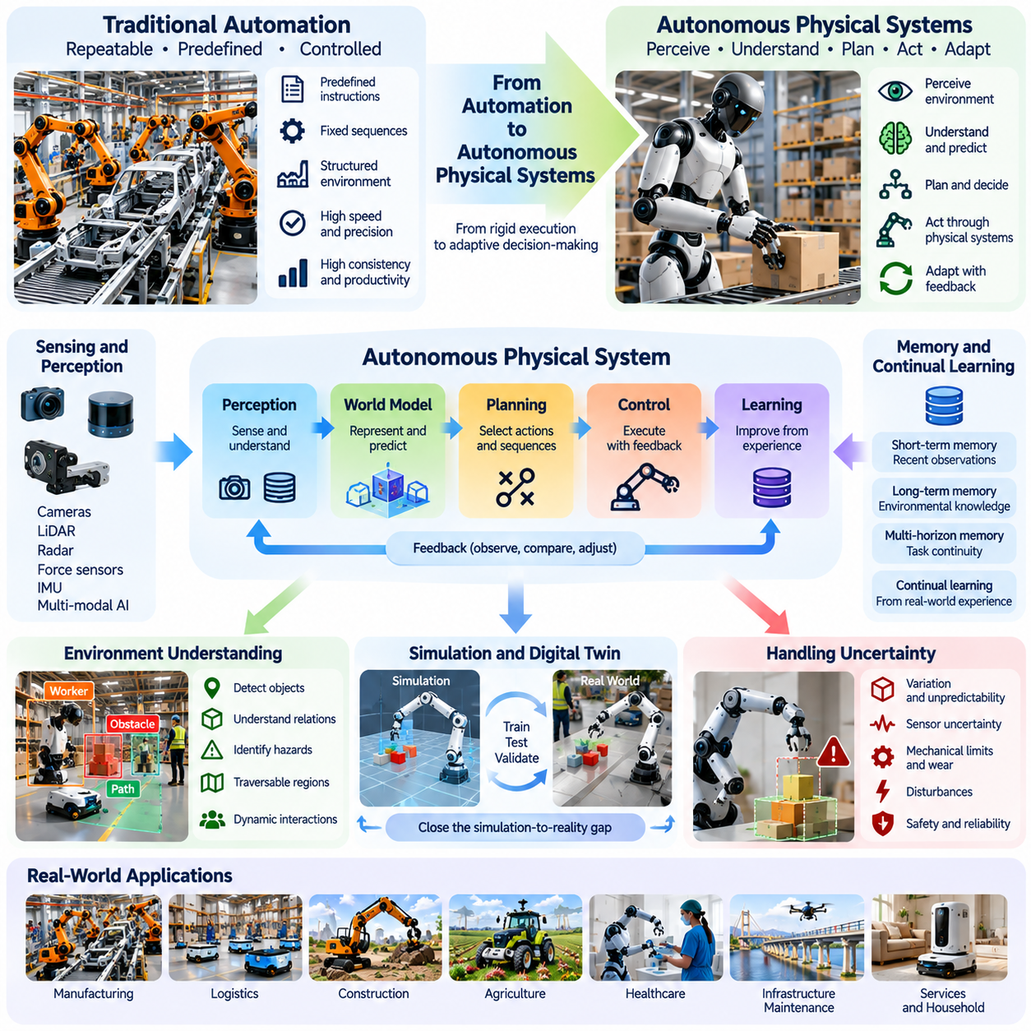
Automation has played a central role in industrial development by allowing machines to perform repetitive physical tasks with speed, precision, and consistency. Traditional automated systems typically operate through predefined instructions, fixed sequences, and controlled environments. Although these systems have dramatically improved productivity, their effectiveness often depends on stable operating conditions and extensive human engineering.
Autonomous physical systems represent a fundamental evolution beyond conventional automation. Rather than executing only predetermined procedures, autonomous machines can perceive environmental conditions, interpret changing situations, select appropriate actions, and adjust their behavior through feedback. This transition shifts machine operation from rigid execution toward adaptive decision-making within defined objectives and constraints.
The distinction between automation and autonomy lies primarily in how systems respond to uncertainty. Conventional automation assumes that relevant operating conditions can be anticipated during system design. Autonomous systems must instead handle variations that cannot be fully specified in advance. They require mechanisms for environmental understanding, predictive reasoning, uncertainty estimation, and adaptive control.
Industrial production illustrates this difference clearly. A traditional robotic assembly line performs programmed motions within a carefully structured workspace. An autonomous manufacturing system may recognize variations in component positions, detect unexpected obstacles, modify manipulation strategies, and recover from selected operational failures. Such capabilities can reduce dependence on extensive manual reprogramming and environmental preparation.
The transition toward autonomy is not a binary replacement of automation but a gradual expansion of machine capabilities. Many practical systems combine deterministic control, rule-based logic, optimization algorithms, and learned policies. The appropriate degree of autonomy depends on task complexity, environmental variability, safety requirements, and economic considerations. Reliable automation remains essential within autonomous architectures.
Perception provides the first major capability required for autonomous physical operation. Cameras, LiDAR, radar, force sensors, inertial measurement units, and other sensing devices generate observations of the environment. Artificial intelligence models transform these measurements into representations of objects, geometry, motion, and operational conditions. Accurate perception allows machines to identify relevant changes and maintain situational awareness.
Environmental understanding extends beyond detecting objects or estimating positions. Autonomous systems must interpret relationships among physical entities, recognize traversable regions, identify hazards, and understand task-relevant constraints. A mobile robot navigating a warehouse, for example, must consider dynamic obstacles, restricted areas, available pathways, and interactions with workers and other machines.
World models provide a framework for connecting perception with predictive decision-making. By representing environmental states and learning how actions influence future conditions, autonomous systems can evaluate potential outcomes before execution. Predictive world models may incorporate geometry, physical dynamics, object interactions, and uncertainty, allowing machines to move beyond purely reactive responses toward deliberate physical planning.
Planning converts environmental understanding into sequences of actions directed toward operational objectives. High-level planners determine goals and task ordering, while motion planners generate feasible trajectories under geometric and dynamic constraints. Lower-level controllers translate planned movements into actuator commands. Effective autonomy requires coordination among these components across different spatial and temporal scales.
Feedback control remains indispensable even when advanced artificial intelligence performs high-level reasoning. Physical machines experience disturbances, mechanical uncertainty, sensor noise, and changing loads. Closed-loop control continuously compares desired behavior with measured outcomes and corrects deviations. Consequently, autonomous intelligence must complement rather than replace established principles of robotics, dynamics, and control engineering.
Learning introduces another important distinction between traditional automation and advanced autonomy. Instead of relying exclusively on manually designed rules, autonomous systems can acquire useful behaviors from demonstrations, simulation, reinforcement learning, and operational experience. Learned policies may improve adaptability, but their deployment requires careful evaluation because training performance does not guarantee reliability under unfamiliar conditions.
Simulation and digital twins can accelerate the development of autonomous physical systems by providing environments for training, testing, and validation. Engineers can expose machines to diverse operating conditions, disturbances, and rare events without immediately risking physical equipment. However, differences between simulated and real environments create a simulation-to-reality gap that must be addressed through calibration, adaptation, and real-world testing.
Memory and continual learning become increasingly important as autonomous systems operate over extended periods. Short-term memory preserves recent observations and immediate task context, while long-term memory maintains environmental knowledge and accumulated experience. Multi-horizon memory architectures may help machines coordinate immediate control decisions with longer-term objectives, operational history, and changing environmental conditions.
Autonomous operation also requires mechanisms for handling unexpected situations. When perception becomes uncertain, equipment behaves abnormally, or planned actions become infeasible, machines must identify the problem and select appropriate recovery strategies. These responses may include replanning, reducing operating speed, requesting human assistance, or transitioning into a predefined safe state.
Human supervision remains essential throughout the transition from automation to autonomy. Supervisors may define objectives, authorize sensitive operations, monitor performance, and intervene when necessary. Teleoperation and shared-control systems provide intermediate approaches in which machines perform routine activities autonomously while humans manage difficult exceptions. Such arrangements can improve operational flexibility without requiring unrestricted autonomy.
Safety engineering becomes more complex as autonomous systems gain greater decision-making authority. Traditional automated machinery can often be evaluated against relatively predictable operating sequences. Autonomous systems must additionally be assessed for uncertain perceptions, unexpected decisions, changing environments, and interactions with people. Independent safety mechanisms, runtime assurance, operational boundaries, and systematic validation are therefore essential.
The economic value of autonomy depends on its ability to reduce operational intervention while maintaining acceptable performance and reliability. A machine that handles diverse conditions without frequent reprogramming may achieve higher utilization and lower supervision costs. However, autonomy also introduces expenses associated with sensors, computing hardware, software development, maintenance, cybersecurity, and safety certification.
Manufacturing and logistics are important environments for the gradual expansion of physical autonomy. Autonomous mobile robots can transport materials, coordinate warehouse operations, and adapt routes when conditions change. Mobile manipulators may eventually combine navigation and object handling within shared workspaces. Their practical effectiveness depends on integration with existing infrastructure, operational processes, and fleet management systems.
Construction, agriculture, healthcare, and infrastructure maintenance present additional opportunities but also greater environmental uncertainty. Uneven terrain, changing weather, deformable materials, human proximity, and unpredictable obstacles create challenges for autonomous perception and control. These sectors may therefore require specialized embodiments, robust world models, and carefully constrained operational capabilities before broader deployment becomes practical.
The emergence of robot foundation models and vision-language-action architectures may further accelerate the transition toward adaptable autonomy. Such models aim to transfer knowledge across tasks and connect human instructions with physical behavior. Nevertheless, general-purpose model outputs must be integrated with embodiment-aware planning, reliable control, safety supervision, and physical feedback to achieve dependable real-world performance.
At larger scales, autonomous physical systems may evolve from isolated machines into coordinated fleets. Shared maps, communication networks, task allocation mechanisms, and collective learning can support cooperation among heterogeneous robots. Fleet-level intelligence may improve resource utilization and operational resilience, although communication failures, cybersecurity risks, and coordination complexity introduce additional engineering challenges.
The progression from automation to autonomous physical systems should therefore be understood as an architectural and operational transformation rather than a simple increase in algorithmic sophistication. Reliable autonomy emerges from integrating perception, world modeling, planning, learning, memory, control, and safety within physically constrained systems. Each component must operate consistently with the others under realistic environmental conditions.
Ultimately, autonomous physical systems may change how civilization organizes production, transportation, infrastructure, and essential services. Their transformative potential arises from the ability to perform increasingly diverse physical activities with reduced dependence on continuous human direction. Achieving this potential will require measurable reliability, responsible governance, economic accessibility, and a sustained commitment to meaningful human oversight.

00.04. Physical AI as a General Purpose Technology
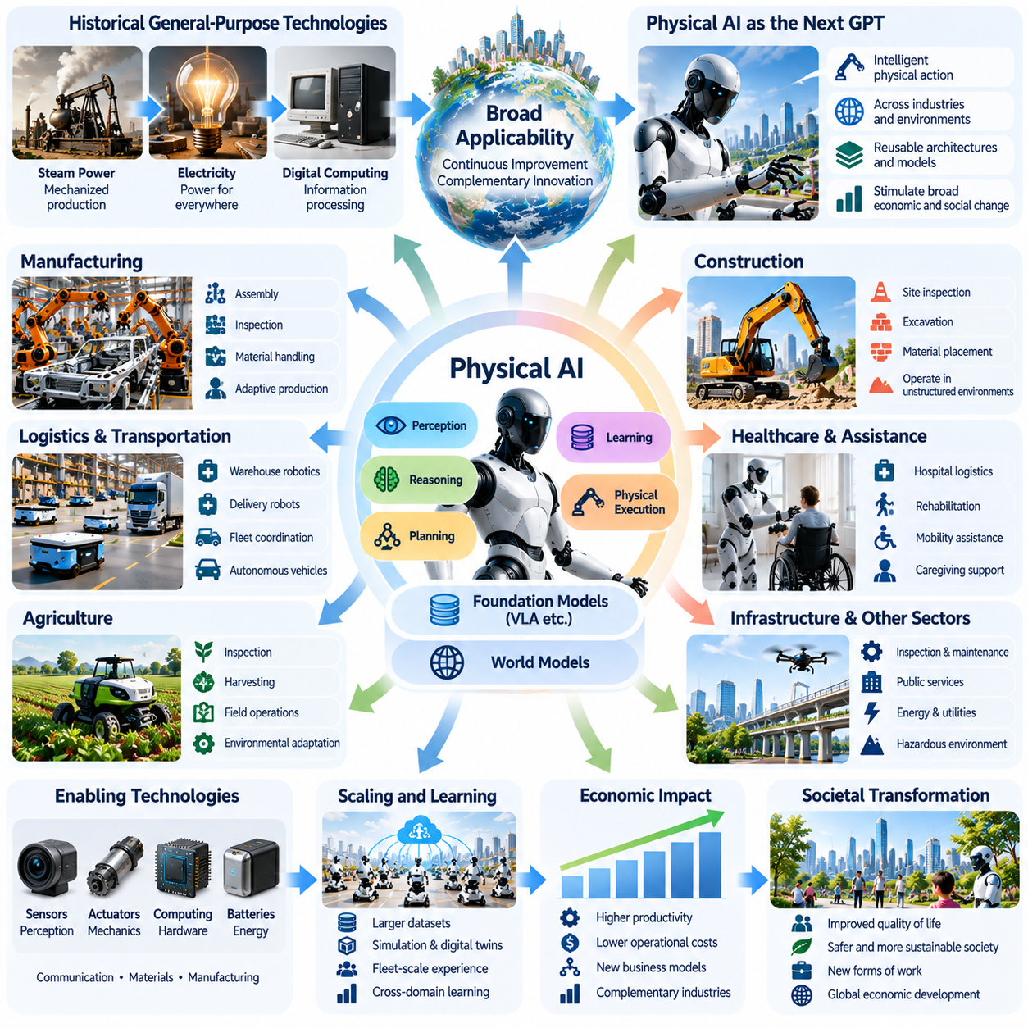
Physical AI has the potential to become a general-purpose technology because its capabilities may extend across numerous industries, economic activities, and social environments. General-purpose technologies are distinguished by their broad applicability, continuous improvement, and capacity to stimulate complementary innovations. Physical AI could exhibit these characteristics by making intelligent physical action available across diverse operational domains.
Historically, technologies such as electricity, steam power, and digital computing transformed economies because they were not restricted to individual applications. Their adoption enabled new production methods, organizational structures, and industrial ecosystems. Physical AI may follow a comparable pattern by providing adaptable machine intelligence that can be integrated into manufacturing, transportation, healthcare, agriculture, construction, and infrastructure.
The general-purpose potential of Physical AI arises from the combination of perception, reasoning, planning, learning, and physical execution. Rather than relying exclusively on specialized automation designed for individual tasks, future systems may reuse common intelligence architectures across different machines. Shared computational foundations could reduce development complexity while allowing adaptation to particular environments and mechanical embodiments.
Robot foundation models represent one possible mechanism for achieving this technological generality. By learning representations from diverse sensory observations, demonstrations, and operational experiences, these models may acquire capabilities transferable across tasks. Vision-language-action architectures further connect semantic understanding with physical behavior, potentially allowing machines to interpret instructions and generate context-sensitive actions.
World models provide another essential component of reusable physical intelligence. These models represent environmental states, physical relationships, and possible future outcomes under different actions. When combined with planning and control, world models may enable machines to reason about unfamiliar situations. Their generality depends on whether learned representations remain useful across different environments, objects, and robot embodiments.
A defining characteristic of general-purpose technologies is their ability to support complementary innovation. Physical AI may encourage advances in sensors, actuators, computing platforms, batteries, communication networks, and robotic materials. Improvements in these supporting technologies can expand autonomous capabilities, while growing demand for intelligent machines can create incentives for further hardware and software development.
The relationship between Physical AI and digital computing is particularly important. Digital computing generalized information processing across industries, while Physical AI may extend programmable intelligence into material production and physical services. This does not imply that physical activities become entirely software-defined, because mechanical structures and environmental constraints remain fundamental. Instead, software intelligence may increasingly determine how physical resources are utilized.
Manufacturing provides an early illustration of this potential. Intelligent robots may support assembly, inspection, material handling, and adaptive production processes. Shared perception and planning architectures could be adapted to different production lines, reducing the need for completely independent automation solutions. However, successful deployment still requires task-specific tooling, safety validation, and integration with existing industrial systems.
Logistics and transportation offer additional opportunities for broad technological diffusion. Autonomous mobile robots, delivery platforms, and intelligent fleet systems can coordinate movement and resource allocation across warehouses, factories, and transportation networks. As navigation, localization, and environmental understanding improve, common software components may become reusable across increasingly diverse mobility applications.
Agriculture and construction demonstrate both the promise and difficulty of general-purpose physical intelligence. Autonomous machines could perform inspection, transportation, harvesting, excavation, and material placement. Yet these environments contain variable terrain, weather conditions, deformable materials, and unpredictable obstacles. Achieving reliable performance requires combining transferable intelligence with specialized mechanical designs and robust environmental adaptation.
Healthcare and personal assistance introduce additional requirements because machines operate near vulnerable individuals and within socially sensitive environments. Physical AI may support hospital logistics, rehabilitation, mobility assistance, and selected caregiving activities. Nevertheless, clinical safety, privacy, human dignity, and professional accountability impose constraints that cannot be resolved through improvements in machine intelligence alone.
The economic influence of Physical AI could extend through productivity spillovers across interconnected industries. Improvements in robotic perception, manipulation, or planning developed for one sector may benefit others. Such knowledge transfer can reduce duplicated research and accelerate innovation. However, the magnitude of these spillovers will depend on interoperability, access to technology, deployment costs, and the availability of transferable operational data.
Scaling effects may further strengthen the general-purpose characteristics of Physical AI. Larger datasets, improved simulation environments, and fleet-scale operational experience could support increasingly capable models. Shared learning systems may distribute validated improvements across multiple machines. Nevertheless, physical learning faces constraints involving data collection costs, safety, embodiment differences, and the limited transferability of some experiences.
Standardization will be important for transforming isolated robotic innovations into broadly accessible technological infrastructure. Common interfaces, communication protocols, safety requirements, and data representations can improve interoperability among machines and software platforms. Open architectures may encourage participation by smaller developers, while proprietary ecosystems may accelerate integrated development but also increase technological dependence.
Physical AI could also reshape business models by separating access to robotic capabilities from direct equipment ownership. Robot-as-a-Service arrangements, shared fleet platforms, and usage-based automation services may allow organizations to adopt intelligent machines without purchasing complete robotic systems. These models could expand market access, although their success depends on utilization, maintenance economics, service reliability, and contractual responsibility.
The diffusion of Physical AI will likely occur unevenly because industries differ in their technical readiness and economic incentives. Structured environments with repetitive tasks may achieve reliable autonomy earlier than highly variable public spaces. Capital-intensive industries may adopt sophisticated systems before smaller organizations can justify their costs. Consequently, technological generality does not guarantee immediate universal deployment.
Labor transformation represents another important consequence of general-purpose physical intelligence. As machines become capable of performing broader categories of physical tasks, organizations may reorganize production processes and redefine human responsibilities. Some activities may be automated, while others may be augmented through human-robot collaboration. The resulting employment effects will depend on productivity gains, demand expansion, workforce adaptation, and institutional responses.
The relationship between Physical AI and economic growth is therefore more complex than the simple substitution of machines for workers. Autonomous systems may increase productive capacity, improve service availability, and enable activities that were previously impractical. At the same time, deployment requires substantial investment in equipment, infrastructure, training, and governance. Productivity improvements will depend on complementary organizational and technological changes.
Energy and environmental considerations may influence the long-term diffusion of Physical AI. Intelligent machines could improve resource efficiency, infrastructure monitoring, and precision operations. However, large-scale deployment would increase demand for electricity, computing hardware, batteries, and industrial materials. The net environmental impact will depend on lifecycle efficiency, energy sources, manufacturing practices, and the extent to which automation reduces waste.
General-purpose technologies also influence geopolitical competition and industrial organization. Countries with strong capabilities in robotics manufacturing, semiconductor production, AI research, and industrial integration may gain strategic advantages. Concentration of computational resources, proprietary datasets, and robotic platforms could create barriers to entry. Policies supporting competition, interoperability, education, and technological access may shape how benefits are distributed.
Physical AI may eventually become an enabling layer for increasingly autonomous infrastructure. Factories, warehouses, transportation systems, energy facilities, and cities could integrate machine perception, planning, and coordinated action into everyday operations. Such systems would require shared environmental representations, secure communication, fleet management, and mechanisms for human oversight. Their development would be gradual and dependent on reliable interoperability.
The emergence of Physical AI as a general-purpose technology should not be treated as inevitable. Broad applicability must be demonstrated through reliable performance, economic viability, and successful transfer across different tasks and environments. Limitations in physical reasoning, manipulation, energy efficiency, safety assurance, and continual learning may constrain diffusion. Progress must therefore be evaluated through practical deployment outcomes rather than model capabilities alone.
Ultimately, the civilizational importance of Physical AI may arise from its capacity to make adaptable physical intelligence a reusable technological resource. If common learning, reasoning, and control foundations can support diverse machines and industries, Physical AI could stimulate widespread innovation and reorganize productive activity. Its long-term impact will depend on technical maturity, institutional governance, economic accessibility, and the responsible integration of autonomous systems into human society.

00.05. Technology Economy Society and Infrastructure
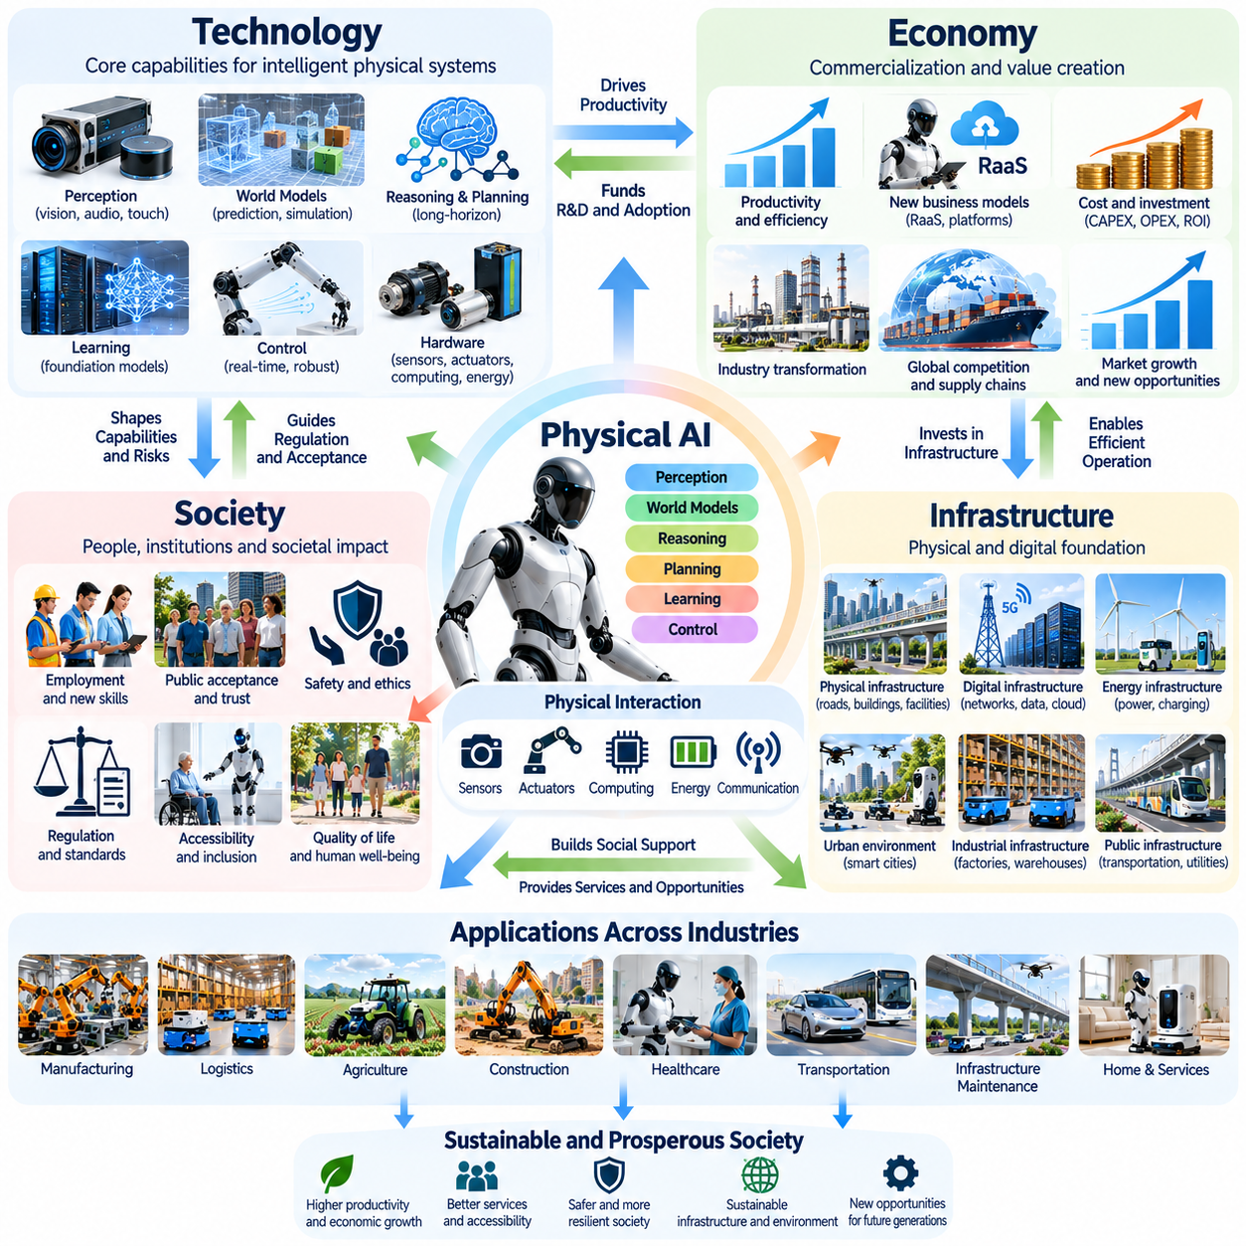
The future of Physical AI cannot be understood through technological progress alone because autonomous physical systems operate within interconnected economic, social, and infrastructural environments. Advances in machine intelligence influence productivity and institutional organization, while economic incentives and social expectations determine which technologies are adopted. These relationships form a complex system of mutual influence.
Technology provides the foundational capabilities that make Physical AI possible. Progress in perception, world modeling, reasoning, planning, learning, and control enables machines to interact with physical environments. Sensors, actuators, computing hardware, communication networks, and energy systems translate these computational capabilities into practical operation. Their integration determines the reliability and usefulness of autonomous machines.
Economic conditions determine whether technological capabilities become commercially viable systems. Organizations evaluate capital expenditure, operating costs, productivity improvements, maintenance requirements, and expected returns before adopting autonomous equipment. Even highly capable robots may experience limited deployment when their costs exceed measurable benefits or when integration requires extensive organizational changes.
Society influences the development of Physical AI through labor expectations, public acceptance, education, regulation, and ethical priorities. Autonomous machines operate alongside people and affect employment, privacy, accessibility, and safety. Consequently, technological success depends not only on machine performance but also on whether individuals and institutions consider these systems trustworthy, beneficial, and compatible with human values.
Infrastructure provides the physical and digital foundation upon which autonomous systems operate. Transportation networks, industrial facilities, energy distribution systems, communication platforms, and public spaces shape the environments available to intelligent machines. Infrastructure designed exclusively for human operation may impose significant limitations on autonomous navigation, coordination, and reliable task execution.
These four dimensions interact through continuous feedback mechanisms. Technological improvements may reduce operating costs, encouraging greater economic investment and wider adoption. Increased deployment generates operational experience that supports further learning and innovation. At the same time, social concerns may influence regulation, while infrastructure limitations can delay commercialization despite improvements in artificial intelligence capabilities.
Manufacturing illustrates the interdependence of technology, economics, society, and infrastructure. Intelligent robots require reliable perception and control, but successful deployment also depends on production economics, workforce organization, factory layouts, and safety procedures. Introducing autonomous equipment may therefore require changes to material flows, employee responsibilities, information systems, and maintenance practices.
Logistics provides another example of this interconnected transformation. Autonomous mobile robots can improve material transportation and warehouse coordination, but their performance depends on facility geometry, communication reliability, traffic management, and integration with inventory systems. Economic benefits arise when technical capabilities align with operational processes and human workers can collaborate safely with automated fleets.
Urban environments introduce additional complexity because Physical AI interacts with public infrastructure and diverse social groups. Autonomous vehicles, delivery robots, inspection machines, and maintenance systems may share streets, buildings, and public facilities. Their successful integration requires accessible infrastructure, clear operating rules, reliable communication, and public confidence in the safety of autonomous behavior.
The relationship between Physical AI and labor markets is particularly significant. Automation can change the demand for specific tasks, alter occupational structures, and create requirements for new technical skills. Some workers may benefit from productivity-enhancing assistance, while others may experience displacement or changing responsibilities. Education, retraining, and institutional adaptation will influence how these effects are distributed.
Economic productivity improvements may also change the structure of industrial competition. Organizations capable of deploying intelligent machines at scale could achieve advantages in operating efficiency, service availability, and production flexibility. However, high initial investment requirements and dependence on specialized technology providers may increase market concentration and create barriers for smaller enterprises.
The distribution of Physical AI capabilities across countries may influence global economic development. Regions with advanced semiconductor industries, robotics manufacturing, computational infrastructure, and technical expertise may adopt autonomous systems more rapidly. Countries lacking these resources could face technological dependence, although accessible platforms and international cooperation may provide alternative pathways for participation.
Energy infrastructure represents a critical dependency for large-scale Physical AI deployment. Autonomous machines require electricity for computation, sensing, actuation, and communication. Battery capacity, charging availability, thermal management, and power reliability directly influence operating duration and economic performance. Widespread adoption may therefore require coordinated investment in energy generation, storage, and distribution.
Digital infrastructure is equally important because autonomous systems increasingly depend on software updates, data management, remote monitoring, and fleet coordination. Edge computing supports time-sensitive control and local decision-making, while cloud platforms can provide large-scale training and shared learning services. Effective architectures must balance latency, bandwidth, privacy, reliability, and operational independence.
World models and digital twins may become important connections between technological intelligence and physical infrastructure. Shared representations of buildings, factories, transportation networks, and urban environments can support planning and coordinated operations. However, maintaining accurate models requires continuous data collection, synchronization, governance, and mechanisms for handling environmental changes.
The development of robot-friendly infrastructure could gradually reduce the complexity of autonomous operation. Standardized docking stations, machine-readable navigation information, accessible pathways, and interoperable communication interfaces may simplify deployment. Nevertheless, infrastructure modification involves substantial costs, and excessive dependence on specialized facilities could limit the flexibility expected from general-purpose Physical AI.
Social acceptance depends strongly on the perceived balance between benefits and risks. People may welcome machines that reduce dangerous work, improve accessibility, or support essential services, while expressing concerns about surveillance, employment disruption, or loss of human control. Transparent operating practices, clear accountability, and meaningful opportunities for human intervention can influence public trust.
Governance provides the institutional mechanisms needed to coordinate technological innovation with economic and social objectives. Safety standards, certification processes, liability frameworks, privacy protections, and cybersecurity requirements establish boundaries for autonomous operation. Effective governance must protect individuals and public infrastructure without unnecessarily preventing beneficial experimentation and responsible innovation.
The environmental consequences of Physical AI require evaluation across complete technology lifecycles. Intelligent machines may reduce waste, improve precision operations, and support infrastructure maintenance. However, manufacturing robots and computing hardware consumes materials and energy. Sustainable development depends on whether operational efficiency gains outweigh the environmental costs of production, deployment, and disposal.
Physical AI may also create new relationships between public and private infrastructure. Commercial robotic fleets could depend on public roads, communication networks, and shared spatial information, while public institutions may rely on privately developed autonomous platforms. These arrangements introduce questions concerning interoperability, data ownership, service continuity, competition, and responsibility for infrastructure investment.
The pace of transformation will vary because technological readiness, economic incentives, social expectations, and infrastructure conditions differ across sectors. Structured industrial facilities may support autonomy earlier than unpredictable public environments. Healthcare and caregiving applications may require more extensive validation because human vulnerability and ethical considerations create additional operational constraints.
Long-term planning must therefore consider interconnected development pathways rather than isolated technological forecasts. A breakthrough in robotic reasoning may have limited impact without affordable hardware, reliable energy, appropriate regulations, and deployable infrastructure. Conversely, improvements in standards, manufacturing scale, and organizational practices may accelerate adoption even when fundamental algorithms advance incrementally.
The transition toward a Physical AI-enabled civilization will involve continuous adaptation among machines, organizations, institutions, and built environments. Technological capabilities will reshape economic opportunities, while social priorities and infrastructure investments will influence subsequent innovation. Understanding these interactions is essential for evaluating realistic development scenarios and identifying critical dependencies.
Ultimately, Physical AI should be understood as part of a broader technological, economic, social, and infrastructural transformation. Its civilizational significance will depend on how effectively intelligent machines are integrated into productive systems and everyday environments. Sustainable progress requires coordinated advances in engineering, investment, governance, education, and infrastructure while preserving human agency and societal well-being.

00.06. Uncertainty in Long Term Forecasting
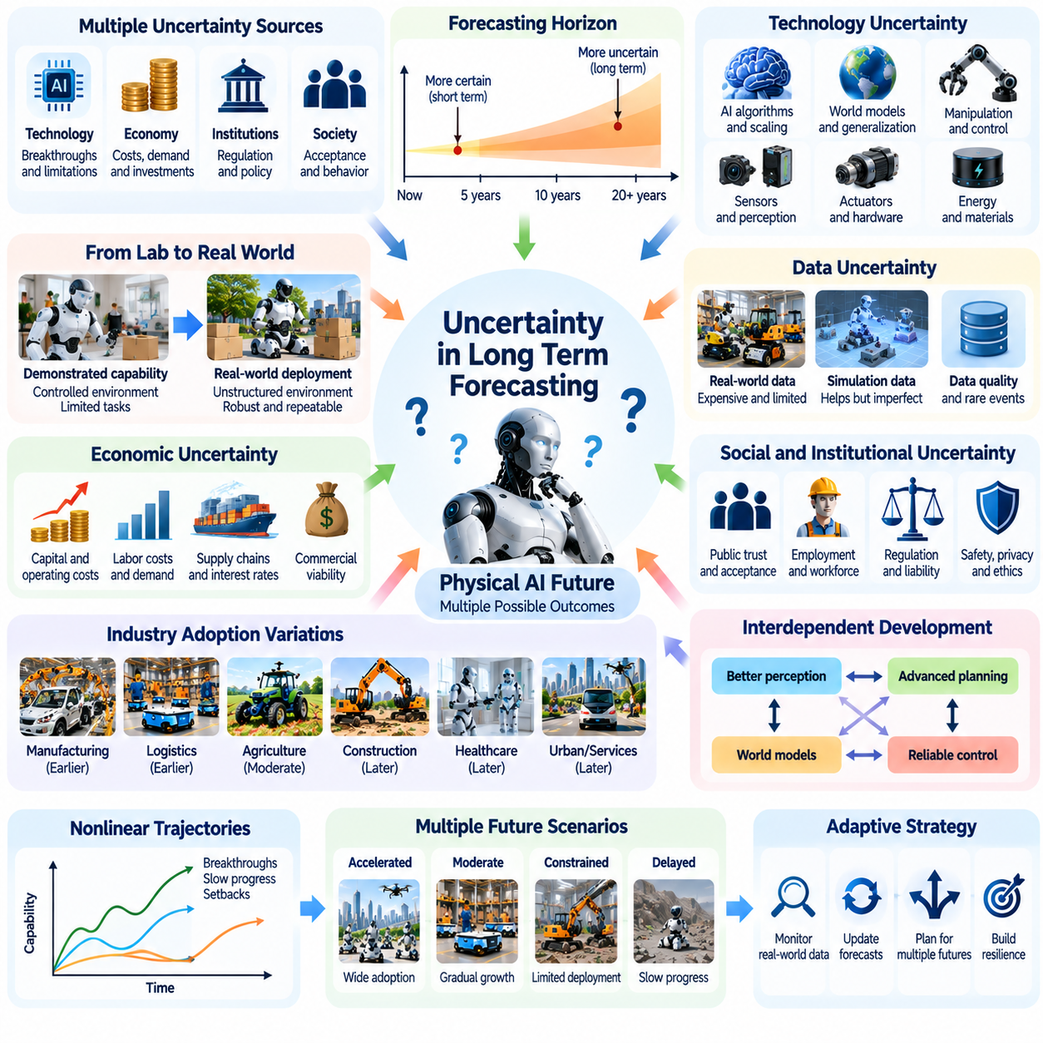
Long-term forecasting of Physical AI involves substantial uncertainty because technological progress interacts with economic conditions, institutional decisions, and unpredictable social developments. Although current research reveals important trends in robotics and artificial intelligence, these trends cannot establish precise future outcomes. Forecasting must therefore distinguish observable evidence, reasonable assumptions, and speculative possibilities.
Uncertainty increases as the forecasting horizon extends from several years to multiple decades. Short-term projections can draw upon existing prototypes, investment commitments, and engineering roadmaps. Longer-term projections depend on developments that may not yet be visible. New scientific discoveries, economic disruptions, regulatory changes, and unexpected technological limitations can significantly alter anticipated trajectories.
Physical AI is particularly difficult to forecast because intelligence must operate through physical systems. Improvements in algorithms do not automatically produce equivalent advances in robotic performance. Sensors, actuators, batteries, mechanical structures, and environmental conditions impose constraints that cannot be eliminated through computation alone. Progress depends on coordinated improvements across multiple technological domains.
The distinction between demonstrated capabilities and projected capabilities is fundamental. A robot successfully performing a task under controlled conditions does not establish reliable performance across unfamiliar environments. Laboratory demonstrations may conceal extensive preparation, human intervention, or restricted operating assumptions. Long-term forecasts must therefore consider robustness, repeatability, generalization, and practical deployment requirements.
Scaling laws provide useful but incomplete information about future Physical AI capabilities. Larger models, datasets, and computational resources may improve learning and generalization, yet physical intelligence faces additional bottlenecks involving interaction data, embodiment diversity, and real-world evaluation. Extrapolating digital AI scaling trends directly into robotics may therefore produce misleading expectations.
World models introduce both promising opportunities and significant forecasting uncertainty. Learning predictive representations of physical environments could improve planning, manipulation, and long-horizon autonomy. However, it remains uncertain how effectively such models will generalize across unfamiliar objects, complex contacts, and changing physical conditions. Predictive accuracy in simulation does not necessarily guarantee reliable real-world control.
Data availability represents another major uncertainty. Large robotic fleets could generate extensive operational experience, while simulation and synthetic data may expand training coverage. Nevertheless, collecting physically meaningful data remains expensive, and rare safety-critical events are difficult to represent adequately. The relationship between dataset scale, data quality, and transferable robotic competence remains an open research question.
Hardware development introduces uncertainties that differ from those encountered in software systems. Advances in actuator efficiency, energy storage, tactile sensing, and manufacturing processes may enable new robotic capabilities. Conversely, limitations in cost, durability, power density, and maintenance could delay deployment. Forecasting must account for the slower development and replacement cycles of physical equipment.
Economic uncertainty strongly influences the practical adoption of autonomous machines. Even technically successful systems may not achieve widespread deployment if capital costs, maintenance expenses, or integration requirements remain excessive. Labor costs, interest rates, supply chains, and customer demand also affect investment decisions. Technological feasibility and commercial viability should therefore be evaluated separately.
The pace of adoption may vary considerably across industries. Structured manufacturing and warehouse environments may support autonomous systems earlier than construction sites, hospitals, or public streets. Differences in environmental complexity, safety requirements, and operational economics create distinct adoption pathways. A single forecast for the entire Physical AI sector may obscure these important variations.
Social and institutional responses create additional uncertainty. Public trust, employment concerns, privacy expectations, and attitudes toward machine autonomy may influence deployment. Governments may establish different certification requirements, liability frameworks, and restrictions on autonomous operation. These decisions can accelerate or constrain adoption independently of improvements in technical performance.
Forecasts concerning labor displacement are especially sensitive to assumptions. The technical ability to automate a task does not imply that an occupation will disappear. Jobs combine multiple activities, interpersonal responsibilities, and organizational functions. Automation may replace selected tasks, augment human capabilities, or create new forms of employment, depending on economic incentives and institutional adaptation.
Uncertainty also arises from interactions among technological components. Improvements in perception may have limited practical value without corresponding advances in manipulation and control. Better planning algorithms may require more accurate world models, while advanced models may depend on affordable computing infrastructure. Such dependencies can create bottlenecks that delay progress despite breakthroughs in individual research areas.
Technological development may follow nonlinear trajectories rather than smooth improvements. Breakthroughs in learning architectures, simulation, or robotic hardware could accelerate capabilities unexpectedly. Conversely, diminishing returns, unresolved reliability problems, or safety incidents may slow progress. Forecasting approaches that assume constant improvement rates can therefore underestimate both acceleration and stagnation.
Historical analogies offer useful perspectives but should not be treated as deterministic evidence. Electricity, automobiles, industrial robots, and digital computing each followed distinctive adoption patterns shaped by infrastructure and institutions. Physical AI shares characteristics with these technologies but also faces unique challenges involving physical interaction and autonomous decision-making. Historical comparisons should illuminate possibilities rather than dictate timelines.
Scenario analysis provides a practical method for addressing uncertainty without claiming precise prediction. Alternative futures can be constructed around different assumptions concerning technological progress, economic viability, regulation, and social acceptance. These scenarios help identify critical dependencies and potential consequences. Their value lies in supporting preparation and decision-making rather than assigning certainty to a particular outcome.
A conservative scenario may involve gradual improvements in specialized robotic systems with limited transfer across tasks. A more accelerated scenario may feature increasingly capable foundation models, shared world models, and scalable fleet learning. An intermediate scenario may combine broad software progress with persistent hardware and deployment constraints. Each pathway produces different implications for productivity and infrastructure investment.
Quantitative forecasting can complement scenario analysis when assumptions and uncertainty ranges are explicitly documented. Measures such as task success rates, intervention frequency, operating costs, energy consumption, and deployment scale provide observable indicators. However, forecasts based on these measures must distinguish experimental performance from sustained commercial operation and avoid presenting uncertain estimates as established facts.
Forecasting frameworks should also consider correlated risks and cascading effects. Semiconductor shortages, energy constraints, cybersecurity incidents, or major regulatory changes may affect multiple robotic industries simultaneously. Interdependence between cloud services, communication networks, and physical infrastructure can amplify disruptions. Evaluating isolated technological variables may underestimate these systemic vulnerabilities.
Expert judgment remains valuable but is vulnerable to cognitive biases. Researchers may overestimate progress in their specialties, while investors may favor optimistic commercialization timelines. Public narratives can alternate between exaggerated expectations and excessive pessimism. Forecasting processes should therefore incorporate diverse expertise, transparent assumptions, independent evaluation, and systematic comparison with observed outcomes.
Continuous forecast revision is essential because new evidence changes the plausibility of competing scenarios. Research benchmarks, real-world deployment results, hardware costs, and regulatory developments can be monitored over time. Forecasts should be updated when assumptions become inconsistent with observed conditions. This adaptive approach is more useful than treating a long-term roadmap as an immutable prediction.
The distinction between uncertainty and ignorance is also important. Some uncertainties can be quantified through experiments, historical observations, and statistical analysis. Others arise from unknown future discoveries or unprecedented social responses. Recognizing these different forms of uncertainty prevents false precision and encourages flexible planning strategies that remain useful across multiple possible futures.
For the period from 2030 to 2040, Physical AI forecasting should emphasize conditional development pathways rather than fixed milestones. Progress in general-purpose manipulation, long-horizon autonomy, embodied learning, and coordinated robotic fleets may substantially influence adoption. Yet the timing and scale of these developments remain uncertain because technical performance must converge with affordability, safety, and infrastructure readiness.
Ultimately, responsible forecasting of Physical AI requires intellectual humility, empirical discipline, and explicit recognition of uncertainty. Long-term projections should clarify what is currently demonstrated, what is technically plausible, and what remains speculative. By combining measurable evidence, alternative scenarios, and continuous reassessment, society can prepare for transformative possibilities without assuming that any particular technological future is inevitable.

00.07. Scenarios vs Predictions
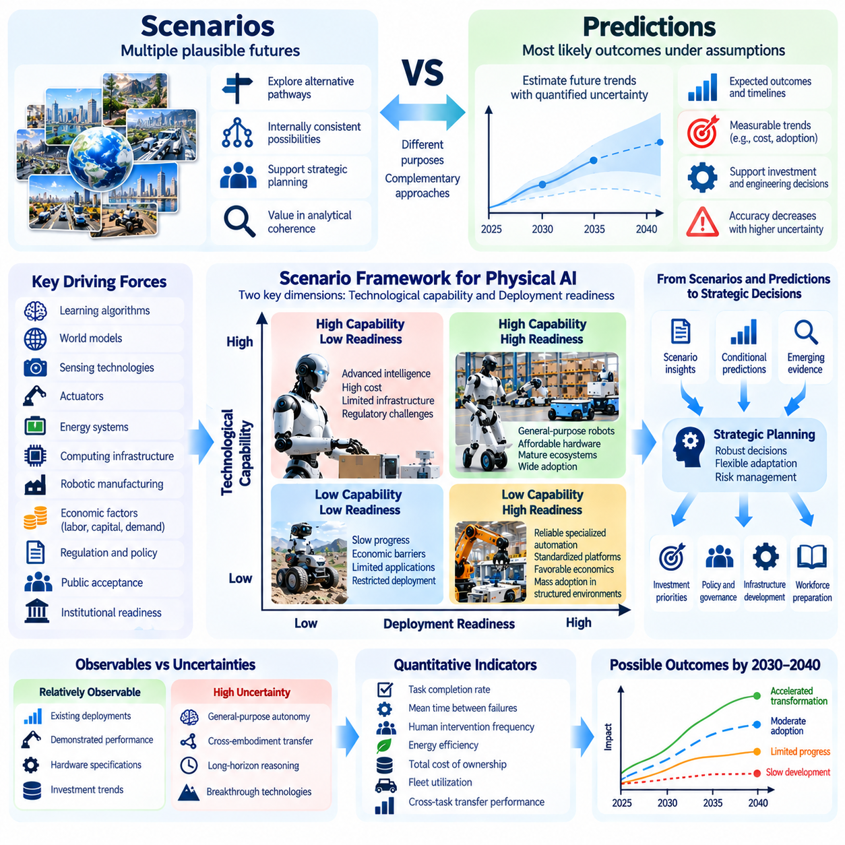
Understanding the future of Physical AI requires a clear distinction between scenarios and predictions. Predictions attempt to estimate what is most likely to happen under specified assumptions, while scenarios explore multiple plausible futures that may emerge from different technological, economic, and social conditions. Both approaches are valuable, but they serve different purposes in long-term strategic planning.
Predictions generally seek to identify expected outcomes, timelines, or measurable trends. They may estimate robotic deployment rates, hardware costs, productivity improvements, or the emergence of specific technical capabilities. Such estimates can support investment and engineering decisions when reliable evidence exists. However, their accuracy decreases when future developments depend on uncertain breakthroughs and complex interactions.
Scenarios do not necessarily identify the most probable future. Instead, they describe internally consistent possibilities that help researchers, policymakers, and organizations examine alternative development pathways. A scenario may explore rapid progress in robot foundation models, persistent hardware limitations, or strict regulatory requirements. Its usefulness depends on analytical coherence rather than predictive certainty.
The distinction becomes especially important when examining Physical AI because technological capability does not automatically translate into widespread adoption. A breakthrough in autonomous manipulation may improve laboratory performance without reducing deployment costs sufficiently. Conversely, incremental technical improvements combined with favorable economics and standardized infrastructure may produce substantial industrial transformation.
Scenario construction begins by identifying major forces that influence future outcomes. For Physical AI, these include learning algorithms, world models, sensing technologies, actuators, energy systems, computing infrastructure, and robotic manufacturing. Economic variables such as labor costs, capital availability, and market demand must also be considered alongside regulation, public acceptance, and institutional readiness.
Uncertainty should be separated from variables that can be observed with reasonable confidence. Existing robotic deployments, demonstrated task performance, hardware specifications, and documented investment trends provide useful starting points. Future breakthroughs in general-purpose autonomy, cross-embodiment transfer, and long-horizon reasoning remain more uncertain. Scenarios should explicitly distinguish these categories.
A useful scenario framework may organize alternative futures around two critical dimensions: technological capability and deployment readiness. Technological capability describes how effectively robots perceive, reason, plan, manipulate, and learn. Deployment readiness concerns affordability, safety certification, infrastructure compatibility, operational reliability, and organizational integration. These dimensions can evolve at different rates.
A high-capability, high-readiness scenario would involve substantial improvements in general-purpose robotic intelligence accompanied by affordable hardware and mature deployment ecosystems. Autonomous systems could expand across manufacturing, logistics, construction, and selected service industries. Even under favorable conditions, adoption would remain dependent on task-specific economics, safety requirements, and regional infrastructure.
A high-capability, low-readiness scenario illustrates why advanced intelligence alone may be insufficient. Robots might demonstrate sophisticated manipulation, predictive world modeling, and flexible task execution while remaining expensive or difficult to maintain. Inadequate infrastructure, unresolved liability questions, or limited safety assurance could restrict commercial deployment despite impressive research achievements.
A low-capability, high-readiness scenario may emphasize reliable specialized automation rather than broadly generalizable intelligence. Standardized platforms, mature industrial interfaces, and favorable operating economics could support extensive adoption within structured environments. Such a future might deliver significant productivity improvements without requiring robots to achieve human-level versatility.
A low-capability, low-readiness scenario would involve slower technical progress combined with persistent economic and institutional barriers. Physical AI deployment might remain concentrated in narrowly defined industrial applications. High maintenance costs, limited transferability, insufficient reliability, and weak investment incentives could constrain expansion. This scenario helps identify vulnerabilities that optimistic forecasts may overlook.
These alternative pathways are analytical tools rather than claims that the future must follow one of four predefined categories. Real development may combine elements from multiple scenarios, change direction over time, or produce unexpected outcomes. Scenario frameworks should therefore remain flexible enough to incorporate emerging evidence, technological discontinuities, and differences among industries and geographic regions.
Predictions can operate within scenarios by estimating conditional outcomes. For example, a model may estimate the economic feasibility of autonomous warehouse operations under assumed robot costs, intervention rates, and utilization levels. Such predictions are meaningful only within their stated conditions. Changing assumptions about maintenance, energy consumption, or labor availability may substantially alter the results.
Quantitative indicators help connect scenarios with observable evidence. Task completion rates, mean time between failures, human intervention frequency, energy efficiency, total cost of ownership, and fleet utilization provide measures of operational maturity. Cross-task transfer performance and recovery from unfamiliar conditions may indicate progress toward general-purpose autonomy. No single metric adequately captures overall readiness.
World model development provides an example of scenario-dependent technological uncertainty. If predictive representations generalize reliably across physical environments, they may improve long-horizon planning and adaptive manipulation. If learned dynamics remain sensitive to unfamiliar contacts, materials, or embodiments, practical benefits may develop more slowly. Both possibilities should remain visible in long-term analysis.
Robot foundation models and vision-language-action systems introduce similar uncertainties. Improvements in multimodal learning may enable broader instruction following and reusable robotic skills. However, reliable physical execution still requires embodiment-aware control, uncertainty handling, and safety mechanisms. Scenarios should evaluate whether model-level improvements translate into sustained autonomous performance under realistic operating conditions.
Economic scenarios must consider more than the direct substitution of human labor. Physical AI may increase productive capacity, reduce hazardous work, improve service availability, and enable previously impractical operations. At the same time, adoption may require substantial investments in facilities, workforce training, maintenance networks, and digital infrastructure. Different assumptions about these complementary costs produce different outcomes.
Social and regulatory developments can substantially redirect technological pathways. Public confidence may grow when autonomous systems demonstrate measurable safety and clear benefits. Conversely, serious incidents, privacy concerns, or employment disruptions may lead to restrictive policies. Scenario analysis should examine how governance arrangements influence adoption without assuming that either unrestricted deployment or permanent prohibition is inevitable.
Infrastructure readiness creates another source of divergence between scenarios. Reliable energy supplies, charging networks, communication systems, machine-readable environments, and interoperable software interfaces can support robotic operations. Where these resources are unavailable, deployment may remain limited even when intelligent machines become technically capable. Infrastructure investment can therefore act as an independent driver of adoption.
Scenario analysis becomes especially valuable when examining developments between 2030 and 2040. Rather than assigning fixed dates to general-purpose robots or autonomous infrastructure, researchers can describe conditional milestones. These may include validated long-horizon autonomy, economically viable mobile manipulation, scalable fleet learning, and certified operation in increasingly complex environments.
A disciplined forecasting process should regularly compare scenario assumptions with new evidence. Research demonstrations, commercial deployment results, manufacturing costs, regulatory decisions, and operational safety records can reveal which pathways are becoming more plausible. Predictions should be recalibrated when observed outcomes diverge from expectations, while scenarios should be revised when important uncertainties change.
Scenario planning also supports decisions that remain valuable across multiple futures. Modular robotic architectures, interoperable interfaces, robust safety systems, workforce development, and flexible infrastructure can reduce dependence on any single technological trajectory. Such investments may preserve strategic options whether general-purpose autonomy develops rapidly or specialized systems remain dominant.
The central objective is not to replace predictions with scenarios but to use each approach appropriately. Predictions provide conditional estimates that support measurable decisions, while scenarios expose assumptions, dependencies, and alternative possibilities. Combining both methods can improve strategic reasoning without creating false confidence about developments that remain fundamentally uncertain.
Ultimately, the future of Physical AI should be examined as a range of plausible technological and civilizational transformations rather than a predetermined destination. Scenarios help society prepare for divergent possibilities, while predictions provide testable expectations within clearly defined conditions. Together, they support adaptive planning, responsible investment, and informed governance as physical intelligence evolves.

00.08. Roadmap of Physical AI and Civilization
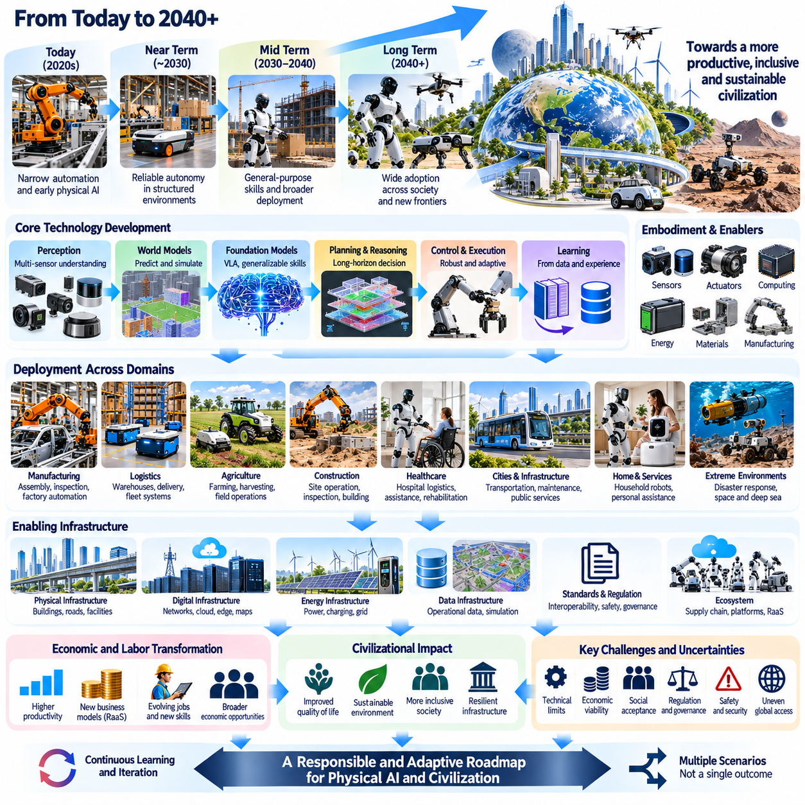
The roadmap of Physical AI and civilization examines how advances in autonomous physical intelligence may influence technological systems, economic structures, social institutions, and human environments over the coming decades. Rather than presenting a predetermined future, this roadmap identifies interconnected development pathways and critical dependencies. Its purpose is to connect engineering progress with broader civilizational consequences.
Physical AI represents a transition from machines that execute predefined instructions toward systems capable of perceiving, predicting, planning, and acting within dynamic environments. This transition requires the integration of artificial intelligence, robotics, control engineering, and physical infrastructure. The resulting capabilities may gradually extend autonomous operation beyond structured industrial settings into increasingly complex domains.
The technological foundation of this transformation includes perception systems, world models, robot foundation models, and adaptive control architectures. These components allow machines to interpret physical conditions, estimate future states, and select appropriate actions. Progress in multimodal learning, action-conditioned prediction, and long-horizon reasoning may expand the range of tasks that autonomous machines can perform reliably.
Physical intelligence also depends on the relationship between computational models and mechanical embodiments. Sensors, actuators, energy systems, and physical structures determine how intelligence interacts with the world. Advances in software cannot fully compensate for inadequate hardware performance. The roadmap must therefore consider coordinated development across algorithms, robotic platforms, materials, manufacturing, and energy technologies.
During the period approaching 2030, a plausible development pathway involves expanding reliable autonomy within relatively structured environments. Manufacturing facilities, warehouses, industrial inspection systems, and selected transportation applications may benefit from improved perception and adaptive planning. Progress will depend on measurable task performance, operational reliability, economic feasibility, and compliance with applicable safety requirements.
The expansion of autonomous systems into less structured environments presents additional challenges. Construction sites, agricultural fields, hospitals, and public spaces contain changing obstacles, uncertain interactions, and diverse human activities. These environments require robust perception, predictive world models, flexible manipulation, and effective recovery strategies. Successful deployment may proceed through carefully constrained operational domains.
The period from 2030 to 2040 may involve increasing integration of general-purpose learning architectures with specialized robotic platforms. Robot foundation models and vision-language-action systems could support reusable skills and more flexible instruction following. However, the degree of generalization across tasks and embodiments remains uncertain. Reliable physical execution will continue to require task-specific validation and safety supervision.
Long-horizon autonomy represents a particularly important research direction. Machines performing extended activities must coordinate immediate control with intermediate planning and long-term objectives. Hierarchical reasoning, multi-horizon memory, and predictive world models may support this coordination. Their practical value will depend on maintaining accurate environmental representations and recovering from accumulated errors during prolonged operation.
The transition from isolated autonomous machines to coordinated robotic fleets may create another major development pathway. Shared maps, distributed task allocation, operational data collection, and collective learning can improve fleet performance. Experience gathered across many robots may support continuous improvement, provided that data quality, privacy, cybersecurity, and differences between robotic embodiments are appropriately managed.
Labor and employment form the first major civilizational dimension of the roadmap. Physical AI may automate selected physical tasks, augment human capabilities, and change occupational responsibilities. Its effects will vary across industries and regions according to technical feasibility and economic incentives. Education, retraining, workplace redesign, and institutional adaptation will influence whether productivity gains translate into broadly shared opportunities.
Economic transformation extends beyond labor substitution. Autonomous physical systems may improve production flexibility, increase infrastructure utilization, and expand access to services. New business models involving shared robotic platforms and Robot-as-a-Service may reduce some adoption barriers. Nevertheless, capital requirements, maintenance costs, market concentration, and unequal technological access could influence the distribution of economic benefits.
Cities and infrastructure constitute another major area of potential transformation. Autonomous transportation, delivery, inspection, and maintenance systems may become increasingly integrated with buildings, roads, utilities, and communication networks. Shared environmental representations and coordinated control could improve operational efficiency. Such integration requires infrastructure adaptation, interoperability, public safety measures, and accountable governance.
Energy infrastructure will play a decisive role in determining the practical scale of Physical AI deployment. Robots require power for computation, sensing, actuation, and communication, while supporting data centers consume additional electricity. Battery technology, charging networks, power management, and energy availability will affect operational economics. Environmental outcomes must be evaluated across manufacturing, operation, and disposal.
The roadmap also considers the extension of Physical AI into remote and hazardous environments. Autonomous systems may support deep-sea inspection, disaster response, industrial maintenance, and space exploration. These applications require robust operation under communication delays, limited energy resources, and uncertain physical conditions. Greater autonomy may reduce dependence on continuous human intervention where direct supervision is impractical.
Space exploration offers a particularly demanding example of long-horizon physical intelligence. Robotic systems operating on planetary surfaces may need to navigate unfamiliar terrain, inspect geological structures, manipulate equipment, and manage limited resources. Predictive planning and autonomous recovery could increase mission flexibility. However, reliability, radiation tolerance, communication constraints, and hardware durability remain substantial challenges.
The convergence of Physical AI and artificial general intelligence introduces another long-term research question. Advances in general reasoning may improve task planning and adaptation, while embodied interaction may provide additional grounding for intelligent systems. Nevertheless, progress in digital intelligence does not automatically establish general physical competence. The relationship between general cognitive capabilities and reliable embodied agency remains unresolved.
Societal consequences will depend on how autonomous capabilities are governed and distributed. Physical AI may improve accessibility, reduce hazardous labor, and support aging populations, but it may also intensify surveillance concerns, economic inequality, and technological dependence. Public trust will require transparent operating boundaries, meaningful human oversight, clear responsibility, and mechanisms for addressing unintended consequences.
Safety and governance must develop alongside technological capabilities rather than after widespread deployment. Autonomous machines introduce risks involving physical harm, uncertain decisions, software vulnerabilities, and interactions with people. Verification, validation, runtime monitoring, cybersecurity, and independent safety mechanisms will remain essential. Regulatory approaches may differ across industries according to operational risk and societal sensitivity.
Standardization and interoperability are important enabling conditions for the roadmap. Common communication protocols, data representations, safety interfaces, and robotic software architectures may reduce integration costs and encourage innovation. Open platforms can support broader participation, while tightly integrated proprietary systems may offer implementation advantages. The resulting technological ecosystem will influence competition and accessibility.
Open research questions include transferable world models, reliable manipulation, continual learning, cross-embodiment generalization, and autonomous operation over extended time horizons. Researchers must also address uncertainty estimation, efficient physical data collection, and systematic evaluation under unfamiliar conditions. Progress should be measured through sustained real-world performance rather than isolated demonstrations or benchmark improvements.
The roadmap must account for the possibility that different technological components advance at different rates. Powerful learning models may emerge before affordable hardware or reliable safety certification becomes available. Conversely, improvements in manufacturing scale and standardized infrastructure may accelerate deployment of specialized systems. These mismatches can produce distinct development trajectories across industries and geographic regions.
Scenario-based planning provides a framework for interpreting these uncertainties. Accelerated scenarios may involve broadly transferable robotic intelligence and mature deployment ecosystems, while conservative scenarios may emphasize specialized autonomy and gradual industrial adoption. Intermediate outcomes may combine strong software progress with persistent physical constraints. Each scenario implies different requirements for investment, governance, and workforce preparation.
A practical roadmap should therefore connect technological milestones with measurable operational and societal indicators. Task success rates, intervention frequency, total cost of ownership, energy efficiency, deployment scale, and safety performance can reveal actual progress. Employment transitions, infrastructure readiness, accessibility, and public acceptance provide complementary measures of civilizational impact. These indicators should be reassessed as evidence develops.
Ultimately, the future of Physical AI and civilization will emerge through interactions among intelligent machines, economic incentives, human institutions, and physical infrastructure. The period from 2030 to 2040 may represent an important phase of technological integration, but its outcomes cannot be specified with certainty. Responsible progress requires coordinated engineering, empirical evaluation, adaptive governance, and sustained attention to human agency and societal well-being.

