Volume 13. Future of Physical AI and Civilization

Chapter 04. Physical AI and Space Exploration

04.01. Why Space Exploration Needs Physical AI
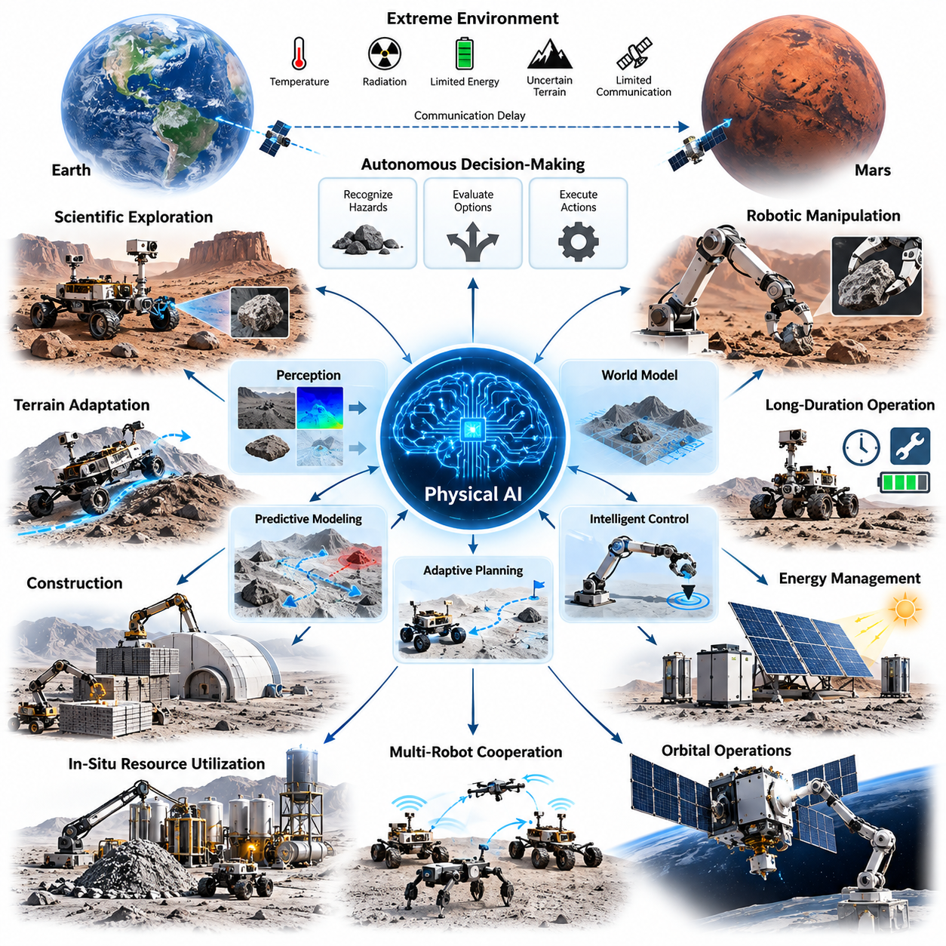
Space exploration represents one of the most demanding environments for autonomous physical intelligence. Unlike terrestrial operations, missions beyond Earth must function under extreme temperatures, radiation exposure, limited energy availability, uncertain terrain, and restricted communication. Physical AI offers a pathway toward machines capable of perceiving unfamiliar environments, reasoning about physical conditions, and performing meaningful actions without continuous human intervention.
Traditional spacecraft automation relies heavily on predefined procedures, carefully engineered control systems, and mission-specific decision rules. These approaches provide reliability but become restrictive when unexpected situations arise. Physical AI extends conventional automation by integrating perception, predictive modeling, adaptive planning, and intelligent control, allowing robotic systems to respond more flexibly to environmental uncertainty while respecting mission safety constraints.
The enormous distances separating Earth from planetary exploration sites create fundamental limitations for remote operation. Communication delays make immediate human intervention impossible during many critical activities, particularly on Mars and more distant destinations. Autonomous robots must therefore recognize hazards, evaluate alternative actions, and execute time-sensitive decisions locally, transforming onboard intelligence from an optional capability into an essential mission resource.
Space environments also contain physical conditions that are difficult to characterize completely before deployment. Planetary surfaces may include unstable regolith, steep slopes, hidden obstacles, loose rocks, and unpredictable mechanical interactions. Physical AI systems can combine visual observations, geometric mapping, contact feedback, and learned dynamics to estimate environmental properties and adapt locomotion strategies to unfamiliar terrain.
Scientific exploration requires more than reaching predetermined coordinates. Robotic explorers must identify potentially valuable geological formations, inspect unusual structures, select sampling locations, and adjust scientific priorities according to observations. Physical AI can connect scientific objectives with embodied decision-making, enabling robots to transform sensor measurements into purposeful exploration activities while preserving human oversight of major mission decisions.
The importance of physical intelligence becomes particularly evident in robotic manipulation. Collecting geological samples, positioning instruments, assembling structures, and handling delicate equipment require precise interaction with uncertain physical objects. Intelligent manipulation systems must estimate object geometry, contact forces, material behavior, and mechanical constraints while continuously correcting actions through visual and tactile feedback.
World models provide a promising foundation for these capabilities by maintaining structured representations of environmental states and predicting the consequences of possible actions. A planetary robot equipped with a predictive world model could evaluate alternative routes, estimate terrain interaction risks, and anticipate equipment behavior before execution. Such models support planning under uncertainty rather than relying exclusively on immediate sensor observations.
Long-duration exploration introduces additional challenges associated with equipment degradation, environmental changes, and limited maintenance opportunities. Robots operating for months or years must detect emerging faults, manage component wear, and modify operating strategies as system capabilities evolve. Physical AI can contribute through predictive maintenance, health-aware planning, anomaly detection, and adaptive resource management, although dependable self-repair remains a major engineering challenge.
Energy availability is another fundamental constraint shaping intelligent behavior in space. Solar illumination, battery capacity, thermal conditions, and computational power determine which activities can be performed safely. Physical AI systems must coordinate sensing, movement, computation, and scientific operations within strict energy budgets. Effective autonomy therefore requires intelligence that considers physical resource consumption alongside mission objectives.
Future lunar and Martian missions may require robotic systems to perform construction activities before human crews arrive. Autonomous machines could prepare landing areas, transport materials, excavate regolith, assemble protective structures, and install scientific infrastructure. These operations demand coordinated perception, manipulation, mobility, and planning, particularly when construction materials and environmental conditions differ from terrestrial engineering assumptions.
In-situ resource utilization further increases the importance of intelligent robotic operations. Extracting water ice, processing regolith, transporting raw materials, and maintaining production equipment involve complex physical processes that cannot always be supervised continuously from Earth. Physical AI could enable adaptive resource extraction and processing systems capable of responding to changing material properties, equipment conditions, and operational requirements.
Orbital environments present a different set of challenges involving microgravity, relative motion, orbital dynamics, and precise contact control. Autonomous servicing robots may inspect satellites, manipulate external components, or assist with assembly and maintenance. Physical AI must integrate visual tracking, dynamic state estimation, trajectory prediction, and force-aware manipulation while ensuring that unintended contact does not compromise spacecraft safety.
Multi-robot cooperation could significantly expand the scale of space exploration. Rather than depending on a single sophisticated platform, future missions may deploy heterogeneous fleets of rovers, aerial vehicles, manipulators, and stationary scientific systems. Shared environmental representations and distributed task planning could allow these machines to exchange discoveries, coordinate resources, and continue productive operations when individual units become unavailable.
Planetary aerial robotics introduces opportunities for exploration beyond the reach of ground vehicles. In environments where atmospheric conditions permit flight, autonomous aerial platforms can inspect cliffs, survey geological formations, and identify routes for surface missions. Physical AI must account for uncertain aerodynamics, limited onboard computation, navigation without satellite positioning, and rapidly changing environmental conditions during flight.
Reliable autonomy also requires learning systems that operate safely under severe restrictions on experimentation. Unlike terrestrial robots, spacecraft cannot freely explore dangerous actions to improve performance. Simulation, physics-informed learning, synthetic data, and carefully validated adaptation mechanisms become essential. These methods can improve robustness before deployment while reducing dependence on risky trial-and-error learning during actual missions.
Human-robot collaboration will remain important even as space systems become increasingly autonomous. Astronauts and ground controllers can establish scientific priorities, authorize high-consequence operations, and interpret discoveries, while robotic systems handle repetitive, hazardous, and time-sensitive physical tasks. Effective collaboration requires transparent decision-making, understandable system status, and mechanisms for transferring authority between humans and autonomous machines.
Safety and reliability distinguish space-oriented Physical AI from many commercial robotic applications. A single incorrect action may permanently damage expensive equipment or terminate an entire mission. Autonomous decisions must therefore operate within verified constraints, incorporate uncertainty estimates, and support graceful degradation. Runtime monitoring, fault containment, redundant sensing, and deterministic fallback controllers remain essential complements to learned intelligence.
The development of persistent extraterrestrial infrastructure will require autonomy extending beyond individual tasks. Robotic systems may eventually maintain power networks, transportation routes, communication equipment, scientific facilities, and resource-processing installations. These interconnected operations demand long-horizon planning, persistent environmental memory, coordinated maintenance, and the ability to recover from disturbances without continuous terrestrial supervision.
Physical AI may also reshape the economics of space exploration by reducing the operational burden associated with remote supervision. More capable autonomy could allow missions to accomplish additional scientific and engineering work with limited communication bandwidth and smaller ground-control workloads. However, these benefits must be balanced against development costs, computational requirements, verification complexity, and the consequences of autonomous failures.
The relationship between space exploration and Physical AI is mutually reinforcing. Space missions create demanding test environments for perception, predictive reasoning, adaptive control, and long-duration autonomy. Advances developed for these missions may subsequently benefit terrestrial applications involving hazardous infrastructure, remote mining, disaster response, and autonomous construction, where communication limitations and environmental uncertainty present related engineering challenges.
Ultimately, Physical AI offers a potential transition from remotely operated space machines toward autonomous systems capable of sustained physical activity beyond Earth. Its significance lies not simply in replacing human control, but in expanding what exploration missions can accomplish under extreme constraints. Achieving this vision will require combining embodied intelligence, reliable hardware, predictive world models, safety engineering, and coordinated human-machine decision-making.

04.02. Autonomy under Communication Delay
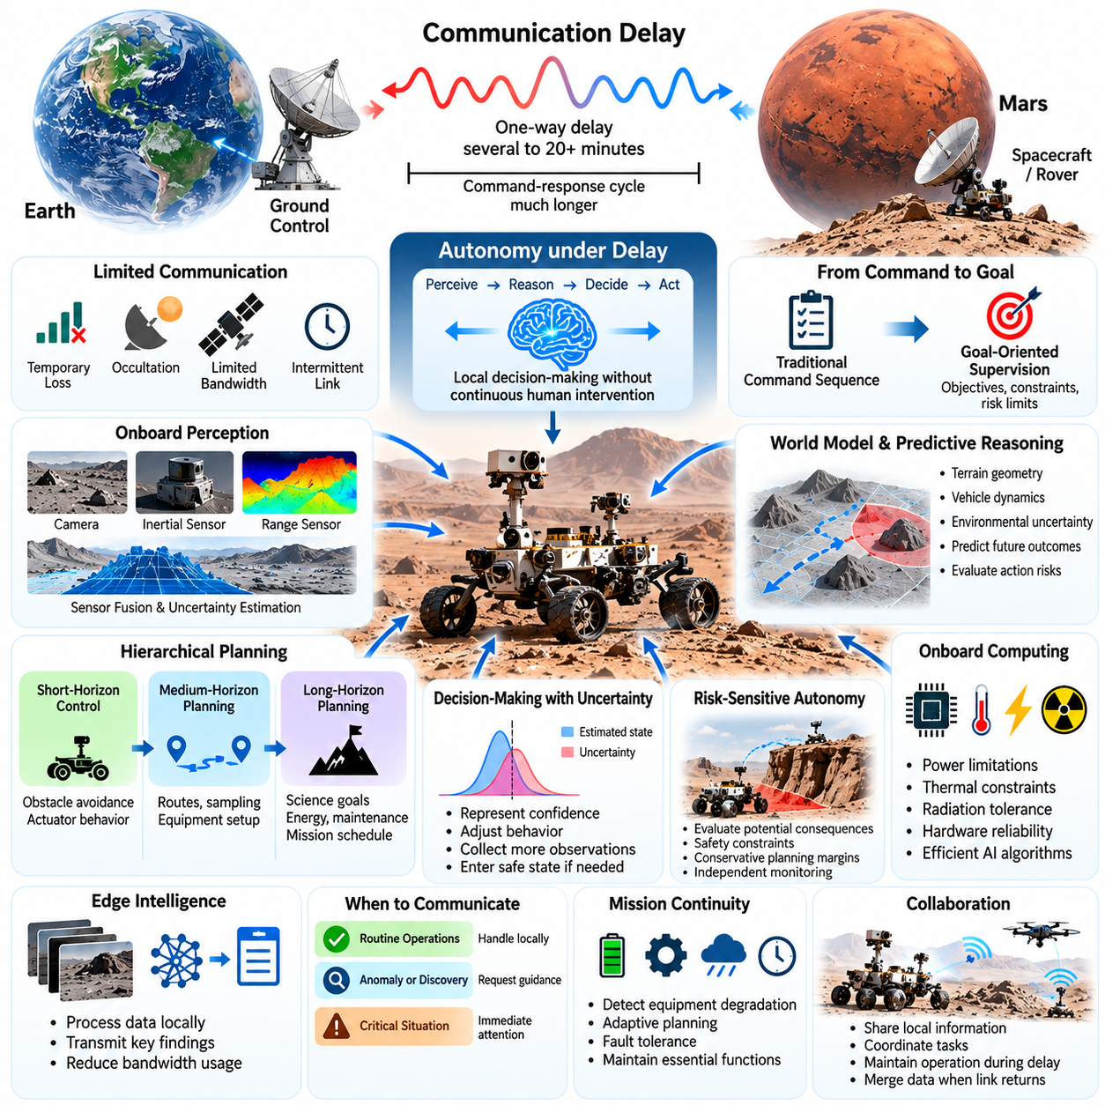
Communication delay is one of the fundamental constraints shaping autonomous space exploration. As spacecraft travel farther from Earth, the time required for radio signals to propagate increases, making immediate human intervention impossible. Physical AI addresses this limitation by enabling robotic systems to perceive their surroundings, interpret mission objectives, and make operational decisions locally without waiting for continuous instructions from ground controllers.
The speed of light establishes an unavoidable physical boundary for remote control. Communication between Earth and Mars typically involves one-way delays of several to more than twenty minutes, depending on planetary positions. A command-response cycle may therefore require substantially longer. Such delays prevent conventional real-time teleoperation and require spacecraft to manage navigation, manipulation, and unexpected environmental events independently.
Communication delay must be distinguished from communication disruption. Space missions may experience temporary signal loss caused by planetary occultation, antenna orientation, orbital geometry, or equipment limitations. Bandwidth restrictions can further reduce the amount of information transmitted. Autonomous systems must therefore remain operational not only when messages arrive late, but also when communication becomes intermittent or temporarily unavailable.
Traditional mission operations commonly separate ground-based planning from onboard execution. Engineers develop command sequences, verify expected outcomes, and transmit instructions for execution during scheduled communication opportunities. Although this approach supports careful supervision, it can reduce operational flexibility when environmental conditions differ from expectations. Physical AI introduces adaptive decision-making within predefined mission boundaries.
Autonomy under communication delay requires a shift from command-level control toward goal-oriented supervision. Instead of specifying every movement, ground operators can provide objectives, operational constraints, and acceptable risk limits. An autonomous robot then determines how to accomplish the assigned task using local observations and planning. This approach reduces dependence on frequent communication while preserving human authority over mission priorities.
Onboard perception provides the immediate information required for independent decisions. Cameras, inertial sensors, range measurements, and other instruments allow robots to estimate their position, identify obstacles, and characterize surrounding terrain. Sensor fusion combines complementary observations into a coherent environmental representation. Because perception must operate without continuous ground assistance, uncertainty estimation and fault detection become especially important.
World models extend perception by predicting how the environment may evolve in response to robot actions. A planetary rover can use an internal representation of terrain geometry, vehicle dynamics, and environmental uncertainty to evaluate possible movements before execution. Predictive reasoning allows the system to anticipate hazards, estimate action outcomes, and select strategies that remain compatible with mission safety requirements.
Autonomous planning must operate across multiple time horizons. Short-horizon control manages immediate obstacle avoidance, traction changes, and actuator behavior. Medium-horizon planning determines routes, sampling sequences, and equipment configurations. Long-horizon planning coordinates scientific objectives, energy consumption, maintenance activities, and mission schedules. These planning levels must exchange information while respecting different computational and timing constraints.
Decision-making under delayed communication also requires explicit management of uncertainty. Environmental observations may be incomplete, sensor measurements may contain errors, and learned models may produce inaccurate predictions. Physical AI systems should represent confidence in their estimates and adjust behavior accordingly. When uncertainty exceeds acceptable limits, the robot may reduce speed, collect additional observations, or enter a predefined safe state.
Risk-sensitive autonomy is particularly important because delayed communication prevents immediate human correction. A navigation error near a steep slope or an incorrect manipulation command could cause irreversible mission damage. Autonomous controllers must evaluate potential consequences rather than optimizing task completion alone. Safety constraints, conservative planning margins, and independent monitoring mechanisms help limit the consequences of uncertain decisions.
Local autonomy depends on reliable onboard computing infrastructure. Spacecraft processors operate under strict limitations involving electrical power, thermal dissipation, radiation tolerance, and hardware reliability. Physical AI algorithms must therefore balance computational complexity against available resources. Efficient perception models, compact world representations, and selective planning strategies can reduce processing demands while maintaining useful decision-making capabilities.
Edge intelligence becomes essential when communication bandwidth cannot support continuous transmission of raw sensor data. Instead of sending every image or measurement to Earth, onboard systems can process observations locally and transmit selected scientific findings, anomalies, and operational summaries. This approach improves communication efficiency while allowing ground teams to focus on information that is most relevant to mission objectives.
Autonomous systems must also determine when communication is necessary. Routine navigation adjustments may be handled locally, while unexpected scientific discoveries or high-consequence operations may require human authorization. Event-driven communication strategies prioritize important messages according to urgency, scientific value, and operational risk. Such mechanisms support efficient collaboration between onboard intelligence and ground-based mission control.
Communication-aware planning incorporates future contact opportunities into operational decisions. A robot may schedule energy-intensive activities before a communication window, postpone irreversible actions until authorization becomes available, or store observations for later transmission. This requires integrating communication schedules with task planning, resource allocation, and system health monitoring rather than treating communication as an independent subsystem.
Delayed feedback creates additional challenges for robotic manipulation. When collecting samples or positioning instruments, contact conditions can change faster than ground operators can respond. Local controllers must regulate motion and force using immediate sensor feedback. Physical AI can support higher-level decisions about grasp selection, tool positioning, and recovery from unsuccessful manipulation attempts while conventional control loops maintain precise physical interaction.
Learning and adaptation under communication delay require carefully controlled mechanisms. Robots may encounter terrain properties or operational conditions that differ from predeployment models. Online system identification can update estimates of vehicle dynamics, friction, or actuator performance. However, unrestricted learning may introduce unpredictable behavior, making validated adaptation boundaries and rollback mechanisms important for mission assurance.
Persistent memory enables autonomous systems to maintain operational continuity across communication interruptions. Robots can store environmental maps, completed tasks, equipment conditions, and previous decision outcomes. This accumulated information supports long-horizon reasoning and prevents unnecessary repetition. Memory management must also account for limited storage capacity, data integrity, and the distinction between verified observations and uncertain model predictions.
Fault management becomes increasingly important as communication delays grow. An autonomous spacecraft must recognize abnormal conditions, isolate suspected failures, and execute appropriate recovery procedures without waiting for ground instructions. Physical AI may improve diagnostic interpretation and recovery planning, but critical protection functions should remain independently verifiable. Reliable autonomy combines adaptive intelligence with deterministic fault-protection mechanisms.
Multi-robot missions introduce additional communication challenges because individual robots may experience different connectivity conditions. Local cooperation can allow robots to share maps, coordinate exploration tasks, and relay important information when communication paths are available. Distributed planning reduces dependence on a single controller, although inconsistent information and delayed synchronization must be managed to prevent conflicting actions.
Human supervision remains essential despite increasing onboard autonomy. Mission controllers define objectives, establish acceptable operating limits, review scientific findings, and authorize critical changes. The autonomous system should explain important decisions through concise operational records and uncertainty indicators. This creates a supervisory relationship in which humans govern mission intent while robots manage time-sensitive physical execution.
Verification and validation are central to deploying autonomy in delayed communication environments. Testing must reproduce realistic communication latency, signal interruptions, sensor uncertainty, hardware faults, and unexpected terrain conditions. Simulation campaigns and hardware-in-the-loop experiments can evaluate autonomous responses before deployment. Particular attention must be given to rare events, recovery behavior, and interactions between learned models and safety controllers.
As exploration extends toward distant planets, moons, and deep-space destinations, communication constraints will become even more significant. Increasing distance and limited contact opportunities will favor systems capable of independent scientific investigation, resource management, and fault recovery. The required level of autonomy will depend on mission objectives, environmental complexity, hardware capabilities, and acceptable operational risk.
Ultimately, autonomy under communication delay transforms space robotics from remotely commanded machinery into systems capable of locally governed physical action. Physical AI provides perception, predictive reasoning, adaptive planning, and intelligent interaction needed to operate beyond immediate human control. Its successful implementation requires a carefully engineered balance between machine independence, computational efficiency, verified safety, and continuing human responsibility for mission decisions.

04.03. Planetary Rovers and Surface Mobility
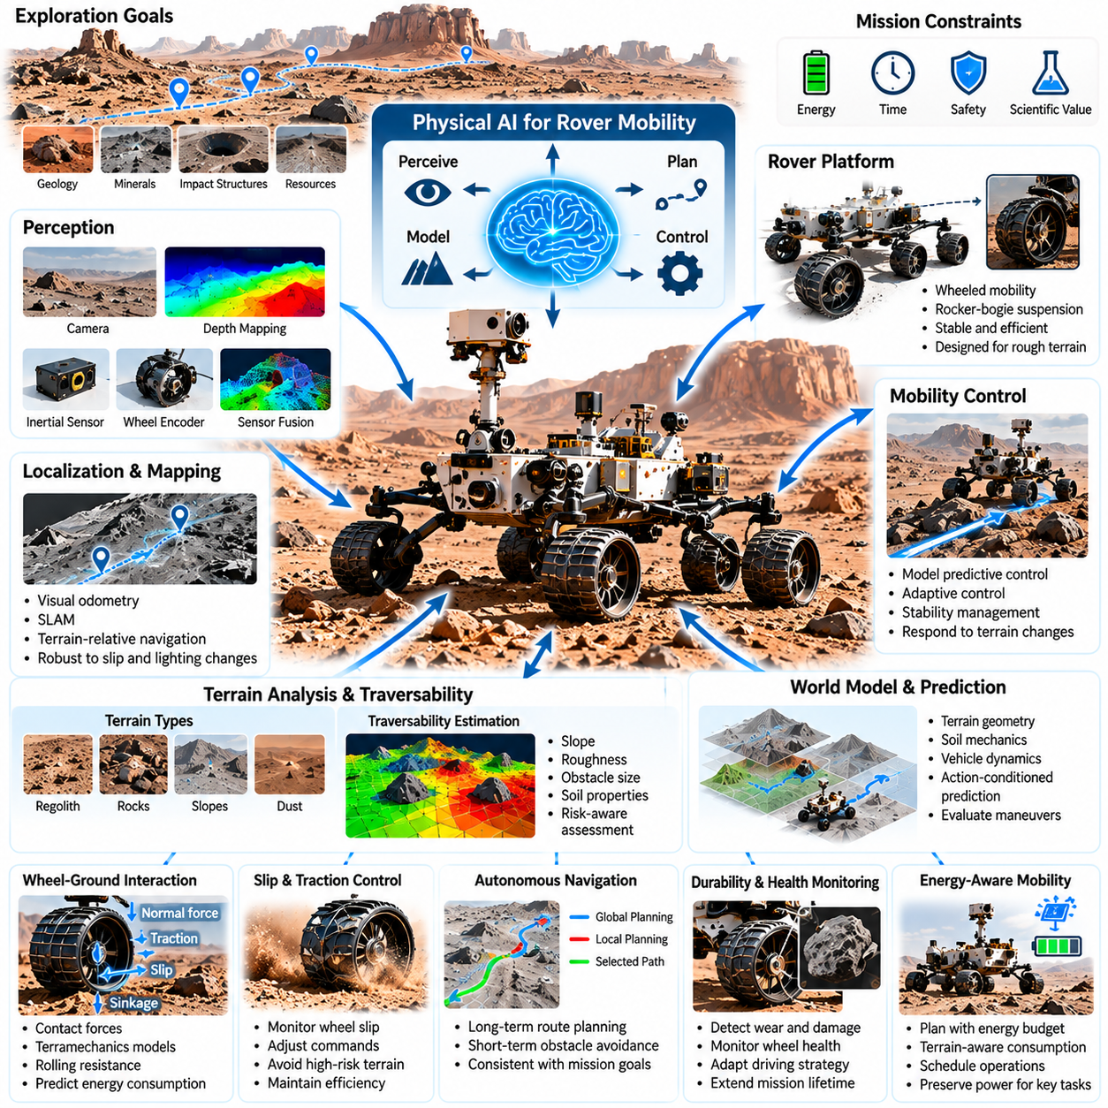
Planetary rovers represent one of the most established forms of embodied intelligence in space exploration. These robotic vehicles operate across unfamiliar surfaces where terrain geometry, soil mechanics, gravity, and environmental conditions differ significantly from those on Earth. Physical AI extends conventional rover autonomy by integrating environmental perception, predictive world models, adaptive mobility planning, and intelligent control into a unified exploration system.
Surface mobility is essential because scientific discoveries depend on reaching geographically distributed locations. Geological formations, mineral deposits, impact structures, and potential resource sites may be separated by difficult terrain. A planetary rover must therefore balance exploration distance, scientific value, mechanical safety, and energy consumption while maintaining sufficient operational capability to complete its mission.
Traditional planetary rovers commonly employ wheeled mobility platforms designed for stability, mechanical simplicity, and efficient movement. Rocker-bogie suspension systems allow multiple wheels to maintain contact with uneven surfaces while distributing loads across obstacles. However, mechanical mobility alone cannot guarantee safe traversal. Intelligent perception and control are necessary to recognize terrain hazards and determine whether a route is physically traversable.
Planetary terrain presents substantial uncertainty because surface appearance does not always reveal mechanical properties. Loose regolith, compacted soil, embedded rocks, dust deposits, and concealed cavities may produce different wheel-ground interactions. Physical AI systems must estimate terrain characteristics from visual, geometric, and proprioceptive observations, allowing mobility decisions to account for both visible geometry and uncertain subsurface behavior.
Traversability estimation is a central capability of intelligent surface mobility. A rover must determine whether a region can be crossed without excessive wheel slip, ground clearance violations, loss of stability, or mechanical damage. Learning-based traversability models can combine terrain slope, roughness, obstacle dimensions, soil appearance, and vehicle characteristics to produce risk-aware assessments of candidate paths.
Wheel-ground interaction modeling provides a physical foundation for rover mobility prediction. Contact forces, normal loading, wheel sinkage, rolling resistance, and longitudinal slip influence traction and energy consumption. Classical terramechanics models describe important aspects of deformable terrain, while data-driven models can adapt predictions using observed rover behavior. Combining these approaches supports more reliable mobility estimation under uncertain planetary conditions.
Localization is particularly challenging because planetary environments generally lack terrestrial satellite navigation infrastructure. Rovers must estimate their position through visual odometry, inertial measurements, wheel encoders, and terrain-relative observations. Simultaneous localization and mapping allows a rover to construct environmental representations while estimating its motion. Robust localization must account for wheel slip, repetitive terrain, lighting variations, and accumulated estimation errors.
Three-dimensional terrain mapping supports both scientific interpretation and safe navigation. Stereo cameras, depth estimation, and other suitable sensing methods can generate local elevation maps, obstacle representations, and surface geometry models. These maps provide spatial context for route selection and hazard avoidance. Physical AI can enrich geometric maps with semantic information about terrain classes, geological features, and expected mobility characteristics.
World models offer a more comprehensive representation of planetary mobility by connecting terrain observations with vehicle dynamics and predicted action outcomes. Instead of treating a map as a static collection of obstacles, a rover can estimate how its wheels and suspension may interact with specific terrain regions. Action-conditioned prediction enables the evaluation of candidate maneuvers before execution, improving planning under environmental uncertainty.
Autonomous navigation requires coordination between global route planning and local motion control. Global planning identifies scientifically valuable destinations and feasible corridors across larger distances. Local planning responds to immediate obstacles, terrain irregularities, and changing traction conditions. Physical AI can connect these planning levels through shared environmental representations, allowing short-term mobility decisions to remain consistent with long-term mission objectives.
Model predictive control provides a useful framework for rover motion planning under physical constraints. By predicting vehicle behavior over a finite horizon, the controller can evaluate steering commands, wheel velocities, stability margins, and expected terrain interactions. Repeated replanning allows the rover to respond to updated observations. The effectiveness of this approach depends on computational efficiency and the accuracy of the underlying dynamics models.
Wheel slip represents a particularly important challenge in loose planetary soil. Excessive slip can increase energy consumption, reduce localization accuracy, accelerate wheel wear, and cause immobilization. Intelligent traction control can monitor wheel motion relative to estimated vehicle displacement and adjust commands accordingly. Predictive models may also identify regions where high slip probability makes an alternative route preferable.
Rover mobility must account for mechanical durability over extended missions. Repeated contact with sharp rocks, abrasive particles, and uneven surfaces can damage wheels, suspension components, and drive mechanisms. Physical AI can incorporate component health estimates into navigation decisions, selecting routes that reduce cumulative mechanical stress. Such health-aware mobility planning connects immediate movement efficiency with long-term mission survivability.
Energy-aware navigation is equally important because planetary rovers operate within limited power budgets. Terrain slope, wheel slip, travel speed, temperature, and onboard computation all influence energy consumption. Intelligent planners can estimate the energy required for candidate routes and compare travel costs against available reserves. This enables the rover to preserve sufficient power for scientific operations, communication, thermal management, and emergency recovery.
Environmental conditions further complicate surface mobility. Dust accumulation, extreme temperatures, variable illumination, and seasonal changes can affect sensing, traction, and equipment performance. On Mars, atmospheric dust and changing solar conditions may influence both perception and available electrical power. On the Moon, severe thermal variations and long periods without sunlight impose different constraints on mobility and mission scheduling.
Autonomous hazard detection must operate continuously during traversal. A rover may encounter unexpected rocks, steep depressions, unstable slopes, or terrain that differs from previously generated maps. Physical AI can combine geometric reasoning, learned hazard recognition, and uncertainty estimation to evaluate these situations. When confidence is insufficient, the rover should slow down, gather additional observations, replan, or stop safely.
Recovery from mobility failures is another essential capability. Wheel entrapment, excessive sinkage, loss of traction, or unexpected vehicle orientation may prevent normal movement. Intelligent recovery planning can evaluate alternative wheel commands, reverse maneuvers, and low-risk escape strategies. However, recovery actions must respect mechanical limits because aggressive attempts can worsen entrapment or permanently damage the mobility system.
Scientific objectives and mobility decisions should be optimized together rather than treated as independent activities. A rover may choose a slightly more difficult route because it provides access to valuable geological observations, while avoiding hazardous terrain that offers limited scientific benefit. Physical AI can support this tradeoff through mission-aware planning that combines expected scientific value, traversal risk, energy expenditure, and remaining operational lifetime.
Long-horizon autonomy becomes increasingly important as exploration distances expand. A rover must remember previously traversed terrain, maintain consistent environmental maps, track resource consumption, and revise exploration strategies as new information becomes available. Persistent world memory can support repeated visits, route reuse, and cumulative understanding of planetary environments, reducing unnecessary exploration effort and improving operational continuity.
Future planetary mobility systems may incorporate heterogeneous locomotion capabilities, including articulated wheels, reconfigurable suspensions, and hybrid wheel-leg mechanisms. These designs could expand access to terrain that conventional wheeled rovers cannot safely traverse. Physical AI would coordinate mechanical configuration, motion planning, and contact control according to local conditions, although increased mobility flexibility introduces additional complexity and reliability challenges.
Ultimately, planetary rovers demonstrate how Physical AI can transform surface exploration from carefully supervised navigation into increasingly adaptive physical autonomy. Reliable progress depends on integrating terrain perception, localization, world modeling, terramechanics, risk-aware planning, and robust control. As these capabilities mature, planetary robots may explore larger areas, operate with less frequent human intervention, and accomplish more ambitious scientific missions across unfamiliar worlds.

04.04. Legged Robots for Extreme Terrain
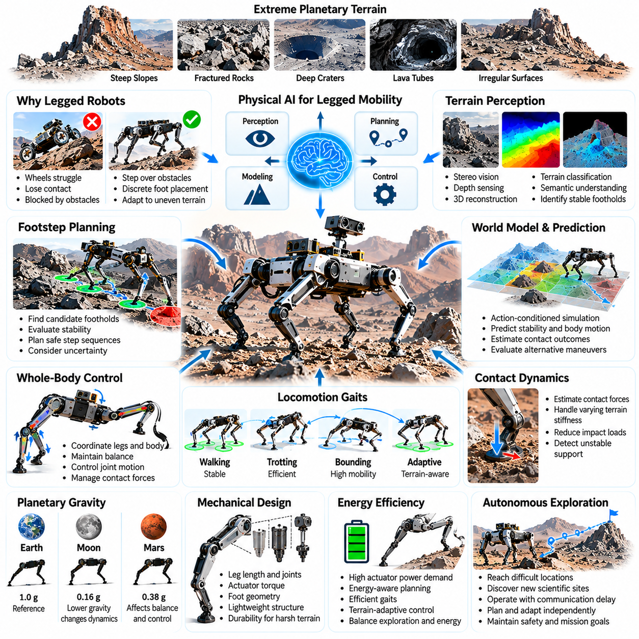
Legged robots offer a promising approach to planetary exploration in environments where conventional wheeled vehicles face severe mobility limitations. Steep slopes, fractured rocks, deep craters, lava tubes, and irregular surfaces may prevent continuous wheel contact or safe traversal. Physical AI enables legged systems to combine terrain perception, adaptive foot placement, dynamic balance, and predictive control, potentially extending robotic exploration into previously inaccessible regions.
Unlike wheeled vehicles, legged robots can select discrete contact locations and reposition their bodies independently of continuous ground support. This capability allows them to step over obstacles, cross gaps, and adapt to uneven terrain. However, legged locomotion introduces additional mechanical complexity, actuator demands, and control challenges, making reliable operation dependent on accurate environmental understanding and coordinated whole-body movement.
Extreme planetary terrain presents challenges that extend beyond visible geometric obstacles. Loose regolith, brittle rock formations, unstable slopes, and partially concealed cavities may cause unexpected foot penetration or contact failure. Intelligent legged robots must estimate both surface geometry and mechanical properties, combining visual perception with proprioceptive sensing and contact feedback to determine where stable support can be established.
Footstep planning is a fundamental capability for autonomous legged mobility. A robot must identify candidate footholds, evaluate their stability, and construct sequences of movements that preserve balance while progressing toward exploration objectives. Physical AI can integrate terrain classification, geometric mapping, contact prediction, and uncertainty estimation to select footholds that minimize slipping, excessive loading, and mechanical instability.
Whole-body control coordinates the motion of the legs, torso, and other articulated components to maintain stability during locomotion. Changes in body orientation, joint configuration, and contact forces affect the robot's center of mass and support conditions. Model-based controllers can enforce kinematic and dynamic constraints, while learned policies may improve adaptation to irregular terrain when operating within validated safety boundaries.
Planetary gravity significantly influences legged locomotion dynamics. Lower gravitational acceleration changes normal contact forces, ballistic motion, balance recovery, and the relationship between actuator effort and body movement. Controllers developed for terrestrial conditions cannot be assumed to transfer directly to lunar or Martian environments. Physics-informed simulation and gravity-aware control are therefore essential for predicting locomotion behavior before deployment.
Contact dynamics represent another major challenge because legged robots repeatedly establish and release physical contact with the environment. Each footfall produces forces that depend on terrain stiffness, friction, impact velocity, and foot geometry. Physical AI can use learned contact models and real-time force estimates to adjust landing behavior, reduce impact loads, and detect unstable support before a loss of balance develops.
Different locomotion gaits offer tradeoffs between stability, speed, energy consumption, and terrain adaptability. Walking gaits can maintain relatively conservative support patterns, while dynamic trotting or bounding may improve mobility under suitable conditions. In space exploration, gait selection must prioritize mission reliability and environmental uncertainty rather than maximum speed. Adaptive gait planning can modify movement patterns according to terrain conditions and system health.
Three-dimensional perception is particularly important when navigating cliffs, caves, crater rims, and fractured surfaces. Stereo vision, depth sensing, and geometric reconstruction can provide local terrain models for foothold selection and body clearance assessment. Semantic understanding may identify loose debris, rock edges, or potentially unstable structures. Combining geometry with predicted contact behavior enables more meaningful assessments of terrain accessibility.
World models can connect environmental observations with the predicted consequences of legged actions. An action-conditioned model may estimate how a planned foot placement affects body stability, joint loading, and future movement opportunities. By simulating candidate motion sequences internally, the robot can compare alternative strategies before execution. Such predictive capabilities are valuable when communication delays prevent immediate human correction.
Hierarchical planning helps manage the different timescales involved in extreme-terrain locomotion. High-level planning selects exploration targets and safe corridors, intermediate planning determines foothold sequences and body trajectories, and low-level control regulates joint motion and contact forces. Physical AI can coordinate these levels through shared terrain representations and feedback, allowing immediate balance corrections without abandoning broader mission objectives.
Mechanical design strongly influences the practical capabilities of legged exploration systems. Leg length, joint arrangement, actuator torque, foot geometry, and structural stiffness determine reachable terrain and available stability margins. Lightweight structures reduce launch mass but may increase vulnerability to impacts and fatigue. Hardware-software co-design is therefore essential for matching intelligent locomotion algorithms with the physical limitations of space-qualified robotic platforms.
Energy efficiency remains a major limitation for legged robots because repeated joint actuation can consume substantial electrical power. Unlike passive rolling, walking frequently requires active support and stabilization. Intelligent locomotion planning can reduce unnecessary movement, select efficient footholds, and adapt gait parameters to terrain difficulty. Energy-aware decisions must preserve sufficient reserves for sensing, scientific operations, communication, and thermal management.
Environmental durability is equally important. Abrasive dust, vacuum exposure, radiation, and extreme thermal cycling can affect actuators, bearings, seals, sensors, and electronic components. Legged robots contain multiple articulated joints that may create additional failure points compared with simpler mobility platforms. Physical AI can monitor joint performance, detect abnormal resistance, and adjust locomotion strategies to reduce mechanical stress, although hardware protection remains indispensable.
Fault-tolerant locomotion may allow a robot to continue operating after partial actuator degradation or sensor failure. By estimating remaining mobility capabilities, the control system can modify gait patterns, redistribute loads, or restrict movement to safer terrain. However, not every mechanical failure can be compensated through software. Reliable autonomy requires explicit operating limits, conservative recovery procedures, and safe-state mechanisms.
Exploration of subsurface environments provides a compelling application for legged robots. Lava tubes, caves, and sheltered geological structures may preserve scientific evidence and offer potential protection from surface radiation and temperature extremes. Legged mobility could enable access through irregular entrances and debris-covered passages. Such missions require autonomous mapping, reliable localization, obstacle negotiation, and communication-aware exploration strategies.
Legged robots may also support scientific manipulation by stabilizing their bodies while interacting with rocks, instruments, or sampling tools. Coordinated whole-body control can distribute contact forces across multiple limbs while positioning sensors or manipulators. This creates opportunities for mobile inspection and sampling in locations unsuitable for conventional rovers, although manipulation loads must be incorporated into balance and stability calculations.
Multi-robot exploration could combine wheeled and legged platforms to exploit their complementary capabilities. Wheeled rovers may transport equipment efficiently across relatively accessible terrain, while legged robots investigate steep slopes, fractured formations, or confined spaces. Shared maps and coordinated task allocation could extend mission coverage. Communication limitations and differing mobility capabilities must be considered when planning cooperative operations.
Training reliable locomotion policies for extraterrestrial environments presents a significant data challenge. Direct planetary experience is scarce, while terrestrial experiments cannot reproduce every relevant physical condition. High-fidelity simulation, domain randomization, physics-informed learning, and controlled hardware testing can improve robustness. Nevertheless, simulation-to-reality differences require conservative validation before learned policies are trusted in critical missions.
Long-duration autonomy requires legged robots to maintain environmental memory and monitor cumulative mechanical degradation. Repeated traversal can reveal stable footholds, hazardous regions, and routes suitable for future missions. Persistent world models may combine these observations with estimates of joint health and energy consumption. Such information supports long-horizon planning that balances scientific exploration with continued mechanical survivability.
The future of legged planetary robotics will depend on advances in compact actuation, efficient control, robust perception, and predictive physical reasoning. Greater adaptability may enable robots to investigate terrain inaccessible to traditional mobility systems, but additional complexity must be justified by scientific value and operational reliability. Legged robots are therefore best understood as complementary exploration platforms rather than universal replacements for wheeled rovers.
Ultimately, legged robots illustrate how Physical AI can expand robotic mobility beyond conventional surface navigation. Their effectiveness depends on integrating terrain understanding, contact dynamics, whole-body control, predictive world models, and safety-aware autonomy. With continued progress in hardware reliability and intelligent control, these systems may become valuable tools for exploring the most challenging geological environments on the Moon, Mars, and other planetary bodies.

04.05. Aerial Robots for Planetary Exploration
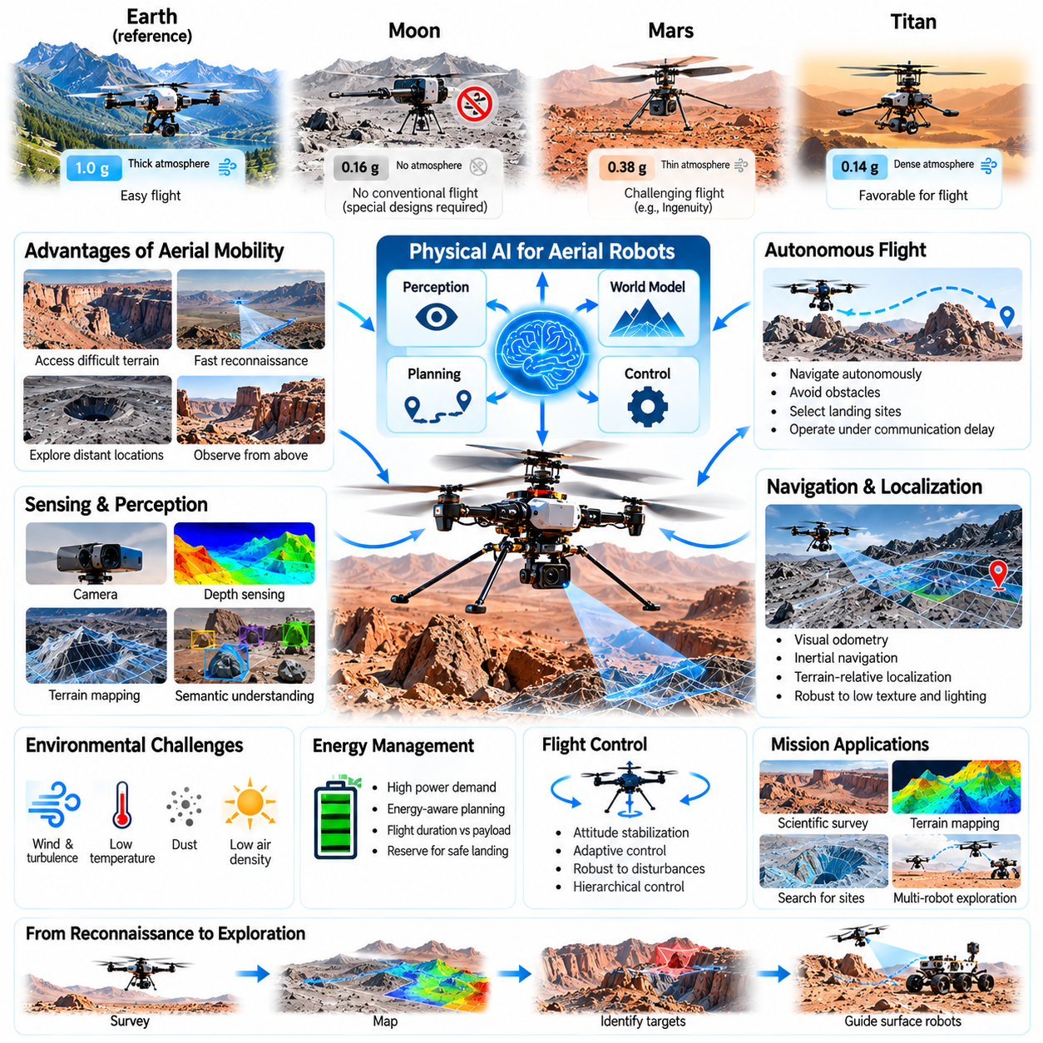
Aerial robots introduce a new dimension to planetary exploration by enabling mobility above terrain that restricts conventional surface vehicles. Flying platforms can investigate cliffs, crater walls, geological formations, and distant locations without requiring continuous ground contact. Physical AI combines autonomous perception, adaptive flight control, environmental modeling, and intelligent mission planning to extend scientific exploration beyond the operational boundaries of wheeled and legged robots.
Planetary flight differs fundamentally from terrestrial aviation because atmospheric density, gravity, temperature, and aerodynamic conditions vary across celestial bodies. Mars possesses a thin atmosphere that makes rotor-generated lift difficult, while Titan offers a dense atmosphere and relatively low gravity. The Moon lacks a substantial atmosphere, preventing conventional aerodynamic flight. Aerial robot designs must therefore reflect the specific physical conditions of each destination.
The successful flights of NASA's Ingenuity helicopter on Mars demonstrated that powered, controlled flight is possible in an extremely thin planetary atmosphere. Ingenuity served primarily as a technology demonstrator, establishing important knowledge about autonomous navigation and rotorcraft operation beyond Earth. Future aerial robots may build upon this experience to perform more extensive scientific surveys, reconnaissance missions, and coordinated exploration activities.
Aerial mobility provides advantages in environments where surface traversal is slow, dangerous, or physically impossible. Flying robots can cross steep slopes, fractured terrain, sand fields, and obstacle-filled regions without directly interacting with every surface feature. This capability allows rapid reconnaissance of potential exploration routes and scientific targets, although flight endurance, landing safety, and environmental uncertainty impose significant operational constraints.
Autonomous flight is essential because communication delays prevent continuous remote piloting from Earth. Planetary aerial robots must estimate their motion, maintain stability, avoid obstacles, and execute landing procedures using onboard intelligence. Physical AI can support these capabilities through integrated perception, state estimation, trajectory planning, and adaptive control, enabling aircraft to complete predefined objectives while responding to unexpected environmental conditions.
Planetary aerial navigation generally cannot depend on conventional terrestrial satellite positioning services. Visual odometry, inertial navigation, terrain-relative localization, and optical flow estimation provide alternative methods for determining aircraft motion. These techniques must account for uncertain visual textures, changing illumination, sensor noise, and accumulated estimation errors. Reliable localization becomes especially important when navigating near cliffs or selecting small landing areas.
Three-dimensional environmental perception supports safe flight through unfamiliar planetary landscapes. Cameras, depth estimation, and suitable ranging sensors can identify obstacles, terrain elevation changes, and potential landing surfaces. Physical AI can combine geometric reconstruction with semantic interpretation to distinguish scientific targets from navigation hazards. Such representations support route selection while helping aircraft avoid terrain collisions and unsuitable landing locations.
World models provide a predictive foundation for intelligent planetary flight. By representing atmospheric conditions, vehicle dynamics, terrain geometry, and environmental uncertainty, an aerial robot can estimate the consequences of candidate maneuvers before execution. Action-conditioned prediction supports trajectory evaluation, obstacle avoidance, and landing assessment. These capabilities become particularly valuable when unexpected conditions invalidate assumptions made during preflight planning.
Atmospheric uncertainty represents a major challenge for autonomous aerial systems. Wind velocity, turbulence, pressure, temperature, and atmospheric density influence aerodynamic forces and vehicle stability. Physical AI can integrate onboard measurements with adaptive dynamics models to estimate changing flight conditions. Robust controllers must maintain safe operation despite modeling errors, especially when environmental disturbances approach the aircraft's control limits.
Flight control requires coordination between fast stabilization loops and higher-level intelligent planning. Low-level controllers regulate attitude, angular velocity, and propulsion to maintain stable flight. Higher-level systems select routes, manage mission objectives, and respond to environmental observations. Hierarchical architectures allow learned planning components to operate alongside verified flight-control mechanisms, reducing the risk associated with unpredictable autonomous decisions.
Energy limitations strongly influence the design and operation of planetary aerial robots. Generating aerodynamic lift requires substantial power, particularly in thin atmospheres where rotor systems must compensate for low air density. Flight duration, payload mass, propulsion efficiency, and battery capacity must be balanced carefully. Energy-aware planning can determine whether proposed missions leave sufficient reserves for safe landing, communication, and thermal management.
Thermal conditions create additional challenges for planetary aircraft. Extremely low temperatures can reduce battery performance, affect mechanical components, and alter sensor characteristics. Repeated thermal cycling may accelerate material degradation and influence actuator reliability. Physical AI can incorporate temperature measurements and equipment health estimates into operational planning, allowing flight schedules and mission priorities to reflect changing hardware conditions.
Autonomous landing is one of the most safety-critical phases of planetary aerial exploration. Landing zones must provide suitable geometry, acceptable slopes, sufficient clearance, and stable surface conditions. Physical AI can evaluate candidate locations using visual observations, terrain models, and uncertainty estimates. During descent, the aircraft must continuously update its state estimate and adjust its trajectory to accommodate unexpected obstacles or navigation errors.
Scientific reconnaissance is a major potential application of planetary aerial robots. Flying platforms can survey geological boundaries, inspect crater interiors, identify exposed mineral layers, and investigate formations that are inaccessible to surface rovers. High-resolution imagery and other scientific measurements can support the selection of future exploration targets. Intelligent mission planning can prioritize observations according to scientific value, accessibility, and remaining energy.
Aerial robots may also function as reconnaissance partners for planetary rovers. An aircraft can survey terrain ahead of a ground vehicle, identify hazardous routes, and locate promising scientific sites. Shared maps and coordinated mission planning can improve exploration efficiency by combining the aircraft's broad spatial coverage with the rover's sustained surface operations. Such cooperation requires reliable information exchange and consistent environmental representations.
Planetary exploration may eventually employ multiple aerial robots operating cooperatively. Distributed aircraft could inspect different geological regions, collect complementary measurements, and establish temporary communication relays where appropriate. Multi-agent Physical AI can support task allocation, cooperative mapping, and coordinated resource management. However, limited communication bandwidth, collision risks, and synchronization delays complicate distributed autonomous operations.
Learning-based flight systems offer opportunities to improve adaptability in unfamiliar environments. Simulation-generated experience can expose control policies to variations in atmospheric density, wind, sensor noise, and vehicle parameters. Domain randomization and physics-informed learning may improve robustness across uncertain conditions. Nevertheless, safety-critical deployment requires extensive validation because simulated aerodynamics cannot perfectly reproduce extraterrestrial flight environments.
Long-duration aerial exploration requires persistent environmental memory and adaptive mission management. Aircraft may accumulate terrain maps, atmospheric observations, landing-site assessments, and records of previous flight performance. These data can support future route planning and improve estimates of environmental risk. Continual learning must remain bounded by validated safety constraints to prevent uncontrolled changes in flight behavior.
Hardware-software co-design is essential because planetary aircraft operate under severe mass, power, and reliability constraints. Rotor geometry, propulsion systems, structural materials, sensors, and onboard processors must be selected together with autonomy algorithms. More sophisticated perception and planning can improve adaptability but increase computational demand. Efficient architectures must therefore balance intelligent capability against physical resource limitations.
The scientific potential of planetary aerial robots depends on selecting destinations where flight provides meaningful advantages. Mars offers opportunities for reconnaissance across difficult terrain, while Titan's atmospheric conditions may support longer-range aerial scientific exploration. Other planetary environments may require alternative propulsion concepts rather than conventional rotorcraft. Mission architecture must account for environmental feasibility, scientific objectives, and acceptable operational risk.
Ultimately, aerial robots demonstrate how Physical AI can expand planetary exploration from surface-bound movement into autonomous three-dimensional mobility. Their success depends on integrating atmospheric modeling, reliable localization, predictive world models, adaptive flight control, and safety-aware mission planning. As these technologies mature, intelligent aerial platforms may become important components of future robotic exploration systems operating across diverse planetary environments.

04.06. Autonomous Manipulation and Scientific Sampling
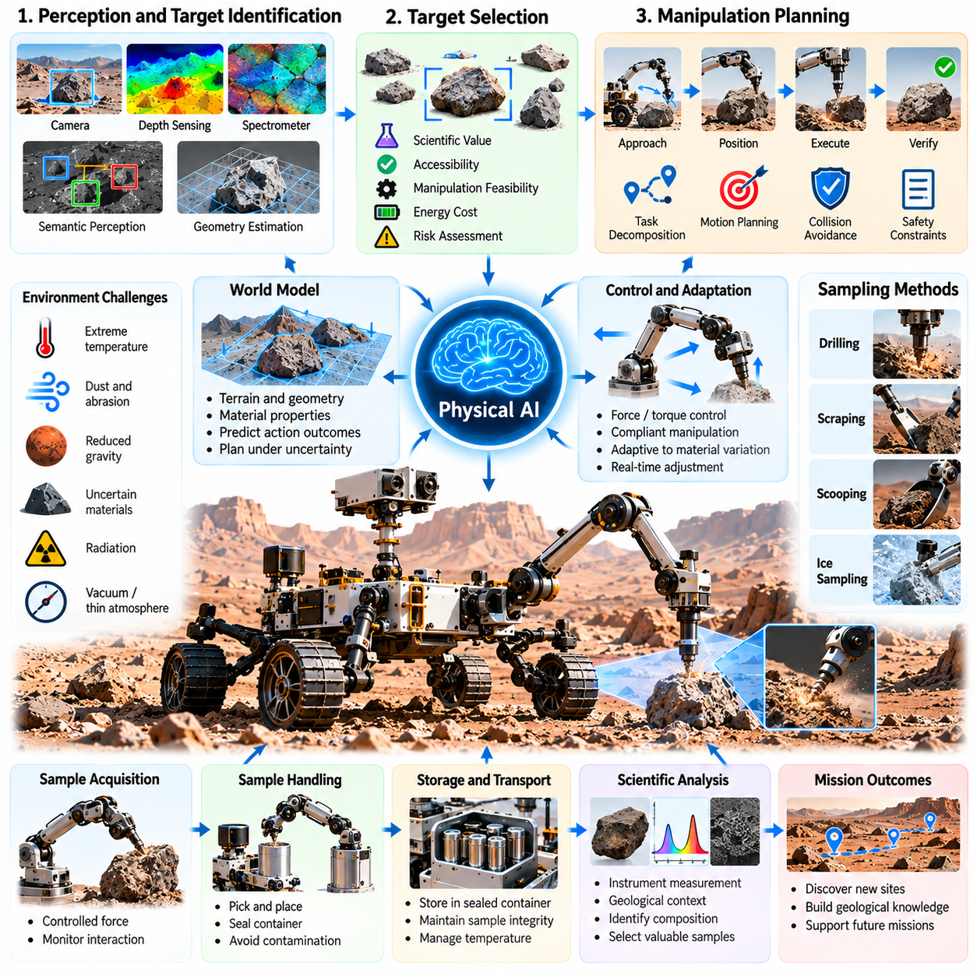
Autonomous manipulation and scientific sampling are essential capabilities for transforming planetary robots from mobile observation platforms into active scientific investigators. Beyond navigating unfamiliar terrain, robots must physically interact with rocks, soil, ice, and geological structures to obtain meaningful measurements. Physical AI integrates perception, manipulation planning, force control, and environmental reasoning to perform these operations with limited human supervision.
Scientific sampling involves more than collecting material from a planetary surface. A robotic system must identify scientifically valuable targets, determine appropriate sampling methods, and preserve the integrity of collected specimens. Geological context, material composition, accessibility, and contamination risks influence every decision. Intelligent autonomy can connect scientific objectives with physical manipulation capabilities to improve sampling effectiveness.
Planetary manipulation differs from terrestrial robotics because environmental conditions are poorly understood and difficult to reproduce. Reduced gravity, abrasive dust, extreme temperatures, vacuum exposure, and uncertain material properties affect robotic interactions. Manipulators must operate reliably despite variations in contact forces, surface resistance, and mechanical behavior. Physical AI can adapt control strategies using observations collected during each interaction.
Perception provides the foundation for autonomous scientific manipulation. Cameras, depth sensors, spectrometers, and other scientific instruments can identify candidate targets and estimate their geometry, orientation, and surface characteristics. Semantic perception helps distinguish rocks, regolith, exposed layers, and potential sampling locations. Combining geometric and scientific observations allows a robot to select targets that are both accessible and scientifically relevant.
Target selection requires reasoning about scientific value and operational feasibility. A mineral-rich formation may provide valuable information but remain difficult to reach or mechanically unstable. Physical AI can evaluate candidate targets according to expected scientific benefit, manipulation difficulty, energy requirements, and potential equipment damage. Such decisions help allocate limited mission resources toward observations with the greatest expected value.
Robotic arms provide a primary mechanism for interacting with planetary environments. Their joints and end effectors enable positioning, grasping, drilling, scraping, and instrument placement. Successful manipulation requires accurate kinematic models, collision avoidance, and coordination with the rover platform. Autonomous systems must also account for structural flexibility, joint limitations, and uncertainty in the relative position of tools and targets.
Manipulation planning connects high-level scientific instructions with executable physical actions. A command to collect a rock sample may require approaching the target, positioning the manipulator, selecting a contact location, applying controlled force, and securing the specimen. Hierarchical planning decomposes these activities into coordinated stages while maintaining awareness of safety constraints, equipment limitations, and mission priorities.
Contact-rich manipulation introduces challenges that cannot be resolved through geometric planning alone. Drilling, scraping, cutting, and gripping involve forces that depend on material stiffness, friction, tool geometry, and interaction speed. Force and torque measurements can reveal unexpected resistance or unstable contact. Physical AI can combine these signals with predictive models to adjust manipulation behavior and reduce the risk of tool damage.
Compliant control is particularly important when interacting with uncertain geological materials. Excessively rigid motion can damage instruments, fracture specimens, or destabilize the robotic platform. Impedance control and force-regulated manipulation allow a robot to respond to contact forces while maintaining desired task behavior. Adaptive controllers can modify interaction parameters as the mechanical characteristics of a target become better understood.
Scientific drilling requires careful coordination of positioning, rotational motion, axial force, and material removal. Different geological formations may produce substantial variations in drilling resistance and tool wear. Autonomous monitoring can detect abnormal vibration, excessive torque, or insufficient penetration. Physical AI may use these observations to adjust drilling parameters, interrupt unsafe operations, or recommend alternative sampling locations.
Regolith and loose-material sampling present different mechanical challenges. Granular materials can flow, compact, adhere to tools, or escape collection containers depending on particle properties and local gravity. Scooping and excavation mechanisms must account for uncertain material behavior and incomplete collection. Learning-based models and contact feedback can help estimate collected quantities and improve the reliability of repeated sampling operations.
Ice sampling introduces additional considerations involving temperature, phase transitions, and contamination control. Subsurface ice may be scientifically valuable because it can preserve information about planetary environmental history. However, extraction procedures can alter fragile samples through heating, mechanical disturbance, or exposure. Intelligent manipulation planning must coordinate tool operation, thermal conditions, and sample preservation requirements.
Sample handling and transfer are critical stages following material acquisition. Collected specimens may need to be deposited into containers, sealed, transported internally, or delivered to analytical instruments. Each transfer introduces risks of material loss, contamination, and mechanical failure. Autonomous verification can use sensor observations and actuator feedback to confirm successful placement before advancing to subsequent scientific procedures.
Contamination prevention is fundamental to trustworthy planetary science. Materials introduced by spacecraft components, previous samples, or sampling equipment can compromise scientific interpretation. Physical AI can support contamination-aware workflows by tracking tool usage, sample histories, and contact events. Nevertheless, reliable contamination control also depends on hardware cleanliness, material selection, validated procedures, and mission-specific planetary protection requirements.
World models can improve autonomous manipulation by representing both environmental structure and the predicted consequences of physical actions. An action-conditioned model may estimate whether a grasp will remain stable, whether drilling will encounter excessive resistance, or whether excavation will disturb nearby material. Such predictions support safer action selection, although uncertainty must be explicitly considered when the robot encounters unfamiliar substances.
Scientific manipulation benefits from closed-loop execution rather than fixed action sequences. A robot can observe the result of each movement, compare it with the intended outcome, and revise subsequent actions. This perception-action feedback loop enables correction of positioning errors, unexpected contact behavior, and incomplete sampling. Physical AI extends this process through learned predictions and task-level reasoning that connect local adjustments with scientific goals.
Long communication delays make onboard manipulation autonomy particularly important. Operators on Earth cannot continuously supervise every contact event or intervene immediately when unexpected resistance occurs. Robots must recognize abnormal conditions, execute bounded recovery actions, and enter safe states when necessary. Human scientists can define objectives and operational constraints while onboard intelligence manages detailed execution within approved limits.
Scientific sampling also requires uncertainty-aware decision-making. A robot may have incomplete knowledge of material composition, target stability, tool condition, or sample quality. Probabilistic estimates can help distinguish actions that are likely to succeed from those requiring additional observation. Active perception allows the system to reposition instruments or perform preliminary measurements before committing to irreversible sampling operations.
Multi-instrument coordination can increase the scientific value of autonomous manipulation. Imaging systems may identify targets, spectrometers may estimate composition, and robotic tools may expose fresh surfaces or collect specimens. Physical AI can organize these activities into adaptive workflows in which each measurement informs subsequent actions. This integration transforms isolated instrument operations into a coherent process of scientific investigation.
Simulation and digital twins provide important development environments for planetary manipulation systems. Physics-based models can reproduce robotic kinematics, contact forces, tool interactions, and representative geological materials. Domain randomization can expose learning algorithms to variations in friction, stiffness, geometry, and sensor noise. However, simulated material behavior remains imperfect, making hardware testing and conservative validation essential.
Long-duration missions require manipulation systems to monitor equipment health and preserve operational capability. Joint wear, actuator degradation, tool damage, and sensor drift can reduce precision over time. Health-aware planning can adjust motion limits, select alternative tools, or reduce contact loads according to estimated component condition. Persistent operational memory can record previous interactions and support more reliable decisions during future sampling activities.
Ultimately, autonomous manipulation and scientific sampling demonstrate how Physical AI can connect intelligent reasoning with direct physical investigation of extraterrestrial environments. Reliable operation requires the integration of perception, world models, contact dynamics, compliant control, scientific planning, and fault management. As these capabilities mature, planetary robots may perform increasingly complex experiments and collect higher-quality scientific evidence with reduced dependence on immediate human intervention.

04.07. Robot Construction and In Situ Infrastructure
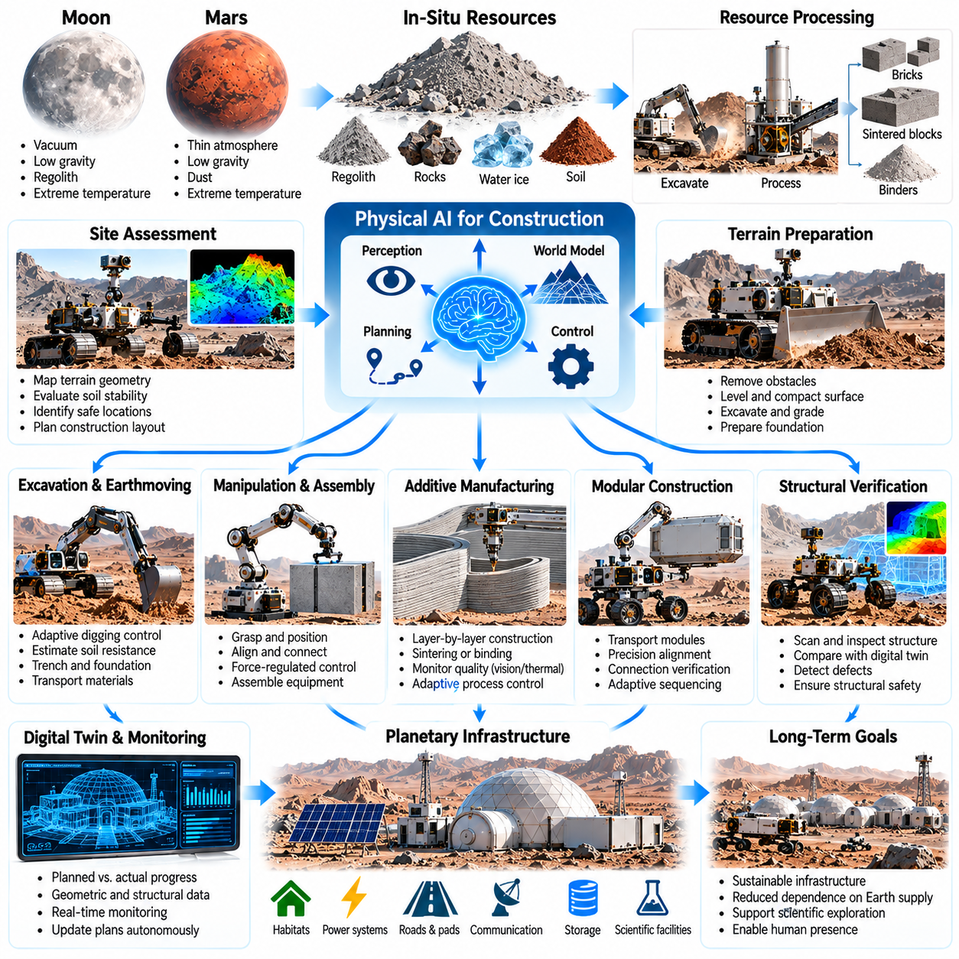
Robotic construction is a fundamental capability for establishing sustainable infrastructure beyond Earth. Lunar and Martian missions will require landing platforms, protective shelters, transportation routes, and scientific facilities that cannot all be transported fully assembled from Earth. Physical AI enables construction robots to perceive unfamiliar terrain, manipulate local materials, coordinate equipment, and execute complex building operations with limited human intervention.
In-situ infrastructure development seeks to reduce dependence on Earth-supplied construction materials and equipment. Transporting large structural components across interplanetary distances creates substantial mass, cost, and logistical constraints. Autonomous construction systems can potentially transform locally available regolith, rocks, and processed resources into useful infrastructure. This approach connects robotic intelligence with planetary resource utilization and long-term settlement planning.
Planetary construction differs significantly from terrestrial building operations because gravity, atmospheric conditions, temperature, and material behavior vary across environments. Lunar vacuum and abrasive regolith introduce challenges involving dust contamination, thermal management, and equipment durability. Martian construction must account for atmospheric dust, uncertain soil mechanics, and extreme environmental conditions. Robots must adapt construction procedures to these physical constraints.
Site assessment represents the first stage of autonomous infrastructure development. Construction robots must evaluate terrain slope, surface roughness, soil bearing capacity, geological stability, and accessibility before selecting suitable locations. Cameras, depth sensors, and geotechnical measurements can support this process. Physical AI can combine environmental observations with predictive models to identify sites that balance structural suitability and operational feasibility.
Terrain preparation is necessary before many planetary structures can be installed or assembled. Robots may need to remove obstacles, level surfaces, compact loose material, and establish stable foundations. These operations require coordinated perception, excavation, grading, and force control. Autonomous systems must continuously evaluate changes in terrain geometry and material resistance to ensure that preparation activities produce the intended physical conditions.
Regolith-based construction offers a potential pathway toward using local planetary materials. Regolith may serve as shielding, fill material, compacted structural layers, or feedstock for processed building components. Techniques such as sintering, additive manufacturing, and material binding have been investigated for extraterrestrial construction. Their practical feasibility depends on local material composition, energy availability, equipment reliability, and structural performance.
Robotic additive manufacturing could support the production of selected infrastructure components directly at planetary sites. Layer-by-layer deposition or consolidation processes may create walls, protective structures, or specialized construction elements. Physical AI can monitor material delivery, geometric accuracy, process temperature, and layer integrity. Closed-loop process control is important because variations in feedstock and environmental conditions can affect construction quality.
Autonomous excavation and earthmoving are essential for foundations, protective berms, trenches, and transportation corridors. Excavation forces depend on soil density, cohesion, friction, and tool geometry, which may be uncertain before operations begin. Physical AI can estimate material resistance from actuator feedback and observed excavation results. Adaptive planning can modify digging depth, tool trajectories, and material transport strategies to improve productivity.
Construction manipulators must handle objects that vary considerably in size, mass, geometry, and mechanical properties. Tasks may include positioning structural elements, connecting modular components, installing equipment, and assembling scientific facilities. Accurate manipulation requires coordinated perception, grasp planning, force regulation, and collision avoidance. Mobile manipulation systems must also account for vehicle stability when handling heavy or extended payloads.
Modular construction can simplify the development of planetary infrastructure by dividing complex facilities into standardized components. Robots may transport, position, align, and connect modules according to predefined assembly plans. Physical AI can support alignment correction, connection verification, and adaptive sequencing when actual conditions differ from design assumptions. Standardized interfaces may reduce manipulation complexity and improve maintainability.
World models provide an important foundation for autonomous construction planning. A construction robot must represent terrain geometry, material locations, equipment states, structural progress, and potential hazards. Action-conditioned models can predict how excavation, material placement, or component assembly will alter the environment. These predictions allow construction plans to be evaluated before execution and updated as physical conditions change.
Digital twins can connect planned infrastructure designs with observed construction progress. A digital representation may contain geometric specifications, structural requirements, equipment configurations, and operational constraints. Robots can compare sensor measurements with expected construction states to detect deviations. Physical AI can use these differences to revise task sequences, request additional inspection, or initiate bounded corrective actions.
Structural verification is essential because construction errors in extraterrestrial environments may be difficult to repair. Robots must assess dimensional accuracy, alignment, foundation stability, connection quality, and material consistency. Cameras, force sensors, and suitable inspection instruments can provide evidence of construction quality. However, autonomous inspection cannot replace validated engineering standards and mission-specific structural qualification procedures.
Multi-robot construction systems could distribute tasks among specialized machines. Excavators may prepare terrain, transport robots may deliver materials, manipulators may assemble components, and inspection robots may verify completed work. Shared maps and coordinated scheduling can improve efficiency while reducing interference between machines. Physical AI must manage resource conflicts, communication limitations, and dependencies between construction activities.
Communication delays make local construction autonomy particularly important for lunar and Martian operations. Remote operators cannot always respond immediately to unexpected terrain behavior, equipment faults, or assembly difficulties. Construction robots must execute approved tasks, detect abnormal conditions, and recover safely within defined operational boundaries. Human engineers can supervise overall objectives while onboard systems manage detailed physical execution.
Energy management is a major constraint on autonomous planetary construction. Excavation, material processing, lifting, transportation, and additive manufacturing can require substantial power. Construction schedules must account for available generation capacity, storage reserves, thermal conditions, and equipment priorities. Physical AI can coordinate energy-intensive operations to reduce peak demand and preserve essential power for communication, safety, and environmental protection.
Infrastructure construction must also consider the long-term effects of dust and material movement. Excavation and transportation may redistribute abrasive particles that interfere with mechanical joints, optical sensors, thermal surfaces, and nearby equipment. Intelligent planning can establish restricted zones, select lower-disturbance procedures, and monitor contamination risks. Environmental management therefore becomes an integral part of construction autonomy.
Protective infrastructure may be especially important for sustained human and robotic presence. Regolith shielding, covered storage areas, equipment enclosures, and appropriately engineered shelters could reduce exposure to radiation, micrometeoroids, and thermal extremes. Autonomous construction robots may assist with material placement and protective structure assembly. The required protection levels must be established through validated environmental and structural analysis.
Transportation infrastructure can improve the efficiency of repeated operations across planetary surfaces. Prepared routes, graded pathways, stable loading areas, and designated equipment zones may reduce mobility risks and mechanical wear. Physical AI can identify frequently traveled corridors and prioritize improvements according to mission demand. Infrastructure planning can therefore connect short-term construction activities with long-term logistics and resource distribution.
Maintenance and repair are necessary because planetary infrastructure will experience mechanical degradation, environmental exposure, and changing operational requirements. Robots may inspect structures, replace damaged modules, restore protective layers, or reconfigure facilities. Persistent world memory can record construction histories, inspection results, and previous repairs. This information supports predictive maintenance and more reliable infrastructure management over extended missions.
The development of autonomous construction requires extensive simulation and physical validation. Digital environments can reproduce representative terrain, material handling, assembly sequences, and multi-robot coordination. Domain randomization can expose learning systems to uncertainty in soil properties, component tolerances, and equipment performance. Nevertheless, experimental verification remains essential because simulated construction processes cannot fully capture extraterrestrial material behavior.
Ultimately, robotic construction and in-situ infrastructure demonstrate how Physical AI can evolve from exploration-oriented autonomy toward the creation and maintenance of persistent off-world facilities. Success requires integrating environmental perception, world models, manipulation, construction planning, quality verification, and resource management. As these capabilities mature, autonomous robots may become essential partners in building sustainable scientific and industrial infrastructure beyond Earth.

04.08. Autonomous Mining and Resource Utilization
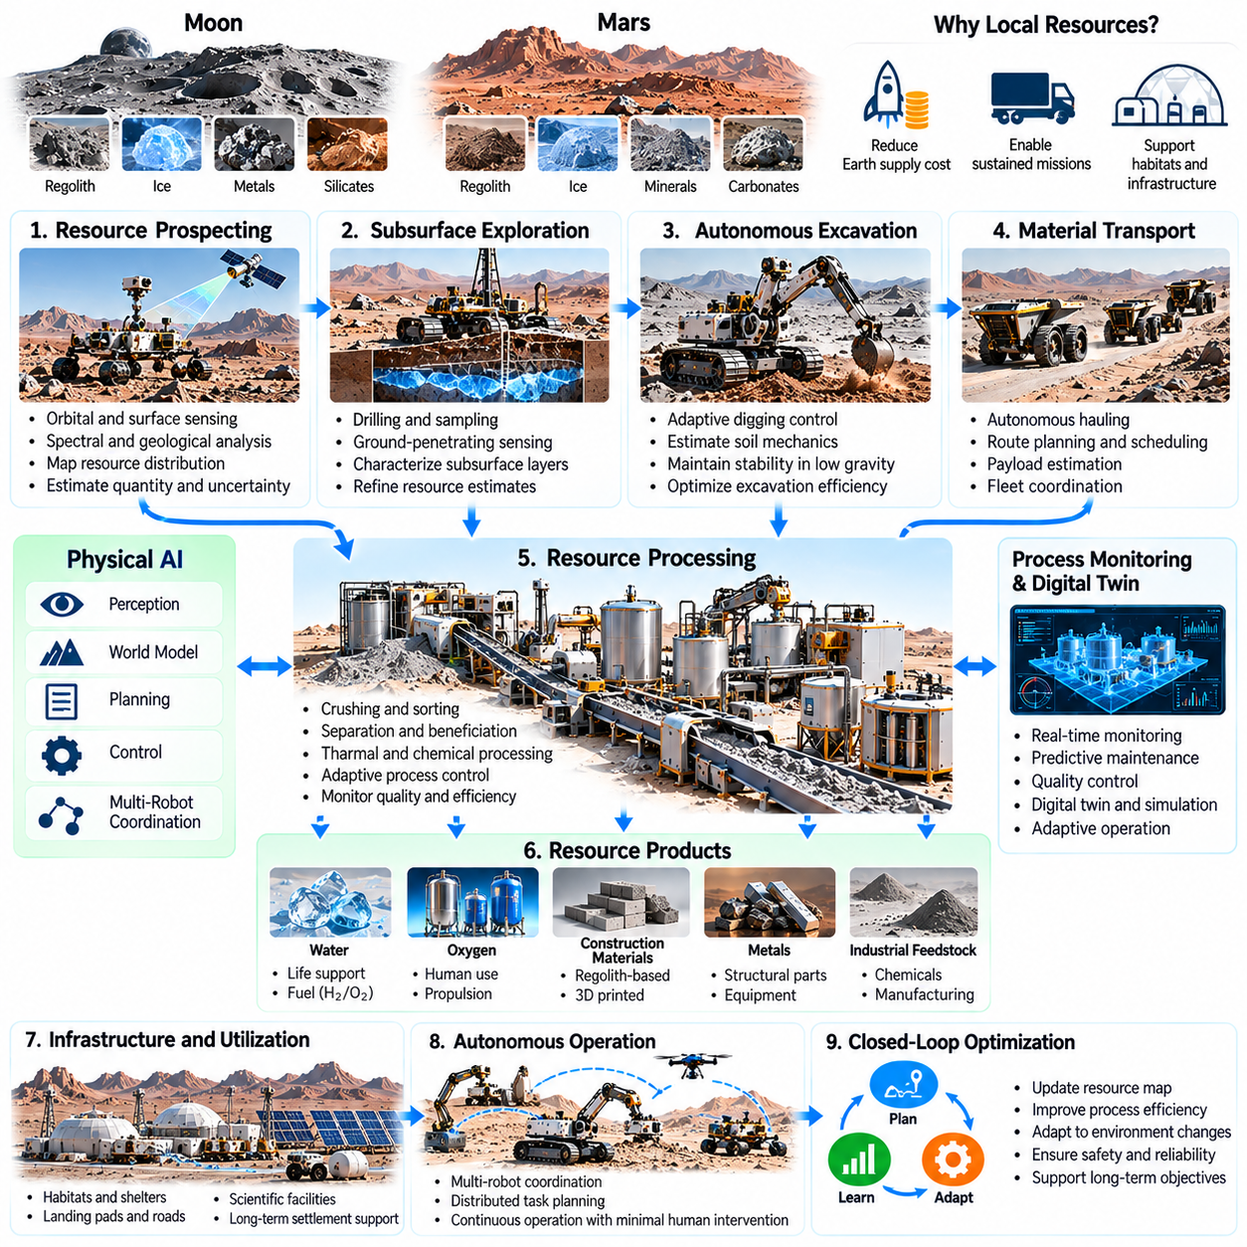
Autonomous mining and resource utilization are essential for extending planetary exploration beyond short-duration missions toward sustained operations. Transporting water, oxygen, construction materials, and industrial feedstocks from Earth imposes substantial logistical costs. Physical AI enables robotic systems to identify local resources, excavate geological materials, manage processing equipment, and coordinate production activities under limited human supervision.
In-situ resource utilization transforms locally available materials into products needed for exploration and infrastructure. Lunar regolith, Martian soil, subsurface ice, and selected mineral deposits may provide useful feedstocks for different processes. However, resource availability does not automatically imply practical recoverability. Autonomous systems must evaluate material concentration, extraction difficulty, energy requirements, and processing efficiency before selecting production strategies.
Resource prospecting begins with the identification and characterization of potentially valuable deposits. Orbital observations, surface imagery, spectroscopy, and geophysical measurements can provide complementary information about geological composition. Physical AI can integrate these observations into spatial resource maps that estimate material distribution and uncertainty. Such maps guide exploration toward locations where extraction is scientifically and economically justified.
Subsurface resources introduce challenges because their properties cannot be determined reliably from surface appearance alone. Ice deposits, buried mineral layers, and heterogeneous regolith may vary substantially across short distances. Autonomous prospecting robots can combine drilling, sampling, ground-penetrating measurements, and geological inference to refine resource estimates. Adaptive exploration planning prioritizes measurements that reduce uncertainty about recoverable material.
Autonomous excavation is a foundational operation in planetary mining. Robotic excavators must penetrate, loosen, collect, and transport materials while maintaining vehicle stability and mechanical reliability. Excavation forces depend on soil cohesion, friction, particle distribution, and tool geometry. Physical AI can use force feedback and observed material movement to adjust digging trajectories, cutting depth, and excavation speed according to local conditions.
Planetary gravity changes the mechanics of excavation and material handling. Reduced gravitational loading can decrease available traction and alter the balance between digging resistance and vehicle stability. Excavation reactions may displace lightweight robots instead of moving the intended material. Intelligent control must coordinate anchoring, contact forces, and equipment motion to maintain stability while achieving useful production rates.
Material transportation connects excavation sites with processing facilities, storage systems, and construction areas. Autonomous hauling robots must navigate uncertain terrain while carrying loads that change vehicle dynamics and energy consumption. Physical AI can coordinate route planning, payload estimation, traffic management, and delivery scheduling. Reliable transportation becomes increasingly important as mining operations expand across distributed resource deposits.
Water extraction is a particularly valuable objective for future lunar and Martian infrastructure. Water may support human consumption, life-support processes, scientific experiments, and production of hydrogen and oxygen. Extracting ice-bearing materials may require excavation, heating, vapor capture, and purification. Autonomous systems must coordinate these operations while accounting for uncertain ice concentration, thermal losses, and equipment degradation.
Oxygen production represents another important application of local resource processing. Oxygen may be extracted from suitable atmospheric constituents or oxygen-bearing minerals through processes appropriate to the planetary environment. Such systems require carefully controlled chemical, thermal, and electrical operations. Physical AI can monitor process conditions, detect abnormal behavior, and optimize equipment scheduling while maintaining validated safety limits.
Local material processing may also support construction and manufacturing. Regolith-derived aggregates, selected metals, and processed mineral compounds could become feedstocks for structural components or specialized equipment. Autonomous processing systems must manage crushing, sorting, separation, heating, and material transfer. Their effectiveness depends on resource composition, process maturity, available power, and the quality requirements of the final products.
Resource beneficiation improves processing efficiency by separating useful constituents from unwanted material before intensive treatment. Mechanical screening, particle classification, magnetic separation, and other techniques may be suitable for particular deposits. Physical AI can monitor material characteristics and adjust processing parameters according to changing feedstock conditions. Adaptive beneficiation may reduce energy consumption and improve downstream production consistency.
World models provide a unified representation of mining environments, equipment states, and material flows. A robotic mining system must track resource locations, excavation progress, storage inventories, vehicle positions, and processing capacity. Action-conditioned models can predict how extraction decisions affect terrain stability, production rates, and resource availability. Such predictive reasoning supports coordinated planning across interconnected mining operations.
Digital twins can connect physical mining equipment with continuously updated operational models. Sensor observations may describe excavator performance, processing temperatures, material throughput, energy consumption, and component health. Comparing expected and observed behavior helps identify inefficiencies or developing faults. Physical AI can use these discrepancies to revise production schedules and recommend bounded corrective actions.
Multi-robot coordination is likely to become important for sustained resource extraction. Prospecting robots may identify deposits, excavators may collect material, transport platforms may deliver feedstocks, and processing robots may manage production equipment. Shared maps and task allocation can reduce idle time and improve utilization. However, communication limitations, equipment dependencies, and conflicting resource demands complicate coordinated operations.
Energy management is a central constraint because mining and material processing can be highly energy-intensive. Excavation, crushing, heating, electrolysis, and transportation may compete for limited electrical power. Physical AI can schedule operations according to generation capacity, storage reserves, thermal conditions, and mission priorities. Production planning must preserve sufficient energy for essential safety systems, communications, and equipment protection.
Autonomous mining must also address equipment durability in abrasive and unfamiliar environments. Dust infiltration, repeated impacts, tool wear, and thermal cycling can degrade mechanical components and sensors. Predictive maintenance systems can estimate remaining component life from vibration, torque, temperature, and operational history. Health-aware planning may reduce excavation loads, redistribute tasks, or schedule repairs before critical failures occur.
Environmental disturbance requires careful consideration even in locations without established ecosystems. Excavation may alter terrain stability, redistribute dust, contaminate scientific sites, or interfere with nearby infrastructure. Autonomous planning can establish exclusion zones and monitor material movement. Responsible resource utilization must also respect planetary protection requirements, scientific preservation priorities, and applicable governance frameworks.
Long communication delays increase the need for local operational autonomy. Earth-based operators cannot continuously control excavation tools or respond immediately to processing abnormalities on Mars. Physical AI must support autonomous fault detection, safe shutdown, bounded recovery, and mission-level replanning. Human supervisors can define production targets and acceptable risks while robotic systems manage detailed execution within approved operational constraints.
Production efficiency must be evaluated across the complete resource utilization chain rather than individual machines. A high excavation rate provides limited benefit if transportation, processing, or storage becomes a bottleneck. Physical AI can coordinate throughput, equipment availability, material quality, and energy consumption across the system. Integrated optimization helps align resource production with the actual needs of exploration and infrastructure development.
Economic feasibility depends on more than the technical ability to extract materials. Equipment mass, launch costs, energy infrastructure, maintenance requirements, production reliability, and resource demand influence overall value. Autonomous systems may reduce operational labor and improve equipment utilization, but complex hardware introduces additional costs. Resource utilization strategies should therefore be assessed through realistic mission-level tradeoffs.
Long-duration mining operations require persistent environmental memory and adaptive resource planning. Robots can accumulate information about deposit quality, excavation resistance, equipment performance, and processing yields. Updated resource models may reveal better extraction locations or indicate that existing sites are becoming less productive. Continual improvement should remain subject to validated operational limits and periodic scientific review.
Ultimately, autonomous mining and resource utilization demonstrate how Physical AI can transform planetary robots from exploration tools into components of sustained extraterrestrial production systems. Their success depends on integrating resource perception, physical manipulation, world models, process control, fleet coordination, and safety-aware optimization. These capabilities may eventually support more independent scientific bases, industrial facilities, and long-term human activities beyond Earth.

04.09. Orbital Robotics and On Orbit Servicing
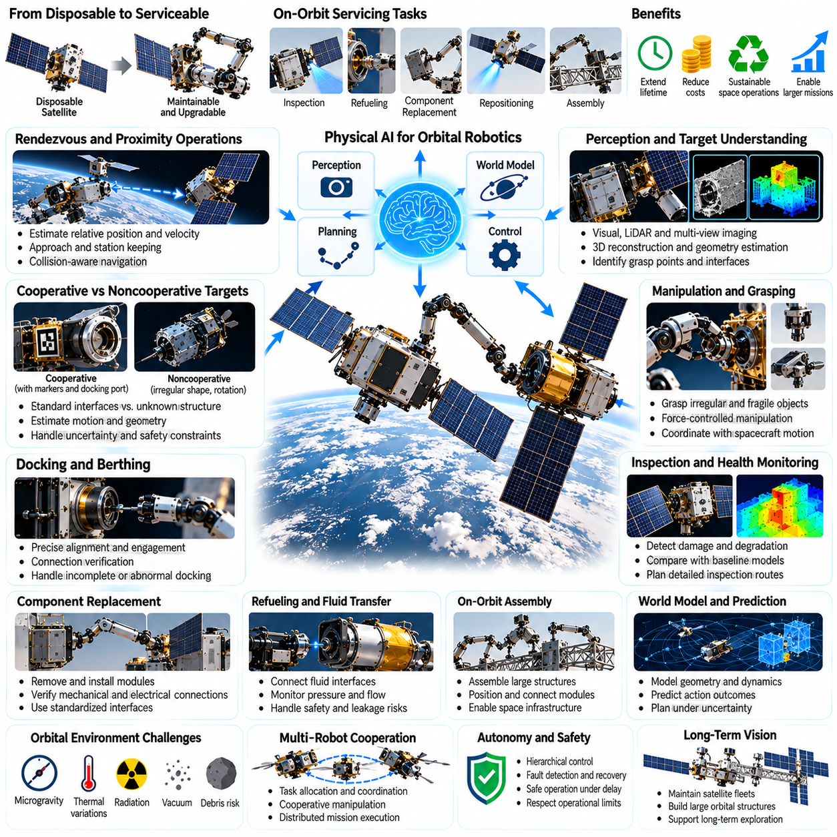
Orbital robotics and on-orbit servicing represent a major transition from disposable spacecraft toward maintainable and adaptable space infrastructure. Traditional satellites are generally designed to operate without physical intervention after launch. Physical AI enables robotic spacecraft to inspect, approach, manipulate, repair, and potentially upgrade orbital assets. These capabilities could extend mission lifetimes, reduce replacement costs, and improve the sustainability of space operations.
On-orbit servicing encompasses inspection, refueling, component replacement, repositioning, and assembly activities performed directly in space. Each operation requires precise coordination between spacecraft navigation, robotic manipulation, and environmental awareness. Unlike terrestrial maintenance, orbital servicing occurs under microgravity, vacuum, radiation, and severe thermal variations. Autonomous systems must account for these conditions while maintaining strict safety margins.
Rendezvous and proximity operations form the foundation of orbital robotic servicing. A servicing spacecraft must approach a target while estimating relative position, velocity, orientation, and rotational motion. Cameras, LiDAR, and other navigation sensors can provide complementary measurements. Physical AI can integrate these observations with orbital dynamics models to support accurate relative navigation and collision-aware approach planning.
Target spacecraft may be cooperative or noncooperative, creating fundamentally different servicing challenges. Cooperative satellites may provide navigation markers, standardized docking interfaces, and attitude stabilization. Noncooperative objects may lack these features and exhibit uncontrolled rotation. Autonomous perception must estimate target geometry and motion without relying on predefined interfaces, while recognizing uncertainty that could make physical interaction unsafe.
Orbital manipulation differs from fixed-base robotics because forces applied by a robotic arm can alter the motion of its spacecraft platform. When a manipulator accelerates or contacts another object, reaction forces and torques influence the combined system. Successful control therefore requires coupled spacecraft-manipulator dynamics. Physical AI must coordinate arm trajectories, attitude control, and momentum management to preserve operational stability.
Autonomous grasping is particularly difficult when servicing objects that were not designed for robotic capture. A target may present irregular surfaces, fragile appendages, uncertain mass properties, or rotating structures. Perception systems must identify suitable contact regions and estimate grasp feasibility. Force-controlled manipulation and compliant end effectors can reduce impact loads, although some targets may remain unsuitable for safe autonomous capture.
Docking and berthing provide mechanisms for establishing stable connections between spacecraft. Docking generally involves controlled engagement between compatible interfaces, while berthing may use robotic manipulation to position an object for attachment. Both require accurate alignment, relative-motion control, and connection verification. Autonomous systems must detect incomplete engagement and avoid applying excessive forces that could damage structural interfaces.
On-orbit inspection offers a comparatively accessible application of robotic servicing. Autonomous spacecraft can examine external structures, solar arrays, antennas, thermal surfaces, and mechanical interfaces for visible damage or degradation. Multi-view imaging and three-dimensional reconstruction can support defect localization. Physical AI can prioritize inspection regions and compare observations with historical records to identify meaningful changes.
Refueling has the potential to extend spacecraft operational lifetimes when compatible servicing interfaces and procedures are available. Robotic systems may need to approach fluid connections, secure transfer mechanisms, and monitor pressure, temperature, and flow conditions. These activities involve substantial technical and safety challenges. Physical AI can assist with positioning, process monitoring, and anomaly detection within carefully validated operational boundaries.
Component replacement could allow selected orbital systems to recover functionality without launching complete replacement spacecraft. Robotic manipulators may remove modular units, install spare components, and verify mechanical or electrical connections. Such operations depend heavily on serviceable spacecraft architecture and standardized interfaces. Physical AI can support alignment, tool selection, and task sequencing while accounting for limited access and uncertain component conditions.
On-orbit assembly enables structures larger than those conveniently accommodated within a single launch vehicle. Robotic spacecraft may position trusses, connect modules, deploy antennas, or construct supporting frameworks. Assembly requires coordination between relative navigation, structural manipulation, and connection verification. Autonomous planning can reduce dependence on continuous ground supervision, particularly during repetitive and geometrically complex operations.
World models provide an important foundation for orbital robotic intelligence. A servicing robot must represent spacecraft geometry, relative motion, component locations, mechanical constraints, and operational hazards. Action-conditioned models can predict how thruster commands, arm movements, or contact forces will influence system behavior. These predictions support planning under uncertainty and help identify potentially unstable interactions before execution.
Orbital environments require reasoning across multiple time horizons. Fast control loops regulate attitude, relative motion, and contact forces, while intermediate planning coordinates inspection and manipulation tasks. Longer-term reasoning manages servicing objectives, energy budgets, and mission schedules. Hierarchical Physical AI architectures can connect these levels while preserving the deterministic behavior required by safety-critical spacecraft control.
Digital twins can support orbital servicing by maintaining computational representations of spacecraft structure, motion, and equipment condition. Sensor measurements update estimates of target geometry, joint states, and system performance. Differences between predicted and observed behavior may reveal calibration errors or developing faults. Digital twins can also support rehearsal and verification of servicing procedures before physical execution.
Communication constraints influence the distribution of intelligence between spacecraft and ground systems. Even when orbital communication delays are relatively small, limited contact windows and intermittent connectivity can prevent continuous supervision. Autonomous robots must execute approved operations, recognize abnormal conditions, and transition safely when communication becomes unavailable. Human operators remain responsible for mission objectives and authorization of critical actions.
Space debris creates additional hazards for robotic servicing missions. Objects in orbit may travel at high relative velocities, and even small debris can damage spacecraft components. Servicing systems must account for conjunction warnings, uncertain object trajectories, and operational exclusion regions. Physical AI can assist with situational awareness and maneuver planning, but collision avoidance requires validated orbital prediction and flight safety procedures.
Energy and thermal management impose substantial constraints on orbital robotic operations. Manipulator movement, sensing, computation, and propulsion consume limited spacecraft resources. Solar illumination, eclipse periods, and equipment heat dissipation influence operational schedules. Physical AI can coordinate servicing activities with power availability and thermal limits, reducing the likelihood that demanding tasks compromise spacecraft health.
Long-duration orbital servicing requires continuous assessment of robotic equipment condition. Joint wear, actuator degradation, sensor drift, and repeated thermal cycling can reduce manipulation accuracy and reliability. Health-aware planning can adjust movement profiles, restrict risky operations, or recommend maintenance actions. Persistent operational memory helps track previous servicing attempts, component behavior, and evolving equipment limitations.
Multi-robot orbital systems could support more complex servicing and assembly missions. Specialized spacecraft may perform inspection, transportation, manipulation, or structural stabilization. Shared environmental representations and coordinated task allocation can improve operational efficiency. However, distributed autonomy introduces challenges involving relative navigation, communication reliability, synchronization, and collision prevention between cooperating robots.
Simulation is indispensable for developing and validating orbital Physical AI. High-fidelity environments can reproduce orbital mechanics, free-floating manipulation, sensor uncertainty, contact dynamics, and spacecraft disturbances. Domain randomization can expose learning systems to variations in target motion, mass properties, and sensor performance. Hardware-in-the-loop testing and carefully staged flight demonstrations remain necessary because simulation cannot capture every operational uncertainty.
Safety assurance is especially important because an unsuccessful servicing maneuver may damage valuable spacecraft or create additional orbital debris. Autonomous actions should operate within verified constraints on approach velocity, contact force, attitude stability, and collision risk. Runtime monitoring can detect violations and trigger predefined fallback behavior. Learning-based intelligence must therefore be integrated with independently validated guidance, navigation, and control systems.
The economic value of orbital servicing depends on spacecraft design, mission lifetime, servicing cost, and the feasibility of repeated operations. Refueling or repairing an expensive satellite may be advantageous when servicing costs are lower than replacement alternatives. Standardized interfaces and modular architectures could improve these economics. Nevertheless, reliable business models require realistic assessments of launch costs, operational risk, and service demand.
Ultimately, orbital robotics and on-orbit servicing demonstrate how Physical AI can transform space systems from isolated assets into maintainable infrastructure. Progress requires the integration of autonomous perception, orbital dynamics, robotic manipulation, predictive world models, and safety-aware planning. As these technologies mature, robotic servicing may enable longer-lived satellites, larger orbital structures, and more sustainable human and robotic activities in space.

04.10. Multi Robot and Swarm Space Systems
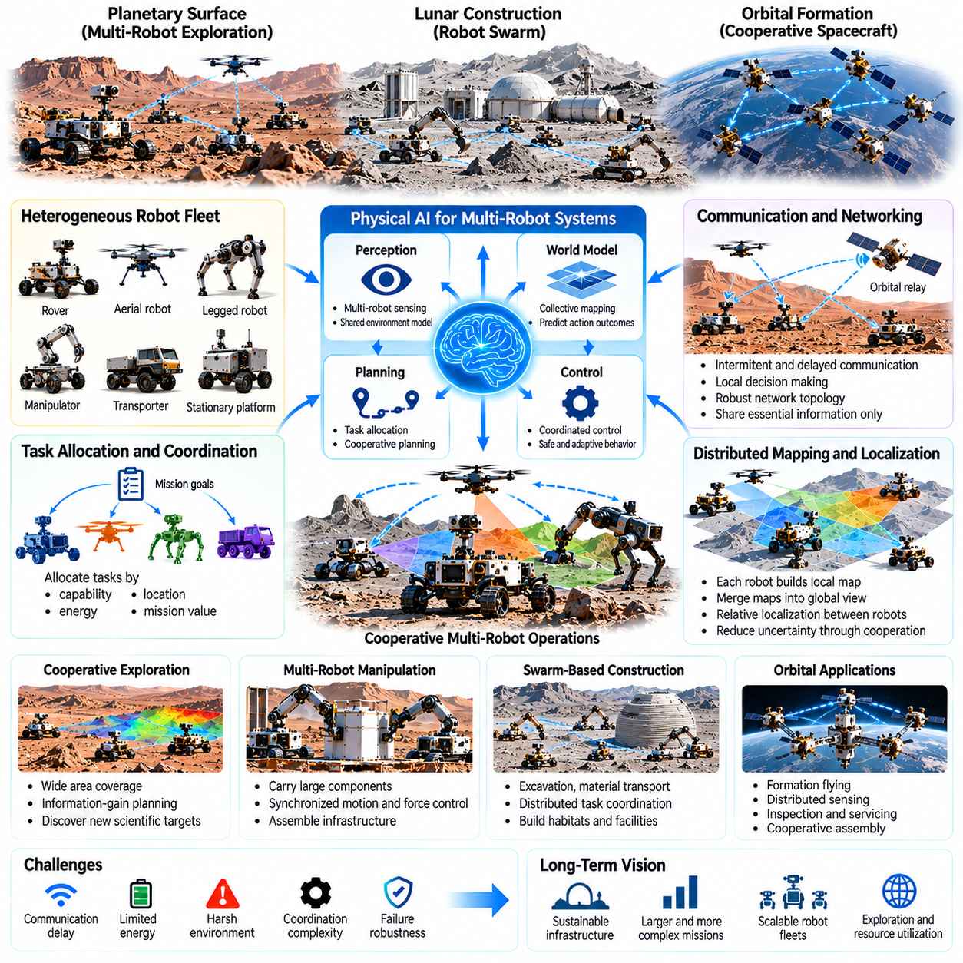
Multi-robot and swarm space systems represent an important evolution from individual autonomous spacecraft toward coordinated networks of intelligent machines. Instead of relying on a single robot to perform every task, distributed systems can divide exploration, construction, inspection, and logistics among specialized agents. Physical AI enables these robots to share information, coordinate actions, and adapt collectively to uncertain extraterrestrial environments.
Space exploration creates strong incentives for distributed robotic architectures because mission environments are extensive, unpredictable, and difficult to access. A single rover or spacecraft has limited sensing coverage, mobility, energy, and operational capacity. Multiple robots can explore different locations simultaneously and provide complementary observations. Their collective effectiveness depends on coordination quality rather than simply increasing the number of machines.
Swarm robotics emphasizes cooperation among numerous relatively simple agents that produce useful collective behavior through local interactions. Individual robots may follow limited rules for movement, communication, and task selection while contributing to broader mission objectives. In space, swarm approaches could support distributed sensing, environmental mapping, and resource reconnaissance. Their advantages depend on communication reliability and robust coordination mechanisms.
Heterogeneous robotic fleets combine machines with different physical capabilities and operational roles. Planetary rovers may transport instruments, aerial robots may survey terrain, manipulators may collect samples, and stationary platforms may provide communication or processing services. Physical AI can coordinate these complementary capabilities through shared mission representations. Effective cooperation requires understanding each robot's limitations, resources, and task dependencies.
Task allocation is a central problem in multi-robot space operations. Robots must determine which agents should perform particular activities according to location, capability, energy reserves, and expected mission value. Centralized scheduling can optimize global objectives when communication is available, while distributed allocation supports local adaptation. Hybrid architectures can combine strategic coordination with autonomous decisions made near the point of execution.
Communication constraints strongly influence the organization of space robot teams. Planetary terrain may obstruct wireless signals, orbital geometry may interrupt connections, and interplanetary distances introduce substantial delays. Robots cannot assume continuous access to a central controller or shared database. Physical AI must support intermittent communication, delayed information exchange, and safe independent operation when network connectivity becomes unavailable.
Shared world models allow cooperating robots to develop a more complete understanding of their environment. Individual agents may contribute terrain maps, obstacle observations, resource estimates, and equipment status information. These observations can be integrated into a collective environmental representation. However, differences in localization accuracy, sensor calibration, and observation time must be considered to prevent inconsistent or misleading shared knowledge.
Distributed mapping is particularly valuable when robots explore large planetary surfaces or complex orbital structures. Each robot can construct a local map while exchanging selected information with nearby agents. Map alignment and data association help combine observations into a consistent representation. Physical AI can prioritize the transmission of informative measurements when communication bandwidth is limited, reducing unnecessary data exchange.
Collective localization enables robots to improve their position estimates through mutual observations and shared environmental features. Relative ranging, visual recognition, and cooperative state estimation can reduce uncertainty when individual navigation sensors are insufficient. Nevertheless, errors may propagate between agents if shared measurements are unreliable. Robust estimation must account for uncertain observations and prevent local failures from destabilizing the entire fleet.
Cooperative exploration requires balancing the discovery of new information against operational risks and resource limitations. Robots may distribute themselves across different regions to maximize coverage while preserving communication links and return paths. Information-gain planning can prioritize locations expected to reduce environmental uncertainty. Physical AI can adjust exploration strategies when terrain conditions, scientific discoveries, or equipment availability change.
Multi-robot manipulation extends collective intelligence into coordinated physical interaction. Several robots may transport large components, stabilize structures, or assemble infrastructure that exceeds the capacity of an individual machine. Such operations require synchronization of motion, contact forces, and load distribution. Predictive models can estimate how actions by one robot affect the stability and mechanical constraints experienced by cooperating agents.
Swarm-based construction could support the gradual development of lunar and Martian infrastructure. Specialized robots may excavate regolith, transport materials, prepare foundations, and assemble modular structures. Distributed task coordination can reduce idle time and accommodate equipment failures. However, construction dependencies require explicit sequencing because some operations cannot begin until preceding structural or material preparation tasks are completed.
Orbital robot formations provide another application of distributed Physical AI. Multiple spacecraft may maintain coordinated relative positions for observation, communication, or scientific measurement. Formation control requires accurate relative navigation, orbital dynamics prediction, and collision avoidance. Autonomous coordination can compensate for disturbances while respecting propulsion limits and safety constraints, enabling configurations that would be difficult for isolated spacecraft.
Resource management becomes increasingly complex as robotic fleets grow. Agents compete for energy, communication bandwidth, charging infrastructure, tools, and transportation capacity. Physical AI can coordinate these shared resources according to mission priorities and expected productivity. Long-horizon planning must also consider battery degradation, maintenance requirements, and the consequences of resource shortages during critical operations.
Fleet-level world memory can preserve experience accumulated across multiple robots and mission phases. Successful traversals, hazardous terrain encounters, manipulation outcomes, and equipment failures provide information that may benefit other agents. Shared experience can improve planning and reduce repeated mistakes. Reliable knowledge transfer requires tracking environmental context, robot morphology, sensor differences, and the uncertainty associated with previous observations.
Collective learning allows robotic teams to improve from distributed operational data. Individual agents may encounter different terrain types, lighting conditions, material properties, and failure modes. Aggregating these experiences can support more generalizable perception and control models. However, onboard learning must remain compatible with validated safety constraints, and model updates require careful testing before deployment across an operational fleet.
Fault tolerance is a major potential advantage of multi-robot architectures. When one robot becomes unavailable, remaining agents may redistribute tasks or modify mission objectives. Redundancy can preserve essential capabilities, although specialized equipment may still create single points of failure. Physical AI must distinguish recoverable local faults from failures that threaten the wider system and coordinate appropriate responses.
Distributed autonomy introduces challenges involving trust, consistency, and conflict resolution. Robots may hold different estimates of environmental conditions or disagree about task priorities. Coordination protocols must resolve competing decisions without causing unsafe actions or operational deadlocks. Hierarchical supervision, explicit safety rules, and bounded local authority can help maintain coherent behavior while preserving adaptability.
Simulation is essential for evaluating collective robotic behavior before deployment. Multi-agent environments can reproduce communication interruptions, uncertain terrain, equipment failures, and competing resource demands. Large-scale experiments can reveal coordination bottlenecks and unexpected interactions. Sim-to-real validation remains necessary because simulated communication, contact dynamics, and environmental uncertainty may differ from actual space operations.
The performance of a robotic swarm should be evaluated through mission-level outcomes rather than the behavior of individual agents alone. Important measures include coverage, task completion, energy efficiency, communication overhead, resilience, and scientific return. Increasing fleet size does not guarantee proportional performance improvements. Coordination costs, interference, and shared resource bottlenecks may eventually outweigh the benefits of additional robots.
Human supervision remains important even when robotic teams operate with substantial autonomy. Mission controllers can define scientific priorities, safety boundaries, and acceptable resource expenditures while allowing robots to coordinate routine activities locally. Transparent reporting helps operators understand collective decisions and emerging risks. Human authority is particularly important when autonomous actions could create irreversible environmental changes or threaten valuable infrastructure.
Ultimately, multi-robot and swarm space systems demonstrate how Physical AI can evolve from individual machine intelligence toward coordinated collective agency. Their success depends on shared world models, distributed planning, reliable communication, cooperative control, and safety-aware learning. As these capabilities mature, robotic teams may support larger exploration campaigns, persistent planetary infrastructure, and increasingly autonomous space operations.

04.11. World Models for Unknown Environments
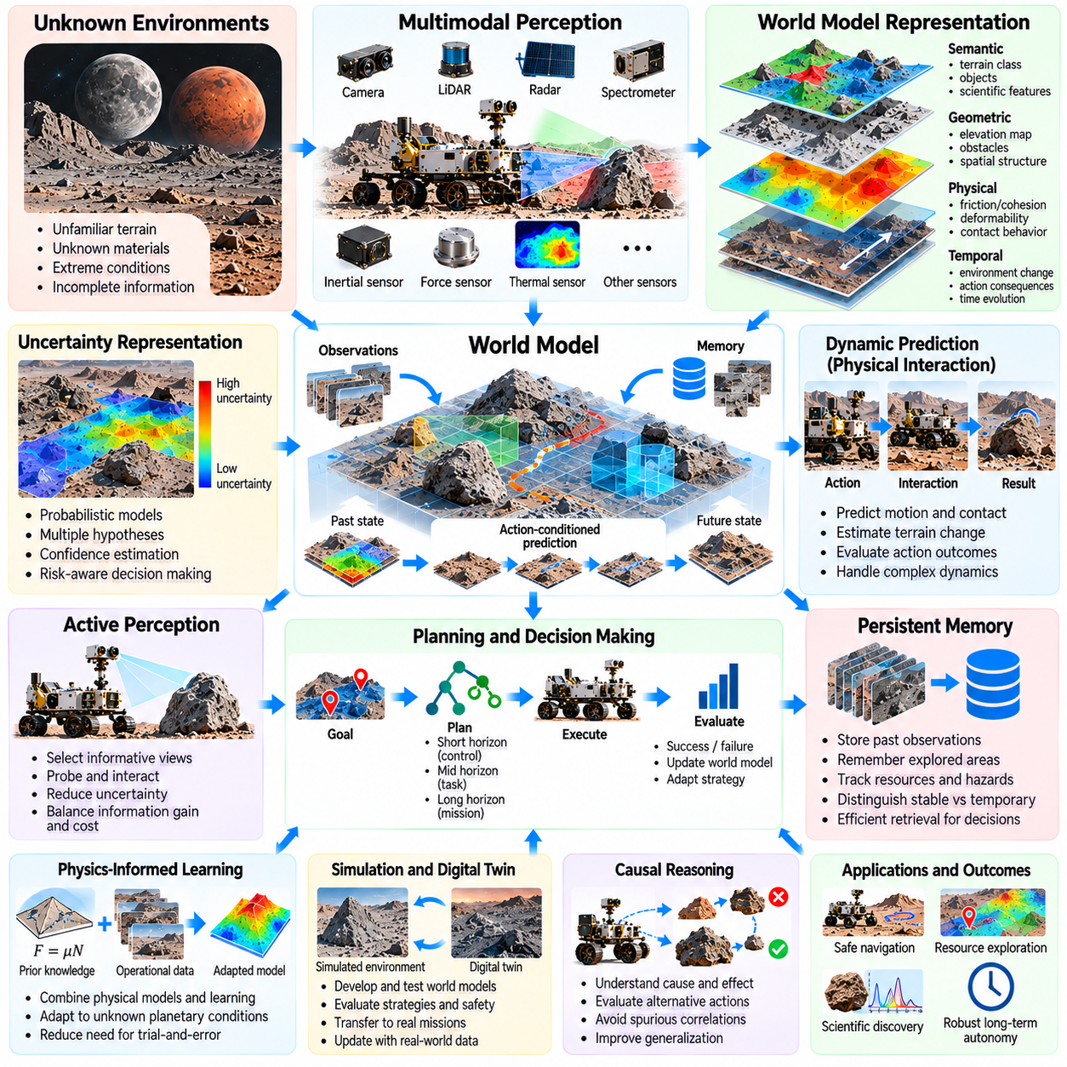
World models are essential for Physical AI operating in extraterrestrial environments where terrain, materials, dynamics, and hazards remain incompletely understood. Unlike terrestrial robots that can rely on extensive prior maps and familiar operating conditions, space robots must interpret unfamiliar observations and act under substantial uncertainty. A world model provides an internal representation of the environment and predicts how its state may evolve through natural processes and robotic actions.
Unknown environments challenge conventional robotic autonomy because perception alone cannot determine every property required for safe action. A camera may reveal the appearance of a planetary surface without establishing its mechanical strength or subsurface composition. Physical AI must infer hidden properties from indirect measurements and interactions. World models connect observations, physical hypotheses, and predicted outcomes to support decisions beyond immediate sensor information.
A useful planetary world model integrates geometric, semantic, physical, and temporal representations. Geometry describes terrain elevation, obstacles, and spatial relationships, while semantic information identifies geological structures and operationally relevant objects. Physical representations estimate friction, cohesion, deformability, and contact behavior. Temporal models capture environmental changes and the consequences of previous robotic activities.
Multimodal perception provides the observational foundation for constructing these representations. Cameras, LiDAR, radar, spectrometers, inertial sensors, and force measurements reveal different aspects of the environment. Sensor fusion combines complementary evidence while accounting for calibration errors and measurement uncertainty. Physical AI must determine which observations are reliable under unfamiliar lighting, dust, temperature, and terrain conditions.
Uncertainty representation is particularly important because extraterrestrial observations are often incomplete or ambiguous. A surface that appears solid may conceal loose material, while a geological formation may have several plausible compositions. Probabilistic world models can maintain competing hypotheses and estimate confidence in predicted outcomes. Planning systems should use these estimates to distinguish acceptable exploration risks from conditions requiring additional observation.
World models must also represent physical dynamics rather than describing static environments alone. Robotic motion can disturb regolith, displace rocks, deform terrain, or change contact conditions. Action-conditioned models predict how these interactions affect future environmental states. Such predictions help robots evaluate whether a proposed movement, excavation, or manipulation action is likely to succeed without compromising stability or equipment safety.
Learning unknown dynamics requires combining prior physical knowledge with new operational experience. Models developed from terrestrial experiments may not accurately describe reduced gravity, unfamiliar granular materials, or extreme thermal conditions. Physics-informed learning can preserve known mechanical relationships while adapting uncertain parameters from observations. This approach reduces dependence on unrestricted trial-and-error learning in hazardous environments.
Active perception enables robots to gather information specifically needed for future decisions. Instead of passively recording sensor data, an autonomous system may reposition a camera, probe a surface, or perform a controlled contact experiment. These actions reveal properties that cannot be inferred reliably from distant observations. World models can estimate the expected information gain and balance exploratory measurements against their energy, time, and safety costs.
Long-horizon prediction is necessary when robots execute missions extending across hours, days, or longer periods. Short-term models may predict immediate motion and contact forces, while longer-term models estimate terrain changes, resource consumption, and operational progress. Hierarchical world models can connect these timescales through shared state representations. Their predictions must account for increasing uncertainty as the planning horizon expands.
Persistent memory allows world models to accumulate knowledge across repeated exploration activities. Previously observed terrain, unsuccessful traversals, geological measurements, and equipment interactions provide valuable context for future operations. Memory systems should distinguish stable environmental properties from temporary conditions. This distinction helps prevent outdated observations from producing incorrect decisions when environments or equipment states change.
Spatial memory is especially important for exploration beyond direct sensor range. Robots may need to remember hazardous slopes, unstable surfaces, communication obstacles, and previously examined scientific targets. Topological maps, metric representations, and semantic memory can provide complementary levels of detail. Physical AI can retrieve relevant information according to mission objectives without processing every historical observation during each decision.
Causal reasoning strengthens world models by connecting physical actions with their consequences. A robot should recognize that excessive wheel torque may increase soil slip or that removing supporting material may destabilize a structure. Causal representations can support counterfactual evaluation of alternative actions. Such reasoning helps distinguish meaningful physical relationships from correlations that may not generalize to unfamiliar planetary conditions.
Simulation provides a controlled environment for developing predictive world models before deployment. Synthetic planetary terrains can expose models to variations in gravity, material properties, lighting, and mechanical interactions. Domain randomization broadens the range of training conditions and reduces dependence on narrow assumptions. However, simulation-derived knowledge must be validated against physical experiments because unknown environmental effects can remain unmodeled.
Online model adaptation allows robots to revise their understanding when observations contradict predictions. Unexpected wheel slip, unusual drilling resistance, or unfamiliar object motion may indicate inaccurate environmental parameters. Physical AI can update selected model components while preserving verified safety constraints. Adaptation should be monitored carefully because incorrect updates may amplify uncertainty or degrade previously reliable capabilities.
Multi-robot exploration creates opportunities for shared world modeling across distributed observations. Different robots may examine the same region from complementary viewpoints or investigate separate locations simultaneously. Their measurements can improve spatial coverage and reduce uncertainty about environmental structure. Shared models must account for inconsistent localization, communication delays, and differences in sensing capability before combining information.
World models also support scientific discovery by connecting robotic observations with testable geological hypotheses. An autonomous explorer may detect unusual mineral signatures, unexpected layering, or evidence of environmental processes. Predictive models can identify observations that would distinguish competing scientific explanations. Physical AI can then recommend sampling or measurement actions that maximize scientific value while respecting mission constraints.
Energy and computational limitations shape how extraterrestrial world models are implemented. High-resolution predictive models may require more memory and processing power than a spacecraft can continuously provide. Hierarchical representations can allocate computational resources according to environmental complexity and decision urgency. Lightweight local models may support real-time control, while more detailed models assist deliberate planning when resources permit.
Safety-aware planning requires world models to represent both expected outcomes and plausible failures. A predicted traversal path may appear efficient but involve uncertain traction, limited recovery options, or exposure to damaging terrain. Risk-sensitive planners can compare alternatives using predicted failure probabilities and consequence estimates. Independent safety monitors remain necessary because learned models cannot guarantee accurate predictions in every unfamiliar situation.
The reliability of a world model should be evaluated through physical decision outcomes rather than prediction accuracy alone. Useful measures include navigation success, manipulation reliability, uncertainty calibration, recovery performance, and scientific information gained. Testing should include unfamiliar terrain and environmental conditions outside the training distribution. A model that produces visually plausible predictions may still be unsuitable for controlling safety-critical robotic actions.
Unknown environments create a persistent tension between exploration and exploitation. Robots must acquire new knowledge while accomplishing scientific, construction, or resource utilization objectives. Excessive caution may prevent valuable discoveries, while aggressive exploration can endanger equipment and mission continuity. World-model-based planning can balance these competing demands by estimating both immediate operational value and future benefits from reduced uncertainty.
Human supervision remains important when world models encounter unfamiliar phenomena or make consequential predictions. Ground operators and scientific teams can review uncertain interpretations, establish exploration priorities, and authorize high-risk operations. Explainable model outputs can communicate assumptions, confidence estimates, and expected consequences. This collaboration combines autonomous physical reasoning with human scientific judgment and mission accountability.
Ultimately, world models for unknown environments provide the predictive foundation for increasingly autonomous space exploration. Their development requires integrating multimodal perception, physical dynamics, uncertainty estimation, causal reasoning, persistent memory, and adaptive planning. As these capabilities improve, Physical AI may enable robots to operate more safely and productively in environments that cannot be fully characterized before arrival.

04.12. Self Repair and Long Duration Autonomy
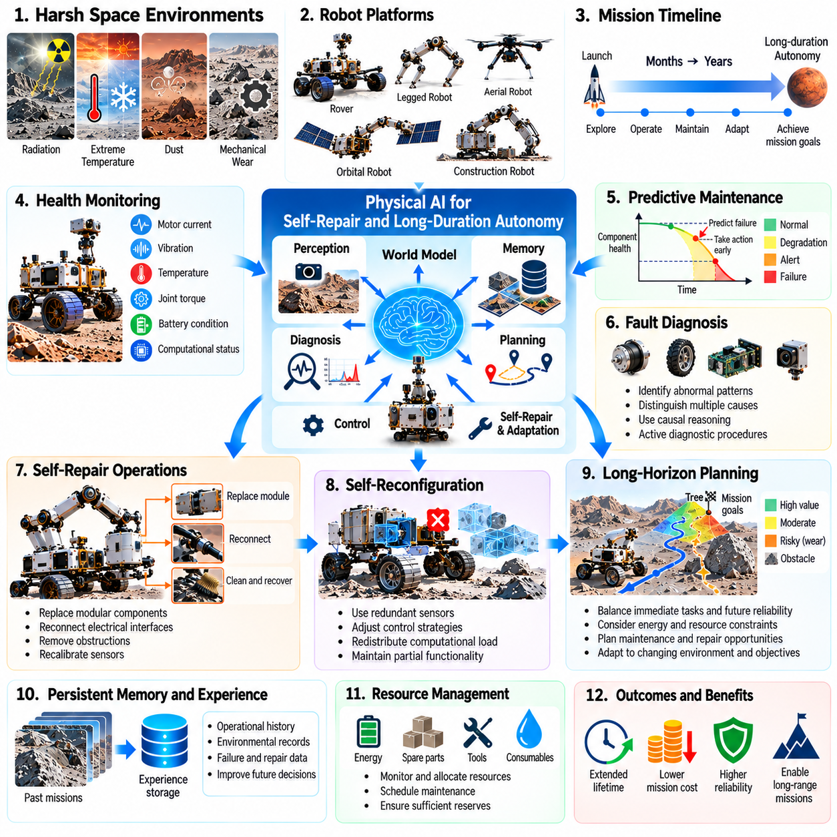
Self-repair and long-duration autonomy are essential for Physical AI systems operating far beyond immediate human assistance. Space robots may need to function for months or years while exposed to radiation, extreme temperatures, dust, and mechanical degradation. Repair missions from Earth can be prohibitively expensive or impossible. Autonomous systems must therefore detect deterioration, preserve essential functions, and recover from failures with limited external intervention.
Long-duration autonomy extends beyond executing predefined tasks without human supervision. A robotic system must maintain its operational capability while environmental conditions, equipment performance, and mission objectives evolve. This requires continuous integration of perception, planning, control, health monitoring, and resource management. Physical AI must reason about both immediate task completion and the long-term consequences of its actions.
Space environments create persistent threats to mechanical, electrical, and computational components. Radiation can disrupt electronics, thermal cycling can weaken connections, and abrasive dust can damage joints and seals. Repeated mechanical loading may gradually reduce actuator performance. Autonomous maintenance systems must distinguish normal aging from emerging faults and unexpected failures that require immediate protective responses.
Health monitoring provides the foundation for autonomous repair and recovery. Sensors can measure motor current, vibration, temperature, joint torque, battery condition, and computational errors. Physical AI can compare these observations with expected operating behavior to identify abnormal patterns. Reliable diagnosis requires combining multiple measurements because individual sensor anomalies do not always indicate actual component failures.
Predictive maintenance enables robots to respond before deterioration causes mission-critical failures. Models of component wear, fatigue, and thermal stress can estimate remaining useful life under different operating conditions. Physical AI may reduce mechanical loads, modify movement patterns, or reschedule demanding tasks. Such adjustments can extend operational life while preserving sufficient capability to accomplish essential mission objectives.
Fault diagnosis becomes particularly challenging when multiple components influence the same observable behavior. Reduced mobility may result from motor degradation, wheel damage, terrain conditions, or power limitations. Causal models can distinguish competing explanations by examining relationships between commands, sensor responses, and environmental states. Active diagnostic procedures may provide additional evidence without exposing the robot to unnecessary risk.
Self-repair involves restoring damaged or degraded functionality through actions performed by the robotic system itself. Potential approaches include replacing modular components, reconnecting electrical interfaces, clearing mechanical obstructions, and recalibrating sensors. These operations require suitable hardware architecture and accessible maintenance interfaces. Physical AI cannot compensate for every physical failure through software intelligence alone.
Modular design improves the feasibility of robotic self-repair by separating complex equipment into replaceable functional units. Standardized mechanical attachments, electrical connectors, and diagnostic interfaces simplify maintenance procedures. A robot equipped with suitable manipulators and spare modules may replace selected failed components. However, repairability must be considered during system design because inaccessible or permanently integrated parts remain difficult to service.
Autonomous manipulation is central to physical maintenance operations. Repair robots must identify damaged components, select appropriate tools, establish stable contact, and execute precise movements. Force feedback and visual sensing help manage alignment and contact uncertainty. In microgravity or reduced-gravity environments, manipulation forces may also disturb the robot platform, requiring coordinated stabilization and motion control.
Self-reconfiguration provides an alternative when direct physical repair is unavailable. A robot may compensate for a failed sensor by using redundant measurements or adjust its control strategy after partial actuator degradation. Reconfigurable systems can redistribute computational workloads and isolate malfunctioning subsystems. These adaptations preserve reduced but useful functionality, although they cannot restore capabilities that depend on irreversibly damaged hardware.
World models support long-duration autonomy by representing environmental conditions, equipment states, and expected physical interactions. A health-aware world model can predict how planned actions influence component wear, energy consumption, and failure probability. Physical AI can compare alternative strategies according to both mission productivity and equipment preservation. Such reasoning connects maintenance decisions with broader operational planning.
Persistent memory allows autonomous systems to accumulate experience across extended missions. Historical records of equipment loads, temperature exposure, repair attempts, and previous anomalies provide context for future diagnosis. Memory systems must preserve the relationships between environmental conditions and observed degradation. This accumulated knowledge can improve maintenance scheduling and reduce repeated exposure to known operational hazards.
Long-horizon planning is necessary because maintenance decisions often involve tradeoffs between immediate productivity and future reliability. A demanding excavation task may accelerate tool wear, while postponing maintenance may increase the likelihood of complete failure. Physical AI must estimate these consequences over multiple timescales. Hierarchical planning can coordinate short-term control, intermediate maintenance activities, and long-term mission objectives.
Energy management strongly influences autonomous survival and recovery. Repair procedures may require substantial power for manipulation, heating, computation, or diagnostic testing. Robots must maintain reserves for communication, thermal protection, and safe shutdown. Physical AI can schedule maintenance according to available energy and environmental conditions, ensuring that repair attempts do not compromise essential survival functions.
Thermal management is particularly important during extended planetary and orbital missions. Extreme temperature variations can affect batteries, electronics, lubricants, and mechanical tolerances. Autonomous systems may adjust operational schedules, activate heaters, or reduce computational loads to remain within acceptable limits. Predictive thermal models can anticipate hazardous conditions and coordinate protective actions before component performance deteriorates.
Software resilience is another essential dimension of long-duration autonomy. Radiation-induced errors, corrupted data, unexpected software states, and computational overload can interrupt robotic operations. Fault-tolerant architectures may use redundant processors, error detection, checkpoint recovery, and controlled software restarts. Physical AI must distinguish recoverable software faults from hardware problems while maintaining reliable safety-critical control.
Autonomous recovery requires a structured response when failures occur. A robot should first stabilize its physical state, isolate potential hazards, and preserve essential resources. It can then evaluate diagnostic evidence and select an approved recovery procedure. If recovery remains uncertain, the system may enter a safe mode and request human assistance. Unrestricted autonomous experimentation is inappropriate when unsuccessful actions could permanently disable the mission.
Multi-robot systems can extend repair capabilities through cooperative maintenance. One robot may inspect damaged equipment while another transports replacement modules or performs manipulation. Shared diagnostic information can help identify common failure patterns across a fleet. Cooperative recovery also provides redundancy when individual robots lose functionality, although repair operations must account for communication limitations and coordination risks.
Simulation and digital twins provide valuable tools for validating autonomous maintenance strategies. Digital representations can estimate equipment degradation and predict the effects of proposed repairs. Simulated fault injection allows developers to evaluate diagnostic accuracy and recovery behavior under controlled conditions. Physical testing remains necessary because actual failures may involve unexpected interactions that simplified models cannot reproduce.
Verification and safety assurance are essential because autonomous repair can introduce new failures. Incorrect component replacement, excessive manipulation forces, or unsuitable software reconfiguration may worsen existing damage. Maintenance actions should operate within validated procedures and monitored safety constraints. Systems must also recognize when available evidence is insufficient to justify intervention and when preserving the current state is safer than attempting repair.
The effectiveness of self-repair should be evaluated through mission continuity rather than repair success alone. Important measures include operational availability, fault detection accuracy, recovery time, resource consumption, and remaining functional capability. A successful maintenance strategy may restore full performance or preserve a reduced operating mode. Long-duration evaluation must also examine whether repeated repairs introduce cumulative risks or accelerate other forms of degradation.
Human oversight remains important for consequential maintenance decisions, particularly when repair procedures involve irreversible actions. Ground operators can establish acceptable risk levels, approve complex interventions, and update maintenance priorities. Communication delays require robots to manage urgent protective responses independently. Transparent diagnostic reports and interpretable recovery plans help maintain human understanding and accountability throughout extended missions.
Ultimately, self-repair and long-duration autonomy transform Physical AI from task-oriented robotic intelligence into systems capable of sustaining their own operational existence. Progress depends on integrating health monitoring, predictive maintenance, modular hardware, autonomous manipulation, world models, persistent memory, and safety-aware planning. These capabilities may enable more resilient spacecraft, planetary robots, and long-lived extraterrestrial infrastructure.

04.13. Human Robot Collaboration in Space
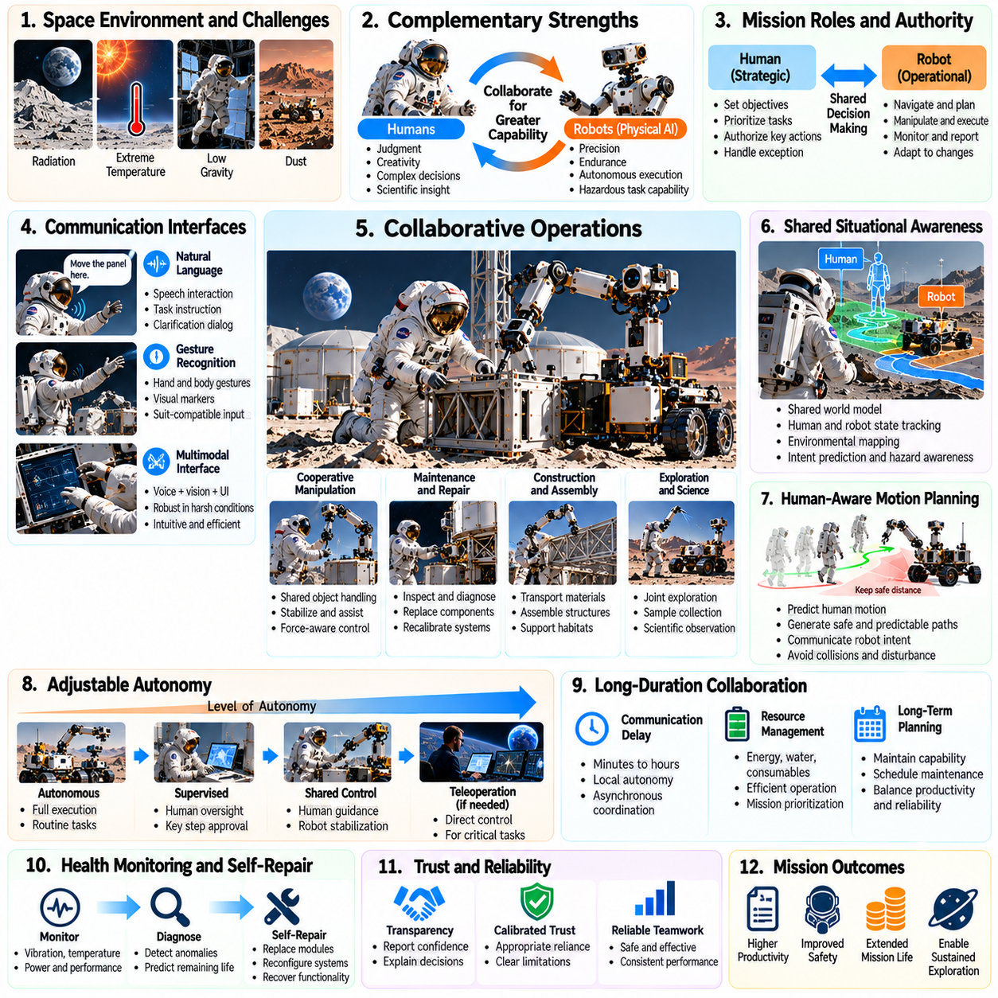
Human-robot collaboration in space represents a fundamental approach to extending human capabilities beyond Earth. Astronauts provide scientific judgment, contextual understanding, and responsibility for complex decisions, while Physical AI systems contribute precision, endurance, and autonomous execution. Effective collaboration combines these complementary strengths to improve mission safety, productivity, and adaptability in demanding extraterrestrial environments.
Space operations expose humans to radiation, reduced gravity, extreme temperatures, and limited life-support resources. Robotic assistants can reduce astronaut exposure by performing repetitive, hazardous, or physically demanding activities. These tasks include equipment inspection, material transportation, surface preparation, and infrastructure maintenance. Physical AI allows robots to adapt their actions to changing conditions rather than following rigidly predefined procedures.
Human-robot collaboration requires a clear distribution of responsibilities between astronauts and autonomous machines. Humans may define mission objectives, establish operational priorities, and authorize consequential actions, while robots handle navigation, manipulation, and routine execution. The allocation of authority should change according to task complexity, environmental uncertainty, and system reliability. Effective autonomy supports human decisions without eliminating meaningful oversight.
Shared situational awareness is essential when humans and robots operate in the same environment. Astronauts must understand robotic intentions, operating states, and potential hazards, while robots must recognize human positions, activities, and immediate needs. Multimodal perception can integrate visual observations, spatial maps, equipment information, and human activity estimates. Shared world models provide a common foundation for coordinated planning and safe interaction.
Natural language interaction can make robotic assistance more accessible during complex space missions. Astronauts may describe objectives, request information, or modify procedures through spoken instructions. Language-capable Physical AI must translate these requests into grounded actions consistent with physical constraints. Ambiguous commands should trigger clarification, especially when incorrect interpretation could damage equipment or threaten crew safety.
Gesture recognition and multimodal interfaces provide additional communication channels when speech is impractical. Astronauts wearing protective suits may experience limited mobility, restricted visibility, or communication interference. Robots can interpret pointing gestures, visual markers, and structured interface commands to support task coordination. Interface design must account for environmental conditions and avoid depending on a single potentially unreliable communication method.
Collaborative manipulation enables astronauts and robots to handle objects that are difficult for either partner to manage independently. A robot may stabilize a component while an astronaut performs assembly, or position tools and materials during maintenance. Such cooperation requires accurate estimation of forces, motion intentions, and contact conditions. Physical AI must adapt its behavior continuously while respecting human safety margins and mechanical limitations.
Physical interaction becomes particularly challenging in microgravity and reduced-gravity environments. Forces applied during manipulation can disturb both robotic platforms and astronauts, creating unexpected motion. Cooperative controllers must consider momentum exchange, anchoring conditions, and the stability of shared objects. Predictive dynamics models can estimate interaction consequences and support coordinated movements that minimize unnecessary physical disturbances.
Human-aware motion planning is necessary when robots navigate near astronauts or shared workspaces. Robots should anticipate possible human movement while maintaining safe distances and accessible escape paths. Collision avoidance alone is insufficient because sudden robotic actions may distract or destabilize crew members. Physical AI should generate predictable trajectories and communicate intended movements before entering sensitive operational areas.
Trust calibration is a central requirement for successful human-robot collaboration. Astronauts must understand what a robot can accomplish reliably and where its capabilities remain uncertain. Excessive trust may encourage unsafe delegation, while insufficient trust can increase workload and reduce operational benefits. Transparent reporting of confidence, limitations, and detected anomalies helps operators maintain appropriate expectations of autonomous performance.
Adjustable autonomy allows robotic systems to operate at different levels of independence according to mission circumstances. During routine logistics, robots may execute complete tasks autonomously, while complex repairs may require step-by-step human authorization. Shared control can combine astronaut commands with robotic stabilization and obstacle avoidance. The system should support smooth transitions between autonomous, supervised, and directly controlled operating modes.
Communication delays complicate collaboration between astronauts, robots, and Earth-based mission controllers. Lunar operations may involve noticeable delays, while Mars missions can experience delays lasting many minutes. Local robotic autonomy becomes essential for time-sensitive safety responses and routine coordination. Ground teams can establish strategic objectives, but nearby humans and robots must often resolve immediate operational problems independently.
World models support collaboration by maintaining representations of shared environments, equipment states, and ongoing human activities. A robot assisting with construction should understand which components are installed, which tools are available, and where astronauts are working. Predictive models can anticipate task dependencies and identify potential conflicts. Persistent memory helps preserve operational context across shifts, interruptions, and changing mission teams.
Long-horizon task planning becomes important when human and robotic activities must be coordinated over extended periods. Habitat construction, scientific exploration, and equipment servicing may involve complex sequences of dependent operations. Physical AI can schedule robotic work around astronaut availability, energy constraints, and environmental conditions. Effective planning should reduce human waiting time while preserving flexibility for unexpected discoveries or urgent maintenance.
Robotic assistants can improve scientific productivity by supporting field exploration and sample collection. Astronauts may identify promising geological targets while robots perform detailed scanning, instrument positioning, or sample transportation. Physical AI can recommend additional measurements based on environmental observations and scientific hypotheses. Human researchers retain responsibility for interpreting discoveries and determining which investigations deserve priority.
Collaborative maintenance is another important application in long-duration space missions. Robots may inspect inaccessible equipment, transport replacement parts, and assist astronauts during complex repairs. Autonomous diagnostics can identify likely faults and suggest maintenance procedures. However, interventions involving irreversible changes or uncertain mechanical conditions may require explicit human approval. Cooperative maintenance combines robotic precision with human adaptability.
Crew workload management must be considered when introducing autonomous assistants. A robot that frequently requests clarification or generates excessive alerts may increase cognitive demands rather than reduce them. Physical AI should prioritize important information and communicate at appropriate moments. Human-centered interfaces can present concise explanations, task progress, and actionable warnings without overwhelming astronauts during critical operations.
Human physiological and behavioral conditions also influence collaborative performance. Fatigue, stress, restricted mobility, and altered spatial orientation may affect astronaut movement and decision-making. Robots can adapt assistance levels using observable task conditions and authorized operational information. Such adaptation must respect privacy, avoid unsupported judgments about human states, and preserve the astronaut's ability to override automated recommendations.
Safety assurance requires systematic evaluation of human-robot interaction under realistic mission conditions. Simulation can reproduce constrained workspaces, reduced gravity, equipment failures, and communication disruptions. Human-in-the-loop testing reveals misunderstandings and coordination failures that purely robotic experiments may overlook. Verification should examine physical safety, interface usability, authority transitions, and recovery from unexpected interactions.
Ethical and organizational considerations become increasingly important as robotic autonomy expands. Mission operators must establish clear accountability for decisions involving crew safety, scientific resources, and environmental impacts. Autonomous systems should provide interpretable records of significant actions and their underlying assumptions. Human authority must remain meaningful even when robots possess superior speed, precision, or computational capacity for particular tasks.
The economic value of collaboration depends on reducing mission risk and improving the effective use of scarce human time. Astronaut activities require extensive training, life-support resources, and operational preparation. Robots can perform preparatory work before crew arrival and continue routine operations between human visits. However, robotic deployment must justify its own costs in mass, power, maintenance, reliability, and integration complexity.
Ultimately, human-robot collaboration in space provides a pathway toward sustained exploration and settlement beyond Earth. Its success depends on shared world models, adaptive autonomy, safe physical interaction, transparent communication, and coordinated long-horizon planning. As Physical AI matures, astronauts and intelligent robots may function as integrated operational teams capable of constructing, maintaining, and exploring increasingly complex extraterrestrial environments.

04.14. Autonomous Lunar and Martian Logistics
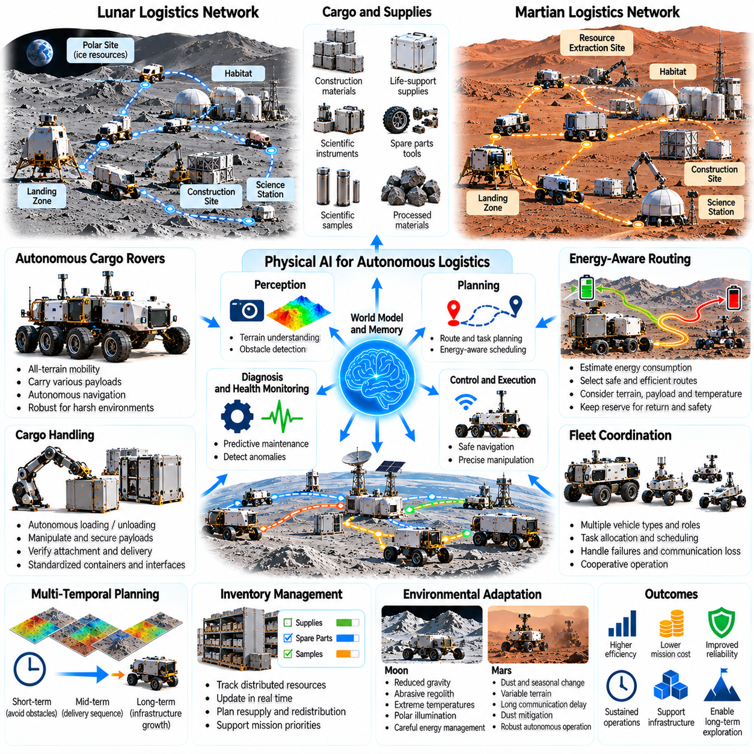
Autonomous lunar and Martian logistics will be essential for sustaining exploration, scientific operations, and future settlements beyond Earth. Transporting equipment, construction materials, scientific samples, and life-support supplies requires reliable coordination across distant locations. Physical AI enables robotic systems to manage these movements with limited human supervision, transforming isolated missions into interconnected extraterrestrial operations.
Unlike terrestrial logistics, planetary transportation must operate without established roads, extensive maintenance networks, or immediate emergency assistance. Lunar regolith, Martian dust, uneven terrain, and extreme temperatures create substantial operational challenges. Autonomous logistics systems must combine environmental perception, mobility planning, equipment monitoring, and resource management to maintain dependable transportation services.
A planetary logistics network may connect landing zones, habitats, scientific stations, resource extraction sites, and construction areas. Each location creates different transportation requirements and operational constraints. Physical AI can coordinate material flows according to mission priorities, available vehicles, and infrastructure conditions. Network planning must also consider travel distances, terrain accessibility, energy availability, and communication coverage.
Autonomous cargo rovers provide a practical foundation for surface transportation. These vehicles may carry tools, spare components, scientific instruments, and processed materials between operational sites. Their navigation systems must account for uncertain traction, obstacles, slopes, and changing surface conditions. Predictive mobility models can estimate travel feasibility while reducing the risk of immobilization or excessive mechanical wear.
Lunar logistics faces distinctive challenges arising from reduced gravity, abrasive regolith, and extreme thermal variation. Polar regions may contain permanently shadowed terrain with limited illumination and difficult navigation conditions. Solar-powered vehicles must carefully manage energy reserves and charging opportunities. Physical AI can adapt transportation schedules and route selection according to illumination, temperature, terrain risk, and infrastructure availability.
Martian logistics must address different environmental constraints, including widespread dust, variable terrain, seasonal conditions, and long communication delays. Dust accumulation may affect solar panels, sensors, and mechanical interfaces. Autonomous vehicles must maintain operational capability despite limited opportunities for direct human intervention. World models can support route prediction and anticipate environmental conditions that may threaten transportation reliability.
Cargo handling requires more than autonomous navigation. Robots must identify containers, secure payloads, transfer materials, and verify successful delivery. Manipulators and specialized loading mechanisms can support operations at depots, habitats, and construction sites. Physical AI must reason about payload mass, center of gravity, attachment integrity, and handling constraints to prevent cargo damage and vehicle instability.
Autonomous loading and unloading become especially important when human labor is scarce. Robotic systems may transfer scientific samples into protected storage, deliver replacement modules, or position construction materials for subsequent assembly. Visual perception and force feedback can support precise alignment and contact control. Standardized containers and mechanical interfaces can substantially improve reliability and reduce operational complexity.
Logistics planning must coordinate transportation tasks across multiple time horizons. Immediate decisions involve obstacle avoidance and vehicle control, while intermediate planning manages delivery sequences and charging schedules. Long-term planning anticipates future resource demands and infrastructure expansion. Hierarchical Physical AI architectures can connect these decisions while adapting to changing mission requirements and equipment availability.
Energy-aware routing is fundamental because transportation consumes resources that may be difficult to replenish. Vehicle energy demand depends on terrain resistance, payload mass, speed, temperature, and travel distance. Predictive models can compare alternative routes according to expected energy consumption and operational risk. Autonomous planners must preserve sufficient reserves for return journeys, communication, thermal protection, and emergency recovery.
Fleet coordination can improve logistics efficiency by distributing transportation responsibilities among specialized vehicles. Heavy cargo platforms may handle construction materials, while smaller robots deliver tools or scientific samples. Shared scheduling can reduce unnecessary travel and equipment idle time. However, fleet-level optimization must account for communication interruptions, vehicle failures, and competition for charging or maintenance facilities.
Distributed logistics systems benefit from shared world models and persistent operational memory. Vehicles can exchange information about hazardous routes, terrain changes, equipment conditions, and delivery locations. Historical travel records help estimate journey duration and resource consumption under different circumstances. Physical AI can update network knowledge as new infrastructure becomes available or previously accessible routes become unsuitable.
Autonomous inventory management connects physical transportation with resource planning. Robotic systems may track supplies, spare parts, scientific samples, and construction materials across distributed storage locations. Inventory records must remain consistent with actual physical quantities and container movements. Physical AI can detect shortages, prioritize critical deliveries, and recommend replenishment strategies based on projected mission demands.
In-situ resource utilization can fundamentally reshape lunar and Martian logistics. Locally extracted water, oxygen, regolith, and other materials may reduce dependence on supplies transported from Earth. Autonomous vehicles can connect extraction facilities with processing plants, storage systems, and operational sites. Coordinated logistics must account for production variability, processing capacity, material handling requirements, and consumption priorities.
Construction logistics presents additional challenges because infrastructure development requires materials to arrive in carefully coordinated sequences. Excavation robots, cargo vehicles, and assembly machines must share schedules and operational information. Delayed deliveries can interrupt construction, while premature deliveries may create storage problems. Physical AI can synchronize transportation with construction progress and adapt plans when equipment or environmental conditions change.
Landing operations create concentrated logistics demands during cargo arrival and deployment. Robotic systems may inspect delivered equipment, unload payloads, establish temporary storage, and transport supplies to designated destinations. Prepositioned autonomous vehicles could prepare infrastructure before human crews arrive. Reliable identification, cargo verification, and safe movement near landing facilities are essential for preventing mission-critical losses.
Maintenance logistics must ensure that transportation systems remain operational throughout extended missions. Vehicles require spare components, diagnostic support, charging access, and occasional physical repairs. Predictive maintenance can identify deteriorating equipment before failures disrupt essential deliveries. Autonomous scheduling can reserve maintenance periods while maintaining enough fleet capacity to support critical habitat and scientific operations.
Communication limitations require logistics networks to operate with substantial local autonomy. Mars missions cannot depend on immediate Earth-based decisions for every delivery or equipment failure. Vehicles must independently manage routine navigation, cargo handling, and recovery procedures within approved operational boundaries. Human operators can establish strategic priorities and authorize exceptional actions when communication opportunities become available.
Safety assurance is particularly important when logistics supports human survival. Delays involving oxygen, water, medical supplies, or essential replacement components may have serious consequences. Physical AI should distinguish critical deliveries from lower-priority transportation tasks and preserve redundancy where feasible. Risk-sensitive planning must consider failure consequences, recovery options, and the availability of alternative vehicles or routes.
Simulation and digital twins can support the development of autonomous planetary logistics before deployment. Virtual environments can reproduce terrain variability, vehicle degradation, communication disruptions, and changing resource demands. Mission-level simulations help evaluate fleet size, depot placement, and delivery strategies. Physical experiments remain necessary to validate mobility, cargo handling, and mechanical reliability under representative conditions.
The economic performance of planetary logistics depends on more than transportation speed. Relevant measures include delivered mass, energy consumption, vehicle utilization, maintenance burden, delivery reliability, and infrastructure cost. A slower but dependable system may provide greater mission value than a faster system with frequent failures. Physical AI can optimize these competing objectives while preserving operational flexibility and long-term sustainability.
Ultimately, autonomous lunar and Martian logistics will provide a critical foundation for persistent human and robotic activity beyond Earth. Its development requires integrating autonomous mobility, manipulation, shared world models, fleet coordination, predictive maintenance, and long-horizon resource planning. As these capabilities mature, Physical AI may transform planetary transportation into resilient infrastructure supporting exploration, industrial activity, and future settlements.

04.15. Physical AI for Off World Settlements
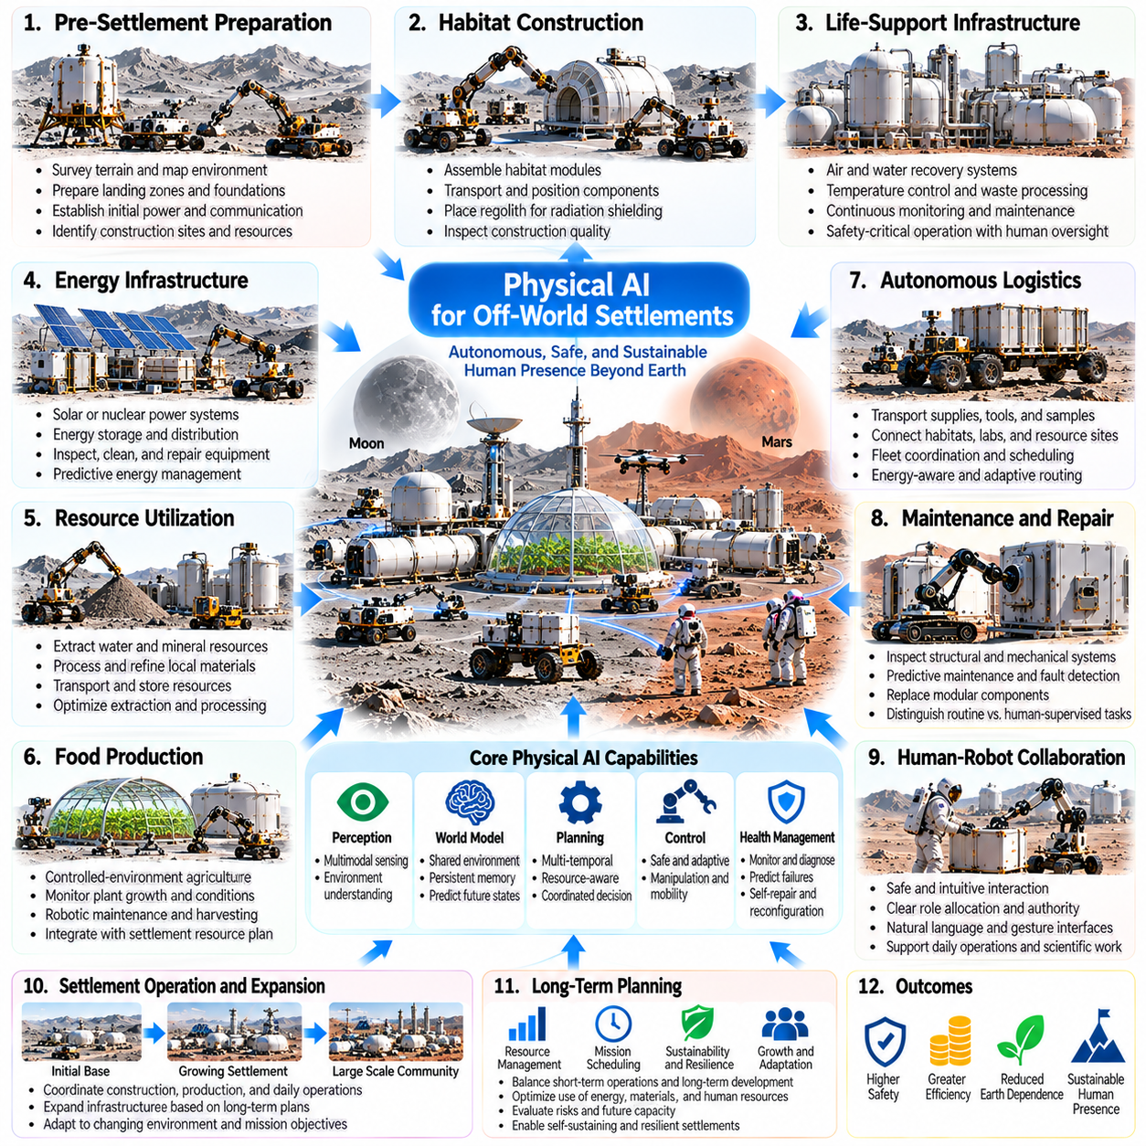
Off-world settlements represent a transition from temporary exploration missions toward sustained human presence beyond Earth. Lunar and Martian communities will require reliable systems for construction, energy, transportation, resource production, and habitat maintenance. Physical AI can coordinate these activities through autonomous machines capable of sensing, reasoning, and acting in unfamiliar environments. Its central purpose is to reduce dependence on continuous human intervention.
Unlike conventional terrestrial cities, extraterrestrial settlements must operate under severe environmental and logistical constraints. Radiation, reduced gravity, extreme temperatures, dust, and limited resources complicate everyday infrastructure operations. Deliveries from Earth may be expensive and infrequent. Physical AI must therefore support resilient local systems that can maintain essential services, recover from disruptions, and adapt to changing settlement requirements.
Settlement development will likely begin with robotic preparation before large human crews arrive. Autonomous machines may survey terrain, identify construction sites, prepare landing zones, and establish initial power infrastructure. Robotic excavation and material handling can support foundation preparation and protective shielding. World models can integrate environmental observations with construction plans, allowing systems to identify hazards and adapt operations to local conditions.
Habitat construction requires coordinated manipulation, transportation, and assembly. Robotic teams may position prefabricated modules, connect structural components, and place protective regolith around occupied facilities. Physical AI can manage task dependencies and monitor alignment, contact forces, and structural stability. Autonomous inspection systems can verify construction quality while identifying defects that require correction before human occupation.
Life-support infrastructure creates particularly demanding reliability requirements. Settlements must manage air circulation, water recovery, temperature regulation, and waste processing within tightly constrained operating conditions. Physical AI can monitor equipment performance and coordinate maintenance activities. However, safety-critical life-support control requires independently validated safeguards, redundancy, and human authority over consequential operational decisions.
Energy infrastructure will determine the practical scale of extraterrestrial settlements. Solar arrays, batteries, thermal storage, and potentially nuclear power systems must operate despite environmental disturbances and equipment degradation. Autonomous robots can inspect installations, clean exposed surfaces, and replace selected components. Predictive energy management can coordinate generation, storage, and consumption while preserving reserves for essential survival functions.
In-situ resource utilization can reduce dependence on imported materials and supplies. Autonomous systems may extract water-bearing materials, process regolith, and transport resources to production facilities. Physical AI can coordinate excavation, material classification, processing, and storage. Resource models must account for uncertain deposits, variable extraction efficiency, equipment wear, and the energy required to transform local materials into useful products.
Food production presents another opportunity for robotic assistance. Controlled-environment agriculture may require continuous monitoring of water, nutrients, illumination, temperature, and plant development. Robotic systems can inspect crops, perform selected maintenance tasks, and transport harvested materials. Physical AI can integrate agricultural observations with settlement resource planning, although biological variability requires careful validation of automated decisions.
Autonomous logistics will connect habitats, laboratories, storage facilities, construction zones, and resource production sites. Cargo robots can distribute tools, replacement components, scientific samples, and essential supplies. Fleet coordination can prioritize critical deliveries while minimizing energy consumption and unnecessary travel. Shared world models allow transportation systems to adapt when terrain, infrastructure, or operational priorities change.
Settlement maintenance must become increasingly autonomous as infrastructure expands. Robots may inspect structural seals, electrical connections, thermal systems, and exposed mechanical equipment. Predictive maintenance can identify deterioration before failures interrupt essential services. Modular hardware and accessible repair interfaces can simplify robotic intervention. Physical AI must distinguish routine servicing from operations requiring explicit human supervision.
Shared environmental world models can provide a common operational foundation for settlement infrastructure. These models may represent terrain, buildings, transportation networks, resource inventories, and equipment conditions. Persistent memory can preserve construction history, maintenance records, and environmental observations. By connecting physical infrastructure with predictive models, Physical AI can support coordinated decisions across otherwise separate operational systems.
Long-horizon planning is essential because settlement activities compete for limited energy, materials, equipment, and human attention. Construction may increase future capacity while temporarily consuming resources needed for daily operations. Physical AI can compare alternative schedules according to operational risk and expected long-term value. Hierarchical planning can connect immediate equipment control with infrastructure expansion and resource sustainability.
Human-robot collaboration will shape daily life within extraterrestrial settlements. Residents may delegate inspection, cleaning, transportation, and repetitive maintenance to autonomous assistants. Natural language interfaces can simplify task requests, while shared situational awareness supports safe physical interaction. Robotic systems should communicate their intentions, limitations, and uncertainties clearly, allowing humans to retain meaningful control over important decisions.
Medical and emergency support may also benefit from Physical AI. Robots can transport supplies, inspect hazardous areas, and assist with approved emergency procedures. Autonomous monitoring of infrastructure may identify conditions threatening crew safety before they escalate. Nevertheless, robotic systems should not replace qualified medical judgment or independently perform high-risk interventions without appropriate authorization and validated safety procedures.
Environmental protection will be an important consideration as settlements grow. Excavation, transportation, waste handling, and industrial processing can alter local terrain and distribute dust or other materials. Physical AI can monitor these effects and support operational boundaries established by mission authorities. Responsible settlement planning must consider scientific preservation, contamination prevention, and the long-term consequences of infrastructure development.
Multi-robot coordination can improve the scalability of settlement operations. Specialized machines may perform construction, inspection, agriculture, logistics, and repair while exchanging relevant information. Distributed task allocation can reduce operational bottlenecks and preserve functionality when individual robots fail. Shared scheduling and resource management must prevent competition between activities from disrupting critical services.
Communication delays make local decision-making essential for lunar and especially Martian settlements. Earth-based teams can provide scientific guidance, technical support, and strategic oversight, but cannot manage every immediate operational event. Physical AI must execute routine tasks and respond to urgent equipment conditions within approved boundaries. Transparent reporting and reliable records allow remote operators to understand decisions made during communication gaps.
Digital twins and simulation environments can support settlement planning and operational validation. Virtual models may reproduce habitat systems, transportation networks, construction activities, and resource flows. Engineers can examine infrastructure configurations and evaluate responses to equipment failures before physical deployment. However, simulations must be continuously updated using operational measurements because real environmental behavior may differ from initial assumptions.
Economic sustainability requires careful evaluation of robotic infrastructure investments. Autonomous systems introduce costs in transportation mass, energy consumption, computing hardware, maintenance, and spare components. Their value depends on reducing human workload, improving reliability, and extending the productive life of settlement assets. Physical AI can support these tradeoffs through lifecycle modeling and coordinated resource allocation rather than maximizing automation without regard to cost.
Settlement resilience depends on the ability to preserve essential functions during unexpected disruptions. Equipment failures, energy shortages, communication interruptions, and environmental hazards may occur simultaneously. Physical AI can support contingency planning, fault isolation, resource redistribution, and prioritized recovery. Critical systems should maintain independent protection mechanisms so that failures in autonomous intelligence do not directly threaten human survival.
As settlements mature, their robotic infrastructure may evolve from task-specific automation toward integrated operational intelligence. Shared world models, persistent memory, predictive maintenance, and multi-agent planning can connect previously independent services. This integration may enable settlements to anticipate resource shortages, schedule infrastructure expansion, and adapt to changing population needs while maintaining operational safety.
Ultimately, Physical AI for off-world settlements provides a technological foundation for sustained human activity beyond Earth. Its development requires integrating autonomous construction, resource utilization, life-support support systems, logistics, maintenance, and human-robot collaboration. As these capabilities mature, intelligent robotic infrastructure may help transform isolated extraterrestrial outposts into resilient, adaptable, and increasingly self-sustaining communities.

04.16. Long Term Autonomous Space Infrastructure
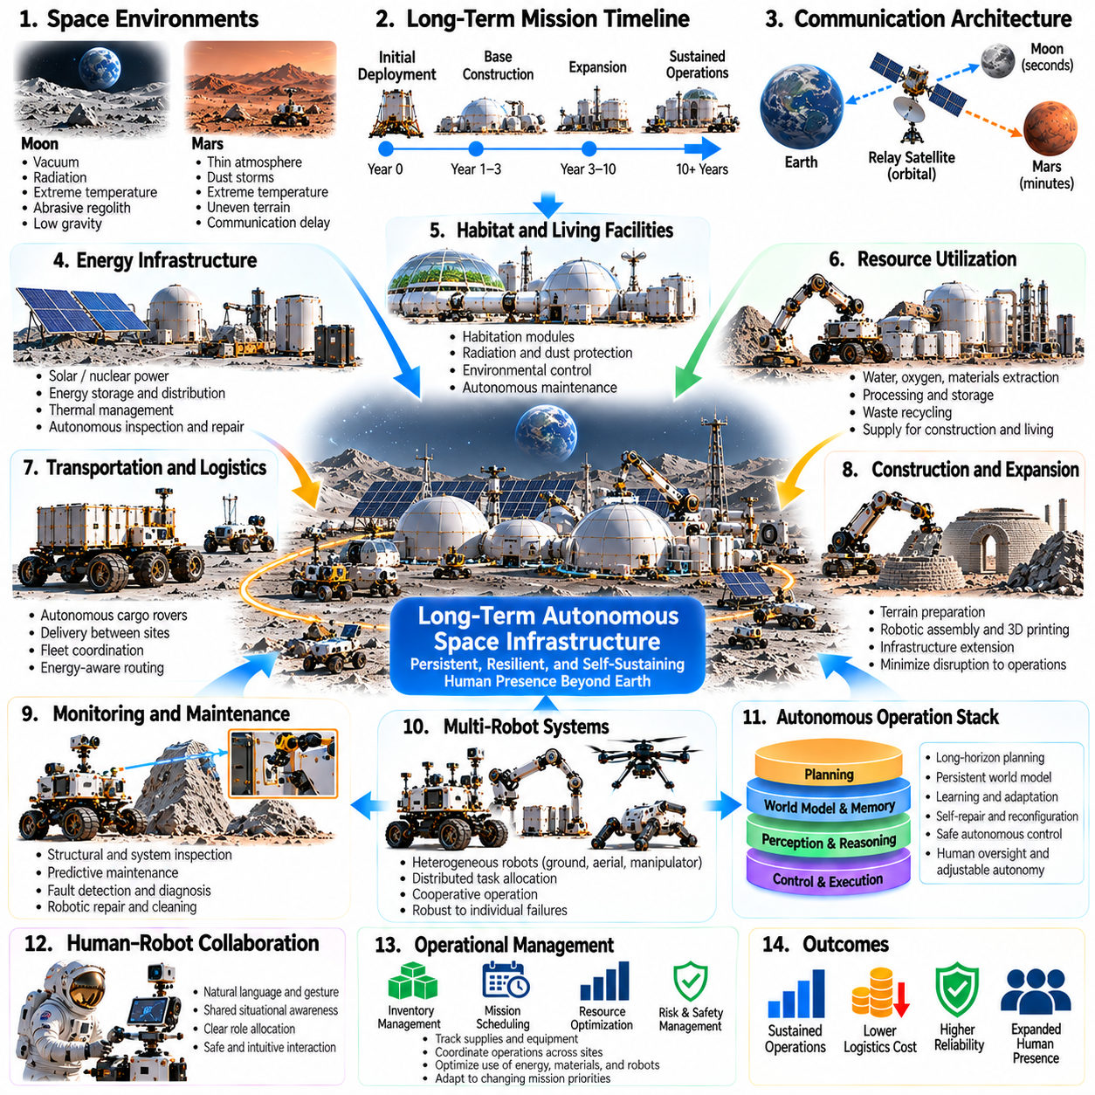
Long-term autonomous space infrastructure represents the transition from isolated robotic missions toward persistent operational systems beyond Earth. Future lunar, Martian, and orbital facilities will require continuous maintenance, resource distribution, environmental monitoring, and infrastructure expansion. Physical AI can provide the intelligence needed to coordinate these activities over years or decades, reducing dependence on constant human supervision.
Unlike short-duration missions, permanent space infrastructure must survive repeated environmental disturbances and progressive equipment degradation. Radiation, thermal cycling, abrasive dust, micrometeoroids, and mechanical fatigue can gradually compromise system performance. Autonomous infrastructure must detect deterioration, predict emerging failures, and maintain essential functions despite limited repair opportunities and delayed support from Earth.
A central requirement is the integration of distributed infrastructure into a coherent operational architecture. Power stations, communication networks, transportation systems, processing facilities, and robotic maintenance platforms must exchange information and coordinate decisions. Physical AI can connect these components through shared operational models while preserving local control capabilities that remain functional during communication interruptions.
Persistent world models provide the foundation for long-term infrastructure intelligence. These models represent physical structures, equipment conditions, environmental changes, and operational dependencies across multiple timescales. Continuous observations update the estimated state of the infrastructure, while predictive dynamics models anticipate future behavior. Persistent memory preserves historical failures, maintenance actions, and environmental patterns.
Long-horizon planning enables autonomous infrastructure to balance immediate operational needs with future sustainability. A robotic system may postpone noncritical construction to preserve energy for essential maintenance or schedule equipment replacement before anticipated degradation. Hierarchical planning connects real-time control with daily scheduling and multi-year development objectives. Decisions must account for uncertainty and changing mission priorities.
Self-monitoring infrastructure requires distributed sensing and reliable fault detection. Sensors can track structural deformation, vibration, electrical performance, thermal conditions, and mechanical wear. Physical AI can combine these measurements to identify abnormal behavior and estimate remaining useful life. Diagnostic systems should distinguish actual equipment deterioration from sensor errors, environmental disturbances, and temporary operational fluctuations.
Autonomous maintenance can reduce the logistical burden of sustaining remote facilities. Inspection robots may identify damaged components, clean contaminated surfaces, and perform selected replacement operations. Manipulators can support modular repair procedures when components are designed for robotic accessibility. Effective maintenance autonomy requires accurate perception, force-controlled interaction, validated procedures, and mechanisms for recovering from unsuccessful repairs.
Self-repair and self-reconfiguration provide additional resilience when replacement materials or human assistance are unavailable. Distributed systems may isolate damaged modules, reroute electrical power, or redistribute workloads among functioning components. Modular robotic platforms could exchange selected parts or replace specialized tools. However, self-repair capabilities must be evaluated against their added mass, complexity, energy consumption, and potential failure modes.
Energy autonomy is fundamental to persistent space operations. Solar generation, storage systems, thermal management, and potentially nuclear power must support variable infrastructure demands. Physical AI can forecast consumption, schedule energy-intensive activities, and coordinate charging across robotic fleets. Safety-critical functions require protected energy reserves and independently verified control mechanisms that remain effective when intelligent planning systems fail.
Autonomous resource management will become increasingly important as extraterrestrial infrastructure expands. Water extraction, oxygen production, material processing, and waste recovery may form interconnected industrial systems. Physical AI can coordinate production rates, storage capacity, and transportation requirements. Resource planning must consider equipment efficiency, uncertain extraction yields, environmental constraints, and the strategic value of maintaining reserves.
Robotic construction enables infrastructure to evolve beyond its initial deployment configuration. Autonomous machines may prepare terrain, assemble structures, extend transportation corridors, and install new communication or energy facilities. Construction planning must account for existing infrastructure and avoid disrupting critical services. Shared world models can connect engineering designs with observed site conditions and continuously updated construction progress.
Multi-robot systems can distribute inspection, transportation, maintenance, and construction responsibilities across specialized platforms. Fleet coordination improves operational flexibility and provides alternatives when individual machines become unavailable. Decentralized task allocation can preserve local functionality during communication failures. Shared learning may improve performance, but updates must be validated before deployment to safety-critical infrastructure.
Communication architecture must support both local autonomy and remote strategic supervision. Lunar systems experience relatively short communication delays, while Martian infrastructure may operate with delays lasting many minutes. Autonomous agents must handle routine decisions and time-sensitive failures without waiting for Earth-based instructions. Reliable logs, synchronized operational records, and explainable decisions support later review and human intervention.
Digital twins can provide a predictive environment for infrastructure management. Virtual representations may combine engineering models, live sensor measurements, maintenance histories, and environmental forecasts. Physical AI can evaluate alternative operating strategies and estimate the consequences of equipment failures. Model uncertainty must remain explicit because inaccurate simulations can produce misleading predictions and unsafe maintenance recommendations.
Cybersecurity and operational integrity become essential when infrastructure depends on interconnected autonomous controllers. Unauthorized commands, corrupted sensor information, or compromised software updates could disrupt critical facilities. Secure communication, access control, fault isolation, and authenticated updates help protect distributed systems. Physical AI should operate within independently enforced safety boundaries rather than serving as the sole mechanism of protection.
Long-duration autonomy also requires robust software lifecycle management. Algorithms, operating systems, and learned models may need updates throughout missions lasting decades. Remote deployment procedures must support compatibility testing, staged activation, rollback, and recovery from incomplete installations. Autonomous systems should preserve stable operational capabilities while incorporating improvements only after appropriate verification and validation.
Environmental stewardship must accompany infrastructure expansion beyond Earth. Mining, construction, transportation, and industrial processing may disturb scientifically valuable terrain or introduce contamination. Autonomous monitoring can document environmental changes and detect violations of established operational boundaries. Physical AI can support resource-efficient planning while preserving human responsibility for scientific protection and environmental governance.
Economic sustainability depends on the relationship between infrastructure capability and lifecycle cost. Autonomous facilities require substantial initial investments in hardware, transportation, energy, computation, and maintenance. Their value emerges through extended operational life, reduced human intervention, and reliable service delivery. Physical AI can support investment decisions by comparing redundancy, repairability, utilization, and expected long-term performance.
Infrastructure resilience must be evaluated against cascading failures across interconnected systems. A power shortage may interrupt communications, disable transportation, and delay essential maintenance simultaneously. Predictive models can identify critical dependencies and recommend protective resource allocation. Autonomous recovery strategies should prioritize life-support services, system stabilization, and restoration of essential functions before secondary objectives.
Human governance remains necessary even when infrastructure operates independently for extended periods. Mission authorities must define acceptable risks, operational priorities, and boundaries for autonomous decisions. Physical AI should maintain auditable records of consequential actions and communicate uncertainties when requesting authorization. Human oversight may occur intermittently, but responsibility for strategic direction and safety standards cannot be delegated entirely to machines.
As infrastructure networks expand, local autonomous facilities may develop into interconnected planetary and orbital ecosystems. Surface settlements, resource stations, communication relays, and orbital servicing platforms could coordinate transportation and industrial activities. Shared operational standards would support interoperability across different robotic systems. Physical AI may provide the adaptive coordination needed to manage these increasingly complex networks.
Ultimately, long-term autonomous space infrastructure requires the convergence of world models, predictive dynamics, persistent memory, hierarchical planning, robotic maintenance, and distributed coordination. Its success depends not simply on autonomous task execution but on preserving functionality through uncertainty, degradation, and environmental change. Mature Physical AI could enable resilient infrastructure that supports sustained exploration, scientific discovery, and human civilization beyond Earth.

