Volume 13. Future of Physical AI and Civilization

Chapter 03. Physical AI and Cities

03.01. Physical AI and the Future City
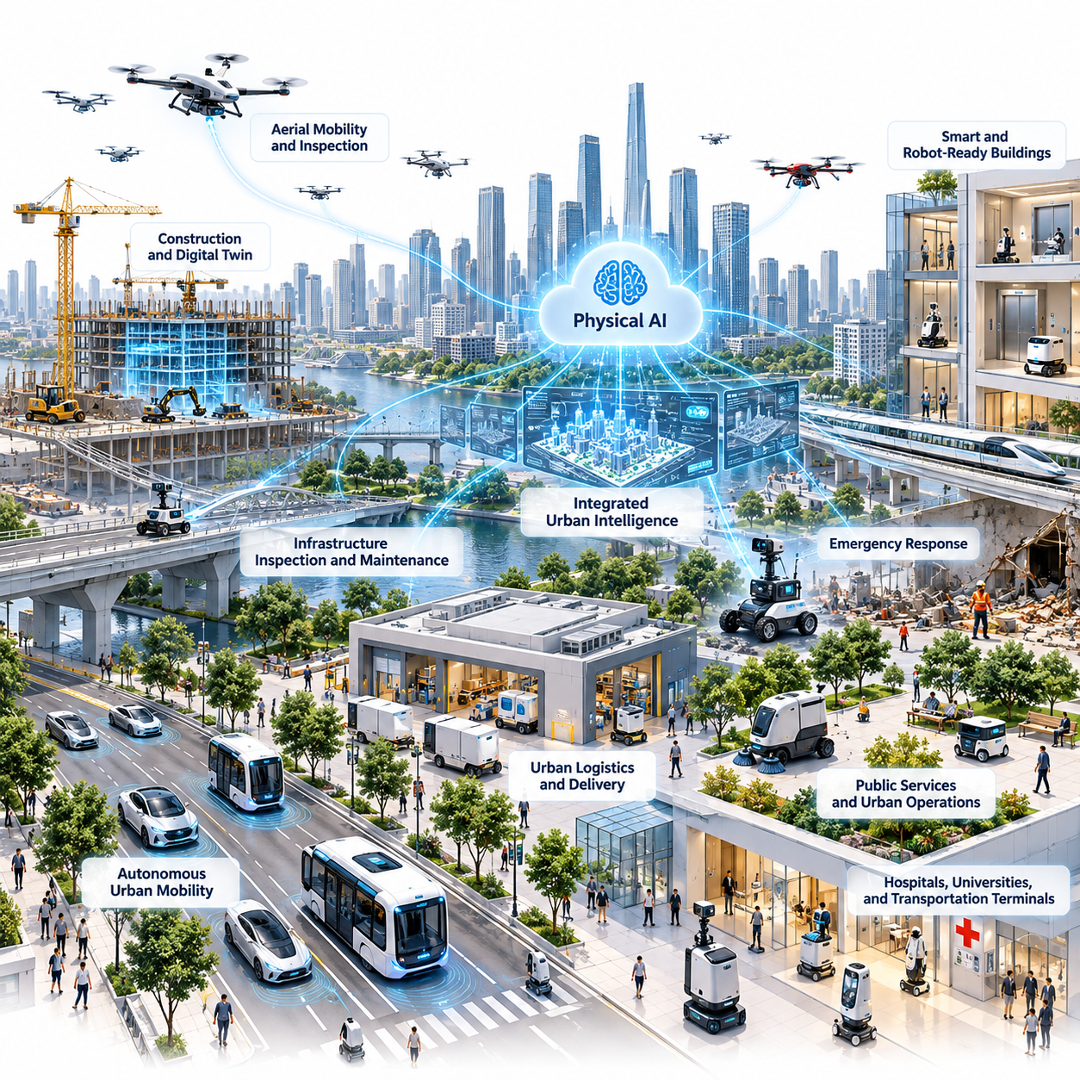
The future city may evolve from a collection of digitally connected infrastructure systems into an environment where intelligent machines continuously perceive, interpret, and interact with the physical world. Physical AI extends urban intelligence beyond information processing by enabling autonomous movement, manipulation, inspection, maintenance, and service delivery. This transformation could fundamentally change how cities operate, adapt, and serve their populations.
Traditional smart cities emphasize sensors, communication networks, cloud platforms, and data analytics to improve urban management. Physical AI introduces an additional operational layer in which autonomous systems can translate digital decisions into physical actions. Rather than merely detecting congestion, infrastructure deterioration, or service demand, future urban systems may deploy intelligent machines to respond directly to changing conditions.
The transition toward Physical AI-enabled cities depends on integrating perception, reasoning, planning, and control within complex urban environments. Autonomous mobile robots, delivery vehicles, inspection platforms, aerial systems, and service robots must operate among pedestrians, buildings, transportation networks, and unpredictable obstacles. Their effectiveness depends on understanding both the physical structure of the city and its continuously changing activities.
Urban environments present particularly demanding challenges for embodied intelligence because they combine structured infrastructure with highly dynamic human behavior. Streets, sidewalks, elevators, intersections, and public facilities follow recognizable patterns, yet their operating conditions vary throughout the day. Physical AI systems must recognize these patterns while adapting safely to unexpected events, temporary restrictions, and unfamiliar situations.
Autonomous urban mobility represents one of the most visible potential applications of Physical AI. Self-driving vehicles, autonomous shuttles, robotic delivery platforms, and intelligent transportation infrastructure could cooperate to improve movement across metropolitan areas. Their successful integration requires reliable localization, predictive perception, coordinated navigation, and decision-making systems capable of handling uncertainty in densely populated environments.
Urban logistics may also undergo substantial transformation as autonomous machines connect distribution centers, neighborhood facilities, commercial buildings, and residential destinations. Mobile robots could transport goods across warehouses, sidewalks, and building interiors while coordinating with elevators and access-control systems. Such integration could create more continuous logistics operations, although deployment would depend on infrastructure compatibility, regulation, and operational economics.
Buildings themselves may gradually become more compatible with autonomous machines. Robot-friendly infrastructure could include standardized navigation interfaces, accessible pathways, automated doors, communication-enabled elevators, and designated service zones. These features would reduce the complexity of robot deployment and allow multiple robotic platforms to operate within shared facilities without requiring extensive environmental modifications.
Physical AI could transform infrastructure maintenance by enabling more frequent observation and targeted intervention. Inspection robots equipped with cameras, LiDAR, thermal sensors, and other instruments may examine bridges, tunnels, pipelines, roads, and public utilities. By combining inspection measurements with predictive models, urban operators could identify deterioration earlier and prioritize maintenance according to risk, urgency, and available resources.
Construction activities could become increasingly connected to autonomous urban infrastructure management. Robotic surveying, automated material transportation, construction-site monitoring, and digital verification systems may improve coordination between design models and physical structures. Integration with building information modeling and digital twins could support continuous comparison between planned construction conditions and observed site progress.
Public service robots may support sanitation, cleaning, waste handling, landscaping, and routine facility maintenance. These systems could perform repetitive or hazardous operations while human personnel concentrate on supervision, complex interventions, and public-facing responsibilities. However, urban service automation must account for pedestrians, environmental variability, accessibility requirements, and the different expectations associated with public spaces.
Emergency response provides another important application domain for Physical AI. Ground robots and aerial platforms could assist with reconnaissance, hazardous-material detection, disaster assessment, and search operations in environments that are dangerous or inaccessible to human responders. Their value would depend on robust communication, reliable autonomy, and coordination with established emergency management procedures rather than complete replacement of human judgment.
Hospitals, universities, transportation terminals, and government facilities may become early environments for coordinated Physical AI deployment. These locations often contain relatively well-defined operating areas, recurring transportation tasks, and centralized facility management. Autonomous systems could support internal logistics, equipment movement, cleaning, and infrastructure inspection while generating operational experience that informs broader urban applications.
Urban aerial mobility could extend Physical AI operations into three-dimensional transportation and inspection environments. Uncrewed aerial systems may support infrastructure surveys, emergency observation, and specialized logistics where permitted. Their integration would require airspace coordination, obstacle avoidance, noise management, secure communication, and mechanisms for protecting people and property beneath flight paths.
As robotic deployments expand, individual autonomy will become insufficient for managing city-scale operations. Multi-robot fleet management platforms may coordinate heterogeneous machines according to task priority, geographic distribution, battery availability, traffic conditions, and service requirements. Coordination across organizations will also require interoperability standards, access permissions, and mechanisms for resolving competing operational demands.
Shared maps and world models could become foundational components of future urban intelligence. Rather than maintaining entirely separate representations of the environment, authorized robotic systems may exchange selected spatial information, traversability conditions, obstacle observations, and infrastructure updates. Such information sharing could improve navigation efficiency and reduce repeated exploration while introducing significant requirements for data quality and security.
City digital twins may provide a computational environment for connecting physical infrastructure with predictive simulation and operational planning. When updated using trustworthy sensor observations, these models could represent transportation flows, building conditions, robot activities, and environmental changes. Physical AI systems could use digital twins to evaluate proposed actions before execution, although simulation uncertainty must remain explicitly recognized.
A city-scale Physical AI architecture may combine onboard intelligence, edge computing, and centralized coordination services. Robots require local perception and safety-critical control that remain functional despite communication interruptions. Edge infrastructure can support low-latency coordination, while cloud platforms may provide fleet analytics, historical learning, large-scale simulation, and updates to shared environmental representations.
Urban robotic data infrastructure must support reliable information exchange without assuming that all collected data should be centralized. Sensor observations, operational events, maintenance histories, and environmental changes may have different requirements for storage, retention, access, and processing. Privacy-preserving learning, selective data sharing, and clear governance policies will be essential for maintaining public confidence.
Safety becomes especially important when autonomous machines operate in environments that were primarily designed for human activities. Physical AI systems must account for pedestrians, cyclists, children, people with disabilities, and other vulnerable participants. Runtime monitoring, uncertainty-aware planning, emergency stopping, operational boundaries, and human intervention mechanisms are necessary components of responsible urban deployment.
Cybersecurity and operational resilience are equally important because connected robots can influence physical infrastructure and public services. Unauthorized commands, corrupted maps, communication failures, or compromised fleet platforms could create consequences beyond conventional information security incidents. Future cities will therefore need secure identity management, authenticated communication, fault isolation, and recovery procedures for autonomous physical systems.
Public acceptance will depend not only on technical performance but also on transparency, accountability, and perceived social value. Residents must understand where autonomous machines operate, what information they collect, and how incidents are investigated. Clear operating rules, accessible reporting channels, and meaningful human oversight can help establish trust while ensuring that deployment decisions remain subject to public governance.
Accessibility should be incorporated into Physical AI infrastructure from the beginning rather than treated as a secondary design consideration. Robots must navigate without obstructing mobility aids, pedestrian pathways, emergency exits, or public transportation access. Inclusive design also means ensuring that robotic services are usable by people with different physical abilities, digital literacy levels, and socioeconomic circumstances.
The economic implications of Physical AI-enabled cities extend beyond the replacement of individual manual tasks. Autonomous services may change infrastructure investment, maintenance costs, transportation productivity, and the organization of urban labor. Their benefits will depend on utilization, reliability, energy consumption, integration expenses, and the distribution of ownership and access across public and private stakeholders.
Environmental sustainability will also influence the development of future robotic cities. Autonomous systems may reduce unnecessary transportation, support more efficient maintenance, and improve the monitoring of energy and resource consumption. However, robot manufacturing, battery production, computing infrastructure, and additional electricity demand introduce environmental costs that must be evaluated across the entire system lifecycle.
The long-term transformation of cities will likely occur through gradual integration rather than immediate replacement of existing infrastructure. Controlled facilities and clearly defined service routes may support initial deployments, followed by increasingly complex public environments as reliability and interoperability improve. Different cities will progress at different rates according to regulation, infrastructure readiness, economic conditions, and social priorities.
Ultimately, the Physical AI-enabled future city should be understood as a coordinated human-machine environment rather than a fully automated urban organism. Its defining capability would be the connection between sensing, predictive understanding, collective planning, and responsible physical action. The success of this transformation will depend on whether autonomous intelligence improves urban safety, accessibility, resilience, sustainability, and human well-being while preserving meaningful human control.

03.02. Autonomous Urban Mobility
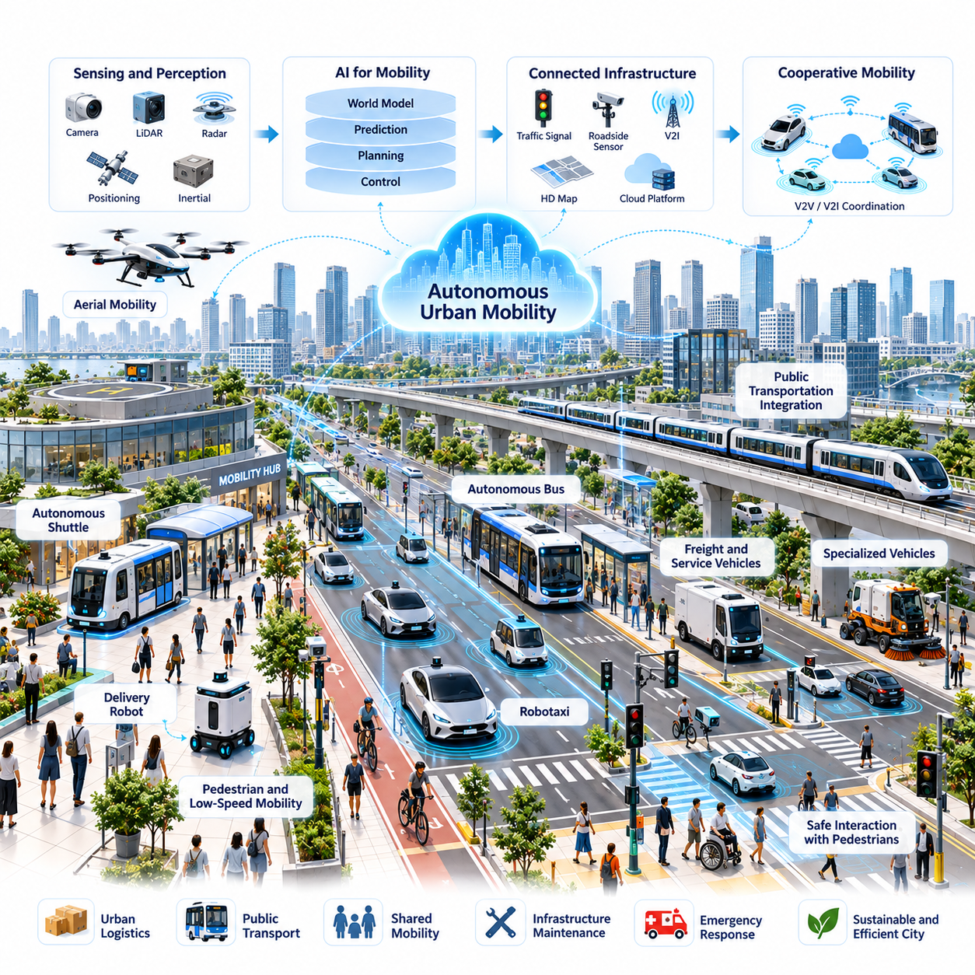
Autonomous urban mobility represents a fundamental transformation in how people, goods, and services move through cities. Physical AI enables transportation systems to perceive their surroundings, interpret complex traffic situations, and execute physical actions with reduced dependence on continuous human control. This evolution could extend urban transportation beyond individually automated vehicles toward coordinated networks of intelligent mobility systems.
Traditional urban transportation relies on human drivers, fixed traffic regulations, and infrastructure designed primarily for manually operated vehicles. Autonomous mobility introduces adaptive decision-making capabilities that respond to real-time environmental conditions. Vehicles and mobile robots can potentially adjust routes, speeds, and operational strategies according to traffic density, pedestrian activity, road conditions, and changing transportation demand.
The technological foundation of autonomous urban mobility combines perception, localization, prediction, planning, and control. Cameras, LiDAR, radar, positioning systems, and inertial sensors provide complementary observations of the surrounding environment. Sensor fusion algorithms integrate these measurements into consistent representations that support obstacle detection, road understanding, vehicle positioning, and reliable navigation through complex urban spaces.
Urban perception requires more than recognizing static objects or identifying traffic signals. Autonomous systems must understand the intentions and possible movements of pedestrians, cyclists, human-driven vehicles, and other autonomous machines. Predictive models estimate how these participants may behave over different time horizons, allowing mobility systems to evaluate potential interactions before selecting appropriate actions.
World models provide an important framework for connecting environmental perception with future-oriented reasoning. An autonomous vehicle may maintain a dynamic representation of road geometry, moving objects, traffic rules, and uncertain environmental conditions. Action-conditioned predictive models can estimate possible future states under alternative driving decisions, supporting safer trajectory selection and more adaptive behavior in unfamiliar situations.
Reliable localization remains essential because urban environments contain tunnels, elevated roads, dense buildings, and areas where satellite positioning becomes unreliable. Autonomous mobility systems may combine visual localization, LiDAR mapping, inertial navigation, wheel odometry, and infrastructure-based positioning. These complementary techniques help maintain accurate vehicle state estimates while reducing dependence on any single positioning technology.
Motion planning translates environmental understanding into executable vehicle trajectories. A planning system must consider collision avoidance, traffic regulations, passenger comfort, vehicle dynamics, and operational efficiency simultaneously. Hierarchical planning architectures may separate route selection, behavioral decisions, and short-horizon trajectory optimization while continuously updating decisions as new sensor information becomes available.
Vehicle control connects planned trajectories with steering, braking, propulsion, and other physical actuators. Model predictive control and feedback-based methods can compensate for disturbances, actuator limitations, and variations in road conditions. However, effective control requires accurate estimates of vehicle dynamics, tire-road interaction, system latency, and uncertainty, particularly during emergency maneuvers or adverse weather.
Autonomous urban mobility encompasses multiple vehicle categories rather than a single universal platform. Robotaxis, autonomous buses, neighborhood shuttles, delivery robots, and specialized service vehicles operate under different physical and regulatory constraints. Their intelligence architectures may share foundational perception and planning capabilities while requiring distinct safety mechanisms, mobility configurations, and operational policies.
Autonomous public transportation could improve service flexibility by connecting high-capacity transit networks with lower-density neighborhoods and underserved destinations. Smaller autonomous shuttles may support demand-responsive transportation, particularly along predictable routes. Their economic feasibility will depend on vehicle utilization, maintenance requirements, supervision costs, accessibility, and integration with existing public transportation systems.
Pedestrian-rich environments create challenges that differ significantly from conventional road driving. Sidewalk delivery robots and low-speed autonomous vehicles must navigate narrow passages, temporary obstacles, crowds, and unpredictable human interactions. Safe operation requires conservative motion policies, socially aware navigation, and mechanisms for yielding appropriately to pedestrians and individuals with mobility limitations.
Connected infrastructure may enhance autonomous mobility by providing information that individual vehicles cannot reliably observe. Traffic signals, roadside sensors, intersection monitoring systems, and vehicle-to-infrastructure communication can share selected traffic conditions and operational warnings. Nevertheless, autonomous vehicles must remain capable of safe operation when communication infrastructure is unavailable, delayed, or compromised.
Cooperative mobility introduces opportunities for coordination among vehicles and transportation infrastructure. Connected autonomous vehicles may exchange intentions, planned maneuvers, or hazard information to improve situational awareness. Such cooperation could support smoother intersection operations and coordinated merging, but interoperability, communication reliability, cybersecurity, and mixed-traffic behavior remain significant technical challenges.
City-scale mobility coordination extends beyond optimizing the behavior of individual vehicles. Fleet management platforms may allocate transportation requests, balance vehicle availability, schedule charging, and adapt service coverage according to demand. Integration with traffic management systems could improve overall network efficiency, although centralized optimization must respect local safety decisions and operational constraints.
Digital twins and simulation environments may accelerate the development of autonomous urban transportation. Detailed virtual representations of roads, intersections, traffic participants, and environmental conditions allow developers to evaluate mobility algorithms across diverse scenarios. Simulation can support rare-event testing and operational planning, but successful deployment still requires extensive real-world validation and careful assessment of simulation-to-reality differences.
Data-driven learning provides another foundation for improving autonomous mobility systems. Vehicle fleets can collect operational observations, intervention records, unusual traffic events, and environmental changes. Carefully curated datasets may support perception refinement, predictive modeling, and policy improvement, while privacy protections and secure data governance remain necessary for responsible large-scale learning.
Safety assurance must address both ordinary transportation conditions and rare, high-consequence events. Autonomous systems require mechanisms for detecting degraded sensors, unexpected obstacles, uncertain predictions, and failures in planning or control. Runtime assurance architectures can monitor system behavior and activate conservative fallback strategies when operating conditions exceed validated capabilities.
The operational design domain defines the conditions under which an autonomous mobility system is intended to function safely. These conditions may include geographic boundaries, road categories, weather limits, speed ranges, and infrastructure requirements. Expanding autonomous mobility across a city requires systematic validation of additional operating conditions rather than assuming that performance in one district transfers automatically to another.
Mixed traffic will likely characterize urban transportation for an extended transition period. Human-driven vehicles, autonomous platforms, cyclists, and pedestrians will share infrastructure while exhibiting different behavioral characteristics. Autonomous systems must therefore anticipate imperfect compliance with traffic rules, ambiguous social signals, and unexpected human decisions without relying on universal adoption of connected transportation technologies.
Accessibility and public acceptance are central to the success of autonomous mobility. Vehicles must accommodate passengers with different physical abilities, communication needs, and levels of technological familiarity. Transparent operating procedures, accessible passenger interfaces, emergency assistance mechanisms, and clear accountability for incidents can help establish trust in autonomous transportation services.
Economic performance will influence the scale and speed of deployment. Autonomous mobility may reduce certain driving-related labor requirements while introducing expenses associated with sensors, computing hardware, fleet supervision, maintenance, insurance, and software validation. Sustainable business models must evaluate total operating costs, vehicle utilization, service reliability, and transportation demand rather than focusing exclusively on automation capability.
Environmental outcomes depend on how autonomous mobility changes transportation behavior and energy consumption. Coordinated routing and efficient driving may reduce wasted travel, while electrified fleets could support lower operational emissions. However, empty vehicle repositioning, increased travel demand, battery production, and computing energy consumption may offset some benefits unless deployment is integrated with broader sustainability policies.
Urban governance will determine how autonomous transportation interacts with public infrastructure and community priorities. Authorities may need to establish operating permissions, safety reporting requirements, curbside access policies, data-sharing standards, and liability frameworks. Effective regulation should encourage innovation while maintaining enforceable safety expectations, fair transportation access, and meaningful oversight of commercial mobility operators.
Over time, autonomous urban mobility could evolve from isolated vehicle deployments into interconnected transportation ecosystems. Shared environmental representations, cooperative fleet management, predictive traffic coordination, and robot-compatible infrastructure may improve system-wide responsiveness. Nevertheless, technical interoperability and coordinated operation will require sustained investment, institutional cooperation, and validated safety mechanisms.
The long-term significance of autonomous urban mobility lies in its potential to connect machine intelligence with the physical organization of cities. Transportation systems could become more adaptive, accessible, and responsive to changing human needs. Achieving this vision will require progress in embodied intelligence, reliable control, infrastructure integration, public governance, and the responsible coordination of human and autonomous mobility.

03.03. Urban Logistics and Autonomous Delivery
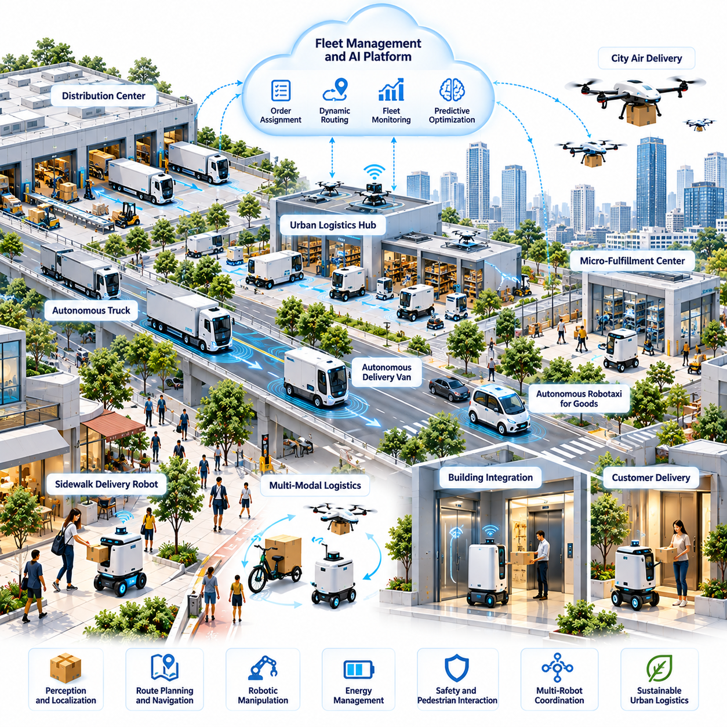
Urban logistics is evolving from a transportation-centered activity into an intelligent network of autonomous physical operations. Physical AI enables delivery vehicles, mobile robots, and logistics infrastructure to perceive changing environments, coordinate movements, and execute transportation tasks with reduced human intervention. This transformation could improve the efficiency, responsiveness, and resilience of goods distribution across increasingly complex metropolitan environments.
Traditional urban logistics depends on centralized distribution centers, human-operated vehicles, and manually coordinated last-mile delivery processes. Growing e-commerce demand, traffic congestion, labor constraints, and customer expectations create pressure for more adaptive systems. Autonomous delivery introduces intelligent machines capable of transporting goods between logistics hubs, commercial facilities, residential buildings, and neighborhood collection points.
The architecture of autonomous urban logistics integrates perception, localization, route planning, manipulation, and fleet coordination. Mobile robots use cameras, LiDAR, inertial sensors, and positioning technologies to understand surrounding conditions. Their onboard intelligence supports local navigation, while fleet management platforms coordinate delivery assignments, vehicle availability, charging schedules, and interactions with logistics infrastructure.
Last-mile delivery represents a particularly important application because final transportation segments frequently involve high operational complexity and relatively low delivery density. Sidewalk robots, autonomous delivery vehicles, and specialized mobile platforms may serve different geographic and commercial requirements. Their effectiveness depends on reliable navigation, safe interaction with pedestrians, and efficient transfer of goods at delivery destinations.
Autonomous delivery requires a continuous understanding of dynamic urban environments. Robots must recognize sidewalks, crossings, entrances, obstacles, construction zones, and temporary access restrictions. World models can maintain spatial representations of these environments while estimating how conditions may evolve. Predictive planning allows robots to select alternative routes and adjust their behavior when unexpected situations arise.
Urban delivery robots operate across environments with different physical constraints. Public roads, pedestrian pathways, parking areas, loading zones, and building interiors impose distinct navigation and safety requirements. A delivery system may therefore require multiple robotic platforms or carefully designed transfer points. Seamless logistics depends on coordinating these environments rather than treating each transportation segment independently.
Micro-fulfillment centers and neighborhood logistics hubs could become important components of autonomous delivery networks. These facilities position inventory closer to customers and provide staging areas for smaller robotic vehicles. By connecting regional distribution centers with local delivery robots, cities may reduce some long-distance delivery movements while improving response times and supporting more flexible distribution strategies.
Building integration is essential for extending autonomous delivery beyond sidewalks and loading areas. Robots may need to interact with automated doors, elevators, access-control systems, delivery lockers, and indoor navigation infrastructure. Standardized interfaces could enable authorized machines to move between outdoor and indoor environments, although security, privacy, accessibility, and building-specific operating policies must remain central considerations.
Robotic manipulation introduces additional capabilities beyond autonomous transportation. Mobile manipulators may load parcels, transfer containers, operate compatible storage systems, or interact with designated delivery interfaces. These operations require object recognition, grasp planning, force control, and reliable verification of successful transfers. Integrating manipulation with mobility could reduce manual handling at selected stages of urban logistics.
Fleet-level intelligence enables autonomous delivery systems to coordinate many robots operating simultaneously. Centralized platforms may assign orders according to geographic proximity, payload capacity, battery state, delivery urgency, and operational restrictions. Local autonomy remains responsible for immediate safety decisions, while fleet coordination optimizes resource allocation and service continuity across the distribution network.
Dynamic routing becomes increasingly important when delivery demand changes throughout the day. Physical AI systems may combine historical demand patterns, real-time traffic observations, weather conditions, and available vehicle capacity to update delivery schedules. Predictive optimization can reduce unnecessary travel and improve service reliability, although unexpected demand and environmental uncertainty require continuous operational adaptation.
Energy management is a major consideration for autonomous urban logistics. Battery-powered robots must balance payload, travel distance, terrain conditions, sensing requirements, and onboard computing consumption. Fleet platforms may coordinate charging opportunities and reserve capacity for urgent assignments. Energy-aware scheduling can improve utilization while reducing the risk of interrupted deliveries and excessive battery degradation.
Multi-modal logistics could connect autonomous trucks, delivery vans, sidewalk robots, cargo bicycles, and aerial platforms within coordinated transportation networks. Different platforms offer advantages under different geographic, regulatory, and payload conditions. Effective integration requires standardized shipment identification, transfer verification, scheduling interfaces, and reliable coordination between independently operated transportation systems.
Aerial delivery may provide specialized capabilities for transporting lightweight or time-sensitive goods across difficult terrain or congested regions. However, practical deployment depends on airspace regulation, weather tolerance, payload limitations, noise restrictions, and safe landing infrastructure. Aerial robots are therefore more appropriately considered complementary logistics platforms rather than universal replacements for ground transportation.
Digital twins can support the planning and evaluation of autonomous urban logistics networks. Virtual models of roads, buildings, distribution hubs, and robotic fleets allow operators to simulate delivery demand, infrastructure constraints, and operational disruptions. These environments can help evaluate fleet size, hub placement, charging infrastructure, and routing strategies before large-scale deployment.
Data collected during autonomous delivery operations can support continuous improvement of robotic intelligence. Navigation failures, unexpected obstacles, delayed deliveries, and human interventions provide information about operational limitations. Carefully curated experience datasets may improve perception, prediction, and planning models, while shared learning across fleets can reduce repeated failures in similar environments.
Safety assurance remains fundamental because autonomous delivery systems interact directly with pedestrians, vehicles, and public infrastructure. Robots must operate within validated speed, payload, and environmental limits while maintaining reliable obstacle detection and emergency stopping capabilities. Runtime monitoring and conservative fallback behaviors are essential when sensors degrade, communications fail, or operating conditions become uncertain.
Human supervision continues to play an important role in practical autonomous delivery operations. Remote operators may assist robots encountering blocked pathways, inaccessible entrances, unusual customer interactions, or mechanical failures. Effective supervision systems should prioritize exceptions rather than requiring continuous manual control, allowing human personnel to manage multiple robots while preserving clear responsibility for safety.
Cybersecurity and shipment integrity introduce additional operational requirements. Autonomous delivery platforms must protect navigation commands, customer information, access credentials, and package tracking records. Secure authentication, encrypted communication, tamper detection, and verified delivery confirmation help prevent unauthorized access and fraudulent transactions. These protections become increasingly important when robots interact with private buildings and shared logistics infrastructure.
The economic viability of autonomous delivery depends on more than eliminating direct driving labor. Capital expenditure, maintenance, supervision, insurance, charging infrastructure, software operations, and delivery density all influence total cost per shipment. High utilization and predictable service regions may improve financial performance, while complex environments and frequent human interventions can reduce expected savings.
Environmental performance must be evaluated across the entire logistics system. Electrified delivery robots may reduce local exhaust emissions and improve energy efficiency for suitable shipments. However, additional vehicle movements, battery manufacturing, computing requirements, and fragmented delivery patterns may offset some advantages. Sustainable deployment requires coordinated routing, appropriate vehicle selection, and lifecycle-based environmental assessment.
Urban governance will influence where autonomous delivery platforms can operate and how they interact with public spaces. Municipal authorities may establish sidewalk access rules, speed restrictions, loading permissions, accessibility requirements, and incident reporting procedures. Regulations must balance innovation with pedestrian safety, equitable infrastructure access, and the protection of public spaces from excessive commercial occupation.
The long-term development of autonomous urban logistics may lead to increasingly interconnected networks of warehouses, buildings, transportation platforms, and intelligent delivery machines. Shared maps, standardized infrastructure interfaces, predictive world models, and coordinated fleet intelligence could support more adaptive distribution systems. Progress will depend on interoperability, reliable autonomy, sustainable economics, and public acceptance.
Ultimately, autonomous delivery represents a broader transition from manually coordinated goods transportation toward intelligent physical distribution systems. Physical AI could enable cities to move goods through interconnected infrastructure with greater flexibility and responsiveness. Its lasting value will depend on whether autonomous logistics improves service accessibility, operational resilience, environmental sustainability, and urban quality of life while maintaining safety and human oversight.

03.04. Robot Friendly Buildings and Infrastructure
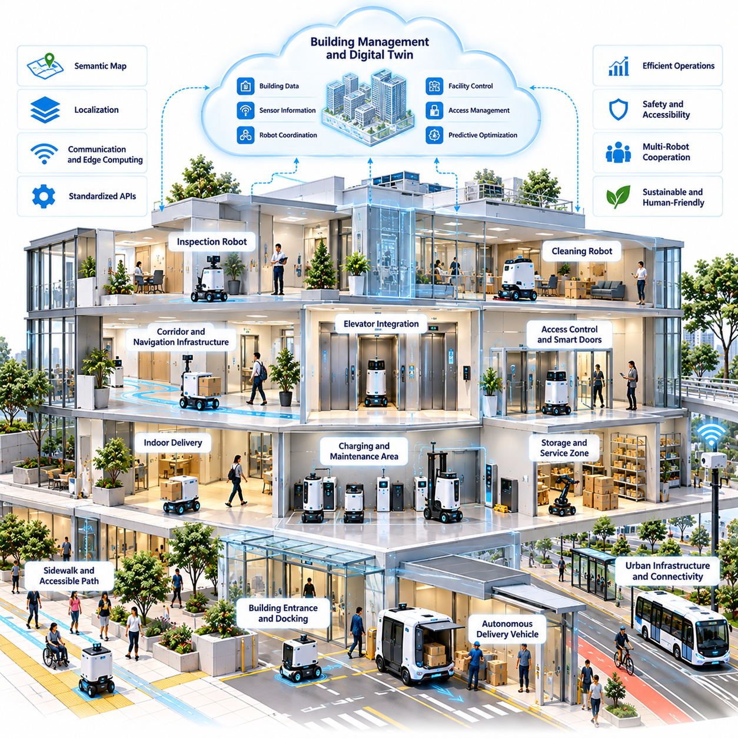
Robot-friendly buildings and infrastructure represent an important foundation for integrating Physical AI into future cities. Conventional urban environments are designed primarily around human mobility, accessibility, and operational requirements. As autonomous robots become more common, buildings and public infrastructure may need to accommodate machine navigation, physical interaction, communication, and energy management without compromising human safety or convenience.
A robot-friendly environment does not necessarily require extensive reconstruction of existing facilities. Instead, it emphasizes designing physical spaces and digital interfaces that reduce unnecessary operational complexity. Standardized access points, predictable pathways, machine-readable information, and interoperable control systems can enable autonomous platforms to perform tasks more reliably while preserving the original functions of buildings and infrastructure.
Building geometry directly influences robotic mobility and operational efficiency. Corridor widths, doorway dimensions, floor transitions, turning spaces, and elevator capacities determine which robotic platforms can navigate a facility. Designers may incorporate robot mobility requirements into architectural planning, ensuring that autonomous mobile robots and service platforms can move safely without obstructing pedestrians or emergency evacuation routes.
Indoor navigation infrastructure provides another essential component of robot-compatible buildings. Robots may combine LiDAR, visual localization, inertial measurements, and semantic maps to determine their positions. Stable environmental landmarks, consistent floor layouts, and updated digital maps can improve localization reliability, particularly in large facilities where repetitive architectural features create ambiguity.
Doors, elevators, and access-control systems are critical interfaces between autonomous robots and building infrastructure. Robots must request access, verify permissions, coordinate movement, and recognize operational restrictions. Standardized application programming interfaces and secure communication protocols could allow different robotic platforms to interact with building systems without requiring customized integration for every deployment.
Elevator integration introduces challenges because robots must coordinate with human passengers and other autonomous machines. A building management system may allocate elevator access according to passenger demand, robot priority, payload restrictions, and service schedules. Safe operation requires reliable door detection, occupancy awareness, emergency handling, and procedures that prevent robotic activities from interfering with accessibility or evacuation.
Robot-friendly buildings may incorporate dedicated waiting areas, charging stations, maintenance zones, and secure storage facilities. These spaces support continuous robotic operations without occupying important pedestrian corridors. Charging infrastructure must consider electrical capacity, battery safety, thermal management, and operational scheduling, particularly when multiple robots share limited energy resources.
The integration of Physical AI with building management systems creates opportunities for coordinated facility operations. Heating, ventilation, lighting, security, and maintenance platforms already generate information about building conditions. Authorized robots could use selected operational data to schedule inspections, navigate restricted areas, or respond to maintenance requests, while building systems provide access permissions and relevant environmental updates.
Building information modeling can support robot-friendly infrastructure throughout design, construction, and operation. Digital representations of rooms, corridors, structural elements, and mechanical systems may provide useful information for robotic navigation and task planning. However, design models must be updated to reflect actual building conditions before they can serve as reliable operational references for autonomous machines.
Digital twins extend static building models by incorporating sensor observations, operational states, and environmental changes. A building digital twin may represent elevator availability, temporary obstacles, maintenance activities, and robot locations. By combining these observations with predictive models, facility operators could simulate robotic workflows, identify potential conflicts, and improve coordination before executing physical tasks.
Shared semantic maps may enable heterogeneous robots to operate within the same building. Cleaning robots, delivery platforms, inspection machines, and mobile manipulators can benefit from common representations of rooms, access points, restricted zones, and traversable pathways. Interoperability requires consistent coordinate systems, map version management, semantic definitions, and mechanisms for handling conflicting environmental observations.
Communication infrastructure must support reliable coordination without becoming a single point of failure. Wireless networks, edge computing systems, and building automation interfaces may exchange navigation updates, task assignments, and access permissions. Nevertheless, robots should retain essential local safety capabilities when connectivity is interrupted, and critical operations should not depend exclusively on remote computing services.
Robot-friendly infrastructure extends beyond individual buildings into sidewalks, transportation terminals, logistics hubs, and public facilities. Smooth surface transitions, accessible crossings, predictable loading zones, and standardized docking interfaces can support movement between indoor and outdoor environments. Urban planning must balance robotic accessibility with pedestrian priority, universal design principles, and existing transportation requirements.
Autonomous logistics illustrates the importance of integrated infrastructure design. A delivery robot may travel from a neighborhood logistics hub to a building entrance, authenticate its access, use an elevator, and transfer a package to a secure receiving station. Completing this workflow requires coordination across transportation infrastructure, building control systems, robotic navigation, and shipment verification mechanisms.
Infrastructure inspection robots introduce different design requirements from delivery or cleaning platforms. These machines may need access to mechanical rooms, utility corridors, inspection ports, rooftops, and confined maintenance spaces. Robot-compatible inspection pathways and standardized sensing locations could reduce operational risks while supporting more frequent monitoring of structural and mechanical conditions.
Physical interfaces must account for the diversity of robotic morphologies. Wheeled robots, legged platforms, mobile manipulators, and specialized inspection machines have different requirements for ground clearance, turning radius, payload handling, and vertical mobility. Rather than optimizing every environment for one robot type, infrastructure designers may define capability classes and interoperable interfaces that accommodate multiple categories of autonomous machines.
Safety engineering remains central to robot-friendly infrastructure. Buildings must maintain clear pedestrian routes, accessible emergency exits, fire protection requirements, and safe interactions between robots and occupants. Autonomous machines should operate within validated speed and force limits, recognize restricted areas, and transition to safe states when unexpected conditions or infrastructure failures occur.
Cybersecurity becomes particularly important when robots interact with building access systems and operational technology. Unauthorized commands or compromised interfaces could affect physical security, elevator operations, or sensitive facility information. Secure authentication, role-based permissions, encrypted communication, audit logging, and network segmentation can reduce these risks while preserving operational interoperability.
Privacy considerations arise because building robots may collect images, spatial measurements, occupancy information, and operational histories. Data governance policies should define what information is collected, how long it is retained, and which organizations may access it. Privacy-preserving perception, selective data processing, and edge-based computation can help reduce unnecessary exposure of information about occupants and visitors.
Accessibility must remain a fundamental design requirement rather than being subordinated to robotic efficiency. Robot pathways should not obstruct wheelchair users, visually impaired pedestrians, or individuals requiring mobility assistance. Human-centered design requires predictable robotic behavior, clear communication signals, appropriate yielding policies, and infrastructure that remains usable when autonomous systems are unavailable.
Economic feasibility will influence how quickly robot-friendly infrastructure becomes widespread. Retrofitting existing buildings may require modifications to doors, elevators, networks, charging facilities, and building management software. Investment decisions should consider robot utilization, integration expenses, maintenance savings, service reliability, and the potential value of supporting multiple robotic applications through shared infrastructure.
New construction projects may offer greater opportunities for integrating robotic requirements during initial architectural design. Early coordination between architects, engineers, facility operators, and robotics developers can reduce later integration costs. Modular interfaces and adaptable infrastructure may also help buildings accommodate future robotic platforms whose physical configurations and intelligence capabilities are not yet fully established.
Standards and certification frameworks could accelerate the development of interoperable robot-friendly environments. Common specifications for access control, elevator communication, docking stations, spatial representations, and safety procedures would reduce dependence on proprietary integrations. However, standardization must accommodate different building categories, local regulations, and evolving robotic technologies without restricting innovation.
The long-term evolution of robot-friendly infrastructure may transform buildings from passive physical environments into active participants in autonomous operations. Buildings could provide structured information, operational permissions, shared environmental context, and coordinated services to intelligent machines. This transformation would connect architectural design, digital infrastructure, and embodied intelligence within increasingly adaptive urban ecosystems.
Ultimately, robot-friendly buildings and infrastructure should be designed to support cooperation between humans and autonomous machines rather than prioritizing automation alone. Their value lies in enabling reliable robotic services while preserving safety, accessibility, security, and operational resilience. As Physical AI advances, infrastructure readiness may become as important as robotic intelligence in determining the practical capabilities of future cities.

03.05. Autonomous Public Infrastructure Inspection
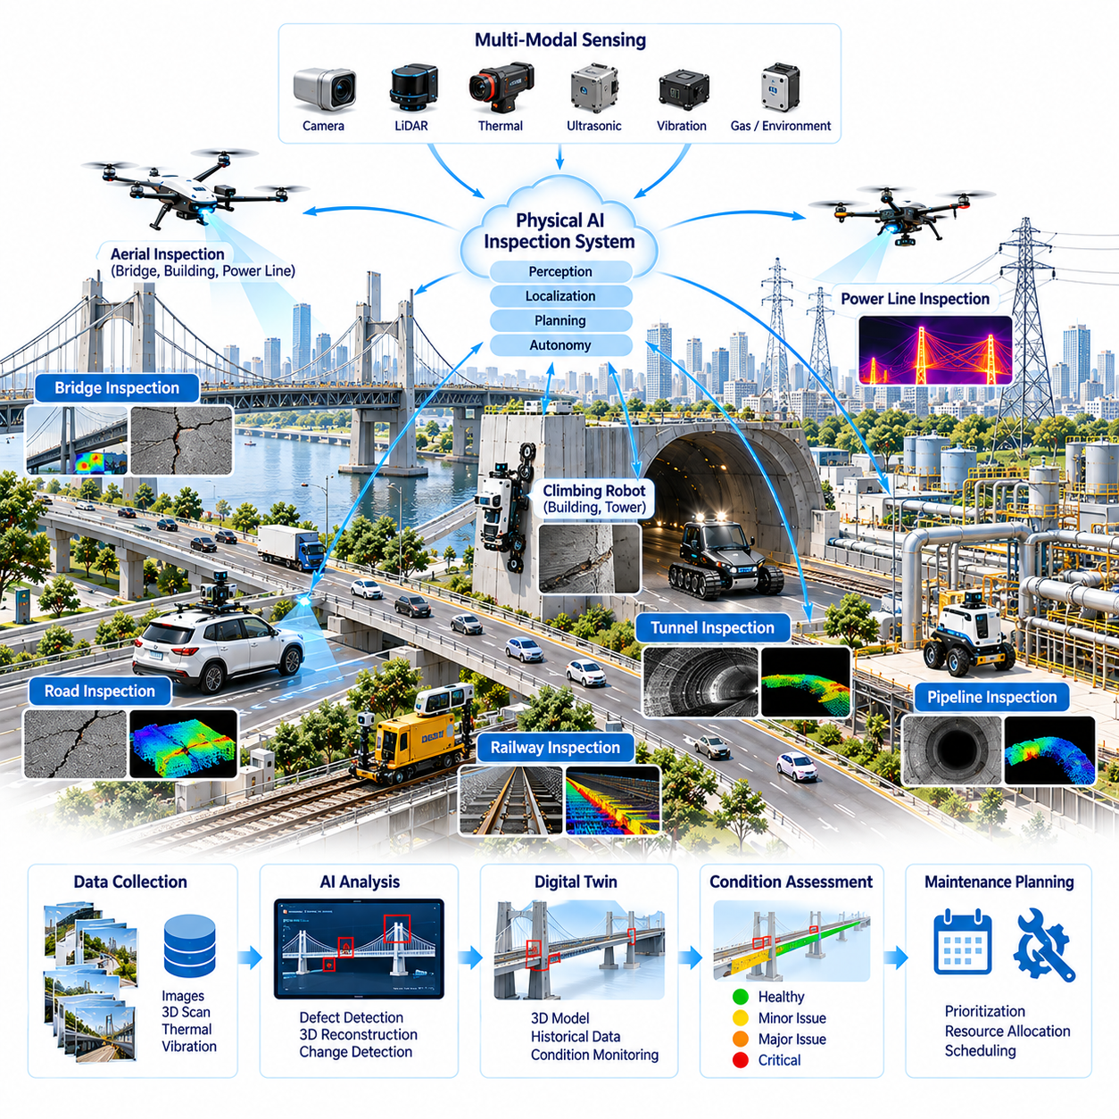
Autonomous public infrastructure inspection represents a major application of Physical AI in the management of future cities. Bridges, tunnels, roads, railways, pipelines, and utility networks require continuous monitoring to maintain safety and operational reliability. Intelligent robotic systems can collect physical measurements, identify abnormal conditions, and support maintenance decisions while reducing human exposure to hazardous inspection environments.
Traditional infrastructure inspection depends heavily on scheduled site visits, manual measurements, and expert visual assessments. These approaches provide valuable information but may involve high labor costs, limited inspection frequency, and inconsistent observation conditions. Autonomous inspection introduces repeatable data collection and continuous monitoring capabilities that could improve the timeliness and consistency of infrastructure condition assessments.
Physical AI inspection systems combine robotic mobility, environmental perception, sensing, localization, and autonomous decision-making. Ground robots, aerial platforms, climbing machines, and specialized inspection vehicles may operate across different infrastructure environments. Their onboard intelligence enables navigation around structural obstacles, selection of observation viewpoints, and adaptation to changing environmental conditions during inspection missions.
Sensor integration is fundamental to autonomous infrastructure inspection. RGB cameras, LiDAR, thermal imaging, ultrasonic sensors, and vibration measurement devices provide complementary information about structural and mechanical conditions. Multimodal sensor fusion can combine geometric measurements with visual and physical indicators, supporting more comprehensive assessments than those obtained from individual sensing technologies.
Structural inspection requires identifying defects such as cracks, corrosion, deformation, surface deterioration, and material displacement. Computer vision models may detect visible abnormalities, while three-dimensional reconstruction techniques can estimate geometric changes over time. However, automated defect detection must account for lighting variations, surface contamination, sensor uncertainty, and the distinction between superficial damage and structural significance.
Autonomous bridge inspection illustrates the importance of integrating mobility and perception. Aerial robots may examine elevated components, while ground or climbing platforms inspect accessible surfaces and structural connections. Accurate localization and viewpoint planning help obtain repeatable observations, enabling engineers to compare inspection records and identify changes that warrant detailed investigation.
Tunnel and underground infrastructure inspection introduces additional challenges because satellite positioning is often unavailable and communication conditions may be unreliable. Robots must navigate confined passages, low-light environments, and potentially hazardous areas. LiDAR-based localization, inertial navigation, visual mapping, and onboard autonomy can support inspection continuity while minimizing dependence on external positioning infrastructure.
Road and pavement inspection may benefit from autonomous vehicles equipped with high-resolution cameras, laser scanners, and inertial measurement systems. These platforms can collect information about surface cracking, potholes, deformation, and pavement irregularities. Combining defect observations with geographic references allows maintenance authorities to prioritize repairs according to severity, location, traffic exposure, and expected deterioration.
Pipeline and utility inspection requires specialized robotic platforms capable of operating within constrained environments. Pipe-crawling robots and inspection vehicles may detect corrosion, leakage indicators, geometric deformation, and internal obstructions. Sensor selection depends on material properties, accessibility, and inspection objectives, while reliable localization is necessary to associate detected anomalies with specific infrastructure segments.
World models can improve autonomous inspection by representing infrastructure geometry, environmental conditions, and the evolving state of inspected assets. Rather than relying exclusively on predefined routes, robots may use predictive environmental representations to anticipate obstacles and identify informative observation locations. Such models support adaptive inspection planning while preserving uncertainty about unobserved or poorly measured regions.
Inspection planning involves selecting routes, viewpoints, sensing configurations, and measurement sequences that maximize useful information within operational constraints. Robots must consider battery capacity, travel distance, sensor coverage, environmental hazards, and inspection priorities. Information-aware planning can direct attention toward regions where existing observations are insufficient or where deterioration is suspected.
Digital twins provide a framework for connecting inspection measurements with infrastructure lifecycle management. A digital representation of a bridge, tunnel, or utility network may integrate design geometry, construction records, historical inspections, and current sensor observations. When properly maintained, these models can support condition comparisons, maintenance simulations, and communication between inspection teams and infrastructure operators.
Temporal analysis is essential because infrastructure deterioration often develops gradually. Repeated robotic inspections can generate time-series measurements of cracks, deformation, temperature patterns, and other observable conditions. Comparing measurements across consistent reference frames may reveal trends that isolated inspections cannot detect, although environmental variability and measurement uncertainty must be considered before concluding that deterioration has occurred.
Predictive maintenance systems may use inspection histories, environmental exposure, operating loads, and engineering models to estimate future infrastructure conditions. Machine learning can identify statistical relationships between observed indicators and maintenance outcomes. Nevertheless, predictions should be interpreted alongside physical engineering knowledge, validated degradation models, and expert assessment rather than treated as definitive forecasts of structural failure.
Autonomous inspection can support risk-based maintenance by improving the availability of condition information. Infrastructure managers may combine defect severity, asset importance, failure consequences, and maintenance costs to prioritize interventions. This approach can help allocate limited resources more effectively, particularly when large urban networks contain many assets with different operating histories and deterioration mechanisms.
Fleet coordination becomes important when multiple inspection robots operate across extensive public infrastructure networks. Centralized platforms may assign inspection missions, manage charging schedules, track equipment availability, and consolidate collected measurements. Heterogeneous fleets can combine aerial, wheeled, climbing, and specialized robotic platforms, allowing inspection capabilities to be matched with the physical characteristics of each asset.
Edge computing enables inspection robots to process sensor data near the point of collection. Onboard inference may identify potential defects, estimate localization confidence, and determine whether additional observations are required. Cloud platforms can support computationally intensive reconstruction, historical analysis, model training, and coordination across large infrastructure portfolios, while critical safety functions remain locally available.
Simulation and digital environments can accelerate the development of autonomous inspection systems. Virtual bridges, tunnels, pipelines, and urban facilities allow developers to evaluate navigation, sensing, and mission planning under diverse conditions. Domain randomization may introduce variations in lighting, geometry, surface appearance, and sensor noise, but real-world validation remains necessary to establish reliable performance.
Safety assurance is particularly important because inspection robots may operate near traffic, electrical equipment, elevated structures, and confined spaces. Autonomous systems require validated operating boundaries, collision avoidance, emergency stopping, and safe recovery procedures. Human supervision remains necessary for hazardous missions, unexpected environmental conditions, and decisions involving structural safety or public access restrictions.
Inspection data quality directly influences the reliability of automated condition assessment. Measurements must be associated with calibrated sensors, accurate timestamps, consistent coordinate systems, and documented operating conditions. Data validation procedures should identify incomplete coverage, corrupted observations, uncertain defect classifications, and inconsistencies between repeated inspections before results are used for maintenance decisions.
Cybersecurity and data governance are important because public infrastructure information may reveal sensitive operational characteristics. Inspection platforms should protect asset maps, sensor records, access credentials, and communication channels. Secure authentication, controlled data sharing, audit trails, and appropriate retention policies can support collaboration between infrastructure owners, contractors, and public authorities without unnecessary exposure of sensitive information.
The economic value of autonomous inspection depends on inspection frequency, robot utilization, labor requirements, deployment complexity, and maintenance outcomes. Robotic systems may reduce access equipment costs and human exposure to hazardous environments while enabling more frequent measurements. However, acquisition, calibration, supervision, software maintenance, and data interpretation expenses must be included in lifecycle cost evaluations.
Public infrastructure inspection will increasingly require interoperability between robotic platforms, engineering databases, geographic information systems, and asset management software. Standardized defect descriptions, spatial references, inspection records, and data exchange interfaces can improve the continuity of infrastructure information. Such integration is essential for converting robotic observations into actionable engineering and maintenance workflows.
Ultimately, autonomous public infrastructure inspection could transform urban maintenance from predominantly periodic observation toward more continuous, evidence-based asset management. Physical AI provides the ability to connect autonomous sensing, environmental understanding, predictive analysis, and coordinated inspection operations. Its long-term contribution will depend on reliable measurements, validated engineering interpretation, responsible deployment, and effective integration with human infrastructure expertise.

03.06. Cleaning Maintenance and City Service Robots
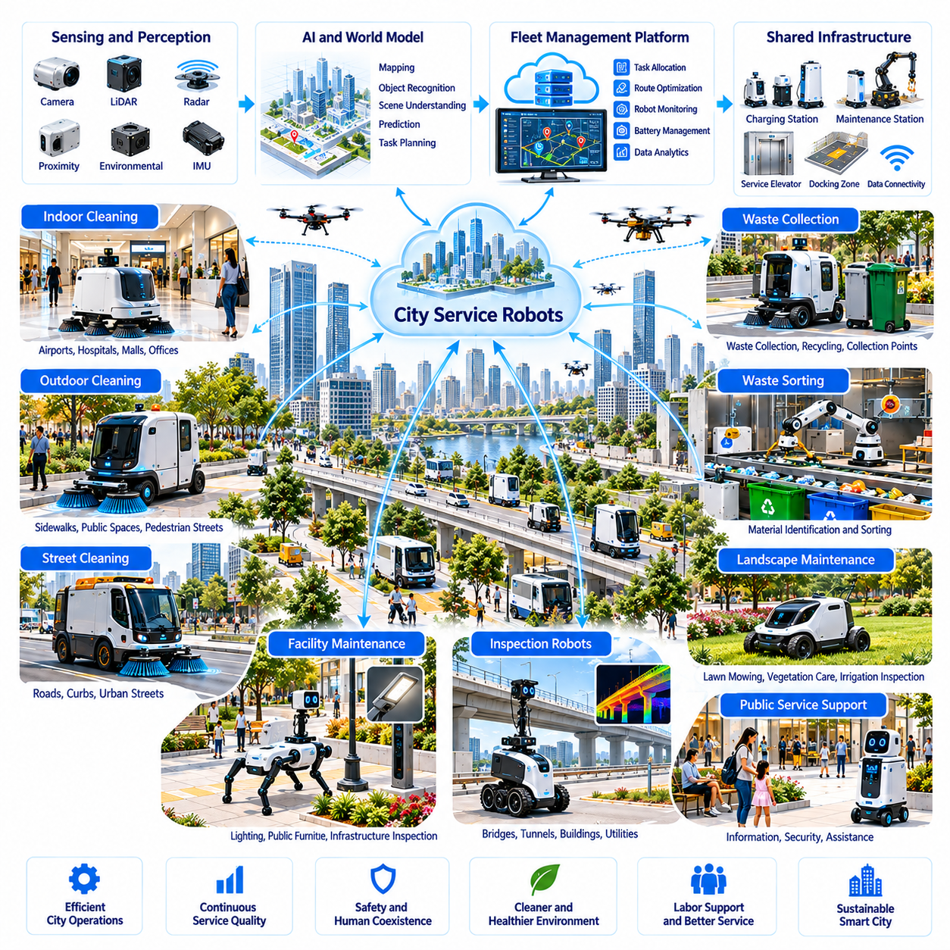
Cleaning, maintenance, and city service robots represent an increasingly important application of Physical AI in urban environments. Cities require continuous cleaning, waste collection, landscape maintenance, and facility servicing to maintain public health and operational quality. Autonomous robotic systems can support these activities through intelligent perception, mobility, and task execution, potentially improving service consistency while reducing exposure to repetitive or hazardous work.
Traditional city maintenance depends on human-operated equipment, fixed schedules, and labor-intensive inspection and cleaning processes. These approaches remain essential but can struggle with fluctuating service demand, large geographic coverage, and workforce limitations. Physical AI introduces adaptive service platforms capable of responding to environmental conditions, prioritizing tasks, and coordinating operations across multiple urban locations.
Autonomous cleaning robots combine environmental perception, localization, motion planning, and specialized cleaning mechanisms. Cameras, LiDAR, proximity sensors, and surface detection systems help robots identify traversable areas and potential obstacles. Cleaning modules may include brushes, vacuum systems, water dispensers, and debris collection mechanisms, allowing robotic platforms to adapt their operations to different surfaces and contamination conditions.
Indoor cleaning robots are increasingly applicable to airports, hospitals, shopping centers, transportation terminals, and public buildings. These environments often contain extensive floor areas requiring frequent maintenance. Autonomous platforms can navigate predefined service zones, avoid pedestrians, and adjust cleaning schedules according to occupancy patterns, although human supervision remains necessary for unusual conditions and complex cleaning tasks.
Outdoor cleaning introduces additional challenges because urban environments are less structured and more variable. Sidewalks, public squares, parks, and pedestrian streets contain irregular surfaces, temporary obstacles, changing weather, and unpredictable human activity. Outdoor service robots require robust mobility, environmental understanding, and conservative safety behavior to operate reliably in these dynamic public spaces.
Street-cleaning robots may combine autonomous navigation with sweeping, debris collection, and surface monitoring functions. Their operational performance depends on recognizing curbs, road boundaries, parked vehicles, pedestrians, and construction barriers. Route planning must consider traffic regulations, cleaning coverage, available operating windows, and the need to avoid disrupting public transportation and pedestrian accessibility.
Waste management represents another opportunity for robotic city services. Autonomous collection platforms may transport waste containers, support recycling operations, or assist personnel at designated collection points. Computer vision and material classification systems can help identify waste categories, although contamination, mixed materials, and uncertain object properties create limitations that require careful validation and human intervention.
Robotic waste sorting may be integrated with automated collection and processing facilities. Manipulation systems equipped with visual sensors and robotic arms can identify and separate selected materials from waste streams. Successful operation requires reliable object recognition, grasp planning, contamination handling, and coordination with conveyor systems, while hazardous or ambiguous materials may require specialized procedures.
Landscape maintenance robots can support lawn mowing, vegetation monitoring, irrigation inspection, and selected groundskeeping activities. Parks and public green spaces introduce uneven terrain, moving obstacles, and seasonal environmental changes. Physical AI systems must distinguish vegetation from people, animals, and protected landscape features while adapting navigation and task planning to variable ground conditions.
Urban facility maintenance extends robotic services beyond cleaning and waste collection. Robots may inspect lighting equipment, monitor public furniture, identify damaged surfaces, or support routine maintenance of transportation facilities. Mobile manipulators could eventually perform selected physical repairs, although reliable tool use, force control, and verification of completed work remain significant technical challenges.
World models can improve service robot autonomy by representing urban geometry, surface conditions, obstacles, and task-relevant environmental states. Robots may combine persistent maps with real-time observations to distinguish temporary changes from stable infrastructure features. Predictive models can help anticipate pedestrian movements, estimate service requirements, and select safer or more efficient operational strategies.
Task planning for city service robots involves more than determining navigation routes. Systems must decide which locations require attention, what equipment is appropriate, and when tasks should be performed. Information from sensors, service requests, historical maintenance records, and environmental conditions can support dynamic prioritization, allowing robots to respond to changing operational needs.
Multi-robot fleet management enables cleaning and maintenance activities to be coordinated across large facilities or urban districts. Fleet platforms may distribute assignments according to robot capability, location, battery state, equipment availability, and service urgency. Coordinated scheduling can reduce redundant coverage and improve utilization, while local robotic controllers retain responsibility for immediate navigation and safety.
Shared infrastructure can support the continuous operation of urban service fleets. Charging stations, water replenishment points, waste disposal interfaces, and maintenance facilities may be distributed across service regions. Standardized docking and resource exchange systems could reduce manual servicing requirements, although automated replenishment must account for contamination control, mechanical reliability, and infrastructure compatibility.
Digital twins provide a framework for planning and monitoring robotic city services. Virtual representations of buildings, streets, parks, and service equipment can integrate maintenance schedules, robot locations, and environmental observations. Operators may use these models to evaluate service coverage, simulate operational disruptions, and optimize fleet deployment before implementing changes in physical environments.
Data-driven learning can improve robotic service quality over time. Cleaning effectiveness, missed areas, obstacle encounters, equipment failures, and human interventions generate operational feedback. Carefully curated datasets may support improvements in perception, task planning, and equipment control, while fleet-level learning can help identify recurring environmental conditions that reduce service performance.
Service quality assessment requires measurable performance indicators rather than relying exclusively on task completion records. Cleaning coverage, residual contamination, response time, equipment availability, and resource consumption provide complementary measures of effectiveness. Sensor-based verification can support consistent evaluation, but uncertain measurements and differences between environments require appropriate validation procedures.
Human-robot collaboration remains essential for complex city maintenance operations. Human workers may supervise robotic fleets, handle exceptional situations, perform specialized repairs, and evaluate service quality. Robots can undertake repetitive or physically demanding tasks, allowing personnel to concentrate on judgment-intensive activities, although workforce transitions require training, operational redesign, and responsible organizational planning.
Safety requirements are particularly demanding when service robots operate in crowded public environments. Autonomous platforms must recognize pedestrians, children, mobility aids, animals, and unexpected obstacles. Speed limits, collision avoidance, emergency stopping, and safe equipment operation are necessary, especially when robots use rotating brushes, cutting mechanisms, pressurized water, or other potentially hazardous tools.
Environmental sustainability is an important consideration in robotic city services. Electrified platforms may reduce local exhaust emissions, while adaptive cleaning schedules can potentially reduce unnecessary water, chemical, and energy consumption. However, battery production, equipment manufacturing, maintenance, and additional robotic travel must be included when evaluating overall environmental performance.
Cybersecurity and privacy become relevant when service robots operate near residents and collect environmental observations. Cameras, location records, and operational logs may contain sensitive information about individuals or facilities. Secure communication, access controls, selective data retention, and privacy-preserving processing can help protect information while supporting the legitimate operational needs of public service providers.
The economic feasibility of city service robotics depends on utilization, equipment cost, labor requirements, maintenance complexity, and measurable service outcomes. Autonomous systems may improve operational consistency and extend service coverage, but supervision, repairs, consumables, and infrastructure integration introduce continuing expenses. Lifecycle cost analysis should compare robotic deployment with realistic alternatives rather than assuming automatic cost reductions.
Municipal governance must establish appropriate operating conditions for autonomous service platforms. Public authorities may define permitted operating areas, equipment safety requirements, noise restrictions, environmental standards, and accountability procedures. Procurement policies and interoperability requirements can also influence whether robotic services develop as isolated systems or as coordinated components of broader urban infrastructure.
The long-term evolution of city service robotics may connect cleaning, maintenance, inspection, and environmental monitoring within shared Physical AI platforms. Robots could exchange maps, report infrastructure abnormalities, coordinate service requests, and contribute observations to city digital twins. Such integration would support more responsive urban operations, provided that data quality, interoperability, safety, and public accountability are maintained.
Ultimately, cleaning, maintenance, and city service robots could transform urban operations from predominantly schedule-based activities into adaptive, data-informed service systems. Physical AI provides the perception, mobility, planning, and coordination capabilities required for this transition. Its lasting value will depend on improving public cleanliness, infrastructure reliability, worker safety, environmental performance, and the everyday quality of urban life.

03.07. Construction and Infrastructure Automation
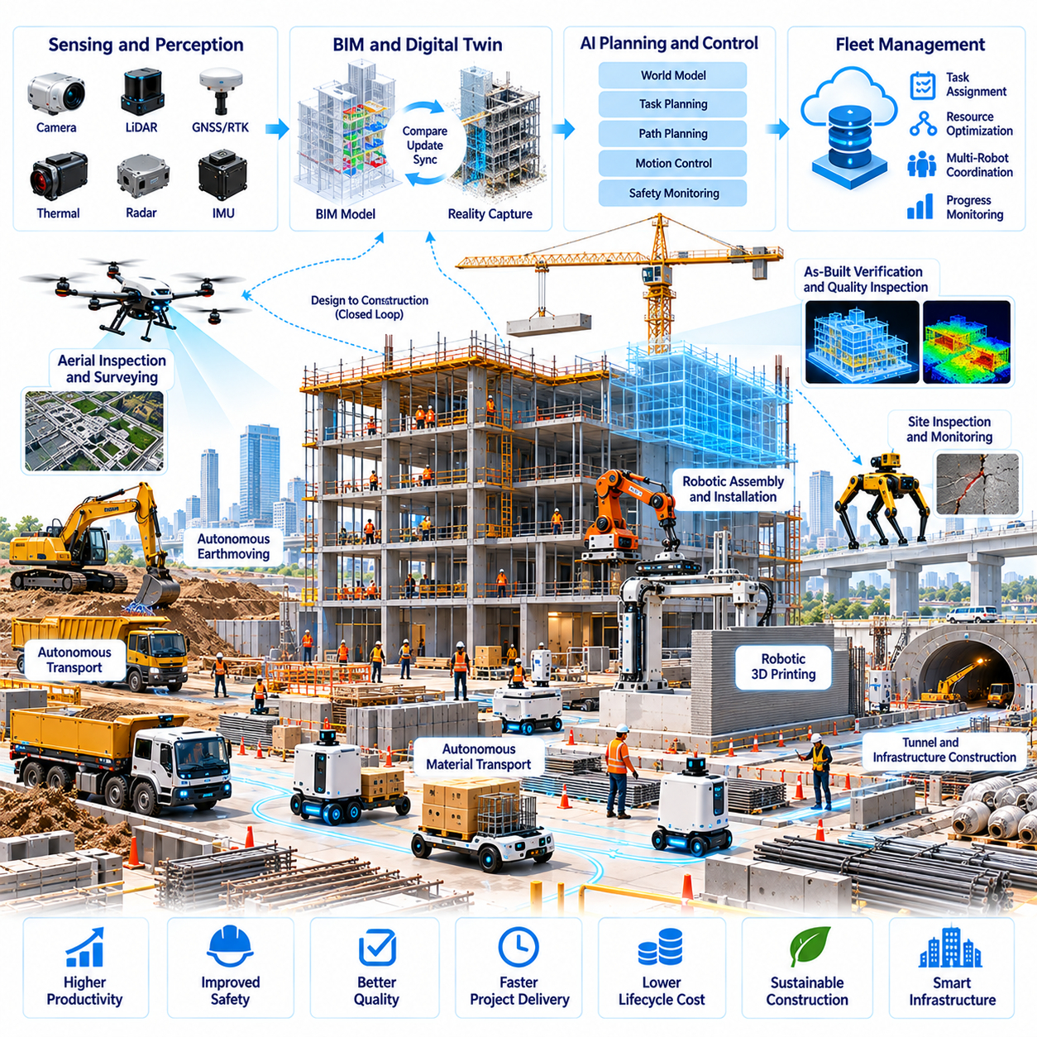
Construction and infrastructure automation represents a major frontier for Physical AI in future cities. Urban development requires complex coordination of machinery, materials, workers, and engineering information across constantly changing sites. Autonomous robotic systems can support construction, inspection, and maintenance activities by combining environmental perception, precise motion control, and intelligent planning, potentially improving productivity, safety, and construction quality.
Traditional construction relies on labor-intensive processes, manually operated equipment, and fragmented information flows between design and execution. Site conditions change continuously as structures are assembled and materials are relocated. Physical AI introduces adaptive automation capable of interpreting these changes, coordinating physical tasks, and connecting digital engineering models with real-world construction operations.
Construction robots require integrated perception, localization, planning, and control systems. Cameras, LiDAR, inertial sensors, and positioning instruments provide information about site geometry, equipment locations, and surrounding activity. Autonomous platforms must interpret incomplete observations while navigating uneven terrain, avoiding obstacles, and maintaining safe separation from workers and machinery.
Building information modeling provides a digital foundation for construction automation. BIM models describe structural geometry, architectural components, materials, and construction relationships. Robotic systems can use this information to identify target locations, plan operations, and compare completed work with design specifications. Reliable integration requires accurate coordinate alignment and continuous updates reflecting actual site conditions.
Digital construction workflows increasingly connect BIM, reality capture, and robotic execution. Laser scanning, photogrammetry, and mobile mapping systems can generate representations of partially completed structures. Comparing measured geometry with design models helps identify deviations, missing components, and installation errors. These observations can guide corrective actions before defects propagate into subsequent construction stages.
Autonomous mobile robots can transport tools, materials, and components across construction sites. Such platforms must accommodate changing pathways, temporary storage areas, uneven surfaces, and unpredictable human activity. Fleet coordination systems may assign transport missions according to material demand, vehicle capacity, and construction schedules, reducing unnecessary movement and supporting more consistent material availability.
Robotic manipulation enables automation of selected assembly and installation tasks. Industrial arms, mobile manipulators, and specialized construction machines may perform drilling, fastening, welding, positioning, or component handling. Successful execution requires accurate object localization, contact-aware motion planning, force control, and verification that installed components satisfy geometric and mechanical requirements.
Autonomous earthmoving and heavy equipment operation offer opportunities for large-scale infrastructure development. Excavators, loaders, compactors, and transport vehicles may use perception and machine control systems to execute constrained operations. Their autonomy must account for terrain variability, soil behavior, equipment dynamics, and nearby personnel, while operating within validated safety boundaries.
Construction layout and surveying can benefit from robotic measurement and marking systems. Autonomous platforms may transfer design coordinates onto floors, walls, or structural surfaces, supporting installation teams with consistent spatial references. High-precision localization and calibration are essential because small positioning errors can accumulate across construction stages and affect downstream assembly accuracy.
Infrastructure construction extends robotic automation into roads, bridges, tunnels, and utility networks. Specialized machines may support pavement operations, reinforcement placement, concrete processing, and underground installation. Different tasks require distinct mobility and manipulation capabilities, making modular robotic architectures and task-specific tooling important for practical deployment.
World models can help construction robots understand evolving site conditions. These models may represent structural elements, temporary obstacles, equipment movement, material locations, and partially completed work. By combining persistent spatial information with current observations, robots can adapt their plans when construction progress changes the environment or previously accessible routes become unavailable.
Construction automation requires close integration between task planning and project scheduling. Robotic operations depend on material readiness, completed prerequisite activities, equipment availability, and access permissions. Planning systems may use project information to identify feasible tasks and coordinate execution, although uncertain progress and unexpected site conditions require continuous reassessment.
Multi-robot coordination becomes increasingly important as autonomous machines perform transportation, surveying, inspection, and assembly within shared construction environments. Fleet management systems can distribute assignments, monitor robot status, and reduce conflicts between activities. Effective coordination must also account for human-operated machinery and construction crews whose movements may not follow predefined schedules.
Digital twins can connect construction planning with observed physical progress. A construction digital twin may integrate design models, robotic measurements, equipment states, and project schedules. Such representations can support progress verification, resource planning, and identification of discrepancies between expected and actual conditions, provided that the underlying data remains accurate and sufficiently current.
Simulation environments provide opportunities to test robotic construction workflows before physical deployment. Virtual sites can reproduce equipment movements, structural geometry, material handling, and selected interaction dynamics. Domain randomization may expose robots to variations in lighting, terrain, and obstacle placement, while real-world validation remains essential for tasks involving uncertain contact and material behavior.
Quality assurance is a central objective of construction automation. Robotic measurement systems can evaluate dimensional tolerances, component alignment, surface conditions, and installation completeness. Automated comparisons between as-designed and as-built information may identify deviations earlier, but engineering acceptance must consider measurement uncertainty, applicable standards, and the structural significance of detected differences.
Precision control becomes particularly important when robotic operations involve drilling, fastening, component positioning, or geometric verification. System accuracy depends on localization, sensor calibration, actuator performance, structural rigidity, and environmental disturbances. Error budgets should distinguish repeatability from absolute accuracy, while independent measurements verify whether completed work satisfies required tolerances.
Safety engineering must address the interaction of robots, heavy machinery, workers, and unstable construction environments. Autonomous platforms require obstacle detection, protective operating zones, emergency stopping, and safe recovery procedures. Risk assessments must consider falling objects, moving equipment, temporary structures, and changing site access conditions rather than assuming a controlled industrial environment.
Human-robot collaboration is likely to remain fundamental throughout the development of construction automation. Skilled workers can supervise robotic operations, resolve unexpected conditions, perform complex assembly, and verify critical engineering outcomes. Effective deployment requires clear responsibility boundaries, understandable system behavior, and training that enables personnel to work safely with autonomous equipment.
Edge computing and reliable communication infrastructure can support construction robots operating across large sites. Onboard processing enables immediate perception and control, while local servers or cloud platforms may coordinate planning, data storage, and model updates. Safety-critical functions should remain available during network interruptions, especially when robots manipulate heavy loads or operate near personnel.
Data generated during construction operations can improve future robotic performance. Navigation failures, positioning errors, manipulation outcomes, and inspection results provide information about system limitations. Structured datasets can support learning and calibration, while fleet-level analysis may reveal recurring problems across projects. Data governance must protect commercially sensitive designs and operational records.
The economic feasibility of construction robotics depends on equipment utilization, integration complexity, labor requirements, maintenance costs, and achievable quality improvements. Repetitive and well-defined tasks may offer earlier opportunities for automation than highly variable activities. Investment evaluation should consider reduced rework, improved safety, schedule reliability, and lifecycle costs rather than focusing exclusively on direct labor substitution.
Standardization and interoperability are important for connecting robotic systems with construction software and engineering workflows. Common coordinate references, BIM interfaces, task descriptions, inspection records, and safety protocols can reduce integration barriers. Open and well-defined interfaces may also allow contractors to combine equipment from different suppliers without rebuilding operational systems for each project.
The long-term evolution of construction automation may connect design, simulation, robotic execution, and infrastructure maintenance within a continuous digital-physical workflow. Physical AI could enable construction sites to become more adaptive and measurable while supporting automated verification and coordinated operations. Its practical success will depend on engineering accuracy, safe deployment, interoperability, and effective cooperation between autonomous machines and construction professionals.

03.08. Emergency Response and Disaster Robotics
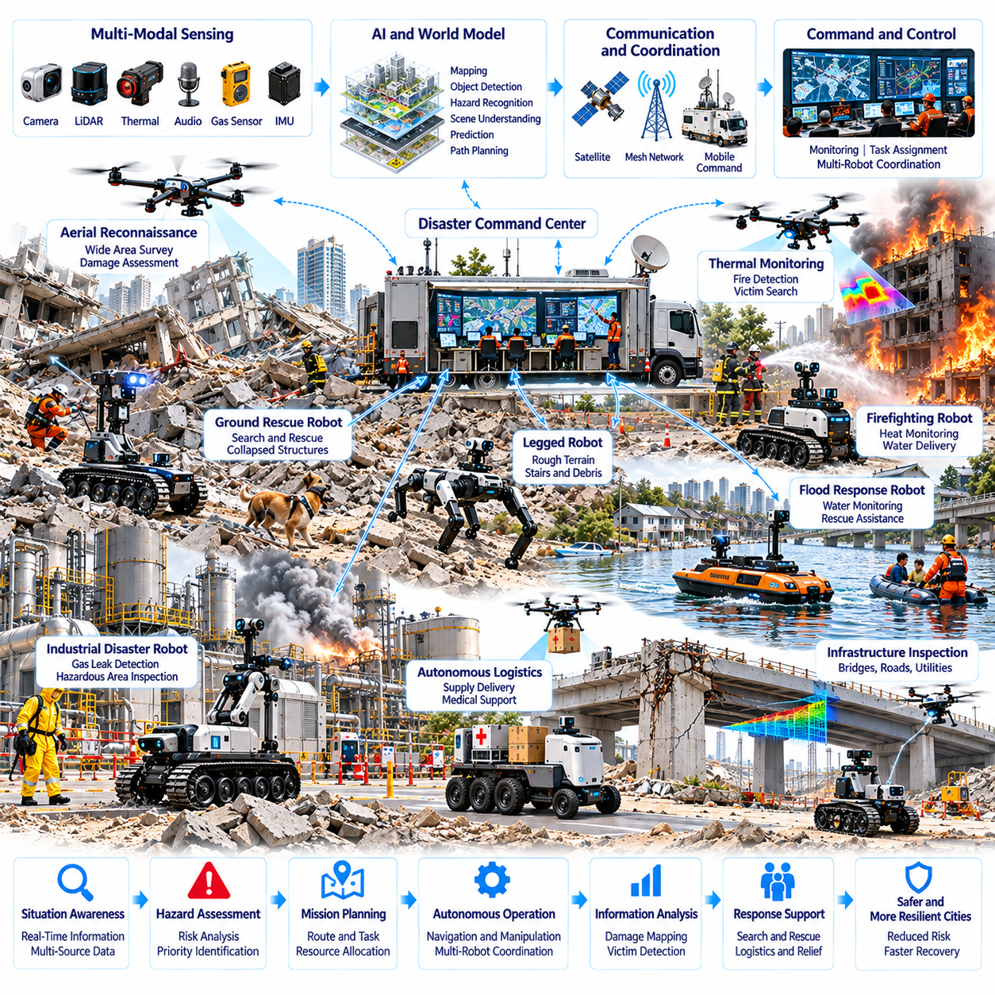
Emergency response and disaster robotics represent critical applications of Physical AI in protecting urban populations and infrastructure. Earthquakes, floods, fires, industrial accidents, and structural collapses create environments where human access may be dangerous or impossible. Autonomous robotic systems can support reconnaissance, hazard assessment, search and rescue, and emergency logistics by combining mobility, perception, and intelligent decision-making.
Traditional emergency operations depend on trained responders, specialized equipment, and rapidly established command structures. However, damaged infrastructure, uncertain hazards, and incomplete information can delay intervention. Physical AI introduces robotic platforms capable of entering hazardous areas, collecting environmental observations, and supporting operational decisions while reducing unnecessary exposure of emergency personnel.
Disaster robotics requires integrated perception, localization, planning, and control under highly uncertain conditions. Cameras, LiDAR, thermal sensors, gas detectors, and inertial measurement systems provide complementary information about damaged environments. Robots must interpret incomplete observations, navigate unstable terrain, and maintain safe behavior despite degraded visibility, unpredictable obstacles, and limited communication.
Ground rescue robots can explore collapsed buildings, underground passages, industrial facilities, and debris-filled environments. Tracked, wheeled, and legged platforms offer different mobility characteristics depending on terrain and access constraints. Their effectiveness depends on obstacle negotiation, mechanical durability, sensor reliability, and the ability to recover safely when navigation or manipulation becomes difficult.
Aerial robots provide rapid situational awareness across disaster-affected regions. Unmanned aerial vehicles can survey damaged structures, flooded neighborhoods, blocked roads, and inaccessible terrain from elevated viewpoints. Thermal imaging and visual mapping may help identify areas requiring closer investigation, although weather, smoke, battery limitations, and airspace restrictions can constrain deployment.
Search and rescue operations benefit from combining multiple sensing modalities. Thermal cameras may detect heat signatures, microphones may capture acoustic signals, and visual systems may identify possible signs of human presence. Sensor fusion can improve candidate detection, but uncertain observations must be interpreted carefully because environmental interference and false positives can affect rescue priorities.
Autonomous navigation becomes particularly challenging when disasters alter previously mapped environments. Collapsed structures, displaced objects, water accumulation, and damaged roads may invalidate existing maps. Robots must construct updated spatial representations while estimating localization uncertainty. Adaptive mapping and exploration strategies can help identify accessible routes without assuming that the environment remains structurally stable.
World models can support disaster response by representing terrain geometry, environmental hazards, infrastructure damage, and potential changes over time. Predictive models may estimate how obstacles, smoke, flooding, or unstable structures could affect robotic operations. However, disaster environments contain substantial uncertainty, requiring continuous observation and conservative decisions rather than excessive reliance on predicted conditions.
Multi-robot coordination can improve coverage and operational efficiency during large-scale emergencies. Aerial platforms may perform regional reconnaissance while ground robots investigate specific locations and transport equipment. Fleet coordination systems can assign missions according to robot capability, battery state, communication availability, and operational urgency while maintaining clear supervision by emergency command personnel.
Communication resilience is essential because disasters frequently damage cellular networks, power systems, and fixed communication infrastructure. Robots may use local wireless links, temporary relay stations, or mobile communication nodes to exchange information. Nevertheless, safety-critical autonomy should remain functional during network interruptions, and robots must support controlled fallback behavior when coordination becomes unavailable.
Emergency logistics represents another important application of autonomous robotic systems. Ground vehicles and aerial platforms may transport medical supplies, communication equipment, sensors, or essential materials to difficult-to-access locations. Mission planning must consider payload limitations, route safety, delivery verification, and the urgency of human needs, particularly when transportation infrastructure has been damaged.
Firefighting robotics can reduce human exposure to extreme heat, toxic smoke, and unstable structures. Specialized ground robots may carry thermal sensors, water delivery systems, or firefighting equipment into hazardous areas. Autonomous assistance requires reliable thermal management, obstacle awareness, and safe equipment control, while tactical firefighting decisions remain subject to qualified human command.
Flood response robots may support water-level monitoring, environmental mapping, infrastructure inspection, and selected rescue assistance tasks. Amphibious vehicles, unmanned surface vessels, and aerial platforms can access different portions of flooded environments. Their operation must account for water currents, floating debris, submerged obstacles, and rapidly changing conditions that challenge conventional navigation systems.
Industrial disaster response may involve chemical leaks, gas releases, electrical hazards, or damaged processing facilities. Robots equipped with specialized sensors can investigate hazardous zones and collect measurements before human entry. Reliable operation requires appropriate environmental protection, calibrated detection instruments, and strict mission boundaries because sensor failures or incorrect hazard interpretation can create serious consequences.
Infrastructure damage assessment can support emergency prioritization and recovery planning. Robots may inspect bridges, roads, tunnels, buildings, and utility systems to identify visible damage and access restrictions. Three-dimensional mapping and image analysis can document observed conditions, but structural safety conclusions require engineering validation rather than relying solely on automated visual classification.
Digital twins can connect pre-disaster infrastructure information with observations collected during emergency operations. Updated virtual representations may incorporate damaged roads, blocked entrances, utility failures, and robotic reconnaissance results. Such models can help emergency teams compare response options, coordinate resources, and identify information gaps, provided that outdated or uncertain observations are clearly distinguished.
Simulation environments can support the training and evaluation of disaster robots before deployment. Virtual environments may reproduce debris fields, smoke, flooding, unstable terrain, and communication disruptions. Domain randomization can expose control and perception systems to diverse conditions, but simulated success does not establish operational reliability without realistic testing and carefully designed field exercises.
Human-robot collaboration is fundamental because emergency response involves ethical judgments, uncertain information, and rapidly changing priorities. Robots can provide observations and perform selected hazardous tasks, while trained responders retain authority over rescue strategies and critical decisions. Interfaces should communicate robot status, confidence levels, detected hazards, and operational limitations without overwhelming personnel.
Safety assurance requires more than conventional collision avoidance in disaster environments. Robots may encounter unstable debris, hazardous substances, damaged electrical systems, and unpredictable structural movement. Risk-aware planning, emergency stopping, controlled retreat, and equipment-specific safety procedures are necessary to prevent robotic operations from creating additional hazards for survivors or responders.
Data quality and uncertainty management are especially important when emergency decisions depend on robotic observations. Sensor readings should include timestamps, geographic references, confidence estimates, and relevant environmental conditions. Systems must distinguish confirmed findings from suspected hazards and incomplete observations, allowing command personnel to evaluate the reliability of information before acting.
Cybersecurity becomes critical when robotic systems exchange sensitive operational information during emergencies. Unauthorized access, communication interference, or manipulated sensor data could disrupt rescue coordination. Secure authentication, protected communication, controlled system access, and operational audit records can help preserve information integrity while supporting rapid collaboration between response organizations.
The economic evaluation of disaster robotics differs from conventional commercial automation because equipment may remain unused for extended periods before becoming essential. Procurement decisions should consider readiness, maintenance, training, deployment speed, and interoperability with existing emergency systems. Shared regional resources and standardized operating procedures may improve preparedness without requiring every organization to maintain identical robotic fleets.
Governance and operational standards influence the safe deployment of emergency robots. Public authorities must establish responsibilities for airspace access, hazardous-site entry, data sharing, and coordination between agencies. Regular exercises and performance validation can improve operational readiness, while clear accountability ensures that robotic recommendations do not replace authorized emergency decision-making.
The long-term development of disaster robotics may connect urban sensing networks, infrastructure digital twins, autonomous fleets, and emergency command platforms. Physical AI could support earlier hazard detection, faster situational assessment, and more coordinated recovery operations. Its effectiveness will depend on robust autonomy, resilient communications, reliable data, and integration with established emergency management practices.
Ultimately, emergency response and disaster robotics can extend human capabilities into environments that are too dangerous, inaccessible, or uncertain for conventional operations. Physical AI provides tools for autonomous exploration, hazard sensing, logistical support, and coordinated intervention. Its most important contribution will be measured by improvements in responder safety, decision quality, rescue effectiveness, and the resilience of cities facing unexpected disasters.

03.09. Hospitals Campuses and Public Service Robots
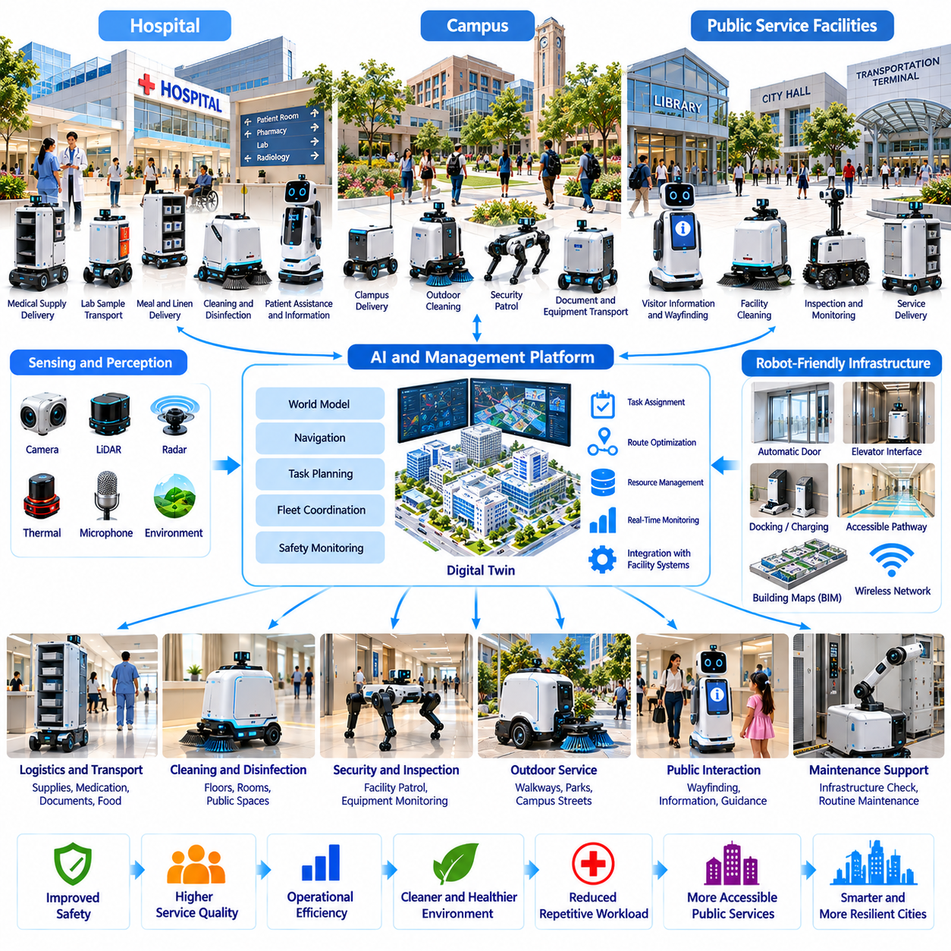
Hospitals, campuses, and public service facilities represent important environments for the deployment of Physical AI in future cities. These institutions operate continuously, serve diverse populations, and require reliable movement of people, materials, and information. Autonomous robots can support transportation, assistance, cleaning, inspection, and facility operations while improving service accessibility and reducing repetitive workloads for human personnel.
Hospitals provide particularly demanding environments because operational efficiency must coexist with patient safety, infection prevention, and clinical priorities. Medical facilities contain interconnected corridors, elevators, treatment areas, and restricted zones. Physical AI systems must navigate these environments reliably while respecting access permissions, responding to changing conditions, and avoiding interference with essential healthcare activities.
Autonomous mobile robots can transport medications, laboratory samples, medical supplies, meals, and linens between hospital departments. Their navigation systems combine localization, obstacle detection, and route planning to operate around patients, staff, and visitors. Integration with elevators, automatic doors, and hospital information systems enables coordinated delivery, although sensitive materials require secure handling and verification.
Hospital logistics automation can reduce time spent on repetitive transportation tasks and improve the availability of essential supplies. Fleet management platforms may prioritize urgent deliveries, allocate robots according to payload requirements, and monitor task completion. However, clinical urgency, contamination risks, and unexpected emergencies require flexible scheduling and clearly defined procedures for human intervention.
Infection control introduces additional requirements for hospital robotics. Cleaning and disinfection robots may support routine sanitation in corridors, rooms, and designated clinical spaces. Their effectiveness depends on surface coverage, appropriate cleaning methods, and validated operating procedures. Automated disinfection must not be assumed to eliminate pathogens without evidence, particularly when human exposure or sensitive equipment creates operational constraints.
Patient-facing robots may provide navigation assistance, appointment guidance, information services, and selected mobility support. Natural language interfaces and multimodal perception can help robots interact with patients and visitors. Nevertheless, language barriers, cognitive limitations, disabilities, and emotional needs require accessible interfaces and human assistance rather than unrestricted reliance on automated interaction.
Campus environments offer broader opportunities for autonomous service deployment. Universities, research parks, corporate campuses, and large institutional complexes contain distributed buildings, pedestrian networks, and shared facilities. Robots may perform deliveries, cleaning, security-related observation, and maintenance support while coordinating movement across indoor and outdoor spaces with different access conditions.
Campus delivery robots can transport documents, food, equipment, and small packages between buildings. Their operation requires reliable localization across transitions between indoor corridors and outdoor pathways. Weather, pedestrian congestion, uneven surfaces, and temporary construction may affect navigation. Successful deployment depends on accessible routes, appropriate operating speeds, and predictable interaction with surrounding pedestrians.
Public service robots can support administrative buildings, libraries, museums, transportation terminals, and community facilities. Their functions may include wayfinding, visitor information, document transportation, and routine environmental monitoring. Physical AI allows these systems to combine conversational assistance with physical movement, although service accuracy depends on current institutional information and reliable task execution.
Robot-friendly infrastructure can substantially improve operational performance in hospitals and campuses. Automated doors, elevator interfaces, designated loading points, charging stations, and accessible pathways reduce navigation and servicing difficulties. Standardized building interfaces may allow robots from different suppliers to operate within shared facilities without requiring extensive modifications to existing infrastructure.
World models provide a foundation for understanding complex institutional environments. Robots may represent building geometry, room functions, pedestrian activity, restricted areas, and operational changes within persistent spatial models. Combining these representations with real-time observations enables adaptive navigation and task planning, while uncertainty estimates help prevent unsafe decisions when environmental information becomes outdated.
Multi-robot fleet management supports coordinated operation across departments, buildings, and service areas. Central platforms may assign tasks according to robot capabilities, location, battery status, and service urgency. Local controllers remain responsible for immediate safety, while fleet-level coordination can reduce congestion, balance workloads, and support predictable service availability throughout large institutions.
Digital twins can connect facility management information with robotic operations. Virtual representations of hospitals and campuses may integrate floor plans, equipment locations, maintenance records, and robot activity. These models can support route optimization, infrastructure planning, and service evaluation, provided that changes in building layouts and operational restrictions are reflected accurately.
Human-robot collaboration remains essential in environments involving vulnerable populations and complex social interactions. Robots may handle routine transportation and information tasks, allowing personnel to focus on clinical care, education, administration, and individualized assistance. Clear escalation procedures are necessary when robots encounter unexpected requests, distressed individuals, or situations requiring professional judgment.
Safety requirements extend beyond conventional obstacle avoidance. Hospital and campus robots must operate around wheelchairs, stretchers, mobility aids, children, and crowded pedestrian areas. Conservative speed control, emergency stopping, accessible interfaces, and reliable detection of vulnerable users are important. Robots must also avoid obstructing emergency exits, clinical equipment, and essential circulation routes.
Privacy and cybersecurity are particularly important because institutional robots may encounter sensitive personal and operational information. Cameras, interaction logs, delivery records, and access credentials require appropriate protection. Secure authentication, data minimization, controlled retention, and network segmentation can reduce risks while allowing robotic systems to integrate with authorized institutional services.
Accessibility and inclusive design should guide the development of public service robots. Interfaces must accommodate differences in language, vision, hearing, mobility, and digital literacy. Voice interaction alone is insufficient for many users, making visual displays, tactile controls, and alternative assistance channels valuable. Robotic services should expand access without creating barriers for people unable or unwilling to use automation.
Operational reliability requires systematic monitoring of navigation performance, delivery accuracy, equipment availability, and service interruptions. Robots should detect failures, communicate their status, and enter safe fallback states when necessary. Maintenance planning must consider batteries, sensors, wheels, manipulators, and software updates, particularly where service interruptions could affect essential institutional operations.
Learning from operational data can improve robotic performance across similar facilities. Navigation difficulties, repeated service requests, human interventions, and task completion records provide useful feedback. Fleet-level learning may identify recurring bottlenecks and improve scheduling policies, but data collection must respect privacy requirements and differences between institutional environments.
The economic feasibility of institutional robotics depends on service volume, labor allocation, equipment utilization, infrastructure integration, and ongoing maintenance costs. Hospitals may prioritize reliability and clinical support, while campuses may emphasize accessibility and service convenience. Evaluation should consider measurable outcomes such as delivery time, staff workload, service availability, and user satisfaction.
Public procurement and governance influence the deployment of robots in institutional environments. Administrators must define operating permissions, responsibility boundaries, safety procedures, and data management requirements. Interoperability standards can reduce dependence on individual suppliers, while transparent evaluation and stakeholder participation can improve trust among employees, patients, students, and visitors.
The long-term evolution of institutional robotics may connect transportation, cleaning, maintenance, assistance, and facility monitoring within shared Physical AI platforms. Robots could exchange spatial information, coordinate service requests, and contribute observations to institutional digital twins. Such integration would support more responsive operations while preserving human oversight and clearly defined service responsibilities.
Hospitals and campuses may also serve as controlled environments for developing broader urban robotic capabilities. Their structured facilities, repeated service tasks, and measurable operational requirements provide opportunities for systematic evaluation. Experience gained in these settings could inform deployment across public buildings and urban districts, although successful transfer requires adaptation to different populations and environmental conditions.
Ultimately, hospitals, campuses, and public service robots illustrate how Physical AI can become part of everyday urban infrastructure. Their value lies not simply in replacing individual tasks but in connecting intelligent mobility, institutional services, and human-centered assistance. Sustainable adoption will depend on safety, accessibility, reliability, privacy protection, and demonstrable improvements in the quality of public services.

03.10. Aerial Mobility and Urban Air Logistics
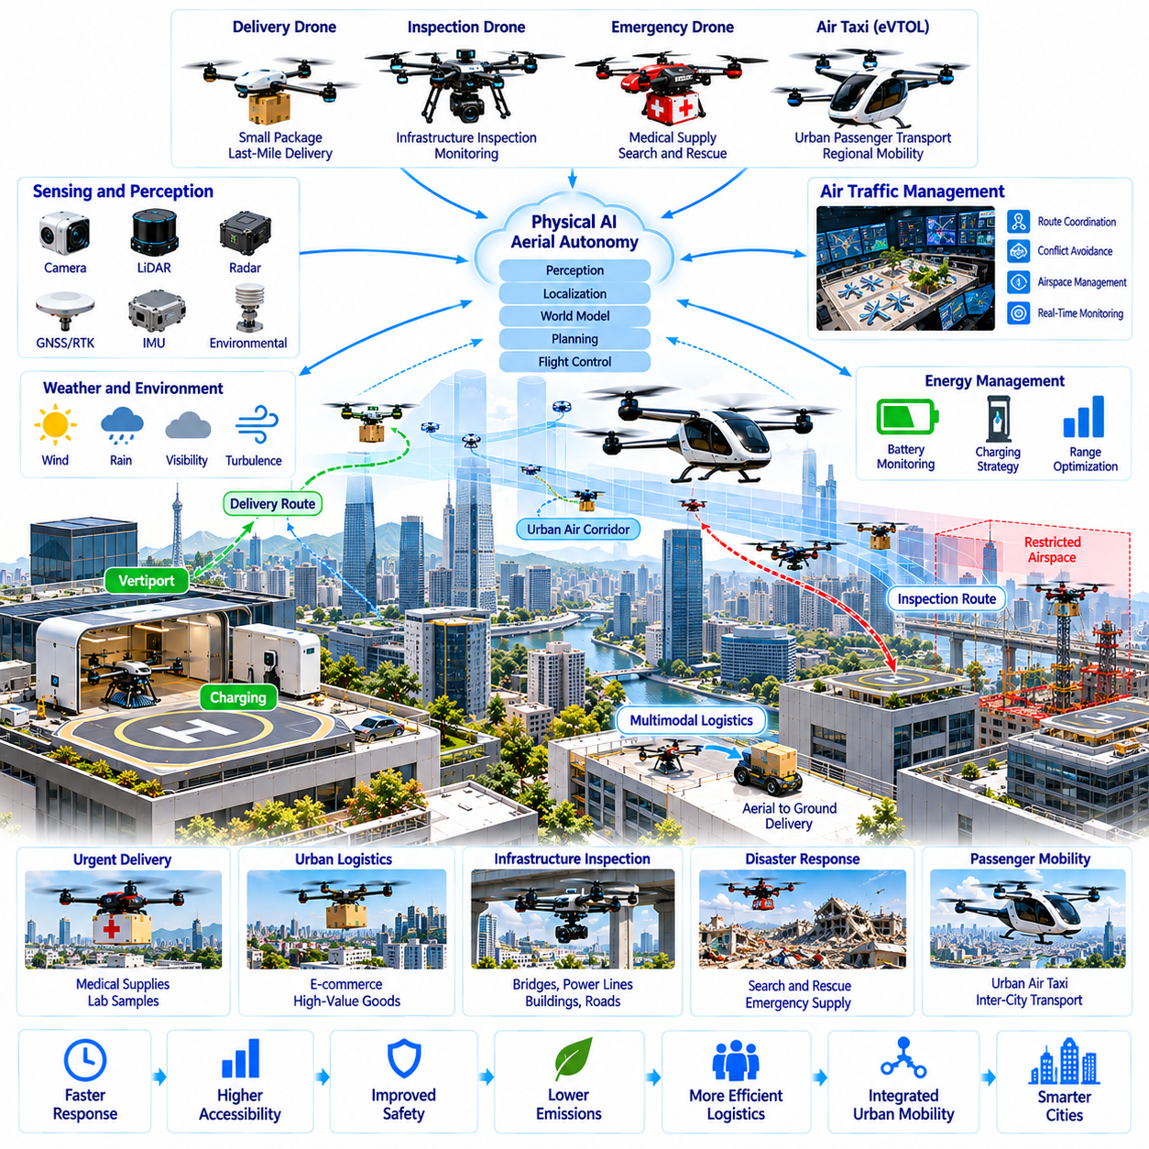
Aerial mobility and urban air logistics represent an emerging dimension of Physical AI in future cities. Autonomous aircraft can extend transportation, delivery, inspection, and emergency services into three-dimensional urban space. By combining intelligent perception, flight control, navigation, and coordinated planning, these systems may complement ground transportation networks, although their practical value depends on safety, regulation, infrastructure, and economic feasibility.
Urban aerial mobility includes unmanned delivery aircraft, inspection drones, emergency response platforms, and potentially autonomous passenger aircraft. These applications differ significantly in payload, operating altitude, range, and safety requirements. Small drones may serve localized logistics missions, while larger electric aircraft could support regional transportation if technical reliability, certification, and supporting infrastructure become sufficiently mature.
The urban air environment presents complex operational challenges. Buildings, communication towers, power lines, bridges, and temporary structures create obstacles across multiple altitudes. Wind turbulence, precipitation, visibility, and electromagnetic interference can further complicate flight. Physical AI systems must maintain reliable environmental awareness while adapting their trajectories to rapidly changing conditions and restricted operating areas.
Autonomous aerial navigation combines satellite positioning, inertial measurements, visual perception, and environmental mapping. Urban canyons may degrade satellite signals through obstruction and multipath effects. Visual-inertial odometry, LiDAR-based localization, and map matching can provide complementary positioning information, but robust systems must estimate uncertainty and maintain safe behavior when localization accuracy deteriorates.
Flight planning requires three-dimensional reasoning about obstacles, airspace restrictions, weather, energy consumption, and mission priorities. Unlike ground robots, aerial vehicles must continuously manage altitude, velocity, and flight stability. Planning systems may generate collision-free trajectories while accounting for vehicle dynamics and emergency landing options, with safety constraints taking precedence over delivery speed or route efficiency.
World models can improve aerial autonomy by representing urban geometry, dynamic obstacles, weather conditions, and evolving airspace activity. Predictive models may estimate the movement of nearby aircraft or changes in environmental conditions. However, uncertainty increases over longer prediction horizons, making frequent observation, trajectory reassessment, and conservative separation policies essential for reliable urban flight.
Urban air logistics may support the transportation of medical supplies, laboratory samples, urgent components, and small commercial packages. Aerial delivery can be valuable where road congestion or geographic barriers delay conventional transportation. Nevertheless, payload capacity, battery endurance, weather limitations, and delivery infrastructure constrain its applicability, making selective high-value missions more plausible than universal replacement of ground logistics.
The delivery process involves more than autonomous flight between two coordinates. Robots must verify cargo identity, maintain secure payload containment, identify suitable landing or transfer locations, and confirm successful delivery. Rooftop stations, designated landing pads, and automated lockers may provide controlled interfaces between aerial vehicles and buildings, reducing risks associated with uncontrolled delivery near pedestrians.
Integration between aerial and ground robots could create multimodal urban logistics networks. Drones may transport urgent packages between distribution hubs, while autonomous mobile robots complete local deliveries inside buildings or pedestrian areas. Coordinated scheduling and standardized cargo interfaces would allow different robotic platforms to exchange materials, although transfer reliability and infrastructure costs remain important considerations.
Urban air traffic management is essential when numerous autonomous aircraft share limited airspace. Traffic coordination systems may distribute flight permissions, manage route conflicts, and communicate temporary restrictions. Reliable identification, position reporting, and separation management are necessary, while coordination with conventional aviation authorities remains fundamental to safe operation in controlled and uncontrolled airspace.
Communication infrastructure supports mission coordination, navigation updates, and remote supervision of aerial fleets. Cellular networks, dedicated radio links, and satellite communication may provide complementary connectivity. However, flight safety cannot depend entirely on continuous network access. Aircraft require onboard capabilities for detecting communication failures, maintaining safe trajectories, and executing appropriate contingency procedures.
Energy management is a major constraint on electric aerial mobility. Battery capacity, payload mass, flight speed, wind conditions, and reserve requirements determine achievable range and operational flexibility. Intelligent mission planning must estimate energy consumption and preserve sufficient reserves for unexpected delays or diversion. Charging infrastructure and battery servicing strategies strongly influence fleet utilization and operating economics.
Vertiports, rooftop facilities, and designated drone stations may become important components of urban aerial infrastructure. These facilities require suitable approach paths, secure landing areas, charging equipment, and ground access. Their locations must consider noise, surrounding buildings, emergency access, and public safety. Infrastructure planning should also account for maintenance operations and integration with existing transportation systems.
Multi-robot fleet management can coordinate aerial missions across urban districts. Fleet platforms may allocate aircraft according to payload requirements, battery state, vehicle availability, and weather conditions. Dynamic scheduling can improve resource utilization and service responsiveness, while safety-critical flight decisions remain subject to onboard control systems and applicable airspace management requirements.
Digital twins can support the planning and monitoring of urban aerial operations. Three-dimensional city models may represent buildings, terrain, air corridors, landing facilities, and selected environmental conditions. Operators can use these representations to evaluate route feasibility, simulate traffic density, and identify infrastructure limitations. Their usefulness depends on accurate geometry and timely updates concerning temporary hazards.
Simulation plays an important role in developing aerial Physical AI systems. Virtual environments can reproduce urban obstacles, wind disturbances, sensor degradation, and interactions between multiple aircraft. Domain randomization may improve robustness across varying conditions, but simulation results must be validated through controlled flight testing because aerodynamic effects and rare failure scenarios are difficult to reproduce completely.
Safety engineering is particularly demanding because aerial system failures may endanger people and property below the aircraft. Redundant sensing, fault detection, flight envelope protection, and emergency landing procedures can reduce operational risk. Risk assessments must consider vehicle mass, population density, ground impact consequences, and the reliability of critical components rather than evaluating navigation performance alone.
Autonomous passenger mobility introduces requirements beyond those of small delivery drones. Passenger-carrying aircraft must satisfy stringent standards for airworthiness, propulsion reliability, emergency procedures, and operational oversight. Electric vertical takeoff and landing aircraft may eventually expand urban transportation options, but widespread autonomy depends on demonstrated safety, certification, infrastructure readiness, and public acceptance.
Noise and environmental performance are important considerations for urban aerial deployment. Electric propulsion may reduce local exhaust emissions, but rotor noise and repeated low-altitude flights can affect residents. Environmental evaluation should consider electricity generation, battery production, infrastructure construction, and lifecycle emissions. Efficient routing alone does not guarantee that aerial delivery is environmentally preferable to ground alternatives.
Privacy and cybersecurity challenges arise when aerial platforms collect images, location information, and operational data above populated areas. Cameras and other sensors may capture information unrelated to their authorized missions. Data minimization, secure communication, access control, and appropriate retention policies can reduce privacy risks, while resilient navigation and authentication systems help protect aircraft against malicious interference.
Public acceptance will influence the scale and location of aerial mobility services. Residents may express concerns about noise, visual intrusion, safety, surveillance, and unequal distribution of benefits. Transparent operating rules, meaningful community consultation, and accessible complaint mechanisms can improve accountability. Deployment strategies should evaluate neighborhood impacts rather than treating technical feasibility as sufficient justification.
The economic viability of urban air logistics depends on aircraft acquisition costs, energy consumption, maintenance, staffing, insurance, infrastructure, and utilization. High-frequency operations may improve asset productivity but also increase noise and airspace management demands. Economic assessments should compare aerial services with ground transportation using realistic delivery volumes, service requirements, and full lifecycle costs.
Regulation and standardization provide the institutional foundation for safe aerial operations. Authorities must establish requirements for aircraft certification, operator responsibility, airspace access, maintenance, and incident reporting. Interoperable communication protocols and standardized operational interfaces can support coordination among different fleet operators, although regulatory frameworks must evolve alongside technological capabilities.
The long-term development of urban aerial mobility may connect autonomous aircraft, ground robots, digital twins, and intelligent transportation infrastructure. Physical AI could support integrated logistics, infrastructure inspection, emergency response, and selected passenger services within coordinated urban networks. Success will depend on reliable autonomy, resilient infrastructure, effective governance, and measurable improvements in urban mobility and public welfare.

03.11. Multi Robot Fleet Management at City Scale
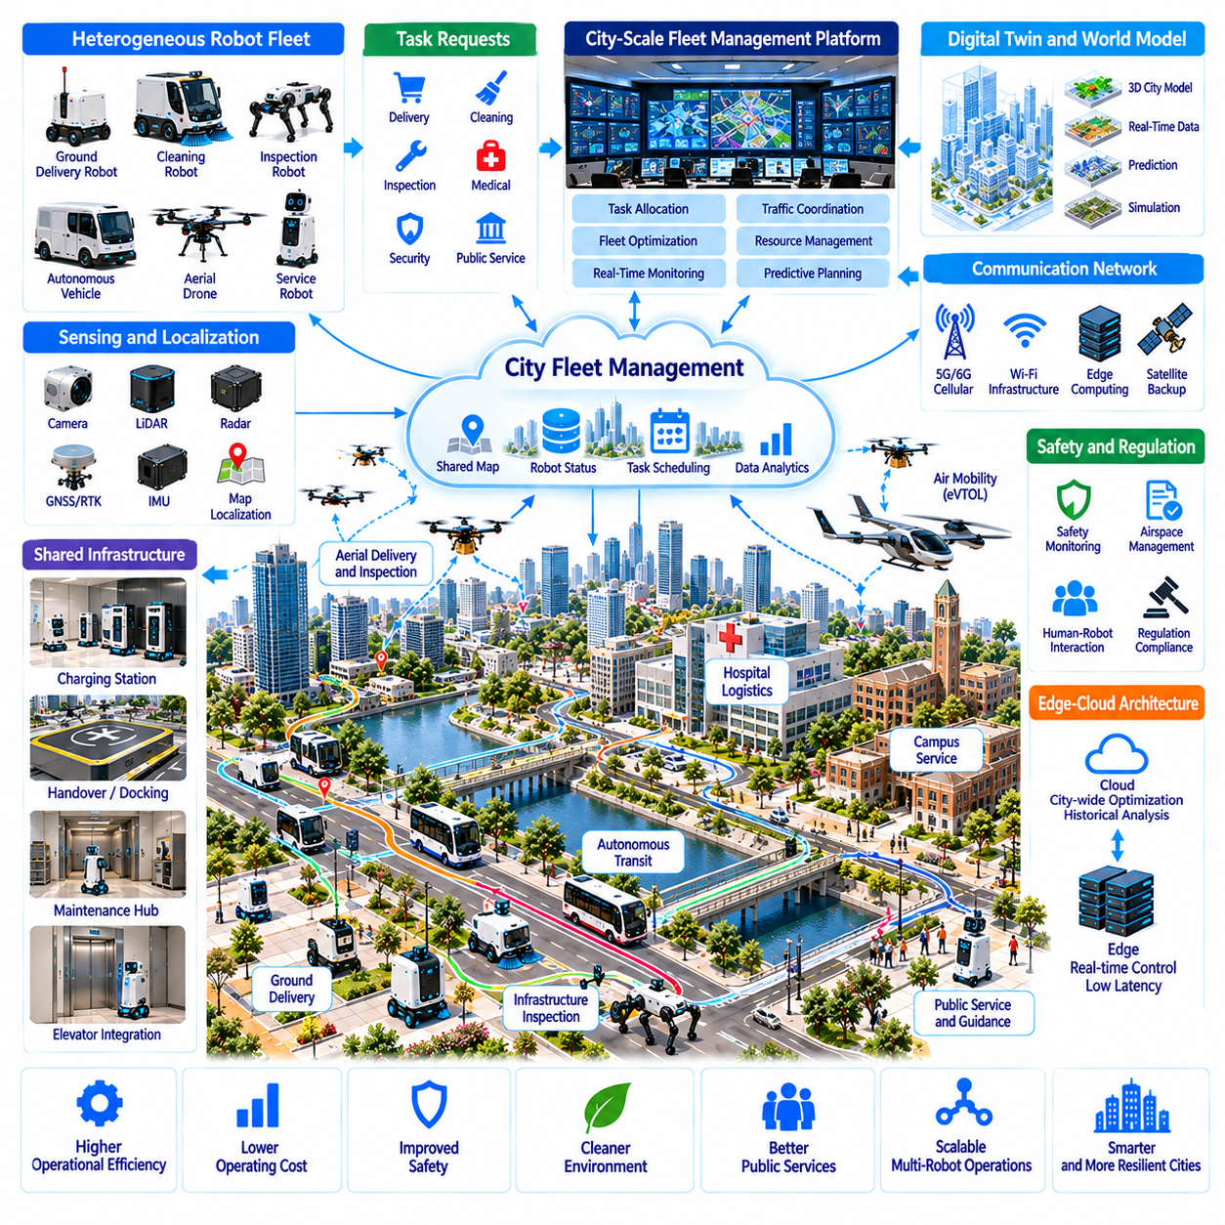
City-scale multi-robot fleet management represents a fundamental capability for integrating Physical AI into urban infrastructure. As autonomous robots expand across transportation, logistics, maintenance, healthcare, and public services, isolated operations become increasingly inefficient. Coordinated fleet management enables heterogeneous robotic systems to share resources, exchange information, and execute distributed tasks while maintaining safety and operational accountability.
Unlike conventional fleet management within factories or warehouses, city-scale coordination involves geographically distributed environments and diverse operating conditions. Robots may navigate sidewalks, roads, buildings, tunnels, and public facilities under different regulations. Managing these systems requires scalable architectures that connect local autonomy with regional coordination and citywide operational supervision.
Heterogeneous fleets may include autonomous mobile robots, delivery vehicles, inspection platforms, cleaning robots, aerial drones, and specialized service machines. Each platform has distinct mobility, sensing, payload, and energy characteristics. Effective management requires standardized descriptions of robot capabilities so that tasks can be assigned according to operational suitability rather than treating all robots as interchangeable resources.
Task allocation is a central function of city-scale fleet intelligence. A management system must match service requests with available robots while considering location, travel time, payload capacity, battery state, and mission priority. Dynamic allocation algorithms can respond to changing demand, equipment failures, and unexpected disruptions, although safety-critical assignments may require additional authorization and human supervision.
Hierarchical coordination architectures can divide responsibilities among individual robots, local fleet controllers, and citywide management platforms. Onboard controllers handle immediate perception, navigation, and collision avoidance. Regional systems coordinate tasks and shared infrastructure, while higher-level platforms optimize resource distribution and service priorities without directly controlling every low-level movement.
Urban fleet operations require reliable localization and shared spatial representations across different environments. Robots may transition between outdoor satellite navigation, indoor visual localization, and infrastructure-assisted positioning. Shared maps can improve route planning and operational consistency, but differences in sensor accuracy, map freshness, and environmental conditions require explicit uncertainty management.
World models provide a deeper representation of urban operating environments by combining geometry, dynamic objects, traffic patterns, and infrastructure states. Predictive models may estimate pedestrian congestion, road accessibility, or temporary service restrictions. Fleet planners can use these representations to anticipate operational conflicts, although predictions must be updated continuously as urban conditions change.
Communication networks connect distributed robots with fleet coordination services. Cellular networks, local wireless infrastructure, and edge computing nodes may support task updates, telemetry, and shared observations. Because connectivity varies across buildings and urban districts, robots must preserve essential autonomous functions during communication interruptions and synchronize operational records when connections recover.
Edge-cloud architectures can balance real-time responsiveness with large-scale computational efficiency. Edge systems may process local observations, coordinate nearby robots, and manage latency-sensitive services. Cloud platforms can support historical analysis, fleet optimization, model updates, and cross-district coordination. Clear functional boundaries prevent network delays from compromising immediate safety decisions.
Traffic coordination becomes important when multiple robots operate in shared pedestrian spaces, building entrances, loading zones, and service corridors. Fleet systems can schedule access to constrained routes and prevent unnecessary congestion. However, robots must independently recognize pedestrians, emergency vehicles, and unexpected obstacles because centralized scheduling cannot guarantee that shared environments remain predictable.
Interoperability is essential when robots from different manufacturers operate within common urban infrastructure. Standardized interfaces for task requests, capability descriptions, status reporting, and facility access can reduce integration costs. Open communication protocols may support coordinated operations, but technical compatibility must be accompanied by consistent safety requirements and clearly assigned responsibilities.
Shared infrastructure can improve the economic efficiency of urban robotic fleets. Charging stations, maintenance facilities, loading areas, and communication nodes may serve multiple robot categories. Coordinated scheduling can reduce infrastructure conflicts and unnecessary travel. Nevertheless, common facilities require appropriate access controls, equipment compatibility, and transparent rules for allocating limited capacity.
Energy-aware fleet management must consider battery capacity, charging availability, travel distance, and mission urgency. Scheduling systems can assign tasks while preserving operational reserves and avoiding excessive battery degradation. Predictive energy models may improve charging decisions, but uncertain terrain, payload variation, and weather conditions require conservative estimates to prevent robots from becoming stranded.
Digital twins can connect city infrastructure information with fleet operations. Three-dimensional urban models may incorporate roads, buildings, pedestrian routes, charging facilities, and robot activity. Operators can use these representations to simulate service demand, evaluate deployment strategies, and identify congestion risks. Reliable integration depends on accurate infrastructure data and timely updates from operational systems.
Fleet-scale learning can transform distributed robotic experience into improvements across the network. Navigation failures, service delays, human interventions, and unusual environmental events provide valuable operational data. Centralized or federated learning approaches may identify recurring problems and improve shared models, provided that updates are validated before deployment and privacy constraints are respected.
Persistent fleet memory can preserve useful knowledge about recurring urban conditions. Robots may contribute observations concerning difficult intersections, unreliable positioning areas, temporary obstacles, and infrastructure changes. Shared experience can reduce repeated exploration and improve route selection, but memory systems must distinguish stable environmental properties from transient events and outdated observations.
Safety assurance becomes more complex as fleet size and operational diversity increase. Individual robots require collision avoidance, emergency stopping, and fault detection, while fleet platforms must manage systemic risks such as coordinated congestion or widespread software failures. Runtime monitoring, controlled deployment, and independent safety mechanisms can reduce the likelihood that centralized errors propagate across large fleets.
Cybersecurity is critical because compromised fleet management infrastructure could affect numerous physical systems simultaneously. Secure authentication, encrypted communication, access segmentation, and software integrity verification help protect distributed operations. Fleet operators must also prepare for communication attacks, unauthorized commands, and corrupted updates through incident response procedures and resilient local autonomy.
Human supervision remains necessary for resolving exceptional situations and maintaining institutional accountability. Remote operators may assist robots that encounter inaccessible routes, equipment failures, or ambiguous interactions. Effective interfaces should prioritize urgent events, display uncertainty, and provide controlled intervention mechanisms. Supervision capacity must scale appropriately rather than assuming that one operator can safely manage unlimited robots.
Operational performance should be evaluated through service completion rates, response times, fleet utilization, energy consumption, and safety outcomes. City-scale systems also require measures of congestion, infrastructure availability, intervention frequency, and geographic service coverage. These metrics help distinguish genuine productivity improvements from apparent efficiency gains achieved by shifting costs onto public infrastructure.
Economic optimization must consider fleet acquisition, maintenance, connectivity, charging, insurance, software operations, and personnel costs. Shared infrastructure and coordinated scheduling may improve utilization, but larger fleets also introduce organizational complexity. Sustainable business models require realistic demand forecasts, measurable service quality, and transparent allocation of operating costs among participating organizations.
Governance frameworks must define how public authorities, infrastructure owners, robot manufacturers, and fleet operators share responsibilities. Permissions for sidewalk access, building entry, data exchange, and emergency operations require enforceable rules. Public oversight is especially important when privately operated robotic fleets depend on shared urban resources or influence pedestrian accessibility and public safety.
The long-term evolution of city-scale fleet management may connect autonomous transportation, public maintenance, emergency response, and institutional services within interoperable Physical AI networks. Hierarchical coordination, shared world models, and collective learning could improve adaptability across urban districts. However, technical integration must preserve local safety autonomy, public accountability, and equitable access to services.
Ultimately, city-scale multi-robot fleet management transforms autonomous robots from isolated machines into coordinated components of urban infrastructure. Its value emerges from collective efficiency, shared intelligence, and reliable service delivery rather than fleet size alone. Successful implementation will depend on interoperability, resilient computing, trustworthy governance, and the ability to operate safely within complex human environments.

03.12. Shared Maps World Models and City Digital Twins
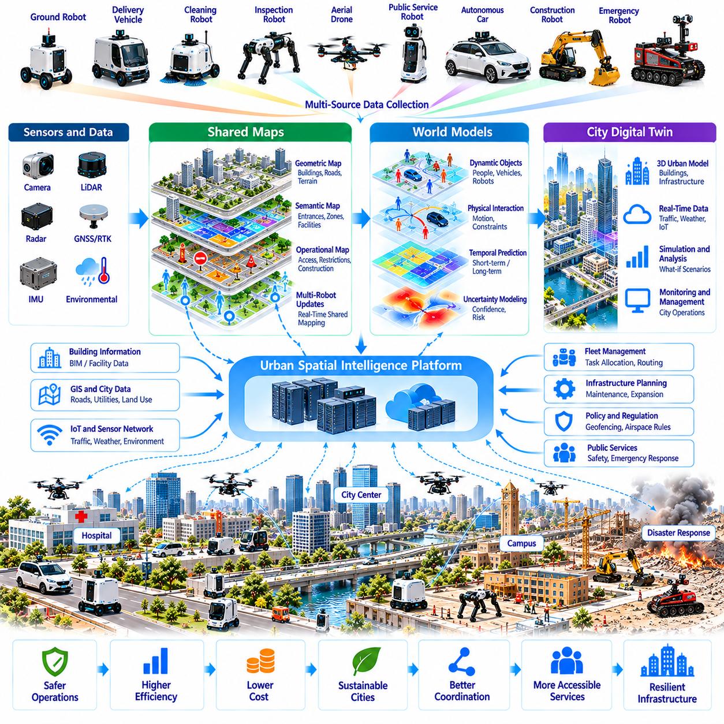
Shared maps, world models, and city digital twins form a foundational intelligence infrastructure for Physical AI in future urban environments. As autonomous robots operate across buildings, roads, sidewalks, and public facilities, they require consistent representations of physical space. Integrating geometric maps, semantic knowledge, dynamic observations, and predictive models can support coordinated navigation, infrastructure management, and intelligent urban services.
Traditional digital maps primarily describe geographic locations, road networks, and relatively stable infrastructure. Physical AI requires richer representations that include traversability, obstacles, access permissions, environmental conditions, and human activity. These representations must support physical decision-making rather than simple geographic visualization, enabling robots to determine where they can move and what actions are appropriate.
Shared mapping allows multiple robots to contribute observations to common spatial representations. Mobile robots, autonomous vehicles, aerial platforms, and inspection systems may collect complementary information using cameras, LiDAR, radar, and positioning sensors. Combining these observations can improve coverage and map freshness, although differences in sensor accuracy, coordinate systems, and observation quality require careful integration.
A city-scale spatial representation typically combines geometric, semantic, and operational information. Geometric layers describe roads, buildings, terrain, and obstacles, while semantic layers identify entrances, pedestrian zones, loading areas, and restricted spaces. Operational layers may contain temporary closures, maintenance activities, and access conditions, allowing robots to interpret urban environments according to their assigned missions.
Localization and mapping must remain consistent across indoor and outdoor environments. Robots may transition between satellite positioning, visual-inertial odometry, LiDAR localization, and infrastructure-assisted navigation. Shared coordinate references and reliable map alignment enable continuous operation across buildings and streets, but localization uncertainty must be represented explicitly to prevent accumulated positioning errors.
World models extend shared maps by representing how environments change and respond to actions. They may encode dynamic objects, physical interactions, temporal relationships, and predicted environmental states. Unlike static maps, world models support reasoning about future conditions, allowing robots to anticipate congestion, moving obstacles, and potential consequences of planned movements.
Predictive world models can improve urban navigation and task planning through short-term and long-term environmental forecasts. Short-term predictions may estimate pedestrian motion and vehicle trajectories, while longer horizons may represent recurring traffic patterns or infrastructure availability. Because prediction uncertainty increases over time, robots must continuously reconcile model forecasts with current sensor observations.
City digital twins provide virtual representations of physical infrastructure and selected operational processes. They may integrate geographic information systems, building information models, transportation networks, utility assets, and real-time sensor observations. Their purpose extends beyond visualization toward simulation, monitoring, planning, and coordinated decision support, although the fidelity of each representation depends on available data.
The relationship between shared maps, world models, and digital twins is complementary rather than interchangeable. Shared maps provide common spatial references, world models support predictive understanding, and digital twins organize representations of infrastructure and operations. Together, they can establish a digital foundation for Physical AI systems while preserving distinct responsibilities for navigation, prediction, and management.
Urban data integration requires consistent spatial references, timestamps, semantic definitions, and metadata. Observations from different robots must be aligned before they can update shared representations. Data pipelines should detect conflicting measurements, estimate confidence, and preserve information provenance, preventing unreliable observations from silently replacing verified infrastructure information.
Map updating becomes essential because cities change continuously. Construction projects, temporary barriers, parked vehicles, damaged surfaces, and seasonal conditions can alter accessibility. Robots may detect these changes during routine operations and submit updates to shared systems. Validation mechanisms must distinguish persistent infrastructure modifications from transient obstacles to avoid unnecessary or misleading map revisions.
Persistent spatial memory can preserve knowledge accumulated through repeated robotic operations. Historical observations may reveal unreliable navigation areas, recurring congestion, or infrastructure deterioration. Memory systems should maintain temporal context and confidence estimates, enabling robots to reuse relevant experience without treating outdated information as current environmental truth.
Multi-robot collaboration benefits from shared spatial intelligence when different platforms operate within overlapping environments. A delivery robot may identify a blocked passage that affects nearby cleaning or inspection robots. Shared updates can improve route selection and reduce repeated exploration, but coordination systems must account for differences in robot dimensions, mobility capabilities, and access permissions.
Hierarchical spatial architectures can support scalability across city districts. Individual robots maintain local maps for immediate control, regional services integrate observations across facilities, and citywide platforms manage broader infrastructure representations. This architecture reduces communication demands while allowing information to propagate between levels according to relevance, reliability, and operational urgency.
Edge-cloud computing can distribute mapping and world-model processing according to latency and computational requirements. Edge systems may support local localization, obstacle tracking, and rapid map updates, while cloud platforms perform large-scale fusion, historical analysis, and model training. Safety-critical navigation must remain functional when connectivity is interrupted or shared information becomes unavailable.
Simulation environments can use city digital twins to evaluate robotic operations before physical deployment. Urban geometry, pedestrian flows, traffic patterns, and infrastructure constraints may be incorporated into virtual scenarios. Simulation can identify route conflicts and infrastructure bottlenecks, but reliable deployment requires validation against real-world conditions because simulated environments cannot reproduce every uncertainty.
Digital twins can also support infrastructure planning for robot-friendly cities. Planners may evaluate sidewalk capacity, charging station placement, delivery access, and interactions between autonomous vehicles and pedestrians. Scenario analysis can compare alternative infrastructure designs, helping authorities identify modifications that improve robotic efficiency without reducing accessibility or public safety.
Uncertainty management is fundamental to shared urban intelligence. Maps may contain outdated geometry, world models may produce inaccurate predictions, and digital twins may omit relevant operational details. Systems should communicate confidence, update frequency, and data limitations so that robots can distinguish verified observations from estimates and respond conservatively when information quality deteriorates.
Cybersecurity and data governance become increasingly important as shared representations connect numerous autonomous systems. Unauthorized modifications to maps or infrastructure states could influence physical robot behavior. Secure authentication, integrity verification, controlled access, and audit records help protect shared information, while governance policies determine who may contribute, validate, and distribute updates.
Privacy protection is essential because urban mapping systems may collect images, trajectories, and observations involving identifiable individuals. Data minimization, anonymization, access restrictions, and retention policies can reduce unnecessary exposure. Shared intelligence platforms should prioritize environmental information relevant to robotic operation rather than accumulating unrestricted records of human movement and activity.
Interoperability requires common data formats and interfaces across robot manufacturers, infrastructure operators, and public agencies. Standardized coordinate systems, semantic ontologies, map exchange protocols, and update procedures can support cross-platform collaboration. However, interoperability also requires agreement on data ownership, validation responsibilities, and the treatment of conflicting information.
The economic value of shared maps and digital twins emerges from reduced duplication, improved navigation, coordinated maintenance, and more efficient infrastructure planning. Common spatial infrastructure may lower deployment costs for multiple robotic services. Nevertheless, continuous data collection, model maintenance, computing resources, and institutional coordination create expenses that must be justified through measurable operational benefits.
Long-term development may connect shared urban maps with predictive world models, autonomous fleet intelligence, and continuously updated digital twins. Physical AI systems could contribute observations while using collective knowledge to improve their actions. Such feedback loops may support increasingly adaptive urban infrastructure, provided that learning mechanisms remain validated, transparent, and compatible with human oversight.
Ultimately, shared maps, world models, and city digital twins can transform urban spatial information into an operational foundation for Physical AI. Their importance lies in connecting perception, prediction, planning, and coordinated action across diverse physical systems. Successful implementation will depend on trustworthy data, scalable computing, interoperability, uncertainty awareness, and responsible governance of shared urban intelligence.

03.13. Urban Robot Data Infrastructure
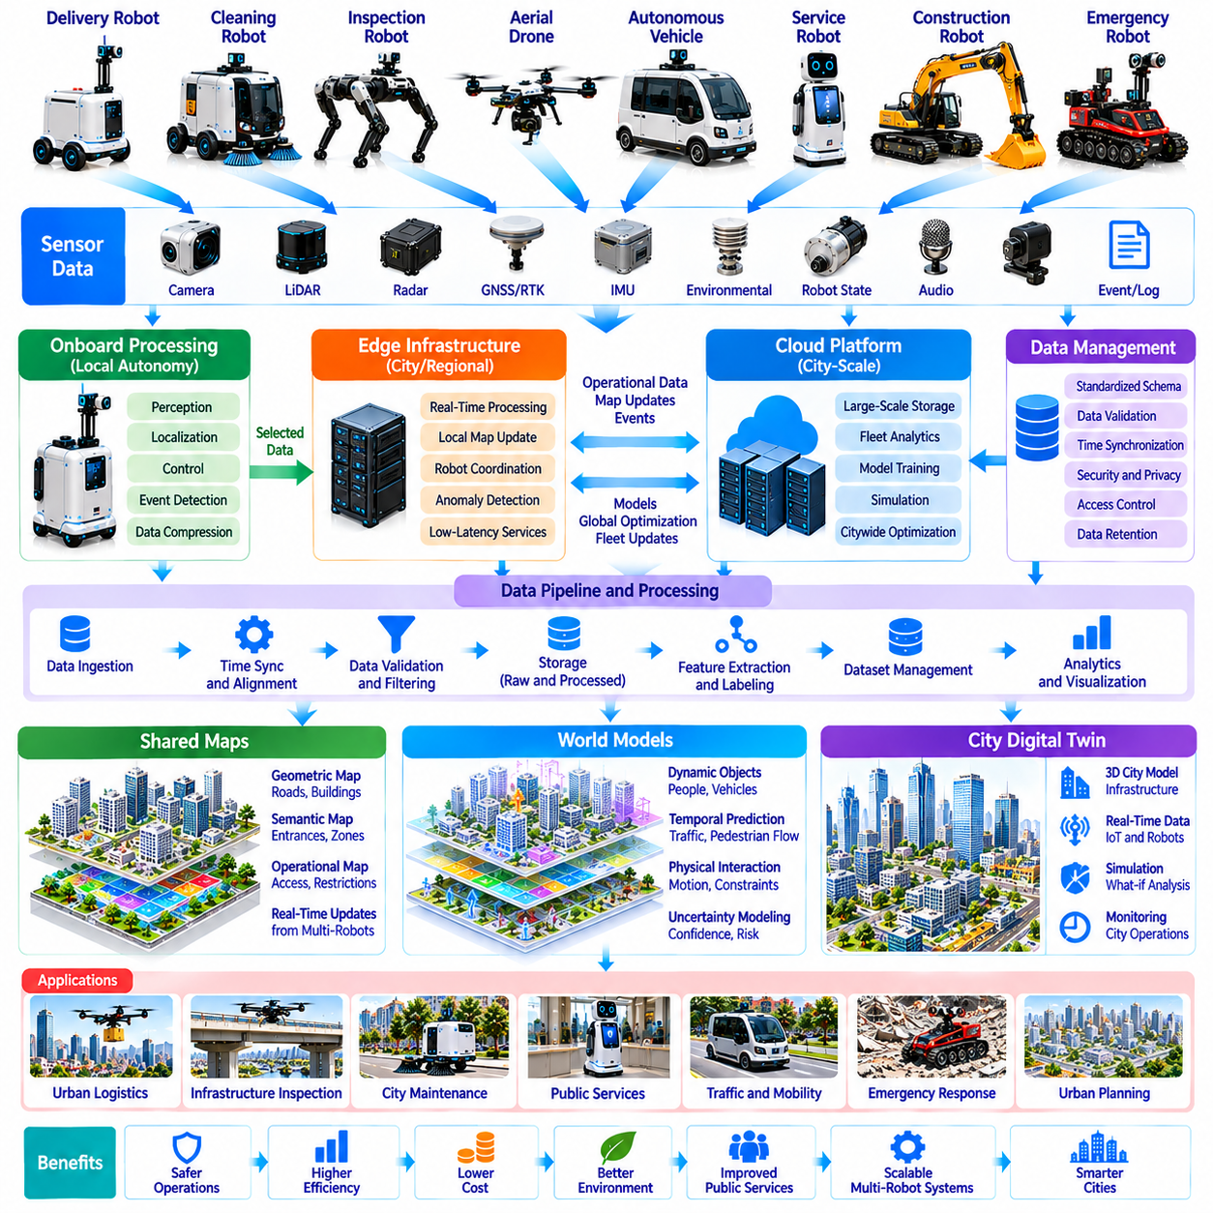
Urban robot data infrastructure provides the digital foundation for operating Physical AI systems across cities. As autonomous robots perform transportation, logistics, inspection, maintenance, and public services, they generate continuous streams of sensor observations, operational records, and environmental information. A coordinated data infrastructure enables these distributed systems to exchange knowledge, improve performance, and support reliable urban operations.
Unlike conventional urban information systems, robot data infrastructure must handle information directly connected to physical actions. Camera images, LiDAR point clouds, localization estimates, trajectories, actuator states, and safety events may require different processing priorities. The infrastructure must distinguish time-critical operational data from information intended for historical analysis, model training, and long-term planning.
A city-scale data architecture typically connects onboard computing, edge infrastructure, regional platforms, and cloud services. Robots process immediate perception and control locally, while nearby edge nodes support low-latency coordination and data aggregation. Regional and cloud platforms manage broader storage, analytics, and learning workloads, creating a hierarchical system that balances responsiveness with computational scalability.
Data acquisition begins with heterogeneous sensors and operational interfaces distributed across robotic platforms. Cameras, radar, LiDAR, inertial sensors, positioning systems, and equipment controllers produce information at different frequencies and resolutions. Reliable ingestion pipelines must preserve timestamps, calibration parameters, coordinate references, and device identities so observations remain interpretable after transmission.
Time synchronization is essential when combining information from multiple robots and infrastructure sensors. Even small timing inconsistencies can distort motion estimation, object tracking, and event reconstruction. Common clock references, synchronization protocols, and timestamp validation help maintain temporal consistency, while systems must account for communication delays and imperfect synchronization across distributed networks.
Urban robot data requires standardized representations to support interoperability. Common schemas can describe robot identity, sensor observations, task states, navigation events, and infrastructure conditions. Semantic ontologies provide consistent meanings for objects, locations, and activities. Standardization reduces integration complexity while allowing specialized robots to retain application-specific data structures.
Data transport must accommodate diverse communication environments, including indoor wireless networks, cellular infrastructure, and intermittent connections. High-bandwidth sensor streams may be processed locally, while compressed observations and operational summaries are transmitted selectively. Adaptive communication policies can prioritize safety-relevant messages and reduce unnecessary network traffic without making local safety dependent on connectivity.
Edge computing supports rapid processing near the physical environment. Edge nodes may aggregate observations, maintain local maps, detect operational anomalies, and coordinate nearby robots. By reducing dependence on distant cloud resources, edge infrastructure can improve responsiveness and limit communication costs. However, edge services require resilient operation, secure management, and clearly defined responsibilities.
Cloud infrastructure provides scalable resources for long-term storage, large-scale analytics, simulation, and model development. Historical fleet data can reveal recurring navigation failures, equipment degradation, and changing service demand. Cloud systems may also support cross-district optimization and shared learning, but operational continuity requires safeguards against outages and centralized service failures.
Data storage architectures must distinguish raw observations, processed features, operational events, and curated training datasets. Raw sensor records preserve detailed evidence, while derived representations support efficient search and analysis. Retention policies should reflect operational value, privacy requirements, and storage costs, preventing uncontrolled accumulation of information with limited practical usefulness.
Data quality management is critical because unreliable observations can propagate into maps, models, and operational decisions. Validation pipelines should detect missing records, sensor drift, calibration errors, inconsistent coordinates, and corrupted measurements. Quality scores and provenance metadata help downstream systems evaluate reliability before using information for navigation, infrastructure monitoring, or machine learning.
Event-driven data pipelines can identify important operational situations without continuously transmitting every sensor measurement. Navigation failures, unexpected obstacles, emergency stops, human interventions, and infrastructure changes may trigger prioritized recording. Event mining can reveal recurring failure patterns, enabling operators to focus data collection and engineering resources on situations with the greatest operational significance.
Shared urban data can support continuously updated maps, predictive world models, and city digital twins. Robot observations may identify temporary road closures, damaged surfaces, changing pedestrian flows, or inaccessible facilities. Integrating these observations with verified infrastructure records improves environmental awareness, provided that update mechanisms distinguish temporary conditions from persistent changes.
Fleet learning systems transform accumulated operational experience into improvements across multiple robotic platforms. Curated datasets can support perception training, navigation policy refinement, and anomaly detection. Federated learning and distributed optimization may reduce the need to centralize sensitive raw data, although model updates still require validation, version control, and safeguards against harmful performance changes.
Privacy protection must be incorporated into data infrastructure from its initial design. Urban robots may encounter identifiable individuals, private spaces, and sensitive activities during ordinary operations. Data minimization, selective recording, anonymization, and access restrictions can reduce unnecessary collection and exposure. Governance policies must define legitimate purposes, retention periods, and conditions for sharing information.
Cybersecurity is equally important because compromised data systems can influence physical robotic behavior. Unauthorized modification of maps, task instructions, or model updates may create operational hazards. Secure authentication, encrypted communication, integrity verification, and segmented access help protect distributed infrastructure. Continuous monitoring and incident response procedures support recovery from attacks or unexpected system failures.
Data governance determines how public agencies, infrastructure operators, robot manufacturers, and service providers exchange information. Clear policies should define ownership, access permissions, validation responsibilities, and permitted secondary uses. Shared data arrangements must balance operational cooperation with commercial confidentiality, public accountability, and applicable legal requirements.
Observability and auditability are essential for managing city-scale robotic operations. Monitoring platforms should track data availability, communication latency, model versions, sensor health, and processing failures. Traceable operational records enable incident investigation and performance evaluation, while audit mechanisms help establish which information influenced a robot's decisions at particular moments.
Scalability becomes challenging as robot populations and sensor density increase. Continuous high-resolution recording can create substantial bandwidth, storage, and processing demands. Selective data collection, compression, distributed indexing, and lifecycle management can reduce resource consumption. Infrastructure planning must consider peak activity, geographic distribution, and the possibility of rapid fleet expansion.
Economic sustainability depends on balancing infrastructure investment with measurable operational benefits. Shared data services may reduce duplicated mapping, improve fleet utilization, and accelerate model development. However, connectivity, storage, cybersecurity, maintenance, and data governance create continuing costs. Economic assessments should account for service reliability, data quality, and the value of avoided operational failures.
Public-sector integration can expand the usefulness of urban robot data infrastructure. Transportation authorities, emergency services, utilities, and municipal maintenance teams may benefit from verified robotic observations. Carefully governed interfaces can support infrastructure inspection and service coordination without granting unrestricted access to operational or personal information.
Long-term development may connect robot-generated observations with persistent spatial memory and predictive urban intelligence. Shared data infrastructure could enable robots to learn from recurring environmental conditions and coordinate across organizational boundaries. Such systems must preserve uncertainty estimates, prevent outdated knowledge from spreading, and ensure that automated updates remain subject to appropriate verification.
Ultimately, urban robot data infrastructure transforms distributed sensor measurements into reliable operational knowledge for Physical AI. Its value extends beyond collecting large datasets to maintaining trustworthy information flows between robots, infrastructure, and human institutions. Successful deployment requires scalable architectures, interoperability, security, privacy protection, data quality, and governance aligned with public interests.

03.14. Safety Privacy and Public Acceptance
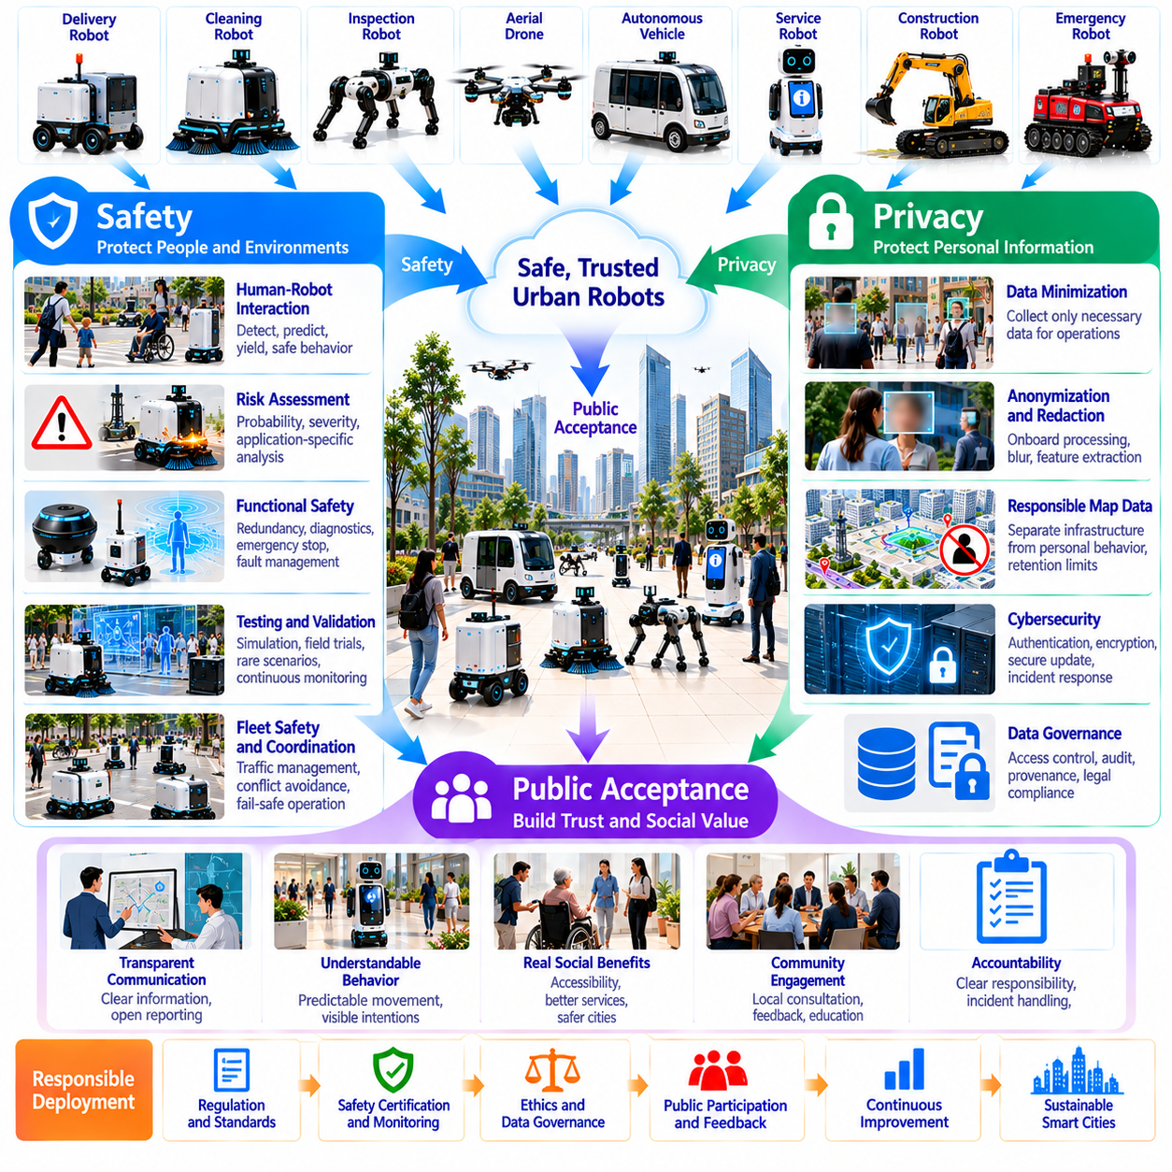
Safety, privacy, and public acceptance are fundamental conditions for integrating Physical AI into urban environments. Autonomous robots increasingly operate in spaces shared with pedestrians, vehicles, workers, and vulnerable populations. Their deployment introduces risks beyond conventional software systems because digital decisions produce physical consequences. Successful urban adoption requires technical reliability, institutional accountability, and sustained public trust.
Urban robotic safety must address interactions within complex and unpredictable human environments. Sidewalks, intersections, hospitals, transportation terminals, and public buildings contain moving obstacles and changing accessibility conditions. Robots must recognize pedestrians, cyclists, mobility aids, and emergency activities while adapting their behavior to local rules. Safety therefore depends on contextual understanding rather than obstacle avoidance alone.
Risk assessment should consider both the probability and severity of potential failures. Vehicle mass, operating speed, payload characteristics, environmental density, and human proximity influence possible consequences. Safety engineering must examine normal operation, foreseeable misuse, component failures, and unusual environmental conditions. Appropriate safeguards should be proportional to the hazards associated with each robotic application.
Functional safety requires dependable sensing, control, actuation, and fault management. Redundant sensors, diagnostic monitoring, emergency stopping, and controlled degradation can reduce the consequences of individual component failures. Robots should transition toward a safe state when critical capabilities become unavailable. However, redundancy alone cannot eliminate failures caused by shared software defects or incorrect environmental assumptions.
Safety assurance extends throughout the robotic system lifecycle. Requirements analysis, simulation, laboratory testing, controlled field trials, and operational monitoring provide complementary evidence of reliability. Testing should include rare but consequential scenarios involving children, crowded spaces, unexpected obstacles, and communication interruptions. Continuous validation is necessary because urban environments and deployed software evolve.
Human-robot interaction introduces additional safety considerations. Robots communicate intentions through movement, lighting, displays, sounds, and predictable stopping behavior. People must be able to understand when a robot intends to turn, cross, approach, or yield. Accessible communication is especially important for individuals with visual, hearing, or mobility impairments, since conventional visual indicators may not serve every pedestrian.
Urban fleet safety also requires coordination among multiple autonomous systems. Independent robots may create congestion, obstruct emergency routes, or compete for narrow passages even when each operates correctly. Fleet management platforms can coordinate access and detect emerging conflicts. Nevertheless, local collision avoidance and emergency responses must remain functional when centralized coordination or communication becomes unavailable.
Privacy risks arise because urban robots frequently use cameras, microphones, positioning sensors, and environmental monitoring systems. These sensors may capture identifiable individuals, private activities, or sensitive locations during ordinary navigation. Data collection should be limited to legitimate operational purposes, with appropriate restrictions on retention, secondary use, and distribution across organizations.
Privacy-by-design principles encourage minimizing personal information before it enters centralized systems. Onboard processing can convert raw observations into navigation features or anonymous environmental descriptions. Selective recording, image redaction, and controlled access may further reduce exposure. However, anonymization techniques require careful evaluation because combined datasets can sometimes enable reidentification.
Shared maps, world models, and city digital twins introduce additional information governance challenges. Persistent records of pedestrian movement, building access, or service activity may reveal patterns unrelated to robotic operations. Systems should distinguish infrastructure knowledge from personal behavioral histories. Data provenance, retention limits, and purpose restrictions help prevent shared intelligence from becoming unrestricted surveillance infrastructure.
Cybersecurity directly affects physical safety when attackers can manipulate robot commands, navigation maps, or software updates. Authentication, encryption, access segmentation, and integrity verification reduce exposure to unauthorized interference. Secure development practices and incident response capabilities are equally important. Robots must retain essential safety functions when networks or external services become compromised.
Public acceptance depends on perceived benefits, understandable risks, and confidence in responsible operation. Residents may welcome improved accessibility, emergency assistance, and reliable public services while opposing intrusive monitoring or sidewalk obstruction. Acceptance can vary across neighborhoods and applications. Deployment decisions should therefore reflect local conditions rather than assuming that technical success guarantees social approval.
Transparency can strengthen trust when organizations explain where robots operate, what information they collect, and how safety incidents are handled. Clear identification of operators and accessible reporting channels allow residents to raise concerns. Public communication should distinguish demonstrated capabilities from experimental functions. Meaningful accountability requires evidence and corrective action rather than promotional claims.
Equity is an important dimension of responsible urban automation. Robotic services may disproportionately benefit commercially attractive districts while imposing noise, congestion, or surveillance burdens elsewhere. Public authorities should evaluate geographic coverage, affordability, disability access, and distribution of operational impacts. Inclusive planning helps ensure that automation improves urban services without reinforcing existing inequalities.
Governance frameworks must assign responsibilities among manufacturers, software developers, fleet operators, infrastructure owners, and public authorities. These responsibilities include certification, maintenance, incident investigation, data protection, and emergency coordination. Regulatory requirements should reflect application-specific risks while allowing controlled innovation. Clear accountability is essential when failures involve several interconnected organizations.
Ultimately, safe and publicly accepted Physical AI requires more than reliable robotic hardware and intelligent algorithms. It demands continuous risk management, privacy protection, cybersecurity, transparent governance, and meaningful public participation. As autonomous systems become embedded in everyday urban life, their legitimacy will depend on whether they respect human rights, preserve accessibility, and deliver measurable public benefits.

03.15. Robot Accessibility and Inclusive City Design
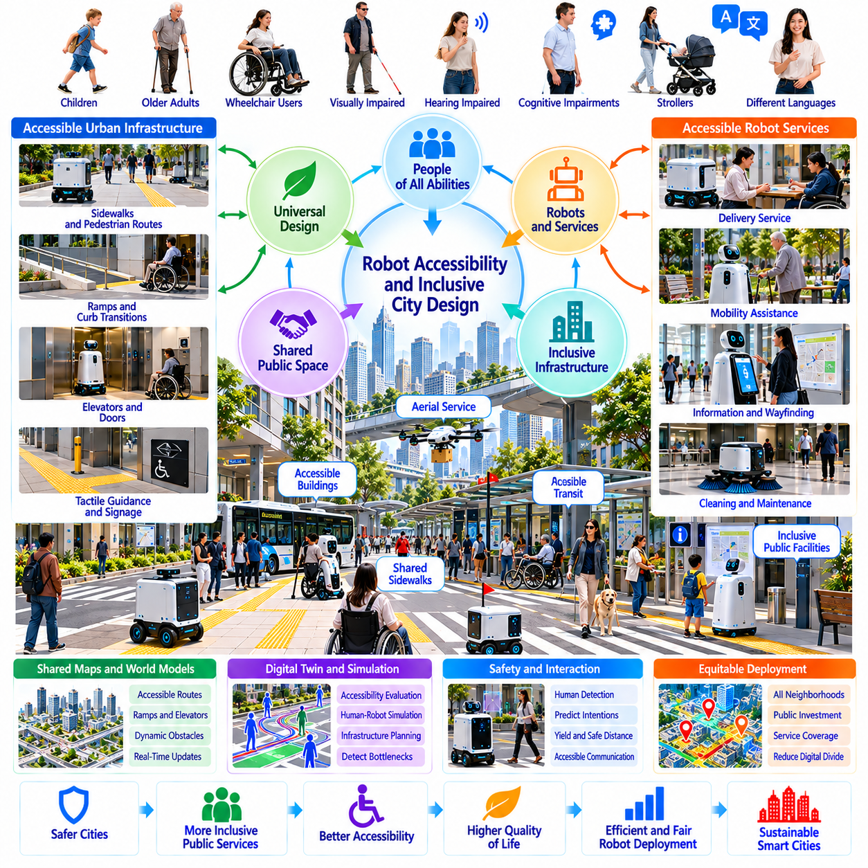
Robot accessibility and inclusive city design are essential to integrating Physical AI into public environments without creating new barriers. As autonomous machines become common in streets, buildings, and transportation facilities, urban infrastructure must accommodate both robotic operation and human diversity. Inclusive design ensures that technological progress improves mobility, independence, and public services for people with different physical and cognitive abilities.
Traditional urban accessibility focuses on removing barriers for pedestrians, wheelchair users, older adults, and people with sensory impairments. Robot accessibility introduces additional requirements involving navigation, infrastructure interfaces, and shared-space behavior. These objectives must be considered together because infrastructure optimized exclusively for robots may unintentionally reduce human accessibility or create conflicts in public spaces.
Universal design provides a useful foundation for robot-inclusive urban planning. Streets, entrances, elevators, and public facilities should remain understandable and usable by people with diverse capabilities. Robotic systems must adapt to these environments rather than demanding extensive modifications that disadvantage pedestrians. The central objective is to improve accessibility for humans while enabling safe and efficient autonomous operation.
Sidewalk design illustrates the challenges of shared human-robot mobility. Delivery robots and maintenance platforms may compete with pedestrians for limited space, particularly near intersections, bus stops, and building entrances. Urban planning should preserve accessible pedestrian routes, adequate turning space, and unobstructed crossings. Robots must yield appropriately and avoid creating obstacles for wheelchair users or people using mobility aids.
Robot navigation systems require accessibility-aware representations of urban infrastructure. Shared maps should identify ramps, stairs, curb transitions, elevators, accessible entrances, and temporary obstructions. Semantic information can distinguish routes suitable for different robot platforms and human mobility needs. Accurate accessibility data supports better planning, but it must be updated as construction, maintenance, and environmental conditions change.
Buildings designed for robotic operation may incorporate automated doors, standardized elevator interfaces, charging areas, and accessible service corridors. However, these features should complement existing accessibility standards rather than replace them. Doorway dimensions, elevator capacity, tactile guidance, and emergency exits must continue to prioritize human requirements while supporting reliable robotic navigation and service delivery.
Human-robot interaction must accommodate different sensory, physical, and cognitive abilities. Robots may communicate intentions through visual displays, speech, sounds, lighting, or predictable movement patterns. No single communication channel serves every individual. Multimodal interaction allows people with visual or hearing impairments to understand robotic behavior, while simple and consistent interfaces reduce cognitive demands.
Inclusive robotic interfaces should support accessible language, adjustable interaction speed, and alternative input methods. Voice commands may help some users but exclude others in noisy environments or when speech is difficult. Touch interfaces, physical controls, and assisted interaction can provide complementary options. Designers should evaluate these mechanisms with representative users rather than assuming that general usability guarantees accessibility.
Physical safety becomes particularly important when robots operate near people with limited mobility or slower reaction times. Sudden movements, narrow passing distances, and unexpected stopping behavior may create disproportionate risks. Navigation policies should account for human comfort, personal space, and movement uncertainty. Conservative behavior near vulnerable pedestrians can improve safety without requiring individuals to adapt to robotic limitations.
Inclusive city design must also consider the accessibility of robotic services themselves. Autonomous delivery, mobility assistance, and public information robots should be usable by people with diverse needs. Service interfaces may require accessible pickup heights, understandable instructions, and assistance mechanisms. A technically successful delivery system offers limited social value if recipients cannot independently retrieve or interact with delivered items.
Digital twins and shared world models can support accessibility evaluation before robotic deployment. Urban planners may simulate pedestrian flows, wheelchair movement, robot traffic, and infrastructure bottlenecks. These representations can identify potential conflicts and compare alternative designs. However, simulated accessibility must be validated through real-world observation and participation by people with different mobility requirements.
Public transportation integration creates opportunities for accessible Physical AI services. Robots may assist with wayfinding, luggage movement, facility inspection, and selected passenger support tasks. Their operation must remain compatible with accessible boarding areas, tactile paving, elevators, and emergency circulation routes. Transportation authorities should evaluate whether robotic services improve overall passenger accessibility rather than merely operational efficiency.
Equitable deployment requires attention to neighborhoods with different infrastructure quality and economic resources. Robot-friendly improvements should not be concentrated exclusively in commercial districts or newly developed areas. Public investment may prioritize locations where accessibility barriers already restrict participation. Inclusive planning evaluates service coverage, affordability, infrastructure readiness, and the distribution of benefits across communities.
Participatory design is essential because accessibility requirements cannot be fully inferred from engineering specifications. People with disabilities, older adults, caregivers, accessibility specialists, and local residents can identify problems overlooked during technical development. Field trials and structured feedback help reveal unexpected interaction difficulties. Meaningful participation should influence design decisions, deployment policies, and ongoing service improvements.
The long-term objective of robot accessibility and inclusive city design is a shared urban environment where autonomous systems enhance human capabilities without restricting individual freedom. Physical AI can contribute to more accessible transportation, public services, and infrastructure management when designed around diverse human needs. Success should be measured through improved independence, equitable access, safety, and the everyday usability of urban spaces.

03.16. From Smart Cities to Physical AI Native Cities
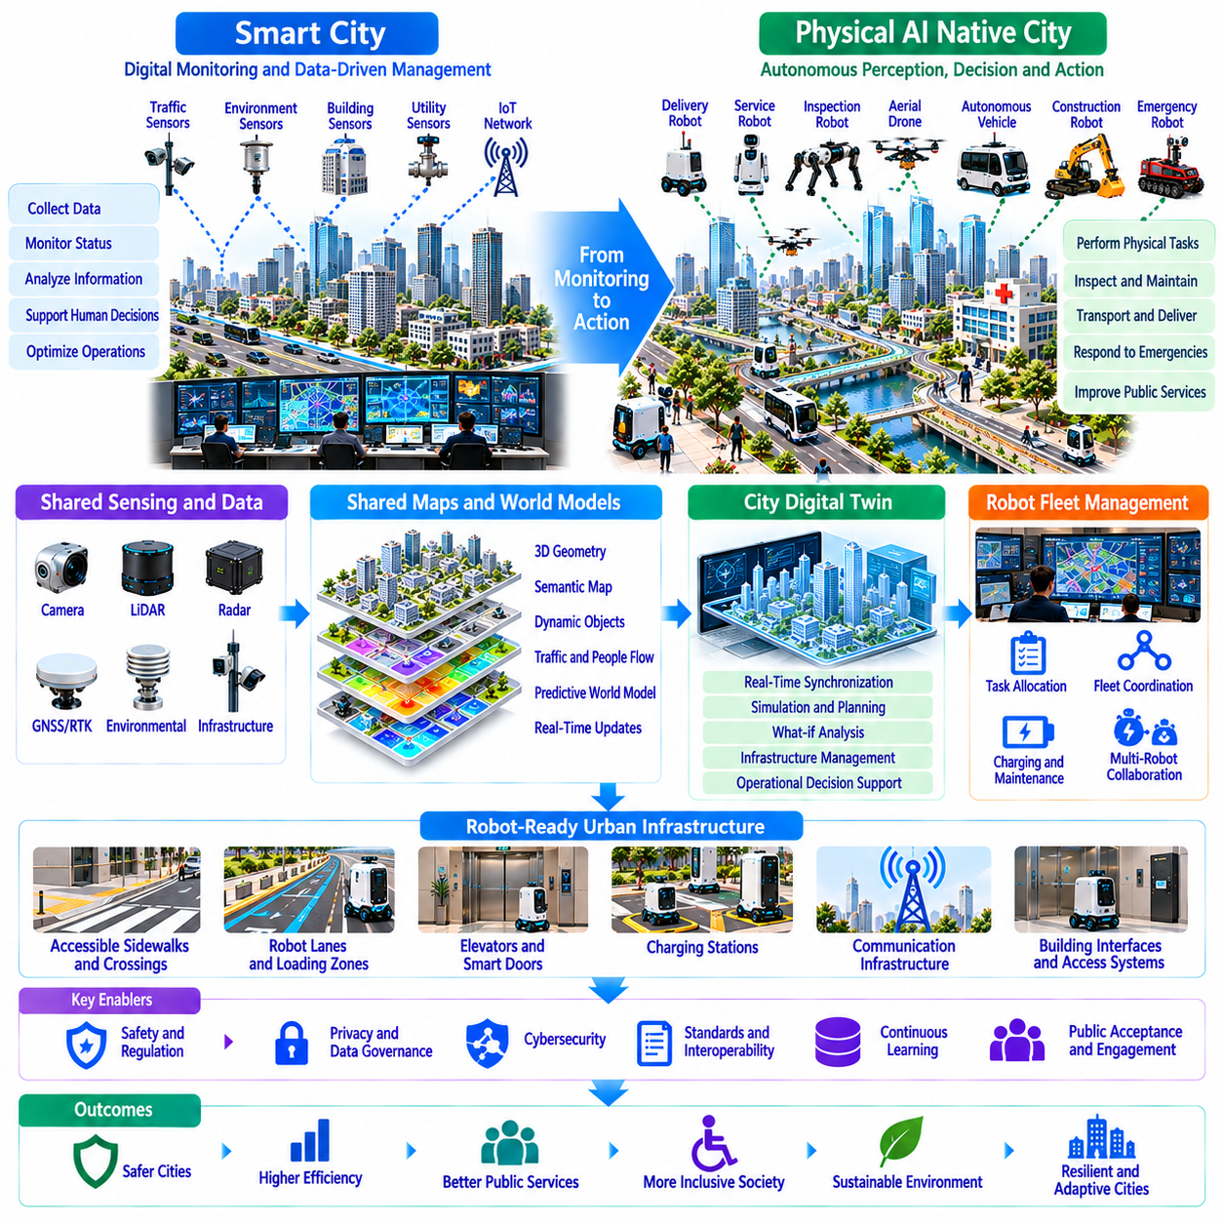
The transition from smart cities to Physical AI-native cities represents a fundamental change in how urban environments are designed, managed, and experienced. Traditional smart cities emphasize digital connectivity, sensor networks, and data-driven decision support. Physical AI-native cities extend these capabilities into autonomous perception, planning, and action, enabling intelligent machines to participate directly in urban operations and infrastructure management.
Conventional smart city architectures primarily collect information from transportation systems, utilities, buildings, and public services. Centralized platforms analyze these observations to support human decisions and operational optimization. Physical AI introduces embodied intelligence that can independently inspect facilities, transport materials, maintain infrastructure, and respond to changing conditions. Urban intelligence consequently evolves from passive monitoring toward active physical intervention.
This transformation requires cities to become environments that support autonomous machines as regular operational participants. Streets, sidewalks, buildings, elevators, loading zones, and public facilities must accommodate robotic mobility and interaction. Robot-compatible infrastructure should complement human accessibility rather than compete with it. The objective is a shared urban environment where people and autonomous systems operate safely and efficiently.
A Physical AI-native city depends on integrated perception across robots and fixed infrastructure. Cameras, LiDAR, radar, positioning systems, and environmental sensors provide complementary observations of urban conditions. Distributed sensing enables robots to detect obstacles, identify infrastructure changes, and anticipate operational constraints. Reliable integration requires synchronized information, consistent spatial references, and mechanisms for managing uncertainty.
Shared maps and world models provide a common representation of the physical city. Static geographic information must be combined with dynamic observations of traffic, pedestrian activity, construction, weather, and infrastructure availability. Predictive world models can estimate how conditions may evolve and support anticipatory planning. Their reliability depends on continuous validation, uncertainty estimation, and timely correction of outdated information.
Urban digital twins may evolve from visualization and simulation platforms into operational environments connected to autonomous systems. Real-world observations update virtual representations, while simulations evaluate proposed actions before physical execution. This connection can support infrastructure maintenance, traffic coordination, and emergency planning. However, digital predictions must remain distinguishable from verified physical conditions.
Hierarchical computing architectures are necessary to balance immediate robotic control with city-scale intelligence. Onboard processors manage safety-critical perception and action, while edge computing supports nearby coordination and low-latency services. Regional platforms and cloud infrastructure enable large-scale learning, optimization, and historical analysis. This distribution reduces dependence on centralized decisions while preserving shared operational knowledge.
City-scale robot fleets require coordination beyond individual navigation. Delivery robots, inspection platforms, cleaning machines, and autonomous vehicles may share routes, facilities, and infrastructure resources. Fleet orchestration systems can manage task allocation, congestion, charging schedules, and service priorities. Interoperability between manufacturers and operators becomes essential when multiple robotic ecosystems occupy the same urban environment.
Physical AI-native infrastructure also requires standardized interfaces between robots and buildings. Elevators, automatic doors, access systems, charging facilities, and service areas can expose secure machine-readable capabilities. Robots may request access or coordinate facility usage without extensive manual intervention. These interfaces must preserve cybersecurity, human priority, and emergency override mechanisms.
Continuous learning distinguishes Physical AI-native cities from static automation deployments. Operational experience can reveal recurring navigation failures, accessibility barriers, equipment degradation, and changing service demand. Curated fleet data supports model improvement and policy refinement across different environments. Learning systems nevertheless require controlled updates, independent validation, and safeguards against performance regression.
Urban autonomy introduces new requirements for safety assurance and public governance. Robotic decisions may influence pedestrian movement, transportation access, infrastructure availability, and emergency operations. Clear operational boundaries, incident reporting, and accountable oversight are necessary. Public institutions must establish how autonomous services are authorized, monitored, corrected, and suspended when unacceptable risks emerge.
Privacy and cybersecurity become foundational properties of the urban operating environment. Distributed robots continuously encounter sensitive spaces and potentially identifiable individuals. Data minimization, secure communication, access controls, and transparent retention policies reduce unnecessary exposure. Shared intelligence must not become unrestricted surveillance, and compromised digital infrastructure must not undermine physical safety.
Economic transformation will accompany the development of Physical AI-native cities. Autonomous services may improve infrastructure utilization, reduce repetitive labor demands, and enable continuous inspection or maintenance. However, deployment requires investment in connectivity, computing, facilities, energy, and operational support. Sustainable adoption depends on measurable service benefits, realistic lifecycle costs, and equitable distribution of economic value.
The transition is likely to proceed through incremental integration rather than immediate replacement of existing urban systems. Controlled deployments in campuses, logistics districts, hospitals, and transportation facilities can establish operational evidence. Successful applications may expand through interoperable infrastructure and shared governance frameworks. Each expansion should evaluate safety, accessibility, reliability, and public acceptance before increasing autonomy.
Ultimately, a Physical AI-native city is not simply a smart city containing more robots. It is an urban ecosystem where physical infrastructure, digital intelligence, autonomous machines, and human institutions operate through coordinated feedback loops. Its defining achievement will be the ability to perceive changing conditions, learn from experience, and improve public services through safe physical action while preserving human control and inclusive urban life.

