Volume 13. Future of Physical AI and Civilization

Chapter 01. Physical AI and Labor

01.01. From Mechanical Automation to Intelligent Labor
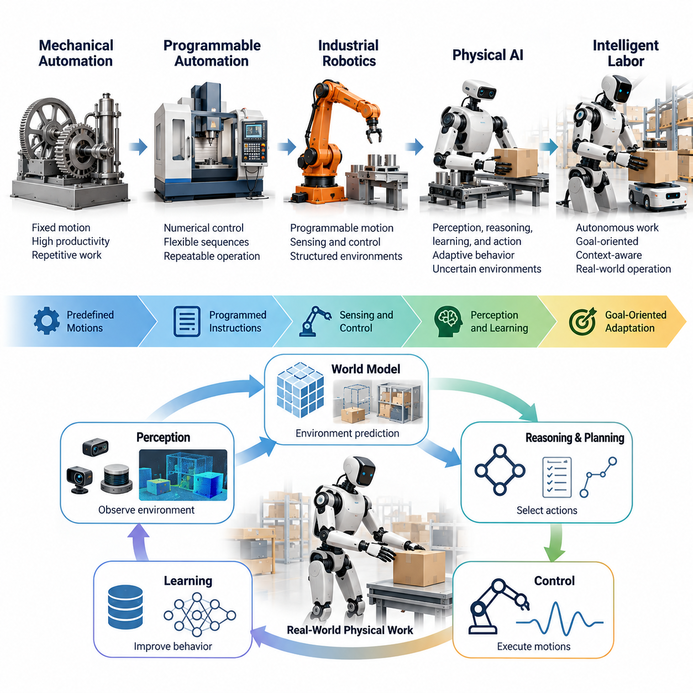
The evolution from mechanical automation to intelligent labor represents a fundamental transformation in how human societies organize physical work. Traditional machines were designed to execute predefined motions under controlled conditions, whereas Physical AI systems increasingly combine perception, reasoning, learning, and action to perform tasks in environments characterized by uncertainty, variability, and continuous change.
Mechanical automation emerged from the need to increase productivity, improve precision, and reduce dependence on repetitive human effort. Early industrial machines converted energy into controlled motion, enabling production at scales beyond manual capabilities. However, these systems generally required carefully structured environments, fixed operating procedures, and human intervention whenever unexpected conditions disrupted normal operation.
The development of programmable automation introduced greater flexibility through numerical control, industrial controllers, and robotic manipulators. Manufacturing systems could execute complex sequences with high repeatability, while sensors provided limited feedback about machine states and production conditions. Nevertheless, most automated equipment remained dependent on explicitly programmed rules and engineering assumptions established before deployment.
Industrial robotics extended mechanical automation by combining programmable motion with increasingly sophisticated sensing and control. Robotic arms became capable of welding, assembly, material handling, and precision manufacturing. Their effectiveness was particularly high in structured environments where objects, workstations, and task sequences remained predictable, but adaptation to unfamiliar situations often required substantial reprogramming.
The emergence of Physical AI changes this relationship between machines and their operating environments. Instead of relying exclusively on predetermined trajectories, intelligent physical systems can interpret sensory observations, estimate environmental states, select actions, and adjust behavior according to changing conditions. This transition introduces adaptive decision-making into activities previously constrained by rigid automation architectures.
Intelligent labor can be understood as physical work performed by autonomous or semi-autonomous systems capable of integrating perception, planning, control, and feedback. Such systems do not merely repeat movements but attempt to achieve operational objectives despite environmental variation. Their intelligence is expressed through reliable task execution, context-sensitive adaptation, and the ability to respond appropriately to unexpected events.
A central distinction between conventional automation and intelligent labor concerns the representation of tasks. Traditional automation frequently defines work as a sequence of machine instructions, while Physical AI can represent work through objectives, constraints, environmental conditions, and desired outcomes. This allows a system to consider alternative action sequences when the original execution plan becomes unsuitable.
Modern perception technologies provide an essential foundation for this transition. Cameras, depth sensors, LiDAR, force sensors, and proprioceptive measurements allow robots to estimate their surroundings and internal physical states. Machine learning models transform these observations into representations of objects, obstacles, surfaces, movements, and interactions that support increasingly sophisticated autonomous behavior.
World models extend perception by representing how physical environments may evolve over time. By combining spatial understanding, object relationships, physical dynamics, and action-dependent predictions, these models can support decisions about future consequences. Their development is particularly important for intelligent labor because successful physical work requires anticipating interactions rather than reacting only to immediate observations.
Learning-based control introduces another important departure from conventional automation. Instead of requiring engineers to specify every possible response, robotic systems can acquire behaviors through demonstrations, reinforcement learning, simulation, and operational experience. These methods may improve adaptation to complex tasks, although reliable deployment still depends on sufficient data coverage, safety constraints, and robust evaluation.
The integration of vision-language-action models offers a possible pathway toward more flexible task specification. Human instructions can be associated with visual observations and physical actions, allowing robots to interpret goals expressed in natural language. However, translating general instructions into dependable real-world execution remains difficult because physical tasks involve geometric precision, contact dynamics, uncertainty, and safety requirements.
Intelligent labor also requires the coordination of multiple temporal horizons. Low-level controllers regulate forces and movements over short intervals, while task planners coordinate actions across longer periods. Higher-level reasoning systems may manage objectives extending across complete workflows. Effective integration of these horizons is necessary for robots to execute meaningful tasks without continuous human direction.
The transition becomes especially visible in manufacturing and logistics. Conventional machines perform repetitive operations at dedicated workstations, whereas intelligent mobile robots can potentially transport materials, recognize changing layouts, manipulate varied objects, and coordinate with other equipment. These capabilities may allow automation to expand beyond isolated production cells into interconnected operational environments.
In construction, agriculture, and infrastructure maintenance, the limitations of mechanical automation become particularly apparent. Worksites change continuously, surfaces are irregular, materials vary, and environmental conditions cannot always be controlled. Physical AI offers the possibility of adapting robotic operations to these circumstances, although perception reliability, mobility, manipulation, and environmental robustness remain major technical challenges.
The transformation of labor should not be interpreted simply as replacing human workers with autonomous machines. Most occupations combine physical execution, judgment, communication, responsibility, and situational awareness. Consequently, intelligent automation is more likely to affect individual tasks at different rates, producing new arrangements of human supervision, robotic execution, and collaborative decision-making across many industries.
Human workers may increasingly concentrate on defining objectives, managing exceptions, supervising autonomous systems, and handling situations requiring social understanding or complex judgment. Robots may assume repetitive, physically demanding, hazardous, or highly standardized activities. The resulting division of responsibilities will depend on technical reliability, deployment economics, organizational design, regulatory requirements, and worker acceptance.
The economic significance of intelligent labor extends beyond improvements in machine productivity. Adaptive robots may increase equipment utilization, reduce operational interruptions, and make automation feasible for smaller production batches or more variable workflows. However, the actual benefits must account for acquisition costs, energy consumption, maintenance, integration, supervision, downtime, and the continuing need for human expertise.
An important consequence is the gradual separation of productive physical capacity from direct human working hours. Conventional automation already supports continuous industrial operation, but intelligent systems could extend this capability to environments requiring frequent adaptation. If reliability and affordability improve sufficiently, organizations may expand productive capacity without proportionally increasing the number of workers assigned to routine physical execution.
Nevertheless, autonomous physical labor remains constrained by fundamental engineering challenges. Robots must operate under uncertain sensory conditions, imperfect models, actuator limitations, and unpredictable human behavior. Errors that might be tolerable in digital applications can produce physical damage or injury. Consequently, intelligent labor requires rigorous safety engineering, uncertainty management, monitoring, and reliable fallback mechanisms.
The transition also changes the meaning of operational knowledge. In conventional automation, expertise is frequently embedded in machine programs, mechanical designs, and human procedures. Physical AI introduces learned policies, shared representations, and experience-based adaptation as additional forms of productive knowledge. Managing these resources becomes increasingly important for maintaining performance across changing tasks and environments.
Large-scale robotic fleets could accelerate this process through collective experience. Operational observations from multiple robots may reveal recurring failures, environmental variations, and opportunities for improved behavior. When supported by appropriate data governance, validation, and controlled deployment, these experiences can contribute to continuous system improvement and the gradual accumulation of reusable physical intelligence.
The development of intelligent labor is therefore not a single technological event but a progressive transformation involving robotics, artificial intelligence, infrastructure, economics, and institutions. Different industries will adopt these capabilities at different speeds because task complexity, safety requirements, labor costs, and environmental variability differ substantially. General-purpose physical labor remains an ambitious objective rather than an established universal capability.
Over the longer term, the distinction between machines as fixed production tools and machines as adaptive participants in productive activity may become increasingly important. Physical AI could enable new organizational models in which humans establish goals, exercise oversight, and contribute specialized expertise while autonomous systems perform growing portions of physical execution. The resulting transformation will depend as much on governance and human choices as on technological progress.
Ultimately, the movement from mechanical automation to intelligent labor represents a shift from programmed motion toward goal-directed physical agency. Its historical importance lies not only in the possibility of producing more goods with fewer repetitive operations, but also in changing how physical capabilities are created, distributed, and coordinated. Understanding this transition provides the foundation for examining the future relationship between Physical AI, human employment, and civilization.

01.02. Task Automation vs Occupation Automation
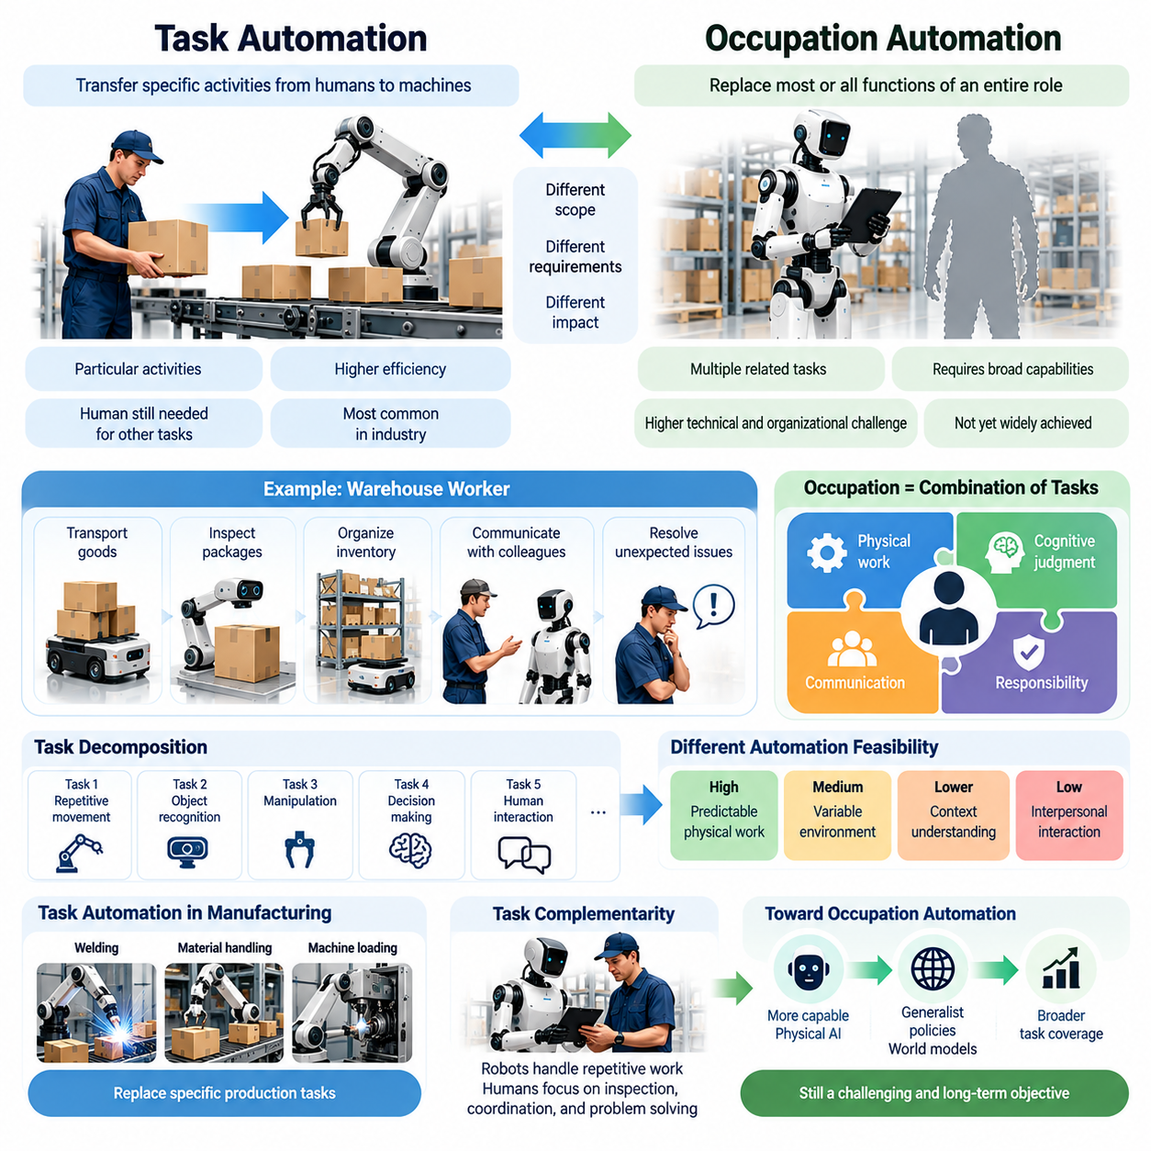
Task automation and occupation automation represent two fundamentally different dimensions of technological change in the labor market. Task automation refers to the transfer of specific activities from humans to machines, while occupation automation implies replacing most or all functions associated with an entire professional role. Understanding this distinction is essential for evaluating how Physical AI may transform employment, productivity, and organizational structures.
An occupation consists of multiple tasks requiring different combinations of physical capabilities, cognitive judgment, communication, and responsibility. A warehouse worker may transport goods, identify damaged packages, organize inventory, communicate with colleagues, and resolve unexpected operational problems. Automating material transportation does not automatically eliminate the broader occupation because many complementary responsibilities remain.
Traditional industrial automation has primarily operated at the task level. Assembly robots perform welding, fastening, and repetitive manipulation, while automated conveyors transport materials along predefined routes. These technologies replace particular activities rather than entire occupational categories. Human workers continue performing setup, maintenance, inspection, exception handling, and coordination across the production process.
Physical AI expands the range of tasks that machines can potentially perform by combining perception, planning, learning, and adaptive control. Autonomous mobile robots can navigate changing environments, while intelligent manipulators can interact with objects exhibiting variations in shape, position, and orientation. Nevertheless, improvements in individual capabilities do not necessarily translate into complete occupational autonomy.
The distinction becomes clearer when considering task decomposition. Complex occupations can be represented as collections of activities with different technical requirements, execution frequencies, and operational dependencies. Some activities involve predictable physical movements, whereas others require contextual understanding or interpersonal interaction. Their automation feasibility must therefore be evaluated separately rather than inferred from an occupational title.
Task automation depends on several interacting factors, including technical feasibility, economic viability, operational reliability, and institutional acceptance. A robotic system may successfully demonstrate a particular activity in laboratory conditions without becoming commercially suitable for continuous deployment. Real-world automation requires acceptable performance under uncertainty, manageable maintenance costs, and compliance with relevant safety requirements.
Occupation automation introduces additional challenges because tasks are rarely independent. Completing one activity may require information generated by another, and unexpected events can change the entire workflow. A robot capable of transporting materials may still require human assistance when inventory records conflict, equipment fails, or priorities change. Such dependencies limit the effectiveness of evaluating occupational replacement through isolated demonstrations.
The concept of task coverage provides a useful framework for understanding automation progress. Task coverage describes the proportion of activities within an occupation that a technological system can perform at an acceptable standard. However, coverage should consider task frequency, duration, economic value, and operational criticality. Automating many minor activities may have less practical impact than automating one time-consuming responsibility.
A related concept is task complementarity, which describes how automated and human activities interact within a workflow. When robots perform repetitive transportation or heavy lifting, human workers may devote more attention to inspection, coordination, and problem-solving. In such cases, automation increases the productivity of remaining human tasks rather than eliminating the occupation itself.
Task substitution occurs when machines directly replace human effort in specific activities. The economic consequences depend on whether displaced working hours can be reassigned to other productive functions. If automation reduces the need for routine handling while increasing demand for supervision and quality assurance, the occupational structure may change without a proportional decline in employment.
Complete occupation automation requires much broader capabilities than individual task substitution. An autonomous system must execute interconnected activities, manage transitions between them, recognize exceptions, and maintain performance across varying circumstances. It must also operate within organizational procedures and accountability structures. These requirements make occupational automation a substantially more demanding objective than automating isolated physical operations.
Physical AI may reduce this gap through generalist robotic policies and increasingly capable world models. Systems that learn reusable representations of objects, actions, and environmental dynamics could transfer knowledge across related tasks. Vision-language-action architectures may also enable flexible instruction following. However, generalization across tasks, environments, and robot embodiments remains an unresolved technical challenge.
Manufacturing provides a practical illustration of these distinctions. Industrial robots may automate material placement, welding, and machine loading while human technicians manage calibration, quality verification, and production changes. Even when several production tasks become autonomous, the manufacturing occupation may evolve toward system supervision and process optimization rather than disappear entirely.
Warehouse operations demonstrate similar dynamics. Autonomous mobile robots can transport inventory between locations, while automated picking systems may handle selected products under suitable conditions. Human workers remain important for irregular objects, damaged goods, inventory discrepancies, and unusual customer requirements. The resulting labor transformation depends on how effectively automated components integrate into the complete workflow.
Construction presents greater obstacles to occupation automation because work environments are highly variable. Robots may perform surveying, layout marking, material transport, or selected installation activities, but construction professionals also interpret drawings, coordinate trades, respond to site conditions, and make safety-critical judgments. Automating these responsibilities requires capabilities extending beyond accurate physical manipulation.
Healthcare illustrates the importance of nonphysical occupational requirements. Robots can support logistics, patient transportation, cleaning, and selected clinical procedures, yet healthcare occupations involve communication, empathy, ethical judgment, and professional accountability. Even sophisticated physical automation does not automatically reproduce these human responsibilities, making task augmentation a more realistic pathway in many healthcare settings.
The economic impact of automation depends on how organizations redesign workflows after introducing intelligent machines. Simply replacing individual tasks may produce limited benefits if remaining processes create bottlenecks. Greater productivity often requires reorganizing work allocation, information flows, equipment utilization, and human responsibilities. Consequently, organizational adaptation becomes as important as technological capability.
Automation exposure should not be confused with actual employment displacement. An occupation may contain numerous technically automatable tasks without experiencing immediate workforce reductions. Adoption depends on capital availability, implementation costs, regulatory constraints, customer expectations, and labor market conditions. Furthermore, productivity improvements may increase output demand and create additional activities that partially offset displaced work.
Task automation can also generate new occupational responsibilities. Robot deployment requires integration engineers, fleet supervisors, maintenance specialists, safety auditors, data engineers, and operational trainers. As autonomous systems become more widespread, these functions may develop into specialized professions. However, the number, accessibility, and compensation of newly created positions may differ substantially from those associated with displaced activities.
Measuring automation therefore requires more than counting robot installations or estimating the percentage of tasks that machines can perform. A comprehensive assessment should examine actual operating hours, human intervention frequency, task completion reliability, labor hours saved, and changes in employment composition. These measurements help distinguish technological demonstrations from economically meaningful transformations of work.
A useful analytical approach is to evaluate occupations as dynamic task networks rather than fixed collections of duties. When one activity becomes automated, the importance, frequency, and organization of remaining activities may change. New tasks can emerge while obsolete procedures disappear. This dynamic perspective explains why occupational transformation cannot be reliably predicted by simply summing the automation probabilities of individual tasks.
The relationship between task automation and occupation automation will also vary across industries and regions. Environments with standardized processes, high labor costs, and substantial production volumes may adopt automation more rapidly. Smaller organizations or highly variable workplaces may experience slower transitions. Differences in infrastructure, workforce skills, regulation, and investment capacity will further influence adoption patterns.
Over time, advances in Physical AI could increase the number of occupations in which machines perform most routine physical activities. Nevertheless, the transition from high task coverage to complete occupational replacement remains dependent on reliability, adaptability, accountability, and economic integration. Human roles may increasingly emphasize oversight, exception management, creative problem-solving, and coordination across autonomous systems.
Ultimately, distinguishing task automation from occupation automation provides a more accurate foundation for understanding the future of labor. Physical AI will not necessarily transform employment through the immediate disappearance of entire professions. Instead, its effects are likely to emerge through successive changes in task allocation, occupational responsibilities, and organizational design, with outcomes determined by both technological capabilities and human economic decisions.

01.03. Physical vs Cognitive Task Automation
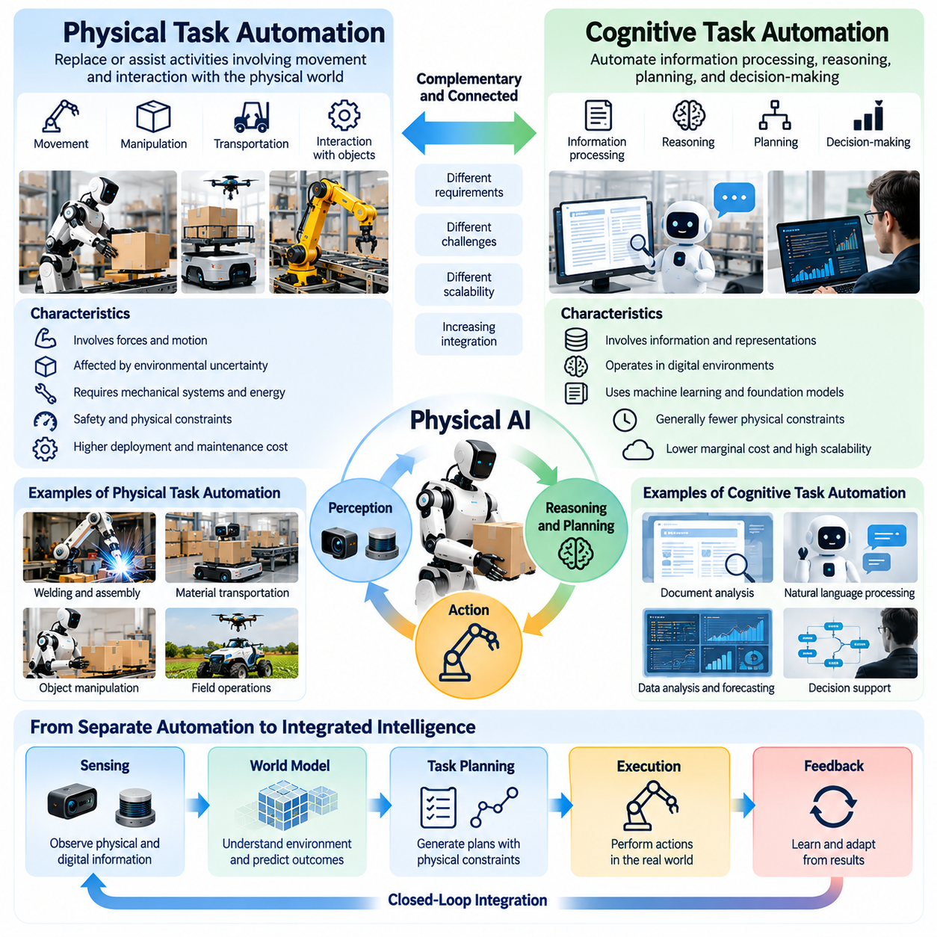
Physical task automation and cognitive task automation represent two complementary dimensions of technological transformation in human labor. Physical automation replaces or assists activities involving movement, manipulation, transportation, and interaction with material environments. Cognitive automation addresses information processing, reasoning, planning, and decision-making. Physical AI increasingly connects these dimensions through integrated perception and action.
Historically, physical automation developed through mechanization, industrial machinery, and programmable robotics. Machines increased human productive capacity by performing repetitive movements with greater speed, strength, and consistency. Cognitive automation evolved through computing, expert systems, and artificial intelligence, allowing software to process information and execute predefined decision procedures without directly interacting with physical objects.
The distinction between physical and cognitive tasks reflects differences in their operational requirements. Physical tasks involve forces, motion, contact dynamics, spatial constraints, and environmental uncertainty. Cognitive tasks primarily involve representations, information relationships, logical operations, and abstract objectives. However, many real-world occupations combine these requirements, making a strict separation increasingly difficult.
Traditional physical automation depends heavily on structured environments and predictable interactions. Industrial robots can execute precise trajectories when object positions, tooling, and workspace conditions remain stable. Cognitive automation often operates in digital environments where information can be copied, transformed, and evaluated without mechanical constraints. These differences influence the cost, reliability, and scalability of automation technologies.
Physical AI introduces intelligence into physical task execution by integrating sensors, computational models, and adaptive control. A robot must perceive its environment, estimate relevant physical states, select appropriate actions, and continuously adjust movement. Unlike purely digital systems, its decisions produce physical consequences that may be difficult to reverse and can introduce safety risks.
Cognitive automation has advanced through machine learning, natural language processing, computer vision, and foundation models. These technologies support document analysis, software generation, information retrieval, forecasting, and decision assistance. Although their outputs can influence physical operations, cognitive systems generally require additional interfaces, actuators, and control mechanisms to execute actions in the material world.
A fundamental difference concerns the relationship between intelligence and embodiment. Cognitive AI can manipulate symbolic or learned representations without possessing a physical body. Physical AI requires embodiment through sensors, actuators, mechanical structures, and environmental interaction. The capabilities of an embodied system depend not only on computational intelligence but also on morphology, energy availability, mechanical precision, and control bandwidth.
The automation of physical tasks also introduces complex temporal requirements. Motor control may require rapid feedback to maintain stability, regulate contact forces, and avoid collisions. Cognitive reasoning can sometimes operate over longer intervals, although time-critical digital applications also exist. Integrated Physical AI architectures must coordinate fast control processes with slower planning and deliberative reasoning.
Environmental uncertainty creates another important distinction. Digital information systems frequently operate with explicit data structures and standardized interfaces, while physical environments contain irregular surfaces, deformable objects, uncertain friction, and unpredictable disturbances. Robots must estimate hidden states and compensate for imperfect measurements. These challenges make reliable physical execution more difficult than producing a plausible digital response.
Physical tasks are also constrained by energy, materials, and mechanical wear. Moving heavy objects requires sufficient actuator torque, structural strength, and power capacity. Repeated operations introduce maintenance requirements and component degradation. Cognitive automation consumes computational resources but generally does not face equivalent mechanical constraints during purely digital execution.
The economic scalability of the two automation categories therefore differs substantially. Cognitive software can often be distributed across many users with relatively low additional deployment costs, although computing expenses remain important. Physical automation requires hardware production, installation, maintenance, safety validation, and site-specific integration. These requirements can slow deployment even when intelligent control algorithms improve rapidly.
Nevertheless, physical and cognitive automation increasingly reinforce each other. Cognitive models can interpret instructions, generate plans, and reason about operational objectives, while physical systems execute actions and collect environmental feedback. This relationship enables closed-loop intelligence in which perception, reasoning, action, and evaluation operate as interconnected components rather than isolated technological functions.
World models provide an important bridge between cognitive reasoning and physical execution. By representing environmental states, object interactions, and predicted consequences of actions, these models support planning grounded in physical dynamics. A robot can potentially evaluate alternative actions before execution, although prediction accuracy remains limited by model uncertainty and unfamiliar operating conditions.
Vision-language-action models extend this integration by connecting visual observations, language instructions, and robotic control outputs. Such architectures can translate high-level task descriptions into action representations, reducing dependence on manually programmed procedures. However, reliable deployment still requires precise control, safety constraints, and mechanisms for detecting failures during execution.
Manufacturing illustrates how cognitive and physical automation can operate together. Cognitive systems may optimize production schedules, analyze quality measurements, and predict equipment failures. Physical robots perform assembly, material handling, and inspection movements. Integrating these capabilities can improve operational coordination, but successful deployment depends on reliable communication between planning systems and physical equipment.
In logistics, cognitive automation supports demand forecasting, inventory planning, and route optimization, while physical automation handles transportation, sorting, and selected picking operations. Their integration enables warehouse systems to coordinate information flows with material movement. Human workers remain essential where uncertain conditions, unusual products, or operational exceptions exceed automated capabilities.
Construction and infrastructure maintenance demonstrate the importance of combining both dimensions. Cognitive systems can analyze engineering drawings, compare digital models with observed conditions, and identify potential discrepancies. Physical robots can perform surveying, scanning, inspection, or selected construction activities. Connecting digital reasoning with accurate physical measurement creates opportunities for more adaptive project execution.
Healthcare provides another example of complementary automation. Cognitive AI can assist with medical information analysis, scheduling, and clinical documentation, while physical robots support logistics, rehabilitation, and selected procedures. However, clinical responsibility, patient communication, and safety requirements limit the extent to which these capabilities can independently replace professional human judgment.
The labor implications of physical and cognitive automation are not identical. Cognitive automation may transform information-intensive occupations by reducing time spent on documentation, analysis, and routine decision support. Physical automation may reduce demand for repetitive movement, transportation, and material handling. Occupations combining both types of work may experience broader restructuring as integrated systems become more capable.
Human workers may increasingly perform functions that connect automated reasoning with physical operations. These responsibilities include defining objectives, validating machine decisions, supervising robotic execution, resolving exceptions, and ensuring compliance with safety requirements. Consequently, the future workforce may require combinations of digital literacy, physical systems knowledge, operational judgment, and interdisciplinary coordination.
The convergence of physical and cognitive automation also introduces new safety and accountability challenges. Errors in cognitive planning can propagate into robotic actions, while inaccurate physical observations can corrupt higher-level decisions. Effective systems therefore require uncertainty estimation, runtime monitoring, verification, and human intervention mechanisms that operate across both computational and physical layers.
Progress toward general-purpose Physical AI depends on overcoming limitations in both domains simultaneously. Advanced reasoning alone cannot compensate for inadequate manipulation, sensing, or mechanical reliability. Similarly, highly capable robotic hardware cannot achieve broad autonomy without contextual understanding and adaptable planning. General physical intelligence requires coordinated development across computation, embodiment, learning, and control.
Ultimately, physical and cognitive task automation should be understood as increasingly interconnected components of intelligent production systems. Their convergence may transform labor by combining the automation of information processing with the automation of material interaction. The resulting changes will depend on technological maturity, economic feasibility, organizational adaptation, and the continuing role of human judgment in complex physical environments.

01.04. Human Robot Task Reallocation
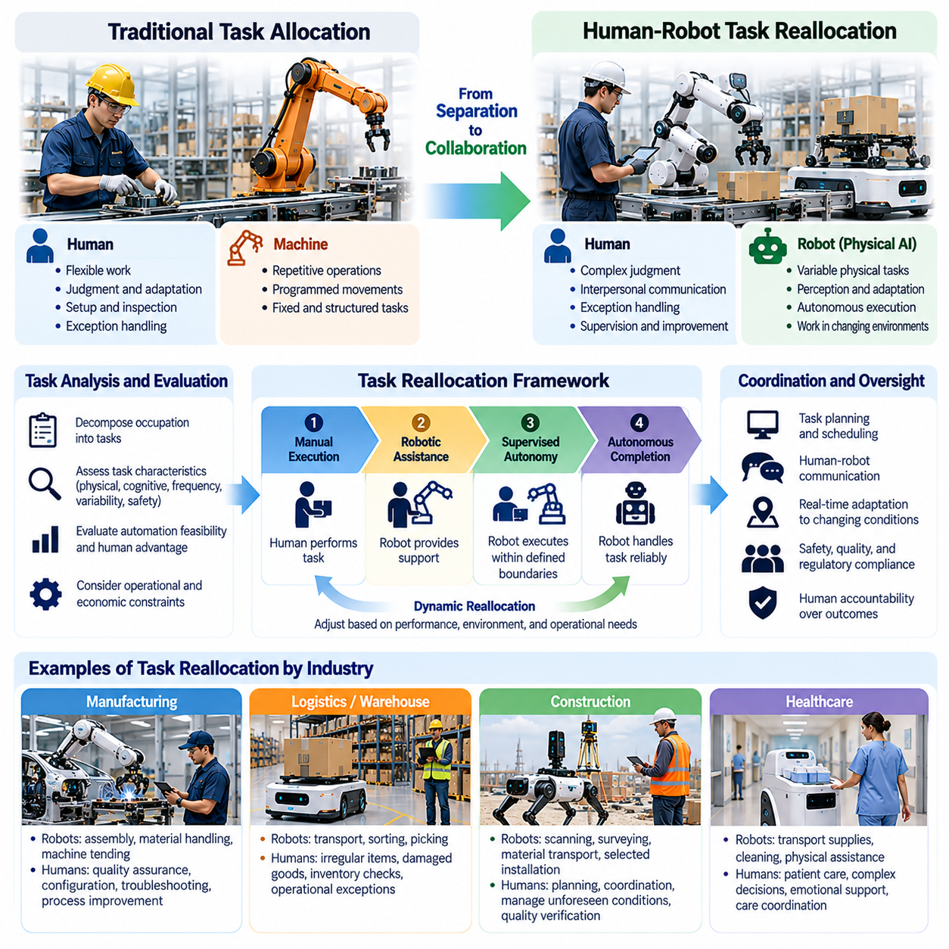
Human-robot task reallocation describes the redistribution of work between human workers and intelligent machines as Physical AI becomes integrated into productive environments. Rather than replacing entire occupations, robotic systems increasingly assume selected activities while humans retain or acquire complementary responsibilities. This transformation changes how work is organized, coordinated, supervised, and evaluated across industries.
Traditional labor allocation has generally assigned machines to repetitive operations and humans to activities requiring flexibility, judgment, and adaptation. Industrial robots execute programmed movements, while workers handle setup, inspection, maintenance, and unexpected situations. Physical AI challenges this division by enabling machines to perform increasingly variable tasks that previously required continuous human involvement.
Effective task reallocation begins with understanding the structure of work. An occupation can be decomposed into activities characterized by physical demands, cognitive complexity, frequency, variability, and safety requirements. Each activity can then be evaluated according to robotic capability, human comparative advantage, operational constraints, and economic feasibility rather than assuming that entire jobs must remain exclusively human or robotic.
Tasks involving repetitive transportation, heavy lifting, predictable manipulation, and hazardous exposure are often attractive candidates for robotic execution. Machines can potentially provide consistent performance while reducing physical strain and occupational risk. However, their suitability depends on environmental conditions, task variability, reliability, and integration costs rather than physical repetition alone.
Human workers may retain responsibilities involving ambiguous situations, ethical judgment, interpersonal communication, and complex exception handling. These activities frequently require contextual knowledge extending beyond immediate sensor observations. Human involvement also remains important when robotic decisions have significant safety, legal, or organizational consequences that require accountable oversight.
Task reallocation should be understood as a dynamic process rather than a permanent division of responsibilities. As robotic capabilities improve, activities initially requiring direct human control may transition toward supervised autonomy. Conversely, unexpected environmental conditions or equipment failures may temporarily return control to human operators, creating flexible arrangements between autonomous execution and human intervention.
A useful framework distinguishes manual execution, robotic assistance, supervised autonomy, and autonomous task completion. Manual execution places primary responsibility for physical actions on humans, while robotic assistance provides mechanical or computational support. Supervised autonomy allows robots to execute tasks independently within defined boundaries, whereas autonomous completion requires reliable handling of expected operating conditions.
The allocation of responsibility must also account for the difference between performing an action and being accountable for its consequences. A robot may independently transport materials or manipulate equipment, but organizations remain responsible for safety, quality, and regulatory compliance. Consequently, increasing machine autonomy does not automatically eliminate human supervisory and institutional responsibilities.
Human-robot collaboration introduces coordination requirements that are absent from isolated automation. Workers and robots must exchange information about task objectives, operating states, spatial constraints, and unexpected events. Effective collaboration requires interfaces that communicate machine intentions and limitations clearly, allowing humans to understand when intervention is necessary and how robotic behavior may affect surrounding activities.
Physical AI can support more adaptive allocation through real-time task planning and environmental awareness. Robots may select activities according to workload, location, available resources, and operational priorities. Human supervisors can redirect assignments when circumstances change, while fleet management systems coordinate multiple machines to reduce congestion, waiting time, and unnecessary movement.
Manufacturing provides an important example of task reallocation. Robots may perform repetitive assembly, material handling, and machine tending, while human workers concentrate on quality assurance, process improvement, equipment configuration, and troubleshooting. As intelligent manipulation improves, the boundary between automated execution and human intervention may shift toward increasingly complex production activities.
Warehouse operations demonstrate how reallocation can transform complete workflows. Autonomous mobile robots can transport inventory, while automated handling systems perform selected sorting and picking operations. Human workers may focus on irregular products, damaged goods, inventory discrepancies, and operational exceptions. Productivity improvements depend on coordinating these responsibilities rather than simply introducing additional robots.
Construction environments require particularly flexible arrangements because tasks and site conditions change continuously. Robots may perform scanning, surveying, layout marking, material transportation, and selected installation activities. Human professionals remain responsible for interpreting engineering requirements, coordinating trades, managing unforeseen conditions, and verifying that completed work satisfies safety and quality standards.
In healthcare, robotic systems may assume physically demanding transportation, supply delivery, cleaning, and selected assistance activities. Medical professionals can then allocate more attention to patient assessment, communication, and clinical decisions. Nevertheless, successful reallocation requires careful consideration of patient safety, privacy, professional responsibility, and the importance of direct human interaction.
Agriculture offers additional opportunities for redistributing physical work. Autonomous machines can support planting, monitoring, spraying, harvesting, and material transport under suitable conditions. Human operators may concentrate on crop management, equipment supervision, environmental assessment, and exceptional situations. The appropriate division depends on terrain, weather, biological variability, and seasonal operational requirements.
Task reallocation also changes the skills required from workers. Employees who previously performed repetitive physical operations may increasingly need capabilities in robot supervision, interface operation, safety monitoring, and basic troubleshooting. Technical specialists may require expertise in perception systems, control architectures, data management, and robotic maintenance, creating demand for continuous education and reskilling.
The transition can produce both augmentation and substitution effects. Augmentation occurs when robotic assistance increases human productivity or reduces physical burden, while substitution occurs when machines directly replace human effort in particular activities. Both effects may coexist within the same organization, making employment outcomes dependent on production demand, organizational strategy, and opportunities for worker reassignment.
Economic evaluation should therefore consider the complete human-robot workflow rather than isolated robotic performance. Relevant factors include task completion time, intervention frequency, system utilization, labor hours, maintenance costs, and operational reliability. A robot that performs individual actions rapidly may provide limited benefits if frequent human assistance creates bottlenecks elsewhere in the process.
Poorly designed reallocation can introduce new operational risks. Excessive reliance on automation may reduce human situational awareness, while unclear responsibility boundaries can delay intervention during failures. Workers may also experience increased cognitive workload when supervising multiple systems simultaneously. Effective deployment requires explicit operating procedures, appropriate staffing, and interfaces designed around human capabilities.
Adaptive autonomy offers a potential mechanism for balancing these concerns. Robotic systems can operate independently when confidence and environmental conditions satisfy defined requirements, while requesting assistance when uncertainty or risk increases. Such arrangements require reliable uncertainty estimation, transparent intervention requests, and safe transitions between autonomous and human-controlled operation.
World models and predictive planning may further improve task allocation by estimating future environmental states and operational consequences. A robot could anticipate congestion, identify potential task conflicts, or recognize when a planned manipulation is unlikely to succeed. Human supervisors could use these predictions to coordinate resources and intervene before local problems disrupt broader workflows.
At organizational scale, human-robot task reallocation becomes a problem of system design rather than individual machine deployment. Workstations, schedules, information systems, training programs, and management practices must evolve together. Organizations that redesign workflows around complementary human and robotic capabilities may achieve greater benefits than those attempting to reproduce existing human procedures through automation alone.
Ultimately, human-robot task reallocation represents a continuous negotiation between technological capability, economic value, safety, and human responsibility. Physical AI may progressively expand the activities machines can perform, but effective labor transformation requires thoughtful coordination rather than indiscriminate replacement. The long-term objective is to develop productive systems in which human judgment and robotic execution contribute complementary strengths.

01.05. Augmentation vs Substitution
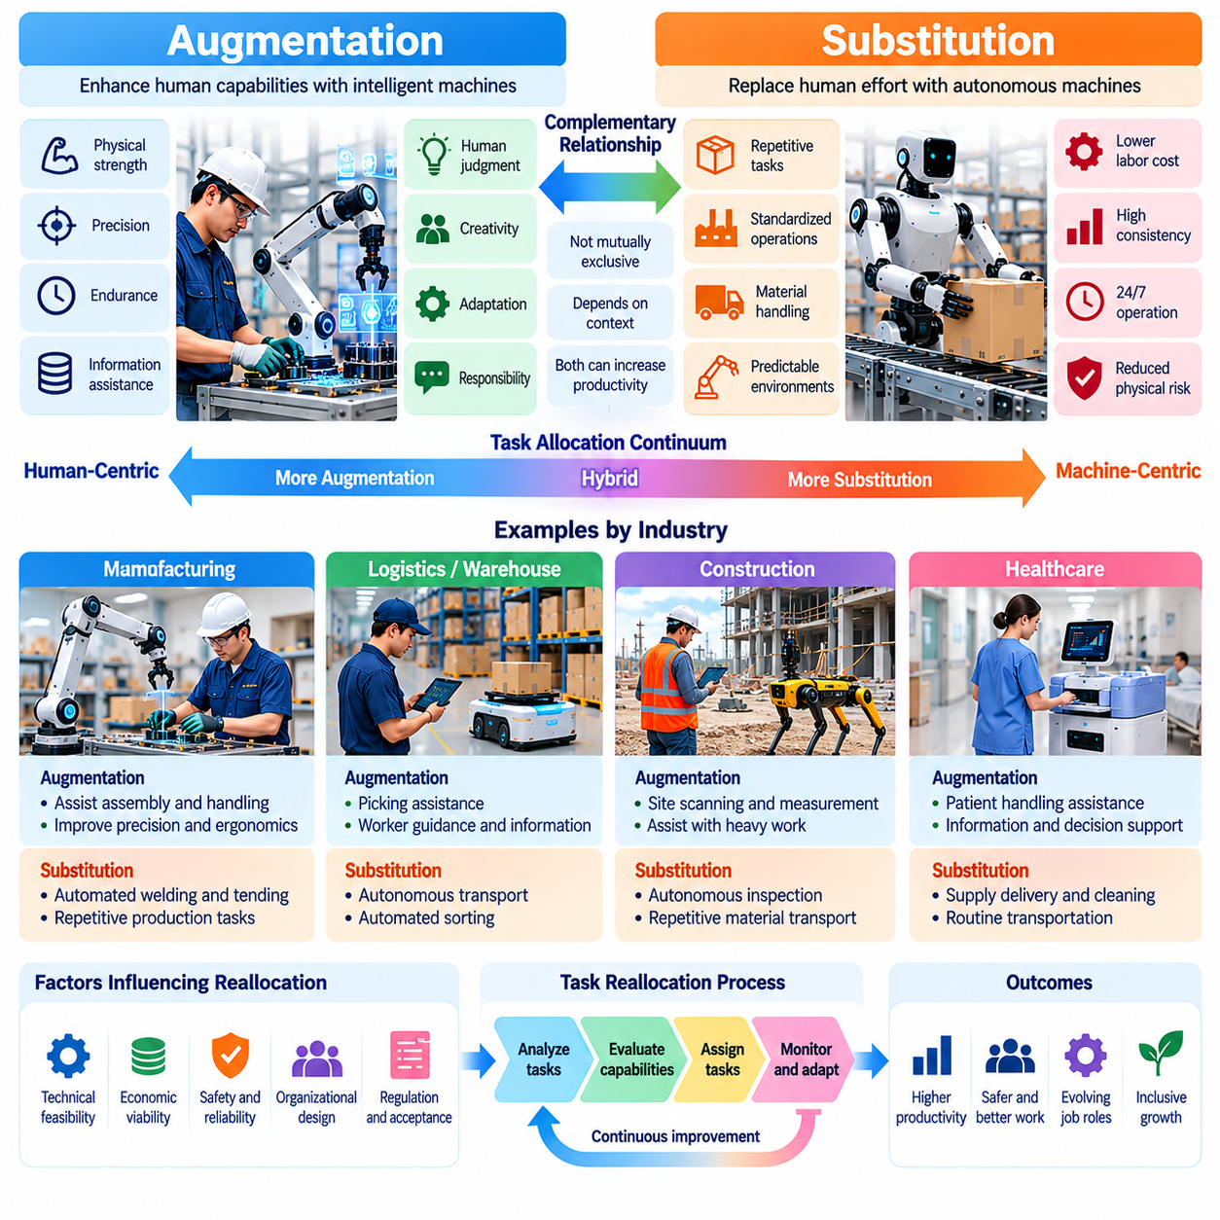
Augmentation and substitution represent two distinct mechanisms through which Physical AI transforms human labor. Augmentation occurs when intelligent machines enhance human capabilities, productivity, or safety, while substitution occurs when robotic systems replace human effort in particular tasks. These mechanisms are not mutually exclusive, and their relative importance depends on technological capabilities, economic incentives, organizational design, and the characteristics of work.
Human augmentation emphasizes cooperation between workers and intelligent machines rather than the elimination of human participation. Robots can provide physical strength, precision, endurance, and computational assistance while humans contribute contextual judgment, creativity, and responsibility. This complementary relationship allows organizations to improve operational performance without necessarily transferring complete control of productive activities to autonomous systems.
Substitution involves transferring activities previously performed by humans to machines capable of executing them independently. Industrial robots replacing manual welding, autonomous vehicles performing selected transportation tasks, and automated handling systems moving warehouse inventory illustrate this mechanism. However, replacing individual activities does not automatically imply eliminating entire occupations, because remaining responsibilities may still require human participation.
The distinction between augmentation and substitution becomes clearer when examining task-level productivity. Augmentation increases the effectiveness of human effort by improving the tools and information available to workers. Substitution reduces the amount of direct human labor required for specific activities. Both mechanisms can increase output per labor hour, but their consequences for employment, wages, skill requirements, and organizational structures may differ substantially.
Physical AI introduces new possibilities for augmentation through intelligent perception, adaptive manipulation, and predictive assistance. A robotic assistant may identify objects, position components, stabilize heavy equipment, or recommend safer movement sequences. Human workers retain authority over important decisions while benefiting from machine capabilities that extend their physical reach, reduce fatigue, and improve execution consistency.
Collaborative robots provide a practical example of augmentation in manufacturing environments. These systems may assist workers with repetitive positioning, component handling, and precision assembly while humans perform complex adjustments and quality verification. Successful collaboration depends on appropriate safety measures, clear responsibility boundaries, and task designs that account for the capabilities and limitations of both participants.
Substitution becomes economically attractive when machines can perform activities at acceptable quality and reliability with lower total operating costs. Repetitive transportation, standardized material handling, and predictable production operations are common candidates. Nevertheless, acquisition expenses, maintenance requirements, energy consumption, supervision, and integration costs must be considered before concluding that robotic substitution provides an economic advantage.
Augmentation can also produce substantial economic benefits by reducing errors, improving ergonomics, and increasing the productive capacity of experienced workers. In some applications, a human supported by intelligent tools may outperform either an unaided worker or a fully autonomous machine. This possibility is particularly important in environments where task variability and exceptional situations make complete automation difficult.
The relationship between augmentation and substitution is dynamic rather than fixed. A robotic system may initially operate as an assistant, gradually assume greater responsibility, and eventually execute selected tasks autonomously. Conversely, activities previously automated may require renewed human participation when operating conditions become uncertain. The resulting division of labor can evolve as technology, infrastructure, and organizational requirements change.
A central determinant of this evolution is the reliability of autonomous execution. Systems that perform well under controlled conditions may still require extensive human supervision in unfamiliar environments. When failure consequences are significant, augmentation may remain preferable even if substitution is technically possible. Safety-critical industries therefore often adopt staged autonomy rather than transferring complete operational authority immediately.
Manufacturing demonstrates how both mechanisms can coexist within the same production system. Autonomous robots may substitute for manual material transfer or repetitive welding, while collaborative manipulators augment workers during complex assembly. Human technicians may also use AI-based inspection and predictive maintenance tools. The combined effect is a redistribution of tasks rather than a uniform movement toward complete workforce replacement.
Warehouse and logistics operations exhibit similar patterns. Autonomous mobile robots can substitute for routine inventory transportation, while intelligent picking assistance can augment workers handling diverse products. Supervisors coordinate automated workflows and resolve exceptions that exceed machine capabilities. The balance between augmentation and substitution depends on product variability, facility design, throughput requirements, and system reliability.
Construction presents strong opportunities for augmentation because worksites contain changing layouts, irregular materials, and complex coordination requirements. Robots can assist with surveying, scanning, material positioning, and physically demanding operations. Substitution may become feasible for selected repetitive tasks, but comprehensive automation remains constrained by environmental uncertainty, safety obligations, and the need for professional judgment.
Healthcare highlights the importance of maintaining human participation even when physical automation becomes technically capable. Robots may augment medical professionals through patient handling, rehabilitation assistance, and supply transportation. Certain logistical activities may be substituted, but clinical decisions, patient relationships, and professional accountability require careful governance. Automation strategies must therefore consider human dignity alongside operational efficiency.
Agriculture provides another setting in which augmentation and substitution can develop simultaneously. Intelligent equipment may assist farmers with crop monitoring, precision spraying, and harvesting decisions, while autonomous machines perform selected field operations. Environmental variability, seasonal demand, and biological uncertainty influence which tasks can be substituted and which benefit more from human-machine cooperation.
The economic consequences of augmentation and substitution depend partly on demand responses. Productivity improvements may lower production costs, increase output, and create additional demand for complementary labor. However, substitution can also reduce employment in particular tasks or occupations when displaced workers cannot transition into new roles. These outcomes vary across industries and cannot be determined from technological capability alone.
Wage effects are similarly complex. Augmentation may increase the productivity and bargaining value of workers whose expertise becomes more effective with intelligent tools. Substitution may reduce demand for certain routine skills while increasing demand for robotics engineering, supervision, and maintenance. The distribution of benefits depends on labor market institutions, worker mobility, training opportunities, and ownership of productive technologies.
Organizational design plays a decisive role in determining whether Physical AI primarily augments or substitutes human labor. Companies can introduce robots to support existing workers, redesign processes around autonomous execution, or combine both approaches. Decisions about staffing, training, workflow integration, and performance evaluation influence whether technological improvements translate into broader productivity gains or concentrated labor displacement.
Human-centered automation emphasizes preserving meaningful human control, particularly when decisions involve safety, ethical responsibility, or complex social interactions. Augmentation strategies can support this objective by keeping workers actively involved in operational decisions. However, poorly designed assistance systems may increase monitoring burdens, reduce autonomy, or create excessive dependence on machine recommendations.
Substitution strategies also require governance mechanisms that clarify responsibility for autonomous behavior. Organizations must establish procedures for monitoring, intervention, maintenance, and incident investigation. Even when robots independently execute physical activities, accountability remains with the relevant human and institutional actors. Effective automation therefore requires operational oversight rather than assuming autonomy eliminates responsibility.
Physical AI architectures can support flexible transitions between augmentation and substitution through adaptive autonomy. Robots may execute routine actions independently while requesting assistance when uncertainty, environmental complexity, or risk exceeds defined thresholds. World models, predictive planning, and confidence estimation can help determine when autonomous execution is appropriate and when human judgment should guide the next action.
Evaluating these strategies requires metrics extending beyond the number of tasks automated. Relevant measures include productivity per worker, total operating cost, task completion reliability, intervention frequency, workplace safety, worker satisfaction, and employment outcomes. Such evaluations should also consider whether automation improves overall system performance or merely transfers hidden costs and responsibilities to remaining employees.
Over the longer term, advances in generalist robotic systems may expand the technical feasibility of substitution across increasingly diverse physical tasks. Nevertheless, augmentation may remain economically and socially valuable where human expertise, adaptability, and accountability provide complementary advantages. The future balance will depend on technological maturity, institutional choices, and how organizations distribute the benefits of intelligent automation.
Ultimately, augmentation and substitution should be understood as alternative but interconnected pathways for integrating Physical AI into human production systems. Their significance extends beyond whether robots replace workers, encompassing how technology changes human capabilities, organizational responsibilities, and economic opportunity. A sustainable transition requires aligning robotic productivity with human well-being, safety, and equitable access to the benefits of technological progress.

01.06. Manufacturing and Logistics Labor Transformation
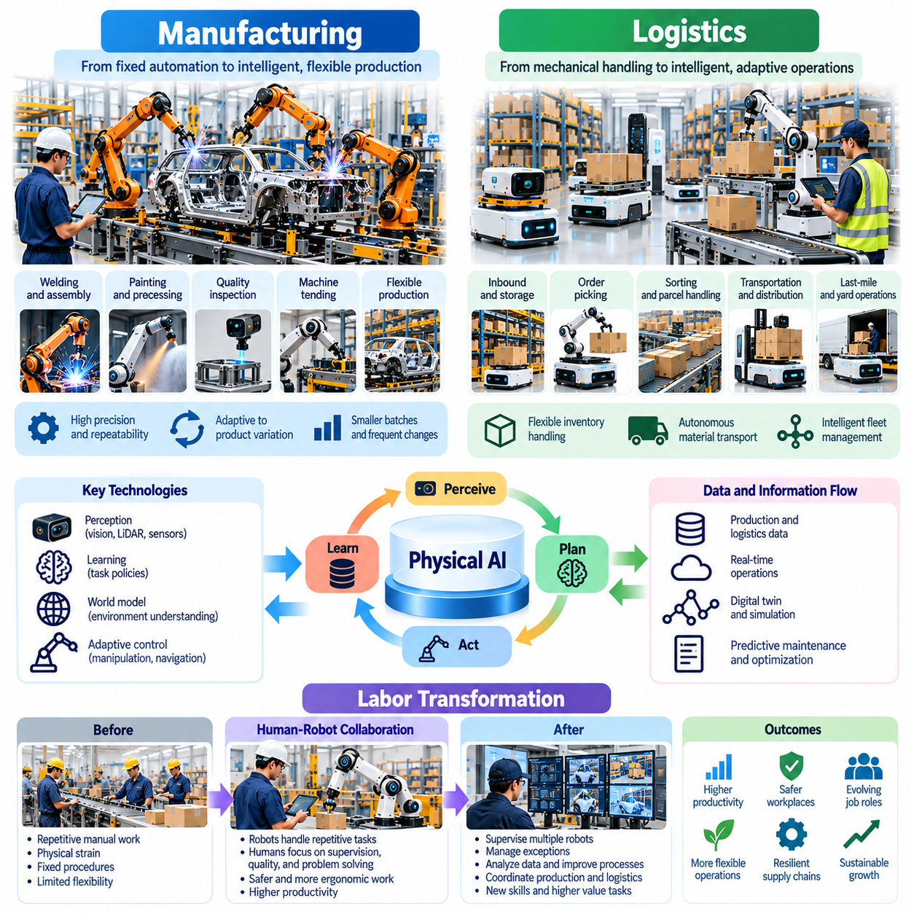
Manufacturing and logistics represent two of the most significant environments for Physical AI-driven labor transformation. Both industries depend on repetitive physical operations, coordinated material flows, and increasingly complex information systems. Intelligent robots can extend automation beyond fixed production sequences, enabling more adaptive execution while changing the responsibilities, skills, and organizational roles of human workers.
Traditional manufacturing automation has concentrated on structured production lines where industrial robots perform welding, assembly, painting, and material handling. These systems deliver high precision and repeatability but often require extensive programming and predictable operating conditions. Physical AI introduces perception, learning, and adaptive control, allowing robotic systems to respond to greater variability in products, materials, and production environments.
The transition toward intelligent manufacturing changes the relationship between workers and machines. Human operators who previously performed repetitive manual operations may increasingly supervise robotic cells, configure equipment, and resolve production exceptions. Robots assume selected execution tasks, while workers become responsible for maintaining operational continuity, interpreting quality information, and coordinating adjustments across production processes.
Flexible manufacturing creates particularly strong demand for adaptive robotic capabilities. Modern factories increasingly handle product variations, smaller production batches, and frequent configuration changes. Traditional automation can become expensive when every variation requires extensive reprogramming. Physical AI can potentially reduce this burden through vision-based manipulation, learned task policies, and more adaptable motion planning.
Human-robot collaboration is another important mechanism of manufacturing transformation. Collaborative robotic systems can assist workers with component positioning, repetitive assembly, and physically demanding handling operations. Humans retain responsibility for complex adjustments, inspection, and exceptional decisions. Effective collaboration requires safety-aware control, intuitive interfaces, and clear procedures for coordinating movement within shared workspaces.
Quality assurance is also evolving through the integration of cognitive and physical automation. Computer vision systems can identify visible defects, while robotic inspection platforms collect measurements from multiple positions. Human specialists interpret uncertain findings, investigate root causes, and determine corrective actions. This combination can shift labor from repetitive inspection toward analytical quality management and continuous process improvement.
Predictive maintenance changes the work of manufacturing technicians by connecting sensor measurements, equipment histories, and machine learning models. Intelligent systems can identify abnormal vibration, temperature, or performance patterns that suggest emerging failures. Maintenance personnel can then prioritize inspections and interventions, although reliable diagnosis still requires engineering judgment and knowledge of physical equipment behavior.
Intralogistics provides a direct connection between manufacturing and broader logistics operations. Autonomous mobile robots transport components, tools, and finished products between production stations and storage areas. Fleet management systems coordinate assignments, routes, and charging schedules. Human logistics personnel increasingly supervise material availability, handle unusual transport requirements, and resolve disruptions affecting production flow.
Warehouse automation is undergoing a similar transformation from fixed mechanical systems toward adaptive robotic operations. Traditional conveyors and automated storage systems efficiently handle standardized flows but may be difficult to modify. Physical AI enables mobile platforms, robotic manipulators, and perception systems to interact with more diverse inventory configurations, supporting flexible warehouse layouts and changing fulfillment requirements.
Order picking remains a challenging area because products vary in shape, weight, packaging, and mechanical properties. Robotic systems must identify objects, estimate grasping conditions, and manipulate items without causing damage. Human workers may continue handling irregular, fragile, or unfamiliar products while robots process suitable inventory categories. The resulting division of labor depends on manipulation reliability and operational economics.
Sorting and parcel handling demonstrate how intelligent automation can reduce repetitive physical workload. Vision-guided systems can classify packages, estimate dimensions, and direct items toward appropriate destinations. Robots may assist with loading, unloading, and transferring parcels between conveyors and transport units. Human personnel remain important for damaged shipments, uncertain classifications, and safety-related exceptions.
Transportation and distribution operations are also affected by advances in autonomous mobility and intelligent coordination. Automated vehicles may support selected movement within factories, warehouses, ports, and controlled logistics facilities. Human operators supervise traffic interactions, respond to unusual conditions, and manage system-level priorities. Deployment depends on environmental complexity, safety validation, infrastructure, and applicable regulations.
The transformation of manufacturing and logistics labor is therefore not limited to replacing manual movement. Intelligent automation changes how operational decisions are made, how information is exchanged, and how workers coordinate production resources. Employees increasingly interact with digital dashboards, robotic control systems, and predictive analytics tools, creating closer integration between physical operations and information management.
These developments create new occupational responsibilities in robotic fleet supervision, automation engineering, sensor calibration, data analysis, and system integration. Workers may need to understand basic robotic behavior, recognize abnormal operating conditions, and perform safe recovery procedures. Technical specialists require deeper knowledge of perception, control, networking, and maintenance, making structured training and reskilling increasingly important.
Labor productivity improvements depend on the performance of the complete production or logistics system rather than isolated robotic tasks. A robot may execute movements quickly but still create bottlenecks if material replenishment, exception handling, or equipment availability is inadequate. Effective deployment requires coordinated scheduling, balanced workloads, reliable maintenance, and careful analysis of interactions between human and robotic activities.
Economic outcomes vary according to facility scale, product diversity, labor costs, and operational requirements. High-volume repetitive processes may justify substantial automation investments, while smaller facilities may benefit more from modular robots and human-assisted systems. Organizations must consider acquisition costs, software integration, energy consumption, maintenance, downtime, and workforce training when evaluating automation strategies.
Safety remains a fundamental requirement during labor transformation. Robots operating near humans must detect obstacles, respect protected zones, and respond appropriately to unexpected movement. Warehouse traffic and shared manufacturing workspaces introduce collision and interaction risks. Safety engineering therefore requires validated control mechanisms, operational procedures, worker education, and continuous monitoring rather than relying exclusively on intelligent perception.
Physical AI also changes the nature of managerial responsibility. Supervisors must coordinate human staffing with robotic capacity, evaluate automated system performance, and respond to operational disruptions. Decisions increasingly involve balancing throughput, equipment utilization, worker workload, and safety. Management practices must evolve to support hybrid workforces in which human and machine capabilities are jointly optimized.
The employment consequences of these changes remain dependent on economic and organizational conditions. Automation may reduce demand for certain repetitive tasks while increasing demand for technical, supervisory, and maintenance roles. Productivity gains may also support production expansion and additional employment in complementary activities. However, workers displaced from existing roles may face transition difficulties without accessible training and reassignment opportunities.
World models and predictive planning may further transform industrial labor by enabling robots to anticipate operational conditions rather than simply react to immediate observations. Systems could estimate future material availability, predict congestion, and evaluate alternative task sequences. Integrating these capabilities with fleet management and manufacturing execution systems may improve coordination across multiple machines and production stages.
Longer-term development may produce manufacturing and logistics environments with increasing levels of autonomous coordination. Robotic systems could dynamically allocate tasks, adapt to changing product requirements, and request human assistance when uncertainty exceeds acceptable limits. Such environments would still require human expertise for strategic planning, engineering changes, safety governance, and exceptional operational decisions.
The successful transformation of manufacturing and logistics depends on aligning technical automation with workforce development and organizational redesign. Introducing robots without adapting workflows, responsibilities, and training can limit productivity gains and create operational instability. A systematic approach should evaluate which tasks are suitable for substitution, which benefit from augmentation, and how human expertise can be preserved and strengthened.
Ultimately, Physical AI is transforming manufacturing and logistics from labor-intensive sequences of isolated operations into increasingly coordinated human-machine production systems. The central change is not merely the number of robots deployed but the redistribution of execution, supervision, reasoning, and responsibility. Sustainable progress requires combining intelligent robotic capabilities with human judgment, safe operations, economic resilience, and opportunities for workforce adaptation.

01.07. Construction Agriculture and Field Work
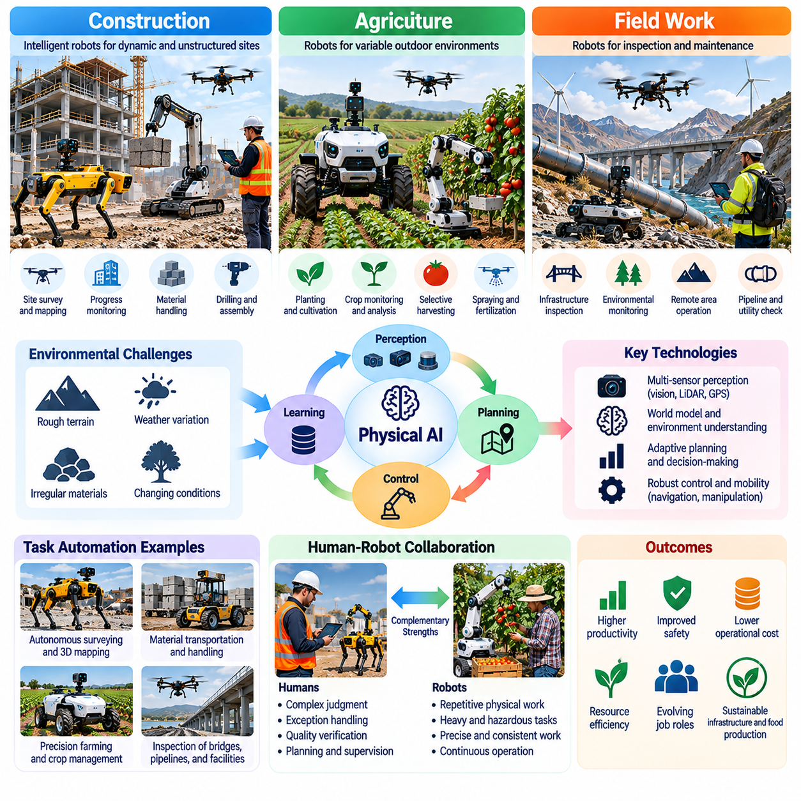
Construction, agriculture, and field work represent some of the most challenging environments for Physical AI-driven labor transformation. Unlike structured factories, these sectors operate across changing terrain, weather conditions, irregular materials, and unpredictable physical interactions. Intelligent robotic systems can reduce dangerous and repetitive labor, but successful deployment requires adaptability, environmental understanding, and close coordination with human expertise.
Construction activities combine heavy material handling, precise measurement, complex coordination, and continuous changes in site conditions. Traditional automation has been limited because construction sites rarely maintain fixed layouts or standardized operating environments. Physical AI introduces mobile perception, autonomous navigation, and adaptive manipulation, potentially extending robotic capabilities into tasks previously dependent on skilled human operators.
Robotic surveying and inspection provide important early opportunities for construction automation. Mobile platforms equipped with LiDAR, cameras, and positioning sensors can capture spatial measurements and compare observed structures with digital engineering models. These capabilities support progress monitoring, dimensional verification, and defect detection, while engineers remain responsible for interpreting discrepancies and approving corrective actions.
The integration of Building Information Modeling with robotic perception creates a foundation for more intelligent construction workflows. Digital design information can guide autonomous scanning, layout marking, and selected installation activities. However, discrepancies between planned geometry and actual site conditions require continuous localization, uncertainty estimation, and measurement validation before robotic systems can execute precision-sensitive operations reliably.
Construction robots can also assist with material transportation, drilling, fastening, and selected assembly activities. Mobile manipulators may position tools or components while human workers supervise complex interactions and verify installation quality. Such systems can reduce physical strain and exposure to hazardous environments, although changing obstacles, unstable surfaces, and shared workspaces create significant safety challenges.
Outdoor construction introduces additional difficulties associated with terrain variability, dust, precipitation, lighting, and temperature. Robotic navigation systems must account for wheel-ground interactions, uneven surfaces, and changing traction conditions. Reliable operation requires robust sensing, mobility control, environmental adaptation, and safe recovery mechanisms rather than assuming that indoor robotic capabilities transfer directly to field environments.
Agriculture presents a different combination of physical uncertainty and biological complexity. Crops vary in size, maturity, geometry, and mechanical sensitivity, while soil conditions and weather change throughout the growing season. Physical AI systems must recognize these variations and adapt their actions accordingly. This makes agricultural automation fundamentally different from repetitive manipulation of standardized industrial components.
Autonomous agricultural machines can support planting, spraying, fertilization, cultivation, and harvesting. Perception systems identify crop rows, obstacles, weeds, and potentially harvestable produce, while control systems coordinate navigation and tool operation. Human farmers increasingly supervise machine performance, interpret environmental conditions, and manage decisions involving crop health, production objectives, and resource allocation.
Precision agriculture combines physical robotics with sensing, prediction, and data-driven decision-making. Field robots and aerial platforms can collect information about vegetation, soil moisture, and spatial variability. Analytical models may recommend targeted interventions, while robotic equipment performs localized operations. This integration can improve resource efficiency, although reliable outcomes depend on sensor quality, biological uncertainty, and agronomic expertise.
Robotic harvesting remains especially challenging because successful manipulation requires perception, contact control, and damage avoidance. Fruits and vegetables may be partially occluded, irregularly positioned, or mechanically delicate. Robots must estimate grasp points, regulate applied forces, and adapt to unexpected movement. Human workers may therefore continue handling difficult cases while automated systems process suitable crops.
Field work extends beyond construction and agriculture into mining, forestry, utilities, environmental monitoring, and infrastructure maintenance. These activities frequently involve remote locations, hazardous conditions, and limited access to communication or support services. Physical AI can support inspection, mapping, transportation, and selected intervention tasks, potentially reducing human exposure to dangerous or physically demanding environments.
Infrastructure inspection illustrates the value of combining mobility with intelligent sensing. Ground robots, climbing platforms, and aerial systems can examine bridges, pipelines, power facilities, and industrial structures. Automated perception may identify visible anomalies or changes over time, but engineering specialists must evaluate structural significance, determine inspection priorities, and authorize maintenance interventions.
Human-robot collaboration in field environments requires flexible responsibility allocation. Robots may execute repetitive measurements, transport equipment, or inspect hazardous areas, while human specialists handle uncertain conditions and complex decisions. Remote supervision and teleoperation provide additional support when autonomous systems encounter unfamiliar situations. Effective coordination depends on communication reliability, operator awareness, and clearly defined intervention procedures.
Connectivity limitations create important differences between field robotics and cloud-dependent automation. Construction sites, farms, and remote infrastructure may experience intermittent networks, limited bandwidth, or communication delays. Edge computing and on-premise intelligence allow robots to maintain essential perception, planning, and control capabilities locally. Cloud systems can support broader analytics and fleet learning without becoming indispensable to immediate safety-critical decisions.
Energy management and mechanical durability are equally important for sustained outdoor deployment. Field robots must operate under constraints involving battery capacity, fuel availability, payload, terrain resistance, and environmental exposure. Dust, moisture, vibration, and repeated mechanical impacts can reduce equipment reliability. Practical automation therefore requires robust hardware design, preventive maintenance, and operational planning alongside advanced artificial intelligence.
The economic feasibility of field automation depends on more than robotic task performance. Construction projects involve temporary worksites and changing requirements, while agricultural operations often face seasonal utilization patterns. Equipment transportation, setup time, maintenance access, and operator training influence total costs. Flexible robotic platforms may provide greater value when they can perform multiple tasks across different sites or operating periods.
Labor transformation in these sectors may initially emphasize augmentation rather than complete substitution. Intelligent machines can extend human strength, improve measurement accuracy, and reduce exposure to dangerous activities without eliminating professional oversight. As reliability improves, selected operations may transition toward supervised autonomy, but broad deployment will depend on the ability to manage environmental variability and exceptional conditions.
The changing division of labor creates demand for new technical and operational skills. Construction workers may need competencies in robotic surveying, digital model interpretation, and automated equipment supervision. Agricultural workers may increasingly use autonomous machinery, sensor analytics, and precision application systems. Field technicians may require knowledge of navigation, calibration, remote diagnostics, and safe recovery procedures.
Safety governance must reflect the distinctive risks of unstructured outdoor environments. Robots may operate near heavy machinery, unstable structures, animals, workers, or public infrastructure. Unexpected environmental changes can invalidate previously safe plans. Effective systems require continuous risk assessment, reliable obstacle detection, emergency stopping mechanisms, and procedures for transferring control to qualified human operators.
World models offer a promising foundation for more capable field robotics by representing terrain, objects, environmental dynamics, and predicted action consequences. Such models could help robots anticipate mobility difficulties, plan manipulation sequences, and evaluate alternative routes. However, their usefulness depends on maintaining accurate state estimates and recognizing when unfamiliar conditions exceed the reliability of learned predictions.
Fleet-scale learning may further improve field automation by collecting experience across construction sites, farms, and infrastructure networks. Robots can record operational failures, unusual terrain conditions, and successful recovery strategies. Curated experience may support model improvement and more robust task policies, although differences between locations require careful validation before transferring learned behaviors into new environments.
Over the longer term, Physical AI may enable increasingly autonomous construction operations, precision agricultural systems, and distributed field maintenance networks. These developments could reduce dangerous labor, improve operational consistency, and address workforce shortages in selected activities. Nevertheless, professional judgment, environmental stewardship, safety responsibility, and complex site coordination will continue to shape the role of human workers.
Ultimately, construction, agriculture, and field work demonstrate that Physical AI must achieve more than accurate movement in controlled environments. Intelligent robots must operate reliably amid uncertainty, physical variability, and changing operational objectives. Sustainable labor transformation will depend on combining embodied intelligence, robust engineering, human supervision, and economically practical deployment strategies that complement the expertise of field professionals.

01.08. Healthcare and Caregiving Labor
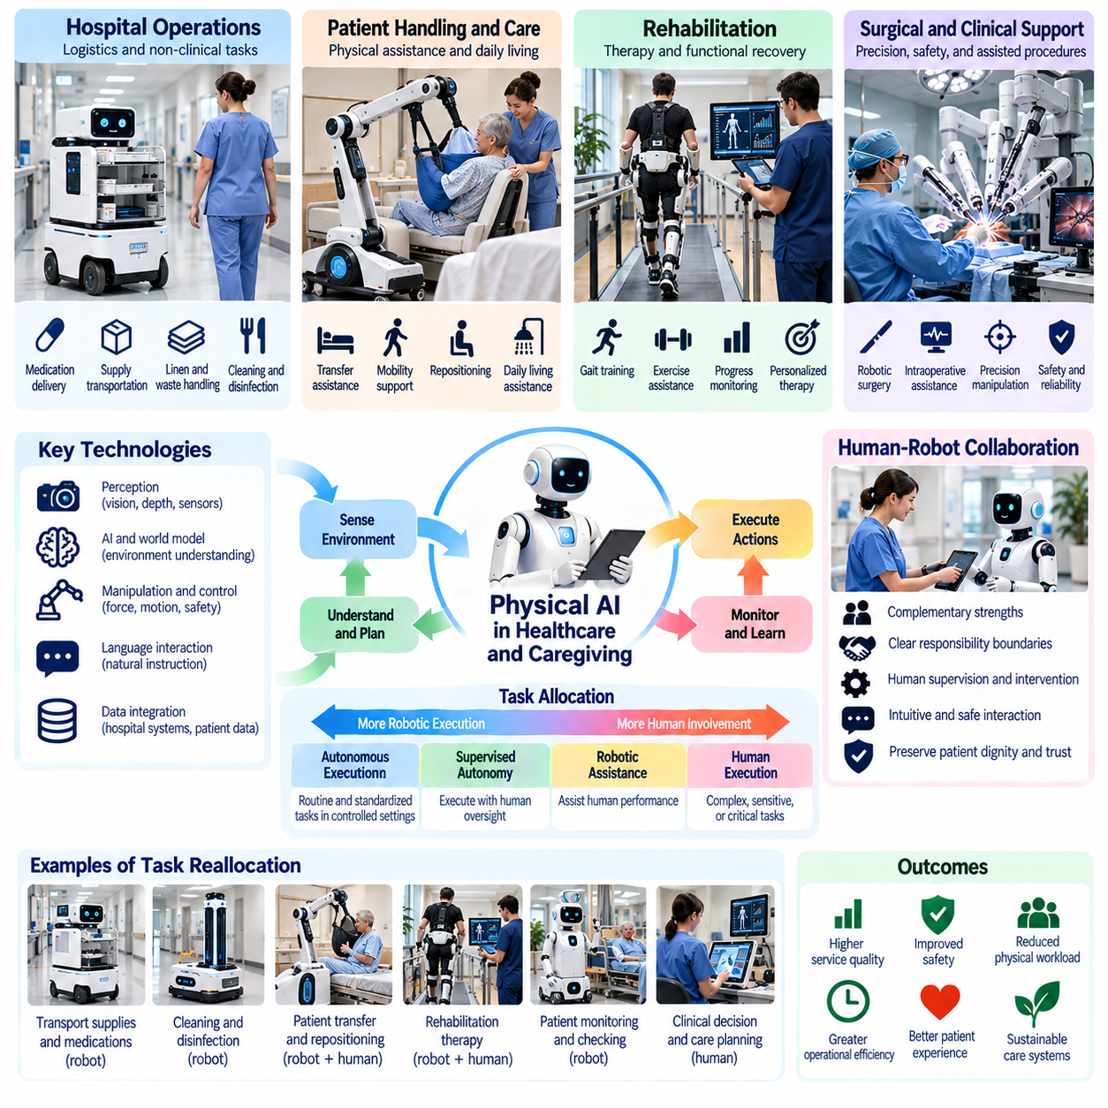
Healthcare and caregiving represent critical domains for Physical AI because they combine physical assistance, complex decision-making, and deeply human relationships. Hospitals, rehabilitation centers, and long-term care facilities depend on labor-intensive activities that require both technical competence and personal attention. Intelligent robotics can reduce physical workloads and improve service continuity, but its adoption must preserve patient safety, dignity, and professional accountability.
Healthcare labor includes clinical treatment, patient transportation, equipment handling, environmental cleaning, and administrative coordination. These activities differ substantially in their suitability for automation. Standardized logistical tasks may be performed by autonomous machines, while diagnosis, treatment decisions, and emotionally sensitive interactions require qualified human oversight. Physical AI therefore encourages selective task reallocation rather than indiscriminate occupational replacement.
Demographic aging and growing demand for long-term care increase interest in robotic assistance. Caregiving workers frequently perform repetitive lifting, mobility support, and daily living assistance under demanding schedules. Physical AI systems may help reduce musculoskeletal strain and improve operational efficiency. However, the quality of caregiving depends on trust, empathy, communication, and individual preferences that cannot be reduced to mechanical task completion.
Patient transportation offers an important application of healthcare robotics. Autonomous mobile robots can move medications, linens, laboratory samples, and medical supplies between hospital departments. Separating logistical transportation from direct clinical responsibilities may allow nurses and caregivers to devote more attention to patients. Reliable deployment requires safe navigation, access control, scheduling integration, and appropriate handling of sensitive materials.
Robotic patient handling presents greater technical and ethical complexity because machines interact directly with vulnerable individuals. Transfer assistance, repositioning, and mobility support require accurate force regulation, body-state estimation, and continuous monitoring. Human caregivers must remain capable of supervising interactions and responding to discomfort or unexpected movement. Mechanical assistance should improve safety without compromising patient autonomy or dignity.
Rehabilitation robotics illustrates how augmentation can improve healthcare labor rather than simply substitute for therapists. Robotic exoskeletons and therapeutic devices may provide repetitive movement assistance and measurable exercise support. Clinicians determine treatment objectives, interpret patient responses, and adjust therapy programs. Effective rehabilitation depends on combining controlled physical assistance with individualized clinical judgment and patient motivation.
Assistive robotics may also support older adults and people with disabilities in everyday activities. Mobile assistants and robotic manipulators can potentially help retrieve objects, transport household items, or support selected mobility tasks. Their practical value depends on reliability, accessibility, affordability, and user acceptance. Systems must accommodate diverse physical abilities and living environments without assuming that all individuals require identical assistance.
Clinical robotics introduces additional requirements when machines participate in procedures involving direct patient contact. Robotic surgical platforms can enhance instrument positioning and controlled manipulation under trained professional supervision. Their use does not eliminate clinical responsibility or guarantee superior outcomes in every procedure. Safety depends on appropriate training, validated performance, procedural selection, and reliable human control.
Physical AI can support hospital infection prevention through automated cleaning, disinfection assistance, and contact-reducing logistical operations. Robots may execute repetitive environmental tasks while personnel verify coverage and compliance with established procedures. These applications require careful evaluation because automated movement or disinfection does not necessarily guarantee infection control. Human inspection and validated protocols remain essential.
Caregiving environments are especially challenging because human behavior is variable and often difficult to predict. Patients may move unexpectedly, communicate discomfort indirectly, or require assistance that changes throughout the day. Robots must interpret uncertain observations and respond conservatively when safety is at risk. Contextual awareness, adaptable control, and accessible human intervention mechanisms are therefore fundamental requirements.
Human-robot collaboration in healthcare requires clear allocation of responsibilities. Robots may perform transportation, positioning assistance, or routine monitoring, while clinicians and caregivers retain authority over medical decisions and sensitive personal interactions. Effective workflows must specify when robots operate autonomously, when supervision is mandatory, and how control transfers to qualified personnel during exceptional situations.
The integration of perception, language understanding, and physical action may enable more intuitive healthcare robots. Vision-language-action systems could interpret instructions, recognize relevant objects, and execute selected assistance tasks. Nevertheless, natural-language commands may be ambiguous, and model outputs can be unreliable. Safety-critical actions require explicit authorization, constrained execution, and independent verification rather than unrestricted generative control.
World models may improve robotic assistance by representing room layouts, equipment locations, human movement, and predicted interaction outcomes. Such models can support navigation, task planning, and anticipation of potential conflicts. However, healthcare environments change continuously, and predictions about human behavior remain uncertain. Robots must recognize model limitations and prioritize safe behavior when observations contradict expectations.
Privacy and data governance are central concerns because healthcare robots may collect images, movement patterns, audio, and other sensitive information. Data collection should be limited to legitimate operational needs, with appropriate access controls and retention policies. Edge computing can support selected local processing requirements, while connected systems require secure communication. Technical convenience must not override patient confidentiality.
Healthcare automation also changes the competencies required from professional staff. Nurses, therapists, technicians, and support workers may increasingly interact with robotic interfaces, automated transport systems, and intelligent monitoring tools. Training must address normal operation, limitations, fault recognition, emergency procedures, and safe intervention. Technical proficiency should complement rather than replace clinical expertise and interpersonal skills.
Economic evaluation must consider the complete healthcare workflow rather than isolated robotic productivity. Equipment acquisition, maintenance, integration, staff training, and supervision contribute to total operating costs. Potential benefits include reduced physical strain, improved logistical efficiency, and more consistent service delivery. However, financial savings should not be assumed without evidence of reliable performance and measurable improvements in care quality.
The employment implications of healthcare robotics are likely to vary across occupations and institutions. Routine logistical activities may require fewer direct labor hours, while technical maintenance, robotic supervision, and patient-centered services may expand. Automation can relieve staffing pressures without necessarily resolving workforce shortages. Its effects depend on organizational choices, reimbursement structures, training opportunities, and the allocation of productivity gains.
Ethical considerations distinguish caregiving from many industrial automation applications. Patients may depend on caregivers for emotional reassurance, personal dignity, and social connection as well as physical assistance. Excessive substitution could reduce meaningful human contact even when routine tasks are completed efficiently. Human-centered design should therefore evaluate autonomy, consent, accessibility, and the social consequences of replacing interpersonal care.
Adaptive autonomy offers a practical framework for managing uncertainty in healthcare robotics. Machines may independently execute low-risk logistical activities while requesting supervision for direct physical assistance or unfamiliar situations. Confidence estimation, runtime monitoring, and safe fallback behaviors can support these transitions. Autonomy levels should reflect task risk, validated capability, and the availability of qualified human assistance.
Long-term progress may enable coordinated robotic systems across hospitals, rehabilitation facilities, and residential care environments. Mobile platforms, assistive manipulators, and intelligent scheduling systems could share operational information and support integrated workflows. Nevertheless, interoperability, cybersecurity, regulatory compliance, and clinical validation will remain important barriers to widespread deployment and reliable institutional adoption.
Healthcare organizations must approach robotic deployment as a transformation of care delivery rather than a simple equipment purchase. Workflows, professional responsibilities, training programs, and patient communication practices require coordinated redesign. Evaluation should include clinical safety, worker well-being, patient experience, service accessibility, and operational performance. Successful adoption depends on involving both healthcare professionals and the people receiving care.
Ultimately, Physical AI can transform healthcare and caregiving labor by reducing physically demanding tasks, supporting clinical workflows, and expanding access to selected forms of assistance. Its greatest value may arise from strengthening human caregivers rather than replacing the relationships at the center of care. Sustainable progress requires combining embodied intelligence, rigorous safety engineering, ethical governance, and continued human responsibility for patient well-being.

01.09. Service and Household Labor
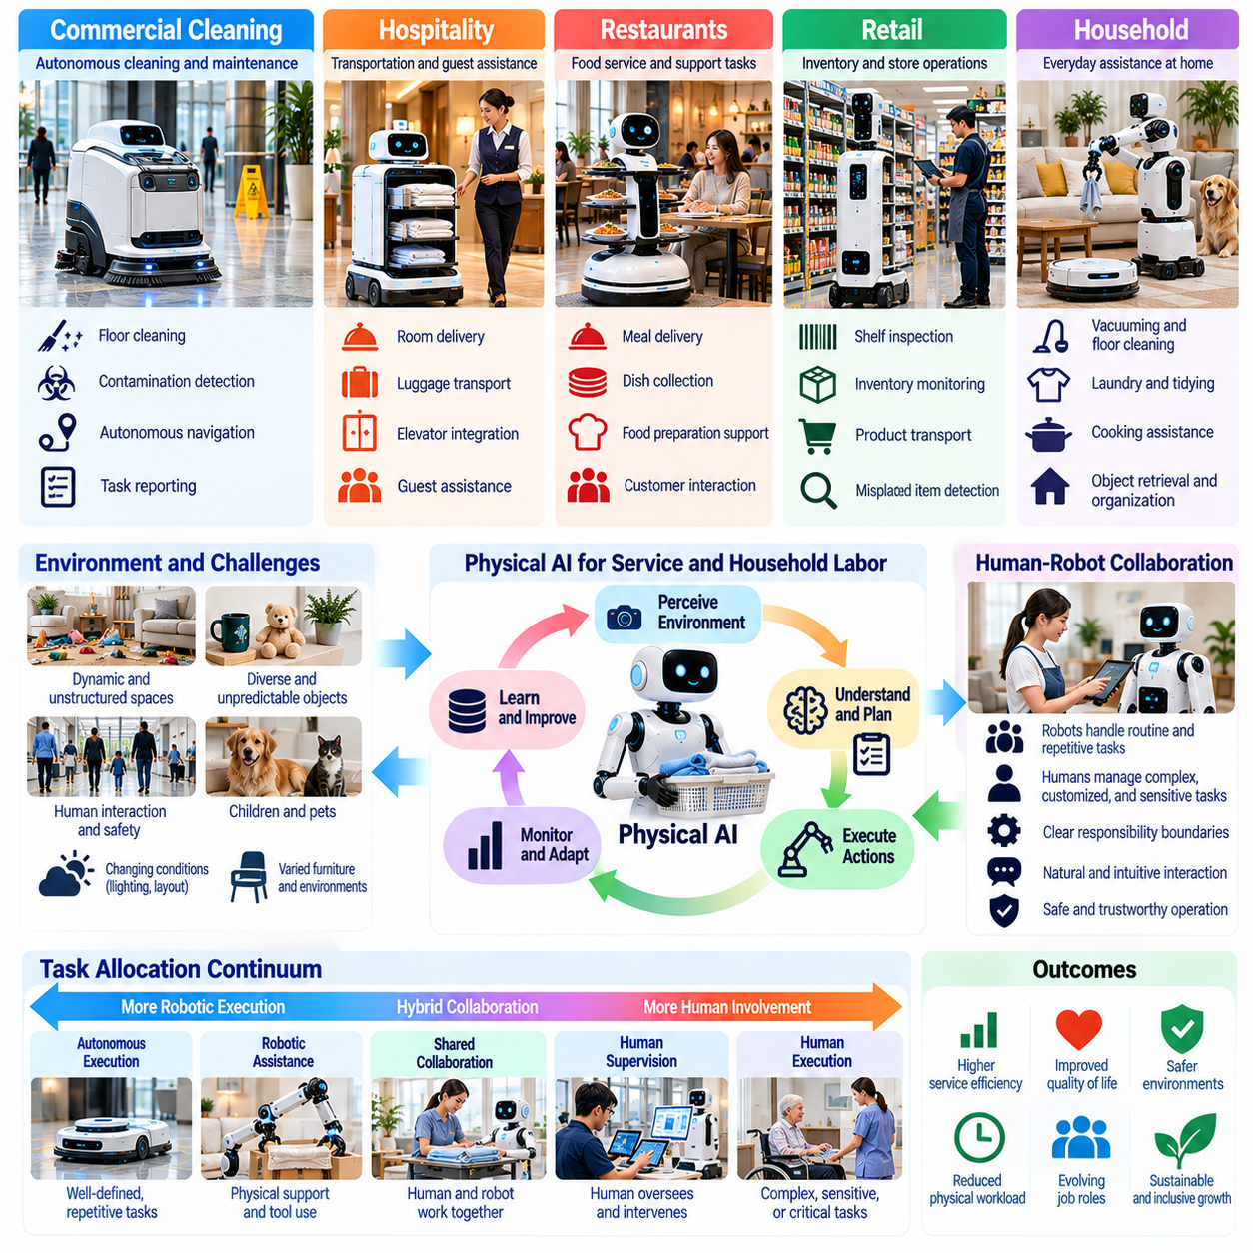
Service and household labor represent a major frontier for Physical AI because they involve diverse physical tasks performed in environments designed primarily for humans. Restaurants, hotels, retail facilities, offices, and private homes require continuous cleaning, transportation, organization, and assistance. Intelligent robots may reduce repetitive workloads and improve service availability, but practical adoption depends on reliability, affordability, safety, and human acceptance.
Unlike industrial production, service environments frequently change in response to human activity. Furniture moves, objects appear unexpectedly, and customers follow unpredictable movement patterns. Robots must recognize these changes while maintaining safe navigation and task execution. Physical AI extends traditional service automation through adaptive perception, contextual reasoning, and flexible action planning, enabling machines to operate beyond narrowly predefined routines.
Commercial cleaning provides an established application area for service robotics. Autonomous floor-cleaning machines can navigate corridors, shopping centers, airports, and office buildings while avoiding obstacles. More advanced systems may identify contaminated areas, adjust cleaning strategies, and report operational results. Human personnel remain responsible for complex surfaces, unusual contamination, equipment maintenance, and verification of cleaning quality.
Hospitality operations offer opportunities for robotic transportation and routine assistance. Mobile robots may deliver towels, supplies, meals, and guest requests within hotels and accommodation facilities. These systems can reduce repetitive walking and allow employees to concentrate on personalized service. However, reliable operation requires elevator integration, access permissions, obstacle handling, and coordination with staff during unexpected situations.
Restaurants and food-service businesses present another combination of repetitive physical work and customer interaction. Robots may transport prepared meals, collect dishes, or assist with selected food preparation activities. Human workers continue managing customer preferences, food quality, sanitation, and exceptional requests. Effective automation requires coordinated workflows that avoid disrupting service or creating additional supervision burdens.
Retail environments may use Physical AI for inventory monitoring, shelf inspection, and merchandise transportation. Mobile platforms equipped with cameras and identification sensors can identify misplaced products, detect empty shelves, and support stock management. Employees can then focus on customer assistance, merchandising decisions, and exception resolution. Automation becomes most valuable when robotic observations integrate reliably with inventory and operational systems.
Household labor presents greater technical variability than many commercial service applications. Homes differ in layout, furniture arrangement, lighting, and available space, while everyday objects vary in size, location, and fragility. Robots must operate around children, pets, and personal belongings. Consequently, general household assistance requires more robust perception, manipulation, and safety capabilities than highly structured industrial automation.
Robotic vacuum cleaners illustrate how narrowly defined household tasks can become widely automated. Their success depends on relatively constrained objectives, established navigation techniques, and acceptable performance under common conditions. Extending automation to laundry, dish handling, cooking, and general tidying is considerably harder because these activities involve deformable objects, complex contact interactions, and changing task requirements.
Household manipulation requires robots to identify objects, estimate physical properties, and select appropriate grasping strategies. A robot handling clothing must accommodate deformable materials, while one organizing kitchen items must distinguish fragile containers from durable utensils. These capabilities demand multimodal perception, force-sensitive control, and adaptive planning. Reliable execution remains difficult when unfamiliar objects or configurations appear.
Domestic assistance also requires understanding the relationship between individual tasks and broader household objectives. Cleaning a room may involve moving objects, organizing surfaces, and restoring items to preferred locations. Successful operation therefore depends on contextual knowledge, task sequencing, and memory of household preferences. Physical AI must move beyond isolated action execution toward coordinated activities that unfold across longer time horizons.
Vision-language-action models may provide more flexible interfaces for service and household robots. Users could describe objectives through natural language while robotic systems connect visual observations with physical actions. However, ambiguous instructions and uncertain environmental conditions create risks. Reliable systems need clarification mechanisms, constrained action policies, and verification procedures before executing potentially harmful or irreversible operations.
World models may help robots anticipate how household and service environments change over time. Representations of object locations, room connectivity, human movement, and physical interactions can support planning and recovery. Persistent memory may allow robots to learn recurring routines and preferred object arrangements. Such models must remain adaptable because household environments are dynamic and previously learned assumptions may become outdated.
Human-robot collaboration in service industries often involves dynamic task allocation. Robots may handle routine transportation, cleaning, or inspection while employees manage customer communication, complex manipulation, and unexpected problems. Supervisors must coordinate robot availability with staffing schedules and service demand. Poorly designed automation can shift excessive monitoring responsibilities onto workers rather than reducing their workload.
Teleoperation and remote assistance provide practical mechanisms for overcoming limitations in robotic autonomy. When a service robot encounters a blocked route, unfamiliar object, or uncertain instruction, a qualified operator may intervene. Repeated interventions can also generate useful training data for improving future performance. Nevertheless, dependence on frequent human assistance may weaken the economic advantages of automation and complicate scaling.
Privacy is particularly important when Physical AI operates inside private homes and customer-facing facilities. Cameras, microphones, spatial maps, and behavioral observations may reveal sensitive personal information. Responsible systems should minimize unnecessary collection, restrict data access, and provide understandable user controls. Local processing can reduce some external data exposure, although cybersecurity and secure software maintenance remain essential.
Safety requirements extend beyond collision avoidance because service robots may interact with fragile objects, electrical appliances, hot surfaces, and vulnerable individuals. Household environments often lack standardized safety zones or trained operators. Robots must therefore recognize uncertainty, limit applied forces, and stop safely when conditions exceed validated capabilities. User convenience should never justify uncontrolled physical actions.
Economic adoption depends on comparing the total cost of robotic assistance with the value of completed work. Commercial facilities may achieve favorable utilization through repetitive daily operations, while household robots often operate intermittently. Acquisition costs, energy consumption, maintenance, software subscriptions, and human intervention affect affordability. Broad adoption requires dependable performance at costs appropriate to individual users and organizations.
Service labor transformation may create a combination of substitution and augmentation. Routine cleaning, delivery, and monitoring activities could require fewer human labor hours, while customer service, supervision, maintenance, and personalized assistance may expand. The resulting employment effects depend on business models, productivity gains, service demand, and worker mobility. Automation does not automatically translate into complete occupational replacement.
Household automation also changes the distribution of unpaid domestic labor. Cleaning, cooking, organizing, and caregiving responsibilities often consume substantial time without appearing directly in conventional employment statistics. Reliable robotic assistance could reduce these burdens and increase time available for paid work, education, or personal activities. However, access may remain unequal if capable systems are expensive or require extensive technical support.
Accessibility and inclusive design are important considerations for domestic robotics. Older adults and people with limited mobility may benefit from assistance with retrieving objects, transporting items, or performing selected household tasks. Systems should accommodate different abilities, communication preferences, and living arrangements. Effective design must preserve user independence and avoid creating unnecessary dependence on proprietary platforms or remote services.
Large-scale deployment may eventually connect service robots through shared learning and fleet management systems. Experiences collected across hotels, commercial facilities, and households could improve navigation, manipulation, and exception handling. However, transferring learned behaviors between environments requires careful validation, particularly when private spaces and human safety are involved. Shared intelligence must coexist with strong data governance and local operational control.
The long-term development of service and household Physical AI may gradually transform robots from specialized appliances into adaptable physical assistants. Progress will depend on reliable manipulation, long-horizon planning, energy efficiency, intuitive interaction, and affordable hardware. General-purpose capability should be evaluated through successful real-world tasks rather than demonstrations alone, with attention to failure rates, supervision needs, and operational costs.
Ultimately, Physical AI may reshape service and household labor by redistributing repetitive physical tasks between humans and intelligent machines. Its societal significance extends beyond commercial productivity to domestic time use, accessibility, and everyday quality of life. Sustainable transformation requires human-centered design, trustworthy autonomy, equitable access, and a clear understanding of which responsibilities should remain under human control.

01.10. Humanoids and General Purpose Robot Labor
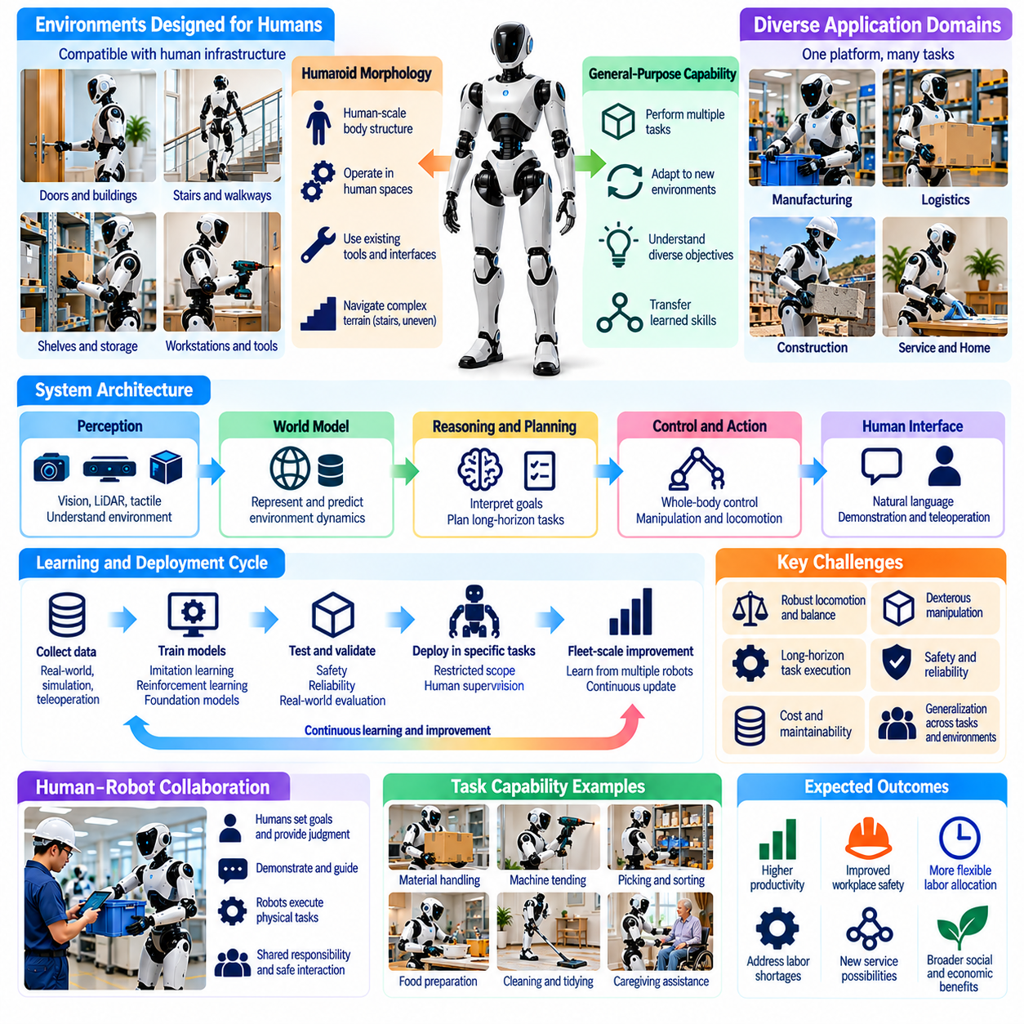
Humanoid robots and general-purpose robotic systems represent a potential turning point in the evolution of Physical AI labor. Unlike specialized machines designed for individual operations, these platforms aim to perform multiple physical tasks across changing environments. Their significance lies in the possibility of transferring intelligent automation into workplaces already organized around human movement, tools, and infrastructure.
Humanoid morphology offers potential compatibility with environments designed for the human body. Doors, stairs, shelves, workstations, and hand-operated tools often assume human proportions and movement capabilities. A humanoid robot may interact with such infrastructure without extensive modification. However, anatomical similarity does not automatically provide superior performance, and alternative robotic configurations may remain more efficient for many tasks.
General-purpose robotic labor should be defined by functional adaptability rather than appearance alone. A robot becomes more general when it can interpret different objectives, manipulate unfamiliar objects, and transfer learned skills between tasks. This capability requires coordinated perception, reasoning, planning, and control. A humanoid body may support versatility, but genuine generality depends primarily on reliable behavior across diverse operating conditions.
The mechanical complexity of humanoid robots introduces substantial engineering challenges. Bipedal locomotion requires continuous balance regulation, coordinated joint control, and rapid responses to external disturbances. Manipulation adds requirements for dexterity, force sensing, and stable whole-body motion. These demands increase computational requirements, energy consumption, and maintenance complexity compared with simpler robotic platforms.
Physical AI may improve humanoid capabilities through learned control policies and predictive world models. Perception systems estimate surrounding geometry, object states, and human activity, while planning models evaluate possible actions and their consequences. Low-level controllers translate selected behaviors into actuator commands. Reliable operation requires these components to cooperate across different time scales while respecting physical and safety constraints.
Vision-language-action models provide a possible interface between human instructions and robotic execution. A worker might request that a robot organize materials, retrieve equipment, or prepare a workstation. The system must interpret the instruction, identify relevant objects, and generate appropriate actions. Nevertheless, linguistic understanding alone does not guarantee physical competence, especially when manipulation requires precise contact and force regulation.
Learning transferable skills is essential for general-purpose robotic labor. A robot trained to grasp one category of objects should ideally adapt to unfamiliar shapes, materials, and placements. Cross-task generalization may reduce the need for separate programming of every operation. However, variations in friction, weight, deformability, and environmental geometry can cause learned policies to fail outside their training distributions.
Long-horizon task execution presents another major challenge. Activities such as preparing a workspace or restocking supplies require multiple dependent actions, persistent state tracking, and recovery from mistakes. Robots must remember completed steps, recognize unexpected outcomes, and revise plans when conditions change. Combining hierarchical planning, memory, and feedback control may enable more reliable execution of extended physical workflows.
Industrial facilities may provide the earliest economically practical environments for general-purpose robots. Factories and warehouses contain recurring tasks, established supervision procedures, and measurable performance objectives. Humanoid robots could potentially handle selected material transfers, machine tending, and workstation preparation. Initial deployments are likely to emphasize restricted task sets rather than unrestricted autonomous operation.
The economic justification for humanoid labor depends on utilization and task versatility. A robot capable of several activities may distribute its acquisition cost across different workflows, reducing idle time. However, versatility provides limited value if task transitions require extensive setup or frequent human intervention. Organizations must evaluate effective throughput, reliability, maintenance, supervision costs, and integration requirements rather than relying on nominal task capability.
Human-robot collaboration will remain central during the development of general-purpose robotic labor. Workers may assign tasks, demonstrate procedures, supervise execution, and resolve exceptions. Robots can perform repetitive physical activities while humans retain responsibility for complex judgments and operational priorities. Effective collaboration requires understandable interfaces, predictable robot behavior, and clearly defined boundaries of authority.
Teleoperation can accelerate humanoid development by providing demonstrations and assistance during difficult tasks. Human operators may remotely control robotic movements, generating examples of successful manipulation and recovery. These experiences can support imitation learning and policy improvement. Nevertheless, teleoperation-intensive systems should not be confused with fully autonomous labor, particularly when evaluating productivity and economic scalability.
Fleet-scale learning offers a pathway toward improving general-purpose capabilities across multiple robots. Operational experiences can reveal common failure patterns, unfamiliar objects, and successful task strategies. Curated data may support foundation-model training and continual adaptation. However, sharing learned behavior requires careful validation because differences in robot hardware, environmental conditions, and task requirements can affect reliability.
Cross-embodiment learning may further expand the usefulness of general-purpose robotic intelligence. Skills acquired through humanoid robots, mobile manipulators, or other platforms may share representations of objects, actions, and physical relationships. Transferring knowledge between embodiments could improve data efficiency. Yet differences in kinematics, actuator capabilities, and contact dynamics prevent straightforward reuse of every learned movement.
Safety presents particularly demanding requirements when humanoids operate near people. Their moving limbs, elevated centers of mass, and substantial mechanical power can create collision, instability, and contact risks. Safe deployment requires validated motion constraints, force limitations, emergency stopping mechanisms, and continuous monitoring. Learned intelligence must operate within independently enforced safety boundaries.
Reliability is equally important because general-purpose robots may encounter situations not anticipated during development. A system that completes most demonstrations successfully may still be unsuitable for continuous production if failures occur unpredictably. Performance evaluation should measure task completion, recovery success, intervention frequency, and safe operating duration. Robustness across changing conditions matters more than isolated demonstrations of complex behavior.
Energy efficiency and hardware durability impose additional limits on practical humanoid labor. Walking, balancing, lifting, and manipulating objects consume energy while producing mechanical wear. Battery capacity, actuator efficiency, thermal management, and maintenance intervals influence operating economics. General-purpose robots must demonstrate sustained useful work rather than merely short periods of technically impressive movement.
The workforce implications of humanoid deployment depend on which tasks become economically automatable. Repetitive handling, transportation, and routine preparation may experience partial substitution, while supervision, maintenance, integration, and exception management may expand. Entire occupations are unlikely to change uniformly because most jobs combine physical execution with communication, judgment, and organizational responsibilities.
Humanoid robots may also influence workplace design and organizational structure. Facilities could retain human-compatible infrastructure while gradually introducing robotic workers, reducing some modification costs. At the same time, charging areas, maintenance procedures, digital task interfaces, and safety protocols will require adaptation. Effective integration depends on redesigning workflows around complementary human and robotic capabilities.
The development of general-purpose robots should not be interpreted as evidence that human-equivalent physical intelligence has already been achieved. Broad autonomy requires dependable perception, physical reasoning, dexterous manipulation, memory, and adaptation under unfamiliar conditions. Progress in individual components does not automatically produce integrated competence. Evaluation must distinguish laboratory demonstrations from sustained, economically useful deployment.
Over the longer term, improvements in foundation models, world models, hardware design, and fleet learning may expand the range of tasks accessible to general-purpose robots. Systems could move between industrial, commercial, and selected domestic activities with less specialized programming. However, deployment speed will depend on safety validation, operating costs, infrastructure compatibility, and the ability to maintain reliability across diverse environments.
Humanoid and general-purpose robotic labor may ultimately change how societies organize physical work. Instead of assigning every repetitive operation to a dedicated machine, organizations could allocate tasks among adaptable robotic platforms and human specialists. The resulting division of labor would depend on comparative capabilities, economic incentives, and institutional choices rather than technological possibility alone.
Ultimately, the significance of humanoids lies not simply in reproducing human appearance but in developing machines capable of useful, adaptable, and accountable physical work. Their contribution to Physical AI will be measured by reliable task execution, safe collaboration, and sustainable economic value. Human-centered deployment must ensure that increasing robotic versatility strengthens productivity and worker well-being without neglecting responsibility, training, or social consequences.

01.11. Human Robot Teams
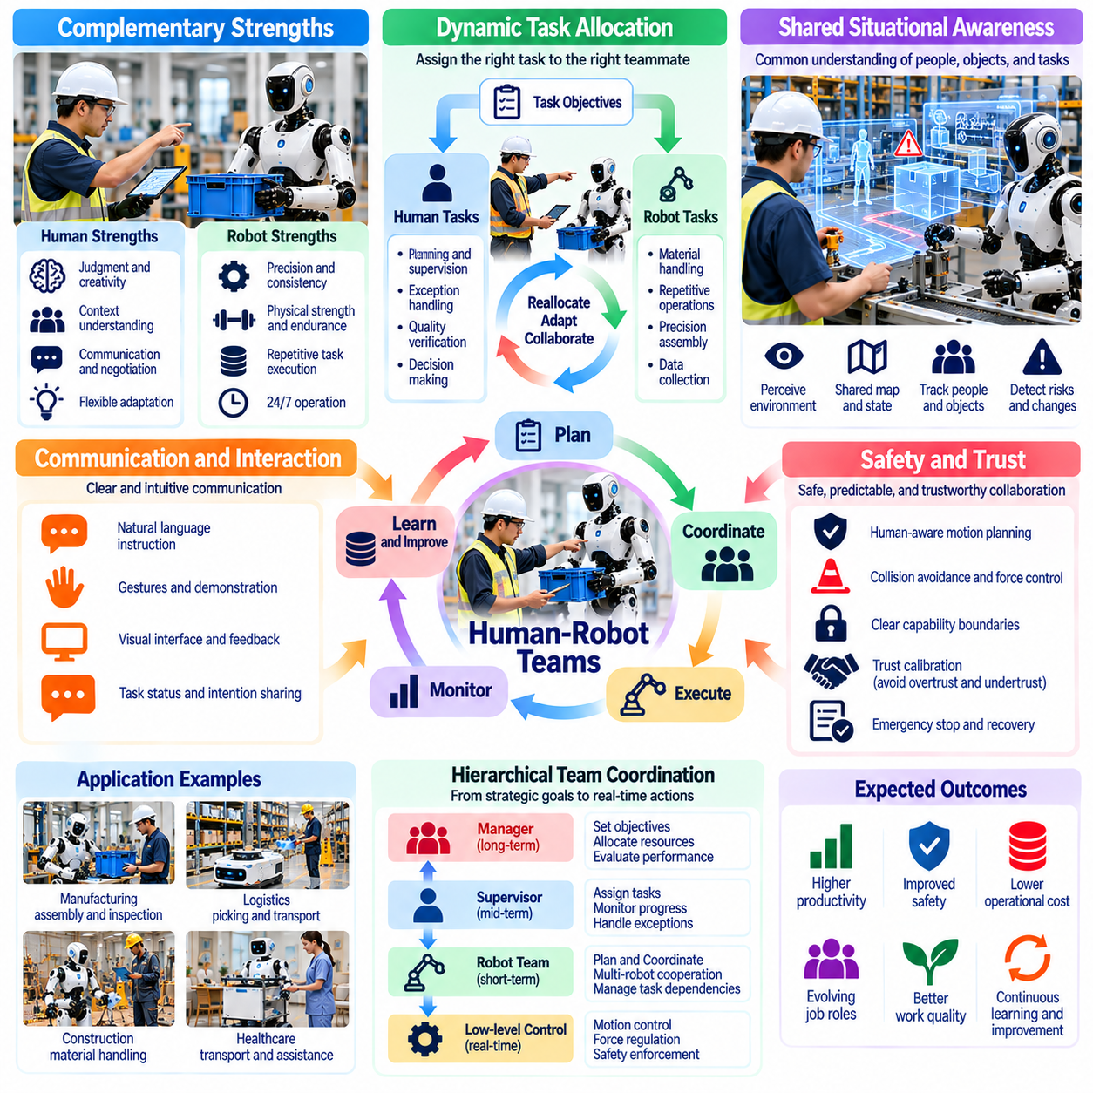
Human-robot teams represent an emerging organizational model in which human workers and intelligent machines cooperate to achieve shared physical objectives. Unlike conventional automation, where machines execute isolated tasks, collaborative systems coordinate decisions, movements, and responsibilities. Their effectiveness depends on combining human judgment, contextual understanding, and adaptability with robotic precision, endurance, and repeatability.
The fundamental principle of human-robot teamwork is complementary capability rather than simple labor substitution. Humans remain effective at interpreting ambiguous situations, negotiating priorities, and responding to social context. Robots can provide consistent execution, physical assistance, and repetitive task performance. Productive collaboration requires assigning responsibilities according to comparative strengths while recognizing the limitations of both participants.
Task allocation becomes a dynamic process when robots possess adaptive intelligence. A human supervisor may assign objectives while robotic systems select appropriate execution strategies within defined boundaries. Tasks can be reassigned when environmental conditions, workload, or system capabilities change. Effective allocation requires awareness of worker availability, robot readiness, task dependencies, and the consequences of delayed execution.
Shared situational awareness is essential for coordinated physical work. Human workers and robots must maintain sufficiently consistent representations of objects, obstacles, task progress, and operational hazards. Perception systems can update environmental information, while interfaces communicate relevant changes to workers. Differences between human understanding and robotic world representations must be detected before they produce unsafe or inefficient actions.
Communication provides the foundation for reliable human-robot coordination. Workers may express goals through speech, gestures, graphical interfaces, or direct physical guidance. Robots must interpret these signals while communicating intentions, limitations, and task status. Effective interaction should minimize ambiguity and avoid overwhelming workers with unnecessary information, particularly during time-sensitive or safety-critical operations.
Predictability strongly influences trust within human-robot teams. Workers need to understand where a robot intends to move, what action it will perform, and when human intervention may be required. Motion planning should consider human expectations as well as collision avoidance. Transparent status reporting and understandable behavior can improve coordination, although excessive confidence in robotic capability may create new safety risks.
Trust calibration requires matching human expectations to demonstrated robotic competence. Undertrust may prevent useful automation, while overtrust can encourage inappropriate delegation of dangerous tasks. Teams should develop trust through validated performance, clear capability boundaries, and consistent communication of uncertainty. Training and operational feedback help workers recognize when autonomous assistance is appropriate and when direct supervision remains necessary.
Collaborative manipulation introduces physical interaction between humans and robotic systems. Workers and robots may jointly position components, transport heavy objects, or assemble structures. Such activities require force coordination, compliant control, and accurate estimation of human movement. Robots must respond safely to unexpected resistance or changes in human intent while maintaining stability and protecting nearby personnel.
Shared workspaces require continuous risk assessment because human behavior cannot be predicted perfectly. Collaborative robots must detect proximity, estimate motion, and adjust speed or force when people approach. Safety mechanisms should remain effective even when perception or learning-based control becomes unreliable. Physical safeguards, validated operating limits, and emergency procedures must complement intelligent planning.
Hierarchical coordination can organize human-robot teams across different decision horizons. Human managers may establish production objectives, supervisors allocate tasks, and robotic controllers execute individual movements. Strategic decisions evolve over longer periods, while motion control operates at much shorter intervals. Connecting these layers requires reliable feedback, explicit authority boundaries, and mechanisms for revising plans.
World models can support teamwork by representing shared environments and predicting the consequences of coordinated actions. A robot may anticipate that a worker will occupy a particular workspace or that moving equipment will obstruct a planned route. Such predictions can improve scheduling and motion planning. However, uncertainty must remain explicit because human intentions and environmental changes cannot be inferred with complete reliability.
Multi-robot teams introduce additional coordination challenges when several machines cooperate with human personnel. Robots may share maps, exchange task status, and negotiate resource access while supervisors manage overall priorities. Fleet management systems can reduce congestion and balance workloads. Nevertheless, communication delays, inconsistent state information, and simultaneous failures can undermine coordination without robust recovery mechanisms.
Exception handling is a defining requirement of practical human-robot teamwork. Robots may encounter unfamiliar objects, blocked passages, damaged equipment, or instructions that conflict with safety constraints. Systems should identify situations beyond their validated competence and request appropriate assistance. Human intervention must be integrated into normal operations rather than treated as evidence that collaboration has failed.
Teleoperation and shared autonomy provide intermediate forms of collaboration between manual control and full robotic independence. An operator may guide a difficult manipulation while the robot maintains balance, collision avoidance, and low-level control. Authority can shift as task complexity and uncertainty change. These arrangements may improve productivity, provided that transitions are understandable and do not create excessive cognitive workload.
Human factors become increasingly important as workers supervise multiple intelligent machines. Monitoring several robots can introduce attention demands, alarm fatigue, and delayed responses to exceptional events. Interface design should prioritize actionable information and distinguish routine updates from urgent warnings. Workload-aware coordination may adjust robotic autonomy or task assignments according to the supervisor's available attention.
Organizational integration requires redesigning workflows rather than merely placing robots beside existing workers. Task sequences, workstation layouts, shift schedules, and maintenance responsibilities may need adjustment. Employees should participate in deployment planning because practical operational knowledge often reveals constraints overlooked during engineering. Successful integration depends on aligning technical capabilities with established working practices.
Training programs must prepare workers to cooperate with robotic teammates safely and effectively. Personnel need to understand robot capabilities, operational limits, communication procedures, and intervention mechanisms. Simulation and supervised practice can expose workers to unusual situations before live deployment. Training should also develop the ability to question robotic recommendations and maintain independent professional judgment.
Performance evaluation should measure team outcomes rather than robot productivity alone. Relevant indicators include total task completion time, quality, worker workload, intervention frequency, safety incidents, and recovery performance. A robot that operates rapidly but repeatedly interrupts colleagues may reduce overall efficiency. Team-level metrics reveal whether automation genuinely improves the combined human-machine workflow.
Economic benefits arise when collaboration increases productive capacity without proportionally increasing supervision and integration costs. Robots may reduce physical fatigue, extend operational coverage, and support workers during labor-intensive activities. However, coordination overhead and unreliable autonomy can offset these gains. Investment decisions should consider sustained team performance, employee acceptance, and the cost of maintaining safe operations.
Human-robot teamwork also raises questions about authority, accountability, and worker autonomy. Organizations must clarify who approves tasks, controls operating limits, and accepts responsibility for consequential decisions. Robotic recommendations should not obscure managerial obligations or professional accountability. Workers need practical mechanisms to stop unsafe operations and report system limitations without inappropriate pressure.
The long-term development of human-robot teams may involve increasingly adaptive cooperation supported by foundation models, persistent memory, and continual learning. Robots could recognize recurring workflows, anticipate assistance needs, and improve coordination through accumulated experience. Nevertheless, behavioral adaptation must remain observable, validated, and reversible when necessary. Learning should strengthen teamwork without introducing unpredictable operational changes.
Human-robot teams may eventually become a standard organizational structure across manufacturing, logistics, construction, healthcare, and service industries. Their configurations will differ according to task risk, environmental complexity, and the importance of interpersonal judgment. Some teams may involve direct physical collaboration, while others rely on supervision and autonomous task execution. No single collaboration model will suit every workplace.
Ultimately, effective human-robot teams depend on designing intelligence around shared responsibility and coordinated action. Their purpose is not merely to maximize robotic autonomy but to improve collective performance, safety, and human well-being. Physical AI will create lasting labor value when machines remain understandable, dependable, and adaptable partners within organizational systems that preserve meaningful human control.

01.12. Supervision Teleoperation and Exception Handling
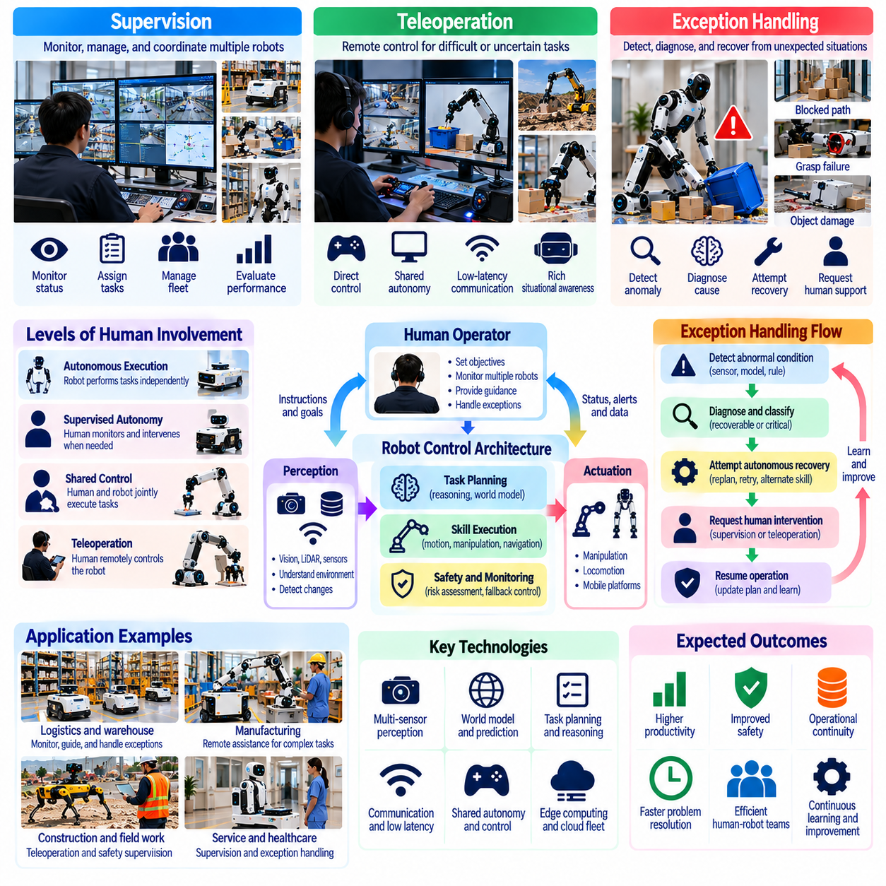
Supervision, teleoperation, and exception handling are essential components of Physical AI labor because autonomous robots cannot reliably manage every situation encountered in real environments. Even advanced systems face unfamiliar objects, unexpected human behavior, and operational failures. Human oversight provides a mechanism for maintaining safety and continuity while allowing machines to execute routine physical tasks with increasing independence.
Supervision differs from direct manual control because a human operator monitors objectives, performance, and operating conditions rather than continuously commanding individual movements. One supervisor may oversee several robots performing independent tasks. This arrangement can improve labor productivity, but its effectiveness depends on system reliability, understandable interfaces, and the frequency of situations requiring intervention.
Teleoperation enables human operators to control robotic systems remotely when autonomous capabilities are insufficient. Control may range from direct joint manipulation to high-level task guidance supported by autonomous stabilization and obstacle avoidance. The appropriate control method depends on communication latency, environmental complexity, and task risk. Effective teleoperation preserves human judgment while exploiting robotic sensing and control capabilities.
Exception handling addresses situations in which normal robotic execution cannot continue safely or successfully. Examples include blocked pathways, damaged objects, uncertain grasping conditions, conflicting instructions, and unexpected equipment behavior. A robust system must detect these deviations, classify their severity, and select an appropriate response. Not every exception requires human intervention, but unresolved uncertainty must trigger controlled escalation.
The distinction between routine operation and exceptional conditions is central to scalable automation. Robots may complete predictable tasks autonomously while requesting assistance for unusual circumstances. This approach reduces the need for continuous human control without assuming universal robotic competence. Successful deployment requires accurate identification of capability boundaries and reliable transitions between autonomous and supervised operation.
Supervisory control architectures commonly separate strategic objectives, task planning, and physical execution. Human supervisors establish priorities and operating constraints, while robotic planners determine task sequences and low-level controllers execute movements. Monitoring systems compare actual performance with expected behavior. Deviations can initiate replanning, safe stopping, or escalation according to predefined operational policies.
Adaptive autonomy allows the degree of human involvement to change according to task complexity and uncertainty. A robot may navigate familiar corridors independently but request guidance when encountering unfamiliar obstacles. During difficult manipulation, a human operator may temporarily control the end effector while autonomous controllers maintain stability. Effective transitions require explicit authority management and predictable control behavior.
Reliable exception detection depends on combining perception, state estimation, and operational monitoring. Robots must identify discrepancies between observed conditions and predicted outcomes. Unexpected contact forces, localization errors, sensor degradation, and repeated task failures may indicate emerging problems. Monitoring should distinguish recoverable disturbances from conditions that threaten safety or exceed validated operating capabilities.
World models can strengthen exception handling by predicting physical consequences and identifying inconsistencies. A robot may recognize that an object has moved unexpectedly or that a planned route is no longer traversable. Predictive models can support alternative action selection and recovery planning. However, model uncertainty must be considered because incorrect predictions may otherwise produce repeated failures or unsafe responses.
Human intervention should follow a structured escalation process rather than relying on arbitrary operator decisions. A robot may first attempt validated recovery procedures, then request remote assistance if uncertainty persists. Safety-critical conditions should trigger immediate protective behavior. Escalation policies must consider task urgency, potential damage, human proximity, and the availability of qualified operators.
Teleoperation interfaces must provide operators with sufficient situational awareness to make reliable decisions. Video streams, depth information, robot state estimates, and force feedback may support remote manipulation. Excessive information can increase cognitive workload, while insufficient feedback can impair control accuracy. Interface design should prioritize relevant observations and communicate uncertainty, system limitations, and intervention requirements clearly.
Communication latency creates significant challenges for remote robotic control. Delayed visual feedback and command transmission can destabilize precise manipulation or complicate obstacle avoidance. Shared autonomy can reduce these effects by assigning fast control loops to onboard systems while operators provide slower supervisory commands. Communication failures require safe fallback behaviors that do not depend on continuous network availability.
Edge computing and on-premise intelligence are particularly important for safety-critical robotic operations. Local controllers can maintain stabilization, collision avoidance, and emergency stopping even when cloud connectivity is unavailable. Remote infrastructure may support fleet supervision, complex reasoning, and data analysis. Effective system architecture separates functions requiring deterministic response from those that can tolerate communication delays.
Supervising multiple robots introduces a complex workload allocation problem. An operator may manage several machines during normal operation but become overloaded when simultaneous exceptions occur. Fleet management systems should estimate intervention demand and prioritize assistance requests. Robot-to-operator ratios must therefore reflect observed exception frequency, intervention duration, task criticality, and operator attention rather than theoretical autonomy alone.
Exception handling also creates opportunities for systematic learning. Human interventions can reveal limitations in perception, planning, manipulation, or environmental understanding. Recorded experiences may become training examples for imitation learning, policy refinement, and improved recovery strategies. Data pipelines should distinguish successful interventions from uncertain or unsafe behavior before incorporating them into future robotic models.
Fleet-scale learning can distribute validated improvements across multiple deployed robots. Recurring exceptions may reveal common environmental patterns, hardware weaknesses, or software limitations. Aggregated operational data can support targeted updates and preventive maintenance. However, new policies require controlled evaluation before deployment because improvements in one environment may introduce failures under different physical conditions.
Human factors strongly influence supervisory effectiveness. Operators may experience attention fatigue, reduced vigilance, and difficulty maintaining awareness across multiple robotic systems. Repeated false alarms can encourage inappropriate dismissal of warnings, while poorly timed alerts may interrupt critical decisions. Interface design, workload management, and training must support sustained attention without requiring constant observation of every robot.
Operational responsibility must remain clearly defined when control shifts between autonomous systems and human operators. Organizations should specify who authorizes remote intervention, who can override robotic decisions, and how actions are recorded. Audit trails can support incident investigation and continuous improvement. Human supervision should provide meaningful authority rather than merely assigning responsibility for decisions operators cannot realistically control.
Safety engineering requires independent protective mechanisms that remain effective during software faults, communication failures, and operator mistakes. Emergency stopping, motion constraints, force limits, and runtime assurance can restrict hazardous behavior. Teleoperation must not bypass essential safety protections without carefully controlled authorization. Robust design assumes that both autonomous intelligence and human intervention can occasionally fail.
Economic evaluation of supervised autonomy must include the hidden labor associated with robotic operation. Operator salaries, training, communication infrastructure, exception resolution, and downtime contribute to total operating costs. A robot with high nominal autonomy may deliver limited savings if frequent interventions consume substantial human time. Meaningful productivity assessment therefore requires measuring effective autonomous work and total supervisory effort.
The development of general-purpose robots may initially increase demand for skilled supervision and remote operation. New roles could include robot fleet supervisor, teleoperation specialist, exception analyst, and autonomy performance engineer. As systems improve, routine interventions may decline while complex troubleshooting and operational optimization become more important. Workforce development should prepare employees for these changing responsibilities.
Long-term progress may shift supervision from continuous monitoring toward exception-driven management. Robots could independently complete extended workflows, recognize their own limitations, and request assistance only when necessary. Persistent memory, hierarchical planning, and uncertainty-aware reasoning may support this transition. Nevertheless, increasing autonomy should be accompanied by stronger validation, transparent reporting, and reliable human override mechanisms.
Ultimately, supervision, teleoperation, and exception handling form the operational bridge between imperfect robotic intelligence and dependable physical labor. Their purpose is not simply to compensate for technological limitations but to establish a scalable framework for safe human-machine cooperation. Physical AI becomes economically and socially valuable when autonomous execution, human expertise, and systematic learning reinforce one another within accountable operational systems.

01.13. New Jobs and Robot Centered Professions
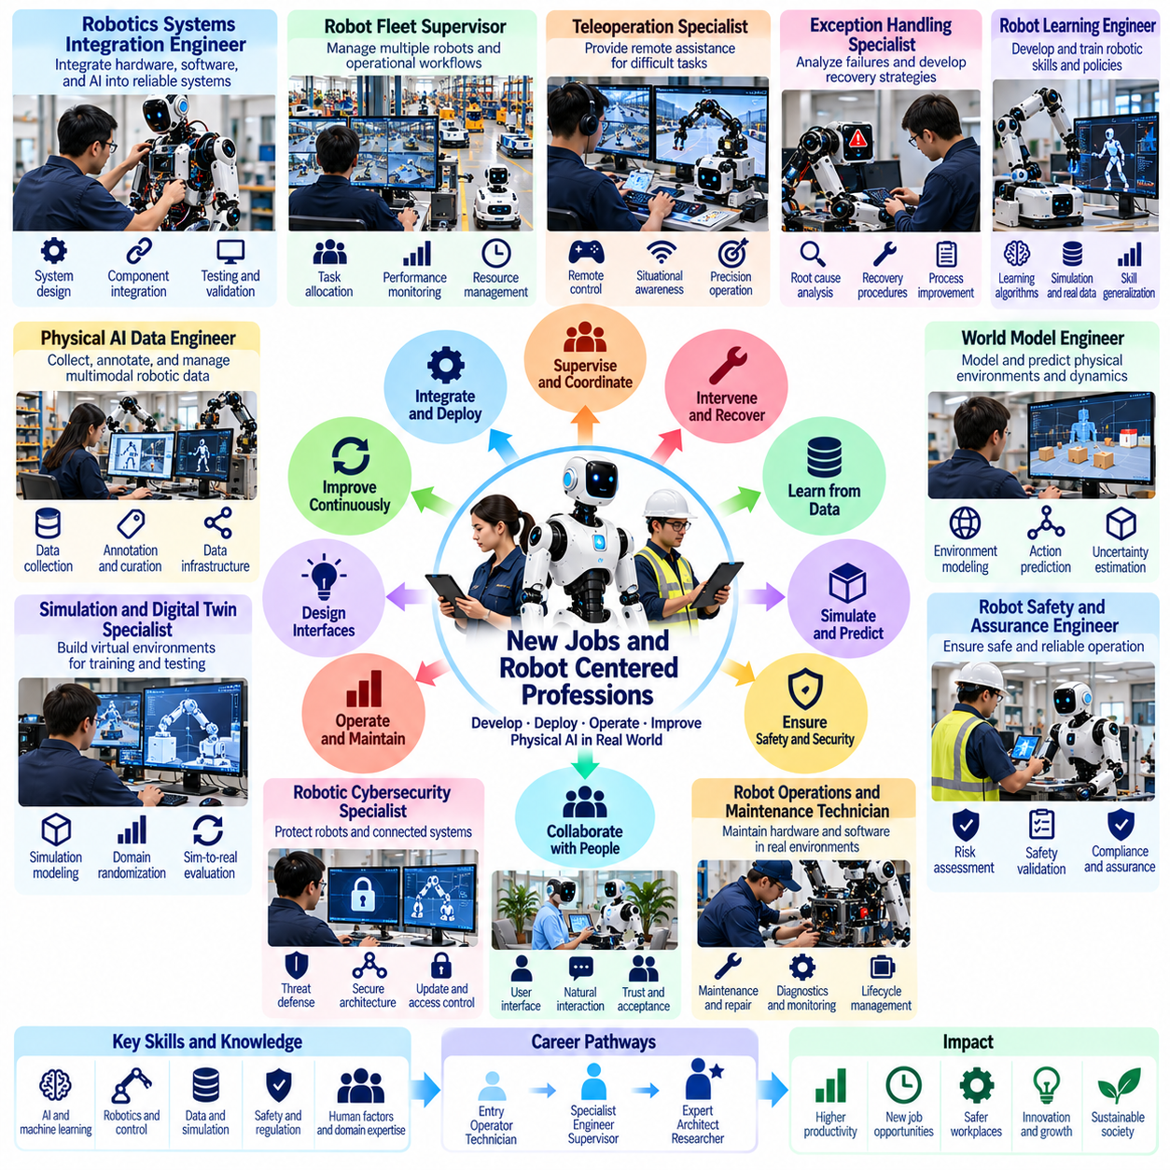
The expansion of Physical AI is expected to create new occupations centered on the development, deployment, supervision, and continuous improvement of intelligent robotic systems. Although automation may reduce demand for certain repetitive tasks, it also introduces technical and organizational responsibilities that existing professions do not fully address. The resulting labor transformation will involve occupational creation, specialization, and the restructuring of established roles.
Robot-centered professions emerge because autonomous machines require extensive support beyond their initial design and installation. Real-world operation involves environmental adaptation, hardware maintenance, software updates, safety validation, and performance monitoring. As robotic fleets expand, organizations will need specialists who understand both intelligent algorithms and physical operations. These professions connect digital intelligence with practical industrial execution.
Robotics systems integration is likely to become an increasingly important professional field. Integration engineers must connect perception models, motion planners, actuators, sensors, and enterprise software into reliable operational systems. Their responsibilities extend beyond component compatibility to workflow design, latency management, and safety coordination. Successful integration requires knowledge of mechanical engineering, embedded computing, artificial intelligence, and operational processes.
Robot fleet supervisors will coordinate groups of autonomous machines operating across factories, warehouses, hospitals, and commercial facilities. Their responsibilities may include task allocation, operational monitoring, intervention prioritization, and resource management. Unlike traditional machine operators, fleet supervisors manage multiple intelligent agents simultaneously. Their effectiveness depends on understanding autonomy limitations, operational risk, and human-machine coordination.
Teleoperation specialists will provide remote assistance when robots encounter situations beyond their autonomous capabilities. These professionals may guide complex manipulation, resolve navigation failures, or demonstrate unfamiliar procedures. Effective teleoperation requires spatial reasoning, situational awareness, and precise control under communication constraints. Over time, teleoperators may increasingly supervise difficult decisions rather than directly controlling every movement.
Exception handling specialists will analyze recurring failures and develop systematic recovery strategies. Their work involves distinguishing perception errors, planning failures, mechanical limitations, and environmental disturbances. By identifying root causes, they can improve operational procedures and recommend changes to robotic policies. This profession combines troubleshooting, safety analysis, data interpretation, and knowledge of physical task execution.
Robot learning engineers will develop policies that enable machines to acquire and refine physical skills. Their work may combine imitation learning, reinforcement learning, simulation, and real-world demonstrations. Unlike conventional software development, robotic learning requires understanding contact dynamics, actuator constraints, and environmental variability. Engineers must evaluate whether learned behaviors remain reliable outside the conditions represented in training data.
Physical AI data engineers will manage the collection, synchronization, annotation, and curation of multimodal robotic experiences. Their datasets may contain camera observations, force measurements, joint states, language instructions, and task outcomes. Maintaining temporal consistency and physical context is essential for useful training data. These specialists will support the data infrastructure required for scalable robotic intelligence.
Simulation and digital twin specialists will construct virtual environments for training, testing, and validating robotic behavior. They must represent geometry, materials, contact forces, sensor characteristics, and operational disturbances with sufficient fidelity. Their responsibilities may include domain randomization, synthetic data generation, and simulation-to-reality evaluation. These professions connect computational modeling with measurable physical performance.
World model engineers may become increasingly important as robots develop predictive representations of physical environments. Their work involves modeling object dynamics, spatial relationships, action consequences, and uncertainty across multiple time horizons. Such models can support planning, manipulation, and recovery from unexpected events. Developing reliable world models requires expertise in machine learning, robotics, physics, and sequential decision-making.
Robot safety and assurance engineers will establish mechanisms for validating autonomous behavior under operational constraints. Their responsibilities include hazard identification, risk assessment, protective control design, and systematic testing. Learning-based systems introduce additional challenges because their behavior may vary across unfamiliar conditions. Safety specialists must integrate established engineering principles with new methods for evaluating adaptive intelligence.
Robotic cybersecurity specialists will protect connected machines against unauthorized access, malicious commands, data manipulation, and software compromise. Physical robots introduce risks beyond conventional information systems because cyberattacks can produce direct mechanical consequences. Security professionals must address device authentication, secure updates, network segmentation, and operational recovery. Their work will increasingly intersect with functional safety and fleet governance.
Human-robot interaction designers will develop interfaces that enable workers to communicate with robotic systems effectively. Their responsibilities may include natural-language instructions, gesture recognition, intention visualization, and intervention workflows. Successful designs must account for human attention, trust calibration, and cognitive workload. These specialists will combine interface engineering, behavioral science, ergonomics, and operational safety.
Robot maintenance professions will also evolve as intelligent machines become mechanically and computationally sophisticated. Technicians may need to diagnose actuator degradation, sensor calibration errors, thermal problems, and software-related performance changes. Predictive maintenance systems can support early fault detection, but skilled personnel remain essential for physical inspection and repair. Maintenance roles will increasingly require combined mechanical, electrical, and digital expertise.
Robot operations analysts will evaluate the economic and operational performance of deployed fleets. They may measure task completion rates, intervention frequency, energy consumption, downtime, and total operating costs. Their analysis can reveal whether automation improves productivity or merely transfers work into hidden supervisory activities. These professionals will help organizations optimize fleet utilization and determine when robotic deployment creates sustainable value.
Robotics deployment consultants and workflow architects will support organizations introducing Physical AI into established operations. Their work may involve identifying suitable tasks, redesigning processes, estimating investment returns, and preparing employees for collaboration. Technical feasibility alone does not guarantee successful adoption. These specialists must align robotic capabilities with organizational objectives, regulatory requirements, and workforce conditions.
Training and education professionals will play a significant role in preparing workers for robot-centered occupations. Instructors may develop programs covering robotic operation, safety procedures, troubleshooting, data literacy, and human-machine collaboration. Practical simulation environments can support experiential learning without exposing trainees to unnecessary hazards. Effective education must combine technical competence with judgment, communication, and adaptability.
The expansion of robotic labor may also create demand for specialists in governance, auditing, and accountability. Organizations will need professionals capable of documenting autonomous decisions, evaluating compliance, and investigating incidents involving robotic systems. These responsibilities require understanding both technical behavior and institutional obligations. Governance roles will become particularly important in healthcare, public infrastructure, and other safety-sensitive environments.
New professions will not emerge independently of existing occupational structures. Electricians, mechanics, software engineers, production managers, and safety officers may incorporate robotic responsibilities into established careers. Some workers will transition into specialized positions, while others will develop hybrid competencies. The balance between entirely new occupations and transformed existing roles will depend on industry conditions and deployment maturity.
Regional labor markets may experience different patterns of occupational creation. Areas with strong manufacturing, robotics research, and technical education ecosystems may develop specialized employment clusters. Regions lacking training infrastructure could face difficulties accessing emerging opportunities. Public institutions, educational organizations, and employers may need to coordinate workforce development to prevent technological adoption from widening existing economic disparities.
Professional certification and competency standards may become important as robotic systems enter safety-critical workplaces. Employers will need credible methods for evaluating operator skills, maintenance competence, and supervisory readiness. Certification frameworks should reflect actual operational responsibilities rather than relying exclusively on theoretical knowledge. Periodic retraining may be necessary as robotic hardware, autonomy capabilities, and safety requirements evolve.
The economic value of robot-centered professions will depend on how effectively they support scalable autonomy. If every robot requires continuous individual supervision, labor savings may remain limited. Conversely, specialists who improve reliability, reduce intervention demand, and maintain large fleets can create substantial productivity gains. Occupational demand will therefore evolve alongside the balance between autonomous capability and human operational support.
Ultimately, Physical AI is likely to transform the structure of professional expertise rather than simply eliminate human participation in physical production. New occupations will emerge around robot intelligence, operational assurance, data infrastructure, maintenance, and human-machine coordination. Their long-term significance lies in enabling dependable automation while preserving human responsibility, professional development, and opportunities for meaningful work.

01.14. Skills Reskilling and Education
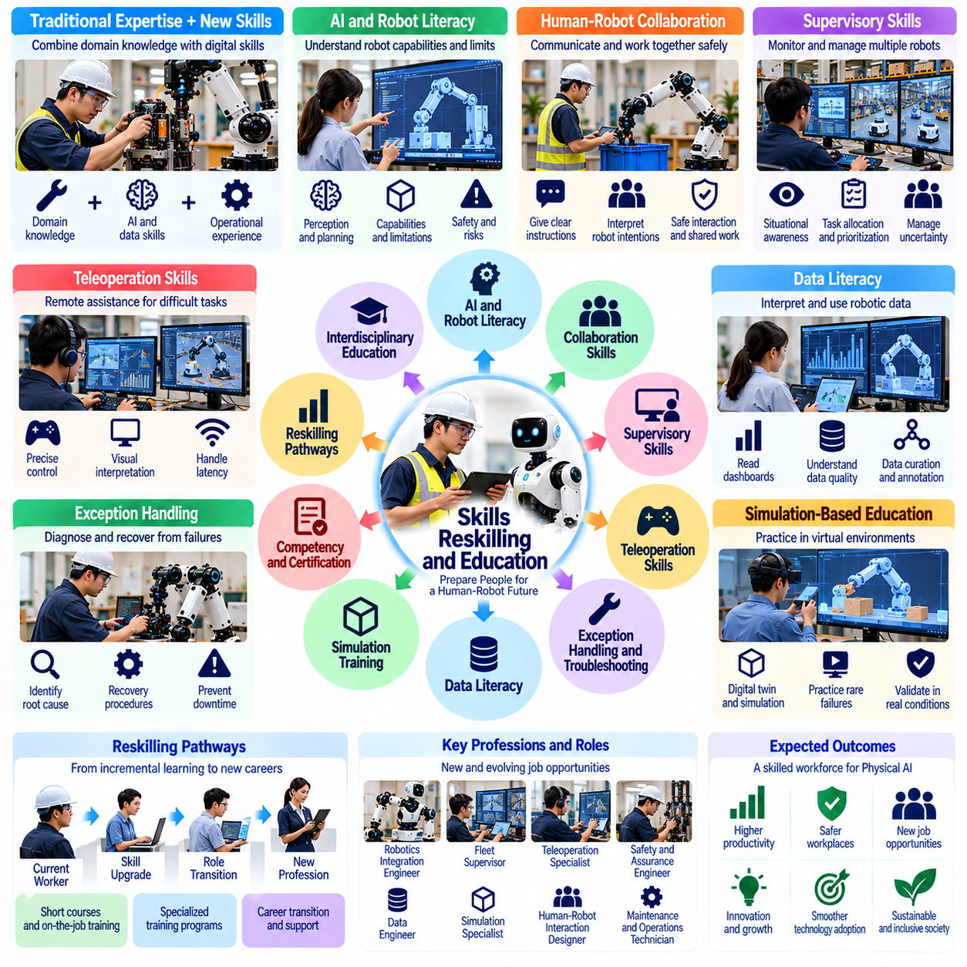
The expansion of Physical AI will transform the skills required across manufacturing, logistics, healthcare, construction, and service industries. As intelligent robots assume selected physical tasks, workers will increasingly need capabilities related to supervision, collaboration, troubleshooting, and system adaptation. Education and reskilling must therefore prepare people not only to operate robotic technologies but also to work effectively within changing human-machine production systems.
The transition toward robot-supported labor will not eliminate the importance of traditional occupational expertise. Knowledge of materials, equipment, safety procedures, and operational workflows remains essential for interpreting robotic behavior. Experienced workers often recognize subtle environmental conditions that automated systems overlook. Future training should combine established domain knowledge with digital competencies rather than treating technological literacy as a complete replacement for practical experience.
Physical AI literacy will become a foundational skill for workers interacting with autonomous machines. Employees should understand how robots perceive environments, interpret instructions, plan movements, and execute actions. They must also recognize the limitations of learned models and the possibility of unexpected behavior. Such literacy does not require every worker to become an artificial intelligence engineer, but it does require informed judgment about robotic capabilities and operational risks.
Human-robot collaboration skills will become increasingly valuable as machines and workers share physical environments. Personnel must learn how to communicate objectives, interpret robot intentions, and coordinate task execution. Understanding safe interaction distances, intervention procedures, and shared authority is essential. Training should emphasize predictable teamwork and the ability to adapt when robotic behavior or environmental conditions differ from expectations.
Supervisory competence will become a central requirement in workplaces operating multiple autonomous robots. Workers may need to monitor fleet performance, prioritize interventions, and identify situations requiring human judgment. Unlike conventional equipment operation, robotic supervision involves managing uncertainty and distributing attention across several intelligent systems. Training must therefore address situational awareness, workload management, and decision-making under time constraints.
Teleoperation skills will support workers who remotely assist robots during difficult or unfamiliar tasks. Operators may require spatial reasoning, precise manipulation, visual interpretation, and familiarity with communication delays. Shared autonomy introduces additional requirements for understanding which functions remain under robotic control. Effective education should include practical exercises that develop coordination between human commands and autonomous stabilization or safety mechanisms.
Exception handling and troubleshooting will remain important because autonomous systems cannot reliably resolve every operational disturbance. Workers should learn to distinguish perception errors, planning failures, mechanical faults, and environmental changes. Structured diagnostic procedures can reduce unnecessary downtime and prevent unsafe interventions. Training should develop systematic reasoning rather than dependence on memorized responses to isolated failure scenarios.
Data literacy will become increasingly relevant as robotic operations generate large volumes of multimodal information. Workers may need to interpret performance dashboards, task logs, sensor measurements, and intervention records. Understanding data quality, uncertainty, and operational context helps prevent misleading conclusions. Advanced specialists will additionally require skills in dataset curation, annotation, validation, and the responsible use of robotic experience data.
Simulation-based education can provide controlled environments for learning complex robotic operations. Digital twins and virtual workspaces allow trainees to practice task allocation, emergency responses, and recovery procedures without exposing people or equipment to unnecessary risks. Simulated exercises can reproduce rare failures that are difficult to encounter during ordinary training. However, practical competence must ultimately be verified under representative real-world conditions.
Reskilling programs should distinguish between incremental skill adaptation and substantial occupational transition. A maintenance technician may need additional training in robotic sensors and software diagnostics, while a displaced production worker may require preparation for an entirely different role. These pathways demand different investments, instructional methods, and support structures. Effective programs should assess existing competencies before prescribing standardized training.
Competency-based education offers a practical framework for preparing workers for Physical AI environments. Instead of measuring learning exclusively through classroom attendance, programs can evaluate demonstrated abilities in supervision, safe intervention, troubleshooting, and task coordination. Performance assessments should reflect realistic operating conditions. Certification systems may help employers identify qualified personnel, provided that standards evolve alongside robotic technologies.
Educational institutions will need to integrate robotics, artificial intelligence, and physical systems engineering across disciplinary boundaries. Mechanical engineering students should understand machine learning and embedded computing, while software specialists should study sensing, actuation, and physical dynamics. Interdisciplinary education can reduce communication barriers between development teams. Practical projects should connect algorithmic concepts with measurable robotic performance.
Vocational education and technical colleges will play a particularly important role in expanding access to robot-centered employment. Training programs can focus on equipment installation, calibration, preventive maintenance, operational supervision, and safety procedures. Partnerships with manufacturers and robotics providers may improve access to current equipment. Curricula should remain sufficiently transferable to avoid dependence on a single vendor or robotic platform.
Continuous learning will become necessary because robotic hardware, foundation models, and autonomy capabilities may evolve faster than traditional educational cycles. Workers will need opportunities to update competencies throughout their careers. Modular courses, workplace training, and periodic reassessment can support this process. Employers should allocate time and resources for learning rather than assuming employees can independently absorb every technological change.
Personalized learning systems may improve the efficiency of reskilling by adapting instruction to individual experience and demonstrated competence. AI-assisted tutors can identify knowledge gaps, recommend exercises, and provide feedback during simulated tasks. However, automated assessment must be transparent and validated. Human instructors remain important for evaluating professional judgment, practical safety awareness, and interpersonal collaboration.
Organizational responsibility is central to successful workforce adaptation. Companies introducing Physical AI should anticipate changes in job requirements and establish training pathways before large-scale deployment. Employees need clear information about emerging roles, expected competencies, and opportunities for advancement. Participatory planning can improve acceptance while ensuring that practical workplace knowledge informs both system design and educational priorities.
Reskilling also involves economic and social barriers that technical instruction alone cannot resolve. Workers may face limited training time, financial constraints, geographic isolation, or uncertainty about future employment. Programs may require wage support, flexible schedules, accessible learning facilities, and career counseling. Without such measures, opportunities created by robotic automation may remain concentrated among workers who already possess advanced technical qualifications.
Public policy can influence whether Physical AI produces inclusive workforce development. Governments may support technical education, apprenticeship programs, portable credentials, and regional training infrastructure. Coordination among employers, educational institutions, and labor organizations can help align training capacity with realistic occupational demand. Policy effectiveness should be evaluated through employment outcomes and skill utilization rather than enrollment numbers alone.
The educational implications of Physical AI extend beyond technical occupations. Managers must understand the economics and limitations of robotic deployment, while healthcare professionals may need skills for supervising assistive systems. Construction workers may interact with autonomous inspection equipment, and service employees may coordinate with mobile robots. Training should therefore be tailored to occupational context rather than restricted to specialized robotics professions.
Human-centered skills may gain importance as routine physical activities become increasingly automated. Communication, ethical judgment, creativity, leadership, and conflict resolution remain difficult to reduce to standardized robotic procedures. Workers may spend more time managing exceptions, supporting customers, and coordinating complex activities. Education should strengthen these capabilities alongside technical literacy, recognizing that valuable work often combines social understanding with practical expertise.
The effectiveness of reskilling should be measured through sustained employment, productivity, safety, and career progression. Completing a training course does not guarantee that workers can perform successfully in robot-supported environments. Employers and educators should track practical competence, job placement, wage development, and adaptation over time. Feedback from these outcomes can guide curriculum improvements and identify groups requiring additional support.
Long-term educational planning must account for uncertainty in the pace and direction of robotic adoption. Some industries may experience rapid deployment, while others face persistent technical, economic, or regulatory constraints. Overly narrow training could prepare workers for occupations that develop more slowly than expected. Broad technical foundations, transferable skills, and flexible learning pathways can improve resilience under changing technological conditions.
Ultimately, skills development, reskilling, and education will determine how broadly the benefits of Physical AI are distributed across society. Intelligent robots can increase productive capacity, but their contribution to human prosperity depends on whether workers can adapt and participate meaningfully. A successful transition requires coordinated investment in technical competence, practical experience, lifelong learning, and institutional support that connects technological progress with sustainable employment opportunities.

01.15. Productivity Wages and Labor Displacement
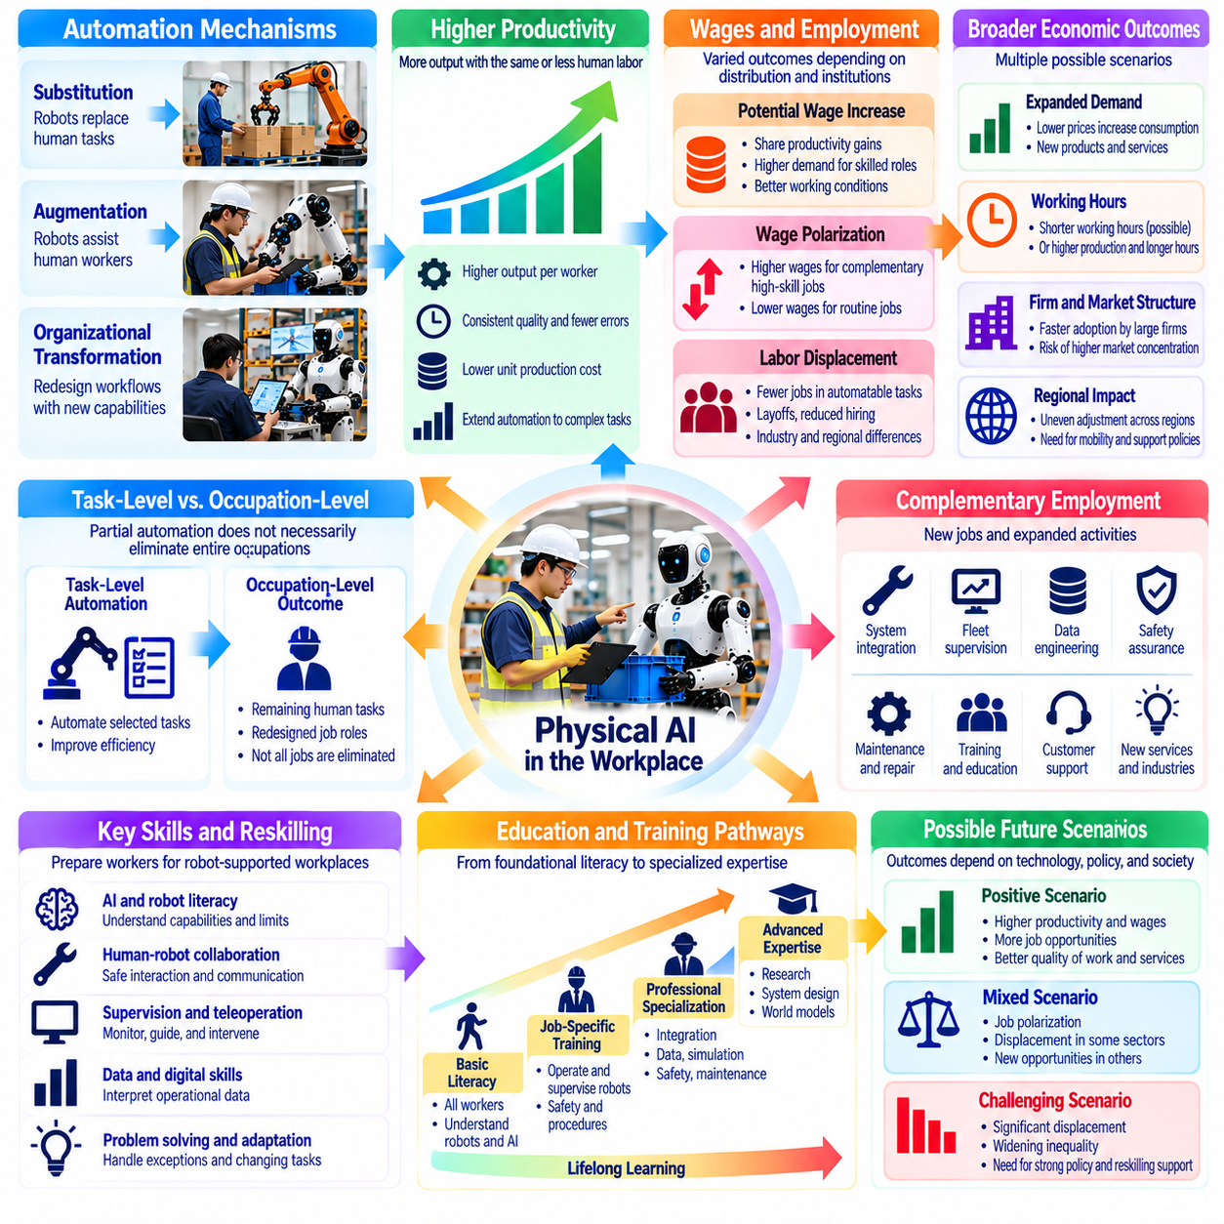
Physical AI has the potential to reshape the relationship between productivity, wages, and employment by extending automation into physical tasks previously dependent on human labor. Intelligent robots may increase output, improve operational consistency, and reduce production costs. However, higher productivity does not automatically translate into higher wages or greater employment. Economic outcomes depend on how technological gains are distributed across workers, firms, and consumers.
Labor productivity measures the amount of output produced per unit of human labor input. When robots perform repetitive handling, transportation, inspection, or assembly tasks, human workers may produce more output with less direct physical effort. Yet productivity improvements must account for robotic capital, maintenance, supervision, and integration costs. Measuring output per worker alone may conceal the additional resources required to sustain automated operations.
Physical AI can influence productivity through substitution, augmentation, and organizational transformation. Substitution occurs when robotic systems replace human execution of specific tasks. Augmentation allows workers to accomplish more through robotic assistance, while organizational transformation redesigns workflows around new capabilities. These mechanisms can operate simultaneously, making the employment consequences of automation more complex than simple worker replacement.
Task-level automation does not necessarily imply occupation-level displacement. Most occupations combine physical execution, communication, judgment, coordination, and exception handling. Robots may automate selected activities while leaving other responsibilities with human workers. Consequently, employment effects depend on the proportion of tasks automated, the importance of remaining duties, and whether organizations redesign jobs around complementary human capabilities.
Wage outcomes depend partly on how automation changes demand for different skills. Workers who supervise robots, integrate systems, or manage complex operations may experience stronger demand for their expertise. Employees whose primary tasks become inexpensive to automate may face weaker bargaining positions. These effects can produce wage polarization if high-skill complementary roles expand while routine occupations experience reduced opportunities.
Productivity growth can support wage increases when workers share in the additional economic value created by automation. Higher output per employee may enable firms to raise compensation while maintaining profitability. However, wage growth also depends on labor market competition, bargaining institutions, organizational policies, and ownership structures. Without mechanisms linking productivity gains to compensation, a larger share of benefits may accrue to capital owners.
Labor displacement occurs when automation reduces demand for human workers in particular tasks, occupations, or industries. Displacement may appear through layoffs, reduced hiring, shorter working hours, or declining opportunities for new entrants. These changes need not occur immediately after robotic deployment. Organizations may initially use automation to address labor shortages or expand capacity before adjusting their employment structures.
The timing of displacement depends on technological maturity and economic feasibility. Robots must achieve sufficient reliability, throughput, and cost efficiency before replacing established labor processes. High acquisition costs, maintenance requirements, and frequent human interventions can delay adoption. Consequently, technical demonstrations of robotic competence should not be interpreted as direct evidence of imminent large-scale employment displacement.
Physical AI may also create complementary employment through new products, services, and operational activities. Robot deployment requires systems integration, fleet supervision, maintenance, data engineering, safety assurance, and training. Increased production capacity may stimulate demand for logistics, customer support, and related services. Nevertheless, newly created positions may differ geographically and professionally from jobs affected by automation.
Demand expansion can partially offset labor displacement when productivity improvements reduce prices and increase consumption. Lower production costs may make goods and services accessible to additional customers, supporting higher output and employment in related activities. The magnitude of this effect depends on demand responsiveness, market competition, and industry structure. Some sectors may expand substantially, while others experience limited additional demand.
The distribution of productivity gains may differ between large corporations and smaller enterprises. Organizations with access to capital, robotics expertise, and extensive operational data may adopt Physical AI more rapidly. Smaller firms may struggle with initial investment and integration complexity. Such differences could increase market concentration unless affordable robotic services, shared infrastructure, and accessible financing broaden participation.
Regional labor markets may experience uneven adjustment as Physical AI spreads across industries. Manufacturing centers, logistics hubs, and technologically advanced regions may undergo rapid changes in task composition. Areas with limited educational resources or alternative employment opportunities may face greater displacement risks. Regional outcomes will depend on industrial specialization, workforce mobility, infrastructure, and institutional support.
The effects of automation on working hours are not predetermined. Higher productivity could enable shorter schedules while maintaining output, but firms may instead increase production or extend operating periods. Workers may benefit from reduced physical strain without experiencing fewer paid hours. The actual outcome depends on labor contracts, market demand, organizational objectives, and the distribution of bargaining power between employers and employees.
Physical AI may improve job quality by reducing dangerous, repetitive, and physically exhausting activities. Robots can assist with heavy lifting, hazardous inspection, and operations in uncomfortable environments. Such improvements may reduce injuries and support longer working careers. However, automation can also introduce intensive monitoring, higher performance expectations, and new supervisory burdens if workplace design prioritizes output without considering worker well-being.
Labor market adjustment involves more than transferring workers from declining occupations into expanding ones. Employees may face mismatches in technical skills, professional experience, geographic location, and wage expectations. Training programs require time, funding, and credible employment pathways. Without coordinated support, productivity gains at the aggregate level may coexist with prolonged unemployment or reduced earnings for affected individuals.
The relationship between automation and inequality depends on ownership and institutional arrangements. When robotic capital is concentrated among a limited number of firms or investors, automation profits may increase wealth disparities. Broader access to capital, employee participation, and competitive markets can influence distributional outcomes. Policy discussions must distinguish between the creation of economic value and the mechanisms through which that value reaches households.
Measuring the economic impact of Physical AI requires separating technical capability from realized productivity. A robot may successfully demonstrate a task yet provide limited economic benefit because of downtime, supervision, or environmental restrictions. Evaluation should consider effective utilization, intervention frequency, quality, capital expenditure, and operating expenses. Reliable measurement is essential for estimating both labor substitution and genuine productivity improvement.
Firm-level productivity gains may not immediately appear as economy-wide growth. Adoption costs, organizational learning, infrastructure limitations, and slow diffusion can delay aggregate benefits. Industries must often redesign workflows and develop complementary capabilities before realizing substantial returns. This adjustment period may create a temporary gap between technological progress and measurable improvements in wages or national productivity.
Public policy can influence how societies manage productivity gains and labor displacement. Education, reskilling, employment services, and transitional income support can reduce adjustment costs for affected workers. Competition policy and infrastructure investment may help broaden access to robotic technologies. Effective interventions should respond to observed labor market conditions rather than assuming that all industries will experience identical automation trajectories.
Long-term employment outcomes remain uncertain because technological progress interacts with demographic change, consumer demand, and institutional choices. Aging populations may use robots to compensate for labor shortages, while other regions may experience stronger displacement pressures. New industries and services could create additional demand for human expertise. Forecasts should therefore use multiple scenarios rather than treating any single employment trajectory as inevitable.
The economic challenge of Physical AI is not simply whether robots can perform human tasks at lower cost. It is whether productivity improvements generate broadly shared prosperity while maintaining opportunities for meaningful employment. This requires attention to wage formation, labor mobility, education, ownership, and organizational design. Technological efficiency and social welfare are related objectives, but they are not automatically equivalent.
Ultimately, Physical AI may increase productive capacity while transforming the composition and value of human labor. Some tasks will become automated, others will be augmented, and new responsibilities will emerge around intelligent machines. The balance between higher productivity, wage growth, and displacement will depend on deployment choices and economic institutions. Sustainable progress requires evaluating automation through both operational performance and its consequences for workers and society.

01.16. Future of Human Work with Physical AI
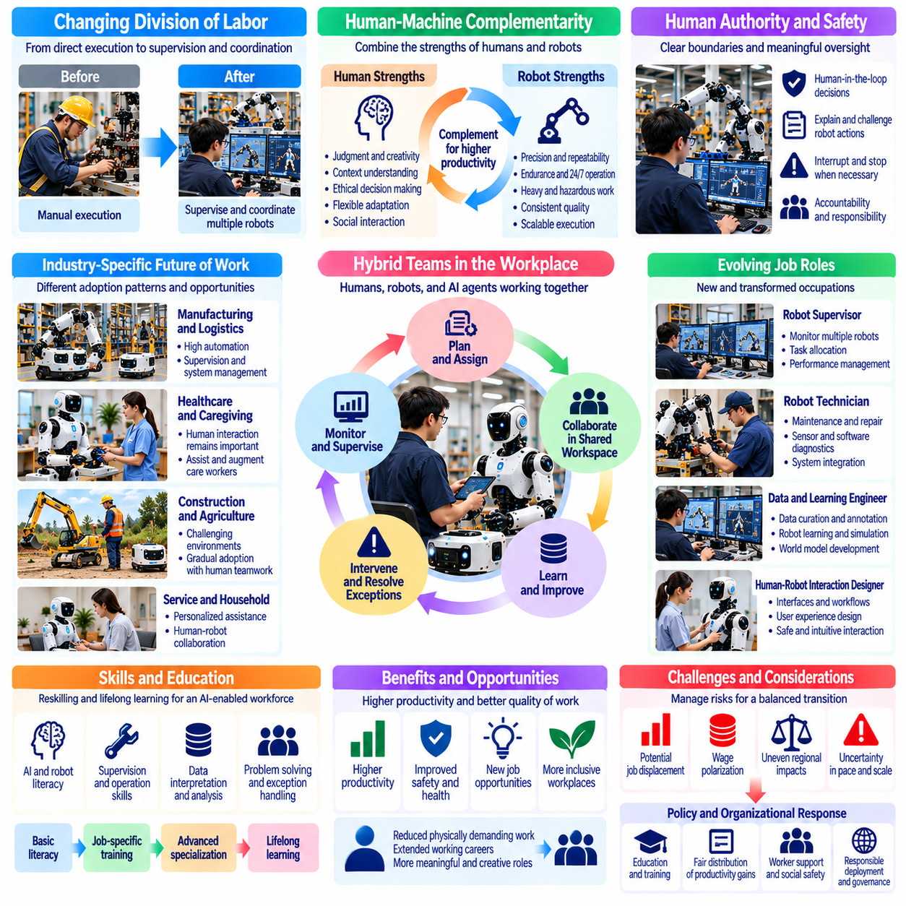
The future of human work with Physical AI will be shaped by the changing relationship between human capabilities and autonomous machines. As robots become capable of performing increasingly complex physical tasks, employment structures may shift from direct execution toward supervision, coordination, and problem solving. However, the significance of this transition extends beyond replacing manual labor. It involves reconsidering how human judgment, responsibility, and creativity contribute to productive activity.
Human work is unlikely to disappear simply because robotic systems become more capable. Most economic activities involve combinations of physical execution, communication, adaptation, and social interaction. Even highly automated environments require people to define objectives, resolve unexpected situations, and evaluate outcomes. The future division of labor will therefore depend on which responsibilities can be delegated reliably and which continue to benefit from human participation.
Physical AI may gradually transform workers from direct operators into supervisors of intelligent physical systems. Instead of manually performing every movement, employees may assign goals, monitor progress, and intervene when autonomous behavior becomes uncertain. One person could potentially coordinate multiple robots, increasing operational leverage. However, effective supervision requires interfaces that preserve situational awareness and prevent excessive cognitive workload.
The concept of human-machine complementarity will become central to future workplace design. Robots may provide precision, endurance, repeatability, and continuous operation, while humans contribute contextual understanding, ethical judgment, and flexible coordination. These strengths are not absolute distinctions, since artificial intelligence capabilities continue to evolve. Successful organizations will allocate responsibilities according to demonstrated reliability rather than assumptions about permanent human or machine superiority.
Human authority over important decisions will remain a significant consideration in safety-sensitive applications. Robots may recommend actions or execute approved procedures, but organizations must establish clear boundaries for autonomous decision-making. Human oversight should include meaningful opportunities to understand, challenge, and interrupt robotic behavior. Responsibility cannot be preserved merely by assigning a nominal supervisor who lacks the information or practical ability to intervene.
The expansion of robotic autonomy may change the meaning of professional expertise. Traditional competence often involves directly performing specialized physical activities through accumulated experience. Future expertise may increasingly include interpreting machine behavior, managing uncertainty, and coordinating complex systems. Nevertheless, practical domain knowledge remains essential because understanding physical processes helps workers recognize failures that automated monitoring may overlook.
Workplace organization may evolve toward hybrid teams consisting of humans, robots, and software agents. Such teams will require mechanisms for assigning tasks, sharing information, resolving conflicts, and coordinating resources. Human workers may supervise physical robots while interacting with digital planning systems that optimize schedules and workflows. Organizational performance will depend on the integration of these participants rather than the isolated intelligence of individual machines.
Physical AI may enable more personalized and adaptive forms of human work. Robotic assistants could adjust their behavior to individual preferences, physical capabilities, and task requirements. Workers may use natural-language instructions or demonstrations to configure assistance without extensive programming. This flexibility could expand access to sophisticated tools, although successful deployment requires reliable interpretation of instructions and appropriate safeguards against unintended actions.
The reduction of physically demanding labor may improve occupational health and extend working careers. Robots can assist with heavy lifting, repetitive manipulation, hazardous inspection, and tasks performed in uncomfortable environments. These benefits may be particularly valuable for aging workforces and employees with physical limitations. However, ergonomic improvements should be assessed alongside possible increases in monitoring pressure, mental fatigue, and supervisory responsibility.
The relationship between Physical AI and employment will differ across industries and regions. Manufacturing and logistics may experience extensive task automation, while healthcare and personal services may retain substantial human interaction requirements. Construction and agriculture present environmental variability that can limit autonomous reliability. Consequently, the future of work should be understood through industry-specific adoption patterns rather than a single universal prediction.
New forms of employment may emerge around robot learning, fleet operations, safety assurance, maintenance, and human-machine interaction. At the same time, existing occupations may incorporate robotic responsibilities without disappearing entirely. Electricians, technicians, healthcare workers, and production managers could develop hybrid roles combining established expertise with intelligent automation. The scale of occupational creation will depend on technological maturity and economic demand.
Education and lifelong learning will become essential components of workforce adaptation. Workers may need competencies in robotic supervision, data interpretation, safety procedures, and exception handling. Training should emphasize transferable skills that remain useful across different robotic platforms and industries. Educational institutions and employers will need to coordinate learning opportunities so technological transitions do not disproportionately disadvantage workers with limited access to training.
The economic benefits of Physical AI will depend on whether productivity gains improve wages, working conditions, and opportunities for participation. Greater output per worker could support higher compensation or shorter working hours, but neither outcome is automatic. Ownership structures, labor institutions, market competition, and organizational policies influence how gains are distributed. A technologically advanced workplace is not necessarily a socially beneficial workplace.
Human dignity and occupational identity will remain important as machines assume responsibilities previously associated with skilled labor. Employment provides more than income; it can offer purpose, recognition, social relationships, and opportunities for achievement. Rapid automation may disrupt these sources of meaning even when aggregate productivity increases. Workforce transition strategies should therefore address professional identity and participation alongside technical retraining and financial support.
The future workplace may place greater emphasis on creativity, interpersonal understanding, and complex decision-making. Workers could spend less time executing routine movements and more time designing processes, assisting customers, coordinating teams, and resolving unusual problems. However, these changes will vary according to organizational choices. Automation does not automatically produce more meaningful work unless institutions deliberately redesign responsibilities around human development and autonomy.
Physical AI may also alter relationships between workers and employers through expanded monitoring capabilities. Robotic systems can generate detailed records of task execution, movement patterns, productivity, and intervention behavior. Such information may improve safety and operational planning, but it can also enable intrusive surveillance or unfair performance evaluation. Transparent data governance, proportional monitoring, and appropriate worker participation will become important workplace safeguards.
As autonomous systems become more capable, questions of accountability will become increasingly complex. Operational failures may involve interactions among robotic hardware, learned policies, human instructions, and organizational procedures. Assigning responsibility requires clear documentation of system behavior and decision authority. Future labor arrangements should ensure that workers are not held accountable for outcomes they could neither reasonably predict nor effectively control.
Physical AI may create opportunities for more inclusive employment when robots compensate for physical limitations or provide accessible assistance. Adaptive interfaces, remote operation, and robotic manipulation could enable participation in tasks previously restricted by strength, mobility, or environmental hazards. Yet accessibility must be incorporated into system design from the beginning. Otherwise, technological complexity may introduce new barriers for workers with limited resources or specialized needs.
Long-term changes in human work will also depend on demographic and social conditions. Aging populations may increasingly rely on robotic assistance to sustain production and essential services. Regions with growing labor forces may face different challenges related to employment creation and wage competition. Public institutions must consider these differences when designing education, social protection, and technology adoption policies. A uniform response is unlikely to address every labor market effectively.
The emergence of increasingly general-purpose robots could expand the range of activities performed autonomously across multiple environments. Nevertheless, general-purpose capability does not guarantee dependable operation under every physical condition. Uncertainty, rare events, and safety constraints may continue to require human involvement. Future systems should therefore support adjustable autonomy, allowing responsibilities to shift between humans and machines according to task difficulty and operational risk.
The long-term objective of Physical AI should not be defined exclusively as minimizing human labor. A broader objective is to increase productive capability while expanding human freedom, safety, and opportunities for meaningful contribution. Robots may reduce the necessity of dangerous or exhausting work, allowing people to pursue activities that require judgment, creativity, and social engagement. Achieving this outcome depends on deliberate technological, organizational, and institutional decisions.
Ultimately, the future of human work with Physical AI will emerge from the interaction of autonomous capability, economic incentives, educational systems, and social values. Some occupations will contract, others will evolve, and new forms of collaboration will develop. The central challenge is ensuring that intelligent machines strengthen human agency rather than merely reducing labor costs. Sustainable progress requires a future in which robotic productivity and human well-being advance together.

