Volume 29. Graph Deep Learning

Chapter 03. GCN and GAT

03.00. Overview
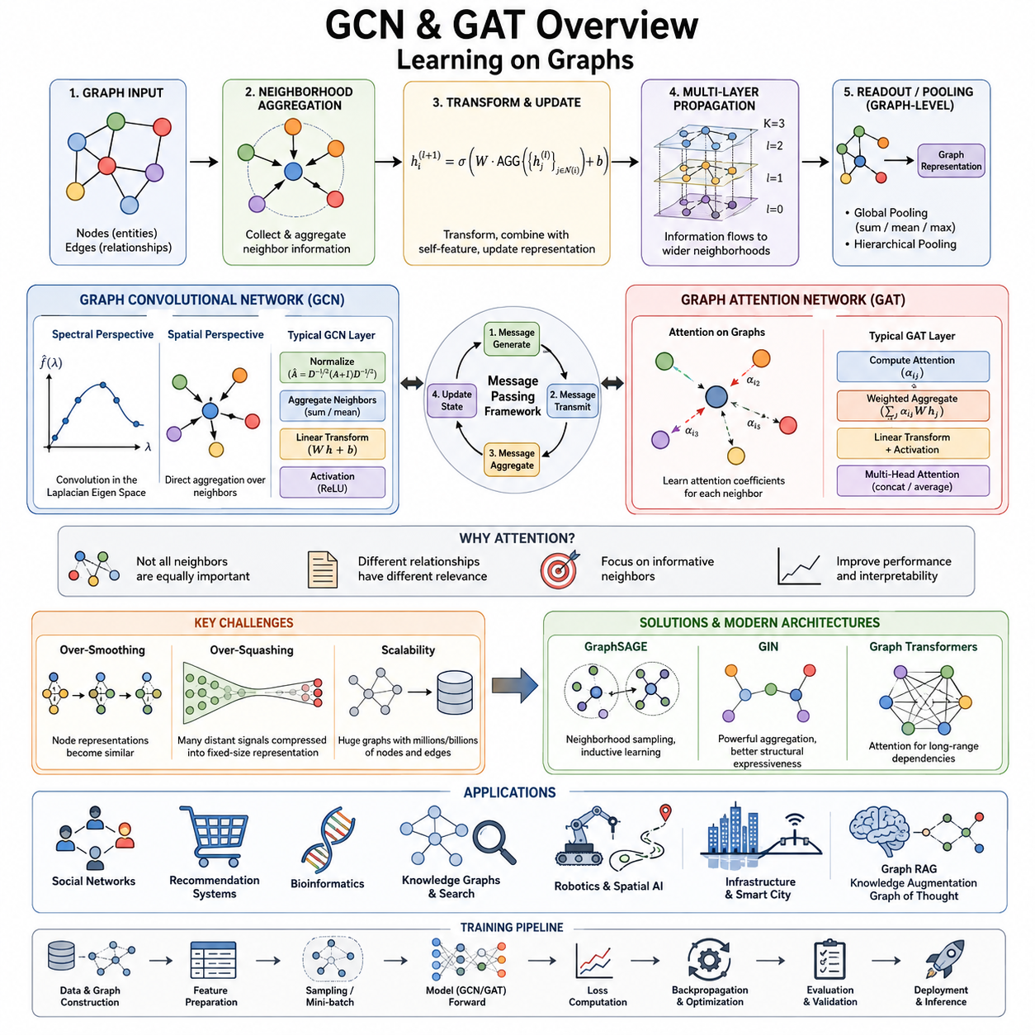
Graph Convolutional Networks and Graph Attention Networks are two central architectures in graph deep learning. They extend neural computation from regular structures such as images and sequences to graphs, where entities are represented as nodes and relationships as edges. Instead of processing each node independently, these models construct representations by combining a node’s own features with information obtained from its local graph neighborhood.
The central idea behind these architectures is neighborhood aggregation. For a node to understand its structural context, information from adjacent nodes is collected, transformed, and integrated into a new representation. Repeating this operation across multiple layers allows information to propagate over increasingly distant regions of the graph. A shallow model captures local relationships, while deeper models can represent broader structural dependencies.
Graph Convolutional Networks, commonly called GCNs, provide a systematic way to perform convolution-like operations on graph structures. Unlike image convolution, where neighboring pixels occupy fixed positions on a grid, graph nodes can have different numbers of neighbors and no universal ordering. GCNs therefore define convolution through graph connectivity, transforming and aggregating neighboring node features according to the graph topology.
GCNs can be understood from both spectral and spatial perspectives. Spectral methods originate from graph signal processing and describe convolution through the eigenstructure of graph operators such as the Laplacian. Spatial methods instead describe computation directly as aggregation over neighboring nodes. Although their mathematical interpretations differ, both perspectives explain how graph structure determines the flow and transformation of information between connected entities.
A typical GCN layer combines neighboring feature vectors, applies learnable transformations, and produces an updated representation for every node. Normalization is important because graph nodes may have widely different degrees. Without appropriate normalization, highly connected nodes could dominate feature propagation. Self-connections are also commonly introduced so that a node preserves and transforms its own information while incorporating information received from surrounding nodes.
Graph Attention Networks, or GATs, extend neighborhood aggregation by allowing the model to learn how important individual neighbors are. A GCN generally aggregates neighboring information according to a predefined normalization rule, whereas a GAT computes attention coefficients from node representations. These coefficients determine how strongly each neighboring node contributes to the updated representation, enabling graph propagation to become adaptive and dependent on learned feature relationships.
Attention on graphs is especially useful when neighboring relationships are not equally informative. In a social network, some connections may strongly influence a user while others contribute little. In a citation network, certain referenced papers may provide more relevant information than others. A GAT can assign different weights to these relationships during computation, allowing the learned representation to emphasize informative neighbors while reducing the influence of less relevant ones.
Both GCN and GAT architectures can be expressed through the broader message passing framework. In this view, connected nodes generate messages, messages are transmitted along edges, incoming messages are aggregated, and each node updates its hidden state. This abstraction separates graph neural computation into reusable operations and provides a common language for describing many GNN architectures beyond the original convolutional and attention-based formulations.
Message passing also explains how receptive fields grow with network depth. After one layer, a node normally contains information from its immediate neighborhood. After two layers, information can arrive from nodes approximately two hops away, and additional layers continue expanding this effective neighborhood. This enables graph networks to combine local observations with progressively wider relational context, although excessive propagation can introduce important optimization and representation problems.
Graph pooling provides another essential operation when predictions must be produced for an entire graph rather than individual nodes or edges. Global pooling summarizes node representations through operations such as summation, averaging, or maximum aggregation. Hierarchical pooling instead learns progressively coarser graph representations, reducing the graph while attempting to preserve important structural information and meaningful groups of interconnected nodes.
Training GCNs and GATs follows familiar deep-learning principles, including differentiable objectives, backpropagation, gradient-based optimization, regularization, and validation. However, graph data introduces additional dependencies because training examples may be connected rather than independent. Node classification, link prediction, and graph classification therefore require careful construction of training splits, neighborhood sampling procedures, mini-batches, and evaluation protocols.
Several characteristic difficulties emerge as graph networks become deeper or operate on larger graphs. Over-smoothing occurs when repeated aggregation makes node representations increasingly similar, reducing their ability to distinguish different nodes. Over-squashing occurs when information from a rapidly expanding neighborhood must be compressed into a fixed-size representation. Scalability becomes another major concern when graphs contain millions or billions of nodes and edges.
These challenges have motivated architectures that extend the basic GCN and GAT principles. GraphSAGE introduces neighborhood sampling and aggregation mechanisms that support inductive learning and large graphs. Graph Isomorphism Networks, or GINs, strengthen structural discrimination through carefully designed aggregation functions. Graph Transformers incorporate transformer-inspired attention mechanisms to model richer dependencies and potentially capture relationships beyond strictly local neighborhoods.
GCNs, GATs, message passing, pooling, and modern GNN architectures should therefore be viewed as parts of one evolving computational framework rather than isolated algorithms. GCN establishes efficient topology-aware propagation, GAT introduces adaptive neighbor weighting, and message passing provides their general abstraction. Pooling extends node representations toward graph-level reasoning, while newer architectures address expressiveness, long-range dependencies, and computational scale.
Together, these methods form the main neural foundation for learning directly from relational structure. They transform graphs from static collections of nodes and edges into trainable computational systems in which information flows through relationships. This foundation supports later developments in graph embeddings, graph generation, knowledge reasoning, robotics and spatial AI, infrastructure networks, and integrations between graphs and large language models described elsewhere in the volume.

03.01. Graph Convolutional Networks
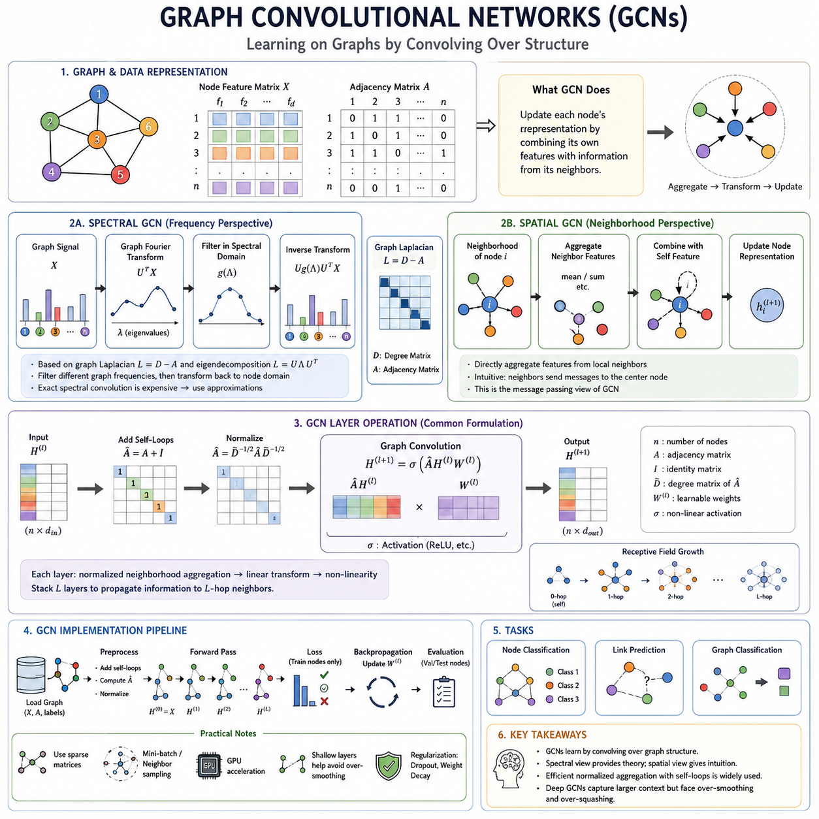
Graph Convolutional Networks, or GCNs, are neural architectures designed to learn representations from data organized as graphs. Unlike conventional neural networks that operate on vectors, grids, or sequences, GCNs explicitly use connections between nodes during computation. Each node representation is updated using its own features together with information propagated from neighboring nodes.
The fundamental operation of a GCN is graph convolution, which generalizes the idea of convolution from regular grids to irregular graph structures. In an image, convolution processes pixels through spatially fixed neighborhoods. A graph has no fixed grid, and nodes can have different numbers of neighbors. Graph convolution therefore relies on graph connectivity to determine which features should interact during representation learning.
A graph can be represented using a node feature matrix X and an adjacency matrix A. The feature matrix contains the attributes associated with each node, while the adjacency matrix describes which pairs of nodes are connected. GCN computation combines these two forms of information so that learned representations reflect both node attributes and relational structure rather than treating either source independently.
Spectral GCNs originate from spectral graph theory and graph signal processing. Their central idea is to define convolution in the graph Fourier domain using the eigenvectors and eigenvalues of the graph Laplacian. The Laplacian captures important structural properties of the graph, while its eigendecomposition provides a frequency-like basis in which signals defined over graph nodes can be analyzed and transformed.
From the spectral perspective, a node feature can be interpreted as a signal distributed across the graph. Graph Fourier transformation maps this signal into the spectral domain, where learnable filters can modify different graph-frequency components. The transformed signal is then mapped back to the node domain. This establishes a mathematical connection between classical convolution, frequency-domain filtering, and learning over irregular graph structures.
Direct spectral convolution can be computationally expensive because eigendecomposition of a large graph Laplacian is costly. It can also depend strongly on a particular graph structure, making transfer to different graphs difficult. Practical GCN formulations simplify spectral filtering through approximations, producing efficient propagation rules that avoid explicit eigendecomposition while retaining the idea of structure-aware feature smoothing.
A widely used GCN formulation augments the adjacency matrix with self-loops so that each node participates in its own update. The resulting adjacency matrix is normalized using node degrees before features are propagated. Conceptually, a layer performs normalized neighborhood aggregation followed by a learnable linear transformation and nonlinear activation. This prevents nodes with many connections from overwhelming nodes with fewer neighbors.
Spatial GCNs describe graph convolution directly in terms of local neighborhoods rather than graph frequencies. For each node, the model identifies connected neighbors, gathers their feature representations, combines them with an aggregation function, and updates the node state. This interpretation closely matches the intuitive idea that connected entities exchange information and is particularly useful for understanding practical graph neural network implementations.
The spatial perspective naturally leads to message passing. A neighboring node creates information that can be interpreted as a message, the graph edge determines where that message can travel, and the receiving node aggregates messages arriving from its neighborhood. A learnable update function then converts the aggregated information and the node's existing representation into a new hidden representation for the next layer.
Stacking GCN layers expands the effective receptive field of each node. A single layer primarily incorporates information from one-hop neighbors, while two layers allow information from approximately two-hop neighborhoods to influence a node. Additional layers extend this propagation farther across the graph, enabling the network to capture relationships that cannot be represented from immediate neighbors alone.
However, deeper propagation does not automatically produce better representations. Repeated neighborhood averaging can cause over-smoothing, where initially distinct node representations become increasingly similar. Information from large neighborhoods can also become compressed into limited-dimensional hidden states, contributing to over-squashing. These effects explain why practical GCN architectures often remain relatively shallow or incorporate improved propagation and residual mechanisms.
GCN implementations typically begin by preparing node features, graph connectivity, labels, and masks or splits for training and evaluation. The adjacency representation is augmented with self-connections and normalized, after which graph convolution layers propagate features through the network. Hidden layers commonly combine graph aggregation, linear transformations, activation functions, and regularization before producing task-specific output representations.
In a basic implementation, a GCN layer can be viewed conceptually as H' = σ(ÂHW), where H represents the current node features, W is a learnable weight matrix, Â represents normalized graph connectivity, and σ is a nonlinear activation function. For the first layer H corresponds to the input feature matrix X. Repeating this computation allows graph structure to participate directly in every stage of feature transformation.
For node classification, the final GCN layer usually produces one representation or prediction vector for each node. A classification objective compares predictions with labels for the training nodes, and backpropagation updates the learnable parameters. Validation and test masks can separate nodes used for optimization from those used for model selection and final evaluation while preserving the underlying graph connections.
GCN implementation can use dense adjacency matrices for small educational examples, but real graphs are usually sparse. Sparse representations store only existing edges rather than every possible node pair, substantially reducing memory and unnecessary computation. Modern graph learning frameworks further provide optimized message-passing primitives, neighborhood sampling, mini-batching, and GPU operations for processing graphs that cannot be handled efficiently as dense matrices.
The spectral and spatial interpretations should not be regarded as competing descriptions. Spectral GCNs provide a mathematical foundation based on graph Laplacians, graph frequencies, and filtering, while spatial GCNs provide an operational interpretation based on neighborhood aggregation and message passing. Many practical GCN models can be understood from both perspectives, linking theoretical graph signal processing with implementable neural computation.
GCNs provide a foundation for numerous later graph neural network architectures. Their normalized propagation mechanism demonstrates how relational structure can become part of a differentiable learning system, while their limitations motivate models such as GraphSAGE, Graph Attention Networks, and more advanced message-passing networks. Understanding spectral GCNs, spatial GCNs, and their implementation therefore establishes the core computational principles required for modern graph deep learning.

03.02. Graph Attention Networks
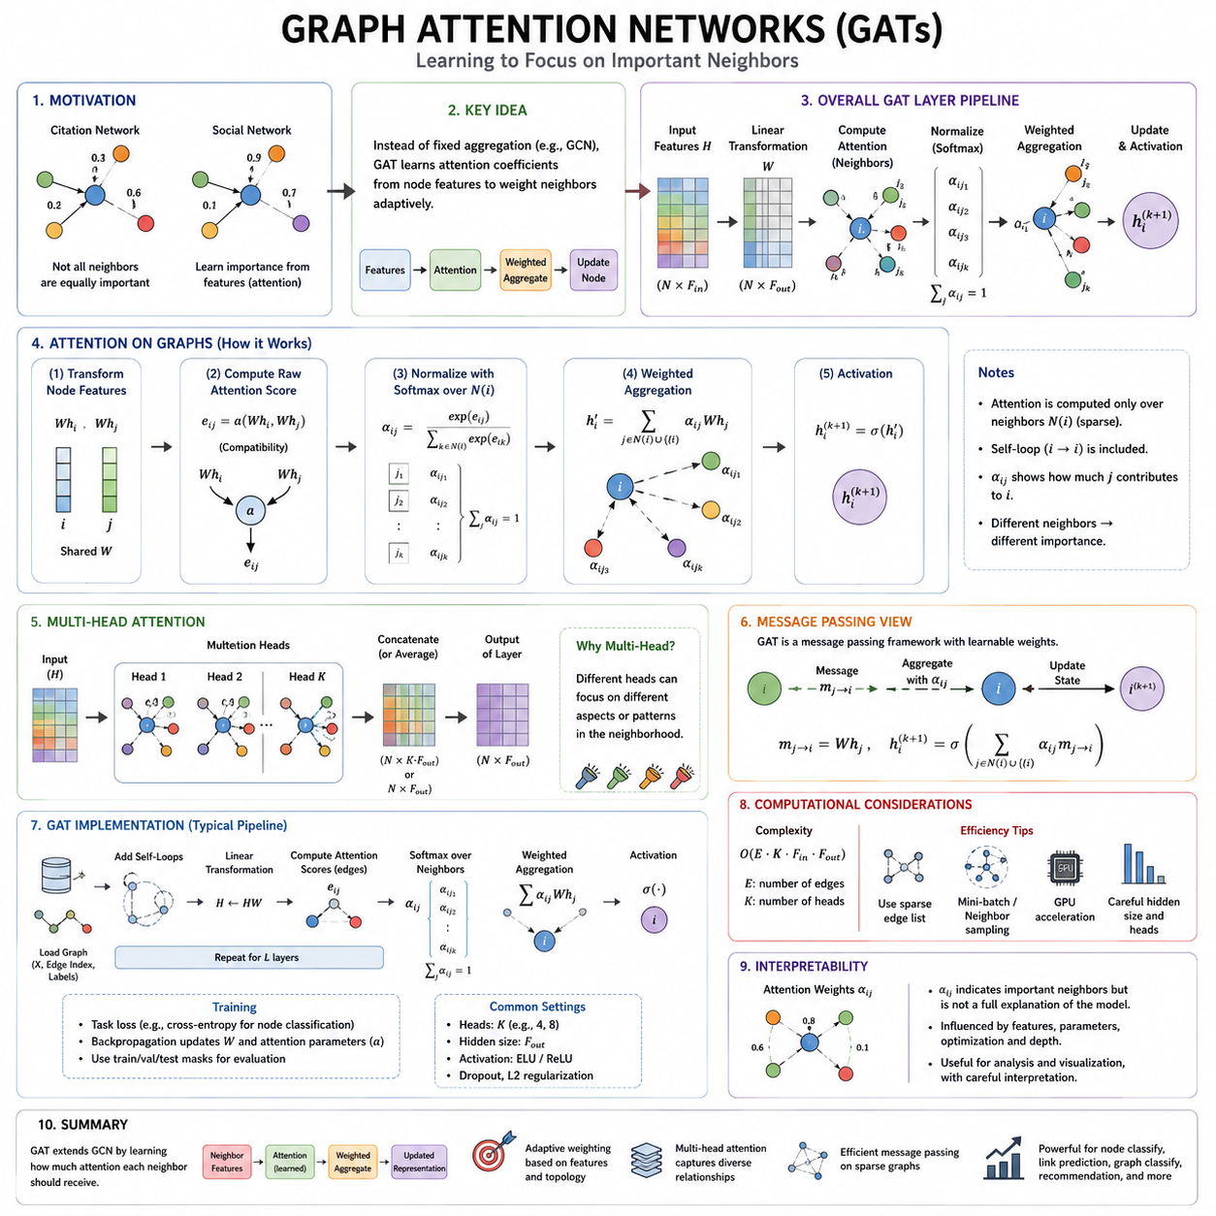
Graph Attention Networks, or GATs, are graph neural networks that use attention mechanisms to determine how strongly neighboring nodes should influence one another. Instead of treating every connected neighbor according to a fixed aggregation rule, a GAT learns attention coefficients from node features. This allows graph representation learning to adapt dynamically to the relevance of relationships within each local neighborhood.
The motivation for graph attention comes from the observation that graph connections are not necessarily equally informative. In a citation network, one referenced paper may be more relevant than another, while in a social network some relationships may exert stronger influence. Attention provides a learnable mechanism that assigns different importance to neighboring nodes according to their current feature representations.
A GAT layer begins with node feature vectors that describe the current representation of every node. A learnable linear transformation is first applied to these features, mapping them into a new representation space. The transformed features are then used to calculate pairwise attention scores between a target node and the neighboring nodes connected to it through the graph structure.
For a node i and one of its neighbors j, an attention mechanism computes an unnormalized score describing their compatibility or relevance. A common formulation applies a shared learnable attention function to the transformed representations of both nodes. Because the same parameters can be reused across graph locations, the model does not depend on a fixed ordering or fixed number of neighboring nodes.
Raw attention scores cannot be directly interpreted as normalized contributions because different nodes may have different neighborhood sizes. GAT therefore commonly applies a softmax operation over the neighbors of each target node. The resulting attention coefficient αij represents the normalized importance of neighbor j when constructing the next representation of node i, with coefficients competing within the local neighborhood.
After attention coefficients have been calculated, neighboring feature vectors are multiplied by their corresponding coefficients and aggregated. More influential neighbors therefore contribute more strongly to the updated node representation. A nonlinear activation function is typically applied after aggregation, producing a new hidden representation that contains both graph connectivity information and feature-dependent relational importance.
This mechanism differs fundamentally from fixed neighborhood aggregation. A conventional GCN generally uses graph structure and degree-based normalization to determine propagation weights, whereas a GAT can learn different propagation strengths for different connected node pairs. Even when two nodes have the same degree and similar graph positions, their neighbors can receive different attention weights because their feature relationships are different.
Attention on graphs remains constrained by graph topology in the standard GAT formulation. A node normally calculates attention only over nodes connected to it, rather than attending globally to every node in the graph. This preserves the sparse relational structure of graph computation while introducing adaptive weighting. Stacking several GAT layers allows information to propagate beyond immediate neighbors into progressively larger neighborhoods.
Multi-head attention is an important component of GAT architectures. Instead of relying on a single attention mechanism, several independent attention heads compute different coefficients and transformed representations. Their outputs can be concatenated to produce richer hidden features or averaged when generating final predictions. Multiple heads can stabilize learning while allowing different relational patterns to be captured simultaneously.
Different attention heads may emphasize different aspects of a neighborhood. One head might focus on neighbors with similar attributes, while another may emphasize structurally or semantically complementary nodes. These interpretations are not guaranteed automatically, but multiple heads increase representational capacity by allowing several attention patterns to operate over the same graph connectivity during a single layer.
A practical GAT implementation starts with node features, edge connectivity, labels, and appropriate training, validation, and test splits. The graph connectivity identifies which node pairs are eligible for attention. Node features are transformed by learnable weight matrices, attention scores are computed for connected pairs, and neighborhood-wise normalization converts those scores into attention coefficients before weighted aggregation is performed.
Conceptually, the update for node i can be written as a weighted sum of transformed neighboring representations. If W is a learnable transformation and αij is the normalized attention coefficient between nodes i and j, the new representation can be expressed as h'i = σ(Σj αij Whj). This equation captures the central GAT principle: graph neighbors contribute according to learned, feature-dependent weights rather than identical or predetermined importance.
Self-loops are commonly included so that each node can attend to its own transformed representation as well as to its neighbors. Without a self-connection, a node update could become dominated entirely by external information. Including the node itself in the attention neighborhood enables the model to learn how much of its previous information should be preserved relative to information received from connected nodes.
During training, the output of one or more GAT layers is connected to a task-specific objective. For node classification, the final layer produces predictions for individual nodes and the loss is computed over labeled training nodes. Backpropagation propagates gradients through the output transformations, weighted aggregation, attention coefficients, and feature transformations, allowing both representation parameters and attention mechanisms to be learned jointly.
Efficient implementation is particularly important because explicitly computing attention for every possible node pair would be prohibitively expensive on large graphs. Standard GAT computation exploits sparse graph connectivity and evaluates attention primarily for existing edges and self-connections. Graph learning libraries can represent connectivity with edge indices or sparse structures and provide optimized scatter, aggregation, and GPU operations.
GATs offer greater flexibility than fixed aggregation methods, but this flexibility introduces additional computational cost. Attention coefficients must be calculated and normalized for edges, and multi-head attention multiplies portions of this work. Large neighborhoods can therefore increase memory and computation substantially. Sampling, sparse operations, mini-batching, and carefully selected hidden dimensions are important when scaling GATs to large graphs.
Attention weights can also provide useful clues about which neighboring nodes contributed strongly to a representation, but they should not automatically be treated as complete explanations of model behavior. Learned coefficients are internal computational quantities influenced by features, parameters, optimization, and network depth. They can support analysis and visualization, yet rigorous interpretability generally requires additional evaluation beyond simply inspecting attention values.
Graph Attention Networks extend the message-passing framework by making message aggregation adaptive. Nodes still exchange information along graph edges, but the receiver learns how strongly each incoming message should influence its next state. This connects GATs naturally to the broader progression from GCNs toward increasingly expressive graph architectures and provides an important bridge between graph neural networks and attention-based models.

03.03. Message Passing Framework
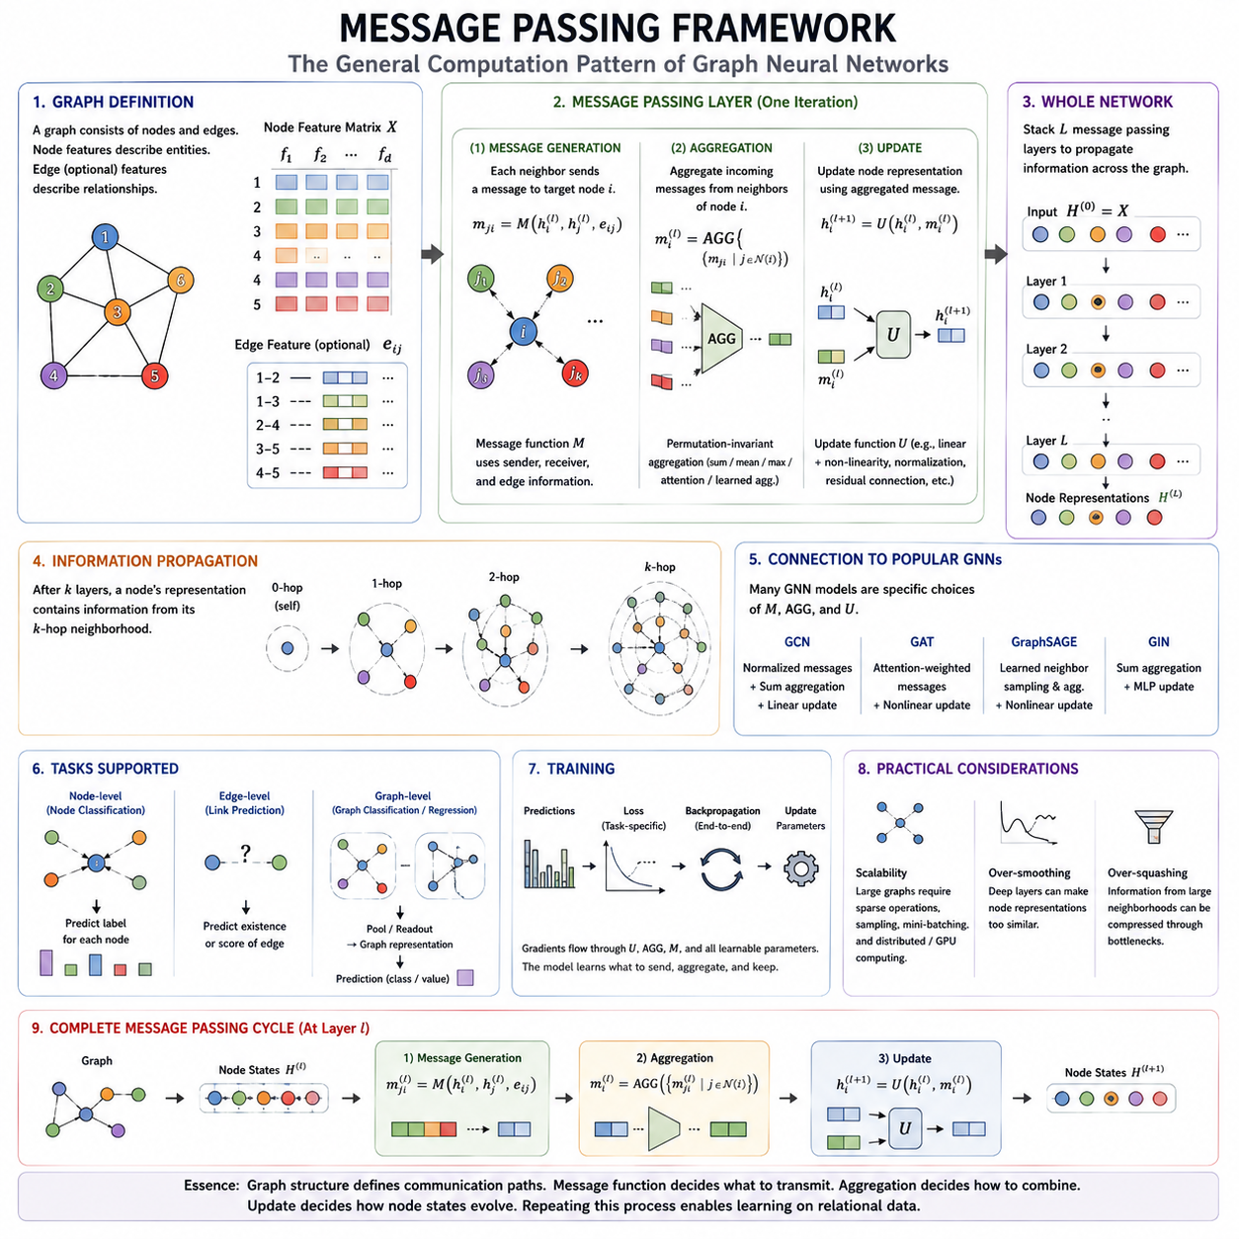
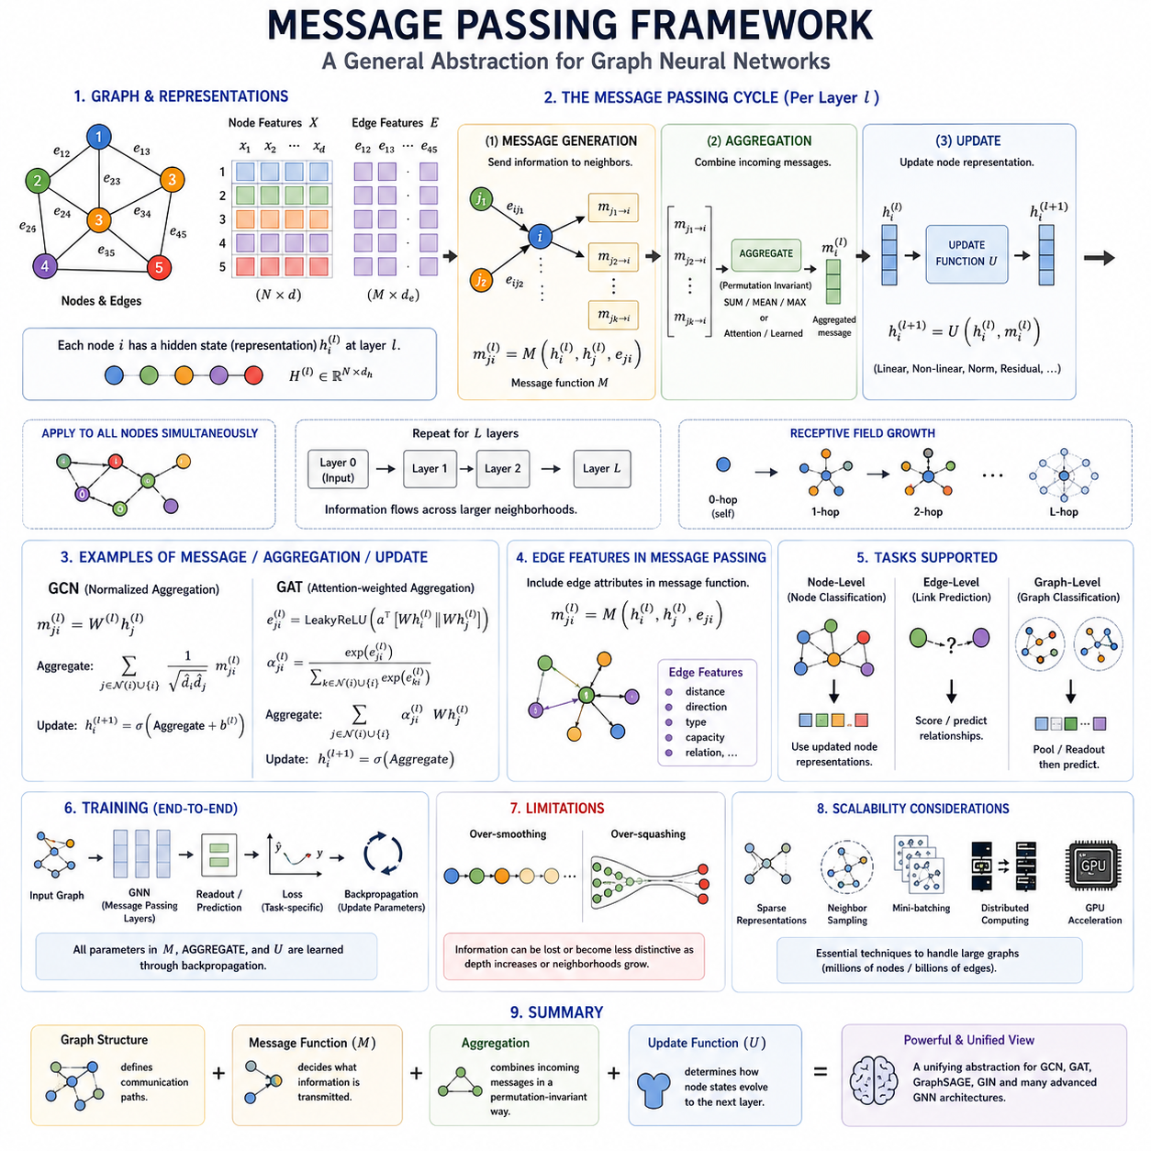
Message Passing Framework provides a general computational abstraction for Graph Neural Networks by describing learning as repeated information exchange between connected nodes. Instead of defining every graph architecture as a separate mechanism, message passing expresses graph computation through a common sequence: generate messages, aggregate incoming information, and update node representations. GCNs, GATs, and many modern GNNs can be interpreted within this framework.
A graph consists of nodes connected by edges, with node features describing entities and optional edge features describing relationships. In message passing, every node maintains a hidden representation that summarizes information currently available to it. During each layer, neighboring nodes communicate through edges, allowing local relational information to become part of the representation used for prediction, classification, or further reasoning.
The first major component is message generation. For a directed interaction from node j to node i, a message is constructed from information associated with the sender, receiver, edge, or combinations of these elements. Conceptually, this operation can be written as mji = M(hi, hj, eij), where M is a message function, hi and hj are node representations, and eij represents optional edge information.
The message function can take many forms depending on the graph architecture. A simple model may transmit a transformed version of the neighboring node feature, while a more expressive model may combine sender features, receiver features, edge attributes, distances, relation types, or learned attention coefficients. Because the message function is usually differentiable and parameterized, the network can learn what information should be transmitted through graph relationships.
Once messages have been generated, the receiving node must combine messages arriving from its neighborhood. This operation is called message aggregation. Because graph neighborhoods have no universal ordering and may contain different numbers of nodes, aggregation should generally be permutation invariant. Common operations include summation, averaging, and maximum aggregation, while more advanced models can use attention or learned aggregation mechanisms.
Permutation invariance is fundamental because the identity of a graph should not depend on the arbitrary ordering used to store its neighbors. If the same neighboring nodes are listed in a different sequence, the aggregated representation should normally remain consistent. Functions such as sum, mean, and maximum naturally satisfy this requirement, making them suitable building blocks for graph neural computation over unordered relational structures.
After aggregation, the node update stage combines the aggregated neighborhood information with the node's existing hidden state. Conceptually, the update can be expressed as hi(l+1) = U(hi(l), mi(l)), where mi represents the aggregated incoming message and U is an update function. The update may contain linear transformations, nonlinear activation functions, normalization, residual connections, or more complex neural modules.
A complete message-passing layer can therefore be understood as a local communication cycle. Neighboring nodes generate messages, edges determine where those messages travel, the receiver aggregates the incoming messages, and an update function creates the next node representation. Applying this process simultaneously across the graph transforms the entire set of node representations while preserving the relational structure encoded by graph connectivity.
Stacking multiple message-passing layers enables information to travel over increasingly large graph distances. After one layer, a node primarily incorporates information from its immediate one-hop neighborhood. After two layers, information originating approximately two hops away can influence its representation. Deeper networks continue expanding this receptive field, allowing local communication to construct representations containing broader structural context.
This propagation mechanism explains how graph neural networks perform relational reasoning without requiring every node to interact directly with every other node. Information can move through intermediate nodes along graph paths. Consequently, a node representation can eventually encode information about distant parts of the graph, although the effectiveness of this process depends on network depth, graph topology, aggregation functions, and representation capacity.
GCNs provide a straightforward example of message passing. Neighboring node features are transformed and aggregated using normalization derived from graph connectivity and node degrees. The resulting information is used to update each node representation. From this viewpoint, graph convolution is not an isolated operation but a particular choice of message, aggregation, and update functions within the more general message-passing framework.
GATs provide another important example. Instead of assigning neighboring messages according to fixed degree-based normalization, GATs learn attention coefficients that determine the relative importance of incoming information. Each neighboring message is weighted before aggregation, allowing the receiving node to emphasize some relationships more strongly than others. GAT can therefore be interpreted as attention-weighted message passing.
Edge features can significantly increase the expressive power of message passing. In many graphs, relationships contain meaningful information beyond simple connectivity, such as distance, direction, interaction type, capacity, or semantic relation. Incorporating these attributes into the message function allows two connected node pairs with similar node features to exchange different messages according to the properties of their relationships.
Message passing can support node-level, edge-level, and graph-level learning tasks. Node classification uses updated node representations directly, while link prediction evaluates relationships between pairs of node embeddings. Graph-level prediction typically introduces a readout or pooling operation that aggregates node representations into a single graph representation, which can then be used for classification, regression, or other global predictions.
Training message-passing networks follows end-to-end differentiable learning. A task-specific loss is computed from model predictions, and backpropagation propagates gradients through update functions, aggregation operations, message functions, and learnable transformations. Parameters are therefore optimized according to the final task rather than requiring manually designed rules for deciding which relational information should be propagated.
Despite its flexibility, message passing has important limitations. Repeated aggregation can produce over-smoothing, where node representations become increasingly similar as network depth grows. Over-squashing occurs when information from rapidly expanding neighborhoods must pass through limited-dimensional representations or narrow graph bottlenecks. These problems can prevent distant information from being preserved even when sufficient message-passing layers are theoretically available.
Scalability is another major consideration because large graphs may contain millions of nodes and billions of edges. Processing every neighboring message in every training step can become computationally expensive. Sparse graph representations, neighborhood sampling, mini-batching, distributed computation, and optimized GPU operations are therefore important engineering techniques for applying message-passing networks to large real-world graphs.
The Message Passing Framework ultimately provides a unified language for understanding graph neural computation. Graph structure defines communication pathways, message functions determine what information is transmitted, aggregation determines how incoming information is combined, and update functions determine how node states evolve. This abstraction connects GCN, GAT, GraphSAGE, GIN, and more advanced graph architectures within a common foundation for relational learning.

03.04. Graph Pooling
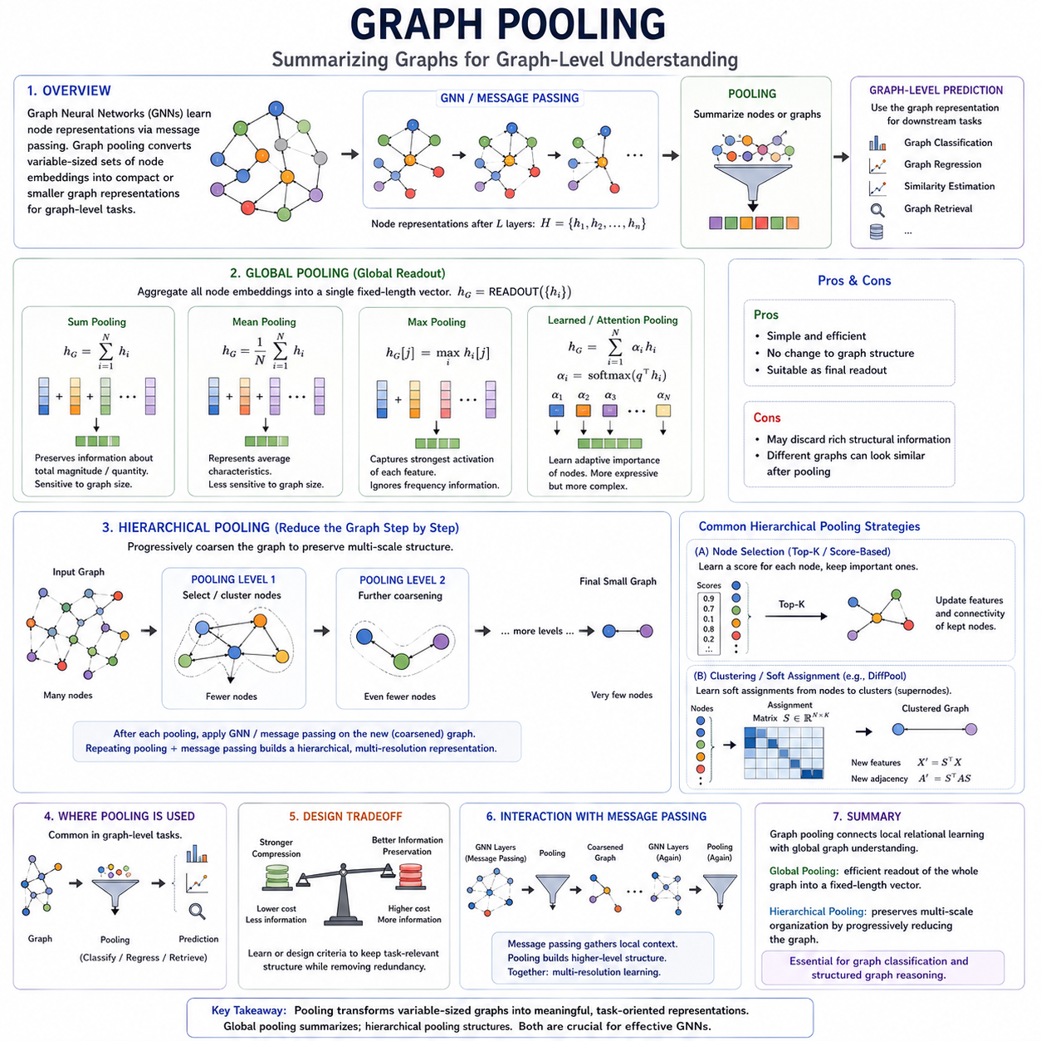
Graph pooling is a fundamental operation that converts collections of node representations into smaller or more compact graph representations. While graph convolution and message passing propagate information among connected nodes, pooling reduces the amount of structural information that must be processed. It is especially important when a model must produce predictions for an entire graph rather than for individual nodes or edges.
The purpose of pooling is similar to dimensional reduction in conventional neural networks, but graphs require special treatment because their nodes have no fixed ordering and different graphs may contain different numbers of nodes. A pooling operation must therefore summarize variable-sized relational structures while preserving information relevant to the downstream task, such as classification, regression, similarity estimation, or graph-level reasoning.
Graph pooling can broadly be divided into global pooling and hierarchical pooling. Global pooling directly summarizes all node representations into a single fixed-dimensional vector, usually near the end of a graph neural network. Hierarchical pooling progressively reduces the graph itself, producing intermediate graphs with fewer nodes while attempting to preserve important structural relationships and higher-level organization.
Global pooling, also called global readout, treats the collection of node embeddings as a set and applies a permutation-invariant aggregation function. If H contains the final node representations, a global pooling function produces a graph representation hG = READOUT({hi}). The resulting vector has a fixed dimensionality regardless of how many nodes were present in the original graph, making comparisons across differently sized graphs possible.
Global sum pooling adds all node representations together. It preserves information related to the accumulated magnitude or quantity of features across the graph and can therefore distinguish graphs containing different numbers of similar nodes. Sum pooling is particularly useful when the total contribution of graph components is meaningful, although its output magnitude may naturally increase as graph size grows.
Global mean pooling calculates the average of all node representations. Unlike sum pooling, its scale is relatively insensitive to the number of nodes, making it useful when the model should represent the typical or average characteristics of a graph. However, averaging may remove information about graph size because two graphs containing different numbers of similar nodes can produce nearly identical mean representations.
Global max pooling selects the maximum activation for each feature dimension across all nodes. This operation emphasizes whether strongly activated patterns appear anywhere in the graph rather than how frequently they occur. It can detect salient node-level characteristics effectively, but information about the number, distribution, and relative organization of activated nodes may be lost during the reduction.
More expressive global readout mechanisms can learn how strongly different nodes should contribute to the graph representation. Attention-based pooling, gated pooling, or learned set functions can assign adaptive importance to node embeddings before combining them. These methods can capture task-dependent relevance more effectively than fixed sum, mean, or maximum operations, although they introduce additional parameters and computational complexity.
Global pooling is computationally simple and does not require explicit modification of graph connectivity. After several GNN layers have propagated relational information into node embeddings, the pooling stage assumes that these embeddings already encode the structural context needed for prediction. The graph is then compressed directly into a single representation that can be passed to fully connected layers or another prediction head.
However, direct global pooling can discard substantial structural information. Two graphs with different internal organizations may produce similar pooled representations when their node embeddings have similar aggregate statistics. This limitation motivates hierarchical pooling, which attempts to preserve multi-scale structure by reducing the graph gradually instead of collapsing all nodes into a single vector in one operation.
Hierarchical pooling constructs a sequence of progressively coarser graph representations. A graph with many nodes is transformed into a smaller graph, which can then be processed by additional graph neural network layers and pooled again. This resembles hierarchical feature extraction in convolutional neural networks, where spatial resolution decreases while increasingly abstract features are learned at deeper stages.
One approach to hierarchical pooling selects a subset of important nodes and removes or suppresses less important ones. A learned scoring function can estimate the relevance of each node, after which highly ranked nodes are retained to form a reduced graph. Their features and connectivity are updated so that subsequent GNN layers operate on a smaller structure while preserving information considered important for the task.
Another approach learns soft assignments from original nodes to clusters or supernodes. Instead of selecting individual nodes directly, the model estimates how strongly each node belongs to a smaller set of latent groups. Node features are aggregated according to these assignments, and the original adjacency structure is transformed into connectivity among the resulting clusters, producing a learned coarse representation of the graph.
This cluster-based interpretation is closely associated with differentiable pooling methods such as DiffPool. A neural network learns an assignment matrix that maps nodes from one graph resolution to another, while another network learns node embeddings. Through differentiable matrix operations, both the cluster assignments and graph representations can be optimized jointly with the final prediction objective using standard backpropagation.
Hierarchical pooling can reveal meaningful multi-scale organization when the graph naturally contains communities, functional modules, spatial regions, molecular substructures, or other nested patterns. Lower layers can represent individual entities and local neighborhoods, while higher pooled levels can represent groups of entities and interactions among groups. This enables graph representations to evolve from fine-grained relationships toward more abstract structural concepts.
The design of hierarchical pooling involves an important tradeoff between compression and information preservation. Aggressive reduction lowers computational cost but may remove nodes or edges that contain useful signals. Weak reduction preserves more information but provides less computational benefit. Effective pooling therefore depends on learning or designing criteria that retain task-relevant structure while eliminating redundancy.
Pooling also interacts closely with message passing. Message-passing layers typically operate before pooling so that nodes accumulate contextual information from their neighborhoods. After hierarchical pooling creates a reduced graph, additional message-passing layers can propagate information among the newly formed nodes or clusters. Repeating message passing and pooling creates a multi-resolution architecture capable of learning increasingly abstract relational representations.
Global and hierarchical pooling therefore serve complementary roles rather than representing mutually exclusive strategies. Global pooling provides a simple final readout for transforming node embeddings into a graph-level vector, while hierarchical pooling restructures the graph during intermediate stages of learning. A hierarchical architecture may ultimately apply global pooling to its final reduced graph before producing a graph-level prediction.
Graph pooling completes an important transition from local relational learning to global graph understanding. Message passing and graph convolution explain how information moves among nodes, while pooling determines how distributed node-level knowledge is compressed into higher-level representations. Global pooling emphasizes efficient graph-level summarization, whereas hierarchical pooling preserves multi-scale organization, providing a foundation for graph classification and structured graph reasoning.

03.05. Training Strategies [w/Code]
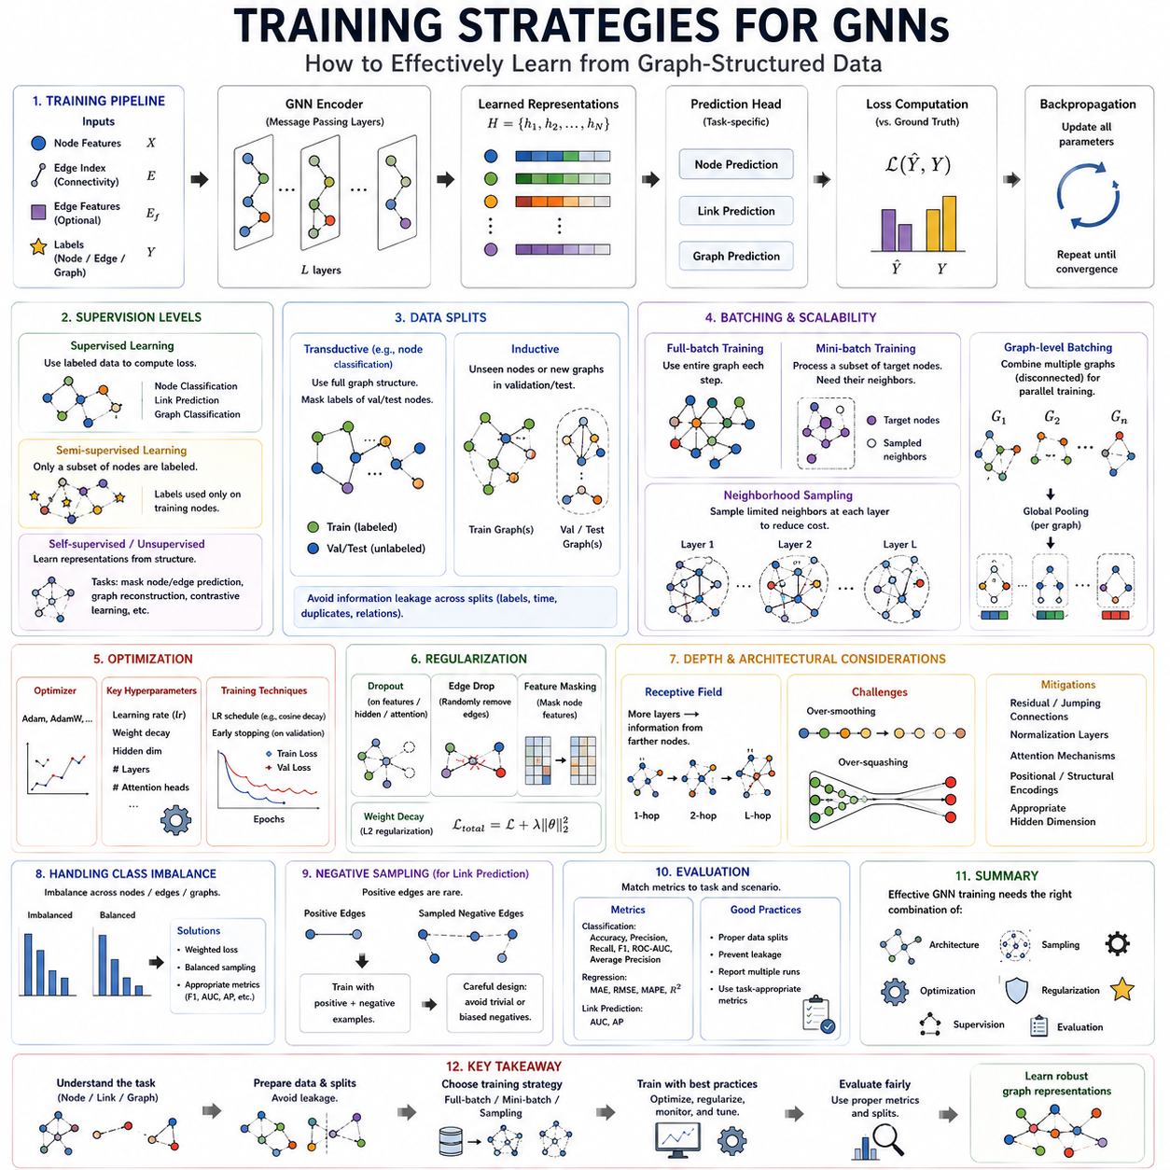
Training strategies for Graph Neural Networks determine how effectively a model learns useful representations from graph-structured data. Although GCNs, GATs, and other message-passing architectures can be optimized with standard gradient-based methods, graph learning introduces dependencies between samples because nodes and edges are interconnected. Training must therefore consider graph structure, supervision level, sampling, regularization, and computational scalability.
A typical training pipeline begins with node features, edge connectivity, optional edge features, and labels associated with nodes, edges, or entire graphs. These inputs are processed through multiple graph neural network layers to produce learned representations. A task-specific prediction head then converts those representations into outputs, and a loss function measures the difference between predictions and target values before backpropagation updates model parameters.
Supervised learning is commonly used when reliable labels are available. Node classification may predict categories for individual nodes, link prediction may determine whether relationships exist between node pairs, and graph classification may assign labels to complete graphs. The loss is calculated from labeled examples, while gradients propagate through pooling, message passing, attention, aggregation, and feature transformations to optimize the network jointly.
Graph learning often operates in a semi-supervised setting because only a fraction of nodes may have labels even though the entire graph structure is available. A GNN can propagate information through labeled and unlabeled regions while computing supervised loss only on selected training nodes. This allows connectivity and neighboring features to provide useful context even when direct annotations are sparse, which is particularly valuable for large relational datasets.
Training, validation, and test splits require careful design because graph samples may not be independent. In transductive node classification, the model can observe the connectivity and features of validation or test nodes during message passing while their labels remain hidden during training. In inductive settings, unseen nodes or entirely new graphs are withheld so that evaluation measures whether learned relational patterns generalize beyond the training graph.
Full-batch training processes the complete graph during each optimization step. This approach is conceptually simple and works well for small or moderately sized graphs because every node can aggregate information from its complete neighborhood. However, memory and computation increase rapidly with graph size, making full-batch training impractical when graphs contain millions of nodes or very large numbers of edges.
Mini-batch training addresses scalability by processing subsets of graph information during each optimization step. Unlike ordinary independent samples, however, selected graph nodes depend on their neighbors for message passing. A mini-batch may therefore require additional neighboring nodes that are not direct training targets. Constructing efficient graph batches requires balancing computational cost with preservation of sufficient neighborhood information.
Neighborhood sampling reduces this cost by selecting only a subset of neighbors at each message-passing layer. Instead of expanding through every connected node, the training process samples a limited number of neighbors for each target. This strategy reduces memory usage and enables stochastic optimization on large graphs, although aggressive sampling may remove useful relational information and introduce additional variance into the learned representation.
Graph-level datasets provide a different batching situation because each training example may be an independent graph. Several graphs can be combined into a disconnected larger graph for efficient parallel computation, while bookkeeping information records which nodes belong to which original graph. Message passing remains confined within each graph, and graph pooling later produces separate graph-level representations for prediction and loss calculation.
The choice of optimization method follows standard deep-learning principles but interacts with graph-specific architecture. Adaptive optimizers such as Adam are frequently used, while learning rate, weight decay, hidden dimension, number of layers, and attention heads can strongly influence performance. Learning-rate schedules and early stopping based on validation performance can improve convergence and reduce unnecessary training after generalization begins to deteriorate.
Regularization is particularly important because GNNs can overfit both node attributes and graph connectivity. Dropout can be applied to hidden representations, feature transformations, or attention coefficients, while weight decay constrains parameter growth. Some methods randomly remove edges or mask node features during training, forcing the model to avoid excessive dependence on particular connections and potentially improving robustness to structural variation.
Network depth must be selected carefully. Adding layers expands the receptive field and allows information from more distant nodes to influence a representation, but excessive depth can lead to over-smoothing. Residual connections, normalization layers, jumping connections, and modified propagation mechanisms can help preserve distinguishable node information while still allowing deeper architectures to exploit wider graph neighborhoods.
Over-squashing presents another training challenge when information from exponentially expanding neighborhoods must be compressed into fixed-dimensional node representations. Increasing depth alone may not solve this problem because graph bottlenecks restrict information flow. Architectural changes, improved connectivity, attention mechanisms, positional or structural encodings, and appropriate hidden dimensions can help models preserve information from distant but relevant regions.
Class imbalance can strongly affect graph learning when some node, edge, or graph categories occur much less frequently than others. A model trained with an unadjusted objective may favor dominant classes while performing poorly on rare categories. Weighted losses, balanced sampling, appropriate evaluation metrics, or task-specific sampling procedures can reduce this bias and provide a more representative assessment of model performance.
Self-supervised and unsupervised strategies can be useful when graph labels are scarce. A model may learn representations by predicting masked node attributes, reconstructing graph relationships, distinguishing positive and negative graph views, or optimizing contrastive objectives. The learned encoder can subsequently be fine-tuned for a supervised downstream task, allowing large amounts of unlabeled relational data to contribute to representation learning.
Negative sampling is especially important for link prediction because the number of absent edges is usually much larger than the number of observed edges. Rather than evaluating every possible unconnected node pair, training selects a manageable subset as negative examples. The sampling strategy must be designed carefully because trivially easy negatives may provide little learning signal, while inappropriate negatives can distort the intended relationship prediction task.
Evaluation should match the graph learning objective and deployment scenario. Accuracy may be appropriate for balanced classification, while precision, recall, F1 score, ROC-AUC, or average precision may be more informative for imbalanced node or link tasks. Graph regression can use error-based metrics. More importantly, data splitting must prevent unintended information leakage through labels, temporal structure, duplicated graphs, or relational dependencies.
Efficient GNN training ultimately requires coordination between model architecture, graph sampling, optimization, regularization, and evaluation. Small graphs may support full-batch learning, while large graphs often require sparse representations, neighborhood sampling, mini-batching, and GPU acceleration. The appropriate strategy depends not only on graph size but also on topology, task type, supervision availability, and the distance over which useful relational information must propagate.
Training strategies transform GCNs, GATs, pooling methods, and message-passing mechanisms from mathematical architectures into practical learning systems. Effective training must preserve useful graph relationships while controlling computational cost, overfitting, over-smoothing, and information bottlenecks. Together, optimization, sampling, regularization, supervision, and rigorous evaluation provide the foundation for reliable graph representation learning across diverse applications.

03.06. Optimization Challenges
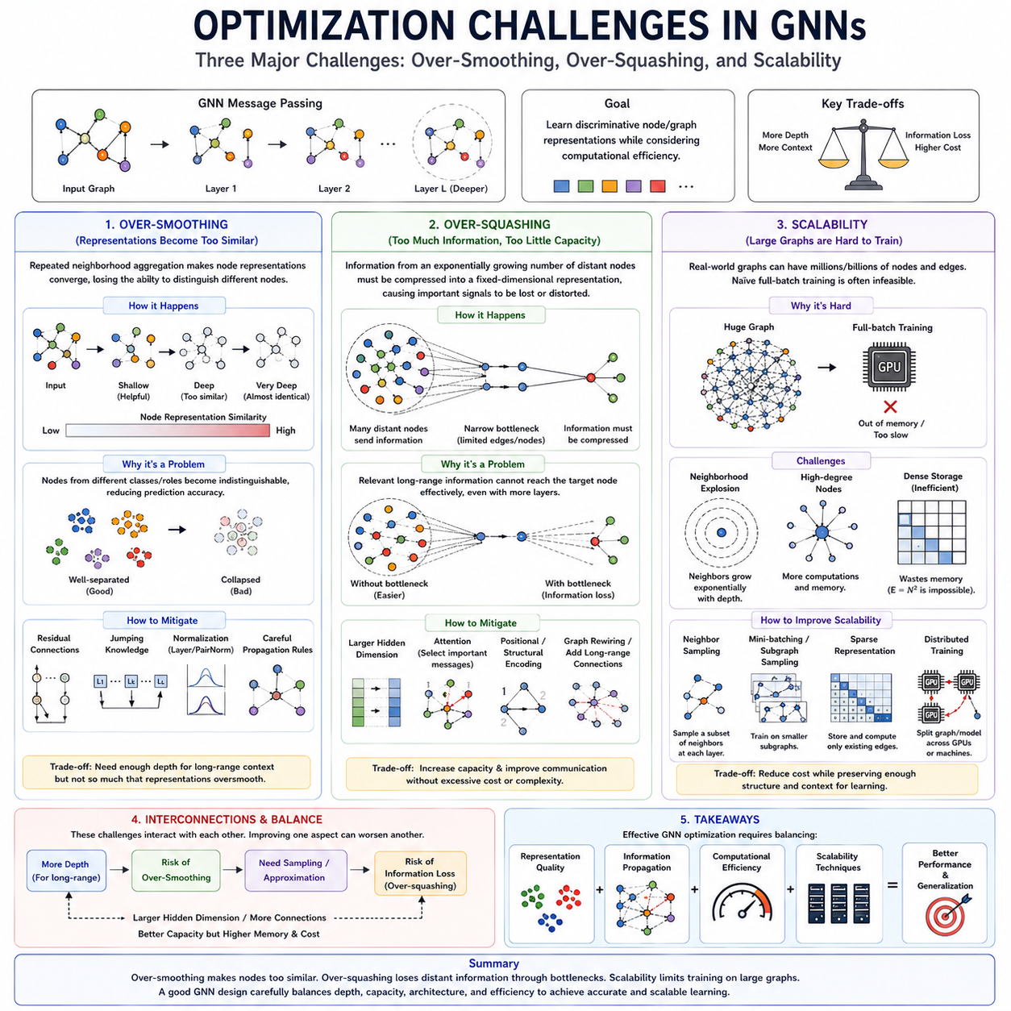
Optimization challenges in Graph Neural Networks arise because learning must operate simultaneously over node features, graph topology, and repeated information propagation. Increasing network depth can theoretically capture broader relational context, but deeper message passing may degrade representations or create severe information bottlenecks. At the same time, large graphs introduce memory and computational demands that make straightforward training increasingly difficult.
Over-smoothing occurs when repeated neighborhood aggregation causes node representations to become progressively more similar. Each message-passing layer mixes a node’s features with information from its neighbors, which can be beneficial initially because local context is incorporated. However, after many propagation steps, representations from different nodes may converge toward similar values and lose the distinctions required for accurate prediction.
The phenomenon can be understood as excessive diffusion of information across the graph. Early GNN layers preserve considerable local identity while incorporating nearby context, but deeper layers repeatedly average or combine representations across increasingly large neighborhoods. Eventually, nodes belonging to different classes, roles, or structural positions may become difficult to distinguish because their embeddings occupy similar regions of the representation space.
Over-smoothing creates an important tradeoff between receptive field and discriminability. A deeper network allows information from distant nodes to reach a target node, potentially capturing long-range dependencies. Yet every additional propagation layer also increases feature mixing. The objective is therefore not simply to maximize depth, but to obtain sufficient relational context while maintaining informative differences among node representations.
Several architectural techniques can reduce over-smoothing. Residual connections allow later layers to preserve information from earlier representations instead of completely replacing it with aggregated features. Jumping connections can combine representations from several depths, while normalization and carefully designed propagation rules can control excessive diffusion. These mechanisms help maintain node-specific information while still enabling communication across wider neighborhoods.
Over-squashing is a different problem. It occurs when information from a rapidly expanding number of distant nodes must be compressed into a fixed-dimensional representation. In many graphs, the number of nodes reachable within several hops grows quickly. Although message passing theoretically allows all of these nodes to influence a target, their information must pass through limited-dimensional vectors and potentially narrow structural bottlenecks.
A useful distinction is that over-smoothing concerns representations becoming too similar, whereas over-squashing concerns too much information being compressed into insufficient representational capacity. A model may therefore experience over-squashing even when node embeddings remain distinguishable. The central difficulty is that relevant long-range signals can become weakened, distorted, or lost before reaching the node that needs them.
Graph topology strongly influences over-squashing. When many communication paths converge through a small number of nodes or edges, those locations become information bottlenecks. Messages originating from large regions of the graph must be compressed as they cross these narrow pathways. Increasing the number of message-passing layers does not necessarily solve the problem because additional depth can increase the amount of information competing for limited capacity.
Methods for mitigating over-squashing attempt to improve either information capacity or communication structure. Larger hidden representations can provide more space for aggregated information, while attention mechanisms can prioritize important messages. Structural or positional encodings can preserve information about graph location. Graph rewiring and alternative connectivity strategies can introduce communication paths that shorten important distances and reduce severe bottlenecks.
Over-smoothing and over-squashing can appear together in deep GNNs but should not be treated as the same optimization problem. Over-smoothing reduces representational diversity through repeated mixing, while over-squashing restricts the transmission of information from large or distant neighborhoods. Effective architecture design must therefore control both the amount of feature diffusion and the capacity of communication pathways.
Scalability introduces a third major challenge because real-world graphs can contain millions or billions of nodes and edges. A full-batch GNN that stores the complete graph and computes every message during each optimization step may exceed available CPU or GPU memory. Even when memory is sufficient, repeatedly processing all edges can make training prohibitively slow for large relational datasets.
The scalability problem becomes more severe as GNN depth increases. To compute the representation of a target node, the model may need its immediate neighbors, their neighbors, and additional neighborhoods for every subsequent layer. This recursive expansion is often called neighborhood explosion. High-degree nodes can cause the number of required computations to grow rapidly, making naive mini-batch construction inefficient.
Neighborhood sampling addresses this problem by selecting a limited subset of neighbors rather than expanding through every available connection. This reduces memory consumption and computation while enabling stochastic mini-batch training. The tradeoff is that sampled neighborhoods provide only an approximation of the complete graph context, so important neighbors may occasionally be omitted and additional sampling variance can influence optimization.
Sparse graph representations are also essential for scalability. Most real graphs contain far fewer edges than the number of all possible node pairs, so storing a dense adjacency matrix wastes substantial memory and computation. Sparse edge lists, sparse matrices, and optimized message-passing kernels process primarily existing relationships, allowing GNN systems to exploit the natural sparsity of large graphs.
Mini-batching, graph partitioning, and subgraph sampling provide additional strategies for large-scale training. A graph can be divided into smaller regions that fit within available memory, and optimization can proceed over selected partitions or sampled subgraphs. However, partition boundaries must be handled carefully because cutting connections between regions can remove useful relational information or reduce the effective context available during message passing.
Distributed computation extends scalability beyond a single accelerator or machine. Graph data, node features, and model operations can be partitioned across multiple GPUs or computing nodes. This increases available memory and processing capacity but introduces communication overhead, synchronization requirements, and load-balancing problems. Efficient distributed GNN systems must therefore balance local computation against the cost of transferring graph information.
Scalability is not only a hardware problem but also an architectural one. Increasing hidden dimensions, message-passing depth, attention heads, or complex edge computations may improve expressive capacity while substantially increasing memory and runtime. Practical GNN design must therefore consider accuracy and efficiency together, selecting an architecture whose computational requirements remain compatible with graph size and deployment constraints.
Optimization challenges are closely interconnected. Increasing depth to capture long-range dependencies can intensify over-smoothing, while the expanding receptive field can worsen over-squashing and neighborhood explosion. Increasing hidden dimensions may reduce information compression but raises memory requirements. Sampling improves scalability but can remove useful relational context. Consequently, solving one limitation can sometimes increase another.
Effective GNN optimization therefore requires balancing representation quality, information propagation, and computational efficiency. Over-smoothing must be controlled so that nodes remain distinguishable, over-squashing must be reduced so that important distant information can survive propagation, and scalability techniques must keep training feasible on large graphs. Together, these challenges define key practical limits of deep message-passing architectures and motivate more advanced GNN designs.

03.07. Modern GNN Architectures
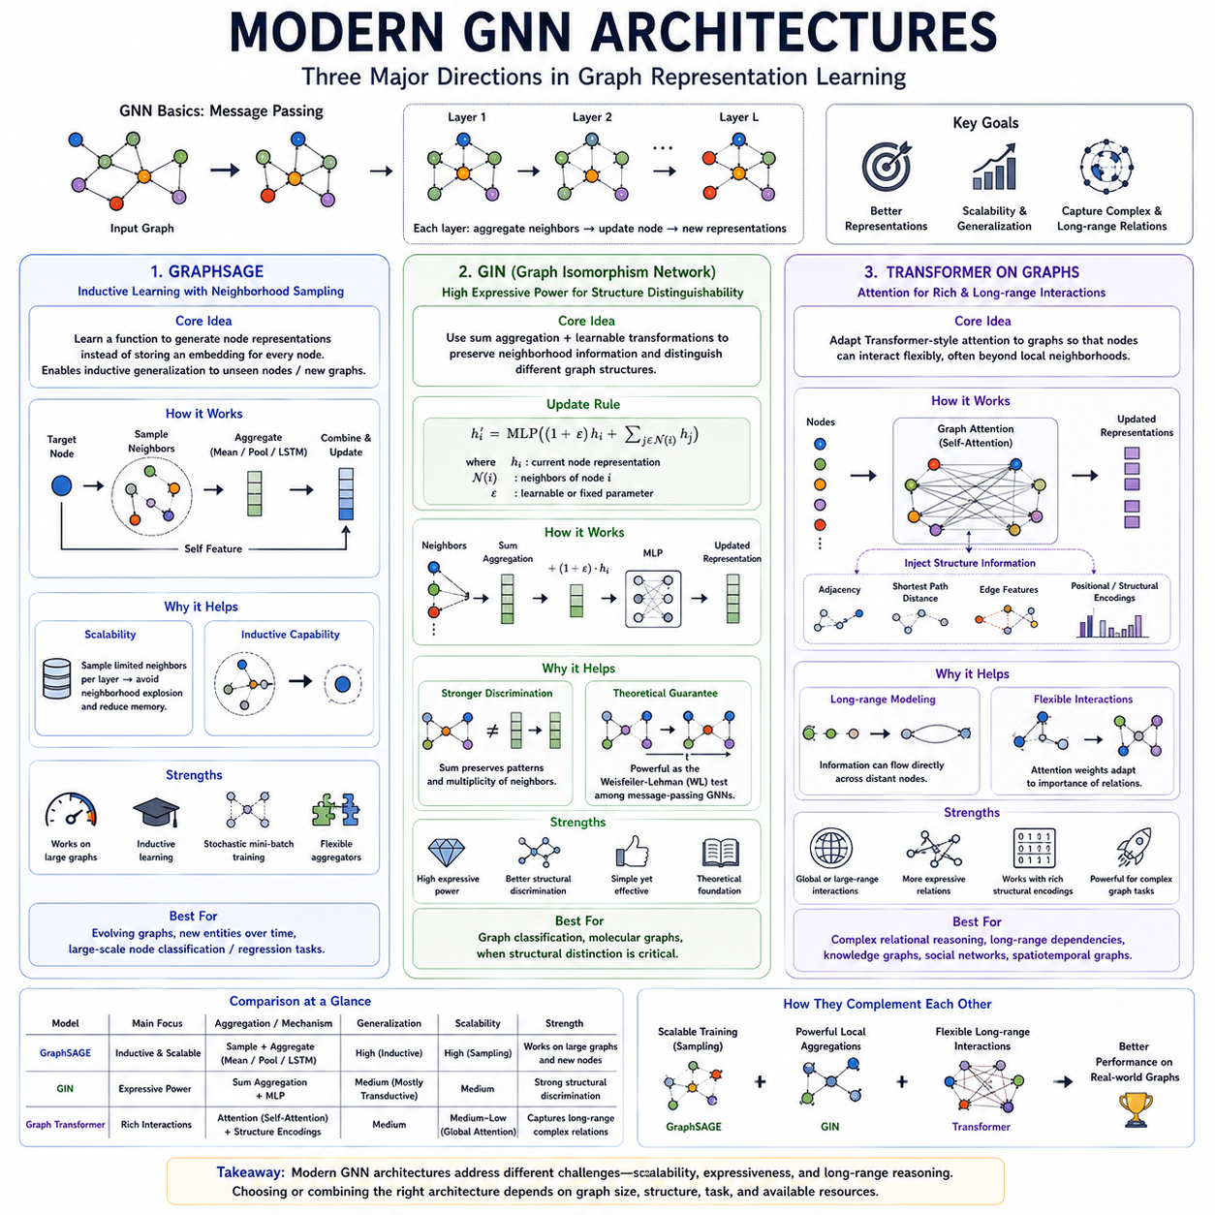
Modern GNN architectures extend basic graph convolution and message passing to improve scalability, expressive power, and long-range relational modeling. GraphSAGE focuses on inductive learning and efficient neighborhood sampling, GIN strengthens the ability to distinguish different graph structures, and graph Transformers introduce attention-based mechanisms for richer interactions. Together, they represent major directions in the evolution of graph representation learning.
GraphSAGE, or Graph Sample and Aggregate, was designed to learn functions that generate node representations rather than storing a separate embedding for every node. This distinction enables inductive learning, where a trained model can produce representations for previously unseen nodes or new graphs as long as suitable node features and neighborhood information are available.
The central operation of GraphSAGE is neighborhood sampling and aggregation. For each target node, the model samples a limited number of neighboring nodes instead of processing the complete neighborhood. Their representations are aggregated using functions such as mean, pooling, or recurrent aggregation, and the resulting neighborhood representation is combined with the target node’s current representation to produce an updated embedding.
Sampling makes GraphSAGE particularly useful for large graphs. In conventional multi-layer message passing, recursively expanding all neighbors can cause neighborhood explosion, where the number of nodes required for one target grows rapidly with depth. GraphSAGE limits this expansion by controlling the number of sampled neighbors at each layer, reducing memory consumption and enabling stochastic mini-batch training.
GraphSAGE also provides an important conceptual transition from transductive to inductive graph learning. Rather than learning only representations tied to nodes observed during training, it learns parameterized aggregation functions that can be reused elsewhere. This makes the architecture suitable for evolving networks in which new users, devices, documents, robots, transactions, or other entities may continuously appear after training.
Graph Isomorphism Network, or GIN, was developed with a different objective: improving the expressive power of message-passing GNNs. A central question in graph learning is whether two nodes or graphs with different structures can receive distinguishable representations. If an aggregation mechanism maps structurally different neighborhoods to the same embedding, subsequent layers may be unable to recover the lost distinction.
GIN uses sum aggregation combined with learnable transformations to preserve neighborhood information effectively. A typical update combines the current node representation with the sum of neighboring representations and applies a multilayer perceptron. Conceptually, this can be expressed as h'i = MLP((1 + ε)hi + Σj hj), where ε may be fixed or learned and controls the contribution of the node’s own representation.
The use of summation is important because mean or maximum aggregation can map different multisets of neighboring features to identical outputs more easily. Sum aggregation can preserve information about both feature patterns and multiplicity. Combined with sufficiently expressive neural transformations, this gives GIN strong discriminative capability within the theoretical limits of standard message-passing graph neural networks.
GIN is closely connected to the Weisfeiler-Lehman graph isomorphism test, a classical procedure for distinguishing graph structures through iterative neighborhood refinement. This connection provides a theoretical framework for analyzing GNN expressiveness. GIN demonstrates that careful design of aggregation and update functions can substantially influence whether structurally different neighborhoods remain distinguishable after message passing.
Graph Transformers represent another major direction by adapting Transformer-style attention to graph-structured data. Standard Transformers allow tokens to interact through self-attention, while graph Transformers treat nodes or other graph elements as entities whose interactions can be determined through attention. This can provide more flexible relational modeling than strictly local neighborhood aggregation.
Directly applying ordinary Transformer attention to graph nodes, however, does not automatically encode graph topology. Graph Transformers therefore often incorporate structural information through adjacency relationships, shortest-path distances, edge features, positional encodings, centrality measures, or other graph-derived biases. These signals inform attention about how nodes are related structurally rather than relying only on their feature similarity.
Graph attention and Transformer attention should also be distinguished conceptually. A conventional GAT usually computes attention within local graph neighborhoods defined by existing edges. A graph Transformer may allow broader or even global attention among nodes, depending on the architecture. This can improve long-range information exchange because distant nodes may communicate without requiring many intermediate message-passing layers.
Global attention can reduce some limitations of local propagation, particularly when important dependencies span large graph distances. Instead of forcing information through a sequence of intermediate nodes, attention can establish more direct interactions. However, global attention may require computation proportional to the square of the number of nodes, creating serious memory and runtime challenges for large graphs.
Modern graph Transformers therefore frequently combine local graph structure with restricted, sparse, hierarchical, or approximate attention. Some architectures use message passing for nearby relationships and attention for selected long-range interactions. Others introduce virtual nodes, structural tokens, or compressed representations. These hybrid strategies seek to obtain broader relational context without paying the full computational cost of unrestricted global attention.
Positional and structural encodings are particularly important because graphs do not provide the natural sequential positions available in language models. Laplacian eigenvectors, random-walk statistics, shortest-path distances, node degrees, and learned structural encodings can provide information about where a node lies within the graph. Such encodings help attention mechanisms distinguish nodes that might otherwise have similar feature representations.
GraphSAGE, GIN, and graph Transformers address different weaknesses of earlier GNNs. GraphSAGE emphasizes inductive generalization and scalability through sampling. GIN emphasizes structural discriminability through expressive aggregation. Graph Transformers emphasize flexible and potentially long-range interaction through attention. Their differences illustrate that no single graph architecture is optimal for every relational learning problem.
These architectures can also be combined rather than treated as isolated alternatives. Sampling strategies inspired by GraphSAGE can support scalable training, expressive aggregation principles from GIN can strengthen local message passing, and Transformer-based attention can model selected long-range dependencies. Modern GNN systems increasingly integrate these ideas according to graph size, topology, task requirements, and available computational resources.
The progression from GCN and GAT toward GraphSAGE, GIN, and graph Transformers reflects the broader development of graph deep learning. Early architectures established effective neighborhood propagation, while later models increasingly address generalization, structural expressiveness, information bottlenecks, and long-range reasoning. Understanding these modern architectures therefore provides a foundation for selecting and designing GNNs for complex real-world relational systems.

