Volume 29. Graph Deep Learning

Chapter 05. Graph Generation and Reasoning

05.00. Overview
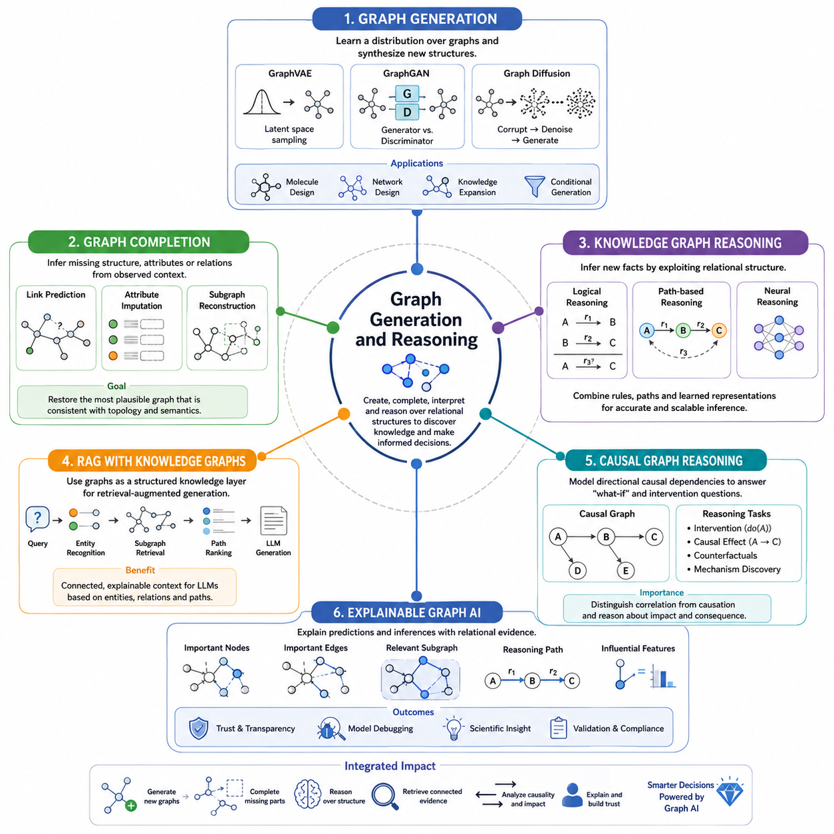
Graph generation and reasoning extend graph deep learning beyond representation and prediction toward systems that can construct, complete, interpret, and reason over relational structures. Instead of assuming that the graph is fixed and fully observed, these methods treat nodes, edges, attributes, and higher-order relationships as objects that may be generated, inferred, revised, or queried. This perspective is essential when relational structure itself contains knowledge that must be discovered or created.
A graph generative model learns a distribution over possible graph structures and attributes. Depending on the application, it may generate an entire graph, add nodes or edges to an existing graph, or produce graph structures conditioned on desired properties. Unlike image generation, graph generation must respect permutation invariance, variable graph sizes, discrete connectivity, and structural constraints. These requirements make graph generation a distinctive form of structured generative modeling.
Variational approaches such as GraphVAE represent graphs through latent variables and decode those variables into candidate nodes, edges, and attributes. The latent space can capture recurring structural patterns and provide a continuous representation from which new graphs are sampled. Generative adversarial approaches introduce competing generator and discriminator objectives, while graph diffusion methods progressively corrupt graph structure and learn how to reverse that process to recover or synthesize plausible graphs.
Graph generation becomes especially useful when the desired output must satisfy relationships rather than merely reproduce individual observations. Molecular discovery can generate candidate molecular graphs, network design can explore alternative connectivity patterns, and knowledge systems can propose missing entities or relations. Conditional generation further allows graph structures to be produced according to target properties, constraints, or contextual information, connecting generative modeling with optimization and structured decision making.
Graph completion addresses a related but different problem: the graph already exists, but part of its structure or information is missing. A model may estimate missing edges, node attributes, relation types, or subgraphs from the observed relational context. Link prediction is therefore one important form of graph completion, but the broader problem includes reconstructing incomplete relational structures and estimating which additions are most consistent with known topology and semantic evidence.
Reasoning over graphs uses explicit relational structure as a substrate for inference. In a knowledge graph, entities are represented as nodes and semantic relations as typed edges, allowing reasoning to operate over chains of relationships rather than isolated feature vectors. A query about an unknown relationship can therefore be approached by examining existing facts, paths, neighborhoods, relation compositions, and learned representations that collectively provide evidence for a conclusion.
Knowledge graph reasoning can combine logical, path-based, and neural approaches. Logical reasoning applies rules or relation compositions to derive new facts, while path-based reasoning searches meaningful sequences connecting entities. Neural reasoning learns differentiable representations and transformations that approximate inference from data. These approaches need not remain separate: modern systems increasingly combine symbolic constraints with learned graph representations to obtain both flexibility and structured inference.
Path-based reasoning is particularly intuitive because a path can represent a sequence of semantic transformations. If one entity is connected to another through several meaningful relations, the complete path may provide evidence unavailable from any individual edge. Neural models can learn which paths, intermediate entities, or relation combinations are informative, transforming graph traversal from a manually specified procedure into a trainable reasoning mechanism capable of handling large relational spaces.
Graph reasoning also provides a natural foundation for retrieval-augmented generation with knowledge graphs. Instead of retrieving independent text passages solely through vector similarity, a system can identify relevant entities and traverse their relationships to construct structured context. This allows retrieval to preserve connections among facts and can provide language models with evidence organized around entities, relations, paths, and neighborhoods rather than disconnected textual fragments.
Knowledge-graph-based retrieval is valuable when answering a question requires multiple connected facts. The system may first identify entities mentioned in a query, retrieve their local subgraphs, expand through selected relations, rank candidate paths, and convert the resulting evidence into context for a generative model. Graph structure therefore acts as an intermediate reasoning layer between retrieval and generation, helping the system organize evidence according to explicit relational dependencies.
Causal graph reasoning introduces a stronger interpretation of edges. Ordinary graphs may indicate association, similarity, interaction, or semantic relationships, whereas causal graphs attempt to represent directional dependencies related to how changes propagate through a system. Reasoning over such structures supports questions involving interventions, causal mechanisms, and possible consequences, extending graph AI from pattern recognition toward models that distinguish relational correlation from hypothesized causal influence.
This distinction is important because predictive relationships do not automatically justify causal conclusions. A graph model may accurately discover that two variables are strongly connected without establishing that changing one will cause the other to change. Causal graph reasoning therefore requires assumptions, structural information, experimental evidence, or causal modeling principles beyond ordinary message passing. When these elements are available, graph representations provide a powerful framework for organizing causal variables and dependencies.
Explainable graph AI addresses another fundamental requirement: understanding why a graph model produced a particular result. Because predictions may depend on neighborhoods, paths, edge types, node attributes, and multiple rounds of message passing, explanations must identify the relational evidence that influenced an output. An explanation may highlight influential nodes, important edges, relevant subgraphs, decisive features, or reasoning paths that contributed most strongly to a prediction or inferred relationship.
Graph explanations are particularly meaningful because they can expose structure rather than only numerical feature importance. A fraud prediction might be explained by a suspicious transaction subnetwork, a biological prediction by a molecular substructure, and a knowledge inference by a sequence of relations connecting two entities. Such explanations can support debugging, scientific interpretation, trust assessment, and validation by revealing whether the model relies on relationships that are plausible for the application.
Taken together, graph generation, completion, reasoning, retrieval, causal analysis, and explainability transform graphs from passive input structures into active computational representations of evolving knowledge. Generation proposes new relational structures, completion reconstructs missing information, reasoning derives conclusions, graph-based retrieval assembles connected evidence, causal models examine directional dependencies, and explanation exposes the relational basis of model behavior. These capabilities form the conceptual bridge from graph representation learning toward knowledge-centered and reasoning-oriented Graph AI.

05.01. Graph Generation
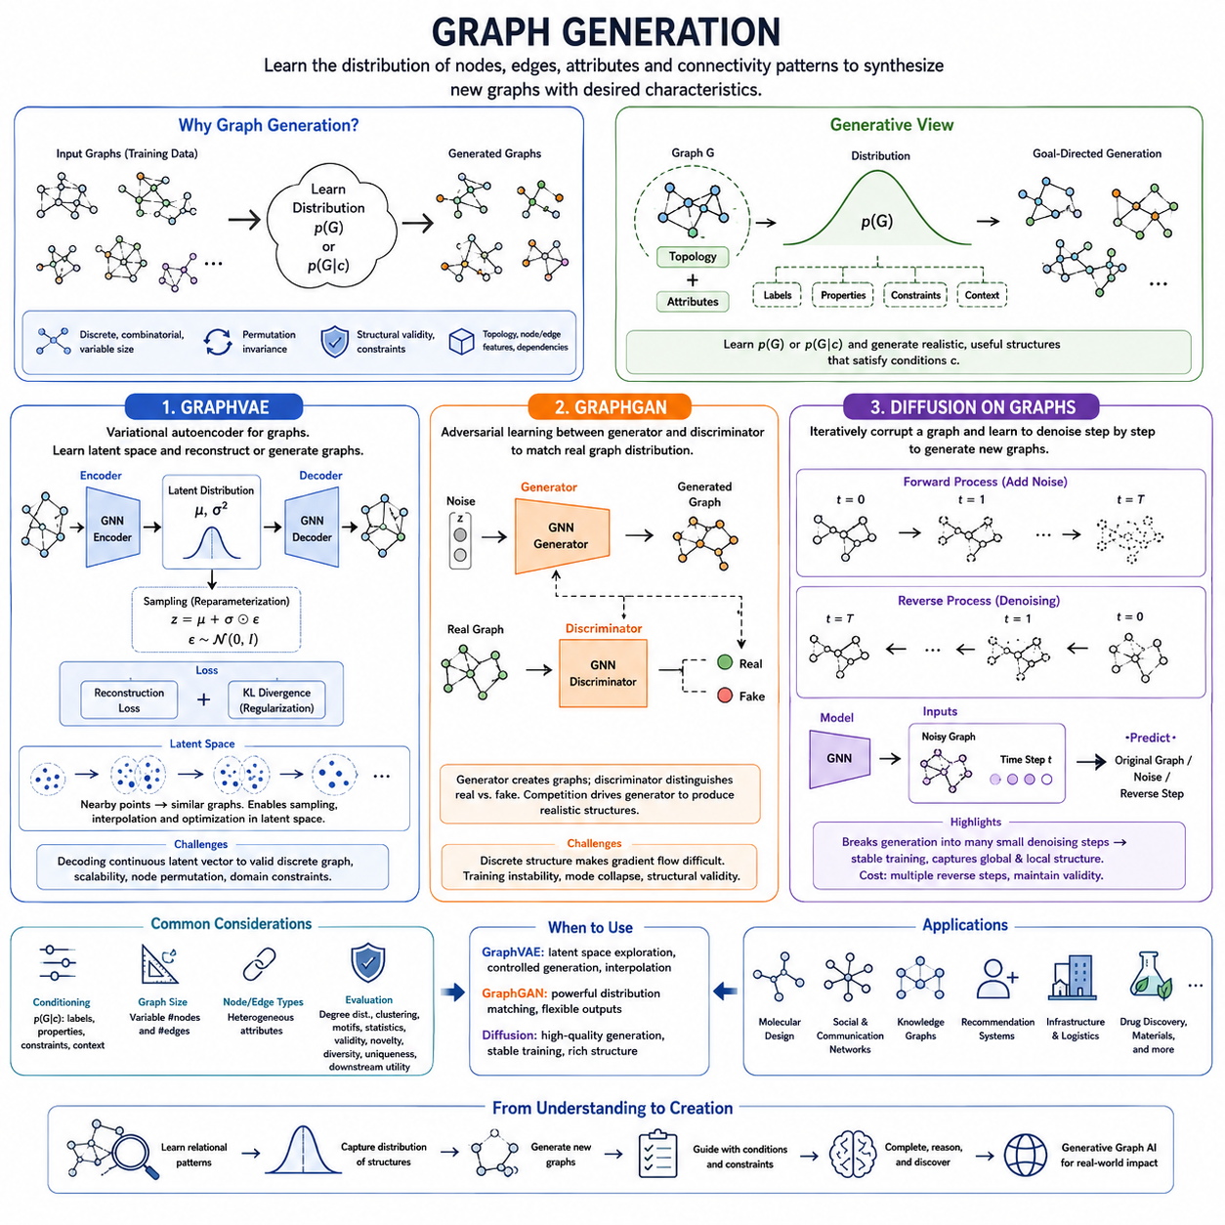
Graph generation focuses on learning how relational structures can be created rather than merely analyzed. A generative graph model attempts to learn the underlying distribution of nodes, edges, attributes, and connectivity patterns observed in training data, then uses this learned distribution to construct new graphs. This extends graph deep learning from predicting properties of existing structures toward synthesizing plausible relational structures with desired characteristics.
Generating graphs is fundamentally different from generating images, text, or ordinary vectors because graphs are discrete, combinatorial, and often variable in size. The same graph can also be represented by many different node orderings without changing its meaning. A successful model must therefore account for permutation invariance, structural validity, variable numbers of nodes and edges, and potentially complex dependencies among topology, node features, and edge attributes.
A graph generative process can be viewed as learning a probability distribution over graphs, commonly expressed conceptually as p(G), where G contains the graph topology together with associated features. Conditional models extend this idea to p(G|c), where c may describe desired properties, labels, constraints, or contextual information. This formulation enables generation to become goal-directed, allowing models to search for structures that are not only realistic but also useful for a particular task.
GraphVAE adapts the variational autoencoder framework to graph-structured data. An encoder transforms an observed graph into a probabilistic latent representation, typically parameterized by a mean and variance. A latent vector is sampled from this distribution and passed to a decoder that attempts to reconstruct graph components such as node attributes, edge probabilities, or adjacency structure. Training balances reconstruction quality against regularization of the latent distribution.
The latent space learned by GraphVAE provides more than graph reconstruction. Nearby latent vectors can correspond to structurally or semantically related graphs, making it possible to sample new structures, interpolate between examples, and explore candidate designs. This property is particularly valuable when graph generation is treated as a search problem, because optimization can potentially be performed in a continuous latent space before candidate representations are decoded into discrete graph structures.
In a minimal GraphVAE implementation, the input graph is encoded into latent parameters μ and log σ². Reparameterization produces z = μ + σ ⊙ ε, where ε is sampled from a standard normal distribution. The decoder maps z into predictions of graph structure and attributes. A typical objective combines a reconstruction loss with a Kullback–Leibler divergence term, encouraging useful reconstruction while keeping the learned latent distribution close to a tractable prior.
The principal difficulty for GraphVAE lies in decoding a continuous latent representation into a valid discrete graph. Predicting an adjacency matrix directly may become expensive as graph size increases, and different node permutations can represent equivalent graphs. Applications may also impose domain-specific validity constraints. Consequently, practical graph variational models often require specialized decoders, matching procedures, constrained generation mechanisms, or representations designed around the structure of the target domain.
GraphGAN approaches graph generation through adversarial learning. Conceptually, a generator attempts to produce graph structures or graph-related samples that resemble observations from the real data distribution, while a discriminator attempts to distinguish generated examples from real ones. Through this competition, the generator gradually learns structural patterns that make its outputs increasingly difficult for the discriminator to identify as synthetic.
Adversarial graph generation is challenging because conventional GANs operate naturally on continuous tensors, whereas graph connectivity is largely discrete. Gradients cannot always propagate straightforwardly through sampled edges or graph construction decisions. GraphGAN-style systems therefore require mechanisms appropriate to their generation target, which may involve neighborhoods, connectivity patterns, node relationships, random walks, or other representations that expose graph structure in a form suitable for adversarial optimization.
The attraction of adversarial learning is that it can learn complex graph distributions without requiring an explicitly specified likelihood for every structural configuration. The discriminator acts as a learned quality signal that encourages generated samples to resemble realistic relational structures. However, graph adversarial training inherits familiar GAN difficulties such as unstable optimization and mode collapse while adding challenges caused by discrete topology and structural constraints.
Diffusion on graphs introduces a different generative principle. Instead of generating a complete graph directly, a forward process progressively corrupts graph information until the original structure becomes difficult to recognize. A learned reverse process then estimates how to remove this corruption step by step. Starting from an appropriately noisy graph state, repeated denoising can ultimately produce a new graph that follows structural patterns learned from the training distribution.
Graph diffusion must define corruption and denoising operations appropriate for graph data. Noise may affect node attributes, edge attributes, connectivity, or combinations of these elements. Because edges and node categories may be discrete rather than continuous, graph diffusion cannot always reuse image diffusion unchanged. The transition process must preserve a mathematically manageable generative trajectory while allowing the reverse model to recover meaningful relational organization.
A simplified diffusion implementation begins by sampling clean graphs and applying progressively stronger perturbations across diffusion steps. A neural network receives the corrupted graph together with information describing the current step and predicts the original structure, the applied noise, or the reverse transition. Training repeatedly exposes the model to different corruption levels, while generation begins from a noisy state and iteratively applies learned reverse transitions until a coherent graph emerges.
Compared with one-shot generation, diffusion decomposes a difficult graph synthesis problem into a sequence of smaller denoising decisions. This can provide stable training and allow the model to refine global and local structure progressively. The price is computational cost: generation generally requires multiple reverse steps, and maintaining valid graph structure throughout the trajectory can be difficult, particularly for large graphs or domains with strict structural and semantic constraints.
GraphVAE, GraphGAN, and graph diffusion therefore represent three complementary perspectives on graph generation. GraphVAE emphasizes probabilistic latent representations and reconstruction, GraphGAN emphasizes adversarial matching between generated and observed graph distributions, and graph diffusion emphasizes iterative corruption and denoising. Their architectures differ, but all attempt to learn the structural regularities required to create relational objects rather than simply classify existing ones.
The appropriate approach depends on the objective and properties of the graph domain. Latent-variable models are attractive when continuous representation and controlled exploration are important, adversarial approaches provide an alternative mechanism for distribution matching, and diffusion models offer powerful iterative generation. In practice, graph size, sparsity, node and edge types, validity constraints, conditioning information, generation speed, and evaluation requirements strongly influence architectural choices.
Evaluation must consider more than whether generated graphs visually or statistically resemble training examples. Useful graph generators should reproduce meaningful structural properties while maintaining diversity and avoiding simple memorization. Depending on the domain, evaluation may examine degree distributions, connectivity, clustering patterns, motifs, graph-level statistics, validity constraints, novelty, uniqueness, and downstream usefulness. Domain-specific requirements can ultimately be more important than generic similarity metrics.
Graph generation consequently forms a bridge between graph representation learning and generative AI. Rather than asking only what an existing graph means, the system begins asking what relational structures could exist, which structures satisfy particular conditions, and how new candidates can be constructed from learned relational knowledge. GraphVAE, GraphGAN, and diffusion on graphs provide major conceptual pathways toward this capability and establish the foundation for graph completion, knowledge reasoning, structured discovery, and increasingly generative forms of Graph AI.

05.02. Graph Completion
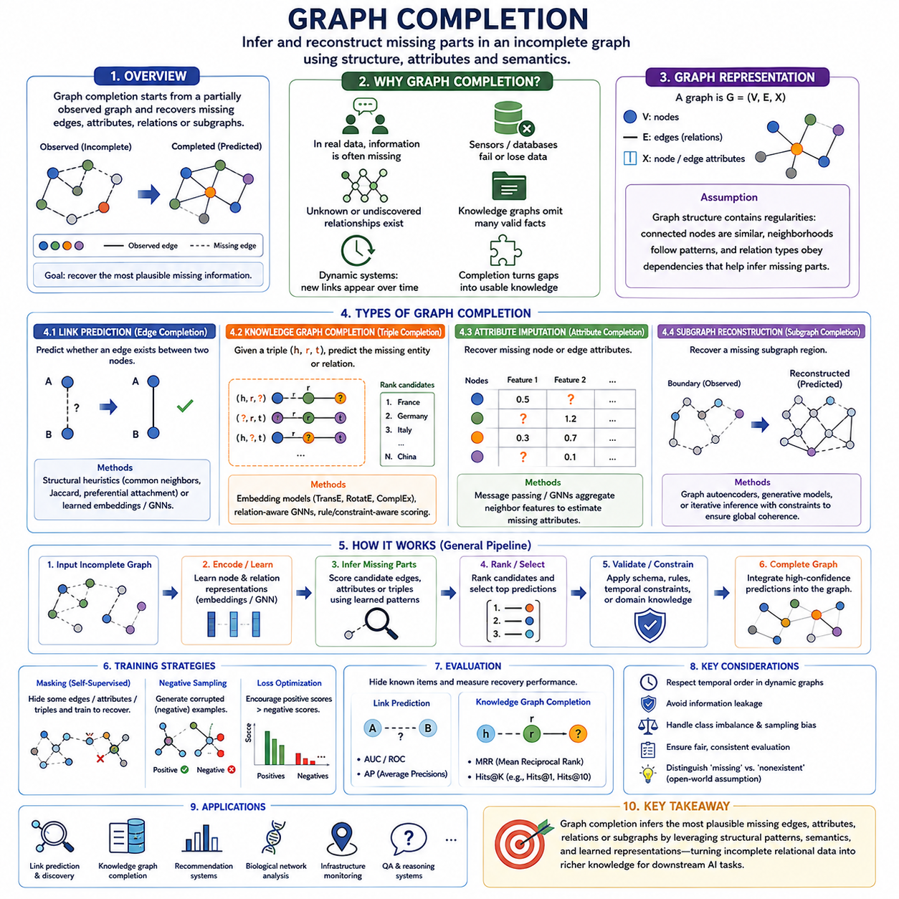
Graph completion addresses the problem of reconstructing missing or uncertain information in an existing graph. Unlike graph generation, which synthesizes new graph structures, completion begins with a partially observed graph and attempts to recover the most plausible missing components from available context. These components may include edges, node attributes, relation types, or portions of a subgraph, making completion a fundamental capability for imperfect real-world relational data.
Real-world graphs are rarely complete. Social networks contain interactions that have not yet been observed, knowledge graphs omit valid facts, biological networks contain undiscovered relationships, and infrastructure graphs may lose information because of sensor or database failures. Graph completion treats these gaps as inference problems rather than assuming that unobserved information is necessarily absent, allowing learned structural patterns to guide reconstruction.
A graph can be represented as G = (V, E, X), where V denotes nodes, E represents edges, and X contains node or graph attributes. Completion attempts to estimate unknown elements using observed portions of G. The underlying assumption is that graph structure contains regularities: connected nodes often exhibit meaningful similarities, neighborhoods form recurring patterns, and relation types obey structural or semantic dependencies that can provide evidence about missing information.
Link prediction is one of the most common graph completion tasks. Given two nodes without an observed edge, a model estimates whether a meaningful relationship should exist between them. Classical methods may use common neighbors, Jaccard similarity, preferential attachment, or other structural heuristics. Learned methods instead derive node representations from graph topology and attributes, then use these representations to calculate the likelihood or score of a candidate connection.
For example, suppose nodes A and B are not directly connected but share several neighbors and participate in similar structural contexts. Their representations may become similar after graph-based learning, increasing the predicted probability of an edge between them. In a knowledge graph, the problem becomes more specific because the system must often predict not only whether entities are connected but also which typed semantic relation connects them.
Knowledge graph completion typically operates on triples represented as (h, r, t), where h is the head entity, r is the relation, and t is the tail entity. During evaluation, a known triple can be partially hidden to create queries such as (h, r, ?), (?, r, t), or sometimes (h, ?, t). The model ranks candidate entities or relations and attempts to place the correct missing component near the top of the ranking.
Embedding methods provide an efficient foundation for this process. Models such as TransE, RotatE, and ComplEx represent entities and relations in continuous geometric spaces and define scoring functions for candidate triples. Known triples are encouraged to receive favorable scores, while corrupted or implausible triples receive worse scores. After training, the scoring function can evaluate previously unobserved triples and identify plausible facts for knowledge graph completion.
Graph neural networks extend completion by incorporating neighborhood information directly. Through message passing, each node aggregates information from connected nodes and edges, producing representations that reflect local structural context. A decoder can then compare pairs of node representations to predict missing edges. Relation-aware GNNs can additionally incorporate edge types, enabling completion in heterogeneous or multi-relational graphs where different connections carry different meanings.
Attribute imputation is another major form of graph completion. In this setting, the graph topology may be available while some node or edge features are missing. Instead of predicting connectivity, the model reconstructs unknown attributes using neighboring features and structural context. If connected nodes tend to share properties or exhibit predictable dependencies, message passing can aggregate available information and estimate values for nodes whose attributes are incomplete.
Attribute completion can involve categorical labels, continuous measurements, semantic features, or other metadata. The task becomes more difficult when missingness is systematic rather than random, because the observed neighborhood may itself be biased or incomplete. Effective models must therefore distinguish genuine relational evidence from artifacts introduced by the data collection process, especially when graph completion is used for scientific or operational decision making.
Subgraph reconstruction considers a larger missing region rather than an individual edge or attribute. A portion of nodes, edges, or relationships may be partially unavailable, and the system attempts to reconstruct a coherent local structure from its surrounding boundary and learned graph patterns. This requires reasoning about multiple components jointly because independently predicting individual edges may produce a collection of connections that is locally probable but globally inconsistent.
Graph autoencoders provide a general architecture for structural reconstruction. An encoder, often implemented using a GNN, maps observed graph information into latent node representations. A decoder then reconstructs the adjacency structure or predicts candidate links from these embeddings. Training compares reconstructed outputs against known graph structure, allowing the latent representation to capture connectivity patterns that can later be used to estimate deliberately hidden or genuinely missing edges.
Self-supervised learning is naturally compatible with graph completion because training targets can be created from the graph itself. Existing edges, attributes, or substructures are intentionally masked or removed, and the model is trained to recover them from the remaining context. This converts graph completion into a masked prediction objective similar in spirit to masked modeling in other AI domains while preserving the relational dependencies unique to graphs.
Negative sampling is important when training link and knowledge graph completion models because the number of possible nonexistent edges or triples can be enormous. Instead of evaluating every possible negative candidate, training selects a manageable subset of corrupted examples. Strategies may include uniform, weighted, or self-adversarial sampling. The model then learns to assign stronger scores to observed positive relations than to sampled negative candidates.
A critical distinction exists between a missing relation and a truly nonexistent relation. Most real graphs follow an open-world assumption: absence from the dataset does not necessarily mean that a fact is false. Treating every unobserved edge as a negative example can therefore introduce incorrect supervision. This issue is especially important in knowledge graphs, scientific networks, and evolving systems where new relationships may continuously be discovered.
Completion can also incorporate semantic constraints. A candidate edge may appear structurally plausible but violate domain knowledge, relation types, temporal order, or logical consistency. For example, heterogeneous graphs may permit only particular relations between specific node types. Combining learned prediction with schema constraints, logical rules, or domain-specific validity checks can therefore improve the reliability of reconstructed graph information.
Temporal graphs introduce another challenge because completion must respect time. A relationship that becomes valid in the future should not leak into training data used to reconstruct an earlier graph state. Dataset construction must preserve chronological ordering when appropriate and prevent information leakage between training, validation, and test sets. These considerations are explicitly important when evaluating completion on dynamic relational data.
Evaluation commonly hides known edges or triples and measures whether the model successfully recovers them. Knowledge graph completion evaluates head or tail prediction by ranking candidate entities, with metrics such as Mean Reciprocal Rank and Hits@K indicating how highly the correct entity appears. Evaluation design must also control information leakage, sampling bias, class imbalance, and split consistency so that reported performance reflects genuine completion ability.
High completion accuracy alone does not guarantee useful reconstruction. Predictions should also be structurally coherent, semantically valid, calibrated when uncertainty matters, and robust to missing or noisy observations. In practical systems, high-confidence predictions may be automatically incorporated while uncertain candidates are retained for human review or additional evidence collection, preventing completion models from turning uncertain predictions into apparently authoritative graph facts.
Graph completion therefore connects representation learning, link prediction, knowledge graph embeddings, GNN message passing, masked modeling, and relational reasoning. Its central objective is not simply to fill empty positions in a data structure, but to infer the most plausible missing information that remains consistent with observed topology and semantics. This capability enables incomplete relational data to become progressively richer and provides a foundation for downstream search, recommendation, reasoning, and knowledge-driven AI systems.

05.03. Knowledge Graph Reasoning
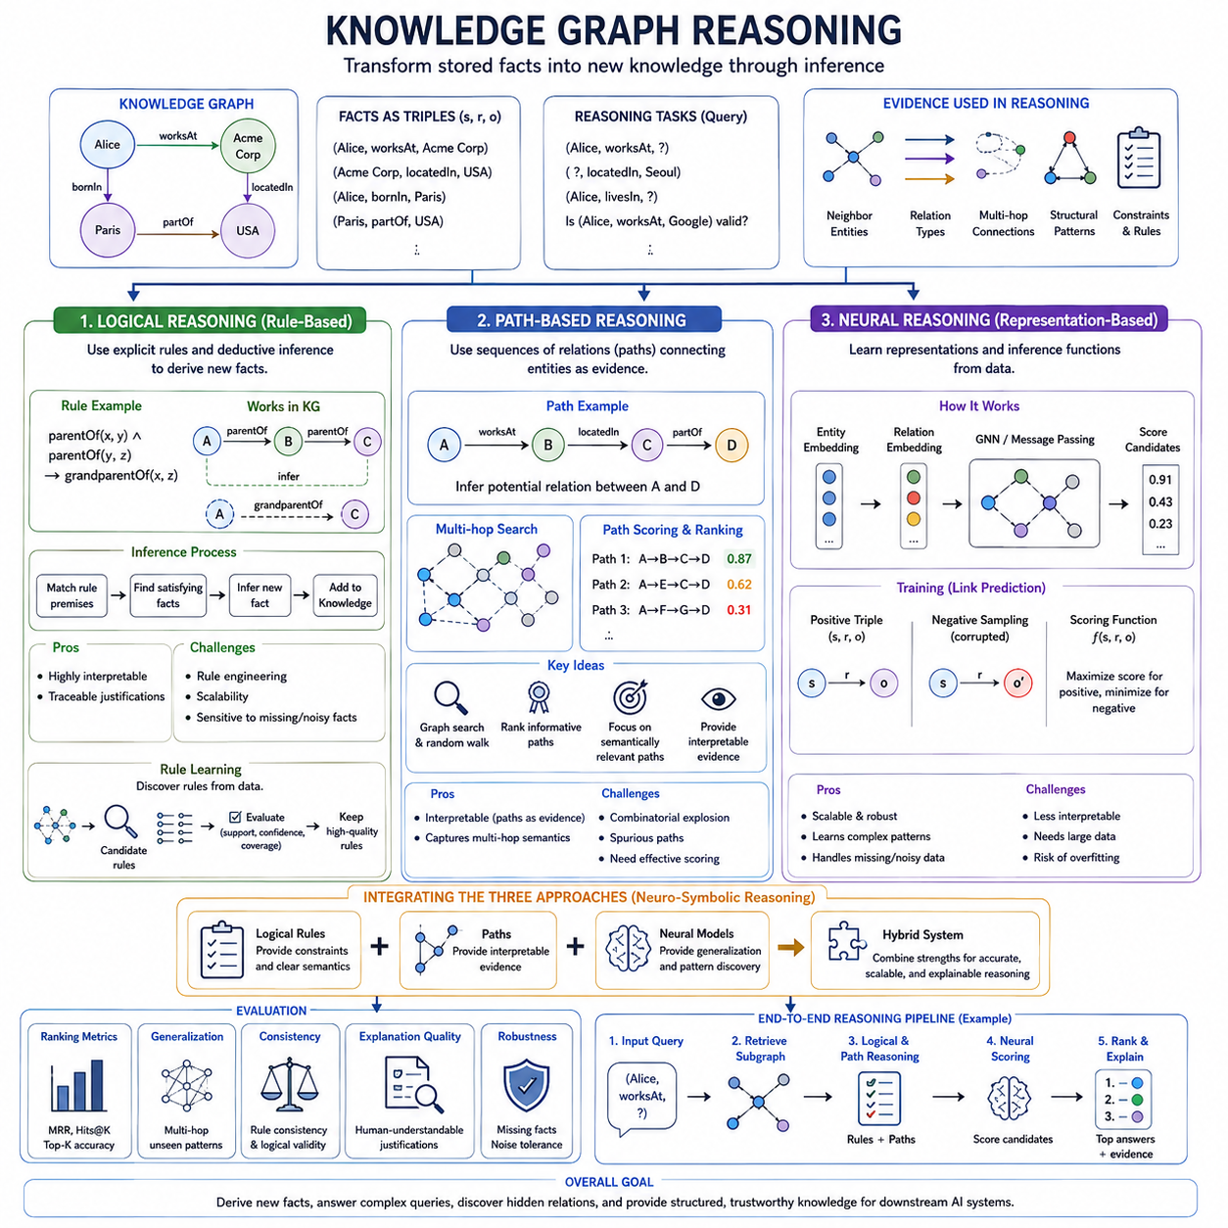
Knowledge graph reasoning transforms a knowledge graph from a structured store of facts into a computational substrate for inference. Entities are represented as nodes and semantic relations as typed edges, usually expressed as triples such as (subject, relation, object). Reasoning seeks facts that are not explicitly stored by exploiting known relations, structural patterns, rules, paths, and learned representations.
A typical reasoning task begins with an incomplete query such as (Alice, worksAt, ?), (?, locatedIn, Seoul), or whether a candidate relation between two entities is valid. Instead of treating each triple independently, the system examines the surrounding graph. Neighboring entities, relation types, multi-hop connections, repeated structural patterns, and semantic constraints can collectively provide evidence for the missing entity or relation.
Knowledge graph reasoning can broadly combine logical reasoning, path-based reasoning, and neural reasoning. Logical reasoning emphasizes explicit rules and interpretable deductions, path-based reasoning uses sequences of relations connecting entities, and neural reasoning learns distributed representations and differentiable inference mechanisms from data. These approaches address the same relational inference problem from complementary symbolic, structural, and statistical perspectives.
Logical reasoning represents knowledge through facts and rules that specify how new facts can be derived. Suppose a graph contains the relations parentOf(A, B) and parentOf(B, C). A rule defining the composition of these relations may infer grandparentOf(A, C). Similarly, rules involving organizational membership, geographic containment, ownership, or category hierarchies can derive relationships that were never directly inserted into the graph.
Rules are often represented conceptually as implications such as r1(x,y) ∧ r2(y,z) → r3(x,z). The left side describes conditions that must hold, while the right side specifies the relation that may be inferred. Reasoning repeatedly matches rule premises against known graph facts and introduces valid conclusions. This creates a systematic mechanism for expanding explicit knowledge into derived knowledge while preserving a traceable inference process.
One major advantage of logical reasoning is interpretability. When a new relation is inferred, the system can identify the facts and rule that produced it. This is valuable in scientific, enterprise, legal, or safety-sensitive knowledge systems where users may need more than a prediction score. However, handcrafted rule systems can become difficult to scale, and rigid rules may struggle when graphs contain missing, noisy, uncertain, or continuously changing information.
Modern logical graph reasoning therefore often incorporates rule learning. Instead of defining every relation composition manually, algorithms search the graph for recurring patterns that reliably imply other relations. Candidate rules can be evaluated according to support, confidence, coverage, or related criteria. This allows symbolic reasoning structures to be discovered from data while retaining the possibility of expressing learned knowledge in relatively understandable relational form.
Path-based reasoning approaches inference through sequences of edges connecting entities. Consider a path A → B → C → D whose relations are worksAt, locatedIn, and partOf. Even when no direct relation exists between A and D, the complete path may contain sufficient relational evidence to infer a meaningful connection. A path therefore acts as a compositional representation of how information propagates through the knowledge graph.
Multi-hop reasoning is central to path-based methods. A one-hop query uses a direct edge, whereas a multi-hop query requires several intermediate entities and relations. As path length increases, the number of possible routes can grow rapidly. Effective reasoning must therefore identify informative paths rather than exhaustively treating every possible traversal as equally useful, especially in large and densely connected knowledge graphs.
Traditional path-based systems may use graph search, random walks, path ranking, or manually specified relation sequences. Learned approaches assign scores to candidate paths or learn which relation transitions are useful for particular queries. The reasoning process can then prioritize paths containing semantically relevant intermediate entities while suppressing paths that are structurally possible but provide weak or misleading evidence.
Path-based reasoning is naturally interpretable because the selected path can be presented as evidence. If a system predicts that entity A is related to entity D, it can expose the intermediate chain A → B → C → D. However, a path is not automatically a valid explanation. Spurious correlations and coincidental connectivity may create plausible-looking routes, so path quality must be evaluated according to semantics as well as topology.
Neural reasoning replaces or augments manually designed inference mechanisms with learned representations. Entities and relations may first be embedded into continuous vector spaces, after which neural networks learn functions that score candidate facts, propagate information, compose relations, or predict missing links. This allows the reasoning system to exploit statistical regularities that would be difficult to encode completely through explicit symbolic rules.
Graph neural networks provide a natural architecture for neural reasoning because message passing allows information to travel across relational neighborhoods. At each layer, an entity representation can aggregate information from connected entities and relation types. Multiple layers permit information from progressively more distant regions of the graph to influence the target representation, providing a differentiable approximation to multi-hop relational inference.
A minimal neural reasoning implementation can encode each entity and relation as trainable vectors, construct positive triples from known facts, and generate negative candidates by replacing subjects or objects. A scoring network evaluates candidate triples, and training encourages valid triples to receive better scores than corrupted ones. More structured implementations use relation-aware message passing, attention, path encoders, or query-conditioned propagation to perform richer inference.
For a query such as (h, r, ?), a neural model can compute representations conditioned on the head entity h and relation r, propagate relevant information through the graph, and assign scores to candidate tail entities. Training uses known answers as supervision, while incorrect candidates provide contrasting examples. During inference, candidate entities are ranked according to their scores, turning knowledge graph reasoning into a structured prediction problem.
Neural reasoning offers robustness and scalability because it can generalize from recurring patterns rather than requiring every inference rule to be explicitly written. Yet its internal reasoning process may be difficult to interpret. A highly accurate prediction does not necessarily reveal which facts justify the conclusion. Neural knowledge graph reasoning therefore increasingly incorporates attention, path extraction, rule constraints, or explanation mechanisms that expose supporting relational evidence.
Logical, path-based, and neural reasoning should not be viewed as mutually exclusive alternatives. Logical rules can constrain neural predictions, neural models can discover candidate patterns that later become symbolic rules, and path-based evidence can explain predictions produced by learned models. Hybrid systems exploit these complementary strengths by combining symbolic precision, structural transparency, and statistical generalization.
A neuro-symbolic graph reasoning system may use neural representations to rank candidate facts while logical constraints eliminate inconsistent possibilities. Another design may retrieve promising paths using graph search and then apply a neural model to evaluate their semantic relevance. Conversely, neural models can identify recurring relation compositions from large graphs and convert high-confidence patterns into explicit rules for subsequent symbolic inference.
Reasoning quality must be evaluated carefully because successful link prediction alone does not guarantee meaningful reasoning. Common evaluation examines whether the correct entity or relation appears near the top of a ranked candidate list, using measures such as Mean Reciprocal Rank and Hits@K. More demanding evaluation also considers multi-hop generalization, rule consistency, explanation quality, robustness to missing facts, and performance on previously unseen relational patterns.
The broader purpose of knowledge graph reasoning is to transform stored relationships into usable knowledge. Logical reasoning derives conclusions through explicit rules, path-based reasoning discovers evidence through relational chains, and neural reasoning learns inference patterns directly from graph data. Their integration creates systems capable of completing missing knowledge, answering multi-hop queries, discovering hidden relationships, and providing structured evidence for downstream AI systems.

05.04. RAG with Knowledge Graphs
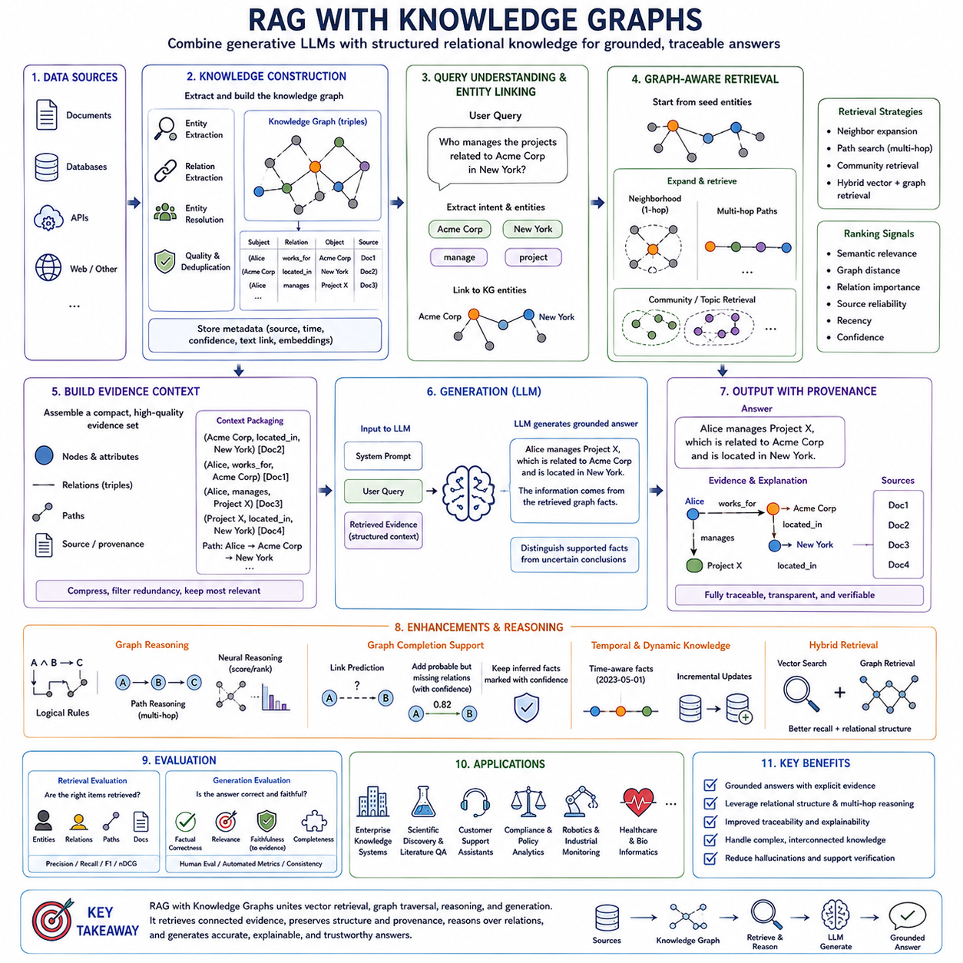
Retrieval-Augmented Generation with Knowledge Graphs combines generative language models with explicit relational knowledge so that answers can be grounded in connected facts rather than produced only from model parameters. Instead of relying exclusively on unstructured document retrieval, the system represents entities and their relationships as a graph and retrieves relevant portions of that structure before generation. This creates a bridge between knowledge representation, graph reasoning, retrieval, and natural-language generation.
Conventional Retrieval-Augmented Generation, or RAG, typically converts documents into chunks, embeds those chunks as vectors, and retrieves semantically similar passages for a user query. This approach is effective for finding relevant text, but vector similarity alone does not explicitly represent how retrieved facts are related. When a question requires several connected facts, independently retrieved chunks may contain useful information without exposing the relational structure required to combine them correctly.
Knowledge Graph RAG addresses this limitation by organizing information around entities, relations, and graph topology. A knowledge graph commonly stores facts as triples such as (subject, relation, object). Documents can still remain important sources, but entities and relations extracted from them provide an additional structured layer. Retrieval can therefore search not only for semantically similar text but also for connected entities, neighborhoods, paths, communities, and subgraphs relevant to the query.
The process generally begins with knowledge construction. Source documents, databases, APIs, or other information repositories are analyzed to identify entities and relations. Entity resolution links different mentions that refer to the same real-world concept, while relation extraction determines meaningful connections between entities. The resulting triples are inserted into a graph, often together with metadata, provenance, timestamps, document references, or embeddings that preserve access to the original evidence.
A user query must then be connected to the graph. Named entities, concepts, relation hints, and semantic intent are extracted from the query and mapped to corresponding graph nodes. This entity linking stage is important because natural-language expressions may differ from canonical graph identifiers. Ambiguous names may correspond to several entities, so contextual evidence and semantic similarity can be used to identify the most plausible graph entry before retrieval begins.
Once seed entities have been identified, the retriever can expand through their graph neighborhoods. A one-hop expansion collects directly connected entities and relations, while multi-hop traversal reaches information connected through longer relational chains. The objective is not to retrieve the largest possible subgraph but to construct a compact evidence graph containing relationships that are relevant to the question while avoiding unrelated branches that would increase noise and context size.
Path-based retrieval is particularly valuable when answering a question requires relational composition. Suppose a query asks how entity A is indirectly connected to entity D. The graph may reveal A → B → C → D even though no direct A-D edge exists. Such a path provides structured evidence that ordinary semantic retrieval might overlook. Candidate paths can be ranked according to relation relevance, path length, confidence, semantic similarity, or learned scoring functions.
Graph retrieval can also operate at the community level. Densely related entities may form communities representing topics, organizations, scientific areas, events, or other coherent structures. Community summaries can provide higher-level context when a query concerns a broad topic rather than an individual entity. This allows a system to move between local entity-centered retrieval and more global graph-level retrieval depending on the scope and abstraction level of the question.
Vector retrieval and graph retrieval are complementary rather than mutually exclusive. Vector search is effective for locating semantically related passages even when explicit graph relationships are unavailable, whereas graph traversal preserves known relational connections. A hybrid system may first use vector similarity to identify relevant documents or entities, then expand through graph relationships, or use graph retrieval first and retrieve supporting text associated with selected nodes and edges.
The retrieved graph cannot usually be passed directly to a language model without transformation. Nodes, edges, paths, attributes, and provenance must be converted into a representation suitable for the model's context window. This may involve serialized triples, concise textual statements, path descriptions, structured records, or summaries of selected subgraphs. The transformation should preserve relational meaning while avoiding unnecessary graph information that could distract the generator.
Evidence ranking is therefore a critical stage. Candidate nodes, paths, triples, and documents may be scored according to semantic relevance, graph distance, relation importance, source reliability, recency, or confidence. Redundant evidence can be merged, while low-value branches are removed. Context compression is particularly important for large knowledge graphs because unrestricted neighborhood expansion can rapidly produce more information than a language model can effectively process.
After retrieval and context construction, the language model generates an answer conditioned on both the original query and the retrieved evidence. The model's role is to synthesize and communicate the information rather than invent missing relationships. A well-designed system can instruct the generator to distinguish supported facts from uncertain conclusions and to avoid answering when the retrieved graph does not provide sufficient evidence. This improves grounding and reduces unsupported generation.
Provenance strengthens this grounding process. Each graph fact can retain references to the document, database record, observation, or source from which it was extracted. When a reasoning path combines several relations, provenance allows the system to trace those relations back to supporting evidence. Knowledge Graph RAG can therefore provide not only an answer but also a structured explanation of which entities, relations, paths, and underlying sources contributed to that answer.
Knowledge graph reasoning can further extend retrieval beyond simple traversal. Logical rules may infer relationships from existing facts, path-based reasoning may identify informative multi-hop chains, and neural reasoning may rank candidate relations or missing links. However, inferred facts should be distinguished from directly observed facts. Otherwise, uncertain predictions may be presented as authoritative knowledge, weakening the reliability that graph-grounded retrieval is intended to provide.
Graph completion can also support RAG when the knowledge graph itself is incomplete. Link prediction or knowledge graph embedding models may suggest potentially missing relations that improve retrieval coverage. These predicted relationships should normally carry confidence information and remain identifiable as inferred evidence. The retrieval system can then decide whether to use them, require corroborating textual evidence, or exclude them when high factual precision is required.
Dynamic knowledge introduces additional requirements. Graph facts may change over time, and retrieved relationships may become outdated. Temporal metadata and versioning can help the retriever select information valid for the requested period. Incremental graph updates can incorporate newly extracted entities and relations without rebuilding the entire knowledge base, allowing Knowledge Graph RAG to operate over continuously evolving enterprise, scientific, robotic, or operational information.
Evaluation must consider both retrieval and generation. Retrieval quality can be assessed by whether relevant entities, relations, paths, and supporting documents are recovered. Generation quality includes factual correctness, answer relevance, faithfulness to retrieved evidence, and completeness. Graph-specific evaluation can additionally examine path validity, relation consistency, provenance coverage, and whether the answer correctly combines information across multiple hops without introducing unsupported connections.
Knowledge Graph RAG is particularly useful for domains in which relationships are as important as individual facts. Enterprise knowledge systems can connect people, projects, products, documents, and organizations; scientific systems can connect papers, methods, datasets, molecules, or biological entities; industrial systems can connect machines, components, failures, maintenance events, and operating conditions. The graph provides relational memory, while the language model provides flexible interpretation and communication.
The overall architecture can therefore be understood as a pipeline from source knowledge to structured retrieval and grounded generation. Information is transformed into entities and relations, stored in a knowledge graph, linked to the user query, expanded into relevant paths or subgraphs, ranked and compressed into evidence, and supplied to a generative model. The resulting answer can remain connected to the relational evidence and provenance that justified its construction.
Ultimately, RAG with Knowledge Graphs moves retrieval from finding isolated pieces of similar text toward assembling connected evidence. Vector retrieval contributes semantic recall, graph traversal contributes relational structure, graph reasoning contributes multi-hop inference, and language models transform the resulting evidence into understandable responses. Their integration creates a knowledge-centered generation architecture capable of answering complex relational questions with greater structure, traceability, and grounding.

05.05. Causal Graph Reasoning
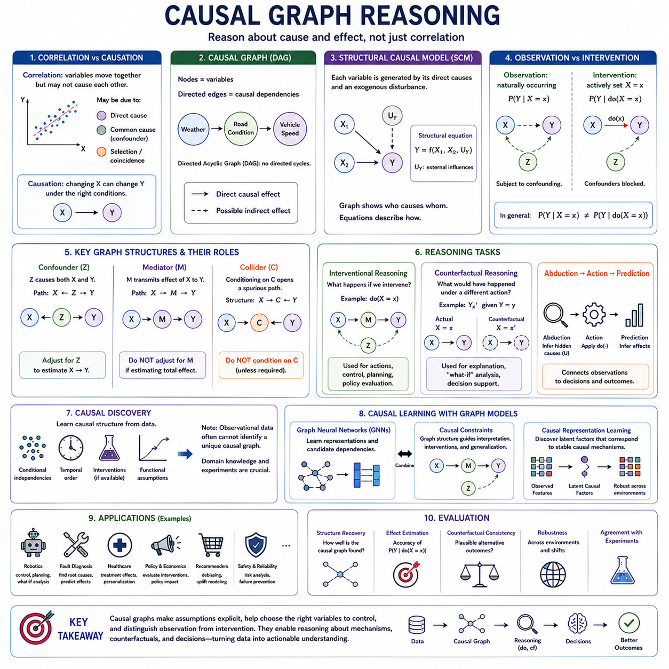
Causal graph reasoning extends graph-based AI from representing relationships toward reasoning about cause and effect. Ordinary graphs may encode similarity, association, interaction, or semantic relations, but a causal graph assigns directional meaning to selected dependencies. An edge X → Y represents the hypothesis that changes in X can causally influence Y under appropriate assumptions, allowing the graph to support questions that cannot be answered reliably from correlation alone.
The distinction between correlation and causation is fundamental. Two variables may be strongly associated because one causes the other, because both are influenced by another variable, or because of selection effects and statistical coincidence. Predictive graph models can exploit such correlations successfully without identifying the underlying mechanism. Causal reasoning instead asks what relationships remain meaningful when the system is actively changed rather than merely observed.
A causal graph commonly represents variables as nodes and causal dependencies as directed edges. Directed Acyclic Graphs, or DAGs, are widely used when relationships can be represented without directed cycles. For example, Weather → Road Condition → Vehicle Speed describes a possible causal chain in which weather affects the road and the road subsequently influences driving behavior. The graph makes assumptions about causal structure explicit and provides a framework for systematic inference.
Structural Causal Models, or SCMs, provide a mathematical interpretation of causal graphs. Each variable is described by a structural equation that determines its value from its direct causes and an exogenous disturbance. Conceptually, Y = f(X, U) states that Y is generated by causal parent X together with external influences U. The graph represents which variables enter each structural equation, while the equations characterize how those causal mechanisms operate.
Observation and intervention must be distinguished carefully. Observing X = x means examining cases in which X naturally takes value x, whereas intervening on X means deliberately forcing it to x while modifying the normal causal mechanism that determines X. This distinction is represented using the do-operator, do(X=x). Consequently, P(Y|X=x) and P(Y|do(X=x)) can differ substantially when confounding variables influence both X and Y.
Consider a graph in which terrain condition affects both commanded velocity and wheel slip. Observational data may show a relationship between velocity and slip, but part of that relationship may arise because both variables respond to terrain. Simply conditioning on velocity does not necessarily isolate its causal effect. Causal graph reasoning identifies such alternative paths and determines which variables must be controlled to estimate the effect of deliberately changing velocity.
A confounder is a variable that causally influences both a potential cause and its outcome. If Z → X and Z → Y while the objective is to estimate X → Y, the path X ← Z → Y creates confounding. Under suitable assumptions, adjusting for Z can block this backdoor path. Graph structure therefore helps determine when statistical association can be converted into a valid estimate of causal influence and when additional information is required.
The backdoor criterion formalizes an important class of these adjustment decisions. A valid adjustment set blocks noncausal paths entering the treatment variable while avoiding inappropriate control of descendants or other problematic variables. Once an appropriate set Z is identified, observational data may sometimes estimate an interventional effect through adjustment. The graph thus acts as a reasoning map for deciding which variables should be conditioned on rather than merely including every available feature.
Mediators require different treatment from confounders. In a chain X → M → Y, variable M transmits part or all of the causal influence of X to Y. Controlling for M can therefore remove the very effect being studied. This illustrates why generic feature selection is insufficient for causal reasoning: variables with similar predictive usefulness can play fundamentally different causal roles depending on their positions within the graph.
Colliders provide another important example. If X → C ← Y, conditioning on C can create a statistical dependency between X and Y even when no causal path connects them directly. This phenomenon demonstrates that adding more observed variables to an analysis does not always improve causal estimation. Causal graphs make such structures visible and provide graphical rules for reasoning about which paths become blocked or opened by conditioning.
Interventional reasoning asks what will happen if an agent actively changes part of the system. A robot might ask how energy consumption changes if velocity is reduced, how localization performance changes if sensor frequency is increased, or how failure probability changes if a component is replaced. These questions concern actions rather than passive observations, making causal models particularly relevant to control, planning, diagnosis, and decision-making systems.
Counterfactual reasoning goes one step further by asking what would have happened under an alternative action after a particular outcome has already been observed. If a robot experienced excessive wheel slip, a counterfactual query might ask whether the slip would still have occurred had the commanded acceleration been lower. Such reasoning requires assumptions about the causal model because the alternative outcome cannot simultaneously be observed in the same real-world event.
Counterfactual inference is often described through abduction, action, and prediction. Abduction uses observed evidence to infer plausible hidden disturbances or contextual conditions. Action modifies the causal model by imposing the hypothetical intervention. Prediction then propagates the modified conditions through the model to estimate the alternative outcome. This sequence connects observed experience with hypothetical decision analysis in a structured manner.
Causal discovery addresses situations where the causal graph itself is not fully known. Algorithms can analyze conditional independencies, statistical asymmetries, temporal information, interventions, or functional assumptions to propose possible causal structures. However, observational data alone frequently cannot identify a unique causal graph. Several structures may explain the same statistical distribution, so domain knowledge and experimental evidence remain important.
Temporal information can strengthen causal analysis because causes normally precede their effects, but temporal ordering alone does not establish causation. Two time-dependent variables may move together because of a common driver or feedback process. Dynamic causal graphs and time-series causal models therefore combine temporal constraints with structural assumptions to distinguish predictive precedence from genuine causal influence as carefully as available evidence permits.
Graph neural networks can be combined with causal reasoning when relationships are large, heterogeneous, or difficult to model manually. Neural components may learn representations, estimate structural functions, or identify candidate dependencies, while causal structure provides constraints on interpretation and intervention. The goal is not to label every learned GNN edge as causal, but to combine representation learning with explicit causal assumptions where those assumptions are justified.
Causal representation learning further attempts to discover latent factors corresponding to meaningful causal variables or mechanisms. Instead of learning representations optimized only for prediction, the model seeks features that remain useful across interventions or environmental changes. This is particularly relevant when systems operate under distribution shifts, because causal mechanisms may remain more stable than correlations observed within a single training environment.
Robotics provides a natural application domain because robots continuously act on their environment and observe consequences. A relational model may describe connections among terrain, payload, battery state, actuator temperature, wheel slip, localization uncertainty, and control commands. Causal reasoning can then help distinguish whether an observed performance degradation is merely associated with these variables or is likely to result from particular mechanisms that can be changed.
Causal graphs can also support fault diagnosis. When a system observes abnormal behavior, reasoning can propagate backward through possible causal dependencies to identify candidate root causes and forward to predict downstream consequences. Combined with intervention data, maintenance history, and physical knowledge, this approach can provide more meaningful diagnostic hypotheses than correlation-based anomaly detection alone, although conclusions remain dependent on the validity of the assumed causal structure.
Evaluation of causal graph reasoning requires more than ordinary prediction accuracy. A model may predict outcomes accurately while estimating intervention effects incorrectly. Evaluation should therefore consider causal structure recovery when ground truth is available, intervention-effect estimation, counterfactual consistency, robustness across environments, and agreement with controlled experiments. Uncertainty should also be represented when multiple causal explanations remain compatible with available evidence.
Causal graph reasoning ultimately changes the question from “what variables are related?” to “what would change if we acted differently, and why?” Graph structure represents hypothesized mechanisms, structural causal models formalize their operation, interventions distinguish action from observation, and counterfactuals analyze alternative outcomes. Together, these concepts extend Graph AI toward systems capable of reasoning about mechanisms, decisions, consequences, and controllable change.

05.06. Explainable Graph AI
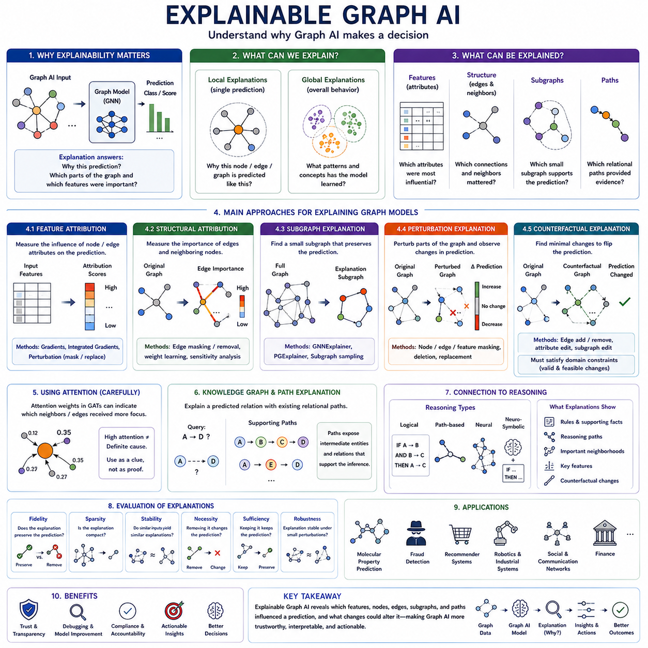
Explainable Graph AI focuses on understanding why a graph-based model produces a particular prediction, classification, recommendation, or inferred relationship. Unlike conventional models that operate mainly on independent feature vectors, graph models depend on both attributes and relational structure. An explanation must therefore identify not only important features but also the nodes, edges, neighborhoods, subgraphs, and message-passing interactions that influenced the model's decision.
Explainability is particularly important for Graph Neural Networks because information can propagate through several layers of connected nodes before reaching a prediction. A target node may be classified according to its own attributes, direct neighbors, distant multi-hop neighbors, edge types, or combinations of these elements. Consequently, inspecting only the final node embedding cannot reveal which parts of the original graph provided the evidence responsible for the output.
Graph explanations can be considered at local and global levels. A local explanation describes why the model generated a particular prediction for one node, edge, or graph instance. A global explanation attempts to characterize the broader patterns learned by the model across many examples. Local explanations are useful for investigating individual decisions, while global explanations help reveal whether the model has learned meaningful structural concepts or undesirable shortcuts.
Feature attribution is one component of graph explainability. The objective is to determine which node or edge attributes contributed most strongly to a prediction. Gradient-based methods can measure how sensitive an output is to changes in input features, while perturbation-based methods modify or mask features and observe the resulting prediction change. Large changes suggest that the altered information was important to the model's original decision.
Structural attribution extends this principle to graph connectivity. Instead of asking only which features matter, the explanation asks which edges and neighboring nodes were necessary for the prediction. An edge can be removed or assigned a lower importance weight, and the resulting output can be compared with the original prediction. Repeating this process produces an importance map over the relational structure surrounding the target.
Subgraph explanations seek a compact region of the original graph that contains sufficient evidence for a prediction. Rather than displaying an entire neighborhood containing hundreds or thousands of nodes, the explanation identifies a smaller set of nodes and edges that preserves the model's output. This provides a more interpretable representation of the relational evidence and is especially useful when message passing spans several hops.
GNNExplainer is a representative approach for generating local explanations of Graph Neural Network predictions. Conceptually, it searches for a subgraph and feature subset that maximize information about the model's prediction. A learnable mask can be applied to candidate edges and features, and optimization determines which elements should remain important. The resulting masked graph highlights structural components that strongly support the original output.
A simplified implementation of this idea begins with a trained GNN and a selected prediction target. Masks are associated with edges or input features and optimized while the model parameters remain fixed. The objective encourages the masked graph to preserve the original prediction while regularization encourages compactness. After optimization, high-weight edges and features can be extracted and visualized as the model's estimated explanation.
Perturbation methods provide another intuitive explanation strategy. Nodes, edges, features, or subgraphs are systematically removed, masked, or replaced, and the model is evaluated again. If removing a particular component causes a substantial decrease in confidence or changes the predicted class, that component is considered influential. These approaches can be model-agnostic, although evaluating many graph perturbations may become computationally expensive.
Counterfactual graph explanations ask a different question: what is the smallest change to the graph that would alter the model's decision? A counterfactual may remove an edge, add a connection, modify an attribute, or change a small subgraph. For example, instead of merely stating why a transaction network was classified as suspicious, the explanation may identify which relational change would cause the model to classify it as normal.
Counterfactual explanations can provide actionable information, but generated modifications must remain valid. Adding an impossible chemical bond, deleting a physically required connection, or changing an immutable entity property may produce a mathematically effective but meaningless explanation. Domain constraints must therefore be incorporated so that counterfactual graph modifications correspond to plausible alternatives rather than arbitrary manipulations of the model input.
Attention mechanisms are sometimes used as indicators of relational importance. A Graph Attention Network can assign different attention weights to neighboring nodes or edges during aggregation, making these weights potentially useful for inspecting which relationships received greater emphasis. However, attention weights should not automatically be treated as faithful explanations because high attention does not necessarily prove that a relationship causally determined the prediction.
Knowledge graphs provide another important setting for explainability. When a system predicts a missing relationship between two entities, an explanation may consist of existing relational paths connecting them. For example, a predicted relation A → D may be supported by A → B → C → D. Such path-based explanations are naturally understandable because they expose the intermediate entities and relations that contributed evidence to the inferred fact.
Explainability is also closely connected to graph reasoning. Logical reasoning can expose the explicit rule and supporting facts used to derive a conclusion, while path-based reasoning can present the relational chain traversed during inference. Neural reasoning is less transparent, so explanation mechanisms can extract influential paths, neighborhoods, or features. Hybrid neuro-symbolic systems can combine learned predictions with structured evidence that users can inspect.
Graph explanations should be evaluated for fidelity rather than visual plausibility alone. A visually convincing highlighted subgraph may not actually represent the information used by the model. Fidelity measures whether retaining the explanation preserves the prediction or removing it significantly changes the prediction. Sparsity measures whether the explanation is sufficiently compact, while stability examines whether similar inputs produce reasonably consistent explanations.
Another important criterion is necessity versus sufficiency. An explanatory subgraph is sufficient if the model can still make the same prediction when primarily that subgraph is retained. It is necessary if removing it significantly weakens or changes the prediction. Strong explanations ideally capture both properties, although practical methods often trade completeness against simplicity because preserving every contributing relationship can make an explanation too large to understand.
Robustness is essential because explanations can change even when predictions remain stable. Small perturbations to graph structure or features may cause an explanation algorithm to select entirely different nodes or edges. This instability can undermine trust, particularly in scientific, industrial, financial, or safety-related applications. Explanation evaluation should therefore examine sensitivity to graph perturbations and uncertainty in the selected evidence.
Explainability must also distinguish model reasoning from causal reasoning. An explanation showing that a GNN relied heavily on a particular edge indicates that the edge influenced the model's computation, not necessarily that the represented relationship is a real-world cause of the outcome. Explainable Graph AI describes why the model behaved as it did, whereas causal graph reasoning asks what mechanisms would produce changes under interventions.
In molecular graphs, explanations can identify atoms, bonds, or functional groups associated with predicted properties. In fraud detection, they can highlight suspicious accounts, transactions, and relational patterns. In recommendation systems, explanations may reveal influential users, products, or interaction paths. In robotics and industrial systems, explanations can expose sensor relationships, component dependencies, communication links, or operational conditions contributing to predictions.
Explainable Graph AI is also valuable during model development. If a model consistently relies on irrelevant nodes, shortcut edges, leakage relationships, or unstable features, explanations can reveal problems that ordinary accuracy metrics may hide. Developers can then modify the dataset, graph construction process, model architecture, or training objective. Explainability therefore serves not only end users but also debugging, validation, and model governance.
The most useful explanation is often a combination of several forms of evidence. Feature attribution can identify influential attributes, structural attribution can identify important connections, subgraph extraction can provide relational context, paths can expose reasoning chains, and counterfactuals can show how decisions might change. Combining these perspectives provides a richer understanding than relying on a single importance score or visualization.
Ultimately, Explainable Graph AI transforms graph predictions from opaque outputs into inspectable relational decisions. It seeks to reveal which features mattered, which nodes and edges carried evidence, which subgraphs supported the prediction, which paths contributed to reasoning, and which changes could alter the result. By combining fidelity, compactness, stability, domain validity, and clear relational evidence, explainability becomes a critical layer for trustworthy and interpretable Graph AI.

