Volume 29. Graph Deep Learning

Chapter 08. Engineering and Deployment

08.01. Graph Data Pipeline [w/Code]
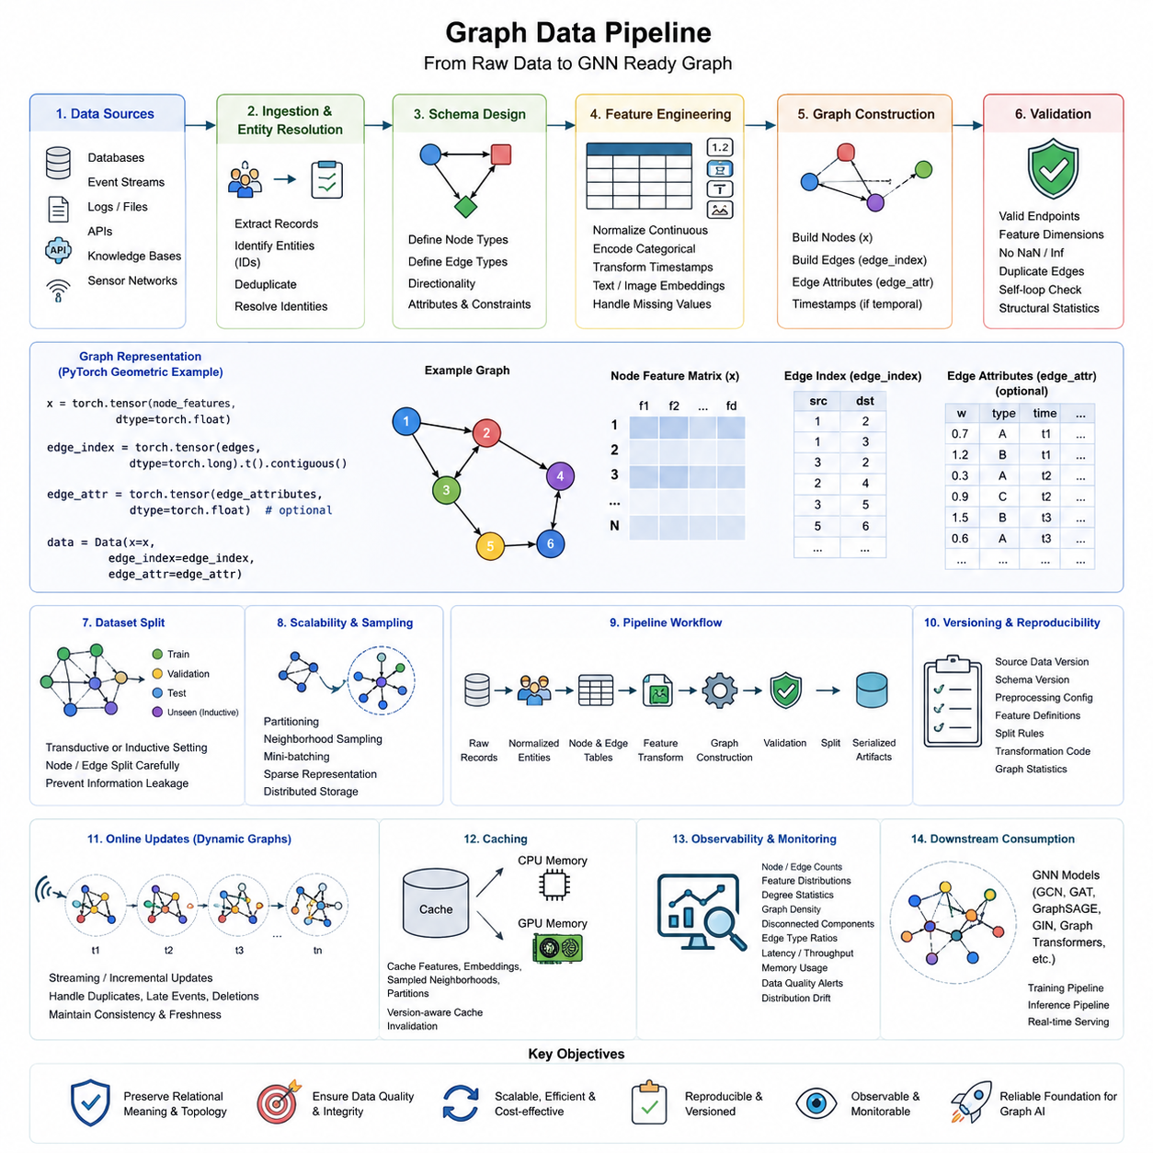
A graph data pipeline transforms raw relational information into a consistent representation that can be consumed by graph learning systems. Unlike conventional tabular pipelines, it must preserve entities, relationships, direction, topology, and associated attributes simultaneously. A production pipeline therefore coordinates ingestion, identity resolution, schema construction, feature processing, graph assembly, validation, partitioning, storage, and delivery to downstream GNN workloads.
Raw graph information may originate from relational databases, event streams, logs, APIs, knowledge bases, sensor networks, or structured files. The first engineering task is to identify which records represent nodes and which interactions represent edges. Stable identifiers are essential because inconsistent entity IDs can fragment one real entity into several nodes or incorrectly merge unrelated entities, producing structural errors that later learning algorithms cannot easily correct.
Graph schema design defines node types, edge types, directionality, attributes, and constraints before model training begins. A homogeneous graph may use one node and edge category, while heterogeneous systems can represent users, products, locations, documents, sensors, or robots as different entity types. Relationships such as purchases, citations, observations, communication links, or spatial adjacency become typed edges that explicitly encode how entities interact.
Feature engineering converts raw attributes into numerical representations suitable for graph models. Continuous variables may be normalized, categorical values encoded, timestamps transformed, and text or images converted into learned embeddings. Missing attributes require explicit handling rather than arbitrary replacement. Feature processing must also remain synchronized with graph topology because a correct feature vector assigned to the wrong node identifier creates a silent but serious data integrity failure.
A minimal graph construction workflow can be expressed with PyTorch Geometric. Node features can be stored in a matrix x, while connectivity is represented by edge_index. For example, x = torch.tensor(node_features, dtype=torch.float) creates the feature matrix, edge_index = torch.tensor(edges, dtype=torch.long).t().contiguous() converts source-target pairs, and data = Data(x=x, edge_index=edge_index) produces a graph object ready for inspection and training.
Edge attributes extend this representation when relationships contain information such as distance, transaction value, communication latency, interaction frequency, confidence, or relationship type. These values must follow exactly the same ordering as edge_index. In temporal applications, timestamps can also be retained so that models distinguish when interactions occurred instead of treating the graph as a permanently static structure. This becomes particularly important for temporal GNNs and continuously changing operational networks.
Validation should occur before graphs enter training. Useful checks include verifying that every edge endpoint refers to a valid node, feature dimensions are consistent, duplicate edges are intentionally handled, prohibited self-loops are detected, and numerical values contain no unexpected NaN or infinite values. Degree distributions, isolated-node counts, connected components, node-type frequencies, and edge-type frequencies provide additional structural diagnostics that can reveal ingestion or transformation errors.
Graph datasets require careful splitting because ordinary random row splitting can introduce structural leakage. In node classification, train, validation, and test masks may share the same topology under a transductive setting, whereas inductive evaluation can reserve previously unseen nodes or subgraphs. Link prediction requires even greater care because validation and test edges must be separated without allowing preprocessing steps or negative sampling procedures to expose information about held-out relationships.
Large graphs cannot always be materialized as one in-memory object. Engineering pipelines therefore use partitioning, neighborhood sampling, mini-batching, compressed sparse representations, and distributed storage. Instead of transferring an entire social, traffic, or knowledge graph to a GPU, a loader may retrieve only the neighborhoods required for the current batch. This separates logical graph size from the amount of graph data that must reside in accelerator memory at any particular moment.
A scalable implementation can organize processing as raw records → normalized entities → node table and edge table → feature transformation → graph construction → validation → dataset split → serialized graph artifacts. Each stage should have explicit inputs and outputs so that failures can be isolated. Intermediate artifacts are valuable because expensive entity resolution or feature extraction does not need to be repeated whenever a GNN architecture or training hyperparameter changes.
Versioning is especially important because graph datasets evolve along two dimensions: attributes and topology. Adding nodes, deleting relationships, correcting identifiers, or changing an edge-generation rule can alter model behavior even when feature-processing code remains unchanged. A reproducible graph artifact should therefore record source-data versions, schema versions, preprocessing configuration, feature definitions, split rules, transformation code, and graph statistics together with the generated dataset.
Production systems should distinguish offline graph construction from online graph updates. Offline pipelines can rebuild large graphs through batch processing, while streaming systems incrementally incorporate newly observed nodes and edges. Incremental updates introduce additional concerns such as duplicate events, late-arriving records, timestamp ordering, deletion semantics, and consistency between graph storage and model-serving representations. Dynamic graphs therefore require explicit policies for both topology updates and feature freshness.
Caching reduces repeated preprocessing and graph-transfer costs. Frequently accessed node features, embeddings, sampled neighborhoods, or graph partitions can be retained in CPU or GPU memory according to access frequency and available capacity. However, cached representations must carry version information because stale embeddings or outdated neighborhoods may silently disconnect inference from the current graph state. Cache invalidation becomes part of graph correctness rather than merely a performance optimization.
Pipeline observability should measure both conventional data quality and graph-specific structural quality. Monitoring can track node and edge counts, feature distributions, graph density, degree statistics, disconnected components, new entity types, edge-type proportions, processing latency, memory consumption, and rejected records. Sudden structural changes may indicate upstream failures, but they can also represent genuine changes in the environment, making graph monitoring useful for detecting both data problems and graph distribution drift.
The pipeline boundary should remain independent from individual GNN architectures whenever possible. GraphSAGE, GCN, GAT, graph transformers, or heterogeneous GNNs may require different loaders or sampling strategies, but they should consume a common validated graph representation. This separation allows model experiments to evolve without rebuilding the complete ingestion system and establishes a stable interface between graph data engineering and the subsequent training pipeline defined in the engineering workflow.
A mature graph data pipeline is therefore not simply a converter that turns CSV files into edge_index tensors. It is the engineering layer that preserves relational meaning while making graph information reproducible, scalable, observable, and computationally accessible. Reliable graph learning depends on this layer because topology errors propagate directly into message passing, neighborhood aggregation, embeddings, reasoning, and predictions, making graph data quality inseparable from model quality.

08.02. Training Pipeline [w/Code]
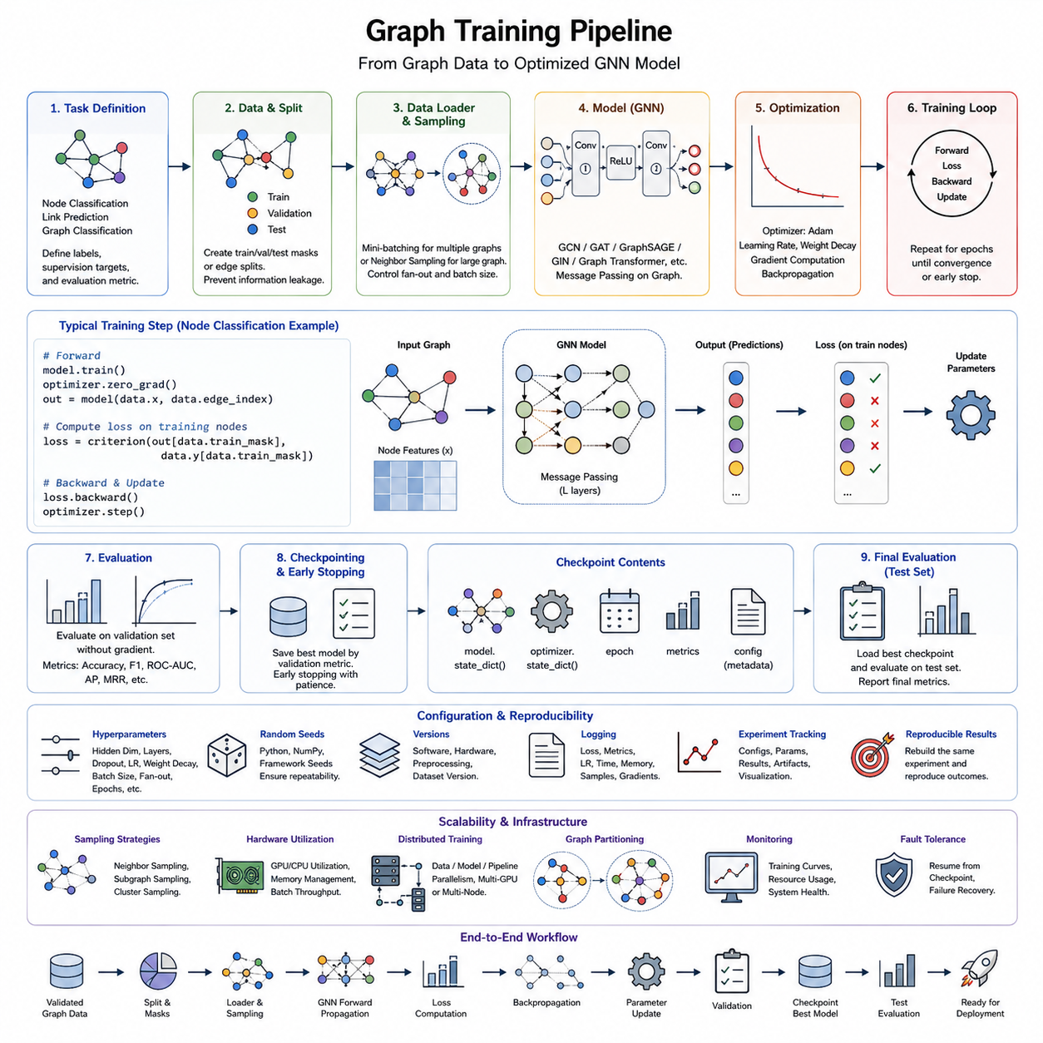
A graph training pipeline converts a validated graph dataset into a reproducible sequence of model optimization, evaluation, checkpointing, and experiment management operations. Within the engineering structure of Graph Deep Learning, it follows graph data preparation and precedes large-scale GNN optimization and deployment. The pipeline must coordinate topology, node and edge features, task labels, sampling rules, model configuration, and hardware execution without breaking their structural relationships.
The first stage defines the learning task and determines which graph elements participate in supervision. Node classification predicts labels for individual nodes, link prediction estimates relationships between node pairs, and graph classification produces outputs for complete graphs or subgraphs. This distinction determines how training examples are constructed, which masks or edge sets are used, and how batches are formed before they reach the model.
A typical PyTorch Geometric workflow begins with a graph object containing node features, connectivity, and optional labels. A compact setup may use data = Data(x=x, edge_index=edge_index, y=y), followed by data = data.to(device) to move graph tensors to the selected accelerator. Training masks such as data.train_mask can identify supervised nodes, while validation and test masks preserve separate evaluation populations.
The model stage instantiates a GNN architecture appropriate for the graph and task. A simple implementation may define conv1 = GCNConv(in_channels, hidden_channels) and conv2 = GCNConv(hidden_channels, out_channels). During the forward pass, h = conv1(x, edge_index) aggregates neighborhood information, an activation such as F.relu(h) introduces nonlinearity, and the second graph layer transforms the learned representation into task-specific outputs.
Optimization follows the same gradient-based principles used in conventional deep learning but operates over representations created through graph message passing. An optimizer such as torch.optim.Adam(model.parameters(), lr=0.01, weight_decay=5e-4) updates parameters after backpropagation. The learning rate controls update magnitude, while weight decay can regularize parameters and reduce overfitting when graph labels or training nodes are limited.
A minimal node-classification training step can be expressed as model.train(), optimizer.zero_grad(), out = model(data.x, data.edge_index), loss = criterion(out[data.train_mask], data.y[data.train_mask]), loss.backward(), and optimizer.step(). The mask ensures that only designated training nodes contribute directly to the supervised loss even when message passing uses a larger portion of the graph topology.
Training and evaluation modes must remain explicitly separated. During validation, model.eval() is used together with disabled gradient computation, after which predictions are evaluated only on the validation mask or held-out graph elements. Accuracy may be appropriate for balanced node classification, while F1 score, ROC-AUC, average precision, ranking metrics, or task-specific measures may be required for imbalanced classification and link prediction problems.
Graph mini-batching differs from ordinary tensor batching because examples can have variable numbers of nodes and edges. For collections of independent graphs, a loader can combine several graphs into a disconnected block-diagonal structure while maintaining graph membership information. For a single massive graph, neighborhood sampling selects limited local subgraphs around target nodes so that message passing can proceed without loading the complete topology into accelerator memory.
Sampling changes both computational cost and the information visible during optimization. Neighbor sampling limits the number of adjacent nodes expanded at each GNN layer, while subgraph and cluster-based approaches train on selected regions of the topology. The sampling configuration should therefore be treated as part of the training specification rather than merely a data-loading detail, because it can influence convergence, representation quality, memory usage, and runtime.
Checkpointing protects long-running graph experiments and provides reproducible model states. A checkpoint can store model.state_dict(), optimizer.state_dict(), epoch, validation metrics, and configuration metadata. The best checkpoint is commonly selected using a validation criterion rather than final training loss. Early stopping can terminate optimization when validation performance fails to improve for a defined patience period, reducing unnecessary computation and limiting overfitting.
Experiment configuration should separate model parameters from executable training logic. Hidden dimensions, layer count, dropout, learning rate, weight decay, batch size, neighborhood fan-out, number of epochs, random seed, and dataset version can be stored in a configuration object or file. This allows experiments to be repeated systematically and makes model comparisons meaningful because differences between runs can be traced to explicit parameter changes.
Reproducibility requires more than storing model weights. Random seeds should be controlled across Python, NumPy, and the deep learning framework when applicable, while graph splits and sampling procedures should also be reproducible. Software versions, hardware configuration, preprocessing versions, dataset identifiers, and model definitions should accompany experiment records so that a result can be reconstructed rather than merely remembered as a final metric.
Training observability exposes problems that final accuracy alone cannot reveal. Useful signals include training and validation loss, task metrics, learning rate, epoch duration, GPU utilization, memory consumption, batch throughput, sampled node and edge counts, and gradient behavior. Unexpected changes in these measurements can reveal exploding gradients, inefficient sampling, data-loading bottlenecks, excessive neighborhood expansion, or graph partitions that create highly uneven computational workloads.
Large-scale training introduces distributed execution in which graph data, sampling, computation, or model parameters may span multiple processors or machines. Communication cost becomes especially important because message passing depends on neighboring nodes that may reside on different partitions. Effective partitioning attempts to reduce cross-partition edges while maintaining balanced workloads, preparing the training system for the scalable GNN techniques that follow later in the engineering chapter.
The complete training workflow can therefore be viewed as validated graph data → task-specific split and loader → GNN forward propagation → loss computation → backpropagation → parameter update → validation → checkpoint selection → final evaluation. Surrounding this core loop are configuration management, reproducibility controls, logging, resource monitoring, and failure recovery, transforming a research training script into a dependable graph learning pipeline.
A well-engineered graph training pipeline separates graph preparation, model definition, optimization, evaluation, and infrastructure concerns while preserving a clear contract between them. This modularity makes it possible to replace a GCN with GAT, GraphSAGE, GIN, or a graph transformer without redesigning the entire workflow. The result is a reusable foundation that connects graph data engineering to scalable training, inference optimization, MLOps integration, and ultimately production Graph AI systems.

08.03. Scaling GNN
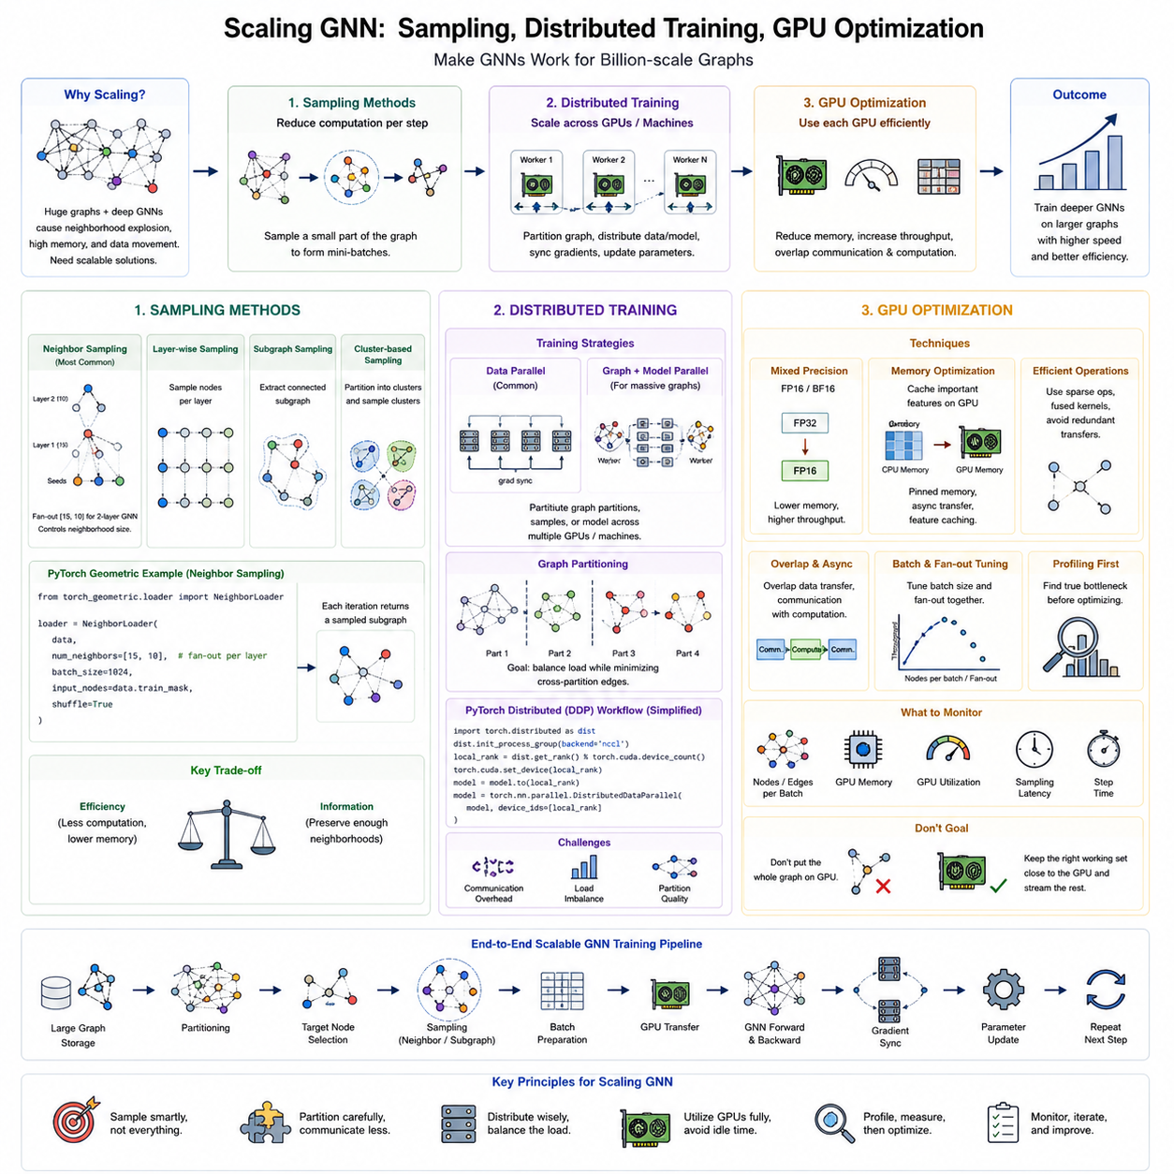
Scaling a Graph Neural Network requires more than increasing batch size or adding GPUs because graph computation is governed by irregular topology and neighborhood expansion. As GNN depth increases, message passing can recursively collect information from rapidly growing neighborhoods, producing high memory consumption and expensive data movement. Scalable GNN engineering therefore combines sampling, partitioning, distributed execution, and accelerator optimization while preserving useful structural context.
Sampling methods reduce the amount of topology processed during each optimization step. Instead of loading every node and edge from a massive graph, the training system selects a computationally manageable subset. This converts full-graph learning into mini-batch training and allows graphs containing millions or billions of relationships to be processed with bounded memory. The central tradeoff is between computational efficiency and preservation of sufficient neighborhood information.
Neighbor sampling begins with a set of target nodes and recursively samples a limited number of neighbors for each GNN layer. For a two-layer model, a fan-out such as [15, 10] can select up to fifteen first-hop neighbors and ten second-hop neighbors per expanded node. This controls neighborhood explosion while maintaining local structural context, making the method particularly suitable for architectures such as GraphSAGE and other message-passing GNNs.
In PyTorch Geometric, neighborhood sampling can be expressed conceptually with loader = NeighborLoader(data, num_neighbors=[15, 10], batch_size=1024, input_nodes=data.train_mask, shuffle=True). Each iteration returns a sampled subgraph containing seed nodes and the neighbors required for message passing. The resulting batch can then be transferred to a GPU and processed without placing the complete graph topology in accelerator memory.
Node-wise sampling is not the only strategy. Layer-wise sampling selects nodes needed by an entire GNN layer, while subgraph sampling extracts connected regions that preserve more internal structure. Cluster-based methods partition the original graph and use individual clusters or groups of clusters as training batches. These approaches can reduce redundant neighborhood expansion and improve data locality, although partition quality may affect how much cross-cluster information is retained.
Graph partitioning becomes increasingly important when a graph exceeds the memory capacity of a single machine. The objective is to divide nodes and edges into balanced partitions while minimizing edges crossing partition boundaries. Good partitions improve locality because most message passing occurs within the same memory or compute domain. Poor partitioning increases remote feature access, communication traffic, synchronization overhead, and imbalance between workers.
Distributed GNN training extends computation across multiple GPUs or multiple machines. Graph partitions, sampled batches, model replicas, or combinations of these components can be distributed among workers. Data parallel training gives each worker a model replica and different graph samples, after which gradients are synchronized. More specialized systems may distribute graph storage and sampling separately from neural-network computation to support graphs larger than aggregate GPU memory.
A simplified PyTorch distributed workflow initializes a process group, assigns one GPU to each process, moves the GNN to the local device, and wraps it with DistributedDataParallel. Conceptually, model = DDP(model, device_ids=[local_rank]) synchronizes gradients across replicas during backward propagation. Each process should receive distinct training samples so that additional GPUs increase effective throughput rather than redundantly processing identical graph batches.
Distributed graph learning is often limited by communication rather than arithmetic. Message passing may require features belonging to neighboring nodes stored on remote partitions, while gradient synchronization also transfers model updates among workers. Communication volume can therefore become comparable to or greater than computation time. Partition-aware sampling, feature caching, asynchronous data preparation, and overlapping communication with computation are important techniques for improving distributed efficiency.
Load balancing presents another challenge because graph degree distributions are frequently highly skewed. A small number of high-degree hubs may generate much larger sampled neighborhoods than ordinary nodes, causing some workers to process significantly more edges than others. Balanced partition sizes alone are therefore insufficient. Practical systems may consider node degree, sampled edge count, feature size, and expected computational workload when assigning graph regions to workers.
GPU optimization begins by recognizing that GNN workloads differ from dense neural networks. Operations such as neighbor gathering, scatter-reduce, sparse matrix multiplication, and irregular memory access can become bottlenecks even when theoretical GPU compute capacity is high. Efficient execution depends on reducing unnecessary transfers, improving memory locality, increasing useful parallelism, and keeping the GPU supplied with graph batches prepared by the CPU or distributed sampler.
Mixed-precision training can reduce GPU memory consumption and increase throughput when the architecture and hardware support lower-precision arithmetic. Automatic mixed precision typically performs suitable operations in FP16 or BF16 while preserving sensitive calculations at higher precision. Gradient scaling may be used with FP16 to avoid numerical underflow. The resulting memory savings can permit larger sampled neighborhoods, larger batches, or deeper GNN architectures.
Memory optimization also includes controlling feature residency. Frequently accessed node features or embeddings can be cached in GPU memory, while less frequently accessed information remains in host memory or distributed graph storage. Pinned CPU memory and asynchronous transfers can reduce data-transfer overhead. The objective is not necessarily to place the entire graph on the GPU, but to keep the most valuable working set close to computation while efficiently streaming the remainder.
Batch size and sampling fan-out must be optimized together because they jointly determine the number of sampled nodes and edges. Increasing the number of target nodes improves parallelism, but large fan-out values can multiply the actual computational graph dramatically. Monitoring nodes per batch, edges per batch, GPU memory, utilization, sampling latency, transfer time, and step duration provides a more meaningful view of GNN efficiency than observing nominal batch size alone.
Profiling is essential before introducing complex scaling mechanisms. Low GPU utilization may indicate slow neighborhood sampling, CPU bottlenecks, synchronization delays, remote feature access, or insufficient batch parallelism rather than an inefficient GNN layer. Profilers and runtime metrics should separate data loading, sampling, host-to-device transfer, forward propagation, backward propagation, gradient synchronization, and optimizer execution so that optimization targets the true bottleneck.
The scalable workflow can therefore be understood as large graph storage → partitioning → target selection → neighborhood or subgraph sampling → batch preparation → GPU transfer → GNN computation → distributed gradient synchronization → parameter update. Caching, mixed precision, asynchronous execution, communication overlap, profiling, and workload balancing surround this path and progressively remove bottlenecks as graph and hardware scale increase.
Sampling Methods, Distributed Training, and GPU Optimization are consequently complementary rather than independent techniques within Scaling GNN. Sampling bounds the computational graph, distributed training expands available compute and memory resources, and GPU optimization improves the efficiency of each worker. Together they provide the engineering foundation for moving GNNs from small research datasets toward large social networks, knowledge graphs, spatial systems, infrastructure networks, and production-scale Graph AI.

08.04. Inference Optimization [w/Code]
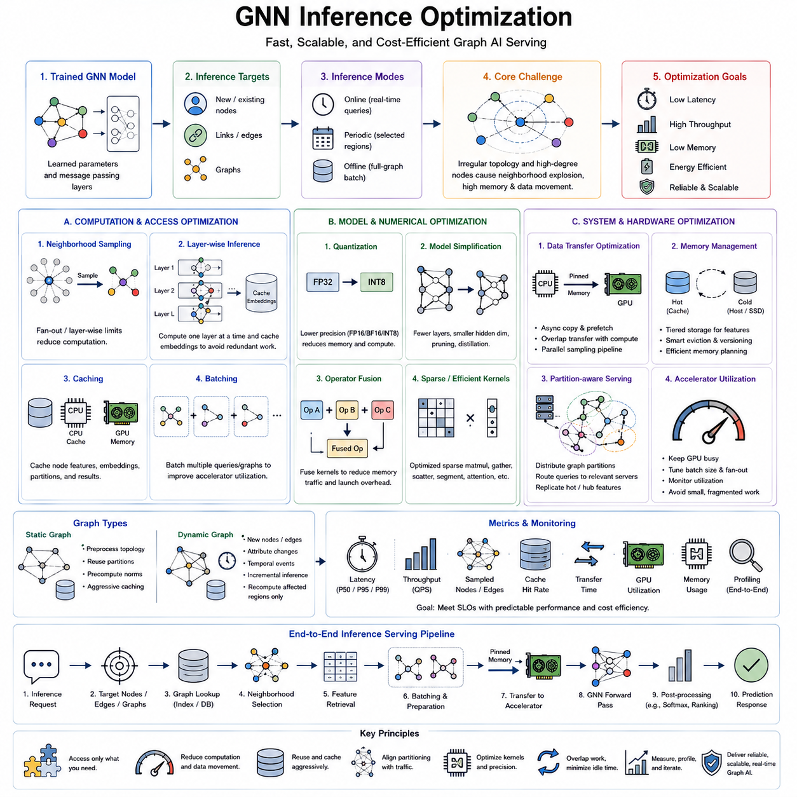
Graph Neural Network inference converts a trained relational model into predictions under operational constraints such as latency, throughput, memory, power, and hardware availability. Unlike dense neural networks, GNN inference combines neural computation with irregular neighborhood access and topology-dependent message passing. Optimization must therefore address both the model execution path and the movement of graph structures, node features, edge information, and intermediate embeddings through the system.
The inference workload depends strongly on the prediction target. Node-level inference may classify newly observed entities, link prediction may score candidate relationships, and graph-level inference may process independent graphs as individual requests. A production design should first determine whether predictions are generated offline for an entire graph, periodically for selected regions, or online for individual queries, because each pattern produces different latency and batching requirements.
Full-graph inference computes embeddings for all nodes and can be efficient when predictions are required for most of a relatively stable graph. However, repeatedly evaluating the entire topology becomes wasteful when only a small number of nodes change or receive queries. Mini-batch and sampled inference instead restrict computation to relevant nodes and neighborhoods, reducing memory requirements while introducing additional sampling and data-access overhead.
Neighborhood explosion remains important during inference because an L-layer message-passing GNN may require information from an L-hop receptive field. High-degree nodes can dramatically increase the number of features and edges retrieved for a single prediction. Fan-out limits, layer-wise inference, cached embeddings, and carefully selected receptive fields can bound this cost while preserving enough relational context for useful predictions.
Layer-wise inference is particularly effective for large static graphs. Instead of recursively constructing a complete multi-hop subgraph for every target batch, the system computes one GNN layer across nodes, stores the resulting embeddings, and then processes the next layer. This can eliminate repeated computation of shared neighbors and transform expensive overlapping neighborhood evaluation into a more systematic sequence of feature propagation operations.
Caching provides another major optimization opportunity because neighboring nodes frequently appear in many inference requests. Frequently accessed node features, intermediate embeddings, graph partitions, or final representations can be retained in CPU or GPU memory. The benefit is greatest when the graph changes slowly, but cache entries require versioning and invalidation policies so that predictions do not unknowingly depend on outdated topology or stale node information.
Batching improves accelerator utilization by combining multiple inference requests into a larger computational unit. For graph-level tasks, independent graphs can be batched naturally, while node and link queries can be grouped according to time windows or compatible neighborhoods. Excessively large batches increase queueing latency, whereas very small batches may leave GPU resources underutilized. Production systems therefore balance per-request latency against aggregate throughput.
Quantization reduces model memory and arithmetic cost by representing weights or activations with lower numerical precision. Depending on framework and hardware support, inference may move from FP32 toward FP16, BF16, INT8, or other optimized representations. GNN quantization requires validation because aggregation operations can react differently to reduced precision, particularly when node degrees, feature magnitudes, or attention scores vary widely across the graph.
Model simplification can reduce inference cost before hardware-specific optimization begins. Fewer message-passing layers reduce receptive-field expansion, smaller hidden dimensions reduce feature traffic, and simpler aggregation operators decrease arithmetic and memory pressure. Distillation can train a smaller student GNN to approximate a larger teacher, while pruning may remove unnecessary parameters or structures when the resulting sparsity can be efficiently exploited by the target runtime.
Kernel optimization targets the low-level operations that dominate GNN execution. Sparse matrix multiplication, gather, scatter, segment reduction, attention, and feature transformation can suffer from irregular memory access and frequent kernel launches. Operator fusion can combine compatible operations, while optimized sparse kernels reduce intermediate memory traffic. The objective is to spend less time moving and reorganizing data relative to performing useful numerical computation.
CPU-to-GPU transfer is often a hidden inference bottleneck. If graph neighborhoods and features are assembled on the CPU for every request, the accelerator may remain idle while waiting for data. Pinned memory, asynchronous copies, prefetching, parallel sampling, feature caching, and overlapping transfer with GPU computation can reduce this delay. Optimizing the GNN model alone provides limited benefit when the input pipeline cannot continuously supply prepared graph batches.
Static and dynamic graphs require different optimization strategies. Static graphs allow topology preprocessing, partition reuse, precomputed normalization, embedding caching, and aggressive memory planning. Dynamic graphs must incorporate newly created nodes, deleted edges, changing attributes, and temporal events, making cached representations harder to maintain. Incremental inference can recompute only affected regions instead of rebuilding predictions for the entire graph after every update.
Distributed inference becomes necessary when the graph, embedding tables, or query volume exceeds a single machine. Graph partitions can be placed across servers while requests are routed toward partitions containing relevant entities. Cross-partition neighborhoods create remote communication, so partition quality and feature placement directly influence latency. Replicating frequently accessed features or high-degree hub information can sometimes reduce expensive remote accesses at the cost of additional memory.
Real-time Graph AI introduces strict service-level objectives for response time and predictability. Average latency alone is insufficient because graph queries can vary dramatically according to node degree and neighborhood size. Systems should therefore monitor median and tail latency such as P95 or P99, batch size, sampled nodes and edges, cache hit rate, transfer time, GPU utilization, memory consumption, and request throughput to identify topology-dependent performance variation.
Profiling should separate graph retrieval, neighborhood sampling, feature lookup, host-to-device transfer, GNN forward execution, post-processing, and communication. A request that appears to have slow model inference may actually spend most of its time retrieving graph features or expanding neighborhoods. End-to-end profiling prevents optimization effort from being concentrated on GPU kernels when the dominant bottleneck lies elsewhere in the graph serving pipeline.
An optimized serving path can be represented as inference request → target nodes or edges → graph lookup → neighborhood selection → feature retrieval → batching → accelerator transfer → GNN forward pass → prediction post-processing → response. Caches, quantization, optimized kernels, asynchronous execution, partition-aware routing, and monitoring surround this path to reduce repeated work and keep computational resources continuously utilized.
Inference optimization is therefore a system-level problem rather than a single model-compression technique. Effective Graph AI serving coordinates topology access, sampling, caching, numerical precision, batching, memory placement, accelerator kernels, and distributed execution according to deployment requirements. This engineering layer connects scalable GNN training to graph databases, MLOps, and real-time Graph AI, which are the subsequent deployment concerns in the chapter structure.

08.05. Graph Databases
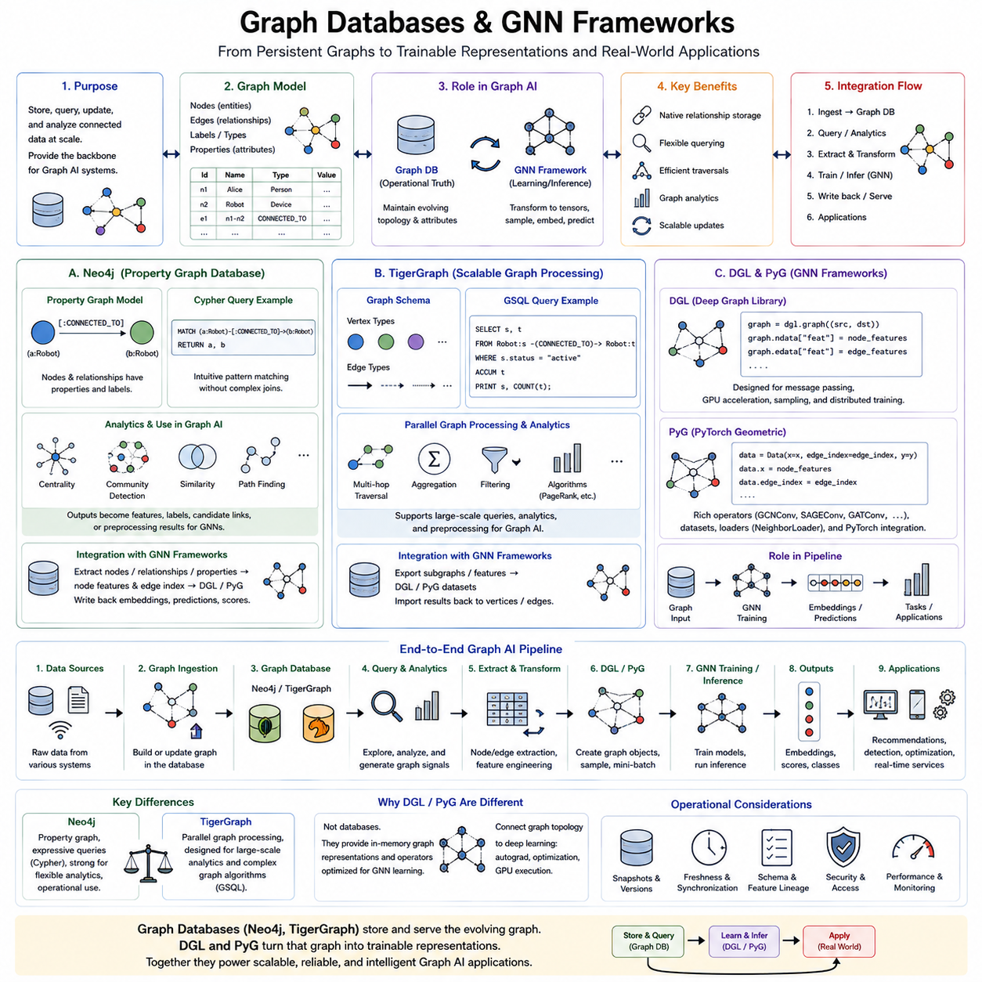
Graph databases provide a persistent infrastructure for storing, querying, updating, and analyzing relational information without flattening connectivity into conventional tables. Within Graph AI engineering, they complement GNN frameworks by maintaining operational topology and attributes while learning systems transform those structures into tensors, sampled neighborhoods, embeddings, and predictions. The database and learning framework therefore serve different but closely connected roles in a production graph architecture.
A graph database commonly represents information through nodes, edges, labels or types, and properties. Nodes identify entities such as people, products, documents, sensors, vehicles, or machines, while edges encode relationships such as ownership, communication, dependency, similarity, or spatial adjacency. Property-based representations attach attributes directly to these elements, allowing applications to combine structural traversal with filtering and attribute-oriented queries.
Neo4j is strongly associated with the property graph model, where nodes and relationships can contain properties and descriptive labels. Its Cypher query language expresses graph patterns in a visually intuitive form. A conceptual query such as MATCH (a:Robot)-[:CONNECTED_TO]->(b:Robot) RETURN a,b searches for connected robot pairs, demonstrating how topology can be queried directly rather than reconstructed through repeated relational-table joins.
Neo4j can operate as more than persistent graph storage because graph analytics can be placed near the operational data. Algorithms for centrality, community detection, similarity, path finding, and related structural analysis can produce additional signals for downstream applications. In a Graph AI pipeline, these computed properties may become features, labels, candidate relationships, retrieval signals, or preprocessing outputs before data is transferred into a GNN training environment.
The integration boundary between Neo4j and GNN frameworks should remain explicit. A database may contain the authoritative operational graph, while an extraction process converts selected nodes, relationships, and properties into node-feature matrices and connectivity structures. Model outputs such as embeddings, predicted classes, anomaly scores, or recommended links can subsequently be written back or exposed through a serving layer, creating a controlled database-to-learning-to-application cycle.
TigerGraph addresses graph storage and analytics with an architecture oriented toward large-scale connected datasets and parallel graph processing. Its graph-oriented execution model is useful when algorithms or queries must traverse substantial portions of highly connected data. Rather than treating graph analytics as a sequence of relational joins, the system can execute computation around vertices and edges while exploiting parallelism across the underlying graph infrastructure.
TigerGraph applications can define graph schemas containing vertex and edge types and execute graph queries through GSQL. Such queries may implement multi-hop traversal, aggregation, filtering, and graph algorithms over large datasets. In Graph AI engineering, this capability can support feature generation, neighborhood discovery, candidate selection, graph statistics, or preprocessing before data is delivered to machine-learning frameworks for representation learning.
The practical difference between Neo4j and TigerGraph should be evaluated through workload requirements rather than treating one as universally superior. Important factors include graph size, traversal complexity, update frequency, query latency, analytics workload, deployment environment, operational tooling, integration requirements, and engineering expertise. Benchmarking with representative topology and queries is more reliable than selecting a database solely from generic performance claims.
DGL, or Deep Graph Library, occupies a different layer from Neo4j and TigerGraph. It is primarily a graph deep-learning framework rather than an operational graph database. DGL represents graph structures in forms designed for tensor computation and message passing, allowing developers to implement GCN, GraphSAGE, GAT, heterogeneous GNNs, and other architectures while integrating graph operations with deep-learning execution on CPUs and GPUs.
A DGL workflow converts graph connectivity into a graph object and associates tensors with nodes and edges. Conceptually, graph = dgl.graph((src, dst)) creates connectivity, while graph.ndata[“feat”] = node_features attaches node features. GNN layers then consume this representation during message passing. Sampling and distributed capabilities can extend the workflow when the graph becomes too large for straightforward full-graph training.
PyTorch Geometric, commonly abbreviated as PyG, similarly provides graph data structures, operators, datasets, loaders, and GNN layers within the PyTorch ecosystem. A graph can be represented through Data(x=x, edge_index=edge_index, y=y), where x contains node features, edge_index stores connectivity, and y provides supervision when required. This compact representation makes PyG particularly convenient for research, experimentation, and custom graph-learning pipelines.
PyG provides operators such as GCNConv, SAGEConv, GATConv, and many other graph-learning components that can be assembled using familiar PyTorch programming patterns. NeighborLoader and related data-loading mechanisms support sampled mini-batch execution for graphs that cannot be efficiently trained through full-graph propagation. Consequently, PyG connects graph topology directly with autograd, optimization, GPU execution, and the broader PyTorch model-development workflow.
DGL and PyG should therefore not be viewed as direct substitutes for operational graph databases. Neo4j or TigerGraph may preserve the continuously evolving source graph used by applications, whereas DGL or PyG creates computational graph representations optimized for learning. A common architecture can use a graph database as the system of record, an extraction and transformation layer for dataset construction, and DGL or PyG as the GNN training and inference environment.
This separation introduces an important synchronization problem. Operational graphs may change after a training dataset has been extracted, producing differences between database topology and model-visible topology. Production systems should therefore track graph snapshots, timestamps, schema versions, feature definitions, and model versions. Without this lineage, an embedding or prediction may be difficult to associate with the exact graph state from which it was generated.
Online inference can connect these components more tightly. A request may identify a target entity, query its relevant neighborhood from the graph database, transform the returned structure into a DGL or PyG representation, execute the trained GNN, and return a prediction. For strict latency requirements, repeatedly performing this entire path may be expensive, so neighborhood caches, feature stores, precomputed embeddings, batching, and incremental updates can reduce database and accelerator overhead.
The resulting engineering architecture can be understood as data sources → graph ingestion → Neo4j or TigerGraph → graph query and analytics → node/edge extraction → feature transformation → DGL or PyG graph representation → GNN training and inference → predictions and embeddings → application or graph update. Each boundary should define identifiers, schemas, versions, serialization formats, and freshness requirements so relational meaning remains consistent across storage and learning systems.
Graph databases and graph-learning frameworks are therefore complementary foundations of production Graph AI. Neo4j emphasizes expressive property-graph storage and querying, TigerGraph emphasizes scalable graph processing and analytics, while DGL and PyG provide computational environments for GNN development and execution. Their effective integration transforms persistent connected data into trainable graph representations and ultimately into deployable relational intelligence for real-world applications.

08.06. Integration with MLOps
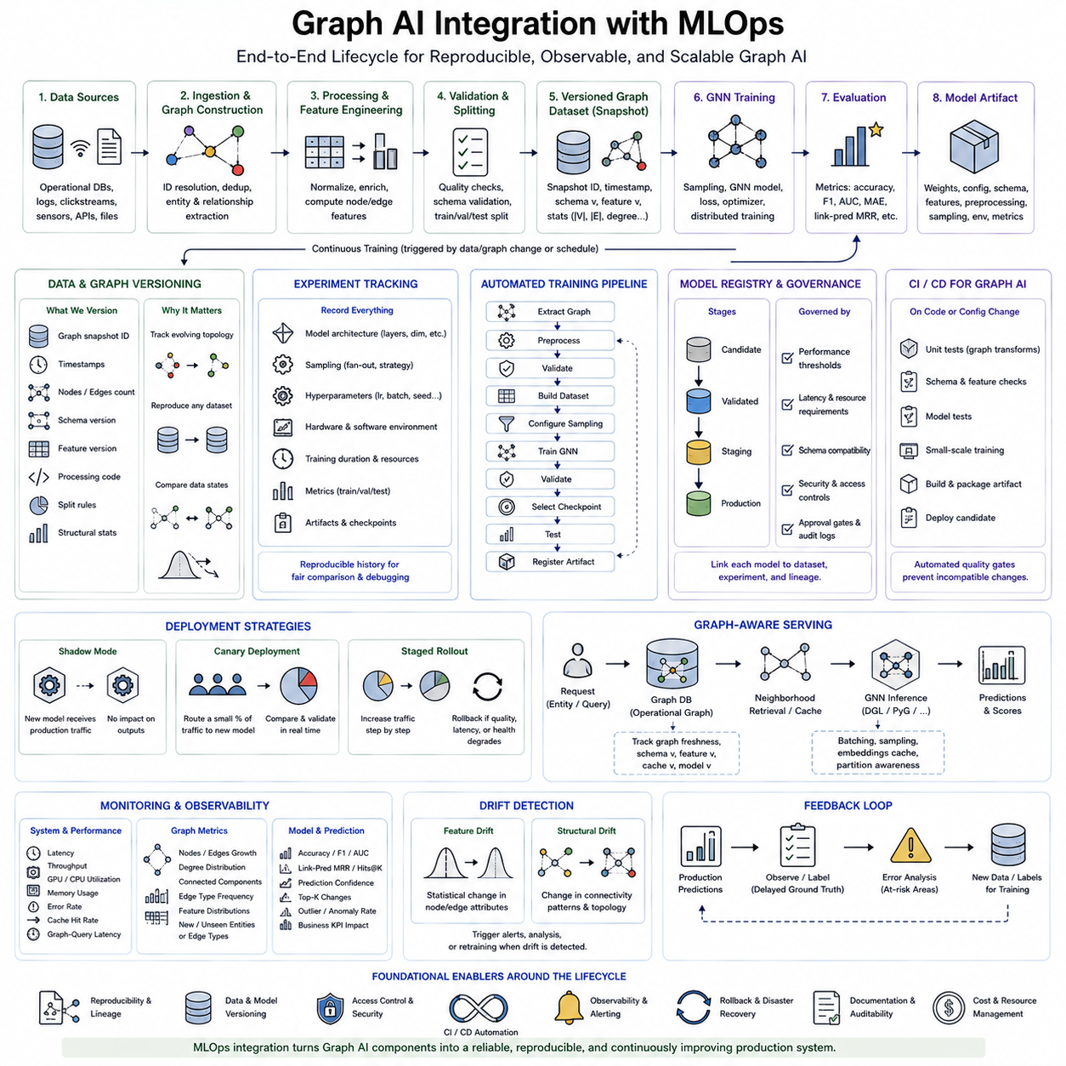
MLOps integration transforms a Graph AI workflow from a collection of training scripts into a controlled engineering lifecycle for data, models, experiments, deployment, and monitoring. For GNN systems, this lifecycle must manage not only model parameters but also graph topology, node and edge features, sampling policies, graph schemas, and dataset snapshots. Changes in relationships can alter model behavior even when the neural architecture and feature definitions remain unchanged.
The lifecycle begins with versioned graph data. Raw sources pass through ingestion, identity resolution, graph construction, feature engineering, validation, and dataset splitting before training. Each generated graph artifact should be associated with source versions, preprocessing code, schema definitions, feature configurations, and split rules. This lineage makes it possible to determine exactly which graph state was used to train, validate, or evaluate a particular GNN model.
Graph data versioning is more complex than conventional tabular versioning because both attributes and connectivity evolve. Adding nodes, deleting edges, modifying relationship types, or changing graph-generation rules can produce a new learning environment. A practical MLOps system therefore records graph snapshot identifiers, timestamps, node and edge counts, schema versions, feature versions, and relevant structural statistics alongside conventional dataset metadata.
Experiment tracking connects these graph versions with model configurations and training results. Each experiment can record the GNN architecture, number of layers, hidden dimensions, sampling fan-out, optimizer, learning rate, batch size, random seed, hardware configuration, software environment, training duration, and evaluation metrics. This creates a reproducible history in which performance differences can be traced to explicit changes in data, topology, model design, or training configuration.
The training pipeline should be automated as a sequence of repeatable stages rather than executed through manually modified scripts. A typical workflow performs graph extraction → preprocessing → validation → dataset construction → sampling configuration → GNN training → validation → checkpoint selection → testing → artifact registration. Pipeline orchestration allows failed stages to be retried independently and prevents expensive upstream graph processing from being repeated when only the model configuration changes.
Model artifacts require more information than trained weights alone. A deployable GNN package may include model parameters, architecture configuration, graph schema compatibility, expected feature dimensions, preprocessing definitions, sampling settings, inference configuration, framework versions, and evaluation results. Packaging these dependencies together reduces the risk that a model is deployed against graph data whose structure or feature semantics differ from those used during training.
A model registry provides a controlled location for storing candidate, validated, staging, and production models. Each registered model should remain linked to its graph dataset and experiment lineage. Promotion to production can depend on predefined acceptance criteria such as predictive quality, inference latency, memory consumption, robustness, and compatibility with the current graph schema. This creates an auditable path from experiment to operational deployment.
Continuous integration and continuous delivery, commonly expressed as CI/CD, can be adapted to Graph AI development. Code changes can trigger unit tests for graph transformations, schema validation, feature consistency checks, model tests, and small-scale training runs. Successful builds can create versioned artifacts and deployment candidates. Automated gates help prevent changes in preprocessing or graph construction from silently producing incompatible inputs for existing models.
Continuous training extends this approach when graph data changes over time. New nodes, edges, interactions, or labels may trigger scheduled or condition-based retraining. Retraining should not occur merely because new data exists; the pipeline can first evaluate whether sufficient structural or statistical change has occurred. This prevents unnecessary computation while allowing the model to adapt when the operational graph has meaningfully diverged from the training distribution.
Deployment strategies should reduce the risk of replacing a working Graph AI model. A new version can first operate in shadow mode, where it receives production inputs without controlling application outputs. Canary deployment can direct a small portion of requests to the new model, while staged rollout progressively increases traffic after validation. If quality, latency, or system health deteriorates, rollback should restore the previous model and its compatible configuration.
Graph serving requires synchronization between the deployed model and the operational graph. The production graph may continue changing while the model remains fixed, creating differences between training-time topology and inference-time topology. MLOps should therefore track graph freshness, feature freshness, schema compatibility, cache versions, and model versions together. This is particularly important when inference uses cached neighborhoods, precomputed embeddings, or distributed graph partitions.
Monitoring must extend beyond conventional model accuracy. Operational metrics include inference latency, throughput, GPU and CPU utilization, memory consumption, cache hit rate, graph-query latency, sampled neighborhood size, and error rate. Graph-specific monitoring can additionally track node and edge growth, degree distributions, connected components, relationship-type frequencies, feature distributions, and the appearance of previously unseen node or edge categories.
Drift detection should distinguish feature drift from structural drift. Feature drift occurs when node or edge attributes change statistically, while structural drift occurs when connectivity patterns themselves change. Variations in degree distributions, community structure, interaction density, edge-type proportions, or neighborhood composition can indicate that the relational environment has changed. A GNN may therefore require retraining even when conventional feature distributions appear relatively stable.
Prediction monitoring closes the feedback loop by connecting deployed outputs with later observations or labels. When ground truth becomes available, the system can compare production predictions with actual outcomes and detect degradation. Misclassified nodes, incorrect link predictions, uncertain outputs, or unusual graph regions can be collected for analysis. These examples can become candidates for labeling, dataset expansion, targeted retraining, or error-driven model improvement.
Observability should connect data, model, and infrastructure signals rather than monitoring each independently. A sudden increase in inference latency may originate from larger sampled neighborhoods rather than GPU failure, while reduced model accuracy may result from a changed graph schema rather than parameter degradation. Correlating graph statistics, pipeline versions, deployment events, hardware metrics, and prediction quality allows engineers to identify the real source of operational problems.
Reproducibility and governance become increasingly important as Graph AI moves into production. Every significant prediction or deployed model should ideally be traceable to a model version, graph snapshot, feature definition, preprocessing pipeline, and configuration. Access controls, audit logs, approval gates, artifact retention policies, and rollback procedures establish operational accountability while supporting debugging, compliance, and long-term maintenance.
The integrated lifecycle can therefore be represented as graph sources → versioned graph pipeline → automated GNN training → experiment tracking → validation → model registry → controlled deployment → graph-aware serving → monitoring and drift detection → feedback → retraining. CI/CD, reproducibility, governance, observability, and rollback surround this cycle and convert individual Graph AI components into a continuously manageable production system.
Integration with MLOps ultimately provides the operational bridge between Graph AI engineering and dependable deployment. Graph databases maintain evolving relational state, GNN frameworks learn representations, inference systems generate predictions, and MLOps coordinates their versions, automation, quality gates, monitoring, and feedback loops. This enables Graph AI to evolve from experimental models into reproducible, observable, scalable, and maintainable production intelligence.

08.07. Real Time Graph AI
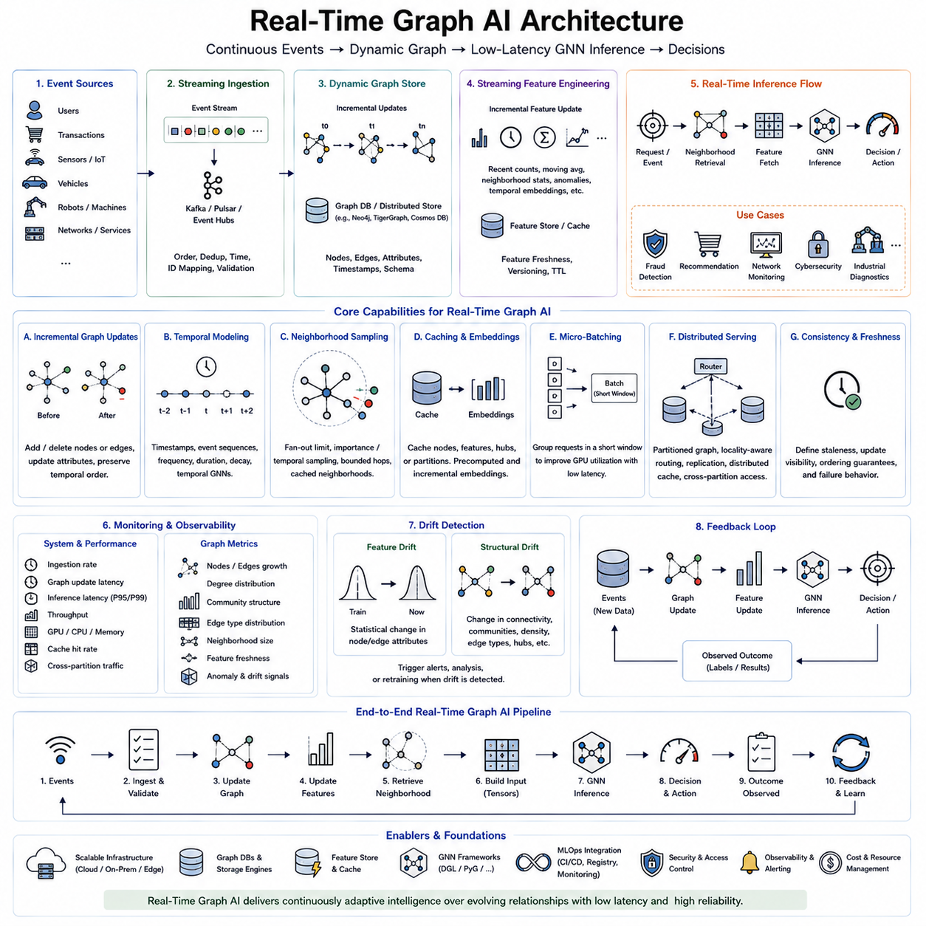
Real-Time Graph AI extends graph learning from periodic offline analysis into systems that continuously interpret changing relationships and produce decisions under strict latency constraints. The graph is no longer treated as a fixed dataset captured before training, but as an evolving operational state in which nodes, edges, attributes, and events may change continuously. Engineering such systems requires coordination among streaming ingestion, dynamic graph storage, incremental computation, low-latency GNN inference, and continuous monitoring.
Real-time graphs commonly originate from event streams generated by users, transactions, sensors, vehicles, robots, communication systems, industrial equipment, or digital services. Each event may create a node, add or remove an edge, modify an attribute, or update the strength and timestamp of an existing relationship. The ingestion layer must preserve event ordering, identifiers, timestamps, and relationship semantics while handling duplicated, delayed, or out-of-order events.
A dynamic graph can be viewed as a sequence of graph states G(t), where each state reflects the topology and features available at a particular time. Rebuilding the complete graph whenever an event arrives is usually impractical, so production systems apply incremental updates. Only affected nodes, edges, indexes, features, or graph partitions are modified, allowing the operational representation to evolve without repeatedly reconstructing the entire relational structure.
Temporal information becomes a first-class component of the graph. Two nodes connected yesterday may have a different relationship significance than nodes interacting milliseconds ago. Timestamps, event sequences, interaction frequency, duration, and temporal decay can therefore become graph features or model inputs. Temporal GNNs and dynamic graph models exploit this information to reason not only about which entities are connected, but also about how relationships evolve through time.
Streaming feature engineering must operate at approximately the same pace as graph updates. Features such as recent interaction counts, moving averages, neighborhood statistics, anomaly indicators, or temporal embeddings may need continuous refresh. Precomputing every feature after each event is inefficient, so systems often maintain incremental aggregates and update only the values affected by incoming events. Feature freshness becomes an explicit operational requirement.
Real-time inference typically begins when an event or application request identifies a target node, edge, or local region. The system retrieves the relevant graph context, selects a neighborhood, obtains node and edge features, constructs the computational representation, and executes the trained GNN. The resulting prediction may support fraud detection, recommendation, network monitoring, traffic reasoning, cybersecurity, industrial diagnostics, or autonomous-system coordination.
Latency is determined by the entire serving path rather than GNN execution alone. A request may spend substantial time retrieving graph data, expanding neighborhoods, loading features, transferring tensors, waiting for batching, or communicating across graph partitions. Consequently, optimization should measure event arrival → graph update → feature availability → neighborhood retrieval → GNN inference → decision output as an end-to-end latency path.
Neighborhood sampling is particularly important because graph queries can have unpredictable computational sizes. A low-degree target may require only a small amount of data, while a high-degree hub can expand into thousands of neighbors. Fan-out limits, importance sampling, temporal sampling, bounded-hop retrieval, and cached neighborhoods can constrain this variability. Predictable inference often requires sacrificing some neighborhood completeness to satisfy real-time deadlines.
Caching reduces repeated graph access when related entities appear frequently across requests. Node features, embeddings, neighborhoods, high-degree hubs, or complete graph partitions can be cached close to the inference accelerator. However, real-time systems must balance cache efficiency against freshness. Version identifiers, timestamps, time-to-live policies, and event-driven invalidation mechanisms help prevent predictions from using relational information that has already become obsolete.
Precomputed embeddings provide extremely fast lookup when the graph changes slowly enough to tolerate delayed representation updates. For rapidly changing regions, incremental embedding computation can update only nodes affected by recent events and propagate changes through a bounded neighborhood. Hybrid architectures may therefore combine stable cached embeddings for most of the graph with real-time recomputation for entities whose local topology or features have recently changed.
Micro-batching can improve GPU utilization without imposing the long delays associated with conventional large batches. Requests arriving within a very short interval are grouped and executed together, increasing accelerator efficiency while preserving low response time. The batching window becomes an important tuning parameter: a longer window improves throughput, while a shorter window reduces queueing latency. Adaptive batching can adjust this tradeoff according to current traffic.
Distributed real-time Graph AI becomes necessary when graph size or request volume exceeds one machine. Graph partitions may be distributed across servers, with requests routed toward the partition containing the target entity. Cross-partition edges require remote feature retrieval or communication, which can increase tail latency. Partition-aware routing, replication of frequently accessed nodes, distributed caches, and locality-aware sampling can reduce communication on critical inference paths.
Consistency requirements depend on the application. Some systems require predictions to reflect the newest graph update immediately, while others can tolerate eventual consistency and slightly stale features in exchange for higher throughput. Financial security or safety-related decisions may demand stronger freshness guarantees than recommendation systems. Real-time architecture should therefore define acceptable staleness, update visibility, ordering guarantees, and failure behavior explicitly.
Monitoring must include graph dynamics as well as infrastructure performance. Useful measurements include event ingestion rate, graph-update latency, feature freshness, node and edge growth, neighborhood size, cache hit rate, inference latency, throughput, memory utilization, and cross-partition traffic. P95 and P99 latency are especially important because irregular topology can produce a small number of exceptionally expensive requests even when average performance appears acceptable.
Structural drift can emerge rapidly in streaming graphs. New communities may form, interaction density may change, hubs may appear, relationship types may shift, or previously uncommon connectivity patterns may become dominant. These changes can reduce prediction quality even when individual node features remain statistically stable. Real-time monitoring should therefore connect topology statistics with model confidence, prediction quality, and operational alerts.
Feedback closes the real-time intelligence loop. New events update the graph, the updated graph influences inference, predictions drive actions, and subsequent outcomes generate additional events. Those outcomes can later become labels or training signals for model improvement. The resulting cycle can be represented as events → graph update → feature update → neighborhood retrieval → GNN inference → decision → observed outcome → graph and model feedback.
Real-Time Graph AI therefore combines streaming systems, dynamic graph management, temporal modeling, incremental computation, optimized GNN inference, distributed infrastructure, and MLOps into one continuously operating architecture. Its defining objective is not simply fast GNN execution, but maintaining useful relational intelligence while the underlying world is changing. This capability enables Graph AI to move from static analytical datasets toward continuously adaptive production systems that perceive and reason over evolving relationships.

