Volume 29. Graph Deep Learning

Chapter 04. Graph Embeddings

04.00. Overview
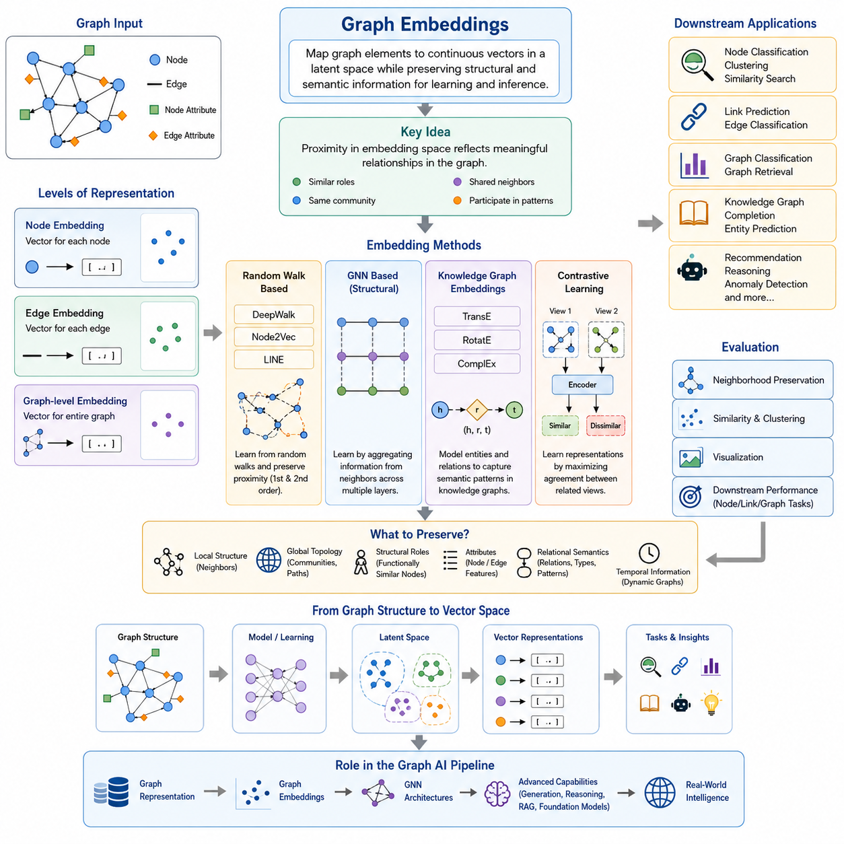
Graph embeddings provide a way to transform discrete graph structures into continuous vector representations that can be processed efficiently by machine learning models. A graph may contain nodes, edges, attributes, and complex connectivity patterns, but these structures cannot always be used directly by conventional learning algorithms. Embedding methods map selected graph elements into a latent vector space while attempting to preserve important structural and semantic information.
The central idea is that proximity in the embedding space should reflect meaningful relationships in the original graph. Nodes that occupy similar structural roles, belong to the same communities, share neighbors, or participate in related patterns can be represented by vectors located near one another. The definition of similarity depends on the embedding objective, so different techniques preserve different combinations of local connectivity, global topology, attributes, and relational semantics.
Graph embeddings can operate at several levels of representation. Node embeddings assign a vector to each node and are useful for node classification, clustering, recommendation, and similarity search. Edge embeddings represent relationships between pairs of nodes and support tasks such as link prediction. Graph-level embeddings compress an entire graph into a single representation, allowing complete graphs to be compared or classified as individual data objects.
Early graph embedding methods often learn representations directly from graph topology without relying on deep message-passing networks. DeepWalk interprets random walks through a graph as sequences and learns node representations from their co-occurrence patterns. Node2Vec extends this principle by controlling the random-walk behavior so that exploration can emphasize local neighborhoods or broader structural roles. LINE instead focuses on preserving first-order and second-order proximity in large networks.
These approaches reveal an important connection between graph learning and distributional representation learning. Just as words occurring in similar linguistic contexts can acquire similar word embeddings, nodes appearing in similar graph neighborhoods can acquire similar graph embeddings. Random walks effectively create graph-based contexts, converting topology into sequences from which representation-learning objectives can extract regularities. This perspective provides an intuitive bridge from classical embedding techniques to modern self-supervised graph learning.
Modern graph neural networks generalize this idea by learning embeddings through repeated neighborhood aggregation. Instead of treating topology only as a source of random-walk sequences, a GNN combines information from connected nodes, edge relationships, and available attributes. Successive layers expand the receptive field, allowing each representation to encode increasingly broader structural context. The resulting embeddings therefore become task-adaptive representations rather than fixed descriptions of graph topology.
Knowledge graph embeddings introduce an additional requirement because edges themselves have explicit semantic types. A knowledge graph commonly represents information as triples consisting of a head entity, relation, and tail entity. Embedding models therefore learn vectors or transformations that capture both entities and relations. Methods such as TransE, RotatE, and ComplEx use different geometric assumptions to represent relational patterns and support tasks such as entity prediction and knowledge graph completion.
TransE models a relation approximately as a translation between entity vectors, providing a simple geometric interpretation of relational structure. RotatE represents relations as rotations in a complex-valued embedding space and can capture several important relation patterns more naturally. ComplEx also uses complex-valued representations but employs a scoring formulation capable of modeling asymmetric relationships. Together, these methods illustrate how the geometry of the latent space determines which relational structures an embedding can express.
Contrastive graph learning extends embeddings toward self-supervised representation learning. Instead of requiring explicit labels for every training example, a model can construct related views of nodes, subgraphs, or entire graphs and learn representations that make related views similar while separating inappropriate matches. Graph augmentations may modify features or topology while preserving important semantic information, encouraging the learned latent space to retain stable properties rather than accidental details.
A useful distinction is therefore between embedding as an output representation and embedding as a learning mechanism. Random-walk algorithms, matrix-based approaches, knowledge graph models, GNN encoders, and contrastive methods may use very different training procedures, yet all can produce continuous representations of graph objects. The embedding is the latent coordinate system in which structural relationships become accessible to downstream statistical and neural learning algorithms.
The quality of an embedding depends on what information must be preserved for the target problem. Local neighborhood preservation may be sufficient for community-oriented tasks, whereas structural-role discovery may require representations that recognize nodes with similar functions even when they are far apart. Knowledge graphs require relational semantics, dynamic graphs may require temporal information, and attributed graphs must balance connectivity with node or edge features. No single embedding geometry is optimal for every graph problem.
Evaluation must consequently consider both intrinsic representation properties and downstream performance. Embeddings can be examined through neighborhood preservation, similarity relationships, clustering quality, or visualization, but their practical usefulness is usually tested through node classification, link prediction, graph classification, retrieval, or other target tasks. The chapter structure therefore places evaluation methods after node, edge, graph-level, knowledge graph, and contrastive embeddings, emphasizing evaluation as a common concern across embedding families.
Graph embeddings ultimately serve as a bridge between symbolic relational structure and numerical learning. They transform connectivity, neighborhoods, roles, attributes, and semantic relations into representations that neural networks and other machine learning algorithms can manipulate. This bridge is fundamental to modern Graph AI because it enables graphs to participate in prediction, retrieval, recommendation, reasoning, clustering, and representation transfer while retaining information derived from their relational organization.
Within the broader Graph Deep Learning pipeline, embeddings connect graph representation and GNN architectures with more advanced capabilities such as graph generation, knowledge graph reasoning, Graph RAG, multimodal graphs, and foundation models for graphs. The progression from graph structure to learned latent representation is therefore not merely a dimensionality-reduction step; it establishes the representational foundation upon which increasingly sophisticated graph intelligence can be constructed.

04.01. Node Embeddings
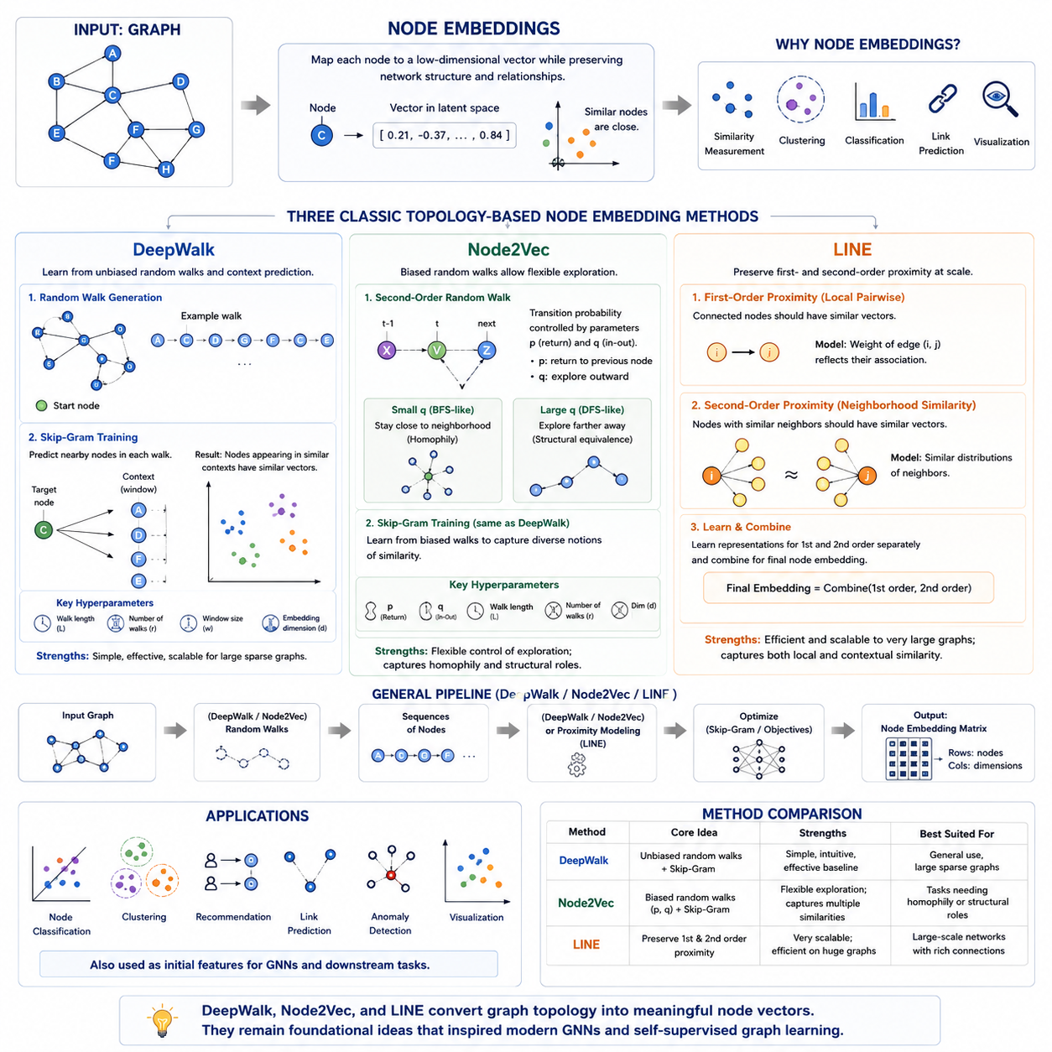
Node embeddings transform individual nodes in a graph into continuous low-dimensional vectors while preserving useful information about their positions and relationships within the network. Instead of representing a node only by a discrete identifier, embedding methods assign it numerical coordinates in a latent space. Nodes with related neighborhoods, connectivity patterns, or structural roles can therefore obtain similar vector representations.
This transformation makes graph information compatible with conventional machine learning operations such as similarity measurement, clustering, classification, and prediction. Once nodes are represented as vectors, cosine similarity or Euclidean distance can estimate relationships that were originally encoded indirectly through graph topology. Node embeddings consequently provide an important bridge between discrete network structures and continuous representation learning.
A major challenge is deciding what kind of graph similarity the latent space should preserve. Two nodes may be considered similar because they are directly connected, share many neighbors, belong to the same community, occur along similar paths, or perform comparable structural roles. Different node embedding algorithms encode different definitions of proximity, meaning that their representations may emphasize local neighborhoods, broader topology, or structural equivalence.
DeepWalk introduced an influential approach based on random walks and ideas borrowed from natural language representation learning. Starting from nodes in a graph, the algorithm repeatedly performs random walks to generate sequences of visited nodes. These sequences can be interpreted similarly to sentences, where nodes correspond to words and graph neighborhoods create the contextual relationships from which distributed representations are learned.
After random walks are generated, DeepWalk typically applies a Skip-Gram-style objective to predict nearby nodes within each walk. If two nodes frequently appear within similar random-walk contexts, their embeddings are encouraged to become close in the latent space. This allows DeepWalk to capture graph proximity without explicitly constructing large matrix factorizations and makes the approach suitable for relatively large sparse networks.
A minimal DeepWalk implementation therefore contains two conceptually separate stages. The first stage samples many random walks from the graph, usually beginning from multiple nodes and repeatedly selecting neighboring nodes. The second stage treats the resulting node sequences as training data for an embedding model. Walk length, number of walks, context-window size, and embedding dimension become important hyperparameters controlling the learned representation.
Node2Vec extends the random-walk principle of DeepWalk by introducing a biased second-order random walk. Rather than choosing every neighboring node with equal probability, Node2Vec adjusts transition probabilities according to the relationship between the previous node, current node, and possible next node. This provides explicit control over how the sampling process explores local neighborhoods and more distant structural patterns.
Two parameters, commonly denoted p and q, govern this behavior. The return parameter p influences the likelihood of immediately revisiting the previous node, while the in-out parameter q controls whether the walk tends to remain close to its current neighborhood or move outward through the graph. By adjusting these parameters, Node2Vec can interpolate between exploration resembling breadth-first search and exploration resembling depth-first search.
Breadth-oriented sampling tends to emphasize homophily, where nodes connected within similar local communities receive related representations. Depth-oriented exploration can capture forms of structural equivalence, where nodes occupying comparable network roles may become similar even when they are not located in the same neighborhood. Node2Vec therefore provides greater flexibility than an unbiased random walk when different graph tasks require different notions of similarity.
From an implementation perspective, Node2Vec follows a pipeline similar to DeepWalk but modifies the walk-generation procedure. Transition probabilities are calculated using the graph structure and the p and q parameters, biased walks are sampled, and the resulting sequences are passed to a Skip-Gram-like embedding learner. The learned vectors can then be exported as a matrix in which each row represents one node in the graph.
DeepWalk and Node2Vec are especially intuitive because they convert graph representation learning into a context-prediction problem. Their effectiveness depends heavily on sampled paths: the walks determine which nodes repeatedly appear together and therefore which relationships become visible to the learning objective. They are transductive methods in their standard forms because embeddings are learned directly for nodes appearing in the training graph rather than through a general node encoder.
LINE, or Large-scale Information Network Embedding, approaches node representation from a different perspective. Instead of relying primarily on sampled walk sequences, LINE explicitly attempts to preserve proximity relationships observed in large networks. Its design emphasizes scalability and can operate on graphs containing very large numbers of nodes and edges by using efficient edge-sampling and optimization strategies.
First-order proximity in LINE represents direct relationships between nodes. If two nodes are connected by an edge with substantial weight, their embeddings should reflect that immediate association. Preserving first-order proximity therefore captures local pairwise structure and is particularly natural when graph edges directly indicate meaningful interactions, associations, communications, or other relationships between entities.
Second-order proximity focuses on similarity between neighborhood distributions rather than only direct connections. Two nodes may not be connected to each other but can still be considered similar when they interact with comparable sets of neighboring nodes. LINE models this relationship using separate representations associated with nodes and their contexts, allowing it to preserve a broader notion of local network structure.
First-order and second-order LINE representations can be learned separately and combined to create a richer node representation. This distinction illustrates a general principle of graph embeddings: direct connectivity and contextual similarity are related but not identical sources of information. Preserving both can provide representations that capture immediate graph relationships while also identifying nodes embedded within similar neighborhood environments.
DeepWalk, Node2Vec, and LINE therefore represent three foundational approaches to topology-driven node embedding. DeepWalk learns from unbiased random-walk contexts, Node2Vec introduces controlled exploration through biased random walks, and LINE directly models first-order and second-order network proximity. Although their optimization procedures differ, all three seek a compact latent space that retains useful relational information from the original graph structure.
The learned embeddings can subsequently serve as features for node classification, clustering, recommendation, anomaly detection, visualization, and link prediction. They can also provide initial node representations for more advanced graph learning systems. Their historical importance extends beyond their direct applications because they established many of the principles later generalized by graph neural networks, self-supervised graph learning, and modern graph representation models.
Unlike classical node embedding methods that directly optimize one vector for each observed node, modern GNN-based approaches learn parameterized functions that generate representations by aggregating features and neighborhood information. This distinction becomes especially important when new nodes or changing graphs must be handled. Nevertheless, DeepWalk, Node2Vec, and LINE remain valuable conceptual foundations for understanding how graph topology can be transformed into meaningful continuous representations.

04.02. Edge Embeddings
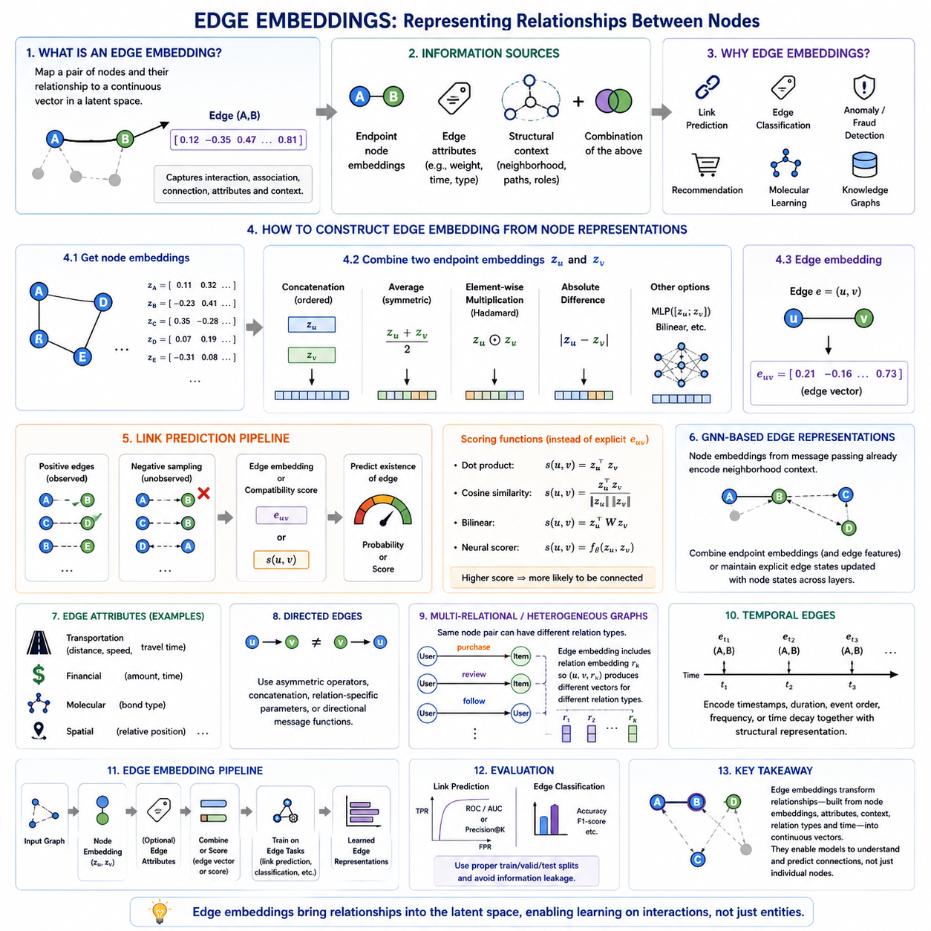
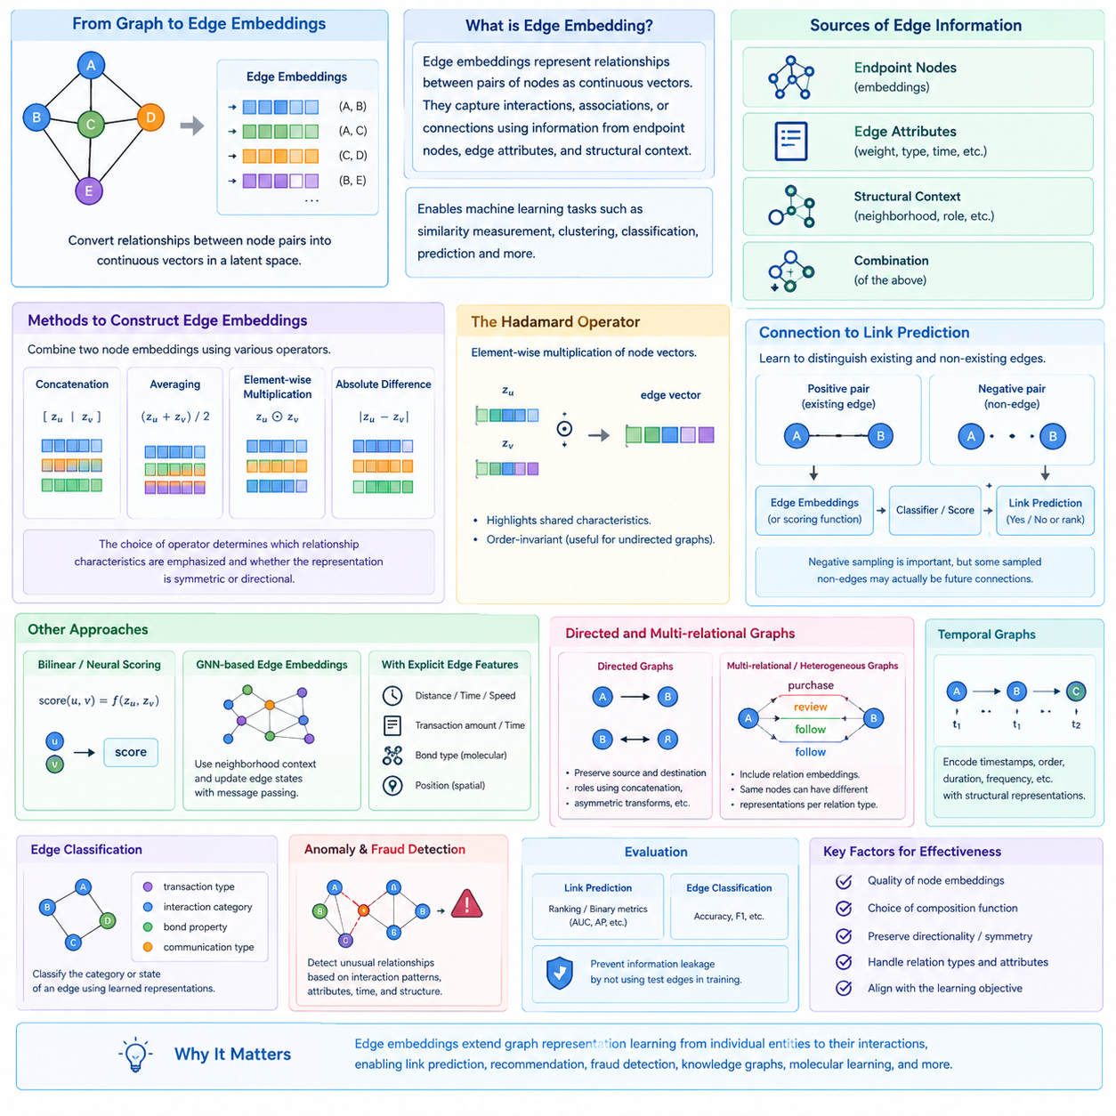
Edge embeddings represent relationships between pairs of nodes as continuous vectors in a latent space. While node embeddings describe individual entities, edge embeddings focus on interactions, associations, or connections between those entities. This distinction is important because many graph-learning problems depend not only on what nodes represent, but also on how pairs of nodes relate to each other through observed or potential edges.
An edge can contain information derived from its endpoint nodes, explicit edge attributes, structural context, or a combination of these sources. For example, an edge in a social network may represent friendship, while one in a transaction network may represent a payment with an amount and timestamp. Edge embeddings provide a unified numerical representation in which these different forms of relational information can be processed by machine learning models.
A common strategy constructs an edge embedding from the embeddings of its two endpoint nodes. If nodes u and v have vectors z_u and z_v, an edge representation can be produced using an operator that combines them. The choice of operator determines which aspects of the relationship are emphasized and whether the resulting representation treats the two endpoints symmetrically or preserves their directional roles.
Simple combination methods include concatenation, averaging, element-wise multiplication, and absolute difference. Concatenation preserves the complete representations of both endpoints and can retain their ordering, making it useful for directed relationships. Averaging produces a compact symmetric representation, while element-wise multiplication emphasizes dimensions in which both nodes have strong responses. Absolute difference represents how far the two node vectors differ along individual dimensions.
The Hadamard operator is a widely used element-wise multiplication technique for constructing edge representations. Given two node embeddings, corresponding dimensions are multiplied to produce the edge vector. When node embeddings encode compatible latent properties, this operation can highlight shared characteristics between the endpoints. It is particularly convenient for undirected graphs because exchanging the order of the two nodes produces the same representation.
Edge embeddings are closely connected to link prediction, one of the fundamental tasks in graph representation learning. Link prediction asks whether an edge should exist between two nodes that are currently unconnected or whether an observed connection is likely to persist. A model can construct embeddings for positive node pairs representing existing edges and negative pairs representing absent edges, then learn a classifier or scoring function that distinguishes them.
Negative sampling is therefore an important part of many edge-embedding pipelines. Graphs explicitly provide observed edges, but they usually do not contain a complete set of labeled non-edges. Training data can be created by sampling pairs of nodes that are not connected and treating them as negative examples. Care is required because some sampled non-edges may represent relationships that simply have not yet been observed rather than genuinely impossible connections.
Instead of constructing an edge vector explicitly, some methods calculate a compatibility score directly from the endpoint embeddings. The dot product, cosine similarity, bilinear functions, or neural scoring networks can estimate how compatible two nodes are. Higher scores can indicate a greater probability of connection. This approach is common in graph autoencoders and link-prediction systems where the decoder reconstructs graph connectivity from latent node representations.
Graph neural networks can produce richer edge representations by incorporating neighborhood context. Node embeddings generated through message passing already summarize information from nearby graph regions, so combining two such embeddings allows an edge representation to reflect more than the endpoints alone. Some architectures additionally maintain explicit edge states and update them together with node states during message passing, allowing relational features to evolve through multiple network layers.
Explicit edge features become particularly important when connections carry their own attributes. Transportation networks may associate roads with distance, speed limits, or travel time; financial graphs may attach transaction value and time; molecular graphs may describe bond type; and spatial graphs may encode relative position. In these situations, an edge embedding can combine endpoint representations with encoded edge attributes to represent both entities and their interaction.
Directed graphs require special consideration because an edge from u to v may have a different meaning from an edge from v to u. Symmetric operators such as averaging or absolute difference cannot distinguish these directions. Concatenation, asymmetric transformations, relation-specific parameters, or directional message functions can preserve source and destination roles. The embedding design must therefore match the semantics of the underlying graph.
Multi-relational and heterogeneous graphs introduce another dimension because the same pair of nodes may participate in different relation types. A user may purchase, review, or follow an item or another user, while knowledge graphs contain explicitly typed semantic relations. Edge representations in such graphs often incorporate relation embeddings so that identical endpoint nodes can produce different representations depending on the type of connection being modeled.
Temporal graphs further extend edge embeddings by introducing time. Relationships may appear, disappear, repeat, or change in strength, making a static edge vector insufficient for some applications. Temporal information such as timestamps, event order, duration, and interaction frequency can be encoded together with structural representations. This allows models to distinguish relationships that are structurally similar but occur at different stages of an evolving graph.
Edge embeddings can also support edge classification, where the objective is not to determine whether a connection exists but to identify its category or state. Examples include classifying transaction types, identifying interaction categories, predicting molecular bond properties, or distinguishing different relationships in communication networks. A learned edge representation becomes the input to a classifier that maps relational patterns into predefined classes.
Anomaly and fraud detection provide another important use case. Suspicious interactions may involve nodes that individually appear normal but form unusual relationships when considered together. Edge representations allow a model to evaluate the interaction itself by comparing it with patterns learned from typical connections. Unusual endpoint combinations, attributes, temporal behavior, or structural contexts can therefore be detected as anomalous edges.
The effectiveness of an edge embedding depends strongly on the quality of its underlying node representations and the chosen composition function. Two excellent node embeddings do not automatically produce an optimal representation for every relationship. The learning objective should encourage the latent space to retain information relevant to the target edge task, and the composition mechanism should preserve properties such as directionality, symmetry, relation type, and edge attributes when required.
Evaluation is usually performed through downstream relational tasks such as link prediction or edge classification. For link prediction, models can be assessed by how effectively they rank true connections above negative pairs using metrics appropriate to binary prediction or ranking. Evaluation protocols must also prevent information leakage, because embeddings constructed using test edges can inadvertently expose the relationships that the model is expected to predict.
Edge embeddings ultimately extend graph representation learning from describing entities to describing interactions. By transforming node pairs, structural context, edge attributes, relation types, and temporal information into continuous representations, they make relationships directly accessible to learning algorithms. This capability forms an important foundation for link prediction, recommendation, fraud detection, knowledge graphs, molecular learning, and other systems in which intelligence depends on understanding connections rather than isolated nodes.

04.03. Graph Level Embeddings
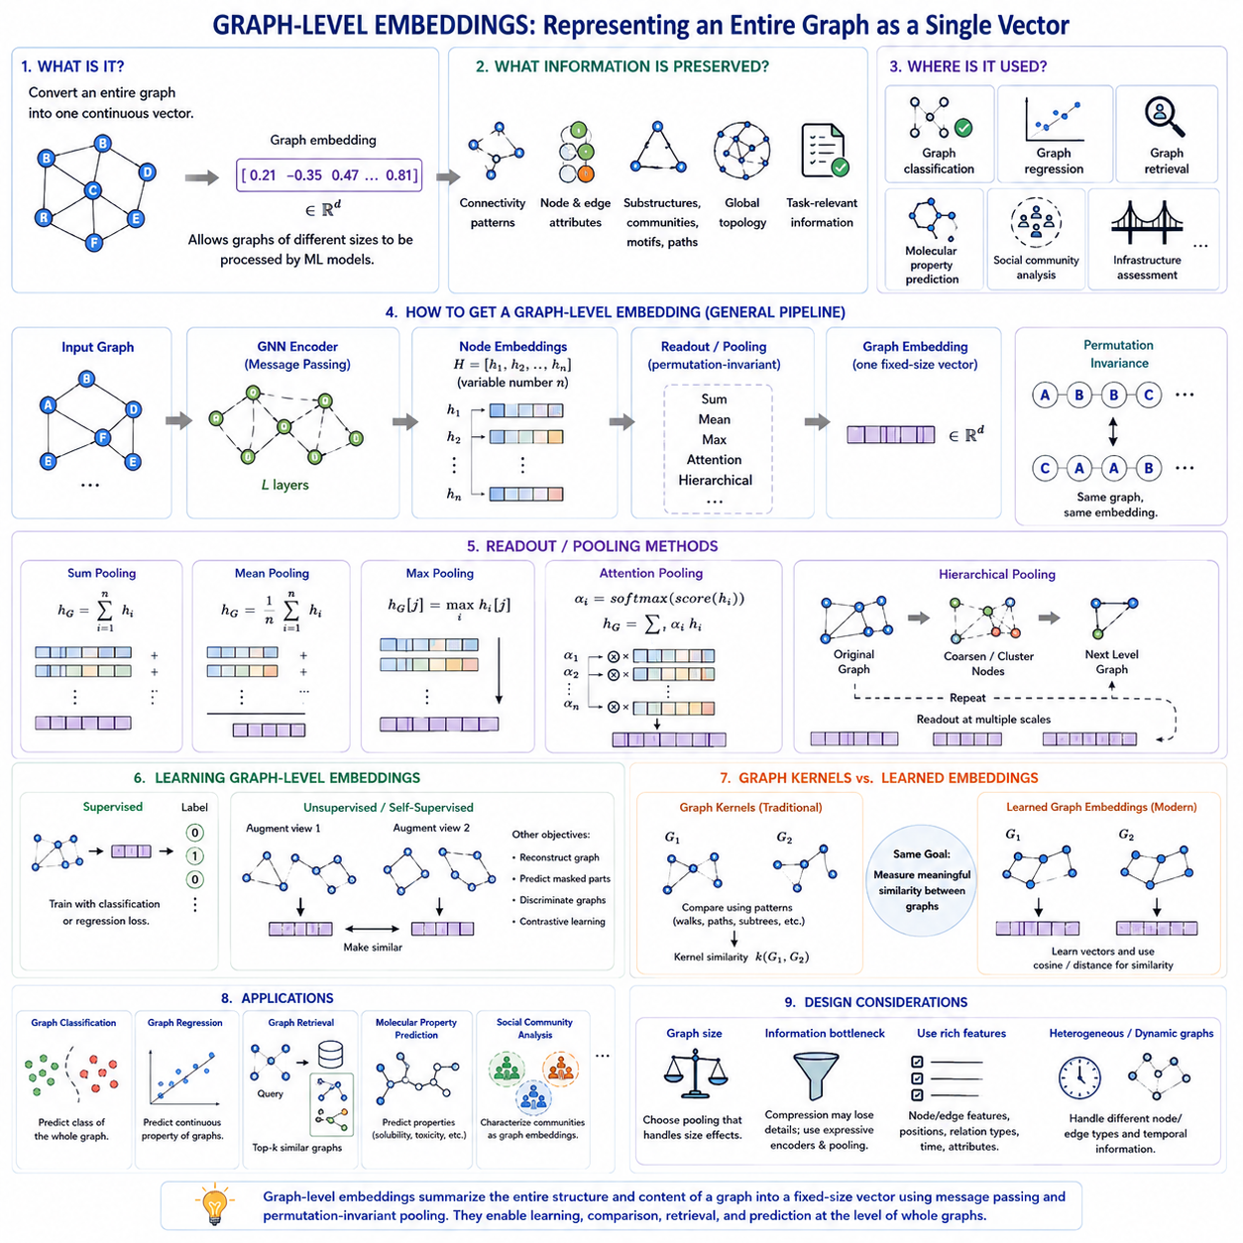
Graph-level embeddings transform an entire graph into a single continuous vector representation. While node embeddings describe individual entities and edge embeddings describe relationships, graph-level embeddings summarize the structure and content of a complete graph. This representation allows graphs with different numbers of nodes and edges to be processed as fixed-dimensional objects by conventional machine learning models.
The objective is not simply to compress every node representation into a smaller vector, but to preserve information that distinguishes one graph from another. Relevant information may include connectivity patterns, node and edge attributes, substructures, communities, motifs, paths, and global topology. A useful graph embedding should retain those characteristics that matter for the downstream task while discarding irrelevant structural variation.
Graph-level representation is essential when each training example is itself a graph. In molecular learning, for example, individual molecules can be represented as graphs whose atoms are nodes and chemical bonds are edges. In other domains, graphs may represent proteins, social communities, transactions, program structures, scenes, or infrastructure networks. The model must therefore produce one representation for each complete graph before classification, regression, retrieval, or comparison can be performed.
A common approach begins by learning representations for individual nodes and then applying a readout or pooling operation. If a graph contains node embeddings h1, h2, through hn, the readout function aggregates these variable-sized sets into a fixed-dimensional graph vector. This creates a general pipeline in which local information is first encoded at the node level and subsequently summarized into a global graph representation.
Simple global pooling methods include sum pooling, mean pooling, and max pooling. Sum pooling accumulates information from all nodes and can preserve signals related to graph size or repeated structures. Mean pooling represents the average characteristics of the nodes and reduces sensitivity to graph size. Max pooling selects the strongest activation in each embedding dimension and can emphasize whether particular latent patterns occur anywhere in the graph.
An important requirement for graph pooling is permutation invariance. A graph does not normally change when its nodes are listed in a different order, so its graph-level representation should also remain unchanged under node reordering. Operations such as sum, mean, and max naturally satisfy this requirement because their results depend on the collection of node representations rather than the order in which those representations are presented.
The quality of simple pooling depends strongly on the node embeddings being aggregated. If message passing has already allowed each node representation to incorporate information from its neighborhood, global pooling can summarize both local features and structural context. Deeper GNN layers can expand the receptive field before pooling, although excessive depth may introduce problems such as over-smoothing or loss of discriminative local information.
More expressive readout mechanisms can learn how different nodes contribute to the final graph representation. Attention-based pooling assigns different importance to nodes instead of treating every node equally. A learned scoring function can identify nodes or substructures that are especially relevant to the target task and give them greater influence. This is useful when only a small portion of a large graph determines its class, property, or behavior.
Hierarchical graph pooling extends this principle by progressively reducing the graph rather than immediately collapsing all nodes into one vector. Nodes can be grouped, selected, or coarsened into higher-level structures, after which additional graph processing is performed. Repeated pooling stages create representations at multiple scales, allowing the model to capture relationships among nodes, local subgraphs, communities, and the graph as a whole.
Graph-level embeddings can also be learned without relying exclusively on supervised labels. Unsupervised and self-supervised objectives can encourage graphs with related structural or semantic properties to occupy nearby regions of the latent space. Models may reconstruct graph information, predict masked components, distinguish graph instances, or learn agreement between augmented views of the same graph. These objectives make graph representation learning possible when labeled graphs are limited.
Contrastive graph learning is particularly useful for graph-level representations. Two augmented views can be generated from the same graph by modifying node features, edges, or substructures while attempting to preserve semantic identity. Their graph embeddings are encouraged to remain similar, whereas representations of unrelated graphs are separated. The resulting latent space can capture graph characteristics that remain stable under acceptable structural perturbations.
Traditional graph kernels provide an important conceptual predecessor to learned graph embeddings. Graph kernels compare graphs using patterns such as walks, paths, neighborhoods, or subtrees without necessarily constructing explicit neural representations. Modern graph embedding methods instead learn continuous vectors that can be optimized jointly with downstream objectives. Both approaches address the same fundamental challenge: measuring meaningful similarity between complex graph structures.
Graph-level embeddings support graph classification when each graph belongs to a discrete category. A molecular graph might be classified according to a biological property, while another graph could be categorized according to structural type or functional behavior. Once the complete graph has been mapped to a vector, a conventional classifier or neural prediction head can operate on that representation much like it would on an image or document embedding.
Graph regression uses the same representation principle but predicts continuous properties. In molecular applications, the target might correspond to a physical or chemical property associated with the complete molecule. In engineering or infrastructure graphs, a graph vector may support prediction of system-level quantities. The embedding must therefore integrate distributed local information into a representation that is informative about a global numerical outcome.
Graph retrieval and similarity search provide another natural application. Graph embeddings can be stored in a vector space, allowing a query graph to retrieve graphs with nearby representations. Instead of repeatedly performing expensive structural graph matching, similarity can be approximated using vector distances or cosine similarity. This makes learned graph representations useful for searching large collections of structured objects.
Graph size presents an important design challenge. Two graphs can represent similar phenomena while containing very different numbers of nodes and edges. Sum pooling may produce larger magnitudes for larger graphs, whereas mean pooling can remove useful information about size. The appropriate readout mechanism therefore depends on whether graph size itself is meaningful and how structural scale relates to the target prediction problem.
Another challenge is preserving fine-grained structure during compression. Mapping an entire graph to one fixed-dimensional vector inevitably creates an information bottleneck. Distinct graphs may become difficult to distinguish if their pooled node representations are too similar. More expressive GNN encoders, hierarchical pooling, attention mechanisms, structural features, and carefully designed learning objectives can reduce this loss but cannot eliminate the fundamental compression tradeoff.
Graph-level embeddings can incorporate more than topology. Node features, edge attributes, positional or structural encodings, relation types, and temporal information can all contribute to the representation before or during pooling. For heterogeneous or dynamic graphs, the readout mechanism may need to distinguish different node types, relation categories, or time-dependent interactions rather than treating every graph component as equivalent.
Evaluation should match the purpose of the learned representation. Supervised graph embeddings can be evaluated through graph classification or regression performance, while general-purpose representations may also be examined through clustering, retrieval, transfer learning, or similarity tasks. Careful train, validation, and test separation remains essential, particularly when graphs share related substructures or originate from correlated sources that could create information leakage.
Graph-level embeddings ultimately convert variable-sized relational structures into fixed-dimensional representations suitable for learning, comparison, and retrieval. Their central challenge is to aggregate local node and edge information without losing the structural properties that define the graph as a whole. By connecting message passing, pooling, hierarchical abstraction, and representation learning, they provide the graph-level counterpart to node and edge embeddings within the broader Graph AI pipeline.

04.04. Knowledge Graph Embeddings
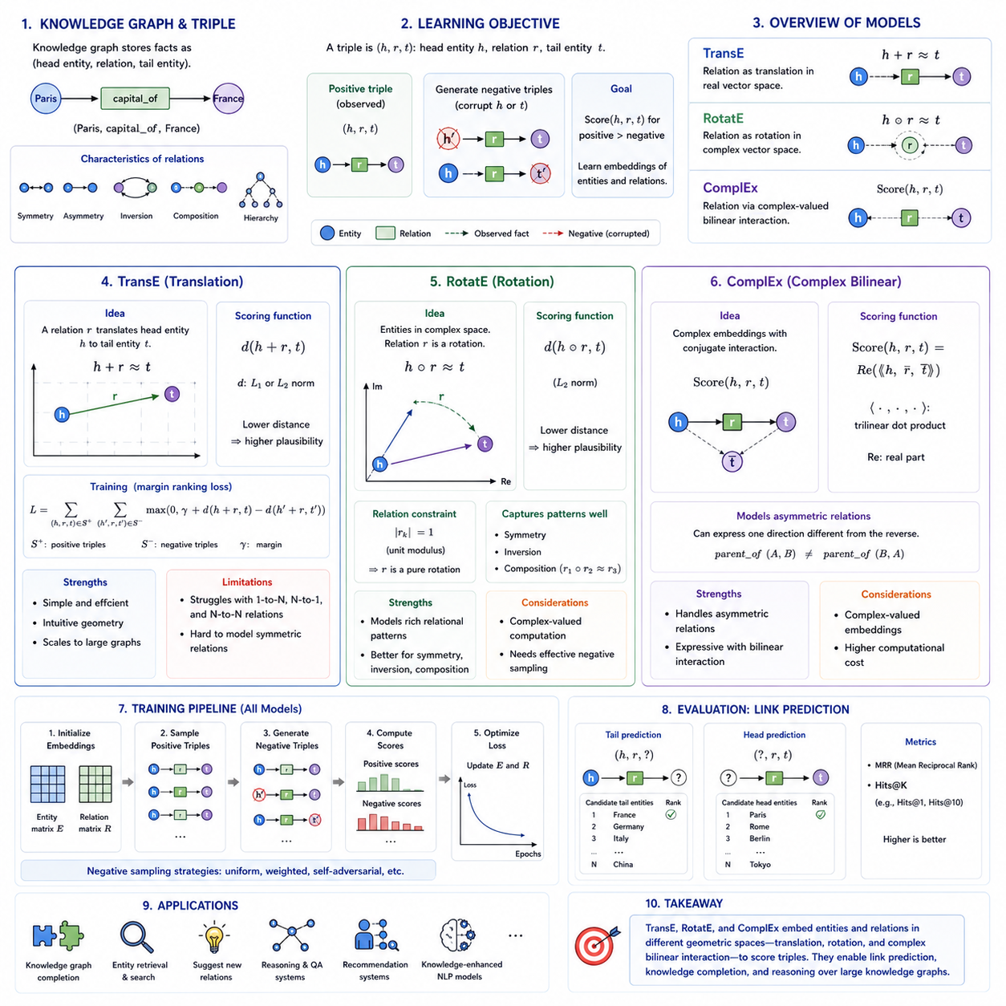
Knowledge graph embeddings transform entities and relations in a knowledge graph into continuous vector representations while preserving the semantic patterns expressed by graph triples. A knowledge graph commonly stores facts as (head entity, relation, tail entity), such as (Paris, capital_of, France). Embedding models assign numerical representations to these components so that plausible facts receive better compatibility scores than implausible combinations.
Unlike ordinary graphs, knowledge graphs contain explicitly typed relations. Two entities may be connected through several different semantic relationships, and each relation can exhibit properties such as symmetry, asymmetry, inversion, composition, or hierarchy. Knowledge graph embedding models must therefore represent not only which entities are related but also how relation types transform or constrain the semantic connection between them.
The fundamental learning problem can be expressed through triples (h, r, t), where h represents the head entity, r the relation, and t the tail entity. During training, observed triples are treated as positive facts, while corrupted triples can be generated by replacing the head or tail entity. The model learns parameters that assign higher plausibility to observed triples and lower plausibility to inappropriate combinations.
TransE provides one of the simplest and most influential geometric interpretations of knowledge graph relations. It represents entities and relations as vectors in the same embedding space and models a valid triple using the approximate relationship h + r ≈ t. In this interpretation, the relation vector acts as a translation that moves the head entity toward the position of the corresponding tail entity.
For example, if a relation represents capital_of, applying its learned translation to the embedding of a capital city should move the representation toward the corresponding country. Training minimizes a distance between h + r and t for valid triples while encouraging corrupted triples to receive larger distances. Common distance functions include L1 and L2 norms, which provide a simple scoring mechanism for evaluating triple plausibility.
A minimal TransE implementation begins by assigning trainable embedding vectors to every entity and relation. A batch of positive triples is sampled, and negative triples are produced by replacing selected head or tail entities. Positive and negative scores are calculated from translation distances, and a margin-based ranking loss or related objective encourages positive triples to achieve better scores than their corrupted alternatives.
The simplicity of TransE gives it several practical advantages. Its scoring function is computationally inexpensive, its geometric interpretation is intuitive, and entity and relation embeddings can be trained efficiently on relatively large knowledge graphs. It also provides an important conceptual foundation for understanding later knowledge graph embedding methods, many of which modify the geometry used to represent relational transformations.
However, a single translation vector cannot naturally represent every relational pattern. One-to-many, many-to-one, and many-to-many relations can force multiple entities toward similar locations, reducing representational flexibility. Symmetric relations are also difficult to model using simple translations because applying the same nonzero translation in both directions conflicts with the geometry required for symmetry.
RotatE addresses several of these limitations by representing entities in a complex-valued embedding space and interpreting each relation as a rotation. For a valid triple, the model seeks a relationship approximately corresponding to h ∘ r ≈ t, where the relation rotates the head representation through element-wise multiplication in complex space. Relation components are constrained to have unit magnitude so that they primarily encode rotation.
This rotational geometry provides an elegant mechanism for representing several important relational patterns. A symmetric relation can correspond to a rotation that becomes its own inverse, while inverse relations can be represented by opposite rotations. Relation composition can also be modeled through successive rotations, allowing combinations of relations to correspond naturally to compositions of transformations in the embedding space.
RotatE therefore changes the interpretation of knowledge graph reasoning from translation to transformation through phase. Entities occupy positions in complex space, while relations determine how their phases are rotated. The resulting geometry is more expressive for relations involving symmetry, inversion, and composition while retaining a relatively structured and interpretable mathematical formulation.
Negative sampling remains important for RotatE because the model must learn which candidate entities should not complete a triple. More informative negative examples can improve training by forcing the model to distinguish plausible alternatives from the correct entity. Modern implementations may therefore use weighted or self-adversarial negative sampling so that difficult negative triples contribute more strongly to optimization.
ComplEx takes another complex-valued approach but models relationships through a bilinear scoring function rather than explicit geometric rotation. Entities and relations are represented using complex vectors, and triple plausibility is calculated through interactions among the head, relation, and conjugated tail embeddings. The use of complex conjugation is crucial because it allows the scoring function to represent asymmetric relationships.
This ability distinguishes ComplEx from simpler real-valued symmetric bilinear models. If a relation such as parent_of holds from one entity to another, the reverse relationship should not automatically receive the same score. Complex-valued interactions allow ComplEx to distinguish these directions while still modeling patterns that require symmetric behavior when the learned relation representation supports them.
The three models therefore express relational knowledge through different latent geometries. TransE treats a relation as a translation, RotatE treats it as a rotation in complex space, and ComplEx represents it through complex-valued bilinear interactions. Their differences illustrate a central principle of knowledge graph embeddings: the mathematical structure of the latent space determines which relational patterns can be represented efficiently.
Knowledge graph embedding models are commonly evaluated through link prediction. Given a partially specified triple such as (h, r, ?), the model scores candidate entities and ranks possible tails. The same procedure can predict missing head entities. Metrics such as Mean Reciprocal Rank and Hits@K measure whether correct entities appear near the top of these rankings and therefore quantify the quality of learned relational representations.
Knowledge graph completion is a natural application of this capability. Real knowledge graphs are incomplete because many valid relationships have never been explicitly recorded. Embedding models can assign high plausibility to missing triples that are consistent with patterns learned from existing facts. These predictions can suggest new relations, support entity retrieval, enrich search systems, and provide candidates for subsequent verification.
The embeddings can also serve as relational representations for downstream reasoning and knowledge-enhanced AI systems. Entity vectors capture patterns of relational context, while relation embeddings encode recurring transformations or interaction structures. They can therefore complement symbolic graph traversal, neural reasoning, recommendation, semantic search, and knowledge-augmented language models rather than functioning only as standalone link-prediction mechanisms.
TransE, RotatE, and ComplEx collectively demonstrate the progression from simple geometric translation toward richer relational representation. TransE provides an intuitive baseline and implementation foundation, RotatE introduces rotational geometry capable of capturing important relation patterns, and ComplEx uses complex-valued bilinear interactions to model asymmetric semantics. Together they establish core ideas for understanding modern knowledge graph representation learning.

04.05. Contrastive Graph Learning [w/Code]
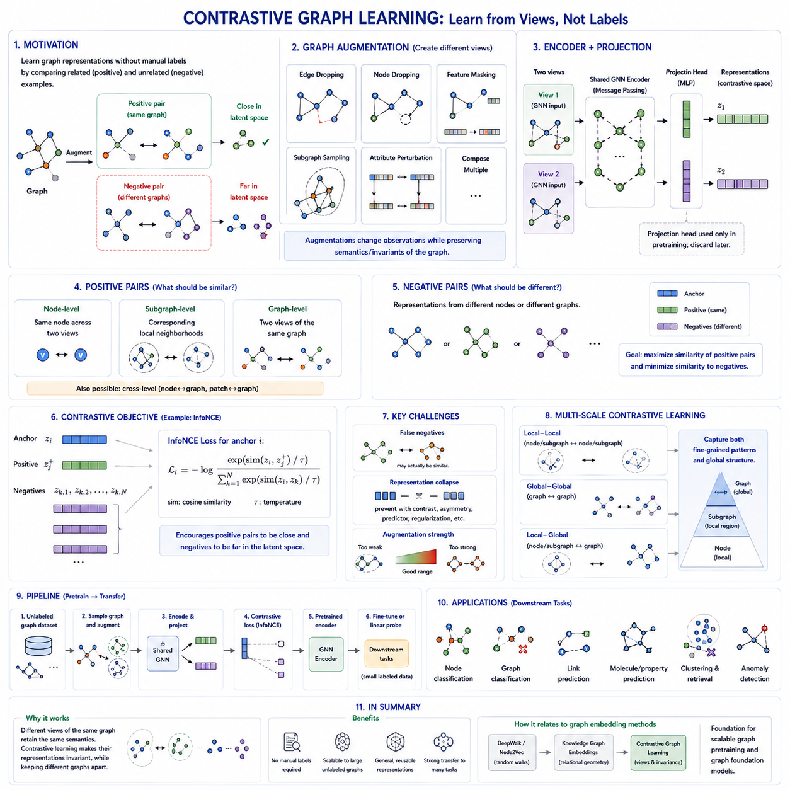
Contrastive graph learning is a self-supervised representation learning approach that trains graph encoders by comparing related and unrelated graph representations. Instead of requiring manually labeled examples, the model constructs positive pairs that should have similar embeddings and negative pairs that should remain distinguishable. This allows structural and semantic knowledge to be learned directly from large collections of unlabeled graphs.
The central principle is invariance. Two representations generated from different but semantically consistent views of the same graph should remain close in the latent space, while representations corresponding to unrelated graph objects should be separated. The learning process therefore requires a careful definition of what constitutes equivalent information and which transformations can be applied without destroying the graph semantics required by downstream tasks.
Graph augmentation provides the different views needed for contrastive learning. Unlike image augmentation, where cropping or color transformations are often intuitive, graph augmentation modifies discrete relational structures. Common strategies include dropping edges, removing or sampling nodes, masking node features, perturbing attributes, extracting subgraphs, or combining several transformations. Each augmentation changes the observation while attempting to preserve meaningful graph identity.
Edge dropping randomly removes selected connections and encourages the encoder to produce stable representations despite moderate changes in connectivity. Feature masking hides portions of node attributes and forces the representation to rely on remaining structural and semantic evidence. Node dropping or subgraph sampling changes the visible graph region more substantially, allowing the model to learn representations that remain useful when only partial relational information is available.
Augmentation strength must be selected carefully because excessive perturbation can change the meaning of a graph. Removing a small number of social connections may preserve community identity, whereas deleting a chemically critical bond can transform one molecular structure into another. Effective contrastive graph learning therefore depends on augmentations that reflect valid invariances of the application domain rather than blindly applying arbitrary structural noise.
After augmentation, two graph views are passed through a shared or related graph encoder. A GNN commonly performs message passing over each view and produces node-level representations containing local structural context. Depending on the learning objective, these node embeddings can be used directly or aggregated through a permutation-invariant readout function to produce graph-level embeddings representing the complete augmented views.
Many contrastive frameworks insert a projection head after the graph encoder. The encoder produces representations intended to contain generally useful information, while the projection network maps them into another latent space in which the contrastive objective is optimized. After pretraining, the projection head can be discarded and the encoder representation retained for downstream classification, regression, retrieval, or other graph-learning tasks.
Positive pairs can be defined at several levels. Two augmented versions of the same node can form a node-level positive pair, while corresponding local neighborhoods can support subgraph-level learning. Two augmented views of the same complete graph can form a graph-level positive pair. Cross-level objectives can additionally compare local node or patch representations with global graph representations, encouraging consistency across multiple structural scales.
Negative pairs traditionally consist of representations originating from different nodes or graphs. The objective encourages positive pairs to obtain higher similarity than negative pairs, often using cosine similarity in the projected latent space. A temperature parameter can control how strongly similarity differences influence the optimization. The resulting objective organizes the embedding space so that semantically consistent observations form coherent representations.
InfoNCE is a widely used contrastive objective. For an anchor representation, its corresponding positive representation is compared against a set of alternatives, and the model is trained to identify the correct positive among them. The denominator contains competing representations, causing the objective to simultaneously increase positive similarity and reduce relative similarity to negatives. Larger and more diverse negative sets can provide a stronger discrimination signal.
However, negative sampling introduces the possibility of false negatives. Two graphs treated as unrelated may actually share the same semantic class or important structural properties. Forcing such examples apart can damage the representation space. This problem has motivated methods that improve negative selection as well as approaches that reduce or eliminate explicit dependence on negative examples while still preventing representation collapse.
Representation collapse occurs when an encoder maps many or all inputs to nearly identical vectors. Such a solution trivially makes positive pairs similar but removes useful information about differences between graph instances. Contrastive objectives avoid this through discrimination against negatives, while non-contrastive self-supervised approaches can use architectural asymmetry, stop-gradient operations, predictors, regularization, or statistical constraints to maintain diverse representations.
Graph contrastive learning can operate locally or globally. Local-local objectives compare node or subgraph representations, global-global objectives compare complete graph embeddings, and local-global objectives encourage node-level representations to remain informative about the graph to which they belong. Combining these scales can help the encoder capture both fine-grained neighborhood patterns and broader structural organization.
One influential family of approaches maximizes agreement between local and global representations. A node embedding should contain information that is consistent with the representation of its parent graph, while nodes or graphs from unrelated contexts provide contrasting examples. This idea connects contrastive graph learning with mutual-information-inspired objectives and encourages representations to capture dependencies spanning multiple levels of graph structure.
Methods such as GraphCL emphasize graph-level contrastive learning through graph augmentations. Multiple transformed views of each graph are encoded, projected, and compared using a contrastive objective. The choice and combination of augmentations become central design decisions because different graph domains preserve semantics under different transformations. GraphCL demonstrates how augmentation-based contrastive principles can be adapted from other modalities to graph-structured data.
GRACE applies related principles primarily to node-level representation learning. It constructs corrupted graph views using topology and attribute augmentations, processes them with graph encoders, and maximizes agreement between representations of corresponding nodes across views. This encourages node embeddings to remain stable under perturbations while still retaining information that distinguishes different nodes within the graph.
Contrastive pretraining separates representation acquisition from downstream supervision. A graph encoder can first learn from a large unlabeled dataset and later be fine-tuned using a smaller labeled dataset. Alternatively, embeddings can be frozen and supplied to a lightweight prediction model. This strategy is particularly valuable when graph labels are expensive but unlabeled relational data are abundant.
The learned representations can support node classification, graph classification, link prediction, molecular property prediction, clustering, retrieval, anomaly detection, and transfer learning. Their usefulness depends on whether the pretraining objective preserves information relevant to these downstream tasks. A representation optimized around inappropriate invariances may perform poorly even when its contrastive training loss appears successful.
Contrastive graph learning therefore involves more than selecting a loss function. Its performance emerges from the interaction among graph augmentation, encoder architecture, pooling, projection, similarity measurement, positive-pair construction, negative sampling, and pretraining data. These components collectively determine which graph properties become invariant, which differences remain distinguishable, and how transferable the resulting latent representations become.
Within graph embedding methods, contrastive learning represents a transition from directly assigning vectors to graph objects toward learning reusable graph encoders through self-supervision. DeepWalk and Node2Vec derive context from random walks, knowledge graph embeddings encode relational geometry, and contrastive graph learning creates supervisory signals from alternative views of graph data. It therefore forms an important foundation for scalable graph pretraining and modern graph foundation models.

04.06. Evaluation Methods
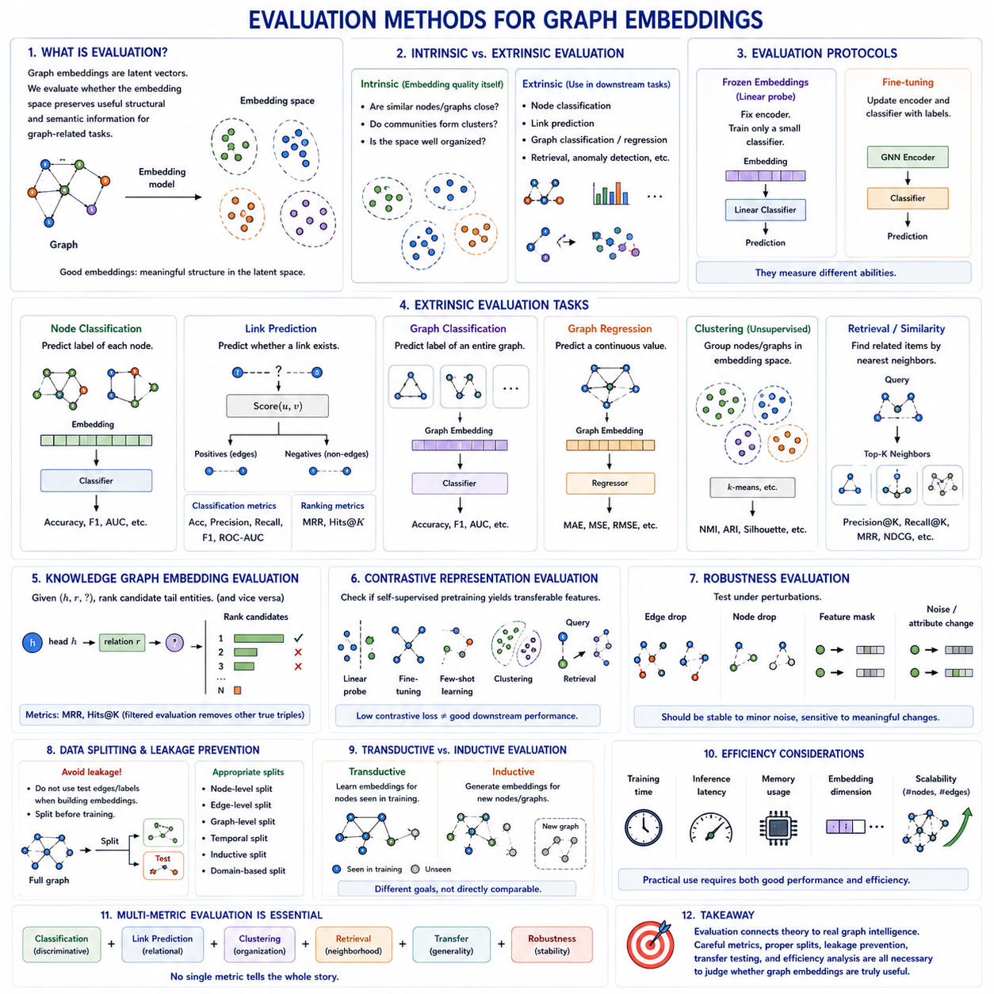
Evaluation methods for graph embeddings determine whether learned representations preserve information that is useful for graph-related tasks. Because an embedding is a compressed latent representation rather than an objective result by itself, its quality cannot be judged only by inspecting vector values. Evaluation must examine whether distances, similarities, neighborhoods, and decision boundaries in the embedding space correspond to meaningful properties of the original graph.
A fundamental distinction exists between intrinsic and extrinsic evaluation. Intrinsic evaluation examines properties of the embedding space itself, such as whether structurally related nodes remain close or whether known communities form coherent clusters. Extrinsic evaluation measures how effectively the embeddings support downstream tasks such as node classification, link prediction, graph classification, regression, retrieval, or anomaly detection.
Node classification is one of the most common evaluation tasks for node embeddings. A representation is learned for each node and then supplied to a classifier that predicts node labels. Strong classification performance indicates that the embedding contains information correlated with the target categories. Linear classifiers are particularly useful because they reveal whether task-relevant information can be extracted easily from the learned latent representation.
Evaluation protocols can use frozen embeddings or fine-tuned encoders. In frozen evaluation, the representation model remains unchanged and only a lightweight classifier is trained, providing a relatively direct measure of representation quality. Fine-tuning updates the encoder using labeled data and measures how effectively pretrained representations can adapt to the target task. The two protocols answer different questions and should therefore not be treated as interchangeable.
Link prediction evaluates whether embeddings preserve information about graph connectivity. Existing edges are typically treated as positive examples, while selected non-connected node pairs serve as negative examples. A scoring function based on dot product, cosine similarity, distance, or a learned decoder estimates whether each pair should be connected. Good embeddings should assign stronger compatibility to true links than to appropriately sampled negative pairs.
Link prediction can be evaluated as either a binary classification or ranking problem. Classification-oriented evaluation may use accuracy, precision, recall, F1 score, or the area under the ROC curve. Ranking-oriented evaluation asks whether true neighbors or missing entities appear near the top of candidate lists and can use measures such as Mean Reciprocal Rank and Hits@K, particularly in knowledge graph embedding and completion tasks.
Graph classification evaluates graph-level embeddings when each sample represents an entire graph. The learned graph vector is passed to a classifier that predicts a category associated with the complete structure. Molecular graphs, proteins, social networks, and program graphs are typical examples. Performance reflects whether pooling and graph encoding successfully preserve global information needed to distinguish graph classes.
Graph regression follows the same principle but predicts continuous values instead of discrete labels. Evaluation can use metrics such as Mean Absolute Error, Mean Squared Error, or Root Mean Squared Error depending on the application. Regression is especially relevant when a graph represents a physical, chemical, engineering, or relational system whose overall properties must be predicted from distributed structural information.
Clustering provides an unsupervised method for examining embedding organization. Algorithms such as k-means can group node or graph vectors according to their positions in latent space. When reference labels are available only for evaluation, measures such as normalized mutual information or adjusted Rand index can compare discovered clusters with known categories. Visualization can supplement this analysis but should not replace quantitative evaluation.
Embedding visualization commonly uses dimensionality-reduction techniques such as PCA, t-SNE, or UMAP to project high-dimensional vectors into two or three dimensions. These plots can reveal clusters, outliers, gradients, and possible structural organization. However, projection inevitably distorts some relationships, so visual separation should be interpreted as exploratory evidence rather than definitive proof of representation quality.
Similarity and retrieval evaluation examine whether nearby vectors correspond to meaningfully related graph objects. For node embeddings, nearest-neighbor queries may retrieve nodes with similar communities or structural roles. For graph-level embeddings, a query graph can retrieve related graphs from a database. Metrics such as Precision@K, Recall@K, or ranking measures can quantify how effectively the latent geometry supports retrieval.
Knowledge graph embeddings require evaluation procedures designed around relational prediction. Given a triple such as (head, relation, ?), candidate tail entities are scored and ranked, while the corresponding procedure can predict missing heads. Mean Reciprocal Rank and Hits@K are widely used because they measure how highly the correct entity is ranked among alternatives. Filtered evaluation can remove other known true triples from candidate negatives.
Evaluation of contrastive graph representations should determine whether self-supervised pretraining produces transferable features rather than merely optimizing the pretraining objective. A low contrastive loss does not guarantee strong downstream performance. Linear probing, fine-tuning, few-shot evaluation, clustering, and retrieval can reveal whether the learned invariances preserve semantic information useful beyond the augmentation-based training process.
Transfer evaluation is particularly important when embeddings are intended to serve as reusable representations. A model can be pretrained on one collection of graphs and evaluated on related but different datasets or tasks. Strong transfer performance suggests that the encoder has learned general structural or semantic patterns rather than memorizing dataset-specific correlations. This becomes increasingly important for large-scale graph pretraining.
Robustness evaluation examines how representations behave when graph inputs are perturbed. Nodes, edges, or attributes may be missing, noisy, corrupted, or slightly modified. Stable embeddings should tolerate reasonable perturbations while remaining sensitive to changes that genuinely alter graph semantics. This distinction is especially important for contrastive learning, where augmentation explicitly teaches selected forms of invariance.
A critical methodological issue is information leakage. If test edges, labels, future interactions, or graph components influence embedding construction during training, downstream results can substantially overestimate generalization performance. Link prediction is especially vulnerable because generating embeddings from the complete graph may expose edges that are later treated as test targets. Dataset splitting must therefore occur at the appropriate stage of the pipeline.
Random splits are not always sufficient for graph data because observations are relationally dependent. Nodes in training and test sets may share neighbors, subgraphs may overlap, and graphs from the same source may contain highly similar structures. Depending on the application, evaluation may require node-level, edge-level, graph-level, temporal, inductive, or domain-based splits to accurately represent the intended deployment scenario.
Transductive and inductive evaluation measure different capabilities. Transductive methods such as classical DeepWalk or Node2Vec typically learn embeddings for nodes already present during training. Inductive evaluation instead tests whether an encoder can generate useful representations for previously unseen nodes or graphs. This distinction is essential when comparing classical embedding algorithms with parameterized GNN encoders designed to generalize beyond the training graph.
Evaluation should also consider efficiency because representation quality is not the only practical requirement. Training time, inference latency, memory consumption, embedding dimension, and scalability with increasing numbers of nodes and edges can determine whether a method is usable in real applications. Two models with similar predictive performance may have very different computational requirements when deployed on large graphs.
No single metric provides a complete assessment of graph embeddings. Classification evaluates discriminative information, link prediction examines relational structure, clustering measures latent organization, retrieval tests neighborhood quality, transfer measures generality, and robustness evaluates stability. Reliable evaluation therefore combines metrics that correspond to the intended use of the representation rather than selecting a benchmark simply because it is convenient.
Evaluation methods ultimately connect graph embedding theory with measurable graph intelligence. Node, edge, graph-level, knowledge graph, and contrastive embeddings use different objectives, but all must demonstrate that their latent representations preserve information relevant to meaningful tasks. Careful metrics, appropriate data splits, leakage prevention, transfer testing, and computational analysis are therefore essential for determining whether a graph representation is genuinely useful.

