Volume 46. Causality and Scientific AI

Chapter 01. Causal Inference

01.00. Overview
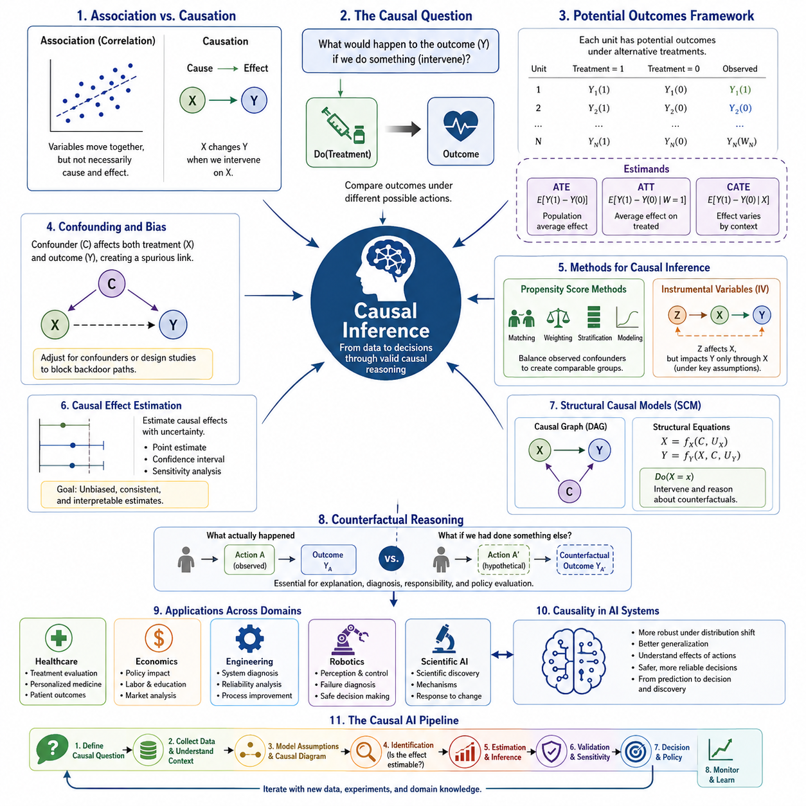
Causal inference is the discipline of reasoning about how changes in one variable produce changes in another. Unlike conventional statistical analysis, which primarily describes patterns of association in observed data, causal inference seeks to answer questions about interventions, mechanisms, and alternative actions. It therefore provides a foundation for moving from prediction toward scientific explanation and decision making.
A central distinction in causal inference is the difference between observing that two variables vary together and establishing that one variable influences the other. Correlation may arise from direct causation, reverse causation, common causes, selection effects, or coincidence. Causal analysis introduces assumptions and formal models that make these possibilities explicit rather than treating predictive association as sufficient evidence.
The fundamental causal question can often be expressed as a comparison between outcomes under different possible conditions. For example, instead of asking whether treatment and recovery are statistically associated, causal inference asks how the outcome for a population would change if treatment were actively assigned rather than withheld. This intervention-oriented perspective separates causal reasoning from ordinary conditional prediction.
One major framework represents causality through potential outcomes. Each unit is conceptually associated with outcomes corresponding to alternative treatments or interventions, although only one of those outcomes can normally be observed. This creates the fundamental problem of causal inference: the causal effect involves a comparison between factual and unobserved counterfactual outcomes that cannot simultaneously be measured for the same unit.
Because individual counterfactual outcomes are unavailable, causal studies commonly estimate effects over populations or meaningful subgroups. Average Treatment Effect (ATE), Average Treatment Effect on the Treated (ATT), and Conditional Average Treatment Effect (CATE) describe different levels of causal effect estimation. These quantities connect formal causal questions with practical evaluation of interventions and heterogeneous responses.
Confounding is one of the principal obstacles to reliable causal estimation. A confounder influences both the variable interpreted as a cause and the outcome being studied, potentially creating a misleading relationship between them. Causal inference therefore requires careful reasoning about which variables should be controlled, which should not be controlled, and whether available observations contain sufficient information for identification.
Randomized experiments provide a powerful mechanism for reducing confounding because treatment assignment can be made independent of many preexisting characteristics. However, experiments may be expensive, unethical, technically impossible, or unavailable in historical datasets. Observational causal inference consequently develops methods for approximating meaningful intervention comparisons when controlled experimentation cannot directly provide the required evidence.
Propensity score methods address observational settings by modeling the probability that a unit receives a treatment given observed characteristics. Matching, weighting, stratification, and related techniques can use this probability to construct more comparable treatment groups. Their usefulness nevertheless depends on assumptions concerning measured confounders, treatment overlap, data quality, and the correctness of the analytical design.
Instrumental variables provide another strategy when important confounding cannot be removed through ordinary adjustment. An instrument affects treatment assignment while influencing the outcome only through the treatment under appropriate assumptions. When a credible instrument exists, it can expose causal variation that would otherwise remain obscured, although finding and validating suitable instruments is often considerably harder than performing the statistical estimation itself.
Causal effect estimation is therefore not simply another prediction problem. A highly accurate predictive model may exploit correlations that disappear when the environment, policy, treatment, or operating condition changes. Causal models instead attempt to represent relationships that remain meaningful under intervention. This distinction becomes especially important when AI systems are expected to recommend actions rather than merely forecast observations.
Structural causal models extend this reasoning by representing variables and causal relationships through structural equations and directed causal graphs. Such representations make assumptions about causal direction visible and support questions involving interventions, identification, and conditional independence. Within the broader volume structure, causal inference therefore serves as the conceptual foundation for later structural causal modeling and do-calculus.
Counterfactual reasoning develops the framework further by asking what would have happened under an action different from the one actually taken. These questions are essential for explanation, responsibility, diagnosis, policy evaluation, and intelligent decision systems. Prediction concerns likely future observations, intervention concerns the consequences of deliberate actions, and counterfactual reasoning compares reality with alternative hypothetical worlds.
For artificial intelligence, causality offers a path beyond systems that primarily learn statistical regularities from large datasets. An AI system capable of distinguishing causes from correlations can potentially reason more robustly about distribution shifts, interventions, failures, and unfamiliar situations. Causal representation learning and causal deep learning seek to combine these objectives with learned representations and modern neural architectures.
Causal reasoning is particularly relevant to reinforcement learning and embodied intelligence because an agent continuously changes its environment through actions. Observations are not merely passive samples; they are partly consequences of previous decisions. Understanding whether an action caused a state transition, rather than merely preceded it, can support more transferable policies, safer exploration, improved credit assignment, and stronger reasoning about alternative actions.
In robotics and engineering, causal inference can connect sensor observations, operating conditions, control actions, component states, failures, and system-level outcomes. A robot may observe that a navigation error occurs together with wheel slip, localization uncertainty, or poor visibility, but reliable diagnosis requires determining which factors actually contribute to the failure. Causal models can organize these relationships around mechanisms and interventions.
Scientific AI extends this principle from prediction toward discovery. Scientific reasoning seeks not only models that reproduce measurements but also explanations of mechanisms, dependencies, and responses to controlled changes. Causal inference therefore forms an important bridge between machine learning and scientific methodology, complementing data-driven pattern recognition with explicit hypotheses about how systems generate observations and respond to intervention.
The broader objective is not to replace statistical learning but to combine prediction, experimentation, domain knowledge, and causal reasoning within a coherent analytical process. Associations help reveal patterns, predictive models estimate likely outcomes, experiments provide intervention evidence, and causal models organize assumptions about mechanisms. Together these capabilities support AI systems that can increasingly reason about why events occur and what actions may change them.

01.01. Association vs Causation
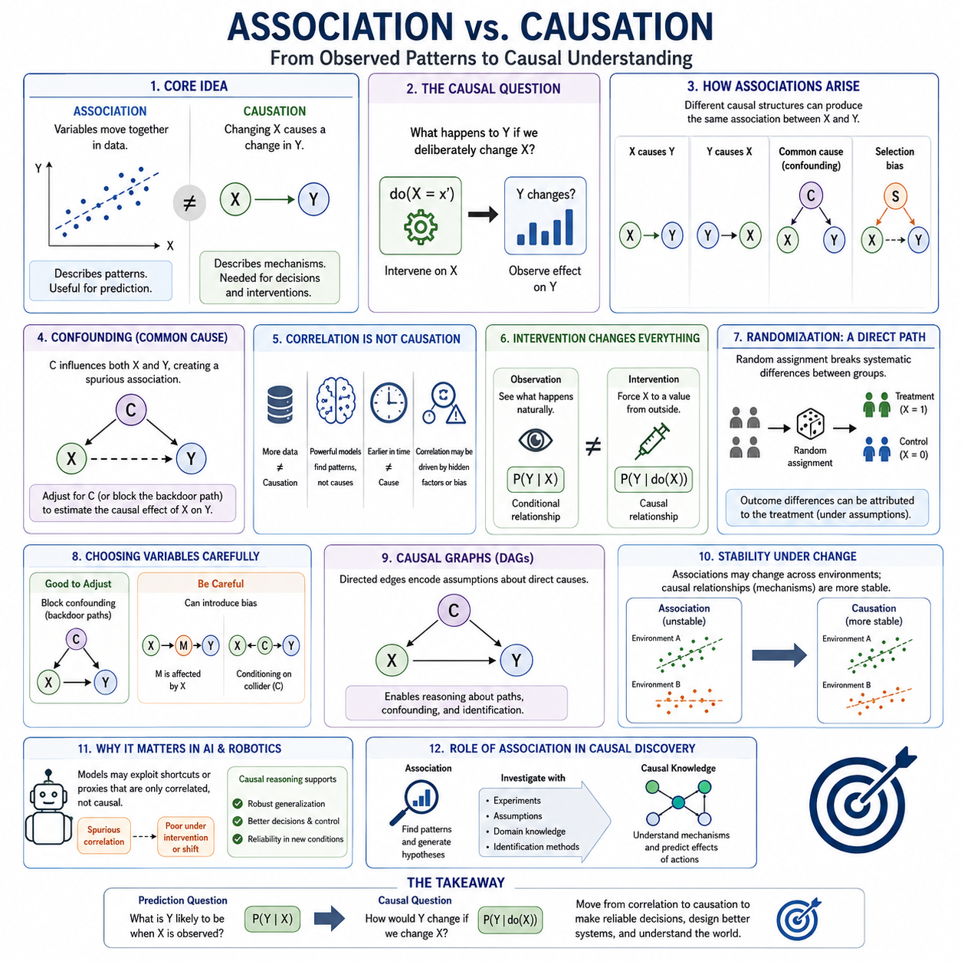
Association describes a statistical relationship between variables, while causation describes a relationship in which changing one variable produces a change in another. Two variables may be strongly associated without either causing the other. This distinction is fundamental to causal inference because predictive patterns alone cannot determine what would happen if a system deliberately intervened on one of the variables.
Statistical association is commonly expressed through quantities such as correlation, conditional probability, regression coefficients, or mutual information. These measures characterize how observations vary together within available data. They can be extremely useful for prediction, pattern discovery, and exploratory analysis, but they do not by themselves specify the mechanism responsible for the observed relationship between variables.
Suppose a dataset shows that variable X is strongly associated with outcome Y. A predictive model may learn P(Y|X) and accurately estimate Y when X is observed. A causal question is different: it asks what would happen to Y if X were deliberately changed. The distinction between observing X and intervening on X is therefore one of the conceptual boundaries separating statistical learning from causal inference.
An observed association can arise through several different causal structures. X may cause Y, Y may cause X, or a third variable C may influence both X and Y. Selection mechanisms, measurement procedures, feedback loops, and sampling processes may also generate statistical dependence. Consequently, identical observational correlations can sometimes be compatible with fundamentally different explanations of how the underlying system operates.
Confounding provides a particularly important example. Imagine that C influences both treatment X and outcome Y. Observational data may then show a relationship between X and Y even when part or all of that relationship originates from C. Simply increasing the amount of observational data does not automatically solve this problem, because more samples can estimate the same confounded association with greater statistical precision.
This limitation illustrates why correlation does not become causation merely because the dataset is large or the predictive model is powerful. Deep neural networks, ensemble methods, and foundation models can identify extremely complex dependencies, yet those dependencies remain observational unless additional causal assumptions or experimental information are introduced. Model capacity improves pattern learning but does not independently establish causal direction.
Reverse causation creates another difficulty. If X and Y are associated, analysts may assume that X influences Y when the actual mechanism operates primarily from Y to X. For example, a system condition may cause both a diagnostic response and subsequent corrective behavior, making the behavior appear associated with the condition. Temporal ordering can provide useful evidence, but occurring earlier does not automatically establish causation.
A causal interpretation becomes stronger when the analysis explicitly considers interventions. Instead of asking whether Y differs among naturally occurring values of X, the question becomes whether Y would change if an external action forced X to a particular value while the relevant causal structure remained otherwise intact. This intervention-oriented formulation provides the conceptual basis for the do-operator and structural causal models developed later in causal analysis.
Randomized controlled experiments offer a direct strategy for separating association from causation. Random assignment attempts to break systematic relationships between treatment and preexisting characteristics, making treatment groups comparable before intervention. Differences in outcomes can then be attributed more credibly to treatment, subject to experimental validity, compliance, measurement quality, sampling, and other assumptions concerning the study design.
Many important causal questions, however, cannot be answered through randomized experiments. Experiments may be unethical, prohibitively expensive, operationally disruptive, or physically impossible. Researchers must then work with observational data and domain knowledge, using assumptions and methods such as adjustment, matching, propensity scores, instrumental variables, natural experiments, or structural causal models to estimate causal effects.
The choice of variables to condition on is especially important. In ordinary prediction, adding informative variables can often improve accuracy. In causal inference, indiscriminate conditioning can introduce bias. Adjusting for a genuine confounder may remove a backdoor source of association, while conditioning on variables affected by treatment or on certain common effects can distort the causal relationship being estimated.
Causal graphs provide a useful language for representing these distinctions. Directed edges can encode assumptions about which variables directly influence others, allowing analysts to reason about causal paths rather than relying only on numerical correlations. A graph containing C → X, C → Y, and X → Y, for example, explicitly distinguishes the causal effect of X on Y from the noncausal association transmitted through C.
Association and causation also differ in their behavior under environmental change. Predictive relationships learned in one dataset may fail when policies, populations, operating conditions, or data-generation processes change. A feature that was previously correlated with an outcome may cease to be informative. Causal relationships that correctly represent underlying mechanisms can potentially provide more stable knowledge across such distribution shifts.
This issue is particularly important in artificial intelligence because many machine learning systems are optimized to minimize prediction error rather than discover causal structure. A model may exploit shortcuts, proxies, background features, or historically stable correlations without understanding why they predict the target. Such systems can perform impressively within their training distribution while failing unexpectedly when deployed under interventions or novel conditions.
In robotics, the distinction becomes concrete because the agent acts upon the world. A robot may observe that localization uncertainty is correlated with navigation failure, but this does not establish whether uncertainty caused the failure, whether difficult terrain caused both, or whether another sensor problem produced the observed relationship. Effective diagnosis and control require reasoning about which intervention would actually change the resulting system behavior.
Scientific AI faces the same challenge at a broader level. Discovering that two measured quantities covary may generate a hypothesis, but scientific explanation requires investigating mechanisms and testing how the system responds when relevant factors are manipulated. Association therefore provides evidence and predictive structure, while causal reasoning organizes that evidence into claims about interventions, mechanisms, and consequences.
The practical lesson is not that association is unimportant. Association is often the first signal from which causal hypotheses emerge, and predictive models can reveal structures worthy of investigation. The critical requirement is to avoid silently converting observational dependence into causal claims. Reliable causal inference combines data with experimental design, explicit assumptions, domain knowledge, identification strategies, and sensitivity analysis.
For advanced AI, mastering this distinction marks a transition from learning what tends to occur toward reasoning about why it occurs and what would happen after an action. Prediction asks what Y is likely to be when X is observed; causal inference asks how Y would change if X were changed. That conceptual shift provides the foundation for potential outcomes, confounding analysis, causal effect estimation, structural causal models, and counterfactual reasoning.

01.02. Potential Outcomes Framework

The Potential Outcomes Framework provides a formal language for defining causal effects by comparing outcomes that could occur under alternative treatments or interventions. For each unit, such as a patient, customer, machine, or robot, the framework considers multiple possible outcomes corresponding to different treatment conditions. Causality is defined through the contrast between these potential outcomes rather than through observed association alone.
For a binary treatment, let T = 1 indicate treatment and T = 0 indicate control. Each unit i is associated with two potential outcomes: Yᵢ(1), the outcome that would occur if the unit received treatment, and Yᵢ(0), the outcome that would occur without treatment. The individual causal effect is therefore Yᵢ(1) − Yᵢ(0), representing how the intervention would change the outcome for that particular unit.
The central difficulty is that only one potential outcome can normally be observed for each unit. If a patient receives treatment, Yᵢ(1) may be observed, but Yᵢ(0) remains counterfactual. If the patient receives no treatment, the opposite occurs. This impossibility of simultaneously observing both outcomes is known as the Fundamental Problem of Causal Inference and motivates statistical estimation over populations.
Observed outcomes can be expressed as Yᵢ = TᵢYᵢ(1) + (1 − Tᵢ)Yᵢ(0). This equation emphasizes that the dataset contains only the potential outcome corresponding to the treatment actually received. Causal inference must therefore reconstruct meaningful comparisons between observed and missing counterfactual outcomes using experimental design, assumptions, matching, weighting, modeling, or other identification strategies.
A key assumption is consistency, which connects the observed outcome to the corresponding potential outcome under the treatment actually received. Another important idea is treatment exchangeability, often expressed as independence between treatment assignment and potential outcomes after conditioning on relevant covariates. Positivity additionally requires that each treatment option has a nonzero probability within the populations for which causal effects are estimated.
The Average Treatment Effect, or ATE, summarizes the expected causal effect of treatment across the overall target population. It is commonly written as ATE = E[Y(1) − Y(0)] = E[Y(1)] − E[Y(0)]. Rather than describing the effect on a specific individual, ATE answers a population-level question: how much would the average outcome change if the entire population were treated instead of untreated?
ATE is especially useful for evaluating broad policies, treatments, operational strategies, and system-wide interventions. A healthcare study may estimate the average benefit of a therapy across an eligible population, while an engineering analysis may estimate the average reduction in component failure under a new maintenance strategy. Its interpretation depends strongly on the population over which the expectation is defined.
The Average Treatment Effect on the Treated, or ATT, focuses specifically on units that actually received treatment. It can be written as ATT = E[Y(1) − Y(0) | T = 1]. For treated units, Y(1) is observed, while Y(0) must be estimated as the counterfactual outcome that would have occurred had those same units not received treatment.
ATT answers a different question from ATE. Instead of asking what treatment would do across the entire population, it asks whether the treatment benefited the population that actually received it. This distinction matters when treatment assignment is selective. For example, high-risk patients, difficult robotic tasks, or heavily loaded machines may be more likely to receive an intervention than typical members of the overall population.
The Conditional Average Treatment Effect, or CATE, describes how treatment effects vary with observed characteristics. It is commonly defined as CATE(x) = E[Y(1) − Y(0) | X = x], where X represents covariates such as age, environment, system condition, workload, terrain, or sensor quality. CATE therefore moves beyond a single population average and represents heterogeneous treatment effects across contexts.
CATE is particularly important when interventions are not equally effective for every unit. A medical treatment may benefit some patient groups more than others, while a robotic control strategy may improve performance on slippery terrain but provide little benefit on stable surfaces. Estimating CATE allows causal models to identify where, when, and for whom a particular intervention is most effective.
The relationship among ATE, ATT, and CATE illustrates different levels of causal resolution. ATE provides an overall population effect, ATT focuses on the treated population, and CATE describes effects conditional on specific characteristics. These estimands are not interchangeable because they answer different decision questions and may produce substantially different numerical results when treatment effects vary across individuals or environments.
Randomized experiments make estimation of potential-outcome quantities relatively straightforward because random assignment tends to balance potential outcomes and covariates between treatment groups. In observational settings, however, treatment assignment may depend on characteristics that also influence outcomes. Methods such as propensity score matching, inverse probability weighting, regression adjustment, and doubly robust estimation are therefore used to approximate comparable groups.
The Potential Outcomes Framework also clarifies why prediction and causal estimation are different tasks. A predictive model estimates likely outcomes given observed variables, whereas a causal model estimates how outcomes would change under alternative interventions. Accurate prediction of Y does not guarantee accurate estimation of Y(1) − Y(0), because predictive variables can include associations that do not represent manipulable causal relationships.
In artificial intelligence, potential outcomes provide a useful framework for evaluating actions, policies, recommendations, and adaptive decisions. An AI system can conceptually compare expected outcomes under different actions before choosing one. In reinforcement learning, healthcare AI, economics, recommendation systems, and autonomous robotics, this perspective supports reasoning about the consequences of alternative decisions rather than merely forecasting observations.
For robotics, ATE might estimate the average effect of introducing a new navigation controller across all operating environments, ATT could measure its effect specifically on robots or missions where the controller was actually deployed, and CATE could reveal how effectiveness changes with terrain, speed, payload, weather, or localization uncertainty. These distinctions support context-sensitive deployment and safer control decisions.
The broader significance of the Potential Outcomes Framework is that it defines causal effects through explicit comparisons between alternative worlds. Observed data provide only one realized outcome, while causal reasoning requires estimating what would have happened under another action. ATE, ATT, and CATE transform this counterfactual idea into estimands that support population-level evaluation, targeted analysis, personalized decisions, and causal AI systems.

01.03. Confounding and Bias
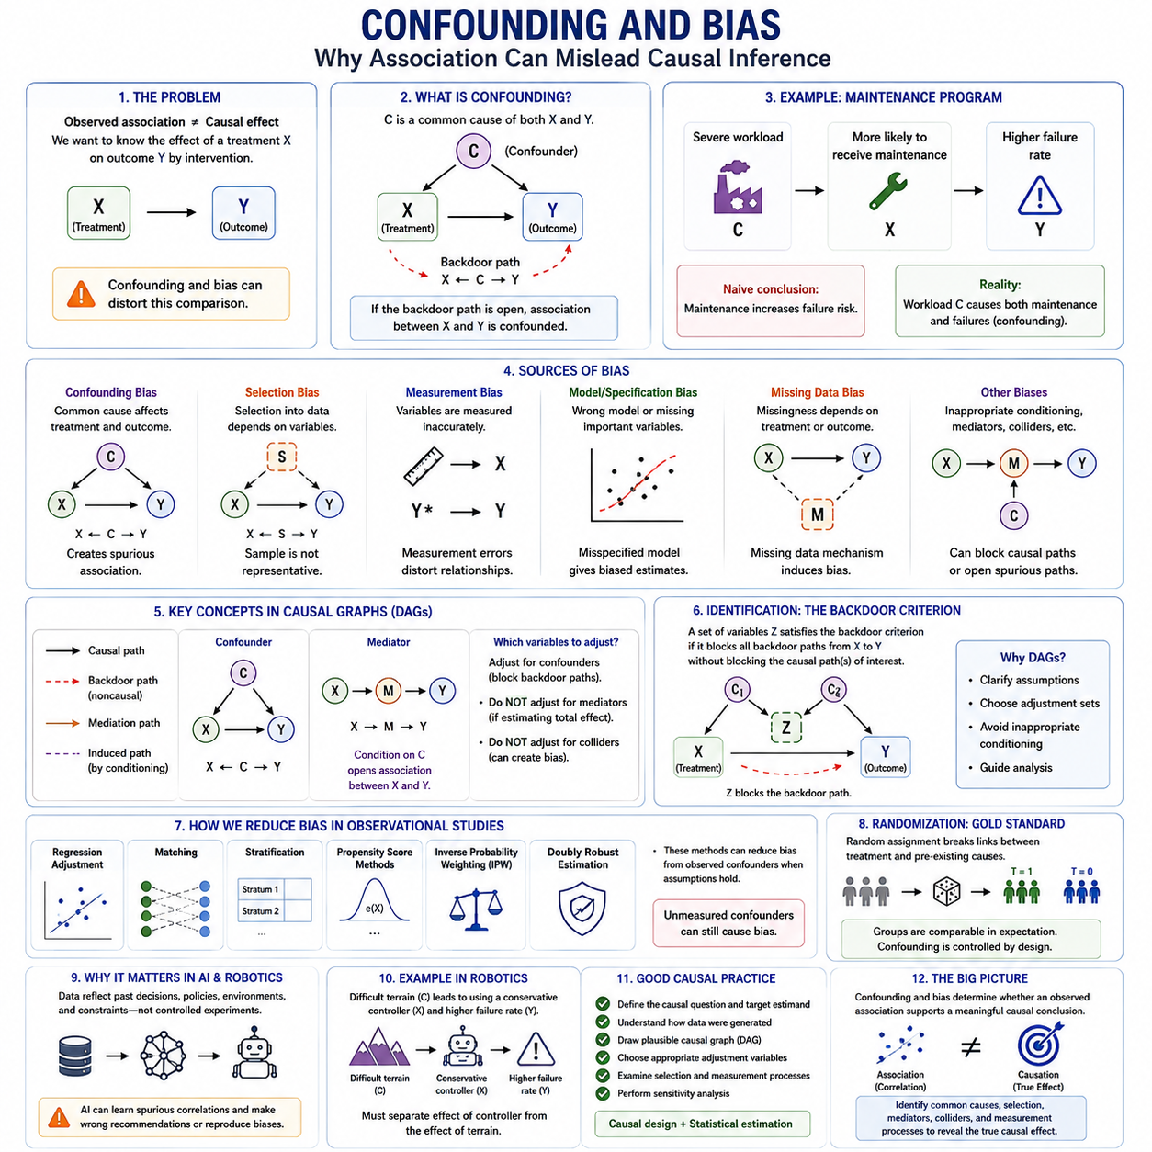
Confounding and bias are central challenges in causal inference because observed relationships do not necessarily represent the effects of interventions. A causal analysis attempts to estimate how an outcome would change if a treatment, action, or exposure were deliberately modified. Confounding and systematic bias can distort this comparison, producing estimates that differ substantially from the true causal effect.
A confounder is a variable that influences both the treatment or exposure and the outcome. Suppose X represents a treatment, Y an outcome, and C a common cause of both. The causal structure C → X and C → Y creates an association between X and Y even without considering any direct effect of X on Y. This noncausal path can contaminate estimates of the treatment effect.
The resulting path X ← C → Y is commonly called a backdoor path. If it remains open, statistical association between X and Y contains both the causal influence transmitted through X → Y and the noncausal association generated through C. Causal adjustment attempts to block appropriate backdoor paths so that the remaining relationship more accurately represents the causal effect of interest.
Confounding explains why simply comparing treated and untreated groups may be misleading. People, machines, environments, or robots receiving an intervention may systematically differ from those that do not receive it. If those differences also affect the outcome, observed group differences combine the treatment effect with preexisting differences. Increasing sample size improves precision but does not automatically remove this structural problem.
Consider a maintenance program applied more frequently to machines operating under severe workloads. If maintained machines subsequently show more failures than other machines, a naive analysis might conclude that maintenance increases failure risk. Workload, however, influences both the probability of receiving maintenance and the probability of failure. Without appropriate adjustment, workload confounds the estimated effect of maintenance.
Bias is a broader concept describing systematic deviation between an estimated quantity and the causal quantity that the analysis intends to recover. Confounding bias is one important form, but causal studies may also suffer from selection bias, measurement bias, missing-data mechanisms, model misspecification, inappropriate conditioning, and other distortions introduced by data collection or analytical decisions.
Selection bias occurs when inclusion in the observed dataset depends on variables related to treatment and outcome. The analyzed sample may then differ systematically from the target population or may contain dependencies created by the selection mechanism itself. This problem is especially important when data are collected only from successful cases, deployed systems, voluntary participants, detected failures, or other selectively observed populations.
Measurement bias arises when treatments, outcomes, confounders, or covariates are measured inaccurately in systematic ways. Sensor calibration errors, inconsistent diagnostic labels, inaccurate self-reports, changing data pipelines, and imperfect proxy variables can alter apparent causal relationships. Large datasets cannot compensate for systematically incorrect measurements when the error mechanism itself changes the relationship being estimated.
Another important source of bias is inappropriate conditioning. In predictive modeling, adding more variables often improves prediction, but causal inference requires greater care. Conditioning on a confounder can remove bias, while conditioning on a mediator may remove part of the causal effect being studied. Conditioning on a collider can create an association that was absent before conditioning and introduce collider bias.
A collider is a variable influenced by two or more variables, as in X → C ← Y. Although X and Y may initially be independent, conditioning on C can make them statistically dependent. This illustrates why causal adjustment cannot be reduced to controlling for every available variable. The correct adjustment set depends on the causal structure and on precisely which causal effect the analysis intends to estimate.
Mediators require a different interpretation. If X affects M and M subsequently affects Y, the path X → M → Y represents part of the mechanism through which X changes Y. Adjusting for M while estimating the total effect of X can block this pathway and produce an estimate of a different causal quantity. Whether a mediator should be controlled therefore depends on the estimand.
Directed acyclic graphs, or DAGs, provide a systematic representation for reasoning about confounding and bias. Nodes represent variables and directed edges encode assumed causal relationships. By examining paths between treatment and outcome, analysts can distinguish causal paths, backdoor paths, mediators, colliders, and potential adjustment variables before applying statistical estimation methods to observational data.
The backdoor criterion formalizes when conditioning on a set of variables can identify a causal effect by blocking noncausal paths from treatment to outcome without improperly blocking the causal pathways of interest. This graphical perspective emphasizes that successful adjustment depends on causal knowledge rather than correlation alone. Statistical algorithms cannot reliably determine the correct adjustment set without sufficient assumptions about data generation.
Randomization provides a powerful defense against confounding because treatment assignment is deliberately separated from preexisting causes of the outcome. In well-designed randomized experiments, treated and control groups are comparable in expectation before treatment. Observational studies lack this guarantee and therefore rely more heavily on measured covariates, domain knowledge, causal assumptions, and appropriate identification strategies.
Common observational approaches include regression adjustment, matching, stratification, propensity score methods, inverse probability weighting, and doubly robust estimation. These techniques can reduce bias caused by observed confounders when their assumptions are satisfied. They cannot automatically eliminate bias from important unmeasured confounders, which is why sensitivity analysis and careful study design remain essential.
Propensity scores summarize the probability of receiving treatment given observed covariates. Matching or weighting units according to these probabilities can improve balance between treated and untreated groups. However, balanced observed variables do not guarantee that unobserved confounders have been balanced. Propensity methods therefore depend on assumptions about which variables have been measured and how treatment assignment occurs.
Confounding is especially important in artificial intelligence because training datasets frequently reflect historical decisions rather than controlled experiments. An AI system may learn relationships produced by previous policies, human selection, operational constraints, or data-collection procedures. If these associations are interpreted as causal mechanisms, the system may recommend interventions that fail when deployed or reproduce biases embedded in historical decision processes.
In robotics, confounding may arise when environmental difficulty influences both control decisions and failure rates. A robot may activate a conservative navigation mode primarily in difficult terrain, causing that mode to appear associated with slower progress or more failures. Causal analysis must distinguish the effect of the controller from the effect of the conditions that caused the controller to be selected.
Reliable causal inference therefore requires more than fitting increasingly accurate statistical models. Analysts must define the causal question, identify the target estimand, understand how data were generated, represent plausible causal relationships, select appropriate adjustment variables, examine selection and measurement processes, and test sensitivity to assumptions. Bias control is fundamentally a problem of causal design as well as statistical estimation.
The broader lesson is that confounding and bias determine whether an observed association can support a meaningful causal conclusion. Data quantity, predictive accuracy, and model complexity cannot substitute for correct causal structure. By explicitly identifying common causes, selection mechanisms, mediators, colliders, and measurement processes, causal inference seeks to transform observational evidence into more reliable knowledge about the consequences of actions.

01.04. Propensity Score Methods [w/Code]
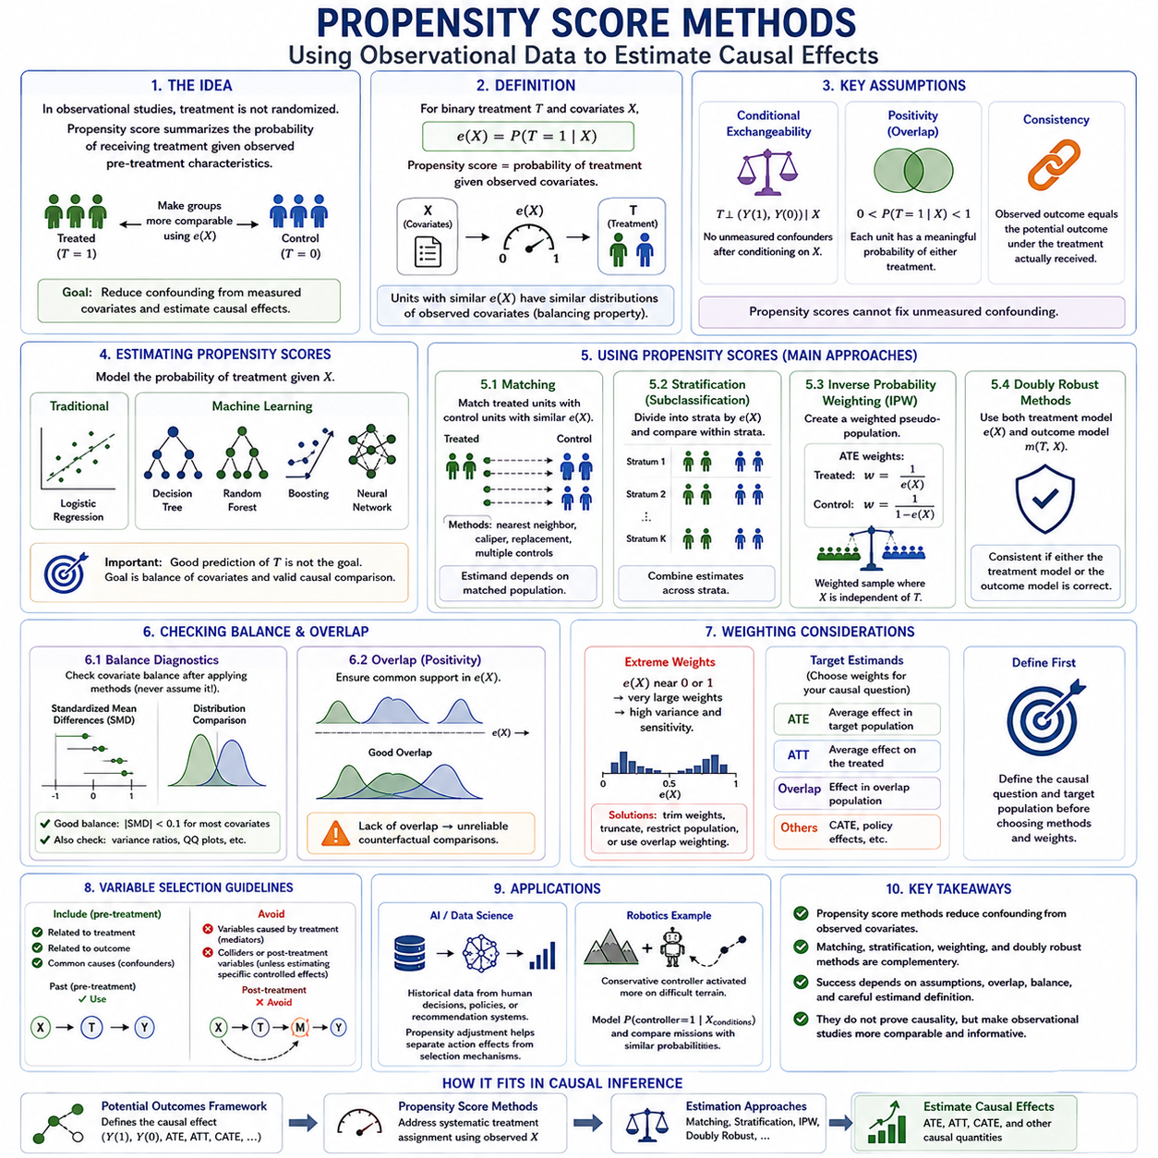
Propensity score methods provide a framework for estimating causal effects from observational data when treatment assignment is not randomized. The propensity score summarizes the probability that a unit receives a treatment given its observed pre-treatment characteristics. By using this probability to construct more comparable treatment and control groups, researchers attempt to reduce confounding caused by systematic differences in measured covariates.
For a binary treatment T and a vector of observed covariates X, the propensity score is commonly defined as e(X) = P(T = 1 | X). Rather than comparing treated and untreated units across many covariates separately, the method compresses information about treatment assignment into a single scalar probability. Units with similar propensity scores should have similar distributions of measured covariates under appropriate assumptions.
The central intuition is to approximate some of the balance produced by randomized experiments. In observational studies, treatment may be preferentially assigned according to age, risk, workload, environmental difficulty, system condition, or previous performance. Directly comparing outcomes can therefore mix treatment effects with these preexisting differences. Propensity score methods seek to balance such observed characteristics before estimating causal effects.
An important property is the balancing property of the propensity score. Conditional on the correctly specified propensity score, the distribution of observed pre-treatment covariates should be similar between treated and untreated units. This does not make an observational study equivalent to a randomized experiment, but it provides a principled mechanism for constructing comparisons that are less confounded by measured characteristics.
Propensity score analysis depends on several important causal assumptions. Conditional exchangeability requires that treatment assignment be independent of potential outcomes after conditioning on the relevant observed covariates. Positivity requires that units within the target population have a meaningful probability of receiving either treatment. Consistency connects observed outcomes with the potential outcome corresponding to the treatment actually received.
The conditional exchangeability assumption is particularly demanding because it effectively requires that all important confounders needed for the analysis have been appropriately measured and included. Propensity scores cannot automatically correct for unknown or unmeasured confounding. A sophisticated propensity model constructed from incomplete causal information may therefore produce excellent statistical balance while still yielding a biased causal estimate.
Propensity scores can be estimated using logistic regression or more flexible machine learning methods such as decision trees, random forests, boosting, and neural models. Predicting treatment assignment accurately, however, is not the ultimate objective. The important goal is to achieve adequate covariate balance and support valid causal comparisons. A treatment prediction model with high classification accuracy can still be unsuitable for causal estimation.
Propensity score matching pairs or groups treated units with untreated units having similar propensity scores. The resulting matched sample attempts to approximate a population in which compared units had similar probabilities of receiving treatment. Matching may use nearest-neighbor rules, calipers, replacement, or multiple controls. The causal estimand depends partly on how the matched population is constructed and which units remain in the analysis.
After matching, balance diagnostics are essential. Analysts should compare the distributions of relevant covariates between treated and control groups rather than assuming that matching succeeded. Standardized mean differences, distributional comparisons, variance ratios, and graphical diagnostics can reveal residual imbalance. Outcome analysis should generally follow satisfactory balance assessment rather than determine how the propensity model is tuned.
Propensity score stratification, also called subclassification, divides units into groups containing similar propensity scores. Treatment and control outcomes are compared within these relatively homogeneous strata and then combined across strata. The approach is conceptually simple and can reduce confounding when sufficient overlap exists, although residual imbalance may remain if strata are too broad or the propensity model is poorly specified.
Inverse probability weighting uses propensity scores to create a weighted pseudo-population. For estimation of the Average Treatment Effect, treated units may receive weights proportional to 1/e(X), while untreated units receive weights proportional to 1/[1 − e(X)]. The weighting procedure attempts to represent a population in which measured covariates are distributed independently of treatment assignment.
Different weighting schemes correspond to different causal questions. Weights can be designed for the Average Treatment Effect, the Average Treatment Effect on the Treated, overlap populations, or other target estimands. Consequently, propensity score analysis should begin by defining the causal question and target population. Choosing a weighting formula before specifying the estimand can lead to a technically correct calculation that answers the wrong question.
Extreme propensity scores create an important practical problem. When e(X) approaches zero for treated units or one for untreated units, inverse probability weights can become very large. A small number of observations may then dominate the estimate, increasing variance and sensitivity to model errors. Trimming, truncating weights, restricting the target population, or using overlap weighting can sometimes improve stability.
The overlap condition is closely connected to positivity. If treated and untreated populations occupy substantially different regions of covariate space, reliable counterfactual comparisons become difficult or impossible. Propensity score distributions should therefore be examined before effect estimation. Lack of common support is not merely a statistical inconvenience; it indicates that the available data contain insufficient comparable observations for certain causal questions.
Propensity scores may also be incorporated into regression adjustment or doubly robust estimators. Doubly robust approaches combine a model for treatment assignment with a model for the outcome. Under appropriate conditions, the causal estimate can remain consistent if either the propensity model or the outcome model is correctly specified. This provides additional protection, although it does not eliminate failures caused by unmeasured confounding or poor causal design.
Variable selection for propensity models should be guided by causal reasoning rather than automated prediction alone. Pre-treatment variables related to the outcome and treatment are often important, whereas variables caused by treatment should generally not be used to remove baseline confounding. Including mediators or inappropriate colliders can change the causal question or introduce bias even when the resulting treatment model appears statistically sophisticated.
In artificial intelligence, propensity score methods are useful when historical datasets contain actions selected by humans, policies, recommendation systems, or previous controllers rather than randomized decisions. The observed outcomes may reflect both the effects of actions and the mechanisms that selected those actions. Propensity-based adjustment can help separate these components when the relevant confounders are measured and sufficient overlap exists.
In robotics, consider a conservative navigation controller that is activated more frequently on difficult terrain. Raw operational logs may associate the controller with slower travel or higher failure rates because challenging conditions influence both controller selection and outcomes. A propensity model can estimate the probability of controller activation from pre-action conditions and support comparisons among missions with similar treatment probabilities.
Propensity score methods therefore do not transform observational data into experimental data, nor do they prove causality by themselves. Their value lies in explicitly modeling treatment assignment and creating more comparable observational groups. Reliable application requires a well-defined estimand, credible confounder selection, sufficient overlap, balance diagnostics, sensitivity analysis, and careful interpretation of the assumptions supporting causal identification.
Within the broader causal inference framework, propensity scores form a bridge between potential outcomes and practical observational analysis. Potential outcomes define the causal effect to be estimated, while propensity methods address systematic treatment assignment using observed covariates. Matching, stratification, weighting, and doubly robust approaches then provide complementary mechanisms for estimating ATE, ATT, CATE-related effects, or other carefully defined causal quantities.

01.05. Instrumental Variables
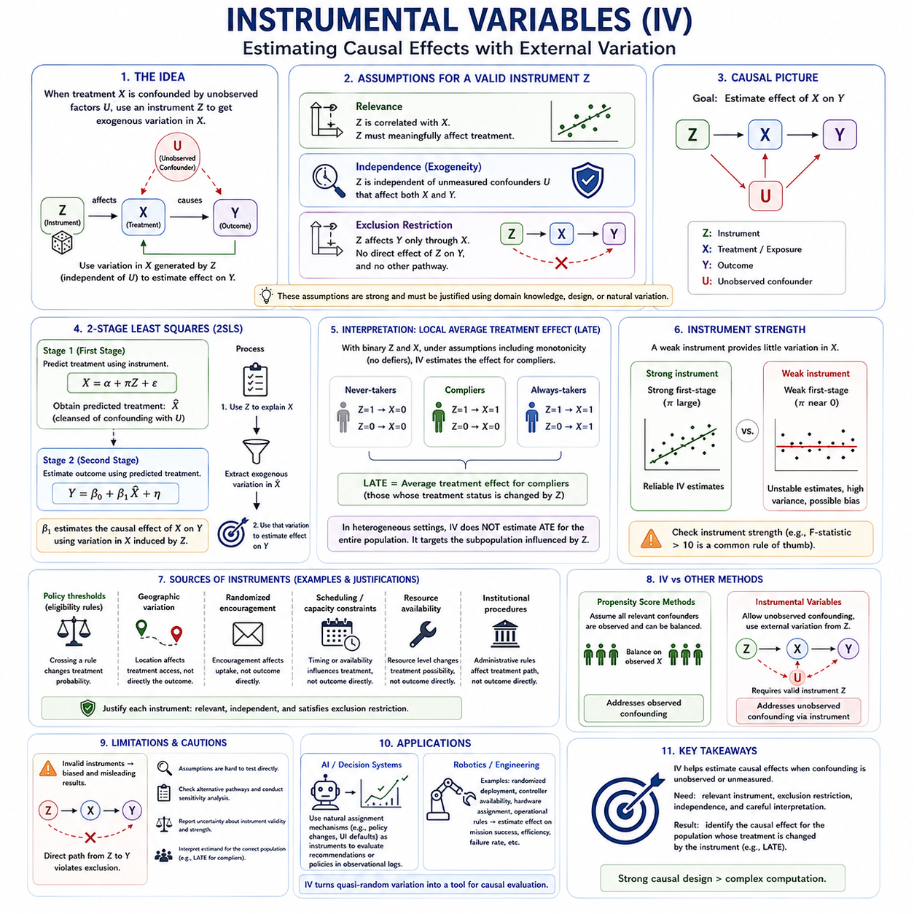
Instrumental variables provide a strategy for estimating causal effects when treatment or exposure is confounded by factors that cannot be fully observed or controlled. Instead of relying only on measured covariates, the method uses an additional variable, called an instrument, that influences treatment assignment while remaining otherwise separated from the outcome-generating process. This makes instrumental variable analysis especially valuable in difficult observational settings.
Let X denote a treatment or exposure, Y the outcome, U unmeasured confounding, and Z an instrumental variable. The basic causal structure is Z → X → Y, while U may influence both X and Y. The purpose of Z is to introduce variation in X that is independent of the confounded pathways represented by U. Causal estimation then uses only the component of treatment variation generated by the instrument.
For an instrumental variable to be valid, it must satisfy several important conditions. First, the relevance condition requires that Z meaningfully affects X. If the instrument has little or no influence on treatment, it provides almost no useful causal variation. Second, the exclusion restriction requires that Z influence Y only through its effect on X, rather than through any separate direct pathway.
A third requirement is independence, sometimes called instrument exogeneity. The instrument should be independent of the unmeasured causes that jointly affect treatment and outcome. In practical terms, Z should behave as though it were assigned independently of important confounding factors. These assumptions are conceptually powerful but often difficult to verify completely from observed data alone.
The exclusion restriction is particularly demanding because many apparently useful instruments may affect the outcome through multiple mechanisms. If Z changes both treatment and some other determinant of Y, then the instrumental variable estimate can be biased. Domain knowledge, experimental design, institutional context, engineering structure, or natural variation are therefore essential for defending the assumption that the instrument operates through treatment alone.
Instrumental variable analysis can be understood as isolating externally generated variation. Observational treatment decisions may be influenced by risk, severity, preferences, environmental difficulty, or hidden system conditions. A valid instrument changes the probability or intensity of treatment without directly carrying those same confounding influences. The resulting variation acts as a quasi-experimental source for estimating causal effects.
A simple linear instrumental variable setting can be expressed through two relationships. The first stage models treatment as a function of the instrument and relevant controls, such as X = α + πZ + ε. The second stage relates the outcome to the predicted treatment generated by the first stage. This two-stage logic forms the basis of two-stage least squares, commonly abbreviated as 2SLS.
In two-stage least squares, the first-stage model estimates the portion of treatment variation explained by the instrument. The predicted treatment values represent variation that is intended to be free from the original confounding between X and Y. The second-stage model then estimates how Y changes with this instrument-induced component of X, rather than with the entire observed treatment variable.
The strength of the first-stage relationship is critical. A weak instrument changes treatment only slightly and can lead to unstable estimates, large uncertainty, and substantial finite-sample bias. Instrumental variable analysis therefore requires explicit assessment of instrument strength rather than assuming that any statistically detectable relationship is sufficient. Weak instruments can make causal estimates less reliable than simpler observational analyses.
When both treatment and instrument are binary, the instrumental variable estimand is often connected to the Local Average Treatment Effect, or LATE. Under additional assumptions such as monotonicity, LATE describes the causal effect among units whose treatment status is changed by the instrument. These units are commonly called compliers, distinguishing them from units whose treatment behavior would not respond to the instrument.
This interpretation is important because an instrumental variable estimate does not necessarily equal the Average Treatment Effect for the entire population. If treatment effects are heterogeneous, IV methods may identify an effect for a specific subpopulation influenced by the instrument. The analyst must therefore carefully distinguish the population targeted by the instrumental variable estimand from broader quantities such as ATE or ATT.
Monotonicity is often introduced to support the LATE interpretation. It requires that the instrument move treatment decisions in a consistent direction rather than causing some units to take treatment while causing others to avoid it. In a binary setting, this assumption rules out so-called defiers. As with exclusion and independence, monotonicity usually relies heavily on substantive knowledge about how the instrument affects behavior.
Natural experiments frequently provide candidate instruments. Policy thresholds, geographic variation, assignment rules, scheduling constraints, randomized encouragement, resource availability, or institutional procedures may influence whether treatment occurs without directly determining the outcome. However, a variable should not be treated as a valid instrument simply because it appears external; each causal assumption must be justified separately.
Randomized encouragement designs illustrate the logic clearly. Individuals may be randomly encouraged to receive a treatment while retaining freedom to accept or reject it. Encouragement can then serve as an instrument for actual treatment if it affects participation, has no direct effect on the outcome other than through treatment, and remains independent of confounders because of randomization.
Instrumental variables are especially useful when unmeasured confounding prevents ordinary adjustment methods from identifying a causal effect. Propensity scores, matching, regression adjustment, and inverse probability weighting primarily address observed confounders. IV methods instead seek a different source of identification by exploiting treatment variation generated by a suitable external variable. The two strategies therefore solve different causal problems.
This does not mean instrumental variables eliminate all modeling challenges. Invalid instruments can produce strongly misleading results, and the required assumptions are often less testable than those used in standard regression. Analysts should examine alternative causal pathways, perform sensitivity analyses, compare multiple plausible specifications, and report uncertainty about instrument validity rather than treating IV estimation as an automatic correction for confounding.
In artificial intelligence, instrumental variables can help analyze historical decision systems in which actions are influenced by unobserved human preferences, hidden policies, or latent environmental factors. A naturally occurring assignment mechanism may create exogenous variation in an action. If the instrument assumptions are credible, that variation can support causal evaluation of recommendations, interventions, or decision policies learned from observational logs.
In robotics and engineering, candidate instruments may arise from scheduling rules, resource allocation, controller availability, randomized software deployment, hardware assignment, or operational constraints. For example, if controller selection is heavily confounded by mission difficulty, a randomized deployment rule could serve as an instrument for controller use and help estimate its effect on mission success without directly manipulating every mission condition.
The main distinction between propensity score methods and instrumental variables lies in how they address confounding. Propensity approaches assume that the relevant confounders have been observed and can be balanced statistically. Instrumental variable methods allow some confounding to remain unobserved but require a credible external source of treatment variation. Choosing between them depends on the available data and causal structure.
Instrumental variables therefore occupy an important position within causal inference. They transform external or quasi-random variation into a tool for estimating treatment effects that would otherwise be obscured by endogeneity and hidden confounding. Their power comes not from complex computation but from strong causal design: a relevant instrument, a defensible exclusion restriction, independence from confounders, and an estimand interpreted for the correct population.

01.06. Causal Effect Estimation [w/Code]
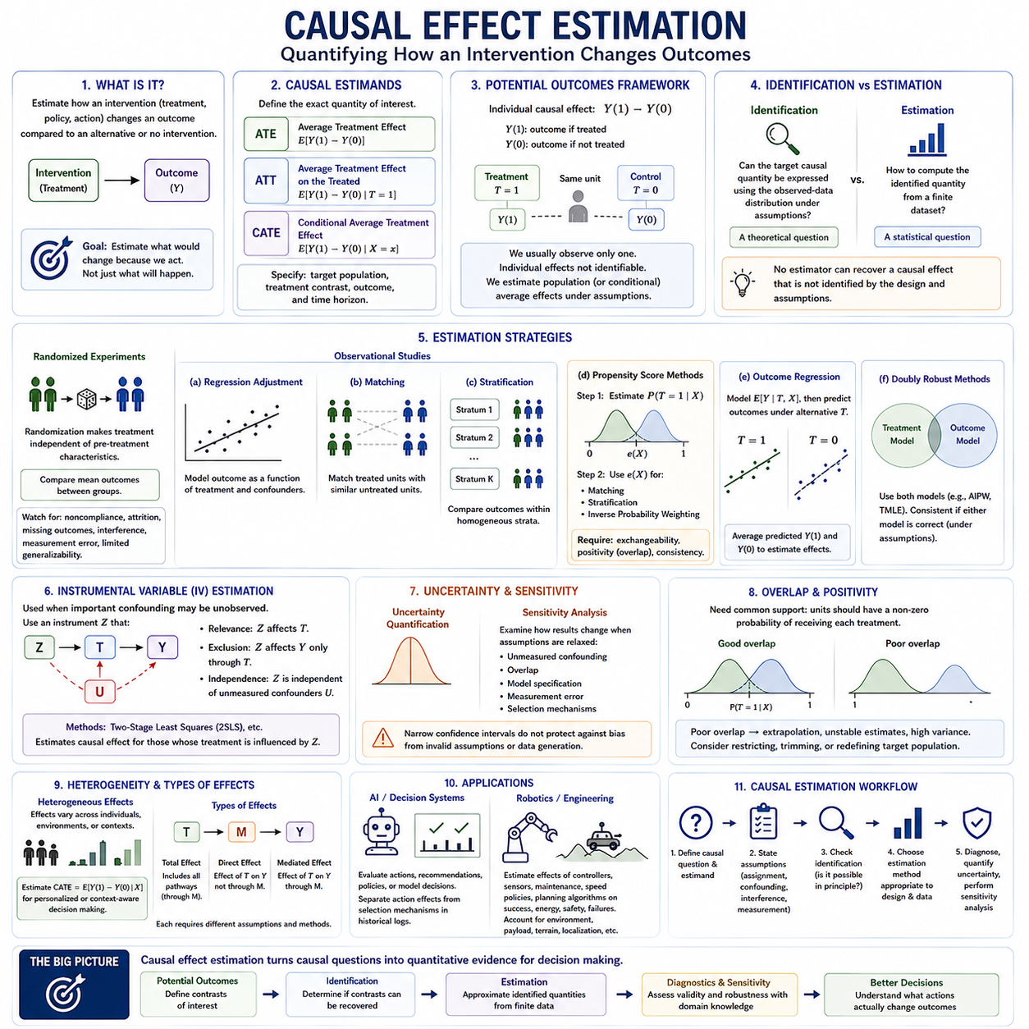
Causal effect estimation is the process of quantifying how an intervention changes an outcome relative to an alternative intervention or no intervention. Unlike ordinary prediction, the goal is not merely to estimate what outcome is likely to occur, but to estimate what would change because a treatment, policy, action, or exposure were deliberately modified. This requires defining a causal estimand before selecting a statistical estimator.
A causal estimand specifies the exact quantity that the analysis seeks to recover. Common examples include the Average Treatment Effect, the Average Treatment Effect on the Treated, and conditional treatment effects for specific subgroups or contexts. Different estimands answer different scientific and operational questions, so causal effect estimation must begin by defining the target population, treatment contrast, outcome, and time horizon.
Within the Potential Outcomes Framework, the individual causal effect is represented by Y(1) − Y(0), where Y(1) denotes the outcome under treatment and Y(0) the outcome under control. Because both potential outcomes cannot normally be observed for the same unit, individual causal effects are generally not directly identifiable. Estimation therefore focuses on population averages or conditional averages under explicit causal assumptions.
Identification and estimation are related but distinct problems. Identification asks whether the desired causal quantity can, in principle, be expressed using the available observed-data distribution under stated assumptions. Estimation asks how to calculate that identified quantity from a finite dataset. No statistical estimator can recover a causal effect that is not identified by the study design and causal assumptions.
Randomized experiments simplify causal effect estimation because treatment assignment is designed to be independent of pre-treatment characteristics. Under proper randomization, the difference in average outcomes between treatment and control groups can estimate an average causal effect. Even then, noncompliance, attrition, missing outcomes, interference, measurement error, and limited generalizability may complicate interpretation.
Observational studies require additional methods because treatment assignment may depend on variables that also affect outcomes. Regression adjustment estimates causal effects after conditioning on measured confounders. Matching constructs comparable treated and untreated units, while stratification compares outcomes within relatively homogeneous groups. These approaches depend on the adequacy of confounder measurement and model specification.
Propensity score methods estimate the probability of treatment from observed pre-treatment covariates and then use this probability for matching, stratification, or weighting. Inverse probability weighting creates a weighted population in which measured covariates are intended to become independent of treatment assignment. These methods estimate causal effects only when assumptions such as exchangeability, positivity, and consistency are sufficiently credible.
Outcome regression provides another major estimation strategy. A model is fitted for the expected outcome as a function of treatment and covariates, and the fitted model is then used to predict outcomes under alternative treatment assignments. By averaging these predicted potential outcomes, analysts can estimate ATE, ATT, or conditional effects. Flexible machine learning can improve modeling but does not remove the need for causal identification.
Doubly robust estimation combines a treatment model with an outcome model. Methods such as augmented inverse probability weighting use information from both components so that, under appropriate conditions, the effect estimate remains consistent when either the propensity model or the outcome model is correctly specified. This additional protection can be valuable, but it does not solve unmeasured confounding or invalid causal assumptions.
Modern causal machine learning methods extend these ideas by using flexible prediction algorithms while attempting to preserve valid causal estimation. Cross-fitting, sample splitting, orthogonalization, targeted learning, causal forests, and related techniques can reduce sensitivity to nuisance-model errors and support heterogeneous effect estimation. Their value lies in separating predictive modeling tasks from the causal estimand of interest.
Instrumental variable estimation addresses a different situation in which important confounding may remain unobserved. A valid instrument generates treatment variation that is independent of those hidden confounders and affects the outcome only through treatment. Estimation methods such as two-stage least squares can then recover a causal effect for the population whose treatment behavior is influenced by the instrument under additional assumptions.
Uncertainty quantification is an essential component of causal effect estimation. A point estimate alone does not indicate how much sampling variation or estimation error is present. Standard errors, confidence intervals, bootstrap procedures, and asymptotic approximations are used to quantify statistical uncertainty. However, narrow confidence intervals do not protect against bias caused by incorrect causal assumptions or data-generation mechanisms.
Sensitivity analysis therefore complements conventional uncertainty estimation. Analysts can examine how conclusions change when assumptions about unmeasured confounding, overlap, model specification, measurement error, or selection mechanisms are weakened. A causal estimate that changes drastically under small departures from assumptions should be interpreted differently from one that remains stable across plausible alternative scenarios.
Overlap and positivity strongly influence estimation quality. When some units have almost no probability of receiving one treatment option, their counterfactual outcomes must be extrapolated from dissimilar observations. This can produce unstable estimates and large variance. Restricting analysis to regions of common support, trimming extreme observations, or redefining the target population may yield more credible causal comparisons.
Treatment effect heterogeneity is another important consideration. A single average effect can hide substantial variation across individuals, environments, or system states. Conditional Average Treatment Effects estimate how causal effects depend on covariates. In healthcare this can support personalized treatment, while in engineering or robotics it can identify operating conditions under which a controller, maintenance policy, or intervention is particularly beneficial or harmful.
Causal effect estimation also requires distinguishing total, direct, and mediated effects. If treatment influences an intermediate variable that subsequently affects the outcome, the total effect includes this pathway. Direct-effect estimation attempts to separate pathways that bypass the mediator. These quantities require different assumptions and adjustment strategies, illustrating why the estimand must be defined before statistical modeling begins.
In artificial intelligence systems, causal effect estimation can evaluate whether actions, recommendations, policies, or model-generated decisions actually improve outcomes. Historical logs often reflect selective decision policies, meaning that observed performance differences may combine action effects with selection mechanisms. Causal estimators provide a framework for separating these components when adequate assumptions and data are available.
In robotics, causal effect estimation can quantify the effect of a navigation controller, sensor configuration, maintenance strategy, speed policy, or planning algorithm on mission success, energy consumption, safety, or failure probability. Environmental difficulty, payload, terrain, and localization quality may influence both action selection and outcome, so raw performance comparisons can be misleading without causal adjustment.
A reliable causal estimation workflow therefore begins with the causal question and target estimand, followed by assumptions about treatment assignment, confounding, interference, measurement, and data generation. Identification should be established before selecting an estimator. Estimation methods are then chosen according to the study design, available covariates, overlap, sample size, and expected treatment-effect heterogeneity.
The broader purpose of causal effect estimation is to convert causal questions into quantitative evidence for decision making. Potential outcomes define the contrasts of interest, identification determines whether those contrasts can be recovered, and statistical estimators approximate them from finite data. When combined with diagnostics, sensitivity analysis, and domain knowledge, causal effect estimation enables more defensible conclusions about what actions actually change outcomes.

01.07. Applications
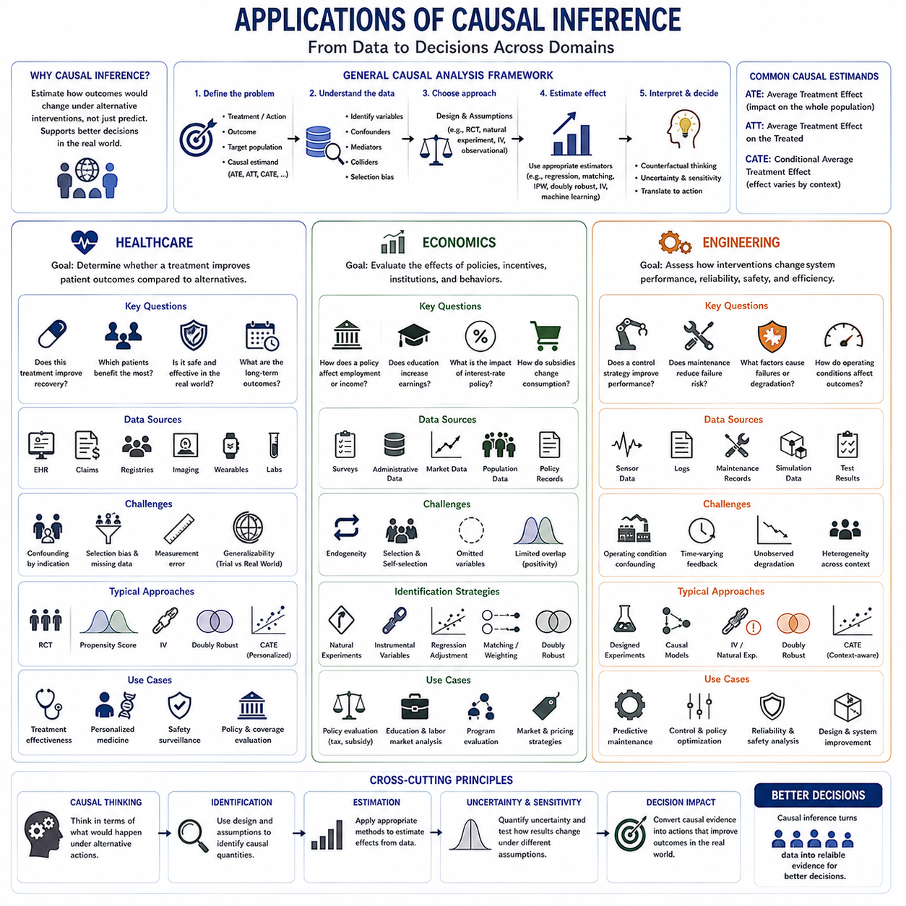
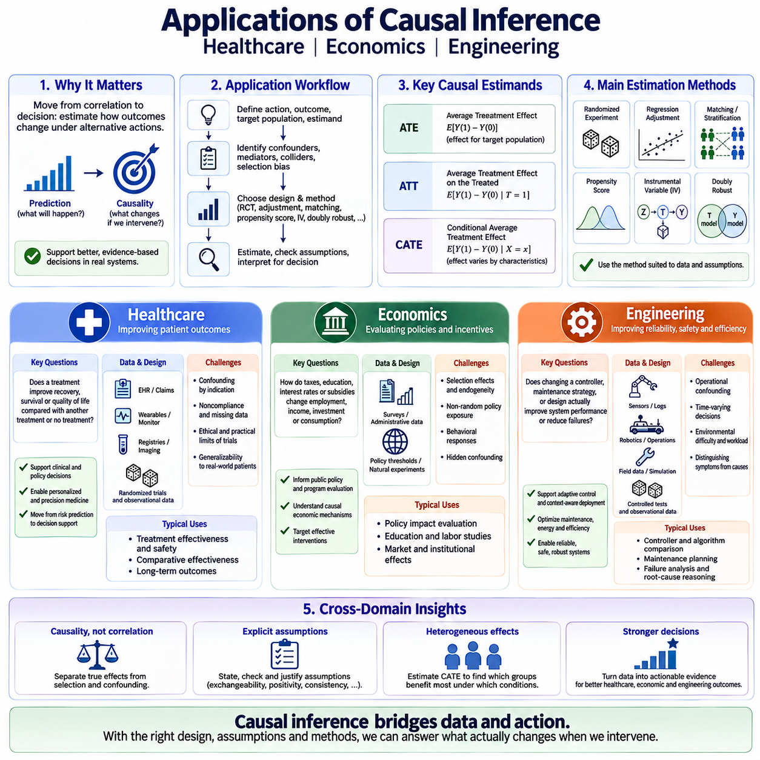
Causal inference becomes most valuable when it is used to support real decisions rather than merely describe statistical relationships. Across healthcare, economics, and engineering, the central objective is to estimate how outcomes would change under alternative interventions. This requires combining domain knowledge, study design, causal assumptions, and appropriate estimation methods instead of relying only on predictive accuracy.
Applications typically begin by defining the treatment or action, the outcome of interest, the target population, and the causal estimand. The analysis must then determine which variables may act as confounders, mediators, colliders, or sources of selection bias. Depending on available data, researchers may use randomized experiments, regression adjustment, matching, propensity scores, instrumental variables, or doubly robust estimators.
In healthcare, causal inference is fundamental because medical decisions are inherently intervention-oriented. Physicians and healthcare systems do not only want to predict whether a patient will recover; they want to know whether a particular treatment will improve recovery compared with another treatment or no treatment. Potential outcomes therefore provide a natural framework for defining treatment effects at individual, subgroup, and population levels.
Randomized controlled trials are often considered the strongest design for estimating medical treatment effects because randomization reduces systematic confounding between treatment groups. However, trials may be costly, slow, ethically constrained, or conducted on populations that differ from real-world patients. Observational healthcare data therefore remain essential for studying effectiveness, safety, treatment utilization, and long-term outcomes.
Electronic health records, insurance claims, registries, imaging systems, wearable devices, and clinical monitoring platforms provide large observational datasets, but treatment assignment in these datasets is rarely random. Patients with more severe disease may receive stronger treatments, for example, creating confounding by indication. Causal methods attempt to distinguish the effect of treatment from the characteristics that caused clinicians to select that treatment.
Average Treatment Effect can estimate the expected impact of applying a treatment across an eligible patient population, whereas Average Treatment Effect on the Treated can evaluate its impact among patients who actually received it. Conditional Average Treatment Effect allows treatment effects to vary with age, disease severity, biomarkers, comorbidities, or other characteristics, supporting personalized and precision medicine.
Propensity score methods can make treated and untreated patient groups more comparable when relevant confounders have been observed. Matching, weighting, and stratification can balance baseline characteristics before outcomes are compared. Instrumental variable approaches may be considered when important confounding remains unmeasured and a credible external source of treatment variation can be identified.
Healthcare AI can combine prediction with causal estimation to move from risk assessment toward decision support. A predictive model may identify patients with high probability of deterioration, while a causal model asks which intervention would actually reduce that risk. This distinction is critical because a variable that predicts poor outcomes is not necessarily a variable whose manipulation will improve those outcomes.
Economics provides another major domain for causal inference because economic questions frequently concern the effects of policies, incentives, institutions, and behavioral interventions. Researchers may ask how taxation affects employment, how education changes earnings, how interest-rate policies influence investment, or how subsidies alter consumption. Such questions cannot be answered reliably by correlation alone because policy exposure is rarely assigned randomly.
Economic data often contain strong selection effects and endogeneity. Individuals choose education, firms choose investments, governments select policies, and consumers respond to prices based on information that may also influence outcomes. Consequently, observed differences between groups may reflect both the causal effect of an economic intervention and the underlying processes that determined who received or selected that intervention.
Natural experiments are therefore especially important in economics. Policy thresholds, regulatory changes, geographic boundaries, institutional rules, or unexpected external events can generate variation that resembles experimental assignment. When the corresponding causal assumptions are defensible, such variation can support estimation of policy effects that would be difficult or impossible to evaluate through randomized experiments.
Instrumental variables have historically been particularly influential in economic applications because they provide a way to address endogeneity and hidden confounding. An instrument can isolate externally generated variation in education, treatment, prices, or policy exposure. However, the resulting estimate must be interpreted carefully because it may correspond to a Local Average Treatment Effect rather than an effect for the entire population.
Causal inference also supports program evaluation and public policy analysis. Governments and organizations can compare alternative interventions not only by observed outcomes but by estimated counterfactual outcomes. This allows analysts to ask what would have happened without the policy, whether observed improvements were actually caused by the intervention, and whether effects differed across regions, industries, income groups, or demographic subpopulations.
Modern economic applications increasingly incorporate machine learning into causal estimation. Flexible models can capture nonlinear relationships and heterogeneous treatment effects, while causal methods constrain interpretation around explicit interventions. Causal forests, orthogonal estimation, cross-fitting, and related techniques can help identify which groups respond differently to policies while reducing sensitivity to predictive model misspecification.
Engineering applications translate causal inference into the analysis of physical systems, operational processes, maintenance strategies, control policies, and system failures. Engineers frequently observe correlations among sensor readings, operating conditions, faults, interventions, and performance outcomes. The causal question is whether changing one of these factors will actually alter reliability, safety, efficiency, or system behavior.
Maintenance provides a clear example. Machines operating under severe conditions may receive maintenance more frequently while also experiencing more failures. A naive analysis could therefore associate maintenance with increased failure rates. Causal analysis recognizes workload or degradation state as potential confounders and attempts to estimate what would have happened to comparable machines under alternative maintenance strategies.
Causal inference can also support failure analysis and root-cause reasoning. Statistical anomaly detection may identify signals associated with a malfunction, but engineering decisions require determining which components, environmental conditions, or control actions actually contributed to the failure. Causal models can help distinguish symptoms from causes and evaluate whether modifying a suspected factor would reduce the probability of recurrence.
In control and robotics, causal reasoning is particularly important because actions continuously influence future observations. A navigation controller, speed policy, sensor configuration, or planning algorithm may be selected differently depending on terrain or mission difficulty. Raw operational logs therefore mix the effects of the control strategy with the conditions that caused it to be selected, creating observational confounding.
Causal effect estimation can compare alternative controllers or operational policies after accounting for these differences. Average effects may characterize overall system improvement, while conditional effects can reveal whether a controller performs better only under specific payloads, surfaces, weather conditions, or localization qualities. This supports adaptive control strategies and context-sensitive deployment rather than one-size-fits-all optimization.
Engineering experiments can also combine designed interventions with observational data. Controlled tests may deliberately vary component parameters, control algorithms, or operating loads, while field data provide broader coverage of real-world conditions. Combining experimental evidence, domain knowledge, simulation, and causal modeling can improve both external validity and the ability to reason about mechanisms.
Scientific and industrial AI systems can benefit from the same principles. Predictive models identify patterns, but causal models evaluate actions and mechanisms. In healthcare this means selecting treatments, in economics it means evaluating policies, and in engineering it means choosing controls, maintenance actions, or design changes. Across all three domains, the transition from prediction to intervention is the defining role of causal inference.
The broader application framework therefore connects causal questions to decisions that can change real systems. Healthcare focuses on treatments and patient outcomes, economics on policies and behavioral responses, and engineering on interventions within physical and operational systems. Despite their differences, all three domains require explicit estimands, credible assumptions, appropriate identification strategies, and careful interpretation of counterfactual comparisons.

