Volume 46. Causality and Scientific AI

Chapter 04. AI for Science

04.00. Overview
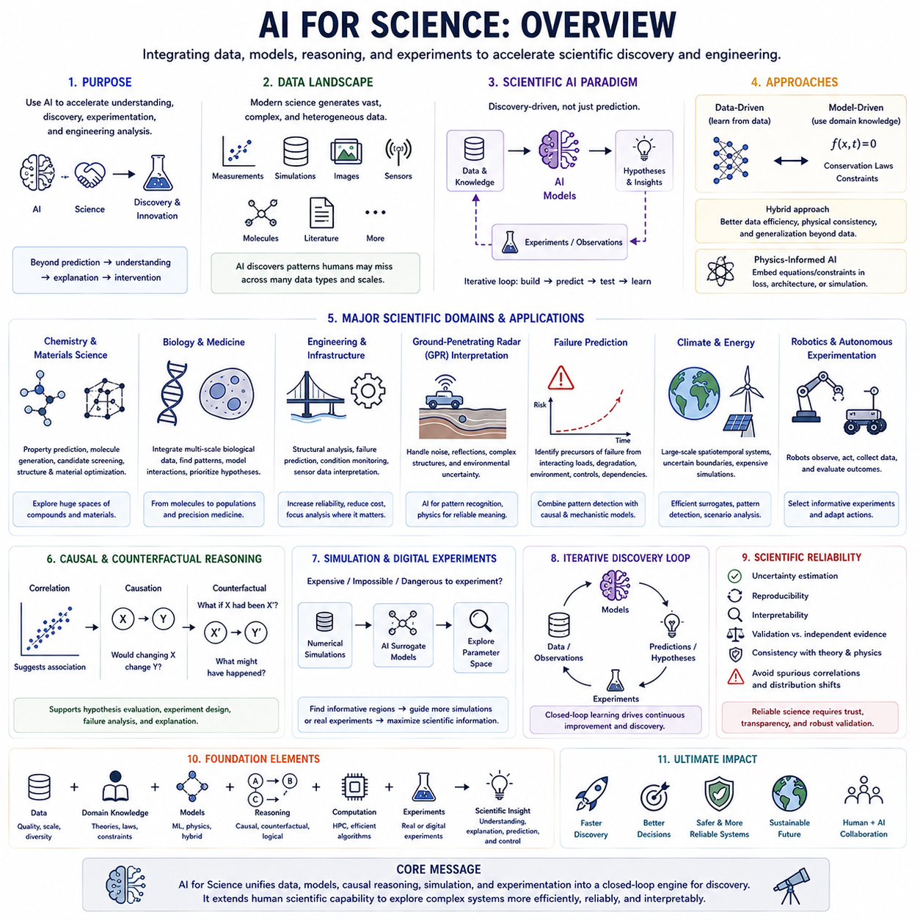
AI for Science refers to the use of artificial intelligence to accelerate scientific understanding, discovery, experimentation, and engineering analysis. Rather than treating AI only as a predictive tool, this field integrates data-driven learning, physical models, causal reasoning, simulation, and domain knowledge to help scientists formulate hypotheses, interpret observations, and explore complex systems more efficiently.
Modern scientific research increasingly produces datasets whose scale, dimensionality, and complexity exceed what can be analyzed effectively through traditional methods alone. AI can discover patterns across experimental measurements, simulations, images, sensor streams, molecular structures, and scientific literature. These capabilities make it possible to investigate relationships that may be difficult to identify through manual analysis or conventional statistical workflows.
A central objective of AI for Science is scientific discovery rather than prediction alone. Scientific models are expected to reveal meaningful relationships, mechanisms, structures, or laws that help explain observed phenomena. AI therefore becomes most valuable when its predictions can be connected to hypotheses, experiments, causal mechanisms, or theoretical constraints instead of remaining isolated numerical outputs.
Scientific AI combines data-driven and model-driven approaches. Data-driven models learn representations and relationships directly from observations, while model-driven approaches incorporate established equations, conservation laws, physical constraints, or mechanistic knowledge. Their combination can improve data efficiency, reduce physically impossible predictions, and provide models that remain meaningful outside narrowly sampled conditions.
Physics-informed AI represents an important bridge between machine learning and scientific modeling. Instead of allowing a neural network to learn arbitrary mappings, physical equations or constraints can be introduced into the training objective, architecture, or simulation process. This enables the model to learn from both observed data and scientific principles, which is particularly valuable when experimental data are limited or expensive.
AI is increasingly used in chemistry and materials science to explore enormous spaces of molecules, compounds, structures, and material configurations. Learned representations can support property prediction, candidate screening, molecular generation, and optimization. When combined with simulation and experimental validation, these methods can shorten the search process from a vast number of possible candidates to a smaller set of scientifically promising alternatives.
Biology and medicine provide similarly complex scientific environments because biological systems operate across molecular, cellular, tissue, organism, and population scales. AI can integrate heterogeneous measurements, identify biological patterns, model interactions, and prioritize hypotheses. Scientific value depends on connecting these patterns to mechanisms and experimental evidence rather than treating statistical prediction as sufficient biological explanation.
Engineering and infrastructure applications extend Scientific AI into systems that must operate under physical constraints and reliability requirements. Structural analysis, failure prediction, condition monitoring, and interpretation of complex sensor data can combine simulation with learned models. AI can reduce computational cost, identify anomalous behavior, and help engineers focus detailed analyses on the most informative components or operating conditions.
Ground-penetrating radar data interpretation illustrates the broader challenge of extracting scientific or engineering meaning from complex measurements. Raw signals may contain noise, reflections, overlapping structures, and uncertain environmental effects. AI can assist with pattern recognition and representation learning, while physical understanding and contextual constraints remain essential for translating detected patterns into reliable interpretations.
Failure prediction is another important application because engineering systems rarely fail through one isolated variable. Failures may emerge from interacting loads, degradation, environmental conditions, control behavior, and component dependencies. AI can identify patterns that precede failure, while causal and mechanistic models help determine which factors are genuine contributors and which are only correlated indicators.
Causal reasoning plays an important role in transforming Scientific AI from pattern discovery toward explanation and intervention. A correlation can suggest where scientists should investigate, but causal models ask whether changing one factor would alter another. Counterfactual reasoning extends this further by examining what might have occurred under different conditions, supporting hypothesis evaluation, experiment design, failure analysis, and scientific explanation.
Simulation provides another foundation for AI-driven science. Numerical models and digital environments can generate large quantities of structured data when physical experiments are expensive, slow, dangerous, or impossible. AI can learn surrogate models that approximate expensive simulations, guide parameter exploration, and identify regions where additional simulation or experimentation would provide the greatest scientific information.
The interaction between AI and experimentation can create an iterative discovery loop. Existing data and scientific knowledge are used to construct models, models generate predictions or hypotheses, and experiments test the most informative possibilities. The resulting observations update the models and refine subsequent hypotheses. Such closed-loop workflows move AI from passive data analysis toward active participation in the scientific process.
Climate and energy research demonstrate the value of integrating large-scale observations with scientific models. These domains involve spatial and temporal systems, interacting physical processes, uncertain boundary conditions, and computationally intensive simulations. AI can provide efficient approximations, detect complex patterns, optimize operations, and support scenario analysis while remaining constrained by scientific knowledge and uncertainty.
Robotics provides another connection between Scientific AI and physical experimentation. Robots can act as autonomous experimental platforms that observe environments, manipulate variables, collect measurements, and evaluate outcomes. Combined with causal reasoning and world models, robotic systems can potentially select informative experiments and adapt their actions according to what previous observations reveal about the underlying system.
A major challenge is scientific reliability. Highly accurate models may still exploit spurious correlations, fail under distribution shifts, violate known constraints, or provide misleading confidence. Scientific AI therefore requires uncertainty estimation, reproducibility, interpretable modeling, benchmark design, validation against independent evidence, and continuous comparison with established theories and physical observations.
The broader goal is not to replace scientific reasoning but to extend its reach. AI can search larger hypothesis spaces, process richer datasets, accelerate simulation, and reveal patterns beyond direct human inspection, while scientific knowledge provides the constraints and interpretation required to make those results meaningful. The strongest systems combine learning, causal reasoning, domain models, experimentation, and human scientific judgment.
Within the structure of AI for Science, these ideas expand into scientific discovery with AI, physics-informed methods, chemistry and materials, biology and medicine, engineering and infrastructure, and the relationship between data-driven and model-driven intelligence. Applications in climate, energy, and robotics demonstrate how these approaches can ultimately support faster, more systematic, and increasingly autonomous scientific discovery.

04.01. Scientific Discovery with AI
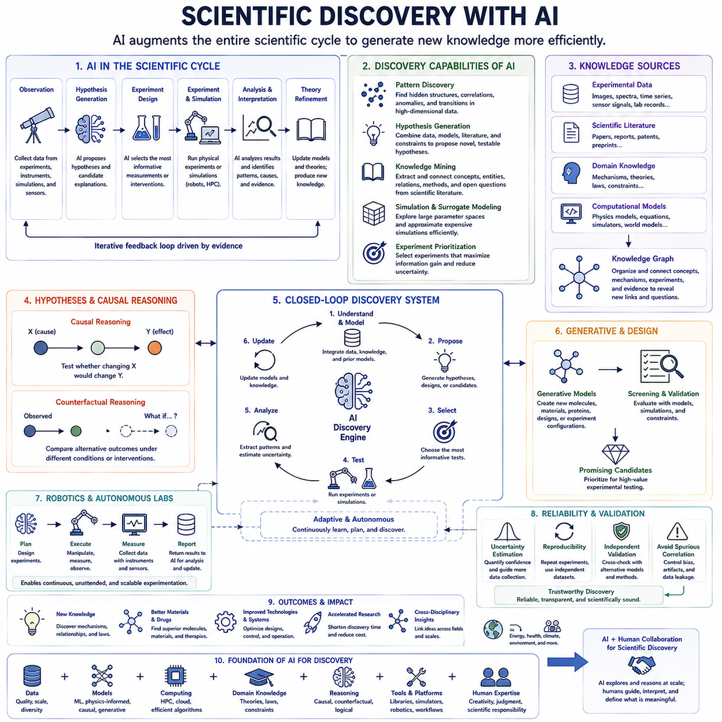
Scientific discovery with AI extends artificial intelligence beyond prediction and automation into the process of generating new scientific knowledge. AI systems can analyze observations, discover hidden structures, propose hypotheses, identify promising experiments, and evaluate competing explanations. Their role is increasingly to augment the scientific cycle by connecting data, models, reasoning, simulation, and experimentation into a more efficient discovery process.
Traditional scientific discovery often begins with observations followed by hypothesis formation, experimental testing, interpretation, and theory refinement. AI can participate in each stage by processing larger datasets and exploring more candidate explanations than researchers can manually examine. This does not eliminate scientific reasoning; instead, it expands the searchable space of patterns, hypotheses, mechanisms, and experimental possibilities.
Pattern discovery is one of the most established contributions of AI to science. Machine learning models can identify relationships in high-dimensional measurements that may be difficult to detect through conventional analysis. Images, spectra, molecular structures, sensor signals, simulation outputs, and experimental records can be transformed into representations that expose clusters, anomalies, correlations, transitions, or previously unrecognized structures.
Scientific discovery, however, requires more than finding statistical patterns. A pattern becomes scientifically meaningful when it can be connected to an interpretable mechanism, reproducible observation, theoretical principle, or experimentally testable hypothesis. AI systems for discovery must therefore move from identifying regularities toward determining which relationships deserve further investigation and what evidence could confirm or reject them.
Hypothesis generation represents a more advanced role for AI. Models can combine existing observations, scientific literature, learned representations, and domain constraints to propose relationships that have not yet been tested. Candidate hypotheses may describe mechanisms, interactions, material properties, biological functions, physical relationships, or explanations for anomalous observations that require further scientific investigation.
The usefulness of automatically generated hypotheses depends strongly on their testability. A hypothesis that cannot produce measurable predictions or distinguish itself from competing explanations provides limited scientific value. AI systems should therefore connect proposed hypotheses to observable consequences, expected measurements, experimental conditions, and criteria that could potentially falsify or support the proposed explanation.
Scientific literature provides another important knowledge source. The volume of published research makes it difficult for individual researchers to continuously integrate findings across disciplines. Language models and knowledge extraction systems can identify entities, relationships, methods, results, and unresolved questions across large document collections, potentially revealing connections between previously separated areas of scientific knowledge.
Knowledge graphs can organize these extracted relationships into structured representations linking concepts, entities, experiments, mechanisms, and evidence. AI can search such graphs for missing relationships, unusual connections, or paths that suggest new hypotheses. When combined with domain expertise, this approach can transform fragmented scientific information into candidate directions for further investigation.
Simulation expands the discovery process by providing virtual environments in which hypotheses can be explored before expensive physical experiments are performed. AI can analyze simulation results, approximate computationally intensive models through surrogate models, and identify parameter regions where unexpected behavior occurs. This allows researchers to explore larger scientific spaces while concentrating physical experimentation on the most informative cases.
AI can also contribute to experimental design by estimating which measurement or intervention would provide the greatest information. Instead of testing candidates uniformly, an intelligent system can prioritize experiments expected to reduce uncertainty, distinguish competing hypotheses, or reveal unexplored regions. Active learning and Bayesian optimization provide computational strategies for selecting informative experiments under limited experimental budgets.
This process naturally leads toward closed-loop scientific discovery. An AI system analyzes existing evidence, proposes hypotheses or candidate configurations, selects experiments, receives new measurements, and updates its internal models. The updated knowledge then determines the next experiment. Repeating this cycle creates an adaptive discovery process in which experimentation is continuously guided by accumulated evidence.
Autonomous laboratories extend the closed-loop concept into physical experimentation. Robotic equipment can prepare samples, manipulate experimental variables, execute measurement procedures, and return results to AI models. When planning, optimization, and laboratory automation are integrated, scientific exploration can proceed continuously while researchers define objectives, constraints, validation procedures, and the scientific interpretation of discoveries.
Causal reasoning becomes important when discovery aims to reveal mechanisms rather than correlations. Observational patterns may suggest relationships, but interventions can determine whether changing one factor produces changes in another. AI systems that combine causal models with experimental design can propose interventions that discriminate between competing causal structures and thereby convert predictive relationships into stronger scientific explanations.
Counterfactual reasoning complements intervention by evaluating alternative possibilities. Scientists may ask whether an observed phenomenon would still have occurred under different initial conditions, parameters, treatments, or environmental states. Counterfactual models allow alternative outcomes to be compared with factual observations, supporting mechanism analysis, hypothesis evaluation, and identification of conditions responsible for particular outcomes.
Generative AI introduces another discovery mechanism by constructing new candidate objects rather than merely evaluating existing ones. In chemistry and materials science, generative models can propose molecular structures or material configurations with desired properties. Similar principles can be applied to proteins, experimental configurations, engineering designs, and other scientific search spaces where the number of possible candidates is enormous.
Generation alone does not constitute discovery because generated candidates must satisfy scientific and physical constraints. Candidate solutions require screening through predictive models, simulations, theoretical checks, or experiments. Effective discovery pipelines therefore combine generation with constraint enforcement, uncertainty estimation, optimization, and validation so that creative exploration remains connected to scientific feasibility.
Representation learning is particularly important when scientific observations are high dimensional. Neural networks can transform complex measurements into latent representations that capture useful structures or factors of variation. For scientific discovery, the challenge is to ensure that these representations correspond to meaningful physical, chemical, biological, or causal properties rather than features that merely improve prediction on a particular dataset.
Discovery systems must also reason about uncertainty. Scientific datasets may be sparse, noisy, biased, or collected under limited conditions, while hypotheses may extend far beyond observed regions. Uncertainty estimation helps distinguish confident predictions from speculative extrapolation and can guide additional measurements toward areas where evidence is insufficient but potentially scientifically valuable.
Reproducibility and independent validation remain essential even when AI produces highly promising discoveries. A discovered relationship may reflect data leakage, experimental artifacts, model bias, or spurious correlations. Results should therefore be tested using independent datasets, alternative models, repeated experiments, and established scientific methods before they are accepted as reliable knowledge.
Human scientists remain central to this process because scientific significance cannot always be reduced to an optimization objective. Researchers determine which questions matter, evaluate whether assumptions are reasonable, recognize conceptual implications, and connect findings with broader theories. AI contributes computational exploration and reasoning capacity, while human expertise provides context, judgment, creativity, and scientific responsibility.
The long-term direction is toward increasingly collaborative and partially autonomous discovery systems. AI may continuously integrate literature, experimental data, simulations, causal models, and robotic experimentation while maintaining multiple hypotheses and selecting informative tests. Scientists can then operate at a higher level, defining objectives and interpreting emerging principles rather than manually exploring every candidate configuration.
Scientific discovery with AI therefore represents a transition from using machine learning primarily to analyze completed experiments toward using AI throughout the discovery cycle itself. By integrating pattern recognition, hypothesis generation, causal reasoning, simulation, experiment selection, generative modeling, and validation, AI can help transform large scientific search spaces into structured pathways toward new knowledge.

04.02. Physics Informed AI [w/Code]
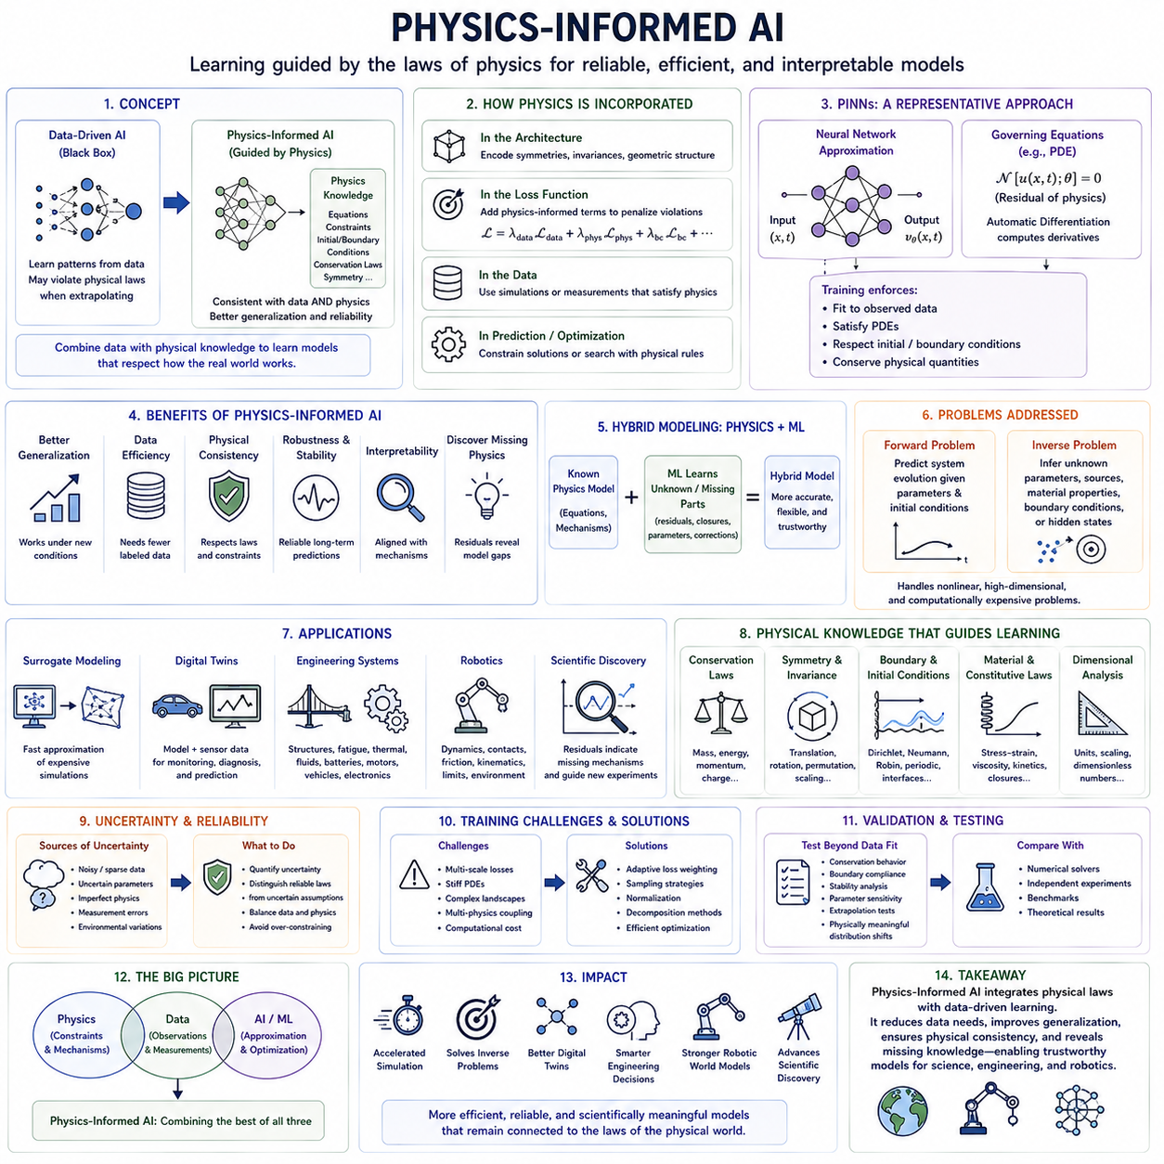
Physics-Informed AI integrates machine learning with established physical knowledge so that learned models are guided by the laws and constraints governing the system being studied. Instead of learning relationships entirely from data, the model incorporates equations, conservation principles, boundary conditions, symmetries, or other scientific knowledge. This creates a bridge between flexible data-driven learning and interpretable model-driven science.
Conventional machine learning typically searches for statistical mappings between inputs and outputs using examples contained in a training dataset. Such models can achieve excellent interpolation performance but may generate physically impossible predictions when observations are sparse or operating conditions change. Physics-informed methods reduce this freedom by restricting learning toward solutions that remain compatible with known properties of the physical system.
Physical knowledge can enter an AI model at several stages. It may be encoded directly into the architecture, introduced as constraints in the loss function, used to generate training data through simulation, or applied during prediction and optimization. The appropriate strategy depends on how much physical knowledge is available, how accurate that knowledge is, and which aspects of the system must still be learned from observations.
Physics-Informed Neural Networks, commonly called PINNs, provide a representative approach. A neural network approximates an unknown physical field or system state while differential equations describing the system are incorporated into the training objective. Automatic differentiation can calculate derivatives of the network output, allowing violations of governing equations to be measured and minimized together with errors against observed data.
A typical physics-informed objective combines several forms of error. Data loss measures disagreement between predictions and observations, while physics loss measures violations of governing equations. Additional terms may enforce initial conditions, boundary conditions, conservation laws, or interface constraints. Training attempts to find model parameters that jointly satisfy empirical evidence and the scientific structure imposed by these different requirements.
Partial differential equations are especially important because many scientific systems are described through spatial and temporal fields. Fluid flow, heat transfer, elasticity, electromagnetism, diffusion, and wave propagation all involve relationships between derivatives across space and time. Physics-informed learning can approximate solutions to such equations while incorporating sparse measurements that help correct unknown parameters or imperfect models.
The relationship between data and physics should not be interpreted as an assumption that physical models are always complete. Real systems may contain unknown forces, unresolved interactions, uncertain parameters, manufacturing variations, or environmental disturbances. Hybrid models can preserve well-understood equations while using machine learning to estimate unknown residual terms, constitutive relationships, closures, or corrections that are difficult to derive analytically.
This hybrid approach is valuable because purely data-driven and purely model-driven systems have complementary weaknesses. Data-driven models may require large datasets and extrapolate poorly, while mechanistic models may become inaccurate when important processes are omitted. Combining them allows scientific knowledge to constrain the solution space while observations compensate for limitations in the available theory.
Conservation laws provide particularly strong forms of physical information. Energy, mass, momentum, charge, and other conserved quantities impose relationships that valid predictions should respect. Embedding these constraints can prevent a learned model from producing trajectories that appear statistically plausible but violate fundamental system behavior, improving reliability in long-horizon prediction and simulation.
Symmetry and invariance can also guide learning. Many physical laws remain unchanged under translations, rotations, permutations, or other transformations. Architectures designed to respect these properties can avoid relearning equivalent relationships from many different examples. This improves data efficiency and can produce representations that better reflect the underlying geometry and structure of the scientific problem.
Physics-informed learning can support both forward and inverse problems. In a forward problem, known physical parameters and initial conditions are used to estimate how a system evolves. In an inverse problem, observations are used to infer unknown parameters, material properties, sources, boundary conditions, or hidden states. AI becomes particularly useful when these inverse relationships are nonlinear, high dimensional, or computationally expensive.
Surrogate modeling represents another major application. High-fidelity numerical simulations may require hours or days of computation for a single configuration. A learned surrogate can approximate the mapping from physical parameters to simulation outcomes much more quickly. Incorporating physics into the surrogate helps maintain plausible behavior while enabling rapid design exploration, uncertainty analysis, optimization, and repeated evaluation.
Digital twins can benefit from the same combination of models and data. A physical model provides the expected behavior of the asset or process, while sensor observations continuously update its estimated state. Machine learning can compensate for unmodeled effects and computational limitations. Physics-informed AI therefore helps connect simulation, sensing, diagnosis, prediction, and operational decision making within a continuously updated representation.
Engineering systems provide numerous applications because their behavior is constrained by mechanics, thermodynamics, electronics, and control theory. Structural deformation, fatigue, thermal management, fluid systems, batteries, motors, vehicles, and robotic mechanisms can all benefit from models that combine sensor observations with physical equations. Such models can support design optimization, condition monitoring, and failure prediction.
Robotics introduces an additional requirement because learned models must remain compatible with physical interaction. Robot motion is constrained by kinematics, dynamics, contacts, friction, actuator limits, and environmental geometry. Physics-informed learning can incorporate these relationships into learned dynamics or world models, reducing physically impossible predictions and improving planning, control, simulation, and adaptation.
Scientific discovery can also benefit when physics-informed models reveal discrepancies between established theory and observation. Persistent residual errors may indicate missing mechanisms, incorrect assumptions, or previously unknown interactions. Instead of treating physics only as a rigid constraint, an intelligent system can analyze where the physical model fails and use those regions to guide hypothesis generation and additional experiments.
Uncertainty remains important because physical knowledge itself may be approximate. Parameters can be uncertain, boundary conditions may be poorly measured, and governing equations may represent simplified descriptions of reality. Excessively rigid constraints can therefore force an AI system toward an incorrect solution. Practical methods should distinguish reliable physical laws from uncertain assumptions and represent confidence in both data and model components.
Training physics-informed models can also be computationally difficult. Multiple loss terms may operate at different numerical scales, differential equations can produce challenging optimization landscapes, and complex systems may contain multiple spatial or temporal scales. Sampling strategies, normalization, adaptive loss weighting, decomposition methods, and improved numerical optimization can therefore be important for stable and accurate learning.
Validation must evaluate more than prediction error on randomly held-out samples. A scientifically useful model should be tested for conservation behavior, boundary-condition compliance, stability, parameter sensitivity, extrapolation, and performance under physically meaningful distribution shifts. Comparison with numerical solvers, independent experiments, and established theoretical results provides stronger evidence than conventional machine-learning accuracy alone.
Physics-Informed AI ultimately represents a broader principle of combining learning with structured scientific knowledge. The objective is not simply to force neural networks to reproduce existing equations, but to allocate different responsibilities appropriately: physics supplies constraints and mechanisms, data reveals unresolved behavior, and AI provides flexible approximation and optimization. Their integration can produce models that are more efficient, reliable, and scientifically meaningful.
Within AI for Science, this approach provides a foundation for connecting scientific theory with modern learning systems. Physics-informed models can accelerate simulation, solve inverse problems, improve digital twins, support engineering analysis, and strengthen robotic world models. More broadly, they demonstrate how AI can move beyond unconstrained statistical fitting toward learning systems whose predictions remain connected to the structure of the physical world.

04.03. Chemistry and Materials
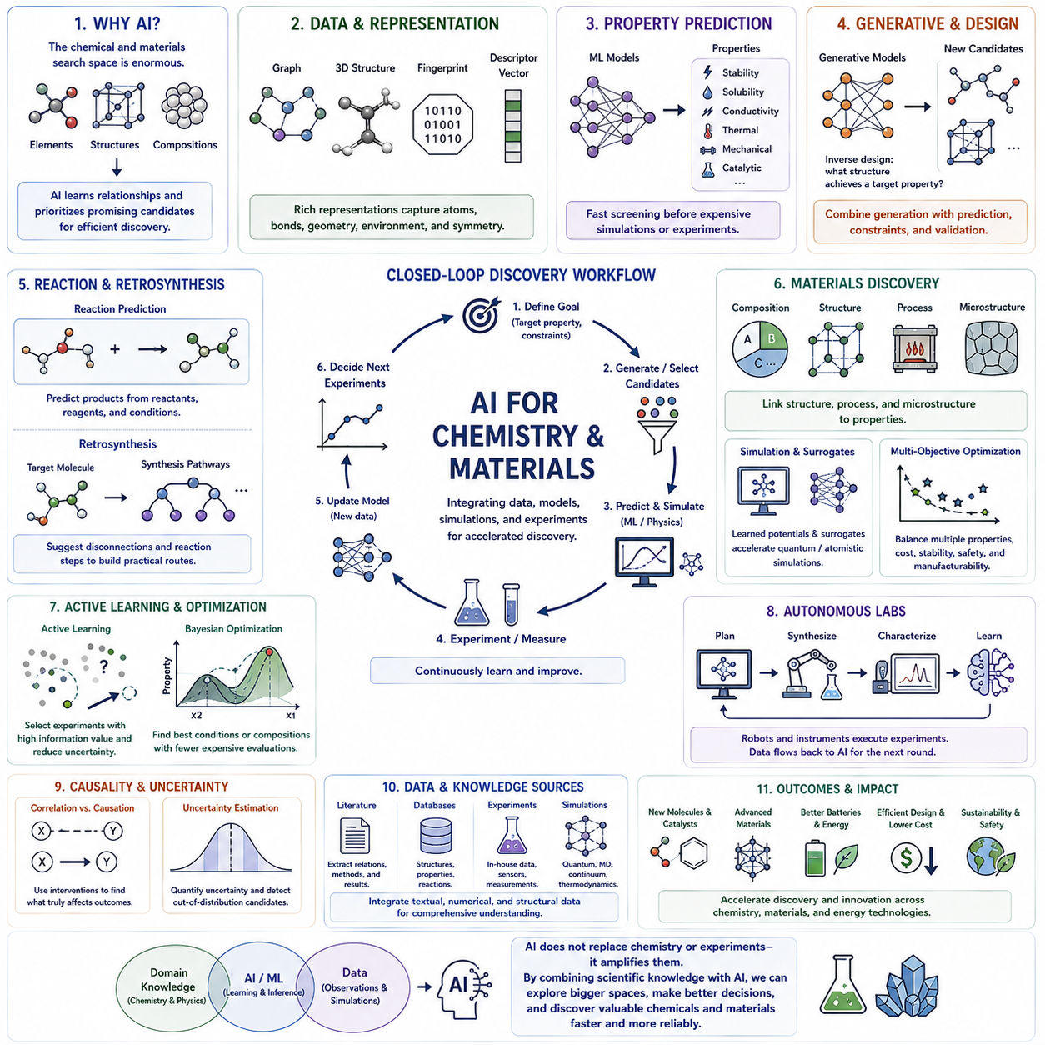
Chemistry and materials science are particularly well suited to AI because their search spaces are extraordinarily large. Even modest combinations of chemical elements, molecular structures, compositions, processing conditions, and crystal arrangements can generate enormous numbers of possible candidates. AI helps researchers navigate these spaces by learning relationships between structure, composition, process, and resulting properties.
Traditional chemical and materials discovery often relies on theoretical understanding, experimental intuition, simulation, and iterative laboratory testing. These methods remain essential, but evaluating candidates one by one can be slow and expensive. AI introduces computational screening and prioritization, allowing researchers to focus experiments and high-fidelity simulations on candidates that are predicted to have scientifically or technologically valuable characteristics.
Molecular representation is a fundamental component of AI-assisted chemistry. Molecules may be represented as graphs containing atoms and bonds, three-dimensional coordinates, fingerprints, strings, or learned embeddings. Different representations capture different aspects of chemical structure. Effective models must preserve information relevant to bonding, geometry, electronic environments, symmetry, and interactions while remaining computationally manageable.
Graph neural networks are especially useful because molecules and many materials naturally possess relational structures. Atoms can be represented as nodes and chemical bonds or spatial relationships as edges. Information is propagated through these structures to learn local and global chemical environments, enabling models to estimate properties without requiring manually designed descriptors for every possible molecular configuration.
Property prediction is one of the most established applications. Machine learning models can estimate quantities such as stability, solubility, conductivity, mechanical strength, thermal behavior, catalytic activity, or electronic properties from molecular or material representations. Fast predictions can serve as filters before computationally intensive quantum calculations, molecular simulations, or physical experiments are performed.
Materials discovery extends this principle from individual molecules to compositions and structures with complex processing histories. A material's final behavior may depend not only on chemical composition but also on crystal structure, defects, interfaces, microstructure, manufacturing conditions, and environmental exposure. AI models can integrate these heterogeneous variables to identify relationships that are difficult to capture with simple empirical equations.
Quantum chemistry provides valuable training signals but is computationally demanding. Electronic-structure calculations can estimate energies, forces, reaction behavior, and molecular properties with high physical relevance, yet their computational cost limits large-scale exploration. Machine-learned surrogate models can approximate selected quantum calculations, enabling much faster evaluation of large candidate spaces while retaining information learned from high-fidelity simulations.
Machine-learned interatomic potentials provide an important example of this strategy. Instead of repeatedly calculating atomic interactions through expensive electronic-structure methods, a learned potential estimates energies and forces from atomic environments. Such models can enable larger and longer molecular or materials simulations, although their reliability depends strongly on the diversity and physical coverage of the training data.
Generative models change the discovery problem from selecting among known candidates to proposing new ones. Models can generate molecular structures, compositions, crystal configurations, or other candidate designs conditioned on desired properties. This inverse-design perspective asks what structure could produce a target behavior rather than only asking what properties an existing structure is likely to possess.
Generated candidates must still satisfy chemical and physical constraints. A mathematically valid representation does not guarantee synthesizability, stability, safety, useful performance, or realistic manufacturing. Effective discovery pipelines therefore combine generation with property prediction, physical simulation, constraint checking, uncertainty estimation, and experimental validation before a proposed candidate can be considered a meaningful discovery.
Reaction prediction provides another major application. AI can learn patterns connecting reactants, reagents, conditions, and products from accumulated reaction data. Such systems may help estimate likely reaction outcomes or propose possible synthesis pathways. However, reliable chemical reasoning must account for reaction mechanisms, selectivity, competing pathways, experimental conditions, and limitations or biases in recorded reaction datasets.
Retrosynthesis reverses the synthesis problem by starting from a target molecule and searching for sequences of reactions that could produce it from available precursors. AI can rank possible bond disconnections and reaction steps, creating candidate synthesis trees. These suggestions can reduce search effort, but practical routes must still be evaluated for feasibility, yield, cost, safety, scalability, and laboratory accessibility.
Catalyst discovery illustrates the importance of connecting structure with mechanism. Catalytic performance can depend on electronic structure, surface geometry, adsorption, reaction intermediates, temperature, pressure, and surrounding chemical conditions. AI can screen potential catalysts and analyze complex relationships, while physics-based simulations and experiments determine whether predicted performance corresponds to the actual reaction mechanism.
Battery and energy materials provide another important domain. Researchers must simultaneously consider energy density, power capability, degradation, thermal stability, cost, availability, manufacturability, and safety. AI can search electrode, electrolyte, interface, and processing spaces while combining experimental measurements with simulations. Multi-objective optimization is especially important because improving one property can degrade another.
Structural and functional materials present similarly coupled design objectives. Mechanical strength, stiffness, toughness, weight, corrosion resistance, thermal behavior, conductivity, and manufacturing constraints may all matter simultaneously. AI-assisted materials design can identify trade-offs and candidate regions in large design spaces, helping researchers move beyond optimizing one isolated property toward balanced material performance.
Scientific literature and materials databases provide additional information for discovery. AI can extract relationships among compounds, properties, synthesis methods, processing conditions, and measured outcomes from large collections of publications and structured datasets. Combining textual knowledge with numerical data and structural representations can reveal candidate connections that may be overlooked when these information sources are analyzed separately.
Active learning can make experimental exploration substantially more efficient. Rather than measuring every candidate, a model estimates both expected performance and uncertainty, then recommends the next experiment expected to provide useful information. New measurements update the model, which selects another candidate. This iterative process concentrates laboratory resources on informative regions of chemical and materials space.
Bayesian optimization provides a related framework when experiments are expensive and the objective is to identify high-performing conditions or compositions with relatively few evaluations. A probabilistic surrogate represents the relationship between design variables and outcomes, while an acquisition strategy balances exploration of uncertain regions with exploitation of candidates already predicted to perform well.
Autonomous laboratories can integrate these ideas into a closed-loop discovery system. AI selects candidate experiments, robotic equipment prepares materials or chemical mixtures, instruments measure the results, and the observations return to the learning system. The model then updates its predictions and chooses subsequent experiments, allowing portions of the discovery process to operate adaptively with reduced manual iteration.
Causal reasoning can further strengthen chemical and materials discovery by distinguishing predictive correlations from variables that genuinely control outcomes. Processing temperature, composition, structure, and measurement conditions may be statistically associated without having equivalent causal roles. Intervention-based experiments can reveal which variables actually change material behavior and help construct more mechanistically meaningful models.
Uncertainty estimation is essential because chemical and materials models frequently encounter candidates unlike those contained in their training data. Predictions far outside the observed chemical space may appear numerically precise while being unreliable. Models should therefore identify out-of-distribution candidates, quantify uncertainty, and direct uncertain but scientifically valuable cases toward higher-fidelity calculations or experiments.
Ultimately, AI transforms chemistry and materials research by connecting prediction, generation, simulation, optimization, and experimentation within a unified discovery workflow. The strongest systems do not replace chemical theory or laboratory science; they use scientific knowledge to constrain learning while AI expands the scale of exploration. This combination can accelerate the search for molecules, catalysts, batteries, structural materials, and functional materials with targeted properties.

04.04. Biology and Medicine
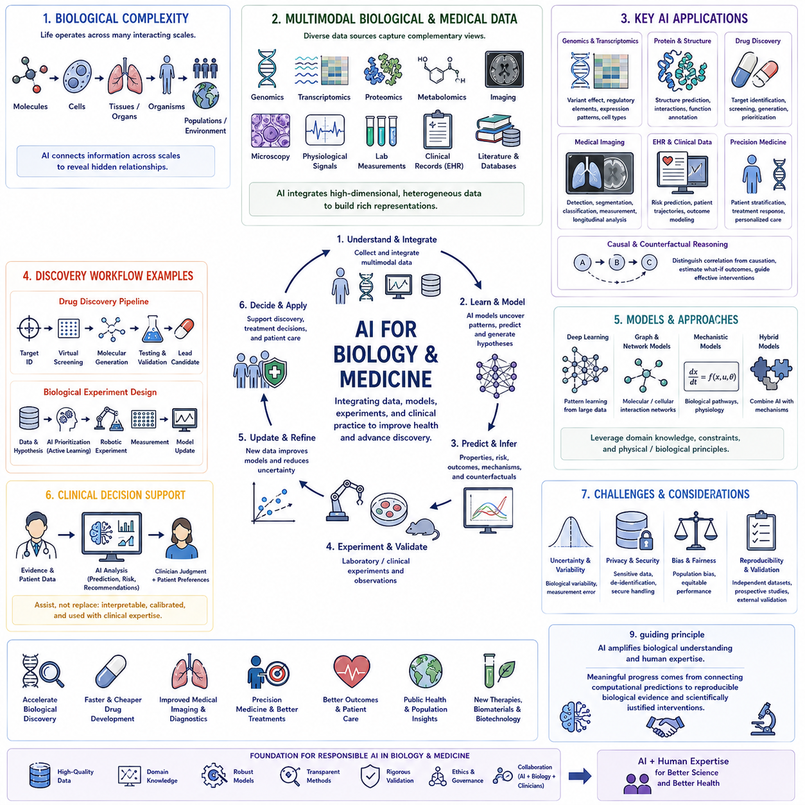
Biology and medicine present some of the most complex environments for AI because living systems operate across many interacting scales. Molecular interactions influence cellular behavior, cells form tissues and organs, organisms interact with environments, and populations exhibit additional patterns. AI can integrate information across these levels to discover relationships that are difficult to identify through isolated experiments or conventional analysis.
Modern biological research generates heterogeneous data from genomics, transcriptomics, proteomics, metabolomics, microscopy, medical imaging, physiological sensors, laboratory measurements, and clinical records. Each source captures a different aspect of biological state. AI provides computational methods for combining these high-dimensional observations and constructing representations that reveal structures, interactions, and potentially meaningful biological patterns.
Genomics is a major application because DNA sequences contain enormous amounts of information related to biological function, regulation, variation, and disease. Machine learning can analyze sequence patterns, identify regulatory elements, estimate functional consequences of genetic variants, and connect genomic differences with observed phenotypes. The challenge is to distinguish genuine biological mechanisms from statistical associations produced by population structure or limited datasets.
Gene expression provides a dynamic view of cellular activity. Transcriptomic measurements can reveal which genes are active under particular conditions, while single-cell technologies expose differences among individual cells that may be hidden in population averages. AI can identify cellular subtypes, developmental trajectories, regulatory relationships, and responses to environmental or therapeutic interventions from these complex datasets.
Proteins represent another fundamental target because their structures and interactions determine many biological functions. AI models can learn relationships between amino-acid sequences, three-dimensional structures, molecular interactions, and functional properties. Structure prediction and representation learning can reduce parts of the experimental search space, while laboratory measurements remain necessary to determine whether predicted structures and interactions correspond to biological behavior.
Drug discovery combines many of these biological and chemical challenges. Candidate compounds must interact with appropriate molecular targets while satisfying requirements involving efficacy, selectivity, toxicity, stability, pharmacokinetics, and manufacturability. AI can support target identification, virtual screening, molecular generation, property prediction, and candidate prioritization, reducing the number of possibilities that require expensive experimental evaluation.
Generative AI can extend drug discovery by proposing molecular structures optimized toward desired characteristics. Instead of screening only existing compound libraries, generative models can explore new regions of chemical space. However, generated molecules must subsequently be evaluated for chemical validity, synthesizability, biological activity, toxicity, and other constraints before they can become scientifically meaningful candidates.
Medical imaging provides a different class of application in which AI extracts information from spatial representations of anatomy and physiology. Radiography, computed tomography, magnetic resonance imaging, ultrasound, microscopy, and pathology images can contain patterns associated with disease or tissue state. Deep learning can assist detection, segmentation, classification, measurement, and longitudinal comparison across large image collections.
AI-assisted imaging should not be understood merely as automated visual recognition. Clinically meaningful interpretation requires information about acquisition conditions, patient context, disease prevalence, uncertainty, and possible confounding variables. A model trained on one hospital or imaging protocol may perform differently elsewhere, making external validation and evaluation under distribution shift essential before conclusions can be generalized.
Electronic health records provide longitudinal information about diagnoses, laboratory tests, medications, procedures, observations, and clinical outcomes. AI can analyze temporal patterns within these records to estimate risks, identify patient trajectories, or support clinical decision processes. Yet medical records are generated through healthcare workflows rather than controlled experiments, so missing data and treatment decisions can introduce substantial bias.
Multimodal AI aims to combine these different biological and medical information sources. A system may jointly analyze imaging, molecular measurements, laboratory values, clinical notes, physiological signals, and demographic variables. Such integration can provide a richer representation of biological state than any single modality, but it also introduces challenges involving synchronization, missing modalities, inconsistent measurements, and differing levels of reliability.
Precision medicine seeks to use individual biological and clinical characteristics to guide prevention, diagnosis, and treatment. AI can identify patient subgroups and estimate how outcomes vary under different therapeutic strategies. The central challenge is not merely predicting who has high risk, but determining which intervention is likely to improve outcomes for a particular patient under clinically realistic conditions.
Causal reasoning becomes especially important at this point. A variable associated with disease does not necessarily cause the disease, and a feature that predicts treatment outcome may not represent an effective intervention target. Causal models can help distinguish biomarkers from mechanisms and can support questions about how outcomes might change if treatments, exposures, or biological processes were deliberately modified.
Counterfactual reasoning extends this approach by considering alternative clinical or biological histories. A system might estimate what could have happened if a different treatment had been administered, if an intervention had occurred earlier, or if a biological factor had been absent. Such reasoning is difficult because the alternative outcome is never directly observed for the same individual and must therefore be inferred from assumptions, models, and available evidence.
Clinical decision support can combine predictive models, causal knowledge, uncertainty, and patient information to assist healthcare professionals. AI may identify relevant evidence, estimate possible risks, or compare treatment alternatives. In high-stakes medical environments, however, recommendations must remain interpretable and appropriately calibrated, with clinicians retaining responsibility for integrating model outputs with examination, patient preferences, and broader medical context.
AI can also support biological experimentation. Models can prioritize genes, proteins, compounds, cell lines, or experimental conditions expected to provide useful information. Active learning can select experiments that reduce uncertainty, while laboratory automation can execute selected procedures. This creates the possibility of closed-loop biological discovery in which models and experiments repeatedly update one another.
Autonomous laboratories could further accelerate portions of this process by combining AI planning with robotic experimentation. Automated platforms can prepare samples, control experimental conditions, collect measurements, and feed results back into learning systems. Researchers can define objectives and constraints while the system explores candidate experiments, although rigorous quality control and scientific validation remain necessary throughout the loop.
Mechanistic modeling provides an important complement to purely data-driven biological AI. Biological pathways, reaction networks, physiological models, and known constraints can provide structure that guides learning. Hybrid approaches can combine these models with machine learning to represent unknown interactions or individual variability, potentially improving interpretability and generalization when data alone are insufficient.
Uncertainty is unavoidable because biological systems exhibit intrinsic variability and medical datasets contain measurement error, incomplete observations, and population differences. AI systems should communicate uncertainty rather than converting uncertain evidence into apparently precise conclusions. Confidence calibration, sensitivity analysis, out-of-distribution detection, and validation across independent populations are therefore essential components of reliable biomedical AI.
Privacy, fairness, and governance introduce additional requirements because biomedical data frequently contain highly sensitive information. Models can inherit biases from datasets that underrepresent particular populations or reflect historical healthcare inequalities. Responsible development requires secure data handling, representative evaluation, transparent validation, and careful assessment of whether performance differences could produce unequal clinical consequences.
Reproducibility remains central to scientific credibility. A biological relationship discovered by AI may arise from batch effects, measurement artifacts, confounding, data leakage, or model-specific behavior. Independent datasets, repeated experiments, prospective studies, and comparison with established biological knowledge are required before computational discoveries can be considered reliable scientific or medical evidence.
The strongest role for AI in biology and medicine is therefore not to replace biological science or clinical judgment, but to connect complex evidence at scales that humans cannot efficiently analyze alone. By integrating molecular data, imaging, clinical observations, mechanistic knowledge, causal reasoning, and experimentation, AI can help researchers formulate better hypotheses and help clinicians interpret increasingly complex information.
Within AI for Science, biology and medicine demonstrate how data-driven intelligence must interact with mechanisms, experimentation, uncertainty, and human expertise. AI can accelerate biological discovery, drug development, medical imaging, precision medicine, and clinical analysis, but meaningful progress depends on connecting computational predictions to reproducible biological evidence and scientifically justified interventions.

04.05. Engineering and Infrastructure
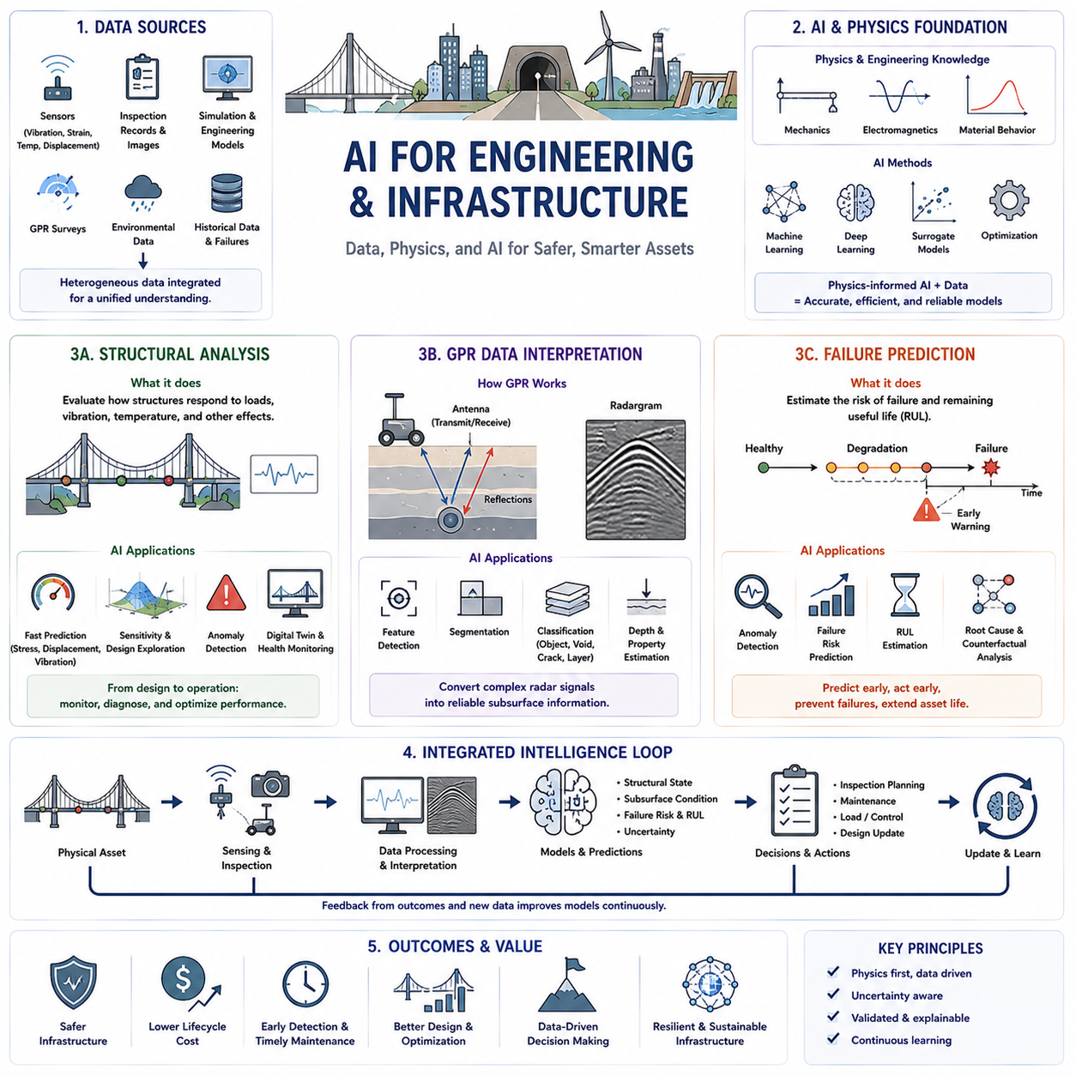
Engineering and infrastructure provide a major domain for AI for Science because physical assets operate under complex combinations of loads, materials, environmental conditions, aging, and human use. AI can combine sensor measurements, engineering models, inspection records, simulations, and historical failures to support structural analysis, subsurface interpretation, and failure prediction while preserving the physical context required for engineering decisions.
Traditional engineering analysis relies heavily on mathematical models, numerical simulation, laboratory testing, field inspection, and established design standards. These methods provide strong physical foundations but can become computationally expensive when structures contain many components, uncertain parameters, nonlinear behavior, or continuously changing operating conditions. AI can complement them by learning efficient approximations and extracting patterns from accumulated engineering data.
Structural analysis evaluates how structures respond to forces, deformation, vibration, temperature, fatigue, and other physical influences. Buildings, bridges, tunnels, industrial facilities, vehicles, and mechanical systems must maintain acceptable behavior across expected operating conditions. AI can assist by connecting structural parameters and measured responses with predictions of stress, displacement, damage, stability, or remaining performance.
Finite element analysis and other numerical methods provide detailed physical simulations but may require substantial computation for large models or repeated parameter studies. Machine-learned surrogate models can approximate selected simulation relationships and evaluate candidate conditions much faster. This enables rapid sensitivity analysis, design-space exploration, uncertainty studies, and optimization while high-fidelity solvers remain available for critical validation.
Physics-informed AI can strengthen structural models by incorporating equilibrium equations, material behavior, boundary conditions, conservation principles, or known mechanical constraints. Rather than allowing a model to learn arbitrary statistical relationships, physical knowledge restricts predictions toward mechanically plausible solutions. Data can then compensate for uncertain material parameters, unknown loads, manufacturing variation, or simplified assumptions in the analytical model.
Structural health monitoring extends analysis from design toward continuous observation of operating assets. Accelerometers, strain gauges, displacement sensors, acoustic sensors, cameras, temperature measurements, and other instruments can provide time-dependent information about structural behavior. AI can detect changes in vibration modes, deformation patterns, or sensor relationships that may indicate deterioration before obvious damage becomes visible.
Digital twins can integrate these measurements with structural models to maintain an evolving representation of an asset. Simulation predicts expected behavior while sensor data correct estimated states and parameters. AI can learn discrepancies between idealized models and actual structures, allowing the digital twin to support inspection planning, anomaly detection, maintenance decisions, and forecasts of future structural condition.
Ground-penetrating radar, or GPR, introduces a different engineering interpretation problem. GPR transmits electromagnetic waves into materials and analyzes reflected signals to infer subsurface structures. It can be applied to roads, bridges, concrete structures, utilities, geological environments, and other infrastructure where important features or defects are hidden below surfaces and cannot be inspected directly.
GPR data interpretation is difficult because reflected signals depend on material properties, geometry, moisture, antenna characteristics, depth, interfaces, and environmental conditions. Raw radargrams may contain clutter, noise, overlapping reflections, hyperbolic patterns, and ambiguous structures. Experienced interpretation therefore combines signal characteristics with physical understanding and contextual knowledge about the inspected environment.
AI can assist GPR interpretation by learning representations of radar signals and identifying patterns associated with buried objects, reinforcement, voids, cracks, layer boundaries, moisture, or other subsurface features. Convolutional neural networks and related models can support detection, segmentation, classification, and automated feature extraction, reducing the amount of repetitive manual interpretation required for large surveys.
However, GPR interpretation cannot safely be reduced to image classification alone. Similar visual patterns may arise from different physical causes, while variations in soil, concrete, water content, antenna frequency, and acquisition geometry can change signal appearance. Reliable AI therefore benefits from electromagnetic knowledge, survey metadata, calibration information, simulation, and uncertainty estimates that connect learned patterns with plausible subsurface structures.
Synthetic data can help when labeled field measurements are limited. Electromagnetic simulation can generate radar responses for controlled variations in geometry, materials, defects, and sensor configurations. These simulations provide training examples that may be difficult to obtain experimentally. Domain adaptation and validation with real measurements are still necessary because simulated signals cannot reproduce every complexity of field conditions.
Failure prediction connects structural analysis and inspection data with future risk. Engineering failures usually develop through interacting processes rather than a single observable variable. Fatigue, corrosion, wear, overload, thermal cycling, vibration, manufacturing defects, environmental exposure, and control behavior may accumulate over time until the system crosses a critical threshold.
AI can learn temporal patterns that precede failure by analyzing sensor histories, operating conditions, maintenance records, inspection results, and environmental data. Instead of waiting for a fixed alarm threshold to be exceeded, models can recognize combinations of weak signals that collectively indicate degradation. This supports earlier maintenance intervention and more efficient allocation of inspection resources.
Remaining useful life estimation extends failure prediction by estimating how long a component or structure may continue operating before reaching an unacceptable condition. Such estimates depend on current degradation, future loading, environmental exposure, maintenance actions, and uncertainty. AI can combine historical degradation trajectories with mechanistic models to generate continuously updated estimates rather than relying only on fixed service intervals.
Anomaly detection is valuable when actual failure examples are rare. A model can learn normal operating patterns and identify observations that deviate from expected behavior. Not every anomaly represents damage, however, because operating modes and environmental changes can also produce unusual signals. Engineering interpretation must therefore distinguish benign variation from changes that indicate genuine deterioration or emerging hazards.
Causal reasoning can improve failure analysis by separating indicators from mechanisms. A sensor variable may strongly correlate with failure without being responsible for the degradation process. Causal models can represent relationships among loads, environmental conditions, component states, control actions, and observed symptoms, helping engineers identify which factors should be changed to reduce the probability of recurrence.
Counterfactual analysis provides a complementary perspective by asking whether failure would have occurred under alternative conditions. Engineers can examine whether reducing a load, changing a material, modifying maintenance timing, correcting a control action, or eliminating an environmental exposure would have prevented the event. Such reasoning connects failure prediction with root-cause analysis and corrective engineering decisions.
Uncertainty must remain explicit throughout structural analysis, GPR interpretation, and failure prediction. Sensor noise, incomplete inspection coverage, uncertain material properties, changing environments, limited failure data, and model approximation all affect confidence. Probabilistic predictions and calibrated uncertainty can help engineers distinguish well-supported conclusions from cases requiring additional inspection, simulation, or measurement.
The three areas can operate as an integrated infrastructure intelligence loop. Structural models describe expected physical behavior, GPR and other sensing technologies reveal hidden or evolving conditions, and failure prediction estimates future risk. New inspection results update the asset model, predicted risks guide subsequent inspections, and maintenance actions create additional evidence about how the physical system responds.
The objective is therefore not to replace engineering analysis with unconstrained machine learning. Reliable systems combine mechanics, electromagnetic theory, numerical simulation, sensing, historical evidence, causal reasoning, and AI. Physical models provide structure, measurements reveal actual conditions, and learned models provide scalable inference across large datasets and infrastructure networks.
Within AI for Science, engineering and infrastructure demonstrate how scientific AI can connect theory with continuously observed physical systems. Structural analysis provides the mechanical foundation, GPR data interpretation extends perception beneath visible surfaces, and failure prediction converts present evidence into future risk estimates. Together they support safer design, condition-aware maintenance, earlier fault detection, and increasingly predictive infrastructure management.

04.06. Data Driven vs Model Driven AI
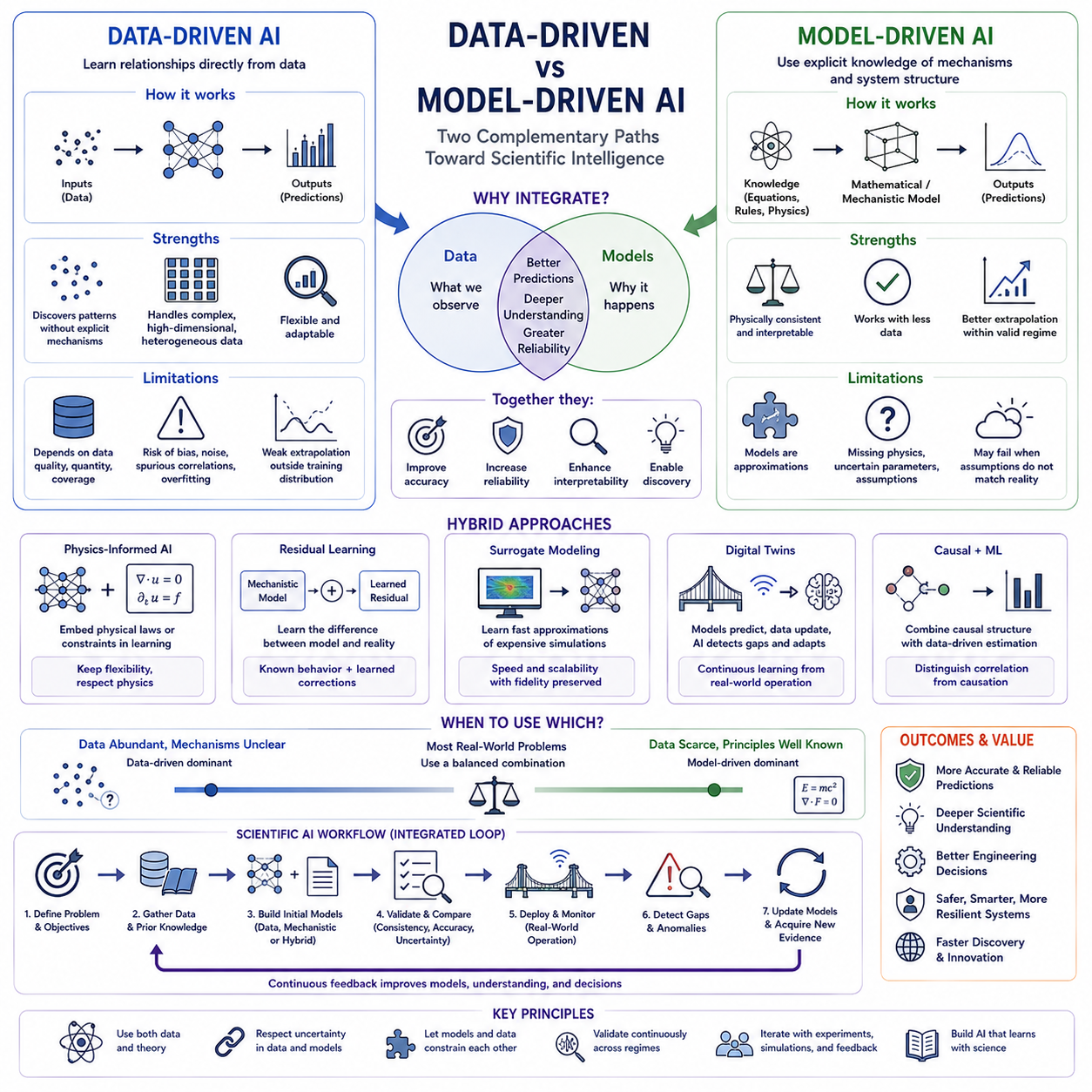
Data-driven AI and model-driven AI represent two complementary approaches to building intelligent scientific systems. Data-driven methods learn relationships directly from observations, while model-driven methods begin with explicit knowledge about mechanisms, equations, constraints, or system structure. Understanding their differences is essential because AI for Science increasingly depends on combining empirical learning with established scientific knowledge.
Data-driven AI assumes that useful relationships can be extracted from sufficiently representative datasets. Machine learning models learn mappings between inputs and outputs without requiring every underlying mechanism to be explicitly specified. Neural networks are particularly effective when relationships are nonlinear, high dimensional, or difficult to formulate analytically, allowing complex behavior to emerge from examples rather than predefined equations.
The strength of data-driven learning lies in flexibility. Models can discover patterns that researchers did not anticipate and can incorporate images, signals, text, sensor streams, experimental measurements, and other heterogeneous information. This makes data-driven AI valuable when physical mechanisms are incompletely understood or when constructing a detailed analytical model would be impractical because the system contains many interacting variables.
However, data-driven models depend strongly on the quality and coverage of their training data. If observations contain bias, noise, missing conditions, or spurious correlations, the learned model may reproduce these weaknesses. Excellent performance within the training distribution does not guarantee reliable behavior under new operating conditions, unusual environments, rare failures, or parameter combinations that were poorly represented during training.
Model-driven AI begins from a different perspective. Instead of learning the entire system from observations, it incorporates prior knowledge about how the system should behave. This knowledge may consist of differential equations, causal structures, conservation laws, geometric constraints, material models, biological pathways, chemical rules, or engineering relationships that define meaningful interactions among system variables.
The principal advantage of model-driven approaches is structural consistency. Predictions are constrained by known relationships and can often be interpreted through mechanisms that scientists or engineers already understand. Such models may require less data because prior knowledge narrows the possible solution space. They can also provide stronger extrapolation when the governing principles remain valid outside the specific conditions represented in available observations.
Yet model-driven approaches have their own limitations. Scientific models are approximations of reality and may omit important interactions, unresolved scales, uncertain parameters, disturbances, manufacturing variation, or changing environmental effects. A theoretically elegant model can therefore produce inaccurate predictions when assumptions no longer match the actual system. Explicit knowledge is valuable only to the extent that its validity and uncertainty are understood.
The distinction can be illustrated through structural engineering. A data-driven model might learn the relationship between sensor signals and structural damage from historical measurements. A model-driven approach might calculate deformation and stress using mechanics and finite element equations. The first learns directly from observed behavior, whereas the second predicts behavior from an explicit representation of structural physics.
Neither approach alone is necessarily sufficient. Historical sensor data may not contain enough examples of severe damage or unusual loading, while a finite element model may not accurately represent aging, unknown boundary conditions, material degradation, or construction variation. A hybrid system can use structural mechanics as a physical foundation while machine learning estimates residual behavior that the analytical model does not adequately capture.
A similar distinction appears in ground-penetrating radar interpretation. A purely data-driven system can learn visual or signal patterns associated with buried objects, voids, reinforcement, or layer boundaries. A model-driven system can use electromagnetic wave propagation and material properties to predict expected reflections. Combining these perspectives can reduce ambiguity by connecting learned patterns to physically plausible subsurface explanations.
Failure prediction also demonstrates the importance of integration. Data-driven models can detect weak statistical patterns preceding degradation, while model-driven approaches represent mechanisms such as fatigue, corrosion, thermal stress, or wear. When these models are combined, observed anomalies can be interpreted relative to known degradation processes, improving both predictive performance and the engineering meaning of the prediction.
Physics-informed AI provides one important hybrid strategy. Physical equations or constraints can be introduced into neural-network architectures, training objectives, or prediction procedures. The model retains the flexibility to learn from observations while being discouraged from producing physically impossible solutions. Data therefore refine the model within a solution space structured by scientific knowledge rather than defining the entire solution independently.
Residual learning provides another hybrid architecture. A mechanistic model first calculates the behavior predicted by known theory, and a learned model estimates the difference between that prediction and actual observations. This decomposition assigns known behavior to established science and unknown behavior to machine learning, making it possible to improve accuracy without discarding the interpretability of the original physical model.
Surrogate modeling offers a different relationship between the two approaches. A computationally expensive model-driven simulator can generate training data, after which a data-driven surrogate learns to approximate its input-output behavior. Once trained, the surrogate can provide much faster predictions for optimization or uncertainty analysis. High-fidelity simulation remains the scientific reference, while machine learning provides computational acceleration.
Digital twins can integrate both approaches continuously. A model-driven representation describes expected physical behavior, while real-time sensor data reveal the actual condition of the system. Machine learning identifies discrepancies, updates uncertain parameters, or predicts unresolved effects. The resulting digital twin evolves through interaction between prior physical knowledge and continuously accumulating operational evidence.
Causal reasoning introduces another form of model-driven structure. Statistical learning can identify variables that predict an outcome, but causal models describe how interventions propagate through a system. Combining causal structure with data-driven estimation allows AI to distinguish predictive indicators from variables whose modification may actually change outcomes, which is critical for scientific experimentation and engineering decision making.
The balance between data-driven and model-driven methods depends on the problem. When abundant representative data exist but mechanisms are poorly understood, data-driven learning may dominate. When observations are scarce but governing principles are well established, model-driven approaches may be more reliable. Many scientific problems lie between these extremes and require different mixtures of empirical evidence and prior knowledge.
Uncertainty should determine how strongly each information source is trusted. Physical equations may be highly reliable in one regime but approximate in another, while measurements may be precise for common conditions but sparse near critical events. Hybrid AI should therefore avoid treating either data or theory as universally correct and instead represent uncertainty associated with observations, parameters, model assumptions, and learned predictions.
Validation must also reflect this combined perspective. Data-driven components should be evaluated for generalization, robustness, and distribution shift, while model-driven components should be tested for assumption validity and parameter sensitivity. Hybrid systems additionally require tests of physical consistency, conservation behavior, extrapolation, uncertainty calibration, and agreement with independent experiments or high-fidelity simulations.
Scientific discovery can emerge from disagreement between the two approaches. When a well-validated data-driven model repeatedly observes behavior that an established model cannot explain, the discrepancy may reveal missing physics, unknown interactions, or incorrect assumptions. Rather than merely correcting prediction error, AI can use these residuals to identify regions where existing scientific understanding requires further investigation.
The relationship between data-driven and model-driven AI is therefore not a competition between modern machine learning and traditional scientific modeling. They provide different forms of knowledge. Data describe what has been observed, while models encode hypotheses about why systems behave as they do. Intelligent scientific systems become stronger when these sources constrain, correct, and inform one another.
For AI for Science, the long-term direction is toward adaptive hybrid intelligence that dynamically combines data, models, simulation, causal knowledge, and experimentation. Such systems can begin with established scientific principles, learn unresolved behavior from observations, detect when assumptions fail, request additional evidence, and update their representations. This integration moves AI beyond statistical prediction toward scientifically grounded reasoning and discovery.

04.07. Applications
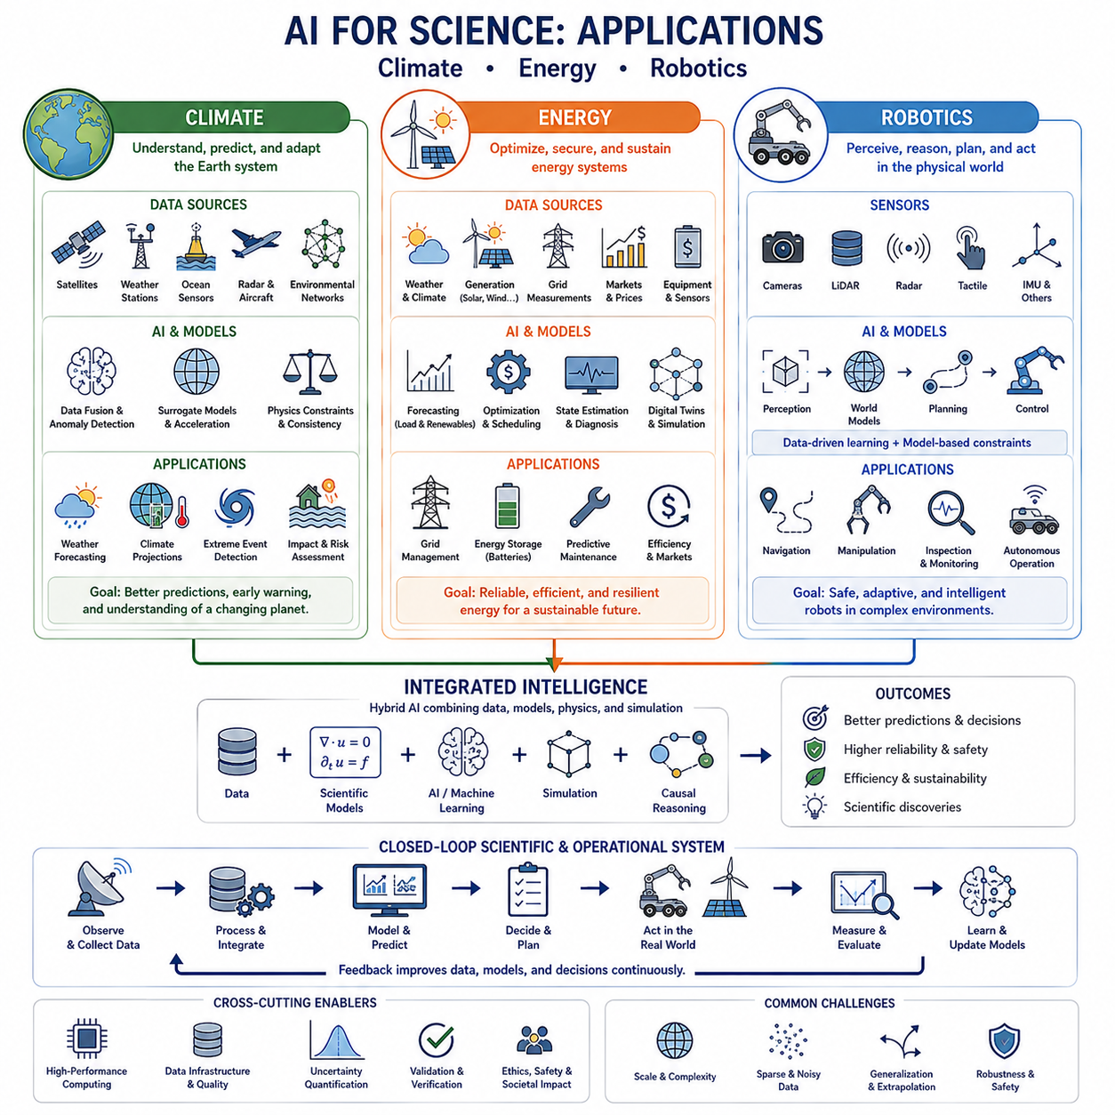
Climate applications of AI for Science combine observations, physical models, simulation, and machine learning to understand a system that spans enormous spatial and temporal scales. Atmospheric circulation, oceans, land surfaces, ice, ecosystems, and human activities interact through nonlinear processes. AI can help integrate these components, accelerate scientific computation, identify patterns, and improve predictions while remaining connected to established climate physics.
Modern climate science relies on observations from satellites, weather stations, ocean sensors, radar, aircraft, and environmental monitoring networks. These measurements differ in resolution, coverage, uncertainty, and sampling frequency. AI can fuse heterogeneous observations into more coherent representations of the Earth system, reconstruct missing information, detect anomalies, and extract relationships that would be difficult to identify from individual data sources.
Climate models numerically represent atmospheric, oceanic, terrestrial, and cryospheric processes, but high-resolution simulations require enormous computational resources. Machine-learned surrogate models can approximate selected components or accelerate expensive calculations. Physics-informed approaches can constrain these learned approximations using conservation laws, governing equations, and known relationships so that computational acceleration does not completely separate predictions from physical consistency.
AI can also support weather and climate forecasting by learning spatial and temporal relationships from historical observations and simulation outputs. Short-term prediction emphasizes rapidly evolving atmospheric states, whereas long-term climate analysis must represent slower processes and changing boundary conditions. Hybrid systems can combine learned forecasting capabilities with numerical models to improve computational efficiency while preserving physically meaningful dynamics.
Extreme events are particularly important because floods, droughts, heat waves, storms, and wildfires can produce severe societal consequences. AI can identify precursors and complex combinations of environmental variables associated with such events. However, rare extremes are often poorly represented in historical datasets, making uncertainty estimation, physical constraints, simulation, and careful validation essential when models extrapolate beyond frequently observed conditions.
Energy applications introduce another tightly coupled scientific and engineering domain. Energy systems connect generation, storage, transmission, consumption, markets, weather, and physical infrastructure. AI can analyze these interactions to improve forecasting, optimization, diagnosis, and control. The greatest value often comes from combining learned patterns with electrical, thermal, mechanical, and economic models rather than treating energy systems as unconstrained statistical datasets.
Renewable energy creates forecasting challenges because solar and wind generation depend strongly on environmental conditions. AI can combine weather forecasts, satellite observations, historical generation, local sensor data, and equipment characteristics to estimate future power production. Improved forecasting supports grid scheduling and storage management while reducing the uncertainty introduced by variable renewable generation.
Energy storage systems, particularly batteries, require models that connect electrochemical behavior with operational measurements. State of charge, state of health, temperature, degradation, charging history, and future load all influence performance. AI can learn complex degradation patterns while physics-based battery models provide mechanistic structure, enabling more reliable lifetime estimation, charging optimization, thermal management, and early detection of abnormal behavior.
Power grids represent large dynamic networks in which generation and consumption must remain continuously balanced. AI can support load forecasting, renewable integration, fault detection, state estimation, and operational planning. Model-driven constraints remain critical because predictions and control actions must respect power-flow relationships, equipment ratings, stability limits, and safety requirements under both normal and disturbed operating conditions.
Digital twins can provide continuously updated representations of energy infrastructure. Physical models describe expected system behavior, sensors provide operational evidence, and AI estimates uncertain states or discrepancies between theory and reality. Such twins can support predictive maintenance, efficiency optimization, failure analysis, and scenario evaluation while adapting as equipment ages and operating conditions change.
Robotics represents a particularly direct application because an intelligent robot must continuously connect perception, prediction, planning, and action with physical reality. Cameras, LiDAR, radar, tactile sensors, inertial measurements, and other sensors provide incomplete observations of the environment. AI transforms these observations into representations of objects, geometry, motion, traversability, interactions, and uncertainty that can support autonomous behavior.
Robot perception is inherently data-driven but must ultimately serve physically constrained action. A perception model may recognize an obstacle or estimate terrain properties, yet the robot must determine whether its actual mass, geometry, traction, actuator capability, and stability allow safe interaction. Scientific and engineering models therefore provide constraints that convert perceptual information into feasible actions rather than merely semantic descriptions.
World models extend robotic intelligence by representing how the environment and robot state may evolve over time. Learned models can predict future observations, object motion, interaction outcomes, or state transitions, while model-driven components can enforce kinematic and dynamic constraints. Combining these approaches can reduce physically impossible predictions and provide more reliable internal simulations for planning.
Planning uses these internal representations to evaluate possible future actions. A robot can compare trajectories, manipulation strategies, or task sequences before executing them in the physical environment. Data-driven models provide learned knowledge about complex environments, while model-driven methods represent collision constraints, dynamics, actuator limits, energy consumption, and safety. Their integration supports planning that is both adaptive and physically executable.
Robot control operates at shorter time scales and requires strong consistency with system dynamics. Learned controllers can adapt to nonlinearities, unknown terrain, payload changes, or difficult interactions, but unconstrained policies may produce unstable or unsafe behavior. Combining classical control, optimization, dynamics models, and machine learning allows adaptive behavior while preserving stability, feasibility, and operational limits.
Simulation plays an important role because collecting real robotic experience can be expensive, slow, or dangerous. Physics simulators can generate large amounts of training experience, while AI learns policies, representations, or predictive models from simulated interaction. The sim-to-real gap remains a major challenge because simulated contact, friction, sensors, materials, and environments cannot perfectly reproduce reality.
Digital twins and continuously updated world models can reduce this gap during operation. Real sensor measurements can identify differences between predicted and actual behavior, allowing uncertain parameters or learned residual models to be updated. A robot can therefore maintain an evolving representation of its own dynamics and environment rather than relying permanently on assumptions established before deployment.
Failure prediction is also important for autonomous robots because degradation of motors, batteries, joints, tires, sensors, or computing systems can alter behavior before complete failure occurs. AI can analyze telemetry and operational histories to detect weak degradation patterns. Combining these observations with physical models enables remaining useful life estimation and maintenance planning while reducing unexpected downtime.
Climate, energy, and robotics become increasingly connected in real-world infrastructure. Autonomous robots may inspect renewable-energy facilities, power networks, coastal infrastructure, forests, agricultural environments, or disaster areas. Climate and weather models can provide environmental context, energy models can manage available power, and robotic intelligence can determine how physical inspection or intervention should be executed.
A field robot, for example, may receive weather forecasts and environmental risk estimates before selecting a mission plan. Its energy model can predict whether battery capacity is sufficient for the expected terrain and temperature, while its world model evaluates possible routes and hazards. During operation, new observations can update environmental, energy, and robotic models simultaneously, creating a closed-loop scientific and operational system.
Causal reasoning can strengthen all three domains by distinguishing correlations from mechanisms. Climate analysis can examine how interventions or forcing variables influence environmental outcomes, energy systems can evaluate how operational decisions affect reliability or efficiency, and robots can predict how actions alter their surroundings. Causal models therefore connect scientific explanation with decisions and physical interventions.
Uncertainty is equally fundamental. Climate forecasts contain uncertainty about future environmental states, energy systems contain uncertainty in demand and generation, and robots operate with incomplete perception and imperfect dynamics. Reliable AI should propagate these uncertainties through prediction and decision processes so that systems can recognize when additional measurements, conservative actions, or human intervention are required.
The common architecture across climate, energy, and robotics is therefore a hybrid loop linking data, scientific models, prediction, decision, action, and new observations. Data-driven AI discovers complex relationships, model-driven knowledge preserves physical structure, simulations explore alternatives, and real-world measurements continuously correct the system. This creates intelligence that learns while remaining grounded in the behavior of physical systems.
Within AI for Science, these applications demonstrate how artificial intelligence can progress from analyzing scientific data toward participating in the operation and understanding of complex physical systems. Climate AI helps model the changing Earth, energy AI helps optimize and protect critical resources, and robotics converts predictions into physical action. Together they illustrate the transition toward adaptive, physics-aware, and scientifically grounded AI.

