Volume 46. Causality and Scientific AI

Chapter 02. Structural Causal Model

02.00. Overview
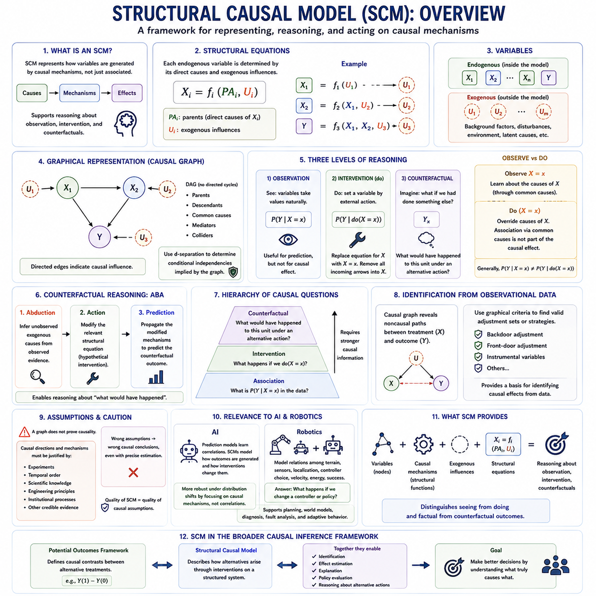
A Structural Causal Model provides a formal framework for representing how variables in a system are generated through causal mechanisms rather than merely associated statistically. An SCM describes each endogenous variable as the result of a structural function involving its direct causes and external influences. This representation makes causal assumptions explicit and provides a foundation for reasoning about observation, intervention, and counterfactual alternatives.
The central idea is that a system can be represented by structural equations of the form Xᵢ = fᵢ(PAᵢ, Uᵢ), where PAᵢ denotes the parent variables that directly cause Xᵢ and Uᵢ represents exogenous influences not explained within the model. Each equation describes a causal mechanism responsible for generating one variable, allowing the complete model to represent how changes propagate through interconnected processes.
SCMs distinguish endogenous variables from exogenous variables. Endogenous variables are determined by relationships represented inside the causal model, while exogenous variables capture background factors originating outside those modeled relationships. These external variables may represent environmental conditions, latent characteristics, disturbances, or other unmodeled causes that influence the system while remaining outside the explicit causal structure.
Structural equations differ fundamentally from ordinary regression equations because their meaning is causal rather than purely predictive. A regression may describe how one variable statistically varies with another, whereas a structural equation asserts a mechanism through which causes generate effects. Consequently, modifying a variable in an SCM requires changing its generating mechanism rather than simply conditioning a statistical distribution on an observed value.
The graphical representation of an SCM is commonly expressed through a directed causal graph. Variables appear as nodes, while directed edges indicate causal relationships. If X directly influences Y, the graph contains X → Y. Multiple equations can therefore be translated into a network of causal dependencies, making complex causal structures easier to inspect and reason about using graphical criteria.
Directed Acyclic Graphs are widely used when the modeled causal relationships contain no directed feedback cycles. A DAG enables analysts to reason systematically about parents, descendants, common causes, mediators, colliders, and alternative paths connecting variables. Graphical concepts such as d-separation can then determine which conditional independencies are implied by the assumed causal structure.
Observation represents the first level of reasoning supported by structural causal models. At this level, the model describes statistical relationships in naturally occurring data and answers questions such as how Y is distributed when X is observed to have a particular value. Observational reasoning is useful for prediction, but observation alone does not determine what would happen if X were deliberately changed.
Intervention introduces the essential distinction between seeing and doing. Pearl's do-operator expresses an intervention as do(X = x), meaning that X is externally fixed to x rather than generated by its ordinary structural equation. The original equation for X is replaced by the imposed value, while the remaining causal mechanisms are preserved. The model can then determine how this intervention propagates downstream.
Graphically, an intervention on X can be understood as removing incoming causal arrows into X and setting X externally. This operation separates intervention from ordinary conditioning. Observing X = x may provide information about the causes that produced X, whereas performing do(X = x) overrides those causes. Therefore, P(Y | X = x) and P(Y | do(X = x)) can represent fundamentally different quantities.
This distinction becomes particularly important in the presence of confounding. If a variable U influences both X and Y, observing X provides information about U and therefore about Y. An intervention on X does not change U, so the association generated through the common cause should not be interpreted as part of X's causal effect. SCMs represent this difference directly through their structural and graphical semantics.
Counterfactual reasoning extends the model beyond interventions by asking what would have happened to a particular unit under an alternative action. A counterfactual question may ask whether an observed failure would still have occurred if a controller had not been activated. Answering such questions requires reasoning about the same underlying system under both the factual and hypothetical conditions.
Counterfactual inference is often described through abduction, action, and prediction. Abduction uses observed evidence to infer information about the underlying exogenous variables. Action modifies the relevant structural equation according to the hypothetical intervention. Prediction then propagates the modified causal mechanisms forward to determine the outcome that would have occurred under the alternative scenario.
These capabilities establish a hierarchy of causal reasoning. Association concerns observations such as P(Y | X), intervention concerns manipulated distributions such as P(Y | do(X)), and counterfactual reasoning concerns hypothetical outcomes for specific situations. Moving upward through this hierarchy requires stronger causal information because observational distributions alone generally cannot answer every intervention or counterfactual question.
SCMs also provide a formal basis for identifying causal effects from observational data. If the assumed causal graph reveals which noncausal paths connect treatment and outcome, graphical criteria can determine whether appropriate adjustment variables exist. Backdoor adjustment, front-door reasoning, instrumental variables, and related identification strategies can therefore be understood within a unified structural framework.
The quality of an SCM depends critically on the validity of its causal assumptions. A graph cannot establish causality merely because arrows have been drawn between variables. The directions and mechanisms should be justified through experiments, temporal relationships, scientific knowledge, engineering principles, institutional processes, or other credible evidence. Incorrect structural assumptions can produce incorrect causal conclusions even when statistical estimation is precise.
Structural causal models are particularly relevant to artificial intelligence because intelligent systems increasingly need to reason about actions rather than only predict observations. A predictive model may learn that certain states are associated with failure, while an SCM can represent which factors actually generate failure and predict how interventions on controllable variables could alter the outcome. This supports decision-oriented and explainable reasoning.
SCMs can also improve robustness when environments change. Statistical correlations learned in one environment may disappear when policies, operating conditions, or data-generation processes change. Causal mechanisms can sometimes remain more stable across such distribution shifts. Representing these mechanisms explicitly can help AI systems distinguish persistent causal structure from correlations that depend on a particular training environment.
In robotics, structural equations can describe relationships among terrain, sensor observations, localization quality, controller selection, velocity, energy consumption, and mission success. Environmental difficulty may influence both controller selection and performance, creating confounding in operational logs. An SCM can represent these pathways and support questions about what would happen if a controller or operating policy were deliberately changed.
A robot equipped with causal reasoning could conceptually move beyond asking what action usually accompanies successful behavior toward asking which action would cause a better future state. Counterfactual reasoning could further support failure diagnosis by comparing an observed trajectory with hypothetical alternatives. Such reasoning connects SCMs with planning, world models, decision systems, fault analysis, and adaptive autonomous behavior.
Structural Causal Models therefore provide more than a graphical visualization of relationships. They combine variables, causal mechanisms, external influences, structural equations, and intervention semantics into a mathematical representation of how a system works. Their central contribution is the ability to distinguish observing from acting and factual outcomes from counterfactual alternatives, providing a foundation for causal inference and causal AI.
Within a broader causal inference framework, SCMs complement the Potential Outcomes Framework by emphasizing explicit mechanisms and graphical structure. Potential outcomes define causal contrasts between alternative treatments, while SCMs describe how those alternatives arise through interventions on a structured system. Together, these perspectives support identification, effect estimation, explanation, policy evaluation, and reasoning about alternative actions in complex systems.

02.01. Causal Graphs (DAG) [w/Code]
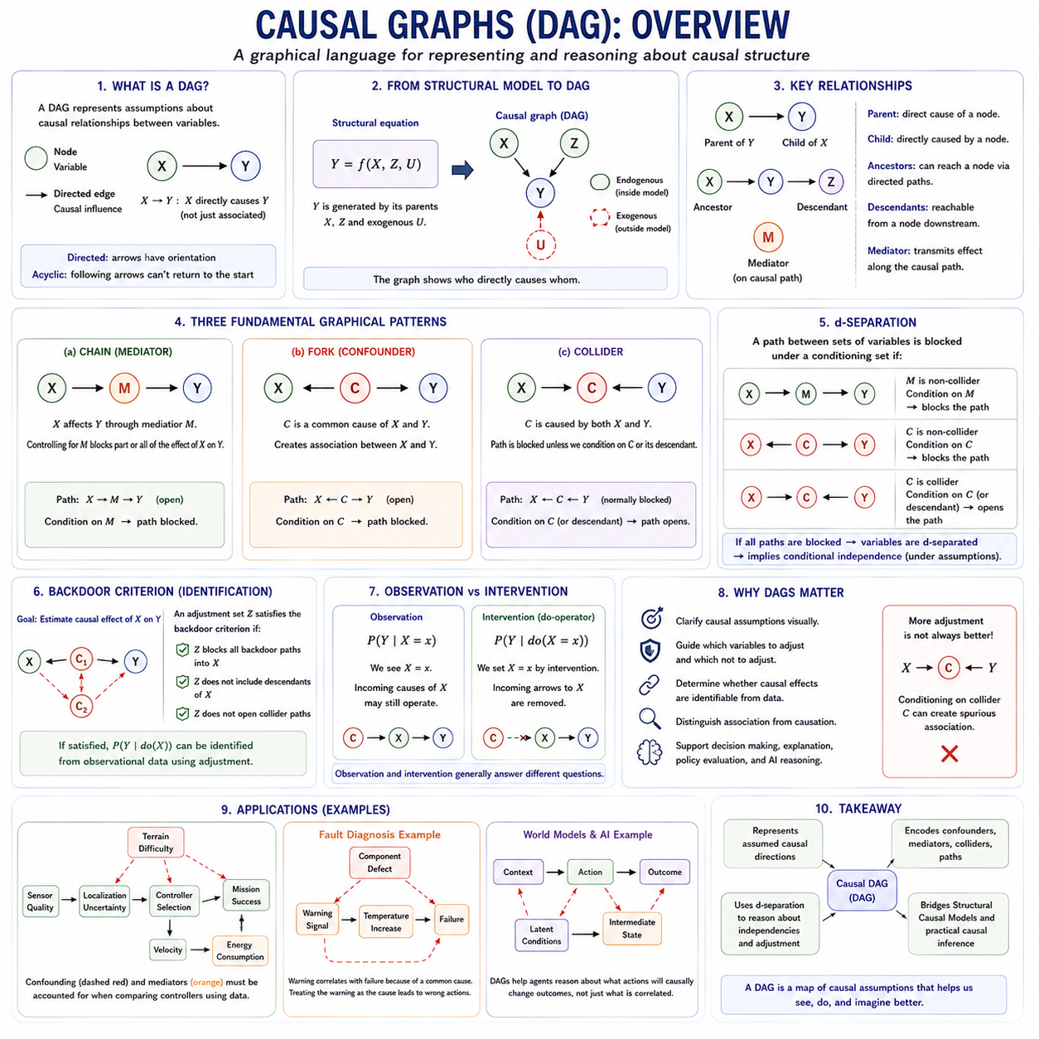
A causal graph provides a compact representation of assumptions about how variables causally influence one another. In a Directed Acyclic Graph, or DAG, variables are represented as nodes and causal relationships as directed edges. An arrow X → Y states that X is assumed to be a direct cause of Y within the modeled system, rather than merely indicating that X and Y are statistically associated.
The term directed means that every causal edge has an orientation, while acyclic means that following directed arrows cannot eventually return to the original variable. Thus, X → Y → Z is permitted, but X → Y → Z → X would violate the DAG assumption. This structure is especially suitable for systems in which causes precede their downstream consequences without explicit instantaneous feedback loops.
DAGs provide a graphical language for Structural Causal Models because structural equations can be translated into causal dependencies. If Y = f(X, Z, U), then X and Z may appear as parents of Y in the corresponding graph. The graph suppresses many mathematical details of the structural functions while preserving information about which variables directly participate in generating other variables.
A parent of a variable is a node with an arrow pointing directly into it, while a child receives a direct causal influence from that node. Ancestors include all variables that can reach a node through directed paths, and descendants include variables reachable downstream. These relationships allow analysts to trace how an intervention or disturbance may propagate through a causal system.
A causal path is a sequence of connected variables through which causal influence may travel. In X → M → Y, X affects Y indirectly through the mediator M. The variable M lies on the causal pathway and transmits part or all of the effect of X. Recognizing mediators is essential because controlling for them can remove portions of the causal effect that an analysis may actually seek to estimate.
Confounding occurs when a common cause influences both a treatment or exposure and an outcome. In the structure X ← C → Y, C creates an association between X and Y even if some of that association does not result from X causing Y. Such a path is commonly called a backdoor path because it enters X through an incoming arrow and can distort estimation of the causal effect X → Y.
Adjustment attempts to block appropriate noncausal paths while preserving the causal pathways relevant to the target effect. If C is a sufficient observed confounder in X ← C → Y, conditioning on C can block the backdoor association. DAGs therefore help determine which variables should be controlled rather than encouraging analysts to include every available variable indiscriminately in a statistical model.
A collider has a fundamentally different structure. In X → C ← Y, both X and Y cause C, making C a collider on the path between them. Without conditioning on C, this path is blocked. Conditioning on the collider, or sometimes on one of its descendants, can open the path and create a statistical association between X and Y even when no such association previously existed.
Collider bias demonstrates why more adjustment is not always better. A variable may strongly predict both treatment selection and observed outcomes yet still be inappropriate to control if its causal position makes it a collider. DAG-based reasoning focuses on the structural role of variables rather than their predictive importance, statistical significance, or correlation strength when selecting adjustment sets.
Chains, forks, and colliders form fundamental graphical patterns. A chain X → M → Y transmits dependence through a mediator, while a fork X ← C → Y represents dependence generated by a common cause. A collider X → C ← Y behaves oppositely because the path is normally closed but may become active after conditioning. Complex graphs can be analyzed by combining these basic structures.
The concept of d-separation formalizes whether paths between variables are blocked or open under a particular conditioning set. If every path between two sets of variables is blocked according to graphical rules, those variables are d-separated. Under the causal model assumptions, d-separation implies corresponding conditional independence relationships that can connect graphical structure with observable probability distributions.
D-separation also provides a systematic way to reason about adjustment. Conditioning on a non-collider generally blocks a path passing through that variable, whereas conditioning on a collider can activate a path that would otherwise remain blocked. Analysts can therefore inspect a DAG to determine whether a proposed adjustment set removes confounding or accidentally introduces new statistical dependence.
The backdoor criterion uses these graphical ideas to identify sets of variables that permit causal effect estimation from observational data. For estimating the effect of X on Y, an acceptable adjustment set blocks relevant paths entering X through the backdoor without improperly controlling for descendants or opening collider paths. When such conditions hold, adjusted observational comparisons can identify an interventional quantity.
DAGs also clarify why temporal order alone is insufficient for causal identification. A variable occurring before another variable may be a cause, a proxy for a hidden cause, or simply correlated through a common ancestor. Temporal information is useful for constraining impossible directions, but causal arrows should additionally reflect scientific knowledge, experimental evidence, physical mechanisms, or credible assumptions about data generation.
Latent or unobserved variables create additional challenges. An unmeasured common cause U may produce X ← U → Y even when U does not appear in the observed dataset. In graphical representations, latent confounding may be shown explicitly or represented using specialized graphical conventions. Its presence can prevent ordinary covariate adjustment from identifying the desired causal effect.
Causal graphs are therefore not automatically discovered truths about a dataset. They encode assumptions about the system that should be justified independently of observed correlations whenever possible. Multiple DAGs can sometimes imply the same set of observational conditional independencies, making them statistically indistinguishable without interventions, temporal constraints, domain knowledge, or additional causal assumptions.
Interventions change the interpretation of a causal graph. Under do(X = x), the natural causes of X are overridden and incoming arrows into X are conceptually removed. The modified graph represents the system after external manipulation. Comparing the original and intervened graphs helps distinguish P(Y | X = x), which describes observation, from P(Y | do(X = x)), which describes the consequences of action.
This graphical intervention perspective is particularly useful for artificial intelligence because intelligent agents act on environments rather than merely observe them. A causal graph can represent relationships among context, decisions, latent conditions, actions, and outcomes. The agent can then reason about which observed associations are actionable and which arise from common causes, selection processes, or other noncausal pathways.
In robotics, a DAG might connect terrain difficulty, sensor quality, localization uncertainty, controller selection, velocity, energy consumption, and mission success. Terrain difficulty could affect both controller selection and mission outcome, creating confounding. Sensor degradation could influence localization and downstream control behavior. Graphical analysis helps separate these mechanisms before comparing controllers using operational data.
Causal graphs can also support fault diagnosis and system safety. A warning signal may correlate strongly with failure because both are consequences of an underlying component defect. Treating the warning itself as the cause could lead to an ineffective intervention. A DAG encourages engineers to distinguish upstream causes, intermediate mechanisms, symptoms, and final outcomes before selecting corrective actions.
For world models and autonomous systems, DAGs provide a useful abstraction for representing directional dependencies among state variables and actions. They can complement learned statistical representations by expressing which changes are expected to produce downstream effects. This can support intervention-aware prediction, causal planning, transfer across environments, explanation, and reasoning about failures or alternative actions.
The primary value of a DAG is therefore not visual simplicity alone, but disciplined causal reasoning. By representing assumed causal direction, confounders, mediators, colliders, paths, and conditional independencies, causal graphs help determine what should be adjusted, what should not be adjusted, and whether an observational distribution can answer an intervention question. They form a central bridge between Structural Causal Models and practical causal inference.

02.02. Structural Equations
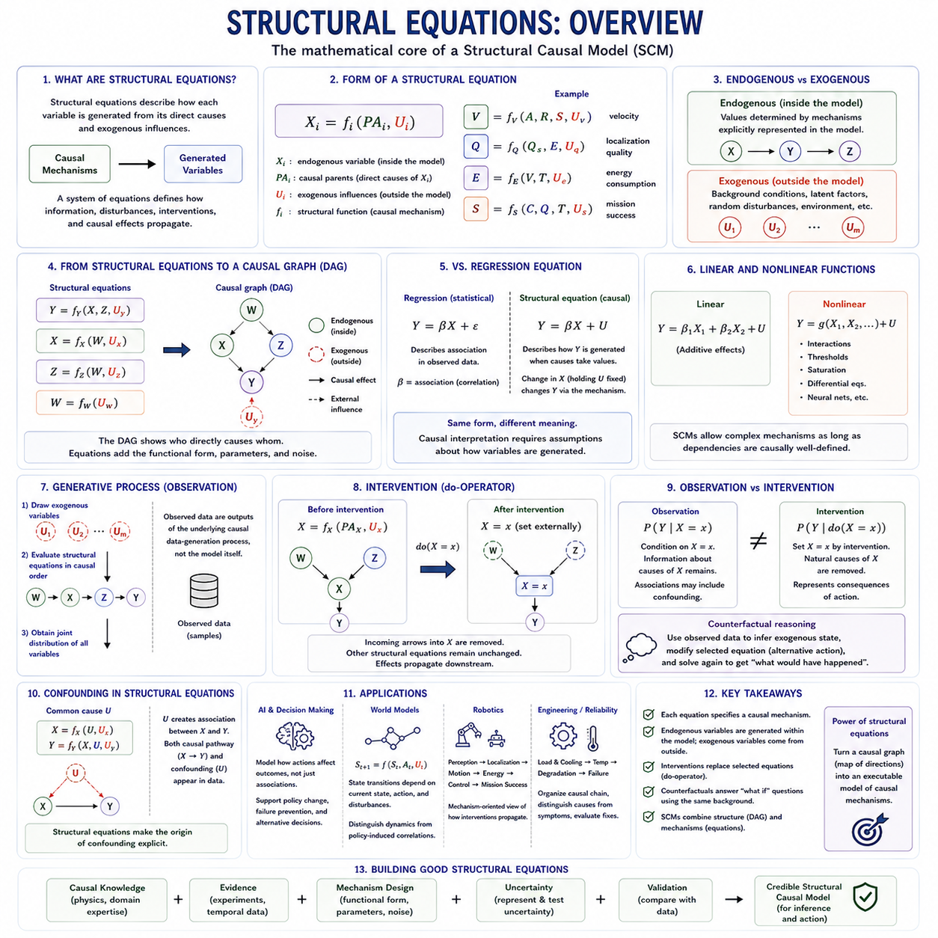
Structural equations are the mathematical core of a Structural Causal Model because they describe how each variable is generated from its direct causes and external influences. Rather than representing only statistical association, a structural equation specifies an assumed causal mechanism. A collection of such equations defines how information, disturbances, interventions, and causal effects propagate through a modeled system.
A typical structural equation can be written as Xᵢ = fᵢ(PAᵢ, Uᵢ), where Xᵢ is an endogenous variable, PAᵢ represents its causal parents, and Uᵢ represents exogenous influences. The function fᵢ specifies the mechanism that transforms these inputs into Xᵢ. Each endogenous variable therefore has its own generating process embedded within the larger causal model.
Endogenous variables are quantities whose values are determined by mechanisms explicitly represented inside the model. If velocity depends on commanded acceleration, terrain resistance, and vehicle state, velocity can be represented as an endogenous variable. Its structural equation specifies how these causes combine, allowing downstream variables such as energy consumption or travel time to depend causally on the resulting velocity.
Exogenous variables represent influences whose generating mechanisms are not modeled explicitly. They may encode background conditions, latent properties, random disturbances, environmental variation, or unknown factors. Although an exogenous variable can affect endogenous variables, the SCM treats its value as originating outside the modeled causal system. This provides a formal boundary between modeled mechanisms and unexplained influences.
Structural equations should not be interpreted in the same way as ordinary regression equations. A regression equation summarizes statistical dependence in observed data, while a structural equation describes how a variable would be generated when its causes take particular values. The distinction becomes crucial under intervention because changing a structural mechanism has consequences that cannot generally be inferred from correlation alone.
For example, consider Y = βX + U. As a purely statistical regression, β may describe association between X and Y. As a structural equation, however, the expression asserts that changing X while holding the relevant background influence U fixed changes Y according to the specified mechanism. The causal interpretation therefore requires assumptions about how X, U, and Y are generated, not merely a fitted coefficient.
Structural equations naturally correspond to causal graphs. If Y = f(X, Z, U), then X and Z can be represented as direct causal parents of Y, producing arrows X → Y and Z → Y. The exogenous variable U represents an external influence on Y. A system of equations can therefore be translated into a Directed Acyclic Graph when the causal dependencies contain no directed cycles.
The equations contain information that a causal graph alone does not fully represent. A DAG specifies which variables directly influence which others, but it does not necessarily specify the functional form, parameter values, noise distributions, or magnitude of effects. Structural equations add these details, allowing the model to generate quantitative outcomes rather than representing only qualitative causal topology.
Structural functions may be linear or nonlinear. A linear model may express Y = β₁X₁ + β₂X₂ + U, while a nonlinear system may use interactions, thresholds, saturation, differential relationships, neural networks, or other complex functions. Structural causal modeling therefore does not require causal mechanisms to be simple; it requires their causal interpretation and dependencies to be explicitly defined.
A complete SCM contains multiple equations whose outputs become inputs to downstream mechanisms. For example, localization quality may depend on sensor quality and environmental conditions, controller behavior may depend on localization and mission state, and mission success may depend on controller behavior and terrain. Solving the equations according to their causal ordering produces the system's observable state.
This generative interpretation is important because it describes how observational data arise. Samples can be conceptually generated by first drawing exogenous variables and then evaluating the structural equations in causal order. The resulting joint distribution reflects both the causal architecture and background variation. Statistical observations are therefore outputs of an underlying causal data-generation process rather than the causal structure itself.
Intervention can be represented directly by modifying a structural equation. Suppose X normally follows X = f(PAₓ, Uₓ). Under the intervention do(X = x), this equation is replaced with X = x. The natural causes of X no longer determine its value, while other structural equations remain unchanged. The consequences of the intervention can then be calculated by propagating the imposed value through downstream equations.
This operation explains the difference between conditioning and intervention. Observing X = x retains the original structural equation and therefore provides information about the causes that produced X. Setting X = x removes the influence of those causes on X for the intervention. Consequently, an observational conditional distribution and an interventional distribution can differ even when they refer to the same numerical value of X.
Structural equations also provide a basis for counterfactual reasoning. Once observations have been used to infer plausible exogenous conditions, a structural equation can be modified to represent an alternative action while keeping the same underlying background state. The modified system is then solved again to answer questions such as what would have happened if a different treatment, controller, policy, or operating decision had been selected.
The stability of causal mechanisms is an important assumption behind this reasoning. When one equation is modified by an intervention, the remaining mechanisms are generally assumed to continue operating according to their original structural functions. This modularity allows individual mechanisms to be changed without redefining the entire system and gives structural equations their powerful interpretation as independently manipulable causal components.
Confounding can also be represented through structural equations. If X = fₓ(U, Uₓ) and Y = fᵧ(X, U, Uᵧ), the common exogenous factor U influences both X and Y. Observed association between X and Y then contains both the causal effect transmitted through X and dependence generated by U. Structural equations make the origin of this confounding explicit within the data-generation process.
In artificial intelligence, structural equations can represent mechanisms connecting context, latent state, actions, intermediate states, and outcomes. Instead of learning only P(Y|X), an AI system can model how controllable variables participate in producing Y. This supports reasoning about interventions, policy changes, failure prevention, and alternative decisions that ordinary predictive models cannot reliably answer from association alone.
Structural equations are particularly relevant to world models because a world model attempts to represent how states evolve under actions. A causal formulation can distinguish environmental dynamics from correlations produced by a particular behavior policy. State transitions may be modeled as Sₜ₊₁ = f(Sₜ, Aₜ, Uₜ), explicitly expressing how current state, action, and external disturbances generate the next state.
In robotics, separate structural equations could describe perception quality, localization uncertainty, motion, energy consumption, controller response, and mission outcome. Terrain may affect wheel slip, slip may affect localization and velocity, and control actions may alter future motion. Such equations provide a mechanism-oriented representation for analyzing how interventions on speed, sensing, planning, or control propagate through the robot.
Engineering failure analysis provides another natural application. Component temperature may depend on load and cooling performance, degradation may depend on temperature and operating time, and failure probability may depend on accumulated degradation. Structural equations organize these mechanisms into a causal chain, helping distinguish upstream causes from downstream symptoms and supporting evaluation of corrective interventions.
The usefulness of structural equations ultimately depends on whether their causal mechanisms are credible. Mathematical sophistication cannot compensate for incorrect causal assumptions. Functions and dependencies should therefore be supported by experiments, physical principles, domain knowledge, temporal information, or other evidence about the actual data-generation process. Uncertainty about mechanisms should be represented and tested rather than hidden.
Structural equations thus transform a causal graph from a map of directional relationships into an executable model of causal mechanisms. They specify how endogenous variables arise from parents and exogenous influences, how interventions replace selected mechanisms, and how alternative outcomes can be generated under counterfactual conditions. This makes them a foundational component of Structural Causal Models, causal inference, and action-oriented AI.

02.03. d Separation
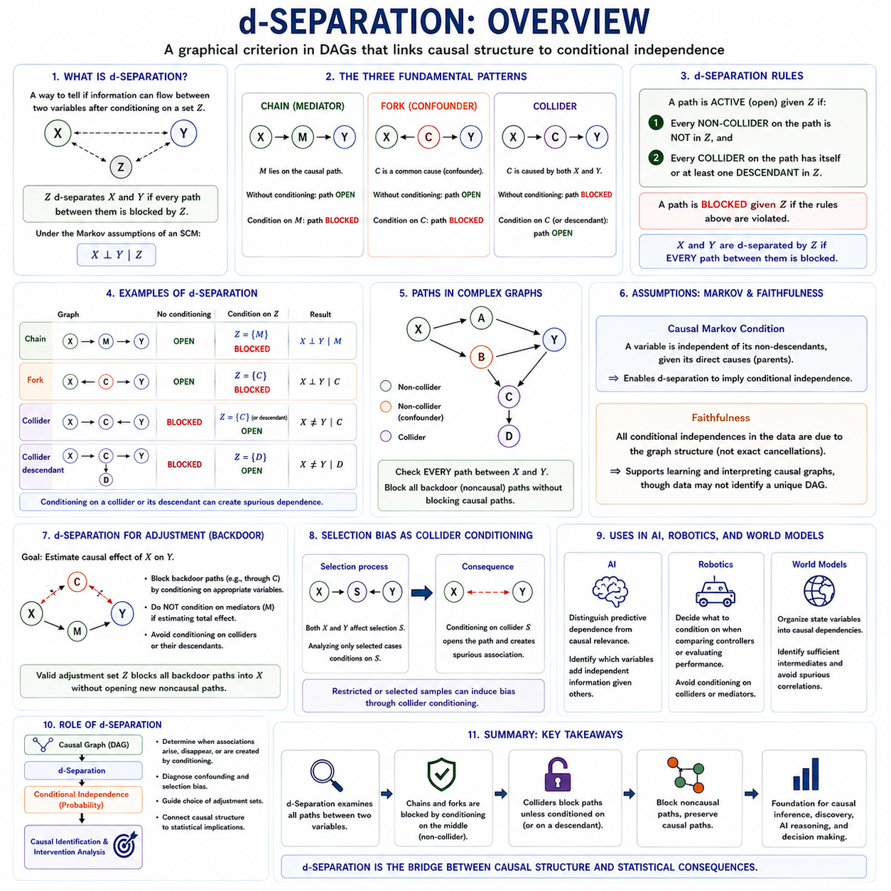
d-Separation is a graphical criterion used in Directed Acyclic Graphs to determine whether information can flow between variables after conditioning on a specified set of other variables. It provides the formal connection between causal graph structure and conditional independence. By examining whether every path between two variables is blocked, analysts can infer which statistical dependencies should disappear under the assumptions encoded by the graph.
The term d-separation stands for directional separation. Consider two variables X and Y connected by one or more paths in a causal graph. A conditioning set Z d-separates X and Y when every path between X and Y is blocked according to the graphical rules. Under the Markov assumptions of a Structural Causal Model, this graphical separation implies the conditional independence relationship X ⟂ Y | Z.
The simplest path structure is a causal chain such as X → M → Y. Without conditioning, information can flow from X through M to Y, so the path is open. If the analysis conditions on the intermediate variable M, the path becomes blocked. Consequently, X and Y become conditionally independent along that path when M fully mediates their relationship and no other open paths connect them.
A second fundamental structure is the fork, represented as X ← C → Y. Here C is a common cause of X and Y and therefore acts as a confounder. Without conditioning on C, the path between X and Y remains open and creates statistical dependence. Conditioning on C blocks this path, which is why adjustment for an appropriate common cause can remove noncausal association between treatment and outcome.
The collider structure behaves in the opposite way. In X → C ← Y, the variable C is caused by both X and Y. Without conditioning on C, the path through the collider is blocked automatically, so X and Y may remain independent along that path. Conditioning on C, however, opens the path and can create dependence between X and Y even when none existed before.
This collider behavior is one of the most important and unintuitive aspects of d-separation. Conditioning is not always a method for removing dependence. If the conditioned variable is a collider, the analysis can introduce a spurious statistical relationship. Conditioning on a descendant of a collider can also open the path because information about the descendant may indirectly provide information about the collider itself.
The three basic structures—chain, fork, and collider—form the foundation for analyzing much larger causal graphs. Any complex path can be examined locally in terms of these configurations. A path is blocked if it contains an appropriate conditioned non-collider, or if it contains a collider for which neither the collider nor any of its descendants is conditioned upon.
More formally, a path is active given a conditioning set Z when every non-collider on the path is outside Z and every collider on the path has itself or at least one descendant included in Z. If these conditions fail, the path is blocked. Two variables are d-separated when every possible path connecting them is blocked under the chosen conditioning set.
The distinction between paths and directed causal paths is important. d-Separation considers all paths connecting variables, regardless of whether every arrow points in the same direction. A path such as X ← C → Y is not a directed causal path from X to Y, but it still transmits statistical association when open. This is why d-separation is useful for identifying confounding and other noncausal dependencies.
Conditional independence inferred through d-separation depends on the assumed causal graph being correct. If the graph omits an important common cause or incorrectly specifies a causal direction, graphical conclusions can also be wrong. d-Separation is therefore a logical consequence of the model assumptions rather than a procedure that automatically discovers the true causal structure from data.
The causal Markov condition provides the key bridge between the graph and probability. It states that, given its direct causes, a variable is independent of its non-descendants that are not its parents. This assumption allows structural relationships represented in a DAG to imply conditional independence properties in the corresponding probability distribution and makes d-separation operational for statistical reasoning.
Faithfulness is often introduced as an additional assumption. It states that conditional independence relationships observed in the data arise from the causal graph structure rather than from exact numerical cancellations among causal effects. Under faithfulness, statistical independence patterns can provide evidence about possible graph structures, although observational data alone may still be unable to determine a unique causal DAG.
d-Separation is especially useful when selecting adjustment variables for causal effect estimation. Suppose the goal is to estimate the effect of treatment X on outcome Y. The analyst must block noncausal paths connecting X and Y while preserving the causal paths through which X genuinely affects Y. Graphical reasoning can reveal whether conditioning on a proposed covariate accomplishes this objective or introduces additional bias.
The backdoor criterion relies directly on d-separation concepts. A valid adjustment set blocks every path from X to Y that enters X through an incoming arrow while avoiding inappropriate adjustment for variables that would distort the causal effect. If a suitable set of observed variables blocks all relevant backdoor paths, causal effects can often be identified from observational data through covariate adjustment.
d-Separation also explains why controlling for descendants of treatment can be problematic. A descendant may be a mediator carrying part of the causal effect or may participate in a collider structure. Conditioning on it can therefore change the estimand, block part of the effect, or open a previously closed noncausal path. The graphical position of a variable matters more than whether it is highly predictive.
For example, consider X → M → Y together with X ← C → Y. If the objective is the total causal effect of X on Y, conditioning on C is desirable because it blocks the confounding path, whereas conditioning on M would remove part of the causal effect itself. d-Separation allows these two variables to be distinguished according to their structural roles rather than their statistical correlations.
Selection bias can also be interpreted through collider conditioning. Suppose treatment X and outcome Y both influence whether a case enters the observed dataset S, producing X → S ← Y. Restricting analysis to selected cases effectively conditions on S and may create an artificial association between X and Y. This graphical view helps explain why datasets collected through selective processes can produce misleading conclusions.
In artificial intelligence, d-separation provides a principled method for determining which variables contain independent information once other variables are known. More importantly, it distinguishes predictive dependence from causal relevance. An AI system can use graphical structure to identify whether an observed relationship persists because of a causal mechanism, a common cause, or conditioning on a selection variable.
For robotics, consider terrain difficulty influencing both localization uncertainty and controller selection, while controller selection affects mission performance. A causal graph can reveal whether terrain should be conditioned on when estimating controller effectiveness. d-Separation helps determine whether the relevant confounding path is blocked and whether additional variables would improve or damage the causal comparison.
In world models, d-separation can help organize state variables into causal dependencies rather than treating every correlated feature as mutually informative. If current state variables block the influence of earlier states on a future outcome, they can act as sufficient causal intermediates for that prediction. This perspective connects graphical causal reasoning with state abstraction, planning, and intervention-aware prediction.
d-Separation is therefore more than a graphical independence test. It is a formal reasoning tool for understanding when associations arise, disappear, or are created by conditioning. By analyzing chains, forks, colliders, descendants, and multiple alternative paths, it provides the foundation for selecting adjustment sets, diagnosing confounding and selection bias, and connecting causal graphs to probability distributions.
Within Structural Causal Models, d-separation serves as the bridge between qualitative causal structure and quantitative statistical implications. The graph specifies assumed mechanisms, d-separation determines which dependencies should remain under conditioning, and causal identification uses those results to evaluate interventions. This makes d-separation a central concept for causal effect estimation, causal discovery, explainable AI, and decision-making systems.

02.04. Do Calculus
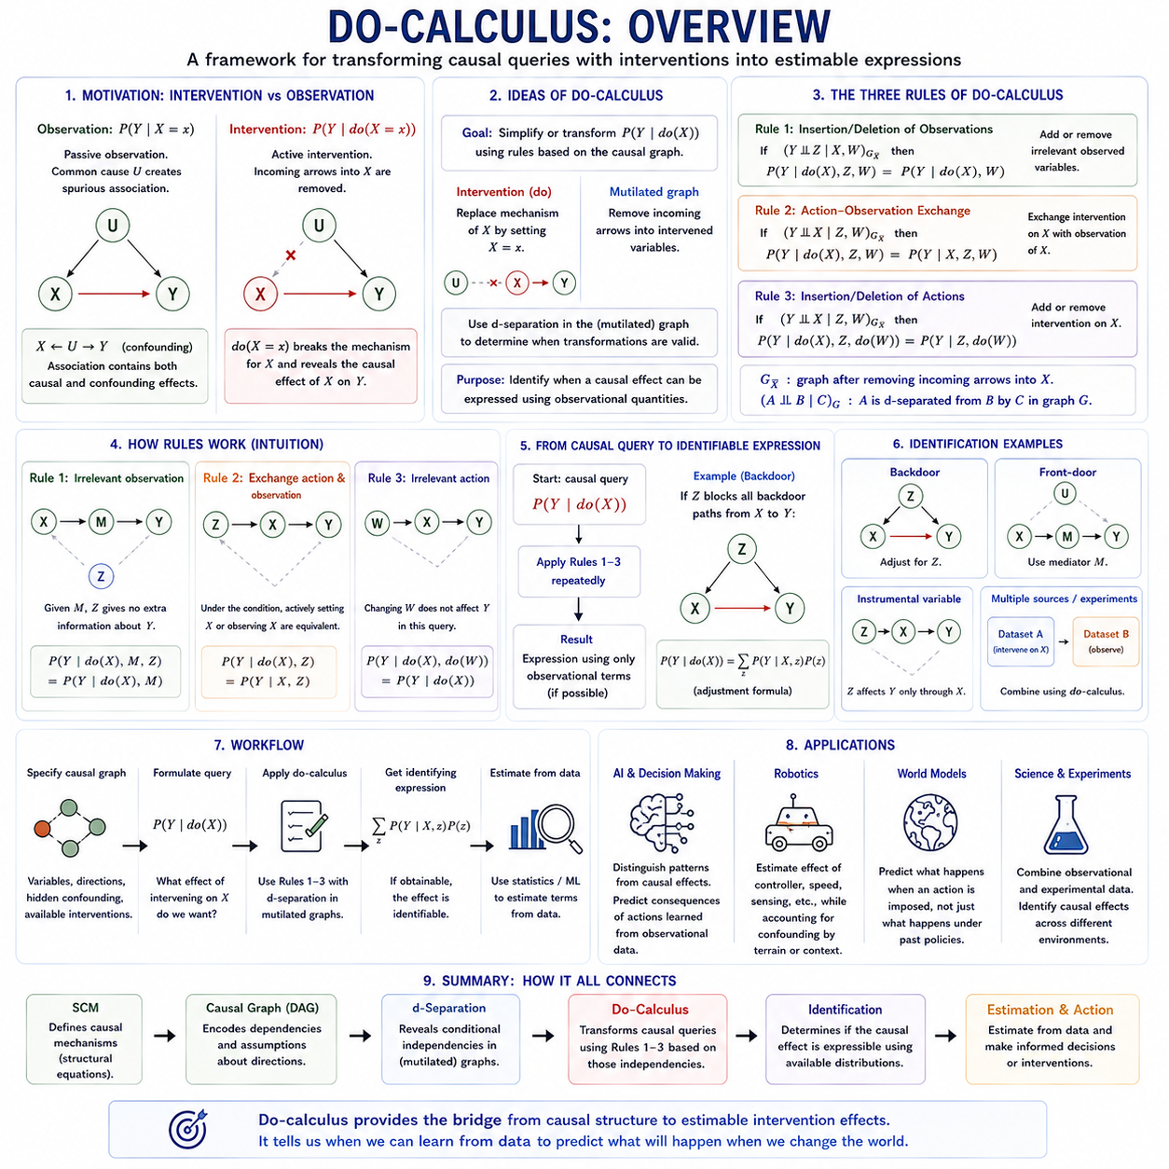
Do-calculus is a formal framework for transforming causal queries involving interventions into expressions that can potentially be estimated from observational or experimental data. Developed within Structural Causal Models, it provides graphical rules for reasoning about distributions such as P(Y | do(X = x)). Its purpose is not ordinary numerical calculation, but determining when intervention effects are identifiable from available information.
The do-operator represents deliberate intervention rather than passive observation. The expression do(X = x) means that X is externally fixed to x by replacing its normal causal mechanism. In a causal graph, this operation conceptually removes the incoming arrows into X. Consequently, P(Y | do(X = x)) describes what happens to Y when X is actively manipulated, which may differ from observing X = x naturally.
This distinction is essential when confounding exists. Suppose U influences both X and Y, producing X ← U → Y, while X may also causally influence Y. Observing X provides information about U, so P(Y | X = x) contains both causal and confounding associations. Performing do(X = x) breaks the mechanism determining X, allowing the causal effect of manipulating X to be distinguished from associations generated by common causes.
Do-calculus operates on causal graphs by modifying edges according to hypothetical interventions and observations. These modified graphs are often called mutilated graphs because selected causal connections are removed. Graphical separation conditions such as d-separation are then evaluated in these transformed graphs. The resulting independence relationships determine whether do-expressions can be inserted, deleted, or exchanged with ordinary observations.
The first rule of do-calculus concerns the insertion or deletion of observations. Under the appropriate d-separation condition in a graph modified by intervention, observing an additional variable Z provides no further information about outcome Y once relevant variables are known. In such circumstances, Z can be added to or removed from the conditional expression without changing the causal quantity being evaluated.
Conceptually, Rule 1 states that irrelevant observations can be ignored when the causal graph shows that their informational pathways to the outcome have already been blocked. This rule resembles ordinary conditional independence reasoning, but it is evaluated in a graph altered by intervention. It therefore connects familiar probabilistic simplification with the causal semantics of manipulated systems.
The second rule concerns action-observation exchange. Under suitable graphical conditions, an intervention do(Z = z) can be exchanged with ordinary conditioning on Z = z. This means that actively setting Z and merely observing Z become equivalent for the causal query under consideration. The rule is powerful because it can convert an intervention term, which may be difficult to estimate, into an observational term.
Rule 2 does not imply that intervention and observation are generally equivalent. Their equivalence holds only when the required graphical separation condition is satisfied in the appropriately modified causal graph. If common causes or other active paths remain, observing Z may reveal information about upstream variables that intervening on Z would not reveal, preventing the exchange between action and observation.
The third rule concerns the insertion or deletion of actions. Under appropriate graphical conditions, an intervention do(Z = z) can be removed entirely from a causal expression because changing Z has no relevant effect on Y within the query being evaluated. This rule is especially important because eliminating intervention operators can move a causal quantity closer to an expression estimable from observational data.
Together, the three rules provide a symbolic transformation system for causal distributions. Rule 1 manipulates observations, Rule 2 exchanges actions and observations, and Rule 3 manipulates actions. By repeatedly applying these rules, a causal query containing do-operators may sometimes be transformed into an expression involving only observational probabilities, thereby establishing identification of the desired causal effect.
The graphical conditions behind do-calculus rely heavily on d-separation. Rather than manipulating probability expressions algebraically without causal meaning, each transformation is justified by conditional independence in a particular modified graph. This makes causal graph structure central to the procedure. The validity of the final expression therefore depends on the validity of the underlying causal assumptions represented by the graph.
A central goal of do-calculus is causal identification. Identification asks whether a causal effect is uniquely determined by the available probability distributions under the assumed causal structure. If P(Y | do(X)) can be transformed into a function of observational quantities such as P(X, Y, Z), then the causal effect is identifiable even when direct randomized intervention data are unavailable.
The backdoor adjustment formula can be viewed as an important causal identification result compatible with this framework. If a set Z blocks all relevant backdoor paths between X and Y and satisfies the required causal conditions, then the intervention distribution can be expressed through observational quantities by averaging conditional outcomes over Z. Confounding is thereby removed through an appropriate adjustment set.
Front-door identification illustrates a more sophisticated situation. Even when X and Y have unobserved confounding, a mediator M may sometimes provide an alternative route to identification if the required graphical conditions hold. The causal effect can then be decomposed through relationships involving X, M, and Y. Do-calculus provides the formal machinery for deriving and validating such transformations.
Instrumental-variable structures are also closely related to graphical causal identification, although standard instrumental-variable estimands often require additional functional or statistical assumptions beyond purely nonparametric graphical identification. A causal graph helps clarify which paths an instrument may influence and which must remain blocked, reinforcing the broader principle that identification depends on structural assumptions rather than correlation alone.
Do-calculus separates the question of identification from the question of estimation. First, causal reasoning determines whether an intervention quantity can be expressed using available distributions. Only after an identifying expression has been derived does statistical estimation begin. Regression, weighting, matching, machine learning, or other estimators may then approximate the quantities appearing in that expression using finite data.
This distinction prevents a common error in causal analysis: applying increasingly sophisticated statistical models to a causal quantity that has never been shown to be identifiable. A highly accurate predictive model cannot compensate for missing causal information. Do-calculus addresses the logical problem first by asking whether observational evidence contains enough information, given the assumed causal graph, to recover the intervention effect.
Do-calculus is also important for combining information from different environments or experiments. Some variables may be experimentally manipulated in one dataset while only observed in another. Graphical causal reasoning can determine whether these sources can be combined to answer a target intervention question. This extends causal inference toward transportability, data fusion, and reasoning across heterogeneous experimental settings.
For artificial intelligence, do-calculus provides a formal distinction between learning patterns and reasoning about actions. An AI system may learn observational distributions from large datasets, but an autonomous agent must often predict the consequences of interventions it has never directly observed. A causal model and do-calculus can determine when observational knowledge is sufficient to support such action-oriented predictions.
In robotics, observational logs may show relationships among terrain, sensor quality, controller choice, velocity, energy use, and mission success. However, controller choice may depend on terrain difficulty, creating confounding. Do-calculus provides a theoretical framework for determining whether the effect of deliberately selecting a controller can be recovered from those logs after accounting for the causal structure.
World models can similarly benefit from intervention semantics. A conventional world model may predict the next state from patterns in past state-action trajectories, while a causal world model asks how future states change when an action is deliberately imposed. Do-calculus provides a language for determining when learned observational dynamics can support valid intervention predictions rather than merely reproduce behavior-policy correlations.
The practical use of do-calculus therefore begins with a credible causal graph, not with symbolic manipulation alone. Analysts must specify variables, causal directions, hidden confounding, and available interventions before applying graphical rules. Domain knowledge, experimental evidence, physical principles, and knowledge of the data-generation process remain essential because incorrect causal assumptions can invalidate an otherwise mathematically correct derivation.
Do-calculus ultimately provides a bridge from causal structure to estimable intervention effects. Structural Causal Models define mechanisms, causal graphs encode their dependencies, d-separation reveals graphical independencies, and do-calculus transforms intervention queries according to those independencies. Together, these concepts create a rigorous foundation for moving from observing how systems behave toward predicting what will happen when intelligent agents deliberately change them.

02.05. Causal Discovery [w/Code]
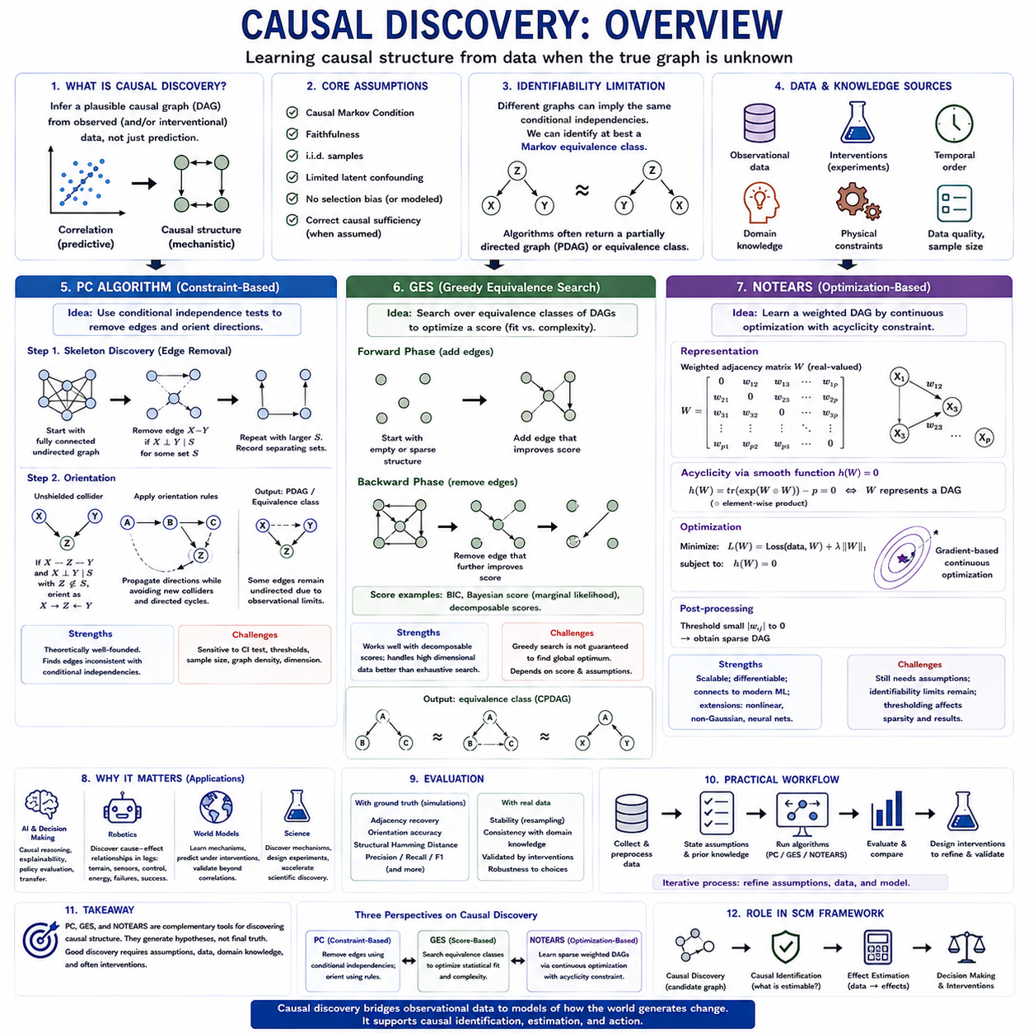
Causal discovery addresses the problem of learning plausible causal structure from data when the complete causal graph is not known in advance. Unlike conventional predictive modeling, which primarily seeks statistical relationships that improve prediction, causal discovery attempts to determine directional dependencies that may represent data-generating mechanisms. Its output is therefore a hypothesis about causal structure rather than automatic proof of causality.
The task is closely connected to Structural Causal Models because an unknown system can be represented as variables linked by structural equations and a Directed Acyclic Graph. Causal discovery algorithms use statistical properties of observed data to restrict the possible DAGs that could have generated those observations. Domain knowledge, temporal ordering, interventions, and physical constraints can then further reduce ambiguity among candidate structures.
Observational causal discovery is fundamentally limited because different causal graphs can imply the same conditional independence relationships. Such graphs belong to a Markov equivalence class and cannot generally be distinguished using observational distributions alone. Consequently, many algorithms return a partially directed graph or an equivalence-class representation rather than claiming that every causal direction has been uniquely identified.
The reliability of causal discovery depends strongly on assumptions about the data-generating process. Common assumptions include the causal Markov condition, faithfulness, independent and identically distributed samples, and restrictions concerning latent confounding or selection bias. Violations of these assumptions can cause an algorithm to remove genuine causal relationships, introduce false ones, or orient edges in incorrect directions.
The PC Algorithm is a constraint-based causal discovery method that learns graph structure through a sequence of conditional independence tests. It typically begins with a densely connected undirected graph containing the observed variables. Edges are progressively removed when statistical tests indicate that two variables become conditionally independent given an appropriate subset of other variables.
For example, if variables X and Y appear dependent initially but become independent after conditioning on Z, the PC Algorithm may remove the edge between X and Y and record Z as a separating set. Repeating this process with increasingly larger conditioning sets produces a graph skeleton representing relationships that cannot be eliminated through the tested conditional independencies.
After discovering the skeleton, the PC Algorithm attempts to orient edges. Unshielded collider structures provide particularly important information. If X and Y are not adjacent, both are adjacent to Z, and Z was not contained in the separating set that made X and Y independent, the structure may be oriented as X → Z ← Y. Additional orientation rules propagate directions while avoiding unsupported colliders and directed cycles.
The final PC output commonly represents a Markov equivalence class rather than one uniquely determined DAG. Some edges may therefore remain undirected because observational conditional independencies cannot establish their orientation. The algorithm is theoretically attractive under its assumptions, but practical performance depends heavily on sample size, the quality of conditional independence tests, dimensionality, and the density of the underlying graph.
Implementing PC in code generally requires preparing a numerical dataset, selecting an appropriate conditional independence test, choosing significance thresholds, running skeleton discovery and orientation, and inspecting the resulting graph. Gaussian data may use partial-correlation-based tests, while discrete or nonlinear settings require suitable alternatives. Sensitivity analysis across thresholds is important because small testing changes can alter the discovered structure.
GES, or Greedy Equivalence Search, approaches causal discovery from a score-based perspective rather than directly performing a sequence of independence tests. Candidate graph structures are evaluated according to a scoring criterion that balances how well the graph explains the observed data against model complexity. Common scoring ideas include Bayesian Information Criterion and Bayesian marginal likelihood formulations.
GES searches through equivalence classes of DAGs using greedy modifications. A forward phase begins with a sparse structure and adds relationships that improve the selected score. A backward phase subsequently removes relationships when deletion further improves the score. Searching over equivalence classes helps avoid treating observationally indistinguishable DAGs as completely separate models during the optimization process.
The score-based perspective can be advantageous when conditional independence testing is unstable or when model comparison can be expressed naturally through a decomposable score. However, the space of possible causal graphs grows extremely rapidly with the number of variables. Greedy search therefore does not guarantee that every possible graph is examined, and the discovered result remains dependent on assumptions embedded in the scoring model.
In practical code, a GES workflow typically includes loading and preprocessing data, selecting a compatible score, executing the forward and backward search phases, and converting the resulting equivalence-class representation into a graph that can be inspected. Researchers should compare structures across scoring choices, sample subsets, and prior constraints rather than interpreting one optimized graph as unquestionable causal truth.
NOTEARS introduces a substantially different approach by formulating DAG learning as continuous optimization. Traditional structure learning is combinatorial because graph edges are discrete and acyclicity must be preserved while searching over possible structures. NOTEARS represents the graph using a weighted adjacency matrix and expresses the DAG requirement through a smooth equality constraint, enabling optimization with continuous numerical methods.
The central innovation is a differentiable acyclicity characterization. Instead of repeatedly checking candidate graphs for cycles through discrete graph operations, NOTEARS defines a smooth function of the weighted adjacency matrix whose value indicates whether the represented graph is acyclic. Structure learning can then be formulated as minimizing a data-fitting objective plus sparsity-related regularization while enforcing this acyclicity constraint.
In the original linear setting, each variable is modeled as a function of other variables through the weighted adjacency matrix. Optimization seeks coefficients that explain the observations while producing a sparse DAG. After optimization, small edge weights are commonly thresholded to obtain a final graph. The threshold influences graph density and therefore should be treated as an important modeling choice rather than an arbitrary cleanup operation.
NOTEARS is significant because it connects causal structure learning with modern differentiable optimization. This idea has encouraged extensions involving nonlinear functions, neural networks, alternative noise models, and richer structural equations. Nevertheless, differentiability does not eliminate the fundamental identifiability problem. A precisely optimized objective cannot recover causal directions that are not identifiable under the assumed observational model.
PC, GES, and NOTEARS therefore represent three complementary perspectives on causal discovery. PC is constraint-based and reasons from conditional independence; GES is score-based and searches for structures that optimize statistical fit and complexity; NOTEARS is optimization-based and converts DAG learning into a constrained continuous problem. Their differences concern how evidence about structure is represented and how candidate graphs are searched.
These methods should not be evaluated solely by whether their resulting graphs look plausible. When ground-truth graphs are available through simulation or controlled systems, evaluation can examine adjacency recovery, edge orientation, structural Hamming distance, precision, recall, and related measures. With real observational data, stability under resampling, consistency with domain knowledge, and validation through interventions become especially important.
Prior knowledge can substantially improve causal discovery. Known temporal ordering can prohibit effects from pointing backward in time, physical architecture can rule out impossible dependencies, and engineering interfaces can constrain which components can directly influence others. Such restrictions reduce the search space and can prevent statistically plausible but physically impossible graphs from being interpreted as candidate causal mechanisms.
Latent confounding presents a major challenge because standard forms of PC, GES, and NOTEARS are often introduced under assumptions that do not freely accommodate arbitrary hidden common causes. If an unobserved variable affects two measured variables, the discovered edge structure may misrepresent that relationship. More specialized algorithms and graphical representations are required when hidden confounding is expected to be substantial.
Interventional data can resolve ambiguities that observational causal discovery cannot. Deliberately manipulating X changes the data-generating mechanism and provides information about downstream responses that ordinary correlation cannot supply. Combining observational data with controlled interventions can therefore orient previously ambiguous edges, test candidate causal mechanisms, and progressively refine the structural model.
Causal discovery has important applications in artificial intelligence because learned causal structure can support reasoning beyond prediction. An AI system may discover candidate dependencies among context, latent state, actions, intermediate variables, and outcomes. These structures can then guide intervention analysis, explainability, transfer, policy evaluation, and the construction of models that distinguish stable mechanisms from environment-specific correlations.
In robotics and autonomous systems, causal discovery can analyze operational logs containing sensor quality, localization error, terrain properties, controller states, velocity, energy use, slip, failures, and mission outcomes. PC may identify conditional independence patterns, GES may search for a high-scoring dependency structure, and NOTEARS may learn a sparse weighted DAG through optimization. Engineering knowledge can then constrain and validate the candidate relationships.
A practical workflow should therefore treat causal discovery as an iterative process rather than a one-step graph-generation procedure. Data are prepared, assumptions are specified, prior constraints are introduced, one or more algorithms are executed, graph stability is evaluated, and discovered relationships are compared with domain knowledge. Where possible, targeted experiments are then designed to distinguish competing causal explanations.
The [w/Code] component is especially valuable because causal discovery is sensitive to implementation choices that are difficult to appreciate conceptually. Code experiments can vary sample size, noise, graph density, independence thresholds, scoring criteria, regularization, and edge thresholds while comparing recovered structures against known synthetic DAGs. Such experiments reveal when an algorithm succeeds and when apparent causal discoveries become unstable.
PC, GES, and NOTEARS should ultimately be viewed as tools for generating and refining causal hypotheses. PC asks which edges survive conditional independence constraints, GES asks which equivalence-class structure best balances fit and complexity, and NOTEARS asks which sparse weighted DAG satisfies a continuous optimization objective. None eliminates the need for assumptions, domain knowledge, or experimental validation.
Within a broader Structural Causal Model framework, causal discovery supplies candidate structure that can later support causal identification and effect estimation. The discovered graph can inform adjustment sets, interventions, structural equations, and counterfactual models, but only after its assumptions have been critically evaluated. Causal discovery therefore forms an important bridge from observational data toward explicit models of how a system may actually generate change.

02.06. Model Identification
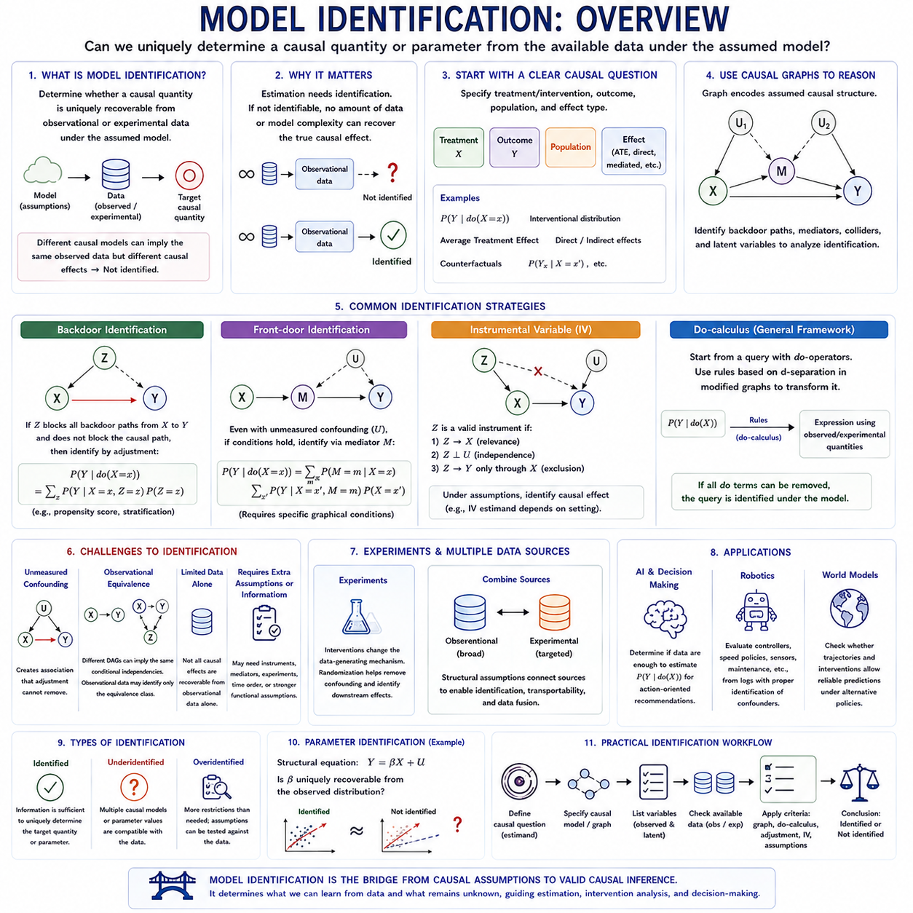
Model identification asks whether the causal quantities or structural parameters of a model can be uniquely determined from the information available. A model may describe plausible causal mechanisms, yet those mechanisms are not necessarily recoverable from observed data. Identification therefore separates what a causal model assumes from what the data can actually determine under those assumptions.
In a Structural Causal Model, identification concerns whether a target quantity such as P(Y | do(X = x)) can be expressed uniquely using observed or experimentally available distributions. If two different causal models generate the same observed data but imply different intervention effects, the desired effect is not identified from those observations alone.
This distinction is fundamental because estimation cannot solve a lack of identification. Statistical estimators operate on finite samples and attempt to approximate quantities that have already been shown to be identifiable. If the target causal effect is not uniquely determined even with an infinite amount of observational data, increasing sample size or model complexity cannot recover it.
Identification begins with a clearly defined causal estimand. The analyst must specify the treatment or intervention, outcome, target population, and type of effect to be recovered. Average Treatment Effect, direct effects, mediated effects, interventional distributions, and counterfactual quantities can require different identification conditions even when they involve the same observed variables.
Causal graphs provide a practical language for analyzing identification. Directed edges represent assumed causal mechanisms, while common causes, mediators, colliders, and latent variables determine which paths connect treatment and outcome. By examining these paths, analysts can determine whether observational associations can be transformed into causal effects through valid adjustment or other identification strategies.
Backdoor identification is one of the most common examples. If an observed set Z blocks every noncausal backdoor path from treatment X to outcome Y without blocking the causal pathways of interest, then the causal effect can be identified through adjustment. The intervention distribution can then be reconstructed by combining observational outcome distributions across values of Z.
Identification becomes more difficult when important common causes are unobserved. If X and Y share a hidden confounder U, ordinary regression or covariate adjustment may not separate the causal effect of X from association induced by U. Additional structure, instruments, mediators, experiments, temporal restrictions, or stronger functional assumptions may then be required.
Front-door identification demonstrates that hidden confounding does not always make a causal effect unrecoverable. Under specific graphical conditions, an observed mediator M can transmit the effect of X to Y while allowing the relevant causal components to be identified separately. The resulting effect can be reconstructed even when the direct X–Y relationship is confounded by an unobserved variable.
Instrumental variables offer another route to identification. A valid instrument Z changes treatment X, is independent of relevant unobserved confounders, and affects outcome Y only through X. Under suitable assumptions, variation induced by Z can isolate causal information that ordinary observational comparisons cannot provide. The exact estimand may depend on additional assumptions and population structure.
Do-calculus provides a general formal framework for identification in causal graphs. Starting from an intervention query containing do-operators, its rules use d-separation properties in modified graphs to transform causal expressions. When all intervention terms can be reduced to quantities available from observed or experimental distributions, the causal query has been identified under the assumed graph.
Model identification should also be distinguished from causal discovery. Causal discovery attempts to infer plausible graphical structure from data, whereas identification assumes a causal structure or equivalence class and asks what causal quantities can be recovered from it. A discovered graph can therefore provide input to identification analysis, but discovering a graph does not automatically identify every causal effect.
Parameter identification is a related but more specific problem. In a structural equation such as Y = βX + U, the question may be whether β can be uniquely recovered from the observed distribution and modeling assumptions. Different parameter values can sometimes produce indistinguishable observational distributions, making the structural parameter unidentified even though the equations appear mathematically well defined.
Models are often described as identified, underidentified, or overidentified. An identified model contains enough independent information to determine the target parameters uniquely. An underidentified model lacks sufficient constraints, allowing multiple parameter values or causal explanations. An overidentified model contains additional restrictions that may allow some assumptions to be tested against observed data.
Observational equivalence is a major source of identification difficulty. Two different DAGs may imply exactly the same conditional independence relationships and therefore belong to the same Markov equivalence class. Observational data alone may determine the equivalence class without determining every edge direction. Interventional data, temporal knowledge, or domain constraints may be required to distinguish the competing models.
Experimental interventions provide especially strong identifying information because they deliberately alter the data-generating mechanism. Randomizing X removes its dependence on natural upstream causes, allowing downstream changes to be attributed more directly to the intervention. Carefully selected experiments can therefore resolve ambiguities that would remain impossible to eliminate using passive observations alone.
Identification can also improve by combining multiple data sources. Observational datasets may cover broad populations, while experimental datasets provide direct intervention information for smaller subsets or environments. Structural assumptions can sometimes connect these sources, supporting data fusion, transportability, and recovery of causal effects that no single dataset could identify independently.
In artificial intelligence, model identification determines whether learned data are sufficient to support action-oriented reasoning. A predictive system may estimate P(Y | X) accurately without identifying P(Y | do(X)). Before an AI system uses observational patterns to recommend interventions, it must establish whether the required causal effect is recoverable under credible assumptions about the environment and decision process.
In robotics, identification arises when operational logs are used to evaluate controllers, speed policies, sensor configurations, or maintenance actions. Terrain difficulty may influence both controller selection and mission success, creating confounding. A causal graph can reveal whether existing measurements provide sufficient adjustment variables or whether controlled interventions are needed to identify the controller's true effect.
World models face a similar challenge. A model trained from trajectories generated by a particular behavior policy may accurately reproduce observed state transitions while failing to identify what would happen under actions rarely or never taken. Identification analysis asks whether available trajectories, structural assumptions, and interventions contain enough information to support reliable predictions under alternative policies.
A practical identification workflow therefore begins by defining the causal question, specifying a credible graph or structural model, identifying latent and observed variables, and determining the available observational or interventional distributions. Graphical criteria, do-calculus, adjustment formulas, instrumental structures, and functional assumptions are then used to test whether the target quantity is uniquely recoverable.
Model identification ultimately defines the boundary between plausible causal explanation and justified causal inference. Structural models describe how a system might generate observations, but identification determines which consequences of that structure can actually be learned from available evidence. It therefore provides the essential bridge from causal assumptions to valid estimation, intervention analysis, and decision-making.

02.07. Applications
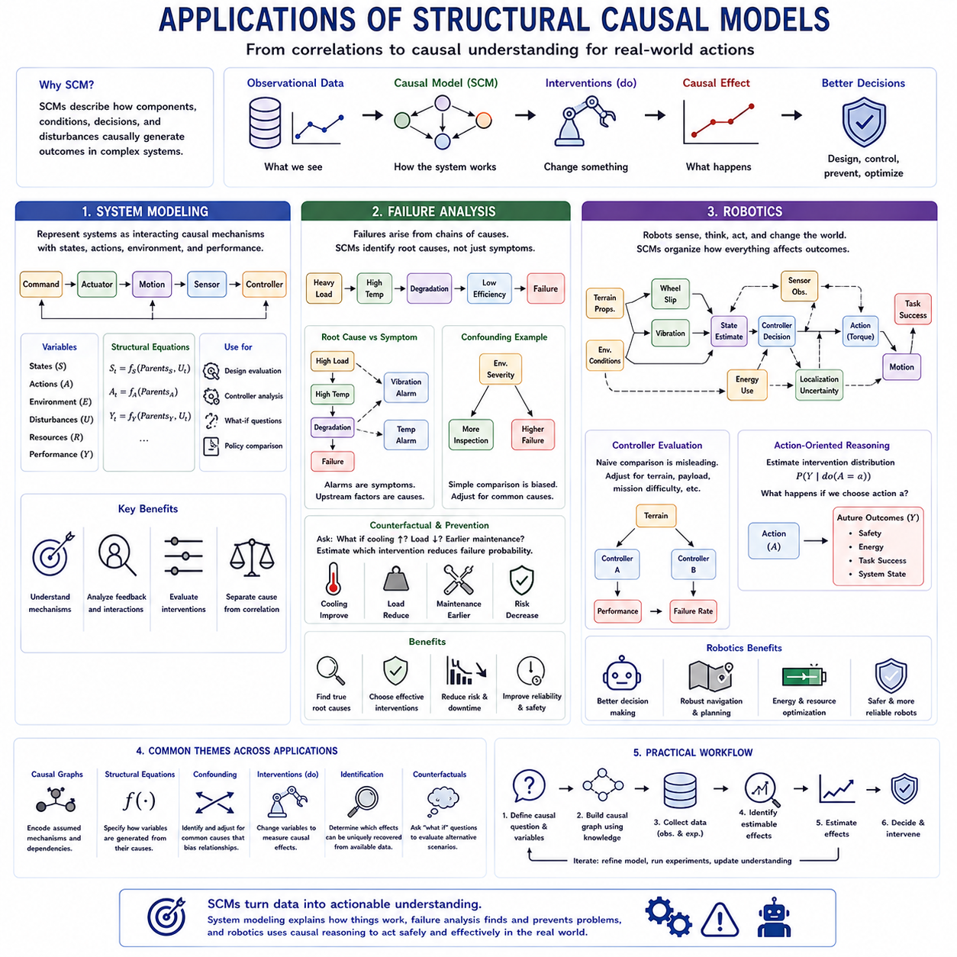
Structural Causal Models become especially valuable when causal reasoning is applied to real systems rather than isolated variables. In system modeling, failure analysis, and robotics, the objective is to represent how components, environmental conditions, control decisions, disturbances, and outcomes influence one another. This shifts modeling from describing observed correlations toward explaining how changes propagate through an interconnected system.
System modeling uses causal structure to represent a system as interacting mechanisms rather than as a single input-output function. Variables may describe physical states, commands, environmental conditions, resources, disturbances, and performance measures. Structural equations specify how each state is generated from its causal parents, while a causal graph provides an interpretable representation of dependencies among the mechanisms.
A complex engineered system can be decomposed into subsystems whose relationships are explicitly causal. For example, commanded torque may influence actuator output, actuator output may change mechanical motion, motion may affect sensor observations, and those observations may influence subsequent control decisions. Such a representation reveals feedback-related dependencies while allowing individual causal mechanisms to be analyzed at an appropriate temporal level.
Causal system models differ from conventional simulation models in their emphasis on interventions. A simulator may reproduce trajectories that resemble historical observations, whereas a causal model seeks to answer what would happen if a component, parameter, controller, or operating condition were deliberately changed. The distinction becomes important when engineers evaluate design alternatives that are poorly represented in existing operational data.
Structural equations can incorporate physical knowledge directly into system models. Conservation laws, kinematic relationships, thermal dynamics, electrical characteristics, and control equations can constrain causal relationships that would otherwise have to be inferred statistically. Data-driven components can then complement known physics where mechanisms are uncertain, producing hybrid causal models that combine engineering knowledge with learned relationships.
Model identification determines whether the effects of proposed system changes can actually be recovered from available evidence. Operational data may reveal strong relationships among variables without uniquely determining their causal direction. Controlled experiments, temporal ordering, known architecture, or physical constraints can reduce this ambiguity and make specific intervention effects identifiable.
Failure analysis is another natural application because failures usually emerge through chains of interacting causes rather than isolated events. Excessive load may increase temperature, elevated temperature may accelerate degradation, degradation may reduce component efficiency, and reduced efficiency may generate further thermal stress. A causal model represents this progression as mechanisms connecting initiating conditions to intermediate states and eventual failure.
This causal representation helps distinguish root causes from symptoms. A temperature alarm, vibration increase, localization error, or voltage drop may be highly predictive of failure without being the underlying cause. Intervening on a symptom may therefore have little effect on system reliability. Structural causal reasoning asks which upstream variables actually generate the failure pathway and which observations merely indicate that the pathway is already active.
Confounding is important in failure data because operating conditions often influence both maintenance decisions and observed failures. Components exposed to severe environments may receive more inspections while also failing more frequently. A simple comparison could incorrectly suggest that inspection increases failure risk. Representing environmental severity as a common cause helps separate maintenance effects from differences in operating conditions.
Counterfactual reasoning extends failure analysis beyond diagnosis. After a failure occurs, engineers can ask whether it would still have occurred if cooling performance had been higher, load had been reduced, maintenance had occurred earlier, or a different controller had been used. Structural equations provide a framework for evaluating these alternative scenarios while preserving relevant background conditions associated with the actual event.
Causal failure models can also support preventive maintenance and reliability engineering. Instead of ranking components only by predicted failure probability, the system can estimate which feasible intervention is expected to reduce that probability. This distinction separates risk prediction from risk reduction: a variable can be an excellent predictor of failure while being a poor target for intervention.
Robotics provides a particularly rich environment for causal modeling because perception, state estimation, planning, control, physical dynamics, and environmental interaction form an interconnected decision system. A robot continuously observes its surroundings, estimates state, selects actions, changes the physical environment, and receives new observations. Causal structure can represent how these processes jointly generate behavior and mission outcomes.
For example, terrain properties may influence wheel slip, vibration, energy consumption, localization uncertainty, and achievable velocity. Controller decisions may affect commanded torque and motion, while motion changes future sensor observations. A causal model can distinguish environmental causes from controller responses, preventing an analysis from incorrectly attributing poor performance to a controller simply because that controller is selected more often in difficult terrain.
Sensor analysis also benefits from causal reasoning. Rain, dust, illumination, vibration, and surface geometry may simultaneously affect several perception sensors and downstream localization performance. Correlations among sensor errors do not necessarily imply direct interactions between sensors. Modeling shared environmental causes helps determine whether improved sensing, sensor fusion, environmental adaptation, or estimator redesign would provide the most effective intervention.
Robot controller evaluation illustrates the difference between observation and intervention. Operational logs may show that a conservative controller has lower average speed and higher failure rates because it is activated in hazardous situations. Comparing raw outcomes between controllers would therefore be misleading. Causal adjustment can account for terrain, mission difficulty, payload, or other variables influencing both controller selection and performance.
Causal models can further support action selection by estimating intervention distributions rather than only observational predictions. A robot may need to evaluate P(Y | do(A = a)), where A is an action and Y represents future safety, energy use, task success, or system state. This formulation explicitly asks what outcome should follow if the robot deliberately chooses an action rather than merely observing that the action occurred historically.
World models and Structural Causal Models can therefore complement one another in robotics. A learned world model may represent high-dimensional state transitions from sensor and action sequences, while causal structure can organize which variables represent controllable actions, environmental mechanisms, latent disturbances, and downstream consequences. This separation can improve reasoning when policies or operating environments differ from those represented in training data.
Failure analysis within robotics can combine these perspectives. A navigation failure may emerge from degraded perception, poor localization, unsuitable planning, actuator limitations, communication delays, or environmental conditions. A causal graph can organize these mechanisms and identify competing pathways to failure, while operational logs and targeted experiments provide evidence for estimating the strengths of individual relationships.
Interventions are particularly valuable for validating such models. Engineers can deliberately vary payload, speed, controller parameters, sensor configurations, terrain conditions, or communication quality while measuring downstream effects. These controlled changes help distinguish causal mechanisms that observational logs alone cannot separate and can resolve ambiguities discovered during causal identification or causal discovery.
System modeling, failure analysis, and robotics also require careful treatment of time. Causes must precede their downstream consequences, but temporal precedence alone does not establish causality. Dynamic causal models can represent states such as Sₜ, actions Aₜ, disturbances Uₜ, and future states Sₜ₊₁, while longer causal chains describe how repeated interactions accumulate into degradation, adaptation, or mission-level outcomes.
The practical value of causal modeling increases when domain knowledge is incorporated explicitly. Engineering architecture can prohibit impossible causal directions, physical equations can constrain structural functions, maintenance records can identify interventions, and robot logs can provide temporal evidence. These constraints reduce the number of plausible causal models and help prevent statistically convenient relationships from being mistaken for physical mechanisms.
A useful engineering workflow therefore combines structural knowledge, observational data, and targeted experiments. Engineers first define the variables and causal question, construct an initial graph from physical and system knowledge, examine confounding and identification, and estimate identifiable effects from available data. Uncertain relationships can then motivate controlled experiments whose results update or reject parts of the proposed model.
Across these applications, the central advantage of Structural Causal Models is the transition from prediction toward intervention-oriented understanding. System modeling explains how changes propagate, failure analysis identifies mechanisms that can actually be modified, and robotics evaluates the consequences of deliberate actions. Together, these applications show how causal models can support diagnosis, design optimization, reliability, autonomy, and safer decision-making in complex engineered systems.

