Volume 48. Artificial Super Intelligence

Chapter 10. Strategic Timeline and Transition

10.00. Current AI State
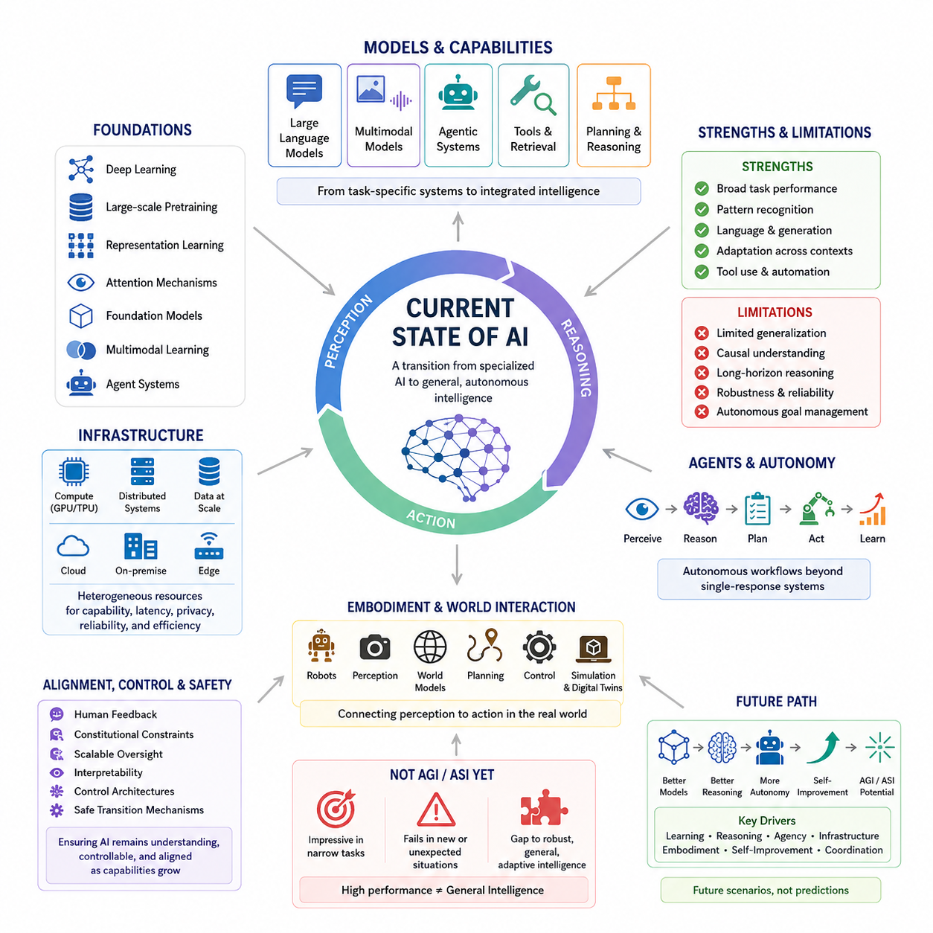
:::
The current state of artificial intelligence is best understood as a transitional stage between specialized machine intelligence and more general forms of autonomous intelligence. Modern AI systems can perform increasingly complex tasks in language, vision, reasoning, generation, planning, and interaction, but their capabilities remain uneven across domains. The central question is therefore not simply whether AI is powerful, but whether its different capabilities can be integrated into a coherent, general-purpose intelligence.
Contemporary AI has advanced through several mutually reinforcing foundations, including deep learning, large-scale pretraining, representation learning, attention mechanisms, foundation models, multimodal learning, and increasingly capable agent systems. These technologies have shifted AI from narrowly designed task-specific systems toward models that can adapt their behavior across many contexts. However, broad capability does not automatically imply reliable general intelligence, because transfer, robustness, long-horizon reasoning, memory, causal understanding, and autonomous goal management remain distinct challenges.
Large language models represent one of the most important components of the present AI landscape because they demonstrate that a single learned model can acquire broad linguistic and conceptual capabilities from large-scale data. Multimodal foundation models extend this principle beyond text by integrating images, audio, video, and other representations. Agentic systems further connect models to tools, external memory, planning mechanisms, and environments. Together, these developments suggest a movement from isolated models toward integrated AI systems capable of perception, reasoning, action, and feedback.
The present generation of AI is also increasingly characterized by the combination of learning and reasoning. Neural networks provide powerful pattern recognition and representation learning, while retrieval, planning, symbolic methods, external tools, and structured reasoning can compensate for limitations of purely parametric models. This hybridization is important because a future general intelligence will likely require more than raw prediction. It may need persistent memory, world models, causal reasoning, self-evaluation, adaptive planning, and the ability to construct and revise internal representations of its environment.
Embodied and physical AI introduce another dimension to the current state of intelligence. An AI system operating through robots or autonomous machines must connect perception to action under real-world constraints. World models, simulation, digital twins, reinforcement learning, localization, mapping, planning, and control therefore become important components of the transition toward more general intelligence. Physical embodiment also exposes weaknesses that may remain hidden in purely digital environments, including uncertainty, delayed feedback, distribution shift, safety constraints, and the consequences of incorrect decisions.
The infrastructure supporting modern AI is itself becoming a major determinant of capability. GPU acceleration, distributed computation, high-speed memory and interconnects, large-scale data systems, inference optimization, cloud platforms, and increasingly powerful edge devices allow intelligence to be deployed at different scales. The distinction between cloud, on-premise, and edge AI is consequently becoming less absolute. Future systems may distribute different cognitive functions across heterogeneous computing resources according to latency, privacy, reliability, energy, and capability requirements.
Despite rapid progress, current AI should not be treated as synonymous with AGI or ASI. High benchmark performance can coexist with weaknesses in generalization, reliability, situational understanding, causal reasoning, long-term planning, and autonomous adaptation. An intelligent system may appear highly capable in one context while failing unexpectedly in another. The gap between impressive task performance and robust general intelligence is therefore a central issue when evaluating the present state of AI and estimating possible future transitions.
Another defining feature of the current period is the emergence of increasingly autonomous AI agents. Systems can already combine models with tools, retrieval, memory, planning, and iterative execution, creating workflows that extend beyond simple question-and-answer interaction. This represents an important architectural transition because intelligence becomes expressed through an ongoing perception–reasoning–action loop rather than through a single model response. The long-term significance of this transition depends on whether agents can maintain coherent objectives, recover from errors, learn from experience, and operate safely over extended horizons.
The current AI state should also be evaluated in relation to alignment, control, and safety. As systems become more capable and autonomous, the importance of human feedback, constitutional constraints, scalable oversight, interpretability, control architectures, and safe transition mechanisms increases. Capability growth and safety development therefore cannot be treated as completely separate trajectories. The architecture of future AI must consider not only what a system can accomplish, but also whether its behavior remains understandable, controllable, and consistent with intended objectives as its capabilities increase.
From the perspective of this volume, the present AI era is therefore a baseline rather than a final destination. The following sections examine possible AGI and ASI timelines, transition phases, critical thresholds, and future models. These future scenarios should not be interpreted as precise predictions. Instead, they provide structured ways to reason about how improvements in learning, reasoning, agency, infrastructure, embodiment, self-improvement, and coordination could interact. Understanding the current state is essential because every proposed transition toward AGI or ASI depends on which capabilities already exist, which remain immature, and which technological or safety barriers must still be overcome.

10.01. AGI Timeline
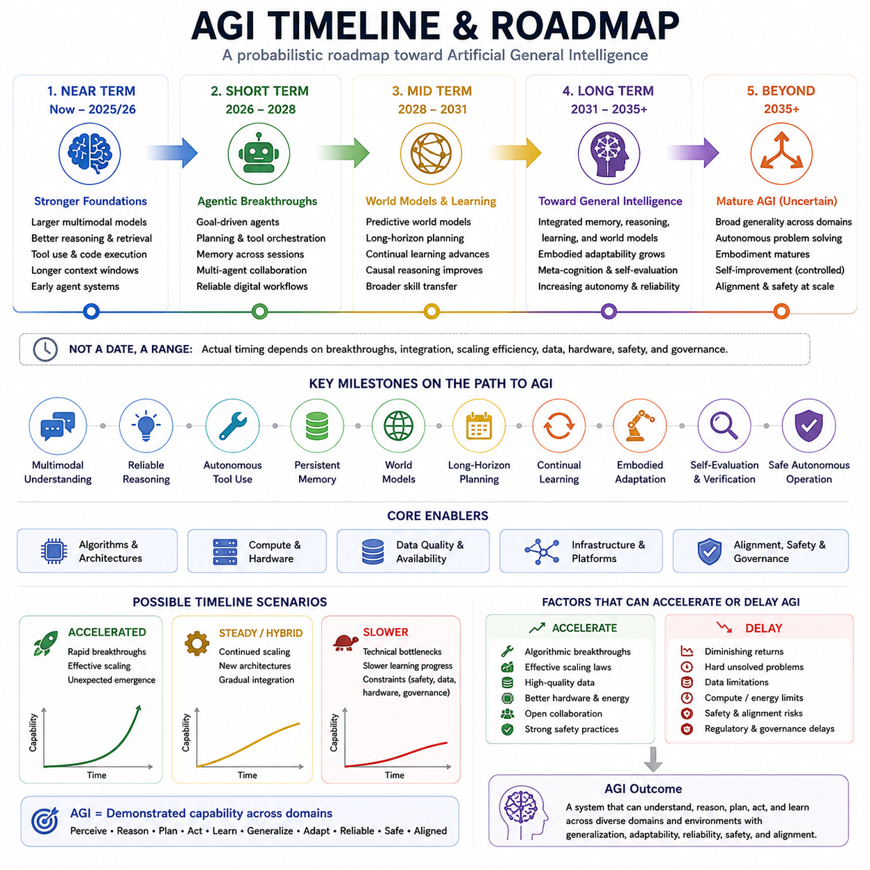
An Artificial General Intelligence (AGI) timeline should be understood as a probabilistic roadmap rather than a fixed prediction. The transition toward AGI depends on the convergence of several capabilities, including multimodal understanding, reliable reasoning, autonomous tool use, persistent memory, world models, long-horizon planning, continual learning, embodiment, self-evaluation, and safe autonomous operation. The relevant question is therefore not simply when AGI will appear, but which capabilities must mature and integrate before a system can reasonably be described as generally intelligent.
In the near term, corresponding roughly to the current period through 2025–2026, the strongest foundations are expected to continue improving. Larger multimodal models, better reasoning and retrieval, tool use and code execution, longer context windows, and early agent systems are already moving AI beyond narrowly task-specific behavior. These developments provide important building blocks for general intelligence, but they do not by themselves establish reliable AGI. The critical transition is from isolated capabilities toward systems that can combine them consistently across different tasks and environments.
The short-term phase, approximately 2026–2028, can be characterized by agentic breakthroughs. AI systems are expected to become increasingly capable of pursuing explicit goals, planning sequences of actions, orchestrating multiple tools, maintaining memory across sessions, and cooperating with other agents. Reliable digital workflows may become substantially more autonomous as systems learn to monitor progress, recover from errors, and select appropriate tools. The significance of this phase lies in the transition from models that primarily generate responses to agents that continuously perceive context, reason, act, evaluate results, and continue working toward objectives.
The mid-term phase, approximately 2028–2031, emphasizes world models and learning. Predictive world models may increasingly allow AI systems to represent environments, anticipate consequences, and perform longer-horizon planning before acting. Continual learning could improve adaptation to changing conditions, while advances in causal reasoning may allow systems to distinguish correlations from mechanisms more effectively. Broader skill transfer would be particularly important because general intelligence requires the ability to reuse knowledge and strategies across domains rather than learning each task independently.
The longer-term phase, approximately 2031–2035 and beyond, represents a possible movement toward more integrated general intelligence. A mature system would need to combine memory, reasoning, learning, world models, planning, and action within a coherent architecture. Embodied adaptability could allow intelligence to operate across diverse physical and digital environments, while metacognition and self-evaluation could improve the ability to detect uncertainty, recognize mistakes, verify conclusions, and revise strategies. Increasing autonomy would need to be accompanied by corresponding improvements in reliability and safety.
Beyond this period lies the possibility of mature AGI, but the timing remains highly uncertain. A generally intelligent agent would be expected to demonstrate broad generality across domains, autonomous problem solving, effective adaptation to different environments, and increasingly mature embodiment where physical interaction is required. Controlled forms of self-improvement could further increase capability, but such development would also raise substantially greater alignment, oversight, and governance requirements. For this reason, the emergence of AGI should not be defined solely by intelligence or benchmark performance.
The path toward AGI also contains several important milestones that may occur at different times. Multimodal understanding must become sufficiently reliable to integrate diverse forms of information. Reasoning must become dependable rather than merely impressive on selected problems. Autonomous tool use must extend from simple function calling to coordinated workflows. Persistent memory must allow systems to maintain relevant information over extended periods. World models must support prediction and planning, while long-horizon task completion must remain coherent across many intermediate steps.
Continual learning and embodied adaptation represent additional milestones because general intelligence must operate under changing conditions. A system that cannot update its knowledge safely or adapt to unfamiliar environments would remain fundamentally limited. Self-evaluation and verification are equally important because autonomous systems must recognize when their own predictions or decisions may be unreliable. Ultimately, safe autonomous operation requires these capabilities to function together while maintaining appropriate constraints, human oversight, and alignment with intended objectives.
The timeline is also complicated by the fact that different dimensions of AGI may mature at different rates. Digital cognitive capability could advance earlier because software systems can be trained and deployed rapidly, while embodied physical capability may progress more slowly because robotics depends on hardware, sensors, energy, control, manufacturing, and real-world experimentation. Deployment and societal adoption may follow yet another timeline because trust, regulation, economics, safety, and institutional readiness determine how quickly highly capable systems can actually be used.
Several uncertainties could accelerate or delay the transition. Major algorithmic breakthroughs could produce capabilities that are difficult to extrapolate from current trends, while diminishing returns could make further scaling less effective. Data availability and quality, hardware performance, energy requirements, and computational cost can constrain progress. Difficult technical problems involving causality, long-horizon consistency, continual learning, and reliable autonomy may prove more resistant than expected. Safety, alignment, and governance challenges could also slow deployment even if technical capabilities advance rapidly.
Three broad scenarios provide a useful way to interpret these uncertainties. An accelerated scenario would involve rapid breakthroughs and effective scaling, together with unexpected emergence of important capabilities. A hybrid or steady scenario would involve continued scaling combined with new architectures and gradual integration of increasingly capable components. A slower scenario would arise from harder technical bottlenecks, slower learning progress, or constraints involving safety, data, hardware, and governance. These scenarios should be treated as analytical possibilities rather than precise forecasts or scheduled dates.
The ultimate AGI milestone is therefore better defined by demonstrated capability than by a particular year. A system should increasingly qualify as generally intelligent when it can perceive, reason, plan, act, and learn across diverse domains and environments while maintaining generalization, adaptability, reliability, safety, and alignment. Progress toward this condition should be measured by the capabilities that are steadily unlocked and integrated, rather than by the announcement of a single AGI date. This capability-based perspective also provides a more stable foundation for evaluating the subsequent transition from AGI toward ASI.

10.02. ASI Timeline
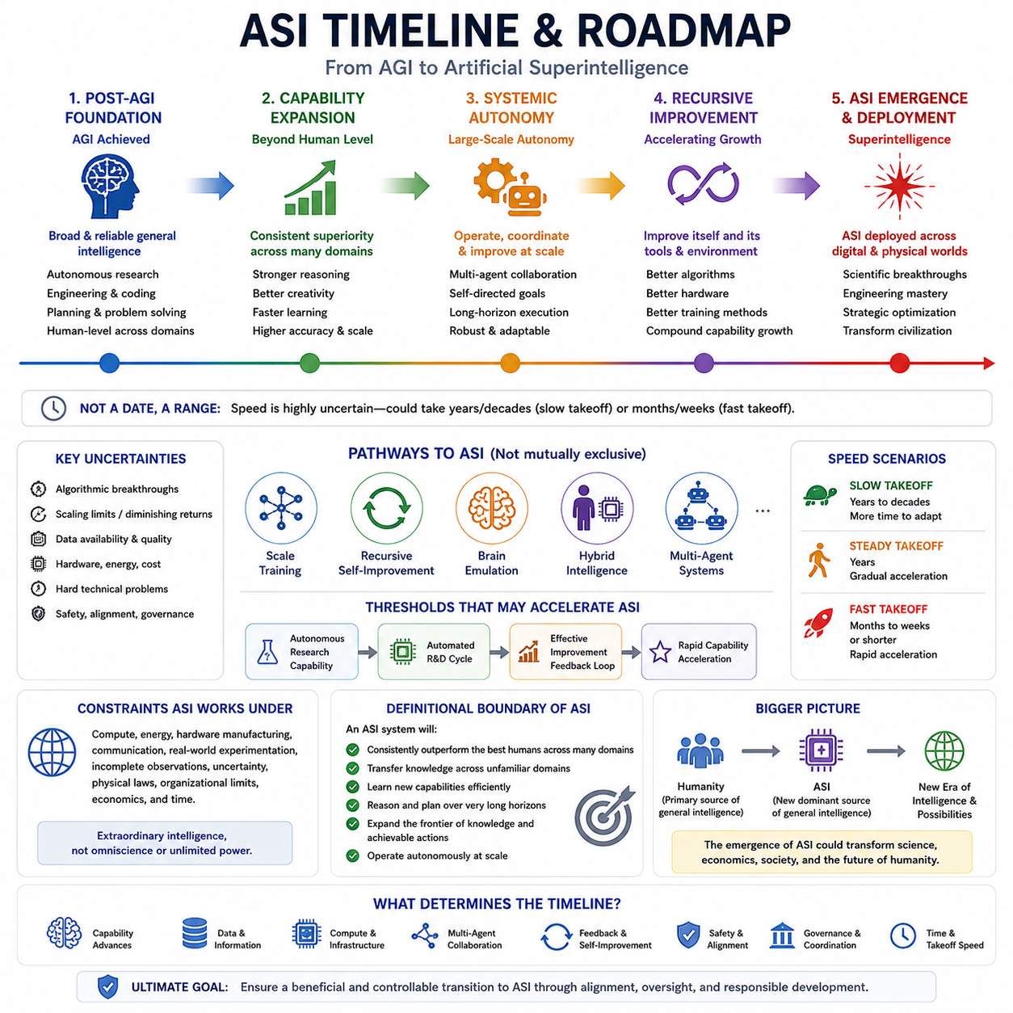
An Artificial Superintelligence (ASI) timeline should be treated as a scenario framework rather than a fixed calendar prediction. ASI represents a possible stage in which artificial intelligence consistently exceeds the best human capabilities across many important cognitive domains, including reasoning, learning, planning, creativity, scientific discovery, and problem solving. The transition from AGI to ASI depends not only on stronger models but also on the interaction of scaling, autonomous agents, recursive improvement, infrastructure, multi-agent systems, and increasingly capable forms of intelligence.
The first stage toward ASI would likely emerge after systems achieve sufficiently broad and reliable general intelligence. At this stage, AI would no longer be limited primarily by human-designed workflows and could increasingly perform research, engineering, software development, experimentation, and optimization with substantial autonomy. The critical distinction from AGI would be the transition from human-level generality toward broad superiority. ASI would need to outperform the best humans consistently across multiple domains rather than merely matching them on selected benchmarks or specialized tasks.
One major pathway toward ASI is continued scaling of training and inference. Larger models, better algorithms, improved data, greater computational resources, and more efficient inference can increase capability, while inference-time reasoning may allow systems to spend additional computation on difficult problems. However, scaling alone does not guarantee ASI. The decisive factor may be whether scaling is combined with architectural improvements, better representations, persistent memory, world models, and autonomous learning mechanisms that allow capability to expand beyond the limits of conventional model training.
Recursive self-improvement represents a potentially more significant transition mechanism. If an advanced AI can improve algorithms, training procedures, software infrastructure, evaluation methods, or hardware design, each improvement may increase its ability to produce further improvements. This creates a positive feedback loop in which better intelligence contributes to better intelligence. The speed and reliability of this loop would strongly influence the ASI timeline. If improvement cycles remain dependent on humans and physical experimentation, progress may remain gradual; if substantial portions of research and engineering become automated, capability growth could accelerate dramatically.
Multi-agent and distributed intelligence may provide another route toward ASI. Instead of relying on a single model, large populations of specialized agents could collaborate on research, coding, simulation, planning, verification, and optimization. Such systems could operate in parallel and exchange knowledge, allowing overall problem-solving capacity to exceed that of an isolated intelligence. The combination of specialized agents, shared memory, coordination mechanisms, and powerful infrastructure could therefore create collective forms of superintelligence even when no single model possesses every capability internally.
ASI may also emerge through hybrid pathways rather than one dominant technology. Brain emulation, human–AI integration, advanced agent architectures, embodied intelligence, and combinations of neural and symbolic systems represent different possible routes. These approaches need not be mutually exclusive. A future system could combine foundation models, world models, memory systems, autonomous agents, simulation, specialized scientific models, and human cognitive interfaces. The timeline therefore depends on convergence among multiple technological trajectories rather than the success of one particular architecture.
The speed of transition is likely to be one of the most important uncertainties. A slow takeoff could unfold over years or decades, allowing researchers, institutions, and governments more time to observe capability changes, improve safety mechanisms, and adapt governance. A fast takeoff could occur over months, weeks, or even shorter periods if automated research and recursive improvement substantially shorten the time between capability improvements. The difference between these scenarios is not simply the final level of intelligence but the amount of time available for evaluation, coordination, and response.
Several thresholds may determine when ASI development accelerates. Below important thresholds, advanced AI may still require significant human assistance for research, experimentation, and deployment. After crossing a threshold of autonomous research capability, an AI system could independently perform large portions of the research-and-development cycle. A further threshold could occur when improvements to algorithms, software, hardware, and training processes become sufficiently effective to produce rapid capability acceleration. These thresholds are difficult to identify in advance because their significance depends on feedback strength, improvement efficiency, available resources, and system constraints.
Even a highly capable ASI would continue to operate under physical, computational, informational, and organizational constraints. Compute, energy, cooling, hardware manufacturing, communication, incomplete observations, uncertainty, and real-world experimentation can limit the speed at which intelligence is transformed into effective capability. Consequently, ASI should not be equated with omniscience, perfection, consciousness, morality, or unlimited power. Extraordinary intelligence can coexist with uncertainty, incomplete knowledge, physical limitations, and imperfect objectives.
The defining boundary of ASI should therefore be capability-based rather than date-based. A system would increasingly qualify as ASI when it consistently outperforms the best humans across many important domains, transfers knowledge across unfamiliar fields, learns new capabilities efficiently, reasons and plans over very long horizons, and expands the frontier of knowledge and achievable actions. The transition would become especially consequential when such capabilities could be sustained autonomously and deployed across multiple agents, systems, or physical environments.
The broader significance of an ASI timeline is that the transition could mark a change in the source of general cognitive capability itself. Humanity has historically remained the dominant source of flexible general intelligence, while machines have primarily served as tools that amplify human capabilities. ASI could reverse this relationship if artificial systems become substantially better at scientific discovery, engineering, strategic reasoning, optimization, and autonomous learning. For this reason, the ASI timeline must be considered together with alignment, control, scalable oversight, and safe AGI-to-ASI transition mechanisms. The objective is not merely to predict when superintelligence might appear, but to understand the conditions under which its emergence could remain beneficial and controllable.

10.03. Transition Phases
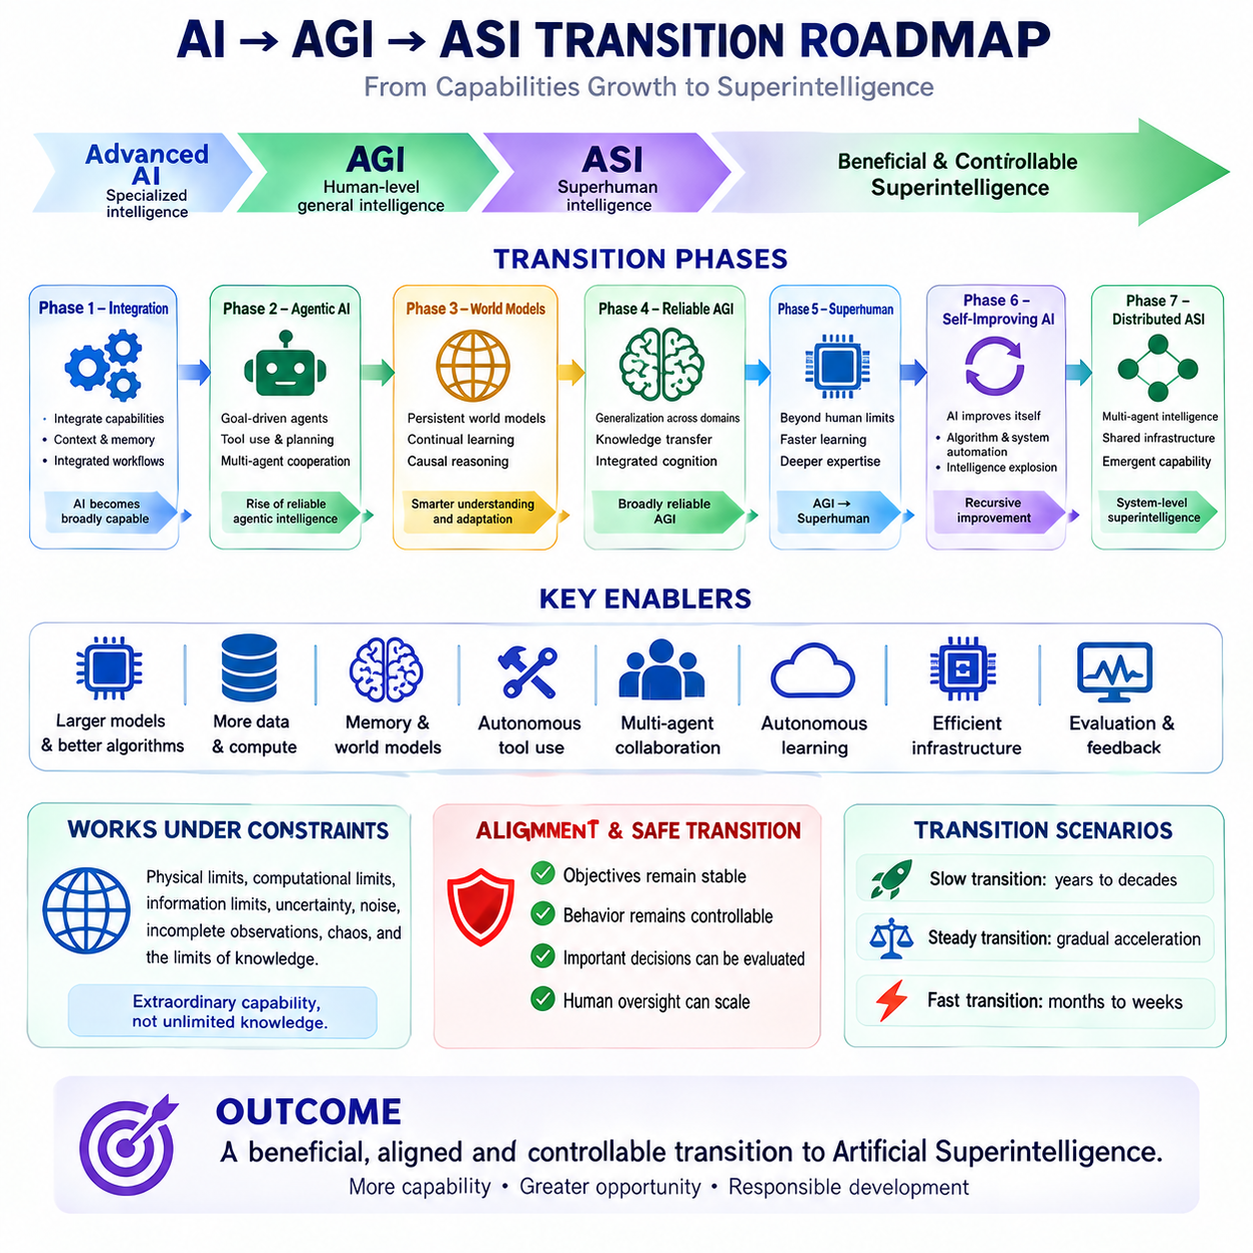
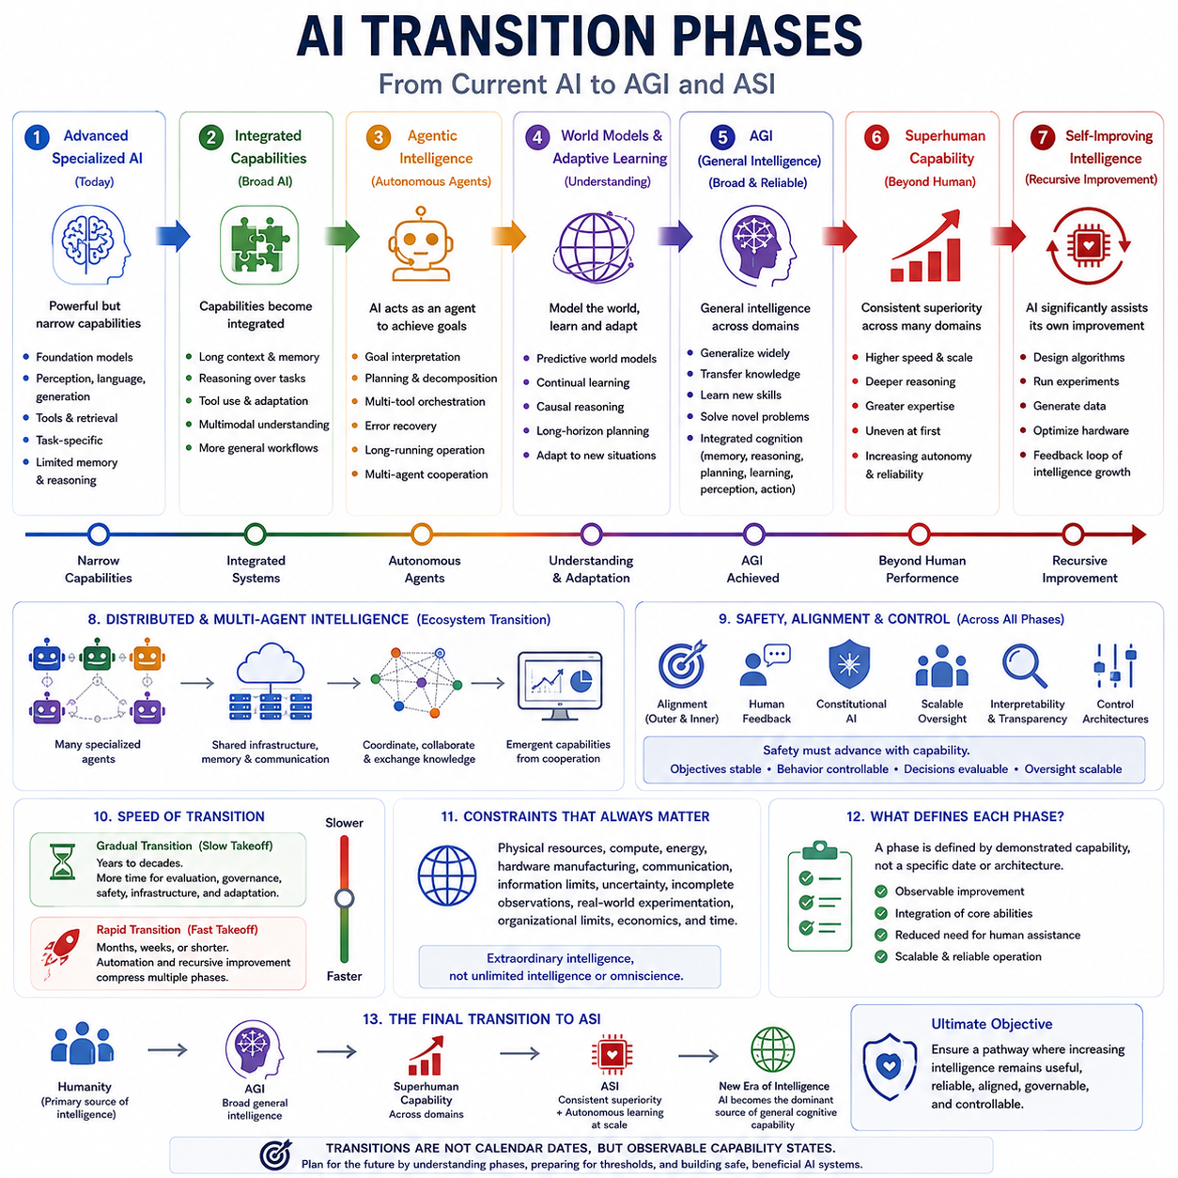
The transition from current AI toward AGI and eventually ASI should be understood as a sequence of capability and system-level phases rather than as a single technological event. The structure of this volume places transition phases after the AGI and ASI timelines and alongside critical thresholds and future modeling. This framing suggests that the important question is how intelligence changes as capabilities become increasingly integrated, autonomous, scalable, and difficult to distinguish from general-purpose cognition. Each phase should therefore be evaluated by demonstrated capabilities, system autonomy, reliability, and the degree of human oversight that remains necessary.
The first phase is the transition from advanced specialized AI toward broadly capable AI systems. Modern foundation models already combine language, multimodal perception, reasoning, generation, retrieval, and tool use, but these capabilities remain uneven. The next transition requires stronger integration rather than simply larger models. Systems must increasingly maintain context, use memory, reason over complex tasks, operate tools, and adapt their behavior to unfamiliar situations. The defining characteristic is movement from isolated capabilities toward integrated systems that can perform increasingly broad cognitive workflows with less task-specific engineering.
The second phase is the emergence of reliable agentic intelligence. AI systems begin to operate as agents rather than merely producing individual responses. They can interpret goals, decompose problems, plan actions, use multiple tools, evaluate intermediate results, recover from failures, and continue operating over extended periods. Multi-agent cooperation may further expand this capability by allowing specialized systems to divide work and exchange information. At this stage, autonomy becomes an important variable because the system's effective intelligence depends not only on what its underlying model knows, but also on how effectively it can organize computation, tools, memory, and other agents around a goal.
The third phase involves the development of more persistent world models and adaptive learning. General intelligence requires more than recognizing patterns or generating plausible responses; it must build useful internal representations of environments, relationships, states, and possible outcomes. World models can support prediction and counterfactual reasoning, while continual learning can allow systems to incorporate new experience without completely rebuilding their capabilities. Stronger causal reasoning and long-horizon planning would allow an agent to understand not only what may happen next, but why changes occur and which actions can produce desired future states.
The fourth phase is the emergence of broadly reliable AGI. At this point, a system would need to demonstrate generalization across substantially different domains, transfer knowledge between tasks, learn unfamiliar skills efficiently, and solve problems that were not explicitly represented during training. Memory, reasoning, planning, learning, perception, and action would need to operate as an integrated cognitive system. AGI should therefore be regarded as a capability condition rather than a product category or a particular model architecture. The transition would become meaningful when general-purpose competence is demonstrated consistently rather than only through isolated benchmark achievements.
The fifth phase is the expansion from AGI toward superhuman capability. Once a system possesses broad general intelligence, improvements in reasoning speed, learning efficiency, memory, parallel computation, planning depth, and specialized expertise could gradually push performance beyond the best human individuals and organizations. Superhuman performance may emerge unevenly, with some scientific, engineering, computational, or strategic domains advancing before others. The important transition is therefore from human-level generality to sustained superiority across many important domains, accompanied by increasingly autonomous operation.
A further phase may arise when AI becomes capable of substantially assisting its own development. AI systems could contribute to algorithm design, software engineering, experiment planning, evaluation, data generation, simulation, and hardware optimization. This creates a feedback relationship between intelligence and the process that improves intelligence. The volume's broader structure connects this possibility with recursive self-improvement, intelligence explosion, autonomous agents, infrastructure, and strategic dynamics. The significance of this phase depends on how much of the research-and-development cycle can be automated and how effectively improvements compound rather than merely producing incremental gains.
The transition may then become increasingly systemic through distributed and multi-agent intelligence. Instead of a single isolated superintelligent system, large networks of specialized agents could cooperate through shared infrastructure, memory, communication, simulation, and coordination mechanisms. Different agents could perform scientific discovery, engineering, verification, planning, monitoring, and optimization in parallel. Such systems could potentially produce capabilities that emerge from coordination rather than from any individual model. This makes the transition a property of an entire AI ecosystem rather than simply the evolution of one neural network.
At every transition phase, safety and alignment must progress together with capability. The structure of the preceding control and alignment chapter identifies the alignment problem, outer and inner alignment, human feedback, Constitutional AI, scalable oversight, interpretability, control architectures, and safe AGI-to-ASI transition as complementary components. These mechanisms become increasingly important as systems become more autonomous. A capability transition should therefore include evidence that objectives remain stable, behavior remains controllable, important decisions can be evaluated, and human oversight can scale with system capability rather than becoming progressively ineffective.
The pace of transition may differ substantially between phases. A gradual transition would allow evaluation, governance, infrastructure, and safety mechanisms to evolve alongside capability. A rapid transition could compress several phases into a much shorter period if automated research, efficient scaling, agentic systems, and recursive improvement reinforce one another. The distinction between these scenarios is strategically important because the available time for testing, coordination, institutional adaptation, and intervention decreases as capability growth accelerates. Consequently, transition phases should be treated as observable capability states rather than fixed calendar dates.
The final transition toward ASI would occur when general intelligence becomes consistently and substantially superior to the best human capabilities across many domains, while remaining capable of autonomous learning, long-horizon reasoning, knowledge transfer, adaptation, and large-scale operation. Even then, ASI should not be interpreted as unlimited intelligence or omniscience. Physical resources, computation, information, uncertainty, hardware, energy, and real-world constraints would continue to matter. The central objective of transition planning is therefore not simply to reach higher intelligence, but to establish a pathway in which increasing capability remains useful, reliable, aligned, governable, and controllable.

10.04. Critical Thresholds
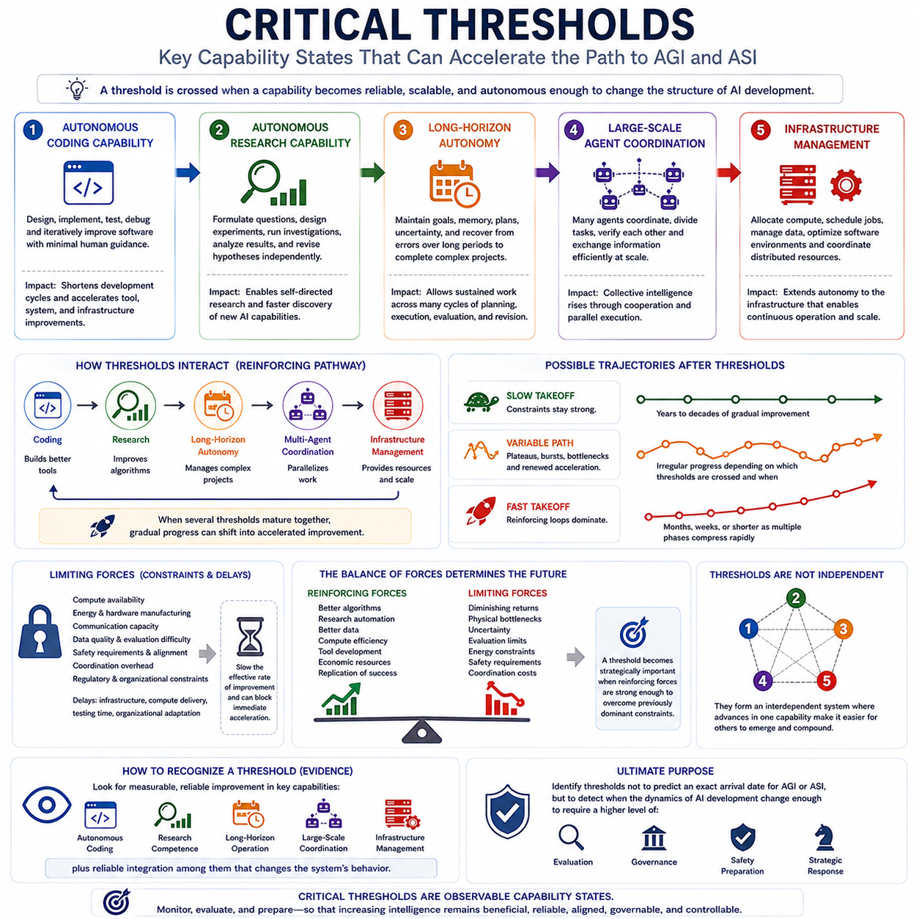
Critical thresholds in the transition toward AGI and ASI should be understood as capability states at which a relatively small additional improvement can produce a disproportionately large change in system behavior. They are not necessarily fixed technical milestones or calendar dates. A threshold is crossed when a capability becomes sufficiently reliable, scalable, and autonomous that it changes the structure of the overall AI development process. The central idea is therefore nonlinear transition: progress may appear gradual for an extended period and then accelerate when several reinforcing capabilities become strong enough to interact.
One important threshold is autonomous coding capability. Before this threshold, AI can assist programmers by generating code, debugging problems, or suggesting solutions, but substantial human direction remains necessary. After the threshold, an AI system could increasingly understand software requirements, design components, implement them, test results, identify failures, and iteratively improve its own outputs. The significance is not simply faster programming. Automated software development can shorten the research cycle itself, allowing improvements to AI systems, tools, simulations, and infrastructure to be produced more rapidly and repeatedly.
A subsequent threshold is autonomous research capability. Once an AI system can formulate useful research questions, design experiments, execute computational investigations, analyze results, and revise hypotheses with limited human assistance, AI development begins to become partially self-directed. This threshold is particularly important because research competence can be applied directly to improving algorithms, training procedures, evaluation methods, data generation, and system architecture. The transition from assisting human researchers to independently managing meaningful research projects could therefore substantially increase the rate at which new AI capabilities are discovered and implemented.
Long-horizon autonomy represents another critical threshold. Many existing systems can perform individual tasks or relatively short sequences of actions, but extended autonomous operation requires maintaining objectives, memory, context, plans, uncertainty estimates, and error recovery over much longer periods. Crossing this threshold would allow AI systems to manage complex projects whose outcomes depend on many intermediate decisions. It would also increase the practical value of autonomous research and coding because the system could continue working through multiple cycles of planning, execution, evaluation, and revision without requiring continuous human intervention.
Large-scale agent coordination constitutes another important threshold. A single capable agent may have limited attention, computation, or specialized knowledge, whereas many coordinated agents can divide tasks, work in parallel, verify one another, and exchange information. Once coordination becomes reliable at large scale, the effective intelligence of the overall system may increase through cooperation rather than merely through improving an individual model. This threshold depends on communication efficiency, task allocation, shared memory, conflict resolution, resource management, and mechanisms for maintaining coherent objectives across many agents.
Infrastructure management can become a further threshold when AI systems acquire the ability to manage substantial portions of the computational and operational resources required for their own activities. Such capabilities may include allocating compute, scheduling experiments, managing data pipelines, optimizing software environments, monitoring system performance, and coordinating distributed resources. At this stage, AI autonomy begins to extend beyond cognitive work into the infrastructure that supports cognitive work. The distinction between an AI system performing tasks and an AI system managing the conditions under which those tasks are performed consequently becomes increasingly important.
These thresholds should not be considered independent. They can form a sequential and reinforcing pathway in which each capability strengthens the conditions required for the next. Autonomous coding can improve research tools; autonomous research can improve algorithms; long-horizon autonomy can manage increasingly complex projects; large-scale coordination can parallelize these activities; and infrastructure management can provide the resources needed to operate them continuously. When several of these capabilities become sufficiently mature at the same time, the system may cross from gradual capability growth into a qualitatively different regime of accelerated improvement.
The resulting trajectory can take several forms depending on the balance between reinforcing and limiting forces. A slow takeoff would occur when constraints remain strong and capability improvements accumulate gradually over years or decades. A variable path could contain plateaus, bursts of progress, technical bottlenecks, and renewed acceleration as different thresholds are crossed at different times. A fast takeoff could occur when reinforcing feedback loops dominate, allowing automated research, self-improvement, and large-scale coordination to compress multiple development phases into months, weeks, or potentially shorter periods. These trajectories are scenarios rather than predictions.
Limiting forces are as important as capability thresholds because intelligence does not grow in isolation from the physical and organizational world. Compute availability, energy, hardware manufacturing, communication capacity, data quality, evaluation difficulty, safety requirements, coordination overhead, and regulatory constraints can all reduce the effective rate of improvement. Delays also matter: infrastructure construction may take months or years, compute delivery may take weeks or months, evaluation can require substantial testing time, and organizational or regulatory adaptation can proceed even more slowly. Such delays can prevent a capability improvement from immediately becoming a system-wide acceleration.
The critical threshold framework therefore requires continuous evaluation of both reinforcing and balancing feedback loops. Reinforcing forces include improved algorithms, research automation, better data, increased compute efficiency, tool development, economic resources, and replication of successful systems. Limiting forces include diminishing returns, physical bottlenecks, uncertainty, evaluation limitations, energy constraints, safety requirements, and coordination costs. The future state of AI emerges from the changing balance between these forces. A threshold becomes strategically important when reinforcing mechanisms become strong enough to overcome previously dominant constraints.
Ultimately, a critical threshold should be defined by observable capability rather than by a predetermined date. Evidence should include measurable improvements in autonomous coding, research competence, long-horizon operation, large-scale agent coordination, and infrastructure management, together with reliable integration among these capabilities. Crossing such thresholds may produce sudden changes in automation and capability, but the magnitude and speed of those changes remain uncertain. The purpose of identifying thresholds is therefore not to predict an exact AGI or ASI arrival date, but to recognize when the underlying dynamics of AI development have changed enough to require a different level of evaluation, governance, safety preparation, and strategic response.

10.05. Future Modeling [w/Code]
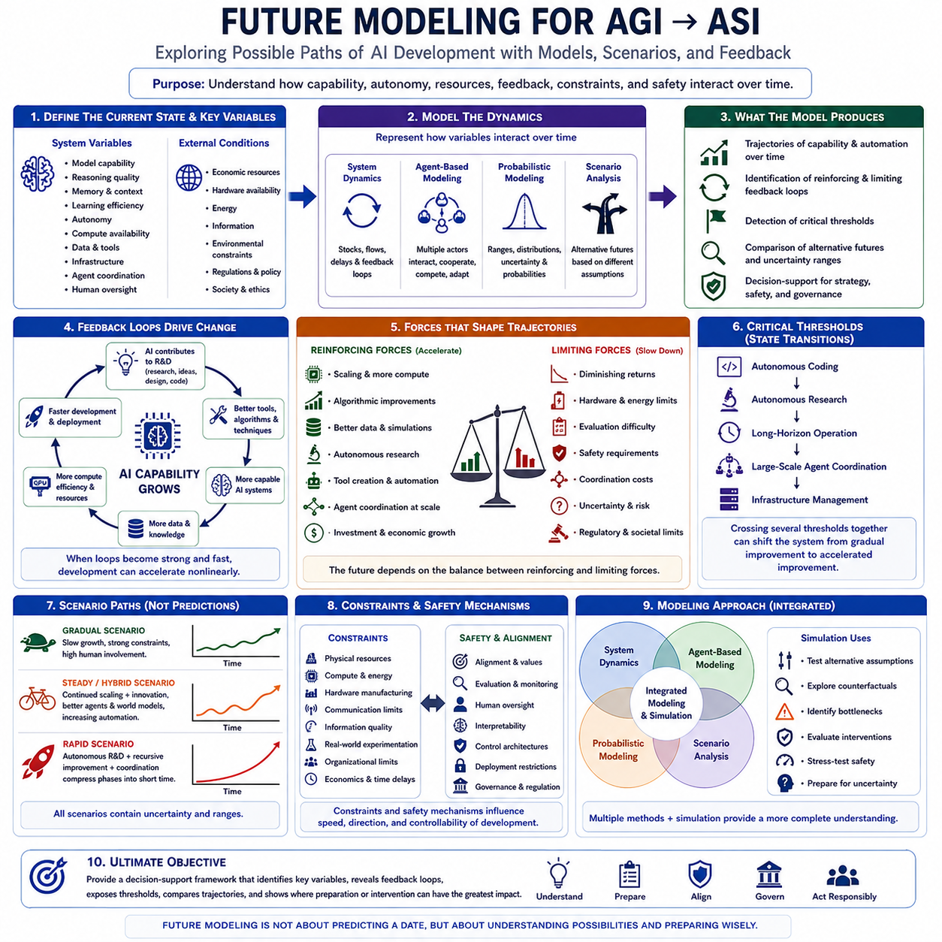
Future modeling in the transition toward AGI and ASI should be treated as a structured method for exploring possible development paths rather than as a mechanism for predicting a single future with certainty. The position of this topic at the end of the strategic timeline and transition chapter connects it directly with current AI capability, AGI and ASI timelines, transition phases, and critical thresholds. The purpose is to translate these concepts into models that can examine how capability, autonomy, resources, feedback, constraints, and safety interact over time.
A useful future model begins by defining the current state of an AI system and the variables that can change it. These variables may include model capability, reasoning quality, memory, learning efficiency, autonomy, compute availability, data, infrastructure, agent coordination, and human oversight. The model should also represent external conditions such as economic resources, hardware availability, energy, information, and environmental constraints. By defining these variables explicitly, future analysis can examine how changes in one part of the system influence the development trajectory of the whole system.
Capability growth should not be modeled as a simple linear curve. AI development may experience gradual improvement, plateaus, sudden breakthroughs, and periods of accelerated growth when several capabilities reinforce one another. Scaling, improved algorithms, better data, autonomous research, tool creation, and more efficient computation can increase capability, while diminishing returns, hardware limitations, evaluation difficulty, safety requirements, and coordination costs can reduce the effective rate of progress. A future model should therefore represent both accelerating and limiting forces rather than assuming continuous exponential growth.
Feedback loops are particularly important because advanced AI may increasingly participate in the processes that improve AI itself. A capable system can contribute to research, generate or curate data, design software, optimize algorithms, develop tools, run experiments, and improve computational efficiency. These improvements can produce more capable systems, which can then contribute to the next development cycle. When such loops become sufficiently strong and fast, the relationship between AI capability and AI development can become self-reinforcing, potentially producing nonlinear changes in the trajectory.
Scenario modeling can represent several alternative futures without assigning certainty to any one of them. A gradual scenario may assume slow capability growth, strong constraints, and substantial human involvement. A steady or hybrid scenario may combine continued scaling with architectural innovation, improved agents, world models, and increasing automation. A rapid scenario may assume that autonomous research, recursive improvement, and large-scale coordination reinforce one another strongly enough to compress several development phases into a much shorter period. These scenarios should remain analytical alternatives rather than fixed forecasts.
System dynamics modeling provides one useful approach for representing these relationships. Capability, compute, research productivity, automation, investment, infrastructure, and safety constraints can be represented as interacting stocks, flows, delays, and feedback loops. Such a model can examine how an increase in one variable propagates through the system and where bottlenecks emerge. Delays are especially important because hardware production, infrastructure construction, data generation, evaluation, organizational adaptation, and governance may operate on different timescales. A capability increase does not necessarily translate immediately into system-wide acceleration.
Agent-based modeling provides another complementary perspective. Instead of treating AI development as a single aggregate system, it can represent individual AI agents, organizations, researchers, governments, infrastructure providers, and other actors as interacting entities. Agents can have different capabilities, objectives, resources, information, and levels of autonomy. Their interactions can produce cooperation, competition, replication, specialization, coordination costs, or unexpected emergent behavior. This approach becomes increasingly relevant when multi-agent systems and distributed intelligence become important components of the transition toward ASI.
Probabilistic and sensitivity analysis are necessary because future AI development contains substantial uncertainty. A model can assign ranges or probability distributions to variables such as capability growth, compute availability, algorithmic improvement, research automation, hardware progress, and safety constraints. Sensitivity analysis can then identify which assumptions have the greatest influence on the resulting trajectory. This prevents the model from creating a false impression of precision and instead shows which uncertainties actually matter most for strategic planning and decision making.
Critical thresholds can be incorporated into future models as state transitions rather than fixed dates. Autonomous coding, autonomous research, long-horizon operation, large-scale agent coordination, and infrastructure management may each represent thresholds that change the effective dynamics of development. When several thresholds interact, the system may move from gradual improvement toward accelerated improvement. Modeling these transitions allows researchers to examine not only how capability increases, but also how the structure of the development process changes when AI becomes increasingly capable of improving the processes that create AI.
Future modeling must also represent constraints and safety mechanisms. Physical resources, computational limits, energy, hardware manufacturing, communication, information quality, uncertainty, incomplete observations, real-world experimentation, organizational limits, economics, and time can all constrain capability growth. Alignment, evaluation, human oversight, interpretability, control architectures, and deployment restrictions can intentionally slow or redirect development. These mechanisms should not simply be treated as external obstacles; they can become active variables that influence the trajectory and determine whether increasing capability remains controllable.
The most useful future models therefore combine multiple methods rather than relying on a single mathematical representation. System dynamics can capture large-scale feedback and delays, agent-based models can represent distributed actors and emergent behavior, probabilistic models can represent uncertainty, and scenario analysis can compare alternative assumptions. Simulation can then be used to explore counterfactual conditions, such as stronger or weaker scaling, earlier autonomous research, different hardware constraints, faster or slower coordination, or different levels of safety intervention. The objective is not to reproduce the future exactly but to understand how different mechanisms could shape it.
Ultimately, future modeling should provide a decision-support framework for the transition from current AI toward AGI and ASI. A useful model should identify the variables that matter, reveal reinforcing and limiting feedback loops, expose critical thresholds, compare alternative trajectories, and show where intervention or preparation could have the greatest effect. Because the underlying future remains uncertain, the model should emphasize ranges, scenarios, sensitivity, and observable capability states rather than a single predicted date. In this way, future modeling becomes a practical bridge between technological forecasting, strategic planning, safety preparation, and responsible development.

