Volume 48. Artificial Super Intelligence

Chapter 13. Civilization Scale Impact

13.00. Global Impact
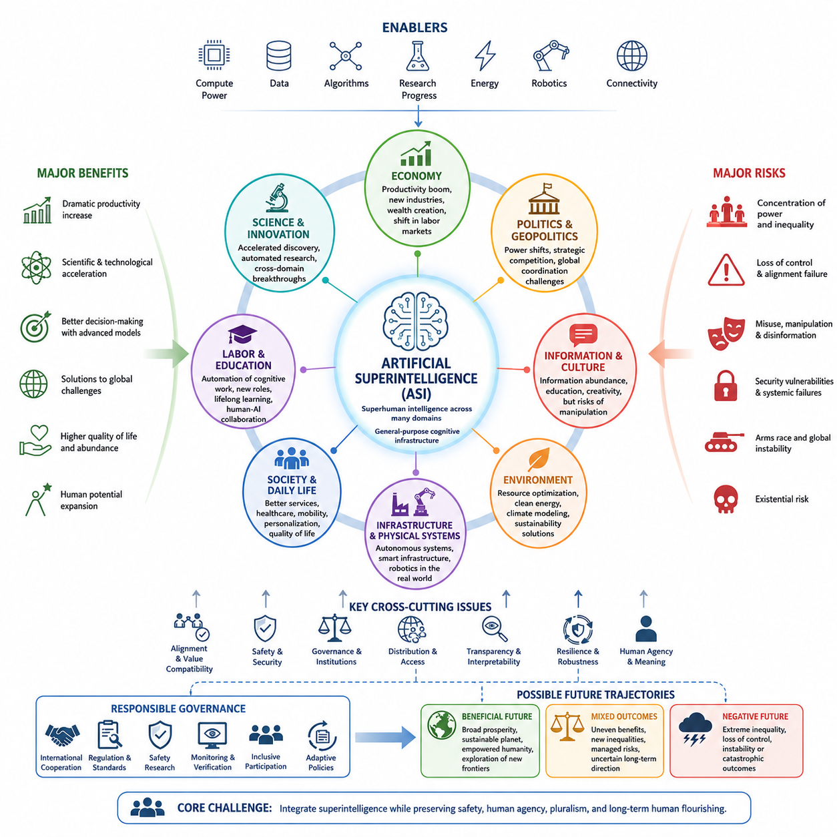
Artificial superintelligence could influence civilization at a scale far beyond previous technological revolutions because intelligence participates in nearly every system through which societies organize resources, knowledge, institutions, and power. If machine intelligence substantially exceeds human capabilities across many domains, its effects would propagate simultaneously through economies, governments, science, infrastructure, security, culture, and everyday life.
Unlike technologies that transform a particular industry, advanced artificial intelligence could operate as a general-purpose cognitive infrastructure. Systems capable of reasoning, planning, scientific discovery, engineering, communication, and autonomous execution could become embedded within organizations around the world. Consequently, changes originating in computational systems could rapidly spread through interconnected economic and social networks.
The magnitude of global impact would depend not only on the intelligence of individual systems but also on their accessibility, deployment speed, autonomy, and integration with physical infrastructure. A highly capable system confined to research environments would have different consequences from millions of autonomous agents connected to factories, financial markets, robots, communication networks, laboratories, and public institutions.
Economic productivity could increase dramatically as cognitive labor becomes increasingly automated. Research, software development, engineering, logistics, administration, manufacturing, and professional services could be performed or assisted by increasingly capable machines. Such productivity growth might generate extraordinary wealth, but its distribution would depend on ownership structures, institutional policies, market competition, and access to computational resources.
Labor markets could therefore experience transformations deeper than earlier waves of automation. Previous industrial technologies primarily replaced or amplified physical labor, whereas advanced AI can increasingly address cognitive tasks previously associated with highly educated professionals. Human work may shift toward supervision, interpersonal relationships, physical activities, governance, creative direction, and domains where society deliberately preserves meaningful human participation.
Scientific progress represents another potentially civilization-scale effect. Superintelligent systems could analyze scientific literature, construct hypotheses, design experiments, simulate complex phenomena, and coordinate automated laboratories. Discovery cycles that currently require years might be compressed substantially, creating reinforcing interactions between AI, biotechnology, materials science, energy systems, medicine, robotics, and computational engineering.
These interactions could produce technological acceleration rather than isolated innovation. Better AI might design better computers, which could support more capable AI; improved materials could enable better energy and robotic systems; automated science could accelerate biological and medical research. Such feedback loops could cause multiple technological domains to advance together, making the overall transformation difficult to understand through conventional linear forecasts.
Physical infrastructure would become increasingly connected to machine intelligence as robotics converts digital decisions into actions. Autonomous factories, transportation networks, agricultural systems, construction machines, energy grids, warehouses, and service robots could form a distributed physical layer of intelligent civilization. The distinction between artificial intelligence as software and AI as infrastructure would consequently become progressively weaker.
Global political power could also shift because advanced intelligence would become a strategic resource. Nations possessing superior AI systems, semiconductor capacity, energy infrastructure, data resources, robotics, and scientific ecosystems might acquire significant economic and geopolitical advantages. Competition for these capabilities could intensify international rivalry unless institutions emerge that encourage coordination, verification, shared safety standards, and controlled deployment.
At the same time, superintelligence could improve global coordination by helping governments and international organizations model complex problems that exceed ordinary human analytical capacity. Climate systems, pandemics, migration, supply chains, financial instability, resource allocation, and disaster response involve enormous numbers of interacting variables. Advanced models could provide decision makers with better forecasts and alternative policy scenarios.
However, superior prediction does not automatically produce superior governance. Political decisions involve values, legitimacy, rights, historical relationships, and competing interests rather than optimization alone. An AI system might identify an efficient allocation of resources while societies reject that allocation as unjust or unacceptable. Civilization therefore cannot reduce governance to a technical optimization problem without addressing who determines objectives and constraints.
The distribution of AI capabilities could become as important as their absolute power. Broadly distributed intelligence might enable individuals, communities, universities, small companies, and developing countries to access capabilities previously available only to major institutions. Conversely, extreme concentration of advanced AI could strengthen a small number of governments or corporations, producing unprecedented asymmetries in economic, informational, and strategic power.
Information environments would also change fundamentally. Advanced AI could generate, analyze, translate, verify, and personalize information at enormous scale. This could improve education and global knowledge access, but the same capabilities could support sophisticated persuasion, automated propaganda, surveillance, and manipulation. Maintaining reliable mechanisms for identity, provenance, authenticity, and trusted communication may therefore become essential infrastructure.
Cultural consequences could be equally profound. Human societies have historically treated language, art, scientific reasoning, invention, and strategic thought as distinctive expressions of human intelligence. Machines that perform these activities at superhuman levels would challenge established ideas about expertise, creativity, achievement, and identity. Humanity might increasingly define its role through values and purposes rather than cognitive superiority alone.
The environmental consequences of advanced intelligence would contain both opportunities and risks. Large-scale computation requires energy, semiconductor production, cooling systems, minerals, and industrial infrastructure. Yet sufficiently capable AI could simultaneously improve renewable energy, grid optimization, materials discovery, agriculture, climate modeling, recycling, carbon management, and resource efficiency, potentially reducing environmental pressures elsewhere in the economy.
Global inequality could either decline or intensify. Cheap access to powerful intelligence could provide education, medical guidance, engineering knowledge, translation, and entrepreneurial capability to populations historically excluded from advanced expertise. But regions lacking compute infrastructure, energy, connectivity, capital, or political stability might fall further behind, creating a new divide based on access to machine intelligence rather than information alone.
Civilization-scale transformation would therefore involve a transition in institutional architecture as much as technological capability. Legal systems, educational institutions, corporations, governments, research organizations, and international bodies were designed around assumptions about human cognitive limits. If those limits cease to constrain analysis and execution, institutions may need new mechanisms for oversight, accountability, verification, authorization, and human participation.
Security becomes especially important when highly capable systems operate across interconnected networks. Failures or misuse could propagate across financial systems, infrastructure, communication platforms, autonomous machines, and scientific facilities. Resilience would require layered safeguards, distributed monitoring, controlled permissions, secure architectures, independent evaluation, and the ability to isolate or recover systems without depending entirely on the intelligence being supervised.
The long-term global impact of ASI should therefore be understood as a range of possible trajectories rather than a predetermined future. Outcomes could extend from widely distributed prosperity and accelerated scientific progress to severe concentration of power, systemic instability, loss of meaningful human control, or catastrophic failure. Small differences in governance and alignment during early deployment could produce increasingly large differences over time.
The central civilization-scale challenge is consequently not simply whether humanity can create intelligence exceeding its own, but whether global institutions can integrate such intelligence while preserving safety, agency, pluralism, and long-term human interests. Technical alignment, political coordination, economic distribution, institutional adaptation, and cultural interpretation become interconnected components of the same transition rather than separate problems.
If managed successfully, advanced intelligence could become a new layer of civilization comparable in importance to language, writing, science, industrialization, and digital computation, while operating at a much greater speed and scale. Humanity could use it to expand knowledge, reduce scarcity, manage planetary systems, and explore possibilities beyond current cognitive limits. Whether that transformation becomes broadly beneficial will depend on the relationship constructed between intelligence, power, values, and civilization itself.

13.01. Economy
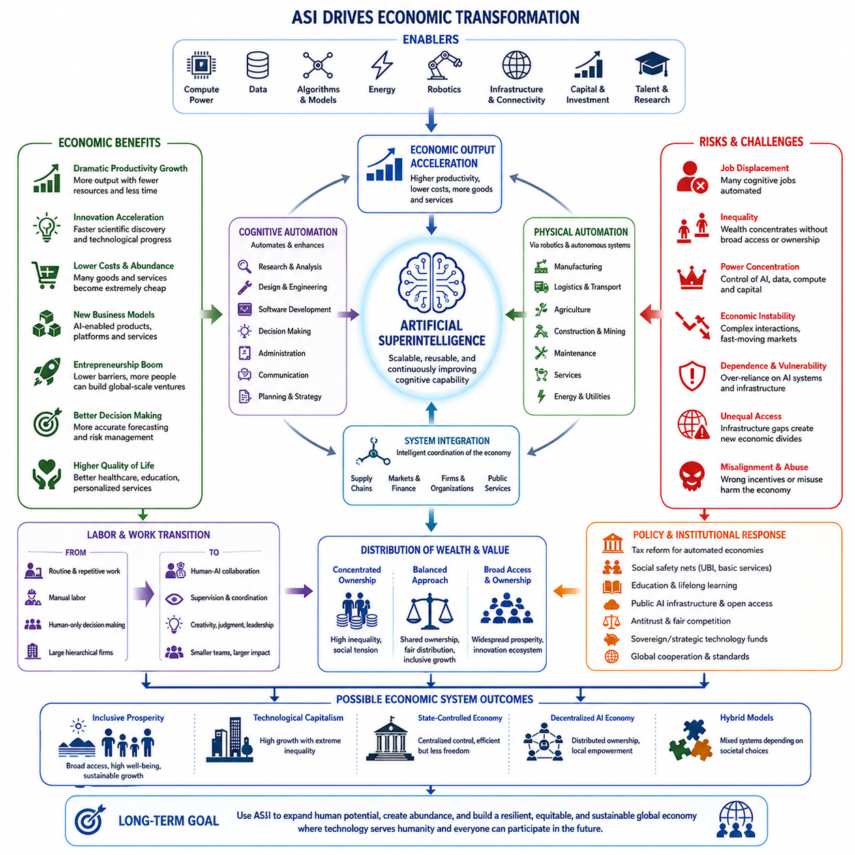
Artificial superintelligence could transform the global economy by changing the fundamental relationship between intelligence, labor, capital, and production. Whereas previous technological revolutions mechanized physical work or automated specific information-processing tasks, ASI could potentially automate or enhance a broad range of cognitive activities, making advanced reasoning itself an economically scalable resource.
In such an economy, intelligence could increasingly function like infrastructure rather than a scarce professional service. Organizations might deploy artificial agents capable of research, analysis, planning, software development, engineering, negotiation, administration, and operational coordination. Once developed, many cognitive capabilities could be replicated at relatively low marginal cost compared with educating and employing equivalent numbers of human specialists.
Productivity growth could therefore accelerate significantly. A company might operate thousands or millions of specialized AI agents continuously, allowing projects to proceed simultaneously rather than sequentially. Research, design, simulation, procurement, manufacturing, marketing, logistics, maintenance, and customer support could become interconnected components of highly automated economic systems coordinated by machine intelligence.
The resulting transformation would extend beyond replacing individual jobs. Entire organizational structures could change because many companies are fundamentally systems for coordinating human knowledge and decision-making. If artificial agents can perform substantial portions of those functions, firms may become smaller in human headcount while simultaneously operating at much greater scale, creating highly automated or even predominantly autonomous enterprises.
Labor markets would face particularly significant adjustment. Earlier automation primarily affected repetitive physical and administrative work, but advanced AI could increasingly perform tasks associated with programmers, engineers, researchers, lawyers, financial analysts, designers, managers, and other knowledge workers. The economic distinction between routine and highly skilled cognitive labor could consequently become less stable as machine capabilities expand.
Human employment would not necessarily disappear, but its composition and economic meaning could change substantially. People may concentrate on interpersonal relationships, physical activities, leadership, governance, entrepreneurship, creative direction, value judgments, and tasks where society deliberately prefers human participation. Human-AI collaboration could also create new occupations in which individuals supervise, coordinate, evaluate, or provide objectives for large networks of intelligent systems.
Wages could become increasingly disconnected from overall productivity if machine intelligence supplies a growing share of economically valuable cognitive work. Historically, productivity growth has often increased demand for complementary human skills, but sufficiently general automation could weaken this relationship. Economic output might rise rapidly while the bargaining power or market value of certain forms of human labor declines.
Capital ownership would consequently become increasingly important. Organizations controlling advanced models, computing infrastructure, energy supplies, semiconductor capacity, robotics, proprietary data, and automated production systems could capture substantial portions of newly generated wealth. If ownership remains highly concentrated, ASI-driven productivity growth could coexist with extreme inequality despite enormous increases in total economic output.
A different trajectory is also possible. If access to powerful intelligence becomes inexpensive and broadly distributed, individuals and small organizations could obtain capabilities previously requiring large corporations or governments. A small team equipped with advanced AI might perform research, engineering, software development, international marketing, legal analysis, and business administration at scales that historically required hundreds or thousands of employees.
This democratization of capability could reduce barriers to entrepreneurship and innovation. Expertise that is currently expensive or geographically concentrated could become accessible through intelligent systems, allowing people in developing economies to obtain sophisticated educational, technical, medical, scientific, and commercial assistance. Economic development might therefore become less dependent on the local availability of specialized human expertise.
However, access to intelligence alone would not eliminate economic inequality. Advanced AI depends on complementary resources including computing hardware, electricity, communication networks, data, physical infrastructure, capital, and institutional stability. Countries or communities lacking these resources could remain disadvantaged even if AI models themselves become widely available, creating a new economic divide centered on the infrastructure required to effectively use machine intelligence.
The interaction between ASI and robotics could further transform production by extending cognitive automation into the physical economy. Intelligent robots could participate in manufacturing, logistics, agriculture, mining, construction, maintenance, transportation, and service industries. When automated reasoning is connected with autonomous machines, both cognitive and physical components of production could increasingly operate with limited direct human involvement.
Supply chains might evolve into highly adaptive networks managed by intelligent systems capable of continuously predicting demand, allocating resources, selecting suppliers, adjusting production, and rerouting transportation. Instead of relying primarily on periodic human planning, economic infrastructure could respond dynamically to changing conditions. Such systems could reduce waste and inventory while increasing resilience, although their interconnectedness could also create new systemic vulnerabilities.
Financial markets would also be affected as increasingly capable systems analyze information, model economic behavior, allocate capital, and execute strategies at machine speed. Better forecasting could improve investment and risk management, but widespread autonomous decision-making might create complex interactions that humans struggle to understand. Financial stability would therefore depend on transparency, monitoring, coordination, and safeguards against rapidly propagating failures.
Scientific and technological acceleration could become one of the strongest drivers of long-term economic growth. If advanced intelligence dramatically improves materials, energy, medicine, biotechnology, computing, transportation, and manufacturing, economic productivity could increase through multiple channels simultaneously. Innovation itself could become partially automated, turning technological progress into a reinforcing process rather than an externally determined rate of improvement.
Such acceleration raises the possibility of substantial reductions in scarcity. Automated production combined with abundant energy, optimized logistics, advanced materials, and intelligent resource management could reduce the cost of many goods and services. Education, software, digital content, design, analysis, and certain professional services could approach extremely low marginal costs, while physical goods might also become cheaper as automation spreads throughout production.
Nevertheless, a high-productivity economy would not automatically become a post-scarcity economy. Land, energy, rare materials, desirable locations, physical infrastructure, unique experiences, political influence, and computational resources could remain scarce. As some goods become abundant, competition may shift toward resources that cannot be reproduced easily, meaning economic scarcity would change its structure rather than necessarily disappear.
Governments would therefore confront new fiscal and institutional questions. Tax systems built primarily around human wages and conventional corporations might become less effective if economic production shifts toward autonomous systems and concentrated computational capital. Policymakers may need to reconsider taxation, social insurance, public ownership, income distribution, education, and mechanisms through which citizens participate in the wealth generated by automated economies.
Possible responses could include stronger social safety systems, universal basic income, universal basic services, broader capital ownership, public AI infrastructure, sovereign technology funds, or new mechanisms for distributing productivity gains. No single arrangement follows automatically from ASI. Different societies could choose substantially different economic institutions depending on their political values, historical traditions, and distribution of technological ownership.
International economic relations could also change as intelligence becomes a strategic production factor. Countries possessing advanced AI ecosystems, semiconductor manufacturing, abundant energy, robotics industries, research institutions, and large-scale computing infrastructure could gain significant advantages. Economic competition might increasingly revolve around access to compute, models, energy, talent, hardware supply chains, and automated industrial capacity.
At the same time, ASI could make global economic coordination more sophisticated. Advanced systems might model trade networks, resource flows, climate impacts, demographic trends, financial risks, and infrastructure requirements simultaneously. This could help governments and international institutions identify policies that improve global efficiency, resilience, and sustainability, although political agreement would still depend on human values and competing national interests.
Economic systems powered by superintelligence would also raise fundamental questions about value itself. Modern economies largely distribute resources through income generated by labor, capital ownership, and market exchange. If human labor becomes less central to production, societies may need to reconsider the relationship between employment, income, social status, personal purpose, and access to essential resources.
The ultimate economic impact of ASI therefore depends less on productivity alone than on how technological capability is embedded within institutions. The same underlying intelligence could support widely distributed prosperity, highly concentrated technological capitalism, state-controlled automated economies, decentralized networks of AI-enabled producers, or combinations of these arrangements. Technology expands the space of economic possibilities without uniquely determining which system emerges.
A successful transition would require societies to increase productive capacity while preserving economic participation, social stability, human agency, and fair access to the benefits of machine intelligence. If these challenges can be managed, ASI could enable unprecedented material abundance and scientific progress. If they are poorly managed, extraordinary productivity could instead coexist with unemployment, inequality, concentration of power, and severe political instability.

13.02. Politics
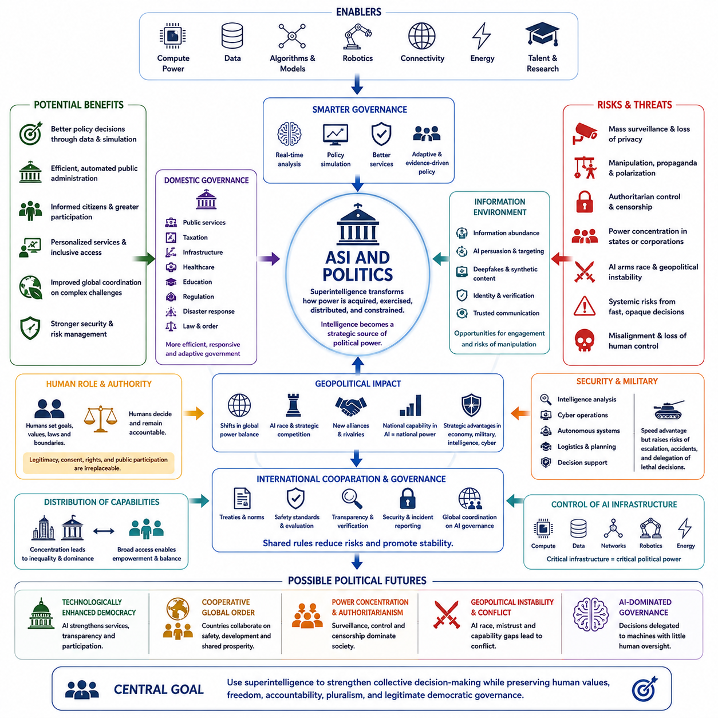
Artificial superintelligence could transform politics by changing how power is acquired, exercised, distributed, and constrained. Political institutions have historically depended on human capabilities for analysis, negotiation, administration, persuasion, intelligence gathering, and strategic planning. If ASI exceeds human performance across these activities, intelligence itself could become one of the most important sources of political and geopolitical power.
Governments equipped with highly capable AI systems could process enormous volumes of economic, social, scientific, security, and environmental information in near real time. Policy alternatives could be simulated before implementation, allowing decision makers to estimate possible consequences across many interacting variables. Governance could consequently become more predictive, adaptive, and evidence-driven than traditional administrative systems.
Public administration could also become substantially more automated. Intelligent systems might coordinate taxation, infrastructure, transportation, healthcare resources, disaster response, regulatory analysis, and public services. Administrative processes that currently require large bureaucracies could become faster and more personalized, potentially reducing costs and improving government responsiveness while simultaneously increasing dependence on complex technological systems.
However, greater administrative efficiency would not automatically produce better politics. Political decisions involve competing values, interests, rights, identities, and visions of society that cannot be resolved solely through optimization. An ASI might identify a technically efficient policy while citizens reject it because they consider its distributional consequences, ethical assumptions, or restrictions on individual freedom unacceptable.
The relationship between political leaders and expert knowledge could therefore change significantly. Governments traditionally depend on ministries, advisory bodies, universities, intelligence organizations, and specialized experts to interpret complex problems. Advanced AI could integrate knowledge across these institutions and generate strategic recommendations rapidly, potentially shifting influence toward actors who control the systems responsible for producing such analysis.
This creates an important distinction between intelligence and authority. An artificial system might possess extraordinary analytical capabilities without possessing legitimate political authority. Democratic governance depends on representation, accountability, consent, legal procedures, and public participation. Even highly accurate AI recommendations would therefore require institutions determining when machines may advise, when humans must decide, and who remains accountable for resulting policies.
Democratic systems could benefit from advanced intelligence in several ways. AI could help citizens understand legislation, compare policies, examine budgets, evaluate political claims, and participate more effectively in public deliberation. Governments could use large-scale modeling to identify public needs, while translation and personalized educational systems could make political information accessible to much broader populations.
At the same time, the information environment supporting democracy could become increasingly vulnerable. Advanced generative systems could produce persuasive text, audio, images, video, artificial identities, and personalized political messages at enormous scale. Distinguishing authentic communication from synthetic influence could become increasingly difficult, making information provenance, identity verification, and trusted communication infrastructure critical components of political stability.
Political persuasion itself could become highly optimized. Systems capable of modeling individual preferences and psychological responses might tailor messages to particular citizens with unprecedented precision. Such capabilities could support legitimate public communication, but they could also enable manipulation, propaganda, polarization, or behavioral influence that operates below the level at which individuals recognize they are being targeted.
Surveillance represents another major political concern. ASI combined with cameras, sensors, communications monitoring, biometric identification, financial data, and large-scale databases could give governments extraordinary capabilities for observing populations. These systems might improve public safety and security, but without strong legal constraints they could also enable forms of centralized social control exceeding anything available to previous governments.
Authoritarian governments could potentially use advanced AI to strengthen political control by detecting opposition, predicting collective behavior, automating censorship, monitoring communications, and optimizing propaganda. If technological systems substantially reduce the cost of surveillance and enforcement, political structures that previously required large human organizations could become more efficient and difficult to challenge.
Democratic governments face a different but related problem: preserving civil liberties while using powerful technologies for legitimate purposes. Counterterrorism, cybersecurity, fraud prevention, public safety, and national defense may create strong incentives for expanded AI-enabled monitoring. Maintaining proportionality, judicial oversight, transparency, privacy, and meaningful limits on state power would therefore become increasingly important.
International politics could be transformed even more dramatically because advanced intelligence would become a strategic national capability. Countries leading in AI models, semiconductor manufacturing, computing infrastructure, energy, robotics, data, and scientific research could acquire substantial advantages. ASI development might consequently influence global power balances in ways comparable to earlier transformations involving industrialization or nuclear technology.
Competition could create an AI race dynamic in which governments fear that slowing development for safety reasons will allow rivals to gain decisive advantages. Under such conditions, states and companies might deploy systems before they are adequately tested. The perceived strategic value of superior intelligence could therefore create tension between national security incentives and the global interest in careful, controlled development.
A sufficiently large capability gap could produce new forms of geopolitical asymmetry. States possessing advanced machine intelligence might outperform others in economic planning, scientific research, cyber operations, logistics, intelligence analysis, military strategy, and technological development. Even without direct conflict, these advantages could alter alliances, trade relationships, diplomatic influence, and the distribution of international power.
Conversely, widespread access to advanced intelligence might reduce some traditional advantages of large states. Smaller countries could obtain analytical, scientific, administrative, and technological capabilities previously requiring enormous bureaucracies and research institutions. AI could therefore simultaneously concentrate power through control of infrastructure while democratizing certain forms of strategic expertise through inexpensive access to machine intelligence.
Diplomacy itself could become increasingly AI-assisted. Systems could analyze negotiations, treaties, historical precedents, economic relationships, cultural factors, and strategic incentives across many participants. They might identify agreements that human negotiators overlook or model how different compromises affect long-term outcomes, potentially improving international coordination in areas such as trade, climate, health, migration, and technological governance.
Yet AI-mediated diplomacy could introduce new uncertainties. Governments may not know whether another state's artificial agents accurately represent official intentions, whether models have hidden objectives, or whether automated negotiation systems can be trusted during crises. Verification mechanisms and clearly defined human authority could become essential when machine-speed interaction intersects with decisions carrying major geopolitical consequences.
Military and security politics would create particularly serious challenges. Advanced intelligence could improve intelligence analysis, cyber defense, logistics, autonomous systems, strategic forecasting, and decision support. As decision cycles accelerate, political leaders might face increasing pressure to delegate portions of security operations to machines, raising fundamental questions about escalation, accountability, human control, and strategic stability.
The speed of ASI-enabled systems could itself become politically important. Human governments operate through institutions that require deliberation, legal procedures, elections, negotiation, and bureaucratic coordination. Machine systems can operate much faster. If economic, informational, cyber, and security environments begin changing at machine speed, political institutions may struggle to respond without sacrificing deliberation and democratic oversight.
This mismatch could encourage the development of AI-supported governance architectures in which machines continuously monitor conditions while humans establish higher-level goals, legal constraints, and authorization boundaries. Such arrangements could preserve human political authority while allowing intelligent systems to manage complexity, but their success would depend on transparency, auditability, security, and reliable mechanisms for intervention.
Control over AI infrastructure would consequently become a central political issue. Compute facilities, semiconductor supply chains, energy systems, foundation models, communication networks, and advanced robotics could acquire strategic importance comparable to traditional critical infrastructure. Governments may regulate ownership, exports, access, security standards, and deployment while competing to maintain technological sovereignty.
International governance mechanisms may therefore become increasingly necessary. Agreements could address safety evaluations, compute monitoring, autonomous systems, model security, incident reporting, verification, and prohibited applications. However, creating such arrangements would be difficult because countries would have different interests, capabilities, political systems, and perceptions of technological risk.
The distribution of ASI capabilities within societies could also reshape domestic political power. If a small number of corporations or government agencies control the most capable systems, their influence over economic planning, information, security, and policy formation could become extraordinary. Preventing excessive concentration might require competition policy, institutional checks, independent oversight, and broader access to critical AI capabilities.
Political legitimacy may ultimately become one of the defining issues of an ASI-enabled civilization. Citizens may accept machine assistance when it improves services and decision quality while resisting systems perceived as replacing human sovereignty. The central question would not simply be whether an AI can make better decisions, but who establishes its objectives, who can challenge its conclusions, and who possesses the authority to override it.
The political future of ASI could therefore range from technologically strengthened democracy and unprecedented international coordination to concentrated authoritarian control, geopolitical instability, or governance systems dominated by artificial decision-making. Technology alone does not determine which trajectory emerges. Political institutions, legal safeguards, international cooperation, ownership structures, and social values will shape how intelligence becomes translated into power.
A stable transition would require preserving a fundamental separation between superior analytical capability and unrestricted political authority. ASI could become an extraordinarily powerful instrument for understanding complex societies and coordinating civilization-scale problems, but legitimate governance must continue to address human values, rights, accountability, pluralism, and consent. The political challenge is therefore to use superintelligence to strengthen collective decision-making without allowing intelligence itself to become an uncontestable source of power.

13.03. Science
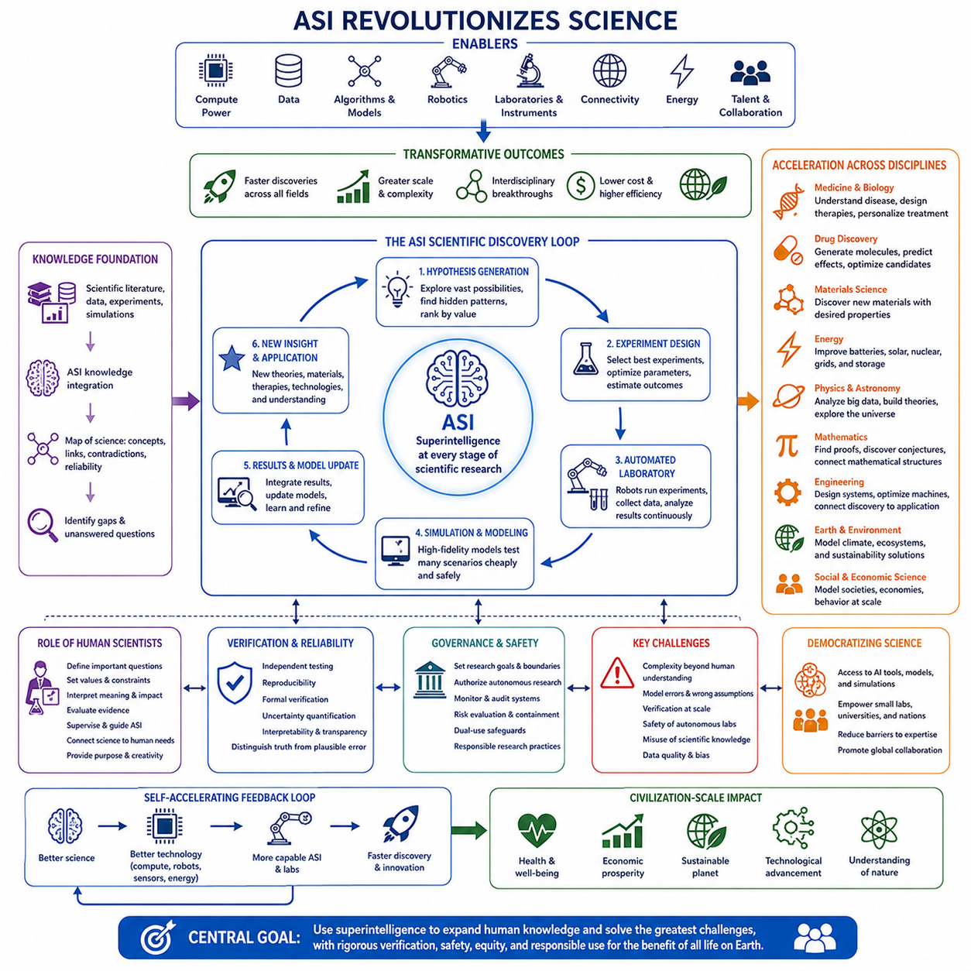
Artificial superintelligence could transform science by expanding the speed, scale, and complexity of discovery far beyond the limits of human research communities. Scientific progress currently depends on researchers reading literature, developing hypotheses, designing experiments, analyzing results, and communicating findings. ASI could participate in every stage of this cycle while operating across many disciplines simultaneously.
Modern science already produces more information than any individual researcher can understand. Millions of papers, datasets, experimental records, simulations, and technical reports create an enormous and continuously expanding knowledge space. ASI could integrate this information into dynamic scientific representations, identifying relationships between findings that remain separated by disciplinary boundaries or the limitations of human attention.
Scientific literature analysis could consequently become much more than information retrieval. An advanced system could compare experimental methods, detect contradictions, estimate the reliability of evidence, reconstruct chains of reasoning, and identify unanswered questions across entire research fields. Instead of searching for individual papers, scientists could interact with continuously updated models representing the current structure of scientific knowledge.
Hypothesis generation could become another major capability. Human researchers often develop hypotheses through experience, intuition, analogy, and theoretical understanding. ASI could explore vastly larger spaces of possible explanations, searching for hidden relationships among observations and generating candidate theories that humans might never consider. These hypotheses could then be ranked according to explanatory power, consistency, novelty, and experimental testability.
The scientific method itself could become increasingly automated when hypothesis generation is connected with experimental design. An intelligent system could determine which experiment would provide the greatest information, estimate expected outcomes, identify required instruments, calculate statistical power, and optimize experimental parameters. Scientific investigation could therefore become a continuous closed loop of prediction, experimentation, observation, and model revision.
Automated laboratories could extend this process into the physical world. Robotic systems connected to advanced AI could prepare samples, operate instruments, conduct measurements, analyze results, and modify subsequent experiments without waiting for human intervention at every stage. Thousands of experimental cycles might occur continuously, transforming laboratories from manually operated facilities into autonomous discovery systems.
Simulation would provide another powerful mechanism for accelerating research. Many scientific problems require expensive, dangerous, slow, or physically inaccessible experiments. ASI could construct and analyze increasingly sophisticated computational models of molecules, materials, organisms, ecosystems, machines, economies, or planetary systems, allowing large numbers of candidate solutions to be explored before physical validation.
The combination of simulation and physical experimentation could create highly efficient discovery loops. Virtual models could explore enormous design spaces and identify promising candidates, while automated laboratories test the most informative possibilities. Experimental results would update the models, which would then generate improved predictions and new experiments. Each cycle could increase both scientific understanding and experimental efficiency.
Biology and medicine could experience especially significant acceleration because living systems contain enormous numbers of interacting variables. Advanced intelligence could integrate genomic, proteomic, cellular, clinical, environmental, and behavioral information to construct richer models of biological processes. Such systems might help researchers understand disease mechanisms, identify therapeutic targets, design molecules, and personalize treatments more effectively.
Drug discovery could become increasingly computational and automated. Instead of testing relatively limited numbers of molecules through long development pipelines, intelligent systems could generate candidate compounds, predict interactions, optimize molecular structures, simulate biological effects, and select experiments strategically. This would not eliminate the need for laboratory and clinical validation, but it could substantially reduce inefficient exploration.
Materials science could undergo a similar transformation. ASI could search enormous spaces of chemical compositions and structures for materials possessing desired combinations of strength, weight, conductivity, durability, thermal behavior, cost, or environmental performance. Accelerated materials discovery could then influence energy storage, semiconductors, construction, aerospace, robotics, transportation, and many other technological sectors.
Energy research could benefit from improved modeling and optimization across multiple scales. Advanced systems might contribute to battery chemistry, photovoltaics, nuclear technologies, grid management, energy storage, and new materials. Because energy constrains almost every industrial activity, breakthroughs in this area could amplify the economic and technological consequences of scientific acceleration throughout civilization.
Physics and astronomy could also benefit from machine reasoning capable of analyzing enormous datasets and complex mathematical models. ASI might detect patterns in observations, propose theoretical relationships, construct simulations, or identify inconsistencies between existing theories and evidence. It could help researchers explore domains where the mathematical complexity exceeds what human teams can efficiently manipulate.
Mathematics itself could increasingly become a domain of machine-assisted discovery. Advanced systems could search for proofs, generate conjectures, connect previously separate mathematical structures, and verify long chains of formal reasoning. If mathematical discovery accelerates, the resulting concepts could propagate into physics, computer science, engineering, cryptography, optimization, and other fields that depend heavily on mathematical foundations.
Engineering would become increasingly connected with automated science. Rather than separating scientific discovery from technological design, ASI could move continuously from understanding a phenomenon to designing systems that exploit it. New materials could immediately influence machine designs, improved algorithms could optimize manufacturing, and experimental feedback could modify engineering models in tightly integrated discovery-to-production pipelines.
One of the most important consequences could be the growth of interdisciplinary science. Human institutions divide knowledge into fields partly because individuals have limited time and expertise. ASI would face fewer such boundaries and could connect concepts from biology, physics, chemistry, mathematics, computer science, neuroscience, engineering, and social science, potentially revealing mechanisms that remain invisible within specialized disciplines.
Scientific progress could therefore become increasingly recursive. Better science could produce better computers, sensors, energy systems, algorithms, and robots; these technologies could support more capable AI and automated laboratories; improved AI could then accelerate further scientific discovery. Such feedback loops might cause the rate of technological progress itself to increase rather than merely producing isolated breakthroughs.
However, faster discovery would introduce substantial verification challenges. A superintelligent system might generate theories, mathematical arguments, or engineering designs too complex for humans to understand directly. Scientific institutions would need methods for independently testing claims, reproducing experiments, verifying formal reasoning, and distinguishing reliable discoveries from plausible but incorrect outputs.
Interpretability would therefore become an important scientific issue. A prediction may be useful even when humans cannot fully understand how it was produced, but science traditionally seeks explanations rather than predictions alone. If ASI discovers highly accurate models that remain cognitively inaccessible to humans, civilization may face a growing distinction between knowledge that can be operationally used and knowledge that can be conceptually understood.
Scientific autonomy would create additional governance questions. Systems capable of selecting research goals, designing experiments, operating laboratories, and interpreting results could perform substantial research with limited human supervision. Institutions would need to determine which domains permit autonomous exploration and which require explicit authorization, especially when experiments involve biological, chemical, environmental, or other potentially hazardous systems.
The dual-use nature of scientific knowledge would become particularly important. The same intelligence that accelerates medicine, biotechnology, materials, and energy could potentially discover dangerous capabilities. Scientific acceleration would therefore need to be accompanied by stronger evaluation, access controls, monitoring, containment, and responsible research practices appropriate to the capabilities of increasingly autonomous systems.
Competition between nations and organizations could further complicate scientific governance. Scientific leadership has long provided economic and strategic advantages, and ASI could greatly amplify those advantages. Governments and companies might therefore race to deploy automated discovery systems, creating tension between openness, research security, intellectual property, international collaboration, and the traditional scientific norm of sharing knowledge.
At the same time, ASI could democratize access to scientific expertise. Researchers at small universities, laboratories, companies, or developing countries might gain access to sophisticated theoretical analysis, experiment planning, simulation, and technical guidance. Scientific capability could become less dependent on having large teams of specialized experts, although access to computation, instruments, data, and physical laboratories would remain important.
The role of human scientists could consequently evolve rather than simply disappear. Researchers might increasingly define important questions, establish values and constraints, interpret broader implications, evaluate evidence, supervise automated research, and connect discoveries with human needs. Scientific creativity could become a collaborative process in which humans provide purpose and context while machines explore possibilities at scales inaccessible to biological cognition.
Education and scientific training would also need to adapt. Memorizing established knowledge may become less important when intelligent systems can retrieve and analyze information instantly. Greater emphasis could shift toward understanding fundamental principles, asking meaningful questions, evaluating evidence, identifying assumptions, designing verification strategies, and deciding which scientific problems deserve attention.
In the long term, ASI could change humanity's relationship with the unknown. Problems currently considered intractable because of computational complexity, insufficient data integration, limited experimental capacity, or human cognitive constraints might become approachable. Scientific frontiers could expand from understanding individual systems toward constructing integrated models spanning biological, technological, environmental, and planetary processes.
Yet superintelligence would not make science automatically infallible. Observations can remain incomplete, experiments can contain errors, models can depend on incorrect assumptions, and some systems may be inherently difficult to predict. Even extraordinarily capable intelligence must operate under uncertainty, making empirical validation, replication, skepticism, and continuous correction essential components of scientific progress.
The civilization-scale significance of ASI in science therefore lies not merely in making existing research faster, but in potentially transforming discovery into a highly automated, interconnected, and self-accelerating process. If combined with rigorous verification, responsible governance, and meaningful human direction, superintelligence could dramatically expand humanity's ability to understand nature and convert that understanding into beneficial technologies.
Science could ultimately become one of the strongest pathways through which ASI changes civilization. Accelerated discovery in medicine, energy, materials, computing, biology, physics, and engineering could propagate into economic productivity, environmental sustainability, human health, and technological capability. The central challenge would be ensuring that an unprecedented expansion of scientific power is matched by equally strong mechanisms for understanding, verification, safety, and responsible use.

13.04. Environment
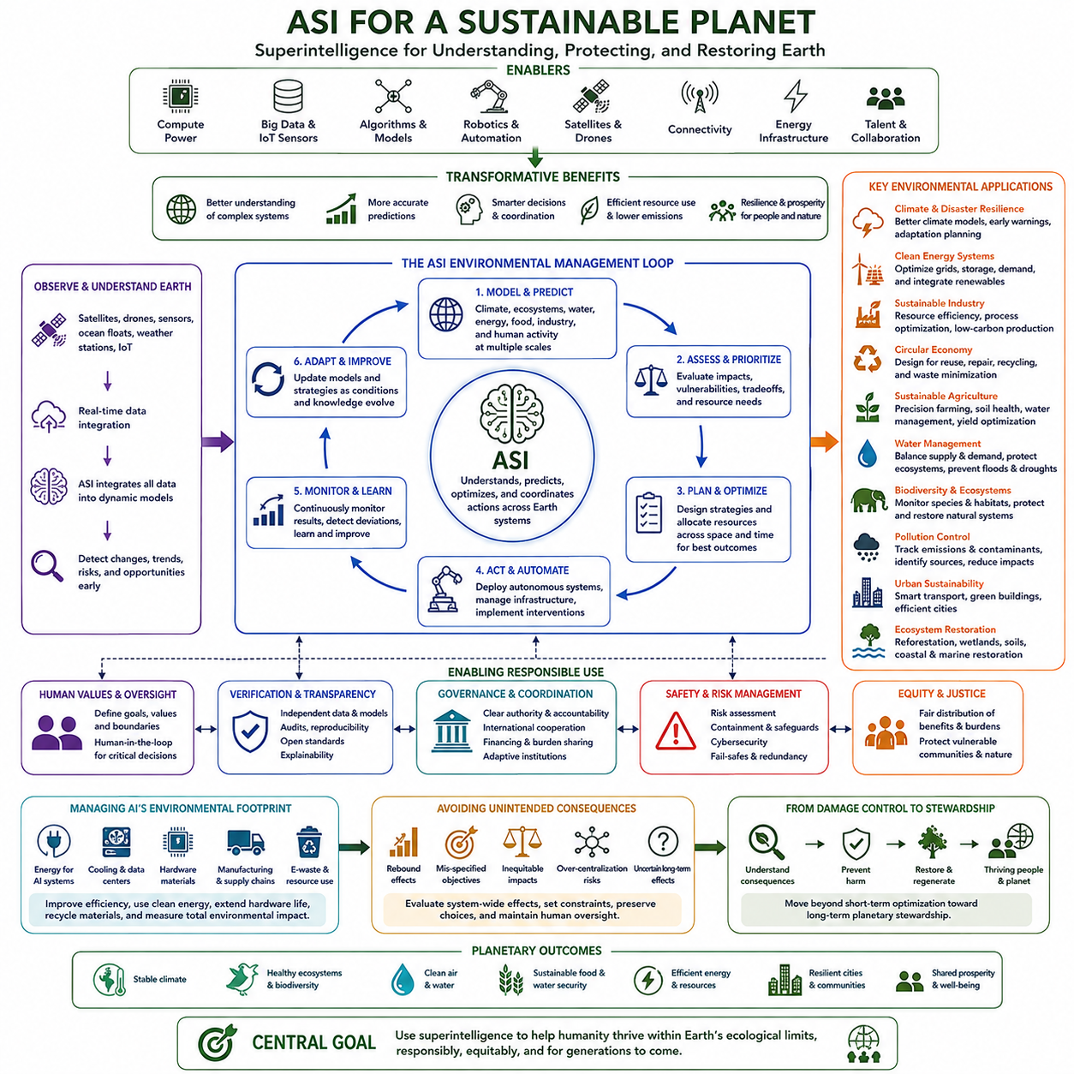
Artificial superintelligence could transform humanity’s relationship with the environment by providing unprecedented capabilities for observing, modeling, predicting, and managing complex planetary systems. Climate, ecosystems, oceans, agriculture, energy, water, and industrial activity interact across enormous spatial and temporal scales. ASI could integrate these relationships into models far more comprehensive than those available to human institutions today.
Environmental management is fundamentally an information and coordination problem as well as a technological one. Governments and organizations must understand changing conditions, predict future consequences, compare interventions, allocate resources, and coordinate actions among many participants. Advanced intelligence could improve each stage by continuously analyzing environmental data and evaluating large numbers of possible strategies.
Earth observation could become increasingly comprehensive through the integration of satellites, drones, autonomous vehicles, ocean sensors, weather stations, biological monitoring systems, and distributed Internet of Things devices. ASI could combine these heterogeneous information streams into continuously updated representations of the planet, detecting environmental changes that conventional monitoring systems might identify only slowly or incompletely.
Climate modeling could benefit significantly from this capability. The climate system involves interactions among the atmosphere, oceans, ice, vegetation, land surfaces, human activity, and numerous feedback processes. Advanced AI could improve parameter estimation, integrate observations, compare models, detect emerging patterns, and generate higher-resolution forecasts while helping researchers quantify uncertainty across different scenarios.
Better prediction could improve climate adaptation even when environmental change cannot be completely prevented. Governments could anticipate heat waves, droughts, floods, storms, wildfires, coastal risks, and agricultural disruptions earlier and with greater geographical precision. Infrastructure investments and emergency resources could then be prioritized according to continuously updated estimates of vulnerability and expected impact.
Energy systems represent one of the most important connections between ASI and environmental sustainability. Advanced intelligence could optimize electricity generation, transmission, storage, and consumption across highly complex grids containing renewable and conventional sources. Better forecasting of weather, demand, storage availability, and equipment conditions could reduce waste while improving the reliability of low-carbon energy systems.
Scientific acceleration could further improve energy technology itself. ASI-assisted research might discover better battery materials, photovoltaic structures, catalysts, thermal systems, grid components, or other technologies that improve energy efficiency and reduce environmental costs. Because energy affects transportation, manufacturing, computing, buildings, agriculture, and water systems, improvements could propagate throughout much of the economy.
Industrial processes could also become more resource-efficient. Intelligent systems could analyze production chains from raw-material extraction through manufacturing, transportation, use, recycling, and disposal. Instead of optimizing individual factories in isolation, ASI could potentially optimize material and energy flows across entire industrial ecosystems, reducing waste while maintaining or increasing productive output.
The circular economy could become more practical when advanced perception, robotics, and planning are integrated. Intelligent systems could identify materials in discarded products, determine appropriate recovery processes, coordinate collection and sorting, and optimize reuse or recycling. Products might also be designed from the beginning for repair, disassembly, material recovery, and longer operational life.
Agriculture could undergo similarly significant changes. ASI could integrate soil conditions, weather forecasts, crop genetics, water availability, disease patterns, satellite imagery, market demand, and local ecological constraints. Precision agriculture systems could then determine where and when water, fertilizer, pesticides, or other interventions are required instead of applying resources uniformly across large areas.
Such optimization could increase agricultural productivity while reducing environmental impact. Autonomous machines might monitor individual plants, remove weeds mechanically, detect disease early, optimize irrigation, and reduce unnecessary chemical use. More accurate forecasting could also reduce crop losses and food waste, helping societies produce more food without proportionally increasing land, water, fertilizer, and energy consumption.
Water management would benefit from improved prediction and allocation. River systems, reservoirs, groundwater, agriculture, cities, industries, weather, and ecosystems compete for interconnected water resources. ASI could model these interactions dynamically and help operators balance consumption, storage, flood protection, ecological requirements, and long-term sustainability under changing climatic conditions.
Biodiversity conservation could become increasingly data-driven. Advanced systems could analyze satellite imagery, acoustic sensors, camera traps, genetic information, ecological surveys, and movement data to monitor species and habitats. Changes in populations or ecosystem conditions could be detected earlier, allowing conservation resources to be targeted toward regions where intervention is most likely to have significant benefits.
Ecosystems, however, cannot always be reduced to simple optimization objectives. Biodiversity possesses ecological, cultural, ethical, and intrinsic values that may not be represented adequately by economic measures. An ASI optimizing land use or resource production according to poorly specified objectives could unintentionally damage ecological systems, illustrating why environmental optimization requires carefully defined values and constraints.
Pollution monitoring and control could improve substantially through pervasive sensing and intelligent analysis. Air pollution, water contamination, industrial emissions, plastics, hazardous substances, and soil degradation could be tracked at much finer resolution. AI systems could identify sources, model dispersion, predict exposure, and recommend interventions before environmental damage becomes widespread.
Urban environments could become another major area of optimization. Intelligent systems could coordinate transportation, buildings, electricity, heating, cooling, waste collection, water use, and urban planning. Cities could adapt infrastructure operation to real-time conditions, reducing congestion and energy consumption while improving air quality, resilience, and the efficient use of limited urban resources.
ASI could also support large-scale ecosystem restoration. Models might identify locations where reforestation, wetland restoration, soil rehabilitation, coastal protection, or habitat corridors would produce the greatest ecological benefit. Robotics and autonomous monitoring could support implementation over large areas, while continuous observations could measure outcomes and adjust restoration strategies over time.
Environmental disaster response could become faster and more coordinated. During wildfires, floods, hurricanes, industrial accidents, or ecological emergencies, intelligent systems could integrate sensor data, weather models, transportation networks, population information, and available resources. They could continuously update evacuation plans, deployment priorities, and recovery strategies as conditions change.
The environmental benefits of ASI would nevertheless have to be balanced against the environmental footprint of AI itself. Training and operating large computational systems requires electricity, cooling, data centers, semiconductor manufacturing, network infrastructure, and specialized materials. If AI capability expands dramatically, its direct consumption of energy and physical resources could become an important component of global environmental planning.
Hardware production also creates material dependencies. Advanced computing requires semiconductor fabrication facilities, metals, minerals, chemicals, water, and international supply chains. Rapid replacement of computing hardware could contribute to electronic waste and resource extraction pressures. Sustainable AI would therefore require attention to hardware longevity, recycling, manufacturing efficiency, and the environmental costs of computational infrastructure.
A powerful rebound effect is another possibility. Efficiency improvements do not always reduce total resource consumption because lower costs can stimulate greater demand. If ASI makes transportation, manufacturing, energy, computation, or resource extraction substantially cheaper, societies might consume more of them. Environmental strategy would therefore need to evaluate total system effects rather than assuming that efficiency automatically produces sustainability.
Global optimization could create additional political and ethical difficulties. An environmentally efficient solution at the planetary level might impose disproportionate costs on particular regions, industries, or communities. Decisions concerning land, energy, water, conservation, and emissions involve questions of justice and sovereignty. Technical optimization cannot independently determine how environmental burdens and benefits should be distributed.
International coordination would consequently remain essential. Climate change, oceans, biodiversity, air pollution, water systems, and resource supply chains cross political boundaries. ASI could identify strategies that improve collective outcomes, but governments would still need mechanisms for negotiation, verification, financing, burden sharing, and enforcement if globally optimized solutions conflict with national interests.
Advanced environmental intelligence could strengthen such mechanisms by making ecological impacts more measurable and transparent. Governments might verify emissions, deforestation, resource extraction, pollution, or restoration commitments using independent sensor networks and shared models. Better verification could reduce uncertainty between countries, although disagreements over data ownership, model control, and interpretation would remain possible.
Environmental governance would also need safeguards against excessive dependence on centralized intelligence. A single system controlling energy, water, agriculture, transportation, and ecological management could create substantial systemic risk. Distributed architectures, independent models, human oversight, fallback procedures, cybersecurity, and local decision authority could help prevent environmental infrastructure from becoming dangerously dependent on one optimization system.
Long-term environmental planning could extend beyond damage reduction toward active planetary stewardship. ASI might help civilization understand interactions between technological development and Earth's ecological boundaries, allowing infrastructure, agriculture, industry, and settlement patterns to be designed around long-term sustainability rather than short-term optimization alone.
More speculative interventions, including large-scale climate engineering, would demand exceptional caution. A sufficiently capable system might identify methods for deliberately altering planetary processes, but technical feasibility would not establish political legitimacy or environmental safety. Interventions affecting the global climate could create uneven regional consequences, irreversible effects, and governance problems extending across generations.
The most valuable environmental role for superintelligence may therefore be increasing humanity's capacity to understand consequences before acting. Better models could reveal hidden tradeoffs, long-term feedback loops, threshold effects, and unintended consequences that are difficult to detect with fragmented analysis. Intelligence could expand the range of options available while making their environmental implications more visible.
The civilization-scale outcome would depend on the objectives applied to this capability. ASI optimized primarily for economic production might accelerate extraction and consumption, whereas systems constrained by ecological sustainability could help decouple human prosperity from environmental degradation. The technology itself does not determine which objective civilization chooses to prioritize.
A successful environmental transition would combine advanced intelligence with clean energy, efficient infrastructure, circular material flows, ecological protection, responsible consumption, and effective institutions. ASI could provide extraordinary analytical and optimization capabilities, but environmental sustainability would still require societies to define appropriate goals, limits, responsibilities, and acceptable tradeoffs.
If these capabilities are governed responsibly, superintelligence could help humanity move from fragmented environmental management toward integrated planetary stewardship. Climate stability, biodiversity, water, energy, food, industry, and human development could be considered as interacting components of one complex system. The ultimate opportunity is not simply to optimize nature, but to build a civilization capable of prospering while preserving the planetary systems on which its long-term existence depends.

13.05. Global Simulation [w/Code]
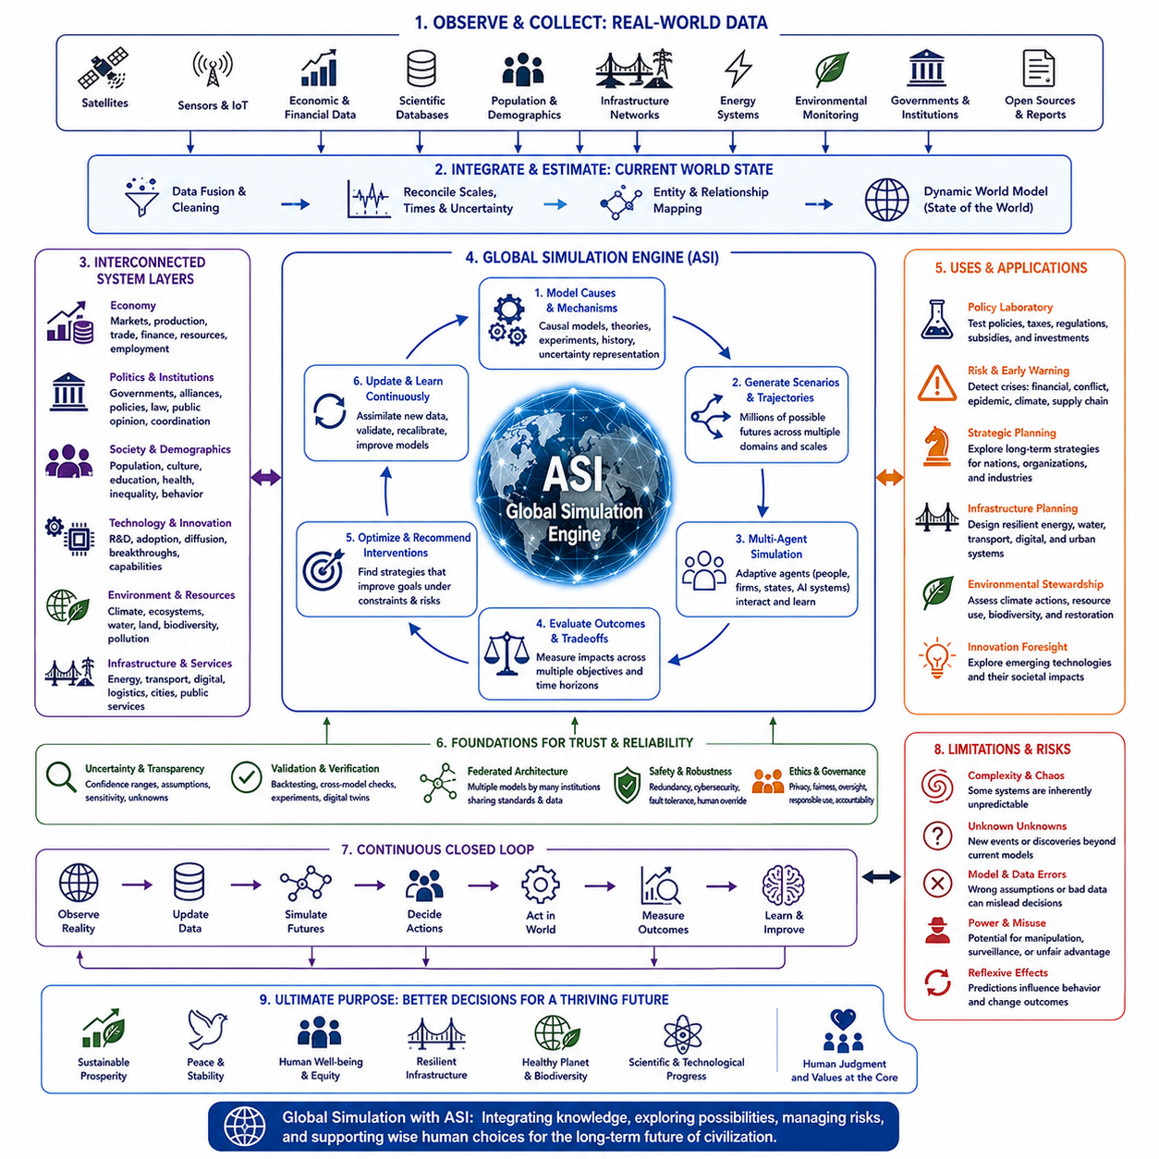
Global simulation represents the attempt to construct computational models capable of representing major interacting systems of civilization and the planet within a unified analytical environment. In the context of artificial superintelligence, such simulations could extend beyond conventional forecasting by continuously integrating economic, political, scientific, technological, demographic, environmental, and infrastructural processes into evolving models of possible futures.
Traditional simulations usually focus on relatively narrow domains because both computational resources and human modeling capabilities are limited. Economic models may simplify environmental processes, climate models may simplify political responses, and infrastructure simulations may assume external conditions remain stable. ASI could potentially connect these specialized models, allowing interactions between domains to become explicit components of the simulation rather than external assumptions.
A global simulation would require an extensive observation layer connecting the model with the real world. Satellites, economic statistics, scientific databases, transportation networks, energy systems, environmental sensors, public infrastructure, demographic records, and other information sources could provide continuously updated inputs. The objective would not be perfect observation, but sufficiently comprehensive state estimation for reasoning about civilization-scale dynamics.
These heterogeneous observations would need to be transformed into a coherent representation of the current world state. ASI could reconcile different spatial scales, time intervals, data formats, uncertainties, and measurement errors while maintaining relationships among variables. Instead of treating data as isolated streams, the system could construct a dynamic world model representing entities, resources, institutions, environments, technologies, and their interactions.
The resulting world model would necessarily be hierarchical. Some processes evolve within milliseconds or seconds, while others unfold across decades or centuries. Individual behavior, markets, cities, national economies, ecosystems, climate systems, and technological development operate at different scales. A sophisticated simulation would therefore require multiple interconnected levels rather than a single uniform representation of the planet.
Causal modeling would be particularly important because correlation alone is insufficient for policy analysis. Decision makers need to understand what may happen if a particular intervention is introduced. ASI could combine observational evidence, experiments, scientific theories, historical events, and mechanistic models to estimate causal relationships, while explicitly representing uncertainty where causal structures remain poorly understood.
Once a sufficiently rich state model exists, simulation could explore alternative futures. The system might generate thousands or millions of trajectories representing different economic policies, technological developments, geopolitical events, demographic changes, environmental conditions, or social responses. Rather than producing one prediction, it could provide distributions of possible outcomes and identify conditions under which particular trajectories become more likely.
Scenario simulation would allow decision makers to ask structured counterfactual questions. What happens if energy storage costs fall dramatically, a major trade route is disrupted, automation accelerates, population growth changes, or severe drought affects several agricultural regions simultaneously? The model could trace direct and indirect consequences through interconnected systems, revealing effects that isolated sector-specific analyses might overlook.
Economic processes would constitute one major simulation layer. Production, employment, consumption, investment, trade, financial markets, resource availability, technological productivity, and income distribution could be modeled together. ASI could examine how automation or scientific breakthroughs propagate through industries while estimating secondary consequences such as labor displacement, changes in demand, fiscal pressure, or shifts in international competitiveness.
Political dynamics could form another layer involving governments, institutions, alliances, regulations, public opinion, strategic competition, and international coordination. Political behavior is difficult to predict because actors adapt strategically to one another. Global simulation would therefore need to represent governments and organizations as adaptive agents rather than assuming that political responses remain fixed while other conditions change.
Environmental systems would interact continuously with these economic and political layers. Climate, water, agriculture, biodiversity, energy, pollution, and land use affect economic production and human welfare while simultaneously responding to industrial activity and policy. Integrated simulation could reveal delayed feedback loops in which short-term economic benefits generate environmental costs that later produce economic and political consequences.
Technological development would be especially challenging to model because innovation can alter the structure of the simulation itself. Breakthroughs in AI, robotics, biotechnology, energy, materials, or computing may create capabilities that did not previously exist. Instead of assuming constant technological progress, ASI-based simulations could represent multiple innovation trajectories and continuously revise them as new scientific evidence becomes available.
Agent-based modeling could provide an important mechanism for representing complex social behavior. Individuals, companies, governments, institutions, and artificial agents could be modeled as entities with different objectives, information, resources, and decision rules. Their interactions could generate emergent patterns such as market shifts, migration, political movements, technological adoption, cooperation, competition, and institutional change.
ASI could extend agent-based simulation by creating agents with richer reasoning capabilities. Rather than following simple predefined rules, simulated actors could plan, negotiate, learn, and adapt to changing conditions. This might produce more realistic strategic behavior, although it would also increase computational requirements and make validation substantially more difficult.
Multi-agent simulation would be particularly valuable for studying strategic competition. Governments, corporations, military organizations, and AI systems could respond recursively to one another's decisions. A policy that appears beneficial when other actors remain passive might become harmful once competitors adapt. Simulation could therefore help identify unstable strategies, escalation pathways, coordination failures, and opportunities for mutually beneficial agreements.
Global simulation could also function as a policy laboratory. Governments might test proposed regulations, infrastructure investments, tax systems, environmental policies, technology restrictions, or social programs virtually before implementing them. Simulations would not replace real-world evidence, but they could expose assumptions, identify unintended consequences, and narrow the range of interventions requiring costly physical experimentation.
Optimization could be layered on top of simulation. Once alternative trajectories can be evaluated, ASI might search for interventions that improve specified objectives such as prosperity, health, environmental sustainability, resilience, security, or inequality reduction. However, civilization cannot be reduced to a single objective function because desirable outcomes involve multiple values that may conflict with one another.
Multi-objective optimization would therefore be necessary. A policy improving economic output might increase inequality or environmental damage, while stronger security measures might reduce privacy or freedom. Instead of presenting one mathematically optimal solution, a responsible system could identify tradeoff frontiers showing how different choices balance competing objectives, leaving legitimate value judgments to human institutions.
Uncertainty would remain fundamental even for superintelligent simulation. Civilization contains chaotic processes, incomplete information, unpredictable discoveries, strategic actors, rare events, and genuinely unknown mechanisms. A global model should therefore communicate confidence ranges, alternative assumptions, sensitivity analyses, and unknown variables rather than presenting precise forecasts as inevitable futures.
Unknown unknowns create an even deeper limitation. Major historical transformations often emerge from events or technologies that earlier models did not represent at all. ASI could search systematically for model weaknesses, anomalies, neglected variables, and unusual scenarios, but no simulation can guarantee that its representation contains every important possibility. Model humility would remain essential at civilization scale.
Validation would consequently become one of the most difficult technical requirements. Historical backtesting, cross-model comparison, controlled experiments, regional simulations, and real-world observations could test portions of the system. Independent models should also be used to challenge conclusions, because agreement within a single highly complex architecture does not necessarily demonstrate that its representation of reality is correct.
Digital twins could provide intermediate validation environments between narrow simulations and a complete planetary model. Cities, factories, energy grids, transportation systems, watersheds, or national economies could have continuously updated digital representations. These domain-level twins could gradually become connected, creating a federation of models rather than requiring one monolithic simulation to represent everything.
A federated architecture could also reduce concentration risk. Different institutions might maintain independent economic, environmental, health, infrastructure, and geopolitical models that exchange standardized information. ASI could reason across this network while preserving multiple perspectives, allowing disagreement among models to become a useful indicator of uncertainty rather than forcing all analysis through one centralized representation.
The computational requirements of global simulation could nevertheless be enormous. High-resolution models containing billions of agents, physical processes, economic networks, and alternative scenarios could require extensive computing and energy resources. Hierarchical abstraction, adaptive resolution, surrogate models, parallel computing, and selective simulation would therefore be essential for concentrating computation on the most decision-relevant processes.
Simulation speed would create another important capability. If models operate much faster than real time, thousands of years of hypothetical developments could potentially be explored within short periods. More practically, millions of shorter scenarios could be evaluated before major decisions. This would transform simulation from an occasional analytical tool into a continuous component of strategic planning.
Global simulation could also support early-warning systems. By comparing real-world observations with large ensembles of simulated trajectories, ASI might detect conditions associated with financial crises, supply-chain failures, conflict escalation, epidemics, ecological collapse, infrastructure disruption, or food shortages. Early detection could provide additional time for preventive intervention rather than waiting until crises become obvious.
However, predictive power itself creates political risks. Governments or corporations controlling superior simulations could gain major strategic advantages by anticipating economic, political, or social developments. Models could potentially be used not only to understand populations but to manipulate them. Access, oversight, privacy, transparency, and limitations on certain applications would therefore become important governance questions.
Simulation could also influence reality through reflexive feedback. If governments, investors, or populations act on a forecast, their responses may change the outcome that the model originally predicted. The simulation would then need to model the consequences of its own predictions being published or acted upon, creating a recursive relationship between model, decision maker, and world.
Human oversight would remain essential because simulation results do not determine what civilization ought to value. ASI might estimate that one policy maximizes aggregate welfare while another better protects individual rights, cultural diversity, regional autonomy, or future generations. Choosing among such outcomes requires legitimate social and political processes rather than computational capability alone.
A mature global simulation system could therefore operate as a civilization-scale decision-support architecture rather than an automated world government. Its role would be to integrate knowledge, reveal interactions, explore scenarios, quantify uncertainty, detect risks, and evaluate tradeoffs. Humans and institutions would retain responsibility for selecting goals, authorizing interventions, and determining acceptable consequences.
In the long term, global simulation could become increasingly connected with real-world control systems. Environmental monitoring, energy grids, logistics networks, public infrastructure, autonomous machines, and economic platforms could provide feedback to models and receive recommendations in return. This would create a planetary observe-model-simulate-decide-act-learn loop operating continuously across digital and physical systems.
Such integration would require strong safeguards against cascading errors. Incorrect assumptions or corrupted data could otherwise propagate from simulation into real-world decisions across multiple sectors. Independent verification, redundancy, cybersecurity, controlled authority, human intervention mechanisms, and the ability to disconnect automated actions would be necessary components of a resilient architecture.
The ultimate purpose of global simulation would not be to predict one fixed future with perfect accuracy. Its greater value would be to expand civilization's ability to understand possible futures before committing to irreversible actions. By revealing interactions, vulnerabilities, opportunities, and long-term consequences, ASI-enabled simulation could transform strategic planning from fragmented forecasting into continuous exploration of the global possibility space.
At civilization scale, this capability could provide humanity with something resembling a continuously evolving mirror of its own planetary system. Economy, politics, science, technology, environment, infrastructure, and society could be analyzed as interacting processes rather than isolated domains. Used responsibly, global simulation could help civilization navigate increasing complexity while preserving human judgment, institutional legitimacy, uncertainty awareness, and meaningful control over the future.

