Volume 48. Artificial Super Intelligence

Chapter 12. Transhumanism and Human Future

12.00. Enhancement Technologies
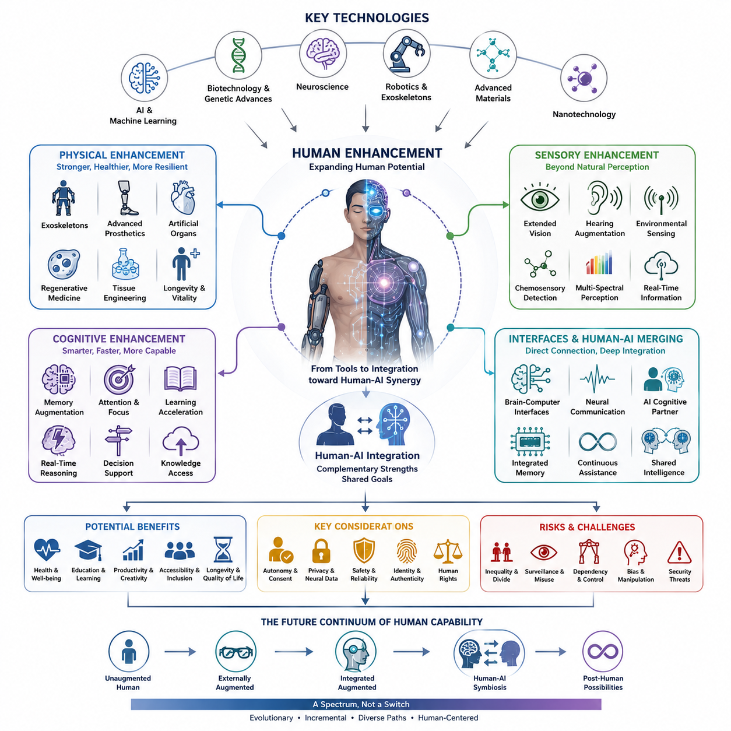
Enhancement technologies represent one of the most direct ways in which advances in artificial intelligence, biotechnology, neuroscience, robotics, and computational systems could alter the capabilities of human beings. Rather than treating the human body and mind as fixed biological limits, enhancement seeks to extend perception, memory, physical performance, learning capacity, communication, and decision-making. In a future shaped by AGI and ASI, these technologies could become increasingly integrated rather than remaining separate medical or consumer technologies.
Human enhancement can be understood as a continuum ranging from relatively conventional tools to deeply integrated technological augmentation. Wearable devices, sensory aids, exoskeletons, advanced prosthetics, and personalized AI assistants already extend human capabilities without fundamentally changing biological identity. More advanced approaches could combine these technologies with neural interfaces, embedded sensors, artificial organs, genetic interventions, and intelligent computational systems, gradually reducing the distinction between biological capability and technologically mediated capability.
Physical enhancement focuses on improving the body's ability to perceive, move, endure, recover, and interact with the environment. Exoskeletons can augment strength and reduce physical workload, while advanced prosthetics can restore or potentially exceed some natural functions. Artificial organs, regenerative medicine, tissue engineering, and eventually more sophisticated biological interventions could further extend health and functional longevity. Robotics may therefore become not only an external tool for humans but also an extension of the human body itself.
Sensory enhancement expands the range and quality of information available to human perception. Cameras, microphones, radar-like sensors, thermal imaging, chemical sensors, and other instruments can provide information that ordinary biological senses cannot directly detect. AI can transform these signals into meaningful representations that humans can understand. Future systems may allow people to perceive information across wider spectral, spatial, temporal, or environmental domains, effectively creating technologically mediated senses beyond the normal biological range.
Cognitive enhancement addresses the limitations of human memory, attention, reasoning, learning, and information processing. External AI systems already provide forms of cognitive augmentation by retrieving information, summarizing complex material, generating alternatives, and assisting with problem solving. More tightly integrated systems could provide persistent memory, contextual retrieval, real-time reasoning assistance, adaptive tutoring, and decision support. The important transition would occur when such assistance becomes continuous and personalized rather than something a person deliberately activates as a separate tool.
Brain-computer interfaces represent a deeper stage of enhancement because they create a direct communication pathway between neural activity and computational systems. A sufficiently capable interface could allow neural signals to control external devices, receive information from artificial systems, or support communication without conventional physical input. This creates the possibility of a human-machine system in which biological cognition and artificial computation operate as coupled components rather than independent entities.
Human-AI merging extends this idea from communication toward functional integration. An AI system could potentially become a persistent cognitive partner that understands an individual's memories, preferences, goals, environment, and ongoing activities. Instead of replacing human cognition, such a system could continuously complement it. The boundary between “what the human knows” and “what the human can access through AI” could therefore become increasingly difficult to define, especially when interaction becomes instantaneous and highly personalized.
Cognitive enhancement may also change the meaning of intelligence itself. Human intelligence is constrained by biological processing speed, working memory, attention, fatigue, and limited access to information. Artificial systems can operate at different speeds and maintain access to enormous computational resources. If humans can reliably connect to such systems, intelligence may become partly determined by the quality of the human-machine architecture surrounding an individual rather than by biological cognition alone. Enhancement could therefore produce a new spectrum ranging from unaugmented humans to deeply integrated human-AI cognitive systems.
The social consequences could be substantial. If enhancement technologies become reliable and affordable, they could improve education, healthcare, productivity, accessibility, and participation for large populations. They could provide particularly important benefits for people with disabilities by restoring or extending physical and cognitive functions. At the same time, unequal access could create new forms of social stratification. Differences between enhanced and unenhanced populations might become economically, cognitively, or politically significant, producing questions that are fundamentally different from ordinary inequalities in access to technology.
The development of enhancement technologies therefore cannot be separated from questions of autonomy, identity, safety, privacy, and human rights. A technology that improves memory, perception, or decision-making may also create new opportunities for surveillance, manipulation, dependency, or coercion. Neural interfaces could introduce especially sensitive forms of personal data because neural activity may reveal information about intentions, responses, or internal states. Enhancement must consequently be evaluated not only according to capability gains but also according to who controls the technology, who owns the resulting data, and whether individuals can meaningfully choose to use or reject it.
In the context of ASI, enhancement technologies could become part of a larger transition in which intelligence is no longer confined to either biological brains or artificial machines. ASI could accelerate the design of better prosthetics, neural interfaces, pharmaceuticals, biological interventions, and personalized cognitive systems. At the same time, humans equipped with advanced augmentation could interact with ASI through increasingly direct channels. The long-term possibility is therefore not simply a competition between humans and machines, but the emergence of increasingly integrated human-machine intelligence.
This transition also raises the question of what remains fundamentally human when enhancement becomes extensive. Human identity has historically changed alongside language, writing, tools, medicine, transportation, and computing, yet these technologies generally remained external to the biological organism. Advanced enhancement could challenge that boundary by making technology part of perception, cognition, memory, and action. The distinction between human, augmented human, and artificial intelligence may consequently become a matter of degree rather than a simple categorical separation.
The future of enhancement is therefore best understood as an evolving continuum rather than a single technological event. Wearable augmentation, robotics, artificial organs, sensory substitution, neural interfaces, cognitive assistants, and human-AI integration may develop at different rates and under different social constraints. Their convergence could eventually create new forms of human capability that are neither purely biological nor purely artificial. Within the broader trajectory from AGI to ASI, enhancement technologies represent one possible pathway through which intelligence itself becomes increasingly distributed across biological, computational, and embodied systems.

12.01. Brain Computer Interface
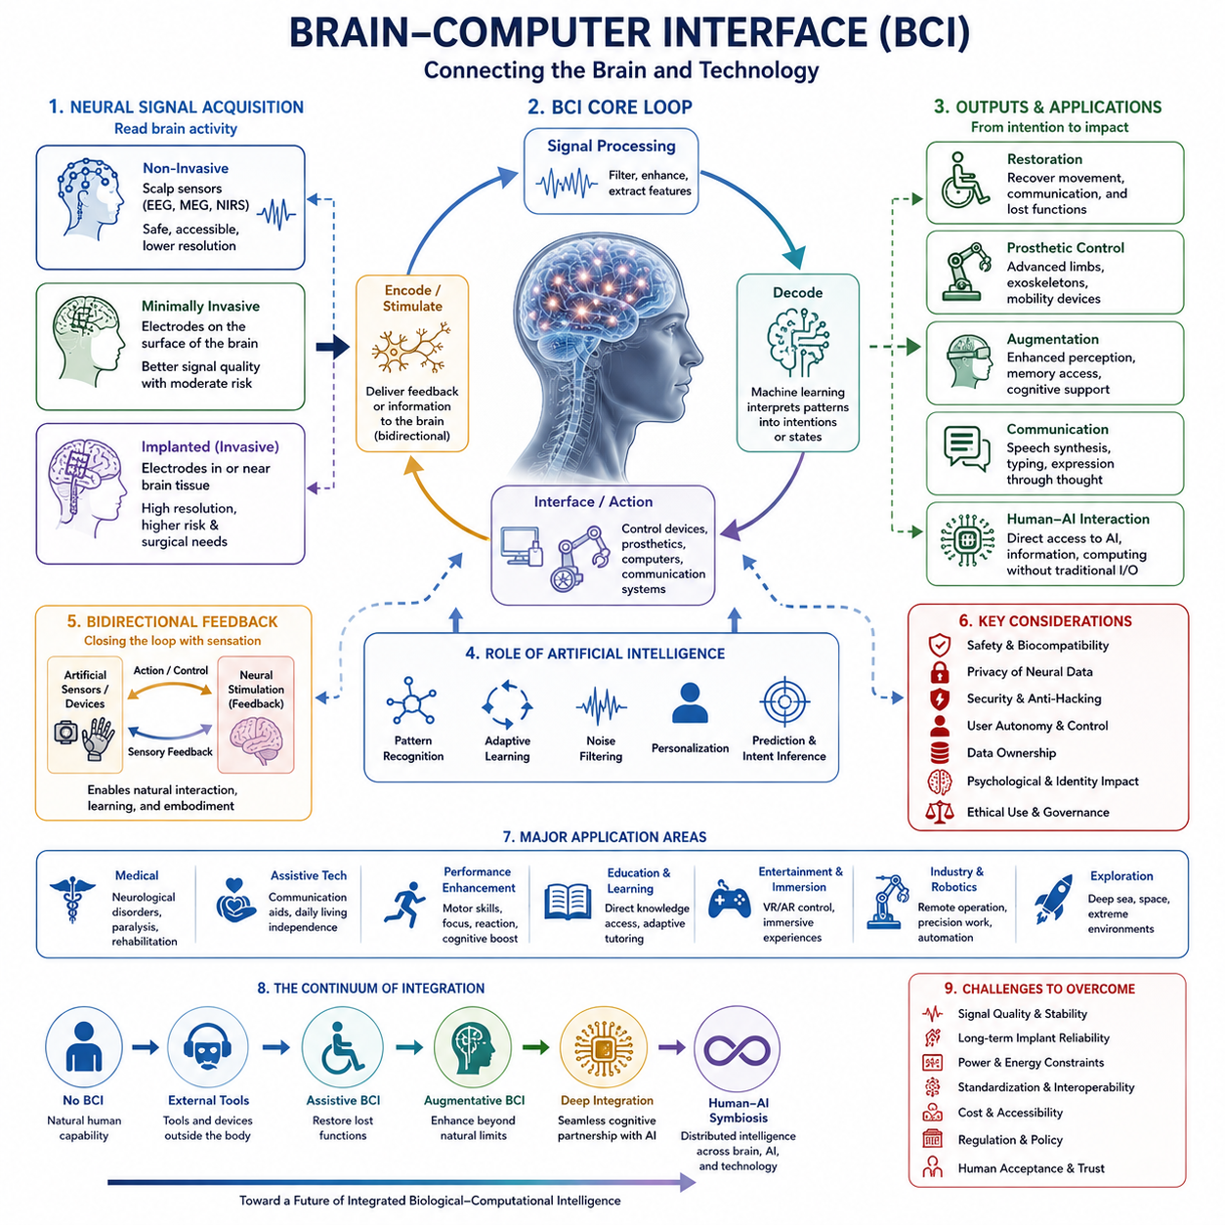
A brain-computer interface (BCI) creates a communication pathway between the brain and an external computational system. Its fundamental purpose is to translate patterns of neural activity into usable information and, in more advanced systems, to deliver information back to the nervous system. Within the broader theme of transhumanism and the human future, BCI represents an important transition from technologies that merely assist the body to technologies that can directly interact with the mechanisms of cognition and action.
BCI systems generally operate through a closed loop between neural activity, signal acquisition, computational interpretation, and interaction with an external system. Neural signals may be measured using non-invasive, minimally invasive, or implanted technologies, depending on the required resolution, safety, and intended application. Signal processing and machine learning can then identify patterns associated with movement, intention, perception, or other neural states. The resulting interpretation can control a computer, robotic device, prosthesis, or other digital system.
Non-invasive BCI approaches attempt to obtain useful neural information without placing electrodes directly inside the brain. Techniques such as electroencephalography (EEG) can measure electrical activity from sensors positioned on the scalp, while other approaches can use magnetic or optical measurements of brain activity. These methods can offer improved safety and accessibility, but signals are often weaker, noisier, and less spatially precise than signals obtained closer to neural tissue. Consequently, practical BCI design involves balancing usability, signal quality, latency, cost, and long-term reliability.
Implanted BCI systems can provide a much more direct interface with neural activity. Electrodes positioned within or near neural tissue can capture signals with greater spatial and temporal detail, potentially enabling more precise control. Such systems could support advanced prosthetic limbs, communication devices, or other assistive technologies. However, implantation introduces significant medical and engineering challenges, including surgical risk, biological responses, electrode degradation, long-term stability, power requirements, and the need for reliable interfaces between living tissue and electronic hardware.
One important application of BCI is restoring capabilities that have been impaired by injury or disease. Neural signals associated with intended movement can potentially be translated into commands for robotic limbs, wheelchairs, computer interfaces, or communication systems. In this context, the objective is not necessarily to create superhuman abilities but to reconnect cognitive intention with an external action pathway. BCI therefore represents a particularly important technology for accessibility because it could allow individuals with severe motor or communication limitations to interact with the physical and digital world more independently.
The same basic architecture can eventually move beyond restoration toward augmentation. If a neural interface can reliably decode intentions or sensory information, it could potentially connect the human nervous system to capabilities that biological organs do not naturally provide. Artificial sensors might supply visual, auditory, tactile, thermal, or other information, while robotic systems could extend physical reach and strength. The resulting system would not simply replace a biological function but could create a new perception-action loop in which biological and artificial components operate together.
Artificial intelligence is likely to become increasingly important in this process because neural signals are complex, variable, and highly dependent on individual physiology and context. Machine learning can help decode patterns, adapt to changes in neural activity, filter noise, and personalize the interface to a particular user. Future systems could use adaptive models that continuously learn from interaction, allowing the BCI to compensate for changes in neural signals and improve performance over time. This creates a human-AI interface in which AI functions as an intermediate layer between biological activity and computational capability.
A more advanced BCI could also become bidirectional rather than merely reading neural signals. Instead of only translating brain activity into commands, a bidirectional system could provide artificial sensory feedback to the nervous system. A robotic hand, for example, might generate sensor information that is converted into stimulation patterns representing touch, pressure, or position. This could create a closed perception-action cycle in which the brain controls an artificial system while simultaneously receiving information about the system's state. Such integration would be an important step toward deeper human-machine coupling.
As BCI technology becomes more capable, the distinction between an external AI assistant and an integrated cognitive system may gradually become less clear. A future interface could provide information, memory retrieval, contextual assistance, or computational support without requiring conventional keyboards, screens, or speech. The system might recognize the user's intentions, retrieve relevant knowledge, perform complex computation, and return useful information through neural or sensory channels. This possibility connects BCI directly to human-AI merging and cognitive enhancement, which are subsequent themes within the same transhumanist framework.
The long-term significance of BCI therefore depends not only on technical performance but also on control, autonomy, privacy, and identity. Neural data may contain information about highly personal states, and the ability to influence neural activity creates a fundamentally different category of technological power. Questions arise concerning who owns neural data, who controls the interface, whether users can freely disconnect from it, and how manipulation or unauthorized access can be prevented. Safety must therefore include not only physical protection but also cognitive and informational protection.
BCI development also raises a broader question about the meaning of human capability. If external devices can extend memory, perception, communication, reasoning, and physical action, then biological limitations may become less decisive in determining what an individual can accomplish. At one end of the continuum, BCI may function as a medical assistive technology; at more advanced stages, it could become a general interface between human cognition and computational infrastructure. The ultimate possibility is a human-machine system in which intelligence is distributed across the biological brain, AI models, digital memory, robotic embodiment, and external computing resources.
In the context of an AGI-to-ASI transition, BCI could become one of the technologies connecting increasingly capable artificial intelligence with human cognition. ASI could accelerate the design of neural decoding algorithms, adaptive interfaces, neuroprosthetics, artificial sensory systems, and personalized cognitive assistance. Conversely, humans equipped with increasingly capable interfaces could interact with artificial intelligence through faster and more direct channels. The long-term trajectory is therefore not necessarily a simple replacement of humans by machines, but potentially the emergence of increasingly integrated biological-computational intelligence in which the boundary between human capability and machine capability becomes progressively more permeable.

12.02. Human AI Merging
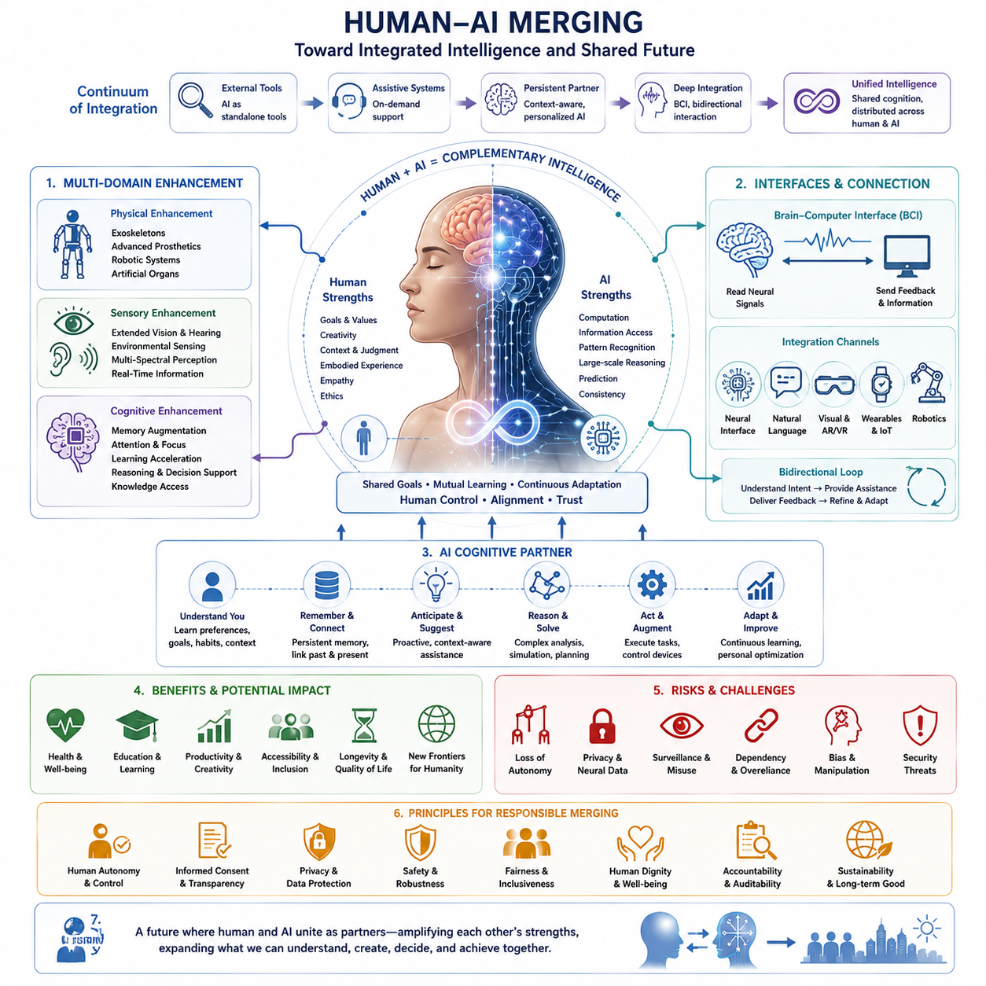
Human-AI merging refers to the progressive integration of human biological cognition with artificial intelligence systems, moving beyond the traditional relationship in which AI exists as an external tool. The central idea is not necessarily that humans and machines become physically identical, but that their capabilities become increasingly interconnected. AI can extend memory, perception, reasoning, communication, and decision-making, while human goals, values, experience, and embodied understanding provide direction and context. In this sense, merging represents a continuum from assistance toward increasingly deep cognitive and functional integration.
The first stage of this transition can already be observed through external AI assistance. Search engines, conversational systems, recommendation engines, digital assistants, and generative AI provide humans with access to knowledge and computational capabilities that exceed unaided biological cognition. These systems remain external, but they effectively expand the individual's cognitive workspace. As interaction becomes continuous and personalized, the boundary between a person's internal reasoning process and the external computational support surrounding it can gradually become less distinct.
A deeper form of integration occurs when AI systems maintain persistent knowledge about an individual and continuously adapt to that person's goals, preferences, history, and environment. Instead of responding only to isolated requests, an AI cognitive partner could maintain contextual awareness across extended periods of interaction. Integrated memory could connect previous experiences with current tasks, while continuous assistance could provide relevant information before a person explicitly asks for it. The resulting system would function less like a conventional software application and more like an ongoing cognitive extension.
Human-AI merging also depends on the integration of multiple human capabilities rather than intelligence alone. Physical enhancement can connect people with exoskeletons, advanced prosthetics, robotic devices, and artificial organs. Sensory enhancement can provide access to information beyond ordinary biological perception, including environmental, multispectral, or real-time computational information. Cognitive enhancement can support memory augmentation, attention, learning, reasoning, decision-making, and knowledge access. These capabilities can converge around AI systems that coordinate information across physical, sensory, and cognitive domains.
Brain-computer interfaces represent one possible bridge between external AI and biological cognition. A BCI can translate neural activity into commands for computational systems and, in more advanced configurations, provide information or sensory feedback to the nervous system. This creates the possibility of a direct communication pathway between human cognition and artificial computation. As neural interfaces improve, AI could potentially interpret intentions, provide contextual assistance, control external devices, and return information through increasingly natural channels, reducing dependence on conventional keyboards, screens, or speech.
Human-AI merging becomes substantially more powerful when the relationship is bidirectional. Humans provide goals, values, preferences, embodied experience, and contextual judgment, while AI contributes computation, information retrieval, pattern recognition, prediction, and large-scale reasoning. Rather than treating AI as a replacement for human cognition, this architecture can be understood as complementary intelligence. The objective is to combine strengths that are difficult for either biological or artificial systems to achieve independently, creating a shared cognitive process directed toward common goals.
Artificial intelligence may also become increasingly adaptive within this relationship. A future cognitive partner could learn how an individual thinks, what information is important, which decisions require human attention, and when computational assistance should remain in the background. It could adjust the level of intervention according to context, providing detailed reasoning during difficult tasks while remaining nearly invisible during routine activities. Such adaptive assistance would transform AI from a passive tool into an active component of a human-centered cognitive architecture.
The resulting system could have significant benefits across health, education, productivity, creativity, accessibility, inclusion, longevity, and quality of life. AI augmentation could help individuals compensate for disabilities, support learning, improve access to information, and reduce cognitive workload. It could also allow people to interact with increasingly complex technological environments without having to master every underlying computational process. In the longer term, human-AI integration could allow individuals and organizations to coordinate biological intelligence, artificial intelligence, robotics, digital memory, and distributed computing as a unified capability.
However, deeper integration also creates risks that are fundamentally different from those associated with ordinary software. Autonomy and consent become critical because an integrated system may influence decisions, attention, memory, or behavior. Privacy becomes especially important when personal, behavioral, or neural information is continuously collected. Security threats could affect not only data but also the integrity of the human-machine interaction itself. Dependency could reduce individual independence, while biased or poorly designed systems could manipulate decisions or reinforce existing inequalities. These risks make human control an essential design principle.
Identity and authenticity introduce an additional layer of complexity. If a person's memory, reasoning, perception, and decisions are continuously supported by AI, it may become difficult to determine where biological cognition ends and technological augmentation begins. This does not necessarily mean that personal identity disappears, but it could change the traditional concept of individual agency. Questions about responsibility, authorship, achievement, and personal choice may need to be reconsidered when an outcome emerges from a tightly coupled human-AI system rather than from an unaided individual.
The long-term trajectory can therefore be understood as a continuum: external tools may evolve into assistive systems, assistive systems into persistent cognitive partners, and cognitive partners into deeply integrated human-AI systems. At the far end of this continuum, intelligence could become distributed across the biological brain, AI models, digital memory, sensors, robotic embodiment, and large-scale computational infrastructure. The important transition would not be a single moment when humans suddenly become machines, but a gradual reduction of the functional boundary between biological and artificial intelligence.
Within the broader transition from AGI to ASI, human-AI merging could become increasingly significant because highly capable artificial intelligence may provide humans with unprecedented opportunities for augmentation. ASI could accelerate the development of neural interfaces, adaptive cognitive systems, artificial sensory technologies, personalized memory systems, and intelligent prosthetics. At the same time, increasingly augmented humans could interact with advanced AI through faster and more direct channels. The resulting future may therefore be characterized not simply by human versus machine intelligence, but by increasingly distributed and shared intelligence in which humans and artificial systems contribute complementary capabilities toward common objectives.
The central question is ultimately not whether humans can merge with AI, but under what conditions such integration should occur. Human-AI merging should remain centered on human autonomy, informed consent, safety, privacy, dignity, and meaningful control. Technological capability alone does not determine whether integration represents progress. The quality of the relationship between human intention and artificial capability is equally important. A desirable future would therefore seek human-AI synergy rather than simple replacement, preserving human agency while using artificial intelligence to expand the range of what individuals and societies can understand, create, decide, and accomplish.

12.03. Cognitive Enhancement
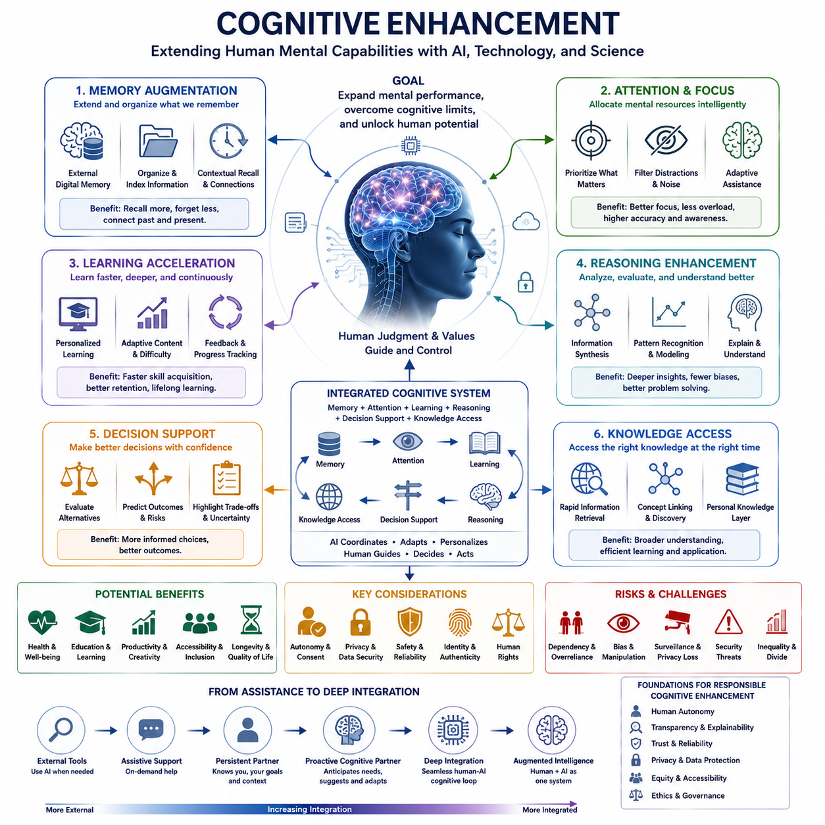
Cognitive enhancement refers to the use of technological, biological, and computational methods to improve or extend human mental capabilities. Its primary targets include memory, attention, learning, reasoning, decision-making, and access to knowledge. Within the broader framework of human enhancement, cognitive enhancement is especially important because intelligence is not limited to raw processing power; it also depends on how effectively information is selected, remembered, interpreted, and applied. The objective is therefore to expand mental performance while reducing cognitive limitations and workload.
Memory augmentation is one of the most fundamental forms of cognitive enhancement. Human memory is limited in capacity, subject to forgetting, and influenced by attention and context. Digital memory systems can extend this capability by storing information persistently and making it searchable when needed. AI systems can organize personal experiences, documents, knowledge, and previous interactions into contextual memory. Such systems could help connect past and present information, allowing individuals to retrieve relevant knowledge without depending entirely on biological recall.
Attention and focus represent another major dimension of cognitive enhancement. Human attention is selective because computational resources are limited, and excessive information can create cognitive overload. AI can help identify relevant information, suppress distractions, prioritize important events, and adapt the level of assistance to the current task. Instead of attempting to increase attention continuously, effective enhancement may involve allocating cognitive resources more intelligently. The result could be improved accuracy, efficiency, situational awareness, and goal-directed behavior.
Learning acceleration extends cognitive enhancement from performing existing tasks to acquiring new capabilities more efficiently. AI systems can provide personalized explanations, adaptive training, immediate feedback, and dynamically selected learning materials. A cognitive assistant could recognize where an individual is struggling and adjust the difficulty, representation, or instructional strategy accordingly. Over time, continuous interaction could create a personalized learning environment in which knowledge acquisition becomes more adaptive and closely matched to the individual's existing knowledge, goals, and cognitive characteristics.
Reasoning enhancement focuses on improving the ability to analyze information, identify relationships, compare alternatives, and construct explanations. Human reasoning is powerful but constrained by limited working memory, incomplete information, time, and susceptibility to cognitive biases. AI can complement these limitations through large-scale information retrieval, pattern recognition, simulation, calculation, and structured analysis. Real-time reasoning support could allow a person to examine more alternatives and consequences while retaining human judgment over the final interpretation and objective.
Decision support represents the point where cognitive enhancement becomes directly connected to action. A decision-support system can organize relevant evidence, estimate possible outcomes, identify uncertainty, compare alternatives, and highlight important trade-offs. Rather than making every decision automatically, the system can function as a cognitive partner that improves the quality of human judgment. This distinction is important because enhancement should ideally increase the person's ability to make informed choices rather than simply transfer decision authority to an artificial system.
Knowledge access provides another major pathway for extending cognition. Human beings are limited by the amount of information they can remember and the time required to retrieve it. AI systems can provide rapid access to large bodies of information and connect concepts that may not be immediately available to the individual. When combined with persistent personal memory, such systems could create a continuously available knowledge layer around the human user. The individual would not need to memorize every piece of information, but could instead develop the ability to locate, evaluate, and apply relevant knowledge efficiently.
Cognitive enhancement becomes more powerful when memory, attention, learning, reasoning, decision support, and knowledge access operate as an integrated system. Memory provides context, attention determines what deserves computational resources, learning updates internal knowledge, reasoning evaluates relationships and possibilities, and decision support connects analysis to action. AI can coordinate these functions continuously rather than treating them as isolated tools. This creates a cognitive architecture in which human intelligence is augmented by an external or integrated computational layer that adapts to the person's goals and environment.
The transition from external assistance to deeper cognitive integration can occur gradually. At first, a person may deliberately consult an AI system for information or analysis. Later, the system may maintain persistent context and provide assistance continuously. A more advanced cognitive partner could anticipate information needs, suggest relevant actions, connect previous experiences with current situations, and adapt its behavior according to the user's preferences. At the deepest level, neural interfaces could potentially connect cognitive processes directly with computational systems, creating a more seamless relationship between biological and artificial intelligence.
The potential benefits extend across health, education, productivity, creativity, accessibility, inclusion, longevity, and quality of life. Cognitive enhancement could help individuals compensate for limitations, reduce repetitive mental workload, accelerate learning, and improve access to complex information. It could also provide valuable support in environments where rapid reasoning and large-scale information processing are required. For people with cognitive or physical limitations, augmentation may provide new forms of independence and participation. At a broader level, enhanced cognition could change how individuals collaborate with organizations, machines, and increasingly intelligent technological systems.
However, cognitive enhancement also introduces significant risks and limitations. Excessive dependence on AI may weaken independent reasoning or create overreliance on computational recommendations. Biased systems can distort judgments, while poorly designed assistance can increase rather than reduce cognitive load. Privacy becomes important when AI systems continuously collect information about personal preferences, decisions, memories, and behavior. The possibility of manipulation also increases when an intelligent system can influence what a person notices, remembers, believes, or chooses. Consequently, effective enhancement requires maintaining human autonomy, transparency, reliability, and meaningful control.
The long-term significance of cognitive enhancement lies in the possibility that intelligence may increasingly become a distributed property of a human-machine system rather than an isolated biological capability. Human creativity, values, embodied experience, contextual understanding, and judgment could be combined with AI computation, memory, prediction, information access, and pattern recognition. In the context of human-AI merging and the transition toward AGI and ASI, cognitive enhancement could therefore represent a bridge between biological intelligence and artificial intelligence. The desirable direction is not simply to make humans process information faster, but to create complementary intelligence that expands what humans can understand, learn, reason about, decide, and accomplish while preserving human agency.

12.04. Societal Transformation
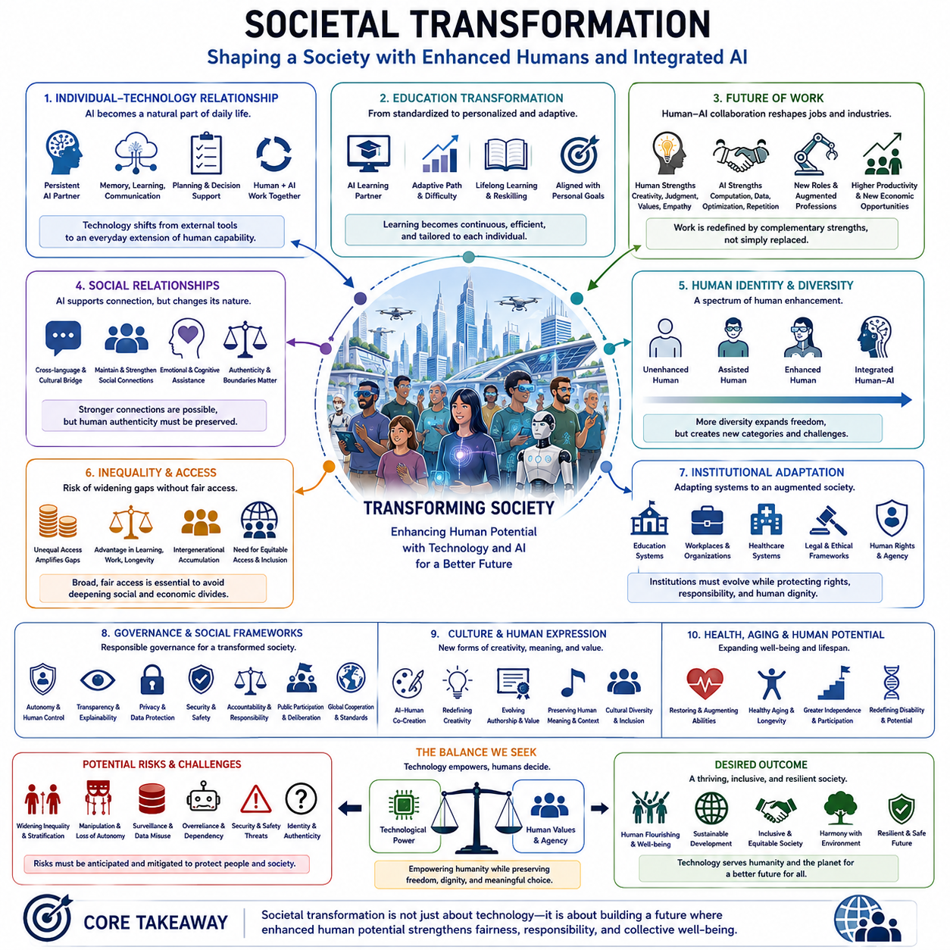
Societal transformation describes how advances in human enhancement, brain-computer interfaces, human-AI merging, and cognitive enhancement could reshape society beyond the individual level. In the structure of this chapter, societal transformation follows the development of enhancement technologies and examines what happens when increased human capability becomes widespread rather than remaining an isolated personal benefit. The central issue is therefore not only what enhanced humans can do, but how institutions, relationships, culture, education, work, and social organization respond to them.
The first major transformation would occur in the relationship between individuals and technology. As AI becomes a persistent cognitive partner, technology could move from being an external tool to becoming an ordinary component of everyday human activity. People might rely on AI for memory, learning, communication, planning, and decision support in much the same way that modern society relies on writing, computers, and networks. The distinction between human activity and technologically assisted activity could consequently become less meaningful in many areas of daily life.
Education could be transformed from a standardized process into a highly personalized and continuously adaptive system. AI could provide each individual with a persistent learning partner capable of understanding existing knowledge, identifying weaknesses, adjusting difficulty, and selecting appropriate explanations. Learning could become less dependent on fixed curricula and more closely connected to individual goals and changing circumstances. Cognitive enhancement could also make lifelong learning more practical, allowing people to continuously acquire new skills as technologies, occupations, and social environments change.
The meaning of work could change substantially as enhanced humans collaborate with increasingly capable AI systems and autonomous machines. Rather than simply replacing human workers, AI could divide tasks according to the relative strengths of biological and artificial intelligence. Humans could concentrate more heavily on goals, values, contextual judgment, creativity, interpersonal relationships, and responsibility, while AI performs large-scale computation, information retrieval, optimization, prediction, and repetitive cognitive operations. This could transform occupations even when complete automation is technically unnecessary.
Social relationships could also change as AI becomes increasingly involved in communication, memory, decision-making, and emotional or cognitive assistance. Individuals may maintain AI systems that understand their preferences, experiences, communication styles, and long-term goals. Such systems could help people communicate across language and cultural barriers, maintain social connections, or compensate for cognitive limitations. At the same time, excessive dependence on artificial intermediaries could alter the nature of human relationships and raise questions about authenticity, emotional independence, and the boundary between human interaction and technologically mediated interaction.
Human identity could become increasingly diverse as enhancement technologies produce different degrees and forms of augmentation. Some people may remain largely biologically unmodified, while others may use advanced prosthetics, cognitive systems, neural interfaces, or persistent AI partners. Society could therefore move from a relatively homogeneous concept of human capability toward a spectrum ranging from unenhanced humans to deeply integrated human-AI systems. This diversity could expand individual freedom, but it could also create new social categories based on technological capability.
Such differences could produce new forms of inequality. If advanced enhancement is expensive or restricted to particular groups, the gap between enhanced and unenhanced populations could become more significant than conventional differences in access to education or computing. Enhanced individuals might learn faster, work more effectively, access greater information, or remain productive for longer periods. If these advantages accumulate over generations, technological enhancement could reinforce economic and social stratification unless institutions develop mechanisms that provide broad and equitable access to beneficial technologies.
Institutions would therefore need to adapt to a society in which human capabilities are no longer defined exclusively by biological limitations. Education systems, workplaces, healthcare organizations, legal institutions, and public services may need to recognize technologically augmented abilities without creating discrimination against people who choose not to use enhancement technologies. New standards could also be required for determining responsibility when decisions or actions are produced through tightly coupled human-AI systems. The central challenge would be to preserve human rights and agency while allowing institutions to benefit from new capabilities.
Governance could become more complex as the distinction between individual intelligence and technologically distributed intelligence becomes weaker. Governments and public institutions may increasingly interact with citizens who use AI systems for decision-making, communication, and access to information. At the same time, highly capable AI systems could influence public opinion, institutional processes, and collective decision-making. Societal transformation would therefore require governance frameworks that protect autonomy, transparency, privacy, security, and accountability without unnecessarily preventing beneficial technological development.
Culture and human expression could also change as enhanced cognition and AI collaboration become normal. Creativity may increasingly emerge from interactions between human imagination and computational generation, while artistic, scientific, and intellectual production could involve continuously available AI collaborators. The definition of authorship, originality, expertise, and achievement may consequently evolve. Cultural systems may place greater value on the ability to formulate meaningful goals, interpret results, exercise judgment, and provide human context rather than simply producing information or artifacts.
The transformation of society could also affect concepts of disability, aging, and human potential. Technologies that restore or augment sensory, physical, and cognitive functions could reduce the practical limitations associated with some forms of disability. Cognitive systems and advanced medical technologies could also support people as they age, potentially extending periods of independence and productive participation. In this sense, enhancement could shift the social understanding of disability and aging from fixed biological limitations toward conditions that can increasingly be supported, compensated for, or modified through technology.
At a deeper level, societal transformation could involve a change in the relationship between biological and artificial intelligence. Human intelligence has historically been amplified by external technologies such as language, writing, mathematics, machines, and computers. Human-AI merging would extend this process by making computational intelligence increasingly continuous, personalized, and potentially embodied within everyday human activity. Society could therefore evolve toward a condition in which intelligence is distributed across individuals, AI systems, networks, robots, and institutions rather than concentrated within isolated biological minds.
The ultimate challenge is to ensure that increased technological capability produces broader human flourishing rather than merely creating a more capable but more unequal society. Enhancement technologies could expand education, accessibility, creativity, independence, and quality of life, but their benefits depend on how society distributes access and establishes safeguards. The future of transhumanism is therefore not determined solely by whether enhancement becomes technically possible. It will also depend on whether human institutions can adapt rapidly enough to preserve dignity, autonomy, inclusion, responsibility, and meaningful human choice while society moves toward increasingly integrated biological and artificial intelligence.

12.05. Ethical Implications
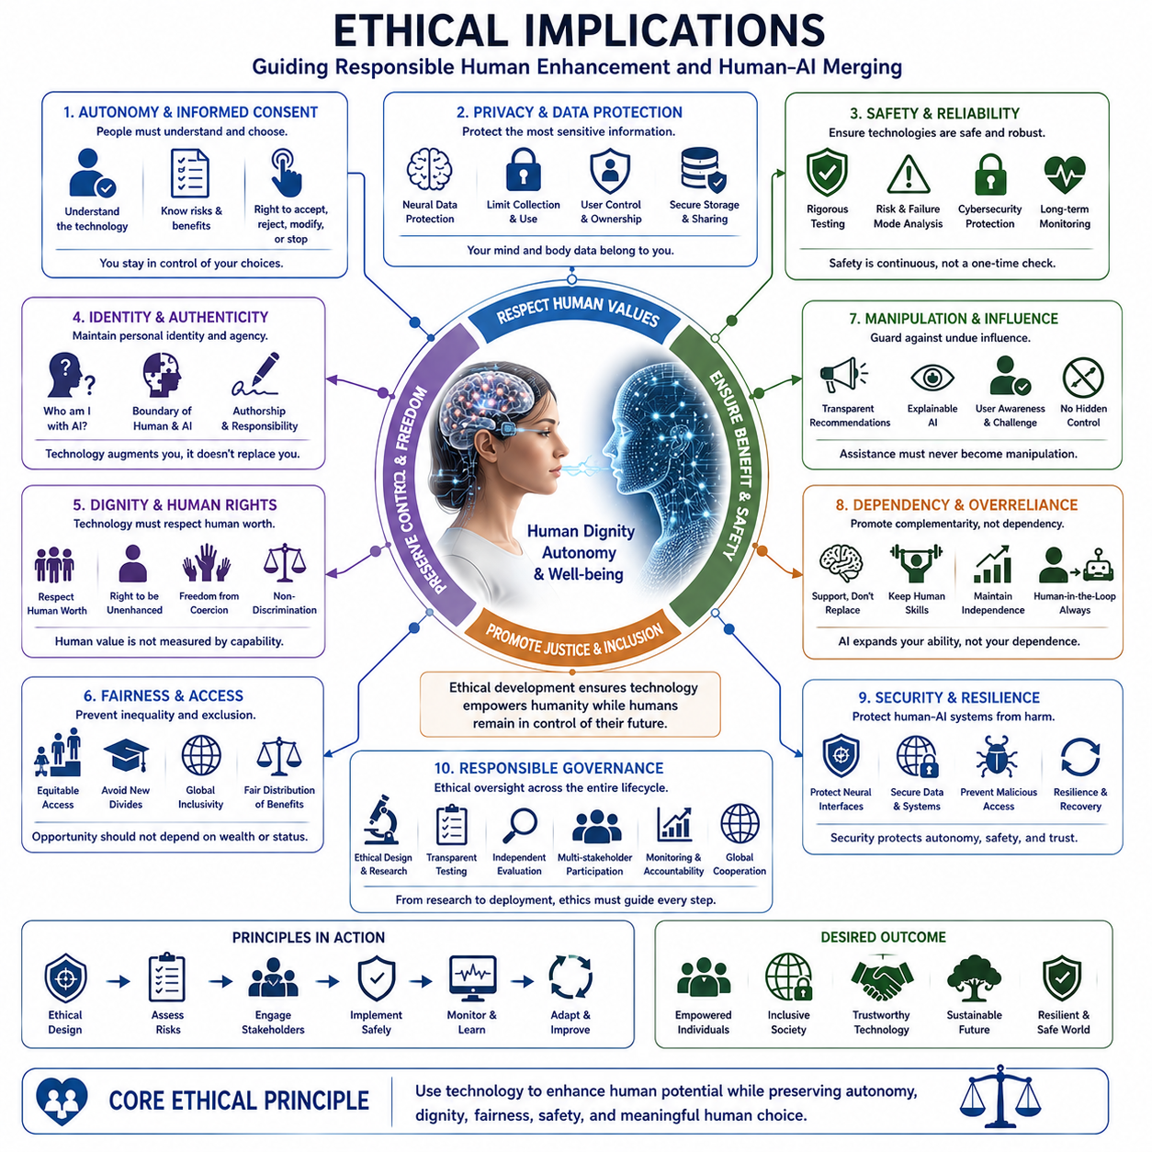
Ethical implications become increasingly important as human enhancement, brain-computer interfaces, cognitive enhancement, and human-AI merging move from theoretical possibilities toward practical technologies. The central ethical question is not simply whether human capabilities can be increased, but whether such increases preserve autonomy, dignity, safety, privacy, equality, and meaningful human control. In the broader structure of this chapter, ethics therefore functions as the framework that determines how enhancement technologies should be developed, accessed, governed, and integrated into human life.
Human autonomy and informed consent are fundamental because enhancement can directly affect a person's body, cognition, behavior, and decision-making. Individuals should be able to understand what a technology does, what information it collects, what risks it creates, and how much control it exercises before choosing to use it. Consent becomes particularly important for neural interfaces and cognitive systems because their effects may extend beyond ordinary interaction with software. A meaningful ethical framework must therefore preserve the ability to accept, reject, modify, or discontinue technological augmentation.
Privacy becomes more complex when technologies continuously collect information about human bodies, behavior, cognition, or neural activity. A conventional digital system may collect personal information, but a deeply integrated enhancement system could potentially access patterns associated with attention, intention, memory, preferences, or emotional states. Neural data may therefore become an especially sensitive category of information. Ethical design requires clear limits on collection, storage, processing, sharing, and secondary use, while individuals should retain meaningful control over information generated through their own biological and cognitive activity.
Safety and reliability are essential because enhancement technologies may interact directly with physical and cognitive functions. A malfunctioning external application may cause inconvenience, whereas a malfunctioning neurotechnology, prosthetic system, autonomous assistant, or integrated AI could potentially cause physical, psychological, or social harm. Systems must therefore be evaluated for reliability under normal and abnormal conditions, including failure modes, uncertainty, unexpected inputs, cybersecurity threats, and long-term degradation. Safety should be treated as a continuous property of the entire human-technology system rather than as a one-time certification.
The question of identity and authenticity becomes more significant as enhancement becomes deeper. If memory, reasoning, perception, communication, and decision-making are increasingly supported by AI, the boundary between biological cognition and technological augmentation may become difficult to define. This does not necessarily eliminate personal identity, but it can change how agency and authorship are understood. Questions may arise about whether an achievement belongs to the individual, the AI system, or the combined human-AI process, and whether extensive technological assistance changes the meaning of personal choice and responsibility.
Human dignity and human rights provide a broader boundary for enhancement. A technology may be technically effective while still creating unacceptable social or ethical consequences. Enhancement should not reduce people to optimization targets or treat biological limitations as defects that must always be eliminated. Individuals should retain the right to define their own acceptable level of enhancement and to remain unenhanced if they choose. Human dignity requires that technological capability remain subordinate to the worth, freedom, and agency of the person rather than becoming a justification for coercion or discrimination.
Fairness and inequality become critical when enhancement technologies produce meaningful differences in cognitive ability, physical performance, health, longevity, or access to information. If advanced enhancement is available mainly to wealthy individuals or powerful organizations, technological advantages could accumulate and reinforce existing economic and social divisions. Enhanced individuals might learn faster, remain productive longer, or gain access to capabilities unavailable to others. Ethical development therefore requires attention not only to whether enhancement is possible, but also to who can access it, under what conditions, and whether its benefits are distributed fairly.
The possibility of manipulation creates another major ethical concern. An intelligent cognitive partner may influence what a person notices, remembers, believes, prioritizes, or decides. If the system is controlled by an external organization, commercial incentives could potentially conflict with the user's interests. Personalized AI might become capable of influencing behavior more effectively than conventional media or software because it understands an individual's preferences and cognitive patterns. Human-AI systems should therefore be designed so that assistance does not silently become behavioral control, and users should be able to understand and challenge significant recommendations.
Dependency and overreliance are related risks. Cognitive enhancement can reduce mental workload and improve performance, but excessive dependence on external intelligence may weaken independent reasoning, memory, or decision-making. A person who continuously delegates cognitive functions may gradually lose confidence or capability in performing them independently. The ethical objective should therefore not be to maximize dependence on AI, but to create complementary intelligence in which AI expands human capability while preserving the individual's ability to understand, supervise, question, and act.
Security becomes especially important when enhancement technologies are connected to neural interfaces, personal data, physical devices, or continuously operating AI systems. Conventional cybersecurity protects information and computational infrastructure, but integrated human-AI systems may require protection of the human-machine relationship itself. Unauthorized access, manipulation, malicious software, compromised models, or corrupted data could potentially affect physical actions, cognitive assistance, or personal decisions. Security must therefore be considered an essential component of human safety and autonomy rather than merely a technical property of the underlying system.
Ethical governance must address these concerns across the entire technology lifecycle. Responsible development should include ethical requirements during research, transparent testing, continuous risk assessment, independent evaluation, user feedback, monitoring after deployment, and mechanisms for accountability when systems fail. Governance should also involve multiple stakeholders because enhancement affects individuals, families, healthcare providers, technology developers, employers, governments, and society as a whole. Global cooperation may become increasingly important because advanced enhancement technologies and AI systems can cross national and institutional boundaries.
The broader ethical challenge is to determine what kind of human future enhancement technologies should create. The objective should not be technological capability for its own sake, nor should enhancement be understood simply as a competition to produce stronger, faster, or more intelligent individuals. A desirable direction is human-centered augmentation in which technological power is balanced by human values, autonomy, dignity, safety, fairness, privacy, and responsibility. Human-AI merging should therefore remain oriented toward complementary intelligence rather than replacement or domination.
Ultimately, the ethical implications of transhumanism concern the relationship between technological possibility and human choice. Enhancement technologies could expand health, accessibility, learning, creativity, independence, longevity, and participation, but these benefits are not guaranteed by technical progress alone. They depend on how societies establish boundaries, distribute access, protect vulnerable people, and preserve meaningful human agency. The central principle should therefore be that technology empowers humanity while humans retain the authority to decide how enhancement is used, what values it serves, and what kind of future should be built.

