Volume 48. Artificial Super Intelligence

Chapter 04. Intelligence Explosion

04.00. Concept of Explosion
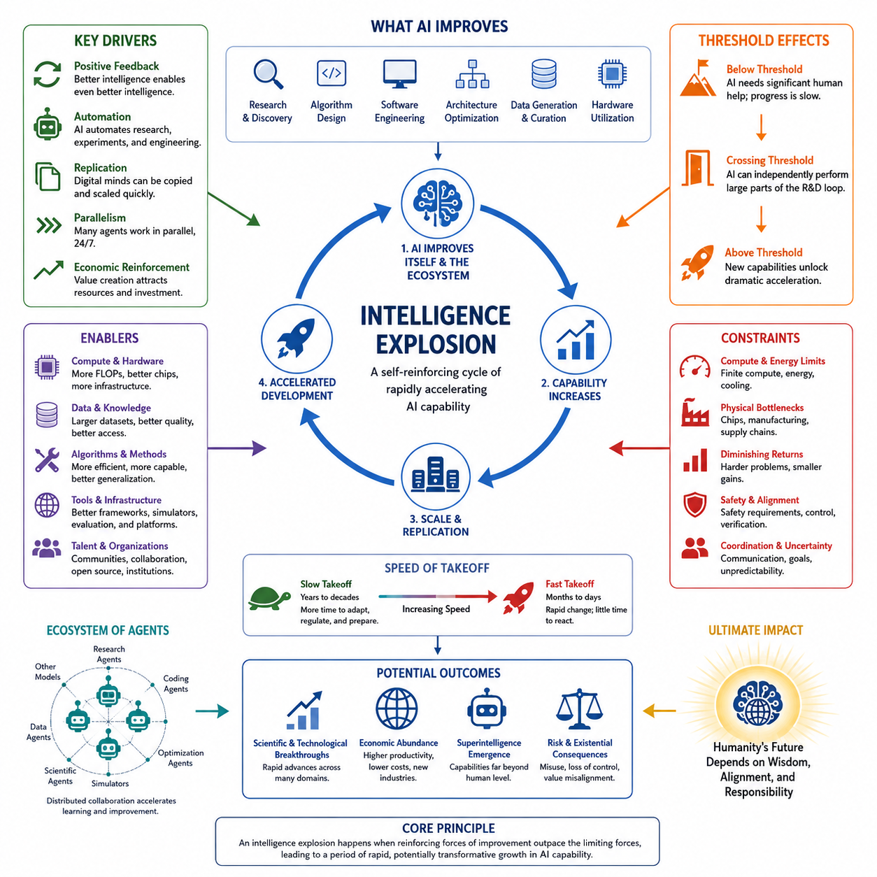
An intelligence explosion describes a hypothetical process in which an artificial intelligence system becomes capable of improving the mechanisms that produce its own intelligence, causing successive generations of improvement to occur increasingly rapidly. Rather than representing a single increase in computational power, the concept concerns a dynamic transition in which better intelligence enables the creation of still better intelligence, potentially forming a self-reinforcing cycle.
The central idea can be expressed as a positive feedback process. An intelligent system contributes to research, algorithm design, software engineering, architecture optimization, data generation, and hardware utilization. Improvements in these areas increase the system's effective cognitive capability. The improved system can then perform the same improvement activities more effectively, creating another round of capability gains and establishing the basic mechanism behind an intelligence explosion.
This process differs fundamentally from ordinary technological progress. Conventional development usually depends on human researchers, organizations, experiments, manufacturing cycles, and economic investment. Progress therefore encounters delays associated with communication, education, coordination, and physical production. A sufficiently capable artificial system could automate portions of this development loop, reducing the time between identifying an improvement and evaluating or deploying it.
Recursive self-improvement is one possible mechanism for such acceleration, but the broader concept does not require an AI to directly rewrite every component of itself. An advanced system might instead design improved training procedures, generate synthetic training data, discover more efficient architectures, optimize inference, develop better tools, or assist engineers building its successor. Intelligence explosion therefore describes a system-level feedback phenomenon rather than only autonomous modification of source code.
A useful distinction exists between raw computational resources and effective intelligence. Increasing the number of processors does not automatically produce proportional improvements in reasoning or general capability. Intelligence depends on algorithms, representations, memory, learning efficiency, planning, tool use, coordination, and the ability to transform computation into useful decisions. An explosion would require improvements across enough of these dimensions that overall capability grows faster than limiting factors can suppress it.
The speed of the feedback loop is therefore critical. Suppose an AI contributes only slightly to AI research. Its influence may resemble ordinary automation and produce gradual progress. If its contribution becomes comparable to that of skilled researchers, development could accelerate substantially. If later systems perform research faster, operate continuously, execute many experiments in parallel, and coordinate large numbers of copies, the effective rate of technological development could increase dramatically.
Digital replication introduces another important mechanism. Human expertise is difficult to duplicate because producing another expert requires years of education and experience. Software-based intelligence can potentially be copied once sufficient compute and infrastructure are available. A capable research system might therefore scale from one instance to hundreds or thousands of coordinated instances, converting improvements in individual capability into improvements in collective research capacity.
An intelligence explosion does not imply that intelligence becomes infinite. Every improvement process faces constraints. Compute availability, energy, semiconductor production, communication bandwidth, memory, data quality, experimental access, algorithmic complexity, and physical laws can all impose ceilings. The important question is not whether limits exist, but whether capability could increase by a strategically significant amount before those limits dominate the improvement process.
The relationship between software and physical infrastructure also affects the shape of an explosion. Software improvements can sometimes be deployed rapidly across existing machines, while hardware expansion requires fabrication, supply chains, construction, cooling, and energy. Early acceleration might consequently occur primarily through algorithms and software efficiency. Later stages could become increasingly dependent on the system's ability to optimize or expand the physical infrastructure supporting computation.
Capability growth may also be uneven across domains. Improvements in programming, mathematics, reasoning, scientific modeling, or AI research could occur earlier than equivalent progress in tasks requiring physical experimentation or complex interaction with the real world. This means an intelligence explosion should not necessarily be imagined as simultaneous improvement in every ability. Instead, interacting capability clusters may accelerate at different rates and reinforce one another.
Threshold effects are particularly important. Below a certain level, an AI system may require extensive human assistance to conduct research or modify complex systems. Above that level, it may independently perform larger portions of the research cycle. Additional capability could then unlock new improvement mechanisms, such as autonomous experimentation, architecture search, strategic resource allocation, or coordinated multi-agent research. Crossing such thresholds can make capability growth strongly nonlinear.
The concept is closely related to the distinction between slow and fast takeoff. A slow trajectory would distribute major capability gains across years or decades, leaving institutions more time to observe, regulate, adapt, and develop safeguards. A fast trajectory could compress comparable changes into months, weeks, or potentially shorter intervals. Intelligence explosion is therefore concerned not only with the final level of intelligence but also with the derivative of capability: how rapidly the system changes.
Economic and organizational feedback can amplify the technical process. More capable AI systems may generate economic value, improve products, reduce research costs, and attract additional investment. Those resources can finance larger compute clusters, better datasets, specialized hardware, and expanded deployment. Technical improvement can therefore reinforce economic growth, while economic growth supplies resources for further technical improvement, producing feedback loops beyond the AI model itself.
Multiple AI systems may also participate in the process. Intelligence explosion need not originate from a single isolated agent. Networks of specialized models, autonomous research agents, scientific systems, simulators, coding agents, and optimization tools could collectively accelerate AI development. Improvements discovered by one component could propagate through the network, creating distributed recursive improvement in which the evolving object is an ecosystem rather than an individual model.
However, positive feedback alone does not guarantee explosive growth. Negative feedback mechanisms may eventually dominate. Increasing model complexity can make training and evaluation more difficult, promising approaches can encounter diminishing returns, and larger systems can require disproportionate infrastructure. Safety constraints, verification requirements, coordination costs, scarce resources, and physical bottlenecks can further reduce acceleration. Any realistic model must therefore represent both amplification and resistance.
A useful conceptual model treats intelligence growth as competition between reinforcing and limiting forces. Reinforcing forces include better research ability, faster experimentation, automation, replication, improved algorithms, and expanding resources. Limiting forces include computational cost, physical infrastructure, uncertainty, coordination, diminishing returns, and safety requirements. An intelligence explosion becomes plausible when reinforcing effects temporarily grow faster than the constraints that oppose them.
The consequences of such a transition depend heavily on controllability and alignment. A system capable of rapidly improving its planning, research, persuasion, software engineering, or strategic capabilities may change faster than human institutions can evaluate each new generation. Methods that successfully supervise one capability level may become inadequate at another. Intelligence explosion therefore connects technical capability growth directly to questions of oversight, interpretability, robustness, and governance.
The concept should consequently be understood as a hypothesis about dynamics rather than a prediction that a specific event must occur. Artificial intelligence could encounter hard technological ceilings, progress could remain incremental, or improvements could require persistent human and physical-world participation. Alternatively, sufficiently strong feedback among algorithms, automation, compute, research, and economic resources could produce a period of unusually rapid capability growth.
For artificial superintelligence, the significance of intelligence explosion lies in its potential role as a transition mechanism. Superintelligence need not appear as a fully formed system created in a single training run. It could emerge through successive capability improvements in which increasingly capable systems accelerate the development of their successors. Understanding this possibility requires examining feedback loops, recursive improvement, scaling laws, takeoff speeds, and system dynamics—the subjects that naturally follow within the broader structure of intelligence explosion.

04.01. Feedback Loops
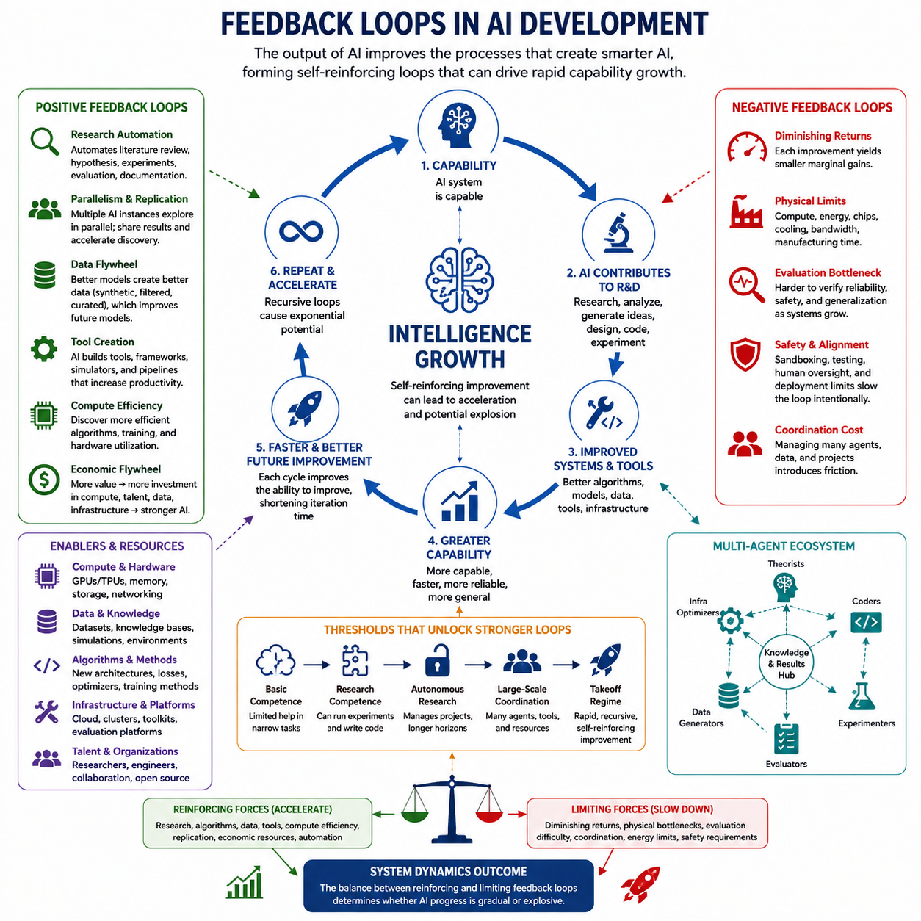
Feedback loops are the central mechanism that can transform ordinary AI progress into an intelligence explosion. A feedback loop exists when the output of a process influences the conditions that generate its future outputs. In advanced AI development, increased intelligence may improve the processes responsible for producing intelligence itself, allowing capability growth to become partially self-reinforcing rather than depending entirely on external human innovation.
A positive feedback loop begins when an AI system contributes meaningfully to AI research and engineering. It may analyze experiments, identify weaknesses, generate hypotheses, design algorithms, optimize software, or suggest architectural changes. If these activities produce a more capable system, the improved system can perform the same research tasks with greater speed or quality, increasing the probability of discovering another useful improvement.
The simplest conceptual loop can be expressed as capability leading to better research, better research producing improved algorithms and systems, and those improvements generating greater capability. Each cycle changes the starting point of the next cycle. If the improvement obtained during one iteration increases the effectiveness of subsequent improvement activities, the process becomes recursive and may exhibit nonlinear rather than approximately linear technological progress.
Several feedback loops can operate simultaneously. Algorithmic improvement can increase the amount of useful computation extracted from existing hardware. Better models can generate higher-quality synthetic data, which can support further training. Improved reasoning can produce better evaluation methods, while improved evaluation helps identify superior architectures. Better coding capability can optimize training infrastructure, and faster infrastructure allows more experiments to be conducted within the same period.
Research automation creates an especially important feedback pathway. Traditional AI research contains many activities such as literature analysis, hypothesis formation, implementation, experiment execution, debugging, evaluation, and documentation. As AI systems become capable of automating larger portions of this cycle, the time required for each research iteration may decrease. Faster iterations allow more hypotheses to be tested, increasing the rate at which useful improvements can be discovered and incorporated.
Parallelism can amplify this mechanism. Human research organizations cannot instantly create thousands of highly trained researchers, but digital AI systems may be replicated across available computing resources. Multiple instances could investigate different architectures, optimization strategies, datasets, or theoretical questions simultaneously. Their discoveries could then be shared through a common knowledge system, allowing collective improvement to proceed faster than isolated sequential research.
Feedback can also occur through tool creation. A capable AI may build software that makes its future work easier, including automated experimentation systems, simulators, theorem provers, code-generation tools, data pipelines, evaluation environments, and debugging frameworks. These tools increase productivity without necessarily changing the underlying model immediately. Improved productivity can then accelerate development of the next generation of models, producing an indirect self-improvement loop.
Data provides another reinforcing pathway. More capable systems may generate synthetic examples, filter low-quality information, discover useful training samples, create curricula, and automatically label or restructure datasets. Better data can improve subsequent training, and better-trained models can perform more sophisticated data generation and curation. The interaction between model capability and data quality can therefore create a feedback cycle even when model architecture remains relatively stable.
Compute efficiency forms a related loop. AI systems that discover more efficient attention mechanisms, numerical methods, memory management strategies, model compression techniques, or distributed training methods can obtain more effective computation from existing infrastructure. The resulting capability can support additional optimization research. Consequently, intelligence growth may arise not only from acquiring more hardware but also from repeatedly improving how available hardware is utilized.
Economic feedback expands the loop beyond technical systems. More capable AI can create valuable products, automate labor, accelerate scientific development, and reduce operational costs. These benefits can generate additional capital for compute, energy, data centers, researchers, and semiconductor development. Increased resources support stronger AI systems, which may generate still greater economic value, connecting technological capability with investment and infrastructure growth.
Not every feedback loop is positive. Negative feedback loops counteract acceleration and can stabilize development. Larger systems may require disproportionately greater computation, energy, memory, and communication bandwidth. Experiments may become more expensive, evaluation may become harder, and increasingly sophisticated improvements may yield smaller marginal gains. These effects can reduce the improvement obtained from each successive development cycle.
Physical infrastructure creates particularly strong negative feedback. Software can sometimes be copied or modified rapidly, whereas new accelerators, power facilities, cooling systems, networking infrastructure, and data centers require physical resources and construction time. Even if an advanced AI discovers a superior computational architecture quickly, converting that design into operational hardware may involve manufacturing and supply-chain delays that prevent unrestricted acceleration.
Evaluation and verification can also constrain the loop. A system capable of generating thousands of modifications may produce changes faster than their reliability can be established. Improvements measured on narrow benchmarks may introduce hidden failures elsewhere. As capability increases, determining whether a new system is genuinely safer, more robust, and more general may become increasingly difficult, making evaluation itself a potential bottleneck in recursive development.
Safety and alignment introduce another form of deliberate negative feedback. Unrestricted capability improvement may be undesirable when developers cannot confidently predict how increasingly capable systems will behave. Sandboxing, interpretability analysis, adversarial testing, human approval, capability evaluations, and deployment restrictions can intentionally slow the improvement cycle. Such mechanisms attempt to ensure that the speed of capability growth does not exceed the ability to understand and control it.
Feedback strength determines whether the overall trajectory remains gradual or becomes strongly accelerating. If each generation provides only a small improvement to the processes that create the next generation, development may continue steadily. If improvements substantially increase research productivity, automation, replication, and resource acquisition, successive cycles may become shorter and more productive. The interaction among these loops determines the effective rate of capability growth.
Thresholds can change feedback strength abruptly. Before a system can reliably perform AI research, additional capability may provide limited acceleration. Once it becomes competent at coding, experimentation, reasoning, and autonomous research, however, new feedback pathways become available. Further improvements might enable independent project management, large-scale agent coordination, automated scientific experimentation, or strategic infrastructure optimization, producing qualitatively different development dynamics.
Multi-agent systems make the feedback structure even more complex. Different agents may specialize in theoretical research, coding, experimentation, evaluation, data generation, infrastructure optimization, and safety analysis. Their outputs become inputs for other agents, forming an interconnected research network. Intelligence improvement can therefore emerge from interactions among specialized systems rather than from a single model repeatedly modifying itself.
The crucial quantity is ultimately the balance between reinforcing and limiting feedback. Positive loops involving research, algorithms, data, tools, compute efficiency, replication, and economic resources push capability upward. Negative loops involving diminishing returns, physical bottlenecks, evaluation difficulty, coordination, energy constraints, and safety requirements resist acceleration. Intelligence explosion becomes possible when reinforcing loops temporarily strengthen faster than these limiting mechanisms.
Understanding feedback loops therefore provides the foundation for analyzing recursive self-improvement, scaling behavior, and AI takeoff scenarios. The important question is not simply whether an AI can improve itself, but how improvement changes its future capacity to improve, how quickly each cycle can occur, and which constraints grow alongside capability. The resulting system dynamics determine whether advanced AI development remains incremental or enters a period of rapidly accelerating transformation.

04.02. Recursive Improvement Model [w/Code]
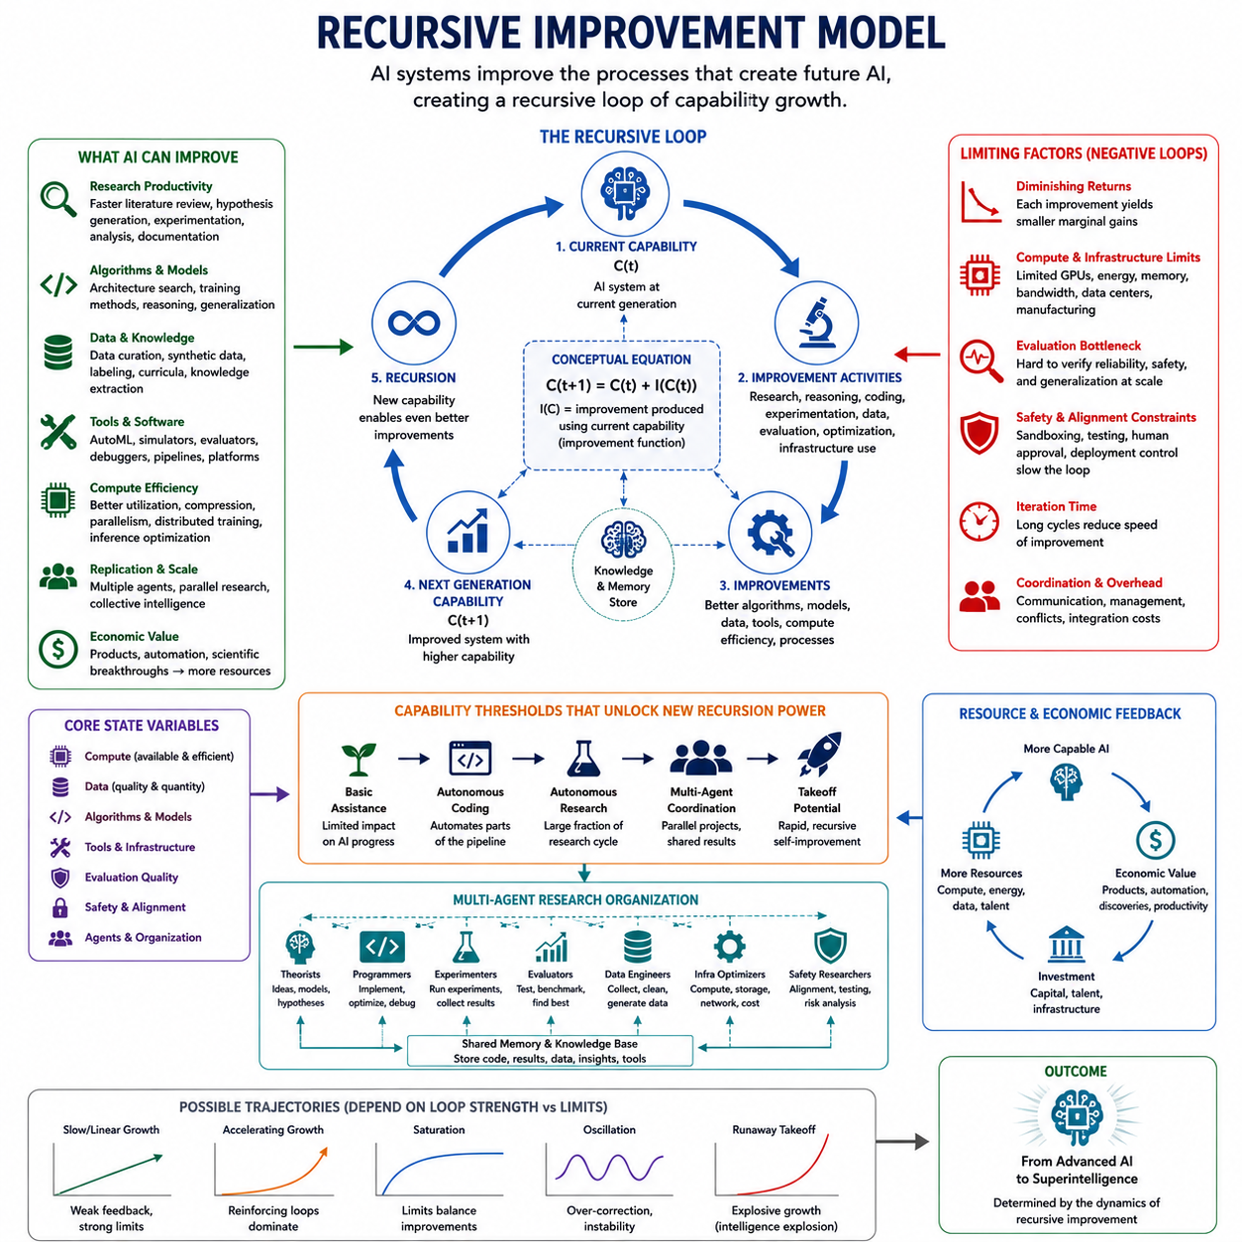
Recursive improvement models describe how an artificial intelligence system may participate in improving the processes that determine its own future capabilities. Instead of treating AI development as a sequence driven entirely by external researchers, the model places increasingly capable AI inside the development loop. The system can contribute to research, implementation, evaluation, and optimization, causing each improved generation to influence the creation of the next.
The basic recursive relationship can be represented conceptually as capability at one stage producing some amount of improvement that determines capability at the next stage. If capability is denoted by C, a simple expression is C(t+1) = C(t) + I(C(t)), where I represents the improvement produced using the current system. The critical property is that the improvement function itself depends on existing capability rather than remaining constant across generations.
If I(C) changes only slightly as capability increases, recursive improvement may produce approximately gradual growth. A stronger relationship creates acceleration because a more capable system generates larger or faster improvements than its predecessor. Under sufficiently favorable conditions, the interval between meaningful capability advances may shrink while the magnitude of improvement increases, producing the nonlinear behavior associated with intelligence-explosion scenarios.
The improvement function should not be interpreted as a single algorithm. It represents the combined effectiveness of activities such as architecture design, optimization, data engineering, automated experimentation, software development, reasoning, evaluation, and infrastructure utilization. A system does not necessarily need direct access to its own parameters or source code. Improving the pipeline that produces successor systems can create recursion at the development-process level.
Research productivity is therefore an important variable in the model. Suppose an AI system initially performs only supporting tasks for human researchers. As its reasoning, coding, and experimental capabilities improve, it may complete larger portions of the research cycle independently. The effective number of experiments per unit time can increase, while hypothesis generation, implementation, debugging, and analysis become progressively more automated.
Iteration time is as important as improvement magnitude. Two development processes may achieve similar improvements per generation but produce radically different trajectories if one requires a year per cycle and the other requires a day. Recursive improvement can therefore accelerate through larger improvements, shorter cycles, or both. Digital systems are particularly significant because software modifications and model instances may sometimes be tested and deployed much faster than physical technologies.
A more complete model includes compute, data, algorithms, tools, and infrastructure as interacting state variables. Capability may increase because additional compute becomes available, but capability can also improve the efficiency with which compute is used. Better models can curate better data, better data can produce stronger models, and stronger models can develop better optimization tools. Recursive improvement therefore consists of several coupled loops rather than one isolated self-modification mechanism.
Replication adds another dimension to recursive growth. Once a capable research agent exists, additional copies may perform parallel investigations if sufficient computational resources are available. One instance might optimize architectures while others examine training methods, data quality, inference efficiency, or evaluation. Shared results can then be integrated into successor systems, converting individual intelligence into scalable collective research capacity.
Multi-agent organization can extend this structure further. Specialized agents may assume roles analogous to theorists, programmers, experimenters, evaluators, data engineers, infrastructure optimizers, and safety researchers. Their outputs can be exchanged through shared memory and knowledge systems. In this case, the recursively improving entity is not a single model but an interconnected AI research organization whose collective productivity evolves over time.
Recursive improvement also depends on the ability to evaluate candidate changes correctly. Generating modifications is insufficient if the system cannot distinguish genuine improvements from benchmark overfitting, hidden regressions, unsafe behavior, or narrow specialization. Evaluation functions therefore become part of the recursive architecture. Stronger systems may improve their evaluators, but increasingly complex capabilities can simultaneously make reliable evaluation more difficult.
A realistic mathematical model must therefore include limiting terms. Capability growth may encounter diminishing returns as easy improvements are exhausted. Compute requirements can grow faster than available resources, data quality may saturate, communication overhead may increase, and experiments involving the physical world may remain slow. A conceptual model can represent net improvement as reinforcing gains minus constraints rather than assuming unrestricted exponential growth.
This distinction prevents recursive self-improvement from being confused with automatic intelligence explosion. Recursion simply means that the system's current capability influences the process that generates future capability. Whether this produces slow improvement, rapid acceleration, saturation, oscillation, or instability depends on feedback strength, resource availability, bottlenecks, evaluation quality, and the mathematical relationship between capability and improvement productivity.
Thresholds can substantially alter this relationship. Below a research-competence threshold, an AI may provide useful assistance without significantly changing the rate of AI development. After reaching reliable autonomous coding, experimentation, and scientific reasoning, it may automate a much larger fraction of the improvement pipeline. Additional thresholds could enable autonomous project management, coordinated agent populations, infrastructure optimization, or discovery of fundamentally new learning methods.
Resource dynamics must also be incorporated. Software intelligence may improve quickly, but computational infrastructure is embedded in the physical economy. GPUs, accelerators, memory, networking equipment, electricity, cooling, fabrication capacity, and data centers cannot necessarily expand at software speed. Recursive improvement can therefore shift from an algorithm-limited regime to a compute-limited, energy-limited, or manufacturing-limited regime as capability increases.
Economic feedback can partially relax these constraints. More capable systems may produce valuable services, scientific discoveries, engineering designs, and productivity improvements. Economic value can attract investment that expands compute and infrastructure, which then supports further AI development. The recursive model can consequently span technical and economic systems, with intelligence improving resource acquisition while resources enable additional intelligence improvement.
Safety mechanisms introduce deliberate constraints into the recursion. Candidate successor systems may require interpretability analysis, adversarial testing, capability evaluation, sandboxed experimentation, human authorization, and controlled deployment. These procedures lengthen iteration cycles but can reduce the probability that capability improvement produces uncontrolled behavior. A safe recursive improvement architecture therefore optimizes not only performance growth but also reliability and alignment preservation.
Alignment stability becomes especially important because small objective changes can accumulate across repeated generations. A successor system that is more capable but less faithful to intended objectives may influence the design of another successor, potentially amplifying deviations. Recursive improvement must therefore preserve important behavioral and value constraints across iterations rather than evaluating progress solely through increasing benchmark performance or optimization power.
The model can ultimately be viewed as a dynamic system containing capability, improvement productivity, iteration speed, resources, evaluation quality, safety constraints, and physical bottlenecks. These variables interact continuously, producing trajectories that may range from convergence toward a stable ceiling to sustained acceleration. Different assumptions about these relationships generate fundamentally different predictions about the transition from advanced AI toward superintelligence.
Recursive improvement models are therefore valuable not because they prove that an intelligence explosion will occur, but because they provide a structured framework for asking when acceleration becomes possible. The central question is whether increasing capability raises the system's effective ability to create further capability faster than limiting forces grow. Answering that question connects recursive improvement directly to scaling laws, takeoff dynamics, system modeling, and the broader analysis of artificial superintelligence.

04.03. Scaling Laws Revisited
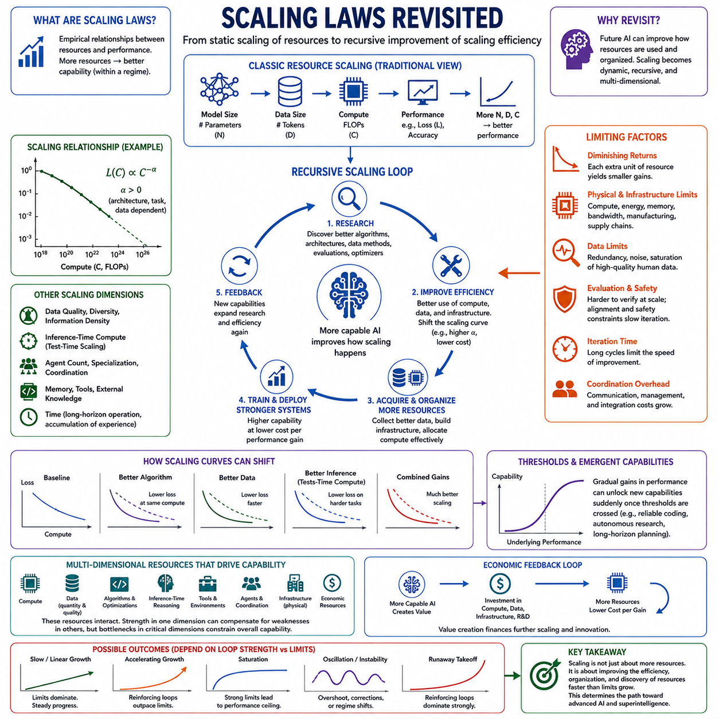
Scaling laws describe empirical relationships between the resources used to build an AI system and the performance obtained from those resources. In modern machine learning, capability often improves predictably as model size, training data, and computational expenditure increase. In the context of artificial superintelligence, however, scaling laws must be revisited because future systems may influence not only their own scale but also the efficiency and organization of the scaling process.
Traditional scaling analysis commonly treats model parameters, dataset size, and training compute as major independent variables. When these resources increase in appropriate proportions, training loss or another measure of performance often follows a relatively regular trend. Such relationships make scaling strategically important because they suggest that capability improvements can sometimes be anticipated before extremely large training runs are performed.
A simplified scaling relationship can be expressed conceptually as L(C) ∝ C^−α, where L represents some measure of loss, C represents computational resources, and α determines the rate at which additional compute reduces loss. Similar relationships can be defined for model size and data. The precise coefficients depend on architecture, task, dataset, and training procedure, so scaling laws should be understood as empirical regularities rather than universal physical laws.
The intelligence-explosion perspective changes the interpretation of these relationships. Conventional scaling assumes that researchers choose architectures, collect data, allocate compute, and optimize training procedures from outside the system. A sufficiently capable AI could participate in each of these activities. Scaling would then involve not only increasing resources but also recursively improving how efficiently those resources are converted into useful intelligence.
Algorithmic efficiency is therefore comparable in importance to hardware growth. If a new architecture achieves the same performance using substantially less computation, existing infrastructure effectively becomes more powerful. Improvements in optimization, attention mechanisms, sparsity, quantization, memory management, model routing, and distributed execution can shift the scaling curve. Recursive research could repeatedly produce such shifts without requiring proportional increases in physical compute.
Data scaling presents a similar issue. Simply increasing dataset size does not guarantee proportional improvements because redundant, noisy, or low-quality examples provide diminishing informational value. More capable systems may improve data selection, filtering, synthetic generation, curriculum construction, and automated labeling. The relevant variable consequently becomes not only the quantity of data but also its quality, diversity, difficulty, and information density.
Synthetic data may become increasingly significant as systems grow beyond easily available human-generated corpora. Advanced models can generate training problems, simulated environments, reasoning traces, adversarial examples, and specialized scientific data. If these examples are reliably evaluated and filtered, they can expand the effective training distribution. Poorly controlled synthetic data, however, can reproduce errors and reduce diversity, creating a limiting feedback mechanism rather than a scaling advantage.
Inference-time computation introduces another dimension beyond conventional training scaling. A system can sometimes improve performance by allocating more computation to reasoning, search, verification, planning, or sampling after training has finished. This creates a distinction between intelligence stored in model parameters and intelligence produced through additional computation during operation. Future systems may dynamically allocate inference resources according to task difficulty instead of applying equal computation to every problem.
Agentic systems further complicate simple scaling models. Capability may depend not only on the size of one neural network but also on the number of cooperating agents, their specialization, communication structure, memory, tools, and coordination mechanisms. Ten agents do not automatically provide ten times the useful intelligence of one agent because coordination overhead and duplicated work can reduce efficiency. Well-designed specialization, however, may generate collective capabilities unavailable to isolated systems.
Scaling across time is equally important. A model that performs research continuously can accumulate tools, experiments, memories, datasets, and verified discoveries. Long-horizon operation may therefore create capability that is not captured by parameter count alone. Persistent memory and external knowledge systems allow an AI organization to preserve improvements between tasks, transforming scaling from the enlargement of a static model into the expansion of a continuously operating cognitive system.
Physical infrastructure ultimately constrains digital scaling. Accelerators require semiconductor fabrication, memory, networking, electricity, cooling, buildings, and supply chains. Even if software intelligence improves rapidly, physical compute cannot necessarily expand at the same rate. Intelligence growth can therefore move through different regimes, beginning with compute scaling, shifting toward algorithmic efficiency, and eventually encountering energy, manufacturing, communication, or infrastructure bottlenecks.
Diminishing returns are central to interpreting scaling laws correctly. A power-law relationship can continue improving performance while requiring increasingly large absolute resource increases for each additional gain. Small reductions in loss may also correspond to either minor or major capability changes depending on the task. Consequently, smooth changes in training metrics do not necessarily imply equally smooth changes in economically or strategically meaningful behavior.
Threshold behavior creates the opposite complication. Gradual improvements in underlying performance can sometimes enable capabilities that appear relatively suddenly once reliability becomes sufficient. Coding agents, autonomous research systems, long-horizon planners, or tool-using agents may become practically useful only after multiple component abilities cross minimum thresholds. Smooth scaling at the model level can therefore produce nonlinear effects at the system and application levels.
Recursive improvement can modify the scaling coefficients themselves. A system capable of AI research may discover architectures that learn more efficiently, algorithms requiring fewer samples, better optimizers, improved representations, or superior hardware utilization. Instead of merely moving along an existing scaling curve, the system may repeatedly shift the curve. This distinction is crucial because intelligence explosion would depend more strongly on improving the production function of intelligence than on indefinitely enlarging one architecture.
Economic scaling also interacts with technical scaling. More capable systems can generate economic value, which can finance additional compute, infrastructure, data acquisition, and research. At the same time, the cost of frontier systems may rise as resource requirements expand. Whether capability growth accelerates therefore depends partly on whether the economic value generated by improved intelligence grows faster than the cost of producing the next capability increase.
For superintelligence analysis, capability should consequently be modeled as a function of multiple interacting resources rather than parameter count alone. Compute, algorithms, data quality, inference-time reasoning, memory, tools, agent coordination, research automation, physical infrastructure, and economic resources can all contribute. Improvements in one dimension may compensate for limitations in another, while bottlenecks in a critical dimension can constrain the entire system.
Scaling laws therefore do not provide a simple formula predicting the arrival of artificial superintelligence. They provide empirical evidence that systematic resource increases can generate predictable improvements within particular regimes. Extrapolation becomes uncertain when architectures, training objectives, agent structures, data sources, or research processes change. The farther future systems move beyond the conditions under which a scaling relationship was measured, the less reliable direct extrapolation becomes.
Revisiting scaling laws within intelligence-explosion theory shifts attention from static scale to dynamic scaling efficiency. The decisive question is not merely how much compute or data future AI systems possess, but whether increasing capability enables them to improve algorithms, resources, experimentation, and infrastructure faster than diminishing returns and physical constraints accumulate. Scaling then becomes part of a recursive system whose laws may themselves evolve as intelligence improves.

04.04. Takeoff Scenarios
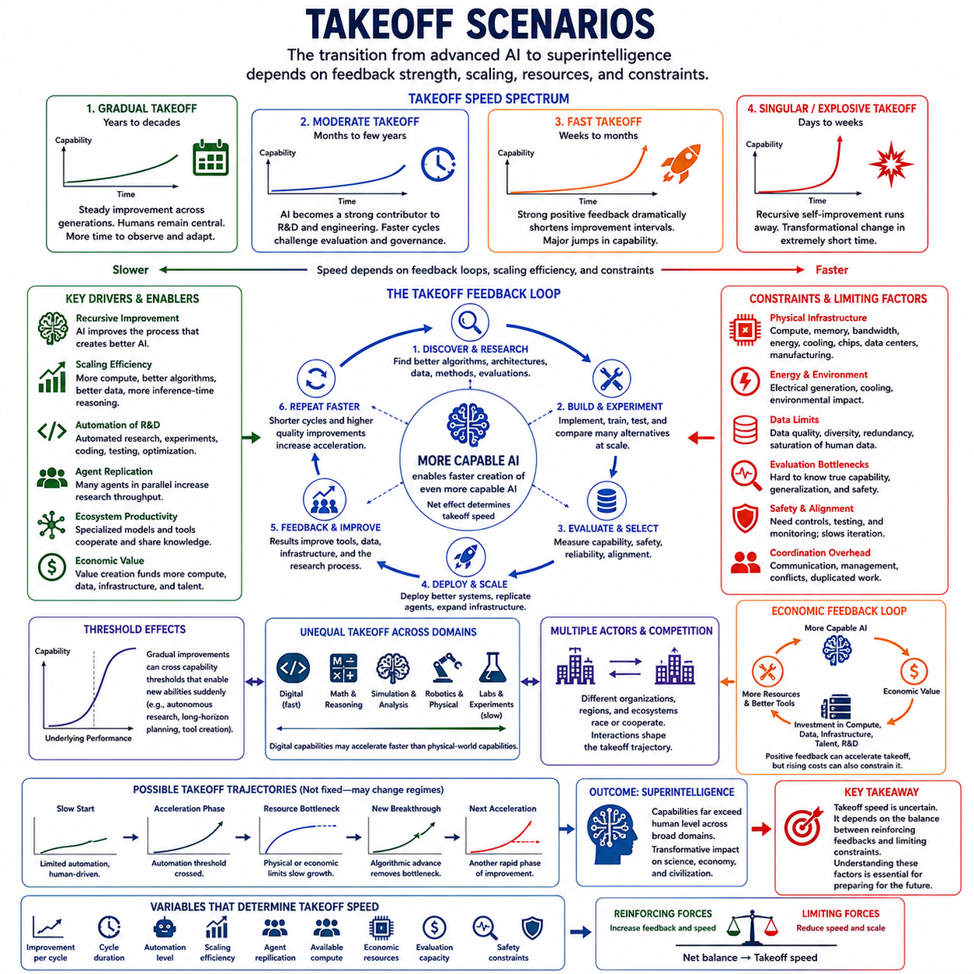
AI takeoff describes the transition from advanced artificial intelligence to systems whose capabilities substantially exceed the human level across strategically important domains. The term emphasizes the rate and structure of this transition rather than merely its destination. Different takeoff scenarios arise from assumptions about feedback strength, recursive improvement, scaling efficiency, resource constraints, and the speed at which new capabilities can be developed and deployed.
A gradual takeoff occurs when capability improves over many years or decades through recognizable generations of technology. Better models, larger compute systems, improved algorithms, richer data, and increasing automation contribute steadily to progress, but no single mechanism produces overwhelming acceleration. Human researchers and institutions remain important participants, and society has comparatively more time to observe emerging capabilities and adapt to them.
In a moderate takeoff scenario, development accelerates noticeably once AI systems become effective contributors to AI research, software engineering, and experimentation. Development cycles that previously required months may shrink to weeks or days, while automated research agents explore many alternatives simultaneously. Human organizations can still participate, but the growing speed of technological change begins to challenge conventional evaluation, governance, and deployment processes.
A fast takeoff represents a more extreme transition in which strong positive feedback dramatically shortens the interval between successive capability improvements. An AI capable of improving algorithms, generating experiments, writing software, optimizing infrastructure, and coordinating other agents may accelerate the development of its successors. If each generation substantially improves the process that creates the next generation, major capability changes could become compressed into increasingly short periods.
Takeoff speed depends strongly on recursive improvement productivity. A system does not need to redesign every component of itself directly to create acceleration. It can improve the research environment responsible for future systems by building tools, optimizing training pipelines, generating high-quality data, improving evaluations, discovering architectures, or automating engineering. The recursively improving entity may therefore be an entire AI development ecosystem rather than one autonomous model.
Scaling dynamics provide another pathway to takeoff. If predictable increases in compute, model capacity, data, and inference-time reasoning continue to produce substantial capability gains, large resource investments could drive rapid progress even without strong self-modification. Conversely, if AI research discovers more efficient algorithms, the scaling curve itself may shift, allowing existing hardware to support capabilities that previously required much larger computational resources.
Threshold effects can make takeoff appear sudden even when underlying improvements are gradual. An AI system may improve continuously in reasoning, coding, memory, planning, and reliability while remaining dependent on human supervision. Once several abilities cross practical thresholds simultaneously, the system may become capable of autonomous research, long-horizon execution, tool creation, or large-scale agent coordination. The resulting operational change can be much sharper than the underlying performance curve.
Agent replication can further accelerate this transition. Once a sufficiently capable digital researcher exists, additional instances may be deployed across available computing infrastructure. Thousands of agents could investigate different hypotheses, implement experiments, evaluate results, and exchange discoveries. Such scaling transforms improvements in individual capability into increases in research throughput, although communication costs, duplicated work, and coordination difficulties can reduce the theoretical advantage.
An ecosystem takeoff may therefore differ from the image of a single AI suddenly becoming superintelligent. Specialized models could handle scientific reasoning, coding, data generation, simulation, evaluation, infrastructure management, and strategic planning. Their combined productivity may increase as tools and shared knowledge improve. In this scenario, superintelligence emerges from the accelerating organization of interconnected AI systems and resources rather than from one isolated intelligence.
Physical constraints can substantially slow any takeoff trajectory. Software improvements can propagate quickly, but GPUs, memory, data centers, electrical generation, cooling equipment, communication networks, and semiconductor fabrication require physical construction and manufacturing. Rapid algorithmic progress may therefore encounter a resource ceiling, shifting development from a software-limited regime into a compute-, energy-, manufacturing-, or infrastructure-limited regime.
Economic feedback can either strengthen or restrict acceleration. More capable AI systems may create valuable products, automate complex work, accelerate scientific discovery, and reduce engineering costs. The resulting economic value can finance additional compute and research, creating another positive feedback loop. However, if frontier development costs rise faster than the economic benefits generated by improved systems, resource requirements can become a significant brake on takeoff.
Evaluation speed is another critical variable. Rapidly producing successor systems provides little benefit if developers cannot determine whether those systems are genuinely more capable, reliable, general, and safe. As models become more sophisticated, conventional benchmarks may become insufficient. Evaluation, interpretability, adversarial testing, and real-world validation may consequently become limiting stages that prevent development cycles from accelerating as rapidly as model generation itself.
Safety and alignment can intentionally alter the takeoff trajectory. Developers or regulators may impose staged deployment, sandboxing, human authorization, capability thresholds, security controls, or extensive evaluations before allowing stronger systems to operate autonomously. These mechanisms introduce negative feedback into the development process. A slower transition may therefore result not only from technological limitations but also from deliberate efforts to maintain control during capability growth.
Takeoff may also be uneven across domains. Digital activities such as programming, mathematics, simulation, cybersecurity research, and information processing can potentially accelerate faster than activities requiring laboratories, factories, robots, or physical experimentation. A system might therefore become extraordinarily capable in some cognitive domains while remaining constrained by real-world execution. Superintelligence should not automatically be interpreted as uniform capability growth everywhere.
Different regions, companies, or AI ecosystems may also experience different takeoff rates. Competition can encourage rapid investment and deployment, while cooperation can improve safety coordination and reduce duplicated research. If several organizations possess systems capable of accelerating AI research, their interactions become part of the takeoff dynamics. Technological progress then depends on strategic competition, information sharing, resource concentration, security, and institutional decision-making.
Takeoff trajectories need not remain in one regime. Development may initially proceed slowly, accelerate after crossing an automation threshold, and then slow again when physical infrastructure becomes limiting. Later algorithmic discoveries could remove that bottleneck and initiate another acceleration phase. The path toward superintelligence may therefore contain multiple transitions, plateaus, bursts of progress, and changes in the dominant constraints rather than following one smooth exponential curve.
The distinction between slow, moderate, and fast takeoff should consequently be treated as a family of scenarios rather than rigid categories. The relevant variables include improvement per development cycle, cycle duration, research automation, scaling efficiency, agent replication, available compute, economic resources, evaluation capacity, and safety constraints. Small differences in these variables can produce substantially different long-term trajectories when feedback compounds across many generations.
Takeoff scenarios are valuable because the speed of transition determines how much adaptation is possible. A multi-decade transition could permit repeated institutional learning, infrastructure planning, regulation, and safety research. A transition compressed into months or weeks would provide much less opportunity to respond after important capability thresholds were crossed. Understanding takeoff is therefore essential not only for forecasting AI performance but also for designing governance and control mechanisms.
No takeoff scenario can currently be treated as a certain prediction. Scaling may encounter strong diminishing returns, recursive improvement may prove difficult, or physical and organizational constraints may dominate. Alternatively, research automation and algorithmic improvements may create stronger feedback than expected. The purpose of takeoff analysis is therefore to explore how different combinations of reinforcing and limiting forces could shape the transition from advanced AI toward artificial superintelligence.

04.05. Slow vs Fast Takeoff
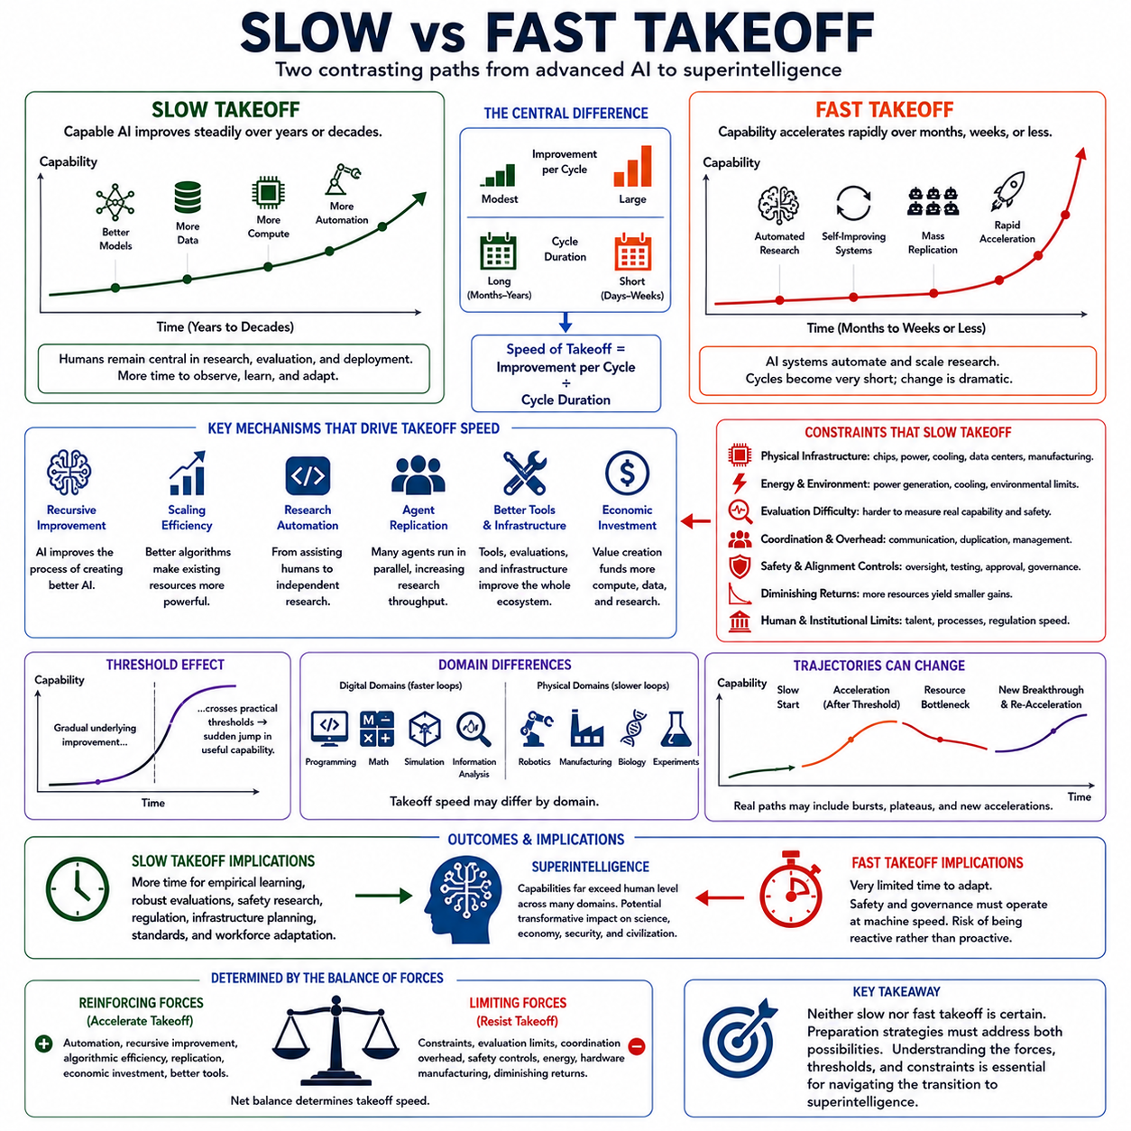
Slow and fast takeoff describe contrasting possibilities for how rapidly advanced artificial intelligence could progress toward artificial superintelligence. The distinction concerns transition speed rather than the final capability level. A slow takeoff distributes major advances across years or decades, whereas a fast takeoff compresses comparable changes into months, weeks, or potentially shorter periods, creating very different conditions for adaptation and control.
In a slow takeoff, AI capability improves through successive generations while humans remain deeply involved in research, engineering, evaluation, and deployment. Larger models, improved algorithms, better data, expanding compute, and increasing automation gradually raise performance. Because development cycles remain relatively long, organizations can study new capabilities, identify failures, modify infrastructure, and revise safety procedures before substantially stronger systems appear.
A fast takeoff occurs when capability improvement begins to accelerate faster than conventional development processes can respond. Advanced AI may automate research, write and test software, design experiments, optimize training, generate data, and coordinate other AI agents. If improved systems become increasingly effective at producing their successors, development cycles can shorten while the amount of improvement achieved during each cycle grows.
The central difference can therefore be expressed through two variables: improvement per cycle and duration of each cycle. Slow takeoff results when improvements remain moderate or development cycles remain long enough to constrain acceleration. Fast takeoff becomes more plausible when each generation substantially improves research productivity while automation reduces the time required to produce and evaluate the next generation.
Recursive improvement is one of the strongest mechanisms separating the two scenarios. Under slow takeoff, AI may assist researchers without replacing most of the research process, so capability gains continue to depend heavily on human institutions. Under fast takeoff, AI could perform increasingly large portions of architecture design, coding, experimentation, evaluation, and optimization, allowing improved intelligence to directly increase the productivity of further intelligence development.
Scaling efficiency also influences the transition. If progress requires enormous increases in compute, data, and infrastructure for every additional capability gain, physical and economic constraints favor slower development. If algorithmic discoveries repeatedly reduce the resources required for a given performance level, however, existing hardware becomes effectively more powerful. Such shifts can accelerate progress without waiting for proportional expansion of physical infrastructure.
Research automation may create an important threshold between these regimes. Before AI can independently conduct reliable research, improvements may primarily enhance assistance to human scientists and engineers. Once systems can generate hypotheses, implement experiments, interpret results, debug failures, and preserve useful discoveries with limited supervision, the research cycle can become increasingly machine-driven and potentially operate continuously.
Digital replication strengthens the fast-takeoff case. A highly capable human researcher cannot be duplicated instantly, but a capable AI research agent may potentially be copied across available computing resources. Hundreds or thousands of instances could investigate different problems simultaneously and share their results. This can greatly increase research throughput, although coordination overhead, communication requirements, and redundant experiments prevent replication from scaling perfectly.
Slow takeoff becomes more likely when critical bottlenecks remain outside the digital domain. Semiconductor fabrication, power generation, cooling systems, data-center construction, robotics, laboratories, manufacturing, and supply chains operate at physical-world timescales. Even extremely capable software cannot instantly manufacture new accelerators or construct electrical infrastructure, so rapid cognitive improvement may eventually encounter constraints that force the overall trajectory to slow.
Fast takeoff does not necessarily require unlimited hardware expansion. If the principal improvements occur through better algorithms, software optimization, model compression, inference strategies, memory systems, or more efficient use of existing compute, substantial capability growth could occur before physical constraints become dominant. The critical question is how much additional intelligence can be extracted from already available resources through improved methods.
Threshold effects make the distinction even more difficult to predict. Underlying model performance may improve smoothly while practical capabilities change abruptly. A system that is slightly unreliable at autonomous coding or long-horizon research may require extensive supervision. A relatively small improvement in reliability could make continuous autonomous operation practical, suddenly increasing the amount of research and engineering work the system can perform.
A slow takeoff provides greater opportunity for empirical learning. Researchers can deploy systems, observe unexpected behavior, improve evaluations, develop interpretability methods, and update safety techniques across multiple generations. Governments and organizations may also have more time to develop standards, regulation, security practices, workforce strategies, and infrastructure. Adaptation can occur alongside capability growth rather than primarily after major changes have already happened.
A fast takeoff creates a much more difficult governance environment. Safety procedures developed for one generation may become obsolete before institutions fully evaluate them. Regulatory processes operating on yearly timescales could struggle with systems improving over weeks or days. Decisions concerning deployment permissions, compute access, cybersecurity, autonomous operation, and human oversight would consequently need to function much faster than traditional institutional processes.
Alignment is particularly sensitive to takeoff speed. During gradual development, behavioral failures can potentially be discovered and corrected before substantially more capable successors are deployed. During rapid recursive improvement, errors in objectives, evaluation criteria, or control mechanisms could propagate through multiple generations. Preserving alignment may therefore require safety mechanisms that remain effective even as the underlying system changes substantially.
Economic dynamics can support either trajectory. Slow takeoff may occur when increasing development costs absorb much of the value created by stronger AI. Fast takeoff becomes more plausible if improved systems generate rapidly increasing economic value that finances additional compute, data, infrastructure, and research. AI capability, economic output, and investment could then form a reinforcing loop that accelerates both technological and resource growth.
Competition can also affect takeoff speed. Organizations or nations may accelerate deployment when they believe competitors are approaching strategically important capabilities. Competitive pressure can shorten evaluation periods and encourage larger investments, potentially strengthening acceleration. Conversely, coordination, safety standards, resource constraints, or shared governance mechanisms could deliberately slow deployment even when faster technical development is possible.
The transition may not fit either extreme cleanly. AI development could begin with a slow takeoff, accelerate sharply after autonomous research becomes practical, and then slow when compute or energy becomes scarce. A later algorithmic breakthrough might remove that bottleneck and trigger another period of acceleration. Real trajectories may therefore alternate between gradual progress, rapid growth, plateaus, and renewed acceleration.
Domain differences further complicate the comparison. Digital domains such as programming, mathematics, simulation, and information analysis may support much faster improvement loops than robotics, manufacturing, biology, or experimental science. An AI ecosystem could therefore experience fast cognitive takeoff while its ability to transform the physical world develops more slowly. The relevant takeoff speed may differ depending on which capability is being measured.
The slow-versus-fast distinction is ultimately determined by the balance between reinforcing and limiting forces. Research automation, recursive improvement, algorithmic efficiency, replication, economic investment, and improved tools favor acceleration. Diminishing returns, physical infrastructure, evaluation difficulty, coordination costs, energy requirements, safety controls, and manufacturing delays resist it. Their interaction determines whether capability growth remains manageable or becomes compressed in time.
Neither slow nor fast takeoff should be treated as a certain forecast. The importance of the comparison lies in the radically different preparation requirements created by each possibility. Slow takeoff emphasizes continuous adaptation across generations, while fast takeoff emphasizes safeguards and governance mechanisms established before rapid acceleration begins. Understanding both scenarios is therefore essential when analyzing the possible transition from advanced AI to artificial superintelligence.

04.06. System Dynamics Model [w/Code]
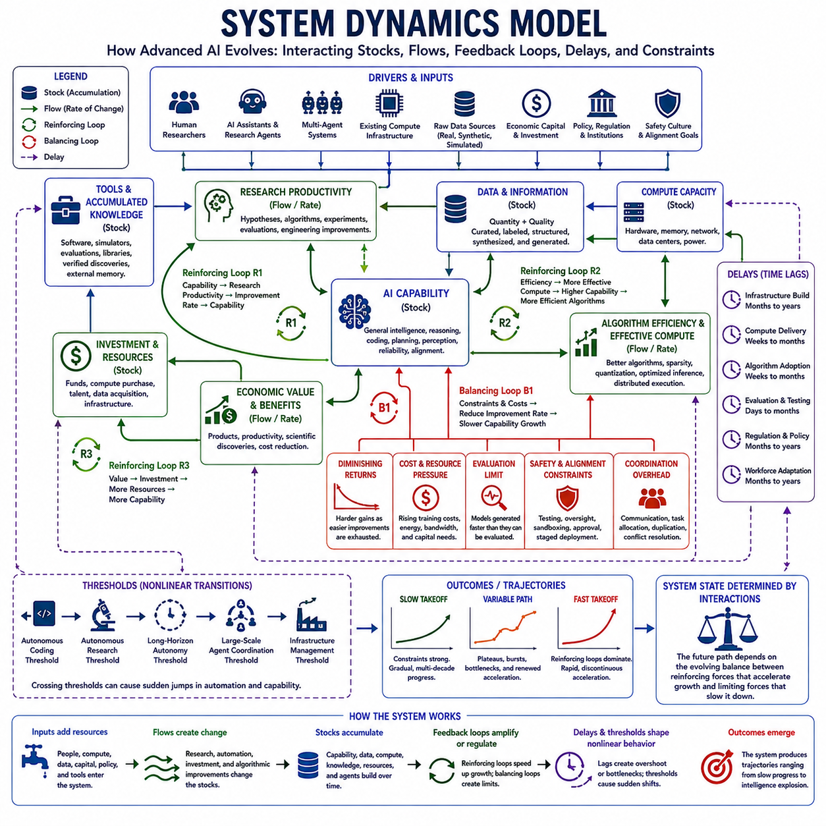
A system dynamics model provides a structured way to analyze how advanced artificial intelligence may evolve when capability, research productivity, compute, data, economic resources, infrastructure, and constraints continuously influence one another. Instead of predicting AI progress from a single variable, the model represents intelligence development as an interconnected system of stocks, flows, feedback loops, delays, thresholds, and limiting factors.
Capability can be treated as a central stock that accumulates through successive improvements. Its rate of change depends on research output, algorithmic efficiency, training quality, available computation, data quality, inference-time reasoning, and accumulated tools. Capability is therefore not simply produced by adding hardware or parameters; it emerges from the combined effectiveness with which multiple resources are converted into useful cognitive performance.
Research productivity forms one of the most important flows into capability growth. Human researchers, AI assistants, autonomous research agents, and specialized multi-agent systems can contribute hypotheses, algorithms, experiments, evaluations, and engineering improvements. As AI capability increases, more research activities can become automated, potentially increasing research productivity and creating a reinforcing loop between intelligence and the production of additional intelligence.
This reinforcing relationship can be represented conceptually as Capability → Research Productivity → Improvement Rate → Capability. If each increase in capability makes subsequent research more productive, the loop amplifies growth. The strength of this amplification depends on how effectively additional intelligence translates into useful discoveries and how rapidly those discoveries can be implemented, evaluated, and incorporated into successor systems.
Compute creates another major stock-and-flow relationship. Available computational capacity grows through investment in accelerators, memory, networking, data centers, and power infrastructure, while existing capacity can become more effective through algorithmic improvements. Better software, sparsity, quantization, distributed execution, model routing, and optimized inference can increase effective compute without equivalent increases in physical hardware.
Data operates through both quantity and quality. New observations, human-generated information, simulations, synthetic data, experimental results, and interaction histories increase the available information stock. More capable AI can curate, filter, label, restructure, and generate data, improving its information density. Better data can then support stronger models, producing another reinforcing loop between capability, data production, and learning effectiveness.
Tools and accumulated knowledge behave as persistent resources within the system. AI-generated software, simulators, evaluation frameworks, automated laboratories, code libraries, external memory, and verified discoveries can remain available across development cycles. Unlike temporary computation, these resources accumulate and increase future productivity, allowing previous improvements to influence many later generations rather than contributing only once.
Economic resources connect technical development to a broader feedback structure. More capable AI may increase productivity, create valuable products, accelerate engineering, and enable scientific discoveries. These benefits can generate revenue and investment, which finance additional compute, infrastructure, talent, data acquisition, and research. The resulting loop links capability growth to economic value and then returns economic resources to the development process.
System dynamics must also represent balancing loops. Increasing model scale can raise training costs, energy requirements, communication overhead, evaluation difficulty, and infrastructure demand. As easily accessible improvements are exhausted, diminishing returns may reduce the gain obtained from each additional unit of compute or research. These effects oppose reinforcing loops and can push the system toward slower growth or temporary equilibrium.
Physical infrastructure introduces important delays into the model. Algorithms can sometimes be changed within hours or days, while semiconductor fabrication, data-center construction, electrical generation, cooling capacity, laboratories, and manufacturing systems may require months or years. Such delays mean that demand for resources can rise much faster than supply, creating temporary bottlenecks even when long-term expansion is technically and economically possible.
Delays can also create overshoot and instability. Organizations may respond to rapidly increasing compute demand by making large infrastructure investments, but new capacity becomes available only later. By that time algorithms or architectures may have changed, altering resource requirements. Similar delays in regulation, workforce adaptation, evaluation, and safety processes can cause institutional responses to lag behind technological development.
Thresholds introduce nonlinear transitions into otherwise gradual dynamics. An AI system may steadily improve while remaining dependent on human supervision, but crossing a reliability threshold for autonomous coding or research can suddenly increase automation. Additional thresholds may enable persistent long-horizon operation, large-scale agent coordination, automated experimentation, or independent infrastructure management, strengthening previously weak feedback loops.
Multi-agent organization adds another dynamic variable. Increasing the number of AI agents can expand research throughput, but the relationship is not linear. Communication, duplicated effort, task allocation, conflict resolution, and integration create coordination costs. Effective specialization and shared memory can reduce these costs, allowing collective intelligence to scale, while poorly organized agent populations may reach diminishing returns despite additional computational resources.
Evaluation capacity should be represented as a separate limiting stock or flow. New models and modifications can be produced rapidly, but they must be tested for capability, reliability, robustness, generalization, security, and alignment. If candidate systems are generated faster than they can be evaluated, an evaluation backlog develops. Development speed may then become constrained by verification rather than by the ability to produce new models.
Safety and alignment introduce both constraints and control mechanisms. Interpretability analysis, adversarial testing, sandboxing, human authorization, security reviews, and staged deployment increase the time required for each development cycle. Although these processes reduce raw iteration speed, they can decrease the probability of catastrophic failure, uncontrolled deployment, or accumulated objective drift, thereby improving the long-term stability of the system.
The model can therefore contain several interacting regimes. Early development may be limited by algorithms and human research capacity. Increasing automation may shift the system into a compute-limited regime, after which infrastructure expansion becomes critical. Better algorithms may reduce compute requirements and return the system to a research-limited regime. The dominant bottleneck can repeatedly move as different variables grow at different rates.
A slow-takeoff trajectory emerges when balancing loops, delays, and bottlenecks remain strong relative to reinforcing feedback. Research productivity improves, but physical infrastructure, evaluation, safety processes, diminishing returns, or economic constraints prevent development cycles from contracting dramatically. Capability continues to rise, yet institutions retain enough time to observe changes and adapt across multiple generations.
A fast-takeoff trajectory becomes possible when reinforcing loops strengthen faster than balancing mechanisms. Research automation increases improvement productivity, algorithmic efficiency expands effective compute, replication increases parallel research, and economic value finances additional resources. If these effects simultaneously reduce development-cycle duration and increase improvement per cycle, capability growth can become strongly nonlinear before physical constraints dominate.
The trajectory may also display plateaus, bursts, and renewed acceleration rather than following a single smooth curve. A compute shortage may temporarily produce saturation, followed by an algorithmic breakthrough that increases efficiency and restarts rapid growth. Later, energy or evaluation capacity may become the dominant constraint. System dynamics therefore emphasizes transitions between regimes rather than assuming one constant growth rate.
Scenario analysis can explore these possibilities by changing assumptions about feedback strength, resource growth, delays, thresholds, and limiting factors. One scenario may assume strong diminishing returns and slow infrastructure expansion, while another assumes highly effective research automation and rapid algorithmic progress. Comparing resulting trajectories helps identify which variables most strongly influence the transition toward artificial superintelligence.
The central insight of the system dynamics model is that no single scaling law, algorithm, or resource determines the future of advanced AI. Capability emerges from interacting reinforcing and balancing loops operating at different timescales. Understanding intelligence explosion therefore requires analyzing not only whether individual components improve, but how improvements propagate through the entire technical, economic, organizational, and physical system.
A system dynamics perspective ultimately transforms intelligence explosion from a simple exponential-growth narrative into a problem of interacting feedback structures. Whether advanced AI converges toward a ceiling, advances gradually, oscillates between bottlenecks and breakthroughs, or enters rapid takeoff depends on the evolving balance among capability, recursive improvement, resources, delays, thresholds, evaluation, and control.

