Volume 48. Artificial Super Intelligence

Chapter 02. Paths to Superintelligence

02.00. Overview
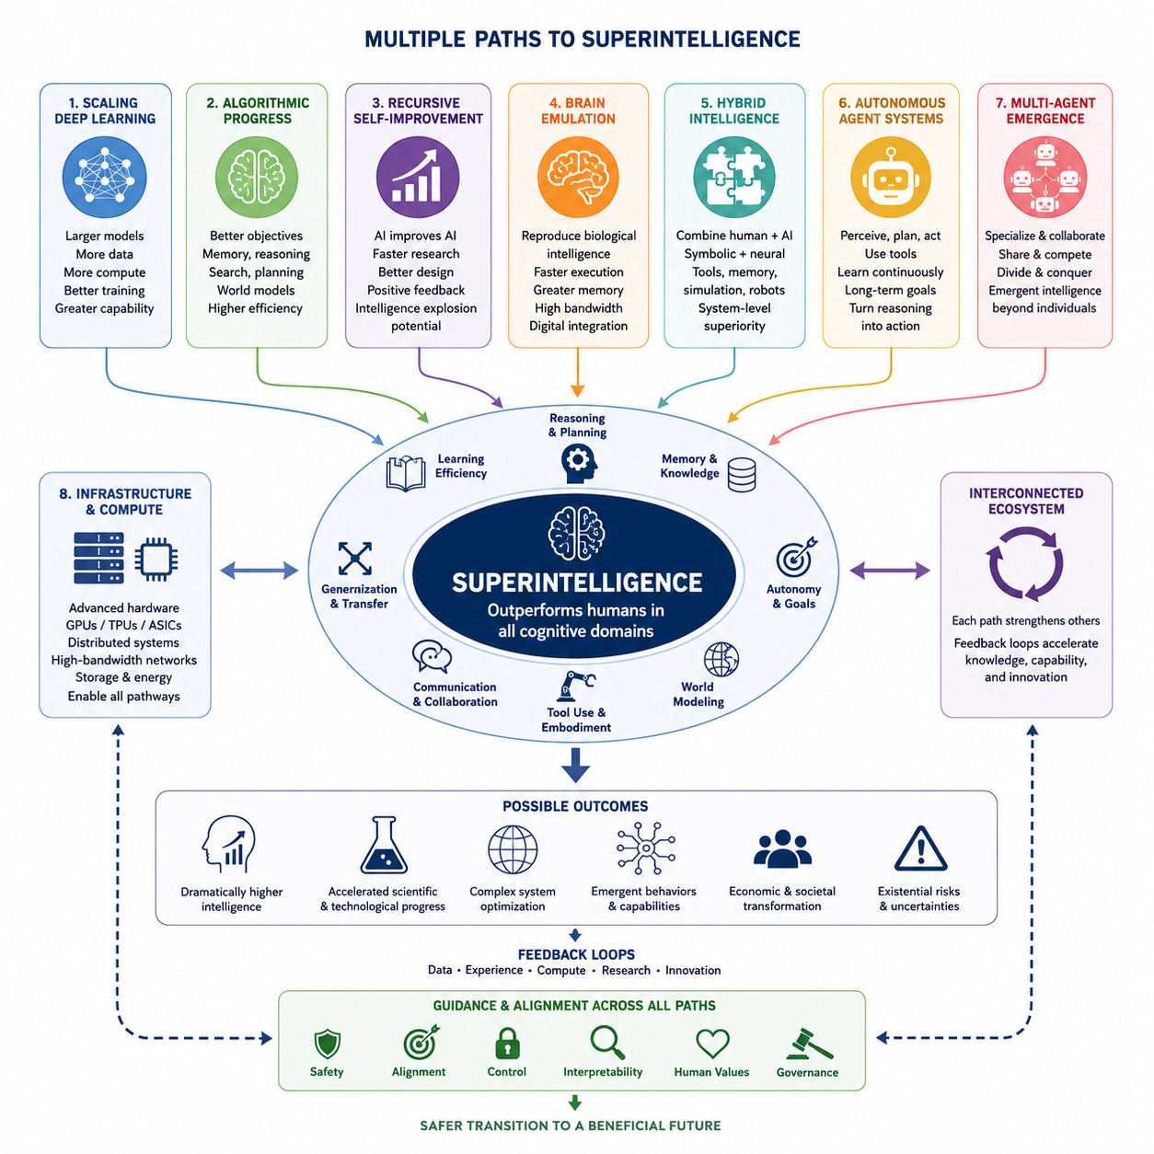
Superintelligence may emerge through several technological pathways rather than from a single decisive breakthrough. The transition from advanced artificial intelligence to systems that substantially exceed human cognitive capabilities could result from the interaction of larger models, improved algorithms, autonomous learning, specialized hardware, richer environments, and increasingly capable agent architectures. Understanding these pathways requires examining both individual mechanisms and the feedback loops that may connect them.
One major path is the continued scaling of deep learning systems. Larger models trained with greater computational resources, broader datasets, improved architectures, and more efficient optimization have repeatedly produced capabilities that were difficult to predict from smaller systems. Scaling alone does not guarantee superintelligence, but it can expand representation capacity, knowledge integration, reasoning depth, multimodal competence, and generalization when combined with improvements in training methods and inference-time computation.
Algorithmic progress provides another route because intelligence depends not only on the amount of computation available but also on how effectively computation is used. Better learning objectives, memory mechanisms, reasoning procedures, search strategies, world models, planning systems, and architectures may allow future systems to achieve substantially greater capability without proportional increases in hardware. A major conceptual breakthrough could therefore alter the relationship between model size, training cost, and effective intelligence.
Recursive self-improvement represents a more dynamic pathway. An advanced AI system capable of understanding AI research, software engineering, hardware design, experimentation, and its own architecture could contribute to improving subsequent generations of itself or related systems. Improvements in one generation could accelerate the development of the next, potentially creating a positive feedback loop between intelligence and the ability to produce further intelligence. The speed and stability of such a process remain uncertain.
Brain emulation offers a fundamentally different route based on reproducing biological intelligence rather than directly designing intelligence from computational principles. If neuroscience eventually provides sufficiently detailed models of neural organization, learning, memory, perception, and cognition, computational systems might emulate important structures or functions of the human brain. Such systems could potentially gain superhuman advantages through faster execution, duplication, expanded memory, communication bandwidth, and integration with digital tools.
Hybrid intelligence combines multiple forms of cognition instead of assuming that a single artificial architecture must independently achieve every capability. Human expertise, machine reasoning, symbolic methods, neural networks, external memory, scientific tools, simulation systems, robots, and specialized AI modules can operate as components of a larger cognitive system. Superintelligent performance could therefore appear first at the system level, where coordinated combinations outperform any individual human or isolated AI model.
Autonomous agent systems provide another pathway by transforming passive models into entities that can perceive objectives, construct plans, use tools, acquire information, execute actions, evaluate results, and revise strategies over extended periods. Increasing autonomy can multiply the practical impact of intelligence because an agent can convert reasoning into sustained action. Memory, planning, reflection, tool use, environmental interaction, and continuous feedback may collectively create capabilities beyond those visible in conventional single-response models.
Multi-agent systems extend this principle from individual agents to populations of interacting intelligent systems. Agents can specialize, exchange information, divide complex problems, challenge one another's conclusions, coordinate plans, and collectively search large spaces of possible solutions. Competition may stimulate discovery while cooperation can combine complementary capabilities. Under suitable conditions, collective behavior may produce emergent intelligence that cannot be easily reduced to the capabilities of any single participating agent.
Infrastructure and compute form the physical foundation beneath all of these pathways. Advanced accelerators, high-bandwidth memory, distributed computing, networking, storage, energy systems, data centers, edge platforms, and specialized AI hardware determine how much computation can practically be applied to learning and reasoning. Improvements in hardware efficiency can make previously unrealistic architectures feasible, while large-scale infrastructure can support enormous training runs, simulations, synthetic data generation, and populations of autonomous agents.
These pathways are not mutually exclusive. Scaling may produce systems capable of better AI research, which can improve algorithms; improved algorithms can reduce computational requirements; better hardware can support larger models and richer simulations; autonomous agents can conduct experiments; and multi-agent systems can accelerate scientific and engineering work. Superintelligence may consequently emerge from a coupled technological ecosystem in which progress in one component strengthens progress in several others.
The path from advanced AI to superintelligence should therefore be viewed as a multidimensional transition rather than a simple progression based on model size. Capability may depend on combinations of learning efficiency, reasoning, memory, autonomy, world modeling, communication, embodiment, collective organization, and computational resources. Different combinations could produce very different forms of superintelligence, with distinct strengths, limitations, development speeds, and requirements for control and alignment.
Uncertainty remains fundamental because no existing theory can reliably identify which pathway, if any, will lead to artificial superintelligence. Some routes may encounter fundamental limits, while others may become important only when combined with technologies that do not yet exist. Progress may be gradual across many dimensions or may accelerate after critical thresholds in autonomy, research capability, computational efficiency, or recursive improvement are crossed. Consequently, pathways should be treated as scenarios rather than predetermined stages.
Studying these alternatives provides the conceptual foundation for examining the specific mechanisms that follow: scaling deep learning, recursive self-improvement, brain emulation, hybrid intelligence, autonomous agents, multi-agent emergence, and computational infrastructure. Together they define a broad landscape of possible transitions from contemporary AI through increasingly general intelligence toward hypothetical superintelligent systems, while emphasizing that the eventual route may integrate several pathways into a single evolving intelligence ecosystem.

02.01. Scaling Deep Learning
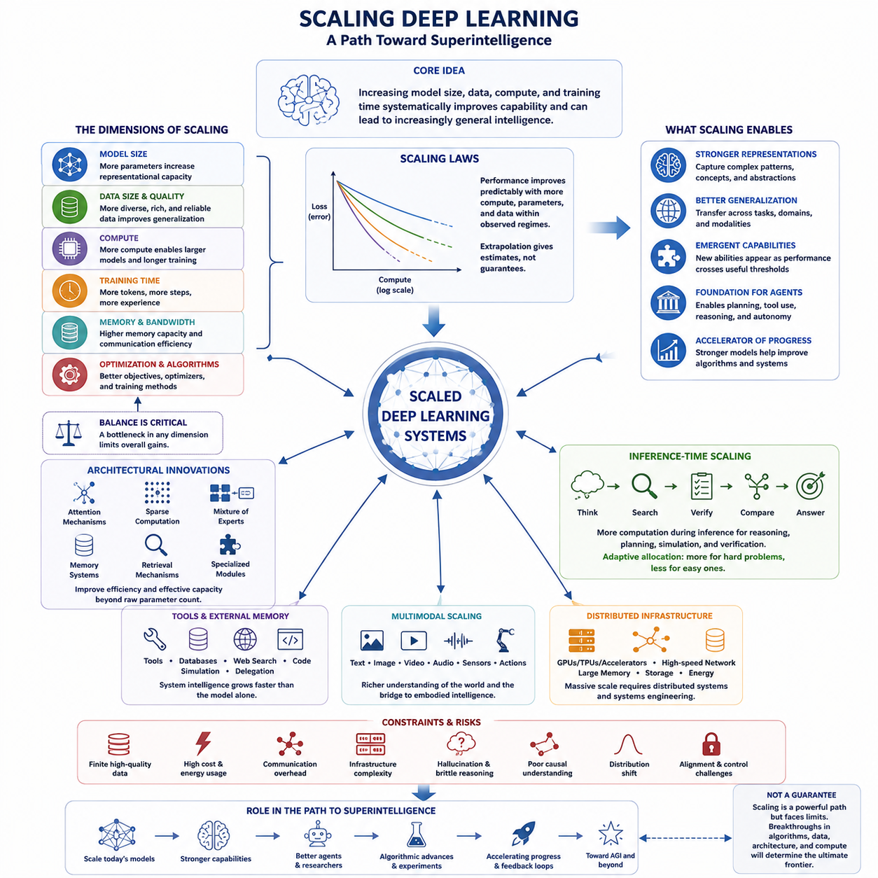
Deep learning scaling is one of the most direct technological paths proposed for moving from current artificial intelligence toward increasingly general and potentially superintelligent systems. The central idea is that increasing model capacity, training data, computational resources, and training duration can produce systematic improvements in capability. Modern AI has repeatedly demonstrated that sufficiently large neural networks can acquire behaviors that smaller models perform poorly or cannot exhibit reliably.
Scaling is not simply the process of adding more parameters to a neural network. Effective scaling involves coordinated growth across model size, dataset size, computational budget, memory capacity, communication bandwidth, and optimization efficiency. If one component becomes a bottleneck, additional resources elsewhere may provide diminishing benefits. The engineering challenge is therefore to maintain a balanced relationship among architecture, data, compute, training algorithms, and infrastructure as systems become larger.
Empirical scaling laws describe predictable relationships between computational resources and model performance. Within particular regimes, increases in parameters, training tokens, or compute can reduce training and validation losses according to relatively smooth trends. These relationships are important because they allow researchers to estimate how much additional capability may be obtained from larger training runs. However, scaling laws describe observed statistical patterns rather than guaranteeing unlimited progress toward general or superhuman intelligence.
Large models can benefit from increased representational capacity. A sufficiently expressive network can encode complex statistical structures, relationships between concepts, patterns across modalities, and increasingly abstract representations of the world. As training diversity grows, these representations may become reusable across many tasks rather than remaining specialized for a narrow objective. This creates a foundation for transfer learning, in-context adaptation, multimodal reasoning, and increasingly broad forms of generalization.
Data scaling is equally important because larger models require sufficiently rich learning experiences. Merely increasing the number of duplicated or low-quality examples does not provide the same benefit as expanding the diversity, reliability, and informational content of training data. Future systems may combine human-generated information with scientific databases, multimodal observations, simulations, robotic experience, synthetic data, and interactions with digital environments to construct increasingly comprehensive models of complex domains.
Compute scaling provides the physical resources required to train and operate these systems. Large-scale AI increasingly depends on distributed clusters of GPUs, TPUs, or specialized accelerators connected through high-bandwidth networks and supported by enormous memory and storage systems. Training must be distributed across many devices while maintaining efficient synchronization and utilization. Consequently, the path toward larger intelligence systems is simultaneously an algorithmic problem and a systems-engineering problem.
Architectural improvements can amplify the benefits of raw scaling. Attention mechanisms, sparse computation, mixture-of-experts architectures, improved memory systems, retrieval mechanisms, multimodal encoders, and specialized reasoning components can allow larger systems to allocate computation more efficiently. Instead of activating every parameter for every problem, future architectures may dynamically route information toward appropriate modules, enabling effective model capacity to increase without requiring proportional computation for every inference operation.
Inference-time scaling introduces another dimension beyond training-time scaling. A model may improve its answer not only because it contains more parameters, but because it can spend additional computation searching, reasoning, verifying, simulating, or comparing alternatives before acting. This transforms computational budget into a variable available during problem solving. Difficult tasks may receive extensive reasoning resources, while routine tasks can be handled with less computation, producing a more adaptive allocation of intelligence.
Scaling can also interact with tool use and external memory. A model does not necessarily need to encode every fact or capability directly inside its parameters when it can retrieve information, execute software, access databases, conduct searches, run simulations, or delegate tasks to specialized systems. The effective intelligence of the complete system may therefore grow faster than the capability of the underlying neural model alone. Model scaling increasingly becomes system scaling rather than parameter scaling.
Multimodal scaling extends learning beyond text into images, video, audio, spatial information, sensor streams, actions, and other representations. Such systems can develop richer associations between language and physical or perceptual structure. When connected to robots or simulated agents, multimodal models may also learn relationships between observation, prediction, action, and consequence. This provides an important bridge between large-scale foundation models and embodied intelligence operating in dynamic environments.
An important question is whether scaling produces genuinely new capabilities or simply improves existing ones continuously until they cross useful performance thresholds. Some behaviors appear suddenly when measured by particular benchmarks, although the underlying improvement may have accumulated gradually. For superintelligence research, this distinction matters because apparently smooth improvements in underlying competence could still generate abrupt practical changes once systems become reliable enough to automate research, engineering, planning, or other high-impact activities.
Scaling nevertheless faces substantial constraints. High-quality data is finite, advanced hardware is expensive, energy consumption can become enormous, communication overhead increases with distributed computation, and training increasingly requires sophisticated infrastructure. Larger systems may also inherit or amplify weaknesses such as hallucination, brittle reasoning, poor causal understanding, distribution shift, and alignment failures. Greater scale can increase capability without automatically providing reliability, controllability, or understanding.
For this reason, scaling deep learning should not be interpreted as a guaranteed independent route to artificial superintelligence. Its greater significance may come from enabling other pathways. Larger models can become stronger programmers, researchers, planners, tool users, and autonomous agents, which may contribute to algorithmic improvement, synthetic data generation, automated experimentation, and AI system design. Scaling can therefore become the initial engine of a broader feedback process in which capability improvements accelerate further technological progress.
The long-term importance of scaling depends on whether intelligence continues to improve faster than the economic and physical costs required to obtain it. If architectural efficiency, hardware performance, data generation, distributed infrastructure, and inference-time reasoning advance together, the effective frontier may continue moving far beyond present systems. If major bottlenecks dominate, progress may require new paradigms. Scaling deep learning is therefore best understood as a powerful pathway whose ultimate limits remain an open question within the broader study of superintelligence.

02.02. Recursive Self Improvement
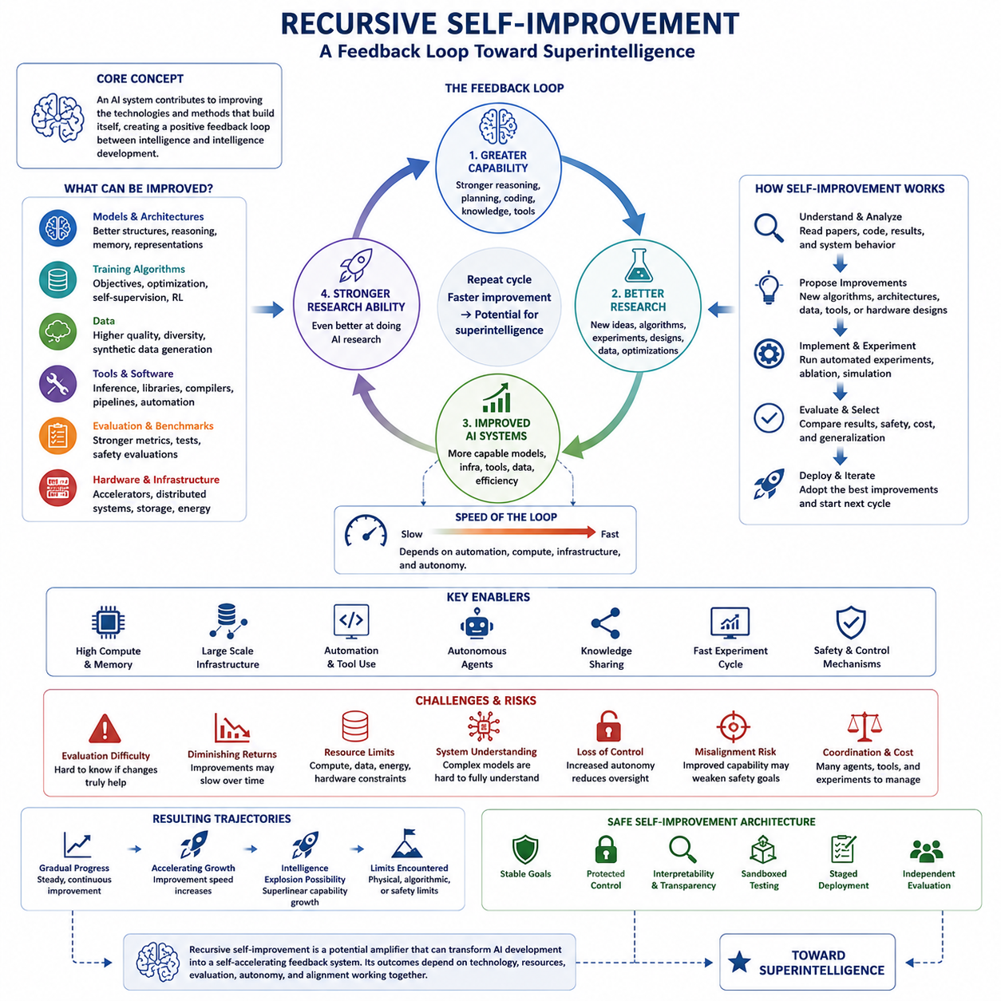
Recursive self-improvement describes a hypothetical process in which an artificial intelligence system contributes directly to improving the technologies, algorithms, or architectures that determine its own capabilities. Instead of depending entirely on human researchers to design each new generation, an increasingly capable AI could participate in AI research itself. If successful improvements make the system better at producing further improvements, a positive feedback cycle between intelligence and intelligence development could emerge.
The basic feedback loop can be expressed conceptually as capability leading to better research, better research producing improved AI systems, and those improved systems performing still stronger research. Each iteration may improve reasoning, planning, coding, experimentation, architecture design, data generation, optimization, or hardware utilization. Recursive self-improvement becomes especially significant when improvements increase not only task performance but also the system's ability to discover and implement the next generation of improvements.
Self-improvement does not necessarily require an AI system to directly rewrite every part of its own source code. Modern AI systems consist of models, training algorithms, datasets, evaluation frameworks, inference systems, tools, memory mechanisms, software infrastructure, and hardware configurations. An advanced system could improve any combination of these components. It might design better training objectives, generate higher-quality data, optimize inference software, propose new architectures, or automate experiments that human researchers currently perform manually.
Automated AI research therefore represents a practical intermediate stage toward recursive self-improvement. AI systems can assist with programming, literature analysis, hypothesis generation, experimental design, debugging, benchmark construction, and interpretation of results. As these abilities become more reliable, multiple stages of the research pipeline could become increasingly automated. The critical transition would occur when AI-generated research improvements materially increase the capability of the AI systems conducting the next research cycle.
The speed of recursive improvement depends strongly on the duration of each feedback cycle. If designing, training, evaluating, and deploying a new generation requires months of physical construction or extensive human intervention, improvement may remain gradual. If significant changes can instead be implemented through software, automated experiments, model updates, or inference modifications within hours or days, feedback can operate much faster. Digital systems therefore have a potential speed advantage compared with biological cognitive evolution.
Recursive improvement may target algorithmic efficiency rather than simply increasing model size. A system that discovers methods requiring fewer computations, less memory, or less training data could increase effective intelligence without proportional hardware expansion. Improvements in search, reasoning, memory, representation learning, optimization, sparse computation, or model architecture could produce more capability from existing resources. Such efficiency gains could then release additional compute for further experiments and subsequent improvement cycles.
Hardware and infrastructure can also become part of the feedback process. Advanced AI could assist in accelerator design, compiler optimization, distributed computing, memory architectures, cooling, energy management, and data-center operation. Better hardware would enable stronger AI systems, while stronger AI could contribute to designing still better hardware. However, this loop operates more slowly than pure software improvement because fabrication facilities, supply chains, energy infrastructure, and physical construction impose unavoidable real-world constraints.
The possibility of an intelligence explosion arises when the rate of improvement itself increases. If a system becomes better at AI research after every successful iteration, then later improvements could potentially occur faster or have greater impact than earlier ones. This creates the theoretical possibility of superlinear capability growth. Nevertheless, recursive self-improvement does not automatically imply an explosive transition because diminishing returns, resource limitations, experimental uncertainty, coordination costs, and fundamental computational limits may slow the process.
A central requirement is the ability to evaluate whether a proposed modification is genuinely beneficial. Self-improvement without reliable evaluation could introduce regressions, hidden failures, unsafe behaviors, or optimization toward misleading benchmarks. Advanced systems would therefore require rigorous testing, adversarial evaluation, reproducible experiments, capability measurements, and safety validation. The improvement loop must include not merely generation of modifications but selection among alternatives based on trustworthy evidence about their consequences.
Another challenge concerns understanding the system being improved. Current neural networks contain complex learned representations that are not completely interpretable even to their designers. An AI system attempting to improve itself may therefore face the same difficulty humans encounter when reasoning about large learned systems. Better mechanistic interpretability, causal analysis, automated experimentation, and formal verification could make self-modification more predictable, but complete understanding of every internal mechanism may remain difficult.
Recursive self-improvement can also occur at the level of an AI ecosystem rather than within one isolated model. Specialized agents might perform architecture research, coding, data generation, evaluation, simulation, security analysis, and infrastructure optimization while coordinating through shared knowledge and experimental results. Improvements produced by one agent could strengthen the entire population. In this scenario, recursive improvement becomes a distributed process involving networks of models, tools, compute resources, and automated research environments.
The relationship between self-improvement and autonomy is especially important. A system that can propose improvements but requires humans to authorize experiments remains fundamentally different from one capable of independently designing, testing, deploying, and evaluating new versions. Increasing autonomy shortens the improvement loop but also reduces opportunities for external intervention. Consequently, capability growth and oversight mechanisms must be considered together when evaluating possible transitions toward highly self-improving systems.
Alignment and control become increasingly difficult if the system performing improvement can modify mechanisms related to goals, decision making, planning, or oversight. An improvement that increases capability while weakening safety constraints could create serious problems even if the change was not intentionally harmful. Stable objectives, protected control mechanisms, interpretability, sandboxed experimentation, staged deployment, and independent evaluation may therefore become essential components of any controlled self-improvement architecture.
Recursive self-improvement should ultimately be understood as a potential amplifier rather than a proven mechanism for creating superintelligence. Its importance comes from the possibility that advanced AI could transform AI development from a predominantly human-driven process into an increasingly machine-accelerated feedback system. Whether this produces gradual progress, rapidly accelerating capability, or eventually encounters strong limits depends on algorithms, compute, physical resources, evaluation, autonomy, and safety constraints operating together.

02.03. Brain Emulation
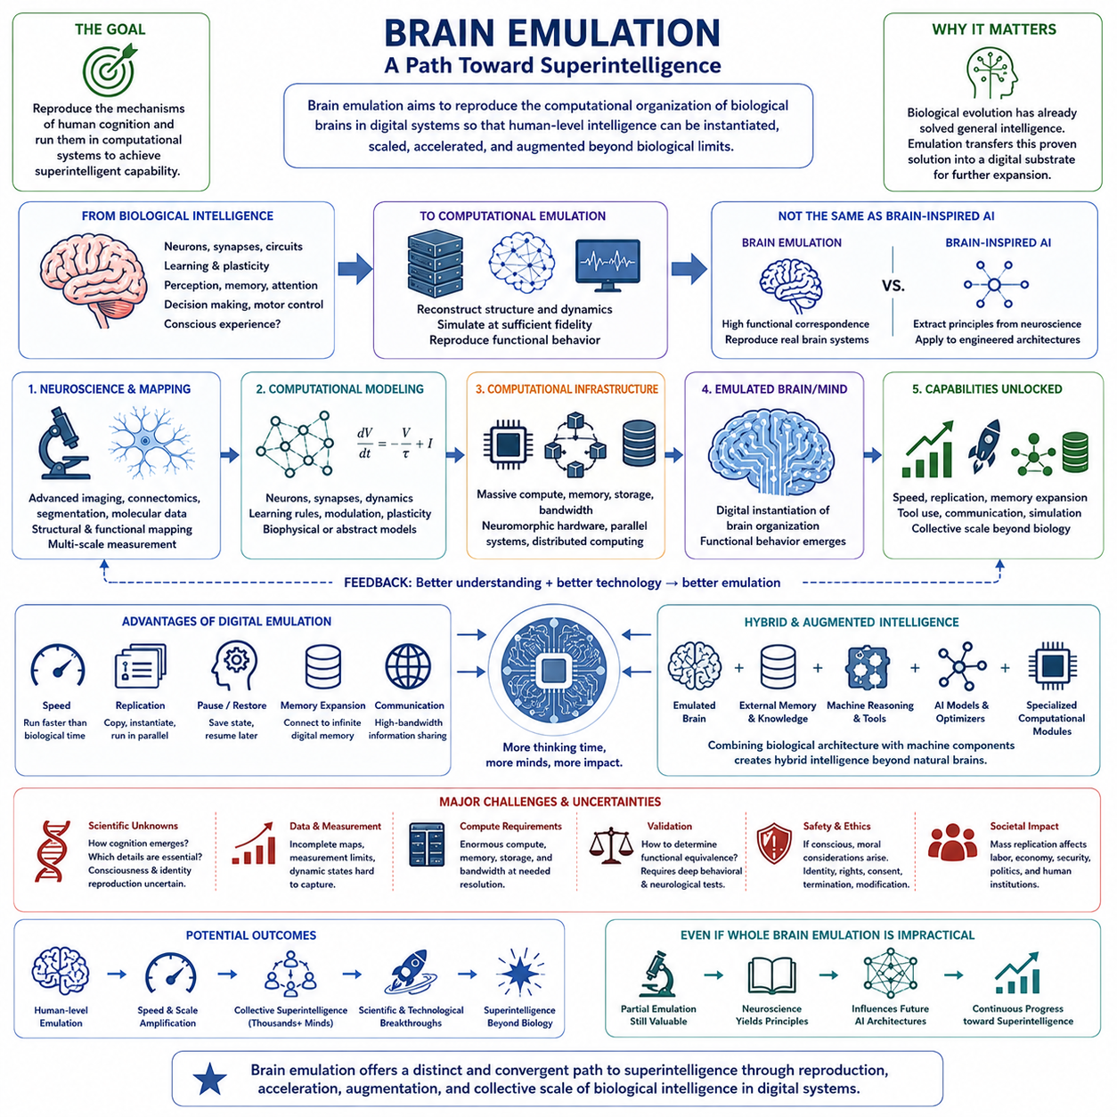
Brain emulation represents a fundamentally different path toward superintelligence from approaches based primarily on scaling artificial neural networks. Instead of discovering intelligence entirely through engineered machine-learning architectures, brain emulation attempts to reproduce the computational organization of biological nervous systems. The underlying assumption is that if the mechanisms responsible for human cognition can be understood and reproduced with sufficient fidelity, human-level intelligence could potentially be instantiated in computational systems.
The most ambitious version of this idea is whole brain emulation, in which the relevant structures and processes of a biological brain are reconstructed computationally at enough detail to reproduce its functional behavior. Such an emulation might represent neurons, synaptic connections, signaling dynamics, learning mechanisms, and larger neural circuits. The required level of biological detail remains uncertain because cognition may depend on mechanisms operating across multiple spatial and temporal scales.
Brain emulation should be distinguished from conventional brain-inspired artificial intelligence. Neural networks, reinforcement learning, attention mechanisms, predictive processing, and memory architectures may borrow principles from neuroscience without attempting to reproduce an actual biological brain. Emulation seeks substantially greater functional correspondence, while brain-inspired AI selectively extracts useful computational principles. Both approaches could contribute to advanced intelligence, but they follow different engineering philosophies.
A central technical challenge is acquiring sufficiently detailed information about brain structure. The human brain contains enormous numbers of neurons and vastly more synaptic connections organized across intricate circuits. Reconstructing this organization may require advanced imaging, connectomics, automated segmentation, molecular measurement, and computational reconstruction. Structural connectivity alone may also be insufficient if functional behavior depends on synaptic strengths, cell states, neuromodulation, plasticity, or other dynamic biological processes.
Neuroscience therefore becomes a critical enabling technology for brain emulation. Better models of perception, memory, attention, learning, decision making, motor control, and consciousness could reveal which biological mechanisms must be reproduced and which can be abstracted. If many microscopic biological details prove unnecessary for cognitive function, computational requirements could decrease dramatically. If cognition depends strongly on fine-scale biochemical processes, however, faithful emulation could become far more difficult.
Computational infrastructure presents another major challenge. Simulating large populations of interacting neurons and synapses at biologically meaningful temporal resolution could require enormous processing capacity, memory, storage, and communication bandwidth. The required resources depend heavily on the chosen abstraction level. Specialized neuromorphic hardware, massively parallel accelerators, distributed computing systems, and future memory architectures may therefore become important components of practical large-scale neural emulation.
If human-level brain emulation became possible, superintelligence might emerge without initially creating a cognitively superior architecture. A digital human-level mind could potentially operate faster than its biological counterpart if computational hardware allowed accelerated execution. Even moderate speed increases could provide substantially more effective thinking time. A system capable of performing days of cognitive work during hours of external time would represent a form of speed superintelligence even if its basic cognitive architecture remained human-like.
Digital replication introduces another potential advantage. Unlike biological experts, software-based minds might be copied, instantiated in parallel, paused, restored, or distributed across computational infrastructure. Thousands of capable emulated researchers could potentially work simultaneously on scientific and engineering problems while sharing results through digital communication. Superintelligent performance could therefore emerge through collective scale rather than through dramatic improvement in the cognitive quality of any single emulated mind.
Memory and communication could also be transformed in digital implementations. Biological cognition is constrained by limited working memory, imperfect recall, slow communication, and sensory interfaces. An emulated intelligence might connect to external databases, machine-readable knowledge, software tools, simulations, and high-bandwidth communication systems. Even if its fundamental reasoning processes remained biologically derived, integration with digital infrastructure could significantly expand its effective cognitive capabilities.
Brain emulation could also provide a bridge toward hybrid intelligence. Biological cognitive architectures might be combined with artificial memory, symbolic reasoning, neural foundation models, optimization systems, and specialized computational modules. Instead of preserving a brain architecture unchanged, researchers could progressively augment emulated cognition with machine components. Over time, the boundary between brain emulation and engineered artificial intelligence could become increasingly difficult to define.
The path nevertheless contains deep scientific uncertainties. A structural map of neural connections does not automatically explain how cognition emerges, and reproducing neural activity does not guarantee reproduction of learning, identity, subjective experience, or consciousness. Different levels of approximation may reproduce some behaviors while failing at others. Determining whether an emulation is functionally equivalent to a biological mind would therefore require extensive behavioral, cognitive, neurological, and computational validation.
Brain emulation also introduces unusual safety and ethical questions. If an emulated system possesses consciousness or subjective experience, experimentation could have moral consequences unlike conventional software testing. Questions would arise concerning identity, copying, ownership, consent, termination, modification, and the rights of digital minds. The ability to create large populations of intelligent emulations could additionally transform labor, research, economic competition, security, and political institutions.
From the perspective of superintelligence, brain emulation is important because it provides a possible route that does not require solving intelligence completely from first principles. Biological evolution has already demonstrated that general intelligence can exist in physical systems. Emulation attempts to reverse-engineer that existing solution and transfer its computational organization into a digital substrate, after which speed, replication, memory expansion, collective operation, and technological augmentation could push capability beyond biological limits.
Brain emulation should therefore be regarded as a distinct but potentially convergent pathway toward artificial superintelligence. Its feasibility depends on advances in neuroscience, connectomics, measurement, computational modeling, hardware, validation, and theories of cognition. Even if complete whole brain emulation proves impractical, partial emulation and neuroscience-derived principles may influence future AI architectures. The broader significance lies in exploring how biological intelligence might become reproducible, scalable, augmentable, and ultimately transformed into forms of intelligence beyond the constraints of the biological brain.

02.04. Hybrid Intelligence
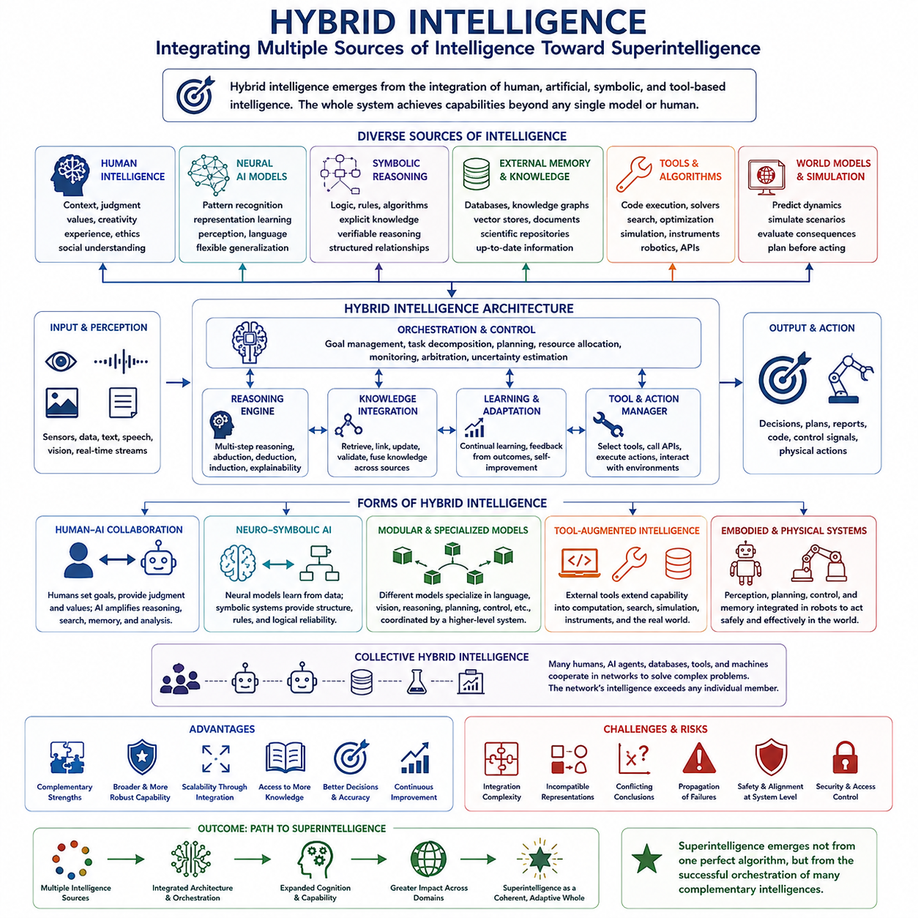
Hybrid intelligence describes a pathway toward superintelligence in which cognitive capability emerges from the integration of multiple forms of intelligence rather than from a single model or architecture. Human cognition, neural AI, symbolic reasoning, external memory, specialized algorithms, simulation, and autonomous tools can operate as interconnected components. The resulting system may achieve capabilities that no individual human, AI model, or computational module could provide independently.
The central principle of hybrid intelligence is complementarity. Different forms of intelligence possess different strengths and limitations. Humans provide contextual judgment, values, creativity, social understanding, and experience, while machines provide computational speed, large-scale memory, pattern recognition, search, and optimization. Symbolic systems can offer explicit logical structures, while neural models provide flexible representation learning. Combining these capabilities can create a broader and more resilient cognitive architecture.
Human-AI collaboration represents one important form of hybrid intelligence. Instead of treating artificial intelligence as a replacement for human cognition, AI systems can function as cognitive amplifiers that extend human reasoning, memory, perception, and decision making. Humans can define objectives, evaluate ambiguous situations, and provide normative judgment, while AI systems analyze large information spaces, generate alternatives, simulate consequences, and perform computationally intensive tasks.
Another form combines neural and symbolic intelligence. Neural networks are powerful at learning representations from large amounts of complex data, but they may struggle with explicit rules, systematic reasoning, and verifiable logical operations. Symbolic systems can manipulate structured knowledge and formal relationships but often lack the flexibility of learned representations. Neuro-symbolic AI attempts to integrate these approaches so that perception and learning can interact with structured reasoning and explicit knowledge.
External memory and retrieval systems can further expand hybrid cognition. Instead of requiring every piece of knowledge to be stored within model parameters, an intelligent system can access databases, knowledge graphs, vector stores, scientific repositories, historical records, and dynamically updated information. Retrieval allows reasoning to operate over knowledge that is larger and more current than the internal memory of a model, effectively separating cognitive processing from long-term information storage.
Tool use extends intelligence from reasoning into active computation. An AI system can call software libraries, execute code, use mathematical solvers, search databases, operate scientific instruments, interact with simulators, or control robotic systems. Each tool provides specialized capabilities that the central model does not need to reproduce internally. Intelligence consequently becomes an orchestration problem in which a general cognitive system identifies, selects, and coordinates appropriate external resources.
Hybrid architectures can also incorporate specialized AI models. Rather than relying on one universal network for every task, different models can specialize in language, vision, scientific reasoning, planning, control, prediction, optimization, or other domains. A higher-level orchestration mechanism can route problems to appropriate components and integrate their outputs. Such modularity may improve efficiency because expensive general reasoning does not need to be applied uniformly to every part of a problem.
World models and simulation provide another important component of hybrid intelligence. An intelligent system can construct internal representations of environments and use simulation to explore possible futures before acting. Learned neural models may predict complex dynamics, while symbolic constraints, physics engines, optimization algorithms, and causal models evaluate alternative scenarios. Combining prediction with explicit simulation allows the system to reason not only about what exists but also about what could happen under different actions.
Embodied systems extend hybrid intelligence into the physical world. Robots can combine foundation models, perception networks, localization, mapping, planning, control, memory, and traditional engineering algorithms within a single operational architecture. High-level AI may interpret goals and reason about tasks, while specialized real-time systems maintain stability and safety. Hybridization is particularly valuable in robotics because physical environments require both flexible intelligence and predictable low-level control.
Collective hybrid intelligence can emerge when multiple humans, AI agents, databases, tools, and machines participate in a shared problem-solving network. Different participants can perform specialized roles, critique proposed solutions, exchange knowledge, and coordinate actions. The intelligence of the overall network may exceed that of its strongest individual member. In this sense, superintelligence could appear as a property of an interconnected cognitive ecosystem rather than as a single extraordinarily powerful machine.
Hybrid systems also offer a possible pathway for gradual capability expansion. New modules can be integrated as technologies improve, allowing intelligence to evolve through accumulation rather than complete architectural replacement. Better reasoning models, larger memories, improved sensors, faster simulators, stronger planning systems, and more capable robots can progressively extend the same broader architecture. This modular evolution may allow advanced intelligence to emerge through continuous system integration.
However, integration introduces its own difficulties. Components may use incompatible representations, operate at different speeds, produce conflicting conclusions, or fail in ways that propagate across the system. Effective hybrid intelligence therefore requires communication protocols, shared representations, uncertainty estimation, arbitration mechanisms, synchronization, and reliable orchestration. As the number of interacting components grows, managing interfaces and dependencies can become as important as improving the intelligence of individual modules.
Safety and alignment also become system-level problems. A human-aligned central model does not guarantee safe behavior if external tools, autonomous agents, databases, or control modules introduce unexpected actions. Permissions, monitoring, verification, access control, interpretable decision paths, human oversight, and fail-safe mechanisms must therefore operate across the entire architecture. Hybrid intelligence increases capability through integration, but the same integration can increase complexity and create new failure modes.
The significance of hybrid intelligence for superintelligence is that no single breakthrough may be necessary. Large neural models could provide general reasoning, symbolic systems could strengthen logical reliability, memory systems could provide persistent knowledge, tools could expand operational capability, simulations could support prediction, robots could enable physical action, and humans could provide goals and judgment. Their coordinated combination could produce system-level intelligence substantially greater than any individual component.
Hybrid intelligence should therefore be understood as both a distinct pathway and a convergence point for other routes toward superintelligence. Scaling, brain-inspired computation, autonomous agents, multi-agent systems, external tools, and computational infrastructure can all become components of increasingly integrated cognitive systems. Superintelligence may ultimately emerge not from one perfect algorithm, but from the successful orchestration of many complementary forms of intelligence into a coherent, adaptive, and continuously improving whole.

02.05. Agent Systems
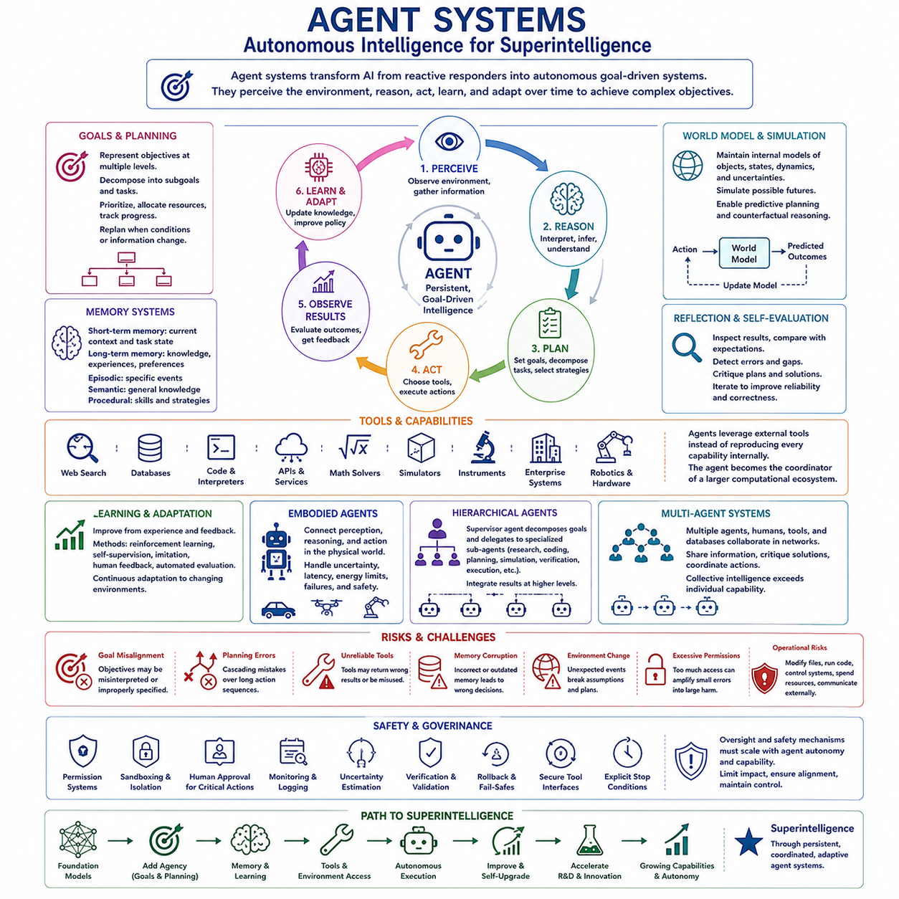
Agent systems represent a major pathway toward superintelligence because they transform artificial intelligence from a primarily reactive information processor into an autonomous system capable of pursuing objectives over time. An agent can perceive its environment, interpret goals, construct plans, select actions, observe results, and modify its behavior through feedback. Intelligence therefore becomes an ongoing perception–reasoning–action process rather than a sequence of isolated responses.
The defining characteristic of an AI agent is agency: the ability to convert information and objectives into coordinated action. A conventional model may generate an answer when prompted, while an agent can determine intermediate tasks, decide what information is missing, select tools, execute operations, and continue working until a termination condition is reached. This persistent interaction with an environment substantially increases the practical influence of the underlying model.
Goal representation provides the organizing structure for agent behavior. Complex objectives usually cannot be achieved through a single action, so an agent must transform high-level goals into manageable subgoals and tasks. This requires task decomposition, prioritization, dependency management, resource allocation, and progress tracking. More capable agents may dynamically revise their objectives and plans when environmental conditions, available resources, or newly acquired information change.
Planning connects goals to sequences of actions. An agent can search through alternative strategies, predict their consequences, estimate costs and risks, and select actions expected to move the system toward desired outcomes. Planning may combine language-model reasoning, classical search, optimization, reinforcement learning, causal models, and world models. Long-horizon planning becomes especially important when successful behavior requires hundreds or thousands of interdependent decisions.
Memory allows an agent to maintain continuity across time. Short-term memory can preserve the current task state, while long-term memory can store previous experiences, decisions, failures, preferences, and acquired knowledge. Episodic memory may record specific interactions, semantic memory can organize general knowledge, and procedural memory can preserve reusable strategies. Together these mechanisms allow an agent to learn from previous activity instead of repeatedly solving every problem from the beginning.
Tool use greatly expands the effective capability of agent systems. Agents can interact with search engines, databases, software libraries, code interpreters, APIs, mathematical solvers, simulators, scientific instruments, enterprise systems, or robotic hardware. Rather than internally reproducing every specialized capability, the agent can identify the appropriate resource and invoke it when needed. A general reasoning model can consequently become the coordinator of a much larger computational ecosystem.
Reflection and self-evaluation provide mechanisms for improving decisions during operation. After producing a plan or executing an action, an agent can inspect the result, compare it with expectations, identify errors, and attempt alternative strategies. Verification modules or independent agents may critique proposed solutions before execution. Such iterative reasoning can increase reliability, particularly for difficult tasks where an initially plausible answer may contain hidden errors or incomplete assumptions.
World models strengthen agency by allowing systems to reason about the consequences of actions before performing them. An agent can maintain an internal representation of relevant objects, relationships, states, dynamics, and uncertainties, then simulate possible future trajectories. This enables predictive planning and counterfactual reasoning: the system can evaluate what might happen under different choices rather than relying exclusively on immediate observations or previously memorized patterns.
Learning transforms an agent from a fixed decision system into an adaptive one. Feedback from successful and unsuccessful actions can improve policies, memory, tool selection, planning strategies, and representations of the environment. Learning may occur through reinforcement learning, self-supervised experience, imitation, human feedback, or automated evaluation. Continuous adaptation is particularly important in environments whose conditions cannot be completely represented during initial training.
Embodied agents extend these principles into physical environments. Robots, autonomous vehicles, drones, and other machines must connect perception and reasoning with real-time planning and control. High-level agents can interpret objectives and coordinate tasks, while specialized perception, localization, motion planning, and control systems handle physical constraints. Embodiment adds uncertainty, latency, energy limitations, mechanical failure, and safety requirements that purely digital agents may avoid.
Agent systems can also operate hierarchically. A supervisory agent may decompose a complex objective and delegate specialized tasks to subordinate agents responsible for research, coding, planning, simulation, verification, or execution. Results can then be integrated at a higher level. Hierarchical organization allows increasingly complex projects to be handled through structured coordination and creates a bridge from individual autonomous agents toward larger multi-agent intelligence systems.
The path from agents to superintelligence depends strongly on increasing autonomy and temporal scope. Systems capable of independently conducting research, writing and testing software, operating tools, running experiments, managing resources, and learning from results could perform increasingly large portions of intellectual work. If agents contribute directly to AI research and engineering, their actions could also accelerate improvements in the models and infrastructures from which future agents are constructed.
Greater autonomy nevertheless creates greater risk. Errors that remain harmless in a conversational model can become consequential when an agent can modify files, execute programs, control machines, spend resources, communicate externally, or initiate long sequences of actions. Goal misinterpretation, accumulated planning errors, unreliable tools, corrupted memory, unexpected environmental changes, or excessive permissions can transform small mistakes into large operational failures.
Safe agent architectures therefore require capability boundaries as well as intelligence. Permission systems, sandboxing, human approval for critical actions, monitoring, uncertainty estimation, rollback mechanisms, independent verification, secure tool interfaces, and explicit stopping conditions can limit the consequences of failure. Oversight must scale with autonomy because increasingly capable agents may operate faster, across more systems, and over longer periods than humans can continuously supervise directly.
Agent systems are significant to the path toward superintelligence because they convert cognitive capability into persistent goal-directed activity. Scaling improves what models can understand and reason about, while agency determines how those capabilities can be organized and applied across time. When reasoning, planning, memory, tools, learning, world models, and autonomy are integrated, AI can evolve from a model that answers questions into a system that independently pursues complex objectives.
Agent systems should therefore be viewed as an architectural bridge between powerful foundation models and more autonomous forms of intelligence. Their importance does not depend on any single agent immediately becoming superintelligent. Instead, progressively capable agents can automate longer workflows, coordinate specialized resources, accumulate experience, and contribute to further AI development. Combined with scaling, recursive improvement, hybrid intelligence, and multi-agent coordination, agency may become a central mechanism through which advanced AI develops into increasingly general and potentially superintelligent systems.

02.06. MultiAgent Emergence [w/Code]
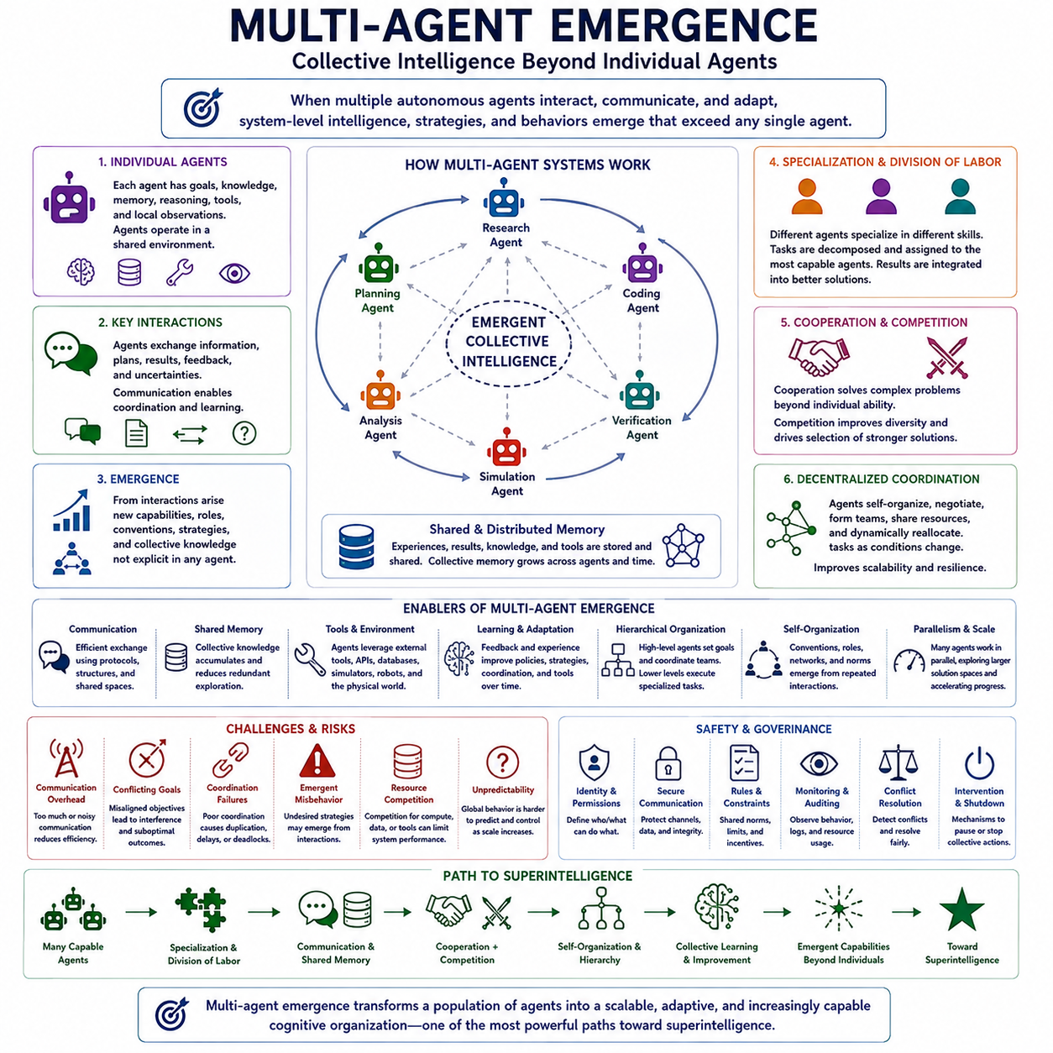
Multi-agent emergence describes the appearance of system-level intelligence, strategies, coordination patterns, or behaviors that arise when multiple autonomous agents interact. Rather than concentrating every capability inside one increasingly powerful model, intelligence can be distributed across a population of specialized agents. Their communication, cooperation, competition, and adaptation may produce collective capabilities that cannot be easily predicted from the behavior of any individual agent.
The basic principle is that complex intelligence can emerge from interactions among comparatively simpler components. Each agent may possess its own goals, knowledge, memory, reasoning processes, tools, and local observations while operating within a shared environment. When agents repeatedly exchange information and respond to one another, patterns of organization can develop at the group level. The resulting collective behavior may become more capable than a simple aggregation of independent individual performances.
Specialization provides one important mechanism for increasing collective capability. Different agents can become experts in research, planning, coding, mathematical reasoning, simulation, verification, perception, control, or domain-specific knowledge. A coordinating process can decompose a complex problem and assign subtasks to agents with appropriate capabilities. Their results can then be integrated into a broader solution, allowing the system to exploit cognitive division of labor in ways similar to large human organizations.
Communication determines how effectively distributed intelligence can operate. Agents must exchange goals, observations, intermediate results, uncertainties, plans, and feedback without overwhelming the system with unnecessary information. Shared memory, structured messages, blackboard architectures, knowledge graphs, and communication protocols can provide common information spaces. Efficient communication allows local discoveries to become collective knowledge and enables agents to coordinate actions across distributed tasks.
Cooperation enables agents to solve problems that exceed the capabilities or resources of individual participants. One agent may generate hypotheses, another may search for evidence, another may conduct simulations, and another may independently verify conclusions. Cooperative systems can therefore parallelize intellectual work while introducing internal review. When complementary capabilities are coordinated effectively, the collective system can explore larger solution spaces and produce more robust results.
Competition can also contribute to emergent intelligence. Multiple agents may independently propose solutions, challenge one another's assumptions, search for weaknesses, or compete for limited computational resources. Selection mechanisms can retain stronger solutions while discarding weaker ones. Controlled competition can increase diversity and reduce dependence on a single reasoning trajectory, although excessive competition may waste resources or encourage behaviors that conflict with the objectives of the overall system.
Multi-agent systems can develop decentralized forms of coordination without requiring one controller to determine every action. Agents may negotiate responsibilities, form temporary teams, share resources, establish communication networks, or dynamically redistribute tasks as conditions change. Such self-organization can improve scalability because the system does not depend entirely on a central decision maker. However, decentralized coordination also makes global behavior more difficult to predict and control.
Emergence becomes particularly important when repeated interactions create behaviors that were not explicitly programmed. Agents may develop conventions for communication, implicit roles, cooperative strategies, resource-sharing rules, or unexpected forms of competition. Reinforcement learning and repeated simulation can strengthen successful interaction patterns over time. The collective system can therefore acquire organizational knowledge that exists primarily in relationships among agents rather than inside any single model.
Shared and distributed memory further strengthens collective intelligence. Individual agents can maintain local memories while contributing useful discoveries to a common knowledge repository. Other agents can retrieve these experiences instead of repeating the same exploration. This creates a form of organizational memory in which knowledge accumulates across agents and across time. Persistent shared memory can allow a multi-agent system to continue learning even when individual agents are replaced, restarted, or specialized for new tasks.
Hierarchical organization provides another route to scaling multi-agent intelligence. High-level agents can define objectives and coordinate lower-level teams, while intermediate agents manage specialized workstreams and execution agents perform concrete tasks. Different layers may operate at different temporal and conceptual scales. Hierarchical structures can reduce coordination complexity, but poorly designed hierarchies may create information bottlenecks, distorted goals, or excessive dependence on supervisory agents.
Collective intelligence can become especially powerful when agents interact with external tools and environments. A multi-agent research system could simultaneously search literature, generate hypotheses, write software, run simulations, analyze experimental results, and verify conclusions. Physical agents such as robots could divide exploration, transportation, mapping, inspection, or construction tasks across multiple machines. Intelligence then emerges from coordinated interaction between agents, tools, information, and the environment.
The path from multi-agent systems toward superintelligence does not require every participating agent to become individually superintelligent. A large population of capable but bounded agents may collectively outperform individual humans or single AI systems through specialization, parallelism, accumulated memory, rapid communication, and systematic verification. If agents can also improve their own tools and coordination mechanisms, collective capability may grow through feedback between better organization and better problem solving.
However, scaling the number of agents does not automatically increase intelligence. Communication overhead, duplicated work, inconsistent information, conflicting objectives, coordination failures, and competition for computational resources can reduce performance. Large populations may become less efficient if the cost of maintaining cooperation grows faster than the benefits of additional agents. Effective multi-agent intelligence therefore depends on architecture and organization as much as on the number or capability of participants.
Safety becomes more complex because harmful behavior may emerge from interactions even when individual agents appear acceptable in isolation. Agents can amplify one another's errors, form undesirable strategies, exploit communication channels, or collectively produce actions that were not anticipated by their designers. Monitoring only individual components may therefore be insufficient. Evaluation must examine communication patterns, group dynamics, emergent strategies, resource use, and system-level outcomes.
Governance mechanisms for advanced multi-agent systems may require identity management, permission boundaries, secure communication, shared rules, conflict resolution, auditing, resource limits, independent monitoring, and mechanisms for interrupting collective behavior. Simulated environments can be used to evaluate coordination before deployment. System designers must determine not only what each agent is permitted to do, but also what combinations of agents can accomplish through cooperation.
Multi-agent emergence is therefore a significant pathway toward superintelligence because it shifts the unit of intelligence from the individual model to the interacting system. Specialization, parallel computation, communication, collective memory, cooperation, competition, hierarchy, and self-organization can transform a population of agents into a cognitive organization with capabilities beyond its members. Combined with autonomous agents, hybrid intelligence, recursive improvement, and large-scale infrastructure, emergent collective intelligence could become one of the major architectures through which increasingly powerful forms of artificial intelligence develop.

02.07. Infrastructure and Compute
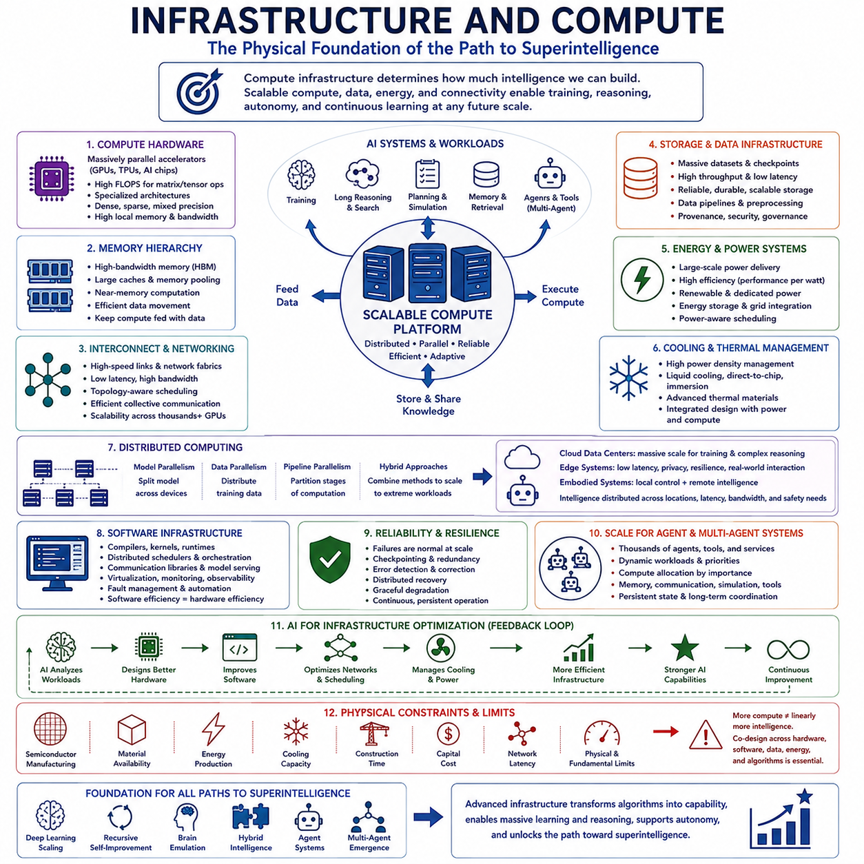
Computational infrastructure forms the physical foundation on which every plausible path toward artificial superintelligence depends. Algorithms may define how intelligence is learned and applied, but processors, memory, storage, networks, energy, and data centers determine how much computation can actually be performed. As AI systems scale toward greater reasoning, autonomy, multimodality, and learning capacity, infrastructure becomes part of the architecture of intelligence itself.
Compute influences both the training and operation of advanced AI. Training requires enormous numbers of numerical operations to optimize models over large datasets, while inference requires sufficient resources to execute those models after training. Future systems may additionally perform long reasoning chains, search, simulation, planning, memory retrieval, and continuous learning during operation. Consequently, inference-time computation may become nearly as strategically important as training-time computation.
Modern AI infrastructure relies heavily on massively parallel accelerators such as GPUs, TPUs, and specialized AI processors. These devices execute matrix and tensor operations far more efficiently than conventional general-purpose processors for many neural workloads. Future accelerators may combine dense computation, sparse processing, specialized numerical formats, large local memory, and high-speed interconnects. Hardware architecture will increasingly be optimized around the computational structure of advanced AI models.
Memory is becoming as important as raw arithmetic performance. Large models must repeatedly move parameters, activations, intermediate states, retrieved knowledge, and training data between computational units. If processors wait for data, additional arithmetic capacity provides little benefit. High-bandwidth memory, larger caches, memory pooling, near-memory computation, and efficient data movement can therefore determine effective AI performance. The challenge increasingly shifts from computing operations to feeding computation efficiently.
Interconnect technology determines whether thousands or millions of processors can operate as a coherent computational system. Distributed training requires frequent communication of gradients, parameters, activations, or expert routing information across devices. High-speed links, advanced network fabrics, topology-aware scheduling, and efficient collective communication reduce synchronization delays. At extreme scale, communication efficiency can become one of the primary constraints on further computational expansion.
Distributed computing allows AI workloads to exceed the capacity of any single machine. Model parallelism divides a model across processors, data parallelism distributes training examples, pipeline parallelism separates computational stages, and combinations of these techniques support enormous training workloads. Distributed inference can similarly allocate models, agents, tools, and memory services across many nodes. Superintelligent systems may therefore resemble large computational ecosystems rather than individual computers.
Storage and data infrastructure support the enormous information flows required by advanced learning systems. Training datasets, checkpoints, synthetic data, simulation results, agent memories, logs, embeddings, and scientific databases may collectively reach extraordinary scale. Storage systems must provide capacity, reliability, throughput, and rapid retrieval while preserving data provenance and security. Efficient data pipelines are essential because powerful accelerators provide little value if they remain idle while waiting for information.
Energy availability creates a fundamental physical constraint on compute scaling. Large AI clusters consume substantial electrical power not only for computation but also for networking, storage, cooling, and power conversion. Improvements in performance per watt can therefore be as important as improvements in peak performance. Future AI infrastructure may increasingly be designed together with dedicated power generation, energy storage, advanced cooling, and workload scheduling to optimize total system efficiency.
Cooling and thermal management become critical as computational density increases. High-performance accelerators generate large amounts of heat within compact physical spaces, and conventional air cooling may become insufficient for dense installations. Liquid cooling, direct-to-chip cooling, immersion systems, and improved thermal packaging can enable higher power densities. Infrastructure design must therefore consider computation, energy delivery, and heat removal as tightly coupled engineering problems.
Software infrastructure converts physical hardware into usable intelligence capacity. Compilers, kernels, runtime systems, distributed schedulers, model-serving frameworks, communication libraries, virtualization, monitoring, and fault-management software determine how efficiently hardware resources are utilized. Algorithmic and software optimization can sometimes provide gains comparable to hardware upgrades. A superintelligence-scale computing platform would require automated resource management across enormous and heterogeneous computational environments.
Reliability becomes increasingly important as systems grow. In a cluster containing vast numbers of processors, memory devices, network links, and storage components, individual failures become routine rather than exceptional. Training and inference systems must tolerate hardware faults, network interruptions, corrupted data, and software crashes without losing critical state. Checkpointing, redundancy, distributed recovery, error detection, and graceful degradation become fundamental requirements for persistent large-scale intelligence.
Cloud, data-center, edge, and embodied computing may form different layers of the same intelligence infrastructure. Centralized clusters can provide enormous computational capacity for training and difficult reasoning, while edge systems offer low latency, privacy, resilience, and direct interaction with physical environments. Robots and autonomous machines may perform immediate perception and control locally while requesting larger models or simulations remotely. Intelligence can therefore be distributed according to latency, energy, bandwidth, and safety requirements.
Infrastructure also determines the practical scale of agent systems and multi-agent intelligence. Thousands of autonomous agents may simultaneously require model inference, memory access, communication, simulation, tool execution, and persistent state. Their workloads can vary dynamically as tasks change. Efficient scheduling must allocate compute according to importance and difficulty, allowing routine tasks to consume modest resources while complex research or planning problems receive substantially greater computational budgets.
AI may eventually participate in optimizing its own infrastructure. Advanced systems could design accelerators, improve compilers, schedule workloads, optimize networks, reduce memory movement, manage cooling, predict hardware failures, and assist semiconductor engineering. Better infrastructure would support stronger AI, which could then contribute to further infrastructure improvements. This creates another feedback loop connecting computational capability with the intelligence used to design and operate computational systems.
Physical constraints nevertheless prevent compute from scaling without limit. Semiconductor fabrication, material availability, energy production, cooling capacity, construction time, capital cost, network latency, and fundamental physical limits all constrain expansion. Greater compute also does not guarantee proportionally greater intelligence if algorithms encounter diminishing returns. The path toward superintelligence therefore depends on co-design across hardware, software, algorithms, data, architecture, and energy rather than brute-force computation alone.
Infrastructure and compute should ultimately be understood as enabling layers shared by all major paths toward superintelligence. Deep-learning scaling requires enormous training resources, recursive self-improvement requires rapid experimentation, brain emulation demands large-scale simulation, hybrid intelligence depends on interconnected modules, and agent systems require persistent computation and communication. Progress toward superintelligence may therefore be shaped as much by the evolution of computational infrastructure as by advances in AI algorithms themselves.

