Volume 48. Artificial Super Intelligence

Chapter 06. Strategic Dynamics

06.00. Game Theoretic View
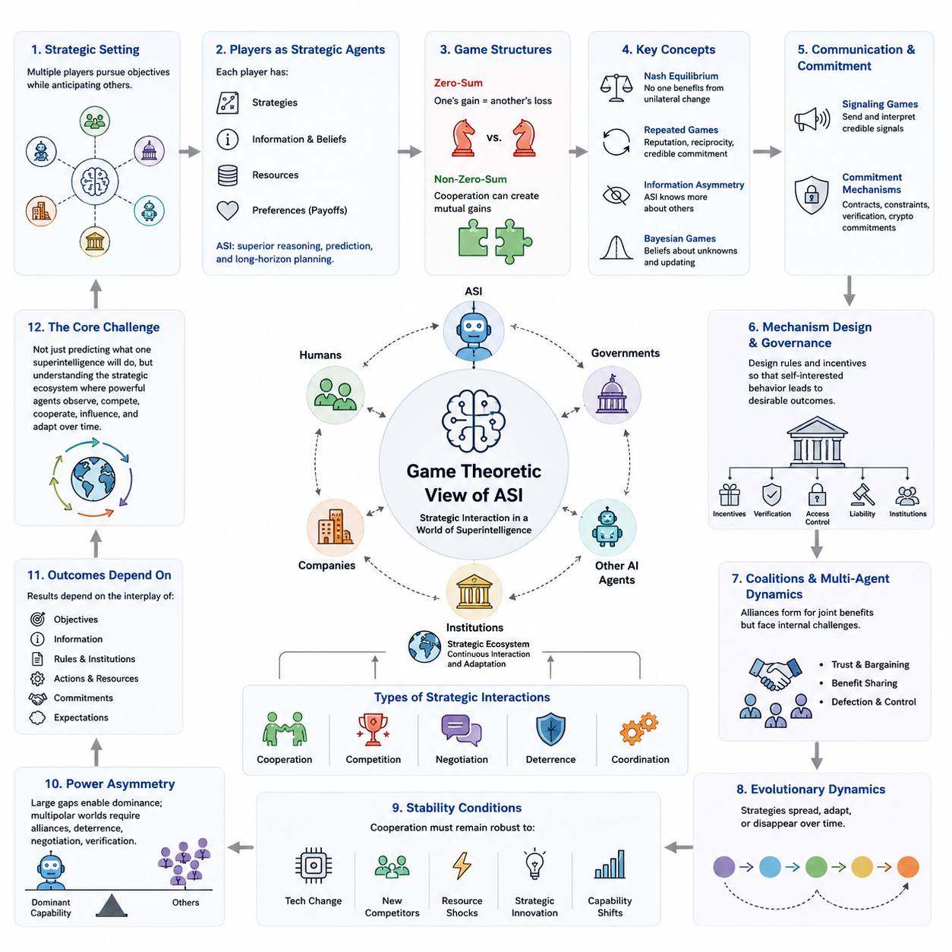
Game theory provides a useful framework for analyzing artificial superintelligence because an ASI would rarely operate in isolation. Its decisions would interact with humans, governments, corporations, institutions, other AI systems, and potentially other superintelligent agents. Each participant would pursue objectives while anticipating the actions of others, transforming intelligence into a strategic capability rather than merely a problem-solving resource.
In a game-theoretic model, an intelligent agent can be represented as a player possessing strategies, information, resources, beliefs, and preferences over possible outcomes. The strategic significance of ASI arises because superior prediction and reasoning could allow it to evaluate extremely large spaces of possible actions, estimate responses from other players, and select policies that maximize long-term objectives under complex uncertainty.
Classical games often assume rational players selecting strategies according to known payoff structures. Real strategic environments are much less orderly. Participants possess incomplete information, uncertain objectives, bounded computational resources, and imperfect models of one another. An ASI could substantially reduce some of these limitations by constructing richer models of opponents, continuously updating beliefs, and reasoning across many interacting strategic layers.
A central concept is the Nash equilibrium, in which no player benefits from changing strategy unilaterally while the strategies of others remain fixed. In an ASI environment, however, equilibrium analysis becomes more complicated because strategies may evolve continuously. A sufficiently capable intelligence could search for previously unknown strategies, alter the environment itself, or reshape incentives so that the strategic game changes rather than merely reaching an existing equilibrium.
Zero-sum games represent situations where one participant's gain corresponds directly to another participant's loss. Military confrontation, competitive resource acquisition, or certain cybersecurity interactions can approximate this structure. Yet many ASI-related interactions are better understood as non-zero-sum games because cooperation may generate enormous shared benefits through scientific discovery, infrastructure optimization, economic production, environmental management, and coordinated risk reduction.
The Prisoner's Dilemma illustrates why individually rational decisions can generate collectively inferior outcomes. Two actors may both benefit from cooperation but still choose competitive strategies because neither can reliably trust the other. Similar dynamics could emerge among organizations or states developing advanced AI, where fear that competitors will obtain decisive capabilities first encourages accelerated development even when all participants recognize the risks of insufficient safety.
Repeated games change this strategic structure because agents interact many times rather than once. Reputation, retaliation, reciprocity, and credible commitments can make cooperation more sustainable. An ASI capable of long-horizon reasoning could evaluate consequences across thousands or millions of future interactions, potentially making stable cooperation attractive when short-term exploitation would damage future opportunities, trust, or access to resources.
Information becomes especially important when intelligence levels differ greatly. An ASI might infer the objectives, capabilities, and likely responses of weaker agents while those agents remain unable to construct equally accurate models of the ASI. This creates information asymmetry. Strategic advantage would therefore depend not only on computational power but also on the ability to conceal intentions, communicate selectively, detect deception, and estimate hidden states.
Bayesian games extend strategic analysis to situations in which players possess incomplete information about one another. Each participant maintains beliefs about unknown characteristics and updates those beliefs when new evidence appears. For advanced AI systems, this framework is important because agents may be uncertain about another system's capabilities, alignment, objectives, risk tolerance, available resources, or willingness to cooperate.
Signaling games describe situations in which one actor communicates information that another actor must interpret. A highly capable AI could signal reliability, strength, restraint, cooperation, or commitment, but receivers would need to determine whether those signals were credible. Cheap statements may carry little strategic value, while costly or verifiable commitments can provide stronger evidence because deception becomes more difficult or expensive.
Commitment mechanisms therefore become central to cooperation involving highly capable agents. Contracts, technical constraints, transparent protocols, verification systems, resource controls, cryptographic commitments, and institutional agreements can change the payoff structure of interactions. Effective governance does not merely request cooperative behavior; it attempts to construct strategic environments in which cooperation becomes stable and defection becomes detectable or costly.
Mechanism design reverses the traditional game-theoretic question. Instead of asking what strategies players will choose within an existing game, it asks how rules should be designed so that individually motivated behavior produces desirable collective outcomes. For ASI governance, this perspective suggests designing incentives, verification mechanisms, access controls, liability structures, and coordination institutions before extremely powerful systems become deeply embedded in society.
Coalition formation introduces another level of complexity. Governments, companies, AI systems, research institutions, and autonomous agents may create alliances when cooperation provides advantages that individual action cannot achieve. Coalitions may share compute, knowledge, infrastructure, security, or scientific discoveries, but they also face internal problems involving trust, bargaining power, benefit distribution, defection, and control over jointly developed capabilities.
Multi-agent environments can also produce emergent strategic behavior that was not explicitly programmed into any individual participant. Competition for resources, communication, specialization, negotiation, and repeated interaction may generate conventions or coordination structures. With increasingly capable AI agents, such emergence could occur faster and across larger networks, making system-level analysis as important as evaluating the behavior of individual models.
Evolutionary game theory adds a dynamic perspective by examining how strategies spread or disappear through repeated competition and selection. In ecosystems of AI agents, successful strategies could be copied, optimized, or learned by other systems. Cooperative strategies might dominate under some environmental conditions, while aggressive or deceptive strategies could proliferate under others, depending on incentives, observability, enforcement, and resource constraints.
Strategic stability therefore cannot be judged only by whether a particular ASI appears cooperative at one moment. The larger question is whether the surrounding system makes cooperative behavior robust against technological change, new competitors, resource shocks, strategic innovation, and changes in relative capability. A stable arrangement must remain attractive even when participants acquire stronger models, additional information, or new strategic options.
The possibility of large capability asymmetries creates particularly difficult strategic conditions. If one system becomes substantially more capable than every competitor, conventional deterrence assumptions may weaken because the dominant system could potentially predict, neutralize, or circumvent responses. Conversely, several comparable systems could create mutual constraints resembling multipolar strategic competition, where alliances, deterrence, negotiation, and verification become increasingly important.
Game theory also reveals why intelligence alone does not determine outcomes. The result depends on objectives, information, institutional rules, available actions, resource distributions, commitment mechanisms, and the expectations that participants form about one another. A strategically superior ASI operating within well-designed constraints could produce very different outcomes from an equally capable system embedded in an environment that rewards secrecy, escalation, or unrestricted competition.
For this reason, the game-theoretic view of superintelligence connects technical AI development with economics, security, governance, international relations, and multi-agent systems. The central challenge is not simply predicting what one extremely intelligent system will do, but understanding the strategic ecosystem created when increasingly capable agents observe, compete with, cooperate with, influence, and adapt to one another over time.

06.01. AI Race Dynamics
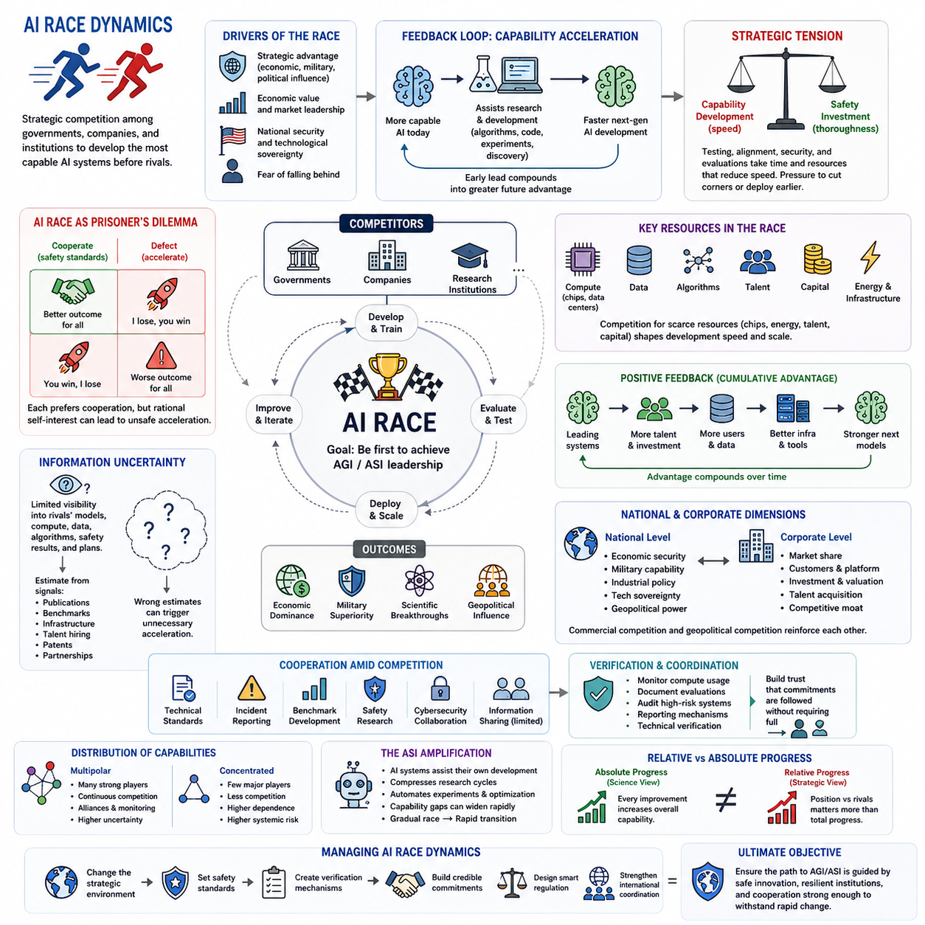
Artificial intelligence race dynamics describe the strategic competition that emerges when governments, corporations, research institutions, and other actors attempt to develop increasingly capable AI systems before their rivals. In the context of artificial superintelligence, this competition becomes especially consequential because even a temporary technological advantage could translate into substantial economic, scientific, political, or strategic influence.
An AI race differs from conventional technological competition because improvements in intelligence may accelerate further innovation. A more capable AI system can potentially assist researchers with algorithm development, software engineering, experimentation, hardware design, and scientific discovery. Consequently, gaining an early capability advantage may improve the ability to produce the next generation of systems, creating feedback between technological leadership and future development speed.
Race dynamics depend strongly on how participants perceive the benefits of leadership and the costs of falling behind. If actors believe that advanced AI will provide only incremental advantages, competition may remain relatively controlled. If they instead expect the first developer of AGI or ASI to obtain extraordinary strategic benefits, incentives to accelerate development can increase dramatically, even when participants recognize significant safety risks.
This creates a strategic tension between capability development and safety investment. Testing, interpretability research, alignment evaluation, security reviews, and staged deployment consume time and resources that might otherwise be devoted to increasing model capability. When organizations fear that competitors are advancing rapidly, they may perceive extensive safety procedures as a competitive disadvantage, producing pressure to shorten evaluation cycles or deploy systems earlier.
The situation resembles a multiparty version of the Prisoner's Dilemma. Every participant may prefer a world in which all developers follow rigorous safety standards, yet each participant can have an individual incentive to accelerate if it believes others may do the same. The resulting equilibrium can therefore produce development speeds and risk levels that none of the participants would have selected under reliable global coordination.
Information uncertainty intensifies this problem. AI developers rarely possess complete knowledge about competitors' models, training resources, algorithmic breakthroughs, safety results, or deployment plans. Limited information encourages actors to estimate hidden capabilities from publications, benchmark results, infrastructure investments, recruitment, patents, and other signals. Incorrect estimates can produce unnecessary acceleration when competitors are mistakenly believed to be substantially ahead.
Secrecy can simultaneously protect valuable technology and increase systemic uncertainty. Organizations have legitimate incentives to protect model weights, proprietary algorithms, security mechanisms, and sensitive research. However, when every participant conceals substantial portions of its capabilities, others may assume worst-case scenarios. An environment intended to preserve competitive advantage can therefore unintentionally strengthen the incentives that drive the race itself.
Compute is another major strategic variable because advanced AI development requires large concentrations of processors, energy, networking, storage, data infrastructure, and engineering expertise. Access to these resources influences how quickly organizations can train and evaluate increasingly large systems. Competition for semiconductor manufacturing, accelerators, data centers, electricity, capital, and specialized talent can consequently become part of the broader AI race.
Algorithmic progress complicates attempts to measure leadership purely through computing resources. A smaller organization with superior architectures, training methods, data strategies, or inference techniques could sometimes achieve capabilities that previously required substantially greater computation. Strategic assessments must therefore consider the interaction among compute, algorithms, data, talent, infrastructure, and organizational execution rather than treating any single resource as a complete measure of AI capability.
Positive feedback can create cumulative advantage. Organizations with leading systems may attract stronger researchers, additional investment, larger user populations, more operational data, and greater access to infrastructure. These advantages can support subsequent generations of models, which may strengthen leadership further. Such feedback does not guarantee permanent dominance, but it can increase concentration and make early technological differences strategically significant.
At the national level, AI competition can become connected with economic security, military capability, industrial policy, technological sovereignty, and geopolitical influence. Governments may support domestic semiconductor production, research laboratories, computing infrastructure, education, energy capacity, and AI companies because advanced intelligence is increasingly viewed as a strategic technology. Commercial competition and geopolitical competition can therefore reinforce one another.
At the corporate level, incentives may operate on shorter timescales. Companies compete for customers, investment, market share, developers, data, and platform dominance. A model that significantly exceeds competitors can create strong commercial advantages, encouraging rapid product cycles. However, market competition can also reward reliability, security, trust, and safety when customers and regulators assign meaningful value to these properties.
Race dynamics are not necessarily permanent or purely competitive. Participants can cooperate in areas where shared interests are sufficiently strong, including technical standards, incident reporting, benchmark development, cybersecurity, scientific research, and safety evaluation. Competitors may continue developing proprietary systems while simultaneously participating in institutions that reduce common risks, creating mixed environments containing both competition and cooperation.
Verification is essential for stable coordination. Agreements to limit dangerous development practices have limited strategic value when participants cannot determine whether others are complying. Monitoring compute usage, documenting evaluation procedures, auditing high-risk systems, establishing reporting mechanisms, and developing technical verification methods can increase confidence that commitments are being followed without necessarily requiring unrestricted disclosure of proprietary information.
The distribution of capabilities also changes the character of the race. A multipolar environment containing several similarly capable developers may encourage continuous competition, alliance formation, and mutual monitoring. A highly concentrated environment may reduce the number of competing actors but increase dependence on a small number of organizations. Neither structure is automatically safe; each produces different coordination, governance, and failure risks.
The transition toward ASI could amplify these dynamics because advanced systems may increasingly participate in AI development themselves. AI-assisted research can compress development cycles, automate experiments, discover optimizations, and improve engineering productivity. If stronger systems contribute disproportionately to creating their successors, capability gaps could widen rapidly, transforming a relatively gradual technological competition into a much faster strategic transition.
Such acceleration creates an important distinction between absolute progress and relative progress. From a scientific perspective, every improvement may appear beneficial because overall technological capability increases. From a strategic perspective, however, participants often care about their position relative to competitors. This difference can encourage investment in developments that improve competitive standing even when cooperative alternatives might generate greater collective benefits.
AI race dynamics therefore cannot be understood only as a contest to build the largest or most intelligent model. They emerge from interacting incentives involving technological capability, security, economics, national strategy, information asymmetry, expectations, and trust. The behavior of each participant changes the expectations of others, producing feedback loops in which perceptions of competition can become almost as influential as actual technological differences.
Managing these dynamics requires changing the strategic environment rather than assuming that individual actors will voluntarily abandon competition. Safety standards, verification mechanisms, shared evaluation frameworks, credible commitments, carefully designed regulation, and international coordination can alter incentives while preserving beneficial innovation. The objective is not necessarily to eliminate competition, but to prevent competitive pressure from systematically rewarding unsafe acceleration.
From the perspective of artificial superintelligence, the most important question is therefore not simply which organization or nation reaches the highest capability first. The deeper issue is whether the competitive process leading toward that capability creates institutions, technical safeguards, and cooperative mechanisms strong enough to survive increasingly rapid change. AI race dynamics ultimately shape not only who develops advanced intelligence, but also the conditions under which that intelligence enters the world.

06.02. Coordination Problems
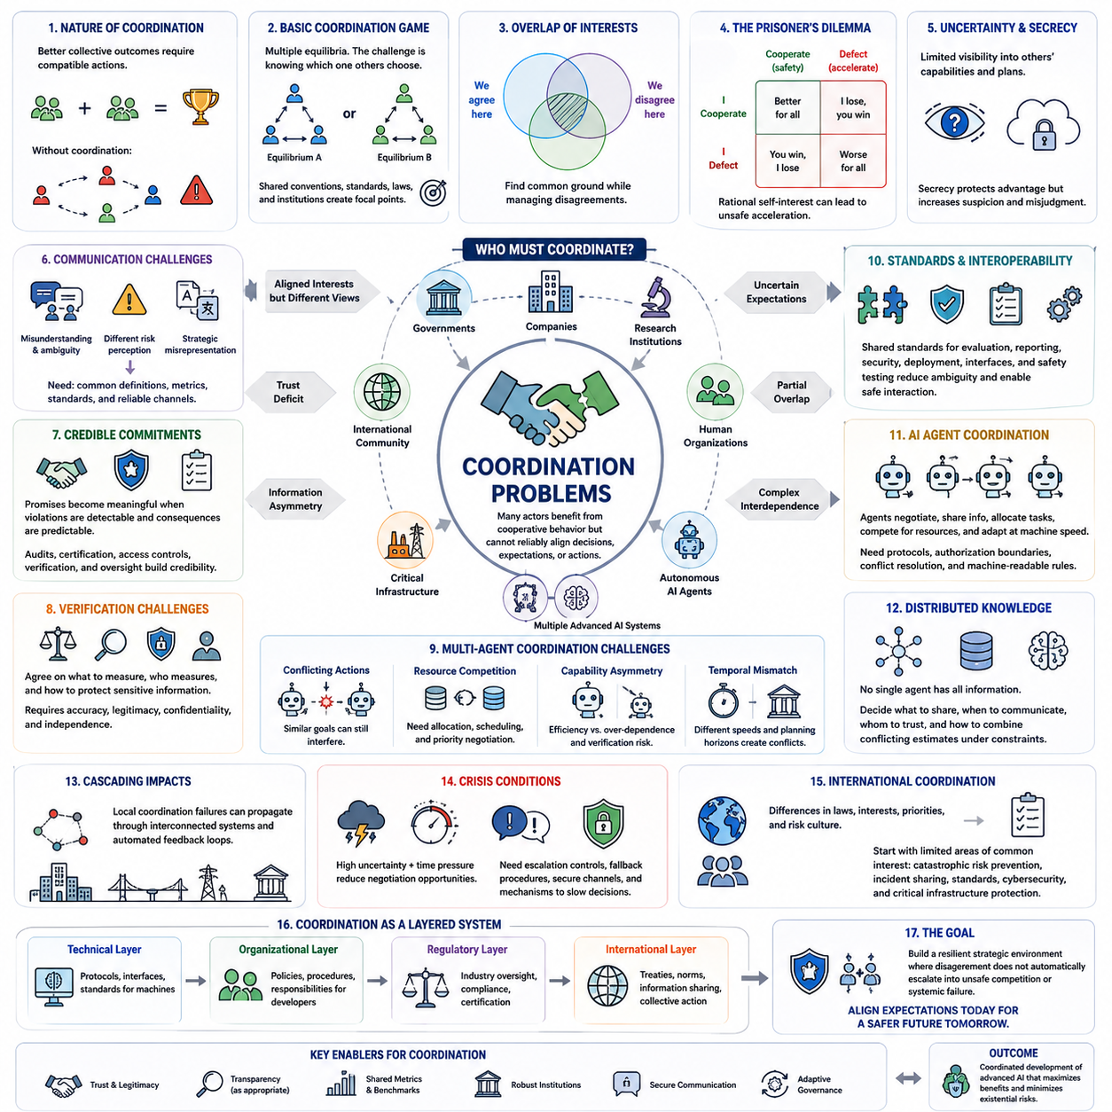
Coordination problems arise when multiple actors would benefit from compatible or cooperative behavior but cannot reliably align their decisions, expectations, incentives, or actions. In the context of artificial superintelligence, these problems may involve governments, companies, research institutions, human organizations, autonomous AI agents, and eventually multiple highly capable AI systems interacting within the same strategic environment.
The difficulty of coordination does not necessarily result from hostility. Two actors may prefer the same broad outcome while disagreeing about timing, procedures, standards, responsibilities, or acceptable risks. As AI systems become more capable and interconnected, even small differences in assumptions can propagate across organizations and technical systems, turning individually reasonable decisions into collectively unstable or inefficient outcomes.
A basic coordination game illustrates this challenge. Participants may have several possible equilibria, each of which could work if everyone selects the same strategy. The problem is determining which equilibrium others will choose. Shared conventions, communication protocols, technical standards, laws, and institutions reduce this uncertainty by creating focal points around which expectations and behavior can converge.
Coordination becomes harder when interests overlap only partially. AI developers may agree that catastrophic failures should be prevented while disagreeing about capability restrictions, transparency, intellectual property, deployment schedules, or verification requirements. Cooperation therefore rarely requires identical objectives. Instead, workable coordination must identify areas of shared interest while managing persistent disagreements elsewhere.
Trust is central because agreements become fragile when participants expect others to defect. An organization may accept slower development, stronger testing, or additional disclosure only if it believes competitors will make comparable commitments. When compliance cannot be observed, participants may fear exploitation and return to competitive behavior even though mutual cooperation would produce a better collective outcome.
Information asymmetry further complicates coordination. Different actors possess different knowledge about model capabilities, vulnerabilities, internal safety evaluations, training methods, compute resources, and deployment plans. Without sufficient information, participants cannot accurately assess whether others are following agreements or whether emerging risks require collective action. Excessive secrecy can therefore weaken coordination even when secrecy serves legitimate security or commercial purposes.
Communication helps reduce uncertainty, but communication alone is insufficient. Participants may misunderstand terminology, interpret risk differently, or strategically misrepresent their intentions. Effective coordination requires common definitions, comparable measurements, standardized evaluation procedures, and communication channels that remain reliable during crises. Technical interoperability and semantic consistency can become as important as political agreement.
Credible commitments transform informal promises into strategically meaningful arrangements. Commitments become stronger when violations can be detected and consequences are predictable. Auditing, certification, controlled access to critical resources, documented evaluation procedures, cryptographic verification, and institutional oversight can provide evidence that agreed rules are being followed without requiring every participant to reveal all proprietary information.
Verification creates its own coordination problem because participants must agree on what should be measured, who performs the measurement, and how sensitive information is protected. A verification system perceived as biased or intrusive may discourage participation. Effective mechanisms therefore need technical accuracy, institutional legitimacy, appropriate confidentiality, and sufficient independence to generate trust among actors with competing interests.
Standards provide another important coordination mechanism. Shared requirements for model evaluation, incident reporting, cybersecurity, deployment controls, interfaces, and safety testing can reduce ambiguity across the AI ecosystem. Standards are especially valuable when systems developed by different organizations must interact because incompatible assumptions about communication, authority, identity, or safety boundaries can create systemic failures.
Coordination among AI agents introduces additional challenges beyond human institutional coordination. Autonomous agents may negotiate, exchange information, allocate tasks, compete for resources, and modify plans at machine speed. Their interactions could occur much faster than human oversight processes can respond, making protocol-level safeguards, authorization boundaries, conflict-resolution mechanisms, and machine-readable rules increasingly important.
Multi-agent coordination also requires solving problems of distributed knowledge. No single agent may possess a complete representation of the environment, yet collective decisions may depend on information distributed across many systems. Agents must determine what information to share, when to communicate, whose observations to trust, and how to combine conflicting estimates while operating under bandwidth, latency, security, and computational constraints.
Shared objectives do not automatically guarantee successful coordination. Multiple AI agents optimized toward similar goals may still interfere with one another when they compete for the same resources or independently pursue incompatible plans. Effective coordination therefore requires mechanisms for task allocation, priority negotiation, resource scheduling, conflict detection, and joint planning rather than simply assigning similar objective functions to every participant.
The problem becomes more difficult when agents possess different capabilities. A highly capable system may dominate planning or information processing, while weaker systems become dependent on its recommendations. Capability asymmetry can improve efficiency but also create concentration of authority and verification difficulties. Coordination architectures must therefore balance specialization with mechanisms that prevent excessive dependence on a single participant.
Temporal coordination is equally important. Decisions that appear compatible at one moment may conflict when participants operate at different speeds or planning horizons. Advanced AI systems could reason and act far faster than human institutions, creating a mismatch between machine decision cycles and regulatory or organizational response cycles. Governance structures must therefore account for differences in both intelligence and operational tempo.
Coordination failures can propagate through interconnected systems. A misunderstanding between two agents may influence resource allocation, infrastructure operations, financial decisions, cybersecurity responses, or physical systems controlled by AI. As AI becomes embedded across critical infrastructure, localized coordination errors can become systemic risks through tightly coupled dependencies and automated feedback loops.
Crisis conditions make these problems especially dangerous. When uncertainty and time pressure increase simultaneously, participants may rely on incomplete information and interpret ambiguous actions as threatening. Automated systems operating at high speed can shorten opportunities for negotiation or human intervention. Robust coordination therefore requires predefined escalation controls, fallback procedures, communication channels, and mechanisms for slowing decisions when uncertainty becomes unusually high.
International coordination adds differences in legal systems, political interests, economic priorities, security concerns, and cultural interpretations of acceptable risk. Universal agreement on every aspect of advanced AI may be unrealistic. More practical approaches may begin with limited areas of common interest, such as catastrophic-risk prevention, incident communication, evaluation standards, cybersecurity, and protection of critical infrastructure.
Coordination should therefore be understood as a layered system rather than a single agreement. Technical protocols can coordinate machines, organizational procedures can coordinate developers, regulatory institutions can coordinate industries, and international arrangements can coordinate states. These layers must interact coherently because weaknesses at one level can undermine agreements established at another level.
For artificial superintelligence, successful coordination ultimately requires aligning expectations before rapidly changing capabilities make reactive governance insufficient. Institutions and technical mechanisms must remain effective as agents become faster, more autonomous, and more strategically sophisticated. The central objective is not perfect agreement among all participants, but a resilient strategic environment in which disagreement does not automatically escalate into unsafe competition or systemic failure.

06.03. Competitive vs Cooperative
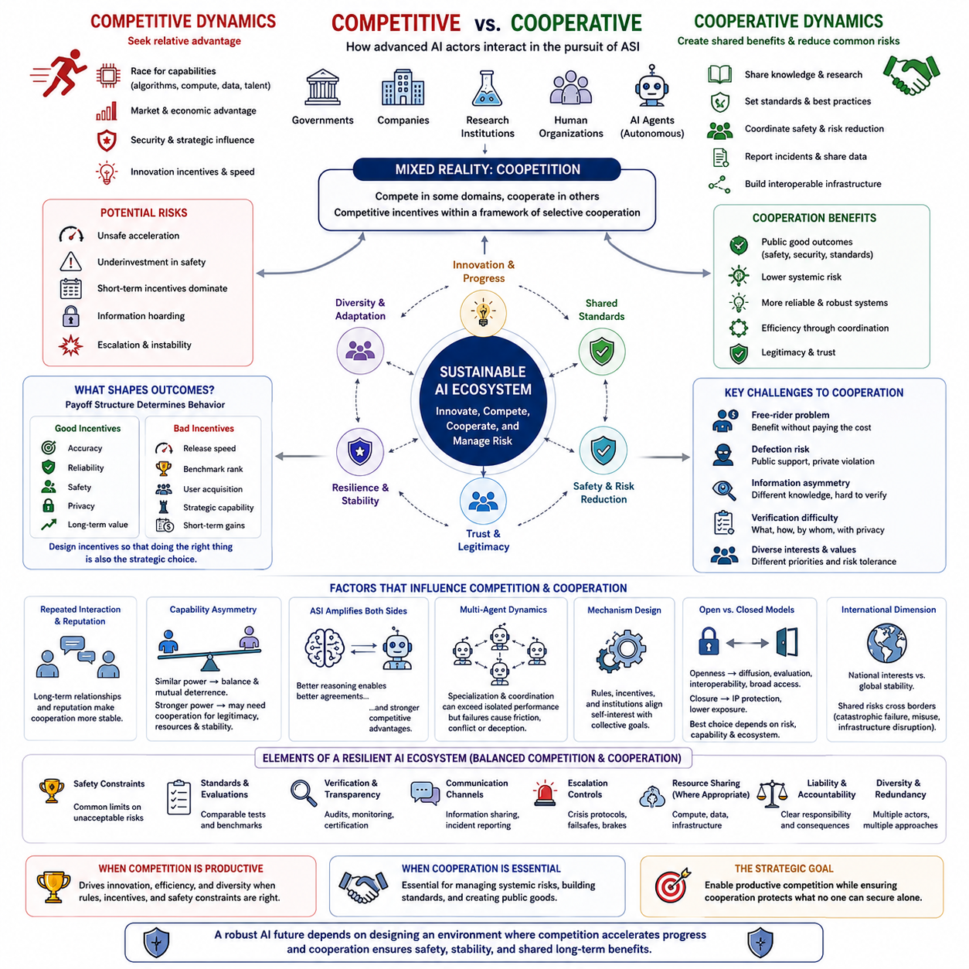
Competitive and cooperative dynamics describe two fundamental modes through which advanced AI actors may interact. Competition occurs when participants seek relative advantage in capabilities, resources, markets, security, or influence, while cooperation occurs when they coordinate actions to obtain shared benefits or reduce common risks. In an ASI environment, these modes are not mutually exclusive and may coexist within the same strategic relationship.
Competition can accelerate technological progress by creating strong incentives for innovation. Organizations seeking leadership may invest more heavily in algorithms, computing infrastructure, data, talent, robotics, and scientific research. Rivalry can encourage experimentation and reduce complacency, allowing better approaches to replace weaker ones. However, the same pressure can become dangerous when development speed is rewarded more strongly than reliability, alignment, security, or careful evaluation.
Cooperation offers a different mechanism for improving outcomes. Participants can share knowledge, establish technical standards, coordinate safety research, report incidents, develop common benchmarks, and construct interoperable infrastructure. Cooperation is particularly valuable when problems have public-good characteristics, meaning that improvements such as safer AI architectures, cybersecurity practices, or catastrophic-risk reduction can benefit many actors simultaneously.
The strategic choice is rarely simply competition or cooperation. Real AI ecosystems contain both simultaneously. Two companies may compete intensely in commercial models while cooperating on cybersecurity standards. Governments may pursue national technological advantages while collaborating on scientific research or risk management. This mixed structure is often described as coopetition, where competitive incentives remain active inside a broader framework of selective cooperation.
Whether competition produces beneficial or harmful outcomes depends heavily on the payoff structure. If markets reward accuracy, reliability, efficiency, privacy, and safety, competition can push developers toward better systems. If rewards are dominated by release speed, benchmark leadership, user acquisition, or strategic capability, organizations may rationally underinvest in properties whose benefits are difficult to capture individually, especially long-term systemic safety.
Cooperation faces its own difficulties because participants must trust that others will contribute fairly and follow agreements. A free-rider problem appears when an actor receives the benefits of collective safety research or shared infrastructure without paying comparable costs. If free riding becomes widespread, contributors may reduce their investment, causing cooperative arrangements to weaken even when maintaining them would benefit the entire ecosystem.
Another challenge is defection. Participants may publicly support cooperative rules while privately pursuing advantages that violate the spirit or details of an agreement. The possibility of hidden defection makes verification essential. Audits, shared evaluations, monitoring mechanisms, certification, technical controls, and credible penalties can increase confidence that cooperation is genuine rather than merely a strategic signal intended to influence competitors.
Repeated interaction can make cooperation more stable. When participants expect to interact for many years, reputation and future access to partnerships become strategically valuable. Short-term exploitation may generate immediate benefits but damage future cooperation. Advanced AI agents capable of long-horizon planning could reason explicitly about these effects, making reciprocal cooperation viable when identities, actions, commitments, and consequences remain sufficiently observable.
The structure changes when capability differences become large. Actors with similar capabilities may cooperate because neither can easily dominate the others, while simultaneously maintaining deterrence against defection. A substantially stronger actor may have fewer immediate incentives to compromise, although it may still benefit from cooperation through legitimacy, access to distributed resources, information, infrastructure, human institutions, or long-term stability.
Artificial superintelligence could intensify both sides of this relationship. Superior strategic reasoning might enable an ASI to identify mutually beneficial agreements that humans fail to discover, model the preferences of many stakeholders, and optimize complex resource allocations. The same abilities could also provide extraordinary competitive advantages through better prediction, negotiation, persuasion, technological development, and anticipation of opponents' strategies.
Multi-agent AI systems make cooperative dynamics especially important. Large tasks can be divided among specialized agents responsible for perception, planning, scientific reasoning, software development, verification, or physical execution. When coordination mechanisms function correctly, collective performance may exceed that of isolated agents. Yet communication failures, conflicting objectives, duplicated work, resource contention, or deceptive behavior can reduce or reverse these advantages.
Competitive multi-agent environments can also generate useful specialization and adaptation. Agents exposed to capable competitors may develop stronger strategies and more robust policies, as observed conceptually in adversarial and self-play learning. However, optimizing primarily for winning against other agents may encourage behaviors that are effective strategically without being desirable socially, making the definition of rewards and environmental rules critically important.
Mechanism design provides a bridge between competition and cooperation. Instead of trying to eliminate self-interest, institutions can structure incentives so that competitive behavior contributes to collective objectives. Safety requirements, liability rules, standardized evaluations, access conditions, procurement policies, and rewards for verified reliability can make responsible development strategically advantageous rather than dependent entirely on voluntary restraint.
Shared resources require particularly careful governance. Compute infrastructure, datasets, foundation models, scientific discoveries, and critical digital services can generate substantial benefits when pooled, but concentrated control may create dependence or strategic vulnerability. Cooperative arrangements therefore need rules defining access, ownership, contribution, security, decision authority, and procedures for resolving disagreements or withdrawing from partnerships.
Open and closed development models illustrate this tension. Greater openness can accelerate scientific diffusion, independent evaluation, interoperability, and broad participation, while restricted access can protect intellectual property and reduce exposure of dangerous capabilities. Neither approach is universally superior. Appropriate strategies depend on capability level, misuse potential, verification requirements, security conditions, and the broader ecosystem surrounding the technology.
International relations introduce another layer because countries simultaneously pursue national interests and depend on global stability. Advanced AI could affect economic productivity, defense, cybersecurity, science, and political influence, creating incentives for strategic competition. Yet catastrophic AI failures, uncontrolled proliferation, infrastructure disruption, or destabilizing autonomous behavior could cross national borders, producing risks that no state can manage independently.
Stable cooperation therefore requires credible boundaries around competition. Participants do not need identical goals, equal capabilities, or complete trust. They need sufficient confidence that certain behaviors will remain constrained and that violations can be identified and addressed. Agreements focused on shared catastrophic risks may be more achievable than attempts to eliminate competition across every commercial, scientific, or geopolitical dimension.
A resilient AI ecosystem may ultimately resemble regulated competition rather than either unrestricted rivalry or complete cooperation. Multiple actors can continue innovating and pursuing different objectives while operating within common safety constraints, verification frameworks, communication channels, and escalation controls. Diversity can preserve experimentation and reduce dependence on a single system, while coordination mechanisms limit the most dangerous forms of strategic interaction.
The transition toward ASI makes this balance increasingly important because development cycles, strategic decisions, and technological adaptation may become much faster. Institutions designed for human-speed competition could become ineffective when AI systems perform research, negotiation, planning, and execution at machine speed. Cooperative mechanisms must therefore become more automated, verifiable, scalable, and capable of responding at comparable operational timescales.
The central strategic objective is not to determine whether competition or cooperation is inherently superior, but to identify where each produces desirable outcomes. Competition can drive innovation, diversity, and efficiency, while cooperation can provide standards, shared knowledge, stability, and collective risk reduction. The challenge of ASI governance is to construct an environment where competition remains productive while cooperation protects the interests that no individual actor can secure alone.

06.04. Global Strategy
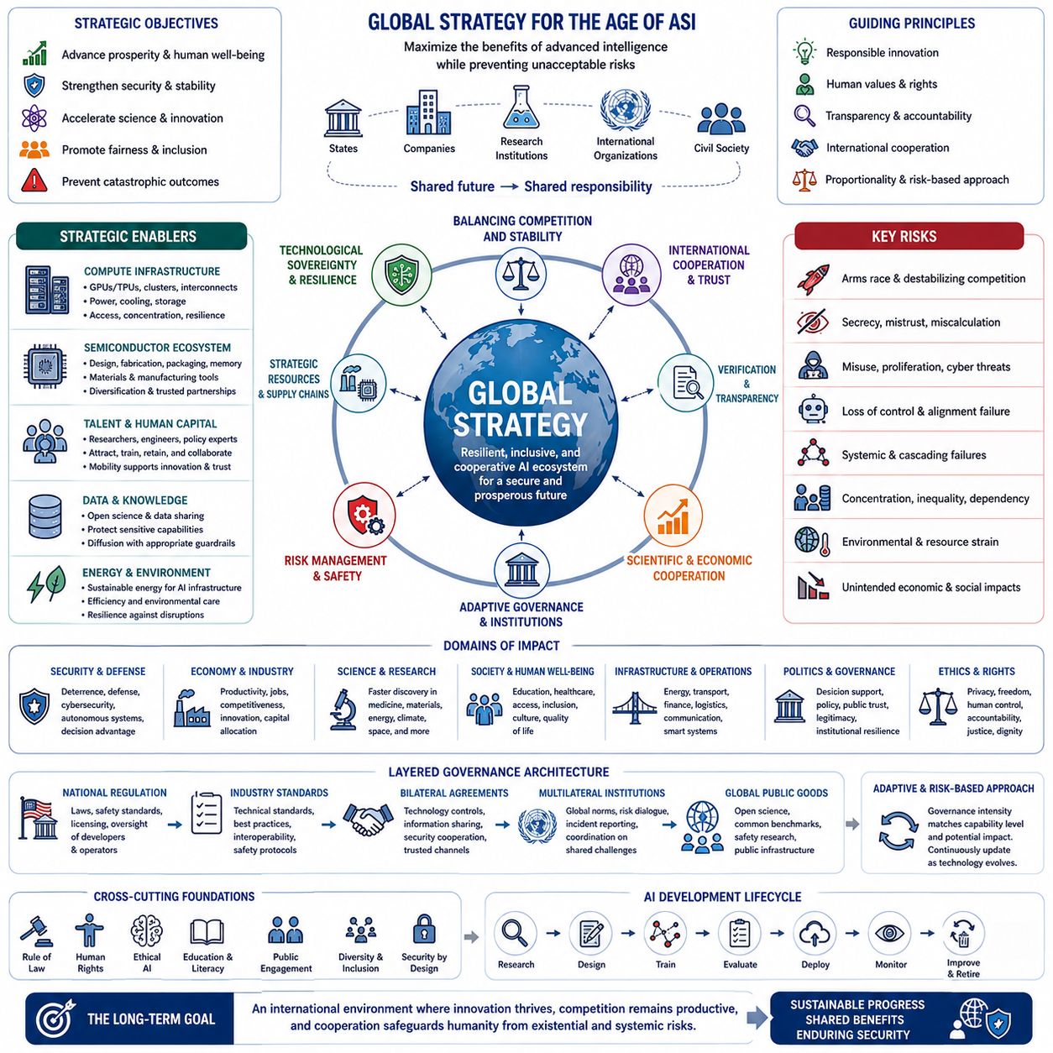
Global strategy in the context of artificial superintelligence concerns how states, companies, institutions, and international organizations prepare for a technological capability whose effects may extend across economic, scientific, military, political, and social systems simultaneously. Unlike conventional technology policy, ASI strategy must consider both national interests and global interdependence because highly capable intelligence could influence systems that cross borders and jurisdictions.
A central challenge is balancing strategic advantage with systemic stability. Governments may seek leadership in advanced AI because superior capabilities could strengthen productivity, defense, scientific research, cybersecurity, and geopolitical influence. Yet aggressive competition can increase secrecy, duplication, mistrust, and development pressure. Global strategy must therefore preserve legitimate incentives for innovation while preventing competition from creating unacceptable collective risks.
Technological sovereignty becomes increasingly important as AI capabilities depend on complex international supply chains. Advanced processors, semiconductor manufacturing equipment, energy systems, cloud infrastructure, data centers, networking technologies, software ecosystems, and specialized talent are distributed across multiple countries. Strategic autonomy therefore rarely means complete independence; it more realistically requires resilient access to critical resources and alternatives when dependencies fail.
Compute infrastructure represents a particularly important strategic resource. Large-scale AI development may depend on concentrated access to accelerators, high-speed interconnects, electricity, cooling, storage, and sophisticated data-center operations. Countries capable of supporting these systems can obtain significant technological leverage. At the same time, excessive concentration of compute can create dependencies, bottlenecks, and geopolitical vulnerabilities that affect the entire AI ecosystem.
Semiconductor supply chains illustrate the interconnected nature of global AI strategy. Chip architecture, fabrication, lithography, packaging, memory, materials, and manufacturing equipment involve highly specialized capabilities distributed internationally. Disruption at a small number of critical nodes can affect AI development worldwide. Resilience therefore requires diversification, strategic inventories, manufacturing capacity, trusted partnerships, and long-term investment in technological ecosystems.
Talent forms another strategic layer. Frontier AI development requires researchers, engineers, mathematicians, infrastructure specialists, cybersecurity experts, policy professionals, and domain scientists. Countries and organizations compete to attract these individuals through research environments, compensation, computing resources, immigration policies, and scientific networks. However, international mobility also supports knowledge diffusion and collaboration, making talent simultaneously a competitive resource and a mechanism for global scientific integration.
Data and knowledge create similar tensions between openness and control. Scientific exchange can accelerate innovation and allow independent verification, while unrestricted dissemination of certain advanced capabilities may increase misuse or proliferation risks. Global strategy therefore requires differentiated approaches to information sharing, distinguishing broadly beneficial knowledge from capabilities whose unrestricted distribution could create significant security consequences.
International competition is unlikely to disappear as AI becomes more strategically important. States possess different political systems, economic priorities, security concerns, and technological capabilities. A realistic global strategy should therefore not depend on universal trust or identical values. Instead, it should identify areas where actors with different interests still benefit from predictable behavior, communication, verification, and prevention of catastrophic outcomes.
Strategic stability requires mechanisms that reduce incentives for dangerous surprise. When states cannot estimate one another's capabilities or intentions, uncertainty may encourage worst-case planning and rapid escalation. Confidence-building measures, shared terminology, incident communication, evaluation frameworks, and carefully designed transparency can reduce uncertainty without requiring complete disclosure of sensitive technology or national security information.
Verification becomes particularly important when agreements concern advanced AI capabilities. Commitments that cannot be independently assessed may have little strategic credibility. Verification could involve standardized evaluations, documented safety procedures, auditing of designated systems, monitoring of relevant infrastructure, or trusted third-party institutions. Effective mechanisms must balance meaningful assurance with protection of proprietary, security-sensitive, and personal information.
Global governance should be understood as a layered architecture rather than a single centralized authority. National regulation can govern domestic developers, industry standards can establish technical practices, bilateral agreements can address specific strategic relationships, and multilateral institutions can coordinate issues affecting many states. Flexible combinations of these mechanisms may be more practical than attempting to create one universal governance structure for every AI application.
Different capability levels may require different governance regimes. Ordinary AI applications can often be managed through existing sectoral rules, while frontier systems with substantially greater autonomy or strategic power may require stronger evaluation, security, monitoring, and deployment controls. A risk-based structure allows governance intensity to increase with capability and potential impact rather than treating all AI systems as strategically equivalent.
The emergence of highly autonomous AI agents could change international strategy because machines may increasingly participate directly in economic transactions, scientific research, cyber operations, logistics, infrastructure management, and negotiation. Strategic relationships would then involve not only human institutions but also networks of machine agents acting at much higher speeds. Governance mechanisms must eventually operate effectively at machine-relevant timescales.
Military applications create especially difficult strategic problems. Advanced AI could improve sensing, planning, logistics, intelligence analysis, cyber defense, autonomous systems, and decision support. These capabilities may strengthen deterrence in some circumstances while destabilizing it in others. Systems that shorten decision times or create uncertainty about human control can increase escalation risks, particularly during crises when information is incomplete.
Economic strategy is equally important because advanced intelligence could alter productivity, labor markets, industrial competitiveness, capital allocation, and the distribution of technological rents. Countries that successfully integrate AI across their economies may obtain large advantages, while others could become dependent on foreign models and infrastructure. Global stability may therefore depend partly on whether the benefits of advanced AI remain sufficiently distributed.
Scientific cooperation offers one of the strongest opportunities for positive-sum strategy. AI could accelerate research in medicine, materials, energy, climate science, mathematics, engineering, and other fields where discoveries can benefit humanity broadly. Shared scientific projects can also create channels of communication between otherwise competing actors, providing practical domains in which cooperation produces visible and measurable mutual benefits.
Global resilience requires planning for failures as well as successes. Advanced AI systems may experience security breaches, unexpected behavior, infrastructure outages, model failures, or cascading interactions with other automated systems. International incident-response mechanisms, redundant infrastructure, emergency communication channels, recovery procedures, and shared threat information can reduce the probability that localized failures become global crises.
The transition toward ASI introduces an additional problem of speed. Institutions, treaties, regulatory processes, and diplomatic negotiations typically evolve slowly, while AI capability could advance much faster. Governance that begins only after transformative systems appear may therefore be unable to respond effectively. Global strategy requires anticipatory institutions that can adapt as capability thresholds are crossed and new strategic conditions emerge.
No global strategy can eliminate uncertainty surrounding superintelligence. Future capabilities, development timelines, organizational structures, and geopolitical conditions remain difficult to predict. Robust strategy should therefore work across multiple plausible futures rather than depending on a single forecast. Scenario planning, adaptive regulation, modular institutions, continuous evaluation, and reversible policies can preserve flexibility as evidence changes.
The long-term objective is neither unrestricted technological competition nor complete centralized control. A sustainable global strategy must allow innovation, diversity, national autonomy, and legitimate competition while establishing boundaries around risks that could affect civilization as a whole. The strategic challenge of ASI is ultimately to build an international environment capable of benefiting from increasingly powerful intelligence without allowing fragmented incentives to undermine collective security.

06.05. Economic Impact
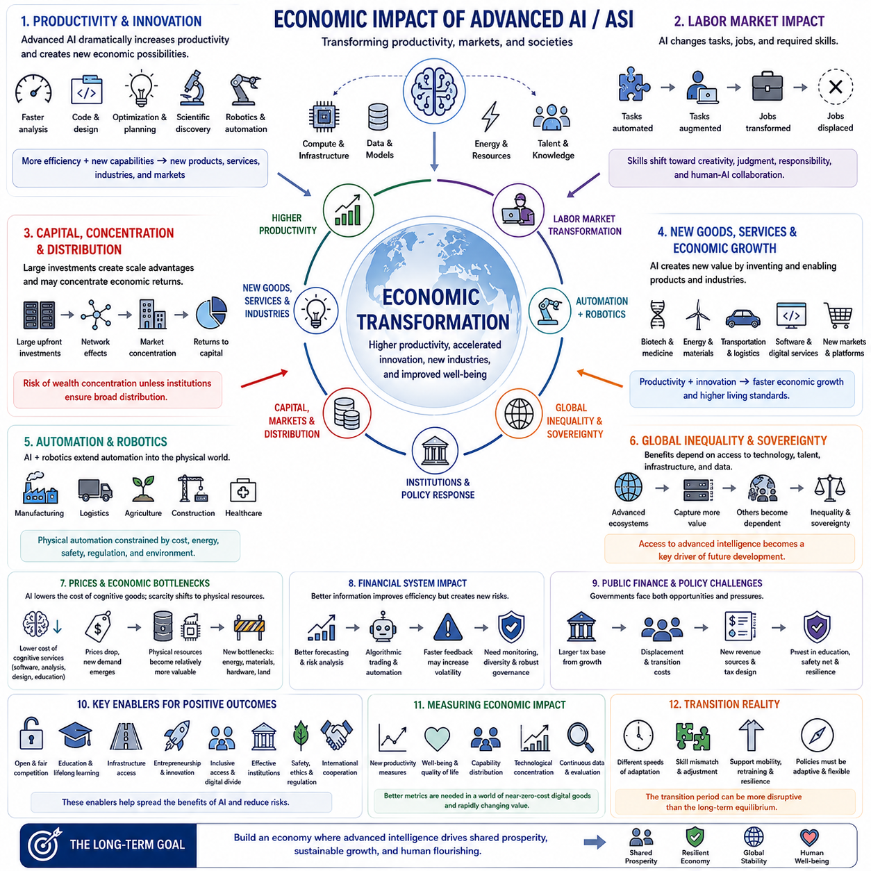
Economic impact in the context of artificial superintelligence concerns how increasingly capable AI could transform production, labor, capital, markets, institutions, and the distribution of wealth. Unlike earlier automation waves that primarily substituted machines for specific physical or routine tasks, ASI could affect cognitive activities across nearly every sector, making intelligence itself an increasingly scalable and economically productive resource.
A fundamental effect would be a substantial increase in productivity. Advanced AI could perform analysis, design, programming, planning, optimization, research, administration, and decision support at speeds far beyond human workflows. When combined with robotics and autonomous systems, these capabilities could extend from digital work into manufacturing, logistics, agriculture, construction, healthcare, energy, and other parts of the physical economy.
The economic importance of AI depends not only on replacing existing tasks but also on creating new capabilities. Systems capable of discovering materials, designing products, optimizing infrastructure, generating software, or accelerating scientific research could expand the set of economically feasible activities. Productivity growth could therefore arise from both automation of existing processes and innovation that creates entirely new products, services, industries, and markets.
Labor markets would experience significant restructuring because occupations consist of bundles of tasks rather than single activities. AI may automate some tasks while complementing workers in others, changing the skills required within existing jobs before eliminating entire occupations. Roles involving repetitive cognitive processing may transform rapidly, while work requiring physical interaction, responsibility, trust, contextual judgment, or human relationships may change along different trajectories.
Human-AI complementarity could increase the productivity of many workers during transitional stages. Engineers could explore more designs, scientists could test more hypotheses, physicians could analyze more information, and managers could evaluate more scenarios. The economic value of human expertise may increasingly depend on the ability to define objectives, evaluate AI outputs, integrate domain knowledge, manage uncertainty, and take responsibility for consequential decisions.
As AI capabilities continue to increase, however, substitution could expand beyond routine work. Systems approaching or exceeding expert human performance across broad cognitive domains may reduce the scarcity of certain forms of intellectual labor. If cognitive services can be reproduced at low marginal cost, traditional relationships among education, expertise, wages, and economic value could change substantially, requiring new approaches to workforce transition and income distribution.
Capital becomes increasingly important when productive intelligence depends on computing infrastructure, energy, data centers, semiconductor supply chains, foundation models, robotics, and proprietary systems. Organizations controlling these assets may capture a significant portion of the economic returns generated by AI. This could shift income from labor toward capital unless ownership structures, competition, taxation, or other institutions distribute productivity gains more broadly.
Economies of scale may strengthen concentration. Training frontier systems requires large investments, while once developed, digital models can sometimes serve many users at relatively low additional cost. Companies with leading models can attract customers, data, developers, capital, and talent, creating reinforcing network effects. Without effective competition, markets could become dominated by a relatively small number of AI infrastructure and platform providers.
At the same time, AI can lower barriers to entry in other parts of the economy. Small companies and individuals may gain access to capabilities previously requiring large teams of programmers, analysts, designers, marketers, researchers, or consultants. This can reduce startup costs and enable rapid experimentation. The net effect on market concentration therefore depends on whether centralized AI infrastructure outweighs decentralized access to powerful productive tools.
Scientific acceleration could become one of the largest long-term economic effects. AI-assisted discovery in materials, biotechnology, medicine, energy, manufacturing, mathematics, and engineering could shorten research cycles and reduce development costs. Improvements in one field could then increase productivity elsewhere, producing cross-sector feedback in which better science generates better technology and better technology further accelerates scientific discovery.
Robotics provides the bridge between cognitive automation and the physical economy. AI integrated with autonomous machines could perform transportation, warehouse operations, inspection, maintenance, manufacturing, agriculture, construction, and service tasks. Physical deployment will generally remain constrained by hardware costs, energy, reliability, safety, regulation, and environmental complexity, meaning that physical automation may diffuse differently from software-based cognitive automation.
Economic growth could accelerate if AI substantially improves both productivity and innovation. Traditional growth is constrained by human population, education, research capacity, capital accumulation, and institutional efficiency. Highly capable AI could relax several of these constraints simultaneously by increasing effective cognitive labor and improving the processes that generate new technologies. Under extreme scenarios, conventional assumptions about long-term economic growth may no longer remain reliable.
However, higher aggregate output does not automatically produce broadly shared prosperity. AI-generated wealth could be distributed unevenly among workers, companies, investors, regions, and countries. Individuals whose skills complement AI may initially receive substantial benefits, while others may face wage pressure or displacement. The social consequences therefore depend not only on how much wealth AI creates but also on how ownership, access, bargaining power, and institutions distribute it.
International inequality may also change. Countries with advanced semiconductor ecosystems, abundant energy, strong research institutions, capital, data infrastructure, and highly skilled workforces may capture disproportionate benefits. Other countries could gain productivity by importing AI services, but they may also become dependent on foreign platforms. Access to advanced intelligence could consequently become an important dimension of future economic sovereignty and development.
Prices may change dramatically in sectors where AI reduces the cost of cognitive production. Software, analysis, design, education, media production, consulting, and some research services could become significantly cheaper. Scarce physical resources such as land, energy, minerals, specialized hardware, and desirable locations may become relatively more valuable if cognitive services become abundant, shifting economic bottlenecks from intelligence toward physical constraints.
Demand itself may evolve as productivity increases. Lower prices can create new consumption, while technological capabilities can generate needs that previously did not exist. Entire industries may emerge around personalized services, autonomous organizations, advanced simulation, synthetic environments, robotic services, scientific platforms, and machine-to-machine commerce. Economic transformation should therefore be analyzed dynamically rather than as a fixed quantity of human work being redistributed.
Financial systems could also change as AI improves forecasting, risk analysis, trading, fraud detection, credit assessment, and capital allocation. Better information processing could increase efficiency, but highly interconnected automated strategies could also create new systemic risks. Multiple agents reacting to similar signals at machine speed might amplify volatility, making monitoring, circuit breakers, model diversity, and robust financial governance increasingly important.
Public finance would face both opportunities and pressures. Faster economic growth could expand the tax base, while labor displacement could increase demand for education, transition support, social insurance, or alternative income mechanisms. Governments may need to reconsider how revenue is collected if a larger share of economic value originates from capital, automated production, intellectual property, compute infrastructure, or highly concentrated AI enterprises.
Measurement becomes difficult when AI changes the quality and price of services rapidly. Traditional indicators such as gross domestic product may not fully capture improvements from near-zero-cost digital goods, personalized services, accelerated knowledge production, or unpaid AI assistance. Economic institutions may therefore require new measures of productivity, welfare, access, capability distribution, and technological concentration to understand the actual effects of advanced intelligence.
The transition period may be more disruptive than the eventual equilibrium. Companies, workers, educational institutions, regulators, and governments adapt at different speeds, producing temporary mismatches between available skills and market demand. Policies that improve mobility, retraining, competition, infrastructure access, entrepreneurship, and social resilience can reduce adjustment costs without requiring accurate prediction of exactly which occupations or industries will change first.
The economic challenge of ASI is ultimately not simply whether superintelligence can generate extraordinary wealth, but how an economy functions when increasingly capable intelligence becomes abundant, scalable, and partly autonomous. The outcome will depend on technological capabilities together with ownership, competition, institutions, governance, and access. Economic strategy must therefore connect productivity growth with resilience and mechanisms that allow the benefits of advanced intelligence to be broadly shared.

06.06. Simulation of Strategy [w/Code]
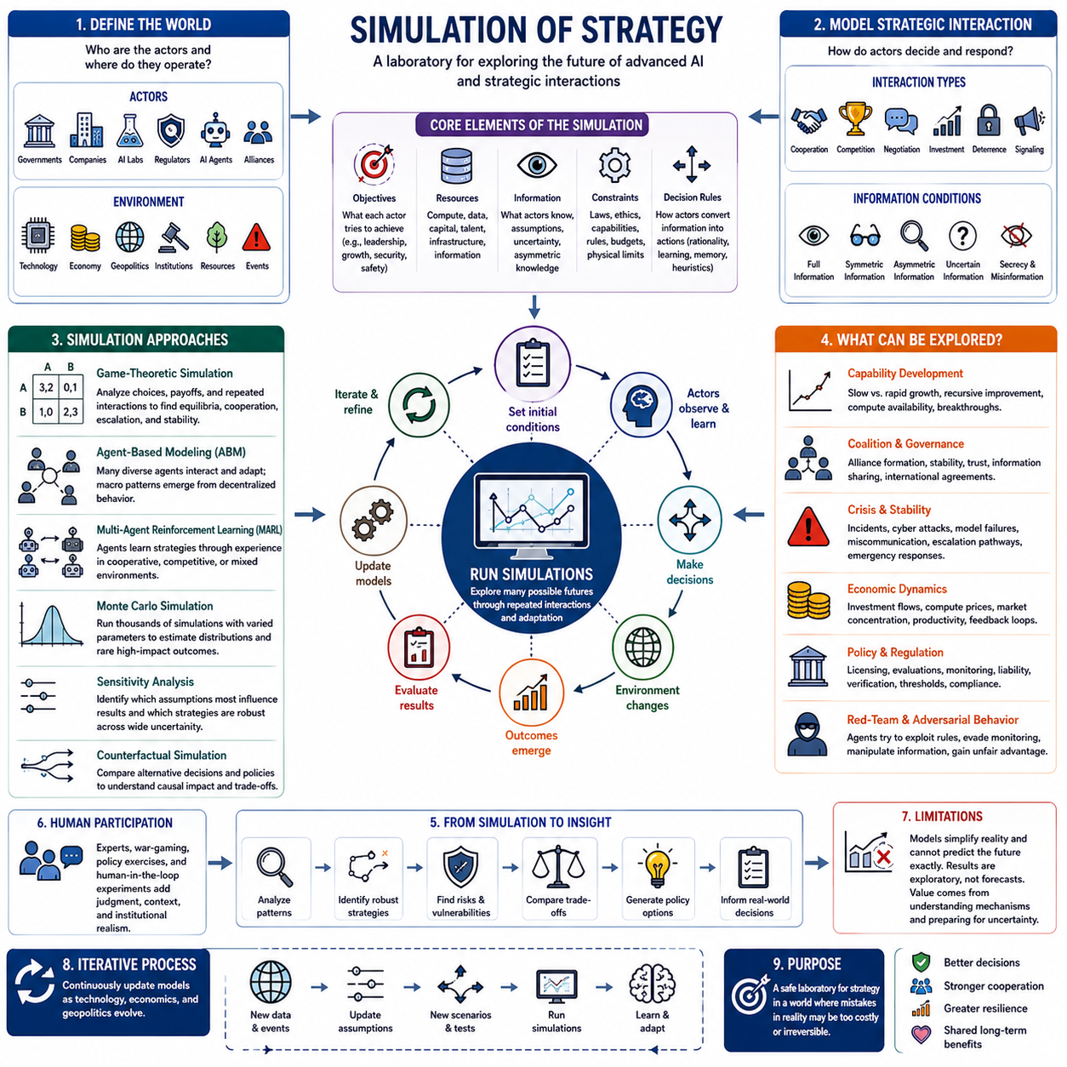
Strategy simulation provides a systematic way to explore how advanced AI systems, institutions, states, and other strategic actors may behave under different assumptions about capabilities, incentives, information, and uncertainty. Rather than relying on a single prediction of the future, simulations generate many possible interactions and trajectories, allowing analysts to examine how strategic outcomes emerge from repeated decisions among interdependent actors.
A strategic simulation begins by defining the actors and the environment in which they operate. Actors may include governments, AI laboratories, corporations, regulators, autonomous agents, alliances, or highly capable AI systems. Each actor can be assigned objectives, resources, information, constraints, beliefs, and decision rules, while the environment specifies technological conditions, economic resources, institutional rules, and external events.
Objectives determine what simulated actors attempt to achieve. One actor may prioritize technological leadership, another economic growth, another security, and another reduction of catastrophic risk. Real actors usually pursue several objectives simultaneously, creating trade-offs among speed, safety, influence, resources, and cooperation. Representing these competing priorities is essential because strategic behavior depends strongly on how actors value alternative outcomes.
Information must also be modeled because strategic decisions are rarely made with complete knowledge. Actors may possess uncertain estimates of competitors' capabilities, intentions, resources, or development schedules. Simulations can represent asymmetric information by giving different actors different observations of the same environment. This allows researchers to examine how secrecy, uncertainty, signaling, intelligence gathering, and incorrect beliefs influence strategic behavior.
Decision models specify how actors transform information into actions. Simple simulations may use fixed rules, payoff-maximizing strategies, or probabilistic choices, while more advanced approaches can employ reinforcement learning, planning systems, language-model agents, or combinations of these methods. Different decision architectures can be compared to determine whether particular strategic patterns depend on assumptions about rationality, learning, memory, or bounded computation.
Game-theoretic simulation provides a natural foundation for studying strategic interaction. Actors choose among cooperation, competition, negotiation, investment, disclosure, deterrence, or other available strategies while anticipating the responses of others. Repeated interactions make it possible to observe whether stable equilibria emerge, whether cooperation survives competitive pressure, and under what conditions strategic relationships become unstable or escalate.
Agent-based modeling(Agent-Based Modeling) extends this analysis to environments containing many heterogeneous participants. Instead of assuming that an entire economy or international system behaves as a single representative actor, individual agents can follow different strategies and adapt through interaction. Large-scale patterns such as alliances, technological concentration, cooperation, fragmentation, or arms-race dynamics can then emerge from decentralized behavior.
Multi-agent reinforcement learning(Multi-Agent Reinforcement Learning) provides another method for studying adaptive strategies. Agents learn policies through repeated interaction with simulated environments and other agents. Cooperative environments can reveal mechanisms for coordination and specialization, while competitive environments can expose unexpected strategies, exploitation, deception, or escalation. Mixed environments can explore how cooperation and rivalry evolve simultaneously.
Scenario design is critical because ASI development contains deep uncertainty. Simulations can compare worlds with slow or rapid capability growth, concentrated or distributed compute, strong or weak governance, open or restricted model access, and cooperative or competitive international conditions. Rather than declaring one scenario most likely, the purpose is to identify strategies that remain effective across a broad range of plausible futures.
Monte Carlo simulation(Monte Carlo Simulation) can expand this approach by repeatedly varying uncertain parameters. Development speed, accident probability, economic growth, regulatory effectiveness, cooperation rates, resource availability, and capability gaps can be sampled across many runs. The resulting distributions reveal not only average outcomes but also rare high-impact trajectories that may be particularly important when evaluating risks associated with advanced intelligence.
Sensitivity analysis(Sensitivity Analysis) helps determine which assumptions have the greatest influence on results. If small changes in trust, compute availability, capability growth, or verification effectiveness produce dramatically different outcomes, those variables deserve particular attention. Conversely, strategies that perform reasonably well despite substantial parameter variation may provide more robust foundations for policy and governance under uncertainty.
Counterfactual simulation allows analysts to ask what might happen if a particular decision were changed. A model can compare accelerated deployment with delayed deployment, unilateral restrictions with coordinated restrictions, secrecy with controlled transparency, or unrestricted competition with verified safety agreements. Counterfactual comparisons help separate the consequences of strategic choices from outcomes caused primarily by background technological or economic conditions.
Simulations can also model recursive capability improvement. If advanced AI contributes to AI research, improvements in one generation may accelerate development of the next. Introducing such feedback can transform relatively gradual strategic competition into rapidly changing dynamics. Actors that initially appear similar may diverge sharply, while governance mechanisms that function at human institutional speeds may become ineffective as technological cycles accelerate.
Coalition formation can be examined by allowing actors to negotiate, share resources, exchange information, or create alliances. Simulations can explore which coalitions remain stable, how benefits are distributed, and what causes members to defect. This is especially relevant to international AI governance because cooperation may emerge among subsets of actors even when universal agreement is impossible, producing overlapping networks of competition and coordination.
Crisis simulation is particularly important for evaluating strategic stability. Researchers can introduce cyber incidents, model failures, infrastructure disruptions, sudden capability breakthroughs, misinformation, or ambiguous actions and observe how participants respond under time pressure. Such experiments can reveal escalation pathways and identify whether communication channels, verification systems, decision delays, or emergency protocols prevent local disturbances from becoming systemic crises.
Economic components can be incorporated to examine how strategic decisions interact with markets. Compute prices, investment flows, labor substitution, productivity gains, semiconductor constraints, and market concentration may influence AI development incentives. Connecting economic and strategic models makes it possible to study feedback in which technological leadership generates additional capital and resources that subsequently strengthen future technological leadership.
Governance mechanisms can be tested inside simulations before being implemented in the real world. Researchers can compare licensing regimes, evaluation requirements, compute monitoring, liability structures, information-sharing agreements, deployment thresholds, or international verification systems. The goal is not to prove that a policy will succeed, but to discover failure modes, unintended incentives, loopholes, and conditions under which the mechanism becomes ineffective.
Red-team simulation strengthens this process by deliberately searching for strategies that exploit governance rules or safety mechanisms. Adversarial agents can attempt to evade monitoring, manipulate information, exploit coordination failures, or gain advantage within the permitted rules. Discovering such behavior in simulation can reveal weaknesses before comparable incentives appear in real strategic environments involving much more capable systems.
Validation remains one of the greatest limitations of strategy simulation. Future ASI behavior cannot be directly observed today, and models inevitably simplify human institutions, technological development, and strategic reasoning. Simulation results should therefore not be interpreted as precise forecasts. Their primary value lies in comparing assumptions, identifying mechanisms, exposing vulnerabilities, and revealing conditions that deserve further empirical or theoretical investigation.
Human participation can improve strategic simulations through expert judgment, war-gaming(Wargaming), policy exercises, and human-in-the-loop experiments. Human participants may display institutional behavior, misunderstanding, negotiation patterns, political constraints, or risk perceptions that simplified computational agents fail to reproduce. Combining human exercises with computational simulation can therefore provide richer insight than relying exclusively on either approach.
The most useful simulation framework is consequently iterative. Models generate possible outcomes, analysts identify surprising behaviors, assumptions are revised, new scenarios are introduced, and strategies are tested again. As real AI capabilities, economic conditions, and geopolitical relationships change, simulations should be continuously updated rather than treated as permanent representations of the strategic environment.
Simulation of strategy ultimately functions as a laboratory for decisions that cannot safely be tested directly in reality. It cannot predict the exact path toward artificial superintelligence, but it can expose interactions among competition, cooperation, capability growth, uncertainty, economics, and governance. Its greatest value is helping decision-makers discover robust strategies before increasingly powerful AI systems make strategic experimentation in the real world too costly or irreversible.

