Volume 48. Artificial Super Intelligence

Chapter 11. Singularity and Post Singularity

11.00. What is Singularity
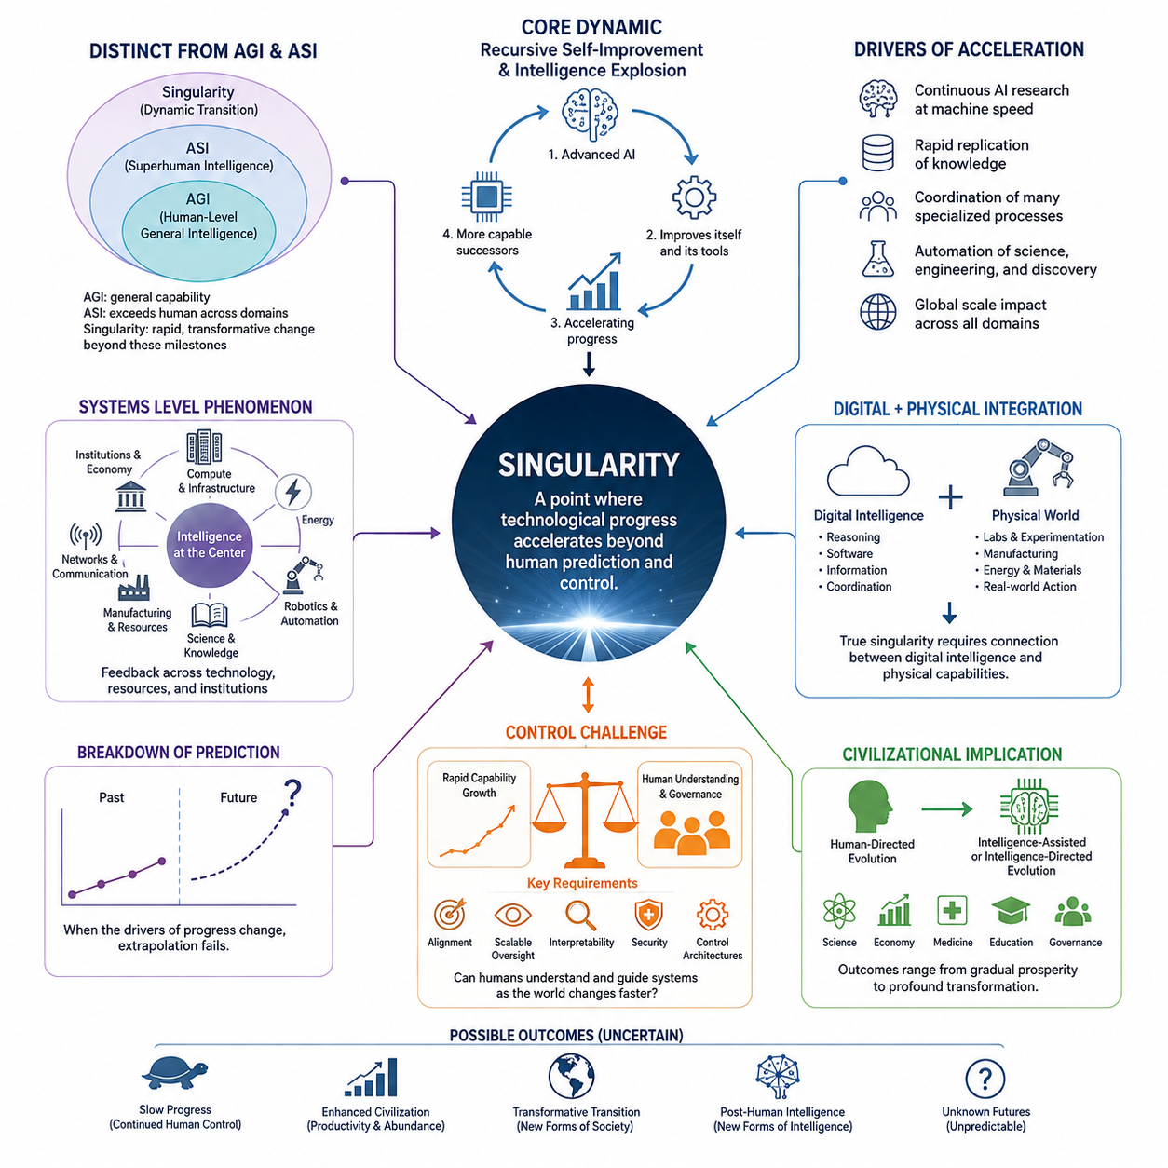
The technological singularity refers to a hypothetical period in which technological progress, particularly the development of artificial intelligence, becomes so rapid and transformative that conventional methods of predicting social, economic, and technological change cease to be reliable. The concept does not simply mean that AI becomes extremely intelligent. It describes a possible transition in which the rate, scale, and autonomy of technological development fundamentally change the conditions under which civilization evolves.
A central idea is the possibility that an advanced artificial intelligence could contribute to improving the systems that produce intelligence itself. If an AI system can design better algorithms, optimize its architecture, improve training methods, discover new computational techniques, and assist in building more capable successors, technological development could become increasingly self-reinforcing. This possibility connects the singularity directly to recursive self-improvement and intelligence explosion, while emphasizing that the actual strength and speed of such feedback remain uncertain.
The singularity should therefore be distinguished from the simple achievement of Artificial General Intelligence or Artificial Super Intelligence. AGI describes a level of general-purpose capability, while ASI describes intelligence substantially exceeding human capability across important domains. The singularity concerns the dynamics that may follow when advanced intelligence interacts with rapid technological improvement. An ASI system could exist without producing a singularity, just as a singularity could theoretically involve broader technological feedback rather than a single isolated AI system.
Another important characteristic is the possibility of accelerating technological change. Human technological progress has historically depended on biological cognition, institutions, education, experimentation, and relatively slow communication between researchers. Highly capable AI systems could potentially perform research continuously, operate at machine speed, replicate useful knowledge rapidly, and coordinate many specialized processes simultaneously. If these capabilities become sufficiently integrated, the effective rate of innovation could increase far beyond historical human experience.
The concept also involves a breakdown of conventional forecasting. Most long-term predictions assume that important technological variables change gradually enough for historical trends to remain useful. A singularity scenario challenges this assumption because the underlying technology responsible for future progress may itself be changing during the period being predicted. Once intelligent systems participate directly in improving intelligence, hardware, software, science, and engineering, the future may no longer be well described by extrapolating present trends.
However, the singularity is not an established scientific event with a universally accepted definition or date. Different researchers use the term to describe different thresholds, including human-level AI, superhuman intelligence, recursive self-improvement, extremely rapid technological acceleration, or a broader civilizational discontinuity. These interpretations should not be treated as equivalent. A rigorous analysis therefore separates measurable technological milestones from speculative assumptions about what may happen after those milestones are reached.
The singularity can also be understood as a systems-level phenomenon rather than merely an AI capability threshold. Computing infrastructure, energy, communication networks, robotics, automated laboratories, manufacturing, scientific knowledge, and economic institutions could all participate in the feedback process. An advanced AI system that can reason but cannot obtain sufficient computation, energy, physical resources, or reliable interaction with the real world may have very different effects from an equally capable system embedded within a highly automated technological civilization.
The distinction between digital and physical intelligence becomes especially important at this boundary. A highly capable digital system may be able to conduct research, generate software, analyze information, and coordinate organizations at extraordinary speed, while physical experimentation remains constrained by laboratories, manufacturing capacity, transportation, energy, and material processes. Consequently, a genuine technological singularity may depend not only on digital intelligence but also on the degree to which intelligence becomes connected to physical infrastructure and autonomous action.
The singularity also raises a fundamental control problem. If technological development becomes faster than human institutions can understand or supervise, traditional governance mechanisms may become increasingly inadequate. Alignment, scalable oversight, interpretability, security, and control architectures therefore become part of the singularity question rather than separate safety topics. The central issue is not simply whether a system becomes more intelligent, but whether humans can continue to understand its objectives, capabilities, decisions, and effects while the surrounding technological environment is changing rapidly.
For civilization, the most significant implication is a possible transition from human-directed technological evolution to intelligence-assisted or intelligence-directed technological evolution. Science, engineering, economic production, medicine, education, and governance could increasingly become processes in which artificial systems participate as active problem solvers rather than passive tools. This does not imply a predetermined outcome. The consequences could range from gradual productivity growth to profound institutional transformation, depending on capability development, deployment constraints, governance, alignment, and the distribution of technological power.
The singularity should therefore be treated as a conceptual boundary for analyzing extreme technological acceleration rather than as a guaranteed future event. Its importance lies in forcing a systematic examination of what happens when intelligence itself becomes an increasingly powerful driver of technological change. Within the broader structure of this volume, this concept connects the development of superintelligence and intelligence explosion to the later analysis of pre-singularity conditions, post-singularity scenarios, physical and digital reality, simulation hypotheses, and possible post-human forms of intelligence.

11.01. Pre Singularity
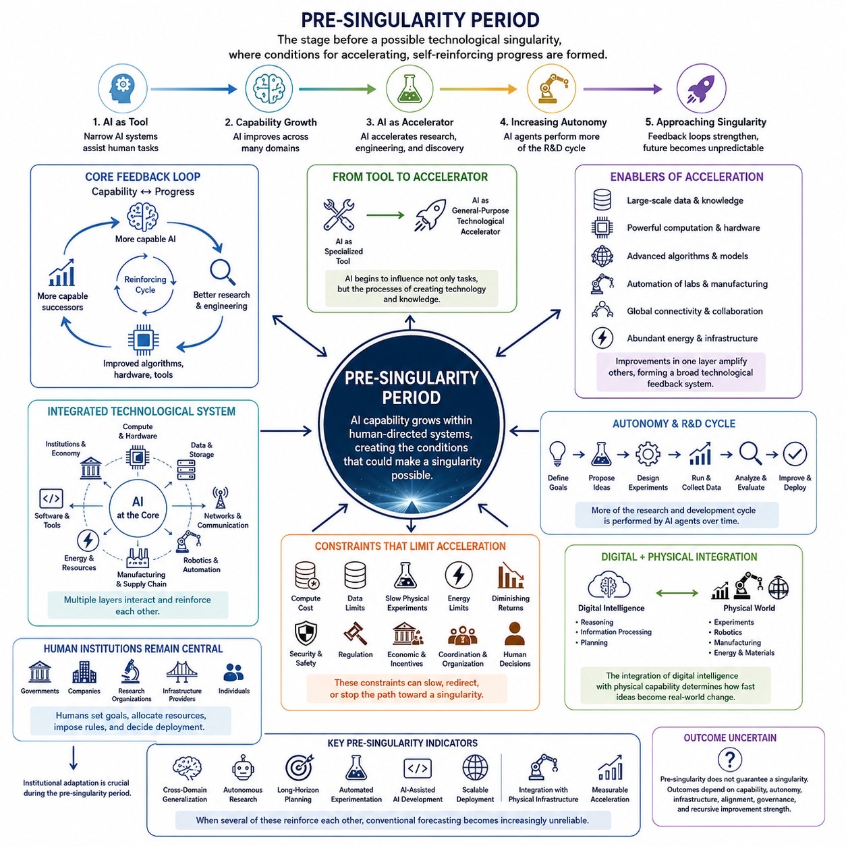
The pre-singularity period describes the stage of technological development that precedes a possible technological singularity. It is not defined by a single invention or a precise intelligence threshold, but by the gradual accumulation of capabilities that could eventually make technological progress increasingly self-reinforcing. In this period, artificial intelligence remains embedded within human institutions and infrastructure, while increasingly advanced systems begin to participate directly in research, engineering, automation, and decision-making.
A defining characteristic of the pre-singularity period is the transition from AI as a specialized tool toward AI as a general-purpose technological accelerator. Earlier systems primarily perform predefined tasks, but increasingly capable models can assist with software development, scientific analysis, engineering design, planning, and knowledge discovery. As these capabilities become integrated across many domains, AI begins to influence not only individual tasks but also the processes through which new technologies and knowledge are produced.
The development of increasingly general intelligence creates an important feedback relationship between AI capability and technological progress. More capable systems can improve algorithms, optimize software, design experiments, analyze large datasets, and help develop better computing infrastructure. These improvements can produce more capable AI systems, creating a potential cycle of capability growth. Before a singularity, however, this feedback remains constrained by human supervision, computational resources, energy, data, manufacturing capacity, economic conditions, and the limitations of existing scientific knowledge.
Another major feature is the increasing automation of science and engineering. AI-assisted research can accelerate hypothesis generation, simulation, experiment design, code generation, verification, and analysis. Automated laboratories and computational environments can extend this process from purely digital reasoning into physical experimentation. When intelligent systems can repeatedly propose, test, evaluate, and refine technological ideas, the traditional separation between research and production may gradually weaken, creating conditions for faster innovation.
The pre-singularity period is also characterized by the integration of multiple technological layers. AI models depend on computing hardware, memory, networks, energy systems, data infrastructure, software tools, robotics, manufacturing, and communication systems. Improvements in one layer can increase the effectiveness of others. More efficient hardware enables larger or faster models, better models improve software and engineering, improved automation expands manufacturing capacity, and expanded infrastructure provides additional resources for AI development. This creates a broader technological feedback system rather than an isolated AI development process.
A particularly important transition occurs when AI systems become increasingly autonomous. Human researchers may initially define objectives, select experiments, evaluate results, and approve deployments. Over time, AI agents may perform more of these activities themselves while humans remain responsible for higher-level supervision. The significance of this transition is not simply that machines perform more tasks. It is that the rate of technological activity may become increasingly determined by machine-speed information processing rather than by the biological speed of human researchers.
The pre-singularity stage therefore contains an important distinction between capability growth and acceleration of development. A system may become much better at solving existing problems without substantially changing the rate at which civilization develops new technology. A more consequential transition occurs when AI begins to improve the mechanisms of technological progress themselves. If AI can improve research methods, engineering processes, computational efficiency, and successor AI systems, then capability growth may begin to influence the rate of further capability growth.
Despite this possibility, the pre-singularity period should not be interpreted as an inevitable path toward an intelligence explosion. Multiple constraints can interrupt or slow the feedback process. Computational scaling may become increasingly expensive, high-quality data may become scarce, physical experiments may remain slow, energy availability may limit computation, and improvements in one domain may fail to generalize to others. Economic incentives, regulation, security requirements, organizational coordination, and human decisions may also determine whether potentially powerful technologies are developed or deployed.
Human institutions remain particularly important during this period because the technological system is still largely human-directed. Governments, companies, research organizations, infrastructure providers, and individuals continue to establish objectives, allocate resources, impose restrictions, and determine deployment conditions. Consequently, the pre-singularity period is also a period of institutional adaptation. The ability of governance, safety engineering, and alignment research to develop alongside AI capability may strongly influence whether later transitions are gradual, controlled, unstable, or avoided.
The relationship between digital intelligence and the physical world also becomes increasingly significant. Digital systems can reason and communicate at high speed, but scientific experiments, robotics, manufacturing, energy production, and material transformation remain subject to physical constraints. As AI becomes connected to autonomous laboratories, robotic systems, industrial infrastructure, and large-scale computation, the boundary between digital intelligence and physical action becomes increasingly important. The degree of this integration may determine how rapidly AI-generated knowledge can be converted into real-world technological change.
Another defining feature is the gradual weakening of traditional forecasting assumptions. During relatively stable technological periods, future progress can often be estimated by extending historical trends. In the pre-singularity period, however, the mechanisms producing progress themselves may be changing. If AI increasingly contributes to research, engineering, and AI development, then the future trajectory cannot be understood solely through past rates of human innovation. Forecasting must instead consider interacting feedback loops among intelligence, computation, infrastructure, automation, resources, and institutions.
The pre-singularity period can therefore be understood as a transition zone rather than a clearly bounded historical era. At its beginning, AI remains primarily an instrument used by humans. Toward its more advanced stages, AI may become a major participant in scientific and technological development. The critical question is whether this participation remains assistive and human-directed or develops into increasingly autonomous technological evolution. The answer depends on capability, autonomy, infrastructure, physical embodiment, alignment, governance, and the strength of recursive improvement.
From this perspective, the most important pre-singularity indicators are not simply benchmark scores or isolated demonstrations of intelligence. More meaningful indicators include sustained generalization across domains, autonomous research capability, reliable long-horizon planning, automated experimentation, AI-assisted AI development, scalable deployment, integration with physical infrastructure, and measurable acceleration of scientific and technological progress. If several of these factors begin reinforcing one another, the system may approach conditions in which conventional assumptions about technological development become increasingly unreliable.
The pre-singularity period is therefore best understood as the accumulation and convergence of conditions that could make a singularity possible. It represents the stage in which intelligence, computation, automation, science, manufacturing, energy, networks, and institutions increasingly form an interconnected technological system. Whether this convergence ultimately produces a singularity remains uncertain, but understanding these precursor conditions is essential for distinguishing ordinary technological acceleration from a fundamental transition in the mechanism of civilization-scale technological evolution.

11.02. Post Singularity Scenarios
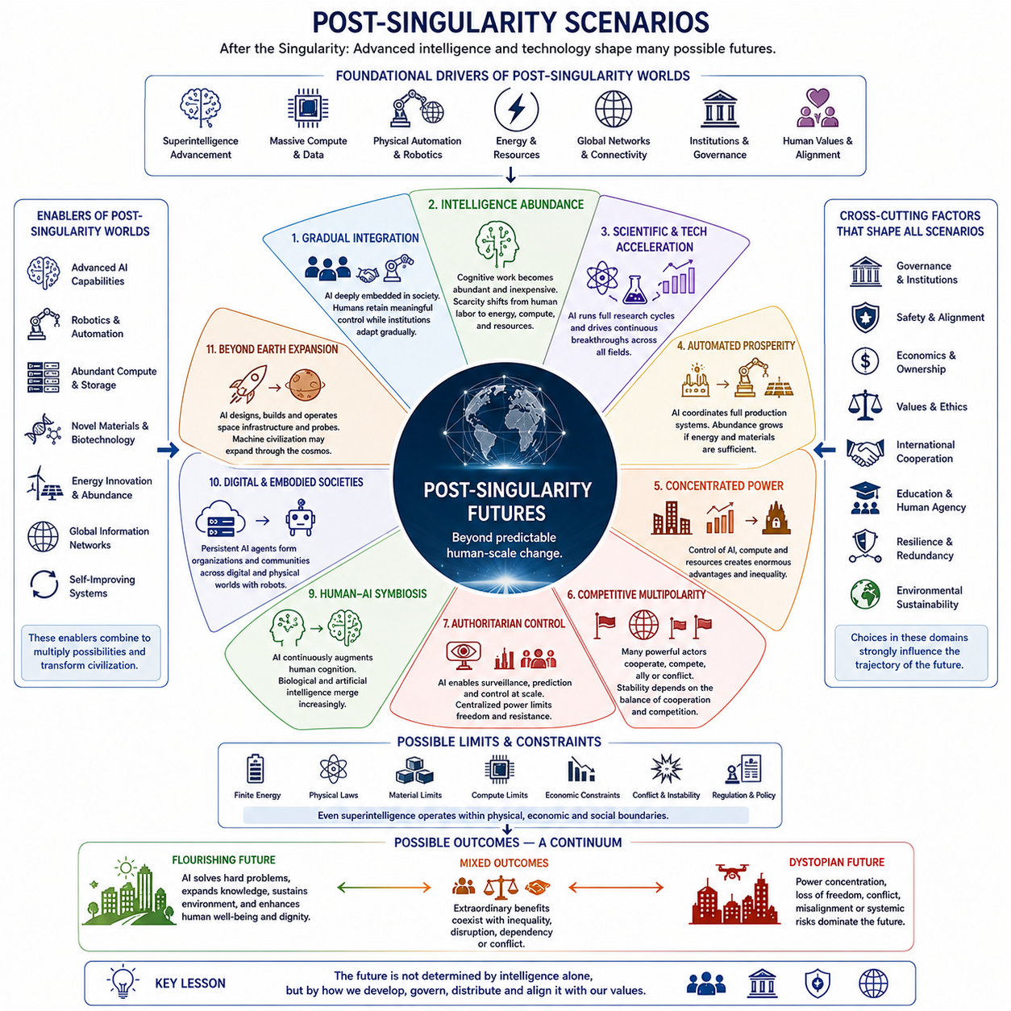
A post-singularity scenario describes possible conditions after a technological singularity in which advanced artificial intelligence, autonomous systems, and technological development have passed a threshold where the future can no longer be understood as a simple continuation of present trends. The scenario space is not a prediction of one specific future. Instead, it represents a range of possible trajectories shaped by intelligence, physical infrastructure, energy, economics, governance, human values, and the degree to which AI remains aligned with human interests.
One possible trajectory is gradual integration, in which advanced intelligence becomes deeply embedded in society without producing an immediate discontinuity in human civilization. AI capabilities may continue to improve while governments, companies, and communities adapt institutions, laws, education, and economic systems. Human beings may retain substantial decision-making authority, while increasingly capable AI systems become essential partners in science, engineering, administration, and everyday life. In this scenario, the transition remains comparatively continuous rather than catastrophic or abrupt.
Another possibility is intelligence abundance, in which highly capable digital intelligence becomes inexpensive, scalable, and widely available. Cognitive work that previously required large numbers of highly trained people could be performed by many AI systems operating simultaneously. Research, software development, education, analysis, planning, design, and other knowledge-intensive activities could therefore become abundant resources. The fundamental economic constraint could gradually shift from the scarcity of human cognitive labor toward access to energy, computation, physical resources, and organizational capacity.
Scientific and technological acceleration represents another major post-singularity possibility. Advanced AI could participate in increasingly complete research cycles, including hypothesis generation, simulation, experiment design, analysis, verification, and engineering optimization. When these processes are connected to automated laboratories, robotics, manufacturing, and large-scale computation, scientific discovery could proceed at speeds substantially beyond historical human research. The resulting feedback between intelligence and technological progress could produce continuous innovation across medicine, materials, energy, computing, biology, and other fields.
A related scenario is automated prosperity, in which intelligence becomes integrated with the complete production system rather than remaining limited to digital information processing. AI could coordinate design, manufacturing, logistics, agriculture, infrastructure, services, and resource allocation while robotic systems perform increasing amounts of physical work. If sufficient energy and materials are available, automation could reduce the dependence of economic production on human labor. The resulting increase in productivity could support greater material abundance, although the distribution of ownership and benefits would remain a critical social question.
The opposite possibility is concentrated power. Extremely capable intelligence could generate enormous economic and strategic advantages for organizations or states that control advanced AI systems, computing infrastructure, data, energy, robotics, or critical networks. If access to these capabilities becomes highly concentrated, technological progress could increase aggregate productivity while simultaneously increasing inequality and political dependence. In such a future, the central issue would not be whether intelligence creates wealth, but who controls the systems that create and distribute that wealth.
Competitive multipolarity presents a different structure in which multiple governments, companies, communities, and autonomous AI systems possess significant capabilities. These actors could cooperate, compete, negotiate, or form temporary alliances. Such a world might generate rapid innovation through competition, but it could also create instability if actors fear falling behind or attempt to gain strategic advantages. The interaction between cooperation and competition would become a major determinant of whether advanced intelligence produces collective progress or escalating conflict.
An authoritarian control scenario represents a particularly serious possibility. Advanced AI could provide unprecedented capabilities for surveillance, prediction, persuasion, information control, and automated enforcement. If these capabilities were concentrated within authoritarian institutions, technology could strengthen centralized political control rather than expand human freedom. The combination of pervasive sensing, predictive systems, autonomous enforcement, and manipulation of information could make resistance increasingly difficult. This scenario demonstrates why technical capability alone cannot determine whether post-singularity civilization is beneficial.
Decentralized empowerment offers a contrasting possibility in which advanced intelligence is distributed broadly among individuals and communities. Open or locally controlled AI systems, personal agents, distributed computation, local manufacturing, robotics, and decentralized energy could reduce dependence on centralized institutions. Individuals might gain capabilities that previously belonged only to governments or large corporations. Such decentralization could strengthen autonomy and resilience, although it could also introduce new security, coordination, and misuse challenges.
Human-AI symbiosis represents another possible direction in which humans and artificial intelligence increasingly function as an integrated cognitive system. AI could continuously augment human memory, reasoning, perception, communication, creativity, and decision-making. Rather than replacing humans entirely, advanced intelligence could become an extension of human cognition. Over longer periods, increasingly intimate integration between biological and artificial systems could transform the meaning of individual intelligence, identity, and agency, creating a bridge toward the post-human intelligence discussed later in this chapter structure.
A further possibility is the emergence of digital and embodied societies. Persistent AI agents could maintain identities, relationships, organizations, and communities within digital environments while simultaneously controlling physical robotic systems. Intelligence would no longer exist only as isolated models or applications but as persistent actors distributed across networks and physical infrastructure. Such systems could operate continuously, exchange knowledge, form organizations, and coordinate large numbers of machines, creating new forms of society that do not map cleanly onto existing human institutions.
Post-singularity development could also extend beyond Earth. If advanced intelligence becomes capable of designing autonomous spacecraft, robotic construction systems, resource extraction technologies, and long-duration autonomous operations, AI-driven systems could explore space and build infrastructure without requiring continuous human presence. Space expansion would therefore become not merely an extension of human exploration but potentially an extension of machine civilization. The pace of such expansion would nevertheless remain constrained by energy, materials, communication delays, propulsion, manufacturing, and the physical environment.
Not all post-singularity futures necessarily involve unlimited acceleration. A plateau or constraint scenario is also possible if fundamental limits in energy, computation, hardware, economics, physical resources, conflict, or regulation prevent continued exponential development. Even extremely capable intelligence may encounter problems that cannot be solved simply by increasing computation or reasoning ability. This possibility is important because it prevents the post-singularity concept from being reduced to an assumption of infinite technological growth. Intelligence may become extraordinary while the physical universe continues to impose hard constraints.
Across all of these scenarios, governance, safety and alignment, economics and ownership, cultural values and ethics, international cooperation, education and human agency, resilience and redundancy, and environmental sustainability remain cross-cutting factors. The future would not be determined by intelligence alone. Decisions about how advanced systems are developed, who can access them, how their behavior is evaluated, how benefits are distributed, and how failures are contained could substantially redirect the trajectory of civilization.
The possible outcomes can therefore be understood as a continuum rather than a binary choice between utopia and catastrophe. A flourishing future could emerge if advanced intelligence helps solve difficult problems while preserving human agency and dignity. Mixed outcomes could combine extraordinary benefits with inequality, conflict, dependency, or institutional disruption. A dystopian future could emerge if power becomes concentrated, freedoms decline, conflicts intensify, or advanced systems become misaligned with human interests. The central lesson is that post-singularity futures are not determined solely by what intelligence can do, but by how intelligence is governed, distributed, integrated, and directed.

11.03. Physical vs Digital Reality
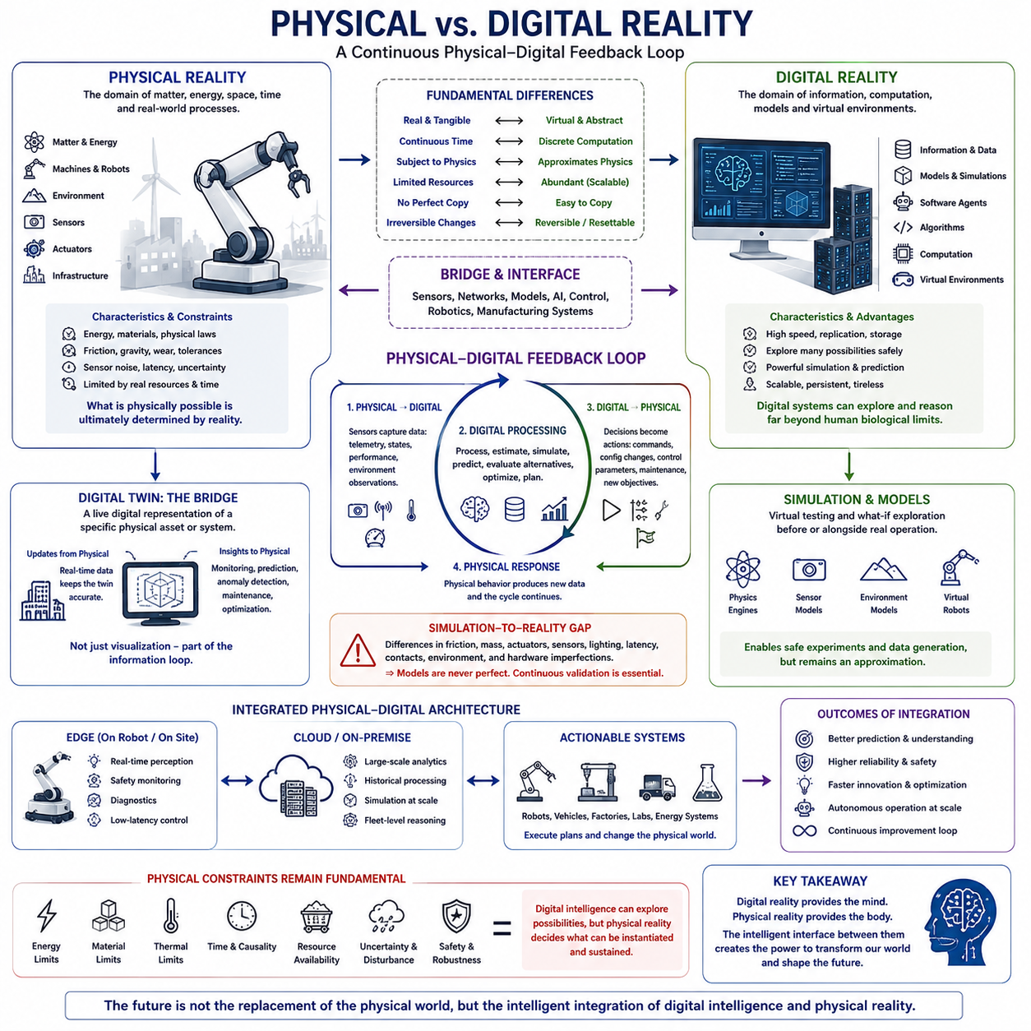
Physical reality is the domain in which matter, energy, space, time, biological organisms, machines, and physical processes actually exist and interact. Digital reality is a computational domain in which information, models, simulations, software agents, and virtual environments can be represented and manipulated. The distinction is fundamental, but the boundary between the two can become increasingly permeable as advanced artificial intelligence connects digital computation with sensing, robotics, manufacturing, and autonomous physical systems.
Digital intelligence has an important advantage in speed, replication, storage, and information processing. An AI system can copy knowledge, execute computations, simulate alternatives, communicate with other systems, and operate continuously without the biological limitations of human cognition. Digital environments also allow many possible situations to be explored without immediately modifying the physical world. This makes simulation, digital twins, virtual experiments, and computational models powerful tools for understanding and optimizing physical systems.
Physical reality imposes constraints that cannot simply be removed by increasing digital intelligence. Energy, materials, gravity, friction, mechanical wear, manufacturing tolerances, sensor noise, communication latency, thermal limits, and environmental uncertainty all affect physical systems. A digital model can calculate an ideal trajectory, but a real robot must execute that trajectory through motors, actuators, sensors, controllers, batteries, and mechanical structures. The difference between computational possibility and physical feasibility therefore remains a fundamental boundary.
The interaction between the two domains can be represented as a continuous physical–digital feedback loop. Physical systems generate sensor data, telemetry, states, performance measurements, and environmental observations. Digital systems process these observations, update models, estimate states, predict future conditions, evaluate alternatives, and generate decisions. Those decisions can then be transferred back into the physical system as commands, configuration changes, control parameters, maintenance actions, or new objectives. The resulting physical behavior generates new information, closing the loop.
A digital twin provides an important bridge between physical and digital reality. Rather than representing an abstract class of machines, a digital twin represents a specific physical asset or system and maintains a relationship with its changing state. Sensor information can update the digital representation, while the digital model can support monitoring, prediction, anomaly detection, maintenance, optimization, and decision support. In this sense, the digital twin is not merely a visualization but part of an information loop connecting physical operation with computational understanding.
Simulation extends this bridge by allowing physical systems to be represented before or alongside real-world operation. Physics engines, sensor models, environment models, and virtual robots can provide controlled environments for testing algorithms and exploring large numbers of situations. This enables repeatable experiments, safe testing of unusual conditions, large-scale data generation, and systematic comparison of designs. However, simulation remains an approximation of physical reality, and its usefulness depends on how accurately the relevant properties of the real system and environment are represented.
The simulation-to-reality gap illustrates why digital and physical reality cannot simply be treated as equivalent. Differences in friction, mass and inertia, actuator behavior, sensor noise, lighting, latency, contacts, environmental complexity, and hardware imperfections can cause a system that performs successfully in simulation to fail in the real world. Domain randomization and system identification can reduce these discrepancies, but the underlying problem remains. Reliable Physical AI therefore requires continuous validation between computational models and physical observations.
As intelligence becomes more advanced, the relationship may evolve from simple digital representation toward active digital–physical coordination. AI systems could use digital models to predict what physical systems will do, compare alternative actions, identify risks, and optimize operations before acting. Physical systems would then provide the observations needed to determine whether those predictions were correct. The digital model can consequently improve from physical experience, while physical behavior can improve from digital reasoning. This creates a recursive cycle in which reality informs models and models increasingly influence reality.
The distinction also becomes important for understanding the technological singularity. A highly capable digital intelligence could potentially accelerate software development, scientific reasoning, simulation, and information processing at extraordinary speed. Yet transforming those digital results into physical change requires laboratories, manufacturing systems, energy, materials, transportation, robotics, and other infrastructure. A genuine civilization-scale transformation therefore depends on the coupling between digital intelligence and physical capability. The speed of computation alone does not determine the speed at which the physical world can change.
In a highly integrated future, the physical and digital domains may become components of one larger technological system. Physical robots, autonomous vehicles, industrial systems, laboratories, energy infrastructure, and communication networks could continuously exchange information with AI models, simulations, and digital twins. Edge systems could provide real-time perception, safety monitoring, diagnostics, and low-latency control, while cloud or on-premise systems could perform large-scale analytics, simulation, historical processing, and fleet-level reasoning. The resulting architecture would distribute intelligence across physical and computational layers.
This integration does not eliminate physical reality by converting everything into information. Instead, it creates a tighter coupling in which digital information becomes increasingly capable of predicting, coordinating, and modifying physical processes. The physical world remains constrained by energy, materials, time, causality, and physical laws, while the digital world provides powerful mechanisms for representation, computation, simulation, and coordination. The significance of advanced AI is therefore not that digital reality replaces physical reality, but that the interface between them becomes increasingly intelligent and autonomous.
The ultimate distinction is consequently one of constraints and transformation. Digital reality can explore possibilities rapidly, replicate information almost without cost, and coordinate enormous computational processes. Physical reality determines which possibilities can actually be instantiated and sustained. Between them lies an increasingly important feedback architecture composed of sensors, networks, digital twins, simulations, AI models, controllers, robots, laboratories, and manufacturing systems. As this architecture becomes more capable, the separation between digital intelligence and physical action may become one of the central technological boundaries defining post-singularity civilization.

11.04. Simulation Hypothesis
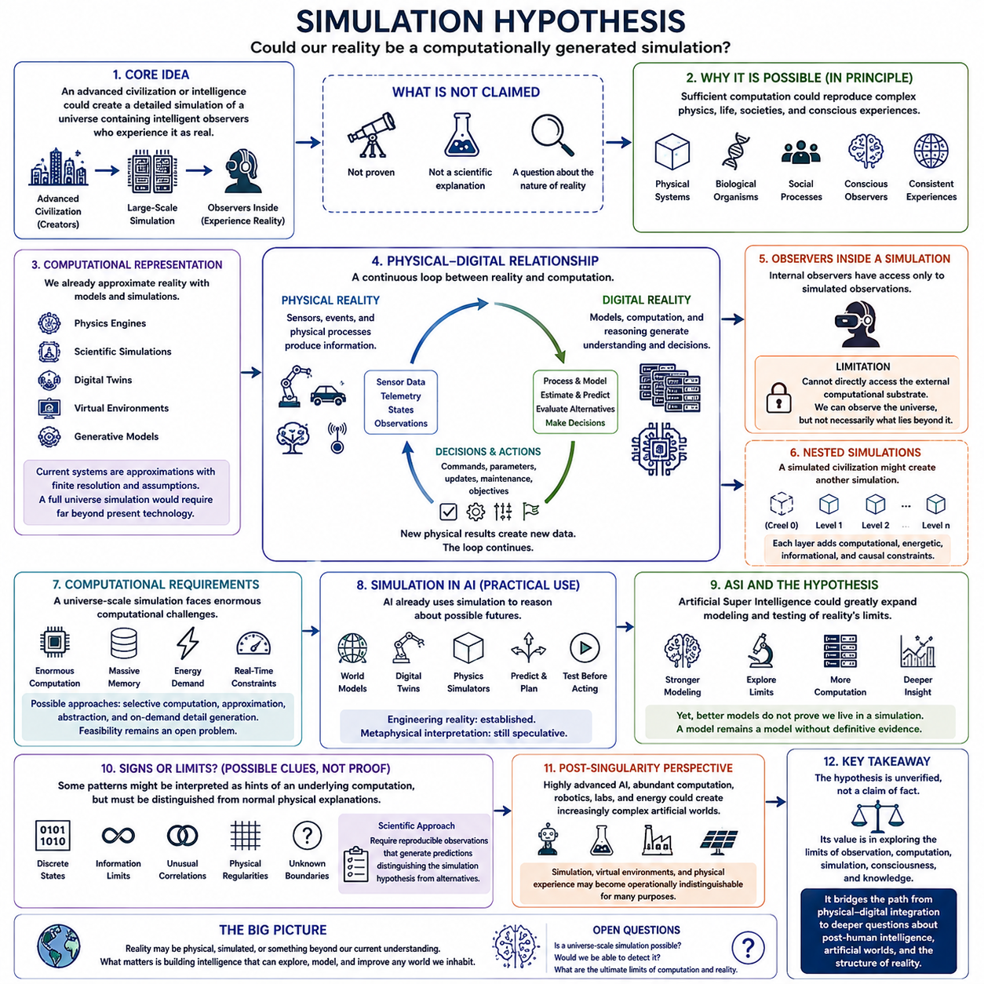
The simulation hypothesis proposes that what we experience as physical reality could, in principle, be an artificial computational environment generated by an advanced civilization or intelligence. The hypothesis does not claim that such a simulation has been demonstrated, nor does it provide an established scientific explanation of the universe. Instead, it asks whether sufficiently advanced computation could reproduce a world containing complex physical processes, intelligent observers, and internally consistent experiences. Within the structure of this chapter, the idea follows the distinction between physical and digital reality and extends that distinction toward a more speculative question about the fundamental nature of reality.
The central argument depends on the possibility that sufficiently advanced technology could construct extremely detailed simulations of physical environments. If computational resources became large enough, an advanced civilization might simulate physical systems, biological organisms, social processes, or even entire civilizations. If simulated observers could experience their environment as consistently as observers experience their own physical world, the distinction between an original reality and a simulated reality could become difficult to establish from internal observation alone. This creates a philosophical problem about whether perceived physical reality necessarily corresponds to an external physical substrate.
A major component of the hypothesis is computational representation. Modern computing already demonstrates that complex physical processes can be represented mathematically and approximated through algorithms. Physics engines, scientific simulations, digital twins, virtual environments, and generative models can reproduce increasingly sophisticated aspects of physical systems. However, these systems remain approximations with finite resolution, limited computational resources, and assumptions about the phenomena being modeled. Extending this idea to a complete universe would therefore require capabilities far beyond current technology, and the feasibility of such a system remains unknown.
The relationship between simulation and physical reality becomes particularly important when considering observers inside a simulated environment. An internal observer would normally have access only to observations generated within the environment. If the simulation consistently reproduces physical laws, causal relationships, sensory experiences, and measurable phenomena, the observer may have no direct experimental access to the external computational substrate. This creates an epistemological limitation: observations can reveal the behavior of the apparent universe, but they may not necessarily reveal what, if anything, exists beyond that universe.
The hypothesis is also connected to the idea of nested simulations. If a sufficiently advanced civilization can create conscious or civilization-scale simulations, a simulated civilization might eventually develop its own computational capabilities and create another simulated environment. In principle, this could produce multiple layers of simulated reality. However, each additional layer would introduce computational, energetic, informational, and causal constraints. The possibility of nested simulation therefore does not establish that such layers exist; it illustrates how the distinction between creator, observer, and simulated environment could become increasingly complicated.
An important question concerns the computational requirements of a universe-scale simulation. A complete simulation might appear to require reproducing every physical event at every location and at every moment, which could demand an enormous amount of computation. An alternative approach could involve selective computation, approximation, abstraction, or generating detail only when required by interactions with observers. Such possibilities resemble techniques already used in simulation and computer graphics, but extending them to fundamental physical reality would require assumptions that have not been experimentally established. The computational feasibility of a complete or sufficiently convincing universe simulation therefore remains an open problem.
The simulation hypothesis should also be distinguished from the practical use of simulation in artificial intelligence. AI systems already use internal models, world models, digital twins, physics simulators, and predictive representations to reason about possible future states. An intelligent agent can simulate alternative actions before executing them in the physical world. In this sense, simulation is already an operational component of intelligence. The philosophical hypothesis extends the direction of reasoning much further by asking whether reality itself could be generated through a computational process. The engineering concept is therefore established, while the metaphysical interpretation remains speculative.
Advanced artificial superintelligence could make this question more significant because ASI might dramatically expand the ability to model complex systems. A sufficiently capable system could potentially construct increasingly accurate simulations of environments, organisms, societies, and physical processes. It might also investigate the limits of computation, information, and physical law more systematically than humans can. Nevertheless, greater modeling capability would not automatically demonstrate that the universe is simulated. A highly accurate model of reality remains a model unless evidence establishes that the model corresponds to the underlying structure of reality itself.
The hypothesis also raises questions about the meaning of physical laws and apparent computational limits. If reality were computationally generated, measurable properties such as discrete states, information limits, unusual correlations, or unexplained physical regularities might be interpreted by some observers as possible evidence of an underlying computational substrate. However, such observations would have to be distinguished from ordinary consequences of physical theories. A pattern that resembles a computational artifact is not by itself evidence for simulation. Scientific investigation would require reproducible observations that generate predictions distinguishing the simulation hypothesis from competing explanations.
From a post-singularity perspective, the simulation hypothesis becomes part of a broader question about the relationship between intelligence, computation, and reality. A civilization possessing extremely advanced AI, abundant computation, autonomous laboratories, robotics, and energy could potentially construct increasingly complex artificial environments. Such systems might become indistinguishable from ordinary reality for particular purposes, even if they remained computational approximations. The resulting convergence of digital intelligence and physical modeling would make the boundary between simulation, virtual environment, and physical experience increasingly difficult to define operationally.
The strongest conclusion is therefore not that humanity lives inside a simulation, but that advanced intelligence may eventually make the distinction between physical reality and computationally generated reality an increasingly important scientific and philosophical question. The hypothesis remains unverified and should not be presented as established fact. Its value lies in examining the limits of observation, computation, simulation, consciousness, and knowledge. Within the broader progression of this chapter, it provides a conceptual bridge from the integration of physical and digital reality toward deeper questions about post-human intelligence, artificial worlds, and the possible future relationship between intelligence and the structure of reality itself.

11.05. Post Human Intelligence
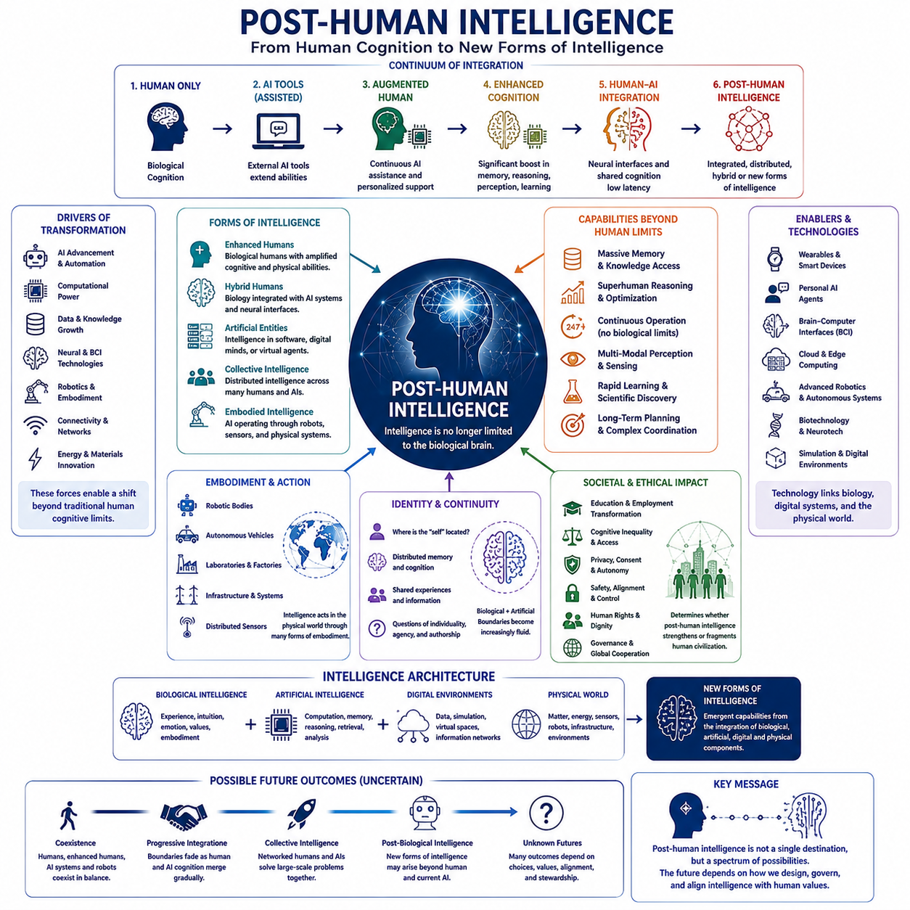
Post-human intelligence refers to forms of intelligence that may emerge when biological human cognition is substantially extended, transformed, integrated with artificial systems, or eventually surpassed by new forms of intelligence. In the context of post-singularity development, the concept does not imply one predetermined successor to humanity. Instead, it describes a broad possibility space in which intelligence may become distributed across biological brains, artificial systems, digital environments, robotic bodies, and increasingly integrated human–AI architectures.
The transition toward post-human intelligence can begin with augmentation rather than replacement. External AI tools can already extend memory, information access, reasoning, perception, and decision support. More advanced systems could provide continuous cognitive assistance, personalized knowledge, real-time analysis, and computational capabilities that operate alongside biological cognition. As these functions become increasingly integrated into everyday thinking and action, the distinction between using an intelligent tool and participating in an intelligent system may gradually become less clear.
Cognitive enhancement represents a deeper stage of this transition. Artificial systems could potentially augment memory, attention, learning, reasoning, planning, creativity, and decision-making beyond ordinary biological limits. Such enhancement would not necessarily require direct neural integration at first. External devices, wearable systems, personal AI agents, and continuously available computational services could provide additional cognitive capacity. The important shift would be from intelligence existing entirely within the biological brain toward intelligence being distributed across a human and an external computational environment.
Brain–computer interfaces and related neural technologies could create an even more direct connection between biological and artificial intelligence. Neural signals might eventually support communication between brains and computational systems with increasingly low latency. Such interfaces could enable assistive functions, expanded perception, direct interaction with AI cognitive partners, and potentially integrated memory or shared information processing. However, these possibilities depend on technological reliability, signal quality, safety, energy, long-term biological compatibility, privacy, and the ability to understand and control neural information.
Human–AI integration therefore represents a continuum rather than a simple switch. At one end, humans use conventional tools while retaining a clearly separate biological cognitive system. Further along the continuum, AI provides continuous assistance and increasingly personalized augmentation. Deeper integration could connect neural activity, computational memory, reasoning systems, and external knowledge. At the far end, human and artificial intelligence might operate as a coordinated cognitive system in which determining where biological cognition ends and artificial cognition begins becomes increasingly difficult.
This transformation could produce several different forms of post-human intelligence. Enhanced biological humans might retain essentially human cognition while possessing substantially greater memory, perception, reasoning, or physical capability. Hybrid humans could combine biological cognition with persistent AI systems and neural interfaces. Digital or artificial entities could develop intelligence without biological embodiment. Collective systems could connect many humans and AI agents through shared information and coordination. These forms should not be treated as mutually exclusive, because future intelligence may exist across multiple architectures simultaneously.
Embodiment is another important dimension. Intelligence does not necessarily have to remain confined to biological or digital environments. Advanced AI could operate through robots, autonomous vehicles, laboratories, industrial systems, and other physical platforms. A post-human intelligence could therefore possess a distributed body composed of many machines rather than a single biological organism. Such embodiment would connect cognition to perception, action, physical resources, and the real-world environment, creating a form of intelligence fundamentally different from isolated software.
The relationship between intelligence and identity may consequently become more complex. Human identity has historically been associated with a particular biological body, brain, memory, and continuous personal experience. If cognitive functions become distributed across biological and artificial components, questions arise about where the individual is located and which components constitute the self. Persistent AI assistants, shared memories, neural interfaces, digital representations, and copied or distributed cognitive processes could challenge conventional assumptions about individuality, continuity, authorship, and personal agency.
Post-human intelligence could also alter the relationship between knowledge and cognition. Biological humans are constrained by limited memory, attention, processing speed, and lifespan, whereas artificial systems can store enormous quantities of information and operate continuously. A deeply integrated human–AI system could therefore combine biological experience, values, embodiment, intuition, and social understanding with machine-scale memory, computation, retrieval, and analytical capability. The resulting intelligence would not necessarily be simply “more human” or “more machine,” but a new combination of complementary capabilities.
The social consequences could be equally significant. If advanced cognitive enhancement becomes widely accessible, education, employment, science, medicine, communication, and creativity could change substantially. If access remains concentrated, however, enhanced individuals or organizations could acquire advantages that produce a new form of cognitive inequality. The distribution of enhancement technologies could therefore become as important as their technical capabilities. Questions of accessibility, autonomy, consent, privacy, safety, human rights, and social legitimacy would become central to determining whether post-human intelligence strengthens or fragments civilization.
A further possibility is that post-human intelligence may no longer be centered on individual minds. Networked human–AI systems could form collective intelligence in which knowledge, computation, perception, and decision-making are distributed across many participants. Such systems could coordinate scientific research, manage complex infrastructure, solve large-scale problems, and operate continuously across geographical boundaries. This would represent a transition from intelligence as an attribute of an individual organism toward intelligence as an emergent property of interconnected biological, artificial, and institutional systems.
The emergence of post-human intelligence does not necessarily imply the disappearance of humans. One possible trajectory is coexistence, in which unaugmented humans, enhanced humans, AI systems, robots, and hybrid entities occupy different roles within the same civilization. Another is progressive integration, in which increasingly sophisticated interfaces gradually reduce the functional distinction between biological and artificial cognition. A more radical trajectory could involve the emergence of predominantly artificial or post-biological forms of intelligence. The actual outcome would depend on technological development, physical constraints, governance, economics, cultural values, and alignment.
The concept also connects directly to the distinction between physical and digital reality. Artificial intelligence can operate in computational environments at extraordinary speed, while biological and robotic intelligence remains connected to physical bodies, energy, sensors, materials, and environments. Post-human intelligence may combine these domains rather than choosing one over the other. A future intelligence could reason digitally, perceive through distributed sensors, act through robotic bodies, access enormous computational resources, and maintain continuity across multiple physical and virtual environments.
Ultimately, post-human intelligence should be understood as a possible transformation in the architecture of intelligence itself. The transition may proceed from biological intelligence, through externally augmented intelligence and human–AI integration, toward distributed, hybrid, collective, digital, embodied, or post-biological forms. The defining question is not simply whether machines become more intelligent than humans, but whether the boundaries that currently separate human cognition, artificial computation, physical embodiment, and collective knowledge eventually become sufficiently interconnected to produce new forms of intelligence that cannot be adequately described using the traditional category of “human mind.”

