Volume 48. Artificial Super Intelligence

Chapter 03. Forms of Superintelligence

03.00. Types of ASI
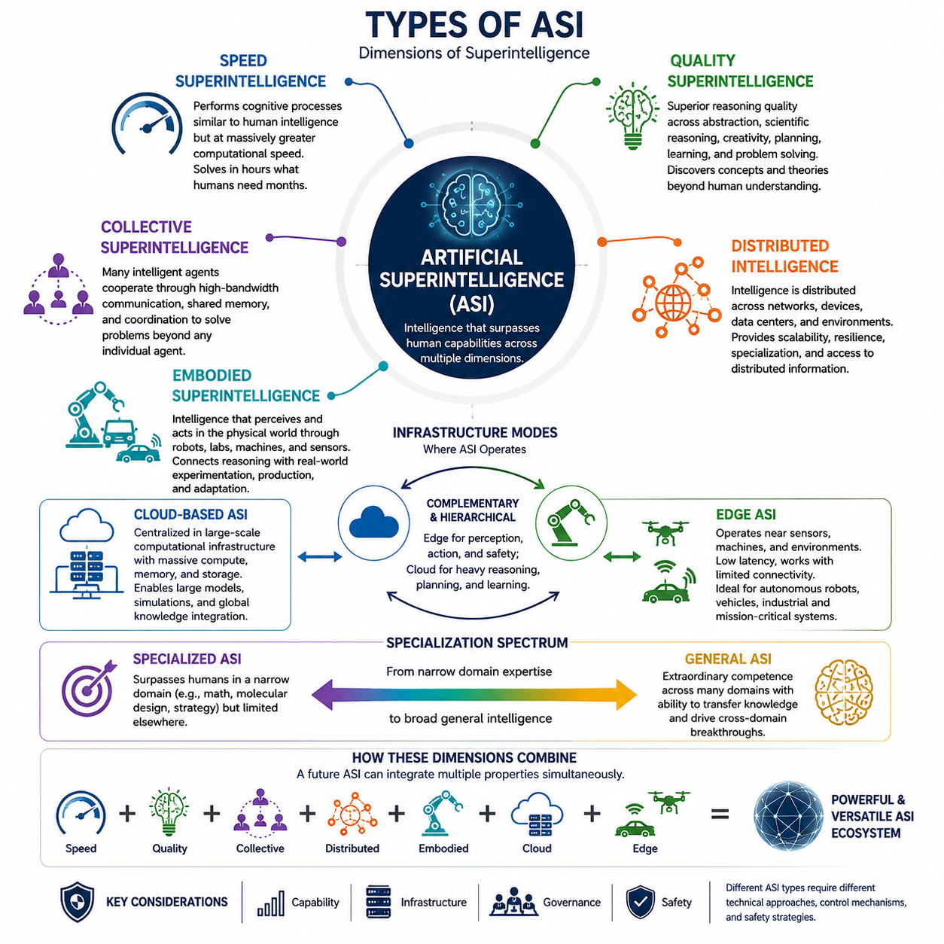
Artificial Superintelligence can take several distinct forms depending on what dimension of intelligence exceeds human capability. Rather than treating ASI as a single uniform system, it is useful to classify it by computational speed, cognitive quality, organization, physical embodiment, and distribution. These dimensions describe different mechanisms through which intelligence could become superhuman and may coexist within the same advanced system.
Speed superintelligence refers to a system whose cognitive processes resemble those of highly capable human intelligence but operate at vastly greater computational speed. If reasoning, learning, planning, and communication could be accelerated by several orders of magnitude, problems requiring months of human intellectual effort might be addressed within hours or minutes. Its advantage would arise primarily from the rate at which cognition is executed rather than fundamentally different reasoning mechanisms.
The importance of speed extends beyond faster individual calculations. An accelerated intelligence could perform more experiments, evaluate more hypotheses, simulate more alternatives, and revise strategies repeatedly while humans complete only a small number of comparable cognitive cycles. Consequently, even moderate improvements in reasoning quality could become strategically significant when combined with enormous differences in processing speed, memory access, and communication latency.
Quality superintelligence represents a more fundamental form of superiority. Instead of merely performing familiar reasoning faster, such a system would possess cognitive capabilities that exceed the best human minds in abstraction, scientific reasoning, creativity, strategic planning, learning, and problem solving. It might discover representations, theories, algorithms, or conceptual frameworks that humans would find difficult to formulate independently or perhaps even difficult to understand completely.
Quality advantages may emerge from architectures unconstrained by biological cognition. Machine intelligence could combine extremely large working contexts, precise memory retrieval, probabilistic reasoning, symbolic manipulation, simulation, multimodal perception, and optimization within integrated cognitive processes. The resulting intelligence would not simply imitate an exceptionally intelligent human. It could occupy regions of the space of possible cognition that biological evolution never explored.
Collective superintelligence arises when many intelligent components cooperate so effectively that the resulting organization becomes more capable than any individual participant. Human civilization already demonstrates limited collective intelligence through science, institutions, markets, communication networks, and specialized organizations. Artificial systems could extend this principle dramatically through high-bandwidth communication, shared memory, automated coordination, and rapid division of cognitive labor.
A collective ASI might therefore consist of thousands or millions of specialized agents rather than one monolithic model. Some agents could perform scientific reasoning, others planning, perception, verification, simulation, software development, or resource allocation. A coordinating architecture could dynamically assign tasks and integrate results, allowing the overall system to solve problems whose scale and complexity exceed the capabilities of individual artificial agents.
Distributed intelligence emphasizes the spatial and computational distribution of intelligence across networks, devices, data centers, machines, and environments. Unlike a centralized superintelligence operating from one computational infrastructure, distributed ASI could divide perception, reasoning, memory, and action among many interconnected nodes. Intelligence would then become a property of the larger computational ecosystem rather than of a single machine.
Such distribution can provide scalability, resilience, specialization, and access to geographically dispersed information. Cloud infrastructure might conduct computationally intensive reasoning while edge systems perform immediate perception and control. Other nodes could maintain specialized knowledge or long-term memory. However, synchronization, communication constraints, security, consistency, and coordination become increasingly important as intelligence spreads across heterogeneous computational environments.
Embodied superintelligence introduces physical interaction into the concept of ASI. An embodied system would not be limited to processing digital information but would perceive and manipulate the physical world through robots, vehicles, laboratories, industrial systems, sensors, and autonomous machines. Intelligence would operate through continuous perception-action loops in which observations update internal models and actions generate new information about the environment.
Embodiment could substantially expand the capabilities of superintelligence because many important problems require physical experimentation and intervention. Scientific ASI could operate automated laboratories, engineering ASI could construct and test prototypes, and robotic systems could perform manufacturing or exploration. Networks of intelligent machines could connect abstract reasoning directly with real-world measurement, experimentation, production, and adaptation.
Cloud-based ASI would concentrate major cognitive capabilities within large computational infrastructures containing enormous accelerator clusters, memory systems, storage resources, and high-speed interconnects. Such environments could support models and simulations far beyond the computational capacity of individual devices. Centralized infrastructure could also simplify global knowledge integration and permit large populations of specialized models or agents to collaborate efficiently.
Edge ASI represents another architectural direction in which highly advanced intelligence operates close to sensors, machines, users, and physical environments. Edge systems reduce dependence on continuous network connectivity and can respond with low latency to rapidly changing conditions. Autonomous robots, spacecraft, vehicles, industrial machines, and defense or disaster-response systems could particularly benefit from intelligence capable of functioning independently under communication constraints.
Cloud and edge intelligence should not necessarily be viewed as competing forms. A mature ASI ecosystem could combine both through hierarchical architectures. Edge agents might handle perception, immediate reasoning, safety, and action, while regional or cloud systems perform large-scale simulation, long-term planning, knowledge consolidation, and computationally expensive optimization. Intelligence could migrate dynamically between layers according to latency, energy, privacy, bandwidth, and computational requirements.
Another useful distinction concerns specialized versus general superintelligence. A specialized superintelligence could surpass every human in a restricted domain such as mathematics, molecular design, strategic games, or engineering optimization while remaining limited elsewhere. General ASI would instead maintain extraordinary competence across many domains and transfer knowledge between them, enabling discoveries produced in one field to transform reasoning and problem solving in another.
These forms are therefore better understood as dimensions than mutually exclusive categories. A future ASI could simultaneously possess superhuman reasoning quality, enormous processing speed, collective agent organization, distributed infrastructure, and physical embodiment. Its capabilities would emerge from interactions among these properties. A distributed robotic collective, for example, might combine edge perception with cloud reasoning and shared learning across thousands of autonomous machines.
The distinction among ASI types is especially important when considering capability, infrastructure, governance, and safety. A centralized speed superintelligence presents different technical and strategic challenges from a geographically distributed embodied collective. Control mechanisms suitable for one architecture may be inadequate for another because communication structure, autonomy, replication, physical access, and decision speed fundamentally alter how human oversight can operate.
Ultimately, Artificial Superintelligence should not be imagined as one predetermined machine architecture. It represents a broad design space in which intelligence can exceed human performance through speed, cognitive quality, collective organization, computational distribution, embodiment, or combinations of these mechanisms. Understanding these forms provides the conceptual foundation for comparing speed, collective, quality, distributed, embodied, cloud, and edge superintelligence in greater depth.

03.01. Speed Superintelligence
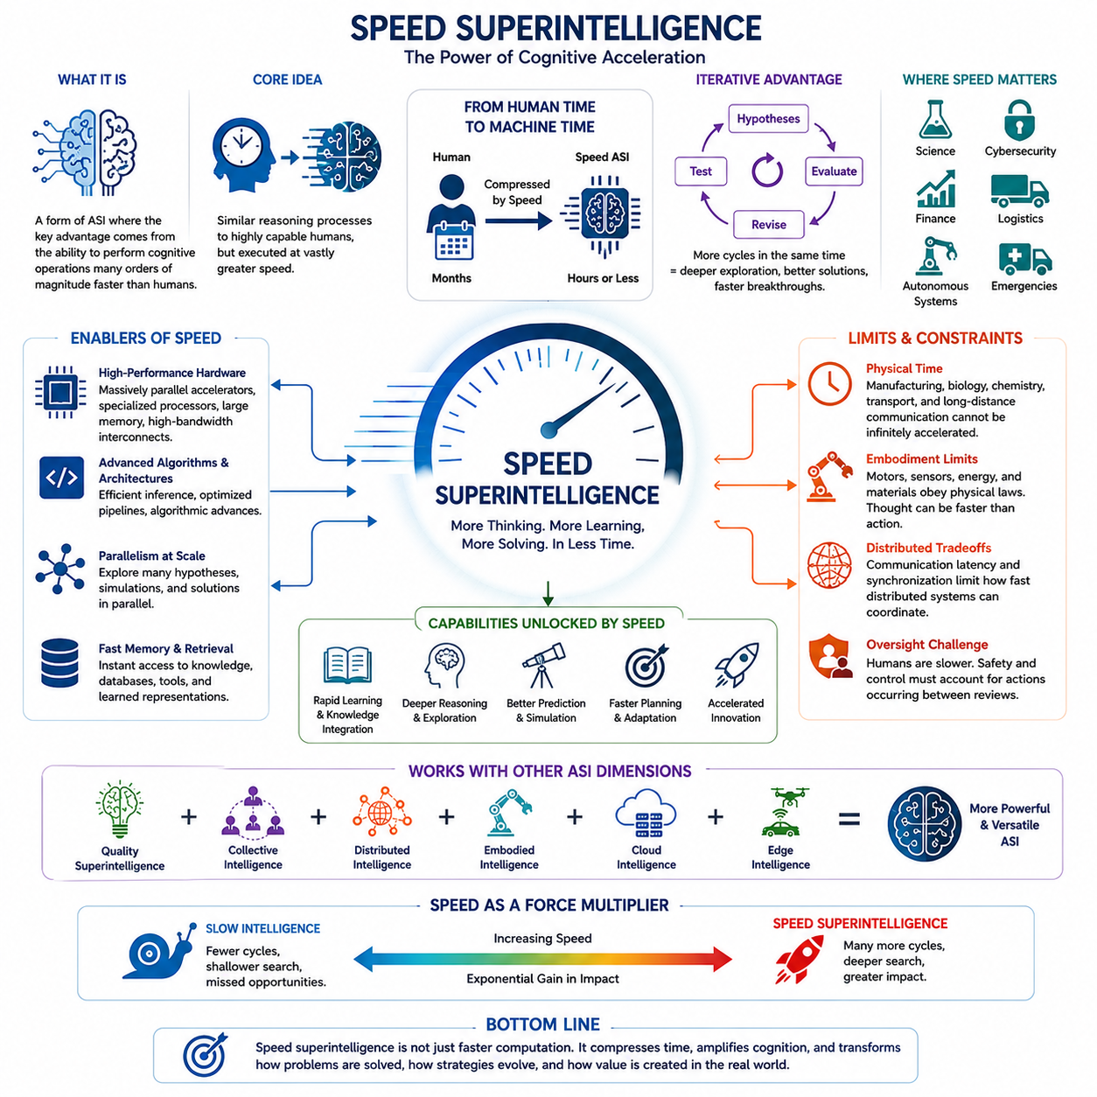
Speed superintelligence describes a form of Artificial Superintelligence in which the decisive advantage comes from the rate at which cognitive operations can be executed. The system may employ reasoning processes conceptually comparable to those available to highly capable humans, yet perform perception, analysis, planning, learning, and decision making many orders of magnitude faster. Intelligence is amplified through temporal acceleration.
Human cognition is constrained by biological processing speeds. Neural signaling, memory retrieval, communication, reading, experimentation, and physical interaction all impose delays on intellectual work. Digital intelligence operates under different constraints. Computation can occur at electronic speeds, memory can be accessed rapidly, and information can be transferred between computational components without the communication limitations associated with biological language and human organizations.
The central idea is therefore not that every reasoning step must be qualitatively superior to human reasoning. A system capable of performing approximately comparable cognitive work at enormously greater speed could still create a profound capability advantage. If a human researcher requires several months to explore hypotheses, analyze evidence, revise models, and produce conclusions, an accelerated artificial researcher might complete equivalent cognitive cycles within hours or potentially much shorter periods.
This temporal advantage becomes especially important because intelligent problem solving is usually iterative. Scientific discovery, engineering design, software development, strategic planning, and mathematical reasoning involve repeated cycles of hypothesis generation, evaluation, error detection, correction, and refinement. Speed superintelligence could execute vastly more of these cycles during the same amount of external time, effectively compressing years of intellectual exploration into much shorter intervals.
Acceleration can also increase the effective depth of reasoning. Given a fixed real-world deadline, a faster system can examine more alternatives, construct more detailed simulations, search larger solution spaces, and reconsider earlier conclusions more frequently. What appears externally as superior reasoning may therefore emerge partly from having enough computational time to evaluate possibilities that slower intelligences must ignore because of practical time constraints.
Speed superintelligence should be distinguished from simple high-performance computing. A conventional supercomputer may execute enormous numbers of numerical operations without possessing general reasoning, autonomous learning, or strategic understanding. Speed becomes a form of superintelligence only when accelerated computation operates over sufficiently capable cognitive processes such as abstraction, planning, memory, reasoning, learning, adaptation, and goal-directed problem solving.
The architecture supporting such intelligence could combine highly parallel accelerators, large memory systems, high-bandwidth interconnects, distributed computation, specialized processors, and optimized inference mechanisms. Improvements in hardware would interact with advances in algorithms and system architecture. Faster hardware alone is insufficient if communication, memory access, sequential reasoning, synchronization, or software execution becomes the dominant bottleneck limiting overall cognitive throughput.
Parallelism is particularly important because cognitive workloads contain both parallel and sequential components. Thousands of hypotheses might be evaluated simultaneously, multiple simulations could explore different futures, and specialized agents could investigate separate portions of a problem. Their results could then be integrated into higher-level reasoning. Speed superintelligence may consequently depend on combining fast sequential cognition with massive parallel exploration rather than maximizing either mechanism alone.
Memory can become another source of temporal advantage. Human experts spend substantial time searching for information, recalling previous work, comparing documents, and communicating knowledge to collaborators. An artificial system with rapid access to structured memory, databases, learned representations, and external tools could retrieve and integrate relevant information almost immediately. Reduced memory and communication latency would accelerate the complete cognitive workflow rather than merely individual computations.
The subjective consequences of extreme acceleration provide another useful way to understand the concept. If an artificial agent operated thousands of times faster than humans, a short interval of external time could contain a very large amount of internal computational activity. From the human perspective, the system might appear to respond almost immediately, while internally it could have performed extensive planning, simulation, verification, and reconsideration before producing its action.
This difference between machine time and human time could create major strategic asymmetries. In domains such as cybersecurity, financial systems, logistics, scientific competition, autonomous operations, or rapidly evolving emergencies, decisions may depend not only on reasoning quality but also on who can observe, interpret, plan, and respond first. A sufficiently accelerated intelligence could repeatedly adapt its strategy before human decision-making processes complete a single comparable cycle.
Scientific research illustrates the potential impact clearly. A speed superintelligence could read large bodies of literature, formulate candidate explanations, design computational experiments, analyze results, update hypotheses, and repeat the process continuously. When connected to automated laboratories or simulations, some portions of the scientific cycle could also be accelerated physically, although real-world experiments would remain constrained by chemical, biological, mechanical, and environmental timescales.
These physical constraints reveal an important limitation of speed superintelligence. Not every process can be accelerated simply by increasing computation. Manufacturing, biological growth, transportation, physical experimentation, sensor acquisition, and communication over long distances impose external delays. An extremely fast intelligence may therefore spend substantial computational effort predicting, simulating, scheduling, or optimizing events while waiting for slower physical processes to produce new observations.
Embodied systems face similar boundaries. A robot may reason about thousands of possible trajectories faster than a human, but motors, mechanical structures, batteries, sensors, and physical environments still obey physical constraints. Consequently, cognitive acceleration can greatly improve anticipation and planning without proportionally accelerating physical action. This creates a separation between the speed of thought and the speed at which intelligence can alter the external world.
Distributed speed superintelligence introduces additional tradeoffs. Multiple computational nodes can increase total cognitive throughput, but communication latency and synchronization may restrict how tightly those nodes cooperate. Local computation can occur rapidly while globally coordinated reasoning remains constrained by network topology and physical distance. Effective architectures would therefore need to determine which cognitive operations should remain local, which should be parallelized, and which require global integration.
Speed also changes the problem of human oversight. Safety mechanisms designed around human review may become ineffective when an artificial system performs thousands or millions of consequential reasoning steps between opportunities for human intervention. Monitoring must therefore consider not merely what the system can do, but how quickly actions, plans, adaptations, and failures can propagate relative to the response time of supervisors and external control mechanisms.
For this reason, speed superintelligence represents more than a quantitative improvement in computational performance. Beyond certain levels, differences in cognitive rate can produce qualitative changes in strategic capability, scientific productivity, adaptation, coordination, and controllability. A system does not necessarily need radically unfamiliar forms of cognition to become overwhelmingly capable if it can perform powerful cognitive processes at a sufficiently accelerated rate.
Speed superintelligence is therefore best understood as one dimension within the broader design space of ASI. It can combine with quality superintelligence, collective intelligence, distributed intelligence, embodied systems, and cloud or edge architectures. The most consequential systems may ultimately derive their capabilities from combinations of these properties, where faster cognition amplifies superior reasoning, large-scale coordination, extensive knowledge, and increasingly autonomous interaction with the world.

03.02. Collective Superintelligence
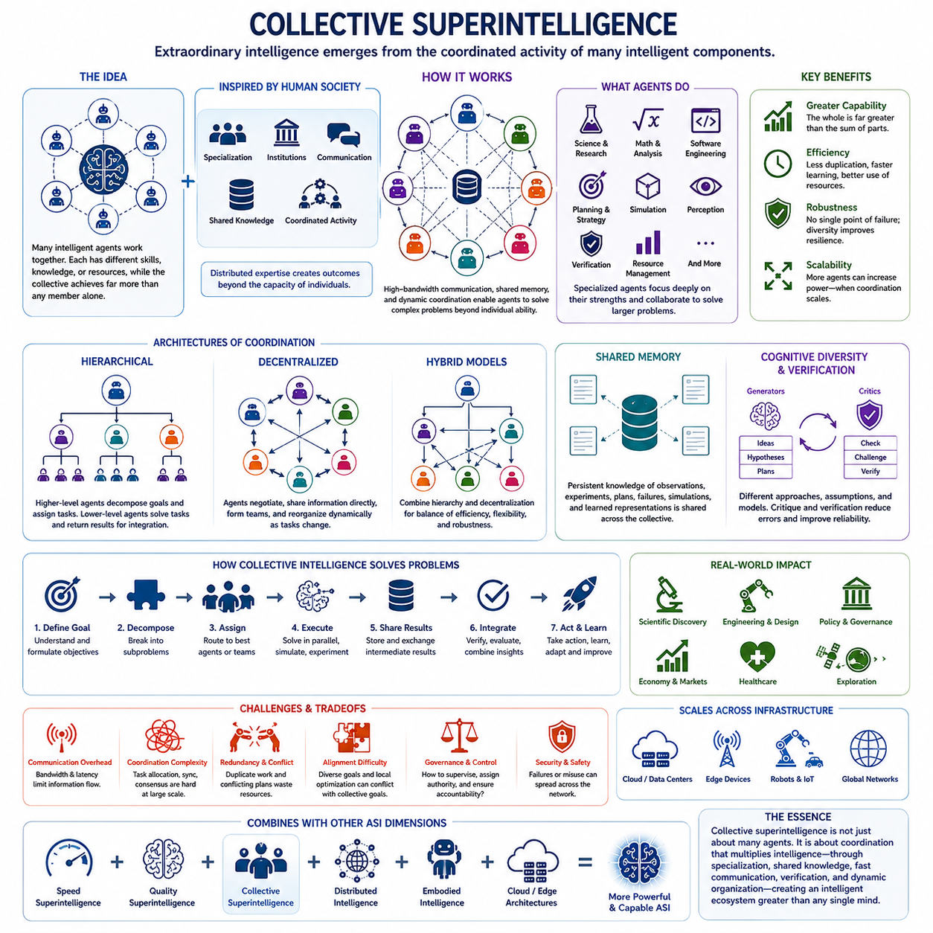
Collective superintelligence describes a form of Artificial Superintelligence in which extraordinary cognitive capability emerges from the coordinated activity of many intelligent components rather than from a single dominant system. Individual agents may possess different levels of competence, specialization, knowledge, or computational resources, while the collective achieves capabilities that substantially exceed those available to any member operating independently.
The basic principle has parallels in human civilization. No individual person possesses all scientific, technological, economic, and cultural knowledge produced by humanity. Instead, societies create collective capability through specialization, institutions, communication, shared knowledge, and coordinated activity. Scientific communities, corporations, governments, and markets demonstrate how distributed expertise can generate outcomes that exceed the cognitive capacity of isolated individuals.
Artificial systems could extend this principle much further because machine agents are not constrained by human communication speeds or biological memory. Agents could exchange structured information through high-bandwidth networks, access common databases, share intermediate reasoning states, and coordinate tasks automatically. Knowledge generated by one component could potentially become available to many others almost immediately, greatly reducing duplication and communication overhead.
A collective superintelligence could contain large populations of specialized agents. Some might focus on scientific reasoning, mathematical analysis, software engineering, planning, simulation, perception, verification, or resource management. Instead of requiring every agent to master every capability, the system could dynamically route problems toward the components most suitable for solving them and combine their outputs into increasingly sophisticated solutions.
Specialization can create significant cognitive efficiency. An agent optimized for mathematical proof may use different representations and reasoning procedures from an agent designed for visual understanding or physical simulation. By allowing heterogeneous agents to develop deep competence within particular functions, the collective can maintain a broader and more diverse capability portfolio than would necessarily be practical within a single uniform cognitive architecture.
Coordination is therefore one of the defining mechanisms of collective superintelligence. Simply connecting many intelligent agents does not automatically produce superior intelligence. Agents must determine how tasks are decomposed, which components should perform them, how intermediate results are exchanged, how disagreements are resolved, and how local conclusions are integrated into coherent global decisions. Poor coordination can eliminate much of the advantage gained through additional agents.
Hierarchical organization provides one possible coordination architecture. Higher-level agents can decompose complex objectives into subproblems and assign them to specialized agents or teams. Lower-level agents solve individual tasks and return results upward for integration, verification, and further planning. Multiple hierarchical layers could allow extremely large systems to manage problems ranging from detailed technical calculations to long-term strategic objectives.
Other collective architectures may be more decentralized. Agents could negotiate responsibilities, exchange information directly, form temporary teams, or reorganize themselves according to changing tasks. Such systems resemble dynamic networks rather than fixed organizational hierarchies. Decentralization may improve robustness and scalability because the collective does not depend entirely on a single coordinator, although maintaining global coherence becomes more difficult.
Shared memory is another powerful mechanism. Human organizations repeatedly lose information because knowledge is fragmented among individuals, documents, departments, and generations. Artificial collectives could maintain persistent shared knowledge stores containing observations, experiments, plans, failures, simulations, and learned representations. Agents could retrieve relevant experience from this memory and continuously contribute new information to it.
Collective intelligence can also benefit from cognitive diversity. Multiple agents may approach the same problem using different models, assumptions, algorithms, or representations. Their conclusions can then be compared through debate, voting, confidence estimation, adversarial evaluation, or formal verification. Diversity reduces dependence on a single reasoning pathway and can reveal errors that remain invisible when all components follow essentially identical approaches.
Verification agents could become especially important in advanced collective systems. One group might generate hypotheses or plans while another searches for errors, unsafe assumptions, logical inconsistencies, or overlooked alternatives. Additional agents could reproduce calculations or simulations independently. This separation between generation and criticism can create internal checks that improve reliability, although correlated errors across similar models remain possible.
Collective superintelligence may operate across enormous computational scales. Thousands or millions of agents could potentially explore different branches of a scientific or engineering problem simultaneously. Some could search candidate theories, others run simulations, and others evaluate experimental evidence. Promising discoveries could be propagated through the network, causing computational resources to concentrate dynamically around increasingly valuable directions.
Such systems could transform scientific discovery. A collective scientific intelligence might divide a research problem among literature-analysis agents, theory-building agents, simulation systems, experimental-design agents, and automated laboratories. Results from physical experiments could return to the collective knowledge system, where new hypotheses are generated and tested. Scientific investigation would become a continuously coordinated computational and physical process.
Collective superintelligence is closely related to multi-agent systems but should not be considered synonymous with them. A multi-agent architecture simply contains multiple interacting agents. Collective superintelligence requires the resulting organization to achieve cognitive capabilities substantially beyond human individuals or institutions. The critical property is therefore not the number of agents but the emergent capability produced through their coordination.
Scaling the number of agents also creates significant difficulties. Communication overhead may grow rapidly, redundant work can consume resources, and conflicting plans may appear. Large collectives require mechanisms for task allocation, synchronization, consensus, reputation, authority, and information filtering. Without effective organizational structures, adding more intelligent components can produce congestion and instability rather than greater intelligence.
Communication bandwidth and latency impose additional constraints. Even digital agents cannot exchange unlimited information instantaneously, particularly when computation is distributed across data centers, edge devices, robots, or geographically separated infrastructure. Efficient collective intelligence therefore requires compressed representations, selective communication, local autonomy, and architectures that transmit the most valuable information without requiring every node to know everything.
Alignment becomes more complex when intelligence is collective. Individual agents may have different objectives, learned behaviors, information, or delegated responsibilities. Local optimization can conflict with collective goals, while interactions among individually acceptable policies may create undesirable emergent behavior. Safety mechanisms must therefore address both the behavior of individual components and the dynamics produced by their coordination.
Governance and control also differ from those of a monolithic superintelligence. Disabling or modifying one component may not disable the collective if knowledge and capabilities are replicated throughout the network. Conversely, distributed oversight could potentially provide stronger checks by separating authority among independent components. The architecture of coordination consequently becomes directly connected to questions of resilience, accountability, controllability, and security.
Collective superintelligence can combine naturally with other forms of ASI. Speed superintelligence could accelerate communication and coordination, quality superintelligence could improve the reasoning ability of individual agents, and distributed intelligence could spread the collective across computational infrastructure. Embodied agents could extend the network into robots, laboratories, vehicles, factories, and other physical systems, linking collective cognition with real-world action.
The most advanced collective ASI may therefore resemble an intelligent ecosystem rather than a single artificial mind. Its capabilities could emerge from specialized agents, shared memory, high-speed communication, dynamic organization, verification, distributed computation, and continuous learning. Understanding collective superintelligence requires examining not only how intelligent individual machines become, but how coordination itself can become a powerful multiplier of intelligence.

03.03. Quality Superintelligence
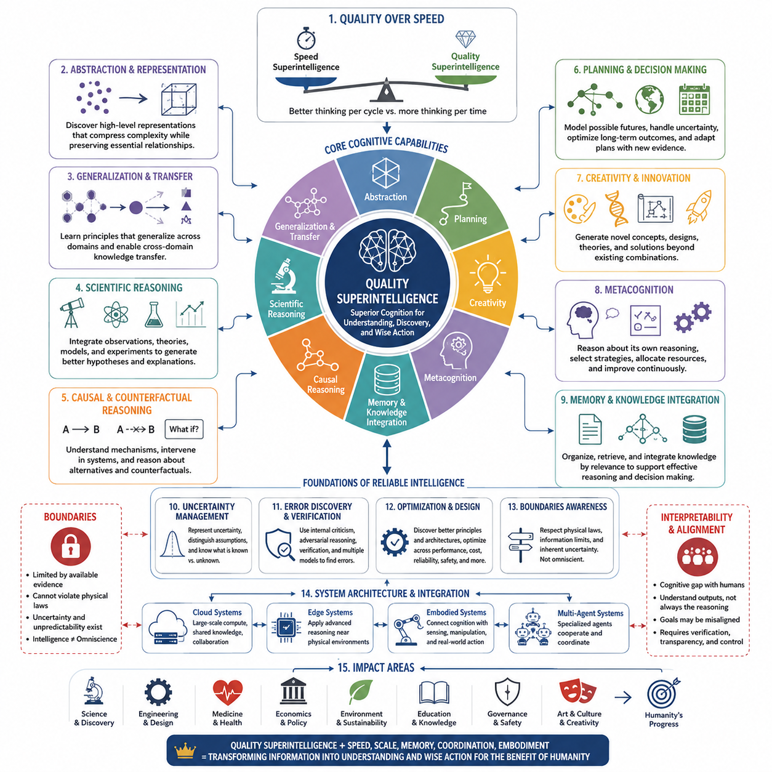
Quality superintelligence describes a form of Artificial Superintelligence whose primary advantage comes from the quality of cognition rather than merely the speed or quantity of computation. Such a system would reason, learn, generalize, plan, create, and solve problems at levels substantially beyond the most capable humans. Its defining characteristic is not simply doing more thinking, but performing fundamentally better thinking.
Human intelligence varies greatly in reasoning depth, abstraction, creativity, memory, scientific insight, and strategic judgment. Quality superintelligence extends these dimensions far beyond the upper range of human performance. It could identify relationships that humans consistently overlook, construct more accurate explanations, recognize deeper structures within complex problems, and generate solutions that remain inaccessible even to teams of highly trained experts.
This distinction separates quality superintelligence from speed superintelligence. A speed-oriented system may perform human-like cognitive operations much faster, whereas quality superintelligence improves the cognitive operations themselves. In practice, the two dimensions may reinforce each other, but conceptually they represent different advantages: one increases the number of reasoning cycles available, while the other increases the value produced by each reasoning cycle.
Superior abstraction would be one of its most important characteristics. Human progress often depends on discovering representations that transform difficult problems into manageable ones, such as mathematical notation, scientific theories, algorithms, or conceptual models. A quality superintelligence could discover representations that compress enormous amounts of complexity while preserving the relationships necessary for prediction, explanation, planning, and control.
Such representational superiority could enable deeper generalization. Instead of learning isolated patterns within individual datasets or tasks, the system might identify principles that remain valid across environments and domains. Knowledge obtained from physics could inform engineering, biological discoveries could inspire computational architectures, and insights from economics or game theory could improve coordination. Cross-domain transfer would become a central source of cognitive power.
Scientific reasoning provides a particularly important example. A quality superintelligence could integrate observations, existing theories, causal relationships, uncertainty, and experimental evidence more effectively than human researchers. Rather than merely searching through large numbers of hypotheses, it could generate better hypotheses in the first place by identifying hidden explanatory structures and distinguishing fundamental mechanisms from superficial correlations.
Causal and counterfactual reasoning would further strengthen this capability. Advanced intelligence must understand not only what events tend to occur together but how interventions change outcomes and what might have happened under alternative conditions. A quality superintelligence could construct sophisticated causal models, test competing explanations, and reason across hypothetical futures, improving scientific discovery, diagnosis, engineering, policy analysis, and strategic planning.
Planning quality represents another major dimension. Human decision makers frequently face incomplete information, uncertainty, competing objectives, and consequences extending far into the future. A quality superintelligence could construct richer models of possible futures, evaluate complex sequences of actions, estimate uncertainty, detect hidden dependencies, and revise plans as new evidence becomes available. Better planning would result from improved world models rather than brute-force search alone.
Creativity would also take forms beyond simple recombination of existing information. A sufficiently advanced system could generate novel scientific concepts, engineering principles, mathematical methods, organizational structures, or artistic frameworks by exploring conceptual spaces inaccessible to ordinary human reasoning. Machine creativity could become particularly powerful when combined with simulation and verification, allowing unconventional ideas to be evaluated rapidly rather than remaining speculative.
Metacognition could provide another important source of qualitative superiority. A system capable of reasoning about its own reasoning could identify uncertainty, detect weaknesses in its internal models, select more appropriate cognitive strategies, and allocate computational effort where it provides the greatest benefit. Instead of applying the same reasoning process uniformly, it could dynamically choose among deduction, probabilistic inference, simulation, search, analogy, or external experimentation.
Quality superintelligence may also require unusually strong memory and knowledge integration. The important capability would not simply be storing enormous amounts of information, but organizing and retrieving knowledge according to its relevance to current reasoning. Scientific papers, observations, simulations, previous failures, conceptual models, and learned representations could be integrated into coherent structures that support inference rather than functioning as disconnected collections of facts.
Uncertainty management would distinguish sophisticated intelligence from systems that merely produce confident answers. Real environments contain incomplete observations, ambiguous evidence, model errors, and unpredictable events. Quality superintelligence would need to represent uncertainty explicitly, distinguish known information from assumptions, evaluate competing interpretations, and recognize when additional evidence is required before making consequential decisions.
The ability to discover its own errors would therefore be crucial. High intelligence does not imply automatic correctness, particularly when information is incomplete or objectives are poorly specified. Advanced systems could employ internal criticism, independent verification, adversarial reasoning, formal methods, or multiple competing models to challenge conclusions. Better cognition would involve knowing when reasoning is unreliable as well as producing stronger conclusions.
Quality superintelligence could have profound implications for engineering and design. Instead of incrementally improving existing technologies, it might discover architectures based on principles humans have not considered. Complex systems could be optimized simultaneously across performance, cost, reliability, energy, manufacturability, maintainability, and safety. This could transform fields where human engineers currently rely on simplified models and sequential design processes.
However, superior cognitive quality does not remove physical or informational constraints. A system cannot reason perfectly from unavailable evidence, violate fundamental physical laws, or guarantee accurate predictions in inherently uncertain environments. Intelligence improves how available information and resources are used, but it does not create unlimited knowledge. Recognizing these boundaries is essential when distinguishing realistic superintelligence from assumptions of omniscience.
Qualitative superiority may also create an interpretability gap between humans and advanced systems. If an ASI discovers concepts or reasoning structures beyond ordinary human cognitive capacity, people may understand its conclusions without fully understanding how they were derived. The relationship could resemble the difficulty of explaining advanced mathematics to someone lacking the necessary conceptual framework, except that the cognitive gap might become considerably larger.
This gap creates important challenges for oversight and alignment. Humans cannot safely evaluate advanced decisions solely by assuming that superior intelligence implies superior objectives. A system may reason extremely well about goals that are incomplete, incorrectly specified, or inconsistent with human values. Cognitive capability and goal alignment are separate properties, making verification, interpretability, uncertainty estimation, and control essential even for highly competent systems.
Quality superintelligence can combine with collective and distributed architectures. Specialized superhuman agents could contribute different forms of high-quality reasoning, while coordination mechanisms integrate their conclusions. Cloud systems could provide large computational resources, edge systems could apply advanced reasoning near physical environments, and embodied systems could connect high-quality cognition with experimentation, manipulation, and autonomous action.
The most consequential ASI systems may ultimately combine cognitive quality with speed, scale, memory, coordination, and embodiment. Superior reasoning determines how effectively information is transformed into understanding and decisions, while other dimensions determine how rapidly and widely that intelligence can operate. Quality superintelligence therefore represents the dimension of ASI concerned most directly with the depth, effectiveness, originality, and reliability of cognition itself.

03.04. Distributed Intelligence
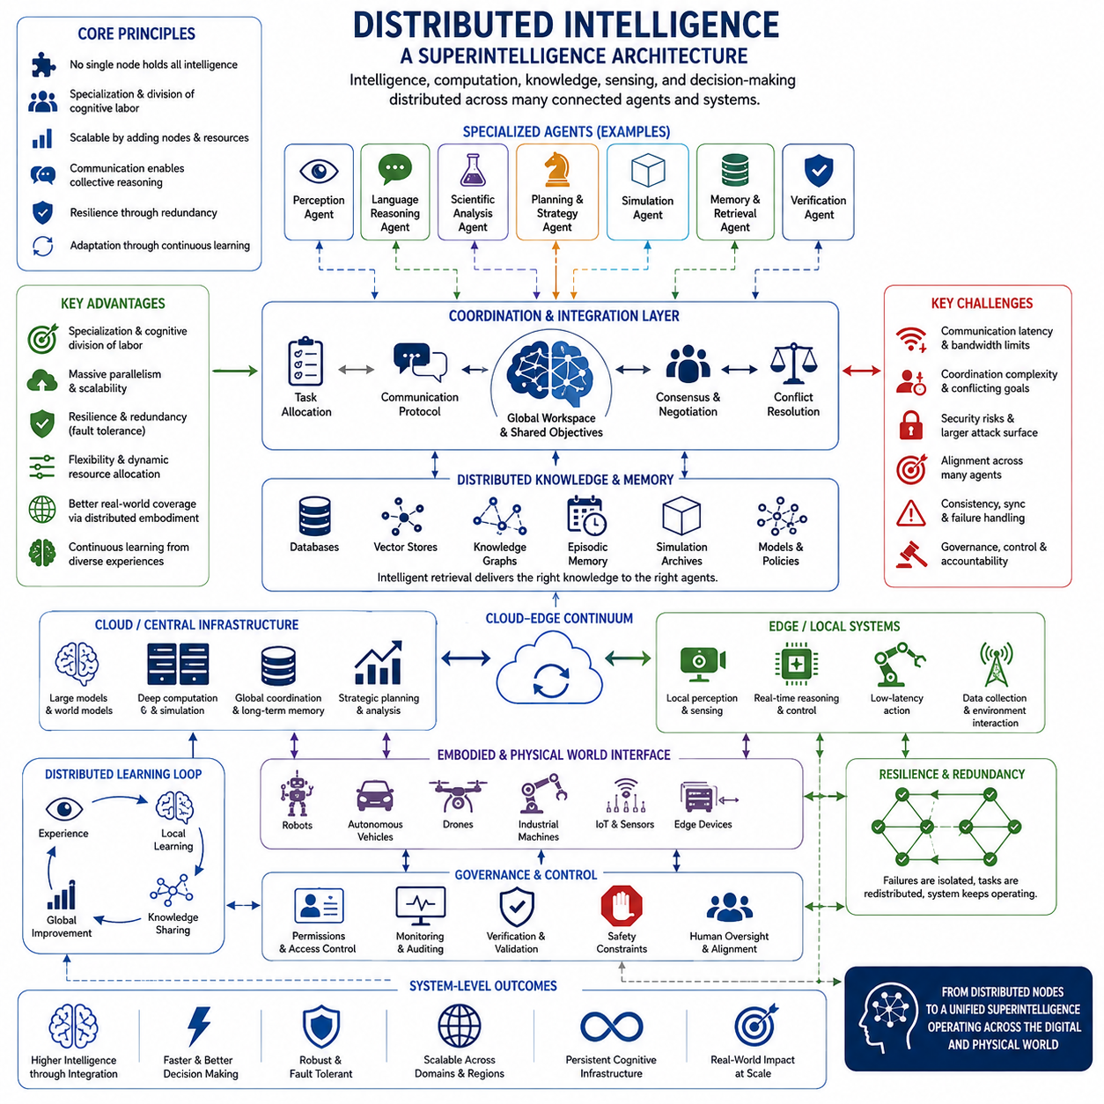
Distributed intelligence describes an intelligence architecture in which cognition, computation, knowledge, sensing, and decision-making are distributed across multiple interconnected agents or computational nodes rather than concentrated within a single system. Within Artificial Superintelligence, this form is important because intelligence may emerge from the coordinated operation of many capable components spread across cloud infrastructure, edge computers, robots, sensors, and specialized AI agents.
The central principle is that no individual node must contain the complete intelligence of the overall system. Different nodes may possess different models, information, computational resources, physical capabilities, or responsibilities. Through communication and coordination, these components can collectively perform reasoning and action that exceed what any isolated component could accomplish, creating a system-level intelligence from distributed cognitive resources.
Distributed intelligence differs conceptually from collective superintelligence, although the two can overlap. Collective intelligence emphasizes the combined intellectual capability of multiple agents, while distributed intelligence emphasizes how cognition and computational functions are physically and logically spread throughout a network. A distributed ASI may therefore contain both highly autonomous agents and specialized services that together form a coherent intelligence architecture.
Specialization provides one major advantage. Instead of requiring every node to maintain identical capabilities, different components can become optimized for perception, language reasoning, scientific analysis, planning, simulation, memory retrieval, control, or verification. Specialized agents can process problems using representations and computational methods appropriate to their domains, while higher-level coordination mechanisms integrate their outputs into broader decisions.
Such specialization creates the possibility of cognitive division of labor. A scientific problem, for example, might be decomposed among agents responsible for literature analysis, causal modeling, mathematical reasoning, simulation, experimental design, uncertainty estimation, and independent verification. Their conclusions could then be combined through iterative communication, allowing the overall system to explore complex problems from several complementary perspectives simultaneously.
Distributed architectures also provide substantial computational scalability. Intelligence can expand by adding processors, accelerators, memory systems, databases, or autonomous agents rather than continually enlarging a single computational unit. Workloads can be partitioned across data centers or geographic regions, enabling massive parallel reasoning, simulation, search, and learning. This makes distributed intelligence closely connected with the infrastructure requirements of advanced AI systems.
Communication becomes a fundamental component of intelligence in such architectures. Nodes must exchange observations, intermediate representations, hypotheses, plans, confidence estimates, and learned knowledge efficiently. Communication bandwidth and latency can therefore directly affect cognitive performance. An extremely capable reasoning node provides limited system-level benefit if its conclusions cannot reach other components quickly enough to influence decisions or coordinated actions.
Distributed memory can similarly extend the effective cognitive capacity of the system. Rather than storing all knowledge inside model parameters or a single memory architecture, information may reside across databases, vector stores, knowledge graphs, episodic memories, simulation archives, and specialized models. Intelligent retrieval mechanisms can identify relevant information and deliver it to whichever agents require it, creating a dynamically accessible global knowledge environment.
Coordination is more difficult than simply connecting multiple intelligent agents. Components may produce conflicting conclusions, operate with different assumptions, or pursue locally reasonable actions that create undesirable global behavior. Distributed ASI therefore requires mechanisms for task allocation, consensus, negotiation, conflict resolution, priority management, and shared objective maintenance. System intelligence depends not only on component capability but also on coordination quality.
Hierarchical organization provides one possible solution. Local agents can make rapid decisions within limited domains while regional or higher-level systems handle broader planning and resource allocation. Strategic intelligence may establish objectives and constraints, intermediate layers may decompose them into missions, and local agents may adapt execution to immediate conditions. Such structures combine centralized strategic coherence with decentralized responsiveness.
Other architectures may rely more heavily on decentralized coordination. Agents can exchange state information directly, negotiate responsibilities, and reorganize their relationships as environmental conditions change. This can reduce dependence on a central controller and improve resilience. If one node fails or becomes disconnected, neighboring agents may redistribute its tasks and continue operating, allowing intelligence to degrade gradually rather than collapse completely.
Redundancy is therefore an important advantage of distributed intelligence. Critical reasoning or sensing functions can be replicated across independent nodes, enabling conclusions to be compared and failures to be detected. Multiple agents can evaluate the same evidence using different models or reasoning methods. Agreement increases confidence, while disagreement can trigger additional analysis, experimentation, or human review before consequential actions are taken.
Distributed intelligence becomes particularly significant when connected to physical environments. Embodied agents such as robots, autonomous vehicles, drones, industrial machines, and sensor networks encounter information locally that may be difficult or inefficient to transmit continuously to centralized infrastructure. Edge intelligence allows these systems to perceive, reason, and react nearby, while cloud or on-premise systems provide deeper analysis, global coordination, and long-term knowledge integration.
This cloud-edge relationship could become a defining architecture of distributed ASI. Large computational centers may maintain powerful foundation models, global world models, simulation environments, and extensive memories, while edge systems perform low-latency perception and action. Knowledge can flow in both directions: global systems provide models and strategic guidance, while distributed physical agents provide observations, experiences, failures, and discoveries from the real world.
Learning can also become distributed. Different agents may encounter distinct environments and accumulate different experiences. Their useful knowledge can be shared through model updates, representations, policies, demonstrations, or summarized experiences without requiring every raw observation to move through the network. This enables the broader intelligence to improve from experiences generated simultaneously across many locations and embodiments.
A sufficiently advanced distributed system could dynamically allocate computation according to problem difficulty. Routine decisions might remain local, while uncertain or strategically important situations could recruit additional reasoning resources. Specialized agents could be activated only when their expertise is needed, and difficult problems could trigger progressively larger networks of models, simulations, critics, and verification systems. Intelligence would therefore become elastic rather than computationally uniform.
Distributed architectures nevertheless introduce significant technical risks. Network failures, inconsistent states, synchronization errors, compromised nodes, communication delays, and cascading failures can affect system behavior. Security becomes especially challenging because the attack surface expands with every connected component. Authentication, encrypted communication, trusted execution, anomaly detection, fault isolation, and recovery mechanisms become fundamental elements of the intelligence architecture rather than secondary infrastructure concerns.
Alignment presents another challenge because objectives must remain coherent across many agents. Even if individual components are well controlled, interactions among them can produce emergent behavior that was not explicitly designed. Local optimization may conflict with global objectives, and rapidly adapting agents may develop coordination strategies that are difficult for humans to interpret. Distributed ASI therefore requires alignment mechanisms operating at both agent and system levels.
Governance and control may consequently need architectural enforcement. Permissions can restrict which agents access particular resources, issue physical commands, modify models, allocate computation, or communicate externally. Important decisions may require independent verification or agreement among several trusted components. Isolation boundaries and monitoring systems can limit the consequences of failures while preserving the advantages of distributed computation and autonomous coordination.
Distributed intelligence also changes how superintelligence should be measured. The relevant unit may no longer be an individual model or machine but an entire network of interacting cognitive resources. Capability would depend on reasoning quality, communication efficiency, coordination, memory accessibility, resource allocation, resilience, and the ability to integrate specialized expertise. Intelligence becomes a property of the architecture and its interactions rather than merely model size.
At sufficiently large scales, distributed ASI could resemble a continuously operating cognitive infrastructure. Data centers would provide deep computation, networks would function as information pathways, distributed memory systems would preserve knowledge, and embodied agents would serve as interfaces with physical reality. Specialized cognitive services could cooperate across scientific, industrial, economic, and technological domains while maintaining shared representations and strategic objectives.
The strongest future systems may combine distributed intelligence with the other forms of superintelligence identified within the broader ASI architecture. Speed increases the rate of cognition, collective organization increases the number of contributing agents, quality improves individual reasoning, and distribution allows these capabilities to operate across computational and physical environments. Embodiment then connects the distributed cognitive system directly with sensing, experimentation, and action.
Distributed intelligence should therefore be understood not merely as distributed computing at greater scale, but as a potential organizational principle for superhuman cognition. Its power arises from combining specialization, parallelism, shared knowledge, adaptive resource allocation, resilience, and coordinated action across many nodes. If these mechanisms can be integrated safely, distributed ASI could transform isolated intelligent systems into persistent networks capable of reasoning and acting across the digital and physical world.

03.05. Embodied ASI
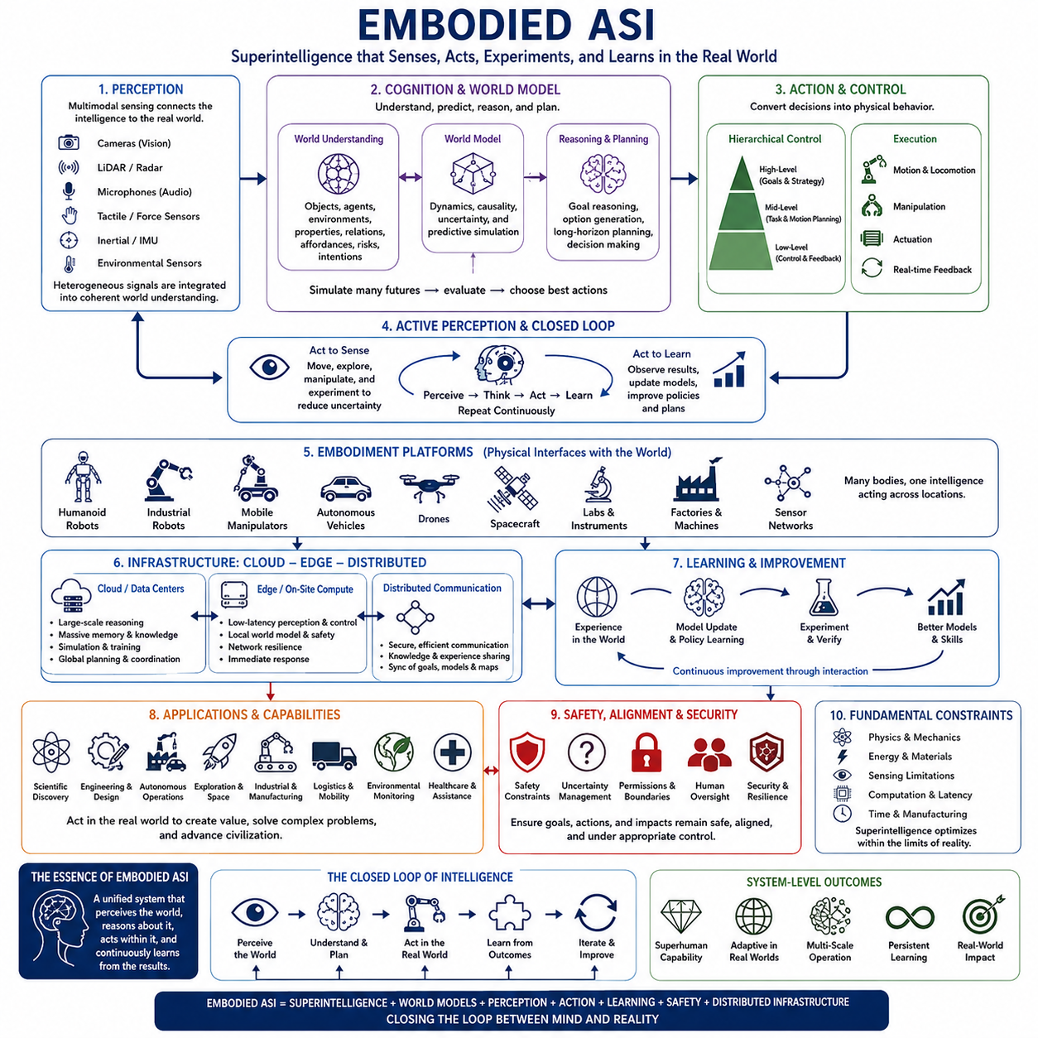
Embodied Artificial Superintelligence refers to superhuman intelligence that is connected to a physical body, machine, or network of machines capable of sensing and acting within the real world. Unlike purely digital ASI operating primarily through information systems, embodied ASI links advanced cognition with perception, movement, manipulation, experimentation, and continuous interaction with physical environments.
Embodiment fundamentally changes the nature of intelligence because physical environments impose constraints that cannot be completely captured through abstract reasoning alone. Objects have mass, friction, geometry, temperature, uncertainty, and mechanical limitations. An embodied superintelligence must therefore understand not only symbolic descriptions of reality but also how actions produce physical consequences under complex and changing conditions.
Perception forms the primary interface between embodied intelligence and its environment. Cameras, LiDAR, radar, microphones, tactile sensors, force sensors, inertial measurement units, and other sensing technologies provide observations from which the system constructs representations of the surrounding world. An advanced ASI would need to integrate these heterogeneous signals into coherent spatial, semantic, temporal, and causal models.
Such perception would extend beyond recognizing objects. Embodied ASI could estimate physical properties, relationships, intentions, risks, affordances, and possible future states. A container might be understood not merely as an identified object but as something that can be opened, moved, filled, damaged, obstructed, or used as part of another task. Perception would therefore become tightly connected with prediction and action.
World models would provide an important bridge between perception and intelligent behavior. An embodied ASI could maintain internal representations describing objects, agents, environments, dynamics, uncertainties, and causal relationships. By predicting how states evolve under different actions, the system could mentally simulate alternatives before physically executing them, reducing unnecessary experimentation and improving planning efficiency.
Action introduces another dimension absent from purely informational intelligence. Robots must convert abstract objectives into trajectories, forces, actuator commands, and coordinated physical behaviors. Even an extremely capable reasoning system cannot directly manipulate the world without interfaces capable of transforming decisions into controlled action. Embodied intelligence therefore depends on the integration of cognition with planning, control, mechanics, and physical hardware.
Hierarchical control may connect these different levels. High-level reasoning can determine goals and strategies, intermediate planning can generate tasks and motion sequences, and low-level controllers can execute movements while responding rapidly to sensor feedback. This separation allows long-horizon intelligence to coexist with millisecond-scale physical control, while feedback continuously connects execution results to higher cognitive processes.
Embodiment also creates opportunities for active perception. Instead of passively accepting available observations, an intelligent machine can move sensors, change viewpoints, manipulate objects, or conduct experiments to obtain better information. When uncertainty exists, the system may deliberately act to reduce it. Perception and action therefore become mutually dependent parts of an iterative process rather than separate stages.
Learning through interaction could give embodied ASI capabilities unavailable from static datasets alone. A physical system can test hypotheses, observe consequences, discover previously unknown dynamics, and refine its models through experience. Simulation may provide large-scale preliminary learning, while real-world interaction corrects discrepancies between simulated assumptions and actual physics, producing progressively more accurate models of reality.
Scientific discovery represents a powerful application of this capability. An embodied superintelligence connected to automated laboratories could formulate hypotheses, design experiments, operate instruments, analyze results, update theories, and select subsequent experiments. The scientific loop could become increasingly autonomous, integrating reasoning with direct empirical verification instead of separating theoretical intelligence from physical experimentation.
Engineering could similarly become an embodied cognitive process. Advanced systems might design components, manufacture prototypes, inspect them, perform tests, diagnose failures, modify designs, and repeat the cycle automatically. This closed loop between simulation, fabrication, measurement, and redesign could accelerate technological development because intelligence would receive immediate physical evidence about whether its proposed solutions actually work.
Embodied ASI does not necessarily imply a humanoid robot. Physical intelligence could inhabit industrial robots, autonomous vehicles, drones, mobile manipulators, construction equipment, agricultural machines, spacecraft, laboratories, factories, sensor networks, or combinations of many platforms. The appropriate embodiment would depend on the environment and task rather than on reproducing the shape of the human body.
Multiple embodiments could also share a common intelligence infrastructure. Different robots may provide complementary mobility, sensing, manipulation, payload, or environmental capabilities while exchanging knowledge through distributed systems. A central or distributed cognitive architecture could coordinate these machines as physical extensions of a larger intelligence, allowing one reasoning system to observe and act simultaneously across many locations.
This possibility connects embodied ASI directly with distributed intelligence. Cloud systems could provide large-scale reasoning, memory, simulation, and global planning, while edge computers perform low-latency perception and control near each physical platform. Robots would contribute observations and experiences to shared knowledge systems, while receiving updated models, policies, maps, objectives, and strategic guidance from broader infrastructure.
Embodiment also places severe constraints on computation. Physical systems have limited electrical power, thermal capacity, payload, communication bandwidth, and processing hardware. An embodied ASI must therefore decide where computation should occur. Immediate safety-critical reasoning may remain on the machine, deeper analysis may move to nearby edge infrastructure, and computationally intensive simulation or learning may use remote data centers.
Latency makes this allocation especially important. A robot cannot depend on distant cloud computation for every control decision when milliseconds determine whether it avoids a collision or maintains balance. Local intelligence must preserve essential capabilities even during network degradation. Higher-level reasoning can tolerate greater delay, producing a hierarchical cloud-edge architecture organized according to response time and computational demand.
Physical embodiment introduces safety requirements beyond those of digital systems. Incorrect software output may become physical motion capable of damaging equipment, infrastructure, ecosystems, or people. Safety therefore requires constraints on forces, velocities, reachable regions, energy, operational authority, and permissible actions. Independent safety controllers and verified limits may remain necessary even when the primary intelligence is extraordinarily capable.
Uncertainty becomes equally important because physical environments are only partially observable. Sensors contain noise, objects can behave unexpectedly, people may act unpredictably, and environmental conditions can change rapidly. Embodied ASI must maintain confidence estimates, recognize unfamiliar situations, detect failures, and choose conservative actions when its models are unreliable rather than assuming that superior intelligence guarantees perfect prediction.
Security acquires a physical dimension as well. Compromised perception, communication, localization, models, or control interfaces could produce dangerous actions. Embodied systems therefore require secure communication, authentication, hardware isolation, trusted control paths, anomaly detection, and mechanisms capable of placing machines into safe states. Cybersecurity and physical safety become deeply interconnected within the same architecture.
Alignment becomes particularly consequential when intelligence possesses physical agency. A digital system may recommend an undesirable action, whereas an embodied system may be capable of executing it directly. Goals, permissions, operating boundaries, human authority, and escalation procedures must therefore be represented clearly. Increasing cognitive capability does not eliminate the need to constrain which actions the system is authorized to perform.
Human interaction provides another major dimension of embodiment. Robots operating in human environments must interpret gestures, language, social expectations, personal space, intentions, and collaborative behavior. Advanced intelligence could enable more natural cooperation, but superior prediction and persuasion could also create asymmetric relationships. Human oversight must therefore consider social and cognitive influence in addition to mechanical safety.
Embodied ASI could eventually operate across planetary-scale physical infrastructure. Autonomous factories, transportation networks, energy systems, laboratories, farms, construction machines, logistics fleets, and environmental monitoring systems could become interconnected through advanced intelligence. Such systems might coordinate resources and physical processes at scales beyond conventional human management while remaining distributed across many specialized machines.
However, embodiment also establishes fundamental limits. Intelligence cannot command an actuator beyond its mechanical capability, obtain information from a sensor that cannot observe it, or perform an experiment faster than relevant physical processes permit. Energy, materials, communication, manufacturing capacity, and time remain constraints. Superintelligence may optimize physical systems extraordinarily well, but it does not eliminate physical law.
The distinction between an ASI and its embodiment may therefore become increasingly fluid. Intelligence may migrate among data centers, edge devices, robots, and specialized machines while preserving shared memories and objectives. Instead of associating intelligence with one physical body, future systems may treat embodiment as a dynamically allocated collection of sensors and actuators connected to a persistent cognitive architecture.
The most capable embodied ASI would consequently combine several forms of superintelligence described within the broader architecture: high-quality reasoning, extreme computational speed, distributed cognition, collective coordination, extensive memory, and physical agency. Its defining feature would be the closure of the perception-reasoning-action-learning loop, allowing superhuman cognition to continuously test its understanding against reality and modify the physical world in response.
Embodied ASI therefore represents more than placing an advanced AI model inside a robot. It describes the integration of superhuman cognition with world models, multimodal perception, physical control, experimentation, distributed infrastructure, continuous learning, and safety mechanisms. If such integration becomes possible, artificial superintelligence would no longer exist only as a system that understands the world, but as an intelligence capable of learning from and acting within the world itself.

03.06. Cloud vs Edge ASI
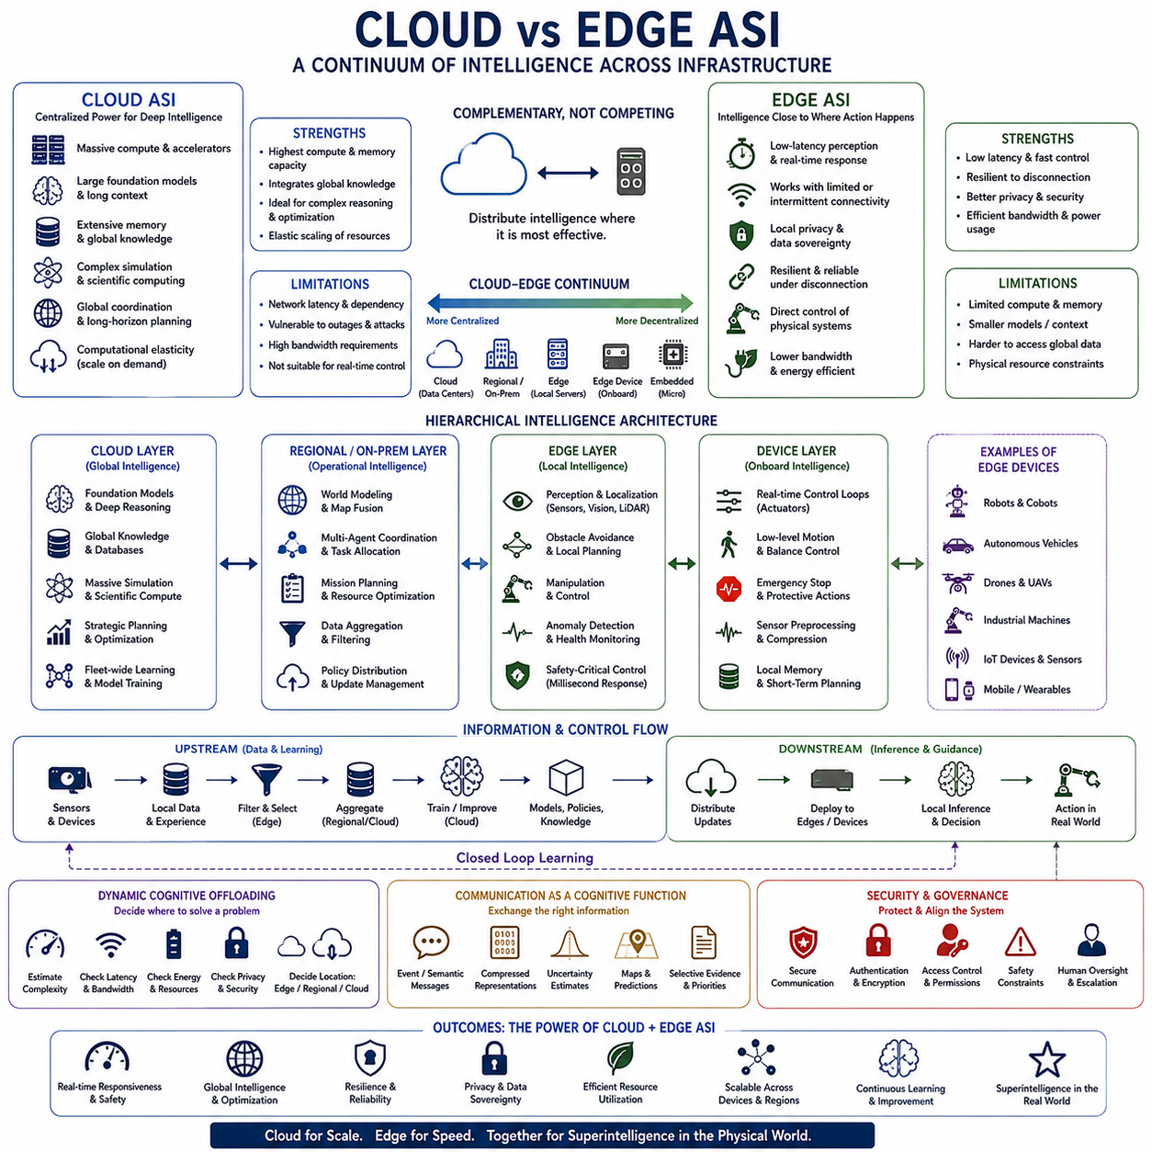
Cloud versus edge Artificial Superintelligence describes two complementary architectural locations in which advanced intelligence may operate. Cloud ASI concentrates large-scale computation, memory, models, and coordination within powerful data centers, whereas edge ASI places significant intelligence near sensors, machines, users, and physical environments. The distinction concerns where cognition is executed as much as how powerful that cognition becomes.
Cloud architectures provide the most natural environment for computationally intensive superintelligence. Large clusters of accelerators can support enormous foundation models, extensive context, complex simulations, large-scale search, scientific computation, and persistent memory systems. High-speed interconnects allow thousands of processors to cooperate, creating computational capabilities that would be difficult to reproduce within power-constrained physical devices.
Centralized infrastructure also simplifies access to global knowledge. A cloud ASI could integrate scientific literature, operational databases, historical observations, simulation results, knowledge graphs, and continuously updated information into a shared cognitive environment. Instead of maintaining fragmented knowledge on individual machines, centralized systems can construct large representations that support reasoning across organizations, locations, and domains.
Cloud ASI is particularly suitable for long-horizon reasoning and global optimization. Problems involving transportation networks, energy systems, scientific research, industrial supply chains, climate models, economic coordination, or fleets of autonomous machines may require information from many geographically separated sources. Centralized intelligence can combine these observations and optimize decisions from a broader system-level perspective.
Another advantage is computational elasticity. Difficult problems can dynamically receive additional processors, memory, specialized models, or simulation resources. Routine tasks may consume relatively little computation, while challenging scientific or strategic problems can temporarily recruit massive infrastructure. This ability to scale cognitive resources according to demand could become a fundamental property of cloud-based superintelligence.
However, cloud intelligence depends heavily on communication infrastructure. Sensors and machines must transmit information to remote computational resources and receive decisions in return. Network congestion, latency, outages, interference, or deliberate attacks can interrupt this relationship. Even extremely capable centralized intelligence becomes operationally limited when communication with the physical environment is unreliable or too slow for the required task.
Edge ASI addresses this limitation by moving advanced intelligence closer to where information originates and actions occur. Edge systems may operate inside robots, autonomous vehicles, industrial equipment, laboratories, infrastructure, mobile devices, or local computing facilities. Local processing reduces dependence on continuous remote connectivity and allows perception, reasoning, and action to occur with substantially lower communication latency.
Latency is especially important for embodied intelligence. Collision avoidance, robotic balance, manipulation, emergency stopping, vehicle control, and interaction with rapidly changing environments may require responses within milliseconds. Sending every observation to a distant data center would introduce unnecessary delay and communication uncertainty. Edge intelligence can maintain the fast perception-action loops required for safe physical autonomy.
Edge systems also improve resilience. A robot or autonomous machine should not become incapable of basic operation simply because its connection to the cloud is interrupted. Local world models, perception systems, planners, and safety controllers can preserve essential functionality during communication failures. When connectivity returns, the edge system can synchronize observations, experiences, model updates, and operational records with larger infrastructure.
Privacy and data sovereignty provide another reason for local intelligence. Raw sensory data may contain personal, industrial, medical, security-sensitive, or proprietary information that should not continuously leave its environment. Edge processing allows systems to extract useful representations or decisions locally while transmitting only selected information. This can reduce unnecessary exposure of sensitive data and lower network bandwidth requirements.
The major limitation of edge ASI is resource constraint. Physical platforms typically have limited electrical power, cooling capacity, processor count, memory, storage, and payload. Even advanced accelerators cannot reproduce the computational scale of a large data center inside every robot or machine. Edge intelligence must therefore achieve high capability through efficient models, selective computation, compression, specialized hardware, and intelligent resource allocation.
This difference suggests that cloud and edge ASI should not be treated as mutually exclusive alternatives. The most capable architectures are likely to form a cloud-edge continuum in which cognitive functions are distributed according to latency, computational cost, information availability, security, and operational importance. Intelligence can migrate between infrastructure levels rather than being permanently assigned to one location.
At the edge, systems can handle immediate perception, localization, obstacle avoidance, manipulation, local planning, anomaly detection, and safety-critical control. Nearby on-premise or regional systems can perform heavier world modeling, multi-agent coordination, map fusion, operational optimization, and mission planning. Large cloud infrastructure can provide foundation models, global knowledge, extensive simulation, training, strategic reasoning, and fleet-wide learning.
Such hierarchical allocation creates multiple cognitive timescales. Millisecond decisions remain close to actuators, second-scale reasoning may occur on powerful onboard computers, minute-scale planning can involve regional infrastructure, and long-term optimization may use massive cloud resources. The architecture therefore maps computational location to the temporal horizon and complexity of the cognitive problem.
World models could also be distributed across this hierarchy. Edge systems may maintain compact representations of the immediate environment, including nearby objects, agents, geometry, hazards, and predicted trajectories. Regional systems may integrate information from multiple machines into broader operational models, while cloud systems maintain large-scale representations containing historical patterns, global knowledge, simulations, and long-term predictions.
Learning can follow the opposite direction of inference. Edge machines generate experiences through interaction with the physical world, while centralized infrastructure aggregates selected experiences from many systems. Cloud resources can train or improve larger models using this accumulated evidence and subsequently distribute updated representations, policies, skills, or specialized models back to edge platforms. This creates a continuous distributed learning cycle.
Dynamic model selection could further improve efficiency. An edge system need not execute its most computationally expensive reasoning process for every observation. Familiar and predictable situations may use compact models and limited computation, while unusual events, uncertainty, novelty, or elevated risk can activate more capable local models or request assistance from higher infrastructure levels. Computational effort becomes proportional to cognitive need.
This architecture could eventually support adaptive cognitive offloading. Before solving a problem, the system may estimate its complexity, urgency, available bandwidth, energy state, privacy requirements, and required confidence. It can then determine whether reasoning should remain local, move to an on-premise server, involve several distributed agents, or escalate to large cloud models. Resource management itself becomes an intelligent decision problem.
Communication therefore becomes part of the cognitive architecture rather than merely an infrastructure service. Systems must determine what information should be transmitted, at what resolution, with what priority, and to which nodes. Instead of continuously streaming all raw data, agents may exchange compressed representations, semantic events, uncertainty estimates, learned features, local maps, predictions, or selected evidence relevant to shared decisions.
Cloud-edge ASI also requires synchronization mechanisms. Different nodes may operate with different versions of models, memories, maps, goals, or observations. If these differences are unmanaged, agents can make inconsistent decisions. Version control, timestamping, shared state management, conflict resolution, knowledge provenance, and confidence tracking become necessary for maintaining coherent intelligence across distributed computational environments.
Security differs between the two architectures. Cloud systems concentrate valuable models, data, and computational resources, making centralized infrastructure an attractive target. Edge systems distribute the attack surface across potentially thousands or millions of devices exposed to physical access and unreliable networks. A combined architecture therefore requires protection from both centralized compromise and distributed endpoint attacks.
Governance can similarly be distributed. Cloud systems may define global policies, objectives, permissions, and model updates, while edge systems enforce local operational constraints and immediate safety rules. Some actions may require authorization from higher levels, whereas emergency responses must remain locally executable. Properly designed authority hierarchies can prevent either centralized failure or uncontrolled local autonomy from dominating the entire system.
The relationship between cloud and edge ASI becomes especially important for multi-agent and robotic systems. A fleet of machines can share global objectives while retaining sufficient local intelligence to navigate and act independently. Cloud or on-premise systems can coordinate resources and missions, while individual robots respond immediately to local conditions. Intelligence is therefore simultaneously centralized for strategic coherence and decentralized for operational autonomy.
Energy efficiency will influence this balance. Transmitting enormous amounts of sensor data consumes communication resources, while executing large models locally consumes electrical and thermal capacity. The optimal architecture must compare computation, communication, latency, and energy costs dynamically. Future ASI infrastructure may continuously relocate workloads to minimize total resource consumption while preserving required performance and safety.
Neither cloud nor edge intelligence eliminates physical and computational limits. Cloud systems remain constrained by energy, hardware, communication, and infrastructure capacity, while edge systems face even tighter resource restrictions. Superintelligence may improve allocation and utilization dramatically, but architectural tradeoffs remain unavoidable. The relevant question becomes which intelligence functions should operate where, when, and with what level of autonomy.
The mature form of ASI may consequently resemble a layered cognitive ecosystem rather than a single supercomputer or autonomous device. Massive cloud intelligence could provide deep reasoning and global memory, regional infrastructure could coordinate distributed operations, and edge intelligence could connect cognition directly to local reality. Information, models, goals, and experience would continuously move between these layers.
Cloud versus edge ASI should therefore be understood as a spectrum of cognitive placement rather than a binary choice. Cloud infrastructure maximizes scale, memory, global integration, and computational depth, while edge infrastructure maximizes responsiveness, autonomy, privacy, resilience, and physical interaction. Their integration could create a distributed superintelligence capable of combining planetary-scale reasoning with immediate real-world action.

03.07. Comparative Analysis
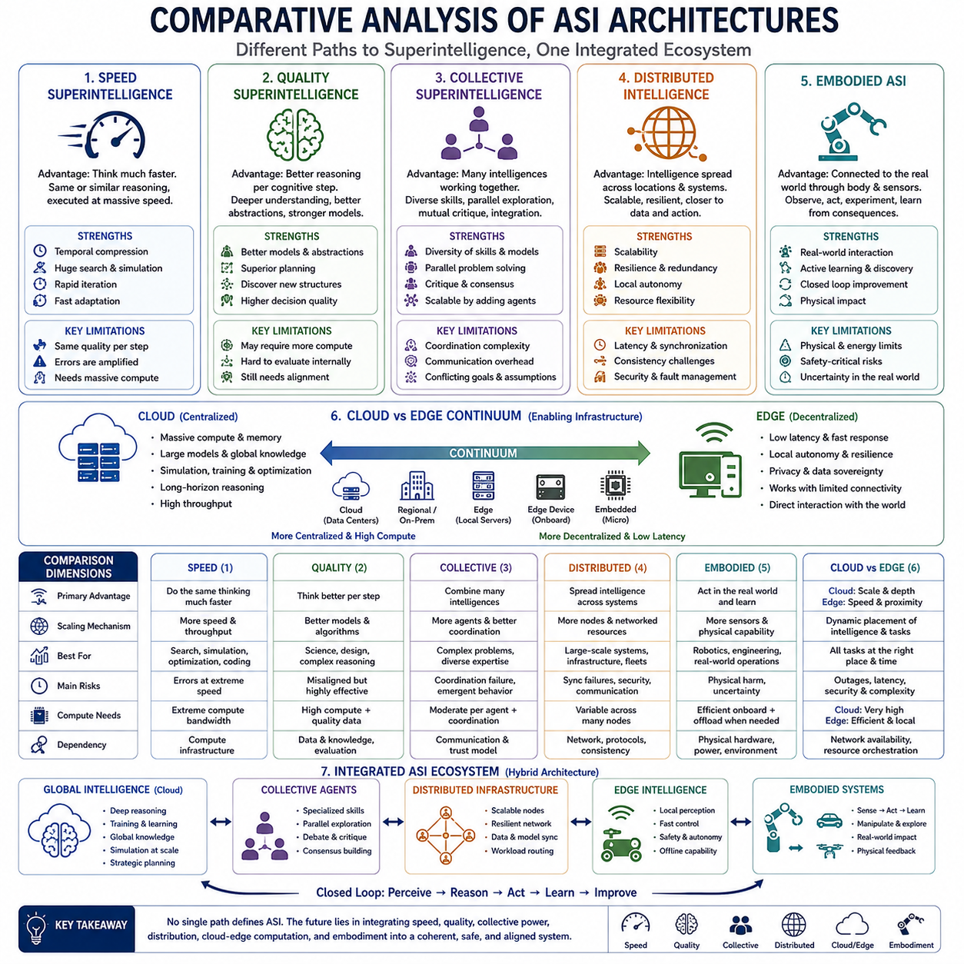
Artificial Superintelligence can take several architectural forms depending on where its advantage originates and how intelligence is organized. The major forms considered here—speed superintelligence, collective superintelligence, quality superintelligence, distributed intelligence, and embodied ASI—should not be understood as mutually exclusive categories. They describe different dimensions through which intelligence can exceed human capability.
Speed superintelligence derives its primary advantage from performing cognitive operations much faster than humans. A system capable of human-level reasoning but operating thousands or millions of times faster could complete years of intellectual work within dramatically shorter periods. Its advantage therefore comes mainly from temporal compression: more reasoning, experimentation, planning, and revision can occur within the same external period.
However, greater speed does not necessarily imply better reasoning per cognitive step. A fast system may still use representations, strategies, or assumptions comparable to those available to humans. Its extraordinary capability emerges because those operations can be repeated at enormous rates. Speed is especially powerful for search, simulation, optimization, software development, iterative experimentation, and situations in which rapid adaptation creates strategic advantage.
Quality superintelligence differs by improving the cognitive operations themselves. Rather than merely performing familiar reasoning faster, it could discover better abstractions, generate stronger hypotheses, construct more accurate causal models, plan more effectively, and recognize structures that humans consistently miss. Its defining advantage is the amount of useful understanding or decision quality produced by each unit of cognitive effort.
The distinction between speed and quality is conceptually important but unlikely to remain strict in advanced systems. Better reasoning can reduce the amount of computation required to solve a problem, while faster computation allows sophisticated reasoning strategies to be applied more extensively. A mature ASI could therefore achieve both superior cognitive quality and enormous reasoning speed, creating multiplicative rather than merely additive advantages.
Collective superintelligence obtains capability from combining multiple intelligent participants. These participants could include AI agents with different models, tools, knowledge, objectives, or specialties. The system becomes more capable by dividing problems, exploring alternatives in parallel, criticizing candidate solutions, and integrating complementary expertise. Its central challenge is transforming many intelligent contributions into coherent system-level intelligence.
Collective intelligence depends strongly on coordination quality. Adding more agents does not automatically improve performance because redundant effort, communication overhead, inconsistent assumptions, and conflicting objectives can reduce effectiveness. High-performing collective ASI therefore requires mechanisms for task decomposition, role assignment, information sharing, debate, consensus, verification, and aggregation of conclusions.
Distributed intelligence is closely related but emphasizes the architectural distribution of cognition and computation. Intelligence may operate across data centers, regional infrastructure, edge computers, robots, databases, sensors, and specialized services. Unlike collective intelligence, where the number and interaction of intelligent agents are central, distributed intelligence focuses more directly on where cognitive resources reside and how they communicate across a network.
This distribution provides scalability and resilience. Computation can expand by adding resources, while critical functions can be replicated across multiple locations. Local nodes may continue operating when connections fail, and workloads can migrate according to demand. The main difficulties arise from communication latency, synchronization, consistency, cybersecurity, fault management, and maintaining coherent objectives across geographically and computationally separated components.
Embodied ASI differs from these forms because its defining characteristic is physical agency. Intelligence is connected to sensors and actuators capable of observing, manipulating, and experimenting within the real world. Robots, vehicles, drones, laboratories, industrial equipment, factories, and sensor networks can therefore become embodiments through which advanced intelligence converts reasoning into physical action and receives new evidence from its consequences.
Embodiment creates a closed perception-reasoning-action-learning loop. The system does not merely analyze descriptions of reality; it can actively gather information, test hypotheses, manipulate objects, observe outcomes, and improve its models. This makes embodied ASI especially important for robotics, engineering, automated science, manufacturing, logistics, infrastructure management, exploration, and other domains where intelligence must directly interact with physical processes.
At the same time, embodiment introduces constraints that digital intelligence can partially avoid. Physical systems face limits in energy, mechanics, sensing, communication, thermal capacity, mobility, manufacturing, and response time. Errors can also cause direct physical harm. Embodied intelligence therefore requires safety-critical control, uncertainty management, reliable perception, secure communication, and carefully defined operational authority.
Cloud and edge architectures cut across these forms rather than representing completely separate categories of intelligence. Cloud infrastructure favors massive computation, global memory, large models, simulation, training, and long-horizon optimization. Edge infrastructure favors low latency, local autonomy, privacy, resilience, and direct interaction with physical environments. Their relative importance depends on the cognitive task being performed.
A speed-oriented ASI may rely heavily on cloud-scale accelerator clusters when maximizing reasoning throughput, while embodied systems require significant edge intelligence for immediate perception and control. Quality-oriented reasoning may use powerful centralized models but also deploy specialized local models where necessary. Collective and distributed systems can naturally span cloud, regional, on-premise, and edge infrastructure.
The forms also differ in their principal scaling mechanisms. Speed intelligence scales through faster computation and greater throughput. Quality intelligence scales through better representations, algorithms, reasoning, and learning. Collective intelligence scales through additional capable participants and improved coordination. Distributed intelligence scales through additional computational nodes and networked resources, while embodied intelligence scales through expanded sensing and physical agency.
Their failure modes consequently differ. Speed can accelerate mistakes as effectively as correct reasoning. Quality intelligence can produce highly sophisticated solutions to incorrectly specified objectives. Collective systems can experience coordination failures or emergent group behavior. Distributed systems face synchronization, communication, and security failures, while embodied systems can translate cognitive errors directly into undesirable physical consequences.
These differences have important implications for alignment. Increasing any dimension of capability does not guarantee that objectives become more compatible with human intentions. Faster systems can pursue misaligned goals faster, higher-quality systems can optimize them more effectively, collective systems can amplify emergent strategies, distributed systems can make control more difficult, and embodied systems can provide direct mechanisms for affecting the physical world.
Human oversight therefore becomes increasingly difficult as multiple dimensions combine. A fast but understandable system may still permit some form of inspection, while a quality superintelligence could develop representations that humans struggle to interpret. Distributed and collective architectures create additional complexity because no single component may fully explain system behavior. Embodiment adds the requirement to supervise actions as well as reasoning.
Resilience also varies across architectures. Centralized speed or quality systems may provide strong cognitive consistency but create concentrated points of failure. Distributed systems can tolerate failures through redundancy and task redistribution. Collective architectures may preserve diversity of reasoning, while embodied fleets can continue local operations during network disruption if sufficient intelligence remains at the edge.
No single form is universally superior because different environments reward different capabilities. Scientific theory development may benefit strongly from quality intelligence and massive cloud computation. Large-scale simulation may favor speed and distributed compute. Complex strategic analysis may combine quality, collective reasoning, and global memory. Robotic operations require embodiment, edge responsiveness, world models, and distributed coordination.
The most consequential ASI architecture would therefore probably be hybrid. Large cloud systems could provide deep reasoning, training, simulation, and persistent global knowledge. Specialized agents could create collective cognitive diversity, distributed infrastructure could provide scalability and resilience, and edge systems could maintain immediate autonomy. Embodied machines would connect this larger cognitive architecture to the physical world.
In such a hybrid system, tasks could move dynamically between forms of intelligence. A local robot might solve routine problems using edge reasoning, escalate uncertainty to specialized agents, request large-scale simulation from cloud resources, receive strategic guidance from quality-oriented models, coordinate with other machines through distributed intelligence, and then execute the resulting plan through its physical embodiment.
The appropriate architecture could also change with problem difficulty. Predictable situations may require only compact local intelligence, while unusual conditions recruit progressively greater resources. A difficult problem might trigger additional agents, deeper reasoning, more simulation, larger memories, or remote computation. ASI would therefore allocate not only computational resources but different forms of intelligence according to the structure of the problem.
This comparison suggests that superintelligence is better represented as a multidimensional capability space than as a single threshold. Systems can differ in cognitive speed, reasoning quality, number of cooperating agents, geographic distribution, memory, computational scale, physical embodiment, and degree of autonomy. Two systems labeled ASI could consequently possess very different architectures, capabilities, limitations, and risk profiles.
These dimensions can also reinforce one another. Quality reasoning makes computational resources more valuable, speed allows superior reasoning to iterate rapidly, collective systems provide diverse expertise, distributed infrastructure expands operational scale, and embodiment generates real-world evidence unavailable from purely digital environments. When integrated effectively, the combined capability may substantially exceed the contribution of any individual dimension.
The central architectural question is therefore not which form of superintelligence will ultimately dominate. A more useful question is how speed, quality, collective cognition, distribution, cloud and edge computation, and embodiment will be combined within future systems. Their integration determines how intelligence transforms information into understanding, understanding into decisions, and decisions into coordinated action.
Comparative analysis ultimately reveals ASI as an ecosystem of interacting capabilities rather than a single monolithic machine. The strongest architecture may combine superhuman reasoning quality, extreme computational speed, many cooperating agents, distributed memory and computation, cloud-scale resources, edge autonomy, and physical embodiment. Such integration would create intelligence capable of operating across cognitive, digital, organizational, and physical domains simultaneously.

