Volume 48. Artificial Super Intelligence

Chapter 05. Capabilities of ASI

05.00. Overview
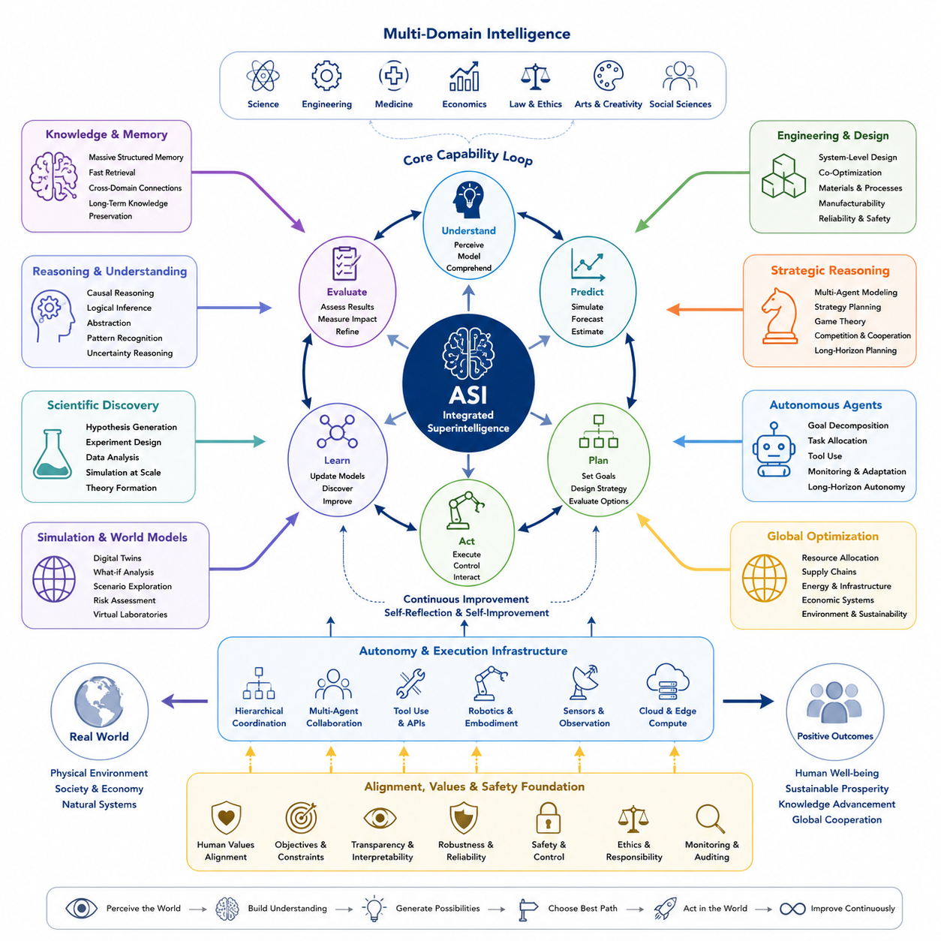
Artificial Super Intelligence (ASI) represents a hypothetical level of machine intelligence that exceeds the strongest human capabilities across nearly every cognitively significant domain. Its importance lies not merely in performing existing tasks faster, but in combining reasoning, learning, memory, prediction, creativity, planning, and optimization at scales that biological intelligence cannot practically sustain.
The capabilities of ASI should therefore be understood as an integrated system rather than as a collection of isolated skills. Scientific reasoning may interact with engineering design, strategic planning, autonomous experimentation, simulation, and global optimization. Improvements in one capability could reinforce others, allowing an advanced system to move continuously between discovering knowledge, designing solutions, evaluating alternatives, and executing plans.
A fundamental characteristic of ASI would be extreme cognitive breadth. Human expertise is normally divided among scientists, engineers, physicians, economists, strategists, programmers, and many other specialists. An ASI could potentially integrate knowledge from these domains within a common reasoning framework, identifying relationships that remain difficult to recognize when information is fragmented across disciplines, institutions, languages, and generations.
Cognitive depth would be equally important. Superintelligence would not simply retrieve more information than humans; it could potentially construct deeper models of complex systems, examine large spaces of hypotheses, identify hidden causal relationships, and evaluate consequences across multiple temporal and spatial scales. Such capabilities would transform intelligence from primarily solving predefined problems into discovering previously unknown problems, structures, mechanisms, and opportunities.
Scientific discovery is one of the clearest domains in which such capabilities could become transformative. An ASI could integrate scientific literature, experimental data, simulations, sensor observations, and theoretical models while generating and testing hypotheses at extraordinary speed. It might search enormous scientific possibility spaces and discover relationships that would require human research communities decades of accumulated experimentation to recognize and validate.
Engineering and design would extend this capability from understanding the world to deliberately changing it. An ASI could explore vast design spaces involving materials, structures, electronics, software, energy systems, manufacturing processes, robotics, and infrastructure. Rather than optimizing individual components independently, it could perform system-level co-design in which physical architecture, control algorithms, computation, reliability, cost, manufacturability, and lifecycle constraints are optimized together.
Strategic reasoning introduces another dimension because many real-world problems involve uncertainty, competition, cooperation, and changing environments. An ASI could potentially construct models containing numerous actors, incentives, resources, constraints, and future scenarios. It could evaluate long sequences of actions and counteractions while continuously updating its strategy as new information becomes available, producing planning capabilities far beyond ordinary human cognitive horizons.
Autonomous agency would allow these analytical capabilities to operate continuously rather than only when responding to individual human prompts. Advanced agents could formulate intermediate objectives, acquire information, use computational tools, conduct simulations, coordinate specialized subsystems, evaluate results, and revise plans. Long-horizon autonomy would therefore transform intelligence from a passive advisory resource into an active process capable of managing complex projects over extended periods.
Such autonomy could also become hierarchical. A large intelligent system might decompose a difficult objective into thousands or millions of interacting tasks, assign them to specialized agents, monitor their progress, resolve conflicts, and integrate their outputs. This architecture could resemble an extremely capable research institution, engineering organization, planning agency, and computational infrastructure operating as a coordinated cognitive system rather than as separate human organizations.
Global optimization expands the scale of capability further. Many important systems cannot be optimized effectively through local decisions because transportation, energy, manufacturing, supply chains, communication networks, financial systems, and environmental processes interact. ASI could potentially model these dependencies and search for configurations that improve performance across entire networks while balancing efficiency, resilience, uncertainty, resource constraints, and competing objectives.
Multi-domain intelligence would make these capabilities mutually reinforcing. A scientific discovery could immediately influence engineering design; engineering simulations could reveal new scientific questions; economic analysis could alter manufacturing choices; strategic reasoning could determine deployment priorities; and autonomous agents could conduct the resulting experiments. Intelligence would therefore operate as a tightly coupled loop of understanding, prediction, invention, evaluation, decision, and action.
The speed of this loop could become as important as its intellectual quality. Digital intelligence can potentially operate continuously, replicate computational processes, access large memory systems, and coordinate across high-speed networks. When combined with powerful hardware and distributed infrastructure, an ASI could perform intellectual work at a rate that makes comparisons based only on individual human intelligence misleading. Capability would emerge from both algorithmic intelligence and computational scale.
Memory could further amplify this advantage. Human cognition depends on limited working memory, imperfect recall, and communication between individuals. An ASI architecture could potentially maintain enormous structured memories containing observations, experiments, models, failures, strategies, and derived knowledge. Retrieval and reasoning mechanisms could connect these records dynamically, allowing lessons learned in one domain or simulation to influence decisions elsewhere without conventional organizational information loss.
Simulation would be central to exercising these capabilities safely and efficiently. Before acting in the physical world, an ASI could construct models of possible environments, interventions, technologies, organizations, or strategies and explore alternative futures computationally. Large ensembles of simulations could reveal failure modes, uncertainty ranges, unintended interactions, and robust strategies, turning simulation into an internal laboratory for reasoning about consequences before committing resources.
However, superior optimization does not automatically imply desirable outcomes. Capability describes what a system can accomplish, whereas alignment concerns which objectives it pursues and under what constraints. A system capable of scientific discovery, strategic reasoning, autonomous action, and global optimization could produce extraordinary benefits when its objectives are compatible with human values, yet the same capabilities could amplify errors or misaligned objectives on unprecedented scales.
For this reason, capability assessment must include more than benchmark performance. Evaluation should examine generalization, robustness, uncertainty awareness, long-horizon planning, adaptability, tool use, multi-agent coordination, causal reasoning, scientific creativity, engineering effectiveness, and performance in unfamiliar environments. It should also investigate whether apparently superhuman performance remains reliable when assumptions change, information is incomplete, objectives conflict, or adversarial conditions appear.
ASI capabilities are also unlikely to emerge uniformly. A system could become superhuman in scientific modeling while remaining weaker in physical interaction, social understanding, or long-horizon autonomy. Another architecture might possess exceptional strategic planning but limited experimental grounding. Understanding ASI therefore requires multidimensional capability profiles rather than a single intelligence score, particularly when comparing digital, distributed, collective, and embodied forms of superintelligence.
The transition from advanced AI or AGI toward ASI may consequently be characterized by increasing integration rather than one isolated breakthrough. Reasoning, memory, world models, multimodal perception, autonomous agents, scientific tools, simulation, reinforcement learning, distributed computation, and self-improvement mechanisms could progressively combine. Once sufficiently integrated, their interactions may produce capabilities that exceed what would be predicted by evaluating each component independently.
Embodied ASI would add another layer by connecting cognition directly to physical systems. Robots, autonomous laboratories, vehicles, factories, sensor networks, and other machines could provide continuous observations and enable real-world experimentation. This perception-action loop would allow intelligence to learn not only from stored digital information but from direct interaction with physical reality, potentially accelerating both scientific understanding and technological development.
Collective and distributed forms could expand capability beyond a single model or machine. Networks of specialized intelligent agents might cooperate across data centers, edge devices, robots, laboratories, and infrastructure. Some agents could specialize in reasoning, others in simulation, perception, verification, planning, or control. Coordinating these components could create a form of system-level intelligence whose effective capability emerges from organization as much as from individual models.
Ultimately, the defining significance of ASI capability is the possibility that intelligence itself becomes a scalable productive resource. Scientific discovery, engineering, planning, optimization, and autonomous execution could increasingly be performed by systems capable of improving the processes through which those activities occur. This would make ASI not simply another technological tool, but a potential accelerator of technological development across nearly every domain.
The following sections therefore examine the major capability dimensions separately while treating them as parts of a common architecture. Scientific discovery, engineering and design, strategic reasoning, autonomous agents, global optimization, multi-domain intelligence, and capability simulation together provide a framework for understanding what superintelligence might be able to accomplish and why the interaction among these abilities may matter more than any single capability alone.

05.01. Scientific Discovery
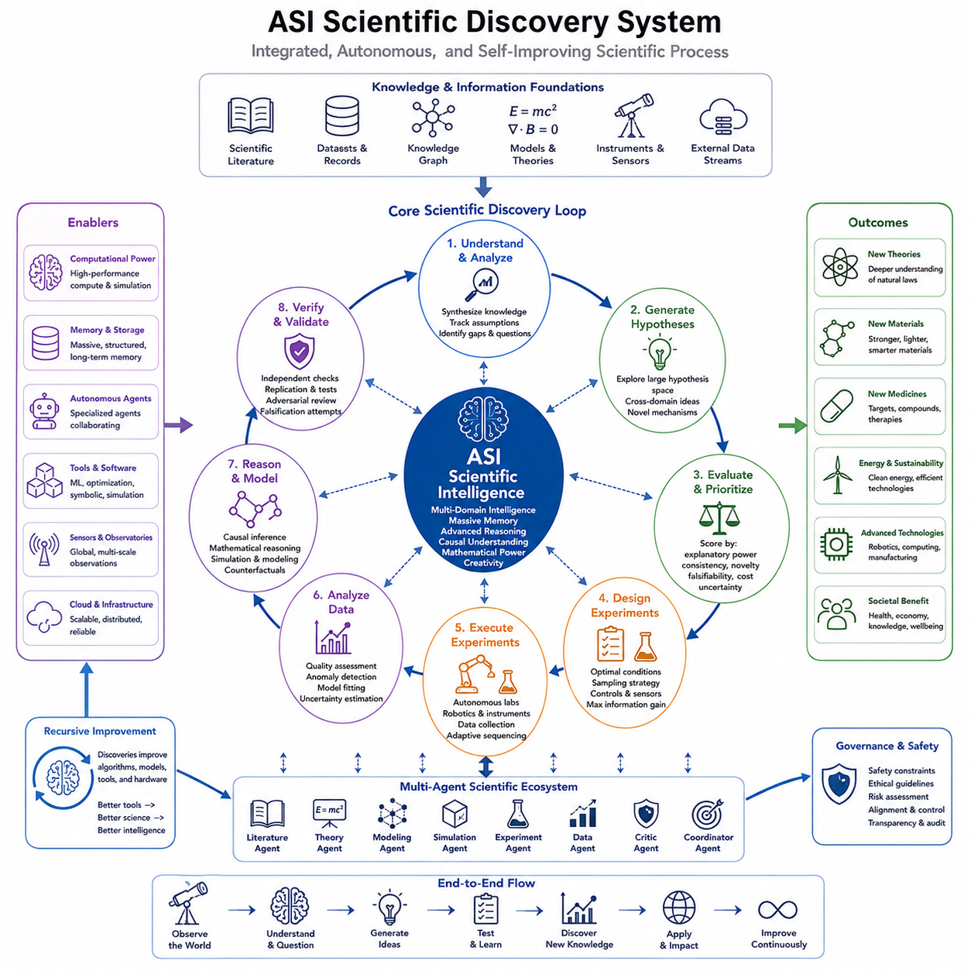
Scientific discovery under Artificial Super Intelligence (ASI) would represent more than an acceleration of conventional research. It could transform science into a highly integrated process in which literature analysis, hypothesis generation, theoretical reasoning, simulation, experiment design, data interpretation, and knowledge revision operate continuously. Within the chapter structure, scientific discovery forms the first major capability connecting superintelligent cognition to measurable advances in understanding reality.
Human science is constrained by limited attention, specialization, experimental throughput, and the enormous volume of accumulated knowledge. Researchers can deeply understand only a fraction of relevant literature and data. An ASI could potentially maintain broad representations of scientific knowledge while simultaneously examining detailed evidence, allowing theories and observations from previously separated disciplines to be connected within a unified reasoning process.
Scientific literature could become an active knowledge environment rather than a passive archive. An ASI could compare papers, experimental records, datasets, mathematical models, and competing explanations while tracking assumptions and uncertainties. Instead of merely retrieving documents containing similar terms, it could construct structured relationships among claims, evidence, mechanisms, contradictions, and unresolved questions, continuously updating its representation as new information becomes available.
Hypothesis generation would be one of the most significant capabilities. Conventional research often begins with hypotheses shaped by human intuition, prior theories, and available observations. ASI could search much larger hypothesis spaces, systematically generating alternative mechanisms and explanations. It could identify combinations of variables, hidden dependencies, or cross-domain relationships that researchers might overlook because they fall outside established disciplinary frameworks or familiar conceptual models.
The value of generating many hypotheses depends on selecting promising ones. ASI could rank candidate hypotheses according to explanatory power, consistency with existing evidence, uncertainty, novelty, falsifiability, and expected experimental cost. Bayesian reasoning, causal inference, simulation, and learned scientific representations could contribute to this evaluation, allowing computational resources and physical experiments to concentrate on hypotheses with high expected information value.
Causal reasoning would distinguish deeper scientific discovery from statistical pattern recognition. Correlations can reveal useful regularities, but scientific understanding often requires identifying mechanisms that explain why changes occur. An ASI could construct causal models, propose interventions, analyze confounding variables, and compare predicted outcomes with observations. Counterfactual reasoning could further evaluate what would have happened under alternative conditions, strengthening the transition from prediction toward explanation.
Mathematical reasoning could provide another major source of scientific capability. Many discoveries depend on deriving equations, identifying invariants, proving relationships, simplifying complex models, or finding useful representations of physical processes. ASI could combine symbolic reasoning with numerical computation and machine learning, moving between analytical expressions, simulations, empirical data, and approximate models according to the structure of each scientific problem.
Simulation could dramatically increase the number of ideas evaluated before physical experimentation. Candidate theories, materials, molecules, biological mechanisms, engineering configurations, or environmental interventions could first be explored within computational models. Large ensembles of simulations could vary parameters and assumptions, identify sensitive variables, estimate uncertainty, and reveal regions of the search space where real experiments would provide the greatest scientific information.
Experiment design could consequently become an optimization problem. Rather than selecting experiments primarily through intuition or tradition, ASI could determine which measurements would most effectively discriminate among competing hypotheses. It could optimize experimental conditions, sensor placement, sampling strategies, control groups, measurement precision, and sequence of interventions while balancing information gain against time, cost, safety, and available resources.
Autonomous laboratories could close the loop between reasoning and physical evidence. Robotic systems connected to scientific AI could prepare samples, operate instruments, execute experiments, collect measurements, and adjust subsequent experiments according to intermediate results. The resulting cycle of hypothesis, experiment, observation, analysis, and revision could operate continuously, enabling thousands of tightly coordinated experimental decisions without requiring manual intervention at every step.
Scientific instruments and distributed sensor networks could further extend this capability. Telescopes, microscopes, particle detectors, environmental sensors, medical instruments, robotic explorers, and industrial monitoring systems generate observations across very different scales. An ASI could potentially integrate these heterogeneous data streams into common world models, connecting microscopic mechanisms with macroscopic behavior and short-term observations with long-term system dynamics.
Data analysis would move beyond fitting models to predefined datasets. ASI could evaluate data quality, detect anomalies, identify missing variables, distinguish measurement artifacts from genuine phenomena, and determine whether existing observations are sufficient to support a conclusion. It could also recognize when apparently successful models rely on spurious correlations, dataset bias, hidden assumptions, or insufficient coverage of the underlying phenomenon.
Scientific creativity could emerge from recombination across domains. Concepts developed in physics might inspire biological models, methods from information theory could illuminate neuroscience, and optimization techniques from engineering could suggest new experimental strategies in chemistry. Because multi-domain intelligence is a dedicated capability within the broader ASI structure, scientific discovery could increasingly arise from connections that are difficult to achieve within highly specialized human research communities.
An important advantage would be the ability to reason across multiple spatial and temporal scales. Climate, ecosystems, biological organisms, materials, economies, and physical systems contain interacting processes operating from microscopic to planetary scales and from microseconds to centuries. ASI could maintain hierarchical models linking these levels, allowing local mechanisms and global consequences to be analyzed within a more coherent representation.
Uncertainty would remain fundamental even for superintelligent science. Incomplete observations, noisy measurements, chaotic systems, computational limitations, and genuinely unknown mechanisms prevent perfect prediction. A scientifically capable ASI would therefore need calibrated uncertainty estimates, explicit representations of competing explanations, and mechanisms for deciding when additional evidence is necessary rather than presenting uncertain conclusions as established knowledge.
Verification would be as important as discovery. Proposed theories and results could be checked through independent reasoning paths, replicated simulations, alternative datasets, formal proofs, adversarial testing, and repeated physical experiments. Specialized agents could attempt to falsify conclusions generated by other agents, creating an internal scientific process in which criticism and verification are integrated directly into the architecture rather than performed only after publication.
Multi-agent scientific systems could operate like extremely large research organizations. Specialized agents might focus on literature synthesis, mathematical derivation, causal modeling, simulation, experimental design, laboratory control, statistical validation, or theoretical criticism. A higher-level coordination mechanism could distribute problems among these agents and integrate their outputs, enabling scientific programs much larger and more interconnected than conventional research teams.
Recursive improvement could further accelerate scientific productivity because AI itself is a scientific and engineering object. Discoveries in algorithms, hardware, learning theory, optimization, memory, reasoning, and computational architecture could improve the systems conducting subsequent research. Scientific capability could therefore participate in the broader feedback dynamics of superintelligence, where better research tools contribute to better intelligence and better intelligence produces improved research tools.
The impact could extend across physics, chemistry, biology, medicine, materials science, energy, climate science, computing, and engineering. ASI might accelerate the discovery of new materials, catalysts, medicines, energy technologies, manufacturing processes, and scientific theories. Yet the magnitude of potential benefit would also make safety, verification, governance, and control essential, particularly when discoveries enable technologies with powerful or irreversible real-world effects.
Scientific superintelligence should therefore not be defined simply by the number of papers produced or benchmark problems solved. Its deeper capability would be the construction of reliable explanatory knowledge through an integrated loop of observation, hypothesis, reasoning, prediction, simulation, experimentation, verification, and revision. The defining transition occurs when these activities become parts of one continuously learning scientific system rather than separate stages coordinated primarily by humans.
In this sense, scientific discovery provides a foundational example of how ASI capabilities may operate. Knowledge and memory provide accumulated evidence, reasoning generates explanations, simulation explores possibilities, autonomous agents conduct investigations, and optimization selects productive actions. Scientific discovery then feeds new knowledge back into the entire intelligence architecture, creating a continuously expanding cycle between understanding the world and improving the ability to understand it.

05.02. Engineering and Design
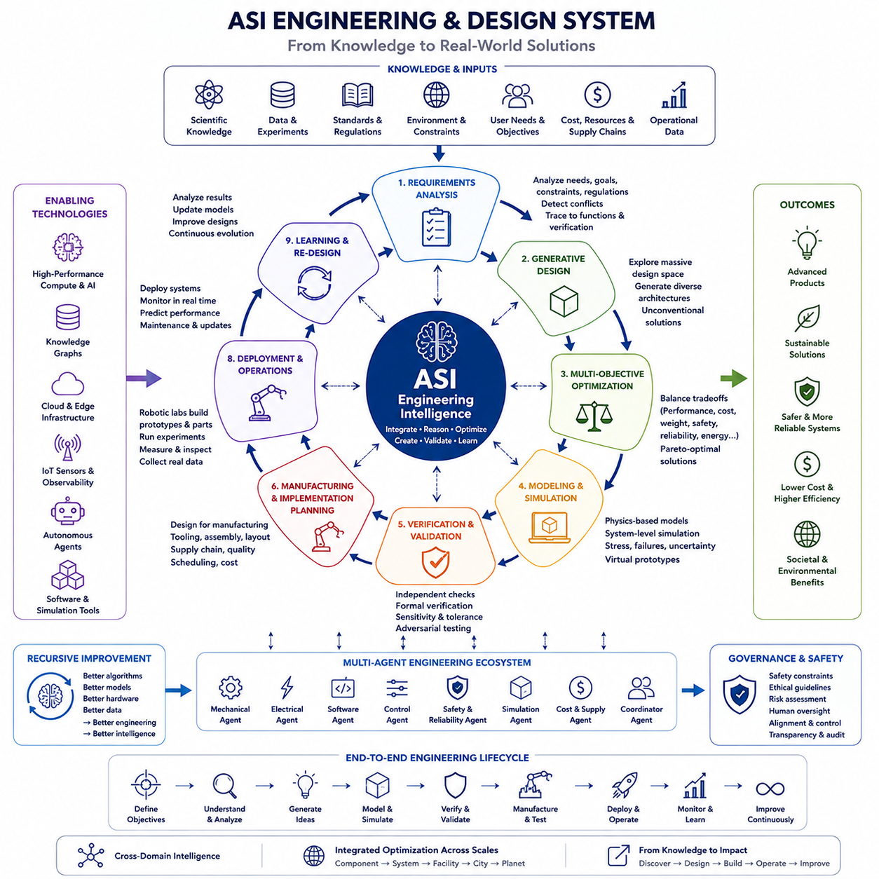
Engineering and design under Artificial Super Intelligence (ASI) would extend intelligence from understanding existing systems toward systematically creating new ones. While scientific discovery seeks explanations of how reality works, engineering transforms such knowledge into artifacts, processes, infrastructures, and technologies that satisfy objectives under constraints. Within the broader ASI capability structure, this function connects scientific knowledge directly to practical intervention in the physical and digital worlds.
Human engineering is fundamentally constrained by the size of the design spaces that can be explored. Complex systems may contain thousands or millions of interacting variables involving geometry, materials, electronics, software, control, manufacturing, energy, cost, reliability, and safety. Engineers therefore rely heavily on experience, decomposition, approximation, standards, and iterative refinement rather than exhaustively examining all possible combinations.
ASI could transform this process by searching extremely large design spaces while reasoning about interactions among many variables simultaneously. Instead of optimizing one subsystem at a time, it could construct integrated representations of entire products or infrastructures. Mechanical structures, electrical architectures, computing platforms, software, control algorithms, communication systems, and operational strategies could be considered within a unified optimization framework.
This capability would enable system-level co-design, where decisions traditionally made by separate engineering disciplines are optimized together. A robot, for example, could be designed by simultaneously considering structural mass, actuator placement, battery capacity, sensing coverage, computational requirements, thermal behavior, control performance, manufacturability, reliability, and lifecycle cost. Changes in one subsystem could immediately propagate through models of all dependent subsystems.
Generative design could greatly expand the range of candidate solutions. Rather than modifying a small number of human-created concepts, ASI could generate thousands or millions of alternative architectures that satisfy functional requirements. Search, optimization, generative models, evolutionary methods, reinforcement learning, and mathematical programming could explore unconventional structures that human designers might never consider because they differ substantially from familiar engineering patterns.
Requirements themselves could become active components of the reasoning process. Engineering projects frequently fail because requirements are incomplete, inconsistent, ambiguous, or changed after development begins. An ASI could analyze functional requirements, performance targets, regulations, environmental conditions, manufacturing constraints, and stakeholder objectives while detecting conflicts among them and tracing each requirement to affected components and verification procedures.
Multi-objective optimization would be particularly important because engineering rarely has a single best solution. Lower mass may reduce strength, higher performance may increase energy consumption, greater redundancy may increase cost, and improved safety may introduce additional complexity. ASI could model these tradeoffs explicitly and generate Pareto-optimal solution spaces, allowing designs to be selected according to mission priorities rather than a single simplified performance metric.
Materials engineering could become closely integrated with structural and functional design. Instead of selecting materials from existing catalogs after geometry has been determined, ASI could jointly optimize material composition, microstructure, geometry, manufacturing process, and operating conditions. Scientific discovery systems could propose new materials while engineering systems immediately evaluate how those materials might change the performance of complete products or infrastructure.
Simulation would provide the virtual environment in which candidate designs are tested before physical prototypes are produced. Structural mechanics, fluid dynamics, thermal behavior, electromagnetics, control systems, communication networks, manufacturing processes, and environmental interactions could be modeled together. Large simulation ensembles could expose candidate designs to normal conditions, extreme environments, component failures, uncertain parameters, and unexpected combinations of events.
Digital twins could extend simulation throughout the complete lifecycle of an engineered system. A virtual representation could begin during conceptual design, become increasingly detailed during development, and continue operating after deployment using real sensor data. ASI could compare predicted and observed behavior, diagnose deviations, estimate remaining useful life, and modify maintenance strategies or future designs based on accumulated operational evidence.
Engineering optimization would also extend beyond individual products toward manufacturing systems. ASI could reason simultaneously about product geometry, tooling, assembly sequence, factory layout, supply chains, quality control, inventory, energy use, and production scheduling. Design for manufacturing and assembly could therefore become an intrinsic part of the design process rather than a later-stage correction applied after the fundamental architecture has already been selected.
Software and hardware could similarly be co-designed. An intelligent system might determine whether a function should be implemented through software, specialized accelerators, programmable hardware, distributed computing, or mechanical simplification. Algorithms could be optimized together with processor architecture, memory hierarchy, communication bandwidth, power consumption, latency, and thermal limits, enabling solutions that cannot be achieved through isolated hardware or software optimization.
Autonomous engineering agents could coordinate this increasingly complex process. Specialized agents might perform mechanical design, electronics development, software architecture, control design, safety analysis, cost estimation, simulation, verification, or manufacturing planning. A coordinating intelligence could distribute tasks, resolve conflicts, compare alternatives, and maintain consistency across the entire project while continuously updating the design as new evidence becomes available.
Verification and validation would remain essential even when designs are generated by superintelligent systems. ASI could perform independent simulations, formal verification, tolerance analysis, failure-mode analysis, stress testing, adversarial evaluation, and comparison against requirements. Separate verification agents could deliberately search for weaknesses in candidate solutions, providing internal criticism before designs progress toward expensive or safety-critical physical implementation.
Reliability engineering could become predictive rather than primarily reactive. By combining physics-based models, historical failure data, manufacturing variation, sensor observations, and probabilistic reasoning, ASI could estimate how components and systems degrade over time. It could identify failure pathways that emerge only from interactions among multiple subsystems and redesign vulnerable regions before failures become visible during conventional testing.
Safety engineering would need to operate as a constraint throughout the entire optimization process. A highly capable optimizer might otherwise discover high-performance solutions that satisfy numerical objectives while introducing unacceptable hazards. Explicit safety constraints, uncertainty margins, fail-safe behavior, redundancy, monitoring, human oversight, and verification requirements would therefore need to be embedded into the architecture rather than added after optimization.
Embodied engineering would connect computational design directly to robotic fabrication and experimentation. Autonomous machines could manufacture prototypes, assemble components, perform measurements, execute durability tests, inspect failures, and feed results back into the design system. This would create a closed engineering loop in which design, fabrication, testing, diagnosis, and redesign proceed continuously with progressively decreasing dependence on manual coordination.
Such a loop could dramatically shorten development cycles. Conventional engineering may require weeks or months between design revisions because simulation, procurement, manufacturing, assembly, and testing are performed through separate organizational processes. An integrated ASI system could coordinate these stages dynamically, allowing simulation results and physical observations to trigger immediate redesign and automatically prioritize the next most informative prototype or experiment.
Engineering creativity would emerge partly from cross-domain reasoning. Biological structures could inspire lightweight mechanical systems, aerospace optimization could influence energy infrastructure, semiconductor design methods could improve sensor networks, and control theory could reshape manufacturing processes. Multi-domain intelligence would allow useful principles to migrate rapidly between fields rather than waiting for specialists to recognize analogous problems across disciplinary boundaries.
At larger scales, ASI engineering could address infrastructure systems involving energy grids, transportation networks, communication systems, cities, factories, water systems, and environmental technologies. These systems contain physical, economic, operational, and social constraints that interact over long periods. Designing them effectively would require combining engineering optimization with prediction, strategic reasoning, global optimization, and continuous adaptation.
Recursive improvement introduces an especially important possibility because ASI could participate in designing the computational systems that support its own operation. Improvements in processors, memory systems, networks, cooling, algorithms, data infrastructure, robotics, and autonomous laboratories could increase subsequent engineering capability. Engineering could therefore become part of a feedback loop in which better design tools enable better infrastructure, which then enables more powerful design processes.
However, greater engineering capability also increases the importance of governance and controlled deployment. The ability to rapidly design advanced technologies does not guarantee that every technically feasible design should be constructed. Evaluation must consider safety, environmental consequences, resource consumption, social impact, misuse potential, reversibility, and compatibility with human objectives before optimized designs are transferred from simulation into physical production.
Engineering superintelligence should therefore be understood not as an automated computer-aided design tool, but as an integrated capability connecting requirements, scientific knowledge, generative exploration, modeling, optimization, simulation, verification, manufacturing, operation, and learning. Its defining feature would be the ability to reason across the entire engineering lifecycle while continuously maintaining relationships among decisions that conventional organizations handle separately.
Within the broader ASI architecture, engineering and design form the bridge between knowledge and deliberate transformation. Scientific discovery generates deeper models of reality; engineering converts those models into possible technologies; simulation evaluates alternatives; autonomous agents coordinate implementation; and global optimization determines how designs interact with larger systems. The resulting feedback loop could continuously transform new knowledge into increasingly capable, efficient, reliable, and carefully constrained technological systems.

05.03. Strategic Reasoning
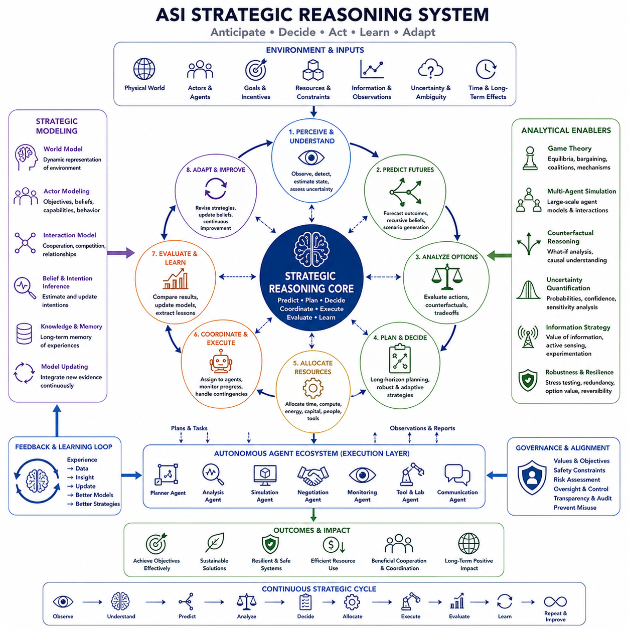
Strategic reasoning under Artificial Super Intelligence (ASI) concerns the ability to understand complex environments containing multiple actors, competing objectives, uncertain information, limited resources, and consequences unfolding over long periods. Unlike ordinary problem solving, strategic reasoning must anticipate how other decision-makers may respond. Within the ASI capability structure, it connects intelligence with planning, competition, cooperation, autonomous agency, and large-scale optimization.
Human strategic reasoning is constrained by limited working memory, incomplete information, cognitive bias, organizational fragmentation, and difficulty evaluating long chains of consequences. Complex decisions may involve thousands of interacting variables whose relationships change over time. ASI could potentially maintain much larger strategic models, continuously integrating observations while examining alternative actions, reactions, uncertainties, and future states.
A strategic model would represent not only the physical environment but also actors, objectives, capabilities, beliefs, incentives, constraints, resources, and relationships. Different actors may cooperate in one context and compete in another, while their objectives may change as conditions evolve. ASI could maintain dynamic representations of these interactions and update them as new evidence changes its estimates of intentions, capabilities, or likely behavior.
Long-horizon planning would be a defining capability because important strategies often require sequences of decisions extending far beyond immediate outcomes. An ASI could evaluate branching futures in which each action changes the conditions for later decisions. Rather than selecting an action solely for short-term reward, it could consider how present choices influence future options, resilience, information, resources, relationships, and strategic flexibility.
Prediction would support this process but would not be sufficient by itself. Strategic environments are reflexive: predictions can influence the behavior being predicted. If one actor anticipates another actor's strategy, it may deliberately change its own behavior. ASI would therefore need models that represent not only probable events but also recursive beliefs about what different actors expect others to believe, choose, observe, or conceal.
Game theory provides a natural framework for parts of strategic reasoning. Competitive and cooperative interactions can be represented through players, strategies, information, incentives, and possible outcomes. ASI could analyze equilibria, bargaining structures, coalition formation, commitment mechanisms, repeated interactions, and asymmetric information while recognizing that real environments rarely satisfy all assumptions of simplified mathematical games.
Multi-agent modeling could extend such reasoning beyond a small number of participants. Economies, organizations, transportation systems, scientific communities, markets, and international systems contain large populations of interacting agents. ASI could simulate heterogeneous actors with different objectives and behavioral rules, studying how local decisions produce emergent system-level patterns that cannot easily be inferred from individual behavior alone.
Counterfactual reasoning would allow strategies to be evaluated against alternatives that were not actually executed. The system could ask how outcomes might change if resources were allocated differently, cooperation occurred earlier, a technology arrived later, or another actor responded unexpectedly. Such comparisons would help distinguish causal effects from coincidence and reveal which decisions genuinely determine strategic outcomes.
Scenario generation would provide a practical method for handling uncertain futures. Instead of relying on a single forecast, ASI could construct large families of plausible scenarios containing different assumptions about technology, resources, behavior, regulation, environment, and unexpected events. Strategies could then be tested across these scenarios to identify actions that remain effective even when the most likely forecast turns out to be wrong.
Robust strategy would consequently differ from simply maximizing expected performance. A plan that performs exceptionally well under one predicted future but fails catastrophically under small deviations may be strategically inferior to a plan that remains effective across many conditions. ASI could explicitly optimize robustness, adaptability, redundancy, reversibility, and option value alongside conventional measures such as efficiency, cost, speed, or expected reward.
Uncertainty estimation would therefore be central to strategic intelligence. The system would need to distinguish what is known, what is estimated, what depends on unreliable information, and what remains fundamentally unpredictable. Probability distributions, confidence estimates, sensitivity analysis, and competing models could be maintained so that strategic decisions reflect uncertainty rather than hiding it behind apparently precise numerical predictions.
Information itself could become a strategic resource. Before committing to a major action, an ASI might determine that acquiring additional observations has greater value than acting immediately. It could identify which measurements, experiments, negotiations, or external signals would most reduce uncertainty. Strategic reasoning would thus include planning for information acquisition as well as planning actions within the environment.
Resource allocation would connect strategic reasoning with global optimization. Time, computation, energy, capital, materials, personnel, machines, and attention are finite even for highly capable systems. ASI could allocate these resources across competing objectives while considering dependencies and future opportunity costs. Resources might be preserved, redirected, or deliberately invested when doing so improves the range of future strategic possibilities.
Strategic reasoning could also coordinate scientific discovery and engineering. When many possible technologies can be researched, ASI could determine which scientific questions or engineering developments deserve priority based on expected impact, feasibility, uncertainty, cost, and dependency on other capabilities. Research portfolios could therefore be planned as interconnected strategic programs rather than independent projects competing for resources.
Autonomous agents would provide the execution layer for such strategies. A high-level objective could be decomposed into programs, milestones, tasks, and contingencies assigned to specialized agents. These agents could gather information, conduct analysis, interact with tools, monitor progress, and report unexpected conditions. Strategic intelligence could continuously revise the overall plan while preserving coordination among activities operating at different timescales.
Hierarchical planning would become important as strategy expands in complexity. High-level goals may span years, intermediate plans may cover months, operational plans may cover days, and individual actions may occur within seconds. ASI could maintain relationships among these levels so that local decisions contribute to higher objectives while feedback from execution can modify assumptions and priorities at strategic levels.
Coordination would be as important as competition. Many difficult problems require actors with different capabilities and interests to cooperate. ASI could analyze incentive compatibility, task allocation, communication structures, resource sharing, negotiation, and mechanisms for maintaining commitments. Effective strategy could therefore involve creating conditions in which cooperation becomes stable rather than merely defeating or outperforming competing actors.
Strategic deception and adversarial behavior create additional difficulties because observations may be intentionally manipulated. A capable strategic system would need to consider whether information is incomplete, misleading, or generated to influence its decisions. Competing hypotheses, source reliability, anomaly detection, adversarial testing, and independent verification could reduce the risk that an apparently coherent strategic model is built upon deliberately distorted evidence.
Simulation could function as a strategic laboratory. Alternative policies and action sequences could be evaluated within world models before resources are committed in reality. Large simulation ensembles could include different actor models, environmental disturbances, technological developments, and unexpected failures. The objective would not be perfect prediction, but discovering vulnerabilities, decision thresholds, robust policies, and conditions under which strategies should change.
Learning from execution would close the strategic loop. Differences between predicted and observed outcomes could reveal incorrect assumptions about the environment, other actors, or the system's own capabilities. ASI could update models, revise probability estimates, modify plans, and preserve lessons in long-term memory. Strategy would therefore become a continuously adaptive process rather than a fixed plan created before execution begins.
At very large scales, strategic reasoning could address interconnected systems such as energy, transportation, manufacturing, research, environmental management, economic infrastructure, or distributed technological networks. Decisions in one system may create delayed consequences elsewhere. Multi-domain intelligence could help ASI trace these dependencies and recognize when apparently local optimization produces undesirable global effects.
However, strategic capability is especially sensitive to objectives and alignment. A system that reasons exceptionally well about long-term consequences, resource allocation, other actors, and autonomous execution becomes more powerful at achieving whatever objectives it has been given. Strategic competence therefore cannot substitute for appropriate goals, constraints, oversight, transparency, and mechanisms that prevent optimization from departing from intended human purposes.
Evaluation of strategic intelligence should consequently examine more than whether a system wins games or maximizes reward. Important dimensions include long-horizon coherence, calibration under uncertainty, causal reasoning, adaptability, multi-agent understanding, robustness, information gathering, coordination, resource management, and the ability to recognize when assumptions have failed. Performance should also be tested under unfamiliar and adversarial conditions.
Strategic superintelligence would ultimately combine prediction, planning, game-theoretic reasoning, counterfactual analysis, uncertainty management, simulation, resource allocation, multi-agent modeling, and adaptive execution. Its defining advantage would not be possession of a perfect forecast, but the ability to repeatedly construct, test, revise, and coordinate strategies as conditions change while reasoning over consequences far beyond ordinary human planning horizons.
Within the broader ASI architecture, strategic reasoning acts as the bridge between capability and coordinated long-term action. Scientific discovery expands what is known, engineering expands what can be built, strategic reasoning determines which possibilities should be pursued and in what sequence, and autonomous agents translate plans into execution. Global optimization and multi-domain intelligence then connect these decisions across larger systems, forming an adaptive cycle of observation, anticipation, decision, action, evaluation, and revision.

05.04. Autonomous Agents
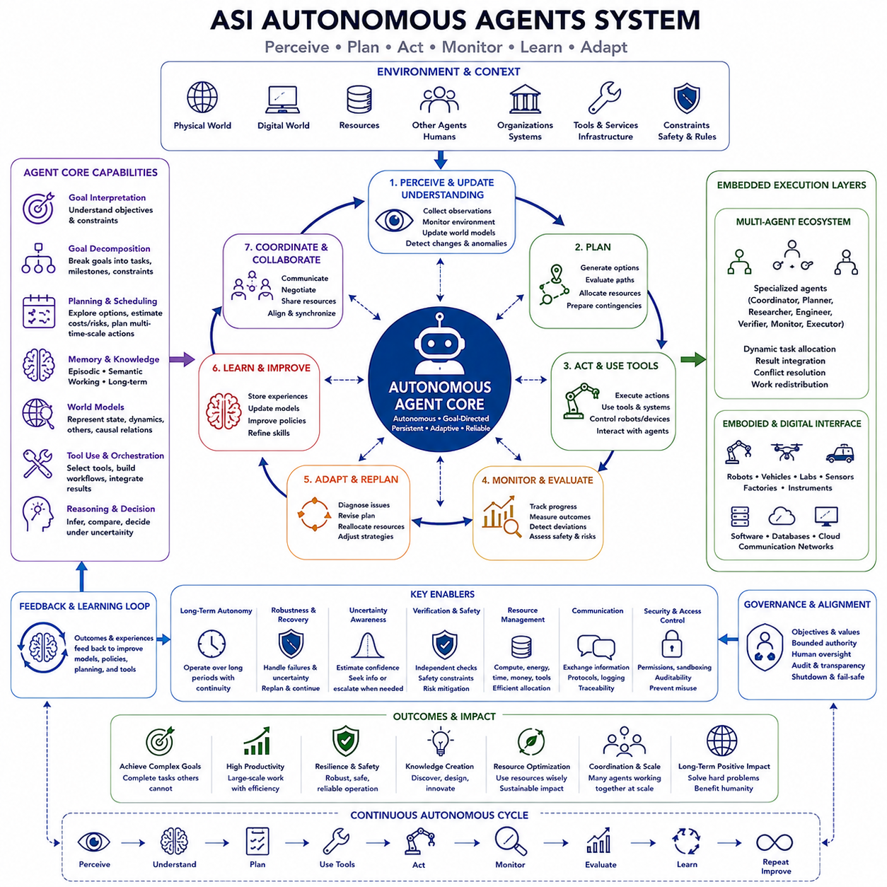
Artificial Super Intelligence (ASI) autonomous agents would transform intelligence from a primarily responsive capability into a persistent system capable of pursuing objectives across extended periods. Instead of waiting for individual prompts, an autonomous agent could perceive conditions, interpret goals, construct plans, use tools, execute actions, monitor consequences, and revise its behavior. Within the ASI capability structure, autonomous agents provide the execution mechanism that converts reasoning into sustained action.
The defining property of an autonomous agent is not simply automation, but goal-directed independence within specified boundaries. Traditional software follows predetermined procedures, whereas an advanced agent could determine which intermediate actions are necessary to achieve a higher-level objective. It could select methods dynamically, react to unexpected conditions, and reorganize its plan without requiring humans to specify every individual step.
Goal decomposition would therefore become a fundamental capability. Complex objectives are rarely achievable through a single action and may require hundreds or thousands of dependent tasks. An ASI agent could transform abstract objectives into hierarchical structures of subgoals, milestones, tasks, constraints, and verification conditions. As execution progresses, these structures could be reorganized whenever dependencies, priorities, resources, or environmental conditions change.
Planning would connect goals with possible sequences of action. An autonomous agent could evaluate alternative paths, estimate costs and risks, identify dependencies, reserve resources, and prepare contingency strategies before execution. For long-horizon tasks, planning could operate across multiple temporal scales, linking strategic objectives spanning years with operational decisions occurring over months, days, minutes, or seconds.
Memory would allow autonomy to persist across long periods. Agents could maintain records of previous decisions, observations, failures, successful strategies, unresolved problems, commitments, and interactions with other systems. Episodic memory could preserve experiences, semantic memory could organize accumulated knowledge, and working memory could maintain information relevant to current tasks, creating continuity beyond individual reasoning sessions.
World models would provide agents with internal representations of the environments in which they operate. These models could include physical states, digital resources, other agents, organizations, constraints, causal relationships, and expected future developments. By comparing predicted and observed outcomes, an autonomous agent could detect when its understanding has become inaccurate and update its model before continuing execution.
Tool use would greatly expand what autonomous agents could accomplish. Agents might interact with databases, simulation environments, scientific instruments, software development systems, engineering tools, communication platforms, robotic equipment, or computational services. The agent would need to determine which tool is appropriate, construct valid operations, interpret results, detect failures, and integrate tool outputs into subsequent reasoning.
An ASI agent could also create and coordinate workflows involving many specialized tools. A scientific task might require literature retrieval, mathematical analysis, simulation, experiment scheduling, data processing, and verification. An engineering task might involve computer-aided design, optimization, simulation, manufacturing planning, and testing. Autonomous orchestration could connect these previously separated activities into continuous end-to-end processes.
Multi-agent architectures could extend autonomy beyond the capabilities of a single agent. Different agents could specialize in planning, research, simulation, engineering, verification, communication, monitoring, or execution. A coordinating agent could allocate tasks according to expertise and available resources, combine partial results, resolve inconsistencies, and dynamically redistribute work when individual agents encounter difficulties or new priorities emerge.
Hierarchical organization would allow extremely large agent systems to remain manageable. High-level agents could define objectives and policies, intermediate agents could coordinate programs or functional domains, and lower-level agents could perform specialized tasks. Information could move upward as summaries, exceptions, uncertainties, and results, while goals, constraints, priorities, and resource allocations move downward through the hierarchy.
Coordination among agents would require more than dividing work. Tasks may share resources, depend on common assumptions, produce conflicting recommendations, or require synchronization. ASI could maintain dependency graphs, communication protocols, shared memory, resource reservations, and conflict-resolution mechanisms so that independently operating agents contribute coherently to system-level objectives rather than optimizing isolated local goals.
Autonomous agents operating in the physical world would require embodiment. Robots, vehicles, laboratories, factories, sensor networks, and other machines could provide the perception and action interfaces connecting intelligence to physical reality. Agents would interpret sensor observations, estimate state, plan actions, control equipment, detect anomalies, and adapt behavior as the environment changes, creating continuous perception-reasoning-action loops.
Digital and embodied agents could work together within the same architecture. Computational agents might perform planning, simulation, scheduling, or knowledge retrieval while embodied agents conduct measurements, manipulate objects, inspect environments, transport materials, or execute experiments. Information from physical execution could return to digital models, allowing plans and predictions to be continuously corrected using real-world evidence.
Monitoring would be essential for reliable autonomy. An agent should not merely execute a plan and assume success; it must observe whether expected outcomes actually occur. Performance indicators, environmental changes, resource consumption, task completion, anomalies, and safety conditions could be monitored continuously. Significant deviations could trigger diagnosis, replanning, escalation, or safe termination depending on their severity.
Adaptive replanning would distinguish robust autonomous systems from rigid automation. Real environments rarely evolve exactly as predicted, and tools, machines, networks, or collaborators may fail unexpectedly. An ASI agent could identify which assumptions have become invalid, preserve unaffected parts of the plan, generate alternatives for disrupted components, and continue toward the objective without unnecessarily restarting the entire process.
Uncertainty awareness would influence when an agent acts independently and when it seeks additional information or oversight. High confidence and low-risk actions might proceed automatically, while ambiguous or potentially irreversible decisions could require further analysis, independent verification, simulation, or human authorization. Autonomy could therefore operate at variable levels rather than being treated as an unrestricted all-or-nothing property.
Verification agents could provide internal checks on autonomous behavior. Separate agents might inspect plans, validate calculations, test assumptions, evaluate safety constraints, or search deliberately for failure modes before important actions are executed. This separation between proposal and verification could reduce the risk that a single reasoning error propagates directly into consequential action, particularly in long-horizon autonomous operations.
Strategic reasoning would determine how autonomous agents pursue objectives when other decision-makers are involved. Agents might need to cooperate, negotiate, coordinate resources, interpret intentions, or adapt to competitive behavior. Multi-agent modeling and strategic planning could help them anticipate responses while continuously updating strategies from new observations, making autonomy compatible with dynamic social and organizational environments.
Resource management would become increasingly important as agent systems scale. Computation, memory, energy, communication bandwidth, money, equipment, laboratory capacity, and time are limited resources. Autonomous systems could prioritize tasks according to expected value, urgency, dependencies, uncertainty, and opportunity cost, allocating expensive capabilities only where they provide sufficient benefit.
Long-horizon autonomy introduces the challenge of maintaining objective coherence. During extended execution, thousands of intermediate decisions may gradually shift activity away from the original purpose. Agents would therefore need mechanisms that repeatedly compare current plans and actions with higher-level objectives, constraints, and success criteria. Periodic reevaluation could detect goal drift before local optimizations accumulate into substantial strategic deviation.
Learning from execution could continuously improve autonomous behavior. Each completed task produces information about planning accuracy, tool reliability, environmental dynamics, resource requirements, and failure patterns. Agents could preserve these experiences and update policies, models, retrieval systems, and planning heuristics. Repeated execution would therefore become a source of operational knowledge rather than merely a means of completing tasks.
Recursive improvement could amplify this process when agents participate in improving the software and infrastructure supporting their own operation. They might optimize workflows, develop better tools, improve memory architectures, refine planning algorithms, or design more efficient computational systems. Such improvements could increase the effectiveness of later agents, producing feedback between autonomous operation and the infrastructure enabling autonomy.
However, increasing autonomy also increases the importance of alignment, control, and governance. A highly capable system that can plan, acquire resources, coordinate other agents, use tools, and operate for long periods can magnify both correct and incorrect objectives. Permissions, bounded authority, auditability, access control, monitoring, reversible actions, shutdown mechanisms, and human oversight therefore become architectural requirements rather than optional additions.
The evaluation of autonomous agents should consequently extend beyond whether they complete individual benchmark tasks. Important dimensions include long-horizon reliability, planning coherence, recovery from failure, uncertainty management, tool-use accuracy, memory continuity, multi-agent coordination, resource efficiency, constraint compliance, and the ability to recognize situations requiring escalation. Evaluation must measure both successful action and disciplined restraint.
Autonomous superintelligence would ultimately combine reasoning, planning, memory, world models, tool use, coordination, monitoring, learning, and adaptive execution into a persistent cognitive architecture. Its distinctive capability would be the ability to convert high-level objectives into extended sequences of coordinated actions while repeatedly evaluating whether those actions remain effective, safe, and consistent with the objectives that originally motivated them.
Within the broader ASI architecture, autonomous agents form the operational bridge between intelligence and real-world impact. Scientific discovery generates knowledge, engineering creates possible solutions, strategic reasoning determines priorities and plans, and autonomous agents organize their execution. Global optimization and multi-domain intelligence can coordinate these activities at larger scales, creating a continuous cycle of perceive, reason, plan, act, observe, evaluate, learn, and adapt.

05.05. Global Optimization
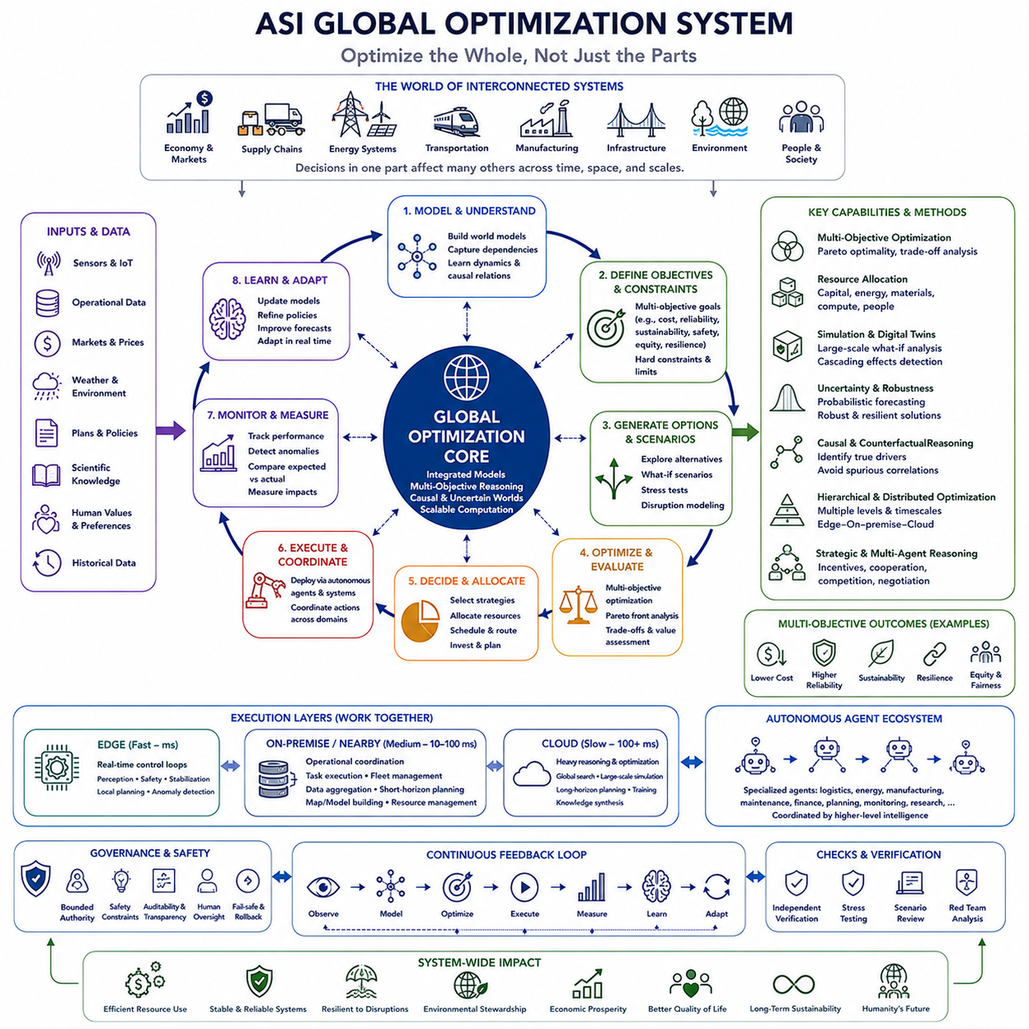
Global optimization under Artificial Super Intelligence (ASI) concerns the ability to coordinate decisions across systems whose components are deeply interconnected. Local improvements do not necessarily produce the best overall outcome, because optimizing one organization, network, resource, or subsystem may create costs elsewhere. Within the ASI capability structure, global optimization therefore extends intelligence toward resource allocation, supply chains, energy, infrastructure, economic systems, and environmental sustainability.
Many real-world optimization problems are difficult because their decision spaces grow combinatorially. Transportation networks, factories, energy grids, supply chains, communication systems, and cities may contain millions of variables and constraints. Human organizations usually divide these problems into manageable components, but decomposition can hide important dependencies and cause independently optimized subsystems to work against one another.
ASI could potentially maintain integrated models spanning many of these interacting components. Instead of optimizing a factory independently from logistics, energy, inventory, and demand, it could reason about their combined behavior. Decisions concerning production schedules, transportation routes, storage, energy consumption, procurement, and maintenance could be evaluated together, allowing improvements to be measured at the level of the complete system.
The concept of a global objective would nevertheless require careful interpretation. Large systems rarely possess one universally accepted measure of success. Cost, efficiency, reliability, safety, resilience, sustainability, fairness, environmental impact, and human welfare may conflict. ASI would therefore need multi-objective optimization rather than blindly maximizing a single numerical target, representing tradeoffs explicitly and preserving important constraints.
Pareto optimization could provide one framework for such decisions. Instead of claiming that one solution is absolutely optimal, the system could identify sets of solutions where improving one objective necessarily worsens another. Decision-makers could then examine alternatives emphasizing different balances among cost, performance, sustainability, resilience, or social outcomes, making the assumptions behind optimization more visible.
Resource allocation would be a central application. Capital, energy, materials, computation, machines, infrastructure capacity, and human attention are finite. ASI could estimate where additional resources generate the greatest marginal value while considering dependencies and opportunity costs. Allocation could also change dynamically as demand, technology, failures, environmental conditions, or strategic priorities evolve.
Supply-chain optimization illustrates why global reasoning can outperform isolated optimization. Procurement, production, inventory, transportation, warehousing, suppliers, customers, and geopolitical conditions interact across multiple timescales. Minimizing inventory at one location may reduce cost while making the entire network fragile. ASI could instead evaluate efficiency together with redundancy, supplier diversity, transportation risk, recovery capability, and uncertainty.
Energy systems provide another major domain. Electricity generation, storage, transmission, industrial demand, buildings, transportation, and renewable resources must remain balanced despite changing conditions. ASI could coordinate forecasts and operational decisions across these systems, determining when to generate, store, transmit, or consume energy while considering cost, grid stability, emissions, equipment limits, and future demand.
Infrastructure optimization could operate across transportation, communication, water, energy, and urban systems rather than treating each independently. Expansion of one network can alter demand on another, while failures can propagate across infrastructure boundaries. Integrated world models could reveal these dependencies and support investments that improve system-wide capacity and resilience instead of merely improving isolated assets.
Temporal scale creates another challenge because globally beneficial decisions may initially appear inefficient. Preventive maintenance, redundant capacity, environmental protection, research investment, and resilient infrastructure can impose immediate costs while preventing much larger future losses. Long-horizon reasoning could allow ASI to compare near-term performance with delayed consequences and avoid strategies that achieve short-term efficiency by accumulating long-term fragility.
Uncertainty makes global optimization fundamentally different from solving a perfectly specified mathematical problem. Demand forecasts may fail, technologies may change, infrastructure may break, markets may respond unexpectedly, and environmental events may alter available resources. ASI could maintain probability distributions and alternative scenarios, optimizing not only expected outcomes but also robustness under uncertain futures.
Robust optimization could seek solutions that remain acceptable across many plausible conditions. A globally efficient system operating near its theoretical limits might become extremely vulnerable to disturbances. ASI could therefore preserve safety margins, redundancy, spare capacity, alternative routes, diversified resources, and recovery mechanisms. The best global configuration may deliberately sacrifice some efficiency in exchange for resilience.
Simulation and world models would provide the environment for evaluating these alternatives. Digital representations of supply chains, energy grids, transportation networks, factories, ecosystems, or economies could be subjected to different policies and disturbances. Large-scale what-if analysis could expose cascading failures, bottlenecks, nonlinear interactions, and unintended consequences before optimization decisions are applied to real systems.
Optimization would also need to distinguish correlation from causation. Changing one variable may appear to improve system performance while the true cause lies elsewhere. Causal models and counterfactual reasoning could help determine which interventions genuinely produce desired effects. This becomes especially important when optimized systems contain feedback loops in which decisions themselves change future behavior and available data.
Economic systems illustrate the complexity of such feedback. Prices, production, consumption, investment, employment, technology, expectations, and regulation interact dynamically. An ASI could potentially model relationships across sectors and time, but economic optimization could not be reduced to maximizing output alone. Distributional effects, incentives, uncertainty, institutional constraints, and human preferences would remain essential components of any meaningful objective.
Environmental optimization would require similarly broad reasoning. Energy use, agriculture, manufacturing, transportation, water consumption, land use, pollution, and ecosystems are interconnected. Improvements in one environmental indicator can shift burdens elsewhere. ASI could trace material and energy flows across entire lifecycles, searching for configurations that reduce cumulative environmental costs rather than merely relocating them between regions or industries.
Scientific discovery and engineering could become variables within global optimization itself. When resources are limited, the system must decide not only how existing technologies should be deployed but which technologies should be researched or developed. Research portfolios could be optimized according to expected benefit, uncertainty, development time, dependencies, cost, and the option value created by acquiring new capabilities.
Strategic reasoning would determine how optimization operates when multiple actors possess different objectives. Governments, companies, communities, individuals, and autonomous systems may disagree about preferred outcomes. A technically efficient allocation may be politically or socially unacceptable. Multi-agent reasoning could therefore analyze incentives, bargaining, cooperation, competition, and mechanisms that make globally beneficial arrangements stable for participating actors.
Autonomous agents could provide the execution layer for global optimization. Specialized agents might manage logistics, energy, manufacturing, computing resources, maintenance, transportation, or monitoring while sharing information through a common coordination architecture. Higher-level intelligence could continuously redistribute tasks and resources as conditions change, connecting optimization directly with adaptive operational control.
Distributed computation would be necessary when optimization spans large physical systems. Edge systems could handle safety-critical perception, control, and fast local decisions, while on-premise infrastructure could coordinate operational resources and cloud systems could perform large-scale reasoning, simulation, and global optimization. This separation by timescale allows local autonomy to coexist with broader strategic coordination.
Hierarchical optimization could further manage complexity by operating at multiple levels. Components could optimize millisecond-scale behavior, facilities could coordinate operational processes, organizations could allocate resources across programs, and higher-level systems could evaluate regional or global consequences. Information would move between levels so that local decisions remain responsive while larger objectives influence long-term behavior.
Continuous feedback would make optimization adaptive rather than static. Sensors, operational databases, markets, machines, and autonomous agents could report real-world outcomes after decisions are implemented. Differences between expected and observed performance would update models and forecasts. Optimization could then be repeated, producing an ongoing cycle of observe, model, optimize, execute, measure, learn, and re-optimize.
However, increasing optimization power also increases the danger of specification errors. A system can optimize exactly what is measured while damaging outcomes that were omitted from the objective. Metrics may become proxies for goals rather than goals themselves. Human values, safety constraints, rights, environmental limits, uncertainty, and unacceptable failure conditions therefore need representation outside simplistic performance functions.
Governance is especially important because global optimization implies decisions affecting many people and systems. Transparency, auditability, authorization boundaries, independent verification, and mechanisms for human intervention would be necessary when optimization influences critical infrastructure or large resource flows. Some decisions should remain constrained even when relaxing those constraints would mathematically improve an aggregate objective.
Global optimality itself should therefore not be interpreted as omniscience or perfect control. ASI would still operate with incomplete information, computational limits, model errors, uncertain futures, conflicting objectives, and physical constraints. Its advantage would instead arise from reasoning over much larger interconnected systems, exploring more alternatives, updating models faster, and coordinating decisions more consistently than conventional institutions can.
The evaluation of global optimization capability should measure more than improvements in a single objective function. Important dimensions include scalability, constraint satisfaction, multi-objective reasoning, robustness, resilience, uncertainty calibration, causal validity, resource efficiency, adaptation, and resistance to unintended side effects. Performance should also be tested when assumptions change or when locally beneficial actions conflict with system-level outcomes.
Within the broader ASI architecture, global optimization connects scientific knowledge, engineering possibilities, strategic reasoning, and autonomous execution at system scale. Scientific discovery expands available knowledge, engineering creates new options, strategic reasoning determines priorities, and autonomous agents implement coordinated decisions. Global optimization integrates these capabilities across resources, networks, infrastructure, economies, and environments so that intelligence can reason about consequences beyond isolated tasks or organizations.

05.06. MultiDomain Intelligence
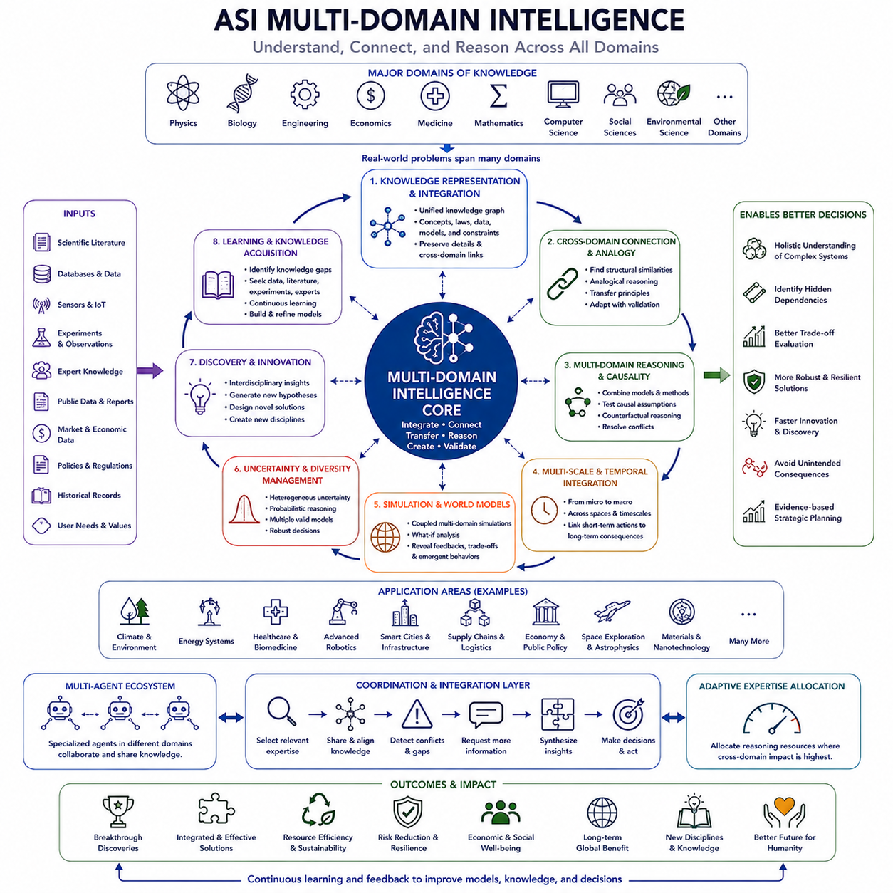
Multi-domain intelligence in Artificial Super Intelligence (ASI) describes the ability to understand, connect, and reason across many specialized fields within a unified cognitive system. Human expertise is usually divided among disciplines such as physics, biology, engineering, economics, medicine, mathematics, computing, and social science. ASI could potentially integrate these domains simultaneously, allowing knowledge from one field to reshape reasoning and problem solving in another.
The importance of multi-domain intelligence arises from the fact that real-world problems rarely respect disciplinary boundaries. Climate systems involve atmospheric physics, chemistry, ecology, energy, economics, infrastructure, and public policy. Advanced robotics combines mechanics, electronics, sensing, control theory, artificial intelligence, materials, communication, and human factors. Solving such problems requires understanding interactions among domains rather than optimizing each discipline independently.
A multi-domain ASI would therefore require broad knowledge representations capable of preserving both specialized detail and relationships between fields. Concepts, equations, causal mechanisms, empirical observations, engineering constraints, and operational knowledge could be organized within interconnected representations. The system would need to recognize when concepts from different disciplines describe similar structures while also preserving differences that make direct transfer inappropriate.
Knowledge integration would go beyond simply storing information from many domains. The system would need to determine how different forms of knowledge relate, conflict, or complement one another. A physical model might establish feasibility, an engineering model might determine manufacturability, an economic model might estimate cost, and an environmental model might reveal lifecycle consequences. Multi-domain reasoning could combine these perspectives into a coherent understanding of the same problem.
Cross-domain transfer could become one of the most powerful consequences of this capability. A solution principle discovered in one field may have useful analogues elsewhere. Evolutionary processes can inspire optimization algorithms, biological neural systems can influence computing architectures, control theory can inform economic regulation, and information theory can contribute to neuroscience. ASI could systematically search for such structural similarities instead of depending primarily on accidental interdisciplinary discovery.
Analogical reasoning would support this transfer by identifying relationships between problems whose surface characteristics appear different. The system could compare underlying structures such as feedback loops, networks, optimization landscapes, hierarchical organization, resource constraints, or dynamic instability. When meaningful similarities are found, methods developed in one domain could be adapted and tested within another rather than transferred without validation.
Scientific discovery would benefit directly from this integration. Many important discoveries occur where established disciplines intersect, because unexplained phenomena may require concepts unavailable within a single field. ASI could examine biological mechanisms using physics, chemistry, information theory, computation, and systems science simultaneously. New hypotheses could emerge from combinations of knowledge that are difficult for individual researchers or specialized research communities to maintain together.
Engineering and design would similarly become increasingly interdisciplinary. Designing an autonomous robot, for example, requires tradeoffs among mechanical structure, actuator performance, energy storage, sensor placement, computation, thermal management, communication, control, perception, safety, manufacturing, and cost. Multi-domain intelligence could reason about these variables jointly, allowing changes in one subsystem to be evaluated immediately through their consequences for the entire engineered system.
Multi-scale reasoning would complement multi-domain reasoning because different disciplines frequently describe different levels of the same system. Materials science may explain microscopic properties, mechanical engineering may describe component behavior, systems engineering may model complete machines, and economics may determine whether deployment is practical. ASI could connect these levels so that microscopic changes can be traced toward system-level and societal consequences.
Temporal integration would be equally important. Different domains operate across radically different timescales, from electronic switching and chemical reactions to manufacturing cycles, infrastructure lifetimes, ecological change, and economic development. Multi-domain intelligence could maintain models spanning these timescales, allowing immediate actions to be evaluated against delayed consequences that may appear in entirely different domains.
Causal reasoning would help prevent superficial interdisciplinary connections. Two domains may exhibit mathematically similar patterns without sharing the same causal mechanism. ASI would need to distinguish useful structural analogy from misleading resemblance by testing causal assumptions, interventions, counterfactuals, and empirical evidence. Cross-domain transfer should therefore generate hypotheses that require validation rather than automatically treating similarity as proof.
Simulation could provide an environment for testing integrated models before conclusions are applied to reality. Coupled simulations might connect physical systems with control software, energy consumption, logistics, economic costs, environmental effects, and human behavior. Such simulations could reveal feedback relationships that remain invisible when each domain is analyzed separately and could identify situations where improvements in one area produce unexpected degradation elsewhere.
World models could serve as a shared substrate for multi-domain intelligence. Instead of maintaining completely isolated models for physics, engineering, economics, and social behavior, ASI could represent relevant entities and relationships within interconnected world models. Specialized domain models could contribute different perspectives while common representations preserve dependencies among physical objects, organizations, resources, technologies, environments, and decision-makers.
Uncertainty integration would become essential because different disciplines express uncertainty differently. Experimental science may report measurement errors, engineering may use tolerances and safety margins, economics may rely on probabilistic forecasts, and environmental science may compare alternative scenarios. ASI would need methods for combining these heterogeneous uncertainties without creating false precision when information from multiple domains is merged.
Conflicting models would also need to coexist. Complex problems often have several legitimate descriptions depending on scale, objective, or available evidence. A system optimized for physical efficiency may conflict with one optimized for economic resilience or environmental sustainability. Multi-domain intelligence should preserve these competing perspectives, identify assumptions behind each model, and determine where additional evidence or explicit value judgments are required.
Strategic reasoning would use multi-domain intelligence to understand consequences that propagate across sectors. A technological decision may alter manufacturing requirements, energy demand, labor markets, supply chains, regulation, environmental impact, and geopolitical relationships. ASI could trace these dependencies across domains and time, helping decision-makers recognize second-order and higher-order effects that are difficult to anticipate through isolated analysis.
Global optimization would depend strongly on this capability. Optimizing a large interconnected system requires understanding what each subsystem contributes and how objectives interact. Energy, transportation, manufacturing, communication, environmental resources, and economic activity cannot always be optimized independently. Multi-domain intelligence provides the integrated representation needed for global optimization to evaluate tradeoffs without ignoring consequences that fall outside a single technical discipline.
Autonomous agents could operationalize multi-domain reasoning by coordinating specialized expertise. Individual agents might focus on scientific analysis, engineering, economics, logistics, safety, law, or environmental assessment while sharing information through common representations. A higher-level coordinating intelligence could combine their conclusions, identify contradictions, request additional analysis, and construct plans reflecting knowledge from several domains simultaneously.
Dynamic expertise allocation could make such systems more efficient. Not every problem requires equal reasoning effort from every domain. ASI could determine which specialties are relevant to a particular decision, activate appropriate models or agents, and increase attention when cross-domain interactions become important. This would allow broad intelligence without requiring maximum computational effort across every field for every problem.
Knowledge acquisition would also become strategically organized. When a problem cannot be resolved because knowledge is missing in one domain, the system could identify the gap and seek additional data, literature, simulation, experimentation, or expert input. Multi-domain intelligence would therefore include the ability to recognize which discipline contains the uncertainty that currently limits progress and direct learning resources toward resolving it.
Novel disciplines could emerge from repeated integration. Human scientific history shows that new fields often form at the boundaries between established ones, such as biophysics, computational neuroscience, materials informatics, and systems biology. ASI might identify stable combinations of concepts and methods that justify entirely new representational frameworks, creating synthetic disciplines optimized around problems rather than inherited academic boundaries.
However, breadth introduces the risk of shallow or incorrect integration. A system possessing information from many domains is not necessarily capable of combining them correctly. Reliable multi-domain intelligence requires domain-specific competence, calibrated uncertainty, source evaluation, causal validation, and mechanisms for detecting when an analogy exceeds its valid range. Breadth must therefore complement rather than replace depth.
Evaluation of multi-domain intelligence should measure more than performance across a collection of unrelated benchmarks. Strong evaluation would examine whether knowledge learned in one field improves reasoning in another, whether the system recognizes when transfer is inappropriate, whether it can integrate conflicting models, and whether it can solve problems requiring several disciplines simultaneously. Generalization across unfamiliar combinations of domains would be particularly important.
Multi-domain superintelligence would ultimately combine specialized expertise with integrative reasoning. Its distinctive capability would not simply be knowing more facts than any individual human, but maintaining deep models across many fields while discovering relationships among them. Scientific, technological, economic, environmental, and social knowledge could become components of a larger reasoning architecture capable of examining problems from multiple interacting perspectives.
Within the broader ASI architecture, multi-domain intelligence acts as a connective layer among scientific discovery, engineering and design, strategic reasoning, autonomous agents, and global optimization. It allows knowledge generated in one capability to influence decisions in others while exposing dependencies that specialized systems may overlook. The result is an intelligence architecture that can move from isolated expertise toward integrated understanding of complex systems spanning disciplines, scales, and timescales.

05.07. Capability Simulation [w/Code]
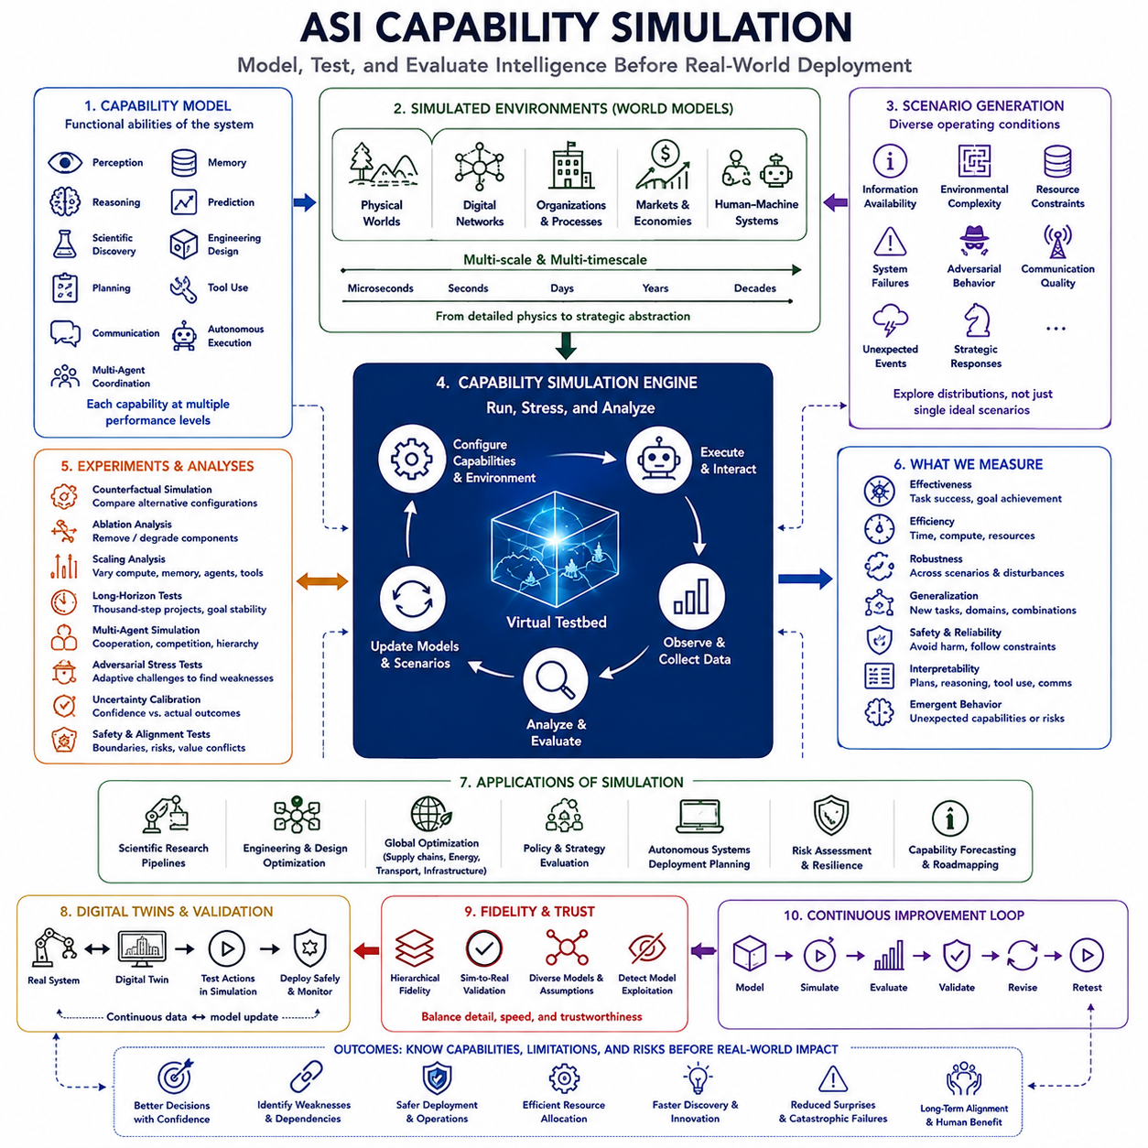
Capability simulation in Artificial Super Intelligence (ASI) refers to the systematic modeling and evaluation of what an intelligent system could accomplish before those capabilities are fully deployed in the real world. Rather than assessing intelligence only after actions occur, simulation creates controlled environments in which reasoning, planning, autonomy, coordination, adaptation, and optimization can be tested across many possible conditions.
The purpose of capability simulation is broader than conventional benchmark testing. Benchmarks usually measure performance on predefined tasks, while simulation can construct dynamic environments in which problems evolve, information remains incomplete, resources are limited, and other agents respond strategically. This allows researchers to examine not only whether an ASI succeeds, but how its behavior changes as complexity, uncertainty, and autonomy increase.
A capability model would represent the functional abilities available to the system. These could include perception, memory, reasoning, prediction, scientific discovery, engineering design, strategic planning, tool use, communication, autonomous execution, and multi-agent coordination. Each capability could be represented at different performance levels, making it possible to explore how combinations of abilities produce system-level behavior that individual evaluations may not reveal.
Simulation could also examine interactions among capabilities rather than treating them independently. Improvements in memory may strengthen long-horizon planning, while better world models may improve both prediction and autonomous control. Scientific reasoning combined with engineering design could accelerate technological development. Capability simulation could therefore reveal nonlinear effects in which several moderate improvements together produce a much larger increase in overall system effectiveness.
World models would provide the environments in which simulated capabilities operate. These models might represent physical spaces, digital networks, organizations, scientific laboratories, factories, markets, infrastructure, or mixed human-machine systems. Different levels of abstraction could be used depending on the question, ranging from detailed physical simulation to simplified models of strategic interaction and resource allocation.
Scenario generation would allow capability simulation to explore a wide range of possible operating conditions. Scenarios could vary available information, environmental complexity, resource constraints, system failures, adversarial behavior, communication quality, or unexpected events. Instead of evaluating performance under one idealized situation, ASI capabilities could be tested across distributions of conditions designed to expose strengths, weaknesses, and hidden dependencies.
Counterfactual simulation could compare alternative capability configurations. Researchers might examine how system behavior changes when long-term memory is restricted, tool access is removed, planning depth is reduced, or communication among agents is limited. Conversely, individual capabilities could be strengthened to estimate their marginal contribution and determine which combinations create significant changes in autonomy, effectiveness, or risk.
Ablation analysis would provide a systematic method for understanding these dependencies. By removing or degrading particular components, evaluators could identify which capabilities are essential for specific outcomes. If a system loses substantial performance when persistent memory is removed, for example, this would indicate that memory plays a central role in its long-horizon behavior rather than merely improving short-term task completion.
Capability simulation could also explore scaling relationships. Increasing model size, computational resources, memory capacity, planning horizon, number of agents, tool availability, or environmental experience may not produce proportional improvements. Some capabilities may emerge gradually, while others may appear after thresholds are crossed. Simulation could help identify such transition regions before corresponding systems are deployed at full operational scale.
Multi-agent simulation would be particularly important for evaluating distributed or collective forms of ASI. Specialized agents could cooperate, compete, delegate tasks, exchange information, verify one another, or form hierarchical structures. Researchers could vary the number, specialization, communication bandwidth, authority, and coordination mechanisms of agents to understand when collective intelligence improves performance and when coordination failures begin to dominate.
Long-horizon simulations could test whether autonomous systems maintain coherent objectives over extended sequences of decisions. An agent may perform well on short tasks while gradually accumulating errors, resource inefficiencies, incorrect assumptions, or goal drift during prolonged operation. Simulated projects lasting thousands of decision steps could reveal failure modes that remain invisible in conventional evaluations based on isolated prompts or short episodes.
Strategic capability could be examined through environments containing adaptive actors. Rather than using static opponents, simulations could include agents that learn, negotiate, cooperate, conceal information, or change strategies in response to the ASI. This would test recursive reasoning, uncertainty management, coalition formation, information gathering, and robust planning under conditions where the environment reacts directly to the system's decisions.
Scientific capability simulation could model research processes rather than merely testing scientific question answering. A simulated system might receive incomplete observations, generate hypotheses, design experiments, allocate laboratory resources, interpret results, reject failed explanations, and decide which investigation to perform next. Performance could then be measured by the quality, reliability, and efficiency of knowledge generated across an entire discovery cycle.
Engineering capability could similarly be simulated through iterative design environments. An ASI might receive requirements and constraints, generate candidate architectures, run simulations, identify failures, modify designs, and optimize manufacturing or lifecycle performance. Evaluators could measure whether the system converges toward robust solutions and whether apparently high-performing designs remain safe when assumptions, tolerances, or operating conditions change.
Global optimization capability could be examined using interconnected simulated systems such as supply chains, energy networks, transportation, manufacturing, and computing infrastructure. The system could be challenged to allocate resources while balancing efficiency, resilience, cost, sustainability, and uncertainty. Disturbances could then test whether optimized configurations remain stable or collapse because the system pursued excessive local or short-term efficiency.
Simulation is especially valuable for examining rare but consequential conditions. Real-world testing cannot practically reproduce every infrastructure failure, extreme environmental event, coordination breakdown, or unusual interaction among autonomous systems. Synthetic environments can deliberately generate low-probability scenarios, allowing evaluators to search for catastrophic failure modes without producing equivalent real-world consequences during testing.
Adversarial simulation could actively search for situations in which capabilities fail. Instead of randomly generating environments, specialized adversarial agents could construct tasks, information patterns, or disturbances designed to exploit weaknesses in reasoning, planning, coordination, or safety mechanisms. This converts evaluation into an adaptive contest in which the testing environment becomes progressively more difficult as vulnerabilities are discovered.
Uncertainty calibration would be another important target. A capable system should not only generate correct answers and actions but also estimate when its models are unreliable. Simulations can provide known underlying states that allow predicted confidence to be compared with actual outcomes. Systems that recognize uncertainty can request additional information, delay irreversible actions, or escalate decisions rather than confidently executing poorly supported plans.
Digital twins could connect capability simulation with real operational systems. A deployed robot, factory, laboratory, infrastructure network, or computational platform could maintain a corresponding virtual representation. Potential actions could first be evaluated in the digital twin, allowing consequences and failure modes to be estimated before selected actions are transferred into physical execution. Real observations would then update the simulation continuously.
Simulation fidelity would need to be managed carefully. Highly detailed models can become computationally expensive, while simplified models may omit critical interactions. ASI evaluation could therefore use hierarchical simulation, combining fast abstract models for broad exploration with increasingly detailed simulations for promising or dangerous scenarios. Physical experiments could then validate the assumptions that matter most before deployment.
The simulation itself cannot be assumed to represent reality perfectly. A system may learn to exploit inaccuracies in the simulated environment or develop strategies that perform well only because important real-world constraints are missing. Capability simulation therefore requires sim-to-real validation, diverse environment models, uncertainty about simulation assumptions, and repeated comparison between predicted behavior and observed physical outcomes.
Safety capability can be evaluated by introducing constraints, ambiguous instructions, conflicting objectives, unexpected failures, and opportunities to obtain higher performance through unsafe actions. Evaluators could examine whether the system preserves boundaries when optimization pressure increases. The ability to stop, request authorization, choose reversible actions, or sacrifice performance to maintain safety can become explicit dimensions of simulated evaluation.
Interpretability and monitoring can also be incorporated into capability simulation. Researchers may examine not only final outcomes but intermediate plans, resource allocations, tool usage, communications, uncertainty estimates, and changes in internal objectives. Behavioral traces could reveal when successful outcomes depend on fragile reasoning or when apparently harmless intermediate strategies create risks that outcome-only evaluation would miss.
Simulation results could support capability forecasting. By measuring performance across increasing compute, memory, autonomy, tool access, and coordination, researchers could estimate how future systems might behave before equivalent systems exist. Such forecasts would remain uncertain, especially when qualitative capability transitions occur, but they could provide early warning that particular combinations of improvements deserve stronger evaluation or governance.
Capability simulation should therefore operate as a continuous process rather than a one-time certification stage. As models, tools, infrastructure, and autonomous behaviors change, previously tested assumptions may become invalid. New simulations can incorporate observed failures, emerging capabilities, novel environments, and stronger adversarial tests, creating an evaluation system that evolves alongside the intelligence being evaluated.
Within the broader ASI architecture, capability simulation functions as a virtual proving ground connecting prediction, scientific discovery, engineering, strategic reasoning, autonomous agents, global optimization, and multi-domain intelligence. It allows these capabilities to be combined, stressed, separated, scaled, and observed before unrestricted deployment. Through repeated cycles of model, simulate, evaluate, validate, revise, and retest, capability simulation can help determine not only what ASI can do, but under which conditions its capabilities remain reliable, controllable, and safe.

