Volume 01. AMR Foundations and System Architecture

14. AMR Product Strategy · AMR 제품 전략

14.01 Product Positioning · 제품 포지셔닝
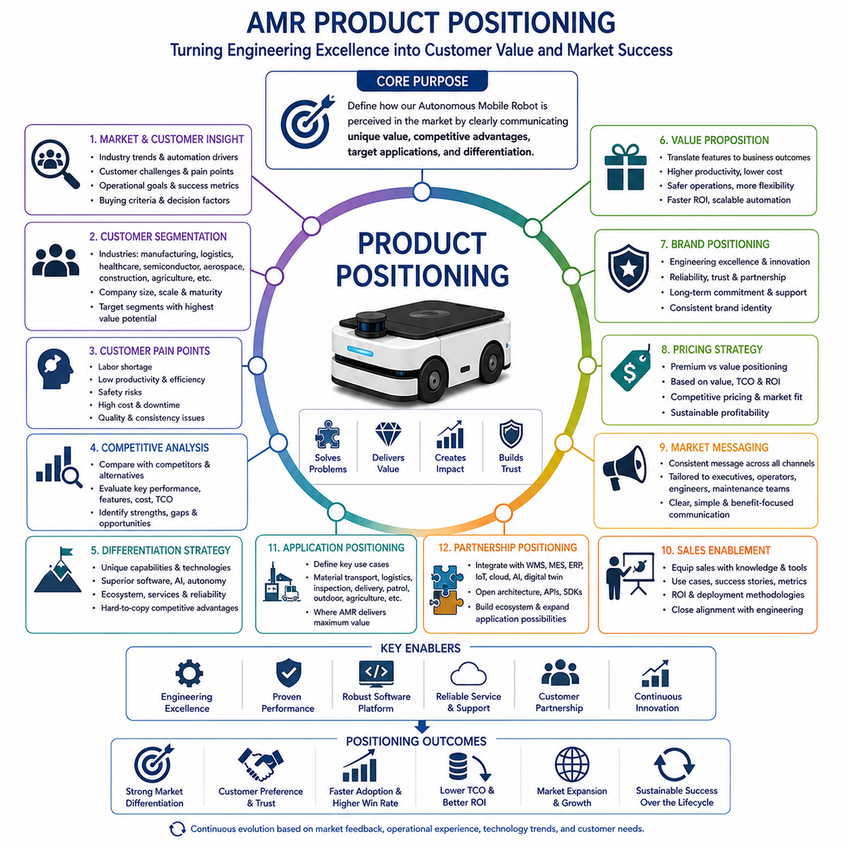
Product positioning defines how an Autonomous Mobile Robot is perceived within the target market by clearly communicating its unique value, competitive advantages, intended applications, and differentiation from alternative solutions. It represents the strategic bridge between engineering excellence and commercial success by transforming technical capabilities into customer-recognizable business value. A technically advanced robot does not automatically achieve market success if customers cannot immediately understand why it is superior, which operational problems it solves, or how it improves productivity compared with existing methods. Product positioning therefore establishes a consistent message that aligns engineering, marketing, sales, manufacturing, customer support, and business development around a unified understanding of the product's purpose and value proposition.
The product positioning process begins with a comprehensive understanding of market requirements rather than internal engineering preferences. Market research identifies industrial trends, customer challenges, operational pain points, workforce shortages, automation demands, digital transformation initiatives, sustainability objectives, and emerging technological opportunities. Engineering teams collaborate closely with marketing specialists to understand how customers evaluate robotic solutions, what operational metrics influence purchasing decisions, and which performance characteristics provide meaningful business value. Effective positioning is built upon customer needs instead of product specifications alone, ensuring that engineering investments directly address real commercial opportunities.
Customer segmentation provides the foundation for defining the most appropriate target markets. Autonomous Mobile Robots serve diverse industries including manufacturing, logistics, healthcare, semiconductor production, aerospace, construction, agriculture, mining, defense, smart cities, and infrastructure inspection. Each industry presents different operational environments, regulatory requirements, productivity expectations, safety standards, integration complexity, and investment priorities. Even within a single industry, customer requirements vary according to company size, operational scale, automation maturity, available infrastructure, labor availability, and digital transformation strategy. Product positioning therefore identifies the customer segments where the robotic platform delivers the highest measurable value rather than attempting to satisfy every possible application simultaneously.
Understanding customer pain points is essential because successful positioning emphasizes problem solving instead of technology promotion. Customers rarely purchase Autonomous Mobile Robots because they contain advanced sensors, artificial intelligence, or sophisticated software architectures. Instead, organizations invest in robotic automation to reduce labor shortages, improve productivity, enhance operational safety, increase process consistency, minimize downtime, reduce operational costs, improve quality, optimize resource utilization, and strengthen business competitiveness. Product positioning translates engineering features into measurable operational outcomes, allowing customers to immediately associate technical innovations with tangible business benefits relevant to their daily operations.
Competitive analysis identifies how the proposed robotic platform differs from existing market alternatives. Engineering teams evaluate direct competitors, indirect competitors, conventional automation systems, manual operations, and emerging robotic technologies according to payload capacity, navigation performance, perception capability, artificial intelligence integration, battery life, charging strategy, software ecosystem, fleet management, safety certification, deployment complexity, maintenance requirements, scalability, reliability, and total cost of ownership. Competitive benchmarking reveals both strengths and weaknesses while identifying opportunities for differentiation that cannot be easily replicated by competing products. Successful positioning highlights sustainable competitive advantages rather than temporary technical superiority.
Differentiation strategy transforms engineering capabilities into unique market identity. Some Autonomous Mobile Robots emphasize high payload transportation, while others focus on precision inspection, collaborative operation, outdoor mobility, intelligent perception, modular architectures, or artificial intelligence driven autonomy. Differentiation may also originate from superior software platforms, rapid deployment methodologies, integrated cloud services, predictive maintenance, cybersecurity, digital twin support, or complete end-to-end operational ecosystems. Effective differentiation does not necessarily require the highest technical specification in every category but instead demonstrates superior value within clearly defined operational scenarios where customer priorities align closely with product strengths.
The value proposition communicates why customers should select the product instead of competing alternatives. A strong value proposition combines technical capability with measurable operational improvement by demonstrating increased productivity, reduced operational cost, enhanced safety, improved flexibility, lower maintenance requirements, simplified deployment, faster return on investment, and scalable automation. Rather than emphasizing isolated engineering specifications, value propositions describe complete business outcomes achieved through practical deployment. Quantifiable performance indicators supported by engineering validation and pilot deployment strengthen customer confidence while reducing perceived purchasing risk during commercial decision making.
Brand positioning extends beyond individual product specifications by establishing long-term organizational identity within the robotics industry. Customers frequently evaluate not only the robot itself but also the engineering expertise, technological leadership, product reliability, service capability, innovation culture, and long-term commitment represented by the manufacturer. Consistent branding communicates trustworthiness, engineering excellence, customer partnership, continuous innovation, and operational reliability across every customer interaction. Strong brand positioning reinforces product positioning while supporting future product introductions and long-term market expansion.
Pricing strategy directly influences product positioning because customers often associate price with technological capability, reliability, service quality, and long-term value. Premium positioning emphasizes advanced functionality, superior reliability, comprehensive service, and long-term operational performance, while value-oriented positioning focuses on affordability, rapid deployment, lower investment barriers, and operational efficiency. Pricing decisions consider manufacturing cost, lifecycle support, software licensing, maintenance services, competitive pricing, customer purchasing behavior, and expected return on investment. Successful pricing aligns perceived customer value with sustainable business profitability rather than simply minimizing product cost.
Market messaging ensures that every customer-facing communication consistently reinforces the intended product position. Marketing materials, technical documentation, product demonstrations, trade exhibitions, digital media, sales presentations, customer training, and engineering discussions communicate the same core value proposition using language appropriate for different audiences. Executives often focus on financial return and business strategy, operational managers emphasize productivity and efficiency, engineers evaluate technical architecture and integration capability, while maintenance organizations prioritize reliability and serviceability. Consistent messaging allows diverse stakeholders to understand how the product addresses their specific priorities without creating conflicting perceptions.
Sales enablement translates product positioning into practical commercial engagement by equipping sales organizations with technical knowledge, competitive comparisons, application examples, customer success stories, operational performance metrics, deployment methodologies, and return-on-investment analyses. Sales engineers explain complex engineering concepts using customer-oriented language while demonstrating how technical capabilities solve practical operational problems. Close collaboration between engineering and sales organizations ensures that customer expectations remain realistic while accurately representing validated product capabilities. Well-prepared sales teams strengthen market confidence and accelerate commercial adoption.
Application positioning defines the specific operational scenarios where the Autonomous Mobile Robot delivers maximum effectiveness. Rather than describing generic mobility capabilities, product positioning identifies concrete use cases such as automated material transportation, warehouse logistics, industrial inspection, hospital delivery, security patrol, outdoor infrastructure monitoring, precision agriculture, construction site support, airport logistics, manufacturing automation, or intelligent facility management. Clearly defined application positioning helps customers visualize practical implementation while simplifying purchasing decisions through immediately recognizable operational relevance.
Partnership positioning highlights how the robotic platform integrates into broader industrial ecosystems rather than functioning as an isolated autonomous machine. Modern Autonomous Mobile Robots increasingly cooperate with warehouse management systems, manufacturing execution systems, enterprise resource planning platforms, cloud computing infrastructure, industrial Internet of Things networks, artificial intelligence services, digital twin platforms, robotic manipulators, industrial sensors, and third-party automation equipment. Open architecture, standardized interfaces, software development kits, application programming interfaces, and modular integration frameworks strengthen market positioning by reducing customer integration risk while expanding future application possibilities.
Product positioning evolves continuously because market conditions, customer expectations, competing technologies, and industrial priorities change throughout the product lifecycle. Customer feedback, operational experience, field deployment results, emerging technologies, regulatory developments, artificial intelligence advancement, workforce transformation, sustainability initiatives, and competitive market dynamics regularly influence positioning strategy. Engineering organizations continuously refine product messaging while preserving consistency with validated technical capabilities. Long-term positioning therefore becomes a dynamic strategic process rather than a one-time marketing activity, ensuring that Autonomous Mobile Robot platforms remain commercially relevant, technologically differentiated, and closely aligned with evolving customer needs throughout their operational lifetime.

14.02 Low / Mid / High Product Strategy · Low/Mid/High 제품 전략
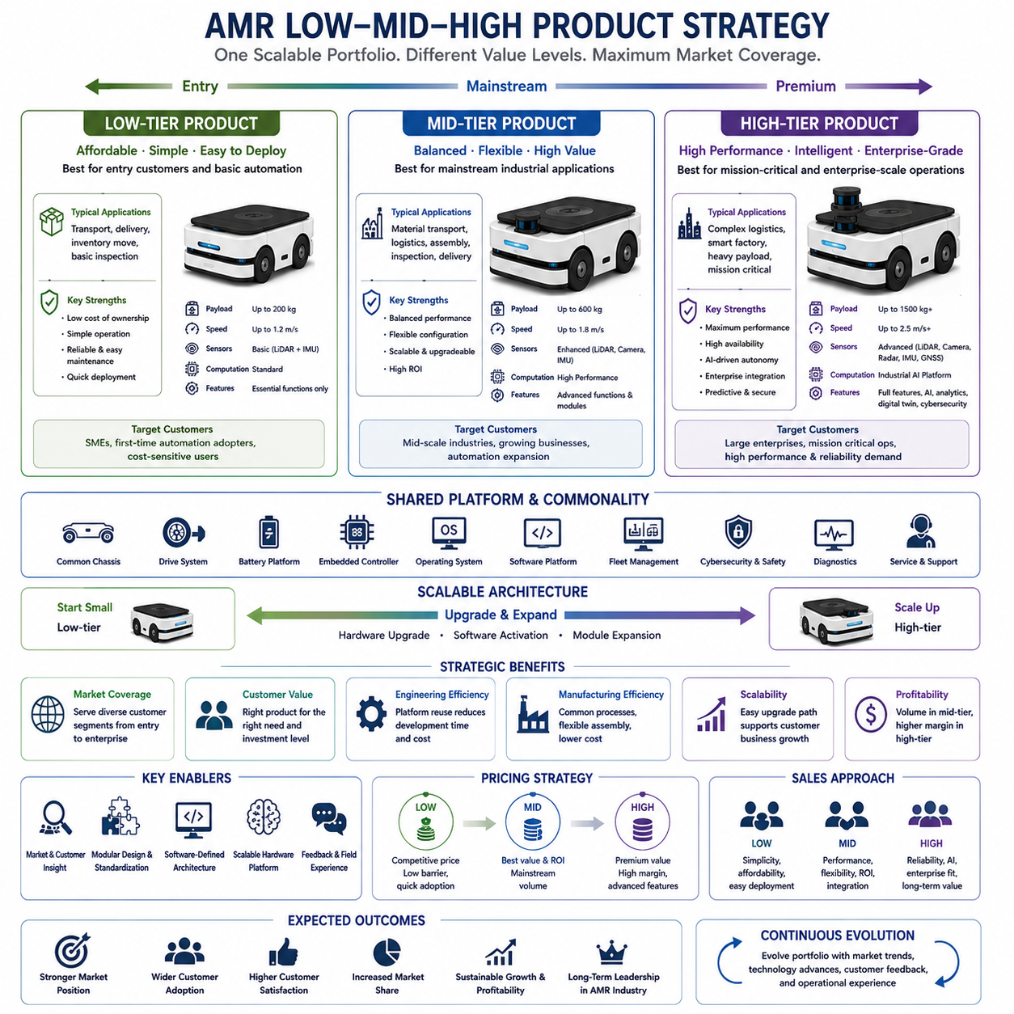
Low-, mid-, and high-tier product strategy establishes a structured product portfolio that allows an Autonomous Mobile Robot manufacturer to serve diverse customer segments while maximizing market coverage, engineering efficiency, and long-term profitability. Instead of developing completely independent products for every customer requirement, manufacturers design a scalable product family that shares common technologies, software platforms, manufacturing processes, and service infrastructure while providing different performance levels, feature sets, and pricing. This strategy enables organizations to address entry-level customers seeking affordable automation, mainstream industrial customers requiring balanced performance, and premium customers demanding maximum capability within a unified product ecosystem. A well-designed product hierarchy strengthens market competitiveness while reducing engineering complexity and manufacturing cost through platform reuse.
The product tier strategy begins with a comprehensive understanding of market segmentation and purchasing behavior. Customers differ significantly in operational scale, investment capacity, automation maturity, technical expertise, infrastructure readiness, and expected return on investment. Small and medium-sized enterprises often prioritize affordability, simplicity, and rapid deployment because they are introducing automation for the first time. Medium-scale industrial organizations generally require balanced performance, flexible integration, and moderate expansion capability. Large enterprises frequently prioritize operational optimization, advanced artificial intelligence, enterprise integration, cybersecurity, high availability, predictive maintenance, and long-term scalability over initial acquisition cost. Product strategy aligns technical capabilities with these differing business priorities.
The low-tier product serves as the entry point into the Autonomous Mobile Robot portfolio by providing essential autonomous functionality at the lowest practical ownership cost. These products emphasize simplicity, reliability, ease of deployment, and minimal maintenance rather than maximum performance. Navigation typically relies on mature localization technologies with limited sensor redundancy and moderate computational capability. Payload capacity, travel speed, perception range, and intelligent decision-making remain optimized for straightforward transportation, delivery, inventory movement, or basic inspection tasks. Hardware configurations minimize unnecessary complexity while preserving sufficient upgrade capability for future customer expansion. Low-tier products reduce barriers to automation adoption by providing attractive investment opportunities for cost-sensitive customers.
Engineering philosophy for entry-level products emphasizes standardization rather than customization. Mechanical structures use common chassis platforms, standardized drive systems, modular batteries, shared electronic controllers, and simplified sensor configurations to reduce manufacturing variation. Software architecture remains compatible with higher product tiers while limiting advanced functionality that is unnecessary for entry-level applications. Fleet management, navigation, safety supervision, and diagnostic capabilities remain fully validated but are intentionally streamlined to simplify operation and reduce computational requirements. Common engineering platforms minimize development effort while supporting efficient manufacturing and service operations across the complete product family.
The mid-tier product targets customers seeking an optimal balance between capability, flexibility, and investment efficiency. These robotic platforms introduce enhanced payload capacity, improved perception performance, greater navigation robustness, stronger computing capability, expanded software functionality, and increased integration flexibility without approaching the complexity or cost of premium systems. Mid-tier products frequently represent the highest sales volume because they satisfy the operational requirements of most industrial customers while maintaining attractive total cost of ownership. They provide the practical balance between affordability and advanced functionality required for widespread commercial adoption.
Mid-tier engineering introduces greater modularity, allowing customers to configure robotic systems according to specific operational requirements. Additional sensor options, larger battery configurations, enhanced industrial computers, advanced wireless communication, expanded fleet management functions, and configurable software modules provide significant flexibility while preserving standardized manufacturing processes. Artificial intelligence capabilities become more prominent through improved perception models, semantic understanding, adaptive navigation, intelligent obstacle avoidance, and predictive operational analytics. Modular architecture enables customers to purchase only the capabilities required today while maintaining upgrade paths supporting future operational expansion.
The high-tier product represents the flagship technological platform designed for customers requiring maximum performance, operational resilience, intelligent autonomy, and enterprise-scale deployment. Premium robotic systems integrate the highest-performance perception sensors, industrial-grade computing platforms, redundant safety architectures, advanced artificial intelligence, high-capacity batteries, sophisticated fleet coordination, predictive maintenance, digital twin integration, cybersecurity protection, and complete enterprise connectivity. These systems operate within highly dynamic industrial environments where reliability, productivity, precision, and operational continuity directly influence critical business operations. Premium products emphasize engineering excellence rather than minimum acquisition cost.
Engineering design for premium systems prioritizes capability without compromising reliability. Multiple perception technologies including LiDAR, radar, vision systems, inertial navigation, GNSS, and sensor fusion provide highly robust environmental awareness. High-performance GPUs accelerate deep learning inference, semantic perception, and intelligent planning algorithms while maintaining deterministic real-time control. Redundant communication networks, industrial safety controllers, advanced diagnostics, predictive maintenance algorithms, and cloud-based operational intelligence support continuous operation under demanding industrial conditions. Enterprise customers frequently require extensive software customization, cybersecurity compliance, regulatory certification, and integration with complex digital manufacturing infrastructure.
Despite significant capability differences among product tiers, successful manufacturers maximize platform commonality throughout the portfolio. Mechanical interfaces, battery technology, embedded controllers, operating systems, middleware, software architecture, fleet management platforms, cybersecurity infrastructure, diagnostic frameworks, and maintenance procedures remain highly standardized whenever practical. Platform commonality reduces engineering cost, simplifies software maintenance, improves manufacturing efficiency, minimizes spare part inventory, accelerates technician training, and supports long-term product evolution. Customers also benefit because operational experience gained from one product tier transfers naturally to higher-performance systems.
Software platform strategy plays a particularly important role because modern Autonomous Mobile Robots increasingly derive competitive advantage from intelligent software rather than hardware alone. Core navigation, localization, communication, safety management, diagnostics, cybersecurity, fleet coordination, and artificial intelligence frameworks remain identical across product tiers whenever possible. Functional differentiation is primarily achieved through software licensing, computational capability, sensor availability, and configurable feature activation rather than completely independent software development. Unified software architecture simplifies engineering validation while supporting continuous feature evolution throughout the entire product portfolio.
Scalable hardware architecture enables efficient manufacturing while preserving future upgrade opportunities. Entry-level products may later receive larger batteries, additional perception sensors, upgraded industrial computers, improved wireless communication modules, or expanded artificial intelligence capability without requiring complete platform replacement. Mid-tier systems may evolve toward premium capability through incremental hardware expansion and software activation. Scalable architecture protects customer investment by allowing operational capability to grow together with business requirements while extending product service life and reducing lifecycle ownership cost.
Pricing strategy across multiple product tiers carefully balances market accessibility and business profitability. Entry-level products attract new customers through competitive acquisition cost and simplified deployment. Mid-tier products maximize sales volume by delivering strong operational value relative to investment. Premium systems generate higher engineering margins through advanced functionality, enterprise integration, specialized applications, and comprehensive lifecycle services. Pricing differentiation reflects measurable operational value rather than arbitrary hardware specifications. Customers therefore perceive clear business justification when selecting increasingly capable robotic platforms aligned with their operational objectives.
Sales strategy differs significantly across product tiers because purchasing motivations vary according to customer maturity and organizational priorities. Entry-level customers emphasize affordability, ease of deployment, rapid implementation, and operational simplicity. Mid-tier customers focus on productivity improvement, operational flexibility, integration capability, and long-term return on investment. Premium customers prioritize business continuity, intelligent automation, cybersecurity, predictive maintenance, digital transformation, enterprise connectivity, and strategic operational optimization. Sales organizations tailor communication, demonstrations, technical documentation, financial analysis, and deployment planning according to these distinct customer expectations while maintaining consistent product positioning across the portfolio.
Manufacturing strategy benefits substantially from a tiered product family because standardized production processes support multiple products using common assembly lines, calibration procedures, quality assurance methods, software deployment systems, testing infrastructure, logistics operations, and service organizations. Manufacturing flexibility allows product configuration during final assembly through modular component selection rather than maintaining completely independent production lines. This approach improves production efficiency, reduces inventory complexity, shortens delivery time, and supports rapid response to changing market demand while maintaining consistent product quality.
The long-term success of a low-, mid-, and high-tier product strategy depends upon continuous portfolio evolution driven by customer feedback, field experience, competitive analysis, technological advancement, manufacturing optimization, and market transformation. Product boundaries gradually evolve as technologies mature, component costs decline, artificial intelligence capabilities expand, and customer expectations increase. Features initially introduced within premium products frequently migrate into mid-tier and eventually entry-level systems as engineering maturity improves and manufacturing economies of scale develop. This progressive technology transfer maintains competitiveness across the complete product family while preserving clear differentiation between product tiers. A successful tiered product strategy therefore creates a sustainable roadmap that simultaneously supports engineering innovation, manufacturing efficiency, customer satisfaction, commercial growth, and long-term leadership within the Autonomous Mobile Robot industry.

14.03 China vs Global Architecture · 중국 vs 글로벌 아키텍처
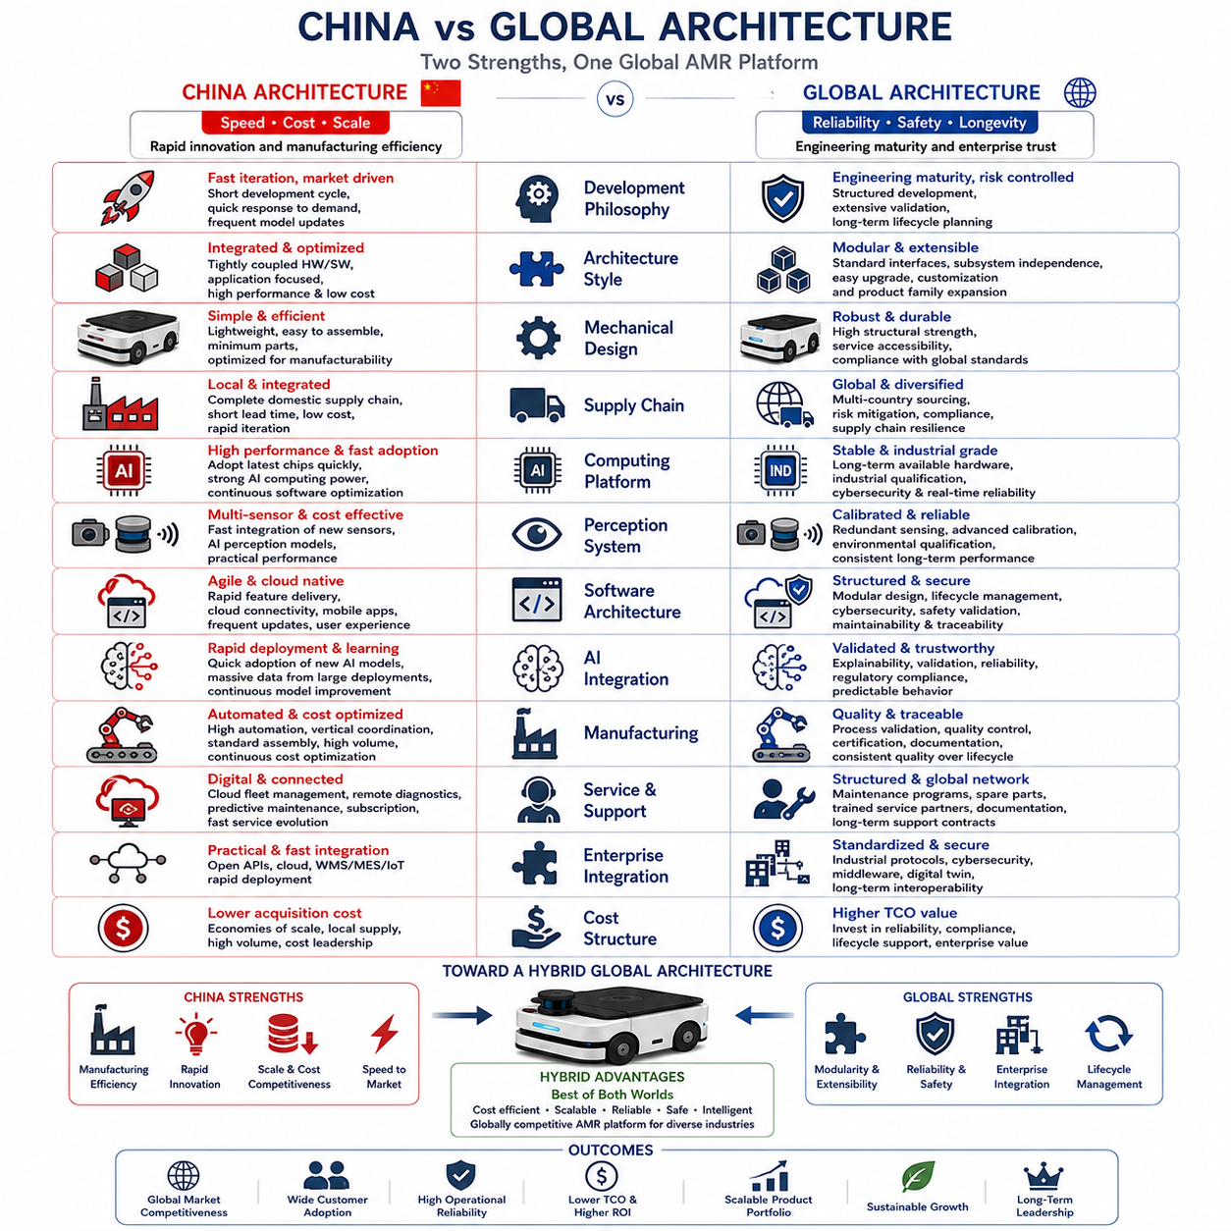
China and global Autonomous Mobile Robot architectures have evolved under different industrial environments, customer expectations, manufacturing ecosystems, and business strategies. While both architectures pursue autonomous navigation, intelligent perception, fleet management, and industrial automation, they often emphasize different priorities regarding cost, scalability, system integration, product lifecycle, software architecture, and technological differentiation. Understanding these architectural differences is essential for manufacturers developing internationally competitive robotic platforms because successful global products frequently combine the manufacturing efficiency and rapid commercialization observed in China with the reliability, modularity, safety, and enterprise integration commonly emphasized by established international robotics companies. Rather than viewing these approaches as competing philosophies, modern engineering increasingly treats them as complementary design strategies that can be integrated into a unified global product architecture.
The Chinese robotics ecosystem has developed rapidly through strong manufacturing infrastructure, vertically integrated supply chains, high domestic demand, and aggressive commercialization. Large production volumes allow manufacturers to optimize hardware cost while accelerating product iteration through continuous field deployment. Engineering decisions frequently prioritize manufacturability, supply chain efficiency, hardware standardization, and rapid product evolution over maintaining long-term compatibility with legacy platforms. Product development cycles are generally shorter, allowing companies to introduce updated models more frequently while responding quickly to changing customer requirements and market opportunities. This rapid development culture has enabled Chinese manufacturers to become highly competitive in cost-sensitive industrial automation markets.
Global robotics manufacturers have traditionally emphasized engineering maturity, long-term reliability, functional safety, certification, and enterprise-scale lifecycle support. Product development typically follows structured engineering processes involving detailed requirements analysis, formal verification, extensive validation, regulatory compliance, and long-term maintenance planning. Development cycles are often longer because engineering organizations invest significant effort in reducing technical risk before commercial release. Although this approach may delay product introduction compared with rapid commercialization strategies, it generally results in highly reliable platforms suitable for mission-critical industrial applications where operational continuity is more valuable than rapid feature introduction.
Architectural philosophy differs significantly between the two approaches. Many Chinese robotic platforms prioritize complete product optimization around predefined customer applications, integrating hardware and software into tightly coupled solutions that maximize performance, cost efficiency, and manufacturing simplicity. Global architectures more frequently emphasize modularity, standardized interfaces, subsystem independence, and platform extensibility. Mechanical structures, perception systems, compute platforms, navigation software, fleet management services, and enterprise interfaces are often designed as replaceable modules supporting long-term technology evolution. Modular architecture increases engineering flexibility while simplifying maintenance, future upgrades, customer customization, and product family expansion.
Mechanical platform design illustrates another important distinction. Chinese manufacturers frequently optimize chassis architecture for manufacturing efficiency, structural simplicity, lightweight construction, and rapid assembly while minimizing component count and production cost. Components are often selected according to domestic supply availability and manufacturing scalability. Global manufacturers generally emphasize structural robustness, environmental durability, service accessibility, modular replacement, long-term fatigue resistance, and compliance with international industrial standards. Although these priorities sometimes increase manufacturing cost, they improve operational reliability throughout extended commercial lifecycles, particularly within demanding industrial environments requiring continuous operation over many years.
Supply chain architecture represents one of the greatest competitive differences. Chinese robotics companies benefit from highly localized manufacturing ecosystems where batteries, motors, controllers, industrial computers, sensors, electronic components, mechanical fabrication, and final assembly can often be sourced within closely connected industrial regions. This concentration significantly reduces procurement time, logistics complexity, manufacturing cost, and engineering iteration cycles. Global manufacturers frequently depend upon geographically distributed suppliers across multiple countries to achieve component diversification, regulatory compliance, specialized technology access, and supply chain resilience. Distributed sourcing increases complexity but reduces dependence upon individual regional manufacturing ecosystems.
Computing architecture has become increasingly important as artificial intelligence capabilities expand. Chinese robotic platforms frequently adopt commercially available high-performance computing hardware soon after market introduction, emphasizing rapid integration of new processors, GPUs, embedded controllers, and artificial intelligence accelerators. Software optimization often evolves continuously through frequent updates driven by operational feedback. Global manufacturers generally prioritize computing platform stability, industrial qualification, long-term availability, thermal validation, cybersecurity certification, and deterministic real-time behavior before introducing new computing technologies. Hardware selection therefore balances computational performance with long-term operational support requirements.
Perception architecture demonstrates similar differences in engineering priorities. Chinese platforms frequently integrate multiple commercially available cameras, LiDAR sensors, radar units, and artificial intelligence perception algorithms to maximize practical capability while maintaining competitive pricing. Sensor configurations evolve rapidly as new technologies become commercially available. Global robotic systems often emphasize calibrated multi-sensor architectures, long-term stability, environmental qualification, redundant sensing, deterministic performance, and comprehensive validation across diverse operational conditions. Extensive sensor calibration and verification procedures contribute to highly consistent localization and perception performance throughout prolonged operational lifetimes.
Software architecture increasingly determines product competitiveness beyond hardware capability alone. Chinese robotics software frequently emphasizes rapid feature delivery, user experience, cloud connectivity, artificial intelligence integration, mobile applications, remote management, and continuous operational improvement through frequent software releases. Software platforms evolve quickly in response to market feedback and customer requests. Global software architecture traditionally emphasizes modular design, software lifecycle management, cybersecurity, configuration control, version traceability, compatibility preservation, safety validation, and long-term maintainability. Structured software engineering simplifies certification, enterprise deployment, and continuous lifecycle support for mission-critical industrial systems.
Artificial intelligence integration has become a major area of architectural differentiation. Chinese manufacturers often deploy newly developed deep learning models, foundation models, vision-language systems, and autonomous decision algorithms rapidly after technological breakthroughs become available. Large domestic deployment volumes generate extensive operational datasets supporting continuous model improvement. Global manufacturers generally adopt artificial intelligence technologies more cautiously, emphasizing explainability, validation, reliability, regulatory compliance, and predictable operational behavior before integrating advanced algorithms into production systems. This conservative approach reduces operational risk while maintaining customer confidence in safety-critical applications.
Manufacturing architecture strongly influences product competitiveness. Chinese production systems frequently integrate highly automated manufacturing, vertically coordinated suppliers, digital production monitoring, standardized assembly, rapid product iteration, and aggressive cost optimization. High manufacturing volume enables continuous process refinement while reducing unit cost through economies of scale. Global manufacturers often prioritize manufacturing traceability, quality assurance, process validation, statistical quality control, international certification, documentation completeness, and lifecycle configuration management. These manufacturing processes support consistent product quality across long operational lifetimes while facilitating regulatory compliance and enterprise customer requirements.
Service architecture also reflects different market priorities. Chinese robotics companies increasingly provide cloud-based fleet management, predictive maintenance, remote diagnostics, mobile service applications, software subscription models, and operational analytics through integrated digital ecosystems. Service capability evolves rapidly alongside software development. Global manufacturers typically emphasize structured maintenance programs, spare part management, certified service organizations, technical documentation, customer training, preventive maintenance procedures, lifecycle support agreements, and global service infrastructure. Enterprise customers frequently value predictable long-term service quality as highly as initial product capability.
Enterprise integration capabilities continue to expand in both markets but often follow different implementation strategies. Chinese robotic platforms commonly provide efficient integration with warehouse management systems, manufacturing execution systems, cloud services, Internet of Things platforms, and industrial automation through practical application interfaces supporting rapid deployment. Global architectures generally emphasize standardized industrial communication protocols, cybersecurity compliance, modular middleware, enterprise architecture compatibility, digital twin integration, and long-term interoperability with complex industrial information systems. Standardization supports integration across multinational organizations operating heterogeneous industrial environments.
Cost structure represents one of the most visible differences between the two architectural approaches. Chinese manufacturers leverage localized production, large-scale manufacturing, rapid iteration, and integrated supply chains to minimize acquisition cost while maintaining competitive functionality. Global manufacturers often accept higher manufacturing cost in exchange for enhanced reliability, regulatory compliance, extended product support, comprehensive validation, advanced documentation, and enterprise-level service capability. Customers therefore evaluate not only purchase price but also total cost of ownership, operational reliability, maintenance requirements, software evolution, lifecycle support, and long-term business value when selecting robotic platforms.
The future direction of Autonomous Mobile Robot architecture is increasingly converging rather than diverging. Chinese manufacturers continue investing heavily in safety engineering, enterprise software, modular architecture, international certification, and long-term lifecycle management as they expand into global markets. At the same time, international robotics companies increasingly adopt agile development methodologies, faster software release cycles, artificial intelligence innovation, cloud-native architectures, cost optimization, and more efficient manufacturing strategies inspired by highly competitive Asian industrial ecosystems. Future globally successful robotic platforms will likely combine the manufacturing efficiency, rapid innovation, and cost competitiveness characteristic of Chinese architecture with the modular engineering, reliability, functional safety, cybersecurity, enterprise integration, and lifecycle management traditionally associated with established international robotics manufacturers. Such hybrid architectures provide the strongest foundation for scalable, intelligent, and commercially sustainable Autonomous Mobile Robot platforms capable of serving increasingly diverse global industrial markets.

14.04 Platform Standardization · 플랫폼 표준화
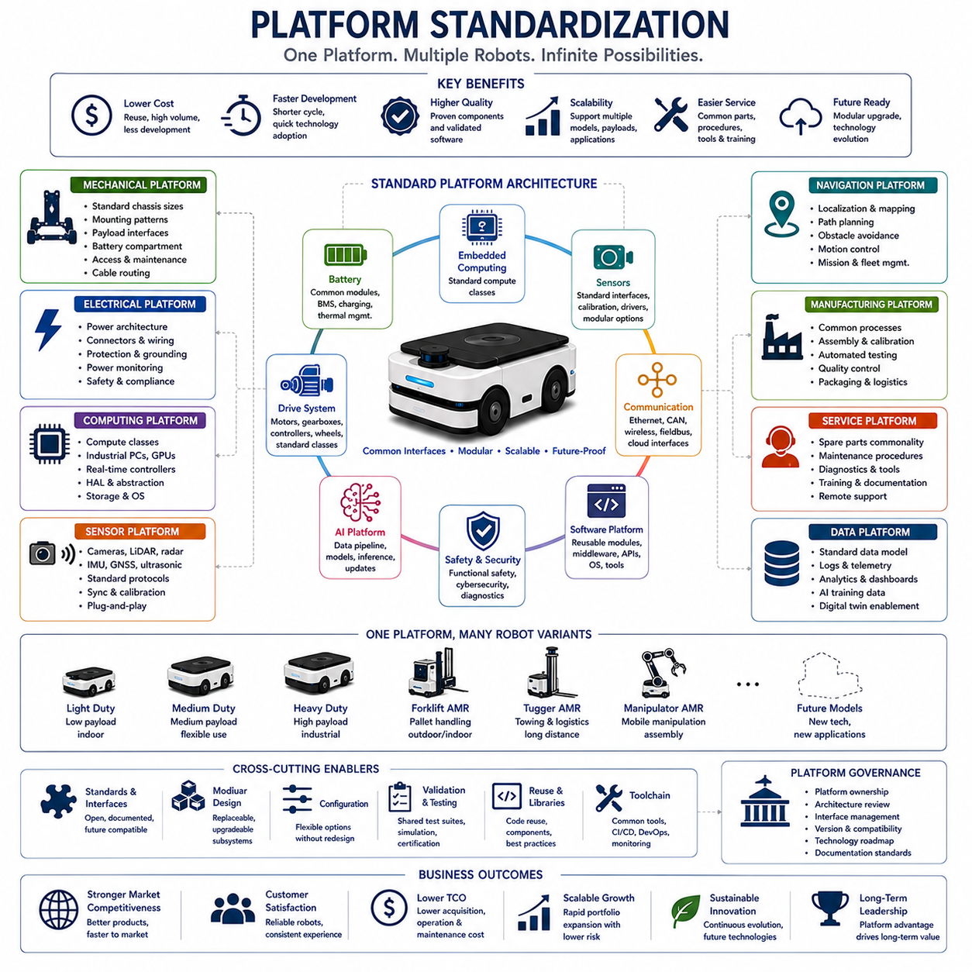
Platform standardization is one of the most important engineering strategies for developing scalable, reliable, and commercially successful Autonomous Mobile Robot systems. Instead of designing every robot as an independent product, manufacturers establish a common engineering platform that can support multiple robot models, payload capacities, industrial applications, and future technology upgrades. Standardization enables engineering teams to reuse hardware, software, manufacturing processes, testing procedures, and service infrastructure while reducing development cost and shortening product development cycles. A well-standardized platform also improves product quality because proven components and validated software modules can be deployed repeatedly across multiple product families. As Autonomous Mobile Robots become increasingly intelligent and interconnected, platform standardization becomes a fundamental driver of engineering efficiency, manufacturing scalability, and long-term business competitiveness.
Platform standardization begins with defining a common system architecture that remains stable across multiple generations of products. This architecture establishes the relationships between mechanical systems, electrical systems, embedded computing, perception sensors, communication networks, artificial intelligence, navigation software, fleet management, and cloud services. Every subsystem is designed according to standardized interfaces that remain compatible even when individual technologies evolve. Rather than redesigning complete robotic systems whenever new hardware becomes available, manufacturers replace only the affected subsystem while preserving compatibility throughout the remaining platform. This architectural stability dramatically reduces engineering effort while accelerating technology adoption.
Mechanical platform standardization provides the physical foundation for scalable product development. Chassis dimensions, structural interfaces, mounting patterns, payload attachment locations, battery compartments, wheel modules, suspension systems, protective covers, maintenance access points, and cable routing are standardized wherever practical. Multiple robot variants can therefore share common structural components while supporting different payload capacities, mobility characteristics, and application requirements. Engineers design mechanical modules so that larger products inherit proven structural concepts from smaller models instead of requiring entirely new engineering. Manufacturing also benefits because common components can be produced at higher volume while simplifying inventory management and supplier coordination.
Drive system standardization further increases platform efficiency by establishing common motor families, gearboxes, wheel assemblies, motor controllers, steering actuators, braking systems, and power transmission architectures. Rather than developing unique drive systems for every product, manufacturers define scalable performance classes covering light-duty, medium-duty, heavy-duty, and high-performance robotic platforms. Common communication protocols, electrical interfaces, diagnostic functions, and maintenance procedures simplify software integration while reducing service complexity. Standardized drive architecture also allows engineering teams to optimize control algorithms once and deploy them consistently across multiple robotic products.
Electrical platform standardization focuses on creating a unified power distribution architecture supporting diverse robotic configurations. Battery voltage, connector specifications, protection circuits, charging interfaces, emergency power management, fuse design, power monitoring, grounding methods, and electrical safety principles remain consistent throughout the product family. Standard electrical architecture simplifies certification, maintenance, troubleshooting, manufacturing, and future upgrades. When additional sensors, industrial computers, robotic manipulators, or specialized payloads are integrated, standardized electrical interfaces reduce engineering effort while minimizing integration risk and improving overall system reliability.
Battery platform standardization has become increasingly important as industrial robotics expands into larger and more demanding applications. Manufacturers frequently establish common battery modules that support multiple energy capacities while sharing identical electrical interfaces, battery management systems, charging protocols, thermal management strategies, mechanical mounting systems, and diagnostic software. Small robots may utilize fewer battery modules, while larger industrial platforms combine multiple standardized modules to achieve greater operational endurance. This modular battery strategy reduces manufacturing cost, simplifies maintenance, and accelerates qualification because core battery technologies remain unchanged throughout the product family.
Embedded computing standardization enables software portability across multiple robotic platforms. Industrial computers, embedded controllers, GPU accelerators, real-time processors, networking hardware, storage systems, and operating systems are selected according to standardized computing classes rather than individual product requirements. Entry-level robots may utilize compact computing modules, while premium systems adopt higher-performance processors without fundamentally changing software architecture. Hardware abstraction layers isolate software from hardware differences, allowing navigation, perception, artificial intelligence, and fleet management software to operate consistently across multiple computing platforms with minimal engineering modification.
Sensor platform standardization establishes common interfaces for cameras, LiDAR, radar, ultrasonic sensors, inertial measurement units, GNSS receivers, environmental sensors, microphones, lighting systems, and additional perception devices. Standard communication protocols, synchronization methods, calibration procedures, diagnostic interfaces, timestamp management, and software drivers allow sensors from different manufacturers to integrate seamlessly within the same robotic architecture. Sensor modularity also enables customers to configure robotic systems according to operational requirements without modifying core software architecture or introducing unnecessary engineering complexity.
Communication architecture standardization supports reliable data exchange throughout increasingly complex robotic ecosystems. Ethernet, CAN, RS-485, USB, wireless communication, industrial fieldbus networks, cloud interfaces, and diagnostic communication channels operate through standardized networking principles that simplify subsystem integration. Common communication frameworks allow perception systems, navigation modules, embedded controllers, battery management, industrial manipulators, safety controllers, and fleet management platforms to exchange information using consistent messaging architectures. Standardized communication greatly simplifies software development while improving interoperability across multiple robotic products and industrial environments.
Software platform standardization represents perhaps the most valuable aspect of modern robotic architecture because software increasingly determines product capability. Core software modules including operating systems, middleware, localization, navigation, mapping, perception, safety supervision, diagnostics, cybersecurity, fleet coordination, cloud communication, data logging, artificial intelligence inference, and system management are developed as reusable software components rather than application-specific implementations. Software modules communicate through standardized interfaces while remaining independent of specific hardware configurations. Continuous software improvement therefore benefits every product built upon the common platform rather than individual robot models alone.
Artificial intelligence platform standardization allows machine learning technologies to scale efficiently throughout an entire product portfolio. Common data pipelines, model deployment frameworks, inference engines, dataset management systems, training infrastructure, validation procedures, performance monitoring, and update mechanisms support consistent artificial intelligence integration across diverse robotic applications. Different products may utilize different neural network models according to computational capability and operational requirements while preserving identical deployment architecture. Unified artificial intelligence infrastructure simplifies model maintenance while accelerating continuous learning from field-generated operational data.
Navigation platform standardization ensures that localization, mapping, path planning, obstacle avoidance, motion control, mission execution, and fleet coordination operate consistently across all robotic products. Individual robots may utilize different sensor combinations according to application complexity, but navigation software architecture remains fundamentally identical. Standard interfaces allow new localization technologies or perception algorithms to replace existing implementations without affecting higher-level mission management software. Consistent navigation architecture simplifies engineering validation while reducing software maintenance throughout long product lifecycles.
Safety platform standardization establishes consistent functional safety principles across the complete robotic portfolio. Emergency stop systems, safety controllers, protective field monitoring, speed supervision, fault detection, redundancy management, diagnostic reporting, cybersecurity protection, and operational recovery procedures follow identical engineering philosophy regardless of robot size or application. Standardized safety architecture simplifies regulatory certification while improving customer confidence because operational behavior remains predictable across multiple products. Safety standardization also accelerates engineering validation by reusing previously certified hardware and software components.
Manufacturing platform standardization transforms engineering consistency into production efficiency. Common manufacturing processes, assembly sequences, calibration procedures, software deployment systems, automated testing equipment, quality assurance methods, inspection criteria, packaging procedures, and logistics operations support multiple robotic products using largely identical production infrastructure. Manufacturing engineers configure final products primarily through modular component selection rather than fundamentally different assembly methods. This approach reduces production cost while improving manufacturing flexibility and shortening product delivery times.
Service platform standardization significantly reduces lifecycle support complexity. Spare parts, maintenance procedures, diagnostic software, service documentation, technician training, predictive maintenance algorithms, firmware updates, remote diagnostics, cloud management tools, and customer support systems operate consistently across the complete product family. Field engineers become familiar with standardized maintenance workflows rather than learning unique procedures for every robotic product. Customers also benefit because expanding their robotic fleet does not require entirely new maintenance organizations or operational training programs.
Data platform standardization has become increasingly valuable as industrial robotics generates massive operational datasets. Sensor recordings, diagnostic information, navigation performance, fleet statistics, maintenance history, artificial intelligence training data, cybersecurity logs, production metrics, and customer usage information are collected using standardized data structures and metadata definitions. Unified data architecture supports enterprise analytics, predictive maintenance, machine learning development, digital twins, operational optimization, and future artificial intelligence capabilities. Standardized datasets also improve interoperability among engineering, manufacturing, quality assurance, and customer support organizations.
Long-term platform governance ensures that standardization evolves systematically rather than becoming fragmented over time. Engineering organizations establish platform ownership, architecture review processes, interface management procedures, version control policies, technology migration strategies, documentation standards, compatibility requirements, and lifecycle planning guidelines. Every new technology introduction is evaluated according to its impact upon the common platform before deployment into commercial products. Governance prevents unnecessary architectural divergence while preserving innovation through carefully managed platform evolution. Successful platform management therefore balances stability with technological advancement.
The future of Autonomous Mobile Robot platform standardization will extend beyond individual manufacturers toward increasingly open industrial ecosystems. Standard interfaces for perception systems, artificial intelligence frameworks, battery technologies, communication protocols, cloud services, fleet management, cybersecurity, digital twins, and industrial automation will enable broader interoperability among robotics vendors, industrial equipment suppliers, software developers, and enterprise customers. Companies maintaining highly standardized internal platforms will adapt more rapidly to these emerging industry standards while preserving engineering consistency, reducing development cost, accelerating product innovation, improving customer satisfaction, and strengthening long-term competitiveness within the rapidly expanding global robotics industry.

14.05 Long-Term Product Roadmaps · 장기 제품 로드맵
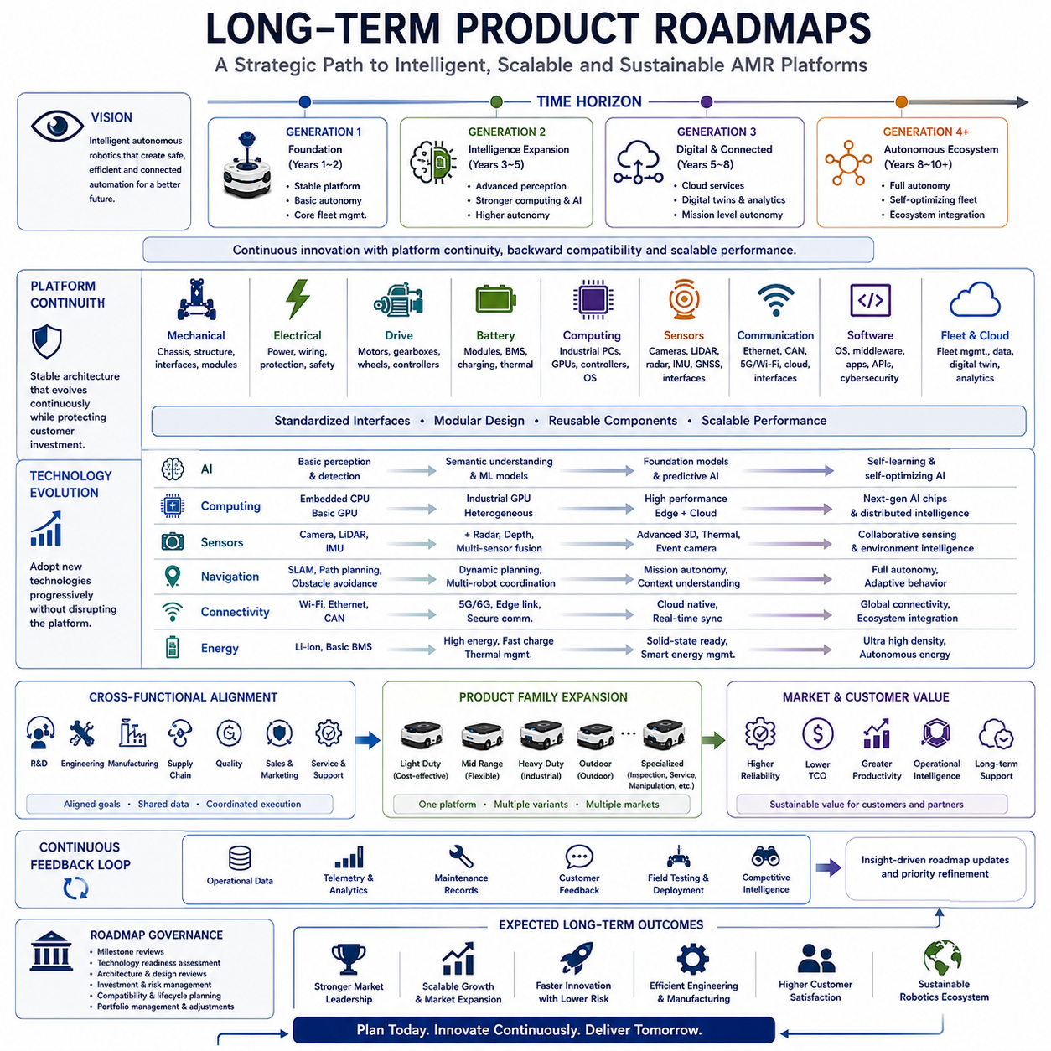
A long-term product roadmap provides the strategic direction that guides the evolution of an Autonomous Mobile Robot platform over many years while maintaining technological consistency, engineering efficiency, commercial competitiveness, and customer confidence. Rather than viewing each product generation as an isolated development project, manufacturers establish a continuous roadmap that aligns research, engineering, manufacturing, software evolution, artificial intelligence, supply chain development, and business strategy within a unified long-term vision. A well-defined roadmap allows organizations to anticipate technological changes, coordinate investment decisions, reduce development risk, and maximize platform reuse across multiple generations of products. It transforms product development from a series of independent engineering activities into a structured process of continuous innovation supported by stable architectural foundations.
Long-term roadmap planning begins with a clear understanding of future market evolution rather than current customer requirements alone. Industrial automation, logistics, manufacturing, healthcare, defense, agriculture, mining, smart cities, and infrastructure inspection continue to evolve as artificial intelligence, connectivity, cloud computing, and autonomous technologies mature. Product planners evaluate how customer expectations, regulatory environments, labor shortages, sustainability initiatives, digital transformation, and industrial competitiveness may change over the next five to ten years. The roadmap therefore represents not only current engineering priorities but also anticipated market opportunities that will define future competitive advantage.
Vision forms the highest level of the roadmap hierarchy by defining the ultimate purpose of the product family. The vision describes what the robotic platform should become rather than specifying individual technical features. It may emphasize intelligent autonomous mobility, fully connected industrial automation, scalable logistics platforms, collaborative robotics, digital manufacturing integration, or AI-driven operational intelligence. This long-term vision provides consistent direction for engineering decisions even as technologies, customer requirements, and competitive environments continue to evolve. Every major architectural decision should contribute toward achieving this strategic objective while preserving flexibility for future innovation.
Product roadmaps normally organize development into multiple generations, each introducing measurable technological advancement while preserving compatibility with previous investments whenever practical. The first generation typically establishes a stable hardware platform, core navigation capability, and basic fleet management infrastructure. The second generation expands intelligence through improved perception, stronger computing, enhanced artificial intelligence, and greater operational autonomy. The third generation often integrates advanced cloud services, digital twins, predictive maintenance, enterprise connectivity, and highly autonomous mission execution. Future generations progressively increase intelligence, scalability, efficiency, and operational value while minimizing unnecessary architectural disruption.
Platform continuity is essential for successful long-term roadmap execution. Mechanical architecture, electrical systems, communication interfaces, embedded software, middleware, fleet management, cybersecurity infrastructure, and engineering processes should evolve gradually rather than changing completely between product generations. Customers investing in robotic fleets expect long operational lifecycles, predictable maintenance, software compatibility, and upgrade opportunities rather than repeated platform replacement. Stable platform evolution therefore protects customer investment while reducing engineering cost through extensive technology reuse. Continuous compatibility also simplifies manufacturing, service operations, documentation management, and software maintenance across multiple product generations.
Technology forecasting plays an increasingly important role within long-term roadmap planning. Engineering organizations continuously monitor emerging technologies including battery chemistry, electric drive systems, artificial intelligence accelerators, embedded processors, perception sensors, communication standards, robotics operating systems, cloud infrastructure, cybersecurity methods, semiconductor development, and advanced manufacturing technologies. Forecasting does not attempt to predict exact future products but instead identifies technological trends likely to influence product competitiveness. Roadmaps therefore include technology migration paths allowing gradual adoption as innovations become commercially mature without destabilizing the overall platform architecture.
Artificial intelligence has become one of the fastest-evolving components within modern robotic roadmaps. Early product generations may focus primarily on autonomous navigation, object detection, and basic perception. Subsequent generations introduce semantic understanding, multi-modal perception, vision-language reasoning, predictive planning, collaborative decision-making, foundation models, self-supervised learning, adaptive behavior, and autonomous optimization. Rather than redesigning complete software systems whenever new AI technologies emerge, roadmap planning establishes modular AI infrastructure capable of continuously integrating improved models while preserving operational stability. This approach allows robotics platforms to benefit from rapid advances in artificial intelligence without requiring complete architectural redesign.
Computing roadmaps evolve alongside artificial intelligence capabilities because increasingly sophisticated algorithms require greater computational performance. Early platforms may utilize embedded CPUs and compact GPU modules sufficient for localization and navigation. Mid-generation products expand computing through industrial GPU acceleration, heterogeneous processing architectures, hardware security modules, and real-time AI inference. Long-term roadmaps anticipate future high-performance embedded computing platforms supporting foundation models, digital twins, advanced simulation, distributed robotics intelligence, and collaborative fleet optimization. Computing architecture therefore remains scalable, allowing incremental performance improvements without disrupting higher-level software architecture.
Sensor evolution also follows structured roadmap planning. Initial robotic platforms commonly integrate cameras, LiDAR, IMUs, and wheel encoders sufficient for reliable navigation. Future generations gradually introduce radar, event cameras, thermal imaging, hyperspectral sensing, advanced three-dimensional perception, environmental monitoring, precision positioning technologies, and collaborative sensing across robotic fleets. Standardized sensor interfaces ensure that new sensing technologies can be incorporated without requiring complete software redesign. Sensor roadmaps therefore preserve engineering investment while enabling continuous improvement in environmental understanding and operational capability.
Software roadmap planning extends far beyond feature development because software increasingly defines long-term product value. Operating systems, middleware, application programming interfaces, cloud connectivity, cybersecurity, diagnostics, fleet management, digital twin integration, simulation environments, software deployment systems, data analytics, and user interfaces evolve continuously throughout product lifecycles. Modular software architecture enables independent development of individual software services while maintaining stable interfaces throughout the platform. Continuous integration, automated testing, DevOps infrastructure, and over-the-air deployment become increasingly important as software complexity grows across multiple product generations.
Manufacturing roadmaps support engineering evolution through progressive improvement of production capability. Early manufacturing emphasizes product stabilization, supplier qualification, quality assurance, and scalable assembly procedures. Later generations introduce automation, digital manufacturing, predictive quality analytics, flexible production systems, advanced inspection technologies, and increasingly efficient supply chain coordination. Manufacturing innovation proceeds in parallel with product evolution, ensuring that higher technical capability does not create excessive production complexity or cost. Long-term planning therefore aligns manufacturing investment with anticipated product growth and commercial expansion.
Supply chain roadmaps strengthen long-term product resilience by reducing dependence upon individual suppliers while encouraging strategic technology partnerships. Manufacturers gradually qualify multiple suppliers, regional manufacturing capabilities, standardized components, alternative semiconductor vendors, battery technologies, sensor providers, and industrial computing platforms. Diversified supply chains reduce operational risk while supporting stable production during global economic fluctuations, geopolitical uncertainty, transportation disruptions, or technology transitions. Long-term roadmap planning therefore includes supplier development as an integral engineering activity rather than a separate procurement function.
Product family expansion represents another important objective of long-term roadmap planning. Instead of developing unrelated robotic products independently, manufacturers extend a common platform into multiple market segments through scalable architecture. Entry-level robots address cost-sensitive customers with standardized configurations. Mid-range products introduce greater flexibility, payload capacity, and intelligent functionality. Premium systems provide enterprise integration, advanced autonomy, predictive maintenance, digital twins, and mission-critical reliability. Specialized variants supporting outdoor operation, industrial inspection, logistics, heavy transportation, collaborative manipulation, and autonomous service applications emerge through modular platform expansion rather than complete platform replacement.
Business strategy and technical strategy remain closely connected throughout long-term roadmap execution. Product launches, manufacturing investment, software licensing, aftermarket services, regional expansion, certification activities, strategic partnerships, cloud services, subscription models, and customer support capabilities must evolve consistently with engineering milestones. Engineering teams therefore collaborate closely with executive management, marketing, manufacturing, finance, sales, and customer support organizations to ensure that technical progress directly supports commercial objectives. Long-term roadmaps integrate these organizational perspectives into coordinated product evolution rather than isolated departmental planning.
Customer feedback continuously refines roadmap priorities throughout the entire product lifecycle. Operational data, maintenance records, software telemetry, fleet analytics, technical support cases, customer interviews, field testing, deployment experience, and competitive benchmarking identify opportunities for future improvement. Rather than reacting independently to every customer request, engineering organizations evaluate feedback according to long-term platform strategy, architectural consistency, commercial value, and implementation complexity. This disciplined prioritization allows products to evolve according to both real-world operational needs and strategic engineering objectives without compromising long-term platform integrity.
Roadmap governance ensures that long-term plans remain realistic, measurable, and adaptable despite changing market conditions. Engineering leadership establishes milestone reviews, technology readiness assessments, architectural reviews, investment evaluations, risk management procedures, compatibility requirements, lifecycle planning, and portfolio management processes that continuously monitor roadmap execution. Strategic adjustments occur when new technologies mature faster than expected, customer priorities change, regulations evolve, or competitive environments shift. Governance therefore balances long-term stability with sufficient flexibility to capture emerging opportunities while avoiding uncontrolled architectural divergence.
The future of Autonomous Mobile Robot product roadmaps will increasingly emphasize intelligent ecosystems rather than isolated robotic platforms. Individual robots will become components of larger digital environments integrating cloud intelligence, enterprise resource planning, manufacturing execution systems, digital twins, industrial Internet of Things infrastructure, collaborative robots, autonomous vehicles, edge computing, and foundation-model-driven artificial intelligence. Long-term roadmaps will therefore prioritize interoperability, modularity, scalable software platforms, continuous artificial intelligence evolution, cybersecurity resilience, sustainable manufacturing, and global lifecycle support. Organizations capable of maintaining disciplined roadmap execution while continuously adapting to technological innovation will establish the strongest competitive position within the rapidly expanding global robotics industry.

