Volume 01. AMR Foundations and System Architecture

Chapter 13. AMR Project Lifecycle

13.1 Concept Phase
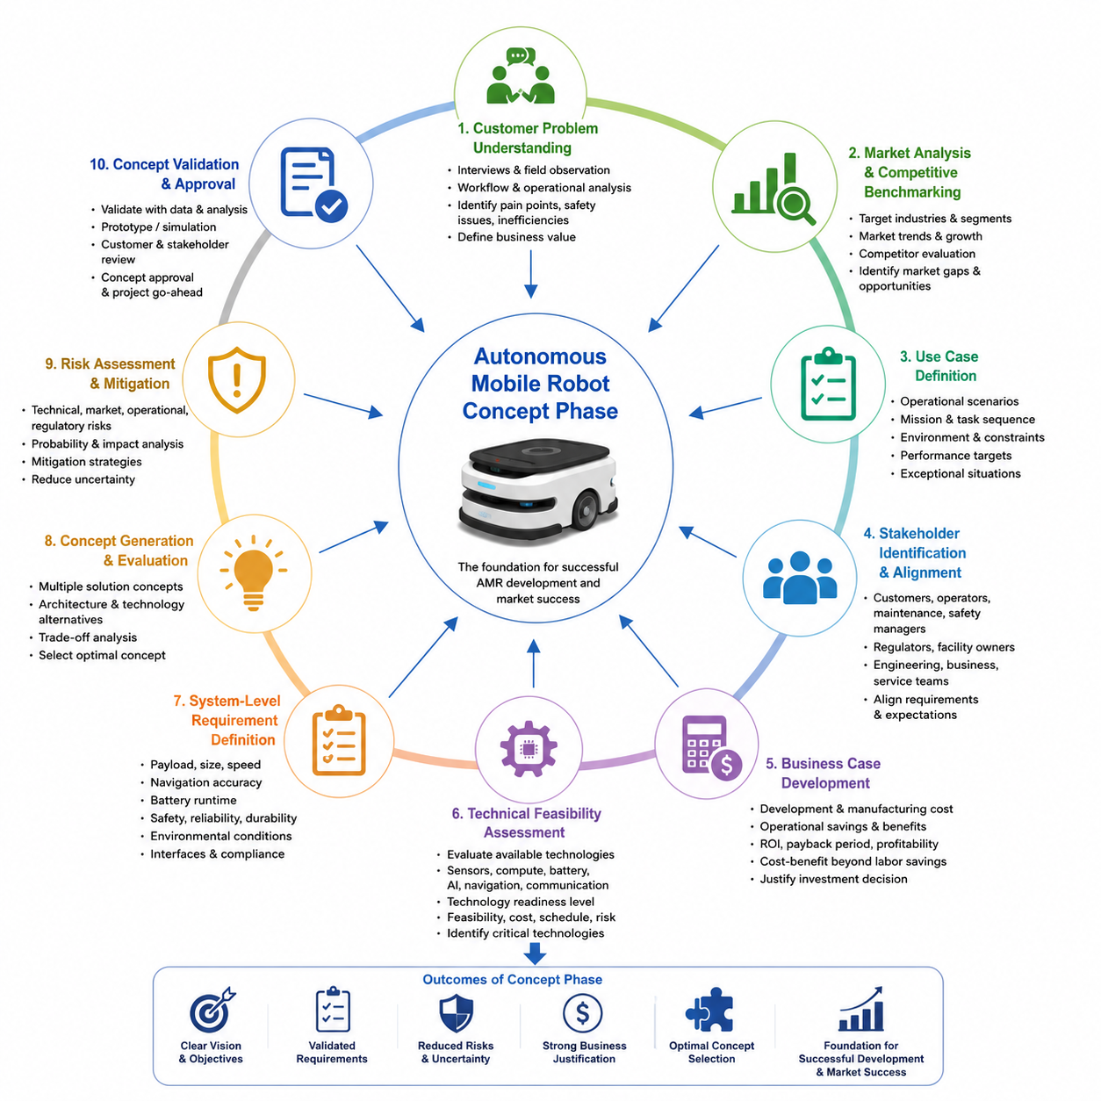
The concept phase is the foundation of every successful Autonomous Mobile Robot development project because it establishes the strategic direction, technical feasibility, business justification, and long-term product vision before significant engineering resources are committed. Decisions made during this early stage influence nearly every aspect of subsequent development, including system architecture, hardware selection, software design, artificial intelligence capabilities, manufacturing strategy, regulatory compliance, and commercialization planning. Unlike later engineering phases that focus on implementation, the concept phase emphasizes understanding the problem to be solved, identifying customer value, evaluating technical alternatives, and reducing uncertainty through systematic analysis. A well-executed concept phase significantly lowers development risk while improving product competitiveness, development efficiency, and long-term market success.
The concept phase begins by clearly defining the customer problem rather than immediately proposing a technical solution. Engineering teams must understand why automation is required, which operational inefficiencies currently exist, what limitations affect existing workflows, and how autonomous robotics can generate measurable business value. Customer interviews, field observations, operational studies, workflow analysis, and stakeholder discussions provide essential information regarding operational challenges, safety concerns, labor shortages, productivity limitations, quality requirements, and future business objectives. This customer-centered approach prevents technology-driven development that may produce technically impressive systems with limited practical value.
Market analysis forms an essential component of concept development because product success depends on addressing actual market demand rather than isolated technical innovation. Engineers and product managers investigate target industries, customer segments, competing robotic platforms, pricing structures, market growth trends, regulatory environments, and emerging technological opportunities. Competitive benchmarking evaluates existing Autonomous Mobile Robot products with respect to payload capacity, navigation performance, sensing architecture, artificial intelligence capabilities, fleet management functionality, safety certifications, operational costs, and customer support services. These analyses reveal market gaps where differentiated products can establish competitive advantages.
Use case definition translates customer needs into realistic operational scenarios that guide the entire development process. Each use case specifies operational objectives, environmental conditions, mission sequences, user interactions, expected outputs, performance requirements, operational constraints, and exceptional situations that the robot must handle safely. Indoor logistics, outdoor inspection, hospital delivery, warehouse transportation, agricultural monitoring, security patrol, infrastructure inspection, and smart city applications each introduce different environmental complexities and operational priorities. Well-defined use cases provide measurable engineering targets while preventing uncontrolled expansion of project scope during later development stages.
Stakeholder identification ensures that all individuals and organizations affected by the robotic system are considered throughout concept development. Primary stakeholders include customers, operators, maintenance personnel, safety managers, facility owners, regulatory authorities, production engineers, software developers, business executives, and service organizations. Each stakeholder group contributes unique requirements, operational expectations, and evaluation criteria that influence system architecture and product functionality. Early stakeholder alignment reduces conflicting requirements while improving communication between technical and business teams throughout the project lifecycle.
Business case development determines whether the proposed robotic solution provides sufficient economic value to justify investment. Financial analysis evaluates expected development costs, manufacturing expenses, operational savings, maintenance requirements, projected sales volumes, pricing strategy, return on investment, payback period, and long-term profitability. Cost-benefit analysis extends beyond direct labor savings by considering quality improvement, operational flexibility, safety enhancement, workforce optimization, reduced downtime, predictive maintenance, and data-driven operational intelligence. A realistic business case provides objective justification for project approval while supporting future investment decisions.
Technical feasibility assessment evaluates whether current technologies can satisfy identified customer requirements within acceptable cost, schedule, and risk constraints. Engineers investigate available sensors, compute platforms, batteries, communication systems, navigation technologies, artificial intelligence algorithms, mechanical architectures, safety components, and manufacturing capabilities. Technology readiness levels help determine whether proposed solutions rely on mature industrial technologies or experimental research requiring additional development effort. Early feasibility studies prevent unrealistic project commitments while identifying critical technologies requiring focused investigation.
System-level requirement definition establishes measurable engineering objectives derived directly from customer needs and operational scenarios. High-level requirements typically specify payload capacity, vehicle dimensions, operating speed, navigation accuracy, battery operating time, environmental protection, communication range, perception capability, safety performance, reliability targets, maintainability, scalability, and regulatory compliance. Requirements must remain clear, measurable, verifiable, achievable, and traceable throughout subsequent design and validation activities. Proper requirement management prevents ambiguity while supporting systematic engineering decision making across multidisciplinary development teams.
Conceptual system architecture provides the first integrated view of how major system components interact to satisfy operational requirements. Rather than defining detailed implementation, conceptual architecture identifies primary functional modules including perception, localization, navigation, motion control, artificial intelligence, communication, fleet management, power systems, safety supervision, and human-machine interfaces. Functional decomposition separates complex robotic behavior into manageable engineering subsystems while establishing clear interfaces between software, electronics, mechanics, and operational services.
Mechanical concept development evaluates alternative vehicle configurations appropriate for intended operational environments. Engineers compare differential drive, four-wheel steering, six-wheel articulated platforms, tracked vehicles, omnidirectional systems, towing architectures, lifting mechanisms, suspension concepts, payload integration methods, and modular chassis designs. Mechanical concepts consider stability, maneuverability, payload distribution, environmental robustness, manufacturability, maintenance accessibility, and future scalability. Concept evaluation frequently includes simplified modeling, preliminary structural calculations, and early packaging studies to eliminate impractical design alternatives before detailed engineering begins.
Electrical and electronic concept development focuses on defining the overall electrical architecture required to support robotic functionality. Preliminary concepts include power distribution, battery technology, charging strategies, motor control architecture, embedded computing, communication networks, sensor interfaces, emergency stop systems, redundant safety circuits, and electrical protection mechanisms. Engineers estimate power consumption, thermal requirements, electrical loads, cable routing complexity, connector strategies, and future expansion capability while ensuring compatibility with industrial standards and safety regulations.
Artificial intelligence concept planning has become increasingly important as modern Autonomous Mobile Robots incorporate advanced perception, decision making, and adaptive behavior. Engineers determine which functions require conventional algorithms and which benefit from machine learning, computer vision, multimodal perception, reinforcement learning, foundation models, or large language model integration. AI capability planning includes data requirements, computational resources, model deployment strategy, cloud-edge distribution, continuous learning considerations, and operational monitoring. Early AI architecture definition ensures appropriate compute platform selection while balancing performance, cost, energy efficiency, and deployment complexity.
Risk identification begins during the concept phase because many development challenges originate from early architectural decisions. Technical risks include immature technologies, insufficient computational resources, localization uncertainty, perception limitations, battery constraints, communication reliability, environmental complexity, software integration challenges, supply chain availability, and manufacturing scalability. Business risks involve market uncertainty, regulatory changes, competitive pressures, customer adoption, investment limitations, and commercialization timing. Systematic risk assessment enables mitigation strategies to be incorporated before expensive engineering activities begin.
Regulatory and standards analysis ensures that concept development aligns with applicable industrial requirements from the earliest stages. Engineers investigate functional safety standards, machinery regulations, electromagnetic compatibility requirements, battery transportation regulations, wireless communication certifications, cybersecurity expectations, environmental protection requirements, and industry-specific operational guidelines. Early compliance planning minimizes costly redesign efforts while supporting efficient certification during later product validation and commercialization phases.
Development planning converts strategic concepts into executable engineering programs by defining project scope, organizational structure, resource allocation, milestone schedules, technology validation activities, prototype planning, supplier engagement, budget distribution, and verification strategies. Cross-functional collaboration among mechanical, electrical, software, artificial intelligence, manufacturing, quality assurance, safety engineering, procurement, and business development teams becomes essential because concept decisions influence every downstream engineering discipline. Effective planning balances technical ambition with practical execution capability while maintaining flexibility for future refinement.
Prototype strategy is established during the concept phase to define how engineering assumptions will be validated before full-scale product development. Early prototypes may include software simulations, digital twins, subsystem demonstrators, hardware proof-of-concept platforms, perception validation systems, navigation test vehicles, or mechanical mockups. Prototype objectives focus on reducing uncertainty surrounding critical technologies rather than demonstrating complete product functionality. Incremental validation enables engineering teams to learn rapidly while minimizing development costs associated with incorrect architectural assumptions.
Verification planning begins much earlier than many organizations expect because measurable success criteria should exist before detailed engineering starts. Concept-phase verification defines how future requirements will be validated through simulation, laboratory testing, field evaluation, customer acceptance, regulatory certification, and long-term operational assessment. Verification planning establishes objective performance metrics, validation scenarios, operational benchmarks, environmental testing conditions, safety demonstrations, reliability targets, and acceptance criteria. Early verification definition ensures that engineering activities remain aligned with measurable project objectives throughout development.
The concept phase concludes with a comprehensive system concept review where technical feasibility, business viability, customer requirements, operational scenarios, architectural decisions, risk assessments, financial analysis, regulatory considerations, and development plans are evaluated collectively. Rather than approving detailed engineering designs, this review confirms that sufficient evidence exists to justify advancing toward prototype development. Successful concept reviews establish organizational confidence, secure development resources, align multidisciplinary teams, and provide a stable strategic foundation for subsequent engineering activities. As Autonomous Mobile Robots become increasingly sophisticated through artificial intelligence, cloud robotics, digital twins, and large-scale fleet coordination, the concept phase will continue evolving into a multidisciplinary systems engineering process that integrates technology innovation, business strategy, operational intelligence, and customer value into a unified development vision capable of supporting scalable, safe, intelligent, and commercially successful robotic platforms.

13.2 Prototype Phase
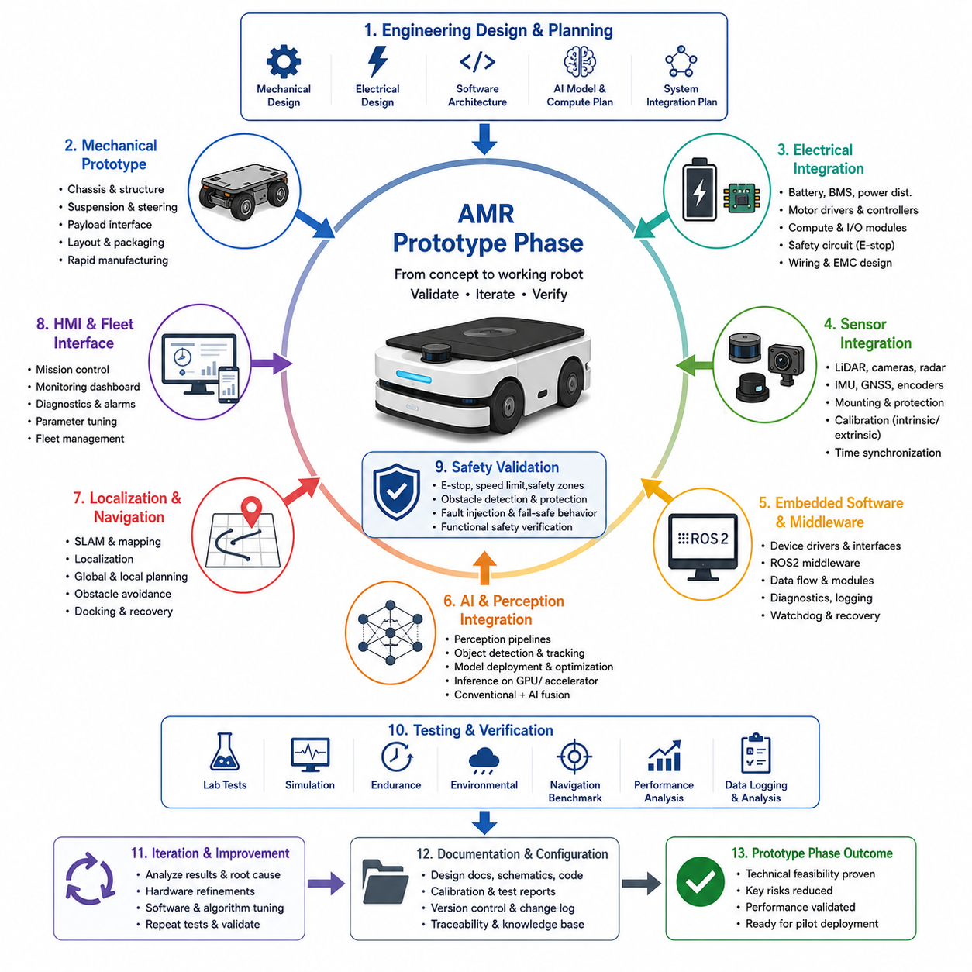
The prototype phase transforms the conceptual vision of an Autonomous Mobile Robot into a tangible engineering system capable of validating the feasibility of the proposed architecture under realistic operating conditions. While the concept phase establishes strategic direction and high-level system requirements, the prototype phase focuses on converting assumptions into measurable engineering evidence. This stage bridges theoretical design and production-ready development by integrating mechanical structures, electrical systems, embedded controllers, perception sensors, artificial intelligence software, navigation algorithms, and safety mechanisms into an operational platform. The primary objective is not to deliver a finished commercial product but to reduce technical uncertainty, verify system interactions, identify architectural weaknesses, and establish confidence before committing significant resources to pilot deployment and mass production.
Prototype development begins with translating system-level requirements into detailed engineering specifications that can be implemented by multidisciplinary teams. Mechanical engineers finalize chassis dimensions, structural layouts, suspension geometry, payload interfaces, and serviceability considerations. Electrical engineers define power distribution, battery integration, motor controllers, communication networks, safety circuits, and sensor connectivity. Software architects establish the middleware framework, communication interfaces, software modules, and data flow between perception, localization, planning, control, and fleet management components. Artificial intelligence engineers determine inference pipelines, model deployment strategies, computational resource allocation, and hardware acceleration methods. This collaborative refinement ensures that every engineering discipline develops compatible subsystems supporting a unified system architecture.
Mechanical prototype construction provides the first physical realization of the robotic platform. Early chassis designs frequently prioritize flexibility over manufacturing optimization because frequent modifications are expected during development. Engineers evaluate structural rigidity, weight distribution, center of gravity, suspension travel, wheel configurations, steering geometry, payload mounting, thermal airflow, cable routing, and maintenance accessibility. Rapid manufacturing technologies such as CNC machining, laser cutting, additive manufacturing, and modular aluminum profiles accelerate design iterations while minimizing cost and fabrication time. Physical integration often reveals packaging conflicts, structural interference, vibration issues, and maintenance challenges that remain invisible within digital design environments.
Electrical prototype integration establishes the foundation for reliable power delivery and hardware communication throughout the robot. Engineers assemble batteries, battery management systems, DC-DC converters, motor drivers, embedded controllers, industrial computers, Ethernet switches, CAN buses, emergency stop circuits, and redundant safety components into a unified electrical architecture. Cable routing receives significant attention because electromagnetic interference, connector accessibility, heat generation, vibration resistance, and maintenance requirements strongly influence long-term reliability. Electrical validation confirms voltage stability, current capacity, thermal performance, fault isolation, startup behavior, and emergency shutdown functionality before software integration begins.
Sensor integration represents one of the most challenging activities during prototype development because autonomous performance depends heavily on accurate perception of the surrounding environment. Engineers install LiDAR sensors, RGB cameras, depth cameras, radar systems, ultrasonic sensors, GNSS receivers, inertial measurement units, wheel encoders, and environmental sensors while carefully considering mounting positions, field of view overlap, vibration isolation, weather protection, and calibration accessibility. Time synchronization using hardware triggers, Precision Time Protocol, or synchronized timestamps ensures that multimodal sensor data remain temporally consistent. Accurate intrinsic and extrinsic calibration establishes reliable coordinate transformations necessary for perception, localization, mapping, and sensor fusion algorithms.
Embedded software development transforms integrated hardware into a functioning robotic platform capable of executing autonomous behaviors. Low-level software initializes hardware devices, monitors system health, communicates with motor controllers, manages power systems, acquires sensor data, and supervises real-time operations. Middleware platforms such as ROS2 organize communication between software nodes while supporting modular development and scalable integration. Logging frameworks, diagnostic services, parameter management, watchdog mechanisms, and fault recovery routines are implemented early because effective debugging becomes increasingly difficult as system complexity grows. Stable embedded software establishes the infrastructure upon which higher-level autonomous capabilities are constructed.
Artificial intelligence integration expands prototype capabilities beyond deterministic robotics by enabling perception, semantic understanding, anomaly detection, object recognition, and adaptive decision making. Deep learning models are deployed onto embedded GPUs or AI accelerators using optimized inference engines to satisfy real-time performance requirements. Engineers evaluate latency, computational utilization, memory consumption, thermal behavior, and energy efficiency while balancing model accuracy against hardware limitations. Prototype evaluation also determines how conventional algorithms and learning-based models cooperate within perception pipelines, ensuring that artificial intelligence complements rather than destabilizes safety-critical robotic behaviors.
Localization and navigation development validate whether the robot can move autonomously within representative operational environments. Engineers integrate odometry, inertial sensing, LiDAR SLAM, visual SLAM, GNSS positioning, map management, localization filters, global path planning, local trajectory generation, obstacle avoidance, docking algorithms, and recovery behaviors into a cohesive navigation framework. Initial testing frequently occurs within controlled laboratory environments before expanding toward increasingly complex indoor or outdoor scenarios. Engineers monitor localization drift, mapping consistency, path accuracy, obstacle avoidance quality, trajectory smoothness, computational latency, and mission completion rates while continuously refining software parameters and sensor configurations.
Human-machine interface development ensures that operators, maintenance personnel, and system administrators can effectively interact with the robotic platform throughout development and future deployment. Prototype interfaces include local touch displays, remote monitoring dashboards, web-based management tools, command-line utilities, mobile applications, and fleet supervision software. Engineers validate system visualization, mission control, diagnostic reporting, software updates, alarm notifications, log management, parameter adjustment, and user authentication. Well-designed interfaces significantly reduce debugging effort while providing operational transparency necessary for engineering evaluation and customer demonstrations.
Safety validation begins immediately during prototype operation because experimental systems frequently operate with incomplete software and evolving hardware configurations. Functional safety mechanisms including emergency stop systems, speed limitation, obstacle detection, protective field monitoring, fail-safe communication, watchdog supervision, battery protection, and controlled shutdown behavior are verified before autonomous testing expands into more complex environments. Engineers intentionally introduce hardware failures, communication interruptions, sensor malfunctions, power disturbances, and software exceptions to confirm that the robot consistently transitions into predictable safe states. Early safety verification prevents hazardous testing conditions while establishing the foundation for future regulatory certification.
Prototype verification relies on systematic testing rather than isolated demonstrations. Engineers execute laboratory experiments, simulation scenarios, subsystem evaluations, endurance tests, environmental exposure, navigation benchmarking, perception accuracy analysis, mechanical stress testing, and integrated mission validation. Data acquisition systems continuously record sensor measurements, actuator states, computational performance, fault events, navigation trajectories, network communication, and operational logs. These datasets enable objective performance evaluation while supporting regression testing as hardware revisions and software updates are introduced throughout the development cycle.
Iteration represents the defining characteristic of successful prototype development because the first integrated system rarely satisfies all performance objectives. Engineering teams repeatedly analyze failures, identify root causes, redesign hardware components, refine algorithms, update software architectures, improve calibration procedures, optimize control parameters, and repeat validation experiments until measurable improvements are achieved. Rapid feedback between mechanical, electrical, software, artificial intelligence, manufacturing, and systems engineering teams accelerates problem resolution while preventing isolated optimizations that negatively affect overall system performance. Every prototype revision contributes valuable engineering knowledge that strengthens the maturity of the final product.
Manufacturing considerations gradually become more influential as prototype maturity increases. Although early prototypes emphasize engineering flexibility, later iterations begin incorporating production-oriented design principles such as standardized components, simplified assembly, modular architectures, improved serviceability, reduced part counts, supplier availability, cost optimization, and manufacturing repeatability. Design for Manufacturing and Design for Assembly practices are introduced incrementally to minimize future production challenges without restricting the rapid experimentation required during technical validation. This transition allows engineering prototypes to evolve naturally toward industrial-grade products while preserving development agility.
Prototype documentation is essential because engineering knowledge accumulated during iterative development must remain traceable throughout the project lifecycle. Engineers maintain mechanical drawings, electrical schematics, software architecture documents, interface definitions, calibration records, validation reports, configuration management records, risk assessments, issue tracking databases, design review minutes, and engineering change histories. Comprehensive documentation enables multidisciplinary collaboration, preserves organizational knowledge, supports regulatory compliance, facilitates future maintenance, and simplifies the transition from prototype engineering to pilot deployment. Configuration management ensures that every validated result remains associated with the exact hardware, software, firmware, and calibration versions used during testing.
The prototype phase concludes with a comprehensive engineering evaluation that determines whether the robotic platform has achieved sufficient technical maturity to progress toward pilot deployment. System architects review integrated performance, safety validation, navigation capability, perception robustness, artificial intelligence effectiveness, mechanical durability, electrical reliability, manufacturing readiness, operational usability, and overall compliance with original engineering objectives. Remaining technical risks, unresolved limitations, recommended architectural improvements, and future development priorities are documented before advancing to the next lifecycle stage. A successful prototype phase demonstrates that the proposed Autonomous Mobile Robot architecture functions as an integrated engineering system under representative operating conditions, providing objective evidence that the project is technically feasible, commercially promising, and sufficiently mature to justify large-scale field validation and subsequent product industrialization. The requested topic, 13_02_Prototype_Phase, aligns with the AMR Project Lifecycle structure defined in the provided project hierarchy.

13.3 Pilot Deployment
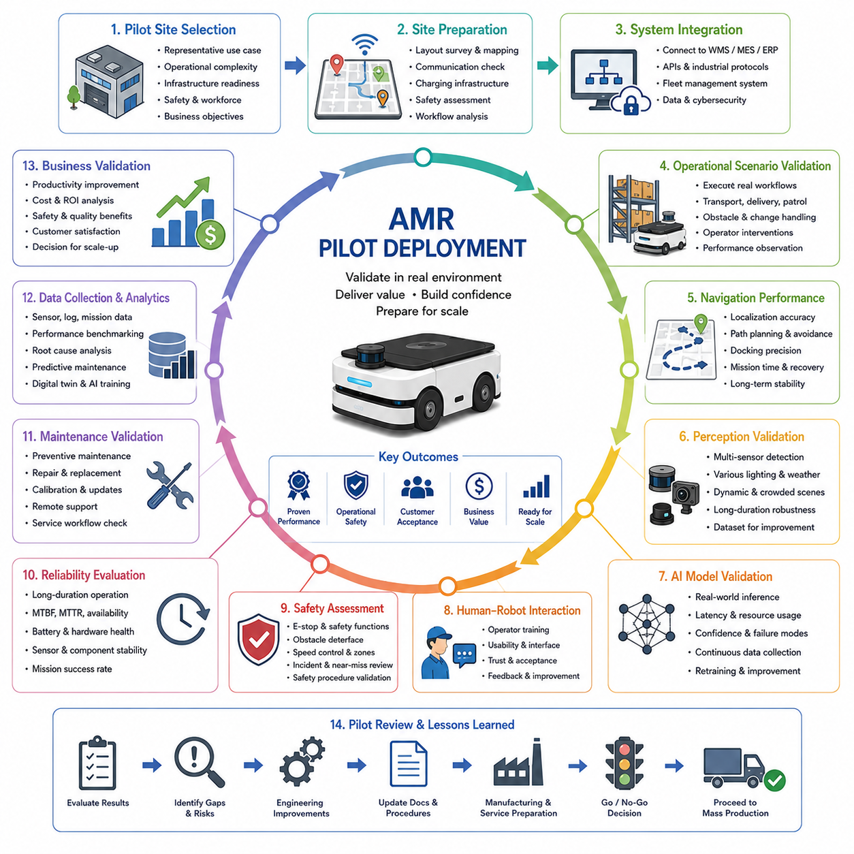
The pilot deployment phase represents the critical transition between engineering development and real-world operational validation in the Autonomous Mobile Robot product lifecycle. While the prototype phase demonstrates that the robot functions as an integrated engineering system under controlled conditions, the pilot deployment phase evaluates whether the complete solution can operate reliably, safely, and efficiently within an actual customer environment. This stage exposes the robotic platform to realistic workflows, operational variability, environmental uncertainty, and human interaction that cannot be fully reproduced inside laboratories or simulation environments. The primary objective is not only to validate technical performance but also to verify operational value, customer acceptance, deployment methodology, service readiness, and long-term commercial feasibility before committing to large-scale production and widespread deployment.
Pilot deployment begins with careful site selection because the quality of field validation depends heavily on representative operational environments. Engineering teams collaborate with customers to identify facilities that reflect intended commercial applications while remaining manageable from both technical and logistical perspectives. Candidate sites are evaluated according to operational complexity, infrastructure readiness, environmental conditions, communication availability, safety requirements, workforce cooperation, maintenance accessibility, and business objectives. Manufacturing plants, logistics warehouses, hospitals, airports, outdoor industrial facilities, construction sites, smart campuses, and infrastructure inspection environments each present unique operational characteristics that influence deployment planning. Selecting an appropriate pilot site ensures that engineering validation produces meaningful evidence applicable to future commercial installations.
Before the robot is introduced into daily operations, comprehensive site preparation activities are performed to establish a stable deployment environment. Engineers survey facility layouts, construct digital maps, measure navigation landmarks, evaluate wireless communication coverage, verify charging infrastructure, inspect floor conditions, analyze pedestrian and vehicle traffic, identify safety hazards, and document operational workflows. Environmental characteristics such as lighting variation, weather exposure, dust levels, temperature fluctuations, reflective surfaces, electromagnetic interference, and GNSS visibility are carefully assessed because these factors significantly influence autonomous navigation and perception performance. Site preparation minimizes unexpected operational disruptions while creating reproducible testing conditions for systematic performance evaluation.
System integration during pilot deployment extends beyond the robotic platform itself by connecting the AMR with existing operational infrastructure. Fleet management systems exchange information with warehouse management systems, manufacturing execution systems, hospital information systems, enterprise resource planning platforms, industrial control systems, cloud monitoring services, and facility management software. Communication interfaces are validated through standardized APIs, industrial protocols, middleware services, and cybersecurity mechanisms to ensure reliable bidirectional information flow. Successful integration demonstrates that the robot functions as part of a larger operational ecosystem rather than as an isolated autonomous machine.
Operational scenario validation focuses on executing representative missions that accurately reflect real customer workflows. Robots perform transportation tasks, inspection missions, material handling, automated delivery, inventory movement, patrol operations, charging routines, docking procedures, and human interaction according to predefined operational schedules. Engineers observe how autonomous behaviors respond to dynamic obstacles, changing environmental conditions, temporary route blockages, unexpected operator interventions, equipment failures, and variable production demands. These real-world scenarios reveal operational behaviors that rarely appear during laboratory testing while providing valuable insight into system robustness and workflow compatibility.
Navigation performance receives extensive attention throughout pilot deployment because autonomous mobility directly determines operational effectiveness. Engineers evaluate localization accuracy, mapping stability, global route planning, local obstacle avoidance, docking precision, mission completion time, recovery behavior, traffic management, and navigation repeatability under continuously changing environmental conditions. Dynamic obstacles including workers, forklifts, vehicles, pallets, movable equipment, and temporary construction areas challenge localization and planning algorithms far beyond controlled engineering environments. Long-term navigation evaluation confirms whether localization remains stable over days or weeks despite environmental evolution and operational disturbances.
Perception validation during pilot operation determines whether the sensing architecture maintains reliable environmental awareness across realistic operational conditions. Camera systems, LiDAR sensors, radar units, ultrasonic sensors, GNSS receivers, inertial measurement units, and sensor fusion algorithms continuously detect obstacles, identify navigation landmarks, recognize operational objects, estimate free space, and monitor environmental changes. Engineers analyze perception accuracy under varying illumination, rain, fog, dust, reflective materials, shadows, crowded environments, and seasonal changes. Long-duration field operation frequently reveals corner cases and rare environmental conditions that become valuable datasets for subsequent algorithm improvement and artificial intelligence refinement.
Artificial intelligence models deployed during pilot validation operate under significantly more diverse conditions than those encountered during engineering development. Computer vision algorithms classify objects, detect anomalies, interpret operational scenes, estimate semantic information, and support autonomous decision making while interacting with previously unseen environments. Engineering teams continuously monitor inference latency, computational resource utilization, prediction confidence, failure modes, and model stability under realistic workloads. Operational datasets collected during pilot deployment frequently become the foundation for retraining perception models, improving robustness, reducing false detections, and expanding autonomous capabilities through continuous learning pipelines.
Human-robot interaction becomes increasingly important during pilot deployment because successful commercial operation depends on effective collaboration between autonomous systems and human workers. Operators receive training regarding robot capabilities, operational limitations, emergency procedures, maintenance routines, user interfaces, and mission management workflows. Engineers observe operator behavior, workload changes, trust development, intervention frequency, acceptance levels, and communication effectiveness throughout daily operations. Customer feedback often identifies usability improvements that are not directly related to technical performance but substantially influence overall product acceptance and long-term operational success.
Safety assessment continues throughout pilot deployment under authentic operational conditions. Functional safety mechanisms, obstacle detection systems, emergency stop functions, speed regulation, protective zones, fault recovery strategies, cybersecurity monitoring, and operational procedures are repeatedly evaluated while interacting with workers, equipment, and facility infrastructure. Safety incidents, near-miss events, unexpected system responses, communication failures, sensor degradation, and environmental hazards are carefully documented and investigated. Continuous safety monitoring ensures that the robotic platform satisfies both engineering safety objectives and customer operational expectations before broader commercial deployment.
Reliability evaluation requires prolonged operation because many engineering issues only emerge after extended system usage. Engineers monitor hardware durability, battery aging, thermal stability, sensor contamination, connector reliability, software memory usage, network stability, actuator wear, calibration drift, and overall mission success rates over weeks or months of continuous operation. Mean Time Between Failures, Mean Time To Repair, operational availability, maintenance frequency, battery health, and component replacement intervals provide objective indicators of product maturity. Long-term reliability assessment establishes confidence that the robotic platform can sustain demanding industrial workloads throughout its expected service life.
Maintenance validation verifies whether field service procedures support efficient long-term operation. Preventive maintenance schedules, software updates, hardware replacement, sensor recalibration, battery servicing, fault diagnosis, spare parts logistics, remote troubleshooting, and predictive maintenance capabilities are exercised under actual operating conditions. Maintenance engineers evaluate accessibility, repair time, required tools, documentation quality, diagnostic interfaces, and service workflows while identifying opportunities to reduce operational downtime. Service readiness becomes equally important as autonomous performance because commercial customers expect high system availability with minimal maintenance complexity.
Operational data collection forms one of the most valuable outcomes of pilot deployment because every autonomous mission generates engineering evidence supporting future product improvement. Robots continuously record sensor streams, localization results, navigation trajectories, perception outputs, system diagnostics, energy consumption, communication statistics, operator interventions, maintenance activities, environmental conditions, and mission outcomes. These datasets support performance benchmarking, root cause analysis, artificial intelligence retraining, predictive maintenance development, software regression testing, digital twin refinement, and future product optimization. Comprehensive data management transforms pilot deployment from a simple field trial into a continuous engineering learning process.
Business validation extends beyond technical performance by evaluating whether the deployed robotic system delivers measurable customer value. Productivity improvement, labor reduction, operational flexibility, safety enhancement, quality consistency, energy efficiency, maintenance cost, deployment cost, return on investment, and customer satisfaction are assessed using objective operational metrics. Customer organizations determine whether observed business benefits justify future procurement, fleet expansion, infrastructure investment, and long-term operational adoption. Positive business outcomes strengthen commercialization strategy while providing valuable reference cases for future sales activities and market expansion.
The pilot deployment phase concludes with a comprehensive operational review involving engineering teams, customer representatives, safety specialists, manufacturing personnel, service organizations, and business stakeholders. Technical performance, operational reliability, safety compliance, artificial intelligence effectiveness, maintenance readiness, customer feedback, financial outcomes, deployment methodology, and remaining development risks are evaluated collectively. Lessons learned from field deployment are incorporated into hardware redesign, software refinement, manufacturing preparation, documentation updates, operational procedures, and commercialization planning. A successful pilot deployment demonstrates that the Autonomous Mobile Robot performs reliably within authentic operational environments, satisfies customer expectations, delivers measurable business value, and possesses sufficient technical maturity to proceed confidently toward mass production, large-scale deployment, and long-term commercial operation.

13.4 Mass Production
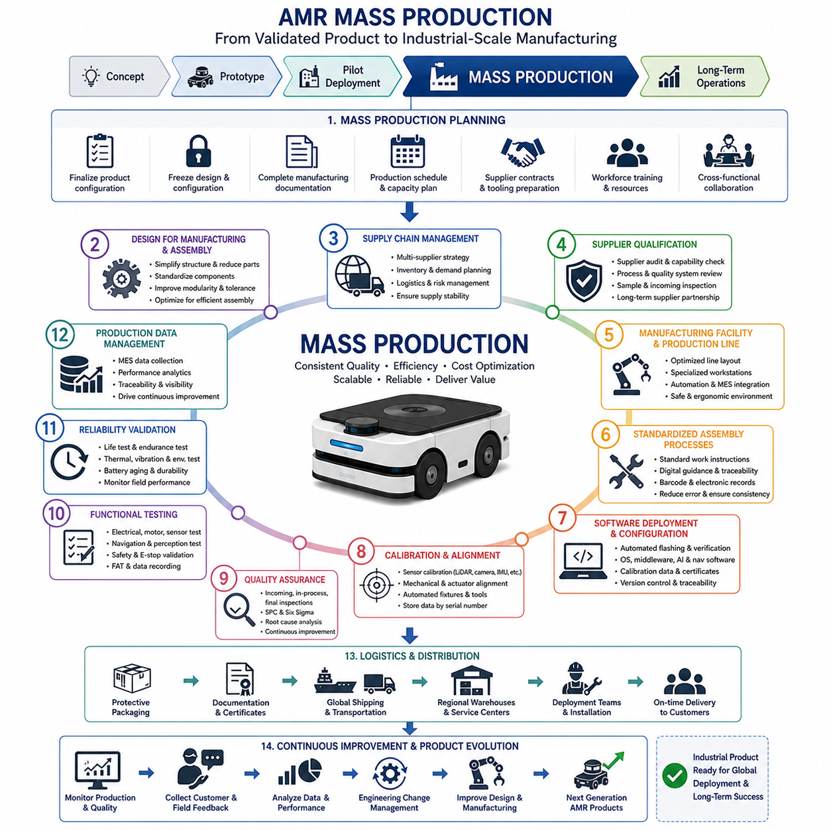
Mass production represents the transition from engineering validation to industrial-scale manufacturing in the Autonomous Mobile Robot product lifecycle. After the concept, prototype, and pilot deployment phases have demonstrated technical feasibility, operational reliability, customer acceptance, and commercial value, the focus shifts toward producing consistent, high-quality robotic systems at economically sustainable volumes. Unlike prototype manufacturing, which emphasizes engineering flexibility and rapid iteration, mass production prioritizes repeatability, efficiency, cost optimization, supply chain stability, manufacturing quality, and scalable operations. The objective is not simply to build larger quantities of robots but to establish a complete industrial ecosystem capable of delivering identical products with predictable performance, controlled costs, and reliable long-term service support.
Mass production planning begins long before manufacturing starts because successful industrialization depends on careful coordination among engineering, procurement, manufacturing, quality assurance, logistics, suppliers, finance, and customer support organizations. Product configurations are finalized, engineering changes are frozen through formal configuration management, manufacturing documentation is completed, production schedules are established, supplier agreements are confirmed, tooling is prepared, workforce training is completed, and factory resources are allocated. Cross-functional collaboration ensures that technical designs are fully compatible with production capabilities while minimizing manufacturing risks associated with late engineering modifications.
Design for Manufacturing becomes a major engineering priority during the transition toward production. Components originally optimized for engineering validation are redesigned to improve manufacturing efficiency without compromising functional performance. Engineers simplify mechanical assemblies, reduce part counts, standardize fasteners, optimize cable routing, increase modularity, minimize manual adjustments, improve tolerance management, and eliminate unnecessary complexity. Manufacturing-oriented redesign reduces assembly time, improves product consistency, lowers production cost, and enhances long-term maintainability while preserving the validated system architecture established during prototype development.
Design for Assembly further improves production efficiency by considering how individual components are installed throughout the manufacturing process. Mechanical interfaces are standardized, electrical connectors become easier to access, sensor mounting procedures are simplified, wiring harnesses are preassembled, and calibration fixtures are integrated directly into production workflows. Engineers analyze assembly sequences to minimize operator movement, reduce installation errors, simplify quality inspections, and improve workstation ergonomics. Efficient assembly processes contribute directly to shorter production cycles, lower labor costs, higher throughput, and more consistent manufacturing quality.
Supply chain management becomes one of the most important success factors because Autonomous Mobile Robots integrate hundreds or even thousands of components originating from multiple global suppliers. Batteries, industrial computers, GPUs, embedded controllers, LiDAR sensors, cameras, motors, gearboxes, bearings, connectors, wiring harnesses, structural components, electronic modules, and safety devices must be available according to synchronized production schedules. Procurement teams establish long-term supplier relationships, qualify alternative vendors, monitor inventory levels, forecast demand, manage transportation risks, and reduce dependency on single-source suppliers. Supply chain resilience protects production continuity against component shortages, geopolitical disruptions, transportation delays, and unexpected market fluctuations.
Supplier qualification ensures that purchased components consistently satisfy technical specifications and manufacturing quality requirements. New suppliers undergo technical audits, manufacturing capability assessments, quality system evaluations, process validation, material certification reviews, and sample inspections before receiving production approval. Incoming components are evaluated according to dimensional accuracy, electrical performance, environmental durability, reliability expectations, and documentation completeness. Strong supplier qualification minimizes production variability while establishing long-term partnerships that support continuous product improvement and manufacturing scalability.
Manufacturing facilities are designed to support efficient, repeatable, and traceable production workflows. Production lines are organized into specialized workstations responsible for chassis assembly, electrical installation, wiring integration, sensor installation, compute platform integration, battery installation, software flashing, calibration, quality inspection, functional testing, packaging, and shipment preparation. Material flow, workstation layout, tooling placement, ergonomic considerations, safety procedures, and automation opportunities are optimized to maximize productivity while maintaining high manufacturing quality. Modern production facilities increasingly integrate digital manufacturing technologies, industrial automation, and manufacturing execution systems to monitor production status in real time.
Assembly processes follow standardized work instructions to ensure that every robot is manufactured using identical procedures regardless of production volume or operator experience. Detailed assembly documentation specifies torque values, tightening sequences, connector verification methods, cable routing standards, adhesive application procedures, calibration requirements, inspection checkpoints, and safety precautions. Digital work instructions, barcode scanning, electronic manufacturing records, and automated verification systems reduce human error while improving process traceability. Standardized manufacturing procedures ensure consistent product quality across multiple production lines and manufacturing locations.
Software deployment during mass production requires careful coordination because every robot must receive verified firmware, operating systems, middleware, artificial intelligence models, navigation software, calibration parameters, security certificates, and configuration files before shipment. Automated flashing systems install software packages directly onto embedded controllers and industrial computers while verifying software integrity through cryptographic validation and version control. Manufacturing software infrastructure maintains traceability between hardware serial numbers, software versions, calibration records, and production history, enabling efficient maintenance, future software updates, and regulatory compliance throughout the product lifecycle.
Calibration becomes an integral manufacturing process because perception accuracy and autonomous performance depend on precise alignment among sensors, mechanical structures, and computational models. Cameras, LiDAR systems, radar units, inertial measurement units, wheel encoders, steering mechanisms, and robotic actuators undergo automated calibration using dedicated fixtures and measurement systems. Calibration data are stored within product databases and associated with each robot's unique serial number. Automated calibration significantly improves manufacturing consistency while reducing human-dependent variability that could negatively affect localization, perception, navigation, and overall autonomous behavior.
Quality assurance operates continuously throughout production rather than relying solely on final product inspection. Incoming material inspection verifies supplier quality before assembly begins. In-process inspections monitor critical manufacturing steps including mechanical assembly, electrical installation, software deployment, calibration, torque verification, and functional integration. Final inspection validates complete system performance through standardized acceptance testing. Statistical Process Control, Six Sigma methodologies, process capability analysis, root cause investigation, and continuous improvement programs help identify manufacturing trends before defects propagate throughout production. Preventive quality management significantly reduces warranty costs while improving customer satisfaction.
Functional testing confirms that every manufactured robot satisfies predefined engineering specifications before leaving the factory. Automated test stations verify electrical functionality, battery charging, motor performance, sensor operation, communication interfaces, emergency stop systems, navigation capability, perception accuracy, software integrity, thermal behavior, and safety supervision. Factory Acceptance Tests simulate representative operational missions to confirm complete system functionality under controlled conditions. Test results are automatically recorded within manufacturing databases, providing complete product traceability while supporting future diagnostics and maintenance activities.
Reliability validation continues even after production begins because manufacturing changes, supplier variations, and process optimization can introduce unintended performance differences. Selected production units undergo accelerated life testing, vibration evaluation, thermal cycling, environmental exposure, endurance operation, battery aging analysis, and long-duration mission testing. Reliability engineering teams continuously compare field performance with manufacturing data to detect early indicators of product degradation. Feedback from production testing supports preventive engineering improvements while maintaining long-term product reliability across large manufacturing volumes.
Production data management enables manufacturers to transform factory operations into data-driven continuous improvement systems. Manufacturing execution systems collect information regarding assembly duration, defect occurrence, test results, calibration values, component traceability, operator performance, equipment utilization, and production efficiency. Data analytics identify process bottlenecks, recurring defects, supplier quality trends, equipment failures, and productivity improvement opportunities. Integration between manufacturing databases, enterprise resource planning systems, quality management platforms, and product lifecycle management systems provides comprehensive visibility across the entire industrial operation.
Logistics and distribution planning ensure that finished Autonomous Mobile Robots reach customers efficiently while maintaining product integrity throughout transportation. Packaging systems protect sensitive sensors, electronic equipment, batteries, and mechanical assemblies from vibration, shock, humidity, and environmental contamination. Shipping documentation includes product configuration records, software versions, calibration certificates, quality reports, regulatory certifications, maintenance instructions, and customer documentation. Distribution networks coordinate factory output with regional warehouses, service centers, deployment teams, and customer installation schedules, supporting efficient global product delivery.
Mass production concludes not as the end of development but as the beginning of continuous product evolution. Manufacturing organizations continuously monitor production quality, customer feedback, field reliability, warranty statistics, maintenance records, operational performance, and supply chain behavior to identify opportunities for incremental improvement. Engineering change management enables validated design enhancements to be introduced systematically without disrupting production stability. Lessons learned from manufacturing, deployment, and customer operation are incorporated into future product generations, ensuring that Autonomous Mobile Robot platforms become progressively more reliable, intelligent, cost-effective, and scalable. Successful mass production demonstrates that the robotic system has matured beyond an engineering prototype into an industrial product capable of being manufactured consistently, deployed globally, maintained efficiently, and supported throughout its complete commercial lifecycle.

13.5 Long-Term Operations
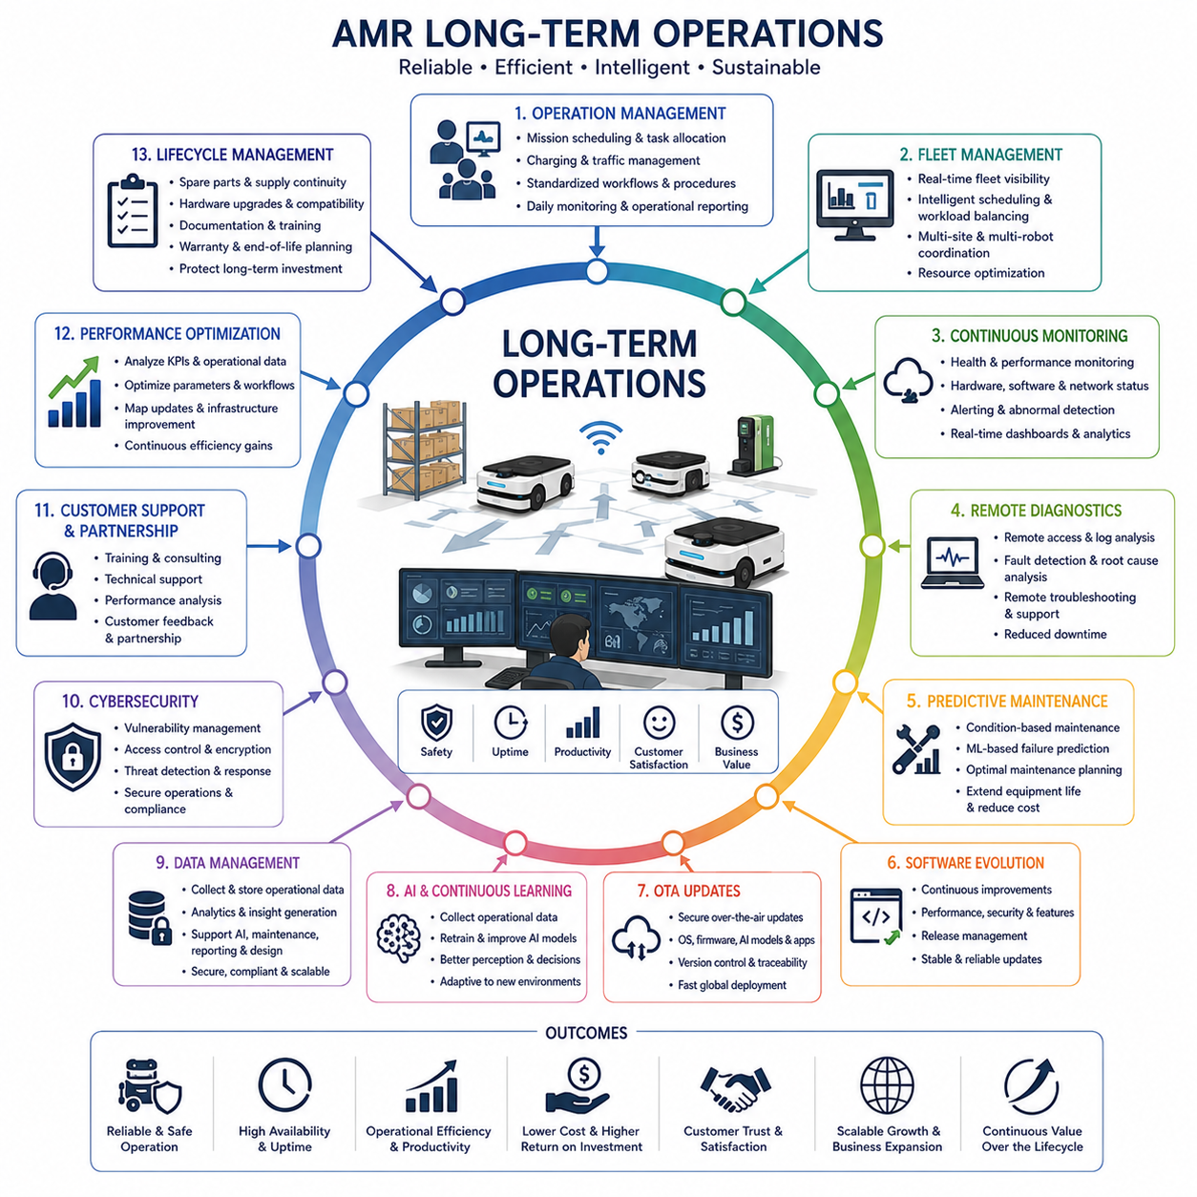
Long-term operations represent the longest and most valuable phase of the Autonomous Mobile Robot product lifecycle because the true success of an autonomous robotic system is ultimately determined by its sustained performance after deployment rather than by engineering achievements during development. Once robots enter commercial service, engineering priorities gradually shift from initial implementation toward operational reliability, continuous optimization, lifecycle management, customer satisfaction, and long-term business sustainability. Unlike previous lifecycle phases that focus on design, validation, or manufacturing, long-term operations emphasize maintaining safe, efficient, intelligent, and economically valuable robotic services over many years while continuously adapting to changing operational environments, evolving customer requirements, advancing technologies, and expanding business opportunities.
Long-term operation begins with establishing stable operational management processes that coordinate autonomous robots, operators, maintenance engineers, fleet supervisors, customer administrators, and remote support organizations. Daily operation includes mission scheduling, task allocation, fleet balancing, charging management, traffic coordination, system monitoring, incident response, and operational reporting. Clear operational procedures ensure that robots perform predictable tasks while minimizing unnecessary downtime, avoiding resource conflicts, and maintaining consistent service quality. Standardized workflows also simplify operator training and improve collaboration between customers and service organizations throughout the product lifecycle.
Fleet management becomes increasingly important as organizations expand from individual robots toward large coordinated robotic fleets operating across multiple facilities. Fleet management systems continuously monitor robot availability, battery status, mission progress, traffic conditions, workload distribution, maintenance schedules, and operational priorities. Intelligent scheduling algorithms dynamically assign missions according to robot capability, current location, remaining energy, and task urgency while minimizing travel distance and operational delay. Centralized fleet coordination significantly improves overall productivity compared with independently operating robots while enabling efficient resource utilization across complex industrial environments.
Continuous operational monitoring provides comprehensive visibility into the health and performance of deployed robotic systems. Embedded diagnostic software continuously observes hardware status, processor utilization, memory consumption, network communication, sensor functionality, battery condition, actuator performance, thermal behavior, and software execution. Cloud-based monitoring platforms aggregate operational information from geographically distributed robots, allowing engineering teams to identify abnormal trends, emerging failures, communication interruptions, and performance degradation before they significantly affect customer operations. Real-time monitoring transforms maintenance from reactive troubleshooting into proactive operational management.
Remote diagnostics significantly reduce maintenance cost and service response time by allowing engineers to investigate robot behavior without physically visiting deployment sites. Diagnostic systems provide access to operational logs, software status, hardware health information, sensor measurements, network statistics, localization history, navigation performance, perception outputs, and fault records through secure remote connections. Engineers reproduce reported failures using recorded operational datasets, identify root causes, deploy corrective software patches, adjust configuration parameters, or recommend hardware replacement based on objective engineering evidence. Remote diagnostic capability substantially improves customer support efficiency while minimizing operational disruption.
Predictive maintenance replaces traditional time-based maintenance with condition-based service strategies supported by continuous data analysis. Machine learning algorithms analyze vibration signatures, motor current, battery degradation, temperature trends, actuator performance, sensor stability, charging cycles, communication quality, and historical maintenance records to estimate component health and predict future failures. Maintenance activities are scheduled before failures occur, reducing unexpected downtime while extending equipment life. Predictive maintenance improves operational availability, lowers maintenance cost, optimizes spare part inventory, and enhances customer confidence through data-driven service planning.
Software maintenance continues throughout operational life because autonomous capabilities evolve long after initial deployment. Engineering teams regularly release improvements addressing navigation performance, perception accuracy, cybersecurity protection, artificial intelligence models, energy efficiency, operational stability, user interface enhancements, and newly requested customer functionality. Software updates follow structured release management procedures including validation testing, compatibility verification, rollback planning, deployment scheduling, and operational monitoring. Well-managed software evolution enables robotic platforms to improve continuously without requiring hardware replacement while protecting operational stability during upgrades.
Over-the-air update infrastructure enables secure software deployment across geographically distributed robotic fleets. Operating systems, firmware, middleware, navigation software, artificial intelligence models, configuration files, cybersecurity certificates, and diagnostic applications can be updated remotely through encrypted communication channels. Update systems verify software integrity before installation, maintain version traceability, support staged deployment strategies, and automatically recover from interrupted installations. Remote software deployment significantly reduces maintenance effort while enabling rapid distribution of critical security patches and performance improvements across global customer installations.
Artificial intelligence models require continuous refinement because operational environments evolve over time. New lighting conditions, environmental changes, seasonal variation, infrastructure modifications, customer workflows, and unexpected operational scenarios generate data distributions not fully represented during initial training. Operational datasets collected from deployed robots support retraining perception models, improving object recognition, expanding semantic understanding, reducing false detections, and enhancing autonomous decision making. Continuous learning transforms deployed robotic systems into progressively more capable intelligent platforms while maintaining compatibility with validated safety requirements.
Data management becomes a strategic operational asset because deployed robots continuously generate valuable engineering information throughout their service lives. Sensor recordings, navigation trajectories, localization estimates, perception outputs, maintenance records, mission statistics, battery performance, communication logs, operator interactions, and environmental observations are securely collected, organized, and analyzed within centralized cloud infrastructure. These operational datasets support engineering research, artificial intelligence improvement, predictive maintenance, digital twin development, software regression testing, customer reporting, and future product design. Effective data governance ensures privacy protection, regulatory compliance, cybersecurity, and efficient long-term knowledge preservation.
Cybersecurity management remains an ongoing operational responsibility because network-connected robotic systems continuously interact with cloud infrastructure, enterprise systems, wireless communication networks, and remote maintenance services. Security operations include vulnerability assessment, authentication management, encryption maintenance, certificate renewal, intrusion detection, software patch deployment, access control monitoring, and incident response planning. Continuous cybersecurity management protects customer operations against evolving threats while ensuring regulatory compliance and maintaining confidence in autonomous robotic infrastructure deployed within critical industrial environments.
Customer support evolves into a long-term engineering partnership rather than a simple technical service function. Support organizations provide training, operational consulting, preventive maintenance, software assistance, troubleshooting, deployment expansion planning, performance analysis, and engineering recommendations based on accumulated operational experience. Customer feedback regarding usability, operational challenges, requested functionality, maintenance concerns, and business objectives directly influences future product development. Strong customer relationships improve product quality while supporting long-term commercial growth through trust, continuous collaboration, and successful operational outcomes.
Performance optimization continues throughout operational life because deployment environments rarely remain static. Engineering teams analyze mission completion time, energy efficiency, navigation accuracy, fleet utilization, traffic congestion, charging strategies, scheduling efficiency, workload balancing, and artificial intelligence performance using continuously collected operational data. Parameter optimization, workflow refinement, map updates, infrastructure improvements, and software enhancements gradually increase operational productivity without requiring major hardware modifications. Continuous optimization ensures that robotic systems remain economically competitive while adapting to changing operational demands.
Lifecycle management coordinates every aspect of long-term product support from initial deployment until final retirement. Engineering organizations maintain spare parts availability, software compatibility, hardware upgrade strategies, supplier continuity, regulatory compliance, documentation updates, maintenance procedures, training materials, warranty management, and end-of-life planning throughout the operational lifetime of the robotic platform. Structured lifecycle management minimizes customer disruption while allowing gradual technology evolution without requiring complete system replacement. Well-managed lifecycle planning protects customer investment while supporting sustainable product evolution over many years.
Field experience collected during long-term operation provides the most valuable source of engineering knowledge for future product generations. Operational incidents, maintenance records, customer feedback, reliability statistics, artificial intelligence performance, software evolution, manufacturing observations, and deployment experiences collectively reveal strengths and limitations that were impossible to identify during development. Engineering teams transform these lessons into improved hardware architectures, more reliable software platforms, enhanced perception algorithms, optimized manufacturing processes, stronger safety mechanisms, and more effective operational procedures. Long-term operational knowledge closes the complete engineering feedback loop, ensuring that each new generation of Autonomous Mobile Robots becomes progressively more reliable, intelligent, maintainable, scalable, and commercially successful while continuously increasing customer value throughout the entire product lifecycle.

