Volume 01. AMR Foundations and System Architecture

20. Outdoor Autonomous Robots · 실외 자율 로봇

20.01 Outdoor Robot Platforms · 실외 로봇 플랫폼
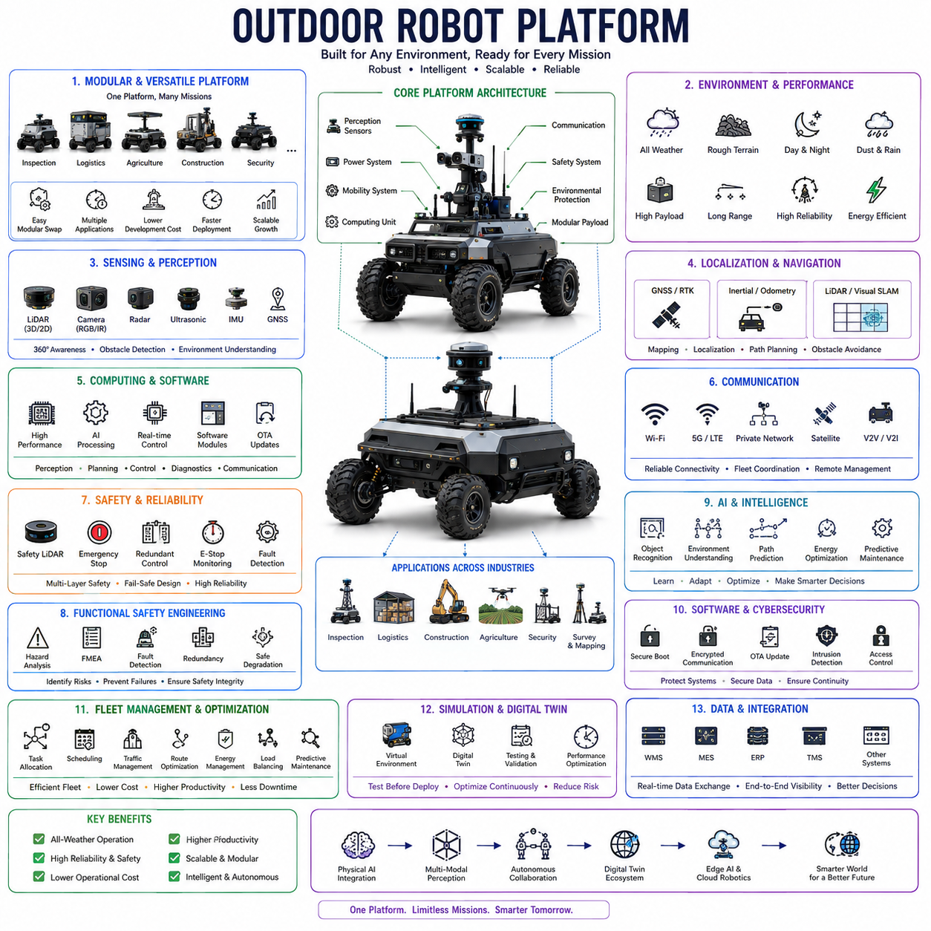
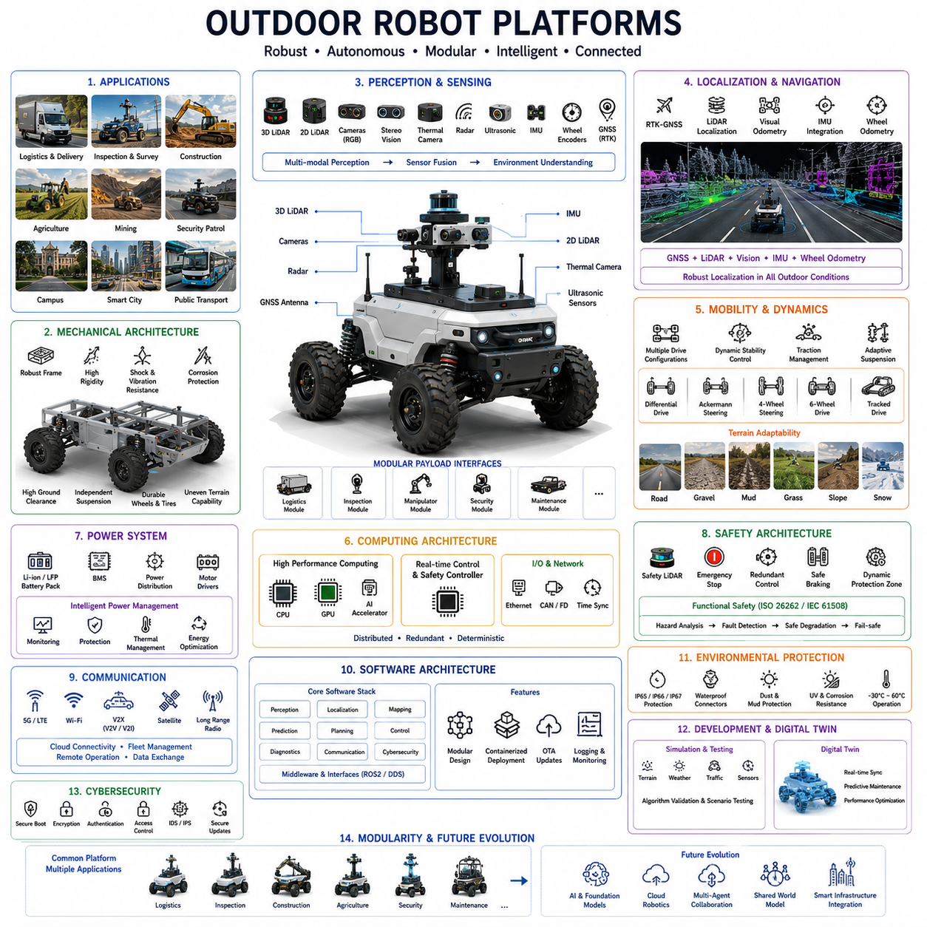
Outdoor robot platforms represent the foundational hardware architecture that enables autonomous robots to operate safely and reliably in complex outdoor environments. Unlike indoor autonomous mobile robots that navigate relatively structured facilities with controlled lighting and smooth floors, outdoor platforms must withstand harsh weather, uneven terrain, dynamic traffic, varying illumination, and continuously changing environmental conditions. These platforms provide the mechanical, electrical, computational, and sensing infrastructure necessary to support autonomous navigation across construction sites, industrial facilities, logistics yards, campuses, smart cities, agricultural fields, mining operations, military installations, and public transportation environments. As autonomous technologies continue expanding beyond warehouses, outdoor robot platforms have become one of the most important enabling technologies for large-scale Physical AI systems.
The primary objective of an outdoor robot platform is to provide a stable, modular, and scalable foundation capable of supporting diverse autonomous applications. Rather than designing separate robots for every task, manufacturers increasingly develop standardized vehicle platforms that can accommodate different payloads, sensors, manipulators, inspection equipment, delivery modules, or specialized industrial tools. This modular philosophy significantly reduces development cost while enabling rapid deployment across multiple industries. A common outdoor platform can therefore evolve from a logistics vehicle into an inspection robot, mobile manipulation system, autonomous security patrol robot, or intelligent maintenance platform through replacement of upper functional modules.
Mechanical architecture forms the structural backbone of every outdoor robot platform. Heavy-duty welded steel frames, aluminum alloy chassis, or hybrid lightweight structures are designed to withstand continuous vibration, impact loading, torsional stress, and long-term outdoor exposure. Structural rigidity directly influences localization accuracy because excessive chassis deformation introduces sensor calibration errors and reduces navigation precision. Engineers therefore optimize structural stiffness while minimizing overall vehicle weight to maximize payload capacity, energy efficiency, and long-term mechanical durability.
Mobility systems determine how effectively outdoor robots traverse challenging terrain. Depending on operational requirements, platforms may employ differential drive, Ackermann steering, four-wheel steering, articulated steering, tracked locomotion, skid steering, or six-wheel drive architectures. Independent suspension systems improve wheel contact on uneven terrain while reducing shock transmission to onboard sensors and computing equipment. High ground clearance, optimized wheelbase geometry, large-diameter tires, and terrain-adaptive suspension allow outdoor platforms to negotiate curbs, potholes, gravel, grass, mud, slopes, and construction debris while maintaining stable autonomous operation.
Vehicle dynamics become substantially more complex outdoors due to varying surface conditions and environmental disturbances. Traction continuously changes across asphalt, concrete, dirt roads, wet surfaces, loose gravel, sand, snow, and ice. Dynamic stability control therefore regulates steering, braking, acceleration, and motor torque according to terrain conditions and vehicle speed. Wheel slip detection algorithms estimate available traction while adaptive controllers modify driving behavior to maintain stability during acceleration, cornering, climbing, and emergency stopping. These dynamic control systems significantly improve operational safety under unpredictable environmental conditions.
Power systems provide the energy required for propulsion, onboard computation, perception sensors, communication equipment, and payload operation. Most modern outdoor robot platforms utilize lithium iron phosphate or lithium-ion battery systems due to their high energy density, long operational lifetime, and excellent charging characteristics. Battery capacities vary from several kilowatt-hours for compact delivery robots to tens of kilowatt-hours for heavy industrial vehicles. Intelligent Battery Management Systems continuously monitor voltage, current, temperature, charging status, cell balancing, and long-term battery health to maximize operational reliability and service life.
Environmental protection represents one of the defining characteristics of outdoor robotic platforms. Mechanical assemblies, electronic control units, batteries, sensors, connectors, and communication equipment require protection against rain, dust, mud, snow, vibration, ultraviolet radiation, corrosion, and extreme temperatures. Industrial platforms commonly achieve IP65, IP66, or IP67 protection ratings while employing sealed electrical enclosures, waterproof connectors, corrosion-resistant coatings, pressure equalization valves, and thermal management systems. Reliable environmental sealing enables continuous autonomous operation under diverse weather conditions throughout extended deployment periods.
Perception systems provide the environmental awareness necessary for autonomous navigation. Outdoor robot platforms typically integrate multiple sensing technologies including three-dimensional LiDAR, two-dimensional LiDAR, RGB cameras, stereo vision, thermal cameras, radar, ultrasonic sensors, inertial measurement units, wheel encoders, and Global Navigation Satellite System receivers. Sensor placement is carefully optimized to maximize field of view while minimizing mutual interference, vibration, contamination, and mechanical obstruction. Multi-modal sensing significantly improves perception robustness across changing illumination, weather, and terrain conditions.
Localization architecture combines global positioning with local environmental understanding. Unlike indoor robots that rely primarily on simultaneous localization and mapping, outdoor platforms frequently integrate GNSS positioning, real-time kinematic corrections, inertial navigation, LiDAR localization, visual odometry, and wheel odometry through advanced sensor fusion algorithms. RTK-GNSS provides centimeter-level global positioning under open-sky conditions, while LiDAR and visual localization maintain accurate positioning whenever satellite visibility deteriorates near buildings, trees, tunnels, or industrial structures. This hybrid localization framework enables reliable autonomous operation across highly diverse outdoor environments.
Computing architecture serves as the central processing infrastructure supporting perception, localization, planning, control, artificial intelligence, and communication. High-performance industrial computers equipped with multicore CPUs, GPU accelerators, AI inference processors, and real-time controllers execute numerous software modules simultaneously. Distributed computing architectures often separate safety-critical motion control from computationally intensive perception algorithms. High-speed Ethernet networks, precision time synchronization, and redundant communication buses ensure deterministic operation across multiple sensing and computing subsystems.
Communication systems connect outdoor robots with cloud infrastructure, fleet management software, remote operators, and nearby robotic platforms. Wi-Fi supports high-bandwidth communication within localized industrial facilities, while private 5G, LTE, satellite communication, or long-range wireless technologies enable operation across geographically distributed environments. Vehicle-to-Vehicle and Vehicle-to-Infrastructure communication further enhance cooperative autonomy by exchanging localization data, traffic information, obstacle observations, and mission updates. Reliable communication significantly improves fleet coordination while enabling remote supervision whenever autonomous systems encounter unexpected situations.
Safety architecture extends beyond conventional industrial robot protection because outdoor robots operate alongside pedestrians, manually driven vehicles, construction equipment, cyclists, and public infrastructure. Safety-rated LiDAR scanners establish dynamic protective zones according to vehicle speed and operational mode. Emergency braking systems, redundant steering controllers, independent safety processors, functional safety software, and continuously monitored emergency stop circuits provide multiple layers of protection. Dynamic risk assessment continuously evaluates surrounding traffic while adapting robot behavior to maintain safe interaction with both humans and vehicles.
Functional safety engineering systematically analyzes potential failures affecting autonomous operation. Hazard analysis evaluates sensor malfunction, steering failure, braking degradation, communication loss, localization uncertainty, power interruption, actuator faults, and software anomalies. Redundant hardware architecture together with fault detection algorithms enable safe degradation whenever abnormal conditions are detected. Safety integrity requirements guide hardware redundancy, software validation, diagnostic coverage, and fail-safe system design to minimize operational risks throughout the vehicle lifecycle.
Artificial intelligence increasingly enhances platform capabilities beyond basic autonomous navigation. Deep learning models recognize roads, vegetation, pedestrians, vehicles, construction equipment, traffic signs, temporary obstacles, and environmental hazards while estimating their future behavior. Machine learning algorithms optimize energy consumption, predict component degradation, estimate terrain traversability, and improve localization under difficult environmental conditions. Foundation models further enable semantic understanding of complex outdoor scenes, allowing autonomous platforms to interpret high-level operational objectives and adapt intelligently to changing mission requirements.
Platform software architecture is typically organized into layered modules supporting perception, localization, mapping, prediction, planning, vehicle control, diagnostics, communication, cybersecurity, and mission management. Middleware frameworks enable standardized communication among software components while allowing individual modules to evolve independently. Containerized software deployment, continuous integration, remote software updates, and modular application interfaces significantly simplify long-term maintenance throughout the platform lifecycle. Standardized software architecture also supports rapid integration of new sensors, AI models, or industrial payloads.
Cybersecurity has become increasingly important as outdoor robot platforms connect continuously to enterprise networks, cloud services, remote maintenance systems, and fleet management infrastructure. Secure boot mechanisms, encrypted communication, authenticated software updates, intrusion detection, role-based access control, secure key management, and hardware security modules protect robotic systems against unauthorized access. Cybersecurity architecture must simultaneously maintain operational availability while protecting both safety-critical control systems and sensitive operational data from evolving cyber threats.
Simulation environments and digital twins substantially accelerate platform development before physical deployment. High-fidelity virtual environments reproduce terrain characteristics, weather conditions, sensor behavior, traffic scenarios, and mechanical dynamics with remarkable accuracy. Engineers validate perception algorithms, localization systems, motion planning, safety functions, and AI decision-making under thousands of simulated scenarios that would be difficult or unsafe to reproduce experimentally. Following deployment, digital twins remain synchronized with operational data, supporting predictive maintenance, software verification, performance optimization, and continuous system improvement throughout operational life.
Outdoor robot platforms provide exceptional flexibility because identical hardware foundations support numerous industrial applications through modular payload integration. Inspection robots carry thermal cameras, gas sensors, or non-destructive testing equipment. Logistics vehicles transport materials throughout industrial campuses. Agricultural platforms integrate precision spraying or harvesting systems. Construction robots perform surveying, mapping, or autonomous transportation. Security platforms carry surveillance sensors while utility robots support infrastructure maintenance. This modularity dramatically reduces development cost while accelerating commercialization across multiple industries.
Future outdoor robot platforms will evolve into intelligent Physical AI infrastructures integrating multimodal perception, foundation models, cloud robotics, digital twins, edge AI computing, and collaborative multi-agent reasoning. Instead of functioning as isolated autonomous vehicles, outdoor platforms will cooperate seamlessly with drones, humanoid robots, autonomous forklifts, construction machinery, industrial manipulators, and smart infrastructure through shared world models and distributed intelligence. These next-generation platforms will continuously learn from operational experience, adapt to changing environments, coordinate complex missions autonomously, and provide the foundational mobility infrastructure supporting highly intelligent outdoor robotic ecosystems across logistics, construction, agriculture, mining, defense, and future smart cities.

20.02 Rough Terrain Navigation · 험지 내비게이션
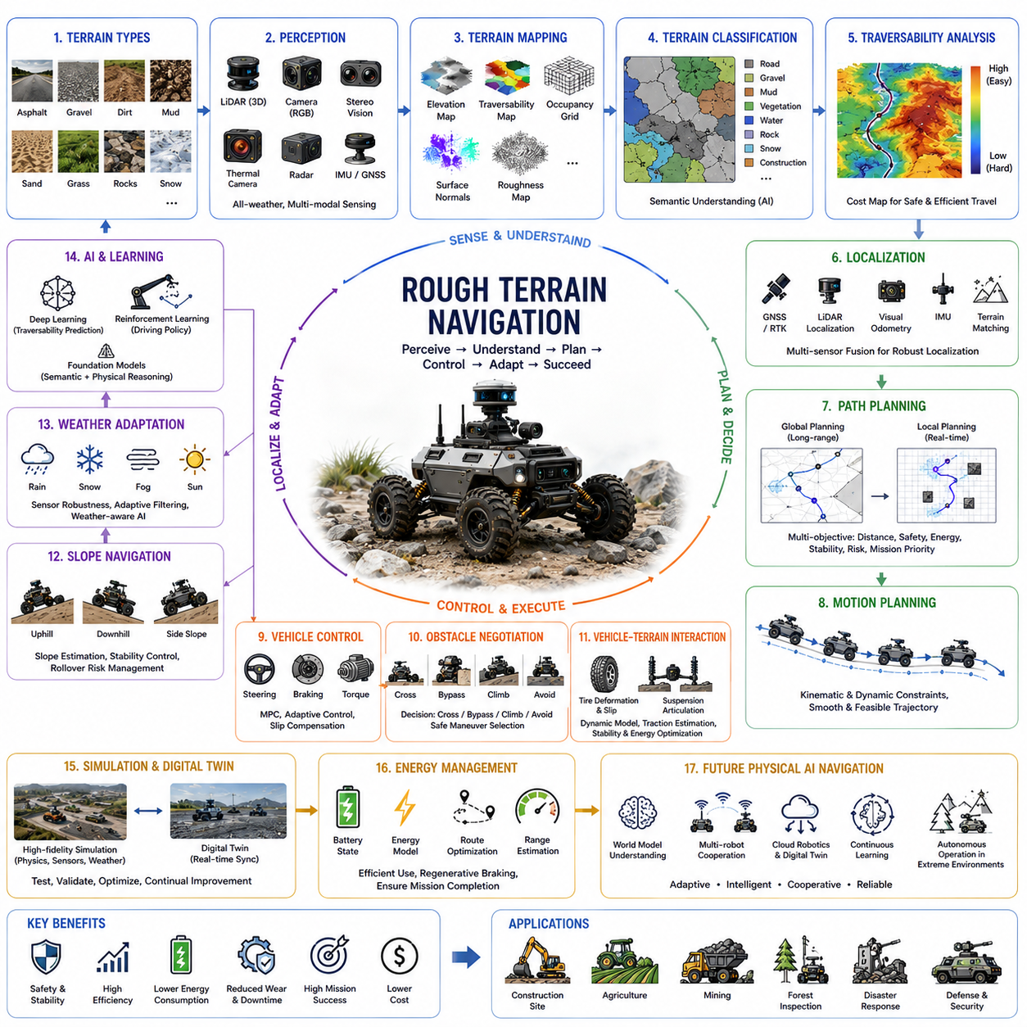
Rough terrain navigation is one of the most demanding capabilities in outdoor autonomous robotics because natural and semi-structured environments rarely provide smooth, predictable driving conditions. Unlike indoor navigation where flat floors, consistent lighting, and well-defined obstacles simplify motion planning, outdoor robots must continuously adapt to uneven ground, loose soil, rocks, mud, sand, grass, snow, slopes, water puddles, and rapidly changing environmental conditions. Successful navigation therefore requires close integration of perception, localization, terrain analysis, vehicle dynamics, path planning, motion control, and artificial intelligence. These capabilities allow autonomous robots to maintain mobility while minimizing safety risks, mechanical stress, energy consumption, and mission interruptions across highly variable operating environments.
The primary objective of rough terrain navigation is to enable autonomous robots to traverse difficult environments while maintaining stability, safety, efficiency, and mission accuracy. Rather than simply avoiding obstacles, the navigation system evaluates the traversability of the entire surrounding environment by estimating terrain quality, slope angles, traction conditions, wheel sinkage, surface roughness, vegetation density, and potential hazards. The robot continuously balances travel efficiency against operational risk, selecting routes that maximize mission success while minimizing the probability of immobilization, rollover, excessive energy usage, or mechanical damage.
Terrain characteristics directly influence navigation performance. Outdoor environments consist of numerous surface types including asphalt, concrete, gravel, dirt roads, sand, mud, snow, ice, grass, loose rocks, forest trails, agricultural fields, and construction sites. Each terrain exhibits unique physical properties such as friction coefficient, load-bearing capacity, surface compliance, roughness, moisture content, and wheel traction. Autonomous systems continuously classify terrain types using sensor data and adapt driving behavior accordingly. This environmental understanding enables robots to maintain safe mobility despite continuously changing ground conditions.
Terrain perception begins with comprehensive environmental sensing. Three-dimensional LiDAR provides highly accurate geometric information for measuring terrain elevation, obstacle dimensions, surface discontinuities, and traversable regions. RGB cameras capture texture, color, shadows, and visual landmarks that assist semantic terrain classification. Stereo vision estimates dense depth maps, while thermal cameras identify water, vegetation, or temperature-related surface variations. Radar complements optical sensors by operating reliably during fog, rain, dust, or darkness. These complementary sensing modalities provide robust environmental awareness across diverse weather and lighting conditions.
Terrain mapping transforms raw sensor measurements into structured environmental representations suitable for navigation. Digital elevation maps describe local terrain height variations while traversability maps estimate the difficulty of crossing different regions. Occupancy grids identify static obstacles, dynamic obstacles, and free space. Surface normal estimation characterizes local slope orientation, whereas roughness metrics quantify terrain irregularity. These layered environmental models continuously update as the robot moves, allowing navigation algorithms to react rapidly to newly observed terrain changes.
Terrain classification extends beyond simple obstacle detection by assigning semantic meaning to observed surfaces. Deep neural networks distinguish road surfaces, gravel, mud, vegetation, water, rocks, snow, construction debris, sidewalks, curbs, and other terrain categories. Machine learning models combine geometric features, visual appearance, reflectivity, thermal characteristics, and radar responses to improve classification accuracy. Semantic understanding enables navigation systems to estimate not only whether a region is physically accessible but also whether it is operationally desirable under current mission objectives.
Traversability analysis estimates how safely a robot can move through each portion of the environment. Instead of representing terrain as simply passable or impassable, traversability models assign continuous cost values reflecting expected vehicle performance. Factors including slope angle, surface roughness, obstacle density, wheel traction, vehicle dimensions, ground clearance, suspension articulation, and payload distribution contribute to traversability estimation. These cost maps provide the foundation for intelligent route optimization that minimizes operational risk while maintaining efficient mission completion.
Vehicle-terrain interaction plays a fundamental role in successful rough terrain navigation. Tire deformation, soil compression, wheel slip, suspension articulation, weight transfer, and vehicle inertia significantly influence mobility. Soft soils may reduce traction while steep slopes alter normal force distribution among wheels. Dynamic vehicle models estimate these interactions continuously, allowing adaptive controllers to regulate steering angles, motor torque, braking force, and suspension response. Accurate vehicle-terrain modeling substantially improves stability, energy efficiency, and obstacle negotiation capability under challenging operating conditions.
Localization becomes increasingly challenging in rough terrain because wheel slip and uneven surfaces reduce the accuracy of wheel odometry. Satellite positioning may also degrade under dense vegetation, steep valleys, or urban canyons. Robust localization therefore integrates GNSS, RTK corrections, inertial measurement units, LiDAR localization, visual odometry, and terrain matching through multi-sensor fusion algorithms. Simultaneous Localization and Mapping remains particularly valuable in off-road environments where previously generated maps can support reliable navigation despite temporary degradation of individual sensing modalities.
Path planning in rough terrain extends far beyond shortest-path optimization. Navigation algorithms evaluate multiple competing objectives including travel distance, estimated traversal time, terrain difficulty, vehicle stability, energy consumption, rollover probability, localization confidence, communication availability, and mission priorities. Global planners identify long-distance routes while local planners continuously adjust trajectories according to newly observed obstacles and terrain changes. This hierarchical planning architecture enables autonomous robots to respond intelligently to unpredictable environmental conditions without sacrificing overall mission efficiency.
Motion planning converts planned routes into dynamically feasible vehicle trajectories. Steering constraints, acceleration limits, suspension motion, wheel articulation, obstacle clearance, and vehicle dimensions are incorporated into trajectory generation. Smooth path generation minimizes unnecessary steering oscillations while preserving passenger comfort for human-carrying platforms and protecting sensitive payloads. Real-time trajectory optimization continuously updates planned motion according to current vehicle state, terrain conditions, and newly detected environmental hazards.
Vehicle control systems execute planned trajectories despite uncertain environmental conditions. Adaptive controllers compensate for wheel slip, changing friction, terrain inclination, payload variation, and dynamic disturbances such as wind or loose surfaces. Model Predictive Control, adaptive PID controllers, sliding mode control, and learning-based control algorithms continuously regulate steering, braking, throttle, and motor torque. Robust control strategies maintain stable vehicle behavior even when terrain conditions differ substantially from initial predictions.
Obstacle negotiation requires sophisticated decision-making beyond conventional obstacle avoidance. Autonomous robots must determine whether obstacles should be crossed, bypassed, climbed, or treated as impassable barriers. Rocks, fallen branches, curbs, shallow ditches, construction debris, and uneven ground require different traversal strategies depending upon vehicle capabilities. Navigation systems evaluate obstacle geometry, approach angle, wheel placement, suspension articulation, and vehicle clearance before selecting the safest crossing maneuver. These decisions directly influence mission reliability and mechanical durability.
Slope navigation presents additional challenges because gravity significantly alters vehicle dynamics. Climbing steep inclines increases motor load, energy consumption, and wheel slip, while descending slopes demands precise braking control to prevent uncontrolled acceleration. Lateral slopes increase rollover risk by shifting the vehicle's center of gravity. Navigation algorithms therefore evaluate longitudinal and lateral slope angles continuously while adjusting speed, steering, wheel torque distribution, and route selection to maintain safe operating margins throughout the mission.
Weather conditions further complicate rough terrain navigation by changing surface characteristics throughout operation. Rain reduces tire friction and creates mud, while snow and ice significantly decrease traction. Fog limits camera visibility, dust contaminates optical sensors, and strong sunlight produces severe illumination variations. Multi-modal perception, sensor redundancy, adaptive filtering, and weather-aware AI models allow autonomous systems to maintain reliable environmental understanding despite continuously changing atmospheric conditions. Robust environmental adaptation substantially improves operational availability throughout all seasons.
Artificial intelligence increasingly enhances rough terrain navigation by learning complex relationships between terrain appearance and vehicle performance. Deep learning predicts traversability directly from sensor observations, while reinforcement learning develops efficient driving strategies through extensive simulation. Foundation models combine semantic reasoning with physical understanding, enabling robots to infer previously unseen terrain characteristics from contextual environmental information. These AI-driven approaches improve navigation robustness while reducing dependence on manually engineered terrain models.
Simulation and digital twins play essential roles in validating rough terrain navigation before field deployment. High-fidelity terrain models reproduce rocks, vegetation, soil deformation, weather effects, sensor noise, and vehicle dynamics with remarkable realism. Engineers evaluate localization accuracy, path planning algorithms, terrain classification, suspension performance, and AI decision-making across thousands of challenging scenarios that would be impractical or unsafe to reproduce experimentally. Digital twins continue supporting system optimization after deployment through continuous synchronization with operational data collected during real-world missions.
Energy management becomes increasingly important in difficult terrain because climbing slopes, traversing soft soil, and overcoming obstacles require substantially greater power than driving on paved roads. Navigation systems therefore consider battery state, terrain difficulty, vehicle efficiency, regenerative braking opportunities, and remaining mission distance during route planning. Intelligent energy-aware navigation extends operational endurance while reducing battery degradation and ensuring sufficient power reserves for mission completion and safe return to charging infrastructure.
Future rough terrain navigation will evolve toward highly adaptive Physical AI systems capable of understanding terrain at semantic, geometric, and physical levels simultaneously. Multi-modal foundation models, world models, cloud robotics, digital twins, cooperative multi-robot exploration, and self-supervised learning will enable autonomous platforms to continuously improve navigation performance through accumulated operational experience. Rather than relying solely on predefined rules, future robots will reason about complex terrain, predict environmental evolution, cooperate with other autonomous systems, and dynamically optimize mobility strategies, enabling reliable autonomous operation across forests, construction sites, disaster zones, agriculture, mining, defense, planetary exploration, and other challenging outdoor environments.

20.03 Smart City Robots · 스마트시티 로봇
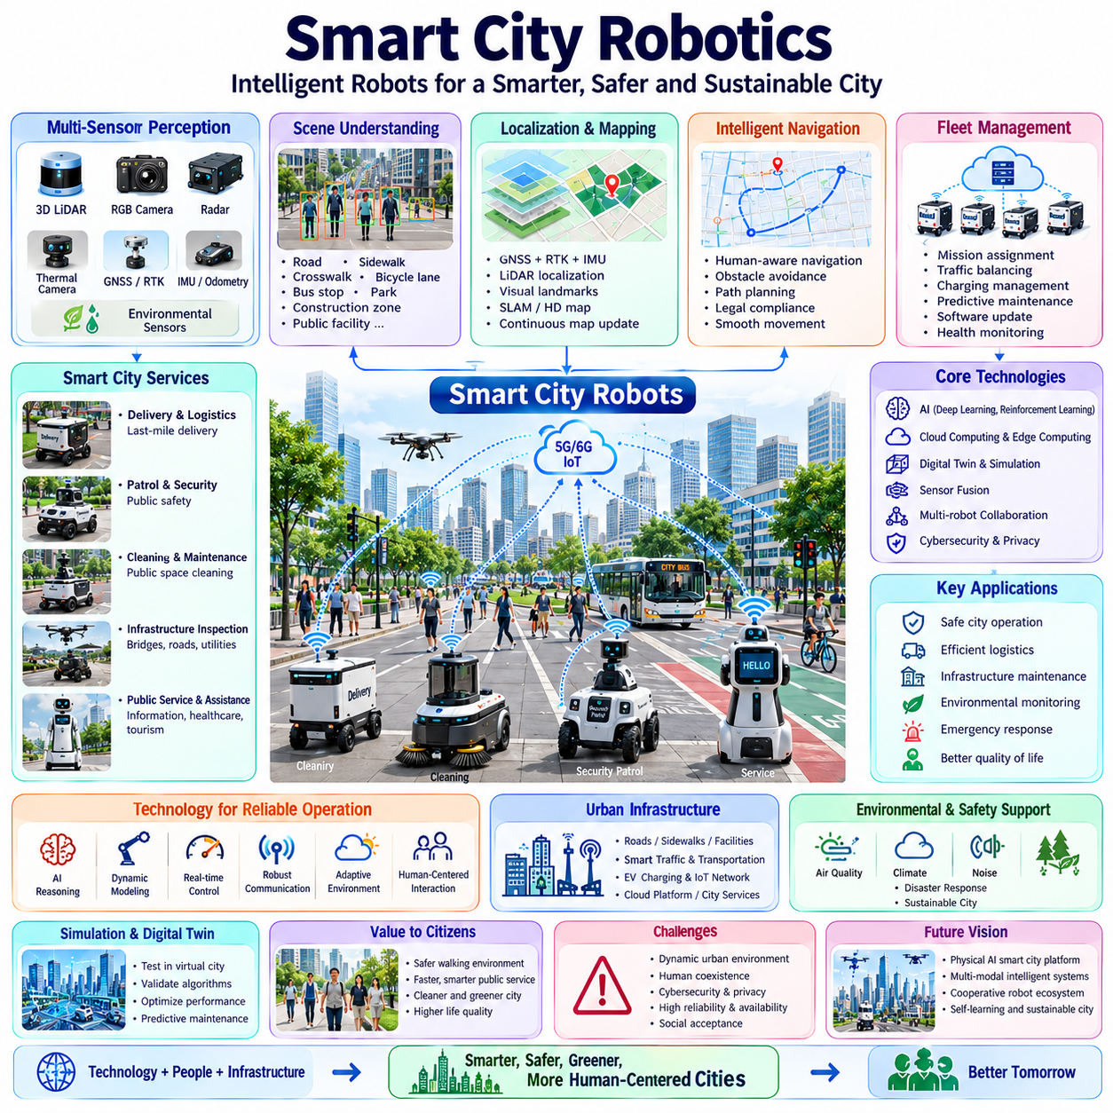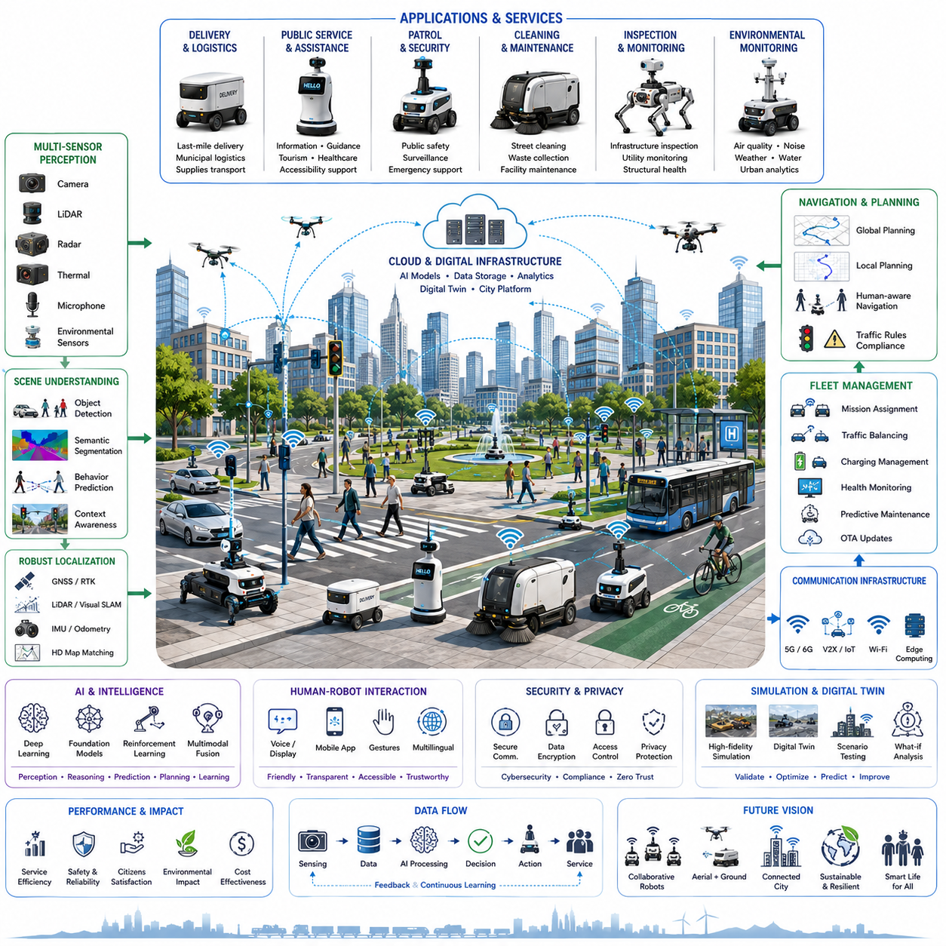
Smart city robots represent the convergence of autonomous robotics, artificial intelligence, connected infrastructure, and digital urban services to improve the quality, efficiency, safety, and sustainability of modern cities. Unlike robots operating in isolated industrial environments, smart city robots function within highly dynamic public spaces where they continuously interact with pedestrians, vehicles, buildings, traffic systems, public utilities, and municipal information platforms. Their successful deployment requires seamless integration of perception, autonomous navigation, cloud intelligence, communication networks, fleet management, and city-scale digital infrastructure. As cities continue their digital transformation, autonomous robots are becoming intelligent mobile agents that extend urban services beyond traditional fixed infrastructure.
The primary objective of smart city robots is to provide intelligent public services while improving operational efficiency and reducing human workload across large urban environments. These robots perform repetitive, hazardous, or labor-intensive tasks that traditionally require significant human resources. Instead of replacing people, they augment municipal operations by continuously collecting information, transporting goods, inspecting infrastructure, supporting emergency response, assisting citizens, and maintaining public facilities. Their ability to operate continuously enables cities to deliver more responsive, data-driven, and citizen-centered services.
Smart city environments are significantly more complex than controlled industrial facilities because they contain continuously changing traffic, pedestrians, cyclists, construction activities, public transportation, weather conditions, and temporary obstacles. Autonomous robots must safely coexist with thousands of unpredictable human activities while respecting traffic regulations, social behaviors, accessibility requirements, and local operational policies. This dynamic operating environment requires highly reliable perception, prediction, decision-making, and motion planning systems capable of adapting to rapidly changing urban conditions without compromising safety or service quality.
Urban perception begins with comprehensive multi-modal sensing. Three-dimensional LiDAR continuously measures surrounding geometry, while RGB cameras recognize traffic signs, pedestrians, bicycles, road markings, and vehicles. Radar provides robust obstacle detection during rain, fog, or darkness, while thermal cameras support nighttime operation and emergency monitoring. GNSS, RTK positioning, IMU, wheel odometry, and visual localization work together to estimate accurate robot positions within large-scale outdoor environments. Environmental sensors additionally monitor air quality, temperature, humidity, noise, radiation, and other municipal indicators that contribute to smart city analytics.
Scene understanding extends beyond simple object detection by interpreting semantic meaning throughout the urban environment. Artificial intelligence identifies sidewalks, roads, bicycle lanes, crosswalks, traffic lights, bus stops, parks, construction zones, public facilities, and restricted areas while simultaneously recognizing pedestrians, animals, emergency vehicles, delivery personnel, and maintenance workers. Context-aware reasoning allows robots to understand both physical surroundings and social situations, enabling safe navigation through crowded public spaces while respecting human priorities and municipal regulations.
Localization within smart cities requires robust multi-sensor fusion because satellite positioning alone often becomes unreliable near tall buildings, underground passages, tunnels, or dense urban infrastructure. High-definition maps, LiDAR localization, visual landmarks, GNSS corrections, inertial navigation, and SLAM cooperate to maintain precise positioning even when individual localization sources temporarily degrade. Continuous map updating further enables robots to adapt to construction activities, temporary road closures, seasonal changes, and evolving city infrastructure without requiring complete remapping.
Navigation in smart cities differs substantially from traditional autonomous driving because service robots frequently operate on sidewalks, pedestrian zones, parks, campuses, industrial districts, hospitals, airports, railway stations, and mixed traffic environments. Navigation systems must simultaneously optimize travel efficiency, pedestrian safety, legal compliance, accessibility, battery usage, service priorities, and operational schedules. Human-aware navigation continuously predicts pedestrian movement while generating smooth trajectories that minimize disruption to surrounding citizens and maintain comfortable social interactions.
Fleet management serves as the operational backbone of large-scale smart city robotics deployments. Instead of controlling individual robots independently, centralized fleet intelligence coordinates hundreds or even thousands of autonomous platforms operating simultaneously across the city. Mission assignment, traffic balancing, charging management, predictive maintenance, software updates, workload distribution, and health monitoring are continuously optimized using cloud-based management systems. This coordinated fleet operation significantly improves service availability while reducing operational costs and maximizing overall infrastructure utilization.
Communication infrastructure provides continuous connectivity between robots, edge computing resources, cloud platforms, municipal databases, and intelligent transportation systems. Modern deployments utilize 5G, emerging 6G technologies, Wi-Fi, V2X communication, IoT networks, and edge computing architectures to exchange perception data, navigation updates, traffic information, mission assignments, software models, and diagnostic information with minimal latency. Distributed computing enables computationally intensive AI workloads to be shared between onboard processors and cloud infrastructure while preserving real-time operational safety.
Smart city robots support a wide variety of public services across urban environments. Autonomous delivery robots transport parcels, food, medicine, and municipal supplies during last-mile logistics operations. Patrol robots monitor public safety, detect suspicious activities, and assist security personnel. Cleaning robots maintain streets, sidewalks, airports, railway stations, and public plazas. Inspection robots examine bridges, tunnels, utility corridors, streetlights, drainage systems, pipelines, and power infrastructure. Service robots provide information, tourism guidance, accessibility assistance, and multilingual interaction for residents and visitors. Each application contributes to a more responsive and efficient urban ecosystem.
Infrastructure inspection represents one of the highest-value applications because many municipal assets require continuous monitoring while remaining geographically distributed. Autonomous inspection robots collect high-resolution imagery, LiDAR scans, thermal measurements, vibration data, acoustic signatures, and environmental observations from roads, bridges, railways, utility networks, and public facilities. Artificial intelligence analyzes these measurements to detect structural deterioration, corrosion, water leakage, surface damage, vegetation intrusion, abnormal temperatures, and other early indicators of infrastructure failure, allowing preventive maintenance before costly breakdowns occur.
Environmental monitoring has become increasingly important as cities pursue sustainability and climate resilience. Mobile robots continuously measure air pollution, particulate matter, greenhouse gases, noise levels, weather conditions, urban heat islands, water quality, and waste accumulation throughout metropolitan regions. Since robots operate continuously across large geographic areas, they generate high-resolution environmental datasets that complement traditional fixed monitoring stations. These continuously updated measurements enable municipalities to make evidence-based policy decisions while improving environmental awareness and public health management.
Artificial intelligence serves as the cognitive foundation of smart city robotics by integrating perception, reasoning, prediction, planning, learning, and human interaction into unified decision-making systems. Deep learning recognizes complex urban objects and activities, while foundation models combine multimodal information with semantic reasoning to interpret previously unseen situations. Reinforcement learning continuously improves navigation efficiency, fleet coordination, and energy management through accumulated operational experience. These AI capabilities enable robots to adapt intelligently as cities evolve rather than relying solely on manually programmed rules.
Human-robot interaction plays a central role because smart city robots operate in shared public environments rather than isolated industrial facilities. Robots communicate through displays, voice interfaces, lighting, gestures, mobile applications, and multilingual conversational systems. Human-centered design ensures that robot behaviors remain predictable, understandable, and socially acceptable while supporting people with disabilities, elderly citizens, tourists, and emergency responders. Transparent communication significantly increases public trust, acceptance, and willingness to interact with autonomous municipal services.
Cybersecurity and privacy protection become essential because smart city robots continuously collect, process, transmit, and store large volumes of operational and environmental information. Secure communication channels, authenticated software updates, encrypted storage, access control, intrusion detection, privacy-preserving data processing, and regulatory compliance collectively protect both municipal infrastructure and citizen information. Zero-trust architectures, continuous vulnerability assessment, and secure fleet management reduce operational risks while maintaining reliable public services across large-scale deployments.
Simulation and digital twins enable municipalities to validate smart city robotic systems before physical deployment. High-fidelity digital replicas reproduce traffic, pedestrians, infrastructure, weather, communication networks, robot fleets, and emergency scenarios, allowing engineers to evaluate navigation algorithms, fleet coordination strategies, service efficiency, safety policies, and AI behavior under thousands of operational conditions. Digital twins continue supporting deployed systems by synchronizing real-world operational data, enabling continuous optimization, predictive maintenance, infrastructure planning, and policy evaluation without disrupting public services.
Performance evaluation focuses on both robotic capability and societal impact. Technical metrics include localization accuracy, navigation success rate, obstacle avoidance reliability, communication latency, battery utilization, mission completion rate, fleet efficiency, and system availability. Municipal performance indicators additionally measure service response time, citizen satisfaction, environmental improvements, infrastructure maintenance quality, operational cost reduction, energy efficiency, public safety enhancement, and overall quality of urban services. Comprehensive evaluation ensures that autonomous systems generate measurable value for both operators and the communities they serve.
Future smart city robots will evolve into collaborative Physical AI ecosystems where heterogeneous ground robots, aerial drones, infrastructure sensors, connected vehicles, cloud intelligence, and digital twins operate as a unified intelligent urban platform. World models, multimodal foundation models, edge-cloud intelligence, lifelong learning, cooperative perception, autonomous fleet collaboration, and city-scale digital infrastructure will enable robots to understand complex urban environments, predict future events, coordinate with other autonomous systems, and continuously improve public services. Rather than functioning as isolated autonomous machines, future smart city robots will become intelligent components of a connected urban ecosystem that supports safer transportation, more efficient infrastructure management, sustainable environmental monitoring, resilient emergency response, and higher quality of life for citizens.

20.04 Agricultural Robots · 농업 로봇
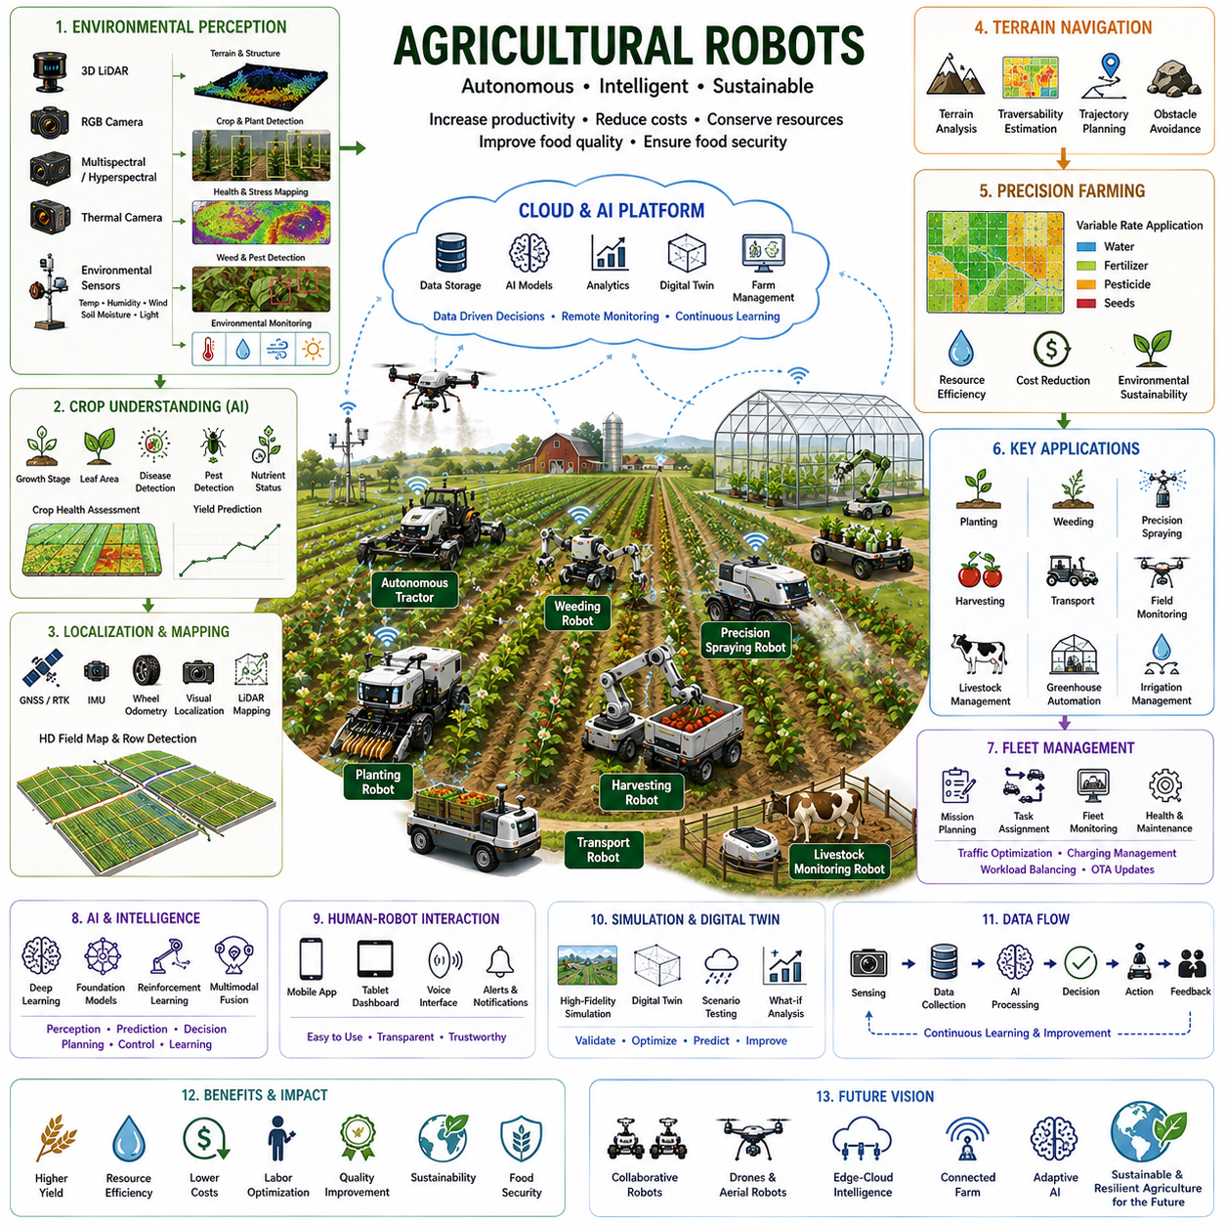
Agricultural robots represent one of the fastest-growing applications of autonomous robotics by combining artificial intelligence, precision agriculture, autonomous navigation, environmental sensing, and data-driven farm management to improve productivity, sustainability, and food security. Unlike traditional agricultural machinery that follows predefined operations under human supervision, agricultural robots continuously perceive changing environmental conditions, analyze crop health, make autonomous decisions, and execute farming tasks with high precision. These intelligent systems operate across diverse environments including crop fields, orchards, vineyards, greenhouses, livestock farms, and indoor vertical farming facilities. Their integration with digital agriculture enables more efficient use of water, fertilizer, pesticides, labor, and energy while increasing crop quality and operational profitability.
The primary objective of agricultural robots is to automate repetitive, labor-intensive, and precision-critical farming operations while maximizing agricultural productivity and minimizing environmental impact. Modern agriculture faces increasing challenges including labor shortages, climate variability, resource limitations, rising production costs, and growing global food demand. Autonomous robots address these challenges by performing continuous monitoring, precise crop management, selective harvesting, targeted spraying, autonomous transportation, and field inspection with significantly greater consistency than conventional manual operations. Their continuous operation enables farms to optimize production throughout the growing season while reducing operational variability.
Agricultural environments are highly dynamic because crops continuously grow, weather changes daily, soil conditions evolve, and biological systems remain inherently unpredictable. Unlike structured industrial facilities, farms contain irregular terrain, uneven soil, vegetation occlusion, varying illumination, seasonal appearance changes, moving livestock, and diverse crop geometries. Robots must therefore continuously adapt their perception, localization, planning, and control strategies according to changing environmental conditions. Robust agricultural autonomy requires intelligent integration of perception, mobility, environmental understanding, crop science, and machine learning to maintain reliable performance throughout complete agricultural production cycles.
Environmental perception begins with comprehensive multi-modal sensing capable of observing both crops and surrounding farmland. Three-dimensional LiDAR measures terrain geometry, crop height, canopy structure, and obstacle locations. RGB cameras identify crop species, fruit maturity, weeds, insects, diseases, and nutrient deficiencies using high-resolution visual information. Multispectral and hyperspectral cameras detect subtle physiological changes invisible to human vision, allowing early identification of crop stress before visible symptoms appear. Thermal cameras estimate plant water stress and irrigation efficiency, while environmental sensors continuously monitor temperature, humidity, wind, solar radiation, soil moisture, and atmospheric conditions that influence plant growth.
Crop understanding extends beyond simple object detection by recognizing biological conditions throughout the farming process. Artificial intelligence estimates crop growth stages, leaf area, flowering conditions, fruit maturity, biomass accumulation, disease progression, pest infestation, nutrient availability, and expected yield. Deep neural networks combine visual appearance, spectral responses, geometric information, and historical observations to generate comprehensive crop health assessments. This semantic understanding enables robots to perform precision agriculture by treating each individual plant according to its specific biological condition rather than applying uniform management across entire fields.
Localization in agricultural environments presents unique challenges because large farms often lack distinctive landmarks while vegetation changes continuously during the growing season. High-precision GNSS with RTK correction provides centimeter-level positioning across open fields, while inertial measurement units, wheel odometry, visual localization, LiDAR mapping, and SLAM compensate whenever satellite reception temporarily degrades. Row detection algorithms further assist navigation by recognizing crop rows and maintaining accurate alignment during planting, cultivation, spraying, and harvesting operations. Continuous localization enables highly repeatable field operations throughout multiple growing seasons.
Terrain navigation must accommodate highly variable agricultural surfaces including soft soil, muddy fields, gravel roads, grass, crop residues, irrigation channels, slopes, and uneven farmland. Navigation systems continuously estimate terrain traversability, wheel traction, soil deformation, and vehicle stability before selecting safe trajectories. Adaptive motion planning minimizes crop damage by avoiding unnecessary plant contact while simultaneously optimizing travel efficiency, energy consumption, and operational productivity. Intelligent terrain adaptation allows robots to operate safely despite changing weather and soil conditions throughout the agricultural season.
Precision farming relies heavily upon data-driven decision-making supported by autonomous robotic platforms. Rather than managing entire fields uniformly, agricultural robots collect plant-level information that enables site-specific crop management. High-resolution field maps describe crop health, weed distribution, soil variability, irrigation status, fertilizer requirements, and expected productivity. These spatial datasets support variable-rate application of water, nutrients, herbicides, and pesticides, significantly reducing resource consumption while maximizing agricultural output. Precision agriculture therefore improves both economic efficiency and environmental sustainability.
Autonomous planting robots increase production consistency by accurately placing seeds according to optimized spacing, depth, orientation, and soil conditions. Vision-guided planting systems monitor seed placement quality while adaptive controllers compensate for terrain irregularities and vehicle motion. Planting parameters continuously adjust according to soil moisture, temperature, crop variety, and expected weather conditions. Precise seed placement improves germination rates, crop uniformity, and final yield while reducing seed waste and unnecessary field operations.
Weeding represents one of the most economically valuable applications of agricultural robotics because conventional herbicide application often affects both weeds and crops. Artificial intelligence distinguishes crops from weeds at the individual plant level using visual appearance, geometry, spectral characteristics, and growth patterns. Robots selectively remove weeds using mechanical tools, laser systems, precision spraying, or electrical treatment while leaving crops unaffected. Targeted weed management substantially reduces herbicide consumption, environmental contamination, production costs, and herbicide resistance development.
Precision spraying enables agricultural robots to apply pesticides, herbicides, fertilizers, and biological treatments only where needed. Multi-sensor perception identifies disease symptoms, insect infestations, nutrient deficiencies, and weed locations before generating precise treatment maps. Individual nozzles activate selectively according to real-time perception results, minimizing chemical usage while maintaining effective crop protection. Intelligent spraying systems reduce environmental impact, improve operator safety, decrease production costs, and enhance long-term agricultural sustainability by eliminating unnecessary chemical application.
Harvesting automation remains among the most technically challenging agricultural robotics applications because fruits and vegetables exhibit highly variable shapes, colors, sizes, maturity levels, and occlusions. Vision systems estimate fruit ripeness, detect harvesting points, evaluate grasping opportunities, and plan collision-free manipulator trajectories. Soft robotic grippers, force sensing, and adaptive manipulation protect delicate produce while maximizing harvesting efficiency. Artificial intelligence continuously optimizes picking sequences according to accessibility, maturity, and expected product quality, significantly improving both harvesting speed and crop value.
Autonomous transportation robots support agricultural logistics by moving harvested products, seeds, fertilizers, equipment, and supplies throughout farms with minimal human intervention. Fleet management coordinates multiple robots operating simultaneously across large agricultural areas while optimizing travel routes, charging schedules, workload distribution, and equipment utilization. Cooperative logistics significantly reduce labor requirements during intensive farming activities including planting, harvesting, and post-harvest processing while improving overall operational efficiency.
Livestock robotics has become increasingly important for modern animal farming. Autonomous robots monitor animal health, feeding behavior, movement patterns, body condition, and environmental conditions using computer vision, thermal sensing, and behavioral analysis. Feeding robots automatically distribute nutrition according to animal requirements while cleaning robots maintain hygienic livestock facilities. Continuous monitoring enables early detection of illness, stress, injury, and abnormal behavior, improving both animal welfare and farm productivity through proactive management.
Greenhouse automation provides highly controlled agricultural environments where robots perform planting, monitoring, pollination, pruning, harvesting, and environmental regulation with exceptional precision. Artificial intelligence continuously optimizes lighting, irrigation, ventilation, humidity, carbon dioxide concentration, and nutrient delivery according to plant growth requirements. Since environmental variables remain measurable and controllable, greenhouse robots achieve high productivity while minimizing water usage, chemical application, and climate-related production risks compared with conventional outdoor agriculture.
Artificial intelligence serves as the decision-making foundation of agricultural robotics by integrating perception, prediction, planning, environmental modeling, and long-term learning. Deep learning recognizes crops, weeds, fruits, diseases, insects, and soil conditions, while foundation models combine multimodal agricultural knowledge with contextual reasoning to interpret previously unseen farming situations. Reinforcement learning continuously improves navigation efficiency, harvesting strategies, spraying accuracy, and energy management through accumulated operational experience. These adaptive AI capabilities enable robots to respond intelligently to changing biological systems throughout multiple growing seasons.
Simulation and digital twins enable agricultural robots to be validated before deployment in real farming environments. High-fidelity agricultural simulations reproduce crop growth, weather conditions, soil deformation, vehicle dynamics, sensor characteristics, irrigation systems, and seasonal changes. Engineers evaluate navigation algorithms, perception accuracy, harvesting strategies, fleet coordination, and AI decision-making across thousands of virtual farming scenarios that would otherwise require years of field testing. Digital twins continue supporting operational farms by synchronizing real-world data for predictive maintenance, yield forecasting, resource optimization, and continuous improvement of agricultural management strategies.
Future agricultural robots will evolve into collaborative Physical AI ecosystems where autonomous ground vehicles, aerial drones, intelligent irrigation systems, environmental sensors, cloud computing, digital twins, and multimodal foundation models cooperate as an integrated agricultural intelligence platform. World models, lifelong learning, edge-cloud intelligence, cooperative perception, autonomous fleet collaboration, and precision environmental modeling will enable farming systems to understand complex biological processes, predict crop development, optimize resource allocation, and continuously improve agricultural productivity. Rather than functioning as isolated autonomous machines, future agricultural robots will become intelligent partners that support sustainable food production, climate-resilient farming, environmental conservation, and global food security through highly adaptive, data-driven agricultural ecosystems.

20.05 GPR and Inspection Robots · GPR·점검 로봇
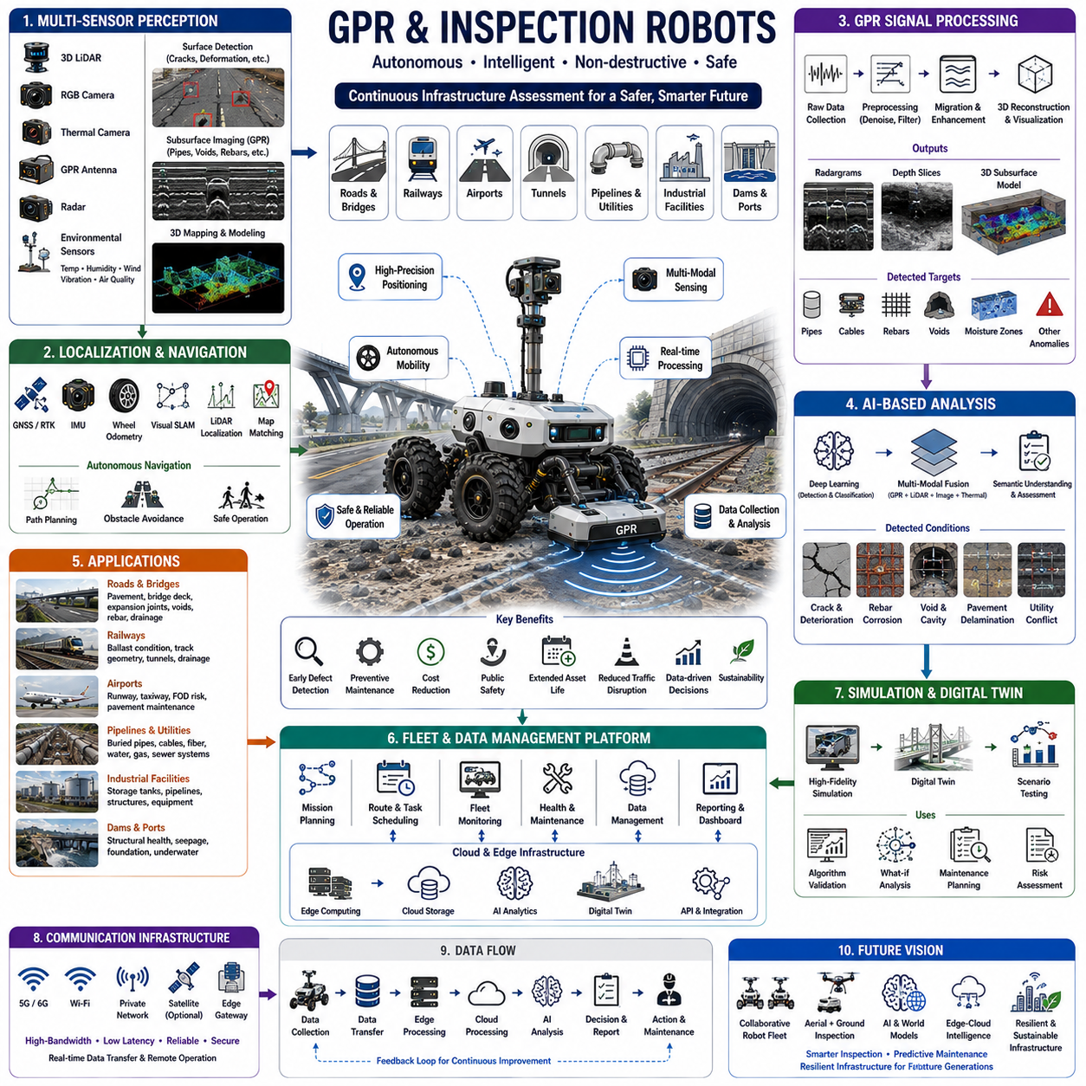
Ground Penetrating Radar (GPR) and inspection robots represent an advanced class of autonomous robotic systems designed to inspect, analyze, and monitor both visible and hidden infrastructure without causing physical damage. By integrating autonomous mobility, artificial intelligence, non-destructive testing technologies, ground penetrating radar, multi-modal sensing, and digital infrastructure management, these robots enable continuous assessment of roads, bridges, tunnels, railways, airports, pipelines, underground utilities, and industrial facilities. Unlike conventional manual inspections that require extensive labor, traffic interruption, or destructive sampling, autonomous inspection robots perform highly repeatable surveys while minimizing operational disruption and improving inspection accuracy. Their ability to collect large amounts of high-quality data supports predictive maintenance, infrastructure resilience, and long-term asset management.
The primary objective of GPR and inspection robots is to identify structural conditions, hidden defects, underground objects, and infrastructure deterioration before failures occur. Instead of reacting to visible damage after it becomes severe, these robotic systems continuously monitor structural health by combining surface inspection with subsurface imaging and environmental sensing. Early detection allows infrastructure owners to schedule preventive maintenance, optimize repair budgets, reduce operational risks, and extend asset lifecycles. Continuous autonomous inspection also improves public safety by reducing the probability of unexpected infrastructure failures while minimizing the need for dangerous manual inspections in hazardous environments.
Ground Penetrating Radar serves as the core sensing technology for subsurface inspection. GPR transmits high-frequency electromagnetic waves into the ground and measures reflected signals generated by changes in dielectric properties between different materials. Variations in soil composition, moisture content, concrete reinforcement, buried utilities, voids, cracks, and underground structures produce distinct reflection patterns that can be analyzed to estimate object depth, geometry, and material characteristics. Since GPR operates without excavation, it provides highly valuable non-destructive information while preserving the integrity of inspected infrastructure. The effectiveness of GPR depends on operating frequency, antenna configuration, soil properties, signal attenuation, and environmental conditions.
Inspection environments vary considerably depending on application domains. Urban roads contain asphalt, reinforced concrete, buried utility networks, drainage systems, communication cables, and transportation infrastructure. Railway inspections involve ballast conditions, sleepers, rails, and subsurface stability. Airport runways require detection of pavement deterioration, moisture intrusion, and foreign object risks. Industrial facilities include pipelines, storage tanks, production equipment, structural steel, and underground utilities. Bridges and tunnels introduce additional complexity through multiple structural materials, reinforcement layouts, confined spaces, vibration, and changing environmental conditions. Autonomous inspection robots must therefore adapt their sensing strategies according to infrastructure characteristics and operational requirements.
Environmental perception combines multiple sensing modalities to achieve comprehensive infrastructure understanding. Three-dimensional LiDAR generates precise geometric models of roads, buildings, tunnels, and surrounding obstacles. RGB cameras detect visible surface defects including cracks, corrosion, deformation, potholes, joint failures, surface wear, and material degradation. Thermal cameras identify abnormal temperature distributions associated with water leakage, electrical faults, insulation failures, or structural deterioration. Radar complements optical sensing by operating reliably during rain, dust, fog, or darkness. GPR simultaneously captures subsurface information, allowing robots to correlate underground structures with visible surface conditions for more complete infrastructure assessment.
Localization represents a critical requirement because inspection results must be accurately referenced to physical infrastructure locations. High-precision GNSS with RTK correction provides centimeter-level positioning in open environments, while LiDAR localization, visual SLAM, inertial measurement units, wheel odometry, and map matching maintain accurate positioning when satellite signals degrade beneath bridges, inside tunnels, or within dense urban environments. Consistent localization allows inspection data collected across multiple surveys to be directly compared over time, enabling long-term structural monitoring and quantitative assessment of infrastructure degradation.
Autonomous navigation enables inspection robots to operate safely within complex transportation environments. Robots may travel on highways, urban streets, industrial facilities, airport pavements, railway corridors, underground tunnels, or construction sites while interacting with pedestrians, maintenance personnel, moving vehicles, and temporary obstacles. Navigation systems continuously evaluate safety, inspection coverage, operational efficiency, traffic regulations, localization confidence, and battery status while generating smooth trajectories that maintain stable sensor operation. Precise navigation is particularly important because GPR measurements require consistent antenna positioning and vehicle speed to ensure high-quality subsurface imaging.
GPR signal processing transforms raw electromagnetic reflections into interpretable subsurface information. Signal preprocessing removes environmental noise, antenna coupling effects, and background reflections while enhancing weak underground responses. Time-zero correction, gain compensation, filtering, migration algorithms, and three-dimensional reconstruction improve image quality and spatial accuracy. Advanced processing techniques generate radargrams, depth slices, volumetric subsurface models, and material classification maps that support infrastructure engineers in identifying buried utilities, reinforcement bars, cavities, moisture zones, and structural discontinuities with improved confidence.
Artificial intelligence significantly enhances GPR interpretation by automatically identifying complex subsurface patterns that traditionally required experienced human analysts. Deep neural networks recognize signatures associated with buried pipes, cables, reinforcement meshes, voids, sinkholes, pavement delamination, concrete deterioration, and underground anomalies. Machine learning combines GPR measurements with LiDAR, RGB imagery, thermal data, and historical inspection records to improve classification accuracy while reducing false detections. Foundation models further enable semantic reasoning across multiple sensing modalities, supporting more comprehensive infrastructure understanding under highly variable operating conditions.
Surface inspection complements subsurface analysis by evaluating visible structural conditions simultaneously with underground sensing. Computer vision algorithms detect pavement cracks, rutting, potholes, joint separation, corrosion, concrete spalling, exposed reinforcement, water accumulation, vegetation intrusion, and structural deformation. High-resolution imaging allows automatic measurement of defect dimensions, progression rates, and maintenance priorities. Integrating surface and subsurface observations enables engineers to understand relationships between visible damage and underlying structural mechanisms rather than evaluating each condition independently.
Structural health monitoring extends inspection beyond periodic surveys by continuously tracking infrastructure conditions throughout operational lifecycles. Autonomous robots repeatedly inspect identical routes while collecting consistent multi-modal datasets that reveal gradual structural changes over months or years. Temporal analysis identifies crack propagation, settlement, moisture migration, corrosion development, pavement deterioration, and foundation movement before critical failures occur. Continuous monitoring transforms infrastructure maintenance from reactive repair toward predictive asset management based on quantitative engineering evidence.
Inspection robots support numerous infrastructure sectors. Highway authorities employ them for pavement condition assessment, bridge deck inspection, and underground utility mapping. Railway operators monitor ballast conditions, track geometry, drainage systems, and tunnel structures. Airports inspect runways, taxiways, and lighting infrastructure while minimizing operational disruptions. Utility companies locate buried pipelines, electrical cables, fiber-optic networks, and water distribution systems. Industrial facilities monitor storage tanks, production equipment, underground process pipelines, and structural integrity. These diverse applications demonstrate the flexibility of autonomous inspection platforms across multiple infrastructure domains.
Fleet management enables large-scale inspection programs covering thousands of kilometers of transportation networks and utility corridors. Multiple robots operate cooperatively while centralized scheduling systems optimize inspection frequency, route planning, charging operations, maintenance scheduling, workload balancing, and data synchronization. Cloud-based management platforms continuously monitor robot health, sensor calibration, mission progress, and communication quality while distributing updated inspection plans according to infrastructure priorities. Coordinated fleet operation substantially improves inspection coverage while reducing operational costs and personnel requirements.
Communication infrastructure connects inspection robots with edge computing platforms, cloud analytics, digital twins, infrastructure databases, and maintenance management systems. High-bandwidth wireless communication using 5G, Wi-Fi, private industrial networks, or future 6G technologies enables rapid transfer of high-resolution GPR data, LiDAR point clouds, imagery, thermal measurements, localization information, and diagnostic reports. Edge computing performs time-critical processing close to inspection sites while cloud platforms support computationally intensive AI analysis, long-term storage, historical comparison, and collaborative engineering review.
Simulation and digital twins provide powerful tools for validating inspection systems before field deployment and for managing infrastructure throughout its lifecycle. High-fidelity digital environments reproduce pavement structures, underground utilities, reinforcement layouts, soil properties, GPR signal propagation, sensor characteristics, and robot dynamics. Engineers evaluate localization performance, navigation algorithms, inspection coverage, AI detection accuracy, and maintenance planning strategies across numerous simulated scenarios. Digital twins continuously synchronize inspection data collected during real operations, enabling predictive maintenance, infrastructure forecasting, lifecycle optimization, and engineering decision support.
Performance evaluation combines robotic metrics with infrastructure management objectives. Technical indicators include localization accuracy, navigation reliability, GPR image quality, detection precision, false alarm rate, inspection coverage, communication latency, battery utilization, mission completion rate, and sensor calibration stability. Infrastructure metrics evaluate defect detection accuracy, maintenance cost reduction, inspection repeatability, infrastructure availability, operational safety improvements, lifecycle extension, and return on investment. Comprehensive evaluation ensures that autonomous inspection systems deliver measurable engineering and economic benefits across large infrastructure networks.
Future GPR and inspection robots will evolve into intelligent Physical AI platforms capable of understanding infrastructure at geometric, material, structural, and semantic levels simultaneously. Multi-modal foundation models, world models, cooperative robot fleets, aerial-ground inspection collaboration, edge-cloud intelligence, self-supervised learning, digital twins, and predictive infrastructure analytics will enable autonomous systems to continuously improve inspection quality through accumulated operational experience. Rather than serving only as automated sensing platforms, future inspection robots will become intelligent engineering partners that proactively assess infrastructure health, predict future deterioration, optimize maintenance planning, coordinate repair activities, and support resilient, sustainable infrastructure management for increasingly complex urban and industrial environments.

