Volume 01. AMR Foundations and System Architecture

07. AMR Reference Models · AMR 레퍼런스 모델

07.01 Layered Robot Architectures · 계층형 로봇 아키텍처
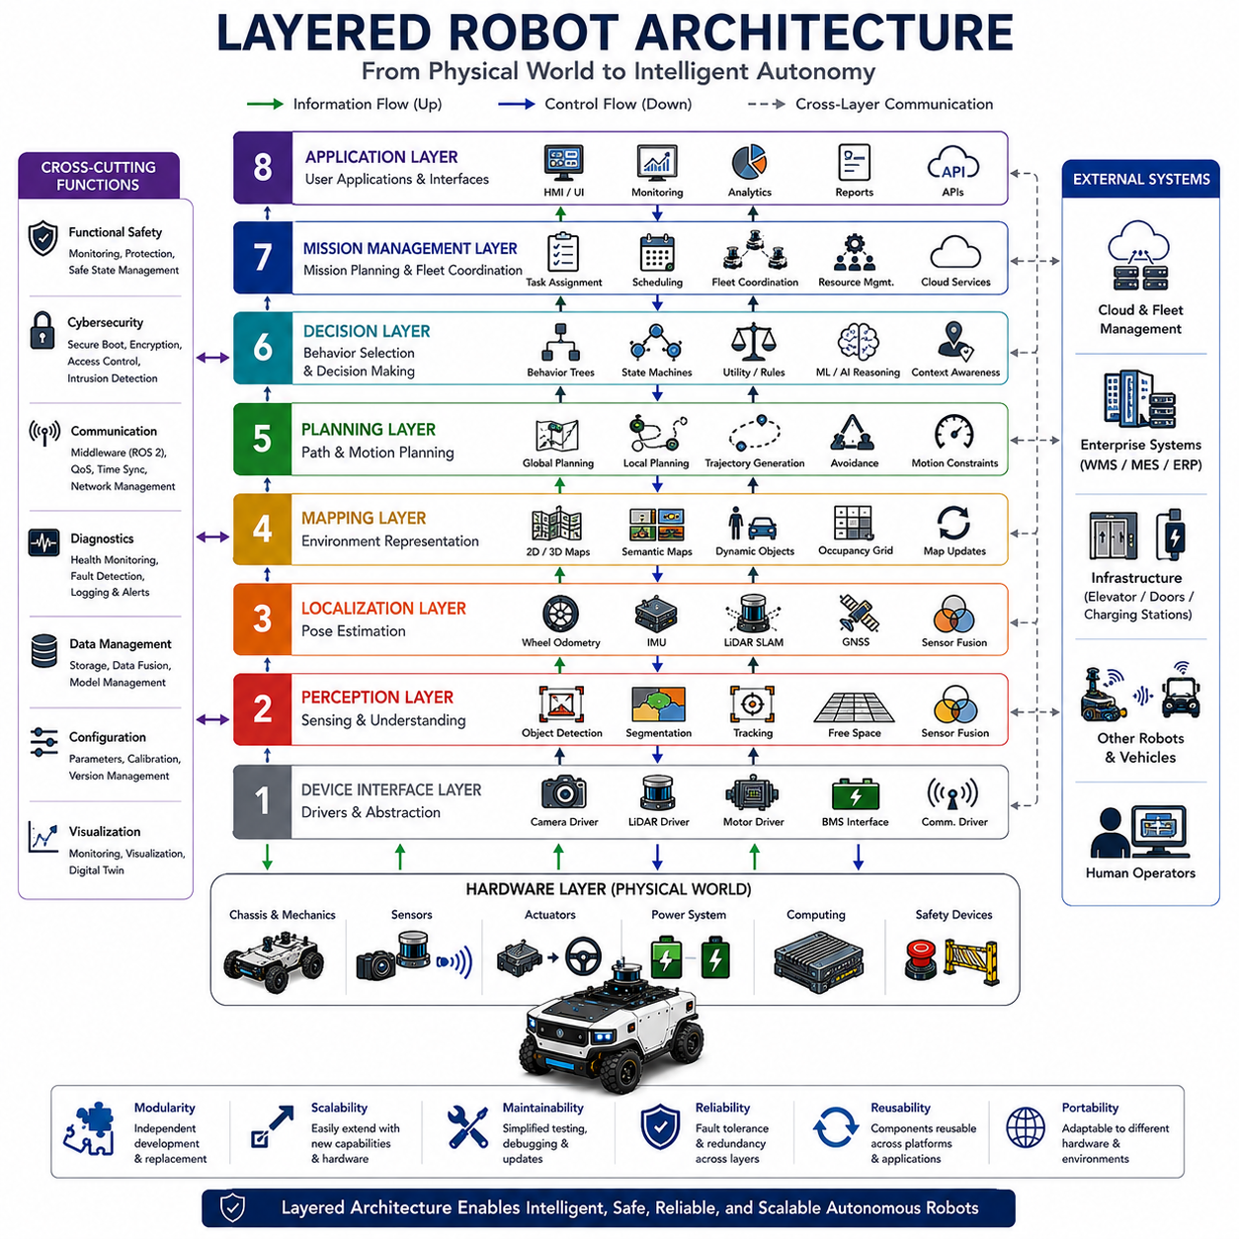
Layered robot architecture is one of the most widely adopted system design methodologies in modern robotics because it organizes complex robotic functionality into multiple abstraction layers with clearly defined responsibilities and interfaces. Instead of building robotic software as one monolithic application, layered architecture divides perception, decision-making, planning, control, communication, and hardware interaction into independent modules that cooperate through standardized interfaces. This separation significantly improves system scalability, maintainability, reliability, portability, and development efficiency. As Autonomous Mobile Robots become increasingly intelligent and computationally sophisticated, layered architectures provide the structural foundation that enables complex autonomous behaviors while maintaining manageable software and hardware complexity across the entire robotic platform.
The fundamental philosophy of layered architecture is abstraction. Each layer focuses exclusively on its own functional responsibilities while hiding internal implementation details from higher or lower layers. Higher layers request services without requiring knowledge of hardware implementation, while lower layers execute commands without understanding high-level mission objectives. This abstraction minimizes interdependencies among software components and allows individual modules to evolve independently. Consequently, engineers can improve localization algorithms, perception models, navigation planners, communication systems, or hardware controllers without redesigning the entire robotic system. Layered abstraction therefore accelerates long-term platform evolution while reducing engineering risk during development.
At the highest level, layered robot architecture is commonly divided into hardware, device interface, perception, localization, planning, decision, mission management, and application layers. Although different robotic platforms may use slightly different terminology, the overall organizational principles remain remarkably consistent across industrial robots, service robots, autonomous vehicles, warehouse automation systems, and humanoid robots. Information generally flows upward from physical sensors toward increasingly abstract reasoning layers, while control commands propagate downward toward motors and actuators. This bidirectional information flow enables continuous interaction between physical environments and intelligent decision-making throughout autonomous operation.
The hardware layer represents the physical foundation of the entire robotic system. It includes chassis structures, drive mechanisms, steering systems, braking systems, manipulators, batteries, computing hardware, communication interfaces, power electronics, sensors, actuators, cooling systems, and safety devices. Every autonomous capability ultimately depends upon reliable hardware operation because software intelligence cannot compensate for mechanical failures or inadequate sensing capability. Hardware architecture therefore emphasizes robustness, environmental durability, modularity, maintainability, energy efficiency, and functional safety while providing standardized electrical, mechanical, and communication interfaces supporting higher software layers.
Immediately above the hardware layer lies the device interface layer, which establishes standardized communication between physical devices and higher-level software modules. Device drivers convert hardware-specific communication protocols into consistent software interfaces independent of individual manufacturers. Camera drivers acquire image streams, LiDAR drivers process point cloud measurements, motor drivers execute motion commands, battery management interfaces monitor electrical status, and communication drivers exchange information across onboard networks. Device abstraction significantly simplifies software development because upper layers interact with standardized interfaces rather than vendor-specific hardware implementations.
The perception layer transforms raw sensor measurements into meaningful environmental understanding. Multiple sensing technologies including cameras, LiDAR, radar, ultrasonic sensors, inertial measurement units, and GNSS receivers continuously generate heterogeneous data describing surrounding environments. Perception algorithms perform sensor fusion, object detection, semantic segmentation, terrain classification, obstacle recognition, free-space estimation, tracking, and environmental modeling. Artificial intelligence increasingly enhances perception through deep neural networks capable of extracting semantic information beyond traditional geometric processing. The perception layer therefore converts low-level sensor signals into structured environmental knowledge supporting higher-level autonomous reasoning.
Closely coupled with perception, the localization layer continuously estimates the robot's position, orientation, velocity, and motion relative to surrounding environments. Localization integrates wheel odometry, inertial navigation, satellite positioning, visual odometry, LiDAR SLAM, map matching, and probabilistic estimation techniques to maintain accurate positioning under varying operational conditions. Robust localization remains essential because every navigation decision depends upon knowing where the robot currently resides. Modern localization architectures dynamically combine multiple complementary sensing modalities, allowing autonomous operation despite temporary sensor degradation, environmental uncertainty, or changing operating conditions.
The mapping layer maintains structured representations of the environment that support autonomous navigation and reasoning. Static maps describe permanent infrastructure such as buildings, corridors, roads, and production facilities, while dynamic maps continuously update temporary obstacles, moving vehicles, people, and changing environmental conditions. Semantic maps extend purely geometric representations by assigning meaningful labels such as doors, charging stations, intersections, storage locations, inspection points, or hazardous areas. High-definition maps further incorporate detailed geometric information supporting centimeter-level navigation accuracy. The mapping layer therefore provides long-term environmental memory enabling efficient autonomous operation across large and complex workspaces.
The planning layer determines how the robot should accomplish assigned objectives while satisfying operational constraints. Global planners calculate efficient routes between distant locations using known environmental maps, whereas local planners continuously generate collision-free trajectories responding to dynamic obstacles and changing environmental conditions. Motion planning additionally considers vehicle kinematics, dynamics, steering limitations, terrain characteristics, safety margins, energy consumption, and mission priorities. Advanced planning algorithms increasingly integrate prediction models capable of anticipating future environmental changes rather than merely reacting to current observations. Planning therefore serves as the bridge connecting environmental understanding with physical robot motion.
The decision layer coordinates autonomous behavior by selecting appropriate actions according to current operational context, mission objectives, environmental conditions, and system status. Decision-making algorithms evaluate competing priorities including safety, efficiency, productivity, battery condition, mission urgency, traffic conditions, communication quality, and resource availability before determining optimal robot behavior. Rule-based systems, finite state machines, behavior trees, utility-based reasoning, reinforcement learning, and foundation model reasoning increasingly contribute to autonomous decision processes. The decision layer therefore transforms planning alternatives into concrete operational choices aligned with organizational objectives while continuously adapting to changing operational situations.
Mission management represents one of the highest abstraction layers within modern robotic architectures. Rather than controlling individual robot movements directly, mission management coordinates complete operational workflows involving multiple robots, external infrastructure, industrial equipment, cloud services, and human operators. Mission schedulers assign tasks, optimize fleet utilization, monitor operational progress, coordinate charging activities, allocate resources, resolve conflicts, and synchronize collaborative activities across entire robotic deployments. Mission management therefore shifts robotic intelligence from individual autonomous machines toward coordinated multi-robot ecosystems capable of executing large-scale industrial operations efficiently.
The communication layer operates horizontally across nearly every architectural level, enabling reliable information exchange among distributed software modules, onboard computers, cloud services, industrial infrastructure, and fleet management systems. Middleware platforms such as ROS 2 provide standardized publish-subscribe communication, service interfaces, parameter management, lifecycle coordination, and distributed execution across independent computational modules. Communication architecture ensures deterministic timing for safety-critical control while simultaneously supporting high-bandwidth perception, artificial intelligence processing, remote monitoring, software updates, and digital twin synchronization. Reliable communication therefore integrates all architectural layers into one coherent autonomous system.
Functional safety spans every architectural layer rather than existing as an isolated subsystem. Safety monitoring supervises hardware health, sensor integrity, communication reliability, software execution, environmental hazards, and operational behavior throughout the robot. Independent safety controllers continuously verify that autonomous functions remain within predefined safety boundaries while initiating protective actions whenever hazardous situations emerge. Safety-certified sensors, redundant communication channels, fault detection algorithms, emergency stopping mechanisms, controlled degradation strategies, and safe state management collectively ensure that failures within individual layers never directly compromise overall operational safety. Layered safety architecture therefore distributes protection mechanisms throughout the complete robotic system.
Artificial intelligence increasingly influences nearly every layer of modern robot architecture. Deep learning enhances perception, probabilistic estimation improves localization, reinforcement learning optimizes planning, large language models assist mission reasoning, predictive analytics supports maintenance, and foundation models integrate multimodal understanding across diverse sensing modalities. Rather than replacing conventional deterministic algorithms entirely, artificial intelligence complements traditional robotics by improving adaptability, semantic understanding, uncertainty management, and autonomous decision quality. Hybrid architectures combining deterministic engineering with machine learning provide practical pathways toward increasingly capable autonomous systems while preserving reliability and explainability.
One of the greatest advantages of layered architecture is modular scalability. New sensors, improved artificial intelligence models, upgraded communication technologies, additional computing hardware, or entirely new robotic capabilities can be integrated into existing platforms without redesigning the complete system. Standardized interfaces allow hardware replacement, software upgrades, distributed computing expansion, cloud integration, and fleet-level coordination while preserving compatibility with existing architectural components. This modularity significantly reduces development cost, accelerates product evolution, simplifies maintenance, and enables long-term technological adaptation as robotic capabilities continue advancing.
Future layered robot architectures will evolve toward highly distributed cognitive systems integrating edge computing, cloud intelligence, digital twins, collaborative perception, autonomous fleets, software-defined robotics, and foundation model reasoning into unified architectural frameworks. Traditional hierarchical boundaries between perception, planning, reasoning, and execution will become increasingly interconnected through shared knowledge representations and continuous learning mechanisms. Despite these technological advances, the fundamental principles of layered abstraction, modular responsibility, standardized interfaces, independent evolution, deterministic safety, and scalable integration will remain essential foundations supporting the next generation of intelligent Autonomous Mobile Robot platforms operating across increasingly diverse, dynamic, and collaborative real-world environments.

07.02 ROS2 Based Architecture · ROS2 기반 아키텍처
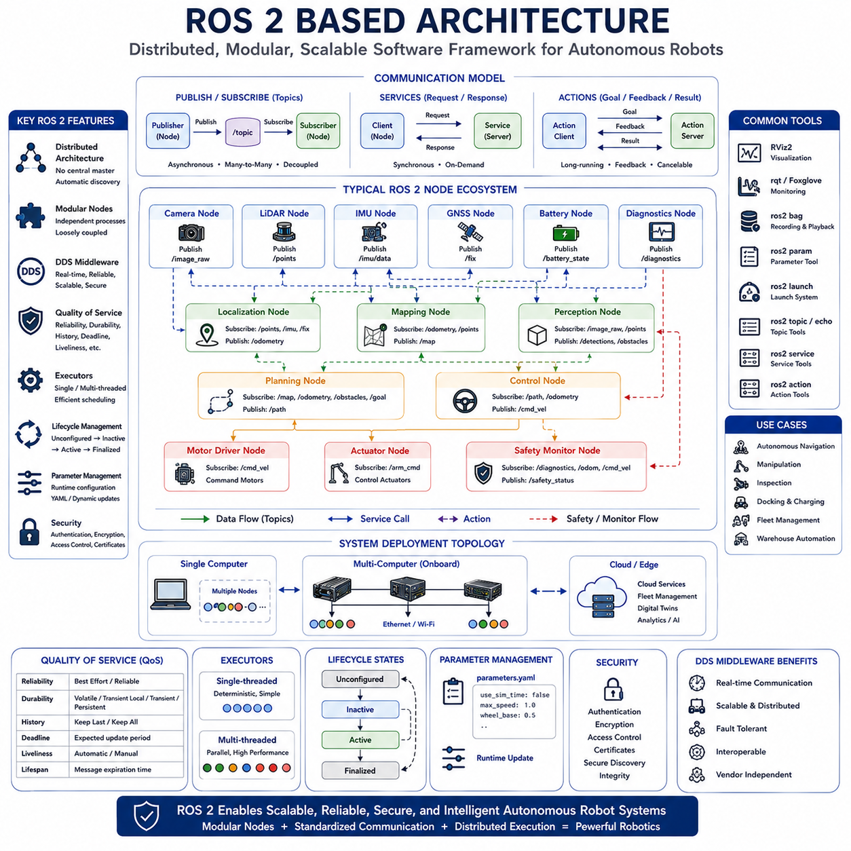
ROS 2 has become one of the most influential software frameworks in modern robotics because it provides a standardized middleware architecture capable of connecting distributed software components into a unified autonomous robotic system. Unlike traditional monolithic robot software, ROS 2 organizes robotic functionality into independent nodes that communicate through standardized interfaces while remaining loosely coupled. This architectural approach significantly improves modularity, scalability, maintainability, portability, and system reliability. As Autonomous Mobile Robots become increasingly sophisticated, ROS 2 serves not merely as a programming framework but as the software backbone supporting perception, localization, navigation, artificial intelligence, communication, fleet management, and cloud integration throughout the entire robotic platform.
The architectural philosophy of ROS 2 emphasizes distributed computing rather than centralized software execution. Individual software components execute independently while exchanging information through middleware communication mechanisms without requiring direct knowledge of each other's internal implementation. Every computational function, including sensor acquisition, localization, object detection, mapping, planning, motor control, diagnostics, and user interfaces, operates as an independent process called a node. This decentralized architecture improves software flexibility because nodes can be developed, tested, updated, restarted, or replaced independently without interrupting the entire robotic system. Distributed execution also enables robotic applications to scale efficiently across multiple processors and multiple onboard computers.
Nodes represent the fundamental computational units within ROS 2 architecture. Each node performs one clearly defined functional responsibility while interacting with other nodes exclusively through standardized communication interfaces. Camera drivers publish image streams, LiDAR nodes generate point clouds, localization nodes estimate robot position, navigation nodes calculate trajectories, planning nodes generate motion commands, battery monitoring nodes supervise power systems, and actuator nodes execute low-level control actions. Since every node remains independent, software developers can combine existing nodes into new robotic applications without modifying their internal implementations. This modular design significantly accelerates software development while promoting code reuse across multiple robotic platforms.
Communication between ROS 2 nodes primarily occurs through the publish-subscribe communication model. Publishers continuously distribute information onto named topics without knowing which components consume the data, while subscribers receive information from topics relevant to their functional responsibilities. Camera nodes publish images, localization modules subscribe to sensor measurements, mapping systems receive localization updates, navigation algorithms consume environmental maps, and visualization tools observe nearly every operational topic simultaneously. The publish-subscribe model eliminates tight coupling among software modules while enabling flexible many-to-many communication across distributed robotic systems. Information producers and consumers therefore evolve independently without requiring architectural redesign.
Topics represent asynchronous communication channels optimized for continuous data streaming throughout robotic systems. High-frequency sensor measurements including camera images, LiDAR point clouds, inertial measurements, odometry estimates, battery status, diagnostic information, environmental observations, and motion commands are typically transmitted through topics. Because publishers and subscribers remain independent, multiple software modules may simultaneously consume identical sensor streams without increasing sensor workload. Topics therefore provide efficient information distribution while supporting highly scalable robotic architectures where new functionality can be introduced simply by subscribing to existing information streams rather than modifying established software components.
Services provide synchronous request-response communication for operations requiring immediate interaction between software components. Unlike continuously streaming topics, services execute only when explicitly requested. Typical service applications include requesting map information, changing operational parameters, resetting localization systems, loading configuration files, querying hardware status, calibrating sensors, initiating diagnostics, or controlling specialized robot functions. The requesting node waits until the service provider completes the requested operation before continuing execution. Services therefore support deterministic interactions appropriate for configuration, management, initialization, and maintenance procedures requiring direct software coordination.
Actions extend service communication by supporting long-running tasks requiring continuous feedback and possible cancellation during execution. Autonomous navigation provides a typical example because traveling toward a destination may require several minutes while continuously reporting progress. Action interfaces allow navigation systems, manipulation controllers, inspection procedures, docking operations, charging sequences, mapping missions, and complex robotic workflows to communicate execution status throughout task completion. Clients receive progress updates, intermediate results, completion notifications, and error reports while retaining the ability to interrupt or modify ongoing operations whenever operational priorities change. Actions therefore represent an essential communication mechanism for mission-level robotic behavior.
ROS 2 introduces significant architectural improvements over the original ROS by replacing the centralized ROS Master with a fully distributed discovery mechanism based upon the Data Distribution Service standard. Nodes automatically discover one another without requiring centralized coordination, improving robustness, scalability, and fault tolerance. Eliminating single points of failure significantly enhances reliability for industrial autonomous systems because communication continues functioning despite failures affecting individual software components. Distributed discovery additionally simplifies deployment across multiple computers, allowing large robotic systems to expand dynamically while preserving communication consistency throughout heterogeneous computing environments.
The Data Distribution Service middleware provides the communication foundation underlying ROS 2 architecture. DDS offers standardized real-time publish-subscribe communication supporting reliability, deterministic timing, configurable quality of service, automatic discovery, multicast communication, security, and distributed execution across heterogeneous hardware platforms. Different DDS implementations optimize communication for varying operational requirements including embedded systems, industrial automation, autonomous vehicles, and cloud-connected robotic fleets. By adopting DDS, ROS 2 inherits mature industrial networking technologies while preserving vendor independence and interoperability across multiple commercial middleware providers.
Quality of Service represents one of the most powerful capabilities introduced within ROS 2 architecture. Different robotic data streams require different communication behaviors depending upon operational importance, timing requirements, bandwidth limitations, and reliability objectives. Critical control commands demand reliable deterministic delivery, whereas high-frequency camera streams may prioritize minimal latency over guaranteed packet delivery. Quality of Service policies allow developers to configure reliability, durability, history depth, message lifetime, communication deadlines, and liveliness monitoring independently for every communication channel. These configurable policies enable ROS 2 to support both real-time control and computationally intensive perception within a unified communication architecture.
Executors coordinate node execution and callback scheduling throughout ROS 2 applications. Since multiple communication events may occur simultaneously, executors determine how callbacks associated with subscriptions, services, timers, and actions are scheduled for execution. Single-threaded executors provide deterministic sequential processing suitable for relatively simple robotic applications, whereas multi-threaded executors exploit modern multicore processors by executing independent callbacks concurrently. Appropriate executor selection significantly influences computational efficiency, responsiveness, resource utilization, and real-time behavior, particularly within perception systems processing multiple high-bandwidth sensor streams simultaneously.
Lifecycle nodes introduce systematic state management for complex robotic software components. Rather than immediately executing after startup, lifecycle nodes progress through well-defined operational states including unconfigured, inactive, active, finalized, and transitional phases. This structured execution model enables deterministic startup sequences, orderly shutdown procedures, controlled software updates, parameter validation, fault recovery, and coordinated system initialization across large robotic deployments. Lifecycle management significantly improves operational reliability because complex robotic systems frequently require carefully orchestrated activation rather than uncontrolled parallel initialization of independent software modules.
Parameter management provides flexible runtime configuration throughout ROS 2 architecture without requiring software recompilation. Individual nodes expose configurable parameters controlling sensor calibration, localization settings, planning behavior, navigation constraints, communication options, safety thresholds, artificial intelligence models, controller gains, and operational preferences. Parameters may be loaded from configuration files, modified dynamically during operation, or managed remotely through supervisory software. This architectural capability significantly simplifies deployment across different robotic platforms while enabling rapid adaptation to changing environments, hardware configurations, and operational requirements without altering application source code.
ROS 2 strongly supports distributed computing across multiple onboard computers and cloud-connected computational resources. Computationally intensive perception algorithms may execute on GPU-equipped artificial intelligence computers, while localization, navigation, control, diagnostics, and fleet management execute on separate processors connected through high-speed Ethernet networks. Additional computing resources may reside within edge servers or cloud infrastructure supporting digital twins, fleet optimization, machine learning deployment, predictive maintenance, and long-term operational analytics. Distributed ROS 2 architectures therefore scale naturally from small educational robots to large industrial autonomous fleets consisting of hundreds of cooperating robotic systems.
Security represents a major enhancement introduced by ROS 2 for industrial and commercial deployment. Secure communication mechanisms provide authentication, encryption, access control, certificate management, secure discovery, and integrity verification protecting robotic communication against unauthorized access and cyber threats. Security policies define which nodes may communicate, which topics remain accessible, and how cryptographic credentials are managed throughout distributed robotic deployments. Secure communication becomes increasingly essential as autonomous robots integrate with enterprise networks, cloud platforms, industrial automation systems, and critical infrastructure requiring trustworthy operation under potentially hostile cybersecurity environments.
Future ROS 2-based architectures will increasingly integrate artificial intelligence, foundation models, digital twins, collaborative perception, software-defined robotics, edge-cloud orchestration, autonomous fleets, and heterogeneous computing into highly distributed cognitive robotic ecosystems. Standardized middleware communication will continue separating functional modules while enabling increasingly sophisticated autonomous reasoning across multiple robots, cloud infrastructure, and industrial environments. As robotic systems evolve toward greater intelligence, scalability, adaptability, and collaboration, the architectural principles established by ROS 2—including modular nodes, standardized communication, distributed execution, configurable quality of service, lifecycle management, and hardware abstraction—will remain fundamental building blocks supporting the next generation of safe, reliable, and intelligent Autonomous Mobile Robot platforms.

07.03 Industrial Reference Architectures · 산업 레퍼런스 아키텍처
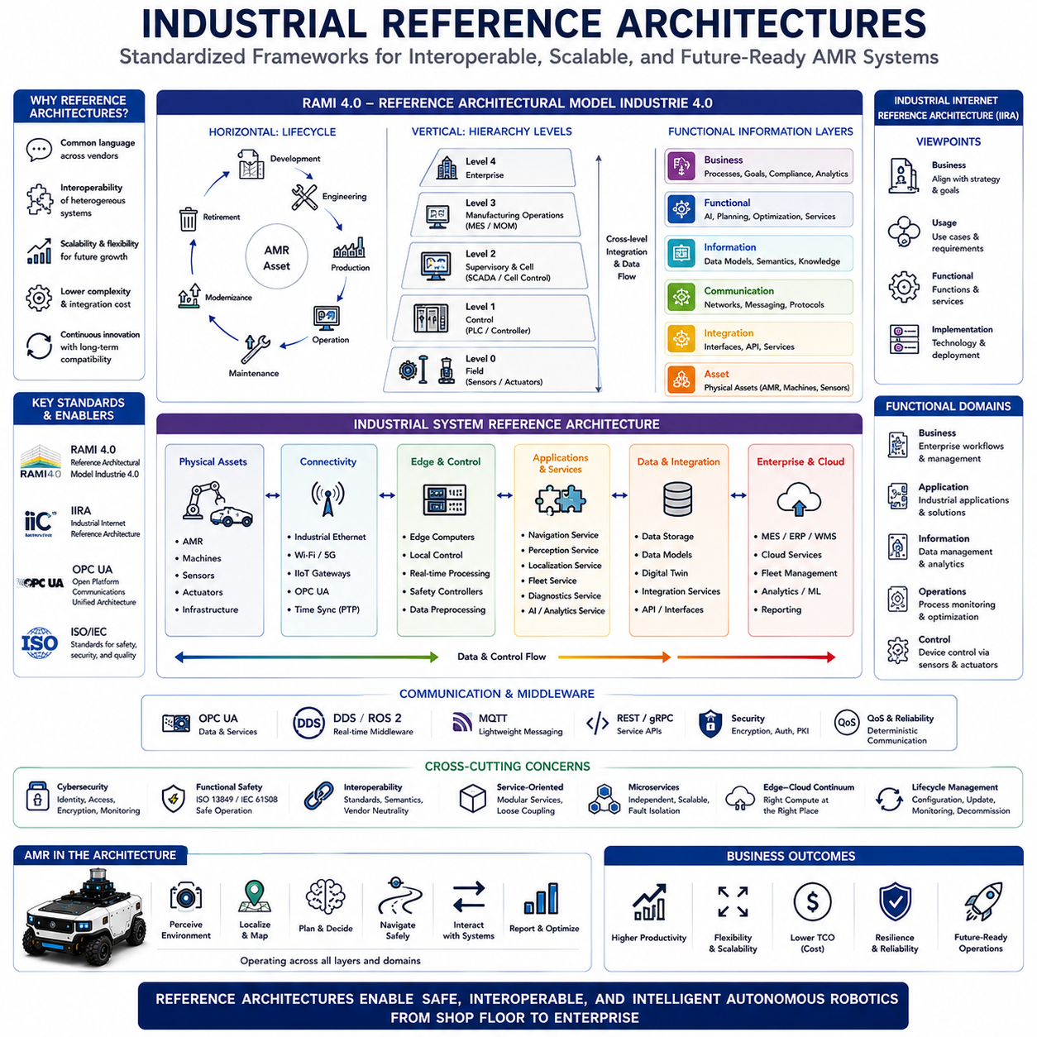
Industrial reference architectures provide standardized system design frameworks that guide the development, integration, deployment, and operation of complex industrial automation systems, including Autonomous Mobile Robots. Rather than defining a single hardware configuration or software implementation, a reference architecture establishes common structural principles, functional layers, communication models, interface definitions, and engineering methodologies that enable interoperability among diverse technologies and vendors. As industrial robotics becomes increasingly connected with cloud computing, artificial intelligence, digital twins, Industrial Internet of Things infrastructures, and enterprise information systems, reference architectures offer a common engineering language that reduces system complexity while improving scalability, maintainability, and long-term compatibility. Modern AMR platforms increasingly adopt these architectural principles to ensure seamless integration with existing industrial ecosystems.
The primary purpose of an industrial reference architecture is to separate concerns by organizing complex systems into logical layers with clearly defined responsibilities. Physical devices, communication infrastructure, control systems, manufacturing execution systems, enterprise resource planning platforms, cloud services, and business applications each operate within specialized architectural domains while interacting through standardized interfaces. This layered organization allows independent evolution of hardware, software, networking, and business systems without disrupting the entire production environment. For autonomous robotics, such architectural separation simplifies system integration while supporting continuous technological advancement throughout the operational lifecycle.
One of the most influential industrial reference architectures is the Reference Architectural Model Industry 4.0, commonly known as RAMI 4.0. Developed within Germany's Industry 4.0 initiative, RAMI 4.0 provides a three-dimensional architectural framework that organizes industrial systems according to lifecycle phases, hierarchical automation levels, and functional information layers. Rather than focusing on specific technologies, RAMI 4.0 establishes a universal conceptual model capable of describing manufacturing assets, digital representations, communication services, information management, business processes, and enterprise integration. Autonomous Mobile Robots naturally fit into this framework as intelligent cyber-physical assets capable of interacting with production equipment, digital services, and factory management systems.
The horizontal dimension of RAMI 4.0 describes the complete lifecycle of industrial assets from product development through engineering, production, operation, maintenance, modernization, and retirement. Every physical asset possesses corresponding digital information that evolves continuously throughout its lifecycle. For AMRs, lifecycle management includes mechanical design, electrical integration, software development, manufacturing, deployment, operational monitoring, predictive maintenance, software updates, fleet optimization, component replacement, and eventual decommissioning. This lifecycle perspective emphasizes that industrial robots are continuously evolving systems rather than static products delivered only once.
The vertical hierarchy within RAMI 4.0 extends traditional industrial automation models by incorporating modern intelligent systems. Individual sensors, actuators, field devices, controllers, workstations, production cells, manufacturing facilities, enterprise management platforms, and cloud services all occupy different hierarchical levels while remaining interconnected through standardized communication. Autonomous Mobile Robots frequently operate across multiple hierarchical levels simultaneously because they physically interact with field devices, coordinate with production systems, exchange information with manufacturing execution systems, and communicate with enterprise-level fleet management and cloud analytics platforms. This cross-layer integration distinguishes modern intelligent robots from conventional industrial machinery.
RAMI 4.0 additionally defines several functional information layers that organize digital capabilities throughout industrial systems. The Asset layer represents physical equipment including robots, sensors, machines, and infrastructure. The Integration layer connects physical assets with digital services through standardized interfaces. The Communication layer provides networking and messaging services. The Information layer manages data models and semantic representations. The Functional layer executes computational services including artificial intelligence, planning, optimization, and analytics. Finally, the Business layer coordinates organizational processes, enterprise objectives, regulatory compliance, and economic decision-making. Together these layers provide a comprehensive framework for integrating autonomous robotic systems within digital manufacturing environments.
Another highly influential industrial architecture is the Industrial Internet Reference Architecture developed by the Industrial Internet Consortium. While RAMI 4.0 primarily emphasizes manufacturing environments, the Industrial Internet Reference Architecture addresses broader industrial cyber-physical systems spanning manufacturing, transportation, healthcare, energy, logistics, infrastructure, and smart cities. The architecture organizes systems according to business, usage, functional, and implementation viewpoints, ensuring that technical solutions remain aligned with operational objectives, stakeholder requirements, and organizational processes. This multidimensional approach provides valuable guidance for deploying autonomous robots across diverse industrial sectors beyond traditional factory automation.
The functional architecture defined by the Industrial Internet Reference Architecture separates industrial systems into control, operations, information, application, and business domains. Control functions interact directly with physical equipment through sensors and actuators. Operational functions supervise industrial processes. Information services manage data storage, analytics, and knowledge representation. Applications deliver specialized industrial capabilities, while business systems coordinate organizational objectives and enterprise workflows. Autonomous Mobile Robots naturally participate within every functional domain because they integrate physical control, autonomous operation, environmental perception, artificial intelligence, fleet coordination, and enterprise logistics into one comprehensive industrial platform.
Open Platform Communications Unified Architecture has become one of the most important industrial communication standards supporting reference architectures across modern manufacturing environments. OPC UA provides secure, platform-independent, service-oriented communication among industrial devices, automation systems, enterprise software, and cloud infrastructure. Beyond simple data transmission, OPC UA defines standardized information models allowing heterogeneous systems to exchange semantically meaningful information rather than isolated communication variables. Autonomous Mobile Robots increasingly employ OPC UA for integration with manufacturing execution systems, programmable logic controllers, supervisory control systems, warehouse management platforms, quality management applications, and enterprise resource planning environments.
Industrial reference architectures increasingly emphasize service-oriented architecture principles rather than tightly coupled system integration. Individual software components expose standardized services accessible through well-defined interfaces independent of implementation details. Navigation services provide route planning capabilities, perception services deliver environmental understanding, localization services estimate robot position, fleet services coordinate multiple robots, diagnostic services supervise system health, and artificial intelligence services support predictive analytics. Service-oriented architectures significantly simplify software evolution because new capabilities can be introduced through additional services without disrupting existing industrial workflows.
Microservice architecture extends service-oriented principles by decomposing complex industrial applications into numerous small, independently deployable software services. Each microservice performs one narrowly defined responsibility while communicating with other services through lightweight communication protocols. Fleet management, mission scheduling, traffic coordination, charging optimization, predictive maintenance, digital twin synchronization, map management, user authentication, and reporting may all execute as separate microservices distributed across cloud infrastructure, edge servers, and onboard computing platforms. This architectural approach improves scalability, fault isolation, continuous deployment, and long-term maintainability throughout large robotic ecosystems.
Edge computing has become an essential architectural component within modern industrial reference architectures because autonomous robots require deterministic local decision-making while simultaneously benefiting from centralized computational resources. Time-critical functions including perception, localization, motion control, collision avoidance, and safety supervision execute onboard with minimal latency. Computationally intensive analytics, machine learning model training, fleet optimization, historical analysis, and enterprise reporting execute within edge servers or cloud infrastructure possessing substantially greater computational capacity. Reference architectures therefore carefully define computational boundaries balancing local autonomy with centralized intelligence according to latency, bandwidth, reliability, and operational safety requirements.
Digital twins represent another major architectural element incorporated into contemporary industrial reference models. Every physical robotic asset possesses a continuously synchronized digital representation containing structural information, operational status, maintenance history, software configuration, environmental context, and performance analytics. Digital twins support predictive maintenance, remote diagnostics, operational optimization, virtual commissioning, simulation-based validation, software testing, and lifecycle management throughout industrial deployments. Rather than functioning solely as visualization tools, digital twins increasingly become active decision-support systems interacting continuously with autonomous robots and enterprise information infrastructure.
Cybersecurity occupies a fundamental position within industrial reference architectures because industrial automation increasingly depends upon interconnected digital systems. Secure communication, authenticated device identity, encrypted information exchange, access control, certificate management, secure software updates, network segmentation, intrusion detection, vulnerability monitoring, and security event management collectively protect industrial operations against unauthorized access and cyber threats. Reference architectures integrate cybersecurity throughout every architectural layer rather than treating it as an isolated protective technology. Autonomous Mobile Robots therefore inherit comprehensive cybersecurity requirements extending across onboard computing, wireless communication, cloud infrastructure, enterprise integration, and operational technology networks.
Functional safety remains equally important within industrial reference architectures because intelligent autonomous systems directly interact with people, industrial machinery, and critical production processes. Safety architectures define redundant sensing, deterministic communication, fault detection, emergency intervention, controlled degradation, safe operational states, and certified control mechanisms ensuring predictable behavior under both normal and abnormal operating conditions. Modern industrial reference architectures increasingly coordinate functional safety with cybersecurity, recognizing that malicious cyber attacks may produce safety-critical consequences equivalent to hardware failures. This integrated perspective supports dependable autonomous operation across complex industrial environments.
One of the greatest strengths of industrial reference architectures is interoperability among heterogeneous technologies. Robots from different manufacturers, industrial sensors, programmable logic controllers, machine vision systems, enterprise databases, warehouse management systems, cloud services, and artificial intelligence platforms can cooperate through standardized interfaces despite independent hardware designs and software implementations. Interoperability reduces vendor lock-in, simplifies system expansion, accelerates technology adoption, and protects long-term industrial investment. Autonomous Mobile Robots therefore become flexible components within evolving digital manufacturing ecosystems rather than isolated automation equipment.
Future industrial reference architectures will increasingly evolve toward highly distributed intelligent ecosystems integrating artificial intelligence, foundation models, collaborative perception, autonomous fleets, edge-cloud orchestration, software-defined manufacturing, digital twins, Industrial Internet of Things infrastructures, and cognitive enterprise systems into unified architectural frameworks. Reference architectures will continue providing stable engineering principles while allowing rapid technological innovation through modular interfaces, standardized communication, semantic interoperability, and scalable system integration. As industrial automation progresses toward fully connected intelligent factories and autonomous supply chains, reference architectures will remain indispensable engineering foundations enabling safe, reliable, interoperable, and continuously evolving Autonomous Mobile Robot systems across global industrial environments.

07.04 AI-Centric Architectures · AI 중심 아키텍처
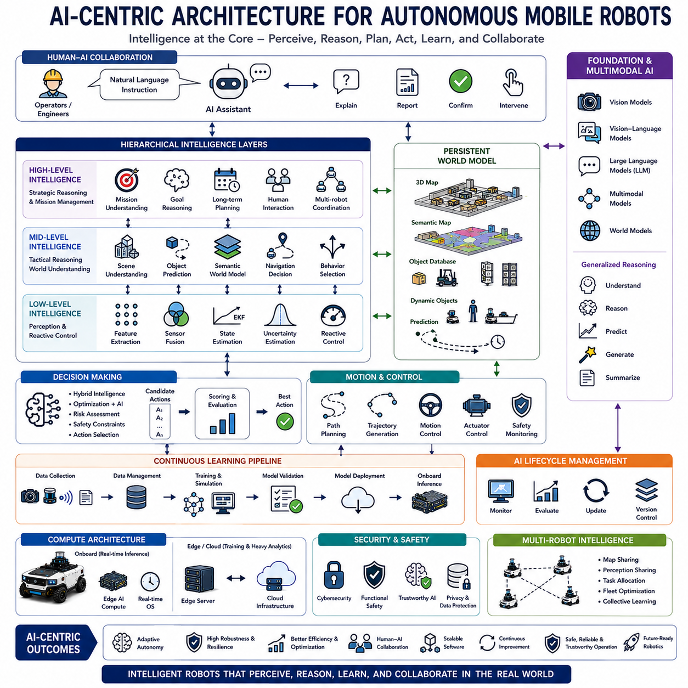
Artificial Intelligence has gradually evolved from being an isolated software component into the central decision-making capability of modern autonomous robotic systems. Traditional robot architectures treated artificial intelligence as an optional module responsible for perception or path planning, while deterministic software managed most operational functions. In contrast, AI-centric architectures position intelligent reasoning at the core of the system, allowing perception, planning, navigation, manipulation, communication, optimization, and human interaction to operate as coordinated cognitive processes. Instead of executing predefined algorithms independently, multiple software modules continuously exchange knowledge through AI models that understand context, predict future events, reason about uncertainty, and generate adaptive behaviors. As Autonomous Mobile Robots become increasingly capable of operating in complex and dynamic environments, AI-centric architectures provide the flexibility, scalability, and learning capability required for long-term autonomous operation.
The primary objective of an AI-centric architecture is to organize every major robotic function around intelligent decision making rather than around individual hardware devices or software modules. Sensor systems continuously observe the environment, localization systems estimate robot pose, perception models interpret surrounding objects, planning algorithms generate possible actions, and control systems execute motion commands. Rather than functioning independently, these components contribute information to shared AI reasoning processes that evaluate environmental conditions, mission objectives, operational constraints, safety requirements, and predicted future states before selecting optimal actions. This integrated intelligence transforms robots from automated machines into adaptive autonomous systems capable of continuously improving operational performance.
Unlike conventional layered architectures that primarily emphasize software modularity, AI-centric architectures introduce hierarchical intelligence operating at multiple cognitive levels. Low-level intelligence processes raw sensor signals, detects features, filters noise, estimates uncertainty, and performs immediate environmental interpretation. Mid-level intelligence integrates multiple perception results, constructs semantic world models, predicts object behavior, and coordinates navigation decisions. High-level intelligence understands mission objectives, optimizes operational efficiency, reasons about long-term goals, interacts with human operators, and coordinates multiple autonomous agents. These hierarchical reasoning layers cooperate continuously, allowing both rapid local reactions and strategic long-term planning within the same autonomous system.
Perception serves as one of the most computationally intensive components within AI-centric architectures. Multiple cameras, LiDARs, radars, ultrasonic sensors, GNSS receivers, IMUs, microphones, and additional sensing modalities simultaneously generate enormous volumes of heterogeneous information. Deep neural networks perform object detection, semantic segmentation, instance segmentation, depth estimation, free-space detection, terrain classification, anomaly detection, and environmental understanding. Rather than relying upon individual sensor outputs, AI models perform multimodal sensor fusion that combines complementary observations into coherent scene representations. This integrated perception provides significantly greater robustness under changing weather, lighting, occlusion, and environmental uncertainty than traditional rule-based sensing pipelines.
World models occupy a central position within many emerging AI-centric robotic architectures. Instead of maintaining only geometric maps, robots construct comprehensive internal representations describing static structures, movable objects, semantic categories, dynamic behaviors, operational constraints, historical observations, and predicted future states. These world models continuously evolve as new sensory information becomes available. Artificial intelligence reasons directly upon these structured representations when selecting navigation routes, planning inspection sequences, avoiding hazards, coordinating multiple robots, and anticipating future environmental changes. Such persistent environmental understanding enables significantly more intelligent decision making than isolated frame-by-frame perception.
Foundation Models are becoming foundational computational engines within next-generation AI-centric robotic architectures. Large Vision Models, Vision-Language Models, Large Language Models, Multimodal Foundation Models, and World Models provide generalized reasoning capabilities that extend beyond narrowly trained perception networks. Rather than training separate models for every individual robotic function, a single foundation model can interpret instructions, analyze images, understand spatial relationships, answer operator questions, generate navigation strategies, summarize operational events, and assist with maintenance diagnostics. This unified intelligence dramatically simplifies software architecture while expanding the range of cognitive capabilities available to autonomous robots.
Multimodal reasoning represents another defining characteristic of AI-centric architectures. Modern robots no longer process vision, language, maps, sensor measurements, and mission objectives independently. Instead, multimodal models jointly analyze visual observations, spoken commands, textual documentation, CAD models, digital twins, localization information, environmental measurements, and historical operational data. Integrated reasoning across multiple information sources enables robots to understand complex industrial environments more naturally while supporting richer interactions with human operators. Multimodal intelligence also improves robustness because complementary information sources compensate for missing or unreliable sensor observations.
Decision-making within AI-centric architectures increasingly combines traditional optimization algorithms with machine learning. Classical graph search, probabilistic planning, model predictive control, optimization theory, and deterministic safety verification remain highly effective for mathematically structured problems. Artificial intelligence complements these methods by predicting uncertain environmental behavior, estimating semantic context, evaluating operational risk, generating candidate solutions, and adapting strategies through experience. Hybrid architectures therefore combine the mathematical guarantees of traditional robotics with the adaptive learning capabilities of modern artificial intelligence, achieving significantly greater robustness than either approach independently.
Learning occupies a continuous role throughout AI-centric robotic systems rather than ending after offline model training. Robots accumulate operational experience during deployment by observing environmental changes, monitoring task performance, evaluating prediction accuracy, identifying failure cases, and recording operator interventions. These operational datasets support continual learning, incremental model improvement, active learning, reinforcement learning, and domain adaptation. Although safety-critical decision making typically relies upon validated models during deployment, collected operational knowledge continuously improves future software versions through structured machine learning pipelines integrated within the broader robotic development lifecycle.
AI-centric architectures increasingly separate inference from training while maintaining close interaction between both computational processes. Edge computers onboard autonomous robots execute optimized inference models providing real-time perception, localization, navigation, and decision making under strict latency constraints. Cloud infrastructure, edge servers, and high-performance computing clusters perform computationally intensive model training, hyperparameter optimization, large-scale simulation, synthetic data generation, validation, and model deployment. This distributed architecture balances deterministic onboard performance with virtually unlimited centralized computational resources, enabling continuous advancement of robotic intelligence without compromising operational safety.
Explainability has become an essential architectural requirement as artificial intelligence assumes greater responsibility for autonomous decision making. Industrial operators, maintenance engineers, safety inspectors, and regulatory authorities increasingly require understandable explanations describing why specific actions were selected. Explainable AI mechanisms record perception confidence, reasoning pathways, prediction uncertainty, planning alternatives, decision priorities, and supporting evidence throughout autonomous operation. Rather than functioning as opaque black boxes, AI systems become transparent cognitive assistants whose reasoning processes can be inspected, audited, validated, and continuously improved during industrial deployment.
Trustworthy artificial intelligence represents another critical design principle within AI-centric architectures. Reliable autonomous operation requires robust handling of uncertainty, anomaly detection, confidence estimation, fault isolation, out-of-distribution detection, adversarial robustness, cybersecurity protection, functional safety integration, and ethical decision constraints. AI systems must recognize situations beyond their competence, request human assistance when necessary, degrade gracefully under unexpected conditions, and maintain predictable behavior despite sensor failures or environmental uncertainty. Consequently, trustworthy AI extends far beyond prediction accuracy and becomes an integrated architectural property spanning perception, reasoning, communication, control, and lifecycle management.
Human-AI collaboration is becoming increasingly important as industrial robots operate alongside engineers, technicians, inspectors, and production personnel. Rather than replacing human expertise, AI-centric architectures provide intelligent decision support that augments human capabilities. Operators may issue natural language instructions, request operational explanations, modify mission priorities, validate inspection results, or intervene during exceptional situations. Artificial intelligence interprets human intent, translates high-level objectives into executable robotic behaviors, continuously reports operational progress, and adapts plans according to changing production requirements. This collaborative interaction improves productivity while maintaining appropriate levels of human oversight.
Digital twins closely complement AI-centric architectures by providing continuously synchronized virtual representations supporting simulation, prediction, optimization, and validation. Artificial intelligence analyzes both real-world observations and simulated future scenarios before selecting operational strategies. Candidate navigation routes, fleet schedules, maintenance plans, inspection sequences, and production workflows can be evaluated virtually before execution within physical environments. This predictive capability significantly reduces operational risk while enabling optimization based upon both current observations and anticipated future conditions.
Multi-robot intelligence represents another emerging capability enabled by AI-centric architectures. Individual robots no longer function as isolated autonomous agents but instead cooperate through distributed artificial intelligence sharing maps, perception results, localization estimates, operational experiences, mission assignments, and environmental knowledge. Collective intelligence enables collaborative exploration, distributed inspection, coordinated logistics, adaptive traffic management, and resilient mission execution even when individual robots experience failures or communication interruptions. Shared learning across fleets further accelerates continuous improvement because operational knowledge acquired by one robot becomes immediately available to all compatible platforms.
Modern AI-centric architectures increasingly employ software-defined robotics principles that separate intelligent behavior from hardware implementation. Perception models, planning strategies, language understanding, mission logic, safety policies, fleet coordination algorithms, and digital twin synchronization execute as modular software services independent of specific robotic platforms. Standardized interfaces allow identical AI services to operate across different mobile robots, manipulators, industrial vehicles, and collaborative robotic systems. This abstraction greatly improves software portability while reducing engineering effort across diverse robotic product families.
Future AI-centric robotic architectures will evolve toward fully cognitive autonomous systems built upon multimodal foundation models, persistent world models, distributed intelligence, collaborative perception, edge-cloud orchestration, lifelong learning, trustworthy AI, digital twins, and large-scale autonomous fleet coordination. Rather than viewing perception, planning, control, communication, and learning as separate software modules, future architectures will integrate these capabilities into unified intelligent reasoning systems capable of understanding complex environments, adapting continuously to changing conditions, collaborating naturally with humans, and optimizing industrial operations throughout the complete lifecycle of autonomous robotic platforms.

07.05 Outdoor Autonomous Platform Models · 실외 자율 플랫폼 모델
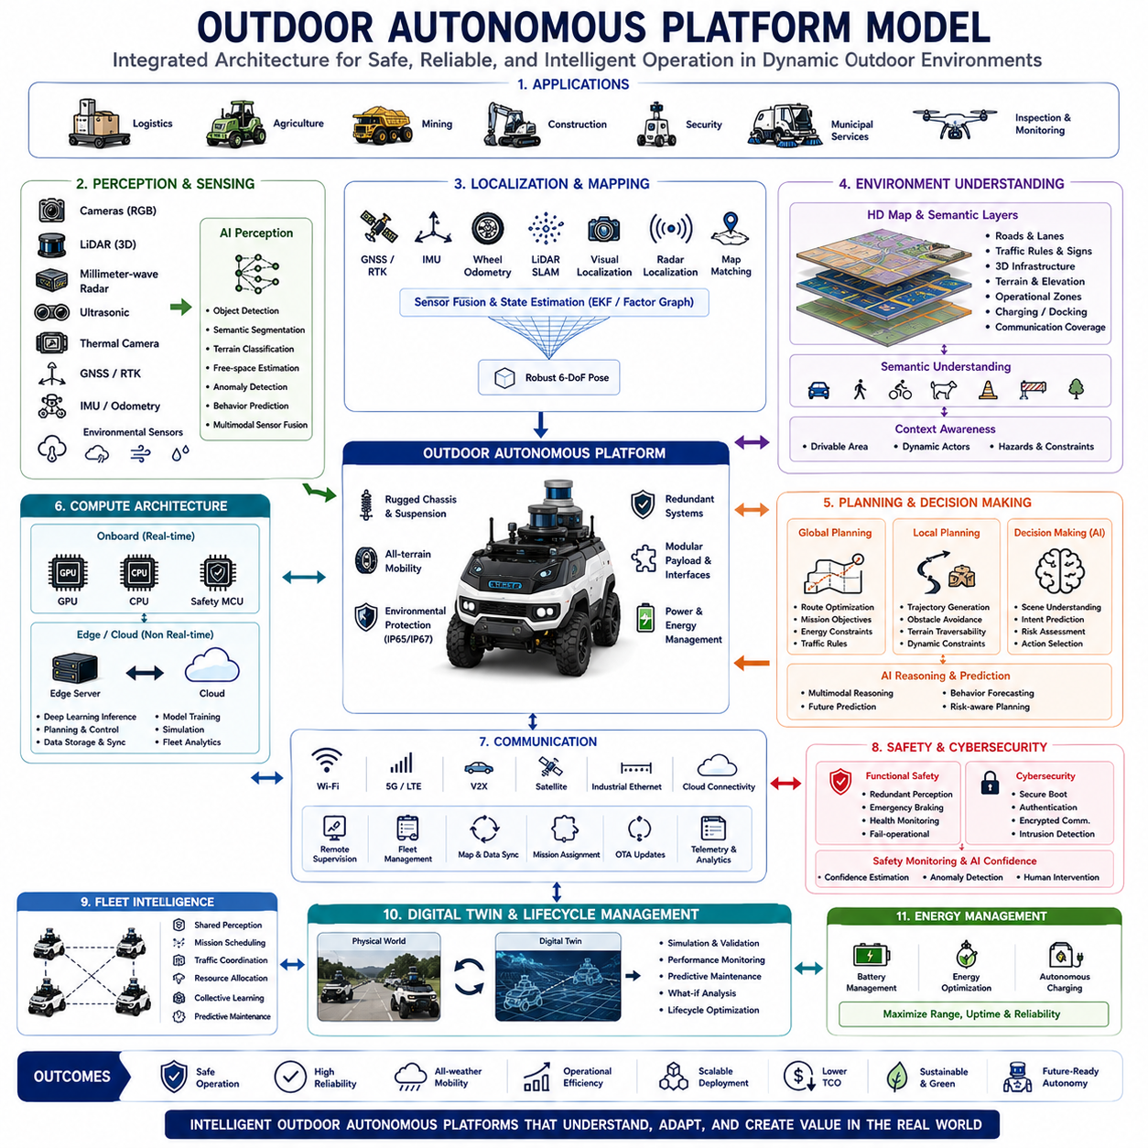
Outdoor autonomous platforms represent one of the most challenging applications of modern robotics because they must operate safely, reliably, and efficiently within highly dynamic environments that cannot be fully controlled or predicted. Unlike indoor Autonomous Mobile Robots that navigate structured factory floors or warehouses, outdoor autonomous platforms continuously encounter changing terrain, weather conditions, natural obstacles, moving vehicles, pedestrians, animals, vegetation, construction zones, and complex traffic situations. Consequently, outdoor robotic systems require significantly more sophisticated system architectures integrating perception, localization, navigation, environmental understanding, artificial intelligence, functional safety, and high-performance computing into a unified autonomous platform capable of adapting to continuously changing operational conditions.
An outdoor autonomous platform is not simply a mobile robot equipped with additional sensors. It represents a complete cyber-physical system integrating mechanical engineering, electrical engineering, embedded computing, artificial intelligence, communication networks, cloud infrastructure, and operational software into a coordinated autonomous ecosystem. The platform must simultaneously manage vehicle dynamics, environmental perception, mission execution, energy management, health monitoring, cybersecurity, functional safety, and interaction with external infrastructure. Successful outdoor autonomy therefore depends on balanced system integration rather than excellence within any individual subsystem.
Outdoor autonomous platforms are designed for a wide variety of industrial applications. Logistics robots transport materials across industrial campuses and distribution centers. Agricultural robots perform precision farming, crop monitoring, and autonomous harvesting. Mining vehicles operate within hazardous environments while reducing human exposure to dangerous conditions. Construction robots conduct surveying, inspection, transportation, and site monitoring. Security robots patrol large facilities, airports, ports, military bases, and critical infrastructure. Municipal service robots perform street cleaning, waste collection, snow removal, and environmental monitoring. Although these applications differ significantly, they share common architectural principles supporting reliable autonomous mobility under highly variable outdoor conditions.
The mechanical platform forms the physical foundation supporting every autonomous capability. Outdoor mobile robots generally employ four-wheel, six-wheel, tracked, articulated, skid-steering, or omnidirectional drive configurations depending upon terrain characteristics and operational objectives. Suspension systems absorb terrain irregularities while maintaining wheel contact and vehicle stability. Ground clearance, wheelbase, approach angle, departure angle, payload distribution, structural rigidity, environmental protection, and vibration isolation directly influence operational capability across uneven terrain. Mechanical architecture therefore strongly determines mobility performance before software algorithms become involved.
Vehicle dynamics become considerably more complex outdoors than within controlled indoor environments. Autonomous platforms must continuously compensate for wheel slip, loose gravel, mud, sand, snow, ice, steep slopes, water accumulation, uneven surfaces, potholes, and variable tire-ground friction. Dynamic control systems estimate vehicle stability, wheel traction, lateral acceleration, yaw motion, roll angle, and braking performance while adapting steering and speed accordingly. Modern outdoor platforms increasingly integrate model-based control with artificial intelligence to predict terrain behavior before instability develops, significantly improving both safety and mobility.
Localization represents one of the most critical architectural challenges for outdoor autonomy. Unlike indoor robots relying primarily upon simultaneous localization and mapping, outdoor systems combine multiple complementary positioning technologies. Global Navigation Satellite Systems provide global positioning, while Real-Time Kinematic corrections improve centimeter-level accuracy under favorable satellite visibility. Inertial Measurement Units maintain short-term position estimates during satellite degradation. Wheel odometry estimates incremental motion, while LiDAR-based localization, visual localization, radar localization, landmark recognition, and map matching provide additional robustness when satellite signals become unreliable. Modern outdoor platforms continuously fuse these heterogeneous localization sources into unified state estimates capable of maintaining reliable navigation across highly diverse operating conditions.
Environmental perception requires significantly greater sensing diversity than indoor robotics because outdoor environments exhibit enormous variability. Multiple cameras observe visual appearance under changing illumination. LiDAR sensors generate detailed three-dimensional geometric structure independent of lighting conditions. Millimeter-wave radar provides reliable detection during rain, fog, dust, and snow while measuring object velocity directly. Ultrasonic sensors support short-range obstacle avoidance. Thermal cameras detect humans and animals during darkness or low visibility. Environmental sensors monitor temperature, humidity, precipitation, wind, air quality, and surface conditions. Artificial intelligence continuously fuses these complementary sensing modalities into comprehensive environmental understanding that remains reliable despite changing weather and environmental uncertainty.
Semantic perception has become increasingly important within outdoor autonomous platforms because geometric obstacle detection alone cannot support intelligent decision making. Artificial intelligence identifies roads, sidewalks, vegetation, buildings, construction barriers, traffic signs, lane markings, intersections, pedestrians, cyclists, parked vehicles, moving vehicles, animals, and temporary obstacles while understanding their semantic meaning and expected behavior. Context-aware perception enables autonomous platforms to distinguish between safely traversable terrain, restricted operational zones, hazardous areas, temporary obstacles, and dynamic traffic participants. Such semantic understanding significantly improves navigation quality beyond purely geometric path planning.
Navigation within outdoor environments involves considerably greater complexity than simple obstacle avoidance. Global route planning selects efficient travel corridors using road networks, digital maps, terrain information, operational priorities, energy constraints, and mission objectives. Local planning continuously adjusts trajectories according to newly observed obstacles, dynamic traffic, terrain conditions, safety constraints, and vehicle dynamics. Motion planning simultaneously considers curvature limits, stopping distance, terrain traversability, actuator limitations, passenger comfort when applicable, and operational efficiency. Hierarchical planning architectures coordinate strategic route optimization with real-time reactive obstacle avoidance while maintaining overall mission objectives.
High-definition maps increasingly serve as foundational knowledge representations within advanced outdoor autonomous platforms. Rather than containing only road geometry, modern digital maps include lane boundaries, traffic rules, speed limits, semantic landmarks, three-dimensional infrastructure models, road surface characteristics, elevation profiles, docking stations, charging facilities, operational restrictions, communication coverage, and historical environmental observations. Artificial intelligence continuously compares live sensor observations against these digital maps to improve localization accuracy, detect environmental changes, identify temporary hazards, and update operational knowledge throughout long-term deployment.
Artificial intelligence now occupies the central decision-making role within many outdoor autonomous platform architectures. Deep neural networks perform perception, semantic segmentation, object detection, free-space estimation, terrain classification, anomaly detection, behavior prediction, and scene understanding. Foundation Models increasingly support multimodal reasoning by integrating visual observations, maps, operational instructions, historical experience, and environmental context into unified cognitive representations. Rather than solving isolated perception tasks independently, AI coordinates multiple autonomous functions through comprehensive environmental reasoning that continuously predicts future situations before selecting optimal operational strategies.
Edge computing enables real-time autonomous decision making despite the enormous computational demands of modern artificial intelligence. High-performance GPUs execute deep neural network inference onboard while dedicated embedded processors supervise deterministic vehicle control, sensor synchronization, communication management, and safety monitoring. Computational workloads are distributed according to latency requirements, ensuring that time-critical perception, localization, obstacle avoidance, and vehicle control execute locally while computationally intensive optimization, fleet coordination, model training, and digital twin simulation execute within edge servers or cloud infrastructure. This distributed architecture balances real-time responsiveness with scalable computational capability.
Communication architecture plays an increasingly important role as outdoor autonomous platforms become connected members of larger intelligent transportation ecosystems. Wireless technologies including Wi-Fi, private 5G, cellular communication, satellite communication, industrial Ethernet, Vehicle-to-Everything communication, and cloud connectivity support fleet coordination, remote supervision, software updates, map synchronization, mission assignment, predictive maintenance, and operational analytics. Communication systems must tolerate intermittent connectivity while ensuring that essential autonomous capabilities continue operating safely even during complete network loss. Consequently, outdoor platforms prioritize operational independence while leveraging connected infrastructure whenever available.
Functional safety and cybersecurity are deeply integrated throughout outdoor autonomous platform architectures because failures may directly threaten human safety and critical infrastructure. Redundant perception, independent emergency braking, health monitoring, diagnostic systems, fail-operational computing, redundant communication channels, secure authentication, encrypted communication, intrusion detection, secure software updates, and continuous system verification collectively ensure dependable autonomous operation. Artificial intelligence additionally estimates operational confidence, detects anomalous environmental conditions, identifies sensor degradation, and requests human intervention whenever autonomous confidence falls below acceptable safety thresholds.
Fleet intelligence extends autonomous capability beyond individual vehicles by enabling cooperative operation among multiple outdoor platforms. Shared perception allows robots to exchange environmental observations and obstacle information. Fleet management optimizes mission scheduling, charging operations, traffic coordination, maintenance planning, and resource allocation across large operational deployments. Collective learning enables operational experience acquired by one platform to improve decision-making across the entire fleet. Distributed intelligence therefore transforms independent autonomous vehicles into coordinated robotic ecosystems capable of solving complex industrial missions collaboratively.
Digital twins provide continuously synchronized virtual representations supporting lifecycle management, simulation, predictive maintenance, and operational optimization throughout outdoor autonomous deployments. Engineers evaluate software updates, navigation strategies, energy consumption, mission planning, hardware modifications, and environmental scenarios within simulation before physical implementation. Operational telemetry continuously updates digital twin models, allowing artificial intelligence to predict component failures, estimate remaining useful life, optimize maintenance scheduling, and evaluate future operational strategies. This integration significantly reduces operational risk while supporting continuous platform improvement throughout extended deployment periods.
Future outdoor autonomous platform models will increasingly evolve toward software-defined, AI-centric, foundation-model-driven robotic ecosystems integrating multimodal perception, persistent world models, collaborative intelligence, digital twins, edge-cloud orchestration, lifelong learning, and autonomous fleet coordination into unified cognitive architectures. Rather than functioning as isolated mobile machines, outdoor autonomous platforms will become intelligent infrastructure participants capable of understanding complex environments, cooperating naturally with humans and other autonomous systems, adapting continuously to changing operational conditions, and optimizing industrial, commercial, agricultural, and public service operations throughout the complete lifecycle of autonomous mobility.

