Volume 01. AMR Foundations and System Architecture

04. AMR Industry Landscape · AMR 산업 현황

04.01 Global AMR Market · 글로벌 AMR 시장
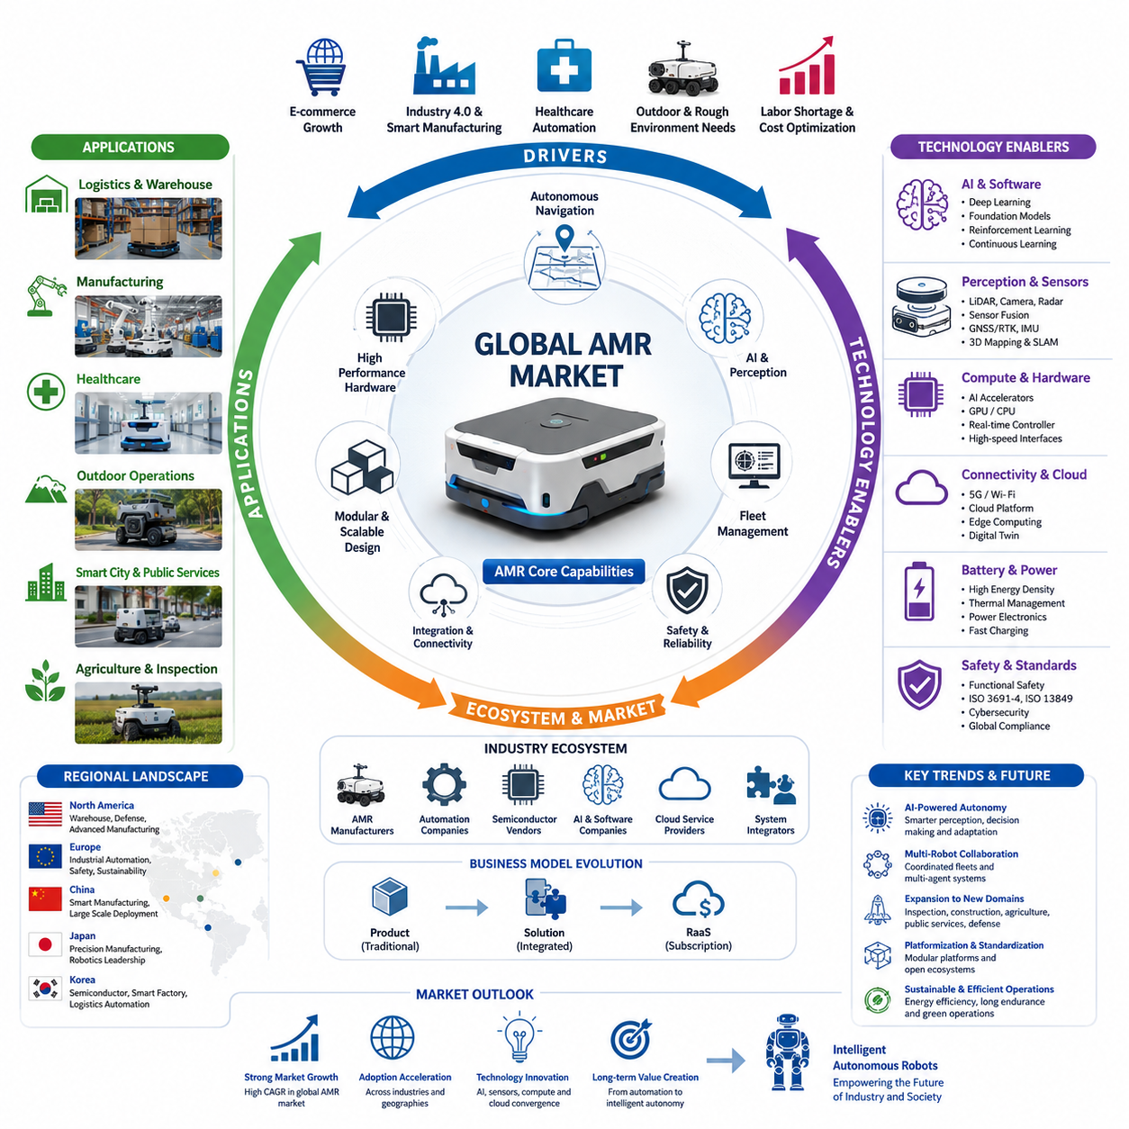
The global Autonomous Mobile Robot (AMR) market has evolved from a niche automation segment into one of the fastest-growing sectors within industrial robotics. Unlike traditional Automated Guided Vehicles (AGVs), which depend on predefined paths and fixed infrastructure, AMRs employ simultaneous localization and mapping (SLAM), sensor fusion, artificial intelligence, and dynamic path planning to operate safely in changing environments. These capabilities significantly reduce installation complexity while increasing operational flexibility, allowing organizations to deploy robots with minimal modifications to existing facilities. As digital transformation accelerates across manufacturing, logistics, healthcare, retail, construction, and public infrastructure, AMRs are increasingly recognized as strategic assets rather than simple material transport machines. Their ability to integrate with enterprise software, cloud platforms, and industrial Internet of Things (IIoT) ecosystems further expands their role in modern automation architectures.
The expansion of e-commerce has become one of the strongest drivers of global AMR adoption. Online retailers and third-party logistics providers face continuous pressure to process growing order volumes while maintaining high delivery speed and accuracy. Warehouses increasingly require automation systems capable of adapting to seasonal demand fluctuations, rapidly changing inventory layouts, and varying order profiles. AMRs provide flexible transport, autonomous picking assistance, inventory movement, and intelligent replenishment without requiring expensive conveyor installations or fixed guide paths. Their ability to collaborate with human workers improves productivity while reducing physical workloads, making them particularly attractive for fulfillment centers operating around the clock. As consumer expectations continue to rise, logistics companies view AMRs as an essential technology for scalable warehouse automation rather than an optional productivity enhancement.
Manufacturing industries are experiencing a similar transformation as factories pursue higher levels of flexibility under Industry 4.0 initiatives. Modern production environments increasingly shift from mass production toward high-mix, low-volume manufacturing, requiring material transport systems that can adapt quickly to changing production schedules. AMRs support just-in-time delivery of components, autonomous work-in-progress transportation, intelligent line feeding, and synchronized collaboration with robotic workcells. Integration with Manufacturing Execution Systems (MES), Enterprise Resource Planning (ERP), Warehouse Management Systems (WMS), and digital twins enables robots to optimize logistics based on real-time production status. Instead of functioning as isolated transport equipment, AMRs become active participants in cyber-physical production systems capable of responding autonomously to manufacturing changes and operational disturbances.
Healthcare has emerged as another important growth sector for AMRs because hospitals require continuous movement of medicine, laboratory samples, meals, sterile equipment, and medical waste throughout complex facilities. Healthcare AMRs reduce repetitive manual transportation tasks while minimizing staff exposure to infectious environments. Modern hospital robots can automatically call elevators, open secure doors, navigate crowded hallways, and coordinate deliveries across multiple departments. Integration with hospital information systems allows robots to prioritize urgent deliveries and maintain complete transportation records for sensitive materials. As healthcare organizations seek greater operational efficiency while addressing workforce shortages, AMRs increasingly contribute to both patient safety and resource optimization without disrupting existing medical workflows.
Outdoor autonomous mobile robots represent one of the fastest-expanding segments of the AMR market. Unlike indoor robots operating within structured facilities, outdoor AMRs must navigate complex terrain, varying weather conditions, uneven surfaces, changing illumination, and dynamic interactions with vehicles and pedestrians. Applications include security patrol, industrial inspection, construction monitoring, mining operations, agricultural automation, airport logistics, railway inspection, utility maintenance, smart city services, and defense support. Outdoor robots require more sophisticated localization techniques that combine GNSS, RTK positioning, LiDAR SLAM, visual localization, inertial navigation, radar sensing, and semantic mapping. Consequently, outdoor AMRs demand higher computing performance, more robust mechanical platforms, enhanced environmental protection, and significantly more advanced perception algorithms than indoor systems.
The competitive landscape of the AMR industry spans specialized robotics companies, industrial automation suppliers, automotive manufacturers, semiconductor vendors, cloud computing providers, and artificial intelligence companies. Traditional robotics manufacturers contribute decades of expertise in industrial automation and safety-certified hardware, while newer startups introduce innovative navigation algorithms, cloud-native fleet management platforms, and AI-driven perception technologies. Semiconductor companies accelerate development by providing increasingly powerful embedded AI processors capable of executing large neural networks with low latency and energy consumption. Cloud providers enable large-scale fleet coordination, predictive maintenance, remote software deployment, and continuous data analytics. The convergence of these industries creates an ecosystem in which software innovation becomes as important as mechanical engineering for long-term competitiveness.
Regional differences significantly influence AMR market development. North America continues to emphasize warehouse automation, advanced manufacturing, defense robotics, and cloud-connected autonomous systems. Europe focuses heavily on industrial automation, functional safety, collaborative robotics, and sustainability-driven manufacturing practices. China has rapidly expanded both manufacturing capacity and domestic robot deployment through aggressive investment in intelligent manufacturing, strong local supply chains, and government-supported automation initiatives. Japan maintains leadership in precision manufacturing and robotics engineering while integrating AMRs into highly automated production environments. South Korea continues to strengthen its position through semiconductor manufacturing, smart factories, logistics automation, and service robotics, supported by strong expertise in electronics, communication technologies, and industrial software. These regional strengths collectively drive rapid technological evolution while intensifying global competition.
The evolution of artificial intelligence has fundamentally changed AMR capabilities beyond conventional navigation. Earlier generations of robots primarily executed deterministic algorithms with limited adaptability, whereas modern AMRs increasingly employ deep learning, reinforcement learning, multimodal perception, foundation models, and large language models to improve environmental understanding and autonomous decision-making. AI enables robots to recognize complex scenes, understand semantic context, predict human movement, classify obstacles, estimate traversability, and optimize mission execution based on accumulated operational experience. Continuous learning frameworks further allow robots to improve performance through fleet-wide data collection, creating systems that become progressively more capable as deployment scales increase across multiple customer environments.
Fleet management has become one of the defining characteristics separating enterprise AMR platforms from standalone mobile robots. Large industrial deployments frequently involve dozens or hundreds of robots operating simultaneously across extensive facilities. Fleet Management Systems (FMS) coordinate task allocation, traffic control, congestion avoidance, charging schedules, maintenance planning, software updates, and operational analytics. Advanced scheduling algorithms optimize robot utilization while minimizing idle time and energy consumption. Cloud connectivity allows operators to monitor geographically distributed robot fleets from centralized control centers, enabling predictive maintenance and operational optimization through large-scale data analysis. Fleet intelligence therefore represents a major source of competitive differentiation within the global AMR industry.
The hardware architecture of modern AMRs continues to evolve alongside advances in semiconductor technology. High-performance embedded GPUs, dedicated AI accelerators, multi-core CPUs, real-time controllers, and high-bandwidth sensor interfaces enable increasingly sophisticated perception and planning algorithms to execute directly on the robot. Modern platforms integrate multiple LiDARs, RGB cameras, depth cameras, radar, ultrasonic sensors, GNSS receivers, inertial measurement units, wheel encoders, and environmental sensors into unified perception systems. Improvements in battery technology, thermal management, power electronics, and industrial networking further increase operational endurance while supporting continuous high-performance computation under demanding environmental conditions. These hardware advances provide the foundation for the next generation of intelligent autonomous systems.
Business models within the AMR industry have also diversified significantly. Rather than selling robots solely as capital equipment, many vendors now provide Robotics-as-a-Service (RaaS), allowing customers to adopt automation with lower initial investment and predictable operational costs. Subscription-based software platforms generate recurring revenue through fleet management, cloud analytics, predictive maintenance, cybersecurity updates, digital twin services, and AI model improvements. This transition from hardware-centric sales toward integrated hardware-software-service ecosystems creates stronger long-term customer relationships while encouraging continuous platform evolution. For customers, the subscription model reduces financial barriers and accelerates deployment of advanced automation technologies across multiple operational sites.
Safety remains a critical factor influencing worldwide AMR adoption. Industrial robots increasingly operate alongside human workers in shared environments, requiring comprehensive functional safety architectures that combine redundant sensing, emergency braking, speed adaptation, protective field monitoring, fault diagnostics, and cybersecurity protections. International safety standards continue evolving to address collaborative robot operation, autonomous navigation, wireless communication security, and AI-assisted decision-making. Regulatory compliance not only protects workers but also increases customer confidence, making certified safety performance a significant competitive advantage for commercial AMR manufacturers entering global markets.
Looking toward the future, the global AMR market is expected to evolve from isolated mobile transportation systems into comprehensive embodied intelligence platforms capable of perception, reasoning, manipulation, communication, and collaborative decision-making. Foundation models, multimodal AI, cloud robotics, digital twins, edge computing, and multi-agent coordination will increasingly merge into unified robot architectures capable of continuous adaptation across diverse environments. AMRs will expand beyond logistics to perform inspection, maintenance, infrastructure management, construction support, agricultural operations, public services, healthcare assistance, and autonomous industrial collaboration. As artificial intelligence becomes more deeply integrated into robotic platforms, the distinction between autonomous mobility and intelligent physical work will gradually disappear, positioning AMRs as foundational components of the next generation of intelligent industrial ecosystems.

04.02 Major AMR Companies · 주요 AMR 기업
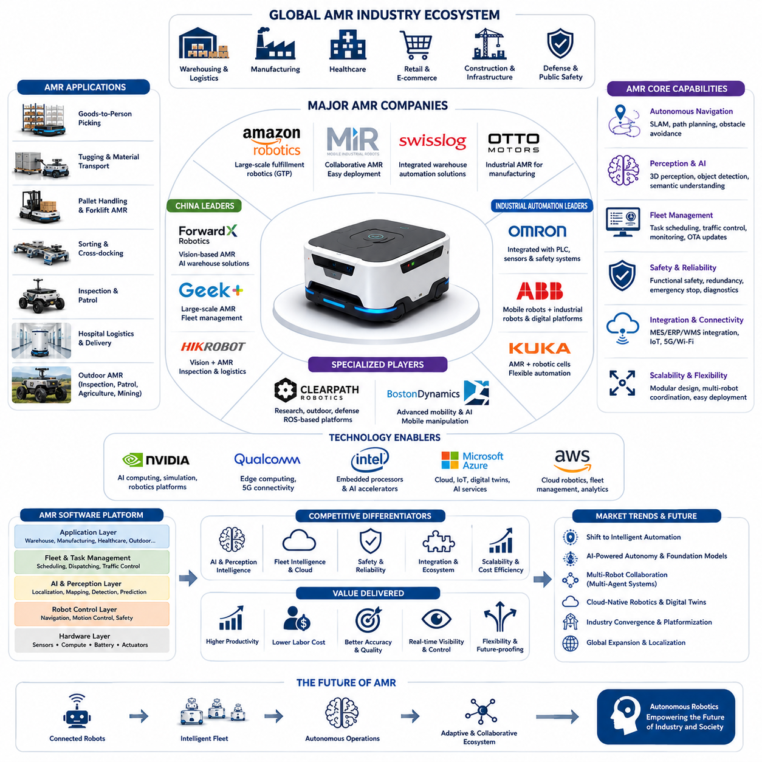
The Autonomous Mobile Robot (AMR) industry has evolved into a highly competitive global ecosystem composed of robotics manufacturers, industrial automation companies, artificial intelligence developers, semiconductor vendors, cloud service providers, and system integration specialists. Unlike the early years of mobile robotics, where companies primarily differentiated themselves through mechanical design, today's leading AMR vendors compete through integrated software platforms, autonomous navigation intelligence, fleet management capabilities, perception algorithms, AI-powered decision making, and complete lifecycle services. Success in the global AMR market increasingly depends on delivering an end-to-end autonomous solution that combines reliable hardware with continuously evolving software, cloud connectivity, and scalable deployment architectures. As a result, competition has shifted from selling individual robots to providing intelligent robotic ecosystems capable of supporting enterprise-wide automation initiatives.
One of the most influential companies in warehouse robotics is Amazon Robotics, whose large-scale deployment of autonomous mobile robots has transformed global fulfillment operations. Originally developed through the acquisition of Kiva Systems, Amazon's robotic platform focuses on goods-to-person logistics, where mobile robots transport storage racks directly to human operators or automated picking stations. The system significantly reduces travel time, increases warehouse density, and optimizes order fulfillment efficiency. Beyond simple transportation, Amazon continuously develops AI-based scheduling, inventory optimization, robot coordination, and warehouse simulation technologies. The company's vertically integrated approach demonstrates how robotics can become a strategic competitive advantage when tightly coupled with logistics software and cloud-scale operational data.
In Europe, companies such as Mobile Industrial Robots (MiR) have established strong leadership in collaborative industrial logistics. MiR specializes in flexible AMRs designed for manufacturing facilities, hospitals, laboratories, and logistics centers where robots must safely operate alongside human workers. Their navigation systems combine LiDAR-based localization, obstacle avoidance, dynamic route planning, and user-friendly fleet management software that allows rapid deployment without extensive infrastructure modification. MiR emphasizes ease of integration with existing production systems, enabling manufacturers to automate internal logistics incrementally while minimizing operational disruption. This modular deployment strategy has made collaborative AMRs attractive to organizations beginning their automation journey.
Swisslog represents another important player by integrating AMRs into comprehensive warehouse automation solutions. Rather than focusing solely on mobile robots, Swisslog combines autonomous transport, automated storage and retrieval systems, robotic picking, conveyor technologies, and warehouse management software into unified logistics platforms. This system-level approach enables customers to optimize complete warehouse workflows instead of isolated transportation tasks. Advanced software coordinates robots, conveyors, elevators, and inventory databases in real time, demonstrating how AMRs become significantly more valuable when integrated into broader automation ecosystems rather than operating independently.
OTTO Motors has gained international recognition by concentrating on industrial material handling within manufacturing environments. Its autonomous vehicles transport raw materials, components, finished products, and production equipment across complex factory floors while interacting seamlessly with Manufacturing Execution Systems, Enterprise Resource Planning platforms, and industrial control systems. OTTO emphasizes reliable autonomous navigation in dynamic industrial environments where forklifts, workers, and other equipment continuously change traffic conditions. By combining robust perception with industrial-grade reliability, OTTO demonstrates the importance of operational stability for mission-critical manufacturing applications.
ForwardX Robotics has emerged as one of China's most prominent AMR companies by leveraging computer vision, AI perception, and intelligent warehouse automation. Unlike navigation systems relying primarily on infrastructure modifications, ForwardX emphasizes vision-based localization, large-scale fleet coordination, and AI-driven warehouse optimization. The company's solutions support order fulfillment, inventory transportation, and autonomous logistics across rapidly expanding e-commerce operations. China's extensive manufacturing capabilities, highly competitive supply chains, and strong domestic demand have enabled companies such as ForwardX to scale rapidly while continuously improving both hardware cost efficiency and AI software capabilities.
Geek+ has become one of the world's largest providers of warehouse AMRs by deploying robots across thousands of logistics facilities worldwide. The company offers autonomous solutions for shelf transportation, picking assistance, sorting, pallet movement, and warehouse inventory management. Its product portfolio supports multiple robot types operating under unified fleet management software capable of coordinating hundreds or even thousands of robots simultaneously. Geek+ demonstrates how scalable software architecture becomes increasingly important as warehouse automation expands beyond individual robots toward fully coordinated autonomous logistics systems.
Hikrobot, a subsidiary within China's broader industrial technology ecosystem, combines machine vision expertise with autonomous mobile robotics to provide integrated manufacturing and logistics automation. The company leverages its strengths in industrial cameras, machine vision algorithms, barcode recognition, and AI inspection technologies to enhance robot perception capabilities. This integration enables AMRs not only to transport materials but also to perform automated identification, quality verification, inventory inspection, and production traceability during transportation tasks. Such convergence illustrates the growing relationship between industrial vision systems and autonomous robotics.
Omron has incorporated AMRs into its broader industrial automation portfolio by integrating mobile robots with programmable logic controllers, industrial sensors, machine safety systems, and factory automation software. Rather than positioning AMRs as standalone products, Omron emphasizes coordinated automation where mobile robots interact directly with robotic arms, assembly stations, conveyors, and production equipment. This unified architecture supports synchronized manufacturing workflows that maximize productivity while maintaining strict industrial safety requirements. The company's long history in industrial control engineering provides significant advantages in integrating autonomous mobility with existing manufacturing infrastructure.
ABB, one of the world's largest industrial automation companies, has also expanded its robotics portfolio to include autonomous mobile robots that cooperate with industrial manipulators and digital manufacturing platforms. ABB focuses on combining robot mobility with industrial AI, cloud analytics, digital twins, predictive maintenance, and flexible manufacturing cells. Its strategy reflects a broader industry trend in which stationary industrial robots and mobile robots increasingly operate together within unified intelligent production environments. Such integration enables fully automated material flow from warehouse storage to production lines and quality inspection stations.
KUKA has similarly developed autonomous mobile platforms designed to complement its industrial robotic systems. The company's AMRs emphasize seamless interaction between mobile transport robots and robotic manipulators, allowing automated production cells to receive components, exchange tools, and transfer finished products without human intervention. KUKA's approach illustrates the evolution from isolated robotic workstations toward intelligent manufacturing systems where mobility becomes an essential element of flexible automation. Integration with digital production planning and factory simulation further enhances operational efficiency.
Clearpath Robotics has established a strong reputation in research, defense, outdoor robotics, and autonomous vehicle development. Unlike companies primarily targeting warehouse automation, Clearpath provides highly configurable robotic platforms that support academic research, autonomous navigation development, defense experimentation, mining, agriculture, and industrial inspection. These platforms often serve as development foundations for advanced perception, autonomous navigation, artificial intelligence, and multi-robot coordination research. The company's emphasis on open software architectures and ROS-based development environments has significantly influenced the broader robotics research community.
Boston Dynamics occupies a unique position within the robotics industry by emphasizing highly dynamic mobility, advanced perception, and sophisticated robotic control rather than conventional logistics automation alone. Although known primarily for legged robots such as Spot, the company has also expanded into warehouse automation through mobile manipulation systems capable of autonomous package handling and industrial inspection. Boston Dynamics demonstrates how breakthroughs in robot locomotion, balance control, and AI perception can influence future generations of autonomous mobile robots operating in environments previously considered inaccessible to traditional wheeled platforms.
NVIDIA is not an AMR manufacturer, yet it has become one of the most influential technology providers supporting the entire robotics industry. Through high-performance embedded computing platforms, GPU acceleration, AI development frameworks, simulation technologies, and digital twin platforms, NVIDIA enables robotics companies to deploy increasingly sophisticated perception, localization, planning, and foundation-model-based intelligence. The availability of powerful edge computing hardware allows modern AMRs to execute complex neural networks directly onboard while maintaining real-time decision-making performance. Consequently, semiconductor innovation has become a fundamental driver of AMR technological advancement.
The competitive landscape continues to evolve as software capabilities become more important than hardware differentiation alone. Leading companies increasingly invest in fleet intelligence, cloud robotics, AI-powered perception, autonomous decision making, predictive maintenance, cybersecurity, and continuous software updates. Rather than competing solely on robot specifications such as payload, speed, or battery capacity, manufacturers now differentiate themselves through software ecosystems that improve operational efficiency throughout the robot lifecycle. Customers increasingly evaluate complete automation platforms based on total cost of ownership, scalability, ease of integration, reliability, AI capability, and long-term service support rather than focusing exclusively on individual robot performance metrics.
Looking toward the future, the distinction between robotics manufacturers, artificial intelligence companies, industrial automation providers, and cloud computing vendors will continue to diminish. Future market leaders are expected to deliver integrated autonomous ecosystems that combine physical robots, foundation models, multimodal AI, cloud-native fleet management, digital twins, edge computing, cybersecurity, and continuous learning into unified intelligent platforms. As autonomous systems become increasingly capable of perception, reasoning, collaboration, and adaptive decision making, competitive advantage will depend less on individual hardware innovations and more on the ability to build scalable software-defined robotic ecosystems capable of supporting global industrial digital transformation.

04.03 China Robotics Ecosystem · 중국 로봇 생태계
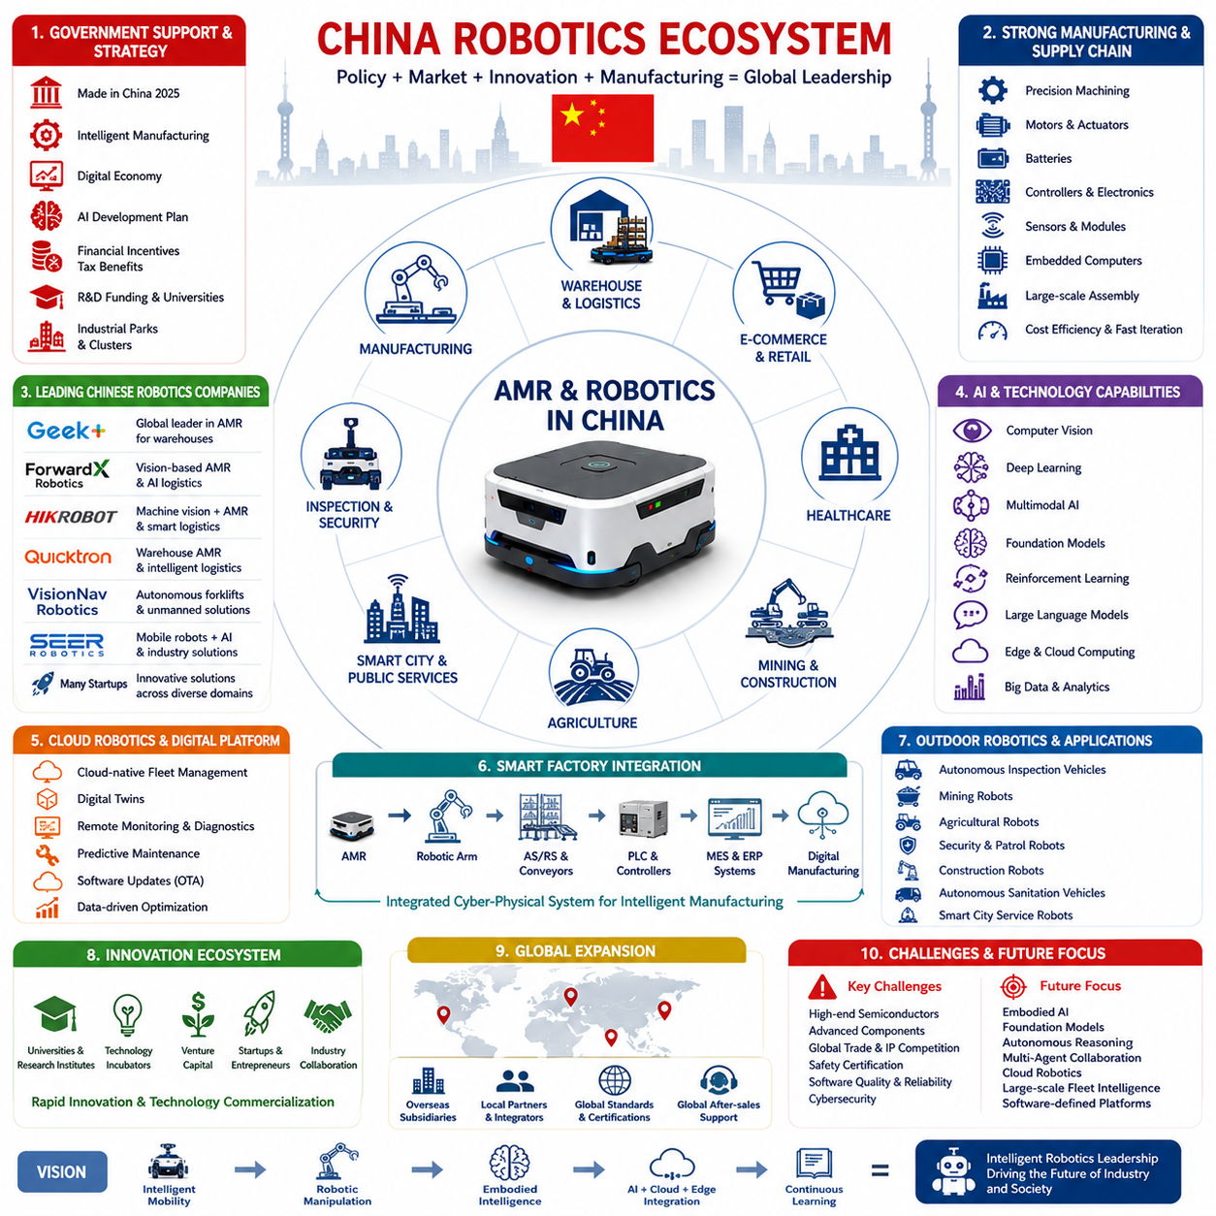
China has emerged as the world's largest and most comprehensive robotics ecosystem by combining government policy, manufacturing capacity, supply chain integration, artificial intelligence development, semiconductor investment, and massive domestic market demand into a unified industrial strategy. Unlike countries where robotics industries have grown primarily through private-sector innovation, China's robotics expansion has been strongly supported by long-term national development programs that identify intelligent manufacturing and robotics as strategic industries. This coordinated approach has accelerated the commercialization of Autonomous Mobile Robots (AMRs), industrial robots, collaborative robots, logistics automation systems, and embodied AI technologies. As a result, China has developed not only competitive robotics companies but also a complete ecosystem capable of designing, manufacturing, deploying, and continuously improving robotic products at unprecedented speed.
Government policy has played a fundamental role in shaping China's robotics ecosystem. National initiatives such as “Made in China 2025,” Intelligent Manufacturing programs, Digital Economy strategies, and AI development roadmaps have encouraged investment across the entire robotics value chain. Financial incentives, tax benefits, industrial parks, research funding, university partnerships, and technology incubators have created favorable conditions for both established manufacturers and emerging startups. Provincial governments actively compete to attract robotics companies by establishing specialized industrial clusters where component suppliers, software developers, research institutes, and manufacturing facilities operate within close geographical proximity. This policy-driven ecosystem significantly reduces development costs while accelerating technology transfer and commercialization.
China's manufacturing capability represents one of its greatest competitive advantages. The country possesses highly mature supply chains covering precision machining, electric motors, batteries, controllers, industrial electronics, sensors, communication modules, embedded computers, structural materials, and large-scale assembly facilities. Many robotics manufacturers can source nearly every hardware component domestically, reducing dependence on international suppliers and shortening product development cycles. Close collaboration between component manufacturers and robot integrators enables rapid design iterations, faster prototype production, and efficient cost optimization. The resulting manufacturing efficiency allows Chinese robotics companies to introduce new products at a pace that few global competitors can match.
The country's enormous domestic market further accelerates robotics innovation. China operates one of the world's largest manufacturing sectors while simultaneously maintaining extensive e-commerce, logistics, healthcare, mining, agriculture, and smart city projects. These diverse industries create continuous demand for warehouse automation, industrial logistics, autonomous inspection, service robots, and outdoor autonomous vehicles. Large deployment volumes generate vast operational datasets that improve navigation algorithms, perception models, fleet management systems, and AI decision-making capabilities. Unlike smaller markets where field data accumulates slowly, China's large-scale commercial deployments provide robotics companies with continuous opportunities for rapid product refinement through real-world operational experience.
Warehouse automation has become one of the strongest sectors within China's robotics ecosystem. Rapid expansion of e-commerce has created enormous demand for intelligent fulfillment centers capable of processing millions of orders daily. Chinese AMR companies have developed autonomous systems supporting goods-to-person logistics, pallet transportation, shelf movement, automated sorting, cross-docking, inventory replenishment, and warehouse inspection. Fleet management software coordinates hundreds or even thousands of mobile robots operating simultaneously inside distribution centers. Continuous optimization through artificial intelligence improves traffic management, task allocation, charging schedules, and inventory flow, allowing logistics operations to achieve exceptional scalability and operational efficiency.
Several Chinese robotics companies have achieved global recognition through aggressive technological innovation and international expansion. Companies such as Geek+, ForwardX Robotics, Hikrobot, Quicktron, VisionNav Robotics, SEER Robotics, and many emerging startups have developed comprehensive portfolios covering warehouse automation, industrial logistics, autonomous forklifts, inspection robots, and fleet management platforms. Rather than competing solely on hardware pricing, these companies increasingly differentiate themselves through software architecture, AI perception, cloud connectivity, digital twin integration, and intelligent operational management. Their ability to combine competitive manufacturing costs with advanced software capabilities has significantly strengthened China's position within the global robotics market.
Artificial intelligence has become deeply integrated into China's robotics ecosystem. Computer vision, deep learning, reinforcement learning, multimodal AI, large language models, and foundation models are increasingly incorporated into perception, navigation, task planning, and human-robot interaction systems. Chinese technology companies invest heavily in AI infrastructure, cloud computing platforms, edge computing hardware, and large-scale data processing, providing robotics developers with powerful computational resources. Continuous AI research allows robots to improve semantic understanding, obstacle recognition, behavioral prediction, adaptive navigation, and autonomous decision making. The integration of AI transforms robots from automated transport machines into intelligent autonomous systems capable of operating within highly dynamic environments.
Semiconductor development has become another strategic priority supporting China's robotics industry. Although advanced processor technology remains highly competitive globally, China continues investing heavily in domestic chip design, embedded AI accelerators, industrial processors, communication hardware, and robotics-specific computing platforms. Robotics companies increasingly optimize software for heterogeneous computing architectures combining CPUs, GPUs, AI accelerators, FPGAs, and dedicated vision processors. This emphasis on computing infrastructure reflects the industry's recognition that future robot performance will depend as much on onboard computational capability as on mechanical engineering or navigation algorithms.
Cloud robotics has emerged as an essential component of China's intelligent manufacturing ecosystem. Modern AMR platforms increasingly integrate cloud-native fleet management, digital twins, remote diagnostics, predictive maintenance, software updates, operational analytics, and centralized monitoring. Cloud platforms aggregate data collected from thousands of deployed robots, enabling continuous improvement of navigation models, perception algorithms, battery management, and mission planning. Enterprise customers benefit from real-time visibility into robot utilization, operational efficiency, maintenance status, and overall logistics performance. Such cloud-based architectures support scalable robotics deployment across geographically distributed manufacturing plants and logistics centers.
China's emphasis on smart factories has accelerated the convergence of robotics with industrial automation. AMRs increasingly interact with robotic manipulators, automated storage systems, production equipment, programmable logic controllers, manufacturing execution systems, and enterprise resource planning software within unified digital manufacturing environments. Material transportation, component delivery, quality inspection, inventory tracking, and production scheduling become integrated into coordinated cyber-physical systems. Rather than functioning independently, autonomous robots participate as intelligent agents within larger industrial ecosystems where real-time information sharing enables adaptive manufacturing and optimized production efficiency.
Outdoor robotics has also experienced rapid growth within China. Autonomous inspection vehicles, mining robots, agricultural robots, security patrol robots, construction robots, autonomous sanitation vehicles, and smart city service robots operate across diverse environments requiring sophisticated localization and perception technologies. These applications combine GNSS positioning, LiDAR SLAM, visual localization, radar sensing, semantic mapping, and AI perception to navigate highly dynamic outdoor conditions. Government investment in infrastructure modernization and smart city initiatives provides numerous opportunities for large-scale deployment of outdoor autonomous systems, further expanding China's robotics ecosystem beyond traditional indoor logistics.
University research and industrial collaboration represent another important characteristic of China's robotics development model. Universities, national laboratories, technology institutes, and industrial companies frequently cooperate on research projects covering artificial intelligence, robot perception, autonomous navigation, human-robot interaction, advanced control systems, and embodied intelligence. Graduate students often transition directly into startup companies or industrial research laboratories, accelerating technology transfer between academia and commercial product development. This close relationship between research institutions and manufacturing enterprises contributes significantly to the rapid commercialization of emerging robotics technologies.
China's robotics ecosystem also benefits from an exceptionally dynamic startup environment. Numerous venture capital firms actively invest in robotics, artificial intelligence, automation software, sensors, semiconductor technologies, and industrial digitalization. Technology incubators and innovation parks provide infrastructure, engineering support, manufacturing resources, and business development assistance to early-stage robotics companies. Competition among startups encourages rapid experimentation with novel robot architectures, software platforms, autonomous navigation methods, and AI-driven operational models. Although many startups remain relatively young, the competitive environment accelerates technological evolution across the entire robotics industry.
Global expansion has become an increasingly important objective for Chinese robotics companies. Many manufacturers now establish overseas subsidiaries, international service centers, regional support organizations, and local integration partners to serve customers across Asia, Europe, North America, and the Middle East. Products increasingly comply with international safety standards, industrial communication protocols, cybersecurity requirements, and regional certification processes. Rather than competing only in domestic markets, Chinese companies increasingly position themselves as global robotics solution providers capable of supporting multinational manufacturing and logistics enterprises through standardized products and localized technical support.
Despite remarkable achievements, China's robotics ecosystem continues to face several strategic challenges. High-end semiconductor dependence, advanced precision components, international trade restrictions, global intellectual property competition, functional safety certification, and increasingly demanding software quality requirements remain important areas requiring continuous investment. At the same time, global competition encourages Chinese companies to strengthen innovation rather than relying solely on manufacturing scale or cost advantages. Future competitiveness will depend on advances in embodied AI, foundation models, autonomous reasoning, multi-agent coordination, cybersecurity, cloud robotics, and intelligent software platforms that deliver sustainable long-term value beyond hardware manufacturing alone.
Looking toward the future, China's robotics ecosystem is expected to transition from large-scale manufacturing leadership toward comprehensive intelligent robotics leadership. Future development will likely integrate autonomous mobility, robotic manipulation, embodied intelligence, multimodal AI, cloud-edge collaboration, digital twins, continuous learning, and large-scale fleet intelligence into unified software-defined robotic platforms. As robots become increasingly capable of understanding complex environments, collaborating with humans, and autonomously adapting to changing operational conditions, China's integrated industrial ecosystem provides a strong foundation for accelerating the global evolution of next-generation intelligent robotics.

04.04 Korea Robotics Ecosystem · 한국 로봇 생태계
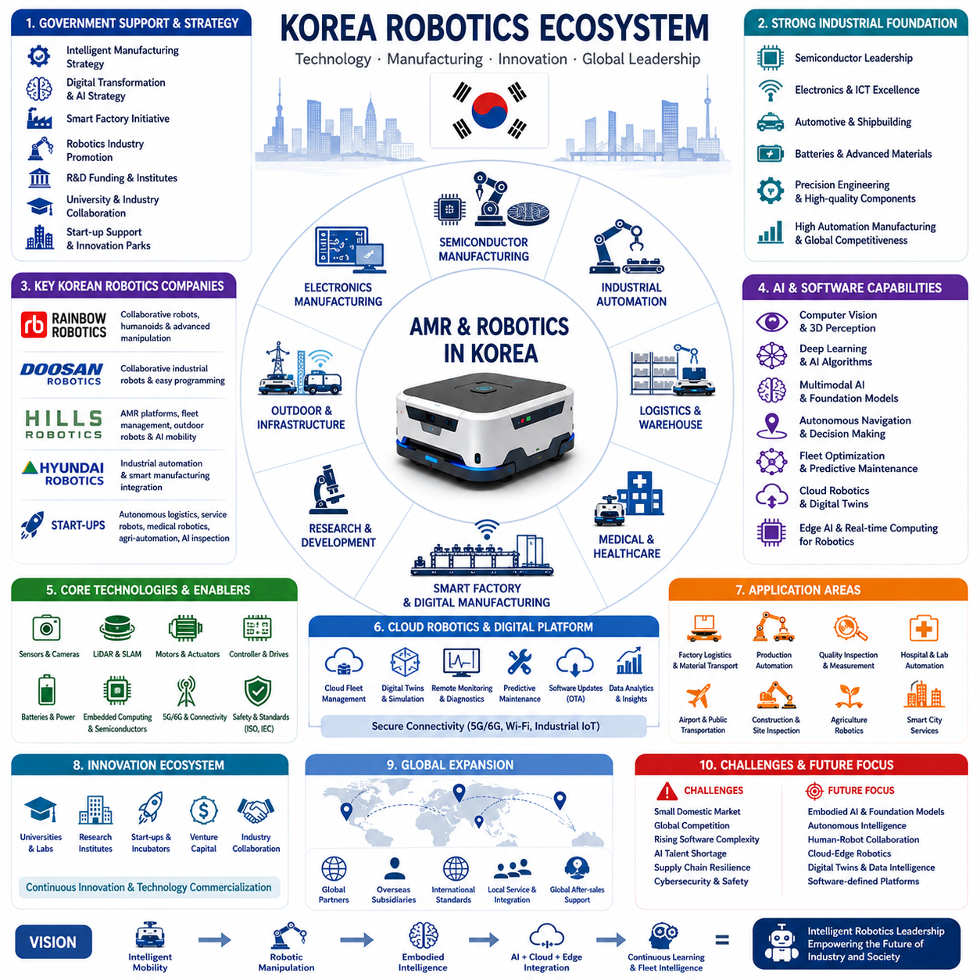
South Korea has developed one of the world's most advanced robotics ecosystems by combining globally competitive manufacturing industries, semiconductor leadership, information and communication technologies, precision engineering, and strong government support for intelligent automation. Although the country's domestic market is considerably smaller than those of China or the United States, Korea has consistently focused on high-value technologies, industrial reliability, and export-oriented innovation. This strategy has enabled Korean robotics companies to establish strong positions in industrial automation, autonomous mobile robots (AMRs), collaborative robotics, semiconductor manufacturing automation, medical robotics, and intelligent logistics systems. Rather than competing primarily through production volume, Korea emphasizes technological sophistication, system integration, and high-quality engineering across the robotics value chain.
Government policy has been a major driving force behind Korea's robotics industry. National strategies promoting intelligent manufacturing, digital transformation, artificial intelligence, and advanced manufacturing have encouraged long-term investment in robotics research, industrial deployment, and commercialization. Government-funded research institutes, university laboratories, technology parks, and public-private partnerships support innovation throughout the robotics ecosystem. Programs encouraging smart factories, autonomous mobility, semiconductor leadership, and AI development create favorable conditions for robotics startups while strengthening collaboration between academia and industry. Long-term policy consistency has provided a stable foundation for continuous technological advancement.
Korea's manufacturing sector provides an exceptional environment for robotics development. Global leadership in semiconductors, consumer electronics, automotive manufacturing, shipbuilding, batteries, and display technologies creates continuous demand for industrial automation. Production facilities increasingly require autonomous transportation, flexible material handling, intelligent inspection, and AI-assisted manufacturing processes. AMRs operate alongside industrial robots, automated production lines, warehouse systems, and quality inspection equipment to improve productivity while reducing labor-intensive operations. The country's highly automated manufacturing environment provides ideal opportunities for testing and refining next-generation robotics technologies under demanding industrial conditions.
Semiconductor manufacturing has become one of the most influential sectors shaping Korea's robotics ecosystem. Semiconductor fabrication facilities require extremely high levels of precision, cleanliness, reliability, and continuous operation. Autonomous robots transport wafers, production materials, equipment, and inspection tools inside highly controlled cleanroom environments. Navigation accuracy, vibration control, contamination prevention, and predictive maintenance become critical engineering requirements. Because semiconductor factories continuously pursue higher productivity and lower defect rates, robotics companies serving this industry develop exceptionally reliable hardware, sophisticated control systems, and advanced fleet management software capable of operating with minimal downtime.
South Korea's global leadership in semiconductor technology also supports robotics computing platforms. Companies producing advanced memory devices, AI accelerators, embedded processors, storage technologies, and high-speed communication hardware provide essential components for intelligent robots. Modern AMRs increasingly require powerful onboard computing capable of executing simultaneous localization and mapping, deep learning inference, sensor fusion, trajectory optimization, and multimodal perception in real time. Korea's semiconductor ecosystem enables close collaboration between robotics developers and electronic component manufacturers, accelerating optimization of hardware and software architectures for industrial robotics applications.
The country's strength in electronics manufacturing further enhances robotics innovation. High-quality sensors, cameras, displays, batteries, motor controllers, communication modules, embedded systems, and industrial electronic components are widely available through domestic suppliers. Close cooperation between electronics companies and robotics manufacturers shortens development cycles while improving reliability and manufacturing quality. This vertically integrated industrial structure allows Korean robotics companies to rapidly prototype, validate, and commercialize new robotic systems while maintaining strict quality standards demanded by global industrial customers.
Autonomous Mobile Robots have become increasingly important within Korea's logistics and manufacturing industries. Smart factories, distribution centers, hospitals, airports, research laboratories, and semiconductor facilities deploy AMRs for autonomous transportation, material delivery, warehouse automation, inspection, and collaborative logistics. Korean companies emphasize highly reliable navigation, precise positioning, robust safety systems, and seamless integration with Manufacturing Execution Systems, Enterprise Resource Planning platforms, Warehouse Management Systems, and Factory Management Systems. Rather than viewing mobile robots as isolated transportation devices, Korean manufacturers increasingly integrate AMRs into comprehensive digital manufacturing ecosystems.
Several Korean robotics companies have established strong positions across different market segments. Rainbow Robotics has gained international attention through collaborative robots, humanoid robotics, and advanced manipulation technologies. Doosan Robotics has become a global leader in collaborative industrial robots emphasizing safety, ease of programming, and flexible manufacturing applications. Hills Robotics has focused on intelligent Autonomous Mobile Robot platforms, fleet management, autonomous navigation, outdoor robotics, and AI-driven industrial mobility. Hyundai Robotics continues expanding industrial automation while integrating robotics into broader smart manufacturing initiatives. Numerous emerging startups further contribute innovative solutions in autonomous logistics, service robotics, agricultural automation, medical robotics, and AI-powered inspection systems.
Artificial intelligence has become a central component of Korea's robotics ecosystem. Computer vision, deep learning, reinforcement learning, multimodal AI, foundation models, large language models, and embodied AI increasingly support perception, navigation, autonomous decision making, and human-robot interaction. Korean universities, research institutes, and technology companies actively develop AI algorithms optimized for industrial robotics applications requiring high reliability and real-time performance. Rather than applying AI solely for perception, developers increasingly integrate AI into fleet optimization, predictive maintenance, operational analytics, adaptive navigation, and autonomous mission planning.
Cloud robotics and digital transformation continue expanding throughout Korea's manufacturing sector. Modern robotic systems increasingly connect with cloud platforms providing fleet management, predictive maintenance, software updates, operational monitoring, digital twins, and centralized analytics. Enterprise customers monitor robot utilization, production efficiency, maintenance schedules, and operational performance across multiple manufacturing sites through integrated cloud dashboards. Cloud-edge collaboration allows computational workloads to be distributed efficiently between onboard processors and centralized AI infrastructure while maintaining low-latency decision making for safety-critical robot operations.
South Korea has also become an important center for smart factory development. Digital manufacturing integrates industrial robots, AMRs, programmable logic controllers, industrial Internet of Things devices, machine vision systems, enterprise software, and cloud analytics into unified cyber-physical production systems. Autonomous transportation becomes synchronized with production scheduling, inventory management, quality control, and equipment monitoring. This integrated approach improves manufacturing flexibility while reducing operational costs and enabling rapid adaptation to changing production requirements. Smart factories therefore serve as both customers and development environments for advanced robotics technologies.
Medical robotics represents another rapidly expanding segment within Korea's robotics ecosystem. Hospitals increasingly deploy autonomous robots for medicine delivery, laboratory sample transportation, sterile equipment logistics, meal distribution, and patient support services. Korea's advanced healthcare infrastructure provides opportunities to integrate AMRs with hospital information systems, elevator controls, automatic doors, and healthcare logistics software. High standards for safety, reliability, and operational efficiency encourage continuous improvement in medical robot design while expanding applications of autonomous mobility beyond traditional industrial environments.
Outdoor robotics has received increasing attention as Korean companies expand beyond indoor automation. Autonomous inspection robots operate within industrial facilities, energy infrastructure, construction sites, ports, airports, railways, agriculture, and smart city environments. Outdoor robots require integration of GNSS positioning, RTK correction, LiDAR SLAM, visual localization, radar sensing, inertial navigation, and AI-based environmental perception. Korean companies leverage expertise in communication technologies, embedded computing, and industrial electronics to develop robust autonomous platforms capable of operating under complex environmental conditions while maintaining industrial reliability.
Academic research plays a vital role in Korea's robotics ecosystem. Universities collaborate extensively with industrial partners on robot perception, autonomous navigation, AI algorithms, semiconductor technologies, human-robot interaction, autonomous vehicles, and embodied intelligence. Government-funded institutes conduct long-term research into advanced robotics while supporting technology commercialization through startup incubation and industrial partnerships. Graduate researchers frequently transition into robotics companies, accelerating technology transfer between fundamental research and commercial product development. This close relationship between academia and industry strengthens Korea's capacity for continuous robotics innovation.
Korea's startup ecosystem continues to expand rapidly in robotics and artificial intelligence. Venture capital investment increasingly supports companies developing AMRs, service robots, AI software platforms, industrial automation, logistics systems, digital twins, autonomous inspection, and semiconductor technologies. Startup accelerators, innovation centers, and government-supported entrepreneurship programs provide technical resources, funding opportunities, testing facilities, and commercialization assistance. Although the number of robotics startups remains smaller than in China, Korean startups often focus on highly specialized technologies targeting global industrial markets rather than competing primarily on production scale.
Despite significant technological strengths, Korea's robotics ecosystem faces several strategic challenges. The domestic market remains relatively limited compared with larger economies, requiring companies to pursue international expansion early in their growth. Increasing global competition, rising software complexity, cybersecurity requirements, functional safety certification, AI talent acquisition, and supply chain resilience require continuous investment. Competition from lower-cost manufacturing regions also encourages Korean companies to differentiate themselves through advanced engineering, premium quality, integrated software platforms, and specialized industrial expertise rather than cost alone.
Looking toward the future, South Korea is well positioned to become a global leader in intelligent industrial robotics by leveraging its strengths in semiconductors, artificial intelligence, advanced manufacturing, communication technologies, and systems engineering. Future robotics platforms are expected to integrate autonomous mobility, manipulation, multimodal AI, foundation models, digital twins, cloud-edge computing, continuous learning, and fleet intelligence into unified software-defined architectures. As embodied AI continues transforming industrial automation, Korea's emphasis on reliability, precision engineering, and integrated technology development provides a strong foundation for building the next generation of intelligent autonomous robotic systems capable of competing successfully in global markets.

04.05 Future Industry Competition · 미래 산업 경쟁
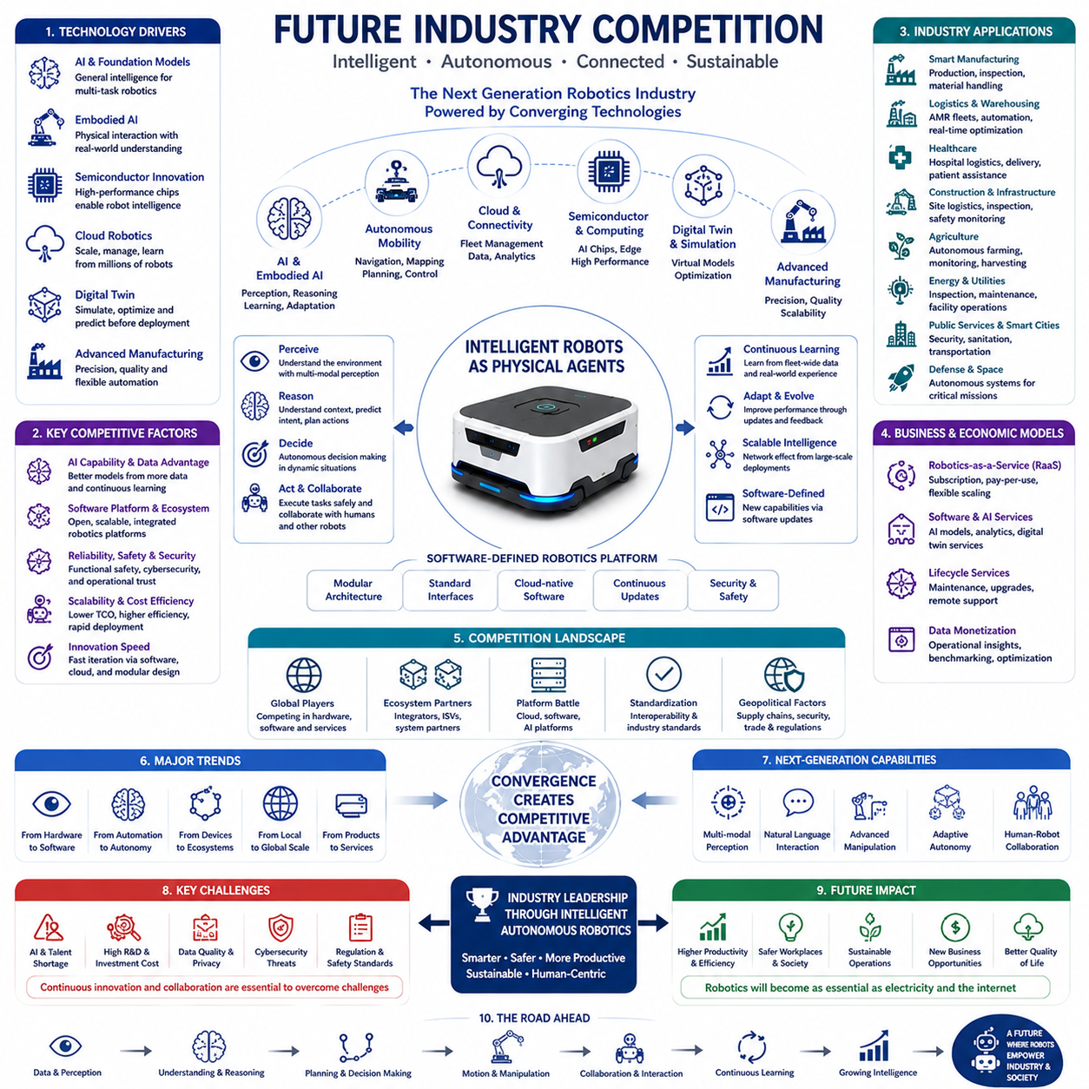
Future competition in the robotics industry will extend far beyond improvements in mechanical hardware. The next generation of industrial competition will be defined by the integration of artificial intelligence, autonomous mobility, cloud computing, semiconductor technology, advanced manufacturing, digital twins, and large-scale software platforms. Autonomous Mobile Robots (AMRs) will no longer function merely as transportation devices but will evolve into intelligent physical agents capable of perception, reasoning, collaboration, and autonomous decision making. Companies that successfully integrate these technologies into scalable software-defined robotic ecosystems will establish significant competitive advantages over those relying primarily on traditional hardware engineering. As robotics increasingly becomes a software-driven industry, continuous innovation rather than manufacturing capacity alone will determine long-term market leadership.
Artificial intelligence will become the central competitive factor across every segment of the robotics industry. Traditional autonomous navigation relied primarily on deterministic algorithms and manually engineered software modules. Future robots will increasingly employ deep learning, reinforcement learning, multimodal AI, foundation models, and embodied intelligence to understand complex environments, predict future events, interpret human intentions, and adapt to previously unseen situations. AI systems capable of continuous learning from fleet-wide operational data will improve robot performance throughout deployment, transforming every installed robot into part of an expanding knowledge network. Companies possessing superior AI infrastructure, high-quality training datasets, and advanced model optimization capabilities will therefore gain substantial competitive advantages.
Foundation models are expected to fundamentally reshape robotics development during the coming decade. Instead of programming robots for narrowly defined tasks, developers will increasingly build general-purpose intelligent systems capable of performing multiple industrial functions using shared knowledge representations. A single robot may transport materials, inspect equipment, communicate with operators, understand maintenance procedures, interpret engineering drawings, and collaborate with other autonomous systems without requiring entirely separate software architectures. This transition mirrors the evolution of large language models in natural language processing, where one foundation model supports numerous downstream applications. Future robotics companies will increasingly compete based on the quality, scalability, and adaptability of their foundation models rather than individual task-specific algorithms.
Embodied AI represents another major transformation influencing future industrial competition. While conventional AI primarily processes digital information, embodied intelligence integrates perception, physical interaction, motion planning, manipulation, environmental reasoning, and continuous feedback within real-world environments. Robots equipped with embodied AI understand not only visual information but also physical constraints, object affordances, spatial relationships, and human behaviors. This enables autonomous systems to perform increasingly complex industrial tasks requiring both cognitive reasoning and physical execution. Companies leading embodied AI research will likely establish dominant positions in manufacturing, logistics, healthcare, construction, agriculture, defense, and infrastructure management.
Semiconductor technology will remain one of the most strategic foundations of future robotics competition. Modern autonomous robots require enormous computational resources to execute perception algorithms, sensor fusion, simultaneous localization and mapping, trajectory planning, neural network inference, and multimodal reasoning simultaneously. Future robotic platforms will increasingly depend upon specialized AI accelerators, heterogeneous computing architectures, high-bandwidth memory, efficient power management, and advanced edge computing processors. Countries and companies capable of developing high-performance semiconductor ecosystems will possess important strategic advantages because computational capability directly influences robot intelligence, responsiveness, and operational efficiency.
Cloud robotics will significantly expand the scale of future robotic systems. Rather than operating independently, millions of robots will increasingly connect through cloud platforms supporting fleet management, software deployment, digital twins, predictive maintenance, cybersecurity monitoring, operational analytics, and collective learning. Every deployed robot will continuously contribute operational experience that improves the performance of the entire fleet. Such large-scale knowledge sharing creates powerful network effects in which companies operating larger robot fleets accumulate superior datasets, enabling faster AI improvement and more effective software optimization. Consequently, cloud infrastructure becomes an essential competitive asset rather than merely a supporting service.
Digital twin technology will transform engineering, manufacturing, and operational management across robotics industries. Virtual representations of robots, production facilities, logistics networks, and industrial infrastructure enable developers to simulate complex operational scenarios before physical deployment. AI algorithms can optimize navigation strategies, production scheduling, maintenance planning, battery utilization, and traffic management using digital twins while minimizing operational risk. Continuous synchronization between physical robots and virtual environments further enables predictive diagnostics and real-time operational optimization. Organizations capable of integrating digital twins into every phase of robot development and deployment will significantly reduce engineering costs while accelerating innovation cycles.
Competition will increasingly shift toward software-defined robotics architectures. Traditional robotics products often required extensive hardware redesign whenever new capabilities were introduced. Future robots will instead receive continuous software updates enabling new navigation functions, AI models, cybersecurity improvements, operational optimizations, and expanded industrial applications throughout their operational lifetime. Software-defined platforms dramatically extend product lifecycles while reducing deployment costs and improving customer satisfaction. Companies emphasizing modular software architectures, standardized interfaces, and cloud-based software distribution will achieve greater scalability than organizations relying primarily on hardware innovation.
Future robotics markets will increasingly favor complete ecosystem providers rather than standalone hardware manufacturers. Customers seek integrated solutions combining robots, fleet management, enterprise software integration, digital twins, cloud analytics, predictive maintenance, cybersecurity, artificial intelligence, and lifecycle support. Successful vendors will therefore provide comprehensive platforms connecting Manufacturing Execution Systems, Enterprise Resource Planning systems, Warehouse Management Systems, Industrial Internet of Things devices, programmable logic controllers, and autonomous robots into unified industrial ecosystems. Such integration increases switching costs while creating long-term recurring software and service revenue beyond initial hardware sales.
International competition will become increasingly influenced by national industrial strategies. Countries investing simultaneously in semiconductors, artificial intelligence, advanced manufacturing, cloud infrastructure, robotics education, and industrial digitalization will strengthen their competitive positions. Government policies supporting research funding, startup ecosystems, technology commercialization, smart manufacturing, and industrial automation can accelerate development of domestic robotics industries. International collaboration, standardization efforts, and technology partnerships will remain important, yet geopolitical considerations surrounding semiconductor supply chains, AI technologies, cybersecurity, and critical infrastructure may increasingly shape future industrial competition.
Autonomous mobility will expand far beyond warehouse logistics into nearly every industrial sector. Future AMRs will operate within factories, construction sites, hospitals, airports, ports, railways, energy facilities, agricultural fields, mining operations, smart cities, military environments, and space exploration missions. These diverse operating environments require robots capable of adapting autonomously to highly dynamic conditions while maintaining safety, reliability, and operational efficiency. Companies capable of developing generalized autonomous mobility platforms supporting multiple industries will access substantially larger global markets than vendors focused on narrow application domains.
Human-robot collaboration will become increasingly sophisticated as robots develop deeper contextual understanding and natural communication abilities. Large language models, multimodal perception, speech recognition, gesture interpretation, and semantic reasoning enable robots to collaborate naturally with human workers rather than simply executing predefined commands. Future industrial robots will understand verbal instructions, explain operational decisions, request clarification when uncertainty exists, and coordinate complex tasks alongside human teams. Such capabilities improve productivity while reducing training requirements, making robotics more accessible to organizations lacking specialized automation expertise.
Cybersecurity will emerge as a defining competitive requirement as robotics systems become increasingly interconnected. Industrial robots connected through cloud platforms, wireless communication networks, enterprise software, and remote maintenance services introduce new cybersecurity challenges requiring secure software architectures, encrypted communications, authentication frameworks, intrusion detection, and continuous vulnerability management. Companies demonstrating strong cybersecurity capabilities will gain greater customer trust, particularly within critical infrastructure, healthcare, defense, semiconductor manufacturing, and government applications where operational security becomes as important as functional performance.
Environmental sustainability will increasingly influence robotics competition as industries pursue carbon reduction, energy efficiency, and circular manufacturing practices. Intelligent robots optimize transportation routes, reduce energy consumption, minimize material waste, improve production efficiency, and support predictive maintenance that extends equipment lifetimes. Battery technologies, energy management systems, lightweight materials, and efficient computing architectures will become increasingly important design considerations. Companies integrating sustainability objectives into robotics engineering will satisfy growing regulatory requirements while reducing total operating costs for industrial customers.
Business competition will continue shifting from hardware sales toward recurring software and service models. Robotics-as-a-Service (RaaS), cloud subscriptions, fleet analytics, AI model licensing, predictive maintenance contracts, digital twin services, and software update programs generate stable long-term revenue while strengthening customer relationships. Rather than evaluating robots solely by purchase price, customers increasingly consider total cost of ownership, operational efficiency, scalability, software capabilities, and lifecycle support. Companies capable of delivering comprehensive subscription-based robotics ecosystems will likely achieve stronger long-term financial performance than businesses relying exclusively on equipment sales.
Looking toward the future, the robotics industry will increasingly resemble the evolution of the computing industry, where hardware serves as the foundation while software, artificial intelligence, cloud services, and digital ecosystems create the greatest economic value. Future industrial leaders will not necessarily be those manufacturing the largest number of robots, but those building intelligent autonomous platforms capable of continuous learning, large-scale coordination, adaptive decision making, and seamless integration across global industrial infrastructure. The convergence of embodied AI, foundation models, cloud robotics, semiconductor innovation, digital twins, and software-defined architectures will redefine competitive advantage, positioning robotics as one of the most strategically important industries of the coming decades.

