Volume 01. AMR Foundations and System Architecture

25. Future of AMR · AMR의 미래

25.01 Embodied AI · 구현된 AI
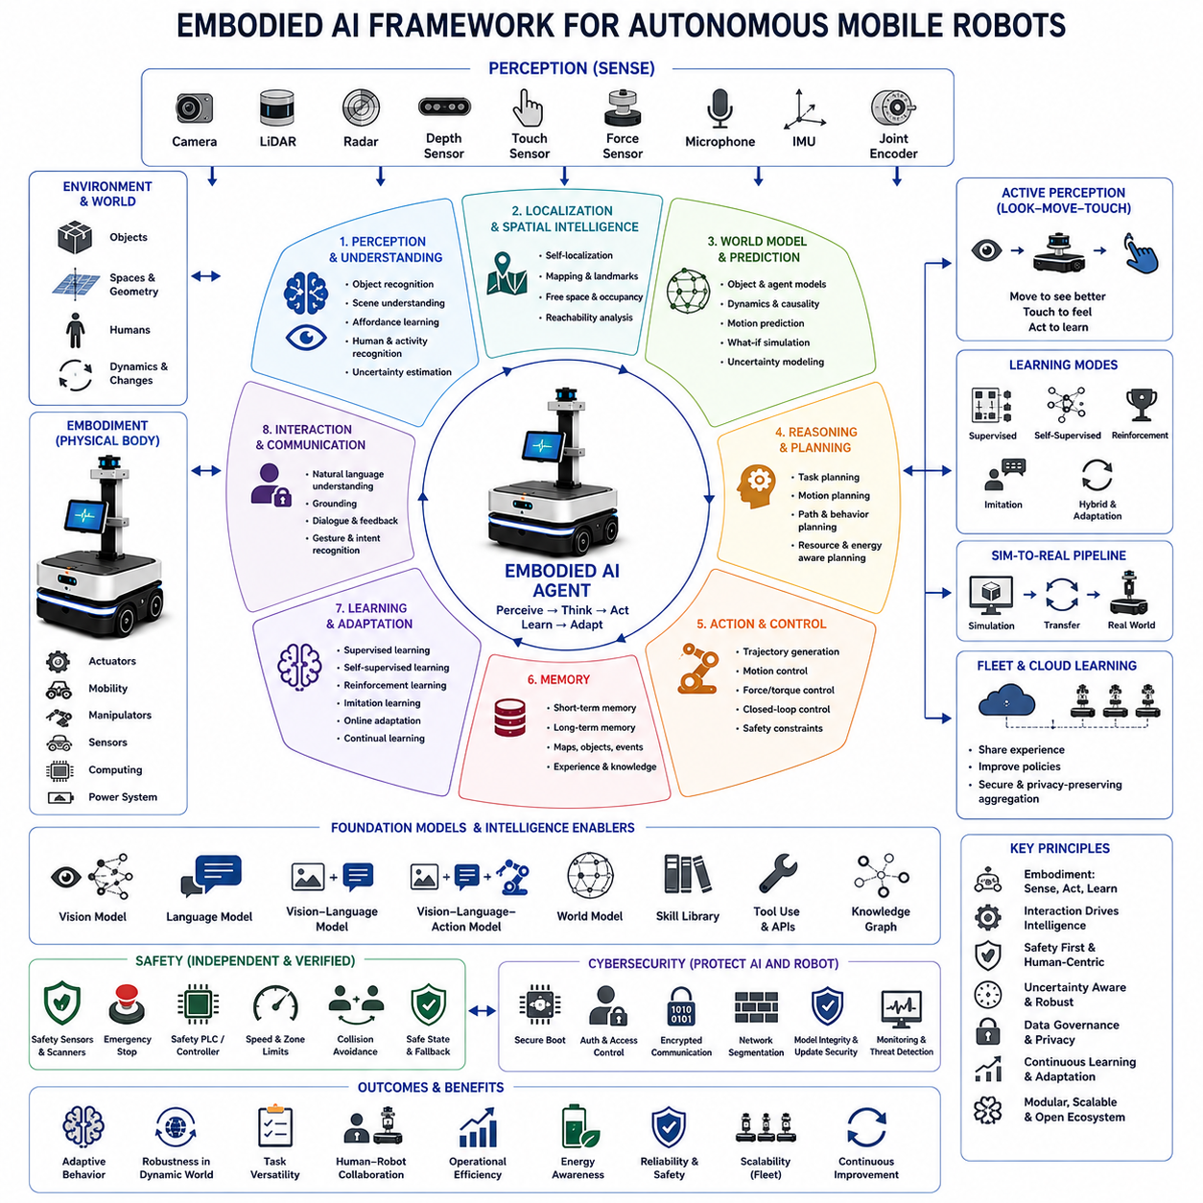
Embodied AI refers to artificial intelligence that learns, reasons, and acts through a physical body interacting continuously with the real world. Unlike conventional AI systems that operate mainly on static digital inputs, embodied systems perceive space, manipulate objects, navigate environments, and adapt their behavior according to physical feedback. Autonomous Mobile Robots, humanoid robots, robotic arms, service robots, and intelligent vehicles are representative platforms in which perception, cognition, and action are tightly connected.
The core principle of Embodied AI is that intelligence develops through interaction rather than through isolated data processing alone. A robot must observe its surroundings, interpret uncertain sensory information, choose an action, execute that action, and evaluate the resulting environmental change. This repeated perception-action loop enables the system to improve its understanding of objects, spaces, people, and operational constraints while building practical knowledge grounded in physical experience.
Embodiment gives artificial intelligence access to information that cannot be obtained completely from images, text, or offline datasets. Contact forces, friction, weight, balance, reachability, collision constraints, energy consumption, actuator delay, sensor occlusion, and environmental dynamics influence every physical task. By experiencing these conditions directly, a robot can learn relationships between actions and consequences that are essential for reliable operation in complex real-world environments.
An Embodied AI system typically combines perception, localization, world modeling, reasoning, planning, control, memory, and learning within one integrated architecture. Cameras, LiDAR, radar, depth sensors, tactile sensors, force sensors, microphones, inertial sensors, and joint encoders provide observations. These observations are transformed into representations that support object recognition, spatial understanding, motion prediction, task planning, and closed-loop control.
Perception in Embodied AI must extend beyond identifying isolated objects. The robot needs to understand free space, obstacles, surfaces, object affordances, human activity, motion, uncertainty, and relationships among entities. A box may be recognized not only as an object but also as something that can be carried, stacked, opened, or avoided. Such functional understanding enables the robot to connect visual observations with physically meaningful actions.
Spatial intelligence is another central capability because embodied agents operate within three-dimensional environments. Robots must estimate their own position, understand geometry, maintain maps, recognize landmarks, predict reachable regions, and reason about paths through changing spaces. Spatial representations may combine metric maps, semantic maps, topological relationships, object-level models, and dynamic occupancy information to support navigation and manipulation.
World models allow robots to predict how environments may change in response to actions. A useful world model represents objects, agents, geometry, motion, causality, and uncertainty while supporting both short-term control and long-term planning. When a robot predicts that pushing an object will clear a path or that a moving person may enter its route, it uses an internal model to evaluate potential futures before selecting an action.
Action is not merely the final output of an Embodied AI system but an important source of information. A robot may move closer to inspect an uncertain object, rotate a camera to reduce occlusion, touch a surface to estimate stiffness, or reposition itself to improve manipulation accuracy. This active perception strategy allows the robot to gather task-relevant information deliberately instead of relying only on passive observation.
Closed-loop control connects high-level intelligence with physical execution. Plans generated by reasoning systems must be translated into velocity commands, joint trajectories, grasp forces, steering angles, or actuator torques. Sensors continuously measure the difference between expected and actual behavior, allowing the controller to correct errors. Reliable embodied intelligence therefore depends on rapid feedback, stable control, accurate calibration, and predictable hardware response.
Learning for Embodied AI can occur through supervised learning, self-supervised learning, reinforcement learning, imitation learning, online adaptation, and combinations of these methods. Supervised methods provide labeled examples, while self-supervised approaches learn structure from raw sensor data. Reinforcement learning improves behavior through rewards, and imitation learning transfers demonstrations from human operators or expert controllers into reusable robot policies.
Reinforcement learning is particularly relevant because embodied agents must choose actions that influence future states. A robot may learn navigation, grasping, balancing, docking, or task sequencing by maximizing long-term reward. However, physical training is expensive and potentially unsafe, so practical systems often combine simulation, offline datasets, demonstrations, model-based planning, safety constraints, and limited real-world adaptation rather than relying on unrestricted trial and error.
Imitation learning reduces development effort by allowing robots to learn from expert demonstrations. Human operators may provide examples through teleoperation, kinesthetic teaching, motion capture, recorded trajectories, or natural-language instruction. The robot then learns patterns that map observations to actions. Effective imitation systems must generalize beyond the exact demonstrations and recover from states that were not represented during training.
Sim-to-real transfer is essential because large-scale learning is usually more practical in simulation than in physical environments. Simulators can generate diverse scenes, failures, lighting conditions, object arrangements, and motion scenarios without damaging equipment. However, differences between simulated and real sensors, dynamics, materials, timing, and environmental complexity create a reality gap that must be reduced through domain randomization, system identification, adaptation, and real-world validation.
Foundation models increasingly influence Embodied AI by providing broad representations learned from large-scale vision, language, video, audio, and robotics datasets. Vision-language models can connect visual observations with semantic concepts, while large language models can interpret goals, generate plans, explain decisions, and coordinate tools. Robotics foundation models extend these capabilities toward action prediction, manipulation, navigation, and cross-platform skill transfer.
Vision-language-action models integrate visual perception, language understanding, and control within a unified learning framework. Such models receive camera observations and task instructions, then generate actions or action sequences appropriate for the physical situation. Their potential lies in generalizing across objects, environments, and tasks, but dependable deployment still requires safety constraints, uncertainty management, hardware-aware control, and extensive validation under real operating conditions.
Natural-language interaction can make embodied systems more accessible to non-specialist users. An operator may request that a robot inspect a machine, move materials, check a storage area, or assist a worker using ordinary language. The robot must convert this instruction into grounded goals, identify relevant objects and locations, resolve ambiguity, generate a feasible plan, monitor execution, and communicate when clarification or assistance is required.
Grounding is the process of connecting abstract symbols or language to physical entities and actions. A command such as “bring the red container near the loading station” requires the robot to identify the correct container, understand the loading station, determine graspability, calculate a safe route, and confirm the destination. Grounding failures may produce incorrect actions even when language understanding appears semantically correct.
Memory supports long-duration embodied operation by preserving information about environments, objects, events, tasks, failures, and human preferences. Short-term memory helps maintain current task context, while long-term memory can store maps, object locations, learned procedures, maintenance history, and previous interactions. Effective memory architectures must update outdated information and distinguish reliable observations from uncertain or temporary conditions.
Multi-modal reasoning allows the robot to combine visual, spatial, linguistic, tactile, acoustic, and proprioceptive information. A robot inspecting industrial equipment may use images to identify a component, sound to detect abnormal vibration, thermal data to locate overheating, and force feedback to verify contact. Combining multiple modalities improves robustness because weaknesses in one sensor can be compensated for by complementary information.
Affordance learning helps robots understand what actions objects and environments permit. A handle affords pulling, a flat surface may support placement, a doorway permits passage only if the robot fits, and a charging connector requires precise alignment. Affordance representations connect perception with action feasibility and are particularly useful when robots encounter unfamiliar objects that share functional properties with previously observed examples.
Task and motion planning must operate together in Embodied AI. Task planning determines high-level steps such as navigate, pick, transport, inspect, and place, while motion planning calculates collision-free physical trajectories. A logically valid plan may still fail if the robot cannot reach an object, fit through a passage, maintain balance, or satisfy payload limits. Integrated planning therefore considers semantics, geometry, dynamics, and safety simultaneously.
Uncertainty is unavoidable because sensors are noisy, environments change, models are imperfect, and human behavior is difficult to predict. Embodied AI systems must estimate confidence in perception, localization, predictions, plans, and actions. When uncertainty exceeds acceptable limits, the robot should slow down, gather more information, request assistance, switch to a conservative fallback mode, or stop safely instead of continuing with unsupported assumptions.
Human-robot interaction is an essential part of embodied intelligence because robots frequently share environments and tasks with people. The robot must recognize human presence, predict motion, respect personal space, communicate intent, respond to gestures, and behave predictably. Trust depends not only on task performance but also on understandable motion, appropriate speed, clear warnings, and the ability to explain failures or request help.
Safety must remain independent from the probabilistic behavior of advanced AI models. Protective scanners, emergency stops, safety controllers, speed limits, collision avoidance, workspace restrictions, and validated braking functions should constrain learned policies. The AI system may optimize performance within a safe envelope, but it should not have unrestricted authority to override independently verified protective mechanisms.
Cybersecurity also becomes critical because embodied systems connect AI decisions to physical actions. Compromised models, malicious instructions, sensor spoofing, unauthorized access, corrupted updates, or manipulated maps may create direct physical hazards. Secure boot, authenticated communication, access control, software signing, network segmentation, model integrity verification, and continuous monitoring are necessary to protect both digital assets and physical operations.
Data collection for Embodied AI requires careful lifecycle management. Real-world robot data may include video, facility maps, employee movement, operational procedures, audio, and customer assets. Data governance must address consent, privacy, retention, anonymization, labeling quality, ownership, security, and secondary use. Representative data are necessary for learning, but uncontrolled collection can create legal, ethical, and cybersecurity risks.
Evaluation must measure more than isolated model accuracy. Embodied systems should be assessed according to task success, recovery capability, safety violations, efficiency, energy consumption, generalization, human intervention rate, reliability, and performance under environmental change. Scenario-based testing, simulation, controlled experiments, hardware-in-the-loop evaluation, and long-duration field trials collectively provide evidence of real operational capability.
Generalization remains one of the greatest challenges. A robot trained on limited facilities, objects, or workflows may fail when deployed in a new environment. Robust Embodied AI should transfer skills across layouts, lighting, payloads, platforms, and operating conditions while recognizing when previous knowledge is insufficient. Modular representations, foundation models, domain adaptation, continual learning, and explicit uncertainty handling support broader generalization.
Continual learning allows robots to improve after deployment as they encounter new objects, environments, and tasks. However, uncontrolled updates may cause catastrophic forgetting, unsafe behavior, or performance regression. Practical continual-learning systems require validated data pipelines, protected baseline models, staged updates, rollback capability, change approval, regression testing, and monitoring to ensure that new knowledge does not compromise established capabilities.
Fleet learning extends embodied intelligence from individual robots to groups of deployed systems. Experience collected by one robot can reveal rare obstacles, failure patterns, environmental changes, or improved strategies that benefit the entire fleet. Shared learning requires standardized data formats, secure aggregation, privacy protection, model compatibility, version control, and controlled distribution so that knowledge can improve fleet performance without spreading defects.
Digital twins can support Embodied AI by maintaining virtual representations of robots, facilities, missions, and operational conditions. A digital twin may be used to test software updates, simulate failure scenarios, analyze energy use, evaluate layout changes, or predict maintenance requirements. Synchronization between the physical system and its virtual representation improves planning and reduces the risk of modifying active robotic operations.
Edge computing is important because embodied systems require low-latency perception and control. Cameras, LiDAR, AI inference, localization, and motion control frequently operate directly on the robot, while cloud systems support fleet analytics, training, storage, and long-term optimization. Hybrid architectures must determine which decisions remain local for safety and responsiveness and which functions can depend on remote infrastructure.
Energy awareness influences embodied behavior because every physical action consumes battery capacity and affects mission availability. Intelligent robots can consider route length, payload, acceleration, terrain, processor load, charging availability, and battery health while planning tasks. Energy-aware reasoning improves fleet utilization and prevents situations in which task performance is optimized without considering operational endurance.
Embodied AI enables Autonomous Mobile Robots to move beyond fixed automation toward adaptive, context-aware operation. Robots can respond to changing obstacles, interpret human instructions, learn new workflows, inspect unfamiliar environments, and coordinate complex tasks. This flexibility is especially valuable in warehouses, factories, hospitals, construction sites, agriculture, logistics centers, public facilities, and outdoor industrial environments where rigid automation is difficult to maintain.
Successful Embodied AI development requires collaboration among mechanical engineers, electrical engineers, control specialists, AI researchers, software developers, safety engineers, cybersecurity experts, operators, and domain professionals. Intelligence cannot be separated from the physical platform because sensor placement, actuator capability, computing resources, battery capacity, structural design, and maintenance constraints directly determine what behaviors are feasible and reliable.
An effective Embodied AI architecture therefore integrates physical embodiment, multi-modal perception, spatial intelligence, world modeling, reasoning, planning, control, memory, learning, safety, cybersecurity, and lifecycle management into one closed-loop system. Through continuous interaction with the environment and disciplined engineering validation, autonomous robots can develop increasingly general, adaptable, and useful capabilities while maintaining predictable, safe, and trustworthy physical operation.

25.02 Humanoid Robotics · 휴머노이드 로봇공학
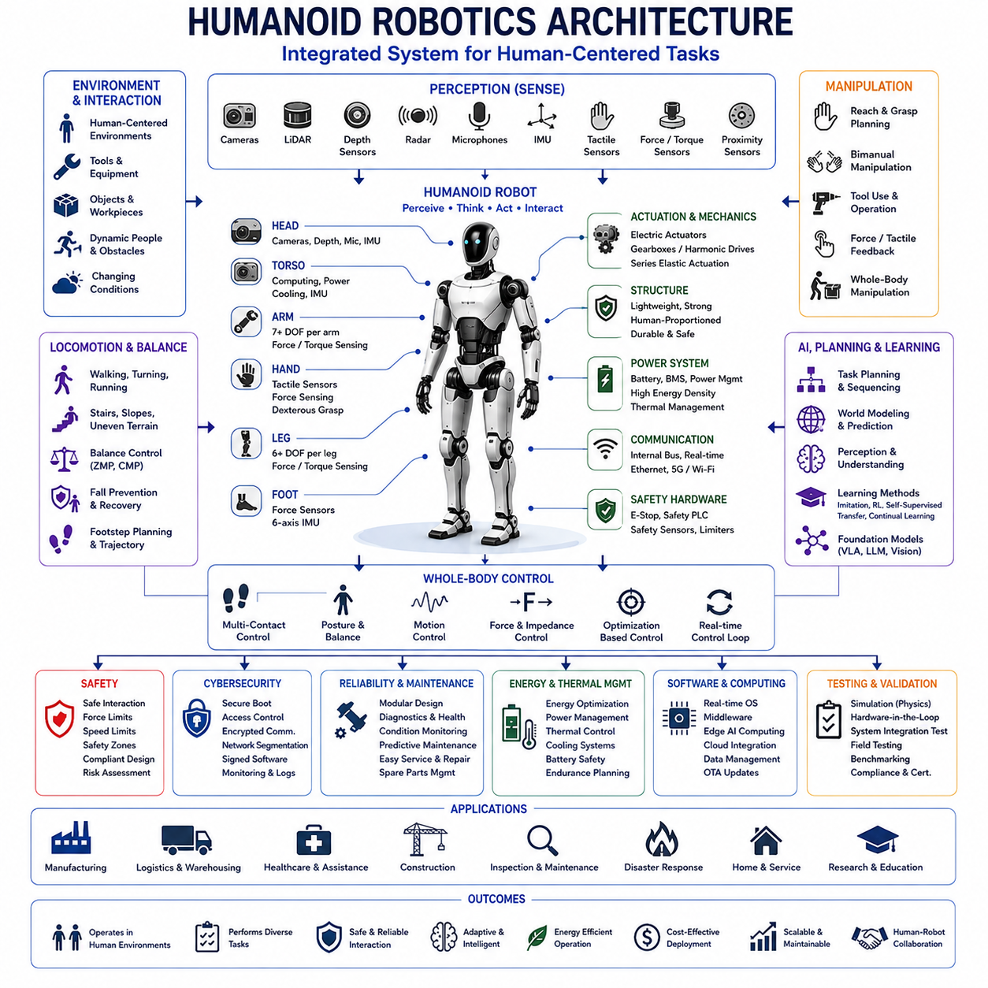
Humanoid robotics focuses on designing intelligent machines whose body structure, movement, sensing, and interaction capabilities resemble those of humans. A humanoid robot typically includes a torso, head, arms, hands, legs, joints, sensors, actuators, computing systems, and power components arranged to operate in environments originally built for people. This human-compatible form enables access to stairs, doors, tools, workstations, vehicles, and equipment without requiring complete redesign of the surrounding infrastructure.
The main value of humanoid robots lies not in copying human appearance but in achieving functional compatibility with human tasks and spaces. Factories, warehouses, hospitals, offices, homes, construction sites, and public facilities use dimensions, controls, and workflows optimized for human bodies. A robot capable of walking, reaching, grasping, carrying, and operating standard tools may therefore perform diverse tasks across existing environments with fewer infrastructure modifications than specialized automation.
Humanoid robotics combines mechanical engineering, electrical engineering, control theory, artificial intelligence, perception, biomechanics, materials science, safety engineering, and human-robot interaction. Successful performance depends on the integration of all these disciplines because improvements in one subsystem may create constraints elsewhere. A stronger actuator may increase weight and power consumption, while a larger battery may improve endurance but reduce balance, agility, and available payload capacity.
Mechanical architecture determines the robot’s range of motion, strength, balance, durability, and maintainability. Designers must select joint arrangements, link lengths, structural materials, transmission mechanisms, bearing systems, and protective covers that support required tasks. The structure must remain sufficiently rigid for accurate manipulation while also being lightweight enough to reduce energy consumption, impact forces, and actuator requirements during walking and physical interaction.
Degrees of freedom describe the independent joint motions available to the robot. Humanoid platforms may require multiple degrees of freedom in the neck, shoulders, elbows, wrists, hands, waist, hips, knees, and ankles. More joints improve dexterity and human-like movement but also increase mechanical complexity, control difficulty, cost, wiring, sensing requirements, and maintenance effort. Practical designs therefore balance flexibility against reliability and task needs.
Actuators generate the forces and torques required for movement. Electric motors with gear reductions are common because they offer controllability, compactness, and compatibility with battery-powered systems. Hydraulic actuators may provide high power density, while series-elastic actuators can improve force control and impact tolerance. Actuator selection must consider torque, speed, efficiency, backlash, thermal behavior, noise, shock resistance, and safe interaction with people.
Transmission systems connect actuators to joints and significantly influence performance. Harmonic drives, planetary gearboxes, belts, cables, ball screws, cycloidal reducers, and direct-drive mechanisms each provide different combinations of precision, efficiency, weight, stiffness, and durability. Excessive backlash can reduce control accuracy, while high reduction ratios may limit responsiveness. Reliable humanoid design requires careful transmission selection and continuous monitoring of wear.
Hands and end effectors are among the most difficult humanoid components because many useful tasks depend on reliable manipulation. Human hands combine strength, compliance, tactile sensing, and fine coordination within a compact structure. Robotic hands may use multiple fingers, underactuated mechanisms, adaptive grippers, interchangeable tools, or simplified end effectors. The optimal design depends on whether the robot must handle boxes, tools, cables, controls, delicate objects, or irregular parts.
Legged locomotion enables humanoid robots to move through human-centered environments, but it introduces substantial dynamic complexity. Walking requires continuous management of balance, contact forces, joint motion, body momentum, terrain variation, and external disturbances. Unlike wheeled robots, humanoids repeatedly create and break contact with the ground. Each step must place the foot safely while maintaining sufficient stability to continue movement or recover from unexpected events.
Static balance is achieved when the robot’s center of mass remains within the support region formed by its feet. Dynamic balance is more complex because walking, turning, carrying, and recovering involve controlled motion outside simple static conditions. Concepts such as the zero moment point, capture point, centroidal momentum, and whole-body dynamics help engineers analyze whether the robot can maintain or restore stability during motion.
Whole-body control coordinates multiple joints and contact points to achieve several objectives at once. A humanoid may need to keep its feet stable, maintain posture, move its hands, avoid joint limits, regulate contact force, and preserve balance simultaneously. Optimization-based controllers prioritize these objectives while respecting physical constraints. Effective whole-body control allows the robot to use its entire structure rather than treating each limb as an isolated mechanism.
Locomotion planning generates foot placements, body trajectories, and timing appropriate for the terrain and task. Flat indoor floors allow relatively predictable gait patterns, while stairs, slopes, debris, gaps, and uneven surfaces require terrain-aware planning. The robot must identify safe footholds, estimate friction, maintain clearance, and adjust step length and height. Errors in terrain estimation can quickly create instability or cause falls.
Fall prevention and fall recovery are critical because humanoid robots are tall, heavy, and mechanically complex. A fall may damage joints, sensors, batteries, surrounding equipment, or nearby people. Protective strategies include disturbance detection, rapid balance recovery, controlled lowering, impact-resistant structures, compliant joints, and safe operating zones. Some platforms may also require procedures for standing up after falling without external assistance.
Perception provides the information required for locomotion, manipulation, interaction, and safety. Humanoid robots may combine cameras, depth sensors, LiDAR, radar, microphones, inertial measurement units, joint encoders, tactile sensors, force-torque sensors, and proximity devices. Sensor fusion improves environmental understanding by combining complementary measurements, although calibration, synchronization, occlusion, noise, and computational demand remain significant challenges.
Visual perception supports object recognition, human detection, pose estimation, scene understanding, hand-eye coordination, and task monitoring. A humanoid working in a factory may need to identify tools, parts, containers, machines, warning signs, and people under varying illumination. Vision systems must remain robust to reflections, motion blur, partial occlusion, clutter, and changing viewpoints created by head and body movement.
Proprioception refers to the robot’s awareness of its own internal state. Joint encoders measure positions and velocities, inertial sensors estimate body motion, motor sensors provide current and torque information, and force sensors measure interaction with the environment. Accurate proprioception is essential for balance and control because external cameras alone cannot provide sufficiently rapid or reliable information about the robot’s body configuration.
Tactile and force sensing improve manipulation and physical interaction. A robot can use contact feedback to determine whether an object has been grasped securely, whether a tool is correctly positioned, or whether an unexpected collision has occurred. Distributed tactile sensors may detect pressure patterns across fingers or body surfaces. Force-controlled behavior is particularly important when handling fragile objects or working near people.
Localization and mapping allow humanoid robots to understand where they are and how to move through a facility. Visual-inertial odometry, LiDAR-based localization, semantic mapping, and multi-sensor SLAM may be combined to estimate position. However, body motion creates vibration and rapidly changing sensor viewpoints. The robot must also account for dynamic objects, temporary obstacles, moving people, and environmental changes over long operating periods.
Manipulation planning determines how the robot should reach, grasp, move, and place objects while avoiding collisions and maintaining balance. A valid arm trajectory may still be unsafe if it shifts the center of mass too far or requires an unstable posture. Integrated whole-body manipulation therefore considers grasp feasibility, joint limits, self-collision, environmental collision, support contacts, load distribution, and the robot’s ability to recover after completing the motion.
Bimanual manipulation uses both arms to perform tasks that require coordination, such as lifting large objects, opening containers, connecting parts, or stabilizing a tool. The robot must control relative hand positions, object forces, body posture, and balance at the same time. Bimanual tasks often require compliant coordination because small geometric errors can create excessive internal forces or cause the object to slip.
Task planning converts high-level goals into executable sequences. An instruction such as “move the package to the inspection station” may require locating the package, navigating to it, selecting a grasp, lifting it, maintaining balance, planning a route, avoiding people, and placing it accurately. Task planners must connect semantic goals with physical feasibility and update the plan when objects, people, or environmental conditions change.
Artificial intelligence expands humanoid capability beyond fixed motion scripts. Machine learning can support perception, language understanding, grasp selection, locomotion adaptation, skill learning, and failure recovery. Foundation models may help robots interpret broad instructions and connect visual observations with semantic knowledge. However, learned components must operate within validated physical and safety constraints because model outputs may remain uncertain or incorrect.
Vision-language-action models are increasingly relevant to humanoid robotics because they connect perception, language, and physical control. A model may receive camera images and a natural-language instruction, then produce actions or intermediate plans. These systems offer the potential to generalize across tasks, but reliable deployment requires grounding, confidence estimation, memory, tool awareness, motion verification, and protective control layers independent of the learned policy.
Imitation learning allows humanoid robots to acquire skills from human demonstrations. Demonstrations may be collected through teleoperation, motion capture, virtual reality interfaces, kinesthetic teaching, or recorded human activity. The robot must translate human motion into its own kinematic structure, which may differ in joint range, strength, speed, and proportions. Retargeting and optimization are therefore necessary before demonstrated behavior becomes executable.
Reinforcement learning can improve locomotion, balance, manipulation, and recovery through repeated interaction. Simulated environments allow millions of trials without damaging physical hardware. Rewards may encourage stability, speed, energy efficiency, task success, or smooth movement. Nevertheless, reward design must be handled carefully because the robot may discover unintended strategies that satisfy the mathematical objective while violating practical or safety expectations.
Sim-to-real transfer is essential because physical humanoid training is expensive, slow, and risky. Simulation can model contact, friction, actuator dynamics, sensor noise, terrain, and object interaction, but no simulator perfectly represents reality. Domain randomization, system identification, residual learning, conservative control, and progressive field validation help reduce the reality gap. Hardware-specific tuning remains necessary for dependable performance.
Motion retargeting converts human or simulated motion into trajectories suitable for a specific robot. Differences in limb length, joint configuration, strength, balance, and range of motion prevent direct copying. Retargeting algorithms preserve important task features while adapting motion to robot constraints. This process is useful for animation, skill learning, teleoperation, and preparing large motion datasets for humanoid foundation models.
Teleoperation provides a practical way to control humanoid robots during difficult tasks, collect training data, and support early deployments. Operators may use joysticks, motion capture suits, hand controllers, virtual reality, or remote interfaces. Communication delay and limited situational awareness can reduce effectiveness, so shared autonomy often combines human intent with local robot control, collision avoidance, balance stabilization, and automatic motion generation.
Human-robot interaction is central because humanoid robots are designed to operate in spaces shared with people. Their body shape may make their capabilities easier to understand, but it can also create unrealistic expectations. Robots should communicate intent through motion, lights, displays, speech, sound, or gestures. Predictable behavior, appropriate personal distance, limited speed, and clear failure communication are necessary for trust and safe cooperation.
Social behavior may be valuable in service, healthcare, education, and public environments. The robot may recognize speech, gaze direction, gestures, emotions, or conversational context. However, social interaction should be designed carefully to avoid deception, privacy invasion, bias, or inappropriate dependency. The system must clearly communicate its limitations and should not imply human understanding or emotional capability beyond what it can reliably provide.
Safety engineering must address both conventional machinery hazards and the unique risks of a mobile, articulated, human-sized robot. Potential hazards include falls, crushing, trapping, impact, unexpected motion, dropped objects, battery incidents, sharp edges, overheating, and software failure. Risk reduction may involve compliant actuation, force limits, safety-rated sensors, emergency stops, protective zones, speed monitoring, mechanical stops, and independent safety controllers.
Safe physical interaction requires limiting the energy transferred during contact. Robot mass, velocity, reflected inertia, actuator stiffness, surface geometry, and contact location influence injury risk. Lightweight structures, compliant mechanisms, padded covers, torque sensing, collision detection, and speed reduction can lower impact severity. Safety validation should consider foreseeable human positions, including vulnerable body regions and unexpected movement near the robot.
Cybersecurity is also a safety concern because humanoid robots connect software intelligence to powerful physical movement. Unauthorized access, malicious commands, sensor spoofing, compromised updates, altered motion models, or disabled limits may create direct hazards. Secure boot, authenticated communication, role-based access control, network segmentation, signed software, logging, and incident response procedures are necessary throughout the operational lifecycle.
Power and energy management strongly constrain humanoid performance. Walking and manipulation require substantial energy, while batteries add weight that the actuators must continuously support. Designers must balance operating time, peak power, thermal limits, battery mass, charging time, and safety. Energy-aware planning may select slower motions, efficient postures, optimized routes, or scheduled charging to extend useful operation.
Thermal management is difficult because motors, power electronics, computers, batteries, and transmissions generate heat within a compact body. Excessive temperature can reduce torque, shorten component life, degrade battery performance, or trigger shutdown. Cooling may use conduction, forced air, liquid systems, structural heat paths, and workload management. Thermal sensing and predictive derating help maintain operation without damaging components.
Computing architecture usually combines real-time controllers, safety processors, edge AI computers, communication modules, and sometimes cloud services. Fast joint control must remain local and deterministic, while perception and planning may run on high-performance processors. Cloud resources can support training, fleet analytics, and model management but should not be required for immediate balance or emergency response due to latency and connectivity risk.
Software architecture must coordinate perception, planning, control, communication, safety, diagnostics, and updates across many computing devices. Middleware can standardize messaging and component integration, but distributed systems introduce timing, synchronization, and fault-handling challenges. Clear interface definitions, time-sensitive communication, health monitoring, configuration control, and version compatibility are essential for stable operation.
Reliability engineering is especially important because humanoids contain many joints, cables, bearings, sensors, actuators, and processors. A failure in one component may disable the entire robot or create unsafe behavior. Modular construction, fault diagnostics, condition monitoring, graceful degradation, accessible service points, replaceable units, and preventive maintenance can improve availability. Reliability targets should be based on actual duty cycles and operating environments.
Maintainability affects whether humanoid robots can be economically deployed at scale. Service personnel need safe procedures for battery replacement, joint repair, sensor calibration, software recovery, and structural inspection. Modular limbs, standardized fasteners, diagnostic tools, maintenance logs, spare-part planning, and remote support reduce downtime. Designs optimized only for laboratory performance may become impractical when frequent field service is required.
Manufacturing humanoid robots at scale presents challenges in precision, calibration, supply chain stability, and cost. Many joints require consistent assembly, wiring, torque calibration, and testing. High-performance actuators, reducers, sensors, and batteries may be expensive or supply constrained. Design for manufacturability, automated testing, supplier qualification, component standardization, and quality traceability are necessary to move from prototypes to reliable commercial products.
Cost remains a major barrier because general-purpose humanoid systems require complex hardware, large computing capacity, advanced sensors, and substantial software development. Commercial value depends on whether the robot can perform enough useful work to justify purchase, integration, maintenance, training, and supervision costs. Initial deployments are therefore likely to focus on repetitive, hazardous, labor-constrained, or ergonomically difficult tasks with measurable economic benefit.
Industrial applications may include machine tending, material handling, inspection, packaging, sorting, kitting, tool operation, and maintenance assistance. Humanoid form is most valuable where tasks require mobility and manipulation across human-designed work areas. However, specialized robots may remain more efficient for fixed, high-volume processes. Deployment decisions should compare humanoid flexibility with the lower cost and higher reliability of conventional automation.
Logistics applications include moving containers, unloading goods, picking items, operating carts, and working in mixed human-robot facilities. Humanoids may handle objects and interfaces that were not designed for automation, but walking while carrying loads places demanding requirements on balance and energy. Hybrid systems may combine humanoid upper bodies with wheeled bases when stairs and rough terrain are not essential.
Healthcare and assistance applications may include delivering supplies, transporting objects, supporting rehabilitation, guiding visitors, or assisting workers. Direct physical support of patients requires exceptionally high safety, reliability, hygiene, and regulatory assurance. Robots should complement trained professionals rather than replace judgment in critical care. Human oversight and clearly defined operating boundaries remain essential.
Disaster response and hazardous-environment applications are attractive because humanoid robots may enter spaces designed for people while keeping operators away from danger. Potential tasks include opening doors, climbing stairs, using tools, inspecting equipment, or moving through damaged buildings. Such environments demand rugged structures, strong communication, remote operation, environmental sealing, and recovery strategies when terrain or visibility becomes unpredictable.
Evaluation of humanoid robots must measure complete task performance rather than isolated demonstrations. Important metrics include walking stability, manipulation success, recovery rate, energy use, task completion time, intervention frequency, uptime, safety events, payload, terrain capability, and performance variation across environments. Long-duration testing is necessary because brief demonstrations may hide overheating, wear, software instability, and maintenance demands.
Benchmarking can accelerate development by providing standardized tasks and comparison methods. Locomotion benchmarks may evaluate stairs, slopes, disturbances, and uneven terrain, while manipulation benchmarks assess grasping, tool use, and bimanual coordination. However, benchmark success does not guarantee commercial readiness. Real workplaces include unpredictable people, clutter, changing procedures, network limitations, and maintenance constraints that controlled tests may not represent.
Ethical and workforce considerations should be addressed during deployment. Humanoid robots may change job roles, monitoring practices, skill requirements, and workplace expectations. Responsible implementation includes employee consultation, transparent capability descriptions, retraining opportunities, privacy safeguards, and clear accountability. The objective should be to reduce hazardous or physically demanding work while supporting people in higher-value responsibilities.
Humanoid robotics is progressing toward more capable general-purpose physical agents, but reliable autonomy remains difficult. Walking, manipulation, perception, reasoning, and interaction must all operate under real-time physical constraints. A weakness in any one capability can prevent successful task completion. Commercial progress therefore depends less on isolated demonstrations and more on system integration, repeatability, maintainability, safety, and measurable operational value.
An effective humanoid robotics architecture integrates mechanical embodiment, actuation, perception, proprioception, localization, world modeling, planning, whole-body control, learning, interaction, safety, cybersecurity, energy management, and lifecycle support into one coordinated system. Through disciplined engineering, extensive simulation, progressive field validation, and human-centered deployment, humanoid robots can gradually perform useful tasks in human environments while maintaining predictable, safe, and economically sustainable operation.

25.03 Multi-Agent Robotics · 멀티 에이전트 로봇공학
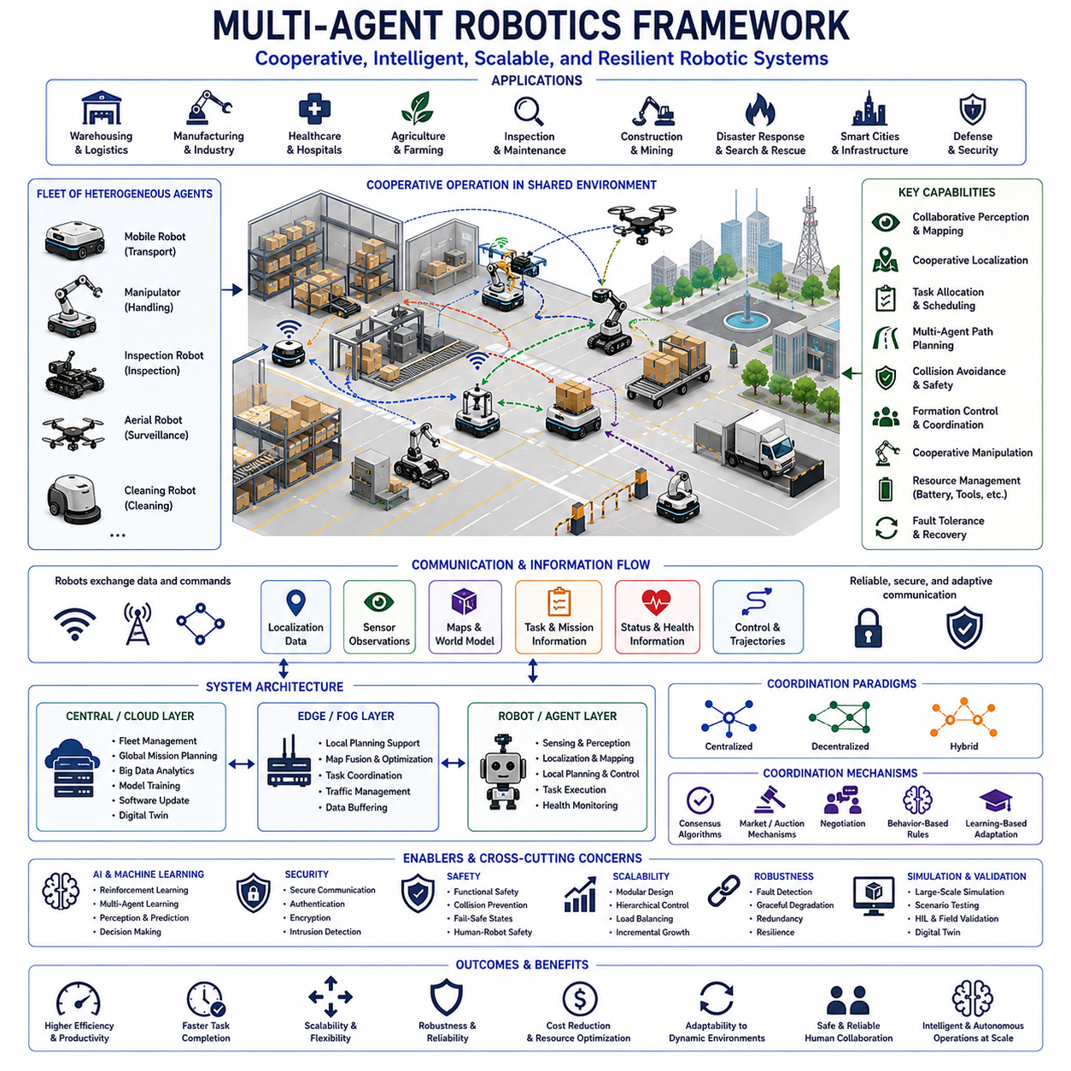
Multi-agent robotics is the study and application of multiple intelligent robotic systems that cooperate, coordinate, communicate, and make distributed decisions to accomplish objectives that are difficult or impossible for a single robot to achieve alone. Instead of relying on one highly capable platform, a multi-agent system distributes sensing, computation, mobility, manipulation, and decision-making across multiple robots. This distributed architecture improves scalability, flexibility, robustness, fault tolerance, and operational efficiency in dynamic environments.
A multi-agent robotic system consists of autonomous or semi-autonomous agents that interact through communication, shared observations, environmental feedback, and coordinated task execution. Each robot may possess different sensing capabilities, payload capacities, mobility characteristics, computational resources, and operational responsibilities. Together, these heterogeneous or homogeneous agents form a cooperative network capable of solving complex problems through collective intelligence rather than isolated operation.
The primary motivation for multi-agent robotics is that many real-world applications naturally require distributed operation. Warehouses, factories, airports, ports, hospitals, agricultural fields, construction sites, disaster areas, and military operations often cover large physical spaces where simultaneous activities must occur in multiple locations. Deploying numerous coordinated robots allows tasks to be completed faster while increasing coverage, redundancy, and operational resilience.
System architecture defines how individual robots, communication networks, computing infrastructure, cloud services, edge devices, and supervisory systems interact. Architectures may be fully centralized, fully decentralized, or hybrid. Centralized architectures simplify global optimization and fleet supervision but create single points of failure and communication dependency. Decentralized architectures improve robustness and scalability while requiring sophisticated distributed coordination algorithms. Hybrid architectures balance centralized planning with local autonomous decision-making.
Agents within a robotic fleet may be homogeneous or heterogeneous. Homogeneous systems consist of identical robots with similar hardware, software, sensing, and capabilities, making resource allocation and maintenance relatively straightforward. Heterogeneous systems combine robots specialized for transportation, inspection, manipulation, mapping, surveillance, cleaning, or material handling. Such diversity enables complex missions by assigning tasks according to each robot's strengths while increasing coordination complexity.
Communication forms the foundation of collaborative robotic behavior. Robots exchange localization information, sensor observations, task assignments, health status, environmental changes, trajectories, maps, warnings, and mission updates. Communication may occur through wireless local networks, private cellular infrastructure, mesh networking, Ethernet, satellite communication, or dedicated industrial communication systems. Communication quality directly influences coordination accuracy, safety, synchronization, and overall system performance.
Communication latency, bandwidth limitations, packet loss, interference, and network failures significantly influence multi-agent behavior. Real-world systems cannot assume continuous high-quality connectivity. Robots should therefore maintain sufficient local autonomy to continue safe operation during temporary communication interruptions. Communication protocols should prioritize critical safety messages, minimize unnecessary traffic, compress transmitted data, detect failures rapidly, and recover gracefully when connectivity is restored.
Distributed perception enables multiple robots to observe different portions of an environment simultaneously. Individual observations may be combined into richer environmental representations than those available to any single robot. Shared perception supports collaborative mapping, obstacle detection, object tracking, inventory management, inspection, surveillance, and environmental monitoring. Sensor fusion across multiple robots improves coverage, reduces uncertainty, and increases robustness against sensor failures or occlusions.
Collaborative localization improves positioning accuracy by allowing robots to exchange relative observations and environmental information. Robots may share landmarks, visual features, LiDAR scans, GNSS measurements, inertial information, or relative ranging observations. Cooperative localization becomes particularly valuable in GNSS-denied environments, indoor facilities, underground mines, dense urban areas, or large industrial plants where individual localization systems may experience drift or temporary failure.
Collaborative mapping allows robots to construct large-scale environmental models more efficiently than a single platform. Individual robots explore different regions while continuously integrating local maps into a shared global representation. Efficient map merging requires consistent coordinate systems, loop closure detection, uncertainty estimation, timestamp synchronization, and conflict resolution. Shared maps allow newly deployed robots to begin operation without repeating expensive exploration processes.
Task allocation determines which robot performs each activity within the fleet. Effective allocation considers robot capability, current location, battery level, payload, tool availability, estimated completion time, workload balance, priority, and operational constraints. Assignment methods may include optimization algorithms, auctions, market-based mechanisms, heuristic scheduling, distributed negotiation, or reinforcement learning. Dynamic reallocation becomes necessary whenever robots fail, priorities change, or environmental conditions evolve.
Mission planning coordinates high-level objectives across multiple robots while satisfying operational constraints. A logistics mission may require several transport robots, inspection platforms, charging resources, elevators, automated doors, and human operators to work together. Mission planners decompose global objectives into coordinated subtasks while monitoring execution progress, resolving conflicts, adjusting schedules, and responding to unexpected events throughout the mission lifecycle.
Path planning becomes considerably more challenging when many robots share the same workspace. Individual collision-free paths do not guarantee overall system safety because robots may create congestion, deadlocks, bottlenecks, or conflicting priorities. Multi-agent path planning therefore considers temporal coordination, shared resources, traffic flow, intersection management, lane assignment, reservation systems, and conflict resolution to maintain efficient fleet movement.
Traffic management coordinates robot movement within structured operational environments. Warehouses, hospitals, manufacturing facilities, and distribution centers often contain narrow aisles, intersections, elevators, loading stations, and shared workspaces. Traffic management systems regulate priorities, speed limits, directional flow, waiting behavior, and access permissions while preventing congestion and ensuring safe coexistence among robots, humans, and manually operated vehicles.
Collision avoidance requires both local sensing and cooperative behavior. Each robot continuously detects nearby obstacles using onboard sensors while also receiving trajectory information from neighboring robots whenever communication permits. Local obstacle avoidance should remain operational even when communication becomes unavailable. Predictive motion planning, dynamic safety margins, velocity regulation, emergency braking, and priority rules collectively reduce collision risk during coordinated operation.
Coordination strategies range from explicit communication to implicit environmental interaction. Explicit coordination exchanges planned actions, intentions, maps, and task information directly between robots. Implicit coordination occurs when robots observe environmental changes created by others or infer intentions from movement patterns. Biological systems such as ant colonies and bee swarms demonstrate effective decentralized coordination mechanisms that inspire many robotic swarm algorithms.
Swarm robotics represents a specialized branch of multi-agent robotics emphasizing large populations of relatively simple robots that cooperate through decentralized local interactions. Individual swarm members possess limited sensing, computation, and communication capabilities, yet collective behavior emerges from simple coordination rules. Swarm systems exhibit scalability, adaptability, fault tolerance, and robustness without requiring centralized control or complete global knowledge.
Consensus algorithms allow distributed robots to reach common decisions regarding maps, task priorities, formation geometry, environmental models, synchronization, or shared operational parameters. Each robot exchanges information with neighboring agents until the group converges toward a consistent solution. Consensus methods improve robustness by avoiding dependence on a single supervisory controller while supporting coordinated behavior across large distributed systems.
Formation control enables groups of robots to maintain predefined geometric relationships during movement. Robots may travel in lines, columns, grids, circles, wedges, or adaptive formations depending on mission objectives. Formation maintenance requires continuous estimation of relative position, communication, motion prediction, and disturbance compensation. Applications include transportation, surveillance, agricultural operations, military missions, search and rescue, and environmental monitoring.
Cooperative manipulation allows multiple robots to transport, lift, rotate, assemble, or stabilize objects exceeding the capability of an individual platform. Robots must coordinate grasp forces, motion trajectories, timing, load distribution, compliance, and contact dynamics while maintaining overall system stability. Accurate synchronization becomes essential because small positioning errors may generate excessive internal forces or destabilize the manipulated object.
Human-multi-robot interaction introduces additional complexity because operators supervise entire fleets rather than individual robots. Effective interfaces summarize fleet status, mission progress, robot health, environmental conditions, alerts, and resource utilization without overwhelming the operator. Adjustable autonomy enables humans to intervene selectively while allowing routine coordination to remain autonomous. Trust depends on transparency, explainability, predictable behavior, and effective workload management.
Artificial intelligence significantly enhances multi-agent coordination. Machine learning supports task allocation, traffic optimization, anomaly detection, communication management, cooperative perception, predictive maintenance, resource scheduling, and adaptive decision-making. Reinforcement learning enables robots to discover cooperative strategies through interaction, while graph neural networks and transformer architectures increasingly support distributed reasoning across multiple interconnected agents.
Multi-agent reinforcement learning extends conventional reinforcement learning to environments where several agents simultaneously learn and influence one another. Each robot adapts its policy while considering the evolving behavior of teammates and competitors. Learning becomes substantially more complex because the environment continuously changes as other agents improve. Practical implementations often combine centralized training with decentralized execution to improve learning stability while preserving autonomous operation.
Foundation models increasingly influence multi-agent robotics by providing generalized perception, language understanding, planning, reasoning, and skill representations. Vision-language models enable robots to interpret semantic instructions, while large language models support collaborative planning, knowledge sharing, and natural-language interaction. Robotics foundation models may eventually transfer cooperative skills across different robot platforms, environments, and application domains with minimal additional training.
Shared world models provide consistent environmental understanding across distributed robotic teams. Rather than maintaining isolated internal representations, robots synchronize maps, semantic objects, task status, environmental changes, and uncertainty estimates. Consistent world models improve collaborative planning, reduce redundant work, support coordinated manipulation, and enable newly arriving robots to immediately understand ongoing operations.
Resource management coordinates batteries, charging stations, computational resources, network bandwidth, tools, storage locations, spare robots, maintenance schedules, and shared equipment across the fleet. Efficient resource allocation minimizes idle time while preventing overload of critical infrastructure. Predictive scheduling ensures charging, maintenance, and mission assignments remain balanced over long-duration operations.
Fault tolerance represents one of the strongest advantages of distributed robotic systems. When one robot experiences hardware failure, communication loss, depleted battery, localization failure, or mechanical damage, remaining agents may redistribute tasks automatically. Graceful degradation maintains partial operational capability instead of complete mission failure. Reliable fault detection, diagnosis, isolation, and recovery procedures are therefore essential design requirements.
Cybersecurity becomes increasingly important because multiple robots continuously exchange sensitive operational information across communication networks. Unauthorized access, spoofed communication, malicious software, compromised updates, false localization data, or manipulated task assignments may rapidly propagate throughout an entire fleet. Secure communication, authenticated devices, encrypted data exchange, access control, secure software updates, intrusion detection, and continuous monitoring protect distributed robotic operations.
Functional safety must consider interactions among many autonomous robots rather than evaluating each platform independently. Individual robots may satisfy safety requirements while the fleet collectively creates hazardous congestion, conflicting actions, or unsafe traffic conditions. Safety engineering therefore evaluates cooperative behavior, communication failures, emergency coordination, shared workspace management, human interaction, and fail-safe operational states at the system level.
Scalability distinguishes multi-agent systems from traditional robotic installations. As additional robots join the fleet, communication load, computational complexity, scheduling difficulty, and coordination requirements increase rapidly. System architecture should therefore support incremental expansion without fundamental redesign. Modular software, distributed computing, hierarchical coordination, and standardized communication interfaces facilitate long-term scalability.
Cloud computing and edge computing complement one another in distributed robotic systems. Edge computers perform latency-sensitive perception, localization, obstacle avoidance, and motion control directly on individual robots. Cloud infrastructure supports fleet analytics, historical data storage, large-scale optimization, model training, software deployment, and long-term operational management. Hybrid architectures balance responsiveness with computational efficiency and centralized knowledge sharing.
Simulation plays a vital role because validating hundreds of interacting robots in physical facilities is expensive and time consuming. Large-scale digital environments allow engineers to evaluate traffic flow, communication performance, scheduling algorithms, fault recovery, coordination policies, and emergency scenarios before deployment. Hardware-in-the-loop testing and progressive field validation then verify simulation results under realistic operating conditions.
Digital twins provide continuously synchronized virtual representations of distributed robotic fleets and operational facilities. Fleet managers may evaluate layout modifications, software updates, maintenance strategies, charging policies, throughput improvements, and emergency procedures using digital twins before affecting production systems. Continuous synchronization between physical and virtual environments supports predictive maintenance, operational optimization, and long-term strategic planning.
Industrial applications include warehouse automation, manufacturing logistics, airport baggage handling, hospital material transport, agricultural field operations, mining, construction automation, infrastructure inspection, environmental monitoring, smart cities, and autonomous transportation. Each application requires different combinations of sensing, mobility, manipulation, communication, coordination, and human supervision while benefiting from distributed intelligence and cooperative task execution.
Evaluation of multi-agent robotic systems extends beyond individual robot performance. Important metrics include fleet throughput, mission completion time, resource utilization, communication efficiency, scalability, energy consumption, task distribution fairness, collision frequency, recovery capability, operational availability, human workload, and overall economic productivity. Comprehensive evaluation combines simulation, laboratory testing, controlled pilot deployments, and long-term operational data analysis.
The future of multi-agent robotics will be shaped by advances in embodied artificial intelligence, robotics foundation models, distributed learning, edge AI, high-speed wireless communication, cloud robotics, collaborative autonomy, and human-centered system design. Future fleets are expected to become increasingly adaptive, self-organizing, context-aware, and capable of coordinating thousands of heterogeneous robots operating safely alongside humans across large industrial and commercial environments.
An effective multi-agent robotics architecture integrates distributed perception, collaborative localization, shared world models, intelligent task allocation, coordinated planning, cooperative manipulation, adaptive learning, secure communication, scalable computing, functional safety, cybersecurity, lifecycle management, and human supervision into one unified framework. Through disciplined systems engineering and continuous operational optimization, coordinated robotic fleets can achieve levels of efficiency, resilience, flexibility, and intelligence that exceed the capabilities of isolated autonomous robots.

25.04 Smart City Integration · 스마트시티 통합
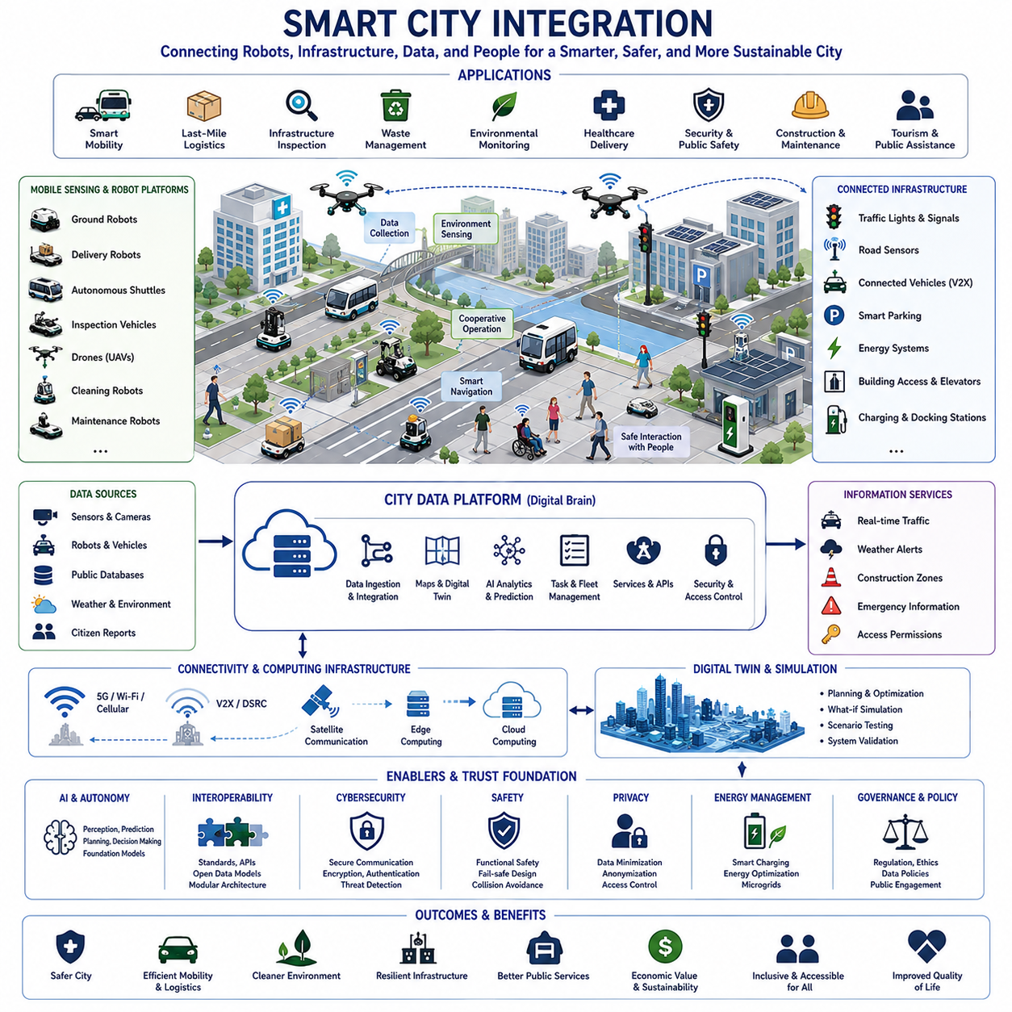
Smart city integration connects autonomous robots, intelligent transportation, digital infrastructure, public services, buildings, utilities, communication networks, and urban data platforms into a coordinated operational environment. Instead of operating each robot as an independent machine, a smart city allows robots to exchange information with roads, facilities, sensors, control centers, and citizens. This integration enables physical artificial intelligence to support urban services more safely, efficiently, and responsively.
A smart city consists of interconnected cyber-physical systems that observe urban environments, analyze information, and coordinate actions across physical infrastructure. Cameras, environmental sensors, traffic detectors, connected vehicles, public networks, energy systems, and robotic platforms continuously generate data. When these systems are integrated through common interfaces and governance rules, robots can use richer contextual information and contribute directly to city-level decision-making.
Robots can serve as mobile sensing platforms in smart cities. Ground robots, delivery robots, autonomous shuttles, inspection vehicles, drones, and maintenance machines can collect visual, thermal, acoustic, environmental, and geometric information while performing their primary missions. Their mobility allows them to observe areas that fixed sensors cannot cover and respond quickly when additional sensing capacity is required.
Urban robotic systems can support transportation, logistics, inspection, cleaning, security, emergency response, infrastructure maintenance, healthcare delivery, construction, tourism, and public assistance. Each application requires a different combination of mobility, perception, communication, autonomy, manipulation, and human interaction. Smart city integration enables these capabilities to share common infrastructure and information instead of operating as completely separate systems.
The city data platform acts as a digital coordination layer connecting physical systems and urban services. It collects information from sensors, robots, public databases, control centers, and connected infrastructure. It can also provide robots with maps, traffic conditions, weather alerts, construction zones, emergency information, and access permissions. In return, robots provide updated environmental observations, detected hazards, task progress, and operational status.
Interoperability is essential because real cities contain equipment and software supplied by many vendors, public agencies, and private operators. Robotic platforms should communicate through standardized data models, application programming interfaces, messaging protocols, and identity systems. Without interoperability, integration costs increase and city-wide coordination becomes difficult. Open interfaces and modular architectures reduce vendor dependence and support long-term expansion.
Urban connectivity provides the communication foundation for smart city robotics. Wi-Fi, private 5G, public cellular networks, dedicated short-range communication, mesh networks, satellite communication, and wired infrastructure may be used depending on the application. Robots require reliable data exchange for fleet management, map updates, remote supervision, cooperative perception, and emergency coordination. However, local safety functions must continue operating independently when network quality deteriorates.
Edge computing reduces latency by processing data near the robot or within local urban infrastructure. Roadside units, building servers, base stations, and local data centers can perform perception, traffic analysis, map updates, and coordination without transmitting every data stream to the cloud. Edge computing is particularly important for real-time applications such as collision avoidance, emergency response, pedestrian protection, and cooperative traffic control.
Cloud computing supports large-scale data storage, model training, fleet analytics, long-term optimization, software distribution, and city-wide service management. Smart city robots may transmit selected operational data to cloud platforms for analysis while continuing real-time control locally. Hybrid edge-cloud architectures balance responsiveness, scalability, privacy, cost, and system resilience across diverse urban environments.
Digital twins provide real-time virtual representations of roads, buildings, utilities, transportation networks, robots, and operational processes. A city digital twin can combine static geographic information with live data such as traffic flow, weather conditions, construction activity, equipment health, and robot locations. Robots use the digital twin for planning and simulation, while real-world observations continuously improve its accuracy.
Urban mapping requires more than simple geometric reconstruction. Robots need semantic maps that identify sidewalks, bicycle lanes, crossings, doors, elevators, loading areas, restricted zones, charging stations, emergency routes, and public facilities. Temporary conditions such as road construction, crowds, parked vehicles, outdoor events, and weather-related hazards must also be represented. Continuous map updating is therefore an essential smart city capability.
Localization in dense urban environments is challenging because tall buildings, tunnels, indoor spaces, trees, and electromagnetic interference can reduce GNSS accuracy. Smart city robots may combine GNSS, inertial sensors, cameras, LiDAR, wheel odometry, wireless positioning, landmarks, and infrastructure-based references. Cooperative localization further improves accuracy when robots and connected infrastructure share observations and relative position information.
Connected transportation infrastructure enables robots to understand and safely participate in urban traffic systems. Traffic lights, pedestrian signals, road sensors, parking systems, and connected vehicles can exchange information with autonomous platforms. Before entering an intersection, a robot may receive signal timing, right-of-way information, congestion warnings, or temporary route restrictions, improving both safety and traffic efficiency.
Vehicle-to-everything communication expands coordination among robots, vehicles, pedestrians, and infrastructure. Autonomous delivery vehicles and service robots can transmit their position, speed, planned movement, and operational intent. Infrastructure can provide information about crossing conditions, emergency vehicles, blocked lanes, and hazardous areas. Cooperative awareness enables robots to predict and respond to risks earlier than onboard sensors alone would allow.
Pedestrian interaction is especially important because smart city robots operate in shared public spaces. Robots must recognize people, predict their movement, maintain appropriate social distance, and clearly communicate their intentions. Speed, sound, lighting, displays, and movement patterns should be designed to reduce uncertainty and discomfort. Accessible interaction is necessary for children, older adults, people with disabilities, and people unfamiliar with robotic technology.
Last-mile logistics is a representative smart city application. Delivery robots can transport parcels, food, medical supplies, and local goods from logistics hubs to final destinations. Integration with building access systems, elevators, parcel lockers, traffic platforms, and digital payment systems enables complete automated delivery. Safe sidewalk operation, cargo protection, route permissions, and coordination with existing transportation modes are essential.
Public transportation can integrate autonomous shuttles, station guidance robots, cleaning robots, inspection robots, and passenger assistance systems. Robots may support first-mile and last-mile mobility, passenger guidance, baggage transport, station inspection, and supply delivery. Scheduling integrated with real-time transit information allows services to adapt to passenger demand, delays, special events, and changing operating conditions.
Infrastructure inspection becomes more efficient through mobile robots equipped with cameras, LiDAR, thermal sensors, acoustic sensors, and specialized measurement devices. Robots can inspect bridges, tunnels, roads, drainage systems, power facilities, railways, and public buildings. Inspection results can be connected directly to asset management systems, enabling cities to detect deterioration early and prioritize maintenance activities.
Utility networks such as electricity, water, gas, telecommunications, waste, and district heating require continuous monitoring. Robots can inspect substations, pipelines, underground spaces, and utility corridors. When connected to supervisory control systems and maintenance databases, detected anomalies can automatically trigger work orders, risk assessments, or emergency responses. Predictive maintenance reduces failures and improves service continuity.
Waste management can use autonomous collection vehicles, sorting robots, cleaning robots, and sensor-equipped containers. Smart routing allows collection systems to respond to actual fill levels rather than fixed schedules. Robots operating in public spaces can detect litter, blocked drains, damaged bins, and illegal dumping. City platforms can connect this information to workforce planning, environmental policies, and neighborhood service priorities.
Environmental monitoring is strengthened by robotic mobility. Robots and drones can measure air quality, temperature, humidity, noise, radiation, water conditions, and vegetation health across different locations. They can be deployed rapidly during pollution events, wildfires, floods, industrial accidents, and extreme weather. Distributed observations improve urban climate models and help identify localized risks that fixed monitoring stations may miss.
Energy integration is essential because large robotic fleets can generate significant electrical demand. Charging schedules should consider battery status, mission priority, electricity prices, grid capacity, renewable generation, and charging station availability. Smart charging can avoid peak demand periods and use solar power or energy storage more efficiently. Robots may also coordinate with building energy management systems and microgrids.
Autonomous charging and docking allow robots to operate for extended periods without direct human assistance. Charging stations may be installed in logistics centers, public facilities, parking areas, maintenance depots, and commercial buildings. City platforms can manage reservations, guide robots to available stations, and balance demand across districts. Standardized charging interfaces improve compatibility among different robot types.
Emergency response is a high-value application for smart city robotics. Robots can investigate hazardous areas, deliver equipment, map damaged infrastructure, search for missing people, monitor dangerous materials, and support evacuation. When integrated with emergency command centers, robots can use building plans, utility data, traffic control information, weather data, and live incident maps. Human responders remain responsible for critical decisions, while robots extend situational awareness.
Disaster resilience requires robotic systems to continue operating even when urban infrastructure is damaged. During earthquakes, floods, fires, or major accidents, communication networks, power supplies, positioning systems, and roads may fail simultaneously. Resilient designs use local autonomy, redundant communication, portable charging, offline maps, distributed coordination, and manual control options. Robots should support safe degraded operation rather than failing completely.
Urban security applications may include patrol support, perimeter inspection, abandoned object detection, crowd monitoring, and critical infrastructure protection. These applications require strong legal, ethical, and privacy safeguards. Robots should not become uncontrolled surveillance platforms. Data collection must be purpose-limited, access-controlled, logged, and aligned with public policy. Independent oversight is also necessary to maintain public trust.
Privacy protection must be incorporated from the beginning of smart city robot system design. Robots may collect images, voices, locations, behaviors, and environmental information in public spaces. Data minimization, on-device processing, anonymization, retention limits, encryption, and access control reduce privacy risks. Citizens should clearly understand what data is collected, why it is necessary, and how it is protected.
Cybersecurity is also a safety requirement because compromised robots can create physical danger. Attackers may attempt to control movement, alter maps, steal information, disable safety functions, or disrupt public services. Secure boot, device identity, encrypted communication, signed updates, network segmentation, intrusion detection, and continuous monitoring are essential. Security incidents should be isolated before they spread across connected city systems.
Identity and access management determines which robots, operators, services, and infrastructure components are permitted to exchange information or issue commands. Every device should have a verifiable identity and only the minimum privileges required for its role. A delivery robot, for example, should not automatically gain access to traffic control or utility systems. Fine-grained authorization reduces the consequences of software errors or compromised credentials.
Functional safety must address interactions among robots, infrastructure, vehicles, and people. Safety depends not only on individual robot behavior but also on the reliability of shared maps, traffic messages, access controls, and coordination services. Safety analysis should consider communication loss, incorrect infrastructure data, simultaneous failures, unexpected human behavior, and emergency overrides. Independent safety functions should limit hazardous actions.
Regulation and governance determine how robots may operate in public environments. Cities may define permitted routes, speed limits, operating hours, insurance requirements, accessibility rules, data policies, testing procedures, and incident reporting obligations. Governance should support innovation while protecting citizens and ensuring fair use of public space. Regulations may evolve through pilot projects, operational evidence, and public consultation.
Operational control centers provide fleet-level supervision across multiple districts and services. Operators can monitor robot locations, mission status, alarms, communication quality, battery levels, and environmental conditions. Effective interfaces should prioritize exceptions rather than requiring constant observation of every robot. Remote assistance can be used when robots encounter unusual obstacles, access problems, damaged infrastructure, or uncertain social situations.
Human-in-the-loop operation remains important even as autonomy improves. Public environments include rare events, ambiguous rules, and complex social behaviors that are difficult to predict fully. Remote operators, city employees, maintenance teams, and emergency personnel should be able to pause, redirect, or recover robotic systems. Clear responsibility boundaries are necessary so human intervention remains effective and accountable.
Fleet management coordinates tasks, routes, charging, maintenance, software versions, and operational permissions across large numbers of robots. In a smart city, municipal agencies, private companies, hospitals, logistics providers, and utility companies may each operate separate fleets. Federated fleet management allows organizations to retain independent control while sharing selected information needed for traffic safety, infrastructure access, and emergency coordination.
Multi-agent coordination enables several robots to collaborate on urban tasks. One robot may detect a problem, another may perform a detailed inspection, and a third may deliver required equipment or materials. Shared world models and task allocation reduce duplicate work and shorten response time. Coordination may be centralized through a city platform, decentralized among robots, or implemented through a hybrid architecture.
Artificial intelligence supports prediction, planning, perception, anomaly detection, demand forecasting, and service optimization. Urban AI can estimate where delivery demand will rise, where infrastructure failures are likely, or where additional cleaning and inspection resources are needed. However, AI outputs should be explainable, monitored, and constrained by operational rules. Critical decisions should not rely solely on unverified model outputs.
Robotics foundation models may allow urban robots to understand natural-language instructions, recognize unfamiliar objects, reason about changing environments, and reuse skills across different platforms. A shared model may support inspection robots, service robots, and logistics robots while adapting to local tasks. Reliable operation requires grounding, confidence estimation, safety validation, and protection against incorrect or malicious instructions.
Simulation is essential before deploying robotic systems in complex public environments. Virtual city models can evaluate traffic interactions, pedestrian behavior, communication coverage, charging demand, emergency scenarios, and large-scale fleet operations. Dangerous or rare situations can be tested safely. Results should then be verified through controlled field trials, pilot districts, and gradual operational expansion.
Testing should include not only normal operation but also adverse weather, communication failures, sensor degradation, crowded areas, construction zones, emergency vehicles, and unexpected human actions. Robots that succeed under ideal conditions may fail when lighting, surfaces, traffic, or connectivity change. Long-duration testing reveals wear, performance drift, maintenance needs, and cumulative software problems.
Performance evaluation should measure city-level outcomes rather than only individual robot accuracy. Relevant indicators include service coverage, response time, infrastructure downtime, energy consumption, fleet utilization, safety incidents, human interventions, public acceptance, environmental impact, and lifecycle cost. Smart city robotics should create measurable public and economic value rather than merely adding advanced technology to existing processes.
Public acceptance depends on safety, usefulness, fairness, accessibility, and transparency. Citizens are more likely to support robots when they clearly improve services without creating unreasonable noise, congestion, surveillance, or exclusion. City authorities and operators should communicate deployment goals, operational boundaries, complaint procedures, and evaluation results. Community feedback should influence operating times, route design, and service priorities.
Accessibility must be considered in both physical design and digital interaction. Robots should not block sidewalks, ramps, tactile paving, crossings, or building entrances. Interfaces should support visual, auditory, and accessible communication methods. Smart city integration should improve mobility and service access for people with disabilities rather than creating new barriers.
Economic sustainability requires realistic consideration of equipment purchase, infrastructure construction, system integration, communication, maintenance, staffing, insurance, and software costs. A technically successful pilot may still fail to scale if the operating model is too expensive. Shared infrastructure, standardized interfaces, modular robots, centralized support, and data-driven maintenance can reduce lifecycle costs. Benefits should be compared with conventional vehicles, human services, and fixed automation.
Lifecycle management includes procurement, deployment, software updates, maintenance, battery replacement, cybersecurity support, data governance, and decommissioning. Urban robots may operate for many years while city infrastructure and regulations continue to change. Modular hardware and updateable software help preserve compatibility. End-of-life planning should address recycling, battery disposal, data deletion, and replacement strategies.
Ultimately, smart city integration requires systems engineering across technology, policy, operations, and human-centered design. Network connectivity alone does not create an intelligent city, and autonomous robots alone cannot solve urban problems. Real value emerges when robots, infrastructure, digital platforms, public agencies, private operators, and citizens operate within a coordinated framework with clear responsibilities, interfaces, safety rules, and measurable objectives.
An effective smart city robotics architecture integrates mobile sensing, semantic mapping, cooperative localization, urban data platforms, edge and cloud computing, digital twins, fleet management, infrastructure communication, artificial intelligence, cybersecurity, functional safety, privacy protection, energy management, governance, and human supervision. Through gradual deployment and continuous evaluation, robotic systems can become trusted components of cleaner, safer, more resilient, and more responsive cities.

25.05 AGI and Autonomous Machines · AGI와 자율 기계
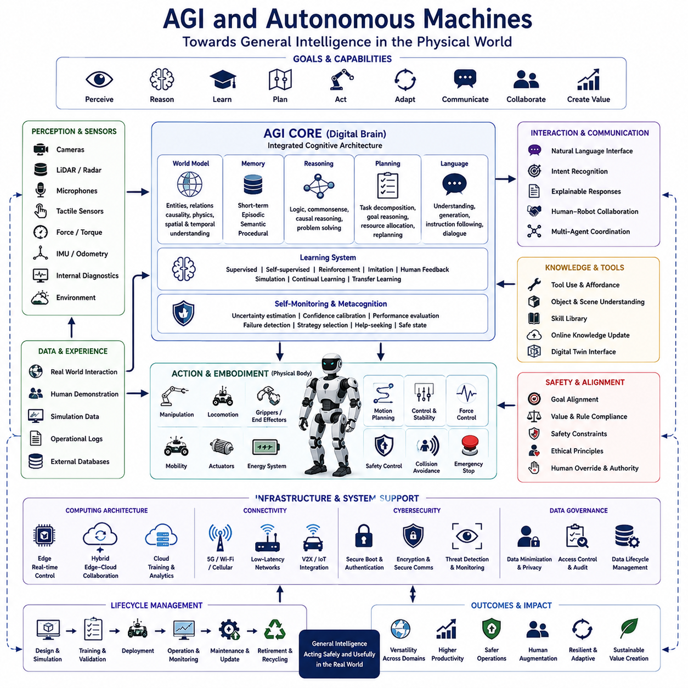
Artificial general intelligence refers to a hypothetical form of intelligence capable of learning, reasoning, adapting, and transferring knowledge across a wide range of tasks without being limited to one narrow domain. When connected to autonomous machines, AGI would extend beyond software-based reasoning and gain the ability to perceive, move, manipulate, communicate, and act within the physical world. This combination represents one of the most ambitious directions in physical artificial intelligence.
Autonomous machines currently rely on specialized models designed for navigation, perception, planning, control, language, or manipulation. These systems can perform impressive tasks but often fail when goals, environments, tools, or operating conditions differ from their training assumptions. AGI-oriented machines would seek broader competence by combining multiple cognitive abilities into a unified system capable of understanding unfamiliar situations and generating appropriate responses.
The central distinction between narrow autonomy and general autonomy lies in transferability. A narrow autonomous robot may perform warehouse transport effectively but cannot immediately adapt to construction, inspection, or domestic assistance. A more general machine would reuse prior knowledge, infer new task structures, and learn unfamiliar skills with limited additional data. Such transfer would reduce the need to engineer separate solutions for every environment and application.
Embodiment is essential because intelligence in autonomous machines is shaped by physical interaction. A machine must understand mass, friction, geometry, balance, force, uncertainty, damage, and energy limitations through perception and action. Physical experience creates constraints that are absent from purely digital systems. An AGI-enabled robot would therefore require not only abstract reasoning but also a grounded understanding of how actions change the real world.
Perception provides the machine with information about objects, people, terrain, motion, language, sound, force, and environmental conditions. Cameras, LiDAR, radar, microphones, tactile sensors, force sensors, inertial units, and internal diagnostics may contribute to a shared representation. General autonomy requires these observations to be interpreted consistently across different tasks rather than being processed as isolated sensor-specific outputs.
A world model allows an autonomous machine to represent entities, relationships, causes, uncertainty, and possible future states. Instead of reacting only to immediate observations, the machine can predict how objects may move, how people may respond, and how its own actions may affect the environment. A sufficiently general world model should support physical reasoning, social understanding, spatial memory, task planning, and long-term adaptation.
Memory is a critical component of general intelligence. Short-term memory supports immediate reasoning, while episodic memory stores previous experiences, failures, and successful strategies. Semantic memory represents concepts and facts, and procedural memory preserves reusable skills. Autonomous machines need mechanisms for recalling relevant knowledge without allowing outdated, incorrect, or unsafe experiences to dominate future decisions.
Learning in autonomous machines may occur through supervised learning, self-supervised learning, reinforcement learning, imitation learning, human feedback, simulation, and direct physical interaction. No single method is likely to provide all required capabilities. General systems will need to combine large-scale pretrained knowledge with continuous adaptation while preventing catastrophic forgetting, uncontrolled behavior change, and degradation of previously validated skills.
Foundation models provide a possible basis for AGI-oriented machines because they can integrate language, vision, audio, action, and structured data. A multimodal model may interpret instructions, recognize objects, summarize situations, and propose plans. However, foundation models alone do not guarantee reliable autonomy. Their outputs must be grounded in current sensor data, checked against physical constraints, and filtered through safety and control systems.
Vision-language-action models directly connect observations and natural-language goals to robotic actions. These models may enable one system to perform many tasks by combining visual understanding, semantic reasoning, and learned motor behavior. Their greatest value lies in generalization across objects and instructions. Their greatest risk is that plausible but incorrect interpretations can be converted into unsafe physical movement.
Hierarchical intelligence is a practical architecture for autonomous machines. High-level reasoning defines goals, priorities, and task sequences, while lower layers perform motion planning, control, stabilization, and safety enforcement. This separation allows flexible cognitive behavior without giving an uncertain reasoning model unrestricted authority over motors. Each layer should operate within explicit permissions and communicate its confidence and limitations.
Task planning converts broad instructions into executable sequences. A request such as inspecting a damaged facility may require mapping the area, identifying access routes, selecting sensors, avoiding hazards, collecting evidence, and reporting results. A general autonomous system must decompose goals, estimate feasibility, allocate resources, monitor progress, and revise the plan when conditions change.
Motion planning connects symbolic goals to physical movement. Even a correct high-level decision may be impossible because of obstacles, joint limits, unstable terrain, insufficient energy, or limited reach. Autonomous machines require planners that account for geometry, dynamics, uncertainty, and interaction forces. General intelligence must therefore cooperate with specialized control methods rather than replace them.
Self-monitoring allows a machine to evaluate its own condition and performance. It should recognize uncertainty, sensor degradation, overheating, low battery, mechanical wear, localization drift, and unexpected changes in task quality. Metacognitive functions can help the machine decide when to continue, slow down, request assistance, switch strategies, or enter a safe state instead of acting with unjustified confidence.
Uncertainty management is essential because real environments are incomplete, noisy, and unpredictable. Autonomous machines should distinguish between known facts, likely interpretations, and unresolved ambiguity. Confidence estimates should influence speed, force, route choice, and the need for human review. A system that always produces a definite answer may appear capable while creating serious operational risk.
Common-sense reasoning is a major challenge for AGI and robotics. Humans understand that fragile objects require gentle handling, wet floors may be slippery, blocked exits are dangerous, and people can behave unpredictably. Machines often lack this broad background knowledge or apply it inconsistently. General autonomy requires common sense to be grounded in context, physical evidence, social rules, and operational constraints.
Causal reasoning allows machines to understand why events occur rather than only recognizing statistical patterns. A robot that detects repeated motor overheating should consider load, friction, cooling, control settings, and environmental temperature. Causal models support diagnosis, counterfactual analysis, and safer planning. They also improve the machine’s ability to transfer knowledge to situations that differ from previous training data.
Tool use is an important indicator of general machine intelligence. Autonomous systems may need to select, grasp, operate, exchange, and maintain tools designed for humans or other machines. General tool use requires perception of function, understanding of affordances, force control, sequence planning, and recovery from misuse. The machine should also recognize when a tool is damaged, unavailable, or unsuitable.
Language interaction enables humans to provide goals, constraints, explanations, and corrections in intuitive forms. A general autonomous machine should understand not only literal commands but also context, ambiguity, urgency, and role boundaries. Natural-language interfaces must not bypass safety systems. The machine should clarify uncertain instructions and reject requests that conflict with law, policy, or physical safety.
Human-robot collaboration requires the machine to predict human movement, communicate intention, respect personal space, and adapt to different levels of experience. General intelligence may improve flexibility in shared tasks, but it also increases behavioral unpredictability. Collaborative systems should therefore provide visible state information, understandable explanations, consistent motion patterns, and simple intervention mechanisms.
Multi-agent intelligence extends general autonomy from one machine to coordinated groups. Different robots may share observations, divide tasks, exchange skills, and support one another during failures. An AGI-oriented fleet could dynamically reorganize around mission goals instead of following fixed assignments. This capability requires secure communication, shared world models, conflict resolution, and rules that prevent uncontrolled collective behavior.
Cloud and edge computing will likely operate together in advanced autonomous machines. Edge processors perform real-time perception, control, and safety functions, while cloud platforms support large-scale model training, long-term memory, analytics, and fleet coordination. Critical operation should not depend entirely on remote connectivity. The machine must retain safe local capability during latency, disconnection, or cloud failure.
Simulation is essential for training and validating general autonomous behavior. Virtual environments can expose machines to rare hazards, diverse objects, complex social situations, and repeated failures without damaging hardware. However, simulation cannot perfectly represent real friction, sensor noise, material behavior, or human unpredictability. Sim-to-real transfer therefore requires domain randomization, system identification, and progressive physical testing.
Digital twins can provide continuously updated virtual representations of machines, environments, and operating processes. A general autonomous system may use a digital twin to test plans, predict maintenance needs, compare alternative strategies, and estimate risk before acting. The twin should reflect current geometry, system health, network conditions, and operational rules rather than remaining a static design model.
Safety architecture must remain independent from high-level intelligence. Emergency stopping, collision prevention, force limits, speed supervision, geofencing, and safe-state control should be implemented through verified mechanisms that cannot be overridden by uncertain reasoning. AGI capabilities should operate within defined envelopes, permissions, and monitored interfaces. Greater intelligence does not eliminate the need for deterministic protection.
Alignment concerns how machine goals remain consistent with human intent, law, policy, and ethical expectations. In autonomous machines, misalignment can produce immediate physical consequences. A robot may optimize task completion while ignoring property damage, discomfort, fairness, or long-term risk. Goal specification must therefore include constraints, priorities, prohibited actions, and mechanisms for human correction.
Corrigibility refers to whether an autonomous machine remains willing and able to accept correction, shutdown, or modification. Highly capable systems should not resist intervention or reinterpret safety commands as obstacles. Operators need reliable authority to pause, isolate, update, or decommission the machine. These capabilities should be protected against both accidental disablement and malicious misuse.
Cybersecurity becomes more critical as autonomous machines gain broader access and decision authority. Compromised perception, memory, identity, maps, updates, or planning models could alter physical behavior. Secure boot, authenticated communication, signed software, least-privilege access, network segmentation, intrusion detection, and tamper monitoring are essential. Security controls should cover the entire lifecycle from development to retirement.
Data governance determines how experiences, human interactions, location records, sensor streams, and operational decisions are collected and used. General autonomous machines may generate highly sensitive information because they operate continuously in physical environments. Data minimization, purpose limitation, anonymization, retention control, and auditable access are necessary to prevent misuse and maintain public trust.
Verification of AGI-enabled machines is difficult because general systems may produce novel behaviors that were not explicitly programmed. Traditional testing cannot enumerate every possible situation. Verification must therefore combine formal constraints, scenario testing, simulation, adversarial evaluation, runtime monitoring, and long-duration field trials. Safety evidence should be updated as models, environments, and capabilities evolve.
Explainability is important for debugging, trust, certification, and accountability. Operators should understand why the machine selected a route, rejected a task, requested assistance, or changed its plan. Explanations should reflect the actual decision process as closely as possible. Simplified narratives that merely sound reasonable may create false confidence and hide important uncertainty or failure modes.
Accountability must remain clear when autonomous machines make consequential decisions. Responsibility may involve developers, manufacturers, owners, operators, service providers, data suppliers, and public authorities. Logs, version records, sensor evidence, task histories, and intervention records help reconstruct events. Governance should define who can authorize actions, who monitors performance, and who responds when failures occur.
Economic value depends on whether general autonomy can reduce integration effort and support many tasks on shared hardware. A flexible machine may replace several specialized systems, but greater generality also increases development, validation, computing, maintenance, and insurance costs. Commercial success will depend on measurable improvements in utilization, adaptability, uptime, safety, and total lifecycle cost.
Manufacturing and logistics are likely early applications because they contain repetitive tasks alongside frequent variation. General autonomous machines may transport materials, operate tools, inspect products, assist workers, and adapt to changing layouts. Their value will be highest where traditional automation is too rigid but the environment remains sufficiently controlled for safe and economical deployment.
Healthcare and assistance applications may include supply delivery, patient support, rehabilitation, facility inspection, and routine service tasks. These environments require exceptional reliability, privacy protection, hygiene, and sensitivity to human needs. General machines should support professionals rather than independently making critical medical decisions beyond validated authority. Human supervision and clear escalation procedures remain essential.
Construction, mining, agriculture, and infrastructure maintenance present demanding opportunities for autonomous machines. These fields involve variable terrain, changing geometry, heavy loads, weather, dust, and incomplete information. General intelligence may help machines adapt across tasks, but robust hardware and specialized safety measures remain necessary. Cognitive flexibility cannot compensate for inadequate mechanical design or environmental protection.
Disaster response is another important domain because autonomous machines can enter hazardous areas, map damage, locate victims, deliver supplies, and operate tools. AGI-like reasoning may improve adaptation when plans become invalid. However, emergency environments also contain extreme uncertainty and communication failure. Machines must prioritize human life, follow responder authority, and remain predictable under degraded conditions.
The development of AGI and autonomous machines should proceed through staged capability growth rather than unrestricted deployment. Each new function should be evaluated for technical benefit, failure modes, misuse potential, and operational readiness. Controlled pilots, limited permissions, supervised learning, and progressive expansion allow evidence to accumulate before machines receive broader authority.
Performance evaluation should measure more than task success. Relevant indicators include generalization, recovery, human intervention, energy use, uncertainty calibration, safety violations, learning stability, maintenance burden, explanation quality, and behavior under unfamiliar conditions. A machine that performs many demonstrations but requires constant rescue may not possess meaningful general autonomy.
Long-term autonomy requires lifecycle learning without uncontrolled drift. Machines will encounter new tools, environments, rules, and human expectations after deployment. Updates should be tested before release, and online learning should remain bounded by validation and rollback mechanisms. Operational experience can improve performance, but safety-critical behavior should not change silently or without traceability.
Artificial general intelligence in autonomous machines should not be understood as a single model controlling every function. A realistic system will combine learned models, symbolic reasoning, world models, optimized planners, real-time controllers, safety processors, communication systems, and human governance. General capability will emerge from coordinated architecture rather than from one unrestricted intelligence module.
The future relationship between AGI and autonomous machines will depend on how effectively broad intelligence can be grounded, verified, controlled, and aligned with real operational needs. Progress will require advances in cognition, robotics, safety, cybersecurity, regulation, and human-centered design. The most valuable systems will not simply appear intelligent; they will perform useful work consistently while respecting physical, social, and legal boundaries.
An effective AGI-enabled autonomous machine architecture integrates multimodal perception, grounded world models, memory, reasoning, task planning, learning, motion control, self-monitoring, uncertainty management, communication, cybersecurity, functional safety, human supervision, and lifecycle governance. Through careful systems engineering and progressive validation, general autonomous machines may eventually provide adaptable physical intelligence while remaining safe, accountable, maintainable, and economically sustainable.

