Volume 01. AMR Foundations and System Architecture

18. Hospital AMR · 병원 AMR

18.01 Hospital Logistics · 병원 물류
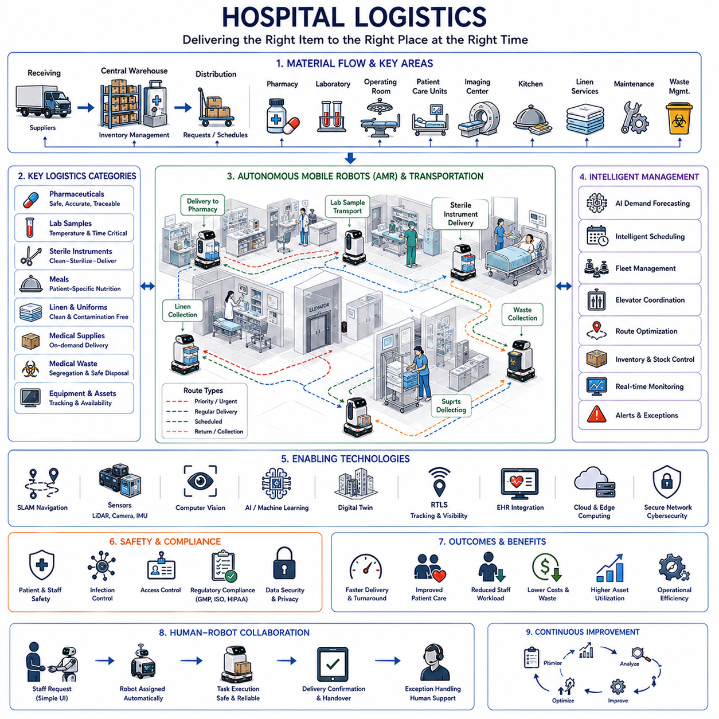
Hospital logistics forms the operational backbone of modern healthcare by ensuring that medical supplies, pharmaceuticals, laboratory samples, sterile instruments, meals, linens, waste, equipment, and patient-related materials are delivered to the correct location at the correct time. Unlike conventional industrial logistics, hospital logistics must balance efficiency with patient safety, infection prevention, regulatory compliance, and uninterrupted clinical operations. Every transportation activity directly or indirectly influences healthcare quality, making logistics an essential component of hospital performance rather than merely a supporting service.
Modern hospitals operate as highly interconnected ecosystems where emergency departments, operating rooms, intensive care units, inpatient wards, outpatient clinics, pharmacies, laboratories, imaging centers, sterilization facilities, kitchens, storage rooms, and waste management systems exchange thousands of materials every day. These activities occur continuously throughout the day and night, requiring reliable coordination across multiple departments while minimizing delays that could affect diagnosis, treatment, or patient recovery.
Material flow within a hospital begins with receiving medical supplies from external vendors. Pharmaceuticals, surgical consumables, medical devices, diagnostic kits, blood products, office supplies, and maintenance materials are inspected, registered, and transferred into central inventory systems. Inventory management ensures that stock levels remain sufficient without excessive overstocking, while expiration dates, storage conditions, and regulatory requirements are continuously monitored to maintain both operational efficiency and patient safety.
Central warehouses serve as logistics hubs that distribute supplies to clinical departments according to scheduled deliveries or real-time requests. Storage systems often separate sterile materials, hazardous chemicals, refrigerated pharmaceuticals, controlled substances, laboratory reagents, and general medical supplies because each category requires different environmental conditions and security controls. Automated inventory systems continuously monitor stock movement and generate replenishment requests before shortages occur.
Pharmacy logistics represents one of the most critical functions in hospital operations. Prescription medications must be accurately prepared, verified, transported, and delivered while maintaining strict traceability throughout the entire distribution process. Temperature-sensitive drugs, chemotherapy medications, narcotics, and biological products require specialized handling procedures. Every delivery must preserve patient identity, dosage accuracy, storage conditions, and regulatory documentation to eliminate medication errors.
Laboratory logistics supports diagnostic medicine by transporting blood samples, tissue specimens, urine samples, microbiology cultures, and pathology materials between clinical departments and laboratory facilities. Transport delays, vibration, contamination, temperature variation, or incorrect labeling may compromise diagnostic accuracy. Efficient logistics therefore contributes directly to faster diagnosis and more effective clinical decision making while maintaining complete sample traceability throughout laboratory workflows.
Sterile Supply Departments perform cleaning, disinfection, inspection, packaging, sterilization, storage, and redistribution of reusable surgical instruments. Thousands of surgical tools circulate continuously between operating rooms and sterilization facilities. Logistics systems monitor instrument locations, sterilization cycles, maintenance history, and availability so that surgical procedures begin without unnecessary delay while ensuring full compliance with infection control regulations.
Operating rooms depend heavily on synchronized logistics because every surgical procedure requires instruments, implants, medications, disposable supplies, imaging equipment, anesthesia devices, and laboratory support to arrive according to precise schedules. Delayed logistics may postpone surgeries, increase operating costs, or affect patient outcomes. Intelligent scheduling systems coordinate surgical preparation with inventory availability, sterilization completion, equipment readiness, and transportation resources.
Hospital meal delivery involves more than simply transporting food. Nutritional requirements vary according to medical condition, allergies, dietary restrictions, medication interactions, and physician prescriptions. Meal preparation systems communicate directly with electronic medical records to ensure patients receive appropriate nutrition. Delivery schedules must coordinate with medical procedures, medication timing, and patient availability while maintaining food quality and hygiene standards.
Linen logistics manages hospital gowns, blankets, towels, surgical drapes, uniforms, and bedding through continuous collection, washing, sterilization, distribution, and replacement cycles. Clean and contaminated materials must remain completely separated throughout transportation. Automated tracking systems improve inventory visibility while reducing losses, ensuring sufficient supplies remain available despite the extremely high daily circulation volume within large healthcare facilities.
Medical waste management requires carefully controlled logistics because infectious waste, pharmaceutical waste, chemical waste, radioactive materials, and ordinary waste follow different disposal procedures. Collection routes, storage locations, transportation equipment, and disposal schedules are designed to minimize contamination risk while satisfying environmental regulations and occupational safety requirements. Proper segregation significantly reduces disposal costs and improves overall hospital safety.
Autonomous Mobile Robots are increasingly transforming hospital logistics by replacing repetitive manual transportation tasks. Mobile robots transport medications, laboratory samples, sterile instruments, meals, linens, medical supplies, and waste throughout hospital corridors without requiring continuous human supervision. Their operation reduces staff workload while allowing nurses and clinical personnel to spend more time providing direct patient care rather than performing routine transportation activities.
Hospital logistics robots navigate complex indoor environments using simultaneous localization and mapping, laser scanners, depth cameras, inertial sensors, elevators, automatic doors, and digital building maps. Unlike industrial factories, hospitals contain unpredictable pedestrian traffic including patients, visitors, wheelchairs, stretchers, medical carts, and emergency response teams. Safe navigation therefore requires continuous environmental perception, dynamic obstacle avoidance, and socially acceptable robot behavior.
Fleet management systems coordinate multiple autonomous robots operating simultaneously across hospital campuses. Transportation requests originate from pharmacies, laboratories, operating rooms, nursing stations, kitchens, and storage facilities. Fleet optimization considers robot availability, battery status, travel distance, elevator access, traffic congestion, delivery priority, and emergency requests before assigning missions. Efficient coordination improves transportation capacity while minimizing unnecessary robot movement.
Elevators represent shared resources requiring intelligent coordination because robots frequently travel between multiple hospital floors. Fleet management systems reserve elevator access, synchronize robot arrival times, communicate with building automation systems, and avoid congestion during peak transportation periods. Elevator scheduling becomes particularly important in large medical centers where hundreds of transportation requests occur simultaneously throughout daily clinical operations.
Artificial Intelligence enhances hospital logistics through predictive demand forecasting, intelligent scheduling, route optimization, anomaly detection, inventory prediction, and operational decision support. Machine learning analyzes historical transportation records, patient admission patterns, seasonal demand, surgical schedules, and emergency activity to anticipate future logistics requirements. Predictive planning reduces delays while improving resource allocation and maintaining service continuity during periods of fluctuating demand.
Computer vision supports autonomous logistics by recognizing doors, corridors, carts, equipment, room numbers, safety signs, and unexpected obstacles. Vision systems also verify delivery locations, monitor loading conditions, confirm package identity, and detect abnormal situations requiring human intervention. Combined with multimodal perception, computer vision significantly improves robot reliability in dynamic healthcare environments where layouts and operating conditions continuously change.
Digital twins provide virtual representations of hospital logistics operations by integrating building layouts, transportation routes, inventory systems, elevator schedules, robot fleets, clinical workflows, and operational performance. Engineers evaluate alternative layouts, fleet sizes, delivery policies, and infrastructure upgrades before implementing changes in real hospitals. Continuous synchronization between physical operations and digital models supports evidence-based planning while minimizing deployment risks.
Real-time location systems provide continuous visibility of medical equipment, wheelchairs, infusion pumps, ventilators, portable imaging systems, stretchers, and logistics robots. Wireless positioning technologies allow hospitals to identify equipment locations instantly, reducing search time and improving asset utilization. Integrated tracking systems also support preventive maintenance scheduling, equipment availability forecasting, and emergency resource allocation during periods of unusually high clinical demand.
Electronic Health Record integration enables logistics systems to support patient-centered healthcare workflows. Transportation priorities may automatically change according to patient admissions, scheduled surgeries, medication orders, laboratory requests, or discharge planning. Logistics activities therefore become closely aligned with clinical decision making rather than functioning as isolated transportation processes, improving coordination across multiple hospital departments.
Cybersecurity becomes increasingly important as logistics robots communicate with hospital information systems, wireless networks, pharmacy databases, laboratory systems, and building management platforms. Authentication, encrypted communication, role-based access control, software integrity verification, audit logging, and continuous security monitoring protect sensitive patient information while preventing unauthorized control of autonomous transportation systems operating throughout clinical facilities.
Safety remains the highest priority within hospital logistics because robots share narrow corridors with vulnerable patients, visitors, and healthcare professionals. Certified safety sensors, emergency stopping systems, speed adaptation, collision avoidance, audible warnings, visual indicators, and operational safety zones ensure predictable robot behavior. Autonomous systems must always prioritize human safety while maintaining efficient transportation performance under continuously changing hospital conditions.
Human-robot collaboration plays an essential role because logistics automation complements rather than replaces healthcare professionals. Nurses, pharmacists, laboratory technicians, surgeons, logistics staff, and maintenance personnel interact with autonomous systems throughout daily operations. Intuitive user interfaces, simple mission requests, transparent status reporting, and reliable exception handling allow staff to trust robotic systems while maintaining complete operational oversight whenever necessary.
Performance evaluation considers operational indicators that directly influence both logistics efficiency and healthcare quality. Hospitals monitor delivery time, transportation accuracy, inventory availability, medication turnaround, laboratory response time, robot utilization, fleet productivity, equipment availability, energy consumption, maintenance cost, and staff workload. Continuous performance analysis identifies improvement opportunities while ensuring logistics investments contribute measurable clinical and financial benefits.
Future hospital logistics will integrate autonomous mobile robots, artificial intelligence, multimodal foundation models, digital twins, predictive analytics, intelligent inventory systems, and fully connected healthcare information platforms into unified logistics ecosystems. Transportation systems will increasingly anticipate clinical demand, coordinate heterogeneous robotic fleets, optimize hospital resources, and support healthcare professionals through intelligent decision assistance. These technologies will create safer, more efficient, and patient-centered hospitals capable of delivering higher-quality medical services while reducing operational complexity and resource consumption.

18.02 Linen Transport Robots · 린넨 운반 로봇
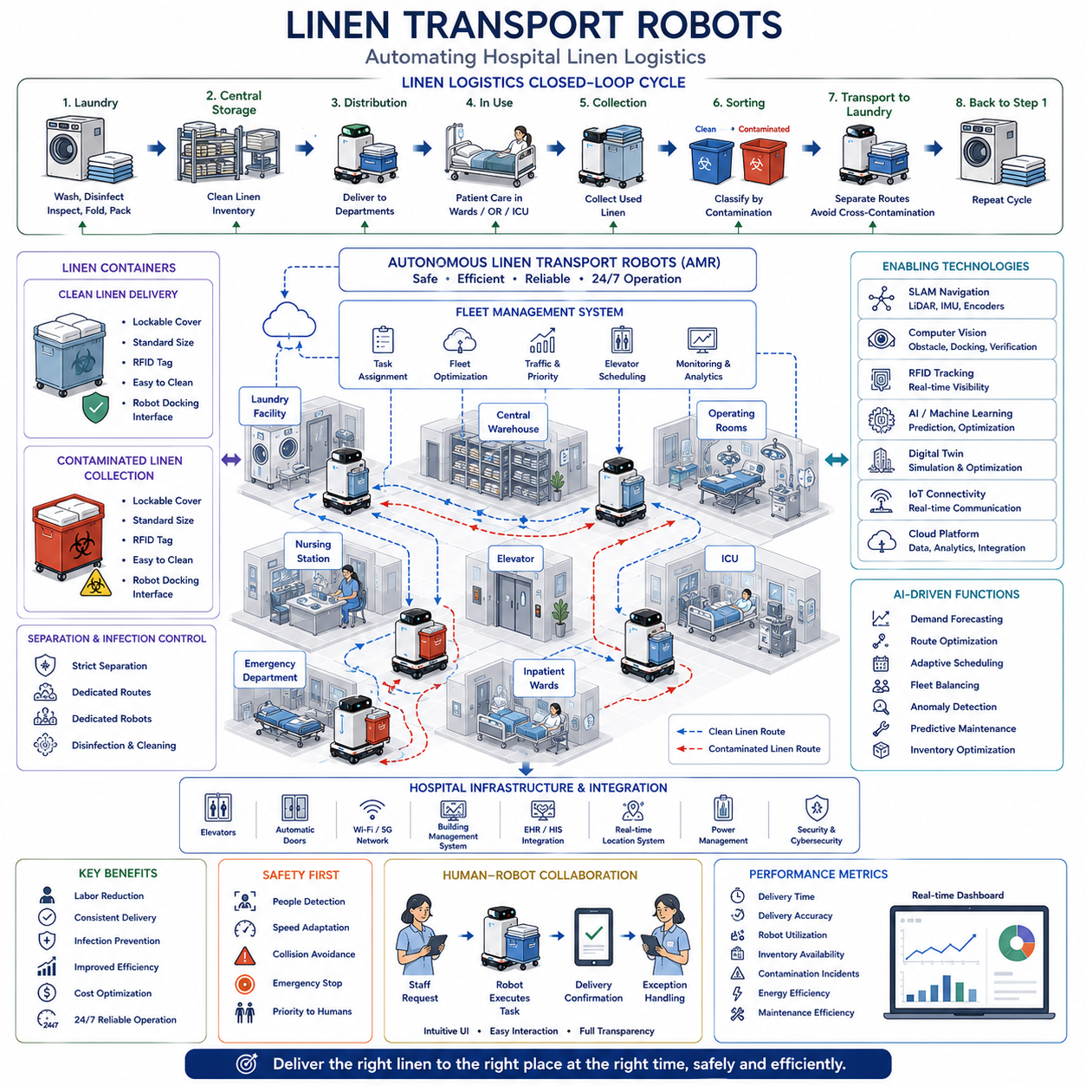
Linen transportation is one of the most repetitive and labor-intensive logistics operations within modern hospitals. Every day, thousands of clean linens must be delivered to patient wards, operating rooms, intensive care units, outpatient clinics, emergency departments, and specialized treatment areas, while contaminated linens are simultaneously collected and transported to centralized laundry facilities. Linen transport robots automate these repetitive transportation tasks, allowing healthcare professionals to focus on patient care while improving operational efficiency, infection control, and logistics reliability throughout the hospital.
Hospital linen includes bed sheets, pillowcases, blankets, patient gowns, surgical drapes, towels, uniforms, curtains, reusable protective garments, and specialized textile products used in clinical procedures. Each category follows specific handling, storage, replacement, and cleaning requirements depending on clinical application and infection control regulations. Continuous availability of clean linen is essential because shortages may directly affect patient admission, surgical scheduling, emergency response, and overall hospital operations.
Linen logistics follows a closed-loop transportation cycle that begins with clean linen leaving the hospital laundry or external laundry service. Clean materials are packaged, transported to central storage, distributed to individual departments, used during patient care, collected after use, classified according to contamination level, transported back to laundry facilities, disinfected, washed, inspected, folded, packaged, and returned for redistribution. Every stage requires accurate tracking to maintain inventory visibility and ensure uninterrupted clinical support.
Clean and contaminated linens must remain completely separated throughout transportation. Cross-contamination introduces infection risks that may compromise patient safety and violate hospital hygiene regulations. Separate transportation containers, dedicated robot missions, isolated storage locations, predefined delivery routes, and carefully controlled loading procedures minimize contamination risk. Robot software enforces transportation rules by preventing inappropriate mixing of clean and contaminated materials within the same mission or storage compartment.
Autonomous Mobile Robots have become an increasingly practical solution for hospital linen transportation because linen delivery follows highly repetitive routes with predictable schedules. Robots transport linen carts between laundry facilities, central warehouses, nursing stations, operating suites, intensive care units, emergency departments, and inpatient wards. Automated transportation reduces manual pushing of heavy carts across long hospital corridors, decreasing physical workload while improving delivery consistency throughout twenty-four-hour hospital operations.
Hospital linen robots typically navigate indoor environments using simultaneous localization and mapping, laser scanners, depth cameras, inertial measurement units, wheel encoders, and digital building maps. Their navigation systems continuously update robot position while detecting patients, visitors, medical equipment, wheelchairs, stretchers, service carts, and other moving obstacles. Safe navigation requires smooth motion planning that minimizes disturbance to healthcare activities while maintaining reliable transportation performance.
Fleet management coordinates multiple linen transport robots operating simultaneously throughout large hospitals. Daily transportation requests vary according to patient admissions, discharges, surgery schedules, emergency activities, and laundry processing capacity. Fleet optimization continuously assigns transportation tasks while considering robot availability, battery status, elevator usage, route congestion, transportation priority, and delivery deadlines. Intelligent scheduling maximizes fleet utilization while minimizing unnecessary travel distance and waiting time.
Hospital elevators represent important shared resources because linen transportation frequently occurs between multiple building floors. Robots communicate with building management systems to request elevators, reserve elevator access, synchronize arrival timing, and coordinate transportation without interfering with patient movement or emergency medical operations. Intelligent elevator scheduling reduces waiting time while maintaining smooth logistics flow across large healthcare facilities containing multiple towers or interconnected buildings.
Linen transportation containers are carefully designed to maintain cleanliness while supporting efficient robotic handling. Containers often include standardized dimensions, stable centers of gravity, lockable covers, washable surfaces, RFID identification, and docking interfaces compatible with autonomous robots. Separate containers are assigned for clean delivery and contaminated collection. Standardization simplifies robotic loading, transportation, inventory management, cleaning operations, and long-term maintenance across the hospital logistics network.
RFID technology significantly improves linen traceability by assigning digital identities to reusable textile products and transportation containers. RFID readers installed on robots, storage stations, laundry facilities, and logistics checkpoints automatically record material movement without manual scanning. Hospitals obtain continuous visibility of inventory location, usage frequency, replacement history, loss rates, and transportation performance, enabling more accurate inventory planning while reducing unnecessary purchasing and material shortages.
Computer vision enhances robotic transportation by recognizing corridor conditions, storage rooms, loading stations, docking locations, transportation carts, safety markings, and unexpected obstacles. Vision algorithms verify correct loading before departure, confirm successful delivery, identify blocked pathways, and detect abnormal transportation situations requiring operator intervention. Multimodal perception combining cameras, laser scanners, and depth sensors significantly improves navigation robustness in crowded hospital environments.
Artificial Intelligence improves linen transportation through predictive demand forecasting, intelligent route optimization, adaptive scheduling, fleet balancing, anomaly detection, and maintenance prediction. Machine learning analyzes historical linen consumption together with patient occupancy, seasonal trends, operating room schedules, infection outbreaks, and emergency events to predict future transportation demand. These predictions allow hospitals to prepare transportation resources before shortages or congestion occur.
Inventory management continuously monitors linen availability across every hospital department. Smart storage systems communicate with robots to request replenishment whenever stock falls below predefined thresholds. Rather than relying on fixed delivery schedules, AI-based inventory control enables demand-driven transportation that responds dynamically to actual clinical consumption. This approach reduces unnecessary inventory while maintaining high service levels throughout hospital operations.
Digital twins provide virtual models of linen logistics by representing transportation routes, storage locations, laundry facilities, robot fleets, inventory levels, and hospital layouts. Engineers evaluate alternative transportation strategies, fleet sizes, storage capacities, delivery schedules, and infrastructure improvements before implementing physical changes. Continuous synchronization between operational data and digital models supports simulation-based optimization while reducing deployment risk.
Human-robot collaboration remains essential because hospital staff interact continuously with linen transport robots during loading, unloading, inventory verification, exception handling, and maintenance activities. User interfaces must remain intuitive so nurses, logistics personnel, and housekeeping staff can easily request deliveries, confirm completed transportation, report abnormalities, and temporarily modify robot missions. Effective collaboration improves operational acceptance while minimizing training requirements.
Safety receives the highest priority because linen robots operate in corridors shared with patients, visitors, nurses, physicians, stretchers, wheelchairs, and emergency response teams. Robots continuously monitor surrounding environments using certified safety sensors, emergency stopping systems, speed adaptation, collision avoidance algorithms, and dynamic obstacle detection. Human movement always receives higher priority than robot transportation, ensuring safe coexistence within busy clinical environments.
Infection prevention extends beyond simple transportation separation. Robot docking stations, transportation compartments, loading mechanisms, and external surfaces must support routine cleaning and disinfection according to hospital infection control procedures. Materials used in robot construction should tolerate repeated exposure to disinfectants without degradation. Maintenance activities also follow hygiene protocols that prevent robots from becoming sources of environmental contamination.
Battery management significantly influences operational efficiency because hospital logistics continue throughout the entire day. Fleet management predicts battery consumption according to transportation workload, travel distance, elevator usage, and expected mission duration. Charging schedules are coordinated automatically so sufficient robots remain available during peak transportation periods while idle robots recharge during lower-demand intervals without disrupting hospital logistics continuity.
Cybersecurity protects transportation robots connected to hospital information systems, inventory databases, wireless communication networks, RFID infrastructure, and fleet management platforms. Authentication, encrypted communication, software integrity verification, access control, continuous monitoring, and secure software updates prevent unauthorized robot control while protecting operational information and maintaining reliable logistics services within critical healthcare environments.
Maintenance strategies combine preventive inspection with predictive diagnostics to maximize robot availability. Sensors continuously monitor wheel condition, drive motors, batteries, brakes, elevators interfaces, navigation sensors, and communication systems. Artificial intelligence estimates component health and predicts maintenance requirements before failures occur. Planned maintenance minimizes operational disruption while extending equipment lifetime and reducing overall ownership cost.
Performance evaluation measures logistics efficiency using indicators such as transportation completion time, delivery accuracy, robot utilization, fleet availability, battery efficiency, inventory availability, contamination incidents, maintenance frequency, energy consumption, and staff workload reduction. Continuous operational analysis identifies improvement opportunities while demonstrating measurable clinical and economic benefits resulting from autonomous linen transportation systems.
Future linen transportation systems will integrate autonomous mobile robots, intelligent inventory management, multimodal foundation models, digital twins, predictive analytics, and hospital-wide logistics orchestration into fully connected healthcare ecosystems. Robots will increasingly coordinate with pharmacy delivery, laboratory transportation, waste collection, meal distribution, and medical supply logistics through unified fleet management platforms. These intelligent logistics networks will improve operational resilience, reduce manual labor, strengthen infection prevention, and support more efficient patient-centered healthcare delivery across next-generation hospitals.

18.03 Medicine Delivery Robots · 의약품 배송 로봇
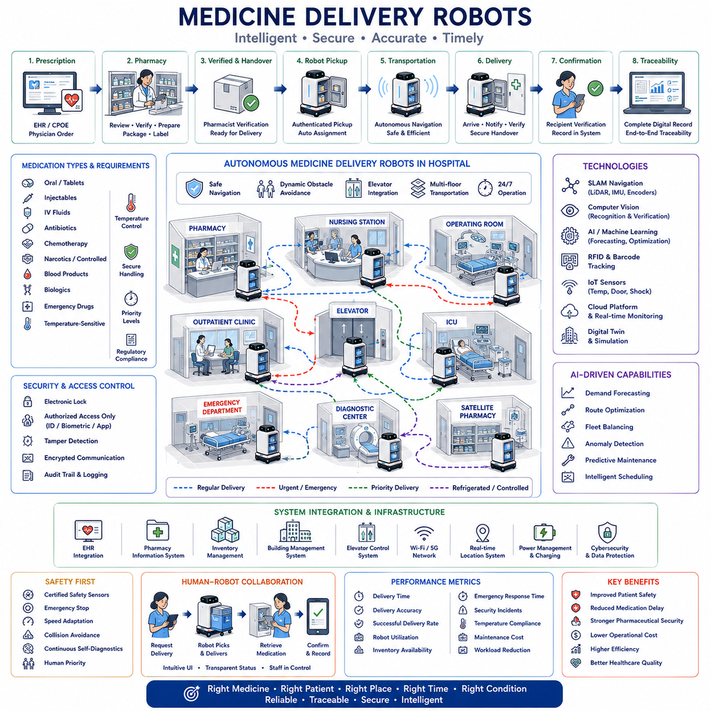
Medicine delivery represents one of the most critical logistics processes within modern hospitals because medications directly influence patient treatment, clinical safety, and healthcare quality. Every prescription must reach the correct patient, at the correct location, at the correct time, and in the correct condition. Medicine delivery robots automate repetitive transportation between hospital pharmacies, nursing stations, operating rooms, intensive care units, emergency departments, outpatient clinics, and specialized treatment areas while maintaining strict security, traceability, and regulatory compliance throughout the entire delivery process.
Hospital pharmacy operations begin with prescription generation through Electronic Health Record systems and Computerized Physician Order Entry platforms. Pharmacists review prescriptions, verify dosages, identify potential drug interactions, prepare medications, and package them according to hospital procedures. Once verified, medications enter the hospital logistics network where autonomous transportation systems deliver them safely to clinical departments. Continuous integration between pharmacy information systems and logistics platforms minimizes delays while reducing the possibility of human handling errors.
Hospital medications include routine oral medicines, injectable drugs, intravenous fluids, antibiotics, chemotherapy agents, narcotics, blood products, biological medications, emergency drugs, and temperature-sensitive pharmaceuticals. Each category has different handling requirements regarding storage temperature, transportation security, delivery priority, expiration control, and regulatory documentation. Medicine delivery systems must recognize these differences automatically and apply appropriate transportation procedures for every delivery mission.
Traceability is one of the most important requirements for pharmaceutical logistics. Every medication package should maintain complete digital records from pharmacy preparation through final delivery. Transportation history includes preparation time, pharmacist verification, robot assignment, delivery route, environmental conditions, arrival time, recipient confirmation, and storage location. Complete traceability supports patient safety, regulatory compliance, inventory management, and post-event investigation whenever unexpected incidents occur.
Autonomous Mobile Robots have become highly effective platforms for medicine transportation because hospitals contain repetitive indoor transportation routes operating continuously throughout the day. Robots transport medications between pharmacies, inpatient wards, outpatient clinics, emergency departments, intensive care units, operating rooms, diagnostic centers, and satellite pharmacies. Automation reduces manual transportation workload while enabling pharmacists and nurses to dedicate more time to direct clinical activities rather than routine logistics tasks.
Medicine delivery robots typically navigate hospitals using simultaneous localization and mapping, laser scanners, depth cameras, inertial measurement units, wheel encoders, and digital building maps. Dynamic hospital environments contain patients, visitors, physicians, nurses, stretchers, wheelchairs, medical equipment, and service carts moving unpredictably through corridors. Robot navigation therefore requires continuous environmental perception, dynamic obstacle avoidance, socially acceptable motion planning, and safe interaction with surrounding people.
Fleet management systems coordinate multiple medicine delivery robots operating simultaneously throughout large healthcare facilities. Delivery requests vary continuously according to patient admissions, physician prescriptions, emergency events, surgical schedules, pharmacy workload, and medication urgency. Fleet optimization assigns transportation missions while considering robot availability, battery condition, route congestion, elevator accessibility, delivery deadlines, and medication priority. Intelligent coordination maximizes fleet efficiency while maintaining reliable clinical service.
Security represents a unique challenge for medicine delivery because many pharmaceuticals require restricted access. Robot compartments incorporate electronic locks, authenticated access control, tamper detection, compartment monitoring, and encrypted communication. Only authorized personnel may retrieve medications after identity verification using employee identification cards, biometric authentication, secure mobile applications, or hospital access systems. Security mechanisms protect controlled substances while maintaining efficient clinical workflows.
Temperature control becomes essential for medications requiring refrigerated or controlled environmental conditions. Certain vaccines, biological products, insulin preparations, blood derivatives, and specialized pharmaceuticals must remain within strict temperature limits during transportation. Medicine delivery robots integrate insulated compartments, temperature monitoring sensors, environmental logging, and alarm systems to ensure pharmaceutical integrity throughout the complete transportation cycle. Environmental records become part of permanent delivery documentation.
Hospital elevators function as critical shared infrastructure because medicine deliveries frequently require transportation between multiple floors. Robots communicate with building automation systems to request elevators, reserve transportation slots, synchronize arrival timing, and coordinate with other logistics robots. Priority policies may grant emergency medication deliveries immediate elevator access while routine deliveries follow standard scheduling procedures that optimize overall building transportation efficiency.
Artificial Intelligence improves medicine delivery through demand forecasting, route optimization, fleet balancing, anomaly detection, predictive maintenance, and intelligent scheduling. Machine learning analyzes historical prescription patterns, patient occupancy, physician activity, seasonal disease trends, emergency admissions, and pharmacy workloads to anticipate future transportation demand. Predictive planning improves robot availability while reducing waiting time for critical medication deliveries throughout hospital operations.
Computer vision supports medicine transportation by recognizing pharmacy counters, delivery stations, medication carts, room numbers, docking locations, corridor conditions, and unexpected obstacles. Vision systems verify compartment loading, confirm package placement, monitor transportation integrity, and detect abnormal situations requiring human intervention. Multimodal perception combining cameras, laser scanners, and depth sensors significantly improves navigation reliability within dynamic hospital environments containing unpredictable pedestrian movement.
RFID technology and barcode identification strengthen pharmaceutical traceability throughout hospital logistics. Individual medication packages, transportation containers, pharmacy shelves, delivery stations, and robot compartments contain digital identifiers automatically scanned during transportation. Continuous identification eliminates manual recording while reducing documentation errors, inventory discrepancies, misplaced medications, and unauthorized access. Real-time visibility improves operational transparency across the entire pharmaceutical distribution network.
Electronic Health Record integration allows medicine delivery robots to become active participants in patient-centered healthcare workflows. Transportation priorities automatically adapt according to new prescriptions, emergency treatments, operating room schedules, patient transfers, discharge planning, and physician orders. Integration between clinical information systems and logistics platforms ensures medication transportation remains synchronized with continuously changing medical activities throughout the hospital.
Digital twins provide virtual representations of hospital pharmaceutical logistics by integrating pharmacy workflows, transportation routes, robot fleets, medication inventories, elevator schedules, delivery stations, and building layouts. Engineers evaluate fleet capacity, transportation policies, storage strategies, infrastructure modifications, and emergency response procedures before implementing operational changes. Continuous synchronization between physical operations and digital models supports simulation-driven optimization while minimizing deployment risk.
Inventory management continuously monitors medication availability throughout pharmacies, automated dispensing cabinets, nursing stations, emergency carts, and specialized treatment units. Smart inventory systems automatically generate replenishment requests whenever stock levels approach predefined thresholds. Demand-driven transportation replaces fixed delivery schedules by responding dynamically to actual clinical consumption. This approach reduces inventory costs while ensuring medications remain available whenever patients require treatment.
Human-robot collaboration remains fundamental because pharmacists, nurses, physicians, logistics personnel, and maintenance engineers interact with medicine delivery robots throughout daily operations. Users request transportation, verify deliveries, retrieve medications, resolve exceptions, and supervise robot activities using intuitive interfaces. Transparent communication and predictable robot behavior increase operational trust while allowing healthcare professionals to maintain complete control over clinical decision making.
Safety extends beyond robot navigation because medication transportation directly influences patient treatment. Robot systems continuously monitor compartment status, transportation integrity, environmental conditions, access authorization, navigation safety, and delivery confirmation. Emergency stop systems, certified safety sensors, speed adaptation, collision avoidance, and continuous self-diagnostics ensure transportation remains safe even within crowded hospital corridors shared by vulnerable patients and busy healthcare professionals.
Cybersecurity protects pharmaceutical logistics against unauthorized access, malicious software, communication interception, and data manipulation. Authentication, encrypted communication, software integrity verification, secure access control, audit logging, network segmentation, and continuous monitoring protect both sensitive patient information and controlled pharmaceutical inventories. Strong cybersecurity becomes increasingly important as autonomous robots integrate directly with hospital information systems and cloud-based logistics platforms.
Maintenance combines preventive servicing with predictive diagnostics to maximize robot reliability. Continuous monitoring of batteries, drive systems, navigation sensors, electronic locks, communication hardware, environmental control systems, and safety devices enables artificial intelligence to estimate component health before failures occur. Planned maintenance minimizes operational disruption while ensuring medicine transportation remains available twenty-four hours per day throughout hospital operations.
Performance evaluation measures operational effectiveness using medication delivery time, transportation accuracy, successful delivery rate, robot utilization, fleet availability, emergency response time, inventory availability, security incidents, temperature compliance, maintenance cost, energy efficiency, and healthcare staff workload reduction. Continuous performance monitoring identifies opportunities for optimization while demonstrating measurable improvements in patient service quality and hospital operational efficiency.
Future medicine delivery systems will integrate autonomous mobile robots, multimodal foundation models, digital twins, predictive analytics, intelligent pharmacy automation, real-time clinical decision support, and hospital-wide logistics orchestration into unified healthcare ecosystems. Robots will increasingly coordinate medication transportation with laboratory logistics, blood delivery, medical supply distribution, linen transportation, and waste management through intelligent fleet management platforms. These integrated systems will improve patient safety, reduce medication delays, strengthen pharmaceutical security, and support highly efficient, data-driven hospitals capable of delivering safer and more responsive healthcare services.

18.04 Telemedicine Robots · 원격진료 로봇
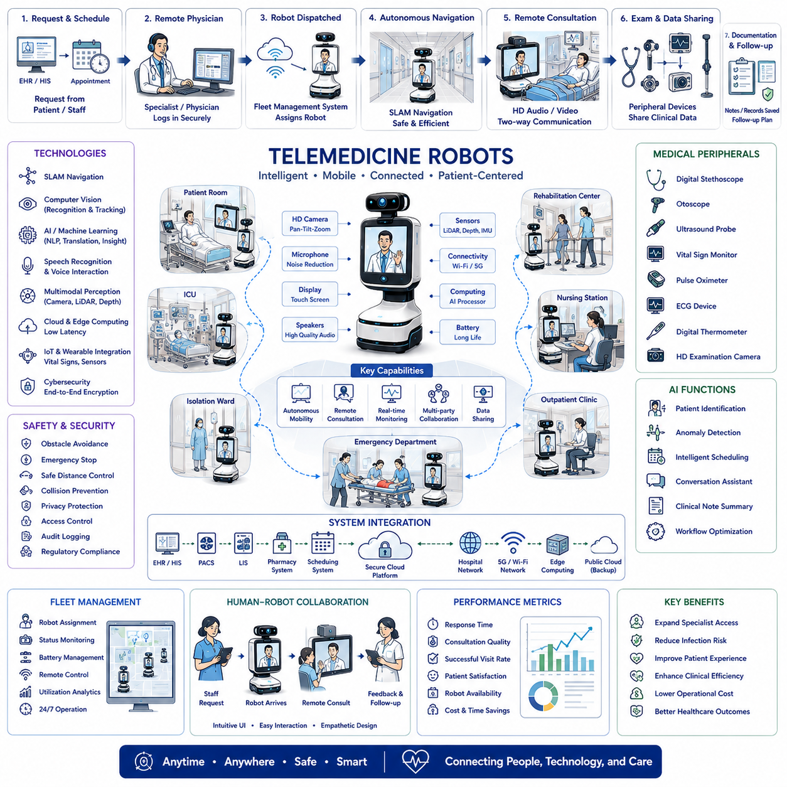
Telemedicine has become an essential component of modern healthcare by enabling physicians, specialists, nurses, and patients to communicate remotely while maintaining high-quality medical services. Telemedicine robots extend this capability by providing autonomous mobility, audiovisual communication, remote examination support, and intelligent navigation within hospitals, nursing homes, rehabilitation centers, quarantine facilities, and home healthcare environments. These robots reduce unnecessary physical contact, improve healthcare accessibility, and allow medical professionals to provide timely care regardless of their physical location.
Telemedicine robots combine mobile robotic platforms with high-definition cameras, microphones, speakers, displays, wireless communication, and intelligent software to create mobile remote consultation systems. Unlike fixed video conferencing equipment, telemedicine robots can autonomously travel to patient rooms, emergency departments, intensive care units, outpatient clinics, isolation wards, and recovery areas. Physicians remotely control consultations while the robot positions itself to provide optimal viewing angles and natural communication with patients and healthcare staff.
One of the primary objectives of telemedicine robots is expanding access to medical expertise. Hospitals often experience shortages of specialists, particularly during nights, weekends, emergencies, or infectious disease outbreaks. Remote consultation allows experienced physicians to evaluate patients without requiring physical travel between facilities. Multiple hospitals can share specialist resources while reducing response time, improving clinical decision-making, and supporting consistent healthcare quality across distributed medical networks.
Telemedicine robots became especially valuable during global infectious disease outbreaks because minimizing direct physical contact reduces disease transmission risks for both patients and healthcare professionals. Robots enter isolation rooms, quarantine areas, and infectious disease wards while physicians communicate remotely using secure audiovisual connections. Medical staff can perform routine consultations, monitor patient conditions, discuss treatment plans, and provide psychological support without unnecessary exposure to contagious environments.
Modern telemedicine robots provide high-resolution video, directional microphones, noise reduction, echo cancellation, and high-quality speakers to enable natural communication. Pan-tilt-zoom cameras allow physicians to inspect wounds, observe facial expressions, monitor respiratory conditions, and communicate with multiple people inside patient rooms. High-definition audiovisual systems significantly improve clinical interaction quality compared with conventional mobile communication devices.
Robot mobility enables telemedicine systems to function as active healthcare assistants rather than passive communication terminals. Autonomous navigation allows robots to move safely between departments while avoiding patients, visitors, medical equipment, wheelchairs, stretchers, and service carts. Simultaneous Localization and Mapping, laser scanners, depth cameras, inertial sensors, and semantic building maps support reliable navigation throughout complex hospital environments where continuous pedestrian movement presents dynamic operational challenges.
Artificial Intelligence enhances telemedicine robots by supporting autonomous navigation, intelligent patient identification, speech recognition, multilingual translation, appointment scheduling, anomaly detection, conversation assistance, and workflow optimization. Machine learning continuously improves navigation performance while Natural Language Processing enables more natural interactions between patients and healthcare professionals. AI assistants may summarize consultation sessions, organize clinical notes, and recommend follow-up activities for healthcare teams.
Computer vision enables telemedicine robots to recognize patient rooms, hospital corridors, medical equipment, healthcare personnel, and environmental obstacles. Vision algorithms support autonomous docking, patient localization, face detection, gesture recognition, occupancy monitoring, and navigation verification. Continuous environmental understanding improves robot safety while allowing physicians to remotely observe patients from multiple viewpoints without requiring manual camera adjustments during consultations.
Hospital communication infrastructure plays a critical role in telemedicine robot performance. Reliable Wi-Fi, private 5G networks, cloud computing platforms, edge computing systems, and cybersecurity infrastructure ensure stable low-latency communication between robots and remote physicians. Adaptive communication algorithms maintain audiovisual quality under varying network conditions while prioritizing clinical communication over less critical background data transmission.
Telemedicine robots integrate directly with Electronic Health Record systems, Hospital Information Systems, Picture Archiving and Communication Systems, laboratory information systems, pharmacy systems, and clinical scheduling platforms. Physicians access medical history, laboratory results, diagnostic images, medication records, and treatment plans during remote consultations without leaving the telemedicine interface. Integrated healthcare information significantly improves clinical efficiency while supporting comprehensive patient evaluation.
Specialized medical peripherals expand telemedicine capabilities beyond audiovisual communication. Digital stethoscopes, otoscopes, ultrasound probes, vital sign monitors, pulse oximeters, ECG devices, digital thermometers, and high-resolution examination cameras can transmit medical measurements directly to remote physicians. Telemedicine robots therefore support both visual consultation and limited remote physical examination while reducing unnecessary patient transportation.
Telemedicine robots also improve multidisciplinary collaboration by connecting physicians, nurses, specialists, pharmacists, therapists, radiologists, and family members during complex treatment discussions. Multiple participants may simultaneously join secure consultation sessions regardless of physical location. Collaborative decision-making improves treatment planning while reducing delays associated with scheduling face-to-face multidisciplinary meetings across different departments.
Patient experience represents an important design consideration because successful telemedicine depends upon comfortable and intuitive human-robot interaction. Robots employ friendly appearance, natural voice communication, adjustable display height, expressive visual interfaces, and predictable movement behavior. Simple user interfaces allow elderly patients, children, and individuals with limited technical experience to communicate confidently with remote healthcare providers without requiring extensive training.
Privacy and cybersecurity remain fundamental requirements because telemedicine robots process sensitive medical information and patient conversations. End-to-end encryption, authenticated access control, secure identity management, audit logging, encrypted storage, software integrity verification, and regulatory compliance protect confidential healthcare information. Robust cybersecurity ensures patient trust while supporting legal and ethical healthcare responsibilities throughout remote medical operations.
Safety extends beyond cybersecurity into physical interaction with vulnerable patients. Telemedicine robots continuously monitor surrounding environments using redundant perception sensors, emergency stop systems, collision avoidance algorithms, speed adaptation, and certified functional safety mechanisms. Navigation policies prioritize human safety by maintaining comfortable interpersonal distances, yielding to pedestrians, and avoiding interference with emergency medical procedures.
Fleet management coordinates multiple telemedicine robots across large healthcare facilities. Intelligent scheduling assigns robots according to physician availability, consultation urgency, patient location, battery condition, network quality, and robot utilization. Automated dispatching minimizes waiting time while maximizing equipment usage throughout hospitals operating twenty-four hours per day. Fleet coordination also supports rapid deployment during emergency situations requiring multiple simultaneous remote consultations.
Digital twins provide virtual representations of telemedicine operations by modeling hospital layouts, communication infrastructure, robot fleets, consultation schedules, wireless coverage, and patient flow. Engineers evaluate navigation performance, communication reliability, infrastructure upgrades, and workflow optimization before implementing operational changes. Simulation-driven analysis reduces deployment risks while supporting continuous improvement of telemedicine services across increasingly complex healthcare environments.
Maintenance combines preventive servicing with predictive diagnostics to ensure continuous operational availability. Batteries, cameras, microphones, speakers, displays, drive systems, navigation sensors, communication hardware, and docking stations are continuously monitored using AI-based health assessment. Predictive maintenance schedules component replacement before failures occur, minimizing unexpected downtime while maintaining reliable healthcare service availability.
Performance evaluation measures consultation response time, communication quality, navigation reliability, successful mission completion, physician utilization, patient satisfaction, robot availability, network stability, operational cost reduction, travel time savings, consultation frequency, and clinical workflow efficiency. Continuous analytics identify opportunities for optimization while demonstrating measurable improvements in healthcare accessibility, specialist utilization, and hospital operational performance.
Future telemedicine robots will integrate multimodal foundation models, large language models, intelligent clinical decision support, advanced speech understanding, emotion recognition, digital twins, autonomous hospital logistics, wearable healthcare devices, and predictive patient monitoring into comprehensive healthcare ecosystems. Rather than functioning solely as communication platforms, future robots will become intelligent healthcare partners capable of coordinating consultations, assisting clinical documentation, supporting personalized patient engagement, integrating with hospital logistics, and enabling highly connected, data-driven, patient-centered healthcare systems across hospitals, clinics, rehabilitation centers, and home care environments.

18.05 Intelligent Hospital Systems · 인텔리전트 병원 시스템
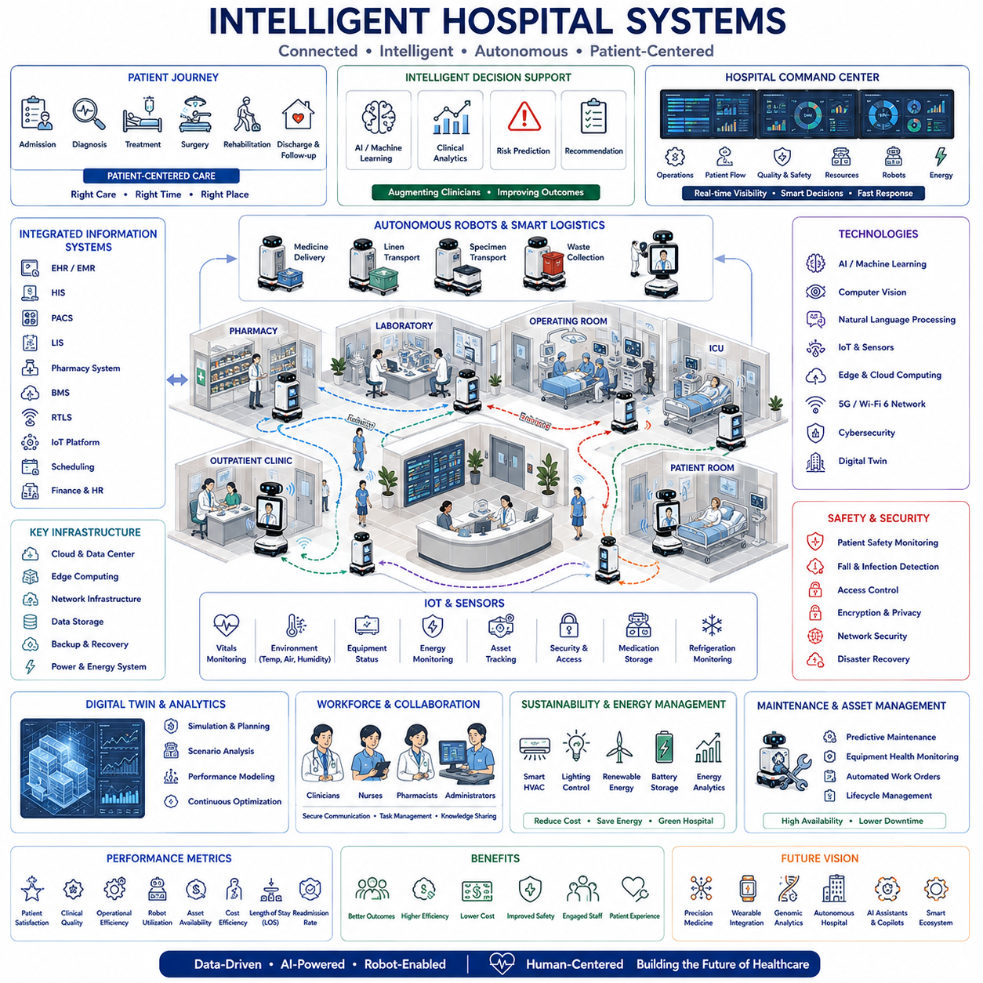
Intelligent hospital systems represent the evolution of modern healthcare from isolated digital applications toward fully integrated, data-driven medical ecosystems. These systems connect clinical operations, hospital logistics, medical equipment, information technology, artificial intelligence, autonomous robots, and digital infrastructure into a unified operational platform. The objective is to improve patient safety, healthcare quality, operational efficiency, resource utilization, and clinical decision-making while enabling hospitals to respond dynamically to continuously changing medical demands.
An intelligent hospital integrates Electronic Health Record systems, Hospital Information Systems, Picture Archiving and Communication Systems, Laboratory Information Systems, Pharmacy Information Systems, Building Management Systems, Real-Time Location Systems, Internet of Things devices, and cloud computing platforms into a common digital architecture. Rather than operating independently, these systems exchange information continuously, creating a comprehensive digital representation of hospital activities that supports coordinated healthcare delivery.
Patient-centered healthcare serves as the foundation of intelligent hospital design. Every clinical process begins with the patient's medical condition, treatment plan, and healthcare journey rather than individual departmental workflows. Medical information follows patients throughout admission, diagnosis, treatment, surgery, rehabilitation, discharge, and long-term follow-up. Continuous information sharing eliminates redundant procedures, reduces communication delays, and improves coordination between healthcare professionals across multiple clinical departments.
Artificial Intelligence functions as the intelligent decision-support layer throughout hospital operations. Machine learning analyzes patient history, laboratory results, medical images, physiological signals, medication records, and clinical observations to identify potential risks, recommend diagnostic pathways, predict disease progression, and optimize treatment planning. Rather than replacing physicians, AI augments clinical expertise by rapidly processing large volumes of healthcare information and presenting meaningful recommendations for human review.
Computer vision contributes to intelligent hospitals by recognizing patients, medical equipment, hospital assets, clinical activities, occupancy conditions, and safety events. Vision systems monitor operating rooms, intensive care units, emergency departments, pharmacies, laboratories, and public areas while supporting workflow analysis, patient identification, equipment tracking, and environmental awareness. Privacy-preserving analytics ensure valuable operational insights while protecting sensitive patient information.
Autonomous Mobile Robots perform essential logistics operations throughout intelligent hospitals. Medicine delivery robots transport pharmaceuticals securely between pharmacies and patient wards. Linen transport robots manage clean and contaminated textile circulation. Specimen transport robots move laboratory samples while preserving chain-of-custody requirements. Waste collection robots reduce infection risks by automating hazardous material transportation. Telemedicine robots expand healthcare accessibility through remote consultation and specialist collaboration across multiple facilities.
Internet of Things technology enables continuous monitoring of hospital infrastructure, medical equipment, patient environments, energy systems, and logistics assets. Smart sensors collect real-time information regarding temperature, humidity, air quality, equipment utilization, occupancy, vibration, power consumption, medication storage conditions, refrigeration status, and environmental safety. Continuous sensing allows intelligent hospital systems to detect abnormal conditions early while supporting predictive maintenance and operational optimization.
Real-Time Location Systems provide continuous visibility into patients, healthcare personnel, mobile equipment, autonomous robots, and medical assets. Hospitals frequently manage thousands of movable devices including infusion pumps, wheelchairs, ventilators, portable imaging systems, and emergency equipment. Location intelligence reduces search time, improves asset utilization, minimizes equipment loss, and enables rapid response during emergency situations while supporting efficient hospital logistics.
Hospital logistics become increasingly autonomous through integrated fleet management platforms coordinating multiple robot types simultaneously. Transportation requests originate automatically from clinical systems whenever medications, laboratory specimens, sterile supplies, meals, linens, blood products, or medical equipment require movement. Intelligent scheduling prioritizes deliveries according to clinical urgency, destination, resource availability, elevator scheduling, battery condition, and hospital traffic conditions while maximizing overall logistics efficiency.
Digital twins provide comprehensive virtual representations of hospital operations by combining architectural models, medical equipment, communication networks, patient flow, logistics systems, workforce allocation, robot fleets, and environmental conditions. Engineers simulate emergency scenarios, infrastructure upgrades, operational policies, patient demand, and disaster response before implementing physical changes. Continuous synchronization between physical hospitals and digital models supports evidence-based operational improvement with minimal disruption.
Cloud computing and edge computing cooperate to support intelligent healthcare applications. Edge computing performs low-latency processing for medical devices, robotic navigation, patient monitoring, and real-time safety functions close to the point of care. Cloud platforms manage large-scale analytics, long-term medical records, machine learning model training, digital twin synchronization, and multi-hospital collaboration. Hybrid computing architectures balance performance, scalability, reliability, and regulatory compliance.
Medical device interoperability enables diverse clinical equipment to exchange standardized healthcare information across manufacturers and departments. Patient monitors, ventilators, infusion pumps, imaging systems, laboratory analyzers, wearable devices, and robotic platforms continuously share operational and clinical data through standardized communication interfaces. Seamless interoperability reduces manual documentation while improving data consistency, clinical efficiency, and comprehensive patient monitoring.
Cybersecurity forms a fundamental component of intelligent hospital infrastructure because healthcare organizations process highly sensitive medical information while operating life-critical systems. Secure authentication, encrypted communication, identity management, access control, network segmentation, intrusion detection, software integrity verification, continuous vulnerability assessment, and security auditing protect both clinical information and operational technology. Robust cybersecurity ensures patient trust while maintaining uninterrupted hospital operations.
Human-centered design remains essential despite increasing automation. Physicians, nurses, pharmacists, therapists, administrators, patients, and visitors interact continuously with intelligent hospital technologies through intuitive interfaces designed to minimize cognitive workload. Decision-support systems present recommendations transparently while preserving clinician authority. Explainable Artificial Intelligence helps healthcare professionals understand model reasoning, increasing confidence and supporting responsible clinical adoption.
Hospital command centers integrate operational information from every connected subsystem into unified dashboards supporting real-time situational awareness. Administrators monitor patient occupancy, emergency department congestion, operating room utilization, equipment availability, robot fleets, energy consumption, security events, infection control indicators, and facility performance simultaneously. Integrated visualization enables rapid operational decisions while improving resource allocation across the hospital.
Energy management contributes significantly to intelligent hospital sustainability because healthcare facilities operate continuously while consuming substantial electrical power. Intelligent control systems optimize heating, ventilation, air conditioning, lighting, renewable energy integration, battery storage, charging infrastructure, and equipment scheduling according to occupancy, environmental conditions, and operational priorities. Energy optimization reduces operating costs while supporting environmental sustainability objectives.
Patient safety remains the highest priority throughout intelligent hospital operations. Continuous monitoring identifies early deterioration, medication conflicts, abnormal vital signs, fall risks, infection indicators, equipment failures, cybersecurity threats, and environmental hazards. Automated alert systems notify appropriate healthcare professionals immediately while intelligent prioritization minimizes alarm fatigue and improves response effectiveness during critical clinical situations.
Maintenance strategies transition from reactive repair toward predictive asset management using Artificial Intelligence and continuous sensor monitoring. Medical equipment, building infrastructure, robotic systems, communication networks, elevators, power systems, and environmental controls are evaluated continuously for signs of degradation. Predictive maintenance schedules service before failures occur, reducing downtime while increasing equipment availability and patient safety.
Performance evaluation relies upon comprehensive operational metrics including patient waiting time, treatment duration, bed occupancy, operating room utilization, emergency response time, medication accuracy, robot utilization, equipment availability, logistics efficiency, energy consumption, cybersecurity incidents, maintenance cost, patient satisfaction, staff productivity, and healthcare quality indicators. Continuous analytics identify opportunities for improvement while supporting evidence-based management decisions.
Future intelligent hospital systems will integrate multimodal foundation models, large language models, autonomous robotics, digital twins, precision medicine, wearable health monitoring, genomic analytics, ambient intelligence, predictive population health management, and collaborative AI assistants into unified healthcare ecosystems. Hospitals will evolve from collections of independent departments into intelligent adaptive environments capable of continuously learning from operational experience, coordinating clinical resources autonomously, supporting personalized patient care, and delivering safer, more efficient, and more resilient healthcare services for increasingly complex medical environments.

