Volume 01. AMR Foundations and System Architecture

21. AMR SW/HW Co-Design · SW/HW 공동 설계

21.01 Hardware-Software Integration · HW-SW 통합
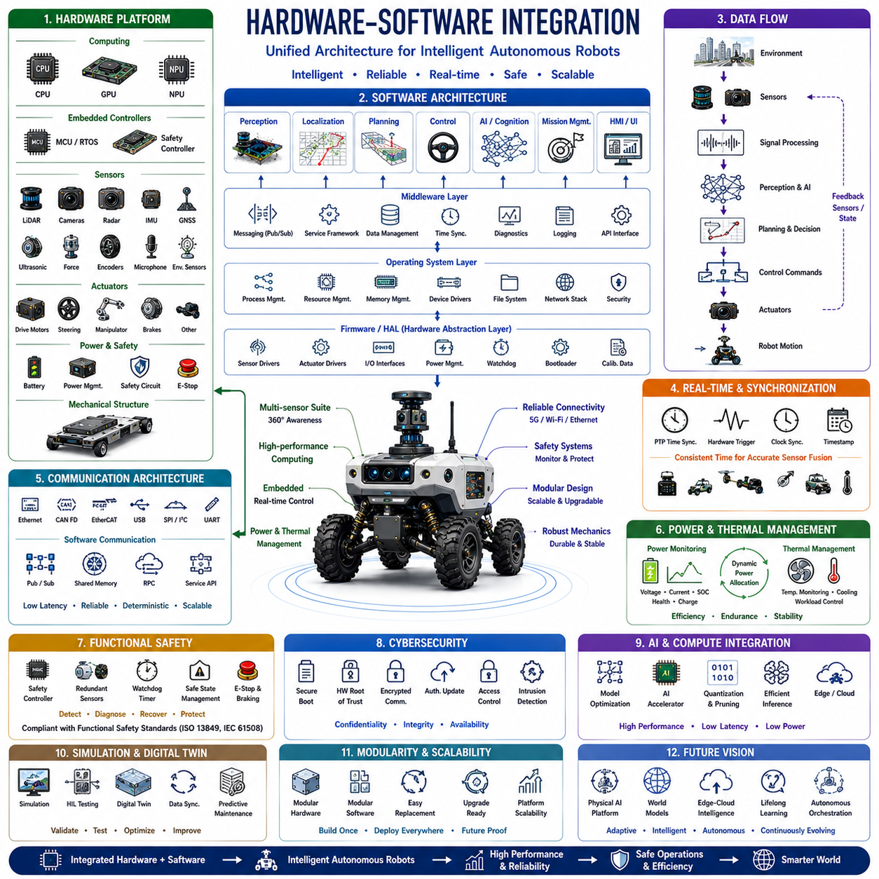
Hardware-software integration forms the technological foundation of every autonomous robot by connecting physical components with computational intelligence into a unified operational system. Rather than treating hardware and software as independent engineering disciplines, modern robotic platforms require tightly coordinated design in which sensors, actuators, embedded controllers, communication networks, operating systems, middleware, artificial intelligence, and application software function as a single integrated architecture. Successful integration determines not only system performance but also reliability, maintainability, scalability, functional safety, and long-term product evolution. As robotic systems become increasingly intelligent through Physical AI and foundation models, the importance of seamless hardware-software integration continues to grow across industrial, commercial, agricultural, logistics, medical, and autonomous transportation applications.
The primary objective of hardware-software integration is to ensure that every physical device and every software component cooperate efficiently under real-world operating conditions. Sensors continuously observe the environment, embedded controllers process low-level signals, middleware coordinates information exchange, artificial intelligence interprets complex situations, and application software executes mission objectives. Every processing stage must operate within strict timing, computational, communication, thermal, and power constraints. Integration therefore focuses not only on functional correctness but also on deterministic execution, resource optimization, fault tolerance, and system robustness throughout the entire operational lifecycle.
A robotic hardware platform typically consists of computing units, embedded controllers, sensors, actuators, communication interfaces, power systems, safety circuits, and mechanical structures. High-performance CPUs execute general-purpose software while GPUs accelerate artificial intelligence, computer vision, and neural network inference. Embedded microcontrollers manage real-time motor control, safety monitoring, sensor acquisition, and peripheral devices. Sensor suites commonly include LiDAR, RGB cameras, stereo vision, radar, ultrasonic sensors, IMUs, GNSS receivers, force sensors, encoders, microphones, environmental sensors, and specialized industrial measurement equipment. Each hardware component contributes unique capabilities while introducing distinct computational, communication, and synchronization requirements.
Software architecture transforms raw hardware capabilities into intelligent autonomous behavior. Low-level firmware initializes hardware, manages peripheral devices, and performs deterministic real-time control. Operating systems allocate computing resources, schedule processes, manage memory, and coordinate communication between software modules. Middleware provides standardized interfaces that allow perception, localization, planning, control, diagnostics, and artificial intelligence modules to exchange information without depending directly on hardware implementations. Application software ultimately integrates these capabilities into mission execution, user interaction, fleet management, cloud connectivity, and operational decision-making.
Embedded systems provide the critical interface between physical hardware and high-level software. Microcontrollers continuously execute motor control algorithms, safety supervision, battery management, sensor synchronization, communication protocols, and fault monitoring with deterministic timing. Unlike general-purpose computing systems, embedded controllers prioritize predictable execution over computational flexibility. Real-time operating systems ensure that control loops meet strict latency requirements while coordinating multiple concurrent hardware interfaces. Proper embedded system design significantly improves reliability, responsiveness, and overall robotic stability during continuous autonomous operation.
Hardware abstraction layers simplify software development by separating application logic from device-specific implementations. Instead of interacting directly with individual sensor registers or communication protocols, software accesses standardized interfaces representing cameras, LiDARs, motors, encoders, communication ports, and power management systems. This abstraction enables hardware replacement, component upgrades, and product customization with minimal software modification. Hardware abstraction also improves code portability across multiple robotic platforms while reducing long-term maintenance complexity throughout successive product generations.
Communication architecture enables reliable information exchange among distributed hardware components and software processes. Internal communication commonly utilizes Ethernet, CAN FD, EtherCAT, RS-485, SPI, I²C, USB, PCIe, UART, and high-speed sensor interfaces depending upon bandwidth, latency, determinism, and environmental requirements. Software communication employs middleware frameworks, publish-subscribe messaging, shared memory, remote procedure calls, and service-oriented architectures to distribute information efficiently across perception, localization, planning, control, diagnostics, and cloud services. Well-designed communication architecture minimizes latency while ensuring synchronization, scalability, and fault isolation.
Time synchronization becomes increasingly important as robotic systems integrate multiple distributed sensors operating at different sampling frequencies. Cameras, LiDARs, radars, IMUs, GNSS receivers, wheel encoders, force sensors, and actuator controllers must maintain consistent timestamps to support accurate sensor fusion. Precision Time Protocol, hardware triggering, synchronized clocks, timestamp correction, and deterministic communication collectively ensure temporal consistency throughout the system. Accurate synchronization directly influences localization accuracy, perception quality, motion planning, and autonomous decision-making by preserving the temporal relationships among independent sensor observations.
Real-time processing represents one of the defining characteristics of autonomous robotic systems. Perception algorithms, localization, obstacle detection, path planning, motor control, safety supervision, and communication operate simultaneously under strict latency constraints. Computational scheduling balances high-frequency control loops with computationally intensive artificial intelligence inference while ensuring that safety-critical functions always receive deterministic execution priority. Effective real-time architecture minimizes response delays, prevents computational overload, and guarantees stable autonomous behavior even during peak computational demand.
Sensor integration combines heterogeneous sensing technologies into a coherent representation of the external environment. Individual sensors possess complementary strengths and weaknesses, making sensor fusion essential for robust perception. Cameras provide rich semantic understanding while LiDAR measures accurate geometry. Radar performs reliably under adverse weather conditions, and IMUs estimate high-frequency motion dynamics. Sensor calibration establishes geometric relationships among devices while synchronization aligns temporal observations. Multi-modal sensor fusion significantly improves environmental awareness, localization robustness, and obstacle detection compared with isolated sensing technologies.
Actuator integration transforms software decisions into physical robot motion through coordinated motor control systems. Electric motors, steering mechanisms, robotic manipulators, hydraulic actuators, braking systems, suspension components, and auxiliary devices require synchronized control across multiple embedded controllers. Motion commands generated by planning algorithms propagate through trajectory controllers, servo loops, motor drivers, and power electronics before producing mechanical action. Continuous feedback from encoders, force sensors, current measurements, and motor diagnostics enables closed-loop control that compensates for disturbances, modeling uncertainty, and changing operating conditions.
Power management directly influences computational reliability and system availability. High-performance processors, GPUs, sensors, communication modules, actuators, and embedded controllers compete for limited battery capacity while generating significant thermal loads. Intelligent power distribution continuously monitors voltage stability, current consumption, battery health, charging status, and thermal conditions. Dynamic power allocation prioritizes safety-critical functions while reducing unnecessary energy consumption. Careful integration of electrical hardware with software power management significantly extends operational endurance and prevents unexpected system shutdowns.
Thermal management becomes increasingly important as robotic computing platforms integrate powerful processors capable of executing advanced artificial intelligence workloads. CPUs, GPUs, power converters, motor drivers, and batteries generate heat that directly influences computational performance and hardware reliability. Temperature sensors continuously monitor critical components while software dynamically adjusts processor frequency, cooling systems, workload allocation, and power consumption according to thermal conditions. Intelligent thermal management maintains computational stability while extending hardware lifetime under continuous autonomous operation.
Functional safety requires close cooperation between hardware protection mechanisms and software supervision. Emergency stop circuits, redundant power supplies, safety controllers, watchdog timers, redundant sensors, brake systems, and hardware fault detection operate together with software diagnostics, health monitoring, fault recovery, and safe-state management. Safety architectures ensure that hazardous failures are detected rapidly and that the robot transitions into predictable safe operating conditions whenever abnormal situations occur. Compliance with functional safety standards depends upon coordinated hardware and software engineering rather than isolated component reliability.
Cybersecurity has become an integral aspect of hardware-software integration because autonomous robots continuously exchange operational data across internal networks, cloud services, and external infrastructure. Secure boot, hardware root of trust, encrypted communication, authenticated firmware updates, access control, intrusion detection, and secure software deployment collectively protect robotic systems from unauthorized modification or malicious attacks. Security mechanisms must be integrated throughout the complete system architecture without compromising deterministic real-time performance or operational reliability.
Artificial intelligence integration extends beyond simply deploying trained neural networks onto robotic hardware. AI software must efficiently utilize heterogeneous computing resources including CPUs, GPUs, NPUs, DSPs, and dedicated AI accelerators while meeting strict latency and power constraints. Model optimization techniques including quantization, pruning, operator fusion, compiler optimization, and hardware acceleration maximize inference performance on embedded platforms. Efficient AI deployment requires close collaboration between machine learning engineers, embedded software developers, hardware architects, and system integration teams throughout product development.
Simulation and digital twins provide comprehensive environments for validating hardware-software integration before physical deployment. Virtual platforms reproduce processor timing, sensor characteristics, communication latency, actuator dynamics, environmental interactions, and software execution behavior under realistic operating conditions. Hardware-in-the-loop testing further integrates actual embedded controllers with simulated environments, enabling comprehensive verification of timing, synchronization, fault handling, and real-time performance. Digital twins continue supporting deployed robotic systems through predictive maintenance, configuration management, software validation, and operational optimization using continuously synchronized field data.
Future hardware-software integration will evolve toward unified Physical AI computing platforms where heterogeneous processors, intelligent sensors, edge-cloud computing, multimodal foundation models, digital twins, software-defined robotics, and autonomous system orchestration operate as a single adaptive computational ecosystem. Standardized hardware abstraction, modular software architectures, intelligent resource scheduling, self-optimizing system configuration, lifelong learning, cooperative edge intelligence, and autonomous system management will continuously improve robotic capabilities through accumulated operational experience. Rather than integrating hardware and software as separate engineering domains, future robotic platforms will function as tightly coupled cyber-physical systems capable of adapting their computational architecture, sensing strategies, resource allocation, and intelligent behavior according to changing missions, environments, and operational objectives.

21.02 AI Compute Architectures · AI 컴퓨트 아키텍처
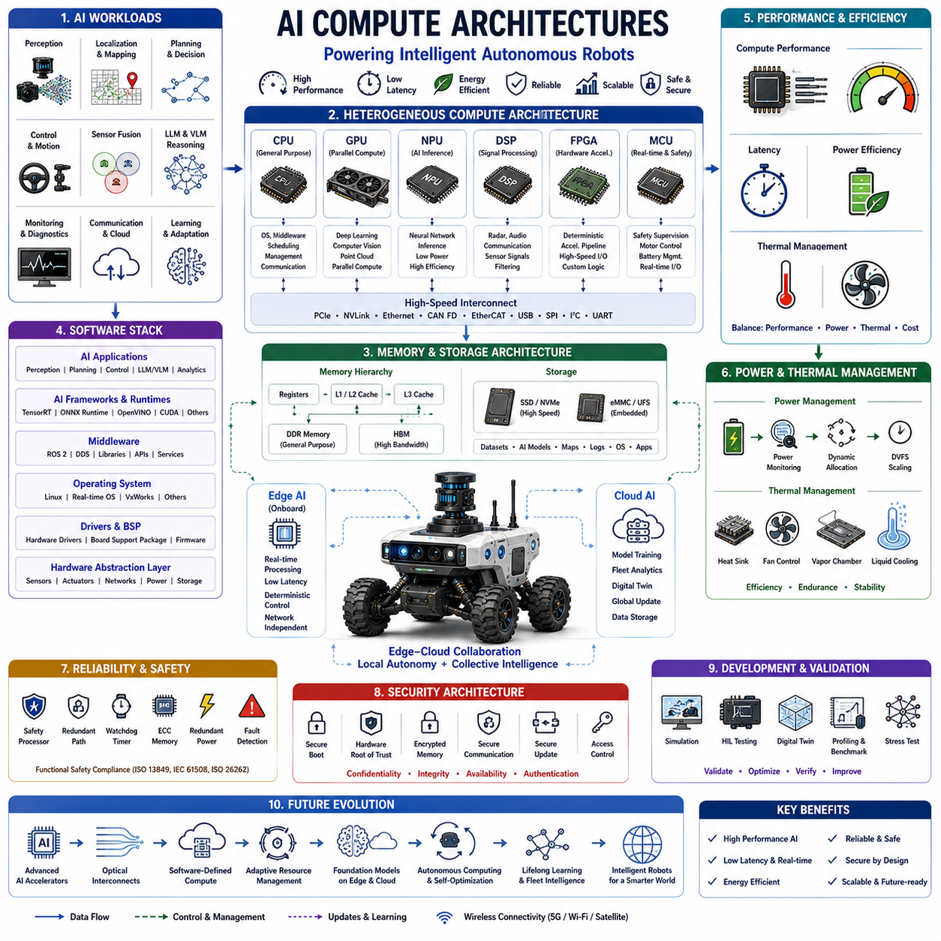
Artificial intelligence compute architectures provide the computational foundation that enables autonomous robots to perceive environments, understand complex situations, make intelligent decisions, and execute real-time actions. Modern AI workloads require enormous computational capability because deep neural networks, computer vision, large language models, multimodal foundation models, sensor fusion, localization, planning, and control algorithms operate simultaneously under strict latency and power constraints. AI compute architecture therefore extends beyond selecting high-performance processors by optimizing the complete computing ecosystem including heterogeneous processors, memory hierarchy, communication networks, storage systems, hardware accelerators, operating systems, middleware, cloud connectivity, and software optimization. Well-designed architectures maximize computational efficiency while satisfying requirements for reliability, scalability, functional safety, energy efficiency, and long-term product evolution.
The primary objective of AI compute architecture is to provide sufficient computational performance for intelligent autonomy while maintaining deterministic execution, low latency, acceptable power consumption, and operational reliability. Unlike traditional embedded systems that primarily execute deterministic control software, autonomous robots must simultaneously process large sensor streams, perform artificial intelligence inference, maintain accurate localization, generate safe trajectories, monitor system health, communicate with cloud infrastructure, and support continuous learning. The architecture therefore balances computational throughput, memory bandwidth, communication latency, thermal limitations, and energy availability to ensure stable operation across diverse deployment environments.
Modern robotic computing platforms employ heterogeneous computing architectures in which multiple specialized processors cooperate according to their computational strengths. Central Processing Units execute operating systems, middleware, task scheduling, communication, diagnostics, and mission management. Graphics Processing Units accelerate deep learning, computer vision, point cloud processing, and parallel numerical computation. Neural Processing Units provide highly efficient neural network inference with reduced power consumption. Digital Signal Processors process sensor signals including audio, radar, and communication waveforms. Field Programmable Gate Arrays implement deterministic hardware acceleration for high-speed signal processing, while embedded microcontrollers perform safety supervision, motor control, battery management, and real-time peripheral control. Cooperative utilization of heterogeneous processors significantly improves computational efficiency compared with relying upon any single processor type.
CPU architecture remains fundamental because general-purpose processors coordinate nearly every software component throughout autonomous robotic systems. Multi-core processors execute concurrent software modules including perception management, localization, planning, diagnostics, communication, fleet management, user interfaces, and operating system services. Modern CPUs provide sophisticated cache hierarchies, branch prediction, out-of-order execution, vector instruction sets, hardware virtualization, and security mechanisms that collectively improve computational performance. Although artificial intelligence workloads increasingly migrate toward specialized accelerators, CPUs continue orchestrating resource management and overall system coordination.
Graphics Processing Units have become the dominant computing engine for artificial intelligence and perception workloads due to their massively parallel computational architecture. Thousands of processing cores simultaneously execute matrix multiplication, convolution, tensor operations, point cloud processing, and image analysis that form the foundation of deep neural network inference. Modern GPUs additionally integrate dedicated Tensor Cores supporting mixed-precision arithmetic, significantly accelerating transformer models, vision-language models, segmentation networks, object detection, simultaneous localization and mapping, and large-scale scientific computation. GPU performance directly influences robotic perception quality, environmental understanding, and intelligent decision-making capability.
Neural Processing Units provide highly specialized hardware optimized specifically for artificial intelligence inference. Rather than supporting general-purpose computation, NPUs accelerate matrix operations, tensor computation, quantized neural networks, activation functions, and attention mechanisms using dedicated arithmetic units with exceptional energy efficiency. Embedded robotic platforms increasingly utilize NPUs because they deliver competitive inference performance while consuming significantly less power than high-performance GPUs. Efficient NPU integration enables autonomous robots to execute sophisticated neural networks continuously within limited battery capacity while maintaining real-time responsiveness.
Memory architecture plays a decisive role because artificial intelligence models frequently process gigabytes of parameters and large sensor datasets simultaneously. High-bandwidth memory transfers become equally important as raw computational capability. Cache hierarchies reduce processor access latency while DDR memory provides general-purpose storage for software execution. High Bandwidth Memory substantially accelerates GPU computation by increasing memory throughput for large neural networks. Persistent storage using solid-state drives manages datasets, operating systems, software models, digital maps, and recorded operational data. Carefully balanced memory architecture prevents computational bottlenecks that would otherwise limit processor utilization and overall system performance.
High-speed interconnect architecture enables efficient communication among distributed computing resources. PCI Express connects CPUs with GPUs, NPUs, storage devices, and high-performance peripherals using extremely high bandwidth. Ethernet supports distributed robotic computing and cloud connectivity, while NVLink provides direct GPU-to-GPU communication for large-scale parallel processing. Embedded communication buses including CAN FD, EtherCAT, SPI, I²C, USB, and UART integrate lower-speed embedded devices and industrial controllers. Efficient communication architecture minimizes data transfer latency while maximizing processor utilization and supporting scalable system expansion.
Artificial intelligence software frameworks translate neural network models into executable workloads optimized for target hardware architectures. Frameworks such as TensorRT, ONNX Runtime, OpenVINO, CUDA libraries, Vulkan Compute, OpenCL, and vendor-specific inference engines optimize neural network execution according to processor capabilities. Model optimization techniques including quantization, pruning, operator fusion, graph optimization, kernel auto-tuning, and mixed-precision computation substantially improve inference speed while reducing memory consumption and energy requirements. Tight integration between software frameworks and hardware architecture determines practical deployment performance.
Edge computing enables autonomous robots to perform computationally intensive artificial intelligence directly on onboard hardware without depending continuously upon cloud infrastructure. Local processing minimizes communication latency while preserving operational independence during network outages. Time-critical tasks including obstacle detection, localization, path planning, motion control, and functional safety always execute at the edge because immediate decision-making is essential for safe autonomy. Edge AI therefore represents the computational core responsible for deterministic robotic intelligence in dynamic real-world environments.
Cloud computing complements edge processing by providing virtually unlimited computational resources for large-scale artificial intelligence training, fleet management, digital twin simulation, long-term data storage, software deployment, predictive analytics, and collaborative learning. Rather than replacing onboard computation, cloud platforms extend robotic intelligence through asynchronous processing of computationally intensive workloads that are not subject to strict real-time constraints. Intelligent workload partitioning between edge and cloud maximizes computational efficiency while maintaining robust autonomous operation regardless of network availability.
Edge-cloud collaboration has become increasingly important because future robotic systems require both deterministic real-time intelligence and large-scale collective learning. Edge processors execute safety-critical perception and control locally while cloud infrastructure aggregates fleet data, updates foundation models, performs global optimization, and distributes improved software throughout deployed robotic fleets. Continuous synchronization enables autonomous robots to benefit from collective operational experience while preserving immediate decision-making capability under local computational control.
Power efficiency represents one of the defining design constraints for autonomous robotic compute architectures because computational capability directly influences battery endurance and thermal management. Dynamic voltage scaling, frequency scaling, processor sleep states, workload migration, hardware acceleration, intelligent scheduling, and adaptive power allocation continuously optimize energy consumption according to operational demands. Efficient compute architecture extends operational duration while maintaining sufficient computational performance for artificial intelligence inference and autonomous navigation throughout prolonged missions.
Thermal architecture directly influences computational reliability because high-performance processors generate substantial heat during sustained artificial intelligence workloads. Excessive temperatures reduce processor frequency, accelerate hardware degradation, and increase system instability. Active cooling, passive heat dissipation, vapor chambers, liquid cooling, intelligent fan control, and thermal-aware workload scheduling collectively maintain stable operating temperatures. Software continuously monitors processor temperatures while dynamically balancing computational load across heterogeneous processors to maximize sustained performance without exceeding thermal limits.
Functional safety requires computing architectures capable of maintaining reliable operation despite hardware failures, software errors, communication faults, or unexpected environmental disturbances. Safety processors independently supervise high-performance computing systems while redundant communication paths, watchdog timers, error-correcting memory, redundant power supplies, lockstep processors, and diagnostic software detect abnormal behavior before hazardous failures occur. Safety-certified computing architectures ensure that autonomous robots maintain predictable behavior under fault conditions while complying with international functional safety standards.
Cybersecurity must be integrated directly into AI compute architectures because autonomous robots exchange large volumes of operational data across distributed networks. Secure boot, hardware root of trust, encrypted memory, trusted execution environments, authenticated software deployment, encrypted communication, secure firmware updates, and hardware security modules collectively protect computational resources against unauthorized access or malicious modification. Security mechanisms must operate without introducing unacceptable latency into real-time robotic control, requiring careful architectural integration throughout both hardware and software layers.
Simulation and digital twins provide comprehensive environments for evaluating AI compute architectures before physical deployment. Virtual platforms reproduce processor timing, memory utilization, communication latency, thermal behavior, power consumption, sensor workloads, artificial intelligence execution, and complete robotic software stacks under representative operational conditions. Hardware-in-the-loop testing validates actual computing hardware using simulated environments, enabling engineers to evaluate computational bottlenecks, synchronization behavior, fault recovery, thermal stability, and real-time performance before field deployment. Digital twins continue supporting deployed robotic systems through workload optimization, predictive maintenance, software validation, and continuous architectural improvement.
Future AI compute architectures will evolve toward highly adaptive Physical AI computing ecosystems integrating heterogeneous processors, multimodal foundation models, edge-cloud intelligence, optical interconnects, advanced AI accelerators, software-defined computing, digital twins, autonomous resource management, and lifelong learning into unified intelligent platforms. Compute resources will continuously reconfigure themselves according to mission objectives, environmental complexity, sensor workloads, and energy availability while collaborating across distributed robotic fleets. Rather than representing fixed hardware configurations, future AI compute architectures will function as self-optimizing computational ecosystems capable of dynamically allocating processing resources, updating artificial intelligence models, coordinating distributed intelligence, and continuously improving autonomous performance throughout the operational lifetime of intelligent robotic systems.

21.03 Sensor and Compute Balancing · 센서·컴퓨트 밸런싱
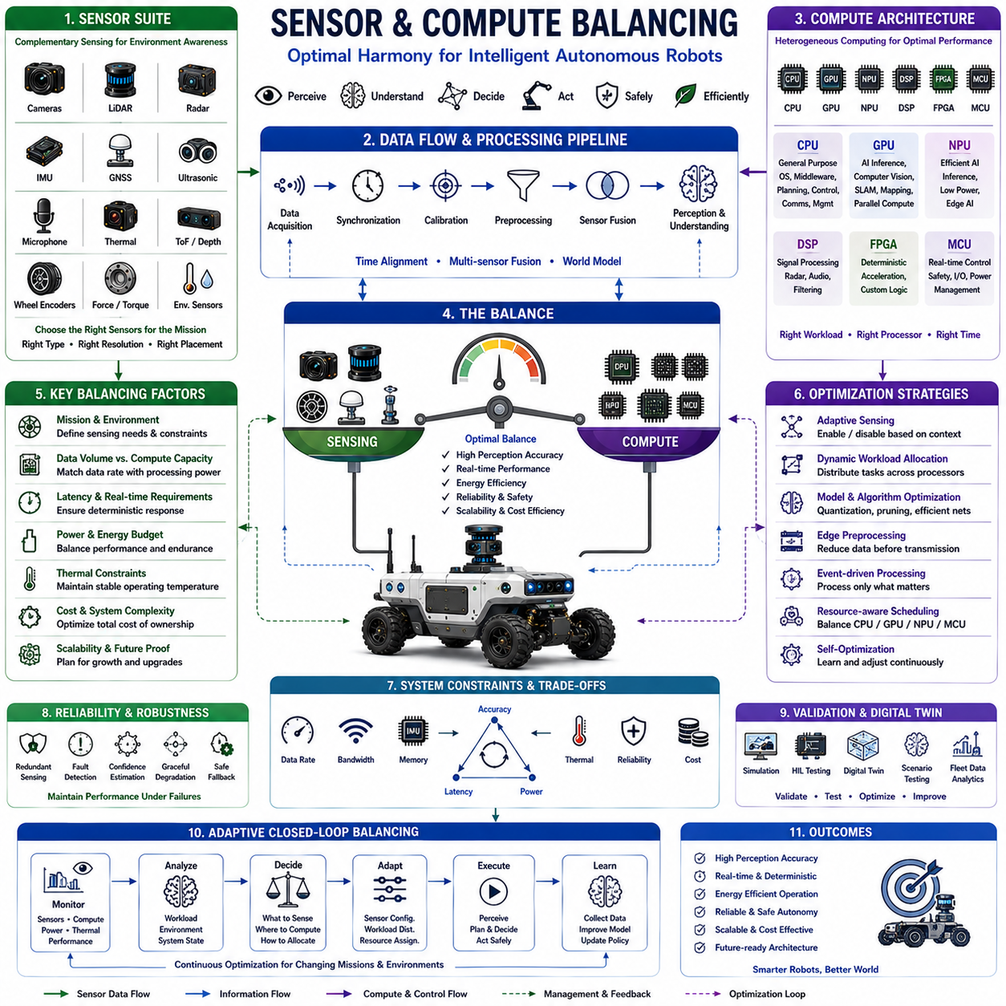
Sensor and compute balancing is one of the most critical system engineering principles in autonomous robotics because sensing capability and computational resources must evolve together to achieve reliable perception, real-time decision making, and efficient autonomous operation. Increasing the number or resolution of sensors continuously improves environmental awareness, but every additional sensor generates larger data streams that require processing, synchronization, storage, communication bandwidth, and energy consumption. Conversely, deploying excessive computational resources without sufficient sensing capability results in underutilized hardware and unnecessary cost. Effective balancing therefore seeks the optimal relationship between sensor configuration, computational architecture, communication infrastructure, power availability, thermal capacity, and mission requirements. A well-balanced robotic platform achieves high perception accuracy, deterministic execution, scalability, and operational efficiency while minimizing unnecessary hardware complexity.
The primary objective of sensor and compute balancing is to maximize useful environmental information while maintaining stable real-time performance under practical hardware constraints. Autonomous robots continuously process images, point clouds, inertial measurements, radar reflections, positioning data, audio signals, and internal diagnostic information. Every sensor contributes valuable information but simultaneously increases computational workload, memory utilization, communication traffic, synchronization complexity, and software maintenance. System designers therefore evaluate not only sensing accuracy but also computational cost, latency, robustness, reliability, energy efficiency, and lifecycle maintainability. Balanced architectures avoid both sensor redundancy that provides little additional value and computational overprovisioning that wastes power and increases system cost.
Sensor selection begins by understanding mission objectives rather than simply maximizing sensor quantity. Industrial inspection robots prioritize precision imaging and accurate positioning, while outdoor autonomous vehicles require long-range perception, weather robustness, and reliable localization. Warehouse robots emphasize obstacle avoidance, navigation accuracy, and fleet coordination, whereas agricultural robots require terrain understanding, crop perception, and environmental adaptation. The sensing suite should therefore reflect operational scenarios, environmental variability, safety requirements, and expected failure conditions. Mission-oriented sensor selection reduces unnecessary computational demand while preserving essential environmental awareness.
Each sensing modality possesses unique strengths and limitations that influence computational requirements differently. Cameras provide rich semantic information but generate extremely large image streams requiring significant artificial intelligence processing. LiDAR produces accurate three-dimensional geometry while demanding intensive point cloud computation. Radar performs reliably under adverse weather conditions with relatively modest data rates but requires advanced signal interpretation algorithms. Inertial Measurement Units provide high-frequency motion estimation using comparatively little computational power. GNSS receivers deliver global positioning with minimal processing requirements, while ultrasonic sensors efficiently detect nearby obstacles. Understanding these computational characteristics enables engineers to combine complementary sensing technologies rather than relying excessively upon any individual sensor.
Sensor resolution directly influences computational workload because higher spatial, temporal, and spectral resolutions generate exponentially larger datasets. Increasing camera resolution from two megapixels to eight megapixels substantially improves image detail but quadruples pixel processing requirements. Higher frame rates improve motion tracking while proportionally increasing computational demand. Dense LiDAR configurations containing hundreds of laser channels significantly improve environmental reconstruction yet produce enormous point cloud volumes requiring advanced parallel processing. Engineers therefore optimize sensor resolution according to actual application requirements rather than selecting maximum specifications indiscriminately. Appropriate resolution selection frequently delivers superior system efficiency without reducing operational capability.
Sensor placement and physical integration strongly affect both perception quality and computational efficiency. Proper sensor positioning minimizes occlusions, improves field-of-view overlap, reduces calibration complexity, and enhances sensor fusion accuracy. Excessively overlapping sensor coverage introduces redundant information requiring unnecessary processing, whereas insufficient overlap degrades environmental understanding and increases localization uncertainty. Mechanical vibration isolation, thermal stability, electromagnetic compatibility, optical cleanliness, and maintenance accessibility further influence long-term sensing reliability. Balanced physical integration therefore contributes directly to computational efficiency by maximizing useful information content while minimizing redundant or degraded data.
Sensor synchronization becomes increasingly important as heterogeneous sensing systems expand. Cameras, LiDARs, radars, IMUs, wheel encoders, GNSS receivers, microphones, and force sensors often operate at different sampling frequencies and communication latencies. Precise timestamp alignment using hardware triggering, Precision Time Protocol, synchronized clocks, deterministic communication, and calibration algorithms ensures that sensor fusion operates upon temporally consistent observations. Poor synchronization significantly increases computational complexity because software must compensate for temporal uncertainty while simultaneously reducing perception accuracy and decision reliability.
Sensor fusion represents one of the largest computational consumers within autonomous robotic systems because heterogeneous information must be integrated into a consistent environmental representation. Low-level fusion combines raw sensor measurements, mid-level fusion merges extracted features, and high-level fusion integrates independent perception results into semantic world models. Artificial intelligence increasingly supports multimodal sensor fusion by learning complementary relationships among cameras, LiDAR, radar, inertial sensing, and language-based contextual reasoning. Efficient fusion algorithms maximize perception robustness while minimizing redundant computation through intelligent information integration rather than simply increasing processing complexity.
Compute resource allocation must carefully prioritize real-time workloads according to operational importance. Functional safety monitoring, motor control, localization, obstacle detection, and collision avoidance require deterministic execution with strict latency guarantees. Artificial intelligence inference, semantic understanding, mapping, behavior prediction, and cloud communication may tolerate slightly greater latency depending upon mission requirements. Modern heterogeneous computing architectures distribute workloads across CPUs, GPUs, NPUs, DSPs, FPGAs, and embedded controllers according to computational characteristics. Proper workload partitioning maximizes processor utilization while preserving predictable system behavior during peak computational demand.
Artificial intelligence workload optimization plays an essential role in maintaining balance between sensing capability and available computing resources. Large neural networks significantly improve perception accuracy but often exceed practical embedded computational budgets. Quantization, pruning, operator fusion, mixed-precision computation, efficient neural architectures, knowledge distillation, adaptive inference, and hardware-specific optimization substantially reduce computational cost while preserving acceptable accuracy. Dynamic model selection further enables robotic systems to adjust inference complexity according to environmental conditions, mission urgency, and available computational resources.
Communication architecture significantly influences sensor-compute balance because raw sensor data frequently traverses distributed processing networks before reaching artificial intelligence modules. High-bandwidth interfaces including PCI Express, Ethernet, and NVLink support computationally intensive sensing systems, whereas CAN FD, EtherCAT, SPI, and UART efficiently connect embedded controllers and lower-bandwidth sensors. Edge preprocessing performed near sensing hardware frequently reduces communication requirements by transmitting extracted features rather than raw sensor streams. Intelligent communication architecture therefore improves computational scalability while reducing latency and network congestion.
Power consumption closely couples sensing capability with computational architecture because every additional sensor and processor increases energy demand. High-resolution cameras, rotating LiDARs, high-performance GPUs, active cooling systems, communication devices, and storage systems collectively influence battery endurance. Dynamic power management continuously adjusts processor frequency, sensor activation schedules, inference complexity, communication bandwidth, and workload allocation according to operational priorities. Adaptive energy management ensures that computational resources remain available for safety-critical functions throughout extended autonomous missions while limiting unnecessary power expenditure.
Thermal balancing is equally important because sensing devices and high-performance processors generate substantial heat during continuous operation. Excessive temperatures reduce sensor stability, processor frequency, battery efficiency, and overall system reliability. Intelligent thermal management coordinates processor scheduling, cooling systems, workload migration, sensor activation, and environmental adaptation to maintain stable operating conditions. Thermal-aware scheduling prevents localized overheating while sustaining predictable computational performance under demanding operational scenarios.
Reliability requires balanced architectures capable of maintaining acceptable performance despite individual sensor failures or computational resource degradation. Redundant sensing, graceful performance degradation, confidence estimation, fault detection, and adaptive workload redistribution enable autonomous systems to continue operating safely even when components malfunction. Artificial intelligence increasingly estimates sensor confidence and dynamically adjusts computational attention toward the most reliable information sources under changing environmental conditions. Balanced redundancy therefore improves operational robustness without introducing unnecessary computational overhead.
Simulation and digital twin technologies provide comprehensive environments for evaluating sensor-compute balancing before physical deployment. Virtual platforms accurately reproduce sensor characteristics, communication latency, processor utilization, synchronization behavior, thermal dynamics, energy consumption, and artificial intelligence workloads across representative operational scenarios. Hardware-in-the-loop testing validates complete sensing and computing architectures under controlled conditions while identifying computational bottlenecks, synchronization errors, excessive power consumption, and insufficient processing margins. Digital twins continue supporting deployed robotic fleets by optimizing workload distribution, validating software updates, and continuously improving system balance using operational data.
Future sensor and compute balancing will evolve toward adaptive autonomous architectures capable of dynamically reconfiguring sensing strategies and computational resource allocation according to mission objectives, environmental complexity, hardware health, energy availability, and artificial intelligence confidence. Event-driven sensing, neuromorphic sensors, software-defined perception, multimodal foundation models, edge-cloud collaboration, intelligent workload orchestration, self-optimizing resource scheduling, and lifelong learning will enable robotic systems to continuously balance sensing and computation without manual engineering intervention. Rather than operating with fixed hardware configurations, future Physical AI platforms will intelligently determine which sensors should remain active, how computational resources should be allocated, where inference should execute, and how perception accuracy, energy efficiency, safety, and operational performance can be simultaneously optimized throughout the complete lifecycle of autonomous intelligent robotic systems.

21.04 Real-Time Constraints · 실시간 제약 조건
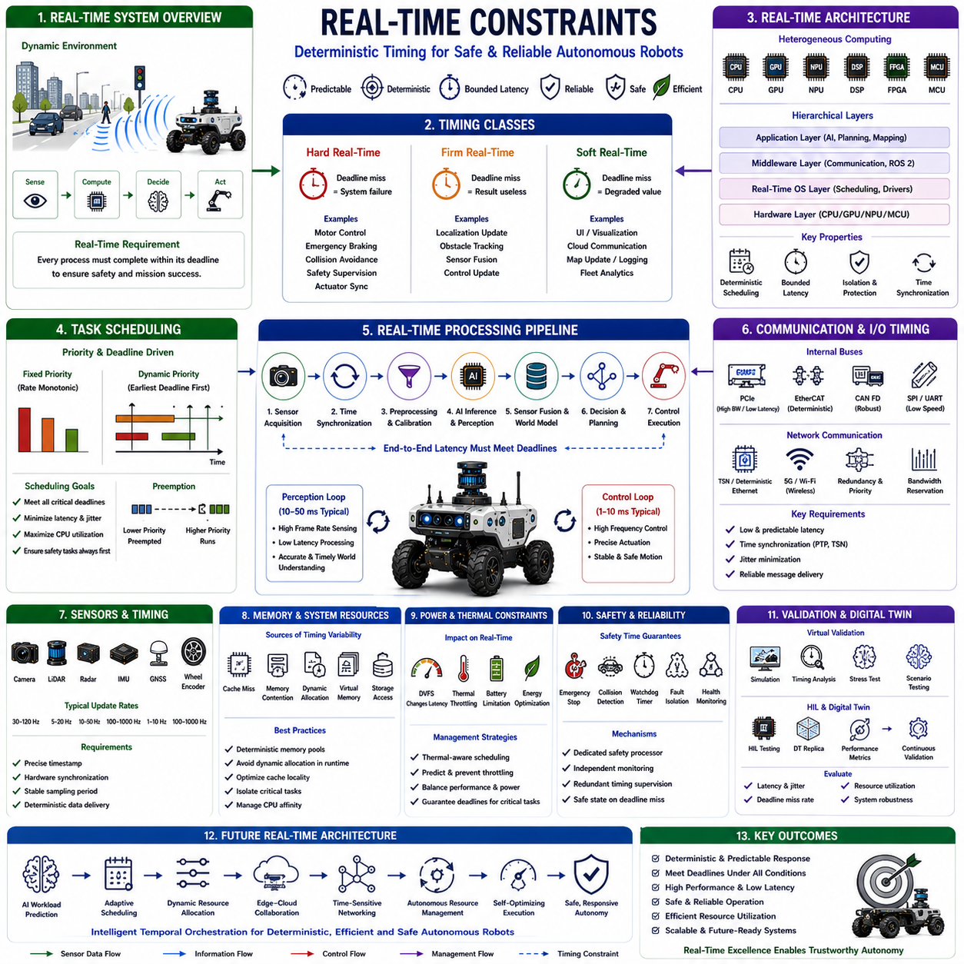
Real-time constraints define the temporal boundaries within which autonomous robotic systems must complete sensing, computation, communication, decision making, and physical control to ensure safe and reliable operation. Unlike conventional computing systems where delayed responses may only reduce performance, autonomous robots interact directly with dynamic physical environments where excessive latency can immediately compromise safety, mission success, and system stability. Every computational process therefore has an associated deadline that determines whether the produced result remains useful. Real-time system design extends beyond maximizing computational speed by guaranteeing deterministic execution, predictable latency, bounded response times, and reliable task completion under both normal and worst-case operating conditions. Effective real-time architectures enable autonomous robots to operate safely despite continuously changing environments, uncertain workloads, and limited computational resources.
The primary objective of real-time constraint management is to guarantee that every critical operation completes within its required deadline regardless of computational load or environmental complexity. Autonomous robots simultaneously execute perception, localization, mapping, planning, motion control, obstacle avoidance, communication, diagnostics, battery management, and artificial intelligence inference. Each process possesses different timing requirements, execution frequencies, computational complexity, and safety priorities. Real-time architecture therefore focuses on predictable timing behavior rather than simply maximizing processor utilization. Maintaining deterministic execution ensures that autonomous systems continue responding consistently even under heavy workloads or unexpected operating conditions.
Real-time systems are commonly classified into hard real-time, firm real-time, and soft real-time categories according to the consequences of missing execution deadlines. Hard real-time tasks cannot tolerate deadline violations because delayed execution may immediately create hazardous conditions. Motor control, emergency braking, collision avoidance, functional safety supervision, and actuator synchronization belong to this category. Firm real-time tasks lose most of their value when deadlines are exceeded but do not necessarily create unsafe situations. Localization updates, obstacle tracking, and sensor fusion frequently operate under firm real-time constraints. Soft real-time tasks remain useful despite occasional timing variation, including user interfaces, cloud communication, map updates, logging, and fleet analytics. Understanding these timing classes allows engineers to allocate computational resources according to operational importance.
Task scheduling represents one of the most important mechanisms for satisfying real-time constraints. Operating systems continuously determine which computational tasks should execute, suspend, or resume according to priority, deadlines, processor availability, and resource dependencies. Fixed-priority scheduling assigns permanent priorities to individual tasks, while dynamic scheduling adjusts priorities according to changing execution deadlines and system conditions. Earliest Deadline First scheduling, Rate Monotonic Scheduling, and mixed-criticality scheduling are commonly employed within robotic systems. Effective scheduling minimizes latency while ensuring that safety-critical operations always receive sufficient computational resources regardless of background processing activity.
Operating systems play a fundamental role in deterministic execution because conventional desktop operating systems primarily optimize average throughput rather than bounded response time. Real-Time Operating Systems provide deterministic scheduling, bounded interrupt latency, predictable context switching, priority inheritance, and precise timer management required for safety-critical robotic applications. Linux systems increasingly incorporate PREEMPT_RT capabilities that significantly reduce scheduling latency while preserving compatibility with modern software ecosystems. Selecting an appropriate operating system depends upon timing requirements, application complexity, certification objectives, hardware architecture, and long-term maintainability.
Interrupt management significantly influences real-time performance because sensors, communication interfaces, timers, and hardware events continuously request immediate processor attention. Poor interrupt handling introduces unpredictable execution delays that propagate throughout dependent software modules. Prioritized interrupt controllers, interrupt affinity assignment, deferred interrupt processing, and efficient driver implementation reduce latency while preventing unnecessary processor disruption. Well-designed interrupt architectures maintain rapid responsiveness without excessively interrupting computationally intensive artificial intelligence or perception workloads.
Sensor acquisition timing establishes the foundation for deterministic perception because every sensing modality operates at specific sampling frequencies and temporal precision requirements. Cameras capture images at defined frame rates, LiDAR systems generate point clouds through rotational scanning, IMUs produce high-frequency inertial measurements, radar systems periodically update target information, and wheel encoders continuously monitor vehicle motion. Maintaining consistent acquisition timing requires hardware synchronization, timestamp accuracy, deterministic communication, and precise scheduling. Stable sensor timing substantially improves sensor fusion accuracy, localization consistency, and downstream artificial intelligence performance.
Communication latency directly affects distributed robotic systems where sensing, computation, and control occur across multiple processors or networked devices. Internal communication buses including PCI Express, EtherCAT, CAN FD, Ethernet, SPI, and UART each exhibit different latency characteristics, bandwidth limitations, and deterministic behavior. External communication through wireless networks introduces additional uncertainty caused by interference, congestion, and varying signal quality. Time-sensitive networking, deterministic Ethernet, message prioritization, communication redundancy, and bandwidth reservation improve timing predictability while reducing communication-induced execution delays.
Artificial intelligence inference introduces unique real-time challenges because modern neural networks require substantial computational resources while autonomous robots demand immediate responses. Large transformer models, multimodal foundation models, semantic segmentation, object detection, and scene understanding algorithms often exhibit variable execution times depending upon input complexity and processor utilization. Model optimization techniques including quantization, pruning, mixed-precision inference, operator fusion, adaptive neural architectures, and hardware acceleration reduce execution latency while preserving acceptable prediction accuracy. Selecting appropriately sized models according to available computational resources remains essential for maintaining deterministic autonomous behavior.
Perception pipelines must satisfy strict timing requirements because environmental understanding directly influences planning and motion control. Raw sensor acquisition, calibration, preprocessing, feature extraction, neural network inference, sensor fusion, object tracking, semantic interpretation, and world model generation collectively form complex processing chains. Excessive latency within any stage delays downstream decision making and increases positional uncertainty. Pipeline optimization therefore focuses upon parallel execution, workload partitioning, asynchronous processing, hardware acceleration, and efficient memory utilization to minimize end-to-end processing delay while maintaining perception accuracy.
Localization and mapping require deterministic update frequencies because navigation accuracy depends upon continuously estimating robot position relative to the environment. Simultaneous Localization and Mapping algorithms integrate visual observations, inertial measurements, LiDAR scans, wheel odometry, GNSS information, and environmental landmarks into consistent spatial representations. Delayed localization updates reduce trajectory accuracy, increase control instability, and complicate obstacle avoidance. Efficient optimization algorithms, incremental mapping techniques, hierarchical representations, and hardware acceleration enable localization systems to satisfy demanding real-time requirements during long-duration autonomous operation.
Motion planning and trajectory generation must operate within bounded execution times because autonomous robots continuously adapt to dynamic environments containing moving obstacles, changing traffic conditions, and uncertain human behavior. Global planning computes long-range navigation strategies, whereas local planning generates immediate collision-free trajectories using current environmental observations. Predictive control, optimization algorithms, behavioral reasoning, and trajectory validation all contribute to computational complexity. Real-time planners therefore employ hierarchical architectures, incremental optimization, parallel processing, and adaptive search strategies that consistently generate safe trajectories before execution deadlines expire.
Low-level motion control represents one of the most stringent hard real-time workloads within autonomous robotic systems. Motor controllers, steering actuators, braking systems, manipulators, and suspension mechanisms execute closed-loop feedback control at frequencies often exceeding hundreds or thousands of cycles per second. Control latency directly affects stability, tracking accuracy, disturbance rejection, and mechanical safety. Dedicated embedded controllers, deterministic communication buses, hardware timers, and real-time firmware ensure precise actuator synchronization while isolating control loops from computational variability introduced by higher-level artificial intelligence processing.
Memory behavior significantly influences real-time predictability because cache misses, memory contention, dynamic allocation, virtual memory translation, and storage access introduce timing variability that is difficult to predict. Real-time software therefore minimizes dynamic memory allocation during execution, employs deterministic memory pools, reduces unnecessary copying, optimizes cache locality, and carefully manages processor affinity. High-performance robotic systems frequently isolate safety-critical software from less deterministic artificial intelligence workloads to preserve predictable execution timing despite complex computational demands.
Power and thermal management must also satisfy real-time requirements because processor frequency scaling, thermal throttling, battery limitations, and energy optimization mechanisms directly influence computational performance. Dynamic voltage scaling improves energy efficiency but may increase execution latency. Excessive processor temperatures automatically reduce operating frequency, extending computational deadlines beyond acceptable limits. Intelligent resource scheduling therefore balances computational performance, thermal stability, and energy consumption while ensuring that safety-critical tasks continue meeting deterministic timing requirements throughout extended autonomous operation.
Functional safety depends fundamentally upon deterministic timing because delayed safety responses may become equivalent to complete system failures. Emergency stop activation, collision detection, actuator shutdown, fault isolation, watchdog supervision, redundancy management, and health monitoring all require guaranteed maximum response times independent of ongoing computational workloads. Safety architectures therefore employ dedicated processors, isolated communication channels, redundant timing supervision, and independent monitoring mechanisms that continuously verify deadline compliance while ensuring predictable transition into safe operational states whenever abnormal timing behavior occurs.
Simulation and digital twins provide comprehensive environments for evaluating real-time performance before physical deployment. Virtual platforms reproduce processor timing, communication latency, interrupt behavior, scheduling policies, sensor synchronization, memory utilization, thermal dynamics, and artificial intelligence execution across representative operating scenarios. Hardware-in-the-loop testing validates complete real-time architectures using actual embedded controllers while exposing timing bottlenecks, deadline violations, synchronization errors, and resource contention under controlled conditions. Continuous validation throughout development ensures that deployed robotic systems maintain deterministic performance despite evolving software functionality and increasing computational complexity.
Future real-time architectures will increasingly integrate heterogeneous processors, intelligent scheduling algorithms, software-defined resource orchestration, time-sensitive networking, adaptive artificial intelligence inference, edge-cloud collaboration, digital twins, and autonomous resource management into unified deterministic computing ecosystems. Rather than relying upon static scheduling policies, future Physical AI platforms will continuously predict workload variations, dynamically redistribute computational resources, optimize execution timing, and coordinate distributed processors according to mission objectives, environmental complexity, hardware health, and safety priorities. Real-time constraint management will evolve from deterministic scheduling alone into intelligent temporal orchestration that continuously guarantees safety, responsiveness, computational efficiency, and adaptive autonomy throughout the operational lifetime of advanced autonomous robotic systems.

21.05 Optimization Strategies · 최적화 전략
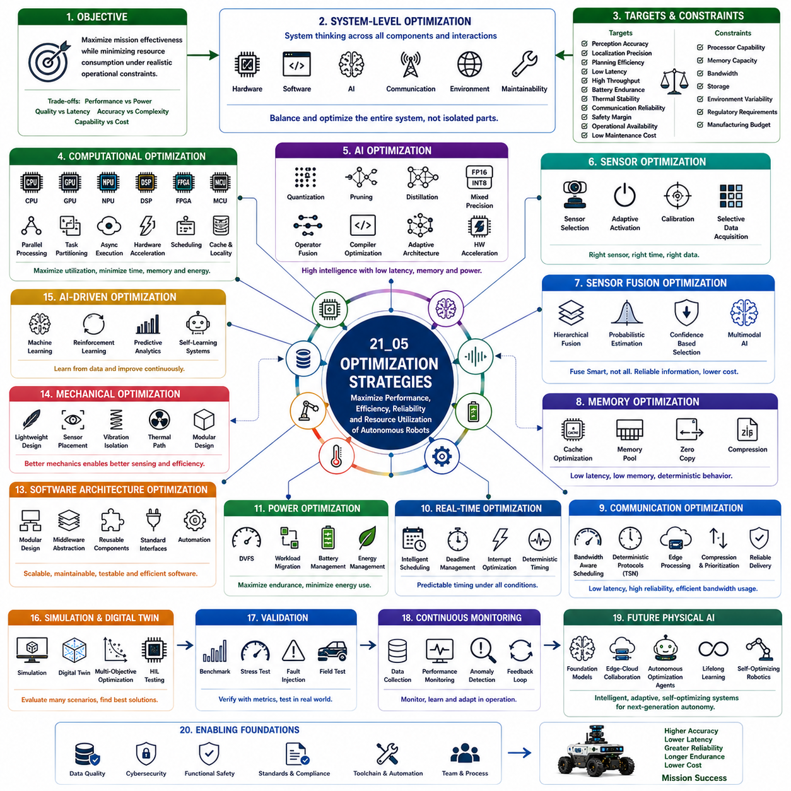
Optimization strategies represent the systematic methodologies used to maximize the performance, efficiency, reliability, scalability, and resource utilization of autonomous robotic systems while satisfying constraints related to computation, power consumption, thermal behavior, safety, communication, and operational requirements. Modern autonomous robots integrate heterogeneous sensors, artificial intelligence, real-time control, distributed computing, and complex software architectures, creating highly interconnected systems whose overall performance depends upon careful optimization across every engineering discipline. Effective optimization extends beyond improving individual algorithms by simultaneously balancing sensing, computation, memory, communication, energy, software architecture, mechanical design, and operational intelligence. Well-designed optimization strategies enable autonomous robots to deliver higher accuracy, lower latency, greater reliability, longer operational endurance, and reduced lifecycle cost without unnecessarily increasing hardware complexity.
The primary objective of optimization is to maximize mission effectiveness while minimizing resource consumption under realistic operational constraints. Autonomous robots continuously trade computational performance against power consumption, perception quality against processing latency, navigation accuracy against computational complexity, and system capability against development cost. Every engineering decision influences multiple performance metrics simultaneously, making optimization a multidimensional process rather than a single-variable improvement. Successful optimization therefore requires system-level thinking that considers interactions among hardware, software, artificial intelligence, communication infrastructure, environmental uncertainty, and long-term maintainability instead of optimizing isolated components independently.
System-level optimization begins by identifying measurable performance objectives and engineering constraints before selecting appropriate optimization methods. Common optimization targets include perception accuracy, localization precision, planning efficiency, response latency, computational throughput, battery endurance, thermal stability, communication reliability, safety margins, operational availability, and maintenance cost. Constraints typically include processor capability, memory capacity, communication bandwidth, storage limitations, environmental variability, regulatory requirements, and manufacturing budgets. Clearly defining optimization objectives enables engineering teams to evaluate design alternatives using quantitative performance metrics rather than subjective preferences.
Computational optimization focuses upon maximizing processor utilization while minimizing execution time, memory consumption, and energy expenditure. Modern autonomous robots distribute workloads across CPUs, GPUs, NPUs, DSPs, FPGAs, and embedded controllers according to computational characteristics. Parallel processing, task partitioning, asynchronous execution, hardware acceleration, efficient scheduling, cache optimization, and memory locality substantially improve overall computational efficiency. Profiling tools continuously identify bottlenecks, enabling engineers to optimize algorithms according to actual runtime behavior instead of theoretical assumptions. Balanced computational optimization increases throughput while preserving deterministic execution required for real-time autonomous operation.
Artificial intelligence optimization has become increasingly important because neural networks represent the largest computational workload within modern robotic systems. Large models generally improve perception capability but often exceed practical embedded computational resources. Quantization reduces numerical precision while preserving acceptable prediction accuracy. Pruning removes redundant neural connections that contribute little to inference quality. Knowledge distillation transfers intelligence from large teacher networks into compact student models suitable for embedded deployment. Operator fusion, mixed-precision inference, compiler optimization, adaptive neural architectures, and hardware-specific acceleration further improve inference efficiency. These optimization techniques enable sophisticated artificial intelligence to operate within practical latency, memory, and energy constraints.
Sensor optimization ensures that environmental perception delivers maximum useful information without generating unnecessary computational burden. Rather than increasing sensor quantity indiscriminately, engineers carefully select sensing modalities according to mission objectives, environmental conditions, reliability requirements, and computational budgets. Adaptive sensor activation dynamically enables or disables sensing devices according to operational context, reducing power consumption and communication traffic. Intelligent sensor scheduling, optimized field-of-view overlap, efficient calibration procedures, and selective data acquisition further improve sensing efficiency while preserving perception accuracy. Well-balanced sensing architectures frequently outperform excessively complex sensor configurations by eliminating redundant information and unnecessary processing.
Sensor fusion optimization integrates heterogeneous sensing modalities into consistent environmental representations while minimizing computational complexity. Efficient fusion architectures perform information integration only where complementary sensing substantially improves decision quality. Hierarchical fusion, probabilistic estimation, adaptive weighting, confidence-based selection, and multimodal artificial intelligence dynamically prioritize the most reliable sensing sources according to environmental conditions. Optimized fusion algorithms improve robustness while avoiding unnecessary processing of redundant measurements. As sensing complexity increases, intelligent fusion becomes essential for maintaining scalable computational performance without sacrificing perception quality.
Memory optimization significantly influences overall system performance because autonomous robotic workloads continuously exchange large sensor datasets, artificial intelligence models, localization maps, and planning information. Efficient cache utilization, memory pooling, zero-copy communication, data compression, locality-aware allocation, optimized buffer management, and deterministic memory scheduling substantially reduce latency while increasing processor efficiency. Real-time systems minimize dynamic memory allocation during execution to avoid unpredictable timing behavior. Well-designed memory architectures improve throughput, reduce energy consumption, and enhance deterministic execution throughout complex autonomous workloads.
Communication optimization minimizes latency, maximizes bandwidth utilization, and ensures reliable information exchange across distributed robotic architectures. Efficient message serialization, bandwidth-aware scheduling, adaptive compression, communication prioritization, deterministic networking, edge preprocessing, and distributed workload allocation reduce network congestion while preserving real-time responsiveness. Time-sensitive communication protocols support predictable message delivery for safety-critical control loops, whereas asynchronous communication efficiently handles cloud services, diagnostics, logging, and fleet management. Optimized communication architectures improve scalability while maintaining deterministic system behavior despite increasing computational complexity.
Real-time optimization guarantees predictable timing behavior despite continuously changing workloads. Scheduling algorithms prioritize safety-critical tasks while efficiently utilizing available processor resources. Worst-case execution analysis identifies timing bottlenecks before deployment. Adaptive workload balancing dynamically redistributes computational tasks according to processor utilization, deadline proximity, and operational importance. Interrupt optimization, deterministic synchronization, efficient context switching, and hardware-assisted scheduling further reduce latency variation. Maintaining deterministic timing remains essential because delayed autonomous decisions may become operationally equivalent to incorrect decisions in dynamic environments.
Power optimization directly influences mission endurance because sensing, computation, communication, and actuation collectively consume significant electrical energy. Dynamic voltage and frequency scaling continuously adjust processor performance according to workload demands. Intelligent workload migration transfers computation toward energy-efficient processors whenever possible. Adaptive sensor scheduling, selective hardware activation, efficient battery management, regenerative energy utilization, and predictive power allocation maximize operational duration without compromising safety. Energy-aware optimization enables autonomous robots to maintain critical capabilities throughout extended missions while minimizing unnecessary power expenditure.
Thermal optimization preserves computational reliability by preventing excessive processor temperatures during sustained artificial intelligence workloads. Intelligent cooling strategies coordinate fan control, heat dissipation, workload migration, processor scheduling, thermal prediction, and adaptive frequency management according to changing environmental conditions. Thermal-aware software distributes computationally intensive tasks across heterogeneous processors to prevent localized overheating. Advanced thermal modeling enables predictive temperature management before hardware protection mechanisms reduce computational performance. Effective thermal optimization maintains consistent processing capability throughout prolonged autonomous operation.
Software architecture optimization emphasizes modularity, scalability, maintainability, and efficient component interaction throughout increasingly complex robotic software ecosystems. Layered architectures, service-oriented communication, middleware abstraction, reusable software modules, standardized interfaces, and efficient dependency management simplify integration while improving long-term maintainability. Continuous profiling, automated testing, compiler optimization, code refactoring, and deployment automation collectively improve software quality without increasing architectural complexity. Optimized software architectures accelerate future feature development while reducing operational risk and maintenance cost.
Mechanical optimization complements computational improvements because physical design strongly influences sensing quality, energy efficiency, reliability, and motion performance. Structural lightweighting reduces energy consumption while preserving mechanical stiffness. Optimized sensor placement improves perception quality and calibration stability. Vibration isolation enhances measurement accuracy, while efficient cooling pathways improve processor reliability. Component accessibility simplifies maintenance, and modular mechanical architectures support rapid hardware upgrades. Mechanical optimization therefore contributes directly to computational efficiency by improving sensing quality and reducing unnecessary processing caused by noisy or unstable measurements.
Artificial intelligence increasingly supports autonomous optimization through continuous analysis of operational data collected during real-world deployment. Machine learning algorithms identify inefficient resource allocation, predict hardware degradation, optimize energy consumption, improve workload distribution, and adapt sensing strategies according to environmental conditions. Reinforcement learning optimizes decision policies through repeated interaction with simulated and physical environments. Predictive analytics anticipate computational bottlenecks before they influence operational performance. Self-learning optimization enables robotic systems to improve continuously throughout their operational lifetime without requiring complete software redesign after every deployment.
Simulation and digital twins provide comprehensive optimization environments before physical implementation. Virtual platforms evaluate computational performance, sensor configurations, communication latency, energy consumption, thermal behavior, motion dynamics, artificial intelligence execution, and software architectures across thousands of representative operating scenarios. Multi-objective optimization algorithms automatically explore design alternatives while balancing competing engineering objectives. Hardware-in-the-loop testing validates optimization strategies using actual processors, sensors, controllers, and communication hardware before deployment. Continuous synchronization between digital twins and operational robots enables ongoing optimization throughout the complete product lifecycle.
Validation represents the final stage of every optimization strategy because improvements must be verified using objective performance metrics rather than theoretical expectations alone. Benchmark datasets, standardized evaluation procedures, stress testing, long-duration endurance experiments, fault injection, environmental variability testing, regression analysis, and field deployment collectively confirm that optimization efforts improve practical system performance without introducing unintended side effects. Continuous monitoring after deployment provides additional operational evidence that optimization strategies remain effective as software evolves, hardware ages, and deployment environments change over time.
Future optimization strategies will evolve toward fully adaptive Physical AI ecosystems capable of continuously optimizing themselves across sensing, computation, communication, energy management, software architecture, artificial intelligence, and fleet-level coordination. Foundation models will coordinate multimodal reasoning while edge-cloud collaboration dynamically allocates computational workloads according to mission requirements and available resources. Autonomous optimization agents will predict future workloads, reorganize software execution, adapt sensing strategies, optimize communication pathways, and continuously improve operational efficiency without direct human intervention. Rather than representing isolated engineering activities performed during development, optimization will become an intelligent lifelong capability embedded within autonomous robotic systems, enabling continuous improvement in performance, safety, efficiency, reliability, and scalability throughout the entire operational lifecycle of next-generation Physical AI platforms.

