Volume 01. AMR Foundations and System Architecture

19. Logistics AMR · 물류 AMR

19.01 Warehouse Automation · 창고 자동화
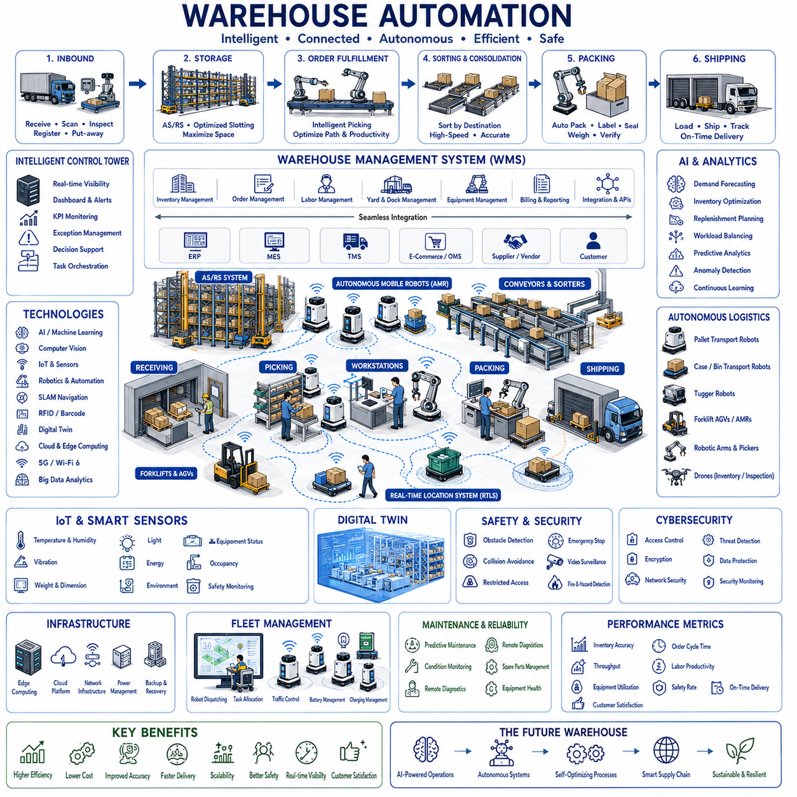
Warehouse automation represents the transformation of traditional storage facilities into intelligent, highly coordinated logistics environments where goods, information, equipment, and personnel operate as an integrated system. Modern warehouse automation combines robotics, Artificial Intelligence, Internet of Things technologies, advanced software platforms, and autonomous transportation systems to improve inventory accuracy, operational efficiency, throughput, safety, and customer responsiveness. Rather than replacing human workers entirely, warehouse automation enables people and intelligent machines to collaborate efficiently across receiving, storage, picking, packing, shipping, and inventory management processes.
A modern automated warehouse begins with inbound logistics where products arrive from suppliers, manufacturers, or distribution centers. Incoming goods are identified using barcode scanners, RFID systems, machine vision, or automated inspection equipment before being registered within the Warehouse Management System. Product dimensions, weight, condition, batch information, expiration dates, and storage requirements are verified automatically, allowing inventory records to be updated immediately while minimizing manual data entry and reducing receiving errors.
Warehouse Management Systems function as the digital control center coordinating inventory, storage locations, order processing, transportation requests, workforce allocation, and equipment utilization. Every movement of goods is continuously recorded and synchronized across enterprise systems including Enterprise Resource Planning, Manufacturing Execution Systems, Transportation Management Systems, and customer order platforms. Real-time inventory visibility enables accurate planning while supporting rapid responses to changing customer demand and operational priorities.
Artificial Intelligence improves warehouse decision-making by analyzing inventory trends, seasonal demand, historical orders, supplier performance, transportation schedules, and warehouse capacity. Machine learning predicts inventory requirements, recommends replenishment timing, optimizes storage allocation, balances workloads, and forecasts shipping demand before operational bottlenecks occur. Intelligent optimization continuously adapts warehouse operations to changing business conditions without requiring extensive manual planning.
Computer vision provides automated perception throughout warehouse environments by recognizing pallets, cartons, containers, forklifts, shelves, robots, workers, and loading docks. Vision systems verify barcode quality, identify damaged packages, detect misplaced inventory, measure pallet dimensions, monitor safety conditions, and support autonomous navigation. Continuous visual inspection improves inventory accuracy while reducing product handling errors and minimizing operational interruptions caused by incorrect storage or shipping.
Autonomous Mobile Robots perform flexible material transportation throughout modern warehouses. Robots transport pallets, cartons, bins, raw materials, finished products, and packaging supplies between receiving areas, storage racks, production lines, sorting stations, packing cells, and shipping docks. Autonomous navigation using Simultaneous Localization and Mapping, laser scanners, depth cameras, inertial measurement units, and semantic warehouse maps allows robots to operate safely within dynamic environments shared with human workers and industrial vehicles.
Automated Storage and Retrieval Systems maximize warehouse space utilization while increasing inventory accessibility and retrieval speed. High-density storage racks combined with automated cranes, shuttle systems, robotic lifts, vertical storage modules, and intelligent conveyors reduce unnecessary travel distance while improving picking accuracy. Automated storage algorithms continuously determine optimal storage positions according to product demand, inventory turnover, weight, dimensions, and handling requirements.
Order fulfillment represents one of the most important warehouse processes because customer satisfaction depends directly upon delivery speed and shipment accuracy. Intelligent picking systems coordinate robots, conveyors, automated guided vehicles, and human workers to collect products efficiently while minimizing travel distance and handling time. AI dynamically selects optimal picking strategies according to order size, product characteristics, workload distribution, and operational priorities throughout each fulfillment cycle.
Sorting and consolidation operations organize products according to destination, shipping method, customer order, transportation route, or production schedule. Automated sortation equipment uses barcode scanners, RFID identification, machine vision, robotic manipulators, and conveyor diverters to classify products rapidly with minimal human intervention. High-speed sorting significantly increases warehouse throughput while reducing shipping errors and improving overall logistics reliability.
Packing automation improves consistency, efficiency, and product protection by automatically selecting appropriate packaging materials according to product dimensions, weight, fragility, and transportation requirements. Intelligent packaging systems perform carton erection, product insertion, cushioning, labeling, sealing, weighing, and shipment verification while minimizing packaging waste. Automated quality inspection confirms package integrity before products enter outbound logistics operations.
Outbound logistics coordinate shipping activities between warehouses, transportation providers, distribution centers, retailers, and end customers. Transportation Management Systems integrate directly with warehouse operations to schedule truck arrivals, loading dock assignments, shipment priorities, carrier selection, and route optimization. Continuous synchronization between warehouse activities and transportation networks reduces waiting time while improving delivery performance and resource utilization.
Internet of Things technology enables continuous monitoring of warehouse infrastructure, equipment, inventory, environmental conditions, and operational assets. Smart sensors measure temperature, humidity, vibration, lighting, equipment status, energy consumption, occupancy, refrigeration conditions, and product storage environments. Continuous sensing supports predictive maintenance, environmental compliance, inventory preservation, and operational optimization while providing complete visibility throughout warehouse facilities.
Real-Time Location Systems continuously monitor the positions of pallets, containers, forklifts, autonomous robots, trailers, mobile equipment, and warehouse personnel. Location intelligence reduces search time, prevents misplaced inventory, supports dynamic task allocation, and improves equipment utilization. Accurate location awareness also strengthens safety by monitoring traffic flow, restricted areas, collision risks, and emergency evacuation procedures within complex warehouse environments.
Fleet Management Systems coordinate multiple autonomous robots operating simultaneously throughout large warehouse facilities. Task allocation considers robot availability, battery status, payload capacity, traffic congestion, equipment compatibility, charging schedules, and transportation priorities. Intelligent fleet coordination prevents congestion while maximizing transportation efficiency, ensuring balanced robot utilization, and supporting continuous twenty-four-hour warehouse operations.
Digital twins provide comprehensive virtual models of warehouse operations by integrating facility layouts, storage systems, inventory, robot fleets, conveyors, workforce allocation, transportation activities, and operational workflows. Engineers evaluate capacity expansion, equipment upgrades, storage strategies, robot deployment, traffic management, and emergency scenarios before implementing physical changes. Continuous synchronization between physical warehouses and digital models enables simulation-driven optimization with reduced operational risk.
Cloud computing and edge computing cooperate to process warehouse information efficiently. Edge computing supports low-latency robotic control, safety monitoring, machine vision, sensor processing, and equipment coordination near operational equipment. Cloud platforms manage large-scale analytics, enterprise integration, machine learning model training, digital twin synchronization, and multi-warehouse coordination across geographically distributed logistics networks. Hybrid computing balances responsiveness, scalability, and centralized operational intelligence.
Safety remains fundamental within automated warehouses where autonomous robots, forklifts, conveyors, cranes, and human workers operate simultaneously. Safety systems include obstacle detection, collision avoidance, emergency stop functions, speed adaptation, restricted access control, traffic management, predictive hazard detection, and continuous environmental monitoring. Human-centered safety policies ensure intelligent automation enhances productivity without compromising worker protection or operational reliability.
Cybersecurity protects warehouse operations against unauthorized access, communication interception, ransomware, software manipulation, and operational disruption. Secure authentication, encrypted communication, identity management, network segmentation, software integrity verification, continuous vulnerability assessment, and security monitoring protect both information systems and operational technology. Strong cybersecurity ensures uninterrupted logistics operations while maintaining inventory integrity and customer trust.
Maintenance strategies increasingly rely upon predictive diagnostics supported by Artificial Intelligence and continuous sensor monitoring. Motors, conveyors, robotic manipulators, autonomous vehicles, storage systems, scanners, communication equipment, and power infrastructure are monitored continuously for signs of wear or abnormal behavior. Predictive maintenance schedules servicing before failures occur, reducing unexpected downtime while improving equipment reliability and warehouse availability.
Warehouse performance is evaluated using inventory accuracy, order fulfillment rate, picking accuracy, throughput, storage utilization, robot utilization, equipment availability, shipment accuracy, order cycle time, transportation efficiency, labor productivity, energy consumption, maintenance cost, safety incidents, and customer satisfaction. Continuous performance analytics identify opportunities for operational improvement while supporting evidence-based management decisions across increasingly complex logistics environments.
Future warehouse automation will integrate multimodal foundation models, large language models, digital twins, autonomous robot fleets, collaborative manipulation, intelligent scheduling, predictive supply chain analytics, advanced computer vision, and self-optimizing logistics platforms into unified warehouse ecosystems. Warehouses will evolve from isolated storage facilities into intelligent distribution hubs capable of autonomous planning, continuous learning, adaptive resource allocation, and seamless coordination with manufacturing systems, transportation networks, suppliers, retailers, and customers. These intelligent logistics ecosystems will deliver higher efficiency, greater flexibility, improved resilience, and faster responses to global supply chain demands while maintaining safe and sustainable warehouse operations.

19.02 Autonomous Forklifts · 자율 지게차
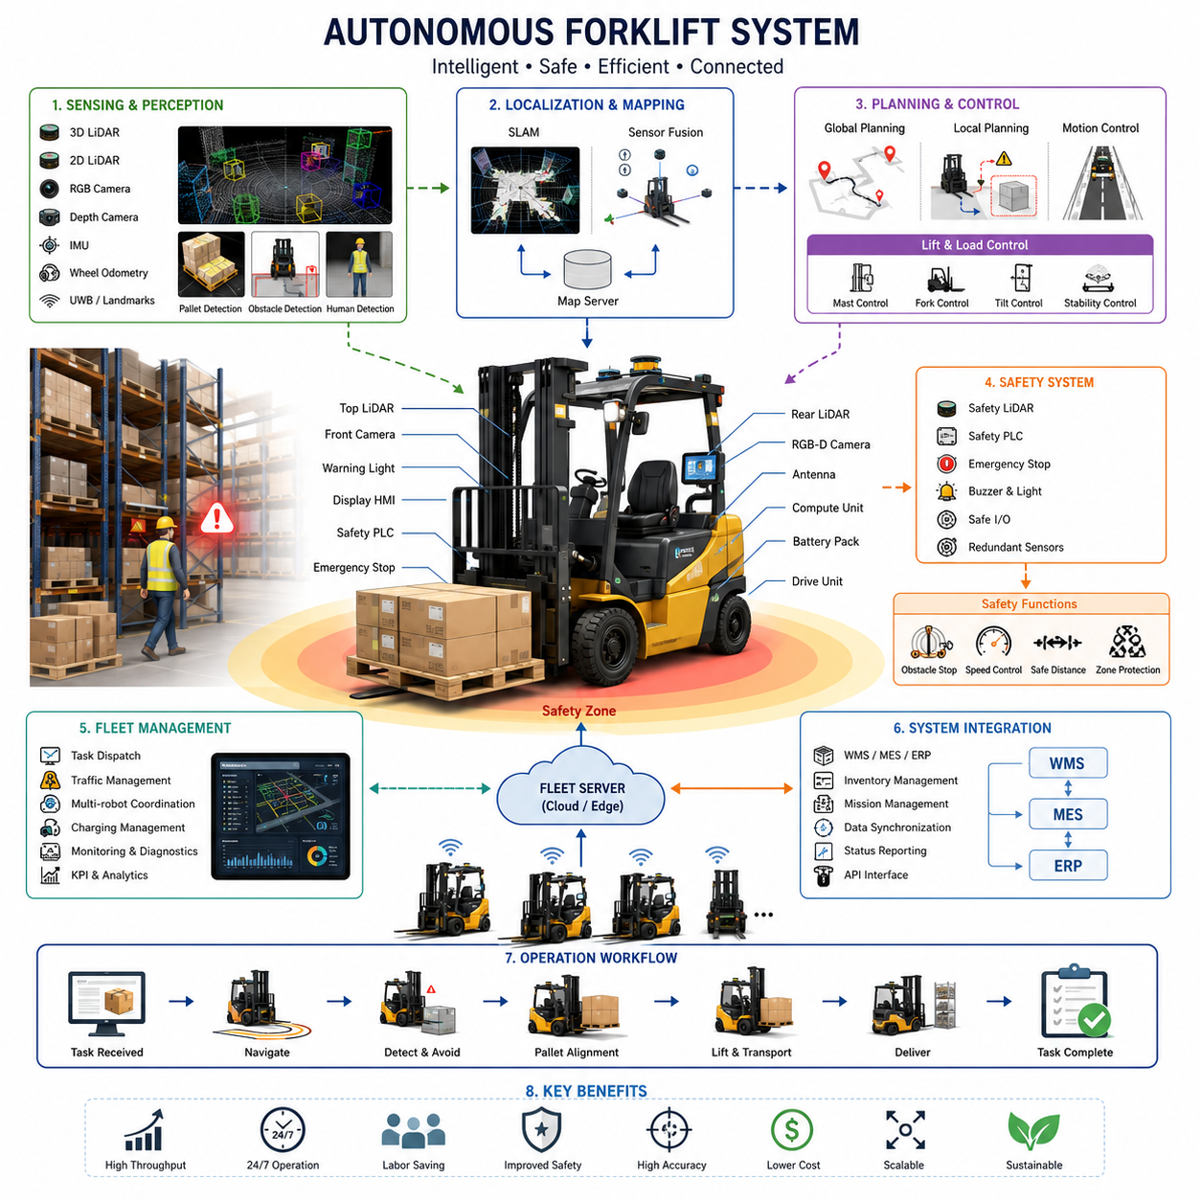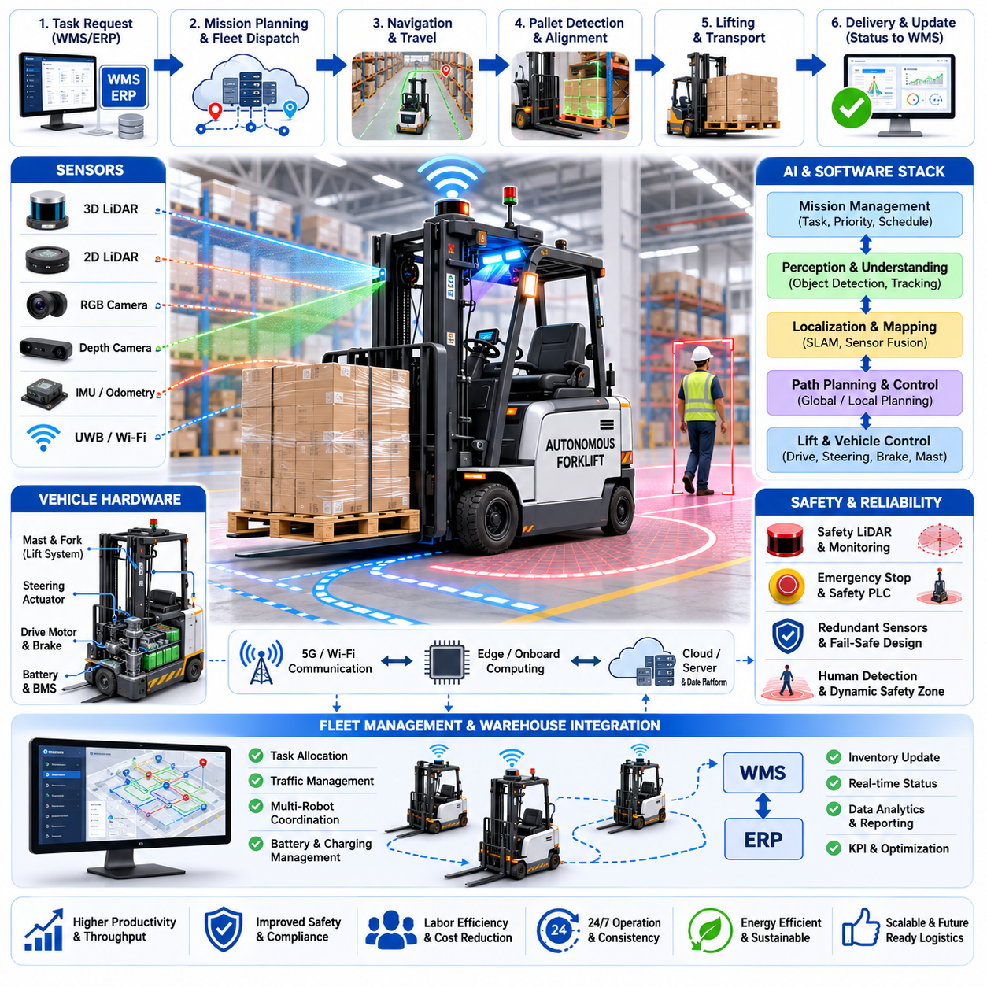
Autonomous forklifts represent one of the most mature categories of industrial autonomous mobile robots, combining traditional material handling equipment with advanced perception, localization, planning, and fleet management technologies. Unlike conventional forklifts that rely entirely on human operators, autonomous forklifts execute pallet transportation, storage, retrieval, loading, unloading, and inventory movement with minimal or no human intervention. They operate continuously in warehouses, factories, distribution centers, cold storage facilities, and logistics hubs where repetitive pallet handling constitutes a major portion of operational costs. By integrating autonomous navigation with industrial lifting mechanisms, these systems significantly improve productivity while reducing accidents, labor shortages, and operational variability.
Modern autonomous forklifts inherit the mechanical robustness of industrial lift trucks while replacing human decision making with layered robotic intelligence. Their architecture consists of a drive-by-wire chassis, steering actuators, lifting and mast control systems, braking modules, perception sensors, localization software, safety controllers, onboard computing platforms, and wireless communication interfaces. High-level mission planning assigns transport tasks, while onboard autonomy independently determines navigation paths, obstacle avoidance strategies, pallet alignment, lifting operations, and safe transportation. This hierarchical architecture separates fleet-level logistics optimization from real-time vehicle control, allowing multiple forklifts to operate cooperatively within large facilities.
Warehouse environments present unique navigation challenges because autonomous forklifts must maneuver inside narrow aisles surrounded by densely packed racks, dynamic workers, manually operated forklifts, carts, and continuously changing inventory. Navigation therefore requires centimeter-level localization together with reliable obstacle detection under varying lighting conditions and highly repetitive structural layouts. Unlike open industrial floors, warehouse aisles often contain visually similar shelves that make camera-only localization unreliable. Consequently, autonomous forklifts typically combine multiple sensing modalities including 2D LiDAR, 3D LiDAR, RGB cameras, depth cameras, IMUs, wheel odometry, and occasionally ultra-wideband positioning or artificial landmarks for enhanced localization robustness.
Localization is one of the most critical components because accurate pallet pickup depends not only on global positioning but also on highly precise relative alignment with pallet pockets. Simultaneous Localization and Mapping technologies allow forklifts to maintain accurate position estimates while continuously updating environmental maps. Sensor fusion algorithms combine wheel encoder measurements, inertial data, LiDAR scan matching, and visual landmarks to compensate for wheel slip, uneven floors, temporary occlusions, and accumulated odometry errors. In large logistics centers, cloud-based map servers distribute synchronized facility maps so every autonomous forklift shares a consistent representation of the operating environment.
Perception systems continuously interpret both static infrastructure and dynamic obstacles. High-resolution LiDAR provides reliable geometric measurements of shelving structures, pallet locations, walls, and transportation corridors. Stereo cameras and depth sensors recognize pallet openings, damaged pallets, stacked goods, and human workers. Deep learning models classify forklifts, pedestrians, carts, autonomous robots, safety barriers, and unexpected obstacles while estimating their trajectories. Multi-sensor fusion increases robustness against dust, reflective wrapping materials, poor illumination, and partially occluded objects commonly encountered in logistics facilities.
Pallet detection constitutes one of the defining capabilities that differentiates autonomous forklifts from general AMRs. The system must recognize pallet geometry under numerous orientations, heights, loading conditions, and packaging variations. Computer vision algorithms identify pallet entry openings while depth sensing estimates fork insertion angles and distances. The robot calculates precise six-degree-of-freedom alignment before initiating the lifting sequence. Even minor alignment errors can cause fork collisions, pallet damage, unstable loads, or failed pickup attempts. Consequently, fine alignment often relies on short-range perception operating independently from global navigation.
Lift control requires synchronized management of mast elevation, fork tilt, lateral positioning, and vehicle movement. Unlike standard mobile robots that transport loads fixed to their chassis, autonomous forklifts actively manipulate payloads whose center of gravity changes throughout lifting operations. Motion planning therefore integrates vehicle dynamics with load stability analysis. Acceleration, deceleration, turning radius, mast movement, and lifting speed are coordinated to prevent load oscillation, product damage, or vehicle instability. Heavy payload transportation further requires continuous monitoring of axle loading, motor torque, braking performance, and battery power consumption.
Path planning extends beyond simple shortest-path optimization. Autonomous forklifts evaluate aisle widths, traffic congestion, turning clearances, rack accessibility, payload dimensions, safety zones, and operational priorities before selecting optimal routes. Global planners compute mission-efficient transportation paths, while local planners continuously react to temporary obstacles and moving workers. Dynamic obstacle avoidance algorithms modify trajectories without sacrificing overall mission efficiency. In large distribution centers, fleet management systems coordinate hundreds of simultaneous transport tasks while minimizing congestion and travel distance.
Traffic management becomes increasingly important as multiple autonomous forklifts, towing robots, picking robots, and manually operated vehicles coexist within the same warehouse. Fleet Management Systems assign transportation missions according to equipment availability, battery status, travel distance, loading priorities, and warehouse throughput objectives. Traffic control algorithms prevent deadlocks at intersections, regulate right-of-way policies, coordinate narrow aisle access, and optimize charging schedules. Communication between robots enables cooperative navigation that minimizes waiting time while maintaining safe separation distances.
Human safety remains the highest priority throughout autonomous forklift operation because these machines often transport loads weighing hundreds or thousands of kilograms. Functional safety architectures incorporate redundant perception systems, emergency braking, safety-rated laser scanners, safety PLCs, emergency stop circuits, and continuous system health monitoring. Safety zones dynamically expand or contract according to vehicle speed, payload weight, and environmental conditions. Human detection algorithms prioritize pedestrian safety by reducing speed, issuing warning signals, or stopping completely whenever collision risk exceeds predefined thresholds.
Compliance with industrial safety regulations requires autonomous forklifts to satisfy both machinery safety standards and industrial vehicle regulations. Safety validation includes emergency stopping performance, braking distance verification, sensor redundancy analysis, fault detection coverage, software integrity testing, cybersecurity assessment, and functional safety certification. Risk assessments evaluate scenarios such as sensor failures, communication loss, localization degradation, actuator malfunctions, unexpected pedestrian behavior, unstable pallet loads, and power interruptions to ensure the vehicle transitions safely into controlled operating states.
Battery management significantly influences operational efficiency because autonomous forklifts often operate continuously across multiple work shifts. Modern systems typically employ lithium-ion battery technologies combined with intelligent Battery Management Systems that monitor cell voltage, temperature, charging cycles, remaining capacity, and battery health. Opportunity charging strategies allow robots to recharge during idle periods instead of waiting for complete discharge. Fleet software schedules charging operations to maximize overall warehouse productivity while ensuring sufficient energy availability for time-critical transportation missions.
Warehouse Management System integration enables autonomous forklifts to become active participants within enterprise logistics operations. Warehouse software assigns pallet movements based on inventory optimization, production schedules, shipping priorities, and receiving operations. Autonomous forklifts automatically receive transportation missions, report task completion, update inventory locations, and synchronize operational status with Manufacturing Execution Systems and Enterprise Resource Planning platforms. This digital integration provides end-to-end visibility from inventory management through physical material movement.
Artificial intelligence increasingly enhances operational intelligence beyond basic navigation. Machine learning models predict traffic congestion, estimate task durations, optimize fleet scheduling, recognize damaged pallets, detect abnormal equipment behavior, and anticipate maintenance requirements. Predictive maintenance algorithms analyze motor currents, vibration signatures, hydraulic pressures, steering performance, braking characteristics, and battery degradation to identify failures before they interrupt warehouse operations. AI-driven analytics continuously improve transportation efficiency using operational data collected across thousands of completed missions.
Simulation and digital twin technologies substantially reduce deployment risks before physical installation. Virtual warehouse models reproduce rack layouts, transportation routes, pallet flows, worker interactions, and operational schedules. Engineers validate navigation algorithms, traffic management strategies, fleet coordination policies, and safety behaviors under numerous operating scenarios without disrupting production. Digital twins continue operating after deployment by comparing real operational data against simulated performance, enabling continuous optimization throughout the autonomous forklift lifecycle.
Autonomous forklifts provide measurable operational benefits including increased throughput, consistent transportation quality, improved inventory accuracy, reduced labor dependency, enhanced workplace safety, and continuous twenty-four-hour operation. Consistent positioning reduces pallet damage while optimized routing decreases travel distance and energy consumption. Automated mission execution eliminates operator variability, allowing logistics processes to achieve highly predictable performance even during peak operational periods. These improvements become increasingly valuable as global labor shortages and supply chain complexity continue to expand.
Future autonomous forklift development is moving toward collaborative multi-robot logistics ecosystems in which forklifts, towing AMRs, pallet shuttles, humanoid robots, robotic manipulators, automated storage systems, and intelligent warehouse software cooperate through shared world models and cloud-based fleet intelligence. Foundation models, multimodal perception, reinforcement learning, edge AI accelerators, and digital twin technologies will enable forklifts to understand semantic warehouse environments, reason about complex logistics objectives, adapt to changing facility layouts, and coordinate seamlessly with both human workers and heterogeneous robotic systems. The result will be highly autonomous logistics infrastructures capable of continuously optimizing warehouse operations while maintaining industrial-grade safety, scalability, and operational reliability.

19.03 Towing AMR Systems · 견인 AMR 시스템
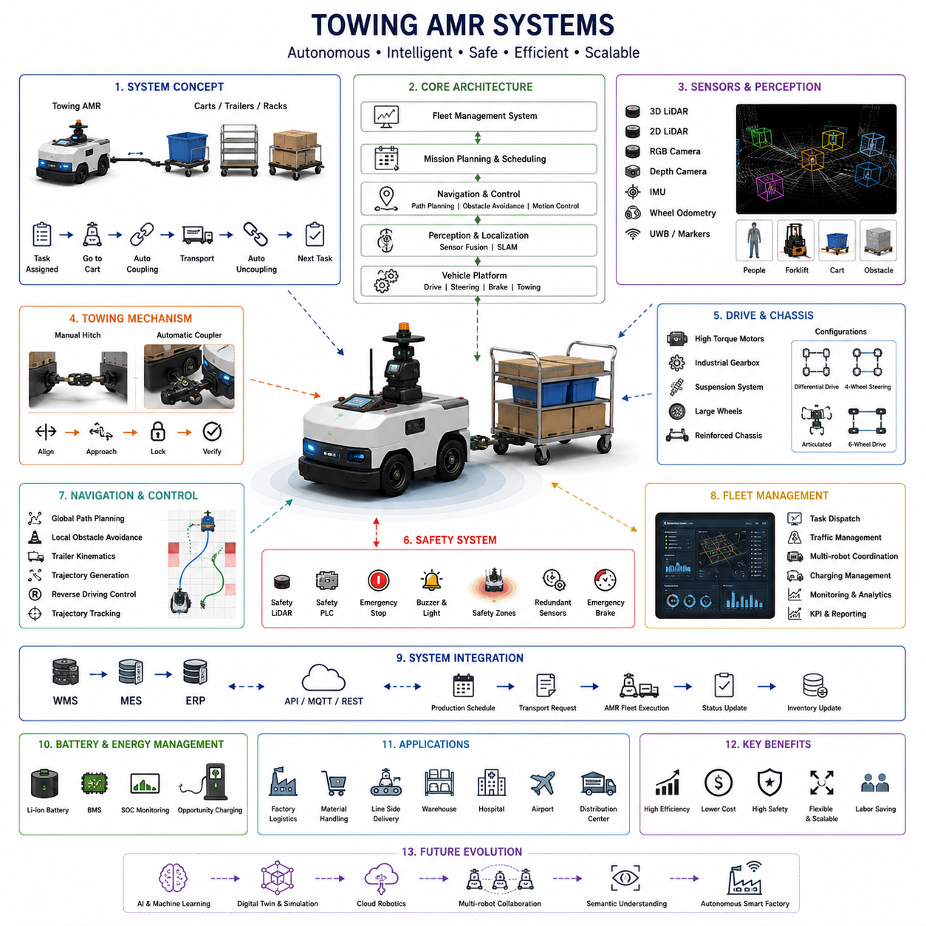
Towing Autonomous Mobile Robot systems are specialized industrial mobile robots designed to pull carts, trailers, racks, pallets, or multiple wheeled carriers rather than carrying payloads directly on their own chassis. Unlike lifting robots or autonomous forklifts, towing AMRs maximize transportation efficiency by separating the mobile drive platform from the transported cargo. This architecture enables a single autonomous vehicle to move various types of passive carts throughout factories, warehouses, hospitals, airports, and manufacturing facilities. By automating repetitive material transportation while minimizing infrastructure modifications, towing AMRs provide an economical and scalable solution for modern intralogistics operations.
The fundamental concept of a towing AMR is based on autonomous mobility combined with intelligent towing capabilities. The robot serves as a reusable powered tractor while standardized carts carry different materials, components, finished products, or production equipment. Once a transportation task is assigned, the AMR autonomously navigates to the designated cart, performs coupling operations, transports the load to its destination, uncouples safely, and proceeds to the next assignment. This separation between powered vehicle and passive cargo carrier reduces fleet costs because multiple carts can be served by a smaller number of autonomous towing robots.
Mechanical architecture plays a significant role in towing performance because pulling heavy trailers introduces dynamic forces that differ substantially from standard AMR applications. The chassis must provide sufficient structural rigidity to withstand continuous towing loads while maintaining precise steering performance. Heavy-duty towing AMRs typically employ reinforced steel frames, high-torque drive motors, industrial gearboxes, large-diameter wheels, and suspension systems capable of absorbing uneven floor conditions. Weight distribution is carefully optimized to maximize wheel traction while preventing excessive tire wear or unstable vehicle behavior during acceleration and braking.
Vehicle configurations vary according to application requirements. Compact indoor towing robots often utilize differential drive systems for high maneuverability in narrow factory aisles, while larger industrial platforms may adopt four-wheel steering, articulated steering, Ackermann steering, or six-wheel drive configurations for transporting heavy loads over long distances. Outdoor towing AMRs frequently employ all-wheel drive and independent suspension systems to negotiate ramps, uneven surfaces, and outdoor environments where traction conditions continuously change.
Drive systems must generate high starting torque because towing operations frequently involve moving stationary loads weighing several tons. Permanent magnet synchronous motors, brushless DC motors, or industrial AC servo motors are commonly integrated with planetary gear reducers to provide efficient low-speed traction. Motor controllers continuously regulate torque output according to payload weight, slope conditions, wheel slip, and vehicle acceleration requirements. Advanced traction control algorithms detect slipping wheels and redistribute driving forces to maintain stable movement even under challenging surface conditions.
The towing mechanism represents one of the defining engineering elements of the entire platform. Simple systems employ fixed tow pins or manually connected hitch assemblies suitable for standardized industrial carts. More advanced platforms integrate automatic coupling systems capable of connecting and disconnecting trailers without human intervention. Automatic couplers utilize mechanical locking mechanisms, electrical actuators, pneumatic systems, or hydraulic devices together with proximity sensors, cameras, or alignment guides to ensure reliable engagement. The entire coupling sequence is monitored continuously to verify successful locking before vehicle movement begins.
Navigation architecture combines global mission planning with highly accurate local positioning. Towing AMRs operate within dynamic industrial environments where workers, manually driven forklifts, autonomous vehicles, and moving production equipment share common transportation corridors. Navigation software integrates global path planning, local obstacle avoidance, behavioral planning, and vehicle motion control into a unified autonomy framework. Because the total vehicle length increases significantly after attaching trailers, planners must account for trailer kinematics, turning radius, off-tracking behavior, and articulation constraints during route generation.
Localization accuracy becomes increasingly important when multiple carts are parked within densely organized staging areas. Sensor fusion combines 2D LiDAR, 3D LiDAR, RGB cameras, depth cameras, wheel odometry, inertial measurement units, and occasionally UWB positioning systems or fiducial markers to estimate vehicle pose with high precision. Simultaneous Localization and Mapping algorithms continuously compensate for wheel slip, floor irregularities, and temporary environmental changes. Accurate localization enables precise docking with transport carts while minimizing alignment errors during automatic coupling.
Perception systems continuously monitor both static infrastructure and dynamic obstacles. Industrial facilities often contain shelving, machinery, pallets, workers, forklifts, and temporary storage locations that create highly dynamic environments. Multi-modal perception integrates geometric information from LiDAR with semantic understanding derived from deep learning vision models. Object detection algorithms classify pedestrians, forklifts, carts, robots, barriers, and unexpected obstacles while estimating their trajectories. Dynamic obstacle prediction enables towing AMRs to reduce speed, modify paths, or stop safely before potential collisions occur.
Motion planning for towing robots is considerably more complex than conventional mobile robot navigation because the transported trailer influences vehicle dynamics throughout every maneuver. Trajectory generation algorithms consider trailer articulation angles, turning radius limitations, swing behavior during acceleration, braking stability, and reversing constraints. Multi-body kinematic models simulate the interaction between towing vehicle and trailer to ensure that planned paths remain physically feasible. These predictive models significantly reduce trailer collisions with shelving, machinery, or infrastructure during tight maneuvers.
Reverse driving represents one of the most technically demanding capabilities in towing systems. Unlike forward motion, reversing requires simultaneous stabilization of trailer articulation while preventing jackknifing. Advanced control algorithms continuously estimate articulation angles and calculate corrective steering commands that maintain stable trailer alignment. Model predictive control techniques anticipate future trailer motion several seconds ahead, enabling smooth reverse parking, docking, and narrow aisle maneuvers that would otherwise require experienced human operators.
Fleet management systems coordinate multiple towing AMRs operating simultaneously throughout large manufacturing plants or logistics centers. Centralized scheduling software assigns transportation missions based on production priorities, cart availability, robot location, battery status, traffic conditions, and estimated travel times. Traffic management algorithms prevent congestion at intersections, coordinate shared corridors, allocate charging resources, and minimize transportation delays. Cooperative fleet optimization increases overall material flow efficiency while reducing unnecessary travel distance and idle time.
Warehouse Management Systems, Manufacturing Execution Systems, and Enterprise Resource Planning platforms exchange operational data continuously with towing AMR fleets. Production schedules automatically generate transportation requests, while completed deliveries update inventory records and manufacturing status in real time. Standard communication interfaces enable seamless integration between autonomous transportation systems and existing industrial software infrastructure. This digital connectivity transforms towing AMRs from isolated autonomous vehicles into intelligent components of enterprise-wide production logistics.
Safety architecture remains fundamental because towing robots frequently transport heavy industrial loads through environments occupied by human workers. Safety-rated LiDAR scanners establish dynamically adjustable protective zones around the vehicle and trailer. Emergency braking systems, redundant safety controllers, independent emergency stop circuits, safety PLCs, audible alarms, warning lights, and continuous system diagnostics provide multiple layers of protection. Vehicle speed is automatically reduced according to payload weight, turning radius, pedestrian proximity, and environmental complexity to ensure compliance with industrial safety requirements.
Functional safety engineering evaluates numerous failure scenarios including sensor malfunction, communication loss, trailer detachment, actuator failure, localization degradation, braking faults, battery abnormalities, and unexpected obstacle appearance. Fault detection algorithms continuously monitor hardware and software health while transitioning the vehicle into predefined safe states whenever abnormal conditions are detected. Redundant sensing, fail-safe braking, and emergency shutdown procedures significantly improve operational reliability in mission-critical industrial environments.
Battery systems directly influence operational productivity because towing AMRs often perform continuous transportation over multiple production shifts. High-capacity lithium iron phosphate or lithium-ion battery packs are commonly employed together with intelligent battery management systems that supervise voltage, current, temperature, state of charge, and long-term battery health. Opportunity charging strategies allow vehicles to recharge automatically during idle periods without interrupting production schedules. Fleet-level energy management further balances charging operations across multiple robots to maximize overall system availability.
Artificial intelligence increasingly enhances transportation efficiency beyond conventional navigation. Machine learning models analyze historical transportation data to predict production bottlenecks, estimate mission completion times, optimize traffic flow, and allocate fleet resources dynamically. Predictive maintenance algorithms monitor motor currents, gearbox vibration, wheel wear, bearing temperatures, braking performance, and battery degradation to identify maintenance requirements before failures occur. AI-driven analytics continuously improve logistics efficiency through data collected from thousands of completed transportation missions.
Simulation environments and digital twin technologies enable engineers to evaluate towing AMR performance before physical deployment. Virtual factory models accurately reproduce production layouts, transportation routes, workstation interactions, trailer configurations, worker movement, and operational schedules. Engineers validate navigation strategies, fleet coordination policies, safety functions, and traffic management algorithms across numerous scenarios without disrupting actual manufacturing. Following deployment, digital twins compare simulated and operational performance to identify optimization opportunities and continuously improve fleet behavior.
Towing AMRs provide numerous operational advantages including flexible transportation, reduced labor dependency, improved safety, lower infrastructure investment, scalable fleet expansion, and efficient utilization of passive transport carts. Because the towing vehicle can service multiple interchangeable trailers, overall capital expenditure is significantly reduced compared with solutions requiring a powered vehicle for every transported load. Continuous autonomous operation also improves production consistency while reducing manual material handling, workplace injuries, and transportation bottlenecks across industrial facilities.
Future towing AMR systems will evolve into highly intelligent logistics platforms integrated with warehouse automation, autonomous forklifts, robotic manipulators, automated storage systems, and enterprise AI. Foundation models, multimodal perception, reinforcement learning, cloud robotics, edge AI computing, and digital twins will enable towing robots to understand semantic production environments, negotiate cooperative transportation tasks, adapt to changing factory layouts, and optimize logistics at the fleet level. These technologies will transform towing AMRs from autonomous transport vehicles into collaborative physical AI systems capable of supporting fully autonomous smart factories and next-generation industrial supply chains.

19.04 Sorting and Delivery Robots · 분류·배송 로봇
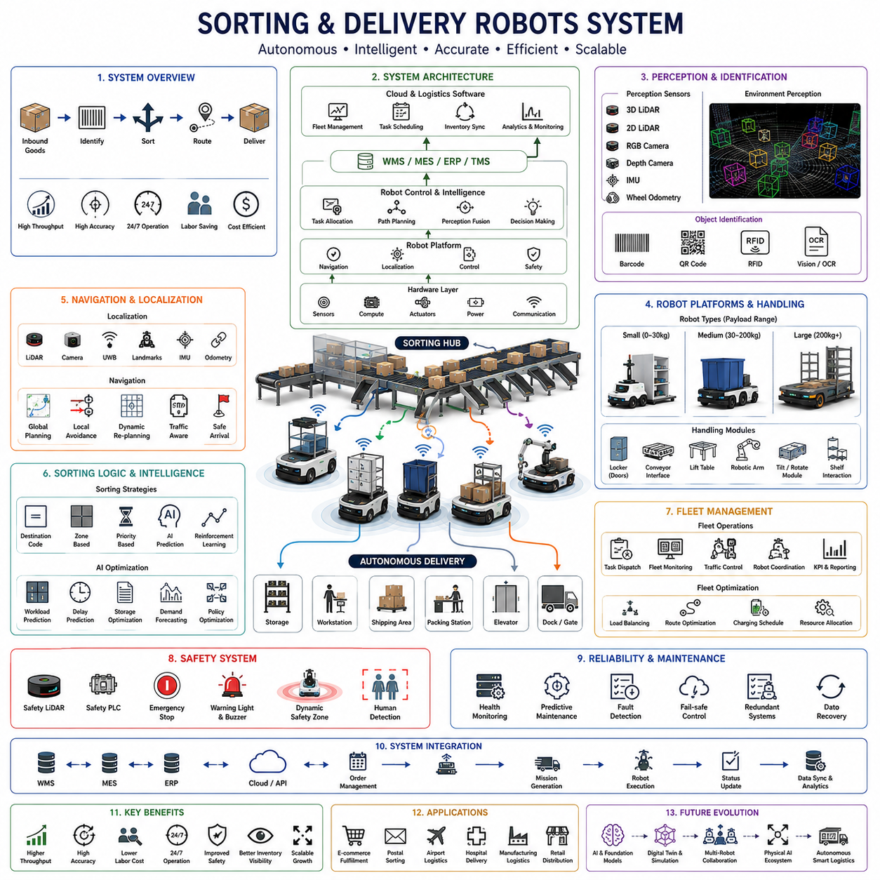
Sorting and delivery robots represent one of the fastest-growing categories of logistics automation, combining autonomous mobility, intelligent object handling, automated identification, and warehouse information systems into highly efficient material distribution platforms. Unlike conventional transportation robots that simply move cargo between fixed locations, sorting and delivery robots actively identify, classify, prioritize, and transport parcels, containers, bins, documents, medical supplies, or manufactured components according to operational requirements. They have become essential technologies in e-commerce fulfillment centers, postal distribution hubs, airports, hospitals, manufacturing facilities, and retail logistics, where millions of items must be processed accurately under demanding throughput requirements.
The primary objective of sorting and delivery robots is to automate repetitive logistics operations while minimizing human intervention and operational delays. Incoming goods are automatically identified, assigned to destination categories, routed through optimized transportation paths, and delivered to predefined locations with minimal manual handling. This integrated workflow significantly reduces sorting errors, improves inventory visibility, shortens order fulfillment cycles, and increases overall warehouse productivity. As customer expectations for same-day and next-day delivery continue to rise, robotic sorting systems have become critical infrastructure supporting modern supply chains.
System architecture typically consists of autonomous mobile platforms, perception sensors, object identification modules, onboard computing systems, wireless communication interfaces, material handling mechanisms, fleet management software, and warehouse management integration. The robotic platform provides autonomous navigation, while specialized upper modules handle package manipulation, bin loading, conveyor transfer, shelf interaction, or compartment management. Cloud-based logistics software coordinates transportation missions, inventory synchronization, delivery scheduling, and operational analytics across large robot fleets operating simultaneously throughout logistics facilities.
Robot configurations vary according to application requirements and payload characteristics. Small indoor delivery robots often transport medical supplies, laboratory samples, food trays, office documents, or retail merchandise using enclosed storage compartments. Medium-sized warehouse robots carry totes, bins, cartons, or pallet containers between storage areas and workstations. Large industrial delivery platforms transport production materials, automotive components, heavy manufacturing equipment, or warehouse containers over long distances. Modular payload systems enable the same autonomous platform to support multiple logistics applications by replacing upper modules without redesigning the vehicle.
Material handling mechanisms differ significantly depending on the operational workflow. Some delivery robots utilize enclosed lockers with electronically controlled access doors for secure package transportation. Others incorporate conveyor interfaces allowing fully automated loading and unloading between robotic vehicles and conveyor systems. Robotic manipulators, lift tables, telescopic conveyors, tilting platforms, or rotating transfer mechanisms may be integrated to automate package exchange with warehouse infrastructure. Modular handling systems maximize flexibility while minimizing mechanical complexity and maintenance requirements.
Sorting accuracy depends heavily on reliable object identification technologies. Barcode scanners remain widely deployed due to their simplicity, speed, and industrial maturity. QR code readers provide increased information density and improved error correction. RFID technology enables contactless identification of multiple items simultaneously, reducing scanning time for high-volume logistics operations. Computer vision systems employing deep learning recognize labels, handwritten addresses, damaged packages, and irregular objects while supporting optical character recognition for automated document processing. Multi-modal identification significantly improves recognition reliability under varying packaging conditions.
Perception architecture continuously monitors both transported goods and surrounding environments. Two-dimensional and three-dimensional LiDAR sensors generate geometric maps for navigation and obstacle avoidance. RGB cameras detect shelves, packages, workers, forklifts, and transportation equipment while providing semantic understanding through deep neural networks. Depth cameras estimate object dimensions, package orientation, and loading conditions for automated manipulation tasks. Sensor fusion integrates geometric, visual, and inertial measurements into a unified environmental representation that supports both autonomous navigation and precise delivery operations.
Navigation systems allow sorting and delivery robots to operate safely within highly dynamic logistics environments. Simultaneous Localization and Mapping algorithms combine LiDAR, cameras, wheel odometry, inertial sensors, and occasionally UWB positioning systems or artificial landmarks to estimate robot pose with centimeter-level accuracy. Global path planners compute efficient transportation routes while local planners continuously react to pedestrians, forklifts, manually operated carts, and temporary obstacles. Adaptive navigation algorithms dynamically reroute robots according to traffic conditions, congestion levels, and operational priorities without interrupting delivery missions.
Task allocation represents one of the most important optimization challenges within large robotic logistics systems. Fleet management software continuously evaluates robot availability, battery status, payload capacity, delivery urgency, destination location, and predicted travel time before assigning transportation missions. Dynamic scheduling algorithms balance workload across multiple robots while minimizing idle time and transportation distance. Intelligent dispatch strategies significantly improve warehouse throughput by reducing bottlenecks and maintaining balanced utilization across the entire robotic fleet.
Sorting algorithms combine operational rules with artificial intelligence to determine optimal item routing. Traditional rule-based systems classify packages according to destination codes, delivery zones, product categories, or transportation priorities. Machine learning algorithms further optimize sorting decisions by predicting workload distribution, transportation delays, storage availability, and processing bottlenecks. Reinforcement learning approaches continuously improve routing policies through operational experience, enabling robotic logistics systems to adapt automatically to changing demand patterns and warehouse configurations.
Fleet coordination becomes increasingly important as hundreds or even thousands of robots operate simultaneously within large fulfillment centers. Traffic management software coordinates intersection priorities, shared transportation corridors, charging schedules, elevator access, docking stations, and loading areas. Cooperative path planning prevents deadlocks while maximizing transportation efficiency. Cloud-based coordination enables robots to exchange operational status, environmental information, obstacle locations, and mission updates in real time, improving overall system robustness and scalability.
Warehouse Management Systems, Manufacturing Execution Systems, Enterprise Resource Planning platforms, and Transportation Management Systems exchange operational data continuously with robotic logistics infrastructure. Customer orders automatically generate delivery missions, inventory updates synchronize storage locations, and transportation completion records update enterprise databases in real time. Standard industrial communication interfaces allow sorting and delivery robots to integrate seamlessly into existing logistics ecosystems without requiring major modifications to warehouse information systems.
Safety engineering remains essential because logistics facilities frequently contain large numbers of human workers operating alongside autonomous robots. Safety-rated LiDAR scanners establish dynamic protective zones that expand according to robot speed and payload conditions. Emergency stop systems, redundant safety controllers, safety PLCs, warning lights, audible alarms, and continuous hardware diagnostics provide multiple layers of operational protection. Human detection algorithms classify pedestrian movement and predict future trajectories, allowing robots to reduce speed or stop before hazardous interactions occur.
Reliability engineering focuses on maintaining continuous logistics operations despite hardware failures or changing environmental conditions. Redundant sensing, fault detection algorithms, predictive diagnostics, fail-safe braking systems, redundant communication channels, and autonomous recovery procedures minimize operational interruptions. Robots continuously monitor battery health, motor temperature, wheel wear, sensor integrity, communication quality, and computational performance. Preventive maintenance scheduling based on operational data significantly reduces unexpected equipment failures and maximizes fleet availability.
Battery technology strongly influences operational efficiency because sorting and delivery robots frequently operate around the clock. Lithium-ion and lithium iron phosphate battery systems provide high energy density, rapid charging capability, and long operational lifetime. Battery Management Systems supervise charging cycles, thermal behavior, state of charge, remaining useful life, and fault conditions. Opportunity charging strategies allow robots to recharge automatically during idle periods while fleet-level energy optimization distributes charging demand across multiple charging stations to maximize overall warehouse productivity.
Artificial intelligence increasingly extends beyond navigation into comprehensive logistics optimization. Deep learning models recognize damaged packages, estimate parcel dimensions, predict transportation delays, optimize storage allocation, and forecast demand fluctuations. Large-scale operational data supports predictive maintenance, workload forecasting, intelligent inventory allocation, and adaptive fleet scheduling. Foundation models and multimodal AI further enhance semantic understanding of logistics operations, enabling robots to interpret complex delivery instructions, understand warehouse layouts, and cooperate naturally with human operators.
Simulation platforms and digital twins play an essential role throughout robot deployment and lifecycle management. Virtual warehouse environments accurately reproduce storage layouts, conveyor systems, sorting stations, delivery routes, traffic conditions, and worker behavior. Engineers validate navigation algorithms, sorting logic, fleet coordination strategies, and safety functions before physical deployment. After installation, digital twins continuously compare simulated performance with operational data to identify inefficiencies, evaluate software updates, and optimize logistics workflows without disrupting production.
Sorting and delivery robots deliver measurable operational improvements including higher throughput, lower labor costs, reduced sorting errors, improved delivery consistency, enhanced inventory accuracy, and twenty-four-hour continuous operation. Automated logistics significantly reduces repetitive manual handling while improving workplace safety and reducing ergonomic injuries. Modular robot platforms allow facilities to expand capacity incrementally by adding additional vehicles rather than redesigning complete logistics infrastructure, providing exceptional scalability for rapidly growing operations.
Future sorting and delivery robots will evolve into intelligent logistics agents operating within fully connected Physical AI ecosystems. Foundation models, multimodal perception, cloud robotics, digital twins, reinforcement learning, edge AI computing, and multi-agent coordination will enable robots to understand semantic logistics objectives, negotiate transportation priorities autonomously, optimize warehouse-wide material flow, and cooperate seamlessly with autonomous forklifts, towing AMRs, robotic manipulators, automated storage systems, drones, and humanoid robots. These developments will transform conventional logistics automation into highly adaptive, self-optimizing distribution networks capable of supporting next-generation smart factories, autonomous warehouses, and globally connected supply chain infrastructures.

19.05 Fleet Optimization · 플릿 최적화
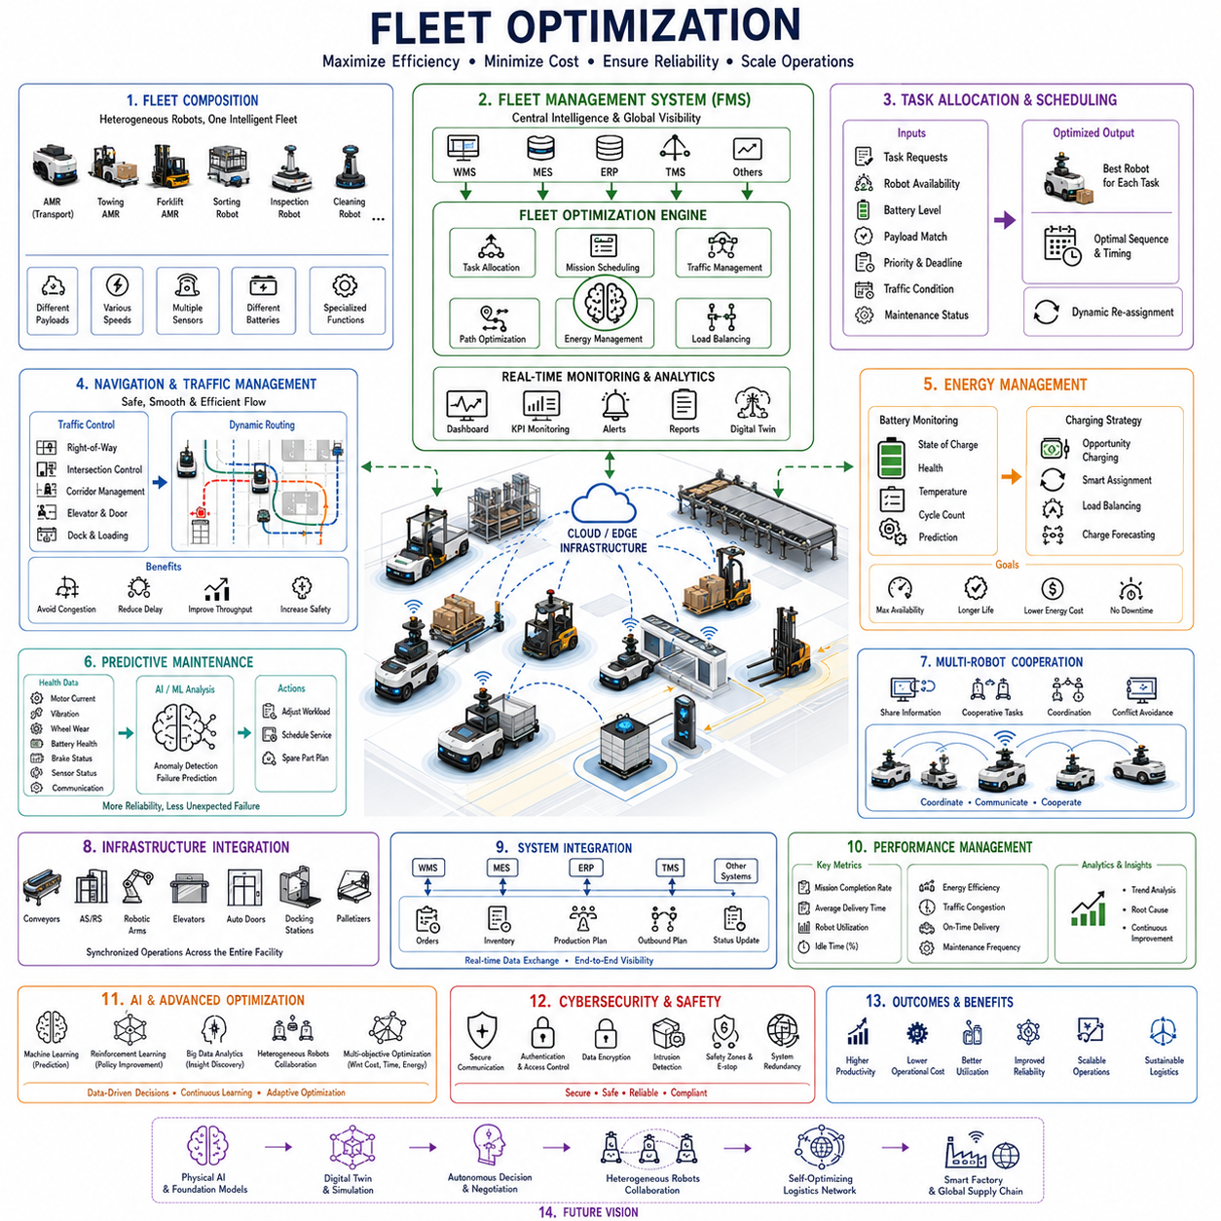
Fleet optimization represents the highest operational intelligence layer within Autonomous Mobile Robot ecosystems, coordinating multiple robots, transportation tasks, warehouse infrastructure, and enterprise software into a unified logistics system. While individual robots optimize their own navigation and task execution, fleet optimization focuses on maximizing overall system efficiency across an entire facility. The objective is not merely to complete transportation missions but to minimize travel distance, reduce idle time, balance workload, prevent congestion, optimize energy consumption, and maintain consistent operational throughput. As modern factories and distribution centers deploy hundreds or even thousands of autonomous robots, fleet optimization has become one of the most important technologies determining the overall productivity and scalability of industrial logistics.
A fleet consists of multiple heterogeneous autonomous vehicles performing transportation, towing, pallet handling, inspection, cleaning, inventory management, or delivery operations simultaneously. These robots may differ in payload capacity, mobility configuration, battery size, sensor architecture, manipulation capability, or operating speed. Fleet optimization software continuously monitors every vehicle, transportation request, charging station, storage area, and traffic condition while dynamically coordinating all available resources. Instead of viewing robots as independent machines, the optimization framework treats the entire robotic ecosystem as a single distributed logistics platform.
Fleet Management Systems serve as the central intelligence responsible for coordinating autonomous robots throughout industrial environments. The system receives transportation requests from Warehouse Management Systems, Manufacturing Execution Systems, Enterprise Resource Planning platforms, hospital information systems, or production scheduling software. It continuously analyzes robot availability, mission priorities, battery levels, traffic conditions, equipment health, delivery deadlines, and operational constraints before assigning tasks. By maintaining global visibility across the entire operation, the Fleet Management System significantly improves resource utilization while reducing unnecessary transportation activities.
Task allocation forms the foundation of fleet optimization because selecting the appropriate robot for each mission directly influences transportation efficiency. Assignment algorithms evaluate travel distance, estimated completion time, payload compatibility, robot availability, current workload, battery capacity, maintenance status, and future mission requirements before selecting the most suitable vehicle. Dynamic task allocation continuously reassigns missions whenever operating conditions change, allowing the fleet to respond effectively to unexpected delays, robot failures, or urgent transportation requests. Intelligent scheduling minimizes overall travel while maintaining balanced workload distribution among all available robots.
Mission scheduling extends beyond assigning individual transportation tasks by determining their execution sequence over time. Scheduling algorithms consider production priorities, delivery deadlines, workstation demand, material availability, transportation dependencies, and expected robot utilization. Multi-objective optimization simultaneously minimizes delivery delays, travel distance, congestion, battery consumption, and idle time while maximizing production throughput. Modern scheduling systems continuously recalculate transportation plans using real-time operational data, enabling rapid adaptation to changing manufacturing conditions and logistics requirements.
Traffic management becomes increasingly complex as robot density increases throughout industrial facilities. Without centralized coordination, robots may compete for shared corridors, intersections, elevators, charging stations, loading docks, or narrow aisles, resulting in congestion and reduced productivity. Fleet optimization software monitors traffic conditions continuously and adjusts robot routes proactively to prevent bottlenecks. Dynamic traffic control establishes right-of-way policies, controls intersection access, coordinates bidirectional traffic, and schedules access to constrained infrastructure. Predictive traffic analysis further identifies future congestion before it occurs, enabling preventive route modifications that improve overall transportation flow.
Path optimization extends traditional robot navigation by considering fleet-wide operational objectives rather than individual shortest paths. Instead of independently selecting the minimum-distance route, each robot evaluates transportation efficiency from the perspective of the entire fleet. Cooperative routing algorithms distribute traffic across multiple available corridors, reducing congestion while improving facility-wide throughput. Global path optimization also accounts for temporary construction zones, blocked aisles, maintenance activities, high-priority transportation lanes, and dynamic environmental changes that influence operational efficiency.
Energy management represents another critical optimization objective because battery availability directly influences fleet productivity. Fleet optimization software continuously monitors battery state of charge, charging station occupancy, expected mission duration, travel distance, and future transportation demand. Opportunity charging strategies schedule partial charging during idle periods without interrupting production. Charging assignments are optimized across multiple stations to prevent charging bottlenecks while ensuring that sufficient robots remain available for transportation tasks. Predictive energy management further estimates future battery consumption based on planned missions and operational conditions.
Load balancing ensures that transportation responsibilities are distributed fairly across the robotic fleet. Without intelligent balancing, frequently assigned robots experience accelerated component wear while other vehicles remain underutilized. Fleet optimization algorithms monitor operating hours, travel distance, payload history, battery cycling, motor utilization, and maintenance records to equalize long-term equipment usage. Balanced workload distribution improves equipment reliability, extends service life, reduces maintenance costs, and maintains consistent fleet availability throughout continuous industrial operations.
Predictive maintenance becomes increasingly valuable when integrated directly into fleet optimization. Each robot continuously reports motor currents, gearbox vibration, wheel wear, battery health, brake performance, communication quality, sensor diagnostics, and computing system status. Machine learning models identify abnormal operational patterns indicating potential failures before they interrupt production. Fleet management software automatically adjusts task allocation by reducing workload on robots approaching maintenance thresholds while scheduling service during periods of lower operational demand. This predictive strategy minimizes unplanned downtime and improves overall fleet reliability.
Multi-robot coordination enables robots to cooperate rather than operate independently. Transportation tasks requiring multiple robots, synchronized deliveries, sequential production support, or coordinated warehouse operations benefit from collaborative planning algorithms. Robots exchange localization information, obstacle observations, traffic conditions, mission progress, and environmental updates through centralized cloud infrastructure or peer-to-peer communication. Cooperative behavior improves navigation efficiency, reduces duplicate sensing efforts, and enables distributed decision-making across large robotic fleets.
Warehouse infrastructure integration significantly enhances optimization capabilities. Fleet management software communicates continuously with conveyor systems, automated storage and retrieval systems, robotic manipulators, elevators, automated doors, docking stations, palletizers, and warehouse control systems. Transportation schedules are synchronized with production equipment availability, preventing robots from arriving before workstations are ready or waiting unnecessarily for downstream processes. This infrastructure-level coordination transforms isolated transportation activities into fully synchronized logistics operations spanning the entire facility.
Enterprise software integration connects fleet optimization with broader business operations. Warehouse Management Systems generate inventory transportation requests, Manufacturing Execution Systems schedule production material flow, Enterprise Resource Planning systems coordinate customer orders, and Transportation Management Systems synchronize outbound logistics. Real-time information exchange enables robots to respond immediately to production changes, inventory updates, order modifications, or equipment failures. Fleet optimization therefore becomes an essential component of digital manufacturing and smart logistics architectures rather than an isolated robotics function.
Artificial intelligence increasingly enhances optimization decisions beyond conventional rule-based scheduling. Machine learning algorithms analyze historical transportation patterns, production cycles, traffic congestion, energy consumption, maintenance records, and workforce activity to predict future operational requirements. Reinforcement learning continuously improves scheduling strategies through experience, discovering transportation policies that maximize long-term productivity under changing operational conditions. Large-scale optimization models integrate thousands of operational variables simultaneously, enabling highly adaptive fleet behavior beyond manually engineered decision rules.
Cloud robotics provides computational scalability for large fleet deployments. Instead of performing every optimization locally on individual robots, cloud infrastructure aggregates operational data from the entire fleet and executes computationally intensive scheduling, optimization, simulation, and predictive analytics. Robots receive optimized missions while continuing to execute local navigation autonomously. Hybrid cloud-edge architectures combine centralized optimization with low-latency onboard control, providing both computational efficiency and real-time responsiveness. This distributed architecture supports facilities operating thousands of robots across multiple buildings or geographically distributed logistics centers.
Digital twin technology provides a virtual representation of the complete robotic fleet and logistics environment. Every robot, charging station, conveyor, workstation, storage rack, and transportation corridor is continuously synchronized with operational data. Engineers evaluate new scheduling policies, traffic management strategies, charging algorithms, infrastructure modifications, and software updates within simulation before deploying them to physical operations. Digital twins also enable root-cause analysis following operational disruptions while supporting continuous optimization throughout the facility lifecycle.
Cybersecurity becomes increasingly important because fleet optimization depends on continuous communication among robots, cloud servers, enterprise software, and industrial infrastructure. Secure communication protocols, authentication mechanisms, encrypted data transmission, role-based access control, intrusion detection, and secure software updates protect fleet operations against cyber threats. Network segmentation isolates safety-critical robot control from enterprise information systems while maintaining necessary operational connectivity. Robust cybersecurity architecture ensures both operational continuity and data integrity across interconnected robotic ecosystems.
Performance measurement relies on comprehensive operational metrics rather than isolated robot statistics. Fleet optimization continuously evaluates mission completion rate, average transportation time, robot utilization, idle percentage, charging efficiency, traffic congestion, delivery punctuality, battery availability, maintenance frequency, throughput, and energy consumption. Advanced analytics correlate these indicators with production performance, warehouse efficiency, and customer service quality. Continuous monitoring allows optimization algorithms to refine scheduling policies while providing management with actionable operational insights for strategic decision-making.
Future fleet optimization systems will evolve into autonomous logistics intelligence platforms powered by Physical AI, foundation models, multimodal perception, digital twins, and multi-agent reasoning. Instead of merely assigning transportation missions, future systems will understand production objectives, anticipate operational disruptions, negotiate priorities among heterogeneous robotic agents, coordinate autonomous forklifts, towing AMRs, sorting robots, drones, humanoid robots, and manufacturing equipment as a unified intelligent ecosystem. These developments will transform conventional fleet management into self-organizing logistics networks capable of continuously optimizing industrial operations with minimal human supervision while supporting highly flexible smart factories and globally connected autonomous supply chains.

