Volume 01. AMR Foundations and System Architecture

15. AMR Standards and Regulations · AMR 표준 및 규제

15.01 Global Robotics Standards · 글로벌 로봇 표준
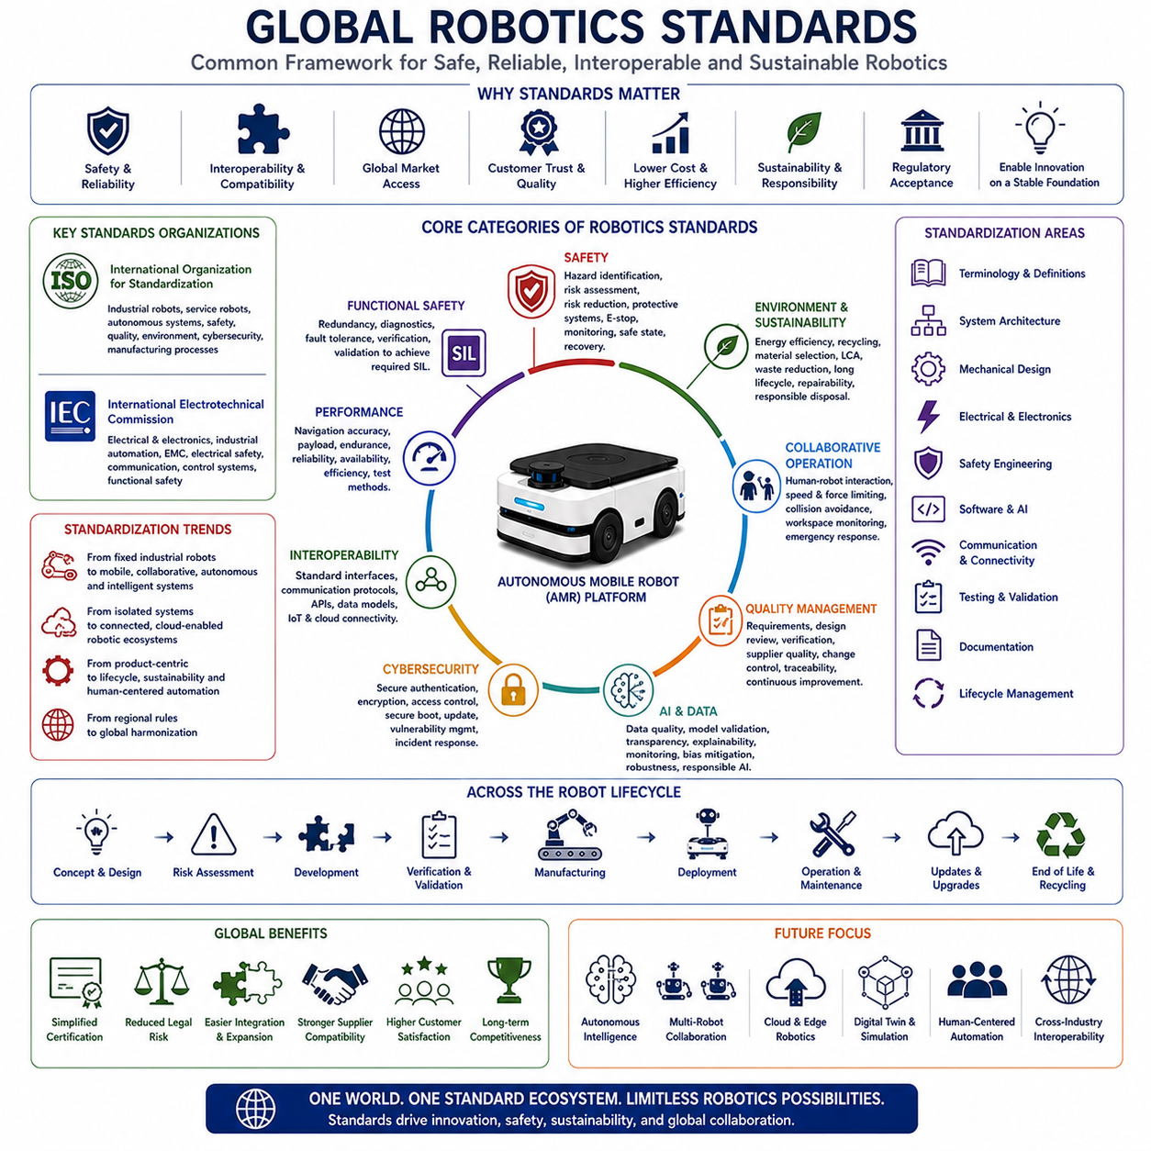
Global robotics standards provide the common engineering framework that enables robots developed by different manufacturers to operate safely, reliably, and interoperably across international markets. As Autonomous Mobile Robots become increasingly integrated into manufacturing, logistics, healthcare, construction, agriculture, defense, and public infrastructure, compliance with internationally recognized standards has become a fundamental requirement rather than an optional engineering objective. Standards establish common terminology, safety principles, performance expectations, testing methodologies, documentation requirements, communication protocols, and quality management practices that support global commercialization. Rather than restricting innovation, international standards create a stable engineering foundation that allows technological advancement while ensuring compatibility, customer confidence, regulatory acceptance, and long-term product sustainability.
The primary objective of global robotics standards is to establish a common technical language across manufacturers, suppliers, regulators, researchers, and end users. Without internationally accepted standards, robotic systems would be developed according to incompatible engineering assumptions, making integration, certification, maintenance, and global deployment significantly more difficult. Standardized terminology ensures that concepts such as autonomy, safety, localization, navigation, collaborative operation, payload capacity, positioning accuracy, functional safety, and risk assessment have consistent definitions regardless of geographic region. Common terminology improves communication among multidisciplinary engineering teams while reducing ambiguity throughout product development and commercial deployment.
The International Organization for Standardization (ISO) serves as one of the most influential organizations governing global robotics standards. ISO develops internationally recognized specifications covering industrial robotics, service robots, autonomous systems, safety engineering, quality management, environmental responsibility, cybersecurity, and manufacturing processes. ISO standards provide manufacturers with structured engineering guidance while supporting international regulatory harmonization. Organizations developing robotic platforms for worldwide deployment frequently adopt ISO standards during the earliest phases of system architecture because compliance becomes significantly more efficient when incorporated into initial engineering decisions rather than added after product completion.
The International Electrotechnical Commission (IEC) complements ISO by developing standards focused primarily on electrical engineering, electronic systems, industrial automation, embedded computing, communication networks, electromagnetic compatibility, electrical safety, programmable controllers, and functional safety. Modern Autonomous Mobile Robots integrate complex electrical architectures combining high-power drive systems, embedded computing platforms, artificial intelligence accelerators, industrial communication networks, perception sensors, battery management systems, and cloud connectivity. IEC standards establish engineering practices that improve electrical reliability, system interoperability, and operational safety throughout the complete product lifecycle.
Industrial robot standards traditionally concentrated on fixed robotic manipulators operating within isolated manufacturing cells. However, modern robotics increasingly emphasizes mobile, collaborative, intelligent, and autonomous systems operating within dynamic environments shared with human workers. Consequently, global standards continue evolving beyond conventional industrial automation toward service robotics, mobile robotics, collaborative operation, autonomous navigation, intelligent perception, cybersecurity, artificial intelligence governance, and cloud-connected robotic ecosystems. Manufacturers therefore monitor ongoing standardization activities continuously because emerging standards frequently influence future product architecture long before regulatory adoption becomes mandatory.
Safety represents the most critical category within global robotics standardization. International safety standards establish systematic engineering approaches for hazard identification, risk analysis, hazard reduction, protective system design, emergency stopping, operational monitoring, fault detection, safe state transition, recovery procedures, and lifecycle validation. Safety engineering considers mechanical hazards, electrical hazards, thermal risks, software failures, communication faults, perception uncertainty, human interaction, environmental conditions, and cybersecurity threats. Rather than addressing individual hazards independently, modern safety standards require integrated system-level analysis ensuring predictable behavior throughout all operational conditions.
Functional safety has become particularly important as robotics systems rely increasingly upon software, electronic control systems, artificial intelligence, and distributed communication networks. Functional safety standards define methods for ensuring that safety-related electronic systems continue performing required protective functions despite hardware failures, software defects, sensor degradation, communication errors, or unexpected operational conditions. Engineers implement redundancy, diagnostic monitoring, fault tolerance, independent verification, deterministic control, and systematic validation to achieve required safety integrity levels. Functional safety therefore extends beyond hardware reliability into comprehensive system architecture supporting dependable autonomous operation.
Risk assessment forms the foundation of nearly every international robotics safety standard. Engineers systematically identify hazards, estimate potential consequences, evaluate exposure frequency, determine risk severity, assess existing protective measures, and implement additional safeguards where necessary. Risk assessment continues throughout the complete product lifecycle, beginning with conceptual design and extending through manufacturing, deployment, operation, maintenance, software updates, and eventual system retirement. Continuous risk evaluation ensures that evolving technologies, changing operating environments, and newly identified hazards are incorporated into future product improvements while maintaining regulatory compliance.
Collaborative robotics standards address situations where robots and humans intentionally share operational workspaces without complete physical separation. Unlike traditional industrial robots operating inside protective barriers, collaborative robotic systems require continuous monitoring of human presence, safe motion planning, collision avoidance, force limitation, speed supervision, emergency response, and intuitive human-machine interaction. Mobile robots operating within factories, hospitals, warehouses, airports, and public facilities increasingly depend upon collaborative safety principles because autonomous navigation frequently occurs alongside workers, visitors, customers, and service personnel within dynamic environments.
Performance standards establish objective methods for evaluating robotic capability using repeatable engineering measurements. Navigation accuracy, positioning repeatability, payload capacity, obstacle detection, battery endurance, environmental robustness, localization reliability, communication latency, operational availability, recovery behavior, energy efficiency, and maintenance performance are measured according to standardized testing methodologies whenever possible. Standardized performance evaluation enables customers to compare products fairly while encouraging manufacturers to optimize engineering quality based upon measurable technical criteria rather than marketing claims alone.
Interoperability standards enable robotic platforms developed by different manufacturers to exchange information through compatible communication architectures. Industrial Ethernet, fieldbus networks, wireless communication, cloud interfaces, industrial Internet of Things frameworks, application programming interfaces, middleware, and standardized messaging protocols support communication among robots, manufacturing systems, warehouse management platforms, enterprise resource planning systems, digital twins, and cloud analytics services. Interoperability significantly reduces system integration complexity while enabling customers to deploy heterogeneous robotic fleets within unified industrial environments.
Cybersecurity has emerged as a rapidly expanding component of international robotics standardization. Connected robots increasingly exchange operational data through wireless networks, cloud platforms, industrial communication systems, and enterprise information infrastructure. Cybersecurity standards define secure authentication, encrypted communication, software integrity verification, access control, secure boot procedures, vulnerability management, incident response, firmware protection, update validation, and operational monitoring practices. Strong cybersecurity architecture protects both operational continuity and sensitive industrial information while maintaining customer trust within digitally connected manufacturing ecosystems.
Artificial intelligence introduces new challenges for international robotics standardization because machine learning algorithms behave differently from conventional deterministic software. Emerging standards increasingly address dataset quality, model validation, algorithm transparency, explainability, performance monitoring, continuous learning, bias mitigation, robustness evaluation, uncertainty estimation, and responsible artificial intelligence deployment. As foundation models and advanced reasoning systems become integrated into robotics platforms, standardization will provide engineering guidance supporting reliable, ethical, and predictable AI-assisted autonomous decision making across diverse operational environments.
Quality management standards contribute significantly to long-term product reliability by establishing systematic engineering processes rather than focusing exclusively on technical specifications. Structured requirements management, configuration control, design reviews, verification planning, supplier qualification, documentation management, change control, manufacturing traceability, corrective action, continuous improvement, and customer feedback integration support consistent engineering quality throughout product development. Quality management standards therefore strengthen every phase of the robotic lifecycle while improving organizational engineering maturity.
Environmental and sustainability standards are becoming increasingly important as robotics manufacturers address global environmental responsibility. Energy efficiency, battery recycling, material selection, manufacturing emissions, lifecycle assessment, resource utilization, waste reduction, packaging optimization, maintenance efficiency, and end-of-life product recovery increasingly influence engineering decisions. Sustainable design principles encourage manufacturers to develop modular platforms supporting long operational lifetimes, component reuse, repairability, software upgrades, and environmentally responsible disposal while reducing total lifecycle environmental impact.
Compliance with international robotics standards provides significant commercial advantages beyond regulatory approval alone. Products designed according to globally recognized engineering standards typically experience simplified certification, improved customer acceptance, reduced legal liability, easier international market access, lower lifecycle maintenance cost, stronger supplier compatibility, enhanced engineering documentation, greater investment confidence, and improved long-term competitiveness. Standards therefore function not only as engineering requirements but also as strategic business assets supporting sustainable global expansion.
The future of global robotics standardization will increasingly focus upon autonomous intelligence, multi-robot collaboration, cloud robotics, edge computing, digital twins, artificial intelligence governance, human-centered automation, cybersecurity resilience, sustainability, and cross-industry interoperability. Future standards will likely evolve from defining individual product requirements toward governing complete robotic ecosystems operating across intelligent factories, smart cities, transportation networks, healthcare systems, and global industrial infrastructure. Organizations actively participating in international standardization while incorporating compliance into their engineering architecture from the earliest development phases will be better positioned to deliver globally competitive robotic platforms that combine technological innovation with operational safety, regulatory acceptance, commercial scalability, and long-term customer value.

15.02 Industrial Safety Standards · 산업 안전 표준
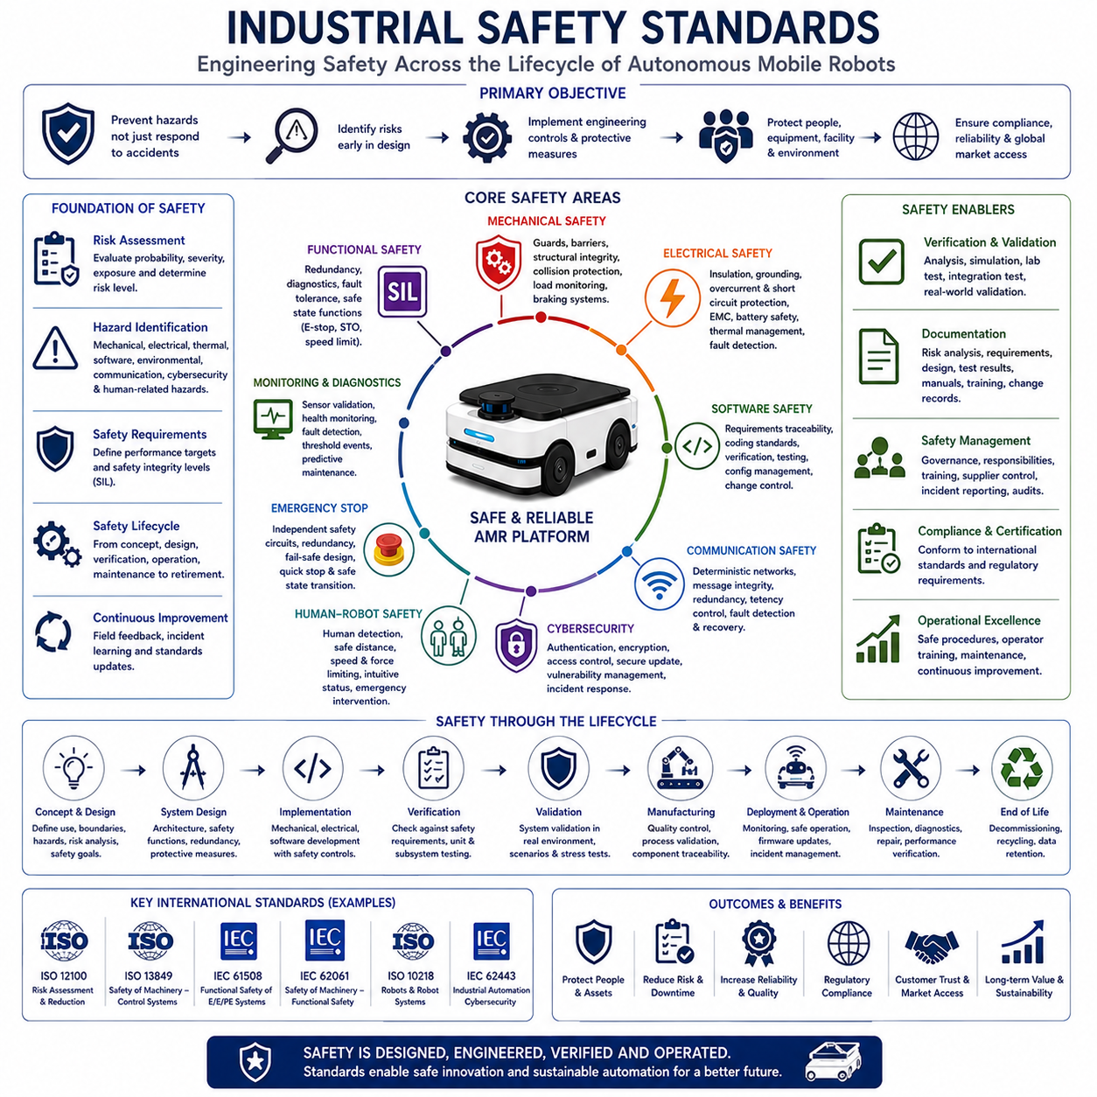
Industrial safety standards establish the engineering principles, technical requirements, operational procedures, and management practices necessary to ensure that industrial equipment, automated machinery, and Autonomous Mobile Robot systems operate without creating unacceptable risks for workers, facilities, equipment, or surrounding environments. As industrial automation becomes increasingly intelligent and interconnected, safety can no longer rely solely on physical protective barriers or operator experience. Instead, modern safety standards define systematic engineering methodologies that integrate mechanical design, electrical engineering, embedded software, functional safety, artificial intelligence, communication systems, cybersecurity, maintenance, and operational management into a unified safety architecture. Compliance with industrial safety standards therefore represents a fundamental engineering responsibility as well as a critical requirement for global commercialization.
The primary objective of industrial safety standards is hazard prevention rather than accident response. Traditional safety practices often focused on minimizing damage after failures occurred, whereas modern safety engineering emphasizes eliminating hazards during the earliest stages of product design. Engineers systematically identify potential risks, evaluate their severity, estimate operational exposure, determine failure probabilities, and implement engineering controls before products enter commercial operation. This proactive approach significantly reduces lifecycle risk while improving reliability, operational efficiency, regulatory compliance, and customer confidence. Safety therefore becomes an integral design parameter equivalent to performance, cost, manufacturability, and maintainability rather than an independent verification activity performed near project completion.
Industrial safety engineering follows a structured lifecycle beginning with conceptual system definition and continuing through product retirement. During concept development, engineers define system boundaries, operational environments, intended applications, user interaction scenarios, maintenance activities, and reasonably foreseeable misuse. Hazard identification then evaluates potential mechanical, electrical, thermal, chemical, software, environmental, communication, cybersecurity, and human-related risks associated with every operational mode. Safety requirements derived from this analysis become engineering specifications guiding architecture development, subsystem design, verification planning, manufacturing, deployment, maintenance, software updates, and long-term operational support throughout the complete product lifecycle.
Risk assessment serves as the analytical foundation of industrial safety standards. Rather than assuming that every hazard requires identical treatment, engineers evaluate both the probability of occurrence and the severity of potential consequences. Frequently occurring low-impact hazards may require different mitigation strategies than rare but catastrophic failures. Risk assessment also considers exposure duration, environmental variability, human behavior, equipment accessibility, maintenance procedures, operator training, and system complexity. The resulting risk profile determines appropriate engineering controls while ensuring that resources focus on reducing the highest operational risks. Continuous reassessment accompanies product evolution because changing technologies and applications introduce new operational conditions throughout the system lifecycle.
Mechanical safety standards establish engineering requirements preventing injuries caused by moving components, structural failures, unstable loads, crushing hazards, shearing mechanisms, sharp edges, excessive vibration, falling objects, or unexpected mechanical motion. Mechanical engineers incorporate structural safety factors, protective guards, physical barriers, emergency stopping mechanisms, collision protection, load monitoring, braking systems, mechanical redundancy, and controlled failure modes throughout product development. Mechanical architecture is designed so that predictable component degradation does not immediately produce hazardous conditions, thereby providing sufficient opportunity for maintenance, diagnostics, and safe operational recovery before catastrophic failure occurs.
Electrical safety standards protect personnel and equipment from hazards associated with electrical energy. Industrial robotic systems frequently combine high-voltage battery systems, motor drives, power electronics, embedded computers, communication hardware, sensors, industrial networks, and charging infrastructure within compact mobile platforms. Electrical safety therefore addresses insulation integrity, grounding systems, overcurrent protection, short-circuit prevention, electromagnetic compatibility, isolation monitoring, connector design, emergency power isolation, battery protection, thermal management, and fault detection. Proper electrical engineering minimizes fire risk, electrical shock, equipment damage, communication interference, and uncontrolled system behavior during abnormal operating conditions.
Functional safety has become one of the most influential concepts within modern industrial automation. Unlike conventional hardware reliability, functional safety focuses specifically on ensuring that safety-related control systems perform their intended protective functions correctly despite hardware failures, software defects, communication interruptions, sensor degradation, environmental disturbances, or unexpected operating conditions. Safety-related functions such as emergency stopping, speed limitation, obstacle detection, protective field monitoring, braking control, safe torque off, and operational supervision must remain dependable under fault conditions. Functional safety therefore requires systematic engineering methodologies including redundancy, diagnostics, fault tolerance, deterministic software behavior, independent verification, and documented lifecycle management.
Programmable electronic systems introduce additional safety challenges because software cannot be evaluated using traditional mechanical reliability methods alone. Embedded software increasingly controls navigation, motion planning, perception, battery management, communication, diagnostics, artificial intelligence, and fleet coordination. Safety standards therefore require structured software development processes including requirements traceability, modular architecture, coding standards, verification planning, static analysis, dynamic testing, configuration management, version control, defect tracking, regression testing, and independent safety validation. Software quality directly influences overall system safety because unexpected software behavior may produce hazardous physical consequences despite perfectly functioning hardware.
Autonomous Mobile Robots introduce unique safety considerations beyond conventional industrial machinery because they operate dynamically within changing environments while interacting directly with workers, vehicles, equipment, and infrastructure. Mobile robots continuously interpret sensor information, plan motion, avoid obstacles, coordinate with fleet management systems, communicate wirelessly, and make autonomous operational decisions. Safety standards therefore address localization uncertainty, perception limitations, communication delays, navigation failures, dynamic obstacle interaction, environmental variability, docking operations, charging procedures, autonomous recovery, and mission interruption. Comprehensive safety architecture must accommodate both predictable operational behavior and unexpected environmental changes without compromising human protection.
Human-robot interaction represents one of the fastest-growing areas within industrial safety engineering. Collaborative industrial environments require robots to detect nearby personnel, monitor separation distances, regulate motion speed, limit collision forces, provide intuitive status indication, support emergency intervention, and recover safely following operational interruptions. Safety engineering considers not only physical protection but also human factors including operator awareness, cognitive workload, interface design, alarm management, maintenance accessibility, procedural clarity, and predictable robot behavior. Human-centered safety design reduces operational errors while improving user confidence and workplace productivity.
Emergency stop architecture remains a fundamental requirement across virtually every industrial safety standard. Emergency stopping systems must immediately place equipment into predefined safe states whenever hazardous conditions arise. Safety engineers define stopping categories according to operational requirements, balancing rapid hazard reduction with equipment protection and controlled recovery. Emergency stop circuits typically operate independently of standard control software while utilizing redundant monitoring, fail-safe design, diagnostic supervision, and periodic validation testing. Modern autonomous systems additionally integrate software-controlled safety transitions supporting safe shutdown, controlled deceleration, autonomous fault isolation, and coordinated fleet-wide emergency response when multiple robotic platforms operate simultaneously.
Protective monitoring systems continuously supervise equipment health and operational safety throughout normal operation. Safety monitoring includes sensor validation, communication integrity, battery condition, processor health, actuator feedback, localization confidence, environmental awareness, obstacle detection, braking performance, cybersecurity status, thermal management, and diagnostic reporting. When abnormal conditions exceed predefined safety thresholds, protective systems initiate warnings, operational restrictions, controlled performance degradation, or safe shutdown procedures depending upon risk severity. Continuous monitoring enables predictive maintenance while preventing hazardous failures from developing unnoticed during extended autonomous operation.
Industrial communication networks increasingly influence operational safety because modern robotic systems exchange large volumes of safety-related information among controllers, sensors, fleet management servers, cloud platforms, and enterprise information systems. Communication safety addresses message integrity, deterministic timing, synchronization accuracy, redundancy management, secure transmission, fault detection, network availability, latency control, and recovery following communication disruption. Safety-critical information must remain distinguishable from non-critical operational traffic while maintaining predictable behavior under abnormal network conditions. Reliable communication architecture therefore becomes essential for distributed autonomous systems operating collaboratively across complex industrial environments.
Cybersecurity has become inseparable from industrial safety because malicious attacks can compromise operational integrity as effectively as hardware failures or software defects. Industrial safety standards increasingly recognize that unauthorized access, malicious software, communication interception, data manipulation, or remote system compromise may directly create hazardous physical conditions. Secure authentication, encrypted communication, secure software updates, access control, intrusion detection, vulnerability management, secure boot mechanisms, incident response planning, and continuous security monitoring therefore contribute directly to operational safety. Modern safety engineering treats cybersecurity as an integrated protective layer supporting trustworthy autonomous operation.
Verification and validation ensure that implemented safety measures perform exactly as intended before commercial deployment. Verification confirms that engineering solutions satisfy specified safety requirements through analysis, inspection, simulation, laboratory testing, and integration testing. Validation demonstrates that the complete robotic system safely fulfills intended operational objectives within realistic environments reflecting expected customer applications. Safety validation includes normal operation, abnormal conditions, fault injection, environmental stress testing, emergency scenarios, maintenance procedures, software updates, communication failures, and recovery behavior. Comprehensive validation provides objective evidence supporting certification, regulatory approval, and customer acceptance.
Safety documentation forms an essential component of industrial safety compliance because engineering decisions must remain traceable throughout the complete product lifecycle. Hazard analyses, risk assessments, safety requirements, architecture descriptions, verification reports, validation results, maintenance procedures, operating instructions, training materials, software revisions, change records, incident investigations, and corrective actions are systematically documented according to standardized engineering practices. Documentation supports regulatory review, customer confidence, maintenance activities, product improvements, and future engineering development while preserving organizational knowledge across multiple product generations.
Safety management extends beyond technical engineering into organizational culture and continuous operational improvement. Manufacturers establish safety governance structures defining engineering responsibilities, design reviews, change management, supplier qualification, incident reporting, corrective action processes, periodic audits, employee training, competency development, and lifecycle monitoring. Operational experience collected from field deployments continuously refines future product designs, risk assessments, maintenance strategies, and engineering standards. Effective safety management therefore transforms isolated technical compliance into a sustainable organizational capability supporting long-term product quality and customer trust.
The future of industrial safety standards will increasingly address artificial intelligence, autonomous decision making, multi-robot collaboration, cloud robotics, digital twins, edge computing, advanced cybersecurity, sustainable automation, and human-centered intelligent workplaces. Future standards will move beyond protecting individual machines toward governing complete autonomous industrial ecosystems where robots, humans, intelligent infrastructure, enterprise software, and artificial intelligence cooperate continuously. Organizations that integrate industrial safety principles into every phase of engineering—from concept development through lifecycle support—will deliver robotic platforms that combine technological innovation with operational reliability, regulatory compliance, commercial success, and long-term societal acceptance.

15.03 EMC and Electrical Standards · EMC 및 전기 표준
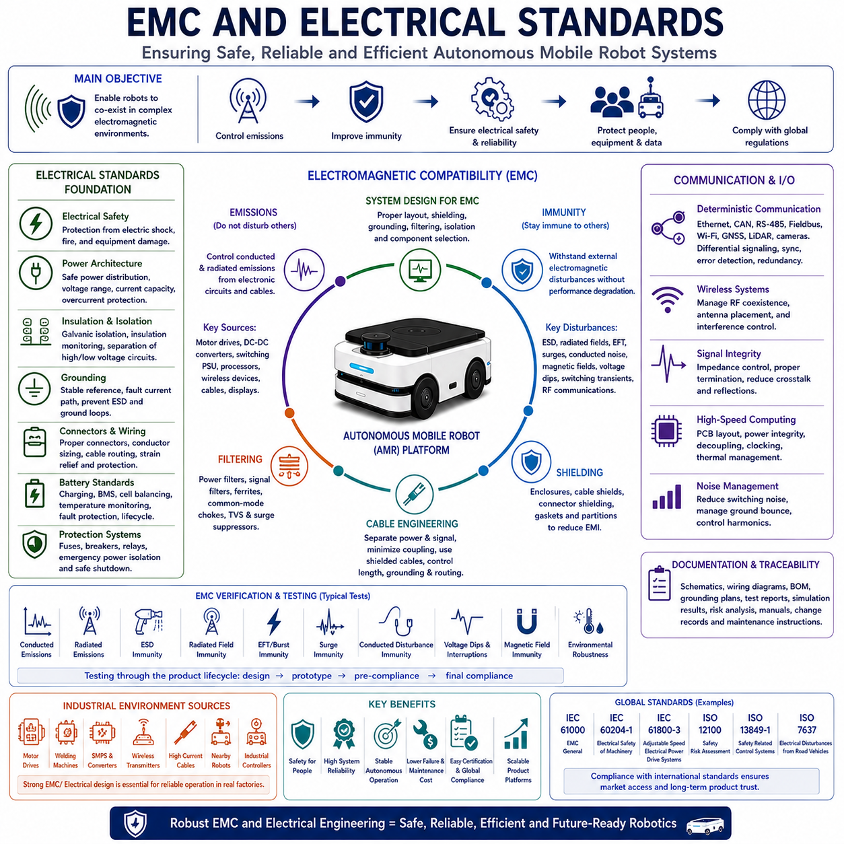
Electromagnetic Compatibility and electrical standards establish the engineering principles required to ensure that Autonomous Mobile Robot systems operate safely, reliably, and efficiently in electrically complex industrial environments. Modern robotic platforms integrate high-power electric motors, battery systems, embedded computers, artificial intelligence accelerators, industrial communication networks, perception sensors, wireless connectivity, and precision electronic control systems within a compact mobile platform. Each subsystem both generates and receives electromagnetic energy, making electromagnetic compatibility an essential design consideration rather than a final compliance activity. Electrical standards therefore define comprehensive engineering requirements covering electrical safety, electromagnetic emissions, immunity, grounding, power quality, insulation, protection systems, testing procedures, documentation, and lifecycle maintenance to guarantee stable operation throughout diverse industrial applications.
The primary objective of electromagnetic compatibility is to ensure that electronic equipment neither produces excessive electromagnetic interference nor becomes excessively vulnerable to interference generated by surrounding devices. Every industrial environment contains numerous potential sources of electromagnetic energy including motor drives, switching power supplies, welding equipment, wireless communication systems, industrial controllers, high-current cables, radio transmitters, and neighboring robotic systems. Without proper electromagnetic compatibility engineering, interference may degrade sensor accuracy, interrupt communication, corrupt data, destabilize embedded processors, trigger false safety events, or even create hazardous operational behavior. EMC engineering therefore seeks to achieve coexistence among all electronic systems operating within shared electromagnetic environments.
Electrical engineering standards define the fundamental architecture governing safe and reliable power distribution throughout robotic platforms. Industrial robots combine battery systems, high-current motor controllers, embedded computers, communication hardware, perception sensors, charging interfaces, safety controllers, lighting systems, auxiliary equipment, and industrial manipulators operating simultaneously under varying electrical loads. Electrical standards specify acceptable voltage ranges, current capacity, insulation methods, conductor sizing, protective devices, connector requirements, grounding principles, isolation strategies, fault detection mechanisms, and emergency power management. Standardized electrical architecture improves system reliability while simplifying manufacturing, maintenance, certification, troubleshooting, and future platform expansion.
Power system architecture forms the electrical backbone of Autonomous Mobile Robots. Energy flows from battery systems through power distribution units toward motor drives, embedded computing platforms, sensors, communication equipment, cooling systems, and auxiliary electronics. Engineers design hierarchical power distribution networks separating high-power propulsion circuits from sensitive low-power electronics while minimizing electrical noise coupling. Power architecture includes voltage conversion, current monitoring, overcurrent protection, redundant supply paths, load prioritization, emergency shutdown capability, thermal protection, and diagnostic monitoring. Proper power architecture ensures stable operation during acceleration, regenerative braking, charging, heavy computational workloads, and unexpected fault conditions.
Battery electrical standards become increasingly important as mobile robotics adopts higher-capacity lithium battery technologies supporting extended operational endurance. Battery systems must safely manage charging, discharging, balancing, temperature monitoring, current limitation, insulation monitoring, fault detection, emergency isolation, state estimation, lifecycle management, and thermal protection throughout thousands of operational cycles. Battery Management Systems continuously supervise cell voltage, temperature distribution, charging efficiency, aging characteristics, fault conditions, and remaining useful capacity. Electrical standards ensure batteries maintain predictable performance while minimizing risks associated with thermal runaway, short circuits, overcharging, deep discharge, mechanical damage, or abnormal environmental conditions.
Grounding architecture represents one of the most important yet frequently underestimated aspects of industrial electrical engineering. Proper grounding establishes stable electrical reference points while safely dissipating fault currents, reducing electromagnetic interference, protecting sensitive electronics, preventing electrostatic discharge, and improving operational safety. Robotic platforms frequently implement multiple grounding strategies including protective earth, chassis grounding, signal grounding, functional grounding, and isolated reference grounds depending upon subsystem requirements. Engineers carefully manage grounding topology to avoid ground loops, circulating currents, electrical noise propagation, and unpredictable signal behavior while maintaining electrical safety throughout the complete system.
Electrical isolation protects both personnel and electronic equipment by preventing hazardous voltages from propagating into low-voltage control circuits. Isolation barriers separate battery systems, motor drives, charging equipment, communication interfaces, embedded processors, sensor electronics, and external industrial networks whenever necessary. Galvanic isolation techniques utilizing transformers, opto-isolators, isolated power converters, differential communication interfaces, and isolated measurement systems significantly reduce fault propagation while improving noise immunity. Isolation architecture becomes particularly important for mobile robots integrating high-power propulsion systems with highly sensitive perception hardware and precision measurement electronics.
Electromagnetic emissions originate whenever electronic equipment switches electrical energy rapidly. Motor controllers, DC-DC converters, switching power supplies, communication transmitters, processors, display systems, high-speed digital interfaces, and wireless devices all generate electromagnetic radiation across broad frequency ranges. EMC emission standards define maximum allowable conducted and radiated emissions measured using standardized laboratory procedures. Reducing emissions requires optimized circuit layout, proper shielding, filtering, cable routing, switching optimization, enclosure design, grounding strategies, and careful component selection. Lower electromagnetic emissions reduce interference affecting neighboring equipment while simplifying compliance with international regulatory requirements.
Electromagnetic immunity complements emission control by ensuring robotic systems continue operating correctly despite external electromagnetic disturbances. Industrial facilities frequently expose robotic platforms to electrostatic discharge, conducted interference, radiated electromagnetic fields, electrical fast transients, surge voltages, magnetic fields, voltage dips, switching noise, and radio-frequency communication systems. Immunity engineering strengthens electronic systems through robust hardware design, signal filtering, differential communication, shielding, software fault recovery, redundant sensing, diagnostic monitoring, and electrical isolation. Strong immunity ensures stable autonomous operation even within electrically demanding industrial environments.
Cable engineering significantly influences both EMC performance and electrical reliability. High-current propulsion cables, communication wiring, sensor interfaces, encoder signals, power distribution, charging connections, antenna cables, and safety circuits must be routed carefully to minimize electromagnetic coupling. Engineers separate noisy power circuits from sensitive signal paths while controlling cable length, shielding continuity, connector quality, grounding termination, twisting geometry, and mechanical protection. Proper cable architecture reduces conducted interference, radiated emissions, signal degradation, communication errors, and maintenance complexity throughout the robotic lifecycle.
Shielding provides one of the most effective methods for controlling electromagnetic interference. Conductive enclosures, cable shields, connector shielding, grounded housings, metallic partitions, and electromagnetic gaskets reduce both radiated emissions and external electromagnetic susceptibility. Shield effectiveness depends upon material conductivity, enclosure continuity, grounding quality, mechanical assembly, ventilation design, and cable entry configuration. Engineers balance shielding performance with thermal management, manufacturing cost, service accessibility, and product weight to achieve practical industrial solutions supporting long-term operational reliability.
Filtering prevents unwanted electrical noise from propagating through power lines, communication networks, and signal interfaces. Power filters suppress conducted emissions generated by switching electronics before they reach external equipment. Signal filters remove high-frequency interference affecting sensor accuracy and communication integrity. Engineers select passive filters, active filters, ferrite components, common-mode chokes, differential filters, surge suppressors, and transient voltage protection devices according to frequency characteristics and operational requirements. Effective filtering substantially improves EMC compliance while increasing measurement accuracy and communication reliability.
Communication systems require careful EMC engineering because industrial robots increasingly depend upon high-speed digital networking for autonomous operation. Ethernet, CAN, RS-485, USB, wireless communication, industrial fieldbus networks, GNSS receivers, cameras, LiDAR sensors, radar systems, and cloud connectivity operate simultaneously within electrically noisy environments. Communication architecture incorporates differential signaling, synchronization methods, error detection, redundancy management, shielding, isolation, deterministic timing, and robust protocol design to maintain reliable information exchange despite electromagnetic disturbances. Stable communication directly supports navigation accuracy, fleet coordination, safety functions, and operational efficiency.
High-speed embedded computing introduces additional EMC challenges because modern artificial intelligence accelerators, industrial GPUs, multi-core processors, high-speed memory systems, PCI Express interfaces, Ethernet switching, and wireless modules generate substantial electromagnetic energy. Printed circuit board layout, impedance control, power integrity, decoupling networks, clock distribution, return current management, signal integrity analysis, and thermal design significantly influence electromagnetic behavior. Computing platform engineers therefore integrate EMC considerations throughout hardware architecture rather than attempting corrective modifications during final product testing.
Thermal management indirectly contributes to electrical reliability because excessive temperature accelerates insulation aging, semiconductor degradation, battery deterioration, connector oxidation, capacitor failure, and electronic drift. Electrical standards therefore incorporate temperature monitoring, cooling system design, airflow management, heat sink optimization, thermal simulation, environmental qualification, and protective shutdown mechanisms. Stable thermal conditions improve long-term EMC performance by maintaining consistent electrical characteristics throughout varying operational environments.
EMC verification follows standardized laboratory testing procedures that objectively evaluate conducted emissions, radiated emissions, electrostatic discharge immunity, radiated field immunity, electrical fast transient immunity, surge immunity, conducted disturbance immunity, power interruption tolerance, magnetic field resistance, and environmental robustness. Testing occurs throughout product development rather than exclusively before certification. Early prototype evaluation identifies design weaknesses before manufacturing investment while final compliance testing confirms conformity with international regulations. Comprehensive verification significantly reduces redesign cost while increasing engineering confidence before commercial deployment.
Documentation forms an essential component of electrical compliance because engineering decisions must remain traceable throughout the complete product lifecycle. Electrical schematics, wiring diagrams, grounding plans, connector definitions, cable specifications, insulation analyses, EMC simulation results, laboratory test reports, verification procedures, maintenance instructions, component qualifications, configuration records, and change histories support manufacturing, certification, maintenance, troubleshooting, regulatory review, and future platform development. Well-maintained documentation also preserves engineering knowledge across multiple product generations while facilitating global product support.
The future of EMC and electrical standards will increasingly address electrified mobility, artificial intelligence computing, high-power battery technologies, wireless charging, collaborative robotics, edge computing, autonomous industrial ecosystems, advanced semiconductor architectures, sustainable energy management, and intelligent electrical diagnostics. As robotic systems become more interconnected and computationally intensive, electrical engineering and electromagnetic compatibility will evolve from compliance-oriented disciplines into strategic technologies enabling higher autonomy, greater reliability, improved cybersecurity, scalable industrial deployment, and long-term operational excellence across the rapidly expanding global robotics industry.

15.04 Outdoor Robot Regulations · 실외 로봇 규정
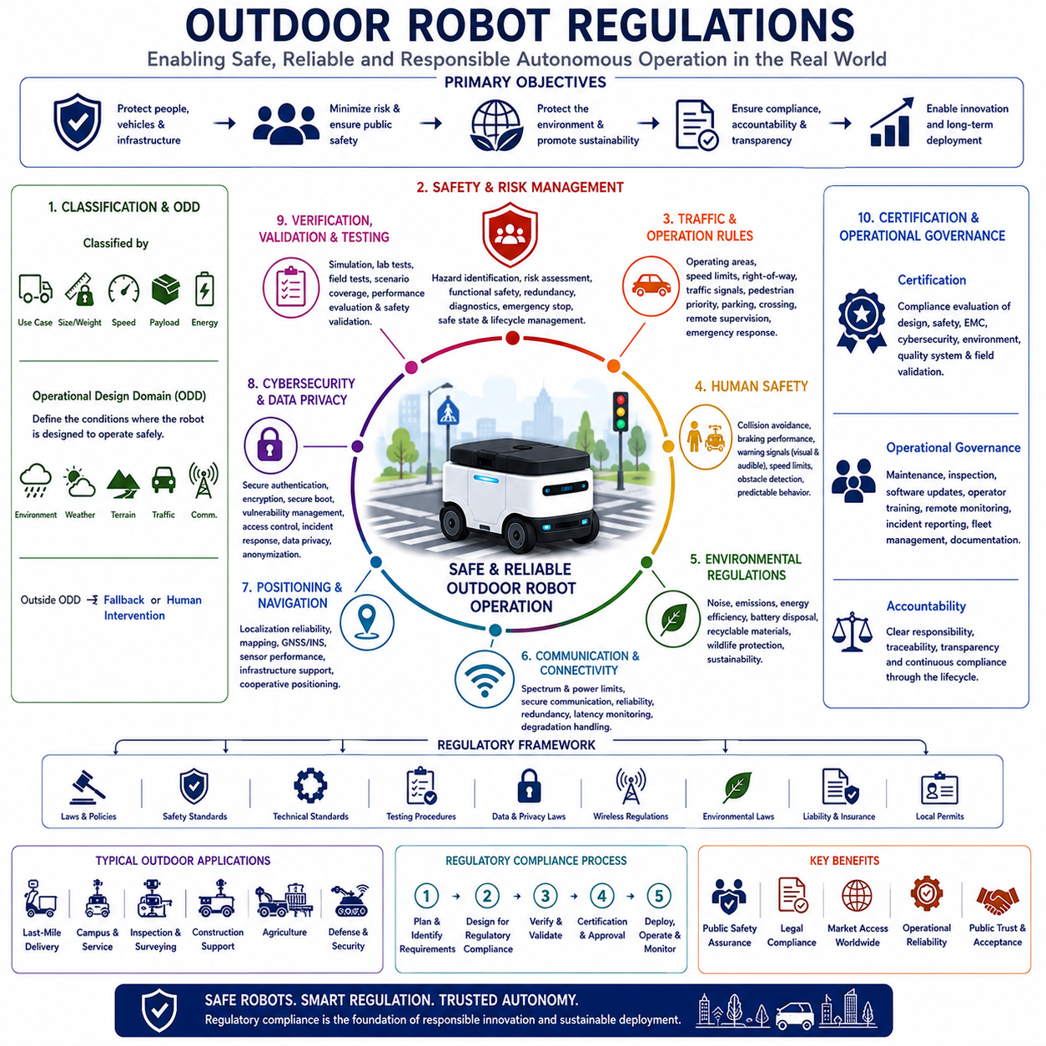
Outdoor robot regulations establish the legal, technical, operational, and safety requirements governing the deployment of autonomous robotic systems within public spaces, industrial sites, transportation corridors, construction areas, agricultural fields, campuses, ports, airports, military facilities, and other outdoor environments. Unlike indoor robots operating within controlled facilities, outdoor Autonomous Mobile Robots encounter unpredictable weather, changing terrain, dynamic traffic, pedestrians, cyclists, animals, construction activities, and diverse infrastructure while interacting directly with the public. Regulatory frameworks therefore extend beyond traditional industrial safety by incorporating transportation law, environmental protection, public safety, cybersecurity, wireless communication, privacy protection, functional safety, and autonomous system governance. Compliance with outdoor robot regulations has become an essential engineering requirement supporting safe commercialization, public acceptance, and long-term operational sustainability.
The primary objective of outdoor robot regulation is to ensure that autonomous systems coexist safely with people, vehicles, infrastructure, and natural environments. Regulatory authorities seek to minimize risks without unnecessarily restricting technological innovation. Rather than prescribing specific engineering solutions, modern regulations increasingly define measurable safety objectives, operational performance requirements, accountability frameworks, testing procedures, documentation standards, and certification processes. This outcome-based regulatory philosophy encourages manufacturers to develop innovative technologies while demonstrating equivalent or improved levels of operational safety through objective engineering evidence.
Regulatory environments vary considerably among countries because transportation systems, legal structures, public infrastructure, labor practices, and societal expectations differ across regions. Manufacturers intending global commercialization therefore evaluate regulations applicable to each target market during the earliest stages of product planning. Design decisions involving vehicle dimensions, operating speed, lighting systems, warning devices, wireless communication, autonomous functions, emergency response, and operator supervision frequently depend upon regional legal requirements. Global product platforms consequently require configurable architectures supporting regulatory adaptation without requiring complete hardware redesign for every geographic market.
Classification represents one of the first regulatory considerations for outdoor robotic systems. Different countries categorize autonomous platforms according to intended application, operational environment, size, weight, maximum speed, payload capacity, energy source, supervision level, and interaction with public infrastructure. A delivery robot operating on sidewalks may follow entirely different regulations than an agricultural robot, construction vehicle, industrial inspection robot, autonomous mining platform, airport logistics system, or military support vehicle. Correct classification determines applicable certification requirements, safety standards, insurance obligations, operational limitations, and governmental oversight throughout the product lifecycle.
Operational Design Domain, commonly abbreviated as ODD, has become a fundamental regulatory concept within autonomous system governance. The Operational Design Domain precisely defines environmental, geographical, weather, lighting, traffic, terrain, infrastructure, communication, and operational conditions under which autonomous systems are designed to function safely. Regulatory approval increasingly depends upon clearly documenting ODD limitations rather than claiming unrestricted autonomous capability. Engineers therefore define measurable operational boundaries including maximum slope, road surface quality, visibility conditions, precipitation intensity, temperature range, wind conditions, localization availability, traffic density, and communication coverage. Safe operation outside the approved ODD requires predefined fallback procedures or human intervention.
Functional safety regulations remain central to outdoor robotic deployment because autonomous systems must maintain safe behavior despite equipment failures, environmental uncertainty, communication interruptions, software defects, sensor degradation, or unexpected operational conditions. Safety regulations require systematic hazard identification, risk assessment, fault detection, redundancy, diagnostic monitoring, emergency stopping, safe state transition, operational supervision, and documented lifecycle management. Outdoor environments introduce additional uncertainties including weather variability, moving obstacles, uneven terrain, temporary infrastructure changes, and communication disruption, requiring safety architectures substantially more robust than equivalent indoor robotic systems.
Human safety receives the highest regulatory priority because outdoor robots frequently operate alongside pedestrians, maintenance personnel, cyclists, construction workers, emergency responders, and conventional vehicles. Regulations define requirements governing collision avoidance, braking performance, stopping distance, warning signals, visual indicators, acoustic alerts, emergency intervention, obstacle detection, speed limitation, safe maneuvering, and predictable autonomous behavior. Human-centered safety engineering extends beyond preventing collisions by ensuring that autonomous robots communicate operational intent clearly enough for surrounding people to anticipate robot behavior confidently within shared environments.
Traffic regulations increasingly influence outdoor robotics as autonomous delivery vehicles, service robots, inspection platforms, and logistics systems begin utilizing sidewalks, service roads, industrial transportation corridors, campuses, ports, and designated public infrastructure. Regulatory agencies define permissible operating areas, speed limits, right-of-way rules, interaction with traffic signals, pedestrian priority, lane usage, parking behavior, crossing procedures, remote supervision, and emergency response requirements. Outdoor robotic systems therefore require navigation software capable of interpreting traffic regulations while adapting safely to dynamic real-world situations that frequently differ from idealized digital maps.
Environmental regulations govern how autonomous robotic systems interact with natural surroundings throughout extended operational lifecycles. Noise emissions, lighting intensity, exhaust emissions where applicable, battery disposal, energy efficiency, electromagnetic compatibility, environmental protection, wildlife disturbance, water contamination prevention, recyclable materials, and lifecycle sustainability increasingly influence product approval. Manufacturers design quieter drive systems, energy-efficient electronics, environmentally responsible battery technologies, recyclable structural materials, and sustainable manufacturing processes supporting long-term environmental responsibility alongside commercial competitiveness.
Wireless communication regulations significantly affect outdoor robotic operation because autonomous systems depend upon reliable communication for fleet coordination, cloud connectivity, remote supervision, software updates, positioning correction, cybersecurity monitoring, and emergency response. National regulatory authorities allocate radio spectrum while specifying transmission power limits, interference protection, communication security, equipment certification, and coexistence requirements with other wireless systems. Communication architecture therefore incorporates licensed and unlicensed frequency bands, redundancy management, secure communication protocols, latency monitoring, and graceful degradation strategies supporting safe operation during communication degradation or complete network interruption.
Positioning and navigation regulations become increasingly important as robotic systems expand into public outdoor environments. High-accuracy Global Navigation Satellite System receivers, inertial navigation systems, LiDAR localization, visual positioning, high-definition maps, roadside infrastructure, and cooperative positioning technologies collectively support reliable navigation. Regulatory authorities increasingly require manufacturers to demonstrate localization reliability under varying environmental conditions including urban canyons, dense vegetation, tunnels, adverse weather, temporary construction, and degraded satellite visibility. Positioning performance therefore becomes a measurable regulatory requirement directly influencing operational approval within specific environments.
Cybersecurity regulations recognize that unauthorized access to autonomous systems may create physical safety hazards comparable to mechanical failures or software defects. Outdoor robots connected continuously to cloud platforms, enterprise systems, wireless infrastructure, and remote operators require secure authentication, encrypted communication, software integrity verification, secure boot procedures, vulnerability management, intrusion detection, access control, incident response, and secure update mechanisms. Regulatory frameworks increasingly require cybersecurity risk assessment throughout the complete product lifecycle while ensuring manufacturers maintain vulnerability management programs following commercial deployment.
Data privacy regulations become particularly significant whenever outdoor robots collect visual imagery, audio information, location data, environmental observations, infrastructure information, or personally identifiable information from public environments. Cameras, microphones, LiDAR sensors, GNSS receivers, environmental monitoring systems, and communication devices generate large volumes of operational data potentially affecting personal privacy. Regulations define permissible data collection, storage duration, anonymization procedures, access control, consent requirements, international data transfer, cybersecurity protection, and accountability mechanisms. Privacy-aware system architecture therefore becomes an integral component of outdoor robotic platform design.
Verification and validation regulations require manufacturers to demonstrate objective evidence that autonomous systems satisfy applicable legal, technical, and operational requirements before commercial deployment. Verification confirms engineering compliance with documented specifications through analysis, simulation, laboratory testing, integration testing, and inspection. Validation demonstrates safe operational behavior under representative environmental conditions including weather variation, dynamic traffic, pedestrian interaction, communication disruption, sensor degradation, emergency scenarios, infrastructure changes, and extended autonomous missions. Field testing often progresses through carefully controlled operational phases before unrestricted commercial deployment receives regulatory approval.
Certification provides formal recognition that robotic systems comply with applicable regulatory requirements. Certification processes typically evaluate engineering documentation, safety analysis, risk assessment, software development processes, electrical compliance, electromagnetic compatibility, environmental testing, cybersecurity practices, quality management systems, manufacturing controls, and operational validation evidence. Certification bodies review objective engineering data rather than marketing claims, ensuring products satisfy internationally recognized safety expectations before entering commercial markets. Maintaining certification additionally requires systematic configuration management, documentation updates, incident reporting, and continuous compliance monitoring throughout product evolution.
Operational governance extends regulatory responsibility beyond initial product approval into long-term deployment management. Manufacturers establish maintenance schedules, inspection procedures, software update policies, operator training programs, remote supervision capabilities, incident reporting mechanisms, diagnostic monitoring, fleet management practices, cybersecurity maintenance, spare parts management, and lifecycle documentation supporting continued regulatory compliance. Field experience collected throughout commercial deployment continuously improves future regulations while refining engineering standards and operational best practices.
International harmonization has become an important objective because autonomous robotic technology increasingly operates across global markets. Organizations including ISO, IEC, regional transportation authorities, industrial safety organizations, and governmental agencies collaborate to develop compatible regulatory frameworks reducing unnecessary certification duplication while preserving public safety. Harmonized regulations simplify international commercialization, encourage technology innovation, reduce engineering complexity, improve supplier interoperability, and strengthen global customer confidence by establishing consistent expectations regarding safety, performance, documentation, cybersecurity, and operational responsibility.
The future of outdoor robot regulations will increasingly address fully autonomous operation, multi-robot coordination, intelligent transportation infrastructure, connected smart cities, artificial intelligence governance, digital twins, edge computing, cloud robotics, cooperative perception, sustainable mobility, and human-centered autonomous ecosystems. Future regulatory frameworks will likely evolve from evaluating individual robotic platforms toward governing interconnected autonomous transportation and service networks operating collaboratively across complex urban and industrial environments. Organizations integrating regulatory compliance into engineering architecture from the earliest stages of product development will achieve faster certification, safer deployment, stronger international competitiveness, and greater public acceptance while supporting the responsible expansion of autonomous outdoor robotics worldwide.

15.05 Cybersecurity Regulations · 사이버보안 규정
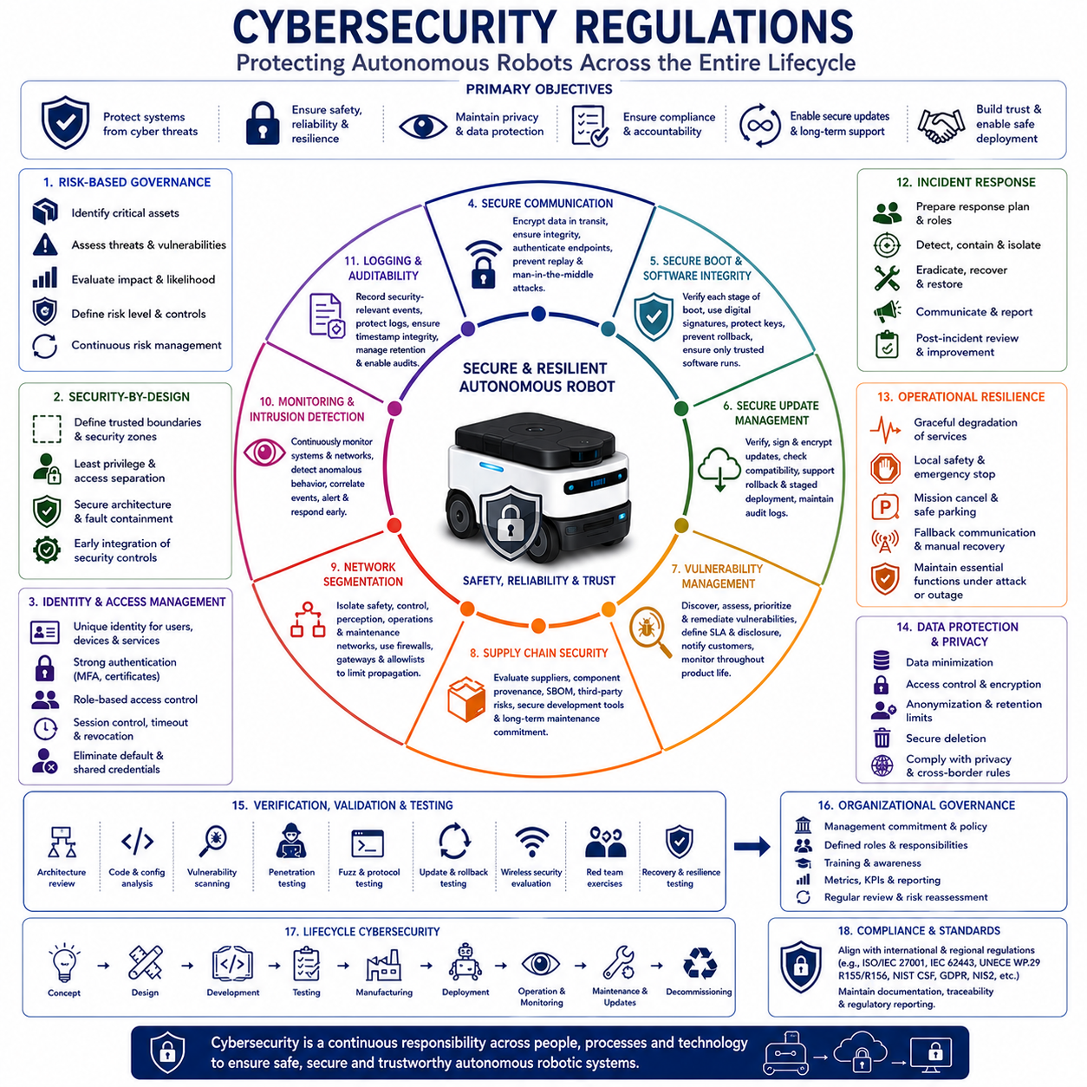
Cybersecurity regulations establish the legal, technical, organizational, and operational requirements needed to protect connected robotic systems from unauthorized access, malicious manipulation, data theft, service disruption, and unsafe control. Modern Autonomous Mobile Robots combine embedded computers, industrial networks, wireless communication, cloud services, remote operators, fleet management platforms, artificial intelligence models, sensors, actuators, and software update mechanisms. Because cyber incidents can directly influence physical movement, cybersecurity has become an essential component of safety, product certification, business continuity, and public trust.
The primary objective of cybersecurity regulation is to ensure that robotic systems remain secure throughout their complete lifecycle, from initial concept development to final decommissioning. Regulations increasingly require manufacturers to identify cyber risks early, define security requirements, implement protective controls, verify resistance against realistic threats, monitor deployed products, respond to vulnerabilities, and preserve security during maintenance and software updates. Cybersecurity is therefore treated as a continuous engineering responsibility rather than a one-time technical review performed immediately before product release.
Risk-based cybersecurity governance begins with understanding which assets require protection and how their compromise could affect operations. Critical assets include control software, safety functions, navigation systems, fleet commands, user credentials, cryptographic keys, artificial intelligence models, maps, operational data, remote access interfaces, cloud services, and update servers. Engineers evaluate threats, vulnerabilities, attack paths, likelihood, potential consequences, and existing controls to determine appropriate protection levels. Higher-risk functions require stronger isolation, monitoring, authentication, redundancy, and recovery mechanisms.
Security-by-design principles require cybersecurity to be integrated into system architecture from the earliest development stage. Engineers define trusted boundaries, communication zones, access privileges, protected interfaces, secure startup sequences, data flows, and fault containment strategies before software implementation begins. Separating propulsion control, safety systems, perception processing, fleet communication, maintenance access, and cloud services reduces the ability of a single compromised component to affect the entire robot. Secure architecture also simplifies verification, certification, troubleshooting, and future product expansion.
Identity and access management regulations ensure that only authorized users, devices, applications, and services can interact with robotic systems. Human operators, maintenance technicians, fleet managers, developers, cloud servers, mobile devices, and individual robots require unique identities and controlled permissions. Strong authentication, role-based access control, multi-factor authentication, certificate management, session expiration, account revocation, and least-privilege policies reduce unauthorized access. Shared default passwords and permanent maintenance accounts are increasingly considered unacceptable within regulated industrial products.
Secure communication requirements protect commands, telemetry, sensor information, software packages, credentials, and operational data transmitted between robots, fleet servers, cloud platforms, charging stations, remote operators, and enterprise systems. Encryption prevents unauthorized reading, while integrity protection detects alteration and authentication confirms the identity of communicating parties. Secure protocols, certificate validation, replay protection, timestamp verification, key rotation, and communication monitoring help prevent command injection, impersonation, eavesdropping, and man-in-the-middle attacks across wired and wireless networks.
Secure boot and software integrity controls ensure that robotic computers execute only approved software. During startup, hardware-based trust mechanisms verify bootloaders, operating systems, drivers, firmware, safety applications, and higher-level software before execution. Digital signatures, cryptographic hashes, trusted platform modules, hardware security modules, rollback protection, and measured boot records strengthen this process. When integrity verification fails, the system should enter a controlled recovery or safe state rather than continuing operation with potentially compromised software.
Software update regulations are particularly important because autonomous robots require continuous correction, feature improvement, cybersecurity maintenance, and artificial intelligence enhancement after deployment. Secure update mechanisms verify package origin, authenticity, integrity, compatibility, and installation status before activating new software. Update systems require encrypted delivery, signed packages, version control, rollback capability, failure recovery, audit logging, and staged deployment. Safety-critical updates must be coordinated carefully to avoid fleet-wide disruption or inconsistent software configurations.
Vulnerability management regulations require manufacturers to maintain structured processes for discovering, evaluating, correcting, and communicating security weaknesses. Vulnerabilities may be identified through internal testing, customer reports, supplier notifications, security researchers, penetration testing, threat intelligence, or automated scanning. Organizations define severity ratings, response deadlines, remediation priorities, disclosure procedures, and customer notification processes. Effective vulnerability management continues throughout the supported life of the product and includes software libraries, operating systems, firmware, cloud services, and third-party components.
Supply chain security has become a major regulatory concern because robotic products depend upon processors, sensors, operating systems, open-source software, communication modules, cloud services, development tools, and external suppliers. A weakness introduced anywhere within this chain may affect the final product. Manufacturers therefore evaluate supplier security practices, component origin, software provenance, update support, known vulnerabilities, access controls, and long-term maintenance commitments. Software bills of materials improve visibility by documenting the software components and dependencies included within each released configuration.
Network segmentation limits the propagation of cyber incidents by separating systems according to operational function and trust level. Safety controllers, motor drives, perception computers, maintenance interfaces, wireless access points, cloud gateways, and enterprise networks should not share unrestricted communication paths. Firewalls, gateways, virtual networks, filtered routing, protocol whitelisting, and data diodes can reduce unnecessary connectivity. Segmentation ensures that a compromised noncritical interface cannot easily gain direct control over safety-critical movement or energy systems.
Monitoring and intrusion detection regulations require robotic systems to identify suspicious activity before it develops into a serious operational incident. Security monitoring may observe failed login attempts, unusual network traffic, unauthorized configuration changes, abnormal process behavior, unexpected software execution, certificate failures, communication anomalies, and repeated access from unknown devices. Event correlation and behavioral analysis help distinguish normal operational variation from potential attacks. Alerts should be prioritized and delivered to responsible personnel without overwhelming operators with excessive false alarms.
Logging and auditability provide the evidence required to investigate security events, demonstrate compliance, support maintenance, and determine responsibility. Logs may record authentication activity, command execution, configuration changes, software updates, network connections, safety events, remote access sessions, fault conditions, and administrative actions. Regulations increasingly require protected timestamps, integrity controls, retention policies, access restrictions, and centralized analysis. Logging systems must balance detailed traceability with storage limits, privacy obligations, communication bandwidth, and operational performance.
Incident response regulations require organizations to prepare defined procedures before a cybersecurity event occurs. Response plans assign roles, communication channels, technical actions, customer notification responsibilities, evidence preservation methods, recovery priorities, and regulatory reporting obligations. During an incident, teams may isolate affected robots, revoke credentials, block network access, deploy emergency updates, restore trusted software, verify safety functions, and inspect related systems. Regular exercises improve readiness and reveal weaknesses in organizational coordination before real attacks occur.
Operational resilience ensures that essential robotic functions remain available even when cybersecurity defenses are challenged. Autonomous systems should degrade gracefully when cloud connections, wireless networks, positioning correction services, or remote supervision become unavailable. Local safety functions, emergency stopping, controlled parking, mission cancellation, communication fallback, and manual recovery should remain possible. Resilience engineering assumes that some preventive controls may eventually fail and therefore focuses on limiting consequences, maintaining safety, and restoring service efficiently.
Data protection regulations govern how robotic systems collect, process, store, transmit, and delete operational information. Outdoor and indoor robots may capture video, audio, location, maps, equipment status, user identities, facility layouts, production information, and maintenance records. Data minimization, access control, encryption, anonymization, retention limits, purpose limitation, secure deletion, and cross-border transfer controls reduce privacy and industrial espionage risks. Protection requirements become stronger when data includes personally identifiable information, confidential production knowledge, or critical infrastructure details.
Artificial intelligence security is becoming an important regulatory area as robots increasingly depend upon learned perception, planning, prediction, and decision functions. Threats include manipulated training data, adversarial inputs, model theft, unauthorized model replacement, hidden backdoors, distribution shift, and unsafe behavior caused by corrupted parameters. Regulations increasingly encourage traceable datasets, controlled model access, signed model packages, evaluation against adversarial conditions, drift monitoring, version management, and human oversight. AI security must be integrated with conventional software and system-level safety engineering.
Remote access creates significant cybersecurity risk because maintenance and support functions often provide powerful privileges over deployed robots. Regulations require remote sessions to use strong authentication, encrypted connections, time-limited authorization, explicit approval, session logging, privilege restriction, and immediate revocation capability. Permanent open ports, undocumented service accounts, and uncontrolled vendor access increase exposure. Secure remote maintenance architecture should allow necessary support while preventing unauthorized commands, hidden configuration changes, or uncontrolled transfer of sensitive data.
Cybersecurity verification and validation demonstrate that implemented controls satisfy documented requirements and resist realistic attacks. Activities include architecture review, code analysis, configuration inspection, vulnerability scanning, penetration testing, protocol testing, fuzz testing, update testing, credential testing, wireless security evaluation, recovery testing, and red-team exercises. Testing should cover both individual components and complete integrated systems. Results must be documented, reviewed, corrected, and repeated whenever significant hardware, software, supplier, or network changes occur.
Documentation and traceability are essential because cybersecurity decisions must remain understandable across development, certification, manufacturing, deployment, and maintenance. Required records may include threat analyses, security requirements, architecture diagrams, interface definitions, risk assessments, test reports, vulnerability records, incident procedures, software inventories, supplier evidence, update histories, key management policies, and configuration baselines. Accurate documentation supports regulatory audits, customer assurance, technical investigation, secure maintenance, and controlled product evolution.
Organizational governance defines who is accountable for cybersecurity throughout the company. Product management, system engineering, software development, information technology, safety teams, quality assurance, manufacturing, legal specialists, suppliers, and customer support must coordinate their responsibilities. Regulations increasingly expect management approval, trained personnel, independent review, security metrics, escalation procedures, and periodic risk reassessment. Strong governance ensures cybersecurity is supported by budgets, schedules, authority, and measurable performance rather than depending solely upon individual engineering effort.
International cybersecurity regulations are gradually converging around common principles such as risk management, secure development, vulnerability handling, update support, supply chain transparency, incident reporting, and lifecycle accountability. However, regional differences remain in privacy law, critical infrastructure protection, product certification, wireless communication, data localization, and mandatory reporting. Global robot manufacturers therefore require adaptable compliance frameworks capable of mapping one engineering security program to multiple national and industry-specific regulatory requirements.
The future of cybersecurity regulation will increasingly address cooperative robot fleets, cloud robotics, edge artificial intelligence, digital twins, autonomous charging, smart infrastructure, vehicle-to-everything communication, remote operation centers, foundation models, and machine-to-machine economic transactions. Regulations will likely demand stronger evidence of continuous monitoring, automated vulnerability response, cryptographic identity, secure data provenance, model integrity, and operational resilience. Organizations that integrate cybersecurity into architecture, safety, quality, and lifecycle governance will achieve more reliable products, faster certification, stronger customer confidence, and safer large-scale deployment of autonomous robotic systems.

