Volume 01. AMR Foundations and System Architecture

05. Indoor vs Outdoor AMR · 실내 vs 실외 AMR

05.01 Indoor AMR Characteristics · 실내 AMR 특성
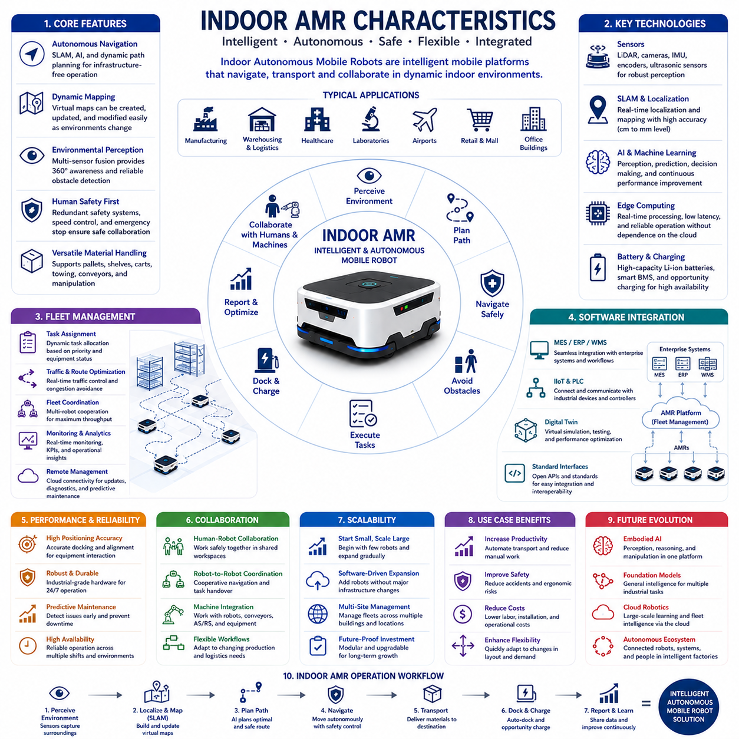
Indoor Autonomous Mobile Robots (AMRs) are intelligent robotic platforms specifically designed to operate within structured indoor environments such as factories, warehouses, hospitals, laboratories, airports, shopping centers, and office buildings. Unlike traditional Automated Guided Vehicles (AGVs), which follow predefined physical guidance systems, indoor AMRs navigate autonomously using onboard sensors, simultaneous localization and mapping (SLAM), artificial intelligence, and dynamic path planning algorithms. Their ability to adapt to changing environments without requiring fixed infrastructure provides organizations with significantly greater operational flexibility, shorter deployment times, and reduced installation costs. As digital transformation accelerates across multiple industries, indoor AMRs have evolved from simple material transport systems into intelligent mobile platforms capable of supporting increasingly complex industrial workflows.
The operating environment of indoor AMRs is generally more structured and predictable than outdoor environments. Floors are typically flat, navigation boundaries are clearly defined, lighting conditions remain relatively stable, and weather-related disturbances are absent. These environmental characteristics simplify localization, perception, obstacle avoidance, and motion planning compared with outdoor robotics. Nevertheless, indoor environments remain highly dynamic because human workers, forklifts, carts, pallet trucks, and other mobile robots continuously change traffic conditions. Therefore, indoor AMRs must combine accurate mapping with real-time obstacle detection and adaptive navigation strategies to ensure safe and efficient operation within shared workspaces.
Navigation represents one of the defining characteristics of indoor AMRs. Most systems utilize simultaneous localization and mapping (SLAM) techniques that combine LiDAR, cameras, inertial measurement units, wheel encoders, and occasionally artificial landmarks to estimate robot position while simultaneously constructing environmental maps. Unlike AGVs that require magnetic tapes, reflective markers, or embedded guide wires, indoor AMRs generate virtual maps that can be updated through software whenever facility layouts change. This flexibility enables rapid deployment in manufacturing facilities where production lines, storage locations, and logistics routes frequently evolve. Dynamic map updating also minimizes operational downtime during facility reconfiguration.
Perception systems provide indoor AMRs with comprehensive environmental awareness. Two-dimensional and three-dimensional LiDAR sensors detect surrounding obstacles with high geometric accuracy, while RGB and depth cameras recognize pallets, shelves, workstations, doors, and human workers. Ultrasonic sensors support short-range obstacle detection near the robot body, and inertial sensors improve localization stability during acceleration and turning. Sensor fusion algorithms integrate information from multiple sensing modalities to improve robustness under varying lighting conditions, temporary occlusions, and crowded operational environments. This multimodal perception architecture enables safe navigation even when individual sensors experience temporary performance degradation.
Human safety remains a primary design objective for indoor AMRs because they frequently operate alongside workers without physical separation barriers. Functional safety architectures continuously monitor protective zones surrounding the robot using redundant sensing systems. Robot speed automatically decreases when people enter warning zones and emergency braking activates when collision risks exceed predefined safety thresholds. Compliance with international safety standards requires reliable fault detection, emergency stop systems, redundant communication channels, and comprehensive diagnostics. Rather than replacing human workers, indoor AMRs are designed to collaborate safely with personnel while reducing repetitive transportation tasks and improving workplace ergonomics.
Material handling constitutes the most common application of indoor AMRs across industrial environments. Robots autonomously transport raw materials, components, finished products, pallets, containers, medical supplies, laboratory samples, and maintenance equipment between different workstations. Modern AMRs support multiple transportation mechanisms including shelf lifting, pallet movement, cart towing, conveyor integration, and robotic manipulation. Automated task scheduling enables continuous logistics operations while minimizing manual transportation effort. As manufacturing systems become increasingly flexible, indoor AMRs provide highly adaptable internal logistics without requiring extensive infrastructure modifications.
Fleet management significantly enhances the operational efficiency of indoor AMR deployments. Modern facilities often employ dozens or hundreds of mobile robots operating simultaneously across large production areas or warehouses. Fleet management software dynamically assigns transportation tasks, optimizes traffic flow, coordinates charging schedules, balances workload distribution, and prevents congestion at intersections or narrow passages. Real-time communication between robots allows cooperative navigation strategies that maximize overall system throughput rather than optimizing individual robot behavior. Cloud connectivity further enables centralized monitoring, software updates, predictive maintenance, and long-term operational analytics across geographically distributed facilities.
Localization accuracy is a critical performance requirement for indoor AMRs. Manufacturing operations frequently require robots to stop precisely at workstations, loading docks, conveyor interfaces, charging stations, or robotic cells. Depending on the application, positioning accuracy may range from several centimeters for general logistics to millimeter-level precision when interacting with industrial automation equipment. High-accuracy localization combines LiDAR scan matching, visual feature recognition, fiducial markers, wheel odometry, and inertial sensing to achieve reliable positioning even in repetitive industrial environments. Continuous localization correction ensures stable navigation despite wheel slip, floor wear, or temporary environmental changes.
Battery technology strongly influences indoor AMR productivity and operational availability. Lithium-ion and lithium iron phosphate battery systems provide high energy density, long operational lifetimes, rapid charging capability, and minimal maintenance requirements. Intelligent battery management systems continuously monitor temperature, voltage balance, charging cycles, remaining capacity, and overall battery health. Many facilities deploy autonomous opportunity charging strategies in which robots automatically recharge during idle periods without interrupting production schedules. Effective energy management maximizes robot utilization while extending battery service life and minimizing operational costs.
Software integration has become one of the most valuable characteristics of modern indoor AMRs. Rather than functioning as isolated transportation devices, robots increasingly integrate with Manufacturing Execution Systems, Enterprise Resource Planning platforms, Warehouse Management Systems, Manufacturing Control Systems, Industrial Internet of Things infrastructure, programmable logic controllers, and digital twin environments. Standard communication interfaces enable automated task generation based on production schedules, inventory status, quality inspection results, or customer orders. Such integration transforms AMRs into active participants within intelligent cyber-physical manufacturing systems rather than standalone mobile machines.
Artificial intelligence increasingly enhances the operational capabilities of indoor AMRs beyond conventional navigation. Machine learning algorithms improve obstacle recognition, semantic scene understanding, pallet identification, human intention prediction, traffic optimization, and adaptive mission planning. Deep learning supports visual inspection, object classification, anomaly detection, and predictive maintenance while continuously improving performance using operational datasets collected across robot fleets. AI-powered scheduling systems optimize transportation efficiency according to production priorities, equipment availability, and facility utilization. As AI technologies continue advancing, indoor AMRs become progressively more autonomous, adaptive, and capable of supporting complex industrial decision-making processes.
Collaborative operation represents another defining characteristic of indoor AMRs. Multiple robots increasingly cooperate with industrial manipulators, automated storage systems, production equipment, inspection stations, and human workers to execute coordinated manufacturing processes. Rather than optimizing individual robot performance, collaborative systems optimize complete production workflows through synchronized transportation, task allocation, and resource sharing. Standardized communication protocols enable interoperability among equipment from different manufacturers, supporting modular automation architectures that can expand incrementally as production requirements evolve.
Scalability distinguishes indoor AMRs from many conventional automation solutions. Organizations often begin deployment with a small number of robots supporting limited logistics functions before gradually expanding to larger fleets covering multiple departments or facilities. Because navigation maps, fleet management software, and enterprise integration architectures are largely software-driven, scaling robot deployments typically requires minimal infrastructure modifications. This modular expansion capability reduces investment risk while allowing organizations to align automation growth with evolving operational requirements and production capacity.
Reliability and maintainability are essential requirements for industrial indoor AMRs operating continuously throughout multiple production shifts. Industrial-grade hardware withstands vibration, dust, temperature variation, and continuous operation while maintaining high positioning accuracy and dependable autonomous navigation. Predictive maintenance algorithms analyze sensor data, motor performance, battery health, and mechanical wear to identify potential failures before operational disruptions occur. Remote diagnostics, software updates, and cloud-based monitoring further reduce maintenance costs while maximizing fleet availability. High operational reliability directly influences manufacturing productivity because logistics interruptions can rapidly propagate throughout interconnected production systems.
Looking toward the future, indoor AMRs will evolve from autonomous transportation platforms into intelligent embodied robotic systems capable of perception, manipulation, reasoning, communication, and continuous learning. Foundation models, multimodal AI, cloud robotics, digital twins, edge computing, and collaborative robot ecosystems will increasingly merge into unified software-defined robotic architectures. Future indoor robots will not only transport materials but also perform inspection, inventory verification, autonomous manipulation, production assistance, quality monitoring, and adaptive collaboration with both humans and other robotic systems. As industrial automation continues advancing toward fully intelligent factories, indoor AMRs will become foundational infrastructure supporting flexible, resilient, and highly autonomous manufacturing ecosystems.

05.02 Outdoor AMR Characteristics · 실외 AMR 특성
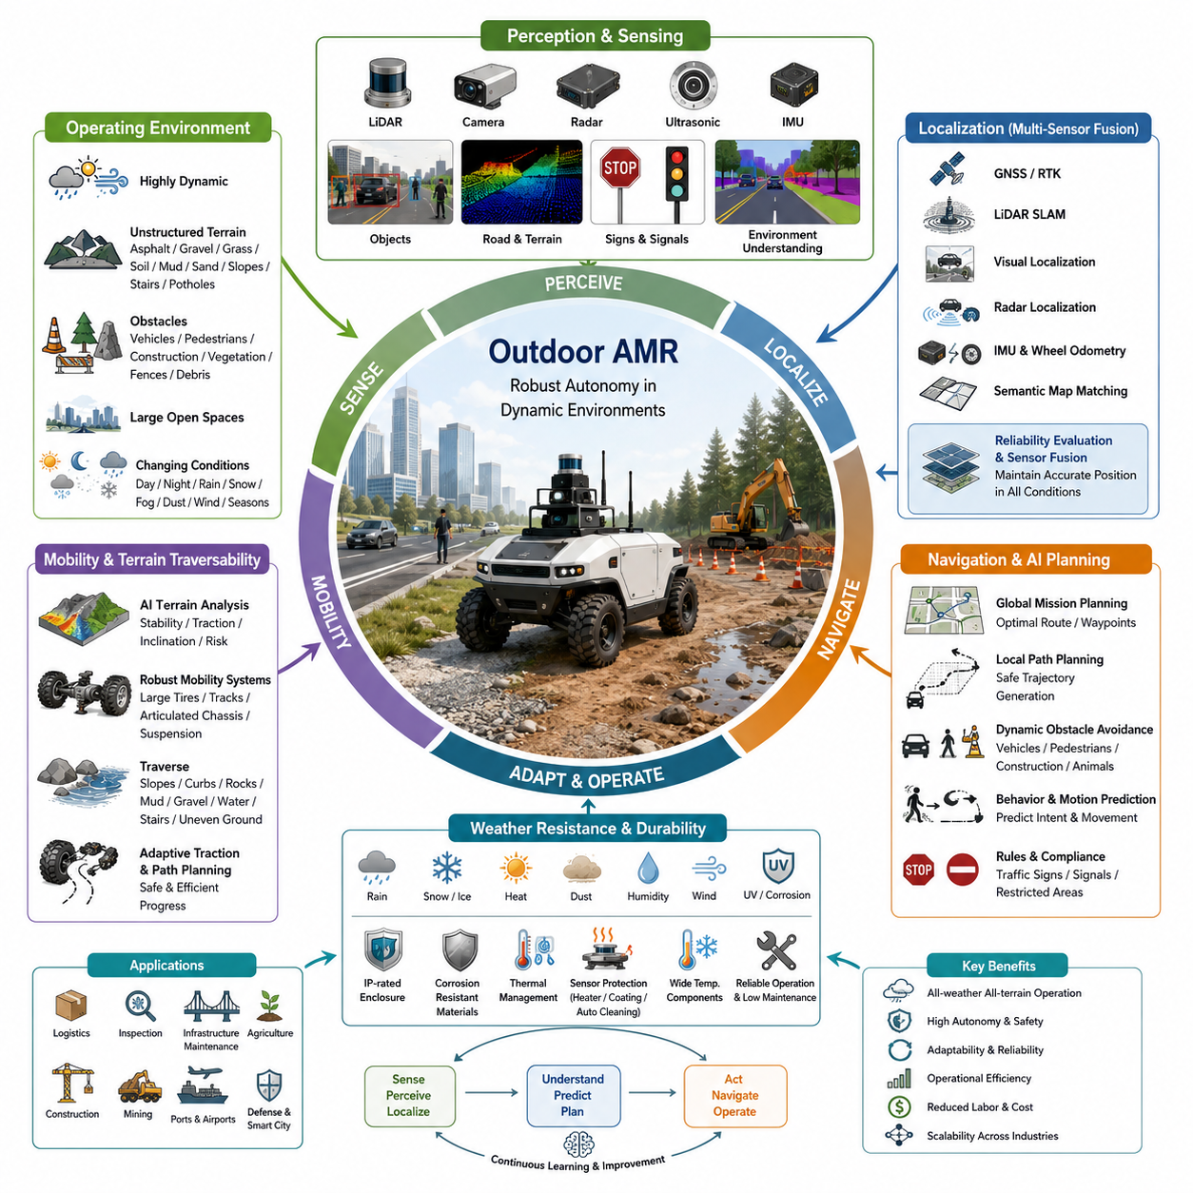
Outdoor Autonomous Mobile Robots (AMRs) are intelligent robotic systems designed to operate in complex, dynamic, and often unpredictable outdoor environments where conventional indoor navigation technologies alone are insufficient. Unlike indoor AMRs that typically move across flat floors inside structured facilities, outdoor robots must navigate uneven terrain, changing weather conditions, varying illumination, natural obstacles, moving vehicles, pedestrians, and large open spaces. Their development represents a significant advancement in autonomous robotics because successful outdoor operation requires the integration of advanced perception, localization, artificial intelligence, mechanical engineering, and environmental adaptability. As industries increasingly automate field operations, outdoor AMRs have become essential platforms for logistics, industrial inspection, infrastructure maintenance, agriculture, construction, mining, ports, airports, defense, and smart city applications.
The operating environment is the defining characteristic separating outdoor AMRs from indoor mobile robots. Outdoor environments continuously change due to sunlight, shadows, rain, snow, fog, dust, wind, vegetation growth, construction activities, traffic patterns, and seasonal variations. Ground surfaces may include asphalt, concrete, gravel, grass, soil, mud, sand, slopes, stairs, drainage channels, and damaged pavement. Unlike structured indoor facilities where maps remain relatively stable, outdoor environments require robots to continuously interpret changing conditions while maintaining safe navigation. Consequently, outdoor AMRs demand significantly higher perception capability, stronger environmental robustness, and more adaptive decision-making algorithms than indoor systems.
Localization represents one of the greatest technical challenges for outdoor autonomous robots. While indoor AMRs often rely primarily on LiDAR-based SLAM, outdoor systems generally combine multiple localization technologies including Global Navigation Satellite Systems (GNSS), Real-Time Kinematic (RTK) positioning, inertial navigation systems, wheel odometry, LiDAR SLAM, visual localization, radar-based localization, and semantic map matching. No single positioning technology remains reliable under every condition. Tall buildings, tunnels, forests, bridges, heavy machinery, or severe weather may reduce GNSS accuracy, while dust, heavy rain, or repetitive terrain can degrade visual and LiDAR performance. Multi-sensor localization therefore continuously evaluates the reliability of each sensor and dynamically fuses multiple information sources to maintain accurate positioning under diverse environmental conditions.
Perception systems for outdoor AMRs are substantially more complex than those used indoors. Long-range LiDAR sensors detect terrain geometry and distant obstacles, while cameras classify vehicles, pedestrians, traffic signs, road markings, vegetation, construction equipment, and infrastructure. Millimeter-wave radar improves perception during rain, fog, snow, dust, and low-visibility conditions where optical sensors become less effective. Ultrasonic sensors protect the immediate vicinity of the robot during low-speed maneuvering, and inertial sensors continuously estimate vehicle motion. Advanced sensor fusion algorithms integrate geometric, visual, inertial, and radar information into unified environmental models capable of supporting robust autonomous navigation under rapidly changing outdoor conditions.
Terrain traversability represents another distinguishing characteristic of outdoor AMRs. Unlike indoor robots operating on smooth industrial floors, outdoor platforms must safely negotiate slopes, uneven ground, potholes, curbs, rocks, mud, loose gravel, water accumulation, and temporary construction obstacles. AI-based terrain analysis estimates surface stability, traction, inclination, and mobility risk before the robot commits to traversing specific regions. Suspension systems, large pneumatic tires, tracked mechanisms, articulated chassis, and adaptive traction control further improve mobility across difficult terrain. Intelligent path planning continuously balances travel efficiency with terrain safety, minimizing the risk of immobilization while maintaining mission progress.
Weather resistance is a fundamental engineering requirement for outdoor autonomous robots. Industrial outdoor platforms frequently operate throughout changing seasons while exposed to rain, snow, ice, heat, humidity, dust, salt spray, ultraviolet radiation, and strong winds. Mechanical structures require corrosion-resistant materials, sealed electronic enclosures, waterproof connectors, industrial cooling systems, and wide-temperature electronic components. Sensors incorporate heating systems, protective windows, hydrophobic coatings, automatic cleaning mechanisms, and environmental compensation algorithms to maintain reliable operation despite adverse weather. Robust environmental engineering significantly extends operational availability while reducing maintenance requirements across long-term field deployments.
Autonomous navigation in outdoor environments requires substantially more sophisticated planning than indoor logistics applications. Path planning algorithms must simultaneously consider road geometry, terrain conditions, moving vehicles, pedestrians, construction zones, traffic regulations, temporary obstacles, restricted areas, and mission priorities. High-level mission planning determines global routes, while local planners continuously generate safe trajectories around dynamic obstacles. Artificial intelligence predicts human behavior, vehicle motion, and environmental evolution to reduce collision risk and improve navigation efficiency. Rather than following static routes, outdoor AMRs continuously adapt navigation strategies based on real-time environmental changes and operational objectives.
Safety becomes increasingly complex as outdoor robots operate in public or semi-public environments shared with pedestrians, bicycles, automobiles, industrial vehicles, and construction equipment. Functional safety architectures monitor multiple protective zones using redundant perception systems capable of detecting both stationary and moving hazards. Emergency braking, speed adaptation, collision prediction, safe stopping distance estimation, and fail-safe operational modes reduce accident risk under uncertain environmental conditions. Compliance with international safety standards requires extensive validation across numerous weather conditions, lighting scenarios, terrain types, and traffic situations. Outdoor safety engineering therefore extends well beyond collision avoidance to encompass comprehensive operational risk management.
Communication infrastructure plays an essential role in outdoor robotic operations. Wireless connectivity through Wi-Fi, private industrial networks, LTE, 5G, satellite communication, or mesh networking enables remote supervision, fleet coordination, cloud connectivity, software updates, predictive maintenance, and operational analytics. Nevertheless, outdoor environments frequently experience communication interruptions caused by terrain, buildings, tunnels, or remote geographic locations. Consequently, outdoor AMRs require sufficient onboard intelligence to continue safe autonomous operation during temporary communication loss while synchronizing operational data automatically once network connectivity is restored. Hybrid cloud-edge computing architectures therefore provide both operational independence and centralized management.
Fleet management becomes increasingly valuable as outdoor robot deployments expand across industrial facilities, ports, airports, campuses, logistics yards, mines, and infrastructure networks. Fleet management platforms coordinate mission assignment, traffic scheduling, charging operations, maintenance planning, software deployment, operational monitoring, and resource allocation across geographically distributed robots. AI-powered scheduling continuously optimizes fleet utilization while minimizing idle time, energy consumption, and unnecessary travel. Cloud analytics aggregate operational information collected from multiple robots to improve navigation models, maintenance strategies, mission planning, and long-term system performance across large operational environments.
Energy management presents unique challenges for outdoor AMRs because operating conditions vary considerably throughout missions. Climbing steep slopes, traversing soft terrain, carrying heavy payloads, operating auxiliary equipment, and functioning under extreme temperatures significantly influence battery consumption. Intelligent energy management systems continuously estimate remaining operational range while considering terrain difficulty, weather forecasts, payload weight, and planned mission complexity. Autonomous charging stations, battery swapping systems, renewable energy integration, and opportunity charging strategies help maximize operational availability. Efficient energy planning therefore becomes essential for maintaining long-duration autonomous missions in remote outdoor locations.
Industrial applications of outdoor AMRs continue expanding rapidly across numerous sectors. Manufacturing facilities employ autonomous robots for yard logistics, inter-building transportation, and infrastructure inspection. Construction companies utilize autonomous platforms for progress monitoring, material delivery, site surveying, and safety inspection. Agriculture increasingly adopts autonomous robots for crop monitoring, precision spraying, harvesting assistance, and field analysis. Mining operations employ robotic vehicles for hazardous material transport, equipment inspection, and environmental monitoring. Energy companies deploy outdoor robots to inspect power plants, substations, pipelines, wind farms, and solar installations. Public infrastructure organizations use autonomous platforms for road inspection, railway monitoring, airport logistics, port operations, and smart city maintenance. The diversity of these applications demonstrates the broad industrial value of robust outdoor autonomy.
Artificial intelligence substantially enhances outdoor robotic capability beyond conventional autonomous navigation. Deep learning enables semantic scene understanding, object recognition, obstacle classification, weather adaptation, terrain segmentation, and anomaly detection. Reinforcement learning improves navigation strategies through accumulated operational experience, while multimodal AI combines visual, geometric, inertial, radar, and language information into comprehensive environmental understanding. Foundation models increasingly provide robots with generalized reasoning capabilities allowing adaptation to unfamiliar situations without extensive manual programming. Continuous fleet learning further enables deployed robots collectively to improve perception accuracy, operational efficiency, and mission reliability throughout their deployment lifecycle.
Mechanical engineering requirements for outdoor AMRs differ significantly from indoor platforms. Chassis structures must tolerate vibration, shock loading, water exposure, temperature cycling, corrosion, and continuous operation over rough terrain. Suspension geometry, steering mechanisms, drivetrain configuration, wheel selection, braking systems, and structural durability directly influence operational performance. Heavy-duty industrial platforms frequently employ four-wheel steering, articulated suspension, differential locking, all-wheel drive, or tracked propulsion depending on application requirements. Mechanical reliability becomes especially important because maintenance opportunities may be limited during extended field operations in remote industrial environments.
Looking toward the future, outdoor AMRs will evolve from autonomous transportation platforms into highly intelligent embodied robotic systems capable of performing inspection, maintenance, manipulation, logistics, environmental monitoring, infrastructure management, collaborative construction, precision agriculture, and autonomous industrial services. Future systems will integrate foundation models, embodied AI, cloud robotics, digital twins, edge computing, high-performance perception, autonomous reasoning, and fleet intelligence into unified software-defined robotic architectures. As autonomous mobility expands beyond controlled industrial sites into increasingly complex real-world environments, outdoor AMRs will become foundational infrastructure supporting resilient, sustainable, and intelligent industrial ecosystems across transportation, manufacturing, energy, public infrastructure, and environmental management.

05.03 Sensor Architecture Differences · 센서 아키텍처 차이
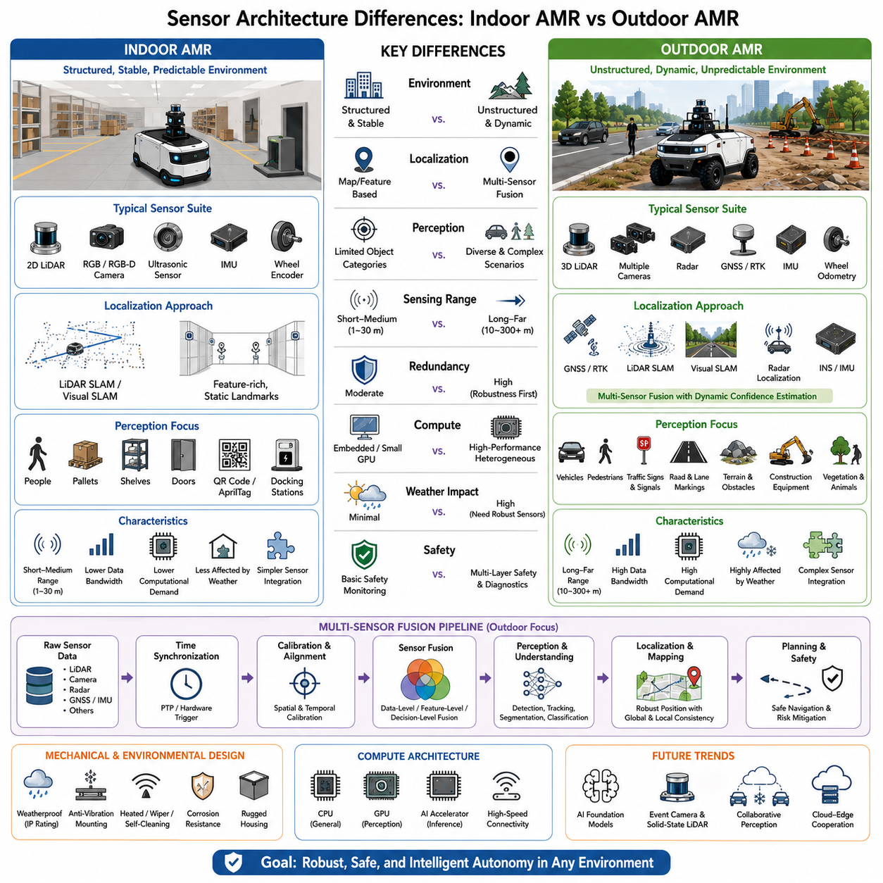
Indoor and outdoor Autonomous Mobile Robots share the same fundamental objective of perceiving their surroundings to enable safe autonomous navigation, but their sensor architectures differ significantly because they operate under entirely different environmental conditions. Indoor AMRs generally function in structured spaces with stable lighting, flat floors, predictable obstacles, and reliable environmental references. Outdoor AMRs must instead operate across open and highly dynamic environments where weather, terrain, illumination, traffic, and environmental uncertainty continuously change. These differences fundamentally influence sensor selection, sensor placement, sensor redundancy, computational requirements, and perception algorithms. Consequently, sensor architecture is not simply a collection of sensing devices but an integrated system engineered to provide robust environmental understanding appropriate for the robot's operational domain.
Indoor AMRs typically employ relatively compact sensor configurations optimized for short- to medium-range perception. Two-dimensional LiDAR often serves as the primary navigation sensor because it accurately detects walls, shelving, pallets, and indoor obstacles while supporting reliable simultaneous localization and mapping. RGB or RGB-D cameras complement LiDAR by recognizing people, packages, QR codes, AprilTags, docking stations, and operational objects. Ultrasonic sensors provide short-range collision protection during docking or narrow corridor navigation, while wheel encoders and inertial measurement units estimate vehicle motion between localization updates. Since indoor facilities usually provide stable environmental conditions, these sensor combinations can achieve highly reliable navigation with moderate computational complexity.
Outdoor AMRs require considerably more diverse sensor suites because no individual sensing technology performs reliably under every environmental condition. Long-range three-dimensional LiDAR extends environmental perception across large open spaces and provides dense geometric information for terrain modeling. Multiple high-resolution RGB cameras observe roads, pedestrians, vehicles, traffic signs, vegetation, and infrastructure from different viewing angles. Millimeter-wave radar contributes reliable obstacle detection during rain, fog, snow, dust, and darkness where optical sensors experience degraded performance. GNSS receivers combined with Real-Time Kinematic positioning provide global localization over wide geographic areas, while inertial navigation systems and wheel odometry maintain vehicle motion estimates whenever satellite reception becomes unreliable. The resulting architecture emphasizes complementary sensing rather than dependence upon any single modality.
The difference between indoor and outdoor localization architectures further illustrates the divergence in sensor design philosophy. Indoor systems frequently depend on LiDAR SLAM or visual SLAM because global satellite positioning is unavailable inside buildings. Stable structural features such as walls, ceilings, pillars, and corridors provide reliable references for continuous localization. Outdoor robots cannot rely exclusively on map-based localization because environmental features may change due to construction, moving vehicles, seasonal vegetation, or weather conditions. Instead, localization continuously fuses GNSS, RTK, LiDAR SLAM, Visual SLAM, radar localization, inertial navigation, wheel odometry, and semantic landmark recognition. Dynamic confidence estimation evaluates the quality of each sensor in real time, allowing the localization framework to adapt automatically when individual sensing technologies become unreliable.
Environmental perception also differs substantially between indoor and outdoor platforms. Indoor perception focuses primarily on identifying people, pallets, forklifts, shelving systems, doors, elevators, charging stations, and predefined navigation landmarks. Object categories remain relatively limited, and environmental variation is comparatively small. Outdoor perception must interpret a far broader range of semantic information, including road boundaries, lane markings, sidewalks, terrain types, construction equipment, traffic signals, bicycles, animals, vegetation, utility infrastructure, and numerous classes of moving vehicles. Semantic scene understanding therefore becomes significantly more complex and requires more sophisticated deep learning models capable of recognizing thousands of object variations under changing environmental conditions.
Sensor range requirements create another major architectural distinction. Indoor robots usually navigate within tens of meters, allowing relatively narrow sensing ranges and limited field-of-view optimization. Navigation decisions often occur at low speeds inside constrained facilities where immediate surroundings dominate operational safety. Outdoor AMRs frequently travel at substantially higher speeds and require long-distance environmental awareness extending hundreds of meters ahead to safely detect vehicles, terrain transitions, intersections, and obstacles. Consequently, outdoor sensor architecture integrates long-range LiDAR, telephoto cameras, wide-angle cameras, radar, and panoramic sensing configurations that collectively provide comprehensive situational awareness across multiple distance scales.
Sensor redundancy becomes increasingly important as environmental complexity grows. Indoor AMRs can often tolerate temporary degradation of one sensing modality because operating conditions remain relatively predictable. Outdoor autonomous systems cannot safely depend on single-point sensing due to the possibility of sunlight glare, rain, snow accumulation, mud contamination, dust, vibration, or partial sensor failure. Multiple overlapping sensing technologies therefore observe the same environment using different physical principles. If cameras experience reduced visibility during fog, radar and LiDAR continue obstacle detection. If GNSS accuracy deteriorates beneath bridges or near tall buildings, LiDAR SLAM and inertial navigation maintain localization. Such functional redundancy substantially improves operational robustness and safety.
Mechanical integration of sensors also differs considerably. Indoor AMRs usually mount sensors inside protected industrial environments where exposure to rain, ultraviolet radiation, temperature extremes, and airborne contaminants is minimal. Outdoor robots require rugged sensor enclosures designed to resist water ingress, dust, vibration, corrosion, thermal cycling, and mechanical impacts. Sensor windows may incorporate hydrophobic coatings, heating elements, automatic wipers, compressed-air cleaning systems, or self-cleaning mechanisms that preserve sensing performance during prolonged field operation. Mechanical vibration isolation additionally protects high-precision sensors such as LiDARs, cameras, and inertial measurement units from shock-induced measurement degradation.
Time synchronization requirements become more demanding as sensor diversity increases. Indoor robots using only a few perception sensors may tolerate modest synchronization errors without significantly affecting navigation quality. Outdoor platforms frequently integrate numerous high-bandwidth sensors operating at different sampling frequencies, including multiple cameras, LiDARs, radars, GNSS receivers, IMUs, and wheel encoders. Accurate timestamp alignment using Precision Time Protocol, hardware trigger synchronization, or dedicated timing distribution systems becomes essential to ensure that sensor fusion algorithms process temporally consistent observations. Even small synchronization errors may introduce localization drift or incorrect obstacle interpretation during high-speed autonomous operation.
Computational architecture scales directly with sensor complexity. Indoor AMRs often execute perception and navigation using embedded processors or compact GPU modules because sensor bandwidth remains relatively modest. Outdoor sensor architectures generate dramatically larger data streams requiring high-performance heterogeneous computing platforms that combine CPUs, GPUs, AI accelerators, and dedicated vision processors. Real-time perception pipelines execute object detection, semantic segmentation, terrain classification, localization, sensor fusion, path planning, and safety monitoring simultaneously. Edge AI hardware therefore becomes an integral component of the sensor architecture rather than a separate computational subsystem.
Artificial intelligence plays a progressively larger role in modern sensor architectures. Traditional perception pipelines primarily extracted geometric features from LiDAR or camera data, whereas current outdoor systems employ deep neural networks to recognize complex environmental semantics, classify traversable terrain, estimate weather conditions, predict object behavior, and identify operational anomalies. Multimodal AI models further combine visual, geometric, inertial, radar, and contextual information into unified environmental representations that significantly improve robustness compared with individual sensing modalities. These learning-based approaches allow perception systems to generalize across diverse operating environments while continuously improving through accumulated operational data.
Functional safety considerations also influence sensor architecture design. Indoor AMRs generally implement safety-certified LiDAR scanners that monitor protective zones surrounding the robot and initiate emergency braking when obstacles enter predefined regions. Outdoor robots must address considerably more complex operational risks involving vehicles, pedestrians, cyclists, construction machinery, and unpredictable environmental events. Safety architectures therefore employ multiple independent sensing channels with overlapping coverage, redundant perception pipelines, diagnostic monitoring, and fail-operational strategies. Continuous health monitoring verifies sensor integrity, communication quality, synchronization accuracy, and computational performance to ensure that autonomous operation remains within certified safety limits.
Future sensor architectures will continue evolving toward highly integrated multimodal perception platforms driven by advances in artificial intelligence, edge computing, and embodied robotics. Foundation models will increasingly interpret sensor information using generalized reasoning capabilities rather than isolated perception algorithms. Event cameras, solid-state LiDARs, imaging radar, hyperspectral sensing, distributed sensor networks, and collaborative fleet perception will expand environmental understanding beyond the capabilities of individual robots. Cloud-edge cooperation will enable fleets to share perception knowledge, semantic maps, and learned environmental representations, allowing outdoor AMRs to operate with increasing intelligence, adaptability, and resilience across complex real-world environments while maintaining safe and reliable autonomous operation.

05.04 Mechanical Platform Differences · 기구 플랫폼 차이
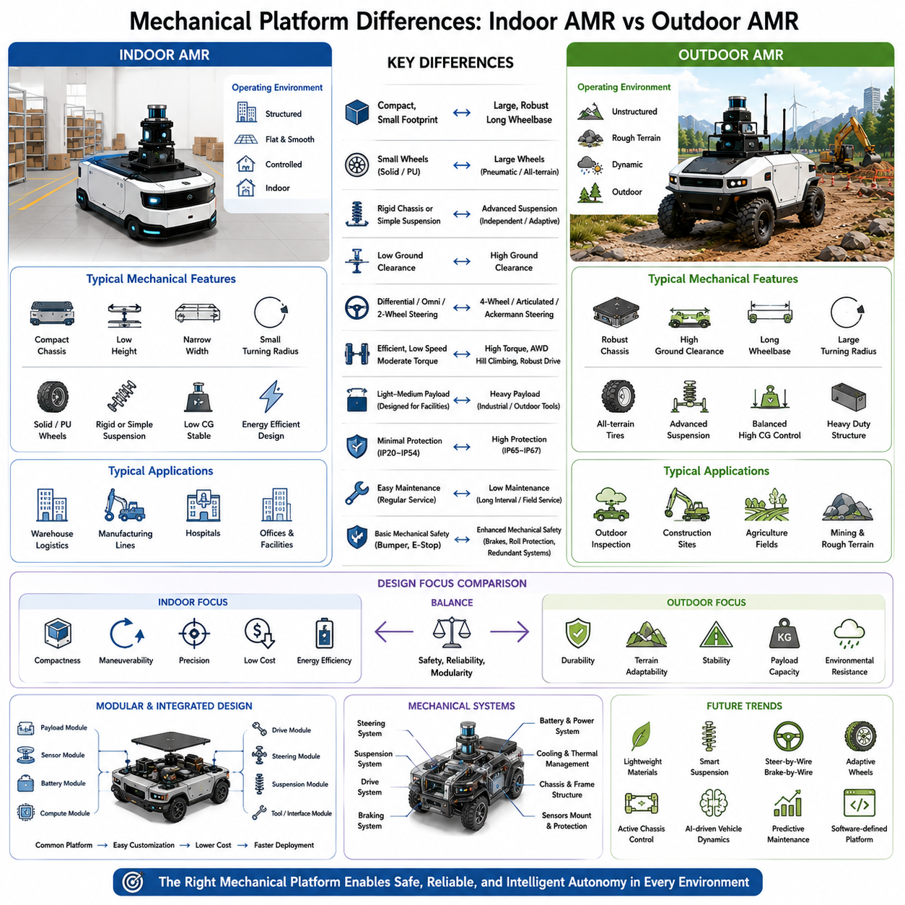
Indoor and outdoor Autonomous Mobile Robots differ not only in sensing and intelligence but also in the mechanical platforms that support autonomous operation. The mechanical platform forms the physical foundation upon which every perception, localization, navigation, and manipulation function depends. Although both categories of robots share common engineering principles such as structural integrity, mobility, power transmission, and safety, their mechanical designs diverge substantially because they operate under fundamentally different environmental conditions and mission requirements. Indoor platforms emphasize compactness, efficiency, precision, and low operating cost, whereas outdoor platforms prioritize durability, terrain adaptability, environmental resistance, and long-term operational reliability. Mechanical architecture therefore represents one of the most significant distinctions between indoor and outdoor autonomous robotic systems.
Indoor AMRs are generally designed for operation on smooth, flat industrial floors with well-controlled environmental conditions. Warehouse floors, hospital corridors, manufacturing facilities, and logistics centers provide relatively predictable surfaces with minimal elevation changes or surface deformation. Consequently, indoor platforms typically employ lightweight chassis structures with compact dimensions optimized for maneuverability within narrow aisles, elevators, and confined workspaces. Small wheel diameters, rigid chassis configurations, and relatively low ground clearance provide sufficient mobility while minimizing overall vehicle height and manufacturing cost. These mechanical characteristics enable precise navigation and efficient operation without requiring excessive structural complexity.
Outdoor AMRs encounter dramatically different operating environments where terrain conditions continuously change throughout every mission. Roads, gravel, grass, soil, mud, sand, rocks, construction sites, drainage channels, slopes, and uneven pavement impose substantially higher mechanical demands than indoor facilities. Outdoor mechanical platforms therefore require reinforced chassis structures capable of resisting vibration, impact loading, torsional stress, and repeated shock events generated during long-distance field operation. Higher ground clearance prevents underbody collisions with terrain obstacles, while increased structural rigidity maintains sensor calibration and vehicle stability despite continuous mechanical loading. Mechanical robustness becomes a primary design objective because failures in remote outdoor environments may result in costly maintenance interruptions or mission failures.
Vehicle dimensions also differ considerably between indoor and outdoor platforms. Indoor AMRs are constrained by building layouts, door widths, aisle dimensions, and elevator capacities, requiring compact vehicle footprints that maximize maneuverability while minimizing occupied floor space. Outdoor robots generally operate in much larger open environments where turning radius and physical dimensions are less restrictive. Consequently, outdoor platforms frequently incorporate longer wheelbases, wider track widths, and larger overall dimensions to improve directional stability, payload capacity, and high-speed driving performance. Larger platforms additionally provide sufficient installation space for batteries, multiple computing units, extensive sensor suites, communication equipment, and industrial payloads required for complex field applications.
Wheel selection represents another major mechanical distinction. Indoor AMRs commonly utilize solid rubber wheels or polyurethane-coated drive wheels designed for smooth industrial flooring. These wheels offer low rolling resistance, high positioning accuracy, minimal maintenance, and reduced floor wear. Outdoor robots instead require pneumatic tires, agricultural tires, all-terrain tires, run-flat tires, or specialized off-road wheel designs capable of absorbing impacts while maintaining traction across loose and uneven surfaces. Tire diameter generally increases significantly because larger wheels improve obstacle climbing capability, reduce rolling resistance on rough terrain, and enhance vehicle stability. Tire selection therefore directly influences mobility, ride comfort, suspension performance, and overall operational capability.
Ground clearance is carefully optimized according to operating environment. Indoor robots typically maintain relatively low clearance because excessive height reduces structural stiffness and unnecessarily raises the center of gravity. Flat indoor floors rarely require significant obstacle clearance beyond small floor transitions or loading dock interfaces. Outdoor AMRs require substantially greater clearance to safely traverse rocks, curbs, potholes, vegetation, drainage channels, snow accumulation, and construction debris. High ground clearance reduces the likelihood of chassis damage while expanding operational capability across diverse terrain types. However, increasing clearance also raises the center of gravity, requiring careful balance between terrain accessibility and vehicle stability.
Suspension systems illustrate one of the clearest differences between indoor and outdoor mechanical engineering. Most indoor AMRs employ rigid chassis structures or simple passive suspension because floor irregularities remain minimal and vehicle speeds are relatively low. Precise positioning benefits from mechanically stiff platforms that minimize unwanted body motion. Outdoor robots experience continuous terrain-induced vibration and shock loading that can degrade sensor performance, reduce component lifetime, and destabilize payloads. Independent suspension, articulated suspension, swing-arm mechanisms, torsion bars, air suspension, or adaptive damping systems therefore become essential mechanical components. These systems maintain wheel contact with uneven terrain while protecting sensitive sensors and electronic systems from excessive vibration.
Steering architecture similarly evolves according to application requirements. Indoor robots frequently employ differential drive, omnidirectional wheels, mecanum wheels, or simple two-wheel steering mechanisms optimized for maneuverability within confined environments. Outdoor platforms often require four-wheel steering, articulated steering, Ackermann steering, skid steering, or hybrid steering configurations capable of balancing maneuverability with high-speed directional stability. Four-wheel steering significantly reduces turning radius for large industrial vehicles while improving control during low-speed maneuvering and high-speed travel. Steering mechanisms therefore become increasingly sophisticated as operational speed, payload, and terrain complexity increase.
Drive systems must also accommodate differing mobility demands. Indoor AMRs typically operate at relatively low speeds with moderate payloads and frequent stop-and-go motion. Efficient electric drive systems prioritize energy efficiency, positioning accuracy, and quiet operation. Outdoor robots require substantially greater traction force, hill-climbing capability, acceleration, and sustained torque output while carrying heavier payloads over uneven terrain. All-wheel drive, electronic differential control, torque vectoring, differential locking, or multi-motor propulsion architectures frequently improve mobility under difficult operating conditions. Drive system engineering therefore extends beyond simple propulsion to encompass comprehensive vehicle dynamics management.
Payload capacity strongly influences platform architecture. Indoor logistics robots commonly transport standardized containers, pallets, medical supplies, or manufacturing materials with payloads optimized for facility workflows. Outdoor AMRs frequently support industrial inspection systems, robotic manipulators, surveying equipment, agricultural implements, heavy construction tools, communication infrastructure, or specialized defense payloads. These applications require reinforced structural frames, modular mounting interfaces, vibration-isolated equipment bays, and balanced weight distribution that preserve vehicle stability while supporting large and often dynamically changing payloads. Mechanical integration therefore becomes increasingly application-specific for outdoor industrial robots.
Environmental protection requirements substantially differentiate platform construction. Indoor robots generally operate within temperature-controlled buildings protected from rain, ultraviolet radiation, dust storms, salt exposure, and severe weather. Outdoor platforms require weatherproof chassis assemblies incorporating sealed bearings, corrosion-resistant materials, waterproof electrical connectors, reinforced cable routing, industrial coatings, and high ingress protection ratings. Mechanical assemblies must withstand repeated thermal expansion, moisture exposure, mud contamination, chemical agents, and prolonged ultraviolet degradation throughout years of continuous field operation. Environmental durability therefore becomes an integral aspect of mechanical engineering rather than an optional enhancement.
Maintenance philosophy also differs between indoor and outdoor mechanical platforms. Indoor robots often receive regular scheduled maintenance within controlled industrial facilities where service equipment and replacement parts remain readily available. Outdoor robots may operate across geographically distributed infrastructure, agricultural fields, mines, ports, or remote industrial sites where maintenance opportunities occur infrequently. Mechanical systems therefore emphasize long service intervals, modular replacement, predictive maintenance capability, simplified inspection procedures, and durable wear-resistant components that minimize operational downtime. Ease of field maintenance becomes a significant design objective alongside performance and reliability.
Mechanical safety requirements increase substantially as outdoor operating environments become more complex. Indoor robots generally interact with trained personnel inside controlled facilities where traffic behavior follows established operational procedures. Outdoor robots share environments with pedestrians, automobiles, bicycles, construction machinery, wildlife, and unpredictable public activity. Mechanical design therefore incorporates robust braking systems, redundant steering actuation, protective bumpers, rollover resistance, impact-absorbing structures, emergency mechanical overrides, and fail-safe drive mechanisms that maintain controllability during unexpected failures. Passive mechanical safety complements active electronic safety systems to reduce operational risk.
Mechanical modularity has become increasingly important across both indoor and outdoor robotic platforms. Standardized chassis architectures enable manufacturers to support multiple product variants using common structural components while adapting payload modules, sensor configurations, battery systems, and drive mechanisms according to specific applications. Outdoor platforms particularly benefit from modular architectures because mission requirements vary significantly across logistics, inspection, agriculture, construction, mining, energy, and defense sectors. Modular engineering reduces development cost, simplifies maintenance, accelerates customization, and extends product lifecycle through incremental hardware upgrades rather than complete platform redesign.
Future mechanical platforms will increasingly integrate lightweight composite materials, advanced structural optimization, intelligent suspension systems, active chassis control, steer-by-wire technologies, brake-by-wire architectures, adaptive wheel systems, and software-defined vehicle dynamics. Mechanical engineering will become more tightly integrated with artificial intelligence, allowing robots to continuously adjust suspension behavior, traction control, steering response, and power distribution according to real-time terrain analysis and mission objectives. As embodied artificial intelligence continues advancing, future mechanical platforms will evolve from passive structural frameworks into intelligent physical systems capable of dynamically adapting their mechanical characteristics to maximize mobility, efficiency, durability, and operational safety across an ever-expanding range of autonomous applications.

05.05 AI and Navigation Differences · AI 및 내비게이션 차이
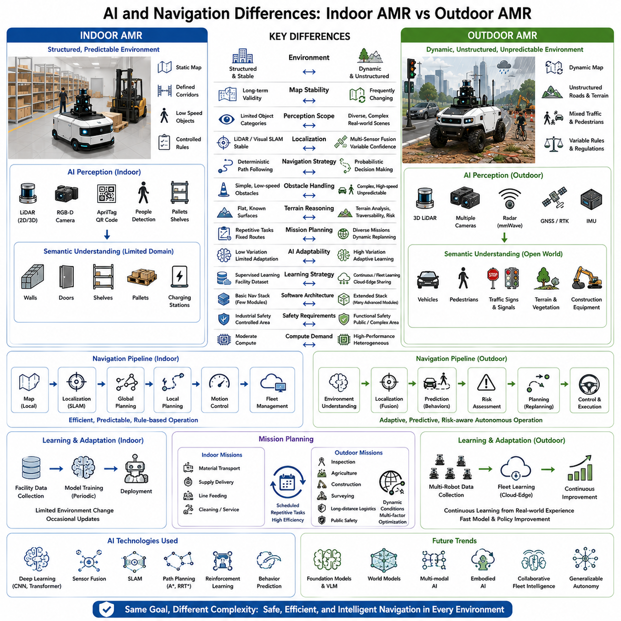
Artificial Intelligence and autonomous navigation form the cognitive foundation of every Autonomous Mobile Robot, enabling machines to perceive, understand, reason about, and safely interact with their operating environment. Although both indoor and outdoor AMRs rely on AI-driven perception, localization, planning, and decision-making, the complexity of their navigation systems differs substantially because of the environments in which they operate. Indoor navigation typically occurs within structured and highly predictable facilities where maps remain relatively stable and operational rules change infrequently. Outdoor navigation must instead cope with dynamic traffic, weather, changing terrain, uncertain environmental conditions, and countless unpredictable events. Consequently, outdoor robots require significantly more sophisticated artificial intelligence, larger computational resources, and more adaptive navigation architectures than indoor systems.
Indoor AMRs generally perform navigation within environments that are carefully designed for operational efficiency. Warehouses, hospitals, manufacturing plants, and distribution centers contain well-defined corridors, fixed shelving, marked work zones, and controlled pedestrian traffic. Navigation therefore primarily involves moving between predefined destinations while avoiding temporary obstacles such as people or forklifts. Since the environment changes relatively slowly, global maps remain valid for long periods, allowing navigation algorithms to optimize routes with relatively modest computational complexity. This structured operating context enables highly reliable autonomous operation using mature navigation technologies that emphasize efficiency and repeatability rather than environmental exploration.
Outdoor navigation operates under fundamentally different assumptions. Roads may become blocked by construction, parked vehicles, temporary barriers, fallen trees, flooding, snow accumulation, or unexpected traffic conditions. Pedestrians, cyclists, automobiles, heavy machinery, and animals continuously alter the surrounding environment. Lighting conditions vary throughout the day, while rain, fog, dust, and seasonal vegetation change perception quality. Consequently, outdoor navigation cannot simply follow predefined routes but must continuously interpret environmental changes, predict future events, and dynamically adjust navigation strategies while maintaining safety and mission objectives. Artificial intelligence therefore becomes deeply integrated into every stage of navigation rather than serving only as an auxiliary perception component.
Environmental understanding illustrates one of the largest differences between indoor and outdoor AI systems. Indoor robots primarily recognize walls, doors, shelving, pallets, elevators, charging stations, and a relatively small number of object categories. Semantic understanding focuses on facility-specific operational elements necessary for logistics or manufacturing workflows. Outdoor robots must interpret considerably richer scenes containing roads, sidewalks, intersections, traffic signs, traffic signals, vegetation, construction equipment, utility infrastructure, vehicles of many types, weather effects, terrain variations, and human activities. Deep neural networks therefore require substantially broader training datasets capable of generalizing across highly diverse real-world environments rather than limited industrial settings.
Artificial intelligence for indoor navigation often emphasizes deterministic planning supported by accurate localization. Once the robot identifies its position within a static map, global planners generate efficient routes while local planners avoid temporary obstacles. Decision-making remains relatively straightforward because navigation rules seldom change unexpectedly. Outdoor AI must continuously evaluate environmental uncertainty while simultaneously estimating traversable terrain, predicting object behavior, interpreting traffic regulations, assessing environmental risk, and selecting appropriate driving strategies. Navigation therefore evolves from deterministic path following into probabilistic decision-making under uncertainty, requiring substantially more advanced reasoning capabilities.
Localization confidence directly influences navigation behavior in both domains, yet the methods differ considerably. Indoor systems usually maintain highly stable localization using LiDAR SLAM, Visual SLAM, or infrastructure-based references because buildings provide consistent structural features. Localization failures occur relatively infrequently and often remain geographically limited. Outdoor localization must integrate GNSS, RTK, LiDAR SLAM, Visual SLAM, inertial navigation, radar localization, semantic landmark recognition, and map matching while continuously estimating confidence in each information source. Navigation algorithms dynamically adjust behavior according to localization uncertainty, reducing speed, increasing safety margins, or selecting alternate routes whenever positioning reliability decreases.
Obstacle avoidance also becomes substantially more complex outdoors. Indoor robots typically encounter pedestrians, carts, pallets, forklifts, and occasionally maintenance equipment moving at relatively low speeds within controlled facilities. Motion prediction remains comparatively simple because object behaviors follow operational procedures. Outdoor robots must anticipate interactions with vehicles traveling at varying speeds, cyclists, unpredictable pedestrians, construction equipment, animals, and temporary road hazards. Artificial intelligence models therefore estimate future trajectories, behavioral intent, collision probability, and environmental evolution before selecting safe navigation actions. Predictive navigation becomes essential for maintaining both operational efficiency and functional safety.
Terrain reasoning represents another important distinction. Indoor robots generally assume flat, traversable surfaces throughout mapped facilities, allowing navigation algorithms to optimize travel distance and traffic flow without considering vehicle dynamics. Outdoor systems continuously evaluate terrain geometry, surface roughness, slope inclination, soil stability, traction conditions, water accumulation, loose gravel, mud, and vegetation density before committing to specific routes. AI-based terrain classification determines not only whether an area is physically traversable but also estimates energy consumption, vehicle stability, rollover risk, and expected travel time. Navigation therefore becomes tightly coupled with mechanical vehicle capability rather than purely geometric path planning.
Mission planning similarly differs between indoor and outdoor operations. Indoor fleet management generally schedules repetitive logistics tasks such as transporting materials, delivering supplies, or servicing production stations. Routes remain highly optimized and predictable because facility layouts rarely change significantly. Outdoor missions often involve infrastructure inspection, agricultural operations, construction monitoring, environmental surveys, public safety, or long-distance logistics across geographically distributed locations. Artificial intelligence must prioritize mission objectives while simultaneously accounting for weather forecasts, terrain accessibility, communication availability, battery consumption, traffic conditions, and operational risk. Strategic planning therefore extends beyond navigation into comprehensive mission optimization.
Artificial intelligence also plays a greater role in adapting outdoor navigation to changing environmental conditions. Indoor navigation parameters often remain relatively constant throughout daily operation because lighting, floor conditions, and traffic density vary only modestly. Outdoor AI continuously adjusts perception thresholds, localization strategies, obstacle detection sensitivity, vehicle speed, and path planning parameters according to weather, visibility, terrain conditions, seasonal changes, and mission priorities. Adaptive learning enables robots to refine navigation policies over time by incorporating operational experience collected across thousands of real-world missions.
Learning strategies further distinguish indoor and outdoor autonomy. Indoor robots frequently rely on supervised learning using facility-specific datasets collected within relatively controlled environments. Once deployed, perception and navigation models require only occasional updates. Outdoor AI benefits significantly from continuous learning architectures that aggregate operational data from multiple robots deployed across diverse geographic regions. Fleet learning enables navigation systems collectively to improve terrain understanding, weather adaptation, object recognition, localization robustness, and decision-making accuracy by sharing accumulated experience through cloud-edge infrastructures. Such collaborative learning dramatically accelerates performance improvement across entire robotic fleets.
Navigation software architecture becomes correspondingly more sophisticated outdoors. Indoor navigation stacks often consist of perception, localization, mapping, global planning, local planning, motion control, and fleet management modules communicating through well-defined interfaces. Outdoor systems incorporate additional layers including semantic reasoning, terrain analysis, weather adaptation, behavior prediction, risk assessment, dynamic mission replanning, communication management, energy optimization, and operational diagnostics. Each subsystem exchanges information continuously through high-bandwidth middleware while maintaining strict real-time performance constraints. Software architecture therefore scales from navigation execution toward comprehensive autonomous decision-making.
Functional safety requirements significantly influence AI design in outdoor robots. Indoor navigation primarily ensures collision avoidance within controlled industrial environments where operational procedures remain well understood. Outdoor autonomous systems must satisfy far more demanding safety objectives because failures may involve public roads, pedestrians, industrial equipment, or critical infrastructure. Artificial intelligence therefore incorporates uncertainty estimation, explainable decision mechanisms, redundant perception pipelines, safety supervisors, confidence-aware planning, and fail-safe operational modes. Navigation decisions increasingly balance operational efficiency against quantified risk, ensuring that safety remains the overriding priority whenever environmental uncertainty increases.
Computational requirements grow proportionally with navigation complexity. Indoor robots can often perform perception, localization, and planning using embedded processors with moderate GPU acceleration because sensing and decision-making remain relatively constrained. Outdoor navigation executes numerous deep learning models simultaneously for object detection, semantic segmentation, terrain analysis, localization, trajectory prediction, behavior planning, environmental reasoning, and safety validation. High-performance heterogeneous computing platforms combining CPUs, GPUs, AI accelerators, and dedicated perception processors therefore become essential for achieving real-time autonomous operation under complex outdoor conditions.
Future developments will increasingly narrow the distinction between navigation and artificial intelligence as robots evolve toward embodied autonomous systems capable of generalized reasoning. Foundation models will provide semantic understanding beyond traditional perception, enabling robots to interpret natural language instructions, infer environmental context, predict complex interactions, and generate adaptive navigation strategies without exhaustive manual programming. World models, multimodal learning, reinforcement learning, and collaborative fleet intelligence will further transform navigation from rule-based autonomy into experience-driven intelligent behavior. As these technologies mature, future indoor and outdoor AMRs will increasingly share common AI foundations while remaining mechanically and operationally optimized for their respective environments.

