Volume 01. AMR Foundations and System Architecture

12. AMR Performance Metrics · AMR 성능 지표

12.01 Navigation Metrics · 내비게이션 지표
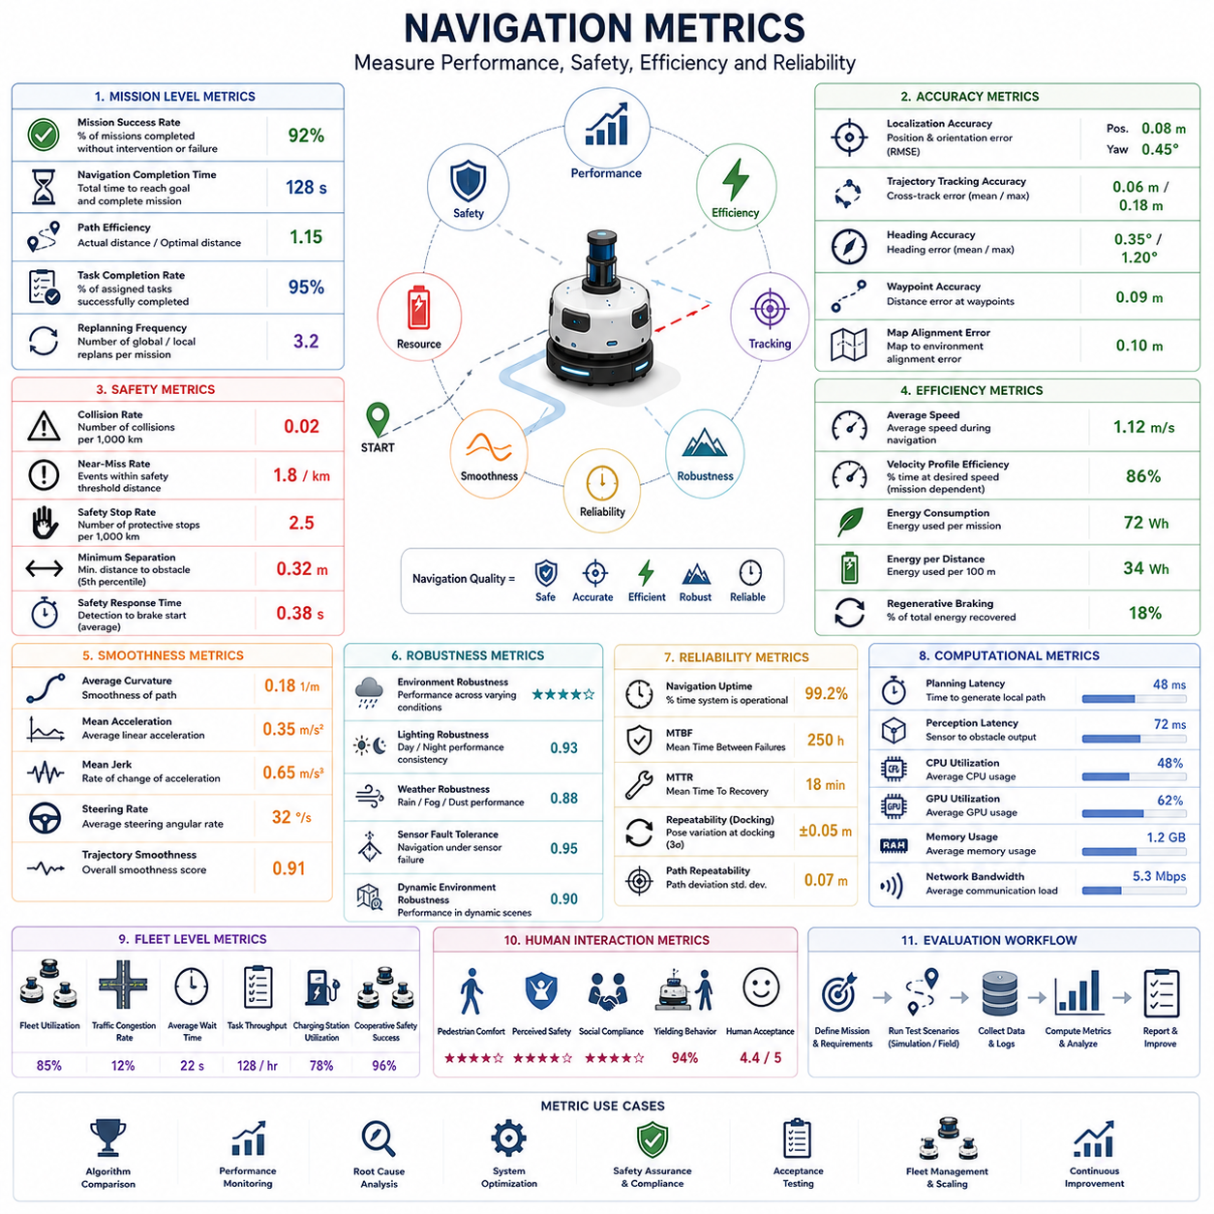
Navigation metrics provide objective and quantitative methods for evaluating the performance, safety, efficiency, robustness, and reliability of autonomous mobile robot navigation systems. Unlike subjective observations or qualitative assessments, navigation metrics transform robot behavior into measurable indicators that support engineering analysis, system optimization, product benchmarking, and acceptance testing. Well-defined metrics enable developers to compare algorithms, validate improvements, identify performance degradation, and ensure that navigation systems consistently satisfy operational requirements across different environments and deployment scenarios.
The primary purpose of navigation metrics is to determine whether the robot achieves its intended mission while maintaining safety, efficiency, and reliability. Successful navigation is not measured solely by reaching the destination. Instead, the evaluation considers how accurately the robot follows planned paths, how efficiently it avoids obstacles, how smoothly it moves, how quickly it reacts to environmental changes, and how consistently it performs under varying operating conditions. Comprehensive evaluation therefore requires multiple complementary metrics rather than relying on a single performance indicator.
Mission success rate is one of the highest-level navigation performance metrics. It represents the percentage of navigation missions completed successfully without operator intervention, collisions, safety violations, or mission cancellation. A successful mission generally requires the robot to reach its destination, complete assigned tasks, and return to an operational state within predefined constraints. Mission success rate provides an overall assessment of navigation capability from the perspective of practical deployment rather than isolated subsystem performance.
Navigation completion time measures the total duration required for the robot to travel from the starting position to the assigned destination while completing its mission objectives. This metric reflects overall operational efficiency by combining path planning performance, obstacle avoidance behavior, vehicle dynamics, and environmental interactions. Excessive completion time may indicate inefficient planning, overly conservative safety behavior, localization uncertainty, or computational bottlenecks that reduce system productivity.
Path efficiency evaluates how closely the executed trajectory matches the optimal or planned route. The ratio between actual travel distance and the theoretically shortest feasible path provides an intuitive measure of navigation quality. Values approaching one indicate efficient route execution, while significantly larger values suggest unnecessary detours, repeated replanning, localization drift, or inefficient obstacle avoidance. Path efficiency directly influences mission duration, battery consumption, and overall fleet productivity.
Trajectory tracking accuracy measures the robot's ability to follow planned paths while minimizing lateral and longitudinal deviations. Position error, heading error, cross-track error, and orientation consistency are commonly evaluated throughout the trajectory. High tracking accuracy is particularly important during docking, narrow corridor navigation, precision material handling, and operations involving robotic manipulators where positioning errors may directly affect task execution quality.
Localization accuracy represents a fundamental navigation metric because every navigation decision depends upon reliable pose estimation. Position error and orientation error are measured relative to ground truth systems such as motion capture systems, total stations, high-grade GNSS receivers, or precisely surveyed reference maps. Localization accuracy should be evaluated under both static and dynamic conditions while considering long-term drift, recovery after localization failure, and robustness against environmental changes.
Obstacle avoidance performance evaluates the robot's ability to detect hazards, predict collision risks, and generate safe alternative trajectories. Important measurements include obstacle detection success rate, minimum separation distance, collision frequency, near-miss frequency, trajectory smoothness during avoidance, and recovery time after obstacles disappear. Successful obstacle avoidance requires balancing safety with operational efficiency rather than simply maximizing obstacle clearance.
Collision rate remains one of the most important safety-related navigation metrics. It measures the frequency of physical contact with obstacles, infrastructure, vehicles, or people during robot operation. Even minor collisions may damage equipment, interrupt production, reduce user confidence, or violate industrial safety requirements. Consequently, many commercial deployments define collision-free operation as a mandatory acceptance criterion rather than a desirable performance objective.
Near-miss events provide valuable safety information even when actual collisions do not occur. A near miss is typically defined as any situation where obstacle separation falls below a predefined safety threshold without physical contact. Monitoring near-miss frequency enables engineers to identify hazardous navigation behaviors before accidents occur. Reducing near misses often improves long-term operational safety more effectively than evaluating collision statistics alone because collisions are relatively rare events.
Safety stopping performance evaluates how rapidly and consistently the robot responds when hazardous situations are detected. Metrics include reaction latency, braking initiation time, stopping distance, deceleration consistency, emergency stop reliability, and compliance with functional safety requirements. These measurements verify that protective actions occur within acceptable limits while avoiding unnecessary emergency stops that reduce operational productivity.
Navigation smoothness measures the quality of robot motion from both mechanical and operational perspectives. Smooth trajectories minimize abrupt steering changes, excessive acceleration, oscillatory motion, and unnecessary velocity fluctuations. Common metrics include average curvature, steering rate, acceleration, jerk, angular velocity variation, and trajectory continuity. Smooth navigation improves passenger comfort, payload stability, mechanical durability, sensor stability, and energy efficiency.
Velocity profile evaluation analyzes whether the robot maintains appropriate speeds throughout different navigation scenarios. Engineers compare commanded velocity with actual vehicle speed while monitoring acceleration, deceleration, speed regulation accuracy, and velocity stability. Effective speed control adapts naturally to corridor width, obstacle density, pedestrian activity, floor conditions, and mission priorities while maintaining compliance with safety regulations.
Energy efficiency has become an increasingly important navigation metric for battery-powered autonomous mobile robots. Navigation algorithms directly influence electrical energy consumption through route selection, acceleration behavior, stopping frequency, steering activity, and idle time. Energy-related metrics commonly include watt-hours per kilometer, energy per completed mission, battery utilization efficiency, regenerative braking effectiveness, and remaining operational range prediction accuracy.
Computational performance metrics evaluate the real-time capability of navigation software. Path planning latency, obstacle processing time, localization update frequency, sensor fusion throughput, CPU utilization, GPU utilization, memory consumption, communication bandwidth, and scheduling consistency determine whether navigation algorithms satisfy timing requirements during continuous autonomous operation. Stable computational performance is essential for maintaining deterministic system behavior.
Robustness metrics measure navigation performance under challenging environmental conditions rather than ideal laboratory scenarios. Testing includes low illumination, rain, fog, dust, cluttered environments, dynamic obstacles, uneven terrain, localization degradation, sensor failures, communication interruptions, and temporary map inconsistencies. Robust systems maintain acceptable navigation performance despite disturbances that significantly challenge perception, localization, and planning subsystems.
Recovery performance evaluates how effectively the navigation system responds after unexpected failures or abnormal operating conditions. Representative scenarios include localization loss, temporary sensor failure, blocked pathways, communication interruptions, actuator faults, and emergency stops. Recovery metrics include recovery success rate, recovery duration, replanning frequency, operator intervention requirements, and mission continuation probability after fault resolution.
Repeatability measures the consistency of navigation performance when identical missions are executed repeatedly under similar operating conditions. Position repeatability, docking repeatability, path consistency, timing variation, and navigation accuracy variance provide valuable insight into long-term system stability. High repeatability simplifies industrial automation because downstream processes can rely upon predictable robot behavior throughout continuous operation.
Availability and reliability metrics quantify long-term operational performance over extended deployment periods. Mean Time Between Failures, Mean Time To Recovery, mission availability, navigation uptime, software stability, sensor reliability, communication reliability, and maintenance frequency collectively describe the practical usability of autonomous navigation systems. High availability is particularly important for industrial environments where unexpected downtime directly affects production efficiency.
Fleet-level navigation metrics extend evaluation beyond individual robots to coordinated multi-robot systems. Important measurements include fleet utilization, traffic congestion frequency, waiting time at intersections, mission scheduling efficiency, charging station utilization, average task throughput, cooperative collision avoidance success, and overall system productivity. Fleet metrics optimize global operational efficiency while maintaining safe interactions among multiple autonomous platforms.
Human interaction metrics evaluate navigation quality in environments shared with pedestrians and manual vehicles. Measurements include pedestrian comfort, perceived safety, social compliance, yielding behavior, human acceptance, interruption frequency, and navigation predictability. Robots operating in hospitals, warehouses, airports, campuses, and public facilities must demonstrate not only technical navigation capability but also socially appropriate movement that promotes user confidence and trust.
Performance evaluation should combine quantitative measurements with qualitative engineering observations to provide a comprehensive understanding of navigation behavior. Statistical analysis, visualization tools, replay systems, failure investigation, root cause analysis, and long-term operational monitoring complement numerical metrics by revealing trends that may not be immediately apparent through isolated measurements. Continuous performance monitoring supports iterative improvement throughout product development and commercial deployment.
Future navigation metrics will increasingly integrate foundation models, digital twins, semantic world models, cloud-based fleet analytics, self-supervised learning, and predictive performance evaluation. Rather than measuring only historical navigation performance, future evaluation systems will estimate future operational risk, predict degradation before failures occur, automatically generate challenging validation scenarios, and continuously refine navigation objectives using data collected from deployed robot fleets. These intelligent evaluation frameworks will provide more comprehensive, adaptive, and reliable assessment of autonomous navigation performance while accelerating the development of next-generation autonomous mobile robots.

12.02 Perception Metrics · 인지 지표
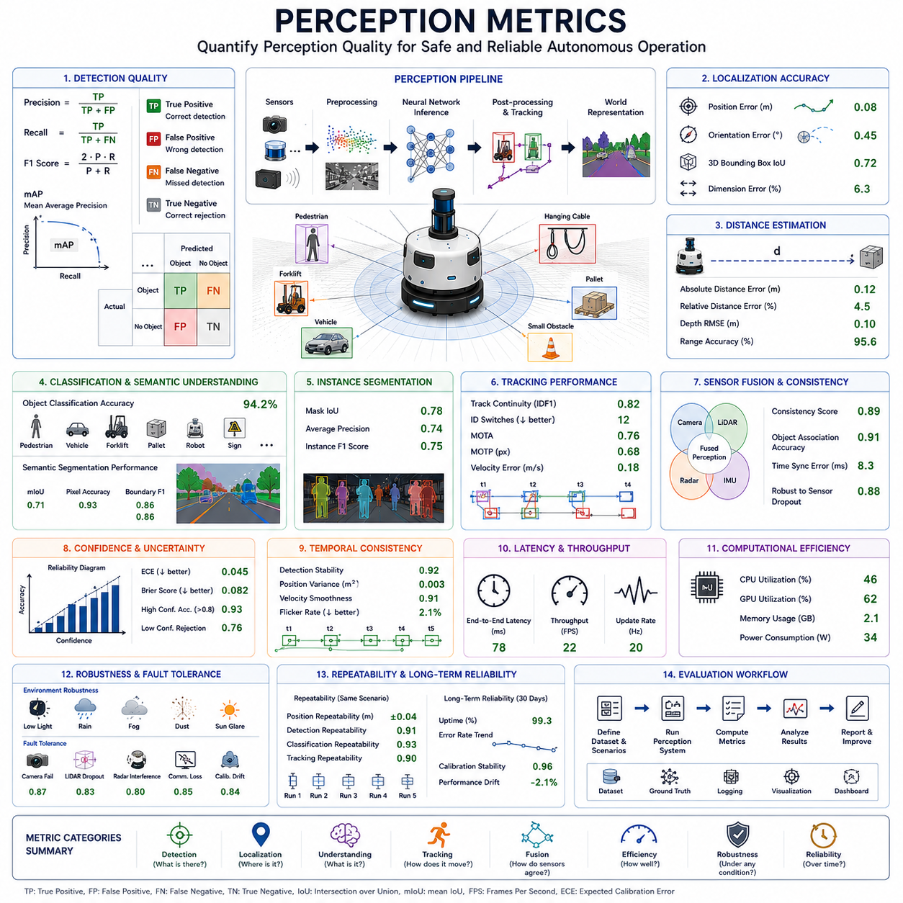
Perception metrics provide objective and quantitative methods for evaluating how effectively an autonomous mobile robot perceives, understands, and interprets its surrounding environment. Since every navigation, planning, and decision-making process depends on perception, accurate performance evaluation is essential throughout system development and deployment. Unlike subjective observations, perception metrics transform sensor outputs and algorithm behavior into measurable values that support engineering optimization, algorithm comparison, product validation, and long-term performance monitoring. Properly designed perception metrics enable engineers to verify that perception systems consistently satisfy operational requirements across different environments, sensor configurations, and deployment conditions.
The primary objective of perception metrics is to determine whether the perception system provides reliable environmental information that supports safe and efficient autonomous operation. Successful perception is not measured solely by object detection accuracy. Instead, evaluation considers object recognition quality, localization precision, semantic understanding, sensor fusion consistency, environmental robustness, computational efficiency, and temporal stability. Since perception consists of multiple interconnected functions, comprehensive evaluation requires numerous complementary metrics rather than relying on any single measurement.
Detection accuracy represents one of the most fundamental perception metrics. It evaluates whether objects existing in the environment are correctly identified by the perception system. Detection accuracy depends on sensor quality, environmental conditions, object appearance, algorithm performance, and sensor calibration. Evaluation should include both static and dynamic objects while covering pedestrians, vehicles, robots, pallets, industrial equipment, construction materials, small obstacles, hanging obstacles, and irregular environmental structures representative of actual operating conditions.
Precision measures the proportion of detected objects that actually correspond to real objects in the environment. High precision indicates that relatively few false detections occur during operation. Excessive false positives may unnecessarily slow the robot, increase computational workload, trigger unnecessary obstacle avoidance, and reduce mission efficiency. Consequently, perception systems should maximize precision while maintaining high detection sensitivity under diverse environmental conditions.
Recall evaluates the percentage of existing objects successfully detected by the perception system. High recall minimizes missed detections that could otherwise result in navigation failures or safety hazards. Missed obstacles represent particularly serious failures because undetected hazards cannot be considered during planning or collision avoidance. Balancing precision and recall is therefore essential, as increasing one metric often influences the other depending on algorithm configuration and operating conditions.
The F1 score provides a balanced performance indicator by combining precision and recall into a single measurement. This metric is particularly useful when comparing different perception algorithms because it reflects overall detection quality rather than emphasizing only one aspect of performance. Engineers frequently use F1 score during algorithm benchmarking, hyperparameter optimization, and regression testing to evaluate improvements throughout software development.
Mean Average Precision has become a widely adopted benchmark for evaluating modern object detection algorithms. This metric summarizes detection accuracy across multiple confidence thresholds and object categories while considering localization quality. Mean Average Precision enables standardized comparison among perception models trained using different neural network architectures, datasets, and optimization techniques. It remains one of the most commonly reported performance metrics within computer vision research and industrial perception development.
Localization accuracy measures how precisely detected objects are positioned within the robot coordinate system. Position error, orientation error, bounding box accuracy, three-dimensional centroid estimation, and object dimension estimation collectively determine localization quality. Accurate localization is essential because navigation, obstacle avoidance, manipulation, and fleet coordination all depend upon precise object positioning rather than simple object recognition alone.
Distance estimation accuracy evaluates the perception system's ability to determine the separation between the robot and surrounding objects. Different sensors provide different ranging characteristics, making quantitative evaluation particularly important. Cameras estimate distance indirectly through geometric inference, whereas LiDAR, radar, and depth cameras measure range more directly. Distance estimation should be evaluated across varying object sizes, surface materials, environmental conditions, and operating ranges to ensure reliable navigation performance.
Object classification accuracy evaluates whether detected objects are assigned to the correct semantic category. Perception systems commonly distinguish among pedestrians, forklifts, autonomous robots, passenger vehicles, trucks, pallets, boxes, traffic signs, construction equipment, vegetation, buildings, and miscellaneous obstacles. Accurate semantic classification supports intelligent navigation decisions because different object categories require different behavioral responses, safety margins, and trajectory planning strategies.
Semantic segmentation performance evaluates how accurately every image pixel or point cloud element is assigned to a semantic class. Unlike object detection, segmentation provides dense environmental understanding by labeling roads, floors, walls, vegetation, buildings, sidewalks, obstacles, traversable regions, and background areas simultaneously. Common evaluation metrics include pixel accuracy, mean Intersection over Union, Dice coefficient, boundary accuracy, and class-specific segmentation performance across representative environmental datasets.
Instance segmentation extends semantic segmentation by distinguishing individual objects belonging to the same category. Rather than labeling multiple pedestrians collectively, instance segmentation identifies each pedestrian separately. Performance evaluation considers mask accuracy, object separation quality, boundary precision, and segmentation consistency under crowded scenes where multiple similar objects appear close together. Accurate instance segmentation supports tracking, behavior prediction, and multi-object interaction analysis.
Object tracking metrics evaluate how consistently the perception system follows detected objects over time. Important measurements include track continuity, identity preservation, trajectory stability, velocity estimation accuracy, acceleration estimation, and track recovery following temporary occlusions. Stable object tracking enables reliable behavior prediction, dynamic obstacle avoidance, cooperative navigation, and interaction with moving objects throughout long-duration autonomous operation.
Multi-object tracking performance becomes increasingly important within crowded industrial and urban environments. The perception system must maintain independent identities for multiple simultaneously moving objects despite crossing trajectories, temporary occlusions, varying appearance, and changing environmental conditions. Metrics such as Multiple Object Tracking Accuracy, Multiple Object Tracking Precision, identity switches, fragmentations, and tracking consistency provide comprehensive evaluation of tracking capability under realistic operational scenarios.
Sensor fusion consistency evaluates how effectively heterogeneous sensor observations combine into a unified environmental representation. Engineers compare fused perception results with individual sensor outputs while monitoring agreement, confidence estimation, object association quality, synchronization accuracy, and robustness against partial sensor failures. Successful sensor fusion should improve overall perception quality while maintaining stable operation whenever individual sensing modalities experience degradation.
Confidence estimation quality measures whether perception confidence values accurately reflect actual detection reliability. Ideally, highly confident detections should almost always be correct, whereas uncertain detections should correspond to genuinely ambiguous situations. Well-calibrated confidence estimates improve downstream planning, obstacle avoidance, and decision-making because navigation algorithms can appropriately balance uncertainty against operational risk when selecting future actions.
Temporal consistency evaluates whether perception outputs remain stable across consecutive sensor frames. Objects should not repeatedly appear and disappear without physical justification, and estimated positions should evolve smoothly according to realistic motion dynamics. Poor temporal consistency increases planning instability, unnecessary trajectory replanning, oscillatory navigation behavior, and computational inefficiency. Stable perception therefore contributes directly to smoother and more predictable autonomous operation.
Latency measures the total time required for sensor observations to become usable perception outputs. End-to-end perception latency includes sensor acquisition, preprocessing, neural network inference, sensor fusion, post-processing, object tracking, and communication to downstream navigation modules. Low latency enables timely obstacle avoidance, accurate motion prediction, and rapid adaptation to changing environments, particularly during high-speed autonomous navigation.
Throughput evaluates the perception system's ability to process continuous streams of sensor data in real time. Common measurements include processed frames per second, point cloud update frequency, sensor fusion update rate, and sustained computational performance during extended operation. Maintaining stable throughput under varying computational workloads is essential for preserving deterministic perception behavior throughout continuous autonomous missions.
Computational efficiency measures processor utilization, graphics processing unit workload, memory consumption, storage bandwidth, communication overhead, and energy consumption associated with perception processing. Efficient perception algorithms maximize environmental understanding while minimizing computational requirements, enabling deployment on embedded computing platforms with limited processing resources, thermal capacity, and electrical power budgets.
Environmental robustness evaluates perception performance under challenging operating conditions that differ significantly from controlled laboratory environments. Testing should include low illumination, direct sunlight, shadows, rain, fog, snow, dust, smoke, reflective surfaces, transparent materials, uneven terrain, cluttered industrial environments, vegetation, and dynamic weather conditions. Robust perception systems maintain acceptable detection accuracy despite substantial environmental variability.
Fault tolerance measures perception performance during partial hardware failures or degraded sensor operation. Representative scenarios include temporary camera failure, LiDAR packet loss, radar interference, communication interruptions, calibration drift, localization degradation, processor overload, and synchronization errors. Effective perception systems should demonstrate graceful degradation by maintaining reduced but safe operational capability until normal functionality is restored.
Repeatability evaluates whether identical perception tasks produce consistent outputs across repeated experiments under similar conditions. Object positions, classifications, confidence values, segmentation boundaries, and tracking trajectories should remain statistically stable over time. High repeatability simplifies algorithm validation, supports industrial automation, and increases confidence that observed performance improvements represent genuine system enhancements rather than random experimental variation.
Long-term reliability measures perception stability throughout prolonged autonomous operation. Engineers evaluate sensor aging, thermal effects, calibration stability, software reliability, communication robustness, memory integrity, computational consistency, and environmental adaptation over weeks or months of deployment. Long-term reliability is particularly important for industrial autonomous robots expected to operate continuously with minimal maintenance or human supervision.
Performance evaluation should combine quantitative metrics with qualitative engineering analysis to provide comprehensive understanding of perception behavior. Statistical analysis, visualization tools, synchronized data replay, error distribution analysis, confusion matrices, failure investigation, root cause analysis, and long-term monitoring complement numerical performance indicators by revealing systematic weaknesses and opportunities for improvement. Continuous evaluation supports iterative refinement throughout product development and commercial deployment.
Future perception metrics will increasingly incorporate foundation models, multimodal world models, digital twins, self-supervised learning, cloud-based fleet analytics, uncertainty-aware evaluation, and predictive performance assessment. Instead of measuring only historical perception quality, future evaluation frameworks will estimate future operational risk, identify emerging performance degradation before failures occur, automatically generate challenging validation scenarios, and continuously refine perception objectives using operational data collected from deployed robot fleets. These intelligent evaluation methodologies will significantly improve the reliability, adaptability, and safety of next-generation autonomous perception systems while accelerating the development of highly capable autonomous mobile robots.

12.03 Safety Metrics · 안전 지표
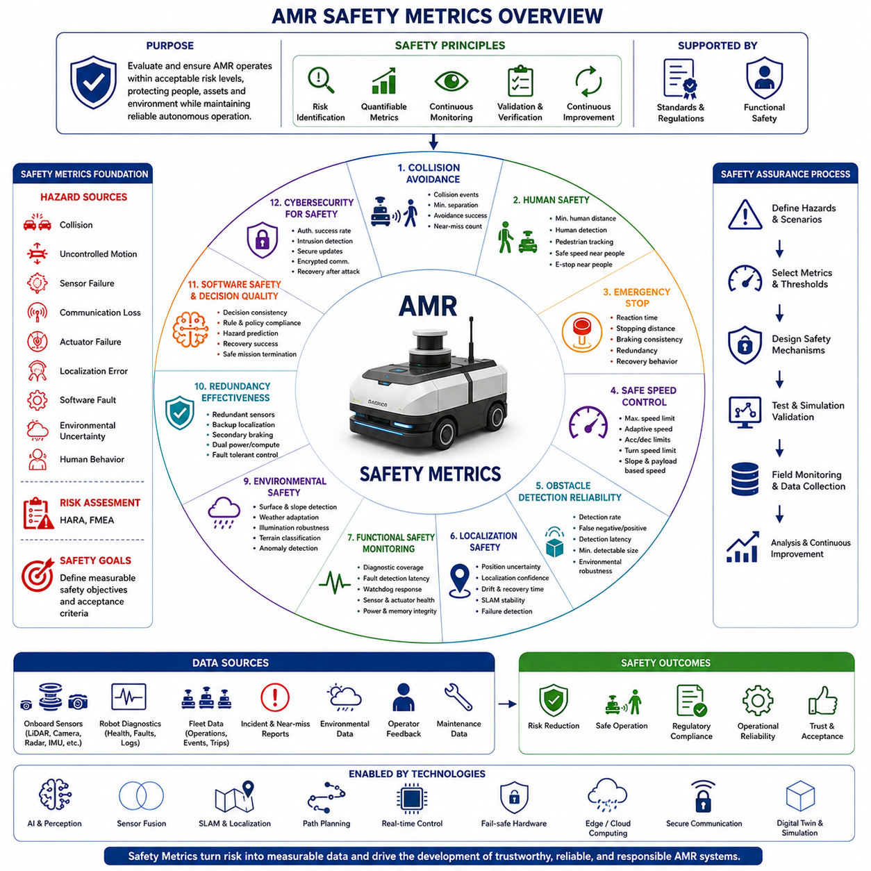
Safety metrics provide objective methods for evaluating whether an Autonomous Mobile Robot operates within acceptable risk levels while maintaining safe interactions with people, equipment, infrastructure, and the surrounding environment. Unlike performance metrics that primarily measure efficiency or productivity, safety metrics quantify the robot's ability to avoid hazardous situations, minimize operational risk, and maintain predictable behavior under both normal and abnormal conditions. These measurements support engineering validation, regulatory compliance, continuous improvement, and long-term operational reliability throughout the complete lifecycle of an AMR system. The importance of safety metrics continues to increase as robots transition from isolated industrial environments into hospitals, warehouses, factories, public spaces, logistics centers, and smart cities where close human-robot interaction becomes routine.
The development of safety metrics begins with a clear understanding of operational hazards and acceptable risk levels. Engineers first identify potential sources of danger including collisions, uncontrolled motion, sensor failures, communication loss, actuator malfunction, localization errors, software faults, environmental uncertainty, and human behavior. Each identified hazard is associated with measurable safety indicators that can be monitored throughout development and deployment. This systematic approach transforms abstract safety requirements into quantifiable engineering targets that can be verified through testing, simulation, and field operation while supporting risk assessment methodologies such as Hazard Analysis and Risk Assessment and Failure Mode and Effects Analysis.
Collision avoidance performance represents one of the most fundamental safety metrics for autonomous mobile robots. The evaluation includes the number of collision events, collision-free operating distance, minimum separation distance to obstacles, emergency intervention frequency, obstacle avoidance success rate, and the ability to safely navigate dynamic environments. Safety validation considers not only complete collision avoidance but also whether the robot maintains sufficient clearance during all navigation scenarios. Continuous monitoring of near-miss events often provides more valuable information than collision statistics alone because these situations reveal safety margins before actual incidents occur.
Human safety metrics focus specifically on protecting workers, operators, visitors, and pedestrians sharing the robot's workspace. Important measurements include minimum human separation distance, human detection accuracy, pedestrian tracking reliability, emergency stop response when humans approach restricted zones, safe speed adaptation near people, and compliance with collaborative operation requirements. Human-aware navigation algorithms are evaluated according to their ability to predict pedestrian movement, reduce unnecessary interference, maintain comfortable interaction distances, and avoid behaviors that could surprise or confuse nearby individuals during everyday operation.
Emergency stop performance is a critical functional safety metric because it directly determines the robot's ability to mitigate hazardous situations after abnormal conditions have been detected. Engineers measure emergency stop reaction time, stopping distance under different payload conditions, braking consistency, deceleration stability, redundant stopping capability, and system recovery behavior following emergency activation. Testing covers both hardware emergency stop circuits and software-generated safety stops to verify that safety mechanisms operate reliably under all operating conditions including maximum speed, maximum payload, downhill motion, and adverse environmental conditions.
Safe speed control metrics evaluate whether the robot continuously maintains operating speeds appropriate for the surrounding environment and current operational context. Maximum allowable speed, adaptive speed reduction near humans, acceleration limits, deceleration smoothness, turning speed limitations, slope-dependent speed adjustment, and payload-dependent velocity constraints are measured throughout normal operation. Dynamic speed regulation ensures that kinetic energy remains within acceptable safety limits while maintaining efficient task execution across varying environmental conditions and operational scenarios.
Obstacle detection reliability serves as a key safety indicator because navigation decisions depend directly on perception accuracy. Important metrics include obstacle detection rate, false negative frequency, false positive frequency, detection latency, minimum detectable obstacle size, sensor coverage completeness, environmental robustness, and perception performance under rain, fog, dust, snow, glare, darkness, or cluttered industrial environments. Sensor fusion architectures are evaluated according to their ability to maintain consistent obstacle awareness despite temporary degradation or failure of individual sensing devices.
Localization safety metrics measure whether the robot always possesses sufficient confidence in its estimated position before executing autonomous decisions. Position uncertainty, localization confidence, map consistency, localization recovery time, drift accumulation, GNSS availability, SLAM stability, and localization failure detection are continuously monitored. Safety-oriented navigation systems automatically reduce operating speed, request operator intervention, or enter controlled safe states whenever localization confidence falls below predefined operational thresholds, thereby preventing unsafe autonomous behavior resulting from incorrect position estimation.
Functional safety monitoring extends beyond navigation to include continuous supervision of hardware and software health. Diagnostic coverage, fault detection latency, processor redundancy effectiveness, communication integrity, watchdog response time, sensor health monitoring, actuator diagnostics, memory integrity, power system monitoring, and fault isolation capability are evaluated to ensure that abnormal conditions are detected before they develop into hazardous failures. These metrics support compliance with functional safety standards and enable fail-safe or fail-operational system behavior depending on application requirements.
Communication reliability contributes directly to operational safety, particularly for fleet-managed robots operating within industrial facilities or public infrastructure. Important safety metrics include communication availability, latency, packet loss rate, synchronization accuracy, command delivery reliability, network recovery time, and resilience against temporary connectivity interruptions. Autonomous robots must demonstrate safe local decision-making even during communication failures while ensuring smooth reintegration with centralized fleet management systems once network connectivity has been restored.
Environmental safety metrics evaluate how effectively robots adapt to changing operating conditions without compromising safety. Surface condition recognition, slope detection accuracy, weather adaptation, illumination robustness, water intrusion detection, terrain classification, obstacle prediction, and environmental anomaly identification all contribute to safe autonomous behavior. Outdoor autonomous robots require additional validation under variable weather, uneven terrain, vegetation, construction zones, and mixed traffic environments where operating conditions continuously evolve throughout daily operation.
Redundancy effectiveness represents an essential safety metric for mission-critical robotic systems. Engineers evaluate redundant sensor agreement, backup localization performance, secondary braking capability, redundant communication channels, dual power supply operation, processor failover behavior, and fault-tolerant control strategies. Effective redundancy ensures that individual component failures do not immediately create hazardous operating conditions and allows the robot to transition into predefined safe operational modes while maintaining sufficient situational awareness.
Safety metrics also evaluate the quality of software decision making during abnormal situations. Decision consistency, rule compliance, safety policy enforcement, hazard prediction accuracy, conflict resolution reliability, autonomous recovery success rate, and safe mission termination behavior provide quantitative insight into the reliability of high-level autonomy. Artificial intelligence components must demonstrate predictable behavior even when operating outside previously observed scenarios, ensuring that uncertain situations lead to conservative rather than aggressive autonomous actions.
Cybersecurity increasingly influences physical safety as modern robots rely on connected software architectures and cloud-based services. Safety-related cybersecurity metrics include authentication success rate, unauthorized access detection, software integrity verification, secure update reliability, encrypted communication coverage, intrusion detection latency, recovery capability following cyber incidents, and resilience against malicious control attempts. Secure robotic architectures ensure that cybersecurity failures cannot directly compromise physical safety or autonomous decision making.
Operational safety metrics collected during field deployment provide valuable information for continuous safety improvement. Incident frequency, near-miss occurrence, operator intervention rate, emergency stop activation frequency, mission abort statistics, maintenance-related safety events, software exception reports, and environmental hazard observations are continuously analyzed using fleet-level operational data. Long-term safety analytics enable engineers to identify recurring operational patterns, optimize safety parameters, improve AI models, and refine risk mitigation strategies based on real-world operational experience rather than laboratory testing alone.
Simulation-based safety validation has become an indispensable component of modern robot development because rare hazardous events cannot always be reproduced safely in physical experiments. Engineers evaluate scenario coverage, hazardous event reproduction, safety margin verification, Monte Carlo robustness analysis, corner case performance, and digital twin validation to assess robot behavior under thousands of diverse operating conditions. Simulation allows systematic exploration of low-probability but high-consequence events while significantly reducing development cost, validation time, and operational risk before deployment into real environments.
Safety metrics ultimately serve as objective evidence that autonomous mobile robots operate within acceptable levels of residual risk while maintaining reliable, predictable, and responsible autonomous behavior. Rather than relying on individual measurements alone, comprehensive safety evaluation integrates perception performance, navigation reliability, emergency response capability, functional safety diagnostics, human interaction quality, cybersecurity resilience, environmental adaptability, operational statistics, and regulatory compliance into a unified safety assurance framework. As autonomous robotics continues expanding into increasingly complex human-centered environments, safety metrics will evolve from simple compliance measurements into intelligent, real-time indicators that continuously assess operational risk, support adaptive safety management, and enable trustworthy autonomous systems capable of safe long-term deployment across diverse industrial and public applications.

12.04 Reliability Metrics · 신뢰성 지표
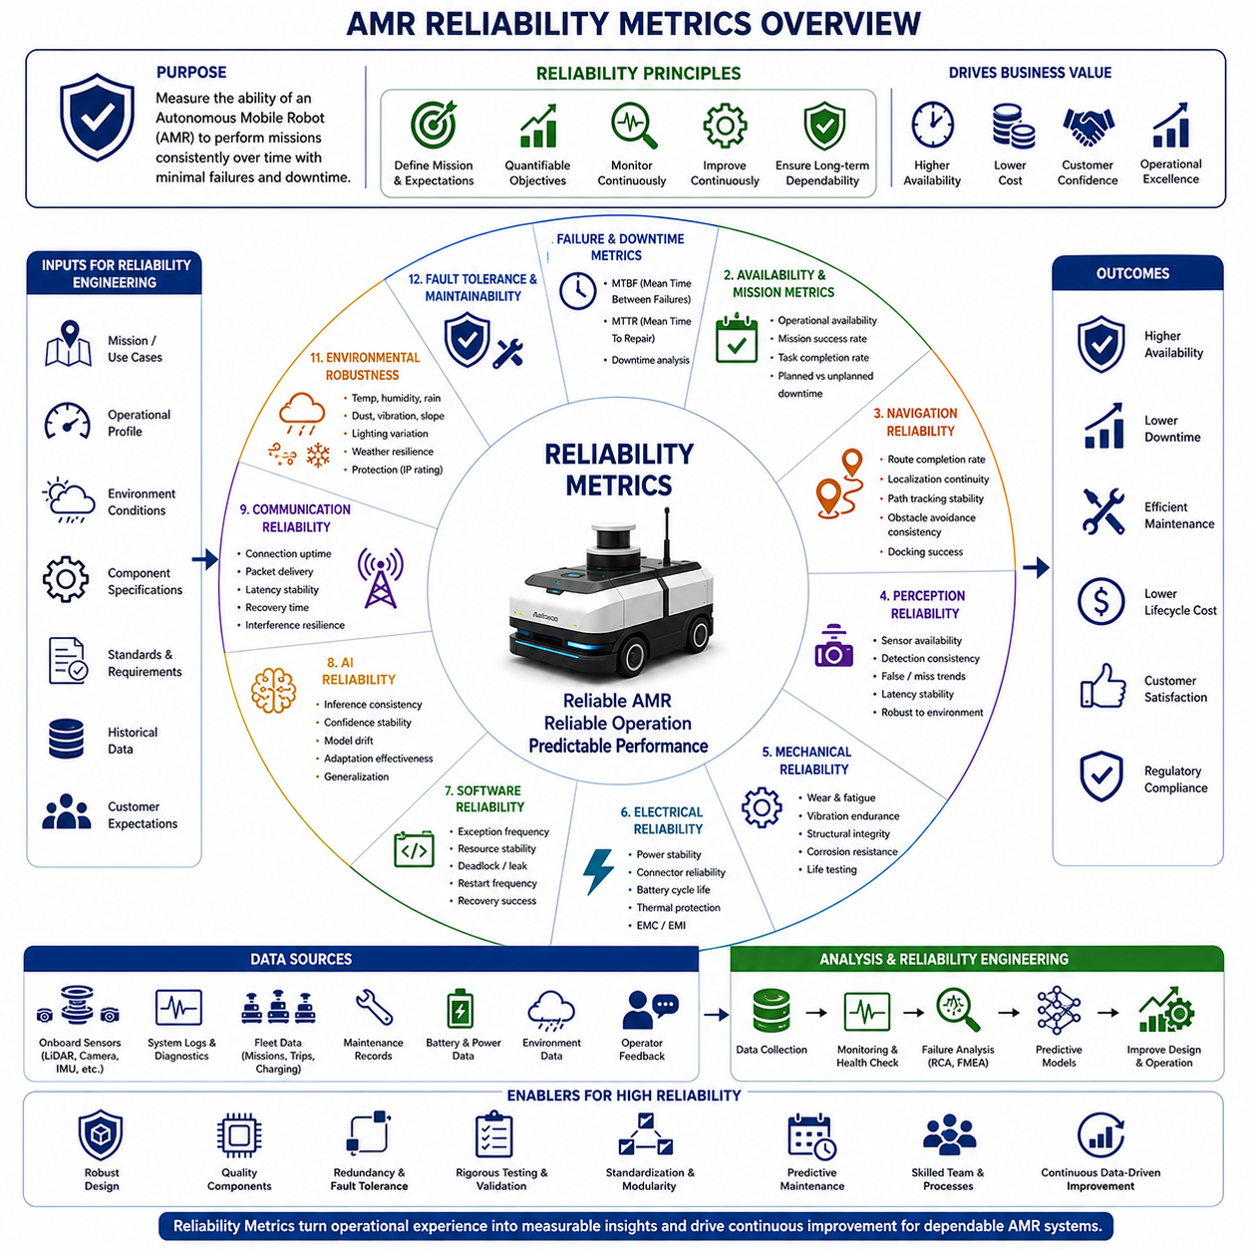
Reliability metrics provide objective measurements of an Autonomous Mobile Robot's ability to perform its intended functions consistently over time without unexpected failures or unacceptable performance degradation. While safety metrics evaluate whether a robot can operate without creating hazardous situations, reliability metrics determine whether the system continues to execute its assigned missions under varying operating conditions throughout its expected service life. High reliability minimizes operational interruptions, reduces maintenance costs, increases customer confidence, and enables predictable long-term deployment in industrial, commercial, healthcare, logistics, and outdoor environments. As AMRs become critical components of automated operations, reliability is no longer viewed solely as a hardware characteristic but as a system-level property emerging from the interaction of mechanical components, electrical systems, sensors, software, artificial intelligence, communication infrastructure, and operational procedures.
The foundation of reliability engineering begins with defining mission profiles and operational expectations before product development starts. Engineers determine expected operating hours, mission frequency, environmental conditions, payload variations, charging cycles, maintenance intervals, communication availability, and acceptable downtime. These operational assumptions establish measurable reliability objectives that guide component selection, architecture design, validation planning, and lifecycle management. Reliability metrics therefore represent engineering requirements that influence every phase of AMR development rather than simply post-deployment evaluation criteria.
Mean Time Between Failures, commonly abbreviated as MTBF, remains one of the most widely recognized reliability indicators for industrial robotic systems. MTBF measures the average operating time between consecutive system failures requiring repair or recovery. Higher MTBF values indicate greater system stability and longer uninterrupted operation. However, engineers must carefully define what constitutes a failure because temporary sensor anomalies, automatically recovered software exceptions, operator interventions, and critical hardware breakdowns have significantly different operational impacts. Consistent failure classification ensures that MTBF accurately reflects practical field reliability rather than statistical ambiguity.
Mean Time To Repair, or MTTR, complements MTBF by measuring the average time required to restore the robot to normal operation after a failure occurs. Repair time includes fault diagnosis, component replacement, software recovery, system verification, and return-to-service procedures. Short MTTR values reduce operational downtime and improve fleet availability even when failures occasionally occur. Modern AMR platforms improve MTTR through modular hardware architecture, standardized electrical interfaces, automatic diagnostic systems, remote software maintenance, predictive fault localization, and simplified field replacement procedures that minimize technician intervention.
Operational availability represents one of the most meaningful reliability metrics because it combines both failure frequency and recovery efficiency into a single measurement. Availability is generally defined as the percentage of scheduled operational time during which the robot remains capable of performing productive work. Planned maintenance, charging operations, software updates, unexpected failures, communication interruptions, and operator interventions all influence system availability. Fleet operators often prioritize availability over individual reliability metrics because it directly reflects productive operational capacity and business performance.
Mission success rate measures the percentage of assigned tasks completed successfully without human intervention or operational failure. Unlike simple hardware reliability, mission success evaluates complete system functionality including navigation, perception, localization, task execution, docking, communication, charging, and software coordination. Partial task completion, emergency mission termination, operator assistance, or degraded operational modes may be classified separately depending on application requirements. Mission-oriented evaluation provides a comprehensive understanding of whether the robot consistently delivers expected operational outcomes under realistic field conditions.
Navigation reliability evaluates the consistency of autonomous mobility throughout extended operational periods. Important metrics include successful route completion rate, localization continuity, path tracking accuracy stability, obstacle avoidance consistency, docking success frequency, recovery from navigation failures, and autonomous rerouting capability. Rather than measuring isolated navigation performance during laboratory testing, reliability assessment focuses on whether navigation performance remains stable across thousands of repeated missions, varying environmental conditions, and long-term map evolution without accumulating unacceptable degradation.
Perception reliability measures the long-term stability of environmental sensing and object understanding throughout continuous operation. Engineers evaluate sensor availability, calibration stability, environmental robustness, object detection consistency, false detection trends, perception latency variation, sensor synchronization reliability, and resilience against temporary environmental disturbances. Reliable perception systems maintain consistent performance despite gradual sensor aging, changing illumination, contamination, vibration, temperature variation, and adverse weather conditions that naturally occur during prolonged field deployment.
Mechanical reliability addresses the durability of physical components subjected to repeated operational stress. Drive motors, steering mechanisms, suspension systems, wheel assemblies, bearings, braking components, couplers, lifting mechanisms, chassis structures, and protective enclosures experience continuous mechanical loading throughout their service lives. Engineers evaluate wear rates, fatigue resistance, vibration endurance, structural integrity, corrosion resistance, sealing effectiveness, thermal expansion effects, and long-term dimensional stability. Accelerated life testing helps predict mechanical reliability before large-scale deployment by reproducing years of operational stress within compressed testing periods.
Electrical reliability focuses on the stability of power distribution, electronic control systems, wiring, connectors, batteries, charging equipment, and embedded controllers. Voltage stability, connector retention, insulation integrity, battery cycle life, charging efficiency, thermal protection effectiveness, power interruption frequency, and electromagnetic compatibility all influence long-term electrical reliability. Robust electrical architecture minimizes intermittent failures that often prove difficult to diagnose during field operation while ensuring predictable behavior under varying electrical loads and environmental conditions.
Software reliability has become equally important because modern autonomous robots rely extensively on complex software architectures. Engineers monitor software exception frequency, memory utilization stability, processor load consistency, communication timeout occurrence, deadlock probability, resource leakage, restart frequency, and autonomous recovery success. Long-duration endurance testing identifies software issues that may not appear during short validation sessions, including memory fragmentation, cumulative resource exhaustion, numerical instability, and concurrency-related synchronization failures.
Artificial intelligence introduces new dimensions of reliability beyond traditional deterministic software systems. AI reliability metrics evaluate inference consistency, prediction confidence stability, robustness against unfamiliar environments, adaptation effectiveness, model drift, anomaly detection capability, and performance consistency across diverse operational scenarios. Machine learning systems must demonstrate repeatable behavior despite variations in environmental appearance, seasonal changes, lighting conditions, sensor noise, and operational diversity. Continuous validation ensures that updated AI models improve performance without introducing unintended reliability degradation.
Communication reliability evaluates whether robots maintain dependable connectivity with fleet management systems, cloud infrastructure, edge computing platforms, and other autonomous agents. Important metrics include communication uptime, packet delivery success, synchronization accuracy, network recovery time, bandwidth utilization, message latency stability, roaming performance, and resilience against wireless interference. Reliable communication supports coordinated fleet operations while ensuring that temporary network interruptions do not compromise autonomous functionality or mission continuity.
Battery reliability significantly influences overall operational performance because autonomous robots depend entirely on predictable energy availability. Engineers monitor battery capacity retention, charge acceptance consistency, discharge efficiency, thermal behavior, cycle lifetime, state-of-health estimation accuracy, charging reliability, and energy prediction precision. Battery degradation models support predictive maintenance planning while preventing unexpected operational interruptions caused by declining energy storage performance over extended deployment periods.
Environmental robustness metrics evaluate reliability under diverse operating conditions rather than ideal laboratory environments. Temperature extremes, humidity, rain, snow, dust, vibration, uneven terrain, electromagnetic interference, lighting variation, and airborne contaminants all influence system reliability. Qualification testing verifies that the robot maintains acceptable operational performance throughout specified environmental operating ranges while identifying performance degradation thresholds that require operational restrictions or maintenance intervention.
Fault tolerance represents an essential characteristic of highly reliable robotic systems. Reliability metrics therefore evaluate automatic fault detection accuracy, diagnostic coverage, fault isolation capability, graceful degradation effectiveness, redundant subsystem utilization, autonomous recovery success, and fail-operational behavior. Instead of immediately terminating operations following every component failure, reliable robots continue performing essential functions using backup resources whenever operational safety permits. Controlled degradation maximizes mission completion while minimizing unnecessary operational interruptions.
Maintenance-related reliability metrics support efficient lifecycle management by quantifying preventive maintenance effectiveness, predictive maintenance accuracy, spare part utilization, maintenance interval optimization, technician workload, service cost trends, and maintenance-induced downtime. Continuous monitoring of component health enables maintenance activities to be scheduled according to actual equipment condition rather than fixed service intervals, reducing unnecessary maintenance while preventing catastrophic failures through early intervention.
Fleet reliability extends individual robot evaluation toward coordinated multi-robot operations. Fleet-level metrics include fleet availability, synchronized mission completion, load balancing efficiency, coordinated charging performance, failure distribution, shared resource utilization, and overall operational resilience. Fleet reliability becomes increasingly important as industrial facilities deploy dozens or hundreds of autonomous robots where isolated failures must not significantly disrupt overall operational productivity or logistics performance.
Field reliability assessment depends heavily on operational data collected throughout the robot's lifecycle. Continuous logging of failures, warnings, maintenance records, environmental conditions, operator feedback, software updates, sensor diagnostics, and mission outcomes enables statistical reliability analysis based on real-world operating experience. Digital twin technologies and cloud-based fleet analytics further enhance reliability engineering by identifying common failure patterns, predicting component degradation, validating maintenance strategies, and supporting data-driven product improvement across entire robot populations.
Reliability metrics ultimately provide quantitative evidence that autonomous mobile robots can sustain dependable long-term operation while maintaining consistent performance, manageable maintenance requirements, and predictable operational costs. Rather than emphasizing isolated component durability, modern reliability engineering integrates mechanical robustness, electrical stability, software maturity, artificial intelligence consistency, communication resilience, energy management, environmental adaptability, fault tolerance, maintainability, and fleet-level operational analytics into a unified reliability framework. As autonomous robotic systems continue expanding into increasingly complex and mission-critical applications, reliability metrics will evolve toward continuous real-time health assessment, predictive lifecycle optimization, autonomous maintenance planning, and self-improving robotic systems capable of maximizing operational availability while minimizing lifecycle cost and unexpected service interruptions.

12.05 Operational KPIs · 운영 KPI
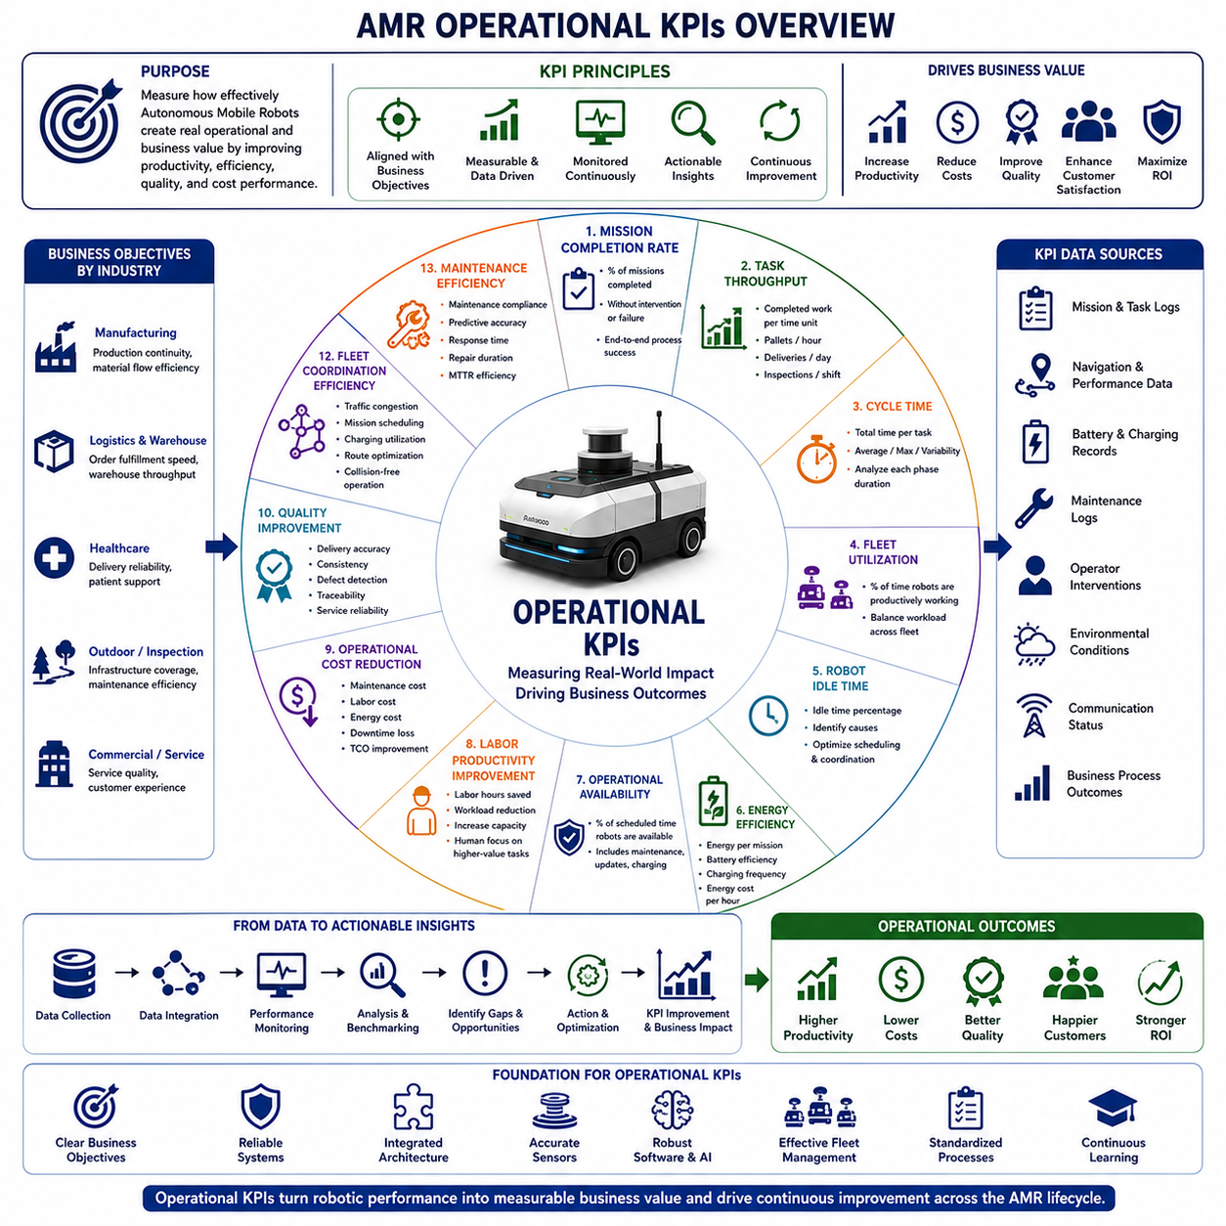
Operational Key Performance Indicators, commonly referred to as Operational KPIs, provide measurable business-oriented metrics that evaluate how effectively an Autonomous Mobile Robot contributes to real-world operational objectives rather than focusing solely on technical system performance. While navigation metrics measure localization accuracy, safety metrics evaluate risk reduction, and reliability metrics quantify long-term system stability, Operational KPIs assess whether autonomous robots generate meaningful operational value by improving productivity, reducing operational costs, increasing service quality, optimizing resource utilization, and supporting organizational goals. These indicators establish a direct relationship between engineering performance and business outcomes, allowing manufacturers, fleet operators, facility managers, and customers to objectively evaluate return on investment throughout the complete operational lifecycle of an AMR deployment.
Operational KPI development begins by identifying the primary business objectives associated with autonomous robot deployment. Different industries prioritize different operational goals depending on their environments and workflows. Manufacturing facilities emphasize production continuity and material flow efficiency, logistics centers prioritize order fulfillment speed and warehouse throughput, hospitals focus on delivery reliability and patient support, while outdoor inspection robots concentrate on infrastructure coverage and maintenance efficiency. Engineers therefore define operational KPIs according to measurable business processes rather than generic robotic capabilities, ensuring that system optimization directly supports organizational performance.
Mission completion rate represents one of the most fundamental operational KPIs because it directly reflects the robot's ability to execute assigned work successfully. This metric measures the percentage of scheduled missions completed without operator intervention, emergency termination, or significant performance degradation. Mission completion considers navigation, perception, localization, task execution, docking, charging, communication, and software coordination as an integrated operational process. High mission completion rates indicate that autonomous robots consistently deliver expected services under realistic operating conditions while minimizing operational disruption and manual assistance.
Task throughput evaluates the amount of productive work completed within a specified period of time. Depending on the application, throughput may represent transported pallets per hour, completed inspections per shift, delivered medical supplies per day, cleaned floor area per hour, inspected infrastructure length per mission, or serviced customer requests per operational cycle. Throughput provides a direct measurement of operational productivity and allows organizations to compare autonomous systems against manual processes, previous automation solutions, or competing robotic platforms. Continuous throughput analysis also reveals operational bottlenecks that limit overall system efficiency.
Cycle time measures the total duration required to complete an individual operational task from initiation to successful completion. A complete mission cycle typically includes task assignment, route planning, autonomous navigation, obstacle avoidance, arrival verification, task execution, reporting, and return to standby or charging locations. Engineers analyze average cycle time, maximum cycle time, cycle time variability, and time consumed by individual operational phases. Reducing unnecessary delays within each cycle improves overall productivity while increasing the number of missions completed during each operational period.
Fleet utilization measures how effectively autonomous robots are employed throughout daily operations. Utilization is generally defined as the percentage of total available operational time spent performing productive work rather than remaining idle, charging, waiting for assignments, or undergoing maintenance. Balanced fleet utilization maximizes investment efficiency while preventing excessive wear on individual robots. Fleet management systems continuously monitor workload distribution and dynamically assign missions to maintain optimal utilization across multiple autonomous platforms operating simultaneously.
Robot idle time serves as an important complementary KPI because excessive inactivity often indicates inefficient operational planning or underutilized assets. Idle periods may result from insufficient task scheduling, communication delays, inefficient routing, waiting for elevators, unavailable loading stations, charging congestion, or poor coordination with human operators. Continuous monitoring of idle time enables engineers and operations managers to optimize workflow scheduling, improve fleet coordination, and increase overall productivity without requiring additional robotic hardware.
Energy efficiency has become an increasingly important operational KPI as autonomous robots operate continuously across large industrial and commercial environments. Engineers evaluate energy consumption per mission, energy usage per transported unit, battery utilization efficiency, charging frequency, charging duration, regenerative energy recovery, standby power consumption, and energy cost per operational hour. Optimizing energy efficiency extends operating duration, reduces charging interruptions, lowers electricity costs, and improves long-term sustainability while supporting environmentally responsible robotic deployment.
Operational availability measures the percentage of scheduled service time during which robots remain capable of performing productive work. Availability differs from reliability because it incorporates planned maintenance, software updates, charging activities, operational scheduling, and organizational constraints in addition to unexpected failures. High operational availability ensures that autonomous robots remain accessible whenever required, minimizing disruptions to production schedules, logistics operations, healthcare services, or municipal activities while maximizing the value of robotic investments.
Labor productivity improvement represents one of the primary economic objectives of AMR deployment. Operational KPIs therefore evaluate the reduction in manual transportation, repetitive inspection tasks, routine material handling, or administrative workload achieved through autonomous operation. Productivity improvements may be measured as labor hours saved, operator workload reduction, increased production capacity, improved staffing flexibility, or enhanced allocation of human workers toward higher-value activities requiring judgment, creativity, or direct customer interaction.
Operational cost reduction measures the financial impact of robotic deployment throughout long-term operation. Engineers and business managers evaluate maintenance costs, labor costs, transportation costs, energy expenses, downtime losses, inventory movement costs, inspection expenses, and facility operating costs before and after automation. Comprehensive cost analysis extends beyond initial equipment investment to include lifecycle operating expenses, software maintenance, spare parts, training, infrastructure support, and productivity improvements that collectively determine total cost of ownership.
Quality improvement represents another essential operational KPI because autonomous systems often perform repetitive tasks more consistently than manual operations. Depending on application requirements, quality indicators include delivery accuracy, inspection repeatability, positioning precision, inventory accuracy, defect detection consistency, documentation completeness, traceability, and service reliability. Standardized autonomous workflows reduce process variation while providing consistent operational quality regardless of shift changes, operator experience, or workload fluctuations.
Customer service performance becomes increasingly important as autonomous robots interact directly with end users in hospitals, hotels, airports, shopping centers, offices, and smart cities. Operational KPIs evaluate response time, service completion reliability, customer waiting time, request fulfillment rate, user satisfaction, interaction quality, multilingual assistance effectiveness, and accessibility support. Positive customer experiences contribute directly to organizational reputation while increasing acceptance of autonomous technologies in public environments.
Fleet coordination efficiency measures the ability of multiple robots to cooperate without creating operational conflicts or unnecessary delays. Engineers evaluate traffic congestion frequency, coordinated mission scheduling, charging station utilization, collision-free fleet operation, shared resource allocation, route optimization effectiveness, and cooperative task execution. Effective fleet coordination maximizes overall system productivity while minimizing travel distance, waiting time, and energy consumption across the entire robotic population.
Maintenance efficiency evaluates how effectively maintenance activities preserve operational performance throughout the robot's lifecycle. Important KPIs include preventive maintenance compliance, predictive maintenance accuracy, maintenance response time, spare part availability, repair duration, technician productivity, maintenance cost per operating hour, and maintenance-related downtime. Data-driven maintenance strategies improve operational continuity while reducing unexpected failures and optimizing service resource allocation.
Artificial intelligence contributes directly to operational KPIs by continuously optimizing robotic decision making based on accumulated operational experience. AI-driven analytics identify workflow inefficiencies, predict operational bottlenecks, recommend route improvements, optimize charging schedules, forecast maintenance requirements, prioritize mission assignments, and adapt operational behavior according to changing environmental conditions. Foundation models, multimodal perception systems, and machine learning algorithms increasingly support intelligent operational optimization beyond traditional rule-based automation.
Operational KPI monitoring depends heavily on continuous data collection throughout daily robot operation. Fleet Management Systems aggregate mission histories, navigation statistics, charging records, maintenance logs, operator interventions, environmental observations, communication status, sensor diagnostics, and business process outcomes into centralized operational databases. Cloud-based analytics transform these raw datasets into meaningful operational dashboards that enable managers to monitor performance trends, compare facilities, benchmark deployments, and identify opportunities for continuous improvement across multiple robotic fleets.
Benchmarking provides essential context for interpreting Operational KPIs because isolated numerical values often lack practical meaning. Organizations compare current performance against historical baselines, manual operations, alternative automation systems, industry best practices, contractual service requirements, and predefined business objectives. Benchmark-driven evaluation enables objective assessment of deployment success while supporting future investment decisions, product development priorities, and operational optimization initiatives based on measurable evidence rather than subjective impressions.
Operational KPIs ultimately bridge the gap between engineering excellence and business value by translating technical system performance into measurable organizational outcomes. Rather than focusing exclusively on navigation accuracy, perception quality, or hardware reliability, Operational KPIs integrate productivity, availability, efficiency, quality, customer satisfaction, cost reduction, fleet coordination, maintenance effectiveness, and strategic business objectives into a unified operational performance framework. As autonomous robotic systems continue expanding across increasingly diverse industries, Operational KPIs will evolve toward real-time business intelligence platforms capable of continuously optimizing robotic operations, predicting organizational performance, supporting autonomous decision making, and maximizing the long-term economic and operational value generated by intelligent robotic ecosystems.

