Volume 01. AMR Foundations and System Architecture

11. Use Case Definition · 유스케이스 정의

11.01 Manufacturing Use Cases · 제조 유스케이스
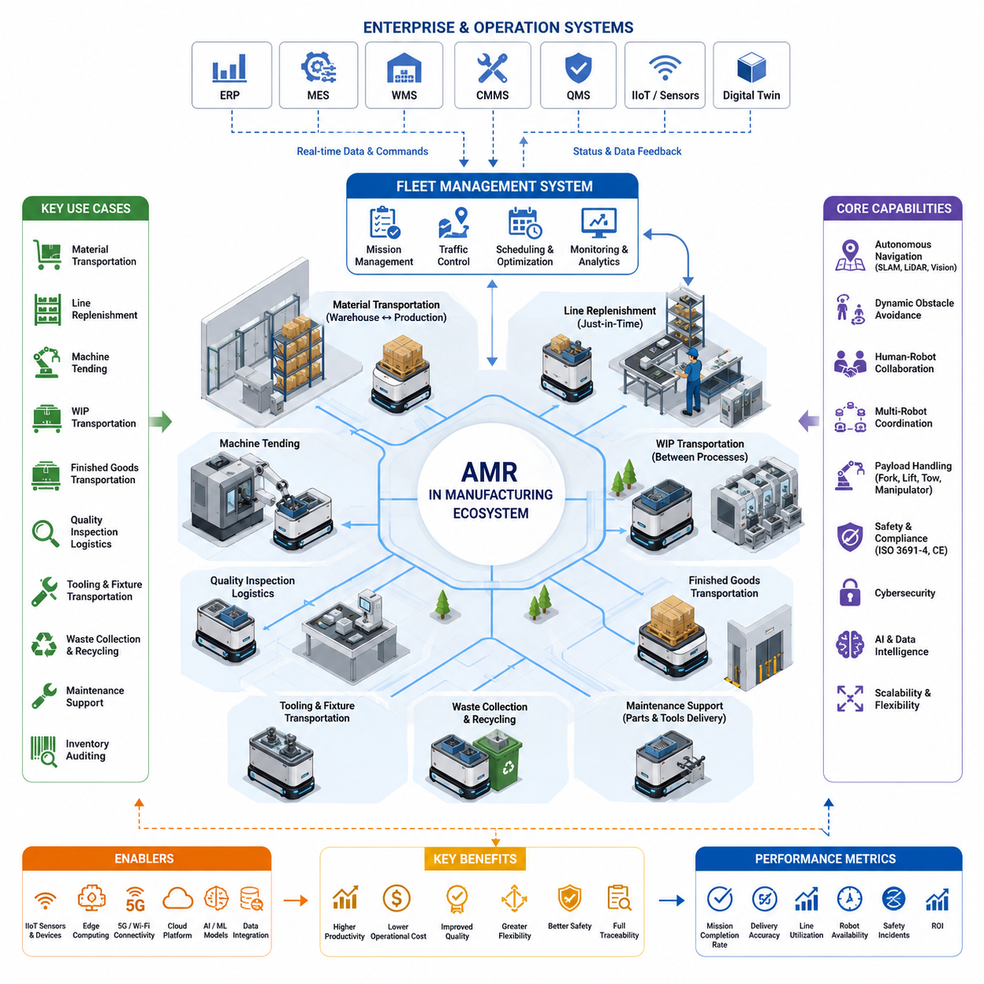
Modern manufacturing environments represent one of the most mature and economically significant application domains for Autonomous Mobile Robots. Unlike traditional Automated Guided Vehicles that follow predetermined routes, AMRs dynamically perceive their surroundings, continuously localize themselves, and autonomously determine safe and efficient paths while interacting with people, machines, and other robots. Manufacturing use cases therefore emphasize operational flexibility, scalability, and intelligent decision making across continuously changing production environments. As factories transition toward Industry 4.0 and increasingly data-driven operations, AMRs become mobile cyber-physical systems that connect production equipment, warehouse infrastructure, enterprise software, and human operators into a unified autonomous manufacturing ecosystem.
Manufacturing use cases begin with understanding production workflows rather than selecting robotic hardware. Every deployment should first identify material flows, production bottlenecks, transportation frequency, safety requirements, environmental constraints, payload characteristics, and interactions with existing automation systems. A successful use case defines not only what the robot transports but also why transportation occurs, when missions are triggered, how exceptions are handled, and which operational metrics determine project success. This process-oriented perspective ensures that AMRs improve the overall manufacturing system instead of merely replacing manual transportation tasks.
One of the most common manufacturing use cases is autonomous material transportation between warehouses and production lines. Raw materials, semi-finished components, packaging supplies, and production tools must be delivered precisely when required without interrupting manufacturing schedules. AMRs receive transport requests directly from Manufacturing Execution Systems, Warehouse Management Systems, Enterprise Resource Planning platforms, or production equipment, allowing logistics operations to respond dynamically to production demand. This just-in-time transportation minimizes inventory accumulation while improving production continuity and reducing unnecessary manual handling.
Production line replenishment represents another high-value application. Components are continuously consumed during assembly, machining, welding, painting, or packaging processes, requiring timely replenishment before shortages interrupt production. AMRs automatically monitor inventory levels through MES integration, RFID systems, barcode scanning, or smart shelving sensors. When inventory reaches predefined thresholds, transport missions are generated automatically, allowing robots to retrieve materials from storage locations and deliver them directly to designated workstations without requiring operator intervention. This approach reduces line stoppages while improving production efficiency and inventory accuracy.
Autonomous transportation of work-in-progress materials is equally important in flexible manufacturing systems. Parts frequently move through multiple production stages such as machining, inspection, heat treatment, assembly, cleaning, coating, and quality verification before becoming finished products. Instead of relying on fixed conveyors that limit production flexibility, AMRs dynamically connect independent manufacturing cells according to current production schedules. As production priorities change, transportation routes, task sequences, and delivery destinations can be updated immediately through software without requiring expensive mechanical modifications to the factory layout.
Machine tending is another widely adopted manufacturing use case. AMRs equipped with robotic manipulators or specialized loading mechanisms transport components to CNC machines, injection molding systems, laser cutters, 3D printers, or automated assembly equipment. After machine processing is completed, finished parts are collected and transported to downstream operations. Integration with machine controllers enables robots to synchronize loading and unloading operations automatically, reducing idle machine time while increasing equipment utilization and enabling lights-out manufacturing during unattended production shifts.
Finished goods transportation forms an essential link between manufacturing and warehouse operations. After products complete final inspection, packaging, and labeling, AMRs transport pallets, containers, or carts from production areas to warehouses, shipping stations, or automated storage systems. Intelligent fleet scheduling prioritizes urgent shipments, balances transportation workloads, and minimizes congestion in shared factory corridors. The result is improved production throughput and faster response to customer orders without requiring dedicated manual transportation personnel.
Quality inspection logistics constitute another critical manufacturing use case. Products requiring dimensional inspection, optical analysis, X-ray evaluation, functional testing, or laboratory verification must be transported efficiently between production stations and inspection facilities. AMRs automatically collect completed products, deliver them to inspection equipment, wait for inspection completion if necessary, and return approved products to production or move rejected products to designated quarantine areas. Digital traceability links transportation history with inspection results, creating comprehensive manufacturing records that support quality assurance and regulatory compliance.
Manufacturing environments frequently require transportation of specialized tooling, fixtures, molds, welding equipment, calibration instruments, and maintenance resources. AMRs enable rapid deployment of these assets between production lines according to changing production schedules. Instead of maintaining duplicate tooling at every workstation, organizations can share expensive equipment efficiently across multiple production cells. Intelligent scheduling ensures that tools arrive before production begins while minimizing idle equipment time and reducing capital investment.
Many factories also employ AMRs for autonomous waste collection and recycling operations. Manufacturing processes generate scrap materials, defective components, packaging waste, metal chips, plastic residues, and consumable materials that require regular removal. Robots can collect waste containers according to predefined schedules or sensor-based fill levels and transport them to centralized recycling or disposal facilities. Separating production logistics from waste management reduces unnecessary human movement while maintaining cleaner and safer manufacturing environments.
Maintenance support represents an increasingly valuable manufacturing application. Maintenance technicians often spend considerable time transporting replacement parts, diagnostic equipment, lubricants, batteries, and specialized tools across large industrial facilities. AMRs can automatically deliver requested maintenance resources directly to technicians after receiving work orders from Computerized Maintenance Management Systems. This reduces technician travel time, accelerates equipment repair, and increases overall production availability by allowing maintenance personnel to concentrate on technical problem solving instead of logistics.
Autonomous inventory auditing has emerged as an important use case in digital manufacturing. AMRs equipped with barcode scanners, RFID readers, cameras, and computer vision systems navigate warehouse aisles and production storage areas while continuously verifying inventory levels and storage locations. Collected information synchronizes with warehouse databases to identify inventory discrepancies, misplaced materials, expired components, or missing stock. Automated inventory verification improves supply chain accuracy while eliminating repetitive manual counting activities.
Collaborative manufacturing environments require robots to safely coexist with operators, forklifts, AGVs, autonomous forklifts, and other AMRs. Manufacturing use cases therefore emphasize dynamic obstacle avoidance, human intention prediction, adaptive speed control, and context-aware navigation behaviors. Robots must recognize pedestrians, temporary obstacles, production carts, open safety gates, and changing workspace configurations while maintaining safe operational distances. Collaborative operation enables robots to support human workers rather than isolate automation within restricted areas.
Flexible manufacturing systems increasingly demand rapid product changeovers and production reconfiguration. AMRs contribute significantly by eliminating fixed transportation infrastructure such as conveyors or guide rails. Production cells can be rearranged according to changing customer requirements, new product introductions, or seasonal demand without extensive facility reconstruction. Mission definitions, navigation maps, and transportation workflows are updated through software, allowing manufacturing operations to adapt quickly while minimizing engineering effort and production downtime.
Large manufacturing facilities commonly deploy heterogeneous robot fleets composed of towing AMRs, pallet-moving robots, autonomous forklifts, inspection robots, collaborative manipulators, and specialized logistics vehicles. Fleet Management Systems coordinate mission allocation, traffic control, charging schedules, route optimization, and resource utilization across all robotic platforms. Manufacturing use cases therefore extend beyond individual robots toward coordinated multi-robot ecosystems where centralized scheduling and decentralized autonomy operate together to maximize factory productivity and transportation efficiency.
Manufacturing use cases also benefit from integration with Industrial Internet of Things infrastructures. Smart sensors, programmable logic controllers, digital twins, environmental monitoring systems, production databases, and edge computing platforms continuously generate operational information that influences robot decision making. AMRs receive production priorities, equipment status, workstation availability, inventory updates, and maintenance alerts in real time, allowing transportation behavior to adapt automatically as manufacturing conditions evolve. Data sharing between physical operations and digital systems creates a responsive manufacturing environment capable of continuous optimization.
Artificial intelligence further enhances manufacturing use cases by enabling predictive and adaptive decision making. Machine learning models forecast production demand, estimate transportation workloads, optimize fleet allocation, predict battery consumption, identify congestion patterns, and recommend improved logistics strategies. Computer vision supports automatic pallet identification, container recognition, workstation localization, and anomaly detection. Foundation models and multimodal AI increasingly assist robots in interpreting complex manufacturing environments, understanding operator instructions, and adapting to previously unseen operational situations while maintaining safe autonomous behavior.
Outdoor manufacturing facilities introduce additional use cases involving transportation between production buildings, warehouses, loading docks, material yards, and inspection stations. Outdoor AMRs must navigate uneven terrain, changing weather, varying illumination, and mixed traffic conditions while maintaining localization accuracy and operational reliability. Integration of GNSS, LiDAR, cameras, radar, IMU, and sensor fusion technologies enables robust navigation across large industrial campuses where traditional indoor localization methods alone are insufficient.
Safety remains a fundamental requirement throughout every manufacturing use case. Robots must comply with applicable industrial safety standards while implementing redundant sensing, emergency stopping, fault diagnosis, functional safety architectures, and cybersecurity protections. Risk assessments identify hazards associated with payload characteristics, robot speed, shared workspaces, and human interactions. Safe operational behaviors include controlled stopping distances, speed adaptation near personnel, protected manual override functions, and continuous health monitoring of critical subsystems. Safety is therefore integrated into every stage of use case definition rather than treated as an isolated engineering activity.
Successful manufacturing deployments require comprehensive operational metrics that extend beyond simple transportation speed. Performance indicators include mission completion rate, delivery accuracy, production line utilization, transportation cycle time, fleet efficiency, robot availability, battery utilization, maintenance frequency, navigation reliability, human intervention rate, safety incident frequency, inventory accuracy, and return on investment. Continuous monitoring of these metrics enables iterative optimization of manufacturing workflows and provides objective evidence of operational improvements after AMR deployment.
As manufacturing evolves toward highly connected autonomous factories, AMR use cases continue expanding from isolated logistics automation to intelligent production orchestration. Future manufacturing robots will coordinate seamlessly with digital twins, AI planning systems, autonomous production equipment, collaborative robotic arms, predictive maintenance platforms, and enterprise decision-support systems. Rather than functioning solely as autonomous transport vehicles, next-generation AMRs will become adaptive manufacturing agents capable of understanding production objectives, coordinating with multiple intelligent systems, and autonomously optimizing factory operations in real time while maintaining high levels of safety, reliability, flexibility, and operational efficiency.

11.02 Hospital Use Cases · 병원 유스케이스
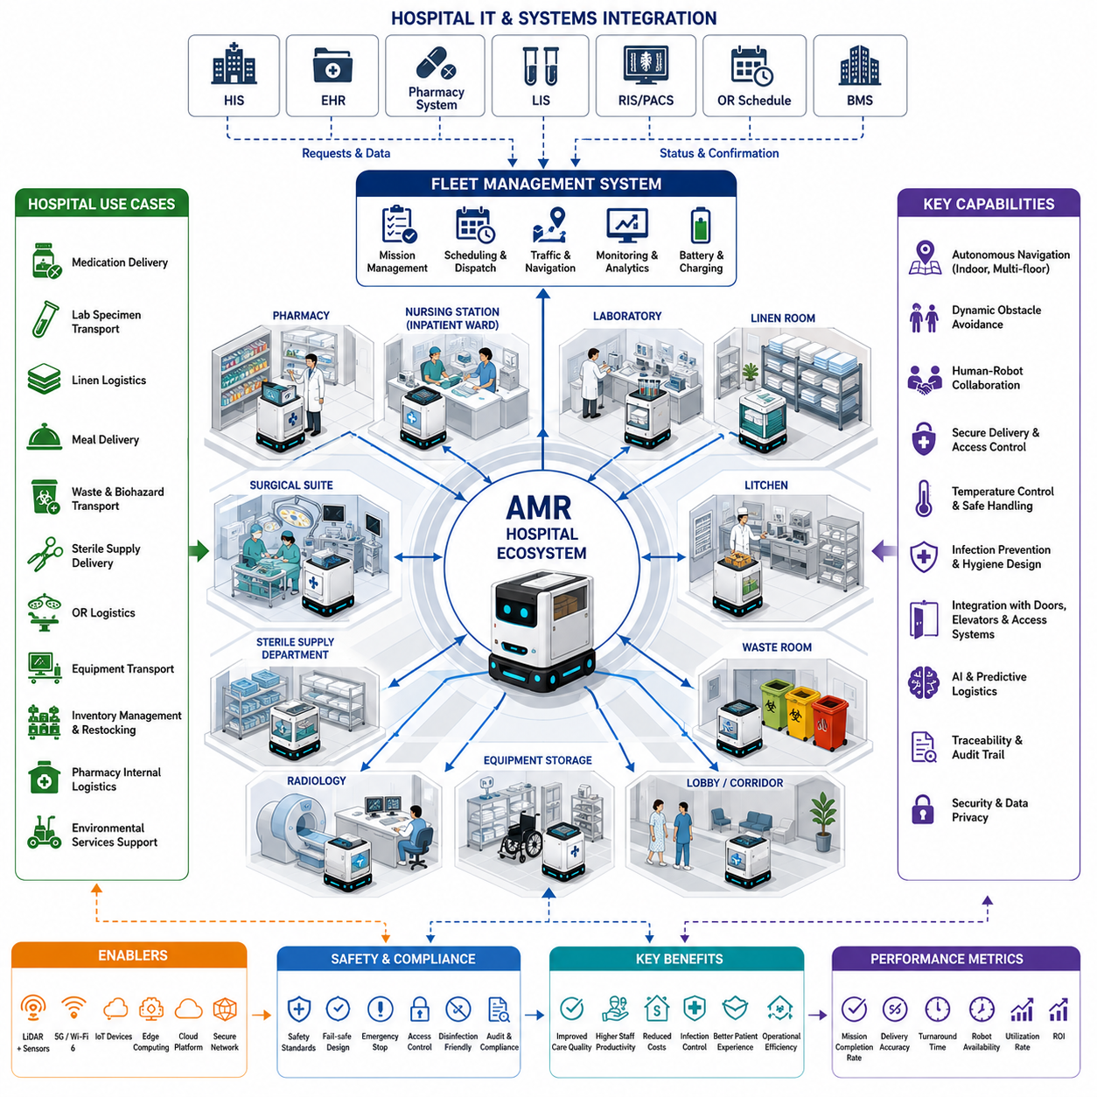
Hospitals represent one of the most complex and highly regulated operational environments for Autonomous Mobile Robots. Unlike manufacturing facilities that emphasize production efficiency or warehouses that prioritize logistics throughput, hospitals require robots to operate safely among patients, healthcare professionals, visitors, and sensitive medical equipment while supporting clinical workflows without disrupting patient care. Hospital use cases therefore extend beyond simple transportation tasks and focus on improving healthcare quality, operational efficiency, infection control, traceability, staff productivity, and patient experience. As modern healthcare increasingly embraces digital transformation, AMRs become intelligent service platforms that integrate physical logistics with hospital information systems, clinical scheduling, and real-time operational management.
Hospital use case definition begins with understanding medical workflows rather than robotic technology. Every hospital consists of interconnected departments including emergency care, inpatient wards, operating rooms, intensive care units, pharmacies, laboratories, radiology, sterilization centers, kitchens, and logistics facilities. Each department has unique transportation requirements, operational priorities, access restrictions, and hygiene regulations. Successful AMR deployment therefore starts by analyzing how medical supplies, medications, laboratory specimens, linens, meals, waste, equipment, and information move throughout the hospital. The objective is to reduce repetitive manual transportation while allowing healthcare professionals to devote more time to direct patient care.
Autonomous medication delivery represents one of the most widely adopted hospital use cases. Pharmacies prepare medications according to physician prescriptions, after which AMRs transport medications securely to nursing stations, inpatient wards, emergency departments, outpatient clinics, or operating rooms. Secure electronic compartments, user authentication, access logging, and delivery confirmation ensure that medications remain protected throughout transportation. Integration with Hospital Information Systems, Electronic Medical Records, and pharmacy management software allows medication delivery requests to be generated automatically while maintaining complete digital traceability from pharmacy preparation to final clinical delivery.
Laboratory specimen transportation is another critical healthcare application. Blood samples, tissue specimens, urine samples, microbiological cultures, and diagnostic materials require timely transportation from patient care units to laboratory facilities while maintaining strict chain-of-custody procedures. AMRs equipped with temperature-controlled compartments, vibration reduction mechanisms, and sealed containers transport biological samples safely without contamination or excessive handling. Automated scheduling minimizes transportation delays, shortens laboratory turnaround time, and enables faster clinical decision making, particularly in emergency medicine where rapid diagnosis directly affects patient outcomes.
Hospital linen logistics provide significant operational benefits through automation. Clean linens, patient gowns, towels, blankets, and surgical textiles must be delivered continuously to multiple departments while used linens are collected and transported to laundry processing facilities. AMRs execute scheduled transportation routes throughout the day, reducing manual cart movement performed by hospital staff. By separating clean and contaminated transportation workflows through dedicated robots or compartment management, hospitals further improve infection prevention while ensuring continuous availability of essential textile supplies.
Meal delivery and nutrition support represent important non-clinical hospital use cases. Hospital kitchens prepare meals according to physician-approved dietary requirements, including diabetic diets, low-sodium meals, pediatric nutrition, and specialized therapeutic diets. AMRs transport meal carts to patient wards according to scheduled meal times while maintaining temperature requirements for hot and cold foods. After meal service, robots collect empty trays and return them to kitchen facilities for cleaning. Automation improves delivery consistency while reducing physical workload for dietary service personnel.
Waste collection and biohazard transportation require strict operational control within healthcare facilities. Hospitals generate general waste, recyclable materials, pharmaceutical waste, infectious waste, and hazardous biological materials that must follow different disposal procedures. AMRs transport sealed waste containers according to predefined safety protocols while minimizing human exposure to potentially hazardous materials. Dedicated navigation routes, isolated storage compartments, and access restrictions ensure that waste transportation remains completely separated from clean logistics, reducing contamination risks throughout hospital operations.
Sterile supply distribution constitutes another high-value hospital application. Central Sterile Supply Departments continuously process surgical instruments, sterile trays, medical devices, and reusable equipment before distributing them to operating rooms and clinical departments. AMRs transport sterile equipment in enclosed compartments designed to preserve sterility throughout transportation. Delivery requests are generated according to surgical schedules and clinical demand, ensuring that operating rooms receive required instruments before procedures begin while improving utilization of expensive medical equipment.
Operating room logistics involve highly coordinated transportation activities with strict timing requirements. Surgical procedures require instruments, implants, consumable materials, blood products, medications, imaging devices, and specialized equipment to arrive at precise times. AMRs support surgical workflows by delivering requested resources before operations begin and transporting completed surgical specimens to pathology laboratories immediately after procedures. Integration with operating room scheduling systems enables transportation activities to adapt automatically as surgical schedules change throughout the day.
Hospital equipment transportation represents another expanding use case. Mobile ultrasound systems, patient monitoring equipment, infusion pumps, ventilators, portable imaging systems, wheelchairs, and specialized diagnostic devices are frequently shared among departments. AMRs can transport or tow selected medical equipment between clinical areas according to operational demand, reducing delays caused by equipment availability while improving utilization of expensive hospital assets. Intelligent scheduling prevents unnecessary duplication of equipment purchases by enabling efficient resource sharing across the entire healthcare facility.
Inventory management within hospitals increasingly benefits from autonomous robotic support. Medical consumables, personal protective equipment, syringes, gloves, dressings, catheters, intravenous supplies, and emergency materials must remain continuously available throughout clinical departments. AMRs equipped with barcode scanners, RFID readers, and inventory verification systems monitor storage locations, identify inventory shortages, and automatically replenish medical supplies from central warehouses. Continuous inventory visibility improves operational readiness while reducing expired inventory and emergency stock shortages.
Hospital pharmacies also benefit from internal inventory transportation and restocking automation. Medication storage areas often contain thousands of pharmaceutical products requiring strict inventory control, expiration monitoring, and secure handling. AMRs transport medications between storage zones, automated dispensing cabinets, compounding facilities, and pharmacy workstations while maintaining electronic records of every movement. This improves inventory accuracy, reduces manual handling errors, and supports regulatory compliance for controlled substances and high-value medications.
Environmental services represent another valuable application area for hospital AMRs. Cleaning equipment, disinfectants, floor care supplies, waste containers, and sanitation resources must be distributed efficiently throughout large healthcare facilities. Robots transport cleaning resources according to maintenance schedules while coordinating with housekeeping personnel. Future systems increasingly integrate autonomous floor cleaning robots with logistics AMRs to create coordinated environmental management platforms capable of maintaining hospital hygiene standards with minimal human intervention.
Hospitals frequently consist of multiple buildings connected through corridors, underground tunnels, elevators, and service pathways. AMRs therefore require reliable autonomous navigation across complex indoor environments with continuously changing traffic conditions. Integration with automatic doors, elevators, access control systems, and building management infrastructure enables robots to travel safely between departments while minimizing disruption to patients and healthcare staff. Dynamic obstacle avoidance is particularly important because hospital corridors contain patients, stretchers, wheelchairs, medical carts, visitors, and emergency response teams moving unpredictably.
Human-robot collaboration is a defining characteristic of hospital robotics. Unlike industrial environments where robots may operate within controlled production areas, hospital robots function continuously alongside nurses, physicians, technicians, patients, visitors, and maintenance personnel. Navigation systems therefore emphasize smooth motion planning, socially acceptable path selection, adaptive speed control, human intention prediction, courteous yielding behavior, and clear communication through visual displays, audio notifications, and status indicators. The objective is to create robots that behave as trusted assistants rather than mobile obstacles.
Infection prevention remains one of the most important design considerations in hospital use cases. Robot surfaces must tolerate frequent disinfection using hospital-grade cleaning agents without degrading sensors or electronic components. Contactless delivery mechanisms, sealed storage compartments, antimicrobial materials, and automated cleaning procedures further reduce contamination risks. Navigation strategies may also separate transportation routes for sterile supplies, contaminated materials, pharmaceutical products, and public traffic, minimizing cross-contamination throughout the facility.
Artificial intelligence significantly enhances hospital operations by enabling predictive logistics and intelligent workflow optimization. Machine learning models forecast medication demand, estimate supply consumption, predict transportation workloads, optimize fleet allocation, and identify operational bottlenecks before they affect patient care. Computer vision supports corridor monitoring, obstacle recognition, occupancy estimation, and autonomous docking, while multimodal AI assists robots in understanding spoken requests, interpreting digital work orders, and coordinating with hospital information systems. AI transforms robotic logistics from reactive transportation into proactive operational support.
Fleet management plays a central role in large hospital deployments where dozens or even hundreds of robots operate simultaneously. Fleet Management Systems allocate missions according to urgency, battery level, department priority, transportation distance, robot availability, and traffic conditions. Emergency medication deliveries receive higher priority than routine linen transportation, while laboratory specimens may require strict delivery deadlines. Intelligent scheduling continuously balances workload across the robotic fleet, maximizing transportation efficiency without compromising critical healthcare operations.
Cybersecurity and data privacy are fundamental requirements for hospital robotic systems because they operate within environments containing sensitive patient information and mission-critical healthcare infrastructure. Robots communicate securely with hospital servers using encrypted communication channels while complying with healthcare cybersecurity policies. Authentication, authorization, audit logging, secure software updates, and network segmentation protect both clinical information and robotic operations against unauthorized access or cyber threats. Maintaining system integrity is essential because robotic failures may directly influence healthcare service delivery.
Performance evaluation of hospital AMR deployments extends beyond transportation speed or operational throughput. Hospitals evaluate mission completion rates, medication delivery accuracy, specimen turnaround time, staff walking distance reduction, patient waiting time, robot availability, fleet utilization, battery efficiency, infection control performance, equipment utilization, maintenance frequency, and overall return on investment. Clinical outcome improvements, healthcare staff satisfaction, operational resilience, and patient experience increasingly become equally important indicators of deployment success alongside traditional engineering performance metrics.
Future hospital use cases will continue evolving toward fully integrated intelligent healthcare ecosystems where AMRs collaborate seamlessly with digital hospitals, smart medical devices, electronic health records, AI diagnostic systems, autonomous service robots, and predictive hospital management platforms. Rather than functioning solely as autonomous transportation vehicles, next-generation healthcare robots will become intelligent clinical logistics agents capable of understanding hospital priorities, adapting to changing patient conditions, coordinating with multiple healthcare systems, and continuously optimizing hospital operations while maintaining the highest standards of patient safety, operational reliability, regulatory compliance, and healthcare quality.

11.03 Logistics Use Cases · 물류 유스케이스
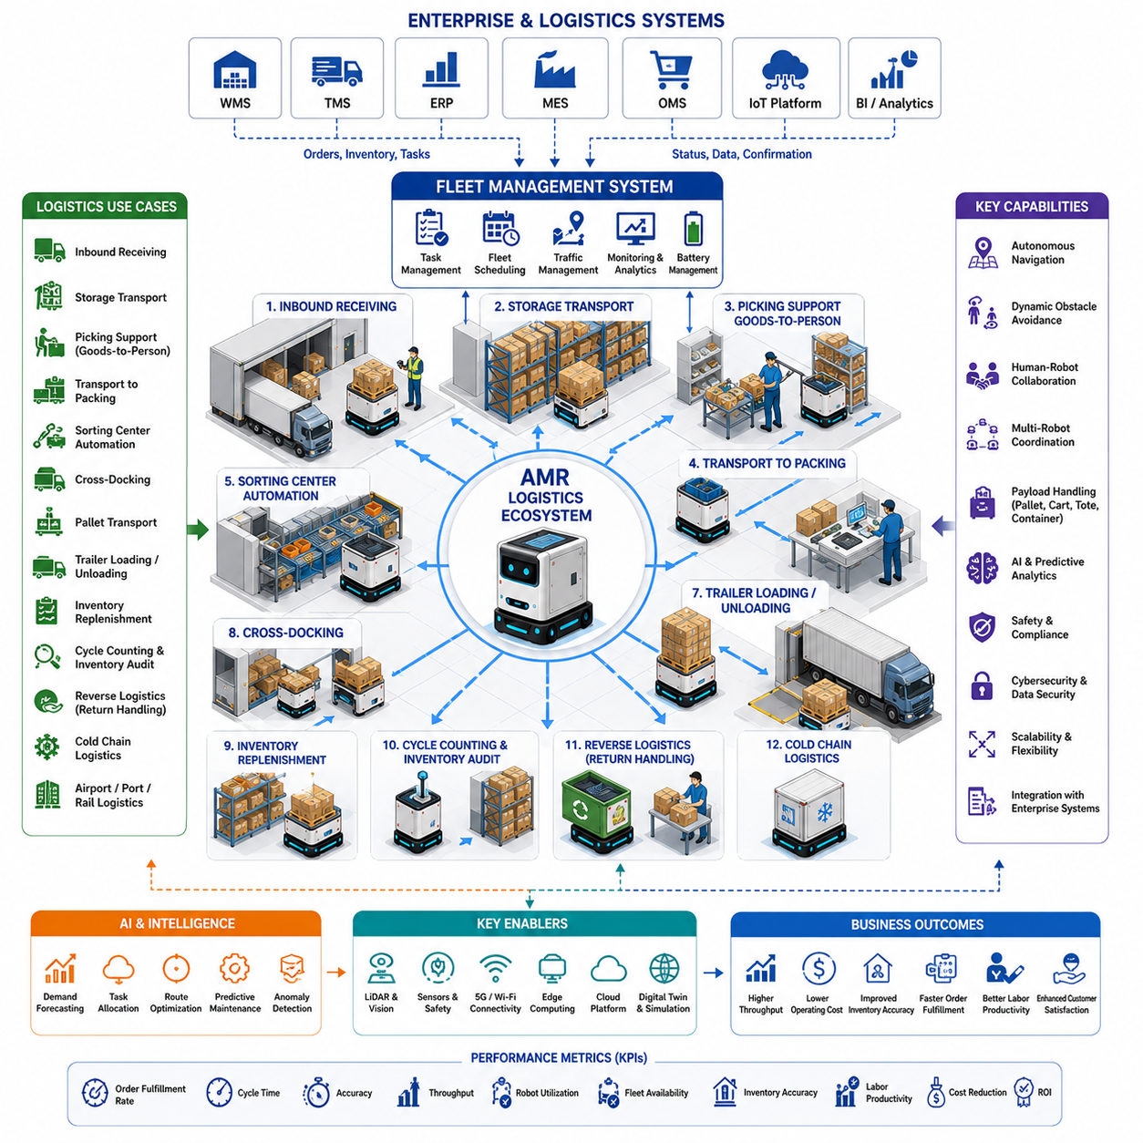
Logistics environments represent one of the largest and fastest-growing application domains for Autonomous Mobile Robots. The rapid expansion of e-commerce, omnichannel retail, global supply chains, and customer expectations for faster deliveries has transformed logistics from a traditional transportation function into an intelligent, data-driven operational ecosystem. Unlike manufacturing environments where material flows generally follow predefined production processes, logistics operations must continuously adapt to fluctuating order volumes, changing inventory locations, variable transportation priorities, and dynamic customer demand. Autonomous Mobile Robots therefore become intelligent logistics agents capable of coordinating warehouse operations, transportation activities, inventory management, and distribution processes while maintaining high operational efficiency and service reliability.
Logistics use case definition begins with analyzing the complete material flow across warehouses, fulfillment centers, cross-docking facilities, distribution centers, and transportation hubs. Successful deployment requires understanding inbound receiving processes, storage operations, order fulfillment, picking workflows, sorting activities, outbound shipping, inventory replenishment, and return logistics. Rather than replacing individual transportation tasks, AMRs should optimize the entire logistics workflow by reducing travel distances, minimizing idle time, improving inventory visibility, and coordinating material movement between multiple operational areas. This system-level perspective ensures that autonomous robots improve end-to-end logistics performance instead of optimizing isolated activities.
Inbound receiving represents one of the first logistics processes supported by AMRs. Goods arriving from suppliers must be unloaded, identified, inspected, labeled, and transported to temporary staging areas or permanent storage locations. AMRs receive transportation requests directly from Warehouse Management Systems after receiving documentation is completed. Integration with barcode scanners, RFID readers, vision systems, and automated identification technologies enables robots to verify shipment information while transporting pallets, containers, cartons, or reusable transport units to designated warehouse zones. Automated receiving reduces congestion around loading docks while accelerating inventory availability for downstream operations.
Warehouse storage transportation is another fundamental logistics use case. After inbound processing, inventory must be transported efficiently to storage racks, automated storage systems, floor locations, or specialized environmental storage areas. AMRs navigate dynamically through warehouse aisles while coordinating with forklifts, pallet movers, conveyors, and human operators. Intelligent storage assignment algorithms determine optimal destination locations according to inventory turnover, product dimensions, handling requirements, and expected future demand. This dynamic storage strategy improves warehouse utilization while reducing future picking distances and transportation costs.
Order picking support has become one of the most valuable applications for logistics AMRs. Rather than requiring warehouse workers to walk long distances while collecting products, robots travel alongside pickers or autonomously transport completed order containers between picking zones and packing stations. Goods-to-person workflows significantly reduce operator travel time while increasing picking productivity and reducing physical fatigue. AI-assisted task allocation dynamically assigns robots to active picking operations according to order priorities, robot availability, and warehouse traffic conditions, maximizing overall fulfillment efficiency.
Autonomous transportation between picking and packing operations further improves warehouse productivity. Once customer orders have been picked, AMRs transport completed order containers to packing workstations where products are verified, packaged, labeled, and prepared for shipment. Intelligent scheduling ensures that packing stations receive a balanced workload while minimizing waiting time for completed orders. Integration with Warehouse Execution Systems enables transportation requests to be generated automatically as picking tasks are completed, eliminating unnecessary manual handling and reducing order processing delays.
Sorting center automation represents another important logistics use case. Distribution centers handling large shipment volumes require continuous movement of parcels, cartons, and containers between inbound conveyors, sorting systems, destination lanes, and outbound loading areas. AMRs transport grouped shipments according to delivery routes, customer destinations, transportation carriers, or regional distribution hubs. Dynamic route optimization continuously adjusts transportation assignments based on changing shipment volumes and operational priorities, improving throughput while reducing bottlenecks during peak operating periods.
Cross-docking facilities particularly benefit from autonomous transportation because inventory remains within the facility only briefly before being transferred directly from inbound to outbound transportation. AMRs move goods rapidly between receiving docks and shipping docks according to transportation schedules and customer delivery requirements. Since cross-docking emphasizes minimal storage time, robots must coordinate closely with transportation management systems to ensure that shipments arrive at outbound loading positions before truck departure deadlines. Intelligent scheduling minimizes product dwell time while improving transportation utilization.
Pallet transportation constitutes one of the most common industrial logistics applications. Heavy pallets containing finished products, raw materials, packaged goods, or retail inventory require frequent movement throughout warehouses and distribution centers. Pallet-moving AMRs and autonomous forklifts transport standardized pallet loads between storage locations, production areas, consolidation zones, and shipping docks while maintaining high positioning accuracy. Sensor fusion combining LiDAR, cameras, IMU, and safety scanners enables reliable navigation even in warehouses with continuously changing layouts and mixed human-machine traffic.
Trailer loading and unloading support continues expanding as logistics automation matures. AMRs transport pallets or containers from staging areas directly into transportation trailers according to optimized loading sequences. Integration with loading dock management systems allows robots to synchronize transportation activities with truck arrival schedules and shipping priorities. Automated trailer loading reduces manual labor while improving loading consistency, transportation capacity utilization, and shipment turnaround time at busy logistics terminals.
Inventory replenishment is essential for maintaining efficient warehouse operations. Fast-moving inventory locations require continuous replenishment from reserve storage to prevent stock shortages during order fulfillment. AMRs monitor inventory levels through Warehouse Management Systems and automatically transport replenishment inventory before picking locations become empty. Predictive replenishment algorithms estimate future consumption based on historical demand, seasonal trends, promotional events, and order forecasts, allowing inventory movement to occur proactively instead of reactively.
Cycle counting and inventory auditing increasingly rely on autonomous robots equipped with computer vision, RFID, barcode scanners, and AI-based recognition systems. AMRs navigate warehouse aisles during operational or off-peak hours while verifying inventory quantities, storage locations, product labels, and package conditions. Continuous automated inventory verification significantly improves inventory accuracy while reducing labor-intensive manual counting activities. Real-time synchronization with warehouse databases enables immediate identification of discrepancies, misplaced products, damaged inventory, or missing stock before operational problems occur.
Reverse logistics has become increasingly important due to the growth of e-commerce and customer return programs. Returned products require inspection, quality evaluation, sorting, refurbishment, recycling, repackaging, or disposal before reentering inventory or leaving the supply chain. AMRs transport returned items between inspection stations, repair centers, quality assurance departments, and warehouse storage areas according to predefined processing workflows. Intelligent classification systems help determine appropriate handling procedures based on product condition, return reason, and business policies.
Cold chain logistics introduces specialized transportation requirements for pharmaceuticals, vaccines, fresh food, frozen products, and temperature-sensitive materials. AMRs equipped with insulated or actively temperature-controlled compartments maintain required environmental conditions throughout transportation while continuously monitoring storage temperatures. Real-time temperature logging, alarm generation, and digital traceability ensure regulatory compliance and preserve product quality during logistics operations. These capabilities are especially important in healthcare, biotechnology, and food distribution industries.
Airport cargo terminals, seaport logistics centers, railway freight facilities, and multimodal transportation hubs increasingly adopt AMRs to improve internal transportation efficiency. Containers, cargo units, baggage, parcels, and freight shipments move continuously between storage areas, customs inspection facilities, security checkpoints, loading equipment, and transportation vehicles. Autonomous navigation systems coordinate safely with trucks, forklifts, cranes, and human workers while adapting to complex outdoor and semi-outdoor operational environments characterized by varying weather conditions and large operational areas.
Human-robot collaboration remains fundamental throughout logistics operations because warehouses continue relying on both automation and skilled human workers. Robots transport heavy loads, perform repetitive transportation, and execute routine logistics missions, while human operators focus on quality verification, exception handling, customer-specific requirements, and decision making. Navigation systems emphasize safe obstacle avoidance, adaptive speed control, human intention prediction, and intuitive interaction methods that enable robots to operate naturally alongside warehouse personnel without disrupting ongoing operations.
Artificial intelligence significantly enhances logistics use cases by transforming robotic transportation into predictive logistics management. Machine learning models forecast order volumes, estimate transportation demand, optimize warehouse traffic, predict battery consumption, balance fleet utilization, and identify operational bottlenecks before performance degrades. Computer vision supports package recognition, pallet identification, container localization, and anomaly detection, while multimodal AI enables robots to understand operational instructions, interpret warehouse events, and coordinate dynamically with enterprise logistics systems.
Fleet Management Systems form the operational intelligence layer for large logistics deployments involving dozens or hundreds of AMRs. Mission allocation considers order priority, transportation distance, robot payload capacity, battery state, charging schedules, traffic conditions, equipment availability, and operational deadlines. Traffic management algorithms prevent congestion within narrow warehouse aisles while coordinating robot movement at intersections, loading docks, elevators, and shared operational zones. Intelligent fleet coordination maximizes robot utilization while minimizing transportation delays across the logistics network.
Cybersecurity and digital integration have become increasingly important because modern logistics operations depend heavily on interconnected enterprise software. Warehouse Management Systems, Enterprise Resource Planning platforms, Transportation Management Systems, Manufacturing Execution Systems, cloud services, IoT infrastructure, and AMR fleets exchange operational information continuously. Secure communication protocols, authentication mechanisms, encrypted data transmission, software integrity verification, and network segmentation protect logistics operations from cyber threats while ensuring continuous business operations and protecting sensitive customer information.
Performance evaluation within logistics environments extends far beyond measuring robot travel speed. Organizations monitor order fulfillment rate, transportation cycle time, inventory accuracy, picking productivity, shipment turnaround time, warehouse throughput, robot utilization, battery efficiency, fleet availability, labor productivity, delivery accuracy, operational cost reduction, and return on investment. These operational metrics are analyzed continuously to identify opportunities for process optimization, warehouse redesign, fleet expansion, and AI-driven workflow improvements. Continuous performance monitoring enables logistics organizations to maintain competitive operational efficiency while adapting to changing customer expectations.
Future logistics use cases will evolve toward fully autonomous supply chain ecosystems where AMRs collaborate seamlessly with autonomous forklifts, robotic picking systems, automated storage and retrieval systems, intelligent conveyors, drone inventory inspection, digital twins, AI planning engines, and cloud-based logistics platforms. Rather than functioning solely as autonomous transport vehicles, next-generation logistics robots will become intelligent supply chain agents capable of understanding business priorities, coordinating warehouse-wide operations, adapting dynamically to market demand, and continuously optimizing logistics performance while maintaining high standards of safety, scalability, reliability, operational flexibility, and customer service excellence.

11.04 Outdoor Patrol Use Cases · 실외 순찰 유스케이스
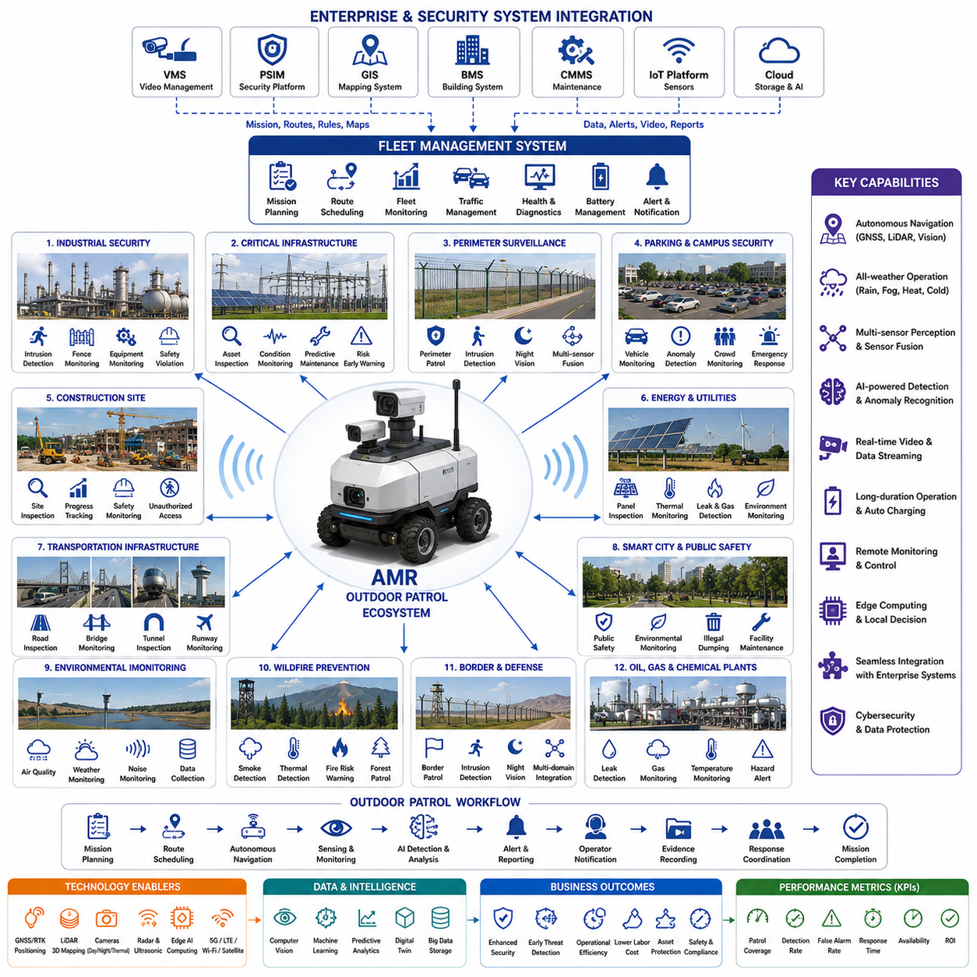
Outdoor patrol represents one of the most demanding application domains for Autonomous Mobile Robots because robots must operate safely and reliably in large, unstructured, and continuously changing environments. Unlike indoor facilities where navigation conditions remain relatively stable, outdoor patrol robots encounter varying weather, changing illumination, uneven terrain, dynamic obstacles, and mixed traffic involving pedestrians, bicycles, vehicles, and industrial equipment. Their mission extends beyond autonomous mobility to continuous environmental awareness, security monitoring, infrastructure inspection, incident detection, and real-time reporting. Outdoor patrol use cases therefore emphasize long-duration autonomous operation, robust perception, operational resilience, and seamless integration with enterprise security and facility management systems.
Outdoor patrol use case definition begins by analyzing operational objectives rather than selecting sensors or robotic platforms. Organizations must identify what assets require protection, which areas require continuous monitoring, how frequently patrols should be performed, what abnormal events should be detected, and how the robot should respond when incidents occur. A complete patrol workflow includes mission planning, route scheduling, autonomous navigation, environmental sensing, anomaly detection, event reporting, operator notification, evidence recording, and mission completion verification. This mission-oriented approach ensures that robotic patrol delivers measurable operational value rather than simply replacing manual security rounds.
Industrial facility security represents one of the most common outdoor patrol applications. Manufacturing plants, refineries, power stations, semiconductor campuses, logistics centers, and large industrial complexes require continuous monitoring of perimeter fences, restricted areas, storage yards, loading docks, pipelines, substations, and production infrastructure. AMRs autonomously patrol predefined routes while continuously collecting video, thermal imagery, environmental data, and sensor measurements. AI-based event detection automatically identifies unauthorized access, open gates, abnormal equipment conditions, damaged infrastructure, or unusual activity, enabling security personnel to respond rapidly before incidents escalate.
Critical infrastructure monitoring is another major outdoor patrol use case. Electrical substations, renewable energy facilities, water treatment plants, telecommunications infrastructure, railway systems, airports, ports, and utility installations often cover extensive geographical areas that are difficult to inspect manually on a continuous basis. Patrol robots perform scheduled inspections while monitoring equipment status, structural integrity, environmental conditions, and operational safety. Continuous autonomous monitoring reduces inspection intervals, improves preventive maintenance planning, and increases operational reliability across essential public infrastructure.
Perimeter surveillance remains one of the primary responsibilities of outdoor patrol robots. Large industrial sites, research campuses, military facilities, warehouses, and commercial complexes require continuous observation of boundary fences, entry gates, restricted access zones, and vulnerable locations. Robots patrol perimeter routes while combining visible cameras, thermal imaging, LiDAR, radar, microphones, and intelligent analytics to detect intrusion attempts, fence damage, unauthorized vehicles, suspicious objects, or abnormal human behavior. Multi-sensor fusion significantly improves detection reliability during both daytime and nighttime operations.
Parking area monitoring has become an increasingly valuable commercial application. Shopping centers, hospitals, office campuses, airports, universities, hotels, and entertainment venues operate large outdoor parking facilities where security incidents, accidents, vehicle theft, and safety concerns may occur. Patrol robots autonomously navigate parking lots while monitoring traffic conditions, identifying illegally parked vehicles, detecting abandoned objects, recognizing accidents, and assisting security personnel through real-time video streaming and incident alerts. Continuous patrol improves situational awareness while reducing the need for frequent manual inspections.
Campus security provides another important deployment scenario. Universities, corporate headquarters, research institutes, technology parks, and government facilities often require twenty-four-hour monitoring across extensive outdoor environments. Robots patrol pedestrian pathways, public gathering areas, recreational facilities, parking structures, and building entrances while maintaining visible security presence. Integration with access control systems, emergency communication infrastructure, and centralized security operation centers enables rapid incident response while improving overall campus safety.
Construction site patrol is becoming increasingly important as construction projects grow larger and more technologically advanced. Construction sites contain valuable equipment, temporary infrastructure, hazardous work areas, and continuously changing layouts that require regular monitoring. Outdoor patrol robots inspect construction progress, verify equipment locations, identify safety hazards, detect unauthorized access during non-working hours, and monitor environmental conditions such as dust, noise, and weather impacts. AI-based comparison between current observations and digital construction plans enables automated progress tracking and deviation detection.
Solar farms, wind farms, and renewable energy facilities represent ideal environments for autonomous patrol operations because they typically span vast geographic areas with relatively repetitive inspection requirements. Robots inspect photovoltaic panels, electrical connections, inverter stations, transformers, support structures, and surrounding environments while collecting thermal images and operational sensor data. Early identification of overheating panels, damaged equipment, vegetation overgrowth, or environmental hazards improves energy production efficiency while reducing maintenance costs through predictive maintenance strategies.
Oil, gas, and petrochemical facilities require continuous inspection of pipelines, storage tanks, pumping stations, valves, processing equipment, and hazardous operating zones. Outdoor patrol robots monitor potential leaks, abnormal temperatures, equipment vibration, smoke, fire indicators, gas concentrations, and unauthorized personnel while maintaining safe distances from hazardous areas. Integration with industrial safety systems enables immediate alarm generation when abnormal operating conditions exceed predefined thresholds, reducing operational risk and improving worker safety.
Smart city applications increasingly employ outdoor patrol robots to monitor parks, pedestrian streets, public squares, transportation terminals, bicycle lanes, and municipal infrastructure. Robots support municipal operations by identifying damaged public facilities, illegal dumping, traffic congestion, graffiti, environmental hazards, overflowing waste containers, and public safety incidents. Integration with city management platforms enables municipal authorities to coordinate maintenance activities efficiently while improving public service quality through continuous autonomous monitoring.
Environmental monitoring has become an important extension of patrol robotics. In addition to visual inspection, robots continuously measure air quality, temperature, humidity, atmospheric pressure, particulate matter, noise levels, radiation, gas concentrations, and weather conditions. Sensor data supports environmental compliance, industrial safety, disaster prevention, and public health initiatives. Long-term environmental monitoring also generates valuable datasets that enable predictive analysis, regulatory reporting, and infrastructure planning through digital twin platforms.
Wildfire prevention and forest monitoring represent emerging outdoor patrol use cases. Autonomous patrol robots monitor forest roads, parks, protected natural areas, and utility corridors while detecting smoke, abnormal heat sources, illegal campfires, fallen trees, or hazardous environmental conditions. Thermal imaging combined with AI-based fire detection algorithms enables early identification of wildfire risks before large-scale incidents develop. Continuous autonomous patrol significantly extends monitoring coverage beyond what human patrol teams can achieve economically.
Border security and defense applications require robust outdoor patrol systems capable of operating under harsh environmental conditions with minimal human supervision. Patrol robots inspect border fences, surveillance zones, military installations, ammunition storage areas, and restricted operational regions while detecting intrusion attempts, suspicious movement, or unauthorized vehicles. Integration with unmanned aerial systems, fixed surveillance infrastructure, and command-and-control systems enables coordinated multi-domain situational awareness for national security operations.
Transportation infrastructure inspection represents another growing use case. Roads, bridges, tunnels, railway corridors, airport runways, and port facilities require regular inspection for structural damage, debris, safety hazards, or operational anomalies. Outdoor patrol robots perform routine inspection missions while capturing high-resolution imagery, three-dimensional point clouds, thermal measurements, and structural condition data. AI-assisted defect recognition identifies pavement deterioration, cracks, corrosion, loose components, vegetation encroachment, or drainage problems before they become critical maintenance issues.
Outdoor patrol robots rely heavily on advanced perception systems because environmental uncertainty is substantially greater than in indoor applications. Multi-modal sensor fusion combines GNSS, RTK positioning, LiDAR, cameras, radar, ultrasonic sensors, IMU, and weather sensing to achieve robust localization and obstacle detection despite rain, fog, dust, snow, changing sunlight, or partial sensor degradation. Redundant perception improves operational safety while maintaining reliable autonomous navigation under challenging environmental conditions.
Artificial intelligence transforms outdoor patrol from passive observation into proactive security and operational intelligence. Computer vision models detect humans, vehicles, animals, smoke, fire, damaged infrastructure, abnormal behavior, safety violations, and environmental anomalies. Machine learning algorithms prioritize detected events according to operational risk, historical incident patterns, geographical context, and organizational policies. Foundation models and multimodal AI further improve scene understanding by combining visual, thermal, audio, environmental, and operational information into comprehensive situational awareness.
Fleet management becomes increasingly important when multiple patrol robots operate across large outdoor environments. Fleet Management Systems coordinate patrol schedules, route allocation, battery charging, mission reassignment, traffic management, maintenance planning, and emergency response. Dynamic mission scheduling allows robots to modify patrol priorities automatically according to weather conditions, detected incidents, security alerts, operator requests, or infrastructure maintenance requirements. Coordinated fleet operation significantly expands surveillance coverage while maintaining efficient utilization of robotic resources.
Reliable communication infrastructure is fundamental to successful outdoor patrol deployment. Robots continuously exchange operational status, sensor data, navigation information, video streams, and incident reports with cloud platforms, security operation centers, and remote operators using Wi-Fi, private LTE, 5G, satellite communication, or hybrid networking architectures. Edge computing enables local decision making during temporary communication loss, while cloud connectivity supports fleet coordination, long-term data storage, AI model updates, and enterprise-wide operational analytics.
Performance evaluation for outdoor patrol deployments extends well beyond navigation accuracy or mission completion. Organizations evaluate patrol coverage, incident detection rate, false alarm frequency, response time, localization accuracy, operational availability, battery endurance, communication reliability, environmental robustness, inspection completeness, maintenance efficiency, cybersecurity resilience, operator workload reduction, and overall return on investment. These metrics provide objective evidence that autonomous patrol improves safety, operational efficiency, and infrastructure reliability while reducing long-term operational costs.
Future outdoor patrol use cases will evolve toward fully autonomous intelligent security ecosystems where ground robots collaborate seamlessly with aerial drones, fixed surveillance cameras, environmental sensor networks, digital twins, AI command centers, and autonomous emergency response systems. Rather than functioning solely as mobile surveillance platforms, next-generation patrol robots will become intelligent autonomous security agents capable of understanding operational context, predicting emerging risks, coordinating with multiple robotic systems, and continuously optimizing security operations while maintaining the highest standards of safety, reliability, resilience, scalability, and autonomous decision making.

11.05 Smart City Use Cases · 스마트시티 유스케이스
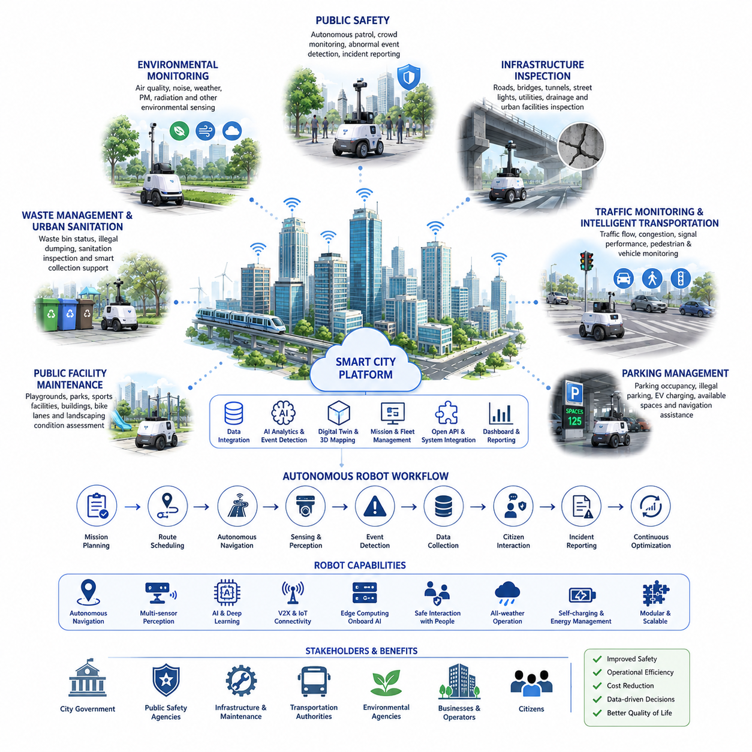
Smart cities represent one of the broadest and most integrated application domains for Autonomous Mobile Robots because they combine transportation, public safety, infrastructure management, environmental monitoring, municipal services, and citizen-centered operations into a unified digital ecosystem. Unlike industrial facilities that focus on specific operational objectives, smart cities require robots to operate across diverse urban environments while interacting with pedestrians, vehicles, public infrastructure, connected sensors, and multiple government agencies. Autonomous robots therefore become intelligent urban service agents capable of continuously collecting information, supporting public operations, improving city efficiency, and enhancing the quality of life through safe and reliable autonomous services.
Smart city use case definition begins by understanding urban operational objectives rather than focusing solely on robotic technology. City planners must identify which municipal services require automation, which public assets require continuous monitoring, what information should be collected, how frequently operations should be performed, and how robotic services integrate with existing smart city platforms. A complete operational workflow includes mission planning, route scheduling, autonomous navigation, environmental sensing, event detection, data collection, citizen interaction, incident reporting, and continuous service optimization. This service-oriented approach ensures that autonomous robots contribute directly to measurable improvements in municipal operations and public services.
Public safety is one of the most important smart city applications for autonomous mobile robots. Urban parks, pedestrian streets, transportation terminals, public plazas, cultural districts, and recreational areas require continuous monitoring to improve safety without increasing manpower requirements. Robots perform scheduled patrols while monitoring crowd density, unusual behavior, accidents, abandoned objects, vandalism, and emergency situations. AI-assisted perception enables early identification of abnormal events, allowing public safety personnel to respond rapidly while maintaining continuous situational awareness throughout large urban environments.
Municipal infrastructure inspection represents another major smart city use case. Roads, sidewalks, bridges, tunnels, street lighting, traffic signals, utility cabinets, drainage systems, bus stops, public benches, and urban facilities require regular inspection to maintain operational reliability and public safety. Autonomous robots perform routine inspection missions while collecting high-resolution imagery, three-dimensional mapping data, thermal measurements, and structural condition information. AI-based defect detection automatically identifies pavement cracks, damaged street furniture, corrosion, water leakage, loose components, or infrastructure deterioration before maintenance problems become critical.
Environmental monitoring has become a fundamental component of smart city operations. Autonomous robots continuously measure air quality, temperature, humidity, atmospheric pressure, particulate matter, noise levels, radiation, weather conditions, and other environmental parameters while moving throughout urban environments. Continuous data collection provides much higher spatial and temporal resolution than fixed monitoring stations alone. These environmental datasets support pollution control, climate adaptation, public health initiatives, disaster prevention, and long-term urban planning through comprehensive environmental intelligence.
Traffic monitoring and intelligent transportation support are increasingly important smart city applications. Robots monitor vehicle flow, pedestrian movement, bicycle traffic, parking utilization, road congestion, traffic signal performance, and temporary construction zones while sharing real-time information with intelligent transportation systems. Integration with connected traffic infrastructure enables municipal authorities to optimize traffic control strategies, improve road safety, reduce congestion, and support emergency vehicle prioritization through continuously updated urban mobility information.
Parking management is another valuable application area for autonomous city robots. Large parking facilities, commercial districts, airports, hospitals, universities, and event venues require continuous monitoring of parking occupancy, illegal parking, abandoned vehicles, electric vehicle charging stations, and pedestrian safety. Robots autonomously inspect parking areas while providing navigation assistance, identifying available parking spaces, monitoring charging infrastructure, and reporting abnormal situations to centralized management systems. Intelligent parking analytics improve space utilization while enhancing customer convenience and operational efficiency.
Waste management and urban sanitation are well suited for autonomous robotic services. Smart city robots inspect waste collection points, recycling stations, public trash containers, illegal dumping locations, and sanitation conditions throughout municipal areas. AI-assisted image analysis identifies overflowing containers, litter accumulation, hazardous waste, damaged collection equipment, or illegal disposal activities. Municipal maintenance teams receive prioritized service requests based on actual field conditions rather than fixed collection schedules, improving operational efficiency while reducing environmental impact.
Public facility maintenance benefits significantly from continuous autonomous inspection. Playgrounds, parks, sports facilities, fountains, public buildings, bicycle lanes, pedestrian pathways, and urban landscaping require regular condition assessment to ensure safe operation. Robots inspect facility conditions while identifying damaged equipment, vegetation overgrowth, broken lighting, irrigation failures, surface deterioration, and maintenance requirements. Integration with municipal asset management systems enables predictive maintenance planning and more efficient allocation of maintenance resources.
Energy management and utility monitoring represent expanding smart city use cases. Autonomous robots inspect electrical distribution equipment, renewable energy installations, district heating systems, water distribution infrastructure, gas pipelines, communication networks, and utility facilities while monitoring operational conditions. Thermal imaging, acoustic sensing, and environmental measurements help detect equipment abnormalities, leaks, overheating components, or infrastructure degradation before failures occur. Continuous autonomous inspection improves service reliability while reducing maintenance costs across essential urban utilities.
Emergency response support has become an increasingly valuable capability for smart city robots. During fires, floods, traffic accidents, hazardous material incidents, severe weather events, or public emergencies, autonomous robots provide rapid situational assessment before human responders fully enter affected areas. Robots collect visual, thermal, environmental, and structural information while identifying hazards, blocked routes, injured individuals, or infrastructure damage. Real-time information significantly improves emergency decision making while reducing risks for first responders during complex urban incidents.
Healthcare support within smart cities extends beyond hospitals into community environments. Robots assist elderly populations by monitoring public walking paths, supporting emergency call systems, delivering medical supplies between community health facilities, and providing health information services in public locations. During public health emergencies, autonomous robots assist with environmental disinfection, contactless delivery, crowd management, and public information broadcasting while minimizing unnecessary human exposure to hazardous environments.
Tourism and public information services represent highly visible smart city applications. Robots provide multilingual visitor assistance, interactive city guidance, navigation support, historical information, transportation guidance, event recommendations, and accessibility assistance for residents and visitors. Integration with city information systems enables robots to provide continuously updated information regarding transportation schedules, weather conditions, public events, emergency notifications, and nearby municipal services while improving the overall visitor experience.
Smart city robots also support cultural heritage preservation by monitoring historical buildings, monuments, archaeological sites, museums, and public artworks. Continuous autonomous inspection identifies structural deterioration, environmental damage, unauthorized activities, graffiti, vandalism, or abnormal environmental conditions that may threaten valuable cultural assets. High-resolution digital documentation further supports long-term preservation planning through digital twin technologies and historical change analysis.
Artificial intelligence serves as the central intelligence layer that transforms autonomous robots from mobile sensing platforms into intelligent urban service systems. Computer vision detects infrastructure defects, environmental hazards, vehicles, pedestrians, bicycles, animals, waste, and abnormal activities. Machine learning prioritizes detected events according to operational importance, historical trends, geographical context, and municipal policies. Foundation models and multimodal AI integrate visual information, environmental measurements, sensor observations, geographic information, and operational knowledge to provide comprehensive urban situational awareness and decision support.
Fleet management becomes essential when large numbers of autonomous robots operate simultaneously throughout metropolitan environments. Fleet Management Systems coordinate mission scheduling, route optimization, charging management, maintenance planning, operational priorities, traffic coordination, and emergency task allocation across diverse municipal services. Dynamic mission reassignment allows robots to adapt automatically to weather changes, emergency incidents, public events, infrastructure failures, or changing operational priorities while maximizing fleet utilization and service coverage.
Communication infrastructure forms the digital backbone of smart city robotic operations. Autonomous robots continuously exchange navigation information, operational status, sensor measurements, video streams, AI inference results, and service reports through Wi-Fi, private LTE, 5G, edge computing platforms, cloud infrastructure, and Internet of Things networks. Edge computing enables local autonomous decision making during temporary communication interruptions, while cloud services support long-term analytics, digital twin synchronization, AI model updates, and citywide operational coordination across multiple municipal departments.
Cybersecurity, privacy protection, and regulatory compliance are fundamental requirements for smart city robotics because robots operate within public environments while collecting significant amounts of operational and environmental information. Secure communication protocols, encrypted data transmission, authenticated access control, privacy-preserving AI processing, software integrity verification, and regulatory compliance frameworks ensure that robotic systems protect sensitive information while maintaining public trust. Responsible data governance enables municipalities to balance operational intelligence with individual privacy and ethical AI deployment.
Performance evaluation for smart city robotic services extends beyond technical navigation metrics. Municipal authorities evaluate public safety improvement, infrastructure inspection accuracy, environmental monitoring coverage, service availability, emergency response time, operational efficiency, maintenance cost reduction, citizen satisfaction, environmental sustainability, energy efficiency, asset utilization, fleet reliability, cybersecurity resilience, and long-term return on investment. These performance indicators provide objective evidence that autonomous robotic systems contribute directly to more efficient, safer, greener, and more resilient urban environments.
Future smart city use cases will evolve toward fully integrated urban intelligence ecosystems where autonomous ground robots, aerial drones, connected vehicles, intelligent infrastructure, digital twins, edge AI platforms, cloud computing, and municipal command centers operate as a coordinated cyber-physical system. Rather than performing isolated municipal tasks, next-generation autonomous robots will function as intelligent city service agents capable of understanding urban context, predicting operational risks, coordinating with multiple autonomous systems, supporting data-driven policy decisions, and continuously optimizing public services while maintaining the highest standards of safety, scalability, sustainability, resilience, interoperability, and citizen-centered autonomous operation.

