Volume 01. AMR Foundations and System Architecture

01. What is AMR · AMR이란 무엇인가

01.01 Definition of AMR · AMR의 정의
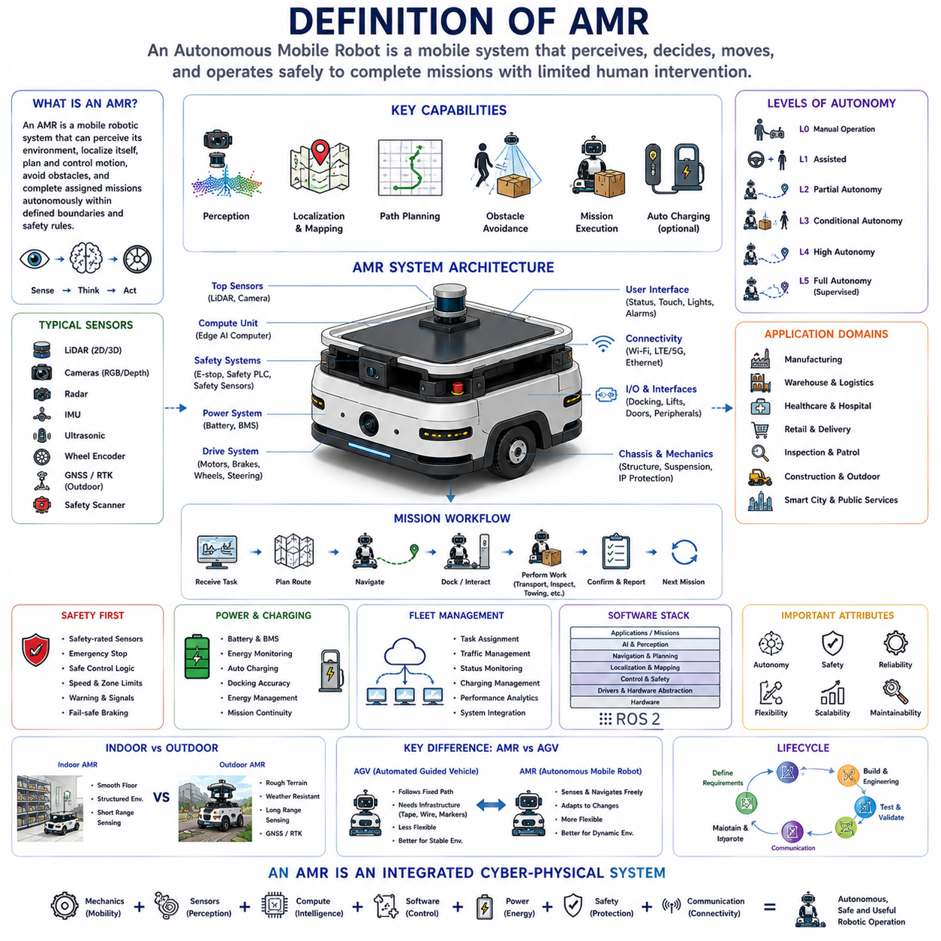
An Autonomous Mobile Robot (AMR) is a mobile robotic system capable of perceiving its surroundings, estimating its own position, planning movement, avoiding obstacles, and completing assigned missions with limited direct human control. Unlike machines that follow only fixed mechanical paths, an AMR continuously interprets environmental information and selects an appropriate route according to current conditions, operational goals, and safety constraints.
The term autonomous describes the robot’s ability to make local operational decisions without requiring an operator to command every movement. Autonomy does not mean that the robot acts without rules or supervision. An AMR operates within defined mission boundaries, safety policies, maps, traffic rules, access permissions, and system-level constraints established by designers, facility managers, fleet controllers, and regulatory requirements.
Mobility refers to the robot’s physical ability to move through an environment using wheels, tracks, steering mechanisms, suspension systems, or other locomotion structures. Most industrial AMRs use wheeled platforms because they provide high energy efficiency, controllability, mechanical simplicity, and sufficient payload capacity. The mechanical configuration may include differential drive, omnidirectional wheels, Ackermann steering, four-wheel steering, or multi-axle outdoor platforms.
The robot element means that the machine combines sensing, computation, control, actuation, and communication into a coordinated physical system. An AMR is therefore not merely a powered cart with navigation software. It is an integrated cyber-physical system in which mechanical design, electrical power, embedded computing, sensors, control software, artificial intelligence, communication networks, and safety functions operate as one product.
A fundamental characteristic of an AMR is environment-aware navigation. The robot receives data from sensors such as LiDAR, cameras, depth cameras, radar, ultrasonic sensors, inertial measurement units, wheel encoders, GNSS receivers, and safety scanners. These observations are transformed into information about free space, obstacles, surfaces, people, vehicles, infrastructure, and the robot’s own motion.
Localization allows the AMR to estimate where it is within a map or operational area. Depending on the application, localization may use wheel odometry, scan matching, visual features, LiDAR-based simultaneous localization and mapping, fiducial markers, magnetic landmarks, GNSS, real-time kinematic positioning, inertial navigation, or combinations of several methods. Reliable localization is essential because every route decision depends on an accurate understanding of the robot’s pose.
Mapping provides the spatial representation used by the robot to understand and navigate its environment. A map may contain walls, lanes, shelves, doors, elevators, docking stations, restricted zones, charging locations, road boundaries, slopes, landmarks, and semantic information. Some AMRs operate with maps created during installation, while others update their maps continuously as the environment changes.
Path planning determines how the robot should travel from its current position to a destination. Global planning selects a route across the larger map, while local planning adjusts the trajectory in response to nearby obstacles and dynamic conditions. A capable AMR can slow down, stop, detour, replan, wait, yield, or request assistance when its original path becomes unsafe or unavailable.
Obstacle avoidance distinguishes an AMR from simpler mobile automation systems that depend heavily on fixed routes. The robot continuously monitors its surroundings and modifies its motion to prevent collisions. However, obstacle avoidance is not simply steering around every detected object. The system must consider braking distance, payload, vehicle dimensions, sensor uncertainty, human movement, traffic rules, and the possibility that stopping may be safer than detouring.
Mission execution gives movement a practical operational purpose. An AMR may transport materials, tow carts, carry shelves, deliver medicine, inspect equipment, patrol facilities, support construction work, move tools, collect data, or position a robotic arm. A mission often contains multiple steps such as receiving a task, traveling to a station, docking, exchanging data, performing work, confirming completion, and proceeding to the next destination.
AMRs are commonly distinguished from Automated Guided Vehicles (AGVs), although the boundary is not always absolute. A traditional AGV usually follows predefined physical or virtual guidance such as magnetic tape, wires, reflectors, markers, or fixed lanes. An AMR generally uses richer sensing and onboard intelligence to localize within a broader environment and to adapt its route when conditions change.
This distinction should not be treated as a simple judgment that AMRs are always better than AGVs. Fixed-route systems can be highly reliable, predictable, inexpensive, and suitable for stable production environments. AMRs provide greater flexibility when layouts change, routes are shared with people, destinations vary, or infrastructure modifications must be minimized. The correct choice depends on the use case, risk level, operational complexity, and lifecycle cost.
An AMR may operate indoors, outdoors, or across mixed environments. Indoor AMRs usually navigate smooth floors, narrow aisles, elevators, doors, production lines, and human workspaces. Outdoor AMRs must additionally handle uneven terrain, slopes, rain, dust, sunlight, temperature variation, vegetation, road traffic, degraded communications, and positioning conditions that may change between open sky and obstructed areas.
The level of autonomy varies widely among AMR products. Some robots autonomously navigate only between predefined stations, while humans manage loading and unloading. More advanced systems can identify objects, manipulate materials, coordinate with machinery, inspect equipment, select task sequences, recover from certain failures, and optimize operations across fleets. Autonomy should therefore be evaluated by function rather than assumed from the product name alone.
Operational autonomy can be understood as the combination of perception, decision-making, control, recovery, and mission management. A robot that can move independently but requires frequent human intervention after minor disturbances has limited practical autonomy. A highly useful AMR must handle common environmental variations, temporary blockages, localization uncertainty, charging needs, communication interruptions, and routine operational exceptions.
Safety is part of the AMR definition rather than an optional additional feature. Autonomous motion in spaces shared with people and equipment creates risks that must be controlled through mechanical design, safety-rated sensors, emergency stops, braking systems, speed limits, protective fields, fault monitoring, safe control logic, warning devices, and validated operating procedures. A robot is not truly operationally autonomous if it cannot maintain an acceptable level of safety.
The safety architecture is often separated from the high-performance autonomy architecture. Artificial intelligence and perception software may provide rich environmental understanding, but certified safety functions typically rely on independently monitored components and deterministic protective behavior. This separation ensures that a failure in advanced navigation or AI software does not automatically remove the robot’s essential collision-prevention capability.
An AMR also requires a reliable power system. Batteries, battery management systems, power distribution units, motor drives, DC conversion modules, charging interfaces, thermal management, and energy monitoring determine how long the robot can operate and how safely it can deliver its mission. Energy autonomy includes not only battery capacity but also the ability to schedule charging and return to operation with minimal human assistance.
Automatic charging is an important feature in many AMR systems. The robot may monitor its state of charge, estimate remaining mission energy, reserve sufficient power for safe return, navigate to a charger, dock accurately, initiate charging, and resume interrupted work. In fleet operations, charging decisions must be coordinated to prevent congestion, unbalanced utilization, or excessive numbers of robots becoming unavailable at the same time.
Communication connects the AMR to operators, fleet managers, enterprise systems, machines, doors, elevators, chargers, and cloud services. Wi-Fi, private cellular networks, Ethernet, industrial protocols, and message-oriented middleware may all be used. The robot should continue essential safe behavior when communication is temporarily unavailable, because network connectivity cannot be assumed to be perfectly reliable.
A fleet management system coordinates multiple AMRs at a higher operational level. It assigns missions, manages traffic, prevents route conflicts, distributes workload, monitors status, schedules charging, records performance, and interfaces with warehouse, manufacturing, hospital, or enterprise software. Individual AMR autonomy and fleet-level coordination must work together, because a locally optimal action may create congestion or inefficiency for the overall system.
The onboard computing architecture typically includes several layers. Low-level controllers manage motors, brakes, steering, battery signals, and safety interfaces. Real-time computers execute localization, motion control, and navigation. More powerful processors or GPUs may support perception, deep learning, inspection, language interaction, and complex planning. Clear interfaces between these layers improve reliability, maintainability, and product scalability.
Software is usually organized into functional modules that exchange well-defined data. These modules may include device drivers, sensor synchronization, localization, mapping, perception, planning, control, diagnostics, mission execution, fleet communication, logging, cybersecurity, and user interfaces. Middleware such as ROS 2 is widely used in development because it supports distributed components, standardized messages, modular testing, and integration across diverse hardware.
An AMR should be understood through its complete functional architecture rather than through one highly visible technology such as LiDAR or artificial intelligence. A robot with excellent perception but poor braking, weak mechanical design, unstable power, inaccurate control, or unreliable software cannot provide dependable autonomy. Product performance emerges from balanced system engineering across all hardware and software domains.
Payload is another defining design parameter. Some AMRs carry lightweight documents, medicine, or small packages, while others transport pallets, tow carts, move large industrial assemblies, or support robotic manipulators. Increased payload affects chassis strength, motor torque, braking distance, battery consumption, stability, suspension, tire selection, docking accuracy, and safety-zone design. Payload capability therefore cannot be evaluated independently from the overall platform.
AMRs can be designed for transportation, towing, lifting, manipulation, inspection, surveillance, service, or multi-purpose operation. A transport AMR emphasizes load capacity and logistics interfaces. An inspection AMR emphasizes sensor positioning, data quality, repeatability, and mission coverage. A mobile manipulator combines navigation with a robotic arm and requires accurate docking, base stability, reachability analysis, and coordinated motion control.
The operating environment strongly influences the definition of an appropriate AMR. A hospital robot must consider hygiene, quiet operation, human interaction, elevators, secure compartments, and patient safety. A factory robot must integrate with production equipment and industrial traffic. An outdoor inspection robot requires weather protection, terrain capability, long-range communication, and robust localization. The same generic AMR architecture cannot be applied unchanged to every domain.
Autonomy also depends on environmental infrastructure. Although AMRs reduce dependence on fixed guidance, they often benefit from maps, markers, charging stations, wireless networks, standardized docking interfaces, controlled traffic rules, and digital facility information. Effective deployment therefore involves designing both the robot and the operational environment. A completely infrastructure-free system is rarely necessary or economically optimal.
Adaptability is one of the main business advantages of AMRs. Routes, stations, missions, and priorities can often be modified through software instead of rebuilding physical guidance infrastructure. This allows factories, warehouses, hospitals, and public facilities to respond more quickly to layout changes, product variation, seasonal demand, and new workflows. Nevertheless, flexibility must be controlled through configuration management and validation.
Reliability determines whether an AMR can function as production equipment rather than as a demonstration platform. Reliable operation requires robust hardware, stable localization, predictable control, fault detection, graceful degradation, diagnostic logging, maintainable software, spare-part planning, and clear recovery procedures. The meaningful measure of autonomy is not a short successful demonstration but sustained performance over thousands of missions.
Maintainability must be considered from the beginning of system design. Sensors need accessible mounting and repeatable calibration. Batteries and drive components need service procedures. Software must support logs, remote diagnosis, controlled updates, rollback, and configuration tracking. A technically advanced AMR that is difficult to repair or diagnose may produce unacceptable downtime and operational cost.
Scalability means that the AMR architecture can support different payload classes, sensor packages, computing levels, application modules, and fleet sizes without complete redesign. Platform-based development allows common mechanical, electrical, and software components to be reused across product families. This reduces engineering cost, simplifies manufacturing, and creates a consistent operational ecosystem.
Cybersecurity has become an essential part of AMR autonomy because robots are connected physical machines. Unauthorized access can affect mission data, maps, software updates, fleet commands, cameras, or physical motion. Secure identity, encrypted communication, access control, signed software, network segmentation, vulnerability management, and incident response are necessary to protect both information and physical operations.
Data is generated throughout AMR operation. Sensor recordings, maps, trajectories, battery status, fault codes, mission histories, intervention events, and environmental observations can support debugging, optimization, predictive maintenance, and AI model development. However, data collection must consider storage capacity, communication cost, privacy, security, ownership, and the practical value of each recorded signal.
Artificial intelligence expands AMR capability but does not replace classical robotics. Deep learning may improve perception, language grounding, anomaly detection, terrain understanding, and behavior prediction. Classical estimation, control, planning, safety logic, and system engineering remain essential because they provide mathematical structure, real-time predictability, and verifiable behavior. Effective AMRs combine both approaches.
Human interaction remains important even in highly autonomous systems. Operators assign goals, supervise operations, respond to exceptional conditions, perform maintenance, and improve workflows. Good AMR design presents clear status information, understandable alarms, intuitive mission controls, and safe methods for manual recovery. The objective is not to remove humans entirely but to reduce repetitive intervention while preserving appropriate oversight.
An AMR is therefore best defined as an integrated mobile robotic platform that can perceive its environment, localize itself, plan and control motion, manage missions, respond to change, communicate with surrounding systems, and maintain safe operation within a defined operational domain. Its autonomy emerges from coordinated system capabilities rather than from a single algorithm, sensor, or marketing label.
From a product perspective, the definition must also include lifecycle capability. A complete AMR product is specified, designed, manufactured, validated, deployed, monitored, maintained, updated, and eventually retired through controlled engineering processes. Prototype autonomy demonstrates technical possibility, while product autonomy demonstrates safety, reliability, maintainability, scalability, cybersecurity, and economic value under real operating conditions.
The future AMR will increasingly combine mobile autonomy with embodied artificial intelligence, richer world models, natural-language interaction, fleet learning, digital twins, and autonomous adaptation. Even as these capabilities advance, the fundamental definition will remain stable: an AMR is a mobile cyber-physical system that understands enough of its environment and mission context to move and work safely without continuous direct control.

01.02 Core Components of AMR · AMR의 핵심 구성요소
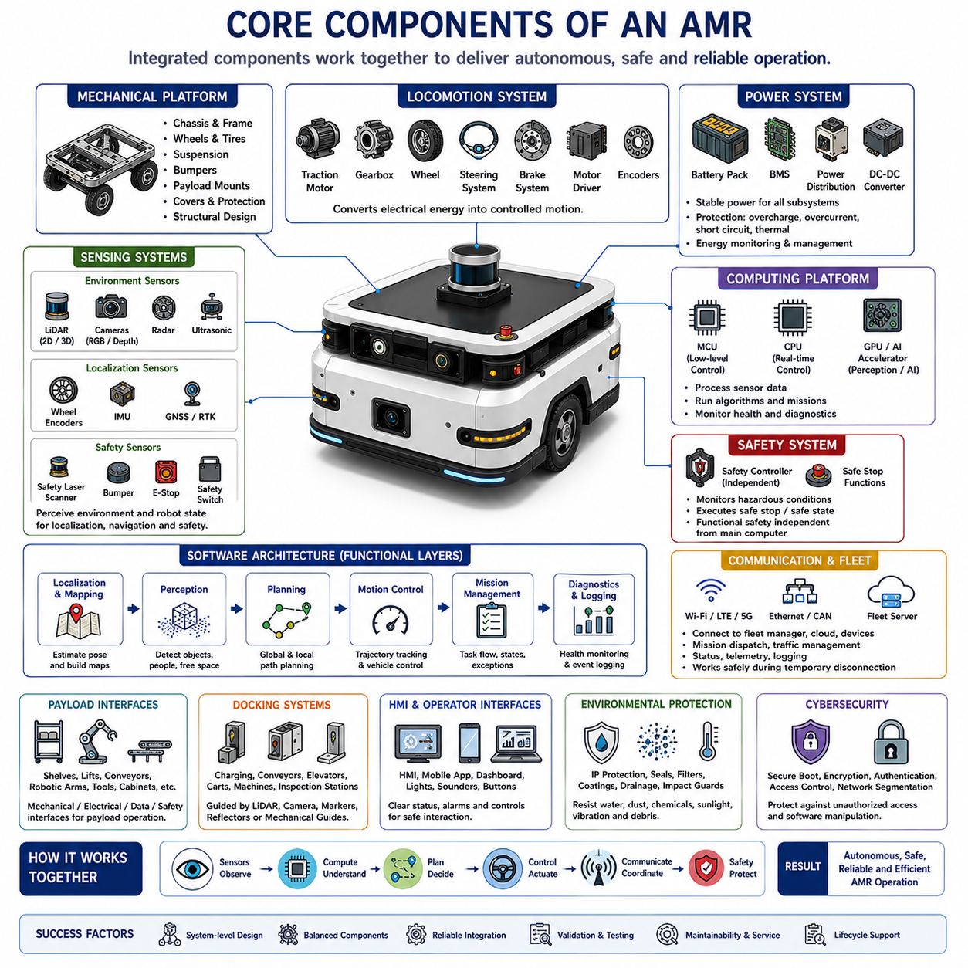
An Autonomous Mobile Robot is created from multiple mechanical, electrical, computational, sensing, software, communication, and safety components that must operate as one coordinated system. No single component provides autonomy by itself. Reliable AMR behavior emerges only when the chassis, drive system, sensors, computing platform, power architecture, control software, and operational interfaces are designed around common requirements.
The mechanical platform forms the physical foundation of the AMR. It includes the chassis, frame, covers, mounting structures, wheels, suspension, payload supports, bumpers, and environmental protection. The platform must withstand static loads, vibration, impact, repeated acceleration, braking forces, and long-term fatigue while preserving the alignment of sensors, motors, and docking equipment.
Chassis design determines the robot’s overall dimensions, structural stiffness, center of gravity, ground clearance, turning envelope, payload capacity, and service accessibility. A lightweight chassis can improve energy efficiency, but insufficient stiffness may reduce docking accuracy and sensor calibration stability. Heavy-duty platforms require reinforced structures while avoiding unnecessary mass that increases motor and battery demands.
The locomotion system converts electrical energy into controlled physical movement. It normally includes traction motors, gearboxes, wheels, steering mechanisms, brakes, motor drivers, and feedback sensors. Depending on the mission, an AMR may use differential drive, omnidirectional drive, Ackermann steering, skid steering, four-wheel steering, or multi-axle configurations designed for rough terrain.
Drive motors must provide enough continuous torque for normal movement and sufficient peak torque for acceleration, slopes, threshold crossing, towing, and recovery. Motor selection must consider vehicle mass, payload, wheel diameter, gear ratio, maximum speed, rolling resistance, gradient, thermal limits, and duty cycle. A motor that satisfies peak torque briefly may still overheat during sustained operation.
Wheel and tire selection affects traction, vibration, energy consumption, floor damage, steering behavior, stopping distance, and positioning accuracy. Indoor robots often use polyurethane or rubber wheels optimized for smooth floors, while outdoor robots require pneumatic or durable off-road tires. Tire deformation and slip must be considered because they influence odometry and motion control.
The braking system provides controlled deceleration, parking stability, and emergency stopping capability. Brakes may be integrated into motors or installed as independent mechanical devices. The design must account for maximum vehicle mass, slope holding, power loss, emergency conditions, and stopping distance. Safety-related braking should remain effective even when the main autonomy computer fails.
The power system supplies stable electrical energy to every AMR subsystem. It typically consists of a battery pack, battery management system, contactors, fuses, circuit breakers, power distribution units, DC-DC converters, charging circuits, and energy monitoring devices. The architecture must isolate faults and prevent a failure in one subsystem from disabling essential control or safety functions.
Lithium-ion and lithium iron phosphate batteries are commonly used because they provide practical combinations of energy density, cycle life, charging performance, and safety. Battery capacity must be selected from actual mission energy rather than nominal driving time alone. Computing, sensors, payload devices, communication equipment, cooling, standby operation, and environmental conditions also consume significant energy.
The battery management system monitors cell voltage, current, temperature, state of charge, state of health, and abnormal operating conditions. It protects the battery from overcharge, over-discharge, overcurrent, overheating, and cell imbalance. Accurate battery estimation is important because unreliable energy information can interrupt missions or prevent the robot from returning safely to a charging station.
Charging components may support manual connection, battery swapping, conductive docking, or contactless charging. Automatic charging requires more than a charger because the robot must identify the station, approach it safely, align accurately, verify electrical contact, negotiate charging conditions, and resume operation. Fleet systems must also coordinate charging demand across multiple robots.
The sensing architecture allows the AMR to observe both the external environment and its own internal state. External sensors detect obstacles, people, vehicles, free space, terrain, landmarks, and infrastructure. Internal sensors measure wheel rotation, steering angle, motor current, battery status, temperature, vibration, actuator state, and other conditions needed for control and diagnostics.
LiDAR is widely used for localization, mapping, obstacle detection, and safety monitoring. A two-dimensional LiDAR measures a horizontal scan plane and is effective in structured indoor environments. Three-dimensional LiDAR captures richer geometric information for outdoor navigation, irregular terrain, overhanging obstacles, and complex scenes, but it requires greater computing power and more sophisticated processing.
Cameras provide visual information about color, texture, symbols, objects, people, signs, and semantic context. RGB cameras support recognition and inspection, while stereo and depth cameras estimate three-dimensional structure. Camera performance is affected by lighting, glare, darkness, motion blur, contamination, and weather, so industrial systems often combine visual sensing with LiDAR or radar.
Radar provides distance and relative velocity information and remains useful in rain, fog, dust, and poor lighting. It can detect moving vehicles and large obstacles at longer ranges, although its spatial resolution may be lower than that of cameras or LiDAR. Imaging radar is increasingly important for robust outdoor AMRs operating in changing weather and traffic conditions.
Ultrasonic sensors are commonly installed around the lower body of an AMR to detect nearby objects and support docking or low-speed maneuvering. They are inexpensive and effective at short range, but their measurements depend on target angle, surface material, and environmental conditions. They are therefore normally used as complementary sensors rather than the main perception source.
Wheel encoders measure wheel rotation and provide essential information for odometry, velocity control, and fault monitoring. Encoder-based motion estimation is computationally efficient but accumulates error because of wheel slip, uneven surfaces, tire wear, and mechanical tolerances. Reliable localization combines encoder information with external observations from LiDAR, cameras, GNSS, or landmarks.
An inertial measurement unit measures angular velocity and linear acceleration. It helps estimate orientation, detect rapid motion, stabilize localization, and monitor slope or vibration. IMU data is particularly valuable during short periods when external sensors are degraded, but integration drift prevents it from providing accurate long-term position without correction from other sensing methods.
Outdoor AMRs may use GNSS and real-time kinematic positioning to obtain global location. GNSS performance is strong under open sky but degrades near buildings, trees, tunnels, and metal structures. For reliable operation, GNSS is commonly fused with IMU, wheel odometry, LiDAR localization, or visual localization so that navigation can continue through temporary signal loss.
The safety sensing system may include safety laser scanners, bumpers, emergency-stop buttons, protective switches, speed monitors, and safety-rated encoders. These devices are connected to a safety controller that operates independently from general autonomy software. The safety system supervises hazardous motion and commands a safe stop when required conditions are violated.
The onboard computing platform processes sensor data, runs navigation algorithms, manages missions, monitors system health, and communicates with external systems. An AMR may use microcontrollers for low-level control, industrial computers for real-time robotics software, and GPUs or AI accelerators for perception and learning. Computing resources must match latency, power, thermal, and reliability requirements.
Low-level controllers handle time-critical functions such as motor current, wheel velocity, steering position, brake activation, and hardware monitoring. These functions require deterministic timing and should not depend on high-level artificial intelligence software. Separating low-level control from navigation and mission functions improves stability and allows the robot to enter a safe state during computer or network faults.
The main autonomy computer executes localization, mapping, perception, path planning, motion control, and mission coordination. It receives synchronized sensor data, maintains the robot state, selects routes, generates trajectories, and sends movement commands to lower-level controllers. Its hardware and operating system must support predictable performance under maximum computational load.
AI accelerators and graphics processors are increasingly used for object detection, semantic segmentation, terrain analysis, human behavior prediction, inspection, and language-based interaction. However, high processing capability increases electrical load, heat generation, cost, and software complexity. Compute selection should therefore follow validated application needs instead of simply choosing the most powerful available device.
Thermal management protects batteries, processors, motor drivers, sensors, and communication devices from excessive temperature. Heat sinks, fans, liquid cooling, conductive chassis structures, filtered airflow, and temperature-based power control may be used. Outdoor systems must manage heat while maintaining resistance to water, dust, vibration, and contamination.
The software architecture coordinates the behavior of all hardware components. Device drivers convert raw hardware signals into standardized data, while middleware carries messages between localization, perception, planning, control, mission, and diagnostic modules. Modular architecture allows individual components to be tested, replaced, upgraded, and reused across different AMR product variants.
Localization software estimates the robot’s pose from wheel odometry, IMU data, LiDAR scans, camera features, GNSS, and map references. Mapping software creates or updates representations of the environment. These two functions are closely connected through simultaneous localization and mapping, but production systems often separate map creation, map management, and operational localization for stability.
Perception software interprets sensor measurements and identifies obstacles, free space, people, vehicles, terrain, workstations, and other task-relevant elements. It may use geometric algorithms, signal processing, deep learning, or combinations of these methods. The perception output must include uncertainty and timing information so that planning does not treat delayed or unreliable detections as absolute truth.
Navigation software converts mission goals into safe movement. Global planning finds routes through the map, local planning responds to nearby conditions, and motion control converts trajectories into wheel and steering commands. Navigation must respect robot geometry, kinematic constraints, stopping distance, safety fields, payload condition, traffic policies, and operational priorities.
Mission management software defines what the robot should accomplish beyond simple movement. It controls sequences such as receiving a transport request, traveling to a pickup location, docking, confirming payload transfer, moving to a destination, completing delivery, charging, and reporting status. Mission logic must handle timeouts, retries, blocked routes, equipment failures, and operator intervention.
Communication components connect the AMR to fleet management, facility systems, doors, elevators, machines, chargers, cloud platforms, and user interfaces. Wireless communication may use Wi-Fi, private LTE, or 5G, while internal networks commonly use Ethernet, CAN, serial communication, or industrial fieldbuses. Network design must separate critical control traffic from noncritical data transfer.
The fleet management system assigns missions, coordinates traffic, prevents deadlocks, schedules charging, balances robot utilization, and monitors performance. It provides the connection between individual robot autonomy and site-level operations. A well-designed AMR must continue safe local operation during temporary fleet communication loss while avoiding actions that require unavailable authorization or coordination.
Human-machine interfaces allow operators and technicians to understand robot status and interact safely with the system. Typical interfaces include displays, indicator lights, sounders, buttons, mobile applications, dashboards, and maintenance tools. Clear information about mission state, battery level, faults, safety stops, and recovery actions reduces downtime and prevents unsafe manual intervention.
Diagnostic and logging components record sensor health, software state, control commands, faults, mission events, network conditions, and performance indicators. These records support debugging, predictive maintenance, root-cause analysis, and product improvement. Time synchronization is essential because events from different controllers and sensors must be reconstructed in the correct temporal order.
Cybersecurity components protect the AMR from unauthorized access and software manipulation. Secure boot, signed updates, authentication, encryption, access control, network segmentation, key management, and audit logs may be required. Security design must include both remote attacks and physical access because robots often operate in open or shared facilities.
Payload interfaces connect the mobile platform to the equipment that performs useful work. They may include shelves, rollers, lifts, conveyors, towing couplers, robotic arms, inspection sensors, secure cabinets, or customized tools. Mechanical, electrical, communication, and safety interfaces must all be defined so that payload operation remains coordinated with vehicle motion.
Docking systems provide repeatable alignment with chargers, conveyors, production machines, elevators, carts, or inspection stations. Docking may rely on LiDAR features, cameras, markers, reflectors, mechanical guides, or proximity sensors. Accuracy requirements should be defined from the connected equipment because unnecessary precision can greatly increase cost and complexity.
Environmental protection components allow the AMR to survive its intended operating domain. Covers, seals, cable glands, protected connectors, drainage paths, filters, coatings, and impact guards defend against water, dust, oil, chemicals, sunlight, and debris. Protection level must be balanced with cooling, maintenance access, weight, and manufacturing cost.
The complete AMR is therefore a layered system in which mechanics provide mobility, electrical components provide energy, sensors provide observations, computers provide processing, software provides intelligence, communication provides coordination, and safety components limit hazardous behavior. The quality of the robot depends less on any single advanced device than on the consistency of all interfaces between these elements.
Successful AMR engineering requires component selection to follow system-level requirements. Payload, speed, runtime, terrain, localization accuracy, stopping distance, environmental exposure, fleet size, and maintenance strategy must be considered together. When components are selected independently, the resulting robot may suffer from insufficient power, unstable control, poor sensing coverage, overheating, or difficult maintenance.
A production-ready AMR must also support the entire product lifecycle. Components should be available, manufacturable, testable, diagnosable, replaceable, and upgradeable. Mechanical drawings, wiring diagrams, interface specifications, software versions, safety validation, calibration procedures, and service documentation must remain synchronized so that the integrated system can be built and maintained consistently.

01.03 AMR Functional Architecture · AMR 기능 아키텍처
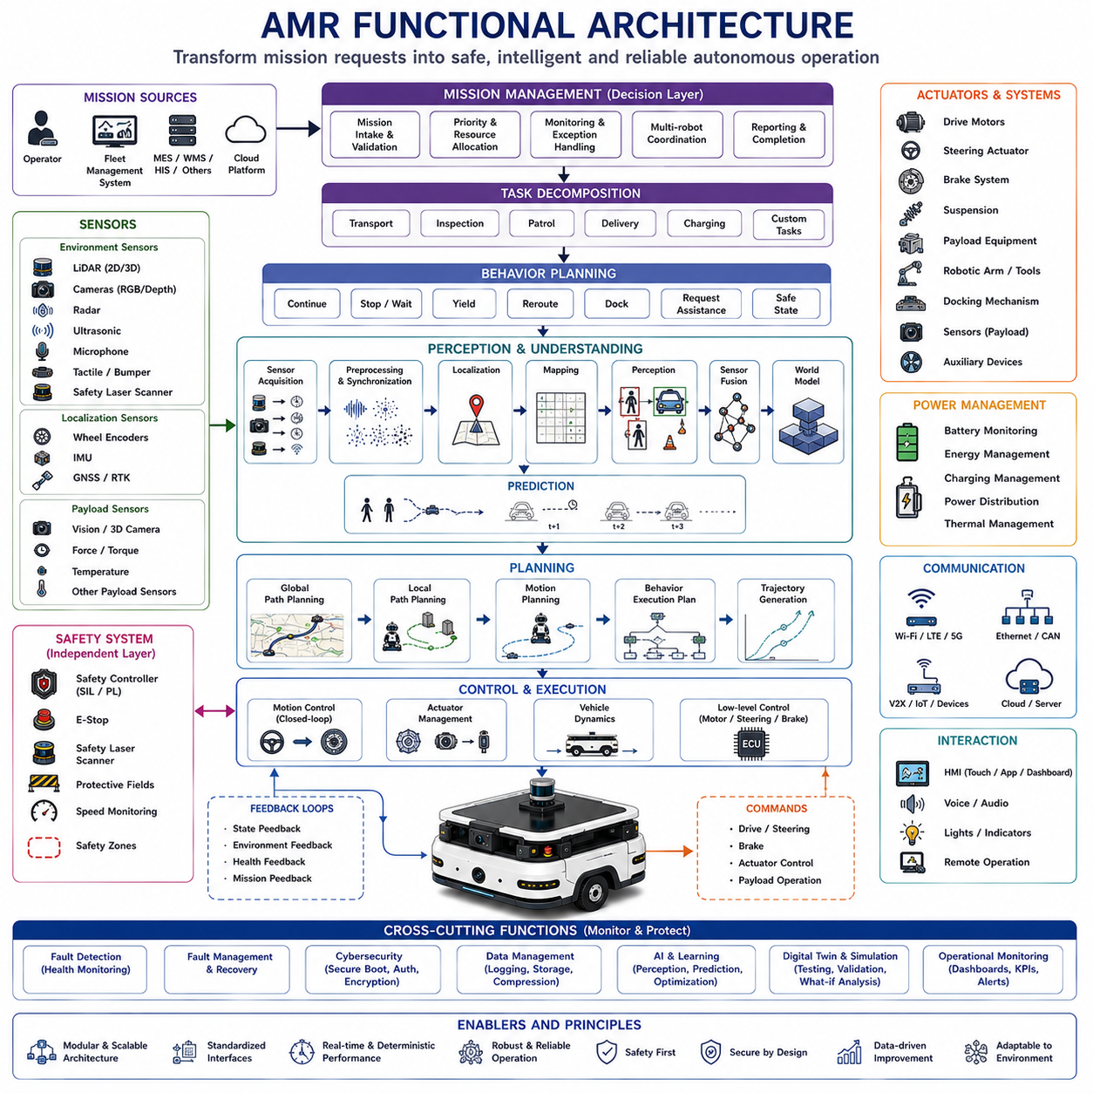
The functional architecture of an Autonomous Mobile Robot (AMR) defines how individual software and hardware functions cooperate to transform mission requests into safe, intelligent, and reliable autonomous operation. Rather than describing physical components alone, functional architecture focuses on the logical organization of capabilities, information flow, decision-making processes, and interactions between subsystems. A well-designed functional architecture ensures that perception, planning, control, safety, communication, and mission execution operate as an integrated system rather than as independent modules.
Unlike mechanical architecture or electrical architecture, which describe physical implementation, functional architecture represents the operational behavior of the robot. It specifies what functions are required, how they exchange information, when they are activated, how decisions are prioritized, and how failures are managed. This abstraction allows engineers to separate system behavior from hardware implementation, making development, validation, maintenance, and future upgrades significantly more efficient.
A modern AMR functional architecture is generally organized into hierarchical layers. Lower layers interact directly with physical hardware and execute deterministic real-time control, while higher layers perform perception, decision-making, mission planning, optimization, and coordination. Information continuously flows both upward and downward, allowing sensor observations to influence mission decisions while mission objectives determine low-level vehicle behavior.
The hardware abstraction layer provides standardized interfaces between physical devices and software applications. Sensors, actuators, communication devices, safety controllers, battery systems, and motor controllers expose common interfaces regardless of specific manufacturers. This abstraction allows hardware replacement or upgrades with minimal impact on higher software layers while improving portability across multiple robot platforms.
The device management layer supervises all onboard hardware resources. It initializes devices during startup, monitors operational health, detects communication failures, reports diagnostic information, manages firmware versions, and coordinates recovery procedures. Device management also maintains synchronized timestamps, calibration parameters, configuration settings, and hardware status information that are required throughout the entire software architecture.
Sensor acquisition functions continuously collect measurements from LiDAR, cameras, radar, ultrasonic sensors, wheel encoders, IMUs, GNSS receivers, safety scanners, microphones, tactile sensors, and additional payload sensors. Time synchronization is critical because sensor measurements originate at different frequencies and communication delays. Accurate temporal alignment allows multiple sensing modalities to contribute to a coherent representation of the surrounding environment.
Sensor preprocessing converts raw measurements into standardized data suitable for higher-level algorithms. This stage performs filtering, distortion correction, synchronization, calibration compensation, coordinate transformation, noise reduction, image rectification, point cloud registration, signal validation, and data compression when necessary. Reliable preprocessing significantly improves the robustness of all downstream perception modules.
Localization functions estimate the robot's position, orientation, velocity, and uncertainty within its operating environment. Multiple localization algorithms may operate simultaneously using wheel odometry, inertial navigation, LiDAR scan matching, visual localization, GNSS positioning, fiducial markers, or hybrid sensor fusion. Localization continuously updates the robot pose while monitoring confidence and automatically detecting localization failures.
Mapping functions maintain spatial representations of the operational environment. Static maps describe permanent infrastructure such as walls, roads, buildings, shelves, charging stations, and workstations. Dynamic maps additionally represent temporary obstacles, moving objects, traffic conditions, environmental changes, and operational restrictions. Future architectures increasingly support persistent world models that accumulate long-term environmental knowledge across repeated missions.
Perception functions transform sensor observations into semantic understanding of the environment. Object detection, semantic segmentation, instance segmentation, free-space estimation, terrain classification, human detection, vehicle recognition, obstacle tracking, anomaly detection, and scene understanding together create a comprehensive description of the robot's surroundings. Modern perception increasingly combines geometric reasoning with deep learning and multimodal foundation models.
Sensor fusion integrates complementary observations from multiple sensing modalities into unified environmental representations. Cameras provide appearance information, LiDAR supplies accurate geometry, radar measures long-range motion, IMUs stabilize localization, and GNSS provides global positioning. Sensor fusion improves robustness because the limitations of one sensor are compensated by the strengths of others under varying operational conditions.
World modeling extends perception beyond instantaneous observations. The robot maintains a persistent internal representation containing three-dimensional geometry, semantic objects, dynamic entities, environmental history, uncertainty, physical properties, and predicted future states. World models allow reasoning over time rather than reacting only to current sensor measurements, enabling more intelligent and predictive behavior.
Prediction functions estimate how dynamic objects are likely to evolve over time. Human trajectories, vehicle motion, moving machinery, robotic coworkers, opening doors, elevators, and environmental changes are predicted to improve planning safety and operational efficiency. Probabilistic prediction accounts for uncertainty rather than assuming a single deterministic future.
Mission management represents the highest operational decision layer. Missions may originate from operators, fleet management systems, manufacturing execution systems, warehouse management systems, hospital information systems, inspection scheduling software, or cloud platforms. Mission management validates requests, prioritizes objectives, allocates resources, monitors progress, handles exceptions, and coordinates interactions between multiple functional subsystems.
Task decomposition translates high-level missions into executable task sequences. A transport mission may include navigation, docking, payload verification, transportation, unloading, charging, and reporting. Inspection missions may involve localization, station alignment, sensor positioning, image acquisition, defect analysis, result reporting, and transition to subsequent inspection stations. Modular task decomposition greatly improves software scalability and reuse.
Behavior planning determines the robot's immediate operational strategy according to mission objectives and environmental conditions. Rather than directly generating wheel commands, behavior planning decides whether the robot should continue moving, stop, wait, yield, reroute, dock, recharge, request assistance, or enter a safe state. These behavioral decisions guide subsequent path planning and motion control.
Global path planning computes efficient routes between distant locations using maps, traffic rules, restricted zones, charging availability, operational priorities, and environmental constraints. Algorithms optimize travel distance, energy consumption, mission completion time, traffic congestion, and safety simultaneously. Future systems increasingly incorporate predictive traffic models and fleet-wide optimization.
Local path planning responds to nearby obstacles and rapidly changing environmental conditions. It continuously adjusts trajectories while respecting vehicle kinematics, dynamic constraints, safety margins, payload stability, and sensor uncertainty. Local planning ensures smooth, collision-free movement despite unpredictable human behavior and temporary environmental changes.
Motion planning transforms planned trajectories into feasible vehicle motions. Steering angle, wheel velocity, acceleration, deceleration, rotational speed, curvature, braking profiles, and vehicle dynamics are all optimized to satisfy physical constraints while maintaining passenger comfort, payload stability, and operational efficiency. Heavy-duty outdoor AMRs require particularly sophisticated motion planning because of large vehicle mass and uneven terrain.
Motion control executes planned trajectories using closed-loop feedback algorithms. Controllers continuously compare desired motion with measured vehicle behavior and compensate for disturbances, wheel slip, terrain irregularities, mechanical tolerances, actuator delays, and payload variation. Stable control ensures that high-level planning decisions are accurately realized under real operating conditions.
Actuator management coordinates traction motors, steering actuators, brakes, suspension mechanisms, payload equipment, robotic manipulators, docking devices, inspection sensors, and auxiliary hardware. Each actuator must operate within mechanical, electrical, thermal, and safety constraints while remaining synchronized with the robot's overall mission state.
Power management supervises battery operation, energy distribution, charging decisions, electrical health, thermal conditions, and remaining operational range. Intelligent power management estimates future energy demand according to mission schedules, terrain, payload, weather, and computational load. It automatically schedules charging while preventing mission interruption and protecting battery lifetime.
Communication management coordinates information exchange between onboard subsystems and external infrastructure. Internal communication connects controllers, sensors, computers, and safety devices, while external communication supports fleet management, cloud services, facility automation, industrial equipment, doors, elevators, traffic infrastructure, and remote operators. Communication architecture must tolerate temporary disconnections without compromising essential safety.
Fleet coordination functions optimize multiple AMRs operating simultaneously within shared environments. Traffic scheduling, mission allocation, congestion avoidance, charging coordination, workload balancing, resource utilization, and collaborative task execution are managed centrally while preserving sufficient local autonomy for each individual robot. Fleet optimization substantially improves overall operational efficiency.
Human-machine interaction enables operators, maintenance personnel, supervisors, and engineers to communicate effectively with the robot. Touchscreens, mobile devices, dashboards, voice interfaces, indicator lights, alarms, augmented reality, and remote operation tools present system status while supporting mission assignment, diagnostics, maintenance, and supervised intervention when necessary.
Safety functions operate independently from general autonomy software. Certified safety controllers supervise emergency stops, safety scanners, protective fields, braking systems, speed limits, safe zones, collision avoidance boundaries, and functional safety requirements. Safety decisions always override operational objectives whenever hazardous conditions are detected.
Fault detection continuously monitors hardware, software, sensors, communication networks, batteries, actuators, localization confidence, perception quality, and computational resources. Diagnostic algorithms identify abnormal behavior before catastrophic failures occur. Early fault detection supports predictive maintenance, graceful degradation, and safe mission recovery.
Fault management determines appropriate responses after anomalies have been detected. Minor failures may trigger sensor redundancy, algorithm switching, reduced operating speed, or temporary mission suspension. More severe failures initiate safe stopping, emergency notification, remote assistance requests, or controlled shutdown procedures. Functional architecture therefore supports resilience rather than assuming perfect hardware reliability.
Cybersecurity functions protect communication channels, software integrity, authentication, access control, encrypted storage, secure boot, firmware updates, identity management, intrusion detection, and audit logging. Because AMRs increasingly interact with enterprise networks and cloud infrastructure, cybersecurity has become an integral functional layer rather than a separate supporting technology.
Data management coordinates storage, retrieval, synchronization, compression, archiving, and distribution of operational information. Sensor recordings, localization data, maps, trajectories, mission histories, diagnostic logs, inspection results, maintenance records, and AI training datasets all require structured lifecycle management. Effective data architecture supports product improvement while minimizing storage cost.
Artificial intelligence increasingly appears throughout multiple functional layers rather than existing as an isolated module. Deep learning supports perception, anomaly detection, language understanding, inspection, behavior prediction, adaptive planning, predictive maintenance, and operator assistance. Nevertheless, deterministic control, state estimation, safety logic, and certified operational behavior remain essential foundations of reliable autonomous systems.
Cloud integration extends onboard functional capabilities through remote computation and centralized knowledge management. Fleet analytics, digital twins, long-term mapping, AI model training, software deployment, maintenance scheduling, operational reporting, and enterprise integration are increasingly performed using hybrid edge-cloud architectures. Critical real-time functions, however, remain onboard to preserve latency and operational safety.
Digital twin functions maintain synchronized virtual representations of physical robots and operational environments. Real-time sensor data updates the digital model continuously, while simulation evaluates software changes, mission strategies, maintenance planning, and failure scenarios before physical deployment. Digital twins significantly reduce validation cost while improving operational confidence.
Learning functions continuously improve robot performance using operational experience. Self-supervised learning, continual learning, fleet learning, reinforcement learning, and adaptive parameter optimization allow future AMRs to refine perception, navigation, planning, and decision-making without requiring complete offline retraining after every deployment.
Operational monitoring provides continuous visibility into robot health, mission execution, environmental conditions, safety events, communication quality, energy consumption, and performance metrics. Dashboards, analytics platforms, and maintenance systems transform operational data into actionable information for engineers, operators, and facility managers responsible for long-term fleet performance.
Scalability is one of the primary objectives of functional architecture. Modular interfaces, standardized data structures, service-oriented software, middleware abstraction, reusable components, and configurable mission logic allow a common architecture to support multiple vehicle sizes, payload classes, application domains, and industrial sectors without extensive redesign.
The functional architecture ultimately serves as the operational blueprint of the AMR. It defines how sensing becomes perception, perception becomes understanding, understanding becomes planning, planning becomes motion, and motion accomplishes meaningful missions while continuously maintaining safety, reliability, efficiency, and adaptability. A successful AMR is therefore not characterized by any individual algorithm or hardware component, but by the seamless coordination of all functional layers into a unified autonomous system capable of reliable long-term operation in complex real-world environments.

01.04 Levels of Robot Autonomy · 로봇 자율성 수준
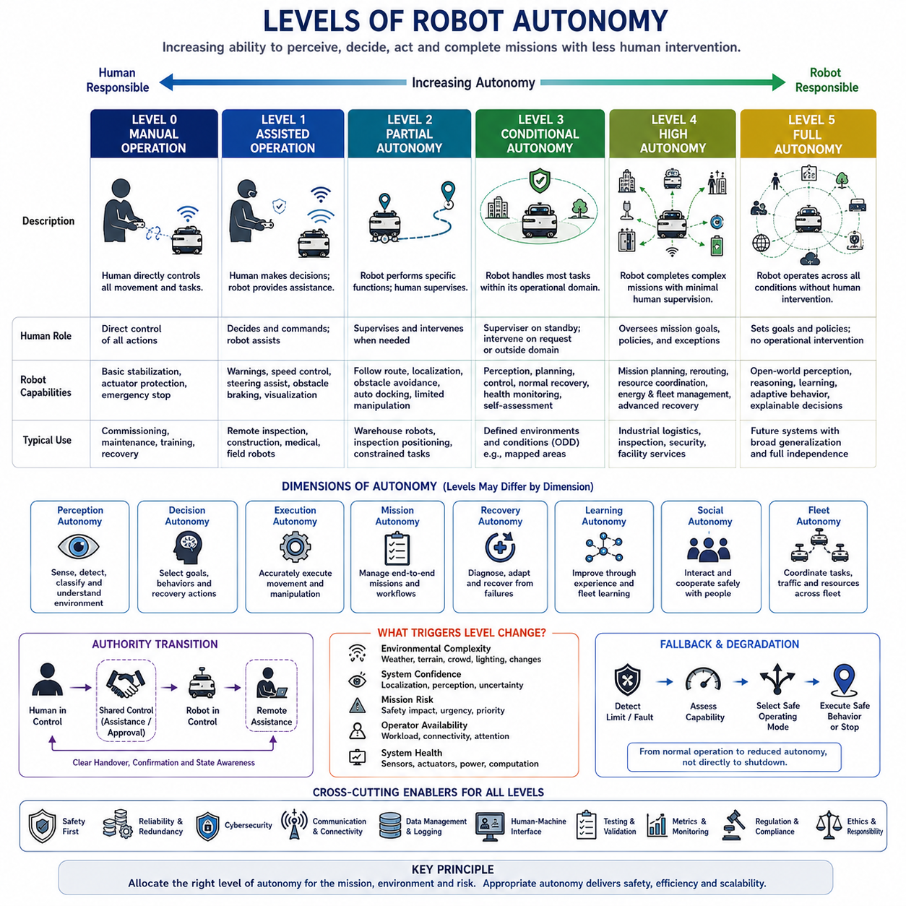
Robot autonomy describes the degree to which a robotic system can perceive its environment, make decisions, execute actions, recover from disturbances, and complete assigned goals without continuous human control. Autonomy is not a single capability but a combination of sensing, reasoning, planning, control, learning, safety, communication, and mission management functions. The level of autonomy therefore depends on how responsibility is divided between the robot, the operator, and the surrounding infrastructure.
A robot with low autonomy performs only limited predefined actions and depends heavily on direct human commands. A highly autonomous robot can interpret complex situations, select appropriate behaviors, adapt to uncertainty, coordinate with other systems, and complete extended missions with minimal supervision. Between these extremes are several intermediate levels that combine automatic functions with different forms of human monitoring, approval, and intervention.
Autonomy should not be confused with automation. Automation usually refers to the repeated execution of predetermined procedures under known conditions, while autonomy involves selecting actions when conditions are uncertain or were not explicitly programmed in advance. An automated conveyor follows a fixed sequence, whereas an autonomous mobile robot may change its route, wait for pedestrians, reassign tasks, or return to a charger according to current conditions.
The lowest practical level is manual operation, where a human directly controls the robot's motion and task execution. The operator observes the environment, decides what should be done, and generates steering, speed, manipulation, or mission commands. The robot may provide basic stabilization, actuator protection, or emergency stopping, but it does not independently determine how to achieve the operational goal.
Manual operation is useful during commissioning, maintenance, recovery, training, and highly unusual situations. It also provides a fallback when autonomous functions are unavailable or unreliable. However, continuous manual control limits scalability because each robot requires dedicated human attention, communication quality must remain stable, and operator workload increases rapidly when several robots operate simultaneously.
The next level is assisted operation, in which the human remains responsible for primary decisions while the robot provides limited support. Assistance may include speed stabilization, collision warnings, obstacle-based braking, steering correction, payload protection, or route visualization. The robot reduces operator workload but does not independently manage complete navigation or mission sequences.
Assisted operation is common in remote-controlled inspection robots, construction equipment, medical robots, and field platforms operating in partially unknown environments. The operator may choose the direction of movement while the robot prevents unsafe commands or maintains a safe distance from obstacles. This level improves safety and precision without transferring full responsibility to the machine.
Partial autonomy allows the robot to perform specific functions independently while the operator supervises the overall task. The robot may follow a predefined route, maintain localization, avoid obstacles, dock automatically, or control a robotic arm during a constrained procedure. Human intervention is still expected when the environment changes beyond the supported operating conditions.
At this level, autonomy is usually limited by function, location, speed, weather, object type, or mission class. A warehouse robot may navigate autonomously inside a mapped facility but require manual control outdoors. An inspection robot may position its sensors automatically while a human selects inspection points and interprets uncertain results. The operational boundary must be clearly defined.
Conditional autonomy enables the robot to manage most functions independently within a specified operational design domain. The robot perceives the environment, plans its actions, controls motion, handles normal disturbances, and monitors system health. A human supervisor is not required to control every action but must remain available to respond when the robot requests assistance or encounters conditions beyond its validated capability.
The operational design domain defines the conditions under which autonomous performance is considered valid. It may include specific buildings, road types, terrain classes, lighting levels, weather conditions, speed ranges, payload limits, communication availability, map quality, and interaction rules. A robot can have high autonomy within a narrow domain while remaining incapable outside that domain.
Conditional autonomy requires reliable detection of system limits. The robot must recognize declining localization confidence, blocked routes, sensor contamination, excessive wheel slip, unsafe terrain, unusual human behavior, or hardware degradation. Detecting that the system no longer understands the situation is as important as understanding normal conditions because safe fallback depends on accurate self-assessment.
High autonomy allows the robot to complete complex missions independently across a broad range of expected conditions. It can decompose mission goals, select routes, coordinate with infrastructure, manage energy, recover from common faults, and adapt behavior without immediate operator approval. Human involvement is focused on supervision, policy, maintenance, and handling rare exceptions rather than continuous operation.
A highly autonomous AMR may receive a transport or inspection objective and independently determine the task sequence. It can choose when to navigate, wait, reroute, dock, recharge, collect data, repeat a failed action, or notify the fleet system. It may also negotiate shared resources such as elevators, doors, charging stations, loading zones, and narrow passages.
Full autonomy represents the theoretical ability to perform all relevant missions under all reasonably expected conditions without human intervention. Such a robot would understand unfamiliar environments, manage novel failures, learn new tasks, explain decisions, cooperate naturally with people, and preserve safety despite incomplete information. In practice, full autonomy remains extremely difficult because real-world environments contain unlimited variation and uncertainty.
The distinction between high autonomy and full autonomy is important. A commercial robot may appear fully autonomous during normal operation but still depend on human support for map creation, exceptional recovery, maintenance, software updates, task definition, or regulatory approval. Claims of autonomy should therefore describe specific capabilities and boundaries rather than relying on broad marketing terms.
Levels of autonomy can be analyzed across multiple dimensions rather than represented by a single number. Navigation autonomy, manipulation autonomy, mission autonomy, learning autonomy, maintenance autonomy, social autonomy, and fleet autonomy may differ significantly within the same system. A robot may navigate independently but require a human to define every mission or confirm every manipulation action.
Perception autonomy concerns the robot's ability to collect and interpret information without human assistance. Low-level systems depend on operator observation, while advanced systems detect objects, classify terrain, track people, estimate free space, recognize task states, and evaluate uncertainty. Perception autonomy is limited not only by sensor quality but also by the system's ability to identify ambiguous or degraded observations.
Decision autonomy describes how independently the robot selects goals, behaviors, and recovery actions. At lower levels, decisions are predetermined or made by operators. At higher levels, the robot evaluates alternatives according to safety, mission priority, energy, time, traffic, uncertainty, and policy. Decision authority must remain consistent with the reliability of perception and prediction.
Execution autonomy refers to the ability to carry out selected actions reliably. A robot may understand what should be done but lack sufficient control accuracy, actuator capability, or environmental robustness to execute it. Motion control, manipulation, docking, payload transfer, and tool operation must therefore be evaluated separately from high-level reasoning.
Mission autonomy measures whether the robot can manage a complete operational workflow rather than isolated movements. This includes accepting a request, checking feasibility, sequencing tasks, coordinating resources, monitoring progress, handling exceptions, reporting completion, and preparing for the next mission. High mission autonomy is essential for large-scale commercial fleets because manual coordination reduces the value of autonomous mobility.
Recovery autonomy determines how the robot reacts when normal execution fails. Low-autonomy systems stop and wait for an operator, while advanced robots diagnose the cause, retry with modified parameters, select alternative routes, switch sensors, reduce speed, request infrastructure support, or return to a safe location. Recovery capability often determines real operational availability more strongly than nominal navigation performance.
Learning autonomy describes how the robot improves through experience. Traditional robots remain fixed until engineers update their software, whereas advanced systems may adapt perception models, optimize routes, refine energy estimates, learn recurring traffic patterns, or share knowledge across a fleet. Learning must be controlled because uncontrolled adaptation can invalidate safety assumptions and create unpredictable behavior.
Human supervision also changes across autonomy levels. Direct control requires continuous attention, while supervisory control allows one person to monitor several robots and intervene only when necessary. At higher levels, the operator manages goals, policies, and exceptions instead of individual movements. The design of alerts and intervention tools becomes increasingly important as continuous observation decreases.
Remote assistance is often used as a practical bridge between conditional and high autonomy. When a robot encounters an unusual situation, a remote operator may provide semantic guidance such as identifying a safe passage, approving a maneuver, or selecting an alternative destination. The robot then continues execution autonomously rather than being driven manually for the entire mission.
Human intervention should be categorized according to urgency and authority. Some situations require immediate emergency control, while others allow delayed approval or advisory input. The system must clearly communicate what happened, what the robot understands, what action is proposed, and what consequences may follow. Poorly designed assistance interfaces can increase risk by forcing operators to decide without sufficient context.
Autonomy levels are closely connected to safety architecture. Higher operational authority must be supported by stronger monitoring, redundancy, fault detection, uncertainty estimation, and fallback behavior. Autonomy software may decide how to accomplish a mission, but independent safety functions must retain the ability to limit speed, stop motion, isolate power, or prevent hazardous actions.
Graceful degradation allows the robot to continue operating at a reduced autonomy level when part of the system becomes unavailable. Loss of a camera may reduce speed, poor GNSS reception may trigger LiDAR localization, and communication failure may restrict the robot to local missions. Instead of changing directly from normal autonomy to complete shutdown, the architecture selects a safe operating mode consistent with remaining capability.
The transition between autonomy levels must be explicitly managed. A robot should not silently transfer responsibility to a human without confirming that the operator is available and understands the situation. Similarly, the robot should not resume autonomous control unexpectedly. Clear state indicators, transition procedures, authority rules, and time limits are necessary to prevent control ambiguity.
Environmental complexity strongly influences effective autonomy. A robot that performs reliably in an empty warehouse may struggle in a crowded hospital, active construction site, public road, or unstructured outdoor terrain. Moving people, weather, dust, poor lighting, surface changes, temporary infrastructure, and unpredictable agents increase the perception and planning demands required for the same nominal autonomy level.
Task complexity also changes autonomy requirements. Point-to-point transportation is simpler than mobile manipulation, collaborative assembly, security patrol, or autonomous inspection. Inspection missions may require the robot to interpret quality criteria, position sensors precisely, decide whether data is sufficient, distinguish defects from normal variation, and determine when additional measurements are necessary.
Infrastructure can increase apparent autonomy by simplifying the environment. Markers, predefined routes, controlled doors, dedicated lanes, standardized docking fixtures, and central traffic management reduce uncertainty and decision complexity. Infrastructure-supported autonomy can be highly effective, but the robot's independence should not be overstated because performance may depend on those external systems.
Fleet-level autonomy extends beyond the capability of an individual robot. The fleet system assigns missions, manages congestion, resolves conflicts, schedules charging, balances workloads, and coordinates shared resources. A locally autonomous robot may still depend heavily on centralized decisions, while a distributed fleet may continue operating even when communication with the central server is temporarily unavailable.
Autonomy must be evaluated through measurable performance rather than descriptive labels alone. Relevant metrics include intervention frequency, mission completion rate, recovery success, localization availability, collision-free operating time, human workload, remote assistance duration, domain coverage, fault tolerance, and safe fallback success. These metrics reveal whether autonomy creates practical operational value.
Testing should include normal scenarios, boundary conditions, degraded sensing, communication loss, unexpected obstacles, human interaction, actuator faults, map changes, and recovery situations. A robot should be validated not only for successful execution but also for correct recognition of unsupported conditions. Safe refusal or assistance requests are essential signs of mature autonomy rather than evidence of failure.
Autonomy is also influenced by legal responsibility, organizational policy, and public acceptance. Even when technically capable, a robot may be required to operate with human supervision because of regulations, insurance, workplace rules, or customer expectations. Deployment decisions therefore balance technical capability with acceptable risk and clearly assigned responsibility.
Explainability becomes more important as decision autonomy increases. Operators and engineers need to understand why the robot stopped, rerouted, rejected a mission, requested help, or selected a particular behavior. Explanations should connect sensor evidence, system confidence, safety rules, and mission constraints without overwhelming users with unnecessary internal details.
Cybersecurity is essential because increased autonomy also increases the consequences of unauthorized control or manipulated data. Identity verification, secure communications, access control, software integrity, intrusion detection, and protected updates prevent external actors from changing mission goals or robot behavior. A compromised autonomous system may continue acting physically without immediate human oversight.
Future robots are likely to use adaptive autonomy rather than remaining at one fixed level. The robot may increase or decrease its decision authority according to environmental complexity, sensor confidence, operator availability, mission risk, and regulatory conditions. Adaptive autonomy allows efficient independent operation while preserving human involvement when uncertainty or potential consequence becomes high.
Shared autonomy will remain important even as artificial intelligence improves. Humans provide contextual judgment, ethical responsibility, strategic intent, and flexible reasoning, while robots provide precise sensing, continuous attention, rapid computation, and repeatable execution. Effective systems allocate control dynamically to the participant best able to manage the current situation.
The highest practical objective is not maximum autonomy under every condition, but appropriate autonomy for the intended mission and environment. Excessive autonomy can increase cost, validation burden, and unpredictable behavior, while insufficient autonomy creates high labor requirements and limited scalability. System architects should select the level that produces reliable operational benefit with acceptable risk.
A mature autonomy framework therefore defines capabilities, limitations, operating domains, transition rules, fallback strategies, human responsibilities, performance metrics, and validation evidence. By treating autonomy as a structured allocation of perception, decision, and execution authority, developers can design robots that are not only intelligent but also understandable, controllable, safe, and suitable for sustained real-world deployment.

01.05 AMR Application Domains · AMR 응용 분야
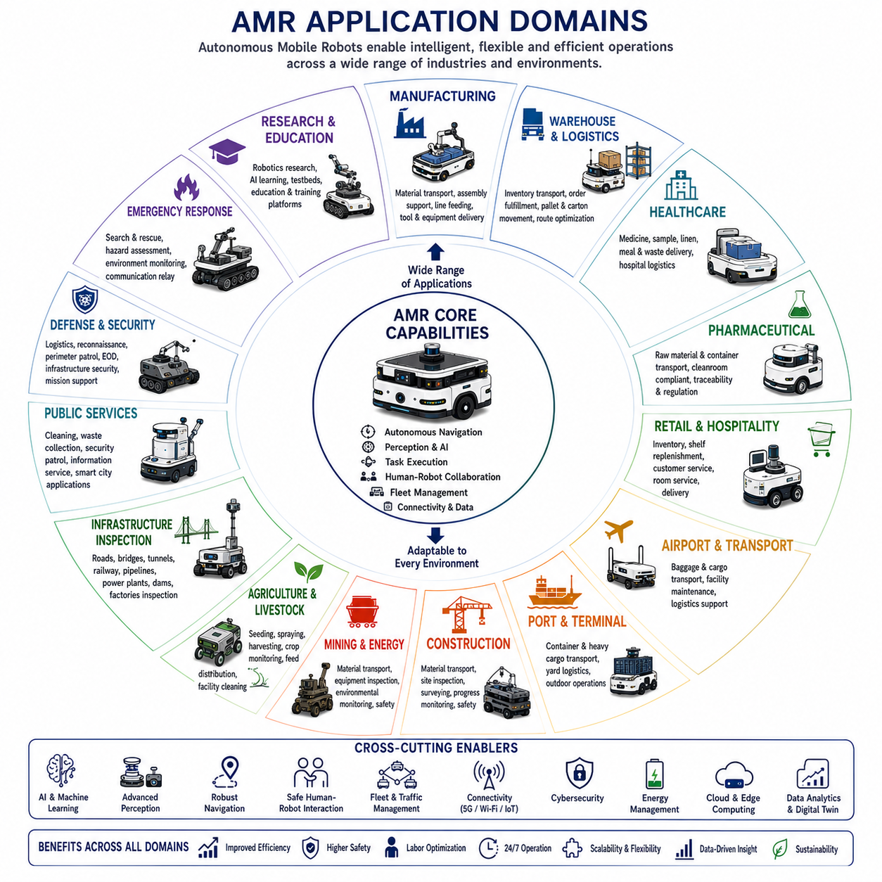
Autonomous Mobile Robots (AMRs) are deployed across an increasingly diverse range of industries because they combine autonomous navigation, intelligent perception, flexible task execution, and continuous operation within dynamic environments. Unlike fixed automation systems, AMRs are not limited to predetermined routes or dedicated infrastructure. Their ability to adapt to changing surroundings allows the same core technology to support logistics, manufacturing, healthcare, agriculture, construction, inspection, defense, public services, and numerous emerging applications with only application-specific modifications.
The application domain of an AMR is determined not only by its mechanical platform but also by its sensing capabilities, software architecture, payload systems, operational environment, safety requirements, communication infrastructure, and mission objectives. A lightweight indoor delivery robot and a heavy outdoor inspection vehicle may share similar autonomy software while employing completely different mechanical structures, sensors, power systems, and environmental protection technologies.
Manufacturing remains one of the largest application domains for AMRs. Modern factories require flexible transportation systems capable of adapting to frequent production changes without extensive infrastructure modification. AMRs transport raw materials, semi-finished products, finished goods, tools, fixtures, and production equipment between workstations while coordinating with manufacturing execution systems, warehouse management systems, industrial robots, conveyors, and human operators.
Industrial logistics increasingly depends on AMRs to improve operational efficiency while reducing labor-intensive transportation tasks. Distribution centers, warehouses, cross-docking facilities, and fulfillment centers use AMRs to transport pallets, cartons, shelves, containers, and inventory throughout large facilities. Dynamic route optimization, automatic traffic management, intelligent task allocation, and fleet coordination significantly improve throughput while maintaining safe human-robot collaboration.
Warehouse automation represents one of the fastest-growing commercial markets for AMRs. Autonomous robots retrieve inventory, replenish storage locations, transport picking carts, support order fulfillment, and optimize warehouse utilization. Integration with inventory management systems enables real-time visibility of material flow while minimizing travel distance, idle time, and manual handling operations.
Automotive manufacturing extensively utilizes AMRs throughout vehicle assembly, component delivery, battery transportation, quality inspection, and production support. As vehicle models change frequently, manufacturers increasingly prefer flexible mobile robots over fixed conveyor systems. AMRs can rapidly adapt to production line modifications, new product introductions, and changing manufacturing layouts without requiring major infrastructure reconstruction.
Semiconductor manufacturing requires extremely precise and reliable material transportation within highly controlled cleanroom environments. Cleanroom-compatible AMRs transport wafers, process carriers, reticles, chemicals, and production tools while maintaining strict contamination control. Navigation, localization, and traffic coordination must satisfy exceptionally high reliability because even brief interruptions can significantly affect production yield.
Electronics manufacturing benefits from AMRs through flexible transportation of sensitive components, printed circuit boards, finished products, testing equipment, and manufacturing tools. Electrostatic discharge protection, precise positioning, lightweight payload handling, and integration with automated production systems are particularly important within electronics production environments.
Healthcare has become a major growth area for autonomous mobile robotics. Hospitals deploy AMRs to transport medications, laboratory samples, sterile instruments, linens, meals, waste containers, and medical supplies between departments. Robots reduce repetitive transportation tasks, allowing healthcare professionals to devote more attention to patient care while maintaining continuous logistics operations around the clock.
Hospital AMRs operate within highly dynamic environments containing patients, visitors, medical staff, emergency situations, elevators, automatic doors, and constantly changing traffic patterns. These systems require advanced human-aware navigation, safe interaction, intuitive communication, and robust fault recovery because safety and reliability directly influence patient care and clinical operations.
Pharmaceutical manufacturing employs AMRs for transporting raw chemicals, production containers, sterile materials, laboratory equipment, packaging materials, and finished medicines. Strict regulatory compliance, traceability, contamination prevention, and environmental monitoring are integrated into robotic workflows to satisfy pharmaceutical quality standards and manufacturing regulations.
Laboratories increasingly utilize AMRs to automate repetitive transportation between analytical instruments, sample preparation stations, storage facilities, and research workspaces. Autonomous laboratory assistants reduce manual handling errors, improve sample traceability, maintain controlled environmental conditions, and support continuous scientific operations during extended experimental procedures.
Food and beverage industries employ AMRs for ingredient transportation, pallet movement, warehouse logistics, production support, cold-storage operations, and finished product distribution. Food-grade materials, wash-down capability, temperature resistance, contamination prevention, and hygienic mechanical design become essential engineering requirements within these environments.
Retail and commercial facilities use AMRs for inventory monitoring, shelf replenishment, customer assistance, floor cleaning, security patrol, and autonomous delivery. Retail robots navigate safely among customers while continuously collecting operational information that improves inventory accuracy, store management, and customer service without interrupting daily business activities.
Hospitality applications include hotel service robots, room delivery systems, luggage transportation, cleaning assistance, and customer guidance. Hotels increasingly deploy autonomous mobile robots to improve service availability while reducing repetitive manual tasks. Multilingual communication, human interaction, elevator integration, and reliable navigation within public spaces are particularly important capabilities.
Airport logistics represents another important application domain. AMRs transport baggage, maintenance equipment, supplies, catering materials, cleaning equipment, and operational tools throughout large airport facilities. Autonomous navigation improves efficiency across complex transportation networks while reducing delays caused by manual logistics operations.
Ports and container terminals require autonomous transportation systems capable of moving heavy cargo across extensive outdoor environments. Heavy-duty AMRs cooperate with cranes, container handling equipment, trucks, automated storage systems, and terminal management software. Outdoor localization, weather resistance, high payload capacity, and long operating endurance are fundamental technical requirements.
Mining operations present extremely challenging environments for autonomous mobile robots. Underground tunnels, open-pit mines, dust, vibration, poor visibility, and hazardous conditions require highly robust sensing and navigation systems. Mining AMRs perform material transportation, infrastructure inspection, equipment monitoring, environmental measurement, and safety assessment while reducing human exposure to dangerous workplaces.
Agriculture increasingly adopts AMRs to improve productivity, sustainability, and resource efficiency. Autonomous agricultural robots perform seeding, spraying, fertilization, harvesting, crop monitoring, weed removal, soil analysis, irrigation inspection, and precision farming operations. Machine vision, multispectral sensing, GNSS positioning, terrain adaptation, and weather resilience enable intelligent field operations throughout changing seasonal conditions.
Livestock farming also benefits from autonomous mobile robots. Agricultural robots distribute feed, monitor animal health, clean facilities, inspect infrastructure, and collect environmental information. Continuous operation reduces labor requirements while improving animal welfare through consistent monitoring and timely response to abnormal conditions.
Forestry applications include autonomous mapping, environmental monitoring, wildfire assessment, timber inventory, road inspection, and ecological surveying. Forest environments challenge perception systems because vegetation, uneven terrain, changing weather, and inconsistent GNSS coverage require sophisticated sensor fusion and adaptive navigation strategies.
Construction sites represent one of the fastest emerging application domains for outdoor AMRs. Construction robots transport building materials, inspect structural progress, monitor equipment utilization, document project status, perform site surveying, and support safety management. Constantly changing environments require frequent map updates, dynamic obstacle handling, and close coordination with construction personnel.
Infrastructure inspection has become a strategic application area for intelligent mobile robots. Roads, bridges, tunnels, railways, airports, dams, pipelines, transmission lines, power plants, factories, and industrial facilities require regular inspection to ensure operational safety. Mobile robots equipped with cameras, LiDAR, thermal imagers, ultrasonic sensors, acoustic sensors, and AI-based inspection software collect consistent, repeatable inspection data while reducing manual inspection effort.
Industrial inspection robots extend beyond simple image collection by integrating autonomous navigation with intelligent defect detection, condition assessment, anomaly identification, measurement automation, and digital reporting. AI-assisted inspection supports predictive maintenance by identifying deterioration before catastrophic failures occur, thereby reducing maintenance cost and improving asset availability.
Energy industries deploy AMRs within power plants, substations, solar farms, wind farms, oil refineries, offshore facilities, and battery energy storage systems. Robots inspect electrical equipment, thermal conditions, mechanical components, pipelines, valves, safety devices, and environmental conditions while minimizing human exposure to hazardous industrial environments.
Oil and gas operations require autonomous robots capable of functioning in explosive atmospheres, offshore platforms, pipelines, refineries, and remote production facilities. Explosion-resistant hardware, hazardous-area certification, corrosion protection, long-range communication, and reliable remote operation complement autonomous navigation under demanding industrial conditions.
Public utility companies increasingly deploy AMRs for inspection and maintenance of water treatment plants, wastewater facilities, electrical substations, telecommunications infrastructure, gas distribution systems, and urban utility networks. Continuous autonomous inspection improves infrastructure reliability while reducing operational costs associated with manual field inspections.
Smart city applications integrate autonomous robots with intelligent urban infrastructure. Service robots support environmental monitoring, public information, autonomous cleaning, waste collection, security patrol, infrastructure inspection, traffic observation, and emergency response. Integration with cloud platforms, IoT networks, digital twins, and municipal management systems enables coordinated urban operations.
Security and surveillance represent significant application domains for autonomous mobile robots. Security AMRs patrol industrial facilities, warehouses, campuses, airports, power plants, government buildings, and commercial properties. Cameras, thermal imaging, acoustic sensing, access control integration, anomaly detection, and autonomous reporting enhance physical security while reducing routine patrol requirements.
Emergency response robots operate within disaster areas, collapsed buildings, hazardous chemical incidents, radiation environments, flood zones, earthquake sites, and industrial accidents. These robots provide situational awareness, victim search, environmental monitoring, communication relay, and infrastructure assessment while minimizing risks to emergency personnel.
Firefighting support robots navigate hazardous environments where temperatures, smoke, toxic gases, structural instability, and limited visibility challenge human responders. Autonomous systems deliver equipment, map damaged structures, locate hazards, monitor environmental conditions, and support coordinated rescue operations without unnecessary human exposure.
Defense organizations increasingly employ autonomous mobile robots for logistics, reconnaissance, explosive ordnance disposal, infrastructure security, perimeter patrol, convoy support, engineering operations, and battlefield situational awareness. Military systems require highly reliable navigation, communication resilience, cybersecurity, robust environmental performance, and mission adaptability under uncertain operational conditions.
Space exploration extends autonomous mobility beyond Earth. Planetary rovers navigate unknown terrain, analyze geological formations, collect scientific samples, inspect spacecraft, and construct environmental maps despite delayed communication with human operators. Space robotics demonstrates the importance of autonomy whenever direct human supervision becomes impossible because of communication latency or operational distance.
Marine and underwater autonomous robots perform harbor inspection, offshore infrastructure monitoring, environmental observation, scientific exploration, aquaculture support, underwater mapping, and pipeline inspection. Autonomous navigation underwater depends on specialized localization technologies because satellite navigation signals cannot penetrate water.
Educational institutions utilize AMRs as research platforms for robotics, artificial intelligence, autonomous navigation, computer vision, multi-robot systems, human-robot interaction, and reinforcement learning. Modular research platforms allow students and engineers to evaluate new algorithms within realistic operational environments before commercial deployment.
Research laboratories continue expanding AMR applications into embodied artificial intelligence, foundation models, multimodal reasoning, adaptive learning, collaborative robotics, semantic mapping, digital twins, and lifelong autonomy. These research efforts gradually transition experimental technologies into reliable industrial products as algorithms mature and computing capabilities continue advancing.
Service robotics combines mobility with customer interaction across offices, shopping centers, museums, libraries, universities, exhibition halls, and public facilities. Information guidance, visitor assistance, autonomous delivery, cleaning, monitoring, and interactive communication create new service opportunities while improving operational efficiency and user experience.
Environmental monitoring increasingly relies on autonomous mobile robots capable of collecting atmospheric, geological, hydrological, biological, and ecological data over extended periods. Mobile sensing platforms monitor air quality, water quality, vegetation health, biodiversity, pollution sources, and climate conditions while continuously adapting sampling locations according to changing environmental observations.
Autonomous delivery represents one of the most visible commercial application domains. Sidewalk delivery robots, campus logistics vehicles, industrial transport robots, and neighborhood delivery platforms move packages, groceries, meals, and medical supplies directly to customers. Reliable localization, pedestrian interaction, regulatory compliance, and efficient fleet coordination determine large-scale deployment success.
Future application domains will increasingly combine multiple capabilities within a single autonomous platform. A construction robot may simultaneously transport materials, inspect structures, generate digital twins, monitor worker safety, and collect project documentation. Similarly, industrial inspection robots will integrate navigation, manipulation, AI-based diagnostics, predictive maintenance, and enterprise data management into unified operational systems.
The expanding diversity of AMR application domains demonstrates that autonomous mobility has become a foundational enabling technology rather than a single-purpose robotic solution. As perception, artificial intelligence, sensing, computing, communication, and energy technologies continue advancing, autonomous mobile robots will increasingly operate across nearly every industrial, commercial, scientific, and public-service sector. The future of AMRs therefore lies not in isolated applications but in highly adaptable robotic platforms capable of supporting a broad spectrum of missions while maintaining safety, efficiency, reliability, scalability, and continuous autonomous operation within complex real-world environments.

