Volume 01. AMR Foundations and System Architecture

09. AMR Design Principles · AMR 설계 원칙

09.01 Modular Design · 모듈러 설계
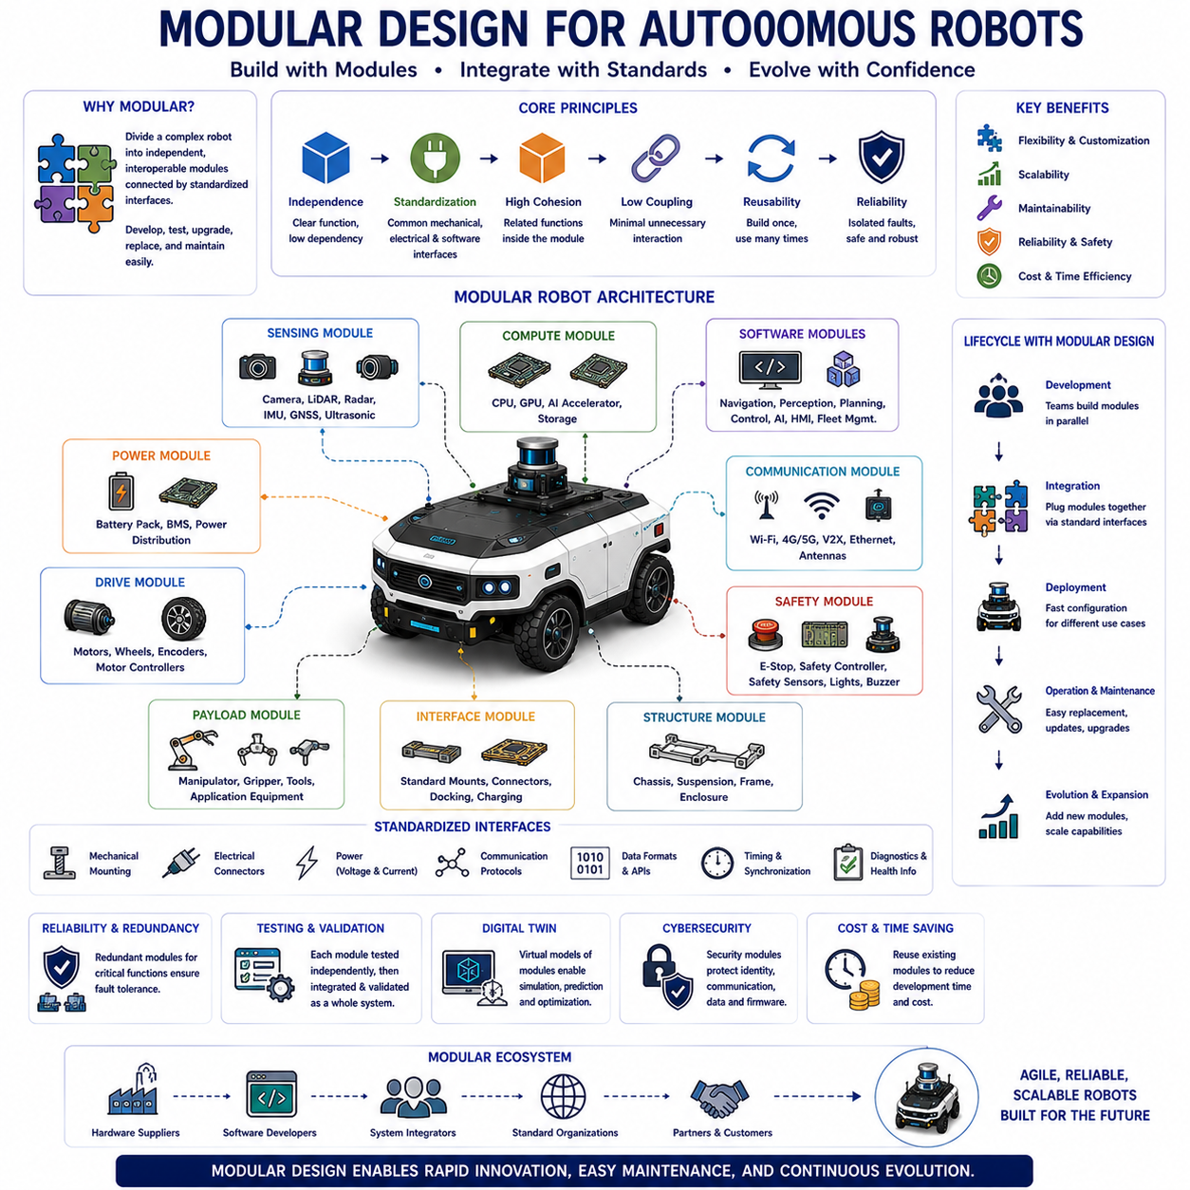
Modular design is a systematic engineering approach that divides a complex robotic system into independent yet interoperable functional units called modules. Each module performs a well-defined responsibility while communicating with other modules through standardized mechanical, electrical, and software interfaces. Rather than developing an autonomous robot as a single integrated structure, modular design enables engineers to construct systems from reusable building blocks that can be independently developed, tested, upgraded, replaced, and maintained. This philosophy has become one of the fundamental architectural principles supporting modern Autonomous Mobile Robots, Physical AI systems, industrial automation platforms, and intelligent robotic ecosystems because it improves flexibility, scalability, reliability, and long-term sustainability throughout the product lifecycle.
The primary objective of modular design is to reduce system complexity while improving engineering efficiency. Large robotic systems often involve mechanical structures, power electronics, sensing devices, computing platforms, communication networks, navigation software, artificial intelligence, and application-specific tools that evolve at different rates. Modular architecture isolates these engineering domains so that improvements or modifications within one subsystem have minimal impact on others. Consequently, development teams can work simultaneously on independent modules while reducing integration risks, shortening development cycles, and improving overall product quality.
A well-designed module possesses several important characteristics. It performs a clearly defined function, minimizes dependencies on other modules, exposes standardized interfaces, hides internal implementation details, and can operate predictably within the overall system architecture. High cohesion within each module ensures that related functions remain closely connected, while low coupling between modules minimizes unnecessary interactions. These software engineering principles equally apply to mechanical assemblies, electrical hardware, communication networks, and artificial intelligence components, allowing complex robotic systems to evolve without requiring complete architectural redesign.
Mechanical modularity forms the physical foundation of many autonomous robotic platforms. The chassis, suspension, steering system, drive units, battery pack, sensor mast, robotic manipulator, payload interface, charging connector, and protective enclosure may each exist as independent mechanical modules connected through standardized mounting interfaces. Such architecture allows manufacturers to develop multiple robot variants using common structural components while adapting payload capacity, mobility characteristics, sensing capability, or application equipment according to customer requirements. Mechanical modularity significantly reduces manufacturing cost while improving maintenance efficiency and product customization.
Electrical modularity separates power distribution, motor control, battery management, sensor interfaces, communication electronics, computing hardware, and safety circuitry into independently replaceable functional units. Standardized electrical connectors, voltage specifications, communication protocols, grounding schemes, and diagnostic interfaces simplify hardware integration while supporting future expansion. When individual electronic modules become obsolete or require technological improvement, replacement can occur without redesigning the entire electrical architecture. This approach significantly extends product lifetime while reducing maintenance complexity and inventory requirements.
Software modularity represents one of the most influential aspects of modern robotic architecture. Navigation, localization, perception, mapping, motion planning, obstacle avoidance, mission management, diagnostics, fleet management, human-machine interfaces, cybersecurity, and artificial intelligence each operate as independent software modules communicating through standardized application programming interfaces and middleware. Software modularity enables individual functions to evolve independently while preserving compatibility across the complete robotic platform. Frameworks such as the Robot Operating System demonstrate how modular software architecture accelerates robotic research, commercial development, and long-term maintainability.
Artificial intelligence has further expanded the importance of modular software architecture. Modern AI systems frequently separate sensor preprocessing, feature extraction, object detection, semantic segmentation, localization, world modeling, trajectory prediction, decision making, language understanding, and multimodal reasoning into specialized computational modules. Foundation Models introduce even greater modularity by providing generalized reasoning capabilities that can support multiple downstream applications without requiring task-specific model redesign. AI modularization enables computational resources to be allocated efficiently while simplifying validation, optimization, and continuous model improvement.
Interface standardization represents the essential mechanism enabling modular design. Mechanical dimensions, electrical connections, communication protocols, data formats, software interfaces, timing requirements, synchronization methods, and diagnostic procedures must all remain clearly defined and consistently implemented. Standardized interfaces allow independently developed modules to operate together without requiring knowledge of each other's internal implementation. Well-defined interface specifications therefore reduce integration complexity while supporting interoperability among hardware from different manufacturers and software developed by separate engineering teams.
Communication middleware plays an important role in modular robotic systems because distributed modules continuously exchange information throughout autonomous operation. Sensor measurements, localization estimates, environmental maps, mission commands, diagnostic information, actuator requests, safety notifications, and artificial intelligence results flow across standardized communication frameworks connecting independently executing software components. Middleware abstracts low-level communication details while providing message routing, synchronization, service discovery, quality-of-service management, fault detection, and distributed execution support across heterogeneous computing platforms.
Scalability naturally emerges from modular architecture because additional functionality can be incorporated by introducing new modules rather than redesigning existing ones. A basic autonomous mobile platform may initially include navigation, localization, and obstacle avoidance. Future expansion may integrate robotic manipulation, visual inspection, warehouse automation, predictive maintenance, conversational artificial intelligence, or collaborative fleet coordination simply by adding compatible functional modules. Scalable architecture therefore supports gradual capability growth while protecting existing engineering investment and minimizing redevelopment effort.
Maintainability improves substantially through modular design because faults can be isolated within specific components rather than requiring investigation of the complete system. Diagnostic procedures identify malfunctioning modules while replacement occurs without extensive disassembly or software modification. Preventive maintenance, firmware updates, hardware upgrades, sensor calibration, battery replacement, and subsystem testing become more efficient because individual modules remain independently accessible. Reduced maintenance time directly increases system availability while lowering operational cost throughout the robot's deployment lifecycle.
Reliability also benefits from modular architecture because independent modules simplify fault isolation, redundancy implementation, and failure recovery. Critical functions such as safety supervision, emergency stopping, localization, communication, or power management may employ redundant modules operating independently while continuously monitoring one another. When one module experiences abnormal behavior, redundant components maintain essential functionality while initiating diagnostic procedures or graceful degradation. Modular redundancy therefore significantly improves system resilience without unnecessarily increasing overall architectural complexity.
Product family development becomes considerably more efficient through modular engineering. Manufacturers frequently construct multiple robot models using common modules while varying only selected components according to payload capacity, environmental requirements, operational speed, battery size, sensor configuration, or application equipment. Shared modules reduce engineering duplication, simplify manufacturing, accelerate certification, and improve spare part management across entire product portfolios. Customers likewise benefit because familiar maintenance procedures, compatible software, and interchangeable components remain consistent throughout multiple generations of robotic products.
Digital twins increasingly leverage modular design by representing each physical subsystem as an independent virtual model synchronized with its real-world counterpart. Mechanical wear, battery condition, thermal behavior, sensor health, computational performance, communication quality, and mission execution can each be simulated independently before integrating into comprehensive system-level analysis. Modular digital twins enable engineers to predict maintenance requirements, evaluate upgrades, validate software changes, optimize operational strategies, and investigate failures with significantly greater accuracy than monolithic simulation approaches.
Cybersecurity similarly benefits from modular architecture because security mechanisms can be distributed throughout multiple independent layers rather than centralized within a single protection system. Authentication, encryption, secure communication, access control, software integrity verification, intrusion detection, and hardware security modules operate independently while collectively protecting the complete robotic platform. Security updates affecting one module need not disrupt unrelated system functionality, thereby reducing operational downtime while maintaining consistent protection against evolving cyber threats.
Verification and validation become more manageable within modular systems because each module can undergo independent testing before system-level integration. Unit testing verifies individual functionality, integration testing confirms interface compatibility, subsystem testing evaluates coordinated operation, and complete system validation demonstrates overall mission performance. Fault injection, hardware-in-the-loop simulation, software-in-the-loop evaluation, digital twins, and field testing collectively ensure that each module satisfies predefined functional and safety requirements before deployment. Modular testing significantly reduces debugging complexity while improving engineering confidence throughout development.
Future modular robotic architectures will evolve toward highly distributed ecosystems integrating standardized hardware modules, service-oriented software, edge computing, cloud intelligence, Foundation Models, collaborative perception, digital twins, autonomous fleets, and continuously learning artificial intelligence. Rather than designing each robotic platform independently, future engineering will increasingly assemble intelligent systems from reusable modules capable of adapting across multiple industries and applications. As Physical AI expands into manufacturing, logistics, agriculture, healthcare, construction, public infrastructure, and autonomous transportation, modular design will remain one of the most important architectural principles supporting rapid innovation, scalable deployment, efficient maintenance, and sustainable long-term technological evolution.

09.02 Scalability · 확장성
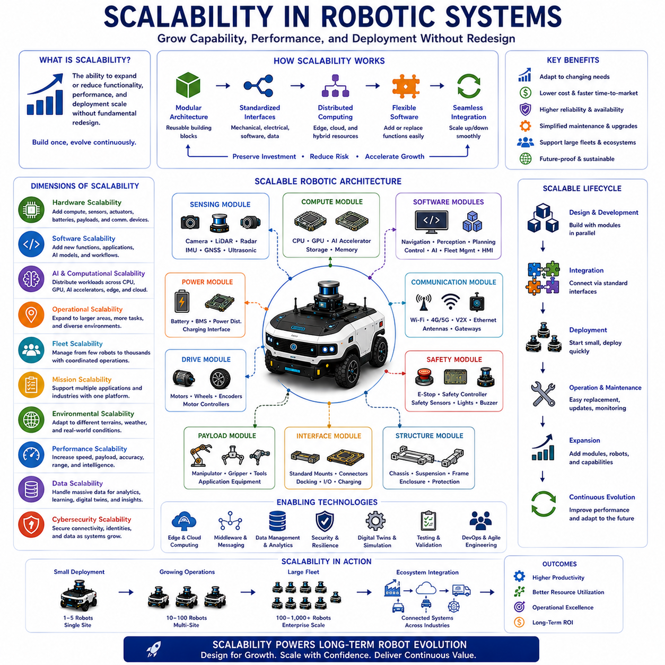
Scalability is the architectural capability that enables a robotic system to increase or decrease its functionality, computational capacity, operational coverage, performance, and deployment scale without requiring fundamental redesign of the underlying architecture. Rather than developing separate robotic platforms for every application or performance requirement, scalable systems are intentionally designed to evolve through modular expansion, standardized interfaces, distributed computing, and flexible software architectures. Scalability allows Autonomous Mobile Robots, Physical AI platforms, and intelligent robotic ecosystems to adapt efficiently to changing customer requirements, technological advances, operational complexity, and business growth throughout the entire product lifecycle. As autonomous systems become increasingly integrated into large industrial infrastructures, scalability has become one of the defining characteristics of successful robotic architectures.
The primary objective of scalability is to preserve engineering investment while supporting continuous growth. Robotic platforms should accommodate increasing computational demand, additional sensors, larger operational environments, expanded software functionality, and growing robot fleets without requiring complete redevelopment. Instead of replacing existing systems whenever new capabilities become necessary, scalable architecture allows incremental enhancement through carefully designed extension mechanisms. This engineering philosophy reduces development cost, shortens deployment time, minimizes technical risk, and enables organizations to respond rapidly to evolving operational requirements.
Scalability exists in multiple dimensions rather than representing a single engineering characteristic. Hardware scalability addresses physical expansion through additional computing units, sensors, actuators, batteries, payload modules, and communication devices. Software scalability enables new functional capabilities, application services, artificial intelligence models, and operational workflows. Computational scalability supports increasing processing requirements through distributed computing and heterogeneous hardware acceleration. Operational scalability extends autonomous behavior across larger facilities, more complex environments, and increasing mission diversity. Organizational scalability supports collaboration among expanding engineering teams while preserving architectural consistency and long-term maintainability.
Hardware scalability forms the physical foundation supporting long-term robotic evolution. Modular chassis architectures permit multiple payload capacities using common structural components. Computing platforms accommodate additional graphics processors, AI accelerators, storage devices, memory modules, and communication interfaces through standardized expansion mechanisms. Sensor systems support new cameras, LiDAR units, radar modules, ultrasonic sensors, environmental monitoring devices, and specialized industrial instrumentation without fundamentally altering the overall system architecture. Such flexibility enables manufacturers to construct diverse product families while maximizing component reuse and minimizing engineering duplication.
Software scalability has become increasingly important as robotic functionality continues expanding beyond traditional navigation and automation tasks. Well-designed software architectures separate perception, localization, mapping, planning, control, diagnostics, cybersecurity, fleet management, digital twins, artificial intelligence, and application-specific functions into independently deployable services communicating through standardized interfaces. New software modules can therefore be introduced without modifying existing functional components, allowing continuous capability growth while preserving software stability. Service-oriented architecture and microservice principles have become widely adopted because they naturally support scalable robotic software ecosystems.
Artificial intelligence introduces unique scalability requirements because computational demand grows rapidly as robotic intelligence becomes more sophisticated. Deep neural networks, multimodal perception, semantic understanding, language models, world models, and Foundation Models require substantial processing resources that frequently exceed the capabilities of conventional embedded systems. Scalable AI architectures therefore distribute computation across CPUs, GPUs, AI accelerators, edge devices, and cloud platforms while dynamically allocating workloads according to latency, bandwidth, energy consumption, and operational priorities. This flexible computational architecture allows robotic intelligence to expand without unnecessary hardware replacement.
Edge computing and cloud computing collectively provide an effective framework supporting computational scalability. Time-critical functions including motor control, obstacle avoidance, localization, and emergency safety remain within low-latency onboard computing systems, while computationally intensive tasks such as large-scale mapping, fleet optimization, historical analytics, predictive maintenance, model training, and knowledge management execute within cloud infrastructure. Dynamic workload distribution continuously balances computational efficiency, communication availability, operational responsiveness, and system reliability. Hybrid edge-cloud architectures therefore enable robotic systems to utilize virtually unlimited computational resources while preserving deterministic real-time behavior.
Communication scalability enables increasing numbers of distributed robotic components to exchange information efficiently without degrading overall system performance. Modern robotic platforms employ high-speed Ethernet, wireless communication, middleware frameworks, publish-subscribe messaging, quality-of-service management, and distributed synchronization mechanisms supporting thousands of concurrent information exchanges among sensors, controllers, artificial intelligence modules, cloud services, and fleet management systems. Scalable communication architecture minimizes bandwidth congestion while ensuring reliable information delivery across increasingly complex autonomous ecosystems.
Fleet scalability represents one of the most important requirements for industrial autonomous mobile robotics. Initial deployments may consist of only a few robots operating independently within limited facilities. As operational demand increases, organizations frequently expand toward dozens, hundreds, or even thousands of coordinated autonomous platforms sharing maps, tasks, charging infrastructure, communication resources, and mission priorities. Scalable fleet management coordinates traffic, workload balancing, charging schedules, maintenance planning, software updates, resource allocation, and collaborative task execution while maintaining overall operational efficiency despite continuously increasing system complexity.
Mission scalability allows robotic systems to perform increasingly diverse operational tasks without architectural redesign. Early deployments often focus on simple transportation or inspection missions. As organizations gain operational experience, additional applications including inventory management, environmental monitoring, predictive maintenance, security patrol, automated cleaning, agricultural operations, collaborative manipulation, construction inspection, and intelligent logistics can be integrated into the same autonomous platform. Mission scalability enables one robotic architecture to support multiple industries and continuously expanding application domains throughout its operational lifetime.
Environmental scalability addresses the robot's ability to operate safely and efficiently across increasingly diverse physical environments. Autonomous systems may initially function within structured warehouses before expanding toward factories, hospitals, airports, campuses, construction sites, ports, farms, mines, public roads, and mixed urban environments. Scalable environmental adaptation requires flexible localization strategies, multimodal perception, robust navigation algorithms, adaptive safety mechanisms, terrain awareness, weather resilience, and semantic environmental understanding capable of generalizing across diverse operational conditions.
Performance scalability enables robotic systems to satisfy progressively increasing operational requirements without compromising stability or safety. Increased sensor resolution, higher navigation speed, larger payload capacity, improved localization accuracy, expanded perception range, more sophisticated artificial intelligence, and higher communication throughput all require proportional growth in computational capability and system architecture. Performance scalability therefore balances processing power, energy consumption, thermal management, communication bandwidth, and software optimization while maintaining deterministic real-time behavior essential for autonomous safety.
Data scalability has become increasingly important as autonomous robots continuously generate massive volumes of sensor information, operational logs, artificial intelligence outputs, environmental maps, diagnostic records, and maintenance history. Efficient storage architectures organize structured and unstructured data while supporting rapid retrieval, distributed synchronization, compression, indexing, security, and long-term archival. Scalable data infrastructure enables continuous learning, operational analytics, digital twins, predictive maintenance, and fleet-wide optimization without overwhelming computational or storage resources.
Cybersecurity scalability ensures that expanding robotic ecosystems remain protected despite increasing connectivity, computational distribution, and organizational complexity. Authentication services, encrypted communication, certificate management, access control, intrusion detection, software integrity verification, security monitoring, and threat response mechanisms must all scale proportionally with system growth. Rather than introducing centralized security bottlenecks, distributed security architectures protect independent subsystems while maintaining coordinated defense across entire robotic infrastructures.
Reliability and fault tolerance become increasingly important as scalable systems expand in size and complexity. Larger robotic ecosystems naturally contain more potential failure points, making redundancy, graceful degradation, fault isolation, self-diagnostics, predictive maintenance, automatic recovery, and distributed supervision essential architectural features. Scalable systems should maintain acceptable operational performance despite localized hardware failures, communication interruptions, sensor degradation, software anomalies, or computational overload. Robust fault management therefore enables scalability without sacrificing dependability.
Verification and validation become progressively more challenging as scalability increases because engineers must demonstrate correct operation across vastly expanded combinations of hardware configurations, software modules, environmental conditions, operational scenarios, and fleet interactions. Hierarchical testing strategies evaluate individual modules, integrated subsystems, complete robotic platforms, multi-robot coordination, cloud services, cybersecurity mechanisms, and large-scale operational workflows independently before validating complete system behavior. Simulation, digital twins, hardware-in-the-loop evaluation, software-in-the-loop testing, stress testing, scalability benchmarking, and field deployment collectively verify that system performance remains predictable as operational scale increases.
Business scalability represents an equally important consideration because engineering architecture directly influences manufacturing efficiency, product customization, maintenance cost, customer support, software distribution, certification, regulatory compliance, and long-term product evolution. A scalable product architecture enables manufacturers to introduce new product variants rapidly, enter additional markets, reduce inventory complexity, simplify spare part logistics, accelerate software deployment, and support expanding customer bases without proportionally increasing engineering effort. Technical scalability therefore becomes a strategic business advantage supporting sustainable commercial growth.
Future scalability in autonomous robotics will increasingly depend upon modular hardware ecosystems, distributed artificial intelligence, Foundation Models, collaborative fleets, cloud-native software, digital twins, standardized interfaces, edge-cloud orchestration, autonomous infrastructure, and continuously learning systems. Rather than viewing scalability as merely increasing system size, future robotic architectures will treat scalability as the ability to adapt intelligently across diverse applications, industries, operational environments, and technological generations. As Physical AI continues expanding throughout manufacturing, logistics, healthcare, agriculture, construction, transportation, and public infrastructure, scalable architecture will remain one of the essential engineering principles enabling intelligent robotic systems to evolve efficiently while preserving reliability, safety, interoperability, and long-term sustainability.

09.03 Reliability Engineering · 신뢰성 공학
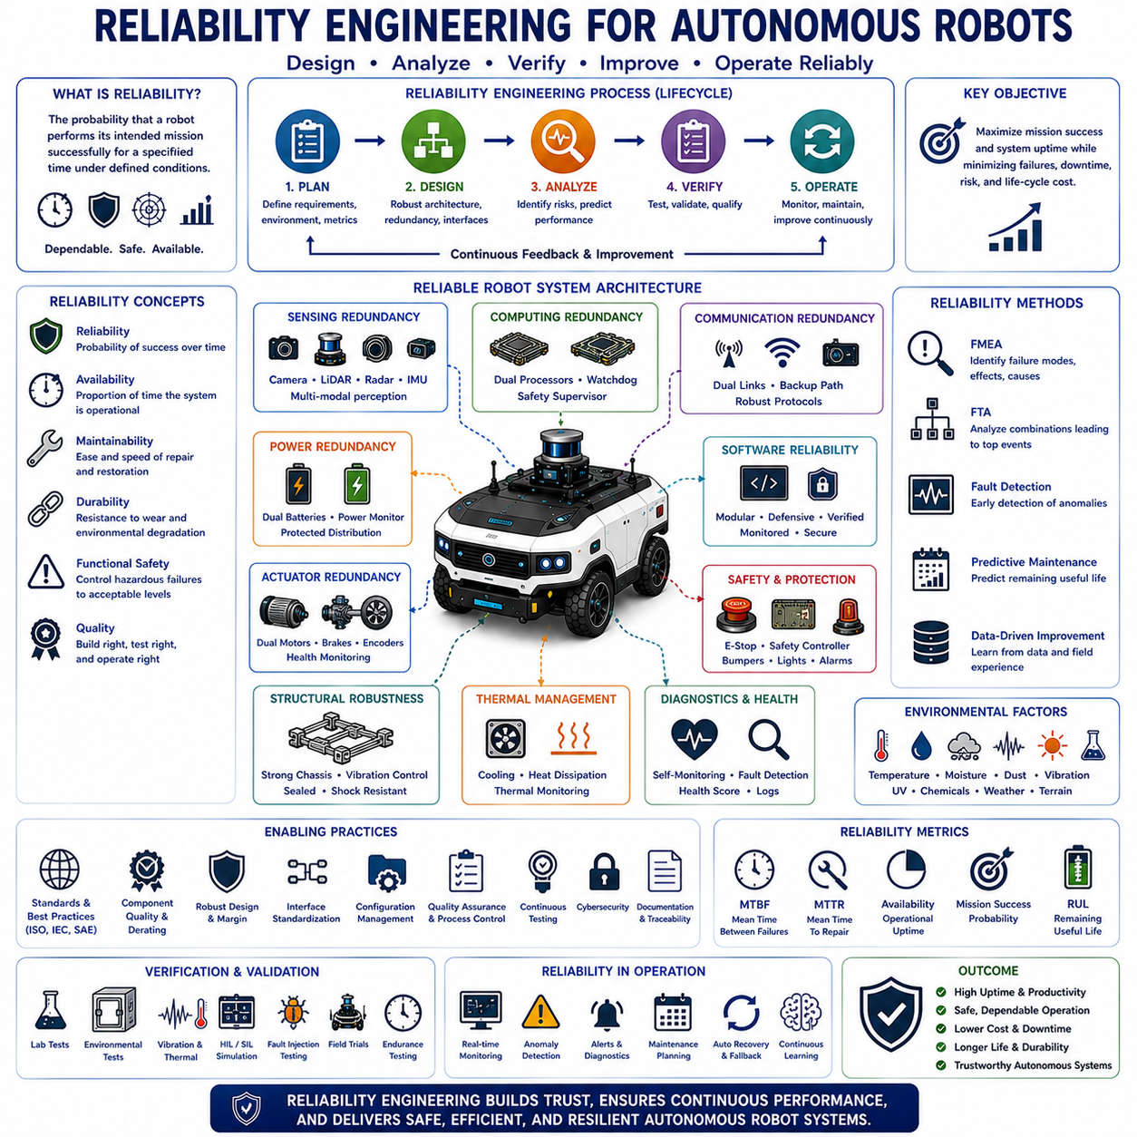
Reliability engineering is the systematic discipline of designing, analyzing, verifying, and continuously improving engineering systems so that they perform their intended functions consistently over a specified period under defined operating conditions. In autonomous robotics, reliability extends beyond preventing component failures by ensuring continuous mission execution despite environmental uncertainty, hardware degradation, software complexity, communication disturbances, and operational variability. Autonomous Mobile Robots, Physical AI platforms, and intelligent industrial systems increasingly operate in mission-critical environments where unexpected downtime directly impacts productivity, safety, maintenance cost, and business continuity. Consequently, reliability engineering has become one of the fundamental design principles supporting dependable autonomous operation throughout the entire product lifecycle.
The primary objective of reliability engineering is to maximize the probability that a robotic system successfully completes its intended mission without unacceptable failure. Rather than assuming failures can be eliminated entirely, reliability engineering recognizes that every component possesses finite lifetime characteristics influenced by manufacturing variation, environmental stress, operational load, aging, and random uncertainty. Engineering therefore focuses on understanding failure mechanisms, minimizing failure probability, detecting abnormal behavior early, preventing fault propagation, and ensuring graceful recovery whenever failures occur. Reliability thus becomes an actively managed system characteristic instead of merely a statistical performance indicator.
Reliability differs from several closely related engineering concepts. Reliability measures the probability of successful operation over time, while availability represents the proportion of time that a system remains operational considering both failures and repair activities. Maintainability evaluates how efficiently failures can be diagnosed, repaired, and restored. Durability focuses on long-term resistance against wear and environmental degradation. Functional safety ensures hazardous failures remain acceptably controlled, whereas reliability seeks to minimize all operational failures regardless of safety consequences. Together, these complementary engineering disciplines create robust autonomous systems capable of supporting continuous industrial operation.
Reliability engineering begins during the earliest stages of system architecture rather than after prototype development. Architectural decisions regarding modularity, redundancy, interface standardization, communication topology, computing distribution, thermal management, power distribution, diagnostic capability, and software organization strongly influence long-term reliability. Systems designed with reliability as a primary architectural objective generally require fewer corrective modifications during later development stages while exhibiting lower maintenance cost and higher operational stability throughout deployment.
Component reliability forms the foundation of overall system dependability. Every mechanical part, electronic device, communication interface, battery cell, actuator, sensor, processor, connector, and software module possesses measurable reliability characteristics determined through laboratory testing, field operation, manufacturer specifications, and statistical analysis. System reliability depends not only upon individual component quality but also upon interaction among interconnected subsystems. Consequently, highly reliable components alone cannot guarantee overall system reliability if architectural integration introduces unnecessary complexity or failure dependencies.
Failure mechanisms vary significantly across different engineering domains. Mechanical components experience wear, fatigue, corrosion, vibration damage, lubrication degradation, bearing failure, gear wear, and structural cracking. Electronic systems encounter thermal stress, voltage instability, electromagnetic interference, connector degradation, semiconductor aging, capacitor failure, and solder fatigue. Batteries gradually lose capacity through repeated charge-discharge cycles while communication systems experience signal degradation, interference, bandwidth congestion, and synchronization loss. Software failures arise from algorithmic errors, memory corruption, resource exhaustion, timing anomalies, unexpected input conditions, and integration defects. Reliability engineering therefore requires multidisciplinary understanding spanning mechanical, electrical, software, and operational domains.
Environmental conditions strongly influence robotic reliability. Temperature extremes accelerate electronic aging while affecting battery performance and mechanical tolerances. Moisture promotes corrosion and insulation degradation. Dust contaminates optical sensors and cooling systems. Vibration increases connector fatigue and mechanical wear. Ultraviolet radiation gradually degrades polymer materials. Chemical exposure damages seals and electronic assemblies. Outdoor autonomous systems additionally encounter rain, snow, ice, mud, sand, salt, wind, and solar heating. Reliability engineering therefore evaluates equipment performance across representative environmental conditions rather than assuming ideal laboratory operation.
Reliability prediction estimates expected system performance before physical deployment. Statistical reliability models combine component failure data, environmental stress factors, operational profiles, redundancy architecture, maintenance schedules, and historical experience to estimate metrics including failure probability, mission success rate, mean time between failures, expected operational lifetime, and maintenance frequency. Although predictive models cannot perfectly anticipate every real-world failure, they provide valuable engineering guidance supporting design optimization, component selection, resource planning, and lifecycle cost estimation.
Failure Mode and Effects Analysis represents one of the most widely applied reliability engineering methodologies. Engineers systematically identify potential failure modes for every subsystem while evaluating their causes, operational consequences, detection capability, occurrence probability, and overall system impact. High-risk failure modes receive priority mitigation through improved design, redundancy, monitoring, preventive maintenance, software protection, or enhanced diagnostic capability. Structured failure analysis enables organizations to address vulnerabilities proactively before deployment rather than reacting after operational failures occur.
Fault Tree Analysis complements failure mode analysis by examining how combinations of multiple failures collectively generate undesirable system-level events. Logical relationships among hardware faults, software anomalies, communication failures, human error, environmental disturbances, and operational conditions reveal complex dependency structures that may remain hidden during component-level evaluation. Fault tree modeling therefore supports systematic reliability improvement while identifying critical single-point failures requiring architectural modification or additional protective mechanisms.
Redundancy significantly improves reliability by ensuring critical functions remain operational despite localized failures. Sensor redundancy combines cameras, LiDAR, radar, ultrasonic sensors, and inertial measurement units observing identical environments through complementary physical principles. Computing redundancy employs independent processors supervising safety-critical algorithms. Communication redundancy provides alternative network paths during connectivity disruption. Power redundancy incorporates backup batteries and protected power distribution. Functional redundancy enables different algorithms to achieve identical operational objectives using diverse computational approaches. Carefully designed redundancy substantially increases mission reliability while minimizing vulnerability to individual component failures.
Fault detection and diagnostic capability represent essential elements of modern reliability engineering. Autonomous robots continuously monitor sensor health, processor utilization, communication latency, battery condition, actuator performance, thermal behavior, localization confidence, software integrity, and operational consistency. Diagnostic algorithms identify abnormal patterns before complete failure occurs, allowing corrective intervention while normal operation remains possible. Self-monitoring transforms reliability engineering from passive failure analysis into continuous operational supervision supporting intelligent maintenance and adaptive mission management.
Predictive maintenance has emerged as one of the most valuable applications of reliability engineering. Rather than replacing components according to fixed schedules or waiting until failures occur, predictive maintenance continuously analyzes operational data to estimate remaining useful life, degradation rate, failure probability, and maintenance priority. Machine learning models identify subtle behavioral changes preceding mechanical wear, battery degradation, motor failure, communication instability, or sensor contamination. Maintenance activities therefore become data-driven, reducing unnecessary replacement while preventing unexpected operational interruptions.
Software reliability has become increasingly important because modern autonomous robots depend heavily upon millions of software instructions controlling perception, localization, planning, artificial intelligence, communication, diagnostics, and mission execution. Reliable software architecture emphasizes modular design, standardized interfaces, defensive programming, deterministic execution, exception handling, automated testing, continuous integration, version management, cybersecurity, and formal verification where appropriate. Software quality assurance extends beyond debugging by establishing disciplined engineering processes supporting long-term reliability across continuous product evolution.
Artificial intelligence introduces additional reliability considerations because learning-based algorithms may exhibit uncertainty beyond conventional deterministic software. Dataset quality, model generalization, environmental diversity, sensor variation, adversarial conditions, and unexpected operational scenarios all influence AI reliability. Modern autonomous systems therefore combine machine learning with deterministic safety supervision, confidence estimation, uncertainty modeling, sensor fusion, fallback algorithms, and explainable artificial intelligence supporting robust decision-making under diverse operating conditions. Reliable AI architecture emphasizes predictable operational behavior despite continuously evolving environmental complexity.
Verification and validation play central roles throughout reliability engineering. Laboratory experiments, environmental testing, vibration qualification, thermal cycling, electromagnetic compatibility evaluation, endurance testing, accelerated lifetime testing, hardware-in-the-loop simulation, software-in-the-loop verification, digital twins, fault injection, field trials, and long-duration operational testing collectively demonstrate that reliability objectives have been achieved. Comprehensive validation extends beyond demonstrating normal functionality by intentionally exposing robotic systems to abnormal conditions, degraded sensing, communication disruption, hardware faults, software anomalies, and realistic environmental variability.
Reliability metrics provide quantitative measures supporting engineering decisions and lifecycle management. Mean Time Between Failures, Mean Time To Repair, Mean Time To Failure, operational availability, mission success probability, repair rate, diagnostic coverage, fault detection latency, and remaining useful life collectively characterize overall system dependability. Continuous monitoring of these indicators enables manufacturers to compare product generations, optimize maintenance strategies, identify emerging reliability concerns, and evaluate engineering improvements using objective statistical evidence rather than subjective observation.
Future reliability engineering will increasingly integrate digital twins, edge computing, cloud analytics, Foundation Models, distributed artificial intelligence, autonomous diagnostics, collaborative fleet learning, predictive analytics, self-healing software architectures, adaptive redundancy, and continuously evolving reliability models. Rather than treating reliability as a static design objective verified before deployment, future autonomous systems will continuously evaluate their own operational health, predict emerging degradation, coordinate maintenance across entire robotic fleets, and autonomously optimize system configuration according to changing environmental conditions and mission requirements. As Physical AI expands into transportation, manufacturing, logistics, healthcare, agriculture, construction, mining, and public infrastructure, reliability engineering will remain one of the most essential engineering disciplines ensuring dependable, resilient, efficient, and trustworthy autonomous robotic operation throughout increasingly complex industrial ecosystems.

09.04 Manufacturability · 제조 가능성
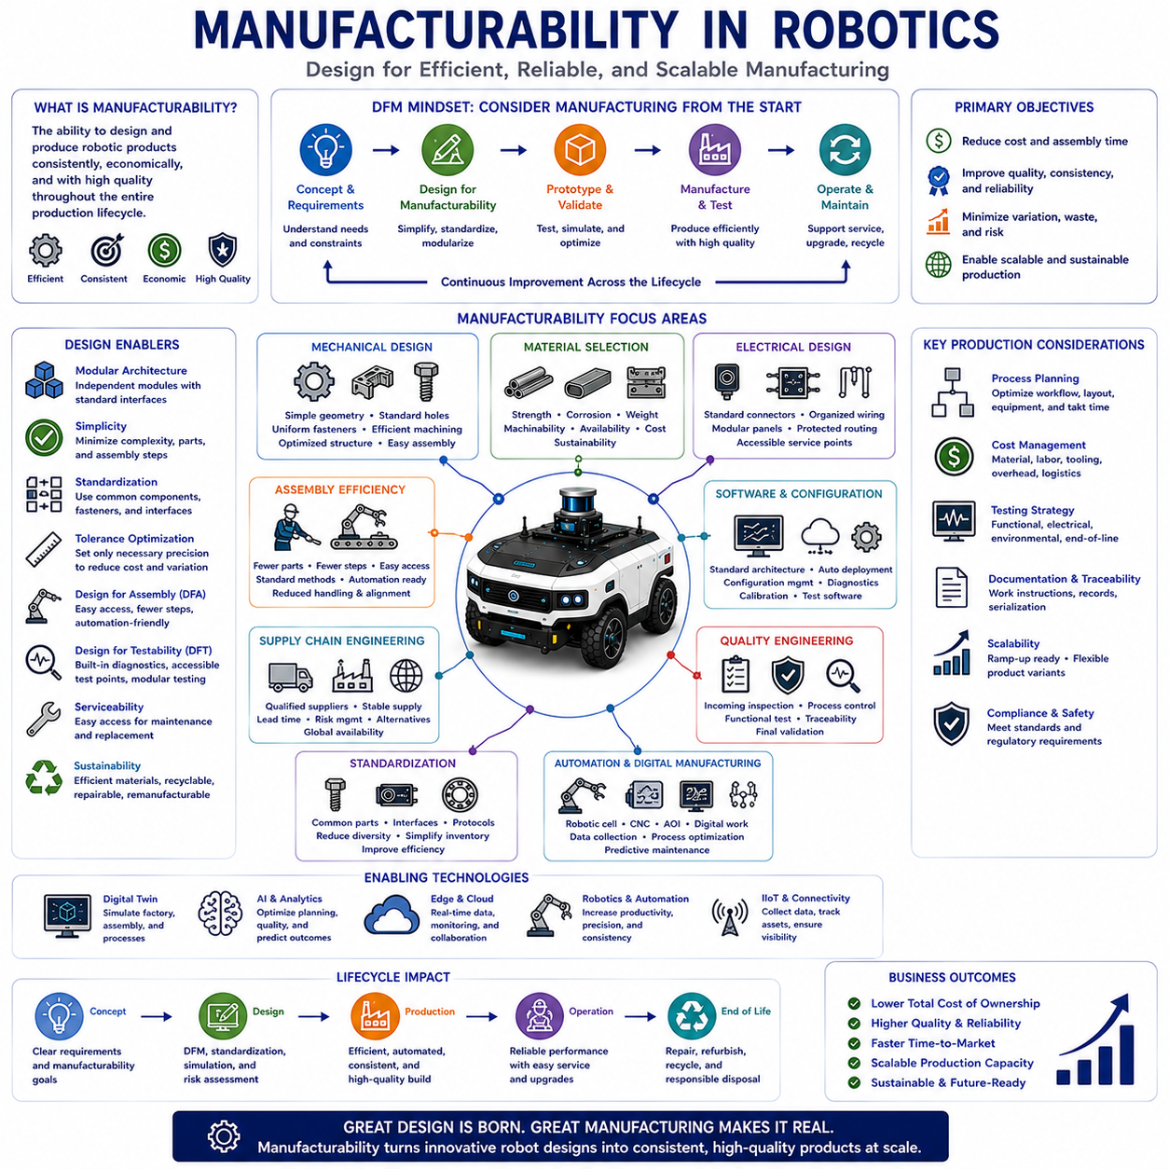
Manufacturability is the engineering capability that enables a product to be manufactured efficiently, consistently, economically, and at high quality throughout its entire production lifecycle. In autonomous robotics, manufacturability extends far beyond simply assembling components by considering how mechanical structures, electrical systems, software, supply chains, production processes, testing procedures, maintenance requirements, and quality assurance interact during mass production. A highly innovative robotic platform provides little commercial value if it cannot be manufactured reliably, maintained efficiently, or scaled economically. Consequently, manufacturability has become one of the most important engineering principles connecting research, product development, manufacturing, and long-term business success within the robotics industry.
The primary objective of manufacturability is to reduce production complexity while maximizing product quality, manufacturing efficiency, and economic competitiveness. Engineering teams seek to minimize production cost, assembly time, material waste, manufacturing variation, and process uncertainty while improving consistency, repeatability, reliability, and customer satisfaction. Rather than treating manufacturing as a separate activity following product design, modern engineering integrates manufacturing considerations from the earliest architectural planning stages. This Design for Manufacturability philosophy enables engineering decisions to support efficient production before prototypes are even constructed.
Manufacturability begins with product architecture because structural organization directly influences production efficiency. Modular architectures divide complex robotic systems into independently manufacturable assemblies that can be fabricated, tested, and integrated separately. Standardized interfaces simplify assembly while reducing engineering dependencies across multiple manufacturing teams. Well-defined subsystem boundaries improve production planning, inventory management, quality inspection, maintenance accessibility, and future product upgrades. Consequently, modular product architecture supports both manufacturing flexibility and long-term product evolution.
Mechanical design strongly influences manufacturing complexity. Components should minimize unnecessary geometric complexity while maintaining structural integrity, functional performance, and safety. Standard hole sizes, uniform fasteners, simplified machining operations, repeatable welding procedures, optimized tolerances, accessible assembly directions, and efficient structural layouts significantly improve manufacturing productivity. Engineers continually evaluate whether each design feature contributes meaningful functional value or merely increases production difficulty. Simplicity often improves both manufacturing efficiency and product reliability simultaneously.
Material selection represents another critical manufacturability consideration. Mechanical strength, corrosion resistance, thermal behavior, machinability, weldability, weight, availability, environmental durability, recyclability, and cost must all be balanced throughout product development. Aluminum alloys, structural steel, stainless steel, engineering plastics, composite materials, and lightweight alloys each provide different manufacturing advantages depending upon application requirements. Selecting materials readily available through stable supply chains reduces procurement risk while simplifying inventory management and production scheduling.
Tolerance engineering plays a central role in manufacturability because excessive precision frequently increases manufacturing cost without proportional functional benefit. Engineers identify which dimensions genuinely require high precision while relaxing noncritical tolerances wherever possible. Proper tolerance allocation simplifies machining, inspection, assembly, and supplier qualification while reducing scrap rates and production variability. Statistical tolerance analysis further ensures that accumulated dimensional variation does not compromise overall system performance or assembly compatibility.
Assembly efficiency directly affects manufacturing cost and production throughput. Products designed for efficient assembly minimize the number of unique components, reduce assembly steps, standardize fastening methods, improve accessibility, eliminate unnecessary adjustments, and simplify alignment procedures. Design for Assembly methodologies encourage engineers to reduce handling complexity while supporting automation wherever feasible. Robotic systems benefiting from simplified assembly generally exhibit improved consistency, reduced labor requirements, shorter production cycles, and fewer assembly-related defects.
Electrical manufacturability addresses efficient integration of wiring harnesses, connectors, printed circuit boards, sensors, actuators, communication devices, batteries, power distribution systems, and embedded computing platforms. Organized cable routing, standardized connectors, modular electrical panels, accessible maintenance points, protected wiring channels, and simplified diagnostic interfaces reduce assembly time while improving long-term serviceability. Electrical architecture should simultaneously satisfy functional requirements, electromagnetic compatibility, safety regulations, and manufacturing efficiency without unnecessary complexity.
Software also contributes significantly to manufacturability despite being physically intangible. Standardized software architecture, automated deployment tools, configuration management, version control, calibration procedures, diagnostic interfaces, cybersecurity implementation, and manufacturing test software all simplify production operations. Factory software installation, hardware configuration, sensor calibration, firmware verification, and functional validation become repeatable automated processes rather than manual engineering activities. Digital manufacturing therefore increasingly depends upon robust software engineering practices supporting efficient production.
Supply chain engineering represents an essential aspect of manufacturability because production reliability depends upon stable availability of qualified components. Engineers evaluate supplier capability, manufacturing capacity, component lifecycle, quality consistency, logistics performance, lead time, geopolitical risk, regulatory compliance, and alternative sourcing options during product development. Designing products using globally available standard components improves manufacturing resilience while reducing vulnerability to supply disruptions. Flexible sourcing strategies further enhance long-term manufacturing sustainability.
Standardization significantly improves manufacturability by reducing unnecessary variation across products, production processes, documentation, tooling, testing, and maintenance. Standard fasteners, connectors, bearings, motors, sensors, electrical interfaces, communication protocols, and software frameworks simplify procurement while reducing inventory diversity. Manufacturing personnel become more efficient through repetitive experience with common components and standardized procedures. Product families sharing standardized modules likewise benefit from reduced engineering duplication and simplified lifecycle support.
Automation increasingly transforms modern robotic manufacturing. Computer numerical control machining, robotic welding, automated assembly, laser cutting, additive manufacturing, automated optical inspection, coordinate measuring machines, digital work instructions, and intelligent quality monitoring improve manufacturing consistency while reducing labor-intensive operations. Digital manufacturing systems continuously collect production data supporting process optimization, predictive maintenance, quality analytics, and continuous improvement throughout the manufacturing lifecycle. Manufacturing automation therefore enhances both productivity and repeatability.
Quality engineering remains inseparable from manufacturability because production efficiency possesses little value without consistent product quality. Incoming material inspection, process monitoring, statistical process control, dimensional verification, electrical testing, software validation, functional testing, environmental qualification, traceability management, and final acceptance testing collectively ensure manufacturing consistency. Rather than relying solely upon final product inspection, modern manufacturing emphasizes building quality directly into production processes through systematic prevention of defects at every stage.
Testing strategy should be considered during initial product design because inaccessible components, inadequate diagnostic capability, or poorly designed interfaces significantly complicate manufacturing validation. Design for Testability introduces accessible measurement points, built-in diagnostics, automated testing interfaces, standardized verification procedures, and modular subsystem testing throughout production. Manufacturing personnel can therefore rapidly identify assembly errors, calibration problems, electrical faults, software anomalies, or mechanical defects before final product integration. Efficient testing reduces production delay while improving customer confidence.
Serviceability and maintainability closely influence manufacturability because products requiring excessive maintenance complexity often indicate unnecessary manufacturing complexity as well. Components requiring routine replacement should remain easily accessible without extensive disassembly. Modular replacement strategies reduce maintenance time while supporting spare part standardization across product families. Engineering decisions benefiting manufacturing frequently improve maintenance efficiency simultaneously, demonstrating the close relationship among design, production, operation, and lifecycle support.
Sustainability has become an increasingly important manufacturability consideration as manufacturers pursue environmentally responsible production. Material utilization, energy efficiency, waste reduction, recyclable materials, environmentally friendly surface treatments, optimized logistics, repairability, remanufacturing, and circular economy principles all influence manufacturing strategy. Products designed for disassembly, refurbishment, and material recovery reduce environmental impact while supporting long-term economic sustainability. Sustainable manufacturing therefore extends beyond regulatory compliance toward responsible lifecycle engineering.
Digital twins increasingly support manufacturability by representing manufacturing processes within virtual environments before physical production begins. Engineers simulate assembly sequences, robotic work cells, manufacturing tolerances, production scheduling, equipment utilization, quality inspection, logistics flow, and factory layout while identifying inefficiencies before implementation. Manufacturing digital twins reduce development risk while accelerating production readiness, improving resource utilization, and supporting continuous optimization throughout factory operation.
Artificial intelligence has begun transforming manufacturability through intelligent production planning, automated quality inspection, predictive maintenance, supply chain optimization, anomaly detection, process optimization, workforce assistance, and autonomous manufacturing analytics. Machine learning continuously analyzes manufacturing data to identify subtle relationships among equipment performance, material characteristics, environmental conditions, operator behavior, and product quality. Foundation Models further support engineering documentation, manufacturing knowledge management, technical assistance, and process standardization across global manufacturing organizations.
Future manufacturability will increasingly integrate modular product architectures, highly automated factories, collaborative robotics, edge-cloud manufacturing intelligence, digital twins, artificial intelligence, standardized industrial interfaces, autonomous quality control, predictive production planning, and sustainable manufacturing ecosystems. Rather than optimizing individual production steps independently, future manufacturing systems will coordinate engineering design, supplier networks, factory operations, logistics, quality management, lifecycle support, and customer feedback within unified digital environments. As Physical AI expands throughout manufacturing, logistics, healthcare, construction, agriculture, transportation, and industrial automation, manufacturability will remain one of the most essential engineering disciplines enabling reliable, scalable, economical, and sustainable production of increasingly intelligent robotic systems.

09.05 Maintainability · 유지보수성
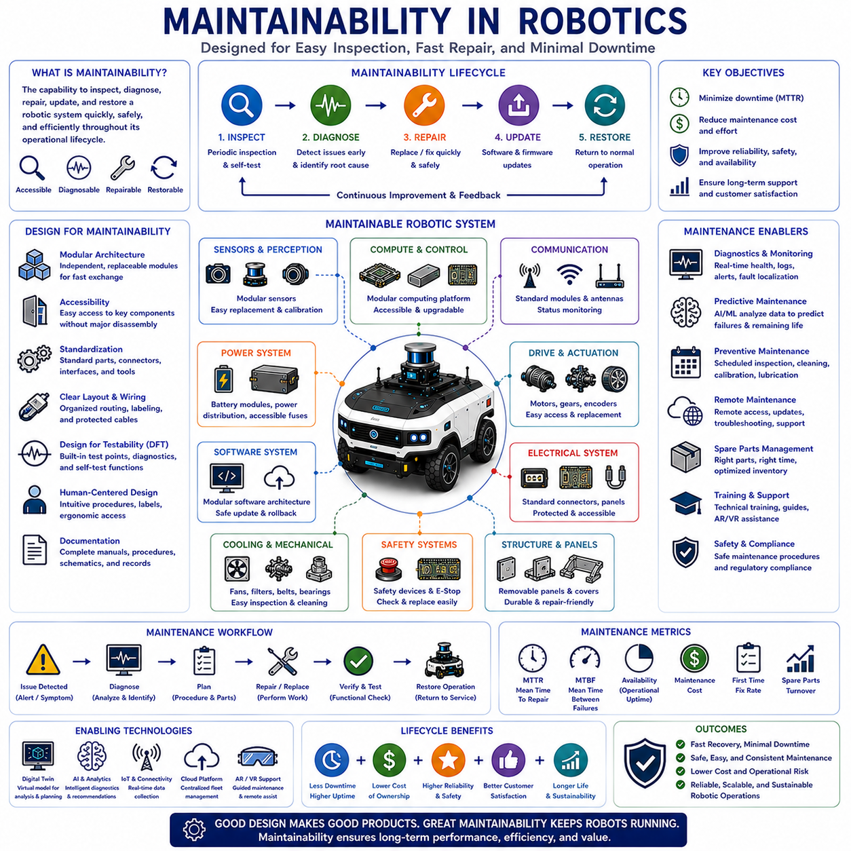
Maintainability is the engineering capability that enables a robotic system to be inspected, diagnosed, repaired, updated, and restored to normal operation quickly, safely, and efficiently throughout its operational lifecycle. In autonomous robotics, maintainability extends beyond replacing failed components by considering accessibility, diagnostics, modular architecture, software updates, spare part management, maintenance planning, and lifecycle support. As autonomous robots become increasingly sophisticated and operate continuously in industrial environments, downtime caused by difficult maintenance directly affects productivity, operational cost, customer satisfaction, and business competitiveness. Consequently, maintainability has become one of the fundamental engineering principles supporting reliable, scalable, and economically sustainable robotic systems.
The primary objective of maintainability is to minimize the time, cost, complexity, and risk associated with restoring a robotic system to full operational capability after maintenance activities become necessary. Rather than assuming failures can always be prevented, maintainability recognizes that inspection, calibration, software updates, preventive maintenance, component replacement, and unexpected repairs will inevitably occur throughout a product's lifetime. Engineering therefore focuses on reducing maintenance effort while improving repair quality, operational safety, diagnostic efficiency, and service consistency across different operating environments.
Maintainability differs from several closely related engineering concepts. Reliability measures the probability that a system operates without failure over time, while maintainability measures how efficiently the system can be restored after maintenance becomes necessary. Availability combines both reliability and maintainability by representing the proportion of time that the system remains operational. Serviceability generally emphasizes practical maintenance accessibility, whereas maintainability encompasses broader engineering considerations including diagnostics, modular design, documentation, training, spare parts, and lifecycle planning. Together, these disciplines establish dependable robotic systems capable of sustained long-term operation.
Maintainability begins during the earliest stages of system architecture rather than after hardware development is complete. Decisions regarding modular organization, subsystem independence, standardized interfaces, cable routing, connector accessibility, maintenance clearance, software architecture, and diagnostic capability significantly influence future service operations. Systems designed with maintenance in mind generally require fewer specialized tools, less technician effort, shorter repair times, and reduced operational interruption compared with systems optimized solely for functional performance.
Modular architecture represents one of the most effective approaches for improving maintainability. Complex robotic systems are divided into independently replaceable modules including sensing units, computing platforms, power systems, drive assemblies, communication devices, batteries, and actuator packages. Faulty modules can be rapidly exchanged without extensive disassembly or complicated repair procedures. Modular replacement minimizes downtime while simplifying inventory management, technician training, logistics planning, and product upgrades throughout multiple generations of robotic platforms.
Mechanical maintainability requires that components expected to undergo periodic inspection or replacement remain easily accessible. Batteries, filters, cooling fans, belts, wheels, bearings, connectors, protective covers, lubrication points, and wearable mechanical components should be positioned for efficient servicing without unnecessary removal of unrelated assemblies. Engineers carefully evaluate maintenance accessibility during product development because even small design improvements can substantially reduce lifetime maintenance cost and service duration.
Electrical maintainability emphasizes organized wiring architecture, standardized connectors, protected cable routing, clearly labeled interfaces, modular electrical panels, accessible diagnostic ports, and simplified power distribution. Poor cable management frequently complicates troubleshooting while increasing maintenance errors and accidental damage during repair activities. Standardized electrical design allows technicians to identify, isolate, replace, and verify electrical components rapidly while minimizing operational disruption and ensuring consistent maintenance quality.
Software maintainability has become equally important because autonomous robots depend upon increasingly complex software controlling perception, localization, navigation, planning, artificial intelligence, communication, diagnostics, and mission execution. Well-structured software architecture employs modular programming, standardized interfaces, version management, automated testing, continuous integration, configuration management, comprehensive documentation, and cybersecurity protection. Software updates should be deployed safely with rollback capability, compatibility verification, and minimal interruption to operational services.
Diagnostic capability represents a cornerstone of maintainability. Autonomous robots continuously monitor processor utilization, battery condition, sensor health, actuator performance, communication quality, thermal behavior, localization confidence, storage utilization, software integrity, and mission execution status. Intelligent diagnostic systems identify abnormal conditions before catastrophic failure occurs while providing technicians with precise fault localization, probable root causes, recommended maintenance procedures, and historical operational trends. Effective diagnostics dramatically reduce troubleshooting time while improving repair accuracy.
Built-in self-test functions further enhance maintainability by automatically evaluating system health during startup, shutdown, scheduled inspection intervals, or continuous operation. Self-test procedures verify sensors, processors, memory, communication networks, power systems, safety devices, storage media, software integrity, and control algorithms without requiring extensive manual intervention. Automated health assessment allows maintenance personnel to focus on confirmed issues rather than performing repetitive diagnostic procedures across healthy subsystems.
Predictive maintenance transforms traditional maintenance strategies through continuous monitoring of equipment condition. Rather than replacing components according to fixed schedules or waiting until complete failure occurs, predictive maintenance analyzes vibration, temperature, electrical current, battery performance, motor efficiency, communication quality, software behavior, and environmental conditions to estimate remaining useful life. Machine learning models identify subtle degradation patterns supporting maintenance scheduling before operational failures interrupt production activities.
Preventive maintenance remains an essential complement to predictive approaches. Scheduled inspection, cleaning, lubrication, calibration, software updates, battery replacement, mechanical adjustment, safety verification, and environmental protection reduce cumulative degradation while extending operational lifetime. Well-planned preventive maintenance balances maintenance frequency against operational availability, avoiding both excessive servicing and insufficient inspection. Engineering organizations continually optimize preventive maintenance schedules using operational experience, statistical analysis, and manufacturer recommendations.
Documentation plays a critical role in maintainability because efficient maintenance depends upon accurate technical information. Assembly drawings, electrical schematics, software architecture, maintenance procedures, troubleshooting guides, calibration instructions, spare part catalogs, inspection records, revision history, and service manuals provide essential support for maintenance personnel. Digital documentation integrated with maintenance management systems enables rapid information retrieval while ensuring technicians always access current engineering data throughout the product lifecycle.
Spare part management significantly influences maintenance efficiency. Frequently replaced components should remain readily available through standardized inventory systems while maintaining compatibility across multiple product generations whenever possible. Standardized fasteners, sensors, actuators, communication modules, batteries, electronic assemblies, and software components simplify logistics while reducing inventory complexity and procurement cost. Effective spare part planning minimizes repair delay while supporting long-term customer service commitments.
Human factors strongly influence maintainability because maintenance activities involve technicians possessing varying levels of experience and expertise. Products should provide intuitive maintenance procedures, clear labeling, ergonomic component access, simplified adjustment mechanisms, visual indicators, standardized tools, and user-friendly diagnostic interfaces. Engineering teams increasingly evaluate maintenance operations using human-centered design principles to reduce operator fatigue, maintenance errors, training requirements, and workplace safety risks.
Remote maintenance has become increasingly valuable as robotic fleets expand across geographically distributed industrial facilities. Secure network connectivity enables remote diagnostics, software updates, configuration management, operational monitoring, fault analysis, cybersecurity maintenance, and technical support without requiring on-site engineering visits. Cloud-connected maintenance platforms further enable centralized fleet supervision while supporting predictive analytics, performance benchmarking, and coordinated maintenance planning across hundreds or thousands of autonomous robotic systems.
Digital twins increasingly support maintainability by providing virtual representations of robotic systems synchronized with operational data. Maintenance engineers analyze component degradation, simulate repair procedures, evaluate software modifications, predict remaining useful life, optimize maintenance scheduling, and investigate abnormal system behavior within virtual environments before implementing physical interventions. Digital twins therefore reduce maintenance uncertainty while improving planning accuracy and minimizing operational disruption.
Artificial intelligence is rapidly transforming maintainability through intelligent diagnostics, automated anomaly detection, maintenance recommendation systems, predictive analytics, knowledge management, technical assistance, and autonomous troubleshooting. Machine learning continuously analyzes operational data collected from sensors, computing systems, communication networks, and maintenance records to identify relationships invisible through conventional engineering analysis. Foundation Models further support maintenance documentation, technical question answering, repair guidance, multilingual service support, and engineering knowledge preservation across global organizations.
Future maintainability will increasingly integrate modular hardware architectures, intelligent diagnostics, collaborative robotics, digital twins, predictive maintenance, cloud-edge analytics, autonomous inspection, augmented reality maintenance assistance, standardized industrial interfaces, self-healing software, and continuously learning artificial intelligence. Rather than responding only after failures occur, future robotic systems will continuously evaluate their own health, predict degradation, recommend maintenance actions, coordinate spare part logistics, optimize service scheduling, and automatically recover from selected faults whenever possible. As Physical AI expands throughout manufacturing, logistics, healthcare, agriculture, transportation, construction, mining, and public infrastructure, maintainability will remain one of the most essential engineering disciplines ensuring long-term reliability, operational efficiency, economic sustainability, and dependable autonomous robotic operation across increasingly complex industrial ecosystems.

