Volume 01. AMR Foundations and System Architecture

16. Industrial AMR Case Studies · 산업 AMR 사례 연구

16.01 Manufacturing Robots · 제조 로봇
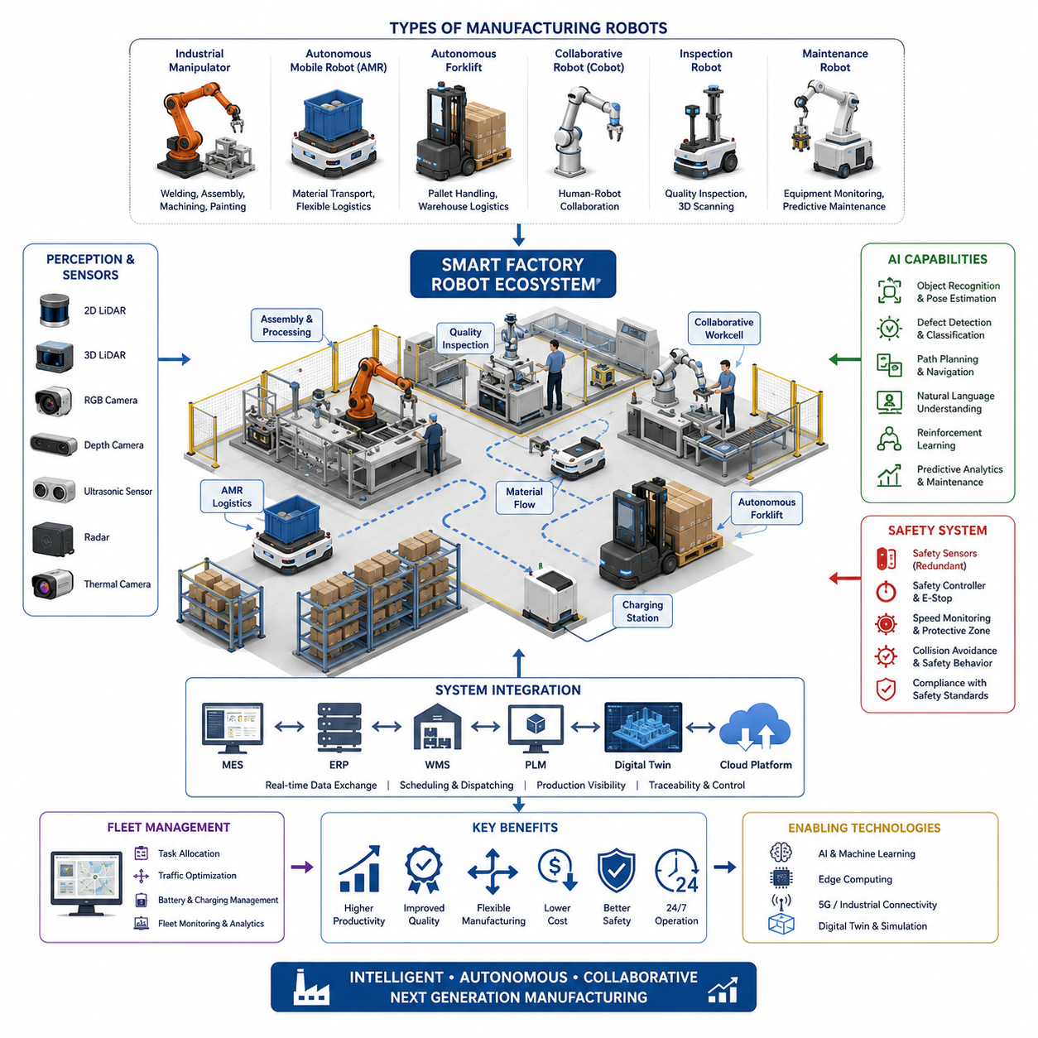
Manufacturing robots have become one of the most influential categories of autonomous mobile robotics because they connect production processes, material handling, quality control, and digital manufacturing into a unified operational ecosystem. Unlike traditional industrial automation that relies on fixed production lines and dedicated conveyor systems, modern manufacturing robots are designed to operate within dynamic factory environments where production schedules, product variants, and workflow priorities change continuously. Their ability to perceive the environment, make autonomous decisions, and cooperate with humans enables manufacturers to achieve significantly higher levels of flexibility while maintaining productivity, safety, and consistent product quality.
The evolution of manufacturing robots has closely followed the transformation of industrial production from mass manufacturing toward highly customized and demand-driven operations. Earlier robotic systems were typically isolated machines programmed for repetitive tasks inside safety cages. Contemporary manufacturing robots integrate advanced perception systems, artificial intelligence, cloud connectivity, and autonomous navigation to perform complex tasks across multiple production areas. Instead of remaining stationary throughout their operational lifetime, modern robots dynamically move between workstations, transport components, inspect products, deliver tools, and support operators wherever production demand exists.
Manufacturing robots encompass a broad range of robotic platforms rather than a single machine category. Industrial robotic manipulators perform assembly, welding, painting, dispensing, and packaging operations with high positional accuracy. Autonomous Mobile Robots transport raw materials, semi-finished products, and completed assemblies throughout factories. Autonomous forklifts automate pallet transportation and warehouse logistics, while collaborative robots assist workers during assembly, inspection, and repetitive manufacturing activities. Inspection robots equipped with cameras, laser scanners, and three-dimensional sensors continuously evaluate product quality without interrupting production flow.
Modern smart factories increasingly deploy heterogeneous fleets consisting of multiple robot types operating simultaneously. Fixed robotic cells execute precision manufacturing tasks while mobile robots deliver materials, remove completed products, replenish inventory, and coordinate logistics among production lines. Inspection robots perform quality verification immediately after manufacturing, while maintenance robots monitor equipment health and identify early signs of mechanical failure. The integration of these specialized robotic platforms creates a highly coordinated manufacturing ecosystem where every robot contributes to overall production efficiency.
Autonomous Mobile Robots have fundamentally changed internal factory logistics by replacing manual transportation processes that traditionally required forklifts or human operators. Rather than following predetermined magnetic strips or embedded guide wires, AMRs continuously localize themselves using LiDAR, cameras, inertial sensors, wheel odometry, and simultaneous localization and mapping technologies. They dynamically calculate optimal paths, avoid obstacles, reroute around congestion, and safely interact with workers operating within the same production environment. This flexibility significantly reduces installation costs while allowing factories to modify layouts without reconstructing navigation infrastructure.
Manufacturing robots rely on sophisticated perception systems that continuously observe their surroundings to ensure safe and efficient operation. Two-dimensional LiDAR sensors provide reliable obstacle detection for navigation, while three-dimensional LiDAR systems generate detailed spatial representations of complex environments. RGB cameras identify objects, workers, and production equipment, whereas depth cameras estimate distances and support manipulation tasks. Ultrasonic sensors improve close-range detection, radar enhances operation under dusty or smoky conditions, and thermal cameras monitor equipment temperatures for predictive maintenance applications.
Artificial intelligence has expanded manufacturing robots from simple automation devices into intelligent production assistants capable of adaptive decision making. Deep learning algorithms recognize production components, classify defects, estimate object poses, and detect abnormal operating conditions. Vision-language models improve human-robot communication by enabling robots to understand natural language instructions and contextual production information. Reinforcement learning optimizes repetitive operations through continuous experience, while foundation models increasingly provide generalized reasoning capabilities applicable across multiple manufacturing scenarios.
Robot manipulators remain central to manufacturing automation because they combine high precision with repeatability across thousands of production cycles. Six-axis industrial robots perform welding, machining, adhesive application, polishing, fastening, and precision assembly operations with minimal variation. Modern manipulators incorporate force-torque sensing, visual servoing, and adaptive trajectory planning to accommodate manufacturing tolerances and component variations. Their integration with mobile platforms enables flexible robotic workcells that can relocate between production areas without extensive infrastructure modifications.
Collaborative robots have introduced a different paradigm by emphasizing safe cooperation between humans and machines. Unlike conventional industrial robots requiring physical safety barriers, collaborative robots monitor interaction forces, reduce operating speed when humans approach, and immediately stop during unexpected contact. This capability allows manufacturers to combine human flexibility with robotic precision, particularly during low-volume, high-mix manufacturing where manual expertise remains essential. Collaborative systems improve ergonomics by assuming physically demanding or repetitive tasks while workers concentrate on decision making and complex assembly operations.
Quality inspection has become one of the fastest growing applications for manufacturing robots because modern production increasingly demands one hundred percent inspection rather than statistical sampling. Mobile inspection robots autonomously visit production stations, capture high-resolution images, construct three-dimensional product models, and compare measured geometries against digital CAD references. Artificial intelligence identifies dimensional deviations, missing components, assembly errors, surface defects, scratches, corrosion, and other manufacturing anomalies. Automated inspection reduces subjectivity while providing consistent quality assessment throughout continuous production.
Manufacturing robots are tightly integrated with Manufacturing Execution Systems, Enterprise Resource Planning platforms, Warehouse Management Systems, and Product Lifecycle Management environments. Production schedules generated by enterprise software determine transportation priorities, assembly sequences, and inspection workflows. Robots continuously exchange operational data through industrial communication protocols, allowing supervisors to monitor production progress, equipment utilization, inventory status, and quality metrics in real time. Digital integration transforms robots into active participants within enterprise-wide manufacturing information systems rather than isolated automation equipment.
Digital twins have emerged as an essential technology for planning, validating, and optimizing manufacturing robot deployments. Virtual factory environments replicate production equipment, robot behavior, material flow, and operational constraints before physical implementation begins. Engineers simulate navigation routes, robot reachability, collision scenarios, production throughput, and workstation utilization using accurate digital models. Continuous synchronization between physical robots and their digital counterparts enables predictive analysis, remote diagnostics, and operational optimization throughout the robot lifecycle.
Safety remains the highest priority in manufacturing robot deployment because robots frequently share operational space with human workers and expensive production equipment. Safety architectures integrate redundant sensors, emergency stop systems, safety-rated controllers, speed monitoring, protective zones, and certified functional safety software. Robots continuously evaluate environmental conditions to determine whether autonomous operation can safely continue or whether protective actions such as speed reduction, controlled stopping, or emergency shutdown are required. Compliance with international industrial safety standards ensures reliable operation across diverse manufacturing facilities.
Manufacturing robots contribute significantly to lean manufacturing principles by minimizing waste across transportation, waiting time, inventory, overproduction, unnecessary motion, defects, and process inefficiencies. Autonomous logistics reduce idle production time by delivering components exactly when required, while intelligent scheduling balances workloads among production stations. Continuous inspection prevents defective products from progressing downstream, and predictive maintenance minimizes unexpected equipment failures. Collectively, these capabilities improve overall equipment effectiveness while lowering operational costs.
Flexible manufacturing represents one of the greatest advantages of modern robotic systems. Instead of designing dedicated production lines for individual products, manufacturers increasingly construct modular manufacturing cells that robots dynamically reconfigure according to current production requirements. AMRs transport interchangeable tooling, collaborative robots support product changeovers, and centralized scheduling software coordinates production across multiple manufacturing cells. Such flexibility enables economical production of customized products without sacrificing productivity or quality.
Predictive maintenance capabilities significantly increase manufacturing robot availability by identifying potential failures before they interrupt production. Embedded sensors continuously monitor motor currents, gearbox temperatures, bearing vibration, battery condition, wheel wear, actuator torque, and communication quality. Machine learning models analyze long-term operational trends to estimate remaining component lifetime and recommend maintenance activities during scheduled production downtime. This proactive maintenance strategy reduces repair costs while maximizing equipment utilization.
Edge computing plays a critical role because many manufacturing applications require deterministic real-time responses with minimal communication latency. High-performance industrial computers equipped with GPU accelerators execute perception algorithms, AI inference, motion planning, and safety monitoring directly on the robot platform. Local processing minimizes dependence on cloud connectivity while ensuring continuous operation even when network conditions fluctuate. Cloud platforms complement edge computing by providing fleet management, software updates, long-term analytics, and centralized operational monitoring.
Multi-robot coordination has become increasingly important as factories deploy dozens or even hundreds of autonomous robots operating simultaneously. Fleet management systems assign transportation missions, optimize traffic flow, schedule charging operations, prevent congestion, and allocate robots according to workload priorities. Cooperative path planning reduces travel time while avoiding deadlocks and unnecessary waiting. Production managers gain comprehensive visibility into fleet utilization, mission completion rates, battery status, and operational performance through centralized management dashboards.
The economic value of manufacturing robots extends beyond direct labor reduction. Increased production consistency, improved quality, reduced material waste, enhanced worker safety, shorter production cycles, faster changeovers, and continuous twenty-four-hour operation collectively generate substantial returns on investment. Robots also improve manufacturing resilience by enabling facilities to maintain production despite labor shortages, increasing product complexity, or fluctuating market demand. As manufacturing becomes increasingly digital and data-driven, robotic systems evolve into strategic production assets rather than isolated automation equipment.
Future manufacturing robots will become increasingly autonomous, collaborative, and intelligent through the convergence of foundation models, multimodal perception, advanced manipulation, cloud-edge computing, and digital twin technologies. Robots will understand high-level production objectives instead of executing only predefined motion sequences, allowing them to adapt to changing environments with minimal human intervention. Continuous learning from operational experience, seamless collaboration across heterogeneous robot fleets, and integration with enterprise-scale artificial intelligence platforms will transform manufacturing robots into adaptive cyber-physical production systems capable of supporting highly flexible, resilient, and globally connected smart factories.

16.02 Warehouse Robots · 창고 로봇
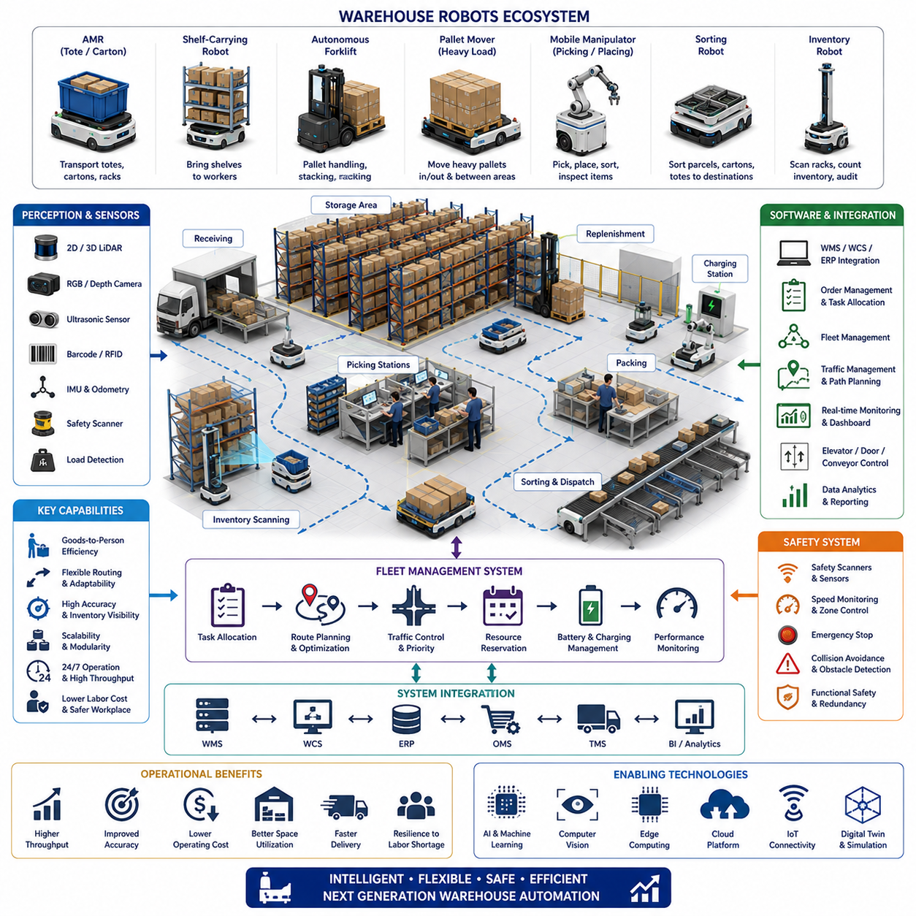
Warehouse robots have become a central component of modern logistics because they connect receiving, storage, inventory management, order fulfillment, packing, and shipping into a coordinated material-flow system. Unlike fixed conveyors that require predefined routes and expensive layout changes, autonomous warehouse robots can adapt to changing demand, inventory locations, aisle conditions, and fulfillment priorities. Their mobility allows warehouses to increase throughput without rebuilding the entire facility, making robotic automation especially valuable in environments where product variety, seasonal demand, and order volume change frequently.
The development of warehouse robotics has been driven by the rapid growth of e-commerce, shorter delivery expectations, labor shortages, and the need for accurate real-time inventory control. Traditional warehouses depended heavily on workers walking long distances to retrieve products from shelves. Modern robotic systems reduce this unproductive travel by bringing shelves, totes, pallets, or individual items directly to picking stations. This goods-to-person approach improves worker productivity while reducing fatigue, search time, and the probability of picking errors.
Warehouse robots include several platform categories designed for different load types and operational tasks. Autonomous Mobile Robots transport totes, cartons, racks, and small pallets between storage and processing areas. Automated guided vehicles move along predefined routes for repetitive transportation. Autonomous forklifts handle pallets at floor level or elevated racks, while robotic pallet movers transfer heavy loads between receiving, storage, and shipping zones. Mobile manipulators combine autonomous navigation with robotic arms to pick, sort, place, and inspect objects without requiring fixed workcells.
Shelf-carrying robots are widely used in fulfillment centers because they reorganize the relationship between workers and inventory. Instead of requiring pickers to walk through long aisles, robots navigate beneath movable storage racks, lift them, and deliver them to ergonomic picking stations. Warehouse software selects the appropriate shelf according to order priority and inventory location. After picking is completed, the robot returns the rack to an optimized storage position, allowing inventory layout to change continuously according to product demand.
Autonomous Mobile Robots provide greater routing flexibility than traditional guided systems because they localize themselves using maps and onboard sensors rather than relying entirely on magnetic tape, wires, or fixed reflectors. LiDAR, cameras, wheel odometry, and inertial sensors allow the robot to estimate its position and detect obstacles. When an aisle becomes blocked, the robot can calculate an alternative route while continuing its assigned mission. This capability reduces operational disruption during layout changes, temporary storage activities, and peak-period congestion.
Autonomous forklifts extend robotic automation into pallet handling operations that require lifting, stacking, and precise alignment with racks. These robots use laser scanners, cameras, depth sensors, and pallet-detection algorithms to identify fork openings and estimate pallet position. They control steering, mast height, fork tilt, and approach speed to safely pick or place loads. Reliable operation requires accurate localization, stable load handling, obstacle detection, and continuous monitoring of payload weight, center of gravity, and available clearance.
Robotic picking systems address one of the most difficult warehouse automation challenges because products vary greatly in shape, size, weight, texture, and packaging. Vision systems identify target objects inside bins or mixed containers, while deep-learning models estimate object pose and determine feasible grasp points. Robotic arms use suction cups, parallel grippers, adaptive fingers, or specialized end effectors to retrieve products. Successful picking depends on reliable perception, collision avoidance, grasp verification, and recovery behavior when an object slips or cannot be reached.
Sorting robots automate the distribution of parcels, cartons, and totes according to destination, carrier, delivery route, or processing requirement. Mobile sorting robots may transport items to designated chutes, while fixed robotic systems classify and redirect packages at high speed. Barcode readers, RFID systems, cameras, and optical character recognition provide item identification. The sorting controller combines this information with warehouse orders and shipping rules to ensure that every product reaches the correct outbound location.
Inventory robots improve stock accuracy by autonomously scanning racks, labels, barcodes, RFID tags, and storage locations. They navigate through aisles during normal operation or low-traffic periods and compare observed inventory with Warehouse Management System records. Cameras and three-dimensional sensors detect misplaced goods, empty locations, blocked labels, damaged packages, and unexpected objects. Continuous inventory monitoring reduces the need for manual cycle counting while providing more reliable information for replenishment and order planning.
Warehouse robot perception must remain reliable in environments containing narrow aisles, reflective packaging, moving workers, forklifts, temporary obstacles, and repetitive rack structures. Two-dimensional LiDAR provides robust navigation and safety-zone monitoring, while three-dimensional LiDAR improves pallet and rack detection. RGB and depth cameras support barcode recognition, object classification, and docking. Ultrasonic sensors cover close-range blind spots, and safety-rated scanners detect people or vehicles before a collision risk develops.
Navigation performance is strongly influenced by warehouse layout and traffic density. Robots must move through intersections, shared aisles, staging zones, charging areas, and workstations without creating congestion. Global path planning selects efficient routes across the facility, while local planning responds to workers and moving equipment. Speed limits may change according to aisle width, visibility, payload condition, and human presence. Effective navigation therefore combines map-based planning, dynamic obstacle avoidance, traffic rules, and safety-aware motion control.
Fleet management systems coordinate large numbers of warehouse robots by assigning tasks, selecting routes, balancing workload, and controlling access to shared resources. A fleet manager considers robot location, battery state, payload capability, current mission, and expected completion time before dispatching a task. It also manages elevators, automatic doors, conveyors, docking stations, and restricted areas. Central coordination prevents deadlocks and reduces congestion while maintaining continuous material flow across the facility.
Traffic management becomes essential when many robots operate in the same warehouse. Intersections, narrow aisles, and loading zones can become bottlenecks if several robots arrive simultaneously. The fleet system may reserve path segments, assign priorities, limit entrance rates, or redirect lower-priority robots. More advanced systems predict future congestion based on active missions and order demand. By coordinating robot movement before conflicts occur, the warehouse can maintain stable throughput even during peak operating periods.
Warehouse robots are tightly integrated with Warehouse Management Systems, Warehouse Control Systems, Enterprise Resource Planning platforms, and order-management software. The management system determines which products must be moved, picked, replenished, or shipped. Robot software converts these business-level requests into executable missions. Status messages, inventory changes, task completion data, and exceptions are exchanged continuously, giving operators real-time visibility into order progress and material movement.
Charging strategy has a direct effect on fleet availability and warehouse productivity. Robots may return to fixed charging stations when battery level reaches a threshold, or they may use opportunity charging during natural idle periods. The fleet manager schedules charging so that too many robots do not become unavailable at the same time. Battery health, temperature, charging power, mission demand, and expected operating duration are considered when deciding whether a robot should continue working or recharge.
Safety systems protect workers, products, racks, and equipment throughout warehouse operation. Emergency-stop circuits, safety scanners, speed monitoring, protective zones, braking systems, and redundant control functions are integrated into each robot. When a person enters a warning zone, the robot may reduce speed before stopping in the protective zone. Load condition, turning radius, stopping distance, and floor condition must also be considered because a heavily loaded robot behaves differently from an empty robot.
Human-robot interaction is a critical design factor because warehouse workers frequently share aisles and workstations with mobile robots. Interfaces must clearly communicate robot direction, status, warnings, and requested actions. Lights, displays, sounds, and projected symbols help workers predict robot behavior. Picking stations should be ergonomically designed so that products arrive at a comfortable height and orientation. Good interaction design reduces confusion while allowing people and robots to cooperate efficiently.
Digital twins and simulation environments support warehouse robot deployment before physical installation begins. Engineers can model rack layouts, robot routes, order profiles, charging stations, and worker activity in a virtual facility. Simulation reveals congestion points, insufficient fleet capacity, poor workstation placement, and charging limitations. Alternative layouts and operating policies can then be evaluated without interrupting the real warehouse. After deployment, operational data can update the digital model for continuous optimization.
Performance evaluation should consider the complete warehouse process rather than robot speed alone. Important measures include orders completed per hour, missions per robot, average travel distance, picking accuracy, inventory accuracy, congestion time, charging utilization, and system availability. A faster robot does not necessarily improve productivity if it creates traffic conflicts or waits frequently at workstations. Effective optimization therefore balances robot motion, human workload, inventory placement, and facility constraints.
Predictive maintenance improves warehouse robot reliability by analyzing motor current, wheel wear, vibration, battery condition, sensor health, braking performance, and communication quality. Changes in these signals can reveal developing mechanical or electrical problems before a failure occurs. Maintenance teams can schedule inspection or replacement during planned downtime instead of responding to unexpected breakdowns. Fleet-level analysis also helps identify recurring issues associated with specific routes, floor conditions, or robot configurations.
Warehouse robotics supports scalable automation because facilities can begin with a limited fleet and expand as order volume increases. Additional robots can often be introduced without major infrastructure changes, provided that traffic, charging, wireless communication, and workstation capacity are reviewed. Modular software and standardized interfaces make it easier to add new robot types, conveyors, sorting systems, or automated storage equipment. This incremental approach reduces initial investment risk while preserving a path toward greater automation.
The economic benefits of warehouse robots extend beyond direct labor savings. They reduce walking distance, improve picking consistency, lower product damage, increase inventory visibility, and support continuous operation. Automation also makes warehouse performance more predictable during demand peaks and labor shortages. However, successful deployment depends on process redesign, system integration, workforce training, maintenance planning, and accurate performance measurement rather than robot installation alone.
Future warehouse robots will combine advanced manipulation, multimodal perception, foundation models, and continuous fleet learning. Robots will understand more complex tasks, handle unfamiliar products, cooperate with workers through natural language, and adapt to changing warehouse conditions. Heterogeneous fleets will coordinate forklifts, mobile manipulators, inventory robots, and sorting platforms as one integrated system. These developments will transform warehouses from manually coordinated storage facilities into intelligent, data-driven fulfillment networks capable of responding dynamically to global supply-chain demand.

16.03 Hospital Robots · 병원 로봇
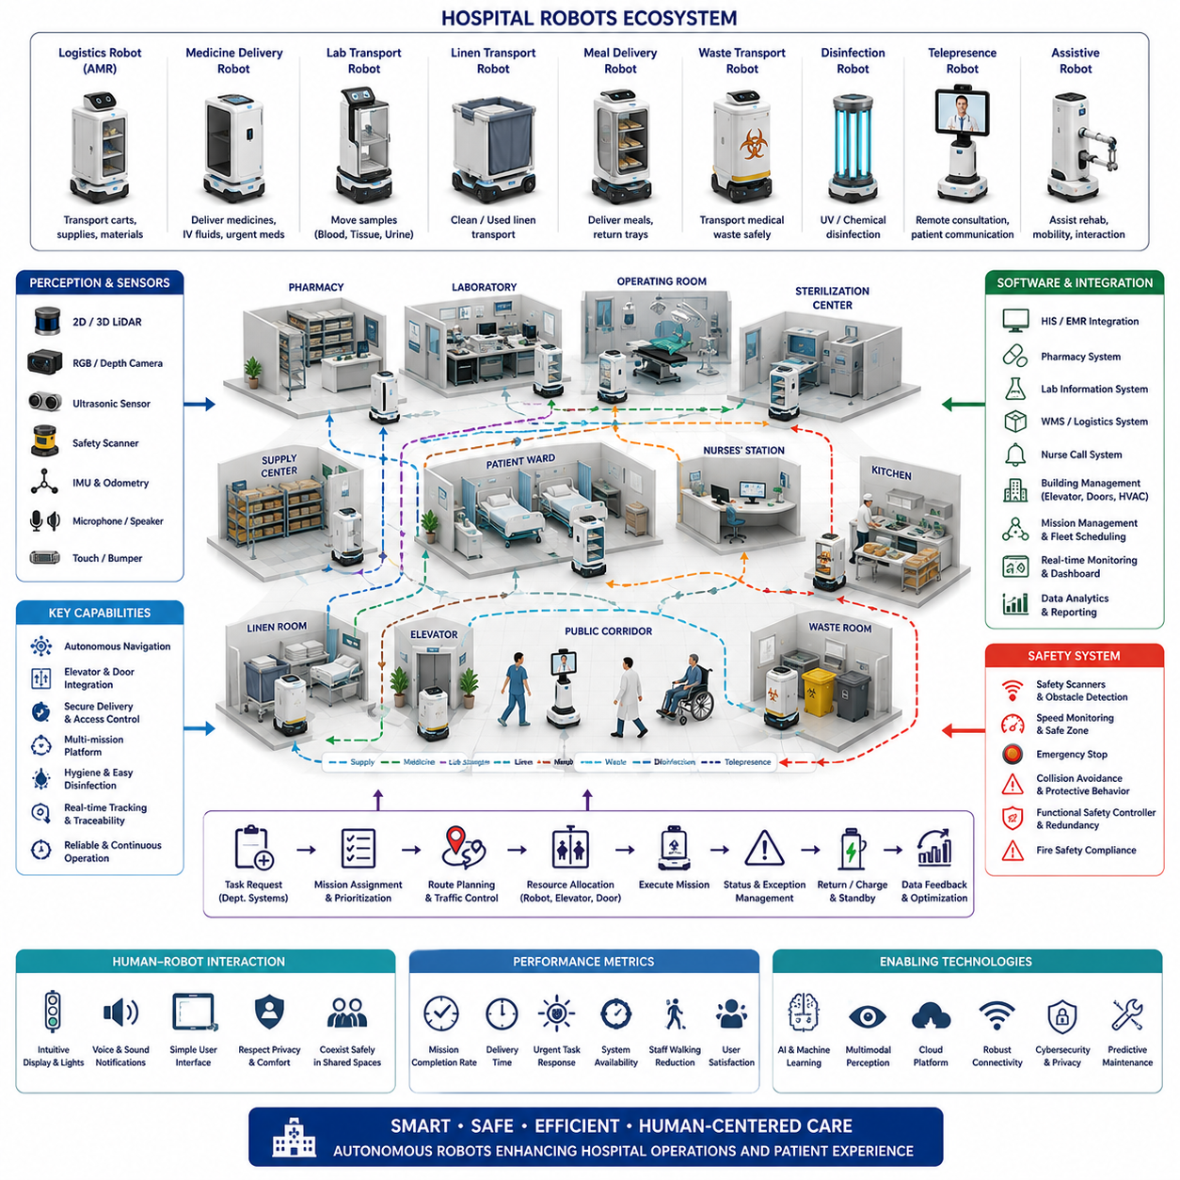
Hospital robots have become an important part of modern healthcare infrastructure because they connect clinical departments, pharmacies, laboratories, wards, operating rooms, kitchens, sterilization areas, and logistics centers. Unlike fixed automation equipment, mobile hospital robots can travel through shared corridors, interact with elevators and automatic doors, and deliver materials according to changing clinical priorities. Their purpose is not to replace medical professionals, but to reduce repetitive transport work and allow staff to spend more time on patient care.
The growth of hospital robotics has been driven by aging populations, workforce shortages, rising operating costs, infection-control requirements, and the increasing complexity of medical logistics. Hospitals move medicines, blood samples, meals, linens, instruments, documents, and waste throughout the day. When nurses or support staff perform these tasks manually, valuable clinical time is lost. Autonomous robots reduce unnecessary walking, improve delivery consistency, and create a more predictable internal logistics system.
Hospital robots include several categories designed for different operational and clinical functions. Autonomous Mobile Robots transport carts, supplies, food, and medical materials between departments. Pharmacy robots store and dispense medicines, while laboratory robots move samples and support automated analysis. Telepresence robots connect patients with remote clinicians, disinfection robots reduce microbial contamination, and assistive robots support rehabilitation, patient mobility, or communication. These systems may operate independently or as part of an integrated hospital robot fleet.
Logistics robots are among the most mature hospital robot applications because many hospital tasks involve repetitive transportation along predictable routes. A robot may collect a cart from the central supply area, deliver it to a ward, retrieve an empty cart, and continue to another department. The same platform can support multiple mission types when payload modules and docking interfaces are standardized. Reliable logistics automation requires accurate navigation, secure cargo handling, automatic charging, and close integration with hospital workflows.
Medicine delivery robots improve pharmacy operations by transporting prescriptions, controlled materials, intravenous fluids, and urgent medication to clinical areas. Secure compartments prevent unauthorized access and may require staff identification before opening. Delivery records provide traceability for each mission, including departure time, arrival time, recipient, and exception status. When connected to pharmacy and hospital information systems, robots can prioritize urgent requests while maintaining routine delivery schedules.
Laboratory transport robots move blood, tissue, urine, and other diagnostic samples between collection points and laboratories. These missions require careful control of delivery time, vibration, temperature, contamination risk, and chain of custody. Barcode or RFID identification links each container to the correct patient and requested test. Automated transport can reduce delays, prevent misplaced samples, and support faster diagnostic turnaround, but the robot must safely handle spills, damaged containers, and unexpected route interruptions.
Linen transport robots support the continuous movement of clean and used textiles across hospital facilities. Clean linen must be protected from contamination, while soiled linen must remain isolated during transport. Robots may tow dedicated carts or carry sealed containers between wards, laundry rooms, and storage areas. Automated scheduling helps maintain sufficient linen stock without excessive inventory. Separate mission rules, docking zones, and cleaning procedures are required to prevent cross-contamination between clean and contaminated materials.
Meal delivery robots transport food carts from hospital kitchens to wards and return used trays after service. These robots must follow strict schedules because meal timing affects medication, treatment, and patient satisfaction. Temperature control, cart stability, and route planning are important when meals travel across large buildings. Integration with elevators and ward access systems enables unattended delivery, while staff interfaces confirm that carts have arrived at the correct location.
Medical waste transport is another valuable application because it reduces staff exposure to potentially hazardous materials. Robots can move sealed containers containing infectious waste, sharps, laboratory waste, or general refuse to designated processing areas. The robot must follow restricted routes and avoid mixing clean logistics with contaminated workflows. Payload compartments and carts require surfaces that tolerate frequent disinfection, while mission records provide traceability for collection, transport, and final handover.
Disinfection robots use ultraviolet light, chemical mist, or other treatment methods to reduce pathogens in patient rooms, operating areas, corridors, and public spaces. Autonomous navigation allows the robot to position itself at multiple locations and calculate treatment coverage. Safety systems prevent human exposure by detecting people, monitoring doors, and stopping the process when necessary. Disinfection robots support environmental cleaning teams, but they do not replace manual removal of dirt or complete infection-control procedures.
Telepresence robots allow clinicians, specialists, and family members to communicate with patients from remote locations. A mobile base carries a camera, microphone, speaker, and display through wards or isolation areas. Remote users can navigate to the patient, conduct visual assessments, participate in consultations, or provide social interaction. Telepresence is especially useful when specialist access is limited or when infection risk restricts physical contact, although privacy and network security must be carefully controlled.
Hospital navigation is more difficult than navigation in many factories or warehouses because corridors are crowded, layouts are complex, and human behavior is highly unpredictable. Robots encounter patients, visitors, wheelchairs, beds, medical carts, cleaning equipment, and emergency teams. They must travel conservatively, maintain comfortable passing distances, and avoid obstructing clinical activity. Navigation software must balance efficient routing with social awareness, low noise, gentle motion, and immediate response to unexpected situations.
Perception systems combine safety-rated laser scanners, LiDAR, cameras, depth sensors, ultrasonic sensors, wheel odometry, and inertial measurement units. These sensors detect obstacles, estimate free space, recognize docking targets, and support localization. Hospital environments contain glass walls, reflective floors, narrow passages, and visually repetitive corridors, which can challenge perception algorithms. Sensor placement and fusion must therefore provide reliable coverage near the floor, at body height, and around transported carts.
Elevator integration is essential in multi-floor hospitals. A robot must request an elevator, wait without blocking people, enter safely, select the destination floor, and confirm that it has exited correctly. Communication may occur through building-management interfaces, wireless controllers, or dedicated elevator modules. The system must handle occupied elevators, emergency priority, communication loss, and doors closing unexpectedly. Robots should always yield to patients, stretchers, and medical staff when elevator capacity is limited.
Automatic doors, access-controlled zones, and fire doors also require coordinated integration. Robots may need digital authorization to enter pharmacies, laboratories, sterile areas, or staff-only corridors. Door status must be confirmed before crossing, and the robot must never interfere with fire-safety functions. Access rules should be mission-specific so that each robot enters only the locations required for its assigned task. Security logs record every request, approval, entry, and failure event.
Fleet management systems coordinate multiple hospital robots and assign tasks according to urgency, location, payload type, battery state, and clinical priority. Routine linen or meal missions may be delayed when an urgent medicine or laboratory sample request appears. The fleet manager also controls traffic at narrow corridors, elevators, docking stations, and charging areas. Central monitoring allows operators to view robot status, mission progress, blocked routes, and service exceptions across the hospital.
Hospital robots must integrate with Hospital Information Systems, pharmacy platforms, laboratory systems, building-management systems, nurse-call systems, and logistics software. High-level requests generated by these systems are converted into robot missions with defined pickup, delivery, authentication, and completion conditions. Integration should avoid exposing unnecessary patient information. Only the minimum data required to perform and verify the mission should be exchanged, stored, and displayed.
Cybersecurity and privacy are critical because hospital robots operate on clinical networks and may process sensitive operational or patient-related information. Secure communication, device authentication, encrypted storage, access control, software signing, and network segmentation reduce the risk of unauthorized access. Telepresence robots require additional protection because they transmit audio and video. Security monitoring and update procedures must continue throughout the full operational life of the robot.
Functional safety is designed around the protection of patients, staff, visitors, equipment, and the transported payload. Emergency-stop buttons, redundant sensing, safety controllers, speed monitoring, protective zones, and reliable braking are fundamental components. Robots should move more slowly near doors, intersections, wards, and crowded areas. When safety conditions are uncertain, the system must enter a controlled stop and request assistance rather than attempting aggressive autonomous recovery.
Human-robot interaction strongly influences acceptance in healthcare environments. Robots should communicate their direction, intention, and status through simple lights, sounds, displays, or projected indicators. Alerts must be noticeable without disturbing patients or creating alarm fatigue. Staff interfaces should support quick task requests, mission cancellation, compartment access, and exception reporting. Clear behavior reduces uncertainty and helps patients and visitors understand how to share space with autonomous machines.
Hospital robots require strict hygiene and cleanability. External surfaces should minimize gaps, exposed fasteners, sharp corners, and materials that absorb liquids. Components must tolerate approved cleaning agents and frequent disinfection without degradation. Wheels and lower chassis areas require special attention because they contact contaminated floors. Payload modules used for medicine, meals, clean linen, samples, or waste should follow different cleaning procedures based on their contamination risk.
Reliability is essential because hospital operations continue throughout the day and night. Robots must maintain stable navigation, communication, charging, docking, and payload handling over long operating periods. Predictive maintenance can monitor battery condition, motor current, wheel wear, sensor contamination, brake performance, and communication quality. Maintenance should be planned around clinical schedules so that robot downtime does not interrupt critical logistics services.
Deployment normally begins with detailed workflow analysis rather than immediate robot installation. Engineers observe transport routes, mission frequency, cart dimensions, elevator use, staffing patterns, and peak congestion. A pilot deployment then tests a limited number of robots in selected departments. Performance data and staff feedback are used to modify routes, interfaces, docking stations, and operating procedures before expansion to additional floors or mission types.
Hospital robot performance should be evaluated using service-level and clinical-support indicators rather than travel speed alone. Important measures include mission completion rate, delivery time, urgent-task response, system availability, staff walking-distance reduction, elevator waiting time, docking success, intervention frequency, and user satisfaction. A robot that moves quickly but frequently blocks corridors or requires assistance may provide less value than a slower system with predictable and reliable behavior.
The economic benefits of hospital robots include lower transport workload, improved material traceability, reduced delivery delay, more consistent service, and better use of professional staff time. Their value is greatest when workflows are redesigned around automation rather than simply copying manual processes. Successful projects require cooperation among clinical teams, pharmacy staff, facility managers, infection-control specialists, information-technology teams, safety engineers, and robot operators.
Future hospital robots will combine multimodal perception, natural-language interaction, advanced manipulation, and intelligent mission planning. Robots will understand more complex requests, identify changing clinical conditions, and cooperate with staff through simple conversational interfaces. Heterogeneous fleets may coordinate logistics robots, disinfection platforms, telepresence systems, and assistive robots through a shared management architecture. This evolution will support hospitals that are safer, more responsive, and more focused on patient-centered care.

16.04 Outdoor Robots · 실외 로봇
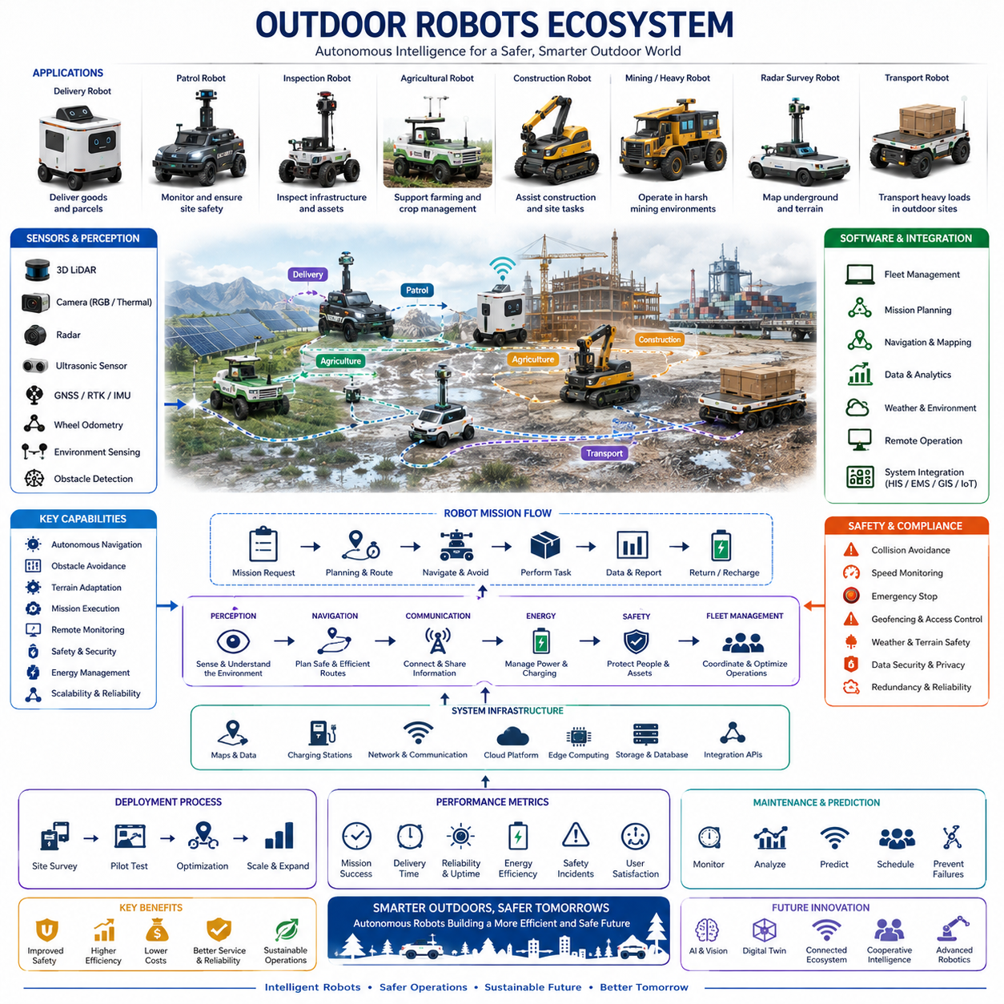
Outdoor robots extend autonomous mobility beyond structured indoor facilities into environments shaped by weather, uneven terrain, public activity, uncertain connectivity, and continuously changing obstacles. They operate across industrial yards, campuses, farms, construction sites, ports, roads, parks, and security zones. Their value comes from performing inspection, transport, monitoring, maintenance, and service missions in locations where fixed automation is impractical and continuous human operation is costly, hazardous, or physically demanding.
The outdoor robot category includes autonomous patrol vehicles, delivery robots, agricultural machines, inspection platforms, construction robots, mining vehicles, ground-penetrating radar systems, and heavy-duty transport robots. Some platforms are compact and designed for sidewalks or pedestrian spaces, while others carry large payloads across industrial sites. Their mechanical structure, sensors, computation, navigation strategy, and safety architecture must be selected according to terrain, speed, mission duration, environmental exposure, and interaction with people or conventional vehicles.
Outdoor operation introduces greater uncertainty than indoor navigation because the environment cannot be fully controlled. Roads may contain potholes, gravel, mud, slopes, curbs, water, vegetation, and temporary construction areas. Lighting changes from direct sunlight to darkness, while rain, fog, snow, dust, and shadows reduce sensor performance. The robot must distinguish between traversable and hazardous surfaces while adapting its speed, route, and behavior to conditions that may change significantly during a single mission.
Mechanical architecture strongly influences outdoor mobility. Platforms may use differential drive, four-wheel steering, skid steering, articulated steering, or six-wheel configurations depending on maneuverability and terrain requirements. Suspension systems maintain wheel contact and reduce vibration, while sufficient ground clearance protects the chassis from rocks, curbs, and surface irregularities. Tires, wheel diameter, tread pattern, and braking capability must be matched to expected loads, slopes, surfaces, and maximum operating speed.
Weather protection is a fundamental outdoor design requirement. Enclosures must prevent water, dust, and debris from damaging batteries, computers, motors, connectors, and sensors. Sealing, drainage, ventilation, and corrosion-resistant materials are required for long-term field operation. Thermal management must handle direct sunlight, high ambient temperature, freezing conditions, and internal heat generated by computing hardware. Heating elements, cooling systems, filtered airflow, or liquid cooling may be necessary for stable year-round operation.
Outdoor robots use multiple perception sensors because no single sensor remains reliable in every environmental condition. Three-dimensional LiDAR provides geometric information for terrain and obstacle detection, while cameras support object recognition, semantic understanding, and visual localization. Radar maintains useful detection capability in rain, fog, dust, and darkness. Ultrasonic sensors cover short-range blind zones, and thermal cameras detect people, animals, heat sources, or equipment abnormalities when visible-light images are insufficient.
Sensor placement must provide wide coverage while reducing vibration, contamination, and self-occlusion. Cameras and LiDAR sensors mounted too low may be blocked by vegetation, splashes, or transported payloads, while high-mounted sensors can improve range but increase mechanical vibration. Protective windows require cleaning strategies because water droplets, dust, insects, and mud can degrade perception. Sensor-health monitoring should detect blocked lenses, unstable calibration, abnormal temperature, or inconsistent measurements before perception performance becomes unsafe.
Localization commonly combines Global Navigation Satellite System data, Real-Time Kinematic correction, inertial measurement, wheel odometry, LiDAR localization, and visual methods. Satellite positioning provides global reference outdoors, but accuracy can deteriorate near buildings, trees, bridges, tunnels, or reflective structures. Local perception therefore supports continued navigation when GNSS becomes unreliable. Robust systems estimate localization confidence and switch or combine methods according to signal quality, environmental structure, and mission requirements.
Mapping for outdoor robots may include geometric, semantic, elevation, and traffic information. A two-dimensional map can represent roads and permitted zones, while a three-dimensional map captures slopes, curbs, overhanging obstacles, and terrain structure. Semantic layers identify sidewalks, vehicle lanes, restricted areas, loading zones, grass, water, and construction regions. Maps must be updated because outdoor environments change through weather, parked vehicles, vegetation growth, temporary barriers, and ongoing civil work.
Terrain perception determines whether a surface can be safely crossed. The robot analyzes slope, roughness, step height, surface continuity, wheel support, and expected traction. A route that appears open in a camera image may contain soft soil, deep water, loose gravel, or a drop-off. Elevation maps and point-cloud analysis help estimate traversability, while learning-based models classify terrain from visual and geometric features. Conservative uncertainty handling is essential when surface condition cannot be confidently determined.
Path planning must consider more than geometric distance. The shortest route may include steep slopes, narrow passages, poor visibility, pedestrian congestion, or surfaces with low traction. Outdoor planners assign costs according to terrain, safety margins, energy use, communication coverage, and mission priority. Local planning reacts to moving people, bicycles, vehicles, animals, and unexpected obstacles. The resulting motion should remain predictable and comfortable while preserving sufficient stopping distance.
Dynamic obstacle prediction is especially important in public or mixed-traffic areas. People and vehicles may approach at high relative speed or behave unpredictably. Perception software detects, classifies, and tracks surrounding objects before estimating their possible future motion. The robot then adjusts speed, changes path, yields, or stops. Behavior planning should follow site rules and social expectations rather than relying only on collision avoidance, because technically safe motion can still appear confusing or aggressive.
Outdoor delivery robots transport parcels, food, tools, or supplies across campuses, residential areas, industrial sites, and controlled public spaces. They require secure cargo compartments, recipient authentication, route monitoring, and reliable docking. Sidewalk operation introduces interactions with pedestrians, crossings, ramps, parked objects, and accessibility features. The robot must not block wheelchair users or create hazards at entrances. Remote supervision is often used to resolve unusual situations without requiring continuous manual driving.
Patrol and security robots perform scheduled monitoring of industrial facilities, campuses, borders, energy sites, and critical infrastructure. Cameras, thermal sensors, microphones, gas detectors, and environmental sensors collect information while the robot follows predefined or adaptive routes. Artificial intelligence can detect intrusion, smoke, abnormal heat, open doors, abandoned objects, or equipment changes. The robot reports events to operators but should avoid making unsupported security decisions when perception confidence is insufficient.
Inspection robots reduce the need for workers to enter hazardous or remote areas. They can inspect pipelines, railways, roads, solar farms, power facilities, storage yards, and large industrial assets. High-resolution cameras, thermal imagers, three-dimensional scanners, acoustic sensors, and vibration instruments identify corrosion, cracks, leakage, deformation, overheating, or missing components. Repeatable robot trajectories improve comparison across inspection cycles and enable long-term condition monitoring.
Agricultural robots operate in fields, orchards, greenhouses, and livestock environments. Their missions include crop monitoring, spraying, mowing, harvesting, weed control, soil measurement, and autonomous transport. Agricultural terrain is highly variable and may include soft ground, steep slopes, narrow crop rows, branches, dust, and mud. Perception systems must distinguish crops, weeds, workers, animals, and obstacles while minimizing damage to plants and soil.
Construction robots perform surveying, progress monitoring, material transport, marking, drilling, and site inspection. Construction sites change continuously, so maps and planned paths may become outdated within hours. Robots must identify temporary structures, excavations, machinery, workers, and unstable surfaces. Integration with Building Information Modeling and digital twins allows planned geometry to be compared with actual progress. However, autonomous decisions must account for incomplete or delayed construction data.
Mining and heavy-industry robots require high payload capacity, durability, and long operating range. They may transport materials, inspect tunnels, monitor stockpiles, or support hazardous operations. Dust, vibration, darkness, weak communication, and large machinery create severe engineering challenges. Redundant sensing, ruggedized components, protected connectors, and local autonomy are necessary because cloud connectivity may be unavailable. Emergency behavior must remain safe even when remote communication is lost.
Ground-penetrating radar robots collect subsurface data for utility mapping, road inspection, archaeology, and infrastructure assessment. The robot maintains stable speed and sensor height while following precise survey lines. Positioning accuracy directly affects the ability to combine radar measurements into a useful underground map. Terrain vibration, wheel slip, GNSS loss, and electromagnetic interference can reduce data quality. Survey planning must therefore coordinate navigation, sensor triggering, localization, and data recording.
Energy management is more difficult outdoors because mission distance, terrain, temperature, payload, wind, and surface resistance affect battery consumption. Climbing slopes or moving through soft ground can increase power demand dramatically. The robot estimates remaining range using current conditions rather than relying only on battery percentage. Mission planning should reserve energy for returning to a safe location, reaching a charger, operating thermal systems, and handling unexpected detours.
Charging infrastructure may include fixed docks, protected outdoor stations, battery swapping, or mobile charging support. Accurate docking is required despite rain, dust, uneven ground, and GNSS variation. Charging interfaces must prevent water ingress and electrical hazards. Fleet systems schedule charging according to mission demand, battery health, weather forecasts, and station availability. For remote operations, energy planning may be the primary constraint determining feasible mission coverage.
Communication systems combine Wi-Fi, private cellular networks, public mobile networks, radio links, and local mesh connectivity. Outdoor coverage can vary significantly because of terrain, buildings, vegetation, and network congestion. Robots should continue safe operation when bandwidth decreases or communication is interrupted. Critical control and safety functions remain onboard, while remote systems provide mission assignment, monitoring, data upload, software management, and operator assistance.
Edge computing allows the robot to execute perception, localization, planning, and safety monitoring without continuous cloud access. GPU-equipped industrial computers process LiDAR and camera data in real time, while separate controllers manage motion and safety functions. Cloud platforms support fleet analytics, map distribution, long-term storage, and model updates. The architecture must allocate functions carefully so that loss of connectivity does not compromise essential autonomy or functional safety.
Functional safety depends on operating speed, mass, braking distance, terrain, payload, and the types of people or vehicles sharing the environment. Safety scanners, emergency-stop circuits, redundant control, speed supervision, brake monitoring, and protective zones form the basic architecture. Outdoor robots must account for downhill stopping distance, reduced traction, sensor degradation, and obstacles outside normal scanning height. Safe behavior should become more conservative as uncertainty increases.
Operational safety also requires geofencing and rule-based access control. Virtual boundaries prevent robots from entering roads, unstable ground, construction zones, or unauthorized areas. Different operating modes may apply to pedestrian spaces, private roads, loading yards, and restricted facilities. Geofence data must be version-controlled and synchronized with current site conditions. Temporary restrictions should be distributed quickly when weather, events, maintenance, or emergencies change access requirements.
Human-robot interaction must communicate robot intention clearly in open and public environments. Lights, displays, sounds, turn indicators, projected paths, and external messages help people understand whether the robot will stop, turn, yield, or continue. Communication should remain simple and culturally understandable. Excessive alarms can create annoyance, while insufficient signaling produces uncertainty. Designers must consider children, elderly people, hearing-impaired users, and individuals unfamiliar with autonomous machines.
Remote operation supports outdoor autonomy when the robot encounters situations outside its validated capability. Operators may review camera views, provide a waypoint, approve a maneuver, or temporarily control the platform. Remote assistance should be designed as exception handling rather than continuous dependence. Communication delay, limited visibility, and operator workload must be considered. Every intervention should be recorded so that recurring failure patterns can guide software, map, and operational improvements.
Fleet management coordinates missions, routes, charging, maintenance, and geographic coverage across multiple outdoor robots. It considers platform capability, payload, weather suitability, current location, battery state, and sensor health before assigning work. Shared route segments and docking areas require traffic management, especially in industrial yards. Fleet data supports performance analysis, incident review, predictive maintenance, and continuous optimization of mission scheduling.
Deployment begins with site characterization and operational design. Engineers examine terrain, slopes, drainage, network coverage, weather exposure, traffic patterns, lighting, restricted areas, and emergency access. Seasonal conditions should be considered because a route validated in summer may become unsafe during snow, heavy rain, or vegetation growth. Pilot testing gradually expands speed, area, mission duration, and environmental difficulty while collecting evidence of reliability and safety.
Performance evaluation should include mission completion rate, intervention frequency, localization availability, obstacle-detection reliability, energy consumption, route efficiency, docking success, communication uptime, and weather-related degradation. Distance traveled alone does not demonstrate operational value. A useful robot must complete meaningful missions reliably and recover safely from expected disturbances. Metrics should be analyzed by terrain, weather, time of day, payload, and operational zone.
Predictive maintenance monitors batteries, motors, steering, brakes, suspension, tires, seals, sensors, connectors, and computing systems. Outdoor wear may result from vibration, water, dust, corrosion, temperature cycling, and physical impact. Sensor contamination and wheel damage can affect autonomy before causing complete hardware failure. Condition-based maintenance detects gradual degradation and schedules service before safety or mission performance is compromised.
The economic value of outdoor robots comes from reducing exposure to hazardous work, extending service hours, improving inspection consistency, and enabling operations in locations with limited labor. Benefits are strongest when the robot is integrated into the complete workflow, including dispatch, data management, maintenance, remote assistance, and exception handling. A technically capable platform may still fail commercially if site preparation, service organization, or responsibility boundaries are unclear.
Future outdoor robots will combine multimodal foundation models, improved terrain understanding, cooperative fleet intelligence, and more capable manipulation. They will interpret complex scenes, follow natural-language missions, share environmental knowledge, and adapt behavior to long-term changes. Integration with digital twins, smart infrastructure, and connected vehicles will create coordinated autonomous ecosystems. These developments will expand outdoor robots from specialized machines into reliable mobile platforms supporting industry, public services, and resilient infrastructure.

16.05 Fleet Management Systems · 플릿 관리 시스템
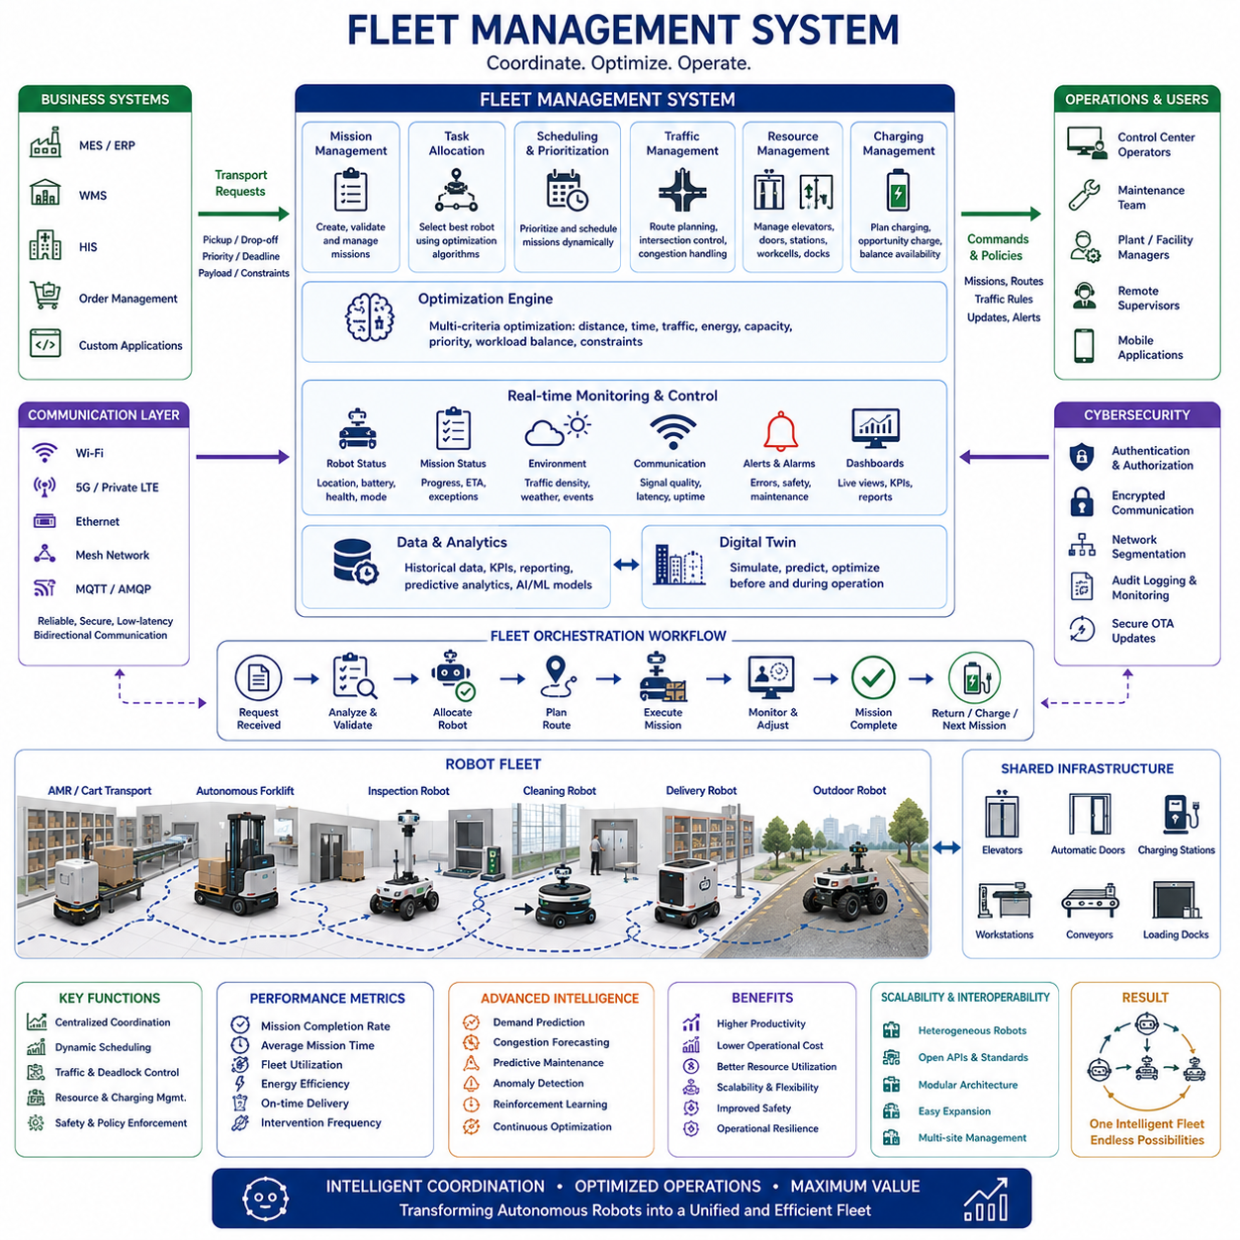
Fleet Management Systems represent the operational intelligence layer that coordinates multiple autonomous robots into a unified and efficient transportation ecosystem. While an individual Autonomous Mobile Robot can independently perform localization, navigation, obstacle avoidance, and task execution, large-scale industrial environments require centralized coordination to maximize productivity, maintain safety, optimize resource utilization, and prevent conflicts among robots. A Fleet Management System transforms numerous independent mobile robots into a cooperative fleet capable of executing complex logistics operations across factories, warehouses, hospitals, campuses, ports, and outdoor industrial facilities.
The evolution of fleet management closely follows the expansion of autonomous mobile robot deployments. Early robotic installations often consisted of only a few robots operating independently with simple scheduling mechanisms. As organizations increased the number of deployed robots, operational complexity grew significantly. Shared corridors, charging stations, elevators, workstations, and transportation routes introduced traffic conflicts, resource competition, and scheduling challenges that could not be solved by individual robots alone. Fleet Management Systems emerged to provide centralized coordination while allowing each robot to maintain local autonomy during navigation and obstacle avoidance.
A Fleet Management System performs considerably more than simple task assignment. It continuously observes robot status, battery condition, payload capability, mission progress, environmental conditions, communication quality, traffic density, and operational priorities. Based on this information, the system dynamically assigns missions, reallocates tasks when conditions change, schedules charging operations, coordinates shared infrastructure, and optimizes fleet utilization. Rather than focusing on the behavior of one robot, the Fleet Management System continuously optimizes the performance of the entire robotic ecosystem.
Mission management forms one of the most important responsibilities of fleet coordination. Business systems such as Manufacturing Execution Systems, Warehouse Management Systems, Enterprise Resource Planning platforms, Hospital Information Systems, or custom operational software generate transportation requests that include pickup locations, delivery destinations, priority levels, payload requirements, deadlines, and operational constraints. The Fleet Management System converts these high-level business requests into executable robot missions while selecting the most appropriate robot according to its location, availability, capability, battery level, and estimated completion time.
Task allocation algorithms determine which robot should perform each mission. Simple systems assign the nearest available robot, but advanced fleet managers consider numerous optimization criteria simultaneously. Travel distance, expected traffic, remaining battery capacity, payload limitations, maintenance status, communication quality, charging schedules, robot specialization, and future workload predictions all influence assignment decisions. Sophisticated optimization algorithms minimize total transportation time while balancing workload fairly across the entire fleet rather than overloading individual robots.
Scheduling becomes increasingly important as fleet size grows. Hundreds of simultaneous transportation requests may compete for a limited number of robots, elevators, loading stations, and charging facilities. The Fleet Management System prioritizes missions according to business objectives while respecting operational constraints. Emergency hospital deliveries, production-critical manufacturing materials, or high-priority customer orders may immediately interrupt lower-priority transportation activities. Intelligent scheduling minimizes delays while ensuring that critical operations receive immediate attention.
Route planning at the fleet level differs significantly from navigation performed by individual robots. Each robot independently computes local obstacle avoidance trajectories, but centralized fleet planning considers the movement of all robots simultaneously. Shared corridors, narrow passages, intersections, loading zones, and docking stations require coordinated scheduling to prevent congestion and unnecessary waiting. Fleet-wide planning reduces travel distance, improves traffic flow, and maximizes overall transportation efficiency throughout the facility.
Traffic management represents one of the most visible responsibilities of a Fleet Management System. Multiple robots operating in shared environments naturally create interactions that may result in congestion or deadlock if unmanaged. Fleet coordination reserves critical path segments, assigns crossing priorities, delays lower-priority vehicles, reroutes traffic around congested regions, and coordinates intersection access. These mechanisms prevent operational gridlock while allowing large robot populations to coexist safely within confined industrial environments.
Deadlock prevention requires continuous monitoring of robot movement and predicted future interactions. A deadlock occurs when multiple robots block each other's progress, making forward movement impossible without external intervention. Fleet Management Systems predict potential deadlocks before they occur by analyzing planned trajectories, shared resources, and robot priorities. When conflicts are detected, route adjustments or temporary waiting strategies are introduced to maintain continuous fleet operation without manual operator involvement.
Resource management extends beyond robots themselves. Industrial facilities contain elevators, automatic doors, charging stations, conveyors, pallet transfer stations, loading docks, inspection cells, and production equipment that multiple robots must share. The Fleet Management System reserves these resources, coordinates access timing, and minimizes waiting periods. Efficient resource allocation prevents bottlenecks while improving utilization of expensive infrastructure components throughout the production environment.
Charging management directly influences fleet availability and operational efficiency. If too many robots simultaneously require charging, transportation capacity may decrease dramatically. Fleet Management Systems continuously monitor battery state, mission demand, expected energy consumption, charger availability, and operational priorities. Charging schedules are optimized so that sufficient robots remain available while depleted vehicles recharge during natural workload reductions whenever possible. Opportunity charging between missions further increases overall operational efficiency.
Battery-aware mission planning improves long-term fleet productivity. Instead of assigning missions solely according to distance, the Fleet Management System estimates expected energy consumption based on payload weight, travel distance, terrain conditions, acceleration profiles, environmental temperature, and predicted traffic. Robots are prevented from accepting missions that may exceed safe operating range, reducing unexpected mission failures caused by battery depletion while maintaining reliable transportation services.
Communication infrastructure provides the information exchange necessary for centralized coordination. Robots continuously transmit localization data, battery condition, mission progress, sensor health, error codes, obstacle reports, communication quality, and operational status to the Fleet Management System. In return, the central controller distributes missions, routing information, traffic instructions, software updates, operational policies, and safety commands. Reliable communication supports coordinated operation while allowing robots to maintain local autonomy if temporary network interruptions occur.
Modern Fleet Management Systems increasingly employ cloud-edge hybrid architectures. Edge computers located within industrial facilities execute latency-sensitive scheduling, traffic management, and operational coordination with deterministic response times. Cloud services perform fleet analytics, software deployment, long-term data storage, artificial intelligence model updates, predictive maintenance analysis, and enterprise-wide operational reporting. Separating real-time control from cloud-based analytics improves both responsiveness and scalability.
Scalability represents a fundamental design requirement because fleet size often increases throughout the operational lifetime of a robotic installation. Small deployments may begin with only five or ten robots, while successful facilities eventually expand to hundreds or even thousands of autonomous vehicles. Fleet Management Systems therefore employ distributed software architectures, efficient communication protocols, scalable databases, and modular microservices capable of supporting continuous expansion without major software redesign.
Interoperability has become increasingly important as industrial facilities deploy heterogeneous robot fleets from multiple manufacturers. Standardized communication interfaces, open APIs, industrial middleware, and common mission protocols allow different robot platforms to operate under unified fleet coordination. Material transport robots, autonomous forklifts, inspection robots, delivery robots, collaborative mobile manipulators, and cleaning robots may all participate within the same Fleet Management System despite having different capabilities and hardware architectures.
Digital twins significantly improve fleet management by creating virtual representations of robots, facilities, traffic conditions, operational workflows, and infrastructure resources. Engineers simulate robot deployment strategies, charging locations, traffic patterns, workstation utilization, and mission scheduling before physical implementation begins. During operation, real-time fleet data continuously updates the digital twin, allowing predictive analysis, performance optimization, capacity planning, and operational decision support without interrupting production.
Artificial intelligence increasingly enhances fleet coordination beyond traditional rule-based scheduling. Machine learning predicts transportation demand, estimates congestion, forecasts battery degradation, identifies abnormal fleet behavior, and recommends scheduling improvements based on historical operational data. Reinforcement learning explores improved dispatch strategies, while foundation models may eventually support natural-language interaction with fleet operators and automated interpretation of complex operational objectives.
Safety coordination extends beyond individual robot safety systems. Although each robot independently performs obstacle detection and emergency stopping, Fleet Management Systems supervise overall operational safety by enforcing speed restrictions, access permissions, geofencing policies, operational zones, traffic regulations, and emergency procedures. Restricted areas, hazardous production zones, pedestrian crossings, and temporary construction regions may require dynamic operational rules distributed to every robot within the fleet.
Cybersecurity plays an essential role because Fleet Management Systems coordinate numerous autonomous assets while communicating with enterprise information systems. Secure authentication, encrypted communication, role-based access control, software integrity verification, audit logging, network segmentation, and intrusion detection protect operational continuity against cyber threats. Secure over-the-air software updates ensure that fleet-wide software improvements can be deployed without compromising system reliability or safety.
Fleet monitoring dashboards provide operators with comprehensive situational awareness. Interactive interfaces visualize robot positions, mission status, battery levels, communication quality, charger utilization, operational alarms, traffic congestion, resource reservations, maintenance status, and facility-wide performance indicators. Historical data supports operational analysis, while predictive dashboards identify emerging issues before they significantly impact productivity. Effective visualization enables operators to supervise hundreds of robots simultaneously with relatively small control teams.
Performance evaluation focuses on overall system efficiency rather than individual robot behavior. Important performance indicators include mission completion rate, average mission duration, fleet utilization, charging efficiency, traffic delay, idle time, battery utilization, resource occupancy, communication reliability, intervention frequency, and operational availability. These measurements help organizations optimize infrastructure investments, identify bottlenecks, improve scheduling policies, and continuously increase transportation productivity.
Predictive maintenance becomes increasingly valuable as fleet size expands. Continuous monitoring of motors, batteries, steering systems, braking performance, sensors, communication hardware, onboard computers, and environmental exposure enables early detection of developing faults. Fleet-wide maintenance planning coordinates repair schedules so that operational capacity remains available while minimizing unexpected failures. Maintenance recommendations increasingly combine statistical analysis, artificial intelligence, and long-term operational history to improve equipment reliability.
Future Fleet Management Systems will evolve from centralized scheduling platforms into intelligent autonomous orchestration systems capable of managing heterogeneous robotic ecosystems across multiple facilities. Foundation models, multimodal reasoning, digital twins, edge-cloud collaboration, cooperative artificial intelligence, and predictive optimization will enable fleets to understand business objectives rather than merely execute predefined transportation requests. Autonomous coordination among thousands of robots, intelligent infrastructure, connected vehicles, enterprise software, and human operators will create highly adaptive logistics ecosystems capable of continuously optimizing productivity, safety, sustainability, and operational resilience across complex industrial environments.

