Volume 03. AMR Sensors and Perception

Chapter 17. Semantic Segmentation

17.1 Semantic Segmentation Basics
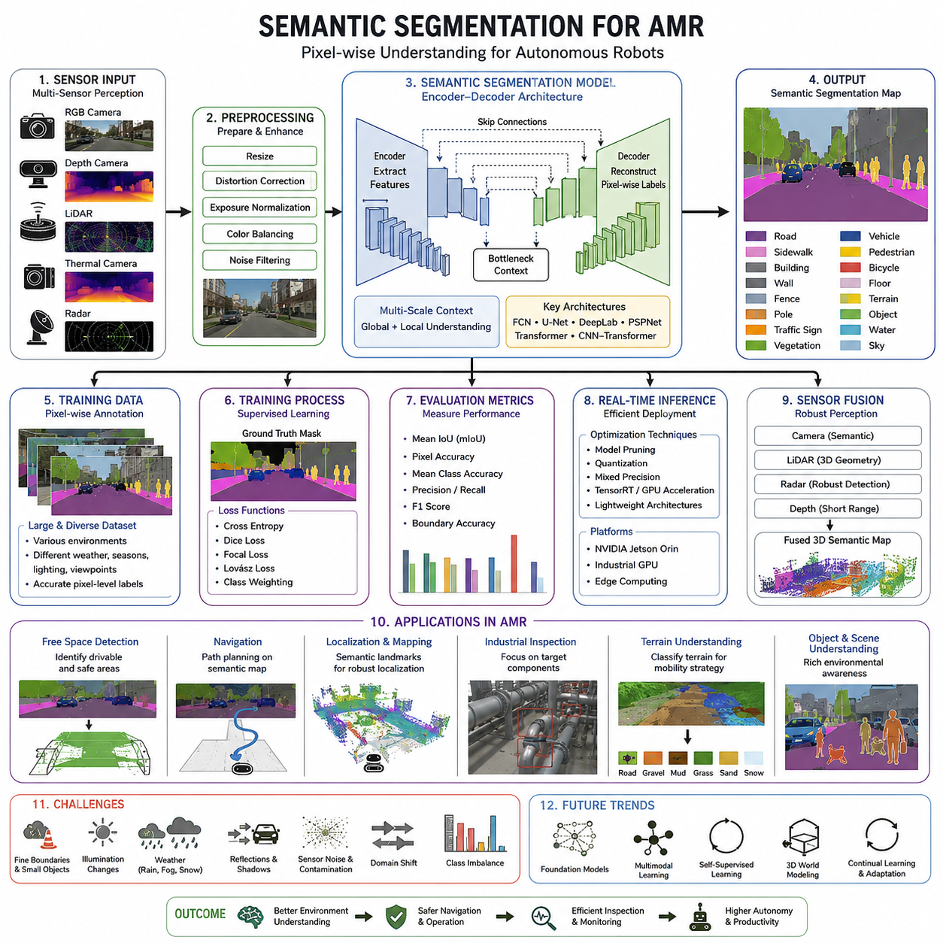
Semantic segmentation is one of the fundamental perception technologies that enables an autonomous mobile robot to understand an entire scene instead of recognizing only isolated objects. Unlike traditional computer vision approaches that classify a whole image or detect objects with rectangular bounding boxes, semantic segmentation assigns a semantic class label to every individual pixel in an image. Every visible point within the camera frame is therefore interpreted as belonging to a meaningful category such as floor, wall, road, grass, pallet, vehicle, pedestrian, machine, shelf, or building. This dense understanding allows the robot to reason about the environment at a much finer level of detail and provides richer information for localization, navigation, obstacle avoidance, inspection, and autonomous decision making.
The importance of semantic segmentation has increased significantly as modern AMRs have evolved from operating in carefully structured indoor facilities toward dynamic outdoor environments. Warehouses, hospitals, construction sites, logistics centers, ports, mines, agricultural fields, and public roads all contain diverse surfaces, irregular obstacles, changing weather conditions, and moving objects. A robot navigating these environments must determine not only where obstacles exist but also understand the meaning of different regions. Knowing that a surface is a drivable road, a pedestrian walkway, loose gravel, wet concrete, or dense vegetation directly influences navigation decisions. Semantic segmentation transforms raw image data into structured environmental knowledge that higher-level planning modules can utilize.
One of the defining characteristics of semantic segmentation is that it performs dense scene understanding rather than sparse object recognition. Every pixel contributes to the final interpretation of the environment. This pixel-level labeling enables robots to estimate precise object boundaries, distinguish traversable and non-traversable regions, and identify semantic relationships between neighboring objects. For example, instead of simply detecting a forklift with a bounding box, semantic segmentation accurately identifies the exact outline of the forklift, separates it from the surrounding floor, and distinguishes its forks, wheels, and body from nearby shelves or workers. Such detailed representations improve downstream perception tasks considerably.
Semantic segmentation differs fundamentally from image classification and object detection. Image classification assigns one label to an entire image, assuming that a single dominant category represents the scene. Object detection predicts rectangular bounding boxes around individual objects while assigning category labels to those boxes. Semantic segmentation extends beyond these approaches by classifying every pixel independently. This eliminates the ambiguity introduced by coarse bounding boxes and allows robots to estimate free space, object shapes, and environmental boundaries with much higher precision. As robotic perception systems become more sophisticated, semantic segmentation increasingly complements rather than replaces object detection.
Another closely related concept is instance segmentation. Although both semantic segmentation and instance segmentation perform pixel-level labeling, they solve different problems. Semantic segmentation groups all objects of the same category into a single region. For example, every pedestrian pixel receives the pedestrian label regardless of how many people are present. Instance segmentation separates each individual object into distinct instances, assigning unique identities to multiple pedestrians. For autonomous navigation, semantic segmentation often provides sufficient environmental understanding, while instance segmentation becomes valuable when tracking individual dynamic objects or performing manipulation tasks.
The perception pipeline for semantic segmentation begins with image acquisition from one or more cameras. RGB cameras provide high-resolution color information, while depth cameras contribute geometric measurements. Thermal cameras may improve perception under poor lighting conditions, and LiDAR can supply complementary three-dimensional information. Raw sensor data first undergoes preprocessing steps including image resizing, distortion correction, exposure normalization, color balancing, and noise filtering. These operations ensure that the neural network receives consistent input despite variations in lighting, camera characteristics, or environmental conditions encountered during field operation.
Modern semantic segmentation systems rely almost entirely on deep neural networks. Early computer vision algorithms attempted pixel classification using handcrafted features such as color histograms, edge detectors, texture descriptors, and region-growing algorithms. While these methods achieved limited success in highly controlled environments, they struggled with illumination changes, occlusions, complex textures, and diverse object appearances. Deep learning replaced handcrafted feature engineering with hierarchical feature extraction, allowing neural networks to automatically learn increasingly abstract representations directly from large annotated datasets.
Convolutional Neural Networks form the foundation of most semantic segmentation architectures. CNN layers progressively transform raw pixel values into high-dimensional feature maps that capture edges, corners, textures, shapes, and semantic concepts. Early layers respond primarily to local image structures, while deeper layers recognize increasingly complex object characteristics. Successful segmentation models combine local spatial detail with global contextual information, allowing the network to identify both small objects and large scene layouts simultaneously. This multi-scale representation is particularly important for robotics, where nearby obstacles and distant landmarks must both be interpreted correctly.
Encoder-decoder architectures have become one of the dominant design patterns for semantic segmentation. The encoder gradually reduces image resolution while extracting increasingly abstract semantic features. Pooling operations and convolutional layers compress spatial information into compact feature representations. The decoder subsequently reconstructs high-resolution segmentation maps through upsampling operations, skip connections, and feature fusion techniques. Skip connections preserve fine image details that would otherwise disappear during encoding, improving boundary accuracy and enabling more precise delineation of objects such as cables, poles, curbs, or machinery.
Several influential semantic segmentation architectures have shaped the field. Fully Convolutional Networks demonstrated that classification networks could be transformed into dense prediction models. U-Net introduced symmetric encoder-decoder structures with skip connections and became especially popular in medical imaging before expanding into robotics. DeepLab incorporated atrous convolutions to capture larger receptive fields without excessive computational cost. PSPNet emphasized pyramid scene parsing to improve global context understanding. More recently, transformer-based architectures and hybrid CNN-transformer models have further enhanced segmentation accuracy by modeling long-range relationships throughout complex scenes.
The success of semantic segmentation depends heavily on carefully prepared datasets with accurate pixel-level annotations. Unlike object detection datasets that require only bounding boxes, semantic segmentation demands dense labeling for every visible pixel. This annotation process is significantly more labor intensive because human annotators must precisely outline object boundaries throughout thousands of images. Common semantic categories include roads, sidewalks, walls, ceilings, floors, vegetation, buildings, vehicles, pedestrians, bicycles, traffic signs, machinery, pallets, shelving, and various industrial equipment depending on the target application. Consistent annotation guidelines are essential because inconsistencies directly reduce model performance during training.
Data diversity is equally important. A robust semantic segmentation model should experience wide variations in illumination, weather, seasons, viewpoints, sensor noise, camera exposure, object appearance, and environmental complexity. Indoor robots require datasets containing different floor materials, lighting conditions, furniture arrangements, people, and industrial equipment. Outdoor robots require additional coverage of asphalt, gravel, grass, mud, snow, puddles, shadows, fog, rain, construction materials, parked vehicles, and natural terrain. Broad dataset diversity allows models to generalize beyond the limited conditions observed during training.
Training semantic segmentation models involves optimizing neural network parameters using supervised learning. Ground truth segmentation masks provide the expected pixel labels for each training image. The network predicts class probabilities for every pixel, and loss functions measure disagreement between predictions and annotations. Cross-entropy loss remains one of the most common optimization objectives, while Dice loss, focal loss, Lovász loss, and hybrid loss formulations improve performance on imbalanced datasets where small classes occupy only limited image regions. Class weighting further compensates for unequal category frequencies by emphasizing rare but safety-critical objects.
Evaluation metrics differ from those used in object detection because pixel-level accuracy is more informative than bounding-box overlap. Mean Intersection over Union has become the standard benchmark for semantic segmentation. It measures overlap between predicted regions and ground truth masks for every class before averaging the results. Pixel accuracy evaluates the percentage of correctly classified pixels but may overestimate performance when dominant classes occupy large portions of the image. Mean class accuracy, boundary accuracy, precision, recall, and F1 score provide additional perspectives on segmentation quality, especially for safety-critical robotics applications.
Real-time inference represents one of the greatest engineering challenges for autonomous robots. High-resolution semantic segmentation networks often require substantial computational resources. Industrial AMRs must balance segmentation accuracy with latency, power consumption, thermal constraints, and embedded hardware limitations. Edge computing platforms such as NVIDIA Jetson Orin, industrial GPUs, TensorRT optimization, mixed precision inference, model pruning, quantization, and efficient network architectures help achieve practical deployment while maintaining acceptable perception performance. Reducing inference latency directly improves navigation responsiveness and operational safety.
Semantic segmentation rarely operates in isolation within an AMR perception system. Instead, it forms one component of a broader multi-sensor perception pipeline. Camera-based segmentation may be fused with LiDAR point clouds to generate semantically labeled three-dimensional environments. Radar contributes robust obstacle detection during rain or fog, while depth cameras improve short-range geometric understanding. Sensor fusion enables the robot to compensate for weaknesses in individual sensing modalities and increases overall perception robustness across diverse operating conditions.
Free-space detection represents one of the most important applications of semantic segmentation. Instead of relying exclusively on obstacle detection, the robot identifies traversable regions suitable for safe motion. Segmentation models classify floor surfaces, roads, sidewalks, and drivable terrain while excluding walls, machinery, vegetation, pedestrians, vehicles, and hazardous regions. Local path planners consume these semantic free-space maps to generate collision-free trajectories that satisfy vehicle kinematic constraints while avoiding unsafe or inaccessible areas. Accurate free-space estimation significantly improves navigation reliability in cluttered industrial environments.
Semantic segmentation also enhances localization and mapping. Semantic landmarks remain more stable over time than raw visual features because object categories generally persist despite illumination or seasonal changes. Buildings remain buildings, roads remain roads, and structural walls remain walls even when textures, shadows, or weather vary considerably. Semantic information therefore improves long-term localization robustness and contributes to semantic mapping, where occupancy grids are enriched with meaningful environmental labels. Such maps enable robots to reason not only about geometry but also about functional characteristics of the surrounding environment.
Industrial inspection robots particularly benefit from semantic segmentation because inspection targets frequently occupy only specific regions within large facilities. Instead of processing every pixel equally, segmentation identifies pipes, valves, electrical cabinets, conveyor systems, machine housings, structural supports, or storage racks before higher-level inspection algorithms perform anomaly detection. Restricting analysis to semantically relevant regions reduces computational cost, minimizes false positives, and improves inspection efficiency by focusing AI resources on meaningful components rather than irrelevant background structures.
Outdoor autonomous robots require even more advanced semantic understanding because terrain characteristics directly influence mobility. Road surfaces, gravel paths, mud, grass, sand, snow, standing water, and rocky terrain exhibit dramatically different traversability properties despite appearing visually similar under certain conditions. Semantic segmentation enables terrain classification that supports adaptive speed control, suspension management, traction estimation, and route planning. Heavy outdoor AMRs operating in logistics yards, construction sites, agricultural fields, or mining environments rely heavily on accurate terrain semantics to maintain safe and efficient mobility.
Several practical challenges remain despite rapid technological progress. Fine object boundaries remain difficult to estimate accurately because neighboring pixels often contain mixed information. Small objects such as cables, tools, safety cones, and narrow poles occupy only limited image regions yet may have significant operational importance. Dynamic lighting, reflections, transparent surfaces, shadows, rain, dust, fog, and sensor contamination further complicate reliable segmentation. Domain shifts between training datasets and deployment environments frequently degrade model performance, emphasizing the importance of continual validation and dataset expansion.
Future semantic segmentation systems will increasingly integrate foundation models, multimodal perception, self-supervised learning, and three-dimensional world modeling. Rather than treating segmentation as an isolated vision task, next-generation perception architectures will combine language understanding, geometric reasoning, temporal consistency, and contextual scene interpretation. Robots will learn semantic representations from enormous multimodal datasets and adapt continuously during deployment. This evolution will enable autonomous systems to achieve more reliable environmental understanding, improved navigation safety, more efficient inspection workflows, and greater operational autonomy across diverse industrial applications.

17.2 Road and Floor Segmentation
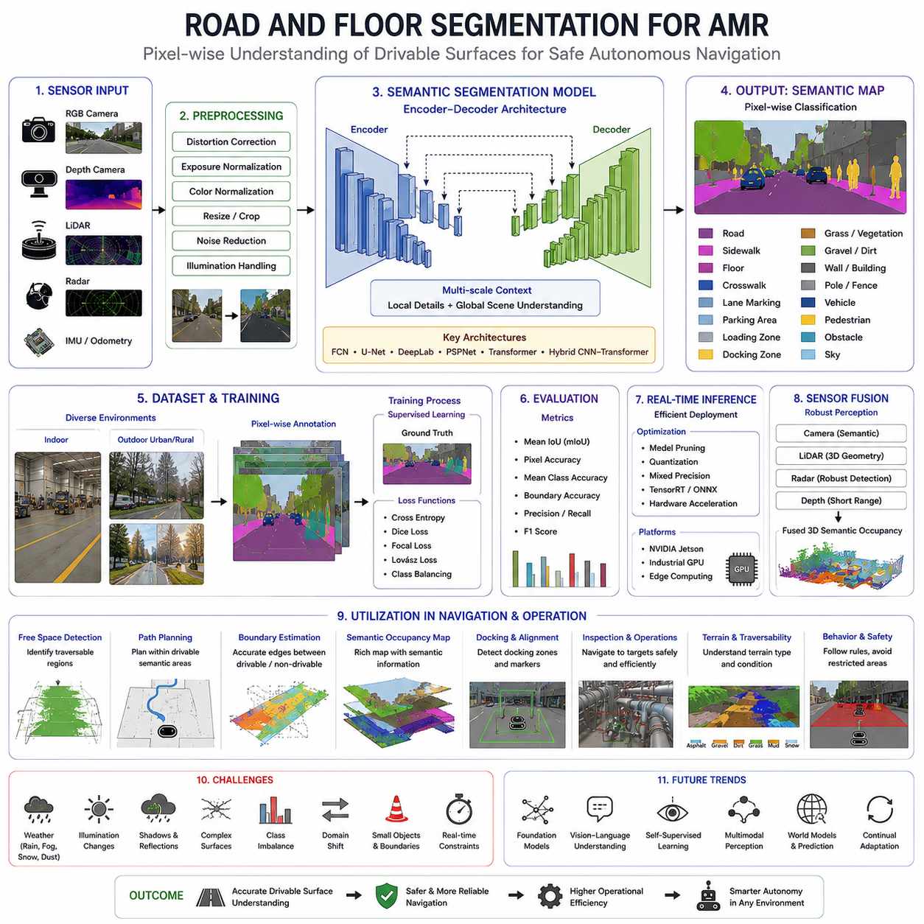
Road and floor segmentation is one of the most fundamental applications of semantic segmentation in autonomous mobile robotics because it enables the robot to distinguish traversable surfaces from the surrounding environment at the pixel level. Instead of merely detecting obstacles, the perception system identifies where the robot can safely drive by assigning every pixel to semantic categories such as road, floor, sidewalk, grass, gravel, wall, machinery, or vegetation. This dense understanding provides the foundation for reliable navigation, obstacle avoidance, path planning, and autonomous decision making in both indoor and outdoor environments.
The concept of road and floor segmentation extends beyond simple surface recognition. A mobile robot must understand whether a visible surface is physically traversable, operationally permitted, and safe under current environmental conditions. Two regions with similar visual appearance may require completely different driving behaviors. For example, polished concrete and wet concrete may appear nearly identical in RGB images, while dry asphalt and loose gravel may share similar colors. Semantic segmentation therefore combines visual appearance with contextual information learned during model training to estimate the functional meaning of each surface.
In autonomous navigation, the driving surface represents the largest continuous semantic region in most environments. Correct identification of this region allows the navigation system to construct a reliable free-space representation without relying solely on obstacle detection. Instead of planning paths only around detected objects, the robot plans trajectories directly inside semantically validated traversable regions. This significantly improves navigation robustness because the robot understands both where obstacles exist and where motion is naturally expected.
Indoor floor segmentation is generally more structured than outdoor road segmentation. Industrial facilities often contain concrete floors, epoxy coatings, tiled surfaces, painted safety zones, storage areas, loading docks, charging stations, and pedestrian walkways. Although these surfaces may appear visually similar, they often possess different operational meanings. A robot operating inside a factory may be allowed to travel only within designated traffic lanes while avoiding pedestrian crossings or restricted maintenance zones. Semantic floor segmentation enables these operational rules to be integrated directly into perception outputs.
Outdoor road segmentation introduces substantially greater complexity because environmental conditions continuously change. Roads may include asphalt, concrete, gravel, dirt, grass, sand, snow, mud, or partially damaged pavement. Lighting varies throughout the day, while shadows from buildings, vehicles, and vegetation continuously alter image appearance. Rain introduces reflections, puddles, and water accumulation that may obscure road boundaries. Seasonal changes further modify vegetation color and surface texture. A practical segmentation model must therefore generalize across a much broader range of environmental variations than indoor systems.
One of the primary objectives of road and floor segmentation is to estimate traversability. Traversability refers to whether the robot can safely drive over a particular surface given its physical capabilities. Traversability depends not only on semantic category but also on robot characteristics including wheel configuration, suspension design, ground clearance, payload, tire properties, and vehicle dimensions. A heavy outdoor AMR capable of traversing gravel or grass may classify those surfaces as drivable, while a small indoor robot may consider identical terrain completely inaccessible.
Semantic segmentation contributes directly to free-space detection by identifying continuous regions suitable for navigation. Classical free-space detection often relied on geometric assumptions such as flat ground estimation or obstacle height thresholds. These methods frequently failed when encountering ramps, slopes, uneven terrain, shadows, or visually ambiguous surfaces. Semantic segmentation improves free-space estimation by incorporating learned semantic understanding into pixel classification. Consequently, free-space maps become more robust under diverse environmental conditions and complex scene layouts.
Road and floor segmentation also improves boundary estimation. Navigation algorithms require accurate knowledge of transitions between traversable and non-traversable regions. These boundaries include curbs, walls, shelves, vegetation edges, construction barriers, drainage channels, and platform edges. Pixel-level segmentation generates much more precise boundary information than rectangular object detection because object contours follow their actual shapes rather than coarse bounding boxes. Precise boundary estimation allows local planners to maximize usable driving space while maintaining safe clearance margins.
Modern road segmentation systems typically process RGB camera images using deep convolutional neural networks or hybrid CNN-transformer architectures. The input image first undergoes preprocessing operations including distortion correction, exposure normalization, image resizing, color normalization, and noise reduction. These preprocessing stages improve input consistency and reduce variations introduced by different camera hardware, illumination conditions, and environmental factors. Standardized inputs improve neural network stability during both training and deployment.
Feature extraction begins within the encoder portion of the segmentation network. Early convolutional layers identify local image features including edges, textures, corners, lane markings, pavement cracks, tile patterns, and color gradients. Deeper layers progressively recognize larger semantic structures such as sidewalks, road surfaces, factory floors, buildings, shelving systems, or vegetation. Multi-scale feature extraction enables simultaneous recognition of small details and large environmental structures, which is essential because road boundaries often extend across large portions of the image while surface defects occupy only small local regions.
The decoder reconstructs dense segmentation maps by combining high-level semantic understanding with preserved spatial details from earlier network layers. Skip connections transfer fine-resolution information directly from encoder stages to decoder stages, allowing accurate reconstruction of road edges, painted lane markings, narrow pathways, and complex floor boundaries. Without these skip connections, fine structural details would be lost during repeated downsampling operations, resulting in blurred segmentation boundaries and reduced navigation accuracy.
Context plays a critical role in road and floor segmentation. Individual pixels rarely contain sufficient information for reliable classification because many surfaces share similar colors or textures. Instead, the segmentation network analyzes surrounding regions to infer semantic meaning. A gray region surrounded by lane markings and vehicles is more likely to represent a road, while a similar gray region enclosed by walls, machinery, and storage racks is likely to represent an indoor factory floor. Learning these contextual relationships significantly improves segmentation reliability.
Semantic segmentation models frequently incorporate multi-scale context aggregation mechanisms such as pyramid pooling, atrous spatial pyramid pooling, or transformer attention modules. These techniques enable simultaneous observation of local image details and global scene structure. Small local image patches provide fine surface textures, while global context reveals environmental layout, object relationships, and navigation corridors. The combination allows segmentation models to distinguish visually similar surfaces appearing in different operational contexts.
Training road and floor segmentation models requires carefully annotated datasets containing dense pixel-level labels. Every visible pixel must be assigned an appropriate semantic category including road, sidewalk, floor, grass, gravel, vegetation, wall, machinery, vehicle, pedestrian, building, or other application-specific classes. Creating these annotations requires considerable manual effort because precise object boundaries must be traced throughout thousands of images. Annotation consistency is particularly important since ambiguous class definitions directly reduce model accuracy during deployment.
Dataset diversity strongly influences generalization performance. Indoor datasets should contain warehouses, hospitals, factories, laboratories, office buildings, logistics centers, and commercial facilities under different lighting conditions. Outdoor datasets should include highways, urban streets, industrial yards, agricultural roads, construction sites, parking lots, ports, and rough terrain. Capturing diverse weather, seasonal variation, sensor viewpoints, camera heights, and environmental conditions enables segmentation models to operate reliably across practical deployment scenarios.
Class imbalance presents a common challenge during segmentation training. Large road or floor regions often dominate image content, while important classes such as curbs, safety markings, drainage channels, cables, or small obstacles occupy relatively few pixels. Without appropriate loss weighting, neural networks may prioritize dominant classes while neglecting safety-critical minority categories. Techniques such as focal loss, Dice loss, Lovász loss, and class-balanced optimization help improve recognition of underrepresented classes.
Road and floor segmentation performance is typically evaluated using mean Intersection over Union, pixel accuracy, mean class accuracy, boundary accuracy, precision, recall, and F1 score. Mean Intersection over Union remains the most widely accepted benchmark because it directly measures overlap between predicted semantic regions and ground-truth annotations. However, practical robotic applications often require additional evaluation focusing specifically on boundary quality and traversable region estimation because navigation performance depends more heavily on these aspects than overall pixel accuracy.
Inference speed represents another critical consideration for autonomous robots. Navigation decisions must be updated continuously as the robot moves through dynamic environments. Industrial AMRs frequently operate between 5 and 20 kilometers per hour, while larger outdoor robotic platforms may travel significantly faster. High perception latency increases stopping distance and reduces navigation responsiveness. Efficient segmentation architectures, TensorRT optimization, mixed precision computation, model pruning, quantization, and hardware acceleration enable practical deployment on embedded computing platforms.
Road and floor segmentation rarely functions independently. Instead, it forms one component within a larger multi-sensor perception architecture. LiDAR contributes accurate geometric measurements describing terrain elevation and obstacle height. Depth cameras improve short-range geometric understanding inside buildings. Radar provides reliable obstacle detection under adverse weather conditions including fog, rain, and dust. Sensor fusion combines semantic image understanding with three-dimensional spatial information, producing significantly more robust perception than any individual sensing modality alone.
One important application is semantic occupancy mapping. Traditional occupancy grids represent only occupied and free cells. Semantic occupancy maps extend this concept by assigning semantic labels to map cells. Instead of representing an area simply as free space, the map distinguishes roads, sidewalks, grass, factory floors, charging stations, loading zones, pedestrian areas, or restricted regions. This enriched environmental representation enables higher-level planning algorithms to incorporate operational rules directly into navigation behavior.
Navigation planners consume segmented road and floor information in multiple ways. Global planners prefer semantically valid transportation corridors while avoiding restricted or hazardous areas. Local planners use high-resolution segmentation maps to generate smooth collision-free trajectories around temporary obstacles. Behavioral planners combine semantic information with traffic rules, pedestrian priorities, docking procedures, and operational constraints. Consequently, semantic segmentation influences nearly every stage of autonomous navigation.
Road segmentation significantly improves autonomous docking operations. During docking, robots must approach charging stations, conveyor systems, elevators, loading bays, or workstations with high positional accuracy. Accurate floor segmentation identifies floor boundaries, painted alignment markers, docking zones, and surrounding structures that assist final positioning. When combined with fiducial markers, LiDAR localization, or visual servoing, semantic segmentation contributes to repeatable centimeter-level docking performance.
Industrial inspection robots similarly benefit from accurate floor understanding. Inspection routes frequently traverse complex facilities containing multiple floor materials, maintenance platforms, equipment foundations, stairways, ramps, and safety barriers. Semantic segmentation enables robots to distinguish operational pathways from restricted equipment areas while simultaneously identifying inspection targets located adjacent to navigable regions. This reduces unnecessary path deviations and improves inspection efficiency.
Outdoor autonomous robots require particularly sophisticated road segmentation because terrain characteristics directly influence vehicle dynamics. Loose gravel produces different traction than asphalt. Wet grass offers different mobility characteristics than compact dirt. Snow may completely obscure road boundaries, while mud introduces slip hazards. Future segmentation systems increasingly estimate not only semantic categories but also terrain traversability, friction coefficients, surface roughness, and expected vehicle stability, allowing navigation systems to adapt driving strategies automatically.
Adverse weather remains one of the greatest challenges for road segmentation. Rain introduces reflections that confuse surface classification. Snow covers road markings and changes surface appearance dramatically. Fog reduces image contrast and obscures distant regions. Dust generated by construction or mining activities decreases visibility and contaminates camera lenses. Robust segmentation models therefore require extensive weather diversity during training as well as complementary sensing modalities capable of compensating for degraded visual conditions.
Illumination variation presents another significant difficulty. Strong sunlight creates harsh shadows that may resemble obstacles. Nighttime operation requires artificial illumination while introducing sensor noise. Indoor lighting changes throughout factories as equipment turns on or off, emergency lighting activates, or large doors open to outdoor sunlight. High dynamic range imaging, adaptive exposure control, image normalization, and robust feature learning all contribute to maintaining segmentation accuracy under changing illumination conditions.
Generalization across different deployment environments remains a persistent research problem. Models trained in one city, factory, or warehouse often experience performance degradation when deployed elsewhere because pavement materials, floor coatings, lighting systems, building layouts, and environmental appearance differ substantially. Domain adaptation, continual learning, synthetic data generation, self-supervised learning, and foundation models increasingly address these challenges by enabling segmentation models to adapt efficiently to previously unseen operational environments.
Foundation vision models are expected to transform future road and floor segmentation systems. Rather than learning only predefined semantic classes, these models acquire broad visual knowledge from enormous multimodal datasets. They demonstrate improved zero-shot generalization, stronger contextual reasoning, and better adaptation to unfamiliar environments. Combined with vision-language models and world models, future segmentation systems will understand not only the appearance of driving surfaces but also their functional roles, operational constraints, and relationships with surrounding infrastructure.
Ultimately, road and floor segmentation represents far more than a pixel classification problem. It serves as the perception layer that connects raw sensor observations with autonomous navigation intelligence. By transforming camera images into dense semantic maps describing traversable surfaces, environmental boundaries, operational zones, and contextual scene understanding, semantic segmentation enables autonomous mobile robots to navigate safely, efficiently, and intelligently across increasingly complex indoor and outdoor environments. As robotic perception continues to evolve toward multimodal foundation models and semantic world understanding, road and floor segmentation will remain one of the indispensable core technologies supporting reliable autonomous mobility.

17.3 Obstacle and Free Space Segmentation
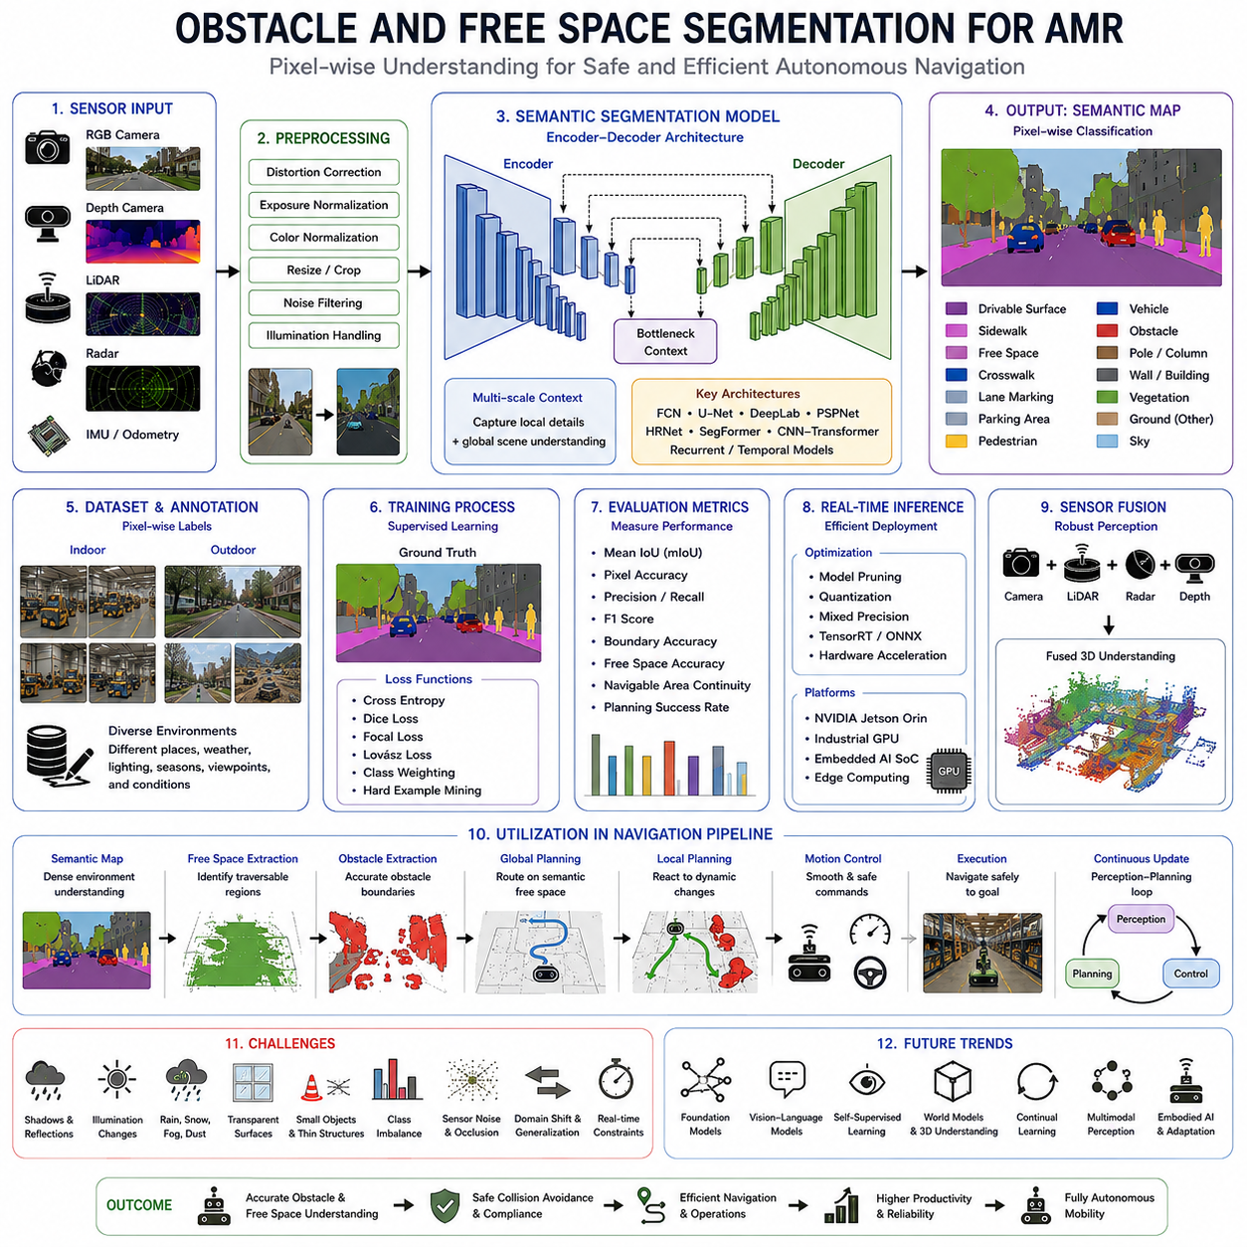
Obstacle and free space segmentation represents one of the most critical perception capabilities in autonomous mobile robotics because it directly determines where a robot can move safely and where movement must be avoided. Unlike conventional object detection systems that only recognize individual obstacles, segmentation performs dense pixel-level scene interpretation by simultaneously identifying occupied regions, traversable free space, environmental boundaries, and semantic surface categories. This comprehensive environmental understanding enables autonomous mobile robots to make continuous navigation decisions in dynamic and unstructured environments while maintaining high levels of operational safety and efficiency.
The fundamental objective of obstacle and free space segmentation is to partition every visible pixel into either traversable or non-traversable regions while preserving semantic meaning. Traversable regions include roads, factory floors, sidewalks, designated driving lanes, and other surfaces that satisfy the robot's mobility requirements. Non-traversable regions include walls, machinery, shelves, vehicles, pedestrians, vegetation, structural columns, construction barriers, and hazardous terrain. Unlike simple binary occupancy estimation, semantic segmentation distinguishes between multiple obstacle categories, allowing navigation algorithms to make context-aware decisions rather than treating every obstacle identically.
Obstacle segmentation differs significantly from traditional obstacle detection because it provides precise object boundaries instead of coarse rectangular bounding boxes. A bounding box often contains large areas that do not belong to the actual object, reducing available driving space and introducing uncertainty into path planning. Pixel-level segmentation accurately follows object contours, allowing the navigation system to estimate available clearance more precisely. This increased geometric accuracy is particularly important for autonomous mobile robots operating in narrow corridors, warehouse aisles, manufacturing facilities, or crowded outdoor environments where available navigation space is limited.
Free space segmentation complements obstacle segmentation by explicitly identifying regions that can safely support robot motion. Instead of treating free space simply as the absence of obstacles, semantic segmentation actively recognizes drivable surfaces based on learned environmental characteristics. This distinction becomes particularly valuable in complex environments where visual appearance alone cannot reliably determine traversability. For example, a flat water surface may appear visually similar to asphalt, while transparent glass walls may resemble open corridors. Semantic understanding enables the robot to interpret these situations correctly despite their visual ambiguity.
The concept of free space extends beyond geometric emptiness. A physically empty region may still be unsuitable for navigation due to operational restrictions, unstable terrain, safety regulations, or mission-specific constraints. For example, pedestrian-only walkways, restricted maintenance areas, hazardous chemical zones, or fragile flooring may all appear visually traversable while remaining operationally prohibited. Semantic free space segmentation incorporates these functional characteristics into environmental interpretation, allowing robots to comply with operational policies in addition to avoiding physical collisions.
Obstacle segmentation is closely related to occupancy mapping but provides substantially richer information. Classical occupancy grids classify map cells only as occupied, free, or unknown. Semantic segmentation enriches these representations by assigning meaningful labels to every occupied region. Instead of simply indicating that an obstacle exists, the perception system identifies whether the obstacle represents a pedestrian, forklift, storage rack, machine, vehicle, construction barrier, vegetation, or temporary equipment. This additional semantic information enables higher-level planning systems to adapt robot behavior according to obstacle type and operational context.
Modern obstacle and free space segmentation systems primarily rely on deep neural networks that perform dense image prediction. Encoder-decoder architectures remain among the most widely adopted solutions because they efficiently combine global contextual understanding with high-resolution spatial detail. The encoder progressively extracts increasingly abstract semantic representations while reducing image resolution. The decoder subsequently reconstructs pixel-level segmentation maps through multi-scale feature fusion and upsampling operations. Skip connections preserve fine structural information necessary for accurately delineating obstacle boundaries and narrow navigation passages.
Multi-scale feature extraction plays an essential role because obstacles appear at dramatically different sizes depending on viewing distance. Nearby objects occupy large portions of the image, while distant obstacles may consist of only a few pixels. Small safety-critical objects such as cables, safety cones, tools, or floor debris require high-resolution local feature extraction, whereas large environmental structures including walls, buildings, loading docks, or warehouse aisles require broad contextual understanding. Multi-scale neural network architectures simultaneously process these different spatial scales to achieve robust segmentation across diverse operational scenarios.
Contextual reasoning substantially improves obstacle classification accuracy. Individual pixels rarely contain sufficient information for reliable semantic interpretation because different objects often exhibit similar colors, textures, or shapes. Instead, neural networks analyze surrounding environmental context to infer object identity. A gray rectangular structure located between warehouse shelves likely represents a pallet, while a similar structure positioned beside moving traffic may represent a roadside barrier. Context-aware segmentation therefore integrates local visual appearance with broader scene relationships to reduce classification ambiguity.
Temporal consistency represents another important characteristic of practical segmentation systems. Autonomous robots continuously observe the environment while moving, generating image sequences rather than isolated frames. Consecutive observations provide valuable temporal information that improves segmentation stability by reducing frame-to-frame prediction fluctuations. Temporal feature fusion, recurrent neural networks, optical flow estimation, and sequential transformer architectures all exploit motion continuity to improve segmentation robustness, particularly under challenging lighting conditions or partial occlusions.
Obstacle segmentation frequently incorporates geometric information obtained from depth sensors or LiDAR systems. Camera images provide rich semantic information but limited direct depth estimation. LiDAR contributes highly accurate three-dimensional geometric measurements that distinguish elevated obstacles from flat surfaces. Depth cameras provide dense distance information within shorter operating ranges. Multi-modal segmentation architectures combine visual semantics with geometric structure, producing substantially more reliable obstacle boundaries and free space estimates than vision-only systems.
Sensor fusion significantly enhances perception robustness under adverse operating conditions. Cameras perform exceptionally well under favorable illumination but may struggle during heavy rain, fog, snow, darkness, or direct sunlight. Radar maintains reliable obstacle detection despite poor visibility but provides lower semantic resolution. LiDAR accurately measures geometry yet may experience reduced performance during heavy precipitation or airborne dust. Fusing multiple sensing modalities allows the perception system to compensate for weaknesses inherent in individual sensors while preserving accurate environmental understanding.
Training obstacle and free space segmentation models requires carefully constructed datasets containing pixel-level annotations for both traversable surfaces and obstacle categories. Annotation quality directly determines segmentation performance because neural networks learn decision boundaries entirely from labeled examples. Annotators must accurately delineate complex object contours, distinguish overlapping objects, and maintain consistent semantic definitions throughout large datasets. Even minor inconsistencies in annotation guidelines can significantly reduce model generalization during deployment.
Dataset diversity strongly influences model robustness. Industrial indoor datasets should contain warehouses, factories, hospitals, laboratories, office buildings, logistics centers, production lines, loading areas, and maintenance facilities under varying illumination conditions. Outdoor datasets should include urban streets, parking lots, ports, construction sites, agricultural fields, industrial complexes, campuses, and rough terrain. Weather variation including rain, fog, snow, strong sunlight, and nighttime operation further improves generalization by exposing segmentation models to realistic operational environments.
Class imbalance remains one of the greatest challenges during segmentation training. Free space often occupies the majority of image pixels, while important obstacle categories such as pedestrians, cables, safety cones, dropped tools, or warning signs appear relatively infrequently. Without appropriate optimization strategies, neural networks naturally emphasize dominant classes while underperforming on minority categories that may be critical for operational safety. Weighted loss functions, focal loss, Dice loss, Lovász optimization, hard example mining, and balanced sampling strategies help mitigate these imbalances during training.
Evaluation metrics for obstacle and free space segmentation extend beyond conventional semantic segmentation benchmarks. Mean Intersection over Union remains the primary quantitative performance indicator because it measures overlap between predicted and annotated regions across multiple semantic classes. Pixel accuracy, precision, recall, F1 score, and boundary accuracy provide complementary perspectives on segmentation quality. However, robotic navigation additionally requires evaluation of traversability estimation accuracy, free space continuity, obstacle boundary precision, navigation corridor consistency, and overall planning performance under realistic operational conditions.
Real-time inference capability represents a fundamental deployment requirement. Autonomous robots continuously generate perception updates while moving through dynamic environments. Navigation decisions often require perception refresh rates exceeding ten or twenty frames per second depending on vehicle speed and operational complexity. Large segmentation networks may achieve excellent benchmark accuracy while remaining unsuitable for embedded deployment due to excessive computational cost. Efficient neural network architectures, TensorRT optimization, mixed precision inference, model pruning, quantization, and hardware acceleration enable practical real-time performance on industrial edge computing platforms.
Obstacle and free space segmentation directly influences every stage of autonomous navigation. Global planners utilize semantic free space maps to generate efficient long-range routes while avoiding restricted regions. Local planners continuously update trajectories according to dynamic obstacle positions and changing free space boundaries. Motion controllers convert planned trajectories into steering and velocity commands while respecting vehicle kinematic constraints. Consequently, segmentation errors propagate throughout the navigation pipeline, emphasizing the importance of maintaining robust perception performance under diverse operating conditions.
Dynamic environments introduce additional complexity because obstacle configurations continuously evolve. Pedestrians, forklifts, automated guided vehicles, construction equipment, and other robots constantly modify the navigable environment. Static maps alone cannot accurately represent these changes. Real-time obstacle segmentation continuously updates environmental occupancy while simultaneously estimating newly available free space as moving obstacles change position. This dynamic environmental understanding enables smooth collision avoidance without unnecessary stopping or conservative navigation behavior.
Industrial warehouse environments illustrate the practical importance of obstacle and free space segmentation. Warehouses contain densely packed shelving systems, pallets, forklifts, workers, conveyor systems, charging stations, temporary storage areas, and changing inventory configurations. Navigation corridors may narrow significantly as operations progress throughout the day. Accurate segmentation enables autonomous mobile robots to maximize usable driving space while maintaining safe separation from workers and equipment despite continuously evolving environmental layouts.
Manufacturing facilities introduce additional perception challenges because production equipment often contains reflective metallic surfaces, complex machinery, overhead structures, suspended cables, moving robotic arms, and temporary maintenance activities. Floor markings indicate transportation routes, safety zones, restricted areas, and emergency pathways. Semantic segmentation distinguishes these operational regions while identifying both permanent infrastructure and temporary obstacles, allowing robots to navigate safely without disrupting ongoing manufacturing processes.
Outdoor autonomous robots encounter even greater environmental diversity. Roads, sidewalks, gravel paths, grass, dirt roads, construction zones, vegetation, parked vehicles, drainage channels, curbs, and uneven terrain all require different navigation strategies. Weather continuously alters surface appearance through rain, snow, mud, shadows, and seasonal vegetation changes. Robust segmentation models therefore require extensive environmental diversity during training while maintaining consistent free space estimation across changing operational conditions.
Terrain understanding naturally extends obstacle and free space segmentation by estimating not only semantic categories but also mobility characteristics. Two regions classified as traversable may nevertheless exhibit substantially different driving properties. Asphalt supports high-speed travel, whereas loose gravel requires reduced speed. Wet grass increases wheel slip, while compact soil offers greater stability. Advanced segmentation systems increasingly estimate terrain traversability, expected traction, surface roughness, and mobility cost simultaneously, enabling adaptive navigation strategies tailored to environmental conditions.
Boundary accuracy remains especially important for precision navigation. Small localization errors combined with inaccurate segmentation boundaries may cause robots to contact shelving systems, loading docks, machinery, or structural walls. Precise obstacle contours allow planners to generate trajectories that maximize operational efficiency while preserving appropriate safety margins. High-quality boundary estimation also improves docking operations where centimeter-level positioning accuracy is often required for charging stations, conveyor interfaces, automated loading systems, or industrial workstations.
Failure analysis demonstrates several common segmentation challenges encountered during practical deployment. Shadows frequently resemble physical obstacles, causing unnecessary path deviations. Highly reflective floors may confuse semantic classification due to changing illumination. Transparent glass walls remain difficult to detect using RGB imagery alone. Rain, snow, mud, and accumulated dust degrade image quality while partially obscuring obstacle boundaries. Sensor contamination further reduces perception accuracy, emphasizing the importance of robust preprocessing, sensor maintenance, and multi-modal fusion.
Generalization across deployment environments remains an active research challenge. Models trained within one warehouse, factory, or city often experience reduced performance when deployed elsewhere due to differences in architecture, floor materials, equipment layout, lighting conditions, environmental appearance, and operational procedures. Domain adaptation, continual learning, synthetic data generation, self-supervised learning, and foundation vision models increasingly address these limitations by improving adaptation to previously unseen environments without requiring complete retraining.
Foundation models are expected to fundamentally reshape obstacle and free space segmentation over the coming years. Instead of learning only predefined semantic categories, large vision foundation models acquire extensive visual knowledge from massive multimodal datasets covering countless environmental conditions and object types. These models demonstrate stronger contextual reasoning, improved zero-shot recognition, and greater robustness against domain shifts. Combined with vision-language models, three-dimensional world models, and embodied AI systems, future segmentation architectures will interpret environmental functionality in addition to geometric occupancy.
Ultimately, obstacle and free space segmentation serves as the perception bridge connecting raw sensor observations with autonomous navigation intelligence. By simultaneously identifying obstacles, traversable regions, semantic object categories, environmental boundaries, and operational constraints at pixel-level resolution, segmentation enables autonomous mobile robots to navigate safely through complex indoor and outdoor environments. As robotic perception evolves toward multimodal foundation models capable of unified scene understanding, obstacle and free space segmentation will remain one of the indispensable technologies supporting reliable, intelligent, and fully autonomous mobility.

17.4 Indoor Scene Segmentation
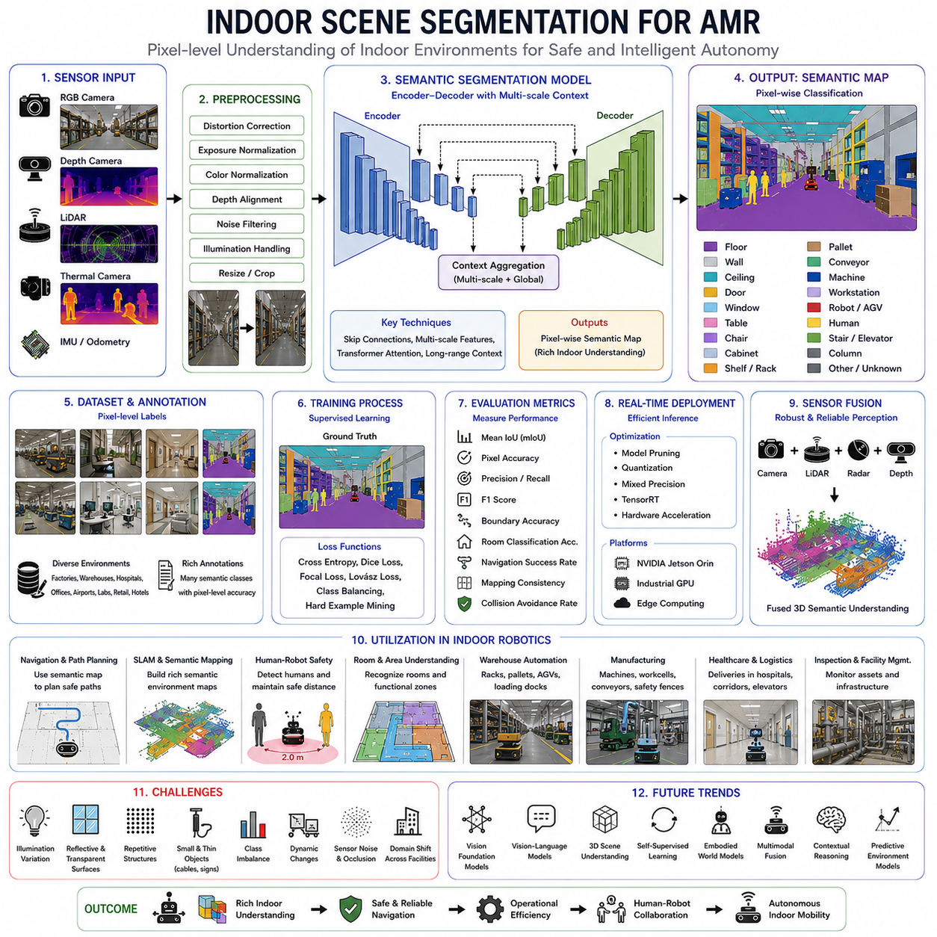
Indoor scene segmentation is a specialized application of semantic segmentation that focuses on understanding complex indoor environments at the pixel level. Instead of identifying only isolated objects, the perception system assigns a semantic label to every visible pixel, enabling an autonomous mobile robot to understand walls, floors, ceilings, doors, furniture, shelves, workstations, machines, corridors, people, and other indoor structures simultaneously. This dense scene interpretation provides the environmental awareness required for reliable indoor navigation, human-robot collaboration, autonomous inspection, warehouse automation, hospital logistics, and intelligent facility management.
Indoor environments differ fundamentally from outdoor environments in both appearance and operational requirements. Outdoor perception primarily deals with roads, vegetation, vehicles, and weather variations, whereas indoor environments contain structured architectural layouts, artificial lighting, narrow corridors, repetitive objects, movable furniture, industrial equipment, transparent surfaces, and highly organized workspaces. Because autonomous mobile robots spend considerable time operating inside factories, warehouses, hospitals, airports, laboratories, and commercial buildings, indoor scene segmentation has become one of the most important perception technologies in industrial robotics.
The primary objective of indoor scene segmentation is to transform raw sensor observations into a structured semantic representation of the environment. Every pixel is classified into meaningful categories such as floor, wall, ceiling, door, window, table, chair, cabinet, shelf, pallet, conveyor, robot, workstation, elevator, staircase, human, or machinery. Rather than simply recognizing objects individually, the segmentation model understands how these elements collectively define the operational environment. This comprehensive understanding allows higher-level navigation, localization, and planning algorithms to reason about both geometric structure and functional meaning.
One of the defining characteristics of indoor scene segmentation is its emphasis on environmental structure. Indoor facilities typically contain permanent architectural elements that remain stable over long periods, including walls, ceilings, columns, support beams, and floor boundaries. These structural features provide reliable semantic landmarks for localization and mapping. By consistently recognizing these stable components, robots maintain accurate environmental awareness despite temporary changes caused by moving equipment, furniture rearrangement, or human activity.
Floor segmentation forms the foundation of indoor scene understanding because the floor represents the primary traversable region for autonomous navigation. However, indoor floors often contain multiple functional zones including transportation lanes, pedestrian walkways, charging stations, loading areas, safety zones, maintenance regions, and restricted workspaces. Although these surfaces may share similar visual appearance, they possess different operational meanings. Semantic segmentation distinguishes these functional areas, enabling robots to follow organizational policies while maintaining efficient navigation behavior.
Wall segmentation is equally important because walls define the navigable boundaries of indoor environments. Accurate wall identification supports localization, map construction, collision avoidance, corridor detection, and room segmentation. Unlike simple obstacle detection, semantic wall segmentation distinguishes permanent architectural structures from temporary obstacles such as movable partitions, stacked inventory, or maintenance equipment. This distinction improves long-term map stability while reducing unnecessary environmental updates caused by temporary changes.
Door segmentation provides valuable information regarding environmental connectivity. Autonomous robots frequently operate across multiple rooms connected through doors, automatic entrances, elevators, and access-controlled gateways. Detecting doors as semantic entities enables navigation systems to reason about room transitions rather than treating every wall opening simply as empty space. Combined with state recognition algorithms that determine whether doors are open or closed, semantic door segmentation contributes significantly to autonomous navigation in large indoor facilities.
Ceiling segmentation may initially appear less important for ground robots, yet it contributes meaningfully to indoor perception. Ceiling structures often contain lighting systems, ventilation ducts, fire suppression equipment, suspended utilities, overhead cranes, and localization markers. Ceiling geometry also provides stable structural references that remain largely unaffected by furniture movement or temporary environmental changes. Three-dimensional indoor mapping systems frequently incorporate ceiling information to improve localization accuracy and structural consistency.
Furniture segmentation plays a critical role in office buildings, hospitals, laboratories, and commercial environments. Chairs, tables, desks, cabinets, hospital beds, examination equipment, waiting areas, and reception counters define the functional organization of indoor spaces. Unlike architectural structures, furniture may occasionally be relocated, requiring perception systems to distinguish movable objects from permanent infrastructure. Accurate furniture segmentation enables robots to adapt dynamically while maintaining stable long-term maps.
Industrial indoor environments introduce additional semantic categories not commonly encountered in public buildings. Manufacturing facilities contain robotic workcells, conveyor systems, machine tools, production lines, safety fences, assembly stations, storage racks, pallets, forklifts, automated guided vehicles, quality inspection stations, and maintenance equipment. Warehouse environments include dense shelving systems, package storage, loading docks, charging stations, sorting equipment, and transportation corridors. Indoor scene segmentation must therefore adapt semantic class definitions according to specific industrial applications.
Human segmentation represents one of the most safety-critical aspects of indoor scene understanding. Industrial standards increasingly require autonomous robots to detect workers reliably under diverse operating conditions. Pixel-level segmentation accurately estimates human body contours rather than coarse bounding boxes, enabling more precise safety zone estimation and improved collision avoidance. Semantic understanding further distinguishes workers from mannequins, posters, machinery, or static human-shaped objects by combining contextual reasoning with temporal observations.
Indoor scene segmentation also supports semantic room classification. Instead of recognizing only individual objects, the perception system infers functional room categories based on overall scene composition. Rooms containing hospital beds, medical equipment, and monitors may be classified as patient rooms. Areas containing shelving and inventory become storage rooms. Conveyor systems and robotic cells indicate production areas, while conference tables and office furniture suggest meeting rooms. This higher-level semantic understanding enables mission planning systems to reason directly about functional spaces rather than only geometric coordinates.
Modern indoor scene segmentation systems primarily employ encoder-decoder neural network architectures that combine high-level semantic reasoning with fine spatial detail. The encoder extracts hierarchical visual features while progressively reducing image resolution. The decoder reconstructs dense semantic predictions through multi-scale feature fusion and skip connections. These architectures preserve small structural details including door frames, narrow corridors, wall edges, floor markings, electrical outlets, and equipment boundaries while simultaneously understanding broader environmental layouts.
Transformer-based segmentation architectures have recently demonstrated significant improvements in indoor scene understanding. Unlike conventional convolutional neural networks that primarily process local neighborhoods, transformers capture long-range spatial relationships throughout the entire image. Indoor environments frequently contain repetitive structures such as ceiling tiles, shelving systems, corridor walls, and production equipment. Long-range attention mechanisms improve semantic consistency by recognizing these repeated structural patterns and integrating global contextual information during prediction.
Multi-scale context aggregation remains particularly important because indoor scenes contain objects spanning dramatically different spatial dimensions. Small safety signs, electrical switches, cables, and tools occupy only a few pixels, whereas floors, walls, ceilings, and large shelving systems extend across most of the image. Effective segmentation models simultaneously analyze local texture details and global structural organization, allowing accurate recognition of both small objects and extensive architectural components.
Indoor perception often relies on multiple sensing modalities beyond conventional RGB cameras. Depth cameras provide dense three-dimensional geometry that significantly improves separation between walls, furniture, machinery, and open floor regions. LiDAR supplies accurate spatial measurements useful for structural mapping. Thermal cameras assist human detection under poor illumination, while event cameras improve robustness during rapid motion. Multi-modal segmentation architectures integrate these complementary sensing modalities to produce more reliable semantic interpretations than any individual sensor alone.
Depth information substantially enhances indoor scene segmentation because geometric structure frequently resolves visual ambiguities. White walls, cabinets, and machinery may share similar colors while exhibiting distinct spatial geometry. Depth measurements distinguish flat walls from protruding furniture and identify object boundaries that remain difficult to observe using RGB imagery alone. Combining semantic appearance with geometric structure produces significantly more robust segmentation, particularly under varying lighting conditions.
Indoor lighting presents unique perception challenges compared with outdoor environments. Artificial illumination varies according to facility design, producing fluorescent lighting, LED panels, skylights, emergency lighting, and localized work lamps. Reflective floors, polished machinery, glass partitions, stainless steel equipment, and glossy surfaces generate strong reflections that confuse visual segmentation models. Shadows cast by shelving systems or moving equipment further complicate scene interpretation. Robust segmentation therefore requires extensive training under diverse indoor illumination conditions.
Transparent and reflective surfaces remain among the most difficult indoor perception problems. Glass walls, automatic sliding doors, display cases, mirrors, polished stainless steel machinery, and reflective floors frequently produce misleading visual cues. Pure RGB segmentation often struggles to distinguish these surfaces from open space. Multi-modal perception combining cameras with LiDAR, radar, or depth sensors significantly improves recognition by incorporating geometric measurements that remain relatively unaffected by optical transparency or reflections.
Training indoor scene segmentation models requires extensive pixel-level annotation across numerous semantic classes. Public datasets such as ScanNet, Matterport3D, SUN RGB-D, Structured3D, NYUv2, and Habitat datasets have substantially accelerated research by providing densely labeled indoor scenes. Industrial applications frequently require additional proprietary datasets containing factory equipment, warehouse infrastructure, medical devices, production machinery, logistics systems, and organization-specific operational environments. Annotation consistency remains essential because inconsistent semantic definitions directly reduce deployment performance.
Data diversity strongly influences generalization capability. Effective indoor segmentation datasets include offices, hospitals, factories, warehouses, airports, laboratories, retail stores, educational facilities, hotels, residential buildings, and public infrastructure. Different architectural styles, furniture arrangements, lighting conditions, camera viewpoints, sensor heights, and operational activities expose segmentation models to realistic environmental variability. This diversity improves robustness when deploying robots into previously unseen facilities.
Class imbalance presents persistent optimization challenges because large structural components dominate indoor imagery. Floors, walls, and ceilings occupy substantial image areas, while critical objects including fire extinguishers, emergency buttons, electrical outlets, warning signs, handheld tools, and cables occupy only limited pixel regions. Weighted loss functions, focal loss, Dice loss, boundary-aware optimization, and hard example mining improve learning for these minority classes without sacrificing segmentation performance on dominant structural elements.
Evaluation metrics extend beyond conventional semantic segmentation benchmarks because practical robotic applications emphasize operational performance. Mean Intersection over Union remains the standard quantitative metric, accompanied by pixel accuracy, precision, recall, F1 score, and boundary accuracy. However, autonomous robots additionally evaluate navigation success rate, localization consistency, free-space estimation quality, collision avoidance reliability, semantic map accuracy, and mission completion efficiency. These system-level metrics more directly reflect the operational value of indoor scene segmentation.
Real-time deployment requires careful optimization because indoor robots continuously process high-resolution sensor streams while executing simultaneous localization, navigation, planning, communication, and mission management. Efficient encoder-decoder architectures, lightweight backbones, TensorRT optimization, mixed precision inference, quantization, structured pruning, knowledge distillation, and hardware acceleration enable semantic segmentation to operate at real-time frame rates on embedded industrial computing platforms such as NVIDIA Jetson Orin or industrial GPU systems.
Indoor scene segmentation directly supports simultaneous localization and mapping by enriching geometric maps with semantic information. Instead of representing only occupied and free cells, semantic maps encode walls, doors, rooms, corridors, workstations, storage areas, elevators, charging stations, and safety zones. Semantic landmarks remain considerably more stable than low-level image features because architectural structures rarely change significantly over time. Consequently, semantic mapping improves long-term localization robustness in dynamic indoor environments.
Navigation planning benefits substantially from semantic scene understanding. Global planners utilize semantic maps to generate efficient routes through corridors, transportation lanes, and designated operational areas. Local planners incorporate dynamic segmentation outputs to avoid moving obstacles while preserving smooth trajectories. Behavioral planners integrate room semantics, operational policies, human activity, and facility regulations into mission execution. Thus, semantic segmentation influences nearly every decision made throughout the autonomous navigation pipeline.
Warehouse automation provides a representative example of practical indoor scene segmentation. Modern warehouses contain dense shelving systems, pallets, inventory containers, forklifts, charging stations, workers, conveyor belts, loading docks, automated storage systems, and autonomous robots operating simultaneously. Semantic segmentation enables robots to distinguish permanent storage infrastructure from temporary inventory while continuously updating navigable free space as warehouse operations evolve throughout the day.
Hospital logistics demonstrates another demanding application. Hospitals contain patient rooms, operating theaters, intensive care units, laboratories, pharmacies, elevators, reception areas, waiting rooms, and sterile environments connected through complex corridor networks. Robots transporting medicine, laboratory samples, meals, or medical equipment must accurately recognize these functional spaces while safely interacting with patients, healthcare workers, visitors, and movable medical equipment. Semantic indoor scene understanding significantly improves navigation reliability in these highly dynamic environments.
Manufacturing facilities require even richer semantic understanding because production lines continuously evolve according to operational schedules. Temporary maintenance activities, equipment replacement, movable workstations, production carts, robotic manipulators, and human operators frequently modify local environments. Indoor segmentation enables robots to distinguish permanent factory infrastructure from temporary operational changes while maintaining accurate navigation and efficient material transportation across production facilities.
Failure analysis reveals several recurring challenges encountered during deployment. Severe illumination variation causes inconsistent semantic predictions. Reflective floors generate false free-space estimates. Glass partitions appear visually transparent despite being physical obstacles. Highly repetitive warehouse shelving occasionally confuses segmentation boundaries. Motion blur during rapid robot movement reduces prediction quality, while sensor contamination from dust or industrial debris gradually degrades perception accuracy. Systematic validation under representative operational conditions therefore remains essential before large-scale deployment.
Future indoor scene segmentation systems will increasingly integrate foundation vision models, vision-language models, three-dimensional scene representations, self-supervised learning, and embodied world models. Rather than predicting only predefined semantic categories, these models will reason about functional relationships between objects, infer intended human activities, understand operational workflows, and anticipate environmental changes. Unified multimodal perception will combine visual appearance, geometry, language, temporal consistency, and contextual reasoning into a comprehensive indoor environmental understanding.
Ultimately, indoor scene segmentation serves as the semantic foundation upon which intelligent indoor autonomy is built. By transforming raw sensor observations into dense semantic representations describing architectural structures, operational regions, movable objects, human activities, and navigable free space, segmentation provides autonomous mobile robots with the environmental awareness necessary for safe, efficient, and reliable operation inside complex buildings. As robotic perception continues evolving toward generalized embodied intelligence, indoor scene segmentation will remain one of the indispensable technologies enabling truly autonomous indoor mobility.

17.5 Outdoor Terrain Segmentation
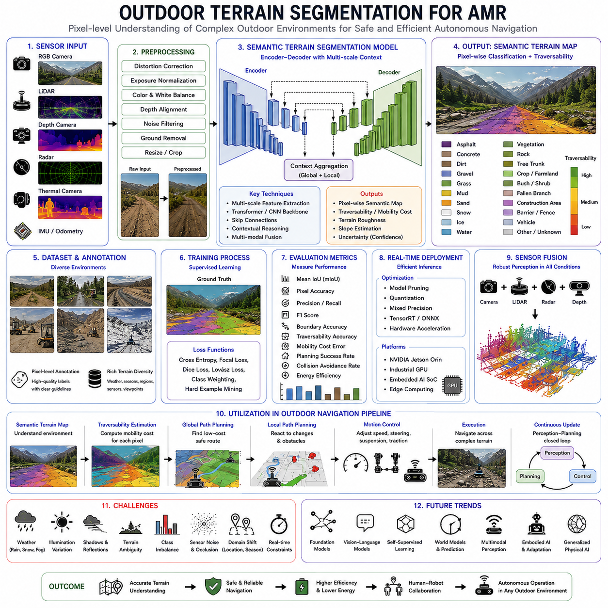
Outdoor terrain segmentation is a specialized branch of semantic segmentation that focuses on understanding natural and semi-structured environments at the pixel level. Unlike indoor scene segmentation, where architectural structures remain relatively stable and organized, outdoor environments contain highly diverse terrain types, irregular surfaces, changing vegetation, unpredictable weather, and dynamic environmental conditions. The primary objective of outdoor terrain segmentation is to assign a semantic label to every visible pixel so that an autonomous mobile robot can accurately distinguish drivable terrain, hazardous regions, vegetation, water, rocks, roads, mud, gravel, sand, snow, and numerous other environmental categories. This dense semantic understanding provides the perception foundation required for safe autonomous navigation in complex outdoor environments.
Outdoor autonomous robots operate in environments that continuously evolve over time. Construction sites change daily as equipment moves and earthworks progress. Agricultural fields transform throughout growing seasons. Mining environments undergo constant excavation. Forest trails vary according to weather, vegetation growth, and fallen debris. Urban environments experience traffic, temporary construction zones, and changing pedestrian activity. Unlike indoor facilities with relatively predictable layouts, outdoor terrain segmentation must therefore generalize across an enormous variety of terrain appearances while remaining robust under continuously changing environmental conditions.
One of the fundamental goals of outdoor terrain segmentation is traversability estimation. Instead of merely identifying what a surface looks like, the perception system determines whether the robot can safely traverse that surface given its physical capabilities. Traversability depends not only on semantic terrain categories but also on vehicle properties including wheel diameter, tire type, suspension geometry, payload, drive configuration, traction control, ground clearance, vehicle mass, and dynamic stability. A terrain classified as traversable for a heavy six-wheel autonomous platform may be completely inaccessible to a lightweight indoor robot.
Semantic terrain understanding extends beyond simple obstacle detection by explicitly recognizing surface characteristics. A perception system capable only of detecting obstacles cannot distinguish between asphalt, compact dirt, loose gravel, wet grass, mud, snow, or sand when these surfaces appear obstacle-free. However, each terrain type produces different mobility characteristics including traction, rolling resistance, suspension loading, wheel slip, and vehicle stability. Outdoor terrain segmentation provides this semantic information directly to navigation algorithms, enabling adaptive driving behavior rather than uniform motion across all surfaces.
Road segmentation forms an important subset of outdoor terrain segmentation but represents only one semantic category among many. Outdoor autonomous robots frequently leave paved roads entirely, operating across gravel paths, agricultural fields, construction sites, industrial yards, forests, mining areas, and natural terrain. Consequently, terrain segmentation must classify significantly broader environmental categories than conventional road segmentation systems developed primarily for passenger vehicles. The perception system therefore learns relationships among diverse natural and artificial surfaces simultaneously rather than focusing exclusively on paved transportation infrastructure.
Natural terrain introduces considerably greater visual diversity than engineered surfaces. Vegetation alone includes grass, shrubs, bushes, trees, crops, weeds, fallen leaves, moss, and seasonal plant variations. Soil appears as dry dirt, wet mud, compact earth, loose sand, gravel mixtures, rocky ground, or partially vegetated terrain. Water exists as puddles, streams, flooded regions, snowmelt, or ice-covered surfaces. Weather continuously modifies these appearances through rainfall, snowfall, dust accumulation, sunlight, shadows, and seasonal environmental changes. Robust terrain segmentation models must therefore generalize across extremely diverse visual conditions.
Terrain semantics directly influence vehicle dynamics. Asphalt typically provides high traction and predictable mobility characteristics suitable for higher travel speeds. Loose gravel reduces lateral stability while increasing wheel slip during acceleration and braking. Mud introduces significant rolling resistance and decreases tire traction. Sand causes wheel sinkage and reduced propulsion efficiency. Wet grass produces lower friction than dry grass, while snow introduces highly variable mobility depending on depth, compaction, and underlying surface conditions. Outdoor terrain segmentation enables navigation systems to adapt vehicle behavior according to these semantic terrain properties.
Terrain classification frequently incorporates terrain traversability scoring rather than purely categorical labels. Instead of assigning only discrete semantic classes, modern perception systems estimate continuous mobility costs representing expected traversal difficulty. Traversability scores integrate semantic classification with geometric roughness, terrain slope, surface consistency, obstacle density, expected wheel slip, and vehicle capability. Path planning algorithms subsequently optimize routes by balancing travel distance, energy consumption, operational safety, and predicted vehicle stability according to these terrain costs.
Multi-class terrain segmentation commonly includes semantic categories such as asphalt, concrete, gravel, dirt, grass, mud, sand, snow, ice, water, vegetation, rocks, tree roots, fallen branches, construction debris, railway crossings, sidewalks, curbs, barriers, buildings, fences, and vehicles. Application-specific systems may further distinguish crop rows, irrigation channels, mining haul roads, forestry trails, beaches, wetlands, or unstable excavation areas depending upon operational requirements. Carefully defined semantic taxonomies improve navigation intelligence by providing richer environmental understanding.
Deep convolutional neural networks remain the dominant computational framework for outdoor terrain segmentation. Encoder-decoder architectures efficiently combine high-level semantic reasoning with detailed spatial localization. Early convolutional layers identify textures, edges, color gradients, and local terrain patterns. Deeper network layers recognize increasingly abstract environmental concepts including road corridors, vegetation clusters, rocky regions, water bodies, and construction zones. Multi-scale feature fusion subsequently reconstructs dense pixel-level segmentation maps suitable for downstream navigation algorithms.
Transformer-based architectures have recently demonstrated significant improvements in outdoor scene understanding because they model long-range spatial dependencies across entire images. Large outdoor environments often contain extended road networks, continuous vegetation regions, large construction sites, agricultural fields, or extensive rocky terrain that exceed the receptive fields of conventional convolutional networks. Self-attention mechanisms enable transformers to integrate global contextual information, improving semantic consistency throughout large environmental scenes while preserving fine local terrain details.
Multi-scale feature extraction remains particularly important because outdoor environments contain objects spanning enormous spatial scales. Individual rocks, puddles, or exposed roots occupy relatively few pixels, whereas forests, fields, roadways, or mountain slopes extend across large image regions. Simultaneously recognizing these vastly different spatial structures requires hierarchical feature extraction capable of preserving local detail while maintaining global contextual awareness. Pyramid pooling, atrous convolutions, transformer attention, and feature pyramid networks all contribute to effective multi-scale terrain understanding.
Contextual reasoning significantly improves terrain classification reliability. Individual image patches frequently appear visually ambiguous when analyzed independently. Brown regions may represent dirt, mud, dry grass, construction debris, or exposed rock depending upon surrounding environmental context. Similarly, green regions may indicate traversable grass, dense shrubs, agricultural crops, or forest canopy. Neural networks therefore analyze neighboring semantic regions, spatial relationships, and large-scale environmental structure to infer terrain identity more accurately than local appearance alone permits.
Outdoor perception increasingly combines multiple sensing modalities rather than relying exclusively on RGB imagery. LiDAR provides highly accurate three-dimensional geometry describing terrain elevation, obstacle height, and surface roughness. Radar contributes robust obstacle detection under rain, fog, snow, and dust where optical sensors degrade significantly. Thermal cameras distinguish living vegetation, humans, animals, and machinery through temperature differences. Event cameras improve dynamic perception during rapid vehicle motion. Multi-modal segmentation architectures fuse these complementary sensing modalities to achieve substantially more reliable terrain understanding.
Depth information substantially improves terrain segmentation because geometric characteristics frequently distinguish visually similar surfaces. Grass and artificial turf may share nearly identical colors while exhibiting different geometric textures. Flat asphalt differs significantly from rocky terrain despite similar grayscale appearance. LiDAR point clouds reveal elevation changes, slopes, surface discontinuities, and obstacle geometry unavailable within conventional RGB images. Fusing semantic appearance with three-dimensional geometry produces significantly more robust traversability estimation than visual perception alone.
Weather represents one of the greatest challenges for outdoor terrain segmentation. Rain modifies surface reflectance while creating puddles, mud, and reduced tire traction. Snow completely alters terrain appearance by covering roads, vegetation, rocks, and obstacles beneath uniform white surfaces. Fog reduces image contrast and obscures distant terrain. Dust generated by agricultural or construction activities decreases visibility while contaminating camera optics. Seasonal changes transform vegetation color, density, and ground coverage. Effective segmentation systems therefore require extensive weather diversity during training together with sensor fusion strategies that maintain perception robustness under adverse environmental conditions.
Illumination variation introduces additional complexity. Strong sunlight generates harsh shadows beneath trees, vehicles, buildings, and terrain features. Low-angle sunlight during morning and evening dramatically alters apparent surface textures. Cloud cover produces diffuse illumination lacking strong visual cues. Nighttime operation requires artificial lighting while increasing sensor noise. Terrain segmentation models must therefore remain robust against substantial lighting variation while preserving consistent semantic interpretation throughout changing environmental conditions.
Outdoor datasets play a critical role in developing robust terrain segmentation systems. Public datasets including RELLIS-3D, SemanticKITTI, A2D2, BDD100K, Mapillary Vistas, WildScenes, RUGD, CADC, Boreas, and numerous agricultural datasets provide pixel-level terrain annotations across diverse operational environments. These datasets expose neural networks to varying weather, seasons, terrain types, sensor viewpoints, geographic regions, and operational scenarios. Industrial deployments frequently supplement public datasets with proprietary application-specific data collected directly within target operational environments.
Annotation quality remains one of the greatest practical challenges because terrain boundaries frequently exhibit gradual transitions rather than sharp object edges. Grass slowly blends into dirt, gravel merges into asphalt, vegetation overlaps rocky surfaces, and mud gradually transitions into compact soil. Human annotators must therefore establish consistent labeling guidelines despite inherently ambiguous terrain boundaries. High-quality annotation protocols directly influence segmentation performance and long-term model reliability during deployment.
Class imbalance presents significant optimization challenges because certain terrain categories dominate most outdoor images. Roads, vegetation, and sky frequently occupy large image regions, whereas safety-critical terrain such as deep mud, standing water, exposed roots, unstable rocks, drainage ditches, or sinkholes appear relatively infrequently. Without appropriate loss weighting, neural networks naturally prioritize dominant classes while underperforming on rare but operationally important terrain categories. Weighted optimization, focal loss, Dice loss, Lovász loss, and hard example mining substantially improve minority class recognition.
Evaluation extends beyond conventional semantic segmentation metrics because practical autonomous navigation depends upon traversability estimation accuracy rather than purely semantic correctness. Mean Intersection over Union remains the primary benchmark, accompanied by pixel accuracy, precision, recall, F1 score, and boundary accuracy. However, field deployment additionally evaluates path planning success, mobility prediction accuracy, vehicle stability, wheel slip estimation, energy efficiency, mission completion rate, and safety performance across representative operational terrain.
Real-time deployment requires efficient computational architectures because outdoor autonomous robots simultaneously perform localization, mapping, object detection, obstacle avoidance, mission planning, communication, and vehicle control while processing multiple high-resolution sensor streams. Industrial edge computing platforms therefore employ lightweight segmentation backbones, TensorRT optimization, mixed precision inference, structured pruning, quantization, knowledge distillation, and hardware acceleration to maintain practical inference latency without sacrificing segmentation quality.
Terrain segmentation directly supports autonomous path planning by providing semantic traversability maps instead of simple occupancy grids. Global planners generate efficient routes that minimize mobility cost while avoiding hazardous terrain. Local planners continuously update trajectories according to changing environmental conditions and newly observed terrain characteristics. Motion controllers adapt steering angles, acceleration, braking, suspension control, and speed according to predicted terrain properties. Consequently, semantic terrain segmentation influences every stage of the autonomous navigation pipeline.
Agricultural robotics provides one of the most important application domains for outdoor terrain segmentation. Autonomous tractors, crop monitoring vehicles, harvesting robots, and precision agriculture platforms navigate crop rows, irrigation channels, muddy soil, grassy boundaries, gravel service roads, and uneven farmland. Semantic terrain understanding enables robots to distinguish crops from weeds, identify field boundaries, recognize drivable soil, avoid irrigation infrastructure, and optimize agricultural operations while minimizing crop damage.
Construction robotics presents equally demanding perception challenges. Construction sites continuously evolve as excavation progresses, equipment relocates, temporary barriers appear, and building structures emerge. Terrain includes compact soil, loose gravel, reinforced concrete, steel materials, excavation pits, mud, debris, temporary roads, and heavy machinery. Semantic terrain segmentation enables autonomous construction equipment and inspection robots to adapt safely despite rapidly changing environmental layouts.
Mining environments require exceptionally robust terrain segmentation because operating conditions remain extremely harsh. Haul roads, exposed rock, loose ore, excavation benches, drainage channels, dust clouds, heavy equipment, unstable slopes, and blasting zones create highly dynamic operational hazards. Semantic understanding assists autonomous mining vehicles by identifying safe travel corridors while recognizing hazardous terrain requiring reduced speed or complete avoidance.
Forest environments introduce additional complexity through dense vegetation, fallen branches, exposed roots, rocks, streams, leaves, uneven soil, and highly variable lighting beneath tree canopies. GPS reception frequently degrades under dense foliage, increasing dependence upon local semantic perception. Terrain segmentation enables forestry robots, environmental monitoring platforms, and autonomous trail vehicles to navigate safely while preserving environmental awareness despite irregular natural landscapes.
Failure analysis demonstrates recurring practical limitations encountered during outdoor deployment. Mud may resemble asphalt under poor lighting. Snow obscures road boundaries completely. Standing water often appears visually identical to traversable pavement while concealing hazardous depressions beneath. Dense vegetation may hide rocks, logs, or drainage channels. Strong shadows occasionally resemble physical obstacles. Domain shifts between training environments and deployment locations reduce segmentation accuracy significantly. Continuous validation and adaptive learning therefore remain essential components of practical outdoor perception systems.
Future outdoor terrain segmentation will increasingly integrate foundation vision models, vision-language reasoning, self-supervised learning, world models, multimodal perception, and embodied artificial intelligence. Rather than predicting only predefined semantic terrain classes, future systems will understand terrain functionality, anticipate environmental changes, estimate vehicle-terrain interaction, predict mobility risk, and reason about long-term mission success. Unified world models will combine visual appearance, geometric structure, physical interaction, temporal consistency, and contextual understanding into comprehensive environmental representations supporting highly autonomous outdoor robotics.
Ultimately, outdoor terrain segmentation serves as the semantic perception layer that transforms raw environmental observations into actionable mobility intelligence. By assigning meaningful semantic labels, traversability estimates, mobility costs, environmental context, and terrain characteristics to every visible pixel, segmentation enables autonomous mobile robots to navigate safely across highly diverse outdoor environments. As autonomous systems evolve toward generalized Physical AI capable of operating reliably across cities, farms, forests, construction sites, ports, and mining operations, outdoor terrain segmentation will remain one of the indispensable core technologies supporting intelligent outdoor autonomy.

17.6 Model Training and Labeling
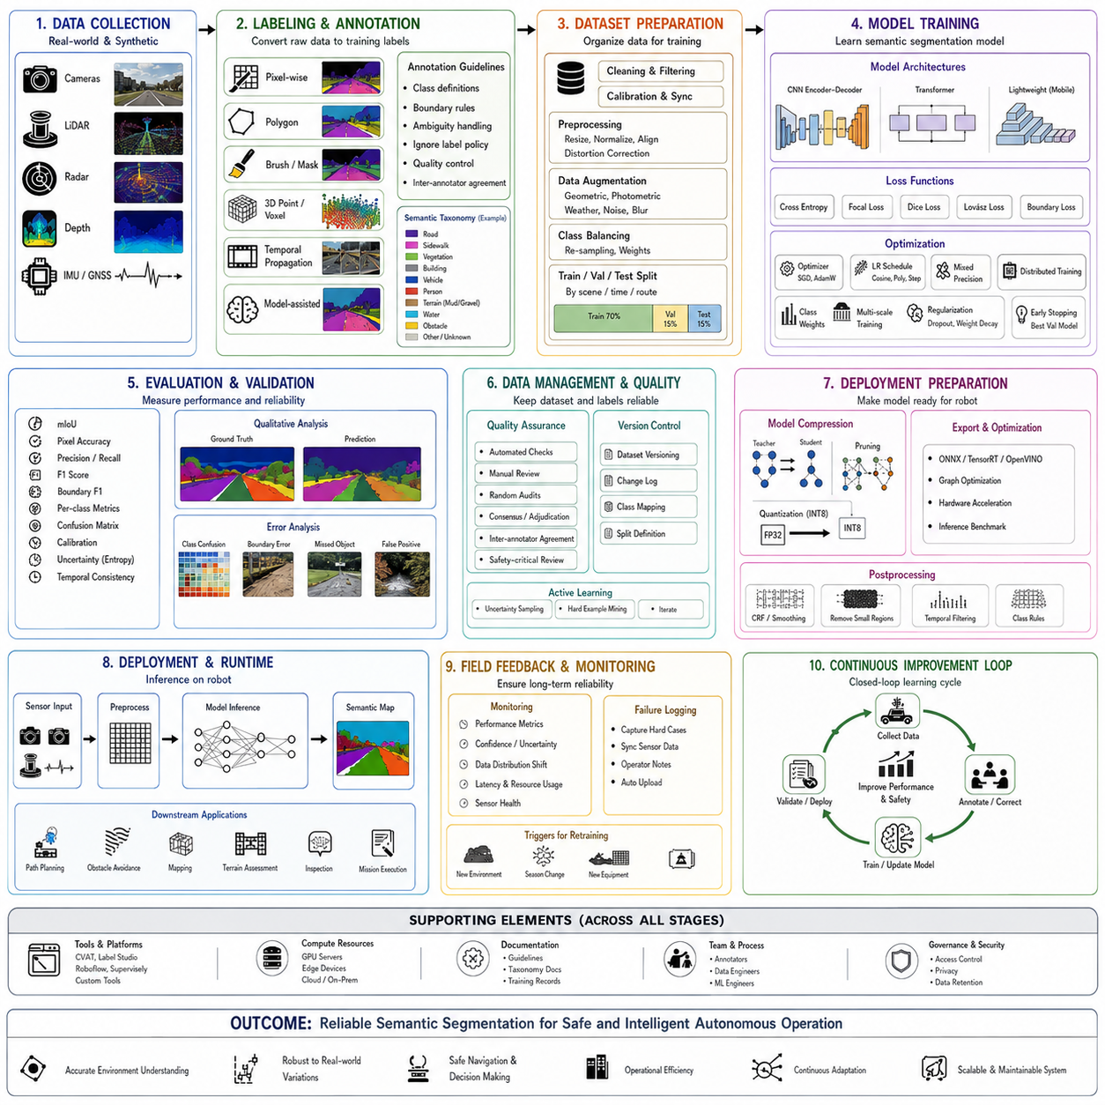
Model training and labeling form the operational foundation of semantic segmentation systems used in autonomous mobile robots, industrial inspection platforms, intelligent transportation systems, and Physical AI applications. A segmentation model can only learn reliable environmental understanding when the training data accurately represents the conditions that the robot will encounter. The complete process includes data collection, annotation policy design, dataset organization, model optimization, validation, error analysis, deployment preparation, and continuous improvement after field operation.
The purpose of model training is not simply to minimize a numerical loss function. The real objective is to develop a perception model that can consistently recognize meaningful environmental regions under realistic operational conditions. For semantic segmentation, every pixel must be assigned to an appropriate class such as road, floor, wall, vegetation, person, vehicle, machine, water, mud, gravel, obstacle, or unknown space. Training must therefore combine local boundary accuracy with global scene understanding and operational safety requirements.
Labeling converts raw sensor data into supervised learning targets. In image segmentation, annotators define the semantic identity of individual pixels or regions. In three-dimensional segmentation, points, voxels, meshes, or projected image regions are assigned class labels. The quality of these labels strongly affects the model because incorrect boundaries, inconsistent class definitions, and missing objects are directly learned as if they were correct examples. Annotation is therefore an engineering process rather than a simple image-marking activity.
A successful labeling program begins with a clearly defined semantic taxonomy. The taxonomy describes which classes exist, how each class differs from neighboring categories, and how ambiguous situations should be handled. A road may need to be separated from a sidewalk, shoulder, gravel path, or construction surface. Vegetation may be divided into grass, shrub, tree, crop, and dense obstacle classes. Industrial environments may require labels for machines, safety fences, racks, pallets, workers, robots, conveyors, and restricted zones.
Class definitions must reflect the decisions that the autonomous system needs to make. Excessively broad categories may not provide enough information for navigation, while excessively detailed categories increase annotation cost and reduce model reliability. For example, separating every type of plant may be unnecessary for a logistics robot, but distinguishing low traversable grass from dense non-traversable vegetation may be essential. The semantic taxonomy should therefore be connected directly to path planning, collision avoidance, inspection, mapping, and mission execution requirements.
Annotation guidelines translate the taxonomy into practical decisions for human labelers. These guidelines explain how to trace boundaries, classify partially visible objects, handle shadows, assign labels to transparent surfaces, and represent overlapping structures. They also define whether temporary objects, reflections, motion blur, sensor artifacts, and uncertain pixels should be assigned to specific classes or marked as ignored. Detailed guidelines improve consistency across annotators and reduce hidden variations in the training data.
Pixel-level labeling is the most precise annotation format for semantic segmentation, but it is also one of the most expensive. Annotators must carefully trace complex boundaries around people, vehicles, vegetation, cables, machinery, and irregular terrain. Thin structures such as poles, branches, wires, and safety barriers require significant time to label accurately. Annotation tools therefore provide polygon drawing, brush editing, boundary snapping, interpolation, superpixel selection, and model-assisted labeling to reduce repetitive manual effort.
Polygon annotation is commonly used because it efficiently defines large regions with relatively clear boundaries. Roads, walls, floors, buildings, fields, and large machines can often be labeled with a small number of polygon points. However, polygon-based labeling may oversimplify curved or irregular boundaries. Dense vegetation, water edges, damaged surfaces, debris, and human silhouettes often require brush-based refinement or automatic contour assistance to produce labels suitable for high-accuracy segmentation.
Brush and mask annotation allow labelers to paint semantic regions directly at the pixel level. This method is more flexible than polygon annotation for complex shapes but can be slower and more dependent on operator skill. Adjustable brush sizes help label both large surfaces and narrow boundaries. High-quality tools also support zooming, opacity control, layer locking, class shortcuts, undo history, and edge-aware painting to prevent accidental contamination between neighboring classes.
Three-dimensional labeling introduces additional complexity because point clouds are sparse, irregular, and dependent on sensor viewpoint. LiDAR points may be labeled directly in three-dimensional space or projected into synchronized camera images. Annotators often use multiple views to understand the true structure of objects and terrain. A point that appears ambiguous from one angle may become clear when viewed from above, from the side, or within a temporally accumulated point cloud.
Temporal annotation can improve efficiency for video and sequential robotic data. Consecutive frames often contain similar objects and environmental structures, allowing labels to be propagated using optical flow, tracking, ego-motion compensation, or three-dimensional registration. Human annotators then correct the propagated masks instead of labeling each frame from the beginning. This approach significantly reduces cost but requires careful review because propagation errors can accumulate around moving objects, occlusions, and newly visible regions.
Model-assisted labeling uses a preliminary segmentation model to generate initial masks that human annotators refine. Even a moderately accurate model can reduce annotation time by automatically identifying large roads, floors, buildings, vegetation regions, and vehicles. The resulting human-corrected labels are added back into the training dataset, producing a repeating improvement cycle. This human-in-the-loop approach gradually increases model accuracy while reducing the amount of fully manual labeling required.
Pre-labeling systems must be used carefully because annotators may accept plausible but incorrect predictions without sufficient review. This behavior can create systematic labeling bias that later models reproduce. To prevent this problem, annotation interfaces should clearly distinguish model-generated regions from human-confirmed labels. Quality-control procedures should also include random audits, disagreement analysis, and independent review of safety-critical classes.
Data collection must represent the actual operational domain rather than only ideal or visually attractive scenes. A model trained on clean daytime images may fail during rain, low light, dust, snow, glare, or sensor contamination. Field datasets should include different locations, seasons, weather conditions, surface materials, camera angles, robot speeds, obstacle densities, and operational events. Rare failure conditions are particularly important because they often create the highest safety risks.
Sensor configuration should remain consistent between data collection and deployment whenever possible. Camera resolution, lens distortion, exposure control, mounting height, field of view, LiDAR position, radar orientation, and synchronization affect the visual and geometric characteristics of the data. If training data is captured with a substantially different sensor configuration, the deployed model may experience domain shift even when operating in the same physical environment.
Dataset diversity must be evaluated at both scene and class levels. A large dataset containing many nearly identical frames may provide less learning value than a smaller but more varied dataset. Diversity analysis can examine geographic distribution, environmental type, lighting, weather, object frequency, terrain type, camera motion, and failure conditions. Sampling strategies should reduce redundant frames while preserving unusual and difficult examples that improve generalization.
Dataset splitting must prevent information leakage between training, validation, and test sets. Randomly dividing neighboring video frames can produce misleadingly high performance because nearly identical scenes appear in all subsets. A stronger approach separates data by route, site, day, season, vehicle, or operational mission. The test set should represent truly unseen conditions so that evaluation reflects expected field performance rather than memorization.
The training set is used to optimize model parameters, while the validation set supports model selection, hyperparameter tuning, and early stopping. The test set should remain isolated until the model configuration is finalized. Repeatedly evaluating on the test set and changing the model accordingly effectively turns the test set into another validation set. Maintaining strict separation protects the credibility of performance estimates.
Data preprocessing prepares images and sensor measurements for efficient learning. Common image operations include resizing, cropping, color normalization, lens distortion correction, exposure adjustment, and conversion to consistent tensor formats. Depth maps may require invalid-point handling, spatial alignment, and noise filtering. LiDAR data may be voxelized, projected into range images, or transformed into a shared coordinate frame with camera data.
Resizing requires a balance between computational efficiency and preservation of small objects. Excessive downsampling can remove thin poles, distant pedestrians, narrow drainage channels, small rocks, cables, and boundary details. Higher-resolution training improves spatial accuracy but increases GPU memory use and inference latency. Multi-scale training and tiled processing can help maintain detail without requiring every training sample to use the maximum sensor resolution.
Data augmentation artificially increases training diversity by transforming existing samples. Geometric augmentation may include horizontal flipping, scaling, random cropping, rotation, perspective variation, and translation. Photometric augmentation may modify brightness, contrast, saturation, hue, blur, noise, shadow, glare, fog, rain, or color temperature. The augmentation policy should represent realistic sensor and environmental variation rather than producing visually impossible scenes.
Segmentation labels must be transformed consistently with the corresponding images. If an image is cropped, rotated, or flipped, the mask must undergo the identical geometric operation using nearest-neighbor interpolation. Smooth interpolation should not be used for class masks because it creates invalid intermediate class values. Misalignment between images and labels can significantly damage boundary learning even when the error is difficult to notice during dataset review.
Synthetic data can supplement real field data when rare conditions are difficult or dangerous to collect. Simulation environments can generate labeled scenes involving unusual obstacles, extreme weather, night operation, equipment failure, or hazardous terrain. Since synthetic images provide automatic pixel-perfect labels, they reduce manual annotation cost. However, differences in texture, lighting, sensor noise, and object behavior may create a simulation-to-reality gap.
Domain randomization reduces dependence on the exact visual appearance of synthetic scenes. Textures, colors, illumination, object positions, weather, terrain roughness, and sensor parameters are varied across generated samples. The model is encouraged to learn stable structural cues rather than memorizing one simulation style. Synthetic data is usually most effective when mixed with real labeled data and followed by fine-tuning on target-domain field samples.
Transfer learning allows segmentation models to begin from parameters learned on large image datasets or foundation models. Pretrained encoders already contain useful representations of edges, textures, shapes, objects, and scene structure. Fine-tuning adapts these representations to the target semantic taxonomy. Transfer learning reduces training time and often improves accuracy when the project-specific labeled dataset is limited.
The choice of model architecture depends on accuracy, latency, memory, sensor input, and deployment platform. Encoder-decoder convolutional networks remain widely used because they provide efficient dense prediction. Transformer-based models improve global context reasoning but may require more computation. Lightweight mobile architectures reduce latency on embedded processors, while larger models may be used for offline annotation assistance, cloud processing, or teacher-model training.
Loss functions determine how training errors influence model updates. Cross-entropy loss is the standard choice for multi-class segmentation because it penalizes incorrect class probabilities at each pixel. However, cross-entropy can be dominated by large classes such as road, floor, sky, wall, or vegetation. Weighted cross-entropy assigns larger penalties to rare or safety-critical classes, helping the model learn objects that occupy relatively few pixels.
Focal Loss reduces the influence of easy, correctly classified pixels and concentrates learning on difficult examples. This is useful when most pixels belong to dominant background classes while critical objects are rare. Dice Loss directly optimizes overlap between predicted and ground-truth masks, making it valuable for imbalanced segmentation tasks. Combining cross-entropy with Dice or Focal Loss often produces more stable optimization than using a single loss alone.
Lovász Loss approximates direct optimization of the Intersection over Union metric, which is widely used for semantic segmentation evaluation. Boundary-aware losses emphasize pixels near class transitions, improving the shape and separation of adjacent regions. Auxiliary losses may be added at intermediate network layers to improve gradient flow and multi-scale learning. The final loss design should reflect both general accuracy and operationally important failure modes.
Class weighting requires careful design. Simple inverse-frequency weighting may assign excessively large weights to extremely rare classes, causing unstable training and false-positive predictions. More moderate methods use logarithmic frequency adjustment, median-frequency balancing, effective sample counts, or manually selected safety weights. Class weights should be validated experimentally rather than treated as fixed theoretical values.
Optimization algorithms update model parameters according to calculated gradients. Stochastic Gradient Descent with momentum remains effective for large-scale segmentation training, while Adam and AdamW provide adaptive learning rates and often converge more quickly. The optimizer interacts strongly with batch size, weight decay, normalization layers, and learning-rate schedules. A configuration that works for one architecture may not transfer directly to another.
Learning-rate scheduling is critical because a rate that is too high causes unstable optimization, while a rate that is too low slows convergence or traps the model in poor solutions. Common schedules include polynomial decay, cosine annealing, step reduction, and one-cycle learning. Warm-up periods gradually increase the learning rate during early training, reducing instability when fine-tuning large pretrained models or using distributed training.
Batch size influences memory consumption, optimization noise, and normalization behavior. Large batches produce stable gradient estimates but require substantial GPU memory. Small batches may improve generalization but create unstable Batch Normalization statistics. Group Normalization, Layer Normalization, gradient accumulation, and synchronized normalization across multiple GPUs can address these limitations while preserving practical training throughput.
Mixed-precision training uses lower-precision arithmetic for many operations while retaining sufficient numerical accuracy. It reduces GPU memory consumption and increases training speed on modern accelerators. Automatic loss scaling prevents small gradient values from underflowing. Mixed precision is now commonly used for large segmentation models, high-resolution inputs, and multi-sensor training where memory requirements would otherwise limit experimentation.
Distributed training allows multiple GPUs or computing nodes to process different mini-batches simultaneously. Data-parallel training reduces the time needed for large datasets, while model parallelism supports architectures that cannot fit within one GPU. Reproducibility becomes more difficult because distributed operations, random sampling, and asynchronous data loading can introduce variation. Training systems should therefore record software versions, seeds, hardware configurations, and experiment parameters.
Experiment tracking is essential for comparing model configurations. Each training run should record the dataset version, annotation taxonomy, preprocessing settings, augmentation policy, model architecture, pretrained checkpoint, optimizer, learning rate, loss weights, batch size, random seed, and evaluation results. Without systematic tracking, improvements cannot be reproduced and regressions may be incorrectly attributed to unrelated changes.
Dataset version control should be treated with the same discipline as source-code version control. New annotations, corrected labels, class changes, removed samples, and additional field data alter the training distribution. Each dataset release should include a unique identifier, change log, class mapping, quality statistics, and split definition. Models must remain traceable to the exact dataset version used during training.
Training monitoring includes loss curves, validation metrics, class-level accuracy, prediction visualizations, and resource utilization. A decreasing training loss does not guarantee useful generalization. If training accuracy improves while validation performance declines, the model may be overfitting. Visual inspection of predicted masks often reveals boundary errors, class confusion, texture bias, and systematic failure patterns that are not obvious from aggregate metrics.
Early stopping prevents unnecessary training once validation performance no longer improves. However, segmentation metrics may fluctuate because of class imbalance and small validation sets. Patience intervals and smoothed metrics help avoid stopping too soon. Model checkpoints should be saved periodically so that the best validation result can be recovered even when later epochs reduce performance.
Overfitting occurs when the model memorizes training scenes rather than learning general environmental structure. It may perform well on familiar routes but fail in new locations, seasons, or lighting conditions. Data augmentation, regularization, dropout, weight decay, diverse sampling, transfer learning, and larger datasets reduce overfitting. Site-based validation is particularly important for detecting memorization of specific backgrounds.
Underfitting occurs when the model is too small, insufficiently trained, poorly optimized, or unable to represent the complexity of the semantic task. Both training and validation performance remain low. Increasing model capacity, improving input resolution, adjusting the learning rate, extending training, correcting label errors, or simplifying the taxonomy may improve performance. Underfitting should not be confused with poor labels or severe domain mismatch.
Validation metrics should be calculated for individual classes rather than only as global averages. A strong mean Intersection over Union score can hide dangerous failures in rare categories such as person, water, cliff, cable, forklift, or safety barrier. Confusion matrices reveal which classes are commonly mistaken for one another. Precision and recall provide additional insight into false-positive and false-negative behavior.
Boundary accuracy deserves special attention because path planning and obstacle avoidance depend on precise spatial separation. A model may correctly identify a large obstacle but predict its boundary several pixels inward, creating an unsafe free-space estimate. Boundary F1 score, contour distance, and class-specific edge analysis help evaluate this behavior. High-resolution validation samples are especially useful for examining thin structures and object edges.
Calibration measures whether predicted confidence corresponds to actual correctness. A well-calibrated model should be accurate approximately as often as its confidence suggests. Overconfident mistakes are dangerous because downstream systems may treat incorrect predictions as reliable. Temperature scaling, ensemble methods, uncertainty estimation, and calibration-aware loss functions can improve confidence quality.
Uncertainty estimation provides information about ambiguous or unfamiliar regions. Predictive entropy, Monte Carlo dropout, deep ensembles, evidential learning, and Bayesian approximations can identify pixels where the model is uncertain. Navigation systems can respond conservatively by reducing speed, increasing obstacle margins, requesting additional sensor observations, or assigning unknown terrain costs to these regions.
Hard example mining focuses training on samples or pixels that the model frequently misclassifies. Difficult examples may include night scenes, reflective surfaces, partially occluded people, wet terrain, thin obstacles, damaged labels, or rare classes. Online hard example mining selects difficult pixels during training, while offline mining identifies challenging field samples for additional annotation. Both approaches improve learning efficiency when used carefully.
Active learning reduces labeling cost by selecting the most informative unlabeled samples. Instead of randomly annotating large volumes of data, the system prioritizes frames with high uncertainty, rare classes, domain novelty, or disagreement among multiple models. Human annotators label these selected samples, and the model is retrained. Repeating this cycle concentrates annotation resources where they produce the greatest performance improvement.
Quality assurance for labels should include automated and human inspection. Automated checks can detect invalid class IDs, empty masks, inconsistent image dimensions, disconnected regions, overlapping polygons, and corrupted files. Statistical analysis can identify unusual class distributions or annotator-specific patterns. Human reviewers should examine difficult classes, boundary consistency, and samples where independent annotators disagree.
Inter-annotator agreement measures the consistency of labeling decisions across multiple people. Low agreement may indicate unclear class definitions rather than poor annotator performance. Ambiguous categories should be clarified, merged, or represented with ignore labels. Consensus annotation, adjudication by senior reviewers, and periodic calibration sessions help maintain consistent labeling across large teams.
The ignore label is useful for pixels that cannot be classified reliably. Examples include severe motion blur, sensor corruption, regions outside the usable field of view, ambiguous reflections, unknown objects, and uncertain boundaries. Ignored pixels are excluded from loss and evaluation calculations. However, excessive use of ignore regions can hide important weaknesses, so the policy must be clearly controlled and audited.
Safety-critical labeling requires special treatment because some classes directly affect collision risk or mission safety. Humans, animals, vehicles, holes, cliffs, water, moving machinery, and restricted zones may require additional review stages. These classes can receive higher loss weights, targeted data collection, specialized augmentation, and conservative evaluation thresholds. Operational safety should take priority over maximizing a single average benchmark score.
Multi-sensor training requires precise temporal and spatial calibration. Camera images, LiDAR scans, radar measurements, depth maps, GNSS, and IMU data must correspond to the same observation time and coordinate frame. Synchronization errors create inconsistent supervision, especially around moving objects. Calibration records should be maintained as versioned configuration data because sensor replacement or mechanical movement can change the alignment.
Fusion architectures can combine sensor data at early, intermediate, or late stages. Early fusion merges raw or low-level features, while intermediate fusion combines learned representations from separate sensor encoders. Late fusion combines independent predictions. Intermediate fusion often provides a practical balance because each sensor retains specialized processing while still contributing to joint semantic reasoning.
Self-supervised learning can reduce dependence on large labeled datasets. Models learn representations from unlabeled images or sensor sequences using reconstruction, contrastive learning, masked prediction, temporal consistency, or cross-modal correspondence. The learned encoder is then fine-tuned using a smaller labeled dataset. This approach is particularly useful for robots that continuously collect large volumes of unlabeled operational data.
Semi-supervised learning combines a limited labeled dataset with a larger unlabeled dataset. The model generates pseudo-labels for unlabeled samples, and confident predictions are used as additional training targets. Consistency regularization encourages similar outputs under augmentation or sensor variation. Pseudo-label quality must be controlled because incorrect predictions can reinforce existing model errors.
Continual learning allows deployed robots to adapt to new environments without retraining entirely from the beginning. New labeled data may include seasonal changes, new equipment, modified facilities, unusual terrain, or previously unseen obstacles. The challenge is catastrophic forgetting, where learning new conditions reduces performance on older environments. Replay buffers, regularization, balanced sampling, and modular adaptation can preserve previous knowledge.
Field validation connects laboratory metrics with actual robotic behavior. The segmentation model should be tested during real navigation missions, not only on stored images. Engineers examine whether predicted free space, obstacles, terrain costs, and semantic regions produce safe planning decisions. Failures should be logged with synchronized sensor data, vehicle state, route information, and operator observations for later analysis.
Shadow deployment allows a new model to run alongside the active production model without controlling the robot. Its predictions are recorded and compared against the deployed system during normal missions. This method exposes the candidate model to realistic data while avoiding direct operational risk. After sufficient analysis, the model can progress through controlled testing, limited deployment, and full release stages.
Model compression prepares trained networks for embedded deployment. Knowledge distillation transfers information from a large teacher model into a smaller student model. Pruning removes less important parameters or channels. Quantization reduces numerical precision, commonly from floating point to INT8. These methods reduce latency, power consumption, and memory use, but must be validated carefully because small classes and boundaries may suffer disproportionate accuracy loss.
Deployment conversion may use frameworks such as ONNX, TensorRT, OpenVINO, or hardware-specific compilers. Differences between training and inference frameworks can produce numerical changes or unsupported operations. Output equivalence testing should compare predictions before and after conversion across a representative validation set. Performance testing must also include preprocessing, data transfer, and postprocessing rather than measuring neural-network execution alone.
Postprocessing can improve segmentation stability through connected-component filtering, conditional random fields, temporal smoothing, geometric consistency, and class-specific rules. Small isolated predictions may be removed, while temporally persistent regions receive higher confidence. However, excessive postprocessing can delay response or hide genuine environmental changes. Rules should remain interpretable and be tested against operational failure cases.
Temporal consistency is important for robotic video because rapidly changing class predictions can destabilize planning. A road region should not alternate between road, gravel, and obstacle in consecutive frames without physical justification. Recurrent networks, feature propagation, optical-flow alignment, and temporal filtering can improve stability. Evaluation should measure flicker and sequence consistency in addition to frame-level accuracy.
Monitoring continues after deployment because data distributions change over time. New construction, seasonal vegetation, sensor aging, lens contamination, firmware updates, and operational expansion can reduce model performance. Monitoring systems track confidence, class frequency, unknown-region rate, latency, memory usage, and disagreement with other sensors. Significant distribution changes should trigger data review and possible retraining.
A closed-loop training process connects field operation with dataset improvement. Difficult scenes are automatically logged, selected for review, labeled, added to a new dataset version, and used for retraining. The updated model is then evaluated against both new failure cases and historical regression sets. This cycle allows the perception system to improve continuously while protecting previously achieved capabilities.
Regression testing ensures that solving one problem does not create another. A model improved for snow should not lose accuracy on dry roads, and a model optimized for small pedestrians should not produce excessive false positives on poles or signs. Regression datasets should include representative normal conditions, historical failures, rare events, and safety-critical scenarios. Release decisions should require performance thresholds across all important subsets.
Governance is essential when multiple teams participate in data collection, labeling, training, and deployment. Responsibilities should be defined for taxonomy ownership, annotation approval, dataset release, model training, safety review, and production deployment. Changes to class definitions or preprocessing must be communicated across the full pipeline. Strong governance prevents silent incompatibilities between labels, models, maps, and downstream software.
Privacy and data security must be considered when robotic datasets contain people, vehicles, facility layouts, license plates, medical environments, or confidential industrial processes. Data handling policies may require access control, encryption, anonymization, face blurring, retention limits, and geographic restrictions. Training efficiency should never override legal, contractual, or ethical obligations related to collected data.
Future model training and labeling systems will increasingly use foundation models, vision-language models, automated annotation, synthetic environments, and interactive learning. Natural-language instructions may define new classes or correct segmentation results without requiring complete manual relabeling. Large pretrained models will generate high-quality initial masks, while human experts focus on ambiguous boundaries, rare hazards, and operationally important exceptions.
Embodied learning will further connect segmentation training with physical robot experience. Instead of learning only from static images and fixed labels, future systems will observe how terrain, objects, and environmental regions affect motion, traction, energy consumption, and mission success. These interactions will provide richer supervision than semantic labels alone, allowing models to learn not only what a region is but also what actions are safe and effective within it.
Ultimately, model training and labeling determine whether a semantic segmentation system becomes a laboratory demonstration or a dependable field capability. Accurate taxonomies, consistent annotations, diverse datasets, disciplined optimization, realistic validation, deployment monitoring, and continuous improvement must operate as one integrated engineering process. When these components are carefully designed, segmentation models can provide reliable environmental understanding that supports safe navigation, intelligent planning, industrial inspection, and generalized Physical AI operation.

17.7 Edge Deployment Optimization
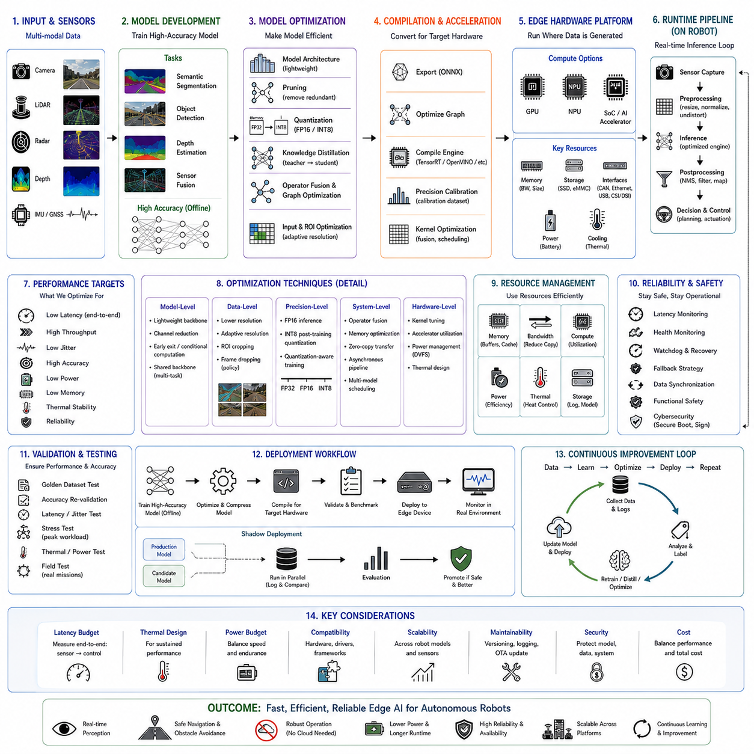
Edge deployment optimization is the process of transforming a trained perception or decision model into a reliable real-time component that can operate directly on an autonomous robot, vehicle, inspection platform, or embedded Physical AI system. The objective is not only to reduce inference time, but also to balance accuracy, latency, power consumption, memory use, thermal stability, hardware compatibility, and long-term operational reliability.
Autonomous mobile robots cannot depend entirely on cloud computing because communication delays, network interruptions, cybersecurity constraints, and remote-site operation can prevent continuous access to external servers. Edge deployment places artificial intelligence processing close to the sensors and actuators. Camera, LiDAR, radar, depth, and inertial data can therefore be processed locally, enabling immediate perception and control decisions even when no stable network connection is available.
The design of an edge inference system begins with a clear definition of operational requirements. Engineers must determine the maximum acceptable latency, minimum frame rate, required segmentation or detection accuracy, sensor resolution, number of simultaneous input streams, and permitted power consumption. These requirements should be connected to vehicle speed, stopping distance, obstacle response time, mission complexity, and the consequences of delayed or incorrect predictions.
Latency is one of the most important performance indicators because it determines how quickly the robot can react to environmental changes. End-to-end latency includes sensor exposure, data transfer, preprocessing, neural-network inference, postprocessing, middleware communication, planning, and actuator command generation. Measuring only the execution time of the neural network creates an incomplete and often misleading picture of actual system responsiveness.
Throughput describes how many frames or sensor samples can be processed during a given period. High throughput is important when several cameras, LiDAR projections, and auxiliary models operate simultaneously. However, maximizing throughput does not always guarantee low latency. Batch processing may increase total frames per second while delaying individual samples, making it unsuitable for safety-critical control loops that require immediate responses to each observation.
Jitter represents variation in processing time between consecutive inference cycles. Even when average latency is acceptable, occasional large delays can destabilize navigation and control. Real-time optimization must therefore consider worst-case and percentile latency rather than only average performance. Predictable execution is particularly important for obstacle avoidance, high-speed outdoor driving, docking, robotic manipulation, and human-robot collaboration.
Hardware selection strongly influences the optimization strategy. Common edge platforms include embedded GPUs, neural processing units, industrial computers, system-on-chip devices, field-programmable gate arrays, and dedicated AI accelerators. Each platform provides different levels of computational performance, memory bandwidth, power efficiency, software support, and environmental durability. The best platform is not necessarily the one with the highest theoretical operations per second.
Graphics processing units provide flexible acceleration for convolutional networks, transformers, sensor fusion, and general-purpose parallel computation. They support widely used frameworks and allow rapid model development. Embedded GPU platforms are especially common in autonomous robots because they combine CPU, GPU, video encoding, memory, and communication interfaces within a compact system. Their main limitations include power consumption, thermal management, and shared memory bandwidth.
Neural processing units are designed specifically for efficient tensor operations. They often deliver high performance per watt for supported neural-network layers but may provide less flexibility than GPUs. Unsupported operators can fall back to slower processors or require model redesign. Engineers must therefore review operator compatibility, numerical precision, compiler maturity, debugging tools, and deployment stability before selecting an NPU-based architecture.
Industrial edge computers offer stronger expansion capability, storage, networking, and environmental robustness than consumer embedded boards. They can support discrete industrial GPUs, multiple Ethernet cameras, LiDAR, radar, and high-speed storage. However, increased performance also requires larger power supplies, cooling systems, mechanical mounting, electromagnetic compatibility design, and careful integration with the robot’s battery and electrical architecture.
Model architecture determines the baseline computational demand before any optimization is applied. Large backbones, high-resolution feature maps, multi-head attention, three-dimensional convolutions, and repeated fusion stages increase processing cost. An architecture designed only for offline benchmark accuracy may be unsuitable for real-time deployment. Edge-oriented development should therefore begin during model selection rather than after training is complete.
Lightweight neural-network architectures reduce computation through depthwise separable convolutions, grouped operations, reduced channel counts, efficient attention, and compact decoder structures. These models may provide slightly lower benchmark accuracy than large networks but offer significantly lower latency and power consumption. The practical objective is to preserve the accuracy required for safe operation while eliminating computational complexity that does not improve field performance.
Input resolution has a major effect on memory consumption and inference time. Higher-resolution images preserve small obstacles, thin boundaries, distant pedestrians, cables, terrain changes, and inspection defects. However, doubling image dimensions can increase the number of processed pixels by approximately four times. Resolution should therefore be selected according to sensing distance, target size, safety margins, and the available compute budget.
Adaptive resolution provides a more flexible alternative to fixed high-resolution inference. The system may process the full image at a moderate resolution while applying high-resolution analysis only to regions of interest. Another approach uses lower resolution during open-space travel and increases detail near obstacles, workstations, or inspection targets. Dynamic resolution control can reduce average computation while maintaining critical perception quality.
Region-of-interest processing limits neural inference to selected parts of the sensor image. Navigation systems may prioritize the predicted travel corridor, while inspection systems focus on the target component. However, aggressive cropping can remove unexpected hazards outside the selected region. Region selection must therefore include safety margins and fallback logic to preserve awareness of objects entering from peripheral areas.
Model pruning removes parameters, channels, filters, attention heads, or network blocks that contribute relatively little to the final output. Unstructured pruning creates sparse weight matrices but may not improve speed unless the hardware and inference engine support sparse operations. Structured pruning removes complete channels or blocks, producing smaller dense models that are more likely to accelerate on standard embedded hardware.
Pruning should be followed by fine-tuning because removing model capacity can reduce accuracy, especially for rare classes and small objects. Sensitivity analysis helps identify layers that tolerate pruning and those that must remain intact. Early feature extraction layers and final task-specific layers may require more conservative treatment. The final pruning ratio should be selected through repeated measurement rather than by applying one uniform value across the network.
Quantization reduces numerical precision to decrease model size, memory bandwidth, latency, and power use. A model trained with 32-bit floating-point values may be converted to 16-bit floating point, 8-bit integer, or another hardware-supported format. Lower precision allows more operations to be executed in parallel and reduces data movement, which is often as important as arithmetic performance on edge devices.
Half-precision inference usually provides a strong balance between speed and accuracy. Many embedded GPUs execute FP16 operations much faster than FP32 while maintaining nearly identical predictions. It is frequently the first optimization applied because conversion is relatively simple and calibration requirements are limited. However, numerical equivalence should still be verified for small probabilities, normalization layers, and unstable custom operations.
Integer quantization can deliver larger efficiency gains but requires more careful validation. Post-training quantization uses a representative calibration dataset to estimate activation ranges and scaling factors. If the calibration data does not reflect real operating conditions, important features may be clipped or represented poorly. Calibration samples should include diverse lighting, terrain, weather, object scales, and difficult environmental cases.
Quantization-aware training simulates low-precision behavior during model optimization. The network learns parameters that remain effective after integer conversion, often preserving higher accuracy than post-training quantization. This method requires additional training effort but is valuable when INT8 deployment causes significant degradation. Safety-critical classes, boundaries, and low-contrast objects should receive particular attention during quantized model evaluation.
Knowledge distillation transfers information from a large teacher model into a smaller student model. The student learns not only from ground-truth labels but also from the teacher’s class probabilities, intermediate features, attention patterns, or boundary predictions. This process can improve the accuracy of compact networks without increasing inference cost. Distillation is especially useful when a high-performing offline model already exists.
Teacher and student architectures do not need to be identical. A transformer-based teacher can guide a lightweight convolutional student, or a multi-sensor teacher can supervise a lower-cost single-sensor model. The distillation objective should emphasize the information most relevant to deployment, such as rare classes, spatial boundaries, uncertainty, and terrain traversability, rather than merely copying all outputs equally.
Operator fusion combines multiple computational steps into fewer optimized kernels. Convolution, bias addition, normalization, and activation can often be executed together, reducing memory transfers and kernel-launch overhead. Inference compilers perform many fusion operations automatically, but custom layers and uncommon network patterns may prevent optimization. Reviewing the compiled execution graph helps identify inefficient operator boundaries.
Graph optimization removes redundant calculations, folds constant values, simplifies tensor shapes, and rearranges operations for better hardware execution. Batch normalization can often be merged into preceding convolution weights during inference. Training-only branches, dropout, gradient operations, and unused outputs should be removed. A clean inference graph improves both performance and deployment reliability.
Framework conversion commonly involves exporting a trained model from a development framework into an interchange format and then compiling it for the target device. ONNX is frequently used as an intermediate representation, while TensorRT, OpenVINO, vendor compilers, or runtime-specific engines generate optimized executables. Each conversion stage must be validated because operator interpretation and numerical behavior may differ.
Unsupported operations are a common deployment obstacle. Custom attention modules, dynamic tensor shapes, uncommon interpolation modes, and framework-specific functions may not be accepted by the target compiler. Engineers may replace unsupported operations with equivalent standard layers, implement optimized plugins, or redesign the model. Custom plugins should be maintained carefully because they increase testing and long-term software support requirements.
Static tensor shapes generally allow stronger compiler optimization than highly dynamic shapes. If input resolution and batch size are fixed during operation, the inference engine can allocate memory and select kernels more efficiently. Dynamic shapes provide flexibility but may introduce overhead and unpredictable performance. Many robotic systems benefit from using a small set of predefined input profiles rather than unrestricted dimensions.
Memory optimization is critical because edge devices often share memory among the CPU, GPU, video decoder, sensor buffers, mapping modules, and neural networks. Model parameters represent only one part of the total requirement. Intermediate feature maps, activation buffers, image queues, point clouds, and middleware copies may consume significantly more memory. Profiling must therefore examine peak system memory during realistic missions.
Memory bandwidth frequently limits performance more than raw arithmetic capacity. Large feature maps must repeatedly move between memory and compute units. Network designs with excessive channel expansion, repeated concatenation, or high-resolution intermediate tensors can become bandwidth-bound. Reducing unnecessary data movement may produce greater speed improvements than reducing the theoretical number of operations alone.
Zero-copy data transfer reduces duplication between sensor acquisition, preprocessing, and inference components. Camera frames can sometimes remain in shared or device-accessible memory instead of being copied through multiple CPU buffers. Hardware video decoders, direct memory access, pinned memory, and unified memory mechanisms can further reduce transfer overhead. The specific implementation depends on the operating system and hardware platform.
Preprocessing can become a hidden bottleneck when resizing, color conversion, normalization, undistortion, and tensor rearrangement are performed sequentially on the CPU. Moving these operations to the GPU or using optimized multimedia pipelines can significantly reduce end-to-end latency. Preprocessing must produce exactly the same numerical format used during training to avoid accuracy loss after optimization.
Postprocessing also requires optimization. Semantic segmentation may involve argmax calculation, confidence filtering, resizing, morphology, connected components, temporal smoothing, and transformation into a navigation map. Object detection may require decoding, thresholding, and non-maximum suppression. Performing these steps inefficiently on the CPU can eliminate the gains achieved through accelerated neural inference.
Asynchronous pipelines allow sensor capture, preprocessing, inference, and postprocessing to operate concurrently. While one frame is being processed by the neural network, the next frame can be prepared and the previous output can be consumed by planning. Proper synchronization and bounded queues are required to prevent stale data. Unlimited buffering can increase apparent throughput while causing the robot to act on outdated observations.
Frame dropping may be preferable to processing every sample when computation cannot keep pace with the sensor rate. A robot should generally use the newest available observation rather than completing a long queue of old frames. Queue policies can discard outdated inputs and preserve low latency. The selected approach must remain compatible with temporal models, tracking, and sensor synchronization requirements.
Multi-model scheduling becomes important when segmentation, detection, depth estimation, localization, speech, and inspection models share one accelerator. Running every model continuously at maximum frequency may exceed compute and power limits. Priority-based scheduling, different update rates, conditional execution, and shared backbones can reduce resource contention. Safety-related models should receive predictable execution priority.
Shared feature extraction allows several perception tasks to use one encoder. A multi-task network may produce semantic segmentation, depth, obstacle boundaries, surface normals, or traversability from common features. This approach reduces duplicated computation but can create task interference during training. The shared design should be evaluated for both efficiency and the accuracy of each operational output.
Conditional computation activates only the network components needed for the current situation. A robot traveling through an open corridor may use a lightweight perception path, while complex intersections or inspection zones trigger additional refinement modules. Mixture-of-experts architectures, early-exit networks, and confidence-based processing can reduce average computation. Their control logic must remain deterministic enough for safety validation.
Early-exit networks produce predictions from intermediate layers when confidence is sufficiently high. Easy scenes can be processed quickly, while difficult scenes continue through deeper layers. This strategy reduces average latency but creates variable execution time. Confidence thresholds must be calibrated carefully, and the system should avoid selecting early outputs for rare or safety-critical situations merely because the model is overconfident.
Thermal management directly affects sustained inference performance. Edge devices may achieve high speed for a short benchmark but reduce clock frequency after prolonged operation because of thermal throttling. Real robots often operate for hours in enclosed compartments, direct sunlight, dusty factories, or hot outdoor environments. Performance testing must therefore measure sustained operation under realistic ambient and enclosure temperatures.
Cooling solutions may include heat sinks, fans, heat pipes, thermal pads, conductive chassis mounting, or liquid cooling for high-power systems. Mechanical design should prevent dust, water, vibration, and airflow blockage from degrading cooling performance. Fan-based cooling introduces maintenance concerns, while passive cooling requires larger surfaces and careful heat spreading. Thermal design must be coordinated with enclosure and ingress-protection requirements.
Power optimization is important because AI computing competes with drive motors, sensors, communication, manipulators, lighting, and auxiliary systems for battery energy. Higher inference performance can shorten mission duration or increase charging frequency. Engineers should measure actual system power during representative workloads rather than relying only on processor specifications. Power limits can be configured to balance speed and endurance.
Dynamic voltage and frequency scaling changes processor operating levels according to workload. The system may use a low-power mode during standby or simple navigation and increase performance during difficult perception tasks. Frequent switching can affect latency consistency, so power-state control should be tested with real mission sequences. Some safety applications may prefer a fixed performance mode for predictable timing.
Energy efficiency should be measured as useful perception work per unit of energy rather than only frames per second. A slightly slower model may be preferable if it provides significantly longer operating time without reducing mission safety. Mission-level evaluation can compare battery consumption, completed tasks, charging interruptions, and computational load across different optimization configurations.
Operating-system configuration influences real-time behavior. Background services, logging, storage activity, network traffic, and uncontrolled process scheduling can introduce latency spikes. CPU affinity, process priority, real-time scheduling policies, isolated cores, and controlled memory allocation can improve predictability. These changes require careful validation because incorrect configuration may starve essential system services.
Containerization improves software portability and dependency management but may add complexity to hardware acceleration, device access, and real-time scheduling. Containers should be configured with appropriate GPU runtimes, shared memory, sensor permissions, and resource limits. The deployment image should be reproducible and versioned so that field systems can be restored or updated consistently.
Middleware configuration affects data movement and latency. Robotics frameworks may serialize, copy, and transmit large images or point clouds between processes. Intra-process communication, shared-memory transport, optimized message formats, and appropriate quality-of-service settings can reduce overhead. Reliable communication settings should be selected according to whether the data is safety-critical, high-bandwidth, or disposable when delayed.
Time synchronization is essential when several sensors and models contribute to one decision. Camera frames, LiDAR scans, radar measurements, IMU data, and vehicle state must correspond to compatible timestamps. Edge optimization that changes buffering or scheduling can accidentally increase temporal misalignment. Performance improvements should never sacrifice synchronization accuracy required for sensor fusion.
Real-time profiling should use representative workloads rather than isolated synthetic inputs. Actual scenes contain varying numbers of objects, point densities, image textures, and postprocessing complexity. Some models have data-dependent execution behavior, while memory and thermal conditions change during long missions. Profiling should include startup, steady-state operation, peak workload, and recovery from overload.
Profiling tools can identify kernel execution time, memory transfers, CPU utilization, GPU occupancy, cache behavior, and power consumption. Timeline visualization reveals gaps where the accelerator is idle while waiting for preprocessing or synchronization. Optimization should focus on measured bottlenecks instead of assumptions. Improving a fast component provides little value when another stage dominates total latency.
Benchmark reproducibility requires fixed model versions, input data, software libraries, clock modes, power settings, and thermal conditions. Results should report batch size, precision, input dimensions, preprocessing, and end-to-end timing method. Comparing only vendor-reported neural-network throughput can lead to unrealistic system expectations because complete robotic pipelines include many additional operations.
Accuracy must be revalidated after every major optimization. Pruning, quantization, resizing, compiler conversion, and postprocessing changes can alter predictions. Evaluation should include global metrics, per-class accuracy, boundary quality, confidence calibration, temporal stability, and downstream navigation results. Small average metric changes may hide serious degradation in rare obstacles or safety-critical regions.
Golden datasets provide fixed reference samples for conversion and optimization testing. The outputs of the original model are compared with optimized versions using numerical tolerances and semantic metrics. Golden data should include common conditions, difficult scenes, rare classes, sensor noise, and historical failures. Automated testing helps detect changes caused by library updates or hardware replacement.
Field testing remains necessary because offline metrics cannot fully represent interaction with motion planning and control. Optimized models should be evaluated during actual navigation, docking, inspection, and obstacle avoidance. Engineers must confirm that latency reduction translates into improved robot behavior and that compression does not create unstable or unsafe decisions under real operational conditions.
Shadow deployment enables an optimized candidate model to run beside the production model without controlling the robot. Predictions, latency, memory use, and confidence are logged during normal missions. This provides large-scale evidence of performance under realistic workloads. Differences between the two models can be reviewed before the candidate is allowed to influence navigation or mission execution.
Fallback strategies protect the robot when the optimized model fails, exceeds latency limits, or reports low confidence. The system may reduce speed, stop safely, switch to a simpler model, rely more strongly on geometric obstacle detection, or request remote assistance. A deployment design should assume that perception can degrade and define a controlled response rather than allowing uncontrolled continuation.
Health monitoring tracks inference rate, queue length, memory use, temperature, power, processor utilization, sensor freshness, and model confidence. Thresholds can detect gradual performance degradation caused by thermal problems, resource leaks, sensor faults, or software conflicts. Monitoring data should be associated with mission logs so that failures can be reconstructed and analyzed.
Over-the-air update capability allows optimized models and inference engines to be distributed to deployed robots. Updates must include integrity verification, compatibility checks, staged rollout, rollback support, and version traceability. A new model should not be installed on all systems simultaneously without prior limited deployment. Hardware variations across the fleet must also be considered.
Model versioning should identify the training dataset, architecture, optimization settings, compiler version, target hardware, calibration data, and validation results. Two models with the same neural-network weights may behave differently after compilation for different accelerators or precision modes. Deployment artifacts should therefore be treated as separate controlled releases rather than simple copies of training checkpoints.
Cybersecurity is part of edge deployment optimization because model files, runtime engines, and update systems can become attack surfaces. Secure boot, encrypted storage, signed artifacts, access control, and authenticated communication protect the inference system from unauthorized modification. Debug ports and unnecessary services should be restricted in production hardware without preventing legitimate maintenance.
Reliability engineering must account for storage corruption, memory errors, power interruption, and unexpected process termination. The inference service should restart safely and report its state to the robot supervisor. Persistent data should be written carefully to avoid damaging storage during frequent logging. Watchdog systems can detect unresponsive processes and initiate recovery procedures.
Optimization decisions should be documented with their measured benefits and accuracy impact. A change that reduces latency by a few milliseconds may not justify significant maintenance complexity or safety risk. Engineering teams should record the reason for each transformation, supported hardware, calibration requirements, benchmark results, and known limitations. Clear documentation simplifies future upgrades and audits.
The best deployment configuration may differ across robot models. A lightweight indoor AMR, an outdoor six-wheel platform, and a mobile inspection robot may use different sensors, accelerators, power budgets, and performance targets. Maintaining one universal model may simplify software management but produce inefficient results. Modular deployment profiles can preserve common architecture while adapting precision and scheduling to each platform.
Future edge optimization will increasingly use automated neural architecture search, hardware-aware training, compiler co-design, sparsity-aware accelerators, and adaptive inference. Models will be trained with explicit awareness of latency, energy, memory, and target-device behavior. Instead of optimizing a completed network after training, performance constraints will become part of the learning objective from the beginning.
Foundation models will also require new deployment strategies because their size exceeds the capacity of many embedded systems. Distillation, low-rank adaptation, token reduction, feature caching, model partitioning, and selective expert activation will help bring foundation-level perception to robots. Some tasks may be divided between a compact real-time edge model and a larger local or remote reasoning model.
Edge-cloud cooperation can support noncritical analytics, fleet learning, map updates, and heavy model retraining while retaining immediate safety functions on the robot. The edge system should remain capable of safe operation without continuous cloud connectivity. Data exchange policies must consider bandwidth, privacy, latency, and cybersecurity. Cloud assistance should enhance autonomy rather than become a single point of failure.
Ultimately, edge deployment optimization converts artificial intelligence from a laboratory model into a dependable robotic capability. Successful deployment requires coordinated decisions across model architecture, numerical precision, compiler design, memory management, scheduling, power, thermal engineering, software integration, validation, and lifecycle monitoring. When these elements are optimized as one system, the robot can achieve fast, efficient, and reliable perception while maintaining the safety and operational stability required for real-world Physical AI.

17.8 Segmentation Error Analysis
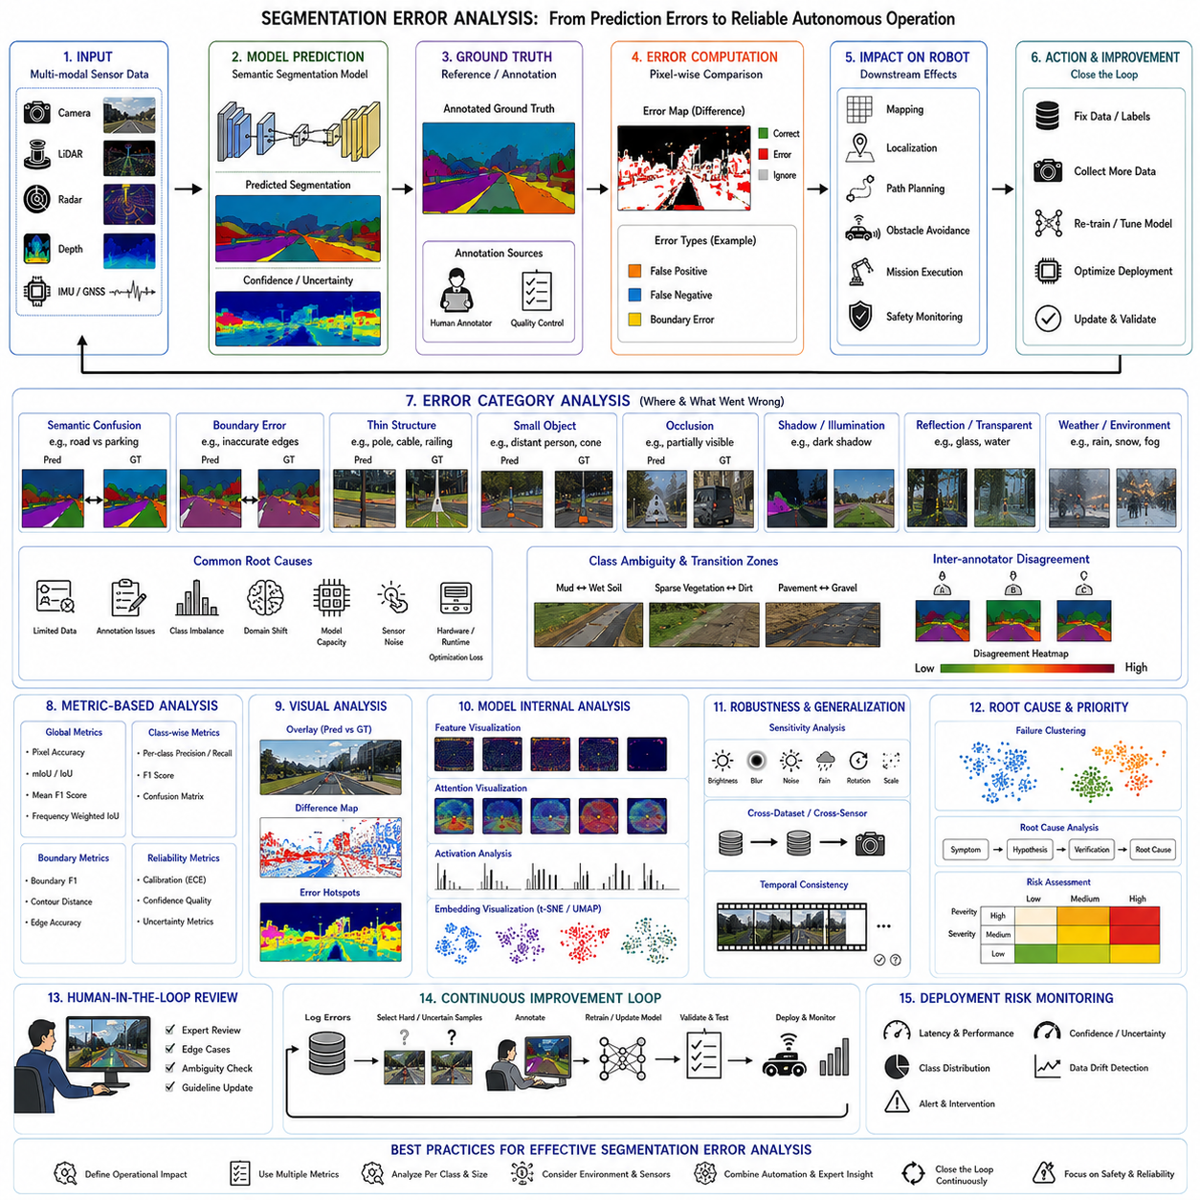
Segmentation error analysis is a systematic engineering process that investigates why semantic segmentation models produce incorrect predictions and how these failures influence the behavior of autonomous systems. Rather than treating prediction errors as isolated numerical results, error analysis examines the relationship between perception failures, environmental conditions, model architecture, sensor limitations, training data, deployment configuration, and robotic decision making. A comprehensive understanding of segmentation errors enables engineers to improve reliability, safety, robustness, and operational performance throughout the entire perception pipeline.
The primary objective of segmentation error analysis is not simply to increase benchmark accuracy. The more important goal is to understand whether prediction errors create meaningful operational risks. A small numerical error in an unimportant background region may have little influence on robot behavior, while a single missed pedestrian, incorrectly segmented obstacle, or inaccurate free-space boundary may directly cause unsafe navigation. Consequently, segmentation errors should always be interpreted within the context of the final robotic application rather than only through statistical metrics.
Semantic segmentation differs from image classification because every pixel contributes to the final environmental understanding. Errors may occur at object boundaries, within homogeneous regions, around thin structures, inside shadowed areas, or across entire semantic classes. Some prediction mistakes affect only visual appearance, whereas others propagate into localization, mapping, path planning, obstacle avoidance, mission execution, and safety monitoring. Error analysis therefore requires both pixel-level examination and system-level evaluation.
Segmentation errors generally originate from multiple interacting factors rather than a single failure source. Dataset limitations, annotation inconsistencies, model capacity, optimization strategy, sensor quality, environmental variation, domain shift, hardware constraints, and runtime processing can all contribute simultaneously. Correctly identifying the dominant cause is often more valuable than simply retraining the model because different failure mechanisms require different engineering solutions.
One of the most common error categories is semantic confusion. This occurs when visually similar regions belong to different semantic classes but are incorrectly assigned the same label. Roads may be confused with parking lots, sidewalks with concrete surfaces, gravel with dirt, walls with cabinets, or vegetation with grass-covered terrain. Semantic confusion usually reflects similarities in visual appearance combined with insufficient contextual reasoning or inadequate class separation during training.
Class ambiguity introduces additional challenges because some environmental regions naturally belong between multiple semantic categories. Mud may gradually transition into wet soil, sparse vegetation may merge with dirt, and partially damaged pavement may resemble gravel. Even human annotators may disagree about the correct label in these transition zones. Models trained on inconsistent annotations inevitably learn inconsistent decision boundaries, making ambiguity analysis an essential component of segmentation quality assessment.
Boundary errors represent another major source of segmentation failure. A model may correctly identify the existence of a vehicle, pedestrian, machine, or obstacle while inaccurately predicting its precise outline. Small boundary deviations may appear insignificant when measured by average accuracy but can substantially alter estimated free space, obstacle dimensions, collision margins, and navigation safety. Boundary analysis therefore deserves independent evaluation beyond conventional semantic metrics.
Thin structures are particularly vulnerable to segmentation errors because they occupy very few pixels. Utility poles, cables, branches, traffic signs, safety barriers, pipes, railings, ladder edges, antenna structures, and narrow machine components often disappear after repeated downsampling within deep neural networks. Although these objects contribute little to global accuracy scores, they may represent significant physical hazards during autonomous operation.
Small-object segmentation presents similar difficulties. Distant pedestrians, traffic cones, inspection defects, warning signs, cables, electrical outlets, valves, tools, and loose debris occupy only limited image regions. Deep feature extraction emphasizes dominant structures while reducing spatial resolution, making these objects increasingly difficult to recognize. Error analysis should therefore evaluate performance separately across multiple object-size categories rather than relying solely on overall statistics.
Occlusion introduces another common failure mechanism. People, vehicles, machinery, furniture, vegetation, and industrial equipment frequently overlap one another within complex environments. A partially visible object may lose distinctive visual characteristics, leading the model to classify it incorrectly or ignore it completely. Temporal consistency, multi-view sensing, depth information, and contextual reasoning can reduce these errors, but occlusion remains one of the most difficult challenges in semantic perception.
Shadow regions frequently generate segmentation mistakes because illumination changes alter apparent object appearance without changing semantic identity. Dark shadows may resemble water, holes, or obstacles, while bright reflections can appear similar to sky or free space. Strong sunlight also produces high dynamic range conditions that reduce local image detail. Error analysis should therefore distinguish failures caused by geometric structure from those produced primarily by illumination variation.
Reflective and transparent surfaces remain among the most difficult perception problems. Glass walls, mirrors, polished floors, metallic equipment, windows, and water surfaces produce complex optical effects that conventional RGB cameras interpret inconsistently. Reflections may create false objects, while transparent obstacles may disappear entirely. Multi-modal sensor fusion using LiDAR, radar, and depth cameras often improves reliability, but segmentation performance should be evaluated specifically for these challenging material classes.
Weather conditions significantly influence segmentation quality in outdoor environments. Rain modifies surface reflectance while introducing water droplets on camera lenses. Snow covers terrain boundaries and changes visual appearance completely. Fog reduces contrast and visibility. Dust decreases image quality and partially obscures distant objects. Seasonal variation alters vegetation color, density, and texture. Comprehensive error analysis therefore requires evaluation across diverse environmental conditions rather than ideal weather alone.
Indoor environments introduce their own environmental challenges. Artificial lighting produces variable color temperatures, fluorescent flicker, reflections, and uneven illumination. Warehouses, factories, hospitals, and offices often contain repetitive textures, movable furniture, temporary equipment, and narrow corridors. Models trained primarily on one building type may exhibit systematic segmentation errors when deployed in another facility with different architectural characteristics.
Motion blur occurs when camera exposure time becomes comparable to vehicle motion. High-speed outdoor robots, rapidly moving manipulators, and vibration-sensitive platforms may generate blurred imagery that obscures object boundaries and small details. Segmentation models often produce unstable predictions under these conditions because motion blur is underrepresented in training datasets. Error analysis should therefore include realistic vehicle speeds and representative operational motion.
Sensor noise contributes directly to segmentation uncertainty. Camera image noise increases under low illumination, while LiDAR measurements may contain sparse returns, multipath reflections, or weather-induced interference. Radar observations include clutter and limited spatial resolution. Depth cameras may produce invalid measurements around reflective or transparent objects. Engineers should distinguish prediction errors originating from model limitations from those caused primarily by sensor quality degradation.
Annotation errors frequently propagate directly into trained models. Incorrect boundaries, missing objects, inconsistent class definitions, labeling fatigue, and ambiguous annotation guidelines all introduce supervision errors. Since supervised learning assumes labels are correct, systematic annotation mistakes become permanent model behavior. Dataset auditing and annotation quality assessment are therefore essential components of segmentation error analysis rather than independent preprocessing tasks.
Inter-annotator disagreement provides valuable information about difficult semantic regions. If multiple experienced annotators consistently disagree on certain boundaries or classes, the underlying semantic definition may require clarification. High disagreement often indicates that the problem itself is ambiguous rather than that the model is inaccurate. Such regions may require revised taxonomies, ignore labels, or probabilistic supervision rather than forcing a single deterministic label.
Dataset imbalance causes models to emphasize dominant classes while neglecting rare but operationally important objects. Roads, walls, floors, vegetation, and sky frequently occupy most image pixels, whereas pedestrians, safety barriers, drainage channels, inspection defects, cables, and emergency equipment appear relatively infrequently. Error analysis should therefore examine class-specific precision, recall, and confusion instead of relying exclusively on global performance metrics.
Domain shift represents one of the most common deployment failures. A model trained using one camera, one geographic region, one season, or one operational environment may experience substantial accuracy degradation elsewhere. Changes in sensor hardware, image compression, lighting, terrain, architecture, weather, or object appearance alter the statistical distribution observed during deployment. Error analysis should explicitly compare training-domain and deployment-domain performance to identify generalization limitations.
Distribution shift can occur gradually during long-term operation. Construction sites evolve daily, factories reorganize production lines, warehouses modify storage layouts, vegetation changes seasonally, and equipment ages over time. Models that initially perform well may slowly accumulate errors as environmental conditions drift away from the original training distribution. Continuous monitoring is therefore necessary to detect emerging segmentation failures before they become operational risks.
Class confusion matrices provide a quantitative summary of semantic misclassification. Instead of measuring only correct predictions, confusion matrices reveal which classes are consistently mistaken for one another. Roads may be confused with parking areas, grass with vegetation, buildings with walls, or machines with storage racks. These relationships often reveal missing contextual information, insufficient training diversity, or ambiguous taxonomy definitions requiring further investigation.
Pixel accuracy remains one of the simplest evaluation metrics, but it should be interpreted cautiously. Large background classes dominate total pixel counts, allowing apparently excellent accuracy despite poor performance on rare safety-critical objects. Mean Intersection over Union provides a more balanced assessment across classes, while boundary metrics, class-specific F1 scores, and rare-class recall often provide deeper insight into operational segmentation quality.
Per-class evaluation is particularly important because autonomous systems rely on different semantic categories for different functions. A navigation robot depends heavily on accurate road, obstacle, free-space, and pedestrian segmentation, whereas an industrial inspection robot prioritizes machinery, equipment, workstations, safety barriers, and inspection targets. Error analysis should therefore align evaluation priorities with operational mission requirements rather than treating every class equally.
Boundary-specific metrics evaluate contour precision independently from region classification. Metrics such as Boundary F1 Score, contour overlap, boundary distance, and edge accuracy reveal prediction quality near semantic transitions. A segmentation mask with correct object identity but inaccurate boundaries may remain acceptable for scene understanding while proving unsuitable for collision avoidance or precision manipulation. Boundary evaluation therefore complements conventional semantic metrics.
Confidence estimation provides additional information beyond predicted class labels. Modern neural networks often assign probability values to each semantic category, but these probabilities are not always well calibrated. Overconfident incorrect predictions are particularly dangerous because downstream planning algorithms may assume high reliability despite substantial uncertainty. Calibration analysis therefore measures whether predicted confidence accurately reflects actual prediction correctness.
Uncertainty estimation identifies regions where the model lacks sufficient confidence. Bayesian approximations, Monte Carlo dropout, deep ensembles, evidential learning, and predictive entropy estimation all provide measures of uncertainty. Autonomous systems can respond conservatively by reducing speed, increasing safety margins, requesting additional sensor observations, or temporarily classifying uncertain regions as unknown rather than making unreliable semantic decisions.
Temporal consistency analysis evaluates prediction stability across consecutive frames. Semantic classes should remain stable unless the environment itself changes. Rapid alternation between road, obstacle, vegetation, or free space without corresponding physical changes indicates unstable perception. Temporal inconsistency may originate from illumination variation, sensor noise, insufficient temporal modeling, or aggressive optimization during edge deployment.
Sequence-level evaluation often reveals problems hidden by frame-level metrics. A model achieving high average accuracy may still generate significant prediction flicker that destabilizes navigation and tracking. Video visualization, temporal confusion analysis, trajectory consistency, and sequence stability measurements provide valuable insight into these dynamic behaviors. Continuous robotic perception should therefore be evaluated as a temporal process rather than a collection of independent images.
Failure clustering groups similar prediction errors according to their underlying causes. Errors may cluster around nighttime operation, reflective floors, muddy terrain, snow-covered roads, dense vegetation, industrial machinery, glass surfaces, or moving pedestrians. Clustering simplifies root-cause analysis because engineers can investigate representative examples rather than thousands of isolated failures. This approach also guides targeted data collection for future model improvement.
Root-cause analysis seeks to identify the fundamental engineering reasons behind segmentation failures. A missed pedestrian may originate from insufficient training data, motion blur, poor annotation, image compression, sensor saturation, quantization error, or excessive pruning. Solving the wrong problem wastes engineering effort without improving reliability. Structured investigation therefore traces each important failure through the complete perception pipeline.
Visualization remains one of the most effective diagnostic tools. Overlaying segmentation masks on original sensor data immediately reveals missing objects, inaccurate boundaries, class confusion, and prediction artifacts. Difference maps comparing ground truth with model predictions further highlight systematic error regions. Interactive visualization enables engineers to recognize patterns that aggregate numerical metrics cannot easily communicate.
Feature visualization investigates internal neural representations rather than final predictions. Intermediate feature maps reveal which image structures activate different layers and whether semantic information remains distinguishable throughout the network. Attention visualization similarly illustrates where transformer models focus during prediction. These techniques help diagnose insufficient context utilization, redundant features, or attention concentrated on irrelevant image regions.
Activation analysis can identify neurons or feature channels that respond strongly to particular semantic categories. Highly specialized channels may indicate efficient representation, whereas redundant activations suggest opportunities for pruning or architectural simplification. Dead neurons that rarely activate may contribute little useful information. Such analyses connect segmentation quality with network efficiency and optimization opportunities.
Embedding visualization projects high-dimensional feature representations into two-dimensional spaces using techniques such as t-distributed stochastic neighbor embedding or uniform manifold approximation. Well-separated semantic clusters indicate discriminative internal representations, whereas overlapping clusters often correspond to confused classes. Embedding analysis therefore provides valuable insight into the separability of learned semantic concepts.
Sensitivity analysis evaluates how prediction quality changes when input conditions are modified. Brightness, contrast, blur, noise, rotation, scale, weather simulation, compression, and sensor perturbation reveal robustness limitations. Sensitivity curves help determine operational tolerance margins and identify environmental factors requiring additional data augmentation or architectural improvements during future training.
Ablation studies isolate the contribution of individual system components. Engineers may remove attention modules, skip connections, multi-scale fusion, temporal processing, sensor modalities, or data augmentation strategies one at a time. Comparing resulting performance reveals which components genuinely improve segmentation quality and which primarily increase computational complexity without proportional operational benefit.
Cross-dataset evaluation provides a strong measure of generalization capability. Models trained using one public dataset should be evaluated on independent datasets collected under different conditions. Significant performance degradation often indicates overfitting to dataset-specific textures, camera characteristics, annotation styles, or environmental statistics. Cross-dataset benchmarking therefore complements conventional validation within a single dataset.
Cross-sensor evaluation examines model robustness across different camera models, resolutions, LiDAR configurations, or depth sensors. Hardware replacement frequently changes image appearance despite identical environments. Error analysis should therefore verify that perception quality remains acceptable after sensor upgrades, manufacturing variation, or maintenance replacement rather than assuming perfect transfer between hardware platforms.
Edge deployment introduces additional error sources beyond model design. Quantization, pruning, compiler optimization, reduced precision arithmetic, limited memory, thermal throttling, and asynchronous scheduling may all modify segmentation outputs. Models validated during offline development should therefore be re-evaluated after deployment optimization to ensure that computational efficiency does not introduce unacceptable perception degradation.
Runtime monitoring enables continuous observation of segmentation quality during deployment. Inference latency, memory consumption, processor utilization, temperature, prediction confidence, class frequency, and uncertainty trends can indicate emerging failures. Sudden changes may signal sensor malfunction, environmental drift, software faults, or hardware degradation. Continuous monitoring therefore supports predictive maintenance as well as perception reliability.
Shadow deployment provides an effective strategy for evaluating improved segmentation models without influencing robot behavior. Candidate models execute alongside production systems while their predictions, confidence estimates, latency, and disagreement with the operational model are recorded. Large-scale comparison under realistic missions provides stronger evidence than isolated laboratory benchmarks before new models are allowed to control navigation.
Regression testing ensures that solving one segmentation problem does not unintentionally create another. A model improved for snow-covered roads should not lose accuracy on dry pavement, while optimization for industrial machinery should not reduce pedestrian detection. Regression datasets therefore include historical failure cases, representative operational scenarios, rare hazards, and previously validated conditions to preserve accumulated system reliability.
Safety analysis focuses specifically on segmentation errors capable of causing hazardous robot behavior. Missing pedestrians, incorrectly labeled free space, undetected cliffs, false traversable terrain, and inaccurate obstacle boundaries receive higher priority than visually noticeable but operationally harmless prediction mistakes. Safety-critical analysis therefore ranks errors according to potential consequences rather than statistical frequency.
Risk assessment combines segmentation error probability with operational impact. A rare failure involving high-speed pedestrian avoidance may deserve greater engineering attention than frequent mistakes involving distant background vegetation. Probability, severity, detectability, and recoverability together determine overall risk priority. This systems-engineering perspective ensures that perception improvement efforts focus on operational safety rather than purely academic benchmark performance.
Human-in-the-loop analysis remains valuable because experienced engineers often recognize subtle failure patterns overlooked by automated metrics. Expert review can identify annotation inconsistencies, unusual environmental conditions, unrealistic model behavior, or emerging operational trends. Combining automated statistical analysis with expert visual inspection provides a more comprehensive understanding than either approach alone.
Continuous error logging enables long-term perception improvement after deployment. Difficult scenes, uncertain predictions, operator interventions, emergency stops, and mission failures should be recorded together with synchronized sensor data, vehicle state, and environmental context. These logs become valuable training resources that support future dataset expansion, active learning, and model refinement based on real operational experience.
Active learning directly connects segmentation error analysis with future data collection. Instead of randomly labeling additional images, engineers prioritize uncertain predictions, rare semantic classes, deployment failures, and previously unseen environments. Annotating these informative samples produces greater improvement per labeled image than expanding already well-represented regions of the dataset.
Root-cause-driven retraining provides a structured improvement strategy. If failures originate primarily from poor weather representation, additional weather data should be collected. If annotation inconsistency dominates, labeling guidelines require revision. If model capacity limits performance, architectural improvements become appropriate. Each retraining cycle should therefore address the identified engineering cause rather than blindly increasing dataset size or training duration.
Future segmentation error analysis will increasingly integrate explainable artificial intelligence, foundation models, uncertainty-aware learning, causal reasoning, and autonomous dataset refinement. Instead of merely reporting incorrect predictions, future systems will explain why failures occurred, estimate their operational consequences, recommend corrective actions, and automatically identify the most valuable additional training samples. Such intelligent analysis will transform perception improvement from a reactive debugging activity into a proactive engineering process.
Ultimately, segmentation error analysis converts prediction failures into engineering knowledge that continuously improves autonomous perception. By systematically investigating semantic confusion, boundary quality, dataset limitations, environmental robustness, uncertainty, deployment effects, and operational consequences, engineers can develop segmentation systems that remain reliable under diverse real-world conditions. As Physical AI platforms become increasingly autonomous, comprehensive error analysis will remain one of the most important disciplines for achieving safe, trustworthy, and continuously improving robotic perception.

