Volume 03. AMR Sensors and Perception

Chapter 08. Ultrasonic Sensors

08.1 Ultrasonic Sensing Principles
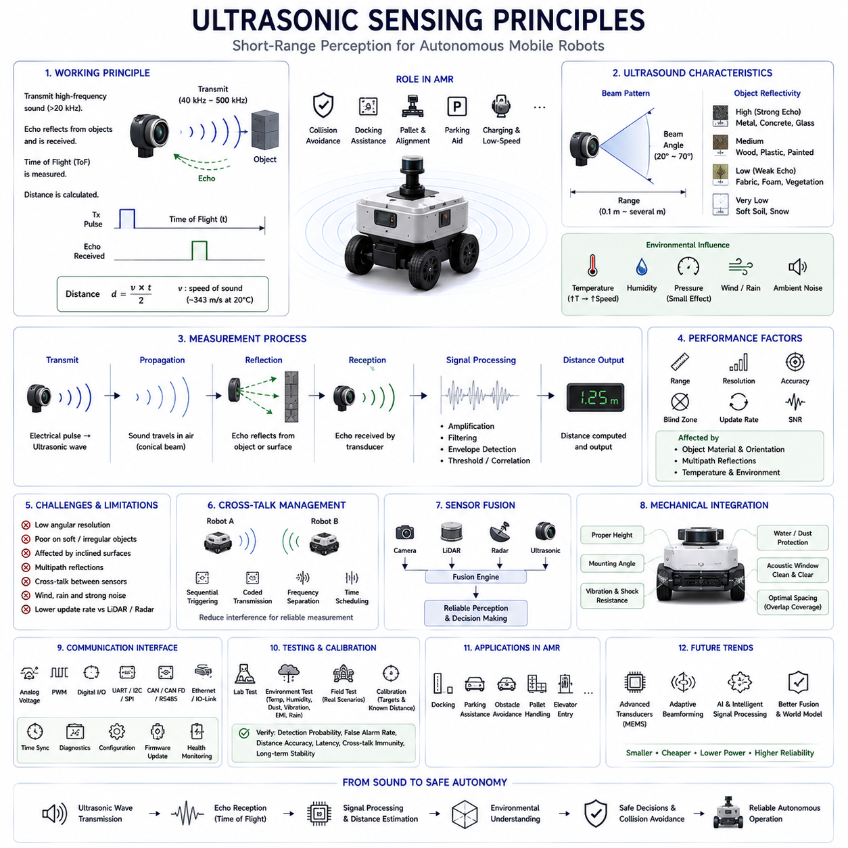
Ultrasonic sensing is one of the oldest and most reliable short-range perception technologies used in Autonomous Mobile Robots. Although modern robots increasingly employ LiDAR, radar, stereo cameras, and three-dimensional vision systems, ultrasonic sensors continue to play an essential role because of their simplicity, low cost, low power consumption, and dependable operation at close distances. Outdoor and indoor AMRs frequently rely on ultrasonic sensing as the final protective perception layer for collision avoidance, docking assistance, obstacle confirmation, and low-speed navigation. Unlike optical sensors that depend on reflected light or electromagnetic waves, ultrasonic sensing measures reflected acoustic energy, making it fundamentally different from camera-, LiDAR-, and radar-based perception systems.
Ultrasonic sensing operates by transmitting high-frequency sound waves that are above the range of human hearing. Most robotic ultrasonic sensors operate between approximately 40 kHz and several hundred kilohertz depending on application requirements. A piezoelectric transducer converts electrical pulses into ultrasonic pressure waves that propagate through the surrounding air. When these waves encounter an object, part of the acoustic energy is reflected back toward the sensor. The receiving element detects the returning echo and converts it into an electrical signal for further processing. By measuring the elapsed time between transmission and reception, the sensor estimates the distance to the reflecting object. This relatively simple operating principle enables accurate short-range distance measurement without requiring complex imaging hardware.
The fundamental measurement principle is known as Time of Flight. Since the speed of sound in air is approximately 343 meters per second under standard atmospheric conditions, the sensor calculates distance by multiplying the measured travel time by the speed of sound and dividing the result by two because the sound travels to the object and back. Extremely accurate timing circuits are therefore essential for precise distance estimation. Even microsecond-level timing errors introduce measurable ranging inaccuracies. The Time of Flight method has become the standard ranging technique for ultrasonic sensors because it provides direct geometric distance measurements without requiring environmental maps or visual feature extraction.
The speed of sound is not constant and varies according to environmental conditions. Air temperature produces the largest influence because warmer air increases molecular activity and allows sound waves to travel faster. Humidity also affects propagation speed, although its influence is generally smaller than that of temperature. Atmospheric pressure has relatively limited impact under ordinary operating conditions. Consequently, high-performance ultrasonic sensing systems often compensate for temperature variations by incorporating internal temperature sensors. Without compensation, measurement accuracy gradually decreases as environmental conditions differ from calibration conditions. Outdoor AMRs operating across seasonal weather changes therefore benefit significantly from dynamic sound-speed correction.
Ultrasonic waves propagate in a conical beam rather than a perfectly narrow line. The beam width depends on transducer diameter, operating frequency, acoustic wavelength, and mechanical housing design. Objects located anywhere within this cone may produce reflections detectable by the receiver. Wider beams increase environmental coverage but reduce spatial resolution because multiple objects may simultaneously contribute reflected energy. Narrower beams improve directional accuracy but reduce obstacle coverage. Engineers therefore carefully select beam characteristics according to the intended robotic application. Parking assistance, docking systems, warehouse robots, agricultural platforms, and industrial AMRs each require different tradeoffs between coverage area and measurement precision.
The acoustic properties of surrounding objects strongly influence ultrasonic measurement quality. Hard, smooth surfaces such as metal, concrete, glass, and painted walls generally reflect sound efficiently, producing strong echoes suitable for accurate ranging. Soft materials including fabric, vegetation, foam, snow, or loose soil absorb significant acoustic energy and generate weaker reflections. Irregular surfaces scatter sound in multiple directions rather than returning energy directly toward the receiver. Object orientation also affects measurement because inclined surfaces may reflect sound away from the sensor. These physical characteristics explain why identical objects located at equal distances sometimes produce substantially different echo strengths and detection reliability.
Measurement range represents one of the defining characteristics of ultrasonic sensing. Most robotic ultrasonic sensors operate effectively between approximately ten centimeters and several meters depending on transducer power, operating frequency, beam characteristics, and target reflectivity. Very short distances may fall inside the sensor's blind zone because transmitted vibrations require time to decay before the receiver can detect returning echoes. Extremely long distances produce weak echoes that become difficult to distinguish from environmental noise. Consequently, ultrasonic sensors excel within short operational ranges where many optical sensors experience reduced accuracy. This makes them particularly valuable for final-stage obstacle detection, docking alignment, pallet positioning, and low-speed maneuvering.
Resolution and accuracy are related but distinct performance measures. Resolution describes the smallest detectable change in measured distance, whereas accuracy indicates how closely measurements correspond to actual physical distances. High-resolution timing electronics allow ultrasonic sensors to detect millimeter-scale distance changes under favorable laboratory conditions. Practical outdoor operation generally produces lower effective accuracy because environmental noise, temperature variation, object orientation, multipath reflections, and transducer tolerances introduce measurement uncertainty. Calibration procedures compensate for systematic errors, while signal filtering reduces random fluctuations. Reliable engineering therefore emphasizes repeatable measurement performance rather than isolated best-case laboratory specifications.
Signal processing plays a crucial role in ultrasonic sensing because raw echoes often contain significant noise and interference. Amplification increases weak return signals before filtering removes unwanted frequency components generated by electrical systems or environmental acoustic sources. Threshold detection determines whether received energy represents a valid reflection or random noise. Envelope detection estimates echo arrival time, while correlation techniques improve ranging precision under challenging conditions. Digital filtering further stabilizes measurements before distance values become available to higher-level perception software. Modern microcontrollers perform these processing operations in real time, enabling compact ultrasonic modules to provide stable distance estimates despite relatively simple hardware.
Multiple reflections frequently complicate ultrasonic perception. Sound waves may reflect from walls, floors, ceilings, machinery, or nearby objects before eventually reaching the receiver through indirect paths. These multipath reflections produce delayed echoes that do not correspond to direct object distances. Large indoor environments with parallel walls often generate particularly strong secondary reflections. Outdoor environments may also create unexpected acoustic propagation through barriers, vehicles, or infrastructure. Signal processing algorithms attempt to distinguish direct echoes from secondary reflections using arrival time, echo strength, waveform characteristics, and temporal consistency. Correct multipath suppression significantly improves obstacle localization accuracy.
Cross-talk becomes an important consideration whenever multiple ultrasonic sensors operate simultaneously. A robot equipped with several sensors may inadvertently receive echoes transmitted by neighboring sensors rather than its own signals. Multiple robots operating close together can experience similar interference. Cross-talk may produce false distance estimates or unstable measurements if left unmanaged. Engineers reduce interference through sequential sensor triggering, coded transmission patterns, frequency separation, synchronization scheduling, or intelligent communication protocols coordinating sensor activation. Proper cross-talk management is especially important for large autonomous platforms employing numerous ultrasonic sensors distributed around the vehicle perimeter.
Ultrasonic sensing performs particularly well during close-range obstacle detection where camera, LiDAR, or radar systems may possess reduced sensitivity. Transparent materials such as glass sometimes challenge LiDAR, while low-profile obstacles may be difficult for vision systems to recognize under unfavorable illumination. Ultrasonic sensors directly measure nearby physical objects regardless of color, lighting, or visual texture. Their wide beam coverage also helps detect obstacles extending beyond the immediate field of view of narrow-beam sensors. Consequently, ultrasonic sensing frequently serves as the final protective layer responsible for preventing low-speed collisions during docking, parking, charging, elevator entry, pallet handling, or confined-space navigation.
Despite these advantages, ultrasonic sensing also possesses several limitations. Low angular resolution prevents accurate object shape reconstruction because each measurement represents an integrated reflection from the entire acoustic beam. Small objects may remain undetected if they reflect insufficient energy toward the receiver. Soft materials absorb sound, while inclined surfaces redirect echoes away from the sensor. Wind, heavy rain, strong acoustic noise, and temperature gradients may additionally influence propagation characteristics. Measurement update rates are generally lower than those of LiDAR or radar because transmitted sound requires finite travel time before subsequent pulses can be emitted. Understanding these limitations is essential for appropriate sensor selection and system design.
Sensor fusion substantially enhances ultrasonic sensing performance by combining complementary measurement principles. Cameras contribute semantic object recognition, LiDAR provides precise three-dimensional geometry, radar measures long-range distance and velocity, while ultrasonic sensors deliver highly reliable close-range obstacle confirmation. Fusion algorithms integrate confidence estimates from every sensing modality according to operating conditions. During docking procedures, ultrasonic measurements often receive greater weighting because centimeter-level proximity information becomes more valuable than distant environmental mapping. Conversely, long-range navigation primarily depends upon LiDAR, radar, and cameras while ultrasonic sensors remain in standby until nearby obstacles enter their effective measurement range.
Mechanical integration significantly influences ultrasonic sensing reliability. Sensor mounting height determines ground reflection behavior, while mounting angle influences coverage geometry and obstacle visibility. Protective housings must resist water, dust, vibration, temperature cycling, and mechanical impacts without degrading acoustic transmission. Acoustic windows should minimize signal attenuation while preventing contamination from mud, snow, or debris. Engineers also avoid installing sensors near high-noise mechanical components generating continuous ultrasonic vibrations. Proper spacing between adjacent sensors reduces cross-talk while ensuring overlapping coverage around the vehicle. Mechanical integration therefore directly contributes to robust perception performance throughout long-term outdoor operation.
Communication interfaces connect ultrasonic sensors with the remainder of the robotic perception system. Simple sensors may provide analog voltage outputs, pulse-width signals, serial communication, or digital switching outputs. More advanced industrial sensors support CAN, CAN FD, Ethernet, RS-485, IO-Link, or other standardized industrial communication protocols. Time synchronization, diagnostic reporting, configuration management, firmware updates, and health monitoring become increasingly important as robotic systems grow more complex. Standardized communication simplifies sensor replacement, maintenance, fleet management, and software portability while supporting centralized perception architectures integrating information from multiple sensing technologies.
Testing and calibration ensure that ultrasonic sensing performs reliably across practical operating conditions. Laboratory experiments verify measurement accuracy using calibrated targets positioned at known distances. Environmental testing evaluates performance across varying temperatures, humidity levels, dust exposure, rainfall, vibration, and electromagnetic interference. Field validation examines obstacle detection during realistic navigation scenarios involving pedestrians, vehicles, loading docks, charging stations, warehouse shelving, and outdoor infrastructure. Engineers analyze detection probability, false alarm rate, distance accuracy, response latency, cross-talk immunity, and long-term measurement stability. Continuous validation identifies gradual sensor degradation before operational safety becomes compromised.
Future ultrasonic sensing technology will continue evolving alongside broader advances in autonomous robotics. Improved piezoelectric materials, digital signal processing, MEMS ultrasonic transducers, adaptive beamforming, artificial intelligence, and multi-sensor fusion will increase measurement accuracy while reducing size, cost, and power consumption. Intelligent ultrasonic systems may automatically classify echo patterns, estimate measurement confidence, compensate for environmental influences, and cooperate directly with cameras, LiDAR, radar, and world-model algorithms. Rather than functioning as isolated proximity sensors, future ultrasonic devices will become integrated perception nodes contributing valuable short-range environmental information to comprehensive Physical AI systems supporting safe, intelligent, and reliable autonomous mobile robots across increasingly diverse operational environments.

08.2 Short Range Distance Measurement
Short-range distance measurement is one of the most fundamental perception capabilities in Autonomous Mobile Robots because numerous navigation and manipulation tasks occur within only a few meters of the robot. While long-range perception technologies such as LiDAR, radar, and vision systems provide environmental awareness for global navigation, short-range sensors are responsible for the final stage of safe interaction with nearby objects. Docking stations, charging systems, warehouse shelves, pallets, elevators, production equipment, walls, pedestrians, and other robots frequently exist within close proximity, requiring precise and reliable distance estimation. Consequently, short-range measurement directly influences navigation safety, operational efficiency, and autonomous decision-making across virtually every AMR application.
The primary objective of short-range distance measurement is to determine the exact separation between the robot and surrounding objects with sufficient accuracy to support safe movement. Unlike global localization, which estimates the robot's position within a large environment, short-range sensing focuses on immediate spatial relationships around the vehicle. The perception system continuously monitors nearby obstacles and updates distance information as the robot moves through dynamic environments. This information supports collision avoidance, precision docking, obstacle detection, path correction, speed regulation, manipulation assistance, and emergency stopping. Reliable short-range perception therefore forms the final protective layer before physical contact can occur.
Several sensing technologies can perform short-range distance measurement, each offering unique strengths and limitations. Ultrasonic sensors estimate distance using acoustic Time of Flight, infrared sensors measure reflected infrared light intensity or travel time, LiDAR calculates optical Time of Flight with laser pulses, stereo cameras estimate depth through geometric triangulation, structured-light sensors project known illumination patterns, and Time-of-Flight cameras directly calculate pixel-level distance using modulated light. Contact switches and tactile bumpers provide physical confirmation when objects are actually touched. Engineers often combine multiple sensing technologies because no single sensor performs optimally under every environmental condition.
Ultrasonic sensing remains one of the most widely used short-range measurement methods because it combines low cost, simple hardware, low power consumption, and reliable operation within several meters. The sensor transmits ultrasonic waves that propagate through air before reflecting from nearby objects. The elapsed travel time between transmission and echo reception determines object distance. Since acoustic propagation is relatively slow compared with electromagnetic waves, precise timing measurements become straightforward using inexpensive electronic circuits. Ultrasonic sensors therefore provide accurate proximity information without requiring complex optics, image processing, or computationally intensive algorithms, making them particularly suitable for industrial AMRs and service robots.
Optical ranging technologies provide complementary capabilities for short-range measurement. Laser-based LiDAR offers high accuracy, narrow beam divergence, and dense geometric information suitable for mapping and localization. Infrared sensors provide inexpensive obstacle detection over relatively short distances, although performance depends on surface reflectivity and ambient illumination. Time-of-Flight cameras produce dense depth images by measuring optical propagation delay across every image pixel simultaneously. Stereo vision estimates depth using image correspondence between multiple cameras. These optical technologies generally provide higher spatial resolution than ultrasonic sensing but may experience performance degradation under dust, fog, rain, bright sunlight, or transparent surfaces.
Measurement range represents one of the most important design parameters for short-range sensing systems. Every sensor possesses a minimum detectable distance, an effective operating region, and a maximum reliable measurement range. Extremely close objects may lie inside the sensor's blind zone where transmitted energy interferes with received signals. Beyond the maximum operating distance, reflected energy becomes too weak for reliable detection. Engineers therefore carefully select sensing technologies whose measurement characteristics match application requirements. Warehouse docking systems may require centimeter-level measurements below one meter, whereas outdoor delivery robots often monitor obstacles several meters ahead while operating at higher speeds.
Accuracy determines how closely measured distances correspond to actual physical separation between sensor and object. High measurement accuracy enables precise docking, narrow corridor navigation, pallet positioning, robotic manipulation, and automated charging. Multiple factors influence ranging accuracy, including sensor calibration, environmental conditions, object reflectivity, measurement noise, electronic timing precision, mounting geometry, and signal processing quality. Systematic errors can often be corrected through calibration procedures, while random measurement fluctuations require statistical filtering. Practical engineering focuses not only on achieving high accuracy under laboratory conditions but also maintaining consistent performance throughout long-term real-world operation.
Measurement resolution describes the smallest detectable change in distance that a sensing system can reliably identify. High-resolution sensors detect very small object movements, allowing precise positioning during docking, manipulation, or automated assembly operations. Resolution depends upon signal bandwidth, timing precision, analog-to-digital conversion, and processing algorithms. Although extremely high laboratory resolution is technically achievable, practical field performance also depends on vibration, temperature variation, electrical noise, and target characteristics. Consequently, effective operational resolution may differ substantially from theoretical hardware specifications, emphasizing the importance of realistic validation under representative operating conditions.
Response time significantly affects the safety of autonomous mobile robots because rapidly moving platforms require continuously updated environmental information. Every measurement involves sensor acquisition, signal propagation, processing, communication, filtering, and integration into higher-level decision algorithms. Delayed measurements reduce available reaction time and increase stopping distance, particularly during higher-speed operation. Consequently, engineers balance measurement accuracy against update frequency to achieve safe dynamic performance. Applications requiring rapid obstacle avoidance generally prioritize fast sensor refresh rates, whereas precision docking may tolerate slower update frequencies in exchange for improved ranging accuracy.
Measurement repeatability is equally important because autonomous decision-making depends upon stable sensor outputs. Even when average accuracy remains acceptable, excessive measurement variation causes navigation oscillations, unstable control behavior, and reduced confidence within sensor fusion algorithms. Repeatability reflects the sensor's ability to produce consistent measurements under identical operating conditions. Engineers evaluate repeatability through repeated measurements of stationary reference targets while analyzing statistical distributions of observed errors. Low measurement variance supports robust filtering, smoother vehicle motion, and more reliable obstacle tracking throughout extended autonomous operation.
Environmental conditions strongly influence short-range distance measurement regardless of sensing technology. Temperature variations modify ultrasonic propagation speed, while rain, fog, snow, dust, and airborne particles influence optical transmission. Bright sunlight affects vision systems, whereas electromagnetic interference may influence electronic circuitry. Wind changes acoustic propagation paths, while vibration alters sensor orientation during measurement. Outdoor robots therefore experience considerably greater environmental variability than indoor platforms. Reliable perception systems compensate for these influences using calibration models, adaptive filtering, environmental monitoring, and sensor fusion to maintain stable ranging performance across diverse operating conditions.
Object characteristics also contribute significantly to measurement reliability. Surface material determines reflection efficiency, while surface geometry influences reflection direction. Highly reflective metal surfaces may generate strong echoes or laser returns, whereas soft fabrics, vegetation, foam, or absorbent materials produce weaker reflections. Transparent glass challenges certain optical sensors, while highly inclined surfaces redirect energy away from receivers. Small obstacles may occupy only part of the sensing beam and therefore generate weaker measurements. Robust perception algorithms consider these physical properties when estimating measurement confidence and selecting appropriate sensor weighting during data fusion.
Sensor placement fundamentally affects measurement quality. Mounting height determines visibility of low obstacles and floor reflections, while installation angle influences effective coverage geometry. Sensors positioned too high may overlook low-profile hazards, whereas sensors mounted too close to the ground may experience excessive ground reflections. Multiple sensors distributed around the vehicle provide comprehensive coverage but require careful overlap planning to eliminate blind regions without introducing excessive redundancy. Mechanical integration must additionally consider vibration isolation, environmental protection, cable routing, thermal management, maintenance accessibility, and electromagnetic compatibility to ensure long-term measurement reliability.
Blind zones represent unavoidable limitations within most short-range sensing technologies. Objects located too close to the sensor cannot always be measured because transmitted signals overlap with receiver recovery periods or optical minimum-focus limitations. Blind regions vary according to sensor type, operating frequency, hardware design, and signal processing architecture. Engineers reduce operational risk by combining complementary sensors whose measurement ranges overlap sufficiently to eliminate coverage gaps. This layered sensing strategy ensures continuous obstacle awareness throughout the robot's entire operating envelope, particularly during slow-speed maneuvering near obstacles.
Sensor fusion substantially improves short-range distance measurement by combining independent sensing principles. Ultrasonic sensors verify nearby object presence, LiDAR supplies high-resolution geometry, cameras contribute semantic interpretation, radar estimates velocity, and tactile sensors confirm physical contact when necessary. Fusion algorithms evaluate measurement confidence from each sensor while considering environmental conditions and historical consistency. If one sensing modality becomes unreliable due to adverse weather or unfavorable object characteristics, alternative sensors continue providing dependable information. This redundancy significantly enhances overall perception robustness, operational safety, and fault tolerance.
Signal filtering reduces measurement noise while preserving genuine environmental information. Moving average filters smooth random fluctuations, median filters reject isolated outliers, Kalman filters estimate object motion through probabilistic prediction, and particle filters manage nonlinear measurement uncertainty. Adaptive filters dynamically modify parameters according to environmental conditions or sensor confidence. Appropriate filtering prevents unnecessary control oscillations while maintaining sufficient responsiveness to rapidly changing situations. Engineers carefully tune filter parameters because excessive smoothing introduces undesirable latency whereas insufficient filtering leaves unstable measurements uncorrected.
Calibration ensures that measured distances correspond accurately to physical reality throughout operational life. Factory calibration establishes baseline sensor characteristics, while field calibration compensates for installation geometry, mechanical tolerances, and environmental influences. Reference targets positioned at known distances enable systematic error correction across the sensor's operating range. Automated calibration procedures increasingly allow robots to verify sensing performance without extensive human intervention. Periodic recalibration maintains measurement quality despite component aging, mechanical wear, temperature cycling, vibration exposure, or hardware replacement during maintenance activities.
Performance evaluation requires comprehensive testing across laboratory, simulated, and real-world environments. Laboratory validation provides controlled reference measurements using calibrated targets and repeatable experimental conditions. Environmental chambers evaluate operation under temperature, humidity, vibration, dust, rain, and electromagnetic interference. Simulation supports rapid algorithm development across numerous virtual scenarios before field deployment. Finally, operational testing within warehouses, factories, hospitals, logistics centers, agricultural environments, construction sites, and urban areas confirms practical performance under realistic dynamic conditions involving moving people, vehicles, machinery, and complex infrastructure.
Future short-range distance measurement technologies will increasingly integrate advanced sensing hardware with intelligent perception software. MEMS-based sensors, solid-state LiDAR, high-resolution Time-of-Flight cameras, adaptive ultrasonic arrays, artificial intelligence, and edge computing will collectively improve measurement precision, reliability, energy efficiency, and environmental robustness. Future perception systems will automatically estimate measurement confidence, identify sensor degradation, compensate for environmental disturbances, and continuously optimize sensing parameters during operation. Rather than functioning as isolated measurement devices, next-generation short-range sensors will become intelligent perception nodes contributing contextual environmental understanding to comprehensive Physical AI architectures supporting safer, more efficient, and more autonomous mobile robotic systems.

08.3 Close Obstacle Detection
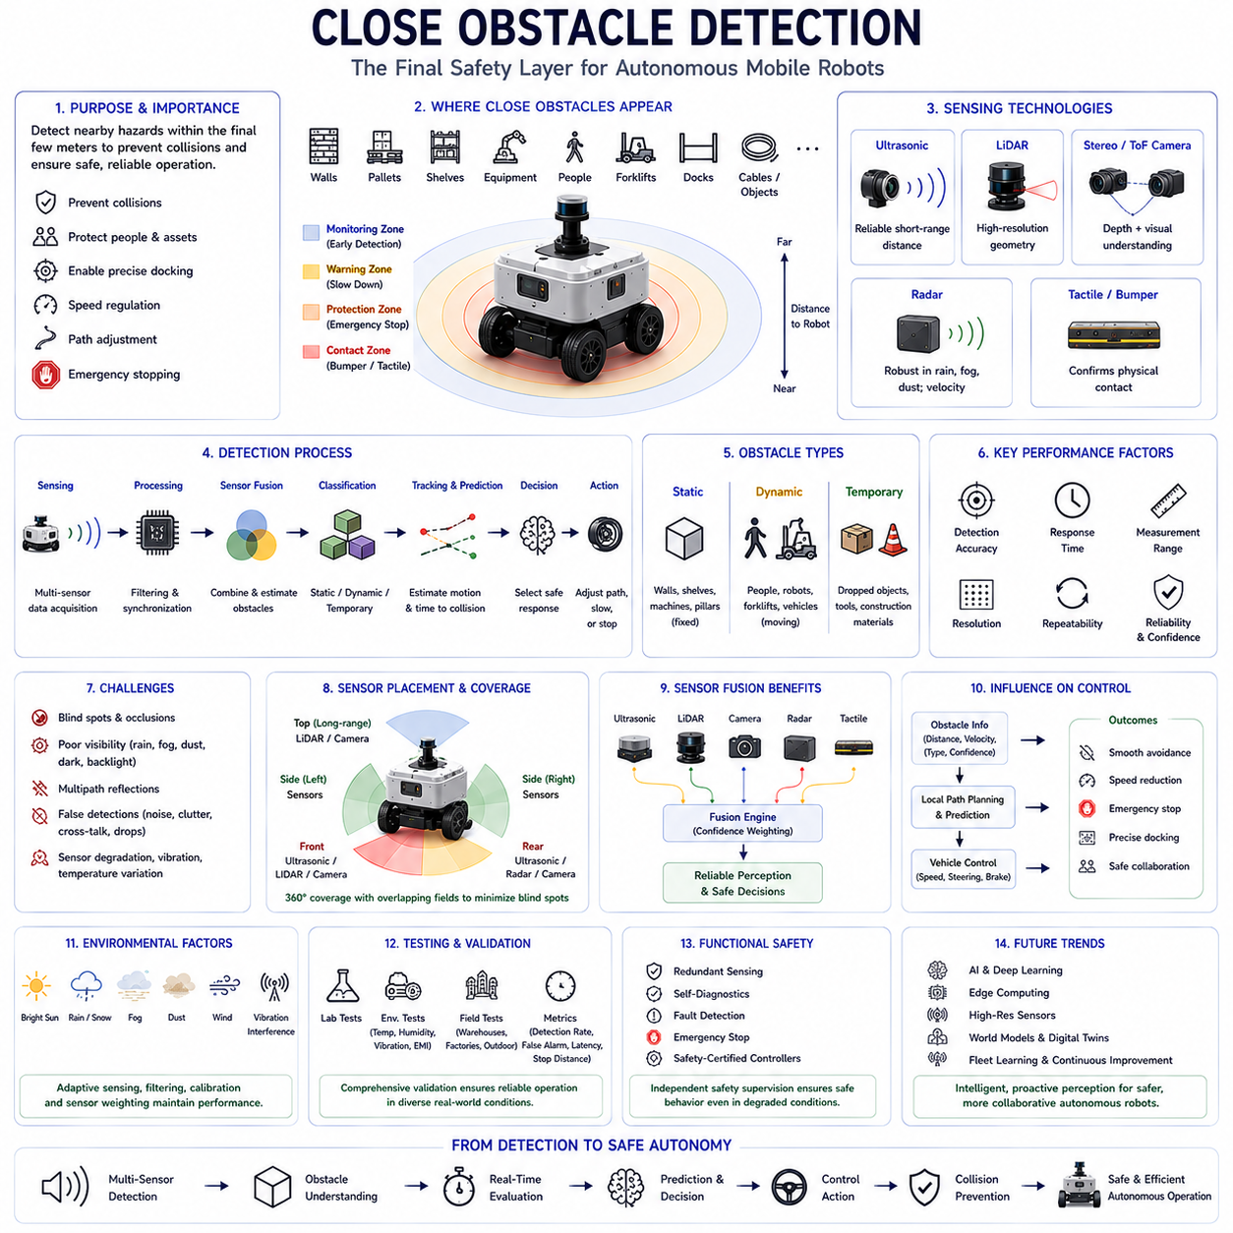
Close obstacle detection is one of the most critical perception functions in Autonomous Mobile Robots because most collisions occur within the final few meters before contact. While global navigation systems determine where the robot should travel and long-range sensors detect distant objects, close obstacle detection focuses on identifying hazards that immediately threaten safe vehicle operation. These hazards include walls, pallets, shelving, equipment, cables, pedestrians, forklifts, loading docks, and unexpected objects that suddenly appear near the robot. Accurate close-range perception enables the robot to react quickly, adjust its trajectory, reduce speed, or stop completely before physical contact occurs. Consequently, close obstacle detection serves as the final safety layer protecting both the robot and its surrounding environment.
The primary objective of close obstacle detection is to recognize nearby objects with sufficient speed, accuracy, and reliability to support safe autonomous operation. Unlike long-range perception, which emphasizes environmental understanding and route planning, close obstacle detection prioritizes immediate collision prevention. The perception system continuously monitors a protective zone surrounding the robot and updates obstacle information in real time. As objects enter progressively smaller safety zones, different control actions are triggered, including speed reduction, path modification, emergency braking, or complete motion suspension. This layered protection strategy allows the robot to respond appropriately according to obstacle distance, relative motion, and operational context.
Modern AMRs employ multiple sensing technologies to achieve reliable close obstacle detection because no individual sensor performs optimally under every condition. Ultrasonic sensors provide dependable short-range distance measurements independent of lighting conditions. LiDAR generates high-resolution geometric information capable of detecting complex object shapes. Stereo cameras and Time-of-Flight cameras estimate depth while simultaneously providing visual context. Radar contributes robust detection under rain, fog, and dust, whereas tactile bumpers confirm physical contact when every other sensing layer has failed. Combining these complementary technologies significantly improves overall perception robustness and reduces the likelihood of undetected hazards.
Ultrasonic sensing remains one of the most widely deployed technologies for close obstacle detection because of its simplicity, reliability, and affordability. The sensor periodically emits ultrasonic pulses that propagate through air before reflecting from nearby objects. The returning echoes provide direct distance measurements using the Time-of-Flight principle. Ultrasonic sensors perform particularly well when detecting nearby walls, machinery, shelving, pallets, and other large structures. Their relatively wide acoustic beam also enables detection of obstacles that may extend beyond the narrow field of view of optical sensors. For this reason, ultrasonic sensing frequently provides the final confirmation before the robot performs docking, parking, charging, or precision positioning operations.
LiDAR complements ultrasonic sensing by providing significantly higher angular resolution and detailed geometric information. Laser beams scan the surrounding environment to generate dense point clouds representing nearby obstacles with centimeter-level precision. Unlike ultrasonic sensors that provide only distance information within relatively broad beams, LiDAR distinguishes object boundaries, shapes, and spatial distribution. This capability enables the robot to navigate through narrow passages, avoid irregular obstacles, and estimate free space with high accuracy. Close obstacle detection therefore often relies upon LiDAR for obstacle localization while ultrasonic sensors verify minimum separation distances immediately before contact.
Vision-based sensing further enhances close obstacle detection by supplying semantic understanding that purely geometric sensors cannot provide. Cameras identify pedestrians, forklifts, safety barriers, warning signs, animals, or dropped objects using artificial intelligence algorithms trained for object recognition. Stereo vision estimates depth by comparing images from multiple viewpoints, while Time-of-Flight cameras generate dense depth maps directly. Visual perception enables the robot to distinguish between different obstacle categories and select appropriate behavioral responses. For example, stationary equipment may require path replanning, whereas moving pedestrians demand continuous trajectory prediction and socially acceptable navigation behavior.
Radar contributes unique advantages when close obstacle detection must remain reliable under adverse environmental conditions. Rain, snow, fog, airborne dust, smoke, and poor illumination significantly reduce the effectiveness of many optical sensors, whereas millimeter-wave radar continues providing stable measurements. Although radar generally offers lower spatial resolution than LiDAR, it accurately estimates both object distance and relative velocity. This capability becomes particularly valuable around moving vehicles, industrial machinery, and outdoor logistics operations where environmental robustness is essential. Consequently, radar increasingly complements short-range sensing systems operating in challenging industrial and outdoor environments.
Protective sensing zones form the foundation of close obstacle detection strategies. Engineers typically define multiple concentric safety regions surrounding the robot according to operational risk. The outer monitoring zone detects approaching objects early enough to support smooth trajectory adjustments. The intermediate warning zone reduces vehicle speed while increasing monitoring frequency. The inner protection zone activates emergency stopping before physical contact becomes possible. Some systems additionally define an immediate contact zone monitored by bumpers or tactile sensors. This hierarchical safety architecture enables gradual responses instead of abrupt emergency actions, improving both operational efficiency and passenger or operator comfort.
Obstacle classification significantly improves close-range perception because different obstacle types require different avoidance strategies. Static obstacles such as walls, shelves, pillars, and machinery remain fixed relative to the environment and can often be incorporated into long-term navigation maps. Dynamic obstacles including pedestrians, forklifts, autonomous robots, and vehicles require continuous motion prediction because their future positions change over time. Temporary obstacles such as dropped packages, maintenance equipment, or construction materials may appear unexpectedly and disappear shortly afterward. Intelligent perception algorithms classify detected objects according to geometric features, appearance, motion patterns, and historical observations, enabling more appropriate navigation decisions.
Relative velocity estimation plays an increasingly important role in close obstacle detection. Distance alone cannot determine collision risk because stationary obstacles and rapidly approaching objects require different responses. Radar directly measures Doppler velocity, while LiDAR and vision systems estimate motion by tracking objects across consecutive observations. Fusion algorithms combine distance and velocity information to calculate Time to Collision, allowing the robot to prioritize hazards according to urgency rather than proximity alone. An object several meters away but moving rapidly toward the robot may require earlier intervention than a stationary obstacle located at the same distance.
Real-time processing is essential because close obstacle detection supports immediate vehicle control. Sensor measurements must be acquired, synchronized, filtered, fused, classified, and transmitted to motion-planning software within extremely short time intervals. Processing delays reduce available reaction time and increase stopping distance, particularly when robots operate at higher speeds. Modern perception architectures therefore utilize multicore processors, graphics processing units, hardware accelerators, and real-time operating systems to achieve deterministic computational performance. Efficient software pipelines minimize latency while maintaining high detection accuracy across continuously changing environments.
Measurement confidence provides valuable information for autonomous decision-making because every sensor possesses uncertainty. Environmental conditions, object reflectivity, sensor noise, communication delays, and calibration quality all influence measurement reliability. Modern perception systems therefore estimate confidence values alongside measured distances. Sensor fusion algorithms dynamically adjust weighting according to these confidence estimates, allowing highly reliable sensors to dominate decision-making under favorable conditions while reducing the influence of degraded measurements. Confidence-aware perception substantially improves robustness during weather changes, sensor contamination, temporary communication failures, or hardware degradation.
Blind spots remain an important challenge for close obstacle detection because no sensor provides complete environmental coverage by itself. Physical mounting constraints, limited fields of view, sensor minimum ranges, structural occlusions, and robot geometry create regions where obstacles may remain temporarily undetected. Engineers address these limitations by carefully positioning multiple sensors around the vehicle perimeter with overlapping coverage. Roof-mounted LiDAR observes distant surroundings, bumper-mounted ultrasonic sensors monitor immediate proximity, side sensors protect lateral movement, and rear sensors support reversing maneuvers. Comprehensive sensor placement minimizes blind regions throughout the robot's operational envelope.
Environmental influences significantly affect close obstacle detection performance. Bright sunlight, heavy rain, dense fog, snow, airborne dust, reflective puddles, vibration, electromagnetic interference, and temperature variation each influence different sensing technologies in unique ways. Optical sensors struggle under adverse visibility, ultrasonic sensors experience altered acoustic propagation during strong winds or temperature changes, while radar may generate clutter from metallic structures. Robust perception systems continuously monitor environmental conditions and adapt sensing strategies accordingly. Dynamic sensor weighting and environmental compensation ensure consistent obstacle detection despite changing operational circumstances.
False detections represent another important consideration because unnecessary emergency stops reduce operational efficiency and user confidence. Electrical noise, multipath reflections, environmental clutter, moving vegetation, rain droplets, sensor cross-talk, and temporary communication errors may all generate false obstacle reports. Signal processing algorithms reduce these effects through filtering, temporal consistency analysis, object tracking, and sensor confirmation. Multi-sensor verification requires independent sensing technologies to agree before high-confidence hazards trigger emergency actions. Such validation significantly decreases nuisance stops while preserving the high safety standards required for autonomous operation.
Sensor fusion provides the most effective solution for reliable close obstacle detection because independent sensing principles compensate for one another's weaknesses. Ultrasonic sensors confirm nearby object presence, LiDAR accurately determines geometry, cameras recognize object categories, radar estimates velocity under poor weather, and tactile sensors verify physical contact. Fusion algorithms integrate these complementary observations into a unified environmental representation while accounting for sensor uncertainty, measurement confidence, and temporal consistency. This integrated perception model enables safer navigation than any individual sensing technology could achieve independently.
Close obstacle detection directly influences motion planning and vehicle control. The local planner continuously evaluates obstacle positions, predicts future trajectories, and generates collision-free paths satisfying vehicle kinematic constraints. If sufficient free space exists, the planner smoothly modifies the robot's trajectory around nearby obstacles. When avoidance becomes impossible, speed decreases progressively until emergency stopping is initiated. Controllers simultaneously consider obstacle distance, relative velocity, braking capability, steering limits, payload characteristics, and surface conditions. Consequently, perception and control operate as tightly integrated subsystems rather than independent functional modules.
Testing and validation are essential because close obstacle detection must perform reliably under highly diverse operational conditions. Laboratory experiments verify sensor accuracy using calibrated reference targets positioned throughout the protective sensing region. Environmental testing evaluates operation under varying temperatures, humidity, vibration, rain, dust, and electromagnetic interference. Field testing exposes robots to realistic warehouse, factory, hospital, logistics, construction, agricultural, and urban environments containing pedestrians, vehicles, equipment, and unpredictable obstacles. Engineers evaluate detection probability, false alarm rate, response latency, tracking stability, emergency stopping performance, and long-term operational reliability before deployment.
Functional safety standards strongly influence the design of close obstacle detection systems. Autonomous robots operating near people must demonstrate predictable behavior even when sensors partially fail or environmental conditions deteriorate. Redundant sensing, continuous self-diagnostics, fault detection, degraded operating modes, emergency stopping functions, and safety-certified controllers collectively reduce operational risk. Safety architectures often separate perception functions from safety supervision, ensuring that independent monitoring systems remain capable of stopping the robot whenever hazardous conditions are detected. Such redundancy supports compliance with international robotic safety standards and industrial deployment requirements.
Future close obstacle detection systems will increasingly incorporate artificial intelligence, edge computing, high-resolution sensors, and world-model reasoning into unified perception architectures. Intelligent algorithms will distinguish hazardous obstacles from harmless objects, predict human intentions, estimate uncertainty, compensate for sensor degradation, and continuously improve through fleet learning. Advanced sensor fusion will integrate ultrasonic sensing, LiDAR, radar, vision, tactile feedback, and digital twin technologies into comprehensive environmental models supporting proactive rather than reactive collision avoidance. As Physical AI continues evolving, close obstacle detection will transition from simple distance measurement toward intelligent spatial understanding that enables safer, smoother, and more collaborative autonomous mobile robot operation across increasingly complex real-world environments.

08.4 Docking and Parking Assistance
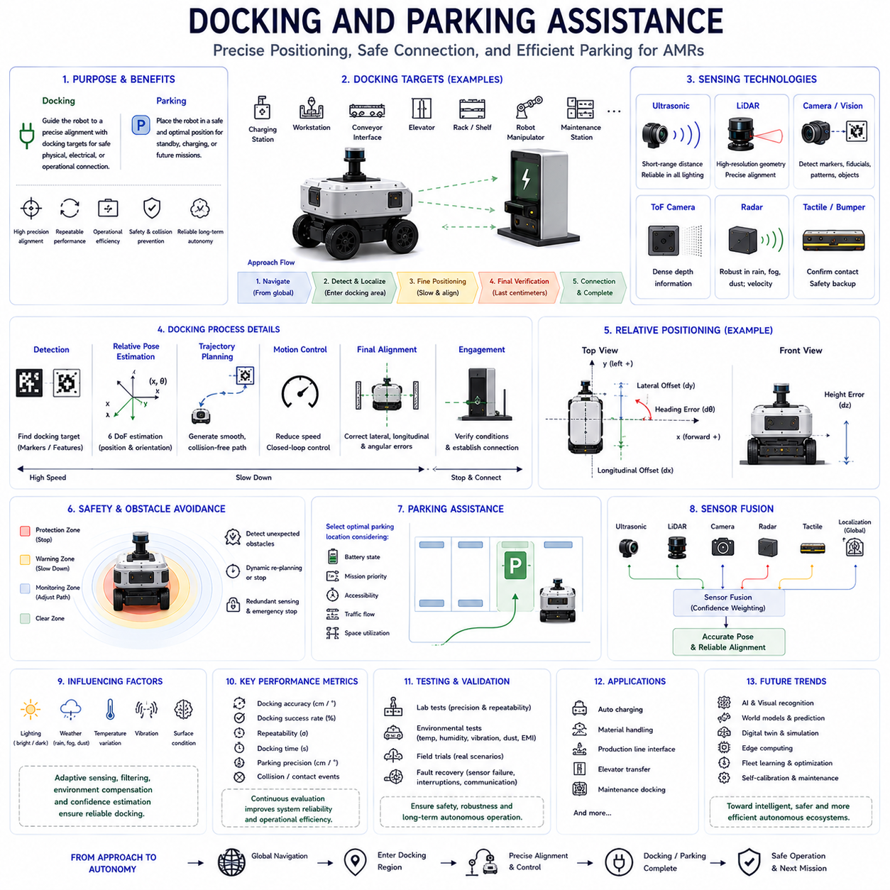
Docking and parking assistance represents one of the most precision-critical functions in Autonomous Mobile Robots because the robot must accurately position itself relative to a designated target while maintaining safety, efficiency, and repeatability. Unlike general navigation, which primarily focuses on reaching a destination, docking requires centimeter-level alignment with charging stations, workstations, conveyor systems, elevators, storage racks, robotic manipulators, or automated production equipment. Parking assistance similarly ensures that the robot reaches its final resting position without collision while optimizing orientation, accessibility, and operational readiness. Reliable docking and parking therefore directly influence mission completion, charging efficiency, production throughput, and long-term autonomous operation.
The primary objective of docking assistance is to guide the robot from a nearby navigation waypoint into a precisely defined final position where mechanical, electrical, or operational interaction can safely occur. Global localization systems typically provide sufficient accuracy for long-distance navigation, but they rarely achieve the precision required for physical docking. Consequently, docking assistance begins once the robot enters a predefined docking region where local perception gradually replaces global navigation. During this final approach, high-resolution sensors continuously estimate relative position, orientation, velocity, and alignment while the control system progressively reduces vehicle speed until accurate positioning is achieved.
Parking assistance follows a similar principle but emphasizes safe and efficient vehicle placement rather than physical interface connection. Industrial robots frequently park inside storage zones, waiting areas, charging queues, production cells, warehouse aisles, inspection stations, or maintenance locations. Proper parking minimizes occupied space, prevents traffic congestion, maintains emergency access routes, and prepares the robot for future missions. Intelligent parking assistance additionally considers battery state, mission priority, fleet scheduling, and operational efficiency when selecting appropriate parking positions. Consequently, parking behavior contributes not only to vehicle safety but also to overall fleet productivity and facility utilization.
Docking operations generally proceed through several consecutive phases. During the initial approach, global navigation guides the robot toward the docking area using localization, mapping, and path-planning algorithms. Once the docking station enters local sensing range, the perception system identifies reference features and estimates relative pose. The robot then transitions into fine positioning mode, gradually reducing speed while continuously correcting lateral, longitudinal, and angular errors. During the final centimeters, dedicated short-range sensors verify alignment before the robot establishes electrical, mechanical, or communication connections. Successful docking concludes only after all interface conditions satisfy predefined operational requirements.
Precise localization forms the foundation of reliable docking assistance. Standard global navigation methods typically achieve position accuracy measured in several centimeters or more depending on environment and sensing technology. Docking, however, often requires significantly higher precision because charging connectors, conveyor interfaces, automated loading mechanisms, or robotic manipulators tolerate only limited alignment error. Local reference measurements therefore supplement global localization during final positioning. Relative measurements between robot and docking station eliminate accumulated global navigation errors, enabling repeatable high-precision docking across thousands of operational cycles without requiring unrealistic global localization accuracy.
Short-range sensors play a central role during docking because they provide the detailed positional information unavailable from long-range perception systems. Ultrasonic sensors accurately estimate nearby distances while remaining insensitive to lighting conditions. LiDAR generates precise geometric measurements of docking structures, walls, and surrounding obstacles. Cameras recognize visual docking markers, fiducial patterns, QR codes, AprilTags, or specialized alignment targets. Time-of-Flight cameras provide dense depth information, whereas radar contributes reliable ranging under adverse weather conditions. Multiple sensing technologies cooperate to generate a comprehensive estimate of relative position and orientation throughout the final docking sequence.
Ultrasonic sensing remains particularly valuable during the last stage of docking because centimeter-level distance measurements are required immediately before physical contact. Charging stations, automated conveyors, pallet transfer systems, and maintenance interfaces frequently depend upon precise separation distances smaller than one meter. Ultrasonic sensors continuously monitor clearance between robot and docking infrastructure while verifying symmetrical spacing across multiple sensing channels. This information enables the controller to correct small positioning errors before contact occurs. Because ultrasonic measurements remain reliable under poor illumination, they continue supporting docking operations during nighttime, indoor warehouses, underground facilities, or visually degraded environments.
Vision-based docking systems provide rich environmental understanding beyond simple distance measurement. Cameras identify docking stations using visual landmarks, fiducial markers, colored patterns, artificial intelligence object recognition, or natural environmental features. Computer vision algorithms estimate relative pose through feature matching, perspective geometry, and image alignment techniques. Some docking systems employ stereo vision or structured-light sensing to reconstruct three-dimensional docking geometry. Visual perception additionally verifies that the docking station remains unobstructed before approach begins. These capabilities enable flexible docking solutions requiring minimal specialized infrastructure while supporting automatic adaptation to diverse industrial environments.
LiDAR-based docking offers exceptional geometric precision because dense point clouds accurately represent surrounding structures. During final alignment, scan matching algorithms compare real-time LiDAR observations with previously stored docking reference maps. Relative pose estimation continuously updates robot position while compensating for accumulated localization errors. LiDAR additionally detects unexpected obstacles occupying the docking region, preventing collisions with misplaced equipment, pallets, or personnel. Because laser measurements provide excellent spatial resolution, LiDAR frequently serves as the primary positioning sensor during precision docking operations requiring highly repeatable alignment over extended operational periods.
Docking markers simplify perception by providing easily recognizable reference features specifically designed for localization. Reflective targets, fiducial markers, QR codes, AprilTags, infrared beacons, laser reflectors, magnetic strips, RFID tags, and visual landmarks each support different docking strategies. Marker-based docking reduces computational complexity because perception algorithms search for known reference patterns rather than arbitrary environmental features. Marker selection depends upon environmental conditions, expected viewing distances, maintenance requirements, installation cost, and required positioning accuracy. Well-designed docking markers substantially improve robustness, particularly within visually repetitive industrial facilities.
Relative pose estimation represents one of the most important computational tasks during docking assistance. Distance measurements alone cannot guarantee successful docking because rotational alignment remains equally critical. The perception system continuously estimates six degrees of freedom describing the robot's position and orientation relative to the docking target. Longitudinal offset, lateral offset, heading error, roll, pitch, and height differences may all influence docking quality depending on application requirements. Estimation algorithms combine multiple sensor observations into a unified pose representation updated throughout the docking maneuver. High-frequency pose updates enable smooth trajectory correction without abrupt steering adjustments.
Motion control during docking differs substantially from ordinary navigation because precision becomes more important than travel speed. The controller gradually reduces velocity as docking progresses while increasing feedback sensitivity to small positioning errors. Closed-loop control continuously corrects steering angle, wheel velocities, and vehicle orientation according to measured relative pose. Predictive controllers estimate future vehicle motion while considering actuator dynamics, payload characteristics, and mechanical constraints. Smooth control minimizes oscillations that might otherwise prevent accurate alignment or damage docking infrastructure. Consequently, docking controllers prioritize stability, repeatability, and precision over maximum operational efficiency.
Safety remains the highest priority throughout docking and parking operations because robots frequently interact closely with infrastructure, equipment, and people. Protective sensing zones continuously monitor the surrounding environment for unexpected obstacles entering the docking path. Emergency stopping functions immediately halt motion whenever safety margins become violated. Redundant sensing verifies docking conditions before mechanical engagement occurs. Human workers may temporarily interrupt docking sequences, requiring perception systems to recognize their presence and suspend operations safely. Functional safety architectures therefore supervise every docking stage independently from ordinary navigation software to ensure predictable behavior under abnormal conditions.
Obstacle avoidance continues operating throughout docking because the environment may change unexpectedly after the robot begins its approach. Personnel, forklifts, carts, packages, or maintenance equipment can suddenly occupy the docking area. Dynamic perception continuously updates environmental information while evaluating whether docking remains safe. Minor obstacles may trigger temporary pauses, whereas larger hazards require trajectory replanning or complete mission cancellation. Adaptive docking algorithms therefore integrate obstacle detection with motion planning rather than assuming that docking environments remain static. This capability significantly improves operational safety within busy industrial facilities.
Environmental conditions influence docking performance through their effects on sensing technologies. Bright sunlight may reduce camera performance, fog and dust degrade optical measurements, rain alters surface appearance, temperature variations influence ultrasonic propagation, and vibration affects sensor stability. Outdoor docking stations present additional challenges including snow accumulation, standing water, changing illumination, and wind-driven contamination. Robust docking systems compensate for environmental variation using sensor fusion, adaptive filtering, automatic exposure control, temperature compensation, and confidence estimation. Multi-sensor redundancy ensures that docking performance remains reliable despite temporary degradation affecting individual sensing modalities.
Sensor fusion provides the highest docking reliability because complementary sensing technologies compensate for one another's limitations. Global localization guides the robot into the docking region, LiDAR estimates precise geometry, cameras recognize docking targets, ultrasonic sensors verify final distances, radar supplies reliable ranging under adverse weather, and tactile sensors confirm successful mechanical engagement when necessary. Fusion algorithms combine these observations according to measurement confidence while maintaining consistent relative pose estimates throughout docking. This integrated perception strategy substantially improves repeatability compared with reliance upon any individual sensor alone.
Parking assistance extends beyond simply stopping the robot. Intelligent parking algorithms evaluate available parking spaces while considering vehicle dimensions, turning radius, accessibility, charging opportunities, fleet scheduling, emergency evacuation routes, and anticipated future missions. The robot selects appropriate parking orientation to simplify subsequent departure while minimizing interference with surrounding traffic. Some fleet management systems dynamically assign parking locations according to battery state, workload distribution, maintenance schedules, or operational priority. Consequently, autonomous parking contributes directly to facility efficiency, energy management, and coordinated fleet operation.
Testing and validation verify that docking and parking assistance perform reliably under realistic operating conditions. Laboratory testing evaluates positioning accuracy using calibrated docking fixtures and repeatable reference measurements. Environmental testing examines performance under varying temperatures, humidity, vibration, dust, electromagnetic interference, and lighting conditions. Field trials assess docking repeatability, charging success rate, parking precision, obstacle avoidance behavior, mission completion time, and long-term mechanical durability. Engineers additionally evaluate fault recovery following interrupted docking attempts, temporary sensor failures, communication delays, or unexpected environmental changes to ensure robust autonomous operation.
Future docking and parking assistance systems will increasingly combine artificial intelligence, digital twins, world models, edge computing, and fleet learning into comprehensive autonomous infrastructure management platforms. Intelligent perception will recognize docking stations without dedicated markers, predict environmental changes before they influence positioning, estimate component wear, optimize charging schedules, and continuously improve alignment accuracy through operational experience collected across entire robot fleets. Rather than functioning as isolated navigation tasks, future docking and parking systems will become intelligent cooperative processes connecting perception, motion planning, energy management, fleet orchestration, and Physical AI into a unified autonomous ecosystem capable of safe, efficient, and highly reliable long-term operation.

08.5 Sensor Placement and Coverage
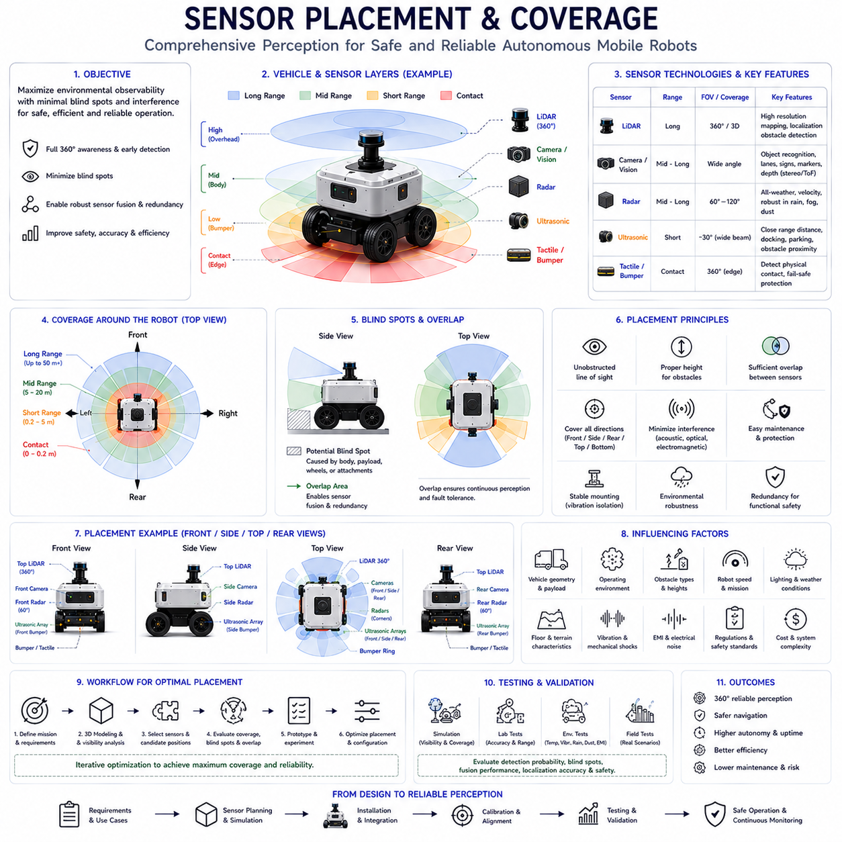
Sensor placement and coverage represent fundamental design considerations in Autonomous Mobile Robots because even the most advanced perception sensors cannot provide reliable environmental understanding if they are installed incorrectly. The performance of ultrasonic sensors, LiDAR, radar, cameras, inertial measurement units, and other perception devices depends not only on their intrinsic specifications but also on their physical position, mounting angle, field of view, environmental exposure, and interaction with neighboring sensors. Poor sensor placement creates blind spots, increases measurement uncertainty, reduces sensor fusion performance, and ultimately compromises navigation safety. Consequently, successful autonomous navigation requires careful optimization of both individual sensor placement and overall sensing coverage across the entire vehicle.
The primary objective of sensor placement is to maximize environmental observability while minimizing blind regions, sensing redundancy, interference, and installation complexity. Every sensor possesses a limited field of view and measurement range, meaning that no single sensor can observe the complete surroundings of the robot. Engineers therefore distribute multiple sensing devices across the vehicle to achieve comprehensive environmental perception. Proper placement ensures that obstacles approaching from any direction can be detected early enough for safe decision-making while maintaining sufficient overlap between neighboring sensors to support reliable sensor fusion and fault tolerance.
Coverage describes the portion of the surrounding environment that can be observed by one or more sensors under normal operating conditions. Effective coverage includes not only the geometric field of view but also measurement range, resolution, environmental robustness, update frequency, and sensing confidence. A theoretically visible region may still provide unreliable measurements because of environmental conditions, object characteristics, or sensor limitations. Engineers therefore evaluate both geometric coverage and effective operational coverage when designing perception systems. The objective is to maintain continuous awareness of all regions relevant to robot motion while avoiding unnecessary sensing overlap that increases system cost and computational complexity.
Sensor placement begins by analyzing the robot's operational requirements rather than selecting hardware first. Warehouse robots primarily require obstacle detection near shelving, pallets, pedestrians, and forklifts. Outdoor delivery robots must monitor roads, sidewalks, vegetation, vehicles, and changing weather conditions. Agricultural robots observe crops, terrain, and machinery, while inspection robots focus on industrial equipment and structural features. Each application presents different environmental characteristics, obstacle distributions, vehicle speeds, and safety requirements. Consequently, optimal sensor placement depends heavily on mission objectives rather than universal installation rules.
The vehicle geometry significantly influences sensor placement decisions. Robot dimensions, wheel configuration, ground clearance, payload location, suspension characteristics, protective covers, and structural components determine available mounting positions. Large payloads may block sensor visibility, while protruding structures create permanent blind regions. Sensor installation must additionally consider maintenance accessibility, wiring routes, vibration isolation, thermal management, and mechanical protection. Engineers frequently perform three-dimensional digital modeling to evaluate sensor visibility before constructing physical prototypes, reducing costly design iterations later in development.
Mounting height represents one of the most important placement parameters because it directly influences obstacle visibility. Sensors positioned too high may overlook low-profile hazards including curbs, cables, dropped objects, or small packages. Conversely, sensors mounted very close to the ground experience increased reflections from road surfaces, puddles, or uneven terrain while becoming more vulnerable to contamination by mud, snow, water, or debris. Appropriate mounting height depends upon vehicle size, expected obstacle dimensions, terrain characteristics, and sensing technology. Many autonomous robots therefore employ multiple sensing layers at different heights to ensure comprehensive vertical coverage.
Sensor orientation determines the direction in which measurements are collected and therefore strongly influences perception quality. Forward-facing sensors primarily support navigation and obstacle avoidance, side-mounted sensors monitor lateral clearance during turning, while rear sensors protect reversing maneuvers. Downward-looking sensors detect floor edges, staircases, drop-offs, and terrain transitions. Upward-facing sensors may monitor overhead obstacles such as hanging structures, conveyor equipment, or tree branches. Proper orientation ensures that every region surrounding the robot receives sufficient observation while minimizing unnecessary overlap or redundant sensing.
Field of view defines the angular region observable by each sensor. Cameras typically provide wide horizontal coverage but limited depth accuracy. LiDAR sensors may generate complete three-hundred-sixty-degree environmental scans depending on hardware configuration. Radar generally offers moderate angular coverage with excellent range performance, whereas ultrasonic sensors produce relatively wide acoustic beams covering nearby obstacles. Engineers combine sensors possessing different fields of view to achieve complementary perception characteristics. Wide-angle sensors provide general environmental awareness while narrow-angle sensors focus on high-precision measurements in safety-critical directions.
Blind spots inevitably appear wherever sensor fields of view fail to overlap sufficiently or become obstructed by the vehicle itself. Wheels, payloads, manipulators, protective structures, batteries, and external accessories may block sensor visibility. Blind regions become particularly hazardous during low-speed maneuvering near walls, shelving, machinery, pedestrians, or loading docks. Engineers identify blind spots using three-dimensional simulation, field testing, and visibility analysis before adjusting sensor placement. Redundant sensing frequently eliminates critical blind regions by providing alternative observation paths from different viewing angles.
Sensor overlap provides several important advantages beyond simple redundancy. Regions observed simultaneously by multiple sensors enable sensor fusion algorithms to compare independent measurements, estimate uncertainty, reject outliers, and improve overall perception accuracy. Overlapping coverage additionally supports fault tolerance because one sensor can partially compensate when another experiences temporary degradation. However, excessive overlap unnecessarily increases system cost, processing requirements, and installation complexity. Engineers therefore balance redundancy against efficiency by carefully selecting overlap regions according to operational risk and functional safety requirements.
Ultrasonic sensor placement focuses primarily on protecting the immediate surroundings of the robot. Sensors are commonly distributed around the front, sides, and rear bumper to monitor close-range obstacles during docking, parking, loading, reversing, and slow-speed navigation. Multiple ultrasonic sensors typically overlap slightly to eliminate short-range blind zones. Because ultrasonic waves propagate in relatively broad beams, careful spacing prevents excessive interference while maintaining continuous proximity coverage. Mounting height and angle are selected to minimize ground reflections without sacrificing detection of low-profile obstacles.
LiDAR placement emphasizes unobstructed environmental observation. Roof-mounted LiDAR provides panoramic visibility while minimizing occlusions caused by the vehicle body. Elevated installation additionally increases sensing range by reducing interference from nearby obstacles. However, roof mounting may reduce sensitivity to very low objects immediately adjacent to the vehicle. Some robots therefore combine roof-mounted LiDAR with lower-mounted sensors providing complementary short-range perception. Mechanical stability becomes particularly important because even slight mounting movement influences localization accuracy and long-term map consistency.
Camera placement depends upon intended perception tasks. Forward-facing cameras primarily support navigation, semantic understanding, traffic interpretation, and object recognition. Side cameras monitor lateral obstacles, pedestrian interaction, and intersection visibility. Rear cameras assist reversing and parking operations. Downward-looking cameras inspect floor markings, docking references, QR codes, or AprilTags. Multi-camera systems frequently provide overlapping visual coverage supporting surround-view perception, panoramic imaging, or three-dimensional reconstruction. Engineers additionally consider lighting conditions, lens contamination, vibration, exposure control, and maintenance accessibility during camera installation.
Radar placement prioritizes long-range environmental awareness together with reliable operation under adverse weather conditions. Forward radar monitors approaching vehicles and distant obstacles, while corner radars improve lateral perception during turning and intersection navigation. Rear radar protects reversing operations and monitors approaching traffic from behind. Radar installation requires attention to surrounding metallic structures because reflections from vehicle components may degrade measurement quality. Protective covers must remain transparent to millimeter-wave signals while providing adequate environmental sealing and mechanical durability.
Sensor interference becomes increasingly important as more sensing devices operate simultaneously. Ultrasonic sensors may experience acoustic cross-talk, multiple LiDAR units can generate optical interference, radar systems may interact through overlapping frequencies, and cameras may influence one another through synchronized lighting systems. Electromagnetic interference originating from power electronics, motors, wireless communication equipment, or switching converters additionally affects sensor electronics. Careful placement, synchronization scheduling, shielding, grounding, and communication management collectively reduce these interference mechanisms while preserving measurement quality across the entire perception system.
Environmental exposure strongly influences long-term sensor performance. Outdoor robots encounter rain, snow, mud, dust, insects, salt spray, ultraviolet radiation, temperature variation, vibration, and mechanical impacts throughout normal operation. Sensor placement therefore considers protective housing design, drainage, cleaning accessibility, heating elements, hydrophobic coatings, and environmental sealing. Sensors requiring unobstructed optical paths must additionally minimize contamination by locating lenses away from wheel spray or exhaust airflow. Robust mechanical integration significantly improves long-term reliability while reducing maintenance requirements.
Sensor placement directly influences localization performance because localization algorithms depend upon consistent environmental observations. LiDAR-based simultaneous localization and mapping benefits from elevated panoramic visibility, whereas visual localization requires stable camera viewpoints with minimal vibration. Inertial measurement units perform best near the vehicle's center of gravity where rotational acceleration effects remain limited. Wheel encoders require precise mechanical alignment to minimize odometry errors. Coordinated placement of these localization sensors significantly improves navigation accuracy throughout diverse operational environments.
Functional safety considerations strongly affect sensor coverage design. Safety-critical regions surrounding the robot require redundant sensing so that individual sensor failures do not immediately compromise obstacle detection capability. Independent sensing principles further improve fault tolerance because different technologies fail under different environmental conditions. Safety standards often require continuous self-diagnostics verifying sensor availability, communication integrity, calibration status, and measurement consistency. Coverage analysis therefore extends beyond ordinary perception performance to include degraded operating conditions, hardware failures, maintenance scenarios, and emergency stopping requirements.
Testing and validation verify that planned sensor placement achieves intended coverage under realistic operating conditions. Three-dimensional simulation predicts visibility before prototype construction, while laboratory experiments evaluate measurement accuracy using calibrated reference targets. Environmental testing examines performance under vibration, temperature variation, rain, dust, snow, electromagnetic interference, and lighting changes. Field testing exposes robots to representative warehouses, factories, hospitals, construction sites, agricultural fields, logistics centers, and urban environments where dynamic obstacles continuously challenge perception. Engineers evaluate detection probability, blind regions, sensor overlap, fusion performance, localization accuracy, and operational safety before finalizing system configuration.
Future sensor placement strategies will increasingly employ artificial intelligence, digital twins, optimization algorithms, and autonomous self-calibration to maximize perception performance. Digital engineering platforms will automatically evaluate thousands of candidate sensor configurations before hardware installation, balancing coverage, cost, computational load, redundancy, and safety requirements simultaneously. Adaptive sensing architectures may dynamically reconfigure active sensors according to mission objectives, environmental conditions, or hardware health. As Physical AI systems continue evolving, sensor placement will transition from static mechanical design toward intelligent perception architecture optimization capable of continuously maintaining optimal environmental awareness throughout the robot's entire operational lifetime.

08.6 Noise and Crosstalk Issues
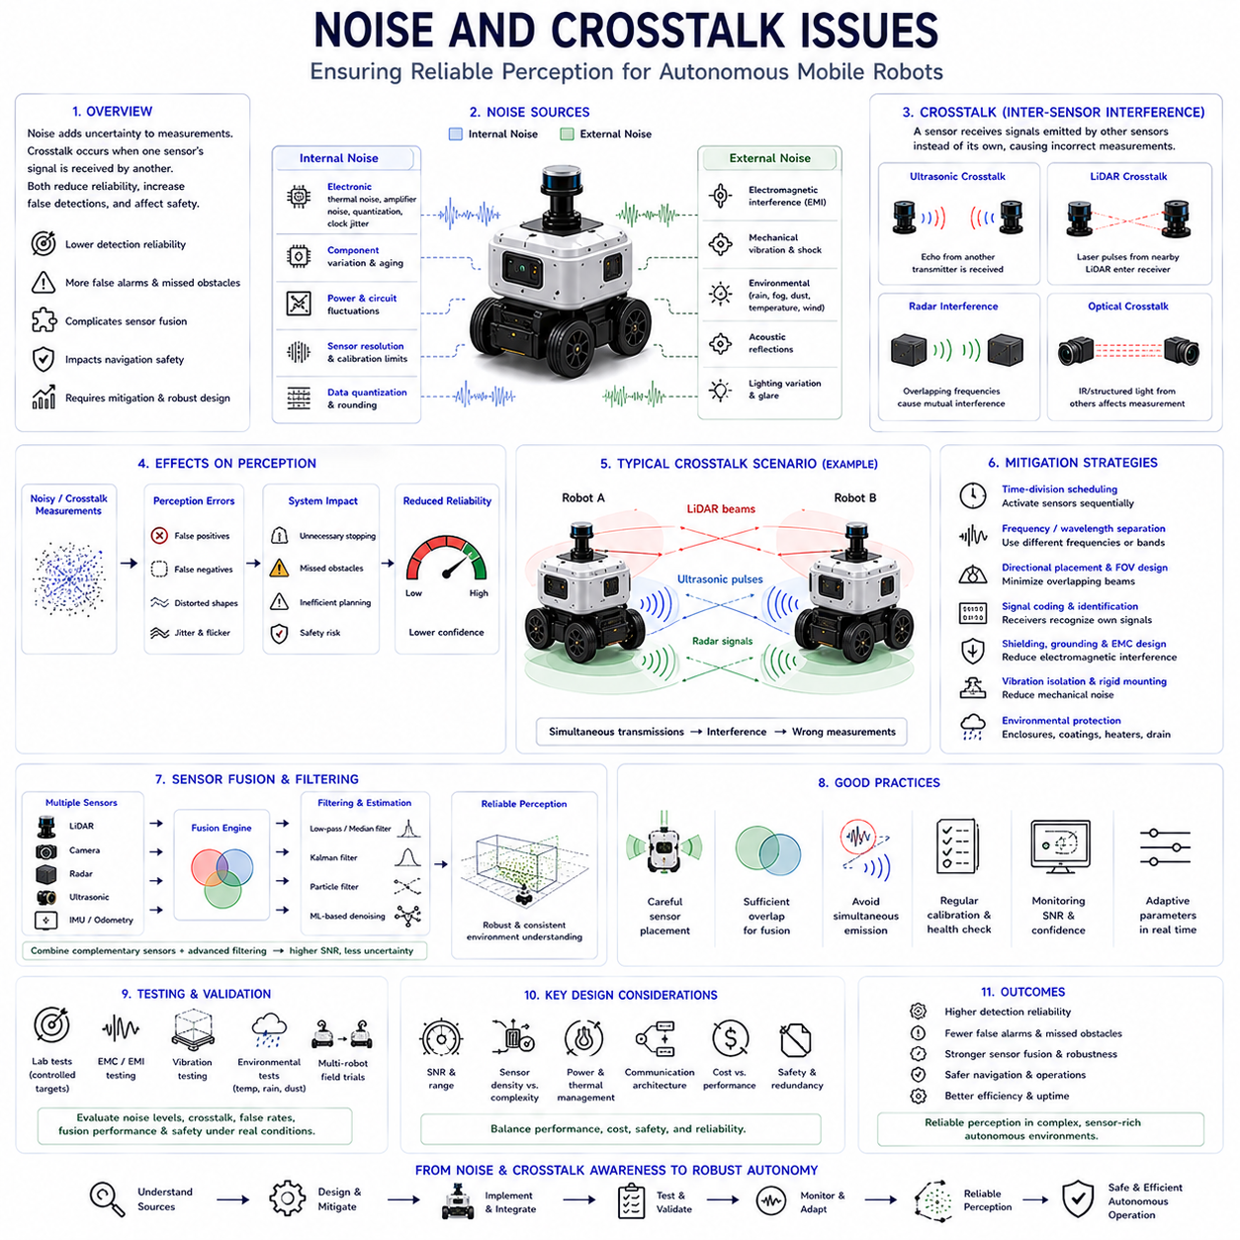
Noise and crosstalk are among the most significant factors that degrade the performance of perception systems in Autonomous Mobile Robots. Even when high-quality sensors are carefully selected and properly calibrated, measurement accuracy can deteriorate because unwanted signals interfere with legitimate sensor observations. Noise introduces random uncertainty into sensor measurements, while crosstalk occurs when signals generated by one sensing device are mistakenly received by another. Both phenomena reduce detection reliability, increase false alarms, complicate sensor fusion, and ultimately affect navigation safety. Consequently, understanding, identifying, and mitigating noise and crosstalk are fundamental requirements in designing robust autonomous perception systems.
Noise refers to unwanted disturbances that corrupt sensor measurements without carrying useful environmental information. Every sensing technology experiences some form of intrinsic noise originating from electronic components, thermal effects, signal quantization, optical imperfections, mechanical vibration, or environmental conditions. These disturbances appear as random fluctuations superimposed upon useful measurements, reducing accuracy and measurement confidence. Since completely eliminating noise is practically impossible, engineers focus on minimizing its influence through careful hardware design, signal processing, filtering algorithms, and robust perception strategies. Successful autonomous systems therefore tolerate a certain level of measurement uncertainty while maintaining reliable operation.
Noise can be broadly categorized into internal and external sources. Internal noise originates within the sensor itself and includes electronic amplifier noise, thermal noise, analog-to-digital conversion errors, clock jitter, sensor aging, and manufacturing variation. External noise arises from environmental influences such as electromagnetic interference, acoustic reflections, mechanical vibration, weather conditions, lighting variation, or surrounding electronic equipment. Although internal noise is generally predictable and stable, external noise changes continuously according to operating conditions. Perception systems must therefore adapt dynamically to varying environmental disturbances while preserving measurement quality.
Electronic noise represents one of the most common internal disturbances affecting perception sensors. Semiconductor devices naturally generate thermal noise due to random electron motion, while amplifiers introduce additional signal distortion during measurement processing. Analog circuits accumulate electrical fluctuations that become increasingly significant when detecting weak sensor signals. High-speed digital electronics, switching power supplies, communication buses, and electric motors further contribute unwanted electromagnetic disturbances. Proper circuit design, grounding, shielding, filtering, and power regulation significantly reduce electronic noise before it propagates into higher-level perception algorithms.
Mechanical vibration introduces another important source of measurement uncertainty. Autonomous robots frequently operate on uneven terrain where suspension movement, wheel impacts, drivetrain vibration, and structural resonance continuously disturb sensor alignment. Cameras experience motion blur, LiDAR measurements become spatially distorted, radar antenna orientation changes slightly, and inertial sensors detect unwanted accelerations. These disturbances degrade localization accuracy and environmental perception. Engineers therefore employ vibration-isolated mounting structures, rigid mechanical integration, structural damping, and motion compensation algorithms to minimize the influence of mechanical oscillations on sensor performance.
Environmental noise varies considerably across different sensing technologies. Cameras are affected by changing illumination, glare, shadows, reflections, rain, fog, snow, dust, and lens contamination. LiDAR experiences degradation due to airborne particles, precipitation, atmospheric scattering, and reflective surfaces. Ultrasonic sensors suffer from wind, temperature variation, humidity changes, and acoustic reflections. Radar generally demonstrates superior environmental robustness but may still encounter multipath reflections and electromagnetic interference. Understanding technology-specific environmental sensitivities allows engineers to combine complementary sensors whose weaknesses occur under different operating conditions.
Signal-to-noise ratio represents one of the most important indicators of measurement quality. This ratio compares useful sensor information against unwanted disturbances, providing an estimate of measurement reliability. High signal-to-noise ratios produce accurate and stable observations, whereas low ratios increase uncertainty, false detections, and missed obstacles. Signal strength depends upon target distance, object reflectivity, environmental conditions, sensor characteristics, and operating configuration. Adaptive perception algorithms frequently estimate signal quality continuously, allowing higher-level decision systems to evaluate confidence before acting upon sensor observations.
Crosstalk differs fundamentally from ordinary noise because it originates from intentional sensing signals emitted by neighboring sensors rather than random disturbances. Instead of receiving echoes from its own transmitted signal, a sensor mistakenly detects emissions produced by another device operating nearby. The receiving system therefore interprets incorrect information as legitimate environmental measurements. Crosstalk becomes increasingly common as autonomous robots incorporate larger numbers of active sensing devices including ultrasonic sensors, LiDAR units, radar systems, structured-light cameras, and wireless communication equipment operating simultaneously within confined spaces.
Ultrasonic crosstalk represents one of the most widely encountered interference problems in mobile robotics. Multiple ultrasonic sensors positioned around a vehicle may transmit acoustic pulses simultaneously. Since sound waves propagate relatively slowly through air, echoes from one transmitter may arrive at neighboring receivers before their own transmitted signals return. The receiving sensor incorrectly associates the foreign echo with its own measurement, generating inaccurate distance estimates or false obstacle detections. Large robotic fleets operating close together may further amplify acoustic interference because neighboring vehicles emit similar ultrasonic frequencies.
Several strategies reduce ultrasonic crosstalk effectively. Time-division scheduling activates only selected sensors during each measurement cycle, preventing simultaneous transmission. Frequency separation assigns slightly different operating frequencies to neighboring devices, reducing acoustic interference probability. Directional sensor placement minimizes overlapping acoustic beams, while intelligent signal coding enables receivers to identify their own transmitted pulses. Modern perception controllers frequently coordinate ultrasonic firing sequences centrally, ensuring that adjacent sensors never emit acoustic signals at the same instant during normal robot operation.
LiDAR crosstalk has become increasingly important as multiple laser scanners operate within shared industrial environments. Modern warehouses, factories, logistics centers, and automated production facilities may contain dozens or even hundreds of autonomous robots simultaneously performing laser scanning. When laser pulses emitted by one LiDAR enter another scanner's receiver, incorrect distance measurements or phantom points may appear within generated point clouds. Although modern LiDAR technologies employ sophisticated pulse coding, wavelength selection, and timing algorithms, dense multi-robot environments continue presenting challenging interference scenarios requiring careful system-level coordination.
Radar systems may also experience mutual interference when multiple units operate within overlapping frequency bands. Automotive radar technology has evolved sophisticated modulation techniques reducing direct interference, yet dense traffic environments containing numerous radar-equipped vehicles still generate measurement degradation. Industrial robots operating collaboratively within confined workspaces face similar challenges. Adaptive frequency allocation, waveform diversity, synchronized transmission scheduling, and advanced signal processing help distinguish desired reflections from interfering radar emissions while maintaining reliable object detection under complex operational conditions.
Optical crosstalk primarily affects cameras, structured-light systems, and time-of-flight imaging devices. Artificial illumination sources, infrared projectors, laser patterns, and structured-light emitters may interfere with neighboring optical systems. For example, multiple depth cameras projecting identical infrared patterns may confuse one another, reducing depth estimation accuracy. Likewise, flashing industrial lighting synchronized with machine operations may introduce image artifacts affecting computer vision algorithms. Engineers mitigate optical interference using wavelength filtering, exposure synchronization, optical shielding, adaptive illumination control, and careful installation geometry.
Electromagnetic interference influences nearly every electronic sensing system. High-current electric motors, switching inverters, battery management systems, wireless communication modules, high-speed processors, and industrial machinery generate electromagnetic fields capable of coupling into sensor wiring and electronic circuits. Long communication cables behave as unintended antennas, transmitting disturbances throughout the perception system. Proper cable routing, twisted-pair wiring, differential communication protocols, shielding, grounding strategies, and electromagnetic compatibility design collectively reduce susceptibility to external electromagnetic disturbances while preserving signal integrity.
Multipath propagation represents another important measurement challenge closely related to interference. Rather than traveling directly between transmitter and target, sensing signals may reflect multiple times from surrounding surfaces before reaching the receiver. Ultrasonic waves reflect from walls and machinery, LiDAR beams bounce from glass or metallic structures, radar signals propagate through multiple reflection paths, and optical systems experience glare from reflective materials. Multipath produces delayed or distorted measurements that may create phantom obstacles or incorrect distance estimates. Advanced perception algorithms therefore evaluate measurement consistency before accepting potentially corrupted observations.
False positives frequently result from severe noise and crosstalk conditions. A perception system incorrectly identifies obstacles that do not actually exist, causing unnecessary braking, hesitation, inefficient path planning, or mission interruption. Conversely, false negatives occur when legitimate obstacles remain undetected because interference masks useful sensor signals. Both situations reduce operational efficiency and compromise safety. Modern autonomous systems therefore estimate measurement confidence continuously, allowing decision algorithms to distinguish between highly reliable observations and uncertain sensor readings requiring additional verification.
Sensor fusion provides one of the most powerful approaches for mitigating noise and crosstalk. Since different sensing technologies exhibit different failure mechanisms, combining multiple independent observations significantly improves robustness. A false ultrasonic measurement may be rejected if LiDAR and camera observations disagree. Likewise, temporary camera degradation caused by sunlight can be compensated using radar and LiDAR measurements. Probabilistic sensor fusion algorithms evaluate measurement consistency, estimate uncertainty, assign confidence weights, and produce unified environmental representations substantially more reliable than individual sensor outputs alone.
Filtering techniques play a central role in suppressing measurement disturbances before higher-level perception processing begins. Low-pass filters reduce high-frequency electronic noise, while median filters eliminate isolated measurement spikes caused by interference. Kalman filters estimate underlying system states by combining noisy observations with motion prediction models. Particle filters manage highly nonlinear uncertainty distributions commonly encountered during autonomous navigation. More recently, machine learning techniques have learned to distinguish meaningful environmental features from interference patterns, enabling increasingly adaptive and context-aware perception systems under complex operating conditions.
System architecture significantly influences overall susceptibility to noise and crosstalk. Careful sensor placement reduces overlapping active sensing regions, while synchronized timing prevents simultaneous transmission among neighboring devices. Dedicated communication buses separate high-speed sensing traffic from motor control signals, minimizing electromagnetic coupling. Modular electronic design further isolates disturbances within individual subsystems rather than allowing interference to propagate throughout the entire robot. Consequently, robust perception depends not only upon sensor technology but equally upon thoughtful electrical, mechanical, computational, and communication architecture.
Testing and validation remain essential because many interference mechanisms only emerge under realistic operational conditions. Laboratory experiments evaluate individual sensor characteristics using controlled targets and calibrated environments, while electromagnetic compatibility testing measures resistance to electrical disturbances. Acoustic chambers analyze ultrasonic interference, vibration tables examine mechanically induced noise, and optical laboratories investigate lighting sensitivity. Field trials involving multiple autonomous robots operating simultaneously provide valuable insight into real-world crosstalk behavior, enabling engineers to refine synchronization strategies, sensor placement, and filtering algorithms before commercial deployment.
Future perception systems will increasingly employ intelligent interference management rather than relying solely on fixed engineering solutions. Artificial intelligence will continuously estimate environmental noise levels, predict interference sources, and dynamically adjust sensing parameters according to operating conditions. Digital twins will simulate electromagnetic, acoustic, optical, and mechanical interactions before physical deployment, optimizing sensor configuration automatically. Adaptive communication protocols, cooperative multi-robot sensing, cognitive radar, intelligent LiDAR scheduling, and self-learning sensor fusion architectures will collectively minimize noise and crosstalk while maximizing perception reliability. These advances will enable future Physical AI systems to maintain highly dependable environmental awareness even within extremely dense, dynamic, and sensor-rich autonomous ecosystems.

08.7 Ultrasonic Safety Limitations
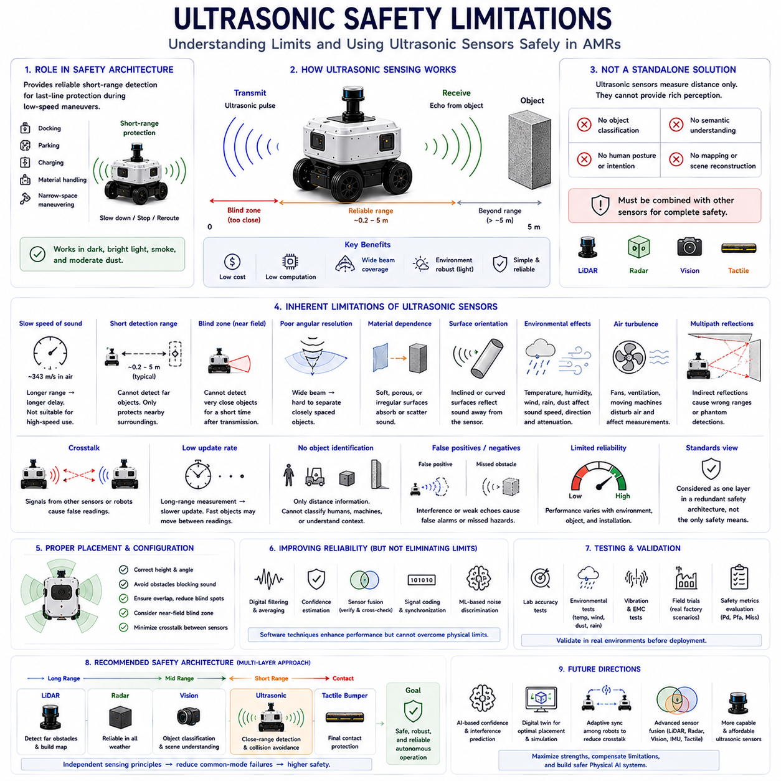
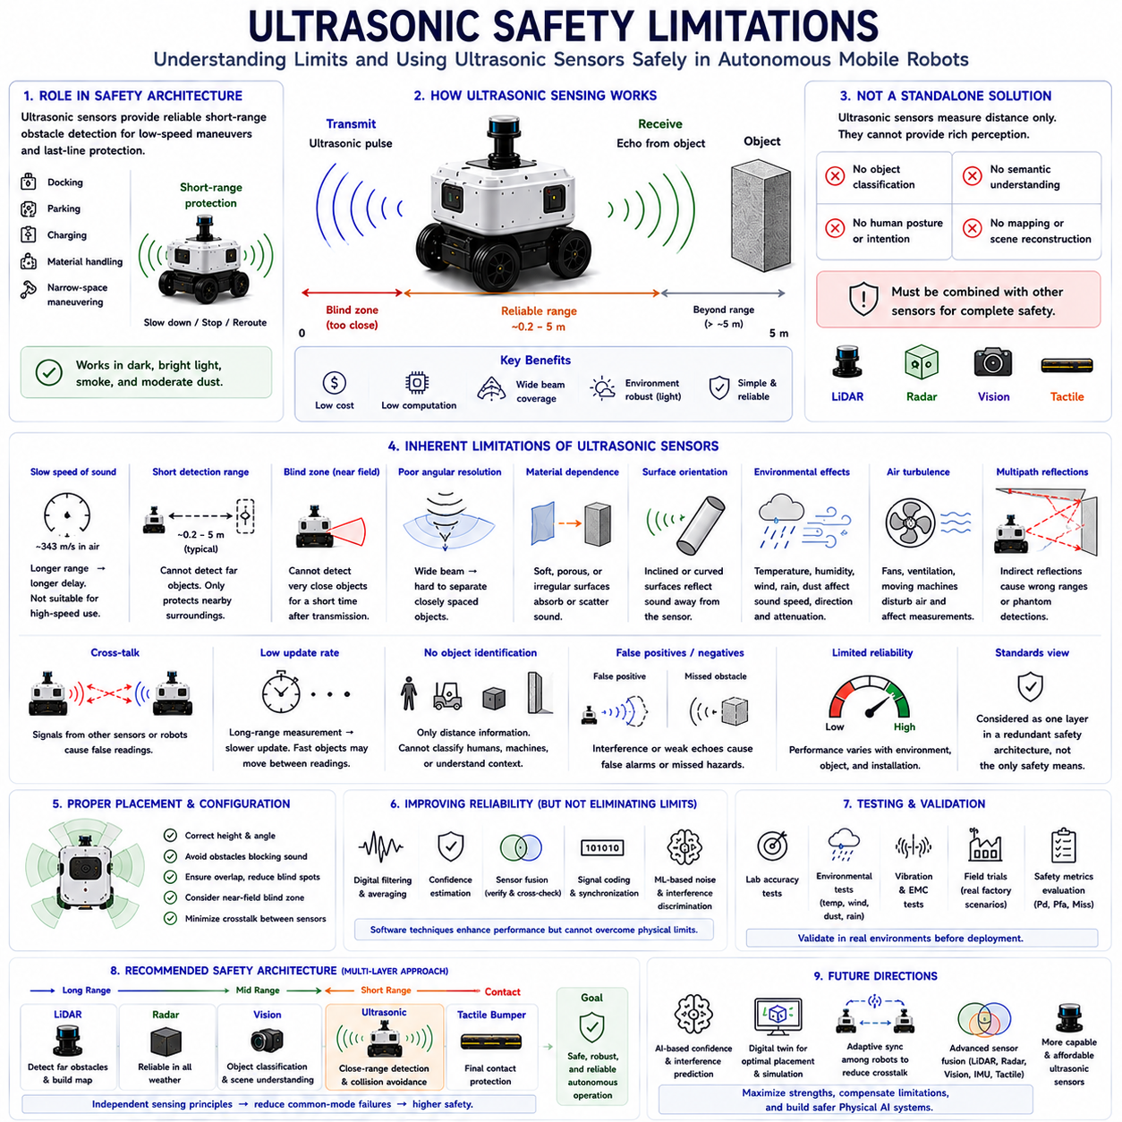
Ultrasonic sensing plays an important role in the safety architecture of Autonomous Mobile Robots because it provides reliable short-range obstacle detection with relatively low cost, low computational requirements, and stable operation under many lighting conditions. However, ultrasonic sensors also possess inherent physical limitations that prevent them from serving as a complete safety solution for autonomous navigation. Their performance depends on acoustic wave propagation, object characteristics, environmental conditions, and sensor configuration. Consequently, understanding these limitations is essential for designing safe perception systems that properly combine ultrasonic sensing with complementary technologies such as LiDAR, radar, vision, and tactile sensors.
The primary safety role of ultrasonic sensing is to detect nearby obstacles before physical contact occurs. During low-speed navigation, docking, parking, charging, material handling, and confined-space maneuvering, ultrasonic sensors provide continuous distance measurements that allow the robot to slow down, stop, or modify its trajectory. Since the sensing principle depends on sound waves rather than visible light, ultrasonic systems continue operating in complete darkness, bright sunlight, smoke, or moderate dust conditions where cameras may experience degraded performance. This characteristic makes ultrasonic sensing an important component within multi-layer safety architectures designed for industrial mobile robots.
Despite these advantages, ultrasonic sensing should never be regarded as a standalone functional safety solution. The technology was originally developed as a proximity sensing method rather than a complete environmental perception system. Ultrasonic sensors cannot classify objects, estimate semantic information, identify human posture, interpret dynamic scenes, or construct detailed environmental maps. They simply measure the presence and approximate distance of reflecting surfaces. Therefore, higher-level perception systems must combine ultrasonic measurements with richer sensing modalities capable of understanding complex environments before making navigation or safety decisions.
One of the most fundamental limitations originates from the relatively slow propagation speed of sound. Acoustic waves travel through air at approximately three hundred forty-three meters per second under normal atmospheric conditions, which is significantly slower than electromagnetic waves used by LiDAR, radar, or cameras. As detection range increases, the time required for transmitted pulses to return also increases proportionally. High-speed autonomous vehicles therefore cannot rely exclusively on ultrasonic sensing because the measurement update rate and available reaction time become insufficient for safe obstacle avoidance at higher travel velocities.
The effective sensing range of ultrasonic sensors remains relatively short compared with other perception technologies. Most industrial ultrasonic devices operate reliably between approximately twenty centimeters and five meters depending on sensor design, operating frequency, target characteristics, and environmental conditions. Objects located beyond this range remain undetectable, preventing early hazard recognition. Consequently, ultrasonic sensing primarily protects the immediate surroundings of the robot while long-range sensors provide advance environmental awareness necessary for path planning, collision prediction, and high-speed navigation.
Blind zones near the sensor face introduce another important safety limitation. Immediately after transmitting an acoustic pulse, the transducer continues vibrating for a brief period before it can receive returning echoes. During this interval, objects located extremely close to the sensor cannot be measured accurately. This minimum detection distance varies according to sensor construction but typically ranges from several centimeters to several tens of centimeters. Engineers must therefore carefully position sensors and define protective stopping distances that account for these unavoidable measurement gaps during low-speed maneuvering.
Angular resolution represents another inherent constraint of ultrasonic sensing. Acoustic beams spread naturally as they propagate through air, producing relatively wide sensing cones instead of highly focused measurement rays. While broad coverage simplifies nearby obstacle detection, it reduces the ability to distinguish closely spaced objects or identify precise obstacle geometry. Multiple nearby surfaces may generate overlapping echoes that merge into a single measurement. Consequently, ultrasonic sensors provide only approximate obstacle location and cannot accurately determine object shape, orientation, or detailed structural characteristics required for advanced navigation.
Object material properties significantly influence ultrasonic measurement reliability. Hard, flat surfaces generally reflect acoustic energy efficiently, producing strong and stable echoes. However, soft materials including fabrics, foam, vegetation, and certain packaging materials absorb rather than reflect sound waves, reducing detectable signal strength. Irregular or porous surfaces scatter acoustic energy in multiple directions, weakening return signals further. As a result, some obstacles may appear smaller than they actually are or remain entirely undetected under unfavorable reflection conditions, requiring complementary sensing technologies to ensure adequate operational safety.
Surface orientation also affects measurement accuracy. Ultrasonic sensing assumes that reflected acoustic energy returns toward the transmitting sensor. When encountering highly inclined or curved surfaces, reflected sound may travel away from the receiver instead of returning directly. Slanted walls, cylindrical objects, pipes, rounded containers, or angled vehicle bodies therefore generate weak or inconsistent echoes. The sensor may incorrectly estimate obstacle distance or fail to detect the object altogether. Engineers compensate partially through sensor placement and overlapping coverage but cannot eliminate this physical limitation entirely.
Environmental conditions continuously influence acoustic wave propagation. Temperature changes modify the speed of sound, causing measurable distance estimation errors if appropriate compensation is unavailable. Humidity alters acoustic attenuation characteristics, while strong wind changes wave propagation direction and effective travel time. Rain, snow, airborne dust, and heavy fog may scatter or absorb ultrasonic energy, reducing sensing performance. Although ultrasonic sensors often outperform cameras under poor lighting conditions, they remain susceptible to environmental influences that limit measurement consistency across changing outdoor operating environments.
Air turbulence generated by vehicle motion or nearby industrial equipment may additionally disturb ultrasonic measurements. High-speed fans, ventilation systems, compressed-air machinery, rotating equipment, or rapidly moving vehicles create local airflow variations affecting acoustic propagation. Since sound waves depend upon stable air transmission, fluctuating airflow may distort measured travel times or reduce echo intensity. Indoor factories with extensive ventilation systems therefore require careful validation to ensure ultrasonic performance remains sufficiently reliable under realistic operating conditions.
Multipath reflection creates another important source of safety uncertainty. Instead of reflecting directly from the nearest obstacle, acoustic waves may bounce repeatedly from walls, machinery, shelving, floors, or ceilings before reaching the receiver. These indirect echoes require longer travel distances, causing incorrect range estimates or phantom obstacle detections. Complex industrial environments containing narrow aisles, metallic equipment, and highly reflective surfaces increase multipath probability substantially. Advanced filtering algorithms help reject inconsistent measurements, but multipath propagation cannot be eliminated completely through software alone.
Cross-talk becomes particularly challenging whenever multiple ultrasonic sensors operate simultaneously. Echoes generated by one transmitter may be received accidentally by neighboring sensors, producing incorrect distance measurements or false obstacle detections. This phenomenon becomes even more severe when several autonomous robots operate within close proximity, each emitting similar ultrasonic frequencies. Time-division scheduling, frequency diversity, signal coding, and centralized synchronization reduce cross-talk considerably, yet dense multi-robot environments continue requiring careful system-level coordination to preserve measurement reliability.
Measurement update frequency also limits ultrasonic safety performance. Since each transmitted pulse must dissipate completely before the next measurement cycle begins, sensing frequency decreases as measurement range increases. Long-range operation therefore produces slower update rates compared with optical sensing technologies capable of rapid continuous observation. Fast-moving obstacles may change position significantly between successive ultrasonic measurements, increasing uncertainty during dynamic interactions with pedestrians, forklifts, automated guided vehicles, or collaborative robots sharing the same workspace.
Ultrasonic sensors provide limited capability for object identification. The technology reports distance information but cannot distinguish between humans, machinery, furniture, walls, pallets, animals, or moving vehicles. All sufficiently reflective objects appear similar from an acoustic perspective. Consequently, ultrasonic sensing cannot independently support advanced behavioral prediction, human intention estimation, object tracking, or semantic scene understanding. Safe autonomous operation therefore requires integration with cameras, LiDAR, artificial intelligence perception algorithms, or other technologies capable of recognizing object categories and interpreting environmental context.
Functional safety standards generally classify ultrasonic sensing as one component within a redundant protective architecture rather than the sole safety mechanism. Safety-critical autonomous robots frequently employ layered sensing strategies where long-range LiDAR detects distant obstacles, cameras classify environmental objects, radar provides reliable operation under adverse weather, ultrasonic sensors protect close-range regions, and tactile bumpers provide final physical contact detection. Independent sensing principles reduce common-mode failures because different technologies experience different environmental limitations. This diversity substantially improves overall system robustness.
Sensor placement significantly influences ultrasonic safety effectiveness. Improper installation height, excessive tilt, structural obstructions, or insufficient overlap between neighboring sensors may introduce blind zones that compromise obstacle detection. Protective housings, bumpers, payloads, robot arms, and external accessories may partially block acoustic propagation. Engineers therefore analyze coverage carefully using three-dimensional simulation and field testing before finalizing sensor configuration. Appropriate placement ensures continuous close-range monitoring while minimizing interference between adjacent sensing devices.
Signal processing techniques improve ultrasonic reliability but cannot eliminate physical limitations entirely. Digital filtering suppresses random electronic noise, while confidence estimation identifies uncertain measurements requiring verification. Temporal averaging reduces isolated outliers, and sensor fusion compares ultrasonic observations with independent sensing modalities before accepting potentially ambiguous detections. Machine learning approaches increasingly assist in distinguishing valid echoes from interference patterns. Nevertheless, software enhancement complements rather than replaces proper sensor selection, placement, and system architecture.
Testing and validation remain essential because ultrasonic safety performance depends strongly upon actual operating environments. Laboratory experiments evaluate sensor accuracy using standardized reference targets, while environmental testing examines performance under varying temperature, humidity, wind, dust, rain, vibration, and electromagnetic conditions. Field trials expose robots to representative industrial facilities where shelving, machinery, pedestrians, forklifts, reflective surfaces, and narrow corridors challenge close-range perception. Engineers evaluate detection probability, false alarm rate, missed obstacle frequency, blind-zone coverage, cross-talk susceptibility, and emergency stopping performance before approving deployment.
Future ultrasonic safety systems will increasingly become intelligent rather than functioning as isolated distance sensors. Artificial intelligence will estimate measurement confidence dynamically, identify abnormal echo patterns, predict environmental interference, and cooperate with digital twins that optimize sensor placement before deployment. Adaptive synchronization among multiple robots will reduce cross-talk automatically, while advanced sensor fusion architectures will integrate ultrasonic measurements seamlessly with LiDAR, radar, vision, inertial sensing, and tactile feedback. Rather than replacing ultrasonic technology, these developments will maximize its strengths while compensating for its inherent physical limitations, creating safer and more dependable Physical AI systems capable of operating confidently in increasingly complex industrial environments.

08.8 Field Testing Ultrasonic Sensors
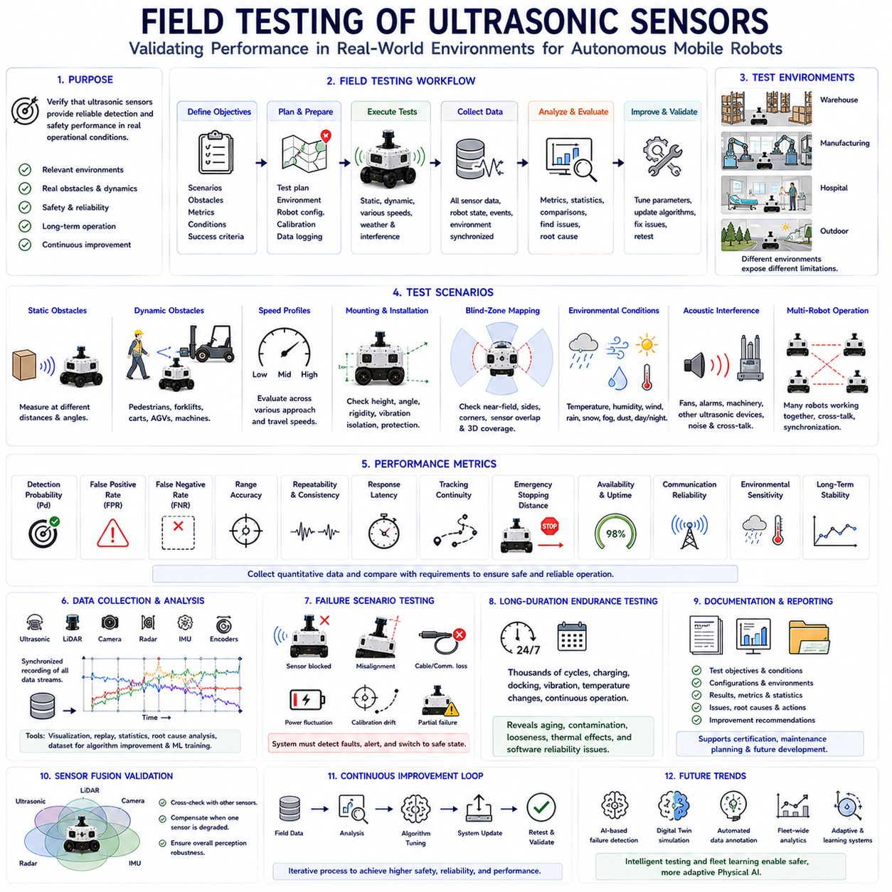
Field testing represents the final and most important stage in validating ultrasonic sensing performance for Autonomous Mobile Robots because laboratory measurements alone cannot fully represent the complexity of real operational environments. Although ultrasonic sensors may demonstrate excellent accuracy under controlled indoor conditions, actual industrial facilities introduce unpredictable obstacles, environmental disturbances, moving personnel, machinery, and weather variations that significantly influence measurement quality. Consequently, comprehensive field testing is essential to verify that ultrasonic sensing systems maintain reliable obstacle detection, consistent safety performance, and stable operation throughout prolonged autonomous missions under realistic working conditions.
The primary objective of field testing is to evaluate whether ultrasonic sensors satisfy operational requirements rather than simply meeting laboratory specifications. Sensor datasheets typically provide measurement range, accuracy, beam angle, and response time under ideal conditions, but actual performance depends upon installation geometry, environmental characteristics, surrounding equipment, and robot dynamics. Field validation therefore measures how effectively ultrasonic sensing supports navigation, docking, parking, collision avoidance, material handling, and emergency stopping during representative daily operations. Engineers focus on operational reliability rather than isolated sensor performance because autonomous systems ultimately succeed only when every subsystem functions together consistently.
Planning a successful field evaluation begins with clearly defining test objectives before any measurements are performed. Engineers identify critical operational scenarios, expected obstacle types, acceptable detection probabilities, required stopping distances, environmental conditions, and performance metrics. Testing plans specify robot speed, payload configuration, sensor calibration status, environmental variables, obstacle placement, and data recording procedures. Well-defined objectives ensure that collected results can be compared consistently across different testing sessions while providing quantitative evidence supporting system validation and future design improvements.
Selecting an appropriate testing environment significantly influences evaluation quality. Indoor warehouses provide structured aisles, shelving systems, pallets, forklifts, and pedestrian interaction representative of logistics applications. Manufacturing facilities introduce machinery, metallic structures, reflective surfaces, electrical interference, and constrained navigation corridors. Hospitals present narrow hallways, moving personnel, wheelchairs, beds, and dynamic public environments. Outdoor testing includes roads, sidewalks, vegetation, weather exposure, uneven terrain, and changing illumination. Each environment exposes different ultrasonic sensing limitations, requiring multiple testing locations before declaring perception systems operationally robust.
Obstacle selection represents another essential aspect of realistic field testing. Industrial robots encounter objects with diverse shapes, dimensions, materials, surface textures, and acoustic reflection characteristics. Test obstacles therefore include walls, pallets, cardboard boxes, wooden crates, metallic equipment, plastic containers, cylindrical columns, pipes, cables, shelving supports, safety barriers, forklifts, carts, machinery, furniture, vegetation, and pedestrians. Soft materials such as foam, fabric, protective clothing, or flexible packaging receive special attention because they absorb ultrasonic energy more readily than rigid reflective surfaces. Comprehensive obstacle diversity ensures accurate characterization of sensing limitations.
Static obstacle testing establishes baseline measurement performance before introducing dynamic scenarios. The robot approaches stationary targets positioned at predetermined distances and orientations while ultrasonic measurements are recorded continuously. Engineers evaluate detection probability, measured distance accuracy, repeatability, response stability, and false detection frequency across the complete sensing range. Objects are positioned directly ahead, laterally, diagonally, and partially within sensor coverage to examine beam characteristics thoroughly. These experiments reveal fundamental sensing capabilities under controlled yet realistic installation conditions before increasing environmental complexity.
Dynamic obstacle testing evaluates ultrasonic performance when both the robot and surrounding objects move simultaneously. Pedestrians walk across robot trajectories, forklifts cross intersections, automated guided vehicles operate nearby, and moving carts enter sensing regions unexpectedly. Relative motion introduces continuously changing obstacle geometry, requiring sensors to update measurements rapidly while maintaining reliable detection. Engineers evaluate response delay, tracking continuity, emergency stopping behavior, obstacle avoidance performance, and collision prevention effectiveness under representative industrial traffic conditions where operational safety depends upon timely perception.
Approach speed significantly influences ultrasonic safety performance during field validation. Low-speed docking and parking operations emphasize measurement precision, whereas moderate navigation speeds require balanced responsiveness and stability. Higher travel velocities reduce available reaction time, increasing dependence upon early obstacle detection and coordinated multi-sensor perception. Engineers therefore perform identical experiments across multiple speed profiles, verifying that protective stopping distances remain adequate throughout the operational velocity range. These tests help define safe speed limits compatible with ultrasonic sensing capabilities and overall vehicle dynamics.
Sensor mounting validation forms an important component of field testing because installation quality directly affects measurement reliability. Engineers verify mounting height, orientation, vibration isolation, mechanical rigidity, environmental protection, and cable routing under actual operating conditions. Minor installation deviations may produce unexpected blind regions, excessive ground reflections, or reduced obstacle visibility. Long-duration operation additionally reveals gradual mechanical loosening or alignment drift caused by vibration, thermal expansion, or repeated impacts. Field testing therefore confirms not only sensor performance but also long-term mechanical integration robustness.
Blind-zone evaluation examines regions immediately surrounding the robot where obstacle detection may become unreliable. Engineers position objects deliberately near sensor boundaries, vehicle corners, wheel locations, payload edges, bumpers, and structural obstructions while monitoring detection continuity. Particular attention focuses on transitions between adjacent ultrasonic sensors where incomplete coverage might permit small obstacles to remain temporarily undetected. Three-dimensional visualization tools frequently illustrate measured coverage maps, allowing engineers to compare actual sensing performance against theoretical installation models and identify regions requiring additional sensor overlap.
Environmental testing evaluates ultrasonic performance under varying weather and atmospheric conditions. Temperature variation influences sound velocity, humidity affects acoustic attenuation, and wind modifies wave propagation. Rain, snow, fog, dust, and airborne particles further alter sensing reliability by scattering or absorbing acoustic energy. Outdoor field trials therefore repeat identical navigation scenarios across different environmental conditions while recording detection performance continuously. Engineers analyze how measurement accuracy, false alarm frequency, and missed obstacle probability vary throughout seasonal environmental changes likely to occur during normal robot operation.
Acoustic interference testing investigates how surrounding industrial equipment influences ultrasonic measurements. Ventilation systems, compressed-air machinery, pneumatic tools, production equipment, warning alarms, and other ultrasonic devices may generate acoustic disturbances affecting sensor performance. Engineers operate robots within active industrial facilities while monitoring measurement stability under realistic noise conditions. Additional experiments intentionally introduce multiple ultrasonic sources simultaneously to evaluate cross-talk susceptibility. These studies verify that synchronization strategies, signal processing algorithms, and sensor placement adequately suppress interference before commercial deployment.
Multi-robot testing has become increasingly important as autonomous fleets expand within logistics centers and manufacturing facilities. Multiple robots equipped with ultrasonic sensors operate simultaneously while sharing navigation space, docking stations, charging areas, and transportation corridors. Engineers evaluate whether ultrasonic emissions from neighboring vehicles introduce false measurements, delayed responses, or obstacle detection failures. Cooperative scheduling, communication coordination, and synchronized sensing architectures undergo validation during these experiments, ensuring reliable perception even under dense fleet operation involving dozens of autonomous platforms.
Data collection represents one of the most valuable outcomes of comprehensive field testing. Every sensor measurement, robot state, environmental condition, localization estimate, actuator command, and system event is recorded continuously for later analysis. Time synchronization across all sensing devices enables accurate reconstruction of operational scenarios during post-processing. High-quality datasets support algorithm refinement, failure investigation, parameter optimization, machine learning development, and future regression testing. Long-term operational datasets frequently become more valuable than isolated experimental results because they reveal subtle performance trends difficult to observe during short evaluations.
Performance metrics provide objective evidence for evaluating ultrasonic sensing quality. Common indicators include detection probability, false positive rate, false negative rate, measurement accuracy, repeatability, response latency, obstacle tracking continuity, emergency stopping distance, sensor availability, communication reliability, and operational uptime. Additional statistical analysis examines measurement variance, confidence estimation accuracy, environmental sensitivity, and long-term stability. Quantitative performance indicators enable direct comparison between different sensor configurations, algorithm versions, or hardware generations while supporting engineering decisions through measurable evidence rather than subjective observation.
Sensor fusion validation verifies that ultrasonic measurements cooperate effectively with complementary perception technologies. Engineers compare independent observations from LiDAR, cameras, radar, inertial sensors, wheel encoders, and ultrasonic sensors during identical operational scenarios. Temporary ultrasonic degradation caused by environmental conditions should be compensated automatically through alternative sensing modalities without compromising overall navigation safety. Likewise, ultrasonic sensors should provide reliable close-range confirmation when optical systems experience lighting challenges. Successful field validation therefore emphasizes complete perception system behavior rather than evaluating ultrasonic sensing in isolation.
Failure scenario testing intentionally introduces abnormal conditions to examine system robustness. Engineers simulate sensor blockage using mud, tape, water droplets, or protective covers while monitoring diagnostic behavior. Cable disconnection, communication interruption, power fluctuation, sensor misalignment, software restart, calibration drift, and partial hardware failure further evaluate fault detection capabilities. Safety architectures must recognize degraded sensing conditions rapidly, notify supervisory systems appropriately, and transition autonomous operation into predefined safe states whenever sensing reliability falls below acceptable thresholds.
Long-duration endurance testing determines whether ultrasonic sensing maintains stable performance throughout extended operational periods. Autonomous robots frequently operate continuously for many hours or even around the clock in industrial environments. Engineers therefore perform prolonged navigation missions covering thousands of obstacle encounters, repeated docking operations, charging cycles, environmental transitions, and mechanical vibration exposure. Performance trends reveal sensor aging, contamination accumulation, thermal effects, mounting degradation, communication instability, and software reliability issues that remain invisible during short experimental sessions.
Testing documentation transforms field observations into engineering knowledge supporting product certification, maintenance planning, and future development. Comprehensive reports describe testing objectives, environmental conditions, equipment configuration, obstacle specifications, performance metrics, identified limitations, corrective actions, and recommended improvements. Photographs, synchronized sensor recordings, trajectory maps, statistical summaries, and failure analyses provide objective evidence supporting design decisions. Well-organized documentation additionally enables reproducible regression testing whenever hardware, software, or perception algorithms evolve during subsequent product development cycles.
Future field testing methodologies will increasingly combine artificial intelligence, digital twins, automated data annotation, and cloud-based fleet analytics to accelerate perception validation. Digital twins will reproduce physical environments before deployment, allowing optimized test planning and sensor placement. Artificial intelligence will identify rare failure patterns automatically, estimate confidence degradation, and recommend additional validation scenarios requiring further investigation. Fleet-wide operational learning will continuously collect anonymous sensing statistics from deployed robots, enabling ultrasonic perception systems to improve throughout their operational lifetime. These intelligent validation strategies will transform field testing from a one-time engineering activity into a continuous lifecycle process supporting increasingly safe, reliable, and adaptive Physical AI systems.

