Volume 03. AMR Sensors and Perception

Chapter 06. Thermal Cameras

06.1 Thermal Imaging Principles
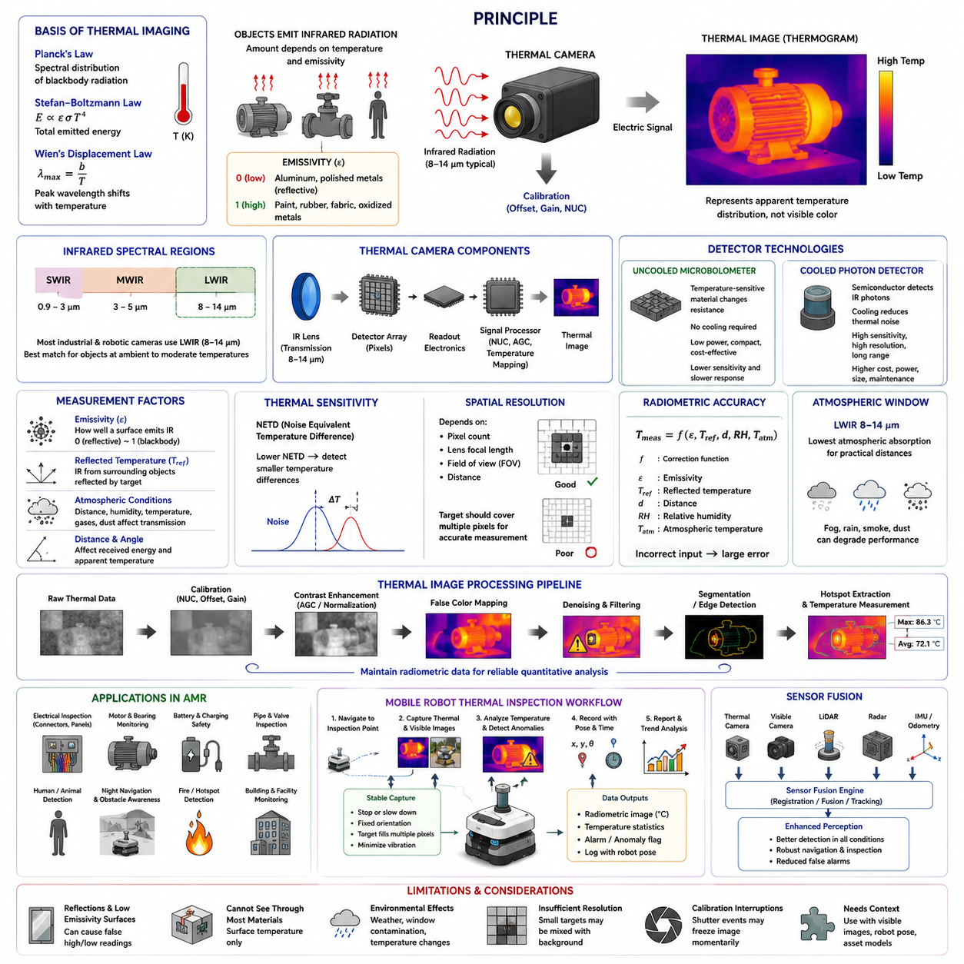
Thermal imaging is a passive sensing method that detects infrared radiation emitted or reflected by objects and converts it into a visible temperature-related image. Every object with a temperature above absolute zero emits electromagnetic energy, and the intensity and spectral distribution of this radiation vary with temperature. Thermal cameras capture this energy without requiring visible illumination, which allows them to operate in complete darkness, smoke, haze, and many low-contrast environments where conventional cameras may provide limited information.
The physical basis of thermal imaging is described by thermal radiation laws. Planck’s law explains the spectral distribution of radiation emitted by an ideal blackbody, while the Stefan–Boltzmann law relates total emitted energy to the fourth power of absolute temperature. Wien’s displacement law indicates that the wavelength of peak emission shifts as temperature changes. Objects near normal industrial and environmental temperatures emit most strongly in the long-wave infrared region, making this band especially useful for robotic inspection and monitoring.
Real materials do not behave as perfect blackbodies. Their ability to emit thermal radiation is described by emissivity, a value between zero and one. High-emissivity materials such as painted surfaces, rubber, fabric, and oxidized metals generally produce reliable thermal readings. Low-emissivity materials such as polished aluminum or stainless steel can reflect radiation from surrounding objects and cause misleading temperature measurements. Accurate thermal interpretation therefore requires knowledge of surface material, finish, viewing angle, and environmental reflections.
Infrared radiation is commonly divided into short-wave, mid-wave, and long-wave spectral regions. Most uncooled thermal cameras used in mobile robots operate in the long-wave infrared band, typically around 8–14 micrometers. This band aligns well with thermal emissions from objects at ambient and moderately elevated temperatures. Mid-wave infrared cameras, generally operating around 3–5 micrometers, can provide higher sensitivity and faster response but often require cooled detectors, increasing cost, size, power consumption, and maintenance complexity.
A thermal camera includes an infrared-transparent lens, detector array, readout electronics, signal processor, and calibration system. The lens focuses incoming infrared energy onto the detector, where each pixel produces an electrical response proportional to the absorbed radiation. The readout integrated circuit collects these signals, and the image processor applies offset correction, gain adjustment, noise filtering, and temperature mapping. The resulting thermogram represents spatial differences in apparent temperature rather than a conventional color or brightness image.
Uncooled microbolometers are widely used in industrial and robotic thermal cameras. Each pixel contains a temperature-sensitive material whose electrical resistance changes when infrared radiation is absorbed. Because the detector operates near ambient temperature, it does not require a cryogenic cooling system. This reduces power consumption and makes compact thermal modules practical for AMRs. However, microbolometers may exhibit slower response, greater drift, and lower sensitivity than cooled photon detectors, requiring frequent internal calibration and compensation.
Cooled thermal detectors use semiconductor materials that directly respond to incoming infrared photons. Cooling reduces thermal noise and improves sensitivity, spatial resolution, frame rate, and detection range. These characteristics make cooled systems suitable for long-range surveillance, gas imaging, scientific measurement, and demanding defense applications. Their disadvantages include higher cost, greater power demand, mechanical complexity, limited cooler life, and longer startup time, which usually make them unsuitable for standard mobile robot inspection unless exceptional performance is required.
Thermal sensitivity is often expressed as Noise Equivalent Temperature Difference, or NETD. A lower NETD value indicates that the camera can distinguish smaller temperature differences. High thermal sensitivity is important when detecting subtle anomalies such as early electrical heating, insulation defects, bearing friction, fluid leakage, or human presence in low-contrast backgrounds. However, sensitivity alone does not determine inspection quality. Spatial resolution, lens selection, calibration, target size, measurement distance, and environmental stability are equally important.
Spatial resolution depends on the detector pixel count, lens focal length, field of view, and distance to the target. A thermal camera may detect a large hot region from far away but may not measure the temperature of a small component accurately if the target covers too few pixels. The instantaneous field of view defines the angular area represented by one pixel. For quantitative inspection, the target should occupy multiple pixels so that edge mixing and background radiation do not dominate the measurement.
The apparent temperature measured by a thermal camera can differ from the true surface temperature because the received radiation includes emitted energy from the target, reflected radiation from nearby sources, and radiation transmitted through the atmosphere. Measurement software may require input values for emissivity, reflected temperature, distance, humidity, and atmospheric temperature. Errors in these parameters can produce significant inaccuracies, particularly for low-emissivity surfaces, long measurement ranges, or environments containing strong heat sources.
Atmospheric conditions affect infrared transmission. Water vapor, carbon dioxide, dust, smoke, and precipitation can absorb or scatter parts of the infrared spectrum. The 8–14 micrometer band is commonly used because it lies within an atmospheric transmission window where absorption is relatively low over practical industrial distances. Even so, heavy rain, dense steam, hot exhaust gases, or contaminated protective windows can reduce image quality and temperature accuracy. Outdoor robotic systems must therefore monitor lens condition and environmental exposure.
Thermal images require calibration and correction before they can be interpreted reliably. Detector pixels do not respond identically, and their output may drift with sensor temperature. Non-uniformity correction compensates for pixel-to-pixel variation, while internal shutters or reference sources periodically provide a uniform temperature target for recalibration. During this process, the image may briefly freeze. Robot perception software must account for these interruptions and avoid treating calibration artifacts as sudden environmental events.
Thermal image processing often includes contrast enhancement, temperature normalization, false-color mapping, denoising, edge detection, segmentation, and hotspot extraction. Automatic gain control adjusts the displayed temperature range to improve visual contrast, but it can also make identical objects appear different between frames. For autonomous inspection, the system should preserve radiometric data and use absolute or consistently normalized temperature values rather than relying only on visual color palettes. This supports repeatable anomaly detection and trend analysis.
Thermal cameras can be radiometric or non-radiometric. Radiometric cameras provide temperature-related data for each pixel, enabling quantitative inspection and threshold-based alarms. Non-radiometric cameras primarily generate thermal contrast images and may be sufficient for navigation, person detection, or general situational awareness. AMR inspection missions typically require radiometric sensors when the objective is to detect overheating motors, electrical panels, batteries, bearings, pipelines, or process equipment with measurable temperature criteria.
Thermal imaging is valuable for human and animal detection because warm bodies often create strong contrast against cooler backgrounds. It can support nighttime navigation, perimeter monitoring, rescue operations, and worker safety. However, thermal appearance changes with clothing, weather, physical activity, and background temperature. On hot days, roads, walls, and machinery may reach temperatures similar to the human body, reducing contrast. Thermal sensing should therefore be combined with tracking, motion analysis, visible cameras, radar, or LiDAR.
In industrial inspection, thermal imaging reveals abnormal heat patterns associated with resistance, friction, overload, insulation failure, fluid blockage, or inefficient energy transfer. Electrical connectors may heat because of loose contacts, motors may show uneven winding temperatures, and bearings may develop localized hotspots before mechanical failure. The thermal pattern is often more informative than a single maximum temperature value. Reliable diagnosis requires comparison with normal operating conditions, load level, ambient temperature, and historical trends.
Thermal inspection from a moving AMR introduces additional challenges. Motion blur, vibration, rapidly changing viewing angles, and varying distance can affect measurement consistency. The robot may need to stop or move slowly at inspection points, maintain a defined camera orientation, and verify that the target occupies a sufficient image area. Stable timestamps and synchronization with robot pose are also required so that detected anomalies can be mapped accurately to physical assets and revisited during later missions.
Lens and protective window materials must be selected specifically for infrared transmission. Ordinary glass blocks most long-wave infrared radiation and cannot be placed in front of a thermal camera. Materials such as germanium, zinc selenide, or specialized polymers are used for lenses and windows. These materials can be sensitive to scratching, contamination, moisture, and impact. Protective housings must therefore balance environmental durability with low infrared attenuation, minimal reflection, and stable performance across temperature changes.
Thermal cameras are often integrated with visible-light cameras to create complementary inspection data. The visible camera provides texture, labels, component identity, and geometric context, while the thermal camera reveals heat distribution. Image registration aligns both modalities so that hotspots can be associated with specific objects. Differences in resolution, lens position, distortion, and field of view must be calibrated carefully. Accurate fusion improves operator interpretation and supports automated defect classification.
Thermal imaging also contributes to battery and charging-system safety in AMRs. Abnormal cell temperature, uneven module heating, connector resistance, cooling failure, or charger overheating may indicate developing faults. A thermal camera can inspect battery enclosures, power electronics, motors, and charging interfaces during operation. It should not replace embedded temperature sensors, because surface temperature may not represent internal cell conditions. Instead, thermal imaging provides additional spatial evidence and can identify localized anomalies not captured by point sensors.
Effective thermal sensing requires understanding both its strengths and limitations. It operates without visible light, detects subtle heat patterns, and supports non-contact inspection, but it cannot see through most solid materials and does not directly measure internal temperature. Reflections, emissivity errors, environmental conditions, and insufficient spatial resolution can produce false conclusions. For autonomous robots, the best results come from combining calibrated thermal data with visible imagery, robot pose, asset models, operating context, and historical measurements.

06.2 Thermal Camera Specifications
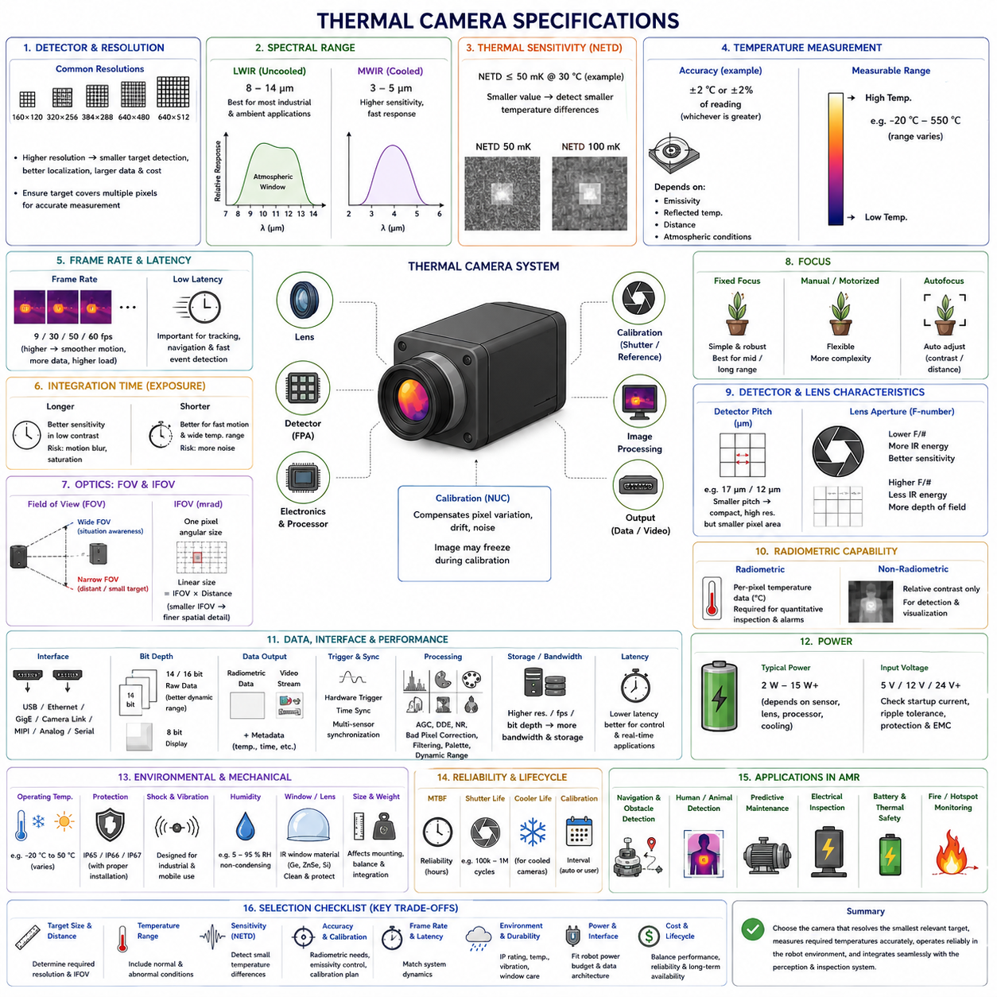
Thermal camera specifications define how effectively a sensor can detect infrared radiation, distinguish temperature differences, measure surface temperature, and produce stable images under real operating conditions. For autonomous mobile robots, the specification sheet must be interpreted as a complete system description rather than as a list of isolated numbers. Detector resolution, spectral response, thermal sensitivity, lens characteristics, calibration accuracy, frame rate, interface, power demand, housing protection, and environmental limits collectively determine whether the camera is suitable for navigation, safety monitoring, predictive maintenance, or quantitative industrial inspection.
Detector resolution indicates the number of infrared-sensitive pixels available in the focal plane array. Common thermal modules may provide resolutions such as 160 × 120, 320 × 256, 384 × 288, 640 × 480, or 640 × 512 pixels. Higher resolution improves the ability to distinguish small targets, localize hotspots, and inspect components from greater distances. However, it also increases sensor cost, data bandwidth, processing load, storage demand, and calibration complexity. The required resolution should therefore be selected from the smallest target size, expected inspection distance, and required measurement repeatability rather than from image quality alone.
Thermal resolution must be distinguished from ordinary visible-camera resolution because each thermal pixel represents a measured infrared energy sample. A target that occupies only one or two pixels may be detectable but cannot usually be measured accurately. Heat from the target becomes mixed with radiation from the background, creating a diluted apparent temperature. For reliable quantitative inspection, the target should cover several pixels in both horizontal and vertical directions. Engineering decisions should therefore consider pixels on target, not simply total pixel count, when selecting a camera for electrical panels, bearings, pipes, batteries, motors, or human detection.
The spectral range specifies the infrared wavelengths to which the detector responds. Most uncooled industrial thermal cameras operate in the long-wave infrared band between approximately 8 and 14 micrometers. This range is well matched to objects near ambient and moderately elevated temperatures and also lies within a useful atmospheric transmission window. Cooled cameras may operate in the mid-wave infrared band around 3 to 5 micrometers, offering higher sensitivity and faster response for specialized applications. Spectral selection affects lens material, detector technology, environmental performance, calibration method, and the types of targets that can be observed.
Thermal sensitivity is commonly expressed as Noise Equivalent Temperature Difference, or NETD. This value indicates the smallest temperature difference that the camera can distinguish above its internal noise level. A specification such as less than 50 millikelvin means that the sensor can theoretically resolve a temperature difference smaller than 0.05 degrees Celsius under defined laboratory conditions. Lower NETD is generally better, especially for detecting subtle heating patterns. However, real performance depends on scene temperature, lens transmission, frame averaging, calibration state, image processing, and environmental stability, so NETD should not be interpreted as absolute measurement accuracy.
Temperature measurement accuracy describes how closely the reported temperature corresponds to the actual target surface temperature. Typical industrial specifications may be expressed as a fixed value, such as ±2 degrees Celsius, or as a percentage of the reading, such as ±2 percent, whichever is greater. This accuracy normally applies only within specified temperature ranges, calibration conditions, distances, emissivity values, and environmental limits. Low-emissivity materials, strong reflections, atmospheric attenuation, and incorrect parameter settings can introduce errors much larger than the nominal camera accuracy. Radiometric performance must therefore be evaluated together with the complete measurement setup.
The measurable temperature range defines the minimum and maximum apparent temperatures that the camera can quantify without saturation. A general-purpose uncooled camera may include multiple ranges, such as a low-temperature mode for ambient environments and a high-temperature mode for industrial equipment. Switching to a wider range often reduces sensitivity because the signal must cover a larger dynamic span. Systems inspecting batteries, electrical cabinets, motors, furnaces, or firefighting environments may require different range configurations. The selected range should include expected abnormal conditions while retaining sufficient sensitivity for early-stage anomaly detection.
Frame rate determines how frequently the thermal image is updated. Low-cost or export-limited cameras may operate near 9 frames per second, while industrial and robotic models commonly provide 30, 50, or 60 frames per second. Higher frame rates improve imaging of moving targets, reduce temporal lag, and support smoother tracking from a mobile platform. They also increase interface bandwidth, processor load, and storage consumption. For stationary inspection points, a moderate frame rate may be sufficient, whereas navigation, human detection, moving machinery monitoring, and fast robot motion generally benefit from higher update rates and low latency.
Integration time, also known as exposure time, controls how long the detector accumulates infrared energy for each frame. Longer integration can improve signal quality in low-contrast scenes but may cause motion blur or saturation when observing hot targets. Shorter integration supports fast motion and wide temperature ranges but can increase noise. Some cameras automatically adjust integration time according to scene temperature, while advanced models provide manual or programmable control. Mobile robot systems should verify that automatic exposure changes do not create abrupt image shifts that could be misinterpreted by anomaly detection or tracking algorithms.
Field of view defines the angular region observed by the camera and is determined by detector size and lens focal length. A wide-angle lens provides broad situational awareness and is useful for navigation, human detection, and inspection in confined spaces. A narrow-angle lens provides greater pixel density on distant targets and is better suited for small components or long-range monitoring. Field of view must be evaluated in both horizontal and vertical directions. Robot designers should also consider mounting height, camera tilt, blind zones, target distance, and overlap with visible cameras or LiDAR sensors.
Instantaneous Field of View, or IFOV, represents the angular coverage of a single detector pixel. It is usually expressed in milliradians and directly affects the smallest spatial feature that can be resolved at a given distance. Multiplying IFOV by target distance gives an approximate pixel footprint on the observed surface. Measurement Field of View may be larger than one pixel because accurate temperature measurement normally requires several adjacent pixels. These values are essential when deciding whether a selected camera can inspect a small connector, cable terminal, bearing housing, battery cell, or pipe joint from the planned robot path.
Minimum focus distance indicates how close a target can be while remaining sharply imaged. Fixed-focus thermal modules are convenient for compact robots but may be optimized for medium or long distances, causing nearby inspection targets to appear blurred. Manual-focus or motorized-focus lenses provide greater flexibility but add mechanical complexity and control requirements. Autofocus systems may use contrast, distance sensors, or motorized lens mechanisms. For AMRs that approach equipment at varying distances, focus capability should be matched to docking accuracy, inspection pose, target depth variation, and required measurement repeatability.
Detector pitch is the physical spacing between adjacent pixels, commonly expressed in micrometers. Smaller pixel pitch enables compact optical systems and can support higher resolution within a smaller sensor package. However, it also reduces the collecting area of each pixel and can affect sensitivity, noise, diffraction behavior, and manufacturing complexity. Typical modern uncooled microbolometers use pitches such as 17 or 12 micrometers. Pixel pitch should not be evaluated independently because detector technology, lens aperture, calibration quality, and signal processing jointly determine actual image performance.
The lens aperture is usually specified by its f-number, which represents the ratio between focal length and effective aperture diameter. A lower f-number allows more infrared energy to reach the detector, potentially improving sensitivity and reducing noise. However, it may also increase optical complexity, cost, size, and susceptibility to aberrations. Thermal lenses are commonly manufactured from germanium or specialized infrared-transmitting materials rather than ordinary glass. Lens coating, transmission efficiency, temperature stability, focus behavior, and protective-window compatibility are critical for maintaining the expected camera specification after installation.
Radiometric capability determines whether temperature information is available for every image pixel. Fully radiometric cameras provide calibrated temperature-related data and are required for quantitative inspection, threshold alarms, temperature statistics, and historical trend analysis. Non-radiometric cameras provide only relative thermal contrast and are mainly suited to detection or visualization. Some modules output both radiometric data and processed video streams. The system integrator should confirm data format, calibration coefficients, metadata availability, temperature units, emissivity settings, and whether the radiometric values remain accessible after compression or network transmission.
Calibration specifications describe how the camera compensates for detector variation, temperature drift, optical effects, and electronic noise. Non-uniformity correction is commonly performed using an internal shutter that temporarily presents a uniform reference surface to the detector. The camera may automatically trigger this process according to time, sensor temperature, or image quality. During correction, the output frame may freeze or become temporarily unavailable. AMR software should receive calibration status or detect these events so that frozen frames are not interpreted as stationary targets, thermal anomalies, or communication failures.
Startup time and warm-up stability are important but frequently overlooked specifications. An uncooled camera may begin streaming images shortly after power-on, yet accurate radiometric performance can require additional time for the detector, housing, lens, and internal electronics to reach thermal equilibrium. Rapid changes in ambient temperature may also create temporary measurement drift. Robots moving between indoor and outdoor areas, refrigerated zones, hot production spaces, or direct sunlight should account for stabilization behavior. Mission planning may need to delay quantitative inspection until the camera reaches a defined operating condition.
Image processing functions can include automatic gain control, digital detail enhancement, noise reduction, bad-pixel replacement, edge enhancement, temporal filtering, palette generation, and dynamic-range compression. These features improve visual readability but may alter the relationship between displayed brightness and absolute temperature. For automated analysis, raw or radiometric data should be preserved whenever possible. Processing latency must also be considered because aggressive filtering and frame averaging can delay response to rapidly changing events. The selected processing mode should match whether the primary goal is operator visualization, machine perception, or quantitative measurement.
Interface specifications determine how image and temperature data are transferred to the robot computer. Common options include USB, Ethernet, Gigabit Ethernet, Camera Link, MIPI, analog video, or proprietary serial interfaces. Ethernet supports longer cable runs and network integration, while USB simplifies local connection but may be sensitive to cable length and connector reliability. The interface must support the required frame rate, resolution, bit depth, metadata, and radiometric stream without packet loss. Timestamping, trigger support, synchronization, and software development kit compatibility are especially important for multi-sensor fusion and inspection mapping.
Image bit depth defines the number of digital levels available to represent the detector signal. Thermal systems often use 14-bit or 16-bit raw data internally, providing much greater dynamic range than an 8-bit display image. High bit depth supports fine temperature discrimination and robust post-processing, but it increases bandwidth and storage requirements. Display palettes usually compress the raw data into 8-bit values for visualization, which can discard quantitative detail. Robotic inspection systems should store radiometric or high-bit-depth data when later reprocessing, auditability, model training, or detailed trend analysis is required.
Power input and consumption affect AMR runtime, thermal management, and electrical architecture. Compact uncooled modules may consume only a few watts, while stabilized housings, heaters, motorized lenses, onboard processors, or cooled detectors require substantially more power. Input voltage tolerance, startup current, reverse-polarity protection, isolation, grounding, and electromagnetic compatibility should be checked carefully. The camera’s own heat generation can influence detector stability if cooling airflow is restricted. Power-quality disturbances from motors, DC-DC converters, charging systems, and computing hardware may also introduce noise or communication faults.
Environmental specifications commonly include operating temperature, storage temperature, humidity tolerance, shock, vibration, ingress protection, and resistance to salt, dust, or chemicals. A camera qualified only for indoor laboratory use may not survive outdoor AMR operation. Industrial housings may provide ratings such as IP65, IP66, or IP67, but the rating applies only when connectors, cable glands, windows, and seals are installed correctly. Condensation prevention, window heating, sun shielding, and thermal isolation may be required when operating across large temperature differences or under changing weather conditions.
Physical dimensions, mass, connector orientation, and mounting features affect sensor placement and robot balance. A lightweight module may be installed on a mast, pan-tilt unit, robotic arm, or inspection head, while heavier cooled systems require stronger mechanical support. Mounting brackets must maintain stable alignment under vibration and impact. The thermal camera should also be positioned to prevent occlusion by robot structures, payloads, cables, or protective guards. Mechanical integration must preserve access for cleaning, focus adjustment, calibration, replacement, and inspection of the infrared window.
Reliability and lifecycle specifications include mean time between failures, shutter life, cooler life, connector durability, calibration interval, software support, and product availability. A cooled detector may provide excellent performance but contain a mechanical cooler with a finite operating life. An internal calibration shutter is also a moving component that can eventually wear. Long-term AMR deployments should consider replacement availability, firmware maintenance, operating-hour logging, and compatibility with future software versions. Industrial product continuity may be more valuable than marginal improvements in image quality.
Selecting a thermal camera for an AMR requires balancing radiometric accuracy, detector resolution, NETD, frame rate, field of view, target distance, environmental durability, interface, power, and cost. No single specification can guarantee successful performance. The appropriate camera is the one that resolves the smallest relevant target, measures the required temperature range, operates reliably within the robot environment, and integrates cleanly with the perception and inspection software. Field validation with representative materials, distances, weather, motion, and abnormal conditions remains essential before final sensor selection.

06.3 Fire and Heat Source Detection
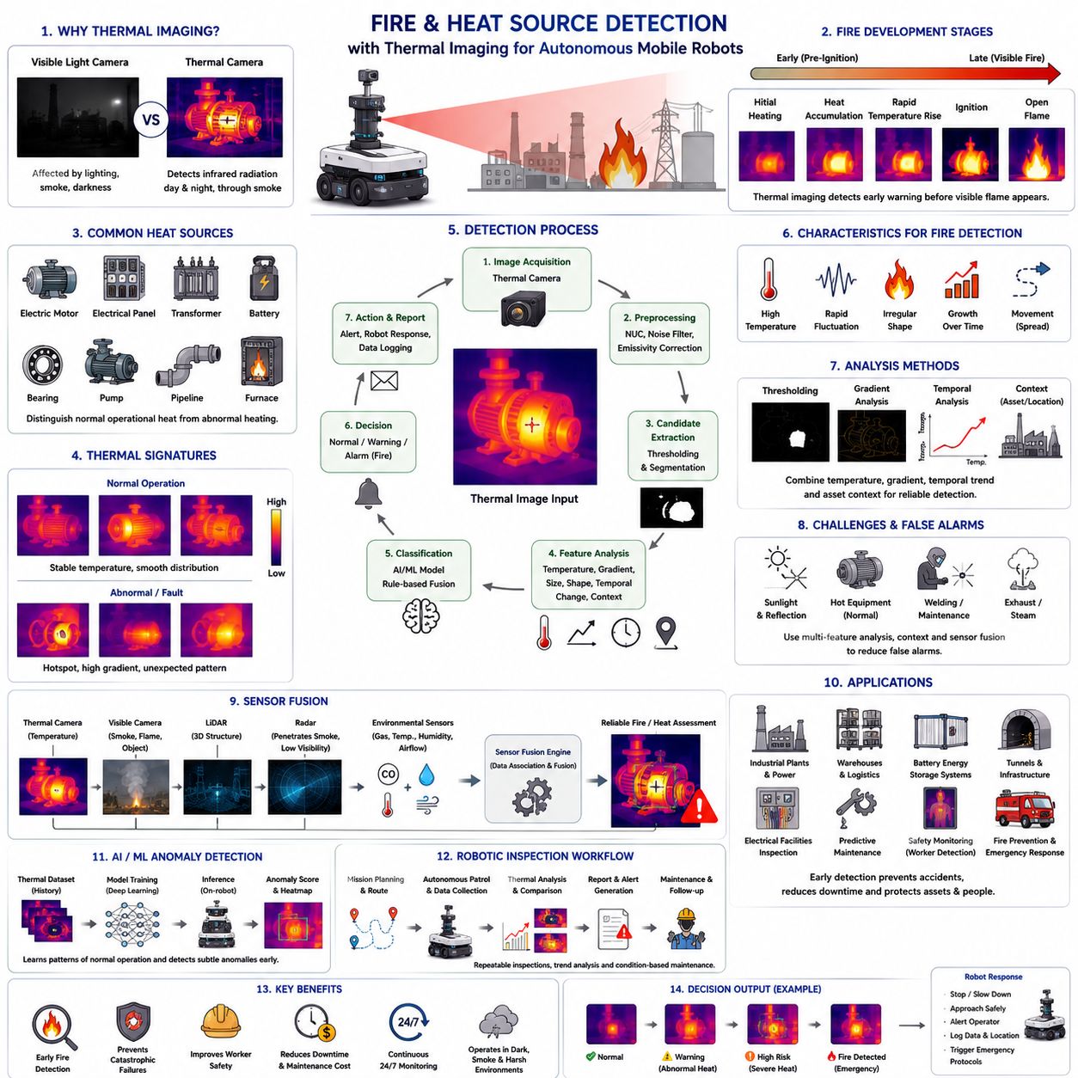
Fire and heat source detection is one of the most valuable applications of thermal imaging technology in autonomous mobile robots. Unlike conventional visible-light cameras, thermal cameras detect infrared radiation emitted by objects and therefore can identify abnormal temperature distributions regardless of ambient lighting conditions. This capability enables robots to recognize overheating equipment, smoldering materials, open flames, hot surfaces, and thermal anomalies before they become visible to the human eye. In industrial facilities, warehouses, power plants, battery storage systems, tunnels, and outdoor infrastructure, early thermal detection significantly improves operational safety and reduces the risk of catastrophic failures.
Every object above absolute zero continuously emits thermal radiation. Under normal operating conditions, industrial equipment exhibits predictable thermal patterns corresponding to its design, operating load, cooling efficiency, and surrounding environment. Fire and heat source detection relies on identifying deviations from these expected thermal distributions. Instead of merely detecting high temperatures, advanced inspection systems evaluate temperature gradients, hotspot formation, temporal changes, spatial continuity, and relationships between neighboring components. A rapidly increasing temperature or an unexpected localized hotspot often provides earlier warning than an absolute temperature threshold alone.
A heat source may originate from normal operation or abnormal conditions. Electric motors, transformers, bearings, hydraulic pumps, batteries, furnaces, pipelines, and welding equipment naturally generate heat during operation. The inspection system must therefore distinguish between acceptable operational heating and abnormal temperature increases that indicate developing faults. This distinction requires reference models describing expected temperature ranges under different operating conditions. Historical inspection records, equipment specifications, environmental conditions, and operating loads all contribute to establishing reliable baseline temperature profiles.
Fire development generally progresses through several stages before visible flames appear. Electrical resistance, mechanical friction, chemical reactions, battery degradation, insulation failure, or combustible material heating may initially produce localized temperature increases. As thermal energy accumulates, surrounding materials gradually warm until ignition occurs. Thermal imaging is particularly effective because it can detect these pre-ignition heating stages when visible cameras still observe no apparent abnormalities. Early intervention during this period significantly reduces equipment damage, operational downtime, and personnel risk.
Thermal cameras detect fire indirectly by measuring infrared radiation rather than observing visible flames themselves. Open flames emit substantial infrared energy because of their high temperature, producing strong thermal signatures. However, fire detection algorithms should not rely solely on absolute temperature. Reflections, sunlight, furnaces, exhaust systems, or heated machinery may generate temperatures comparable to flames. Robust systems analyze multiple characteristics including temperature intensity, spatial shape, temporal fluctuation, growth rate, movement patterns, and relationships with surrounding objects before declaring a fire event.
Hotspot detection represents one of the most common industrial inspection tasks. A hotspot is a localized region exhibiting significantly higher temperature than adjacent areas. Such regions may indicate loose electrical connections, overloaded circuits, worn bearings, blocked airflow, cooling failure, excessive mechanical friction, insulation breakdown, or internal component degradation. The inspection algorithm first segments the thermal image, identifies candidate hotspots exceeding predefined criteria, and evaluates their size, intensity, persistence, and evolution. False detections caused by reflections or transient environmental effects should be eliminated before generating maintenance alarms.
Temperature thresholding provides the simplest fire detection strategy. Pixels exceeding predefined temperature limits are classified as potential hazards. Although computationally efficient, fixed thresholds are often insufficient because ambient temperature, equipment loading, seasonal variations, solar heating, and material emissivity influence measured temperatures. Adaptive thresholding methods dynamically adjust detection criteria according to local background temperature, historical observations, equipment type, or environmental conditions. These adaptive approaches substantially reduce false alarms while maintaining high sensitivity to abnormal heating.
Temperature gradient analysis provides additional information beyond absolute temperature. Instead of evaluating only the hottest pixel, gradient analysis measures how rapidly temperature changes across neighboring pixels. Fires and abnormal heat sources frequently produce steep thermal gradients around hotspot boundaries. Uniformly heated surfaces generally exhibit smooth temperature transitions. Gradient information therefore helps distinguish localized failures from normal operating conditions. Combined analysis of absolute temperature and spatial gradients significantly improves detection robustness in complex industrial environments.
Temporal analysis is equally important because fire development is a dynamic process. Individual thermal frames provide only instantaneous information, whereas continuous monitoring reveals heating trends over time. Inspection software tracks temperature changes, hotspot expansion, cooling behavior, and thermal stability across successive observations. A slowly increasing hotspot may indicate progressive bearing wear, while rapid temperature escalation may signal imminent electrical failure or combustion. Trend analysis often provides more reliable maintenance information than single-frame temperature measurements.
Spatial context further improves detection reliability. A high temperature observed on an industrial furnace may represent completely normal operation, whereas the same temperature on an electrical junction box could indicate severe failure. Modern inspection systems therefore incorporate equipment location, equipment category, expected operating temperature, inspection history, and facility layout into decision making. Asset-specific temperature models reduce nuisance alarms while improving sensitivity to genuine abnormal conditions.
Flame detection differs from general heat source detection because flames exhibit distinctive temporal and spatial characteristics. Flames continuously flicker, change shape, and generate turbulent thermal distributions. Thermal image sequences reveal rapid fluctuations in temperature intensity and geometry that differ substantially from stable heated machinery. Advanced algorithms analyze motion frequency, boundary instability, thermal oscillation, and expansion behavior to distinguish open flames from stationary hot equipment. Combining thermal information with visible-light imaging further increases discrimination accuracy.
Smoke presents additional challenges because its temperature may be similar to the surrounding environment during early combustion stages. Thermal cameras cannot always visualize smoke directly, particularly when smoke temperature approaches ambient conditions. However, thermal imaging often detects the heat source generating the smoke before the smoke itself becomes visible. Hot exhaust gases, heated ceilings, localized convection, and elevated structural temperatures may indirectly indicate developing fire conditions even when visible smoke remains limited.
Battery thermal runaway represents an increasingly important application for thermal fire detection. Lithium-ion battery failures often begin with localized internal heating caused by mechanical damage, manufacturing defects, electrical abuse, or overcharging. Before visible smoke or flames appear, one or more battery cells typically exhibit abnormal surface temperature increases. Thermal imaging enables continuous monitoring of battery modules, connectors, busbars, cooling channels, and charging interfaces. Early identification of abnormal heating provides valuable time for protective shutdown and emergency response before thermal runaway propagates throughout the battery pack.
Electrical inspection is another major application. Loose terminals, corroded contacts, overloaded conductors, damaged insulation, unbalanced phases, deteriorated circuit breakers, and failing transformers frequently generate excess heat long before electrical malfunction becomes obvious. Thermal inspection allows autonomous robots to monitor electrical cabinets during normal operation without interrupting production. Comparing measured temperatures against baseline conditions enables predictive maintenance while reducing manual inspection frequency and improving worker safety around energized equipment.
Mechanical systems also exhibit characteristic thermal signatures during degradation. Bearings experiencing lubrication failure, gearboxes with abnormal friction, conveyor rollers under excessive load, brake systems, rotating shafts, and hydraulic pumps gradually develop localized heating before catastrophic failure occurs. Thermal cameras observe these temperature distributions continuously without requiring physical contact. Machine learning models trained on historical thermal patterns can identify early degradation stages that remain difficult to recognize through simple threshold-based methods.
Environmental influences must always be considered during fire detection. Direct sunlight, reflections from polished metal surfaces, recently operated machinery, heated concrete, steam pipes, exhaust vents, weather conditions, and changing ambient temperature can alter thermal images substantially. Wind may cool exposed surfaces, while rain can temporarily reduce apparent temperatures despite continuing internal heating. Reliable systems combine thermal measurements with environmental sensors, weather information, operational status, and historical observations to minimize false alarms caused by changing environmental conditions.
False positives remain one of the greatest challenges in autonomous fire monitoring. Reflected infrared radiation from nearby heat sources may produce apparent hotspots on low-emissivity materials. Human workers, vehicles, welding operations, portable heaters, or maintenance activities can temporarily alter thermal scenes without indicating dangerous conditions. Intelligent inspection software therefore combines object recognition, asset identification, temporal consistency analysis, geometric constraints, and contextual reasoning before generating emergency alarms. Multi-level alarm strategies further separate maintenance warnings from immediate fire emergencies.
Sensor fusion significantly enhances fire and heat source detection performance. Visible-light cameras contribute smoke visualization, flame color, object recognition, and environmental context. LiDAR provides three-dimensional structural information and obstacle localization. Radar maintains reliable perception during smoke, fog, or darkness. Environmental sensors measure gas concentration, humidity, airflow, and ambient temperature. Combining these complementary sensing modalities allows autonomous robots to produce more reliable fire assessments than any individual sensor operating independently.
Artificial intelligence has become increasingly important for thermal anomaly analysis. Deep learning models trained using thousands of thermal images learn complex relationships between temperature distribution, equipment geometry, operating conditions, and fault development. Rather than relying solely on manually selected thresholds, neural networks classify thermal patterns associated with electrical faults, mechanical wear, battery abnormalities, human presence, fire, and environmental influences. Explainable AI techniques further provide confidence estimates and visual attention maps supporting operator interpretation and maintenance decision making.
Autonomous mobile robots equipped with thermal cameras perform scheduled patrols across industrial facilities, collecting repeatable thermal data from predefined inspection points. Localization systems ensure that thermal images are acquired from nearly identical viewpoints during every inspection cycle. This repeatability greatly improves trend analysis because temperature changes can be attributed to equipment condition rather than viewpoint variation. Inspection results are transmitted to maintenance management systems where historical comparisons, predictive analytics, and work-order generation support condition-based maintenance strategies.
Effective fire and heat source detection requires careful integration of thermal sensing, environmental modeling, inspection planning, artificial intelligence, and operational context. Thermal cameras provide unique visibility into temperature distributions that remain invisible to conventional imaging systems, enabling earlier recognition of hazardous conditions. However, successful deployment depends on proper calibration, emissivity compensation, environmental awareness, robust anomaly detection algorithms, and multi-sensor fusion. When these elements operate together, autonomous robots become capable of continuously monitoring complex industrial environments, identifying abnormal heating before failures escalate, and substantially improving both operational safety and equipment reliability.

06.4 Human Detection in Low Light
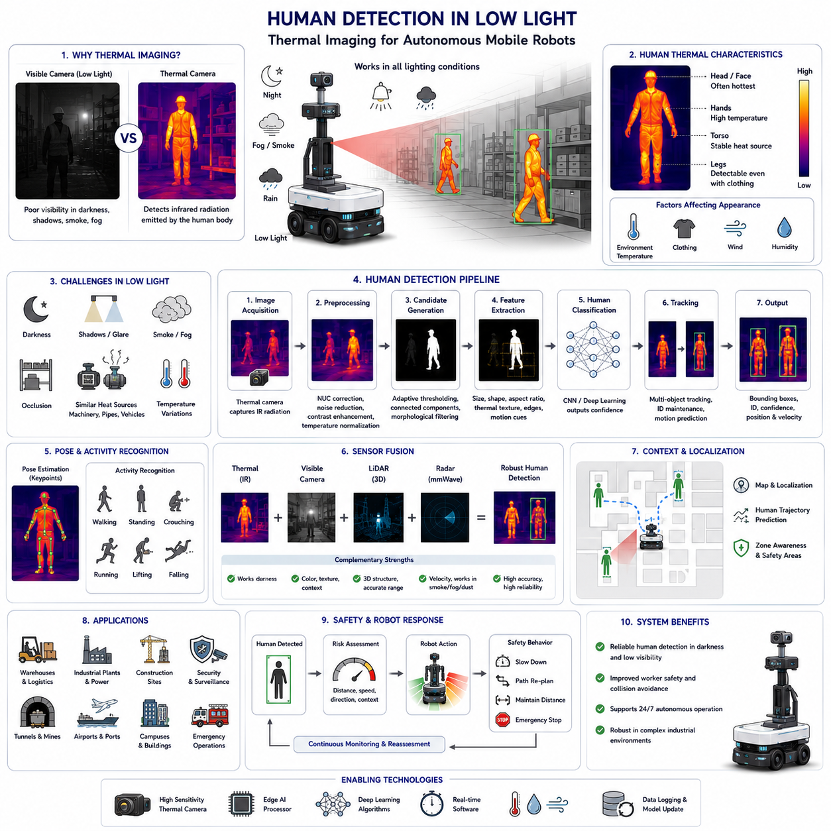
Human detection in low-light environments is one of the most important perception capabilities for autonomous mobile robots operating in industrial facilities, warehouses, construction sites, underground infrastructure, campuses, ports, airports, mines, and outdoor security applications. Conventional visible-light cameras depend heavily on ambient illumination and often experience severe performance degradation during nighttime operation or in poorly illuminated areas. Thermal imaging provides an alternative sensing modality by detecting infrared radiation naturally emitted by the human body rather than relying on reflected visible light. This capability enables robots to recognize human presence regardless of darkness while significantly improving operational safety and collision avoidance.
Every human body continuously emits thermal radiation because normal body temperature remains substantially higher than the surrounding environment under most operating conditions. Human skin typically exhibits an emissivity close to that of an ideal blackbody, allowing thermal cameras to capture stable infrared signatures. Unlike visible cameras that require sufficient illumination to observe body shape, clothing texture, or facial features, thermal cameras respond primarily to temperature distribution. Consequently, humans remain detectable even in complete darkness, light fog, smoke, shadows, or environments where conventional cameras produce images with insufficient contrast for reliable object recognition.
Low-light environments include more than complete darkness. Industrial facilities frequently contain partially illuminated corridors, emergency lighting, underground passages, equipment rooms, warehouses, loading docks, tunnels, utility plants, and outdoor work areas where illumination varies significantly throughout the day. Human detection algorithms operating under these conditions must remain robust against changing lighting, shadows, glare, headlights, reflections, and temporary illumination changes. Thermal imaging greatly reduces sensitivity to these lighting variations because infrared radiation is largely independent of visible illumination, providing consistent target visibility across a wide range of operating conditions.
Human thermal appearance depends on multiple physiological and environmental factors. Skin temperature is influenced by metabolism, blood circulation, physical activity, clothing, weather conditions, humidity, wind, and surrounding temperature. Heavy protective clothing may partially block body heat, reducing the apparent thermal signature. Conversely, exposed faces, hands, and neck regions often remain clearly distinguishable even when most of the body is covered. Thermal perception systems therefore analyze complete temperature distributions rather than relying exclusively on the hottest regions within the image.
Human detection begins with thermal image acquisition. The infrared detector continuously measures radiation emitted from the environment and converts it into digital temperature-related images. Before object recognition begins, image preprocessing compensates for detector non-uniformity, corrects sensor drift, reduces noise, adjusts contrast, and normalizes temperature values. Adaptive image enhancement techniques improve the visibility of human targets while preserving important thermal gradients. These preprocessing steps establish a stable input for downstream perception algorithms operating under continuously changing environmental conditions.
Candidate generation identifies image regions that potentially contain humans. Traditional systems often apply adaptive temperature thresholding to separate warmer objects from cooler backgrounds. Connected-component analysis groups neighboring pixels into candidate regions according to size, shape, and thermal continuity. Morphological filtering removes isolated noise and small artifacts while preserving human-sized structures. Although thresholding provides computational efficiency, it may produce false detections when non-human heat sources such as machinery, exhaust pipes, electrical equipment, or recently operated vehicles exhibit temperatures comparable to the human body.
Feature extraction provides richer information than temperature alone. Human bodies exhibit characteristic geometric proportions, thermal distributions, edge structures, and spatial relationships that distinguish them from most industrial equipment. Features may include body height, width, aspect ratio, symmetry, centroid position, contour shape, thermal texture, temperature variance, and limb configuration. Motion information further improves discrimination because walking, standing, bending, running, and climbing generate dynamic thermal patterns that differ substantially from stationary machinery or heated infrastructure.
Machine learning has substantially improved thermal human detection performance. Earlier approaches relied primarily on manually designed features combined with classifiers such as Support Vector Machines or Random Forests. Modern systems increasingly employ convolutional neural networks trained directly on thermal image datasets. Deep learning models automatically learn discriminative thermal representations from large numbers of labeled examples, enabling robust detection across varying body poses, clothing types, environmental conditions, camera viewpoints, and operating distances without extensive manual feature engineering.
Object detection networks simultaneously estimate human location and confidence scores within thermal images. One-stage detectors prioritize real-time performance for mobile robots, while two-stage detectors may provide higher localization accuracy in computationally unconstrained systems. Detection outputs typically consist of bounding boxes surrounding each person together with classification confidence. Confidence thresholds can be adjusted according to operational requirements. Safety-critical robots generally prefer lower detection thresholds to minimize missed detections, even if this increases the number of false positives requiring additional verification.
Object tracking significantly improves detection reliability across consecutive frames. Instead of analyzing each image independently, tracking algorithms associate detected humans over time using position, velocity, appearance, and motion consistency. Kalman filters, particle filters, probabilistic data association, and multiple-object tracking algorithms maintain stable identities despite temporary occlusions, missed detections, or changing viewpoints. Tracking also enables prediction of future human motion, supporting proactive collision avoidance and smoother robot navigation within shared workspaces.
Human pose estimation provides additional semantic understanding beyond simple detection. Although thermal imagery contains less surface texture than visible imagery, deep neural networks can estimate approximate body keypoints including head, shoulders, elbows, hips, knees, and feet under favorable imaging conditions. Pose estimation supports activity recognition such as walking, sitting, crouching, lifting, climbing, falling, or lying on the ground. These capabilities improve worker safety monitoring and enable more intelligent interaction between autonomous robots and nearby personnel.
Human activity recognition extends perception from identifying people to understanding their behavior. Temporal neural networks analyze sequences of thermal images to classify activities including standing, approaching, retreating, running, waving, carrying objects, operating machinery, or entering restricted areas. Activity information enables robots to adjust navigation strategies according to predicted human intentions. For example, a stationary worker inspecting equipment requires different avoidance behavior than a rapidly approaching forklift operator or maintenance technician crossing the robot path.
Occlusion remains a significant challenge for thermal human detection. Industrial environments frequently contain shelves, machinery, pallets, vehicles, containers, pipes, walls, and structural columns that partially block human visibility. Only a small portion of the body may remain observable, reducing detection confidence. Multi-frame tracking, multiple camera viewpoints, probabilistic reasoning, and sensor fusion help recover partially occluded targets. Robots operating in complex facilities should minimize blind zones through careful camera placement and overlapping sensor coverage.
Environmental temperature strongly influences thermal contrast. During cold nights, human bodies typically appear significantly warmer than the surroundings, simplifying detection. Conversely, hot summer afternoons, heated industrial equipment, asphalt surfaces exposed to direct sunlight, or high-temperature manufacturing processes may reduce thermal contrast. Some background surfaces may temporarily approach human skin temperature, increasing false detections. Adaptive background modeling and context-aware detection algorithms continuously update thermal expectations to maintain reliable performance under changing environmental conditions.
Weather conditions introduce additional complexity. Rain cools exposed surfaces and clothing while increasing humidity, which may alter thermal signatures. Wind accelerates convective heat transfer, reducing apparent skin temperature in exposed body regions. Fog and smoke generally affect thermal imaging less than visible cameras but can still reduce infrared transmission over long distances. Snow, ice, and wet clothing also modify apparent thermal distributions. Robust detection systems compensate for these effects through adaptive calibration, environmental sensing, and continuously updated detection models.
Industrial facilities contain numerous artificial heat sources capable of generating false alarms. Electric motors, transformers, furnaces, boilers, welding stations, exhaust systems, heated pipelines, charging stations, and recently operated machinery often exhibit temperatures similar to or exceeding those of humans. Detection algorithms therefore evaluate not only temperature magnitude but also object geometry, motion, temporal stability, contextual location, and expected operational behavior. Combining multiple discriminative features substantially reduces confusion between workers and industrial equipment.
Sensor fusion provides the most reliable solution for low-light human detection. Visible-light cameras contribute color, texture, signs, clothing appearance, and contextual information during daytime operation. LiDAR supplies accurate three-dimensional geometry and obstacle localization. Millimeter-wave radar directly measures range and velocity while maintaining performance in smoke, fog, and dust. Thermal cameras provide robust nighttime human visibility. Combining these complementary sensing modalities enables autonomous robots to achieve substantially higher detection accuracy and fault tolerance than any individual sensor operating alone.
Localization information further strengthens human detection. Robot pose estimation allows thermal observations to be projected into a global facility map, enabling repeated observations from different viewpoints to be associated with the same individual. Static heat sources remain fixed within the environment, whereas humans move continuously. Mapping and localization therefore help distinguish stationary equipment from dynamic personnel. Historical occupancy information also supports prediction of likely pedestrian pathways, improving navigation safety in frequently traversed industrial areas.
Artificial intelligence increasingly integrates thermal perception with scene understanding. Foundation models and multimodal neural networks simultaneously process thermal images, visible imagery, depth information, radar measurements, and language-based contextual knowledge. Rather than performing isolated human detection, these systems interpret complete workplace situations including worker activity, equipment condition, environmental hazards, safety zones, and operational procedures. Context-aware reasoning significantly improves decision quality compared with independent sensor processing pipelines.
Human detection directly supports functional safety within autonomous robot systems. Safety controllers use detection results to regulate robot speed, modify navigation paths, maintain protective separation distances, and initiate emergency stopping when necessary. Dynamic safety zones may expand according to robot speed, payload, stopping distance, or environmental uncertainty. Thermal perception complements traditional safety sensors by maintaining reliable human visibility during nighttime operation, power outages, smoke events, or other degraded visual conditions where conventional cameras become unreliable.
Performance evaluation requires carefully designed datasets representing realistic operating conditions. Benchmark datasets should include indoor and outdoor environments, varying illumination, different weather conditions, multiple body poses, diverse clothing, partial occlusions, crowded scenes, moving machinery, and challenging industrial backgrounds. Evaluation metrics commonly include precision, recall, mean Average Precision, false alarm rate, missed detection rate, tracking accuracy, latency, and computational efficiency. Continuous field validation remains essential because thermal appearance varies substantially across facilities, climates, seasons, and operational scenarios.
Reliable human detection in low-light environments depends on the integration of thermal imaging, robust preprocessing, machine learning, object tracking, sensor fusion, environmental awareness, and safety-oriented decision making. Thermal cameras provide a unique sensing capability that remains largely independent of visible illumination, making them indispensable for autonomous robots operating around human workers during nighttime or degraded visibility conditions. When combined with complementary perception sensors and intelligent scene understanding, thermal human detection significantly improves navigation safety, operational reliability, worker protection, and overall system resilience in modern industrial environments.

06.5 Industrial Inspection Applications
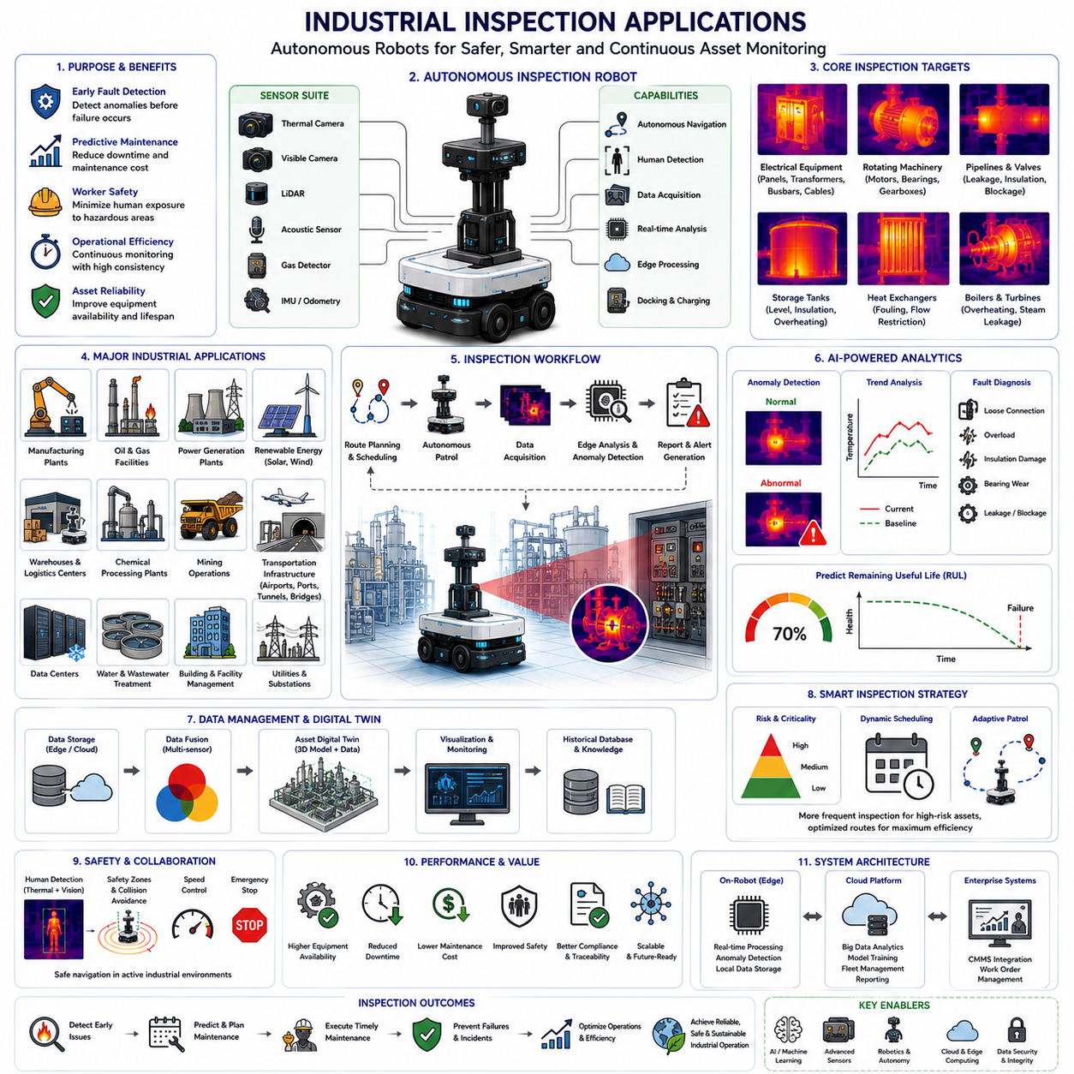
Industrial inspection has evolved from periodic manual observation into continuous autonomous monitoring supported by intelligent robotic systems. Modern industrial facilities contain thousands of assets operating simultaneously, including rotating machinery, electrical equipment, pipelines, storage tanks, conveyors, production lines, substations, and utility infrastructure. Maintaining these assets through manual inspection alone is labor-intensive, time-consuming, and often exposes workers to hazardous environments. Autonomous Mobile Robots (AMRs) equipped with thermal cameras, visible cameras, LiDAR, acoustic sensors, gas detectors, and artificial intelligence enable continuous inspection while improving operational efficiency, equipment reliability, and workplace safety.
Industrial inspection is fundamentally concerned with identifying abnormal conditions before they develop into equipment failures or safety incidents. Instead of waiting until a machine fails unexpectedly, predictive inspection continuously evaluates asset health using multiple sensing technologies. Thermal imaging plays a particularly important role because excessive heat is one of the earliest indicators of mechanical wear, electrical degradation, excessive friction, overload, lubrication failure, insulation damage, and component aging. By detecting abnormal thermal behavior during routine robot patrols, maintenance personnel can intervene before production is interrupted.
Manufacturing facilities represent one of the largest application areas for autonomous inspection. Production lines operate continuously with minimal downtime, making early fault detection extremely valuable. Robots patrol predefined routes while monitoring motors, bearings, gearboxes, conveyors, robotic manipulators, hydraulic systems, pneumatic equipment, and electrical control cabinets. Thermal images collected over time establish baseline operating temperatures for each asset. Artificial intelligence compares current observations with historical trends, allowing maintenance teams to detect gradual degradation long before conventional threshold alarms are triggered.
Electrical equipment inspection has become one of the most mature applications of thermal imaging. Electrical resistance naturally generates heat, making temperature an effective indicator of equipment condition. Autonomous inspection robots monitor switchgear, transformers, circuit breakers, busbars, cable connections, electrical panels, battery systems, chargers, and distribution cabinets. Loose electrical connections, overloaded circuits, deteriorated insulation, phase imbalance, and abnormal contact resistance often appear as localized hotspots before catastrophic failure occurs. Continuous robotic inspection enables rapid identification of these developing faults without requiring direct human exposure to energized equipment.
Mechanical equipment inspection focuses on identifying abnormal heat generated by friction and mechanical inefficiency. Bearings with insufficient lubrication, misaligned shafts, damaged gears, worn couplings, deteriorating belts, and overloaded motors gradually exhibit elevated operating temperatures. Thermal imaging detects these changes while vibration analysis, acoustic monitoring, and motor current analysis provide complementary diagnostic information. Sensor fusion significantly improves diagnostic confidence by confirming that multiple independent measurements indicate the same developing fault rather than isolated measurement noise.
Oil and gas facilities contain numerous hazardous environments where minimizing human exposure is a primary operational objective. Inspection robots equipped with thermal cameras routinely monitor pipelines, valves, pumps, compressors, storage tanks, pressure vessels, flare systems, heat exchangers, and processing equipment. Abnormal temperature distributions may indicate insulation damage, internal leakage, restricted flow, excessive pressure loss, or chemical process instability. Robots also reduce inspection frequency requirements for personnel working in explosive atmospheres while providing more frequent and consistent monitoring than manual inspection schedules.
Power generation facilities rely heavily on continuous inspection because equipment failures may interrupt electricity production or damage expensive infrastructure. Thermal inspection robots monitor generators, turbines, transformers, cooling systems, substations, switchyards, transmission equipment, battery energy storage systems, and auxiliary machinery. Steam leakage, overheating electrical components, insulation degradation, cooling inefficiencies, and bearing wear produce recognizable thermal patterns that artificial intelligence can identify automatically. Continuous inspection supports predictive maintenance while improving overall plant availability.
Renewable energy installations increasingly employ autonomous inspection systems to reduce maintenance costs across geographically distributed assets. Solar farms require regular monitoring of photovoltaic modules, inverters, transformers, junction boxes, and electrical connections. Defective solar cells frequently appear as localized hotspots that reduce energy conversion efficiency. Wind turbines benefit from thermal inspection of generators, power converters, bearings, braking systems, yaw mechanisms, and electrical cabinets. Autonomous robots reduce inspection time while providing consistent measurements across large renewable energy facilities.
Warehouses and logistics centers represent another major application for autonomous inspection. Robots simultaneously perform material transportation and infrastructure monitoring while moving throughout the facility. Thermal cameras inspect conveyor motors, automated storage systems, charging stations, electrical panels, refrigeration equipment, HVAC systems, battery charging areas, and warehouse infrastructure. Since inspection occurs during normal transportation tasks, no additional labor or operational downtime is required. This dual-purpose operation significantly improves return on investment while maximizing utilization of mobile robotic platforms.
Chemical processing facilities demand continuous monitoring because process stability directly affects product quality and operational safety. Autonomous inspection robots observe reactors, mixing systems, pipelines, storage vessels, pumps, valves, heat exchangers, and chemical transfer equipment. Unexpected thermal gradients may indicate blocked flow, excessive reaction rates, insulation failure, leakage, or cooling system malfunction. Combining thermal imaging with gas sensors enables simultaneous detection of abnormal heat and hazardous gas releases, improving overall situational awareness during routine plant operation.
Mining operations present particularly challenging environments for human inspectors due to dust, darkness, vibration, uneven terrain, and heavy equipment movement. Autonomous inspection vehicles equipped with thermal imaging safely monitor conveyor systems, crushers, ventilation equipment, electrical substations, underground infrastructure, haul trucks, and excavation machinery. Thermal sensing remains effective under poor lighting conditions while eliminating many risks associated with manual inspection in hazardous mining environments. Continuous monitoring also supports predictive maintenance for critical production equipment operating under severe mechanical stress.
Transportation infrastructure increasingly benefits from robotic inspection technologies. Airports, railway stations, ports, tunnels, bridges, highways, and utility corridors require regular condition assessment across extensive geographical areas. Autonomous inspection robots identify overheating electrical cabinets, damaged lighting systems, mechanical equipment faults, tunnel ventilation problems, emergency power system abnormalities, and structural temperature anomalies. Regular inspection improves infrastructure reliability while reducing inspection costs associated with large distributed facilities.
Data centers have emerged as an important industrial inspection application because thermal management directly influences computing reliability. Inspection robots monitor server racks, cooling systems, power distribution units, backup batteries, electrical panels, network equipment, and air conditioning infrastructure. Localized hotspots often indicate blocked airflow, failing cooling fans, overloaded servers, deteriorating power supplies, or electrical connection problems. Continuous thermal inspection enables rapid corrective action before excessive temperatures reduce equipment lifetime or cause unexpected service interruptions.
Industrial inspection increasingly relies on artificial intelligence rather than fixed alarm thresholds. Traditional systems simply report temperatures exceeding predefined limits. Modern machine learning algorithms analyze temporal trends, spatial temperature distributions, equipment operating conditions, maintenance history, production schedules, environmental influences, and relationships among multiple sensors. Rather than identifying only severe failures, intelligent inspection predicts gradual degradation, estimates remaining useful life, and recommends optimal maintenance timing based on continuously evolving equipment behavior.
Digital twins further enhance industrial inspection by integrating thermal observations into virtual equipment models. Each inspected asset maintains a continuously updated digital representation containing geometry, operating parameters, maintenance records, historical sensor measurements, inspection images, and performance indicators. Thermal abnormalities detected by autonomous robots automatically update the corresponding digital twin, enabling engineers to visualize equipment condition, analyze degradation trends, compare similar assets, and evaluate maintenance priorities across the entire facility from a centralized management platform.
Cloud computing and edge computing cooperate to support modern robotic inspection systems. Edge processors located on autonomous robots perform real-time image acquisition, object detection, thermal analysis, and immediate anomaly identification with minimal communication delay. More computationally intensive tasks including long-term trend analysis, fleet optimization, deep learning model retraining, and enterprise-wide asset analytics are executed within cloud infrastructure. This distributed architecture balances real-time responsiveness with large-scale computational capability while minimizing network bandwidth requirements.
Inspection route planning significantly influences operational efficiency. Rather than following fixed patrol schedules indefinitely, intelligent robots dynamically adjust inspection frequency according to equipment criticality, operational condition, maintenance history, environmental risk, and previous inspection results. High-risk assets receive more frequent monitoring, whereas stable equipment may require fewer inspection visits. Dynamic scheduling maximizes inspection effectiveness while reducing unnecessary robot travel and improving fleet utilization across large industrial facilities.
Safety remains the highest priority throughout autonomous inspection operations. Inspection robots continuously monitor human presence while navigating active industrial environments containing workers, vehicles, forklifts, and production machinery. Thermal imaging complements visible cameras by maintaining reliable human detection during nighttime operation, smoke events, or poorly illuminated facilities. Navigation systems adjust robot speed, modify travel paths, maintain protective separation distances, and execute emergency stopping whenever personnel enter designated safety zones, ensuring safe collaboration between autonomous systems and human workers.
Performance evaluation of industrial inspection systems extends beyond conventional object detection accuracy. Effective inspection platforms are assessed according to anomaly detection rate, false alarm frequency, localization precision, diagnostic accuracy, inspection coverage, route completion efficiency, maintenance cost reduction, equipment availability improvement, mean time between failures, system reliability, computational latency, and return on investment. Comprehensive field validation across diverse industrial environments is essential because inspection requirements vary considerably among manufacturing plants, energy facilities, logistics centers, and critical infrastructure.
The future of industrial inspection lies in fully autonomous, continuously learning robotic ecosystems capable of understanding complete operational environments rather than isolated sensor measurements. Foundation models, multimodal perception, advanced thermal imaging, digital twins, predictive analytics, and intelligent fleet coordination will enable inspection robots to transform raw sensor observations into actionable maintenance knowledge. These integrated systems will support safer workplaces, higher equipment reliability, reduced maintenance costs, increased operational efficiency, and more resilient industrial infrastructure while allowing human experts to focus on high-value engineering decisions instead of repetitive inspection activities.

06.6 Thermal Data Preprocessing
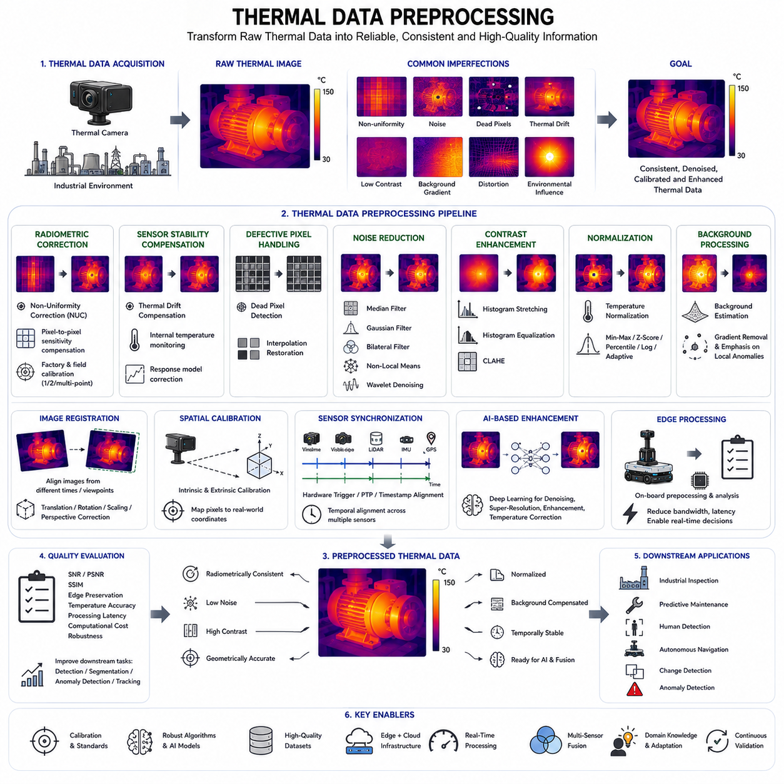
Thermal data preprocessing is a fundamental stage in every thermal vision system because the quality of subsequent analysis depends directly on the quality of the input thermal image. Raw infrared images collected by thermal cameras contain various imperfections introduced by sensor characteristics, environmental conditions, electronic noise, optical limitations, and temperature fluctuations. Without appropriate preprocessing, artificial intelligence algorithms may interpret these imperfections as meaningful thermal patterns, leading to inaccurate object detection, unstable temperature estimation, poor segmentation, and unreliable inspection results. Therefore, preprocessing serves as the essential foundation that transforms raw thermal measurements into stable and reliable data suitable for computer vision and machine learning applications.
Unlike conventional RGB cameras that measure reflected visible light, thermal cameras measure infrared radiation emitted by objects within the scene. Each detector element converts incoming infrared energy into electrical signals that are subsequently digitized into thermal images. During this conversion process, multiple sources of uncertainty are introduced, including detector non-uniformity, electronic noise, thermal drift, sensor aging, optical distortion, atmospheric attenuation, and environmental interference. Consequently, raw thermal images often exhibit inconsistent brightness, uneven temperature distributions, random noise, dead pixels, and temporal instability even when observing stationary objects under constant environmental conditions.
The first objective of thermal preprocessing is to establish radiometric consistency across the entire image. Every detector element within an infrared focal plane array exhibits slightly different sensitivity characteristics due to manufacturing tolerances and material variations. As a result, neighboring pixels observing identical temperatures may produce different digital values. These fixed-pattern artifacts reduce image quality and interfere with temperature-based analysis. Radiometric correction compensates for detector variability, ensuring that identical thermal radiation produces consistent digital responses across the complete sensor array.
Non-Uniformity Correction (NUC) is one of the most important preprocessing procedures in thermal imaging systems. NUC compensates for pixel-to-pixel sensitivity variations by estimating correction coefficients for each detector element. Factory calibration establishes initial correction parameters using precisely controlled blackbody reference sources, while field calibration continuously updates these parameters as environmental conditions change. Modern thermal cameras employ one-point, two-point, or multi-point calibration methods depending on required accuracy, operating temperature range, and computational resources available within the imaging system.
Thermal drift compensation addresses gradual changes in sensor response caused by temperature fluctuations inside the camera itself. Infrared detectors, optical components, electronic circuits, and mechanical structures continuously experience temperature changes during operation. These internal variations influence detector sensitivity and introduce measurement errors even when external scene temperatures remain unchanged. Drift compensation continuously monitors internal sensor conditions using embedded temperature sensors and mathematical correction models. This process stabilizes long-term thermal measurements and improves temperature repeatability during extended inspection operations.
Dead pixel correction identifies detector elements that produce permanently incorrect outputs due to manufacturing defects, aging, or physical damage. Dead pixels may appear completely dark, permanently bright, or exhibit abnormal responses unrelated to incoming infrared radiation. Because isolated defective pixels can significantly affect feature extraction and object detection algorithms, preprocessing replaces their values using interpolation from neighboring valid pixels. Adaptive interpolation methods preserve local image structures while minimizing artificial smoothing that could distort important thermal boundaries.
Noise reduction is another essential preprocessing operation because thermal detectors inherently generate electronic noise. Noise originates from detector electronics, analog signal amplification, analog-to-digital conversion, photon statistics, and environmental interference. Random noise becomes particularly significant when measuring small temperature differences or operating under low thermal contrast conditions. Various filtering techniques including Gaussian filters, median filters, bilateral filters, non-local means filtering, and wavelet-based denoising reduce unwanted noise while preserving meaningful thermal structures required for subsequent analysis.
Median filtering is widely applied in thermal imaging because it effectively removes impulse noise without excessively blurring object boundaries. Instead of averaging neighboring pixels, the median filter replaces each pixel with the median value within a local neighborhood. This operation preserves sharp thermal edges while eliminating isolated abnormal values generated by detector noise or transmission errors. Since many thermal inspection tasks depend upon accurate boundary localization, median filtering frequently provides an excellent balance between noise suppression and feature preservation.
Gaussian filtering smooths high-frequency noise through weighted averaging using a Gaussian distribution. Unlike median filtering, Gaussian smoothing produces gradual transitions between neighboring pixels and reduces overall image variance. Although excessive smoothing may decrease spatial resolution, carefully selected Gaussian kernels effectively suppress random fluctuations while maintaining overall thermal distributions. Gaussian preprocessing is commonly employed before gradient computation, edge detection, segmentation, and convolutional neural network inference because it stabilizes local image statistics.
Bilateral filtering extends conventional smoothing by simultaneously considering spatial proximity and temperature similarity. Pixels located nearby but possessing substantially different temperatures receive lower weighting than similar neighboring pixels. Consequently, bilateral filtering suppresses noise inside homogeneous regions while preserving important thermal edges separating different objects. This property makes bilateral filtering particularly valuable for industrial inspection, human detection, and equipment monitoring where accurate thermal boundaries directly influence object segmentation and defect localization.
Contrast enhancement improves visibility when thermal images exhibit limited temperature variation. Many inspection environments contain relatively narrow temperature ranges that produce low-contrast images despite meaningful thermal differences. Histogram stretching expands the available intensity range, increasing visual separation between warmer and cooler regions. Histogram equalization redistributes intensity values to improve global contrast, while adaptive histogram equalization operates locally, enhancing small thermal details that might otherwise remain difficult to observe under uniform global processing.
Contrast Limited Adaptive Histogram Equalization (CLAHE) has become particularly popular for thermal image enhancement because it avoids excessive amplification of image noise. Instead of equalizing the entire image uniformly, CLAHE processes small local regions independently while limiting maximum contrast enhancement. This approach reveals subtle thermal variations without introducing artificial artifacts caused by over-amplifying homogeneous background regions. CLAHE significantly improves visualization and often enhances deep learning performance when thermal images exhibit low intrinsic contrast.
Temperature normalization ensures that thermal measurements remain comparable across different environmental conditions and acquisition sessions. Absolute temperature values vary according to ambient conditions, camera calibration, viewing distance, atmospheric transmission, and object emissivity. Normalization transforms thermal data into standardized numerical ranges while preserving relative temperature relationships. Common normalization methods include min-max scaling, z-score normalization, percentile normalization, logarithmic transformation, and adaptive normalization based on scene-specific statistical characteristics.
Background normalization compensates for slowly varying environmental temperature distributions across the image. Industrial facilities frequently contain temperature gradients generated by sunlight, HVAC systems, furnaces, machinery, or outdoor weather conditions. These gradual variations may obscure localized anomalies associated with defective equipment or human presence. Background estimation algorithms model large-scale temperature trends and subtract them from the original image, emphasizing local thermal deviations that are more relevant for inspection and anomaly detection.
Image registration aligns multiple thermal images acquired at different times or from different viewpoints. Accurate alignment enables pixel-wise comparison of temperature distributions across inspection sessions, facilitating change detection and long-term equipment monitoring. Registration algorithms identify corresponding image features using geometric landmarks, thermal textures, or optimization techniques before estimating spatial transformations including translation, rotation, scaling, and perspective correction. Stable registration is essential for predictive maintenance systems relying upon temporal comparison of repeated inspections.
Spatial calibration establishes the geometric relationship between thermal pixels and physical coordinates within the observed environment. Lens distortion, perspective projection, camera mounting errors, and optical characteristics influence image geometry. Calibration determines intrinsic camera parameters and extrinsic positioning relative to the robot coordinate system. Accurate spatial calibration enables thermal measurements to be projected into three-dimensional maps, integrated with LiDAR point clouds, and associated with precise equipment locations during autonomous inspection missions.
Sensor synchronization represents another important preprocessing task within multimodal robotic perception systems. Thermal cameras frequently operate alongside RGB cameras, LiDAR, radar, inertial measurement units, and positioning sensors. Accurate temporal synchronization ensures that measurements from different sensors correspond to the same physical event. Hardware triggering, Precision Time Protocol (PTP), timestamp alignment, and interpolation techniques minimize temporal offsets, allowing reliable sensor fusion and consistent environmental representation across heterogeneous sensing modalities.
Thermal preprocessing increasingly incorporates artificial intelligence to optimize image quality automatically. Deep learning models can learn complex noise characteristics, detector nonlinearities, atmospheric distortions, and environmental influences directly from training data. Neural network-based denoising, super-resolution, dead pixel restoration, image enhancement, and temperature correction frequently outperform traditional handcrafted algorithms under challenging operating conditions. These intelligent preprocessing methods continuously improve as larger thermal datasets become available across diverse industrial environments.
Edge computing enables preprocessing to occur directly on autonomous robots before thermal data are transmitted across communication networks. Performing correction, filtering, normalization, segmentation, and anomaly detection locally reduces communication bandwidth, minimizes latency, and enables immediate decision making during safety-critical operations. Only relevant thermal events, extracted features, or compressed inspection summaries require transmission to centralized cloud platforms, significantly improving overall system efficiency while preserving real-time responsiveness.
Performance evaluation of preprocessing algorithms requires objective assessment using both image quality metrics and downstream application performance. Common evaluation criteria include signal-to-noise ratio, peak signal-to-noise ratio, structural similarity index, edge preservation, temperature accuracy, computational complexity, processing latency, energy consumption, and robustness under varying environmental conditions. Equally important is measuring improvements in object detection accuracy, segmentation quality, anomaly detection reliability, and inspection performance after preprocessing has been applied to raw thermal imagery.
Thermal data preprocessing is therefore much more than simple image enhancement. It establishes the reliability, consistency, and interpretability of thermal measurements before higher-level perception algorithms begin their analysis. By combining radiometric correction, non-uniformity correction, drift compensation, dead pixel restoration, noise suppression, contrast enhancement, normalization, geometric calibration, sensor synchronization, and artificial intelligence, modern preprocessing pipelines transform imperfect raw infrared measurements into robust thermal representations. These high-quality thermal datasets provide the essential foundation for accurate industrial inspection, autonomous navigation, predictive maintenance, human detection, and intelligent robotic perception in complex real-world environments.

06.7 Thermal Camera Calibration
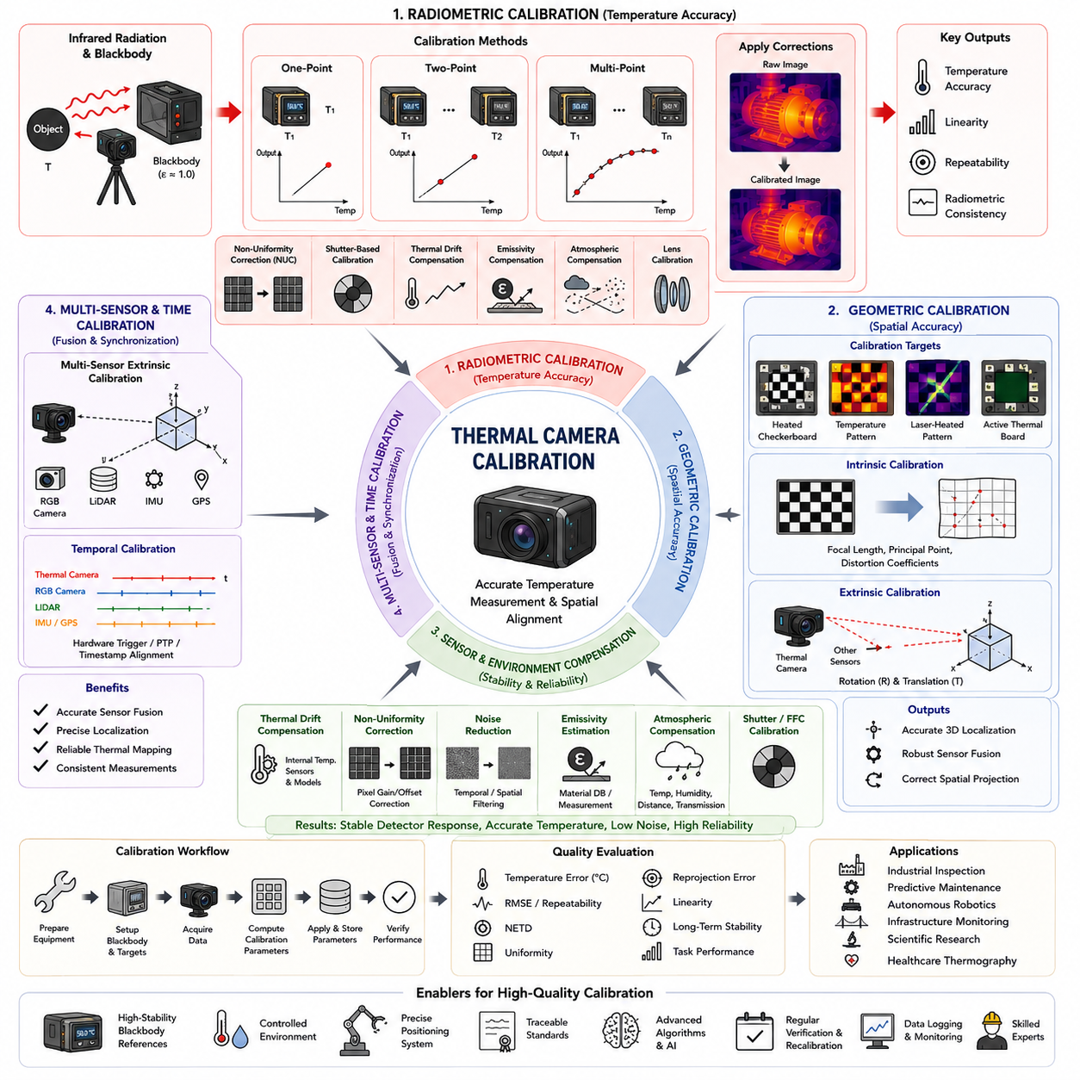
Thermal camera calibration is one of the most critical processes in thermal imaging systems because it determines whether measured infrared radiation can be converted into accurate and repeatable temperature information. Every thermal camera contains infrared detectors, optical components, electronic circuits, and signal processing algorithms that introduce measurement uncertainties during image acquisition. Without proper calibration, identical objects observed under identical environmental conditions may produce different temperature readings over time or across different cameras. Consequently, calibration establishes the quantitative relationship between infrared energy received by the sensor and the digital temperature values used for inspection, monitoring, and artificial intelligence applications.
Unlike visible-light cameras that primarily require geometric calibration for accurate imaging, thermal cameras require both radiometric and geometric calibration. Radiometric calibration ensures that measured pixel values correspond accurately to actual object temperatures, while geometric calibration establishes the spatial relationship between image coordinates and physical locations. Both calibration processes are essential for industrial inspection, autonomous robotics, predictive maintenance, and scientific measurements where accurate temperature estimation and spatial localization must be achieved simultaneously. A well-calibrated thermal camera therefore provides not only visually meaningful images but also physically reliable temperature data.
The foundation of thermal camera calibration begins with understanding infrared radiation and blackbody emission principles. Every object above absolute zero continuously emits infrared energy according to its temperature, emissivity, and material properties. The relationship between emitted radiation and temperature follows Planck's Law, while the total emitted energy is described by the Stefan-Boltzmann Law. During calibration, highly stable blackbody reference sources generate precisely controlled thermal radiation that closely approximates an ideal emitter with emissivity approaching one. These references allow calibration algorithms to establish accurate mappings between detector responses and absolute temperatures.
Radiometric calibration converts raw detector outputs into physically meaningful temperature measurements. Infrared detectors measure incoming radiation intensity rather than temperature directly. The sensor output depends upon detector sensitivity, amplifier gain, analog-to-digital conversion characteristics, lens transmission, atmospheric absorption, and environmental conditions. Radiometric calibration compensates for these factors using mathematical correction models derived from carefully controlled reference measurements. The resulting calibration coefficients enable the camera to estimate object temperatures with significantly improved accuracy under various operating conditions.
Blackbody calibration sources play a central role in thermal camera calibration because they provide highly stable and well-characterized infrared radiation. A calibration blackbody consists of a temperature-controlled cavity with nearly perfect emissivity and precisely regulated thermal stability. During factory calibration, the camera observes multiple blackbody temperatures covering the intended operating range. Detector responses recorded at these known temperatures are used to estimate calibration parameters through regression or polynomial fitting techniques. High-performance industrial cameras may undergo calibration at numerous temperature points to minimize interpolation errors across wide measurement ranges.
One-point calibration is among the simplest radiometric calibration methods. The detector array observes a uniform blackbody surface maintained at a single known temperature, allowing offset errors to be estimated and corrected. This method is computationally efficient and suitable for applications where detector gain variations remain relatively stable. However, one-point calibration cannot compensate for nonlinear detector responses across broader temperature ranges. Consequently, it is primarily used for field recalibration or systems operating within limited thermal environments rather than precision measurement applications.
Two-point calibration significantly improves measurement accuracy by observing two blackbody temperatures representing different regions of the operating range. These measurements estimate both detector gain and offset for every pixel within the focal plane array. Linear interpolation between the two calibration points provides substantially better temperature estimation than single-point calibration. Because detector sensitivity varies across manufacturing processes, two-point calibration has become the standard procedure for many industrial thermal cameras requiring accurate temperature measurements over moderate temperature intervals.
Multi-point calibration extends the previous approach by measuring detector responses at numerous carefully selected blackbody temperatures. Polynomial regression or nonlinear curve fitting models describe complex detector behavior throughout the complete measurement range. This approach accurately represents nonlinear detector characteristics, optical transmission effects, and temperature-dependent sensor responses. Although multi-point calibration requires longer calibration time and greater computational resources, it provides the highest temperature accuracy for demanding scientific, aerospace, semiconductor, and industrial inspection applications where measurement precision is critical.
Non-Uniformity Correction (NUC) represents one of the most important calibration procedures performed after detector manufacturing. Every infrared detector element exhibits slightly different sensitivity due to microscopic variations in material composition and fabrication tolerances. These differences generate fixed-pattern noise that appears as stripes, patches, or brightness inconsistencies throughout thermal images. NUC estimates pixel-specific correction coefficients using blackbody references and applies these corrections continuously during camera operation. As a result, identical thermal radiation produces uniform image responses across the entire detector array.
Shutter-based calibration provides an efficient mechanism for maintaining detector stability during long-term operation. Many uncooled thermal cameras contain an internal mechanical shutter that periodically moves in front of the detector array, presenting a uniform temperature reference. Because every detector simultaneously observes the same thermal target, new correction coefficients can be estimated without requiring external calibration equipment. This automatic recalibration compensates for thermal drift, electronic fluctuations, and environmental changes while minimizing interruptions during continuous inspection or surveillance operations.
Thermal drift compensation addresses gradual changes in detector response caused by temperature variations inside the camera itself. Electronic components, infrared detectors, lenses, and mechanical structures experience thermal expansion and changing electrical characteristics during operation. These internal changes modify detector sensitivity and measurement accuracy even if the external scene remains constant. Embedded temperature sensors continuously monitor internal camera conditions, allowing compensation algorithms to update calibration parameters dynamically. This process significantly improves long-term temperature stability in industrial environments where cameras operate continuously for extended periods.
Emissivity calibration represents another essential aspect of accurate temperature measurement. Real materials rarely behave as perfect blackbody emitters. Instead, every surface possesses an emissivity value describing how efficiently it emits infrared radiation relative to an ideal emitter. Polished metals typically exhibit low emissivity, while painted surfaces, plastics, rubber, and human skin generally possess higher emissivity values. Incorrect emissivity assumptions produce substantial temperature estimation errors. Therefore, calibration procedures frequently include emissivity compensation using known material properties, reference coatings, or experimentally determined correction factors.
Atmospheric compensation becomes increasingly important when thermal cameras observe distant objects. Infrared radiation interacts with atmospheric gases, humidity, dust, smoke, and suspended particles before reaching the detector. These interactions reduce transmitted radiation and introduce additional emission from the atmosphere itself. Calibration models therefore incorporate ambient temperature, relative humidity, viewing distance, and atmospheric transmission coefficients to estimate radiation losses accurately. Such compensation is particularly important for outdoor inspection, aerial thermography, power line monitoring, and environmental surveillance applications.
Lens calibration addresses optical effects introduced by infrared lenses and protective windows. Every optical system introduces transmission losses, distortion, vignetting, chromatic effects, and spatial resolution variations across the image field. Infrared optics often utilize germanium, zinc selenide, or chalcogenide glass rather than conventional visible-light materials, making accurate optical characterization particularly important. Calibration procedures estimate intrinsic camera parameters, lens distortion coefficients, focal length, and optical center location to ensure accurate geometric measurements and reliable integration with robotic navigation systems.
Geometric calibration establishes the relationship between thermal image coordinates and real-world spatial coordinates. Standard checkerboard calibration techniques used for RGB cameras cannot be directly applied because conventional printed patterns exhibit little thermal contrast. Instead, specialized heated checkerboards, temperature-controlled calibration targets, laser-heated patterns, or actively illuminated thermal calibration boards generate clearly visible thermal features. These targets enable accurate estimation of intrinsic parameters, distortion models, and camera pose, supporting three-dimensional reconstruction and sensor fusion applications.
Extrinsic calibration determines the spatial relationship between thermal cameras and other sensors within autonomous robotic systems. Modern inspection robots frequently combine thermal cameras with RGB cameras, LiDAR, radar, inertial measurement units, and GNSS receivers. Accurate sensor fusion requires precise estimation of rotation and translation between sensor coordinate systems. Calibration algorithms identify corresponding geometric features observed by multiple sensors before computing rigid-body transformations. Reliable extrinsic calibration enables thermal anomalies to be projected accurately into three-dimensional maps and digital twins.
Temporal calibration ensures synchronization between thermal image acquisition and measurements obtained from other sensing devices. Even small timing offsets may generate significant spatial inconsistencies when robots move through dynamic environments. Hardware triggering, Precision Time Protocol (PTP), timestamp alignment, and interpolation algorithms synchronize thermal cameras with navigation sensors, industrial controllers, and robotic actuators. Accurate temporal calibration supports consistent sensor fusion, precise localization, and reliable thermal mapping during autonomous inspection missions.
Factory calibration provides the initial reference parameters for every thermal camera before deployment. Manufacturers perform calibration under carefully controlled laboratory conditions using certified blackbody sources, environmental chambers, precision positioning systems, and traceable temperature standards. Factory calibration establishes baseline detector characteristics, geometric parameters, and optical corrections that remain stored within camera memory. These parameters provide the starting point for all subsequent field calibration procedures performed throughout the operational lifetime of the imaging system.
Field calibration maintains measurement accuracy after deployment under real operating conditions. Environmental temperature variations, mechanical vibration, transportation, aging, contamination, and long-term component degradation gradually alter detector characteristics. Periodic recalibration using portable blackbody references, built-in shutters, or automatic calibration routines restores measurement accuracy without returning the camera to the manufacturer. Industrial maintenance schedules frequently include regular thermal camera verification to ensure inspection reliability throughout years of continuous operation.
Artificial intelligence is increasingly enhancing thermal camera calibration by learning complex detector behavior that traditional analytical models cannot easily describe. Deep neural networks can estimate nonlinear correction functions, compensate for detector aging, restore degraded measurements, estimate emissivity, and suppress calibration artifacts directly from large training datasets. AI-based calibration adapts continuously to changing environmental conditions while reducing dependence upon manual recalibration procedures. These intelligent approaches are becoming increasingly valuable for autonomous robots operating in diverse and dynamic industrial environments.
Calibration quality is evaluated using objective performance metrics that quantify temperature accuracy and measurement consistency. Common metrics include absolute temperature error, root mean square error, repeatability, reproducibility, spatial uniformity, temporal stability, detector noise equivalent temperature difference, geometric reprojection error, calibration residuals, and long-term drift characteristics. Performance evaluation also measures improvements in downstream applications including defect detection, thermal segmentation, predictive maintenance, anomaly detection, and autonomous inspection accuracy after calibration has been completed.
Thermal camera calibration ultimately provides the scientific foundation for every quantitative thermal imaging application. By integrating radiometric calibration, geometric calibration, detector uniformity correction, thermal drift compensation, emissivity estimation, atmospheric correction, optical characterization, sensor synchronization, and artificial intelligence-based adaptation, modern thermal imaging systems achieve highly accurate, stable, and repeatable temperature measurements. These calibrated thermal cameras enable reliable industrial inspection, intelligent robotics, predictive maintenance, infrastructure monitoring, scientific research, healthcare diagnostics, and numerous autonomous perception systems that depend upon trustworthy infrared measurements under complex real-world operating conditions.

06.8 Thermal Perception Testing
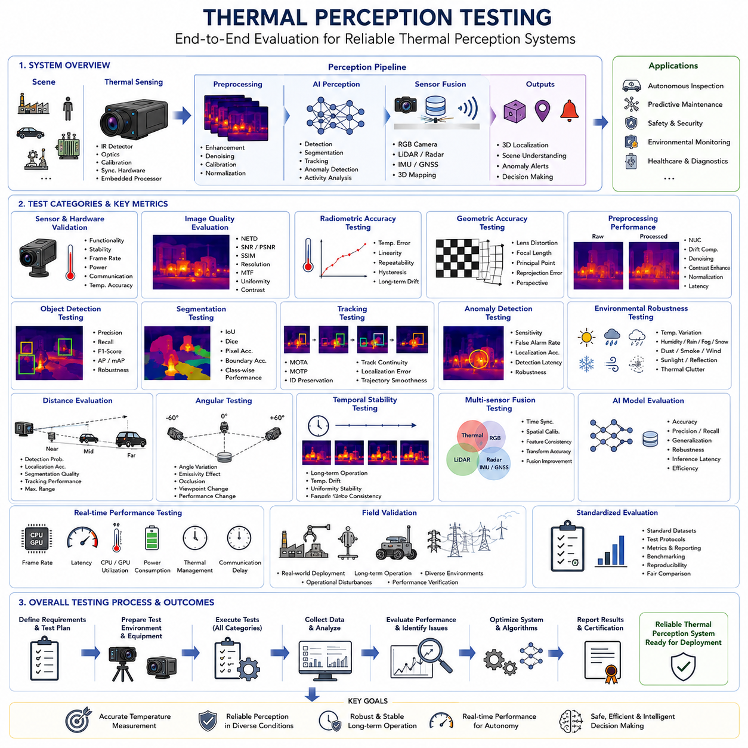
Thermal perception testing is the systematic process of evaluating whether thermal sensing systems can reliably detect, recognize, localize, and interpret thermal information under realistic operating conditions. Unlike conventional camera testing that primarily focuses on visual image quality, thermal perception testing evaluates both temperature measurement performance and machine perception capability. The objective is not only to verify that the thermal camera captures accurate infrared images, but also to ensure that the complete perception pipeline—including preprocessing, calibration, sensor fusion, artificial intelligence, object recognition, tracking, and decision-making—operates reliably in complex real-world environments. Comprehensive testing therefore provides quantitative evidence that thermal perception systems satisfy safety, performance, and operational requirements before deployment.
Modern thermal perception systems consist of multiple interacting components rather than a standalone thermal camera. The sensing subsystem includes infrared detectors, optical assemblies, calibration modules, synchronization hardware, and embedded processors. Data processing involves image enhancement, radiometric correction, geometric calibration, and thermal normalization before artificial intelligence algorithms perform object detection, semantic segmentation, anomaly recognition, and activity analysis. Finally, perception outputs support autonomous navigation, industrial inspection, predictive maintenance, and human safety monitoring. Effective testing therefore evaluates both individual subsystem performance and complete end-to-end system behavior across representative operational scenarios.
The first stage of thermal perception testing verifies sensor functionality and hardware integrity. Detector response, image stability, frame rate consistency, power consumption, communication reliability, and temperature measurement accuracy are evaluated under controlled laboratory conditions. Blackbody reference sources provide stable thermal targets that enable verification of detector linearity, repeatability, radiometric consistency, and calibration accuracy. Hardware validation ensures that the thermal camera satisfies its specified operating characteristics before higher-level perception algorithms are evaluated. Any hardware instability introduced during this stage may propagate throughout the perception pipeline and significantly reduce overall system performance.
Image quality evaluation represents another fundamental component of thermal perception testing. Unlike RGB imaging systems, thermal image quality depends strongly on detector sensitivity, noise characteristics, thermal contrast, optical transmission, and environmental conditions. Common evaluation metrics include Noise Equivalent Temperature Difference (NETD), signal-to-noise ratio, peak signal-to-noise ratio, structural similarity index, spatial resolution, modulation transfer function, image uniformity, and thermal contrast preservation. These measurements objectively quantify image quality while identifying limitations that may influence downstream perception algorithms under varying environmental conditions.
Radiometric accuracy testing evaluates whether measured temperatures correspond accurately to actual object temperatures across the specified operating range. Blackbody calibration equipment generates reference temperatures spanning low, medium, and high operating conditions. The thermal camera observes these targets while measurement errors, linearity, repeatability, hysteresis, and long-term drift are recorded. Radiometric evaluation is particularly important for industrial inspection, predictive maintenance, healthcare monitoring, and scientific measurement where small temperature differences often indicate critical operational conditions or emerging equipment failures.
Geometric accuracy testing verifies that thermal images accurately represent physical object geometry and spatial relationships. Calibration targets with precisely known dimensions allow measurement of lens distortion, focal length estimation, principal point location, reprojection error, and perspective correction accuracy. Geometric validation becomes increasingly important when thermal cameras are integrated with robotic manipulators, autonomous mobile robots, LiDAR systems, and three-dimensional reconstruction pipelines. Accurate geometry enables thermal information to be projected correctly into digital twins, inspection maps, and robot navigation systems.
Thermal perception testing also evaluates image preprocessing performance because every perception algorithm depends upon the quality of preprocessed thermal images. Testing measures the effectiveness of non-uniformity correction, thermal drift compensation, dead pixel restoration, noise reduction, contrast enhancement, histogram equalization, background normalization, and image registration algorithms. Objective metrics compare raw and processed images using noise suppression efficiency, edge preservation, temperature consistency, computational latency, and artifact generation. Preprocessing evaluation ensures that image enhancement improves perception performance without introducing artificial thermal patterns or reducing spatial information.
Object detection testing measures the capability of thermal perception systems to identify target objects under diverse operating conditions. Typical targets include humans, vehicles, machinery, electrical equipment, pipelines, industrial infrastructure, animals, and safety hazards. Detection performance is evaluated across varying distances, viewing angles, object sizes, thermal contrasts, environmental temperatures, and background complexity. Standard evaluation metrics such as precision, recall, F1-score, Average Precision, and mean Average Precision quantify detection reliability while supporting direct comparison between alternative perception algorithms and system configurations.
Thermal segmentation testing evaluates the ability to classify every pixel according to its corresponding object or material category. Semantic segmentation separates humans, machinery, buildings, vegetation, roads, equipment, and background regions based solely upon thermal information or multimodal sensor fusion. Evaluation commonly employs Intersection over Union, Dice coefficient, pixel accuracy, boundary accuracy, and class-specific performance metrics. High-quality segmentation is particularly important for autonomous inspection, environmental monitoring, medical imaging, and industrial process control where accurate spatial delineation directly influences decision making.
Object tracking evaluation measures whether thermal perception systems can continuously monitor moving targets across consecutive image frames. Tracking algorithms estimate object trajectories while maintaining identity through occlusions, illumination changes, thermal fluctuations, background clutter, and viewpoint variations. Performance metrics include Multiple Object Tracking Accuracy, Multiple Object Tracking Precision, identity preservation, track continuity, localization error, trajectory smoothness, and recovery after temporary target disappearance. Reliable thermal tracking supports autonomous surveillance, human safety systems, security monitoring, and intelligent transportation applications.
Anomaly detection testing evaluates the capability of thermal perception systems to identify abnormal temperature distributions associated with equipment failures, overheating, electrical faults, mechanical wear, fluid leakage, insulation degradation, or fire hazards. Because many industrial abnormalities develop gradually before catastrophic failure occurs, testing includes subtle temperature anomalies exhibiting only slight deviations from normal operating conditions. Evaluation measures detection sensitivity, false alarm rate, localization accuracy, detection latency, and robustness against normal environmental temperature variations. Accurate anomaly detection forms the foundation of predictive maintenance strategies across numerous industrial sectors.
Environmental robustness testing examines system performance under realistic operating conditions rather than ideal laboratory environments. Thermal perception systems encounter varying ambient temperatures, humidity, rainfall, fog, snow, dust, smoke, wind, direct sunlight, reflections, and thermal clutter throughout practical deployment. Testing systematically introduces these environmental variables while monitoring changes in image quality, temperature accuracy, object detection, segmentation, tracking, and anomaly recognition. Robust systems maintain reliable perception despite substantial environmental variability without requiring extensive manual recalibration.
Distance evaluation investigates perception performance across different observation ranges. Thermal resolution decreases as target distance increases, reducing object size and temperature measurement accuracy. Testing measures detection probability, localization accuracy, segmentation quality, and tracking performance from close-range inspection distances through long-range surveillance scenarios. These evaluations establish operational envelopes defining maximum effective detection ranges for different target categories, camera optics, environmental conditions, and required confidence levels.
Angular testing evaluates system performance under varying viewing directions and object orientations. Many industrial components exhibit directional emissivity characteristics, while complex geometries produce self-occlusion and varying thermal signatures depending upon observation angle. Testing rotates both camera and target across representative viewing geometries while recording changes in temperature measurement accuracy and perception performance. Angular evaluation identifies viewing configurations producing optimal thermal visibility and supports inspection path planning for autonomous robotic systems.
Temporal stability testing measures perception consistency throughout prolonged continuous operation. Industrial inspection robots frequently operate for many hours without interruption, during which detector temperatures, electronic components, calibration parameters, and environmental conditions gradually change. Testing continuously monitors temperature accuracy, image quality, detector uniformity, processing latency, detection performance, and synchronization over extended operating periods. Long-duration evaluation verifies that perception performance remains stable despite thermal drift, component aging, and changing environmental conditions.
Multisensor fusion testing evaluates integration between thermal cameras and complementary sensing technologies including RGB cameras, LiDAR, radar, inertial measurement units, ultrasonic sensors, GNSS receivers, and three-dimensional mapping systems. Testing verifies temporal synchronization, spatial calibration, feature consistency, coordinate transformation accuracy, and perception improvement resulting from sensor fusion. Comparative evaluation demonstrates whether multimodal perception provides superior robustness, localization accuracy, and environmental understanding relative to individual sensing modalities operating independently.
Artificial intelligence evaluation represents one of the most important stages of thermal perception testing because modern perception systems increasingly depend upon deep learning models. Neural networks are evaluated using independent validation datasets containing representative operational scenarios that were not used during model training. Testing measures classification accuracy, detection precision, segmentation quality, robustness against environmental variation, inference latency, computational efficiency, memory consumption, and generalization capability across unseen thermal environments. Reliable AI evaluation ensures that learned models remain dependable outside laboratory conditions.
Real-time performance testing determines whether thermal perception systems satisfy computational constraints imposed by autonomous robotic platforms. Embedded processors must complete image acquisition, preprocessing, calibration, sensor fusion, inference, tracking, mapping, and decision making within strict timing requirements. Evaluation measures frame processing rate, end-to-end latency, processor utilization, memory bandwidth, GPU efficiency, power consumption, thermal management, and communication delays. Real-time validation guarantees that perception outputs remain available quickly enough to support safe autonomous navigation and industrial operations.
Field validation represents the final stage of thermal perception testing because laboratory experiments cannot fully reproduce the diversity of real operational environments. Autonomous inspection robots, mobile platforms, industrial monitoring systems, and surveillance applications undergo extended field trials across representative deployment locations. Testing records perception performance during actual production activities, varying weather conditions, operational disturbances, and long-term continuous use. Field validation frequently reveals practical challenges that remain undetected during controlled laboratory evaluation while providing confidence for large-scale commercial deployment.
Performance assessment relies upon standardized evaluation protocols to ensure objective comparison between thermal perception systems. Test datasets, calibration procedures, environmental conditions, measurement equipment, statistical analysis methods, and reporting formats should remain consistent across repeated evaluations. Standardized benchmarks improve reproducibility while enabling manufacturers, researchers, regulatory organizations, and industrial users to compare competing technologies fairly. Such evaluation frameworks accelerate technological progress by providing measurable performance targets for future thermal perception systems.
Thermal perception testing therefore extends far beyond simply verifying thermal camera operation. It evaluates the complete perception ecosystem from detector performance and calibration through preprocessing, artificial intelligence, multisensor fusion, autonomous decision making, and real-world operational reliability. By systematically validating hardware accuracy, software robustness, environmental adaptability, computational efficiency, and long-term stability, comprehensive testing ensures that thermal perception systems deliver trustworthy information under demanding industrial conditions. These rigorous evaluation procedures establish the technical foundation for reliable autonomous inspection, predictive maintenance, intelligent robotics, infrastructure monitoring, healthcare diagnostics, safety systems, and future Physical AI applications that increasingly depend upon accurate thermal perception.

