Volume 03. AMR Sensors and Perception

Chapter 16. Object Tracking

16.1 Object Tracking Concepts
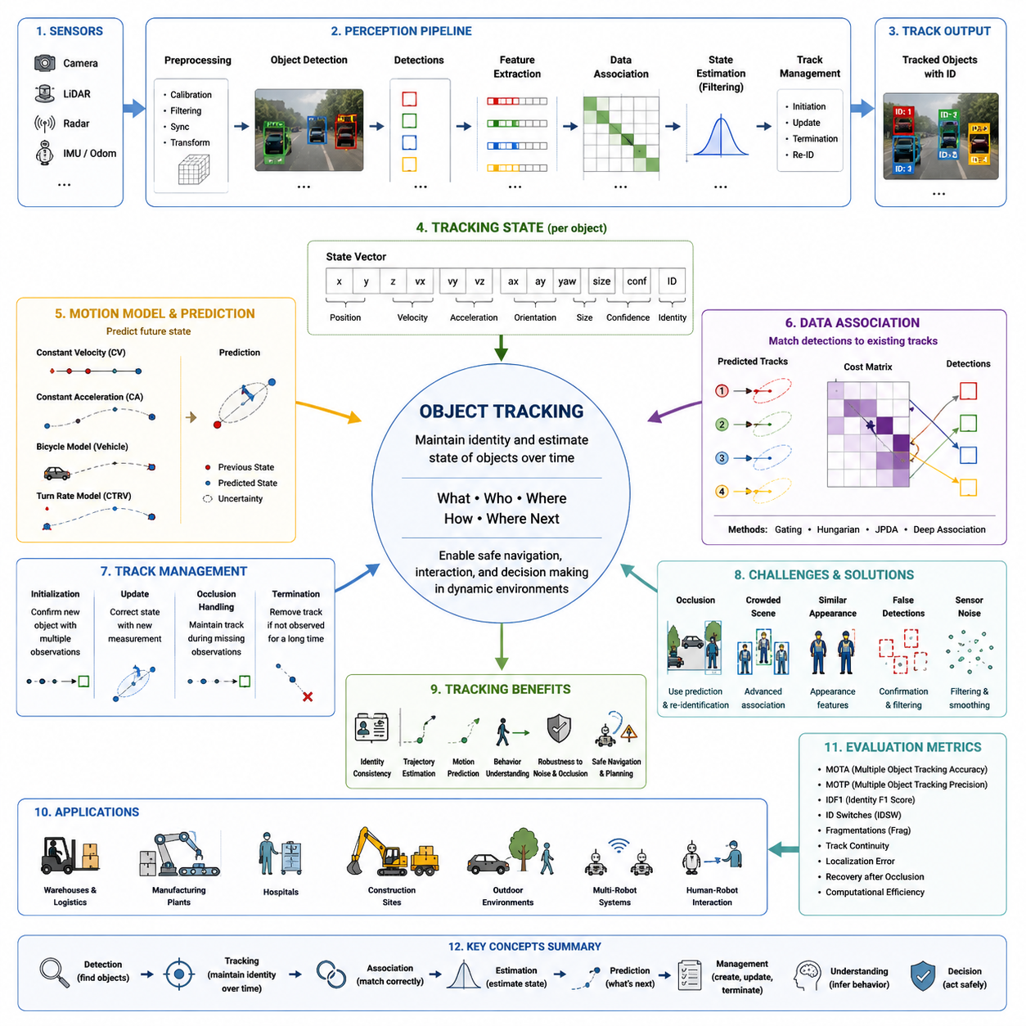
Object tracking is a fundamental capability in modern robotic perception because autonomous systems must continuously understand not only what objects exist in the environment but also how those objects move over time. While object detection identifies objects independently in each sensor frame, tracking establishes temporal continuity by assigning persistent identities to detected objects across consecutive observations. This temporal understanding allows an autonomous mobile robot to estimate trajectories, predict future motion, distinguish dynamic obstacles from static infrastructure, and make navigation decisions based on evolving environmental conditions rather than isolated snapshots.
An autonomous robot rarely operates in a perfectly static environment. Workers walk through factories, forklifts cross intersections, pallets are transported between workstations, and vehicles continuously change their positions. Every sensor frame represents only a single observation of a constantly changing world. Object tracking transforms these independent observations into coherent motion histories, enabling the perception system to recognize that a person detected several seconds earlier is the same individual currently approaching the robot instead of treating each observation as a completely new object.
The primary objective of object tracking is to maintain a stable identity for each observed target while continuously estimating its position, velocity, direction, and sometimes higher-level behavioral characteristics. A successful tracking system minimizes identity switches, maintains robustness during temporary sensor failures, survives partial occlusions, and rapidly recovers when objects reappear. The tracking process therefore serves as the temporal memory of the perception system, connecting past observations with present measurements and future predictions into a unified representation.
Unlike detection algorithms that focus on appearance within individual frames, tracking algorithms must simultaneously solve spatial and temporal association problems. Each new observation must be matched with previously tracked objects while considering measurement uncertainty, object motion, sensor noise, and possible false detections. The complexity increases significantly when multiple similar objects move close together, overlap, or temporarily disappear from the field of view before becoming visible again.
The distinction between detection and tracking is essential for understanding modern perception architectures. Detection answers the question of what is present at the current moment, whereas tracking answers who each object is, where it came from, how it is moving, and where it is likely to be in the near future. Detection produces independent measurements, while tracking constructs continuous histories. As a result, many robotic systems first execute object detection and then pass the detected bounding boxes, point clusters, or segmentation masks into dedicated tracking modules.
Object tracking can be viewed as a recursive estimation problem in which every new sensor measurement updates an internal model of each object's state. This state typically contains spatial coordinates, velocity estimates, heading direction, acceleration, object dimensions, confidence values, and unique identification numbers. As additional observations become available, the state estimate becomes progressively more accurate, allowing the robot to reduce uncertainty and improve motion prediction even under noisy sensing conditions.
Tracking performance depends heavily on the characteristics of the sensing modalities used by the robot. RGB cameras provide rich appearance information that supports visual matching but are sensitive to lighting variations and weather conditions. LiDAR sensors provide highly accurate geometric measurements and reliable distance estimation but contain less appearance information for distinguishing similar objects. Radar offers robust velocity measurements in rain, fog, and dust but has relatively low spatial resolution. Modern robotic platforms therefore frequently combine multiple sensing modalities to improve overall tracking robustness.
The perception pipeline generally begins with synchronized sensor acquisition followed by preprocessing operations such as image correction, point cloud filtering, timestamp alignment, and coordinate transformation. Object detection algorithms identify candidate targets within each sensor stream, producing observations that are subsequently associated with existing tracks. Motion estimation algorithms update object states using prediction and measurement correction, while track management modules determine whether tracks should be created, maintained, merged, split, or terminated.
Temporal consistency represents one of the most valuable properties provided by tracking. Sensor measurements inevitably contain noise, missed detections, and occasional false positives. A single incorrect detection should not immediately influence robot behavior if previous observations indicate otherwise. Tracking algorithms smooth these measurement fluctuations by integrating information collected over multiple frames, thereby reducing estimation variance and improving the stability of downstream planning and navigation algorithms.
Object identity management forms another critical aspect of tracking. Every tracked target receives a persistent identifier that remains associated with the object throughout its observable lifetime. Maintaining this identity becomes particularly challenging when multiple objects exhibit similar appearances or trajectories. Industrial facilities often contain workers wearing identical uniforms, forklifts with similar dimensions, or autonomous robots sharing nearly identical physical characteristics. Effective identity management prevents confusion between these similar objects during long observation periods.
Motion models provide mathematical descriptions of how tracked objects are expected to move over time. Simple models assume constant velocity, while more advanced formulations include acceleration, turning behavior, or vehicle-specific kinematic constraints. Selecting an appropriate motion model depends on the operational environment and the object categories being tracked. Human motion, warehouse vehicles, mobile robots, and construction equipment each exhibit distinct movement characteristics that influence prediction accuracy.
Prediction enables the tracker to estimate future object positions even before new sensor measurements become available. During short periods of occlusion, temporary sensor failure, or intermittent visibility, prediction allows tracks to survive despite missing observations. If the predicted location closely matches the next measurement, the track continues seamlessly. Otherwise, uncertainty gradually increases until the system determines that the object has likely disappeared or a new object has entered the scene.
Occlusion handling represents one of the most difficult challenges in practical tracking systems. Objects frequently become partially or completely hidden behind machinery, shelving, parked vehicles, structural columns, or other moving objects. Although visual information may temporarily disappear, the robot should avoid immediately deleting the corresponding track. Instead, prediction mechanisms preserve the estimated object state until new observations either confirm or invalidate the expected trajectory. Effective occlusion management greatly improves tracking continuity in crowded industrial environments.
Dynamic environments introduce additional complexity because numerous independently moving objects continuously interact. Two workers may cross paths, forklifts may temporarily overlap from the camera viewpoint, and autonomous robots may travel in opposite directions within narrow corridors. Tracking algorithms must correctly separate these interactions while preserving individual identities. This requirement has motivated the development of sophisticated data association techniques capable of resolving ambiguous observations under highly dynamic operating conditions.
Data association determines which new observations correspond to existing tracks. The process considers spatial proximity, predicted motion, object size, appearance similarity, velocity consistency, and measurement uncertainty. Incorrect associations can produce identity switches, fragmented trajectories, or duplicated tracks that degrade navigation safety. Consequently, data association remains one of the central research problems in object tracking and significantly influences overall system performance.
Track initialization occurs when the perception system observes an object that cannot be matched with any existing track. Rather than immediately creating a permanent track, many systems require multiple consecutive observations before confirming the object's existence. This confirmation process reduces the influence of sensor noise and transient false detections. Once confirmed, the object receives a persistent identity and enters the active tracking database maintained by the perception system.
Track termination follows the opposite process. When an object has not been observed for an extended period, the system gradually increases uncertainty while continuing short-term prediction. If no supporting measurements arrive within predefined limits, the track is removed from memory to conserve computational resources and prevent outdated information from influencing future decisions. Proper termination policies balance persistence against responsiveness in changing environments.
Real-time execution is an essential requirement because tracking directly supports collision avoidance and motion planning. Autonomous robots often operate with perception update rates between ten and several dozen frames per second, depending on sensor configuration and computational resources. The tracking module must therefore complete prediction, association, state estimation, and track management within strict timing constraints while maintaining deterministic latency suitable for safety-critical robotic applications.
Object tracking also contributes significantly to behavior understanding. Continuous trajectories reveal whether pedestrians are approaching, crossing, standing still, or moving away from the robot. Similarly, tracked industrial vehicles may indicate turning intentions, acceleration patterns, or imminent intersection conflicts. By analyzing motion histories rather than isolated detections, autonomous systems obtain richer contextual information that supports safer navigation decisions and more natural interactions with surrounding humans and machines.
Modern robotic tracking systems increasingly integrate deep learning with classical estimation techniques. Neural networks provide highly accurate object detection, feature extraction, and appearance representation, while probabilistic filters maintain temporal consistency and motion estimation. This hybrid architecture combines the strengths of data-driven perception with mathematically grounded state estimation, producing robust tracking performance across diverse industrial and outdoor operating conditions.
Evaluation of tracking quality extends beyond simple detection accuracy because temporal consistency must also be assessed. Performance measurements consider trajectory continuity, identity preservation, localization precision, recovery after occlusion, robustness against false detections, computational efficiency, and long-term stability. A tracker that produces highly accurate positions but frequently changes object identities may still be unsuitable for autonomous navigation because planning modules depend on stable object histories rather than isolated measurements.
Object tracking ultimately serves as the bridge between perception and intelligent decision making within autonomous mobile robots. Detection provides awareness of the current environment, whereas tracking transforms that awareness into a continuously evolving representation of dynamic reality. By preserving identities, estimating motion, predicting future behavior, and maintaining temporal consistency across sensor observations, object tracking enables robots to safely navigate complex environments, cooperate with humans, respond intelligently to moving obstacles, and perform reliable autonomous operations across warehouses, factories, hospitals, construction sites, logistics centers, and outdoor industrial facilities. This conceptual foundation establishes the basis for more advanced topics including single-object tracking, multi-object tracking, identity assignment, motion modeling, behavior prediction, and quantitative tracking performance evaluation that together form the complete object tracking framework within modern robotic perception systems.

16.2 Single Object Tracking
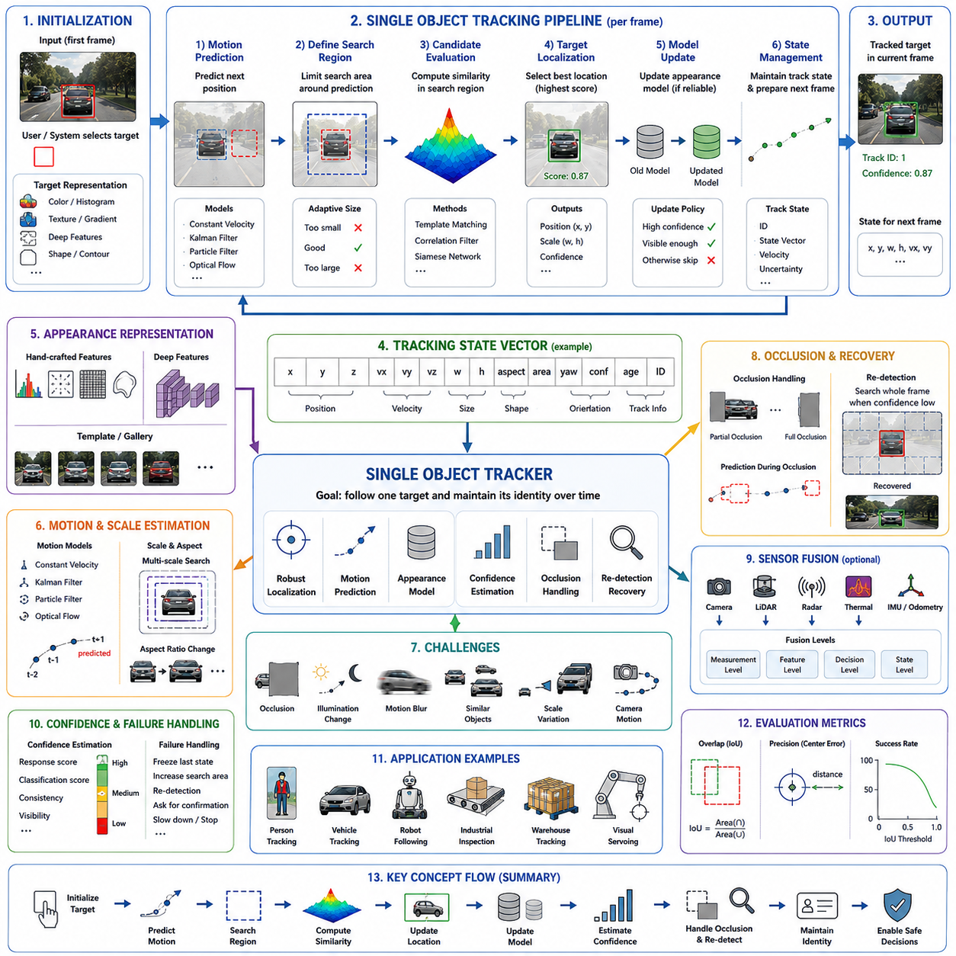
Single object tracking is a perception task in which a system follows one designated target across a sequence of images or sensor frames. The target is usually specified in the first frame through a bounding box, mask, point, template, or manually selected region. After initialization, the tracker estimates the target location in every subsequent frame while adapting to motion, scale changes, appearance variation, occlusion, and background interference.
Unlike object detection, which searches an entire scene for every object category in each frame, single object tracking concentrates computational attention on one known target. The tracker does not repeatedly ask what objects are present. Instead, it asks where the selected target has moved and whether the current visual evidence still corresponds to the original target. This focused formulation enables efficient temporal processing and supports applications that require continuous observation of one important object.
The target may be a person, vehicle, mobile robot, pallet, machine component, tool, package, animal, or any visually identifiable object. The tracking algorithm must preserve the relationship between the initial target description and later observations, even when the object changes its orientation, distance, illumination, pose, or visible surface. The challenge is therefore not only to find a similar region, but to maintain the identity of the original target over time.
A typical single object tracking process begins with target initialization. The initial bounding box defines the target position and provides the first appearance representation. The tracker extracts visual features such as color, texture, edges, shape, deep neural features, or combinations of these descriptors. These features become a reference model that guides the search for the target in later frames.
After initialization, the tracker predicts a likely search region based on the previous target position and estimated motion. Restricting the search to a local area significantly reduces computation and lowers the probability of confusing the target with unrelated objects elsewhere in the image. However, an excessively small search region may lose the target during rapid motion, while an overly large region increases ambiguity and processing cost.
In each new frame, candidate regions within the search area are compared with the stored target representation. A similarity function produces a response map or confidence score that indicates how strongly each candidate matches the target. The location with the highest reliable score is selected as the new estimate. The tracker then updates its internal state and prepares to process the next frame.
The simplest tracking approach is template matching, in which the image patch from the initial target is compared directly with candidate patches in later frames. Although this method is easy to understand, fixed templates are sensitive to appearance changes, scale variation, deformation, and illumination differences. A target that rotates or changes its visible shape may no longer resemble the original template, causing tracking accuracy to degrade rapidly.
Feature-based approaches improve robustness by representing the target through more stable visual characteristics. Histograms of color, gradient orientation, local texture, keypoints, or deep feature maps can tolerate moderate changes in appearance. Rather than requiring exact pixel correspondence, these methods compare higher-level patterns that remain recognizable under translation, partial deformation, or lighting variation.
Correlation filter trackers became widely used because they combine efficient computation with accurate localization. These trackers learn a filter that generates a strong response at the target center and weaker responses elsewhere. Fast Fourier Transform operations allow the filter to evaluate many translated candidates efficiently. This structure makes correlation filters suitable for real-time tracking on systems with limited computational resources.
Traditional correlation filters may still struggle when the target experiences severe deformation, long-term occlusion, or the presence of similar nearby objects. Their update mechanisms can also introduce model drift when incorrect observations are incorporated into the target model. Modern variants address these weaknesses through regularization, multi-scale estimation, background suppression, reliability weighting, and improved feature representation.
Siamese network tracking represents another important approach. A Siamese tracker uses two neural network branches with shared parameters. One branch processes the target template, while the other processes the search region from the current frame. The network compares both feature representations and produces a similarity map that identifies the most likely target position.
Because the template and search image are processed through the same feature extractor, Siamese networks learn a general matching function rather than memorizing one object category. This allows the tracker to follow previously unseen targets after receiving only an initial example. The method is particularly useful when a robot must track arbitrary objects without requiring category-specific retraining.
Many Siamese trackers operate without extensive online learning during deployment. Their matching capability is learned offline from large video datasets, enabling fast inference after initialization. This design reduces computational overhead and avoids unstable model updates. However, a completely fixed target representation may become outdated when the target undergoes major appearance changes during a long sequence.
To address this issue, advanced trackers combine offline-learned matching with controlled online adaptation. The system may store multiple target templates captured under different viewing conditions or update the appearance model only when confidence is high. Conservative updates reduce the risk of learning the background, an occluding object, or a visually similar distractor as part of the target model.
Model drift is one of the central failure modes in single object tracking. Drift occurs when small localization errors accumulate and gradually shift the tracker away from the actual target. Once the tracking box contains significant background content, the appearance model may adapt to the wrong region. The tracker can then continue following an irrelevant object or static background pattern with apparently high confidence.
Reliable model updating is therefore essential. The tracker should consider response quality, classification confidence, target visibility, motion consistency, and boundary conditions before modifying its internal representation. Updates may be suspended when the target is heavily occluded, leaves the image, moves unpredictably, or produces an ambiguous response. This prevents unreliable observations from corrupting the learned target model.
Motion prediction provides another layer of stability. A simple model may assume constant velocity and estimate the next target position from recent displacement. More advanced models use a Kalman filter, particle filter, optical flow, or learned temporal network. Prediction helps center the search region and allows the tracker to continue estimating motion during brief periods of missing or weak visual evidence.
The Kalman filter is effective when target motion can be approximated by a linear model with Gaussian uncertainty. It predicts the target state using previous position and velocity, then corrects the prediction using the new measurement. The balance between model prediction and visual observation depends on their estimated uncertainty. This combination can smooth noisy localization and improve short-term continuity.
Particle filters are useful when the target state has nonlinear dynamics or multiple possible locations. Instead of maintaining one Gaussian estimate, the filter represents uncertainty through many weighted samples. Each particle corresponds to a possible target state, and its weight depends on visual similarity. Particle filters can recover from ambiguous motion more effectively, although they require greater computational effort.
Optical flow estimates the apparent motion of pixels or local features between consecutive frames. Sparse optical flow can track selected points on the target, while dense optical flow estimates motion throughout the image. Flow information supports precise short-term tracking, especially when frame-to-frame movement is small. However, optical flow becomes unreliable under large displacement, low texture, motion blur, or sudden illumination changes.
Scale estimation is necessary because a target appears larger as it approaches the camera and smaller as it moves away. A tracker with a fixed bounding box size may gradually include excessive background or exclude significant parts of the target. Multi-scale search evaluates candidate regions at several sizes, while dedicated regression models estimate width and height changes directly.
Aspect ratio changes also occur when an object rotates, deforms, or changes pose. A walking person, articulated robot arm, or turning vehicle may occupy a substantially different shape over time. Trackers that estimate only translation and uniform scale may not accurately represent these transformations. Modern systems therefore often predict bounding box coordinates through learned regression rather than relying solely on fixed geometric assumptions.
Rotation presents an additional challenge because standard axis-aligned bounding boxes cannot represent object orientation precisely. For applications involving aerial imagery, rotating machinery, grasped objects, or mobile robots viewed from above, oriented bounding boxes may be more appropriate. The tracker must then estimate not only position and size but also angular orientation, increasing both state complexity and training requirements.
Occlusion occurs when another object, structure, or environmental element partially or completely blocks the target. During partial occlusion, the tracker should rely on the visible target regions and reduce the influence of hidden parts. Attention mechanisms, part-based models, segmentation masks, and reliability maps can help identify which visual features remain trustworthy.
Complete occlusion is more difficult because no direct visual measurement is available. A short-term tracker may continue predicting the target position for several frames, but uncertainty grows rapidly. If the target remains hidden for a long period, the tracker must either declare failure or switch to a wider re-detection process. The correct strategy depends on whether the application prioritizes speed, precision, or long-term recovery.
Short-term single object tracking typically assumes that the target remains visible and within a limited search region. When the target disappears, the sequence may be considered unsuccessful. Long-term tracking includes explicit target presence detection, failure recognition, and global re-detection. These additional capabilities allow the system to recover after extended occlusion, camera motion, or temporary departure from the field of view.
Target presence confidence should represent whether the target is genuinely visible rather than merely indicating the best available match. A response map always contains a maximum, even when the target is absent. Therefore, the tracker needs confidence calibration based on response sharpness, classification scores, consistency, and learned absence indicators. Without reliable presence estimation, the system may continue reporting false locations during target disappearance.
Re-detection searches a larger image region or the complete frame using a stable target representation. It may use a separate detector, global feature matching, memory bank, or long-term template. Re-detection is computationally more expensive than local tracking, so it is usually activated only after confidence falls below a threshold. Successful recovery requires distinguishing the target from similar distractors that may have appeared during its absence.
Distractor objects are visually similar regions that compete with the true target. Examples include workers wearing identical uniforms, vehicles of the same model, repeated boxes, production components, or multiple robots with similar shapes. A tracker focused only on local appearance may switch to a distractor when both objects come close or overlap.
Discriminative tracking reduces this risk by learning not only what the target looks like but also how it differs from the surrounding background and nearby objects. Negative examples are collected from regions around the target, and the classifier learns a decision boundary between target and non-target appearances. The quality and diversity of these negative samples strongly influence tracking stability.
Hard negative mining emphasizes confusing background regions that receive high target scores. By learning from these difficult examples, the tracker becomes better at rejecting similar objects. However, aggressive adaptation to recent negatives may reduce the ability to recognize the target after a major appearance change. The update process must therefore balance discrimination, adaptability, and long-term identity preservation.
Background clutter can interfere with localization even when no similar object is present. Repetitive textures, strong edges, reflections, shadows, and moving machinery may create false responses. Robust trackers use contextual information, spatial regularization, attention, segmentation, and multi-level features to suppress irrelevant structures. The tracker should remain sensitive to target evidence while avoiding excessive dependence on unstable background patterns.
Illumination variation affects color, contrast, texture, and visibility. Indoor robots may move between bright work areas and dark storage spaces, while outdoor systems experience sunlight, shadows, headlights, and weather changes. Feature normalization, data augmentation, exposure control, infrared sensing, and multi-modal fusion can improve tracking under these conditions.
Motion blur occurs when the target or camera moves rapidly during image exposure. The target may lose clear edges and texture, reducing feature similarity. Higher shutter speed, stabilized cameras, motion-aware training, and broader search regions can reduce the impact. Prediction from previous velocity also helps maintain continuity until sharper visual evidence becomes available.
Camera motion must be distinguished from target motion. A camera mounted on a mobile robot can translate, rotate, vibrate, and change elevation, causing the entire image to shift. A tracker that assumes a stationary camera may interpret background movement as target displacement. Visual odometry, inertial measurement, frame registration, or global motion compensation can separate camera-induced motion from independent target motion.
Egomotion compensation is particularly important for autonomous mobile robots. Wheel odometry, inertial measurement unit data, visual odometry, or simultaneous localization and mapping results can estimate camera movement between frames. The target prediction can then be expressed in a stabilized coordinate system, improving the accuracy of search region placement and reducing unnecessary expansion.
Sensor fusion can strengthen single object tracking beyond visual information alone. A camera provides detailed appearance, while LiDAR supplies accurate range and three-dimensional geometry. Radar measures relative velocity and remains robust in poor weather. Thermal cameras improve visibility in darkness. Combining these sensors can preserve tracking when one modality becomes unreliable.
Fusion may occur at the measurement, feature, decision, or state level. Early fusion combines raw or low-level sensor information, while late fusion integrates independent tracking outputs. Feature-level fusion learns joint representations, and state-level fusion combines position and velocity estimates with uncertainty. The most appropriate architecture depends on synchronization quality, sensor calibration, computational resources, and operational requirements.
Three-dimensional single object tracking estimates target position and size in world coordinates rather than only in the image plane. This is valuable for robotic navigation, manipulation, inspection, and collision avoidance. A 3D tracker may use LiDAR point clouds, stereo vision, depth cameras, radar, or fused sensing to maintain the target state across time.
Point cloud tracking often begins with a 3D bounding box or segmented point cluster. The tracker searches for the object in the next point cloud using geometric similarity, motion prediction, learned features, or point-wise correspondence. Sparse measurements, range-dependent density, self-occlusion, and background points make this process challenging, particularly for small or distant targets.
Coordinate system selection affects how the target state is represented. Image coordinates are suitable for visual display, but robot-centered or world-centered coordinates are more useful for navigation and planning. A robot-centered frame changes as the platform moves, while a world frame provides stable trajectory interpretation. Accurate calibration and time synchronization are required to transform observations between these coordinate systems.
Single object tracking can support active perception, in which the camera or robot changes its motion to keep the target observable. A pan-tilt-zoom camera may rotate and zoom based on the estimated target position. A mobile robot may adjust its route to maintain a safe viewing distance. The tracker therefore becomes part of a closed-loop control system rather than a passive observation module.
In visual servoing, target tracking directly influences actuator commands. The difference between the target location and desired image position becomes an error signal for camera, robot, or manipulator control. Because tracking errors can produce incorrect movement, latency, stability, uncertainty, and failure detection must be carefully managed. Safety limits should prevent abrupt or hazardous responses to uncertain estimates.
Human tracking is a common single object tracking application. A service robot may follow a designated worker, patient, customer, or operator while maintaining appropriate distance and orientation. Human pose changes, body deformation, clothing similarity, crowd interactions, and temporary occlusion make this task difficult. Re-identification features and body-part information can help preserve the selected identity.
Vehicle tracking supports traffic monitoring, autonomous driving, security, and outdoor robotics. Vehicles generally follow stronger motion constraints than pedestrians, allowing the use of lane structure, heading, wheel motion, and kinematic models. However, rapid acceleration, turning, partial visibility, and similar vehicle appearances still create challenges, especially in intersections or dense traffic.
Industrial inspection systems may track a particular product, defect region, moving component, or tool during an inspection process. Accurate tracking allows the inspection sensor to maintain alignment with the target while the conveyor, manipulator, or mobile platform moves. In these cases, geometric precision and synchronization may be more important than broad category recognition.
Warehouse robots can track a selected pallet, cart, container, forklift, or worker. The tracker may support following behavior, handover operations, loading verification, or dynamic safety zones. Repetitive visual structures and nearly identical assets make identity preservation difficult, so tracking may be combined with markers, barcodes, radio-frequency identification, or digital task information.
Tracking confidence should be communicated to downstream modules rather than presenting every estimate as equally reliable. The state may include localization uncertainty, visibility probability, model quality, and recovery status. Navigation or control systems can then slow down, increase safety distance, request re-detection, or stop the robot when confidence becomes insufficient.
Latency is especially important in fast-moving scenarios. Even a precise target estimate becomes outdated if processing takes too long. The end-to-end delay includes image exposure, sensor transmission, preprocessing, feature extraction, localization, state estimation, and communication to the controller. Real-time performance should therefore be evaluated through both frame rate and total system latency.
High frame rate can improve short-term continuity because target displacement between frames becomes smaller. However, higher frame rate increases data bandwidth and computation. The system must balance spatial resolution, temporal resolution, model complexity, and hardware capability. Efficient feature reuse, reduced search regions, model compression, and hardware acceleration can help maintain real-time operation.
Memory management also influences long-duration tracking. The system may store historical templates, appearance features, confidence values, and motion states. Retaining too little history limits recovery from major appearance changes, while retaining too much data increases computation and may preserve outdated information. Memory selection strategies should prioritize reliable and diverse target observations.
Training datasets for single object tracking contain videos with target annotations across consecutive frames. The training process exposes models to translation, scale variation, deformation, occlusion, blur, illumination change, and background clutter. Data diversity is critical because the tracker must generalize to object categories and environments not encountered during deployment.
Synthetic data can supplement real videos by generating controlled motion, occlusion, lighting, and appearance transformations. Simulation environments can produce accurate annotations and rare failure scenarios. However, synthetic imagery may differ from real sensor characteristics, creating a domain gap. Domain randomization, realistic rendering, and fine-tuning with field data help reduce this difference.
Online learning allows the tracker to adapt during operation, whereas offline learning establishes general tracking knowledge before deployment. Online adaptation improves responsiveness to a specific target but introduces the risk of drift. Offline models provide stable behavior but may not capture unique target changes. Hybrid systems use a robust offline backbone with carefully controlled online components.
Evaluation protocols measure whether the predicted target location overlaps the ground-truth region. Intersection over Union compares the overlap between predicted and annotated bounding boxes. Success plots summarize the percentage of frames exceeding different overlap thresholds. Precision measures the distance between predicted and actual target centers, often evaluated across a range of distance thresholds.
Normalized precision accounts for object size or image dimensions, making comparisons fairer across sequences. Robustness measures tracking failures, while accuracy measures localization quality during successful tracking. Long-term evaluations additionally consider target absence detection, re-detection delay, false positive duration, and recovery success after disappearance.
Benchmark results should be interpreted carefully because average scores may hide important failure modes. A tracker may perform well on short, clear sequences but fail under complete occlusion or similar-object interaction. Application-specific evaluation should therefore include the environmental conditions, object types, camera motion, latency requirements, and safety consequences expected in actual deployment.
Qualitative analysis remains valuable even when numerical metrics are available. Visualizing predicted boxes, response maps, confidence values, search regions, and model updates can reveal drift, scale errors, delayed recovery, or distractor confusion. Frame-by-frame inspection helps engineers understand why a tracker failed and whether the root cause lies in initialization, appearance modeling, motion estimation, or confidence management.
Debugging should begin with verification of image timestamps, frame order, coordinate conventions, and bounding box formats. An apparent tracking failure may result from incorrect image resizing, aspect ratio changes, delayed sensor data, or inconsistent coordinate transformations. Establishing a reliable data pipeline is necessary before modifying the tracking algorithm itself.
Initialization quality has a major influence on performance. A box that includes excessive background may cause the tracker to learn irrelevant features, while an overly tight box may exclude distinctive target parts. The initial region should represent the full target accurately without including nearby distractors. In automatic systems, initialization confidence should be checked before tracking begins.
Threshold selection affects model updates, absence detection, re-detection, and termination. Fixed thresholds may not generalize across environments or object types. Confidence calibration and adaptive thresholds can improve reliability by considering response statistics, motion uncertainty, target size, and recent history. Nevertheless, threshold behavior must remain understandable and testable for safety-related applications.
Failure handling should be designed explicitly rather than assuming that the tracker will always succeed. The system should define what happens when confidence collapses, the target leaves the scene, multiple candidates appear, or sensor data becomes unavailable. Possible actions include freezing the last reliable state, expanding the search, activating re-detection, requesting operator confirmation, slowing the robot, or entering a safe stop.
A practical single object tracking system is therefore more than a visual matching algorithm. It combines target representation, local search, motion prediction, scale estimation, confidence evaluation, model adaptation, occlusion handling, re-detection, sensor fusion, and track state management. Each component contributes to the ability to preserve one target identity through complex temporal changes.
The final design must reflect the intended operating environment. A lightweight camera tracker for video editing has different requirements from a safety-critical tracker on an autonomous robot. Industrial systems may prioritize deterministic timing, uncertainty output, controlled failure behavior, calibration stability, and integration with navigation or control. Consumer applications may emphasize visual smoothness, broad generalization, and ease of initialization.
Single object tracking forms an important foundation for more complex perception tasks. The principles of target representation, motion prediction, confidence management, and temporal consistency are also used in multi-object tracking, re-identification, behavior analysis, and autonomous navigation. Understanding these mechanisms provides the conceptual basis for designing reliable tracking systems that can maintain attention on one selected target while the robot, camera, object, and surrounding environment continuously change.

16.3 Multi Object Tracking
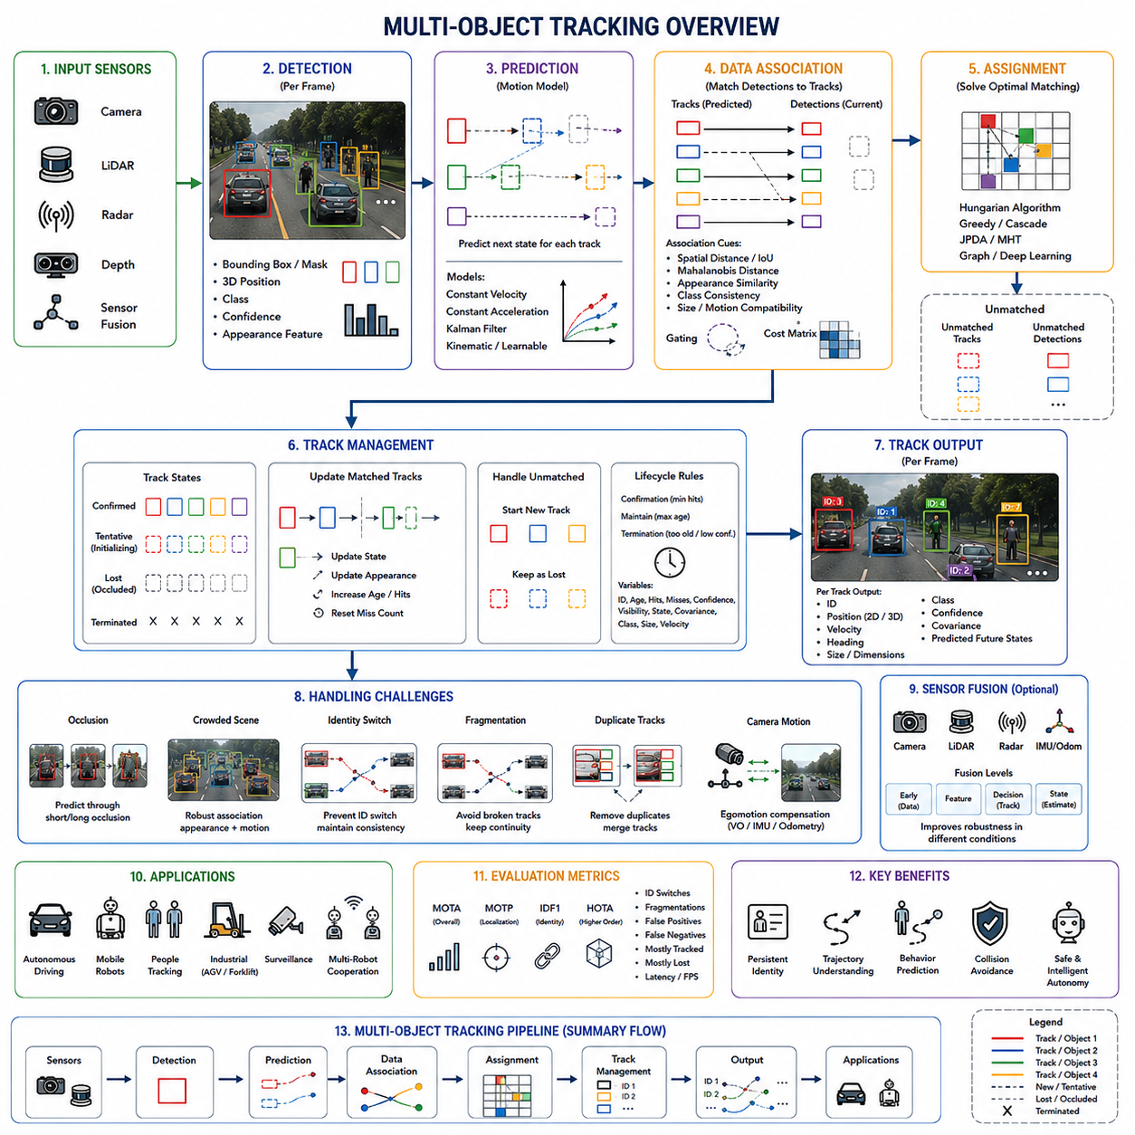
Multi-object tracking is the process of detecting, identifying, and continuously estimating the states of multiple objects across a sequence of sensor observations. Unlike single object tracking, which follows one predefined target, multi-object tracking must discover several targets, assign a persistent identity to each one, and maintain those identities while objects enter, leave, overlap, disappear, or interact within a dynamic environment.
The core objective is not simply to locate objects in every frame. A multi-object tracker must determine which observation belongs to which previously known object. It therefore transforms independent detections into continuous trajectories that describe where each target has been, how it is moving, and where it may move next. This temporal organization is essential for autonomous robots operating around people, vehicles, equipment, and other robots.
A typical multi-object tracking system receives detections from cameras, LiDAR, radar, depth sensors, or fused perception modules. Each detection may contain a bounding box, segmentation mask, three-dimensional position, object class, confidence score, and appearance feature. The tracking system compares these new measurements with existing tracks and decides whether they represent known objects, new objects, or unreliable observations.
The most widely used architecture is tracking-by-detection. In this approach, an object detector first identifies candidate objects independently in each frame. The tracking module then links detections across time. This separation allows advanced detectors and tracking algorithms to be developed independently, but the final tracking quality remains strongly dependent on the detector’s accuracy, consistency, latency, and ability to handle partial visibility.
Missed detections create gaps in object trajectories, while false detections may generate temporary or duplicated tracks. Inaccurate bounding boxes can disturb association and state estimation, especially when objects are close together. Therefore, multi-object tracking must compensate for imperfect detection through motion prediction, confirmation logic, uncertainty modeling, appearance matching, and track management rather than assuming that every measurement is correct.
Each active track stores an estimated object state. This state may include position, velocity, acceleration, heading, dimensions, class, confidence, age, visibility, and a unique track identifier. In image-based systems, the state may be represented by bounding box center, width, and height. In robotic systems, world-coordinate position and velocity are often more useful because navigation and collision avoidance require metric spatial information.
A prediction stage estimates where every tracked object is expected to appear in the next frame. Simple systems assume constant velocity, while more advanced trackers use constant acceleration, coordinated turn models, vehicle kinematics, recurrent neural networks, or learned trajectory models. Prediction narrows the region where a matching detection should be found and supports temporary tracking when observations are unavailable.
The Kalman filter is commonly used for state prediction and correction. It projects the previous state forward using a motion model and produces an uncertainty estimate. When a new detection becomes available, the filter combines the prediction and measurement according to their relative uncertainties. This recursive process smooths noisy detections and provides continuous estimates of position and velocity.
Prediction alone cannot determine object identity because multiple targets may occupy nearby regions. Data association is therefore the central operation in multi-object tracking. It evaluates the compatibility between existing tracks and new detections, producing possible track-to-detection matches. The association process must reject unlikely matches while selecting the most consistent global assignment among many competing possibilities.
Spatial distance is one of the simplest association cues. A detection located near a predicted track is more likely to correspond to that track than one located far away. Distance may be measured between object centers, three-dimensional positions, bounding boxes, or predicted state vectors. However, spatial proximity alone is insufficient when several similar objects move closely together or cross one another.
Intersection over Union compares the overlap between a predicted bounding box and a detected bounding box. A high overlap indicates a likely match, making this measure efficient for image-based tracking. Its reliability decreases when objects move rapidly, detections are delayed, camera motion is strong, or bounding boxes vary significantly. Motion compensation and adaptive gating are often needed in these situations.
Mahalanobis distance evaluates the difference between a predicted state and a detection while considering state uncertainty. A track with high uncertainty can accept observations over a wider area, while a confident track uses a narrower association region. This probabilistic distance is especially useful with Kalman filters because it directly incorporates the predicted covariance of each track.
Appearance information helps distinguish objects that are close in space. Deep neural networks can extract compact feature vectors that represent clothing, texture, shape, vehicle appearance, or other visual characteristics. The tracker compares these features using cosine similarity or another distance measure. A strong appearance match can preserve identity even when motion prediction becomes ambiguous.
Appearance-based matching is closely related to person or object re-identification. Re-identification models are trained to produce similar features for different views of the same object and dissimilar features for different objects. These representations are particularly important in crowded scenes, but their reliability may decrease because of identical uniforms, similar vehicles, poor lighting, low resolution, or major viewpoint changes.
Effective trackers combine motion and appearance rather than relying on only one source. Motion is usually reliable over short time intervals, while appearance supports identity preservation during interactions and reappearance. The cost assigned to a possible match may include position difference, overlap, feature similarity, class consistency, size compatibility, and temporal information. The relative weighting should reflect the sensor configuration and operating environment.
Association gating eliminates impossible or highly unlikely matches before optimization. A detection may be rejected if it lies outside a predicted spatial region, has an incompatible object class, differs excessively in size, or violates physical movement constraints. Gating reduces computation and prevents obviously incorrect associations, but overly strict gates may reject the correct match during abrupt motion or long detection gaps.
After constructing an association cost matrix, the tracker selects an assignment between tracks and detections. The Hungarian algorithm is widely used to find a minimum-cost one-to-one matching. Each track can be assigned to at most one detection, and each detection can update at most one track. This global solution is more consistent than independently selecting the nearest detection for each track.
Greedy matching is computationally simpler and repeatedly selects the lowest-cost available pair. It may work in sparse scenes but can produce suboptimal assignments when several tracks compete for the same detection. Cascade matching improves priority handling by associating recently observed or highly reliable tracks before uncertain tracks, reducing the risk that unstable tracks take measurements away from established ones.
More advanced probabilistic association techniques account for ambiguity directly. Joint Probabilistic Data Association estimates probabilities for multiple possible assignments rather than committing immediately to one match. Multiple Hypothesis Tracking preserves several competing association histories until later evidence resolves the ambiguity. These methods can be robust in dense scenes but require greater computation and memory.
Modern deep learning trackers may learn association directly from data. Graph neural networks can represent detections as nodes and possible temporal relationships as edges. The network learns whether pairs of observations belong to the same trajectory by considering appearance, motion, context, and neighboring objects. Transformer-based methods can also model long-range temporal relationships and jointly reason about several targets.
Joint detection and tracking systems integrate object detection, feature extraction, association, and trajectory estimation within one neural architecture. Instead of processing each frame independently, the model may propagate object queries or track embeddings over time. This can reduce duplicated computation and improve temporal consistency, although training and deployment become more complex.
Track initialization begins when a detection cannot be assigned to an existing track. Immediate confirmation may create many false tracks from detector noise. Therefore, most systems first create a tentative track and require repeated supporting observations before assigning confirmed status. The number of required detections depends on the detector reliability, frame rate, object speed, and safety requirements.
Track confirmation introduces a tradeoff between responsiveness and reliability. A short confirmation period allows the system to recognize newly appearing objects quickly but increases false track creation. A longer period filters transient errors but delays awareness of real objects. In collision-sensitive robotic applications, tentative tracks may still influence safety behavior even before full confirmation.
When an active track receives a matched detection, its state, uncertainty, appearance representation, confidence, and visibility are updated. The update rate should be carefully controlled. Rapid appearance adaptation helps follow changing targets but can cause identity drift. Conservative adaptation protects long-term identity but may fail when the target rotates, changes scale, or enters a different lighting condition.
An unmatched track is not always removed immediately. The missing detection may result from occlusion, detector failure, sensor noise, or temporary departure from the field of view. The tracker usually keeps the track alive for a predefined period while predicting its movement. During this period, uncertainty increases, and the track may be marked as lost, occluded, or temporarily inactive.
Track termination occurs when the object has remained unmatched beyond an allowed age or its confidence becomes too low. Removing stale tracks prevents old predictions from influencing planning and reduces computational load. However, terminating a track too quickly causes trajectory fragmentation, while retaining it too long may produce ghost objects and incorrect associations when new targets enter the same area.
Track age, hit count, missed count, and time since last observation are common management variables. A mature track with many reliable observations may be preserved through a longer occlusion than a newly created track. Adaptive termination policies can also consider object speed, scene boundaries, expected visibility, sensor coverage, and whether the object is predicted to remain inside the observable region.
Occlusion is one of the greatest challenges in multi-object tracking. Partial occlusion occurs when part of an object remains visible, while complete occlusion temporarily removes all direct evidence. In crowded scenes, multiple objects may overlap and produce merged detections. The tracker must maintain separate identities even when the detector reports incomplete, unstable, or combined object regions.
Motion prediction supports short occlusions, but longer occlusions require stronger identity information. Appearance memory, trajectory history, scene geometry, and behavior constraints can help reconnect a lost track with a later detection. The tracker must also avoid matching the returning target to another object that followed a similar path during the hidden interval.
Identity switches occur when a tracker assigns an existing identifier to the wrong object. This frequently happens when targets cross, overlap, or look similar. An identity switch can corrupt behavior prediction, safety analysis, and trajectory statistics even when localization remains accurate. Preventing such switches is therefore one of the primary objectives of multi-object tracking.
Trajectory fragmentation occurs when one physical object is represented by multiple track segments. A missed detection or premature termination may end the original track, and a later detection may create a new identity. Fragmentation makes it difficult to analyze long-term movement and can cause downstream systems to interpret one object as several different objects.
Duplicate tracks arise when multiple tracks follow the same physical target. This may happen because of repeated detections, unstable initialization, sensor fusion errors, or incomplete association. Duplicate removal can compare spatial overlap, velocity, appearance, and observation history. However, merging tracks too aggressively risks combining two distinct objects moving close together.
Crowded environments increase the number of possible associations and reduce the visual separation between objects. People may walk in groups, forklifts may queue at intersections, and mobile robots may share narrow paths. In such conditions, the tracker benefits from scene-level reasoning rather than treating each target independently. Group motion, collision constraints, and mutual exclusion can improve consistency.
Object interactions contain useful tracking information. Two solid objects cannot occupy the same physical space, vehicles generally follow feasible turning paths, and pedestrians exhibit characteristic acceleration and social behavior. Incorporating these constraints can reject physically impossible assignments. Nevertheless, models should remain flexible enough to handle unusual or abrupt actions.
Camera motion complicates image-based multi-object tracking because every background and foreground region shifts simultaneously. A mobile robot may turn, accelerate, vibrate, or travel over uneven terrain. Without compensation, predicted bounding boxes may be displaced even when objects remain stationary in the world. Visual odometry, inertial data, feature-based registration, or known robot pose can estimate and remove egomotion.
Representing tracks in world coordinates provides significant benefits for mobile robots. Once camera or LiDAR measurements are transformed into a common coordinate frame, object motion can be separated from platform motion. World-coordinate trajectories are easier to use for path planning, speed estimation, collision prediction, map interaction, and multi-sensor fusion.
Accurate coordinate transformation requires calibrated sensor extrinsics and precise timing. Even small timestamp differences can produce large position errors when the robot or target moves quickly. Time synchronization between cameras, LiDAR, radar, IMU, odometry, and computing modules is therefore a fundamental requirement for reliable multi-object tracking.
Two-dimensional tracking represents objects in image coordinates, usually with axis-aligned bounding boxes. It is efficient and useful for surveillance, video analysis, and camera-based behavior understanding. However, image position does not directly provide metric distance, and apparent motion depends on perspective. These limitations reduce its direct usefulness for robotic navigation.
Three-dimensional multi-object tracking estimates position, velocity, orientation, and dimensions in physical coordinates. LiDAR-based systems often associate 3D bounding boxes or point clusters across frames. Camera-based 3D systems infer depth using stereo vision, monocular estimation, or multi-view geometry. Three-dimensional tracking provides information required for collision avoidance and motion planning.
LiDAR tracking offers accurate geometry and stable distance measurements but must handle sparse point clouds, partial scans, and changing point density. A distant pedestrian may contain only a few points, while a nearby vehicle produces many. Point cloud detections can also change shape as the sensor viewpoint changes, making geometric association more difficult.
Radar contributes direct radial velocity through Doppler measurement and remains effective in darkness, rain, dust, and fog. Its spatial resolution and object classification ability are often lower than those of cameras or LiDAR. Radar tracking may therefore use velocity and range for robust motion estimation while relying on other sensors for identity and semantic information.
Camera, LiDAR, and radar fusion can significantly improve multi-object tracking. Cameras provide appearance and class information, LiDAR provides precise three-dimensional geometry, and radar contributes robust velocity. Fusion reduces dependence on one sensor and improves continuity when environmental conditions degrade a specific modality.
Fusion can occur before detection, during feature extraction, at the association stage, or after independent tracks are produced. Early fusion may exploit complementary raw data but requires precise calibration and synchronization. Late fusion is modular and easier to maintain but must resolve disagreements between separate trackers. State-level fusion combines estimates according to their uncertainty.
Multi-camera tracking extends identity management across overlapping or non-overlapping views. A target may leave one camera and later appear in another. The system must use camera geometry, transition time, appearance features, and scene topology to preserve identity. This capability is important in factories, warehouses, campuses, transportation hubs, and distributed security systems.
In overlapping camera regions, geometric projection can determine whether detections from different views correspond to the same object. In non-overlapping regions, re-identification and expected travel time become more important. Consistent global identifiers allow a facility-level system to reconstruct trajectories beyond the field of view of any single sensor.
Multi-robot tracking introduces another distributed perception problem. Several autonomous robots may observe the same people, vehicles, or assets from different locations. Sharing tracks can extend coverage and reduce blind spots, but the system must align coordinate frames, synchronize timestamps, avoid duplicate global identities, and manage communication delays or packet loss.
A centralized fusion server can collect observations from all robots and maintain global tracks. This simplifies global consistency but creates bandwidth, latency, and single-point-of-failure concerns. Distributed approaches allow robots to maintain local tracks and exchange selected states or features, improving resilience but making identity reconciliation more difficult.
Human tracking requires special attention because body shape changes continuously and individuals often interact closely. Appearance may vary with pose, viewpoint, clothing folds, and partial visibility. Pedestrian trackers commonly combine bounding box motion, re-identification features, pose cues, and social movement patterns to maintain identity in crowded environments.
Vehicle tracking benefits from more constrained motion and stable shapes, but it must handle rapid movement, turning, lane changes, and partial visibility. Orientation and velocity are particularly important for predicting collision risk. In industrial environments, the tracked vehicles may include forklifts, carts, automated guided vehicles, autonomous mobile robots, and construction machinery.
Tracking other robots is essential for cooperative navigation and fleet safety. Each robot may already broadcast its planned trajectory and identity through a network, but perception-based tracking remains necessary when communication is delayed, inaccurate, or unavailable. Combining communicated state with independent sensor observations provides redundancy and helps detect localization faults.
Static objects can also appear temporarily dynamic because of sensor noise, platform movement, or inconsistent detection. A tracker should distinguish truly moving targets from stationary infrastructure, parked vehicles, and fixed equipment. Velocity filtering, map comparison, long-term observation, and world-coordinate consistency help classify objects according to their motion state.
The output of a multi-object tracker is usually a structured set of active tracks. Each entry may contain an identifier, class, position, velocity, dimensions, heading, confidence, covariance, age, visibility, and predicted future states. Downstream modules should receive both the estimate and its uncertainty so they can adapt decisions according to tracking quality.
Collision avoidance uses tracked positions and velocities to estimate future separation between the robot and surrounding objects. Time to collision, closest point of approach, predicted occupancy, and safety zone intrusion can be calculated from trajectories. Stable tracking prevents the planner from reacting independently to every noisy detection and supports smoother motion.
Behavior prediction builds on tracking histories to estimate intention. A pedestrian trajectory may indicate crossing, following, waiting, or approaching behavior. A vehicle trajectory may reveal turning or yielding. The quality of behavior prediction depends on track continuity because fragmented or switched identities produce misleading motion histories.
Fleet management systems can use multi-object tracking to understand traffic flow, congestion, blocked aisles, and interaction between robots and workers. Aggregated trajectories reveal frequently used routes and dangerous intersections. However, long-term storage and analysis of human movement must consider privacy, data governance, and access control requirements.
Real-time performance is critical because multi-object tracking complexity increases with the number of detections and tracks. Association between all possible pairs can become expensive in crowded scenes. Gating, spatial indexing, hierarchical matching, feature caching, parallel processing, and hardware acceleration are commonly used to reduce computational load.
Latency must be measured across the complete perception pipeline rather than only within the tracking algorithm. Sensor exposure, data transfer, detection inference, association, state estimation, fusion, and message communication all contribute to delay. A high frame rate does not guarantee timely results if buffering or asynchronous processing introduces old measurements.
Track prediction should account for processing delay by estimating the object state at the time the result will be used, not only at the sensor timestamp. This is especially important for fast vehicles and robots. Timestamp-aware extrapolation can reduce the difference between the reported state and the object’s actual current position.
Confidence management should combine detector confidence, association quality, prediction uncertainty, appearance consistency, visibility, and track maturity. A single scalar confidence may be useful for simple interfaces, but complex systems benefit from separate measures. Downstream modules can then distinguish uncertain localization from uncertain identity or uncertain existence.
Failure handling must be explicit in safety-related applications. When tracking quality degrades, the robot may increase safety margins, reduce speed, switch to a conservative planner, request additional sensor coverage, or stop. The system should not continue producing apparently precise trajectories when uncertainty has become excessive.
Training data for multi-object tracking requires temporally consistent object identities across video sequences. Annotation is more complex than frame-level detection because each object must retain the same identifier across visible frames. Occlusion, re-entry, camera changes, and overlapping objects make high-quality annotation expensive and sometimes ambiguous.
Synthetic environments can generate large quantities of perfectly labeled trajectories, including rare collision risks and dense crowd interactions. They also allow controlled variation of lighting, weather, sensor noise, and object behavior. Domain adaptation and field-data validation remain necessary because simulated appearance and motion may not fully represent real deployment conditions.
Evaluation of multi-object tracking must measure both localization and identity consistency. Multiple Object Tracking Accuracy combines false positives, missed targets, and identity switches into one measure. Although widely recognized, it can hide differences between trackers because several types of errors are aggregated into a single score.
Multiple Object Tracking Precision evaluates localization error for correctly matched objects. Identity-based measures such as IDF1 assess how consistently predicted identities correspond to ground-truth identities over time. Higher Order Tracking Accuracy evaluates detection, association, and localization in a more balanced way, supporting detailed comparison of modern tracking systems.
Other useful measures include the number of identity switches, trajectory fragments, mostly tracked targets, mostly lost targets, false positives, false negatives, and track initialization delay. Runtime, memory use, latency, and energy consumption should also be measured for robotic deployment because an accurate algorithm may still be impractical on embedded hardware.
Benchmark scores should be supplemented with scenario-based evaluation. A tracker may perform well on ordinary sequences yet fail when several workers cross at close range, when a forklift blocks another vehicle, or when the robot turns quickly. Test datasets should represent actual sensor placement, frame rate, object density, lighting, weather, vibration, and operational behavior.
Debugging begins with visualization of detections, predictions, association costs, selected matches, track states, and confidence values. Engineers should inspect when identities switch, where tracks fragment, and why tracks are initialized or terminated. Displaying gating regions and appearance similarities often reveals whether failures originate from motion modeling, features, or management rules.
Data pipeline verification is equally important. Incorrect timestamps, inconsistent coordinate frames, duplicate sensor messages, frame drops, and resizing errors can resemble algorithmic failures. Calibration and synchronization should be confirmed before tuning association weights or replacing the tracking model.
Association thresholds should be validated across different object speeds and densities. A threshold that works in open areas may fail in crowded zones. Adaptive gating based on uncertainty, motion state, object class, and sensor quality can improve performance, but the adaptation logic must remain testable and understandable.
Class consistency can support association because a pedestrian track should usually not match a vehicle detection. However, detector class predictions may fluctuate, especially for small or partially visible objects. Strict class gating can fragment tracks when classifications change. A class probability history is often more reliable than one-frame labels.
Appearance feature storage also requires careful design. Keeping only the latest feature allows rapid adaptation but forgets earlier views. Averaging all features may blur distinctive information. A gallery of selected high-confidence observations can preserve front, side, rear, and different lighting appearances while limiting memory use.
Privacy considerations arise when appearance features are used to track people. Even when raw images are not stored, feature embeddings may contain identifying information. Systems should apply data minimization, retention limits, secure access, and appropriate anonymization according to the operational context and applicable policies.
The final design of a multi-object tracker depends on its intended function. A video analytics system may prioritize long-term identity and statistical accuracy, while a mobile robot prioritizes low latency, metric position, uncertainty, and safe failure behavior. A fleet system may require distributed identity management, and an industrial inspection system may prioritize precise synchronization with equipment motion.
Multi-object tracking therefore combines object detection, state estimation, motion prediction, appearance modeling, data association, identity management, occlusion handling, track lifecycle control, and sensor fusion. The system must maintain a coherent representation of many independently moving targets despite incomplete and uncertain observations.
When these elements operate reliably, multi-object tracking provides the dynamic world model required for safe and intelligent autonomy. It enables robots to understand who and what is moving around them, maintain persistent identities, predict interactions, avoid collisions, coordinate with other machines, and make decisions based on continuous trajectories rather than disconnected detections.

16.4 ID Assignment and Reidentification
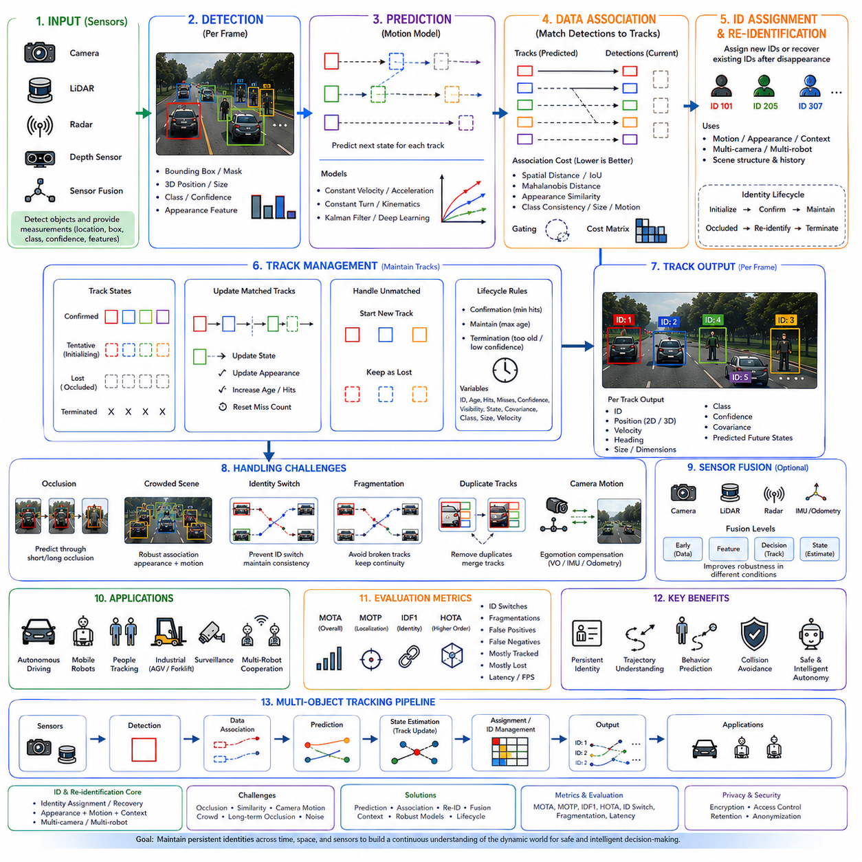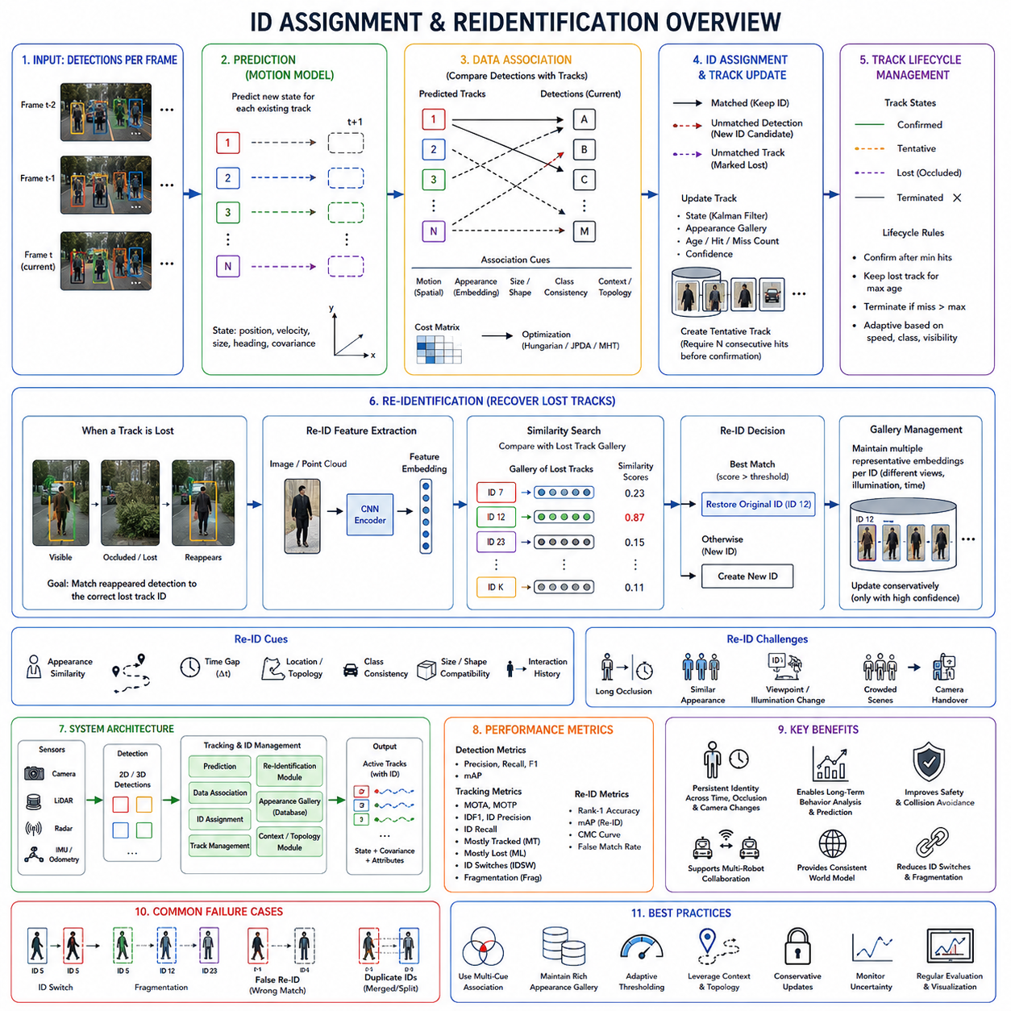
Single-object tracking focuses on maintaining the position of one predefined target throughout a video sequence, whereas multi-object tracking must simultaneously manage numerous independent targets while preserving a unique identity for each one. The ability to assign, maintain, recover, and verify object identities is therefore one of the most important components of a modern perception system. Identity assignment ensures that every detected object receives a unique identifier when it first appears, while re-identification allows the system to recover that same identity after the object has disappeared because of occlusion, sensor limitations, camera transitions, or temporary tracking failure. Together, these two functions transform frame-by-frame detections into long, continuous object trajectories that can support autonomous decision making.
Identity assignment begins when a newly detected object cannot be associated with any existing track. Rather than immediately assigning an arbitrary identifier, the tracking system first determines whether the detection represents a genuinely new object or a previously tracked object that has temporarily disappeared. This distinction is important because assigning unnecessary new identifiers leads to fragmented trajectories, while incorrectly reusing an existing identifier creates identity switches that propagate errors into downstream modules such as behavior prediction, navigation, and collision avoidance.
Persistent identity is the foundation of temporal scene understanding. Every tracked object is represented by an identifier that remains stable throughout its observable lifetime. The identifier itself carries no semantic meaning; instead, it functions as a reference that links all historical observations of the same object. Position estimates, velocity profiles, trajectory history, appearance descriptors, behavior statistics, interaction history, and uncertainty estimates are all associated with this persistent identifier. Without such continuity, the perception system would repeatedly treat the same physical object as unrelated detections, making long-term reasoning impossible.
Identity management differs fundamentally from object classification. Object classification determines whether an object is a pedestrian, vehicle, pallet, robot, or bicycle, whereas identity assignment distinguishes between different individuals within the same category. Two workers wearing identical uniforms belong to the same semantic class but require different identities because they occupy different positions, move independently, and may interact differently with the robot. Similarly, multiple autonomous mobile robots operating within one factory must each maintain distinct identities even when their physical appearance is nearly identical.
The identity lifecycle begins with initialization. During this stage, the tracking system observes a new detection that cannot be matched with existing tracks. Instead of immediately declaring a new identity, many systems create a tentative track that requires several consecutive observations before confirmation. This confirmation period reduces the probability that temporary detector noise, reflections, shadows, or false positives receive permanent identifiers. Once sufficient evidence has accumulated, a unique identity is assigned and becomes part of the active tracking database.
Identity maintenance requires continuous association between incoming observations and previously established tracks. At every sensor update, the tracking system compares new detections with predicted object states. If the correspondence is sufficiently reliable, the existing identity is preserved. This apparently simple process becomes increasingly difficult as object density increases, objects cross paths, partial occlusion occurs, or sensor quality deteriorates. Maintaining identity therefore depends on combining multiple complementary sources of information rather than relying on a single matching criterion.
Motion consistency provides one of the strongest cues for identity maintenance over short time intervals. Every tracked object follows a physically plausible trajectory that can be predicted using previous observations. Objects rarely teleport, instantly reverse direction without cause, or violate dynamic constraints. Consequently, predicted position, velocity, heading, and acceleration provide valuable evidence when determining whether a new detection corresponds to an existing identity. Motion prediction significantly narrows the search space before more computationally expensive appearance comparisons are performed.
Appearance consistency complements motion prediction by providing visual evidence. Modern systems extract deep feature representations that summarize clothing, body shape, vehicle geometry, color distribution, texture patterns, structural details, and semantic characteristics. Unlike raw pixel comparisons, these learned embeddings remain relatively stable despite moderate viewpoint changes, illumination variation, partial occlusion, or scale differences. Appearance descriptors therefore play a central role whenever multiple objects occupy similar spatial regions.
Identity assignment rarely depends on appearance alone because many environments contain visually similar objects. Factory workers frequently wear identical safety clothing, warehouse pallets often have uniform shapes, autonomous robots are intentionally manufactured to look alike, and vehicles from the same fleet may differ only by small details. In these situations, temporal continuity, motion prediction, interaction history, and contextual information become equally important. Robust identity assignment always integrates multiple evidence sources instead of depending exclusively on visual similarity.
Data association forms the computational foundation of identity maintenance. Each incoming detection is evaluated against every active track using motion, appearance, object size, orientation, classification consistency, confidence, and temporal history. These similarities are converted into an association cost matrix. Optimization algorithms then determine which assignments minimize global inconsistency while respecting one-to-one correspondence constraints. Once assignments are established, existing identities are preserved, unmatched detections may initiate new identities, and unmatched tracks may enter temporary inactive states.
Association confidence should not be interpreted as a binary decision. Every possible correspondence contains uncertainty resulting from sensor noise, localization errors, imperfect appearance representation, and prediction uncertainty. Advanced tracking systems explicitly estimate this uncertainty and propagate it throughout the tracking process. Low-confidence associations may postpone identity updates, while high-confidence associations permit appearance adaptation and state correction. Managing uncertainty prevents unstable identity decisions that could otherwise degrade long-term tracking quality.
Identity switches represent one of the most serious tracking failures. An identity switch occurs when the tracking system mistakenly assigns one object's identifier to another physical object. Although localization accuracy may remain high, temporal consistency is lost because trajectories become mixed together. Downstream modules may incorrectly infer behavior, estimate future motion, or evaluate safety risk. Preventing identity switches is therefore often more important than achieving small improvements in localization precision.
Several situations commonly produce identity switches. Objects crossing each other create temporary ambiguity because predicted positions overlap. Complete occlusion removes visual evidence for extended periods. Similar appearance increases confusion when multiple objects occupy nearby regions. Abrupt camera motion changes relative object positions, while delayed sensor measurements produce outdated predictions. Effective identity management anticipates these scenarios and incorporates mechanisms specifically designed to reduce their impact.
Occlusion handling is closely connected to identity preservation. During partial occlusion, only a subset of object features remains visible. During complete occlusion, no direct observations are available. Rather than immediately terminating the track, the system predicts object motion while gradually increasing uncertainty. If the object reappears within the expected region and its appearance remains consistent, the original identity can be restored without interruption. Otherwise, the tracker must determine whether a completely new identity should be created.
Long-term occlusion presents significantly greater challenges than short-term occlusion. Motion prediction becomes increasingly uncertain as prediction duration increases. Environmental interactions may alter object trajectories, while appearance may change because of viewpoint variation or illumination differences. Consequently, long-term recovery requires stronger appearance models, richer historical memory, scene constraints, and often dedicated re-identification algorithms capable of matching observations across extended temporal gaps.
Re-identification refers to recognizing that two separate observations belong to the same physical object despite interruptions in tracking continuity. Unlike ordinary tracking, which assumes continuous visibility, re-identification explicitly addresses situations where the target disappears and later reappears. Successful re-identification restores the original identity rather than creating a new one, thereby preserving a continuous trajectory despite temporary observation loss.
Person re-identification has become one of the most actively studied topics within computer vision. The objective is to recognize the same individual across different cameras, viewpoints, times, and environmental conditions. Deep neural networks are trained using large datasets containing multiple images of the same person captured under varying illumination, pose, background, and camera configurations. The resulting embedding space places images of the same individual close together while separating different individuals.
Object re-identification extends these principles beyond humans. Vehicles, robots, industrial containers, packages, tools, and equipment can all be represented by learned feature embeddings. However, non-human objects often present different challenges. Industrial equipment may contain repetitive geometry, autonomous robots may intentionally share identical appearance, and packages may lack distinctive visual features. Consequently, appearance descriptors are frequently supplemented by operational context, spatial information, and mission history.
Deep metric learning provides the mathematical basis for many modern re-identification systems. Instead of directly classifying identities, the neural network learns an embedding space where feature distance corresponds to identity similarity. Training objectives such as triplet loss, contrastive loss, circle loss, and proxy-based losses encourage samples from the same identity to cluster together while separating different identities. During deployment, nearest-neighbor search within this embedding space enables efficient identity retrieval.
Feature embeddings should remain discriminative despite common environmental variations. Changes in camera viewpoint, scale, lighting, pose, partial occlusion, motion blur, image compression, and sensor noise all modify visual appearance. High-quality embeddings suppress irrelevant variation while preserving identity-specific characteristics. Achieving this balance requires extensive training data covering realistic environmental diversity rather than only ideal laboratory conditions.
Embedding dimensionality influences both recognition accuracy and computational efficiency. Higher-dimensional representations generally preserve richer information but require more memory, slower comparisons, and increased storage for long-term databases. Lower-dimensional embeddings improve computational efficiency but may lose discriminative detail. Practical systems therefore optimize embedding size according to deployment constraints such as embedded computing capability, database scale, latency requirements, and expected object diversity.
Similarity measurement converts feature embeddings into quantitative identity scores. Cosine similarity is widely used because embedding magnitude becomes less important than directional consistency. Euclidean distance, Mahalanobis distance, and learned similarity functions are also common. Appropriate similarity thresholds must distinguish genuine identity matches from unrelated objects while accommodating normal appearance variation produced by environmental changes.
Threshold selection strongly influences re-identification performance. Overly strict thresholds reject genuine matches whenever appearance changes significantly. Overly relaxed thresholds incorrectly merge different objects into the same identity. Adaptive thresholds that incorporate observation quality, temporal separation, viewpoint change, and environmental conditions generally outperform globally fixed thresholds. Threshold calibration should be validated using representative deployment scenarios rather than relying solely on benchmark datasets.
Memory management represents another important aspect of re-identification. Each confirmed identity accumulates historical appearance information over time. Simply retaining the latest observation allows rapid adaptation but forgets earlier viewpoints. Averaging every observation may blur distinctive features. Many systems therefore maintain an appearance gallery containing several representative embeddings collected under different orientations, distances, lighting conditions, and environmental contexts. Gallery management policies determine which observations remain useful and which should be discarded.
Online appearance updating must balance adaptability and stability. Gradual appearance changes resulting from illumination, scale, or viewpoint should be incorporated into the identity model. However, updating during heavy occlusion or incorrect association risks contaminating the identity representation. Conservative update policies typically require high association confidence before modifying stored appearance descriptors. This strategy reduces long-term identity drift while still allowing gradual adaptation.
Contextual information significantly improves identity assignment. Objects do not move randomly but interact with structured environments. Workers generally remain within accessible walkways, forklifts follow transportation routes, autonomous robots execute planned missions, and vehicles obey traffic patterns. Contextual constraints reduce the likelihood of implausible identity matches by eliminating physically unrealistic hypotheses before appearance comparison is performed.
Scene topology provides additional identity cues. Doors connect specific rooms, corridors constrain movement, elevators link floors, and production lines follow predefined layouts. When an object disappears from one camera, topology predicts where it is likely to reappear. Multi-camera re-identification systems frequently integrate camera transition probabilities, expected travel time, and facility maps to narrow candidate identities before visual comparison begins.
Multi-camera identity assignment introduces additional complexity because different cameras produce different viewpoints, resolutions, color responses, and illumination characteristics. Camera calibration differences may significantly alter appearance descriptors. Cross-camera re-identification therefore emphasizes viewpoint-invariant features and camera-independent embedding learning. Domain adaptation techniques further reduce appearance differences introduced by heterogeneous imaging systems.
Distributed robotic systems extend identity assignment beyond individual perception modules. Multiple autonomous robots observing overlapping environments may independently create separate identities for the same physical object. Collaborative identity management requires sharing observations, synchronizing coordinate frames, reconciling duplicate identities, and maintaining globally consistent identifiers despite communication latency and intermittent connectivity.
Global identity management often separates local tracking identifiers from persistent global identities. Individual robots maintain lightweight local tracks optimized for immediate perception. A centralized or distributed fusion module subsequently merges compatible local tracks into global identities using appearance, spatial consistency, temporal overlap, and communication metadata. This hierarchical approach improves scalability while maintaining consistent facility-wide tracking.
Identity databases must support efficient retrieval because large facilities may accumulate thousands of historical observations. Approximate nearest-neighbor search algorithms accelerate similarity matching within high-dimensional embedding spaces. Hierarchical indexing, feature quantization, and memory compression further improve scalability while preserving acceptable retrieval accuracy. Efficient database design becomes increasingly important for continuous long-term operation.
Identity aging policies determine how long inactive identities remain available for future re-identification. Short retention periods reduce memory requirements but prevent recovery after extended absence. Excessively long retention increases computational complexity and raises the probability of accidental false matches. Adaptive aging considers object category, operational context, expected revisit frequency, and storage capacity when deciding whether inactive identities should remain searchable.
False re-identification occurs when an inactive identity is incorrectly assigned to a newly observed object. Such errors are particularly harmful because they connect unrelated trajectories separated by substantial time intervals. Preventing false re-identification requires conservative similarity thresholds, motion consistency checks, contextual reasoning, and confidence estimation. Many systems require multiple independent evidence sources before restoring historical identities.
Identity fragmentation represents the opposite failure. Instead of reconnecting separated observations, the tracker repeatedly generates new identifiers for the same physical object. Although localization remains accurate, trajectory continuity is lost. Fragmentation complicates behavior analysis, trajectory prediction, productivity measurement, and long-term statistical analysis. Effective re-identification algorithms minimize fragmentation while avoiding incorrect identity merges.
Identity merging occurs when observations from multiple physical objects become associated with a single identifier. Identity splitting occurs when one physical object is represented by several simultaneous identities. Both errors reduce tracking consistency and propagate incorrect information throughout higher-level reasoning modules. Careful track lifecycle management helps prevent these failures through confirmation logic, confidence monitoring, and duplicate suppression.
Human identity assignment presents unique challenges because appearance changes continuously through body articulation, clothing deformation, carried objects, and social interactions. Faces may not always remain visible, and privacy considerations often restrict facial recognition. Consequently, person re-identification generally emphasizes whole-body appearance, gait characteristics, body proportions, clothing texture, and temporal behavior rather than relying exclusively on facial information.
Vehicle re-identification benefits from relatively rigid geometry but must accommodate viewpoint changes, illumination variation, partial occlusion, and visually identical fleet vehicles. Distinguishing similar delivery trucks or industrial transport vehicles often requires combining appearance with trajectory continuity, operational schedules, license information where available, or fleet communication data. Multiple complementary cues significantly improve robustness compared with visual appearance alone.
Autonomous robot re-identification introduces additional opportunities because robots frequently broadcast internal status information. Wireless communication may provide identifiers, planned trajectories, localization estimates, and operational states. Sensor-based perception nevertheless remains necessary because communication failures, localization drift, or network latency may temporarily invalidate transmitted information. Cross-validation between communication and perception improves overall system reliability.
Three-dimensional sensing enhances identity assignment by providing geometric consistency unavailable in ordinary images. Object dimensions, orientation, volume, and structural shape remain relatively stable across changing illumination. LiDAR point cloud descriptors, voxel features, and geometric embeddings complement visual appearance and improve re-identification whenever color or texture becomes unreliable.
Sensor fusion further strengthens identity management. Cameras contribute detailed appearance, LiDAR provides geometry, radar supplies motion information, and thermal sensors improve robustness under poor illumination. Fusion strategies combine complementary evidence before identity assignment, reducing dependence on any individual sensing modality. Multi-modal identity representations generally outperform single-modality approaches in challenging outdoor and industrial environments.
Self-supervised learning has recently emerged as an attractive approach for identity representation learning. Rather than relying exclusively on manually labeled identities, self-supervised methods exploit temporal continuity, multi-view consistency, and predictive objectives to learn robust feature embeddings. These approaches reduce annotation requirements while improving generalization across previously unseen environments and object categories.
Foundation models and vision-language models may further improve future identity assignment by incorporating semantic understanding alongside visual appearance. Instead of comparing low-level image features alone, future systems may integrate object attributes, textual descriptions, operational context, and environmental knowledge into unified identity representations. Such semantic reasoning could improve robustness whenever visual observations become incomplete or ambiguous.
Evaluation of identity assignment requires metrics beyond ordinary localization accuracy. Identity Precision measures how often predicted identities correspond to correct ground-truth identities, while Identity Recall evaluates how completely ground-truth identities are recovered throughout a sequence. The harmonic mean of these quantities forms IDF1, one of the most widely used measures for identity preservation in multi-object tracking.
Identity switches provide another important evaluation metric. Every switch indicates that an object's identifier changed incorrectly during tracking. Fragmentation counts how often one trajectory becomes separated into multiple track segments. Mostly tracked objects, mostly lost objects, identity consistency, and long-term trajectory completeness provide additional insight into tracker performance beyond simple detection accuracy.
Benchmark datasets containing persistent identity annotations enable standardized comparison between algorithms. Nevertheless, benchmark performance should not be interpreted as sufficient evidence for deployment readiness. Real industrial environments often contain heavier occlusion, more similar objects, different sensor configurations, stronger illumination variation, and stricter real-time requirements than publicly available datasets. Application-specific evaluation therefore remains essential.
Visualization greatly assists debugging of identity management systems. Engineers should inspect trajectory histories, identity labels, similarity scores, association matrices, feature distances, and gallery updates. Observing exactly when identities switch or fragment often reveals weaknesses in appearance modeling, motion prediction, threshold selection, or track lifecycle policies. Interactive visualization accelerates iterative algorithm refinement.
Failure handling should explicitly address uncertain identity situations. Rather than making aggressive identity assignments under ambiguous conditions, the tracker may temporarily maintain multiple hypotheses, delay appearance updates, increase uncertainty estimates, or request additional observations before committing to a final decision. Conservative identity management generally produces more reliable long-term trajectories than overly confident early assignments.
Privacy considerations have become increasingly important for identity assignment technologies. Appearance embeddings, even without storing raw images, may still contain personally identifiable information. Practical deployment should therefore incorporate secure storage, limited retention, controlled access, encryption, anonymization where appropriate, and compliance with applicable privacy regulations and organizational governance policies.
The design of identity assignment systems should reflect operational objectives. Surveillance applications may prioritize long-term identity continuity across extensive camera networks. Industrial robotics emphasizes deterministic timing, safety, and integration with navigation. Warehouse automation focuses on workers, forklifts, robots, and inventory assets. Autonomous driving prioritizes rapid response under dynamic traffic conditions. Different applications therefore require different balances between appearance complexity, computational efficiency, memory usage, and recovery capability.
Identity assignment and re-identification ultimately transform isolated observations into coherent object histories. By preserving persistent identities despite occlusion, appearance variation, camera transitions, temporary disappearance, and environmental uncertainty, these technologies enable autonomous systems to reason about long-term behavior, predict future interactions, maintain situational awareness, coordinate with multiple intelligent agents, and make safe decisions based on continuous temporal understanding rather than disconnected frame-by-frame detections.

16.5 Kalman Filter and Motion Models
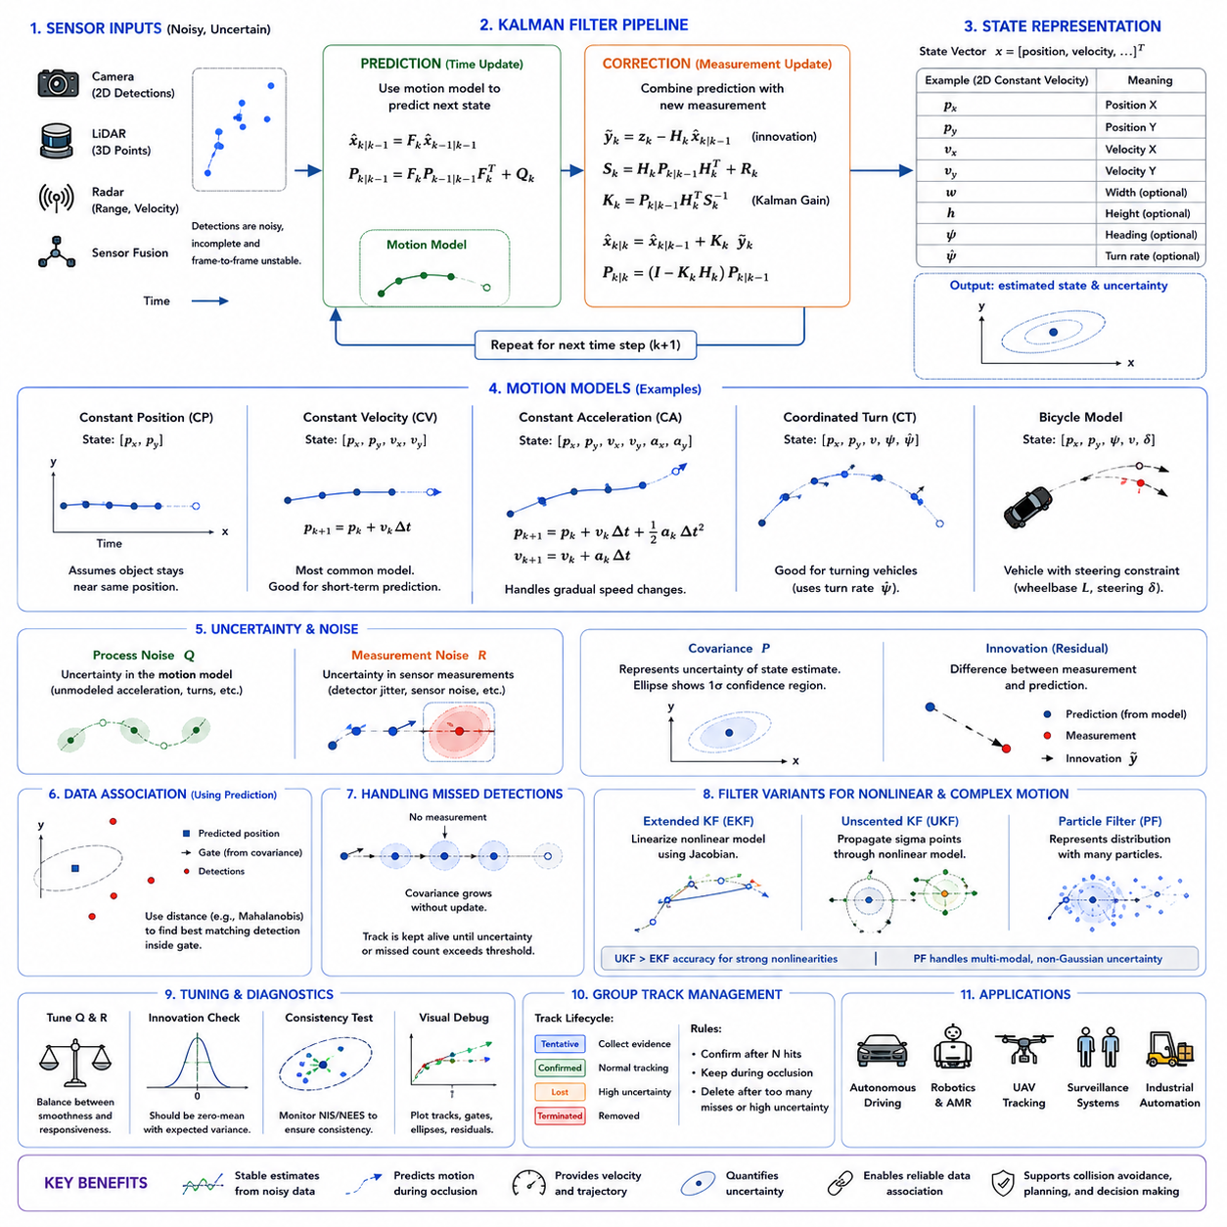
The Kalman filter is one of the most widely used estimation methods in object tracking because it provides a computationally efficient way to predict motion, combine uncertain measurements, and maintain a stable estimate of an object state over time. In robotic perception, detections from cameras, LiDAR, radar, or fused sensors are often noisy and incomplete. The Kalman filter reduces this instability by combining a mathematical motion model with new observations in a recursive estimation process.
A motion model describes how an object state is expected to evolve between consecutive time steps. The state may include position, velocity, acceleration, heading, object size, or other variables required by the tracking system. Instead of estimating every state value independently from each new detection, the tracker uses the previous state and the motion model to predict the next state. This predicted state becomes the temporal reference for processing the next measurement.
The Kalman filter operates through two main stages: prediction and correction. During prediction, the previous state estimate is propagated forward according to the selected motion model. During correction, a new sensor measurement is compared with the prediction, and the difference is used to update the state. The filter determines how strongly it should trust the prediction or the measurement according to their estimated uncertainties.
This recursive structure makes the Kalman filter suitable for real-time robotic systems. Only the previous state estimate and uncertainty need to be stored, rather than the entire measurement history. Every new observation updates the current estimate, which then becomes the starting point for the next prediction. The required matrix operations are relatively efficient and can be executed at high frame rates on embedded processors.
The state vector is the central representation within the filter. For a two-dimensional object tracker, the state may contain horizontal position, vertical position, horizontal velocity, and vertical velocity. A bounding-box tracker may additionally include width, height, and their rates of change. A three-dimensional robotic tracker may represent position, velocity, orientation, dimensions, and uncertainty in a world-centered coordinate system.
State selection should reflect the information required by downstream applications. A surveillance system may need only image-plane coordinates and bounding-box size, while an autonomous mobile robot requires metric position and velocity for collision prediction. Adding more state variables can improve physical representation, but it also increases model complexity, computational cost, and sensitivity to incorrect assumptions.
The state transition model defines how the state changes from one time step to the next. It is represented mathematically by a state transition matrix in a linear Kalman filter. This matrix incorporates the elapsed time between updates and the assumed motion behavior. For example, a constant-velocity model updates position using the previous velocity while keeping velocity approximately unchanged.
The constant-position model is the simplest possible motion assumption. It assumes that the object remains near its previous position between consecutive frames. This model may be sufficient for stationary equipment or very high frame-rate tracking where movement between frames is minimal. However, it performs poorly when objects move continuously because the predicted state always lags behind the actual motion.
The constant-velocity model assumes that velocity remains approximately unchanged over a short interval. Position is predicted by adding velocity multiplied by the elapsed time to the previous position. This model is widely used for pedestrians, vehicles, mobile robots, and general object tracking because it provides a practical balance between simplicity and predictive ability.
Although real objects accelerate, turn, and stop, the constant-velocity assumption often remains effective over short periods. Frequent sensor updates correct deviations before the prediction error becomes excessive. The model becomes less reliable when the sampling interval is long, when the target moves abruptly, or when the object's motion is strongly constrained by nonlinear dynamics.
The constant-acceleration model extends the state vector by including acceleration. Position is predicted using position, velocity, acceleration, and elapsed time, while velocity is updated using acceleration. This model can better represent vehicles that gradually speed up or slow down. However, acceleration estimates are often noisy, and unnecessary state variables can reduce filter stability.
A coordinated-turn model is useful when vehicles or robots move along curved trajectories. Instead of assuming straight-line motion, the model includes turn rate and heading. This representation can improve prediction during cornering, lane changes, or circular motion. Because trigonometric relationships are nonlinear, coordinated-turn tracking often requires an extended or unscented Kalman filter rather than a basic linear filter.
A bicycle motion model provides a simplified representation of wheeled vehicles with steering constraints. It describes motion through position, heading, speed, wheelbase, and steering angle. This model is appropriate when tracking cars, forklifts, or autonomous platforms whose lateral motion is constrained. It produces more realistic predictions than an unconstrained Cartesian model when vehicle orientation and steering behavior are available.
Pedestrian motion is less constrained than vehicle motion. People may stop, reverse direction, sidestep, or accelerate unexpectedly. A simple constant-velocity model often provides acceptable short-term predictions, but its uncertainty should increase quickly when observations are missing. More advanced pedestrian trackers may combine the Kalman filter with social motion models or learned trajectory predictors.
The elapsed time between measurements directly influences motion prediction. If sensor updates arrive at a fixed rate, the transition matrix can remain constant. In practical robotic systems, timestamps may vary because of communication delays, dropped frames, asynchronous sensors, or computational load. The filter should therefore calculate transition terms using the actual time interval rather than assuming constant timing.
Incorrect timing produces systematic prediction errors. If the filter assumes a shorter interval than the true delay, it underestimates object displacement. If it assumes a longer interval, it overshoots the expected position. Accurate timestamp management and time synchronization are therefore essential parts of motion estimation, especially for fast-moving objects or mobile sensor platforms.
The covariance matrix represents uncertainty in the state estimate. Each diagonal element describes uncertainty in one state variable, while off-diagonal terms represent correlations between variables. For example, uncertainty in velocity affects future position uncertainty. The covariance grows during prediction because motion is not perfectly known and decreases during correction when reliable measurements become available.
Process noise represents uncertainty in the motion model. Even if a constant-velocity model is used, real objects may accelerate, turn, or interact with the environment. The process-noise covariance expresses how much unmodeled motion is expected. A larger value allows the filter to adapt quickly to unexpected movement but produces less smooth estimates. A smaller value creates smoother trajectories but can cause slow response.
Measurement noise represents uncertainty in sensor observations. Camera detections may vary because of bounding-box instability, LiDAR clusters may shift as point density changes, and radar measurements may contain range or angular noise. The measurement-noise covariance tells the filter how much confidence to place in these observations. Accurate values improve the balance between prediction and correction.
If measurement noise is underestimated, the filter follows noisy detections too aggressively and loses its smoothing benefit. If it is overestimated, the filter ignores useful observations and relies too heavily on its motion model. The result may be delayed response, especially during acceleration or turning. Measurement-noise parameters should therefore be derived from sensor characteristics and validated using real operational data.
The observation model connects the internal state to the quantities actually measured by the sensor. A detector may measure only object position, while the state vector also contains velocity. The observation matrix selects the observable components and maps them into measurement space. Velocity is then inferred indirectly from changes in measured position over time.
Some sensors directly observe additional state variables. Radar can provide radial velocity, LiDAR can estimate three-dimensional position and dimensions, and vision algorithms may estimate orientation or optical flow. When these measurements are available, the observation model can include them. Direct velocity measurement often improves filter convergence and robustness during short detection gaps.
The innovation, also called the measurement residual, is the difference between the actual measurement and the predicted measurement. It indicates how surprising the new observation is compared with the expected state. A small innovation suggests strong agreement, while a large innovation may indicate abrupt motion, incorrect association, sensor noise, or a false detection.
Innovation covariance combines predicted state uncertainty and measurement uncertainty. It provides a normalized basis for evaluating whether a measurement is compatible with a track. This quantity is commonly used in Mahalanobis-distance gating, where detections outside a statistically plausible region are rejected before data association.
The Kalman gain determines how much the state estimate changes during correction. A high gain gives greater influence to the measurement, while a low gain preserves more of the prediction. The gain is calculated automatically from predicted uncertainty and measurement uncertainty. When the prediction is uncertain and the measurement is reliable, the correction becomes strong. When the measurement is noisy, the filter changes only slightly.
The correction stage updates both the state estimate and covariance. After incorporating the measurement, uncertainty generally decreases because the system has received new evidence. This corrected state becomes the basis for the next prediction. Repeated prediction and correction create a continuous trajectory that is more stable than independent frame-level detections.
Kalman filtering does not eliminate the need for accurate data association. The filter predicts where each object should appear, but the tracking system must still determine which new detection belongs to which track. If a wrong detection is assigned, the filter may smoothly follow the wrong object. Motion estimation and identity assignment must therefore be designed as connected components.
Prediction supports data association by producing an expected position and uncertainty region for every track. Detections can be compared with these predictions using Euclidean distance, Intersection over Union, or Mahalanobis distance. Tracks with small uncertainty use narrow gates, while uncertain tracks allow wider candidate regions. This adaptive gating reduces impossible matches and improves computational efficiency.
Mahalanobis distance is particularly appropriate because it considers the shape and scale of predicted uncertainty. If horizontal motion is uncertain but vertical motion is stable, the gating region becomes wider horizontally than vertically. A simple circular distance threshold cannot represent this directional uncertainty. Covariance-aware gating is therefore more consistent with the probabilistic structure of the Kalman filter.
During a missed detection, the prediction stage can continue without correction. The object state is propagated forward according to the motion model, but covariance increases because no new measurement reduces uncertainty. This allows short-term track continuity through occlusion or detector failure. However, predictions become less reliable as the number of missed updates increases.
Track management should use growing covariance and missed-frame count to decide how long a track remains active. A slow-moving object in a structured environment may be retained longer than a fast-moving object with unpredictable motion. When uncertainty exceeds an acceptable limit, the system may mark the track as lost, activate re-detection, or terminate the track.
Repeated prediction without correction can create ghost trajectories if an object has actually left the scene. Motion models do not know whether an object remains present. Therefore, the filter must be combined with visibility reasoning, scene boundaries, confidence management, and track lifecycle rules. Probabilistic state estimation is only one component of a complete tracking system.
The standard Kalman filter assumes that state transitions and observations are linear. It also assumes Gaussian process and measurement noise. These assumptions make the equations efficient and mathematically convenient. Many practical tracking problems approximately satisfy them over short intervals, which explains the filter's widespread success despite the complexity of real-world motion.
Nonlinear motion and measurement relationships require modified filtering methods. The Extended Kalman Filter linearizes nonlinear functions around the current estimate using Jacobian matrices. It is commonly used for orientation, coordinated turns, range-bearing measurements, and vehicle kinematics. The quality of the approximation depends on how nonlinear the system is near the estimated state.
The Extended Kalman Filter can perform poorly when uncertainty is large or the nonlinear function changes sharply. Linearization errors may lead to inconsistent covariance or divergence. Careful model design, angle normalization, numerical stability, and initialization are necessary when using this method in robotic tracking.
The Unscented Kalman Filter handles nonlinear systems by propagating a selected set of sigma points through the nonlinear functions. These points capture the mean and covariance of the state distribution without explicit derivatives. The transformed points are recombined to estimate the predicted mean and uncertainty. This often provides better nonlinear approximation than first-order linearization.
The Unscented Kalman Filter requires more computation than the Extended Kalman Filter but can simplify implementation when analytical Jacobians are difficult to derive. It is useful for strongly nonlinear vehicle motion, orientation tracking, and multi-sensor systems. Nevertheless, it still represents uncertainty with a single Gaussian distribution and may struggle with multiple competing hypotheses.
A particle filter represents the state distribution using many weighted samples rather than one Gaussian. It can model nonlinear dynamics, non-Gaussian uncertainty, and multiple possible target locations. Each particle is propagated through the motion model and weighted according to measurement likelihood. Although flexible, particle filters usually require greater computation than Kalman-based methods.
The choice between filtering methods should depend on the motion characteristics, sensor model, available computation, and required accuracy. A linear Kalman filter is often sufficient for short-term image-plane tracking. An Extended or Unscented Kalman Filter may be appropriate for nonlinear three-dimensional motion. Particle filters are useful when ambiguity or multimodal uncertainty is significant.
Motion-model switching can improve performance when objects exhibit several behavior modes. A vehicle may move straight, turn, stop, and accelerate. One fixed model cannot represent every condition equally well. An Interacting Multiple Model filter maintains several motion models simultaneously and estimates the probability of each one based on measurements.
In an Interacting Multiple Model framework, separate filters may represent constant velocity, constant acceleration, and coordinated turn. Their state estimates are mixed according to transition probabilities. When the object begins turning, the coordinated-turn model receives greater weight. When motion becomes straight again, the constant-velocity model may dominate.
This multi-model strategy improves responsiveness without requiring one highly complex model. However, it increases computation and introduces additional parameters such as model transition probabilities. The selected set of models should reflect realistic object behaviors rather than including unnecessary alternatives.
Model mismatch occurs when the assumed motion differs substantially from actual behavior. A constant-velocity filter applied to a sharply turning vehicle produces large innovations and delayed correction. A model designed for vehicles may perform poorly for pedestrians. Monitoring innovation statistics can reveal systematic mismatch and indicate when model parameters or structures need adjustment.
Filter divergence occurs when estimation errors and covariance become inconsistent or grow uncontrollably. Causes include incorrect models, underestimated process noise, wrong measurements, numerical instability, poor initialization, and data association errors. A diverged filter may continue producing confident but incorrect estimates, making consistency monitoring essential.
Covariance should reflect actual estimation error. If covariance is too small, the filter becomes overconfident and rejects valid measurements. If it is too large, association gates expand excessively and allow incorrect matches. Statistical consistency tests compare innovation behavior with expected distributions to assess whether covariance tuning is realistic.
Initialization strongly affects early tracking performance. When a new object is first detected, its position is observed but velocity may be unknown. Initial velocity can be set to zero with high uncertainty or estimated from several consecutive detections. Immediate velocity assumptions may cause poor prediction, while delayed initialization may reduce responsiveness.
A tentative track can collect multiple observations before full filter confirmation. The displacement between early detections provides an initial velocity estimate and helps distinguish real objects from noise. Initial covariance should be larger for unknown variables and smaller for directly measured quantities. This allows the filter to adapt quickly during the first updates.
Bounding-box tracking often uses a state containing center coordinates, aspect ratio, height, and their rates of change. Predicting size can stabilize association when object scale changes gradually. However, abrupt pose changes or detector instability may violate the size model. Process noise for bounding-box dimensions may therefore require different tuning from position variables.
In three-dimensional tracking, the state may include position, velocity, yaw angle, yaw rate, length, width, and height. Object dimensions often remain approximately constant, while orientation and velocity evolve. Vehicle-specific constraints can be added to improve realism. Care is required when representing angles because values wrap around at fixed boundaries.
Angle normalization ensures that differences such as positive and negative values near the wrap boundary are interpreted correctly. Without normalization, a small physical rotation may appear as a very large numerical innovation. Orientation filters should use appropriate circular mathematics or alternative representations such as sine and cosine components.
For a mobile robot, object tracking must account for sensor-platform motion. A stationary object can appear to move in camera or robot coordinates as the platform moves. One approach is to transform detections into a stable world frame before filtering. Another is to include robot egomotion in the state transition or measurement model.
World-frame tracking simplifies interpretation because static objects remain stationary and moving objects have physical trajectories independent of the robot. However, errors in robot localization and sensor calibration enter the object measurements. The measurement covariance should reflect these additional uncertainty sources rather than considering detector noise alone.
Robot-centered tracking may provide lower-latency local estimates and avoid dependence on a global map. However, the target state changes whenever the robot moves, even if the object is static. Accurate odometry and coordinate transformation are required between frames. The choice of frame should reflect the needs of planning, mapping, and sensor fusion.
Multi-sensor tracking can use separate Kalman updates whenever measurements arrive asynchronously. A high-rate radar may update velocity frequently, while a camera supplies class and appearance at a lower rate. LiDAR may provide precise geometry at another timestamp. The filter predicts the state to each measurement time before performing the corresponding correction.
Asynchronous updates avoid forcing all sensors into one artificial frame rate. However, they require accurate timestamps and careful management of out-of-sequence measurements. If an older measurement arrives after a newer update, directly applying it may corrupt the state. Buffering, state rollback, or delayed fusion strategies may be necessary.
Sensor fusion benefits from uncertainty-aware estimation because different sensors have different strengths. Camera depth may be uncertain at long range, LiDAR provides accurate distance but sparse shape, and radar measures velocity robustly but has limited angular resolution. Measurement covariance allows the filter to weight each source according to its reliability.
Adaptive noise estimation can improve robustness when sensor quality changes. Camera measurement uncertainty may increase during motion blur or poor lighting. LiDAR uncertainty may increase for distant or partially visible targets. Radar uncertainty may depend on multipath conditions. Confidence scores and sensor-quality indicators can be mapped into dynamic covariance values.
However, detector confidence is not automatically equivalent to localization uncertainty. A detector may be confident about object class while the bounding box remains imprecise. Calibration is required before using confidence to scale measurement noise. Empirical error analysis on validation data provides a more reliable relationship between reported confidence and actual measurement accuracy.
Motion models also support future trajectory prediction. The filter can propagate the current state several time steps ahead to estimate likely future positions. These predictions are useful for collision avoidance, time-to-collision calculation, path planning, and interaction analysis. Uncertainty should expand with prediction horizon to reflect decreasing confidence.
Long-horizon prediction based only on simple Kalman models is limited. Human intent, traffic rules, path topology, and interaction with other agents influence future motion. The Kalman filter provides a strong short-term kinematic baseline, while higher-level behavior models are needed for longer-term prediction. Combining both levels creates a more complete forecasting system.
Collision checking should consider predicted covariance rather than only the mean trajectory. A highly uncertain pedestrian prediction should create a wider safety region than a confident vehicle track. Probabilistic occupancy can represent the chance that an object enters a particular area. Conservative planning can then respond appropriately to uncertainty.
Real-time implementation requires attention to matrix dimensions, numerical precision, and memory allocation. Small fixed-size matrices can be optimized heavily, and repeated dynamic allocation should be avoided. For large numbers of tracks, filter operations are usually independent and can be parallelized. The computational cost is often lower than detection or appearance-feature extraction.
Numerical stability remains important despite the small size of typical tracking filters. Covariance matrices should remain symmetric and positive semidefinite. Rounding errors can gradually violate these properties. Stable covariance-update formulations, matrix decomposition methods, and periodic symmetry correction can reduce numerical problems.
The Joseph form of covariance update is sometimes used because it better preserves positive semidefiniteness under numerical error. Square-root Kalman filters propagate matrix factors instead of covariance directly and provide improved stability. These variants may be appropriate for high-precision, long-duration, or safety-critical estimation systems.
Filter tuning should be performed systematically rather than through arbitrary trial and error. Engineers can begin with measured sensor error, expected object acceleration, frame rate, and typical motion patterns. Logged trajectories can then be replayed while comparing estimation errors, innovations, covariance, association results, and response to missed detections.
Visual debugging is especially valuable. Displaying raw detections, predicted states, corrected states, covariance ellipses, and track histories reveals whether the filter lags, overshoots, oscillates, or becomes overconfident. Covariance ellipses show how uncertainty grows during occlusion and contracts after reliable updates.
Innovation plots provide another useful diagnostic tool. Persistent bias may indicate calibration error or model mismatch. Large isolated innovations may indicate abrupt motion or incorrect detections. Innovations consistently smaller than expected may suggest excessive covariance, while unusually frequent large values may indicate underestimated noise.
Evaluation should include localization accuracy, velocity error, prediction error, track continuity, association quality, and recovery after missed measurements. A smooth trajectory is not necessarily accurate, and an accurate instantaneous estimate may be unsuitable if latency is excessive. The filter should be evaluated within the complete tracking and control pipeline.
Scenario-based testing should cover constant motion, acceleration, turning, stopping, reversal, occlusion, sensor dropouts, delayed measurements, and sudden camera movement. Different object classes should be tested separately because their motion characteristics differ. Field data should include realistic frame rates, vibration, lighting, and communication delays.
Safety-related applications require defined fallback behavior. If covariance exceeds a threshold, innovations become inconsistent, or measurements disappear, the system should communicate degraded confidence to downstream modules. The robot may slow down, enlarge safety margins, activate an alternative sensor, request re-detection, or stop when tracking reliability is insufficient.
The Kalman filter should not be treated as an isolated algorithm that automatically solves motion estimation. Its performance depends on correct state design, realistic motion assumptions, noise tuning, sensor calibration, timestamps, data association, lifecycle management, and failure handling. Weakness in any of these areas can produce confident but incorrect tracks.
A well-designed Kalman-based tracker provides more than visual smoothing. It creates a probabilistic temporal model of each object's state, predicts motion during short observation gaps, supports statistically meaningful association, estimates velocity, and communicates uncertainty. These capabilities are essential for converting unstable sensor detections into a coherent dynamic representation.
Motion models provide the physical assumptions that allow the filter to connect past and future observations. Simple models offer efficiency and robustness, while advanced nonlinear or multiple-model approaches represent more complex behavior. The correct design is not the most complicated model, but the simplest model that captures the motion patterns required by the application.
When properly integrated, the Kalman filter and motion model form the temporal estimation core of object tracking. They allow autonomous robots to maintain stable positions and velocities, bridge short occlusions, reject unlikely measurements, predict near-term trajectories, and quantify uncertainty. This foundation supports reliable identity management, multi-object tracking, collision avoidance, behavior prediction, and safe decision making in continuously changing environments.

16.6 Tracking for Humans and Vehicles
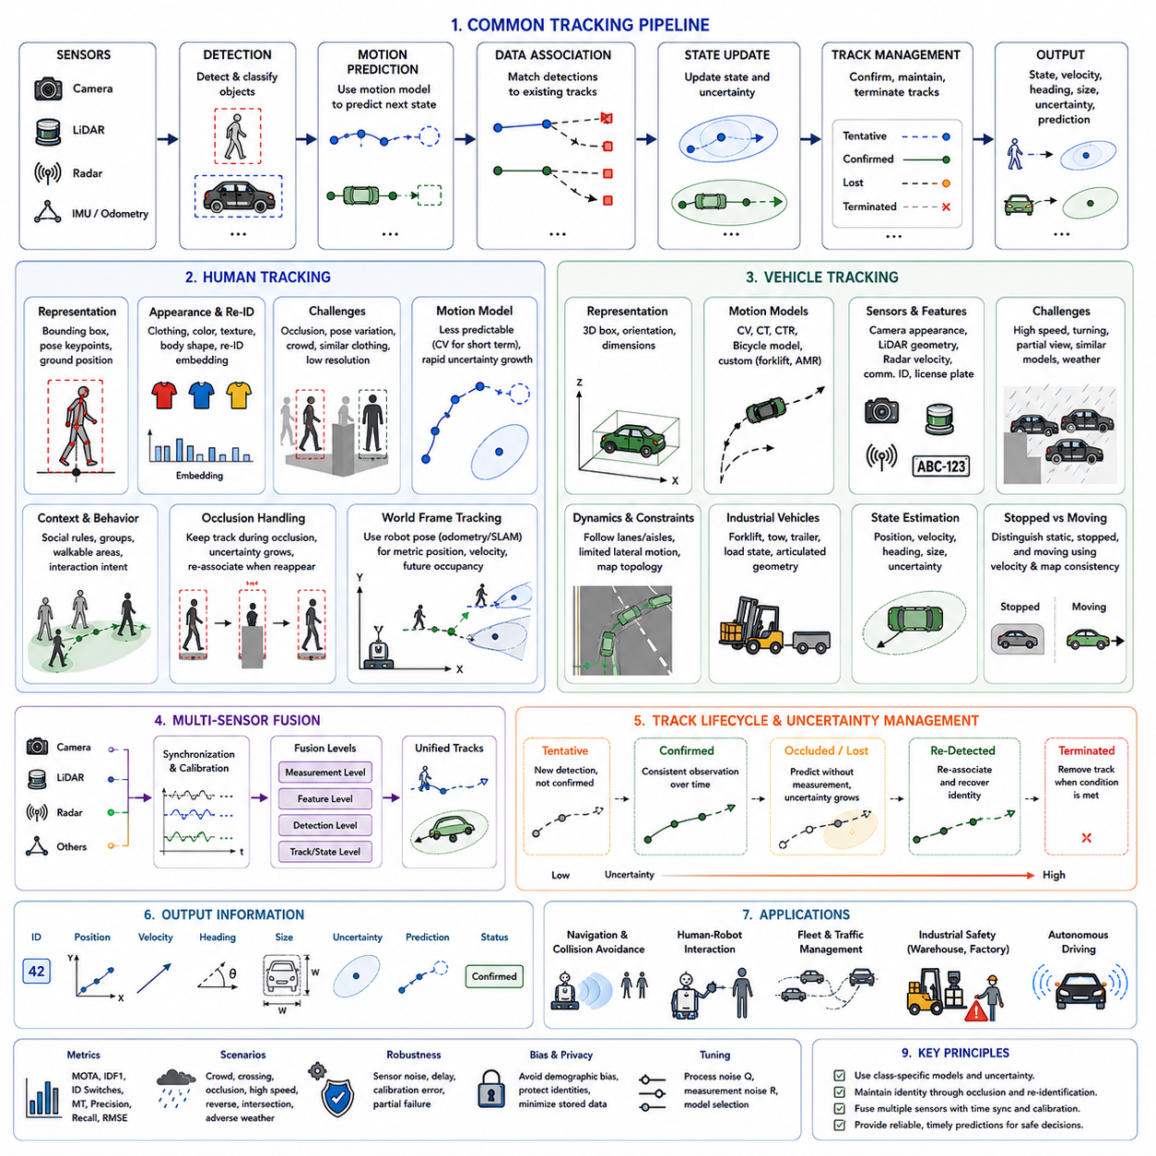
Tracking humans and vehicles is a central function of robotic perception because these object classes dominate many dynamic environments. People move with flexible, irregular behavior, while vehicles generally follow stronger geometric and kinematic constraints. A reliable tracking system must account for these differences while producing stable identities, positions, velocities, headings, and future motion estimates that can support navigation, interaction, and safety decisions.
Human and vehicle tracking share a common processing structure. Sensors collect observations, detectors identify candidate objects, motion models predict their next states, and data association links new detections to existing tracks. Despite this shared architecture, the representation, model assumptions, uncertainty settings, and failure-handling strategies should be adapted to the physical and behavioral characteristics of each object category.
Human tracking is particularly challenging because the human body is articulated and changes shape continuously. Walking, running, crouching, turning, carrying objects, and moving the arms all alter the visible silhouette. A bounding box that represents a standing person may change significantly during bending or partial occlusion. Trackers must preserve identity despite these rapid appearance and geometry variations.
Vehicle tracking benefits from relatively stable rigid-body geometry. The length, width, and structural appearance of a vehicle usually remain constant, while its position, heading, and visible surfaces change. This stability supports stronger motion and shape constraints. However, rapid movement, turning, similar vehicle models, partial visibility, and changing viewpoints still create significant tracking difficulties.
The sensing configuration strongly influences tracking performance. Cameras provide rich information about human clothing, body shape, vehicle color, model, and structural details. LiDAR provides accurate range and three-dimensional geometry, while radar directly measures relative velocity and remains robust in darkness, rain, fog, and dust. Combining these modalities can improve continuity and reduce dependence on any single sensor.
Camera-based human tracking usually begins with pedestrian detection. The detector produces a bounding box, confidence score, class label, and sometimes a segmentation mask or pose estimate. The tracking module then predicts the expected location of each person and matches new pedestrian detections to existing tracks using motion, overlap, appearance, and contextual information.
Human appearance features may include clothing color, texture, body proportions, carried objects, and deep re-identification embeddings. These features help distinguish nearby people, especially when their paths cross. However, identical uniforms, protective clothing, helmets, reflective vests, and low image resolution can make different workers appear almost indistinguishable.
Pose information provides an additional cue for human tracking. Keypoints representing the head, shoulders, elbows, hips, knees, and ankles describe body structure more precisely than a rectangular bounding box. Pose consistency can improve association during partial occlusion and help determine whether two overlapping detections belong to separate people.
Pose-based methods must nevertheless handle missing or inaccurate keypoints. Body parts may be hidden by equipment, other workers, or the image boundary. Loose clothing and unusual postures can also reduce pose accuracy. A robust tracker therefore treats pose as one source of evidence rather than as the only basis for identity assignment.
Human movement is less predictable than vehicle movement. A person can stop suddenly, change direction, step sideways, reverse, or move around an obstacle without following a fixed path. Constant-velocity models are effective for short-term prediction, but their uncertainty should expand rapidly during missing observations or unexpected movement.
Social context can improve pedestrian tracking and prediction. People tend to avoid collisions, follow walkable paths, move in groups, and adjust their speed around others. A tracker can use these behavioral patterns to reject physically unlikely associations and estimate future trajectories. However, social models must remain flexible because people sometimes act unpredictably.
Human tracking on mobile robots must compensate for platform motion. When the robot turns or accelerates, all people appear to shift in the image, even if they are stationary in the environment. Visual odometry, wheel odometry, inertial measurements, or simultaneous localization and mapping results can be used to transform detections into a stable coordinate frame.
World-coordinate human tracking is especially valuable for autonomous navigation. It provides metric distance, relative velocity, crossing direction, and predicted occupancy around the robot. These quantities allow the planner to create dynamic safety zones and estimate whether a person may enter the robot’s path.
The definition of the tracked human position should be chosen carefully. In an image, the bounding-box center may shift as a person changes pose. For navigation, the ground contact point near the feet is often more meaningful because it approximates the person’s position on the floor. Three-dimensional sensors or calibrated camera geometry can estimate this location.
Partial occlusion is common in factories, warehouses, hospitals, and public facilities. A person may be hidden behind shelves, machinery, carts, other workers, or the robot itself. The tracker should preserve the track using motion prediction, visible body parts, appearance memory, and scene geometry rather than immediately assigning a new identity.
Complete occlusion requires the system to continue predicting without direct measurement. The uncertainty should increase with time, and appearance updates should be suspended. When the person reappears, the tracker compares the new detection with the lost track’s predicted position, historical appearance gallery, and expected movement path before restoring the identity.
Crowded scenes greatly increase association ambiguity. Several people may overlap, walk together, or cross within a small area. Simple nearest-neighbor matching often causes identity switches. Strong pedestrian tracking combines deep appearance embeddings, motion gating, pose cues, track maturity, and global assignment across all visible people.
Group behavior can be both helpful and difficult. People walking together may maintain similar velocity and direction, which supports group-level prediction. At the same time, similar motion makes individual identities harder to distinguish. The tracker should model group context while preserving separate object states for each person.
Re-identification is important when people leave and re-enter the sensor field or move between cameras. The system stores representative appearance features for each identity and compares later detections with this gallery. Time gap, camera topology, expected travel duration, and spatial context should accompany visual similarity to prevent false identity restoration.
Privacy is a significant concern in human tracking. Even without facial recognition, appearance embeddings and long-term trajectories may contain identifying information. Practical systems should minimize retained data, limit access, secure stored features, define retention periods, and separate immediate safety tracking from long-term analytics.
Face recognition is not required for most robotic tracking functions. A robot often needs to know that the same nearby person continues along a trajectory, not the person’s legal identity. Anonymous temporary track identifiers are generally sufficient for collision avoidance, following behavior, and local interaction.
Human intention estimation builds on stable tracking. A person’s trajectory may indicate crossing, approaching, waiting, following, or moving away. Head orientation, body pose, walking direction, and environmental context can strengthen this inference. The tracker provides the temporal foundation, while a behavior model estimates the likely next action.
A robot should not assume that a person will continue moving exactly as predicted. Human behavior contains substantial uncertainty, especially near intersections, doorways, workstations, and obstacles. Safety planning should therefore use probabilistic future occupancy and conservative margins rather than relying only on one predicted path.
Vehicle tracking includes passenger cars, trucks, buses, forklifts, carts, automated guided vehicles, autonomous mobile robots, construction machines, and other industrial transport equipment. Although these vehicles differ greatly in size and dynamics, they generally follow stronger motion constraints than pedestrians.
Vehicle detectors may produce two-dimensional bounding boxes, segmentation masks, oriented boxes, or three-dimensional cuboids. For robotic applications, three-dimensional representation is preferable because it provides metric position, dimensions, heading, and occupied space. This information can be used directly for path planning and collision analysis.
Vehicle orientation is an important state variable. Two vehicles at the same position and speed may present different risks depending on their heading. Estimating orientation also improves motion prediction because most ground vehicles move primarily along their longitudinal axis rather than translating freely in any direction.
A constant-velocity model can track vehicles during short straight movements, but turning requires more advanced models. Coordinated-turn, constant-turn-rate, and bicycle models represent curved motion more realistically. Forklifts and mobile robots may require custom models because they can steer sharply, rotate in place, or drive in reverse.
Vehicle dimensions are usually stable and provide useful identity and association cues. Length, width, height, wheelbase, and shape can distinguish cars from trucks or forklifts. However, sensor visibility changes with viewpoint, and partial point clouds may cause estimated dimensions to fluctuate. Filters should avoid adapting permanent dimensions too aggressively.
Vehicle velocity may be estimated from consecutive positions or measured directly by radar. Radar velocity is valuable for fast targets and poor visibility, although it mainly provides radial motion relative to the sensor. Fusion with LiDAR geometry and camera semantics produces a more complete state estimate.
LiDAR-based vehicle tracking associates three-dimensional boxes or point clusters between scans. Accurate range measurement supports collision prediction, but sparse points and partial visibility can destabilize detection. As a vehicle turns, different surfaces become visible, changing the point cloud even though the physical object remains the same.
Camera-based vehicle tracking offers strong appearance information, including color, shape, lights, markings, and model-specific details. These features help maintain identity in traffic or fleet environments. However, changing illumination, reflections, shadows, and similar fleet vehicles can reduce reliability.
Vehicle re-identification may combine visual embeddings with license plates, fleet markings, communication identifiers, dimensions, and route history. In industrial environments, forklifts or AMRs may look identical, making visual features insufficient. Network messages and mission records can then serve as additional identity evidence.
Communication-based identity should not replace perception completely. Vehicle broadcasts may be delayed, missing, incorrect, or affected by localization drift. Independent sensor tracking provides redundancy and allows the system to detect disagreement between reported and observed states.
Industrial vehicles introduce special hazards because their motion can be less predictable than ordinary road traffic. Forklifts may reverse frequently, turn sharply, carry loads that block visibility, and operate near workers. The tracker must estimate both vehicle body motion and, where relevant, the geometry of the carried load.
Load state changes the occupied space and risk profile of a forklift or transport robot. A raised pallet, extended fork, or towed cart may not fit within the standard vehicle body box. Tracking systems may require compound object models or articulated geometry to represent these configurations safely.
Towing vehicles and trailer systems are another complex case. The tractor and trailer follow related but different trajectories, particularly during turning. Treating the combination as one rigid object may produce inaccurate occupancy estimates. Articulated tracking models can represent the connection angle and separate body dimensions.
Autonomous mobile robots may move omnidirectionally or rotate in place, violating ordinary vehicle assumptions. A differential-drive AMR follows different constraints from a four-wheel-steering platform or mecanum-wheel robot. Motion-model selection should therefore reflect the actual platform kinematics.
Vehicle motion is strongly influenced by environmental topology. Road lanes, warehouse aisles, loading zones, intersections, and one-way paths constrain feasible trajectories. Map-based tracking can use these structures to improve prediction and reject associations that require physically impossible movement.
Lane or aisle association helps estimate likely future paths. A vehicle traveling within a constrained corridor is more likely to continue along the corridor than cross a wall or shelf. Nevertheless, the system must handle lane changes, obstacle avoidance, parking, and exceptional operational maneuvers.
Static and moving vehicle classification is important. Parked cars, inactive forklifts, or stopped AMRs should not generate continuously moving predictions because of measurement noise. World-coordinate velocity filtering and map consistency can determine whether an object is stationary, temporarily stopped, or actively moving.
A stopped vehicle should generally retain its track because it may move again. Immediate classification as static infrastructure could cause delayed response when motion resumes. The tracker can maintain a dynamic object identity with near-zero velocity and update its motion state when new evidence appears.
Camera and sensor placement affects both human and vehicle visibility. Low-mounted sensors may be blocked by nearby objects, while high-mounted cameras improve scene coverage but alter perspective. Sensor locations should be designed to minimize blind spots around the robot and maintain visibility of relevant body or vehicle features.
Field of view is equally important. Wide-angle cameras capture more context but reduce object resolution. Narrow views provide detailed appearance but lose targets more easily during rapid movement. Multi-camera systems can provide complementary coverage, but identity handover between views requires calibration and re-identification.
Thermal cameras can improve human and vehicle tracking in darkness or smoke. People and operating vehicles often produce distinctive heat patterns. Thermal imagery contains less clothing color and texture information, however, so fusion with visible cameras or geometric sensors is usually more effective than thermal tracking alone.
Weather conditions affect outdoor tracking. Rain, fog, snow, dust, glare, and strong shadows reduce camera reliability. LiDAR may experience reflection or attenuation, while radar remains relatively robust but has lower spatial resolution. Multi-sensor fusion allows the system to adapt to changing environmental quality.
Sensor fusion can occur at measurement, feature, detection, association, or track level. Early fusion may combine camera and LiDAR information before detection. Late fusion independently tracks objects in each modality and then merges tracks. State-level fusion combines position and velocity estimates according to uncertainty.
The fusion architecture should preserve object identity across modalities. A camera detection and LiDAR cluster representing the same person or vehicle must not create duplicate tracks. Cross-sensor association uses projected position, timing, class, dimensions, and motion consistency to determine correspondence.
Time synchronization is essential for dynamic objects. If a camera image and LiDAR scan are captured at different moments, a fast vehicle may appear in different positions. Without temporal compensation, the fusion system may treat one object as two separate targets or estimate an incorrect shape.
Calibration accuracy also affects fusion. Incorrect camera-to-LiDAR transformation shifts projected measurements and weakens association. Calibration should be verified under vibration, temperature change, mechanical maintenance, and long-term operation. Online monitoring can detect gradual alignment degradation.
Human and vehicle tracks should use class-specific process noise. Pedestrians require greater lateral and directional uncertainty because they can maneuver freely. Road vehicles may use lower lateral uncertainty but stronger longitudinal prediction. Forklifts and omnidirectional robots may require customized settings.
Class-specific lifecycle rules can also improve performance. A fast vehicle may leave the field quickly and require shorter retention after disappearing near a boundary. A person hidden behind a known obstacle may justify longer retention. Track confirmation and termination should reflect object behavior and sensor coverage.
Incorrect class labels can fragment tracking. A partially visible cyclist may alternate between person and bicycle classes, while a forklift carrying a pallet may be misclassified as another vehicle type. Strict class matching may terminate valid tracks. Maintaining a class probability distribution over time is often more robust than using one-frame labels.
The tracker should distinguish identity uncertainty from position uncertainty. A person may be localized accurately but confused with another nearby person. A vehicle’s identity may be clear while its exact depth remains uncertain. Separate confidence values allow downstream systems to respond appropriately to different error types.
For collision avoidance, existence and position uncertainty are usually more critical than long-term identity. Even a tentative pedestrian track should influence safety behavior. For behavior analysis or fleet statistics, persistent identity becomes more important. Tracking outputs should therefore support multiple consumers with different priorities.
Human-following robots require a selected-target identity that remains stable among nearby people. The system may combine visual appearance, operator confirmation, relative position, and interaction history. If confidence drops, the robot should slow down or stop rather than follow the wrong person.
Service robots in hospitals or public facilities must track people without behaving aggressively. Maintaining comfortable distance, respecting personal space, and predicting crossing behavior are as important as pure localization accuracy. The planner should interpret tracking uncertainty conservatively and avoid abrupt reactions.
Warehouse systems use tracking to protect workers around forklifts, conveyors, and AMRs. The system can estimate dynamic danger zones, detect unsafe approach, and reduce robot speed near people. Reliable world-coordinate tracking is essential because image-plane proximity alone does not indicate actual collision risk.
Outdoor mobile robots may encounter pedestrians, bicycles, passenger vehicles, and heavy equipment simultaneously. A unified tracker can maintain a shared dynamic world model, but each class requires different motion assumptions and dimensions. Hierarchical tracking frameworks can share common association logic while using class-specific state models.
Autonomous driving places particularly strict requirements on vehicle and pedestrian tracking. High relative speed, long range, partial visibility, and complex interactions demand low latency and accurate uncertainty estimates. The system must remain reliable during rapid ego-motion and changing weather or illumination.
Construction and mining environments introduce large machines with unusual movement patterns. Excavators rotate their upper bodies independently, loaders articulate at the center, and dump trucks operate on uneven terrain. Simple vehicle models may not capture these motions. Tracking may require articulated state representations and terrain-aware prediction.
Human workers in construction environments may be partially hidden by equipment and wear visually similar protective clothing. Helmet, vest, body pose, and location context can support detection and re-identification. Radar and thermal sensors may improve robustness in dust or low visibility.
Evaluation should separate human and vehicle performance because their failure patterns differ. Human tracking tests should emphasize crowded scenes, pose variation, crossing, and occlusion. Vehicle tests should include high speed, turning, reverse motion, partial views, and similar models.
Common metrics include detection precision and recall, position error, velocity error, identity switches, track fragmentation, mostly tracked objects, and lost-track recovery. Three-dimensional systems should additionally evaluate heading, dimensions, and world-coordinate localization.
Safety evaluation should consider time-to-detection, time-to-confirmation, latency, and missed-object duration. A tracker with high average accuracy may still be unsafe if it recognizes a fast vehicle too late. Worst-case behavior and recovery time are as important as mean performance.
Scenario-based testing should reproduce realistic interactions. Examples include a person emerging from behind a forklift, several workers crossing in front of the robot, a vehicle reversing from a blind area, an AMR turning at an aisle intersection, or a pedestrian stopping suddenly.
Testing should include sensor degradation and failure. Cameras may become overexposed, LiDAR returns may be sparse, radar may generate multipath reflections, and network packets may be delayed. The system should report reduced confidence and maintain safe behavior instead of silently continuing with invalid tracks.
Visual debugging should display detections, identities, predicted trajectories, velocities, uncertainty regions, and sensor sources. Reviewing identity changes and missed associations helps determine whether failures originate from detection, motion prediction, appearance features, calibration, or lifecycle rules.
Trajectory visualization in world coordinates is especially useful. Human tracks should show realistic walking paths and uncertainty growth during occlusion. Vehicle tracks should align with aisles or roads and maintain plausible headings. Sudden jumps often indicate association, timing, or coordinate transformation errors.
Innovation and residual analysis can reveal model mismatch. Large lateral residuals for pedestrians may indicate insufficient process noise. Persistent turning errors for vehicles may show that a constant-velocity model is inadequate. Class-specific diagnostics support more effective tuning.
Dataset design should reflect actual operational environments. Public pedestrian or traffic benchmarks may not represent industrial uniforms, warehouse layouts, AMR motion, camera mounting, or sensor noise. Field data should include representative people, vehicles, lighting, density, occlusion, and unusual events.
Synthetic simulation can generate hazardous scenarios that are difficult to collect safely. It can provide exact identities, positions, velocities, and occlusion states for humans and vehicles. Domain randomization and sensor-noise modeling help reduce the gap between simulation and field deployment.
Continuous monitoring is necessary after deployment because environmental conditions change. New uniforms, vehicle models, layout modifications, sensor relocation, or seasonal lighting can alter tracking performance. Logged uncertainty and failure events help identify when retraining or recalibration is required.
Human tracking systems should be assessed for demographic and clothing-related bias. Performance should not depend excessively on body type, clothing color, mobility aids, or other visual characteristics. Diverse validation data and failure analysis are necessary for equitable and safe operation.
Vehicle tracking should cover different sizes, colors, reflective surfaces, attachments, and load states. Small carts, dark vehicles, transparent windshields, reflective industrial bodies, and unusual machinery may challenge detectors and appearance models. Broad data coverage improves robustness.
Fallback behavior must be defined for both classes. If a human track becomes uncertain near the planned path, the robot may slow down or stop. If a vehicle track is lost at high speed, the planner may enlarge the predicted occupancy region or enter a conservative safety state.
The tracking system should communicate predicted states at the time they will be used. Processing and communication delay can make current estimates outdated. Timestamp-aware extrapolation is especially important for vehicles, but it also matters for running people or nearby crossing pedestrians.
Output interfaces should include object type, track identity, position, velocity, heading, dimensions, confidence, covariance, visibility, lifecycle status, and short-term predicted trajectory. These outputs allow planning, safety, behavior prediction, visualization, and analytics modules to use the same tracking foundation.
A unified tracking framework does not mean identical treatment for all objects. Shared components such as detection input, data association, and lifecycle management can reduce complexity, while human-specific and vehicle-specific models preserve realistic behavior. Modularity supports future expansion to bicycles, animals, machines, or other dynamic objects.
Reliable human and vehicle tracking converts uncertain sensor detections into a coherent model of the surrounding dynamic environment. It allows robots to distinguish individual people and vehicles, estimate their movement, maintain identity through occlusion, and anticipate possible interactions.
When designed with class-specific motion, appearance, geometry, uncertainty, and safety requirements, tracking becomes more than a visualization function. It becomes a core decision-support capability that enables autonomous systems to navigate around humans, cooperate with other machines, avoid collisions, and behave predictably in complex real-world environments.

16.7 Tracking Performance Metrics
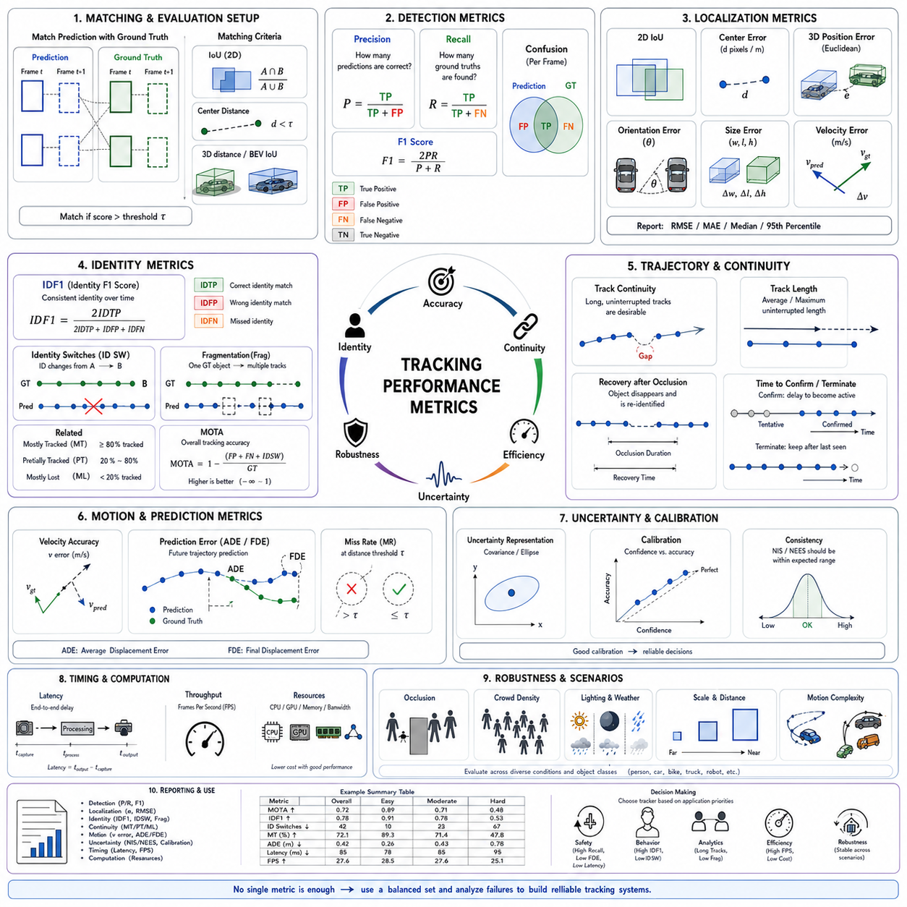
Tracking performance metrics provide a structured way to evaluate whether an object tracking system maintains accurate positions, stable identities, continuous trajectories, and reliable operation over time. Unlike object detection metrics, which assess isolated predictions in individual frames, tracking metrics must consider temporal consistency. A tracker may localize objects accurately in one frame yet still fail if identities switch, tracks fragment, or objects are lost during occlusion.
A complete tracking evaluation should therefore measure several dimensions at the same time. These dimensions include detection quality, localization precision, identity consistency, trajectory continuity, robustness to missed observations, recovery after occlusion, computational efficiency, latency, and uncertainty calibration. No single metric can represent all of these properties without hiding important failure modes.
Before metrics can be calculated, predicted tracks must be matched with ground-truth objects. This matching process usually relies on spatial overlap, center distance, or three-dimensional position error. A predicted object is considered a valid match only when it satisfies a defined threshold. Incorrect threshold selection can significantly change results, so evaluation protocols must use consistent rules across all tested systems.
Intersection over Union is widely used for matching two-dimensional bounding boxes. It measures the overlapping area divided by the combined area of the predicted and ground-truth boxes. A value of one indicates perfect overlap, while a value of zero indicates no overlap. Higher thresholds require more precise localization but may classify slightly shifted yet useful tracks as failures.
Center-distance matching evaluates the distance between predicted and ground-truth object centers. It is often used when bounding-box size varies or when only target coordinates are important. Distance may be expressed in image pixels, normalized image units, or physical meters. For robotic applications, metric world-coordinate distance is usually more meaningful than image-plane distance.
Three-dimensional tracking requires evaluation in physical space. Matching may use Euclidean position distance, bird’s-eye-view overlap, three-dimensional box overlap, heading difference, or dimension error. A track that appears accurate in an image may still have a large depth error, making it unsafe for collision avoidance. Three-dimensional evaluation should therefore include position, orientation, size, and velocity accuracy.
Detection precision measures the proportion of predicted objects that correspond to real objects. High precision means that the tracker produces few false positive tracks. False positives may originate from detector noise, reflections, duplicated tracks, stale predictions, or incorrect re-detection. In robotic systems, false tracks can cause unnecessary braking, path deviation, or reduced operational efficiency.
Detection recall measures the proportion of ground-truth objects that are successfully tracked. High recall indicates that few real objects are missed. Low recall can result from detector failure, excessive confirmation delay, aggressive track termination, poor sensor coverage, or long occlusion. For safety applications, missing a real person or vehicle is generally more serious than producing a small number of temporary false tracks.
The F1 score combines precision and recall using their harmonic mean. It provides a balanced summary when both false positives and missed objects matter. However, it evaluates object presence rather than long-term identity. A tracker can achieve a strong F1 score while repeatedly assigning new identifiers to the same physical object, so identity-focused metrics are also required.
False positives count predicted objects that cannot be matched to any ground-truth target. False negatives count ground-truth objects with no corresponding prediction. These raw counts are useful because aggregated scores can hide the actual scale of the problem. Engineers should inspect where and why these errors occur rather than relying only on normalized performance values.
Multiple Object Tracking Accuracy is one of the most widely recognized tracking metrics. It combines false positives, false negatives, and identity switches relative to the number of ground-truth observations. A higher value generally indicates better overall tracking. However, the metric combines different error types, so two trackers with similar scores may behave very differently in practice.
A tracker with many missed objects but few identity switches may receive a score similar to another tracker with strong recall but unstable identities. These systems are not equivalent for behavior prediction, safety analysis, or long-term trajectory statistics. Multiple Object Tracking Accuracy should therefore be interpreted together with separate false-positive, false-negative, and identity-switch counts.
Multiple Object Tracking Precision evaluates localization quality for correctly matched objects. Depending on the benchmark, it may use bounding-box overlap or spatial distance. The name can be misleading because it does not measure detection precision in the usual classification sense. It primarily indicates how accurately a tracker places objects after successful association.
Localization error should also be reported directly when possible. Position root mean square error, mean absolute error, median error, and percentile error provide clear physical interpretation. Percentile values are useful because average error may appear acceptable even when rare but severe deviations occur. Safety-related systems should examine worst-case and high-percentile errors.
Velocity accuracy is essential for dynamic planning. A tracker may localize objects correctly but estimate velocity poorly because of noisy detections, unsuitable motion models, timing errors, or excessive filtering delay. Velocity error should be evaluated separately in longitudinal, lateral, and absolute terms when the application depends on collision prediction.
Heading and turn-rate errors are important for vehicle tracking. A small position error may still lead to an incorrect future trajectory if orientation is wrong. Evaluation should consider angular wraparound so that headings near positive and negative boundaries are compared correctly. Vehicle-specific tests should include straight movement, turning, reverse motion, and stopping.
Identity Precision measures the fraction of predicted identity assignments that correspond to the correct ground-truth identity. Identity Recall measures how completely the observations of each real identity are recovered. Their harmonic mean is known as IDF1, which has become one of the principal metrics for evaluating identity preservation in multi-object tracking.
IDF1 emphasizes whether a tracker consistently follows the same physical object under one identity. It is particularly valuable in applications involving long-term behavior analysis, person re-identification, vehicle flow monitoring, and multi-camera tracking. A high IDF1 score indicates that predicted and ground-truth identity trajectories correspond well over time.
Identity switches count the number of times a tracked identity changes from one physical object to another. This error commonly occurs when objects cross, overlap, disappear, or have similar appearances. Even one identity switch can contaminate two trajectories at once, because the histories of both objects may become mixed after the incorrect assignment.
The importance of identity switches depends on the application. Local collision avoidance may tolerate an identity change if object position remains accurate, while behavior prediction or human-following functions may fail completely. Therefore, identity-switch counts should be interpreted in relation to the intended use rather than as an isolated universal measure.
Trajectory fragmentation counts how often one ground-truth object is represented by multiple disconnected track segments. Fragmentation usually results from missed detections, premature termination, failed re-identification, or overly strict association thresholds. A highly fragmented tracker repeatedly loses and recreates the same object even if individual detections remain accurate.
Fragmentation reduces the usefulness of historical motion information. A behavior model may receive only short trajectory segments and fail to recognize long-term intent. Fleet analytics may count one physical asset several times. Tracking systems intended for long-duration analysis should therefore prioritize continuous identity recovery as well as frame-level accuracy.
Mostly Tracked measures the proportion of ground-truth trajectories that are successfully tracked for most of their visible duration. Mostly Lost measures trajectories that are observed for only a small portion of their duration. These metrics provide an intuitive understanding of whether the system follows complete objects or merely captures brief fragments.
Partially Tracked objects fall between Mostly Tracked and Mostly Lost. Examining the distribution across these categories helps reveal whether performance is broadly consistent or concentrated on easy targets. A system may track nearby, large objects well while repeatedly losing distant or partially visible objects.
Higher Order Tracking Accuracy was introduced to provide a more balanced assessment of detection and association. It evaluates whether objects are detected and whether their temporal relationships remain correct. By separating detection accuracy, association accuracy, and localization accuracy, it provides clearer diagnostic information than metrics that combine all errors into one value.
HOTA is useful when comparing modern trackers because it avoids allowing one performance dimension to dominate completely. A system with excellent detection but poor association cannot achieve a high score, and a system with stable identities but many missed objects is also penalized. This balance better reflects the integrated nature of tracking.
Association Accuracy within the HOTA framework measures the quality of identity relationships across matched detections. It asks whether observations that should belong to the same trajectory are linked correctly and whether observations from different objects remain separate. This directly evaluates temporal organization rather than only frame-level correctness.
Detection Accuracy within HOTA evaluates whether objects are found and matched at each frame. Localization Accuracy evaluates spatial alignment of matched predictions. Reporting these components separately helps engineers determine whether improvement should focus on the detector, state estimator, data association, or identity management.
Track continuity can also be measured using average uninterrupted track length, maximum gap duration, successful recovery rate, and time until re-identification. These metrics are especially useful for systems operating under frequent occlusion. A tracker may recover most lost objects eventually but still require an unacceptably long delay.
Recovery after occlusion should be evaluated according to occlusion length and severity. Short partial occlusion, long complete occlusion, crossing objects, and re-entry after leaving the field of view represent different challenges. Results should be grouped by scenario because an average recovery score may hide failure under the most safety-critical conditions.
Time to confirmation measures how long a newly visible object remains tentative before becoming an active confirmed track. A short confirmation delay improves responsiveness, but overly rapid confirmation may create false tracks. In safety systems, tentative objects may still need to influence planning even before formal confirmation.
Time to termination measures how long a lost object continues to be predicted after its last valid observation. Long retention improves recovery from occlusion but can generate ghost tracks. Short retention removes stale information quickly but increases fragmentation. The appropriate value depends on object class, speed, visibility, and environmental structure.
Track existence accuracy evaluates whether the tracker correctly determines when an object is present or absent. This is different from localization because a tracker may continue outputting a plausible position after the object has left the scene. Long-term trackers should explicitly evaluate absence detection and false-presence duration.
Track age and maturity can be analyzed to understand stability. Mature tracks should generally have lower identity uncertainty than newly created tracks. If mature tracks frequently switch or terminate, the appearance model, motion model, or association logic may be unreliable. Performance grouped by track age can expose these weaknesses.
Confidence calibration measures whether reported confidence corresponds to actual correctness. Among tracks assigned a confidence of approximately eighty percent, roughly eighty percent should be valid under a well-calibrated system. Overconfident trackers are dangerous because downstream modules may trust inaccurate positions or identities.
Calibration may be evaluated using reliability diagrams, expected calibration error, negative log-likelihood, or proper scoring rules. Separate calibration should be considered for object existence, localization, identity, and future prediction because one confidence value may not accurately represent all uncertainty types.
Covariance consistency is important when Kalman filters or probabilistic estimators are used. The predicted covariance should match the observed estimation error over time. If covariance is too small, the system is overconfident and association gates become too narrow. If it is too large, the tracker becomes unnecessarily uncertain and may accept incorrect matches.
Normalized Innovation Squared evaluates whether measurement residuals are statistically consistent with predicted innovation covariance. Normalized Estimation Error Squared compares actual state error with estimated state covariance when ground truth is available. These metrics help diagnose incorrect process-noise and measurement-noise tuning.
Prediction metrics assess future trajectory estimates rather than only current states. Average Displacement Error measures mean distance between predicted and actual future positions. Final Displacement Error measures error at the end of the prediction horizon. Both should be reported over multiple horizons because short-term and long-term behavior differ.
Miss rate at a specified distance threshold indicates how often the predicted trajectory fails to remain sufficiently close to the actual path. Probabilistic predictors may be evaluated with likelihood-based metrics, coverage probability, or minimum error among several trajectory hypotheses. Simple deterministic metrics are insufficient when the model outputs multiple possible futures.
Collision-related metrics are valuable for robotic systems. Time-to-collision error, closest-point-of-approach error, predicted occupancy accuracy, and safety-zone violation detection directly connect tracking performance with operational risk. A tracker may perform well on generic benchmarks yet estimate collision timing poorly because of velocity bias.
Latency is a critical performance metric. Tracking output represents a past sensor state unless processing and communication delays are compensated. End-to-end latency includes sensor exposure, data transfer, detection, feature extraction, association, state estimation, fusion, and message delivery to planning or control.
Frames per second measures throughput but does not fully describe latency. A pipelined system may process many frames per second while each output arrives significantly late. Real-time evaluation should therefore report both throughput and per-frame end-to-end delay, including average, maximum, and percentile latency.
Latency jitter also matters because irregular update timing can destabilize prediction and control. A tracker with constant moderate delay may be easier to compensate than one with highly variable delay. Timestamp-aware extrapolation can reduce effective position error, but only when the timing information is accurate.
Computational efficiency includes processor use, graphics processor use, memory consumption, data bandwidth, and energy demand. Embedded robots operate under thermal and power constraints, so an algorithm with slightly higher benchmark accuracy may be unsuitable if it causes throttling, excessive battery consumption, or unpredictable execution time.
Scalability should be evaluated as object density increases. Data association, appearance comparison, and feature storage become more expensive when many tracks and detections are present. Runtime should be measured across sparse, moderate, and crowded scenes rather than only under average load.
Memory consumption may grow with stored appearance galleries, trajectory history, multiple hypotheses, and multi-camera identities. Long-duration systems should evaluate whether memory remains bounded. Uncontrolled growth can eventually reduce performance or cause system failure even when short benchmark sequences run successfully.
Robustness evaluation should examine environmental variation. Lighting changes, shadows, rain, fog, dust, motion blur, vibration, sensor noise, background clutter, and reflective surfaces can affect tracking. Results should be grouped by condition so that weaknesses are not hidden by easier data.
Object size and distance should also be considered. Large nearby objects are easier to detect and associate than small distant ones. Performance can be reported across size or range categories. For three-dimensional tracking, distance-binned error is particularly important because point density and depth uncertainty change with range.
Occlusion-level analysis divides performance according to visible fraction or occlusion duration. Trackers often perform well under full visibility but degrade sharply during heavy occlusion. Reporting identity switches and recall by occlusion level helps determine whether motion prediction, appearance memory, or re-identification requires improvement.
Class-specific evaluation is necessary because pedestrians, vehicles, bicycles, forklifts, and mobile robots exhibit different movement and appearance. An overall average may conceal poor performance for a safety-critical minority class. Each important operational class should have separate detection, localization, identity, and continuity results.
Human tracking evaluation should emphasize crossing, crowd density, pose variation, and identity preservation. Vehicle tracking should emphasize velocity, heading, turn prediction, reverse motion, and dimension stability. Industrial vehicle tests should additionally consider carried loads, trailers, articulated movement, and unusual kinematics.
Multi-camera tracking requires metrics for cross-camera identity consistency. The system should maintain the same global identity when an object moves between views. Evaluation may consider cross-camera IDF1, handover success rate, false handover rate, transition delay, and recovery after non-overlapping camera gaps.
Multi-robot tracking adds distributed consistency requirements. Different robots observing the same object should converge on one global identity and compatible state estimates. Metrics may include duplicate global tracks, fusion latency, disagreement between robots, communication bandwidth, and robustness to packet loss.
Benchmark datasets provide standardized comparisons, but their results should not be treated as proof of deployment readiness. Public datasets may use different cameras, object densities, frame rates, environmental conditions, and annotation policies from the target system. A tracker optimized for a benchmark may fail under industrial vibration or unusual sensor placement.
Ground-truth quality also limits evaluation reliability. Identity annotations may be ambiguous during full occlusion, bounding boxes may vary between annotators, and synchronization errors may affect three-dimensional labels. Evaluation reports should document annotation uncertainty and avoid interpreting tiny score differences as meaningful when ground truth is imperfect.
Metric thresholds must be selected transparently. Changing an overlap threshold, distance gate, or minimum track duration can alter rankings. Results should use established benchmark settings when comparison is intended and application-specific thresholds when operational safety or performance is being assessed.
Statistical uncertainty should accompany reported scores. Different sequences may produce substantially different results, especially when datasets are small. Confidence intervals, bootstrap estimates, per-sequence distributions, and repeated runs help determine whether an apparent performance improvement is consistent or caused by limited sample variation.
Average metrics can hide catastrophic failures. Engineers should inspect worst-case sequences, maximum localization error, longest missed-object duration, and largest latency spike. Safety validation should emphasize tail behavior because rare severe errors may dominate operational risk.
Error correlation is also important. Several small errors may occur together during difficult conditions. For example, motion blur may reduce detector recall, corrupt appearance features, increase identity switches, and delay recovery simultaneously. Scenario-level analysis captures these interactions better than isolated metric averages.
A tracking evaluation report should therefore include both aggregate results and detailed breakdowns. Core values may summarize detection, association, localization, identity, latency, and computation, while scenario tables and visual examples explain where failures occur. This combination supports informed engineering decisions.
Visual evaluation remains valuable even with comprehensive numerical metrics. Overlaying ground-truth and predicted tracks reveals identity swaps, delayed motion estimates, oversized uncertainty, duplicated tracks, and premature termination. Trajectory plots and association timelines often make failure mechanisms immediately understandable.
Evaluation should be repeatable and version controlled. Dataset versions, calibration files, model weights, configuration parameters, random seeds, metric implementations, hardware, and software dependencies should be recorded. Small implementation differences can produce inconsistent results even when the same metric name is used.
Regression testing is essential during system development. Every algorithm or parameter change should be evaluated against a fixed collection of representative scenarios. Automated thresholds can detect degradation in recall, identity stability, latency, or resource use before the update reaches field deployment.
Field monitoring should continue after deployment because real operating conditions change. New vehicle types, worker clothing, sensor aging, layout modification, seasonal lighting, and software updates may alter performance. Operational metrics and selected failure logs can reveal gradual degradation not visible during initial testing.
Privacy-preserving evaluation should be considered when human tracks are involved. Metrics can often be calculated using anonymous temporary identifiers without storing personally identifying information. Data retention and access should be limited while still allowing sufficient analysis of tracking failures and safety performance.
The most appropriate metric depends on the application goal. Collision avoidance emphasizes recall, position, velocity, latency, and uncertainty. Human-following emphasizes identity consistency and recovery. Fleet analytics requires continuous long-term trajectories. Multi-camera surveillance prioritizes re-identification and global identity preservation.
No tracker should be selected using a single headline score. A robust choice requires examining detection quality, identity performance, localization, continuity, uncertainty, latency, computational cost, scenario robustness, and failure behavior. Tradeoffs should be made explicitly according to operational priorities.
Tracking performance metrics ultimately provide the evidence needed to determine whether a perception system is accurate, stable, timely, and safe enough for its intended environment. When metrics are carefully selected, consistently implemented, and combined with scenario analysis, they reveal not only how often a tracker succeeds but also how, when, and why it fails.
A mature evaluation framework turns tracking development into a measurable engineering process. It connects algorithm behavior with real system requirements, guides parameter tuning, supports fair model comparison, detects regressions, and informs safety decisions. This framework is essential for converting promising tracking algorithms into reliable perception components for autonomous robots and intelligent mobility systems.

16.8 Tracking Debugging and Validation
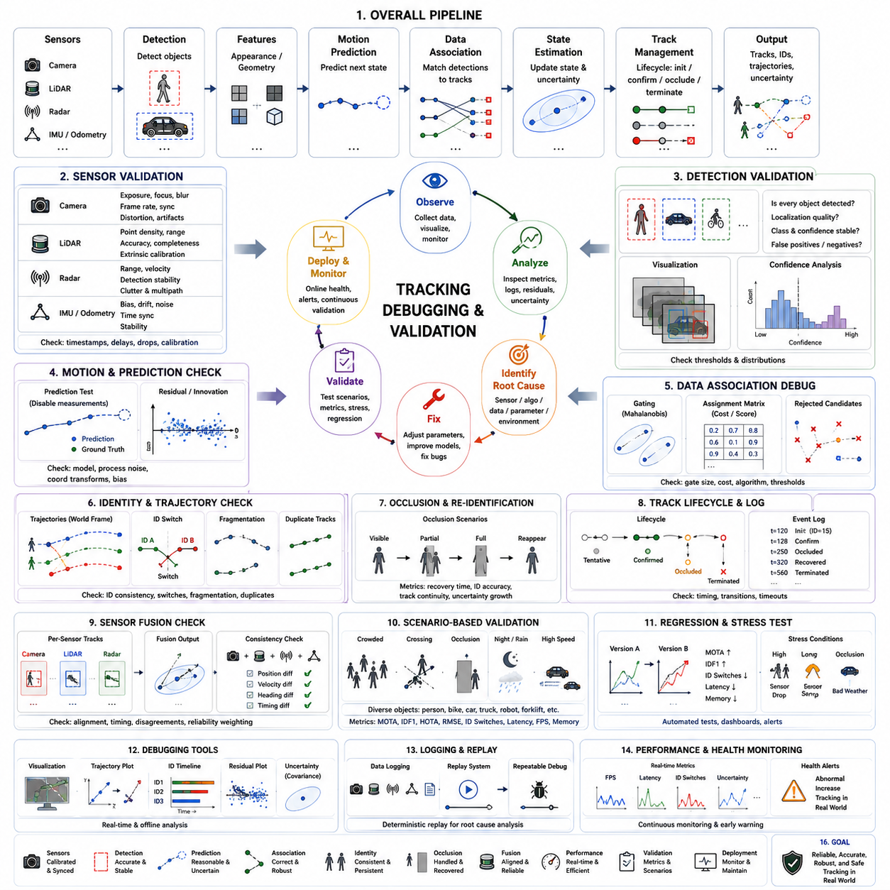
Debugging and validation are essential activities in the development of object tracking systems because tracking performance depends on the interaction of multiple components rather than on a single algorithm. Detection, feature extraction, motion prediction, data association, state estimation, sensor fusion, and track management all contribute to the final result. A tracking failure is often caused by the combined effect of several small errors instead of one obvious software defect. Systematic debugging therefore requires engineers to analyze the complete processing pipeline rather than isolated modules.
Unlike static perception algorithms, tracking introduces temporal dependencies that make debugging more challenging. A small error in one frame can influence future predictions, alter identity assignments, increase uncertainty, and eventually produce completely different trajectories. Some failures may not become visible until dozens or hundreds of frames later. Effective validation must therefore examine not only individual frames but also the evolution of object states over time.
A structured debugging strategy begins by defining expected system behavior. Engineers should specify how tracks are initialized, confirmed, updated, occluded, re-identified, merged, split, and terminated. Clear expectations allow abnormal behavior to be recognized quickly. Without predefined operational rules, developers may struggle to determine whether an observed trajectory represents an implementation bug, a parameter issue, or an unavoidable limitation of the tracking model.
The first validation step is usually sensor verification. Cameras, LiDAR, radar, inertial measurement units, wheel encoders, and positioning sensors should all be checked independently before evaluating the tracking algorithm. Incorrect timestamps, dropped frames, synchronization errors, calibration drift, communication delays, or unstable measurements can significantly reduce tracking performance even when the tracking software itself is implemented correctly.
Camera validation begins with image quality assessment. Exposure, focus, motion blur, rolling shutter distortion, frame rate, color consistency, compression artifacts, and lens contamination all affect downstream detection and tracking. Engineers should verify that images remain stable under different illumination conditions and that synchronization with other sensors remains accurate throughout long-duration operation.
LiDAR validation should confirm point density, scan completeness, distance accuracy, timing consistency, and extrinsic calibration. Mechanical vibration, sensor contamination, rain, fog, or reflective materials may introduce unexpected measurement behavior. Engineers should compare point clouds collected from static environments to ensure that localization noise remains within expected limits before evaluating moving objects.
Radar validation focuses on range accuracy, velocity measurement, object detection stability, and clutter rejection. Multipath reflections, interference, and environmental obstacles may create false detections or unstable velocity estimates. Since radar is often used for velocity estimation under adverse weather conditions, engineers should verify its consistency across different environmental scenarios rather than relying only on laboratory testing.
Time synchronization is one of the most important validation tasks in multi-sensor tracking. Even small timing offsets between cameras, LiDAR, radar, and inertial sensors can produce incorrect associations for fast-moving objects. Engineers should verify synchronization using hardware timestamps, precision time protocols, trigger signals, or synchronized recording systems to ensure that all sensor observations correspond to the same physical moment.
Calibration validation ensures that measurements from different sensors describe the same physical world consistently. Extrinsic calibration errors shift object positions between coordinate systems, while intrinsic calibration errors distort image geometry. Debugging should include visualization of projected LiDAR points on camera images and comparison of reconstructed object locations across all sensing modalities.
After sensor verification, object detection should be validated independently from tracking. Detection errors propagate directly into the tracking module, making later debugging unnecessarily complicated. Engineers should first evaluate whether every visible object is detected consistently before analyzing data association or motion prediction. Reliable tracking cannot compensate for fundamentally unreliable detection.
Detection visualization is an effective debugging technique. Every frame should display predicted bounding boxes, confidence scores, class labels, segmentation masks, or three-dimensional cuboids together with the corresponding sensor data. Visual overlays allow developers to identify missing detections, duplicated detections, unstable classifications, and localization errors much faster than numerical logs alone.
Detection confidence should also be analyzed statistically. Histograms of confidence values can reveal whether thresholds are too conservative or too permissive. Large numbers of low-confidence detections may increase false tracks, while excessively high thresholds may eliminate valid observations. Validation should compare confidence distributions across multiple environments rather than relying on a single dataset.
Track initialization requires careful debugging because premature track creation often produces unstable identities. Engineers should examine how many observations are required before a tentative object becomes a confirmed track. If confirmation occurs too quickly, temporary noise may generate persistent false tracks. If confirmation is delayed excessively, rapidly moving objects may disappear before becoming active tracks.
Track confirmation timing should be visualized together with object trajectories. Displaying tentative and confirmed states using different colors allows engineers to observe whether confirmation occurs consistently across different object types, distances, and speeds. This visualization often reveals parameter tuning problems that numerical metrics alone cannot explain.
Motion prediction should be validated independently from measurement updates. Engineers can temporarily disable measurements after several frames and observe whether predicted trajectories remain physically reasonable. If predictions diverge rapidly during short measurement gaps, the motion model, process noise, or coordinate transformation may require adjustment.
Prediction residuals provide valuable debugging information. The residual represents the difference between predicted and measured object states. Large systematic residuals may indicate inaccurate motion models, incorrect coordinate transformations, poor calibration, or sensor bias. Residual statistics should be monitored continuously throughout testing rather than only after major failures occur.
Innovation analysis is particularly useful when Kalman filtering is employed. Innovation values should follow expected statistical behavior if process and measurement noise are modeled correctly. Consistently large innovations suggest underestimated uncertainty or incorrect motion assumptions, while unusually small innovations may indicate excessive filtering or overly conservative covariance estimates.
Covariance visualization helps engineers understand uncertainty propagation. Position uncertainty can be displayed as ellipses in two-dimensional space or ellipsoids in three-dimensional space. Uncertainty should increase during occlusion, decrease after successful measurements, and remain consistent with observed estimation error. Unrealistically small covariance often causes incorrect data association.
Data association debugging is one of the most challenging aspects of tracking validation. Association decisions determine whether new detections belong to existing tracks or should create new identities. Developers should visualize matching scores, gating regions, assignment matrices, and rejected candidates to understand why a particular association decision was made.
Association gating should be verified carefully. Gates that are too narrow reject correct observations, increasing fragmentation and identity loss. Gates that are too large accept incorrect matches, producing identity switches. Validation should examine successful and rejected associations under different object speeds, densities, and sensor uncertainties.
Assignment algorithms should also be validated using controlled scenarios. Synthetic datasets containing only a few moving objects allow engineers to verify that the association algorithm behaves correctly before testing crowded real-world environments. Simple scenarios make unexpected assignment behavior easier to identify than highly complex scenes.
Identity consistency should be monitored throughout long sequences. Every tracked object should maintain the same identifier whenever possible. Engineers should visualize identity histories, assignment timelines, and object trajectories simultaneously. Identity switches often become immediately obvious when track colors unexpectedly exchange between crossing objects.
Trajectory visualization is one of the most effective debugging tools. Plotting complete object trajectories in world coordinates allows developers to detect unrealistic motion, sudden position jumps, fragmented tracks, duplicated objects, or incorrect coordinate transformations. Long-term trajectory plots often reveal problems that are invisible in frame-by-frame visualization.
Coordinate transformation debugging is especially important for mobile robots. Object positions should remain stable in the world frame even when the robot accelerates, rotates, or changes elevation. If stationary objects appear to move with the robot, localization errors or transformation inconsistencies may be responsible rather than the tracking algorithm itself.
Ego-motion compensation should be validated independently. Engineers can compare object trajectories before and after ego-motion correction to verify that stationary infrastructure remains fixed in global coordinates. Errors in odometry, inertial measurements, or simultaneous localization and mapping may propagate directly into object tracking despite correct detection and association.
Occlusion handling requires dedicated validation scenarios. Controlled experiments should include temporary partial occlusion, complete disappearance, crossing pedestrians, vehicles passing behind obstacles, and reappearance after long interruptions. Each scenario should evaluate identity preservation, uncertainty growth, and successful recovery after measurements become available again.
Re-identification should be tested separately from ordinary tracking. Objects should intentionally leave the sensor field and later return from different directions or under different viewing conditions. Engineers should measure recovery time, identity accuracy, and false re-identification frequency while varying appearance changes, illumination, and observation duration.
Track lifecycle management should be validated using detailed event logs. Every transition between tentative, confirmed, occluded, lost, recovered, and terminated states should be recorded with timestamps and triggering conditions. Reviewing lifecycle histories often reveals unexpected state transitions caused by parameter tuning rather than algorithmic errors.
Track termination logic deserves particular attention. Tracks should disappear when objects truly leave the environment, but temporary sensor failures should not immediately terminate valid identities. Engineers should compare different termination timeouts across slow-moving pedestrians, rapidly moving vehicles, stationary objects, and highly cluttered environments.
Duplicate track detection is another important debugging task. Multiple tracks should never represent the same physical object unless explicitly required by the application. Duplicate tracks frequently originate from repeated initialization, delayed association, sensor fusion errors, or incorrect track splitting. Visualization should clearly indicate when several identities overlap the same object.
Track merging and splitting should also be validated. Closely spaced pedestrians, articulated vehicles, or temporarily overlapping objects may cause multiple tracks to merge incorrectly or one track to split into several identities. Controlled scenarios with known object interactions help identify weaknesses in these algorithms.
Multi-sensor fusion debugging requires engineers to isolate each sensor contribution. Fusion performance should first be evaluated using individual sensors independently before enabling combined operation. Incremental testing makes it easier to identify which sensing modality introduces instability into the fused tracking result.
Fusion visualization should indicate which sensors contributed to each track update. Displaying camera observations, LiDAR clusters, radar detections, and fused states together allows developers to understand how conflicting measurements are resolved. Engineers should verify that missing measurements from one sensor do not cause unnecessary track termination.
Sensor disagreement should be analyzed quantitatively. Position differences, velocity inconsistencies, heading discrepancies, and timing offsets between sensing modalities can indicate calibration problems, synchronization errors, or environmental effects. Logging these disagreements throughout testing helps identify intermittent problems that visual inspection may overlook.
False positive analysis should investigate why nonexistent objects become active tracks. Reflections, shadows, sensor noise, duplicated detections, repeated initialization, and environmental clutter are common causes. Engineers should classify false tracks according to their origin rather than treating all false positives as identical failures.
False negative analysis focuses on missing objects. Engineers should determine whether failures originate from detection, association, confirmation delay, occlusion handling, or premature termination. Understanding the source of each missed object allows targeted improvements rather than broad parameter adjustments affecting the entire system.
Identity switch analysis should record the exact frame where each switch occurs. Reviewing surrounding frames usually reveals whether the error resulted from crossing objects, appearance similarity, temporary occlusion, poor motion prediction, or excessive association uncertainty. Frame-by-frame investigation remains one of the most reliable debugging techniques for identity preservation.
Scenario-based validation provides more meaningful results than purely random testing. Engineers should design representative scenarios including crowded intersections, warehouse aisles, factory floors, construction sites, hospital corridors, parking lots, and outdoor roads. Each scenario stresses different components of the tracking pipeline and exposes different failure mechanisms.
Environmental validation should include changing illumination, day and night operation, rain, fog, dust, snow, reflections, moving shadows, and strong backlighting. Tracking systems that perform well only under ideal laboratory conditions rarely achieve reliable field performance. Environmental diversity is therefore essential during validation.
Object diversity should also be considered. Validation datasets should include pedestrians of different heights, clothing, walking styles, bicycles, passenger vehicles, trucks, forklifts, autonomous mobile robots, construction equipment, and partially visible objects. Diverse object characteristics improve confidence that the tracker generalizes beyond limited benchmark datasets.
Ground truth quality directly influences debugging effectiveness. Poor annotations may incorrectly suggest tracking failures where none exist. Engineers should periodically review annotation accuracy, synchronization quality, object identities, and coordinate consistency before drawing conclusions from evaluation metrics. Reliable validation depends on reliable reference data.
Simulation provides an efficient debugging environment because every object state is known precisely. Engineers can reproduce identical scenarios repeatedly while modifying only one parameter at a time. Controlled simulation simplifies isolation of algorithmic defects before expensive field testing begins.
Synthetic stress testing intentionally creates difficult conditions beyond ordinary operational environments. Extremely dense traffic, rapid accelerations, sensor failures, packet loss, severe weather, and complete communication interruptions help determine system robustness. Validation should identify the operational limits beyond which tracking performance becomes unacceptable.
Regression testing ensures that software improvements do not unintentionally degrade existing capabilities. Every software update should automatically execute a standardized collection of tracking scenarios. Engineers should compare identity consistency, localization accuracy, computational performance, and latency with previous software versions before deployment.
Performance regression dashboards simplify long-term development. Historical graphs showing identity switches, localization error, track continuity, latency, and resource usage reveal gradual performance changes that individual benchmark reports may fail to highlight. Continuous monitoring supports stable software evolution.
Computational profiling should accompany algorithm debugging. Developers should measure processor utilization, graphics processor workload, memory allocation, communication bandwidth, and execution time for every pipeline stage. Performance bottlenecks often appear only under heavy object density or long-duration operation.
Real-time scheduling should be validated together with computational performance. A tracking algorithm may produce accurate results but still fail operationally if processing deadlines are missed. Engineers should verify deterministic execution under maximum expected system load, including simultaneous perception, localization, planning, and communication tasks.
Memory debugging is especially important for long-duration missions. Appearance databases, trajectory histories, multiple hypotheses, and sensor buffers may gradually increase memory consumption. Validation should verify that memory remains stable during hours or days of continuous operation without causing performance degradation.
Logging infrastructure should capture sufficient information to reproduce failures. Raw sensor data, detector outputs, predicted states, association scores, covariance matrices, track events, timing information, and configuration parameters should all be recorded. Comprehensive logs enable offline analysis without repeating expensive field experiments.
Replay systems provide deterministic debugging capability. Engineers should reproduce recorded sensor sequences while modifying algorithm parameters or software implementations. Identical replay conditions allow direct comparison between different algorithm versions without environmental variation influencing the results.
Visualization dashboards significantly accelerate debugging. Interactive displays should present synchronized sensor streams, object tracks, uncertainty regions, identity histories, timing statistics, and performance metrics within a unified interface. Engineers can then correlate failures across multiple modules without switching between separate diagnostic tools.
Validation reports should summarize both quantitative metrics and qualitative observations. Numerical scores provide objective comparison, while representative visualization examples explain why particular failures occurred. Combining statistical analysis with visual evidence produces a more complete understanding of system behavior.
Acceptance testing should define measurable operational requirements before deployment. Minimum detection recall, maximum identity switch frequency, localization accuracy, computational latency, and resource consumption should all satisfy predefined engineering criteria. Deployment decisions should rely on these objective requirements rather than subjective visual impressions.
Field validation must extend beyond controlled experiments. Real deployments introduce unexpected environmental conditions, human behavior, sensor aging, mechanical wear, and communication variability that rarely appear during laboratory testing. Continuous operational monitoring remains essential even after formal validation has been completed.
Online health monitoring can detect tracking degradation during deployment. Abnormal increases in uncertainty, identity switches, missed detections, computational delay, or sensor disagreement may indicate hardware faults or environmental changes. Early warning enables preventive maintenance before complete system failure occurs.
Explainable debugging techniques improve engineering efficiency by revealing why tracking decisions were made. Rather than reporting only the final track state, the system should expose association scores, feature similarities, motion predictions, uncertainty values, and confidence estimates. Transparent reasoning greatly simplifies diagnosis of unexpected behavior.
Parameter sensitivity analysis helps identify robust operating regions. Process noise, measurement noise, confirmation thresholds, association gates, termination delays, and confidence thresholds should be varied systematically to determine how strongly performance depends on each parameter. Stable parameter regions generally indicate a more reliable tracking architecture.
Cross-validation using multiple datasets reduces the risk of overfitting to one benchmark. Algorithms optimized exclusively for a single dataset may perform poorly under different camera configurations, sensor characteristics, or environmental conditions. Validation should therefore include multiple public datasets together with representative field recordings.
Human expert review remains valuable even in highly automated evaluation frameworks. Experienced engineers can often recognize unrealistic trajectories, unusual object behavior, or visualization artifacts that numerical metrics fail to capture. Combining automated testing with expert inspection produces more reliable conclusions than either approach alone.
Safety validation requires particular attention to worst-case behavior rather than average performance. Engineers should investigate maximum localization error, longest object disappearance, largest uncertainty growth, greatest computational delay, and most severe identity failures. Rare extreme cases often dominate operational safety risk.
Debugging should ultimately focus on identifying root causes instead of treating symptoms. Repeated identity switches may originate from poor detection, inaccurate motion prediction, incorrect calibration, excessive latency, or weak appearance features. Addressing the underlying cause generally produces broader improvements than adjusting association parameters alone.
Successful tracking validation is therefore a continuous engineering process rather than a final testing stage. Every software modification, hardware update, environmental change, or sensor replacement should trigger renewed verification. Continuous debugging, systematic validation, and objective performance analysis ensure that tracking systems remain accurate, reliable, and safe throughout their operational lifetime.

