Volume 03. AMR Sensors and Perception

Chapter 15. Object Detection

15.1 Object Detection Basics
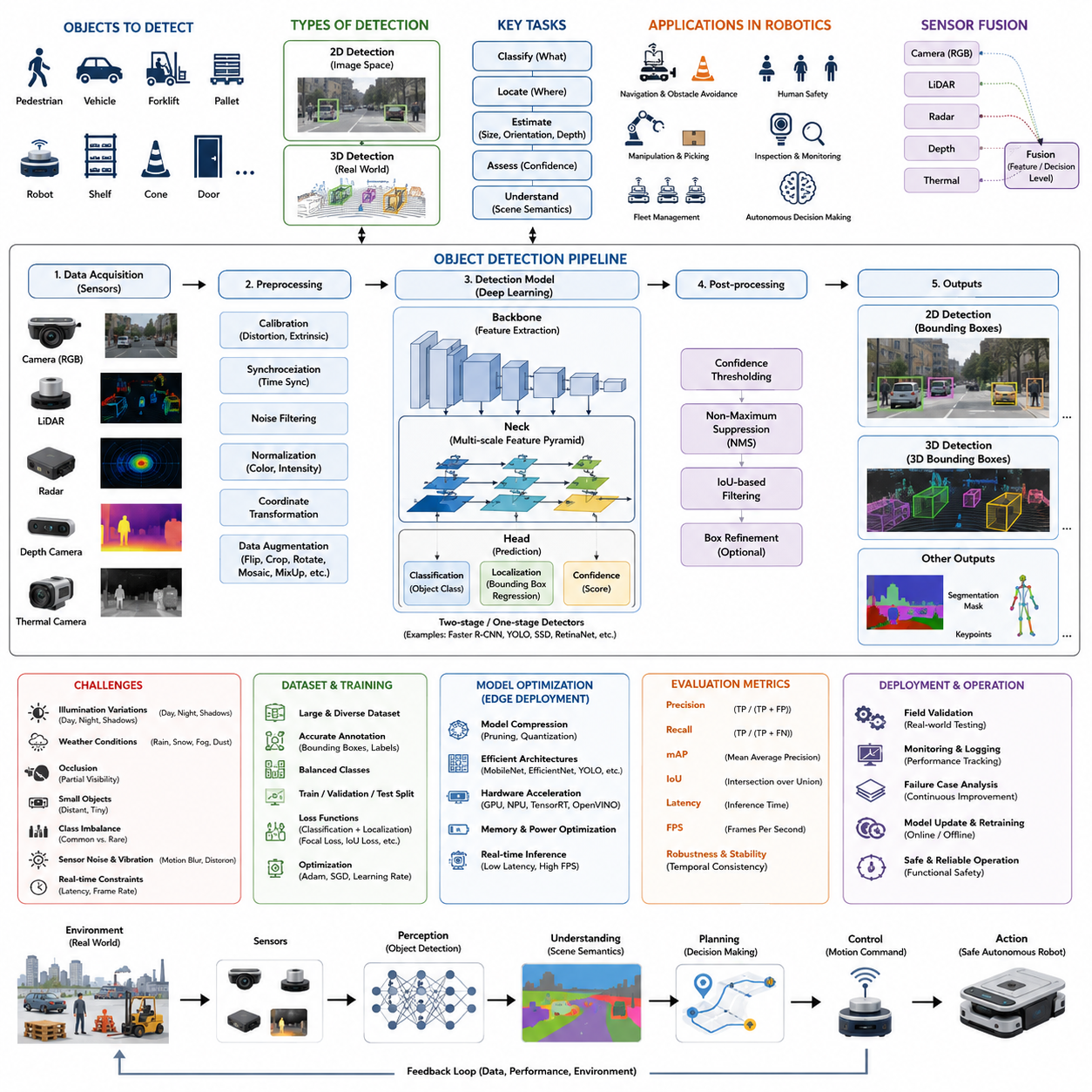
Object detection is one of the most fundamental capabilities in autonomous mobile robots because it enables the robot to recognize meaningful entities within its surrounding environment instead of merely processing raw sensor measurements. Cameras, LiDARs, depth sensors, radars, and thermal imagers continuously produce enormous amounts of data, but these measurements alone carry little semantic meaning. Object detection transforms pixels, point clouds, or radar reflections into identifiable objects such as pedestrians, forklifts, pallets, vehicles, robots, shelves, doors, traffic cones, or construction equipment. This semantic understanding allows higher-level autonomy modules to reason about the environment, evaluate potential hazards, predict future interactions, and generate safe navigation behaviors. Without reliable object detection, an AMR would perceive only geometric structures without understanding which objects require avoidance, interaction, or task execution.
The concept of object detection extends beyond simply recognizing that an object exists. A complete detection system identifies the category of the object, estimates its spatial location, determines its confidence level, and provides sufficient information for subsequent planning algorithms. Most modern perception systems generate bounding boxes, segmentation masks, keypoints, or three-dimensional cuboids describing detected objects. These outputs serve as the interface between perception and decision-making modules. The localization accuracy, classification reliability, and processing speed of the detector directly influence navigation quality, collision avoidance, manipulation success, and overall system safety.
Historically, robotic object detection relied heavily on handcrafted feature extraction methods. Engineers designed algorithms based on edge detection, color histograms, corner features, Haar cascades, Histogram of Oriented Gradients, Scale-Invariant Feature Transform, and Speeded-Up Robust Features. These methods achieved acceptable performance under controlled conditions but struggled when illumination changed, object appearance varied, or environmental complexity increased. Industrial environments containing reflective metals, shadows, moving workers, dust, and clutter frequently caused these traditional techniques to fail. Their inability to generalize across diverse operating conditions motivated the transition toward machine learning and eventually deep learning.
The emergence of convolutional neural networks fundamentally transformed object detection. Rather than requiring manually engineered features, neural networks automatically learned hierarchical visual representations directly from training data. Early layers extracted simple edges and textures, intermediate layers recognized object parts, and deeper layers identified complete semantic objects. As computational resources improved, these networks surpassed handcrafted algorithms in accuracy, robustness, and adaptability. Today, nearly every state-of-the-art robotic perception system employs deep neural networks for object detection because they can learn highly discriminative features across diverse operating environments.
Modern object detection can generally be categorized into two-dimensional and three-dimensional detection. Two-dimensional detection identifies objects within camera images and outputs rectangular bounding boxes defined by image coordinates. These detections provide object identity and approximate image location but do not directly describe physical distance or orientation. Three-dimensional detection extends this concept by estimating the object's position, dimensions, and orientation within real-world coordinates using LiDAR, stereo vision, depth cameras, or sensor fusion. Three-dimensional detection is particularly valuable for autonomous robots because navigation decisions depend on actual spatial relationships rather than image positions alone.
Object detection also differs from image classification. Image classification assigns a single category to an entire image without specifying where the object appears. An image containing multiple pedestrians, vehicles, and traffic signs may simply receive the label “street scene.” Detection instead identifies each object individually, producing separate predictions for every relevant instance. This distinction is critical in robotics because navigation requires precise knowledge of object locations rather than a global description of the environment.
Another important distinction exists between object detection and semantic segmentation. Detection predicts bounding regions surrounding objects, whereas semantic segmentation classifies every individual pixel according to its semantic category. Segmentation provides finer spatial information, particularly around object boundaries, while detection generally requires less computational effort and is sufficient for many navigation tasks. In practical robotic systems, detection and segmentation are often combined to provide both computational efficiency and detailed scene understanding.
The perception pipeline surrounding object detection begins with sensor acquisition. Cameras capture RGB images, LiDAR sensors generate point clouds, radars measure range and velocity, and depth cameras estimate distance information. Raw sensor data undergo preprocessing steps including distortion correction, color normalization, temporal synchronization, coordinate transformation, noise filtering, and exposure adjustment. These preprocessing operations improve input quality before inference. The prepared data are then passed into neural network models that perform feature extraction, region proposal generation, classification, localization, and confidence estimation.
Feature extraction is one of the most critical stages of deep learning-based object detection. Convolutional layers progressively transform raw images into compact feature maps that emphasize meaningful patterns while suppressing irrelevant information. Low-level features describe edges, gradients, and textures. Mid-level representations identify shapes and object components. High-level semantic features capture complete object identities. Multi-scale feature pyramids further enable detection across different object sizes by preserving information at multiple spatial resolutions.
Most modern detection architectures employ backbone networks followed by detection heads. The backbone extracts hierarchical features from the input image, while the detection head predicts object categories and bounding boxes. Common backbone architectures include ResNet, EfficientNet, CSPDarknet, MobileNet, and Vision Transformers. Detection heads vary depending on algorithm design but typically perform classification, localization, confidence estimation, and sometimes object orientation prediction. Separating backbone and head architectures allows engineers to optimize computational efficiency while maintaining detection accuracy.
Object detectors are commonly divided into two-stage and single-stage architectures. Two-stage detectors first generate candidate object regions and subsequently classify each candidate individually. This approach generally achieves higher localization accuracy but introduces additional computational complexity. Single-stage detectors directly predict object categories and bounding boxes from dense feature maps without an intermediate proposal stage. Although historically slightly less accurate, modern single-stage detectors achieve competitive performance while significantly improving inference speed, making them highly suitable for real-time robotics.
Real-time operation is one of the defining requirements of robotic object detection. Autonomous robots continuously move through dynamic environments where perception delays directly influence stopping distance and collision avoidance capability. Detection latency includes sensor exposure, image transfer, preprocessing, neural network inference, post-processing, communication, and decision-making. Even relatively small delays accumulate into significant reaction distances for fast-moving outdoor robots. Consequently, balancing detection accuracy with computational efficiency becomes one of the central engineering challenges during system design.
Bounding box regression estimates the precise location and dimensions of detected objects. Unlike image classification, which predicts only categories, detection simultaneously solves localization and classification problems. During training, regression networks learn to minimize the discrepancy between predicted boxes and annotated ground truth boxes. Loss functions such as Smooth L1 Loss, IoU-based losses, Generalized IoU, Complete IoU, and Distance IoU help optimize localization performance while improving overlap between predictions and target annotations.
Confidence scores accompany every detection result and represent the estimated probability that a predicted object truly belongs to the assigned category. During post-processing, detections below predefined confidence thresholds are discarded to reduce false positives. Selecting appropriate thresholds requires careful engineering trade-offs. Excessively high thresholds reduce false detections but increase missed objects, while overly permissive thresholds detect more objects but introduce unnecessary false alarms. Industrial deployments typically optimize thresholds according to operational safety requirements rather than benchmark performance alone.
Non-Maximum Suppression is another essential component of detection systems. Neural networks often generate multiple overlapping predictions corresponding to the same physical object. Non-Maximum Suppression removes redundant detections by retaining only the highest-confidence prediction while eliminating neighboring boxes with excessive overlap. Various improvements including Soft-NMS and Weighted Box Fusion further refine duplicate removal while preserving localization accuracy in crowded environments.
Dataset quality strongly influences detector performance. Large, diverse, accurately labeled datasets enable neural networks to generalize across different environments and operating conditions. Object detection datasets typically include bounding box annotations, object categories, visibility information, occlusion levels, truncation indicators, and sometimes three-dimensional labels. Balanced representation of various object classes prevents bias toward frequently occurring categories. Data diversity should encompass weather conditions, lighting variations, seasonal changes, sensor viewpoints, object sizes, and background complexity.
Data annotation itself represents one of the most labor-intensive aspects of object detection development. Human annotators manually draw bounding boxes around thousands or millions of objects while assigning appropriate semantic labels. Annotation consistency is essential because inconsistent labeling introduces noisy supervision during training. Clear labeling guidelines specifying object boundaries, partially visible objects, overlapping instances, ignored regions, and ambiguous categories significantly improve dataset reliability.
Data augmentation increases training diversity without requiring additional data collection. Common augmentation techniques include horizontal flipping, random cropping, scaling, rotation, brightness adjustment, color jitter, Gaussian noise, blur, cutout, MixUp, Mosaic augmentation, and synthetic image generation. These augmentations expose neural networks to a broader range of appearance variations, thereby improving robustness under real-world operating conditions. However, augmentation strategies must remain physically realistic to avoid introducing misleading training examples.
Robotic object detection faces unique challenges beyond conventional computer vision applications. Cameras mounted on moving robots experience motion blur, vibration, changing viewpoints, rolling shutter distortions, varying illumination, and dynamic backgrounds. Outdoor robots additionally encounter rain, snow, fog, dust, strong sunlight, nighttime operation, shadows, and seasonal environmental changes. These conditions significantly complicate reliable detection compared with static surveillance systems.
Occlusion represents another major challenge. Industrial environments frequently contain partially hidden workers, overlapping pallets, parked vehicles, machinery, and shelving systems. Human operators can often infer partially visible objects using contextual reasoning, but neural networks require sufficient representative training data to develop similar robustness. Advanced architectures incorporating contextual reasoning, attention mechanisms, and temporal information improve performance under partial visibility.
Small object detection remains particularly difficult because distant pedestrians, traffic signs, cables, or tools occupy only a limited number of pixels. Information loss during convolutional downsampling reduces discriminative features available for classification. Multi-scale feature pyramids, super-resolution techniques, higher-resolution sensors, and specialized training strategies help improve detection performance for small objects, although computational requirements increase correspondingly.
Class imbalance frequently affects industrial datasets. Common objects such as pallets, walls, and forklifts appear far more often than rare safety hazards or unusual equipment. Without appropriate balancing strategies, neural networks become biased toward frequent categories while underperforming on infrequent but safety-critical objects. Solutions include weighted loss functions, focal loss, oversampling, synthetic data generation, and targeted data collection for underrepresented categories.
Sensor fusion substantially improves object detection reliability by combining complementary sensing modalities. RGB cameras provide rich texture and color information, LiDAR supplies accurate geometric measurements, radar contributes robust velocity estimation under adverse weather, and thermal cameras detect heat-emitting objects under poor illumination. Fusion may occur at raw data, feature representation, or decision levels. Well-designed fusion architectures increase robustness against failures affecting individual sensors while improving overall perception accuracy.
Edge deployment introduces additional engineering considerations. Robotic perception systems often execute on embedded GPUs, AI accelerators, or specialized inference processors with limited computational resources and strict power budgets. Large neural networks achieving exceptional benchmark accuracy may prove impractical for mobile deployment due to excessive latency or energy consumption. Model compression, pruning, quantization, TensorRT optimization, operator fusion, and hardware-specific acceleration become essential for maintaining real-time performance within embedded constraints.
Performance evaluation extends beyond simple accuracy measurements. Precision quantifies the proportion of detections that are correct, whereas recall measures how many true objects are successfully detected. Mean Average Precision summarizes detection performance across multiple confidence thresholds and object categories. Intersection over Union evaluates localization quality by measuring overlap between predicted and ground truth bounding boxes. In robotic safety applications, latency, frame rate, false negative rate, false positive rate, detection stability, temporal consistency, and computational resource utilization often carry equal or greater practical importance than benchmark accuracy alone.
Continuous validation under representative field conditions is necessary before deploying object detection systems into operational robots. Laboratory datasets rarely capture the full diversity of industrial environments, changing weather, sensor contamination, mechanical vibration, and evolving operational scenarios. Engineers therefore conduct structured field tests covering various lighting conditions, seasonal variations, object configurations, and operational speeds. Failure cases should be systematically recorded, analyzed, categorized, and incorporated into future training datasets to support continuous improvement.
Ultimately, object detection serves as the semantic bridge connecting raw perception with intelligent robotic behavior. Reliable detection transforms sensor measurements into actionable environmental understanding, enabling navigation, obstacle avoidance, human safety, manipulation, inspection, fleet coordination, and autonomous decision making. As deep learning architectures, multimodal perception, foundation models, and edge computing technologies continue to advance, object detection will evolve from recognizing isolated objects toward comprehensive scene understanding, contextual reasoning, and predictive perception. These developments will establish object detection not merely as an isolated computer vision task but as one of the foundational intelligence components enabling safe, efficient, and highly autonomous AMR systems operating in increasingly complex real-world environments.

15.2 2D Object Detection
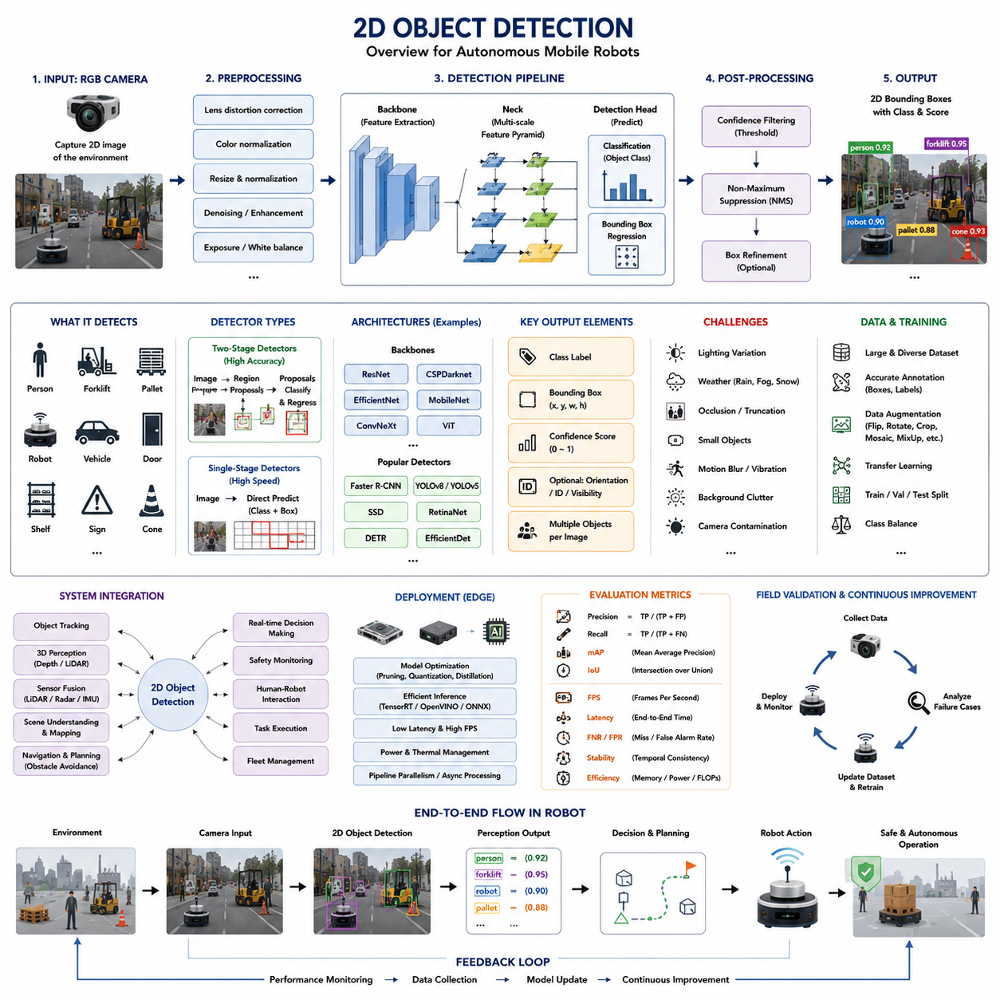
Two-dimensional object detection is the most widely deployed perception technology in modern autonomous mobile robots because it provides an efficient and reliable method for recognizing and localizing objects within camera images. While robots perceive the physical world in three dimensions, RGB cameras naturally capture two-dimensional image projections. A 2D object detector analyzes these images and identifies semantic objects such as pedestrians, forklifts, pallets, robots, vehicles, doors, shelves, warning signs, traffic cones, and industrial equipment. The detector outputs both the object category and its location in image coordinates, allowing higher-level perception and navigation modules to interpret the scene and react appropriately. Although 2D detection does not directly estimate physical depth, it forms the foundation of many robotic perception pipelines due to its computational efficiency, mature algorithms, and extensive availability of training datasets.
The primary output of a 2D object detector is a rectangular bounding box surrounding each detected object. Each bounding box is accompanied by a semantic class label and a confidence score representing the probability that the prediction is correct. The bounding box is typically described by four parameters corresponding to the center position, width, and height, or alternatively by the coordinates of the upper-left and lower-right corners. These image-space coordinates provide sufficient information for visualization, tracking, object association, and subsequent perception stages. In many robotic systems, the detection output also includes additional attributes such as object orientation estimates, visibility scores, occlusion indicators, and instance identifiers that support downstream processing.
Unlike image classification, which assigns a single label to an entire image, 2D object detection simultaneously solves localization and recognition. A warehouse image may contain multiple workers, forklifts, pallets, shelves, autonomous robots, and warning signs. Instead of describing the entire scene as a warehouse, the detector independently identifies every visible object and assigns separate bounding boxes to each instance. This ability to recognize multiple objects within a single frame enables robots to reason about dynamic environments containing numerous interacting entities.
The importance of 2D object detection extends across nearly every robotic application. Indoor logistics robots rely on cameras to detect workers, transport carts, doors, loading stations, and storage racks. Outdoor autonomous platforms recognize vehicles, pedestrians, bicycles, traffic infrastructure, construction barriers, and road signs. Agricultural robots identify crops, weeds, fruits, branches, and agricultural machinery. Inspection robots detect valves, pipes, gauges, electrical panels, structural defects, and maintenance targets. Despite the diversity of applications, the underlying detection principles remain remarkably similar, differing primarily in training data and object categories.
The complete processing pipeline begins with image acquisition from RGB cameras. Camera quality significantly influences detection performance because neural networks depend on image clarity, resolution, color fidelity, dynamic range, and exposure consistency. Global shutter cameras generally provide superior images for moving robots because they eliminate rolling shutter distortion. Lens selection also affects detection quality by determining field of view, perspective distortion, and pixel density across the observed scene. Wide-angle lenses increase environmental coverage but reduce object resolution, whereas narrow lenses improve distant object visibility while limiting scene coverage.
Raw images typically undergo several preprocessing operations before entering the neural network. Lens distortion correction removes geometric deformation introduced by optical systems. Color normalization reduces illumination variability across different environments. Image resizing adapts incoming frames to the fixed input dimensions expected by the neural network. Pixel normalization standardizes numerical values to improve training stability. Additional preprocessing may include histogram equalization, gamma correction, denoising, white balance adjustment, or contrast enhancement depending on environmental conditions and camera characteristics.
Modern 2D object detectors are almost exclusively based on deep convolutional neural networks or transformer-based vision architectures. The detector receives the processed image as input and extracts hierarchical visual features using a backbone network. Early convolutional layers identify edges, textures, and simple geometric structures. Intermediate layers recognize corners, contours, and object parts. Deep layers encode semantic representations corresponding to complete objects. This hierarchical feature extraction enables the detector to distinguish visually similar categories while remaining robust against variations in viewpoint, scale, lighting, and background clutter.
Feature pyramids play an essential role in 2D object detection because objects appear at multiple scales within the same image. Nearby forklifts may occupy thousands of pixels, whereas distant workers may cover only several dozen pixels. Multi-scale feature extraction preserves information at different resolutions, allowing the detector to recognize both large and small objects simultaneously. Feature Pyramid Networks, Path Aggregation Networks, and Bi-directional Feature Pyramid Networks improve performance by combining semantic information across multiple feature levels, thereby enhancing detection accuracy over a wide range of object sizes.
Two-stage object detectors first generate candidate object regions before classifying them individually. Region proposal mechanisms identify image areas likely to contain objects, significantly reducing the search space for detailed classification. These detectors often achieve excellent localization accuracy because they dedicate substantial computation to each candidate region. However, their computational complexity generally limits inference speed, making them more suitable for offline analysis or robotic applications where maximum precision outweighs real-time constraints.
Single-stage detectors eliminate the intermediate proposal generation process by directly predicting object categories and bounding boxes from dense feature maps. This unified approach significantly reduces computational latency while maintaining competitive accuracy. Single-stage architectures have become dominant in robotics because autonomous systems require continuous perception at high frame rates. Real-time detection enables rapid obstacle recognition, dynamic path planning, collision avoidance, and safe interaction with moving objects in changing environments.
The backbone network serves as the primary feature extractor within the detector architecture. Common backbone families include ResNet, CSPDarknet, EfficientNet, MobileNet, ConvNeXt, Vision Transformers, and hybrid convolution-transformer models. Large backbones generally produce higher detection accuracy due to increased representational capacity but require greater computational resources. Lightweight backbones sacrifice some accuracy to achieve faster inference and reduced power consumption, making them suitable for embedded robotic platforms operating under strict energy constraints.
Following feature extraction, the detection head performs classification and localization. Classification branches estimate the probability that an object belongs to each semantic category. Localization branches regress the precise bounding box coordinates surrounding each detected object. Some architectures further predict object orientation, instance masks, keypoints, or uncertainty estimates. Separating classification and localization tasks allows the network to optimize each objective independently while sharing common feature representations extracted by the backbone.
Bounding box regression constitutes one of the most challenging optimization problems within object detection. The detector must estimate object position, size, and aspect ratio with high precision despite perspective distortion, partial occlusion, and varying viewpoints. During training, predicted boxes are compared against manually annotated ground truth boxes using specialized localization loss functions. Smooth L1 Loss, IoU Loss, Generalized IoU, Distance IoU, and Complete IoU each emphasize different geometric aspects of localization quality and contribute to improved spatial accuracy.
Object classification and bounding box regression are optimized jointly during training through multi-task learning. The classification loss encourages correct semantic predictions, while localization loss minimizes geometric errors. The combined objective enables the detector to simultaneously improve recognition accuracy and spatial precision. Proper balancing of these loss components is important because excessive emphasis on localization may reduce classification quality, whereas overemphasizing classification can produce inaccurate bounding boxes.
Anchor-based and anchor-free detection strategies represent two major design philosophies. Anchor-based detectors predefined numerous reference boxes with different sizes and aspect ratios distributed throughout the image. The network predicts adjustments relative to these anchors. While effective, anchor tuning introduces engineering complexity because anchor configurations must match dataset characteristics. Anchor-free detectors instead predict object centers and dimensions directly, simplifying network design and reducing hyperparameter sensitivity. Recent architectures increasingly favor anchor-free approaches due to their conceptual simplicity and competitive performance.
Confidence estimation allows the detector to quantify prediction reliability. Each detected object receives a confidence score reflecting both localization certainty and classification probability. Post-processing algorithms remove predictions below predefined confidence thresholds, reducing false positives. Selecting an appropriate threshold requires careful consideration of application requirements. Safety-critical robots typically prioritize high recall to minimize missed detections, accepting somewhat higher false positive rates if necessary. Conversely, industrial inspection systems may emphasize precision to reduce unnecessary interventions triggered by incorrect detections.
Multiple overlapping detections frequently correspond to the same physical object. Non-Maximum Suppression addresses this problem by retaining only the highest-confidence prediction while removing redundant overlapping boxes. The overlap between boxes is measured using Intersection over Union, which compares shared area relative to total combined area. Traditional Non-Maximum Suppression uses fixed thresholds, whereas Soft-NMS gradually decreases confidence scores instead of immediately discarding overlapping predictions. Weighted Box Fusion further improves localization by combining multiple highly similar predictions into a single refined bounding box.
Image resolution strongly influences detection performance. Higher-resolution images preserve more visual detail, improving recognition of distant or small objects. However, increased resolution proportionally raises computational requirements, memory consumption, and inference latency. Robotic engineers therefore balance image resolution against real-time processing requirements. Some systems dynamically adjust input resolution according to robot speed, environmental complexity, or available computational resources, allocating greater processing capacity only when necessary.
Lighting conditions significantly affect camera-based perception. Strong sunlight may create saturated regions, shadows, and lens flare. Indoor factories exhibit nonuniform artificial illumination, reflections from metallic surfaces, and rapidly changing brightness near loading docks. Nighttime environments introduce low signal-to-noise ratios, while tunnels or warehouses may contain localized lighting variations. Robust 2D object detectors therefore require diverse training data encompassing numerous illumination scenarios. Additional preprocessing techniques including adaptive exposure control, HDR imaging, and brightness normalization further improve robustness.
Weather introduces additional perception challenges for outdoor robots. Rain reduces image contrast and creates water droplets on camera lenses. Fog scatters light, reducing visibility over long distances. Snow partially obscures scene structure, while dust introduces random visual artifacts. Camera contamination from mud, insects, or debris further degrades image quality. Since purely vision-based detection performance deteriorates under such conditions, practical outdoor robots often integrate sensor fusion with LiDAR or radar to maintain reliable perception during adverse weather.
Occlusion remains one of the most difficult problems in 2D object detection. Workers may be partially hidden behind machinery, pallets may overlap, and vehicles frequently obscure one another in crowded environments. Humans naturally infer partially visible objects using contextual reasoning, whereas neural networks require extensive representative examples during training. Attention mechanisms, contextual feature aggregation, transformer architectures, and temporal fusion across multiple frames substantially improve robustness against partial visibility.
Small object detection presents another major challenge because distant objects occupy relatively few pixels. Downsampling within convolutional networks gradually reduces spatial resolution, potentially eliminating discriminative information for tiny objects. Multi-scale feature pyramids, higher-resolution training, super-resolution preprocessing, adaptive receptive fields, and specialized loss functions improve performance for small objects. Nevertheless, small object detection remains one of the most actively researched areas within computer vision because many safety-critical obstacles initially appear only as tiny image regions.
Motion blur caused by robot movement or fast-moving objects can significantly reduce detection accuracy. High vehicle speeds, rough terrain, mechanical vibration, or long camera exposure times create blurred images that obscure object boundaries. Global shutter sensors, vibration isolation, shorter exposure settings, higher frame rates, image stabilization, and motion-aware data augmentation help mitigate these effects. Designing camera mounting systems with appropriate mechanical damping further improves image quality during high-speed operation.
Dataset quality ultimately determines detector capability. Effective training requires large, diverse, accurately annotated datasets covering all operational scenarios expected during deployment. Images should represent varying weather conditions, seasons, viewpoints, lighting, object sizes, occlusion levels, camera heights, and environmental backgrounds. Balanced representation of each object category prevents the model from overfitting to frequently occurring classes while neglecting rare but important objects.
Annotation consistency is equally important. Every object should be labeled according to clearly defined guidelines specifying box boundaries, partially visible instances, truncation, ignored regions, and ambiguous cases. Inconsistent annotations introduce supervisory noise that limits achievable accuracy regardless of network architecture. Many industrial organizations therefore establish detailed annotation standards and quality assurance procedures before initiating large-scale labeling projects.
Data augmentation artificially increases dataset diversity by generating modified training samples. Common techniques include random horizontal flipping, scaling, cropping, translation, rotation, brightness variation, color jitter, Gaussian blur, additive noise, MixUp, Mosaic augmentation, Copy-Paste augmentation, and CutMix. Carefully designed augmentation improves robustness against environmental variability while reducing overfitting. However, unrealistic augmentations may produce physically impossible images that negatively affect generalization.
Transfer learning has become the standard approach for robotic object detection because collecting millions of labeled robotic images remains impractical. Networks are first pretrained on large public datasets containing diverse visual concepts before being fine-tuned using application-specific robotic data. Pretraining provides strong general visual representations that substantially reduce required training time and labeled dataset size while improving final accuracy.
Edge deployment introduces unique engineering constraints absent from laboratory environments. Industrial robots frequently execute inference on embedded GPUs, AI accelerators, or low-power processors operating within strict thermal and energy budgets. Network compression through pruning, quantization, knowledge distillation, TensorRT optimization, mixed precision inference, and operator fusion significantly reduces computational requirements without severely compromising accuracy. Selecting an appropriate balance between model complexity and inference speed remains one of the most important practical engineering decisions.
Real-time scheduling also influences perception quality. Detection latency includes camera acquisition, preprocessing, neural network inference, post-processing, message transmission, and integration into navigation software. High-frequency perception loops reduce reaction time but increase processor utilization. Engineers therefore profile each pipeline component individually, identifying bottlenecks that limit system throughput. Pipeline parallelism, asynchronous execution, GPU optimization, and zero-copy communication further reduce end-to-end latency.
Performance evaluation extends well beyond overall accuracy. Precision measures the proportion of predicted objects that are correct, whereas recall measures how many actual objects are successfully detected. Mean Average Precision summarizes detector performance across object categories and confidence thresholds. Intersection over Union evaluates localization quality by comparing predicted and annotated bounding boxes. Equally important in robotics are frame rate, inference latency, temporal consistency, false negative rate, false positive rate, computational efficiency, memory consumption, and energy usage. These operational metrics often determine deployment success more directly than benchmark accuracy alone.
Field validation is indispensable because laboratory datasets cannot fully represent real deployment environments. Engineers should evaluate detection performance under varying illumination, weather, camera contamination, seasonal changes, warehouse layouts, traffic density, and operational speeds. Failure cases should be systematically recorded, categorized, reproduced, and incorporated into future training datasets. Continuous data collection and periodic model retraining enable perception systems to adapt to evolving operational environments throughout the robot's service life.
Ultimately, two-dimensional object detection provides the semantic perception capability that enables autonomous mobile robots to understand visual scenes efficiently and reliably. Although three-dimensional perception offers richer spatial information, 2D detection remains indispensable due to its computational efficiency, mature software ecosystem, extensive public datasets, and compatibility with modern edge AI hardware. As vision transformers, multimodal foundation models, self-supervised learning, and efficient embedded accelerators continue to mature, 2D object detection will evolve beyond isolated object recognition toward comprehensive scene understanding, contextual reasoning, predictive perception, and seamless integration with tracking, segmentation, sensor fusion, and embodied intelligence. Within modern AMR architectures, it serves not merely as a computer vision algorithm but as one of the fundamental perception technologies supporting safe, intelligent, and autonomous robotic operation.

15.3 3D Object Detection
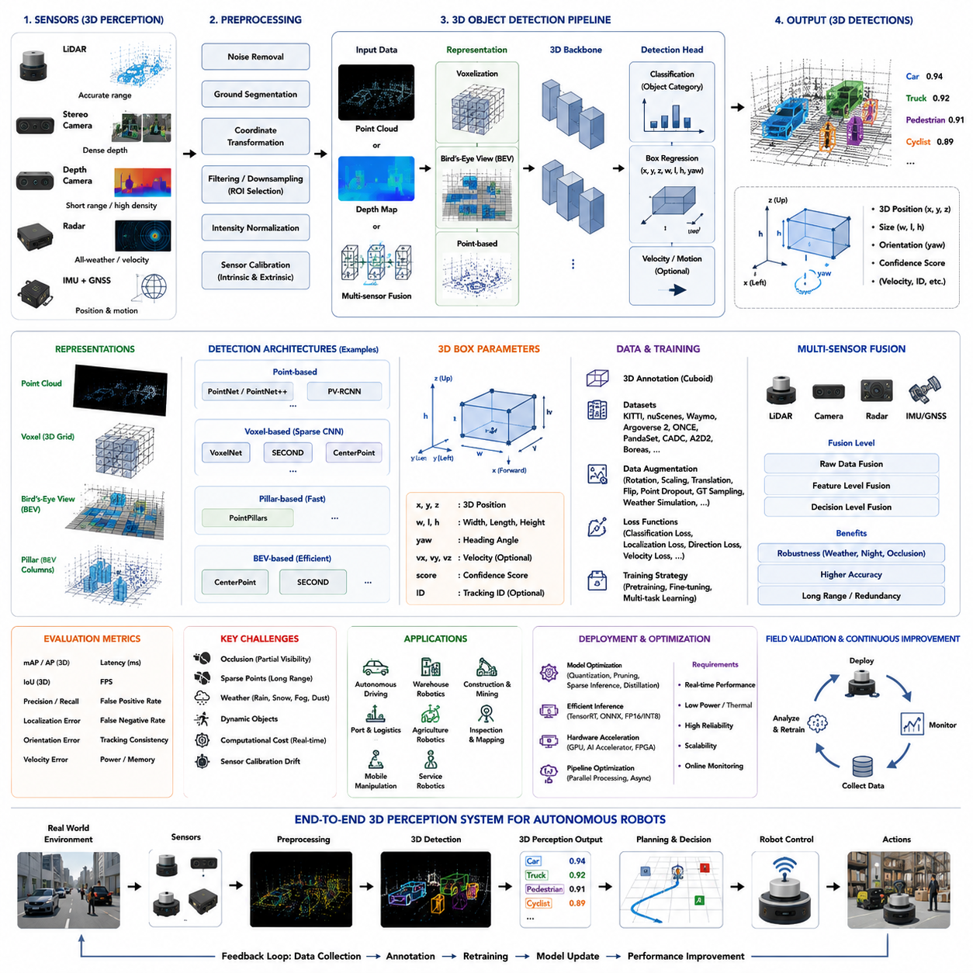
Three-dimensional object detection is one of the most important perception technologies for autonomous mobile robots operating in complex real-world environments because it enables the robot to understand not only what objects exist but also exactly where they are located in physical space. Unlike two-dimensional object detection, which identifies objects only within image coordinates, three-dimensional object detection estimates the object's position, dimensions, orientation, and spatial relationship in the real world. This geometric understanding allows autonomous robots to perform accurate obstacle avoidance, trajectory planning, manipulation, docking, inspection, and interaction with dynamic environments. As industrial robots increasingly operate outdoors, in warehouses, factories, construction sites, mines, ports, and smart cities, reliable 3D object detection has become a foundational capability supporting safe and intelligent autonomy.
The primary objective of a 3D object detector is to convert raw spatial sensor measurements into semantic object descriptions. A complete detection output normally includes the object category, three-dimensional position, object dimensions, heading angle, confidence score, and sometimes object velocity or motion state. Instead of producing two-dimensional bounding boxes in image coordinates, the detector estimates three-dimensional cuboids aligned with the physical object. These cuboids define the object's width, height, length, orientation, and location within a global or robot-centered coordinate system. Such representations provide the navigation system with sufficient geometric information for collision checking, path planning, and interaction planning.
Three-dimensional object detection differs fundamentally from two-dimensional detection because the perception problem is no longer limited to recognizing image features. Instead, the detector must estimate object geometry in physical space while accounting for viewpoint changes, sensor uncertainty, incomplete observations, and environmental complexity. The detector therefore combines semantic recognition with geometric reasoning. This additional spatial understanding enables robots to distinguish between nearby and distant objects, estimate safe passing distances, determine object orientation, and predict possible collisions, capabilities that are impossible using image-space information alone.
The development of 3D object detection has been driven largely by advances in depth sensing technologies. Modern robotic platforms employ three-dimensional LiDAR sensors, stereo cameras, structured-light cameras, time-of-flight cameras, radar systems, and multi-sensor fusion architectures to estimate spatial information. Each sensing modality offers different strengths and limitations. LiDAR provides highly accurate geometric measurements but limited texture information. Cameras supply rich visual appearance but require depth estimation. Radar operates reliably under adverse weather but offers relatively sparse spatial resolution. Combining these complementary sensing modalities significantly improves overall perception robustness.
LiDAR has become the dominant sensing modality for outdoor three-dimensional object detection because it directly measures distance through laser ranging. A rotating or solid-state LiDAR emits laser pulses and records the reflected signals to generate a three-dimensional point cloud representing surrounding objects and terrain. Each point contains spatial coordinates and sometimes reflectivity information. The resulting point cloud serves as the primary input for many modern detection algorithms. Since LiDAR measurements are independent of ambient illumination, they remain effective during nighttime operation and under varying lighting conditions, making them highly suitable for autonomous vehicles and outdoor robots.
Stereo vision provides another important approach for three-dimensional perception. Two synchronized RGB cameras observe the same scene from slightly different viewpoints. Corresponding image features are matched between the left and right images, allowing depth estimation through triangulation. Stereo systems generate dense depth maps containing geometric information across the entire image. While stereo cameras provide richer visual appearance than LiDAR alone, their depth accuracy depends strongly on texture quality, lighting conditions, calibration accuracy, and viewing distance. Stereo-based 3D object detection therefore often benefits from additional sensor fusion with LiDAR or radar.
Depth cameras extend stereo concepts by directly measuring object distance using active sensing technologies such as structured light or time-of-flight imaging. These sensors generate dense depth images suitable for indoor robotics, warehouse automation, service robots, and manipulation tasks. Although depth cameras typically operate over shorter ranges than LiDAR, they provide highly detailed geometric measurements that improve close-range object detection, human interaction, manipulation, docking, and inspection applications.
Radar-based three-dimensional perception has recently gained increasing attention because radar maintains robust performance under rain, snow, fog, dust, and smoke where optical sensors may degrade significantly. Modern imaging radar systems estimate object distance, velocity, and sometimes elevation information simultaneously. Although radar point clouds are considerably sparser than LiDAR data, advances in deep learning have substantially improved radar-based object detection. Multi-modal perception systems increasingly incorporate radar to enhance robustness under challenging environmental conditions.
The raw input for three-dimensional object detection usually consists of point clouds, voxel representations, depth maps, or fused sensor data. Point clouds are unordered collections of three-dimensional coordinates describing visible surfaces within the environment. Unlike images arranged on regular pixel grids, point clouds exhibit irregular spatial distributions, varying densities, missing observations, and nonuniform sampling. Processing such irregular geometric data presents unique algorithmic challenges that differ substantially from traditional image-based computer vision.
Point cloud preprocessing plays an essential role before neural network inference begins. Noise removal eliminates isolated measurement errors caused by sensor uncertainty or environmental interference. Ground segmentation separates traversable terrain from elevated objects, reducing computational complexity. Coordinate transformation converts sensor measurements into a common robot reference frame using extrinsic calibration parameters. Intensity normalization, point filtering, downsampling, and region-of-interest selection further improve computational efficiency while preserving relevant environmental information for detection.
Voxelization is one of the most common techniques used to process irregular point clouds efficiently. The three-dimensional space surrounding the robot is divided into regular volumetric cells called voxels. Points falling within each voxel are aggregated to produce structured feature representations compatible with convolutional neural networks. Voxel-based methods significantly simplify neural network computation while maintaining much of the underlying geometric information. However, voxel resolution must be carefully selected because excessively coarse voxels reduce localization accuracy whereas very fine voxels dramatically increase computational cost.
Bird's-Eye View representation offers another highly effective processing strategy. Rather than directly analyzing irregular point clouds, three-dimensional information is projected onto a two-dimensional top-down representation. Height, density, reflectivity, and occupancy information are encoded within multiple feature channels. Since autonomous navigation naturally operates within horizontal ground coordinates, Bird's-Eye View representations provide an efficient compromise between computational complexity and geometric accuracy. Many state-of-the-art autonomous driving systems employ Bird's-Eye View perception as their primary intermediate representation.
Modern three-dimensional object detectors are predominantly based on deep learning architectures. Early approaches adapted conventional convolutional neural networks to voxelized representations, while later methods directly processed raw point clouds using specialized neural network architectures. Networks such as PointNet, PointNet++, VoxelNet, SECOND, PointPillars, PV-RCNN, CenterPoint, and transformer-based architectures have significantly advanced detection accuracy and computational efficiency. Each architecture represents different trade-offs between processing speed, memory consumption, localization precision, and robustness under sparse observations.
Point-based neural networks process raw point clouds directly without voxelization. Instead of converting spatial measurements into regular grids, these architectures learn features from individual points while preserving precise geometric relationships. Hierarchical neighborhood aggregation enables increasingly complex spatial reasoning across multiple scales. Direct point processing generally produces highly accurate localization because original geometric precision remains intact. However, computational requirements increase substantially for dense point clouds, motivating efficient sampling and neighborhood selection strategies.
Voxel-based detectors transform irregular point clouds into structured volumetric representations suitable for conventional convolutional operations. Sparse convolution techniques further improve computational efficiency by processing only occupied voxels instead of the entire three-dimensional space. Sparse convolution has become one of the most influential advances in modern three-dimensional perception because it dramatically reduces memory usage while maintaining high detection accuracy. Most industrial LiDAR-based detection systems now employ sparse convolutional backbones.
Pillar-based representations further simplify voxel processing by collapsing vertical information into vertical columns known as pillars. Since autonomous driving primarily depends on horizontal positioning, reducing three-dimensional voxels into two-dimensional pillars significantly accelerates inference while preserving sufficient geometric information for many navigation tasks. PointPillars demonstrated that efficient pillar representations can achieve real-time performance without sacrificing practical detection quality, making pillar-based detectors highly attractive for embedded robotic systems.
Three-dimensional object detectors generally predict oriented bounding boxes rather than axis-aligned boxes. Unlike image-space rectangles, real-world objects possess arbitrary orientations relative to the robot. Consequently, detection outputs typically include object position along the X, Y, and Z axes, physical dimensions including width, length, and height, and heading angle describing object orientation. Some detectors additionally estimate object velocity, acceleration, articulation state, or motion uncertainty. Accurate orientation estimation is particularly important for autonomous driving because vehicle heading influences trajectory prediction and collision assessment.
Training three-dimensional object detectors requires carefully annotated datasets containing accurate spatial labels. Annotators manually define three-dimensional cuboids surrounding every visible object while specifying object category, orientation, visibility, and sometimes tracking identifiers. Label generation often relies on specialized annotation software integrating synchronized camera images, LiDAR point clouds, and Bird's-Eye View visualizations. Producing accurate three-dimensional annotations requires considerably greater effort than two-dimensional labeling because spatial geometry must remain consistent across multiple sensor perspectives.
Public benchmark datasets have played a crucial role in advancing three-dimensional perception research. Datasets such as KITTI, nuScenes, Waymo Open Dataset, Argoverse 2, ONCE, PandaSet, CADC, A2D2, and Boreas provide synchronized multi-sensor recordings together with high-quality three-dimensional annotations. These datasets cover diverse driving conditions, weather, urban environments, highways, rural roads, industrial facilities, and seasonal variations. Their standardized evaluation protocols enable objective comparison among competing detection algorithms while accelerating research progress across the robotics community.
Data augmentation substantially improves detector generalization by exposing neural networks to greater environmental diversity. Three-dimensional augmentation differs from image augmentation because geometric consistency must remain physically valid. Common techniques include random rotation, scaling, translation, point dropout, object insertion, ground truth sampling, local perturbation, intensity variation, weather simulation, and synthetic point cloud generation. Some systems additionally employ domain randomization within simulation environments to generate diverse training data that transfer effectively to real-world deployment.
Sensor calibration remains absolutely essential for reliable three-dimensional object detection. Intrinsic calibration ensures each sensor accurately measures its own observations, while extrinsic calibration establishes precise geometric relationships among multiple sensors. Even small calibration errors introduce systematic localization offsets that degrade detection accuracy, sensor fusion performance, and downstream navigation. Continuous calibration monitoring therefore forms an important component of industrial autonomous robot maintenance.
Multi-sensor fusion significantly enhances three-dimensional detection reliability by combining complementary sensing capabilities. Camera images contribute rich semantic appearance information, LiDAR provides accurate geometry, radar supplies robust velocity measurements, and GNSS together with IMU establish global localization context. Fusion may occur at raw data level, feature representation level, or decision level. Properly designed fusion architectures improve detection robustness under adverse weather, partial occlusion, low illumination, and temporary sensor failures.
Occlusion presents one of the greatest challenges in three-dimensional object detection. Many objects remain only partially visible because they are blocked by vehicles, buildings, vegetation, shelving systems, machinery, or other obstacles. LiDAR sensors observe only visible surfaces, leaving hidden object regions unmeasured. Deep learning models therefore learn to infer complete object geometry from partial observations using contextual reasoning and prior shape knowledge. Temporal integration across multiple frames further improves robustness because moving robots gradually reveal previously hidden object surfaces.
Sparse observations represent another significant challenge. Distant objects generate relatively few LiDAR returns, reducing geometric detail available for classification. Small pedestrians or traffic cones may be represented by only a handful of points. Advanced feature aggregation techniques, multi-scale representations, transformer attention mechanisms, and temporal accumulation help improve detection performance under sparse sampling conditions. Nevertheless, long-range detection remains an active research topic because sensing density naturally decreases with increasing distance.
Environmental conditions substantially influence three-dimensional perception quality. Rain attenuates LiDAR returns, snow introduces numerous false reflections, dust obscures laser propagation, and dense fog reduces effective sensing range. Camera-based depth estimation simultaneously suffers from reduced visibility and image contrast. Radar generally remains more robust under these adverse conditions, motivating increasing adoption of radar-LiDAR-camera fusion architectures capable of maintaining reliable detection despite environmental degradation.
Real-time performance remains a critical engineering requirement for three-dimensional object detection. Autonomous robots continuously move through dynamic environments where perception latency directly affects reaction distance and safety. Processing pipelines include sensor acquisition, synchronization, preprocessing, neural network inference, post-processing, sensor fusion, and communication with planning modules. Embedded robotic platforms therefore require efficient network architectures capable of balancing detection accuracy against computational complexity, memory consumption, power usage, and thermal constraints.
Model optimization techniques play an increasingly important role during deployment. Quantization reduces numerical precision while preserving acceptable detection accuracy. Pruning removes redundant neural network parameters. Sparse inference exploits empty spatial regions to minimize computation. TensorRT optimization, mixed-precision execution, operator fusion, and hardware-specific acceleration further improve inference speed. Industrial robotic systems frequently combine multiple optimization strategies to achieve reliable real-time operation on embedded GPUs and AI accelerators.
Performance evaluation extends beyond conventional detection accuracy. Average Precision, mean Average Precision, Intersection over Union, localization error, orientation error, recall, precision, and false detection rate remain important benchmark metrics. However, robotic deployment additionally requires evaluation of latency, temporal stability, tracking consistency, power consumption, robustness under adverse weather, sensor degradation tolerance, calibration sensitivity, and long-term operational reliability. Successful field deployment ultimately depends on maintaining consistent perception performance rather than maximizing benchmark scores alone.
Field validation should encompass representative operational scenarios including daytime, nighttime, rain, fog, snow, construction zones, warehouses, loading docks, industrial facilities, urban traffic, rural roads, and dynamic pedestrian interactions. Engineers should systematically record perception failures, classify root causes, reproduce problematic situations, and incorporate new data into continuous retraining workflows. Long-term perception improvement depends upon establishing robust feedback loops connecting field operation, data collection, annotation, model refinement, deployment, and performance monitoring.
Three-dimensional object detection forms the geometric foundation upon which higher-level autonomous behaviors are built. Navigation planners require accurate object positions to generate collision-free trajectories. Obstacle avoidance algorithms depend upon reliable spatial boundaries. Manipulation systems require precise object pose estimation for grasp planning. Inspection robots use three-dimensional localization to align sensors with target components. Multi-robot coordination depends upon consistent environmental representations shared across fleet management systems. Consequently, improvements in three-dimensional detection directly translate into safer navigation, more reliable manipulation, greater operational efficiency, and higher levels of robotic autonomy.
As robotics continues evolving toward embodied intelligence, three-dimensional object detection is expanding beyond isolated object recognition into comprehensive spatial scene understanding. Future perception systems will integrate foundation models, vision-language reasoning, temporal world models, neural scene representations, occupancy prediction, semantic mapping, and predictive motion estimation within unified architectures. Rather than merely identifying objects individually, next-generation perception systems will understand complete environments, infer object relationships, anticipate future interactions, and continuously refine world models through long-term observation. Within advanced autonomous mobile robots, three-dimensional object detection therefore represents not simply another perception algorithm but one of the central technologies enabling safe, intelligent, and fully autonomous operation across increasingly diverse and unstructured real-world environments.

15.4 Dataset Collection and Labeling
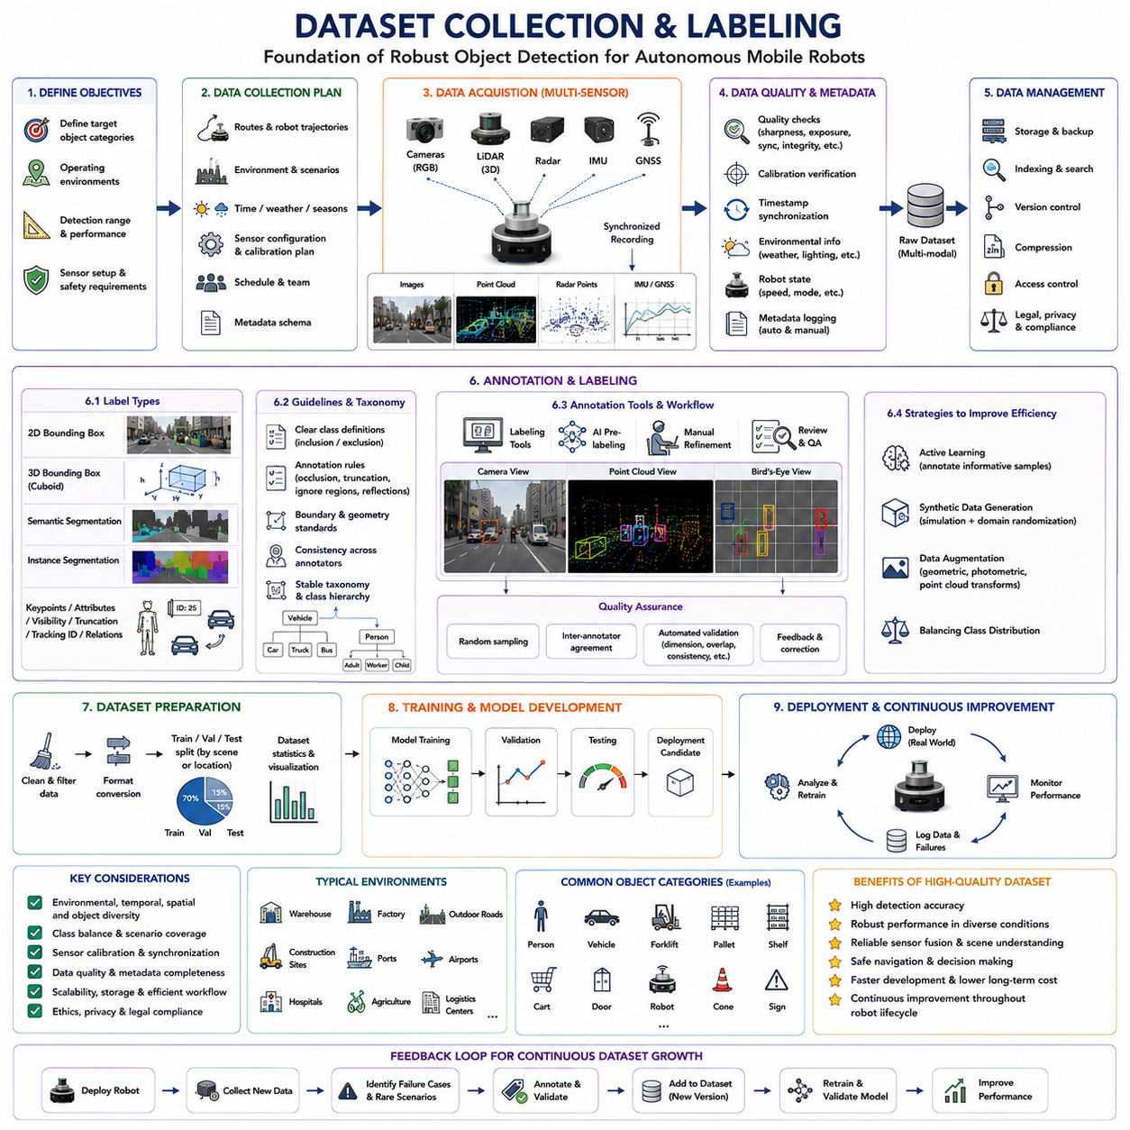
Dataset collection and labeling form the foundation of every successful object detection system because the quality of a machine learning model is ultimately constrained by the quality of the data used during training. Regardless of how advanced a neural network architecture becomes; its performance cannot exceed the information contained within its training dataset. For autonomous mobile robots, perception systems must operate safely across highly diverse environments including warehouses, factories, outdoor roads, construction sites, agricultural fields, ports, airports, hospitals, and logistics centers. Consequently, the dataset must accurately represent these environments together with the wide variety of objects, lighting conditions, weather, viewpoints, and operational situations that the robot will encounter throughout its deployment lifecycle. A carefully designed dataset therefore serves not merely as a collection of images or sensor recordings but as the knowledge base from which the perception system learns to understand the physical world.
Dataset development begins by clearly defining the perception objectives of the robotic system. Engineers must determine which object categories need to be detected, the expected operating environments, required detection distances, sensor configurations, and safety requirements before collecting any data. A warehouse robot may prioritize pallets, forklifts, workers, shelves, loading stations, and transport carts, whereas an outdoor autonomous vehicle focuses on pedestrians, vehicles, bicycles, traffic signs, road barriers, construction equipment, and lane markings. Inspection robots require datasets emphasizing industrial components such as valves, pipes, electrical cabinets, gauges, structural defects, and maintenance targets. Defining these objectives early ensures that subsequent data collection efforts remain aligned with actual deployment requirements rather than accumulating large quantities of irrelevant data.
The scope of the dataset should reflect the complete operational design domain of the robot. A perception model trained only under ideal laboratory conditions will perform poorly when deployed into real industrial environments characterized by changing illumination, dynamic obstacles, sensor contamination, seasonal variation, and unpredictable human activities. Engineers therefore identify every expected operational scenario including daytime, nighttime, indoor facilities, outdoor roads, narrow corridors, loading docks, intersections, parking areas, storage yards, tunnels, construction zones, and emergency situations. The resulting dataset should comprehensively cover this operational diversity to maximize generalization capability.
Sensor selection strongly influences dataset characteristics because different sensors observe the environment in fundamentally different ways. RGB cameras provide detailed texture and color information, LiDAR sensors measure precise geometry, radar supplies robust range and velocity estimates, thermal cameras detect heat signatures, stereo cameras estimate depth, and inertial sensors describe robot motion. Many modern robotic datasets record synchronized data from multiple sensors simultaneously. Such multimodal datasets enable future development of sensor fusion algorithms while preserving maximum flexibility for different perception architectures.
Data collection campaigns should follow structured acquisition plans rather than opportunistic recording. Engineers typically specify recording routes, robot trajectories, travel speeds, environmental conditions, sensor configurations, calibration procedures, and collection schedules before entering the field. Structured planning ensures balanced representation of different scenarios while minimizing redundancy. It also simplifies later analysis because each recording session possesses well-documented metadata describing environmental conditions, sensor settings, software versions, and operational context.
Environmental diversity is one of the most important considerations during data acquisition. Images collected exclusively under clear daytime conditions produce perception systems that often fail during rain, snow, fog, dusk, nighttime, or strong backlighting. Similarly, industrial environments exhibit changing illumination caused by artificial lighting, open doors, reflective machinery, welding operations, and moving equipment. Successful datasets intentionally capture substantial variability in weather, seasons, lighting, shadows, reflections, dust, smoke, and environmental clutter. These variations significantly improve model robustness during real deployment.
Temporal diversity further strengthens dataset quality. The same warehouse appears different throughout the day due to changing worker activity, equipment movement, inventory levels, and lighting conditions. Outdoor environments vary across seasons as vegetation changes, snow accumulates, leaves fall, and construction progresses. Recording data repeatedly over extended periods enables neural networks to learn stable object representations rather than memorizing transient environmental details. Long-term collection campaigns therefore contribute significantly to perception robustness.
Spatial diversity is equally essential. Recording only one factory, warehouse, or street limits the detector's ability to generalize toward new environments. Multiple facilities should therefore participate whenever possible. Differences in architecture, floor materials, shelving arrangements, road geometry, building layouts, vegetation, traffic density, and industrial equipment expose neural networks to broader appearance variations. Geographic diversity additionally introduces different weather patterns, lighting characteristics, construction styles, and transportation infrastructure that improve deployment readiness.
Object diversity directly affects detection performance across individual categories. Every object class should appear under numerous viewpoints, distances, scales, orientations, backgrounds, and occlusion conditions. Workers wearing different clothing, helmets, reflective vests, or carrying equipment should all be represented. Vehicles should include various colors, sizes, manufacturers, loading conditions, and viewing angles. Industrial equipment should likewise encompass different models, ages, wear conditions, and installation environments. Such diversity prevents detectors from associating objects with incidental visual features unrelated to their semantic identity.
Class balance requires careful attention throughout dataset construction. Frequently occurring objects such as walls, floors, shelves, and vehicles naturally dominate many robotic datasets, whereas rare but safety-critical objects may appear only occasionally. If left unbalanced, neural networks become biased toward common classes while underperforming on infrequent categories. Engineers therefore monitor class distributions continuously during collection, deliberately acquiring additional recordings containing underrepresented objects until acceptable balance is achieved. This targeted acquisition strategy often proves more valuable than indiscriminately collecting larger quantities of redundant data.
Data quality must be continuously monitored during acquisition. Poorly focused images, overexposed scenes, sensor synchronization failures, corrupted recordings, missing timestamps, incomplete metadata, calibration errors, and hardware malfunctions reduce dataset reliability. Automated quality assurance software often evaluates image sharpness, exposure distribution, timestamp consistency, sensor synchronization, frame completeness, storage integrity, and calibration status immediately after recording. Early identification of quality problems prevents expensive recollection campaigns after field operations have concluded.
Sensor calibration should be verified throughout the collection process because accurate geometric relationships between sensors directly influence perception quality. Camera intrinsic calibration, LiDAR alignment, radar mounting orientation, inertial measurement calibration, and global positioning accuracy all require periodic validation. Even small calibration errors introduce systematic inconsistencies into the dataset, negatively affecting sensor fusion algorithms and geometric learning. Recording calibration metadata together with every acquisition session further supports future dataset maintenance and reproducibility.
Synchronization among multiple sensors is particularly important for autonomous robotics. Cameras, LiDAR, radar, IMU, GNSS, wheel encoders, and control systems frequently operate at different sampling frequencies. Accurate timestamp alignment ensures that all sensor measurements correspond to the same physical moment despite differing update rates. Hardware synchronization using Precision Time Protocol, pulse-per-second signals, hardware triggers, or synchronized clocks generally produces superior temporal consistency compared with software synchronization performed after acquisition.
Metadata collection significantly increases the long-term value of robotic datasets. Besides raw sensor measurements, engineers record environmental conditions, weather, temperature, geographic location, vehicle speed, robot configuration, sensor firmware versions, software revisions, calibration files, collection personnel, recording dates, and operational notes. Comprehensive metadata simplifies future analysis, debugging, benchmarking, and dataset extension. It also supports reproducibility by allowing experiments to be reconstructed accurately years after initial collection.
Once data acquisition is complete, annotation transforms raw sensor recordings into supervised learning datasets. Annotation identifies every relevant object together with its semantic category and spatial location. Depending upon the perception task, annotations may include two-dimensional bounding boxes, three-dimensional cuboids, semantic segmentation masks, instance segmentation masks, keypoints, object tracking identifiers, attributes, visibility indicators, truncation labels, motion states, or relationships among objects. Accurate annotation provides the supervisory information required for neural network optimization.
Annotation guidelines should be established before large-scale labeling begins. These guidelines precisely define class definitions, object boundaries, occlusion handling, truncation policies, ambiguous situations, ignored regions, partially visible objects, reflections, transparent surfaces, overlapping objects, and annotation precision requirements. Without consistent guidelines, different annotators inevitably interpret similar scenes differently, introducing label noise that limits achievable detection accuracy. High-quality annotation standards therefore represent one of the most valuable assets within any perception development organization.
Object taxonomy should remain stable throughout the project lifecycle. Every semantic category requires a precise definition specifying inclusion and exclusion criteria. Engineers decide whether different pallet types belong to one category or multiple subclasses, whether parked and moving vehicles receive identical labels, whether human workers carrying equipment remain pedestrians, and whether robotic platforms receive independent categories. Carefully designed taxonomies simplify both annotation and model training while supporting future dataset expansion.
Bounding box annotation remains the most common labeling technique for object detection. Annotators manually draw rectangles tightly enclosing every visible object while assigning the appropriate semantic category. Accurate box placement requires balancing geometric precision against annotation efficiency. Boxes should encompass the visible extent of the object while minimizing surrounding background. Consistent annotation practices across millions of objects significantly improve localization learning during detector training.
Three-dimensional annotation introduces additional complexity because annotators define oriented cuboids within physical space rather than image rectangles. Three-dimensional labeling software typically displays synchronized camera images, point clouds, and Bird's-Eye View projections simultaneously. Annotators adjust cuboid position, dimensions, orientation, and category until the cuboid accurately encloses the corresponding object. Because depth perception and geometric consistency are involved, three-dimensional annotation generally requires substantially more time and expertise than two-dimensional labeling.
Semantic segmentation labeling classifies every pixel or point according to its semantic category. This provides considerably richer supervisory information than bounding boxes because object boundaries become explicitly defined. However, segmentation annotation demands substantially greater manual effort. Consequently, many organizations combine dense segmentation labels for selected datasets with simpler bounding boxes across larger datasets, balancing annotation cost against learning effectiveness.
Quality assurance remains essential throughout annotation. Independent reviewers inspect randomly sampled annotations, identify systematic errors, measure inter-annotator agreement, and provide corrective feedback. Automated validation algorithms further detect impossible object dimensions, overlapping identifiers, inconsistent categories, missing annotations, invalid geometries, and temporal discontinuities. Continuous quality monitoring ensures annotation consistency while preventing gradual degradation across large labeling teams.
Annotation tools significantly influence labeling productivity. Modern platforms support collaborative workflows, version control, automatic interpolation across video sequences, AI-assisted pre-labeling, geometric editing, point cloud visualization, keyboard shortcuts, and cloud-based quality review. Integrating automated pre-labeling with human verification dramatically accelerates annotation while maintaining high accuracy. Nevertheless, human oversight remains indispensable because autonomous labeling algorithms still generate systematic errors requiring expert correction.
Active learning increasingly improves dataset efficiency by intelligently selecting the most informative samples for annotation. Rather than labeling every collected frame equally, uncertainty estimation identifies images where the current model performs poorly or exhibits low confidence. Human annotators prioritize these challenging samples, maximizing model improvement per labeled example. Active learning therefore reduces annotation cost while accelerating perception system development.
Synthetic data generation complements real-world data collection by producing perfectly labeled virtual environments. Simulation engines create unlimited combinations of objects, weather, lighting, backgrounds, and robot trajectories without manual annotation effort. Domain randomization intentionally varies textures, materials, illumination, and object placement so extensively that neural networks learn robust semantic representations transferable to real-world environments. Although synthetic data rarely replaces real observations entirely, it substantially enriches training diversity.
Data augmentation further expands training diversity after annotation. Common image augmentations include brightness variation, color jitter, blur, noise injection, geometric transformation, MixUp, Mosaic augmentation, Copy-Paste augmentation, and CutMix. Three-dimensional datasets additionally employ random rotation, translation, scaling, point dropout, object insertion, ground truth sampling, weather simulation, and sensor noise modeling. Proper augmentation exposes neural networks to broader environmental variability while reducing overfitting.
Dataset partitioning into training, validation, and testing subsets requires careful planning. Random splitting may inadvertently place nearly identical scenes into multiple subsets, producing overly optimistic evaluation results. Instead, recordings are typically separated according to geographic location, recording session, environment, or time period to ensure meaningful generalization assessment. Test datasets should remain isolated throughout development, providing unbiased evaluation after model optimization concludes.
Dataset version management becomes increasingly important as perception systems evolve. New recordings, corrected annotations, revised taxonomies, additional sensor modalities, and improved quality standards continuously modify the dataset over time. Version control enables researchers to reproduce previous experiments, compare model performance fairly, identify regression causes, and maintain historical consistency across long-term development projects. Industrial organizations frequently maintain detailed dataset changelogs documenting every modification.
Legal, ethical, and privacy considerations accompany all data collection activities. Public recording may capture identifiable individuals, vehicle license plates, sensitive industrial equipment, confidential facilities, or proprietary manufacturing processes. Appropriate consent procedures, anonymization techniques, data retention policies, and regulatory compliance measures must therefore accompany dataset development. Privacy protection becomes especially important when robots operate within hospitals, offices, factories, residential neighborhoods, or public transportation systems.
Storage infrastructure must accommodate enormous volumes of multimodal sensor data. Modern autonomous robot datasets frequently exceed tens or hundreds of terabytes, particularly when multiple high-resolution cameras, LiDAR sensors, radar systems, and inertial measurements are recorded simultaneously. Efficient storage architectures incorporate compression, hierarchical organization, metadata indexing, distributed file systems, cloud synchronization, backup strategies, and high-speed retrieval mechanisms supporting large-scale machine learning workflows.
Continuous dataset improvement extends throughout the robot's operational lifetime. Field-deployed robots inevitably encounter environmental conditions, object appearances, failure cases, and rare situations absent from the original dataset. Logging systems record these challenging observations together with perception failures and operator interventions. Engineers subsequently annotate these new examples, integrate them into future dataset versions, retrain detection models, validate improvements, and redeploy updated perception software. This iterative feedback loop enables perception capability to improve continuously as operational experience accumulates.
Ultimately, dataset collection and labeling represent far more than preliminary preparation steps before neural network training. They constitute the fundamental engineering process through which autonomous robots acquire environmental knowledge. High-quality datasets enable accurate object detection, reliable sensor fusion, robust scene understanding, safe navigation, and trustworthy decision-making across diverse operating conditions. As robotics advances toward foundation models, self-supervised learning, continual learning, and embodied intelligence, dataset development will increasingly evolve from static offline collection into continuous knowledge acquisition systems that allow robots to expand their understanding of the world throughout their entire operational lifetime.

15.5 AI Model Training
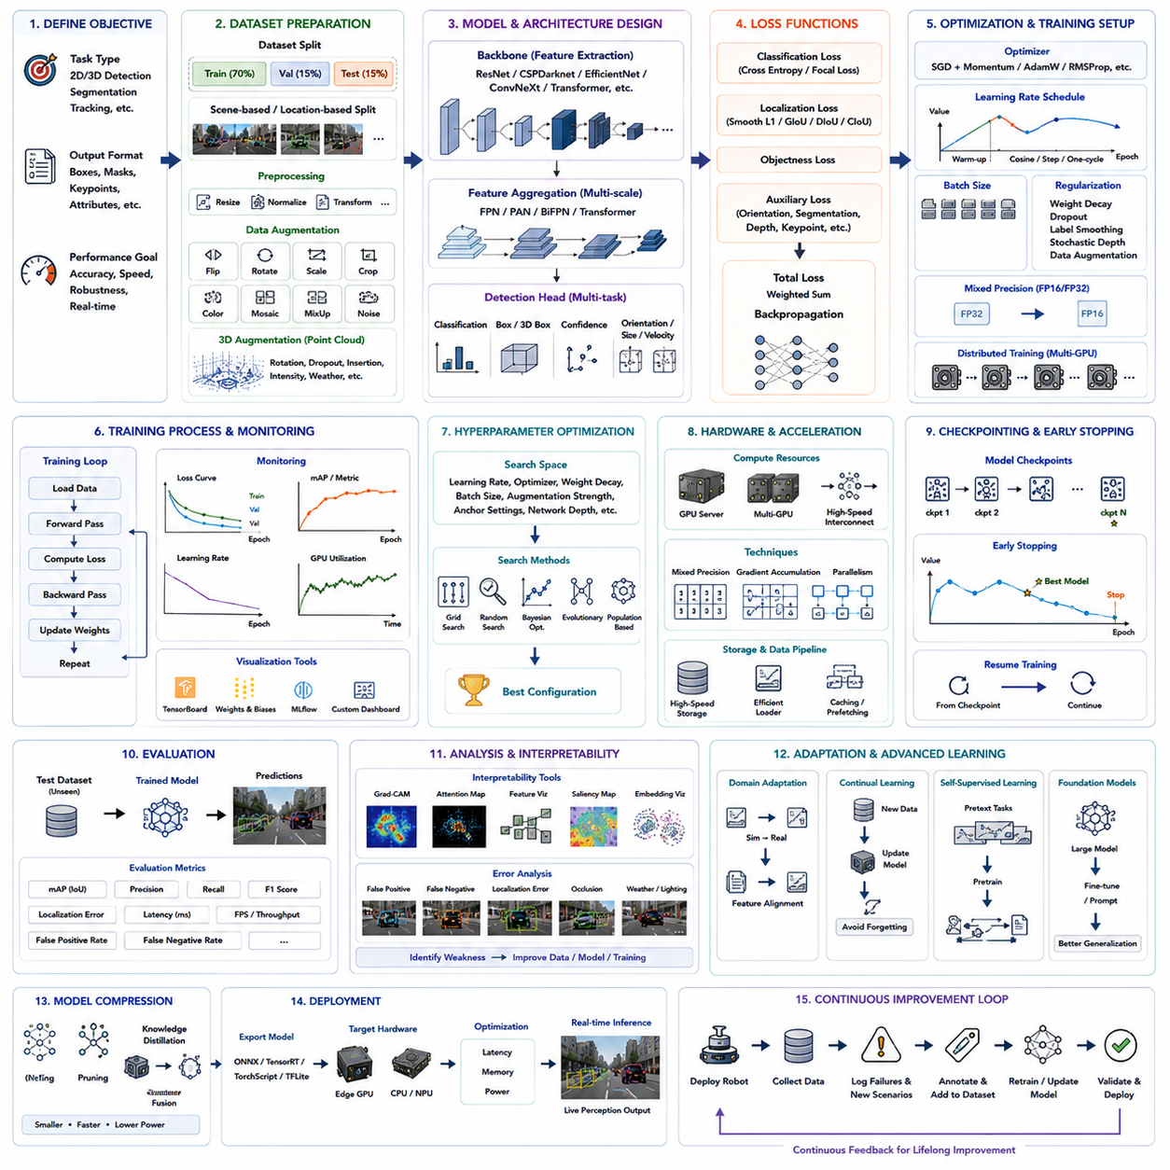
AI model training is the core engineering process that transforms collected data into an intelligent perception system capable of recognizing and understanding objects in real-world environments. In autonomous mobile robots, object detection models must not only identify objects accurately but also operate reliably under strict real-time constraints while maintaining robustness across diverse operational conditions. The objective of training is therefore not simply to minimize mathematical loss functions but to develop a model that consistently performs in practical deployment scenarios involving changing weather, dynamic obstacles, sensor noise, varying illumination, and complex industrial environments. Successful AI training combines data quality, network architecture, optimization strategies, computational resources, and systematic validation into an integrated engineering workflow.
The training process begins with clearly defining the learning objective. Engineers first determine the perception task that the model must solve, such as two-dimensional object detection, three-dimensional object detection, semantic segmentation, instance segmentation, object tracking, or multi-task perception. Each task requires different output representations, network architectures, loss functions, evaluation metrics, and computational resources. Clearly specifying the desired outputs before training ensures that every component of the pipeline, from dataset preparation to deployment, remains aligned with the final operational requirements of the robotic system.
Preparing the training dataset is often the most influential step in AI model development. Even the most sophisticated neural network cannot compensate for poor-quality data or inconsistent annotations. The dataset is first divided into training, validation, and testing subsets while ensuring that nearly identical scenes do not appear across multiple subsets. Scene-based or location-based partitioning is generally preferred over random sampling because it better evaluates a model's ability to generalize to unseen environments. Maintaining independent validation and testing datasets also prevents optimistic performance estimates caused by information leakage during model development.
Data preprocessing standardizes the input before it enters the neural network. Images are resized to consistent resolutions, normalized according to predefined statistical distributions, and converted into tensor representations suitable for GPU computation. For LiDAR-based perception, point clouds may undergo filtering, voxelization, Bird's-Eye View transformation, or sparse tensor conversion. Sensor synchronization, coordinate transformation, calibration correction, and timestamp verification are completed before training begins to ensure geometric consistency across all sensor modalities.
Data augmentation substantially increases the diversity of the training dataset without requiring additional data collection. Random horizontal flipping, rotation, translation, scaling, brightness adjustment, contrast modification, Gaussian noise, blur, Mosaic augmentation, MixUp, CutMix, and Copy-Paste techniques expose the model to broader environmental variability. Three-dimensional datasets further employ point cloud rotation, random point dropout, object insertion, weather simulation, intensity perturbation, and domain randomization. Proper augmentation reduces overfitting while encouraging the network to learn generalized semantic features rather than memorizing individual training examples.
Transfer learning has become the standard starting point for most modern object detection systems. Instead of initializing every network parameter randomly, engineers typically begin with models pretrained on large-scale datasets such as ImageNet, COCO, Open Images, or other domain-specific repositories. Pretrained networks have already learned fundamental visual representations including edges, textures, shapes, and object structures. Fine-tuning these models on task-specific robotic datasets significantly reduces training time, lowers computational cost, and improves convergence stability, especially when only limited labeled data are available.
Selecting an appropriate neural network architecture requires balancing detection accuracy, inference speed, computational complexity, and deployment hardware limitations. Two-stage detectors generally provide higher localization accuracy by separating proposal generation and classification, whereas single-stage detectors directly predict object locations and categories in one forward pass, enabling much faster inference. Modern robotics increasingly favors efficient architectures capable of maintaining high detection accuracy while satisfying strict real-time constraints on embedded computing platforms.
Backbone networks perform hierarchical feature extraction from the input data. Early convolutional layers identify simple visual structures such as edges and corners, while deeper layers progressively learn textures, object parts, and semantic concepts. Popular backbone architectures include ResNet, CSPDarknet, EfficientNet, MobileNet, ConvNeXt, and transformer-based visual encoders. The backbone determines much of the computational complexity and representational capacity of the perception system, making it one of the most important architectural decisions during model design.
Feature aggregation further enhances perception performance by combining information from multiple spatial resolutions. Small objects require high-resolution features, whereas large objects benefit from deeper semantic representations. Feature Pyramid Networks, Path Aggregation Networks, BiFPN, and similar multi-scale architectures integrate hierarchical information across different feature levels, allowing detectors to recognize objects ranging from nearby pedestrians to distant traffic signs within a single unified framework.
The detection head converts extracted features into object predictions. For each potential object, the network estimates class probabilities, bounding box coordinates, confidence scores, and, in three-dimensional systems, additional parameters including object dimensions, orientation, and velocity. Multi-task detection heads simultaneously optimize several related objectives, allowing shared feature representations to improve both localization and classification performance. Modern architectures often employ decoupled heads that independently optimize classification and regression tasks to improve convergence stability.
Training requires defining an appropriate loss function that quantitatively measures prediction error. Classification loss evaluates category prediction accuracy, localization loss measures bounding box alignment, objectness loss estimates the probability that an object exists, and auxiliary losses may supervise orientation, segmentation, depth estimation, or keypoint prediction. Common classification losses include cross-entropy loss and focal loss, while localization frequently employs Smooth L1 loss, Generalized IoU, Distance IoU, Complete IoU, or other geometric optimization objectives. Carefully balancing these losses ensures stable multi-task learning throughout optimization.
Optimization algorithms iteratively adjust network parameters to minimize the total training loss. Stochastic Gradient Descent with momentum has historically been the dominant optimization method because of its strong generalization characteristics. More recently, adaptive optimizers including Adam, AdamW, RMSProp, and Lion have become increasingly popular due to their faster convergence and reduced hyperparameter sensitivity. Choosing an optimizer depends upon dataset size, architecture complexity, available computational resources, and desired convergence behavior.
The learning rate is one of the most influential hyperparameters in AI training. If the learning rate is too high, optimization becomes unstable and may diverge entirely. If it is too low, convergence becomes extremely slow and may become trapped in poor local minima. Modern training strategies therefore employ learning rate schedules such as cosine annealing, step decay, exponential decay, warm-up initialization, cyclic learning rates, or one-cycle policies. These schedules improve optimization stability while accelerating convergence toward high-quality solutions.
Batch size significantly affects training efficiency and optimization dynamics. Larger batches improve GPU utilization and reduce gradient variance but require greater memory capacity. Smaller batches consume less memory and often improve generalization through noisier gradient estimates, although they increase training time. Distributed training across multiple GPUs enables larger effective batch sizes while maintaining practical training durations for large-scale robotic perception datasets.
Modern AI training relies heavily on GPU acceleration because neural network computation involves billions of matrix operations. Industrial perception training frequently utilizes multiple high-performance GPUs connected through high-bandwidth communication links. Mixed precision training further improves computational efficiency by combining FP16 and FP32 arithmetic, reducing memory consumption while maintaining numerical stability. Hardware accelerators continue to evolve, enabling increasingly complex perception models without proportionally increasing training duration.
Distributed training has become essential for foundation-scale perception models. Data parallelism distributes different mini-batches across multiple GPUs, while model parallelism partitions extremely large neural networks among multiple devices. Gradient synchronization algorithms ensure that all processing units update consistent parameter values despite simultaneous computation. Efficient communication strategies minimize synchronization overhead, allowing near-linear scalability across large computing clusters.
Regularization techniques improve generalization by discouraging excessive memorization of the training dataset. Weight decay penalizes overly large parameter values, dropout randomly disables neurons during training, label smoothing softens classification targets, stochastic depth randomly skips network layers, and data augmentation introduces additional variability. These techniques collectively reduce overfitting while improving robustness to unseen environments encountered during real robotic deployment.
Monitoring training progress is critical for identifying optimization problems before computational resources are wasted. Engineers continuously observe training loss, validation loss, learning rate evolution, gradient magnitude, GPU utilization, memory consumption, and evaluation metrics. Visualization platforms such as TensorBoard, Weights & Biases, MLflow, or custom monitoring dashboards provide real-time insight into optimization behavior. Sudden divergence, oscillating losses, vanishing gradients, or unexpected validation degradation often indicate configuration errors requiring immediate investigation.
Validation occurs repeatedly throughout training without modifying network parameters. The validation dataset estimates how well the model generalizes beyond the training data while supporting hyperparameter tuning, architecture comparison, and checkpoint selection. Early stopping automatically terminates training when validation performance ceases improving, preventing unnecessary computation and reducing overfitting. The best-performing validation checkpoint is typically selected for subsequent testing and deployment.
Hyperparameter optimization systematically searches for improved training configurations. Learning rate, optimizer choice, weight decay, augmentation strength, anchor configuration, network depth, activation functions, input resolution, and batch size all influence final performance. Grid search, random search, Bayesian optimization, evolutionary algorithms, and population-based training automate this exploration, allowing engineers to identify high-performing configurations more efficiently than manual experimentation.
Evaluation metrics provide objective measurements of detection performance after training. Mean Average Precision remains the most widely used metric for object detection because it simultaneously considers localization and classification quality across multiple confidence thresholds. Additional metrics including Precision, Recall, F1 Score, Average Recall, localization error, inference latency, throughput, false positive rate, and false negative rate provide complementary perspectives on model behavior. Industrial robotics often supplements benchmark metrics with task-specific operational evaluations reflecting real deployment requirements.
Model interpretability has become increasingly important as AI systems assume safety-critical responsibilities. Feature visualization, activation mapping, Grad-CAM, saliency analysis, attention visualization, error clustering, and embedding projection techniques help engineers understand why particular predictions are produced. Such interpretability tools facilitate debugging, improve trustworthiness, identify dataset deficiencies, and support certification efforts for industrial robotic systems operating alongside human workers.
Failure analysis represents an essential component of model improvement. Rather than focusing exclusively on overall accuracy, engineers carefully investigate false positives, false negatives, localization failures, occlusion errors, weather-related degradation, illumination sensitivity, distant object failures, and category confusion. Each failure case provides valuable insight into weaknesses within the dataset, annotation quality, model architecture, or optimization strategy. Continuous failure-driven improvement often produces larger performance gains than simply increasing training duration.
Domain adaptation enables models trained in one environment to operate effectively in another. Robots developed using simulated data frequently encounter distribution differences when deployed in real factories or outdoor environments. Fine-tuning with small amounts of target-domain data, adversarial adaptation, style transfer, feature alignment, and self-training techniques reduce these domain gaps while minimizing additional annotation requirements. Such adaptation strategies significantly improve deployment efficiency across multiple industrial facilities.
Continual learning addresses the challenge of expanding perception capability without forgetting previously acquired knowledge. As robots encounter new environments, object categories, and operational scenarios, additional training data become available throughout deployment. Naively retraining on only recent data often causes catastrophic forgetting of earlier knowledge. Memory replay, parameter regularization, dynamic architectures, and incremental optimization techniques enable perception systems to continuously improve while preserving previously learned capabilities.
Self-supervised learning has emerged as a promising approach for reducing dependence on manually labeled datasets. Instead of relying exclusively on human annotations, models learn meaningful representations by predicting missing information, matching different sensor views, reconstructing observations, or contrasting positive and negative examples. These pretrained representations are subsequently fine-tuned using relatively small labeled datasets, dramatically reducing annotation effort while improving robustness across diverse operating conditions.
Foundation models are beginning to transform perception training by leveraging enormous multimodal datasets collected across many domains. Rather than training specialized detectors from scratch for each application, engineers increasingly adapt pretrained vision-language models through fine-tuning or prompt-based optimization. These large-scale representations exhibit remarkable transferability, enabling robots to recognize novel objects, interpret semantic relationships, and generalize more effectively across unfamiliar environments than conventional narrowly trained perception systems.
Model compression prepares trained networks for deployment on resource-constrained robotic hardware. Quantization reduces numerical precision, pruning removes redundant parameters, knowledge distillation transfers knowledge from large teacher models into compact student networks, and operator fusion simplifies computational graphs. These optimization techniques substantially reduce memory requirements, inference latency, and power consumption while preserving most detection accuracy, making advanced perception feasible on embedded computing platforms.
Training does not conclude when optimization ends. Deployment into real operational environments inevitably reveals previously unseen scenarios, environmental conditions, sensor degradations, and rare safety-critical events. Operational logging systems capture these observations together with perception failures and human interventions. Engineers subsequently integrate these new samples into updated datasets, retrain improved models, validate performance gains, and redeploy enhanced perception software. This continuous improvement cycle transforms AI training from a one-time development activity into an ongoing engineering process that evolves throughout the operational lifetime of autonomous robotic systems.
Ultimately, AI model training is far more than executing optimization algorithms on powerful hardware. It represents a comprehensive engineering discipline integrating data science, machine learning, computer vision, robotics, software engineering, and systems validation into a unified development framework. High-quality training produces perception models capable of understanding complex environments with accuracy, efficiency, robustness, and reliability. As robotics advances toward foundation models, embodied intelligence, continual learning, and world models, AI training will increasingly evolve from isolated offline optimization into continuous autonomous knowledge acquisition, enabling future robots to improve their perception capabilities throughout their entire operational lives while safely interacting with an ever-changing physical world.

15.6 Edge Inference Optimization
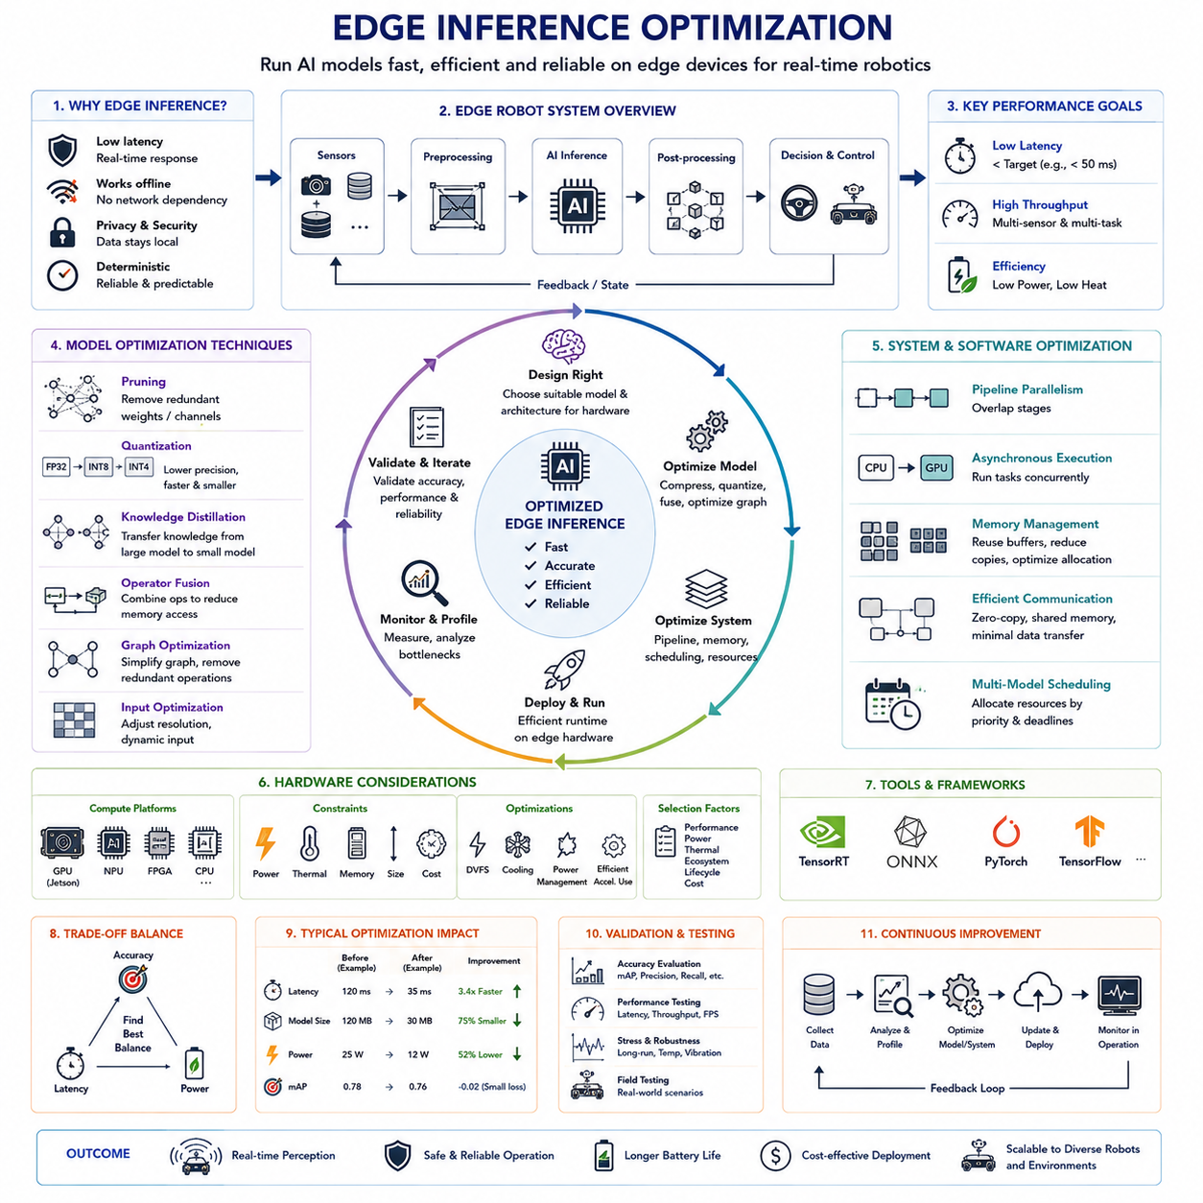
Edge inference optimization is the engineering discipline that enables artificial intelligence models to execute efficiently on embedded computing platforms while maintaining sufficient accuracy for real-time robotic perception. Unlike cloud-based inference, where computational resources can be expanded almost without limit, autonomous mobile robots operate under strict constraints involving processor capability, memory capacity, power consumption, thermal dissipation, physical size, and battery life. Every millisecond of latency directly influences navigation safety, obstacle avoidance, and decision-making. Consequently, edge optimization is not simply about accelerating inference but about achieving the best balance among computational efficiency, prediction accuracy, energy consumption, reliability, and long-term operational stability. A well-optimized edge AI system allows robots to perceive, understand, and react to rapidly changing environments without depending on external computing infrastructure.
The motivation for edge inference originates from the fundamental requirements of autonomous robotics. Robots often operate in environments where network connectivity is unavailable, unreliable, or introduces unacceptable communication delays. Industrial factories, underground facilities, construction sites, mines, agricultural fields, disaster response areas, and military applications all require local decision-making regardless of cloud accessibility. Executing AI models directly on embedded hardware eliminates network latency, reduces bandwidth requirements, improves data privacy, and ensures deterministic response times. These advantages make edge inference indispensable for safety-critical robotic systems.
Real-time performance is the primary objective of edge optimization. Object detection, semantic segmentation, localization, path planning, and obstacle avoidance all depend upon continuous perception updates. If inference requires excessive processing time, the robot reacts using outdated environmental information, increasing the probability of navigation errors and collisions. The acceptable latency depends upon robot velocity, stopping distance, sensor update frequency, and application requirements. High-speed outdoor autonomous vehicles require significantly lower inference latency than slower indoor service robots. Therefore, optimization targets must always be defined according to complete system-level performance rather than isolated benchmark measurements.
Latency represents the elapsed time between sensor acquisition and usable prediction output. Total system latency includes sensor exposure, image transfer, preprocessing, neural network execution, post-processing, communication between software modules, and control response. Neural network inference frequently represents only part of this delay. Consequently, optimization efforts should address the complete perception pipeline instead of focusing exclusively on model execution speed. Reducing preprocessing overhead, improving memory transfers, optimizing sensor synchronization, and simplifying post-processing often produce substantial improvements in overall system responsiveness.
Throughput measures how many inference operations can be completed within a given time period. While latency determines response speed for a single observation, throughput becomes important when multiple cameras, LiDAR sensors, or simultaneous perception tasks operate concurrently. Modern autonomous robots frequently process several high-resolution camera streams together with depth sensors, radar, localization, and tracking algorithms. Efficient throughput optimization ensures that all perception components receive sufficient computational resources without causing processing bottlenecks or scheduling delays.
Edge computing hardware varies widely depending on application requirements. Low-power microcontrollers execute simple neural networks for wearable devices and small sensors, while embedded GPUs support complex perception systems for autonomous robots. Popular robotics platforms include NVIDIA Jetson modules, Intel integrated accelerators, Qualcomm AI processors, AMD adaptive computing devices, FPGA-based inference systems, and specialized neural processing units. Selecting appropriate hardware requires balancing computational capability, power consumption, software ecosystem maturity, thermal requirements, lifecycle availability, and deployment cost.
Hardware-aware model design significantly improves deployment efficiency. Neural network architectures optimized for cloud GPUs may perform poorly on embedded processors because memory bandwidth, cache hierarchy, instruction scheduling, and parallel execution characteristics differ substantially. Efficient architectures such as MobileNet, EfficientNet, ShuffleNet, GhostNet, YOLO-Nano, YOLOv8-Nano, PP-YOLOE, and lightweight transformer variants intentionally minimize computational complexity while preserving acceptable detection accuracy. Hardware-aware neural architecture search further automates the discovery of architectures specifically optimized for target edge platforms.
Model complexity directly influences inference speed. Computational cost generally increases with network depth, feature dimensions, convolution size, attention operations, and input resolution. Larger models often achieve higher accuracy but require significantly greater memory and processing resources. Edge optimization therefore seeks an appropriate operating point where additional computational complexity no longer produces meaningful performance improvements. This balance depends upon the operational requirements of each robotic application rather than absolute benchmark rankings.
Input resolution strongly affects computational requirements because convolutional operations scale approximately with image size. Doubling both image width and height increases pixel count by approximately four times, substantially increasing inference time. However, excessively reducing resolution may eliminate small object details required for accurate detection. Selecting an appropriate resolution therefore requires understanding object sizes, sensor characteristics, required detection distance, and safety margins. Adaptive resolution strategies dynamically adjust input size according to environmental complexity or robot operating mode.
Model pruning removes redundant parameters that contribute little to prediction quality. Many neural networks contain considerable redundancy introduced during large-scale optimization. Structured pruning eliminates entire filters, channels, layers, or attention heads, whereas unstructured pruning removes individual weights. Structured pruning generally provides greater deployment benefits because resulting models remain compatible with optimized hardware execution libraries. Careful iterative pruning can substantially reduce computational requirements while preserving most detection accuracy.
Quantization is among the most effective optimization techniques for embedded deployment. Standard training typically represents neural network parameters using thirty-two-bit floating-point numbers. Quantization converts these values into lower-precision formats such as sixteen-bit floating point, eight-bit integers, or even four-bit representations. Lower precision substantially reduces memory consumption, accelerates arithmetic operations, improves cache utilization, and decreases power consumption. Modern hardware accelerators frequently include dedicated integer arithmetic units that execute quantized inference considerably faster than floating-point computation.
Post-training quantization applies numerical conversion after training has completed, making deployment relatively straightforward. However, some accuracy degradation may occur because quantization errors accumulate throughout network computation. Quantization-aware training addresses this limitation by simulating reduced numerical precision during optimization. The network gradually adapts to quantization effects, producing significantly better accuracy after deployment. Quantization-aware approaches have therefore become increasingly common for industrial perception systems requiring both efficiency and reliability.
Knowledge distillation transfers information from a large, highly accurate teacher model into a smaller student model suitable for embedded deployment. Instead of learning exclusively from manually labeled data, the student additionally learns to reproduce the teacher's internal probability distributions and feature representations. This supplementary supervision allows compact models to achieve significantly better performance than independently trained networks of similar size. Knowledge distillation has become a standard technique for deploying advanced perception capabilities onto resource-constrained robotic hardware.
Operator fusion reduces computational overhead by combining multiple mathematical operations into a single optimized execution kernel. Consecutive convolution, normalization, activation, scaling, and bias operations can frequently be merged during model compilation, eliminating unnecessary intermediate memory transfers. Reduced memory traffic often contributes more to performance improvement than raw arithmetic acceleration because embedded processors are frequently limited by memory bandwidth rather than computational throughput.
Graph optimization further improves inference efficiency by simplifying computational graphs before deployment. Constant folding precomputes fixed mathematical expressions, dead node elimination removes unused operations, redundant tensor transformations disappear, and memory allocation becomes more efficient. Deployment frameworks automatically perform many of these optimizations during model compilation, producing execution graphs specifically adapted to target hardware architectures.
Efficient memory management is essential because embedded platforms possess far less memory than cloud servers. Intermediate feature maps often consume more memory than network parameters themselves. Memory reuse strategies recycle temporary buffers whenever possible, while tensor scheduling minimizes simultaneous allocation requirements. Efficient allocation reduces memory fragmentation, prevents allocation failures, and improves cache locality. These optimizations become especially important for high-resolution perception pipelines processing multiple sensor streams simultaneously.
Batch processing improves throughput on server platforms but is often unsuitable for real-time robotics because each observation must be processed immediately. Instead of waiting to accumulate multiple images into large batches, robots generally execute inference on individual frames. Consequently, optimization emphasizes single-batch latency rather than maximum throughput. Nevertheless, asynchronous execution across multiple independent sensor streams can still improve hardware utilization without increasing perception delay.
Pipeline parallelism allows different processing stages to execute simultaneously rather than sequentially. While one frame undergoes preprocessing, another executes neural inference, and a third completes post-processing. Proper pipeline scheduling significantly increases overall throughput while maintaining low latency. Efficient robotic software frameworks coordinate sensor acquisition, perception, localization, planning, and control as overlapping computational pipelines rather than isolated sequential operations.
Asynchronous execution further improves system efficiency by preventing unnecessary processor idle time. CPU cores prepare incoming sensor data while GPUs perform inference concurrently. Direct memory access transfers sensor measurements without interrupting computation, and post-processing begins immediately after inference completion. Careful synchronization ensures correct data dependencies while maximizing utilization across heterogeneous computing resources. Modern robotics middleware increasingly supports asynchronous execution as a fundamental architectural principle.
TensorRT has become one of the most widely used optimization frameworks for NVIDIA-based embedded robotics platforms. TensorRT automatically performs graph optimization, operator fusion, precision calibration, layer scheduling, memory optimization, and kernel selection specifically adapted to the underlying GPU architecture. Models exported from PyTorch, TensorFlow, or ONNX frequently achieve substantial inference acceleration after TensorRT optimization without requiring modifications to the original neural network architecture.
ONNX provides a standardized intermediate representation that improves interoperability among machine learning frameworks and deployment environments. Models developed using PyTorch, TensorFlow, PaddlePaddle, or other frameworks can be exported into ONNX format before optimization by hardware-specific runtimes. This standardized representation simplifies deployment across multiple embedded platforms while reducing dependency upon any single development framework.
Thermal management significantly influences long-term inference performance. Embedded processors automatically reduce operating frequency when temperatures exceed safe limits, producing performance degradation commonly known as thermal throttling. Robots operating outdoors during summer, inside enclosed industrial equipment, or under continuous high computational load require effective cooling strategies including heat sinks, heat pipes, forced airflow, liquid cooling, or intelligent workload scheduling. Stable thermal performance ensures consistent inference latency throughout extended missions.
Power consumption represents another major design constraint because mobile robots rely upon finite battery capacity. Large neural networks executing continuously may significantly reduce operational duration. Efficient architectures, reduced numerical precision, dynamic frequency scaling, workload scheduling, sleep management, and intelligent accelerator utilization all contribute to extending battery life without sacrificing essential perception capability. Energy efficiency therefore becomes equally important as computational efficiency during edge optimization.
Dynamic inference techniques adapt computational effort according to environmental complexity. Simple scenes containing few objects may require only lightweight processing, whereas crowded industrial environments justify deeper analysis. Early-exit networks terminate computation once prediction confidence exceeds predefined thresholds, adaptive resolution changes input size according to operating conditions, and conditional computation activates only relevant network components. These dynamic strategies reduce average computational cost while preserving accuracy during difficult scenarios.
Multi-model scheduling becomes necessary when robots simultaneously execute numerous AI tasks including object detection, semantic segmentation, localization, speech recognition, anomaly detection, predictive maintenance, and human interaction. Resource allocation algorithms distribute computational capacity among competing workloads according to safety priority, timing requirements, and current operational context. Safety-critical perception tasks generally receive deterministic scheduling guarantees regardless of secondary application demands.
Edge optimization extends beyond neural network execution to include communication between perception modules. Excessive copying of large images or feature tensors consumes significant bandwidth and processing time. Zero-copy memory sharing, direct GPU buffer access, unified memory architectures, and efficient inter-process communication minimize unnecessary data movement throughout the perception pipeline. Reducing communication overhead frequently provides substantial system-level performance improvements.
Performance profiling identifies optimization opportunities by measuring execution time across every component of the perception pipeline. Engineers analyze preprocessing duration, GPU kernel execution, memory transfers, CPU utilization, cache behavior, thermal stability, synchronization overhead, and post-processing latency. Profiling tools reveal computational bottlenecks that are often impossible to identify through theoretical analysis alone. Optimization should therefore remain guided by measured performance rather than assumptions.
Validation after optimization is essential because computational improvements must not compromise perception quality. Every optimization stage including pruning, quantization, operator fusion, graph simplification, and model compression requires comprehensive reevaluation using representative deployment datasets. Engineers compare detection accuracy, localization precision, false positive rate, latency, power consumption, thermal stability, memory utilization, and long-duration reliability before approving optimized models for field deployment.
Field testing provides the final verification of edge inference performance. Laboratory benchmarks cannot fully reproduce vibration, temperature variation, lighting changes, electromagnetic interference, sensor contamination, unexpected obstacles, or long-duration operation encountered by real autonomous robots. Extended field evaluations therefore confirm whether optimized perception systems maintain stable performance under realistic deployment conditions. Continuous monitoring during operation further identifies rare failure scenarios requiring future optimization.
Future edge inference optimization will increasingly rely upon hardware-software co-design, where neural network architectures and embedded processors are developed simultaneously rather than independently. Emerging AI accelerators, memory-centric computing, sparse computation engines, adaptive neural execution, neuromorphic processors, and foundation model compression techniques promise substantial improvements in computational efficiency. At the same time, automated optimization frameworks will increasingly generate deployment-specific inference pipelines requiring minimal manual engineering.
Ultimately, edge inference optimization transforms advanced artificial intelligence from a laboratory demonstration into a practical capability deployable within autonomous robots operating in real environments. It integrates neural network compression, hardware acceleration, compiler optimization, memory management, scheduling, thermal engineering, power optimization, and systems validation into a unified engineering discipline. As perception models continue growing in complexity and capability, edge optimization will become even more critical, enabling increasingly intelligent robots to perform sophisticated reasoning directly on embedded hardware while maintaining the speed, reliability, efficiency, and safety required for continuous autonomous operation.

15.7 Detection Performance Metrics
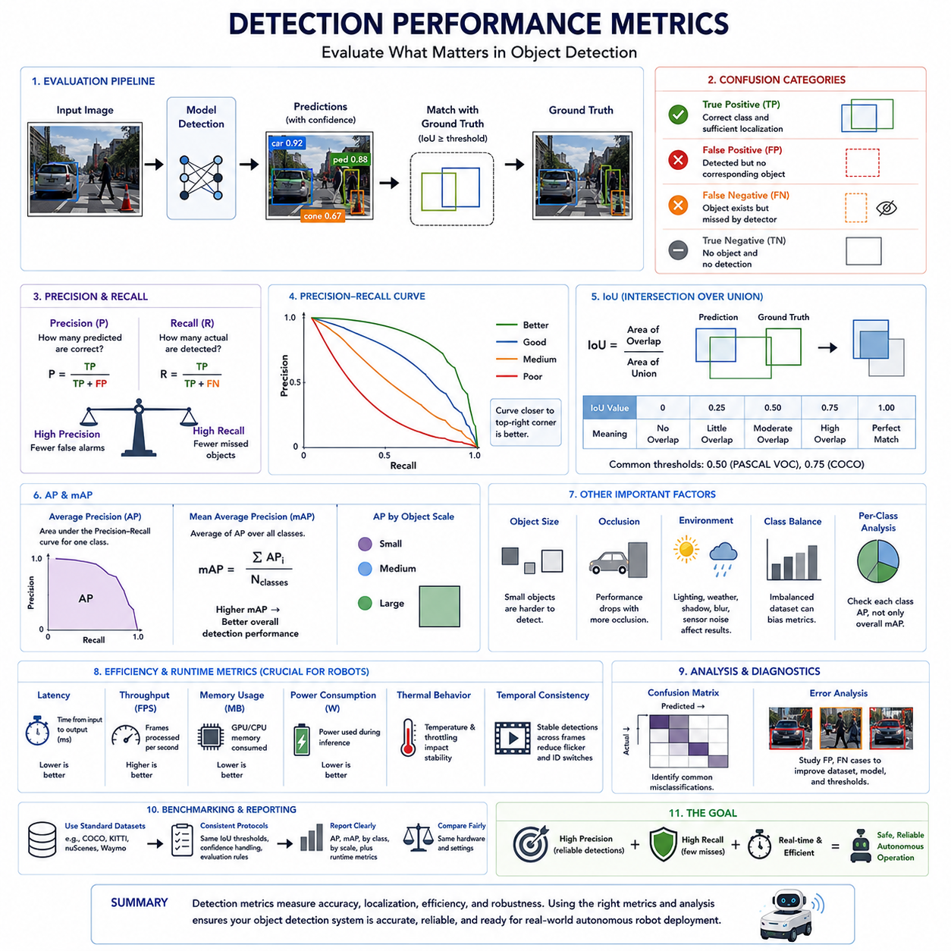
Detection performance metrics provide the quantitative foundation for evaluating the quality, reliability, and practical usefulness of an object detection system. A detection model may appear visually impressive during demonstrations, yet still fail to satisfy the strict accuracy, consistency, and real-time requirements demanded by autonomous mobile robots. Performance metrics transform subjective impressions into measurable engineering criteria that allow developers to compare algorithms, monitor improvements, identify weaknesses, and verify whether a perception system is suitable for deployment in safety-critical environments. Within the complete perception development lifecycle, these metrics serve as objective evidence supporting design decisions, optimization efforts, validation activities, and field acceptance testing.
Unlike general image classification, object detection simultaneously solves multiple problems. The system must correctly determine whether an object exists, identify its category, estimate its spatial location through a bounding box or three-dimensional representation, and perform these tasks within strict computational deadlines. Consequently, evaluating object detection requires multiple complementary metrics rather than a single accuracy value. High classification performance alone does not guarantee accurate localization, while excellent localization becomes meaningless if objects are consistently assigned incorrect classes. Similarly, outstanding offline accuracy loses practical value if the inference latency exceeds the robot's control cycle. Detection performance therefore represents the balanced evaluation of recognition quality, localization precision, computational efficiency, and operational robustness.
The evaluation process begins by defining a reliable reference dataset containing manually annotated ground truth objects. Human experts identify every relevant object within each image or point cloud and specify its class together with the corresponding bounding box, segmentation mask, or three-dimensional cuboid. These annotations become the benchmark against which model predictions are compared. Because ground truth itself influences every subsequent metric, annotation quality directly determines evaluation reliability. Poorly labeled datasets may underestimate capable models or overestimate weak ones, emphasizing that dataset quality and metric quality are inseparable components of the perception engineering process.
A prediction becomes meaningful only after it is matched against a corresponding ground truth object. This matching process normally depends on both semantic correctness and geometric overlap. The predicted category must match the annotated class, while the predicted bounding box must overlap sufficiently with the reference box according to predefined criteria. Only after successful matching can the prediction contribute positively to evaluation statistics. Predictions that fail this process become either localization errors or classification errors, illustrating that object detection evaluates multiple dimensions simultaneously rather than considering classification alone.
The most fundamental concepts in detection evaluation are True Positive, False Positive, False Negative, and occasionally True Negative. A True Positive occurs when the detector correctly identifies an existing object with acceptable localization accuracy. A False Positive represents an incorrect detection where no valid object exists or where the predicted class is incorrect. A False Negative occurs when a real object is completely missed by the detector. In large-scale object detection, True Negative measurements generally receive less attention because background pixels vastly outnumber foreground objects, making them less informative than positive detection statistics.
False Positive errors produce unnecessary reactions by the robot. An autonomous vehicle may brake unnecessarily because a shadow is interpreted as an obstacle, or a warehouse robot may repeatedly stop due to incorrectly detected pallets. Frequent false alarms reduce operational efficiency, decrease user confidence, and may even encourage operators to ignore legitimate warnings. Consequently, minimizing False Positives is particularly important for maintaining productive autonomous operation while preserving trust in the perception system.
False Negative errors are often even more critical because they represent missed detections. An undetected pedestrian, forklift, construction worker, cable, or roadside obstacle may directly compromise operational safety. Many safety-critical applications therefore prioritize reducing False Negatives even if doing so slightly increases False Positives. The acceptable balance depends on the operational design domain, risk assessment, and functional safety requirements of the autonomous system.
Precision measures how many predicted detections are actually correct. It is calculated as the number of True Positives divided by the sum of True Positives and False Positives. High precision indicates that when the detector reports an object, that prediction is usually reliable. Precision therefore reflects prediction quality rather than prediction completeness. Systems optimized for high precision generate relatively few incorrect detections but may become conservative, detecting only objects for which they possess high confidence.
Recall measures how many existing objects are successfully detected. It is calculated as the number of True Positives divided by the sum of True Positives and False Negatives. High recall indicates that the detector successfully finds most relevant objects within the environment. Recall emphasizes completeness rather than selectivity. Systems optimized solely for high recall may detect nearly every object but often produce numerous false alarms, illustrating the inherent tradeoff between precision and recall.
Neither precision nor recall alone completely describes detector quality. Increasing confidence thresholds generally improves precision while reducing recall because fewer uncertain predictions remain. Lowering confidence thresholds usually increases recall but introduces more False Positives. Engineers therefore analyze both metrics together rather than optimizing either independently. Selecting an appropriate operating threshold depends upon application priorities, environmental conditions, and acceptable safety margins.
The relationship between precision and recall is commonly visualized using the Precision-Recall curve. By continuously varying the confidence threshold from very strict to very permissive, multiple precision-recall pairs are generated and plotted. This curve illustrates detector behavior across all possible operating points instead of evaluating only one threshold. Curves positioned closer to the upper-right corner generally indicate stronger overall detection capability because they simultaneously maintain high precision and high recall over a broad range of operating conditions.
Average Precision, commonly abbreviated as AP, summarizes the Precision-Recall curve into a single numerical value. Rather than measuring detector performance at only one threshold, AP integrates precision across different recall levels, producing a more comprehensive representation of overall detection quality. Modern object detection benchmarks frequently compute AP separately for every object category before combining them into higher-level performance indicators. This approach enables developers to identify classes that remain difficult while maintaining an overall system evaluation.
Mean Average Precision, widely known as mAP, represents the average of AP values across all object categories. Because autonomous robots typically recognize numerous classes including pedestrians, vehicles, pallets, traffic cones, machinery, signs, and infrastructure, mAP provides a convenient summary describing overall detector capability. However, developers should avoid relying exclusively on a single mAP value because excellent performance on common classes may conceal poor performance on rare but safety-critical categories.
Intersection over Union, commonly called IoU, evaluates localization accuracy by measuring the geometric overlap between predicted and ground truth bounding boxes. IoU is calculated as the ratio between the overlapping area and the combined union area of both boxes. An IoU value of one indicates perfect alignment, whereas zero indicates no overlap. Evaluation protocols usually specify minimum IoU thresholds such as 0.5 or 0.75 before predictions qualify as True Positives. Increasing the IoU threshold demands increasingly accurate localization and therefore provides a stricter assessment of detector quality.
Different evaluation datasets adopt different IoU standards depending upon application requirements. Some benchmarks report AP at IoU 0.50, emphasizing object recognition, while others average performance across multiple IoU thresholds to evaluate both recognition and localization accuracy simultaneously. Three-dimensional object detection introduces volumetric IoU calculations that compare cuboid overlap rather than two-dimensional rectangles, reflecting the additional complexity of spatial perception for autonomous robots.
Confidence scores accompany nearly every detection generated by modern neural networks. Each predicted object receives a probability representing the model's confidence that the detected object belongs to a particular category. Confidence thresholds determine which detections remain and which are discarded before evaluation or deployment. Selecting this threshold significantly influences Precision, Recall, AP, and overall operational behavior. Practical deployment therefore requires threshold optimization based on real-world operational objectives rather than relying solely on default values.
Classification accuracy alone provides limited insight for object detection because localization errors remain unaccounted for. A detector may correctly classify an object as a pedestrian while producing an inaccurate bounding box that fails to satisfy IoU requirements. Likewise, a perfectly localized box assigned the wrong semantic class remains operationally incorrect. Detection metrics therefore intentionally combine classification correctness with localization precision, distinguishing object detection from conventional image classification evaluation.
Object size significantly influences detector performance. Large nearby vehicles generally achieve higher AP values than distant pedestrians, traffic cones, cables, or partially occluded obstacles. Consequently, many benchmarks separately report performance for small, medium, and large objects. This stratified evaluation provides valuable engineering insight because robots frequently encounter safety-critical small objects whose reliable detection remains substantially more difficult than recognizing large obstacles.
Occlusion represents another major evaluation dimension. Objects may be partially hidden behind shelves, vehicles, machinery, vegetation, or structural elements. Detection systems typically perform well under full visibility but experience degraded precision and recall as occlusion increases. Performance metrics therefore often distinguish fully visible objects from partially visible or heavily occluded ones, helping engineers understand detector limitations under realistic operating conditions.
Environmental diversity also affects performance evaluation. Lighting variation, weather conditions, shadows, reflections, dust, fog, snow, rain, motion blur, camera contamination, and sensor vibration introduce distribution shifts that challenge detection algorithms. Comprehensive evaluation therefore includes multiple environmental scenarios rather than relying exclusively on ideal laboratory conditions. Reporting metrics separately across these conditions reveals robustness characteristics that remain hidden within aggregate performance values.
For autonomous mobile robots, computational performance metrics are equally important. Inference latency measures the elapsed time between sensor acquisition and completed object detection. Excessive latency delays decision making and increases stopping distance, particularly for high-speed outdoor robots. Performance evaluation therefore includes average latency, worst-case latency, and sometimes deterministic timing guarantees to ensure perception remains synchronized with navigation and control systems.
Frames Per Second, commonly abbreviated FPS, measures how many complete inference cycles the detector can execute each second. Higher FPS enables smoother perception updates and improved responsiveness to rapidly changing environments. However, FPS alone should never replace latency analysis because batch processing may artificially increase throughput while simultaneously increasing individual detection delay. Real-time robotic systems therefore evaluate both throughput and response latency together.
Memory consumption represents another practical deployment metric. Embedded AI computers possess finite memory resources shared among perception, localization, planning, mapping, communication, and control software. Detection models requiring excessive GPU memory may limit simultaneous execution of other essential modules. Performance evaluation therefore frequently includes memory utilization, peak allocation, and storage requirements to ensure compatibility with embedded computing platforms.
Power consumption and thermal behavior become especially important for battery-powered outdoor robots. Large neural networks operating continuously may substantially reduce operational endurance while increasing processor temperature and potentially triggering thermal throttling. Engineers therefore evaluate energy efficiency alongside detection accuracy, seeking architectures that maximize useful perception while minimizing electrical power and cooling requirements. These metrics directly influence robot endurance, maintenance intervals, and long-term deployment costs.
Robustness metrics extend beyond individual frames by evaluating temporal stability across continuous sequences. Ideally, objects should remain consistently detected while moving through the sensor field of view. Frequent appearance and disappearance of detections, unstable confidence values, or rapidly fluctuating bounding boxes reduce downstream tracking performance and navigation reliability. Temporal consistency therefore forms an increasingly important evaluation criterion for autonomous robotic perception systems.
Confusion matrices provide another valuable diagnostic tool by illustrating which object categories are commonly misclassified. Instead of reporting only overall accuracy, the confusion matrix reveals specific relationships such as bicycles mistaken for motorcycles, pallets confused with boxes, or pedestrians confused with construction workers. These patterns guide targeted dataset expansion, model refinement, and algorithm improvement more effectively than aggregate statistics alone.
Benchmarking enables objective comparison between competing detection models. Standardized datasets, evaluation protocols, IoU thresholds, hardware configurations, and reporting procedures ensure fair comparison across different research groups and industrial developers. Well-known public benchmarks provide common reference points, while industrial organizations frequently establish proprietary benchmark suites representing their specific operational environments. Consistent benchmarking accelerates technological progress by allowing meaningful performance comparisons under reproducible conditions.
Ultimately, detection performance metrics transform perception development from subjective experimentation into measurable engineering practice. Precision, Recall, AP, mAP, IoU, latency, throughput, memory utilization, power efficiency, robustness, temporal consistency, and benchmark evaluation collectively provide a multidimensional understanding of detector capability. Rather than optimizing a single numerical value, successful autonomous robot perception balances recognition accuracy, localization precision, computational efficiency, operational robustness, and real-world reliability. Through systematic measurement, continuous benchmarking, and comprehensive field validation, detection performance metrics ensure that object detection systems satisfy both academic evaluation standards and the demanding operational requirements of safe, dependable, and intelligent autonomous mobile robots.

15.8 Field Detection Failure Cases
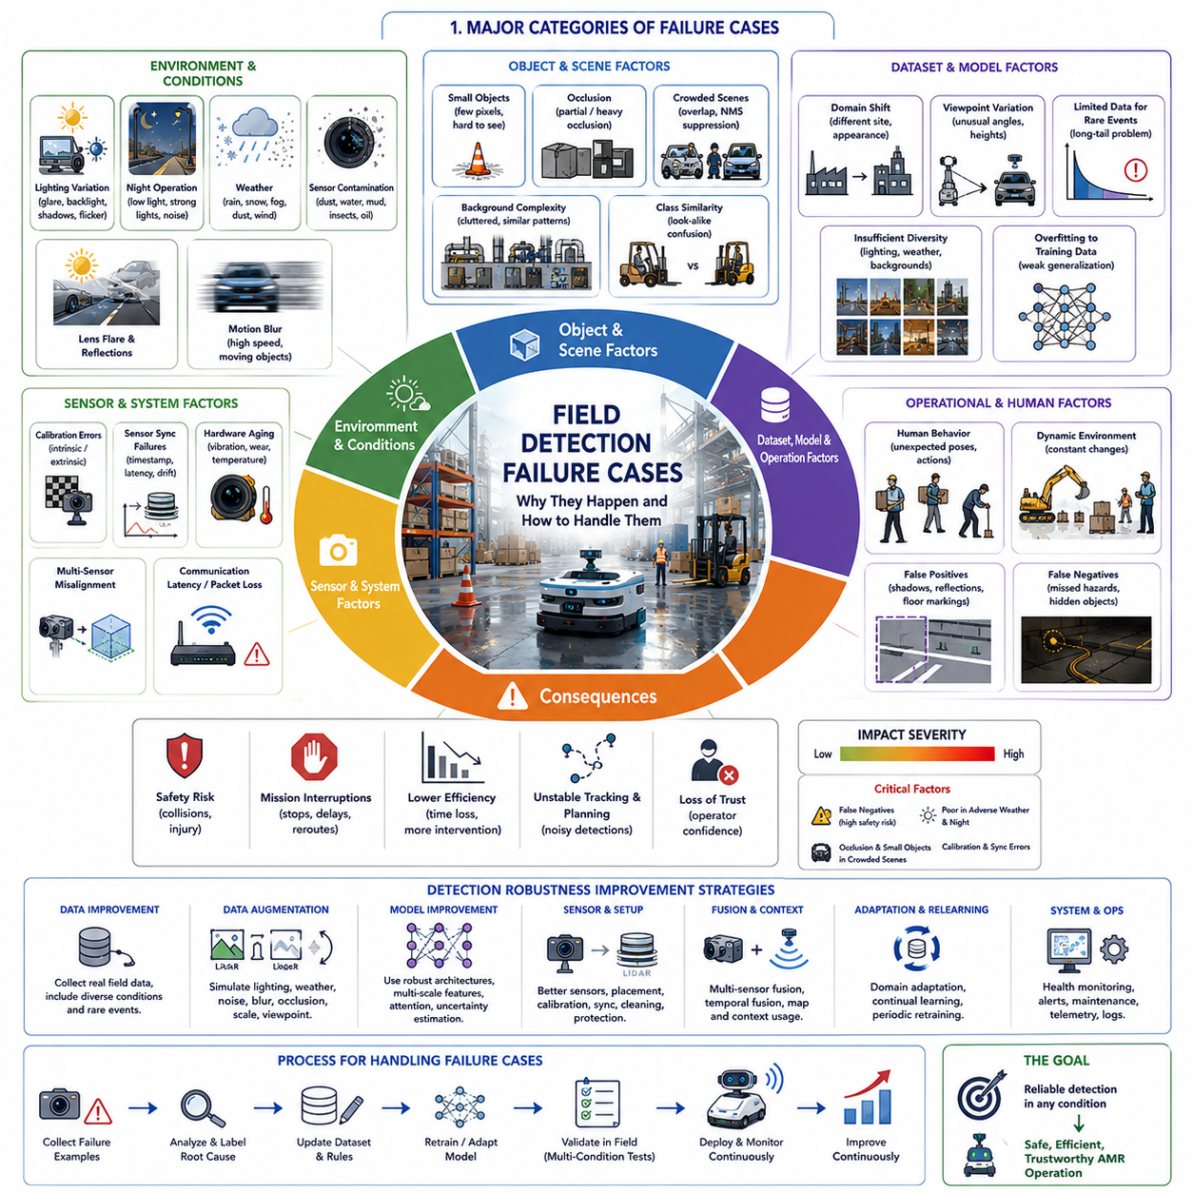
Field detection failure cases represent the practical situations in which an object detection system performs significantly worse than expected despite achieving excellent benchmark scores during laboratory evaluation. While modern deep learning detectors frequently report high Mean Average Precision on standardized datasets, real deployment environments expose numerous conditions that are absent or underrepresented in training data. Autonomous Mobile Robots operating in warehouses, factories, construction sites, agricultural fields, urban roads, ports, mines, or outdoor logistics facilities continuously encounter changing illumination, adverse weather, unexpected obstacles, damaged infrastructure, sensor contamination, and dynamic human behavior. Understanding these failure cases is essential because deployment success depends not only on average benchmark performance but also on reliable operation under rare, complex, and safety-critical situations.
One of the most fundamental causes of field failures is the distribution gap between training data and operational environments. Deep neural networks learn statistical patterns from the datasets used during training. When deployment environments differ substantially from these learned distributions, prediction accuracy naturally decreases. A detector trained primarily on clear daytime images may struggle under heavy rain or nighttime conditions. Likewise, models developed using well-organized warehouse datasets may experience severe degradation when deployed inside dusty construction sites or cluttered industrial facilities. The difference between laboratory data and operational reality therefore becomes one of the primary sources of perception failures.
Lighting variation remains among the most common causes of object detection degradation. Most datasets contain images collected under relatively balanced illumination, whereas real environments include direct sunlight, long shadows, backlighting, reflections, flickering artificial lights, tunnel entrances, and rapidly changing brightness. Cameras exposed to these conditions may experience saturation, underexposure, or reduced contrast. Objects that appear highly distinguishable under ideal illumination may become nearly invisible under unfavorable lighting. Consequently, field validation across multiple lighting conditions becomes essential before autonomous deployment.
Nighttime operation introduces additional challenges beyond simple brightness reduction. Artificial lighting often produces localized illumination, strong reflections, uneven exposure, and significant image noise. Vehicle headlights, industrial floodlights, warning beacons, and reflective safety clothing create high dynamic range scenes that exceed camera capabilities. Infrared cameras and thermal imaging sensors can partially compensate for these limitations, yet each sensing modality introduces its own constraints regarding resolution, object appearance, and environmental sensitivity. Reliable nighttime perception therefore frequently requires multimodal sensor fusion rather than relying solely on conventional RGB cameras.
Weather conditions significantly influence detection reliability. Rain introduces water droplets on camera lenses, reduces image contrast, and generates visual artifacts that may resemble obstacles. Snow modifies ground appearance while partially covering landmarks and infrastructure. Fog scatters light, reducing visibility and degrading distant object recognition. Dust generated by construction vehicles or agricultural machinery obscures sensors and decreases image quality. Strong wind may shake cameras or move vegetation unexpectedly, introducing additional uncertainty. Each environmental factor affects different sensing technologies differently, requiring comprehensive evaluation across realistic operational conditions.
Sensor contamination represents another common real-world failure source. Cameras deployed for extended periods inevitably accumulate dust, mud, water stains, insects, oil residue, scratches, or condensation. These contaminants partially block the field of view, introduce blurred regions, or create persistent artifacts that confuse detection algorithms. Laboratory evaluations generally assume clean sensors, whereas practical robotic systems must tolerate gradual sensor degradation over weeks or months of continuous operation. Automatic sensor health monitoring and maintenance scheduling therefore become essential components of long-term autonomous operation.
Lens flare and optical reflections frequently produce false detections. Bright sunlight entering the camera lens creates internal reflections, ghost artifacts, reduced contrast, and localized saturation. Highly reflective metallic machinery, polished floors, wet pavement, glass walls, mirrors, and vehicle surfaces further complicate perception by generating reflections that resemble genuine objects. Detection networks sometimes interpret these artifacts as pedestrians, vehicles, or obstacles, leading to unnecessary braking or mission interruption. Optical filtering, improved camera placement, and dataset expansion help reduce these failures but rarely eliminate them entirely.
Motion blur occurs whenever camera exposure time becomes significant relative to platform velocity or object motion. High-speed outdoor robots, rapidly moving vehicles, rotating machinery, or sudden robot acceleration can all produce blurred images that obscure object boundaries. Fine structural details disappear, making classification increasingly difficult. Motion blur particularly affects small objects and distant targets whose limited pixel representation already challenges detection algorithms. Exposure optimization, high-frame-rate cameras, and image stabilization techniques help mitigate this problem but introduce additional hardware and computational requirements.
Small object detection remains considerably more difficult than detecting larger objects. Traffic cones, cables, tools, debris, safety markers, animals, and distant pedestrians often occupy only a small number of pixels within high-resolution images. Minor changes in lighting, compression artifacts, or image noise can completely obscure these objects. Yet many of these seemingly insignificant objects carry substantial operational importance because they may represent hazards or navigation constraints. Improving small object detection generally requires higher-resolution sensing, feature pyramid architectures, specialized datasets, and extensive data augmentation.
Occlusion represents one of the most persistent perception challenges. Objects rarely appear fully visible in complex operational environments. Workers may stand behind machinery, vehicles may partially block pedestrians, shelves may conceal packages, and vegetation may obscure roadside obstacles. Deep learning models frequently identify fully visible objects accurately but experience progressively lower confidence as visible object area decreases. Partial occlusion may also cause classification confusion because only incomplete visual features remain available. Robust perception therefore depends upon temporal observation, multiple viewpoints, and sensor fusion rather than single-frame image interpretation.
Crowded environments create additional ambiguity because multiple objects overlap spatially. Construction sites, warehouses, loading docks, and public facilities frequently contain groups of workers, vehicles, equipment, and moving materials positioned closely together. Bounding boxes overlap significantly, increasing the difficulty of separating individual instances. Non-Maximum Suppression algorithms sometimes remove valid detections because nearby objects appear excessively similar. Instance segmentation and transformer-based detection architectures improve performance under such conditions but still encounter limitations within highly congested scenes.
Background complexity often influences detection quality more than expected. Laboratory datasets typically contain relatively clean backgrounds that simplify feature extraction. Real industrial environments include cables, pipes, stacked materials, scaffolding, containers, warning signs, machinery, vegetation, and numerous unrelated visual structures. Complex backgrounds increase feature ambiguity and may cause false detections or missed objects. Improving robustness requires exposing detection models to highly diverse backgrounds during training rather than relying solely on carefully curated datasets.
Class similarity introduces another frequent failure mode. Objects possessing similar geometric appearance may become difficult to distinguish, especially under poor imaging conditions. Pallets resemble stacked boxes, forklifts resemble industrial vehicles, bicycles resemble motorcycles from certain viewpoints, and workers carrying equipment may resemble static machinery. Deep learning models occasionally rely upon superficial visual cues rather than semantically meaningful characteristics, producing systematic misclassification. Confusion matrix analysis helps identify these recurring mistakes and guides targeted dataset enhancement.
Domain shift frequently occurs when deploying models across different operational sites. Even within the same industry, factories differ in floor color, lighting configuration, equipment arrangement, worker uniforms, safety signs, machine appearance, and product geometry. Models trained in one facility often experience measurable performance reduction after deployment elsewhere. Continuous learning, domain adaptation, transfer learning, and periodic retraining using locally collected data become important strategies for maintaining acceptable detection performance across multiple customer sites.
Camera viewpoint variation also influences detector reliability. Many datasets contain objects captured from conventional eye-level perspectives. Autonomous robots, however, frequently mount cameras close to the ground, above machinery, on robotic manipulators, or on elevated inspection platforms. These unusual viewpoints change apparent object geometry, visible features, and perspective distortion. Objects familiar during training may appear substantially different when observed from alternative camera positions, reducing recognition accuracy despite identical semantic content.
Camera calibration errors introduce subtle yet important localization inaccuracies. Intrinsic calibration changes caused by temperature variation, mechanical vibration, accidental impacts, or long-term hardware aging gradually alter image geometry. Extrinsic calibration errors become particularly problematic in multi-camera systems where perception depends upon consistent spatial alignment. Small calibration deviations may produce incorrect three-dimensional localization even when object classification remains accurate. Regular calibration verification therefore becomes an essential maintenance procedure for autonomous robotic platforms.
Sensor synchronization failures become increasingly significant within multimodal perception systems. Cameras, LiDAR, radar, GNSS, and IMU sensors operate at different frequencies and must remain temporally aligned. Network latency, timestamp errors, clock drift, or synchronization failures cause data originating from different moments to be fused incorrectly. A moving pedestrian detected by the camera may no longer occupy the corresponding LiDAR position, producing inconsistent perception results. Precision Time Protocol synchronization and hardware triggering significantly reduce such failures.
Environmental dynamics often invalidate assumptions learned during offline training. Construction sites continuously change as materials move, temporary barriers appear, vehicles relocate, and work zones expand. Agricultural fields evolve with crop growth, seasonal variation, and harvesting activities. Warehouses reorganize inventory layouts while ports rearrange shipping containers daily. Static datasets cannot fully represent these evolving environments, making continual dataset updates and adaptive learning increasingly important for long-term deployment.
Adversarial environmental conditions occasionally expose unexpected detector weaknesses. Bright warning tape, unusual graffiti, damaged traffic signs, torn labels, irregular object textures, camouflage patterns, or partially destroyed infrastructure may cause substantial prediction errors despite appearing unremarkable to human observers. Although intentionally adversarial attacks receive considerable academic attention, naturally occurring environmental anomalies often produce comparable practical challenges. Field testing therefore should include unusual and degraded conditions rather than only nominal operational scenarios.
Human behavior introduces another layer of complexity because people frequently violate expected motion patterns. Workers may suddenly crouch behind equipment, carry oversized objects, wear reflective protective clothing, push carts, climb ladders, or perform maintenance inside confined spaces. Detection systems trained primarily on standing pedestrians may experience reduced accuracy when encountering these uncommon poses. Expanding datasets to include diverse human activities significantly improves perception robustness in industrial environments.
False Positive accumulation can become operationally disruptive even when individual errors appear insignificant. A robot that occasionally mistakes floor markings, shadows, reflections, or stationary equipment for obstacles may repeatedly interrupt missions, reducing productivity and increasing operator intervention. While each isolated false detection seems harmless, their cumulative operational impact can substantially decrease overall system efficiency. Practical evaluation therefore considers sustained mission performance rather than analyzing individual frames independently.
False Negative failures remain particularly critical because undetected hazards directly threaten operational safety. Missing a pedestrian crossing behind equipment, overlooking a suspended cable, failing to recognize a fallen pallet, or ignoring unexpected debris may lead to collisions or unsafe robot behavior. Safety-oriented perception systems therefore intentionally favor conservative operation, accepting occasional false alarms in exchange for minimizing dangerous missed detections. Risk assessment determines the acceptable balance according to application-specific safety requirements.
Temporal inconsistency frequently appears during continuous operation even when individual frames achieve satisfactory detection accuracy. Objects may intermittently disappear and reappear across successive frames because confidence scores fluctuate around detection thresholds. Bounding boxes may oscillate significantly despite stationary objects, complicating downstream tracking and motion prediction. Stable perception requires temporal filtering, object tracking, confidence smoothing, and multi-frame reasoning rather than evaluating each frame independently.
Long-term deployment exposes hardware aging effects rarely considered during laboratory testing. Camera sensors gradually lose sensitivity, lenses accumulate microscopic damage, mechanical mounts loosen due to vibration, electronic components drift thermally, and protective housings experience environmental wear. These gradual degradations slowly reduce detection quality over months or years. Preventive maintenance schedules, automated health diagnostics, periodic recalibration, and continuous performance monitoring become essential for sustaining reliable autonomous operation throughout the robot lifecycle.
Dataset limitations frequently explain recurring field failures. Rare events such as overturned vehicles, damaged equipment, emergency responders, unusual construction machinery, flooded roads, collapsed shelving, wildlife crossings, or unexpected human activities often appear too infrequently within publicly available datasets. Consequently, detectors lack sufficient experience recognizing these situations. Active learning strategies that automatically collect difficult field examples enable continuous dataset expansion focused on real operational weaknesses instead of randomly collecting additional ordinary samples.
Root cause analysis forms an essential component of perception engineering whenever failures occur. Engineers systematically determine whether errors originated from insufficient training data, annotation mistakes, inappropriate confidence thresholds, sensor hardware limitations, environmental conditions, synchronization failures, localization inaccuracies, or downstream decision logic. Effective analysis avoids treating all failures identically and instead identifies the specific subsystem responsible for each operational deficiency. Structured failure databases greatly accelerate long-term perception improvement.
Field validation should therefore extend far beyond conventional benchmark evaluation. Successful autonomous perception requires systematic testing across different seasons, weather conditions, lighting scenarios, operational sites, sensor conditions, object densities, human behaviors, vehicle speeds, and environmental changes. Continuous monitoring after deployment remains equally important because operational environments evolve over time. By carefully analyzing real-world detection failure cases, expanding representative datasets, improving model robustness, optimizing sensor configurations, and incorporating continual learning strategies, autonomous mobile robots gradually achieve the reliability, safety, and resilience necessary for dependable operation in complex industrial and outdoor environments.

