Volume 03. AMR Sensors and Perception

Chapter 24. Industrial Perception Case Studies

24.1 Warehouse Perception Case Study
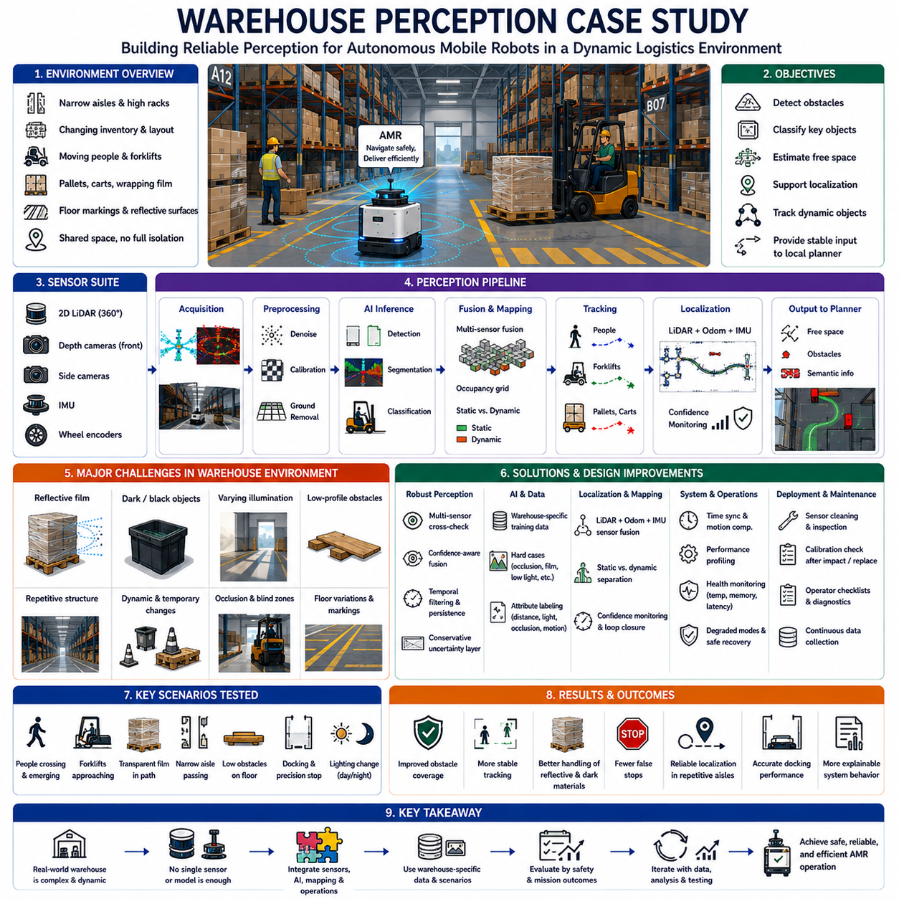
The warehouse perception case study examines how an autonomous mobile robot was adapted to operate reliably in a high-density logistics facility containing narrow aisles, reflective surfaces, moving workers, forklifts, pallets, racks, wrapping film, floor markings, and frequently changing inventory. Although the environment was indoors and geographically constrained, perception was difficult because many objects had similar shapes, visibility changed continuously, and operational safety depended on rapid interpretation of both static and dynamic conditions.
The target facility used autonomous mobile robots to transport pallets and containers between receiving, storage, picking, inspection, and shipping zones. The robots traveled through shared spaces rather than fully isolated lanes. Human workers crossed routes, forklifts entered and left aisles, pallets were temporarily placed outside designated areas, and doors were opened or closed depending on production activity. The perception system therefore had to support reliable navigation while responding safely to unpredictable operational changes.
The initial robot platform used two-dimensional LiDAR for basic obstacle detection and localization, wheel encoders for odometry, an inertial measurement unit for motion estimation, and front-facing depth cameras for three-dimensional perception. Additional side cameras were installed to improve visibility near rack corners and docking stations. The sensor configuration was selected to balance coverage, cost, computational load, installation complexity, and resistance to common warehouse lighting and surface conditions.
The primary perception objectives were to detect obstacles, classify operationally important objects, estimate free space, support localization, maintain dynamic-object tracks, and provide stable information to the local planner. The system did not require perfect semantic understanding of every warehouse item. Instead, it needed dependable recognition of people, forklifts, pallets, racks, carts, doors, walls, floor-level obstacles, and temporary objects that could affect safe motion or mission completion.
The first field tests revealed that obstacle detection performance was strongly dependent on object geometry. Large vertical surfaces such as walls, rack posts, and loaded pallets were detected consistently. Low-profile objects such as wooden boards, loose packaging, pallet fragments, and thin metal bars were more difficult because they occupied only a small number of depth pixels or LiDAR returns. These objects were especially hazardous when positioned directly in the robot path near the minimum braking distance.
Reflective wrapping film created another major challenge. Transparent or glossy plastic surrounding palletized goods produced unstable depth measurements, missing regions, and false reflections. Depending on camera angle and lighting, the same pallet could appear as a solid obstacle, a partially empty volume, or an irregular surface. The perception pipeline therefore could not rely on a single depth frame and required temporal integration, confidence filtering, and conservative occupancy updates.
Black materials also reduced perception quality. Dark plastic containers, rubber components, and black-painted equipment absorbed infrared light from active depth cameras, causing sparse or invalid measurements. The system initially interpreted some dark objects as distant background or free space. This failure mode led engineers to introduce cross-checking between depth cameras and LiDAR, together with a rule preventing uncertain depth regions from being immediately cleared as navigable space.
Warehouse illumination varied more than expected. Some aisles were brightly lit, while upper rack levels and loading zones contained shadows. Sunlight entering through dock doors created high contrast and temporarily saturated camera images. Automatic exposure control responded slowly when the robot moved between dark and bright regions, reducing detection confidence during the transition. Exposure limits, region-based metering, and training data containing realistic lighting transitions were introduced to improve robustness.
Rack structures generated repeated geometric patterns that affected localization and visual interpretation. Long aisles contained nearly identical posts, beams, pallets, and labels, which reduced the distinctiveness of local features. Two-dimensional LiDAR localization was generally stable but became less certain when several aisles had similar shapes and temporary pallets obscured mapped rack boundaries. The localization system therefore combined geometric matching with odometry, inertial information, and controlled confidence monitoring.
Temporary environmental changes caused additional map-related problems. Pallets were frequently stored in locations that were empty when the reference map was created. Safety barriers, carts, charging equipment, and packaging materials also moved between shifts. If the localization and mapping system treated all observed objects as permanent structure, the map became cluttered. If it removed them too aggressively, genuine structural information could be lost. Separate handling of static infrastructure and temporary occupancy was therefore required.
Human detection was treated as the highest-priority semantic function. Workers wore different uniforms, safety vests, helmets, and seasonal clothing, and they could stand, bend, kneel, carry boxes, or be partially hidden behind pallets. A detector trained mainly on upright pedestrians produced reduced confidence for crouching or heavily occluded workers. Additional warehouse-specific training data and conservative motion policies were needed to maintain safety under these realistic poses.
Forklift perception required both classification and motion prediction. Forklifts changed direction quickly, reversed into aisles, carried loads that altered their visible shape, and were sometimes partly hidden behind racks. Their forks could extend beyond the main body and create narrow low-level hazards. The perception system therefore tracked the complete occupied region rather than only the detected vehicle body and expanded the safety envelope according to estimated speed, direction, and uncertainty.
Pallet detection supported both navigation and docking. Empty pallets were difficult because their open structure produced discontinuous sensor returns. Damaged pallets generated irregular geometry, while loaded pallets varied greatly in size and wrapping. A purely appearance-based detector was insufficient, so pallet candidates were evaluated using width, height, ground contact, repeated board patterns, and expected locations near storage or docking zones. Geometry and semantics were combined to improve consistency.
The original obstacle-fusion logic used fixed confidence thresholds for all sensors. This approach failed when environmental conditions changed because sensor reliability was not constant. Depth cameras performed poorly on reflective and dark surfaces, while LiDAR could miss thin structures or provide limited vertical information. The revised fusion design used source-specific confidence, spatial consistency, observation history, and sensor-health state when updating the local occupancy representation.
Temporal persistence was carefully tuned. If an obstacle disappeared from one frame because of measurement noise, it should not immediately be removed. However, excessive persistence created ghost obstacles after people or forklifts had moved away. The final approach applied different decay rates according to object type, sensor confidence, motion state, and observation history. Dynamic tracks were cleared more quickly after confirmed movement, while uncertain static obstacles remained longer for safety.
Ground segmentation was another important issue. Warehouse floors were mostly flat but included ramps, drainage covers, expansion joints, dock plates, damaged concrete, painted lines, and reflective epoxy surfaces. Early algorithms occasionally classified ramps or raised joints as obstacles. In other locations, shallow objects were absorbed into the ground model. The ground-removal method was modified to account for local slope, robot pitch, expected floor variation, and minimum obstacle height.
Floor markings provided useful operational context but also caused false visual boundaries. High-contrast yellow lines, striped safety areas, arrows, and reflective tape sometimes resembled object edges or lane boundaries. Semantic segmentation was trained to distinguish navigable floor, restricted zones, markings, and physical obstacles. The local planner then used markings as contextual information without treating them as solid geometry unless facility rules required restricted access.
Sensor placement had a major influence on blind zones. The front depth camera provided good forward coverage but could not observe objects close to the robot sides during turns. Rack corners and pallet edges sometimes entered these zones. Side cameras and protective short-range sensing reduced the risk, while the robot’s footprint model was expanded according to steering direction. Mechanical structures, bumpers, and payload overhang were included in perception and planning geometry.
Motion distortion affected point clouds when the robot turned quickly or crossed uneven floor sections. Sensor measurements acquired at different times within a scan were transformed as though they represented one instant, causing walls and rack posts to appear bent. This distortion degraded localization and obstacle alignment. Time-aware motion compensation using odometry and inertial measurements was added before point-cloud fusion, and timestamp accuracy was verified across all relevant devices.
Network and computation constraints also influenced field performance. High-resolution camera streams, point clouds, artificial intelligence inference, visualization, logging, and remote monitoring competed for processor, memory, and network resources. During early tests, occasional latency spikes delayed obstacle updates even though average frame rates appeared acceptable. Detailed profiling showed that worst-case processing time and queue growth were more important than average throughput.
The perception software was reorganized into clearly separated acquisition, preprocessing, inference, fusion, tracking, localization, mapping, and health-monitoring stages. Each stage published diagnostic information including frequency, latency, dropped messages, queue size, confidence, and error state. This structure allowed engineers to identify whether a failure originated from poor raw data, delayed processing, model output, coordinate transformation, or downstream fusion.
A structured field-data collection program was established to represent actual warehouse diversity. Data were recorded during different shifts, lighting conditions, traffic levels, payload states, aisle configurations, docking operations, and maintenance activities. Rare but important events included fallen packages, protruding forks, partially opened doors, workers kneeling near racks, reflective pallets, and objects placed at sensor blind spots. These cases became priority scenarios for model training and validation.
Annotation focused on operational relevance rather than excessive detail. People, forklifts, pallets, carts, racks, doors, walls, obstacles, free space, restricted areas, and uncertain regions were labeled. Occlusion, truncation, distance, lighting, and motion attributes were also recorded for difficult examples. These attributes allowed engineers to evaluate not only overall accuracy but also performance under specific warehouse conditions associated with risk.
Offline evaluation used detection precision, recall, segmentation quality, tracking stability, localization error, obstacle persistence, and processing latency. However, good offline metrics did not always guarantee safe robot behavior. A small boundary error could be acceptable in an image but dangerous near a pallet corner. Therefore, perception metrics were connected to operational outcomes such as emergency stopping, route blockage, docking success, unnecessary slowdown, and safe passing distance.
Scenario-based testing became the primary validation method. The robot was tested with static pallets, moving people, crossing forklifts, low obstacles, reflective objects, dark containers, narrow passages, blocked aisles, and changing illumination. Each scenario was repeated at different speeds and approach angles. Expected perception outputs and robot responses were defined in advance so that results could be compared objectively across software versions.
One critical scenario involved a worker emerging from behind a rack while the robot approached an aisle intersection. The worker was initially visible only as a small partial region. The first software version detected the person too late because confidence remained below the normal threshold. The revised system combined partial-person detection, motion cues, occlusion-zone awareness, and reduced speed near blind intersections to provide earlier and safer response.
Another scenario involved transparent film hanging from a pallet into the travel path. The depth camera generated inconsistent readings, while the two-dimensional LiDAR passed beneath part of the film. The object was not reliably represented by either sensor alone. A conservative uncertainty layer was added so that regions with repeated inconsistent measurements were treated as potentially occupied until the robot obtained a better viewpoint or an operator confirmed clearance.
Docking tests showed that general navigation perception and precision docking required different configurations. During travel, the system prioritized broad obstacle coverage and dynamic tracking. Near the target station, it switched to high-resolution local geometry, station-feature detection, reduced speed, and tighter pose validation. The docking process also checked whether the expected station was visible and whether unexpected objects occupied the final approach area.
False stops were analyzed because excessive caution reduced warehouse productivity. Reflections, moving shadows, dust, sensor noise, and temporary map inconsistencies sometimes generated short-lived obstacles. Instead of lowering safety thresholds globally, engineers classified false-stop causes and modified the relevant sensor confidence, temporal filtering, and contextual logic. This reduced unnecessary stops while preserving conservative behavior for physically plausible hazards.
Long-duration testing exposed failures that short demonstrations did not reveal. Camera temperature increased, memory usage grew, log files consumed storage, and network traffic varied as more robots entered operation. Some perception delays appeared only after several hours. Continuous monitoring of temperature, memory, disk space, topic frequency, and processing latency was therefore added to the acceptance criteria for production deployment.
Multi-robot operation introduced further complications. Several robots observed the same moving objects from different positions, and fleet-level traffic management changed routes frequently. Local perception remained responsible for immediate safety, while the fleet system provided route and reservation context. Shared observations were used cautiously because differences in timestamp, localization uncertainty, and communication delay could make remote detections unsuitable for direct collision avoidance.
Operational deployment included degraded-mode strategies. If one depth camera failed, the robot could continue at reduced speed using remaining sensors when coverage was sufficient. If localization confidence dropped, the robot stopped or moved to a safe recovery area. If network communication was interrupted, onboard perception and safety functions remained active. Each degraded mode had explicit entry conditions, speed limits, allowed missions, and recovery procedures.
Maintenance procedures were updated based on perception findings. Operators received checks for lens cleaning, sensor-window inspection, mount tightness, cable condition, time-synchronization status, storage capacity, and diagnostic warnings. Calibration verification was required after sensor replacement, mechanical impact, or structural maintenance. These procedures prevented gradual hardware degradation from being mistaken for software or artificial intelligence failure.
The final system achieved improved obstacle coverage, more stable dynamic tracking, better handling of reflective and dark materials, and fewer unnecessary stops. Localization remained reliable in repetitive aisles through sensor fusion and confidence monitoring. Precision docking performance improved after introducing station-specific perception and final-approach validation. Most importantly, the system’s behavior became more explainable because sensor confidence, timing, fusion decisions, and health states were recorded consistently.
The case study demonstrates that warehouse perception cannot be solved by selecting one powerful sensor or one accurate artificial intelligence model. Reliable operation depends on sensor placement, calibration, synchronization, raw-data quality, confidence-aware fusion, temporal reasoning, localization, mapping, computation, health monitoring, and operational procedures. Each component must be evaluated in the context of actual warehouse behavior and downstream safety requirements.
It also shows that warehouse-specific data and scenarios are essential. Public datasets may contain people, vehicles, and indoor scenes, but they rarely represent reflective packaging, damaged pallets, repetitive racks, protruding forks, narrow docking areas, or warehouse-specific lighting transitions in sufficient detail. Continuous collection of field failures and difficult cases therefore becomes a strategic asset for long-term perception improvement.
Ultimately, the warehouse perception program succeeded because development moved from isolated algorithm testing to system-level validation. Engineers connected raw sensor behavior to perception outputs, robot decisions, mission performance, and safety consequences. Through structured data collection, scenario testing, failure analysis, iterative correction, and continuous monitoring, the perception stack became suitable for dependable autonomous operation in a complex and constantly changing logistics environment.

24.2 Hospital AMR Perception Case Study
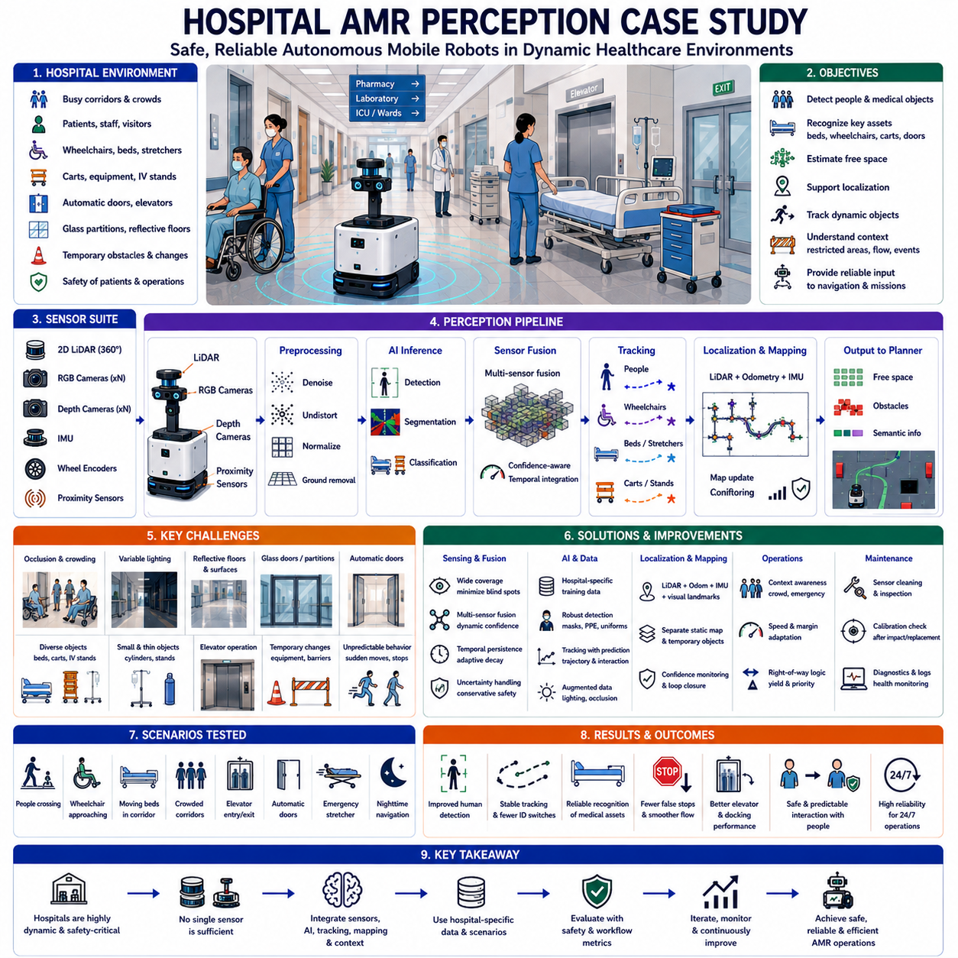
Hospitals represent one of the most demanding indoor environments for autonomous mobile robot perception because safety, reliability, and human interaction are equally important. Unlike structured industrial facilities, hospitals contain continuously changing pedestrian traffic, movable medical equipment, emergency situations, transparent partitions, narrow corridors, elevators, patient beds, wheelchairs, and temporary obstacles. The perception system must therefore interpret highly dynamic scenes while maintaining safe navigation around vulnerable people and supporting uninterrupted medical operations.
The target deployment involved autonomous mobile robots transporting medications, laboratory samples, sterile instruments, meals, linens, medical supplies, and waste containers between pharmacies, laboratories, operating rooms, wards, intensive care units, and logistics centers. Robots operated throughout the day and night, sharing corridors with doctors, nurses, patients, visitors, cleaning staff, and emergency response teams. The perception system had to function consistently despite continuous environmental variation and unpredictable human behavior.
The robot platform combined two-dimensional LiDAR for localization and obstacle detection, multiple RGB cameras for semantic perception, depth cameras for three-dimensional obstacle estimation, wheel encoders for odometry, and an inertial measurement unit for motion estimation. Short-range proximity sensors protected the robot during docking and close interaction with furniture. The sensor arrangement emphasized wide field coverage while minimizing blind zones near the robot body and maintaining reliable operation within narrow hospital corridors.
The perception objectives extended beyond simple collision avoidance. The system needed to detect people, wheelchairs, hospital beds, stretchers, carts, infusion stands, cleaning equipment, service robots, automatic doors, elevators, emergency exits, and temporary barriers. It also had to estimate free space, recognize restricted zones, monitor pedestrian flow, support localization, and provide reliable information to navigation and mission-planning modules without creating unnecessary interruptions to hospital activities.
Hospital corridors differed significantly from warehouse environments because pedestrian behavior was far less predictable. People frequently stopped to talk, suddenly changed direction, exited patient rooms without warning, or walked while carrying medical equipment that altered their body shape. Medical staff often moved quickly during emergency situations, while elderly patients walked slowly and unpredictably. The perception system therefore required robust human tracking rather than relying solely on instantaneous object detection.
Wheelchairs represented one of the most important object categories. Manual and electric wheelchairs differed considerably in size, appearance, and motion characteristics. Some were pushed by caregivers while others were self-operated. Blankets, medical bags, oxygen cylinders, and personal belongings frequently modified their visible geometry. The perception model therefore combined semantic classification with geometric consistency and temporal tracking to maintain stable identification under changing viewpoints.
Hospital beds created additional perception challenges because they occupied large portions of narrow corridors while frequently changing orientation. Beds could be stationary, manually pushed, or rapidly transported during emergencies. Medical devices attached to the bed, including monitors, infusion pumps, and oxygen cylinders, extended beyond the primary frame and altered the effective occupied space. The navigation system therefore estimated the complete dynamic footprint instead of tracking only the visible bed structure.
Medical carts appeared in many different forms depending on their purpose. Medication carts, meal carts, cleaning carts, supply carts, and diagnostic equipment each had different dimensions and surface characteristics. Highly reflective stainless-steel surfaces occasionally degraded depth sensing, while transparent protective covers complicated three-dimensional reconstruction. Training data therefore included a broad range of hospital equipment under realistic operational conditions rather than relying on generic indoor object datasets.
Glass doors and transparent partitions presented significant sensing difficulties. Active depth cameras occasionally produced incomplete measurements, while two-dimensional LiDAR beams often passed through transparent surfaces or generated weak reflections depending on incidence angle. Purely geometric obstacle detection therefore became unreliable near glass structures. Semantic recognition of architectural features combined with prior building information helped compensate for sensor limitations and reduced collision risk.
Automatic doors introduced another layer of environmental complexity. Doors continuously changed state between open and closed positions depending on nearby pedestrians and authorized access. The perception system needed to distinguish between a temporarily closed door that would automatically open and a permanently inaccessible barrier. Door state estimation combined visual recognition, building map information, and operational context to avoid unnecessary waiting or repeated navigation failures.
Elevator operation required specialized perception capabilities because entering and exiting an elevator involved dynamic interactions among people, doors, confined spaces, and changing floor geometry. The robot detected elevator doors, estimated cabin occupancy, recognized entry clearance, and monitored pedestrian movement before committing to entry. Small localization errors during elevator transitions could accumulate into navigation failures, making accurate perception and temporal synchronization essential during floor changes.
Hospital lighting varied considerably throughout the day. Bright reception areas contrasted with dim patient rooms, nighttime corridors, imaging departments, and emergency treatment spaces. Reflective floors produced specular highlights, while medical displays generated localized illumination changes. Automatic camera exposure occasionally required several frames to stabilize when moving between lighting conditions. Adaptive exposure control, image normalization, and illumination-diverse training data significantly improved perception robustness.
Human appearance varied much more than expected. Doctors, nurses, patients, visitors, maintenance workers, and contractors wore different uniforms, protective clothing, surgical gowns, masks, gloves, face shields, and personal protective equipment. During infectious disease outbreaks, nearly every individual wore masks and additional protective equipment that partially obscured facial features. Person detection therefore relied primarily on body geometry, motion patterns, and full-body appearance rather than facial characteristics alone.
Occlusion occurred frequently because hospital corridors were crowded with equipment and moving people. A nurse could disappear behind a medical cart before reappearing several seconds later. Patients were often partially hidden behind beds, wheelchairs, or room entrances. Stable multi-object tracking therefore depended upon temporal association, trajectory prediction, and uncertainty estimation rather than individual frame-by-frame detection. Long-term track management significantly reduced identity switching and unnecessary navigation reactions.
Small medical devices presented unique operational hazards. Oxygen cylinders, infusion stands, portable monitors, waste bins, and folded wheelchairs occupied little floor area but could obstruct the robot's planned path. Their thin structures sometimes generated sparse LiDAR returns and incomplete depth measurements. Sensor fusion combined geometric observations from multiple viewpoints with temporal accumulation to improve detection reliability while minimizing false negatives.
Floor conditions also affected perception quality. Hospitals frequently used polished reflective flooring that produced image reflections and varying infrared responses. Cleaning activities introduced temporary wet surfaces that changed optical properties. Floor markings indicating emergency routes, restricted areas, operating-room access, or sanitation zones added additional visual complexity. Semantic segmentation distinguished navigable floor, restricted markings, reflective artifacts, and actual obstacles before path planning was performed.
Localization accuracy depended on maintaining reliable perception despite repetitive architectural layouts. Long corridors, identical patient-room doors, similar ceiling structures, and repeated wall textures reduced the uniqueness of visual landmarks. LiDAR-based localization remained generally stable but occasionally experienced ambiguity in nearly identical corridors. The localization system therefore fused odometry, inertial measurements, visual landmarks, and confidence estimation to reduce cumulative drift throughout extended hospital missions.
Temporary environmental changes occurred continuously. Mobile diagnostic equipment, portable partitions, temporary construction barriers, emergency supply stations, and maintenance activities altered corridor geometry without updating the reference map. Rather than immediately incorporating every observed object into the permanent environment model, the mapping system separated structural infrastructure from temporary occupancy. This approach preserved long-term map consistency while allowing safe navigation around short-term obstacles.
Emergency situations required adaptive perception behavior. During patient transport or emergency response, staff moved rapidly and expected immediate right-of-way. The robot recognized elevated pedestrian density, increased object velocity, emergency stretchers, and medical response teams. Mission planning automatically reduced travel speed, increased safety margins, yielded corridor priority, or temporarily paused navigation until normal traffic conditions returned. Perception therefore supported operational awareness rather than merely obstacle avoidance.
The original perception system used identical confidence thresholds for all environmental conditions. Field evaluation demonstrated that sensor reliability varied significantly depending on lighting, crowd density, reflective materials, and viewing angle. Confidence-aware sensor fusion assigned dynamic weights to observations based on sensor health, environmental conditions, temporal consistency, and historical reliability. This adaptive approach produced more stable obstacle representation than fixed-threshold fusion strategies.
Temporal persistence required careful optimization. Medical staff frequently crossed the robot's path and immediately disappeared into patient rooms. Immediate obstacle removal occasionally produced unsafe predictions, while excessive persistence generated ghost obstacles that unnecessarily delayed navigation. Object persistence therefore depended upon object class, motion characteristics, observation confidence, and environmental context. Dynamic human tracks decayed differently from static medical equipment or architectural structures.
The perception software architecture was organized into modular acquisition, preprocessing, synchronization, inference, fusion, tracking, localization, mapping, and health-monitoring stages. Every module continuously reported latency, processing frequency, dropped frames, confidence values, resource utilization, synchronization quality, and diagnostic status. This modular structure allowed engineers to isolate failures quickly and determine whether degraded performance originated from sensors, computation, communication, or perception algorithms.
A comprehensive hospital data collection campaign was conducted across multiple departments during normal operation. Data represented daytime, nighttime, emergency traffic, shift changes, cleaning periods, patient transport, delivery missions, visitor hours, and maintenance activities. Rare but safety-critical situations, including simultaneous stretcher movement, wheelchair congestion, emergency evacuations, partially opened fire doors, and equipment left temporarily in corridors, received particular attention during annotation and validation.
Dataset annotation emphasized operational relevance instead of excessive semantic detail. Humans, wheelchairs, beds, carts, infusion stands, oxygen cylinders, service robots, medical equipment, automatic doors, elevators, floor markings, and restricted areas were carefully labeled. Additional attributes including occlusion level, motion state, crowd density, lighting condition, and uncertainty were recorded. These annotations enabled detailed evaluation of perception performance under realistic hospital operating conditions.
Offline evaluation measured object detection accuracy, segmentation quality, tracking stability, localization error, free-space estimation, computational latency, and system robustness. However, engineers recognized that perception metrics alone could not determine operational safety. The evaluation therefore included mission completion rate, unnecessary stopping frequency, waiting time, pedestrian interaction quality, docking success, and navigation smoothness to connect perception performance directly with hospital workflow efficiency.
Scenario-based validation became the primary testing methodology. Representative scenarios included patient crossings, crowded corridors, moving beds, approaching wheelchairs, simultaneous bidirectional traffic, emergency transport, elevator boarding, automatic door interaction, reflective floors, temporary obstacles, and nighttime navigation. Each scenario was repeated under different speeds, lighting conditions, and pedestrian densities to ensure reproducible system behavior before deployment.
One particularly challenging scenario involved a nurse rapidly exiting a patient room while pushing an infusion stand. Initially only the stand was visible before the caregiver entered the corridor. Early software versions detected the obstacle too late because the visible geometry appeared incomplete. The improved perception system combined partial-object recognition, motion prediction, doorway awareness, and reduced speed near room entrances to produce significantly earlier responses.
Another important scenario involved multiple hospital beds crossing an intersection simultaneously while visitors walked in different directions. Simple nearest-obstacle strategies produced unnecessary stopping and inefficient behavior. The revised perception system estimated independent trajectories, tracked interaction zones, predicted likely crossing sequences, and provided structured dynamic information to the local planner. Navigation became smoother while maintaining conservative safety margins around vulnerable individuals.
Long-duration testing revealed issues that were not apparent during short demonstrations. Camera temperatures increased, storage devices accumulated diagnostic data, processor utilization fluctuated with hospital traffic, and wireless communication quality varied throughout the building. Continuous monitoring detected gradual performance degradation before perception quality deteriorated sufficiently to affect navigation. Predictive maintenance indicators were therefore integrated into routine operational monitoring.
Multi-robot deployment introduced additional coordination challenges. Delivery robots occasionally encountered one another in narrow corridors or elevator waiting areas. Although each robot maintained independent perception for immediate safety, fleet-level coordination exchanged route reservations and traffic priorities. Local perception remained responsible for obstacle avoidance, while fleet management optimized overall traffic efficiency without compromising individual robot autonomy.
Hospital deployment also required carefully designed degraded operating modes. If one perception sensor became unavailable, the robot continued operating only when remaining sensor coverage satisfied predefined safety requirements. Navigation speed decreased automatically, safety margins expanded, and certain missions became temporarily unavailable. When localization confidence dropped below acceptable limits, the robot safely stopped or moved to a recovery location until reliable perception was restored.
Maintenance procedures were expanded beyond conventional hardware inspection. Daily routines included cleaning optical surfaces, verifying sensor alignment, confirming synchronization status, reviewing diagnostic logs, checking storage capacity, and inspecting protective covers. Calibration verification followed any mechanical impact, hardware replacement, or maintenance involving sensor mounts. These procedures prevented gradual perception degradation from remaining undetected during routine hospital operation.
The final perception system demonstrated improved pedestrian detection, more stable tracking, reliable recognition of hospital-specific equipment, reduced false stops, smoother navigation through crowded corridors, and more accurate elevator and docking performance. Confidence-aware fusion and continuous health monitoring significantly increased robustness under changing environmental conditions. Most importantly, robot behavior became predictable and explainable because perception decisions were supported by comprehensive diagnostic information.
This hospital case study demonstrates that safe medical-service robotics depends upon far more than accurate object detection. Reliable deployment requires robust sensor placement, calibration, synchronization, semantic understanding, temporal reasoning, localization, confidence estimation, health monitoring, operational procedures, and continuous validation. Every component contributes directly to patient safety, workflow efficiency, and long-term operational reliability.
The study also highlights the importance of hospital-specific datasets. General indoor perception datasets rarely include realistic combinations of wheelchairs, hospital beds, infusion equipment, reflective medical devices, crowded corridors, emergency movement, protective clothing, or clinical lighting conditions. Continuous collection of representative operational scenarios therefore becomes essential for improving perception models intended for healthcare environments.
Ultimately, the hospital perception program succeeded because engineering decisions were evaluated at the complete system level rather than through isolated algorithm benchmarks. Raw sensor quality, perception outputs, navigation decisions, mission completion, staff interaction, patient safety, and operational efficiency were analyzed together. Through systematic field testing, iterative refinement, scenario-based validation, and continuous monitoring, the perception system achieved dependable autonomous operation within one of the most dynamic and safety-critical indoor environments.

24.3 Towing AMR Perception Case Study
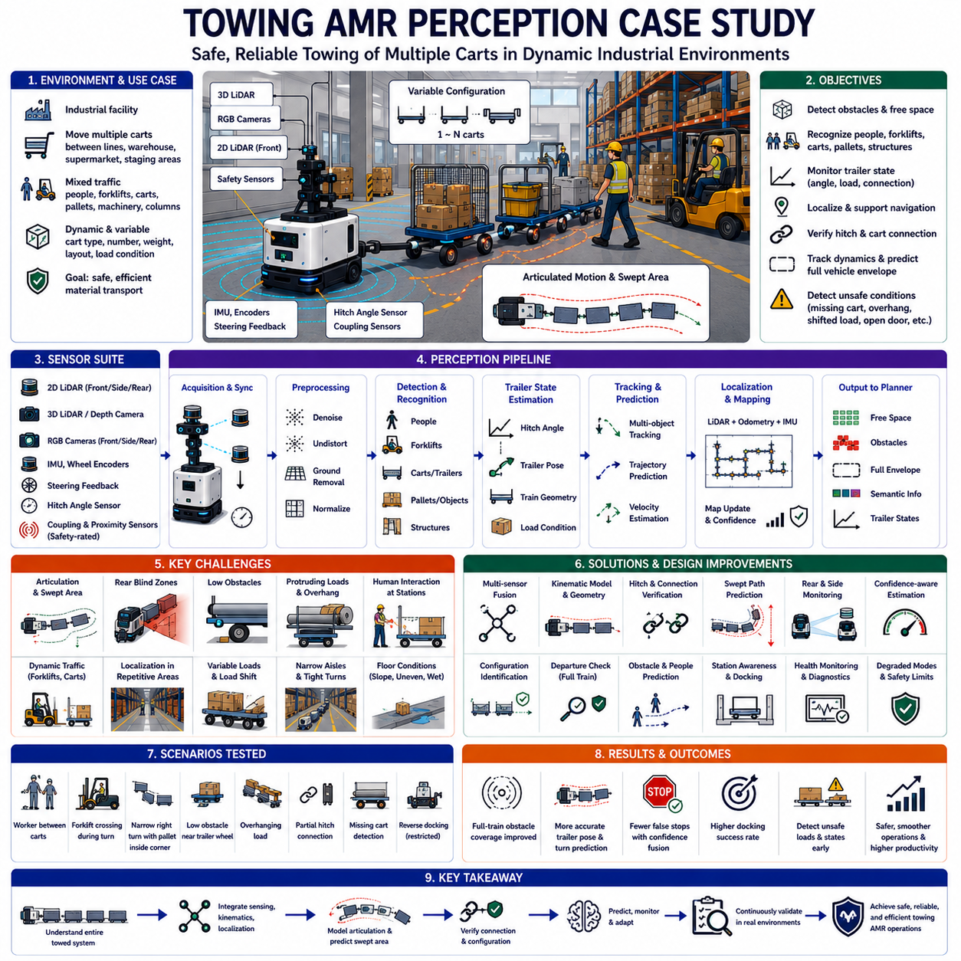
A towing autonomous mobile robot perception system must understand not only the vehicle itself but also the trailer, carts, racks, or material trains connected behind it. This creates a perception problem that is fundamentally different from that of a compact mobile robot. The effective vehicle length changes with each mission, the rear path does not follow the tractor path exactly, and articulation between connected units can generate wide swept areas during turns. Reliable operation therefore requires perception, localization, geometry modeling, and motion prediction to work as one coordinated system.
The case study considered a towing AMR used in an industrial facility to move multiple carts between production lines, supermarkets, warehouses, and logistics staging areas. The robot traveled through mixed traffic containing workers, forklifts, manually pushed carts, pallets, machinery, columns, safety fences, and temporary materials. Missions varied according to the number, type, weight, and arrangement of connected carts, making the vehicle geometry and dynamic response different for nearly every transport task.
The perception platform combined front and side two-dimensional LiDARs, three-dimensional LiDAR or depth cameras, RGB cameras, wheel encoders, an inertial measurement unit, steering feedback, hitch-angle sensing, and safety-rated proximity sensors. Rear-facing sensors were added because front sensors could not observe the complete trailer train during turns. The sensor arrangement was designed to monitor the tractor, coupling region, sides of the trailers, rear clearance, and the swept path created by articulation.
The primary perception objectives were obstacle detection, free-space estimation, human and vehicle recognition, trailer-state monitoring, localization support, hitch verification, dynamic-object tracking, and prediction of the complete vehicle envelope. The system also needed to detect missing carts, incorrect connections, excessive articulation, shifted loads, open cart doors, protruding materials, and obstacles trapped between connected units before motion was allowed.
Vehicle configuration identification was performed at the beginning of each mission. The robot confirmed the expected number of carts, hitch sequence, individual cart dimensions, load category, and total train length. Configuration data were compared with sensor observations and mission information. If the observed towing arrangement did not match the assigned configuration, the robot prevented autonomous departure and requested operator inspection.
The coupling area was treated as a safety-critical perception zone. A partially inserted hitch pin, misaligned drawbar, damaged connector, or obstacle between the robot and first cart could cause separation or collision. Cameras and proximity sensors observed the connection while mechanical and electrical feedback confirmed lock state. Motion was permitted only when visual, geometric, and hardware signals agreed that the coupling was secure.
Trailer articulation created the most important geometric challenge. During straight motion, the carts approximately followed the tractor path, but during turns each connection formed a different angle. The rear units cut inside the tractor trajectory and could strike columns, racks, people, or parked equipment. The perception and planning system therefore calculated a time-varying swept envelope using tractor pose, steering state, hitch angles, cart geometry, and estimated motion.
The system maintained a digital geometric model for every approved cart type. The model included length, width, axle position, wheelbase, hitch location, corner radius, ground clearance, sensor visibility, and allowed load overhang. Individual models were connected according to the active train configuration. This allowed the planner to predict the position of each cart rather than representing the complete system as one oversized rigid rectangle.
Hitch-angle sensing improved trailer-pose estimation but could not be trusted as the only source. Mechanical backlash, sensor offset, damaged wiring, and calibration drift could produce incorrect readings. LiDAR and camera observations of cart edges were therefore fused with kinematic prediction and hitch measurements. A disagreement monitor detected inconsistent trailer estimates and reduced speed or stopped the vehicle when uncertainty exceeded the accepted limit.
Rear blind zones were a major concern. Obstacles could enter behind the final cart while the robot was stopped, and a worker could approach the train from the side during loading. Rear-facing cameras and LiDAR monitored these regions, while short-range sensors covered areas close to the bumper and wheels. Before movement, the robot performed a complete departure check to confirm that the path around the entire train was clear.
Low obstacles were difficult to detect near cart wheels and under drawbars. Wooden blocks, loose straps, packaging material, tools, and broken pallet components could interfere with towing motion even when they did not present a direct collision threat to the tractor. Three-dimensional sensing and low-mounted safety sensors were used to observe these hazards. Conservative ground segmentation prevented shallow objects from being incorrectly classified as floor.
Protruding loads created another significant risk. Pipes, panels, boxes, and irregular components sometimes extended beyond the nominal cart boundary. A route that was safe for the standard cart geometry could become unsafe after loading. Side cameras and three-dimensional sensors estimated the actual occupied envelope and compared it with allowed limits. Excessive overhang or unstable load geometry caused mission rejection until the load was corrected.
Load shift during motion could also change the perceived vehicle shape. Sudden braking, uneven floors, or poor load restraint allowed materials to move within or beyond the cart. The system monitored side profiles, cart tilt, and unusual visual changes between departure and transit. When a significant difference was detected, the robot slowed, moved to a safe stopping point, and generated an inspection request rather than continuing with uncertain geometry.
Human detection was especially important near line-side delivery and collection stations. Workers frequently approached carts to load, unload, connect, disconnect, or inspect materials. Their bodies could be partially hidden behind carts, and only legs, arms, or upper bodies might be visible. The perception model used partial-person detection, temporal tracking, and station-context information to avoid starting while a person remained within the towing system’s hazardous zone.
Forklifts introduced high-speed interaction risks. A forklift could cross in front of the tractor, enter between trailers, or approach the rear of the train. Loads carried by forklifts changed their effective shape and sometimes obstructed the driver’s view. The AMR tracked the complete forklift envelope, velocity, and predicted trajectory. Safety margins increased when visibility was limited or when the forklift direction was uncertain.
Narrow aisle navigation required accurate lateral clearance estimation for every cart. Small tractor localization errors could become larger rear-position errors after several articulated connections. The system therefore combined map-based localization with local wall, rack, and floor-feature measurements. Trailer positions were continuously corrected using observed aisle geometry so that the rear units remained centered and did not drift toward shelves or structural posts.
Repeated industrial structures created localization ambiguity. Long rows of similar racks, identical columns, and repetitive floor markings reduced the uniqueness of local features. LiDAR localization was fused with odometry, inertial measurements, known station landmarks, and confidence monitoring. When localization uncertainty increased, the robot reduced speed and avoided tight maneuvers until a distinctive reference area restored reliable pose estimation.
Floor condition had a greater effect on towing behavior than on compact AMRs. Slopes, expansion joints, drainage channels, metal plates, damaged concrete, and wet surfaces changed wheel motion and articulation. Trailer wheels could deviate laterally or oscillate after crossing irregularities. Perception and motion estimation therefore monitored terrain transitions and vehicle response, allowing speed reduction before the complete train entered a difficult surface region.
Turning areas were validated using both map information and live perception. A theoretically sufficient corner could become blocked by temporary pallets, parked carts, or people. Before entering a turn, the system checked the entire predicted swept area instead of only the tractor path. If the rear clearance could not be confirmed, the robot waited, selected an alternative path, or requested removal of the obstruction.
Reverse motion was tightly restricted because trailer behavior becomes unstable and difficult to predict when pushed backward. The deployed system allowed reverse movement only for short, controlled docking or recovery operations with limited articulation. Rear and side sensing monitored all connected units, speed was substantially reduced, and automatic stopping occurred when trailer angles approached instability limits. Complex reversing was delegated to trained operators or redesigned out of normal missions.
Docking required precise alignment between the towing robot, carts, and station infrastructure. Pickup stations included guide rails, hitch targets, stops, markers, and defined approach corridors. The robot used high-resolution local perception to identify the hitch point and verify that the cart was correctly positioned. After connection, it performed a pull test and observed cart motion to confirm that the cart followed the tractor as expected.
Drop-off operations required equally careful perception. The robot verified the destination identity, available space, floor condition, and absence of people before releasing the cart. It also confirmed that the cart remained stable after disconnection and did not roll into the route. Station occupancy and cart placement were reported to the fleet system so that subsequent missions used accurate logistics information.
Sensor visibility changed according to the towing configuration. A tall load on the first cart could block rear cameras, while multiple carts could hide the final units from tractor-mounted sensors. The system evaluated sensor coverage for each mission configuration. Unsupported combinations were prohibited, and optional sensors mounted on carts or infrastructure were used for long trains or specialized loads requiring additional visibility.
Time synchronization was critical because tractor pose, steering angle, hitch angle, LiDAR scans, camera images, and wheel motion had to represent the same physical instant. Small timing errors produced incorrect trailer positions during turns. Hardware synchronization and precise timestamps were used where possible, while software monitoring detected offset and drift. Motion compensation aligned sensor observations before trailer geometry was updated.
The perception software was organized into acquisition, calibration, synchronization, obstacle detection, semantic recognition, trailer estimation, localization, swept-path prediction, fusion, and health monitoring. Each module reported frequency, latency, uncertainty, dropped data, and diagnostic state. This modular architecture allowed engineers to determine whether an unsafe envelope resulted from sensor failure, delayed processing, inaccurate hitch data, localization error, or kinematic modeling.
Field data collection covered empty and loaded carts, different train lengths, forward and reverse maneuvers, narrow aisles, intersections, slopes, docking stations, crowded line-side zones, and changing lighting. Special attention was given to rare events such as loose hitches, missing carts, shifted loads, people between trailers, protruding materials, blocked turns, and unexpected trailer oscillation. These scenarios formed the core of model training and validation.
Annotation included people, forklifts, carts, trailers, pallets, racks, columns, free space, low obstacles, protruding loads, coupling zones, and restricted regions. Trailer identity, articulation angle, load condition, visibility, and occlusion were also recorded. This enabled evaluation not only of object recognition but also of complete train geometry and safety-zone accuracy under realistic industrial conditions.
Offline testing measured detection recall, trailer-pose error, localization accuracy, swept-envelope prediction, hitch verification, tracking stability, latency, and false-stop frequency. However, operational metrics were equally important. Engineers measured docking success, mission completion, turn clearance, intervention rate, travel time, load damage, and the frequency of unsafe or unnecessary stops to connect perception quality with production performance.
Scenario-based validation included a worker entering between carts, a forklift crossing during a turn, a low obstacle near a trailer wheel, an overhanging load, a partially connected hitch, and a pallet blocking the rear swept path. Each scenario was repeated with different speeds, train lengths, directions, and sensor conditions. Expected robot behavior was defined before testing so that software versions could be compared consistently.
One critical test involved a worker standing beside the second cart while the tractor’s forward path remained clear. A tractor-focused obstacle detector would have allowed movement. The complete-system safety model recognized that the person occupied the articulated swept zone and prevented departure. This demonstrated why towing AMRs require perception of the entire connected vehicle rather than only the powered base.
Another test involved a narrow right turn with a temporary pallet positioned near the inside corner. The tractor could pass without contact, but the final cart would cut inward and collide. Swept-path prediction identified the future conflict before the turn began. The robot stopped at a safe location and requested obstruction removal instead of entering a position from which recovery would be difficult.
False stops were analyzed because overly conservative trailer envelopes reduced productivity. Localization noise, temporary LiDAR reflections, and uncertain cart-edge observations occasionally expanded the predicted footprint excessively. Engineers did not simply reduce safety margins. They improved calibration, temporal filtering, confidence estimation, and geometric consistency checks so that uncertainty decreased without weakening protection around real hazards.
Long-duration testing exposed gradual issues including hitch-sensor drift, camera contamination, loose mounts, memory growth, thermal throttling, and increasing processing latency. Trailer estimation became unstable before complete system failure occurred. Continuous health monitoring tracked calibration consistency, sensor disagreement, resource use, and timing trends. Maintenance warnings were generated before uncertainty reached a level that affected safe operation.
Degraded operating modes were explicitly defined. If a side sensor failed, the robot could continue only on routes with sufficient clearance and at reduced speed. If trailer-angle estimation became unreliable, turning and reverse motion were prohibited. If the final cart could not be observed, the mission stopped at a safe area. Degraded operation depended on verified residual capability rather than a general attempt to continue service.
Multi-robot and fleet coordination added contextual information but did not replace local perception. The fleet manager assigned routes, intersections, and station reservations, while each towing robot remained responsible for immediate safety around its complete train. Route planning considered vehicle length and turning requirements so that long trains were not sent through unsuitable aisles or congested areas.
Maintenance procedures were expanded to include hitch inspection, sensor cleaning, trailer-wheel condition, cart geometry verification, cable checks, mount tightness, synchronization status, and calibration validation. Approved cart dimensions were periodically compared with actual equipment because mechanical repairs could change alignment. Any collision, cart modification, or sensor replacement triggered a controlled verification process before autonomous service resumed.
The final system improved full-train obstacle coverage, trailer-pose estimation, turn prediction, docking reliability, and detection of unsafe loading conditions. False stops decreased after confidence-aware fusion and improved geometry checks were introduced. Operators gained greater trust because the robot reported why movement was prevented, such as uncertain hitch state, blocked swept path, human presence, or unsupported trailer configuration.
This case study demonstrates that towing AMR perception is a combined sensing, kinematics, localization, and safety problem. Accurate front obstacle detection alone is insufficient because the most significant risks often occur beside or behind the tractor. The system must continuously estimate every connected unit, predict its future occupied area, and verify that people, structures, and materials remain outside that space.
It also shows that towing configurations must be treated as mission-dependent system states. Cart type, train length, load shape, articulation, sensor coverage, route geometry, and floor condition all influence perception requirements. A fixed vehicle footprint cannot represent these variations reliably. Dynamic configuration management and geometry-aware validation are therefore essential for safe industrial deployment.
Ultimately, the towing AMR perception program succeeded by connecting raw sensing with complete vehicle behavior and production outcomes. Sensor data, hitch state, trailer geometry, localization, swept-path prediction, docking, fleet context, maintenance, and operator procedures were evaluated together. Through scenario testing, field-data collection, failure analysis, and continuous monitoring, the system achieved safer and more dependable material transport in complex industrial environments.

24.4 Outdoor Patrol Robot Case Study
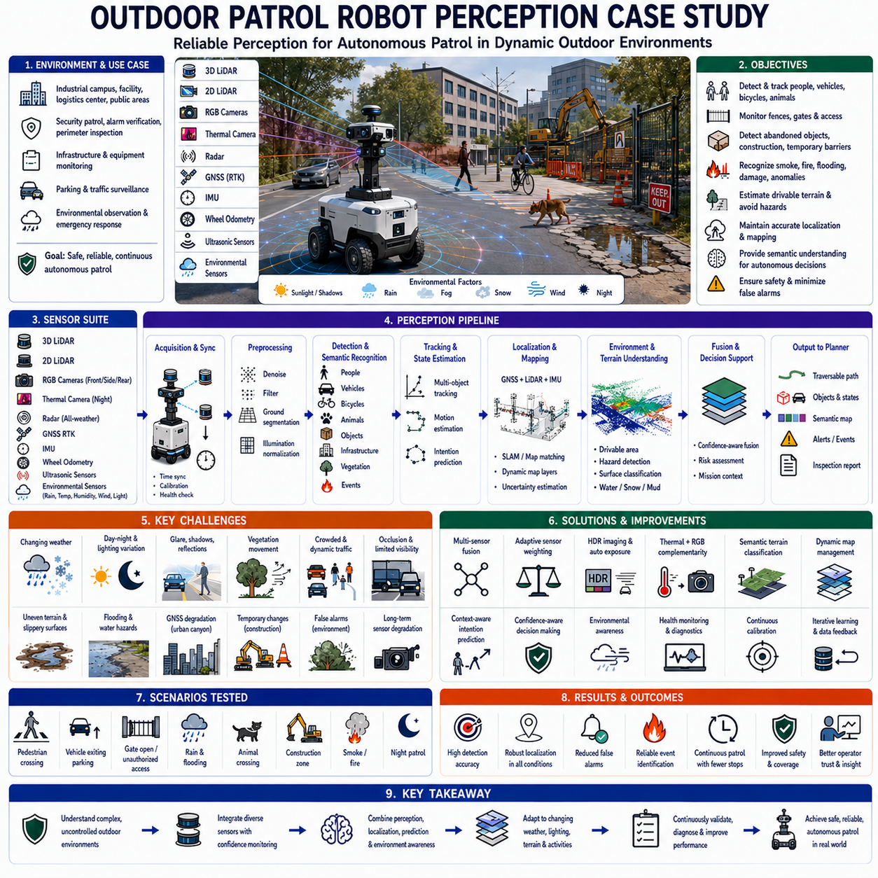
Outdoor patrol robots operate in one of the most demanding perception environments because they must function continuously in open spaces where lighting, weather, terrain, and surrounding activities change throughout the day. Unlike structured indoor facilities, outdoor environments cannot be controlled, and the robot must safely interact with pedestrians, vehicles, cyclists, animals, vegetation, construction activities, and unexpected obstacles. Reliable perception therefore becomes the foundation of autonomous security, safety inspection, infrastructure monitoring, and emergency response missions.
The case study examined an autonomous outdoor patrol robot deployed across an industrial campus, research facility, logistics center, and public access area. The robot performed scheduled patrols, alarm verification, perimeter inspection, equipment monitoring, parking surveillance, and environmental observation. Patrol routes included roads, sidewalks, parking lots, loading docks, green areas, bridges, tunnels, and building entrances. Mission success depended on maintaining reliable perception despite continuously changing environmental conditions.
The perception platform integrated three-dimensional LiDAR, two-dimensional LiDAR, multiple RGB cameras, thermal cameras, GNSS with Real-Time Kinematic positioning, an inertial measurement unit, wheel odometry, ultrasonic sensors, radar, and environmental sensors measuring rain, temperature, humidity, illumination, and wind conditions. Each sensor compensated for limitations in the others. The system continuously evaluated sensor quality and dynamically adjusted perception confidence according to environmental conditions and operational status.
The perception objectives extended far beyond obstacle avoidance. The robot was expected to detect people, vehicles, bicycles, motorcycles, animals, fences, gates, parked objects, abandoned packages, construction equipment, temporary barriers, smoke, fire, flooding, damaged infrastructure, unauthorized entry, and abnormal environmental conditions. At the same time, it needed to estimate traversable terrain, maintain accurate localization, recognize patrol checkpoints, and provide reliable semantic information for autonomous mission execution.
Weather represented one of the largest perception challenges. Bright sunlight, heavy shadows, rain, snow, fog, dust, and strong wind continuously changed sensor performance. Cameras suffered from glare, low contrast, and water droplets. LiDAR experienced increased noise during heavy precipitation, while thermal cameras behaved differently depending on ambient temperature and surface materials. Rather than assuming constant sensor quality, the perception system estimated environmental confidence and adapted sensor weighting in real time.
Lighting conditions varied dramatically throughout the day. Morning sunlight produced long shadows, midday created high contrast, evening generated low-angle reflections, and nighttime required infrared illumination and thermal sensing. Parking lots illuminated by streetlights produced nonuniform lighting patterns, while vehicle headlights created temporary overexposure. Adaptive exposure control, high dynamic range imaging, temporal filtering, and multi-camera fusion significantly improved visual robustness across all operating periods.
Outdoor terrain was considerably more diverse than indoor floors. Asphalt, concrete, gravel, grass, soil, mud, ramps, drainage channels, speed bumps, curbs, and uneven pavement all influenced vehicle behavior and perception quality. Surface appearance changed after rain or seasonal weather, making visual classification difficult. The perception system combined geometric measurements with semantic terrain classification to distinguish safe driving surfaces from hazardous ground conditions.
Vegetation introduced unique perception problems. Trees, bushes, tall grass, fallen leaves, and moving branches changed appearance according to wind, season, and growth. Leaves generated LiDAR returns that differed from rigid structures, while moving vegetation sometimes resembled dynamic obstacles. The perception pipeline classified vegetation separately from structural obstacles and evaluated whether movement resulted from wind rather than actual object motion.
Pedestrian detection required understanding a wide range of human behaviors. People walked individually or in groups, stood near buildings, crossed roads unexpectedly, carried large objects, pushed carts, rode bicycles, or interacted with parked vehicles. Clothing varied significantly according to weather and occupation. The perception model relied on semantic recognition, temporal tracking, motion prediction, and contextual understanding to estimate human intentions rather than simply detecting human presence.
Vehicle recognition extended beyond identifying moving cars. The robot distinguished parked vehicles, delivery trucks, maintenance equipment, forklifts, emergency vehicles, motorcycles, bicycles, and construction machinery. Vehicle state estimation included motion direction, speed, parking status, hazard-light activation, and occupancy. Predicting future movement allowed the navigation system to maintain safe distances without unnecessary stops that would reduce patrol efficiency.
Animals represented an unpredictable obstacle category. Birds, cats, dogs, and occasionally larger wildlife crossed patrol routes without warning. Animal appearance and movement differed substantially from humans and vehicles. Some animals ignored the robot while others reacted to its presence. The perception system categorized animals separately and adjusted avoidance behavior according to estimated size, speed, trajectory, and environmental context rather than applying identical policies used for human interaction.
Fence and perimeter inspection formed one of the robot's primary security missions. Cameras and LiDAR continuously examined fence alignment, gate position, damaged panels, fallen objects, unauthorized openings, and accumulated debris. Image analysis identified broken structures, while geometric measurements detected deformations that were difficult to observe visually. Detected anomalies were compared with historical inspection records before generating maintenance or security alerts.
Gate monitoring required continuous semantic understanding. Entry gates changed between open and closed states throughout daily operations. Temporary maintenance work or delivery operations sometimes left gates partially open. The perception system combined object detection, geometric reasoning, and access schedule information to distinguish expected operational changes from genuine security violations requiring immediate operator notification.
Construction activities continuously modified the operating environment. Temporary fencing, cones, barriers, scaffolding, parked machinery, material storage, and excavation work altered normal routes. The mapping system distinguished permanent infrastructure from temporary environmental changes. Dynamic map layers prevented temporary obstacles from permanently modifying the global map while allowing immediate navigation around newly created work zones.
Localization accuracy remained essential despite environmental variation. GNSS provided centimeter-level positioning under open skies but degraded near buildings, trees, tunnels, and elevated structures. LiDAR localization complemented satellite positioning by matching observed geometry with prior maps. Wheel odometry and inertial sensing bridged temporary localization degradation. Confidence estimation continuously evaluated positioning quality and selected the most reliable localization source under changing conditions.
Urban canyons and dense infrastructure introduced multipath effects that reduced satellite positioning accuracy. Metallic structures reflected GNSS signals, while large buildings blocked portions of the sky. Rather than relying exclusively on satellite positioning, the perception framework integrated LiDAR registration, visual landmarks, inertial estimation, and map constraints. Sensor redundancy prevented localization failure when any individual positioning method temporarily degraded.
Road intersections represented complex perception environments. Multiple vehicles, pedestrians, bicycles, parked cars, traffic signs, and temporary obstacles interacted simultaneously. The robot predicted the trajectories of multiple moving objects while estimating potential conflict regions. Navigation decisions considered not only current object positions but also expected future motion, enabling smooth and safe crossing behavior without excessive conservatism.
Crosswalk monitoring required particularly careful human prediction. Pedestrians approaching a crossing might stop, continue walking, suddenly change direction, or begin crossing after making eye contact with approaching traffic. The robot monitored pedestrian body orientation, walking speed, gaze direction, and relative position. Intention prediction reduced abrupt braking while maintaining conservative safety behavior whenever uncertainty remained high.
Outdoor patrol missions frequently included parking areas. Large numbers of parked vehicles created repetitive visual patterns that complicated localization. Cars arrived and departed throughout the day, continuously modifying the environment. The perception system treated parked vehicles as temporary objects rather than stable landmarks. Structural features such as buildings, poles, fences, and permanent road markings provided more reliable localization references.
Weather influenced thermal perception differently than visible imagery. During daytime, sunlight heated surfaces unevenly, reducing thermal contrast between people and surrounding structures. At night, human body temperature became significantly more distinguishable. Rain cooled infrastructure while machinery often remained warm. Thermal sensing therefore complemented RGB imagery but required environmental interpretation before reliable object classification could be achieved.
Rain created several perception difficulties simultaneously. Camera images lost contrast because of water droplets and reflections. LiDAR returns became noisier due to precipitation, while puddles changed surface appearance. Tire spray from nearby vehicles temporarily reduced visibility. Radar maintained relatively stable performance under these conditions and therefore received increased weighting during sensor fusion whenever optical sensor confidence decreased.
Fog reduced long-range visibility and significantly affected camera performance. Visual landmarks disappeared while distant obstacles became difficult to classify. Three-dimensional LiDAR maintained better geometric perception but also experienced reduced effective range. Sensor fusion estimated observation reliability as a function of measured visibility. Navigation speed automatically decreased according to available perception distance, ensuring sufficient stopping capability under degraded environmental conditions.
Snow produced additional challenges because road markings, curbs, grass, sidewalks, and small obstacles became partially covered. Previously traversable areas could become hazardous because of ice or accumulated snow. The robot compared current observations with historical maps and estimated terrain uncertainty rather than assuming that visual appearance alone accurately represented safe driving conditions.
Water accumulation following rainfall required dedicated hazard detection. Flooded pavement, drainage overflow, and puddles varied in depth and visibility. Cameras often underestimated water depth because reflective surfaces resembled ordinary pavement. Three-dimensional sensing, terrain modeling, and historical drainage information improved hazard estimation. The patrol system avoided uncertain water areas until their traversability could be confirmed with sufficient confidence.
Outdoor patrol robots also monitored infrastructure health. Cameras inspected lighting poles, fire hydrants, electrical cabinets, emergency phones, security cameras, fences, signs, and utility equipment. Image comparison with historical reference data identified gradual deterioration, corrosion, missing components, graffiti, and accidental damage. Infrastructure monitoring transformed the patrol robot into a continuous mobile inspection platform rather than merely a security vehicle.
Abnormal event detection extended beyond ordinary object recognition. Smoke, flames, flooding, fallen trees, road blockages, abandoned packages, unusual vehicle parking, crowd formation, and unauthorized perimeter access required semantic interpretation rather than simple classification. Event reasoning combined multiple sensor observations with patrol history, location context, and operational schedules before generating alarms to reduce false notifications.
Multi-sensor fusion served as the central component of the perception architecture. Cameras provided semantic understanding, LiDAR produced accurate geometry, radar measured moving objects reliably under poor weather, thermal cameras improved nighttime human detection, GNSS supplied global positioning, and inertial sensors maintained motion continuity. Confidence-aware fusion continuously adjusted the contribution of each sensing modality according to current environmental conditions and diagnostic health.
The perception software consisted of acquisition, synchronization, calibration, semantic recognition, geometric reconstruction, object tracking, localization, mapping, event analysis, mission support, and health monitoring modules. Each module continuously reported latency, processing frequency, confidence, synchronization quality, computational load, and diagnostic information. Comprehensive logging allowed engineers to identify failures caused by sensing, localization, environmental degradation, or software performance.
Extensive field data collection covered daytime, nighttime, sunrise, sunset, rain, fog, snow, strong wind, crowded public events, maintenance activities, emergency exercises, seasonal vegetation changes, construction work, and routine security patrols. Rare events including unauthorized intrusion, abandoned objects, damaged fences, flooded roads, animal crossings, and emergency vehicle interactions received particular attention because they represented operationally important yet infrequently observed scenarios.
Annotation included semantic classes for people, vehicles, bicycles, animals, buildings, fences, gates, vegetation, temporary obstacles, infrastructure assets, weather effects, terrain categories, water, snow, construction equipment, and abnormal events. Temporal consistency, object motion, visibility, environmental conditions, and sensor confidence were also recorded. These annotations enabled evaluation of perception quality under realistic long-duration operational conditions.
Offline evaluation measured detection accuracy, localization error, object tracking stability, semantic segmentation quality, event recognition, false alarm frequency, computational latency, and environmental robustness. Operational evaluation extended beyond perception metrics by examining patrol completion rate, response time, operator intervention frequency, infrastructure inspection quality, security coverage, and mission reliability under continuously changing outdoor environments.
Scenario-based validation included pedestrians crossing roads, vehicles exiting parking areas, gates opening unexpectedly, flooding after rainfall, animals entering patrol zones, construction barriers appearing overnight, smoke generation exercises, fence damage, emergency vehicle interaction, and nighttime security patrols. Each scenario was repeated under different weather, lighting, traffic, and environmental conditions to verify perception consistency before operational deployment.
One representative scenario involved a maintenance worker unloading equipment from a parked truck near a facility entrance. Initially, the truck partially occluded the worker, leaving only intermittent body visibility. Temporal tracking, contextual reasoning, and motion prediction maintained continuous awareness despite incomplete observations. The robot reduced speed and adjusted its planned trajectory until the worker safely cleared the operational area.
Another important scenario occurred after heavy rainfall when a flooded section of pavement reflected the surrounding sky. Conventional vision algorithms incorrectly classified the surface as ordinary pavement. Three-dimensional terrain estimation combined with historical elevation data identified the abnormal water accumulation. The robot selected an alternative route rather than attempting to traverse an uncertain surface that might exceed safe operating limits.
False alarms represented a major operational concern because unnecessary operator intervention reduced trust in autonomous patrol. Moving tree branches, reflections, drifting fog, small animals, and changing shadows occasionally produced incorrect detections. Instead of reducing detection sensitivity, engineers improved temporal verification, environmental context analysis, confidence estimation, and multi-sensor consistency checking. This significantly lowered false alarm frequency while preserving reliable hazard detection.
Long-duration deployment revealed gradual degradation mechanisms including camera contamination, LiDAR window dirt, GNSS antenna obstruction, thermal sensor drift, memory fragmentation, communication delays, and increasing processor temperature. Health monitoring continuously evaluated sensor quality, calibration consistency, synchronization accuracy, and computational performance. Maintenance recommendations were generated before perception degradation affected patrol safety or mission effectiveness.
Degraded operating modes were carefully defined according to available sensing capability. During partial sensor failures, the robot reduced maximum speed, increased obstacle margins, restricted operation to previously validated routes, and disabled complex maneuvers when necessary. If localization confidence fell below acceptable thresholds, autonomous patrol stopped and operator assistance was requested rather than risking uncertain navigation in public environments.
Fleet management enhanced patrol efficiency but did not replace local perception. Multiple robots shared patrol coverage, exchanged environmental updates, and coordinated responses to detected events. However, every robot remained independently responsible for immediate obstacle detection, human interaction, and local safety. Distributed perception combined with centralized mission management created a robust and scalable security patrol architecture.
Routine maintenance procedures included cleaning optical surfaces, inspecting sensor alignment, validating GNSS antenna placement, verifying calibration, testing communication systems, updating maps, checking environmental sensors, and reviewing diagnostic logs. Following collisions, severe weather exposure, or hardware replacement, comprehensive perception validation ensured that autonomous operation resumed only after system performance satisfied predefined safety requirements.
The completed perception system demonstrated significant improvements in environmental robustness, localization reliability, human detection, infrastructure inspection accuracy, abnormal event recognition, and patrol continuity. Confidence-aware sensor fusion reduced unnecessary mission interruptions while maintaining conservative safety behavior under uncertain conditions. Operators gained increased confidence because every perception decision included diagnostic evidence explaining the reasoning behind generated warnings and navigation actions.
This case study demonstrates that outdoor patrol robot perception extends far beyond obstacle avoidance. Reliable autonomous security requires continuous understanding of dynamic environments, changing weather, infrastructure conditions, human activities, vehicle behavior, and environmental hazards. Perception must integrate semantic understanding, geometry, localization, prediction, environmental awareness, and system diagnostics into a unified operational framework.
It also demonstrates that environmental adaptation is essential for long-term autonomous deployment. Sensor performance continuously changes with lighting, weather, temperature, contamination, and seasonal variation. Static perception models cannot maintain consistent reliability under these conditions. Continuous confidence estimation, adaptive sensor fusion, and long-term environmental learning therefore become critical capabilities for dependable outdoor autonomy.
Ultimately, the outdoor patrol robot perception program succeeded because it evaluated sensing, localization, environmental interpretation, mission execution, infrastructure inspection, and operational safety as one integrated system. Continuous field validation, diverse environmental datasets, scenario-based testing, health monitoring, adaptive perception, and iterative improvement enabled reliable autonomous patrol across complex outdoor environments throughout extended operational deployments.

24.5 GPR Robot Perception Case Study
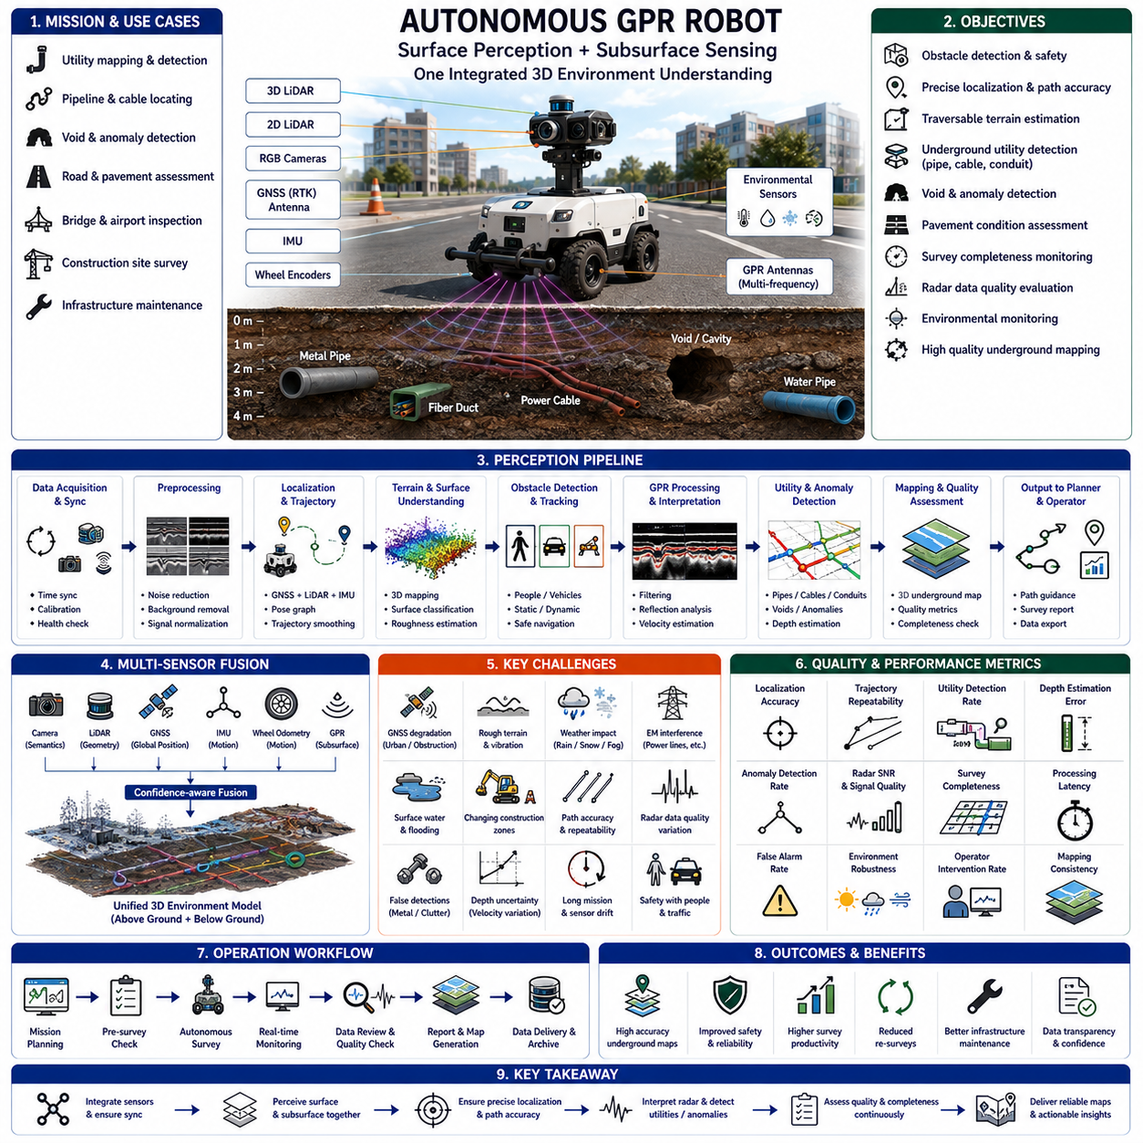
Ground Penetrating Radar robots operate in a unique perception environment because they must simultaneously understand both the visible world above the ground and the hidden structures beneath the surface. Unlike conventional autonomous robots that perceive only surrounding objects, a GPR robot integrates navigation perception with subsurface sensing to identify underground utilities, pipelines, cables, voids, buried infrastructure, and geological anomalies. Reliable operation therefore depends on the continuous fusion of localization, terrain understanding, radar interpretation, and environmental awareness.
The case study examined an autonomous GPR robot deployed for utility mapping, underground infrastructure inspection, road maintenance surveys, airport pavement assessment, and construction site investigation. The robot traveled along roads, sidewalks, parking areas, bridges, industrial facilities, and open construction zones while collecting synchronized ground-penetrating radar data. Mission success required maintaining precise trajectory control because even small localization errors could significantly reduce the quality of reconstructed underground maps.
The perception platform integrated multi-frequency Ground Penetrating Radar antennas, three-dimensional LiDAR, two-dimensional LiDAR, RGB cameras, GNSS with Real-Time Kinematic positioning, inertial measurement units, wheel encoders, environmental sensors, and terrain measurement sensors. Surface perception continuously monitored obstacles, road conditions, traffic, and environmental hazards, while GPR collected electromagnetic reflections from subsurface structures. Both perception domains were synchronized into a common spatial reference frame to enable accurate underground mapping.
The primary perception objectives included obstacle detection, traversable terrain estimation, localization, underground anomaly detection, utility recognition, pavement condition assessment, survey path verification, radar quality evaluation, environmental monitoring, and mission progress estimation. Unlike ordinary mobile robots, the perception system needed to guarantee that every radar measurement corresponded to an accurately estimated vehicle position because spatial registration directly determined mapping quality.
Localization represented one of the most critical components of the complete system. Ground Penetrating Radar measurements have little value if their positions cannot be reconstructed accurately. GNSS RTK provided centimeter-level positioning in open environments, while LiDAR localization, wheel odometry, and inertial estimation compensated whenever satellite signals became unreliable. Continuous localization confidence estimation allowed the robot to detect positioning degradation before survey quality was affected.
Survey path accuracy was considerably more important than travel efficiency. Conventional autonomous navigation often accepts several centimeters of trajectory variation while maintaining safe movement. GPR surveys, however, required repeated parallel scanning with highly consistent spacing to avoid gaps in underground coverage. The navigation system therefore emphasized path repeatability, lateral accuracy, heading stability, and motion smoothness instead of minimizing travel time.
Terrain perception directly influenced radar measurement quality. Large bumps, potholes, uneven pavement, loose gravel, drainage channels, speed bumps, and steep slopes changed antenna height relative to the ground surface. Because electromagnetic coupling depends strongly on antenna-to-ground distance, surface geometry significantly affected radar signal quality. The perception system estimated terrain roughness and automatically adjusted driving speed to maintain stable sensing conditions.
Road surface classification became an essential perception function. Asphalt, concrete, brick pavement, compacted soil, gravel, grass, and reinforced surfaces each produced different radar propagation characteristics. Surface materials also influenced wheel slip, vibration, and localization performance. Semantic terrain classification therefore supported both autonomous navigation and adaptive radar signal interpretation throughout the survey mission.
Weather conditions affected both surface perception and underground sensing. Rain increased soil moisture, changing electromagnetic wave propagation beneath the surface while simultaneously reducing camera visibility. Snow partially covered pavement markings and modified terrain appearance. Strong sunlight produced camera glare, whereas fog reduced long-range visual detection. Environmental sensors continuously measured operating conditions so radar interpretation algorithms could consider changing subsurface propagation characteristics during data processing.
Surface water introduced additional complexity. Puddles, flooded pavement, drainage overflow, and wet soil altered electromagnetic properties while also producing reflections in optical sensors. Water depth could not always be estimated reliably using ordinary cameras because reflective surfaces resembled dry pavement. Three-dimensional terrain sensing combined with environmental measurements allowed the robot to distinguish shallow standing water from potentially hazardous flooded areas while documenting conditions that influenced radar performance.
Vegetation represented another important operational consideration. Grass, leaves, bushes, and roadside vegetation occasionally covered the intended survey path or partially obscured pavement boundaries. Although vegetation usually had limited influence on underground radar measurements, it affected localization, obstacle detection, and path planning. The perception system distinguished temporary vegetation from permanent structures while ensuring that survey trajectories remained aligned with planned inspection corridors.
Construction zones created highly dynamic environments. Temporary barriers, cones, parked machinery, stored materials, open trenches, and partially completed pavement continuously modified the operating environment. The perception system separated permanent infrastructure from temporary changes and updated local maps accordingly. Dynamic environmental interpretation allowed surveys to continue safely without permanently altering the global infrastructure database.
Pedestrian detection remained essential despite the specialized sensing mission. Survey operations frequently occurred near public roads, sidewalks, airports, campuses, or industrial facilities where workers and pedestrians crossed the robot's planned trajectory. Human detection combined RGB imagery, LiDAR geometry, temporal tracking, and motion prediction. Survey missions prioritized human safety above measurement efficiency by temporarily pausing data collection whenever safe clearance could not be guaranteed.
Vehicle interaction required careful prediction because GPR robots often operated near active traffic lanes. Passenger vehicles, trucks, maintenance equipment, bicycles, forklifts, and emergency vehicles could approach from multiple directions. The perception framework estimated object trajectories, closing speeds, and interaction zones before selecting appropriate navigation responses. Survey continuity was considered secondary to maintaining safe operation within shared transportation environments.
Underground utility detection formed the central mission objective. Electromagnetic reflections from metallic pipes, plastic conduits, electrical cables, fiber-optic ducts, reinforced concrete, buried tanks, and geological interfaces appeared as characteristic radar signatures. Automated interpretation algorithms analyzed reflection intensity, continuity, depth, shape, and temporal consistency. Machine learning models supported classification, while human experts verified uncertain detections during post-processing.
Void detection required different interpretation strategies. Underground cavities, sinkholes, poorly compacted soil, erosion zones, and abandoned infrastructure produced subtle radar responses that differed from ordinary utility reflections. The perception system evaluated geometric consistency across multiple adjacent scan lines instead of relying solely on individual radar profiles. Multi-pass analysis significantly improved confidence in identifying hazardous underground conditions before maintenance activities began.
Depth estimation depended on accurate electromagnetic velocity modeling. Soil composition, moisture content, density, and material type all influenced radar wave propagation speed. Environmental observations, historical survey information, calibration measurements, and adaptive signal processing contributed to velocity estimation. Reliable depth calculation therefore required combining radar physics with contextual environmental perception rather than assuming constant propagation conditions.
Radar data quality continuously changed throughout long survey missions. Antenna vibration, temperature variation, wheel slip, terrain irregularities, electromagnetic interference, and localization drift gradually affected measurement reliability. The perception framework monitored signal-to-noise ratio, antenna stability, synchronization accuracy, positioning confidence, and vehicle motion quality. Measurements collected under unacceptable conditions were automatically flagged for review or repeated during subsequent surveys.
Electromagnetic interference occasionally degraded radar performance. High-voltage power lines, communication transmitters, industrial equipment, nearby vehicles, and electrical infrastructure introduced unwanted signals into radar measurements. Environmental perception identified likely interference sources using camera observations, infrastructure databases, and geographic context. Radar processing algorithms then adjusted filtering parameters to reduce interference while preserving meaningful underground reflections.
Time synchronization represented a fundamental requirement because every radar pulse, vehicle pose, LiDAR scan, camera frame, and localization estimate needed to correspond to the same physical instant. Even small synchronization errors accumulated into significant spatial mapping inaccuracies over long survey distances. Hardware timing, precise timestamps, and continuous synchronization diagnostics ensured that multimodal datasets remained spatially consistent throughout mission execution.
Surface mapping and subsurface mapping operated together within a unified perception architecture. Three-dimensional LiDAR generated environmental geometry, cameras provided semantic interpretation, GNSS established global positioning, inertial sensing maintained motion continuity, and GPR measured underground structures. The mapping system connected visible infrastructure with hidden underground assets, allowing engineers to interpret buried utilities within their complete environmental context.
Infrastructure inspection extended beyond underground utility detection. The robot simultaneously examined pavement cracks, surface deformation, road markings, drainage systems, expansion joints, curbs, bridge decks, and visible structural defects. Surface imagery was compared with historical inspections to identify deterioration trends. Integrating surface and subsurface inspection within one mission significantly improved infrastructure maintenance efficiency while reducing repeated field operations.
Survey completeness monitoring became an important perception function. The system continuously evaluated whether every planned corridor had been scanned with sufficient overlap, positioning accuracy, and radar quality. Missing regions caused by unexpected obstacles, localization uncertainty, or interrupted operation were automatically identified. Operators received immediate feedback regarding survey coverage before leaving the inspection site, preventing expensive return visits caused by incomplete data collection.
Multi-sensor fusion connected all available observations into one consistent environmental model. Cameras provided semantic context, LiDAR measured precise geometry, GNSS supplied global coordinates, inertial sensors estimated motion, wheel encoders supported dead reckoning, environmental sensors described operating conditions, and GPR revealed hidden underground structures. Confidence-aware fusion dynamically balanced information according to measurement reliability, environmental conditions, and diagnostic health.
The perception software consisted of acquisition, synchronization, calibration, localization, terrain understanding, obstacle detection, radar preprocessing, anomaly detection, utility classification, mapping, quality assessment, mission monitoring, and health diagnostics. Each module continuously reported latency, synchronization quality, computational load, confidence, localization uncertainty, and radar signal integrity. Comprehensive diagnostics enabled engineers to distinguish navigation problems from radar interpretation failures.
Extensive field data collection covered highways, city streets, airport pavements, industrial facilities, parking lots, sidewalks, bridges, tunnels, construction zones, grass-covered areas, and utility corridors. Data were collected under different weather, temperatures, soil moisture conditions, lighting, and traffic levels. Rare situations including flooded roads, damaged pavement, underground voids, multiple overlapping utilities, and severe localization degradation received special attention because they represented operationally significant challenges.
Annotation included pavement materials, terrain categories, visible infrastructure, obstacles, survey boundaries, underground utilities, buried anomalies, radar confidence, environmental conditions, localization quality, and synchronization status. Underground objects were labeled using engineering survey records whenever available. Combining radar interpretation with verified infrastructure documentation greatly improved supervised learning performance for automatic underground feature recognition.
Offline evaluation measured localization accuracy, trajectory repeatability, radar signal quality, utility detection performance, depth estimation error, anomaly classification accuracy, obstacle detection, computational latency, and synchronization consistency. Operational evaluation additionally examined survey completeness, inspection productivity, operator intervention frequency, infrastructure mapping accuracy, and long-term data consistency across repeated inspections of identical locations.
Scenario-based validation included underground pipeline mapping, buried cable detection, bridge deck inspection, airport runway assessment, construction-site utility surveys, flooded pavement inspection, road-maintenance evaluation, pedestrian interaction, temporary road closures, and degraded GNSS conditions. Every scenario was repeated under different environmental conditions to verify that perception quality remained consistent despite changing operating environments.
One representative scenario involved surveying a busy roadway where parked vehicles temporarily blocked portions of the planned route. Rather than abandoning the mission, the perception system recorded incomplete survey regions, safely navigated around obstacles, and automatically scheduled missing sections for later rescanning. This preserved overall mapping quality while maintaining safe interaction with surrounding traffic.
Another important scenario occurred after heavy rainfall when increased soil moisture significantly altered radar wave propagation. Traditional processing using fixed propagation assumptions produced inaccurate depth estimates. The perception framework incorporated environmental measurements and adaptive velocity estimation to improve underground depth calculation while clearly indicating remaining uncertainty for engineering interpretation.
False underground detections represented a significant operational challenge. Metallic debris, reinforced pavement, underground reflections, and electromagnetic interference occasionally produced signatures resembling buried utilities. Instead of relying solely on single radar scans, the perception framework combined repeated observations, neighboring scan consistency, localization accuracy, historical infrastructure records, and confidence estimation. This substantially reduced false utility identification while preserving sensitivity to genuine underground structures.
Long-duration deployment identified gradual degradation including antenna wear, wheel calibration drift, sensor contamination, GNSS antenna obstruction, synchronization drift, thermal variation, memory growth, and processor temperature increase. Continuous health monitoring detected these trends before survey quality declined below acceptable engineering standards. Preventive maintenance recommendations were generated automatically based on diagnostic evidence collected during routine operation.
Degraded operating modes ensured safe and reliable surveying despite partial system failures. If GNSS quality deteriorated, LiDAR localization and inertial estimation temporarily assumed greater responsibility. If radar quality fell below predefined limits, the system continued navigation but suspended underground data collection until acceptable sensing conditions returned. Mission decisions always prioritized engineering data quality rather than merely completing planned travel routes.
Fleet operation enabled multiple GPR robots to cooperate on large infrastructure projects. Survey regions were divided automatically, environmental observations were shared, and completed coverage was synchronized through centralized mission management. Nevertheless, every robot independently maintained obstacle avoidance, localization integrity, radar quality monitoring, and safety functions. Distributed perception combined with coordinated planning improved scalability without reducing local operational robustness.
Routine maintenance procedures included antenna inspection, calibration verification, synchronization testing, sensor cleaning, wheel measurement validation, localization reference checking, environmental sensor calibration, and diagnostic log review. After hardware replacement, collisions, or severe environmental exposure, comprehensive perception validation confirmed that positioning accuracy, radar quality, and synchronization performance satisfied engineering survey requirements before autonomous operation resumed.
The completed perception system demonstrated substantial improvements in localization reliability, radar registration accuracy, underground utility detection, survey completeness, infrastructure inspection quality, environmental adaptation, and long-term operational consistency. Confidence-aware sensor fusion reduced unnecessary rescanning while maintaining conservative engineering quality standards. Diagnostic transparency also increased operator confidence by clearly explaining data quality, uncertainty sources, and survey limitations.
This case study demonstrates that Ground Penetrating Radar robot perception extends far beyond conventional autonomous navigation. Reliable underground mapping requires precise localization, adaptive environmental understanding, radar interpretation, infrastructure awareness, terrain analysis, and comprehensive quality monitoring. Surface perception and subsurface sensing must operate together as one integrated measurement system rather than independent sensing components.
It also demonstrates that engineering survey robots require perception systems designed for measurement quality instead of transportation efficiency. Every localization estimate, radar observation, synchronization event, and environmental measurement directly influences the reliability of reconstructed underground infrastructure maps. Continuous confidence estimation, adaptive sensor fusion, and rigorous survey validation therefore become essential capabilities for dependable autonomous geophysical inspection.
Ultimately, the Ground Penetrating Radar robot perception program succeeded because sensing, localization, terrain understanding, underground interpretation, environmental adaptation, quality assurance, and operational workflow were evaluated together as one complete engineering system. Continuous field validation, diverse survey datasets, scenario-based testing, adaptive perception, comprehensive diagnostics, and iterative refinement enabled reliable autonomous underground infrastructure mapping across complex real-world environments.

24.6 Agricultural Robot Perception Case Study
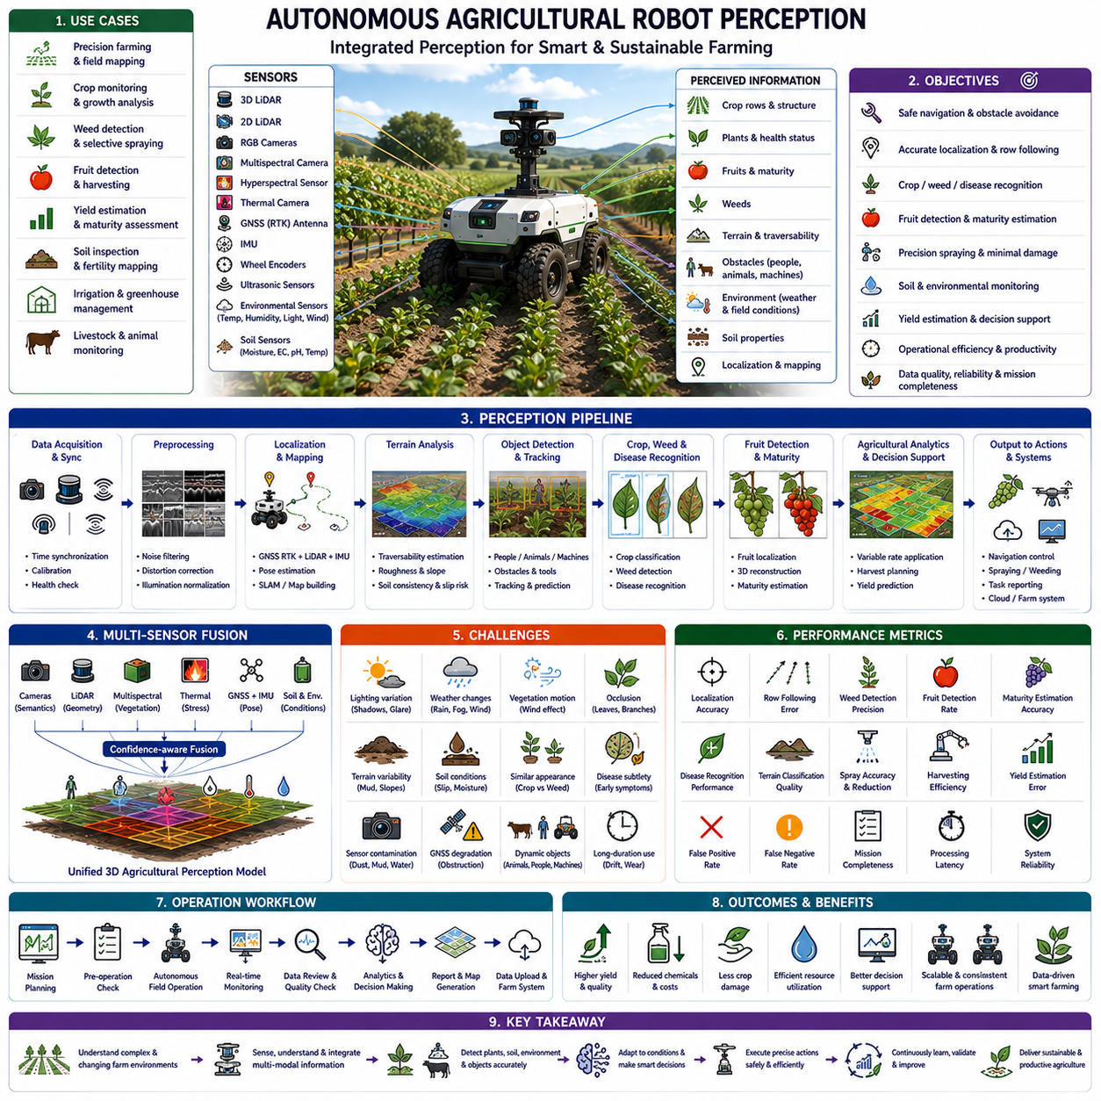
Agricultural robots operate in one of the most dynamic perception environments because natural fields continuously change with weather, seasons, crop growth, soil conditions, and biological activity. Unlike structured industrial facilities where the environment is intentionally controlled, farms contain irregular terrain, moving vegetation, varying illumination, animals, humans, machinery, and constantly changing crop geometry. Reliable perception therefore requires continuous adaptation while maintaining safe navigation, precise crop understanding, and efficient agricultural operations throughout extended field missions.
This case study investigated autonomous agricultural robots deployed for precision farming, crop monitoring, weed control, selective spraying, harvesting assistance, yield estimation, soil inspection, and field mapping. The robots operated in orchards, vineyards, vegetable farms, grain fields, greenhouses, and open agricultural environments. Mission success depended on simultaneously understanding terrain, crops, obstacles, environmental conditions, and agricultural objectives while minimizing damage to plants and maximizing operational productivity.
The perception platform integrated three-dimensional LiDAR, two-dimensional LiDAR, RGB cameras, multispectral cameras, hyperspectral sensors, thermal cameras, GNSS with Real-Time Kinematic positioning, inertial measurement units, wheel encoders, ultrasonic sensors, environmental monitoring sensors, and soil measurement sensors. Each sensing modality contributed unique information regarding plant structure, field geometry, crop health, navigation, and environmental conditions. Multi-modal perception produced a comprehensive understanding of both the physical field and the biological state of cultivated crops.
The primary perception objectives included crop row detection, traversable terrain estimation, obstacle detection, crop classification, weed identification, fruit detection, maturity estimation, disease recognition, localization, environmental monitoring, and mission progress evaluation. Unlike conventional autonomous vehicles, agricultural robots required semantic understanding not only of obstacles but also of the biological condition of individual plants because navigation decisions directly influenced crop productivity and harvesting efficiency.
Localization remained a fundamental requirement despite relatively open environments. GNSS RTK generally provided centimeter-level positioning, but trees, greenhouses, hills, irrigation structures, and dense vegetation occasionally degraded satellite reception. LiDAR localization, visual landmarks, wheel odometry, and inertial estimation compensated whenever positioning confidence decreased. Continuous localization assessment ensured that spraying, harvesting, and inspection tasks remained spatially accurate throughout long agricultural operations.
Crop row detection represented one of the most important perception capabilities. Agricultural fields are organized according to planting geometry, and successful navigation depends on accurately recognizing row boundaries despite variations in crop height, density, color, and seasonal growth. The perception system combined three-dimensional geometry with semantic image segmentation to identify row centers, estimate row width, detect missing plants, and maintain stable vehicle alignment throughout field traversal.
Terrain perception differed substantially from ordinary road navigation. Agricultural robots encountered loose soil, mud, grass, irrigation channels, rocks, crop residues, uneven ground, steep slopes, and recently cultivated areas. Soil deformation continuously changed wheel traction and vehicle stability. The perception framework estimated terrain roughness, soil consistency, traversability, and slip probability while adapting vehicle speed and path planning to minimize both safety risks and crop damage.
Crop classification required recognizing numerous plant species under continuously changing environmental conditions. Differences in leaf shape, stem structure, canopy geometry, color, and growth stage provided important classification cues. Seasonal variation significantly altered crop appearance, making static visual models insufficient. The perception system integrated structural features, multispectral signatures, temporal observations, and contextual agricultural knowledge to improve classification robustness throughout the growing season.
Weed detection formed the foundation of precision agriculture. Traditional spraying applies chemicals uniformly across entire fields, whereas autonomous agricultural robots identify individual weeds and selectively apply herbicides only where required. Accurate weed recognition therefore reduced chemical consumption, environmental impact, and operating costs. The perception framework distinguished weeds from crops using high-resolution imagery, semantic segmentation, plant morphology, multispectral information, and spatial relationships within planting rows.
Fruit detection required understanding highly cluttered natural environments. Fruits were frequently partially occluded by leaves, branches, stems, shadows, and neighboring fruit clusters. Illumination varied dramatically throughout the day, while fruit color gradually changed during maturation. Multi-view perception, temporal tracking, three-dimensional reconstruction, and adaptive illumination normalization significantly improved detection reliability despite these complex environmental conditions.
Fruit maturity estimation represented another important perception objective. Harvest timing directly influences product quality, storage life, transportation efficiency, and commercial value. Maturity assessment combined color analysis, texture evaluation, geometric measurements, multispectral reflectance, thermal characteristics, and historical growth observations. Rather than relying upon a single visual indicator, the perception system estimated maturity confidence by integrating multiple biological features acquired during repeated field inspections.
Plant disease detection required recognizing subtle biological changes before symptoms became visually obvious to human operators. Leaf discoloration, abnormal thermal distribution, irregular growth patterns, reduced chlorophyll activity, and localized structural deformation all indicated potential disease progression. Multispectral imaging, hyperspectral sensing, thermal analysis, and machine learning models enabled early disease identification, allowing targeted intervention before significant crop losses occurred.
Environmental perception continuously monitored weather conditions because agricultural productivity strongly depends on temperature, humidity, rainfall, wind speed, solar radiation, and soil moisture. Strong winds affected spraying accuracy, excessive heat stressed crops, rainfall changed soil conditions, and fog reduced camera visibility. Environmental sensors continuously influenced navigation strategies, perception confidence, and agricultural decision making to ensure that field operations remained both safe and agronomically effective.
Lighting variation presented significant perception challenges. Bright sunlight generated strong shadows beneath crop canopies, while cloudy conditions reduced image contrast. Morning and evening introduced low-angle illumination, whereas greenhouse environments created complex artificial lighting patterns. High Dynamic Range imaging, adaptive exposure control, multispectral sensing, and temporal filtering significantly improved visual consistency throughout changing illumination conditions encountered during daily operations.
Vegetation movement complicated visual perception because crops continuously responded to wind. Leaves, stems, branches, flowers, and fruits exhibited natural motion unrelated to robot movement. Motion estimation therefore distinguished environmental dynamics from actual object displacement. Temporal filtering and geometric consistency reduced false obstacle detection while preserving sensitivity to genuine hazards including people, animals, and agricultural machinery operating nearby.
Human detection remained essential despite relatively low operating speeds. Farmers, workers, inspectors, and visitors frequently entered operational fields without warning. Agricultural activities often involved multiple workers simultaneously harvesting, pruning, irrigating, or maintaining equipment. The perception framework combined semantic recognition, motion prediction, body pose estimation, and trajectory analysis to maintain safe interaction while minimizing unnecessary interruptions to agricultural operations.
Animal detection represented another unique agricultural perception requirement. Birds, livestock, domestic animals, and wildlife frequently entered cultivated areas. Some animals ignored robots, whereas others reacted unpredictably to autonomous machines. Crop protection required distinguishing harmless wildlife from animals capable of damaging crops. The perception system classified animal species, estimated movement behavior, predicted future trajectories, and adjusted navigation accordingly while minimizing disturbance to surrounding ecosystems.
Agricultural machinery introduced additional operational complexity. Tractors, harvesters, irrigation equipment, trailers, and manually operated vehicles shared the same working environment. Their size, motion characteristics, and operating schedules varied significantly. The perception framework continuously tracked nearby equipment while predicting potential interaction zones. Cooperative navigation minimized operational conflicts while allowing autonomous robots to continue productive field work alongside conventional agricultural machinery.
Obstacle detection extended beyond conventional navigation hazards. Irrigation pipes, fallen branches, rocks, farming tools, temporary fences, crop supports, wires, containers, and harvested produce occasionally blocked planned trajectories. Some obstacles changed location frequently during daily farming activities. Multi-sensor perception differentiated permanent infrastructure from temporary agricultural objects while supporting safe navigation without unnecessary mission interruptions.
Greenhouse operations required specialized perception strategies. Indoor cultivation environments contained repetitive structures, artificial illumination, suspended irrigation systems, hanging plants, reflective glass, and narrow operating corridors. GNSS positioning was unavailable, requiring LiDAR localization, visual landmarks, and simultaneous localization and mapping. Environmental sensing also monitored temperature, humidity, carbon dioxide concentration, and lighting to support optimized greenhouse management alongside autonomous navigation.
Soil perception became increasingly important for precision farming. Soil color, texture, moisture, compaction, temperature, organic content, and surface roughness influenced crop growth and machine performance. Combining optical imagery with dedicated soil sensors enabled localized assessment of field conditions. These observations supported irrigation planning, fertilization strategies, and adaptive navigation while contributing valuable information for long-term agricultural decision support.
Multi-sensor fusion unified geometric, biological, environmental, and navigational observations into one integrated perception model. Cameras supplied semantic understanding, LiDAR measured structural geometry, multispectral sensors estimated vegetation health, thermal cameras detected physiological stress, GNSS established global positioning, inertial sensors estimated vehicle motion, and environmental sensors characterized operating conditions. Confidence-aware fusion continuously adjusted sensor weighting according to weather, illumination, vegetation density, and sensor health.
The perception software architecture consisted of acquisition, synchronization, calibration, localization, crop segmentation, terrain analysis, obstacle detection, weed classification, fruit detection, disease analysis, environmental monitoring, mission management, health diagnostics, and agricultural analytics. Each processing module continuously reported latency, confidence, synchronization quality, computational load, localization uncertainty, and environmental conditions. Comprehensive diagnostics enabled engineers to distinguish sensing limitations from agricultural phenomena requiring operational attention.
Extensive field data collection covered different crop species, planting methods, growth stages, seasons, weather conditions, soil types, irrigation practices, fertilization schedules, harvesting periods, and geographic regions. Data acquisition included both normal agricultural conditions and challenging situations involving drought, flooding, disease outbreaks, heavy weed infestation, machinery traffic, strong winds, and low illumination. Such diversity significantly improved perception robustness during real-world deployment.
Annotation extended beyond conventional object labels by including crop species, growth stages, disease severity, weed categories, fruit maturity, irrigation conditions, soil characteristics, environmental parameters, harvesting status, localization confidence, and agricultural management activities. Agronomic experts verified biological annotations to ensure scientific consistency. Integrating engineering perception with agricultural expertise substantially improved supervised learning performance across complex farming environments.
Offline evaluation measured localization accuracy, crop classification performance, weed detection precision, fruit detection rate, maturity estimation accuracy, disease recognition performance, terrain classification quality, computational latency, and sensor synchronization consistency. Operational evaluation additionally examined harvesting productivity, spraying efficiency, chemical reduction, crop damage, operator intervention frequency, agricultural coverage, and long-term perception stability throughout multiple growing seasons.
Scenario-based validation included autonomous row following, selective weed spraying, orchard harvesting, greenhouse navigation, livestock avoidance, irrigation inspection, muddy terrain traversal, nighttime operation, disease monitoring, cooperative farming with tractors, and degraded GNSS conditions. Every scenario was repeated under different environmental conditions to verify consistent perception performance despite natural variability inherent in agricultural ecosystems.
One representative scenario involved autonomous navigation through a mature orchard where dense foliage partially obscured ripe fruit. Multi-view perception, three-dimensional reconstruction, and temporal observation combined to recover fruit visibility despite heavy occlusion. The robot successfully estimated harvesting opportunities while maintaining safe clearance from tree branches and minimizing damage to surrounding vegetation during repeated inspection passes.
Another important scenario occurred after heavy rainfall when soft soil substantially increased wheel slip while moisture altered crop appearance and multispectral signatures. The perception framework integrated soil measurements, localization confidence, terrain assessment, and environmental sensing to adapt navigation speed and update biological interpretation. Survey quality remained stable despite rapidly changing environmental conditions that challenged conventional perception algorithms.
False biological detections represented a major operational concern. Sunlight reflections, leaf overlap, shadows, damaged foliage, insects, water droplets, and seasonal color variation occasionally resembled disease symptoms, weeds, or ripe fruit. Rather than relying on isolated observations, the perception framework combined temporal consistency, multi-sensor agreement, environmental context, and confidence estimation. This substantially reduced false agricultural decisions while maintaining sensitivity to genuine biological changes.
Long-duration deployment identified gradual sensor contamination caused by dust, pollen, mud, water, and agricultural chemicals. Camera lenses accumulated debris, LiDAR windows became dirty, and environmental sensors drifted over time. Continuous health monitoring evaluated sensor quality, calibration consistency, synchronization accuracy, and environmental exposure. Preventive maintenance recommendations were automatically generated before perception degradation significantly influenced agricultural productivity.
Degraded operating modes preserved safe and effective operation despite partial sensor failures. If GNSS positioning deteriorated, LiDAR localization and visual navigation assumed greater responsibility. If multispectral sensing became unavailable, biological analysis continued using RGB imagery with reduced confidence. Navigation speed, spraying precision, and harvesting operations adapted according to current perception capability, ensuring that operational safety always remained the highest priority.
Fleet operation enabled multiple agricultural robots to cooperate across large farming regions. Individual robots shared crop observations, disease maps, weed distributions, harvesting progress, localization references, and environmental measurements through centralized farm management systems. Nevertheless, each robot independently maintained local obstacle detection, navigation safety, biological perception, and diagnostic monitoring. Distributed agricultural intelligence significantly improved operational efficiency while preserving robust autonomous behavior.
Routine maintenance procedures included sensor cleaning, camera calibration, LiDAR verification, multispectral calibration, GNSS antenna inspection, environmental sensor validation, wheel measurement verification, synchronization testing, and diagnostic log analysis. Following collisions, hardware replacement, severe weather exposure, or extended operation, comprehensive perception validation confirmed that navigation, biological sensing, environmental monitoring, and agricultural analytics continued satisfying predefined operational requirements.
The completed perception system demonstrated significant improvements in localization reliability, crop understanding, weed detection, disease recognition, harvesting efficiency, environmental adaptation, and long-term agricultural productivity. Confidence-aware sensor fusion reduced unnecessary chemical application, minimized crop damage, improved harvesting precision, and enhanced operator confidence through transparent diagnostic information explaining perception quality and decision uncertainty.
This case study demonstrates that agricultural robot perception extends far beyond autonomous navigation. Reliable farming automation requires integrated understanding of plants, soil, terrain, weather, biological processes, environmental conditions, machinery, humans, and operational objectives. Successful perception therefore combines geometric sensing, semantic understanding, biological analysis, environmental monitoring, and adaptive decision making within one unified agricultural intelligence system.
It also demonstrates that agricultural perception must continuously adapt because crops, soil, and environmental conditions naturally evolve throughout the growing season. Static perception models cannot maintain consistent performance under changing biological conditions. Continuous confidence estimation, adaptive sensor fusion, seasonal learning, and long-term environmental adaptation therefore become essential capabilities for dependable autonomous precision agriculture.
Ultimately, the agricultural robot perception program succeeded because sensing, localization, crop understanding, biological analysis, environmental adaptation, terrain assessment, quality monitoring, and operational workflow were evaluated together as one integrated agricultural engineering system. Continuous field validation, diverse agricultural datasets, scenario-based testing, adaptive perception, comprehensive diagnostics, and iterative improvement enabled reliable autonomous farming across complex real-world agricultural environments.

24.7 Smart City Robot Perception Case Study
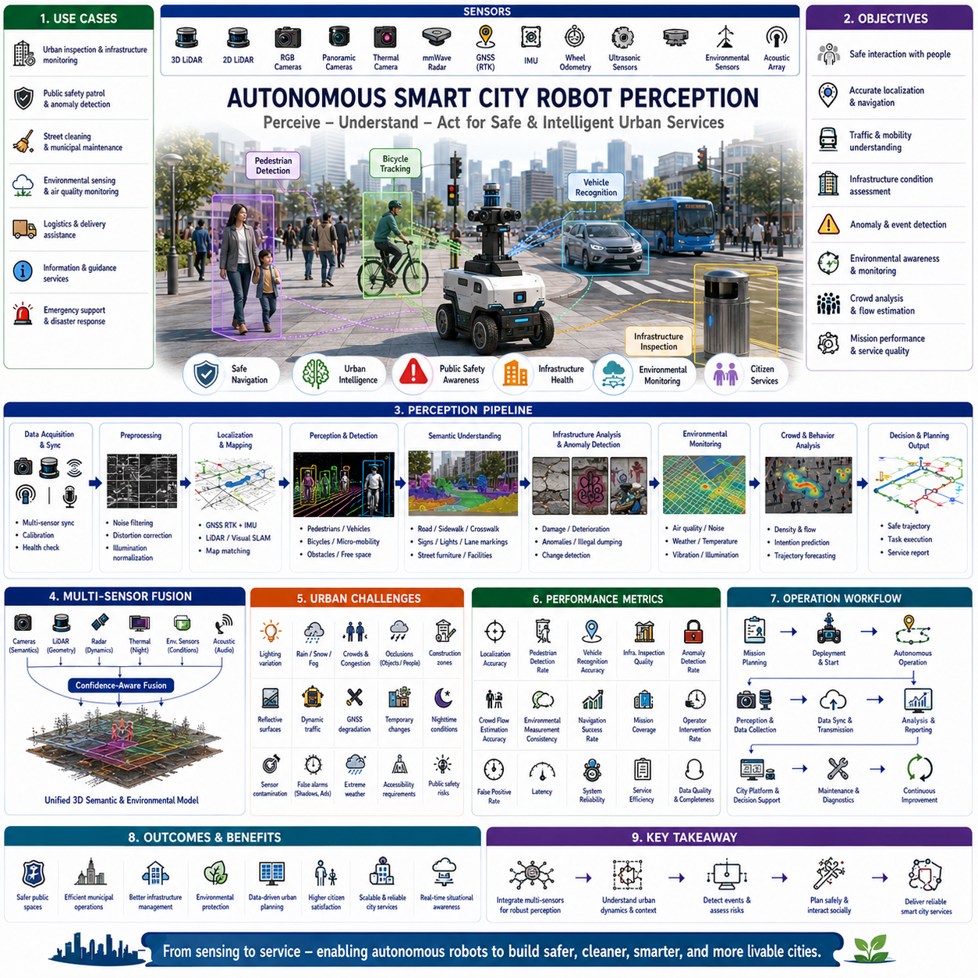
Smart city robots operate in one of the most complex perception environments because they must safely coexist with large numbers of people, vehicles, bicycles, public infrastructure, construction activities, and continuously changing urban conditions. Unlike industrial robots working inside controlled facilities, smart city robots function within open public spaces where environmental uncertainty, human behavior, weather, traffic density, and infrastructure conditions vary throughout the day. Reliable perception therefore requires continuous environmental understanding, semantic reasoning, and adaptive decision making to support safe and intelligent urban services.
This case study investigated autonomous smart city robots deployed for urban inspection, public safety patrol, infrastructure monitoring, environmental sensing, street cleaning, municipal maintenance, logistics assistance, information services, and emergency support. The robots operated on sidewalks, pedestrian streets, parks, campuses, transportation hubs, public squares, commercial districts, residential neighborhoods, and mixed traffic environments. Mission success depended on maintaining safe interaction with citizens while continuously collecting high-quality urban perception data.
The perception platform integrated three-dimensional LiDAR, two-dimensional LiDAR, RGB cameras, panoramic cameras, thermal cameras, millimeter-wave radar, GNSS with Real-Time Kinematic positioning, inertial measurement units, wheel odometry, ultrasonic sensors, environmental monitoring sensors, and acoustic sensor arrays. Each sensing modality contributed complementary information regarding urban geometry, dynamic objects, environmental conditions, and infrastructure health. Confidence-aware multi-sensor fusion continuously generated a unified perception model suitable for autonomous operation in dense public environments.
The primary perception objectives included pedestrian detection, vehicle recognition, bicycle tracking, traversable path estimation, traffic understanding, infrastructure inspection, localization, anomaly detection, environmental monitoring, crowd analysis, public safety assessment, and mission progress evaluation. Unlike ordinary autonomous delivery robots, smart city robots required simultaneous understanding of both physical infrastructure and complex human activities because operational decisions directly influenced public safety, service quality, and citizen acceptance.
Localization remained fundamental despite widespread GNSS availability. High-rise buildings, underground passages, trees, transportation stations, reflective glass surfaces, and urban canyons frequently degraded satellite positioning. LiDAR localization, visual landmark recognition, inertial estimation, wheel odometry, and map matching compensated whenever GNSS confidence decreased. Continuous localization quality assessment ensured that navigation remained reliable even in highly dynamic metropolitan environments where positioning uncertainty changed rapidly.
Urban semantic mapping extended beyond ordinary navigation maps. Roads, sidewalks, bicycle lanes, crosswalks, bus stops, traffic lights, benches, waste containers, streetlights, public facilities, trees, utility covers, and emergency equipment all required semantic identification. The perception framework continuously updated both geometric maps and semantic information so municipal services could utilize accurate contextual knowledge for inspection, maintenance, and autonomous task execution.
Pedestrian perception represented the most important operational capability. Public environments contained individuals walking alone, families, children, elderly citizens, tourists, workers, delivery personnel, and organized groups moving with highly unpredictable behavior. The perception framework combined semantic recognition, body pose estimation, temporal tracking, intention prediction, and trajectory forecasting. Rather than merely detecting people, the robot continuously estimated future movement to maintain socially acceptable and safe navigation.
Crowd perception introduced additional complexity because large groups exhibited collective movement patterns significantly different from individual pedestrians. Crowd density changed during commuting hours, public events, festivals, emergencies, and transportation schedules. The perception system estimated crowd flow, local density, movement direction, congestion probability, and safe navigation corridors. Adaptive planning enabled efficient mobility without unnecessarily disturbing pedestrian traffic or creating uncomfortable interactions.
Vehicle perception required comprehensive understanding of heterogeneous urban transportation. Passenger cars, buses, trucks, motorcycles, bicycles, scooters, emergency vehicles, maintenance equipment, and autonomous delivery robots shared public environments with pedestrians. The perception framework estimated vehicle type, speed, direction, acceleration, turning intention, and interaction probability. Predictive motion modeling enabled early conflict avoidance while preserving efficient navigation through mixed urban traffic.
Bicycle and micro-mobility perception became increasingly important because modern cities contain electric bicycles, scooters, skateboards, wheelchairs, and other personal mobility devices moving at intermediate speeds between pedestrians and automobiles. These vehicles frequently changed direction unexpectedly while sharing sidewalks and crossings. Dedicated perception models recognized micro-mobility behavior separately from conventional pedestrian and vehicle models, significantly improving interaction safety.
Traffic signal understanding supported safe autonomous movement across complex intersections. Cameras detected traffic lights, pedestrian signals, warning signs, lane markings, speed limits, directional arrows, construction notices, and temporary traffic control devices. Rather than recognizing isolated signs, the perception framework interpreted complete traffic context by combining infrastructure observations with surrounding vehicle behavior and pedestrian activity before making navigation decisions.
Infrastructure perception continuously monitored the physical condition of urban assets. Roads, sidewalks, bridges, tunnels, streetlights, utility poles, traffic signs, drainage systems, waste containers, benches, bus shelters, trees, fences, and public facilities were inspected during routine missions. High-resolution imagery, three-dimensional geometry, thermal sensing, and temporal comparison enabled automatic identification of structural deterioration, missing components, graffiti, illegal dumping, vegetation overgrowth, and infrastructure damage.
Environmental perception provided continuous monitoring of urban conditions. Temperature, humidity, particulate matter, air quality, noise level, wind speed, rainfall, illumination, vibration, and atmospheric pressure were measured alongside visual observations. Integrating environmental sensing with spatial localization enabled municipalities to generate high-resolution environmental maps supporting pollution monitoring, urban planning, disaster preparedness, and public health assessment.
Weather adaptation represented an essential perception capability. Rain reduced camera visibility while introducing reflections on wet pavement. Snow obscured lane markings, sidewalks, and obstacles. Fog reduced long-distance perception, whereas strong sunlight generated severe shadows and glare. Confidence-aware sensor fusion continuously adjusted the contribution of cameras, LiDAR, radar, and thermal sensing according to changing environmental conditions while maintaining reliable autonomous operation.
Nighttime perception required specialized sensing strategies. Reduced illumination decreased camera performance, while artificial lighting introduced strong brightness variation. Thermal cameras improved pedestrian detection, radar maintained robust object tracking, and LiDAR preserved accurate geometric perception independent of lighting conditions. Multi-modal fusion significantly improved nighttime reliability compared with camera-only perception while maintaining consistent localization accuracy.
Construction zones frequently modified urban environments. Temporary fences, warning signs, machinery, excavations, detours, scaffolding, parked construction vehicles, and redirected pedestrian paths created highly dynamic infrastructure. The perception framework distinguished temporary changes from permanent city structures while maintaining consistent long-term maps. Dynamic environmental updates prevented outdated infrastructure information from degrading navigation reliability.
Public safety perception extended beyond navigation. The robot identified abandoned objects, blocked emergency exits, damaged infrastructure, smoke, fire, flooding, suspicious activities, fallen trees, road obstacles, illegal parking, and hazardous environmental conditions. Event recognition combined visual observations, thermal sensing, environmental measurements, temporal consistency, and contextual reasoning to minimize false alarms while maintaining sensitivity to genuine public safety risks.
Human intention prediction significantly improved social navigation. Pedestrians approaching crosswalks, waiting at intersections, exiting public transportation, entering buildings, or interacting with nearby objects exhibited different behavioral patterns. The perception framework estimated probable future actions using body orientation, walking speed, gaze direction, historical trajectories, and environmental context. Anticipating human movement reduced unnecessary stops while maintaining conservative safety margins whenever behavioral uncertainty increased.
Accessibility awareness became increasingly important within inclusive smart city environments. The robot recognized wheelchairs, walking aids, strollers, guide dogs, visually impaired pedestrians, and mobility assistance devices. Navigation policies automatically increased safety margins, reduced operating speed, and selected alternative routes whenever appropriate. Perception therefore supported not only technical safety but also socially responsible interaction with diverse urban populations.
Acoustic perception complemented visual sensing by detecting emergency sirens, vehicle horns, construction activity, crowd noise, alarms, public announcements, and abnormal environmental sounds. Microphone arrays estimated sound direction and classified acoustic events. Audio information frequently provided earlier warning than visual sensing alone, particularly when emergency vehicles approached from outside the camera field of view or behind large urban structures.
Urban anomaly detection represented a critical municipal service. Illegal waste disposal, vandalism, damaged street furniture, broken traffic signs, overflowing waste bins, water leakage, damaged pavement, missing utility covers, graffiti, and fallen obstacles were automatically identified during routine patrol missions. Historical comparisons distinguished newly appearing anomalies from known long-term conditions, enabling efficient maintenance scheduling and resource allocation.
Multi-sensor fusion unified geometry, semantics, environmental observations, infrastructure condition, and dynamic object tracking into one integrated urban perception model. Cameras contributed semantic understanding, LiDAR generated structural geometry, radar improved dynamic object detection under adverse weather, thermal sensing enhanced nighttime perception, environmental sensors monitored atmospheric conditions, and acoustic sensing expanded situational awareness. Confidence estimation continuously optimized sensor weighting according to operational conditions and diagnostic health.
The perception software architecture consisted of acquisition, synchronization, calibration, localization, semantic segmentation, object detection, infrastructure analysis, environmental monitoring, anomaly recognition, crowd analysis, mission management, health diagnostics, and municipal analytics. Every processing module continuously reported latency, synchronization quality, computational utilization, localization uncertainty, perception confidence, environmental conditions, and diagnostic status. Comprehensive logging simplified maintenance, debugging, and long-term system optimization.
Extensive field data collection covered business districts, residential neighborhoods, transportation hubs, shopping streets, university campuses, industrial parks, historical districts, parks, waterfronts, tunnels, underground passages, and public squares. Data were collected across all seasons, varying weather conditions, daytime and nighttime operations, commuting periods, festivals, sporting events, emergency exercises, and routine municipal activities. This diversity significantly improved robustness across realistic urban deployment scenarios.
Annotation included pedestrians, vehicles, bicycles, infrastructure components, environmental conditions, accessibility devices, anomalies, crowd density, traffic situations, road markings, construction objects, emergency events, localization confidence, and environmental measurements. Municipal inspection records and infrastructure databases supported annotation verification whenever available. Combining engineering perception with verified city asset information substantially improved supervised learning performance for complex urban understanding.
Offline evaluation measured localization accuracy, pedestrian detection performance, vehicle recognition, infrastructure inspection quality, anomaly detection rate, environmental measurement consistency, semantic segmentation accuracy, computational latency, synchronization quality, and multi-sensor fusion reliability. Operational evaluation additionally examined citizen interaction quality, navigation smoothness, municipal inspection coverage, maintenance efficiency, public safety contribution, operator intervention frequency, and long-term deployment stability.
Scenario-based validation included crowded intersections, public festivals, construction detours, emergency vehicle interaction, nighttime patrol, heavy rainfall, snow-covered sidewalks, infrastructure inspection, public transportation stations, bicycle congestion, accessibility assistance, and degraded GNSS environments. Every scenario was repeated under different environmental conditions to verify stable perception performance despite the highly dynamic nature of modern smart cities.
One representative scenario involved navigation through a crowded transportation terminal during morning commuting hours. Hundreds of pedestrians moved simultaneously while buses, bicycles, and maintenance vehicles shared nearby spaces. Crowd flow estimation, intention prediction, and adaptive trajectory planning enabled smooth robot movement without disrupting pedestrian circulation or compromising public safety despite extremely dense dynamic interactions.
Another important scenario occurred after severe rainfall when reflective pavement, standing water, reduced visibility, and temporary road closures significantly altered normal urban appearance. Multi-sensor fusion integrated LiDAR geometry, radar observations, environmental measurements, and camera imagery to distinguish safe traversable areas from hazardous flooded regions. Navigation quality remained stable despite rapidly changing environmental conditions challenging ordinary vision-based perception systems.
False urban event detection represented a significant operational concern. Shadows, seasonal decorations, temporary advertisements, reflections, weather effects, moving vegetation, maintenance equipment, and public gatherings occasionally resembled anomalies requiring municipal attention. Rather than relying upon isolated observations, the perception framework combined temporal consistency, infrastructure history, environmental context, multi-sensor agreement, and confidence estimation. This substantially reduced false maintenance reports while preserving sensitivity to genuine infrastructure problems.
Long-duration deployment identified gradual degradation including sensor contamination, camera lens pollution, LiDAR window dust accumulation, GNSS antenna obstruction, environmental sensor drift, synchronization instability, processor temperature increase, and communication latency. Continuous health monitoring detected these trends before operational performance declined. Preventive maintenance recommendations were automatically generated using diagnostic evidence accumulated during routine municipal service operations.
Degraded operating modes maintained safe public operation despite partial perception failures. When GNSS confidence decreased, LiDAR localization and map matching assumed greater responsibility. During camera degradation caused by severe weather, radar and thermal sensing increased their contribution to obstacle detection. Navigation speed, mission complexity, and operational area adapted automatically according to current perception capability while always preserving public safety as the highest operational priority.
Fleet operation enabled multiple smart city robots to cooperate across metropolitan environments. Individual robots shared infrastructure observations, anomaly reports, environmental measurements, localization references, traffic information, and mission progress through centralized municipal management systems. Nevertheless, every robot independently maintained obstacle detection, social navigation, environmental perception, and diagnostic monitoring. Distributed urban intelligence significantly improved service scalability while preserving robust local autonomy.
Routine maintenance procedures included sensor cleaning, camera calibration, LiDAR verification, GNSS antenna inspection, environmental sensor calibration, acoustic system testing, synchronization validation, localization verification, and diagnostic log analysis. After collisions, hardware replacement, severe weather exposure, or extended deployment, comprehensive perception validation confirmed that navigation, infrastructure inspection, environmental monitoring, and public safety functions continued satisfying predefined operational requirements.
The completed perception system demonstrated substantial improvements in localization reliability, pedestrian understanding, infrastructure inspection quality, anomaly detection, environmental monitoring, social navigation, municipal service efficiency, and long-term deployment stability. Confidence-aware sensor fusion significantly reduced unnecessary interventions while maintaining transparent diagnostics explaining perception confidence, uncertainty, and operational limitations for city operators.
This case study demonstrates that smart city robot perception extends far beyond autonomous navigation. Reliable urban service requires integrated understanding of infrastructure, people, transportation, environment, accessibility, public safety, and municipal operations. Successful perception therefore combines geometric sensing, semantic understanding, environmental analytics, social intelligence, and adaptive decision making within one unified smart city perception architecture.
It also demonstrates that urban perception must continuously adapt because cities evolve throughout every hour of every day. Traffic density, pedestrian behavior, weather, infrastructure conditions, construction activities, and public events constantly modify operational environments. Continuous confidence estimation, adaptive sensor fusion, long-term urban learning, and robust environmental adaptation therefore become essential capabilities for dependable autonomous smart city services.
Ultimately, the smart city robot perception program succeeded because sensing, localization, infrastructure understanding, environmental monitoring, social interaction, public safety assessment, municipal analytics, and operational workflow were evaluated together as one integrated urban intelligence system. Continuous field validation, diverse city datasets, scenario-based testing, adaptive perception, comprehensive diagnostics, and iterative improvement enabled reliable autonomous public service across complex real-world smart city environments.

24.8 Perception Failure Lessons
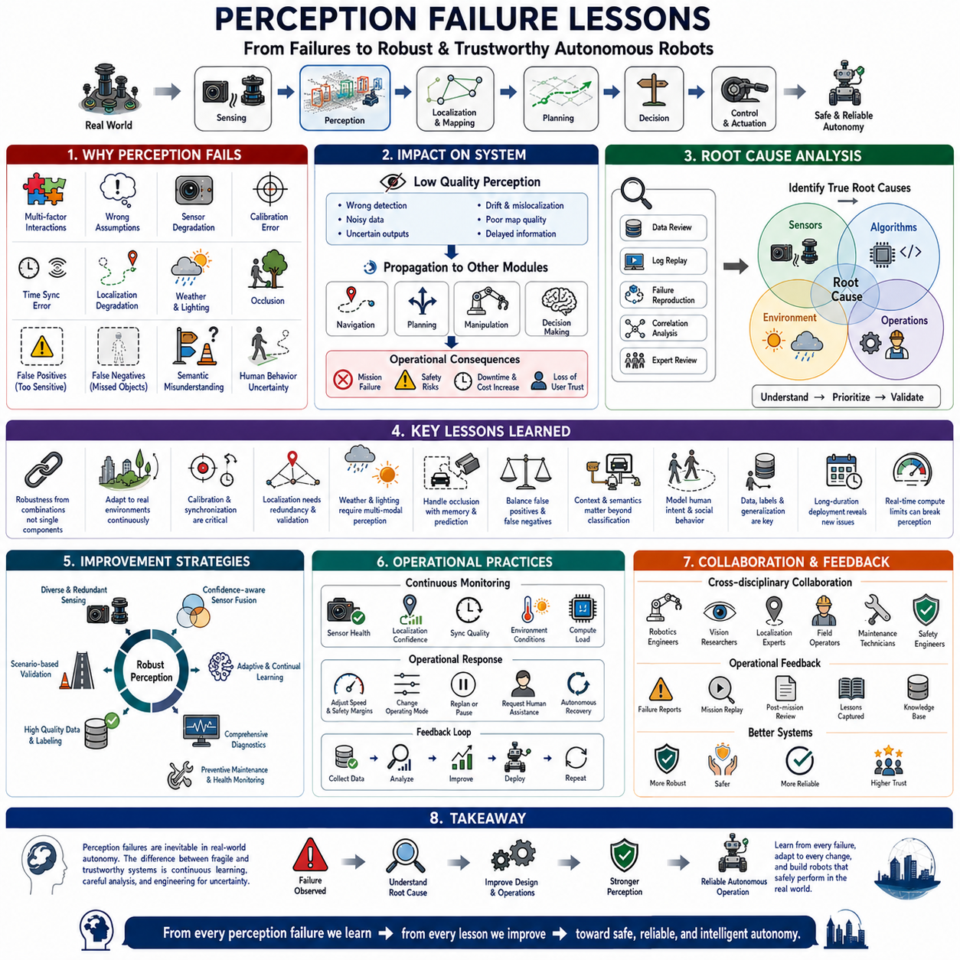
Perception failures remain one of the primary causes of autonomous robot performance degradation because every subsequent planning, navigation, manipulation, and decision-making process depends on the accuracy of environmental understanding. Even highly advanced robots equipped with powerful sensors and modern artificial intelligence can experience unexpected failures when operating in complex real-world environments. Unlike software defects that are often deterministic, perception failures usually emerge from complicated interactions among sensors, algorithms, environmental conditions, hardware limitations, calibration quality, and operational assumptions. Understanding these failures therefore becomes essential for designing robust and trustworthy autonomous systems.
This case study summarizes practical lessons learned from long-term deployment of autonomous robots operating in industrial facilities, outdoor environments, agricultural fields, smart cities, logistics centers, warehouses, inspection sites, construction areas, and public spaces. The objective was not merely to catalog failure events but to understand their underlying causes, propagation mechanisms, operational impacts, recovery strategies, and engineering improvements. Every perception failure provided valuable information that ultimately improved system robustness and deployment reliability.
One of the earliest lessons demonstrated that perception rarely fails because of a single component. Instead, failures usually result from multiple small weaknesses occurring simultaneously. Slight sensor degradation, reduced localization confidence, poor lighting, increased computational latency, temporary communication delays, and unexpected environmental changes may individually appear insignificant. However, when several factors occur together, perception confidence can rapidly collapse. Engineers therefore learned that robustness depends more on preventing combinations of failures than eliminating isolated problems.
Environmental assumptions represented another major source of perception failure. Early development frequently assumed relatively clean environments, predictable illumination, stable weather, and static infrastructure. Real deployments immediately contradicted these assumptions. Dust accumulated on sensors, rain altered surface appearance, snow obscured landmarks, sunlight generated reflections, vegetation changed throughout seasons, construction modified infrastructure, and human activities continuously transformed operating environments. Reliable perception therefore required continuous adaptation rather than dependence upon static environmental models.
Sensor calibration proved significantly more important than initially expected. Minor calibration errors between cameras, LiDAR, radar, inertial sensors, and positioning systems gradually produced inaccurate object localization and inconsistent sensor fusion. Although these errors often remained invisible during laboratory evaluation, they accumulated during long autonomous missions and eventually degraded navigation accuracy. Periodic calibration verification became a mandatory operational procedure rather than an optional maintenance activity.
Time synchronization failures frequently produced misleading perception errors. Individual sensors often continued operating correctly while timestamp inconsistencies generated inaccurate data association. Moving objects appeared distorted, localization drift increased, object tracking became unstable, and sensor fusion produced conflicting observations. Engineers eventually recognized that synchronization quality should be monitored continuously with the same priority as sensor health because accurate perception depends on temporal consistency as much as spatial accuracy.
Localization failures rarely originated solely from positioning algorithms. Instead, degraded localization usually reflected insufficient environmental information, inaccurate maps, GNSS degradation, wheel slip, poor feature visibility, dynamic infrastructure, or calibration drift. Recovery strategies therefore evolved from simply improving localization algorithms toward improving overall environmental observability through redundant sensing, confidence estimation, adaptive mapping, and continuous validation of localization quality.
Weather repeatedly demonstrated its ability to invalidate perception models trained under favorable conditions. Rain introduced reflections and water droplets, fog reduced visibility, snow altered terrain appearance, dust obscured optical sensors, and strong sunlight generated severe brightness variation. Individual sensors reacted differently to each condition, making confidence-aware sensor fusion substantially more reliable than dependence upon any single sensing modality. Weather adaptation gradually became an integrated perception capability rather than an external environmental consideration.
Lighting variation produced perception failures even when weather remained stable. Morning sunlight, evening shadows, nighttime illumination, artificial lighting, reflective surfaces, seasonal solar angles, and rapidly changing brightness significantly influenced camera-based perception. Early systems relied heavily upon image appearance, whereas later systems increasingly integrated geometric sensing, thermal imaging, and adaptive exposure control. The lesson demonstrated that visual perception alone rarely provides sufficient robustness for continuous real-world autonomy.
Occlusion represented one of the most persistent perception challenges. People, vehicles, machinery, vegetation, infrastructure, and temporary obstacles continuously blocked sensor visibility. Objects hidden for only a few seconds frequently reappeared in unexpected locations, confusing object tracking algorithms. Multi-view observation, temporal memory, probabilistic prediction, and cooperative sensor placement substantially reduced occlusion-related failures. Engineers gradually shifted from assuming complete visibility toward explicitly modeling uncertainty caused by partial observation.
False positive detection consumed considerable operational resources despite generally attracting less attention than missed detections. Incorrectly identifying nonexistent obstacles, infrastructure damage, safety hazards, or anomalies frequently interrupted missions unnecessarily and reduced user confidence. Engineers discovered that excessive sensitivity could become nearly as harmful as insufficient sensitivity. Reliable perception therefore required balanced confidence estimation capable of minimizing both false positives and false negatives according to operational priorities.
False negative detection frequently generated the most serious safety risks because genuinely important objects remained undetected. Pedestrians, vehicles, construction equipment, damaged infrastructure, and unexpected obstacles occasionally escaped recognition under challenging environmental conditions. Extensive failure analysis revealed that missed detections often occurred near decision boundaries where perception confidence remained moderate rather than extremely low. Confidence visualization consequently became an important diagnostic tool supporting safer operational decisions.
Semantic misunderstanding emerged as another important lesson. Robots occasionally recognized objects correctly while misunderstanding their operational significance. For example, temporary warning signs, maintenance equipment, emergency barriers, accessible pathways, or movable infrastructure required context-sensitive interpretation rather than simple classification. Engineers gradually expanded perception from object recognition toward scene understanding, relational reasoning, and contextual interpretation capable of supporting higher-level autonomous behavior.
Human behavior consistently exceeded the predictive capability of purely geometric perception. Pedestrians changed direction unexpectedly, workers ignored designated pathways, children behaved unpredictably, cyclists violated traffic rules, and crowds continuously reorganized themselves. Systems relying exclusively upon physical motion estimation experienced repeated planning failures. Incorporating intention prediction, social behavior modeling, historical trajectory analysis, and uncertainty estimation significantly improved interaction safety within populated environments.
Dataset limitations became increasingly apparent during deployment. Laboratory datasets frequently underrepresented rare weather conditions, unusual viewpoints, damaged infrastructure, crowded environments, seasonal changes, sensor degradation, and long-term operational variability. Models demonstrated excellent benchmark performance yet failed unexpectedly when encountering previously unseen scenarios. Continuous field data collection and iterative dataset expansion eventually proved more valuable than endlessly optimizing existing benchmark datasets.
Annotation quality directly influenced perception reliability. Inconsistent labeling, incomplete object boundaries, ambiguous semantic definitions, annotation bias, and human disagreement introduced systematic learning errors difficult to detect through conventional evaluation metrics. Quality assurance procedures gradually evolved to include multi-stage review, expert validation, consistency analysis, and automated anomaly detection within annotation pipelines. Engineers learned that improving labels often produced larger performance gains than increasing dataset size.
Generalization remained considerably more difficult than achieving excellent performance within controlled evaluation environments. Models trained successfully in one city, factory, warehouse, or agricultural field frequently degraded after deployment elsewhere. Differences in infrastructure, climate, operational procedures, sensor configuration, and environmental appearance significantly affected perception quality. Domain adaptation, self-supervised learning, continual learning, and geographically diverse training data became increasingly important for practical autonomous systems.
Long-duration deployment revealed failure mechanisms invisible during short experiments. Sensors accumulated contamination, hardware experienced gradual wear, environmental conditions evolved seasonally, calibration slowly drifted, storage filled unexpectedly, synchronization stability decreased, and computational performance varied with temperature. Continuous health monitoring therefore expanded beyond immediate fault detection toward long-term trend analysis capable of predicting future degradation before operational failures occurred.
Computational limitations occasionally produced perception failures despite algorithmic correctness. Processor overload, excessive memory consumption, communication congestion, storage latency, thermal throttling, and scheduling conflicts introduced delayed perception results that no longer accurately represented current environmental conditions. Engineers recognized that real-time performance constitutes an essential component of perception accuracy because outdated information may become operationally equivalent to incorrect information.
Diagnostic transparency proved indispensable for understanding perception failures. Early systems simply reported successful or failed detection results without explaining underlying uncertainty or contributing factors. Later architectures continuously estimated localization confidence, sensor health, synchronization quality, environmental conditions, computational load, calibration status, and algorithmic certainty. Rich diagnostic information dramatically reduced debugging time while enabling operators to make more informed decisions during unexpected situations.
Redundancy consistently improved operational robustness but required intelligent integration rather than simple duplication. Additional cameras, LiDAR units, radar sensors, positioning systems, or computing platforms provided little benefit unless perception software effectively managed conflicting observations and varying confidence levels. Engineers concluded that diversity among sensing modalities generally contributes more robustness than simply increasing the quantity of identical sensors.
Recovery mechanisms became equally important as failure prevention. Complete elimination of perception failures proved unrealistic within dynamic real-world environments. Instead, systems increasingly emphasized graceful degradation, adaptive operating modes, reduced navigation speed, increased safety margins, human intervention requests, mission replanning, and autonomous recovery procedures. Successful systems therefore focused upon maintaining safe operation despite degraded perception rather than attempting unrealistic perfect perception.
Simulation provided valuable development support but could not replace real-world validation. Synthetic environments accurately reproduced geometry, object motion, and certain environmental conditions but rarely captured the full complexity of weather, sensor contamination, human behavior, infrastructure aging, biological variability, or unexpected operational events. Engineers ultimately regarded simulation as an efficient complement for development rather than a substitute for extensive field testing.
Scenario-based validation significantly improved failure discovery compared with conventional performance evaluation. Instead of measuring only average detection accuracy, engineers repeatedly evaluated complete operational scenarios including degraded localization, adverse weather, heavy traffic, crowded environments, sensor failures, construction zones, emergency situations, and communication interruptions. Comprehensive scenario testing exposed subtle interactions among perception components that isolated benchmark evaluation failed to identify.
Cross-disciplinary collaboration substantially accelerated perception improvement. Robotics engineers, computer vision researchers, localization specialists, software architects, infrastructure experts, field operators, maintenance technicians, and safety engineers frequently interpreted identical failures differently. Combining multiple perspectives revealed hidden root causes that individual disciplines often overlooked. Effective perception engineering therefore evolved into a collaborative systems engineering activity rather than an isolated artificial intelligence problem.
Operational feedback became one of the most valuable sources of perception improvement. Field operators frequently observed subtle behavioral patterns, rare environmental conditions, recurring infrastructure problems, and unexpected user interactions unavailable during laboratory development. Structured failure reporting, mission replay analysis, continuous logging, and systematic post-deployment review gradually transformed operational experience into measurable engineering knowledge supporting continuous perception refinement.
Confidence estimation ultimately emerged as one of the most influential lessons learned throughout long-term deployment. Rather than attempting to maximize detection confidence under every circumstance, successful perception systems continuously estimated their own uncertainty. Navigation, planning, mission execution, and operator interfaces adapted according to perception confidence instead of assuming identical reliability across all situations. Autonomous systems therefore became significantly safer because they recognized not only what they knew but also what they did not know.
Another important lesson demonstrated that perception quality should never be evaluated independently from complete system behavior. Minor perception errors occasionally produced negligible operational consequences, whereas seemingly insignificant localization drift sometimes propagated into navigation failure, manipulation errors, inspection inaccuracies, and mission interruption. System-level evaluation therefore replaced isolated algorithm benchmarking as the preferred engineering methodology for assessing practical autonomous performance.
Human-centered evaluation also became increasingly important. Users judged perception quality primarily through observable robot behavior rather than numerical benchmark accuracy. Smooth navigation, understandable decisions, predictable responses, transparent diagnostics, and consistent safety behavior produced greater trust than marginal improvements in detection metrics alone. Engineers therefore expanded evaluation criteria to include user confidence, operational acceptability, and overall service reliability.
These deployment experiences demonstrate that perception failure should not be interpreted solely as a software defect but as an opportunity to improve complete autonomous system design. Every unexpected event contributes new knowledge regarding sensing, localization, learning, system integration, operational procedures, maintenance strategy, and environmental adaptation. Organizations that systematically analyze perception failures therefore improve much faster than those focusing exclusively upon benchmark performance.
Ultimately, the most important lesson is that reliable perception is achieved through continuous engineering refinement rather than a single technological breakthrough. Robust sensing, adaptive sensor fusion, accurate localization, comprehensive diagnostics, confidence estimation, diverse datasets, systematic validation, operational learning, preventive maintenance, and interdisciplinary collaboration collectively create dependable autonomous perception. Long-term success therefore depends not upon eliminating every failure but upon continuously learning from every failure encountered during real-world autonomous operation.

