Volume 03. AMR Sensors and Perception

Chapter 07. Radar Systems

07.1 Radar Sensing Principles
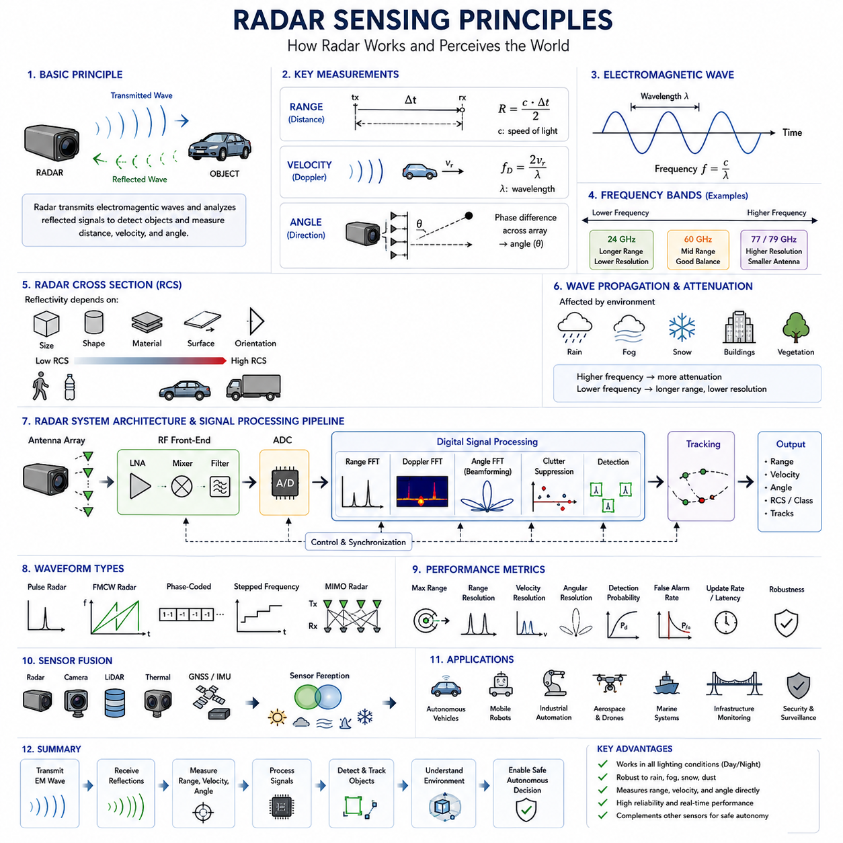
Radar sensing is one of the most important perception technologies used in autonomous systems because it provides reliable environmental awareness under conditions where optical sensors may experience significant performance degradation. Unlike cameras that rely on visible light or thermal cameras that detect infrared radiation emitted by objects, radar actively transmits electromagnetic waves and analyzes the reflected signals to determine the presence, distance, speed, and direction of surrounding objects. This active sensing capability enables radar to operate effectively during daytime, nighttime, heavy rain, snow, fog, dust, and smoke, making it an indispensable component of modern autonomous vehicles, industrial robots, mobile robots, maritime systems, aerospace platforms, and intelligent infrastructure. Radar sensing principles therefore form a fundamental foundation for robust perception systems operating in diverse environmental conditions.
The basic operating principle of radar begins with the transmission of electromagnetic energy from a transmitting antenna toward the surrounding environment. When these electromagnetic waves encounter an object, part of the transmitted energy is reflected, scattered, or absorbed depending on the object's material properties, geometry, surface roughness, orientation, and electrical conductivity. The reflected signals travel back toward the receiving antenna, where they are amplified, digitized, and processed to estimate various target characteristics. By measuring the propagation time, frequency variation, phase information, and signal amplitude, radar systems calculate target distance, relative velocity, angle of arrival, and object characteristics with high reliability. This active measurement process distinguishes radar from passive sensing technologies and provides stable performance regardless of ambient lighting conditions.
Electromagnetic wave propagation forms the physical basis of radar sensing. Radar systems typically operate within microwave frequency bands ranging from several gigahertz to hundreds of gigahertz. As electromagnetic waves propagate through free space, their energy spreads over increasing distances while experiencing attenuation due to atmospheric absorption, precipitation, and interactions with surrounding objects. The propagation velocity is approximately equal to the speed of light, allowing distance measurements to be determined directly from signal travel time. Since electromagnetic waves can penetrate fog, smoke, light rain, and certain non-metallic materials more effectively than visible light, radar provides environmental perception capabilities that complement optical sensing systems under adverse weather conditions.
Radar frequency selection significantly influences sensing performance because different frequency bands exhibit distinct propagation characteristics and spatial resolution. Lower-frequency radar generally provides longer detection ranges and better penetration through environmental obstacles but produces lower spatial resolution. Higher-frequency radar offers improved angular resolution and smaller antenna dimensions while typically reducing maximum detection distance. Modern automotive and robotic radar systems commonly employ millimeter-wave frequencies around 24 GHz, 60 GHz, 77 GHz, and 79 GHz because these frequency bands provide an effective balance between range, resolution, antenna size, bandwidth availability, and regulatory compliance. Frequency selection therefore represents an important design consideration depending on the intended sensing application.
The radar range measurement principle is based primarily on signal propagation delay. After transmitting an electromagnetic pulse or continuously modulated waveform, the radar measures the elapsed time required for the reflected signal to return from the target. Since electromagnetic waves travel at nearly three hundred million meters per second, even very small timing differences correspond to measurable distance variations. The target distance is calculated by multiplying the measured propagation time by the speed of light and dividing by two because the signal travels to the target and then returns to the radar. Accurate timing synchronization and high-speed signal processing are therefore essential for achieving precise distance estimation.
Velocity estimation represents another fundamental capability of radar sensing through exploitation of the Doppler effect. When an object moves relative to the radar sensor, the frequency of the reflected electromagnetic wave changes proportionally to the target's radial velocity. Objects approaching the radar produce positive frequency shifts, while receding objects generate negative frequency shifts. By measuring this Doppler frequency difference, radar systems estimate relative speed directly without requiring multiple image frames or object tracking. Doppler-based velocity estimation enables reliable detection of moving vehicles, pedestrians, industrial equipment, drones, and other dynamic objects while simultaneously distinguishing stationary obstacles from moving targets.
Angular estimation determines the spatial direction from which reflected signals arrive at the radar receiver. Multiple receiving antennas arranged in carefully designed arrays observe slight phase differences between simultaneously received signals. Signal processing algorithms analyze these phase relationships to estimate target azimuth and elevation angles. Advanced antenna array configurations, beamforming techniques, and Multiple Input Multiple Output (MIMO) radar architectures substantially improve angular resolution while allowing accurate localization of multiple targets within complex environments. Angle estimation enables radar systems to construct two-dimensional or three-dimensional representations of surrounding objects rather than providing only range information.
Radar cross section plays a central role in determining target detectability because it quantifies how effectively an object reflects electromagnetic energy toward the radar receiver. Radar cross section depends upon target size, shape, material composition, surface roughness, orientation, and operating frequency rather than simply physical dimensions alone. Metallic objects generally exhibit stronger radar reflections than plastic, rubber, or composite materials. Large flat surfaces may produce strong specular reflections under favorable viewing angles, while irregular surfaces scatter electromagnetic energy more diffusely. Understanding radar cross section characteristics allows perception systems to interpret reflected signal strength more accurately during object detection and classification.
Signal attenuation influences radar performance as electromagnetic waves propagate through the environment. Atmospheric gases, rain, snow, fog, dust, vegetation, buildings, and various physical obstacles reduce transmitted signal energy before reflections return to the radar receiver. Higher operating frequencies generally experience greater atmospheric attenuation, while heavy precipitation increases signal loss significantly. Radar system designers therefore carefully balance operating frequency, transmitter power, antenna gain, receiver sensitivity, and signal processing capability to achieve reliable performance across expected environmental conditions while satisfying regulatory limitations regarding electromagnetic emissions.
Noise and interference constitute important challenges in radar sensing systems. Thermal noise generated by electronic components establishes the fundamental sensitivity limit of radar receivers, while electromagnetic interference originating from nearby radar systems, wireless communication devices, industrial equipment, and environmental reflections may degrade detection performance. Multipath propagation introduces additional complexity when reflected signals arrive along multiple paths after bouncing from buildings, vehicles, or other structures. Modern radar systems employ adaptive filtering, interference suppression, frequency management, and advanced digital signal processing algorithms to improve signal quality and maintain reliable target detection despite challenging electromagnetic environments.
Radar waveform design directly influences sensing performance by determining measurement accuracy, ambiguity characteristics, and environmental robustness. Early radar systems primarily employed pulsed waveforms for straightforward range measurement. Modern sensing platforms increasingly utilize Frequency Modulated Continuous Wave (FMCW) radar because continuous transmission combined with frequency modulation enables simultaneous estimation of target range and velocity while reducing hardware complexity. Alternative waveform designs include phase-coded sequences, chirp signals, stepped-frequency modulation, and orthogonal waveforms supporting MIMO radar architectures. Careful waveform selection optimizes sensing capability for specific applications ranging from automotive perception to industrial inspection.
Frequency Modulated Continuous Wave radar has become the dominant sensing technology for autonomous vehicles and mobile robotics because it simultaneously estimates range, velocity, and angle with high accuracy while maintaining relatively compact hardware. During operation, the transmitted frequency changes continuously according to a predefined chirp pattern. Reflected signals exhibit frequency differences proportional to target distance, while Doppler effects caused by target motion modify the received frequency further. Signal processing algorithms separate these effects to estimate both range and velocity simultaneously. FMCW radar therefore provides efficient multidimensional environmental perception suitable for real-time autonomous navigation.
Radar signal processing transforms raw electromagnetic measurements into meaningful environmental information. Analog front-end electronics amplify weak reflected signals before analog-to-digital conversion generates digital data suitable for computational processing. Fast Fourier Transform algorithms convert time-domain signals into frequency-domain representations, revealing target range and Doppler characteristics. Additional processing stages perform clutter suppression, interference mitigation, noise filtering, target detection, peak estimation, angle calculation, object association, and trajectory tracking. Advanced artificial intelligence techniques increasingly complement traditional signal processing by improving target classification, anomaly detection, and environmental understanding.
Target detection algorithms determine whether reflected signals correspond to actual physical objects or random measurement noise. Constant False Alarm Rate techniques dynamically adjust detection thresholds according to local noise statistics, maintaining consistent detection reliability across varying environmental conditions. Candidate targets identified during thresholding undergo further validation using signal strength, spatial continuity, temporal consistency, Doppler characteristics, and tracking information. Reliable target detection minimizes both missed detections and false alarms while providing accurate environmental awareness required for autonomous decision making.
Object tracking extends radar perception beyond individual measurements by continuously estimating target motion across consecutive sensing cycles. Tracking algorithms associate newly detected radar reflections with previously observed objects while estimating position, velocity, acceleration, and predicted future trajectories. Kalman filters, Extended Kalman Filters, Unscented Kalman Filters, Particle Filters, and multiple hypothesis tracking algorithms provide statistically optimal state estimation under uncertain measurement conditions. Robust tracking enables autonomous systems to anticipate object motion and perform safe navigation within dynamic environments containing numerous moving obstacles.
Radar sensing performance is commonly evaluated using quantitative metrics including maximum detection range, minimum detectable range, range resolution, velocity resolution, angular resolution, detection probability, false alarm rate, tracking accuracy, update frequency, latency, and environmental robustness. Resolution describes the radar's ability to distinguish closely spaced targets, while detection probability measures the likelihood of correctly identifying actual objects. These metrics enable objective comparison between radar systems and guide optimization during sensor development, calibration, and field validation.
Modern perception systems rarely rely upon radar alone because each sensing modality possesses complementary strengths and limitations. Cameras provide rich semantic information and high spatial resolution but are sensitive to lighting conditions. LiDAR generates accurate three-dimensional geometry but may experience reduced performance during adverse weather. Thermal cameras detect heat signatures independently of visible illumination yet provide limited geometric detail. Radar contributes reliable range and velocity estimation while remaining robust during rain, fog, snow, and darkness. Sensor fusion combines these complementary capabilities to achieve more accurate, reliable, and comprehensive environmental perception than any individual sensing technology operating independently.
Artificial intelligence has become increasingly important in radar perception by improving target classification, feature extraction, clutter suppression, occupancy estimation, and semantic scene understanding. Deep neural networks learn discriminative representations directly from radar signal maps, range-Doppler images, range-angle images, and point cloud data. Machine learning models also enhance interference mitigation, multipath suppression, and object recognition under challenging environmental conditions. As radar datasets continue to expand, AI-based radar perception is expected to become an increasingly significant component of autonomous robotic perception systems.
Radar sensing continues to evolve toward higher frequencies, wider bandwidths, larger antenna arrays, more powerful signal processors, and tighter integration with artificial intelligence and multisensor perception frameworks. Emerging technologies including imaging radar, four-dimensional radar, digital beamforming, distributed radar networks, cognitive radar, and software-defined radar significantly improve environmental understanding beyond conventional range and velocity estimation. These advances enable increasingly detailed scene reconstruction while supporting autonomous navigation, intelligent transportation, industrial automation, infrastructure monitoring, security surveillance, aerospace applications, and future Physical AI systems requiring robust perception across diverse operational environments.

07.2 Millimeter Wave Radar
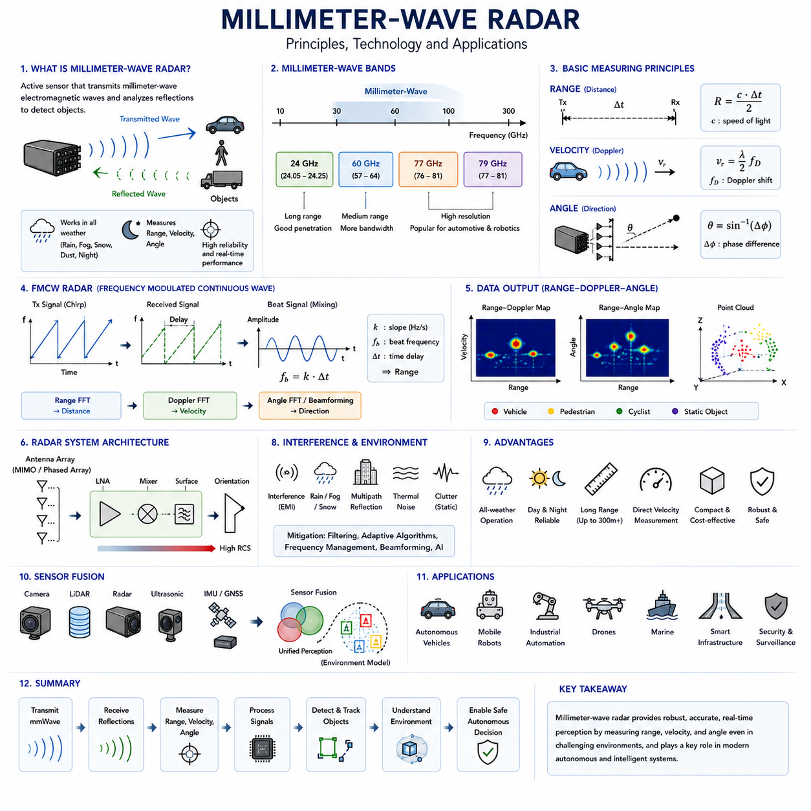
Millimeter-wave radar has become one of the most important sensing technologies for autonomous systems because it combines long detection range, accurate velocity estimation, compact hardware, and exceptional robustness under challenging environmental conditions. Unlike visible-light cameras that rely on ambient illumination or LiDAR systems that can experience performance degradation in heavy rain or dense fog, millimeter-wave radar actively transmits electromagnetic waves and analyzes their reflections from surrounding objects. This active sensing capability enables reliable perception during both daytime and nighttime while maintaining stable operation in rain, snow, fog, smoke, dust, and other low-visibility environments. As autonomous vehicles, mobile robots, industrial automation systems, drones, and intelligent transportation infrastructures continue to evolve, millimeter-wave radar has become a fundamental perception sensor that complements cameras, LiDAR, ultrasonic sensors, and inertial navigation systems. Its ability to directly measure distance, relative velocity, and object direction makes it indispensable for modern autonomous navigation.
The term millimeter-wave refers to electromagnetic waves with wavelengths ranging approximately from one to ten millimeters, corresponding to frequencies between about 30 GHz and 300 GHz. Automotive and robotic radar systems commonly operate within the 24 GHz, 60 GHz, 77 GHz, and 79 GHz frequency bands because these frequencies provide an effective balance among antenna size, detection range, bandwidth availability, resolution, and regulatory compliance. Higher frequencies enable physically smaller antennas while supporting wider bandwidths that improve range resolution. Since wavelength is inversely proportional to frequency, millimeter-wave radar can integrate multiple antenna elements into compact arrays without significantly increasing system dimensions. This characteristic has enabled radar sensors to become sufficiently small and affordable for widespread deployment in commercial vehicles, industrial robots, service robots, and intelligent infrastructure.
Millimeter-wave radar operates according to the same fundamental principles as conventional radar but benefits from higher operating frequencies and wider signal bandwidths. A radar transmitter generates electromagnetic waves that propagate through the surrounding environment until they encounter physical objects. Depending on material composition, surface geometry, orientation, electrical conductivity, and surface roughness, portions of the transmitted energy are reflected toward the receiving antenna while the remaining energy is scattered or absorbed. The received echoes contain valuable information regarding object distance, velocity, direction, and reflective characteristics. Advanced signal processing algorithms analyze propagation delay, frequency shifts, phase differences, and signal amplitude to reconstruct an accurate representation of the surrounding environment. This capability allows millimeter-wave radar to detect both stationary and moving targets with high reliability.
One of the most significant advantages of millimeter-wave radar is its superior environmental robustness. Optical sensors often experience severe degradation under poor lighting conditions or adverse weather, whereas millimeter-wave electromagnetic signals penetrate rain, fog, smoke, dust, and moderate vegetation far more effectively than visible light. Although atmospheric attenuation gradually increases at higher frequencies, particularly under heavy rainfall, modern radar systems compensate through optimized transmitter power, antenna gain, receiver sensitivity, and sophisticated digital signal processing. Consequently, millimeter-wave radar maintains consistent perception performance even when cameras or LiDAR systems experience reduced visibility. This robustness significantly improves operational safety for autonomous vehicles and robots operating continuously across varying weather and environmental conditions.
Distance measurement represents one of the primary sensing functions of millimeter-wave radar. Modern systems predominantly employ Frequency Modulated Continuous Wave (FMCW) technology, where transmitted signals continuously sweep across a predefined frequency range. Because reflected signals arrive with a delay proportional to target distance, the frequency difference between transmitted and received chirp signals becomes directly related to propagation time. Signal processing algorithms calculate this beat frequency to estimate object distance with remarkable precision. Wider modulation bandwidths improve range resolution, allowing nearby objects to be distinguished more accurately. Consequently, millimeter-wave radar can reliably detect multiple targets simultaneously while maintaining accurate distance estimation across short-, medium-, and long-range sensing applications.
Velocity estimation is another unique capability that distinguishes radar from many other perception sensors. The Doppler effect causes reflected electromagnetic waves to experience frequency shifts whenever a target moves relative to the radar sensor. Objects approaching the radar generate positive Doppler shifts, whereas receding objects generate negative shifts. By analyzing these frequency changes, radar systems directly estimate relative velocity without requiring multiple image frames or feature tracking. This direct velocity measurement significantly enhances obstacle prediction, collision avoidance, adaptive cruise control, autonomous navigation, and dynamic object tracking. Since velocity estimation occurs simultaneously with range measurement, millimeter-wave radar provides highly efficient perception suitable for real-time robotic decision making.
Angular estimation enables millimeter-wave radar to determine the direction from which reflected signals arrive. Modern radar systems typically employ multiple transmitting and receiving antennas arranged as phased arrays or Multiple Input Multiple Output (MIMO) configurations. Each antenna receives echoes with slightly different phase characteristics depending on target location. Beamforming algorithms analyze these phase differences to estimate azimuth and elevation angles with increasing precision. Higher frequencies allow larger antenna arrays to be integrated into compact hardware, improving angular resolution while maintaining practical sensor dimensions. As antenna technology and digital beamforming algorithms continue to advance, millimeter-wave radar increasingly approaches three-dimensional environmental perception capabilities traditionally associated with optical sensors.
Frequency Modulated Continuous Wave technology has become the dominant architecture for automotive and robotic millimeter-wave radar because it simultaneously measures range and velocity while maintaining relatively simple hardware implementation. A sequence of frequency chirps is continuously transmitted, and reflected signals are mixed with locally generated reference signals to produce beat frequencies. Fast Fourier Transform processing converts time-domain signals into frequency-domain representations that reveal target distances. Additional Doppler processing across multiple chirps estimates target velocity, while angle estimation algorithms reconstruct spatial direction. The resulting range-Doppler-angle representation provides a comprehensive description of surrounding objects and serves as the foundation for higher-level perception algorithms.
Signal processing forms the computational core of every millimeter-wave radar system. Raw analog echoes first pass through low-noise amplifiers, filters, mixers, and analog-to-digital converters before entering digital processing pipelines. Range FFT extracts distance information, Doppler FFT estimates target velocity, and angle FFT or beamforming algorithms determine spatial direction. Subsequent processing stages suppress clutter, remove interference, filter noise, associate detections across multiple observations, and generate stable object tracks. Constant False Alarm Rate detection automatically adjusts detection thresholds according to background noise characteristics, maintaining reliable target identification across varying environments. These processing stages transform weak reflected electromagnetic signals into meaningful environmental information suitable for autonomous decision making.
Radar Cross Section plays a critical role in target detection because reflected signal strength depends not only on object size but also on shape, material composition, orientation, and operating frequency. Metallic vehicles generally produce stronger reflections than pedestrians or plastic objects, while flat surfaces generate more concentrated reflections under favorable viewing angles. Irregular surfaces scatter energy in multiple directions, reducing detectable signal strength. Understanding Radar Cross Section characteristics allows perception algorithms to interpret reflection patterns more effectively while improving target classification and confidence estimation. Machine learning techniques increasingly exploit Radar Cross Section signatures to distinguish among vehicles, pedestrians, cyclists, infrastructure, and other objects.
Millimeter-wave radar systems must address various interference sources that can affect sensing performance. Thermal noise establishes the receiver sensitivity limit, while electromagnetic interference from neighboring radar systems, communication equipment, and industrial electronics may introduce measurement errors. Multipath propagation caused by reflections from buildings, road surfaces, tunnels, and metallic structures generates additional echoes that complicate target interpretation. Modern radar architectures incorporate adaptive filtering, interference suppression, waveform optimization, frequency management, and digital beamforming techniques to minimize these effects. Advanced signal processing algorithms further distinguish genuine targets from clutter and false detections, ensuring stable perception performance in complex urban and industrial environments.
Radar resolution determines how accurately nearby objects can be separated in space and velocity. Range resolution primarily depends on signal bandwidth, while angular resolution is influenced by antenna aperture and array geometry. Velocity resolution depends on coherent observation time and waveform design. Millimeter-wave radar benefits from wide available bandwidths that significantly improve range resolution compared with lower-frequency radar systems. Larger antenna arrays further enhance directional accuracy without increasing physical sensor size excessively. Engineers carefully optimize bandwidth, antenna configuration, waveform parameters, computational complexity, and power consumption to achieve balanced sensing performance suitable for autonomous driving and robotic applications.
Modern millimeter-wave radar increasingly incorporates artificial intelligence to improve perception capabilities beyond traditional signal processing. Deep learning algorithms analyze radar point clouds, range-Doppler maps, range-angle maps, and micro-Doppler signatures to classify objects, estimate occupancy, recognize human activities, and improve environmental understanding. AI-based methods also enhance clutter suppression, interference mitigation, sensor calibration, object association, and multi-target tracking. Rather than replacing conventional radar processing, machine learning complements physics-based algorithms by extracting higher-level semantic information from complex radar measurements. This combination significantly improves perception reliability under challenging real-world operating conditions.
Sensor fusion represents one of the most important applications of millimeter-wave radar in autonomous systems. Cameras provide rich semantic understanding and visual appearance, LiDAR delivers dense three-dimensional geometry, ultrasonic sensors detect nearby obstacles, while inertial sensors estimate vehicle motion. Millimeter-wave radar uniquely contributes robust distance measurements, direct velocity estimation, and reliable operation during adverse weather and poor illumination. Sensor fusion algorithms integrate complementary information from these sensing modalities to produce a comprehensive environmental model with greater accuracy, redundancy, and reliability than any individual sensor could achieve independently. This multi-sensor approach has become the preferred architecture for autonomous vehicles, intelligent mobile robots, and advanced industrial automation systems.
Millimeter-wave radar continues to evolve toward higher frequencies, larger antenna arrays, wider bandwidths, improved semiconductor integration, and more powerful artificial intelligence algorithms. Emerging four-dimensional imaging radar combines precise range, velocity, azimuth, and elevation estimation to generate increasingly detailed representations of complex environments. Digital beamforming, distributed radar networks, software-defined radar architectures, cognitive radar, and AI-driven perception pipelines further expand sensing capabilities while reducing hardware complexity. As semiconductor manufacturing advances and computational performance continues to increase, millimeter-wave radar will play an even greater role in future Physical AI systems by providing reliable, real-time environmental perception that remains robust across diverse operational conditions and challenging environments.

07.3 Range Doppler and Velocity
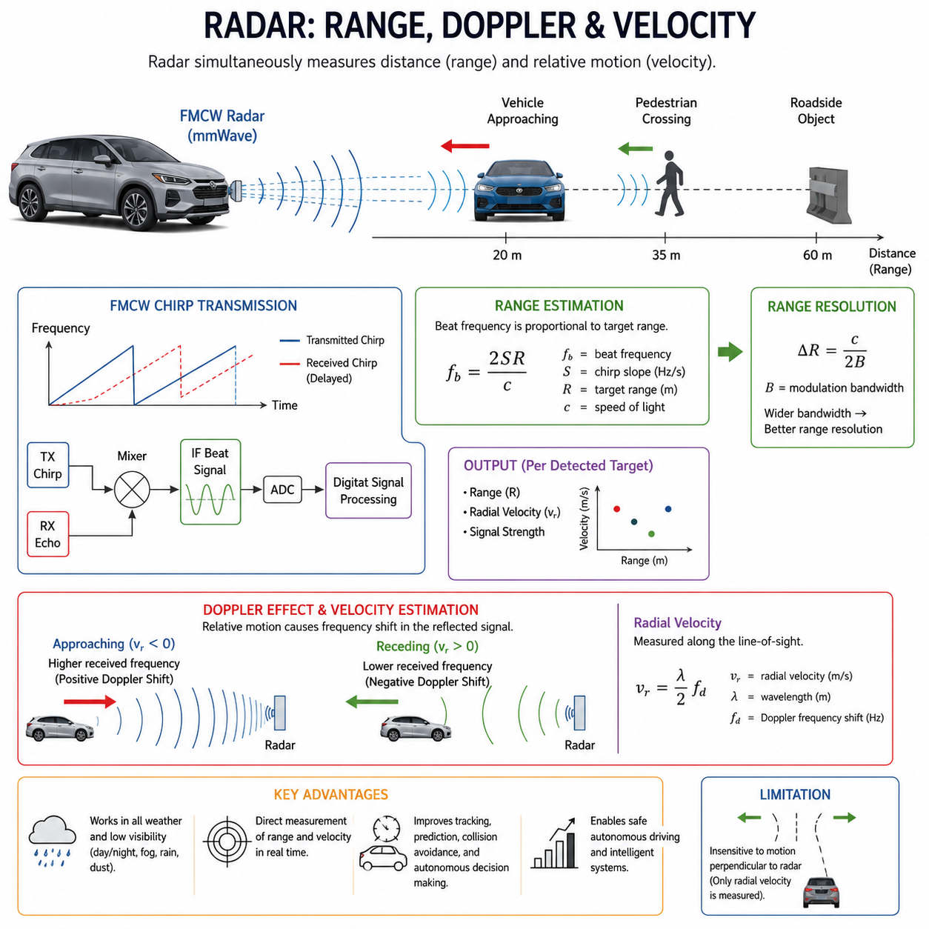
Range, Doppler, and velocity estimation constitute the core capabilities that distinguish radar from most other perception sensors. While cameras primarily observe visual appearance and LiDAR accurately reconstructs three-dimensional geometry, radar directly measures both the distance to an object and its relative motion simultaneously. This dual measurement capability enables autonomous vehicles, mobile robots, industrial automation systems, drones, and intelligent transportation infrastructures to understand not only where surrounding objects are located but also how they are moving. The combination of range estimation and Doppler-based velocity measurement significantly improves obstacle prediction, collision avoidance, target tracking, and autonomous decision making. As modern perception systems increasingly rely on sensor fusion, radar provides unique motion information that cannot be obtained directly from optical sensors without complex multi-frame analysis.
Range represents the distance between the radar sensor and a reflecting object. Accurate range estimation forms the foundation of every radar perception system because nearly all higher-level functions depend upon reliable distance information. Modern millimeter-wave radar predominantly employs Frequency Modulated Continuous Wave technology, where transmitted electromagnetic waves continuously sweep across a specified frequency bandwidth. When reflected signals return from surrounding objects, they exhibit a propagation delay proportional to the travel distance. By comparing transmitted and received signals, radar processors calculate a beat frequency that directly corresponds to target range. Since electromagnetic waves propagate at the speed of light, extremely small time differences represent measurable distance variations. Advanced digital signal processing converts these tiny propagation delays into highly accurate range estimates suitable for real-time autonomous navigation.
The mathematical relationship between propagation time and target distance is relatively straightforward but requires extremely precise timing measurements. Electromagnetic waves travel to the target and back to the receiver, meaning the measured propagation time includes a round-trip journey. Consequently, target distance equals half of the total travel distance. Although the actual propagation delay is typically measured in nanoseconds, modern radar electronics combined with high-speed analog-to-digital converters and digital signal processors achieve remarkably accurate range estimation. Wide modulation bandwidth further improves range resolution, allowing closely spaced objects to be distinguished individually. This capability enables radar systems to detect multiple vehicles, pedestrians, roadside structures, and obstacles simultaneously even within congested urban environments.
Frequency Modulated Continuous Wave radar generates continuously transmitted chirp signals whose frequencies increase or decrease linearly over time. As reflected signals return with propagation delay, their instantaneous frequencies differ slightly from those currently being transmitted. Mixing transmitted and received signals produces an intermediate beat frequency proportional to target distance. Unlike pulsed radar systems that directly measure time-of-flight using discrete pulses, FMCW radar estimates distance through frequency differences, enabling lower transmitter power, continuous operation, compact hardware implementation, and improved measurement precision. These characteristics explain why FMCW architecture has become the dominant radar technology for automotive safety systems, autonomous robots, industrial sensing, and intelligent infrastructure applications.
While range identifies object position, velocity estimation determines how objects move relative to the radar sensor. Relative motion introduces the Doppler effect, a physical phenomenon observed whenever wave sources and observers move with respect to one another. If an object approaches the radar, reflected electromagnetic waves experience a positive frequency shift because successive wavefronts arrive closer together. Conversely, objects moving away generate negative frequency shifts as wavefront spacing effectively increases. Radar processors accurately measure these frequency changes to estimate radial velocity, representing motion directly toward or away from the radar. Unlike cameras, which require sequential image processing and feature tracking to estimate motion, radar obtains velocity measurements directly from electromagnetic wave physics.
The Doppler effect provides several important advantages for autonomous perception. Direct velocity measurement enables immediate recognition of moving vehicles, pedestrians, cyclists, industrial machinery, and dynamic obstacles without requiring temporal image analysis. Since radar independently estimates both distance and velocity within each observation cycle, prediction algorithms receive accurate motion information with minimal computational delay. This capability substantially improves adaptive cruise control, emergency braking, autonomous navigation, object tracking, and collision prediction. Even when environmental visibility deteriorates because of darkness, fog, rain, or dust, Doppler measurements remain reliable, providing continuous motion awareness under conditions where optical perception may become significantly degraded.
Radar velocity measurements represent only the radial component of object motion rather than complete three-dimensional velocity vectors. Radial velocity corresponds exclusively to movement toward or away from the radar sensor. Objects traveling perpendicular to the radar beam exhibit little or no Doppler frequency shift despite potentially moving at considerable speed. Consequently, radar alone cannot always determine complete object trajectories. Modern autonomous systems address this limitation through multiple radar viewpoints, sensor fusion with cameras and LiDAR, vehicle motion estimation, target tracking algorithms, and probabilistic filtering techniques. These complementary methods reconstruct full object trajectories while preserving the unique advantages of radar-based velocity estimation.
Range and Doppler information are processed simultaneously within modern FMCW radar systems through sequential signal processing stages. Initially, received signals undergo analog amplification, filtering, frequency mixing, and analog-to-digital conversion. A Fast Fourier Transform applied along individual chirps estimates beat frequencies corresponding to target ranges. Subsequently, multiple consecutive chirps are analyzed using another Fourier Transform to estimate Doppler frequencies associated with target velocities. This two-dimensional frequency analysis generates a Range-Doppler Map in which each detected object occupies a specific position according to its measured distance and radial velocity. The resulting representation forms one of the most fundamental data structures within modern radar perception systems.
A Range-Doppler Map provides an intuitive visualization of surrounding dynamic environments. The horizontal axis typically represents target distance, while the vertical axis corresponds to radial velocity. Stationary objects appear near zero Doppler frequency regardless of distance, whereas moving objects shift upward or downward depending on whether they approach or recede from the radar. Bright regions indicate strong radar reflections produced by significant targets such as vehicles, infrastructure, or industrial equipment. Multiple objects naturally occupy different locations within the map according to their independent ranges and velocities. Signal processing algorithms detect these peaks, suppress background noise, remove clutter, and extract stable target measurements for subsequent tracking and classification.
Range resolution determines the minimum distance separating two objects before radar recognizes them as independent targets. This resolution depends primarily upon transmitted signal bandwidth rather than carrier frequency itself. Wider bandwidth produces smaller range cells, allowing nearby objects to be distinguished more accurately. Modern automotive radar commonly employs bandwidths approaching several gigahertz, enabling range resolutions measured in only a few centimeters. High range resolution becomes increasingly important during dense urban driving, warehouse automation, precision docking, and industrial inspection, where multiple closely spaced objects must be reliably separated. Engineers continuously optimize waveform design, hardware capabilities, and signal processing complexity to maximize practical range resolution.
Velocity resolution describes the radar's ability to distinguish objects moving at slightly different speeds. Unlike range resolution, velocity resolution depends largely upon coherent observation time and the number of transmitted chirps processed together. Longer observation intervals improve velocity discrimination because smaller Doppler frequency differences become measurable. However, increasing observation duration also reduces responsiveness to rapidly changing environments. Radar designers therefore balance velocity precision against real-time performance according to application requirements. Autonomous vehicles operating at highway speeds, for example, require accurate velocity estimation while maintaining rapid perception updates to support safe high-speed navigation and emergency response.
Maximum unambiguous range and maximum measurable velocity represent two important design constraints within radar systems. If transmitted chirps repeat too rapidly, distant reflections may overlap with subsequent transmissions, producing ambiguous range measurements. Similarly, excessively high target velocities may generate Doppler frequencies beyond measurable limits, introducing velocity ambiguities. Radar waveform parameters, including chirp duration, repetition frequency, modulation bandwidth, and observation interval, must therefore be carefully selected according to expected operational environments. Different applications such as indoor robotics, highway vehicles, drones, marine navigation, and industrial automation require different optimization strategies because their sensing distances and target velocities vary substantially.
Clutter significantly influences Range-Doppler analysis because many reflected signals originate from stationary environmental structures rather than moving objects of interest. Buildings, road surfaces, guardrails, vegetation, walls, machinery, and infrastructure generate persistent reflections that may obscure weaker dynamic targets. Fortunately, stationary clutter generally exhibits near-zero Doppler frequency, enabling radar processors to suppress these reflections using Moving Target Indication techniques, adaptive filtering, clutter maps, and background subtraction algorithms. Removing stationary clutter enhances detection sensitivity for pedestrians, cyclists, vehicles, and other moving targets while reducing false detections that might otherwise degrade autonomous perception performance.
Noise and interference further complicate radar signal interpretation. Thermal receiver noise establishes the fundamental sensitivity limit, while neighboring radar sensors, communication systems, and industrial electronics introduce electromagnetic interference. Multipath propagation generates additional reflected signals arriving along indirect paths, potentially producing ghost targets or distorted measurements. Advanced radar processors apply adaptive thresholding through Constant False Alarm Rate detection, interference cancellation algorithms, beamforming, waveform optimization, and probabilistic target association to distinguish genuine objects from measurement artifacts. These techniques maintain reliable range and velocity estimation even within highly congested electromagnetic environments encountered in modern cities and industrial facilities.
Target tracking algorithms extend individual range and Doppler measurements across time to estimate continuous object trajectories. Each radar observation provides instantaneous position and radial velocity, but autonomous systems require persistent knowledge regarding object identity, motion history, acceleration, and predicted future location. Kalman Filters, Extended Kalman Filters, Unscented Kalman Filters, Particle Filters, Joint Probabilistic Data Association, and Multiple Hypothesis Tracking algorithms associate successive radar observations into coherent object tracks. These tracking methods compensate for measurement uncertainty, temporary occlusions, missed detections, and noisy observations while providing stable motion estimates for higher-level planning and decision-making systems.
Artificial intelligence increasingly complements conventional Range-Doppler processing by learning complex patterns directly from radar measurements. Deep neural networks analyze Range-Doppler Maps, Range-Angle Maps, micro-Doppler signatures, and radar point clouds to classify objects, recognize human activities, estimate occupancy, detect anomalies, and improve environmental understanding. Rather than replacing physics-based radar processing, machine learning enhances interpretation of processed radar representations while preserving reliable range and velocity estimation obtained through well-established signal processing methods. This hybrid approach combines mathematical modeling with data-driven intelligence, enabling more robust perception across diverse operational conditions.
The integration of range estimation, Doppler processing, velocity analysis, advanced tracking, and artificial intelligence has transformed modern radar into a highly capable perception sensor suitable for autonomous systems operating in complex environments. Continuous improvements in semiconductor technology, digital signal processing, antenna design, waveform optimization, and machine learning continue to increase measurement accuracy, angular resolution, detection reliability, and computational efficiency. As four-dimensional imaging radar and cognitive radar technologies mature, future systems will provide richer environmental representations while maintaining the unique capability of directly measuring object distance and motion under nearly all weather and lighting conditions. Consequently, Range-Doppler processing and velocity estimation will remain fundamental components of next-generation autonomous vehicles, intelligent robots, industrial automation platforms, and Physical AI systems.

07.4 Radar for Outdoor AMR
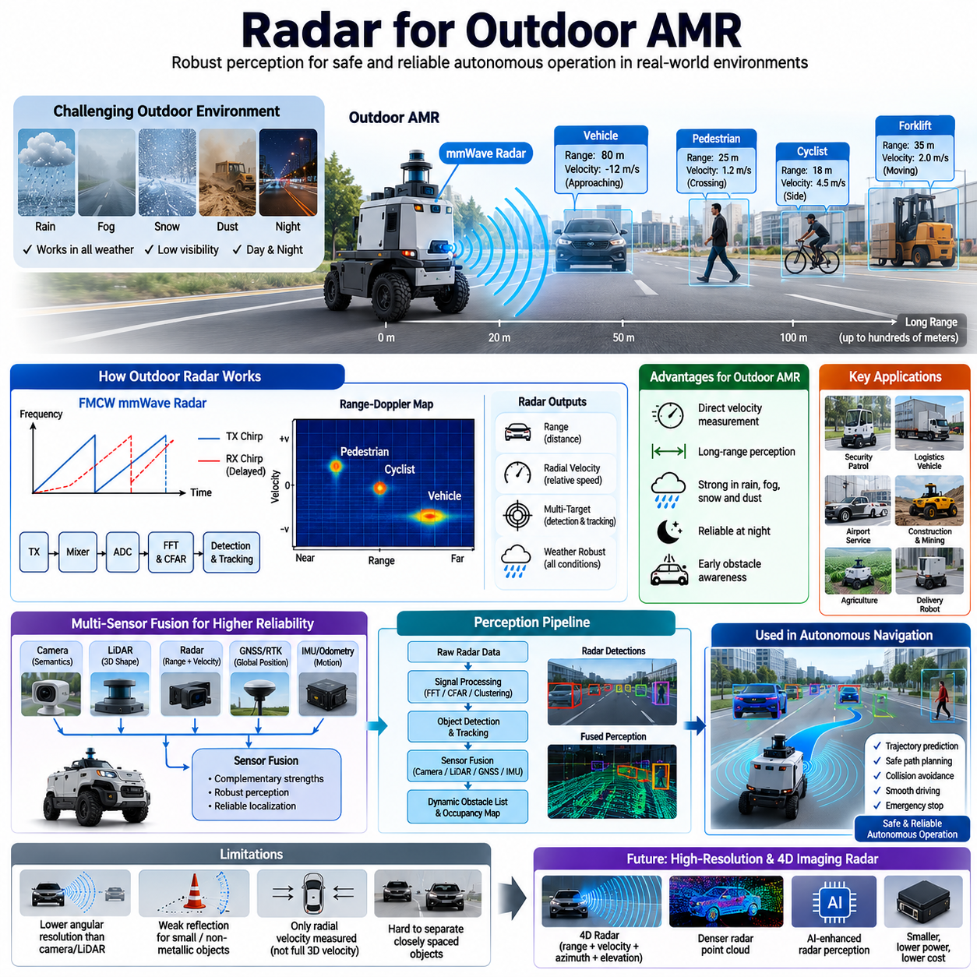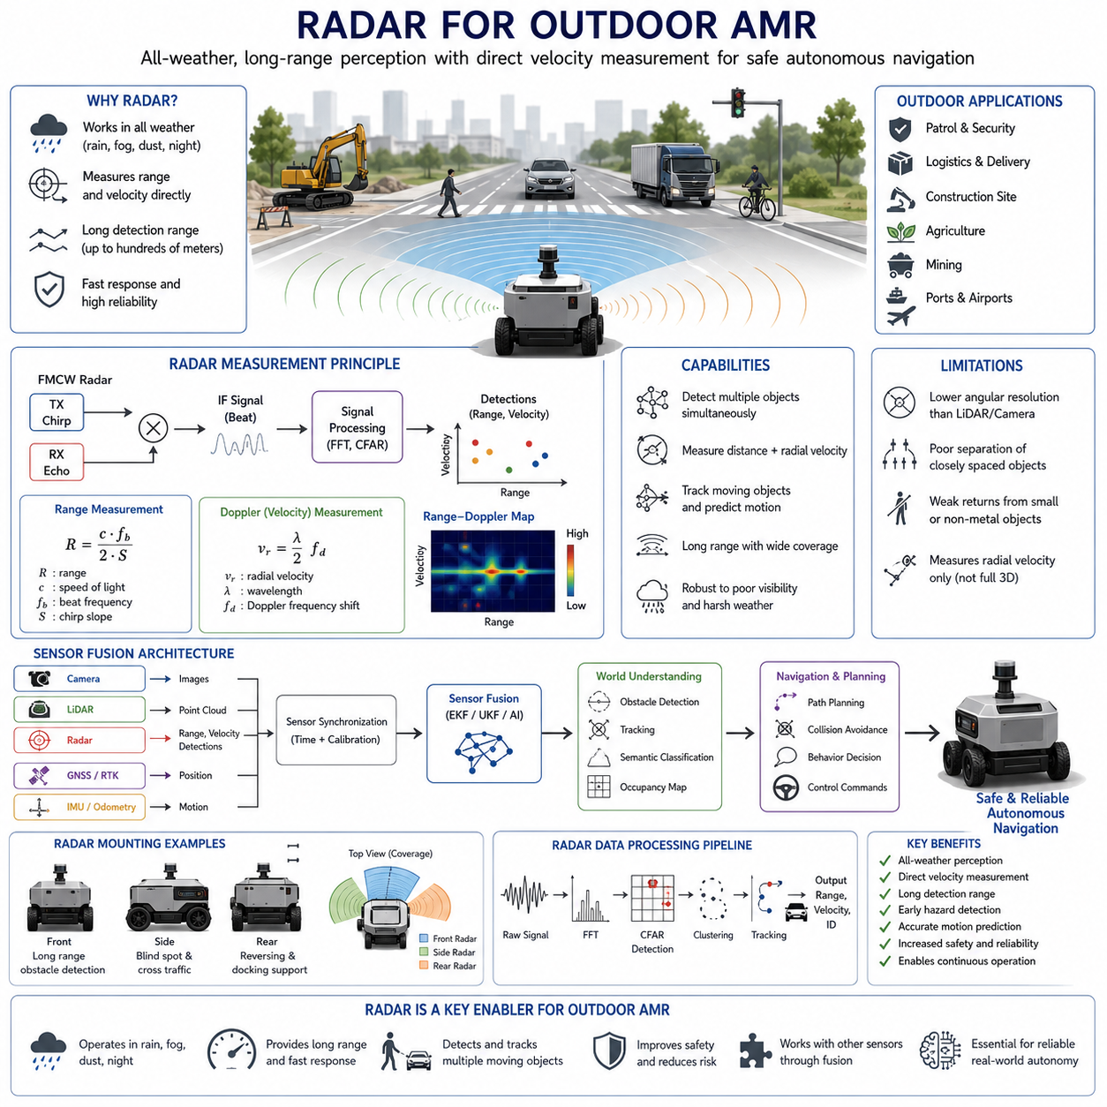
Radar has become one of the most important perception sensors for Outdoor Autonomous Mobile Robots because it provides reliable environmental awareness under conditions where optical sensors often struggle. Outdoor robots operate in highly dynamic environments that include moving vehicles, pedestrians, cyclists, construction equipment, vegetation, rough terrain, and continuously changing weather. Unlike indoor robots that navigate within relatively structured spaces, outdoor platforms must perceive both static infrastructure and unpredictable moving objects across large distances. Millimeter-wave radar offers a unique capability by directly measuring both target distance and relative velocity, allowing the robot to understand not only where surrounding objects are located but also how they are moving. This ability significantly improves navigation safety, obstacle prediction, and autonomous decision making, making radar an essential component of modern outdoor perception systems rather than merely an optional sensor. Radar integration within outdoor AMRs represents an important evolution toward perception systems capable of operating continuously regardless of environmental conditions.
Outdoor environments introduce sensing challenges that differ substantially from warehouses or factory floors. Roads, construction sites, mining areas, agricultural fields, ports, airports, and smart city infrastructures contain objects with varying sizes, materials, and motion characteristics. Bright sunlight, heavy shadows, rain, fog, snow, dust, smoke, and darkness frequently reduce the effectiveness of cameras, while airborne particles and water droplets may partially degrade LiDAR performance. Radar is considerably less sensitive to these environmental factors because millimeter-wave electromagnetic signals penetrate many visibility-reducing conditions more effectively than visible or infrared light. As a result, outdoor AMRs equipped with radar maintain stable perception during adverse weather while other sensors experience increasing uncertainty. This weather robustness allows autonomous systems to continue operating safely over longer periods without relying exclusively on favorable environmental conditions, thereby improving operational availability and mission reliability.
One of the greatest advantages of radar in outdoor AMRs is its ability to measure object velocity directly using the Doppler effect. Cameras estimate motion by comparing multiple image frames, and LiDAR generally requires point cloud registration across time before motion can be inferred. Radar, however, measures radial velocity within every sensing cycle through physical frequency shifts in reflected electromagnetic waves. This immediate motion information enables the robot to rapidly identify approaching vehicles, crossing pedestrians, bicycles, forklifts, construction machinery, and other dynamic obstacles. Direct velocity estimation reduces computational latency while providing highly valuable inputs for prediction algorithms. Consequently, radar allows autonomous navigation software to distinguish stationary infrastructure from moving hazards more quickly, supporting safer trajectory planning and faster emergency responses during real-world operation.
Long-range perception represents another important reason why radar is widely adopted for outdoor robotic platforms. Modern millimeter-wave radar sensors routinely detect large objects hundreds of meters away while simultaneously monitoring nearby obstacles. Such long detection distances provide valuable reaction time for autonomous systems traveling at moderate or high speeds. Patrol robots, logistics vehicles, agricultural robots, autonomous trucks, and heavy outdoor AMRs benefit from early awareness of approaching traffic, intersections, work zones, or unexpected obstacles beyond the effective range of short-distance perception sensors. Long-range radar measurements improve behavioral planning by allowing path planners to anticipate future interactions rather than merely reacting to immediate obstacles. Earlier decision making leads to smoother navigation, lower braking forces, improved passenger comfort where applicable, and reduced collision risk.
Outdoor AMRs commonly operate in environments populated by multiple moving targets simultaneously. Vehicles travel at different speeds, pedestrians cross pathways unpredictably, cyclists move alongside roads, and industrial equipment follows independent operating patterns. Radar naturally supports multi-target detection because Range-Doppler processing separates objects according to both distance and radial velocity. Multiple independent reflections appear as distinct peaks within the Range-Doppler Map, allowing signal processing algorithms to detect numerous targets simultaneously without requiring sequential scanning. Advanced tracking algorithms then associate these detections over time to estimate continuous trajectories. This capability enables outdoor robots to monitor complex traffic situations while maintaining stable awareness of surrounding dynamic environments even when multiple objects overlap visually from a camera perspective.
Radar also contributes significantly to collision avoidance systems by improving prediction accuracy. Autonomous navigation depends not only on identifying obstacles but also on estimating where those obstacles will move in the near future. Since radar continuously provides accurate velocity measurements together with target range, trajectory prediction algorithms receive reliable motion estimates immediately after target detection. Kalman Filters, Extended Kalman Filters, Unscented Kalman Filters, Particle Filters, and multiple-object tracking frameworks combine radar observations across successive measurement cycles to estimate acceleration, heading, and future position. These predictions enable the navigation system to adjust robot speed, select alternative routes, or perform controlled emergency stops before hazardous situations develop. Reliable prediction becomes especially important for outdoor robots operating among human workers or public traffic.
Despite its advantages, radar alone cannot provide complete environmental understanding. Millimeter-wave radar generally offers lower angular resolution than modern cameras or high-channel-count LiDAR systems. Although radar accurately measures distance and velocity, distinguishing between closely spaced objects located at similar ranges may remain difficult. Small non-metallic obstacles, thin poles, wires, or objects with weak radar reflectivity may also produce limited returns. Furthermore, Doppler measurements describe only the radial component of motion rather than full three-dimensional velocity. Objects moving perpendicular to the radar beam may generate little measurable Doppler shift despite traveling rapidly. Consequently, radar should be considered one component of a complementary perception architecture rather than a complete sensing solution for autonomous outdoor operation.
Sensor fusion therefore plays a central role in Outdoor AMR perception. Cameras contribute rich semantic information including traffic signs, lane markings, colors, and object appearance. LiDAR supplies highly accurate three-dimensional geometry for mapping and obstacle localization. GNSS and RTK provide global positioning, while IMUs and wheel odometry estimate vehicle motion between absolute measurements. Radar complements these sensors by contributing robust distance and direct velocity measurements under all weather conditions. Fusion algorithms combine the strengths of every sensing modality while compensating for individual weaknesses. Camera-radar fusion improves object classification, LiDAR-radar fusion enhances dynamic obstacle tracking, and GNSS-IMU-radar integration increases localization robustness during degraded visibility. The result is a perception system substantially more reliable than any individual sensor operating independently.
Radar hardware integration within outdoor robots requires careful engineering consideration. Sensor mounting height influences ground reflection, obstacle visibility, and coverage distance. Forward-facing radar provides long-range collision monitoring, while side-mounted sensors improve blind-spot detection and cross-traffic awareness. Rear radar assists reversing, docking, and trailer operation for towing robots. Mechanical vibration isolation, waterproof enclosures, thermal management, and electromagnetic compatibility all affect radar measurement quality during continuous outdoor operation. Engineers must additionally consider antenna field of view, overlapping sensor coverage, mounting angles, cable routing, power stability, and synchronization with other perception devices. Proper integration ensures radar performance remains consistent despite vehicle vibration, uneven terrain, or harsh environmental exposure.
The software architecture supporting outdoor radar is equally important. Raw radar detections undergo amplification, filtering, analog-to-digital conversion, Fast Fourier Transform processing, Constant False Alarm Rate detection, clustering, and target tracking before reaching higher-level perception modules. These processed observations are synchronized with LiDAR point clouds, camera images, GNSS positioning, and inertial measurements through common timestamps and middleware such as ROS2. Real-time perception pipelines continuously update occupancy maps, dynamic obstacle lists, and navigation cost maps using fused radar information. Artificial intelligence further improves radar interpretation by analyzing Range-Doppler Maps, Range-Angle Maps, and radar point clouds to classify targets, recognize motion patterns, and reduce false detections. This combination of physics-based signal processing and AI-based interpretation provides highly reliable perception suitable for demanding outdoor autonomy.
Outdoor radar applications continue expanding across many robotic industries. Security patrol robots monitor moving intruders under nighttime conditions. Agricultural robots navigate fields despite dust and changing illumination. Mining vehicles detect heavy equipment within harsh industrial environments. Autonomous construction robots avoid workers and machinery amid airborne debris. Port logistics vehicles maintain safe operation during rain and sea fog, while airport service robots detect aircraft support equipment under continuously changing weather. Delivery robots operating on public sidewalks benefit from reliable pedestrian tracking even in darkness or adverse weather. Across these diverse applications, radar consistently contributes stable perception where purely optical sensing may become unreliable, allowing autonomous systems to maintain safe operation over extended deployment periods.
Future Outdoor AMRs will increasingly adopt high-resolution imaging radar and four-dimensional radar technologies capable of simultaneously estimating range, velocity, azimuth, and elevation with significantly improved angular precision. Semiconductor advances, larger antenna arrays, digital beamforming, MIMO radar architectures, and AI-assisted signal processing continue increasing environmental detail while reducing sensor size, power consumption, and cost. Radar point clouds are gradually becoming denser, enabling perception pipelines more comparable to three-dimensional LiDAR while preserving radar's superior weather robustness and direct velocity measurement capability. As Physical AI systems evolve toward richer world models and more intelligent autonomous behavior, radar will remain a foundational sensing technology that enables reliable outdoor perception across diverse operational environments, supporting safe navigation, robust obstacle avoidance, accurate motion prediction, and resilient autonomous decision making for the next generation of Outdoor Autonomous Mobile Robots.

07.5 Radar in Rain, Fog, and Dust
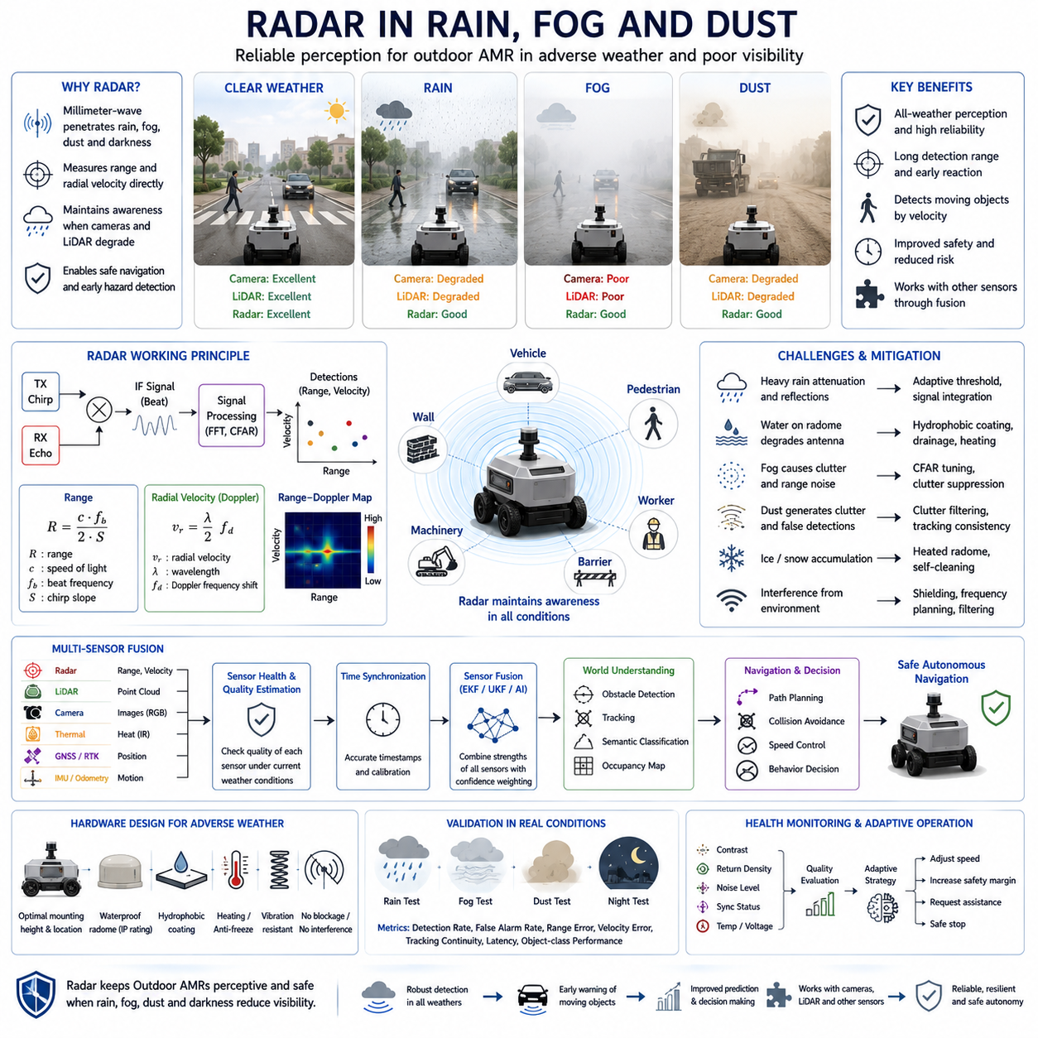
Radar provides a critical layer of environmental perception for autonomous mobile robots operating in rain, fog, dust, smoke, and other visibility-degrading conditions. Outdoor AMRs cannot assume that cameras and LiDAR will always deliver stable measurements because weather can obscure objects, scatter light, reduce contrast, and contaminate sensor surfaces. Millimeter-wave radar addresses these limitations by transmitting electromagnetic waves that remain effective when visible light is weak or blocked. It measures object distance and relative velocity directly, allowing the robot to maintain awareness of vehicles, pedestrians, machinery, and structural obstacles even when optical perception becomes uncertain.
Rain affects perception sensors through several physical mechanisms. Water droplets reduce image contrast, create reflections on camera lenses, and scatter laser energy emitted by LiDAR systems. Wet roads also produce glare and complex reflections that may confuse vision-based segmentation and object detection algorithms. Millimeter-wave radar is generally more resistant to rainfall because its wavelength is much longer than visible light and typical LiDAR wavelengths. Most rain droplets therefore have a relatively limited effect on transmitted radar energy. Although very heavy rainfall can introduce attenuation and additional reflections, radar usually continues to provide usable range and velocity measurements when cameras or LiDAR experience significant degradation.
The practical influence of rain depends on radar frequency, rainfall intensity, target distance, antenna design, and signal-processing capability. Automotive and robotic radar systems commonly operate near 24 GHz, 60 GHz, 77 GHz, or 79 GHz, with higher-frequency systems supporting compact antennas and improved resolution. Strong rainfall can absorb and scatter part of the transmitted energy, reducing the signal-to-noise ratio of distant or weak targets. Water accumulated on a radar cover may also modify antenna characteristics. Engineers compensate through suitable radar placement, hydrophobic radome coatings, drainage structures, adaptive detection thresholds, signal integration, and health monitoring that identifies abnormal reductions in measurement quality.
Fog presents a severe challenge for cameras because suspended water droplets scatter visible light and reduce the contrast between objects and their backgrounds. Dense fog may make vehicles, workers, road boundaries, and industrial structures almost invisible in ordinary images. LiDAR performance can also deteriorate because laser pulses interact with fog particles, producing false near-range returns and reducing effective detection distance. Radar waves pass through fog with substantially less scattering, enabling continued detection of objects beyond the reliable range of optical sensors. This makes radar especially valuable for AMRs operating at ports, airports, coastal facilities, mountain roads, logistics yards, and industrial areas where fog may appear suddenly.
Radar does not completely eliminate uncertainty in fog, but it preserves essential geometric and motion information required for safe operation. A radar sensor can continue measuring the range and radial velocity of an approaching truck even when the truck cannot be clearly classified by a camera. The autonomous system can therefore reduce speed, enlarge its safety margin, or stop before entering an uncertain area. When visibility improves, camera and LiDAR information can refine the classification and shape of the detected object. This behavior demonstrates the importance of confidence-aware sensor fusion, in which radar supports safety-critical detection while other sensors provide detailed semantic and geometric interpretation whenever environmental conditions permit.
Dust is another major perception problem for outdoor AMRs used in construction, agriculture, mining, quarrying, waste management, and unpaved logistics areas. Dust clouds may be generated by wind, vehicle tires, excavation, loading operations, or moving machinery. Cameras lose contrast and may interpret illuminated particles as visual noise, while LiDAR can produce large numbers of returns from airborne particles. These effects may create false obstacles, hide real targets, or destabilize localization. Radar is comparatively insensitive to fine dust because small particles produce weak reflections at millimeter-wave frequencies. It can therefore detect large vehicles, workers, barriers, and equipment through dust that significantly limits optical sensing.
The robustness of radar in dust depends on particle density, composition, moisture content, and target reflectivity. Dry fine dust usually has a limited impact, whereas wet or metallic particles may produce stronger attenuation or clutter. Dense material clouds can also reduce the strength of distant target returns. For this reason, radar measurements must still be evaluated using confidence values and temporal consistency. Tracking algorithms can distinguish persistent moving targets from random particle reflections by analyzing range, velocity, signal strength, and motion history. Adaptive clutter suppression and probabilistic data association further improve detection stability in environments where dust conditions change rapidly during robot operation.
Radar is also effective at night because its measurement process does not depend on sunlight or artificial illumination. Cameras may require headlights, infrared illuminators, or high-sensitivity imaging sensors, all of which can still be affected by glare, shadows, exposure transitions, and reflective surfaces. Radar continuously transmits its own electromagnetic signal and measures the returned energy, providing similar fundamental operation during the day and at night. This capability is important for security patrol robots, autonomous delivery platforms, airport service vehicles, mining machines, and industrial inspection robots that operate continuously across multiple shifts. Nighttime radar detection provides early awareness of moving people and vehicles before they enter a camera’s reliable recognition range.
Adverse-weather radar processing begins with the separation of meaningful target reflections from noise, clutter, and interference. Fast Fourier Transform processing estimates range and Doppler frequency, while Constant False Alarm Rate detection adjusts detection thresholds according to the local background level. Clustering combines related radar points into target candidates, and tracking algorithms associate those candidates over time. During rain or dust, adaptive thresholds are particularly important because the noise environment may vary across distance and direction. A fixed threshold can generate excessive false alarms or miss weak objects. Modern processors therefore adjust sensitivity dynamically while preserving safety margins for vulnerable road users and small obstacles.
Sensor fusion provides the most reliable strategy for perception in rain, fog, and dust. Radar contributes robust range and velocity measurements, LiDAR contributes detailed three-dimensional structure, and cameras provide object appearance and semantic information. Thermal cameras may improve human detection in darkness or smoke, while GNSS, IMU, and wheel odometry support localization when environmental features become difficult to observe. Fusion software should not treat all sensors as equally reliable under every condition. Instead, it should estimate measurement quality and adjust the influence of each sensor dynamically. During clear weather, camera and LiDAR data may dominate classification and mapping, while radar receives greater importance when visibility deteriorates.
Weather-aware perception requires explicit detection of sensor degradation. The AMR should monitor camera contrast, LiDAR return density, radar noise level, target consistency, lens contamination, communication status, temperature, and synchronization quality. When one sensor becomes unreliable, the system should not silently continue using corrupted measurements. It should reduce the affected sensor’s confidence, notify diagnostic software, and adapt the navigation strategy. Appropriate responses may include lowering speed, increasing following distance, restricting access to complex areas, requesting remote assistance, or performing a controlled stop. This degraded-operation concept is essential because radar robustness improves safety but does not guarantee complete perception under every possible environmental condition.
Mechanical design strongly influences radar performance in adverse weather. The radar should be mounted where accumulated water, mud, ice, or dust is unlikely to block the antenna. The radome must use a material that permits millimeter-wave transmission with minimal distortion while providing suitable ingress protection. Heating may be required to prevent snow or ice accumulation, while cleaning systems can remove mud from sensors mounted near the ground. Mounting brackets must resist vibration and preserve calibration across rough terrain. Engineers should also prevent nearby metal structures, body panels, cables, or payload equipment from disturbing the antenna pattern or generating persistent reflections that reduce detection quality.
Validation must reproduce realistic environmental conditions rather than relying only on laboratory measurements. Rain testing should cover different intensities, droplet sizes, wet surfaces, and water accumulation on the radome. Fog testing should evaluate detection range at multiple visibility levels, while dust testing should include relevant particle types and densities from the intended workplace. Tests should measure probability of detection, false alarm rate, range error, velocity error, tracking continuity, latency, and object-class-specific performance. Static barriers, pedestrians, vehicles, machinery, and small obstacles should be evaluated separately because their radar reflectivity differs significantly. Results must also be compared with camera and LiDAR degradation under identical conditions.
Recorded field data is essential for debugging and continuous improvement. Radar detections, raw or intermediate signals, camera images, LiDAR point clouds, weather observations, robot motion, localization results, and control commands should share accurate timestamps. Engineers can replay synchronized datasets to determine whether failures originated from weak radar reflections, inappropriate detection thresholds, incorrect calibration, tracking errors, fusion logic, or navigation responses. Scenario-based analysis is more informative than isolated sensor metrics because autonomous safety depends on the entire perception and decision pipeline. Difficult cases should be added to regression datasets so that future software versions can be tested against previously observed rain, fog, and dust failures.
Artificial intelligence can enhance radar interpretation during adverse weather by learning patterns that are difficult to model using fixed signal-processing rules. Neural networks can analyze Range-Doppler Maps, Range-Angle Maps, temporal radar sequences, and fused sensor features to distinguish vehicles, pedestrians, vegetation, rainfall artifacts, and background clutter. AI can also estimate sensor confidence and detect unusual radar behavior caused by contamination or interference. However, learned models must be trained with representative environmental data and validated against rare safety-critical scenarios. Physics-based processing should remain the reliable foundation, while machine learning adds classification, pattern recognition, and adaptive interpretation capabilities.
Radar enables Outdoor AMRs to maintain useful perception when rain, fog, dust, darkness, or smoke reduces the effectiveness of optical sensing. Its direct measurement of range and radial velocity supports early obstacle detection, dynamic-object tracking, collision prediction, and controlled navigation under degraded visibility. Nevertheless, radar has limitations in angular resolution, object classification, and detection of small low-reflectivity targets. Safe operation therefore depends on multi-sensor fusion, adaptive confidence management, mechanical protection, health monitoring, and comprehensive weather validation. When these elements are designed as an integrated system, radar becomes a central technology for reliable and resilient autonomous operation in demanding real-world environments.

07.6 Radar Object Detection
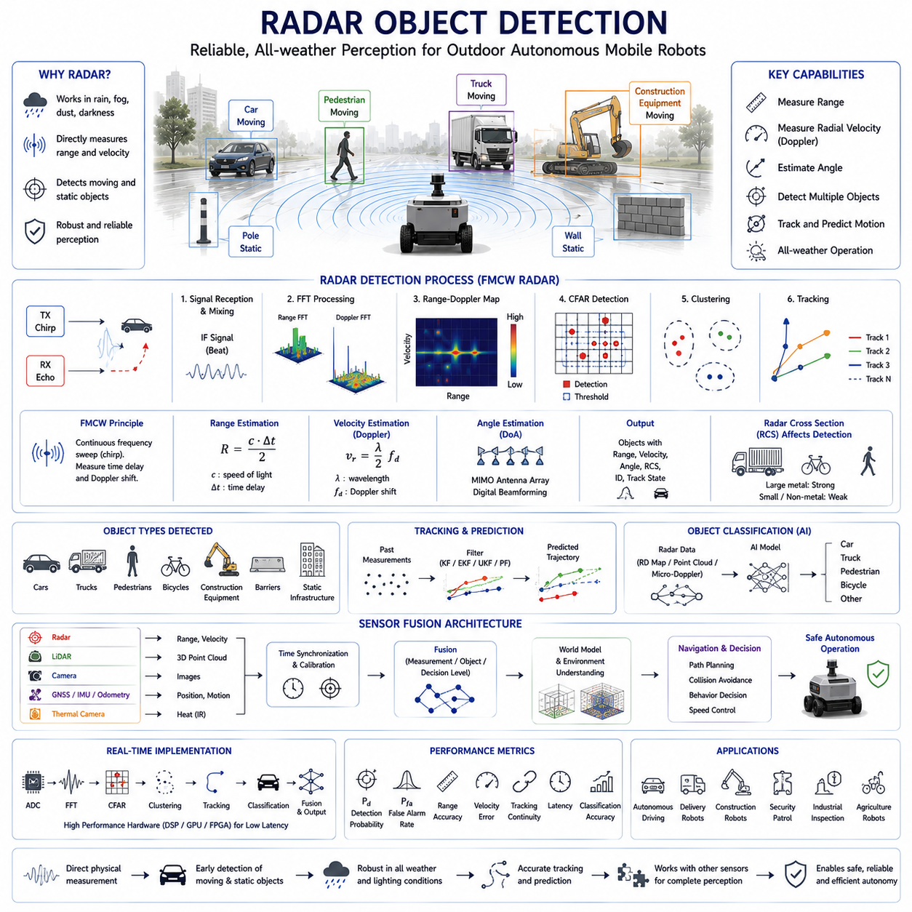
Object detection is one of the primary functions of radar perception systems used in Autonomous Mobile Robots operating in outdoor environments. While radar was originally developed for military surveillance and air traffic monitoring, modern millimeter-wave radar has evolved into a compact and highly capable sensor that enables autonomous robots to detect surrounding objects reliably under diverse environmental conditions. Radar object detection is fundamentally different from camera-based or LiDAR-based detection because it directly measures physical quantities such as distance, relative velocity, signal strength, and angular position instead of relying solely on visual appearance. This physical measurement capability allows radar to detect objects even when visibility is poor due to rain, fog, dust, smoke, or darkness. As a result, radar has become an essential perception sensor for outdoor AMRs that require continuous operation regardless of weather or lighting conditions.
The radar object detection process begins with the transmission of electromagnetic waves toward the surrounding environment. Modern automotive and robotic radars typically employ Frequency Modulated Continuous Wave (FMCW) technology, where the transmitted signal continuously changes its frequency according to a predefined chirp pattern. When these waves encounter an object, part of the energy is reflected back toward the radar receiver. The receiver compares the transmitted signal with the returned echo to estimate the time delay, frequency shift, and phase difference. These measurements provide accurate estimates of target distance, relative velocity through the Doppler effect, and angular direction when multiple receiving antennas are used. Every radar measurement cycle generates a set of physical observations that become the foundation for subsequent object detection algorithms.
Radar detects objects by identifying significant reflections within received signals rather than interpreting visual features. After analog signals are digitized, Fast Fourier Transform processing converts the time-domain signal into the frequency domain. Multiple FFT operations estimate target range and Doppler velocity, producing the well-known Range-Doppler Map. Each bright peak in this map represents a reflected target whose position corresponds to a specific distance and relative velocity. Signal processing algorithms search for these peaks while suppressing background noise and interference. This approach differs fundamentally from image recognition because radar first detects measurable physical objects before any semantic interpretation occurs. Consequently, radar maintains stable detection performance even when object appearance changes dramatically due to illumination or weather.
One of the most important components of radar object detection is Constant False Alarm Rate detection. Radar signals naturally contain thermal noise, multipath reflections, atmospheric effects, and interference from nearby objects. If every reflection were interpreted as an object, the autonomous system would generate numerous false detections that reduce navigation reliability. CFAR algorithms estimate the local background noise surrounding each measurement cell and calculate adaptive detection thresholds. Only reflections whose signal strength significantly exceeds the estimated background level are accepted as potential targets. Adaptive thresholding enables radar systems to maintain relatively stable detection performance across changing environments, including open roads, urban areas, industrial facilities, forests, and construction sites where reflection characteristics differ substantially.
Once candidate reflections are detected, neighboring radar returns belonging to the same physical object must be grouped together. This process is known as clustering. Large vehicles, buildings, machinery, or barriers often produce multiple radar reflections from different structural surfaces. Rather than treating every reflection as an independent obstacle, clustering algorithms combine nearby detections according to distance, velocity, angle, and signal characteristics. Popular approaches include Density-Based Spatial Clustering of Applications with Noise (DBSCAN), hierarchical clustering, grid-based clustering, and probabilistic clustering methods. Proper clustering significantly reduces measurement complexity while producing object representations that are more suitable for tracking and decision making within autonomous navigation systems.
Following clustering, radar systems estimate complete object states through target tracking algorithms. Radar measurements obtained during a single sensing cycle provide only instantaneous observations. Autonomous robots, however, require continuous knowledge of object motion over time. Tracking algorithms associate newly detected objects with previous observations and estimate trajectories using mathematical prediction models. Kalman Filters, Extended Kalman Filters, Unscented Kalman Filters, Particle Filters, Joint Probabilistic Data Association, and Multiple Hypothesis Tracking algorithms are commonly employed. These methods estimate object position, velocity, acceleration, heading, and future motion while compensating for measurement uncertainty. Stable tracking prevents temporary missed detections from immediately causing object disappearance and provides reliable inputs for motion planning.
Radar object detection performs particularly well when identifying moving objects because Doppler measurements provide direct information about radial velocity. Cameras generally estimate motion by comparing multiple consecutive images, while LiDAR often determines movement through point cloud registration across successive scans. Radar measures relative velocity directly during each observation cycle by analyzing frequency shifts caused by object motion. Vehicles approaching the robot, pedestrians crossing roads, bicycles, forklifts, construction equipment, and other moving obstacles can therefore be distinguished immediately from stationary infrastructure. This capability greatly improves motion prediction accuracy and reduces computational delay, enabling faster and safer responses in dynamic environments.
Static object detection is equally important for autonomous navigation. Buildings, walls, fences, barriers, parked vehicles, poles, containers, loading docks, and large machinery define the navigable workspace for outdoor robots. Although stationary objects produce little or no Doppler shift, they generate strong reflections within the range dimension of radar measurements. Static obstacles are integrated into occupancy maps and local environment models that support localization, path planning, and collision avoidance. However, radar generally provides lower spatial resolution than LiDAR, making precise boundary estimation more challenging. Consequently, radar contributes reliable obstacle awareness while LiDAR and cameras often provide more detailed geometric representations during sensor fusion.
The radar cross section of an object strongly influences detection performance. Radar Cross Section represents the effective reflective area of an object as observed by electromagnetic waves. Large metallic vehicles typically produce strong radar reflections because their surfaces efficiently reflect incident energy. Pedestrians, bicycles, vegetation, plastic barriers, wooden structures, and non-metallic objects often generate weaker reflections depending on shape, material, orientation, and frequency. Radar cross section is not simply proportional to physical size; complex geometry, surface roughness, and aspect angle significantly affect reflection strength. Therefore, radar object detection algorithms frequently combine multiple observations over time to improve confidence when detecting weak or partially visible targets.
Angular resolution plays a major role in determining how accurately radar separates nearby objects. Traditional radar systems using limited antenna arrays often struggle to distinguish multiple targets located at similar distances but slightly different directions. Modern radar employs Multiple Input Multiple Output antenna architectures together with digital beamforming to improve angular resolution substantially. Imaging radar and four-dimensional radar technologies further estimate elevation in addition to range, azimuth, and velocity. These advances generate denser radar point clouds that increasingly resemble sparse LiDAR measurements while preserving radar's excellent weather robustness and direct velocity estimation capabilities. Higher angular resolution enables autonomous robots to distinguish pedestrians standing beside vehicles, separate roadside infrastructure, and improve navigation within crowded environments.
Object classification represents a higher level of radar perception beyond simple detection. Radar initially identifies physical targets through signal processing, but autonomous robots must ultimately determine whether detected objects correspond to pedestrians, vehicles, bicycles, animals, construction equipment, or stationary infrastructure. Machine learning techniques increasingly perform this classification using radar-derived representations including Range-Doppler Maps, Range-Angle Maps, micro-Doppler signatures, and radar point clouds. Convolutional Neural Networks, Graph Neural Networks, Transformer architectures, and multimodal learning frameworks recognize characteristic motion patterns and reflection structures associated with different object categories. AI-based classification significantly expands radar capability beyond traditional signal processing alone.
Sensor fusion substantially improves radar object detection performance by combining complementary sensing modalities. Radar contributes robust measurements of distance and velocity regardless of weather, while cameras provide rich semantic appearance information and LiDAR supplies detailed three-dimensional geometry. GNSS, IMU, and wheel odometry support localization, whereas thermal cameras enhance human detection under low-light conditions. Fusion may occur at measurement level, feature level, object level, or decision level depending on system architecture. Confidence estimation plays a critical role because sensor reliability changes according to environmental conditions. During heavy rain or dense fog, radar measurements may receive greater weighting than optical sensors, whereas cameras and LiDAR dominate geometric interpretation under favorable visibility.
Real-time implementation requires highly optimized radar processing pipelines capable of meeting strict latency requirements. Autonomous navigation systems typically update perception at frequencies ranging from ten to several tens of Hertz depending on platform speed and sensor configuration. Radar processing therefore integrates high-speed analog-to-digital conversion, FFT computation, CFAR detection, clustering, tracking, classification, and sensor fusion within milliseconds. Dedicated digital signal processors, Graphics Processing Units, Field Programmable Gate Arrays, and specialized radar accelerators are increasingly employed to satisfy computational demands while minimizing power consumption. Efficient software architecture ensures that radar detections remain synchronized with camera images, LiDAR point clouds, and localization information throughout the perception pipeline.
Radar object detection also requires careful validation under diverse operational scenarios. Detection performance should be evaluated across varying weather conditions, target distances, vehicle speeds, object types, traffic densities, and environmental clutter levels. Important performance metrics include probability of detection, false alarm rate, localization accuracy, velocity estimation error, tracking continuity, classification accuracy, processing latency, and robustness under adverse weather. Validation datasets should include pedestrians, passenger vehicles, trucks, motorcycles, bicycles, construction machinery, roadside infrastructure, vegetation, and partially occluded objects. Both controlled experiments and long-term field deployments are necessary because real-world radar behavior often differs from laboratory measurements due to complex electromagnetic interactions.
Future radar object detection systems will become increasingly intelligent through advances in semiconductor technology, antenna design, AI-based perception, and high-resolution imaging radar. Larger virtual antenna arrays, digital beamforming, adaptive waveform design, and improved signal processing will generate denser and more informative radar point clouds. Artificial intelligence will continue improving object classification, trajectory prediction, anomaly detection, and confidence estimation by learning complex radar signatures that traditional algorithms cannot easily model. Combined with LiDAR, cameras, GNSS, and inertial sensing, next-generation radar object detection will provide highly reliable environmental understanding capable of supporting Physical AI, world models, predictive navigation, and fully autonomous outdoor mobile robots operating safely across diverse real-world environments.

07.7 CAN, Ethernet, and Data Interfaces
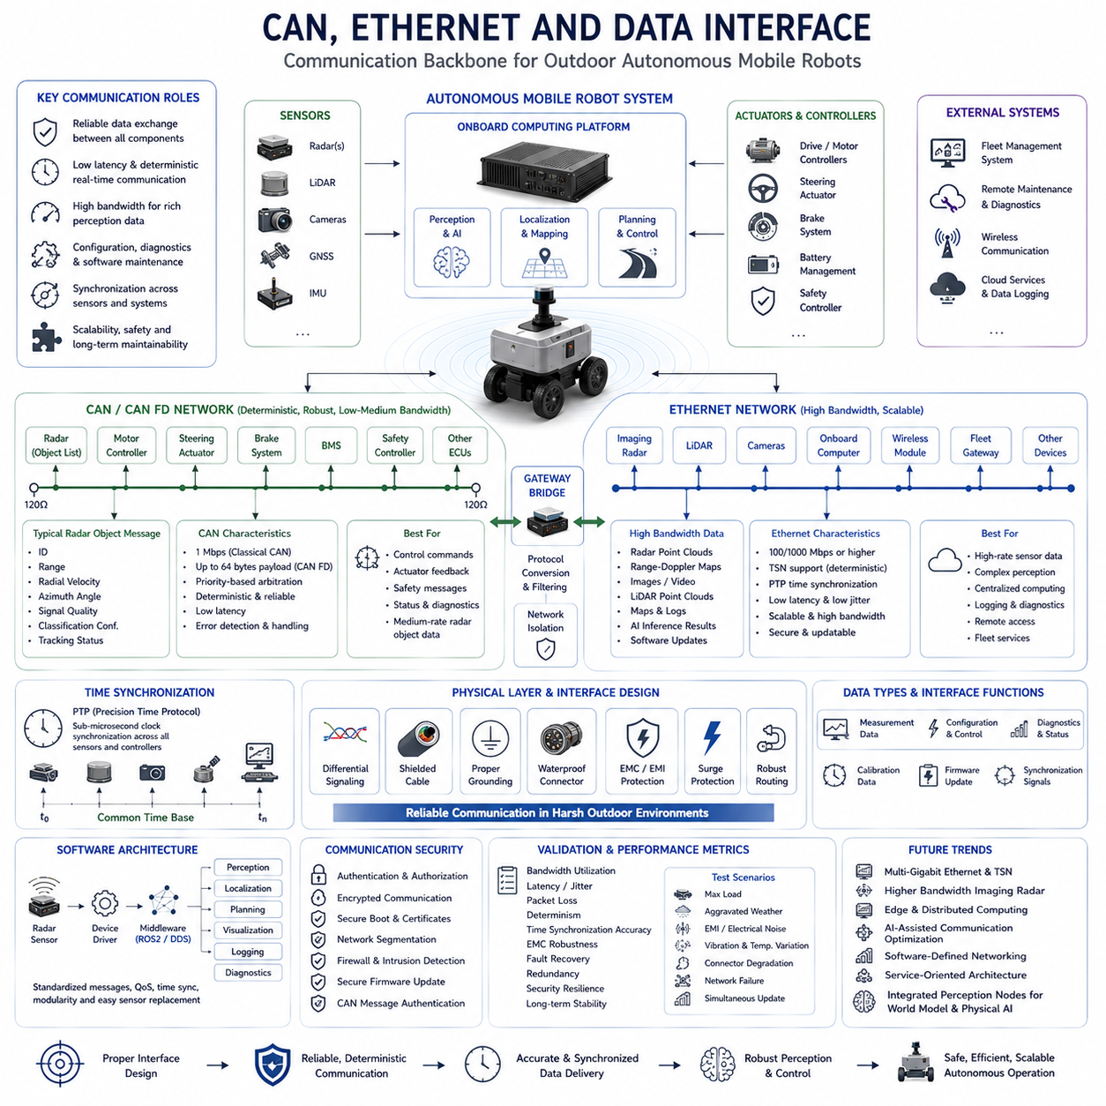
CAN (Controller Area Network), Ethernet, and other industrial communication interfaces form the digital backbone of modern autonomous mobile robots by enabling reliable data exchange among sensors, controllers, computing platforms, actuators, and external infrastructure. A radar sensor is not an isolated perception device; it operates as part of an integrated robotic system in which every measurement must be delivered to perception software with minimal latency and high reliability. The quality of autonomous navigation depends not only on radar sensing performance but also on how efficiently radar data flows through the communication architecture. Outdoor AMRs often combine multiple radars, LiDARs, cameras, GNSS receivers, inertial sensors, motor controllers, safety controllers, and onboard computers. These components exchange information continuously through standardized communication networks, making interface selection a critical aspect of system architecture. Proper communication design directly affects perception accuracy, control responsiveness, scalability, diagnostics, and long-term maintainability.
Radar communication requirements differ significantly depending on sensor capability and application. Simple short-range radar modules may transmit only object lists containing distance, velocity, angle, and target confidence. Advanced imaging radar systems produce dense radar point clouds or even radar images requiring considerably higher bandwidth. Some radar sensors additionally provide diagnostic information, calibration status, temperature measurements, synchronization signals, firmware updates, and configuration parameters. Consequently, communication interfaces must support not only measurement transmission but also device configuration, software maintenance, fault monitoring, and synchronization with the remainder of the autonomous system. Interface selection therefore depends upon bandwidth, latency, determinism, reliability, scalability, electromagnetic compatibility, cable length, power consumption, and system complexity.
Controller Area Network has become one of the most widely adopted communication standards in automotive and robotic systems because of its simplicity, robustness, and deterministic arbitration mechanism. CAN was originally developed for vehicle electronic control units, allowing multiple controllers to communicate through a shared differential bus without requiring a central master. Every device connected to the network continuously monitors bus activity and transmits messages according to identifier-based arbitration rules. Higher-priority messages automatically gain transmission access while lower-priority messages wait without causing collisions. This deterministic behavior enables reliable real-time communication even under heavy network utilization, making CAN highly suitable for motion control, actuator coordination, safety systems, battery management, and radar object reporting within outdoor AMRs.
Many commercial automotive radar sensors transmit detected object lists directly through CAN because the required bandwidth remains relatively modest. Individual radar detections typically include target identifier, range, radial velocity, azimuth angle, signal quality, object classification confidence, and tracking status. Even when dozens of objects are detected simultaneously, compressed object messages often remain well within CAN bandwidth limitations. Robot controllers receive these messages, integrate them with information from additional sensors, and forward the results to perception and navigation software. CAN therefore provides a simple and mature solution for medium-data-rate radar applications where deterministic communication is more important than extremely high bandwidth.
Classical CAN supports communication speeds up to one megabit per second, which remains sufficient for numerous control-oriented applications. However, autonomous robots increasingly employ high-resolution perception sensors generating much larger datasets than conventional automotive systems. CAN Flexible Data Rate addresses this limitation by increasing payload size from eight bytes to sixty-four bytes while supporting significantly faster data transmission during the data phase. CAN FD substantially improves communication efficiency for radar object lists, diagnostic information, calibration data, software configuration, and status monitoring. Many modern radar sensors therefore support both Classical CAN and CAN FD, allowing system designers to balance compatibility with legacy hardware against higher communication performance required by advanced robotic platforms.
Despite its strengths, CAN has limitations that become increasingly significant for high-performance perception systems. Bandwidth remains relatively low compared with modern high-speed interfaces, making raw radar point cloud transmission impractical for imaging radar producing thousands of measurement points each frame. Shared bus architecture also means communication capacity decreases as additional devices join the network. Large software updates, sensor calibration files, synchronized multi-radar measurements, and high-frequency diagnostic streams may overload conventional CAN systems. Consequently, outdoor AMRs employing advanced perception architectures increasingly complement CAN with Ethernet while preserving CAN for deterministic control functions and safety-critical communication.
Ethernet has emerged as the dominant high-bandwidth communication technology for modern autonomous robotic systems. Originally developed for office and enterprise networking, industrial Ethernet has evolved into a highly reliable communication platform capable of supporting deterministic real-time operation. Standard Gigabit Ethernet provides data rates three orders of magnitude greater than Classical CAN, allowing transmission of radar point clouds, high-resolution camera images, LiDAR data, mapping information, artificial intelligence results, software updates, and remote diagnostics through a common infrastructure. Ethernet therefore enables centralized perception architectures where multiple high-bandwidth sensors stream data directly into powerful onboard computing platforms equipped with GPUs and AI accelerators.
Modern imaging radar systems increasingly employ Ethernet because dense radar point clouds require substantially higher communication bandwidth than simple object lists. Instead of transmitting only processed target information, Ethernet-connected radar may provide raw detections, intermediate signal processing results, Range-Doppler Maps, Range-Angle Maps, micro-Doppler signatures, or complete radar point clouds suitable for AI-based perception. High-bandwidth interfaces enable advanced algorithms running on centralized computing platforms to perform sensor fusion, object classification, simultaneous localization and mapping, motion prediction, and world model construction using richer radar information than traditional automotive interfaces could support.
Industrial Ethernet implementations frequently incorporate deterministic communication extensions that support precise timing and synchronized distributed systems. Time-Sensitive Networking introduces traffic scheduling, bandwidth reservation, and bounded latency mechanisms suitable for autonomous robots requiring predictable communication performance. Precision Time Protocol synchronizes clocks across sensors and computing devices with sub-microsecond accuracy. Radar, cameras, LiDARs, GNSS receivers, and inertial sensors therefore generate measurements sharing a common global timestamp. Accurate synchronization significantly improves sensor fusion because perception algorithms can combine measurements captured at nearly identical physical moments despite originating from different devices connected through distributed communication networks.
Outdoor AMRs commonly employ hybrid communication architectures that combine CAN and Ethernet according to functional requirements. CAN connects motion controllers, steering actuators, braking systems, battery management systems, safety controllers, emergency stop circuits, and moderate-bandwidth radar sensors requiring deterministic communication. Ethernet simultaneously connects imaging radar, LiDAR, cameras, high-performance computing platforms, fleet management gateways, wireless communication modules, and remote maintenance systems. Gateway controllers exchange information between both networks while isolating safety-critical traffic from computationally intensive perception data. Such hierarchical communication architectures maximize performance while maintaining system reliability and simplifying network management.
Data interface design extends beyond selecting communication protocols alone. Electrical characteristics including voltage levels, differential signaling, shielding, grounding, connector selection, cable routing, impedance matching, and electromagnetic compatibility strongly influence communication reliability within electrically noisy outdoor environments. Radar sensors mounted near electric motors, inverters, switching power supplies, or high-current battery cables may experience significant electromagnetic interference if wiring is poorly designed. Shielded twisted-pair cables, proper grounding strategies, galvanic isolation, surge protection, waterproof connectors, and robust cable management therefore become essential engineering considerations ensuring stable communication throughout long-term outdoor operation.
Software architecture is equally important for effective radar communication. Device drivers acquire measurements from physical interfaces before transferring them into middleware layers such as ROS2, DDS, or proprietary robotic frameworks. Middleware abstracts hardware-specific communication details while providing standardized message structures, synchronization mechanisms, quality-of-service policies, and distributed communication services. Radar drivers publish timestamped measurements that become immediately available to localization, mapping, perception, planning, visualization, recording, and diagnostic modules. Modular software architecture allows radar hardware to be replaced or upgraded with minimal changes to higher-level perception algorithms provided standardized interface definitions remain consistent.
Diagnostic communication represents another essential function of radar interfaces. Autonomous robots continuously monitor sensor health, communication quality, operating temperature, supply voltage, synchronization status, firmware versions, calibration integrity, internal processing load, and detected hardware faults. CAN and Ethernet both support diagnostic messaging allowing maintenance software to identify developing failures before operational safety becomes compromised. Remote firmware updates, parameter configuration, performance logging, event recording, predictive maintenance, and cybersecurity monitoring increasingly rely upon standardized communication services integrated directly into radar interface architectures. Effective diagnostics reduce maintenance costs while increasing operational availability across large autonomous robot fleets.
Communication security has become increasingly important as autonomous robots connect to enterprise networks, cloud services, fleet management systems, and remote maintenance platforms. Unauthorized modification of radar configuration, communication parameters, firmware, or sensor measurements could significantly degrade autonomous operation. Modern Ethernet systems therefore incorporate authentication, encrypted communication, secure boot mechanisms, digital certificates, network segmentation, firewall protection, intrusion detection, and secure firmware update procedures. CAN security extensions including message authentication and gateway filtering similarly reduce vulnerability to malicious message injection. Cybersecurity must therefore be considered alongside traditional communication performance when designing next-generation outdoor robotic systems.
Validation of radar communication interfaces requires considerably more than confirming successful data transmission. Engineers evaluate bandwidth utilization, communication latency, jitter, synchronization accuracy, packet loss, bus loading, processor utilization, electromagnetic robustness, fault recovery, redundant communication behavior, cybersecurity resilience, and long-term operational stability. Stress testing should include maximum sensor load, simultaneous software updates, adverse weather, electrical interference, vibration, temperature variation, connector degradation, and network failures. Performance metrics determine whether perception information reaches decision-making software within acceptable deadlines under all anticipated operating conditions. Comprehensive communication validation ensures that radar measurements remain trustworthy throughout the complete autonomous navigation pipeline.
Future radar communication systems will continue evolving toward higher bandwidth, greater determinism, tighter synchronization, stronger cybersecurity, and increasingly software-defined architectures. Multi-gigabit Ethernet, deterministic TSN networks, intelligent edge processing, AI-assisted communication optimization, distributed computing, software-defined networking, and service-oriented vehicle architectures will enable radar sensors to exchange substantially richer perception information with autonomous computing platforms. Rather than functioning as isolated hardware devices, future radar systems will become fully integrated networked perception nodes contributing directly to world models, digital twins, cooperative perception, fleet intelligence, and Physical AI. Reliable communication interfaces will therefore remain a foundational technology supporting safe, scalable, and intelligent outdoor autonomous mobile robots operating in increasingly complex real-world environments.

07.8 Radar Testing and Debugging
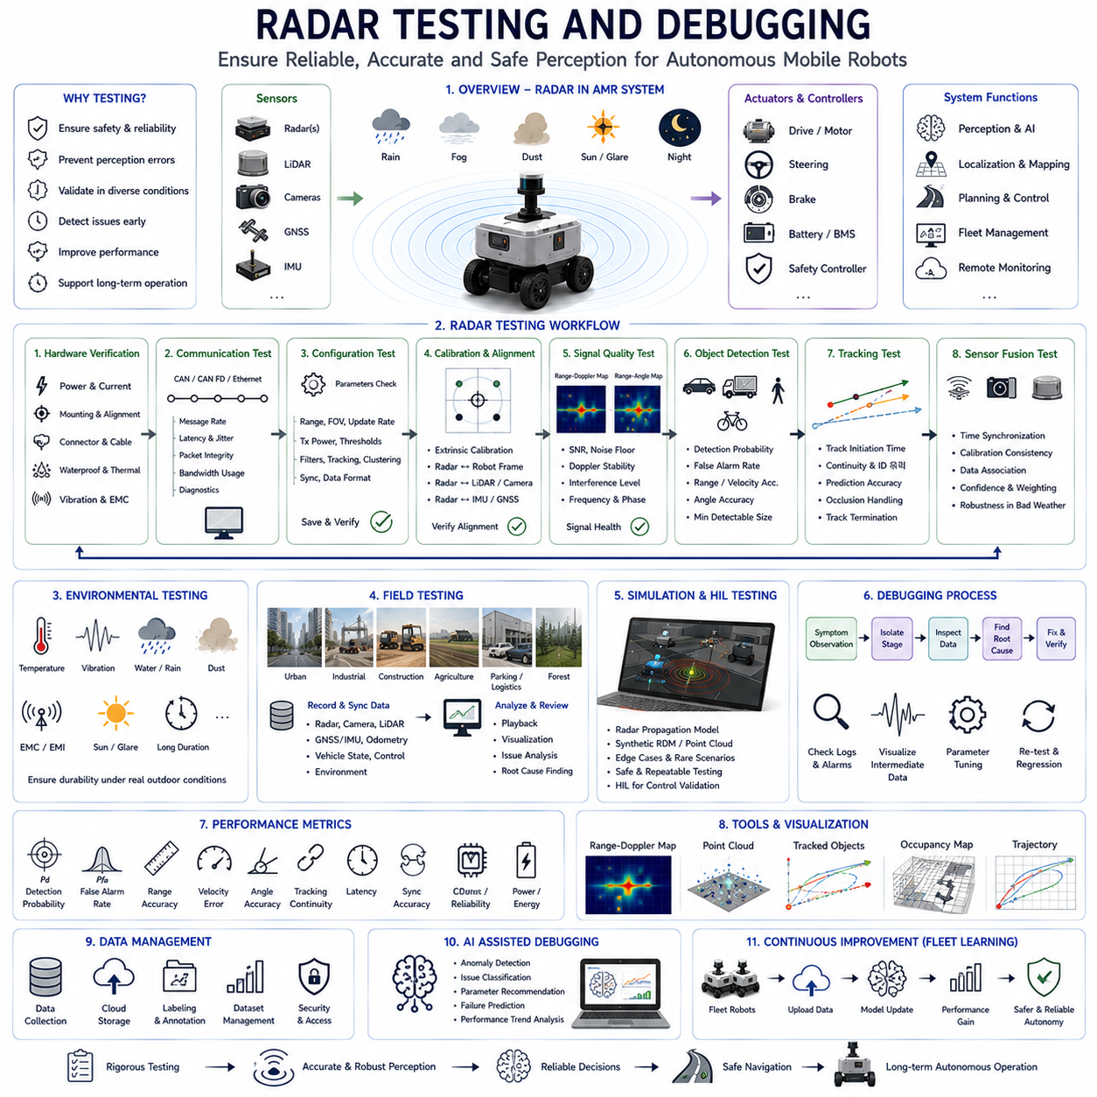
Radar testing and debugging are essential engineering activities that ensure radar perception systems operate reliably, accurately, and safely throughout the complete lifecycle of an Autonomous Mobile Robot. Unlike laboratory sensors operating in controlled environments, radar installed on outdoor AMRs must function continuously under changing weather, varying terrain, electromagnetic interference, vibration, temperature fluctuations, and highly dynamic traffic conditions. Even small errors in radar configuration, synchronization, calibration, communication, or signal processing can propagate through the perception pipeline and eventually influence navigation decisions. Consequently, radar validation extends far beyond confirming that a sensor powers on and detects objects. Engineers must verify every stage of the sensing process, including hardware performance, communication integrity, synchronization accuracy, signal processing, object detection, sensor fusion, trajectory prediction, and overall autonomous behavior. Comprehensive testing ensures that radar contributes trustworthy environmental information during both normal operation and rare safety-critical situations.
The radar development lifecycle generally begins with hardware verification before software integration takes place. Engineers first confirm that the radar sensor receives stable electrical power, operates within specified voltage limits, and maintains acceptable current consumption under various operating modes. Mechanical installation is carefully inspected to ensure that mounting brackets, vibration isolators, connectors, antenna orientation, and protective radomes satisfy design specifications. Cable routing is examined to minimize electromagnetic interference from motors, power converters, battery cables, and switching electronics. Waterproof sealing, thermal management, grounding strategy, and connector integrity are also verified before functional testing begins. Establishing a stable hardware foundation significantly reduces later debugging complexity because many apparent perception problems ultimately originate from electrical or mechanical integration issues rather than radar signal processing itself.
Communication testing represents the next major phase of radar validation. Radar sensors connected through CAN, CAN FD, Ethernet, or industrial communication protocols must exchange information reliably with onboard computing systems. Engineers verify message transmission frequency, communication latency, packet integrity, bandwidth utilization, synchronization signals, firmware compatibility, and diagnostic communication. Communication analyzers monitor bus loading, message timing, dropped packets, retransmissions, and protocol violations during continuous operation. Gateway devices transferring information between multiple communication networks are also evaluated to ensure deterministic message forwarding. Stable communication is particularly important because even brief interruptions in radar measurements may degrade tracking performance or introduce uncertainty into sensor fusion algorithms responsible for autonomous navigation.
Sensor configuration testing ensures that radar operating parameters correspond to the intended application. Modern radar sensors often support configurable measurement range, field of view, update frequency, transmit power, detection thresholds, filtering parameters, tracking settings, clustering behavior, synchronization options, and communication formats. Incorrect parameter selection may reduce detection performance even when hardware functions normally. Engineers therefore validate every configurable option against system requirements and verify that stored parameters remain unchanged following firmware updates, power cycling, or maintenance procedures. Configuration management becomes especially important for large robot fleets where identical radar behavior must be maintained across multiple autonomous platforms operating within different deployment locations.
Calibration is another critical aspect of radar testing because measurement accuracy depends heavily on correct sensor alignment. Mechanical installation errors may introduce systematic angular offsets, height errors, or orientation deviations that affect object localization. Radar coordinate systems must be accurately registered relative to the robot coordinate frame, LiDAR coordinate frame, camera coordinate frame, IMU reference frame, and vehicle body reference. Calibration procedures estimate translation and rotational offsets between sensors using reference targets, calibration patterns, or optimization algorithms. Validation confirms that transformed radar measurements correctly align with observations from other sensors. Even small calibration errors can reduce sensor fusion quality, produce inaccurate object trajectories, or generate localization drift during long-term autonomous operation.
Signal quality evaluation focuses on the physical characteristics of received radar measurements before higher-level perception algorithms are applied. Engineers analyze received signal strength, noise floor, signal-to-noise ratio, Doppler stability, antenna performance, interference levels, frequency accuracy, and phase consistency. Range-Doppler Maps, Range-Angle Maps, and intermediate signal processing outputs provide valuable insight into radar behavior under different environmental conditions. Unusual noise patterns, missing reflections, excessive clutter, or unstable Doppler measurements frequently indicate hardware degradation, electromagnetic interference, environmental contamination, or inappropriate signal processing parameters. Early identification of signal-level abnormalities greatly simplifies subsequent debugging because many perception failures originate during the earliest stages of radar processing.
Object detection testing evaluates whether radar correctly identifies physical targets across diverse operating conditions. Standard validation targets include passenger vehicles, trucks, motorcycles, bicycles, pedestrians, construction machinery, roadside barriers, poles, buildings, vegetation, traffic signs, and partially occluded obstacles. Engineers measure detection probability, false alarm rate, range accuracy, velocity accuracy, angular accuracy, and minimum detectable object size across varying distances. Controlled experiments isolate individual variables such as target material, aspect angle, speed, and environmental clutter. Field testing subsequently verifies detection robustness within realistic traffic scenarios containing multiple moving objects simultaneously. Comprehensive object detection evaluation ensures that radar performance remains predictable under both ordinary and challenging operating conditions.
Tracking validation extends beyond initial object detection by evaluating how consistently radar follows moving targets over time. Reliable autonomous navigation requires continuous object trajectories rather than isolated measurements. Engineers therefore analyze track initiation time, trajectory continuity, identity preservation, track termination behavior, prediction accuracy, acceleration estimation, heading stability, and response to temporary measurement loss. Scenarios involving crossing pedestrians, overtaking vehicles, merging traffic, parked cars, and closely spaced objects are particularly valuable because they challenge data association algorithms responsible for maintaining correct target identities. Robust tracking validation confirms that perception software maintains stable awareness of dynamic environments despite occasional measurement uncertainty or temporary occlusions.
Sensor fusion testing examines how radar interacts with cameras, LiDARs, GNSS receivers, inertial sensors, wheel odometry, and other perception devices. Since autonomous navigation rarely depends upon radar alone, engineers evaluate fused perception outputs rather than isolated sensor performance. Synchronization accuracy, timestamp consistency, calibration quality, confidence estimation, object association, and environmental modeling are carefully analyzed. Test scenarios intentionally include weather conditions where different sensors experience varying performance degradation. Heavy rain, dense fog, dust, darkness, glare, and partial sensor failures allow engineers to verify whether fusion algorithms appropriately adjust sensor weighting according to measurement confidence. Effective sensor fusion testing ensures that radar complements other sensing modalities rather than introducing inconsistent environmental interpretations.
Environmental testing exposes radar systems to realistic operating conditions expected during long-term deployment. Temperature chambers evaluate sensor performance across specified operating ranges, while vibration tables reproduce mechanical loading generated during outdoor navigation. Waterproof testing verifies operation during rainfall and high-pressure cleaning procedures. Dust chambers simulate mining, agriculture, construction, and industrial environments where airborne particles continuously surround the robot. Electromagnetic compatibility testing confirms reliable operation near electric motors, power converters, communication equipment, and high-current battery systems. Long-duration endurance testing identifies gradual performance degradation caused by thermal cycling, connector wear, contamination, or electronic aging. Environmental validation therefore confirms both immediate functionality and long-term operational reliability.
Real-world field testing represents one of the most valuable stages of radar validation because laboratory experiments cannot reproduce every operational scenario encountered during autonomous deployment. Outdoor robots should be evaluated across urban roads, industrial facilities, construction sites, agricultural fields, logistics yards, parking areas, forests, and mixed traffic environments. Different weather conditions, lighting conditions, traffic densities, and seasonal variations reveal perception behaviors impossible to predict entirely through simulation. Engineers continuously record synchronized radar measurements, camera images, LiDAR point clouds, localization data, vehicle states, control commands, and environmental observations. These datasets enable detailed offline analysis whenever unexpected autonomous behavior occurs, supporting systematic debugging of complex perception interactions.
Simulation has become an increasingly important complement to physical radar testing. Modern robotics simulators incorporate realistic radar propagation models capable of generating synthetic Range-Doppler Maps, radar point clouds, object detections, and environmental reflections. Simulation enables engineers to evaluate hazardous scenarios that would be difficult, expensive, or unsafe to reproduce physically. Edge cases including sudden pedestrian crossings, high-speed approaching vehicles, sensor failures, communication interruptions, and severe weather conditions can be repeatedly executed under controlled conditions. Synthetic datasets also accelerate development of machine learning algorithms requiring large quantities of labeled radar data. Although simulation cannot fully replace field testing, it significantly improves development efficiency by identifying software defects before deployment.
Debugging radar perception requires systematic analysis rather than isolated trial-and-error modifications. Engineers typically begin by confirming hardware health, communication status, and synchronization before examining intermediate signal processing outputs. Each processing stage—including FFT computation, CFAR detection, clustering, tracking, classification, sensor fusion, and navigation decisions—is inspected independently to determine where abnormal behavior first appears. Visualization tools displaying Range-Doppler Maps, radar point clouds, tracked objects, fused perception results, occupancy maps, and planned trajectories provide valuable diagnostic insight. Logging every intermediate processing result enables engineers to replay complex scenarios repeatedly while evaluating software modifications without requiring immediate field testing after every code revision.
Performance evaluation relies upon quantitative metrics that objectively characterize radar behavior. Detection probability, false alarm rate, localization accuracy, velocity estimation error, angular resolution, tracking continuity, latency, synchronization accuracy, communication reliability, computational load, processor utilization, and energy consumption are measured throughout validation campaigns. Regression testing compares these metrics across software versions to ensure that new algorithm improvements do not unintentionally degrade previously validated capabilities. Performance dashboards allow engineering teams to monitor long-term trends, identify emerging issues, and prioritize optimization efforts according to measurable technical evidence rather than subjective observations.
Artificial intelligence increasingly supports radar testing and debugging by automatically identifying unusual sensor behavior, communication anomalies, calibration drift, or perception inconsistencies. Machine learning models analyze large collections of recorded operational data to discover subtle failure patterns that human engineers might overlook. AI-assisted debugging tools may classify radar artifacts, detect synchronization problems, estimate sensor confidence, recommend parameter adjustments, or predict hardware failures before they affect autonomous operation. Nevertheless, AI should complement rather than replace rigorous engineering validation. Physics-based testing, repeatable experiments, controlled measurements, and systematic root-cause analysis remain essential because safety-critical autonomous systems require explainable and verifiable performance under all foreseeable operating conditions.
Future radar testing methodologies will increasingly combine automated validation, digital twins, cloud-based data management, continuous software integration, hardware-in-the-loop simulation, and large-scale fleet learning. Autonomous robots operating in different environments will continuously contribute operational datasets that improve perception algorithms through closed-loop development processes. Intelligent validation frameworks will automatically compare new software versions against extensive libraries of historical scenarios while monitoring safety metrics, perception accuracy, communication performance, and computational efficiency. Radar testing will therefore evolve from isolated engineering activities into continuous lifecycle management supporting highly reliable Physical AI systems capable of safe autonomous operation across diverse real-world environments throughout years of deployment.

