Volume 03. AMR Sensors and Perception

Chapter 18. 3D Perception

18.1 3D Perception Overview
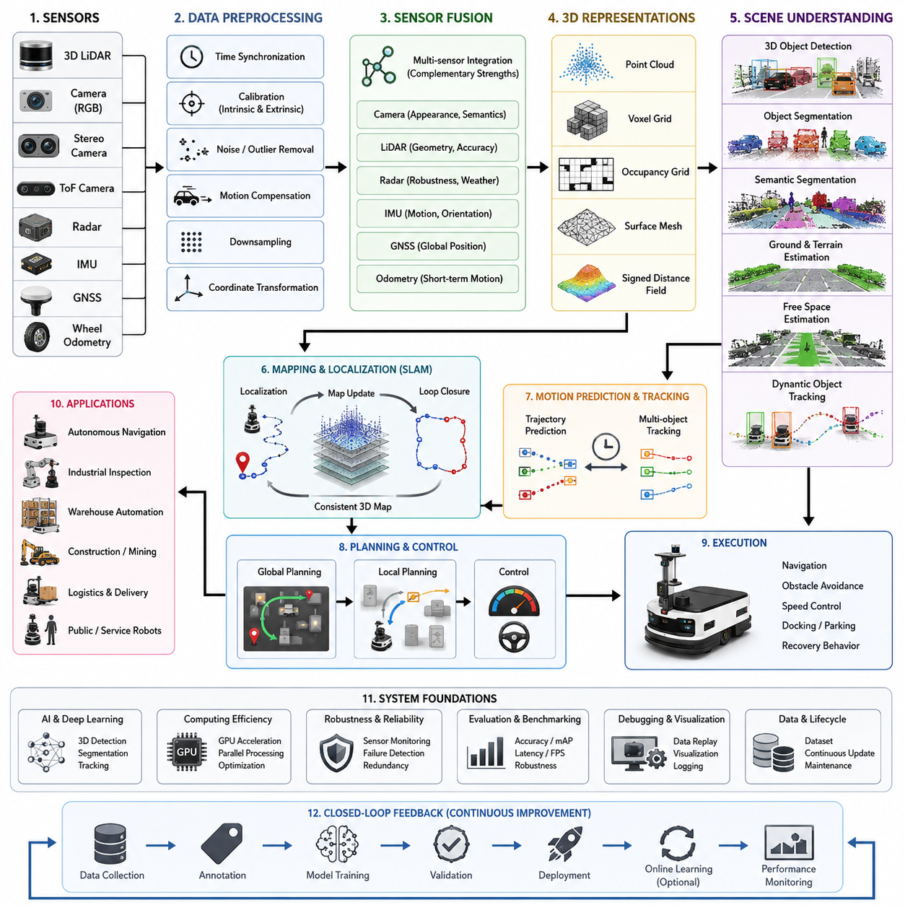
Three-dimensional perception is one of the most important capabilities in autonomous mobile robots because it enables the robot to understand the physical structure of the surrounding world rather than relying only on two-dimensional observations. Unlike conventional image processing that interprets pixels on a flat image plane, 3D perception reconstructs the geometry of the environment by estimating depth, shape, orientation, and spatial relationships between objects. This geometric understanding allows autonomous robots to reason about obstacles, free space, terrain, movable objects, and complex environmental structures in a way that closely resembles how humans interpret real-world scenes.
Modern AMRs operate in warehouses, factories, hospitals, logistics centers, construction sites, mines, ports, campuses, and outdoor environments where the surrounding world continuously changes. Static maps alone cannot represent these dynamic conditions because workers, vehicles, pallets, machines, doors, carts, and temporary obstacles constantly appear and disappear. Three-dimensional perception continuously observes these environmental changes and provides an updated digital representation that supports navigation, localization, planning, manipulation, inspection, and safety monitoring. The perception system therefore becomes one of the primary information sources for nearly every intelligent subsystem inside the robot.
The primary objective of 3D perception is not merely generating point clouds or depth images but transforming raw sensor measurements into meaningful environmental understanding. Raw sensor data contains millions of individual measurements that have little practical value without interpretation. Through successive processing stages, these measurements become organized into surfaces, objects, semantic categories, occupancy maps, traversable regions, motion estimates, and scene descriptions that higher-level software modules can directly utilize for autonomous decision making.
Three-dimensional perception generally begins with one or more depth-producing sensors. Three-dimensional LiDAR directly measures distances by emitting laser pulses and recording their return time, producing highly accurate point clouds suitable for large-scale mapping and outdoor navigation. Stereo cameras estimate depth through image disparity, while Time-of-Flight cameras calculate distance by measuring light travel time. Structured light sensors project known patterns onto nearby objects and reconstruct depth from deformation. Radar can also contribute coarse three-dimensional information under adverse weather conditions where optical sensors become unreliable. Each sensing technology offers unique advantages and limitations, making sensor selection highly dependent on application requirements.
No single sensor can reliably perceive every environment under every operating condition. Cameras provide rich texture and color information but are sensitive to lighting variation. LiDAR delivers accurate geometric measurements but lacks semantic appearance information. Radar operates well in rain, fog, snow, and dust but provides lower spatial resolution. Ultrasonic sensors remain effective for short-range obstacle detection although their angular resolution is limited. Consequently, practical 3D perception systems almost always integrate multiple sensing modalities through sensor fusion, allowing the strengths of one sensor to compensate for the weaknesses of another.
Sensor fusion significantly improves perception robustness because different sensors observe complementary aspects of the environment. Camera images identify object appearance, colors, text, traffic signs, safety labels, and semantic categories. LiDAR precisely measures geometric structure and distance. IMU measurements stabilize motion estimation during rapid vehicle movement. GNSS contributes global positioning in outdoor environments. Wheel odometry estimates short-term motion between sensor updates. When these information sources are combined through probabilistic estimation algorithms and AI-based fusion networks, the robot produces a significantly more reliable environmental model than any individual sensor could achieve independently.
Raw three-dimensional measurements are usually affected by measurement noise, missing points, motion distortion, reflections, multipath effects, environmental interference, and sensor inaccuracies. Consequently, preprocessing represents a critical component of every perception pipeline. Typical preprocessing operations include filtering invalid points, removing statistical outliers, compensating for motion distortion, synchronizing timestamps, correcting calibration errors, downsampling dense point clouds, normal estimation, coordinate transformation, and noise suppression. These preprocessing stages improve both computational efficiency and the accuracy of downstream perception algorithms.
Calibration is fundamental for accurate three-dimensional perception because measurements from different sensors must be expressed within a common coordinate system. Intrinsic calibration determines the internal characteristics of cameras and depth sensors, while extrinsic calibration estimates their precise physical relationship with respect to the robot body or another sensor. Even small calibration errors can create significant inconsistencies when fusing multiple data sources, leading to inaccurate object localization, distorted maps, or unstable navigation performance. Regular calibration verification therefore becomes an essential maintenance activity throughout the robot lifecycle.
Time synchronization is equally important because every sensor observes the world at slightly different moments. If camera images, LiDAR scans, IMU measurements, and wheel encoder data are captured asynchronously, moving objects may appear in conflicting positions, resulting in inaccurate fusion results. Precision Time Protocol, hardware triggers, timestamp alignment, and deterministic communication networks are frequently employed to minimize temporal inconsistencies. High-quality synchronization becomes especially important for robots traveling at higher speeds or operating in highly dynamic environments.
After preprocessing, three-dimensional perception transforms sensor measurements into structured spatial representations. Point clouds represent individual sampled locations in three-dimensional space, while voxel grids divide space into uniformly sized volumetric cells that facilitate efficient processing. Occupancy grids estimate whether spatial regions are occupied, free, or unknown. Surface meshes describe continuous geometric surfaces, whereas signed distance fields encode proximity to surrounding geometry. Different representations offer different tradeoffs between computational complexity, memory consumption, geometric accuracy, and planning efficiency.
Object segmentation divides the three-dimensional scene into individual physical entities. Rather than analyzing millions of independent points, segmentation algorithms group measurements belonging to the same object based on spatial continuity, surface characteristics, motion consistency, semantic classification, or learned feature embeddings. Once segmentation is complete, subsequent algorithms can estimate object dimensions, orientation, pose, velocity, and category. Accurate segmentation substantially simplifies higher-level reasoning because the robot begins operating on meaningful objects instead of disconnected measurements.
Three-dimensional object detection estimates the location and physical dimensions of objects within the surrounding environment. Modern perception systems frequently employ deep neural networks that directly process point clouds, voxel representations, bird's-eye-view projections, or multi-modal sensor fusion features. These models predict three-dimensional bounding boxes together with object class labels, orientation, confidence scores, and occasionally motion estimates. Such information supports collision avoidance, path planning, traffic interaction, inventory management, automated inspection, and autonomous manipulation.
Scene understanding extends beyond detecting individual objects by interpreting relationships among them. Instead of recognizing isolated obstacles, the perception system identifies roads, sidewalks, warehouse aisles, shelves, machinery, workstations, charging stations, loading docks, entrances, exits, stairs, ramps, vegetation, construction zones, and human work areas. Understanding these semantic relationships allows robots to behave intelligently within complex environments because navigation decisions become context-aware rather than relying solely on geometric obstacle avoidance.
Free-space estimation represents one of the most critical outputs of three-dimensional perception. Autonomous navigation requires knowledge not only of where obstacles exist but also of where safe traversal remains possible. Ground plane estimation, terrain analysis, obstacle height filtering, and occupancy analysis collectively determine navigable regions. Local planners subsequently utilize these free-space maps to generate collision-free trajectories while continuously adapting to environmental changes.
Ground estimation deserves particular attention because many perceived objects actually belong to the driving surface itself. Roads, factory floors, sidewalks, uneven terrain, gravel, grass, slopes, ramps, and construction surfaces exhibit different geometric characteristics. Robust ground segmentation prevents the robot from incorrectly classifying the floor as an obstacle while simultaneously detecting hazards such as curbs, potholes, steps, rocks, or debris. Outdoor autonomous robots especially rely on accurate terrain classification to maintain vehicle stability and safe mobility.
Dynamic object perception introduces additional complexity because pedestrians, forklifts, bicycles, automobiles, service robots, and industrial machinery continuously change position. Static mapping alone cannot adequately represent these moving elements. Motion estimation algorithms combine temporal observations from consecutive sensor frames to estimate object trajectories, velocities, and future motion. This dynamic understanding enables predictive collision avoidance rather than reactive emergency stopping.
Tracking maintains persistent identities for detected objects across time. Without tracking, the robot repeatedly detects new objects in every frame without understanding their continuity. Multi-object tracking associates detections across consecutive observations using motion models, feature similarity, geometric consistency, and probabilistic filtering. Persistent tracking enables prediction of future movement, interaction analysis, traffic awareness, and human behavior understanding, significantly improving autonomous navigation safety.
Artificial intelligence has fundamentally transformed three-dimensional perception. Earlier systems relied primarily on handcrafted geometric algorithms, clustering methods, and deterministic feature extraction techniques. Contemporary perception increasingly employs deep learning architectures capable of learning complex spatial representations directly from large datasets. Networks such as PointNet, PointNet++, Point Transformer, sparse convolutional networks, BEV-based architectures, and multimodal transformer models substantially improve detection accuracy under challenging environmental conditions while reducing manual engineering effort.
Recent developments increasingly integrate multimodal foundation models into robotic perception. Rather than interpreting geometry alone, future perception systems combine visual appearance, language understanding, temporal reasoning, spatial memory, and contextual knowledge. These models support richer scene understanding by interpreting high-level concepts such as work zones, emergency situations, inspection priorities, restricted areas, and human intentions. Consequently, perception evolves from geometric measurement toward comprehensive environmental reasoning.
Three-dimensional perception also plays a central role in simultaneous localization and mapping. Feature extraction from point clouds supports scan registration, loop closure detection, map updating, and localization refinement. Accurate perception allows the robot to continuously compare incoming observations against previously constructed maps, maintaining reliable localization despite environmental changes. Robust mapping therefore depends heavily upon stable perception performance, while improved maps further enhance future perception quality through mutual reinforcement.
Navigation modules consume numerous outputs generated by three-dimensional perception. Obstacle maps, traversable regions, semantic information, object trajectories, occupancy grids, and terrain classifications collectively influence global route planning, local trajectory generation, velocity control, emergency braking, docking, parking, and recovery behaviors. Rather than functioning independently, perception and navigation operate as tightly coupled subsystems that continuously exchange information throughout autonomous operation.
Industrial inspection robots rely on three-dimensional perception for highly accurate positioning relative to inspected assets. Instead of depending solely on global localization, the robot performs local geometric alignment using dense point clouds or reconstructed surfaces. This process estimates precise six-degree-of-freedom transformations that align CAD models with observed structures. Such alignment enables repeatable inspection trajectories, robotic manipulation, defect localization, and measurement consistency across repeated inspection cycles.
Computational efficiency remains one of the largest engineering challenges because modern perception sensors generate enormous data volumes. High-resolution LiDAR systems may produce millions of points per second, while multiple synchronized cameras simultaneously stream high-definition images. Processing these data in real time requires GPU acceleration, parallel computing, optimized memory management, efficient spatial indexing, sparse computation, and hardware-aware software architectures. Real-time constraints often dictate algorithm selection as strongly as detection accuracy.
System robustness becomes especially important for deployment in real industrial environments. Rain, fog, snow, dust, direct sunlight, reflective surfaces, vibration, temperature variation, electromagnetic interference, and sensor contamination all degrade perception quality. Robust systems therefore continuously monitor sensor health, estimate confidence levels, detect failures, activate redundancy mechanisms, and gracefully degrade functionality when certain sensing modalities become unavailable. Reliability engineering is therefore inseparable from perception algorithm design.
Evaluation of three-dimensional perception requires comprehensive quantitative metrics. Detection precision, recall, localization error, intersection-over-union, mean average precision, depth estimation error, point cloud registration accuracy, latency, throughput, frame rate, tracking consistency, false positive rate, false negative rate, and robustness under environmental variation collectively characterize system performance. Benchmark datasets provide standardized comparisons, but field validation remains indispensable because real deployment environments exhibit significantly greater complexity than laboratory conditions.
Debugging perception systems requires systematic analysis across the complete sensing pipeline. Engineers inspect raw sensor outputs, calibration parameters, synchronization quality, preprocessing results, intermediate representations, AI inference outputs, fusion consistency, navigation interfaces, and recorded operational logs. ROS2 bag replay, visualization tools, synchronized timeline inspection, and automated regression testing greatly accelerate root cause identification. Successful perception engineering therefore combines algorithm development with disciplined system-level debugging methodologies.
As autonomous robots continue expanding into increasingly unstructured environments, three-dimensional perception will evolve from isolated sensing algorithms into comprehensive world modeling systems. Future robots will construct continuously updated digital representations that integrate geometry, semantics, temporal dynamics, physical properties, uncertainty estimation, and predictive reasoning into unified environmental models. These world models will support perception, localization, navigation, manipulation, inspection, interaction, and long-term autonomy through a shared understanding of the surrounding environment. Consequently, three-dimensional perception should be regarded not merely as a sensing technology but as the foundational capability that enables intelligent autonomous robots to interpret, reason about, and safely interact with the three-dimensional physical world.

18.2 Point Cloud Preprocessing
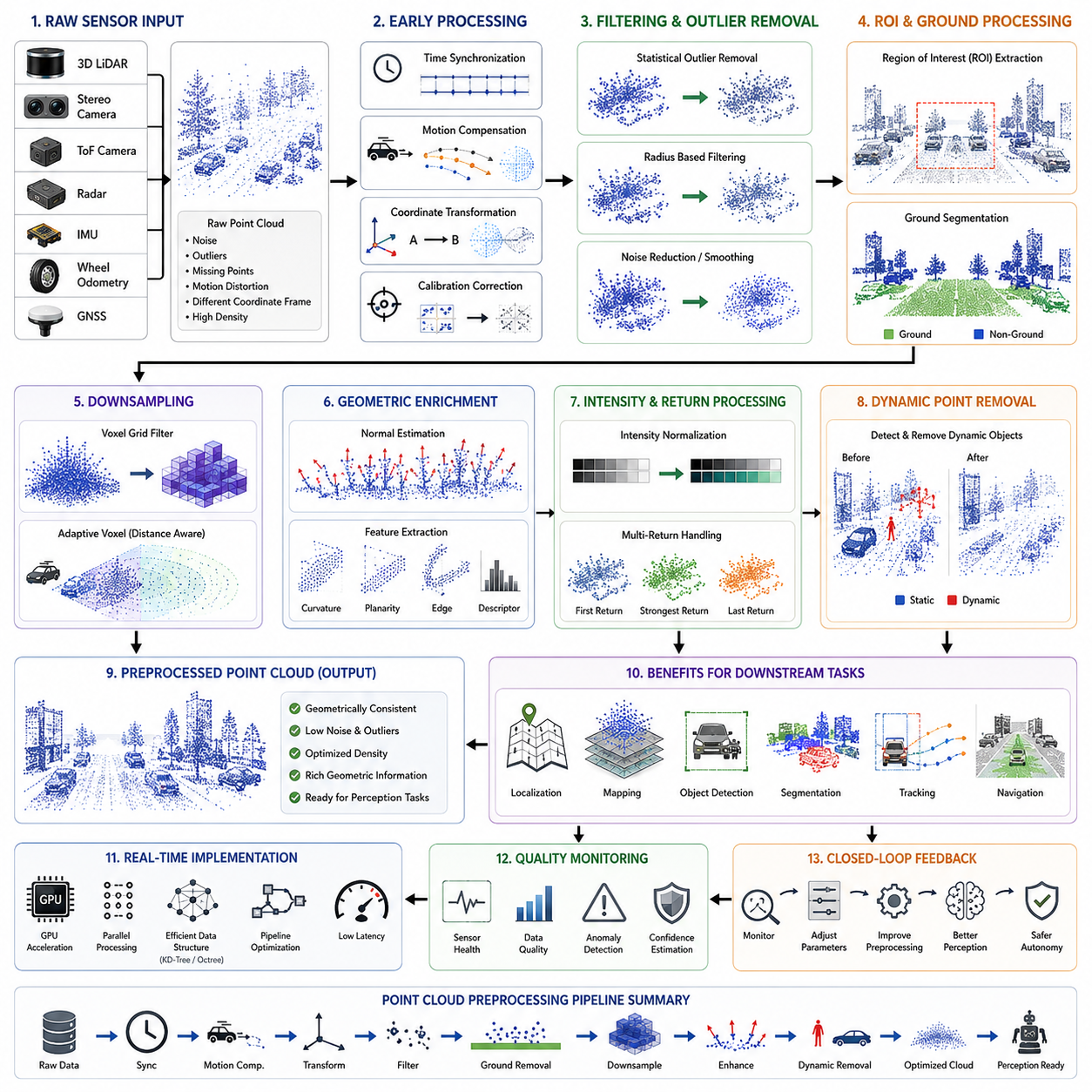
Point cloud preprocessing represents the essential first computational stage of every three-dimensional perception pipeline because raw sensor measurements cannot be directly consumed by localization, mapping, navigation, object detection, or scene understanding algorithms. Although modern three-dimensional sensors generate increasingly dense and accurate measurements, their outputs inevitably contain noise, missing observations, measurement uncertainty, synchronization inconsistencies, motion distortion, and environmental artifacts. Without systematic preprocessing, these imperfections propagate throughout the perception pipeline and significantly reduce the accuracy and stability of downstream modules. Consequently, point cloud preprocessing should not be considered merely as data cleaning but as the process of transforming raw sensor measurements into geometrically consistent, computationally efficient, and information-rich spatial representations suitable for autonomous decision making.
A point cloud is fundamentally a collection of three-dimensional spatial samples representing the visible surfaces of objects within the sensor's field of view. Each point usually contains Cartesian coordinates consisting of X, Y, and Z values expressed relative to the sensor coordinate frame. Depending on sensor technology, additional attributes such as intensity, reflectivity, return number, timestamp, color, semantic label, confidence score, surface normal, or Doppler velocity may also be available. Unlike images that are organized on a regular pixel grid, point clouds are irregular, sparse, unordered, and highly nonuniform. This irregular structure introduces unique computational challenges because traditional image processing techniques cannot be directly applied without additional representation or transformation.
Raw point clouds generated by three-dimensional LiDAR, stereo vision, structured-light cameras, or Time-of-Flight sensors frequently contain measurement imperfections that originate from both hardware limitations and environmental conditions. Laser divergence, detector sensitivity, electronic noise, optical interference, atmospheric scattering, multiple reflections, rain, fog, dust, snow, vibration, temperature variation, and synchronization latency all influence measurement quality. Even under ideal operating conditions, small uncertainties accumulate over millions of measurements, making preprocessing indispensable before any meaningful interpretation can begin.
The primary objective of preprocessing is to maximize the information quality available to downstream perception algorithms while minimizing unnecessary computational burden. Rather than indiscriminately removing data, preprocessing seeks to preserve meaningful geometric structures while eliminating measurements that reduce estimation accuracy. Successful preprocessing improves localization robustness, map consistency, object detection accuracy, segmentation quality, trajectory prediction, free-space estimation, and navigation safety. Therefore, preprocessing directly influences the overall performance of the entire autonomous robotic system rather than functioning as an isolated software component.
Point cloud preprocessing usually begins immediately after sensor acquisition. Modern perception architectures receive continuous streams of raw measurements at frequencies ranging from several Hertz to hundreds of Hertz depending on the sensing modality. Before any spatial reasoning occurs, these incoming measurements are synchronized with other sensor streams, transformed into common coordinate systems, corrected for known systematic errors, filtered for invalid observations, and prepared for higher-level geometric analysis. This sequential processing pipeline ensures that all subsequent perception modules operate on internally consistent spatial information.
Time synchronization represents one of the earliest preprocessing operations because every point within a point cloud corresponds to a specific acquisition time. Mechanical rotating LiDAR sensors require tens of milliseconds to complete a full revolution, meaning that different portions of a single scan are actually measured at different times. During vehicle motion, this temporal discrepancy produces geometric distortion commonly known as motion distortion or rolling acquisition error. Accurate timestamp alignment with IMU, wheel odometry, GNSS, cameras, and other sensors enables subsequent algorithms to compensate for vehicle movement occurring during scan acquisition.
Motion compensation removes geometric distortion introduced while the robot moves during sensor acquisition. Instead of assuming that all points were measured simultaneously, motion compensation estimates the robot trajectory throughout the scan period using inertial measurements, odometry, or continuous-time motion estimation. Individual points are then transformed into a common reference time, producing geometrically consistent point clouds. This correction becomes increasingly important as vehicle speed increases because even moderate motion can significantly deform environmental geometry, degrading scan registration and object detection accuracy.
Coordinate transformation constitutes another fundamental preprocessing operation. Individual sensors measure points within their own local coordinate frames, yet autonomous robots require all observations to be expressed within a common reference frame. Extrinsic calibration parameters define rigid transformations between sensors, allowing point clouds from LiDAR, depth cameras, stereo systems, radar, and additional sensing devices to be accurately merged. Precise coordinate transformation establishes geometric consistency throughout the perception pipeline and enables reliable multi-sensor fusion.
Calibration quality directly determines preprocessing accuracy. Small rotational errors between sensors may produce large positional discrepancies at longer distances, while translational calibration errors distort fused environmental models. Consequently, preprocessing frequently incorporates calibration verification procedures that continuously monitor sensor consistency during operation. Modern autonomous systems increasingly employ online calibration refinement algorithms capable of detecting gradual sensor displacement resulting from vibration, thermal expansion, maintenance operations, or mechanical wear.
Filtering represents one of the most recognizable preprocessing tasks because raw point clouds inevitably contain measurements that do not correspond to meaningful physical surfaces. These outliers may originate from atmospheric particles, sensor reflections, electronic interference, transparent materials, highly reflective metallic surfaces, or random measurement noise. Effective filtering removes these observations while preserving legitimate environmental geometry. Overly aggressive filtering risks removing important structural details, whereas insufficient filtering allows noise to propagate into higher-level perception algorithms.
Statistical outlier removal identifies isolated measurements whose local neighborhoods differ significantly from surrounding points. Since legitimate environmental surfaces generally produce spatially coherent measurements, isolated points exhibiting unusually large nearest-neighbor distances are classified as probable noise. Statistical filtering estimates local distance distributions and removes observations that deviate beyond predefined confidence thresholds. This approach effectively suppresses sparse measurement noise while preserving continuous surfaces and structural boundaries.
Radius-based filtering provides an alternative approach by evaluating local point density within fixed spatial neighborhoods. Measurements lacking sufficient neighboring points inside predefined search radii are considered unreliable and removed. Radius filtering proves particularly effective for eliminating isolated artifacts generated by atmospheric interference or sporadic sensor failures. However, parameter selection requires careful consideration because excessively small radii may preserve noise, whereas overly large neighborhoods risk eliminating legitimate thin structures such as cables, poles, or vegetation.
Ground removal frequently constitutes an important preprocessing stage for outdoor perception systems. Since roads, factory floors, parking lots, warehouse surfaces, and sidewalks often dominate point cloud measurements, many downstream algorithms benefit from temporarily separating ground observations from above-ground structures. Ground segmentation algorithms estimate local terrain geometry using plane fitting, progressive morphological filtering, elevation analysis, or learning-based approaches. Removing dominant ground surfaces significantly reduces computational complexity during object detection while preserving navigable surface information for motion planning.
Downsampling reduces computational cost by decreasing point cloud density without significantly sacrificing geometric fidelity. Modern high-resolution LiDAR systems generate millions of measurements every second, overwhelming real-time perception pipelines if processed directly. Voxel grid filtering represents the most widely adopted downsampling technique. Space is partitioned into uniformly sized volumetric cells, and all points within each voxel are replaced by representative centroids. This approach preserves overall geometric structure while substantially reducing memory consumption and computational requirements.
Selecting appropriate voxel resolution involves balancing geometric accuracy against processing efficiency. Fine voxel resolutions preserve detailed environmental structure but provide limited computational savings. Coarse voxel resolutions dramatically accelerate processing but may remove small obstacles, narrow poles, cables, vegetation, or fine architectural features. Practical autonomous systems often employ adaptive voxel sizes depending on sensing range, environmental complexity, computational resources, and application-specific safety requirements.
Pass-through filtering restricts processing to regions of practical interest by removing measurements outside predefined spatial boundaries. Autonomous vehicles rarely require analysis of extremely distant observations, underground measurements, or points located above operational height limits. Restricting computation to application-relevant regions substantially improves efficiency while simplifying downstream perception tasks. Such spatial cropping also removes portions of the sensor field containing persistent irrelevant structures such as portions of the robot itself.
Region-of-interest extraction further refines computational focus by selecting specific spatial volumes according to operational objectives. Warehouse robots may emphasize shelf regions while ignoring ceiling structures. Autonomous forklifts concentrate on pallet heights. Agricultural robots prioritize crop rows. Construction robots focus on excavation zones. Intelligent region selection reduces unnecessary processing while preserving information critical for specific mission objectives, allowing perception resources to be allocated more efficiently.
Noise reduction extends beyond isolated point removal because many legitimate measurements exhibit small random positional perturbations. Surface smoothing algorithms reduce local geometric variation while preserving essential structural characteristics. Moving least squares, bilateral filtering, Gaussian smoothing, and neighborhood averaging improve surface continuity and normal estimation accuracy. Effective smoothing enhances scan registration, surface reconstruction, and object recognition without excessively blurring geometric edges.
Preserving edges remains particularly important during smoothing because structural boundaries frequently contain valuable semantic information. Building corners, curb edges, machinery outlines, pallet boundaries, and object contours contribute significantly to localization and recognition performance. Edge-preserving filters selectively smooth locally planar regions while maintaining sharp geometric discontinuities. Such approaches improve robustness without sacrificing environmental detail essential for autonomous navigation.
Surface normal estimation provides additional geometric information frequently required by higher-level perception algorithms. Surface normals describe local orientation by estimating tangent planes surrounding each measurement. Registration algorithms utilize normals for correspondence estimation, segmentation algorithms exploit orientation discontinuities, while object recognition networks incorporate surface orientation into learned geometric representations. Reliable normal estimation therefore depends heavily upon prior noise reduction and neighborhood consistency established during preprocessing.
Neighborhood construction underlies numerous preprocessing operations because most geometric analyses require local spatial relationships. Efficient nearest-neighbor search structures including KD-trees, octrees, voxel hashing, and spatial indexing significantly accelerate neighborhood queries. Since neighborhood searches dominate computational complexity in many preprocessing algorithms, optimized spatial data structures substantially influence overall perception performance and real-time capability.
Point cloud registration preparation represents another essential preprocessing objective. Scan registration algorithms estimate relative sensor motion by identifying geometric correspondences between consecutive observations. Successful correspondence estimation requires geometrically stable, low-noise, uniformly sampled point clouds. Consequently, preprocessing often enhances geometric repeatability through filtering, downsampling, normal estimation, and feature extraction before registration begins. Higher-quality preprocessing directly improves localization accuracy and map consistency throughout extended autonomous operation.
Feature extraction transforms raw spatial measurements into more descriptive geometric representations suitable for registration and recognition. Local geometric descriptors characterize curvature, roughness, planarity, linearity, eigenvalue distributions, surface variation, and neighborhood topology. These features support correspondence matching, segmentation, classification, and place recognition. Robust feature extraction depends upon preprocessing stages that ensure neighborhood consistency and measurement reliability.
Intensity normalization may also be incorporated into preprocessing when LiDAR reflectivity measurements are available. Raw intensity values vary according to sensor characteristics, incidence angle, material properties, atmospheric conditions, and measurement distance. Normalization reduces these variations, allowing downstream learning algorithms to exploit reflectivity more consistently for semantic classification, material recognition, and environmental understanding.
Multi-return LiDAR systems frequently record multiple reflections generated by partially transparent vegetation, fences, rain, or complex structures. Preprocessing determines whether first returns, strongest returns, last returns, or combinations thereof should be retained depending on application objectives. Forest mapping, agricultural robotics, and urban navigation may each require different return selection strategies because environmental characteristics differ substantially across operational domains.
Dynamic point removal becomes increasingly important within long-term mapping systems. Moving vehicles, pedestrians, forklifts, robots, animals, and temporary obstacles introduce inconsistencies into static environmental models. Preprocessing may identify potentially dynamic observations using temporal consistency analysis, semantic segmentation, motion estimation, or probabilistic occupancy models. Removing dynamic objects before map construction significantly improves localization repeatability and long-term map stability.
Semantic-aware preprocessing represents an emerging research direction where artificial intelligence assists traditional geometric processing. Rather than treating all measurements equally, learning-based systems identify semantically meaningful structures during preprocessing itself. Road surfaces, vegetation, buildings, humans, vehicles, machinery, and infrastructure may receive specialized processing strategies optimized for their unique geometric characteristics. Such adaptive preprocessing improves overall perception quality while preserving computational efficiency.
Deep learning has increasingly influenced preprocessing methodologies beyond conventional rule-based filtering. Neural networks now estimate denoised point clouds, complete missing observations, infer hidden surfaces, remove motion artifacts, enhance resolution, and predict confidence values directly from raw measurements. Unlike handcrafted algorithms relying upon manually selected thresholds, learning-based preprocessing adapts to diverse environments through data-driven optimization, often achieving greater robustness across challenging operational conditions.
Real-time implementation remains a defining engineering constraint because autonomous robots continuously generate enormous sensing volumes. Preprocessing algorithms must satisfy strict latency budgets while maintaining deterministic execution characteristics. GPU acceleration, parallel processing, SIMD optimization, asynchronous pipelines, sparse computation, memory pooling, and hardware-aware software architectures enable modern preprocessing systems to process millions of points within milliseconds, supporting high-frequency autonomous perception without exceeding computational resource limitations.
Robust preprocessing also requires continuous quality assessment throughout system operation. Confidence estimation, sensor health monitoring, statistical consistency analysis, anomaly detection, and runtime diagnostics identify degraded sensing conditions before downstream perception failures occur. By monitoring preprocessing quality metrics in real time, autonomous robots can adapt sensor weighting, modify operational behavior, activate redundant sensing modalities, or safely reduce operating speed whenever environmental uncertainty increases.
Ultimately, point cloud preprocessing establishes the geometric foundation upon which every subsequent three-dimensional perception capability depends. Object detection, semantic segmentation, scene understanding, localization, mapping, motion prediction, free-space estimation, navigation, manipulation, and autonomous decision making all assume that incoming spatial measurements accurately represent physical reality. Careful preprocessing transforms noisy, irregular, and computationally expensive raw sensor outputs into structured, reliable, and information-rich geometric representations that enable modern autonomous mobile robots to perceive, understand, and safely interact with complex three-dimensional environments.

18.3 3D Object Clustering
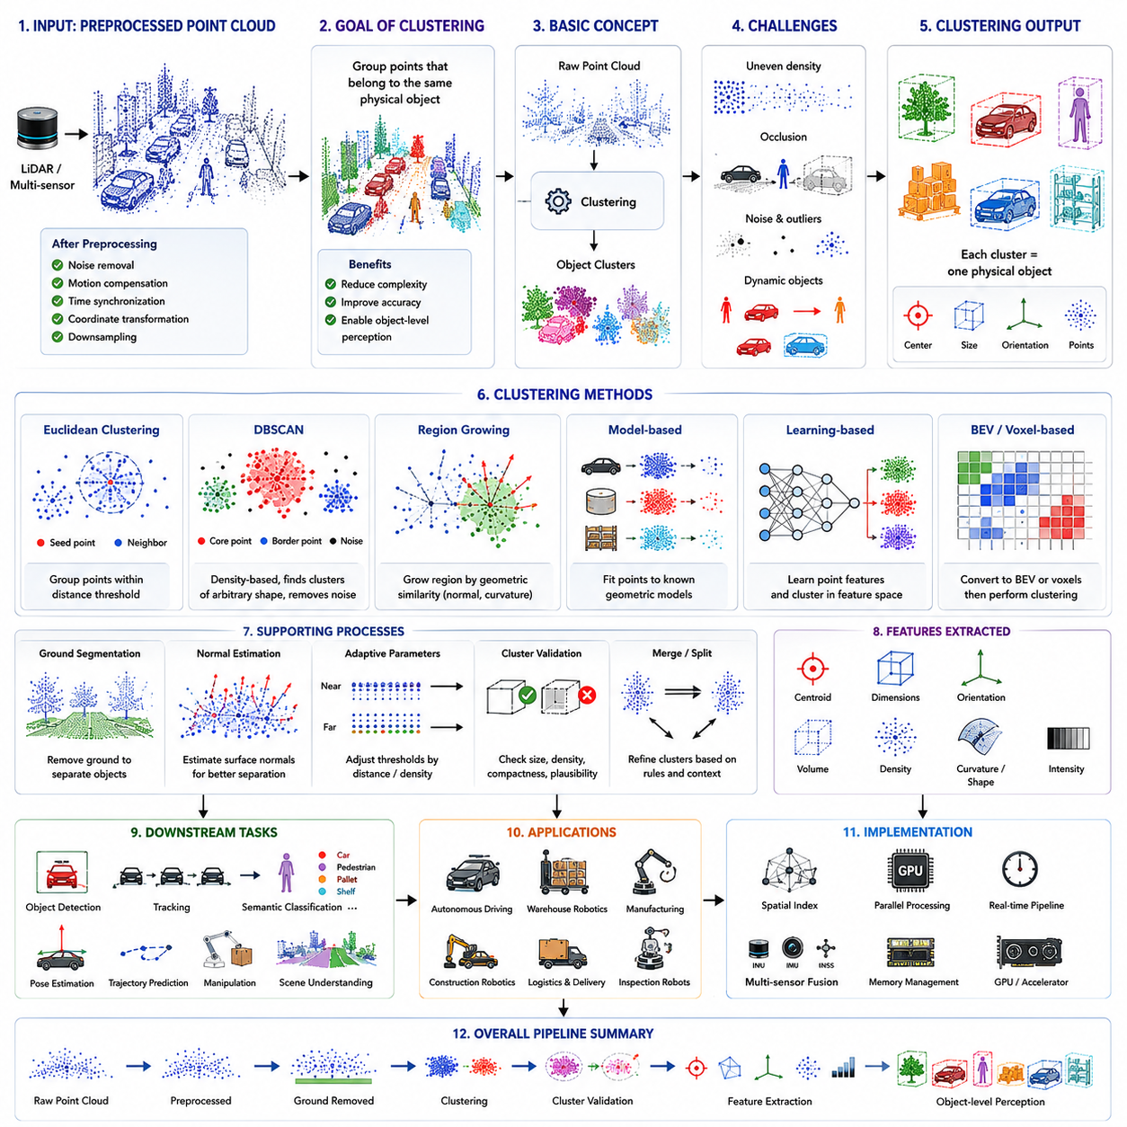
Three-dimensional object clustering is one of the most fundamental operations in modern robotic perception because it transforms millions of independent spatial measurements into meaningful physical objects that autonomous systems can understand and reason about. Raw point clouds consist only of individual three-dimensional coordinates without any explicit information regarding which points belong to the same object. Before higher-level perception algorithms can recognize vehicles, pedestrians, machinery, pallets, shelves, walls, or construction equipment, the perception system must first determine which spatial measurements represent individual physical entities. Object clustering therefore serves as the critical bridge between low-level geometric sensing and high-level semantic understanding, allowing autonomous mobile robots to convert unstructured spatial data into organized representations suitable for navigation, planning, manipulation, inspection, and intelligent decision making.
Unlike image segmentation where neighboring pixels naturally form regular two-dimensional grids, point cloud clustering operates on irregular, sparse, and unordered three-dimensional measurements. Neighboring points are not arranged according to fixed image coordinates but instead exist as discrete samples distributed throughout physical space. The density of measurements often varies significantly with distance, viewing angle, surface reflectivity, sensor resolution, and environmental conditions. Consequently, clustering algorithms must analyze true geometric relationships between points rather than relying upon predefined neighborhood structures. This characteristic makes three-dimensional clustering substantially more challenging than conventional image segmentation while simultaneously providing richer geometric information.
The primary objective of object clustering is to partition a point cloud into subsets where each subset corresponds to an individual physical object or meaningful environmental structure. Ideally, every cluster contains all points belonging to one object while excluding measurements associated with surrounding structures. Accurate clustering greatly simplifies downstream perception because object detection, tracking, semantic classification, pose estimation, trajectory prediction, and manipulation algorithms can subsequently process compact object-level representations rather than millions of unrelated points. Effective clustering therefore reduces computational complexity while improving both perception accuracy and system interpretability.
Three-dimensional clustering is usually performed after point cloud preprocessing has already removed obvious noise, corrected motion distortion, synchronized sensor measurements, transformed coordinate systems, and reduced unnecessary point density through downsampling. These preprocessing stages establish geometrically consistent input data that significantly improves clustering reliability. If clustering were performed directly on noisy or distorted point clouds, small measurement errors could incorrectly divide single objects into multiple clusters or merge unrelated objects together. Consequently, preprocessing quality directly influences clustering performance throughout the perception pipeline.
Euclidean clustering remains one of the most widely adopted approaches for robotic perception because of its conceptual simplicity and computational efficiency. This method groups points according to spatial proximity by assuming that measurements located sufficiently close together most likely belong to the same physical object. Beginning from an initial seed point, neighboring points within a predefined distance threshold are recursively added to the cluster until no additional nearby measurements remain. The algorithm then repeats this process for remaining unassigned points until every measurement belongs to either an identified cluster or background noise. Despite its simplicity, Euclidean clustering performs remarkably well for numerous industrial and autonomous driving applications.
Distance threshold selection represents one of the most important parameters influencing Euclidean clustering performance. Small thresholds preserve separation between nearby objects but may incorrectly divide large objects into multiple clusters whenever measurement density decreases. Large thresholds improve cluster continuity yet risk merging adjacent objects that should remain independent. Practical robotic systems frequently adapt clustering thresholds according to sensing distance because point cloud density naturally decreases with increasing range. Such adaptive parameter selection substantially improves clustering robustness across diverse operating conditions.
Neighborhood search constitutes the computational foundation of nearly every clustering algorithm because identifying nearby measurements dominates processing time. Efficient spatial indexing structures including KD-trees, octrees, voxel hashing, and hierarchical spatial grids accelerate nearest-neighbor queries by several orders of magnitude compared with exhaustive distance computation. Since modern LiDAR systems generate millions of measurements every second, optimized neighborhood search becomes essential for maintaining real-time perception performance. Many practical implementations devote significant engineering effort toward efficient spatial indexing because overall clustering speed depends heavily upon neighborhood search efficiency.
Density-based clustering algorithms provide greater flexibility when object shapes exhibit substantial geometric variation. Rather than relying exclusively upon fixed distance thresholds, density-based approaches identify connected regions containing sufficiently dense measurements while automatically treating sparse observations as noise. DBSCAN represents one of the best-known density-based clustering methods and has been widely adopted throughout robotics because it naturally identifies arbitrarily shaped objects without requiring prior knowledge of cluster quantity. Furthermore, isolated measurement noise remains excluded from resulting clusters, improving downstream perception robustness.
DBSCAN determines cluster membership using two principal parameters consisting of neighborhood radius and minimum neighboring point count. Points possessing sufficiently dense local neighborhoods become core points, while neighboring observations connected to these cores expand clusters outward. Measurements lacking adequate local support remain classified as noise rather than being forced into incorrect object assignments. This behavior makes DBSCAN particularly attractive for outdoor perception where atmospheric interference, vegetation, dust, or reflective materials frequently generate isolated measurement artifacts.
Although density-based methods exhibit significant robustness advantages, they also encounter practical limitations under varying point densities. Since LiDAR sampling density naturally decreases with increasing distance, distant objects often appear substantially sparser than nearby structures. Fixed neighborhood parameters may therefore successfully cluster nearby vehicles while incorrectly fragmenting distant pedestrians or traffic signs. Adaptive density estimation, multi-resolution clustering, and hierarchical parameter selection have consequently become important research directions for improving clustering consistency across varying sensing ranges.
Region-growing clustering expands object boundaries according to local geometric similarity rather than simple spatial proximity alone. Beginning with seed points, neighboring measurements are incorporated whenever local surface characteristics including normal orientation, curvature, roughness, or planar consistency satisfy predefined similarity criteria. Such approaches perform particularly well when segmenting continuous surfaces including walls, floors, roofs, building facades, machinery panels, or infrastructure components. Because geometric continuity frequently persists despite moderate spatial separation, region-growing methods often outperform purely distance-based clustering within structured industrial environments.
Surface normal estimation frequently supports advanced clustering because neighboring points belonging to the same object generally exhibit similar local orientation. Significant changes in surface normals often indicate physical boundaries separating distinct objects. By incorporating orientation consistency into clustering decisions, algorithms distinguish adjacent surfaces even when spatial distance alone proves insufficient. Normal-based clustering becomes especially valuable for separating touching objects, extracting planar structures, and identifying manufactured components possessing well-defined geometric characteristics.
Model-based clustering incorporates prior geometric knowledge regarding expected object shapes. Instead of relying exclusively upon generic spatial relationships, algorithms compare observed measurements against predefined models describing vehicles, pallets, cylindrical poles, storage racks, containers, machinery, or robotic manipulators. Such approaches improve clustering accuracy whenever object geometry remains relatively predictable. However, model dependence reduces flexibility because unexpected object shapes may fail to satisfy predefined assumptions, limiting applicability within highly diverse or unstructured environments.
Learning-based clustering has recently emerged as one of the most active research areas in three-dimensional perception. Deep neural networks no longer rely solely upon handcrafted geometric rules but instead learn discriminative spatial feature representations directly from large annotated datasets. Individual points become embedded within high-dimensional feature spaces where measurements belonging to the same physical object naturally cluster together regardless of geometric complexity. This learned representation significantly improves robustness under partial occlusion, varying object shape, complex backgrounds, and dynamic environmental conditions.
Point-based neural architectures including PointNet, PointNet++, Dynamic Graph CNN, Point Transformer, and related networks directly process irregular point cloud measurements without requiring conversion into regular voxel grids. These architectures learn local and global geometric relationships while preserving fine spatial detail. Learned point embeddings subsequently support clustering through feature similarity rather than purely geometric distance, allowing semantically related measurements to remain grouped despite incomplete or noisy observations. Such capability substantially enhances perception robustness within realistic operating environments.
Voxel-based perception systems adopt an alternative strategy by first discretizing continuous space into uniformly sized volumetric cells before performing clustering. Although voxelization introduces minor geometric approximation, regular grid structures enable efficient three-dimensional convolutional neural networks and GPU acceleration. Object clusters emerge from connected occupied voxels possessing similar learned feature representations. Voxel-based approaches therefore balance computational efficiency against geometric fidelity, making them highly attractive for large-scale autonomous driving and industrial robotics applications.
Bird's-eye-view representations have likewise become increasingly popular because projecting point clouds onto horizontal planes significantly simplifies clustering complexity. Ground vehicles primarily operate upon approximately planar surfaces, allowing many relevant environmental structures to be effectively represented within top-down occupancy maps. Object separation often becomes substantially easier after removing vertical redundancy, while efficient two-dimensional image processing techniques may subsequently perform clustering. Nevertheless, important vertical geometric information must remain available for complete three-dimensional object understanding.
Ground segmentation usually precedes clustering because separating dominant terrain surfaces dramatically simplifies subsequent object extraction. Roads, factory floors, sidewalks, warehouse aisles, and parking lots frequently account for the majority of observed measurements. Removing these extensive planar structures prevents clustering algorithms from incorrectly connecting independent objects through continuous ground surfaces. Consequently, vehicles, pedestrians, pallets, machinery, and infrastructure components become significantly easier to isolate as individual clusters.
Occlusion introduces one of the greatest challenges for three-dimensional clustering because physical objects frequently become only partially visible from a given sensor viewpoint. Vehicles may obscure pedestrians, machinery may conceal storage containers, and shelving systems may block warehouse inventory. Partial observations reduce cluster completeness and occasionally divide single objects into multiple disconnected components. Robust clustering algorithms therefore incorporate temporal integration, multi-view sensing, semantic reasoning, or predictive modeling to reconstruct complete object representations despite incomplete instantaneous observations.
Dynamic environments further complicate clustering because moving objects continuously alter spatial relationships between consecutive observations. Pedestrians, forklifts, mobile robots, automobiles, and construction equipment may approach, separate, intersect, or temporarily occlude one another. Clustering algorithms must therefore distinguish genuine object interaction from temporary geometric proximity. Temporal consistency analysis and multi-object tracking consequently operate closely alongside clustering, maintaining stable object identities despite continuous environmental change.
Cluster validation evaluates whether generated clusters represent meaningful physical objects rather than accidental groupings of measurements. Simple validation criteria include minimum and maximum point counts, physical dimensions, aspect ratio, volume, compactness, point density, surface continuity, and geometric plausibility. Clusters failing these criteria may be discarded as noise or merged with neighboring structures. More advanced systems additionally incorporate semantic classification confidence, motion consistency, temporal persistence, and probabilistic uncertainty estimates when evaluating cluster validity.
Feature extraction from clusters transforms geometric groupings into descriptive object representations suitable for downstream perception. Cluster centroids estimate approximate object location, while principal component analysis determines dominant orientation and spatial extent. Bounding dimensions, convex hulls, surface area, point density, curvature statistics, reflectivity distributions, and geometric descriptors collectively characterize cluster properties. These features subsequently support object recognition, behavior prediction, manipulation planning, and semantic understanding throughout the autonomous perception pipeline.
Object tracking relies heavily upon stable clustering because tracking algorithms associate object observations across consecutive sensor frames. If clustering frequently divides one object into multiple clusters or inconsistently merges neighboring structures, tracking performance deteriorates significantly. Conversely, consistent clustering enables reliable trajectory estimation, velocity calculation, acceleration prediction, and long-term object identity maintenance. High-quality clustering therefore directly improves navigation safety by providing stable environmental awareness over extended operational periods.
Semantic classification frequently follows clustering because object-level representations greatly simplify recognition compared with processing raw point clouds directly. Rather than classifying millions of independent points, neural networks analyze compact cluster descriptors representing coherent physical entities. Vehicles, pedestrians, bicycles, forklifts, shelving systems, traffic cones, construction barriers, trees, and industrial equipment each exhibit distinctive geometric characteristics that become more readily identifiable after clustering organizes raw measurements into meaningful object candidates.
Industrial autonomous mobile robots employ clustering throughout numerous operational scenarios. Warehouse systems identify pallets, shelving units, storage containers, and forklifts to support inventory transportation. Manufacturing robots isolate workpieces, production equipment, safety barriers, and human workers to maintain safe operation. Outdoor logistics vehicles distinguish automobiles, pedestrians, vegetation, loading docks, and infrastructure while navigating complex facilities. Construction robots identify excavation machinery, building materials, temporary obstacles, and structural components despite highly dynamic environmental conditions. Across these diverse applications, clustering consistently serves as the fundamental mechanism transforming geometric measurements into actionable environmental knowledge.
Computational efficiency remains a critical engineering consideration because clustering must operate continuously within strict real-time constraints. Parallel neighborhood searches, GPU acceleration, efficient memory allocation, spatial partitioning, incremental processing, asynchronous execution, and hierarchical clustering strategies collectively enable processing of millions of measurements per second. Modern perception systems increasingly distribute clustering workloads across heterogeneous computing architectures containing CPUs, GPUs, AI accelerators, and dedicated perception processors to satisfy demanding latency requirements while maintaining high perception accuracy.
Future three-dimensional object clustering will increasingly integrate geometric reasoning, semantic understanding, temporal consistency, multimodal sensor fusion, and foundation-model intelligence into unified perception architectures. Rather than treating clustering as an isolated geometric operation, future autonomous systems will jointly optimize object discovery, recognition, tracking, prediction, and scene understanding through shared learned world representations. These integrated approaches will enable robots to identify complex objects more accurately, maintain robust perception under adverse environmental conditions, and continuously improve environmental understanding throughout long-term autonomous operation, establishing object clustering as a central component of next-generation intelligent robotic perception systems.

18.4 3D Bounding Box Detection
Three-dimensional bounding box detection is one of the most important perception tasks in autonomous robotics because it converts clustered point clouds into structured object representations that can be directly understood by planning, navigation, tracking, and decision-making systems. While object clustering determines which points belong to the same physical object, it does not explicitly describe the object's precise spatial extent, orientation, dimensions, or pose. Three-dimensional bounding box detection addresses this limitation by estimating a compact geometric enclosure around every detected object. The resulting bounding box provides a standardized representation that enables autonomous mobile robots to reason about surrounding objects using a small number of meaningful geometric parameters instead of millions of individual point measurements.
Unlike conventional two-dimensional object detection that estimates rectangular regions within image coordinates, three-dimensional bounding box detection operates directly in physical space. Each detected object is represented by its three-dimensional position, width, length, height, orientation, and confidence score. This representation accurately reflects the object's actual occupancy within the environment and allows autonomous systems to calculate distances, predict motion, estimate collision risk, and generate safe trajectories. Since robotic decision making occurs in physical space rather than image coordinates, three-dimensional bounding boxes provide substantially more useful information than traditional image-based detections.
The primary purpose of three-dimensional bounding box detection is to transform complex geometric observations into simplified yet physically meaningful object descriptions. Point clouds often contain thousands of measurements describing a single vehicle, pallet, pedestrian, forklift, or industrial machine. Processing every point individually throughout the entire perception pipeline would be computationally expensive and unnecessary. Instead, the perception system estimates one compact bounding box that summarizes the object's location, dimensions, orientation, and spatial occupancy. Downstream algorithms subsequently operate on these efficient representations while preserving sufficient geometric accuracy for autonomous decision making.
Bounding boxes serve as the common language shared among perception, localization, prediction, planning, tracking, mapping, and robot control modules. Once every detected object is represented by a standardized geometric model, different software components can exchange information without directly processing raw sensor measurements. Navigation algorithms evaluate collision risks using bounding boxes, tracking systems maintain object identities through consecutive observations, behavior prediction estimates future box trajectories, and manipulation systems determine grasping strategies according to object dimensions. Standardized geometric representation therefore simplifies system integration while improving computational efficiency.
Three-dimensional bounding boxes generally describe seven primary parameters consisting of three-dimensional center position, object width, object length, object height, and rotational orientation around the vertical axis. Some perception systems additionally estimate object velocity, acceleration, angular velocity, semantic classification confidence, object existence probability, and uncertainty covariance. Together these parameters provide a compact but comprehensive description of each detected object that can be interpreted consistently across multiple autonomous subsystems operating within the robot architecture.
Bounding box estimation normally follows several preceding perception stages including sensor acquisition, point cloud preprocessing, object clustering, and feature extraction. Raw sensor measurements are first synchronized, filtered, transformed into common coordinate systems, and organized into meaningful object candidates. Detection algorithms then analyze each candidate or directly process the complete point cloud to estimate precise object boundaries. Finally, post-processing removes duplicate detections, refines geometric parameters, and integrates detection results with object tracking and semantic classification. Consequently, three-dimensional bounding box detection functions as one component within a larger end-to-end perception pipeline rather than as an isolated algorithm.
Classical geometric approaches estimate bounding boxes directly from clustered point clouds without requiring machine learning. Principal Component Analysis is frequently employed to determine dominant object orientation by analyzing covariance among measured points. Once principal directions have been estimated, axis-aligned or oriented bounding boxes can be constructed around the observed measurements. Such methods remain computationally efficient, require no training data, and perform well for relatively simple objects exhibiting regular geometric structure. However, they often struggle with incomplete observations, irregular object shapes, and severe occlusion encountered within realistic operational environments.
Axis-aligned bounding boxes represent the simplest geometric approximation because box edges remain parallel to the global coordinate system. Although computationally efficient, axis-aligned representations frequently include substantial empty space whenever objects rotate relative to the environment. Vehicles turning through intersections, forklifts maneuvering within warehouses, or construction equipment operating at arbitrary orientations cannot be accurately represented using globally aligned boxes. Consequently, most modern autonomous perception systems instead estimate oriented bounding boxes capable of matching actual object orientation within three-dimensional space.
Oriented bounding boxes significantly improve geometric representation by allowing rotation around one or more coordinate axes. For ground vehicles and mobile robots, rotation around the vertical axis generally dominates because most objects remain approximately upright during normal operation. Estimating accurate orientation enables planners to predict occupied space more precisely, particularly for elongated objects including vehicles, pallets, trailers, shipping containers, shelving systems, and industrial machinery. Improved orientation estimation therefore directly contributes to safer navigation and more efficient motion planning.
Point cloud sparsity introduces one of the primary challenges in bounding box estimation. Objects located near the sensor contain dense measurements, whereas distant objects may be represented by only a few scattered points. Sparse observations make it increasingly difficult to estimate accurate dimensions, orientation, and object boundaries. Weather conditions, partial occlusion, limited sensor resolution, and unfavorable viewing angles further reduce measurement density. Robust detection algorithms must therefore infer complete object geometry despite incomplete or noisy observations while maintaining reliable uncertainty estimates regarding prediction quality.
Occlusion represents another significant challenge because many real-world objects remain only partially visible from a single sensor viewpoint. Vehicles may block pedestrians, shelving systems may conceal warehouse inventory, and industrial equipment may obscure structural components. Bounding box estimation must therefore infer unseen portions of objects based upon limited visible evidence. Deep learning methods excel in such situations because training on extensive datasets enables neural networks to learn typical object geometry and predict plausible complete bounding boxes despite partial observations unavailable to purely geometric algorithms.
Modern perception increasingly relies upon deep neural networks for three-dimensional bounding box detection because learned representations substantially outperform handcrafted geometric methods under complex environmental conditions. Rather than relying exclusively upon explicit mathematical rules, neural networks automatically discover spatial features useful for object localization, classification, orientation estimation, and size prediction. Large annotated datasets containing diverse environmental conditions allow these models to generalize across varying object appearances, sensor viewpoints, weather conditions, and operational scenarios encountered during autonomous robot deployment.
Point-based neural networks directly process irregular point cloud measurements without first converting them into regular grid structures. Architectures such as PointNet, PointNet++, PointRCNN, and transformer-based point processing networks learn hierarchical spatial features directly from unordered point sets. These learned features support simultaneous object classification and bounding box regression while preserving fine geometric detail. Because point-based methods avoid quantization errors introduced by voxelization, they frequently provide excellent geometric accuracy, particularly for small objects requiring precise localization.
Voxel-based detection architectures discretize continuous three-dimensional space into uniformly sized volumetric cells before applying three-dimensional convolutional neural networks. This regular representation enables highly efficient GPU acceleration while preserving most relevant geometric information. Sparse convolution techniques further improve computational efficiency by restricting computation to occupied spatial regions rather than processing empty space. Voxel-based approaches therefore achieve favorable tradeoffs between accuracy and inference speed, making them widely adopted within industrial autonomous driving and robotic perception systems.
Bird's-eye-view representations have become particularly influential because projecting point clouds onto horizontal planes simplifies object localization while preserving critical spatial relationships. Since ground vehicles primarily operate upon approximately planar surfaces, top-down representations effectively capture object positions, orientation, and spatial occupancy. Deep neural networks process these projected feature maps similarly to conventional images while still estimating complete three-dimensional bounding boxes. Many state-of-the-art perception systems combine bird's-eye-view representations with point-based or voxel-based features to maximize both computational efficiency and detection accuracy.
Anchor-based detection methods estimate bounding boxes by refining predefined reference boxes distributed throughout three-dimensional space. Each anchor approximates expected object dimensions for particular semantic categories including vehicles, pedestrians, bicycles, pallets, or industrial equipment. Neural networks predict offsets correcting anchor position, orientation, and dimensions according to observed sensor data. Although anchor-based methods initially dominated three-dimensional detection research, careful anchor design remains necessary because inappropriate reference boxes reduce detection accuracy across diverse object categories.
Anchor-free detection has recently gained popularity because it eliminates manually designed reference boxes while simplifying network architecture. Instead of refining predefined anchors, anchor-free approaches directly predict object centers together with associated dimensions and orientation parameters. This strategy reduces engineering complexity while often improving generalization across novel object categories. Many contemporary perception systems therefore favor anchor-free formulations due to their conceptual simplicity, computational efficiency, and competitive detection performance.
Bounding box regression estimates continuous geometric parameters describing object location and shape. Unlike classification tasks producing discrete semantic labels, regression predicts precise numerical values including object center coordinates, dimensions, and rotational orientation. Regression accuracy strongly influences navigation safety because small geometric errors may significantly alter estimated collision risk, free-space availability, or manipulation feasibility. Consequently, modern neural networks jointly optimize classification confidence and regression precision using carefully designed multi-task loss functions balancing multiple perception objectives simultaneously.
Orientation estimation deserves particular attention because rotational ambiguity frequently complicates three-dimensional object detection. Symmetric objects often appear similar from multiple viewing directions, while sparse observations provide limited orientation cues. Deep learning models therefore incorporate specialized orientation prediction strategies including discrete angle classification, continuous angle regression, hybrid estimation methods, or periodic orientation representations accounting for rotational symmetry. Accurate orientation estimation becomes especially important for elongated industrial objects whose occupied space varies substantially according to heading direction.
Dimension estimation similarly benefits from learned object priors because partial observations frequently conceal complete object extent. Vehicles observed from frontal viewpoints reveal limited length information, while shelving systems viewed obliquely obscure true depth. Deep neural networks learn typical object proportions from annotated training datasets, allowing dimension estimation despite incomplete geometric evidence. Such learned geometric priors significantly improve detection robustness under realistic operating conditions where complete observations rarely occur.
Multi-sensor fusion substantially enhances bounding box detection by combining complementary sensing modalities. LiDAR contributes precise geometric measurements, RGB cameras provide rich semantic appearance information, radar supplies robust velocity estimation under adverse weather, while depth cameras improve near-field perception. Fusion may occur at raw data level, feature level, or decision level depending upon system architecture. Properly integrated multimodal perception generally achieves higher detection accuracy, greater robustness, and improved environmental understanding than any individual sensing modality operating independently.
Temporal integration further improves bounding box stability by combining observations across consecutive sensor frames. Individual detections often fluctuate because of measurement noise, sparse observations, temporary occlusion, or sensor uncertainty. Multi-frame perception accumulates geometric evidence over time, producing smoother object trajectories and more stable bounding box estimates. Temporal consistency additionally improves detection of distant or partially visible objects that gradually become observable as the robot continues moving through its environment.
Post-processing refines raw detection outputs before they are transmitted to downstream robotic subsystems. Non-Maximum Suppression removes duplicate detections corresponding to the same physical object by retaining only the highest-confidence prediction. Confidence thresholding eliminates uncertain detections likely representing false positives. Geometric consistency checks verify plausible object dimensions, while temporal filtering smooths parameter variations between consecutive observations. These post-processing operations substantially improve overall perception reliability despite introducing relatively little additional computational cost.
Detection confidence provides valuable information regarding prediction reliability rather than merely indicating object existence. High-confidence detections generally correspond to well-observed objects supported by abundant sensor evidence, whereas low-confidence predictions often arise from partial observations, severe occlusion, sensor noise, or environmental uncertainty. Autonomous decision-making systems increasingly incorporate confidence information when evaluating collision risk, selecting navigation strategies, adjusting operating speed, or activating redundant sensing modalities. Confidence-aware perception therefore enhances operational safety under uncertain environmental conditions.
Performance evaluation employs multiple quantitative metrics assessing both localization accuracy and semantic correctness. Three-dimensional Intersection over Union measures overlap between predicted and ground-truth bounding boxes. Mean Average Precision summarizes detection performance across confidence thresholds and semantic categories. Center localization error, orientation error, dimension error, translation accuracy, velocity estimation error, inference latency, and frame processing frequency collectively characterize practical perception quality. Comprehensive evaluation across diverse environmental conditions remains essential because laboratory performance alone rarely predicts real-world operational robustness.
Industrial autonomous mobile robots depend extensively upon accurate three-dimensional bounding box detection throughout daily operation. Warehouse robots detect pallets, shelving units, forklifts, and workers while navigating narrow aisles. Manufacturing robots identify production equipment, transport carts, safety barriers, and workpieces requiring manipulation or inspection. Outdoor logistics vehicles estimate bounding boxes surrounding automobiles, pedestrians, construction machinery, loading docks, and infrastructure. Inspection robots localize industrial assets before executing measurement routines, while agricultural robots detect crops, equipment, and terrain obstacles during autonomous field operation. Across these diverse applications, bounding boxes provide standardized geometric representations supporting intelligent interaction with complex physical environments.
Real-time implementation remains one of the defining engineering challenges because modern autonomous robots continuously process enormous sensing volumes while maintaining strict latency requirements. Efficient GPU utilization, sparse computation, optimized memory management, parallel neural network execution, hardware acceleration, asynchronous perception pipelines, and model compression collectively enable high-frequency three-dimensional bounding box detection within embedded robotic computing platforms. Balancing computational efficiency against detection accuracy remains a central objective throughout perception system engineering.
Future three-dimensional bounding box detection will increasingly evolve beyond isolated geometric estimation toward holistic scene understanding integrated with foundation models, multimodal reasoning, world modeling, and long-term environmental memory. Rather than estimating independent boxes frame by frame, future perception systems will jointly reason about object identity, physical interaction, temporal continuity, semantic relationships, behavioral intention, and environmental context. These unified representations will enable autonomous robots to interpret complex dynamic environments with human-like spatial awareness, establishing three-dimensional bounding box detection as a foundational component of next-generation intelligent robotic perception.

18.5 Occupancy Grid and Voxel Maps
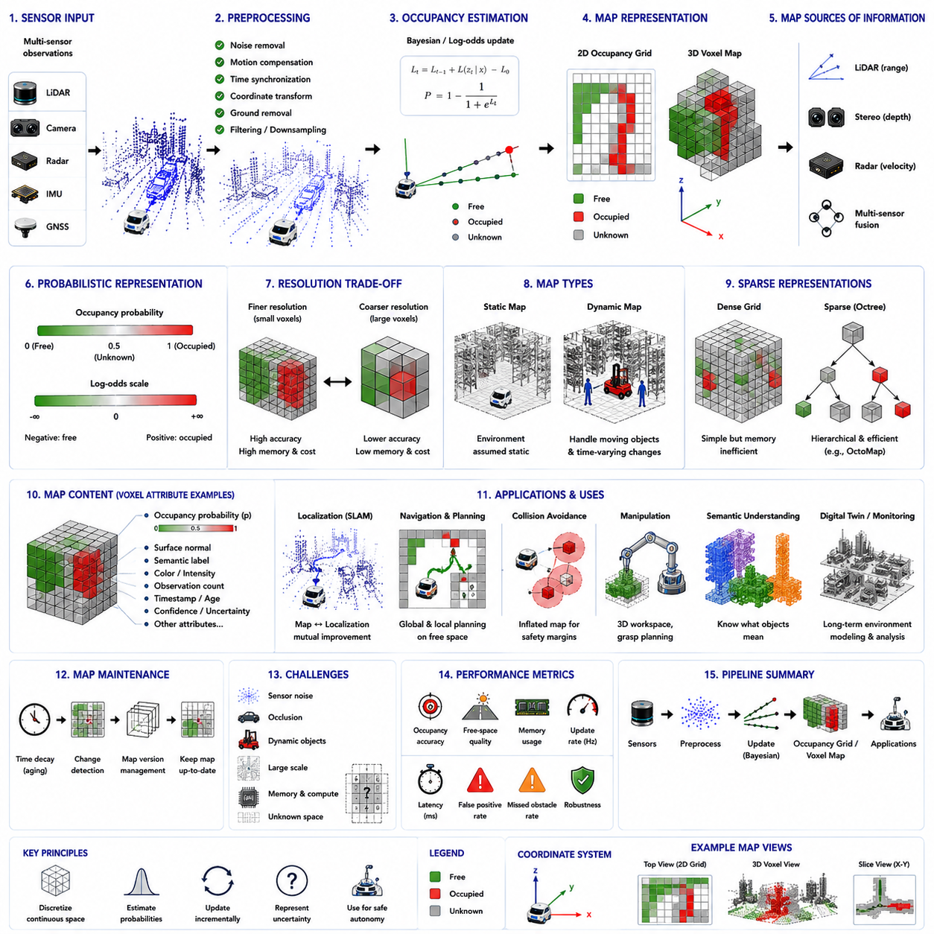
Occupancy grid mapping and voxel mapping are among the most fundamental spatial representation techniques in autonomous robotics because they convert raw sensor observations into structured environmental models that can be efficiently interpreted by navigation, planning, localization, obstacle avoidance, and decision-making algorithms. While point clouds preserve highly detailed geometric measurements, they remain irregular, sparse, and computationally expensive to process directly. Occupancy grids and voxel maps instead organize spatial information into regular discrete cells, allowing robots to reason about the surrounding environment using consistent mathematical structures. These representations transform millions of independent sensor measurements into compact spatial models that accurately describe free space, occupied space, and unknown regions while supporting efficient real-time computation.
The primary objective of occupancy mapping is not simply to visualize the environment but to estimate the probability that every location within the robot's operational space is occupied by a physical object. Unlike deterministic maps that classify each location as either occupied or empty, occupancy maps explicitly model uncertainty resulting from sensor noise, limited observations, dynamic environments, and incomplete measurements. Every grid cell therefore represents a probabilistic estimate describing whether the corresponding physical region is occupied, free, or currently unknown. This probabilistic representation enables autonomous systems to make safer navigation decisions while continuously refining environmental knowledge as additional sensor observations become available.
Occupancy grids were originally developed for two-dimensional mobile robotics, where the operating environment could be represented as a horizontal plane divided into uniformly sized square cells. Each cell stores an occupancy probability estimated from repeated sensor observations. Although originally designed for laser range finders operating in relatively structured indoor environments, occupancy grid concepts have evolved into comprehensive three-dimensional mapping frameworks supporting autonomous vehicles, warehouse robots, industrial inspection systems, agricultural machinery, construction robots, and outdoor autonomous mobile platforms operating within highly dynamic environments.
Voxel maps extend the occupancy grid concept into three-dimensional space by replacing two-dimensional square cells with volumetric cubes called voxels. Every voxel represents a finite volume rather than an area, allowing the robot to describe the complete spatial structure of buildings, machinery, vegetation, infrastructure, shelves, containers, staircases, ramps, ceilings, and other complex three-dimensional objects. Instead of reasoning only about horizontal navigation surfaces, voxel maps enable full volumetric understanding of the surrounding world, making them indispensable for autonomous inspection, robotic manipulation, aerial robotics, construction automation, and digital twin generation.
The selection of map resolution represents one of the most important design decisions because voxel size directly influences mapping accuracy, computational cost, and memory consumption. Small voxels preserve fine geometric details and allow highly accurate obstacle representation, but dramatically increase memory requirements and computational complexity. Larger voxels reduce computational burden while sacrificing geometric precision and potentially eliminating narrow passages or small obstacles. Practical robotic systems therefore balance spatial resolution against available computational resources, operational speed, sensing range, and application-specific safety requirements.
Occupancy estimation usually begins immediately after sensor acquisition and point cloud preprocessing. LiDAR scans, stereo cameras, depth sensors, radar measurements, or fused multi-sensor observations are transformed into a common coordinate frame before being projected into the map representation. Each sensor observation contributes evidence regarding whether specific spatial cells should be considered occupied or free. Repeated observations gradually increase confidence while contradictory measurements modify existing occupancy probabilities. Consequently, occupancy maps evolve continuously rather than remaining fixed throughout robot operation.
Probabilistic occupancy estimation commonly employs Bayesian inference because sensor observations inherently contain uncertainty. Instead of treating every measurement as absolute truth, Bayesian updating combines prior occupancy beliefs with newly acquired sensor evidence to produce refined probability estimates. Cells repeatedly observed as containing obstacles gradually approach high occupancy probability, whereas repeatedly observed free regions converge toward low occupancy probability. Areas lacking sufficient observations remain classified as unknown until additional sensor information becomes available. This probabilistic framework naturally accommodates noisy measurements while providing mathematically consistent uncertainty management.
Log-odds representations are frequently used instead of directly storing probabilities because repeated Bayesian updates become computationally simpler in logarithmic form. Positive log-odds indicate increasing confidence that space is occupied, while negative values indicate increasing confidence that space is free. Independent sensor observations can then be incorporated through simple additive updates rather than repeated probability multiplication and normalization. This representation improves numerical stability, computational efficiency, and implementation simplicity, making log-odds mapping the standard approach within many modern robotic mapping systems.
Sensor models play a critical role in occupancy estimation because different sensing technologies observe the environment differently. LiDAR accurately measures obstacle distance along narrow laser beams, stereo vision estimates depth through image correspondence, radar detects objects despite adverse weather but with lower spatial resolution, while ultrasonic sensors provide coarse short-range obstacle detection. Inverse sensor models describe how each observation modifies occupancy probability within affected cells. Accurate sensor modeling significantly improves mapping quality because occupancy updates correctly reflect the strengths and limitations of each sensing modality.
Ray tracing represents one of the most important occupancy update mechanisms. Whenever a range sensor detects an obstacle, every cell along the measurement path before the detected object receives evidence supporting free space, while the endpoint receives evidence supporting occupancy. This distinction allows the robot to identify traversable regions rather than merely obstacle locations. Efficient ray traversal algorithms such as Bresenham line tracing or voxel traversal methods update thousands of cells rapidly, enabling real-time map construction even under high-frequency sensing conditions.
Unknown space constitutes an equally important component of occupancy mapping because autonomous systems must distinguish between observed free regions and areas that have never been measured. Assuming unknown regions are free could result in dangerous collisions, while assuming they are occupied unnecessarily restricts robot mobility. Most autonomous navigation systems therefore treat unknown space conservatively according to operational risk requirements. Exploration robots intentionally seek unknown regions, whereas industrial robots operating in safety-critical environments generally avoid them until reliable observations become available.
Static occupancy maps assume that environmental structures remain unchanged over time. Such representations perform well in controlled industrial facilities, warehouses, production lines, and structured indoor environments where permanent obstacles rarely move. However, many real-world environments contain pedestrians, vehicles, forklifts, service robots, movable inventory, construction equipment, and temporary obstacles that continuously alter occupancy. Dynamic occupancy mapping therefore extends conventional approaches by estimating both occupancy probability and temporal persistence, allowing transient obstacles to disappear naturally after sufficient contradictory observations.
Voxel maps provide substantially richer environmental representation because each voxel stores volumetric information rather than merely indicating floor occupancy. Besides occupancy probability, modern voxel structures frequently contain surface normals, semantic labels, color information, reflectivity, observation counts, confidence values, timestamps, material properties, temperature measurements, and learned feature embeddings. Rich voxel representations therefore support perception, localization, semantic understanding, manipulation planning, digital twin generation, and environmental monitoring within a unified spatial framework.
Dense voxel grids provide straightforward implementation but suffer from excessive memory consumption because enormous volumes of empty space must still be represented explicitly. Autonomous robots frequently operate within large warehouses, outdoor facilities, factories, construction sites, or urban environments where most spatial volume remains empty. Efficient sparse representations therefore become essential. Sparse voxel structures allocate memory only for occupied or observed regions, dramatically reducing storage requirements while preserving high spatial resolution where environmental information actually exists.
Octree data structures represent one of the most widely adopted sparse mapping techniques because they hierarchically subdivide space according to environmental complexity. Large empty regions remain represented by coarse nodes, whereas geometrically detailed areas receive progressively finer subdivision. This adaptive representation significantly reduces memory usage while maintaining high-resolution mapping around obstacles and important structures. OctoMap has consequently become one of the most influential open-source three-dimensional occupancy mapping frameworks within robotics research and industrial autonomous systems.
Hierarchical spatial representations also accelerate computational performance because planning, collision checking, visibility analysis, and nearest-neighbor searches operate across adaptive resolution levels. Broad planning algorithms first examine coarse spatial structure before refining computations only where necessary. Such hierarchical reasoning substantially improves scalability within large operational environments while preserving geometric detail in regions requiring precise navigation or manipulation. Adaptive spatial decomposition therefore benefits both memory efficiency and computational speed simultaneously.
Voxel maps integrate naturally with simultaneous localization and mapping because map construction and robot localization continuously reinforce one another. As localization accuracy improves, newly acquired sensor observations become more precisely integrated into the voxel map. Conversely, richer voxel representations provide additional geometric features supporting more accurate scan registration and localization refinement. This mutual dependency creates a positive feedback loop where mapping and localization progressively improve throughout long-term autonomous operation.
Navigation systems rely extensively upon occupancy maps because safe path planning fundamentally depends upon distinguishing traversable space from obstacles. Global planners analyze occupancy maps to compute collision-free routes toward distant goals, while local planners continuously evaluate nearby occupancy changes caused by dynamic obstacles. Cost maps frequently derive directly from occupancy probabilities by assigning increased traversal cost near occupied regions while encouraging motion through confidently free space. Consequently, occupancy estimation directly influences robot safety, efficiency, and navigation robustness.
Collision avoidance similarly depends upon accurate occupancy estimation because robots must continuously evaluate surrounding free space during motion. Inflated occupancy maps enlarge detected obstacles according to robot dimensions and safety margins, ensuring planned trajectories maintain adequate clearance despite localization uncertainty, sensing inaccuracies, or control imperfections. Adaptive inflation strategies further modify safety margins according to vehicle speed, environmental complexity, or operational risk level, allowing intelligent balance between navigation efficiency and collision prevention.
Three-dimensional manipulation also benefits significantly from voxel mapping because robotic arms require volumetric understanding rather than merely two-dimensional obstacle information. Grasp planning, reachability analysis, collision checking, object placement, and workspace optimization all depend upon accurate three-dimensional occupancy representation. Industrial manipulation systems frequently employ local high-resolution voxel maps surrounding target objects while maintaining lower-resolution global maps for efficient environmental awareness.
Semantic occupancy mapping represents an important evolution beyond purely geometric representation. Instead of storing only occupancy probability, semantic voxel maps additionally classify environmental regions according to object category, functional purpose, material type, or operational significance. Individual voxels may therefore represent roads, walls, shelving systems, machinery, vegetation, vehicles, pedestrians, charging stations, inspection targets, or hazardous zones. Semantic occupancy maps enable context-aware navigation and task planning because robots understand not only where obstacles exist but also what those obstacles represent.
Artificial intelligence increasingly enhances occupancy mapping through learned spatial representations capable of predicting missing observations, completing partially visible structures, estimating traversability, identifying dynamic objects, and integrating multimodal sensor information. Deep neural networks learn complex environmental patterns directly from large datasets, improving occupancy estimation under adverse weather, partial occlusion, sparse observations, or sensor degradation. Foundation models further extend these capabilities by incorporating semantic reasoning and contextual understanding into volumetric world representation.
Real-time implementation remains one of the principal engineering challenges because occupancy maps require continuous updating as robots navigate through changing environments. High-frequency LiDAR systems, multiple synchronized cameras, radar sensors, and inertial measurements collectively generate enormous data volumes. Efficient GPU acceleration, parallel voxel updates, sparse memory allocation, asynchronous processing pipelines, and optimized spatial indexing therefore become essential for maintaining low-latency mapping without sacrificing representation accuracy or environmental coverage.
Map maintenance represents another critical consideration during long-term deployment because environments gradually evolve through construction, equipment relocation, seasonal vegetation changes, inventory movement, and infrastructure modification. Long-term occupancy systems therefore incorporate temporal decay mechanisms, confidence aging, change detection, and map version management to distinguish persistent structural modifications from temporary environmental variation. Continuous map adaptation ensures that occupancy representations remain accurate throughout extended autonomous operation rather than becoming progressively outdated.
Performance evaluation considers multiple quantitative measures including occupancy classification accuracy, free-space estimation quality, memory consumption, computational latency, update frequency, localization consistency, map completeness, false occupancy rate, missed obstacle rate, and robustness under varying environmental conditions. Practical evaluation additionally examines long-term stability, dynamic obstacle adaptation, scalability across large operational environments, and compatibility with downstream perception, navigation, and planning modules. Comprehensive evaluation remains essential because mapping quality directly influences every subsequent autonomous behavior.
Occupancy grids and voxel maps should therefore be viewed not simply as environmental visualization techniques but as foundational world representations supporting nearly every aspect of autonomous robotic intelligence. They provide the structured spatial memory required for localization, perception, navigation, collision avoidance, manipulation, semantic understanding, digital twins, and long-term autonomous reasoning. As autonomous systems continue evolving toward foundation-model-driven world models, occupancy grids and voxel maps will likewise evolve into increasingly intelligent volumetric representations that combine geometry, semantics, temporal dynamics, uncertainty estimation, and predictive reasoning within unified three-dimensional environmental models capable of supporting the next generation of intelligent autonomous robots.

18.6 3D Scene Understanding
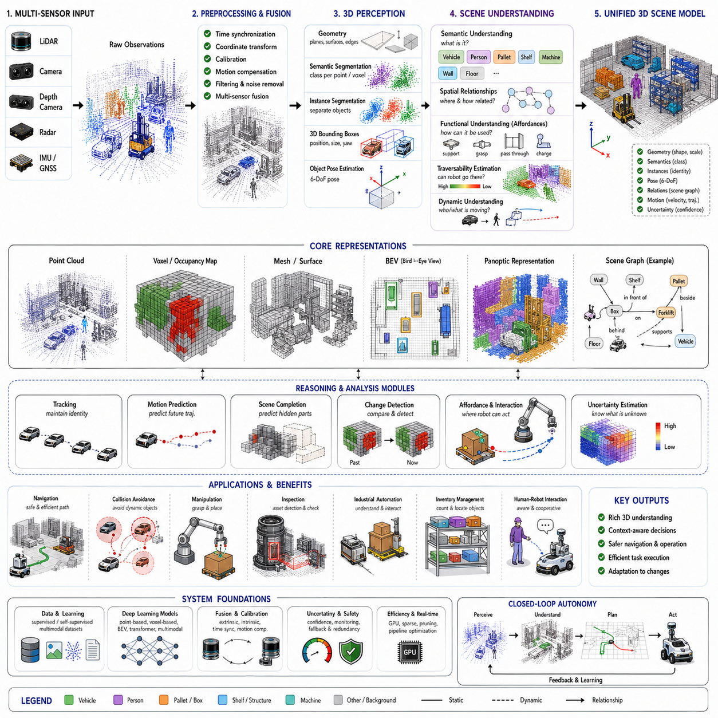
Three-dimensional scene understanding is the process through which an autonomous robot interprets the geometric structure, semantic meaning, spatial relationships, functional properties, and temporal behavior of objects within its surrounding environment. Unlike basic obstacle detection, which identifies only whether something blocks the robot’s path, 3D scene understanding builds a richer model of what exists, where it is located, how different elements are related, and how the environment may change. This capability enables robots to move beyond reactive sensing toward context-aware reasoning, safer planning, intelligent interaction, and long-term autonomous operation.
The foundation of 3D scene understanding is accurate spatial perception. Sensors such as LiDAR, stereo cameras, depth cameras, radar, structured-light sensors, and inertial systems generate measurements describing surfaces, distances, motion, and appearance. These raw observations are transformed into common coordinate frames and organized as point clouds, depth maps, meshes, occupancy grids, voxel maps, or learned three-dimensional feature representations. The resulting spatial model allows the robot to estimate the shape, scale, position, orientation, and physical extent of surrounding structures.
Scene understanding differs from simple object recognition because it considers the environment as an interconnected system rather than a collection of isolated objects. A robot must understand that a pallet is placed on the floor, a box is stacked on another box, a machine is located behind a safety fence, and a worker is standing near an operating vehicle. These relationships provide essential context for navigation and decision-making. The same object may require different behavior depending on its position, surrounding objects, operational state, and functional role within the scene.
Geometric understanding provides the first layer of interpretation. Planes, edges, surfaces, corners, openings, slopes, steps, and volumetric obstacles are extracted from sensor data to describe environmental structure. Ground planes are separated from walls and elevated objects, while vertical clearances and traversable surfaces are estimated for safe motion. In industrial environments, geometric analysis identifies corridors, work cells, loading zones, racks, docking stations, machinery, and restricted spaces. Accurate geometric reasoning is especially important when semantic recognition is uncertain or unavailable.
Semantic segmentation assigns a meaningful category to each point, pixel, voxel, or surface element within the scene. Instead of representing all measured points identically, the robot distinguishes road, floor, wall, vegetation, vehicle, pedestrian, pallet, shelf, machine, and other relevant classes. This dense semantic representation enables more precise environmental understanding than object-level detection alone. A robot can determine which surfaces are traversable, which structures are permanent, which objects are movable, and which regions require special safety behavior.
Instance segmentation extends semantic segmentation by separating individual objects belonging to the same class. Multiple vehicles, pallets, workers, or containers must be represented as distinct entities even when they share the same semantic label. Each instance receives an identity, spatial extent, and associated geometric features. Instance-level understanding supports tracking, manipulation, inventory management, collision prediction, and interaction planning because the robot reasons about specific physical objects rather than only general categories.
Panoptic scene understanding combines semantic segmentation and instance segmentation into a unified representation. Every visible or measured region receives both a semantic category and, where appropriate, a unique instance identity. Continuous background elements such as floors, walls, and roads are treated as semantic regions, while countable objects such as vehicles, people, boxes, and equipment are represented individually. This unified approach reduces inconsistencies between separate perception modules and provides a more complete description of the environment.
Three-dimensional bounding boxes provide compact object representations within the scene model. Each detected object can be described by its center, width, length, height, orientation, class, velocity, and confidence. Bounding boxes simplify downstream processing because planning and tracking modules do not need to repeatedly process every raw point. However, boxes alone cannot fully represent irregular object shapes or functional surfaces, so advanced systems combine bounding boxes with instance masks, meshes, keypoints, surface models, or voxel-based representations.
Object pose estimation determines how an object is positioned and oriented within the environment. For industrial inspection, assembly, grasping, and docking tasks, a semantic label is insufficient because the robot must know the object’s precise six-degree-of-freedom pose. Pose estimation may use geometric registration, keypoint matching, feature correspondences, model fitting, or neural networks. Accurate pose information allows robots to align tools, transform predefined task plans, calculate reachability, and interact safely with complex equipment.
Spatial relationships are essential for higher-level scene reasoning. The robot may infer relations such as above, below, inside, beside, attached to, supported by, approaching, crossing, or blocking. These relationships form a structured scene graph in which objects are represented as nodes and their relationships as edges. Scene graphs provide a compact symbolic representation that connects low-level perception with high-level planning. They allow the robot to answer practical questions such as which aisle is blocked, which object is inside a container, or which worker is closest to a moving vehicle.
Functional understanding goes beyond recognizing an object’s category by identifying how it can be used or interacted with. A horizontal surface may support placement, a handle may enable grasping, a doorway may permit passage, and a charging station may provide energy. These possible interactions are often described as affordances. Affordance recognition enables robots to select actions based on object function rather than appearance alone. This capability is especially important in manipulation, service robotics, maintenance, and adaptive industrial automation.
Traversability estimation represents another important component of scene understanding. A surface may be geometrically visible but still unsuitable for robot motion because of slope, roughness, softness, instability, water, vegetation, debris, or limited clearance. Traversability models combine geometry, semantics, vehicle capability, and environmental conditions to estimate whether a region can be crossed safely. Outdoor robots often require continuous traversability scores rather than binary free-space labels because terrain difficulty changes gradually across the environment.
Dynamic scene understanding identifies which elements are moving and predicts how their positions may change. Pedestrians, vehicles, forklifts, robots, machinery, doors, and suspended loads create time-dependent hazards that cannot be represented accurately by static maps. Multi-frame perception estimates velocity, acceleration, trajectory, and motion uncertainty for dynamic objects. The resulting temporal scene model allows the robot to anticipate future occupancy and select actions before a collision risk becomes immediate.
Object tracking maintains consistent identities across time. A detection in one frame must be associated with the same physical object in later frames despite occlusion, viewpoint changes, missed detections, and sensor noise. Tracking algorithms use motion models, appearance features, geometric similarity, and data association to preserve identity. Stable tracking supports behavior prediction, trajectory estimation, interaction analysis, and long-term environmental monitoring. Without tracking, the robot sees disconnected observations rather than persistent entities.
Temporal fusion improves scene understanding by integrating information from multiple observations. A single frame may contain sparse data, occlusion, motion blur, or incomplete surfaces. Accumulating measurements over time creates denser geometry and more stable semantic estimates. However, the robot must compensate for its own motion and separate static structures from moving objects before combining frames. Effective temporal fusion increases detection range, reduces noise, improves map completeness, and supports reliable reasoning under difficult sensing conditions.
Multi-sensor fusion further strengthens scene interpretation by combining complementary sensing modalities. LiDAR provides accurate geometry, cameras provide color and semantic detail, radar provides robust range and velocity under adverse weather, and inertial sensors support motion estimation. Fusion can occur at the raw-data, feature, object, or decision level. The most appropriate strategy depends on sensor synchronization, calibration accuracy, computational resources, and application requirements. Robust fusion reduces dependence on any single sensor and improves overall reliability.
Calibration and coordinate management are fundamental because all scene elements must be expressed consistently. Incorrect extrinsic calibration causes objects observed by different sensors to appear misaligned, while timing errors create distortions when either the robot or surrounding objects move. Scene understanding systems therefore require accurate intrinsic calibration, sensor-to-sensor transformations, robot-frame alignment, timestamp synchronization, and motion compensation. Even highly advanced neural networks cannot fully overcome poor calibration in safety-critical applications.
Uncertainty must be represented explicitly throughout the scene model. Sensor noise, partial visibility, class ambiguity, localization error, and model limitations all affect confidence. A robust system estimates uncertainty for object position, size, orientation, semantic label, velocity, and predicted trajectory. Downstream planners can then apply larger safety margins when uncertainty is high and operate more efficiently when perception is reliable. Confidence-aware reasoning is essential for safe autonomous behavior in unfamiliar or changing environments.
Occlusion is one of the most difficult challenges in 3D scene understanding. Objects may be partially hidden by vehicles, shelves, walls, vegetation, machinery, or other obstacles. The robot must infer whether an object continues behind the visible region and estimate possible hidden space. Temporal observations, learned object priors, multi-view sensing, and occupancy reasoning help recover missing information. Nevertheless, the system should preserve uncertainty rather than treating inferred geometry as confirmed observation.
Scene completion attempts to predict unobserved geometric and semantic structure from partial sensor measurements. A robot may observe only one side of a vehicle or a limited section of a room, yet still require an approximate model of the complete scene for planning. Deep neural networks learn common structural patterns and predict likely hidden surfaces or occupancy. Scene completion improves environmental awareness, but predicted content must be distinguished from directly measured data to avoid unsafe assumptions.
Deep learning has transformed 3D scene understanding by automatically learning features from large datasets. Point-based networks process irregular point clouds directly, voxel-based networks apply sparse three-dimensional convolutions, and bird’s-eye-view models create efficient top-down representations. Transformer architectures capture long-range relationships between objects and regions, while multimodal networks combine images, point clouds, text, and map information. These approaches often outperform hand-designed methods in complex scenes but require substantial data, computation, and careful validation.
Self-supervised and weakly supervised learning reduce dependence on expensive manual annotation. Robots can learn geometric consistency from multiple views, temporal continuity from video, correspondence from sensor motion, and semantic relationships from pretrained vision-language models. Large quantities of unlabeled operational data can therefore be used to improve scene representations. This is particularly valuable in industrial environments where specialized equipment and unusual objects may not appear in public datasets.
Three-dimensional scene graphs provide a bridge between perception and reasoning. Objects, surfaces, rooms, zones, and functional areas are represented as entities connected through geometric, semantic, and temporal relationships. A scene graph may describe that a robot is inside a warehouse, a pallet is near a shelf, a worker is approaching an intersection, and a loading zone is currently occupied. This structured knowledge supports task planning, question answering, fault analysis, and explainable autonomous decision-making.
Long-term scene understanding requires the robot to distinguish permanent structures from temporary changes. Walls, columns, and fixed machines may remain stable for years, while pallets, vehicles, tools, and workers change continuously. Long-term maps therefore maintain multiple temporal layers, confidence histories, change records, and object persistence estimates. This allows the robot to update its environmental knowledge without repeatedly forgetting stable information or preserving outdated temporary obstacles.
Change detection identifies differences between current observations and previously stored scene models. It can reveal moved equipment, new obstacles, missing inventory, damaged infrastructure, construction modifications, or unauthorized objects. Industrial inspection and security robots rely heavily on this capability because the objective is often not merely to navigate but to identify meaningful environmental changes. Reliable change detection requires accurate registration and careful separation of true modifications from sensing noise.
Digital twin integration extends scene understanding into operational monitoring and simulation. The robot’s live three-dimensional observations can be aligned with CAD models, building information models, factory layouts, or asset databases. Differences between the observed scene and the expected digital model may indicate installation errors, deformation, missing components, or maintenance needs. Conversely, the digital twin provides prior geometric and semantic knowledge that helps the robot interpret difficult scenes and localize specific assets.
Navigation benefits from scene understanding because the planner can consider object meaning and behavior rather than only geometric occupancy. A robot may pass close to a fixed wall but maintain greater distance from a person or moving forklift. It may prefer designated lanes, avoid hazardous areas, yield at intersections, and approach docking stations from specific directions. Semantic and relational information therefore enables behavior that is safer, more efficient, and more compatible with human environments.
Manipulation also depends on detailed 3D scene interpretation. A robotic arm must identify target objects, estimate poses, understand support surfaces, detect obstacles, and predict the consequences of movement. Scene understanding provides the spatial context needed to decide where to grasp, how to approach, whether the object is accessible, and where it can be placed. In mobile manipulation, navigation and arm planning must share a unified scene representation to avoid inconsistencies.
Industrial inspection robots use 3D scene understanding to locate assets, determine accessible viewpoints, transform inspection plans, detect environmental changes, and verify safe operating conditions. The robot must understand not only the target machine but also surrounding structures, temporary obstacles, workers, lighting equipment, and available approach paths. Accurate scene interpretation allows inspection missions to adapt when real conditions differ from predefined CAD or map information.
Performance evaluation requires more than measuring object detection accuracy. Relevant metrics include semantic segmentation quality, instance separation, pose error, scene completion accuracy, depth accuracy, relation prediction, tracking consistency, motion prediction error, map stability, latency, memory usage, and robustness under environmental variation. Evaluation should also examine downstream task success because a perception model with high benchmark accuracy may still perform poorly when integrated with real navigation or manipulation systems.
Real-time deployment requires efficient processing because scene understanding combines multiple computationally demanding functions. Sparse convolutions, GPU acceleration, model pruning, quantization, region-of-interest processing, asynchronous pipelines, and hierarchical representations reduce latency. Systems may use a lightweight model for continuous perception and activate more detailed reasoning only when complex interactions or inspection tasks require it. This adaptive computation strategy helps maintain both responsiveness and high accuracy.
Safety-critical scene understanding should include redundancy and failure monitoring. Geometric obstacle detection can remain active even when semantic classification becomes uncertain, while independent sensors can verify important hazards. The system should detect degraded visibility, calibration drift, sensor blockage, excessive uncertainty, and unsupported environmental conditions. When confidence falls below acceptable limits, the robot should reduce speed, increase safety margins, request assistance, or transition to a safe state.
Future 3D scene understanding will increasingly combine foundation models, world models, semantic maps, language interfaces, and long-term memory. Robots will not merely detect objects but build persistent representations of environments, understand task context, explain relationships, predict future events, and reason about possible actions. Vision-language and multimodal models will allow operators to query scenes using natural language and define tasks through semantic descriptions rather than low-level coordinates.
A mature 3D scene understanding system therefore functions as the central world model of an autonomous robot. It integrates geometry, semantics, instances, motion, uncertainty, affordances, relationships, and temporal history into a unified representation. This model connects sensor data with navigation, manipulation, inspection, prediction, and decision-making. As robotic systems become more autonomous, adaptable, and collaborative, three-dimensional scene understanding will remain one of the most important foundations for safe and intelligent interaction with the physical world.

18.7 3D Perception for Navigation
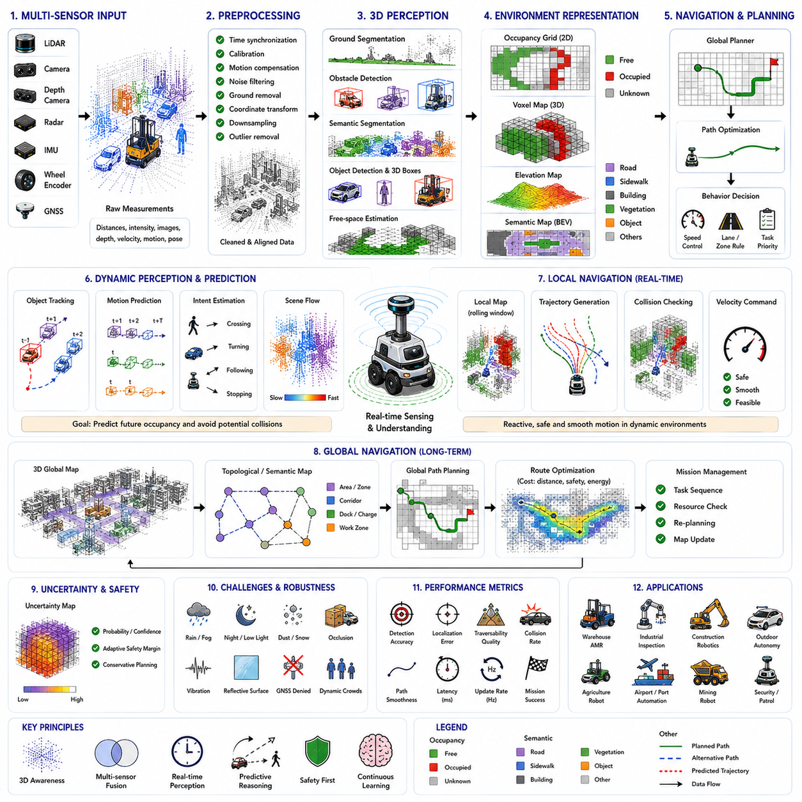
Three-dimensional perception for navigation is the capability that enables an autonomous robot to understand the surrounding environment in three dimensions and use that understanding to move safely, efficiently, and intelligently toward a desired destination. Unlike conventional two-dimensional navigation, which primarily considers horizontal obstacles and planar motion, 3D perception incorporates height, volume, terrain geometry, object structure, spatial relationships, and dynamic environmental changes into navigation decisions. This richer environmental awareness allows robots to operate reliably in warehouses, factories, construction sites, outdoor roads, forests, mines, ports, airports, and other complex real-world environments where purely two-dimensional representations are insufficient.
The primary objective of 3D perception for navigation is to convert raw sensor observations into actionable environmental knowledge. Sensors continuously measure distances, surfaces, object locations, motion, and environmental geometry. These measurements are transformed into structured representations that distinguish traversable regions, occupied space, free space, hazards, and unknown areas. Navigation algorithms then utilize these representations to determine where the robot can safely travel, what obstacles should be avoided, how terrain affects mobility, and which path best satisfies operational objectives while maintaining safety margins.
Three-dimensional navigation begins with multi-sensor perception because no single sensing technology provides complete environmental understanding under every condition. LiDAR delivers highly accurate geometric measurements, stereo cameras estimate dense depth through image correspondence, depth cameras provide short-range three-dimensional structure, radar offers reliable obstacle detection during rain, snow, fog, or dust, while inertial sensors estimate robot motion. Global Navigation Satellite Systems provide absolute positioning in open environments, whereas wheel encoders measure local motion. Combining these complementary sensors produces a robust perception system capable of operating under widely varying environmental conditions.
Sensor synchronization represents a critical prerequisite because navigation decisions depend upon consistent spatial information collected at nearly the same instant. If LiDAR, cameras, radar, and inertial sensors are not accurately synchronized, moving objects may appear in inconsistent locations, creating distorted environmental models. Precise timestamp alignment, hardware triggering, network time synchronization, and motion compensation therefore ensure that all sensor measurements represent the same physical scene despite robot movement or dynamic environmental changes.
Calibration provides another essential foundation for accurate navigation. Intrinsic calibration estimates the internal characteristics of each sensor, while extrinsic calibration determines the precise spatial relationship between sensors mounted on the robot platform. Small calibration errors accumulate throughout the perception pipeline and may produce incorrect obstacle locations, inaccurate free-space estimation, or unreliable localization. Consequently, robust navigation systems continuously verify calibration quality and compensate for mechanical vibration, temperature variation, and long-term sensor drift whenever possible.
Raw sensor measurements typically undergo several preprocessing stages before navigation algorithms begin environmental reasoning. Noise filtering removes isolated measurements caused by sensor uncertainty, motion compensation corrects distortions produced by robot movement during sensor acquisition, coordinate transformation converts all observations into a common reference frame, and downsampling reduces computational cost while preserving important geometric information. Ground removal further separates traversable surfaces from elevated obstacles, simplifying later perception stages without sacrificing environmental awareness.
Point clouds provide one of the most common intermediate representations for three-dimensional navigation because they preserve detailed geometric information describing surrounding objects and terrain. Each point contains spatial coordinates and may additionally include intensity, color, timestamp, semantic labels, or confidence estimates. Although point clouds accurately describe complex environments, they remain computationally expensive for real-time navigation. Most navigation systems therefore transform point clouds into more structured representations such as occupancy grids, voxel maps, elevation maps, or bird's-eye-view feature maps.
Ground segmentation plays a particularly important role because autonomous mobile robots usually move on supporting surfaces rather than through arbitrary three-dimensional space. Ground extraction algorithms distinguish navigable terrain from obstacles by analyzing local surface geometry, elevation continuity, slope, curvature, and neighboring point distributions. Accurate ground segmentation enables the robot to identify roads, floors, ramps, loading platforms, sidewalks, and traversable natural terrain while rejecting walls, machinery, vehicles, vegetation, and suspended obstacles.
Free-space estimation determines which regions of the environment can safely accommodate robot motion. Instead of identifying only obstacles, free-space algorithms estimate continuous traversable regions based on sensor observations and robot dimensions. Free space changes continuously as new sensor measurements become available or obstacles move throughout the environment. Reliable free-space estimation allows planners to generate smooth trajectories while maintaining adequate clearance from surrounding structures and minimizing unnecessary detours.
Occupancy mapping converts geometric observations into probabilistic environmental representations suitable for navigation planning. Individual cells or voxels store occupancy probabilities representing whether corresponding regions contain physical obstacles, free space, or insufficient observations. Bayesian updates continuously refine occupancy estimates as new sensor measurements arrive, allowing navigation algorithms to reason about uncertainty while avoiding dangerous assumptions regarding partially observed environments. Occupancy maps therefore provide an effective balance between geometric accuracy, computational efficiency, and uncertainty management.
Voxel representations further improve navigation by preserving complete three-dimensional environmental structure. Overhanging obstacles, bridges, suspended equipment, shelving systems, staircases, tunnels, pipes, and multi-level industrial facilities cannot be represented adequately within two-dimensional maps. Three-dimensional voxel models enable robots to evaluate vertical clearance, overhead hazards, structural complexity, and navigable volume. Such representations are particularly valuable for warehouse automation, inspection robots, aerial vehicles, and construction robotics operating within highly structured environments.
Elevation mapping offers a specialized representation for outdoor navigation where terrain shape significantly influences mobility. Instead of storing complete volumetric occupancy, elevation maps estimate surface height for each horizontal location. Additional information such as slope, roughness, traversability, vegetation density, water accumulation, and terrain uncertainty may also be maintained. Off-road autonomous vehicles rely heavily on elevation maps because terrain geometry often determines whether a route is physically traversable despite containing no explicit obstacles.
Semantic perception enriches navigation by identifying environmental meaning rather than merely geometric occupancy. Roads, sidewalks, pedestrian crossings, loading areas, charging stations, work zones, hazardous regions, restricted areas, storage racks, machinery, and emergency exits receive semantic labels describing their operational significance. Navigation planners can then incorporate organizational rules, traffic policies, operational priorities, and human safety requirements rather than relying exclusively upon geometric obstacle avoidance.
Object detection provides compact representations of surrounding dynamic and static entities. Vehicles, pedestrians, forklifts, mobile robots, containers, pallets, construction equipment, machinery, and temporary obstacles are detected, classified, and localized within the scene. Three-dimensional bounding boxes estimate object position, orientation, dimensions, velocity, and confidence. These structured object descriptions allow planning algorithms to predict future interactions without repeatedly processing every raw sensor measurement during each planning cycle.
Dynamic object tracking maintains persistent identities for moving obstacles throughout navigation. Individual pedestrians, vehicles, robots, or forklifts are associated across consecutive sensor frames despite partial occlusion, missed detections, or changing viewpoints. Motion models estimate velocity, acceleration, heading, and future trajectories. By maintaining continuous object histories, the navigation system anticipates future conflicts rather than reacting only to instantaneous observations, improving both efficiency and operational safety.
Motion prediction extends dynamic perception by estimating probable future positions of moving objects. Human walking behavior, vehicle dynamics, forklift turning patterns, and robot trajectories follow characteristic motion constraints that predictive models exploit. Rather than planning solely around current obstacle positions, navigation systems evaluate expected future occupancy throughout the planning horizon. Predictive navigation significantly reduces collision risk in crowded industrial environments containing numerous independently moving agents.
Traversability analysis evaluates whether terrain can safely support robot movement. Flat geometric surfaces may remain unsuitable because of excessive slope, loose gravel, mud, vegetation, snow, water, uneven ground, debris, structural instability, or limited wheel traction. Traversability models integrate geometric measurements, semantic classification, terrain properties, vehicle dynamics, and historical experience to estimate navigation difficulty continuously across the environment. This capability proves especially important for outdoor autonomous vehicles operating beyond structured roads.
Obstacle classification further improves navigation quality because different obstacle categories require different planning behavior. Permanent infrastructure such as walls or buildings usually remains fixed, while pedestrians, forklifts, service robots, and vehicles exhibit unpredictable motion. Soft vegetation may be traversable for heavy outdoor robots but impassable for smaller platforms. Fragile equipment demands greater clearance than stationary storage racks. Understanding obstacle characteristics enables navigation policies tailored to operational context rather than uniform avoidance behavior.
Local navigation relies upon continuous high-frequency perception updates. Nearby obstacles, free space, dynamic objects, and terrain conditions are monitored repeatedly while the robot executes planned motion. Local planners react rapidly to environmental changes, generate collision-free trajectories, and adjust speed according to available free space, obstacle proximity, perception confidence, and environmental uncertainty. Real-time local perception therefore provides immediate operational safety during autonomous movement.
Global navigation benefits from broader three-dimensional environmental understanding accumulated over extended operating periods. Large-scale maps contain building layouts, roads, warehouses, production lines, inspection routes, charging stations, restricted zones, and frequently changing operational areas. Three-dimensional perception continuously updates these maps by detecting structural modifications, temporary obstacles, relocated inventory, or newly accessible routes. Consequently, long-term navigation adapts naturally as operational environments evolve.
Localization and navigation remain tightly coupled because accurate navigation depends upon reliable robot position estimation. Simultaneous Localization and Mapping continuously aligns new sensor observations with previously constructed environmental models. Rich three-dimensional perception provides abundant geometric features supporting accurate registration, while improved localization enables more consistent map updates. This positive feedback relationship significantly enhances navigation robustness throughout extended autonomous missions.
Uncertainty estimation plays an increasingly important role within navigation perception. Sensor noise, adverse weather, partial visibility, localization error, moving obstacles, and imperfect semantic classification all introduce uncertainty into environmental understanding. Instead of ignoring these limitations, modern navigation systems estimate confidence for occupancy, object position, terrain classification, semantic labels, and predicted trajectories. Planning algorithms then expand safety margins automatically whenever perception confidence decreases, maintaining safe operation under uncertain conditions.
Adverse environmental conditions represent major challenges for three-dimensional navigation perception. Rain, fog, dust, snow, strong sunlight, darkness, reflective surfaces, smoke, water accumulation, and airborne particles may degrade individual sensors differently. Multi-sensor fusion provides robustness because complementary sensing modalities compensate for each other's weaknesses. Radar remains reliable during poor visibility, LiDAR maintains geometric accuracy under moderate illumination changes, while cameras contribute valuable semantic information whenever visual conditions permit.
Occlusion frequently limits environmental visibility during navigation. Buildings, shelving systems, parked vehicles, machinery, vegetation, containers, and infrastructure may conceal pedestrians or moving equipment. Temporal sensor fusion, multi-view observations, predictive tracking, and occupancy reasoning help estimate hidden space while preserving uncertainty regarding unseen regions. Safe navigation requires conservative planning whenever important environmental information remains unavailable due to persistent occlusion.
Artificial intelligence has substantially expanded navigation perception capabilities through deep neural networks trained on large-scale multimodal datasets. Point-based networks process raw point clouds directly, voxel networks perform efficient sparse three-dimensional convolution, bird's-eye-view models simplify navigation reasoning, and transformer architectures capture long-range spatial dependencies throughout complex environments. Learned representations increasingly outperform manually designed features while adapting more effectively to diverse operational conditions.
Foundation models and multimodal perception systems are beginning to influence navigation by integrating geometry, semantics, language, prior knowledge, and environmental context into unified world representations. Instead of independently detecting obstacles and planning paths, future navigation systems will reason about object purpose, expected human behavior, operational intent, and task objectives simultaneously. Natural language instructions, semantic maps, and contextual understanding will increasingly guide autonomous navigation beyond purely geometric path planning.
Real-time implementation remains one of the most demanding engineering challenges because navigation perception processes continuous high-bandwidth sensor streams under strict latency constraints. GPU acceleration, sparse computation, hierarchical spatial structures, adaptive resolution, asynchronous processing pipelines, model compression, and hardware-specific optimization enable perception systems to maintain high update frequencies while preserving sufficient geometric and semantic accuracy for safe autonomous operation.
Performance evaluation extends beyond perception accuracy alone because navigation ultimately measures operational success. Relevant metrics include obstacle detection accuracy, localization precision, traversability estimation quality, free-space completeness, dynamic object prediction error, collision rate, trajectory smoothness, computational latency, update frequency, energy efficiency, and mission completion success. Integrated evaluation ensures that improvements within perception translate into measurable gains in autonomous navigation performance.
Industrial autonomous robots rely heavily upon three-dimensional perception because operational environments continuously change throughout normal production. Pallets move, forklifts travel, workers relocate equipment, inventory accumulates, temporary barriers appear, and machinery changes operational state. Navigation perception therefore functions not merely as a sensing module but as a continuously updated environmental intelligence system supporting logistics automation, industrial inspection, warehouse management, construction robotics, agricultural autonomy, and service robotics.
The future of three-dimensional perception for navigation will increasingly merge geometric sensing, semantic understanding, predictive reasoning, foundation models, digital twins, and long-term world memory into unified autonomous intelligence. Rather than simply avoiding obstacles, robots will understand operational context, anticipate environmental evolution, cooperate naturally with humans, optimize mission efficiency, and continuously refine environmental knowledge through lifelong learning. Three-dimensional perception will therefore remain one of the most fundamental technologies enabling intelligent, reliable, and safe autonomous navigation across every major application domain of modern robotics.

18.8 3D Perception Testing
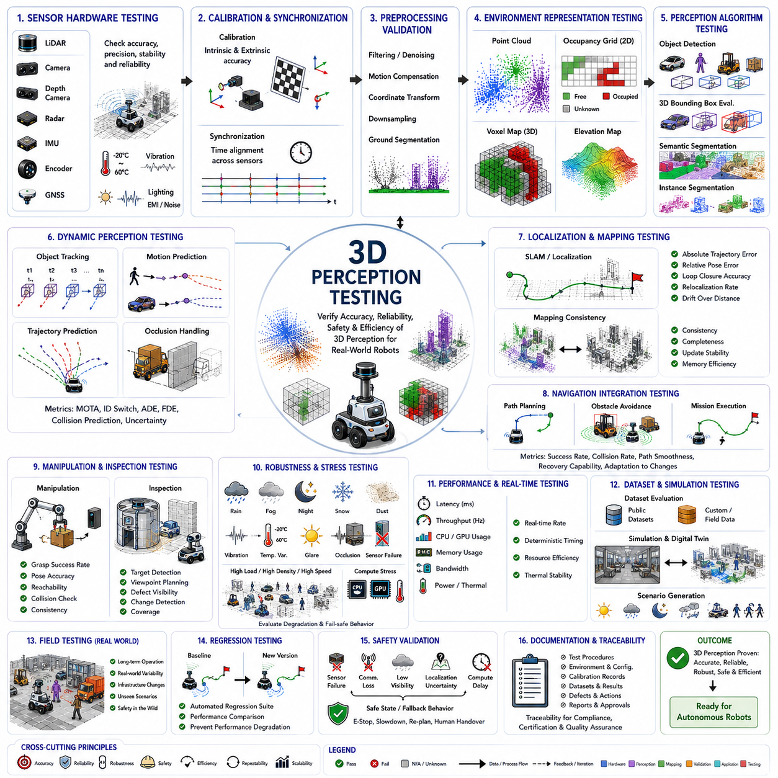
Three-dimensional perception testing is the systematic process of evaluating whether a robotic perception system accurately, reliably, safely, and efficiently understands three-dimensional environments under realistic operating conditions. Unlike algorithm benchmarking performed only on static datasets, perception testing examines the complete sensing pipeline, including sensor hardware, synchronization, calibration, preprocessing, perception algorithms, environmental representation, object understanding, navigation support, computational performance, and system robustness. Comprehensive testing ensures that three-dimensional perception satisfies both technical performance requirements and operational safety requirements before deployment in real autonomous robots.
The primary objective of 3D perception testing is to verify that environmental understanding remains sufficiently accurate for downstream robotic functions. Navigation, localization, obstacle avoidance, manipulation, inspection, mapping, and autonomous decision-making all depend directly upon perception quality. Even relatively small perception errors may accumulate into localization drift, unsafe trajectory generation, missed obstacle detection, inaccurate object manipulation, or inspection failures. Testing therefore evaluates not only perception accuracy itself but also its influence on complete robotic system behavior.
Testing should begin by validating sensor hardware because inaccurate measurements cannot be corrected completely by later software processing. LiDAR range accuracy, camera image quality, depth sensor precision, radar measurement consistency, inertial sensor stability, encoder repeatability, and GNSS positioning performance should each be verified individually. Environmental conditions including temperature variation, vibration, electromagnetic interference, humidity, lighting, and mechanical shock must also be considered because they directly influence long-term sensing reliability during practical robotic operation.
Sensor calibration represents one of the first verification steps because accurate perception depends upon precise geometric relationships between sensing devices. Intrinsic calibration evaluates focal length, lens distortion, principal point, and imaging characteristics, while extrinsic calibration estimates the rigid transformation between multiple sensors and the robot coordinate frame. Testing verifies calibration accuracy through reprojection error, registration consistency, target alignment, and long-term stability. Calibration drift should also be evaluated after prolonged operation, transportation, vibration exposure, or hardware replacement.
Time synchronization testing ensures that all sensors observe approximately the same physical scene despite operating at different sampling frequencies. Cameras, LiDAR, radar, inertial sensors, wheel encoders, and GNSS receivers generate measurements asynchronously unless synchronization mechanisms are implemented correctly. Timestamp consistency, hardware trigger accuracy, network latency, clock drift, and synchronization recovery after communication interruption should therefore be validated. Accurate synchronization becomes especially important whenever the robot or surrounding objects move rapidly.
Raw data quality assessment evaluates measurements before perception algorithms begin interpretation. Point cloud density, image sharpness, motion blur, sensor noise, missing returns, range accuracy, intensity consistency, and measurement completeness are analyzed across different operating conditions. Statistical analysis identifies systematic sensor bias, random noise characteristics, dropout frequency, corrupted measurements, and environmental influences. Understanding raw data quality helps distinguish hardware limitations from algorithmic deficiencies during later testing stages.
Preprocessing validation confirms that filtering, motion compensation, coordinate transformation, downsampling, outlier removal, and ground segmentation operate correctly without introducing undesirable artifacts. Testing compares processed data against original measurements while measuring computational cost and information preservation. Excessive filtering may remove small obstacles, whereas insufficient filtering leaves noisy measurements that degrade perception quality. Proper preprocessing therefore balances computational efficiency with preservation of meaningful environmental information.
Point cloud evaluation examines geometric representation quality before higher-level perception begins. Metrics include point density, spatial distribution, registration accuracy, surface continuity, reconstruction completeness, and measurement consistency across repeated observations. Static scenes should produce nearly identical point clouds under repeated scanning, while dynamic scenes require consistent separation between stationary structures and moving objects. Accurate point cloud generation forms the geometric foundation for nearly every subsequent perception module.
Ground segmentation testing verifies that traversable surfaces are reliably distinguished from obstacles under varying terrain conditions. Indoor floors, outdoor roads, ramps, uneven ground, gravel, grass, mud, construction debris, stairs, and complex industrial environments should all be included. Testing evaluates classification accuracy, boundary precision, robustness under sensor noise, and computational latency. Incorrect ground segmentation directly influences obstacle detection, localization, free-space estimation, and navigation safety.
Occupancy mapping should be evaluated by comparing generated maps against accurately surveyed reference environments. Testing examines occupancy probability accuracy, free-space estimation, unknown-space representation, map consistency, memory efficiency, update frequency, and long-term stability. Dynamic environments further require evaluation of temporal updating, obstacle persistence, and removal of transient objects. Occupancy maps should remain geometrically consistent despite repeated observations from different robot positions.
Voxel mapping validation extends occupancy testing into complete three-dimensional environmental representation. Test scenarios should include multilevel buildings, shelving systems, bridges, overhanging obstacles, tunnels, pipelines, staircases, machinery, and irregular industrial structures. Evaluation measures voxel accuracy, spatial resolution, memory consumption, volumetric completeness, geometric consistency, and update efficiency. Sparse voxel structures should also be compared with dense representations to evaluate scalability across large operational environments.
Object detection testing measures whether perception algorithms correctly identify relevant objects within the environment. Standard metrics include precision, recall, F1 score, Average Precision, Mean Average Precision, localization accuracy, classification accuracy, confidence calibration, and detection latency. Test datasets should include varying object sizes, viewing angles, distances, lighting conditions, occlusion levels, and environmental complexity. Evaluation must include both frequently occurring and relatively rare object categories to ensure reliable generalization.
Three-dimensional bounding box evaluation examines estimated object position, dimensions, orientation, and spatial extent. Metrics commonly include three-dimensional Intersection over Union, center localization error, dimension error, orientation error, translation accuracy, rotation accuracy, and confidence estimation quality. Performance should be evaluated separately across different object categories because vehicles, pedestrians, machinery, pallets, shelving, and containers present distinct geometric challenges.
Semantic segmentation testing evaluates whether every point, pixel, or voxel receives the correct semantic category. Metrics include pixel accuracy, point accuracy, class accuracy, mean Intersection over Union, boundary accuracy, confusion matrices, and per-class precision and recall. Industrial applications should emphasize classes relevant to operational safety and task execution rather than only benchmark categories. Testing should also examine semantic stability across changing illumination, weather, seasonal variation, and sensor degradation.
Instance segmentation validation measures the ability to separate multiple objects belonging to the same semantic category. Crowded warehouses, manufacturing facilities, parking areas, construction sites, and logistics environments provide particularly challenging evaluation scenarios. Metrics include Average Precision, mask accuracy, boundary quality, instance consistency, and segmentation completeness. Accurate instance separation supports reliable tracking, manipulation, inventory management, and collision prediction.
Object tracking evaluation determines whether identities remain consistent across time despite occlusion, missed detections, viewpoint variation, and sensor noise. Metrics such as Multiple Object Tracking Accuracy, Multiple Object Tracking Precision, identity switches, track fragmentation, trajectory continuity, and association accuracy quantify tracking performance. Long-duration evaluation remains especially important because cumulative identity errors significantly affect behavior prediction and navigation reliability.
Motion prediction testing evaluates the accuracy of future trajectory estimation for dynamic objects. Pedestrians, vehicles, forklifts, mobile robots, and industrial equipment exhibit different motion characteristics that should be represented within evaluation datasets. Metrics include Average Displacement Error, Final Displacement Error, prediction uncertainty, collision prediction accuracy, and long-term trajectory consistency. Reliable prediction enables autonomous systems to avoid hazardous situations before they develop.
Localization support testing verifies whether perception provides sufficient geometric information for reliable pose estimation. Simultaneous Localization and Mapping systems should be evaluated using absolute trajectory error, relative pose error, loop closure accuracy, map consistency, relocalization success rate, and drift accumulation. Long-distance operation, repeated traversals, and changing environments reveal localization weaknesses that may remain hidden during short laboratory experiments.
Navigation-oriented perception testing evaluates perception quality through complete autonomous missions rather than isolated perception metrics. Success criteria include collision-free navigation, path smoothness, mission completion rate, obstacle avoidance performance, recovery from unexpected obstacles, and adaptation to environmental changes. Integrated system testing often reveals interactions between perception, planning, localization, and control that individual module evaluation cannot detect.
Robotic manipulation testing evaluates whether perception accurately supports grasp planning, pose estimation, object localization, reachability analysis, collision checking, and placement planning. Evaluation includes grasp success rate, pose estimation error, manipulation accuracy, object recognition robustness, and execution consistency under varying viewpoints and partial occlusion. Mobile manipulation additionally requires coordination between navigation perception and arm perception within shared environmental representations.
Industrial inspection testing focuses upon asset localization, inspection target identification, viewpoint planning, defect visibility, environmental registration, and change detection. Robots should demonstrate reliable operation despite varying lighting, reflective materials, vibration, clutter, temporary obstacles, and operational machinery. Evaluation measures inspection coverage, localization repeatability, viewpoint accuracy, inspection success rate, and consistency between repeated inspection missions.
Environmental robustness testing examines perception performance under diverse operating conditions including rain, snow, fog, dust, darkness, glare, reflective surfaces, smoke, vibration, temperature variation, humidity, electromagnetic interference, and partial sensor failure. Multi-sensor fusion should demonstrate graceful degradation when individual sensors become unreliable. Safety-critical robotic systems require extensive validation under worst-case operating conditions rather than only ideal laboratory environments.
Occlusion testing evaluates system behavior when objects become partially or temporarily hidden behind structures, vehicles, shelving, vegetation, machinery, or other obstacles. Perception should maintain appropriate uncertainty while exploiting temporal observations, multi-view sensing, and predictive reasoning to preserve situational awareness. Hidden objects should not simply disappear from environmental models without sufficient supporting evidence.
Stress testing deliberately exposes perception systems to computational overload and extreme operating conditions. High object density, rapid robot motion, large point clouds, multiple simultaneous sensor streams, communication delays, processor utilization, limited memory, and reduced computational resources evaluate system stability beyond nominal operating conditions. Graceful degradation remains preferable to sudden perception failure during resource exhaustion.
Real-time performance evaluation measures computational latency, throughput, frame rate, processor utilization, GPU utilization, memory consumption, bandwidth requirements, power consumption, thermal stability, and scheduling consistency. Autonomous robots frequently require perception updates at tens of Hertz while maintaining deterministic timing. Performance optimization therefore becomes equally important as perception accuracy for practical deployment on embedded robotic platforms.
Dataset evaluation remains an important component of perception testing because benchmark datasets frequently differ substantially from real operational environments. Public datasets support algorithm comparison, while organization-specific datasets better represent actual deployment conditions. Testing should therefore combine standardized benchmark evaluation with operational field data collected across representative environments, seasonal changes, and realistic mission scenarios.
Simulation-based testing provides safe, repeatable evaluation before field deployment. Physics-based simulators generate diverse weather conditions, lighting variations, dynamic traffic, sensor noise, and rare hazardous scenarios that may be difficult or unsafe to reproduce experimentally. Digital twins additionally enable comparison between simulated perception and real-world observations, improving both algorithm development and system verification while reducing development cost and operational risk.
Field testing ultimately provides the most important validation because real environments contain unpredictable interactions absent from simulation or curated datasets. Long-duration operation, changing weather, human activity, unexpected obstacles, infrastructure modifications, sensor aging, and operational variability expose practical limitations that controlled laboratory experiments often overlook. Field validation therefore remains indispensable before commercial or industrial deployment.
Regression testing ensures that software updates, parameter modifications, neural network retraining, hardware replacement, or calibration changes do not unintentionally degrade previously validated perception capabilities. Automated regression frameworks repeatedly execute standardized perception tests and compare new results against established performance baselines. Continuous regression testing supports safe software evolution throughout the robotic system lifecycle.
Safety validation integrates perception testing with hazard analysis and functional safety requirements. Testing verifies safe behavior during sensor failure, communication interruption, degraded visibility, localization uncertainty, conflicting sensor observations, excessive computational delay, and unexpected environmental conditions. Emergency stop triggering, fallback navigation, confidence monitoring, and safe-state transitions should all operate correctly whenever perception quality falls below acceptable operational thresholds.
Documentation and traceability represent essential aspects of professional perception testing. Test procedures, environmental conditions, sensor configurations, software versions, calibration records, datasets, performance metrics, observed failures, corrective actions, and verification results should all be systematically documented. Complete traceability supports certification, regulatory compliance, maintenance, reproducibility, and long-term quality assurance throughout the entire development lifecycle.
Future three-dimensional perception testing will increasingly incorporate foundation models, world models, synthetic data generation, automated scenario creation, digital twins, continuous fleet learning, and cloud-assisted validation. Rather than evaluating isolated algorithms, future testing frameworks will verify complete autonomous intelligence systems operating continuously across diverse environments and evolving throughout their operational lifetime. Comprehensive three-dimensional perception testing will therefore remain one of the most critical engineering disciplines for achieving safe, trustworthy, and commercially deployable autonomous robotic systems.

