Volume 03. AMR Sensors and Perception

Chapter 20. Free Space Detection

20.1 Free Space Concepts
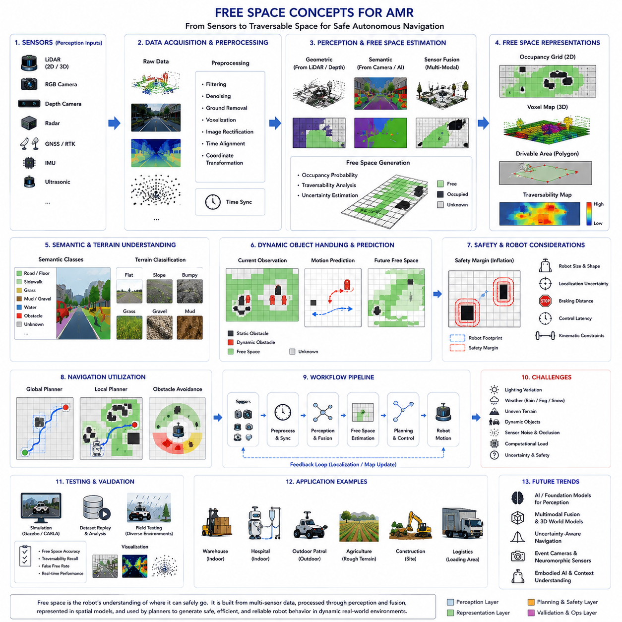
Free space concepts represent one of the most fundamental ideas in autonomous mobile robot navigation because autonomous robots must continuously determine where they can safely move within dynamic and often unpredictable environments. In both indoor and outdoor AMR systems, the robot’s ability to identify traversable space directly affects navigation safety, motion planning quality, collision avoidance performance, operational efficiency, and overall autonomy capability. Unlike static industrial automation systems that operate in fixed and highly controlled environments, autonomous robots must constantly interpret changing surroundings that include obstacles, humans, vehicles, terrain irregularities, weather conditions, and environmental uncertainties. Therefore, free space detection becomes a core perception function that transforms raw sensor observations into actionable spatial understanding for navigation and control systems.
The concept of free space can be broadly defined as the region of the environment that is considered traversable and safe for robot movement. This definition may appear simple at first glance, but in practice, determining free space is an extremely complex perception and reasoning problem. A robot must distinguish between traversable ground and obstacles, estimate terrain stability, understand environmental boundaries, account for dynamic objects, and predict safe future motion regions in real time. The challenge becomes even more difficult in outdoor autonomous systems where environmental conditions constantly change due to lighting variation, rain, snow, fog, mud, gravel, vegetation, shadows, reflections, and uneven terrain.
Free space perception forms the foundation of autonomous navigation. Local planners, global planners, obstacle avoidance systems, behavior planners, and safety controllers all depend heavily on accurate free-space information. If the perception system incorrectly identifies an obstacle as free space, the robot may collide with objects, humans, or infrastructure. Conversely, if traversable regions are incorrectly classified as obstacles, the robot may become overly conservative, inefficient, or completely unable to navigate through the environment. Therefore, free-space estimation accuracy directly influences both safety and operational productivity.
In robotics systems, free space is often represented using spatial models such as occupancy grids, traversability maps, semantic segmentation masks, point cloud representations, polygonal drivable regions, or voxel maps. Each representation provides different tradeoffs between computational complexity, memory efficiency, geometric accuracy, and suitability for navigation algorithms. Occupancy grids are among the most widely used free-space representations in AMR systems because they provide a simple probabilistic framework for classifying space as occupied, free, or unknown. Each cell within the grid stores occupancy probability values derived from sensor observations.
The distinction between free space and obstacle space is not always binary. Real-world environments contain uncertain regions, partially observable areas, sensor noise, and ambiguous terrain conditions. Therefore, many modern systems represent free space probabilistically rather than using hard classifications. Confidence estimation becomes especially important in outdoor autonomous robots where sensor reliability may fluctuate due to adverse environmental conditions. A muddy surface, reflective floor, or water puddle may appear traversable under some sensing modalities but hazardous under others.
Ground plane estimation is one of the most important techniques used in free-space analysis. Many autonomous robots assume that traversable space is closely related to the ground surface. By estimating the geometry of the ground plane using LiDAR, stereo vision, depth cameras, or IMU data, the robot can identify regions that are physically reachable. However, real-world terrain rarely forms a perfectly flat plane. Slopes, curbs, ramps, potholes, stairs, gravel, grass, and uneven terrain complicate free-space estimation significantly. Therefore, advanced systems use adaptive terrain modeling rather than assuming ideal planar surfaces.
Indoor free-space detection and outdoor free-space detection differ substantially. Indoor environments typically contain flat floors, structured geometry, stable lighting, and predictable navigation corridors. As a result, indoor AMRs often rely heavily on 2D LiDAR-based occupancy grids and relatively simple obstacle segmentation methods. Outdoor environments are far more challenging because the terrain is unstructured and highly variable. Outdoor robots require multi-sensor perception systems combining LiDAR, RGB cameras, radar, GNSS, IMU, thermal cameras, and sometimes ultrasonic sensors to achieve robust free-space understanding.
Free-space perception is deeply connected to semantic understanding. A physically open region may not necessarily be traversable. For example, grass, mud, snow, water, railroad tracks, steep slopes, construction zones, or fragile surfaces may appear geometrically open but operationally unsafe. Therefore, modern free-space systems increasingly integrate semantic segmentation and terrain classification into navigation perception pipelines. Semantic understanding allows robots to reason not only about geometry but also about terrain type and operational safety.
Camera-based free-space detection has become increasingly important due to advances in deep learning and semantic segmentation. Convolutional neural networks and transformer-based vision models can classify image regions into road, floor, sidewalk, grass, obstacle, vehicle, pedestrian, and other semantic categories. These segmentation outputs are then converted into drivable area maps for navigation systems. Camera-based methods are especially useful for long-range perception because cameras provide rich semantic information at relatively low hardware cost.
However, camera-only free-space detection has several limitations. Visual perception is highly sensitive to lighting conditions, shadows, glare, rain, fog, snow, and low-light environments. Depth estimation from monocular cameras may also be uncertain. Therefore, many advanced AMR systems combine cameras with LiDAR sensors. LiDAR provides accurate geometric distance measurements independent of lighting conditions, while cameras contribute semantic understanding. Multi-sensor fusion significantly improves robustness and environmental understanding.
LiDAR-based free-space detection focuses primarily on geometric reasoning. LiDAR sensors generate point clouds representing the surrounding environment in three dimensions. Free-space algorithms analyze the distribution of points to identify ground surfaces, obstacle boundaries, height discontinuities, and traversable corridors. Ground removal algorithms are commonly used to separate obstacle points from terrain points. However, LiDAR systems also face challenges including sparse data at long range, weather sensitivity, reflective surfaces, and limited semantic understanding.
Radar-based free-space estimation is becoming increasingly important for outdoor autonomous robots. Millimeter-wave radar performs robustly under rain, fog, dust, and snow conditions where optical sensors degrade significantly. Radar systems can detect large obstacles and estimate relative motion reliably even in adverse weather. However, radar provides lower spatial resolution than cameras or LiDAR. Therefore, radar is often used as a complementary sensing modality rather than a standalone free-space perception system.
Dynamic obstacle handling represents another major challenge in free-space perception. Humans, vehicles, bicycles, forklifts, animals, and moving machinery continuously alter traversable space. Therefore, free-space systems must operate temporally rather than relying only on instantaneous observations. Dynamic occupancy grids and spatiotemporal prediction models are increasingly used to estimate future free-space availability. Autonomous robots must anticipate how the environment will evolve over time rather than reacting only to current conditions.
Safety margins play an important role in free-space generation. Navigation systems rarely use raw free-space boundaries directly. Instead, safety buffers are added around obstacles to account for localization uncertainty, sensor noise, braking distance, robot dimensions, motion prediction error, and control latency. Safety zone expansion becomes especially important in high-speed outdoor robots or heavy industrial platforms carrying large payloads.
Robot geometry and kinematics strongly influence free-space interpretation. A small indoor AMR can navigate through narrow corridors and tight corners, whereas a large outdoor robot with a wide turning radius requires significantly larger traversable regions. Towing AMRs with trailers introduce even more complexity because the trailer path differs from the tractor path during turning maneuvers. Therefore, free-space planning must consider the complete robot footprint and motion constraints.
Free-space estimation also depends heavily on localization quality. If the robot’s estimated position is inaccurate, free-space representations may become misaligned with the real environment. This can produce navigation oscillations, obstacle collisions, or path planning instability. Therefore, free-space systems are tightly integrated with SLAM, localization, and map alignment frameworks.
Real-time performance is a major engineering requirement for free-space perception systems. Autonomous robots continuously move through dynamic environments and require rapid environmental updates. High-latency free-space estimation may cause the robot to react too slowly to changing obstacles or terrain conditions. Therefore, modern systems use GPU acceleration, parallel processing pipelines, TensorRT optimization, ROS2 multi-threading, and efficient sensor fusion architectures to achieve deterministic low-latency operation.
Occupancy grid mapping remains one of the most widely used free-space modeling methods in robotics. In occupancy grids, the environment is divided into discrete cells, each representing occupancy probability. Bayesian filtering methods are often used to update cell states over time using repeated sensor observations. Occupancy grids provide simple and computationally efficient free-space representations compatible with many path planning algorithms such as A*, Dijkstra, DWA, and costmap-based planners.
Voxel-based free-space representations extend occupancy grids into three dimensions. These models are especially useful for outdoor robots navigating uneven terrain or detecting overhanging obstacles. Voxel maps represent volumetric occupancy and allow robots to reason about height, slope, and three-dimensional traversability. However, voxel systems require substantially greater computational and memory resources.
Free-space uncertainty estimation is becoming increasingly important in modern AI-driven robotics systems. Deep learning models may produce incorrect segmentation under unfamiliar environmental conditions. Therefore, confidence estimation and uncertainty-aware navigation frameworks are increasingly integrated into autonomous systems. The robot may reduce speed, increase safety margins, or request operator intervention when perception uncertainty becomes excessive.
Weather and environmental robustness represent major operational requirements for outdoor autonomous robots. Rain can distort camera images and introduce LiDAR reflections. Fog reduces visibility dramatically. Snow may obscure terrain boundaries. Mud and dust can contaminate sensors. Strong sunlight may produce camera glare and thermal distortion. Therefore, robust free-space perception often requires multimodal sensing architectures capable of compensating for the weaknesses of individual sensor modalities.
Industrial applications demonstrate the diversity of free-space requirements. Warehouse AMRs require accurate aisle navigation and pallet avoidance. Hospital robots require smooth human-aware corridor navigation. Outdoor patrol robots require robust road and terrain understanding under changing weather conditions. Agricultural robots require crop-row detection and terrain traversability estimation. GPR inspection robots must navigate while carrying large sensing payloads across uneven surfaces. Smart city robots require dynamic pedestrian and vehicle interaction awareness.
Testing and validation are essential components of free-space engineering. Engineers must evaluate free-space accuracy across diverse operational scenarios including narrow corridors, crowded environments, reflective floors, steep slopes, rough terrain, low-light conditions, rain, fog, and dynamic obstacle interactions. Field testing is especially important because real-world environments contain complexities not fully represented in laboratory or simulation environments.
Simulation platforms such as Gazebo, Isaac Sim, and CARLA are widely used for free-space algorithm development and testing. Synthetic environments enable large-scale testing of edge cases and dangerous scenarios without operational risk. Digital twin systems also allow engineers to replay operational data and evaluate algorithm improvements systematically.
Future free-space systems will increasingly incorporate foundation models, semantic world understanding, multimodal reasoning, and embodied AI architectures. Rather than simply identifying geometric traversability, future robots may understand operational context, social navigation rules, human intentions, infrastructure semantics, and environmental affordances. Event cameras, neuromorphic perception systems, and real-time 3D world models may further improve perception robustness and latency performance.
The evolution of free-space concepts reflects the broader evolution of autonomous robotics itself. Early robotics systems relied primarily on geometric obstacle avoidance, whereas modern systems increasingly integrate semantics, uncertainty estimation, prediction, and multimodal reasoning into navigation perception frameworks. Future autonomous robots will likely reason about free space not only as empty geometry but as a rich operational understanding of where, when, and how movement can occur safely and efficiently.
Ultimately, free-space perception is not merely a technical perception task. It is the process by which autonomous robots understand navigable reality. Effective free-space systems enable safe navigation, robust obstacle avoidance, efficient motion planning, adaptive terrain handling, scalable autonomous deployment, and trustworthy real-world robotic intelligence. In advanced AMR platforms, free-space concepts form one of the foundational pillars supporting practical autonomous mobility.

20.2 Ground Plane Estimation
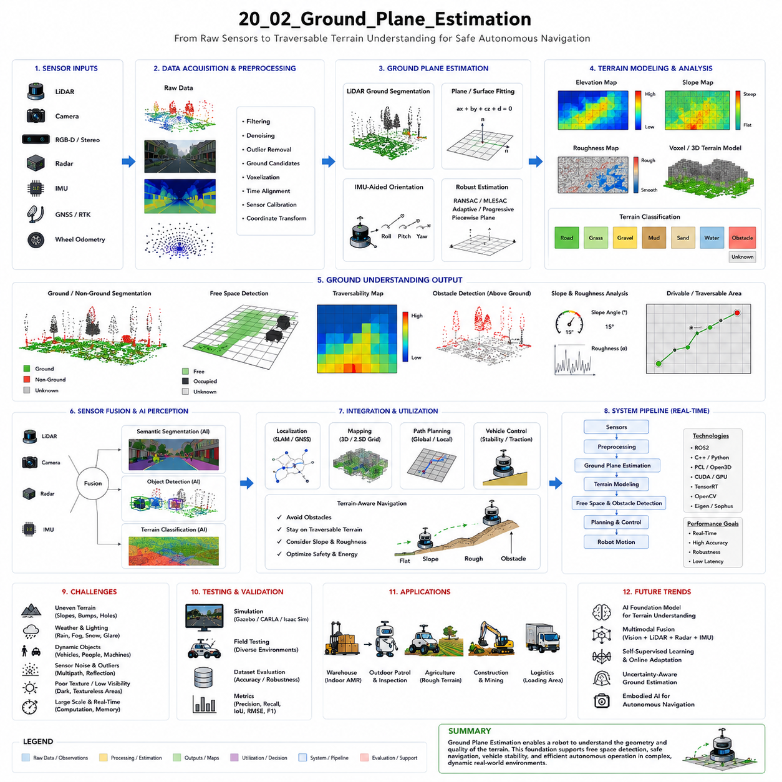
Ground plane estimation is one of the most fundamental technologies in autonomous mobile robot navigation because it enables robots to distinguish between traversable terrain and non-traversable obstacles. In both indoor and outdoor autonomous systems, robots continuously observe the surrounding environment using LiDAR, cameras, radar, depth sensors, IMU systems, and other sensing modalities. However, raw sensor data alone does not directly indicate where the robot can safely move. The robot must first understand the structure of the ground surface itself. Ground plane estimation provides this foundational environmental understanding by identifying the geometry, orientation, elevation, slope, and continuity of the terrain beneath the robot. This information becomes essential for free-space detection, obstacle segmentation, localization, mapping, path planning, vehicle stability control, and overall autonomous navigation safety.
At its core, ground plane estimation refers to the process of modeling the navigable surface upon which the robot operates. In simple environments, the ground may appear flat and uniform, such as the floor inside a warehouse or hospital corridor. However, real-world environments are rarely ideal. Outdoor autonomous robots must navigate uneven terrain, slopes, potholes, curbs, gravel, grass, mud, ramps, railway crossings, construction areas, and damaged infrastructure. Even indoor robots may encounter floor transitions, ramps, cables, debris, reflective surfaces, or partially obstructed corridors. Therefore, accurate ground modeling is far more complex than simply detecting a horizontal plane.
Ground plane estimation is fundamentally important because most navigation systems assume that obstacles are objects protruding above the ground surface. If the robot can accurately estimate the geometry of the ground, then objects deviating from that surface can be classified as obstacles. Conversely, regions consistent with the ground model can be considered potentially traversable. Thus, ground estimation becomes one of the foundational preprocessing steps for free-space analysis and obstacle detection.
In robotics systems, ground plane estimation is closely linked to coordinate systems and robot pose estimation. The robot continuously moves through the environment, causing its sensors to change position and orientation over time. Therefore, the estimated ground model must remain consistent across changing viewpoints and robot motion states. IMU sensors play a particularly important role because they provide roll, pitch, and yaw measurements that help stabilize terrain estimation under dynamic vehicle movement.
One of the simplest approaches to ground plane estimation is planar modeling. In flat indoor environments, the ground can often be approximated using a single mathematical plane. LiDAR point clouds or depth sensor measurements are analyzed to fit a plane equation representing the floor surface. Algorithms such as RANSAC are commonly used to identify dominant planar structures while rejecting outlier points belonging to obstacles. RANSAC-based methods are computationally efficient and widely used in structured environments.
However, planar assumptions quickly break down in outdoor environments. Real terrain contains elevation changes, surface irregularities, slopes, and discontinuities that cannot be modeled accurately using a single plane. Therefore, advanced systems use piecewise planar models, spline-based terrain fitting, adaptive elevation maps, or probabilistic surface representations. These methods allow robots to estimate locally varying terrain geometry while maintaining robustness against sensor noise and environmental complexity.
LiDAR-based ground plane estimation is among the most widely used approaches in outdoor autonomous robotics. LiDAR sensors provide dense three-dimensional point cloud data describing the surrounding environment. Ground estimation algorithms analyze height distributions, local surface normals, point continuity, and elevation gradients to classify ground points. One common approach involves dividing the environment into radial sectors or grid cells and estimating the lowest consistent surface within each region.
Ground segmentation algorithms frequently exploit geometric continuity assumptions. The ground surface tends to vary smoothly over short distances, whereas obstacles often produce abrupt height discontinuities. Therefore, slope analysis and elevation difference thresholds are commonly used to separate terrain points from obstacle points. However, these assumptions may fail in highly irregular terrain, rocky environments, staircases, or construction zones.
Camera-based ground plane estimation has also become increasingly important due to advances in computer vision and deep learning. Monocular cameras, stereo vision systems, and RGB-D cameras can estimate drivable surfaces using visual appearance and geometric cues. Semantic segmentation networks classify image regions into categories such as road, floor, grass, obstacle, sidewalk, mud, or water. These semantic predictions are then converted into traversability maps.
Stereo vision systems estimate depth by comparing disparities between left and right camera images. From this depth information, the robot can reconstruct three-dimensional surface geometry and estimate ground structure. Stereo-based methods are especially useful in environments where LiDAR cost or power consumption must be minimized. However, stereo vision performance degrades under poor lighting, fog, rain, glare, shadows, or textureless surfaces.
RGB-D cameras combine color imaging with direct depth sensing. These systems are widely used in indoor AMRs because they provide accurate short-range depth measurements. Ground plane estimation using RGB-D sensors often involves extracting dominant planar surfaces while filtering dynamic obstacles and noise. However, RGB-D cameras typically have limited range and may struggle in outdoor sunlight conditions.
Radar-based terrain estimation is becoming increasingly important in harsh outdoor environments. Millimeter-wave radar can operate robustly under rain, fog, snow, and dust conditions where optical sensors degrade significantly. Radar can detect large terrain structures and estimate relative geometry even under poor visibility. However, radar data has lower spatial resolution and greater uncertainty than LiDAR or cameras. Therefore, radar is usually integrated as part of a multimodal sensing framework rather than used independently for precise ground modeling.
Ground plane estimation becomes particularly challenging in dynamic environments. Moving vehicles, pedestrians, forklifts, construction machinery, and temporary obstacles continuously alter sensor observations. Therefore, ground estimation systems must distinguish between static terrain structure and dynamic object interference. Temporal filtering and sensor fusion methods are often used to stabilize ground estimation across time.
Terrain classification is closely connected to ground plane estimation. A geometrically flat surface may still be operationally hazardous. For example, mud, ice, loose gravel, wet grass, sand, or damaged pavement may appear traversable but provide insufficient traction or stability. Therefore, modern robotics systems increasingly integrate semantic terrain understanding into ground estimation pipelines. The robot may classify terrain according to traversability risk, traction quality, vibration characteristics, or load-bearing capability.
Slope estimation represents another major component of ground analysis. Autonomous robots must continuously evaluate terrain inclination because excessive slope angles may reduce stability, traction, or braking capability. Heavy payload robots, towing platforms, and outdoor industrial AMRs are especially sensitive to slope conditions. Therefore, ground plane estimation systems often generate slope maps and terrain inclination profiles used by navigation and vehicle control systems.
Ground roughness estimation is also important for outdoor robotics. Uneven terrain may induce vibration, wheel slip, suspension instability, or payload disturbance. LiDAR and depth sensors can estimate surface roughness by analyzing local elevation variance and terrain continuity. Navigation systems may then select smoother paths to improve stability and reduce mechanical stress.
One of the most important engineering challenges in ground plane estimation is handling sensor noise and uncertainty. Real sensor measurements contain noise due to environmental conditions, hardware limitations, vibration, motion blur, multipath effects, and calibration errors. Therefore, robust filtering techniques are essential. Kalman filters, particle filters, Bayesian estimation frameworks, and probabilistic occupancy models are commonly used to improve terrain estimation reliability.
Real-time performance is critically important in ground plane estimation systems. Autonomous robots continuously move through changing environments and require rapid terrain updates. Delayed ground estimation may cause the robot to react too slowly to curbs, holes, obstacles, or terrain transitions. Therefore, high-performance systems use GPU acceleration, parallel processing pipelines, ROS2 multi-threading, CUDA optimization, and efficient point cloud processing frameworks.
Voxel-based terrain modeling is widely used for three-dimensional ground representation. Instead of representing the environment as a single plane, voxel maps divide space into volumetric cells storing occupancy and elevation information. Voxel-based systems provide robust three-dimensional understanding of terrain geometry and support obstacle overhang detection, slope analysis, and complex traversability reasoning. However, voxel systems require substantial computational resources and memory bandwidth.
Elevation mapping represents another common approach. Elevation maps store terrain height values within grid structures. These maps are especially useful for outdoor robots navigating uneven terrain. Elevation mapping systems may also integrate uncertainty estimates representing terrain confidence and sensor reliability. Dynamic updating mechanisms continuously refine the terrain model as new sensor observations arrive.
Ground plane estimation is tightly integrated with localization and SLAM systems. Terrain features often provide valuable localization cues, especially in outdoor environments where GNSS signals may degrade. Conversely, localization errors can distort terrain estimation if sensor data becomes spatially misaligned. Therefore, modern autonomous systems tightly couple ground estimation, localization, and mapping frameworks into unified perception architectures.
Autonomous vehicle stability depends heavily on accurate ground modeling. Heavy outdoor robots carrying large payloads or towing trailers must continuously monitor terrain geometry to avoid rollover risk, wheel slip, or loss of traction. Ground estimation systems therefore interact closely with vehicle dynamics controllers, suspension systems, traction control modules, and braking systems.
Ground plane estimation also affects energy efficiency. Rough terrain, steep slopes, and unstable surfaces increase energy consumption significantly. Navigation systems may therefore incorporate terrain-aware path planning strategies that optimize not only distance but also terrain smoothness and energy efficiency.
Testing and validation are essential components of ground plane engineering. Engineers evaluate terrain estimation accuracy across diverse environmental conditions including gravel roads, muddy terrain, grass fields, snow-covered surfaces, railway tracks, construction sites, reflective floors, ramps, and uneven industrial environments. Outdoor testing is especially important because environmental variability often reveals failure modes not visible in simulation or laboratory testing.
Simulation platforms such as Gazebo, CARLA, Isaac Sim, and digital twin environments are widely used for terrain algorithm development. Synthetic environments allow engineers to evaluate extreme terrain conditions safely and repeatedly. Simulation also supports automated regression testing and performance benchmarking across large scenario libraries.
Machine learning and deep learning are increasingly transforming ground plane estimation. Neural networks can learn complex terrain patterns directly from sensor data without relying entirely on handcrafted geometric rules. Self-supervised learning methods are also emerging, allowing robots to learn traversability properties from operational experience. Future systems may integrate foundation models capable of holistic scene understanding including terrain semantics, environmental context, and robot dynamics simultaneously.
Future autonomous systems will likely move beyond simple geometric ground estimation toward rich traversability reasoning frameworks. Robots may evaluate terrain not only according to shape but also according to operational suitability, stability risk, energy efficiency, traction quality, environmental uncertainty, and mission-specific constraints. Multimodal embodied AI systems may integrate vision, sound, vibration, force sensing, and environmental semantics into unified terrain understanding models.
The evolution of ground plane estimation reflects the broader evolution of autonomous robotics itself. Early robotics systems assumed ideal flat floors and highly structured environments. Modern autonomous robots must operate safely within highly dynamic, uncertain, and unstructured real-world environments. As robots become more capable and intelligent, ground estimation systems must evolve from simple planar modeling toward comprehensive environmental understanding architectures.
Ultimately, ground plane estimation is not merely a geometric perception task. It is the process through which autonomous robots understand the physical structure of the world beneath them. Accurate ground modeling enables safe navigation, robust obstacle detection, terrain-aware planning, vehicle stability control, efficient mobility, and reliable autonomous operation. In advanced AMR systems, ground plane estimation becomes one of the foundational technologies enabling practical real-world autonomy.

20.3 Drivable Area Detection
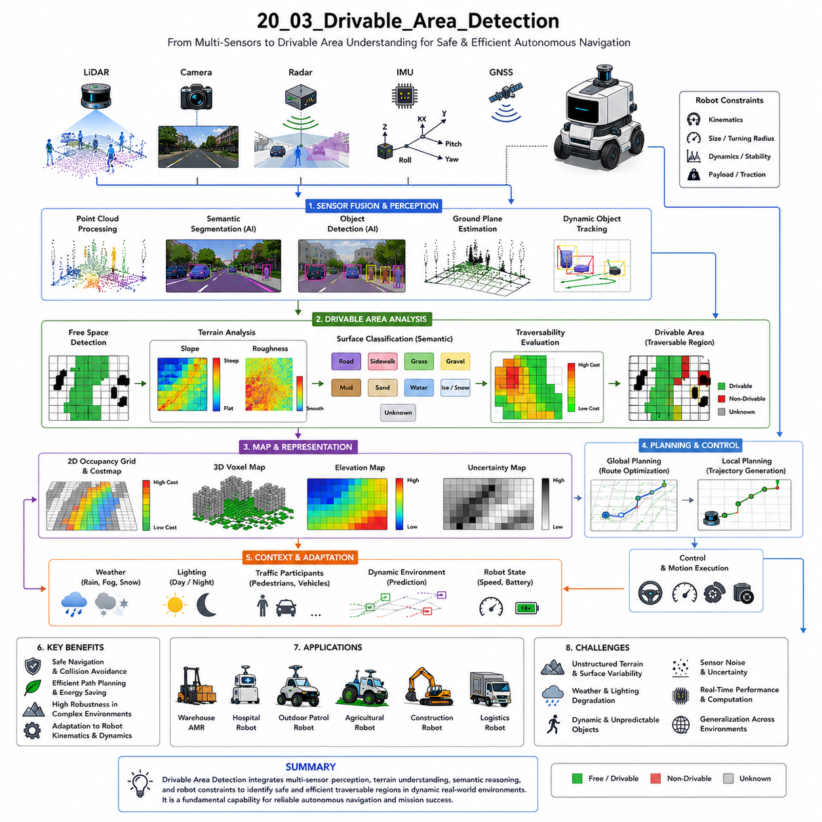
Drivable area detection is one of the most critical perception functions in autonomous mobile robot systems because it determines where the robot can safely and efficiently move within the surrounding environment. While obstacle detection identifies objects that must be avoided, drivable area detection focuses on identifying continuous traversable regions suitable for navigation. In practical autonomous systems, understanding drivable space is fundamentally important for motion planning, collision avoidance, vehicle stability, energy efficiency, route optimization, and operational safety. Modern AMRs operating in warehouses, hospitals, factories, smart cities, agricultural fields, logistics hubs, industrial plants, and outdoor construction environments all require robust drivable area perception capabilities to function autonomously under real-world conditions.
At a conceptual level, drivable area detection refers to the process of classifying portions of the environment as navigable or non-navigable for a specific robot platform. However, this problem is significantly more complex than simple free-space estimation. A region that appears physically empty may not actually be safe or suitable for robot traversal. Surface material, terrain roughness, slope angle, traction conditions, weather effects, obstacle proximity, dynamic object behavior, and robot kinematic limitations all influence whether an area should be considered drivable. Therefore, drivable area perception combines geometric reasoning, semantic understanding, terrain analysis, and operational safety evaluation into a unified environmental interpretation framework.
Drivable area detection is closely related to free-space estimation but differs in several important ways. Free-space perception primarily identifies regions that are unoccupied by obstacles, whereas drivable area perception evaluates whether those regions are operationally suitable for movement. For example, water puddles, mud, ice, soft sand, steep slopes, railroad tracks, damaged pavement, loose gravel, or unstable terrain may be geometrically free but operationally unsafe. Therefore, drivable area systems must reason about traversability quality rather than simply obstacle absence.
In autonomous navigation systems, drivable area perception serves as a foundational input to path planning algorithms. Local planners rely on accurate drivable region maps to generate safe trajectories, avoid obstacles, and maintain smooth motion behavior. Global planners also use traversability information to optimize route selection over longer distances. If drivable area estimation is inaccurate, the robot may collide with obstacles, become stuck, lose stability, or fail to complete missions efficiently. Consequently, drivable area reliability directly affects both safety and operational productivity.
One of the simplest forms of drivable area detection involves geometric free-space analysis. In structured indoor environments such as warehouses or hospitals, flat floors and predictable layouts allow robots to classify traversable areas using relatively simple geometric rules. Two-dimensional LiDAR sensors are commonly used to generate occupancy grids representing free and occupied regions. Local planners then interpret unoccupied floor regions as drivable space. This approach is computationally efficient and works well in highly structured environments.
However, outdoor autonomous systems require significantly more sophisticated drivable area perception. Outdoor environments are unstructured, dynamic, and highly variable. Terrain surfaces may contain slopes, potholes, curbs, vegetation, mud, gravel, snow, standing water, shadows, debris, and irregular boundaries. Lighting conditions change continuously due to weather and time of day. Therefore, modern outdoor robots rely heavily on multi-sensor fusion and AI-based semantic perception to achieve robust drivable area understanding.
Ground plane estimation forms one of the most important foundations of drivable area detection. By estimating the geometry of the terrain beneath the robot, the system can identify surfaces likely to support safe movement. Ground estimation algorithms analyze LiDAR point clouds, stereo vision depth maps, IMU orientation data, and elevation maps to determine terrain continuity and slope characteristics. Regions that satisfy predefined slope and roughness constraints may then be classified as potentially drivable.
Slope analysis is especially important in outdoor robotics systems. Excessive terrain inclination may reduce vehicle stability, braking performance, traction, or steering controllability. Heavy-duty outdoor robots, towing platforms, and high-center-of-gravity vehicles are particularly sensitive to slope conditions. Therefore, drivable area systems continuously estimate terrain inclination and apply robot-specific traversability constraints. Navigation systems may avoid steep terrain or dynamically reduce speed depending on slope severity.
Surface roughness estimation is another key component of drivable area perception. Rough terrain can induce vibration, wheel slip, suspension instability, payload disturbance, or mechanical stress. LiDAR and depth-based perception systems analyze local elevation variance and surface continuity to estimate terrain roughness metrics. Path planning systems may then prefer smoother surfaces to improve stability, comfort, and energy efficiency.
Semantic segmentation has become one of the most powerful approaches for drivable area detection due to advances in deep learning and computer vision. Modern semantic segmentation networks classify image regions into categories such as road, sidewalk, grass, mud, water, obstacle, pedestrian area, construction zone, or vehicle lane. These semantic labels provide rich contextual understanding beyond pure geometry. For example, the robot may distinguish between paved roads and soft grass even when both surfaces appear geometrically flat.
Camera-based drivable area detection is widely used because RGB cameras provide rich semantic information at relatively low cost. Deep neural networks trained on large datasets can identify road boundaries, lane markings, sidewalks, curbs, and drivable surfaces under diverse environmental conditions. Transformer-based vision models have further improved segmentation accuracy and scene understanding capabilities. However, camera-only systems remain vulnerable to adverse weather, poor lighting, glare, fog, snow, shadows, and sensor contamination.
LiDAR-based drivable area estimation focuses more heavily on geometric analysis. LiDAR sensors provide accurate three-dimensional measurements independent of lighting conditions. Algorithms analyze height continuity, local surface normals, obstacle boundaries, and terrain structure to estimate traversable regions. LiDAR-based methods are particularly robust in low-light environments and provide accurate short-range obstacle detection. However, LiDAR alone often lacks sufficient semantic understanding to distinguish between visually similar but operationally different surfaces.
Radar is becoming increasingly important in drivable area perception for outdoor robots. Millimeter-wave radar performs reliably under rain, fog, snow, and dust conditions where optical sensors degrade significantly. Radar can detect large obstacles and estimate relative motion robustly. However, radar provides relatively low spatial resolution and limited semantic detail. Therefore, radar is usually integrated into multimodal perception systems rather than used independently.
Multi-sensor fusion significantly improves drivable area robustness and reliability. By combining LiDAR geometry, camera semantics, radar robustness, IMU stabilization, and GNSS localization, autonomous systems can compensate for the weaknesses of individual sensors. For example, LiDAR may provide accurate obstacle geometry while cameras identify road boundaries and semantic terrain types. Radar may maintain environmental awareness under heavy rain conditions when camera visibility deteriorates.
Dynamic obstacle handling introduces additional complexity into drivable area detection. Pedestrians, vehicles, forklifts, bicycles, animals, and moving machinery continuously alter navigable space. Therefore, drivable area systems must continuously update traversability estimates in real time. Dynamic occupancy grids, spatiotemporal prediction models, and object trajectory forecasting are commonly integrated into perception pipelines. Autonomous robots must reason not only about current drivable space but also about how that space may evolve in the near future.
Robot kinematics strongly influence drivable area interpretation. A small indoor AMR may navigate through narrow corridors and tight corners that are inaccessible to larger outdoor vehicles. Ackermann-steering vehicles require wider turning radii than differential-drive robots. Towing AMRs must account for trailer swing behavior and off-tracking effects. Therefore, drivable area systems must incorporate robot-specific geometry, wheelbase, turning radius, articulation constraints, payload distribution, and stability characteristics.
Vehicle dynamics also affect traversability assessment. Terrain that is theoretically traversable at low speed may become unsafe at higher velocities. Braking distance, wheel slip probability, rollover risk, suspension dynamics, and traction limits all depend on vehicle speed and terrain conditions. Therefore, advanced drivable area systems increasingly integrate vehicle dynamics models into perception and planning frameworks.
Occupancy grids remain one of the most widely used drivable area representations in robotics. Grid-based maps classify spatial regions as free, occupied, or unknown while also storing traversability costs. Costmap-based navigation systems assign higher traversal costs to rough terrain, narrow corridors, dynamic obstacle regions, or uncertain areas. Path planners then optimize routes according to both safety and efficiency objectives.
Voxel-based drivable area representations extend occupancy modeling into three dimensions. Voxel maps allow robots to reason about terrain height, overhanging obstacles, uneven surfaces, and volumetric occupancy simultaneously. Three-dimensional traversability analysis becomes especially important for outdoor robots navigating rugged terrain, construction zones, forests, mines, or agricultural environments.
Probabilistic traversability estimation is increasingly important in AI-driven robotics systems. Environmental uncertainty, sensor noise, incomplete observations, and unpredictable terrain conditions make deterministic classification unreliable in many real-world situations. Therefore, modern systems often estimate drivable area confidence values rather than binary classifications. Navigation systems may reduce speed, increase safety margins, or request operator assistance when traversability uncertainty becomes excessive.
Weather robustness remains one of the largest challenges in outdoor drivable area perception. Rain may distort camera images and create LiDAR reflections. Snow may obscure road boundaries and terrain structure. Fog reduces visibility significantly. Mud and dust contaminate sensor surfaces. Strong sunlight introduces glare and thermal distortion. Therefore, autonomous outdoor robots require highly robust multimodal sensing architectures and adaptive perception strategies.
Real-time performance is critically important in drivable area systems. Autonomous robots continuously move through changing environments and require rapid perception updates. High-latency drivable area estimation may cause delayed reactions to terrain changes or moving obstacles. Therefore, modern perception pipelines rely heavily on GPU acceleration, CUDA optimization, TensorRT inference acceleration, ROS2 multi-threading, and parallel sensor processing architectures.
Localization quality strongly influences drivable area accuracy. If the robot’s estimated position drifts relative to the environment, traversability maps may become spatially inconsistent with reality. Therefore, drivable area systems are tightly integrated with SLAM, localization, map alignment, and pose estimation frameworks.
Testing and validation are essential for reliable drivable area deployment. Engineers evaluate traversability performance across diverse environmental conditions including wet roads, gravel surfaces, mud, snow, grass, ramps, curbs, reflective floors, crowded environments, construction zones, and low-light conditions. Edge-case testing is particularly important because unusual terrain conditions often reveal failure modes not visible during standard evaluation.
Simulation platforms such as Gazebo, Isaac Sim, CARLA, and digital twin environments are widely used for drivable area algorithm development. Simulation enables large-scale testing of dangerous or rare operational scenarios without physical risk. Synthetic sensor data generation also supports AI dataset augmentation and regression testing workflows.
Industrial applications demonstrate the diversity of drivable area requirements. Warehouse AMRs prioritize aisle navigation and pallet avoidance. Hospital robots require smooth human-aware navigation through narrow corridors. Outdoor patrol robots must navigate roads, sidewalks, and mixed urban terrain under varying weather conditions. Agricultural robots require crop-row traversability analysis and soft-soil handling. GPR inspection robots must carry heavy payloads across uneven infrastructure surfaces. Smart city robots must interact safely with pedestrians, vehicles, bicycles, and urban infrastructure simultaneously.
Machine learning and embodied AI are increasingly transforming drivable area perception. Future systems may integrate semantic world understanding, terrain reasoning, social navigation behavior, infrastructure semantics, and mission-specific operational constraints into unified traversability models. Foundation models and multimodal reasoning architectures may eventually allow robots to interpret drivable space similarly to human drivers.
The future of drivable area detection will likely move beyond simple obstacle-free navigation toward context-aware operational intelligence. Autonomous robots may reason about legal driving zones, pedestrian behavior, weather adaptation, road regulations, traffic flow, infrastructure conditions, energy efficiency, and cooperative multi-robot movement simultaneously. Such systems will require deeply integrated perception, planning, reasoning, and control architectures.
Ultimately, drivable area detection is not merely a perception problem. It is the process through which autonomous robots determine where movement is operationally safe, physically feasible, and mission-efficient. Effective drivable area perception enables robust navigation, adaptive terrain handling, safe obstacle avoidance, efficient route planning, scalable autonomous deployment, and trustworthy real-world robotic mobility. In advanced AMR systems, drivable area detection becomes one of the foundational technologies enabling practical autonomous operation in complex real-world environments.

20.4 Floor and Road Boundary Detection
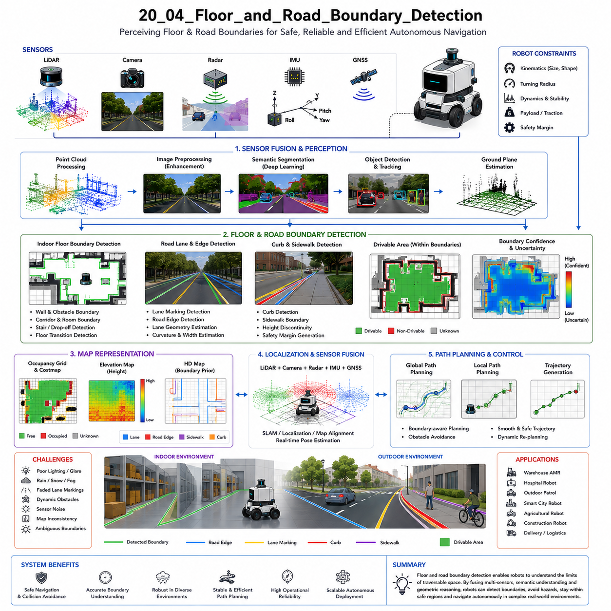
Floor and road boundary detection is one of the most important perception technologies in autonomous mobile robot systems because it enables robots to understand the navigable limits of their operational environment. Autonomous robots must continuously determine not only where traversable space exists but also where that traversable space ends. In indoor AMRs, floor boundary detection allows robots to remain within corridors, avoid walls, prevent collisions with shelves or furniture, and safely navigate structured environments. In outdoor autonomous robots, road boundary detection becomes even more critical because robots must distinguish between roads, sidewalks, curbs, grass, ditches, construction areas, traffic lanes, pedestrian zones, and unsafe terrain. Therefore, boundary detection serves as a foundational capability for safe navigation, path planning, localization, free-space estimation, and autonomous decision-making.
At a conceptual level, floor and road boundaries represent the transition regions between traversable and non-traversable areas. These boundaries define the operational envelope within which the robot can move safely. In practice, however, boundary detection is far more complicated than identifying simple lines or edges. Real-world environments contain irregular geometry, incomplete markings, damaged surfaces, changing lighting conditions, moving obstacles, shadows, weather effects, sensor noise, and temporary obstructions. Furthermore, boundaries may not always be physically visible. Some roads have no painted lane markings, some indoor spaces have smooth transitions without walls, and some outdoor environments contain ambiguous terrain transitions. Therefore, boundary detection requires a combination of geometric analysis, semantic understanding, sensor fusion, and contextual reasoning.
Floor and road boundary detection are closely connected to free-space estimation and drivable area detection. While free-space perception determines which regions are physically open, boundary detection determines the safe operational limits of those regions. For example, a sidewalk edge may still appear geometrically free, but stepping beyond the curb may be dangerous for the robot. Similarly, an indoor floor may transition into a staircase, loading dock edge, or hazardous industrial area. Therefore, accurate boundary understanding is essential for operational safety.
Indoor boundary detection often relies heavily on geometric structure because indoor environments are typically more structured and predictable than outdoor environments. Warehouses, hospitals, factories, airports, and office buildings usually contain walls, corridors, doors, shelves, and floor transitions that define navigable space. Two-dimensional LiDAR sensors are widely used in indoor AMRs because they can accurately detect walls and structural boundaries at low computational cost. Occupancy grid maps generated from LiDAR scans provide reliable environmental structure information for navigation systems.
However, even indoor environments present significant challenges. Reflective floors, glass walls, transparent doors, moving crowds, carts, furniture rearrangement, and temporary obstacles can confuse boundary detection systems. Floor surfaces may contain low-contrast transitions that are difficult to detect geometrically. Furthermore, large open spaces such as warehouses or hospital lobbies may lack strong geometric constraints. Therefore, modern indoor robots increasingly integrate semantic perception and visual understanding into boundary detection pipelines.
Outdoor road boundary detection is substantially more difficult than indoor floor boundary estimation. Roads and navigable terrain may contain faded lane markings, damaged pavement, shadows, puddles, mud, snow, gravel, grass intrusion, construction zones, or irregular edges. Weather conditions and lighting variation continuously alter environmental appearance. Autonomous outdoor robots must therefore maintain robust boundary understanding under highly dynamic and uncertain conditions.
One of the most common approaches to road boundary detection involves lane and edge extraction using cameras. Vision-based systems analyze RGB images to identify lane markings, curbs, road edges, sidewalks, and terrain transitions. Traditional computer vision methods use edge detection, Hough transforms, color segmentation, and perspective transformation to estimate road geometry. However, deep learning and semantic segmentation have increasingly replaced purely handcrafted approaches due to superior robustness and environmental understanding.
Semantic segmentation networks classify image pixels into categories such as road, sidewalk, grass, curb, building, obstacle, vehicle, or pedestrian region. These outputs allow robots to identify not only the geometric shape of boundaries but also their semantic meaning. For example, the system may distinguish between a road edge and a painted parking line. Transformer-based vision architectures have further improved boundary detection performance under complex environmental conditions.
Camera-based boundary detection provides rich semantic information and long-range perception capability, but it also suffers from several limitations. Performance degrades significantly under low-light conditions, glare, fog, rain, snow, shadows, sensor contamination, and strong sunlight. Monocular cameras also lack direct depth measurement. Therefore, many advanced AMR systems combine cameras with LiDAR sensors for improved robustness.
LiDAR-based boundary detection focuses primarily on geometric reasoning. LiDAR sensors generate three-dimensional point clouds representing environmental structure. Boundary estimation algorithms analyze height discontinuities, curb geometry, wall structures, elevation changes, and obstacle contours to determine navigable limits. LiDAR performs robustly under low-light conditions and provides accurate distance measurements. However, LiDAR alone often lacks sufficient semantic understanding to interpret visually ambiguous boundaries.
Curb detection is one of the most important tasks in outdoor boundary estimation. Curbs define safe transitions between roads, sidewalks, and pedestrian areas. LiDAR-based curb detection algorithms analyze local height changes and edge continuity to estimate curb geometry. However, curbs may be partially damaged, covered by debris, snow, vegetation, or shadows. Therefore, robust curb detection often requires multimodal sensor fusion.
Radar-based boundary estimation is becoming increasingly important in harsh environmental conditions. Millimeter-wave radar can operate reliably under rain, fog, dust, and snow where optical sensors degrade significantly. Radar can detect large road edges and obstacle structures under poor visibility conditions. However, radar spatial resolution remains relatively low compared to LiDAR and cameras. Therefore, radar is generally used as a complementary sensing modality rather than a standalone boundary perception solution.
Ground plane estimation strongly supports boundary detection. By understanding the geometry of the traversable surface, robots can identify abrupt terrain transitions corresponding to curbs, ditches, walls, stairs, or unsafe terrain edges. Elevation maps and slope analysis are commonly integrated into boundary estimation systems.
Dynamic environments introduce additional complexity into floor and road boundary detection. Moving vehicles, pedestrians, bicycles, forklifts, construction equipment, and temporary obstacles may temporarily obscure or alter visible boundaries. Therefore, autonomous systems must continuously update boundary estimates in real time while maintaining temporal consistency. Spatiotemporal filtering and object tracking frameworks help stabilize boundary understanding under dynamic conditions.
Localization quality significantly affects boundary detection reliability. If the robot’s pose estimate drifts relative to the environment, detected boundaries may become spatially inconsistent with the real world. Therefore, boundary perception is tightly integrated with SLAM, localization, HD maps, and coordinate transformation systems.
Map-based boundary assistance is widely used in advanced autonomous systems. High-definition maps may contain pre-recorded lane geometry, sidewalk boundaries, road edges, construction zones, and semantic infrastructure information. Real-time perception systems compare live sensor observations against map priors to improve robustness and detect environmental changes. However, maps alone are insufficient because real-world environments change continuously.
Boundary uncertainty estimation is increasingly important in modern robotics systems. Environmental noise, weather conditions, sensor degradation, incomplete observations, and ambiguous terrain transitions make deterministic boundary estimation unreliable in many situations. Therefore, many modern systems estimate confidence values and uncertainty metrics associated with detected boundaries. Navigation systems may reduce speed or increase safety margins when boundary confidence becomes low.
Robot geometry and kinematics strongly influence operational boundary interpretation. A small differential-drive indoor robot may safely navigate near walls and narrow corridors, whereas a large outdoor Ackermann-steering vehicle requires significantly wider operational margins. Towing robots require additional clearance for trailer swing behavior. Therefore, boundary perception systems must incorporate robot-specific motion constraints and footprint dimensions.
Safety zones and operational margins are essential components of practical boundary handling. Autonomous robots rarely navigate directly on detected boundaries. Instead, planners expand boundaries inward to create safety buffers accounting for localization error, control uncertainty, braking distance, sensor latency, and obstacle prediction uncertainty. Heavy industrial robots and high-speed outdoor vehicles typically require larger safety margins.
Real-time performance is critically important in boundary detection systems. Autonomous robots continuously move through dynamic environments and require rapid environmental updates. Delayed boundary estimation may cause unsafe navigation behavior, especially at higher speeds. Therefore, modern perception systems rely heavily on GPU acceleration, ROS2 multi-threading, TensorRT optimization, CUDA processing pipelines, and efficient sensor fusion frameworks.
Machine learning has significantly transformed boundary perception. Deep neural networks can learn complex environmental patterns directly from data rather than relying solely on handcrafted geometric rules. Self-supervised learning and reinforcement learning methods are also emerging for adaptive traversability understanding. Future systems may learn environment-specific boundary behavior automatically from operational experience.
Industrial applications demonstrate the diversity of boundary detection requirements. Warehouse AMRs require aisle boundary estimation and shelf avoidance. Hospital robots require smooth corridor following and pedestrian-aware navigation. Outdoor patrol robots require robust sidewalk and road-edge detection under changing weather conditions. Agricultural robots require crop-row boundary understanding and field edge detection. Construction robots must operate safely near excavation edges and hazardous zones. Smart city robots must interpret roads, sidewalks, pedestrian crossings, bike lanes, and urban infrastructure simultaneously.
Testing and validation are essential for reliable deployment. Engineers evaluate boundary detection systems under diverse conditions including low light, rain, fog, snow, glare, reflective surfaces, crowded environments, damaged roads, faded lane markings, temporary obstacles, and uneven terrain. Edge-case testing is particularly important because unusual environmental conditions often reveal critical failure modes.
Simulation platforms such as Gazebo, CARLA, Isaac Sim, and digital twin environments support large-scale boundary perception testing. Synthetic environments allow engineers to evaluate dangerous or rare scenarios safely and repeatedly. Simulation also enables automated regression testing and AI dataset generation workflows.
Future floor and road boundary systems will likely evolve toward semantic world understanding rather than simple geometric edge detection. Robots may eventually interpret social navigation zones, legal movement regions, pedestrian intent, traffic regulations, environmental risk, infrastructure semantics, and cooperative robot interactions simultaneously. Foundation models and multimodal embodied AI architectures may provide higher-level contextual understanding comparable to human navigation reasoning.
The future of boundary perception is closely tied to the evolution of autonomous mobility itself. Early robotics systems relied primarily on geometric wall following and line detection. Modern systems increasingly integrate semantics, prediction, uncertainty estimation, multimodal sensor fusion, and AI reasoning into perception pipelines. Future robots may understand boundaries not merely as physical edges but as dynamic operational constraints shaped by environment, mission objectives, human behavior, and safety policies.
Ultimately, floor and road boundary detection are not merely perception tasks. They are the mechanisms through which autonomous robots understand the operational limits of safe mobility. Effective boundary perception enables safe navigation, robust obstacle avoidance, stable path planning, adaptive environmental interaction, scalable autonomous deployment, and trustworthy real-world robotic intelligence. In advanced AMR systems, floor and road boundary detection become foundational technologies supporting practical autonomous operation in complex indoor and outdoor environments.

20.5 Slope and Terrain Classification
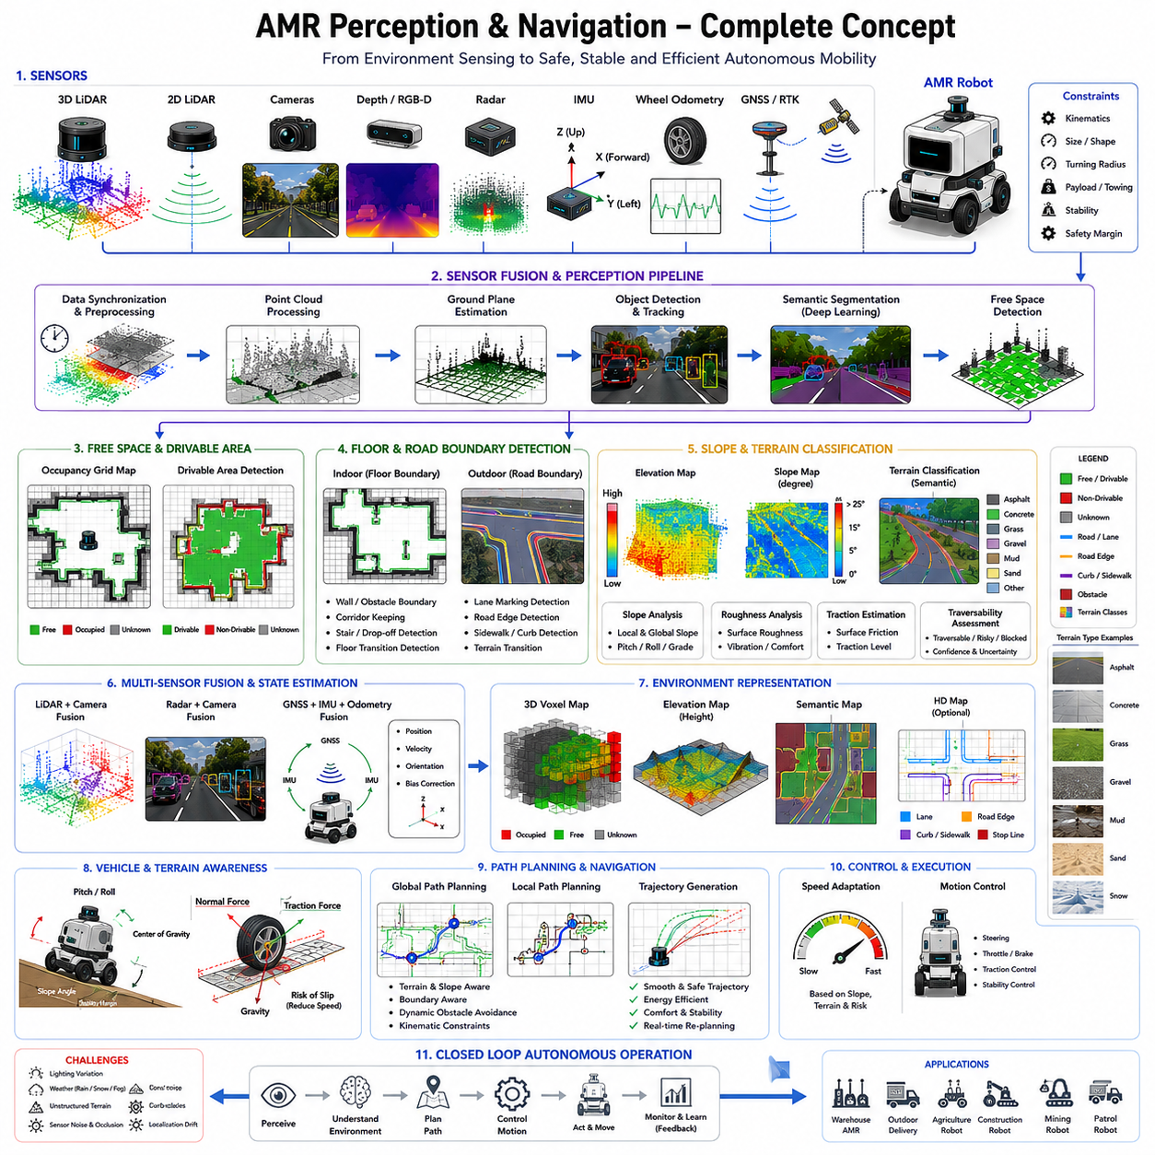
Slope and terrain classification represent some of the most critical perception and navigation capabilities in autonomous mobile robot systems because real-world environments are rarely flat, uniform, or predictable. Autonomous robots operating indoors and outdoors must continuously evaluate the shape, inclination, stability, texture, and traversability of the terrain beneath and around them. While basic free-space detection identifies obstacle-free regions, slope and terrain classification determine whether those regions are actually safe and operationally feasible for robot movement. Therefore, terrain understanding becomes essential for navigation safety, vehicle stability, traction control, motion planning, energy efficiency, suspension management, payload safety, and long-term autonomous reliability. In advanced AMR platforms, slope and terrain analysis form one of the core layers connecting perception with autonomous driving intelligence.
At a conceptual level, slope classification refers to the process of estimating terrain inclination relative to the robot’s reference frame, while terrain classification refers to identifying the physical characteristics and semantic properties of the surface itself. These two tasks are deeply interconnected because the operational safety of a terrain depends not only on its material composition but also on its geometric shape and inclination. A smooth asphalt road with a moderate slope may be easily traversable, whereas loose gravel on the same slope may become hazardous due to reduced traction and increased wheel slip probability.
In practical robotics systems, terrain classification extends far beyond simply identifying ground surfaces. Modern autonomous robots must distinguish between asphalt, concrete, tile floors, grass, gravel, mud, snow, sand, railway ballast, wet surfaces, ramps, curbs, damaged pavement, metal grating, wooden flooring, industrial coatings, loose soil, and many other terrain types. Each terrain category has different implications for robot mobility, traction, vibration, wheel wear, braking performance, suspension loading, and operational risk.
Slope estimation is particularly important for outdoor autonomous robots and heavy industrial AMRs. High payload platforms, towing robots, agricultural robots, outdoor patrol robots, mining robots, railway inspection systems, and construction robots frequently encounter uneven terrain and significant elevation changes. Excessive slope angles may reduce vehicle stability, increase rollover risk, overload motors, reduce braking capability, or cause wheel slip. Therefore, robots must continuously monitor terrain inclination and dynamically adapt navigation behavior according to operational constraints.
One of the most important aspects of slope estimation is distinguishing between local slope and global slope. Global slope refers to the overall terrain inclination over larger areas, such as a long uphill road or inclined factory floor. Local slope refers to smaller terrain variations such as potholes, curbs, rocks, ramps, or uneven surfaces. Both types of slope significantly influence robot behavior. A robot may safely climb a moderate global slope while still becoming unstable due to a sudden local terrain discontinuity.
Ground plane estimation provides the geometric foundation for slope analysis. By estimating the orientation and elevation structure of the terrain surface, robots can compute pitch, roll, height gradients, and local surface normals. LiDAR, stereo cameras, RGB-D sensors, IMUs, radar, and wheel odometry systems all contribute to terrain geometry estimation. Sensor fusion architectures combine these heterogeneous observations to improve robustness and stability.
LiDAR-based slope estimation is widely used in outdoor robotics because LiDAR sensors provide accurate three-dimensional point cloud measurements independent of lighting conditions. Terrain analysis algorithms process point cloud elevation data to estimate local surface orientation and height continuity. Surface normal estimation methods calculate the orientation of terrain patches by analyzing neighboring points. Elevation gradients are then used to estimate traversability and slope severity.
However, LiDAR-based terrain analysis also faces important challenges. Sparse long-range data, vegetation interference, rain reflections, dust contamination, and uneven point density may reduce estimation reliability. Rough terrain and dynamic obstacles can also complicate ground segmentation. Therefore, filtering and probabilistic modeling techniques are commonly integrated into terrain analysis pipelines.
Camera-based terrain classification has become increasingly important due to advances in deep learning and semantic segmentation. RGB cameras provide rich visual information about surface appearance, texture, color, and semantic structure. Deep neural networks can classify terrain categories directly from image data. For example, AI models may distinguish between asphalt, grass, mud, gravel, snow, or wet surfaces based on visual texture and contextual cues.
Semantic segmentation networks are widely used for terrain classification because they classify image pixels into terrain categories with dense spatial resolution. Transformer-based vision models have further improved segmentation robustness under complex environmental conditions. These systems provide important contextual understanding that purely geometric methods cannot easily capture.
However, camera-based methods remain sensitive to environmental conditions. Rain, fog, shadows, glare, snow, low-light environments, and sensor contamination can significantly degrade perception quality. Furthermore, monocular cameras lack direct depth measurements. Therefore, camera-based terrain classification is often combined with LiDAR and IMU-based geometric analysis.
RGB-D cameras provide both visual and depth information simultaneously. Indoor AMRs frequently use RGB-D sensors for terrain and floor analysis because they offer accurate short-range depth estimation combined with semantic appearance information. RGB-D systems can detect floor transitions, ramps, staircases, and obstacles effectively within structured environments. However, RGB-D cameras typically struggle under strong outdoor sunlight and long-range perception conditions.
Radar-based terrain perception is becoming increasingly important in harsh outdoor environments. Millimeter-wave radar performs robustly under rain, fog, snow, dust, and smoke conditions where optical sensors degrade significantly. Radar can estimate large terrain structures and detect obstacles under poor visibility conditions. However, radar provides relatively low spatial resolution and limited semantic detail. Therefore, radar is typically used as part of a multimodal terrain perception architecture.
Terrain roughness estimation is another essential component of terrain classification. Rough terrain affects vehicle vibration, suspension loading, payload stability, sensor calibration, wheel wear, and passenger comfort in human-carrying robots. LiDAR and depth sensors analyze local height variance, surface continuity, and frequency-domain terrain characteristics to estimate roughness metrics. Navigation systems may then prefer smoother paths to improve operational stability and reduce mechanical stress.
Traction estimation is critically important in autonomous robotics systems. Different terrain types provide different levels of wheel grip and stability. Wet surfaces, mud, snow, loose gravel, ice, and sand may significantly reduce traction. Reduced traction increases braking distance, wheel slip probability, and steering instability. Therefore, advanced AMR systems increasingly integrate traction-aware navigation strategies into planning and control frameworks.
Wheel slip detection is closely connected to terrain classification. Wheel odometry measurements may diverge from actual vehicle motion under low-traction conditions. By comparing wheel encoder data against IMU acceleration, GNSS velocity, visual odometry, or LiDAR-based motion estimation, robots can detect slippage conditions and adjust control behavior accordingly.
Terrain classification also strongly influences energy efficiency. Rough terrain, steep slopes, loose surfaces, and unstable ground significantly increase power consumption. Heavy outdoor robots may consume substantially more energy while traversing mud or gravel compared to smooth asphalt. Therefore, energy-aware path planning increasingly incorporates terrain classification into route optimization algorithms.
Vehicle dynamics play a central role in slope and terrain analysis. Terrain that is operationally safe at low speed may become hazardous at higher velocity due to increased rollover forces, suspension instability, or braking limitations. Therefore, modern autonomous systems tightly integrate terrain perception with vehicle dynamics modeling, traction control, suspension management, and stability control frameworks.
Heavy payload robots are particularly sensitive to terrain conditions because their center of gravity strongly influences rollover stability. Towing robots additionally face trailer articulation challenges on slopes and uneven terrain. Agricultural and mining robots must often operate under highly variable terrain conditions where wheel sinkage and traction loss become major operational risks.
Semantic terrain understanding extends beyond geometric analysis. Terrain may have contextual operational meaning depending on mission objectives and environmental rules. For example, grass may be traversable for agricultural robots but prohibited for urban delivery robots. Sidewalks may be legal for some autonomous service robots but not for industrial platforms. Therefore, modern terrain classification increasingly incorporates semantic world understanding and policy-aware navigation reasoning.
Probabilistic terrain estimation is becoming increasingly important because real-world terrain perception is inherently uncertain. Sensor noise, weather effects, incomplete observations, vegetation occlusion, and environmental ambiguity make deterministic classification unreliable in many situations. Therefore, many modern robotics systems estimate terrain confidence values and uncertainty metrics. Navigation systems may reduce speed, increase safety margins, or request operator assistance when terrain uncertainty becomes excessive.
Machine learning is transforming terrain perception dramatically. Deep neural networks can learn complex terrain patterns directly from operational datasets without relying solely on handcrafted geometric rules. Self-supervised learning methods allow robots to learn terrain traversability from driving experience. Reinforcement learning approaches can optimize terrain-aware navigation policies dynamically.
Foundation models and multimodal embodied AI architectures may eventually revolutionize terrain understanding. Future robots may reason about terrain similarly to humans by integrating visual appearance, geometry, vibration feedback, wheel slip behavior, environmental context, and operational goals into unified world models. Such systems may adapt automatically to previously unseen terrain types without requiring explicit retraining.
Real-time performance is critically important in slope and terrain classification systems. Autonomous robots continuously move through dynamic environments and require rapid terrain updates. High-latency terrain estimation may cause delayed reactions to dangerous slopes, unstable terrain, or sudden surface transitions. Therefore, modern systems rely heavily on GPU acceleration, CUDA optimization, ROS2 multi-threading, TensorRT inference acceleration, and efficient point cloud processing architectures.
Localization quality strongly affects terrain perception accuracy. If robot pose estimation drifts relative to the environment, terrain maps may become spatially inconsistent. Therefore, terrain classification systems are tightly integrated with SLAM, localization, HD mapping, coordinate transformation, and map alignment frameworks.
Voxel maps and elevation maps are widely used for terrain representation. Elevation maps store terrain height information across spatial grids, while voxel maps represent three-dimensional volumetric occupancy. These representations support slope estimation, roughness analysis, traversability reasoning, and obstacle detection simultaneously.
Industrial applications demonstrate the diversity of terrain classification requirements. Warehouse AMRs primarily analyze flat industrial floors and loading ramps. Hospital robots require smooth floor transition handling and human-safe navigation. Agricultural robots must classify soil conditions, crop rows, mud, and uneven farmland terrain. Outdoor patrol robots must navigate sidewalks, grass, roads, gravel, and weather-damaged surfaces. Mining robots operate in highly rugged environments with loose rocks and unstable slopes. GPR inspection robots frequently traverse damaged infrastructure, railway ballast, and uneven underground inspection paths.
Testing and validation are essential components of terrain perception engineering. Engineers evaluate terrain classification systems across diverse conditions including wet roads, snow-covered surfaces, mud, gravel, grass, ramps, reflective floors, railway crossings, industrial facilities, low-light environments, and adverse weather. Edge-case testing is particularly important because unusual terrain conditions often reveal operational failure modes not visible during standard evaluation.
Simulation environments such as Gazebo, CARLA, Isaac Sim, and digital twin platforms support large-scale terrain algorithm testing. Synthetic terrain generation enables repeated evaluation of dangerous or rare operational scenarios without physical risk. Simulation also supports regression testing, AI dataset generation, and reinforcement learning workflows.
Future terrain classification systems will likely evolve toward comprehensive embodied environmental understanding rather than simple geometric traversability estimation. Autonomous robots may eventually reason about terrain according to operational safety, energy efficiency, mission objectives, human interaction, environmental regulations, infrastructure semantics, weather adaptation, and long-term vehicle reliability simultaneously.
The evolution of slope and terrain classification reflects the broader evolution of autonomous robotics itself. Early robots assumed flat, structured, predictable environments. Modern autonomous systems must operate safely within highly dynamic, uncertain, and unstructured real-world environments. Therefore, terrain perception systems must evolve from simple slope estimation toward holistic environmental intelligence architectures.
Ultimately, slope and terrain classification are not merely perception tasks. They are the mechanisms through which autonomous robots understand the physical reality of the surfaces upon which they operate. Effective terrain perception enables safe navigation, stable vehicle control, adaptive mobility, efficient energy management, robust obstacle handling, scalable autonomous deployment, and trustworthy real-world robotic intelligence. In advanced AMR systems, slope and terrain classification become foundational technologies supporting practical autonomous operation across complex indoor and outdoor environments.

20.6 Free Space with LiDAR and Camera
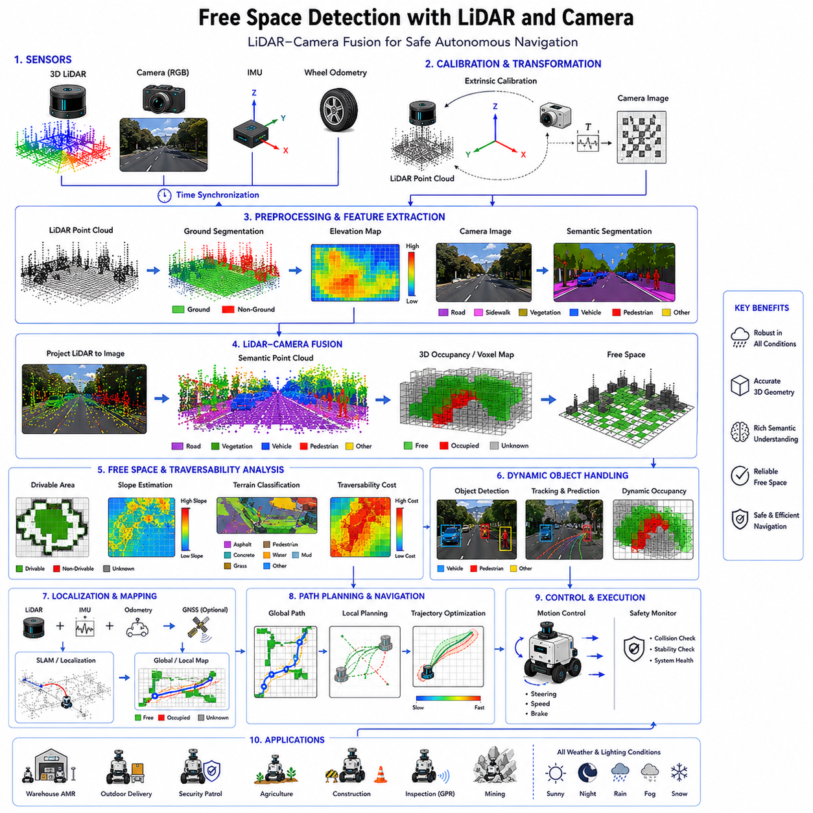
Free space detection using LiDAR and cameras represents one of the most important perception architectures in modern autonomous mobile robot systems because it combines precise geometric sensing with rich semantic understanding. Autonomous robots operating in real-world indoor and outdoor environments must continuously determine where safe and traversable space exists while simultaneously understanding obstacles, terrain boundaries, road structures, environmental semantics, and dynamic object behavior. LiDAR and camera sensor fusion has become one of the most widely adopted approaches for achieving robust free-space perception because the strengths of one sensing modality compensate for the weaknesses of the other. In advanced AMR platforms, LiDAR-camera fusion forms the core foundation for autonomous navigation, drivable area estimation, obstacle avoidance, semantic scene understanding, and real-time motion planning.
At a conceptual level, free-space detection refers to the process of identifying regions within the environment that are safe and operationally suitable for robot movement. However, determining free space in real-world environments is far more complicated than simply detecting obstacle-free regions. Autonomous robots must interpret complex terrain geometry, dynamic objects, road boundaries, floor transitions, weather effects, shadows, vegetation, reflective surfaces, and uncertain environmental conditions. Therefore, modern free-space systems require both geometric accuracy and semantic reasoning capabilities simultaneously.
LiDAR sensors provide highly accurate three-dimensional geometric measurements of the surrounding environment. Cameras provide dense visual and semantic information about object appearance, terrain texture, environmental context, and scene structure. By combining these sensing modalities, robots can generate robust environmental understanding that neither modality could achieve independently. LiDAR contributes reliable distance and shape estimation, while cameras provide semantic interpretation and contextual awareness.
One of the primary reasons LiDAR-camera fusion is so important is that individual sensors have inherent limitations. LiDAR performs robustly under low-light conditions and provides precise depth measurements, but it lacks rich semantic understanding and often struggles with visually ambiguous surfaces. Cameras provide excellent semantic perception and high-resolution visual information, but they are highly sensitive to lighting conditions, glare, fog, shadows, rain, snow, and motion blur. Therefore, fusion architectures create complementary robustness by integrating both modalities into unified perception pipelines.
Free-space perception using LiDAR and cameras typically begins with synchronized sensor acquisition. Time synchronization is critically important because autonomous robots operate within dynamic environments where both the robot and surrounding objects continuously move. Even small temporal misalignment between LiDAR scans and camera frames can introduce significant fusion errors. Therefore, modern systems often use hardware triggering, Precision Time Protocol (PTP), Network Time Protocol (NTP), ROS2 message synchronization, or dedicated sensor timestamp alignment frameworks.
Calibration is another foundational requirement for LiDAR-camera free-space perception. Extrinsic calibration determines the precise spatial relationship between the LiDAR coordinate frame and the camera coordinate frame. Intrinsic camera calibration corrects lens distortion and image geometry. Accurate calibration allows the robot to project LiDAR points into camera images and align semantic information with three-dimensional geometry. Small calibration errors may produce major perception inconsistencies, especially at long distances.
LiDAR-based free-space estimation primarily relies on geometric analysis. LiDAR sensors generate point clouds representing the spatial structure of the environment. Ground plane estimation algorithms classify terrain points and obstacle points based on height continuity, elevation gradients, local surface normals, and geometric consistency. Regions that satisfy traversability constraints are classified as potential free space.
Ground segmentation is one of the most important preprocessing stages in LiDAR free-space detection. Since most obstacles protrude above the ground surface, separating ground points from non-ground points enables robots to identify traversable terrain. Common techniques include RANSAC plane fitting, elevation map analysis, voxel-based filtering, slope thresholding, and local surface normal estimation.
However, geometric analysis alone is insufficient in many real-world environments. A geometrically flat region may still be operationally unsafe due to mud, water, grass, ice, snow, loose gravel, construction areas, or unstable terrain. Therefore, semantic understanding provided by cameras becomes critically important.
Camera-based free-space perception relies heavily on semantic segmentation and scene understanding. Deep learning models classify image pixels into categories such as road, floor, sidewalk, grass, obstacle, vehicle, pedestrian, curb, mud, water, or construction zone. These semantic outputs provide contextual understanding beyond pure geometry. For example, the system may distinguish between a paved road and a puddle even when both surfaces appear geometrically flat.
Modern semantic segmentation networks often use convolutional neural networks, transformer architectures, encoder-decoder models, or multimodal fusion networks. These systems generate dense semantic masks representing drivable and non-drivable regions. Transformer-based architectures have significantly improved segmentation robustness under complex environmental conditions.
One of the major advantages of cameras is long-range semantic perception. Cameras can identify road structures, lane boundaries, terrain transitions, and object categories at distances where LiDAR point clouds become sparse. This long-range contextual understanding significantly improves navigation planning and anticipatory motion behavior.
However, camera-only perception systems face major operational challenges. Lighting variation, glare, shadows, rain, fog, snow, dust, and nighttime conditions may degrade image quality significantly. Monocular cameras also lack direct depth measurements. Therefore, camera perception is substantially strengthened when fused with LiDAR geometry.
LiDAR-camera fusion architectures generally fall into three categories: early fusion, mid-level fusion, and late fusion. Early fusion combines raw sensor data before feature extraction. For example, LiDAR points may be projected into image space and combined directly with RGB pixel values. Mid-level fusion combines extracted features from both modalities within neural network architectures. Late fusion merges independently processed perception outputs such as object detections or segmentation masks.
Early fusion offers strong cross-modal interaction but requires highly accurate synchronization and calibration. Mid-level fusion provides flexible feature learning and is widely used in modern AI systems. Late fusion is computationally simpler and more modular but may lose some cross-modal contextual relationships.
Point cloud projection is one of the most common LiDAR-camera fusion techniques. LiDAR points are projected into image coordinates using calibration matrices. Semantic labels predicted from camera images are then associated with corresponding three-dimensional LiDAR points. This process creates semantically enriched point clouds that combine geometry and contextual understanding simultaneously.
Semantic point clouds are particularly valuable for autonomous navigation because they enable robots to reason about both terrain structure and terrain meaning. For example, the robot may identify a region not only as flat geometry but also as wet asphalt, grass, gravel, sidewalk, or pedestrian zone. This richer understanding significantly improves traversability reasoning.
Occupancy grids remain one of the most widely used free-space representations in robotics systems. LiDAR-camera fusion pipelines often generate occupancy maps where cells represent free, occupied, or unknown space. Semantic information may also be integrated into occupancy maps to represent terrain classes, road boundaries, uncertainty levels, or traversability costs.
Voxel maps extend occupancy grids into three-dimensional representations. Voxel-based free-space modeling supports obstacle overhang detection, uneven terrain handling, volumetric occupancy reasoning, and three-dimensional navigation planning. Outdoor autonomous robots operating in rugged environments frequently rely on voxel-based perception systems.
Dynamic obstacle handling is critically important in free-space perception. Pedestrians, vehicles, forklifts, bicycles, animals, and moving machinery continuously alter navigable space. Therefore, free-space systems must continuously update environmental understanding in real time. Object tracking, trajectory prediction, spatiotemporal filtering, and dynamic occupancy grids are commonly integrated into fusion pipelines.
Localization quality strongly influences free-space accuracy. If the robot’s estimated pose drifts relative to the environment, fused semantic and geometric maps may become spatially inconsistent. Therefore, free-space systems are tightly integrated with SLAM, localization, GNSS, IMU fusion, odometry correction, and map alignment frameworks.
Terrain classification is closely connected to LiDAR-camera free-space perception. Slope estimation, roughness analysis, traction estimation, wheel slip prediction, and terrain semantics all influence traversability assessment. Heavy outdoor robots, towing AMRs, agricultural robots, railway inspection robots, and mining robots are especially sensitive to terrain conditions.
Weather robustness represents one of the largest challenges in outdoor free-space perception. Rain may create LiDAR reflections and distort camera images. Fog reduces visibility significantly. Snow obscures terrain boundaries. Dust and mud contaminate sensors. Strong sunlight produces glare and thermal distortion. Therefore, multimodal sensor fusion becomes essential for maintaining operational reliability under adverse environmental conditions.
Radar integration is increasingly used alongside LiDAR and cameras for additional robustness. Millimeter-wave radar performs reliably under rain, fog, snow, and dust conditions where optical sensors degrade. Although radar provides lower spatial resolution, it contributes robust obstacle awareness and motion estimation under poor visibility conditions.
Real-time performance is critically important in free-space perception systems. Autonomous robots continuously move through dynamic environments and require rapid environmental updates. High-latency perception may produce delayed reactions to obstacles, terrain transitions, or moving objects. Therefore, modern systems heavily utilize GPU acceleration, CUDA optimization, TensorRT inference acceleration, ROS2 multi-threading, parallel sensor pipelines, and efficient point cloud processing frameworks.
Robot geometry and kinematics also influence free-space interpretation. A small differential-drive robot may navigate through narrow corridors, whereas large outdoor Ackermann-steering vehicles require wider turning margins. Towing robots require additional free-space consideration for trailer articulation and off-tracking behavior. Therefore, free-space planners incorporate robot-specific footprint and kinematic constraints.
Vehicle dynamics further affect traversability reasoning. Terrain that is theoretically traversable at low speed may become unsafe at higher velocities due to rollover risk, braking limitations, suspension instability, or wheel slip. Therefore, advanced systems increasingly integrate vehicle dynamics models into perception and planning architectures.
Machine learning and AI have dramatically transformed LiDAR-camera free-space detection. Deep neural networks can learn complex multimodal environmental patterns directly from large datasets. Self-supervised learning methods allow robots to improve traversability estimation through operational experience. Reinforcement learning approaches can optimize terrain-aware navigation policies dynamically.
Foundation models and multimodal embodied AI architectures may eventually revolutionize free-space understanding. Future autonomous robots may interpret environmental structure, semantics, physical interaction, operational risk, social behavior, and mission objectives simultaneously within unified world models. Such systems may approach human-level environmental reasoning capability.
Industrial applications demonstrate the diversity of LiDAR-camera free-space requirements. Warehouse AMRs require aisle navigation and pallet avoidance. Hospital robots require smooth human-aware corridor navigation. Outdoor patrol robots must navigate sidewalks, roads, grass, and mixed terrain under changing weather conditions. Agricultural robots must analyze crop rows and soil conditions. GPR inspection robots must carry heavy sensing payloads across uneven infrastructure terrain. Smart city robots must interact safely with pedestrians, bicycles, vehicles, and urban infrastructure simultaneously.
Testing and validation are essential components of free-space engineering. Engineers evaluate perception systems across diverse conditions including rain, fog, snow, mud, gravel, reflective surfaces, low-light environments, crowded spaces, damaged roads, and construction zones. Edge-case testing is particularly important because unusual environmental conditions often reveal failure modes not visible during standard evaluation.
Simulation platforms such as Gazebo, CARLA, Isaac Sim, and digital twin environments support large-scale free-space algorithm testing. Synthetic environments enable repeated evaluation of dangerous or rare scenarios without physical risk. Simulation also supports regression testing, AI dataset generation, and reinforcement learning workflows.
The future of LiDAR-camera free-space perception will likely evolve toward comprehensive semantic environmental intelligence rather than simple obstacle-free navigation. Autonomous robots may eventually reason about legal movement regions, pedestrian behavior, road regulations, environmental risk, infrastructure semantics, energy efficiency, weather adaptation, and cooperative multi-robot coordination simultaneously.
Ultimately, free-space perception using LiDAR and cameras is not merely a sensor fusion problem. It is the process through which autonomous robots construct operational understanding of navigable reality. Effective LiDAR-camera fusion enables robust navigation, safe obstacle avoidance, adaptive terrain handling, efficient motion planning, scalable autonomous deployment, and trustworthy real-world robotic intelligence. In advanced AMR systems, LiDAR-camera free-space perception becomes one of the foundational technologies enabling practical autonomous mobility across complex indoor and outdoor environments.

20.7 Free Space for Local Planning
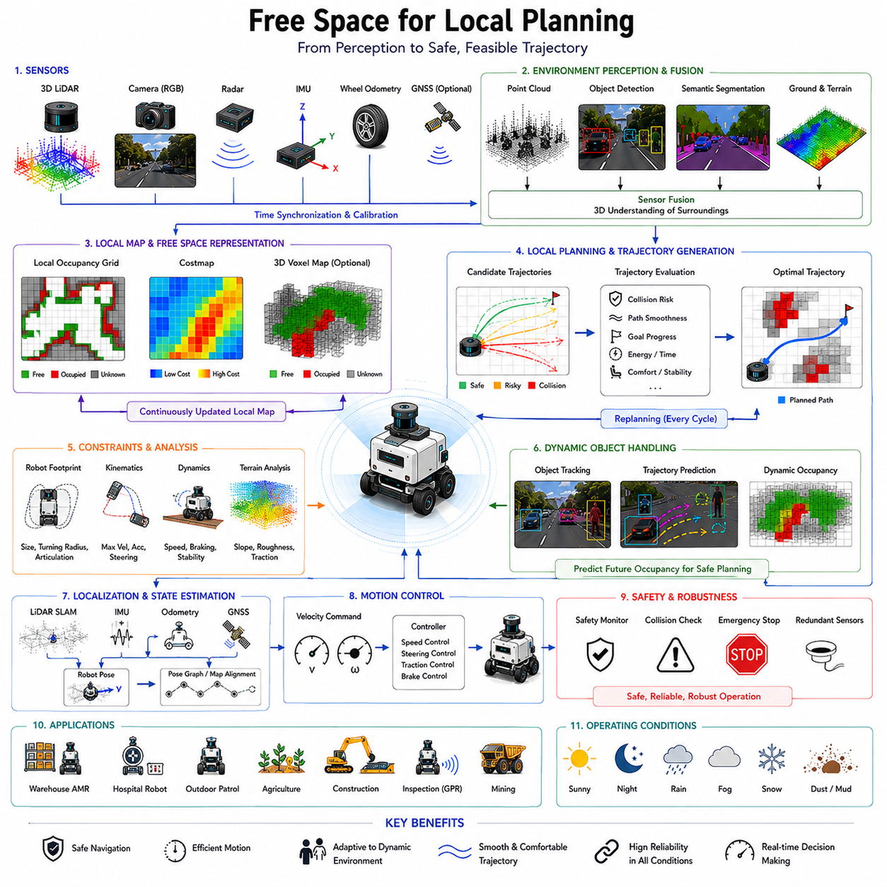
Free space for local planning is one of the most essential components of autonomous mobile robot navigation because it directly determines how a robot moves safely and efficiently through dynamic real-world environments. While global planning determines long-range mission objectives and overall route selection, local planning focuses on immediate motion decisions based on real-time environmental perception. The local planner continuously analyzes nearby free space, obstacles, terrain conditions, robot dynamics, and operational constraints in order to generate safe and feasible trajectories. Therefore, accurate free-space estimation becomes the foundation of local autonomous decision-making, obstacle avoidance, motion smoothness, safety assurance, and adaptive mobility behavior. In modern AMR systems, free-space understanding for local planning forms the critical bridge between perception and real-time motion control.
At a conceptual level, free space for local planning refers to the representation of navigable regions surrounding the robot that can be safely traversed within a short prediction horizon. Unlike global maps, which may represent large-scale environments over long distances, local free-space maps focus on the immediate operational area around the robot. These maps must be updated continuously because the local environment changes dynamically due to robot motion, moving obstacles, environmental uncertainty, and sensor updates.
Local planning operates under strict real-time constraints. Autonomous robots moving through warehouses, hospitals, factories, urban environments, agricultural fields, or industrial plants cannot wait several seconds for motion decisions. Instead, local planners must react within milliseconds to changing conditions. Therefore, free-space estimation for local planning requires highly efficient perception pipelines, low-latency sensor processing, and deterministic computational performance.
Free-space estimation for local planning begins with environmental perception. LiDAR sensors, cameras, radar, RGB-D sensors, IMUs, wheel odometry, GNSS systems, and ultrasonic sensors all contribute to understanding nearby navigable space. Sensor fusion architectures combine these heterogeneous inputs to generate unified local environmental models. These models represent free space, occupied space, unknown regions, terrain conditions, dynamic obstacles, and traversability constraints.
Occupancy grids are among the most widely used free-space representations for local planning. In occupancy grid mapping, the surrounding environment is divided into discrete cells representing free, occupied, or unknown states. Local planners analyze these grids to determine feasible motion corridors and obstacle-free trajectories. Occupancy grids provide computational simplicity, fast update rates, and compatibility with many path-planning algorithms.
Costmaps extend occupancy grids by assigning traversal costs to spatial regions. Instead of treating free space as uniformly traversable, costmaps represent varying levels of operational difficulty or risk. Regions near obstacles may receive higher costs due to collision risk. Rough terrain, narrow corridors, steep slopes, dynamic obstacle zones, or uncertain regions may also receive elevated traversal costs. Local planners then optimize trajectories according to both safety and efficiency objectives.
Dynamic occupancy grids are particularly important for real-world local planning because surrounding environments continuously change. Pedestrians, forklifts, vehicles, bicycles, robots, animals, and moving machinery all alter navigable space over time. Dynamic occupancy grids incorporate temporal prediction and object tracking to estimate how free space may evolve in the near future. This predictive capability enables smoother and safer motion behavior.
One of the most important functions of local planning is obstacle avoidance. The local planner continuously evaluates nearby free space to avoid collisions while maintaining progress toward navigation goals. Obstacle avoidance requires not only identifying current obstacle positions but also predicting future obstacle movement. Therefore, free-space estimation often integrates object detection, tracking, trajectory prediction, and behavioral forecasting frameworks.
Static obstacles and dynamic obstacles introduce fundamentally different planning challenges. Static obstacles such as walls, shelves, curbs, barriers, or infrastructure elements remain fixed in space and can be represented consistently within local maps. Dynamic obstacles such as pedestrians or vehicles require continuous prediction and adaptive replanning. Therefore, local free-space systems must support both stable environmental representation and rapid dynamic updates simultaneously.
Robot geometry strongly influences local free-space interpretation. Small indoor differential-drive robots may navigate narrow corridors and tight turns, whereas large outdoor Ackermann-steering vehicles require significantly wider maneuvering space. Towing robots require additional clearance for trailer articulation and off-tracking behavior. Therefore, local planners incorporate robot-specific footprint models, wheelbase constraints, turning radius limitations, articulation behavior, and safety margins into free-space analysis.
Kinematic constraints play a major role in local planning. Differential-drive robots, omnidirectional robots, tracked vehicles, and Ackermann-steering platforms all have fundamentally different motion capabilities. A path that is geometrically collision-free may still be physically infeasible due to steering limitations or turning radius constraints. Therefore, local planners must evaluate free space according to robot-specific motion feasibility.
Vehicle dynamics further complicate local planning. Terrain conditions, speed, payload distribution, traction limits, braking distance, suspension behavior, and rollover risk all influence whether a trajectory is operationally safe. High-speed outdoor robots require longer stopping distances and larger safety margins than slow indoor robots. Heavy payload platforms may become unstable during aggressive maneuvers or while traversing steep slopes. Therefore, modern local planners increasingly integrate vehicle dynamics models into trajectory generation frameworks.
Trajectory generation is one of the core outputs of local planning systems. The planner continuously generates candidate trajectories through free space while considering obstacles, robot constraints, navigation goals, and safety requirements. These candidate trajectories are evaluated according to criteria such as collision risk, path smoothness, energy efficiency, trajectory stability, comfort, and mission efficiency.
Sampling-based local planning methods are widely used in robotics systems. Dynamic Window Approach (DWA), Timed Elastic Band (TEB), Model Predictive Control (MPC), lattice planners, and trajectory rollout methods generate multiple candidate trajectories and select the optimal solution according to evaluation metrics. These methods rely heavily on accurate free-space representations.
Dynamic Window Approach evaluates feasible velocity commands within the robot’s acceleration and kinematic constraints. Candidate trajectories are simulated forward over short horizons, and trajectories leading to collisions are rejected. Remaining trajectories are scored according to obstacle clearance, path alignment, speed, and goal progress.
Timed Elastic Band planning models trajectories as deformable paths optimized according to obstacle constraints and motion smoothness. TEB planners continuously adjust trajectories in response to changing free space and dynamic obstacles. This produces highly adaptive and smooth navigation behavior.
Model Predictive Control represents one of the most advanced local planning approaches. MPC predicts future robot states over finite time horizons and optimizes control actions according to system dynamics and environmental constraints. Free-space estimation becomes critically important because prediction quality directly affects planning safety and stability.
Voxel maps and three-dimensional local maps are increasingly important in advanced robotics systems. While two-dimensional occupancy grids work well for many indoor applications, outdoor robots often require three-dimensional environmental understanding. Overhanging obstacles, uneven terrain, slopes, vegetation, construction zones, and rough terrain require volumetric free-space reasoning.
Terrain analysis is closely integrated with local planning free-space perception. Traversability depends not only on obstacle presence but also on terrain characteristics such as slope, roughness, traction, stability, and surface type. Agricultural robots, mining robots, GPR inspection robots, railway inspection systems, and outdoor patrol robots are particularly sensitive to terrain conditions.
Localization quality strongly influences local planning accuracy. If the robot’s estimated position drifts relative to the environment, local free-space maps may become spatially inconsistent. Therefore, local planners are tightly integrated with SLAM, localization, GNSS fusion, IMU stabilization, odometry correction, and map alignment frameworks.
Semantic understanding increasingly enhances local planning quality. Semantic segmentation systems classify environmental regions into categories such as road, sidewalk, grass, obstacle, pedestrian zone, construction area, vehicle lane, or restricted area. These semantic labels provide contextual understanding that geometric free-space analysis alone cannot provide.
Human-aware navigation represents another important aspect of local planning. Robots operating around humans must maintain socially acceptable motion behavior. Local planners therefore incorporate human trajectory prediction, personal space modeling, crowd behavior analysis, and social navigation policies into free-space reasoning frameworks.
Weather robustness is critically important for outdoor local planning systems. Rain, fog, snow, dust, mud, shadows, glare, and low-light conditions significantly affect sensor performance and environmental perception. LiDAR-camera-radar sensor fusion architectures improve robustness under adverse environmental conditions.
Real-time performance is absolutely essential in local planning systems. Autonomous robots continuously move through dynamic environments and require rapid trajectory updates. Delayed planning responses may produce unsafe navigation behavior or collisions. Therefore, modern local planners rely heavily on GPU acceleration, CUDA optimization, ROS2 multi-threading, TensorRT inference acceleration, parallel perception pipelines, and efficient data structures.
Uncertainty estimation is increasingly important in local planning. Real-world environments contain incomplete observations, sensor noise, localization drift, dynamic uncertainty, and ambiguous environmental structures. Therefore, modern planners often represent free-space confidence values and probabilistic obstacle boundaries rather than deterministic maps.
Safety validation is one of the most critical aspects of local planning design. Autonomous robots must maintain collision-free operation even under unexpected environmental conditions, sensor degradation, or temporary perception failures. Therefore, emergency braking systems, fail-safe stopping behavior, safety monitors, and redundant perception architectures are often integrated into local planning frameworks.
Machine learning and AI are rapidly transforming local planning systems. Deep neural networks can learn navigation policies directly from large operational datasets. Reinforcement learning enables robots to optimize navigation behavior through experience. Self-supervised learning allows robots to improve traversability estimation and obstacle prediction over time.
Foundation models and embodied AI architectures may eventually revolutionize local planning. Future robots may reason about free space similarly to humans by integrating environmental semantics, social behavior, terrain understanding, motion prediction, infrastructure awareness, and mission objectives into unified world models.
Industrial applications demonstrate the diversity of local planning requirements. Warehouse AMRs prioritize aisle navigation and pallet avoidance. Hospital robots require smooth human-aware corridor navigation. Outdoor patrol robots navigate roads, sidewalks, grass, and urban infrastructure under changing weather conditions. Agricultural robots analyze crop rows and uneven terrain. Construction robots operate near hazardous excavation zones. GPR inspection robots carry heavy sensing payloads across damaged infrastructure surfaces.
Testing and validation are essential components of local planning development. Engineers evaluate planning performance under crowded environments, dynamic obstacle interactions, adverse weather, low-light conditions, rough terrain, reflective surfaces, narrow corridors, construction zones, and emergency situations. Edge-case testing is particularly important because unusual environmental conditions often reveal critical failure modes.
Simulation platforms such as Gazebo, CARLA, Isaac Sim, and digital twin environments support large-scale local planning evaluation. Simulation enables safe testing of dangerous scenarios and supports regression testing, AI training, reinforcement learning, and autonomous behavior optimization.
Future local planning systems will likely evolve toward holistic autonomous behavioral intelligence rather than simple collision-free trajectory generation. Autonomous robots may eventually reason about social interaction, legal movement zones, energy optimization, environmental risk, infrastructure semantics, cooperative multi-robot coordination, and mission-level objectives simultaneously.
The evolution of free space for local planning reflects the broader evolution of autonomous robotics itself. Early robotics systems relied on simple reactive obstacle avoidance and geometric navigation. Modern autonomous systems increasingly integrate semantic understanding, predictive modeling, multimodal sensor fusion, uncertainty reasoning, AI-based decision-making, and adaptive behavioral intelligence.
Ultimately, free space for local planning is not merely a mapping problem. It is the process through which autonomous robots determine how to move safely, efficiently, smoothly, and intelligently through the immediate surrounding world. Effective local free-space planning enables robust navigation, adaptive obstacle avoidance, stable motion control, safe human interaction, scalable autonomous deployment, and trustworthy real-world robotic intelligence. In advanced AMR systems, free-space perception for local planning becomes one of the foundational technologies enabling practical real-time autonomous mobility.

20.8 Free Space Validation
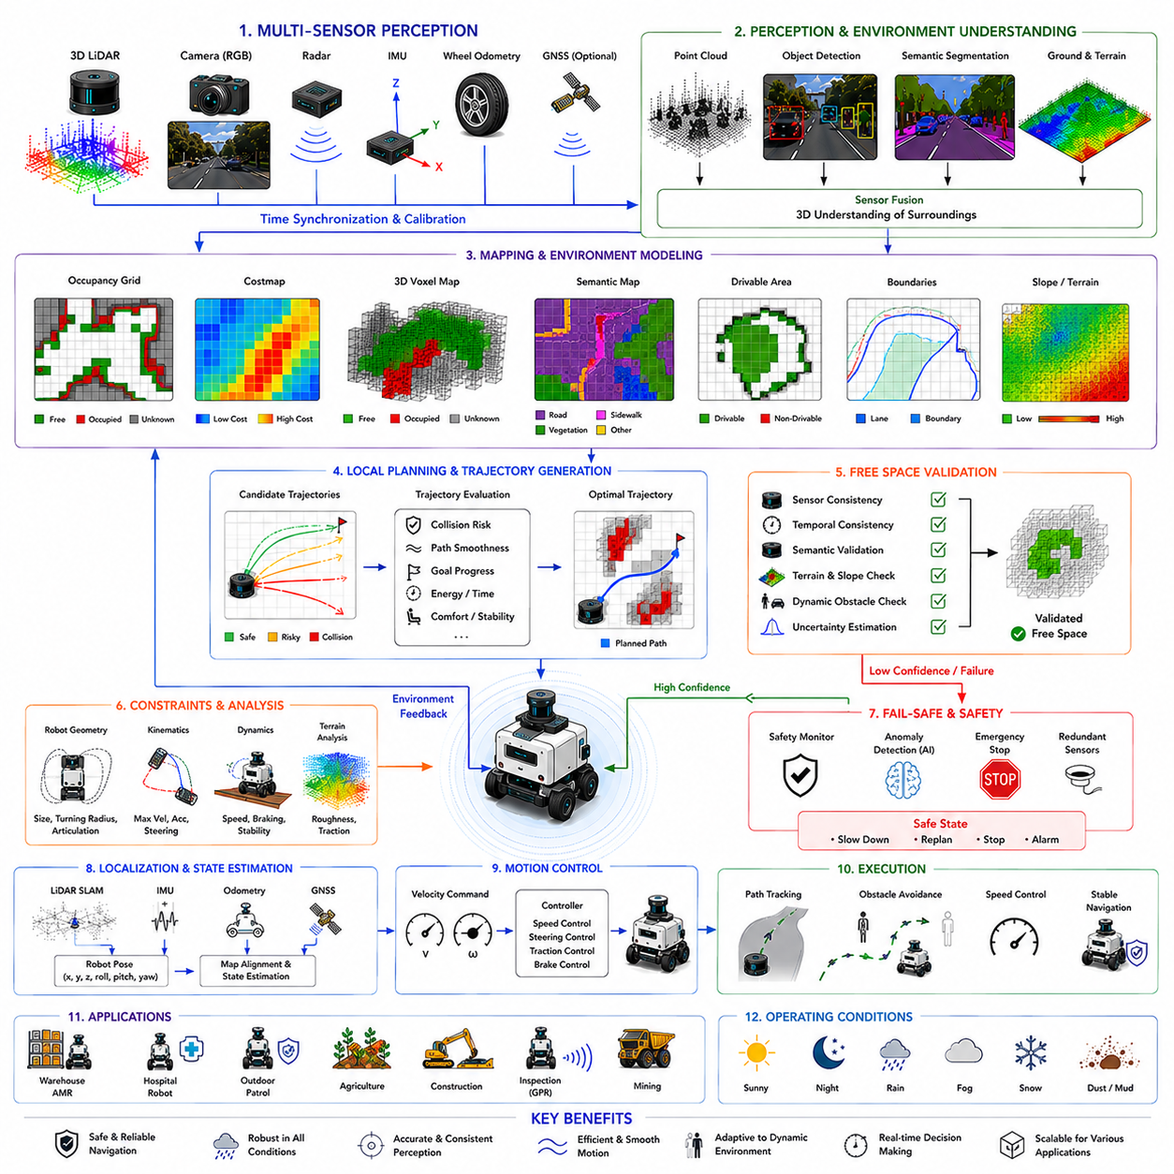
Free space validation is one of the most critical safety and reliability processes in autonomous mobile robot systems because it determines whether the robot’s perceived navigable space is truly safe, operationally feasible, and trustworthy for autonomous movement. While free-space detection identifies regions that appear traversable based on sensor perception and environmental interpretation, free-space validation evaluates the correctness, consistency, confidence, and operational safety of those estimations before the robot commits to motion execution. In advanced AMR systems, free-space validation acts as the final verification layer between perception and autonomous control, ensuring that navigation decisions are robust against sensor noise, environmental uncertainty, dynamic obstacles, perception failures, and unexpected real-world conditions.
At a conceptual level, free-space validation refers to the process of confirming that detected navigable regions satisfy all necessary operational, geometric, semantic, dynamic, and safety constraints required for safe robot movement. Autonomous robots operating in warehouses, hospitals, factories, outdoor roads, construction zones, agricultural fields, railway systems, smart cities, mines, and industrial plants continuously perceive free space using LiDAR, cameras, radar, depth sensors, IMUs, GNSS systems, and other sensing modalities. However, sensor perception alone cannot guarantee correctness. Environmental ambiguity, weather conditions, sensor degradation, dynamic changes, localization errors, and AI prediction uncertainty can all produce inaccurate free-space estimates. Therefore, free-space validation becomes essential for preventing unsafe autonomous behavior.
One of the primary goals of free-space validation is collision prevention. Even small perception errors may lead to severe operational consequences, especially in heavy industrial robots, towing AMRs, high-speed outdoor platforms, or human-interactive service robots. Incorrectly classifying an obstacle as traversable free space may result in collisions, rollover events, payload instability, equipment damage, or human injury. Therefore, validation systems continuously verify free-space integrity before motion commands are executed.
Free-space validation is closely connected to traversability analysis. A region may appear geometrically free but still be operationally unsafe due to terrain instability, excessive slope, low traction, standing water, mud, snow, gravel, loose soil, or structural damage. Therefore, validation systems evaluate not only obstacle absence but also terrain quality, surface stability, and operational suitability.
Sensor consistency checking is one of the most important components of free-space validation. Modern autonomous robots rely on multiple sensing modalities simultaneously, including LiDAR, cameras, radar, RGB-D sensors, ultrasonic sensors, IMUs, and wheel odometry systems. Each sensor has different strengths and weaknesses. Validation systems compare outputs across sensors to identify inconsistencies or anomalies. For example, if a camera identifies a region as drivable road while LiDAR detects a vertical obstacle, the system may flag the area as uncertain and reduce navigation confidence.
LiDAR-camera cross-validation is widely used in advanced perception systems. LiDAR provides accurate geometric measurements, while cameras provide semantic understanding. Validation systems compare geometric free-space estimation against semantic segmentation outputs. If semantic labels indicate water, vegetation, construction zones, or obstacles within geometrically traversable regions, the planner may reject those areas or apply higher traversal costs.
Temporal consistency validation is another essential component. Real-world environments typically change continuously but not instantaneously. Therefore, free-space estimates should exhibit reasonable temporal continuity across consecutive sensor frames. Sudden large changes in perceived free space may indicate sensor noise, localization drift, calibration failure, environmental occlusion, or perception instability. Temporal filtering and historical consistency analysis help stabilize free-space understanding.
Localization consistency also plays a major role in validation. If robot pose estimation drifts relative to the environment, free-space maps may become spatially inconsistent. For example, obstacles may appear shifted relative to previously observed positions. Therefore, free-space validation systems are tightly integrated with SLAM, localization correction, GNSS fusion, IMU stabilization, odometry verification, and map alignment frameworks.
Occupancy grid validation is widely used in local navigation systems. Occupancy grids classify environmental cells as free, occupied, or unknown. Validation layers evaluate occupancy stability, spatial consistency, update confidence, and sensor agreement. Cells with conflicting observations may be assigned uncertain or probabilistic states rather than deterministic classifications.
Probabilistic free-space modeling is becoming increasingly important because real-world perception is inherently uncertain. Sensor noise, weather effects, incomplete observations, reflective surfaces, dynamic obstacles, shadows, dust, fog, and occlusions introduce ambiguity into environmental interpretation. Therefore, modern free-space validation systems often represent confidence values, probability distributions, uncertainty metrics, and risk estimates rather than binary free-space labels.
Unknown space handling is one of the most difficult challenges in free-space validation. Autonomous robots frequently encounter partially observed or completely unobserved regions. A region that appears free due to missing sensor coverage may actually contain hidden obstacles or hazardous terrain. Therefore, conservative safety policies are often applied to unknown space. Some systems classify unknown regions as non-traversable by default, while others apply uncertainty-dependent traversal penalties.
Dynamic obstacle validation is critically important in real-world autonomous operation. Pedestrians, forklifts, vehicles, bicycles, animals, and moving machinery continuously alter navigable space. Validation systems therefore integrate object tracking, trajectory prediction, spatiotemporal occupancy estimation, and behavioral forecasting. Predicted future obstacle motion is incorporated into free-space safety analysis to avoid unsafe trajectory generation.
Prediction uncertainty becomes especially important when robots operate near humans. Human motion is inherently unpredictable, and sudden behavioral changes may invalidate previously safe trajectories. Therefore, human-aware validation systems often maintain larger safety margins around pedestrians and reduce navigation speed in crowded environments.
Robot geometry and kinematic constraints strongly influence free-space validation. A region that is geometrically traversable for a small indoor robot may be infeasible for a large outdoor vehicle or towing platform. Validation systems therefore evaluate robot footprint dimensions, wheelbase, articulation behavior, turning radius, steering limitations, and dynamic maneuverability before approving free-space regions for trajectory generation.
Vehicle dynamics validation is particularly important for outdoor robots and heavy payload systems. Terrain slope, traction limits, braking distance, suspension behavior, wheel slip probability, and rollover risk all influence operational safety. Validation systems may reject free-space regions that exceed dynamic stability thresholds even if those areas are geometrically obstacle-free.
Terrain-aware validation is increasingly important in advanced robotics systems. Surface roughness, terrain material, vibration characteristics, load-bearing capability, and traction quality all influence traversability. Agricultural robots, mining robots, GPR inspection robots, railway inspection systems, and construction robots are especially sensitive to terrain conditions. Validation frameworks therefore integrate terrain classification, roughness analysis, traction estimation, and slope evaluation into free-space safety assessment.
Semantic validation extends beyond geometric reasoning. Semantic understanding allows robots to recognize contextually unsafe regions such as restricted areas, pedestrian-only zones, emergency exits, railway tracks, hazardous industrial zones, or legally prohibited navigation regions. Therefore, free-space validation increasingly incorporates semantic world understanding and policy-aware navigation constraints.
Map consistency validation is commonly used in industrial autonomous systems. High-definition maps may contain road boundaries, lane geometry, infrastructure zones, construction areas, semantic regions, and operational constraints. Real-time free-space observations are compared against map priors to detect anomalies or environmental changes. However, maps alone cannot guarantee correctness because real-world environments continuously evolve.
Sensor degradation monitoring is an important aspect of validation engineering. LiDAR contamination, camera blur, radar interference, calibration drift, sensor overheating, water droplets, mud accumulation, dust contamination, and hardware failures may degrade perception quality significantly. Validation systems continuously monitor sensor health and reliability to adjust free-space confidence dynamically.
Weather robustness remains one of the greatest challenges in free-space validation. Rain may create LiDAR reflections and distort camera images. Snow obscures terrain boundaries. Fog reduces visibility. Strong sunlight creates glare and thermal artifacts. Dust and mud contaminate sensor surfaces. Therefore, multimodal sensor fusion and adaptive validation strategies are essential for maintaining reliable autonomous operation under adverse environmental conditions.
Redundancy is a core principle of free-space validation. Safety-critical robotics systems rarely rely on a single sensor or perception algorithm. Instead, multiple independent sensing and validation pathways operate simultaneously. Redundant LiDARs, stereo cameras, radar systems, ultrasonic sensors, and independent perception networks improve fault tolerance and operational safety.
Fail-safe behavior is tightly integrated with free-space validation systems. When validation confidence falls below acceptable thresholds, robots may reduce speed, increase safety margins, request operator intervention, or execute emergency stopping procedures. Safety monitors continuously supervise free-space reliability to prevent unsafe autonomous actions.
Real-time performance is critically important in validation systems. Autonomous robots continuously move through dynamic environments and require rapid safety verification before executing motion commands. Delayed validation responses may produce unsafe navigation behavior. Therefore, validation pipelines rely heavily on GPU acceleration, CUDA optimization, ROS2 multi-threading, TensorRT inference acceleration, and parallel processing architectures.
Machine learning and AI are increasingly transforming free-space validation. Deep neural networks can learn complex environmental consistency patterns directly from operational datasets. Self-supervised learning enables robots to improve validation reliability through experience. AI models can detect subtle perception anomalies that may not be captured by handcrafted rules.
Anomaly detection systems are becoming increasingly important in free-space validation. AI-based anomaly detection can identify unusual sensor behavior, environmental inconsistencies, or unexpected perception outputs. Such systems improve robustness against rare edge-case scenarios that traditional deterministic validation methods may miss.
Simulation and digital twin environments play a major role in validation development. Platforms such as Gazebo, CARLA, Isaac Sim, and custom digital twins allow engineers to test free-space validation under dangerous or rare scenarios safely and repeatedly. Simulation supports regression testing, failure analysis, sensor degradation testing, weather robustness evaluation, and AI training workflows.
Industrial applications demonstrate the diversity of free-space validation requirements. Warehouse AMRs require reliable aisle navigation and pallet avoidance. Hospital robots require human-safe navigation in crowded corridors. Outdoor patrol robots must operate under changing weather conditions and mixed terrain environments. Agricultural robots validate crop-row traversability and soft-soil conditions. Construction robots operate near hazardous excavation zones. Mining robots navigate unstable rocky terrain. GPR inspection robots validate traversability across damaged infrastructure surfaces and uneven underground terrain.
Safety certification and regulatory compliance are increasingly important for free-space validation systems. Industrial robots, autonomous vehicles, medical robots, and collaborative robots must satisfy strict functional safety requirements. Validation architectures often align with standards such as ISO 3691-4, ISO 26262, IEC 61508, IEC 61496, and other robotics safety frameworks.
Future free-space validation systems will likely evolve toward holistic autonomous safety intelligence rather than simple perception verification. Autonomous robots may eventually reason about environmental risk, social interaction, infrastructure semantics, legal navigation constraints, mission objectives, weather adaptation, and cooperative multi-robot behavior simultaneously.
Foundation models and embodied AI architectures may revolutionize validation reasoning. Future robots may understand environmental safety similarly to humans by integrating geometry, semantics, physics, uncertainty, operational context, and behavioral prediction into unified world models. Such systems may achieve far more adaptive and resilient navigation behavior than current deterministic validation pipelines.
The evolution of free-space validation reflects the broader evolution of autonomous robotics itself. Early robotics systems relied primarily on geometric obstacle avoidance with limited environmental understanding. Modern autonomous systems increasingly integrate multimodal sensor fusion, semantic reasoning, uncertainty modeling, predictive intelligence, AI-based anomaly detection, and functional safety architectures.
Ultimately, free-space validation is not merely a perception verification process. It is the mechanism through which autonomous robots determine whether their understanding of the world is sufficiently trustworthy for safe motion execution. Effective free-space validation enables robust navigation, safe obstacle avoidance, adaptive terrain handling, stable motion planning, scalable autonomous deployment, functional safety compliance, and trustworthy real-world robotic intelligence. In advanced AMR systems, free-space validation becomes one of the foundational technologies enabling practical, safe, and reliable autonomous mobility in complex real-world environments.

