Volume 03. AMR Sensors and Perception

Chapter 05. Depth Cameras

05.1 Depth Camera Principles
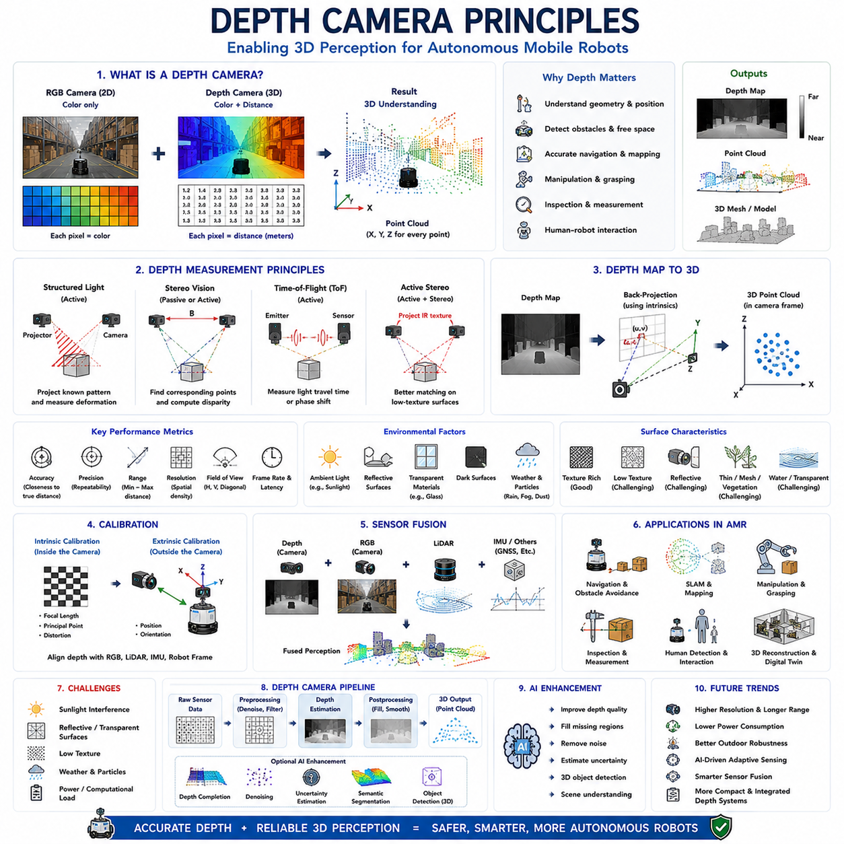
Depth cameras have become one of the most important perception sensors in modern Autonomous Mobile Robots (AMRs) because they provide not only visual appearance but also direct three-dimensional geometric information about the surrounding environment. Unlike conventional RGB cameras that capture only two-dimensional color images, depth cameras measure the distance between the sensor and every visible point within the scene. The resulting depth information enables robots to understand object positions, surface geometry, obstacle dimensions, free space, and environmental structure with considerably greater reliability than image-based perception alone. This capability significantly improves navigation, obstacle avoidance, manipulation, inspection, mapping, and human-robot interaction. As robotic systems become increasingly autonomous, depth cameras continue to evolve into fundamental components of perception architectures that require accurate spatial understanding in dynamic and complex environments.
The fundamental purpose of a depth camera is to estimate the distance from the camera to objects throughout the observed scene. Instead of representing each pixel solely by color intensity, every image pixel additionally contains depth information corresponding to the physical distance between the camera and the observed surface. This combination of color and geometric information enables robots to construct three-dimensional representations of their surroundings while simultaneously recognizing object appearance. Consequently, depth cameras bridge the gap between traditional image sensing and three-dimensional environmental perception, allowing robotic systems to interpret not only what objects exist but also where they are located in physical space.
Depth measurement differs fundamentally from ordinary image acquisition because the camera must actively or passively estimate spatial distance. Conventional cameras simply record incoming light intensity after optical projection onto an image sensor. A depth camera, however, performs additional calculations or physical measurements to determine object distance. Depending upon the sensing technology, this estimation may rely upon geometric triangulation, structured light projection, time-of-flight measurement, stereo correspondence, or other ranging principles. Although implementation methods differ considerably, every depth camera ultimately seeks to assign reliable distance values to every visible point within the camera's field of view.
Depth information is commonly represented as a depth map. A depth map resembles a grayscale image, but pixel intensity corresponds to measured distance rather than reflected brightness. Nearby objects typically appear brighter or darker depending upon visualization convention, while distant objects appear with opposite intensity values. Unlike ordinary grayscale images, these intensity values represent physical metric distances that can be directly converted into three-dimensional coordinates. Consequently, depth maps provide a dense geometric description of the environment suitable for navigation, obstacle detection, localization, manipulation, and environmental reconstruction.
The relationship between depth images and three-dimensional geometry forms the basis of robotic spatial perception. Every pixel within the depth image corresponds to a unique viewing direction determined by the camera's intrinsic calibration parameters. Combining pixel coordinates with measured depth allows computation of three-dimensional coordinates relative to the camera reference frame. Repeating this calculation for every valid pixel generates a point cloud representing the observed environment. Point clouds constitute one of the most widely used three-dimensional data structures in robotics because they preserve geometric information while remaining computationally efficient for perception algorithms.
Modern depth cameras generally employ one of several measurement principles. Structured Light systems project known infrared patterns onto observed surfaces and estimate depth through geometric deformation of the projected pattern. Stereo Vision estimates depth by matching corresponding image features between two synchronized cameras separated by a known baseline distance. Time-of-Flight cameras directly measure light propagation time or phase shift between emitted and reflected infrared illumination. Active Stereo systems combine projected infrared texture with stereo matching to improve performance on low-texture surfaces. Although these technologies differ in implementation, they all ultimately estimate three-dimensional geometry from observed optical information.
Depth cameras may be broadly categorized as active or passive sensing systems. Active depth cameras emit their own illumination, typically infrared light, to assist depth estimation independently of ambient lighting conditions. Structured Light and Time-of-Flight technologies belong to this category. Passive depth cameras rely entirely upon naturally available illumination and image correspondence without projecting additional energy into the environment. Stereo camera systems frequently operate passively, although many modern stereo cameras incorporate active infrared projection to improve robustness. Active sensing generally performs better under controlled indoor environments, while passive approaches remain advantageous outdoors where strong sunlight may interfere with projected infrared patterns.
Measurement accuracy represents one of the most important performance characteristics of any depth camera. Accuracy describes how closely measured distances correspond to true physical distances. Multiple factors influence measurement accuracy, including sensor resolution, optical quality, calibration precision, illumination conditions, object reflectivity, viewing angle, environmental interference, and ranging technology. High-accuracy depth sensing directly improves localization, manipulation precision, obstacle avoidance, dimensional inspection, and three-dimensional reconstruction. Consequently, robotic applications requiring precise interaction with the environment often prioritize measurement accuracy over acquisition speed or sensing range.
Precision differs from accuracy and describes the repeatability of repeated measurements under identical conditions. A sensor may consistently report nearly identical depth values despite exhibiting systematic calibration error. Such measurements demonstrate high precision but limited accuracy. Conversely, a sensor may produce unbiased average measurements while exhibiting substantial random variation between consecutive observations. Successful robotic perception requires both high accuracy and high precision because localization, mapping, and manipulation depend upon reliable and repeatable geometric information. Calibration procedures therefore seek to improve absolute accuracy while hardware quality influences measurement precision.
Measurement range defines the minimum and maximum distances over which reliable depth estimates remain available. Very close objects may fall inside the sensor's minimum operating distance, preventing reliable ranging because optical geometry becomes unfavorable. Extremely distant objects produce weak reflected signals or insufficient image disparity, reducing measurement reliability. Different robotic applications require different sensing ranges. Indoor mobile robots typically prioritize short- to medium-range sensing, whereas outdoor autonomous vehicles often require substantially longer operating distances to support safe high-speed navigation.
Spatial resolution determines how densely depth measurements sample the observed environment. Higher spatial resolution increases geometric detail, allowing recognition of smaller objects and finer surface structures. However, increased resolution also raises computational requirements, memory consumption, communication bandwidth, and processing latency. Engineers therefore balance sensing resolution against available computational resources according to application requirements. Some robotic systems intentionally acquire lower-resolution depth data while preserving higher-resolution RGB imagery, subsequently combining both information sources through sensor fusion.
Field of view significantly influences practical depth camera performance. Wide fields of view enable observation of larger environmental regions, reducing blind areas during navigation. Narrow fields of view concentrate sensing resources upon smaller regions while often providing higher effective spatial resolution and improved measurement precision. Horizontal, vertical, and diagonal viewing angles all influence environmental coverage. Camera placement and field-of-view selection therefore require careful consideration of robot geometry, navigation requirements, obstacle distribution, and operational tasks rather than maximizing viewing angle alone.
Environmental conditions strongly influence depth camera performance. Ambient illumination, particularly direct sunlight, may interfere with infrared-based ranging technologies. Highly reflective surfaces generate multipath reflections or signal saturation, while transparent materials such as glass allow transmitted light rather than reflected ranging signals. Dark surfaces absorb infrared energy, reducing measurement reliability, whereas highly textured objects often improve correspondence matching. Rain, fog, dust, smoke, and airborne particles additionally scatter emitted light, introducing ranging uncertainty. Understanding these environmental limitations remains essential for successful deployment outside controlled laboratory conditions.
Surface characteristics also influence measurement quality. Smooth, featureless surfaces challenge stereo correspondence because insufficient visual features exist for reliable image matching. Highly reflective metallic surfaces generate distorted infrared reflections, while transparent materials frequently appear invisible or produce incorrect depth estimates. Curved objects, thin structures, vegetation, mesh fences, and water surfaces introduce additional sensing challenges because optical reflections deviate from assumptions underlying many ranging algorithms. Robust robotic perception therefore frequently combines depth cameras with complementary sensing modalities to compensate for individual sensor limitations.
Calibration plays a central role in depth camera performance. Intrinsic calibration estimates optical parameters describing image formation, while extrinsic calibration determines geometric relationships between the depth camera and other sensors or robot coordinate systems. Accurate calibration allows depth measurements to align consistently with RGB imagery, LiDAR point clouds, inertial measurements, wheel odometry, and robot kinematic models. Calibration errors propagate directly into localization, mapping, manipulation, and inspection algorithms, making periodic verification essential throughout long-term robotic operation.
Depth cameras rarely operate independently within robotic perception architectures. Instead, they typically complement RGB cameras, LiDAR, radar, ultrasonic sensors, inertial measurement units, and global navigation systems. RGB imagery contributes semantic appearance information, LiDAR provides highly accurate long-range geometry, radar maintains robustness under adverse weather, while depth cameras supply dense local three-dimensional structure. Sensor fusion combines these complementary strengths, enabling perception systems to compensate for weaknesses exhibited by individual sensing modalities under specific environmental conditions.
Point cloud generation represents one of the most valuable outputs produced by depth cameras. Every valid depth measurement transforms into a three-dimensional point expressed within the camera coordinate system. Millions of such points collectively describe surrounding surfaces, objects, obstacles, and environmental geometry. Point clouds support numerous robotic functions including obstacle detection, occupancy mapping, simultaneous localization and mapping, surface reconstruction, object segmentation, manipulation planning, dimensional measurement, and digital twin generation. Many robotic software frameworks therefore treat point clouds as primary perception data structures rather than intermediate processing results.
Computational efficiency remains an important consideration because depth processing often requires significantly greater computational resources than ordinary image processing. Point cloud generation, filtering, registration, segmentation, feature extraction, surface reconstruction, and sensor fusion all consume substantial processing power. Modern robotic systems increasingly employ dedicated graphics processors, AI accelerators, parallel processing architectures, and optimized perception libraries to achieve real-time depth processing. Efficient algorithm design becomes especially important for battery-powered autonomous robots where computational power directly influences energy consumption and operational endurance.
Artificial intelligence increasingly enhances depth perception by improving measurement quality, filling missing depth regions, removing noise, estimating uncertainty, reconstructing occluded surfaces, and combining depth with semantic understanding. Deep learning models now perform depth completion, monocular depth estimation, point cloud segmentation, three-dimensional object detection, scene understanding, and multimodal perception using both RGB and depth information simultaneously. Rather than replacing physical ranging technologies, artificial intelligence complements them by improving robustness under challenging sensing conditions while extracting increasingly meaningful spatial representations from raw geometric data.
The future of depth camera technology will emphasize higher resolution, longer sensing range, lower power consumption, improved outdoor robustness, tighter integration with artificial intelligence, and increasingly intelligent sensor fusion. Emerging depth cameras will dynamically adapt measurement strategies according to environmental conditions, automatically estimate sensing uncertainty, cooperate with complementary perception sensors, and optimize data acquisition for specific robotic missions. As autonomous mobile robots continue expanding into increasingly complex industrial, commercial, and public environments, depth cameras will remain indispensable perception sensors that provide the accurate three-dimensional spatial understanding necessary for safe, intelligent, and highly autonomous robotic operation.

05.2 Stereo Depth Cameras
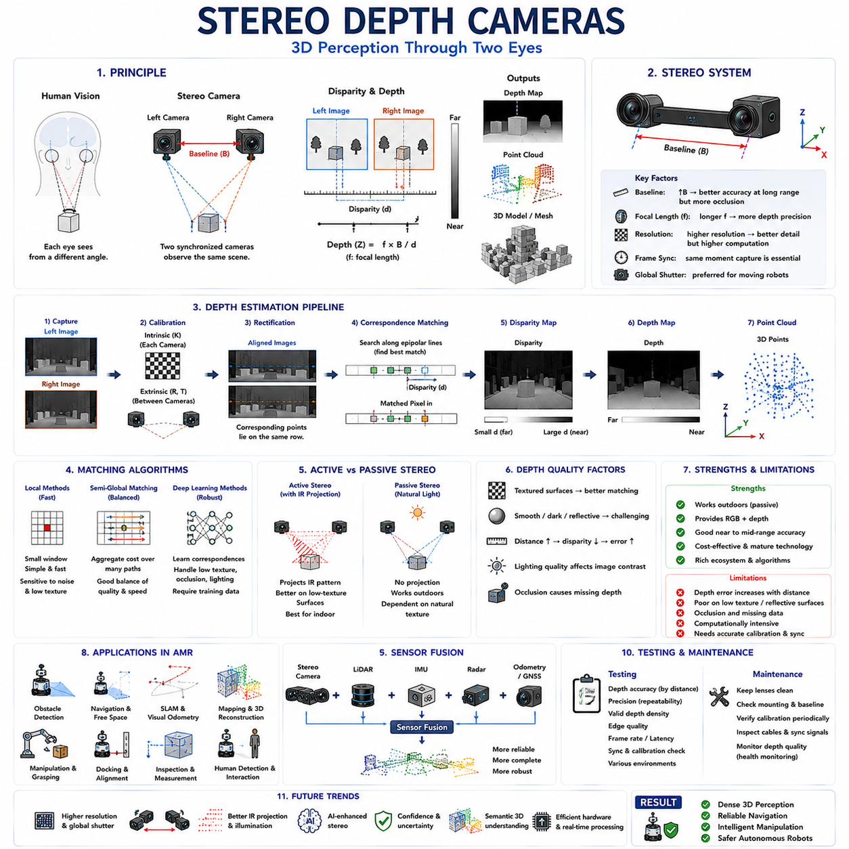
Stereo depth cameras estimate three-dimensional structure by observing the same scene from two spatially separated viewpoints. Their operating principle is similar to human binocular vision, in which the left and right eyes receive slightly different images of the environment. By identifying corresponding visual features in both images and measuring their horizontal displacement, the system calculates the distance to each visible point. This displacement is called disparity, and it becomes larger for nearby objects and smaller for distant objects. Stereo depth cameras therefore convert ordinary image pairs into depth maps, point clouds, and three-dimensional environmental models that support reliable perception in Autonomous Mobile Robots (AMRs).
A stereo camera system normally consists of two synchronized cameras mounted with a precisely known distance between their optical centers. This distance is called the baseline and strongly influences depth performance. A longer baseline creates greater disparity for objects at the same distance, improving depth accuracy at medium and long ranges. However, an excessively wide baseline increases occlusion differences between the two images and makes correspondence matching more difficult. A shorter baseline supports compact mechanical design and near-field sensing but produces limited disparity for distant objects. Selecting the baseline therefore requires balancing robot size, target range, measurement accuracy, and environmental complexity.
Stereo triangulation provides the mathematical foundation of depth estimation. After corresponding pixels are identified in the left and right images, object depth can be calculated using the camera focal length, the known baseline, and the measured disparity. Depth is inversely proportional to disparity, meaning that small disparity errors create increasingly large distance errors for far objects. This relationship explains why stereo cameras generally provide better relative accuracy at close and medium distances than at extreme range. Reliable depth estimation therefore depends upon precise calibration, high image quality, accurate correspondence matching, and sufficient image resolution.
Before depth can be calculated, the two cameras must be geometrically calibrated. Intrinsic calibration determines the focal length, principal point, pixel geometry, and lens distortion of each individual camera. Extrinsic calibration estimates the relative position and orientation between the left and right camera frames. Even very small alignment errors can shift corresponding image features away from their expected locations and substantially reduce depth accuracy. Stereo systems therefore require mechanically stable mounting structures and periodic calibration verification, particularly when installed on robots exposed to vibration, impact, temperature cycling, or structural deformation.
Stereo rectification transforms the two camera images so that corresponding points appear on the same horizontal image rows. Without rectification, correspondence algorithms would need to search across two-dimensional image regions, greatly increasing computational complexity. After rectification, the search can be restricted mainly to horizontal scan lines, improving processing speed and reliability. Rectification uses the calibration parameters of both cameras to remove lens distortion and align their virtual image planes. Accurate rectification is essential because even small vertical misalignment may cause incorrect disparity estimates, fragmented depth maps, and unstable three-dimensional geometry.
Correspondence matching is the central computational challenge in stereo depth perception. The system must determine which pixel or image feature in the left image represents the same physical surface point in the right image. Traditional algorithms compare local pixel blocks, edges, gradients, or texture patterns across candidate disparities. More advanced methods aggregate matching costs across larger image regions, enforce geometric consistency, and optimize disparity smoothness. Modern deep learning approaches learn correspondence directly from large stereo datasets, improving performance under difficult lighting, repetitive texture, partial occlusion, and weak visual structure.
Local stereo matching algorithms estimate disparity using small image neighborhoods around each pixel. These methods are computationally efficient and can operate in real time on embedded robotic hardware. However, they are sensitive to noise, repetitive patterns, low-texture surfaces, and local illumination differences. Large matching windows improve robustness but may blur depth boundaries by combining pixels from different objects. Small windows preserve object edges but provide insufficient information for reliable matching. Local methods therefore require careful parameter selection and are most effective in environments containing strong texture and consistent lighting.
Global and semi-global stereo algorithms improve depth consistency by considering relationships across broader image regions. Instead of selecting disparity independently for every pixel, they minimize an optimization cost that combines image similarity with smoothness constraints. This approach reduces random disparity noise and improves performance on weakly textured surfaces. Semi-Global Matching is particularly common in robotic stereo systems because it approximates global optimization while maintaining practical computational requirements. It provides a useful balance between depth quality, processing speed, memory usage, and embedded deployment feasibility.
Active stereo cameras improve passive stereo matching by projecting an infrared texture pattern into the environment. The projected pattern creates artificial visual features on walls, floors, boxes, and other surfaces that may otherwise contain insufficient natural texture. Infrared-sensitive stereo cameras detect this pattern and use it to calculate disparity more reliably. Active stereo performs especially well in controlled indoor environments such as warehouses, factories, hospitals, and laboratories. However, strong sunlight may overpower the projected infrared pattern, reducing its value during outdoor operation and causing the system to behave more like a passive stereo camera.
Passive stereo cameras rely entirely upon natural scene texture and ambient illumination. They do not emit infrared energy, making them suitable for outdoor operation where projected patterns may be overwhelmed by sunlight. Passive systems can also achieve longer sensing ranges when high-resolution cameras and sufficiently wide baselines are used. Their primary limitation is poor performance on smooth, repetitive, dark, or uniformly colored surfaces. Concrete walls, clean floors, blank panels, and featureless packaging may provide insufficient correspondence information, resulting in missing or unreliable depth values.
Depth resolution and accuracy depend strongly upon image resolution. Higher-resolution cameras provide more pixels across each object, allowing smaller disparity changes to be measured and improving depth detail. This is particularly valuable for detecting thin obstacles, small objects, surface discontinuities, and distant targets. However, high-resolution stereo processing significantly increases memory bandwidth, computational load, latency, and power consumption because correspondence must be evaluated across both images and many candidate disparities. Robotic system designers therefore select resolution according to operational speed, sensing range, available processors, and required geometric precision.
Frame synchronization is essential because the left and right images must represent the same physical moment. If the cameras capture at different times while the robot or surrounding objects are moving, corresponding features shift for reasons unrelated to geometric disparity. This temporal mismatch produces incorrect depth, duplicated structures, and unstable moving-object boundaries. Hardware synchronization provides the most reliable solution by triggering both cameras from the same timing source. Accurate timestamps remain important even with synchronized exposure because the resulting depth data must also align with LiDAR, IMU, wheel odometry, and other robotic sensors.
Global shutter image sensors are generally preferred for stereo depth cameras installed on moving robots. A global shutter captures all pixels at nearly the same moment, preserving geometric consistency during vehicle motion, vibration, or rapid object movement. Rolling shutter sensors expose image rows sequentially, causing different parts of the image to represent slightly different times. If two rolling shutter cameras are not perfectly synchronized, motion-related distortion may differ between them and degrade correspondence matching. Although rolling shutter cameras may reduce cost and power consumption, global shutter technology usually provides more reliable stereo geometry for dynamic AMR applications.
The depth map produced by stereo processing represents disparity converted into physical distance. Each valid pixel contains an estimated range from the camera to the corresponding scene point. Invalid regions arise where correspondence cannot be established reliably, including occluded areas visible to only one camera, reflective surfaces, transparent objects, low-texture regions, and image boundaries. Post-processing techniques such as confidence filtering, speckle removal, hole filling, edge-preserving smoothing, and temporal filtering improve the usability of raw depth maps. These operations must preserve real obstacle boundaries while suppressing random measurement noise.
Occlusion is an unavoidable property of stereo geometry. Because the left and right cameras observe the scene from different positions, some surfaces visible in one image are hidden in the other. Correspondence cannot be calculated for these regions because no matching observation exists. Occlusion commonly occurs near object edges, behind foreground obstacles, and around narrow structures. Stereo algorithms detect many occluded pixels through left-right consistency checks, which compare disparities estimated in both viewing directions. Recognizing invalid depth is often safer than forcing uncertain measurements into the final map.
Reflective and transparent materials create significant challenges for stereo systems. Glass may reveal background features rather than the physical surface itself, causing the camera to estimate the distance to objects behind the glass. Polished metal and glossy floors generate reflections that appear at different positions in the two images and violate normal correspondence assumptions. Dark materials may provide weak image contrast, while repetitive industrial patterns can produce ambiguous matches. For safe robotic operation, stereo depth should therefore be combined with confidence estimation and complementary sensors when such materials are common.
Stereo depth cameras provide several advantages over structured light and Time-of-Flight systems. Passive stereo can operate without emitting energy, supports outdoor use, and may achieve long range with appropriate optics and baseline design. Stereo cameras also provide full-intensity images that support object detection, semantic segmentation, visual odometry, and human recognition in addition to depth estimation. Because depth is derived from ordinary camera images, the same hardware can contribute simultaneously to semantic and geometric perception. This multifunctional capability makes stereo systems attractive for AMRs constrained by size, cost, weight, and power.
Nevertheless, stereo depth has limitations that must be understood during system design. Depth error increases rapidly with distance, correspondence processing can be computationally expensive, and low-texture scenes may generate incomplete maps. Performance also depends upon image quality, calibration stability, synchronization, and lighting. Unlike active ranging systems, passive stereo does not directly measure physical travel time or projected pattern deformation. It infers depth from visual correspondence, making confidence highly dependent upon scene content. Engineers must therefore evaluate stereo performance using representative operational environments rather than relying only upon ideal laboratory specifications.
Stereo depth supports obstacle detection by providing dense spatial information in front of and around the robot. The resulting depth map can identify objects protruding from the floor, estimate obstacle height and width, determine free-space boundaries, and detect negative obstacles when sufficient geometry is visible. Point clouds generated from stereo depth contribute to occupancy grids, local cost maps, terrain analysis, and collision avoidance. Compared with two-dimensional RGB detection alone, stereo geometry allows navigation systems to distinguish visually similar objects according to their actual position and physical extent.
Visual odometry and SLAM also benefit from stereo sensing. A monocular camera can estimate motion from image changes but cannot directly determine absolute scale without additional assumptions or sensors. Stereo cameras recover metric depth from each image pair, enabling motion estimation in real-world units. Feature points can be triangulated immediately and tracked across time to estimate camera motion and construct three-dimensional maps. Stereo visual odometry therefore provides valuable localization capability in indoor spaces, urban environments, underground facilities, and GNSS-denied areas where external positioning is limited.
Manipulation and docking applications use stereo depth to estimate object position relative to the robot. A manipulator can identify grasp targets, evaluate approach clearance, calculate object orientation, and verify successful placement using three-dimensional measurements. AMRs can use stereo cameras to align with racks, conveyors, pallets, charging stations, trailers, and inspection targets. Accuracy requirements for these applications are generally higher than for basic obstacle avoidance, making calibration quality, mounting rigidity, working distance, and region-specific depth performance especially important.
Stereo depth cameras are commonly integrated with RGB object detection and semantic segmentation. Neural networks identify object classes in the image, while stereo depth estimates the three-dimensional position and dimensions of each detected region. This combination enables semantic point clouds in which geometric points carry labels such as pedestrian, pallet, forklift, wall, floor, machine, or vehicle. Semantic three-dimensional perception supports behavior prediction, path planning, inventory management, inspection, and human-robot interaction by linking physical geometry with meaningful environmental categories.
Sensor fusion further improves reliability. LiDAR provides precise and often longer-range geometric measurements, radar detects objects under rain, fog, dust, and poor lighting, while IMU data helps compensate for camera motion. Stereo depth contributes dense local geometry and rich visual information. Fusion algorithms combine these measurements using calibrated coordinate transformations and synchronized timestamps. The system can then reduce false obstacles, fill missing depth regions, validate uncertain measurements, and maintain safe navigation when one sensing modality becomes temporarily unreliable.
Testing stereo depth cameras requires more than checking whether a depth image is available. Engineers evaluate depth accuracy across distance, precision over repeated measurements, density of valid pixels, edge quality, frame rate, latency, synchronization, and sensitivity to environmental conditions. Calibration targets, flat reference surfaces, three-dimensional objects, moving targets, and representative materials help quantify performance. Tests should include indoor and outdoor lighting, vibration, temperature variation, low-texture surfaces, reflective materials, and realistic robot motion to ensure that laboratory results remain valid during deployment.
Maintenance focuses on preserving optical alignment and image quality. Both lenses must remain clean because contamination on either camera can reduce correspondence quality across a large portion of the depth map. Mounting brackets, baseline geometry, cable connections, synchronization signals, and calibration files require periodic inspection. Even small mechanical shifts may degrade stereo accuracy without causing obvious image failure. Condition monitoring can detect increasing reprojection error, declining valid-depth density, frame desynchronization, or unusual noise patterns before they become serious operational problems.
Artificial intelligence is rapidly improving stereo depth estimation. Learned stereo networks use large datasets to identify correspondences, infer depth in weakly textured regions, preserve object boundaries, and estimate uncertainty. Some systems combine geometric stereo with monocular depth prediction, allowing the neural network to fill missing regions while retaining metric constraints from triangulation. Other methods integrate temporal image sequences, semantic information, and sensor fusion to improve stability. These approaches increase robustness but also require careful validation because inferred depth may appear visually plausible even when it is geometrically incorrect.
The future of stereo depth cameras will involve higher-resolution global shutter sensors, adaptive baselines, improved infrared projection, integrated AI accelerators, and more efficient depth-processing architectures. Cameras will estimate not only depth but also confidence, surface type, motion, and semantic meaning in a unified perception pipeline. Intelligent systems will automatically adjust exposure, matching range, filtering strength, and active illumination according to scene conditions. As stereo technology becomes more compact and computationally efficient, it will remain a highly versatile solution for AMRs requiring dense three-dimensional perception, visual understanding, outdoor capability, and close integration with autonomous navigation and manipulation.

05.3 ToF Depth Cameras
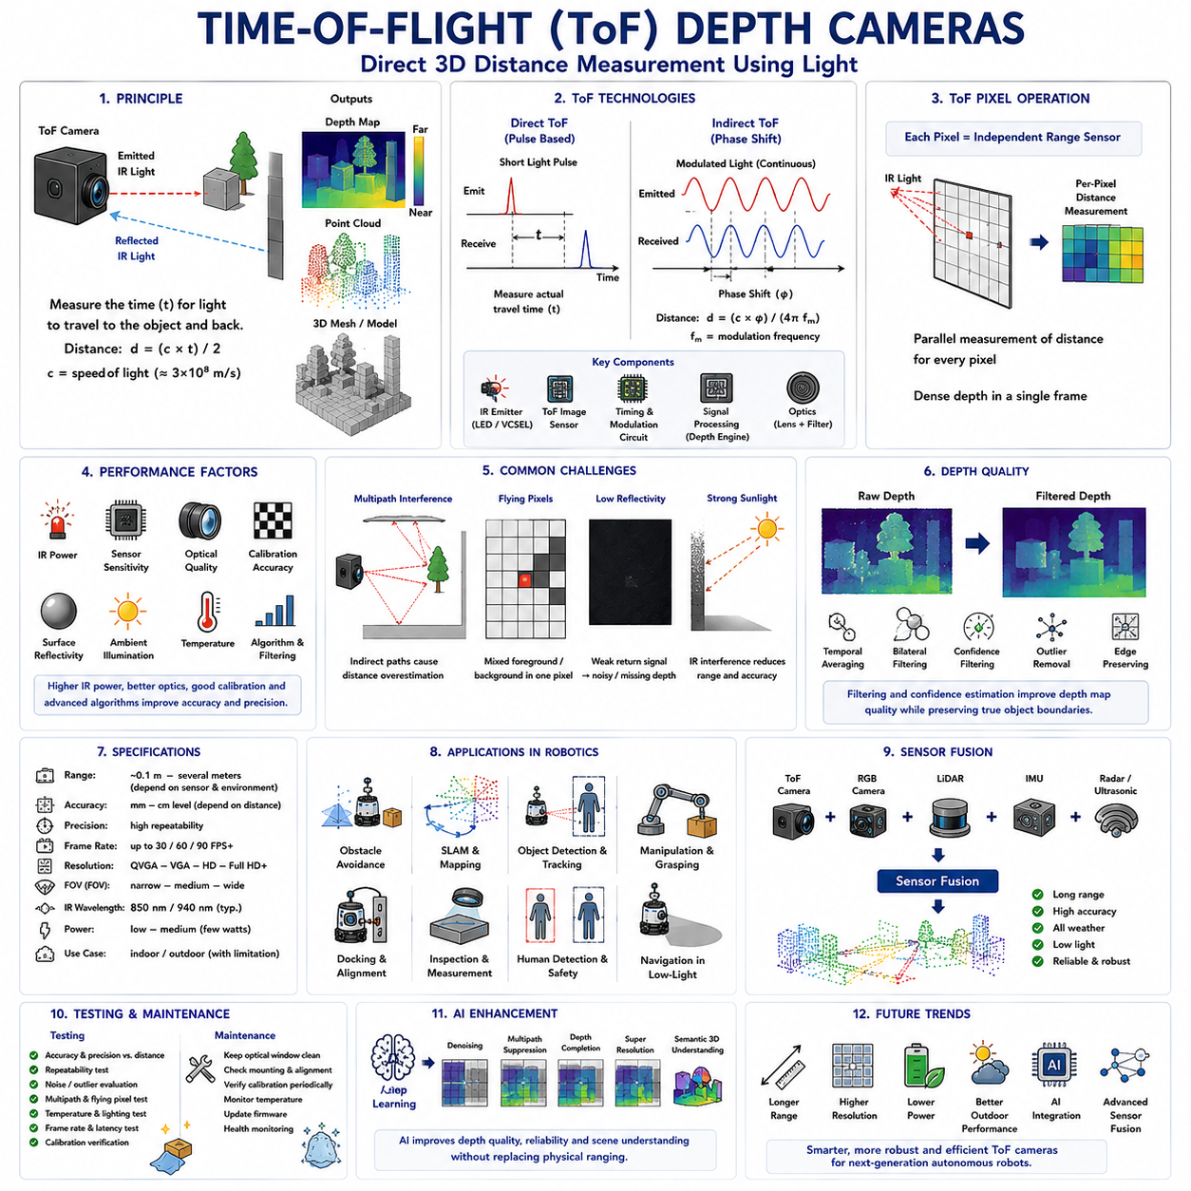
Time-of-Flight (ToF) depth cameras have become one of the most important three-dimensional perception sensors in modern Autonomous Mobile Robots (AMRs) because they directly measure the distance between the camera and surrounding objects using the physical propagation of light. Unlike stereo depth cameras that estimate distance through image correspondence or structured light systems that rely on projected pattern deformation, ToF cameras determine depth by measuring how long emitted infrared light takes to travel to an object and return to the sensor. This direct ranging principle enables rapid generation of dense depth maps with relatively low computational complexity. As robotic systems increasingly require real-time perception, obstacle avoidance, mapping, inspection, and human interaction, Time-of-Flight technology has emerged as an attractive solution for reliable short- and medium-range three-dimensional sensing.
The fundamental operating principle of a Time-of-Flight camera is based on the constant speed of light. The camera actively emits infrared light toward the environment and measures information associated with the reflected signal returning from surrounding surfaces. Since light travels at approximately three hundred million meters per second, the travel time between emission and reception can be converted into physical distance. Every image pixel independently estimates the distance to the observed point, allowing the camera to generate a complete depth image in a single acquisition cycle. Unlike conventional RGB cameras that capture only color information, ToF cameras directly produce dense geometric measurements describing the three-dimensional structure of the environment.
Although the basic principle appears straightforward, measuring extremely short light propagation times presents significant engineering challenges. Light requires only a few nanoseconds to travel several meters, making direct time measurement impractical using ordinary electronic circuits. Modern ToF cameras therefore employ specialized image sensors, high-speed modulation electronics, precise timing circuits, and advanced signal processing techniques to estimate these extremely small delays accurately. Rather than measuring time with ordinary clocks, many commercial systems determine distance indirectly through phase shift analysis or other modulation-based techniques that provide high precision while maintaining compact hardware suitable for robotic applications.
Time-of-Flight technology is generally divided into two primary categories: Direct Time-of-Flight and Indirect Time-of-Flight. Direct ToF attempts to measure the actual travel time of individual light pulses between the camera and observed objects. This approach resembles laser ranging systems and often supports longer measurement distances with excellent accuracy, although it requires extremely sophisticated timing electronics. Indirect ToF instead emits continuously modulated infrared light and measures the phase difference between transmitted and received signals. Because phase measurement is easier to implement with semiconductor image sensors, indirect ToF has become the dominant technology for compact depth cameras used in robotics, industrial automation, consumer electronics, and service robots.
Active infrared illumination distinguishes Time-of-Flight cameras from passive vision systems. The camera generates its own illumination independently of environmental lighting conditions, allowing reliable operation in dim indoor environments where conventional cameras may struggle. Infrared wavelengths remain invisible to human observers while providing sufficient reflected energy for distance estimation. Since illumination originates directly from the sensor, ToF cameras can acquire depth information even in scenes lacking natural texture or visible visual features. This capability makes them particularly valuable in warehouses, hospitals, laboratories, manufacturing facilities, and service environments where lighting conditions may vary significantly throughout normal operation.
Every pixel within a Time-of-Flight image sensor functions as an independent distance measurement device. Instead of recording only reflected light intensity, each pixel estimates the distance to its corresponding scene point using specialized electronic circuits integrated into the image sensor. Consequently, ToF cameras produce dense depth maps in which nearly every valid pixel contains a direct distance measurement. This parallel acquisition process enables rapid frame generation without requiring computationally expensive stereo correspondence or feature matching. Dense pixel-level ranging significantly benefits robotic perception because complete environmental geometry becomes immediately available for navigation, manipulation, mapping, and obstacle avoidance.
Depth information generated by ToF cameras is commonly represented as a depth map, where every image pixel stores the measured distance between the sensor and the observed surface. These depth values may subsequently be converted into three-dimensional coordinates using camera calibration parameters, producing point clouds suitable for robotic processing. Since every measurement originates directly from physical ranging rather than geometric inference, ToF depth maps often exhibit smooth and continuous spatial coverage across surfaces containing little visual texture. This characteristic distinguishes Time-of-Flight technology from stereo vision, which may struggle when correspondence cannot be established reliably.
Measurement range represents one of the most important performance characteristics of a ToF camera. Most compact robotic ToF sensors provide reliable operation over short and medium distances, typically extending from several centimeters to several meters depending upon illumination power, sensor sensitivity, optical design, and environmental conditions. Measurement accuracy generally decreases as distance increases because reflected optical energy weakens and signal-to-noise ratio declines. Different robotic applications therefore select ToF cameras according to operational workspace dimensions rather than attempting to maximize measurement range under every circumstance.
Measurement accuracy depends upon multiple interacting factors including infrared illumination power, receiver sensitivity, optical quality, electronic noise, calibration precision, object reflectivity, environmental illumination, and signal processing algorithms. Although ToF cameras directly measure distance, they remain susceptible to systematic and random measurement errors. Careful calibration compensates for fixed biases while filtering algorithms suppress random noise. Industrial robotic applications requiring precise manipulation or dimensional inspection frequently combine factory calibration with application-specific refinement to achieve optimal geometric performance throughout operational deployment.
Measurement precision describes the repeatability of repeated distance observations under identical conditions. High precision ensures that successive measurements vary only slightly, supporting stable localization, mapping, object tracking, and robotic manipulation. Sensor temperature, electronic noise, illumination stability, and signal integration time all influence measurement precision. Engineers therefore evaluate both accuracy and precision when selecting ToF cameras because repeatable measurements often prove equally important as absolute geometric correctness for many autonomous robotic functions.
Ambient illumination significantly influences Time-of-Flight performance despite the camera's active infrared projection. Strong sunlight contains substantial infrared energy that may interfere with emitted signals, reducing measurement reliability and limiting operating distance. Indoor environments generally present fewer interference problems because ambient infrared radiation remains comparatively weak. Outdoor deployment therefore requires careful sensor selection, optical filtering, adaptive exposure control, increased illumination power, and advanced signal processing capable of separating reflected measurement signals from background infrared interference.
Surface reflectivity strongly affects ranging quality because ToF cameras depend upon reflected infrared energy returning to the sensor. Bright diffuse surfaces typically produce strong reflections supporting accurate distance estimation. Highly absorptive dark materials reflect relatively little infrared energy, reducing measurement confidence. Highly reflective metallic surfaces may generate multiple reflection paths that distort measured distances, while transparent materials such as glass transmit infrared light instead of reflecting it efficiently. Engineers must therefore understand material optical characteristics when designing robotic systems intended for diverse industrial environments.
Multipath interference represents one of the most important challenges in Time-of-Flight sensing. Ideally, emitted infrared light travels directly from the camera to an object and immediately returns to the sensor. In practice, however, light may reflect from multiple surfaces before reaching the receiver. These indirect reflection paths increase effective travel distance, causing measured depth to exceed true object distance. Corners, narrow passages, reflective machinery, polished floors, and enclosed industrial spaces commonly produce multipath effects. Modern ToF cameras increasingly incorporate advanced signal processing algorithms capable of identifying and suppressing multipath-induced ranging errors.
Flying pixels constitute another characteristic artifact associated with Time-of-Flight imaging. These incorrect measurements frequently occur near object boundaries where individual sensor pixels simultaneously observe foreground and background surfaces. Mixed reflected signals produce intermediate distance estimates that correspond to no physical object. Flying pixels may also appear near thin structures, vegetation, mesh fences, or partially transparent materials. Spatial filtering, confidence estimation, temporal integration, and edge-aware processing reduce these artifacts while preserving genuine geometric discontinuities required for reliable robotic navigation.
Depth noise inevitably affects all ranging systems, including Time-of-Flight cameras. Electronic noise, photon statistics, thermal variation, environmental interference, and limited reflected signal strength introduce uncertainty into measured distances. Noise generally increases with measurement range because weaker reflected signals reduce estimation confidence. Various filtering techniques including temporal averaging, bilateral filtering, confidence-weighted smoothing, statistical outlier removal, and machine learning-based denoising improve depth quality while attempting to preserve sharp object boundaries essential for obstacle detection and manipulation.
Spatial resolution determines the density of depth measurements across the observed scene. Higher-resolution ToF cameras capture finer geometric detail, enabling detection of smaller obstacles, narrow openings, thin objects, and complex surface structures. However, increasing spatial resolution also increases sensor complexity, communication bandwidth, memory consumption, and computational requirements. Robotic designers therefore balance geometric detail against processing capability, energy consumption, frame rate, and overall system cost according to mission-specific operational requirements.
Frame rate represents another important advantage of Time-of-Flight technology. Since every pixel independently estimates depth without requiring stereo correspondence calculations, ToF cameras often generate dense depth images at relatively high acquisition frequencies. High frame rates improve obstacle tracking, dynamic environment perception, collision avoidance, and manipulation of moving objects. Rapid updates additionally reduce motion-induced perception latency, allowing autonomous robots to respond more quickly to environmental changes while maintaining stable navigation under continuously changing operational conditions.
Calibration remains essential despite the direct measurement principle employed by ToF cameras. Intrinsic calibration compensates for lens distortion, optical geometry, and sensor characteristics, while extrinsic calibration aligns the depth camera with RGB cameras, LiDAR sensors, inertial measurement units, robot coordinate frames, and manipulation systems. Temperature variation, mechanical vibration, structural deformation, and long-term component aging may gradually alter calibration parameters. Periodic verification therefore maintains measurement consistency throughout extended robotic deployment.
Time-of-Flight cameras integrate naturally with RGB cameras to create RGB-D perception systems. RGB images contribute semantic appearance, texture, and color information, while ToF sensors provide dense metric depth. Combining both sensing modalities enables object recognition together with precise three-dimensional localization. RGB-D data support obstacle detection, semantic segmentation, object tracking, manipulation planning, visual inspection, human recognition, and simultaneous localization and mapping. Many modern robotic software frameworks therefore treat RGB-D sensing as a unified perception modality rather than independent image and depth measurements.
Sensor fusion further enhances robustness by combining ToF measurements with complementary sensing technologies. LiDAR contributes long-range geometric information, stereo cameras provide passive outdoor depth estimation, radar maintains operation under adverse weather, ultrasonic sensors improve very short-range obstacle detection, and inertial sensors stabilize robot motion estimation. Fusion algorithms exploit the strengths of each modality while compensating for individual weaknesses. Consequently, ToF cameras frequently operate as one component within comprehensive multi-sensor perception architectures supporting reliable autonomous navigation across diverse operating environments.
Object detection and manipulation benefit substantially from Time-of-Flight sensing because object position, orientation, size, and surrounding free space become immediately available. Robots can estimate grasp locations, approach trajectories, docking alignment, pallet geometry, conveyor position, charging station interfaces, and inspection targets using dense depth information. Human-robot collaboration similarly improves because three-dimensional measurements enable safer monitoring of worker positions, motion, and separation distance. These capabilities extend beyond ordinary two-dimensional vision by incorporating accurate spatial understanding into every perception task.
Simultaneous Localization and Mapping also benefits from Time-of-Flight depth sensing. Dense geometric observations provide reliable environmental structure independent of visual texture, supporting localization within warehouses, offices, hospitals, laboratories, and manufacturing facilities. Point clouds generated from ToF depth maps contribute to occupancy grids, surface reconstruction, loop closure verification, and digital twin generation. Although LiDAR often provides longer-range mapping capability, Time-of-Flight cameras offer dense local geometry that complements other perception sensors and improves environmental understanding during close-range robotic operation.
Testing Time-of-Flight cameras involves evaluating depth accuracy, precision, repeatability, frame rate, latency, spatial resolution, calibration stability, multipath susceptibility, flying pixel occurrence, temperature dependence, and environmental robustness. Engineers verify performance across different distances, surface materials, lighting conditions, operating temperatures, and robot motion profiles. Controlled calibration targets together with representative industrial objects ensure that laboratory measurements accurately predict field performance. Long-duration testing further reveals gradual drift, synchronization problems, electronic instability, or thermal effects that may not appear during short evaluations.
Routine maintenance focuses upon preserving optical cleanliness, mechanical stability, calibration integrity, firmware consistency, and thermal management. Protective windows should remain free of dust, oil, water droplets, scratches, and contamination because infrared transmission directly influences measurement quality. Mounting brackets, electrical connectors, synchronization interfaces, cooling systems, and calibration parameters require periodic inspection throughout the operational lifetime of the robot. Predictive maintenance increasingly monitors sensor temperature, confidence statistics, noise levels, and depth quality automatically, allowing developing faults to be detected before significant perception degradation occurs.
Artificial intelligence is increasingly enhancing Time-of-Flight perception by reducing noise, correcting multipath interference, estimating confidence, filling missing depth regions, improving spatial resolution, and integrating geometric information with semantic scene understanding. Deep learning models analyze raw ToF measurements together with RGB images to generate cleaner point clouds, more reliable object boundaries, and improved three-dimensional segmentation. Rather than replacing physical ranging technology, artificial intelligence complements it by extracting richer environmental understanding while improving robustness under challenging sensing conditions.
The future of Time-of-Flight depth cameras will emphasize longer sensing range, higher spatial resolution, lower power consumption, improved outdoor performance, faster frame rates, reduced multipath artifacts, integrated artificial intelligence, and tighter sensor fusion. Next-generation systems will dynamically optimize illumination power, modulation frequency, exposure time, and signal processing according to environmental conditions while simultaneously estimating measurement uncertainty. As autonomous mobile robots expand into increasingly demanding industrial, commercial, medical, agricultural, and public environments, Time-of-Flight cameras will remain indispensable perception sensors capable of providing dense, real-time, three-dimensional environmental understanding essential for safe, intelligent, and highly autonomous robotic operation.

05.4 Structured Light Cameras
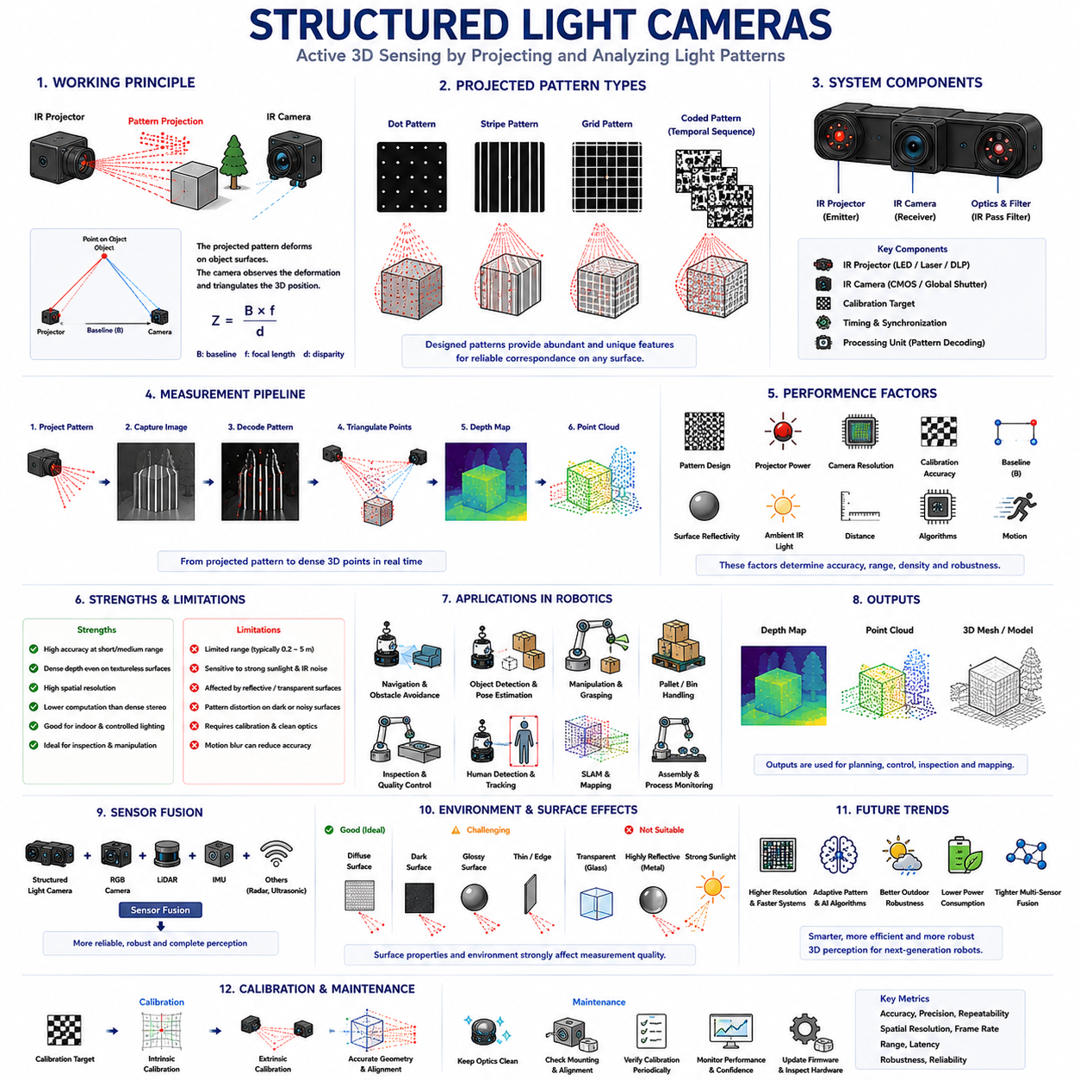
Structured Light cameras represent one of the earliest commercially successful active three-dimensional sensing technologies and remain widely used in robotics, industrial automation, medical imaging, and consumer electronics. Unlike conventional RGB cameras that capture only color information or stereo vision systems that rely solely on passive image correspondence, Structured Light cameras actively project a known optical pattern onto the surrounding environment and analyze how that pattern deforms across object surfaces. The deformation directly reflects the three-dimensional geometry of the scene, allowing the camera to estimate object distance with high accuracy. For Autonomous Mobile Robots (AMRs), Structured Light cameras provide dense depth information that supports navigation, manipulation, obstacle avoidance, inspection, human detection, and environmental reconstruction in controlled indoor environments.
The fundamental principle of Structured Light is based on geometric triangulation. The system consists of an infrared projector and one or more infrared cameras positioned at precisely known locations. Instead of illuminating the environment uniformly, the projector emits a carefully designed pattern composed of dots, stripes, grids, or coded textures. When this pattern strikes three-dimensional objects, its shape changes according to surface geometry. The camera observes the deformed pattern and compares it with the original projected pattern. Because the relative positions of the projector and camera are precisely calibrated, every observed deformation can be converted into an accurate three-dimensional distance measurement.
Unlike stereo vision, which searches for corresponding natural image features between two cameras, Structured Light creates artificial visual features that are always available regardless of surface texture. This capability significantly improves depth estimation on smooth walls, plain floors, cardboard boxes, painted surfaces, and other objects that contain few naturally distinguishable image features. Since the projected pattern provides abundant correspondence points, the camera can estimate depth even when the visible appearance lacks sufficient texture for conventional stereo matching. This characteristic makes Structured Light particularly attractive for indoor robotic applications where uniform surfaces frequently dominate the environment.
The projected pattern forms the core of the Structured Light measurement process. Various projection strategies have been developed depending upon application requirements. Dot projection generates thousands of infrared points distributed across the field of view, creating numerous correspondence locations for triangulation. Stripe projection emits parallel or coded lines that deform continuously across object surfaces. Grid projection produces intersecting horizontal and vertical structures, while coded binary patterns sequentially project multiple images containing unique spatial information. Each projection method balances measurement density, computational complexity, acquisition speed, and robustness under different environmental conditions.
Pattern design plays a significant role in measurement performance. Ideally, every projected feature should possess sufficient uniqueness to avoid ambiguity during correspondence analysis. If multiple projected features appear identical, the camera may incorrectly associate observed features with the wrong projected locations, producing depth errors. Consequently, structured patterns often incorporate pseudo-random distributions, coded sequences, varying spatial frequencies, or mathematically optimized arrangements that maximize uniqueness while preserving optical efficiency. Advances in projection pattern design have substantially improved measurement accuracy and robustness over successive generations of Structured Light systems.
Depth estimation relies upon triangulation rather than direct distance measurement. The projector and camera observe the same projected feature from different viewpoints. The apparent displacement between projected and observed feature locations depends upon object distance. Since the baseline separating projector and camera remains fixed and calibration parameters are known, geometric triangulation calculates the three-dimensional coordinates of every observed point. This principle resembles stereo vision mathematically, but the correspondence problem becomes substantially easier because the projected pattern provides intentionally designed visual features rather than relying on unpredictable natural image texture.
Calibration represents one of the most critical aspects of Structured Light systems. Intrinsic calibration estimates optical characteristics including focal length, principal point, lens distortion, and pixel geometry for both the camera and projector. Unlike ordinary cameras, the projector must also be treated as an inverse imaging device possessing its own virtual optical model. Extrinsic calibration determines the precise spatial relationship between projector and camera coordinate systems. Small calibration errors directly propagate into depth estimation, reducing measurement accuracy and introducing systematic geometric distortion throughout reconstructed three-dimensional scenes.
Image acquisition occurs simultaneously with infrared pattern projection. The infrared-sensitive camera captures both reflected illumination intensity and projected feature positions. Ambient visible lighting generally has minimal influence because optical filters reject most wavelengths outside the infrared spectrum. However, other infrared sources, particularly sunlight, may significantly interfere with projected patterns. Therefore, Structured Light systems typically perform best indoors where environmental infrared interference remains relatively low. Controlled illumination conditions substantially improve measurement reliability, repeatability, and depth accuracy.
Pattern decoding converts captured infrared images into geometric information. The system identifies individual projected features, determines their corresponding locations within the original projection pattern, and calculates disparity between projected and observed positions. Advanced decoding algorithms incorporate error detection, confidence estimation, spatial consistency verification, and sub-pixel localization to improve depth precision. Since correspondence derives from intentionally generated optical features, computational complexity generally remains lower than dense stereo matching while providing comparable or superior measurement density within suitable operating environments.
Depth maps generated by Structured Light cameras typically contain dense geometric information covering most visible surfaces. Every successfully decoded projected feature contributes a distance estimate, producing high-resolution representations of environmental geometry. These depth maps may subsequently transform into point clouds, surface meshes, occupancy maps, or three-dimensional object models suitable for robotic processing. Because measurement density remains relatively uniform across textured and textureless regions alike, Structured Light frequently produces smoother depth coverage than passive stereo systems operating under identical indoor conditions.
Measurement accuracy depends upon multiple factors including projector quality, camera resolution, optical alignment, calibration precision, projection pattern design, ambient illumination, surface reflectivity, object distance, and decoding algorithm performance. Structured Light generally provides excellent accuracy at short and medium ranges because projected feature displacement remains sufficiently large for precise triangulation. As measurement distance increases, projected patterns become less distinct, reducing correspondence precision and ultimately limiting practical sensing range compared with some alternative ranging technologies.
Measurement range constitutes one of the principal limitations of Structured Light technology. Since projected infrared illumination spreads across increasing surface area as distance grows, reflected signal intensity decreases rapidly. Simultaneously, projected feature size increases while apparent deformation diminishes, reducing triangulation sensitivity. Most commercial Structured Light cameras therefore operate optimally within relatively short indoor distances appropriate for manipulation, inspection, human interaction, and mobile robot navigation. Long-range outdoor perception generally requires complementary sensing technologies better suited for extended operating distances.
Surface properties strongly influence Structured Light performance. Diffuse surfaces reflect projected patterns uniformly, supporting accurate feature detection and reliable triangulation. Highly reflective metallic objects produce specular reflections that distort projected features and introduce decoding ambiguity. Transparent materials transmit rather than reflect infrared illumination, preventing reliable pattern observation. Dark absorptive surfaces reduce reflected optical energy, lowering measurement confidence. Curved surfaces, thin structures, and highly complex geometries additionally alter projected patterns in ways that challenge correspondence algorithms. Successful robotic deployment therefore requires understanding material-dependent sensing limitations.
Ambient environmental conditions significantly affect measurement quality. Strong sunlight contains substantial infrared radiation capable of overwhelming projected patterns, making outdoor operation particularly challenging. Dust, smoke, fog, and airborne particles scatter infrared illumination, reducing projected feature contrast. Water droplets and reflective industrial contaminants introduce additional optical interference. Indoor environments generally provide much more favorable operating conditions because artificial lighting contributes relatively little competing infrared energy. Consequently, Structured Light has become especially popular for warehouses, hospitals, laboratories, factories, logistics centers, and collaborative robotic workspaces.
Motion introduces another practical consideration. Because many Structured Light systems require projection and image capture within finite exposure intervals, rapid robot motion or fast-moving objects may distort projected feature locations. Motion blur reduces decoding accuracy, particularly when exposure times become relatively long under weak illumination. Some advanced systems employ higher projection power, faster image sensors, shorter exposures, or temporal compensation algorithms to minimize motion-induced measurement errors. Nevertheless, extremely dynamic environments remain more challenging than relatively static scenes typically encountered during industrial inspection or manipulation tasks.
Spatial resolution represents one of Structured Light's significant advantages. Modern projectors generate thousands or millions of projected features distributed across the observed scene, producing dense depth measurements capable of representing fine geometric detail. High spatial resolution supports detection of small objects, narrow obstacles, surface defects, dimensional variation, and subtle geometric discontinuities. Such detail proves valuable for robotic inspection, quality control, object recognition, precision manipulation, and digital twin generation where accurate surface representation directly influences task performance.
Frame rate depends upon projection strategy and processing architecture. Systems projecting single static patterns generally achieve higher acquisition frequencies suitable for real-time robotics. Sequential coded-pattern approaches often require multiple projected images, increasing measurement accuracy but reducing temporal resolution. Engineers therefore balance acquisition speed against depth quality according to application requirements. Mobile robots navigating dynamic environments prioritize higher frame rates, whereas industrial dimensional inspection may accept slower acquisition in exchange for improved geometric precision.
Structured Light cameras integrate naturally with RGB cameras to create RGB-D sensing systems. RGB images contribute color, texture, semantic appearance, and object recognition capability, while Structured Light supplies dense metric geometry. Combining both information sources enables robots to identify objects while simultaneously determining their precise three-dimensional position, orientation, dimensions, and surrounding free space. RGB-D perception supports navigation, manipulation, inventory management, quality inspection, pallet handling, human detection, gesture recognition, and simultaneous localization and mapping throughout diverse robotic applications.
Sensor fusion further expands Structured Light capability. LiDAR contributes long-range geometry, stereo vision provides passive outdoor depth estimation, Time-of-Flight cameras offer alternative active ranging, radar improves adverse-weather robustness, and inertial sensors stabilize motion estimation. Structured Light complements these technologies by providing exceptionally dense short-range geometry under favorable indoor conditions. Multi-sensor fusion algorithms combine complementary strengths while reducing individual sensor weaknesses, producing more reliable perception than any single sensing modality alone.
Robotic manipulation benefits substantially from Structured Light sensing because dense three-dimensional geometry accurately describes graspable objects and surrounding workspace structure. Robots estimate object pose, surface orientation, grasp candidates, collision-free approach paths, and placement locations directly from reconstructed point clouds. Assembly automation, bin picking, machine tending, pallet handling, and service robotics all exploit high-density depth information to improve manipulation reliability. Human-robot collaboration similarly benefits because precise three-dimensional monitoring enhances worker safety while enabling more natural interactive behavior.
Inspection and metrology represent additional application domains where Structured Light excels. High-resolution surface measurements allow robots to detect manufacturing defects, dimensional deviations, assembly errors, deformation, wear, cracks, scratches, and missing components. Since depth measurements derive from dense projected features rather than sparse sampling, fine geometric variations become easier to identify. Industrial quality assurance increasingly integrates Structured Light sensors into automated inspection stations requiring accurate three-dimensional measurement without physical contact.
Testing Structured Light cameras involves evaluating measurement accuracy, precision, calibration stability, frame rate, spatial resolution, environmental robustness, pattern decoding reliability, synchronization, optical alignment, and material-dependent performance. Engineers examine operation across varying distances, surface textures, reflectivity, lighting conditions, temperatures, vibration levels, and robot motion profiles. Controlled calibration targets together with representative industrial objects provide quantitative benchmarks supporting reliable system validation before field deployment.
Routine maintenance emphasizes optical cleanliness and calibration preservation. Dust, oil, fingerprints, scratches, and protective window contamination reduce projected pattern visibility, degrading decoding accuracy. Projector optics, camera lenses, mounting structures, synchronization electronics, firmware versions, and calibration parameters require periodic inspection throughout the operational lifetime of the robotic system. Predictive maintenance increasingly monitors projected pattern quality, depth confidence, geometric consistency, optical alignment, and electronic health automatically, allowing gradual degradation to be identified before operational performance becomes unacceptable.
Artificial intelligence increasingly enhances Structured Light perception by improving pattern decoding, removing noise, estimating confidence, reconstructing missing depth regions, correcting optical artifacts, and integrating semantic understanding with geometric reconstruction. Deep learning algorithms combine RGB appearance with structured depth measurements to generate cleaner point clouds, improved object segmentation, and more reliable environmental interpretation. Rather than replacing the underlying triangulation principle, artificial intelligence strengthens measurement robustness while extracting increasingly meaningful three-dimensional information from captured sensor data.
The future of Structured Light cameras will emphasize higher projection efficiency, improved outdoor robustness, increased spatial resolution, lower power consumption, faster projection technology, integrated artificial intelligence, adaptive pattern generation, and tighter multi-sensor fusion. Future systems will dynamically modify projected patterns according to environmental conditions, automatically estimate measurement uncertainty, optimize decoding strategies in real time, and cooperate intelligently with complementary perception sensors. As Autonomous Mobile Robots continue expanding across manufacturing, logistics, healthcare, retail, laboratories, and service industries, Structured Light cameras will remain highly valuable short-range three-dimensional sensors capable of delivering dense, accurate, and reliable geometric perception for increasingly intelligent robotic systems.

05.5 Depth Map and Point Cloud Generation
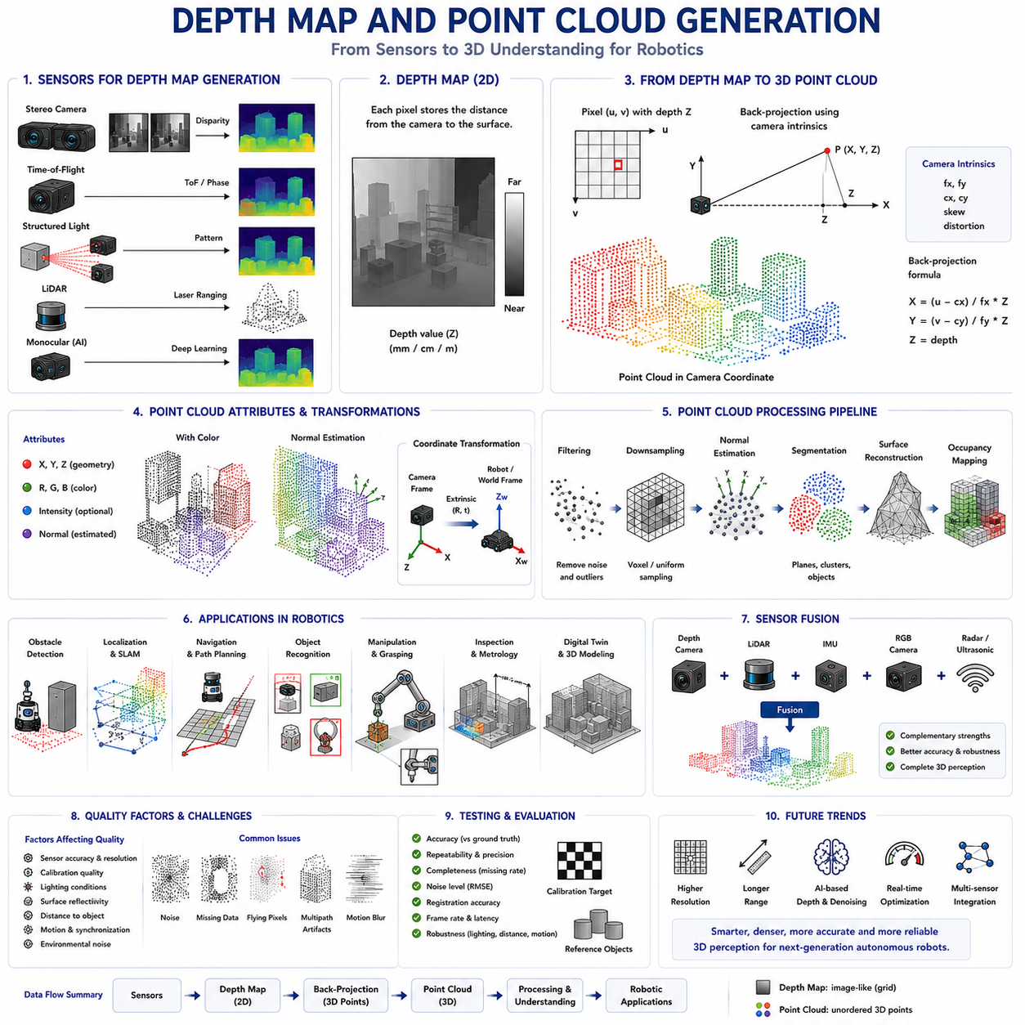
Depth maps and point clouds are two of the most fundamental three-dimensional data representations used in modern robotics, autonomous driving, computer vision, and digital twins. Although they represent the same physical environment, they organize spatial information in different forms optimized for different computational tasks. A depth map stores the distance between the camera and visible surfaces in an image-like structure, while a point cloud represents the environment as a collection of three-dimensional coordinates distributed throughout space. Together, these two representations form the foundation of perception pipelines in Autonomous Mobile Robots (AMRs), enabling obstacle detection, localization, mapping, object recognition, manipulation, navigation, and environmental reconstruction. Understanding how depth maps are generated and transformed into point clouds is essential for designing reliable robotic perception systems.
A depth map is essentially a two-dimensional image in which every pixel contains a measured or estimated distance rather than color intensity. Unlike ordinary RGB images, whose pixel values represent red, green, and blue color components, depth maps assign each pixel a numerical value corresponding to the distance from the camera to the observed surface. Depending on the sensor, these values may represent millimeters, centimeters, or meters. Since every image pixel corresponds to a viewing direction determined by the camera optics, the depth value allows each observed location to be positioned within three-dimensional space. The depth map therefore serves as an intermediate representation that connects conventional image processing with geometric spatial understanding.
Depth maps can be generated using several sensing technologies. Stereo cameras estimate depth through triangulation after matching corresponding image features between two viewpoints. Time-of-Flight cameras directly measure the travel time or phase shift of emitted infrared light reflected from surrounding objects. Structured Light systems project known infrared patterns and calculate depth from pattern deformation. LiDAR sensors measure distance using laser ranging, while monocular depth estimation uses deep learning to infer approximate distance from a single RGB image. Although these technologies differ significantly in measurement principles, they ultimately produce depth maps that can be processed using similar geometric algorithms.
The quality of a depth map depends upon measurement accuracy, spatial resolution, temporal stability, noise characteristics, and environmental conditions. High-quality depth maps contain dense and reliable measurements covering nearly every visible surface with minimal missing regions. Low-quality depth maps may contain noise, invalid pixels, missing depth values, flying pixels, multipath artifacts, or measurement discontinuities caused by sensor limitations. The characteristics of the generated depth map strongly influence every subsequent stage of robotic perception, making sensor selection, calibration, filtering, and validation essential parts of system design.
Each pixel within a depth map possesses a unique relationship with the camera coordinate system. Camera calibration determines the intrinsic parameters describing focal length, principal point, pixel size, and optical distortion. Using these parameters together with the measured depth value, every image pixel can be transformed into an exact three-dimensional coordinate relative to the camera. This geometric conversion forms the mathematical bridge between image space and physical space. Rather than representing only image coordinates, every valid pixel becomes an observable point occupying a precise location in the surrounding environment.
Point cloud generation begins by projecting every valid depth pixel into three-dimensional coordinates. Each point is represented by its X, Y, and Z position relative to the camera reference frame. X and Y describe horizontal and vertical position, while Z represents distance along the viewing direction. Because this conversion is applied independently to every pixel, the resulting point cloud forms a dense spatial sampling of all visible surfaces. Unlike image representations constrained by pixel grids, point clouds exist directly within physical three-dimensional space, allowing geometric reasoning independent of camera viewpoint.
Point clouds provide a flexible representation suitable for many robotic applications because they preserve true spatial geometry. Distances, angles, surface orientation, object dimensions, free space, and obstacle relationships can all be calculated directly from point coordinates. Since points are represented independently rather than connected through predefined image neighborhoods, point clouds naturally support transformations between coordinate systems, multi-sensor registration, environmental reconstruction, and long-term mapping. Their geometric flexibility makes them one of the most widely used data structures in robotic perception.
Color information can also be associated with point clouds. When depth maps are synchronized with RGB images, every three-dimensional point inherits the corresponding color values from the camera image. The resulting RGB point cloud combines geometric coordinates with visual appearance, enabling semantic interpretation together with spatial reasoning. Colored point clouds improve object recognition, scene visualization, inspection, digital twins, and human interpretation because geometric structure and visual texture remain aligned within the same representation.
Coordinate transformation plays a central role after point cloud generation. Initially, all points exist within the local coordinate frame of the depth camera. Robotic applications frequently require transformation into the robot coordinate system, manipulator frame, LiDAR frame, inertial measurement frame, map frame, or global navigation frame. These transformations use extrinsic calibration parameters describing relative sensor positions and orientations. Accurate coordinate transformations allow information collected by multiple sensors to contribute consistently to a unified spatial model of the environment.
Point cloud density depends primarily upon sensor resolution, field of view, object distance, and measurement technology. High-resolution depth sensors produce dense point clouds capable of representing small objects and fine geometric detail. Lower-resolution sensors generate sparser clouds that reduce computational requirements while sacrificing geometric precision. Point density also decreases naturally with increasing distance because individual pixels represent progressively larger physical surface areas. Engineers therefore select sensing hardware according to required geometric detail, processing capability, operational range, and robotic task complexity.
Point cloud quality is influenced by numerous measurement errors. Electronic noise introduces random position variation, while calibration errors create systematic geometric distortion. Motion blur, rolling shutter artifacts, synchronization errors, optical interference, multipath reflections, and environmental conditions further degrade spatial accuracy. Invalid depth measurements produce missing regions, whereas flying pixels create false geometry near object boundaries. Understanding these error sources is essential because robotic decision-making depends directly upon the reliability of perceived environmental structure.
Filtering represents an important preprocessing stage before point clouds are used by higher-level algorithms. Statistical filters remove isolated outlier points inconsistent with neighboring geometry. Radius filters eliminate sparse measurements lacking sufficient local support. Voxel grid filtering reduces point density by replacing multiple neighboring points with representative samples while preserving overall shape. Bilateral filtering smooths measurement noise while maintaining sharp geometric boundaries. Proper filtering improves computational efficiency, increases geometric consistency, and reduces perception errors without significantly degrading meaningful environmental information.
Downsampling is frequently required because modern depth sensors generate hundreds of thousands or even millions of points every second. Processing every point individually may exceed the computational capability of embedded robotic hardware. Voxel-based downsampling partitions three-dimensional space into small cubes and replaces all contained points with a representative point. This process preserves large-scale geometry while significantly reducing memory consumption, processing time, and communication bandwidth. Appropriate downsampling allows real-time robotic perception without unnecessary computational expense.
Normal estimation extends point cloud information beyond simple position coordinates. Surface normals describe the local orientation of surrounding geometry by analyzing neighboring point distributions. Normal vectors enable robots to distinguish flat surfaces from edges, corners, curved objects, and complex structures. Many higher-level algorithms including object segmentation, surface reconstruction, grasp planning, terrain analysis, and registration rely upon accurate normal estimation. Consequently, surface orientation represents an important geometric feature derived directly from point cloud neighborhoods.
Segmentation divides point clouds into meaningful geometric regions representing individual objects, surfaces, or environmental structures. Plane segmentation identifies floors, walls, tables, and other flat surfaces. Cluster extraction groups neighboring points belonging to the same physical object. Region-growing algorithms expand segments according to local geometric similarity. More advanced semantic segmentation combines geometric information with artificial intelligence to classify points according to object categories such as pedestrians, vehicles, pallets, shelves, machines, vegetation, or structural components. Segmentation transforms raw geometry into interpretable environmental knowledge.
Registration aligns multiple point clouds collected from different viewpoints or at different times into a common coordinate system. Robots continuously acquire depth data while moving through the environment. Registration algorithms estimate relative sensor motion by identifying corresponding geometric structures between successive point clouds. Iterative Closest Point, feature-based registration, and learning-based registration methods progressively construct large-scale environmental models from overlapping local observations. Registration therefore forms one of the core computational foundations of Simultaneous Localization and Mapping.
Surface reconstruction converts discrete point clouds into continuous geometric models representing environmental surfaces. Triangular meshes connect neighboring points into polygonal structures suitable for visualization, simulation, collision detection, digital twins, and manufacturing inspection. Surface reconstruction additionally fills small measurement gaps while preserving overall geometry. Depending upon application requirements, reconstruction algorithms balance geometric accuracy, computational complexity, smoothness, and robustness against measurement noise. Continuous surface models often simplify downstream robotic planning compared with unstructured point collections.
Occupancy mapping transforms point clouds into spatial representations describing free space and obstacles. Individual points indicate observed surfaces, while empty regions between the sensor and measured points represent traversable space. Occupancy grids discretize the environment into cells classified as occupied, free, or unknown. Three-dimensional voxel maps extend this representation into volumetric space. Navigation planners use occupancy information to generate collision-free paths while continuously updating environmental knowledge as new depth observations become available during robot operation.
Object detection benefits substantially from point cloud geometry because physical dimensions, orientation, and spatial position become directly measurable. Three-dimensional bounding boxes accurately describe obstacle extent, supporting safer navigation than image-based detection alone. Robots distinguish overlapping objects according to physical separation rather than visual appearance alone. Manipulation systems estimate grasp locations directly from reconstructed geometry. Industrial inspection measures dimensional tolerances using actual three-dimensional coordinates rather than two-dimensional image projections. Point cloud geometry therefore enhances numerous robotic perception capabilities beyond conventional image analysis.
Sensor fusion significantly improves depth perception reliability. RGB cameras contribute semantic appearance, LiDAR provides long-range geometry, radar maintains operation under adverse weather, ultrasonic sensors detect nearby obstacles, and inertial sensors estimate robot motion. Point clouds generated from depth cameras complement these sensing modalities by supplying dense local geometry. Fusion algorithms transform all observations into common coordinate systems where complementary measurements reinforce one another while compensating for individual sensor limitations. Multi-sensor point cloud fusion increasingly defines state-of-the-art robotic perception architectures.
Artificial intelligence has dramatically expanded point cloud processing capabilities. Deep neural networks directly analyze three-dimensional point distributions for classification, segmentation, object detection, pose estimation, scene understanding, completion, denoising, and registration. Architectures specifically designed for unordered point sets preserve geometric relationships without requiring conversion into conventional image representations. Learning-based methods increasingly outperform traditional handcrafted algorithms under complex environmental conditions while simultaneously extracting richer semantic understanding from geometric observations.
Computational efficiency remains one of the greatest challenges associated with point cloud processing. Dense three-dimensional data consume substantial memory, communication bandwidth, and processor resources. Real-time autonomous robots therefore employ optimized spatial indexing structures such as KD-trees, octrees, voxel hierarchies, and hash-based representations to accelerate neighborhood searches and geometric computation. Parallel processing using Graphics Processing Units and dedicated AI accelerators further enables real-time perception despite continuously increasing sensor resolution and environmental complexity.
Testing depth map generation requires evaluating measurement accuracy, repeatability, spatial consistency, temporal stability, missing pixel ratio, noise level, calibration quality, latency, synchronization, and robustness under representative environmental conditions. Point cloud evaluation extends these metrics by measuring registration accuracy, geometric distortion, surface reconstruction quality, segmentation reliability, and mapping consistency. Engineers verify performance using calibrated reference objects, precision measurement equipment, controlled laboratory environments, and realistic operational scenarios to ensure reliable perception throughout the robot's intended deployment conditions.
Routine maintenance focuses upon preserving sensor calibration, optical cleanliness, synchronization accuracy, firmware integrity, and mechanical stability. Lens contamination, protective window damage, thermal drift, vibration, connector degradation, and mounting displacement gradually reduce geometric accuracy if left uncorrected. Continuous monitoring of point cloud density, depth confidence, calibration error, registration quality, and environmental consistency enables predictive maintenance strategies capable of identifying developing sensor faults before they significantly degrade autonomous operation.
Future developments in depth map and point cloud generation will emphasize higher sensor resolution, improved depth accuracy, longer sensing range, reduced power consumption, intelligent adaptive filtering, tighter multi-sensor integration, and increasingly powerful artificial intelligence. Future perception systems will automatically estimate measurement uncertainty, dynamically optimize sensing parameters, reconstruct complete environments from incomplete observations, and continuously fuse information collected across multiple sensing modalities. As Autonomous Mobile Robots become increasingly intelligent and autonomous, depth maps and point clouds will remain the primary geometric representations supporting safe navigation, accurate manipulation, reliable environmental understanding, and robust decision-making across virtually every robotic application.

05.6 Near Field Object Detection
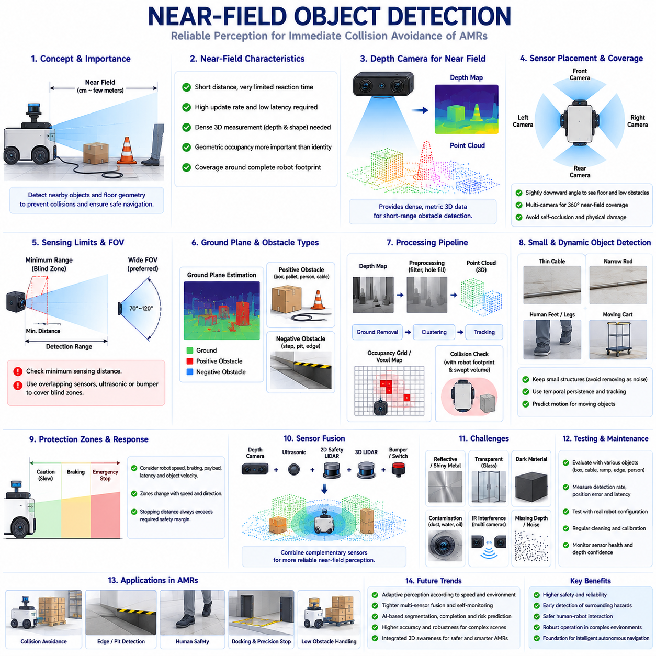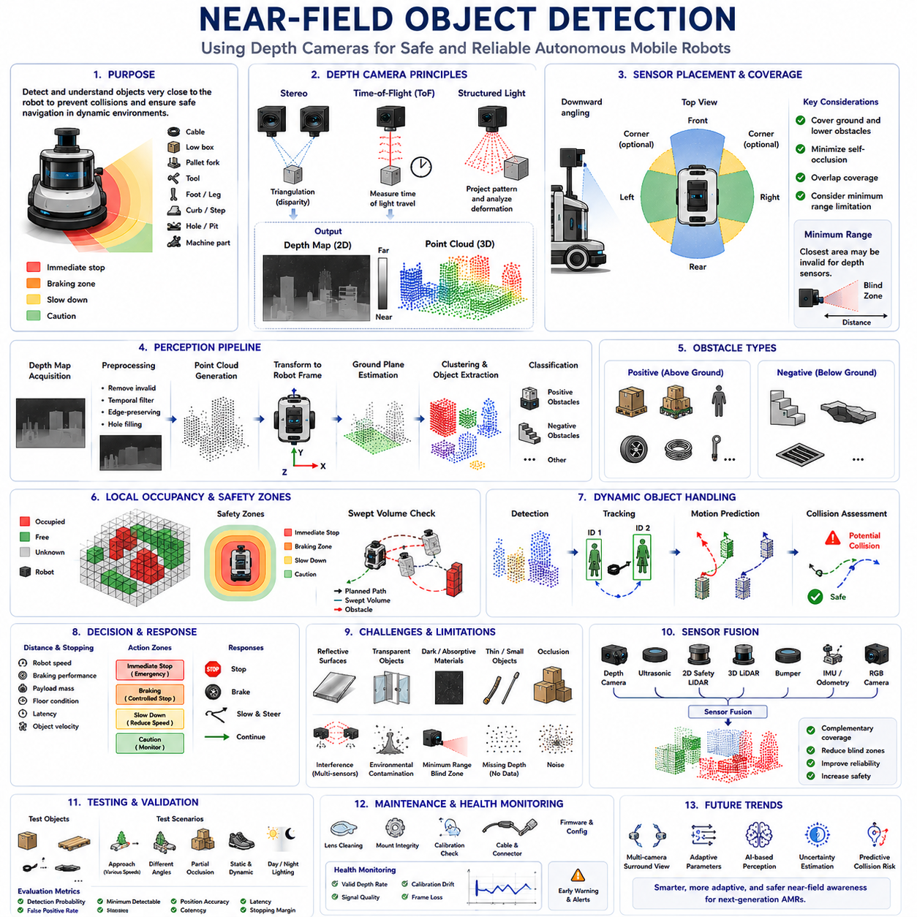
Near-field object detection is a critical perception function for Autonomous Mobile Robots because many of the most hazardous objects appear within the short distance immediately surrounding the platform. Cables, pallet forks, dropped tools, low boxes, feet, curbs, floor openings, trailer components, and projecting machine structures may remain invisible to sensors designed mainly for medium- or long-range observation. Depth cameras are especially valuable in this region because they provide dense three-dimensional measurements rather than a single scanning plane. By reconstructing nearby geometry, an AMR can determine whether an object occupies its path, estimate its size and position, and select an appropriate response before contact occurs. Within the depth-camera chapter structure, this function connects depth-map generation with practical collision avoidance and local environmental understanding.
The near field does not have one universal distance definition because its practical boundary depends on robot size, speed, braking capability, sensor mounting, and operational environment. For a compact indoor AMR, it may refer to the region extending from several centimeters to a few meters around the chassis. For a larger or faster platform, the functional near field may extend farther because a greater stopping distance is required. The most important feature of this region is not its exact numerical range but the limited reaction time available after an object is detected. Near-field perception must therefore operate with low latency, high update frequency, dependable coverage, and clearly defined confidence so that motion control can respond immediately.
Near-field detection differs from ordinary long-range object recognition because geometric occupancy is often more important than semantic identity. A robot does not always need to know whether a nearby obstruction is a wrench, cable bundle, shoe, or piece of packaging before avoiding it. It first needs to determine whether physical matter occupies the planned swept path of the vehicle. Semantic classification remains useful for predicting behavior and selecting specialized responses, but immediate collision prevention depends primarily on reliable distance, height, width, and location measurements. Depth cameras support this requirement by producing dense depth maps and point clouds that represent the shape of nearby surfaces in metric three-dimensional space.
Sensor placement has a decisive influence on near-field performance. A camera mounted high on the robot can observe a broad area but may fail to see the region immediately beside the chassis because the robot body creates self-occlusion. A camera mounted too low may provide excellent ground visibility but become easily contaminated, damaged, or blocked by nearby structures. Engineers commonly angle depth cameras downward so that their field of view covers the ground plane, frontal approach area, and lower portions of nearby obstacles. Multiple cameras may be installed at the front, rear, sides, or corners to create overlapping coverage around the complete robot footprint.
The minimum sensing distance of a depth camera must be carefully considered. Stereo, Time-of-Flight, and Structured Light cameras cannot always measure objects located directly against the protective window. Optical geometry, emitter-receiver separation, signal saturation, or insufficient disparity may create an invalid region close to the sensor. If this minimum range overlaps the physical area that the robot could contact, an undetected blind zone remains. Designers address this problem through sensor positioning, overlapping depth-camera coverage, ultrasonic sensors, bumpers, contact switches, or mechanical structures that prevent objects from entering an unobserved hazardous region.
Field of view determines how much of the surrounding area can be monitored simultaneously. Wide-angle depth cameras provide broad coverage and reduce the number of sensors required, but individual pixels then represent larger physical areas and may provide less geometric detail. Narrower fields of view concentrate resolution within smaller regions but create larger blind areas around the platform. Near-field object detection generally favors wide horizontal and vertical coverage because objects may enter from many directions or remain close to the floor. The final design must balance coverage, resolution, optical distortion, computational load, and the number of cameras that can be integrated into the robot.
Ground-plane estimation is one of the first processing stages in near-field detection. The robot must distinguish normal floor surfaces from obstacles protruding above them and from depressions extending below them. Depth points belonging to the floor can be identified through plane fitting, geometric models, or learned segmentation. Once the ground surface is estimated, the system measures the relative height of surrounding points. Objects exceeding a configured height threshold are classified as potential positive obstacles, while sudden absence or downward displacement of expected floor measurements may indicate a negative obstacle such as a step, pit, drainage channel, or loading-dock edge.
Positive obstacle detection focuses on physical structures rising above the traversable surface. Examples include pallets, boxes, people, wheels, tools, support legs, cables, and low machine components. The processing pipeline transforms depth data into the robot coordinate frame, removes points belonging to the robot body, estimates the ground surface, and groups remaining points into geometric clusters. Each cluster can then be evaluated according to distance, height, width, volume, and location relative to the planned vehicle path. Even small obstacles may require avoidance if they could damage wheels, destabilize the platform, interfere with payloads, or create unsafe contact.
Negative obstacles are more difficult because they are represented by missing or downward-shifted surface geometry rather than directly visible solid objects. Steps, holes, ditches, platform edges, ramps, and open elevator thresholds may create severe hazards for mobile robots. A downward-looking depth camera can observe changes in floor height and identify discontinuities before the wheels reach them. However, reflective floors, poor viewing angles, limited range, and invalid depth pixels may resemble negative obstacles. Reliable detection therefore requires geometric continuity analysis, temporal confirmation, confidence assessment, and often fusion with additional sensors.
Small-object detection depends heavily on depth resolution and mounting geometry. A thin cable may occupy only a few pixels, while a narrow metal rod or pallet strap may produce intermittent measurements. If aggressive filtering removes these sparse points as noise, a real obstacle can disappear from the processed map. Conversely, retaining every isolated point may generate frequent false alarms. Near-field algorithms must therefore distinguish measurement noise from physically consistent small structures by considering temporal persistence, neighboring geometry, sensor confidence, and the expected motion of the robot and object.
Depth-map preprocessing improves the reliability of nearby obstacle measurements. Invalid pixels are removed, range values outside the operational region are rejected, and temporal filtering reduces random fluctuations between frames. Edge-preserving filters suppress noise while maintaining sharp boundaries between foreground objects and background surfaces. Hole filling may restore small missing areas, but excessive interpolation can create false surfaces across genuine gaps. Near-field processing must remain conservative because an apparently smooth depth map is not necessarily safer if important discontinuities or thin objects have been removed.
Point-cloud conversion allows detected geometry to be analyzed relative to the physical robot. Each valid depth pixel is back-projected into a three-dimensional point using the camera's intrinsic parameters. Extrinsic calibration then transforms these points from the camera frame into the robot base frame. Once expressed in a common coordinate system, the data can be compared directly with the chassis footprint, wheel locations, manipulator workspace, payload envelope, and planned trajectory. This transformation converts a visual observation into actionable information about whether nearby geometry intersects the space the robot intends to occupy.
Robot-body masking prevents the perception system from detecting its own structure as an obstacle. Depth cameras mounted near covers, wheels, lifting mechanisms, forks, robot arms, or payload supports may observe parts of the vehicle within their field of view. A static geometric mask can remove fixed chassis components, while dynamic kinematic models are required when manipulators, lifts, steering assemblies, or payloads move. Accurate self-masking is essential because an overly small mask produces persistent false obstacles, whereas an overly large mask removes genuine environmental objects located close to the robot.
Occupancy grids and voxel maps provide convenient representations for near-field navigation. The observed space is divided into cells or three-dimensional volumes classified as free, occupied, or unknown. Depth rays between the camera and measured surfaces contribute evidence of free space, while measured points indicate occupied boundaries. The local map is updated continuously as new frames arrive and old observations decay. Motion planners use this representation to evaluate whether candidate trajectories remain clear and to modify speed, steering, or stopping behavior according to the proximity and confidence of detected obstacles.
The robot's swept volume must be considered rather than only its current footprint. During turning, a rectangular or elongated AMR occupies a curved region that may extend beyond the instantaneous chassis boundary. Payloads, forks, towing devices, manipulators, and trailers further enlarge this moving envelope. Near-field detection therefore projects candidate trajectories into the local map and checks whether any detected geometry intersects the expected swept path. This predictive approach allows the robot to detect side collisions during turns and rear or payload collisions that would be missed by a simple forward-distance threshold.
Dynamic objects require tracking across consecutive depth frames. A person, cart, forklift, or another robot may enter the near field rapidly and continue moving toward the AMR. Clusters detected in each frame can be associated over time to estimate velocity and direction. Motion prediction then determines whether the object is likely to cross the robot's trajectory even if no immediate overlap exists. Reliable tracking reduces unnecessary stops for objects moving safely away while enabling earlier intervention when an approaching object presents increasing collision risk.
Human detection requires special attention because body parts may appear near the robot before the complete person is visible. Feet, legs, hands, or clothing can enter a camera's field of view from behind racks, machines, payloads, or corners. Pure geometric detection can identify these structures as obstacles even without semantic classification, providing an important first layer of protection. RGB or depth-based neural networks may then classify the object as human and support behavior prediction. However, non-safety-rated depth-camera perception should not automatically be treated as a replacement for certified protective devices where functional safety regulations require them.
Stopping decisions depend on more than measured distance. The control system must account for robot speed, braking response, communication delay, processing latency, floor conditions, payload mass, steering state, and object approach velocity. A near-field protection strategy often defines multiple zones around the robot. An outer region may trigger caution or speed reduction, a closer region may require controlled braking, and an immediate region may command an emergency stop through an appropriate safety architecture. These zones may change dynamically according to speed and direction so that the protected distance always exceeds the required stopping distance.
Depth confidence should accompany every near-field measurement. A numerical distance without information about reliability can lead to unsafe decisions when the sensor observes glass, black materials, polished metal, direct sunlight, or mixed foreground and background pixels. Confidence may be derived from reflected signal strength, stereo matching cost, consistency between frames, sensor-provided quality values, or agreement with other sensing modalities. Low-confidence regions should not automatically be interpreted as free space. In safety-oriented navigation, uncertain space is frequently treated conservatively as unknown until additional evidence becomes available.
Reflective, transparent, and absorptive materials remain major challenges. Glass doors may allow a depth camera to observe the environment behind the glass instead of the physical barrier. Glossy metal can create false distances through multipath reflection, while dark rubber or fabric may return weak infrared signals. Thin reflective forks, wires, and polished rails may appear intermittently as the viewing angle changes. These limitations make sensor diversity important. A near-field system should combine geometric evidence across time and, where necessary, use ultrasonic, LiDAR, radar, bumper, or contact sensors to cover material-dependent weaknesses.
Environmental contamination also affects close-range detection because depth cameras are commonly mounted near the floor. Dust, oil, water droplets, mud, packaging fragments, and cleaning residue can obstruct the optical window or scatter active infrared illumination. Contamination may create persistent false obstacles, missing depth regions, or gradually reduced measurement range. Protective housings, recessed mounting, air cleaning, hydrophobic coatings, lens heaters, and routine inspection improve reliability. Online diagnostics should monitor valid-depth density, signal quality, image contrast, and spatial noise to identify contamination before perception performance becomes unacceptable.
Multiple depth cameras can provide surround coverage, but their active illumination systems may interfere with one another. Structured Light and active stereo devices can project overlapping infrared patterns, while multiple ToF cameras may create modulation interference. The resulting depth noise may vary as robots move or as other sensor-equipped platforms enter the area. Hardware synchronization, different modulation frequencies, time-multiplexed operation, coded illumination, or careful sensor orientation can reduce interference. Testing should include multiple robots and realistic traffic conditions rather than evaluating each camera only in isolation.
Sensor fusion improves near-field reliability by combining complementary measurement principles. Depth cameras provide dense local geometry, ultrasonic sensors cover extremely close regions, 2D safety LiDAR monitors certified protective planes, 3D LiDAR observes larger structures, and bumpers provide final contact detection. RGB cameras contribute semantic classification, while wheel odometry and IMU data help compensate for robot motion. Fusion must preserve uncertainty and timing information so that conflicting measurements are resolved systematically rather than merged without understanding their reliability.
Real-time performance is essential because near-field information becomes outdated quickly. The complete processing chain includes exposure, sensor readout, communication, depth calculation, filtering, point-cloud transformation, object extraction, tracking, map update, planning, and control response. Engineers must measure end-to-end latency rather than considering camera frame rate alone. A high-frame-rate sensor may still provide delayed information if buffering or computation is excessive. Deterministic timing and bounded worst-case latency are particularly important when detection results influence protective slowing or stopping.
Testing near-field object detection requires representative objects and realistic approach scenarios. Evaluation should include large boxes, low pallets, thin rods, cables, dark materials, reflective metal, transparent panels, human feet, moving carts, floor edges, ramps, and partially occluded targets. Objects should be placed throughout the complete field of view and moved toward the robot at different speeds and angles. Performance metrics include detection probability, false-positive rate, minimum detectable size, position error, latency, coverage, stopping margin, and behavior under sensor degradation.
Validation must also consider the complete robot configuration. A camera that performs well on a stationary bench may behave differently after installation because of vibration, chassis occlusion, protective windows, electrical interference, thermal conditions, and motion. Tests should be repeated with actual payloads, attachments, manipulators, and trailers because these components alter blind zones and swept volumes. The robot should be evaluated during straight motion, turning, reversing, docking, acceleration, braking, and operation on uneven surfaces. Only integrated testing can confirm that the sensing and control system respond correctly as a complete product.
Maintenance preserves near-field detection performance throughout deployment. Camera windows require regular cleaning, mounting brackets must remain rigid, calibration should be verified after impact or structural work, and cables and connectors should be inspected for intermittent faults. Software configuration, masks, detection thresholds, and transformation parameters require controlled version management. Continuous health monitoring can identify increasing invalid-depth ratios, calibration drift, frame loss, reduced confidence, and abnormal noise before they cause a hazardous perception gap.
Artificial intelligence increasingly improves near-field detection through depth completion, semantic segmentation, small-object recognition, motion prediction, and uncertainty estimation. Learned models can combine RGB appearance with depth geometry to distinguish obstacles from floor markings, shadows, reflections, and harmless environmental structures. They can also infer object boundaries where raw depth contains missing pixels. Nevertheless, AI-generated geometry must be validated carefully because a visually plausible reconstruction may not correspond to the actual physical scene. Conservative confidence handling remains essential for safety-related decisions.
Future near-field perception will become more adaptive and self-monitoring. Robots will dynamically select sensor exposure, filtering strength, detection thresholds, and protective zones according to speed, payload, floor condition, environmental complexity, and sensor health. Multiple cameras and complementary ranging sensors will cooperate through synchronized fusion, while onboard AI continuously estimates uncertainty and predicts developing collision risks. Near-field object detection will therefore evolve from a simple distance threshold into an integrated three-dimensional awareness system that understands geometry, motion, semantics, confidence, and vehicle dynamics to support safer and more efficient autonomous operation.

05.7 Depth Camera Limitations
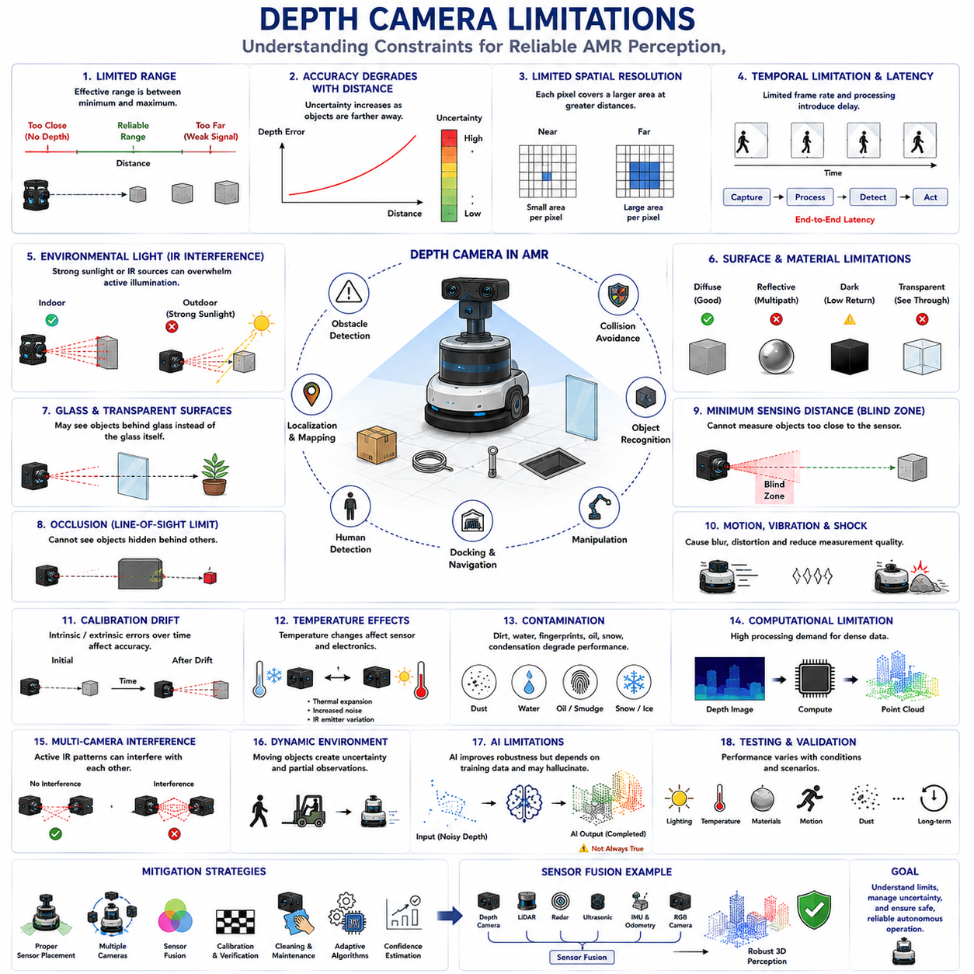
Depth cameras have become indispensable perception sensors in Autonomous Mobile Robots (AMRs) because they provide direct three-dimensional information that conventional RGB cameras cannot obtain. They enable obstacle detection, localization, mapping, object recognition, manipulation, docking, human detection, and numerous other robotic functions through dense geometric measurements of the surrounding environment. Despite these advantages, no depth sensing technology is universally reliable under every operating condition. Every depth camera possesses inherent physical, optical, computational, and environmental limitations that influence measurement quality and system reliability. Understanding these limitations is essential because practical robotic systems must be designed around sensor constraints rather than assuming ideal performance. Robust autonomous navigation depends not only on selecting an appropriate depth camera but also on recognizing where its measurements become unreliable and compensating through sensor fusion, intelligent algorithms, and careful system engineering.
One of the most fundamental limitations of depth cameras is their restricted sensing range. Every depth sensing technology operates effectively only within a specific distance interval determined by its measurement principle, optical configuration, signal strength, and sensor resolution. Objects located too close may fall inside the minimum sensing distance where valid depth cannot be estimated, while objects located too far produce signals that become too weak for reliable measurement. The practical operating range therefore represents only a subset of the theoretical sensing capability specified by the manufacturer. Engineers must select depth cameras whose reliable operating distance matches the robot's intended application rather than relying solely on maximum advertised measurement ranges.
Measurement accuracy naturally decreases as object distance increases. Regardless of whether depth is obtained through stereo triangulation, Time-of-Flight measurement, or Structured Light projection, small measurement uncertainties become increasingly significant at greater distances. In stereo systems, disparity decreases rapidly as distance grows, making depth estimation more sensitive to image correspondence errors. In Time-of-Flight cameras, reflected infrared signals weaken with distance, reducing signal-to-noise ratio. Structured Light patterns similarly become less distinguishable as projection intensity spreads across larger areas. Consequently, long-range depth measurements generally exhibit larger uncertainty than nearby observations, requiring planners to interpret distant geometry more conservatively.
Spatial resolution also imposes practical limitations. Every depth image contains a finite number of pixels, and each pixel represents an increasingly larger physical area as object distance increases. Small obstacles such as cables, narrow pipes, pallet straps, bolts, tools, or thin poles may occupy only one or two pixels or disappear entirely beyond certain distances. Even if the sensor accurately measures large surfaces, insufficient spatial sampling can prevent reliable detection of small hazards. Increasing image resolution improves geometric detail but simultaneously increases computational requirements, communication bandwidth, memory consumption, and processing latency. Designers therefore balance geometric precision against real-time performance according to application requirements.
Temporal resolution represents another important constraint. Although many modern depth cameras operate at thirty or sixty frames per second, some applications require significantly faster environmental updates. High-speed robots, rapidly moving manipulators, or environments containing fast-moving people and vehicles may change substantially between successive depth frames. Motion occurring during sensor exposure can introduce measurement distortion, while limited frame rates increase reaction delay. Overall system latency includes exposure, sensor readout, communication, depth calculation, filtering, point cloud generation, object detection, planning, and control execution. Consequently, the effective responsiveness of the perception system depends upon complete end-to-end processing rather than camera frame rate alone.
Active depth cameras rely heavily upon infrared illumination, creating several environmental limitations. Time-of-Flight and Structured Light systems project infrared energy into the environment before measuring reflected signals. Strong sunlight contains significant infrared radiation capable of overwhelming projected illumination, reducing measurement quality or eliminating depth estimation entirely. Outdoor operation therefore becomes substantially more difficult than indoor operation. Optical filters, increased emitter power, adaptive exposure control, improved signal processing, and sensor fusion partially mitigate these effects, but direct sunlight remains one of the most challenging conditions for active depth sensing technologies.
Surface reflectivity significantly influences measurement reliability. Diffuse surfaces scatter infrared illumination uniformly and generally produce accurate depth estimates. Highly reflective metallic objects generate specular reflections that redirect projected light away from the receiver or create multiple reflection paths. Dark absorptive materials reflect very little infrared energy, reducing measurement confidence. Transparent materials such as glass transmit rather than reflect infrared light, while translucent materials scatter light unpredictably. Consequently, identical geometric objects constructed from different materials may produce dramatically different depth measurements despite occupying the same physical position.
Glass represents one of the most difficult materials for depth cameras. Rather than reflecting projected infrared illumination consistently, glass often allows light to pass through or reflects it at unexpected angles. A depth camera may therefore observe objects located behind the glass instead of detecting the glass surface itself. Automatic doors, display cabinets, laboratory partitions, elevator walls, protective barriers, and vehicle windows may become partially invisible depending upon viewing angle and lighting conditions. Since glass frequently appears as open space, robots relying exclusively upon depth measurements may incorrectly classify hazardous barriers as traversable regions unless complementary sensing technologies provide additional evidence.
Highly reflective surfaces introduce multipath interference, particularly for Time-of-Flight cameras. Instead of returning directly from the observed object, emitted infrared light may reflect multiple times before reaching the sensor. Because the total optical path becomes longer than the actual object distance, measured depth values become systematically incorrect. Industrial machinery, polished floors, stainless steel equipment, aluminum structures, mirrors, and glossy painted surfaces frequently generate such effects. Advanced signal processing algorithms estimate and suppress multipath artifacts, but complete elimination remains difficult under complex reflective conditions.
Occlusion is an unavoidable geometric limitation affecting every optical sensor. A depth camera measures only surfaces directly visible from its viewpoint. Objects hidden behind larger structures remain completely unobservable regardless of sensor accuracy. Shelves block items stored behind them, pallets conceal lower objects, machinery hides workers, and robot payloads create self-occlusion around the chassis. Single-camera systems therefore possess unavoidable blind regions determined by viewing geometry. Multiple cameras positioned strategically around the robot reduce but cannot entirely eliminate occlusion because complex three-dimensional environments continuously create new hidden regions.
Minimum sensing distance creates another practical blind zone. Depth cameras cannot always estimate geometry located immediately adjacent to their protective windows because triangulation geometry, optical baseline, sensor saturation, or projector-receiver overlap becomes inadequate. Objects entering this region may remain undetected until physical contact occurs. Engineers address this limitation through sensor placement, overlapping camera coverage, ultrasonic sensors, contact bumpers, or protective mechanical structures. Blind-zone analysis should therefore be considered during mechanical design rather than after robot integration.
Rolling motion, vibration, and mechanical shock affect measurement quality even when cameras remain properly calibrated. Robot motion during image acquisition may introduce blur, distort correspondence matching, reduce pattern sharpness, or alter optical alignment. Industrial vehicles operating over uneven floors experience continuous vibration capable of degrading both optical performance and calibration stability over time. Mechanical mounting systems must therefore provide sufficient rigidity, damping, and environmental protection to preserve measurement quality throughout long-term deployment under realistic operating conditions.
Calibration itself represents an important source of uncertainty. Intrinsic calibration determines optical parameters describing camera geometry, while extrinsic calibration establishes spatial relationships between sensors and the robot coordinate system. Small calibration errors propagate directly into point cloud generation, localization, obstacle detection, manipulation, and mapping. Mechanical impacts, thermal expansion, maintenance activities, component replacement, and structural deformation may gradually alter calibration throughout the robot's operational lifetime. Periodic verification and recalibration therefore remain essential maintenance activities for reliable perception.
Temperature variation influences both electronic and optical behavior. Image sensors, infrared emitters, processors, lenses, and mechanical structures all exhibit temperature-dependent characteristics. Thermal expansion slightly modifies optical alignment, while electronic noise generally increases with sensor temperature. Infrared emitter output may vary under different thermal conditions, influencing active sensing performance. Outdoor robots experience particularly large temperature fluctuations across daily operation, requiring thermal compensation algorithms and robust hardware design to maintain stable depth accuracy throughout changing environmental conditions.
Environmental contamination gradually reduces optical performance. Dust, dirt, water droplets, mud, fingerprints, oil films, cleaning residue, snow, and condensation alter optical transmission through protective windows. Active infrared illumination becomes scattered or attenuated before reaching surrounding objects, while reflected signals similarly degrade before reaching the receiver. The resulting measurements exhibit increased noise, missing depth regions, reduced sensing range, or complete sensing failure. Protective housings, hydrophobic coatings, air cleaning systems, window heaters, and regular maintenance substantially improve long-term reliability but cannot completely eliminate contamination-related challenges.
Depth cameras generate significant computational demands because raw sensor measurements require extensive processing before becoming useful geometric information. Stereo correspondence, Time-of-Flight signal interpretation, pattern decoding, filtering, point cloud generation, segmentation, tracking, mapping, and sensor fusion collectively consume considerable processor resources. High-resolution sensors produce millions of measurements every second, requiring efficient algorithms and hardware acceleration to maintain real-time performance. Computational limitations often determine practical system capability as much as sensor hardware itself.
Bandwidth and memory consumption also become important considerations. Dense depth images, colored point clouds, synchronized RGB streams, confidence maps, and temporal history require substantial communication bandwidth between sensors and processing units. Embedded robotic computers frequently operate under strict power and memory constraints, requiring compression, downsampling, region-of-interest processing, or selective computation. Efficient data management therefore represents an important aspect of practical depth-camera system design, particularly for battery-powered mobile robots.
Sensor interference may occur when multiple active depth cameras operate simultaneously. Structured Light projectors may overlap, confusing pattern decoding, while multiple Time-of-Flight sensors transmitting similar modulation frequencies can interfere with one another. In warehouses containing numerous autonomous robots, neighboring platforms may unintentionally degrade each other's depth measurements. Hardware synchronization, coded illumination, time multiplexing, frequency separation, and intelligent sensor scheduling reduce interference, but large-scale multi-robot deployments require careful electromagnetic and optical compatibility planning.
Dynamic environments introduce additional complexity because moving objects continuously alter observed geometry. Humans, forklifts, doors, conveyors, suspended loads, and other robots generate changing point clouds that complicate localization, mapping, and object tracking. Temporary occlusions, partial observations, and rapidly changing scenes increase uncertainty throughout the perception pipeline. Robust tracking algorithms, temporal filtering, probabilistic mapping, and semantic reasoning help distinguish permanent environmental structures from transient dynamic objects without introducing excessive computational delay.
Artificial intelligence has significantly improved depth-camera robustness but also introduces new limitations. Learning-based depth completion, denoising, segmentation, and object recognition frequently outperform traditional algorithms under challenging conditions. However, neural networks depend heavily upon representative training data and may generalize poorly when encountering unfamiliar environments, unusual materials, unexpected lighting, or rare object configurations. AI-generated geometric estimates may appear visually plausible despite deviating from physical reality. Consequently, learned perception should complement rather than replace physically measured depth information whenever reliable metric geometry is required.
Sensor fusion has become the most effective strategy for overcoming individual depth-camera limitations. LiDAR provides accurate long-range geometry, radar performs well under adverse weather, ultrasonic sensors monitor extremely close obstacles, RGB cameras contribute semantic appearance, inertial sensors estimate motion, and wheel odometry supports localization. Each sensing modality possesses strengths compensating for weaknesses elsewhere in the perception system. Fusion algorithms integrate complementary measurements while considering uncertainty associated with every sensor, producing significantly more reliable environmental understanding than any individual technology operating independently.
Testing depth-camera limitations requires considerably more than laboratory accuracy measurements. Engineers must evaluate performance across varying illumination, temperature, humidity, vibration, dust, reflective materials, transparent surfaces, moving objects, sensor contamination, and long-duration operation. Small laboratory calibration targets cannot adequately represent real industrial environments containing forklifts, storage racks, machinery, personnel, reflective metals, and changing environmental conditions. Comprehensive validation therefore requires realistic operational scenarios reflecting the full diversity of situations expected throughout the robot's deployment lifecycle.
Maintenance strategies should focus not only on hardware integrity but also on sustained perception quality. Routine inspection includes cleaning optical windows, verifying mounting rigidity, checking synchronization, confirming calibration, updating firmware, monitoring sensor health, and evaluating measurement confidence statistics. Automated diagnostics increasingly detect degradation through changes in point density, noise level, invalid measurement ratio, signal strength, or calibration consistency before failures become operationally significant. Predictive maintenance therefore reduces unexpected perception failures while improving long-term reliability and system availability.
Future depth-camera technology will continue reducing many current limitations through improved sensor physics, higher spatial resolution, more powerful infrared emitters, enhanced signal processing, integrated artificial intelligence, adaptive sensing strategies, and tighter multi-sensor cooperation. Nevertheless, every sensing technology will continue exhibiting physical constraints determined by optics, geometry, materials, and environmental conditions. The objective of future robotic perception is therefore not to eliminate every limitation entirely but to understand uncertainty, quantify confidence, fuse complementary information intelligently, and maintain safe autonomous operation despite inevitable imperfections in individual sensor measurements.

05.8 Depth Camera Validation
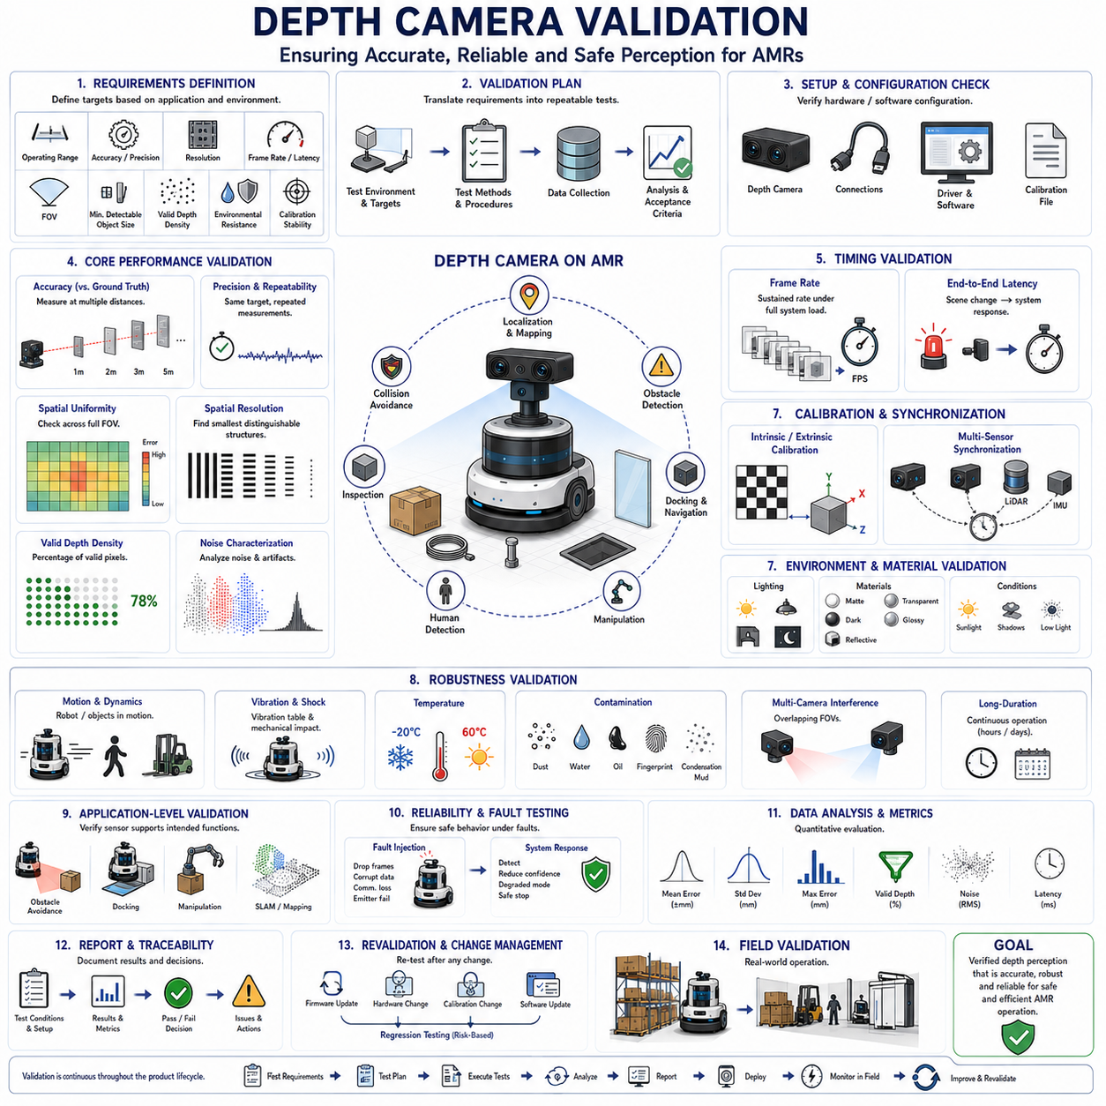
Depth camera validation is the systematic process of confirming that a depth sensing system satisfies its intended performance, reliability, integration, and operational requirements before deployment in an Autonomous Mobile Robot (AMR). Unlike basic functional testing, which may only confirm that the sensor produces depth images, validation evaluates whether those measurements remain sufficiently accurate, stable, timely, and trustworthy under realistic operating conditions. The process examines the complete sensing chain, including optics, illumination, electronics, firmware, calibration, communication, preprocessing, point cloud generation, sensor fusion, and application-level behavior. Effective validation therefore determines whether the depth camera can support safe navigation, obstacle detection, localization, manipulation, docking, inspection, and human-aware operation throughout the robot's expected lifecycle.
Validation begins with clearly defined requirements because measurement results have meaning only when compared with explicit acceptance criteria. Engineers specify operating range, accuracy, precision, spatial resolution, frame rate, latency, field of view, minimum detectable object size, valid-depth density, environmental resistance, and calibration stability according to the robot's intended mission. Requirements should reflect actual operating conditions rather than ideal laboratory specifications. A warehouse AMR, collaborative service robot, industrial inspection platform, and outdoor mobile robot require different validation targets because their speeds, obstacle types, surfaces, lighting conditions, and safety margins differ significantly.
A validation plan translates system requirements into repeatable test methods. It identifies the equipment, test environments, reference targets, object materials, distances, camera settings, software versions, measurement procedures, data formats, and statistical evaluation methods required for each test. The plan should define how many samples are collected, how environmental variables are controlled, and how pass or fail decisions are made. Traceability between requirements and test cases is essential so that every important sensing function is verified and no requirement remains unsupported by objective evidence.
Initial validation confirms the basic hardware and software configuration of the depth camera. Engineers verify sensor model, serial number, firmware version, interface type, resolution, frame rate, pixel format, depth unit, exposure mode, emitter configuration, synchronization setting, and calibration file. The processing computer, driver, middleware, and robotic software stack must recognize the device correctly and receive continuous image streams without unexpected format conversion. Configuration records should be preserved because even small parameter changes may significantly alter sensing range, noise, latency, or valid-depth density.
Reference measurement equipment is required to evaluate depth accuracy objectively. Precision rulers, laser distance meters, coordinate measurement devices, surveyed targets, calibrated translation stages, and accurately positioned planar surfaces provide known geometric truth. The reference system must itself possess substantially better accuracy than the depth camera under evaluation. Otherwise, measurement uncertainty from the test equipment may obscure actual sensor performance. Reference targets should remain mechanically stable and be positioned at multiple distances and viewing angles throughout the camera's complete operational range.
Depth accuracy validation compares measured distance values with known physical distances. Flat reference panels are commonly placed perpendicular to the optical axis at predetermined positions, and depth values are sampled across selected image regions. Mean error, absolute error, percentage error, and distance-dependent bias are calculated for each position. Measurements should include the minimum operating distance, normal working range, and maximum required distance. Since accuracy often degrades near range boundaries, testing only at the center of the measurement range may produce an unrealistic assessment of practical performance.
Precision and repeatability validation determine how consistently the camera reproduces measurements under unchanged conditions. A static target is observed repeatedly over time while the system records depth variation for selected pixels or geometric regions. Standard deviation, range, temporal noise, and drift are calculated from the repeated measurements. High repeatability is particularly important for docking, robotic manipulation, dimensional inspection, and localization because unstable depth values may create inconsistent control commands even when average distance accuracy appears acceptable.
Spatial uniformity testing evaluates whether depth accuracy remains consistent across the entire field of view. Optical distortion, illumination falloff, lens characteristics, and calibration quality may produce greater error near image corners or edges than at the center. A large planar target covering the complete view allows engineers to compare measured geometry throughout the depth image. Residual surface curvature, local bias, invalid regions, and edge distortion are quantified. This test ensures that objects appearing away from the optical center remain measurable with sufficient reliability during real robot operation.
Spatial resolution validation determines the smallest geometric structures that the camera can distinguish. Test objects may include narrow bars, cables, rods, gaps, steps, edges, holes, or patterns with progressively decreasing dimensions. These targets are observed at different distances and orientations to determine when their geometry becomes merged, fragmented, or completely lost. The result defines practical minimum detectable object dimensions rather than relying only on nominal sensor pixel count. Such information is essential for near-field obstacle detection and industrial inspection applications involving small or thin structures.
Valid-depth density is another important validation metric. A depth image may possess high nominal resolution while containing large areas of invalid or missing measurements. Engineers calculate the percentage of valid pixels across representative surfaces, distances, and environmental conditions. The distribution of invalid regions is also important because concentrated gaps near object boundaries or floor surfaces may create greater operational risk than randomly scattered missing pixels. Validation should distinguish sensor limitations from losses introduced by filtering, confidence thresholds, or communication errors.
Depth noise characterization examines random variations and structured artifacts within the measurement output. Noise may appear as pixel-level fluctuations, speckle patterns, surface roughness, flying pixels, edge instability, or periodic interference. Engineers evaluate noise on flat surfaces, object boundaries, corners, and complex structures. Statistical measures such as root mean square error, local variance, and spatial frequency distribution help quantify the behavior. Understanding noise characteristics supports the design of filtering algorithms without removing genuine small objects or critical geometric discontinuities.
Frame rate validation confirms that the camera delivers depth data at the required frequency during full system operation. Testing should occur while object detection, point cloud processing, mapping, sensor fusion, logging, and navigation software run simultaneously because computational load may reduce effective acquisition speed. Engineers record frame timestamps over extended periods and calculate average rate, minimum rate, jitter, and dropped-frame frequency. Stable timing is often more valuable than occasional high frame rates because perception and control algorithms depend upon predictable updates.
End-to-end latency validation measures the complete delay between a physical scene change and the corresponding response within robotic software or control. The test may use synchronized visual markers, moving targets, flashing light sources visible to associated cameras, or electronic trigger signals. Sensor exposure, readout, internal depth calculation, transmission, operating system buffering, driver execution, preprocessing, object detection, and control communication all contribute to total latency. Since collision avoidance depends upon timely information, validation must consider worst-case latency rather than only average delay.
Synchronization validation becomes essential when the depth camera operates with RGB cameras, LiDAR, IMU, wheel odometry, radar, or multiple depth cameras. Engineers verify timestamp alignment, trigger behavior, clock drift, frame correspondence, and temporal consistency during static and dynamic motion. Even small synchronization errors can produce inaccurate sensor fusion, distorted point clouds, unstable object tracking, and incorrect motion compensation. Long-duration tests are required because devices may appear synchronized initially while gradually drifting apart over time.
Intrinsic calibration validation checks whether the camera's focal length, principal point, distortion coefficients, and depth scale remain correct. Standard calibration targets and known geometry are used to calculate reprojection error and geometric consistency. Extrinsic calibration validation confirms the camera's position and orientation relative to the robot base frame and other sensors. Test objects observed by multiple sensors should align correctly after coordinate transformation. Calibration verification must be repeated after mechanical impact, sensor replacement, bracket adjustment, or significant temperature cycling.
Point cloud validation extends beyond raw depth-image assessment. Engineers transform valid depth pixels into three-dimensional points and compare reconstructed geometry with known reference objects. Plane flatness, object dimensions, edge location, surface orientation, and coordinate consistency are measured in the point cloud. Registration between successive frames is also evaluated during camera or robot motion. This confirms that calibration, back-projection, coordinate transformation, filtering, and synchronization operate correctly as a complete geometric pipeline.
Environmental lighting validation examines performance under dark conditions, artificial lighting, direct sunlight, backlighting, shadows, reflections, and rapidly changing illumination. Active infrared cameras may perform well indoors but lose range or accuracy under strong solar radiation. Passive stereo cameras may require sufficient natural texture and image contrast. Tests should therefore reproduce the actual lighting transitions expected during operation, including movement through doors, loading docks, tunnels, windows, and reflective industrial spaces. Exposure adaptation time and depth recovery after sudden lighting change should also be measured.
Material-based validation is necessary because depth cameras respond differently to diffuse, dark, reflective, transparent, translucent, and textured surfaces. Representative targets should include cardboard, painted metal, stainless steel, black rubber, fabric, plastic, glass, polished floors, and glossy packaging. Engineers record accuracy, confidence, valid-depth density, and artifact behavior for each material at different angles. These results reveal operational blind spots that may not appear when only matte calibration panels are used.
Multipath and flying-pixel validation are particularly important for Time-of-Flight cameras. Corners, narrow passages, reflective panels, and adjacent surfaces are arranged to create indirect reflection paths. Engineers compare the resulting depth measurements with known geometry and identify regions where distance is overestimated or mixed. Thin objects and foreground boundaries are used to measure flying-pixel frequency and position error. Filtering may reduce these artifacts, but validation must confirm that the correction does not remove real obstacles or shift true boundaries.
Motion validation evaluates depth quality while the robot or observed objects are moving. Tests include straight travel, turning, acceleration, braking, vibration, uneven floors, moving pedestrians, rotating machinery, and passing vehicles. Engineers measure depth distortion, object-boundary stability, tracking continuity, frame synchronization, and latency under realistic motion profiles. Global shutter, rolling shutter, exposure time, and motion compensation settings may all influence performance. Static laboratory results alone cannot demonstrate suitability for a moving AMR.
Vibration and mechanical durability validation confirm that mounting structures preserve optical alignment and sensor function during long-term operation. The camera and bracket may be tested on vibration tables using profiles derived from expected robot motion. Shock tests reproduce impacts, curb crossings, docking contact, and handling events. Depth accuracy and calibration are measured before and after mechanical testing to identify permanent changes. Fasteners, connectors, cables, protective windows, and housing seals should also be inspected for damage or loosening.
Temperature validation measures performance across the expected thermal operating range. Cameras are placed in controlled chambers or tested during realistic cold-start, warm-up, and high-temperature operation. Depth bias, noise, valid-range reduction, emitter output, frame rate, and calibration stability are monitored as temperature changes. Warm-up behavior deserves attention because some sensors require time to reach thermal equilibrium before stable measurements become available. Acceptance criteria may define both initial startup performance and stabilized operating performance.
Contamination validation determines how dust, water droplets, oil films, fingerprints, condensation, mud, and scratches affect depth output. Controlled levels of contamination are applied to protective windows while monitoring measurement range, confidence, noise, and invalid-depth ratio. The purpose is not to approve operation with severely obstructed optics but to identify degradation signatures that onboard diagnostics can recognize. Cleaning procedures, air purge systems, hydrophobic coatings, window heaters, and maintenance intervals can then be validated using objective performance data.
Multi-camera interference validation is required when several active depth cameras operate on one robot or when multiple robots share the same environment. Engineers test overlapping fields of view, different orientations, distances, trigger modes, and emitter configurations. They observe whether infrared pattern interference or modulation conflicts increase noise, create missing depth, or generate false geometry. Time multiplexing, synchronization, modulation-frequency separation, emitter scheduling, or selective illumination should be evaluated as mitigation strategies under realistic fleet conditions.
Application-level validation confirms that sensor measurements actually support the intended robotic function. For obstacle avoidance, representative objects are placed within the planned trajectory and stopping behavior is evaluated. For docking, repeated approach accuracy and final alignment are measured. For manipulation, object pose and grasp success are assessed. For SLAM, localization drift and mapping consistency are evaluated. A depth camera may satisfy laboratory accuracy criteria yet still fail application requirements because of latency, occlusion, filtering, coordinate errors, or software integration problems.
Fault-injection testing evaluates how the system behaves when the camera becomes degraded or unavailable. Engineers simulate frame loss, frozen images, corrupted depth, incorrect timestamps, communication interruption, calibration mismatch, high invalid-pixel ratios, and sudden emitter failure. The perception system should detect these faults, reduce confidence, transition to an appropriate degraded mode, or stop the robot when necessary. Validation must confirm that missing or uncertain depth is never silently interpreted as clear space in safety-critical motion planning.
Long-duration validation identifies gradual failures that short tests cannot reveal. The depth camera operates continuously for many hours or days while frame rate, temperature, synchronization, point density, calibration, noise, and communication stability are monitored. Repeated power cycles, sleep and wake transitions, network reconnection, and software restarts should also be tested. Long-term validation reveals memory leaks, thermal drift, intermittent connector faults, timestamp discontinuities, emitter aging, and rare firmware problems that may otherwise appear only after field deployment.
Statistical analysis converts collected test data into meaningful engineering evidence. Mean error alone is insufficient because extreme values, environmental sensitivity, and variation across the field of view may determine actual risk. Engineers examine maximum error, percentiles, confidence intervals, standard deviation, missing-data rate, false-detection rate, and worst-case latency. Results should be separated according to distance, material, lighting, temperature, motion, and sensor configuration. This allows limitations to be traced to specific operational conditions rather than hidden within overall averages.
Validation reports preserve traceability and support design decisions. Each report should describe the tested configuration, equipment, calibration status, procedures, environmental conditions, software version, raw data location, results, deviations, failures, and corrective actions. Pass or fail conclusions must reference predefined acceptance criteria rather than subjective visual judgment. Unresolved limitations should be documented explicitly so that navigation rules, maintenance procedures, sensor fusion, or operational restrictions can compensate for them during deployment.
Revalidation is required whenever changes may influence depth performance. Firmware updates, driver changes, new filtering algorithms, calibration modifications, protective window replacement, bracket redesign, cable routing changes, processor replacement, or software optimization may alter measurement quality or timing. Repeating only a small functional check is insufficient if the change affects validated characteristics. A risk-based regression strategy determines which tests must be repeated while preserving evidence that unchanged requirements remain satisfied.
Field validation represents the final confirmation that the complete robot performs reliably within its intended operational design domain. The AMR should operate through realistic routes, obstacle configurations, lighting transitions, surface materials, traffic patterns, docking areas, and environmental disturbances. Engineers compare field behavior with laboratory predictions and investigate any differences. Successful field validation confirms not that the depth camera is perfect, but that its capabilities, limitations, diagnostics, fusion strategy, and control responses are collectively sufficient for dependable robotic operation.
Future depth camera validation will become increasingly automated, continuous, and model-based. Digital twins will simulate camera placement, lighting, materials, motion, and failure conditions before hardware testing begins. Automated test rigs will evaluate thousands of parameter combinations, while onboard diagnostics will monitor calibration, confidence, noise, and coverage throughout deployment. Artificial intelligence will help detect subtle performance degradation and predict remaining useful life. Nevertheless, physical reference testing and realistic field validation will remain essential because safe autonomous operation ultimately depends upon measurable agreement between sensed geometry and the real world.

