Volume 03. AMR Sensors and Perception

Chapter 21. Human and Vehicle Detection

21.1 Human Detection Requirements
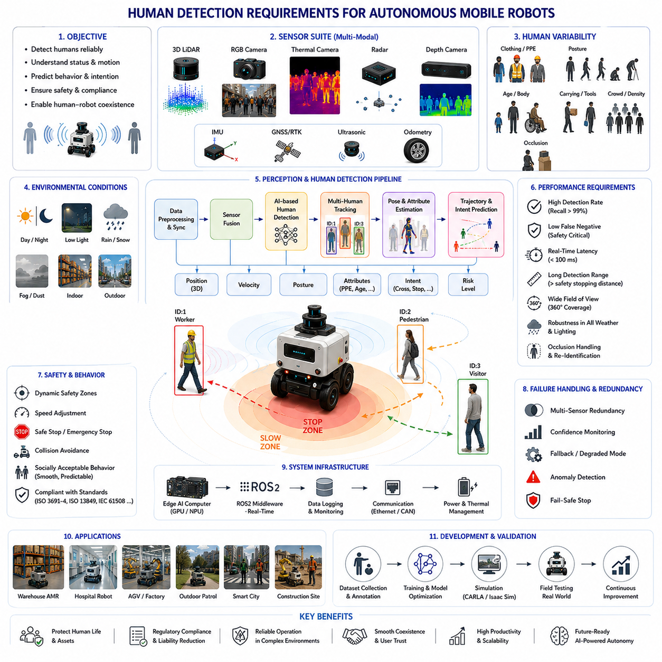
Human detection is one of the most important perception capabilities in autonomous mobile robot systems because humans represent the highest-priority dynamic entities in real-world environments. Unlike static obstacles or predictable infrastructure elements, humans exhibit highly dynamic, non-deterministic, and context-dependent behavior. Autonomous robots operating in warehouses, hospitals, factories, smart cities, airports, logistics centers, construction sites, railway facilities, agricultural environments, and outdoor public areas must continuously detect, track, classify, and predict human motion in real time in order to ensure operational safety, regulatory compliance, and socially acceptable behavior. Therefore, human detection becomes a foundational requirement for safe autonomous mobility and human-robot coexistence.
At a conceptual level, human detection refers to the process through which an autonomous robot identifies the presence, location, posture, movement, and operational relevance of humans within the surrounding environment. However, human detection in robotics extends far beyond traditional object detection problems. Human-aware perception systems must operate reliably under varying lighting conditions, weather environments, occlusions, crowd density, motion complexity, and sensor uncertainty. Furthermore, robots must not only detect humans but also understand safety risk, predict future movement, estimate behavioral intention, and adapt navigation behavior dynamically.
Human detection requirements are fundamentally driven by safety. In industrial and public environments, collisions between robots and humans may result in injury, legal liability, operational shutdown, regulatory violations, and loss of public trust. Therefore, safety-oriented perception architecture is central to autonomous robot design. Human detection systems must achieve high detection accuracy, low false-negative rates, fast reaction time, and robust operation across diverse environmental conditions.
One of the most critical requirements for human detection is reliability under dynamic real-world conditions. Human appearance varies significantly according to clothing, posture, body shape, accessories, motion patterns, and environmental context. Workers may wear reflective vests, helmets, backpacks, or protective equipment. Hospital patients may use wheelchairs or walkers. Pedestrians may carry bags, umbrellas, bicycles, or tools. Children, elderly individuals, and workers exhibit different motion characteristics. Therefore, detection systems must generalize across wide human variability.
Lighting variation is one of the major challenges in human detection. Indoor robots may encounter fluorescent lighting, shadows, reflections, and low-light corridors. Outdoor robots must operate under direct sunlight, nighttime conditions, rain, fog, snow, glare, and rapidly changing illumination. Camera-based systems are particularly sensitive to environmental lighting conditions. Therefore, modern human detection architectures often combine RGB cameras with thermal cameras, LiDAR, radar, depth sensors, and multimodal fusion frameworks.
Camera-based human detection remains one of the most widely used approaches due to the rich semantic information provided by visual imagery. Deep learning models such as YOLO, Faster R-CNN, SSD, RetinaNet, DETR, and transformer-based architectures can detect human bodies, limbs, faces, and posture features directly from RGB images. These systems achieve high semantic understanding and strong classification capability.
However, camera-only systems have important limitations. Occlusion, motion blur, poor lighting, adverse weather, glare, shadows, and low contrast can significantly degrade detection reliability. Therefore, multimodal sensor fusion becomes essential for safety-critical robotics applications.
LiDAR-based human detection provides geometric robustness independent of ambient lighting. Three-dimensional point clouds enable robots to detect human-shaped spatial structures and estimate precise distance information. LiDAR is particularly valuable for collision avoidance because it provides accurate range estimation even under low-light conditions. However, LiDAR point clouds may become sparse at long distances and often lack rich semantic understanding.
Thermal cameras significantly improve human detection under nighttime or low-visibility conditions. Human bodies emit infrared radiation that can be detected even in darkness, smoke, or visually cluttered environments. Thermal sensing is widely used in outdoor patrol robots, security systems, industrial inspection robots, defense applications, and nighttime autonomous platforms. However, thermal sensors may struggle in extremely hot environments or when thermal contrast is low.
Radar systems are increasingly integrated into human detection pipelines because they operate robustly under rain, fog, dust, smoke, and snow conditions. Millimeter-wave radar provides velocity estimation through Doppler measurements and contributes strong dynamic obstacle awareness. Although radar resolution is lower than cameras or LiDAR, radar improves robustness under adverse weather conditions.
Depth cameras and stereo vision systems are widely used for near-field human detection. RGB-D sensors provide both visual imagery and depth estimation, enabling robots to identify nearby humans and estimate spatial relationships accurately. Indoor AMRs, collaborative robots, and hospital robots frequently use depth cameras for short-range human-aware navigation.
Sensor fusion is one of the most important architectural requirements for modern human detection systems. Each sensor modality has different strengths and weaknesses. Fusion architectures combine complementary sensing capabilities to improve detection robustness, environmental coverage, and operational safety. LiDAR-camera fusion, radar-camera fusion, thermal-camera fusion, and multimodal AI fusion are widely used in advanced robotics systems.
Human detection systems must operate in real time. Autonomous robots continuously move through dynamic environments and require rapid perception updates in order to avoid collisions safely. Detection latency directly influences stopping distance and reaction capability. High-speed outdoor robots require extremely low-latency perception pipelines because delayed detection may result in unsafe operation.
Reaction time requirements are strongly connected to vehicle dynamics. Heavy payload robots, towing AMRs, outdoor autonomous vehicles, and high-speed mobile platforms require longer braking distances than small indoor robots. Therefore, human detection systems must account for robot speed, mass, traction, braking capability, and dynamic stopping constraints.
Detection range is another critical requirement. The required human detection distance depends on robot speed, operational environment, and safety policy. Indoor warehouse AMRs moving at low speeds may require short-range detection only. Outdoor autonomous robots operating at higher speeds require long-range human detection to maintain sufficient reaction time.
Field of view coverage is equally important. Humans may approach the robot from the front, rear, sides, or diagonal directions. Blind spots create severe safety risks. Therefore, autonomous robots often use multiple cameras, multiple LiDAR units, wide-angle sensors, radar coverage zones, and overlapping sensor placement strategies.
Occlusion handling represents one of the greatest challenges in human detection. Humans may be partially hidden behind shelves, vehicles, machinery, walls, pallets, vegetation, infrastructure, or crowds. Temporary occlusion may cause unstable detection or tracking failure. Therefore, modern systems integrate temporal tracking, trajectory prediction, multi-view perception, and probabilistic reasoning to maintain robust awareness under partial visibility conditions.
Human pose variability significantly increases perception complexity. Humans may walk, run, crouch, sit, bend, carry objects, operate machinery, or lie on the ground. Industrial workers may adopt unusual postures during maintenance or operational tasks. Therefore, human detection systems must recognize a wide range of body configurations and motion patterns.
Crowded environments further complicate human detection. Airports, hospitals, logistics centers, public sidewalks, and smart-city environments may contain large numbers of pedestrians moving simultaneously. Multi-human detection and tracking require robust identity assignment, trajectory separation, crowd analysis, and behavior prediction capabilities.
Human trajectory prediction is increasingly important in advanced autonomous systems. Simply detecting humans is insufficient for safe navigation. Robots must anticipate future pedestrian movement and proactively adjust navigation behavior. Trajectory prediction models estimate likely future motion paths based on current movement, environmental context, social interaction, and behavioral patterns.
Behavior prediction extends beyond simple trajectory estimation. Advanced AI systems increasingly attempt to predict human intention, crossing behavior, stopping probability, group interaction, attention direction, and operational risk. Such capabilities improve navigation smoothness and social compatibility.
Human-aware navigation is tightly integrated with detection systems. Robots operating around humans must maintain socially acceptable behavior. Abrupt stopping, aggressive turning, close passing, or unpredictable motion may create discomfort or safety concerns. Therefore, human detection directly influences navigation policy, speed control, safety margins, and path planning.
Safety zone management is one of the most important operational uses of human detection. Industrial AMRs often define dynamic safety zones around the robot. If humans enter warning zones, robots may reduce speed. If humans enter critical zones, robots may stop immediately. Safety zone behavior is commonly integrated with safety LiDAR systems and functional safety controllers.
Functional safety requirements strongly influence human detection architecture. Industrial autonomous systems often comply with standards such as ISO 3691-4, ISO 13849, IEC 61508, IEC 61496, ISO 13482, and other safety frameworks. Safety-certified sensing hardware and redundant perception pathways are frequently required in human-interactive environments.
Redundancy is a key principle of safety-critical human detection systems. Autonomous robots rarely rely on a single sensor or AI model for human safety. Instead, multiple sensing modalities and independent detection pipelines operate simultaneously. Redundant LiDAR, stereo cameras, radar systems, thermal sensors, and safety controllers improve fault tolerance.
False negatives represent one of the most dangerous failure modes in human detection. Missing a human entirely may result in severe collisions or injury. Therefore, human detection systems are typically optimized to minimize false negatives even at the cost of increased false positives. Conservative safety behavior is generally preferred over aggressive navigation efficiency.
False positives also create operational challenges. Incorrectly classifying objects as humans may produce unnecessary stopping, reduced productivity, inefficient navigation, or operational instability. Therefore, balancing sensitivity and precision becomes a major engineering challenge.
Environmental robustness is critically important for real-world deployment. Dust, rain, fog, smoke, snow, mud, vibration, electromagnetic interference, sensor contamination, and lighting variation all affect detection performance. Outdoor autonomous robots require particularly robust human detection systems capable of operating reliably under adverse environmental conditions.
Thermal management and computational efficiency are also important design considerations. Modern AI-based human detection systems often rely on GPU acceleration, CUDA optimization, TensorRT inference acceleration, ROS2 multi-threading, and edge AI hardware such as Jetson platforms. Real-time detection must be maintained within strict power and thermal constraints.
Dataset diversity strongly influences AI detection performance. Human detection models require large-scale datasets covering various ethnicities, clothing styles, body shapes, safety equipment, environmental conditions, weather scenarios, lighting conditions, poses, crowd density, and operational contexts. Insufficient dataset diversity may produce dangerous perception bias or failure modes.
Data labeling quality is equally important. Bounding boxes, segmentation masks, skeletal keypoints, occlusion labels, safety gear annotations, and trajectory labels all contribute to AI model accuracy. Industrial human detection datasets often require specialized labeling workflows.
Human detection evaluation metrics commonly include precision, recall, mean average precision (mAP), detection latency, false-positive rate, false-negative rate, tracking accuracy, trajectory prediction error, and safety response time. Safety-critical robotics systems often prioritize recall and low false-negative rates over raw detection precision.
Simulation environments play an important role in human detection development. Platforms such as Gazebo, CARLA, Isaac Sim, and digital twins allow engineers to test robots under diverse human-interaction scenarios safely and repeatedly. Simulation supports rare-event testing, crowd simulation, trajectory prediction validation, weather robustness analysis, and AI training workflows.
Field testing remains essential because real-world human behavior is extremely difficult to simulate perfectly. Human unpredictability, environmental complexity, sensor noise, and operational variability frequently expose edge cases not visible during laboratory evaluation. Therefore, extensive real-world testing is required before deployment.
Industrial applications demonstrate the diversity of human detection requirements. Warehouse AMRs detect workers and forklifts in narrow aisles. Hospital robots navigate around patients, doctors, nurses, and visitors. Outdoor patrol robots detect pedestrians under varying weather and lighting conditions. Agricultural robots identify workers in crop fields. Construction robots operate near heavy machinery and dynamic human activity. Smart-city robots interact with pedestrians, bicycles, and urban traffic environments simultaneously.
Future human detection systems will likely evolve toward holistic human understanding rather than simple object detection. Autonomous robots may eventually interpret body language, emotional state, gaze direction, gesture commands, social interaction, operational intent, and environmental context simultaneously.
Foundation models and embodied AI architectures may dramatically improve human-aware robotics. Future systems may integrate multimodal world understanding, natural language interaction, behavioral prediction, social reasoning, and adaptive safety intelligence into unified perception frameworks.
The evolution of human detection reflects the broader evolution of autonomous robotics itself. Early robotics systems relied primarily on geometric obstacle avoidance with limited human awareness. Modern autonomous systems increasingly integrate multimodal sensor fusion, AI perception, semantic understanding, predictive intelligence, social navigation, and functional safety engineering.
Ultimately, human detection is not merely an object recognition problem. It is the process through which autonomous robots perceive, understand, predict, and safely interact with humans in shared environments. Effective human detection enables safe autonomous navigation, collision avoidance, social compatibility, functional safety compliance, scalable deployment, and trustworthy human-robot coexistence. In advanced AMR systems, human detection becomes one of the most fundamental technologies enabling practical and socially acceptable autonomous mobility in real-world environments.

21.2 Pedestrian Detection
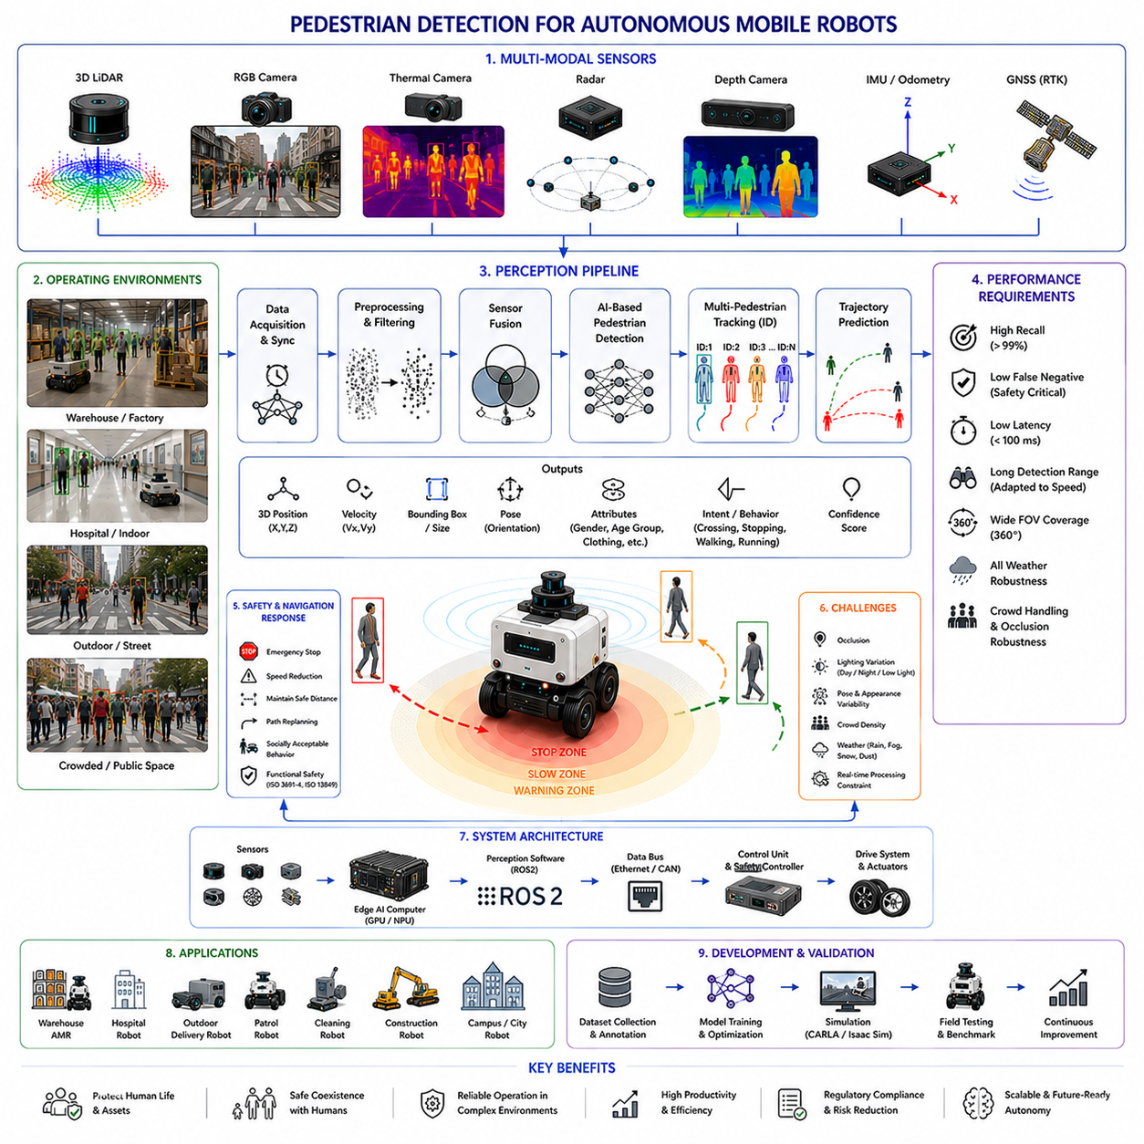
Pedestrian detection is one of the most critical perception functions in autonomous mobile robot systems because pedestrians represent highly dynamic, unpredictable, and safety-critical entities within real-world operating environments. Unlike static obstacles, infrastructure elements, or predictable machinery, pedestrians continuously change speed, direction, posture, intention, and interaction patterns. Autonomous robots operating in warehouses, hospitals, factories, logistics centers, airports, smart cities, campuses, sidewalks, industrial complexes, railway stations, shopping malls, and outdoor public environments must detect pedestrians accurately and reliably in real time in order to ensure safe navigation, collision avoidance, social compatibility, and regulatory compliance. Therefore, pedestrian detection becomes one of the foundational technologies enabling practical human-centered autonomous mobility.
At a conceptual level, pedestrian detection refers to the process through which autonomous robots identify human individuals moving within the surrounding environment and distinguish them from other dynamic or static objects. However, pedestrian detection extends far beyond traditional visual object recognition. Modern robotics systems must estimate pedestrian position, distance, velocity, trajectory, body orientation, intent, and future movement behavior while simultaneously accounting for environmental uncertainty, sensor limitations, and dynamic operational constraints.
Pedestrian detection is fundamentally driven by safety requirements. Human safety has the highest operational priority in nearly all autonomous robotics systems. A collision between a robot and a pedestrian may result in injury, legal liability, equipment damage, operational shutdown, regulatory penalties, and loss of public trust. Therefore, pedestrian detection systems are designed with extremely conservative safety objectives, emphasizing high recall, low false-negative rates, fast response time, and robust environmental operation.
One of the primary challenges in pedestrian detection is human unpredictability. Pedestrians frequently change direction suddenly, stop unexpectedly, accelerate irregularly, interact socially, carry objects, or behave differently according to environmental context. Human movement patterns are inherently non-deterministic and influenced by countless contextual variables. Therefore, pedestrian detection systems must continuously adapt to rapidly changing environmental conditions.
Pedestrian appearance variability significantly increases perception complexity. Pedestrians differ according to clothing style, body shape, height, posture, age, ethnicity, accessories, and carried objects. Workers may wear reflective vests, helmets, backpacks, or industrial equipment. Hospital patients may use wheelchairs or walking aids. Urban pedestrians may carry umbrellas, luggage, bicycles, or shopping bags. Children and elderly individuals exhibit substantially different motion characteristics. Therefore, detection systems must generalize across wide appearance variability while maintaining reliable detection performance.
Lighting conditions represent one of the largest operational challenges in pedestrian detection. Indoor robots may encounter fluorescent lighting, shadows, reflective surfaces, and low-light corridors. Outdoor robots must operate under direct sunlight, nighttime conditions, rain, fog, snow, glare, and rapidly changing illumination. Camera-based systems are particularly sensitive to lighting variation. Therefore, modern pedestrian detection architectures frequently combine RGB cameras with LiDAR, thermal cameras, radar, depth sensors, and multimodal sensor fusion frameworks.
RGB camera-based pedestrian detection remains one of the most widely used approaches because visual imagery provides rich semantic information. Deep learning models such as YOLO, Faster R-CNN, SSD, RetinaNet, EfficientDet, DETR, transformer-based detectors, and segmentation networks can identify pedestrian shapes, body structures, and contextual features directly from image data. These models provide strong classification performance and high semantic understanding.
However, camera-only systems face major operational limitations. Motion blur, poor illumination, occlusion, weather effects, glare, shadows, low contrast, and camera contamination can significantly reduce detection reliability. Nighttime environments are especially challenging for visible-spectrum cameras. Therefore, safety-critical autonomous systems rarely rely solely on RGB cameras for pedestrian detection.
LiDAR-based pedestrian detection provides robust geometric perception independent of ambient lighting conditions. Three-dimensional point clouds enable robots to detect human-shaped spatial structures and estimate precise distance information. LiDAR systems are especially important for collision avoidance because accurate range estimation directly influences stopping distance and trajectory planning. However, LiDAR point clouds may become sparse at long distances and often lack detailed semantic information.
Thermal cameras significantly improve pedestrian detection under nighttime and low-visibility conditions. Human bodies emit infrared radiation that can be detected even in darkness, smoke, or visually cluttered environments. Thermal sensing is particularly valuable for outdoor patrol robots, security systems, industrial inspection robots, defense robotics, railway inspection systems, and nighttime autonomous vehicles. However, thermal cameras may struggle in extremely hot environments or when thermal contrast is weak.
Radar systems are increasingly integrated into pedestrian detection pipelines because radar operates robustly under rain, fog, snow, smoke, and dust conditions. Millimeter-wave radar provides velocity estimation using Doppler measurements and contributes strong dynamic obstacle awareness. Although radar has lower spatial resolution than cameras or LiDAR, it significantly improves robustness under adverse environmental conditions.
Depth cameras and stereo vision systems are widely used for short-range pedestrian detection. RGB-D sensors provide both visual imagery and depth estimation simultaneously, enabling robots to identify nearby pedestrians and estimate spatial relationships accurately. Indoor AMRs, collaborative robots, hospital service robots, and logistics robots frequently rely on depth cameras for near-field human-aware navigation.
Sensor fusion is one of the most important architectural requirements for pedestrian detection systems. Each sensing modality possesses unique strengths and weaknesses. Fusion architectures combine complementary sensing capabilities to improve robustness, environmental coverage, and operational safety. LiDAR-camera fusion, radar-camera fusion, thermal-camera fusion, and AI-based multimodal fusion are widely used in advanced robotics systems.
Real-time performance is critically important in pedestrian detection systems. Autonomous robots continuously move through dynamic environments and require rapid perception updates to avoid collisions safely. Detection latency directly affects reaction capability and stopping distance. High-speed outdoor autonomous platforms require extremely low-latency perception pipelines because delayed pedestrian detection may result in unsafe operation.
Detection range requirements depend strongly on robot speed and operational environment. Indoor warehouse AMRs moving at low speeds may require only short-range pedestrian detection. Outdoor autonomous robots operating at higher velocities require long-range pedestrian awareness to maintain sufficient stopping distance and reaction time. Therefore, pedestrian detection systems must be designed according to vehicle dynamics and operational safety margins.
Field-of-view coverage is equally important. Pedestrians may approach from the front, rear, sides, or diagonal directions. Blind spots create severe safety risks. Therefore, autonomous robots often use multiple cameras, overlapping LiDAR coverage, radar sensing zones, wide-angle lenses, and redundant sensor placement strategies to maximize environmental visibility.
Occlusion handling represents one of the most difficult challenges in pedestrian detection. Pedestrians may be partially hidden behind shelves, pallets, vehicles, walls, machinery, vegetation, infrastructure, crowds, or other obstacles. Temporary occlusion can cause unstable detection and tracking failures. Therefore, modern systems integrate temporal tracking, trajectory prediction, multi-view perception, and probabilistic reasoning to maintain robust pedestrian awareness under partial visibility conditions.
Crowded environments significantly increase perception complexity. Airports, shopping malls, hospitals, public sidewalks, logistics centers, and smart-city environments may contain large numbers of pedestrians moving simultaneously. Multi-pedestrian detection and tracking require robust identity assignment, trajectory separation, crowd analysis, and motion prediction capabilities.
Pedestrian tracking is tightly integrated with detection systems. Detection identifies pedestrian presence, while tracking maintains consistent identity and trajectory estimation across time. Multi-object tracking systems associate detections across consecutive sensor frames, enabling robots to estimate pedestrian velocity, movement direction, acceleration, and future behavior.
Trajectory prediction is becoming increasingly important in advanced pedestrian-aware robotics systems. Simply detecting pedestrians is insufficient for safe navigation. Robots must anticipate future human movement and proactively adjust navigation behavior. Trajectory prediction models estimate likely future motion paths based on current movement, environmental structure, crowd interaction, and behavioral patterns.
Behavior prediction extends beyond trajectory estimation alone. Advanced AI systems increasingly attempt to predict pedestrian intention, crossing behavior, stopping probability, group interaction, attention direction, and risk level. Such capabilities improve navigation smoothness, safety margins, and socially acceptable robot behavior.
Social navigation is closely connected to pedestrian detection. Robots operating near humans must maintain comfortable and predictable motion behavior. Abrupt stopping, aggressive turning, narrow passing distance, or unpredictable movement may create discomfort or safety concerns. Therefore, pedestrian detection directly influences path planning, speed control, trajectory generation, and navigation policy.
Safety zone management is one of the most important operational applications of pedestrian detection. Industrial AMRs commonly define dynamic safety zones surrounding the robot. If pedestrians enter warning zones, robots reduce speed. If pedestrians enter critical zones, robots stop immediately. Safety-zone behavior is often integrated with safety LiDAR systems, certified controllers, and functional safety frameworks.
Functional safety requirements strongly influence pedestrian detection architecture. Industrial autonomous systems often comply with standards such as ISO 3691-4, ISO 13849, IEC 61508, IEC 61496, ISO 13482, and other robotics safety standards. Safety-certified sensing hardware, redundant perception systems, and deterministic fail-safe behavior are frequently required in pedestrian-interactive environments.
Redundancy is a key design principle of safety-critical pedestrian detection systems. Autonomous robots rarely rely on a single sensor or AI model for pedestrian safety. Instead, multiple independent sensing modalities and detection pipelines operate simultaneously. Redundant LiDARs, stereo cameras, radar systems, thermal sensors, and safety controllers improve fault tolerance and operational reliability.
False negatives represent one of the most dangerous failure modes in pedestrian detection. Missing a pedestrian entirely may lead to severe collisions or injury. Therefore, pedestrian detection systems are typically optimized to minimize false negatives even at the cost of increased false positives. Conservative safety behavior is generally preferred over aggressive navigation efficiency.
False positives also create operational challenges. Incorrectly classifying objects as pedestrians may produce unnecessary stopping, reduced productivity, inefficient navigation, and unstable robot behavior. Therefore, balancing sensitivity and precision becomes a major engineering challenge.
Environmental robustness is critically important for real-world deployment. Rain, fog, snow, smoke, dust, mud, vibration, electromagnetic interference, lighting variation, and sensor contamination all affect pedestrian detection performance. Outdoor autonomous robots require particularly robust perception systems capable of operating reliably under adverse environmental conditions.
Thermal management and computational efficiency are also important system-level considerations. Modern AI-based pedestrian detection systems often rely heavily on GPU acceleration, CUDA optimization, TensorRT inference acceleration, ROS2 multi-threading, and edge AI hardware such as Jetson platforms. Real-time perception must be maintained within strict power, thermal, and computational constraints.
Dataset diversity strongly influences AI detection performance. Pedestrian detection models require large-scale datasets covering different ethnicities, clothing styles, body types, weather conditions, lighting scenarios, crowd densities, body poses, safety equipment, environmental structures, and operational contexts. Insufficient dataset diversity may produce dangerous bias or perception failure modes.
Data labeling quality is equally important. Bounding boxes, segmentation masks, skeletal keypoints, occlusion labels, trajectory annotations, and behavioral labels all contribute to model accuracy. Industrial pedestrian detection datasets often require highly specialized labeling workflows.
Pedestrian detection evaluation metrics commonly include precision, recall, mean average precision (mAP), false-positive rate, false-negative rate, detection latency, tracking accuracy, trajectory prediction error, identity consistency, and safety response time. Safety-critical robotics systems typically prioritize recall and low false-negative rates over raw detection precision.
Simulation environments play a major role in pedestrian detection development. Platforms such as Gazebo, CARLA, Isaac Sim, and digital twins allow engineers to test autonomous robots under diverse human-interaction scenarios safely and repeatedly. Simulation supports rare-event testing, crowd simulation, weather robustness analysis, trajectory prediction validation, and AI training workflows.
Field testing remains essential because real-world pedestrian behavior is extremely difficult to simulate perfectly. Human unpredictability, environmental complexity, operational variability, and sensor noise frequently expose edge cases not visible during laboratory evaluation. Therefore, extensive real-world validation is required before deployment.
Industrial applications demonstrate the diversity of pedestrian detection requirements. Warehouse AMRs detect workers moving between shelves and forklifts. Hospital robots navigate around patients, doctors, nurses, and visitors. Outdoor patrol robots detect pedestrians under varying weather and lighting conditions. Agricultural robots identify workers within crop fields. Construction robots operate near heavy machinery and dynamic worker activity. Smart-city robots interact simultaneously with pedestrians, bicycles, scooters, and urban traffic environments.
Future pedestrian detection systems will likely evolve toward holistic human understanding rather than simple object recognition. Autonomous robots may eventually interpret body language, emotional state, gaze direction, gesture commands, group interaction, environmental context, and operational intent simultaneously.
Foundation models and embodied AI architectures may dramatically improve pedestrian-aware robotics. Future systems may integrate multimodal world understanding, natural language interaction, behavioral prediction, social reasoning, and adaptive safety intelligence into unified perception frameworks.
The evolution of pedestrian detection reflects the broader evolution of autonomous robotics itself. Early robotics systems relied primarily on geometric obstacle avoidance with limited human awareness. Modern autonomous systems increasingly integrate multimodal sensor fusion, AI perception, semantic understanding, predictive intelligence, social navigation, and functional safety engineering.
Ultimately, pedestrian detection is not merely a visual recognition problem. It is the process through which autonomous robots perceive, understand, predict, and safely interact with moving humans within shared environments. Effective pedestrian detection enables safe autonomous navigation, collision avoidance, socially acceptable behavior, regulatory compliance, scalable deployment, and trustworthy human-robot coexistence. In advanced AMR systems, pedestrian detection becomes one of the most fundamental technologies enabling practical and human-centered autonomous mobility in complex real-world environments.

21.3 Worker and Safety Gear Detection
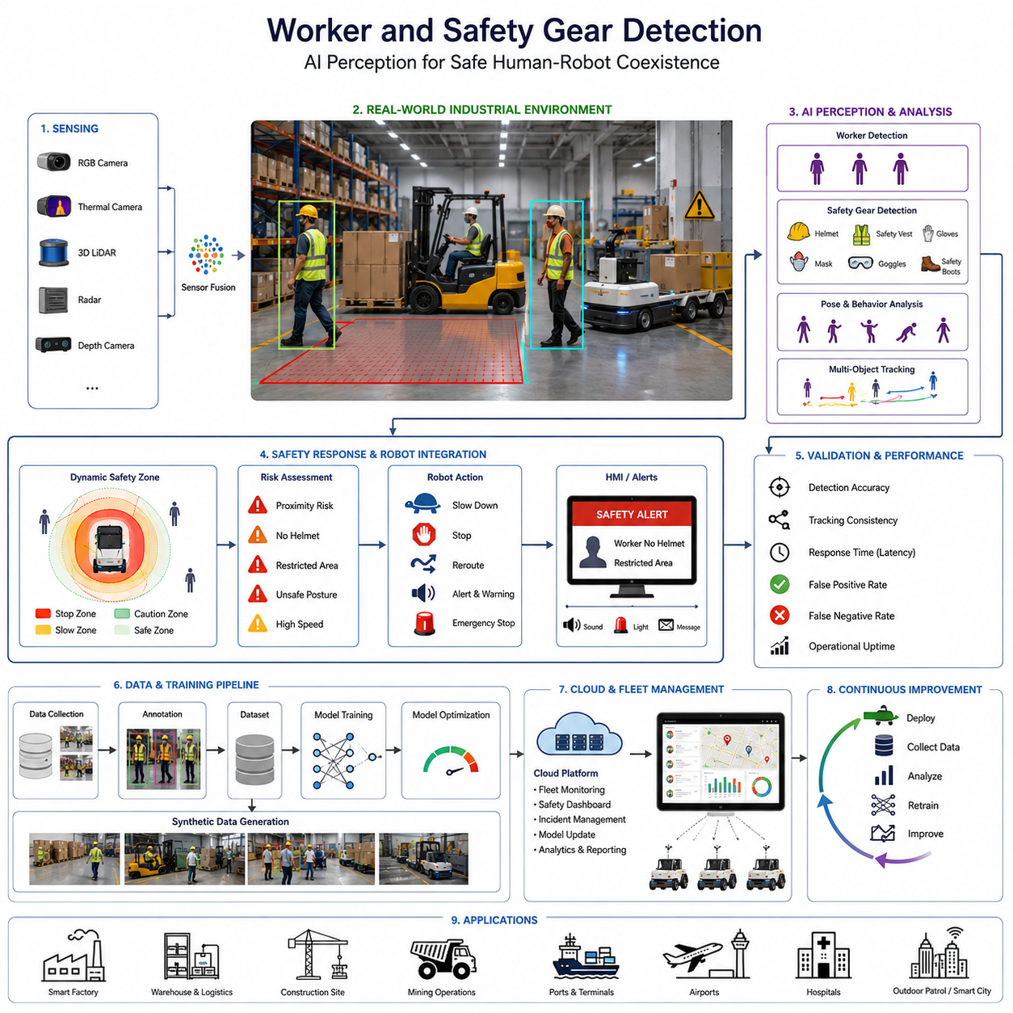
Worker and safety gear detection has become one of the most important perception capabilities in modern Autonomous Mobile Robots (AMRs), industrial robotics, smart factories, construction automation systems, mining robots, logistics robots, and outdoor autonomous platforms. As robotic systems increasingly operate alongside human workers in dynamic industrial environments, ensuring human safety becomes a critical engineering requirement. Traditional industrial safety systems relied primarily on physical barriers, warning signs, safety zones, emergency stop switches, and manual supervision. However, modern intelligent robotic systems require active perception-based safety systems capable of detecting workers, recognizing safety equipment usage, understanding worker behavior, predicting risk situations, and responding autonomously in real time. Therefore, worker and safety gear detection represents a core component of AI-driven industrial safety architecture and human-centered robotic autonomy.
The primary objective of worker and safety gear detection is not simply object recognition but operational risk reduction. Industrial environments contain numerous hazards including moving forklifts, towing AMRs, robotic manipulators, heavy machinery, high-voltage systems, suspended loads, hazardous materials, construction zones, and confined spaces. In these environments, AI perception systems must continuously monitor whether workers are present, whether they are positioned safely, and whether required safety equipment is being worn correctly. This transforms perception systems from passive monitoring tools into active operational safety systems integrated directly with robot navigation, fleet management, and industrial safety workflows.
Worker detection begins with human perception fundamentals. Unlike generic pedestrian detection systems designed for urban autonomous driving, industrial worker detection must function under highly challenging environmental conditions. Workers may wear reflective clothing, helmets, safety vests, gloves, masks, goggles, protective suits, or specialized industrial uniforms. Their appearance may vary dramatically across factories, warehouses, construction sites, ports, mining facilities, hospitals, airports, and outdoor industrial environments. Additionally, workers may be partially occluded by machinery, shelves, pallets, containers, vehicles, or industrial infrastructure. Therefore, worker detection systems require highly robust perception architectures capable of handling complex industrial scenes.
Modern worker detection systems typically combine multiple sensor modalities including RGB cameras, thermal cameras, 3D LiDAR, depth cameras, radar systems, and AI-based sensor fusion architectures. RGB cameras provide high-resolution visual information suitable for object classification and safety gear recognition. Thermal cameras improve human detection reliability under low-light or night conditions. LiDAR systems provide precise 3D spatial localization and obstacle geometry. Radar systems improve robustness under rain, fog, smoke, or dust conditions. Sensor fusion enables the perception system to maintain reliable human detection performance even when individual sensors experience degradation or environmental limitations.
Safety gear detection extends human detection into semantic industrial safety analysis. The perception system must recognize whether workers are wearing helmets, safety vests, gloves, masks, goggles, protective boots, hearing protection devices, reflective clothing, or fall-protection equipment depending on the operational environment. This requires fine-grained object recognition and high-resolution visual analysis because many safety items occupy only small image regions and may vary significantly in shape, color, orientation, and appearance.
Helmet detection is one of the most widely deployed industrial safety AI applications. In many construction sites, logistics centers, manufacturing plants, and heavy industrial facilities, helmets are mandatory safety equipment. AI-based helmet detection systems analyze worker head regions and determine whether approved safety helmets are present. Advanced systems further classify helmet colors, detect damaged helmets, identify improper helmet placement, and recognize non-compliant safety conditions. These systems are frequently integrated with facility access control systems, surveillance infrastructure, autonomous robots, and fleet management systems.
Safety vest detection is similarly important because reflective vests improve worker visibility around autonomous vehicles and industrial machinery. AI perception systems must detect both the presence and visibility quality of reflective safety gear under varying lighting conditions. Outdoor environments introduce additional challenges due to sunlight reflections, rain, dust contamination, and night operation. Thermal and radar fusion systems often improve reliability under such conditions.
Worker posture analysis has become increasingly important in advanced industrial safety systems. Beyond detecting whether a worker is present, AI systems now analyze body posture, motion patterns, and behavior to identify dangerous situations. Examples include detecting workers lying on the ground, entering restricted zones, climbing unsafe structures, approaching dangerous machinery, falling, running unexpectedly, or performing unsafe actions near moving vehicles. Pose estimation models, skeletal tracking systems, and temporal behavior analysis algorithms are commonly integrated into industrial perception pipelines to support such functionality.
Real-time performance is a critical requirement for worker and safety gear detection systems. Industrial robots and autonomous vehicles often operate in environments where response delays of even a few hundred milliseconds may create serious safety risks. Therefore, AI inference pipelines must achieve low-latency processing while maintaining high detection accuracy. Edge AI systems using NVIDIA Jetson platforms, TensorRT optimization, GPU acceleration, and efficient neural network architectures are commonly deployed to satisfy real-time industrial safety requirements.
Dataset engineering is one of the most important challenges in worker and safety gear detection development. Public datasets often lack sufficient diversity for industrial environments because worker appearance, industrial layouts, weather conditions, lighting variability, and safety equipment differ significantly across industries and countries. Therefore, organizations frequently build custom datasets collected from factories, warehouses, ports, construction sites, mines, airports, hospitals, and outdoor industrial operations. These datasets require extensive annotation including worker bounding boxes, helmet labels, vest labels, pose information, behavior classification, and safety-zone interaction labeling.
Synthetic data generation has become increasingly important because collecting dangerous or rare industrial scenarios from real environments is difficult and sometimes unsafe. Simulation platforms such as Isaac Sim, Gazebo, CARLA, Unity, and digital twin environments can generate synthetic industrial scenes containing workers, forklifts, robots, pallets, construction equipment, and diverse safety gear configurations. Synthetic datasets significantly accelerate AI training while improving edge-case coverage.
Occlusion handling is one of the most difficult technical challenges in industrial worker detection. Workers are frequently partially hidden behind pallets, shelves, machinery, containers, vehicles, or infrastructure. Advanced AI systems therefore integrate temporal tracking, multi-camera fusion, 3D perception, and trajectory prediction to maintain stable worker identification even during temporary visual obstruction.
Multi-worker environments further increase perception complexity. Warehouses, ports, smart factories, and logistics centers may contain dozens or hundreds of workers moving simultaneously alongside autonomous vehicles. Multi-object tracking systems are therefore required to maintain persistent worker identities, estimate motion trajectories, predict future positions, and avoid tracking confusion between individuals.
Safety-zone integration is a fundamental aspect of industrial robot safety systems. Worker detection outputs are often integrated directly into robot navigation and safety controllers. Dynamic safety zones may expand or contract depending on worker proximity, robot speed, payload weight, and operational context. If workers approach dangerous regions, robots may reduce speed, stop movement, reroute trajectories, activate warning signals, or trigger emergency shutdown procedures.
Worker trajectory prediction becomes increasingly important for predictive safety systems. Instead of reacting only after workers enter hazardous zones, advanced AI systems attempt to forecast worker movement patterns and proactively prevent collisions or unsafe interactions. Trajectory prediction models integrate motion history, environmental context, robot state, and multi-agent interaction analysis to estimate future worker motion.
Privacy and ethical considerations are also important in worker monitoring systems. Continuous AI surveillance may raise concerns regarding worker privacy, labor rights, biometric monitoring, and operational transparency. Therefore, industrial safety AI systems must comply with regulatory requirements while balancing safety objectives with ethical deployment principles. Privacy-preserving AI architectures, anonymized tracking systems, and restricted data retention policies are increasingly important.
Weather robustness becomes essential for outdoor worker detection systems. Construction robots, agricultural robots, mining robots, patrol robots, railway inspection systems, and smart city robots must detect workers reliably under rain, fog, snow, dust, smoke, low light, and nighttime conditions. Multi-sensor fusion architectures combining thermal cameras, radar, LiDAR, and RGB cameras significantly improve operational robustness.
Worker and safety gear detection also play a critical role in collaborative robotics environments. Human-robot collaboration requires robots to understand worker intent, maintain safe operating distances, adapt motion behavior dynamically, and coordinate safely with nearby personnel. Collaborative industrial robots therefore integrate worker perception directly into motion planning and behavior control systems.
Industrial deployment validation is a major engineering process for safety perception systems. Detection systems must undergo extensive testing under varying lighting conditions, worker clothing variations, environmental clutter, weather conditions, sensor failures, network delays, and operational edge cases. Validation metrics include detection precision, recall, false positive rate, false negative rate, latency, tracking consistency, safety response time, and operational uptime.
Functional safety integration is another critical requirement. Worker detection systems are increasingly integrated into ISO 3691-4 industrial AMR safety architectures, emergency stop systems, safety PLCs, and operational risk management frameworks. In safety-critical applications, AI perception outputs may influence certified safety decisions requiring deterministic response behavior and fail-safe system design.
Cloud robotics and fleet management systems further extend worker safety monitoring capabilities. Centralized monitoring platforms can aggregate safety telemetry across multiple robots and facilities, enabling large-scale operational analytics, incident tracking, predictive safety analysis, and continuous AI model improvement. Operational data collected during deployment may later support retraining, failure analysis, and safety optimization workflows.
Future worker and safety gear detection systems are expected to evolve toward multimodal embodied AI architectures capable of understanding not only worker appearance but also contextual industrial behavior and operational intent. Foundation models, vision-language-action systems, real-time world models, multimodal reasoning systems, and embodied industrial AI agents may eventually enable robots to understand complex workplace semantics and predict hazardous situations before they occur.
Ultimately, worker and safety gear detection are not isolated AI perception functions but essential components of next-generation industrial autonomy. Reliable human detection, safety compliance recognition, behavior analysis, trajectory prediction, and safety-response integration collectively enable autonomous robots to operate safely and efficiently alongside human workers. As AMRs expand into factories, logistics centers, ports, construction sites, mines, hospitals, railways, airports, and smart cities, advanced worker safety perception systems will become one of the foundational technologies enabling trustworthy human-robot coexistence.

21.4 Vehicle Detection
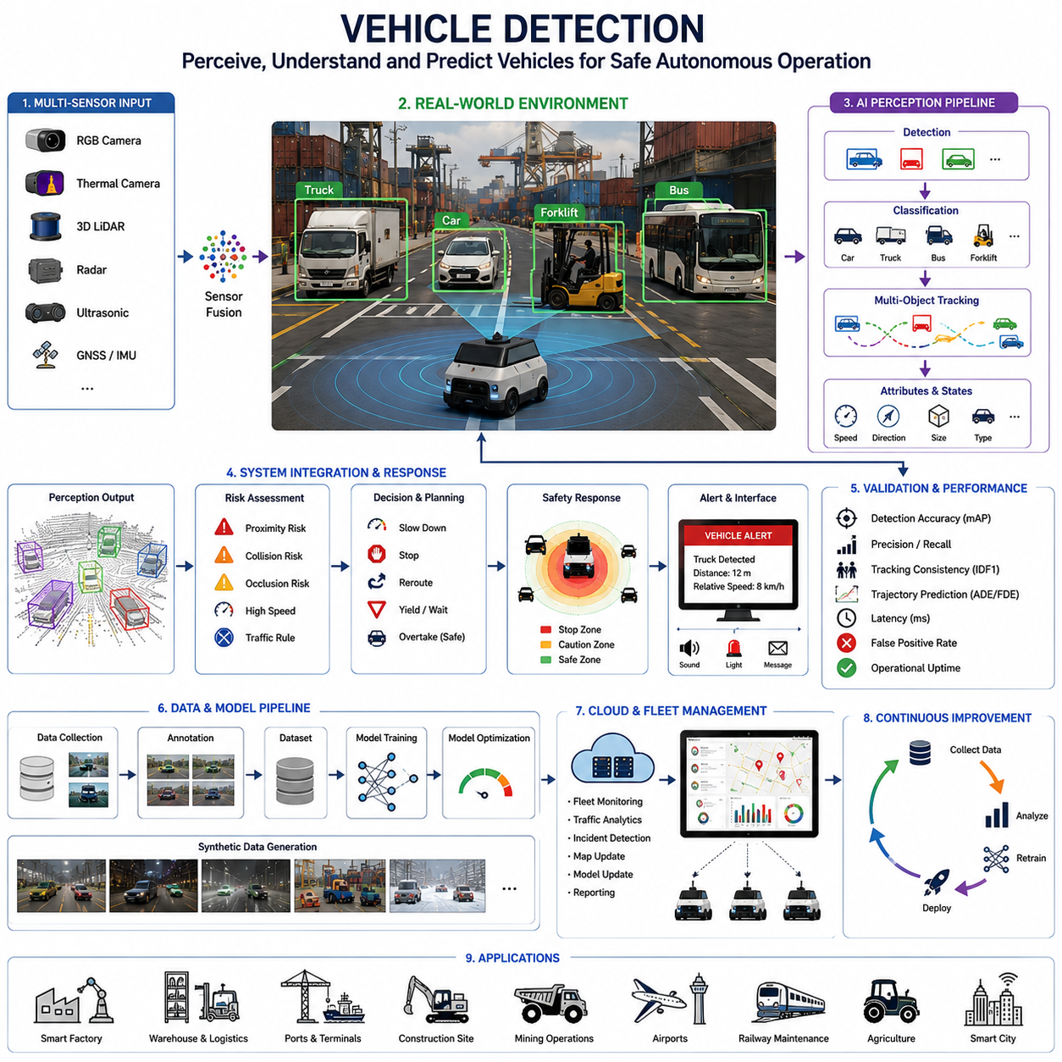
Vehicle detection is one of the most fundamental perception capabilities in modern autonomous systems, intelligent transportation platforms, industrial robotics, smart city infrastructure, logistics automation, and outdoor Autonomous Mobile Robots (AMRs). As robotic systems increasingly operate in environments shared with cars, trucks, forklifts, buses, towing vehicles, delivery platforms, construction equipment, agricultural machinery, airport ground vehicles, railway maintenance systems, and mobile industrial equipment, reliable vehicle perception becomes essential for operational safety, autonomous navigation, collision avoidance, fleet coordination, and intelligent infrastructure management. Vehicle detection is therefore not simply an object recognition task but a critical component of large-scale autonomous mobility and intelligent environmental understanding.
The primary objective of vehicle detection is to identify, localize, classify, track, and predict the behavior of surrounding vehicles in real time under highly dynamic operational conditions. Unlike static industrial inspection systems, autonomous robotic platforms operate in continuously changing environments where vehicles may move unpredictably, interact with pedestrians, enter blind zones, change velocity suddenly, or operate under adverse environmental conditions. Therefore, vehicle detection systems must combine high perception accuracy with low-latency processing, robust environmental adaptability, and reliable multi-object tracking capabilities.
Modern vehicle detection systems typically integrate multiple sensor modalities including RGB cameras, thermal cameras, stereo vision systems, 3D LiDAR, radar systems, ultrasonic sensors, GNSS, IMU, and AI-based sensor fusion architectures. RGB cameras provide rich semantic information and support fine-grained object classification. Thermal cameras improve detection reliability during low-light and nighttime operation. LiDAR provides highly accurate three-dimensional spatial geometry and distance estimation. Radar systems maintain robust detection performance under rain, fog, snow, dust, and smoke conditions. Ultrasonic sensors support short-range obstacle awareness for docking and low-speed navigation. Sensor fusion enables autonomous systems to maintain reliable vehicle perception performance even when individual sensors experience environmental degradation.
Vehicle classification is one of the most important components of perception-driven mobility systems. AI systems must distinguish between passenger vehicles, forklifts, trucks, buses, towing vehicles, motorcycles, bicycles, agricultural machinery, construction equipment, airport service vehicles, railway maintenance vehicles, and autonomous robotic platforms. Each vehicle category exhibits different motion behavior, operational risk, acceleration patterns, braking characteristics, visibility constraints, and interaction rules. Therefore, vehicle classification directly influences motion planning, risk analysis, trajectory prediction, and autonomous decision-making.
Industrial environments introduce additional challenges for vehicle detection systems. Warehouses, ports, factories, mines, airports, logistics centers, and construction sites often contain narrow pathways, reflective surfaces, cluttered infrastructure, dynamic lighting conditions, heavy machinery, and dense multi-vehicle operations. Forklifts may carry large payloads that partially occlude visibility. Towing vehicles may pull long articulated trailers. Construction machinery may operate irregularly near autonomous robots. Under such conditions, vehicle detection systems must maintain reliable performance despite partial occlusion, severe environmental complexity, and unpredictable operational behavior.
Outdoor vehicle detection systems must additionally handle environmental variability including rain, snow, fog, dust, sunlight glare, shadows, nighttime operation, wet roads, vibration, and terrain irregularities. Autonomous delivery robots, outdoor logistics AMRs, smart city robots, agricultural robots, railway inspection robots, mining vehicles, and patrol systems frequently operate under harsh weather conditions where traditional vision-only systems become unreliable. Multi-sensor fusion architectures combining radar, thermal imaging, LiDAR, and RGB cameras significantly improve operational robustness in such environments.
Real-time inference performance is one of the most critical requirements for vehicle detection systems. Autonomous platforms often operate at speeds where even small perception delays may result in unsafe behavior or collisions. Therefore, AI inference pipelines must achieve high throughput and low latency while maintaining stable detection accuracy. Edge AI systems using NVIDIA Jetson platforms, GPU acceleration, TensorRT optimization, FPGA acceleration, and efficient deep learning architectures are commonly deployed to satisfy real-time autonomous perception requirements.
Deep learning has dramatically transformed vehicle detection technology. Modern AI systems commonly use convolutional neural networks, transformer-based architectures, multi-scale feature extraction networks, anchor-free object detectors, vision transformers, and temporal tracking frameworks. Models such as YOLO, Faster R-CNN, SSD, DETR, CenterNet, and transformer-based perception systems are widely used in robotics and autonomous driving applications. These models enable accurate vehicle detection even under complex environmental conditions involving motion blur, low illumination, heavy traffic, or partial occlusion.
Dataset engineering is a foundational aspect of vehicle detection development. High-quality datasets must include diverse vehicle categories, multiple viewing angles, varying weather conditions, different road environments, industrial settings, nighttime scenes, and rare operational edge cases. Public datasets such as KITTI, nuScenes, Waymo Open Dataset, BDD100K, Argoverse, and industrial custom datasets are commonly used for training and benchmarking. However, many industrial environments require domain-specific datasets because public urban-driving datasets often fail to represent warehouses, ports, mines, agricultural fields, or industrial facilities accurately.
Synthetic data generation is becoming increasingly important because collecting large-scale annotated vehicle datasets in dangerous or rare operational conditions is expensive and time-consuming. Simulation environments such as CARLA, Isaac Sim, Gazebo, Unreal Engine, Unity-based simulators, and digital twin platforms can generate realistic synthetic vehicle scenes with controllable weather, lighting, traffic density, sensor noise, and operational scenarios. Synthetic datasets significantly improve edge-case coverage and accelerate AI model development.
Vehicle tracking is another critical component of autonomous perception systems. Detecting vehicles in individual frames is insufficient for autonomous operation because robots must understand vehicle motion continuity over time. Multi-object tracking systems maintain persistent vehicle identities, estimate motion trajectories, predict future movement, and analyze traffic behavior. Tracking stability becomes especially important in crowded logistics centers, urban intersections, industrial yards, and warehouse operations where multiple vehicles move simultaneously.
Trajectory prediction systems extend vehicle detection into predictive environmental intelligence. Autonomous robots must estimate where nearby vehicles are likely to move in the near future to avoid collisions and plan safe trajectories. Trajectory prediction models analyze motion history, lane structure, environmental geometry, traffic rules, vehicle interactions, and behavioral patterns to estimate future motion distributions. Advanced AI systems may further incorporate intention prediction and multi-agent interaction reasoning.
Vehicle detection also plays a central role in autonomous navigation and path planning. Perception outputs directly influence obstacle avoidance systems, dynamic replanning algorithms, safe-speed estimation, free-space analysis, and traffic interaction strategies. If vehicle detection reliability degrades, autonomous navigation safety may collapse rapidly. Therefore, perception redundancy, sensor diversity, and fail-safe detection architectures are essential for safety-critical autonomous systems.
Safety-zone integration becomes especially important in industrial robotics environments. Autonomous robots operating near forklifts, towing vehicles, cranes, and heavy equipment must dynamically adjust navigation behavior depending on vehicle proximity and operational risk. Dynamic safety zones may trigger speed reduction, rerouting, emergency braking, warning signals, or operational shutdown procedures when dangerous interactions are detected.
Vehicle detection systems are also tightly integrated with smart city infrastructure and intelligent transportation systems. Modern smart cities increasingly deploy AI perception platforms for traffic monitoring, congestion analysis, parking management, incident detection, infrastructure monitoring, public safety, and fleet optimization. Edge AI cameras, roadside perception units, cloud analytics systems, and distributed telemetry platforms enable large-scale vehicle monitoring and operational analytics.
Railway and industrial inspection robots require specialized vehicle detection architectures because they frequently interact with rail vehicles, maintenance equipment, industrial carts, towing systems, and restricted operational zones. Railway maintenance robots must identify approaching trains and maintenance vehicles reliably under vibration-heavy outdoor conditions. Industrial inspection robots operating in ports or factories must recognize forklifts, AGVs, container vehicles, and articulated towing platforms.
Collaborative robotics environments introduce additional perception challenges because autonomous robots must coexist safely with both vehicles and human workers simultaneously. Vehicle detection systems are therefore often integrated with pedestrian detection, worker safety monitoring, human trajectory prediction, and multi-agent safety coordination systems. This enables intelligent coordination between robots, vehicles, and human personnel.
Validation and benchmarking are fundamental engineering processes for vehicle detection systems. AI models must undergo extensive evaluation under varying weather conditions, lighting variability, sensor degradation, communication delays, high-density traffic, partial occlusion, industrial clutter, and operational edge cases. Validation metrics commonly include precision, recall, mAP, tracking consistency, trajectory prediction accuracy, inference latency, false positive rate, false negative rate, operational uptime, and collision avoidance reliability.
Functional safety integration is increasingly important because vehicle detection systems directly influence autonomous operational decisions. Safety-critical robotic systems frequently integrate perception outputs into ISO 3691-4 industrial AMR safety architectures, emergency stop systems, safety PLCs, collision avoidance controllers, and operational risk management frameworks. Deterministic response behavior, redundancy-aware architecture, and fail-safe operation become essential engineering requirements.
Cloud robotics and fleet management systems further extend vehicle detection capabilities by aggregating perception telemetry across large fleets of autonomous robots and intelligent infrastructure systems. Centralized analytics platforms enable large-scale traffic monitoring, operational optimization, predictive maintenance analysis, incident investigation, fleet coordination, and continuous AI model improvement. Operational telemetry collected during deployment may later support retraining pipelines, anomaly detection systems, and safety optimization workflows.
Future vehicle detection systems are expected to evolve toward multimodal embodied AI architectures capable of understanding not only vehicle appearance but also contextual traffic behavior, operational semantics, environmental reasoning, and predictive interaction modeling. Foundation models, vision-language-action systems, real-time world models, autonomous reasoning agents, and multimodal AI systems may eventually enable robots to understand complex mobility ecosystems with human-like situational awareness.
Ultimately, vehicle detection is not an isolated computer vision problem but one of the foundational perception technologies enabling trustworthy autonomous mobility. Reliable vehicle perception supports safe navigation, intelligent traffic interaction, operational efficiency, industrial safety, fleet coordination, and human-robot coexistence. As AMRs continue expanding into logistics, ports, smart factories, construction sites, mining operations, hospitals, airports, railways, agriculture, and smart city environments, advanced vehicle detection systems will become one of the essential technologies enabling scalable and safe autonomous robotic ecosystems.

21.5 Forklift and Industrial Machine Detection
Forklift and industrial machine detection has become one of the most important perception capabilities in modern industrial robotics, Autonomous Mobile Robots (AMRs), smart factories, warehouse automation systems, port logistics platforms, mining operations, airport logistics systems, and outdoor autonomous industrial robots. As industrial environments become increasingly automated and interconnected, autonomous systems must safely coexist with forklifts, cranes, towing vehicles, excavators, reach stackers, loaders, pallet movers, industrial trucks, robotic manipulators, and heavy machinery operating continuously in dynamic environments. Under these conditions, reliable industrial machine perception becomes essential for operational safety, autonomous navigation, collision avoidance, fleet coordination, intelligent logistics orchestration, and large-scale industrial automation. Therefore, forklift and industrial machine detection is not merely a computer vision problem but a foundational perception technology enabling safe industrial autonomy and intelligent machine collaboration.
The primary objective of forklift and industrial machine detection is to identify, localize, classify, track, and predict the behavior of industrial equipment operating in complex environments. Unlike standard vehicle detection in urban driving scenarios, industrial environments contain highly specialized machines with diverse sizes, geometries, motion behaviors, payload conditions, visibility constraints, and operational patterns. Forklifts may lift pallets vertically, towing vehicles may pull articulated trailers, cranes may rotate heavy loads overhead, and construction machines may move unpredictably near autonomous robots. Therefore, industrial machine perception systems must combine high detection accuracy, low-latency processing, environmental robustness, predictive safety intelligence, and reliable multi-object tracking.
Forklift detection is one of the most critical industrial safety functions because forklifts are among the most common causes of industrial collisions and workplace accidents. Warehouses, factories, logistics centers, ports, and industrial yards frequently contain both human workers and autonomous robots operating alongside manually driven forklifts. Forklifts may reverse unexpectedly, carry large loads blocking visibility, move quickly around blind corners, or operate in narrow aisles. AI perception systems must therefore continuously monitor forklift position, orientation, speed, lifting state, payload condition, and motion trajectory to prevent dangerous interactions with workers and autonomous systems.
Industrial machine detection systems commonly integrate multiple sensor modalities including RGB cameras, thermal cameras, 3D LiDAR, radar systems, stereo cameras, ultrasonic sensors, depth cameras, GNSS, IMU, and AI-based sensor fusion architectures. RGB cameras provide high-resolution semantic information suitable for machine classification and payload recognition. Thermal cameras improve machine visibility under low-light and nighttime conditions. LiDAR systems provide highly accurate three-dimensional geometry and distance measurements. Radar systems improve robustness under dust, rain, smoke, fog, and industrial contamination conditions. Multi-sensor fusion allows the perception system to maintain stable operational awareness even when individual sensors experience degradation.
Machine classification becomes a central component of industrial perception intelligence. AI systems must distinguish between forklifts, towing vehicles, pallet movers, automated guided vehicles (AGVs), AMRs, cranes, excavators, loaders, terminal tractors, container handlers, industrial trucks, mining vehicles, airport service equipment, railway maintenance machines, and robotic manipulators. Each machine category exhibits unique motion behavior, operational risk, acceleration patterns, maneuverability limits, stopping distances, and interaction rules. Therefore, machine classification directly influences navigation planning, dynamic safety-zone generation, risk prediction, fleet coordination, and autonomous decision-making.
Payload-aware perception is especially important in forklift and industrial machine detection. Unlike ordinary vehicles, industrial machines frequently carry large payloads whose geometry may significantly alter visibility, balance, stopping behavior, maneuverability, and operational risk. Forklifts carrying tall pallets may partially block sensor visibility and create dangerous blind zones. Cranes may transport suspended loads introducing dynamic motion instability. Industrial perception systems therefore require payload detection, load-state estimation, center-of-gravity awareness, and dynamic risk analysis capabilities.
Industrial environments introduce highly challenging perception conditions. Warehouses, ports, factories, mines, airports, construction zones, and logistics centers contain narrow pathways, stacked materials, reflective metal surfaces, heavy machinery vibration, dynamic lighting changes, dense traffic, and severe occlusion. Industrial machines are frequently partially hidden behind shelves, containers, pallets, or infrastructure. Dust, smoke, fog, rain, and poor illumination further complicate perception reliability. Therefore, industrial machine detection systems must maintain stable performance under extreme environmental complexity and operational variability.
Real-time inference performance is one of the most important requirements for industrial perception systems. Autonomous robots and industrial vehicles frequently operate in environments where even small perception delays may result in severe collisions or safety incidents. Therefore, AI inference pipelines must achieve low latency while maintaining high perception accuracy and tracking stability. Edge AI systems using NVIDIA Jetson platforms, GPU acceleration, TensorRT optimization, FPGA acceleration, and lightweight neural network architectures are widely deployed in industrial robotics applications.
Deep learning has transformed industrial machine perception dramatically. Modern AI systems commonly use convolutional neural networks, transformer-based perception models, multi-scale feature extraction architectures, anchor-free detectors, temporal tracking systems, and multimodal sensor fusion networks. Models such as YOLO, Faster R-CNN, SSD, DETR, CenterNet, vision transformers, and industrial AI perception frameworks are widely used for forklift and heavy equipment detection. These systems can detect industrial machines reliably even under low-light conditions, motion blur, partial occlusion, and high-density industrial traffic.
Dataset engineering is one of the most difficult challenges in industrial machine detection development. Public autonomous driving datasets rarely contain sufficient industrial machine diversity because urban traffic datasets do not represent warehouses, ports, factories, mines, or industrial logistics environments accurately. Therefore, organizations often build custom industrial datasets collected from operational facilities. These datasets require extensive annotation including machine categories, forklift forks, payload states, articulated trailers, lifting height, motion direction, safety-zone interaction, and worker-machine proximity relationships.
Synthetic data generation is becoming increasingly important because collecting dangerous industrial scenarios from real environments is expensive, difficult, and potentially unsafe. Simulation environments such as Isaac Sim, Gazebo, CARLA, Unreal Engine, Unity-based industrial simulators, and digital twin platforms can generate realistic industrial scenes containing forklifts, cranes, AMRs, AGVs, towing systems, workers, pallets, containers, and industrial infrastructure. Synthetic datasets significantly improve AI training scalability and edge-case coverage.
Forklift trajectory prediction becomes increasingly important for predictive industrial safety systems. Autonomous robots must estimate future forklift motion to avoid collisions and maintain safe navigation behavior. Trajectory prediction systems analyze motion history, aisle geometry, payload conditions, operational context, traffic flow, and multi-agent interactions to estimate future movement patterns. Advanced AI systems may further predict operator intent and abnormal machine behavior.
Safety-zone integration is a core component of industrial robot safety architecture. Forklift and industrial machine perception outputs are directly integrated into autonomous navigation systems, emergency braking systems, safety PLCs, operational risk management frameworks, and fleet coordination systems. Dynamic safety zones may expand depending on forklift speed, payload weight, proximity to workers, machine turning radius, or environmental complexity. Robots may reduce speed, reroute paths, activate warning systems, or stop entirely when hazardous interactions are detected.
Worker-machine interaction analysis is another major area of industrial safety AI. Industrial environments frequently contain complex interactions between forklifts, robots, and human workers. AI systems therefore integrate worker detection, forklift detection, trajectory prediction, pose estimation, and multi-agent interaction analysis to identify unsafe behaviors such as workers approaching moving forklifts, forklifts reversing near pedestrians, unsafe loading operations, or dangerous crossing situations.
Industrial machine detection also supports autonomous fleet management and intelligent logistics orchestration. Smart warehouses and automated ports increasingly coordinate hundreds of forklifts, AGVs, AMRs, towing systems, and industrial machines simultaneously. Perception telemetry collected from distributed autonomous systems supports traffic optimization, congestion analysis, predictive maintenance, operational analytics, energy efficiency optimization, and intelligent task scheduling.
Construction and mining environments introduce additional perception challenges due to rough terrain, extreme weather, heavy vibration, dust contamination, and irregular machine movement. Excavators, dump trucks, loaders, cranes, and mining equipment may operate unpredictably near autonomous systems. Therefore, ruggedized multi-sensor fusion systems combining radar, thermal imaging, LiDAR, and RGB perception are commonly required for reliable industrial machine detection.
Railway and port logistics operations also require specialized industrial perception systems. Port automation systems must detect container trucks, terminal tractors, reach stackers, cranes, and towing vehicles operating continuously in high-density logistics environments. Railway maintenance robots must recognize maintenance vehicles, track equipment, and industrial transport systems operating along rail infrastructure. These environments frequently involve harsh weather, metallic clutter, and communication limitations.
Functional safety integration is increasingly important because industrial machine detection directly influences autonomous operational safety decisions. Perception systems are often integrated into ISO 3691-4 industrial AMR safety architectures, emergency stop systems, safety-certified control systems, collision avoidance controllers, and industrial risk management frameworks. Deterministic behavior, fail-safe operation, sensor redundancy, and operational reliability become essential engineering requirements.
Validation and benchmarking are critical engineering processes for industrial perception systems. AI models must undergo extensive testing under varying lighting conditions, machine types, payload configurations, weather environments, sensor degradation scenarios, communication delays, occlusion conditions, and operational edge cases. Validation metrics commonly include detection precision, recall, mAP, tracking consistency, inference latency, trajectory prediction accuracy, false positive rate, false negative rate, operational uptime, and safety response reliability.
Cloud robotics and digital twin systems further extend industrial machine perception capabilities. Centralized analytics platforms aggregate telemetry collected from multiple robots, forklifts, industrial vehicles, and infrastructure systems to support large-scale operational monitoring, predictive maintenance analysis, incident investigation, safety optimization, and continuous AI model improvement. Digital twin environments allow engineers to reproduce operational incidents safely and validate software updates before deployment.
Future forklift and industrial machine detection systems are expected to evolve toward multimodal embodied AI architectures capable of understanding not only machine appearance but also operational semantics, industrial workflows, worker intent, environmental context, and predictive risk behavior. Foundation models, vision-language-action systems, real-time industrial world models, multimodal reasoning architectures, and autonomous industrial AI agents may eventually enable robots to understand complex industrial ecosystems with near-human situational awareness.
Ultimately, forklift and industrial machine detection are not isolated AI perception functions but essential technologies enabling safe industrial autonomy and intelligent machine collaboration. Reliable industrial perception supports collision avoidance, operational efficiency, human safety, logistics optimization, autonomous navigation, fleet coordination, and trustworthy human-robot-machine coexistence. As AMRs continue expanding into smart factories, warehouses, ports, mining operations, airports, railways, construction sites, and industrial smart city infrastructure, advanced industrial machine detection systems will become one of the foundational technologies enabling scalable and safe industrial robotics ecosystems.

21.6 Behavior and Trajectory Prediction
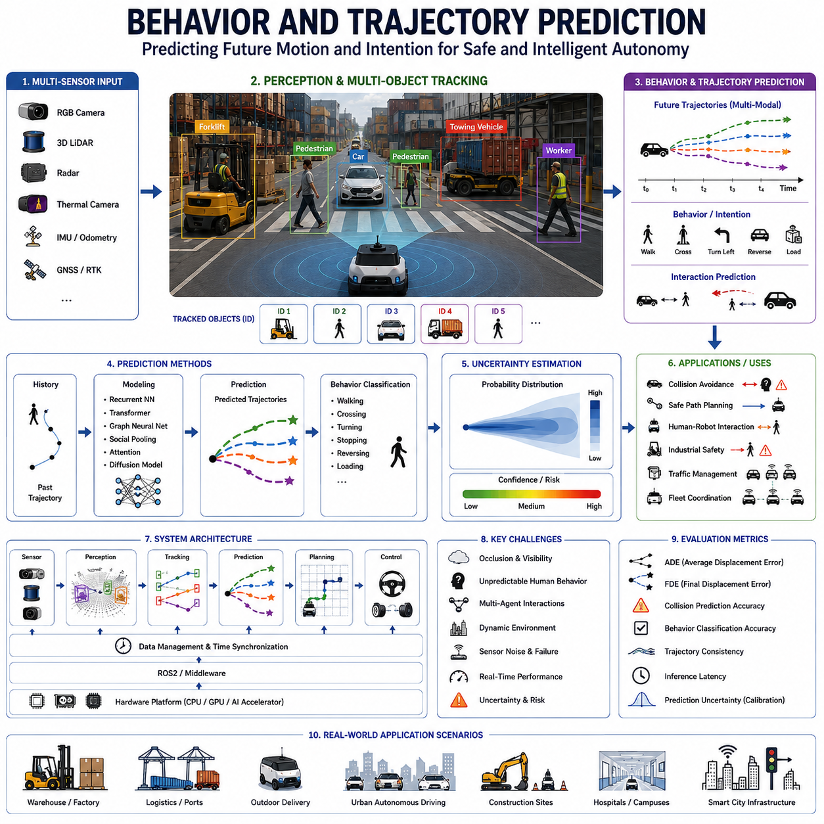
Behavior and trajectory prediction has become one of the most important intelligence capabilities in modern Autonomous Mobile Robots (AMRs), autonomous driving systems, industrial robotics, smart factory automation, outdoor delivery robots, logistics platforms, smart city infrastructure, and embodied AI systems. While traditional robotic perception focused primarily on detecting objects and estimating their positions, modern autonomous systems must go far beyond static perception. Robots operating in dynamic real-world environments must continuously predict how humans, vehicles, forklifts, industrial machines, bicycles, robots, and other moving agents are likely to behave in the near future. Therefore, behavior and trajectory prediction represents a critical bridge between perception, situational awareness, navigation intelligence, safety engineering, and autonomous decision-making.
The primary objective of behavior and trajectory prediction is to estimate the future motion, intention, interaction patterns, and operational behavior of dynamic agents surrounding an autonomous system. Unlike static obstacle detection, trajectory prediction attempts to answer future-oriented questions such as where a pedestrian will walk, whether a forklift will reverse, whether a vehicle intends to turn, whether a worker may cross a robot path, or whether multiple moving agents are likely to create collision risks. This predictive capability is essential because autonomous systems require sufficient reaction time to avoid dangerous situations and optimize navigation behavior safely and efficiently.
Trajectory prediction begins with motion understanding fundamentals. Every dynamic object operating in real-world environments follows certain physical, behavioral, environmental, and operational constraints. Humans tend to follow walkable paths and avoid collisions. Vehicles obey lane structures, turning limitations, and traffic rules. Forklifts move differently when carrying heavy payloads. Industrial workers may behave differently depending on operational tasks and nearby machinery. Robots must therefore analyze both geometric motion patterns and contextual environmental semantics to estimate future trajectories accurately.
Modern trajectory prediction systems integrate multiple sensor modalities including RGB cameras, thermal cameras, 3D LiDAR, radar systems, stereo cameras, depth sensors, GNSS, IMU, and AI-based sensor fusion architectures. RGB cameras provide semantic understanding of agent appearance and environmental context. LiDAR systems provide precise three-dimensional localization and motion estimation. Radar systems provide robust velocity measurements under adverse weather conditions. Thermal cameras improve human tracking reliability under low-light conditions. Multi-sensor fusion enables stable trajectory estimation even when individual sensors experience degradation or partial failure.
Human behavior prediction is one of the most difficult and important areas within autonomous robotics perception. Human movement is highly dynamic, context dependent, and sometimes unpredictable. Pedestrians may suddenly change direction, stop unexpectedly, accelerate, interact socially with others, or violate expected navigation patterns. Workers inside industrial facilities may become distracted, carry objects, enter restricted areas, or move irregularly near machinery. Therefore, AI systems must combine trajectory estimation with contextual scene understanding, social interaction modeling, and behavioral intention analysis.
Vehicle trajectory prediction introduces additional complexity because vehicles operate under both physical constraints and traffic rules. Cars, buses, forklifts, towing vehicles, autonomous robots, agricultural machinery, and construction equipment each exhibit different acceleration profiles, braking distances, turning radii, maneuverability limitations, and operational behaviors. Trajectory prediction systems must therefore incorporate motion dynamics, road geometry, free-space estimation, traffic structure, obstacle interactions, and environmental context.
Industrial environments create especially challenging prediction conditions. Warehouses, ports, smart factories, airports, mines, construction sites, and logistics centers frequently contain dense multi-agent traffic involving forklifts, AMRs, AGVs, towing systems, workers, robotic manipulators, cranes, and industrial vehicles operating simultaneously. In such environments, autonomous systems must continuously predict future interactions between many moving agents under severe occlusion, narrow pathways, limited visibility, and dynamic operational constraints.
Multi-agent interaction modeling has become one of the most important research areas in modern robotics AI. Traditional trajectory prediction systems estimated future motion independently for each object. However, real-world environments involve strong interactions between agents. Pedestrians avoid one another socially. Vehicles yield or compete at intersections. Forklifts slow down near workers. Robots coordinate motion within fleets. Therefore, advanced AI systems model social behavior, collision avoidance patterns, traffic negotiation, cooperative motion, and interaction-aware prediction.
Deep learning has dramatically transformed trajectory prediction technology. Modern AI systems commonly use recurrent neural networks, temporal convolutional architectures, graph neural networks, transformers, attention-based models, diffusion models, and multimodal trajectory prediction architectures. These models learn complex behavioral patterns directly from large-scale operational datasets. Transformer-based models and graph-based interaction networks are particularly effective for modeling long-term dependencies and multi-agent interactions.
Temporal tracking forms the foundation of trajectory prediction. Autonomous systems must maintain stable object identities over time using multi-object tracking systems. Tracking pipelines estimate object velocity, acceleration, heading angle, motion continuity, and interaction history. Accurate tracking becomes critical because trajectory prediction quality strongly depends on the reliability of historical motion data.
Context-aware prediction is increasingly important in modern autonomous systems. Trajectory estimation cannot rely solely on object motion history because environmental semantics strongly influence future behavior. Sidewalk geometry, road lanes, intersections, crosswalks, loading zones, warehouse aisles, industrial safety zones, doorways, elevator areas, docking stations, and operational workflows all constrain possible future trajectories. AI systems therefore integrate scene understanding and semantic mapping into trajectory prediction pipelines.
Behavior classification further extends prediction intelligence beyond geometric motion estimation. AI systems may classify agents as walking, running, stopping, reversing, yielding, loading, turning, docking, overtaking, crossing, or waiting. Industrial robots may additionally identify behaviors such as pallet pickup, forklift loading, crane operation, worker-machine interaction, or hazardous motion patterns. Behavior classification significantly improves predictive decision-making and risk assessment.
Prediction uncertainty estimation is another critical requirement for trustworthy autonomous systems. Future behavior is inherently uncertain, especially in crowded or highly dynamic environments. Therefore, AI systems must estimate not only a single predicted trajectory but also probability distributions over multiple possible futures. Multimodal prediction architectures generate multiple potential trajectories with associated confidence levels, enabling safer planning under uncertainty.
Real-time inference performance is essential for operational safety. Autonomous robots and vehicles operate continuously in dynamic environments where delayed prediction may result in unsafe navigation decisions. Therefore, trajectory prediction pipelines must maintain low-latency processing while handling large numbers of tracked agents simultaneously. Edge AI systems using NVIDIA Jetson platforms, GPU acceleration, TensorRT optimization, distributed inference architectures, and lightweight neural network models are commonly deployed in robotics applications.
Trajectory prediction directly influences autonomous navigation and motion planning. Navigation systems use predicted trajectories to estimate future collision risks, optimize local path planning, maintain safe distances, negotiate traffic interactions, and perform smooth navigation behavior. Prediction-aware navigation systems are significantly safer and more efficient than purely reactive systems.
Safety-zone integration is especially important in industrial robotics environments. Predicted trajectories of workers, forklifts, vehicles, and robots are integrated directly into safety management systems. Dynamic safety zones may expand proactively if predicted trajectories indicate possible future collisions. Robots may reduce speed, reroute paths, stop motion, activate alarms, or modify operational behavior based on future risk estimation rather than only current obstacle positions.
Autonomous fleet management systems rely heavily on predictive intelligence. Smart warehouses, logistics centers, airports, ports, hospitals, and industrial facilities often coordinate hundreds of robots and industrial vehicles simultaneously. Fleet-level trajectory prediction enables traffic optimization, congestion prevention, intelligent scheduling, cooperative navigation, and operational efficiency improvement.
Behavior prediction is also a foundational capability for human-robot interaction. Collaborative robots operating near human workers must understand human intention, anticipate movement, maintain comfortable interaction distances, and adapt robot behavior naturally. Predictive human-aware navigation greatly improves both operational safety and human trust in autonomous systems.
Adverse weather environments create additional trajectory prediction challenges. Rain, fog, dust, smoke, snow, nighttime conditions, and sensor contamination may degrade perception quality significantly. Multi-sensor fusion architectures combining radar, thermal imaging, LiDAR, and RGB perception improve tracking stability and predictive reliability under such harsh environmental conditions.
Simulation and digital twin environments play a major role in trajectory prediction development. Large-scale simulation systems generate synthetic interaction scenarios involving pedestrians, forklifts, robots, vehicles, industrial equipment, and dynamic operational workflows. Digital twins further allow engineers to reproduce operational failures safely and validate prediction models before deployment into real environments.
Dataset engineering is one of the most important aspects of trajectory prediction research. High-quality datasets must contain long-duration temporal sequences, multi-agent interactions, diverse environmental conditions, operational edge cases, industrial workflows, and accurate trajectory annotations. Public datasets such as nuScenes, Waymo Open Dataset, Argoverse, ETH/UCY pedestrian datasets, and industrial robotics datasets are widely used for research and benchmarking.
Validation and benchmarking are fundamental engineering processes for behavior prediction systems. AI models must undergo extensive evaluation under varying environmental conditions, agent densities, weather environments, occlusion scenarios, industrial traffic conditions, and operational edge cases. Common validation metrics include Average Displacement Error (ADE), Final Displacement Error (FDE), collision prediction accuracy, behavior classification accuracy, trajectory consistency, prediction uncertainty calibration, inference latency, and operational reliability.
Functional safety integration is becoming increasingly important because trajectory prediction directly influences autonomous operational decisions. Safety-critical robotic systems increasingly integrate predictive AI outputs into ISO 3691-4 industrial AMR safety architectures, emergency stop systems, collision avoidance controllers, operational risk management frameworks, and fleet coordination systems. Deterministic fail-safe behavior and prediction-aware safety engineering therefore become essential.
Cloud robotics and distributed AI systems further extend predictive intelligence capabilities. Centralized cloud analytics platforms aggregate telemetry collected from large robot fleets, industrial infrastructure, traffic systems, and operational environments. This operational data supports large-scale behavioral learning, continuous model improvement, predictive analytics, incident investigation, and adaptive fleet optimization.
Future behavior and trajectory prediction systems are expected to evolve toward multimodal embodied AI architectures capable of understanding human intention, social interaction, operational semantics, environmental reasoning, and long-term predictive planning simultaneously. Foundation models, vision-language-action systems, world models, multimodal reasoning architectures, and embodied AI agents may eventually enable robots to understand and anticipate complex real-world dynamics with near-human situational awareness.
Ultimately, behavior and trajectory prediction are not isolated AI perception functions but foundational intelligence capabilities enabling trustworthy autonomous systems. Reliable predictive perception supports safe navigation, collision avoidance, industrial safety, human-robot interaction, traffic coordination, operational efficiency, fleet optimization, and intelligent autonomous behavior. As AMRs continue expanding into smart factories, warehouses, hospitals, ports, railways, airports, construction sites, mining operations, agriculture, defense, and smart city infrastructure, advanced behavior and trajectory prediction systems will become one of the most critical technologies enabling scalable, safe, and intelligent robotic autonomy.

21.7 Safety Response Integration
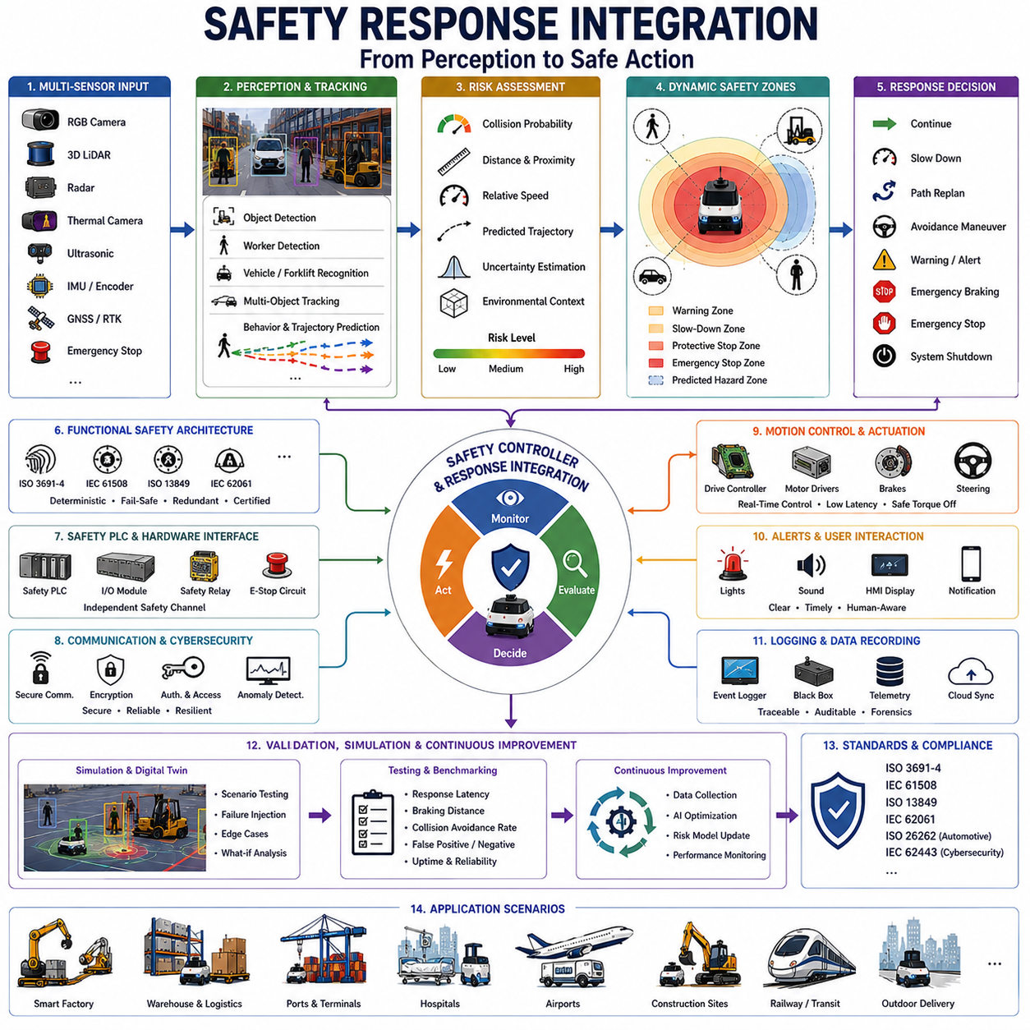
Safety response integration is one of the most critical system-level engineering disciplines in modern Autonomous Mobile Robots (AMRs), industrial robotics, autonomous vehicles, smart factories, logistics automation systems, collaborative robotics platforms, and intelligent industrial infrastructure. While perception systems, behavior prediction algorithms, and autonomous navigation technologies provide situational awareness and decision-making intelligence, autonomous systems ultimately require reliable mechanisms capable of converting safety intelligence into immediate operational action. Therefore, safety response integration represents the direct connection between AI perception, operational risk analysis, motion control, emergency intervention, functional safety architecture, and real-world autonomous behavior. Without reliable safety response integration, even highly advanced perception systems cannot guarantee operational safety in dynamic environments.
The primary objective of safety response integration is to ensure that autonomous systems can react safely, predictably, and reliably when hazardous situations are detected. Modern autonomous robots operate in highly dynamic environments containing workers, forklifts, vehicles, industrial machines, pedestrians, obstacles, construction equipment, railway systems, airport traffic, and unpredictable environmental conditions. In these environments, safety response systems must continuously evaluate operational risk and determine appropriate reactions ranging from speed reduction and path replanning to emergency braking and complete system shutdown.
Safety response integration begins with risk perception and hazard identification. Autonomous systems continuously receive information from perception pipelines including object detection, worker detection, vehicle tracking, forklift recognition, behavior prediction, trajectory estimation, environmental mapping, and sensor fusion systems. These perception outputs alone are insufficient for safety operation unless integrated into real-time risk analysis frameworks capable of evaluating collision probability, operational danger level, uncertainty estimation, and response urgency.
Modern safety response systems integrate multiple sensor modalities including RGB cameras, thermal cameras, 3D LiDAR, radar systems, ultrasonic sensors, depth cameras, GNSS, IMU, encoder systems, emergency stop interfaces, safety PLCs, and AI-based sensor fusion architectures. Multi-sensor integration is essential because safety-critical systems cannot rely on single-sensor operation. If one sensor experiences failure, environmental degradation, occlusion, contamination, or communication interruption, redundant sensing systems must continue supporting safe operation.
Dynamic risk assessment is one of the most important components of safety response integration. Unlike static industrial safety systems, autonomous robots must continuously evaluate rapidly changing operational conditions. Risk levels may change within milliseconds due to worker movement, vehicle acceleration, forklift reversal, unexpected pedestrian behavior, sensor uncertainty, terrain instability, payload shifts, or communication latency. Therefore, safety systems require real-time risk scoring architectures capable of continuously updating operational safety states.
Safety-zone management forms the operational core of many industrial autonomous systems. Modern AMRs frequently use layered safety-zone architectures consisting of warning zones, slow-down zones, protective stop zones, collision avoidance regions, emergency stop boundaries, and predictive hazard regions. These zones dynamically expand or contract depending on robot speed, payload weight, braking distance, environmental complexity, worker proximity, machine type, and predicted future trajectories. Safety response integration continuously connects perception intelligence with these adaptive safety regions.
Emergency braking integration is one of the most critical functional safety mechanisms in autonomous robotics. When high-risk conditions are detected, robots must perform controlled deceleration or immediate emergency stopping within certified response times. Emergency braking systems must account for robot velocity, payload inertia, floor friction, terrain slope, wheel slip conditions, towing loads, and actuator latency. Heavy outdoor robots, towing AMRs, industrial forklifts, and high-speed autonomous platforms require especially sophisticated braking response integration due to large stopping distances and dynamic stability constraints.
Path replanning and evasive maneuver integration extend safety response beyond simple stopping behavior. In many operational scenarios, stopping immediately may create secondary risks or operational inefficiency. Therefore, advanced autonomous systems dynamically modify navigation trajectories to avoid obstacles, reroute around workers, negotiate traffic interactions, and maintain safe operational flow. Trajectory prediction and behavior analysis systems play critical roles in enabling intelligent safety-aware navigation behavior.
Worker safety integration is one of the most important areas within industrial robotics safety engineering. Autonomous systems operating near human workers must maintain strict compliance with industrial safety regulations and human-centered operational principles. Safety systems continuously monitor worker position, posture, motion direction, safety gear usage, proximity to hazardous equipment, and predicted future movement. Robots may reduce speed proactively, activate warning signals, modify operational behavior, or stop entirely when workers approach dangerous zones.
Forklift and industrial machine interaction safety is similarly important because industrial facilities often contain mixed traffic involving robots, forklifts, towing systems, cranes, AGVs, trucks, and human workers simultaneously. Safety response systems must evaluate multi-agent interaction risks continuously while accounting for machine momentum, payload instability, blind zones, reversing operations, and industrial workflow constraints.
Behavior prediction integration significantly improves safety system intelligence. Instead of reacting only after hazards appear, predictive safety systems estimate future collision risks before dangerous situations fully develop. Trajectory prediction models estimate whether pedestrians may cross robot paths, whether forklifts may reverse unexpectedly, or whether multiple moving agents may create traffic conflicts. This predictive capability enables proactive safety responses rather than purely reactive intervention.
Functional safety architecture is a foundational engineering requirement for safety response integration. Modern industrial AMRs increasingly comply with standards such as ISO 3691-4, IEC 61508, ISO 13849, IEC 62061, and other industrial functional safety frameworks. Safety response systems therefore require deterministic behavior, certified hardware components, fail-safe communication mechanisms, redundant sensing architectures, and validated emergency response pathways.
Safety PLC integration is widely used within industrial autonomous systems. Safety PLCs provide deterministic safety control independent from higher-level AI software stacks. Perception systems may provide environmental intelligence, but certified safety controllers ultimately execute emergency stop decisions, motor shutdown commands, brake activation signals, and protective operational responses. This separation between AI intelligence and certified safety control is essential for achieving industrial-grade operational reliability.
Communication latency management becomes critically important in distributed autonomous systems. Cloud robotics platforms, fleet management systems, and distributed industrial infrastructure may introduce network latency, packet loss, synchronization drift, or communication interruption. Safety response integration therefore prioritizes local edge-level safety control capable of operating independently from cloud infrastructure during communication failure conditions.
Cybersecurity integration is becoming increasingly important within safety-critical robotics systems. Autonomous platforms connected to industrial networks may become vulnerable to cyberattacks, unauthorized control signals, spoofed sensor data, communication manipulation, or malicious operational interference. Therefore, safety response systems increasingly incorporate cybersecurity-aware architecture including encrypted communication, authentication protocols, anomaly detection, secure safety channels, and operational isolation mechanisms.
Environmental robustness is another major engineering requirement. Autonomous systems operating outdoors or within harsh industrial facilities must maintain reliable safety response performance under rain, fog, snow, dust, vibration, smoke, darkness, electromagnetic interference, extreme temperatures, and sensor contamination conditions. Multi-sensor redundancy and ruggedized hardware architecture significantly improve operational safety robustness.
Collaborative robotics environments require advanced human-aware safety integration. Collaborative robots operating near workers must maintain comfortable interaction distances, adapt movement behavior naturally, avoid abrupt motion, and communicate operational intent clearly. Human trust in autonomous systems depends heavily on predictable and transparent safety response behavior.
Simulation and digital twin systems play major roles in safety response validation. Safety-critical operational scenarios are often dangerous or impractical to reproduce physically. Simulation environments therefore allow engineers to test collision scenarios, emergency braking behavior, worker-machine interactions, sensor failures, communication loss, industrial traffic conflicts, and edge-case operational failures safely. Digital twins further support real-time operational monitoring and incident analysis using synchronized virtual representations of deployed robot systems.
Validation and benchmarking are fundamental engineering processes for safety response integration. Safety systems must undergo extensive testing under varying environmental conditions, machine types, worker densities, weather conditions, payload states, sensor degradation scenarios, communication delays, and operational edge cases. Validation metrics commonly include response latency, braking distance, collision avoidance success rate, false positive rate, false negative rate, operational uptime, deterministic response consistency, and safety certification compliance.
Cloud robotics and fleet safety orchestration extend safety response integration toward large-scale autonomous infrastructure management. Smart warehouses, ports, factories, airports, hospitals, and logistics centers increasingly coordinate hundreds of robots simultaneously. Centralized fleet safety systems aggregate telemetry from distributed autonomous systems to support operational analytics, traffic optimization, predictive maintenance, incident investigation, risk forecasting, and adaptive operational control.
AI-driven safety optimization is becoming increasingly important within next-generation robotics systems. Machine learning models may continuously analyze operational telemetry to improve risk assessment accuracy, optimize braking behavior, reduce false alarms, enhance worker safety prediction, and improve traffic coordination efficiency. However, AI-driven optimization must always remain constrained by deterministic functional safety architectures to maintain certification compliance and operational trustworthiness.
Future safety response integration systems are expected to evolve toward multimodal embodied AI architectures capable of understanding operational semantics, environmental context, human intention, social interaction patterns, industrial workflows, and predictive hazard dynamics simultaneously. Foundation models, world models, vision-language-action systems, multimodal reasoning architectures, and embodied industrial AI agents may eventually enable autonomous systems to perform human-like safety reasoning under highly complex operational conditions.
Ultimately, safety response integration is not an isolated subsystem but one of the foundational engineering pillars enabling trustworthy autonomous operation. Reliable safety integration connects AI perception, behavior prediction, navigation planning, functional safety architecture, emergency control systems, and operational risk management into a unified autonomous safety ecosystem. As AMRs continue expanding into smart factories, warehouses, ports, hospitals, railways, construction sites, mining operations, airports, defense systems, agriculture, and smart city infrastructure, advanced safety response integration technologies will become essential for enabling scalable, reliable, and human-safe autonomous robotic ecosystems.

21.8 Field Testing Human and Vehicle Detection
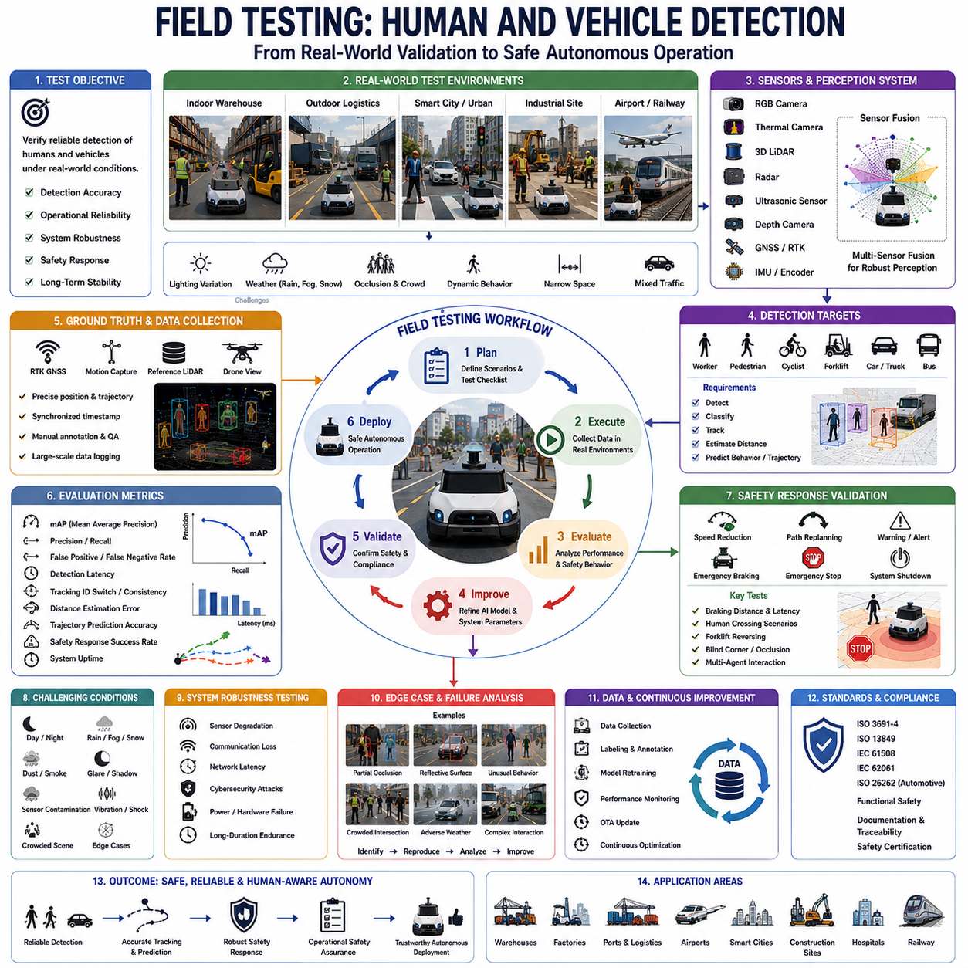
Field testing for human and vehicle detection is one of the most important validation processes in modern Autonomous Mobile Robots (AMRs), autonomous vehicles, industrial robotics systems, smart factory automation platforms, outdoor delivery robots, intelligent transportation systems, and safety-critical AI perception architectures. While laboratory testing and simulation environments provide valuable early-stage validation, real-world field testing is ultimately required to verify whether AI perception systems can operate reliably under complex operational conditions involving dynamic human behavior, moving vehicles, environmental uncertainty, adverse weather, industrial interference, and unpredictable edge cases. Therefore, field testing represents the critical transition between theoretical AI performance and trustworthy real-world autonomous deployment.
The primary objective of field testing is to evaluate whether human and vehicle detection systems maintain reliable operational safety under realistic environmental conditions. Autonomous robots operating in warehouses, ports, factories, hospitals, construction sites, airports, railways, smart cities, logistics centers, and outdoor industrial facilities must continuously detect workers, pedestrians, forklifts, trucks, buses, towing vehicles, bicycles, industrial machines, and other dynamic agents. Detection failures in such environments may directly lead to collisions, operational accidents, or unsafe robot behavior. Therefore, field testing focuses not only on AI detection accuracy but also on operational reliability, system robustness, safety response behavior, and long-term deployment stability.
Human detection field testing is particularly important because humans behave unpredictably and interact dynamically with autonomous systems. Unlike scripted simulation scenarios, real-world workers and pedestrians may move irregularly, stop suddenly, change direction unexpectedly, carry objects, walk in groups, become partially occluded, wear different clothing styles, or violate expected traffic behavior. Industrial workers may additionally interact with forklifts, industrial machines, pallets, or safety barriers while performing operational tasks. Therefore, field testing must validate whether AI systems can maintain stable human perception under highly dynamic behavioral conditions.
Vehicle detection field testing is equally critical because autonomous robots frequently coexist with moving vehicles in mixed-traffic environments. Warehouses may contain forklifts and AGVs. Smart factories may contain towing systems and industrial trucks. Outdoor delivery robots may interact with passenger vehicles, buses, motorcycles, bicycles, and pedestrians simultaneously. Ports and logistics centers may contain cranes, terminal tractors, container trucks, and autonomous transport platforms. Under these conditions, perception systems must continuously identify, classify, track, and predict vehicle behavior accurately under operational stress conditions.
Field testing environments vary significantly depending on deployment targets. Indoor warehouse testing focuses on narrow aisles, shelving structures, reflective surfaces, pallet stacks, worker interactions, and forklift traffic. Outdoor logistics testing emphasizes weather variability, sunlight glare, rain, fog, dust, uneven terrain, and long-range perception stability. Smart city testing includes pedestrian crossings, urban traffic interaction, bicycles, parked vehicles, construction zones, and dynamic public environments. Railway and airport testing introduce additional operational complexity involving high-speed vehicles, restricted zones, vibration, communication interference, and safety-critical infrastructure.
Environmental variability is one of the most difficult challenges during field testing. AI perception systems must operate under changing lighting conditions including daytime, nighttime, sunrise, sunset, shadow transitions, artificial lighting, tunnel environments, and flashing industrial lights. Weather conditions such as rain, snow, fog, dust, smoke, wind, and sensor contamination may significantly degrade perception quality. Therefore, field testing campaigns must intentionally evaluate systems across diverse environmental conditions to measure operational robustness.
Sensor validation forms a major component of field testing. Modern human and vehicle detection systems integrate RGB cameras, thermal cameras, 3D LiDAR, radar systems, ultrasonic sensors, depth cameras, GNSS, IMU, and AI-based sensor fusion architectures. Field testing evaluates whether these sensors maintain stable synchronization, calibration consistency, spatial alignment, temporal accuracy, and environmental robustness during long-duration operation. Vibration, thermal expansion, dust contamination, water intrusion, electromagnetic interference, and physical impacts may gradually degrade sensor performance over time.
Sensor fusion validation is especially important because real-world environments frequently cause partial sensor degradation. Cameras may fail under darkness or glare. LiDAR performance may degrade under heavy rain or fog. Radar systems may generate false reflections near metallic structures. GNSS may become unstable near buildings or industrial infrastructure. Field testing therefore evaluates whether multi-sensor fusion architectures maintain reliable perception despite temporary degradation of individual sensing modalities.
Ground truth generation is one of the most technically challenging aspects of field testing. Accurate evaluation requires precise knowledge of actual human and vehicle positions, motion trajectories, detection events, and operational outcomes. Ground truth systems commonly use RTK GNSS, motion capture systems, external tracking infrastructure, synchronized reference sensors, drone monitoring systems, or manually annotated datasets. Accurate temporal synchronization between perception systems and ground truth references is essential for reliable benchmarking.
Detection accuracy evaluation measures whether AI systems correctly identify humans, vehicles, forklifts, bicycles, industrial machines, and other dynamic agents. Common evaluation metrics include precision, recall, mean Average Precision (mAP), false positive rate, false negative rate, detection latency, tracking consistency, object classification accuracy, and distance estimation accuracy. However, field testing extends beyond static metrics because operational safety also depends on long-term reliability and failure handling.
Tracking validation is another critical testing component. Autonomous systems must maintain stable object identities over time while estimating velocity, acceleration, motion direction, and future trajectories. Field testing therefore evaluates multi-object tracking consistency during occlusion, crowd density changes, high-speed motion, crossing traffic, and multi-agent interaction scenarios. Tracking failures may cause dangerous trajectory prediction errors or unstable navigation behavior.
Behavior prediction validation is becoming increasingly important in advanced autonomous systems. Perception systems must not only detect humans and vehicles but also estimate future movement and operational intention. Field testing evaluates whether trajectory prediction systems correctly estimate pedestrian crossing behavior, forklift reversing motion, vehicle turning intention, worker movement patterns, and multi-agent interaction risks. Prediction validation often requires long-duration scenario collection and statistical performance analysis.
Safety response validation forms one of the most important aspects of field testing. Detection systems are tightly integrated with autonomous navigation, braking systems, safety PLCs, collision avoidance controllers, and operational risk management frameworks. Therefore, field testing evaluates whether robots perform appropriate operational responses when hazards are detected. Safety responses may include speed reduction, path replanning, warning activation, emergency braking, emergency stop, or system shutdown.
Emergency braking validation is especially important for industrial and outdoor autonomous systems. Heavy AMRs, towing robots, autonomous forklifts, and outdoor delivery platforms may require significant stopping distances depending on speed, payload weight, terrain slope, wheel friction, and environmental conditions. Field testing measures braking latency, stopping distance, dynamic stability, wheel slip behavior, and emergency stop consistency under varying operational conditions.
Human safety validation is a core objective of all autonomous field testing. Robots operating near workers and pedestrians must demonstrate predictable, transparent, and fail-safe behavior. Testing scenarios may intentionally include workers crossing robot paths, entering safety zones, approaching blind corners, carrying objects, or interacting near industrial machines. The goal is to verify that autonomous systems consistently prioritize human safety under all operational conditions.
Industrial machine interaction testing introduces additional complexity. Warehouses and factories frequently contain forklifts, cranes, towing systems, AGVs, AMRs, industrial trucks, robotic manipulators, and mixed human-machine traffic. Field testing evaluates how perception systems handle multi-agent industrial interactions, narrow pathways, heavy occlusion, dynamic loading operations, and dense operational traffic.
Communication robustness testing is increasingly important for distributed robotics systems. Autonomous fleets often depend on wireless communication infrastructure including Wi-Fi, 5G, industrial Ethernet, V2X systems, cloud robotics platforms, and fleet management systems. Field testing evaluates whether perception and safety systems continue operating safely during network latency, packet loss, communication interruption, synchronization drift, or cloud service failure.
Cybersecurity testing is also becoming essential for modern autonomous platforms. Field testing may evaluate resilience against spoofed sensor signals, unauthorized communication attempts, malicious data injection, or abnormal operational commands. Safety-critical perception systems increasingly require cybersecurity-aware validation to ensure trustworthy autonomous operation.
Long-duration endurance testing is critical for validating real-world deployment readiness. Autonomous systems may operate continuously for hours, days, or weeks under changing environmental conditions. Field testing therefore evaluates thermal stability, sensor degradation, calibration drift, hardware reliability, software robustness, memory stability, logging consistency, and operational uptime over extended deployment periods.
Edge-case testing represents one of the most valuable aspects of field validation. Rare operational failures often emerge only during large-scale real-world deployment. Examples include unusual worker behavior, reflective surfaces, sensor blockage, crowded intersections, adverse weather combinations, unusual vehicle configurations, unexpected traffic interactions, or simultaneous multi-system failures. Identifying and reproducing such edge cases significantly improves AI system robustness.
Simulation and digital twin integration increasingly complement physical field testing. Digital twins allow engineers to replay operational incidents, reproduce failure conditions, test software updates safely, and evaluate alternative safety strategies using synchronized virtual environments. Combining simulation with real-world telemetry significantly accelerates perception system improvement.
Dataset collection during field testing provides valuable data for continuous AI model improvement. Operational telemetry, sensor recordings, detection failures, near-miss events, environmental edge cases, and human-machine interactions may later support retraining pipelines, anomaly detection systems, trajectory prediction refinement, and safety optimization workflows. Data engineering therefore becomes tightly integrated with field validation processes.
Functional safety compliance testing is increasingly required for commercial autonomous deployment. Industrial robots and AMRs often require compliance with standards such as ISO 3691-4, ISO 13849, IEC 61508, IEC 62061, and other industrial safety frameworks. Field testing therefore includes documentation, traceability analysis, deterministic behavior validation, fail-safe verification, redundancy testing, and safety certification workflows.
Operational analytics and fleet-level monitoring further extend field testing capabilities. Large-scale deployments generate massive telemetry datasets describing perception performance, operational incidents, safety events, traffic interactions, environmental conditions, and system health. Centralized analytics platforms support predictive maintenance, operational optimization, incident investigation, and continuous AI model refinement.
Future field testing systems are expected to evolve toward large-scale autonomous validation ecosystems combining real-world testing, simulation, digital twins, cloud robotics, fleet telemetry analytics, and AI-driven safety optimization simultaneously. Foundation models, world models, multimodal reasoning systems, and embodied AI architectures may eventually enable autonomous systems to self-evaluate operational risk and continuously improve safety performance during deployment.
Ultimately, field testing for human and vehicle detection is not merely a verification procedure but one of the foundational engineering processes enabling trustworthy autonomous robotics. Reliable field validation ensures that AI perception systems can operate safely under real-world complexity, environmental uncertainty, dynamic human behavior, industrial traffic interactions, and unpredictable operational conditions. As AMRs continue expanding into factories, warehouses, ports, airports, hospitals, construction sites, mining operations, railways, agriculture, defense systems, and smart city infrastructure, advanced field testing methodologies will become essential for enabling scalable, reliable, and human-safe autonomous robotic ecosystems.

