Volume 03. AMR Sensors and Perception

Chapter 13. Sensor Fusion

13.1 Sensor Fusion Concepts
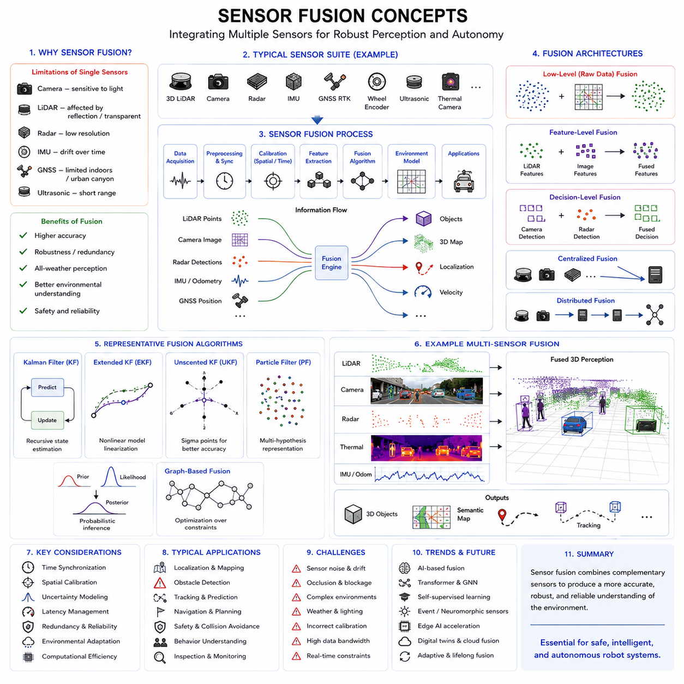
Sensor fusion is one of the most important foundational technologies in modern robotics, autonomous vehicles, industrial automation systems, intelligent perception platforms, and AI-driven autonomous machines. Autonomous Mobile Robots (AMRs), outdoor autonomous robots, collaborative robots, industrial towing robots, smart city robots, railway inspection systems, agricultural robots, and autonomous logistics platforms all rely heavily on sensor fusion to achieve robust environmental perception, accurate localization, reliable navigation, and safe autonomous operation.
In robotics systems, no single sensor can perfectly perceive the environment under all operating conditions. Every sensor has strengths, weaknesses, environmental limitations, measurement uncertainty, noise characteristics, latency issues, field-of-view constraints, and failure modes. Sensor fusion addresses these limitations by combining information from multiple heterogeneous sensors into a unified and more reliable representation of the environment.
Sensor fusion can be defined as the process of integrating information from multiple sensors, perception modules, localization systems, and environmental measurements to improve the accuracy, robustness, reliability, and completeness of robotic perception and decision-making. By combining complementary sensing modalities, robotic systems can overcome individual sensor weaknesses and operate more reliably in complex real-world environments.
For example, cameras provide rich semantic and texture information but are sensitive to lighting conditions. LiDAR provides accurate geometric distance measurements but may struggle with transparent or highly reflective surfaces. Radar operates reliably in rain, fog, and dust but provides lower spatial resolution. IMUs provide high-frequency motion information but suffer from drift over time. GNSS provides global positioning outdoors but may fail in tunnels, urban canyons, or indoor environments. Sensor fusion enables these different sensing modalities to complement each other.
Modern autonomous robots frequently integrate multiple sensors simultaneously. A typical outdoor autonomous robot may include 3D LiDARs, 2D safety LiDARs, RGB cameras, depth cameras, thermal cameras, millimeter-wave radars, GNSS RTK systems, IMUs, wheel encoders, ultrasonic sensors, and environmental monitoring sensors. These sensors continuously generate large amounts of heterogeneous data that must be fused into a coherent world model.
Sensor fusion improves system robustness because redundant sensors can compensate for individual sensor failures. If one sensor becomes temporarily unavailable or unreliable, other sensors may continue supporting autonomous operation. This redundancy is especially important in safety-critical robotics applications.
Sensor fusion also improves environmental understanding. Different sensors observe different physical properties of the environment. Cameras capture color and texture, LiDAR measures geometry, radar measures velocity, thermal cameras detect heat signatures, and GPR systems observe underground structures. Fusion systems combine these observations into richer environmental representations.
The importance of sensor fusion increases significantly in challenging environments. Outdoor autonomous robots operating in rain, fog, snow, dust, smoke, darkness, or highly dynamic industrial environments cannot rely on a single sensing modality. Robust fusion architectures are therefore essential for all-weather autonomous operation.
Sensor fusion architectures are generally divided into several major categories, including low-level fusion, feature-level fusion, decision-level fusion, centralized fusion, distributed fusion, deterministic fusion, probabilistic fusion, and AI-based multimodal fusion.
Low-level fusion, also called raw-data fusion, combines sensor data directly at the measurement level. For example, LiDAR point clouds and RGB camera images may be fused before object detection. This approach preserves maximum information content but requires high computational resources and accurate synchronization.
Feature-level fusion combines extracted features from multiple sensors rather than raw measurements. Examples include combining visual features from cameras with geometric features from LiDAR or motion features from radar. Feature-level fusion reduces computational load while preserving meaningful environmental information.
Decision-level fusion combines independent outputs from multiple perception modules. For example, separate camera and radar object detection systems may independently classify obstacles, and a higher-level fusion module combines their decisions. This architecture improves modularity and fault isolation.
Centralized fusion architectures collect all sensor data into a single processing system. Centralized fusion enables global optimization and unified perception but requires high communication bandwidth and powerful computing resources.
Distributed fusion architectures process sensor data locally before sharing summarized information with other subsystems. Distributed fusion is increasingly important in large-scale robotic systems containing multiple edge computers and distributed AI accelerators.
Deterministic fusion approaches rely on explicit mathematical models and physics-based algorithms. Examples include Kalman Filters, Extended Kalman Filters (EKF), Unscented Kalman Filters (UKF), particle filters, Bayesian estimation, and graph optimization methods.
Probabilistic fusion approaches explicitly model uncertainty and measurement noise. Since all sensors contain uncertainty, probabilistic methods provide mathematically consistent mechanisms for combining uncertain observations.
Kalman filtering is one of the most widely used sensor fusion techniques in robotics. Kalman Filters estimate system states recursively using prediction and measurement updates. These filters are especially effective for fusing IMU, GNSS, wheel odometry, and motion estimation data.
Extended Kalman Filters are commonly used in nonlinear robotics systems. Since robot motion and sensor models are often nonlinear, EKF approximates nonlinear dynamics using linearization techniques.
Unscented Kalman Filters improve nonlinear estimation accuracy by using sigma-point sampling instead of local linearization. UKF methods are often used in advanced autonomous robotics systems.
Particle filters represent probability distributions using multiple weighted hypotheses. Particle filters are particularly useful for localization problems involving ambiguity or multimodal uncertainty.
Bayesian fusion methods form the mathematical foundation of many robotics perception systems. Bayesian estimation continuously updates belief states as new sensor measurements arrive.
Graph-based fusion approaches are increasingly common in SLAM systems. Multi-sensor SLAM systems represent sensor relationships and robot poses as optimization graphs. These graphs are solved using nonlinear optimization algorithms.
Time synchronization is critically important in sensor fusion systems. Sensors operating at different frequencies and latencies must maintain temporal consistency. Incorrect synchronization may cause severe fusion errors.
For example, a robot moving at high speed may travel significant distances between sensor acquisitions. If camera images and LiDAR scans are not synchronized correctly, object positions become inconsistent across modalities.
Spatial calibration is equally important in sensor fusion systems. Extrinsic calibration determines the geometric relationship between sensors. Even small calibration errors may significantly reduce fusion quality.
LiDAR-camera fusion is one of the most widely used multimodal perception approaches. Cameras provide semantic understanding while LiDAR provides accurate geometric measurements. Together they enable robust object detection, obstacle avoidance, semantic mapping, and autonomous navigation.
Radar-camera fusion is especially important for adverse-weather operation. Radar maintains robust detection capability in rain, fog, snow, and dust where camera performance may degrade.
GNSS-IMU fusion is fundamental for outdoor localization. GNSS provides global positioning while IMUs provide high-frequency motion estimation. Fusion enables stable localization even during temporary GNSS degradation.
Wheel odometry fusion improves short-term motion estimation accuracy. Wheel encoders provide relative motion information, although wheel slip and terrain conditions may introduce errors.
Thermal-camera fusion enables robust perception under low-light or nighttime conditions. Thermal sensors detect heat signatures independent of visible illumination.
GPR fusion systems are increasingly important in underground infrastructure inspection robotics. GPR data may be fused with GNSS, IMU, wheel encoders, LiDAR, and vision systems to improve underground mapping accuracy.
Sensor fusion also plays a critical role in obstacle detection systems. Static obstacles, dynamic obstacles, pedestrians, forklifts, industrial machinery, and vehicles may all require different sensing modalities for reliable detection.
Autonomous safety systems rely heavily on sensor fusion redundancy. Safety-certified systems often require multiple independent sensing modalities to reduce false negatives and improve operational safety.
Artificial intelligence is becoming increasingly important in sensor fusion architectures. Deep learning models now perform multimodal fusion using convolutional neural networks, transformers, graph neural networks, and multimodal foundation models.
AI-based fusion systems can automatically learn cross-modal relationships between sensors. For example, neural networks may learn correlations between LiDAR geometry and camera appearance.
Transformer-based multimodal fusion architectures are especially important in modern embodied AI systems. Attention mechanisms allow models to selectively integrate information from multiple modalities dynamically.
Vision-Language-Action models may eventually integrate sensor fusion directly into unified embodied intelligence architectures. These systems combine visual perception, language reasoning, spatial understanding, and robotic control.
Edge AI acceleration is essential for real-time sensor fusion. Modern autonomous robots frequently use GPUs, TPUs, FPGAs, and AI accelerators to process multimodal sensor streams in real time.
Sensor fusion pipelines often require massive computational resources. High-resolution cameras, dense LiDAR point clouds, radar detections, thermal imagery, and high-frequency IMU streams create large data bandwidth requirements.
Real-time constraints are extremely important in robotics sensor fusion systems. Autonomous robots must process sensor data within strict latency limits to ensure safe operation. Excessive processing delay may produce outdated environmental understanding.
ROS2 provides important infrastructure for sensor fusion systems. ROS2 supports synchronized message passing, DDS middleware communication, TF2 coordinate transformations, and distributed processing architectures.
Message synchronization frameworks such as ROS2 message_filters help align sensor data temporally before fusion processing. Accurate timestamps are essential for stable fusion performance.
Perception pipelines usually include multiple stages, including sensor acquisition, preprocessing, synchronization, calibration correction, feature extraction, fusion processing, object detection, tracking, semantic interpretation, and navigation integration.
Sensor fusion debugging is a major robotics engineering challenge. Fusion failures may produce unstable localization, distorted maps, inconsistent object tracking, duplicated obstacles, false detections, or unsafe navigation behavior.
Visualization tools are extremely important for debugging fusion systems. Engineers commonly overlay LiDAR points onto camera images, compare radar detections with vision detections, and visualize fused occupancy grids or semantic maps.
Calibration validation is also critical. Engineers continuously verify intrinsic and extrinsic calibration accuracy to maintain reliable fusion performance.
Fusion systems must also manage uncertainty and confidence estimation. Sensors may become unreliable due to weather, lighting, vibration, electromagnetic interference, contamination, or hardware degradation.
Adaptive fusion architectures dynamically adjust sensor weighting depending on environmental conditions. For example, camera reliability may decrease at night while radar weighting increases.
Adverse weather perception is one of the most challenging applications of sensor fusion. Rain, fog, snow, mud, dust, smoke, and direct sunlight may affect sensors differently. Robust multimodal fusion is therefore essential for outdoor autonomous systems.
Industrial robotics environments also create difficult fusion challenges. Reflective surfaces, metallic structures, electromagnetic noise, dynamic machinery, and crowded environments may reduce perception reliability.
Multi-robot sensor fusion is becoming increasingly important in smart factories and smart cities. Multiple robots may share maps, localization data, obstacle information, and semantic understanding through distributed cloud architectures.
Cloud robotics platforms may aggregate sensor data from entire robot fleets to improve collective perception and operational intelligence.
Digital twin systems also depend heavily on sensor fusion. Real-time digital environments require accurate integration of multimodal sensor data from physical robots.
Cybersecurity is becoming increasingly important in sensor fusion systems. Malicious sensor spoofing or communication attacks may corrupt fusion results and destabilize autonomous systems.
Functional safety standards increasingly require robust fusion validation and redundancy analysis. Safety-critical autonomous robots must demonstrate reliable perception under failure conditions.
Future sensor fusion systems will likely become increasingly AI-driven, adaptive, distributed, and multimodal. Foundation models for robotics may eventually unify perception, reasoning, localization, navigation, and manipulation into integrated embodied intelligence systems.
Event cameras, neuromorphic sensors, quantum sensing technologies, advanced radar systems, hyperspectral cameras, and AI-native sensors may significantly expand future sensor fusion capabilities.
Self-supervised learning may reduce dependence on manually labeled multimodal datasets. Robots may increasingly learn sensor relationships directly from operational experience.
Future autonomous systems will likely integrate perception, world modeling, prediction, planning, and control into unified end-to-end multimodal architectures. Sensor fusion will remain one of the central enabling technologies for these systems.
In conclusion, sensor fusion concepts form one of the most important foundations of modern autonomous robotics systems. By combining complementary sensing modalities, fusion architectures improve perception robustness, localization accuracy, environmental understanding, navigation reliability, and operational safety. As autonomous systems continue evolving toward increasingly intelligent, distributed, and multimodal architectures, advanced sensor fusion technologies will become even more essential across all domains of robotics and embodied AI.

13.2 Early, Mid, and Late Fusion
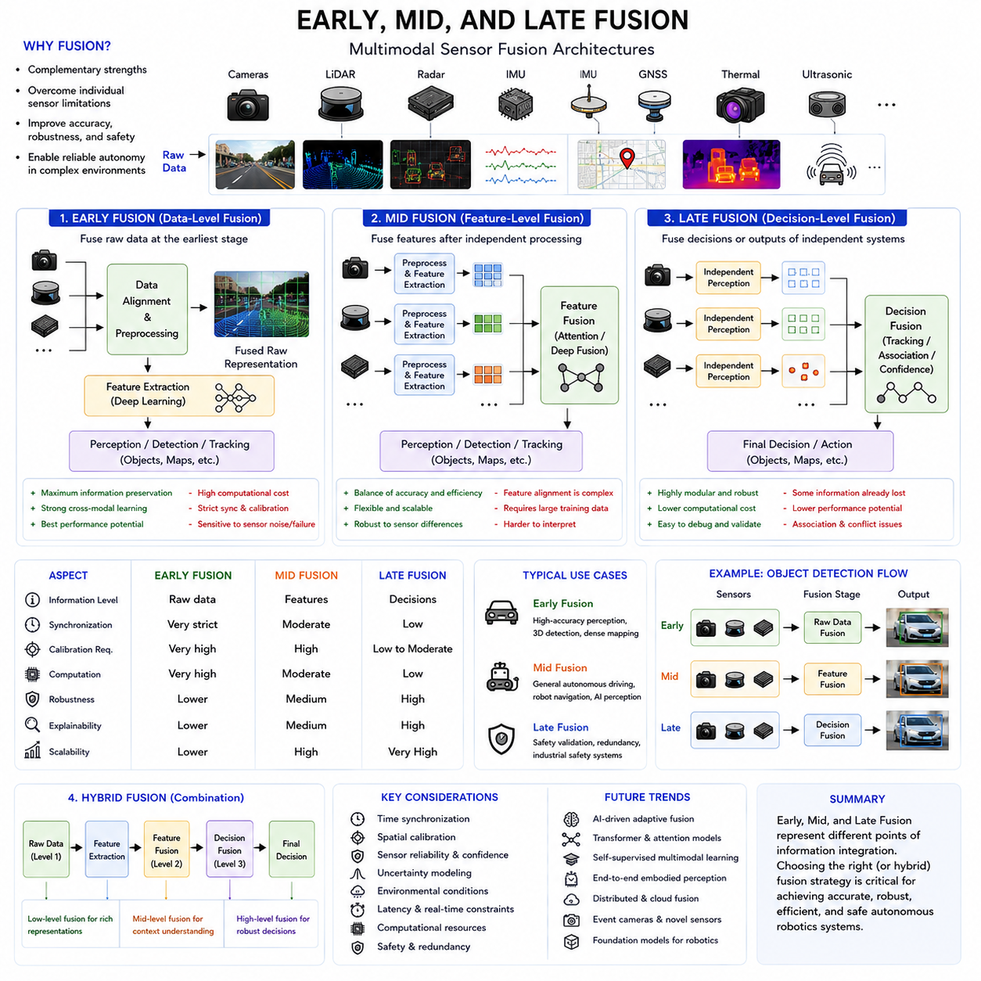
Early Fusion, Mid Fusion, and Late Fusion are three of the most important architectural concepts in modern sensor fusion systems for robotics, autonomous vehicles, industrial AI platforms, intelligent perception systems, and multimodal deep learning applications. Autonomous Mobile Robots (AMRs), outdoor autonomous robots, collaborative industrial robots, autonomous logistics systems, railway inspection platforms, agricultural robots, smart city robots, and AI-driven perception engines all rely heavily on multimodal sensor fusion architectures to achieve reliable environmental understanding and autonomous decision-making.
As robotics systems become increasingly dependent on multiple heterogeneous sensors such as cameras, LiDARs, radars, IMUs, GNSS systems, thermal cameras, ultrasonic sensors, depth sensors, and Ground Penetrating Radar systems, the question of how and when sensor information should be combined becomes critically important. Early Fusion, Mid Fusion, and Late Fusion represent different strategies for integrating multimodal sensor information within perception and AI pipelines.
Each fusion architecture has unique advantages, disadvantages, computational characteristics, synchronization requirements, robustness properties, scalability considerations, and application domains. The choice of fusion architecture significantly affects perception quality, AI inference accuracy, computational load, latency, robustness, explainability, and safety performance.
Early Fusion, also called data-level fusion or raw-data fusion, combines sensor information at the earliest stage of the processing pipeline. In Early Fusion systems, raw measurements or minimally processed sensor data are merged before feature extraction or higher-level interpretation occurs.
For example, a robotics perception system may directly project LiDAR point clouds onto RGB camera images to create combined multimodal representations before object detection is performed. Similarly, radar range measurements may be fused directly with image pixels or depth maps during preprocessing stages.
The primary advantage of Early Fusion is that it preserves maximum information content from each sensor modality. Since fusion occurs before feature extraction, the AI model or perception algorithm has direct access to low-level multimodal relationships. This allows the system to learn complex cross-modal correlations that may otherwise be lost during independent feature extraction.
Early Fusion is especially effective in deep learning architectures where neural networks automatically learn multimodal representations. Convolutional neural networks and transformer-based architectures can extract joint features from fused multimodal inputs.
In autonomous driving systems, Early Fusion may combine LiDAR geometry with RGB semantic information to improve object detection accuracy. The fused representation may contain both spatial structure and visual texture simultaneously.
Early Fusion also improves the possibility of dense multimodal interaction. Features extracted later in the pipeline may inherently incorporate information from multiple sensor modalities rather than isolated sensor streams.
However, Early Fusion introduces several major engineering challenges. One of the most difficult problems is synchronization. Since raw sensor data is fused directly, temporal consistency between sensors becomes critically important. Even small synchronization errors may significantly degrade fusion quality.
Spatial calibration is also extremely important in Early Fusion systems. Raw sensor data must align accurately in a common coordinate frame. Small extrinsic calibration errors may produce severe multimodal inconsistencies.
Computational complexity is another major challenge. Raw sensor streams often contain extremely large data volumes. High-resolution cameras, dense LiDAR point clouds, radar measurements, thermal imagery, and depth maps generate massive computational loads when fused directly.
Bandwidth and memory requirements may therefore become very large in Early Fusion systems. Real-time processing becomes increasingly difficult as sensor resolution increases.
Sensor heterogeneity also creates challenges. Different sensors operate using fundamentally different physical measurement principles. Cameras capture visual appearance, LiDAR measures geometry, radar measures Doppler velocity, thermal cameras detect infrared radiation, and GPR systems measure underground electromagnetic reflections. Directly combining these modalities may require complex preprocessing pipelines.
Early Fusion systems are also more sensitive to sensor failures. Since fusion occurs at low levels, corruption or degradation in one sensor modality may propagate throughout the entire perception pipeline.
Despite these challenges, Early Fusion remains highly important in modern AI-based perception systems. Deep multimodal learning architectures increasingly rely on Early Fusion strategies to maximize cross-modal representation learning.
Mid Fusion, also called feature-level fusion, combines sensor information after independent feature extraction but before final decision-making. Each sensor modality first passes through dedicated preprocessing and feature extraction stages. The extracted features are then merged into a shared multimodal representation.
Mid Fusion represents a balance between preserving multimodal information and reducing computational complexity. Instead of fusing raw data directly, the system fuses more compact and semantically meaningful feature representations.
For example, a camera processing pipeline may extract convolutional feature maps from RGB images, while a LiDAR processing pipeline extracts geometric features from point clouds. These feature representations are then combined inside a shared fusion network.
Mid Fusion is widely used in modern autonomous robotics systems because it provides strong multimodal learning capability while remaining computationally manageable. It also allows sensor-specific preprocessing pipelines to optimize feature extraction independently.
Transformer-based multimodal fusion architectures frequently use Mid Fusion approaches. Each sensor modality may first generate embedding representations, and attention mechanisms then integrate these embeddings dynamically.
Mid Fusion architectures are especially popular in autonomous driving perception systems. Camera features, LiDAR voxel features, radar features, thermal features, and map features may all be fused within shared neural network layers.
One major advantage of Mid Fusion is flexibility. Different sensor modalities can maintain specialized preprocessing pipelines while still benefiting from cross-modal interaction during higher-level reasoning.
Mid Fusion also improves robustness to sensor differences. Since fusion occurs after sensor-specific feature extraction, each modality can compensate for its own measurement characteristics independently before fusion occurs.
Computational efficiency is generally better than Early Fusion because feature representations are usually more compact than raw sensor data. This reduces bandwidth and memory requirements.
Mid Fusion architectures are also more scalable. Additional sensor modalities can often be integrated by adding dedicated feature extraction branches without redesigning the entire perception system.
Another important advantage is modularity. Sensor-specific feature extraction modules can be updated or replaced independently without changing the entire fusion architecture.
However, Mid Fusion also introduces challenges. One important issue is feature compatibility. Features extracted from different modalities may have different dimensions, spatial resolutions, semantic meanings, and temporal properties.
Feature alignment therefore becomes an important engineering problem. Neural networks often use projection layers, attention modules, graph neural networks, or spatial transformation modules to align multimodal features.
Synchronization remains important in Mid Fusion systems, although requirements may be slightly more tolerant compared to Early Fusion. Temporal inconsistencies can still reduce fusion quality significantly.
Feature selection also becomes critical. Poor feature extraction quality in one modality may negatively affect overall fusion performance. Sensor-specific neural networks must therefore be optimized carefully.
Interpretability is another challenge. Deep multimodal fusion networks may become difficult to explain because cross-modal interactions occur inside complex neural architectures.
Training Mid Fusion systems also requires large multimodal datasets with accurate synchronization and calibration. Creating such datasets can be expensive and time-consuming.
Late Fusion, also called decision-level fusion, combines information after independent perception or decision-making has already occurred. Each sensor modality independently generates object detections, classifications, tracking results, localization estimates, or semantic interpretations. A higher-level fusion module then combines these independent outputs.
For example, a camera object detector and a radar object detector may independently identify vehicles. A Late Fusion module then combines their outputs to generate final object decisions.
Late Fusion is one of the most modular and fault-tolerant fusion architectures. Since each modality operates independently, failure in one sensor system does not necessarily corrupt the entire perception pipeline.
One major advantage of Late Fusion is robustness. Independent perception pipelines can continue operating even if one sensor becomes unreliable or unavailable.
Late Fusion also simplifies engineering complexity. Since fusion occurs at higher semantic levels, synchronization and calibration requirements are often less strict compared to Early Fusion systems.
Computational requirements may also be lower because only high-level decisions rather than raw sensor data are exchanged between modules.
Late Fusion architectures are especially common in safety-critical robotics systems because independent redundancy improves fault isolation and validation simplicity.
Industrial autonomous systems frequently use Late Fusion for safety validation. Separate perception pipelines may independently verify obstacle detections before safety actions are triggered.
Late Fusion also improves explainability. Engineers can inspect the independent outputs of each sensor modality separately, making debugging and validation easier.
Scalability is another important advantage. Additional sensors can often be integrated without modifying existing perception pipelines significantly.
However, Late Fusion also has important limitations. Since fusion occurs after high-level interpretation, some low-level multimodal relationships may already be lost.
This may reduce maximum achievable perception accuracy compared to Early or Mid Fusion systems. Independent perception systems cannot learn rich cross-modal feature interactions.
Late Fusion may also produce inconsistent outputs between modalities. Different sensors may independently classify objects differently, requiring conflict resolution mechanisms.
Association problems become important in Late Fusion systems. The fusion engine must determine which detections from different modalities correspond to the same physical object.
Confidence estimation becomes critical. Fusion systems often use probabilistic weighting to combine decisions based on sensor reliability estimates.
Modern robotics systems increasingly use hybrid fusion architectures that combine Early, Mid, and Late Fusion strategies simultaneously. Different sensor modalities and perception tasks may benefit from different fusion levels.
For example, a robot may use Early Fusion between LiDAR and camera systems for dense object perception, Mid Fusion for multimodal AI feature integration, and Late Fusion for safety validation.
Hybrid architectures allow robotics systems to balance accuracy, robustness, computational efficiency, explainability, and fault tolerance.
Artificial intelligence is rapidly transforming fusion architectures. Deep multimodal learning systems increasingly blur the boundaries between Early, Mid, and Late Fusion concepts.
Transformer-based multimodal architectures may dynamically perform fusion at multiple hierarchical levels simultaneously using attention mechanisms.
Foundation models for robotics may eventually integrate perception, language understanding, spatial reasoning, planning, and control into unified multimodal architectures.
ROS2-based robotics systems provide important infrastructure for multimodal fusion architectures. ROS2 supports distributed communication, synchronized message passing, TF2 coordinate transformations, DDS middleware integration, and scalable perception pipelines.
Edge AI acceleration is essential for modern fusion systems. GPUs, TPUs, FPGAs, and AI accelerators process multimodal fusion pipelines in real time.
Autonomous outdoor robots create especially difficult fusion challenges due to weather variability, vibration, lighting changes, environmental complexity, and high-speed motion.
Rain, fog, snow, dust, direct sunlight, and low-light environments affect sensors differently. Fusion architectures must adapt dynamically to changing sensor reliability.
Adaptive fusion systems are becoming increasingly important. AI models may dynamically adjust sensor weighting depending on environmental conditions and confidence estimates.
Self-supervised learning may also improve future fusion systems. Robots may automatically learn cross-modal relationships directly from operational experience without requiring extensive labeled datasets.
Future embodied AI systems will likely use deeply integrated multimodal fusion architectures combining visual perception, geometric understanding, motion estimation, semantic reasoning, environmental prediction, and autonomous control.
Humanoid robots, collaborative industrial robots, autonomous logistics systems, smart city robots, and autonomous infrastructure inspection systems will all depend heavily on advanced multimodal fusion architectures.
Sensor fusion validation and debugging remain major engineering challenges. Visualization tools, synchronization analysis, calibration validation, uncertainty estimation, and performance monitoring are all essential.
Functional safety standards increasingly require robust validation of multimodal fusion systems. Autonomous robots operating around humans must demonstrate reliable behavior under sensor failure conditions.
Cybersecurity is also becoming increasingly important. Sensor spoofing attacks or communication corruption may destabilize fusion architectures if proper validation mechanisms are absent.
Future fusion systems may become increasingly distributed across cloud robotics infrastructures. Multi-robot fleets may share multimodal sensor information collectively to improve perception robustness.
Digital twin systems also depend heavily on multimodal fusion architectures. Real-world sensor streams must align consistently with virtual simulation environments.
In conclusion, Early Fusion, Mid Fusion, and Late Fusion represent three of the most important architectural strategies in modern multimodal sensor fusion systems. Each approach provides different advantages in terms of information preservation, computational complexity, robustness, scalability, interpretability, synchronization requirements, and fault tolerance. Modern robotics systems increasingly combine these strategies into hybrid architectures capable of supporting advanced autonomous perception and AI-driven embodied intelligence. As robotics systems continue evolving toward more distributed, multimodal, AI-native, and safety-critical platforms, advanced fusion architectures will remain one of the most essential technologies enabling reliable autonomous operation.

13.3 Kalman Filter-Based Fusion
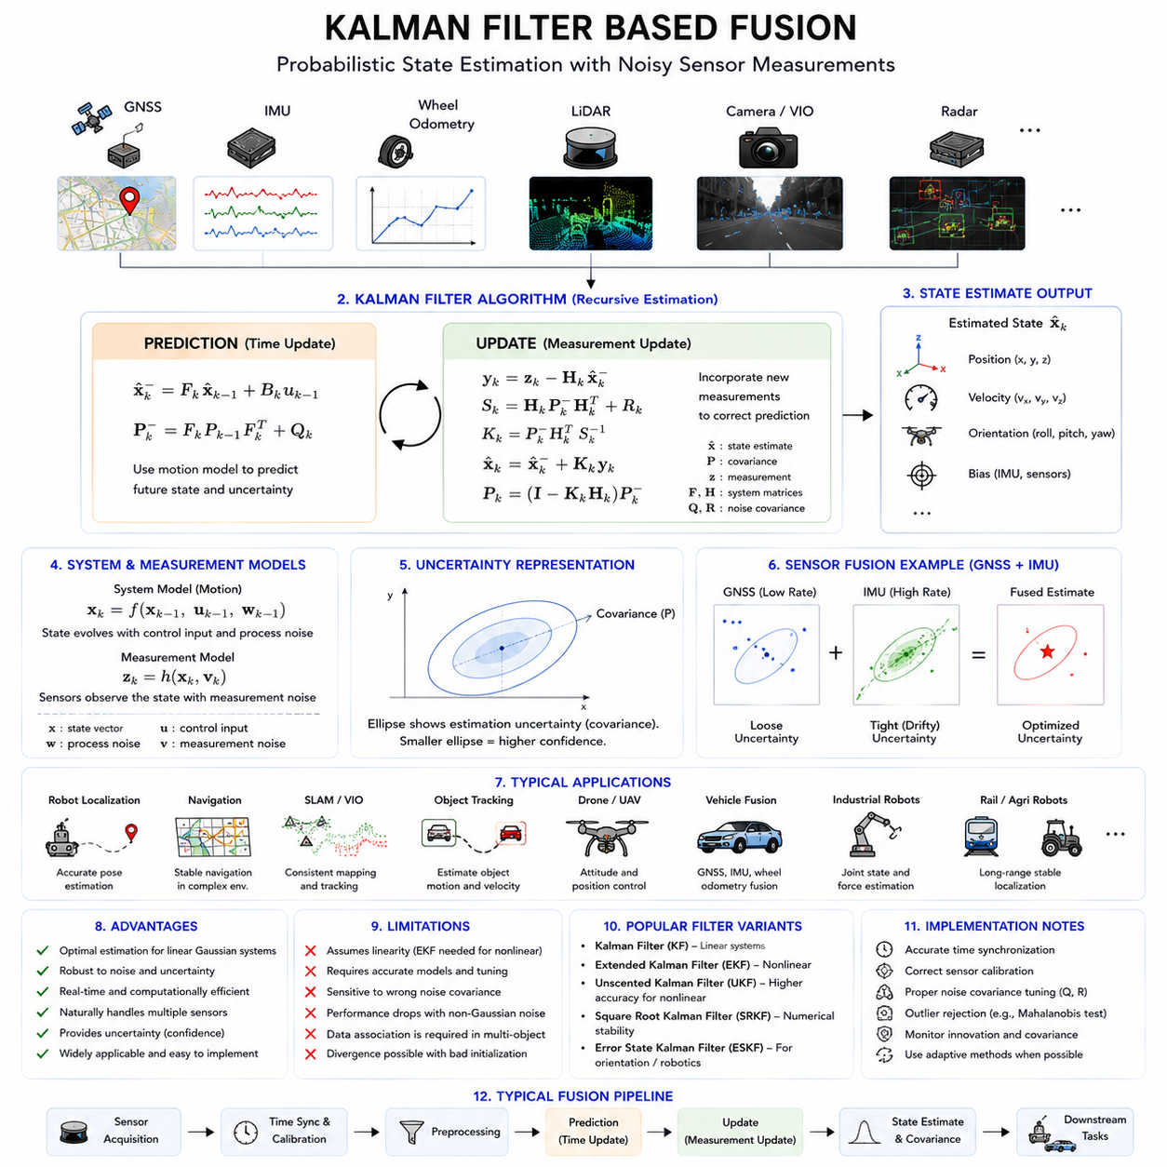
Kalman Filter Based Fusion is one of the most fundamental and widely used technologies in modern robotics, autonomous vehicles, industrial automation systems, aerospace systems, navigation platforms, and intelligent sensor fusion architectures. Autonomous Mobile Robots (AMRs), outdoor autonomous vehicles, railway inspection robots, agricultural robots, collaborative industrial robots, drones, unmanned ground vehicles, and smart infrastructure monitoring systems all rely heavily on Kalman-filter-based estimation methods to achieve accurate localization, stable navigation, robust sensor fusion, and reliable state estimation.
The Kalman Filter is a recursive probabilistic estimation algorithm designed to estimate the internal state of a dynamic system from noisy and uncertain sensor measurements. It provides mathematically optimal state estimation under specific assumptions regarding system dynamics and noise characteristics. Since real-world robotics systems operate in environments filled with uncertainty, noise, disturbances, delays, and incomplete observations, Kalman-filter-based fusion has become one of the most important foundations of autonomous robotics.
In robotics applications, sensor measurements are never perfectly accurate. Cameras may suffer from motion blur or lighting variations. LiDAR systems may experience reflection errors or sparse measurements. GNSS signals may drift or become temporarily unavailable. IMUs accumulate drift over time. Wheel encoders may experience wheel slip. Radar measurements may contain clutter or multipath reflections. Kalman Filter Based Fusion combines these imperfect sensor observations into a more stable and reliable estimate of the robot state.
The primary objective of Kalman Filter Based Fusion is state estimation. State estimation refers to determining the internal condition of the robot or system at a particular time. Typical robotic state variables include position, velocity, acceleration, orientation, angular velocity, sensor bias, and environmental parameters.
For example, an outdoor autonomous robot may use Kalman filtering to estimate its 3D position, heading angle, velocity, and IMU bias by combining data from GNSS, IMU, wheel odometry, LiDAR localization, and visual odometry systems.
The Kalman Filter operates recursively through two major phases: prediction and update. During the prediction stage, the filter estimates the future system state based on a mathematical motion model. During the update stage, the filter corrects this prediction using new sensor measurements.
The prediction phase uses the system dynamics model to estimate how the robot state evolves over time. For example, if a robot is moving forward at a known velocity, the prediction step estimates the future position using kinematic equations.
The update phase incorporates sensor measurements into the prediction. Since sensor measurements contain uncertainty, the Kalman Filter computes an optimal balance between predicted estimates and measured observations.
One of the most important strengths of the Kalman Filter is uncertainty modeling. The filter explicitly represents uncertainty using covariance matrices. These covariance matrices describe the confidence level associated with state estimates and sensor measurements.
Process noise covariance represents uncertainty in the motion model. Real robots do not move perfectly according to mathematical equations because of wheel slip, vibration, terrain irregularities, actuator inaccuracies, and environmental disturbances.
Measurement noise covariance represents uncertainty in sensor observations. Different sensors have different noise characteristics depending on environmental conditions and sensor quality.
Kalman filtering continuously updates uncertainty estimates as new observations arrive. This probabilistic approach allows the system to dynamically adapt to changing sensor reliability.
The standard Kalman Filter assumes linear system dynamics and Gaussian noise distributions. In linear systems, state transitions and sensor measurements can be represented using matrix equations.
The mathematical structure of the Kalman Filter includes several key matrices, including the state vector, state transition matrix, control matrix, observation matrix, process noise covariance matrix, and measurement noise covariance matrix.
The state vector represents the variables being estimated. In mobile robotics, the state vector may include x-position, y-position, velocity, acceleration, heading angle, angular velocity, and sensor biases.
The state transition matrix models how the system evolves over time. This matrix encodes the robot kinematics or dynamics equations.
The observation matrix maps the internal state variables to measurable sensor outputs. Different sensors may observe different subsets of the system state.
The Kalman Gain is one of the most important components of the filter. The Kalman Gain determines how strongly the filter trusts sensor measurements relative to predicted estimates.
If sensor uncertainty is low, the Kalman Gain increases, giving more weight to sensor observations. If sensor uncertainty is high, the filter relies more heavily on predictions.
This adaptive weighting mechanism makes Kalman Filter Based Fusion highly effective in noisy real-world environments.
However, standard Kalman Filters are limited to linear systems. Most robotics systems contain nonlinear motion and sensor models. Robot rotations, camera projections, IMU dynamics, and vehicle steering systems are all nonlinear.
To address nonlinear systems, robotics engineers commonly use the Extended Kalman Filter (EKF). The EKF linearizes nonlinear system equations around the current estimate using Jacobian matrices.
Extended Kalman Filters are among the most widely used fusion algorithms in robotics. EKFs are commonly used in autonomous vehicles, drones, mobile robots, and SLAM systems.
For example, GNSS-IMU fusion systems often use EKF architectures. GNSS provides absolute global positioning while IMUs provide high-frequency acceleration and rotational measurements. EKF fusion combines these modalities to produce stable localization estimates.
Wheel odometry is frequently integrated into EKF systems as well. Wheel encoders provide short-term relative motion estimation, although wheel slip may introduce errors.
LiDAR localization systems may also provide pose updates to EKF frameworks. LiDAR scan matching can improve localization accuracy in GPS-denied environments.
Visual-Inertial Odometry (VIO) systems frequently rely on EKF architectures. Cameras provide visual feature tracking while IMUs provide high-frequency motion dynamics. Fusion improves localization robustness.
Unscented Kalman Filters (UKF) provide another important nonlinear fusion approach. Unlike EKF, UKF avoids local linearization by using sigma-point sampling techniques.
UKF methods generally provide better nonlinear estimation accuracy compared to EKF, especially for highly nonlinear robotics systems. However, UKF may require greater computational resources.
Particle filters represent another major probabilistic fusion method. Instead of Gaussian covariance models, particle filters represent probability distributions using multiple weighted hypotheses.
Particle filters are especially useful in ambiguous localization problems where multiple possible robot positions exist simultaneously. Monte Carlo Localization is a well-known particle-filter-based localization technique.
Kalman-filter-based fusion is heavily used in autonomous navigation systems. Autonomous robots continuously estimate their pose, velocity, acceleration, and environmental relationships during movement.
Localization systems represent one of the most important applications of Kalman filtering. Outdoor autonomous robots often combine GNSS RTK, IMU, wheel odometry, LiDAR localization, and visual odometry within EKF frameworks.
Sensor fusion improves localization robustness because different sensors compensate for each other's weaknesses. GNSS provides global reference positioning but may experience outages. IMUs provide smooth short-term estimation but accumulate drift. Wheel odometry provides relative motion information but suffers from wheel slip.
Fusion combines these complementary strengths into stable pose estimation.
Kalman filtering also plays an important role in obstacle tracking systems. Radar tracking systems frequently use Kalman filters to estimate object trajectories and velocities.
Multi-object tracking systems use Kalman filtering to predict future object motion and maintain object identity over time.
Autonomous driving systems commonly use Kalman filters for vehicle tracking, pedestrian tracking, lane estimation, and motion prediction.
Industrial robotics systems also use Kalman-filter-based fusion extensively. Collaborative robots estimate joint states, actuator dynamics, and force interactions using probabilistic estimation methods.
Railway inspection robots use Kalman filtering to stabilize localization and track inspection trajectories over long distances.
Agricultural robots use Kalman-based fusion for row following, terrain estimation, autonomous steering, and precision navigation.
Ground Penetrating Radar (GPR) robotics systems can also benefit from Kalman-based fusion. GPR position estimation may combine wheel encoders, IMU measurements, GNSS positioning, and LiDAR localization to improve underground reconstruction accuracy.
Kalman filters are highly important in aerospace systems. Aircraft navigation, satellite orbit estimation, missile guidance systems, and drone flight controllers all depend heavily on probabilistic state estimation.
Drone flight control systems continuously fuse IMU, GNSS, barometer, magnetometer, visual odometry, and range sensor measurements using EKF architectures.
Time synchronization is critically important in Kalman Filter Based Fusion. Since measurements arrive asynchronously from multiple sensors, accurate timestamps are essential.
Synchronization errors may significantly degrade estimation quality. Delayed sensor measurements can destabilize state estimation or produce inaccurate motion compensation.
ROS2-based robotics systems provide important infrastructure for Kalman-filter-based fusion architectures. ROS2 supports synchronized message passing, TF2 coordinate transformations, DDS communication, and distributed sensor processing.
The robot_localization package in ROS2 is one of the most widely used EKF fusion frameworks in robotics. It supports fusion of IMU, GNSS, odometry, visual localization, and other sensor modalities.
Real-time constraints are extremely important in Kalman-filter-based systems. Autonomous robots must update state estimates continuously with low latency.
Embedded systems and edge AI platforms frequently execute Kalman filtering pipelines at high frequencies. IMU fusion systems may run at hundreds or thousands of Hertz.
Computational efficiency is one of the major advantages of Kalman filters. Compared to deep neural networks or large optimization systems, Kalman filtering is relatively lightweight computationally.
However, Kalman filtering also has limitations. Performance depends heavily on accurate system models and noise covariance tuning.
Incorrect covariance tuning may produce unstable estimation behavior. Overconfident covariance settings may cause filter divergence, while overly conservative settings may reduce responsiveness.
Non-Gaussian noise can also reduce filter performance. Real-world sensor errors may not follow ideal Gaussian distributions.
Strong nonlinear dynamics may also challenge EKF assumptions. Severe nonlinearities may require UKF, particle filters, or graph optimization methods instead.
Data association problems can become difficult in multi-object tracking systems. The filter must determine which sensor observations correspond to which tracked objects.
Sensor failure detection is another important issue. Kalman-filter-based fusion systems must detect corrupted sensor measurements and reject outliers.
Outlier rejection methods are commonly integrated into fusion pipelines. Mahalanobis distance analysis is frequently used to identify abnormal measurements.
Adaptive Kalman filtering is becoming increasingly important. Adaptive filters dynamically adjust covariance parameters depending on environmental conditions and sensor reliability.
For example, GNSS covariance may increase automatically during urban canyon operation, while camera confidence may decrease at night or during heavy rain.
Artificial intelligence is also influencing Kalman-based fusion systems. AI models may estimate sensor reliability, optimize covariance tuning, or predict system uncertainties dynamically.
Hybrid AI-Kalman architectures are becoming increasingly common. Deep learning models provide semantic understanding while Kalman filters provide physically consistent probabilistic state estimation.
Transformer-based perception systems may eventually integrate probabilistic estimation and multimodal fusion into unified embodied AI architectures.
Future autonomous systems will likely combine Kalman filtering, graph optimization, deep learning, probabilistic reasoning, and multimodal foundation models together.
Cloud robotics and distributed robotics systems introduce additional fusion challenges. Multi-robot fleets may share localization estimates, maps, and sensor observations through distributed fusion architectures.
Digital twin systems also rely heavily on Kalman-filter-based estimation for maintaining alignment between physical robots and virtual simulation environments.
Cybersecurity is becoming increasingly important in probabilistic fusion systems. Spoofed GNSS signals, corrupted sensor data, or malicious communication attacks may destabilize estimation pipelines.
Functional safety standards increasingly require robust validation of localization and fusion systems. Safety-critical autonomous systems must demonstrate stable operation under degraded sensor conditions.
Future sensor technologies such as neuromorphic sensors, event cameras, advanced radar systems, quantum sensing technologies, and AI-native sensors may further expand probabilistic fusion capabilities.
Self-supervised learning may also improve future state estimation systems. Robots may increasingly learn uncertainty models and sensor relationships directly from operational experience.
In conclusion, Kalman Filter Based Fusion represents one of the most important probabilistic estimation frameworks in modern robotics and autonomous systems. By combining prediction models with noisy sensor observations, Kalman-based fusion enables robust localization, stable navigation, reliable tracking, accurate motion estimation, and safe autonomous operation. As robotics systems continue evolving toward increasingly distributed, multimodal, AI-driven, and safety-critical architectures, Kalman-filter-based probabilistic fusion will remain one of the foundational technologies enabling intelligent autonomous machines.

13.4 LiDAR-Camera Fusion
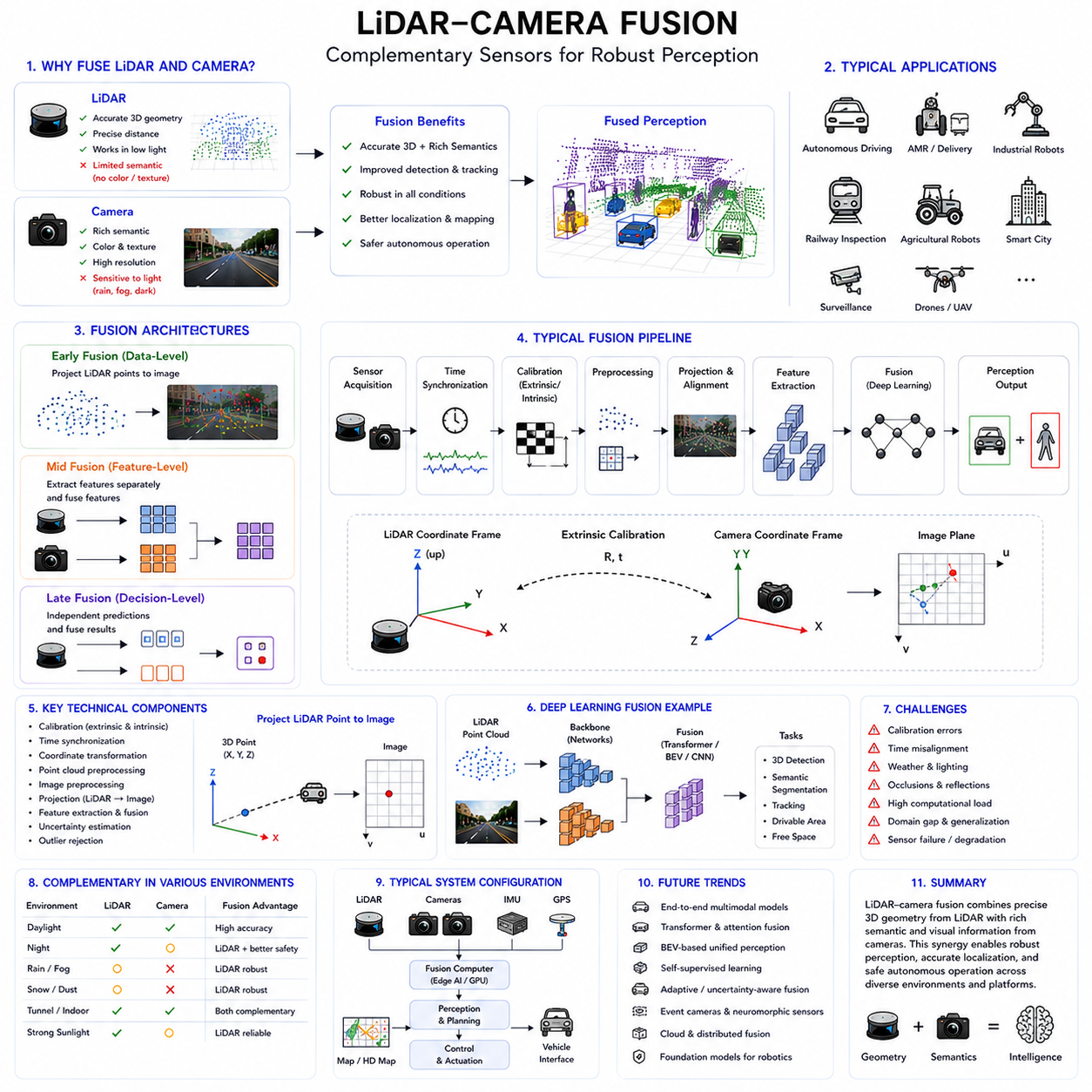
LiDAR-Camera Fusion is one of the most important multimodal perception technologies in modern robotics, autonomous vehicles, intelligent transportation systems, industrial automation platforms, smart city infrastructure, and AI-driven autonomous machines. Autonomous Mobile Robots (AMRs), outdoor autonomous robots, self-driving vehicles, railway inspection robots, agricultural robots, autonomous delivery systems, collaborative industrial robots, and intelligent surveillance platforms all rely heavily on LiDAR-camera fusion to achieve robust environmental understanding, accurate obstacle detection, semantic perception, reliable localization, and safe autonomous operation.
LiDAR and cameras are among the most complementary sensing modalities available in robotics systems. LiDAR provides highly accurate geometric distance measurements and three-dimensional spatial structure, while cameras provide rich semantic, texture, and color information. Individually, each sensor has limitations, but together they form one of the most powerful perception combinations used in modern autonomous systems.
LiDAR sensors operate by emitting laser pulses and measuring the return time of reflected light. By scanning the environment repeatedly, LiDAR generates three-dimensional point clouds representing surrounding geometry. LiDAR provides accurate distance estimation, object shape information, spatial boundaries, terrain profiles, and obstacle geometry independent of ambient lighting conditions.
However, LiDAR systems also have limitations. LiDAR point clouds often contain sparse semantic information. A LiDAR may detect the shape of an object but cannot easily determine whether the object is a pedestrian, vehicle, traffic sign, construction cone, animal, or vegetation without additional processing.
Cameras provide complementary capabilities. RGB cameras capture detailed visual appearance, color, texture, lane markings, signs, text, and semantic scene information. Deep learning models can classify and recognize objects using visual features extracted from camera images.
However, camera systems also suffer from important limitations. Camera performance is highly sensitive to lighting conditions, shadows, glare, fog, rain, snow, low-light environments, and motion blur. Cameras also estimate depth indirectly unless stereo or depth cameras are used.
LiDAR-camera fusion combines the strengths of both sensing modalities while compensating for their weaknesses. LiDAR contributes accurate geometric structure and depth measurements, while cameras contribute semantic understanding and visual appearance information.
Modern autonomous systems frequently rely on LiDAR-camera fusion as a central component of their perception architecture. The fused multimodal representation supports obstacle detection, semantic segmentation, object classification, localization, SLAM, free-space estimation, terrain analysis, path planning, and autonomous navigation.
One of the most important applications of LiDAR-camera fusion is object detection. In autonomous driving systems, robots must reliably detect pedestrians, vehicles, bicycles, forklifts, barriers, machinery, and dynamic obstacles.
LiDAR provides accurate 3D position and shape information, while cameras provide semantic classification. Fusion improves detection accuracy significantly compared to single-sensor systems.
For example, a camera may visually identify a pedestrian, while LiDAR confirms the pedestrian’s precise three-dimensional position and distance relative to the robot. Fusion reduces false positives and improves localization precision.
LiDAR-camera fusion is especially valuable in complex outdoor environments. Construction sites, industrial plants, warehouses, ports, airports, smart cities, railways, and agricultural fields contain highly diverse environmental conditions that challenge individual sensing modalities.
Fusion architectures are generally divided into Early Fusion, Mid Fusion, and Late Fusion approaches. Early Fusion combines raw sensor data before feature extraction. Mid Fusion combines extracted features from each modality. Late Fusion combines independent perception results at higher semantic levels.
Early Fusion in LiDAR-camera systems often involves projecting LiDAR points directly onto image planes. The fused representation allows neural networks to learn joint geometric and visual features simultaneously.
This projection process requires accurate extrinsic calibration between the LiDAR and camera coordinate systems. Extrinsic calibration determines the relative position and orientation between sensors.
Intrinsic calibration is also important. Camera intrinsic calibration defines focal length, optical center, distortion coefficients, and image geometry parameters required for accurate projection.
Calibration quality directly affects fusion performance. Small calibration errors may produce projection misalignment between LiDAR points and image features, reducing object detection accuracy.
Time synchronization is another critical requirement in LiDAR-camera fusion systems. LiDAR scans and camera images must correspond to the same physical scene state.
Synchronization errors become especially problematic during robot motion. A robot moving at high speed may travel significant distances between sensor acquisitions. Misaligned timestamps may therefore produce inconsistent multimodal representations.
Hardware triggering systems are often used to improve synchronization quality. Precision Time Protocol (PTP), PPS synchronization, hardware timestamps, and ROS2 synchronized message pipelines help maintain temporal consistency.
LiDAR-camera fusion pipelines typically include multiple stages. These stages may include sensor acquisition, synchronization, preprocessing, calibration correction, coordinate transformation, feature extraction, multimodal fusion, object detection, semantic interpretation, tracking, and navigation integration.
Coordinate transformation is one of the most important technical components of LiDAR-camera fusion. LiDAR point clouds exist in three-dimensional spatial coordinates, while camera images exist in two-dimensional image coordinates.
Projection algorithms transform LiDAR points into image space using calibration matrices and geometric transformations. This allows corresponding visual and geometric features to align spatially.
Point cloud preprocessing is often necessary before fusion. Raw LiDAR point clouds may contain noise, reflections, sparse regions, or invalid points. Filtering, voxelization, clustering, and outlier removal improve fusion quality.
Image preprocessing is also important. Cameras may require distortion correction, exposure normalization, contrast enhancement, denoising, or semantic preprocessing before fusion.
Deep learning has transformed LiDAR-camera fusion architectures significantly. Modern fusion systems increasingly rely on multimodal neural networks capable of learning cross-modal relationships automatically.
Convolutional Neural Networks (CNNs) are widely used for image feature extraction, while point-based neural networks, voxel networks, graph neural networks, and transformer architectures process LiDAR point clouds.
Transformer-based multimodal architectures are becoming especially important. Attention mechanisms allow neural networks to dynamically integrate information from LiDAR and camera modalities.
BEV (Bird’s Eye View) fusion architectures are particularly common in autonomous driving systems. LiDAR and camera information are projected into unified top-down spatial representations.
BEV representations simplify obstacle detection, lane detection, motion planning, and map generation. Autonomous driving companies frequently use BEV-based fusion pipelines.
Semantic segmentation is another major application of LiDAR-camera fusion. Cameras provide semantic appearance information, while LiDAR provides spatial consistency and geometry.
Fusion improves segmentation robustness under difficult environmental conditions. Roads, sidewalks, curbs, vegetation, buildings, rails, tunnels, and obstacles can be segmented more accurately using multimodal perception.
LiDAR-camera fusion also plays a critical role in SLAM systems. Visual SLAM systems may struggle under poor lighting conditions, while LiDAR SLAM systems may lack semantic understanding.
Fusion improves localization robustness, loop closure detection, map consistency, and environmental understanding.
Visual-LiDAR-Inertial Odometry systems are increasingly common in advanced robotics platforms. Cameras, LiDARs, and IMUs provide complementary motion estimation information.
Outdoor autonomous robots often combine LiDAR-camera fusion with GNSS RTK and IMU systems. GNSS provides global positioning, IMUs provide high-frequency motion estimation, and LiDAR-camera fusion provides local environmental understanding.
Obstacle tracking systems also benefit greatly from LiDAR-camera fusion. Multi-object tracking algorithms use fused geometric and semantic information to maintain stable object identities.
Industrial robotics systems frequently use LiDAR-camera fusion for safety monitoring. Collaborative robots operating near humans require highly reliable obstacle detection systems.
Warehouse AMRs may fuse LiDAR geometry with camera semantics for pallet detection, forklift tracking, aisle navigation, and inventory monitoring.
Agricultural robots use LiDAR-camera fusion for crop row detection, fruit recognition, terrain estimation, weed detection, and autonomous navigation.
Railway inspection robots use fusion architectures for track inspection, obstacle monitoring, tunnel analysis, and structural defect detection.
Smart city robots use LiDAR-camera fusion for pedestrian detection, traffic monitoring, autonomous delivery, infrastructure inspection, and urban navigation.
Adverse weather perception is one of the most challenging problems in LiDAR-camera fusion. Rain, fog, snow, dust, direct sunlight, and nighttime conditions affect sensors differently.
Cameras may degrade significantly in low-light or foggy environments, while LiDAR performance may degrade in heavy rain or dense snow due to laser scattering.
Adaptive fusion systems dynamically adjust sensor weighting depending on environmental conditions and sensor confidence estimates.
Uncertainty estimation is therefore extremely important. Fusion systems must continuously estimate sensor reliability and confidence levels during operation.
Sensor failures must also be detected robustly. A blocked camera lens, dirty LiDAR window, calibration shift, synchronization error, or communication failure may reduce perception quality.
Redundant perception architectures are commonly used in safety-critical systems. Multiple sensing modalities provide fail-safe redundancy.
ROS2 provides important infrastructure for LiDAR-camera fusion systems. ROS2 supports synchronized message passing, TF2 coordinate transformations, DDS middleware communication, distributed sensor processing, and scalable multimodal perception pipelines.
The ROS2 ecosystem includes many tools supporting LiDAR-camera fusion, including point cloud processing libraries, image transport systems, calibration frameworks, SLAM packages, and visualization tools.
RViz visualization is especially important for debugging LiDAR-camera fusion systems. Engineers commonly visualize projected point clouds on top of camera images to inspect calibration and synchronization quality.
Foxglove Studio, PlotJuggler, and custom visualization dashboards are also widely used for fusion debugging and performance analysis.
Computational efficiency is a major challenge in LiDAR-camera fusion systems. High-resolution cameras and dense LiDAR point clouds generate massive data bandwidth requirements.
Edge AI acceleration is therefore essential. GPUs, TPUs, FPGAs, and dedicated AI accelerators process multimodal fusion pipelines in real time.
Latency is critically important in autonomous systems. Perception delays may result in outdated environmental understanding and unsafe robot behavior.
Real-time operating systems, deterministic DDS communication, hardware synchronization, and optimized neural network inference pipelines are often required.
Cybersecurity is becoming increasingly important in multimodal perception systems. Sensor spoofing attacks, adversarial image manipulation, LiDAR interference, or communication corruption may destabilize perception pipelines.
Functional safety standards increasingly require rigorous validation of fusion architectures. Autonomous systems operating near humans must demonstrate reliable behavior even under degraded sensor conditions.
Future LiDAR-camera fusion systems will likely become increasingly AI-driven, adaptive, distributed, and multimodal. Foundation models for robotics may integrate visual perception, geometric reasoning, localization, semantic understanding, prediction, and control into unified architectures.
Event cameras, neuromorphic sensors, hyperspectral cameras, advanced radar systems, thermal imaging systems, and AI-native sensors may further expand future fusion capabilities.
Self-supervised learning may reduce dependence on manually labeled multimodal datasets. Robots may increasingly learn cross-modal relationships directly from operational experience.
Cloud robotics and distributed multi-robot systems may share fused perception information collectively to improve environmental understanding at larger scales.
Digital twin systems also depend heavily on multimodal fusion architectures. Physical sensor streams must remain aligned with virtual simulation environments.
Future embodied AI systems will likely integrate LiDAR-camera fusion deeply within unified perception, reasoning, planning, and action architectures.
Humanoid robots, autonomous industrial vehicles, smart infrastructure inspection robots, collaborative robots, and autonomous logistics systems will all rely heavily on advanced multimodal perception fusion.
In conclusion, LiDAR-camera fusion represents one of the most important multimodal perception technologies in modern robotics and autonomous systems. By combining precise geometric structure from LiDAR with rich semantic understanding from cameras, fusion architectures significantly improve perception robustness, localization accuracy, environmental understanding, obstacle detection, and autonomous navigation reliability. As autonomous systems continue evolving toward increasingly intelligent, distributed, AI-driven, and safety-critical architectures, LiDAR-camera fusion will remain one of the foundational technologies enabling reliable embodied intelligence and autonomous robotic operation.

13.5 Radar-Camera Fusion
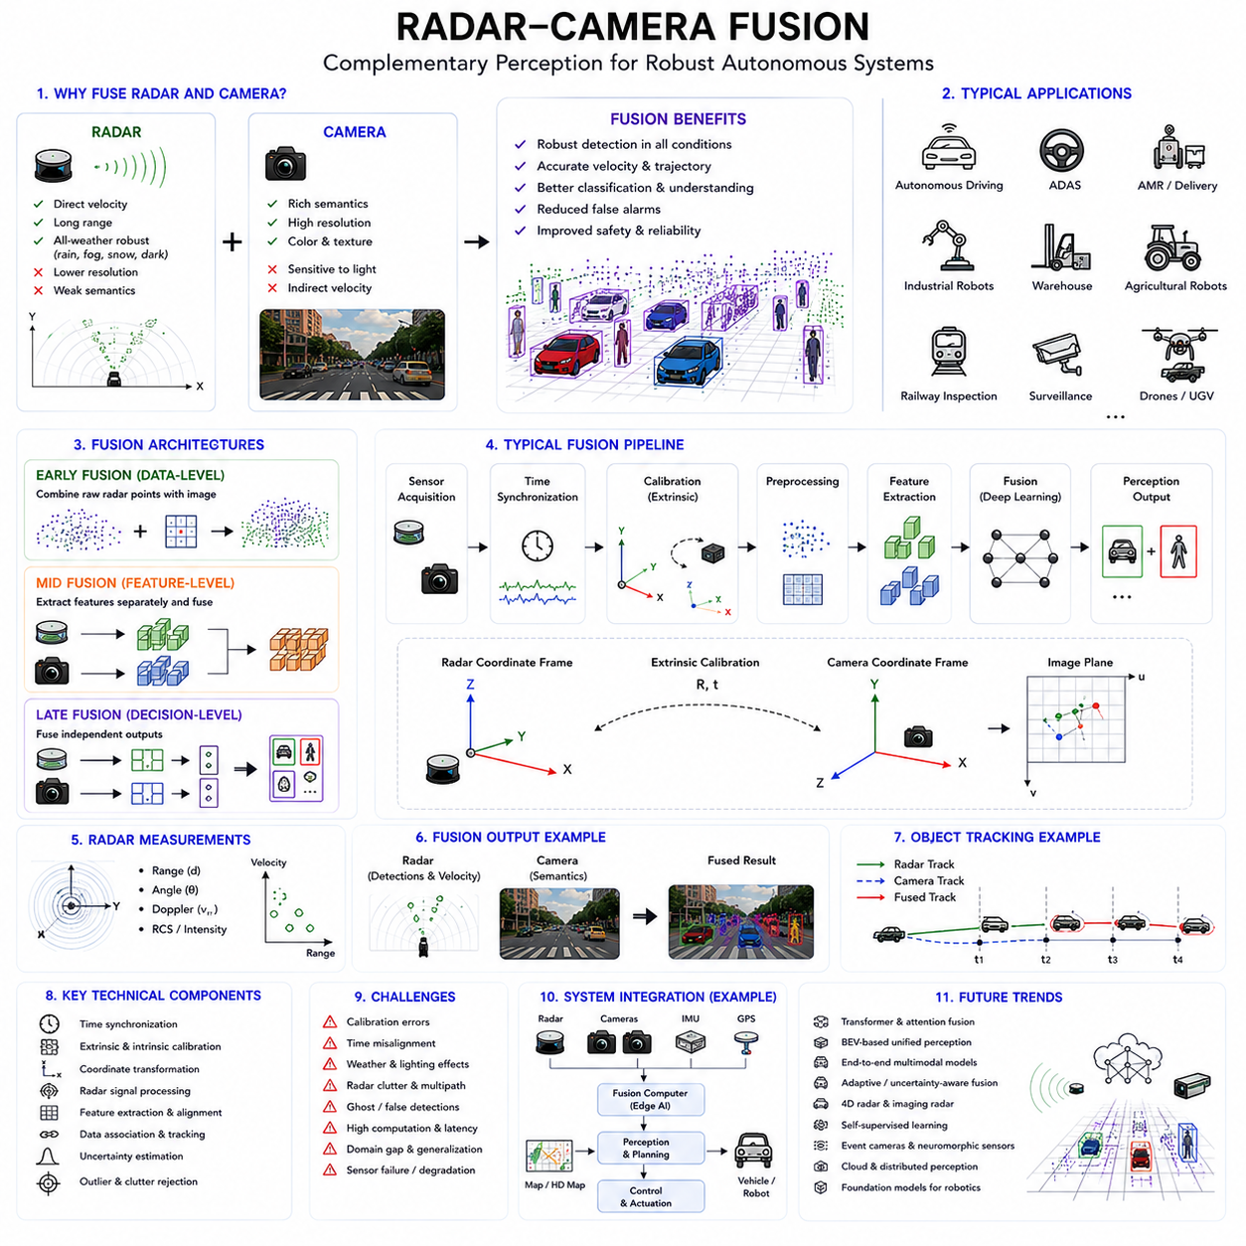
Radar-Camera Fusion is one of the most important multimodal perception technologies in modern autonomous robotics, intelligent transportation systems, autonomous vehicles, industrial automation platforms, smart city infrastructure, defense systems, railway inspection platforms, and AI-driven autonomous machines. Autonomous Mobile Robots (AMRs), outdoor autonomous robots, autonomous delivery systems, collaborative industrial robots, self-driving vehicles, agricultural robots, surveillance systems, and intelligent infrastructure monitoring platforms increasingly rely on radar-camera fusion to achieve robust environmental perception, reliable obstacle detection, stable object tracking, and safe autonomous operation under diverse environmental conditions.
Radar and camera systems provide highly complementary sensing capabilities. Cameras provide rich semantic understanding, texture information, color appearance, object classification capability, lane markings, traffic signs, and detailed scene interpretation. Radar systems provide accurate velocity measurements, long-range detection capability, motion estimation, and strong environmental robustness under rain, fog, snow, dust, smoke, and low-light conditions.
The complementary nature of radar and cameras makes their fusion highly valuable for autonomous systems operating in complex real-world environments. Cameras excel at semantic understanding but are vulnerable to poor lighting and weather conditions. Radar performs reliably in adverse environmental conditions but generally provides lower spatial resolution and weaker semantic understanding.
By combining these sensing modalities, radar-camera fusion systems achieve more reliable perception performance than either sensor can provide individually. Modern autonomous systems increasingly depend on such multimodal fusion architectures for safety-critical operation.
Radar systems operate using radio-frequency electromagnetic waves. A radar sensor emits radio waves and measures reflected signals from surrounding objects. By analyzing reflected wave characteristics such as propagation delay, Doppler frequency shift, signal strength, and phase variation, radar systems estimate object distance, velocity, direction, and relative motion.
One of the greatest strengths of radar is direct velocity measurement. Doppler radar can estimate relative object speed accurately without relying solely on frame-to-frame visual tracking. This capability is especially important in high-speed autonomous driving systems and dynamic industrial environments.
Radar systems also provide strong environmental robustness. Unlike cameras, radar performance is minimally affected by darkness, fog, rain, snow, dust, smoke, or glare. This makes radar highly valuable for all-weather autonomous perception systems.
However, radar systems also have important limitations. Radar measurements generally have lower angular resolution compared to cameras and LiDAR systems. Radar point clouds are often sparse and may contain clutter, ghost detections, multipath reflections, and ambiguous object shapes.
Cameras provide complementary capabilities. RGB cameras capture detailed visual appearance, object texture, semantic scene understanding, traffic signs, lane markings, labels, text, and object categories. Deep learning models operating on image data can classify objects with high semantic accuracy.
However, cameras suffer from important limitations. Low-light conditions, direct sunlight, shadows, fog, rain, snow, motion blur, and camera contamination may significantly reduce perception quality. Cameras also estimate motion indirectly using temporal visual tracking rather than direct velocity sensing.
Radar-camera fusion combines the strengths of both sensing modalities while compensating for their weaknesses. Radar contributes robust motion estimation and environmental resilience, while cameras contribute semantic understanding and detailed visual perception.
Modern autonomous systems use radar-camera fusion for many critical tasks, including object detection, obstacle tracking, collision avoidance, pedestrian detection, vehicle tracking, free-space estimation, path planning, autonomous navigation, safety monitoring, and intelligent traffic analysis.
One of the most important applications of radar-camera fusion is dynamic object tracking. Autonomous robots and vehicles must continuously monitor moving objects such as pedestrians, cars, bicycles, forklifts, industrial vehicles, drones, and mobile machinery.
Radar provides direct relative velocity measurements, while cameras provide semantic classification and visual object boundaries. Fusion significantly improves tracking stability and prediction accuracy.
For example, radar may detect an approaching vehicle and estimate its velocity precisely, while the camera classifies the object visually as a truck, car, or motorcycle. Fusion combines motion understanding and semantic interpretation into a unified perception result.
Radar-camera fusion is especially valuable in adverse weather environments. Rain, fog, snow, dust, smoke, and nighttime conditions often reduce camera reliability significantly. Radar remains relatively robust under these conditions.
Autonomous outdoor robots operating in industrial sites, smart cities, construction zones, ports, railways, warehouses, airports, and agricultural environments require such robust multimodal perception systems for safe operation.
Radar-camera fusion architectures are generally categorized into Early Fusion, Mid Fusion, and Late Fusion approaches.
Early Fusion combines raw radar measurements with camera image data before feature extraction occurs. For example, radar detections may be projected directly onto image planes to create multimodal input representations.
Early Fusion preserves low-level cross-modal relationships and enables neural networks to learn direct associations between radar reflections and visual features. However, Early Fusion requires highly accurate synchronization and calibration.
Mid Fusion combines features extracted independently from radar and camera processing pipelines. Radar feature maps and image feature embeddings are fused inside multimodal neural networks.
Mid Fusion balances information preservation with computational efficiency and is widely used in modern deep learning perception systems.
Late Fusion combines high-level outputs such as object detections, tracking results, or semantic classifications generated independently by radar and camera systems.
Late Fusion improves modularity, fault tolerance, and explainability while simplifying synchronization requirements. Many safety-critical industrial systems use Late Fusion for redundant perception validation.
Time synchronization is critically important in radar-camera fusion systems. Radar measurements and camera images must correspond to the same physical scene state.
Synchronization errors may produce inconsistent multimodal representations. A moving vehicle detected by radar may appear spatially shifted relative to camera observations if timestamps are misaligned.
Hardware synchronization mechanisms such as Precision Time Protocol (PTP), PPS synchronization, hardware timestamps, deterministic DDS communication, and ROS2 synchronized message pipelines help maintain temporal consistency.
Extrinsic calibration is another essential component of radar-camera fusion systems. Radar coordinate systems and camera coordinate systems must be aligned accurately.
Calibration determines the relative translation and rotation between radar and camera sensors. Accurate calibration enables radar detections to project correctly into image coordinates.
Intrinsic camera calibration is also important. Camera projection geometry, focal length, distortion coefficients, and optical center parameters affect multimodal alignment quality.
Radar calibration introduces unique challenges because radar measurements often have lower spatial density and more uncertain object boundaries compared to LiDAR systems.
Radar reflections may also vary depending on material properties, object orientation, and environmental conditions. Metallic structures may produce strong reflections, while some materials may generate weaker responses.
Radar clutter is another important challenge. Industrial environments may contain reflections from walls, pipes, vehicles, machinery, fences, and moving infrastructure components.
Signal processing plays a major role in radar-camera fusion systems. Radar systems perform filtering, Doppler processing, angle estimation, range processing, target clustering, and object tracking before fusion occurs.
Radar point clouds are often sparse compared to LiDAR point clouds. Therefore, radar-camera fusion systems must handle sparse geometric measurements carefully.
Deep learning has significantly transformed radar-camera fusion architectures. Modern multimodal perception systems increasingly use neural networks capable of learning cross-modal relationships automatically.
Convolutional neural networks extract visual features from camera images, while radar signal processing networks extract motion and geometric information from radar measurements.
Transformer-based multimodal architectures are becoming increasingly important. Attention mechanisms allow AI systems to integrate radar and camera information dynamically depending on environmental context and sensor confidence.
Bird’s Eye View (BEV) fusion architectures are especially common in autonomous driving systems. Radar and camera information are projected into unified top-down spatial representations for perception and planning.
BEV fusion simplifies object tracking, free-space estimation, lane detection, trajectory prediction, and motion planning.
Radar-camera fusion is widely used in autonomous driving systems for Advanced Driver Assistance Systems (ADAS). Adaptive cruise control, automatic emergency braking, blind spot monitoring, collision warning, and lane-change assistance all rely heavily on radar-camera fusion.
Pedestrian detection systems also benefit greatly from radar-camera fusion. Cameras identify pedestrian appearance while radar measures motion dynamics and relative velocity.
Industrial robotics systems increasingly use radar-camera fusion for safety monitoring. Collaborative robots operating near humans require highly reliable dynamic obstacle detection.
Warehouse robots may use radar-camera fusion for forklift detection, worker tracking, aisle navigation, and autonomous transportation.
Agricultural robots use radar-camera fusion for autonomous navigation under dust, fog, or nighttime conditions. Crop rows, tractors, workers, and obstacles can be detected more reliably.
Railway inspection robots use radar-camera fusion for obstacle monitoring, tunnel inspection, rail-crossing safety analysis, and dynamic environment perception.
Smart city robots use radar-camera fusion for traffic monitoring, pedestrian flow analysis, autonomous delivery, infrastructure monitoring, and public safety systems.
Military and defense systems also rely heavily on radar-camera fusion. Autonomous surveillance platforms, unmanned ground vehicles, and security systems require robust all-weather perception.
Uncertainty estimation is critically important in radar-camera fusion. Sensor reliability varies depending on environmental conditions, lighting, weather, vibration, and interference.
Adaptive fusion systems dynamically adjust sensor weighting based on confidence estimation. Camera weighting may decrease during heavy fog, while radar weighting increases.
False detections and ghost objects are major radar challenges. Multipath reflections may create ambiguous detections. Fusion with camera semantics helps suppress false positives.
Sensor failure detection is also essential. Camera contamination, radar interference, synchronization failure, calibration drift, communication errors, or hardware malfunction must be detected robustly.
Redundant perception architectures improve operational safety. Multiple sensing modalities provide fail-safe perception capability in safety-critical systems.
ROS2 provides important infrastructure for radar-camera fusion systems. ROS2 supports synchronized communication, TF2 coordinate transformations, DDS middleware integration, scalable perception pipelines, and distributed robotics architectures.
ROS2 message_filters help synchronize radar and camera data streams temporally before fusion processing.
RViz visualization tools are commonly used to inspect radar-camera alignment. Engineers visualize projected radar detections on camera images to validate calibration and synchronization quality.
Foxglove Studio, PlotJuggler, MATLAB, and custom visualization dashboards are also widely used for fusion debugging and performance monitoring.
Computational efficiency is a major challenge in radar-camera fusion systems. High-resolution image processing, neural network inference, radar signal processing, and object tracking require significant computing resources.
Edge AI acceleration platforms using GPUs, TPUs, FPGAs, and dedicated AI accelerators enable real-time multimodal fusion.
Latency management is critically important in autonomous systems. Delayed perception outputs may produce unsafe autonomous behavior.
Real-time operating systems, deterministic communication middleware, hardware synchronization, optimized AI inference pipelines, and efficient scheduling architectures are therefore essential.
Cybersecurity is becoming increasingly important in multimodal perception systems. Radar spoofing attacks, adversarial visual attacks, communication corruption, or electromagnetic interference may destabilize perception systems.
Functional safety standards increasingly require rigorous validation of multimodal perception architectures. Autonomous robots operating near humans must maintain safe operation even under degraded sensing conditions.
Future radar-camera fusion systems will likely become increasingly AI-driven, adaptive, distributed, and multimodal. Foundation models for robotics may integrate radar, vision, language, localization, prediction, planning, and control into unified embodied AI architectures.
Advanced radar systems with higher angular resolution, imaging radar technology, 4D radar systems, neuromorphic sensors, event cameras, thermal imaging systems, and AI-native sensors may significantly improve future fusion capabilities.
Self-supervised learning may reduce dependence on manually labeled multimodal datasets. Robots may increasingly learn radar-vision relationships directly from operational experience.
Cloud robotics and distributed multi-robot systems may share fused radar-camera perception information collectively to improve environmental understanding across larger operational environments.
Digital twin systems also depend heavily on multimodal perception fusion. Physical sensor streams must remain aligned with virtual simulation environments.
Humanoid robots, autonomous industrial vehicles, smart infrastructure inspection systems, autonomous logistics robots, and future embodied AI systems will all depend heavily on advanced radar-camera fusion architectures.
In conclusion, radar-camera fusion represents one of the most important multimodal perception technologies in modern autonomous robotics and intelligent transportation systems. By combining radar’s robust motion estimation and environmental resilience with camera-based semantic understanding and visual perception, fusion architectures significantly improve obstacle detection, object tracking, localization robustness, environmental understanding, and autonomous safety. As robotics systems continue evolving toward increasingly intelligent, distributed, AI-driven, and safety-critical architectures, radar-camera fusion will remain one of the foundational technologies enabling reliable autonomous operation and embodied intelligence.

13.6 GNSS-IMU-Odometry Fusion
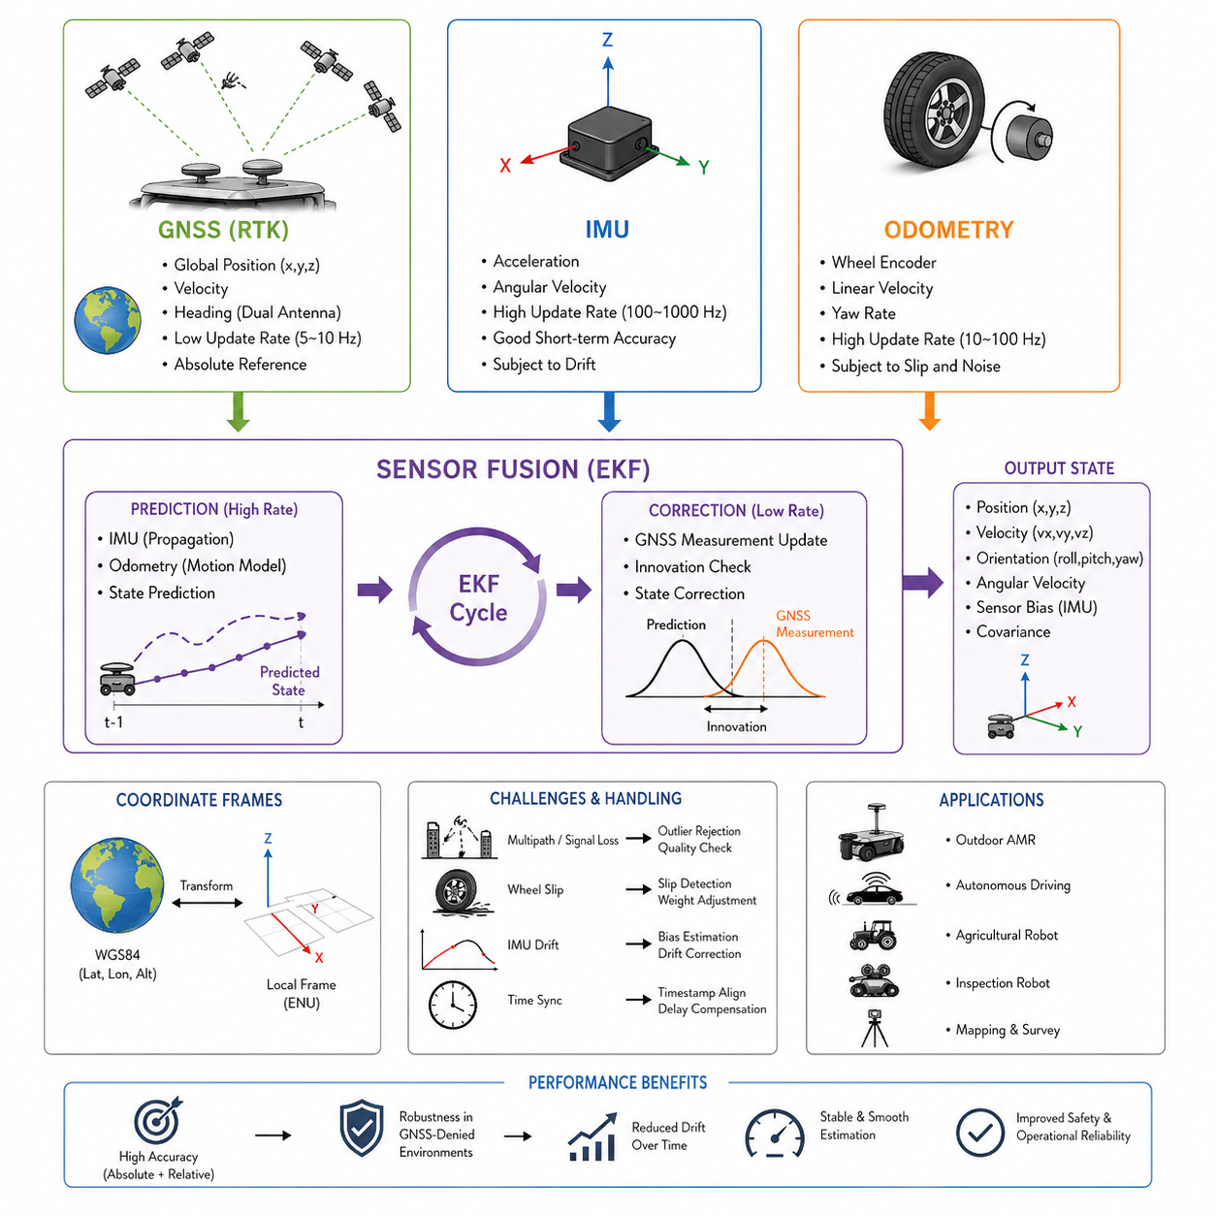
Modern Autonomous Mobile Robots (AMRs), outdoor delivery robots, autonomous inspection systems, agricultural robots, defense robots, and smart city robotic platforms all require highly reliable localization systems. A robot that cannot accurately estimate its own position, heading, velocity, and motion state cannot safely navigate in real-world environments. Although GNSS, IMU, and wheel odometry are individually powerful localization technologies, each sensor has limitations when used independently. GNSS signals can be blocked or degraded in urban canyons, tunnels, forests, factories, or under bridges. IMU sensors suffer from drift accumulation over time. Wheel odometry becomes inaccurate on slippery surfaces, uneven terrain, or during wheel slip conditions. Because of these limitations, modern robotic systems combine GNSS, IMU, and odometry into a unified sensor fusion framework capable of producing stable and robust localization estimates.
GNSS_IMU_Odometry_Fusion is one of the most important technologies in outdoor autonomous robotics because it forms the foundation of localization, navigation, mapping, motion planning, and autonomous driving control. In practical robotic deployments, localization failures are among the most common causes of field operation instability. A robot may suddenly jump several meters due to GNSS multipath reflections, or heading estimation may drift because of IMU bias accumulation. Wheel odometry may also fail when the robot traverses mud, gravel, snow, wet floors, or steep slopes. Sensor fusion techniques are therefore used to compensate for weaknesses in one sensor using strengths from other sensors.
GNSS provides globally referenced positioning information. Typical GNSS systems include GPS, GLONASS, Galileo, and BeiDou satellite constellations. Standard GNSS positioning accuracy is usually within several meters, while RTK-enabled GNSS can achieve centimeter-level positioning accuracy under ideal conditions. GNSS is extremely valuable because it provides absolute global coordinates. However, GNSS update rates are relatively low compared to IMU sensors, and signal quality can degrade significantly in dense urban environments or near reflective surfaces.
IMU sensors provide acceleration and angular velocity measurements at very high frequencies, often between 100 Hz and 1000 Hz. IMUs are critical because they provide continuous motion estimation even when GNSS signals are temporarily unavailable. IMUs measure linear acceleration using accelerometers and rotational velocity using gyroscopes. By integrating acceleration and angular velocity over time, the robot can estimate orientation, velocity, and relative motion. However, even very small sensor biases accumulate over time, causing drift errors. Low-cost MEMS IMUs commonly used in AMRs are especially susceptible to drift.
Wheel odometry estimates robot motion using wheel encoder data. By counting wheel rotations and applying robot kinematic models, the system estimates translational and rotational displacement. Wheel odometry is computationally efficient and highly responsive. It works well on stable indoor surfaces and structured roads. However, wheel slip, uneven terrain, tire deformation, mechanical backlash, and encoder noise can introduce substantial errors. Outdoor robots operating on gravel, sand, grass, mud, or steep terrain frequently experience odometry degradation.
The purpose of GNSS_IMU_Odometry_Fusion is to combine these three complementary sensing modalities into a unified localization estimate. GNSS provides global correction, IMU provides high-frequency motion continuity, and odometry provides local displacement estimation. Together, they create a localization system that is significantly more robust than any single sensor alone.
The most common mathematical framework used in GNSS_IMU_Odometry_Fusion is the Extended Kalman Filter (EKF). The EKF estimates the robot state vector using prediction and correction steps. The prediction step uses IMU and odometry data to estimate the robot motion continuously. The correction step uses GNSS measurements to periodically reduce accumulated drift. This probabilistic framework allows the system to maintain smooth localization while correcting long-term errors.
The robot state vector in a fusion system typically includes position, velocity, orientation, angular velocity, accelerometer bias, gyroscope bias, and sometimes wheel slip parameters. The EKF continuously updates this state estimate using sensor observations. Modern robotics platforms often implement localization fusion using ROS2 packages such as robot_localization, nav2, or custom sensor fusion frameworks.
Coordinate systems are critically important in sensor fusion systems. GNSS measurements are typically represented in global geographic coordinate frames such as WGS84 latitude, longitude, and altitude. However, robotic navigation systems usually operate in local Cartesian coordinate frames such as ENU (East-North-Up), NED (North-East-Down), or map frames. Proper coordinate transformation is therefore required before fusion can occur.
The IMU coordinate frame must also be precisely aligned with the robot body frame. Misalignment between sensor axes introduces orientation estimation errors. Extrinsic calibration is therefore essential. Similarly, wheel odometry measurements must correspond accurately to the robot kinematic model. Incorrect wheel diameter, wheelbase, encoder scaling, or steering geometry can introduce cumulative localization drift.
Time synchronization is another major challenge in GNSS_IMU_Odometry_Fusion systems. GNSS receivers may operate at 5 Hz or 10 Hz, while IMUs operate at hundreds of Hertz. Wheel encoders may update at different rates again. If timestamps are not accurately synchronized, fusion performance degrades significantly. Modern robotic systems therefore use synchronized clocks, hardware triggering, PTP, or ROS2 time synchronization frameworks.
In outdoor autonomous robots, GNSS is often fused with dual-antenna heading systems. Dual GNSS antennas provide direct heading estimation independent of vehicle motion. This is particularly useful for slow-moving robots where heading estimation from wheel odometry becomes unstable. Large outdoor AMRs, autonomous agricultural platforms, and GPR inspection robots frequently use dual-antenna GNSS systems for enhanced orientation estimation.
GNSS multipath is one of the most serious practical challenges in urban robotics. Signals reflected from buildings, vehicles, metal structures, or industrial facilities produce inaccurate position estimates. Multipath errors may cause sudden jumps in localization results. Fusion systems must therefore detect abnormal GNSS measurements and reject unreliable observations. Statistical outlier rejection, covariance adjustment, innovation monitoring, and quality metrics such as HDOP are commonly used.
IMU bias estimation is another essential component of sensor fusion. Accelerometer and gyroscope biases slowly change due to temperature, vibration, aging, and mechanical stress. Advanced fusion systems continuously estimate these biases online. Temperature-compensated IMUs and industrial-grade inertial navigation systems improve performance significantly but increase system cost.
Wheel slip detection is also extremely important for outdoor robots. When the wheel rotates without corresponding vehicle movement, odometry becomes unreliable. Fusion systems may detect wheel slip using inconsistencies between IMU acceleration, GNSS velocity, and wheel encoder estimates. Once slip is detected, the system may reduce odometry weighting temporarily.
Robotic platforms operating in smart cities often encounter GNSS-denied environments such as tunnels, underground parking structures, urban canyons, bridges, warehouses, or industrial plants. During GNSS outages, IMU and odometry become the primary localization sources. However, drift accumulates over time. Therefore, robots often integrate additional sensors such as LiDAR SLAM, Visual SLAM, radar localization, or landmark-based localization to maintain accuracy.
Outdoor GPR robots present unique localization challenges because accurate underground mapping requires highly precise spatial alignment. If localization errors accumulate, underground anomaly maps become distorted. Therefore, GPR robots frequently combine RTK GNSS, high-grade IMU systems, wheel odometry, and LiDAR SLAM simultaneously. In some systems, localization accuracy requirements may be below several centimeters.
Heavy outdoor autonomous platforms operating on rough terrain introduce additional challenges. Large vibrations affect IMU stability, wheel slip increases odometry uncertainty, and GNSS antennas may experience dynamic motion. Suspension systems, vibration isolation, rigid sensor mounting, and sensor filtering are therefore essential mechanical considerations.
Sensor fusion architecture may be implemented using centralized fusion or distributed fusion methods. In centralized fusion, all raw sensor measurements are processed in a single estimator. In distributed fusion, independent estimators process subsets of sensors before combining results at a higher level. Centralized fusion generally provides higher accuracy but requires more computational resources.
Modern AI-based localization systems are increasingly incorporating machine learning into fusion pipelines. Neural networks may estimate wheel slip probability, predict GNSS reliability, classify terrain conditions, or optimize covariance estimation dynamically. However, traditional probabilistic estimation methods such as Kalman filtering remain dominant in safety-critical robotic systems because of their interpretability and reliability.
ROS2-based robotic systems commonly implement GNSS_IMU_Odometry_Fusion using the robot_localization package. This package supports EKF and UKF fusion methods and allows integration of IMU, GNSS, wheel encoders, Visual SLAM, and LiDAR localization simultaneously. The typical ROS2 localization architecture includes sensor drivers, coordinate transforms, localization nodes, map servers, and navigation stacks.
Localization performance evaluation is extremely important during robot development. Metrics commonly used include absolute trajectory error, relative pose error, heading error, drift rate, localization stability, and recovery performance after GNSS outages. Engineers frequently compare fused trajectories against ground truth systems such as motion capture systems, total stations, or survey-grade GNSS equipment.
Field testing should include diverse environmental conditions such as open sky environments, urban canyons, forests, tunnels, industrial facilities, slopes, wet terrain, gravel roads, and high-vibration conditions. Localization systems that perform well only in ideal environments are insufficient for industrial deployment.
Safety considerations are critically important in localization fusion systems. Autonomous robots operating near humans, vehicles, or industrial equipment require highly reliable localization. Sensor failures, synchronization errors, or estimator divergence may lead to unsafe robot behavior. Therefore, redundancy, fault detection, and health monitoring mechanisms are essential.
Many industrial robots implement localization confidence estimation. The system continuously evaluates sensor quality metrics and estimator consistency. If localization uncertainty exceeds safe limits, the robot may reduce speed, stop operation, or transition into a degraded mode.
Future GNSS_IMU_Odometry_Fusion systems will become increasingly integrated with AI-driven world models, semantic localization, and multi-robot cooperative positioning. High-definition maps, edge AI accelerators, and cloud robotics will further enhance localization reliability. Multi-frequency GNSS receivers, MEMS IMU advancements, and improved sensor fusion algorithms will also reduce cost while improving performance.
Autonomous robots deployed in smart cities, logistics centers, hospitals, factories, ports, railways, agriculture, and defense environments will increasingly depend on robust multi-sensor localization frameworks. GNSS_IMU_Odometry_Fusion will therefore remain one of the foundational technologies enabling reliable autonomous navigation in real-world robotic systems.
The structure of this chapter is aligned with the “13_Sensor_Fusion” section within the AMR perception architecture and specifically corresponds to “13_06_GNSS_IMU_Odometry_Fusion” in the uploaded robotics engineering manual. Additionally, this topic belongs to the broader “Volume_03_AMR_Sensors_and_Perception” framework of the AMR robotics development process documentation.

13.7 AI-Based Sensor Fusion
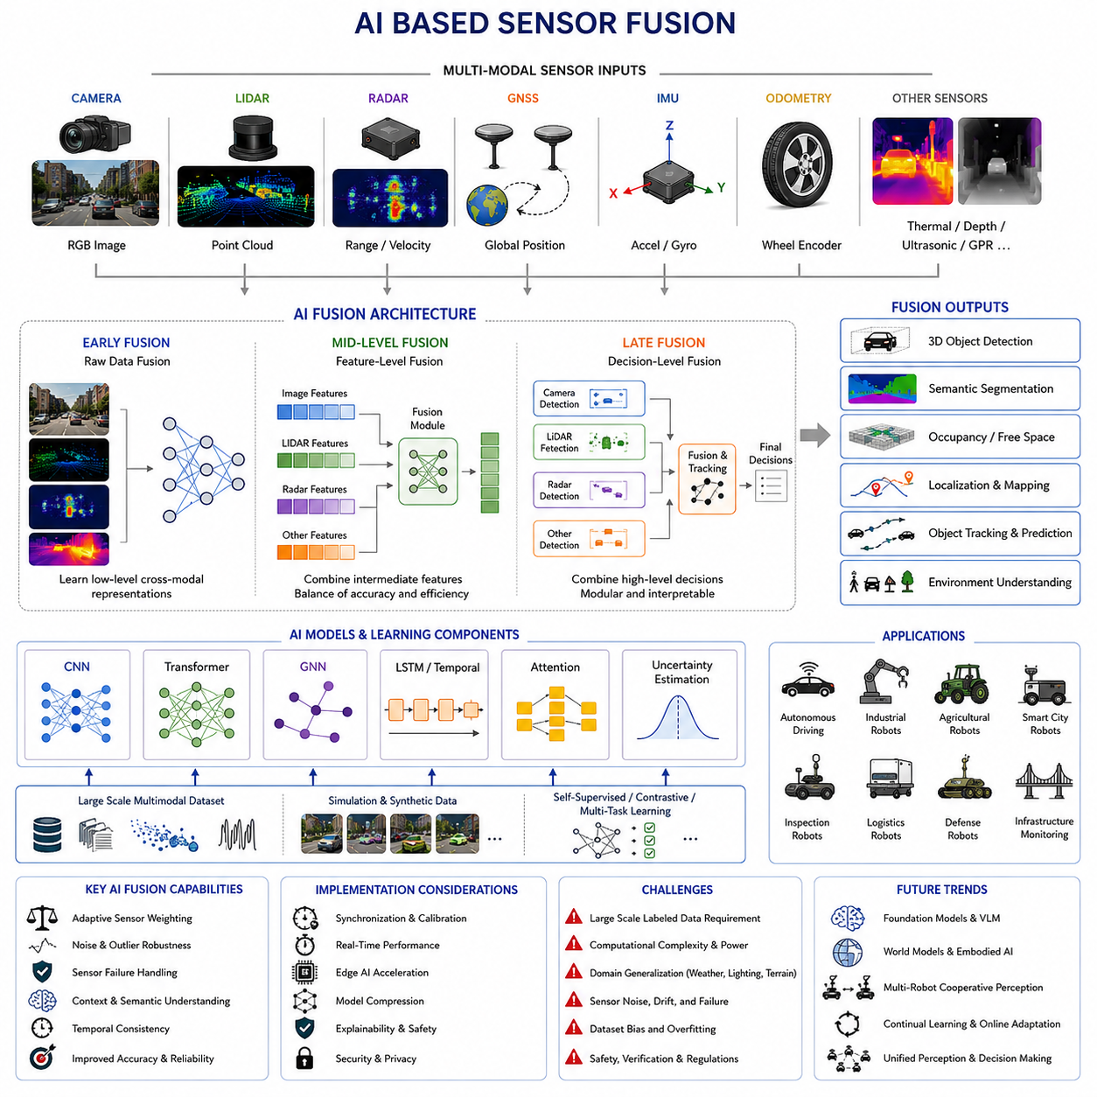
Modern Autonomous Mobile Robots (AMRs), autonomous vehicles, industrial robots, agricultural robots, smart city robots, defense systems, and intelligent inspection platforms increasingly depend on advanced sensor fusion systems to achieve reliable autonomy. Traditional sensor fusion methods such as Kalman Filters, Extended Kalman Filters (EKF), Unscented Kalman Filters (UKF), Particle Filters, and Bayesian Estimation frameworks have been widely used for decades. These methods remain extremely important because they provide mathematically interpretable and computationally efficient state estimation. However, modern robotic environments are becoming increasingly complex, dynamic, and unstructured. As a result, conventional fusion techniques alone are often insufficient to fully model real-world uncertainty, nonlinear sensor relationships, and semantic environmental understanding.
AI_Based_Sensor_Fusion represents the next evolution of robotic perception systems. Instead of relying solely on deterministic mathematical models, AI-driven fusion systems use machine learning and deep learning techniques to learn relationships between heterogeneous sensor modalities directly from data. AI-based fusion systems can combine information from cameras, LiDAR, radar, ultrasonic sensors, GNSS, IMU, thermal cameras, wheel odometry, depth cameras, GPR sensors, and many other sensing modalities into unified perception and localization frameworks.
The primary goal of AI_Based_Sensor_Fusion is to improve perception robustness, environmental understanding, localization stability, obstacle detection accuracy, semantic scene interpretation, and autonomous decision-making performance. AI-based fusion systems are especially valuable in environments where sensor uncertainty is highly nonlinear or difficult to model analytically.
Traditional fusion systems generally assume Gaussian noise distributions and relatively predictable sensor behavior. Real-world environments rarely satisfy these assumptions. Rain, fog, dust, snow, glare, reflections, vibration, electromagnetic interference, wheel slip, sensor aging, and dynamic obstacles all introduce complex nonlinear effects. AI-based fusion systems attempt to learn these relationships automatically from large datasets.
One of the most important concepts in AI_Based_Sensor_Fusion is multimodal learning. Different sensors observe the environment in fundamentally different ways. Cameras provide dense texture and color information. LiDAR provides accurate geometric distance measurements. Radar performs well in rain and fog while measuring object velocity directly. Thermal cameras detect heat signatures even in darkness. GNSS provides global positioning. IMU sensors measure inertial motion. Each sensor modality has unique strengths and weaknesses.
AI-based fusion systems attempt to learn complementary representations from these multiple sensor modalities. Deep neural networks can combine spatial, temporal, semantic, and geometric information simultaneously. This allows robots to build richer environmental models than would be possible using individual sensors independently.
Sensor fusion architectures are generally categorized into Early Fusion, Mid-Level Fusion, and Late Fusion frameworks. In Early Fusion systems, raw sensor data is combined before feature extraction. For example, raw LiDAR point clouds and camera images may be projected into a common representation space before entering a neural network. Early fusion allows deep models to learn low-level cross-modal relationships directly.
Mid-Level Fusion combines intermediate feature representations extracted independently from each sensor modality. For example, CNN features from RGB cameras may be fused with voxel features from LiDAR point clouds and Doppler features from radar systems. This approach is widely used because it balances computational efficiency and fusion effectiveness.
Late Fusion combines high-level decisions or object detections from independent perception modules. For example, camera-based pedestrian detection and LiDAR-based obstacle detection may each produce object candidates that are later merged using probabilistic reasoning or neural confidence estimation. Late fusion is relatively modular and easier to debug, but it may lose some cross-modal contextual information.
Deep learning plays a central role in AI_Based_Sensor_Fusion. Convolutional Neural Networks (CNNs), Vision Transformers (ViTs), Graph Neural Networks (GNNs), Recurrent Neural Networks (RNNs), Long Short-Term Memory (LSTM) networks, and attention-based architectures are commonly used in modern robotic perception systems.
CNN-based fusion architectures are widely used for image-LiDAR fusion tasks. In autonomous driving systems, LiDAR point clouds may be projected onto camera images to generate depth-enhanced visual perception. CNNs can learn joint representations that improve object detection, semantic segmentation, drivable area estimation, and free-space detection.
Transformers are increasingly replacing conventional CNN architectures in multimodal perception systems. Transformer-based architectures use attention mechanisms to learn relationships between different sensor modalities dynamically. Multi-head attention mechanisms allow the system to focus selectively on the most relevant sensor information under changing environmental conditions.
For example, during heavy fog conditions, camera reliability decreases significantly while radar reliability remains relatively stable. An AI-based fusion model using attention mechanisms may automatically reduce the weighting of camera features while increasing reliance on radar information. This dynamic sensor weighting capability is one of the major advantages of AI-based fusion systems.
Temporal sensor fusion is another important area of AI-based perception. Robots operate in continuously changing environments, and instantaneous sensor measurements often contain ambiguity or noise. Temporal fusion models use sequential sensor observations to improve perception stability over time.
LSTM networks and temporal transformers are commonly used for sequential sensor fusion. These models can learn motion patterns, object trajectories, environmental dynamics, and sensor reliability trends. Temporal fusion improves object tracking, trajectory prediction, localization stability, and dynamic obstacle understanding.
AI-based fusion is particularly important in autonomous driving and outdoor AMR systems. Outdoor environments are extremely diverse and unpredictable. Lighting conditions change continuously. Roads may be wet, snowy, dusty, or reflective. Pedestrians, vehicles, bicycles, animals, and industrial machines move dynamically. Traditional rule-based fusion systems struggle to model all these complexities explicitly.
Autonomous driving platforms frequently combine camera, LiDAR, radar, GNSS, IMU, HD maps, and wheel odometry simultaneously. AI-based fusion models integrate semantic understanding with geometric reasoning. For example, a vision model may classify an object as a pedestrian while LiDAR provides precise 3D distance measurements and radar estimates velocity. Together, these sensors create a highly reliable obstacle understanding system.
Semantic sensor fusion is becoming increasingly important in robotics. Traditional fusion systems focus mainly on geometric state estimation. AI-based systems additionally perform semantic interpretation of the environment. The robot not only detects objects but also understands their meaning, behavior, and context.
For example, a construction robot may distinguish workers, forklifts, cranes, safety barriers, and excavation zones semantically. A hospital robot may recognize patients, nurses, medical carts, beds, elevators, and emergency areas. A smart city robot may identify pedestrians, bicycles, traffic lights, delivery vehicles, and road infrastructure.
Occupancy grid generation is another important application of AI-based fusion. Traditional occupancy grids classify space as occupied or free. AI-enhanced occupancy systems incorporate semantic and probabilistic reasoning simultaneously. The system may estimate drivable areas, terrain types, pedestrian zones, vegetation, water hazards, and slope conditions dynamically.
AI_Based_Sensor_Fusion is also critical for localization systems. AI models may estimate GNSS reliability, detect wheel slip, classify terrain conditions, estimate IMU drift, or optimize covariance parameters dynamically. Neural networks can improve localization robustness by adapting fusion behavior to changing environmental conditions.
For example, an outdoor agricultural robot operating in muddy terrain may experience severe wheel slip. An AI-based fusion system can detect abnormal motion behavior using camera, IMU, and wheel encoder inconsistencies. The system may then reduce odometry weighting automatically while increasing reliance on GNSS and visual localization.
In industrial robotics, AI-based fusion improves safety significantly. Safety-critical robots must operate reliably around humans, forklifts, vehicles, and industrial equipment. AI-enhanced perception systems improve human detection, trajectory prediction, behavior understanding, and collision avoidance.
Sensor redundancy is a major advantage of multimodal AI systems. If one sensor fails or degrades, the system can continue operating using alternative sensor modalities. For example, if cameras fail in darkness, thermal cameras and radar may continue functioning. If GNSS signals degrade in urban canyons, LiDAR SLAM and visual odometry may maintain localization continuity.
Data synchronization remains one of the most challenging aspects of AI_Based_Sensor_Fusion. Different sensors operate at different frequencies, resolutions, latencies, and coordinate frames. Accurate timestamp synchronization and calibration are essential. Poor synchronization introduces fusion errors that can severely degrade AI model performance.
Calibration is equally critical. Camera-LiDAR extrinsic calibration, radar alignment, IMU orientation calibration, and sensor coordinate transformation accuracy all directly affect fusion quality. AI models trained on calibrated datasets may fail when deployed on poorly calibrated systems.
Dataset collection is one of the largest challenges in AI-based fusion development. Large multimodal datasets are required to train robust models. These datasets must include synchronized sensor streams, accurate annotations, diverse weather conditions, lighting variations, terrain types, and operational scenarios.
Modern autonomous driving datasets such as KITTI, nuScenes, Waymo Open Dataset, Argoverse, and PandaSet are widely used for fusion research. However, industrial robots, agricultural robots, GPR robots, and smart city robots often require highly specialized datasets not available publicly.
Simulation environments are increasingly used for multimodal fusion training. Platforms such as NVIDIA Isaac Sim, CARLA, Gazebo, and AirSim allow synthetic generation of synchronized multimodal sensor data. Synthetic data can accelerate development significantly, although domain adaptation challenges remain.
Edge AI acceleration is essential for real-time AI_Based_Sensor_Fusion. Modern robotic systems often use NVIDIA Jetson Orin, Jetson Thor, RTX GPUs, TensorRT acceleration, FPGA accelerators, or custom AI ASICs. Real-time fusion processing requires high computational throughput with low latency.
Latency is extremely important in safety-critical systems. If sensor fusion pipelines introduce excessive delay, obstacle avoidance performance degrades significantly. Therefore, AI fusion architectures must balance accuracy, robustness, computational complexity, and real-time responsiveness carefully.
Model compression techniques such as quantization, pruning, knowledge distillation, and TensorRT optimization are frequently used to deploy large multimodal fusion models onto edge devices. Outdoor robots often have strict power consumption and thermal management constraints, making optimization essential.
Explainability is another major issue in AI_Based_Sensor_Fusion. Traditional Kalman Filter systems are mathematically interpretable, while deep neural networks are often considered black boxes. Safety-critical robotics applications require explainable and verifiable perception systems. Therefore, hybrid fusion systems combining classical estimation methods with AI-based perception are increasingly common.
For example, an EKF localization framework may still perform core state estimation while AI models dynamically estimate sensor confidence, wheel slip probability, or environmental semantics. This hybrid approach combines the stability of classical estimation with the adaptability of deep learning.
Robustness testing is essential for AI-based fusion systems. Models must be evaluated under rain, snow, fog, dust, glare, low light, vibration, sensor failure, electromagnetic interference, and partial sensor degradation conditions. Field testing is often more important than laboratory benchmark performance.
Cybersecurity is becoming increasingly important as robotic perception systems become more connected. Sensor spoofing attacks, GNSS jamming, adversarial image attacks, and malicious data injection can potentially compromise AI fusion systems. Future fusion architectures will require robust security monitoring and anomaly detection capabilities.
Foundation Models and Vision-Language Models (VLMs) are beginning to influence AI_Based_Sensor_Fusion research. Future robots may fuse not only physical sensor streams but also semantic world knowledge, language understanding, and high-level reasoning capabilities. Embodied AI systems will likely integrate multimodal sensor fusion with world models and cognitive reasoning systems.
Multi-robot sensor fusion is another emerging area. Fleets of robots may share localization maps, semantic observations, obstacle detections, and environmental understanding through cloud or edge networks. Cooperative perception may dramatically improve safety and operational efficiency in large-scale robotic deployments.
Future AI_Based_Sensor_Fusion systems will likely evolve toward fully unified world models capable of simultaneously performing localization, mapping, semantic understanding, trajectory prediction, and autonomous decision-making within a single multimodal AI framework.
Autonomous robots operating in smart cities, factories, ports, logistics centers, railways, hospitals, agriculture, defense, and infrastructure inspection environments will increasingly depend on advanced AI-driven multimodal perception systems. AI_Based_Sensor_Fusion will therefore become one of the foundational technologies enabling next-generation embodied intelligence and real-world robotic autonomy.
This section corresponds to “13_07_AI_Based_Sensor_Fusion” within the “13_Sensor_Fusion” chapter structure of the AMR Sensors and Perception engineering framework. It is also part of the broader AMR robotics development architecture defined within the uploaded development manual structure.

13.8 Fusion Testing and Validation
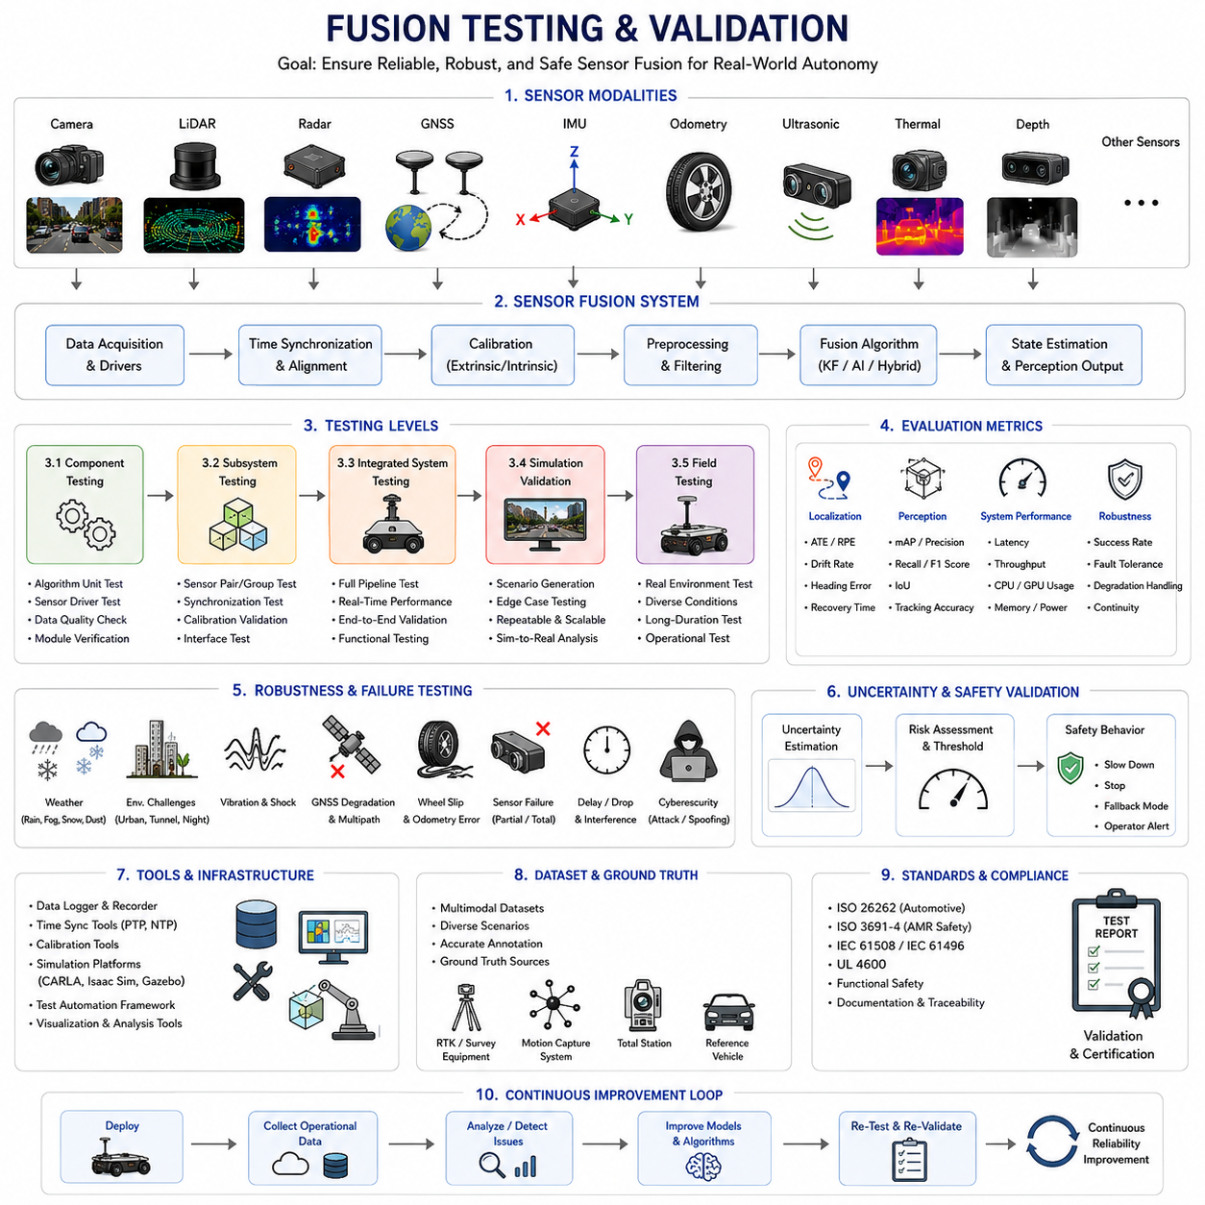
Modern Autonomous Mobile Robots (AMRs), autonomous vehicles, industrial robots, smart city robots, agricultural platforms, railway inspection systems, logistics robots, and defense robots all rely heavily on sensor fusion systems to achieve stable perception, localization, navigation, and autonomous decision-making. Sensor fusion systems integrate multiple sensing modalities such as LiDAR, cameras, radar, GNSS, IMU, ultrasonic sensors, wheel odometry, thermal cameras, depth sensors, and AI-based perception modules into a unified understanding of the environment. However, the performance of a fusion system cannot be assumed simply because the individual sensors operate correctly. Even if every sensor functions properly on its own, incorrect synchronization, calibration errors, environmental interference, algorithm instability, or AI model failures can cause severe degradation of the overall robotic system.
Fusion_Testing_and_Validation refers to the complete engineering process used to verify, evaluate, validate, and certify the reliability, robustness, safety, and operational performance of sensor fusion systems. In safety-critical robotics, fusion validation is not optional. Autonomous robots operating around humans, vehicles, industrial machinery, medical facilities, railway infrastructure, or public roads require highly reliable perception and localization systems. A failure in sensor fusion can lead directly to navigation errors, obstacle collisions, localization drift, unsafe robot behavior, or catastrophic accidents.
The primary objective of fusion testing is to ensure that the robot maintains stable and reliable perception under real-world operating conditions. Sensor fusion systems must function correctly not only in ideal laboratory environments but also under rain, fog, dust, snow, glare, vibration, darkness, electromagnetic interference, sensor degradation, network delay, GNSS multipath, wheel slip, and highly dynamic environments.
Fusion validation typically begins with sensor-level verification. Each sensor must first be tested independently before integration into the full fusion architecture. Cameras are evaluated for image quality, exposure stability, frame synchronization, motion blur, and low-light performance. LiDAR sensors are tested for point cloud accuracy, range stability, angular resolution, and outdoor reliability. Radar systems are evaluated for range accuracy, velocity estimation, interference resistance, and adverse weather performance. GNSS systems are tested for positioning accuracy, heading stability, RTK convergence, and multipath robustness. IMU systems are validated for bias stability, drift characteristics, vibration resistance, and thermal performance.
Once individual sensors are validated, multi-sensor integration testing begins. Integration testing verifies that the sensors operate correctly as a unified system. Synchronization testing is especially important because different sensors operate at different frequencies and latencies. A LiDAR may operate at 10 Hz, a camera at 30 FPS, an IMU at 400 Hz, and radar at another frequency entirely. Timestamp alignment errors can severely degrade fusion performance.
Time synchronization validation often involves hardware timestamp analysis, ROS2 timestamp verification, PTP synchronization testing, latency measurement, and delay compensation analysis. Engineers frequently use synchronized ground truth signals or hardware trigger systems to evaluate synchronization accuracy.
Calibration validation is another critical aspect of fusion testing. Extrinsic calibration between cameras, LiDARs, radars, IMUs, GNSS antennas, and robot body frames must remain highly accurate. Small calibration errors can significantly degrade perception quality. Camera-LiDAR projection alignment, radar coordinate alignment, IMU orientation alignment, and GNSS antenna offsets must all be verified carefully.
Dynamic calibration drift is a major real-world challenge. Mechanical vibration, thermal expansion, impacts, suspension movement, and long-term mechanical wear can slowly alter sensor alignment over time. Therefore, fusion validation must include long-term operational testing under realistic environmental conditions.
Fusion systems are generally tested across several levels including component testing, subsystem testing, integrated system testing, simulation validation, field testing, stress testing, failure testing, and operational acceptance testing.
Component testing focuses on individual algorithms and software modules. For example, Kalman Filters, neural fusion models, object tracking systems, localization estimators, and occupancy mapping modules are validated independently using recorded datasets or simulation data.
Subsystem testing evaluates groups of related modules together. For example, GNSS_IMU_Odometry_Fusion may be tested separately from LiDAR_Camera_Object_Detection_Fusion. This modular testing approach simplifies debugging and fault isolation.
Integrated system testing evaluates the complete perception and autonomy pipeline simultaneously. The robot must process sensor data in real time while maintaining stable navigation, obstacle detection, localization, path planning, and motion control.
Simulation-based testing has become increasingly important in modern robotics development. Simulation platforms such as NVIDIA Isaac Sim, Gazebo, CARLA, AirSim, and Webots allow engineers to generate large-scale multimodal sensor datasets under controlled conditions. Simulation enables rapid testing of rare edge cases that may be difficult or dangerous to reproduce physically.
For example, simulation environments can generate heavy fog, severe rain, snowstorms, GNSS outages, pedestrian crossings, sensor failures, multi-vehicle interactions, or complex urban traffic scenarios repeatedly and safely. Simulation also allows repeatable benchmarking under identical conditions.
However, simulation alone is insufficient. Sim-to-real gaps remain one of the largest challenges in robotics validation. Synthetic sensor noise, lighting models, terrain physics, weather behavior, and material reflectivity may differ significantly from real-world environments. Therefore, simulation testing must always be complemented with extensive real-world field validation.
Field testing is the most critical phase of fusion validation. Real environments introduce unpredictable factors impossible to model perfectly in simulation. Outdoor robots must be tested under diverse weather conditions, lighting conditions, terrain types, traffic situations, and operational scenarios.
Field testing for outdoor autonomous robots often includes open roads, industrial facilities, urban canyons, tunnels, gravel roads, muddy terrain, slopes, bridges, parking lots, construction zones, forests, agricultural environments, ports, railways, and crowded pedestrian areas.
Localization fusion systems require highly specialized validation procedures. GNSS_IMU_Odometry_Fusion systems are commonly evaluated using ground truth systems such as RTK survey equipment, total stations, motion capture systems, or high-precision reference vehicles.
Metrics commonly used in localization validation include Absolute Trajectory Error (ATE), Relative Pose Error (RPE), heading accuracy, drift rate, localization continuity, recovery time after GNSS outages, covariance consistency, and estimator stability.
Perception fusion systems are evaluated using metrics such as precision, recall, mean Average Precision (mAP), Intersection over Union (IoU), tracking accuracy, false positive rate, false negative rate, detection latency, and semantic segmentation quality.
Sensor fusion validation also includes robustness testing. Robustness testing intentionally introduces disturbances and abnormal conditions to evaluate system stability. Engineers may intentionally inject GNSS noise, disconnect sensors, introduce timestamp delays, apply vibration, generate artificial wheel slip, or simulate partial sensor failures.
Failure mode testing is especially important for safety-critical robots. The system must behave safely even when sensors fail unexpectedly. For example, if GNSS becomes unavailable, the robot may switch to LiDAR SLAM and visual odometry. If cameras fail in darkness, thermal cameras and radar may provide redundancy.
Fusion systems must also handle degraded operational modes safely. Autonomous robots should not simply continue operating blindly after major sensor failures. Instead, the system may reduce speed, restrict motion, notify operators, or transition into safe stop conditions.
AI_Based_Sensor_Fusion systems introduce additional validation complexity. Traditional rule-based fusion systems are relatively deterministic, but deep learning models are probabilistic and data-driven. AI models may behave unpredictably in previously unseen environmental conditions.
Dataset quality therefore becomes extremely important. AI fusion validation requires highly diverse datasets including multiple weather conditions, lighting conditions, terrain types, obstacle types, operational domains, and sensor degradation scenarios.
Bias analysis is another major concern in AI-based fusion testing. If training datasets contain insufficient diversity, models may overfit specific environments while failing in unfamiliar conditions. For example, a robot trained only in sunny environments may perform poorly at night or during snowfall.
Adversarial robustness testing is becoming increasingly important. AI-based perception systems may be vulnerable to adversarial attacks, spoofing, sensor interference, reflective materials, or manipulated environmental features. Fusion systems must therefore include anomaly detection and sensor reliability estimation mechanisms.
Fusion testing often includes uncertainty estimation validation. Modern fusion systems should not only produce predictions but also estimate confidence levels. Reliable uncertainty estimation is critical for safe autonomous operation.
For example, if perception uncertainty increases during heavy fog, the robot may automatically reduce speed or increase following distance. If localization covariance increases due to GNSS degradation, the navigation system may enter a degraded operational mode.
Real-time performance testing is another critical area. Fusion systems must process large volumes of multimodal sensor data within strict latency constraints. Even highly accurate fusion models become unusable if inference latency is excessive.
Performance validation typically measures CPU utilization, GPU utilization, memory usage, thermal behavior, power consumption, frame processing time, pipeline throughput, and worst-case latency. Outdoor robots operating on embedded edge AI systems often face severe computational and thermal limitations.
Edge AI acceleration technologies such as TensorRT, CUDA optimization, FPGA acceleration, quantization, and model pruning are frequently tested to achieve real-time performance targets.
Long-duration endurance testing is also extremely important. Many sensor fusion failures appear only after hours or days of continuous operation. Memory leaks, synchronization drift, thermal effects, sensor aging, and accumulated estimator instability may gradually degrade system performance.
Autonomous robots intended for industrial deployment may require hundreds or thousands of operational testing hours before deployment approval. Long-term reliability metrics are especially important for logistics robots, hospital robots, railway inspection robots, mining robots, and defense systems.
Safety certification is another major aspect of fusion validation. Autonomous robotic systems may need to comply with standards such as ISO 3691-4, ISO 26262, IEC 61508, IEC 61496, UL 4600, or other functional safety frameworks depending on application domain.
Safety validation often requires hazard analysis, failure tree analysis, redundancy verification, operational risk analysis, and emergency behavior testing. Sensor fusion systems must demonstrate predictable behavior under both nominal and failure conditions.
Human safety testing is particularly important for collaborative robots and public-environment robots. Human detection fusion systems must reliably identify pedestrians, workers, children, wheelchairs, bicycles, forklifts, and unexpected obstacles under highly diverse conditions.
Weather validation is especially critical for outdoor robotics. Rain droplets on camera lenses, fog scattering in LiDAR, radar reflections, snow accumulation, mud contamination, sunlight glare, and nighttime visibility all significantly affect sensor behavior.
Many outdoor autonomous robot projects now include dedicated environmental chambers and weather simulation facilities. These facilities allow controlled testing of temperature extremes, humidity, vibration, dust, water ingress, and thermal cycling.
Cybersecurity validation is becoming increasingly important as sensor fusion systems become more connected. GNSS spoofing, CAN bus attacks, malicious sensor injection, network latency attacks, and adversarial AI attacks all represent emerging threats.
Future fusion validation systems will likely become increasingly automated. AI-based testing frameworks may automatically generate failure scenarios, edge cases, adversarial conditions, and operational stress situations. Digital twins may continuously monitor real-world robot fleets and validate perception system performance online.
Cloud robotics and fleet learning systems may also enable continuous operational validation. Real-world operational data collected from deployed robots can continuously improve fusion models and detect previously unseen failure conditions.
In the future, fusion testing will evolve beyond simple accuracy benchmarking toward holistic system reliability evaluation. Autonomous robots must not only perceive the environment accurately but also behave safely, predictably, robustly, and ethically under highly uncertain real-world conditions.
Fusion_Testing_and_Validation will therefore remain one of the most important engineering disciplines in next-generation robotics development. Reliable sensor fusion validation is essential for enabling safe, scalable, and trustworthy autonomous robotic systems across smart cities, factories, hospitals, logistics centers, railways, agriculture, defense, and infrastructure monitoring applications.
This section corresponds to “13_08_Fusion_Testing_and_Validation” within the “13_Sensor_Fusion” chapter structure of the AMR Sensors and Perception engineering framework. It also belongs to the broader AMR robotics architecture defined within the uploaded AMR development manual structure.

