Volume 01. Electrical Architecture Fundamentals

Chapter 01. History of EE Architecture

01.01. 1950s Simple Wiring Era
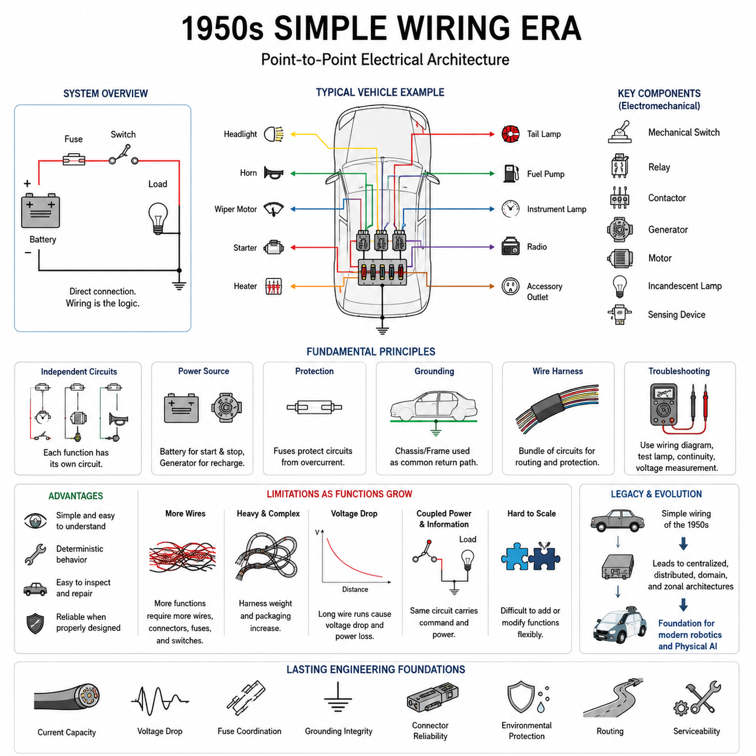
The 1950s represented an era in which electrical architecture was dominated by simple point-to-point wiring. Electrical systems were relatively small, and most functions were implemented by directly connecting a power source, switch, load, and ground through dedicated wires. There were no electronic control units, digital networks, or software-defined functions.
A typical electrical function could be understood simply by following the physical wire from one component to another. When a driver or machine operator activated a switch, electrical current flowed directly toward a lamp, motor, solenoid, heater, or other load. The wiring itself therefore represented both the physical connection and much of the functional logic of the electrical system.
This architecture was strongly influenced by electromechanical technology. Mechanical switches, relays, contactors, generators, motors, incandescent lamps, and basic sensing devices formed the primary building blocks. Relays provided an important method for allowing a relatively small control current to switch a larger load current, enabling designers to separate operator interfaces from higher-power electrical circuits.
Electrical functions were generally independent from one another. A lighting circuit could have its own switch, fuse, wires, and lamps, while a horn, starter, wiper motor, or auxiliary device used another dedicated circuit. Because little information needed to be exchanged between functions, there was limited motivation for communication networks or centralized electronic processing.
The battery and generator formed the foundation of many mobile electrical systems. The battery supplied energy when the engine was stopped and supported high-current loads such as starting, while the generator replenished electrical energy during operation. Power distribution was comparatively straightforward because the number of electrical loads was small compared with modern vehicles, robots, and automated machines.
Circuit protection was nevertheless essential. Fuses were placed in important branches so that excessive current caused by a short circuit or overload would interrupt the affected path before wiring overheated. This established a fundamental architectural principle that remains important today: electrical distribution must be designed together with conductor capacity, load characteristics, and protection devices.
Grounding practices were also relatively simple. In vehicles and many machines, the metallic chassis or frame could serve as a common electrical return path, reducing the amount of dedicated return wiring required. This approach reduced cost and harness complexity, but reliable electrical performance depended heavily on clean mechanical connections, suitable grounding points, and protection against corrosion.
Wire harnesses of the period were fundamentally collections of individual circuits bundled together for installation and mechanical protection. Harness engineering focused primarily on conductor size, insulation, routing, termination, abrasion protection, and maintainability. The architecture was therefore closely coupled to the physical arrangement of the machine rather than abstracted through electronic networks or software.
Troubleshooting reflected this physical architecture. Technicians commonly used wiring diagrams, test lamps, continuity measurements, and voltage measurements to trace faults through individual circuits. A malfunction could often be isolated by following the electrical path from the source through a fuse and switch toward the load and then checking the return path to ground.
The simplicity of point-to-point wiring provided several advantages. Circuits were conceptually transparent, behavior was usually deterministic, and individual failures could often be understood without sophisticated diagnostic equipment. A technician with knowledge of basic electricity and access to a wiring diagram could inspect much of the system directly and repair damaged wires, terminals, switches, or relays.
However, the same architecture became increasingly inefficient as electrical functionality expanded. Every new feature could require additional switches, wires, connectors, protection devices, and routing space. Adding functions therefore increased harness mass and packaging complexity almost directly with the number of electrical connections, creating scalability limitations that would become increasingly important in later decades.
Long wire runs also introduced electrical engineering constraints. Every conductor possessed resistance, so high-current loads could experience significant voltage drop when located far from the power source or control switch. Designers consequently needed appropriate conductor sizes and relay placement to prevent excessive losses, heating, and degraded load performance, particularly for motors and other demanding devices.
The architecture contained little separation between information and electrical power. A switch frequently controlled a load by physically carrying the current associated with that function. Modern systems often transmit a low-power command as digital information and allow a local controller to operate the load, but the simple wiring era commonly combined command transmission and power switching within the same circuit.
This distinction is important for understanding the historical evolution of electrical and electronic architecture. As systems accumulated more functions, directly wiring every command to every load became increasingly difficult. The eventual introduction of centralized control, electronic modules, distributed controllers, communication buses, domain controllers, and zonal architectures can therefore be viewed partly as responses to the scaling limits of direct wiring.
From a system engineering perspective, the 1950s architecture can be interpreted as a largely physical implementation of functional relationships. The location of switches, relays, loads, fuses, and wires strongly determined how the system behaved. Changing functionality often required changing hardware connections, whereas modern architectures increasingly allow behavior to be modified through electronics, configuration, communication, and software.
The simple wiring era also established engineering disciplines that remain fundamental despite enormous technological change. Current capacity, voltage drop, fuse coordination, grounding integrity, connector reliability, environmental protection, routing, and serviceability are still essential in modern electrical systems. The broader robotics electrical engineering structure continues to treat these subjects as foundational engineering areas.
For robotics, this historical stage provides a useful baseline for understanding architectural evolution. A simple machine can still be constructed with switches, relays, motors, sensors, and dedicated wiring, but increasing autonomy introduces computing, communication, sensing, safety, and intelligent control requirements. Each new layer changes the electrical architecture from a collection of circuits toward an interconnected system of power and information.
Modern Physical AI systems are far removed from the 1950s in computational capability, yet their physical actions ultimately depend on electrical paths that deliver energy to sensors, processors, communication devices, motor drives, and actuators. Understanding the simple wiring era therefore clarifies an enduring principle: sophisticated intelligence can operate only when the underlying electrical architecture distributes power and signals reliably.
The historical importance of this era is consequently not that its architecture was primitive, but that it reveals the simplest form of electrical system organization. Function, wiring, protection, switching, and load were directly connected and easily visible. Later centralized, distributed, domain, and zonal architectures progressively introduced abstraction to overcome the limitations of this direct physical relationship.

01.02. Centralized Architecture
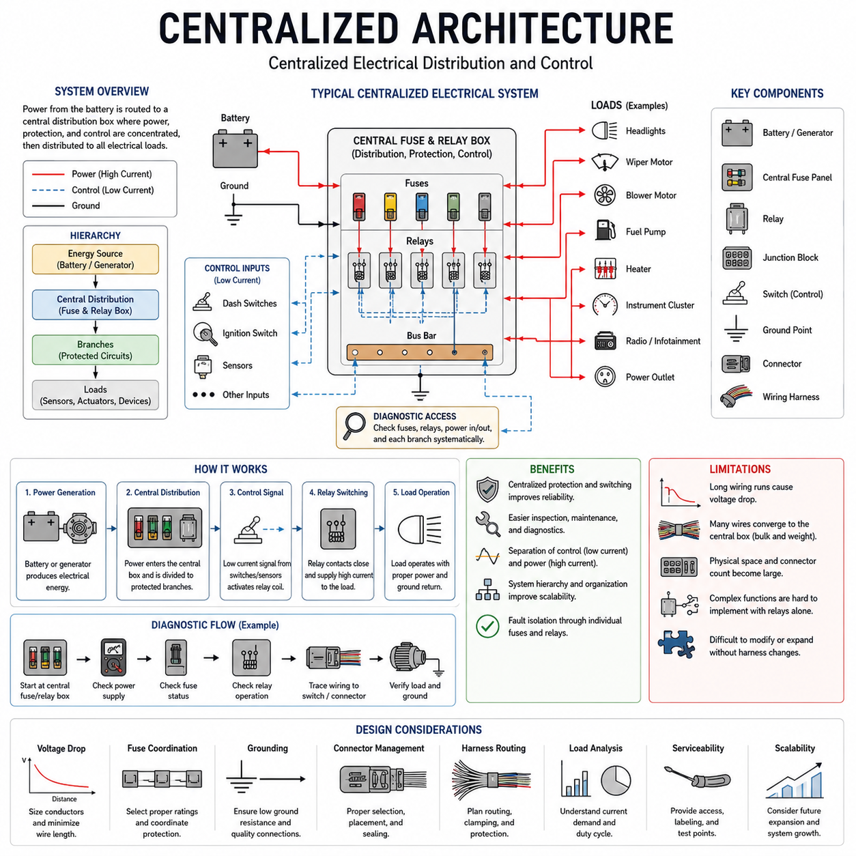
The centralized architecture emerged as electrical systems became too complex for purely independent point-to-point circuits. Instead of allowing every function to operate through its own isolated wiring path, designers began concentrating switching, protection, and control functions around central locations. This created an intermediate architectural stage between simple wiring and later distributed electronic control.
In a centralized electrical system, power from the battery or generator is typically routed toward a central distribution point before being divided among individual loads. Fuse panels, relay boxes, junction blocks, and centralized control assemblies become important architectural elements. This organization provides a structured location where electrical power can be distributed, protected, switched, and diagnosed.
Centralization does not necessarily mean that a single electronic computer controls the entire system. Early centralized architectures were often primarily electrical or electromechanical rather than digital. Relays, switches, fuses, and wiring logic could still implement most functions, but these components were organized around common distribution and control locations instead of being scattered as independent circuits throughout the machine.
The central fuse and relay box became an important example of this architectural principle. Battery power could enter the box through a relatively small number of high-capacity conductors and then be divided into multiple protected branches. Individual fuses protected specific circuits, while relays allowed low-current control signals to switch higher-current loads without routing full load current through operator switches.
This arrangement improved the separation between control and power. A dashboard switch, for example, could carry only the current required to energize a relay coil, while the relay contacts controlled the larger current supplied to a lamp, motor, heater, or other load. The resulting architecture reduced electrical stress on switches and enabled greater flexibility in locating high-current distribution paths.
Centralized architecture also introduced a clearer hierarchy into the electrical system. The battery and charging system formed the primary energy source, central distribution hardware formed an intermediate layer, and individual electrical loads occupied the endpoints. Instead of viewing the machine as a collection of unrelated circuits, engineers could increasingly treat it as an organized power distribution and control system.
Wire harness design consequently became more structured. Harness branches could originate from central junction or distribution locations and extend toward groups of loads positioned in different physical areas. This made electrical packaging more systematic, although long wiring runs were still required because signals and power often had to travel between centralized components and remotely located devices.
Centralization therefore reduced some forms of complexity while creating others. Consolidating fuses and relays simplified inspection and maintenance, but a large central location could accumulate many wires and connectors. As the number of electrical functions increased, central junction areas became dense, and harnesses required increasingly careful routing, identification, connector allocation, and mechanical protection.
The architecture provided important advantages for circuit protection. Because multiple branches originated from known distribution locations, engineers could organize fuse ratings and circuit assignments more systematically. Faults could be isolated to individual protected branches, preventing a single short circuit from disabling every electrical function while also protecting conductors against excessive current and thermal damage.
Grounding remained another fundamental part of the architecture. Chassis or frame grounding could continue to provide common return paths, while dedicated ground conductors were used where electrical reliability demanded better control. As the number of loads increased, designers had to consider ground resistance, shared return currents, connection quality, and voltage differences between grounding locations more carefully.
Diagnostic procedures also benefited from centralized organization. A technician could begin troubleshooting at the central fuse or relay location and determine whether electrical power was correctly supplied to a particular branch. From there, the circuit could be traced toward switches, connectors, wiring, and loads. This provided a more systematic diagnostic path than searching through completely independent wiring arrangements.
However, centralized architecture still depended heavily on physical wiring. Every remote lamp, motor, sensor, switch, and actuator required electrical connections back toward a central or intermediate location. As functionality expanded, the number of conductors and connector terminals increased, producing heavier harnesses and larger bundles that were increasingly difficult to package inside vehicles and machines.
Voltage drop also remained an important limitation. Centralized power distribution could require significant distances between the distribution point and electrical loads. High-current devices located far from the central box required sufficiently large conductors to maintain acceptable voltage levels. Harness length, conductor resistance, connector resistance, current demand, and grounding quality therefore became increasingly important design parameters.
A further limitation appeared when electrical systems began requiring more sophisticated functional interaction. Relays and hardwired logic were effective for simple switching relationships, but complicated behaviors required increasingly complex combinations of wiring and electromechanical components. Functional changes could require modifications to harness connections, relay arrangements, switches, or physical circuit designs rather than simple software changes.
The development of electronic control units gradually changed this situation. Electronic controllers could receive multiple input signals, execute control logic electronically, and command several outputs. Centralized electronic control therefore represented an important extension of centralized electrical distribution, replacing portions of hardwired functional logic with programmable or electronically implemented decision-making.
Yet a single centralized controller also faced scalability constraints. As more sensors and actuators were connected, the controller required increasing numbers of input and output channels, connector pins, and dedicated wires. Long sensor and actuator connections converged toward the central controller, producing large harness bundles and creating practical limits in packaging, serviceability, electromagnetic compatibility, and system expansion.
These limitations eventually encouraged the transition toward distributed ECU architecture, which appears as the next stage in the historical structure of electrical architecture. Instead of connecting every function directly to one central control location, distributed systems place electronic controllers closer to particular functions and allow controllers to exchange information through communication networks.
The historical importance of centralized architecture lies in its introduction of system-level organization. Electrical systems were no longer merely collections of direct circuits; they increasingly contained identifiable layers for energy generation, power distribution, protection, control, wiring, and loads. This hierarchical thinking became fundamental to later automotive, industrial, robotics, and Physical AI electrical architectures.
For robotics, the same architectural concept remains easy to recognize. A relatively simple robot may contain a central battery, main fuse, emergency disconnect, power distribution unit, controller, and several branches supplying motors, sensors, and auxiliary devices. Although modern implementations use sophisticated electronics, the fundamental idea of organizing electrical resources around centralized power and control points remains highly relevant.
Modern architectures extend far beyond this stage through distributed controllers, communication networks, domain controllers, zonal controllers, and high-performance computing. Nevertheless, centralized architecture established the transition from direct physical wiring toward structured system architecture. It demonstrated that increasing electrical complexity requires deliberate organization of power, protection, control, diagnostics, and connectivity rather than simply adding more individual circuits.

01.03. Distributed ECU Architecture
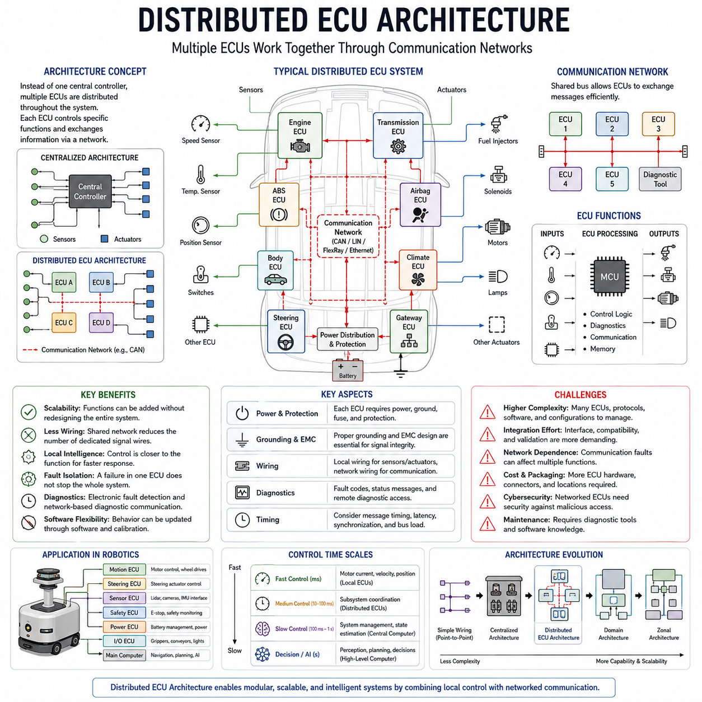
Distributed ECU architecture emerged when centralized electrical systems could no longer scale efficiently with the growing number of sensors, actuators, and electronically controlled functions. Instead of routing every signal and control wire to one central controller, multiple Electronic Control Units, or ECUs, were distributed throughout the vehicle or machine and assigned responsibility for specific functions or subsystems.
An ECU is an embedded electronic controller that receives input signals, executes control logic, and generates outputs for connected devices. Typical inputs may originate from switches, position sensors, temperature sensors, speed sensors, or other ECUs. Outputs can command relays, solenoids, motors, valves, lamps, and other actuators, allowing electrical behavior to be implemented electronically rather than entirely through hardwired logic.
The fundamental architectural change was the movement of intelligence closer to individual functions. Rather than sending every sensor and actuator connection to one central point, an ECU could be installed near the subsystem it controlled. Local wiring connected sensors and actuators to the ECU, while communication networks allowed different ECUs to exchange information required for coordinated system behavior.
This approach created a distinction between local electrical connections and network communication. A sensor value measured by one ECU no longer needed a dedicated physical wire extending to every controller that required the information. The ECU could convert the measurement into electronic data and transmit it over a shared communication bus, where multiple participating controllers could receive and use the same information.
Automotive systems became a major driver of distributed ECU development. Engine control, transmission control, braking, body electronics, instrumentation, climate control, steering, and other functions increasingly received dedicated electronic controllers. Each ECU could be optimized for its own functional requirements while participating in a larger vehicle-level electrical and electronic architecture.
Communication networks were therefore essential to the practical expansion of distributed control. Technologies such as Controller Area Network, commonly known as CAN, allowed many ECUs to exchange messages through a shared network rather than through large numbers of dedicated point-to-point signal wires. This reduced some wiring requirements while enabling coordinated functions that depended on information from multiple subsystems.
The communication bus also changed the meaning of wiring within the architecture. Earlier systems primarily used wires to directly represent individual electrical functions, whereas distributed systems increasingly used network wiring to transport encoded information. A small number of communication conductors could carry many different signals, commands, status messages, and diagnostic data between electronic controllers.
Distributed ECUs enabled more sophisticated control algorithms because individual controllers contained processors, memory, input and output interfaces, and embedded software. Functional behavior could increasingly be defined by software rather than exclusively by physical circuit connections. Calibration parameters and control strategies could also be changed without redesigning the complete electrical harness, providing greater engineering flexibility.
This software-based control introduced a new relationship between electrical architecture and software architecture. Hardware still determined power delivery, physical interfaces, signal integrity, and communication connectivity, but software increasingly determined how components behaved. Electrical and electronic architecture therefore evolved from a primarily wiring-centered discipline toward coordinated hardware, communication, and software system engineering.
Power distribution remained necessary even though control became distributed. Every ECU required a suitable power supply, ground connection, circuit protection, and electrical interface to its local sensors and actuators. Consequently, distributed architecture did not eliminate traditional electrical engineering requirements. Fuse coordination, voltage drop, grounding, connector reliability, harness routing, and environmental protection remained fundamental design concerns.
Grounding and electromagnetic compatibility became increasingly important as electronic controllers and communication networks multiplied. Differences in ground potential, switching noise from motors and actuators, electromagnetic interference, and poor connector interfaces could disturb sensitive electronic signals. Electrical architecture therefore had to support both reliable power delivery and reliable information transfer throughout the system.
Diagnostics also changed significantly. An ECU could monitor its inputs, outputs, internal states, and communication status, allowing faults to be detected electronically. Diagnostic information could be stored as fault codes or transmitted across the network to diagnostic equipment. Troubleshooting therefore began moving from purely physical continuity testing toward combined electrical, electronic, communication, and software-based diagnosis.
Distributed architecture also improved fault isolation. A failure in one ECU or local subsystem did not necessarily require the entire system to stop operating, depending on system design and functional dependencies. Engineers could divide functionality into controlled subsystems and define appropriate fallback behavior. This principle later became increasingly important for safety-related automotive, industrial, and robotic systems.
However, distribution introduced new forms of complexity. A system containing many ECUs required communication protocols, message definitions, timing requirements, network management, software configuration, diagnostics, and compatibility between controllers. The architecture could contain dozens of independently developed electronic modules, making system integration considerably more difficult than the electrical integration of earlier centralized systems.
The number of ECUs itself eventually became a scalability problem. Adding a new function often resulted in another controller, connector, mounting location, power connection, communication interface, and software component. Although network communication reduced dedicated signal wiring, large numbers of ECUs increased hardware cost, packaging requirements, software dependencies, network traffic, and integration effort.
Timing also became an architectural consideration. A local control function might require rapid and deterministic response, while other information could tolerate slower communication. Designers therefore needed to consider sampling rates, message periods, communication latency, bus utilization, and synchronization. Electrical architecture was no longer concerned only with where current flowed, but also with when information arrived and how controllers coordinated their actions.
For robotics, distributed ECU principles are directly applicable. A mobile robot can contain separate controllers for motor drives, steering, battery management, safety devices, manipulators, sensor interfaces, and auxiliary equipment. Local controllers can execute fast low-level control loops while a higher-level computer exchanges commands and status information with them through communication networks.
This separation is especially important when control operates at different time scales. A motor controller may regulate current, velocity, or position much faster than a central computer performs perception, planning, or intelligent decision-making. Distributed control allows time-critical actuator behavior to remain local while higher-level computing coordinates overall robot behavior through structured communication interfaces.
As systems continued to grow, however, assigning a separate ECU to every function became inefficient. Manufacturers therefore began consolidating related controllers into larger functional groups, leading toward domain architecture. Engine, chassis, body, infotainment, autonomous driving, or other functions could be organized around more powerful domain controllers rather than continuously increasing the number of independent ECUs.
Distributed ECU architecture therefore represents a critical stage in the evolution from simple wiring toward modern intelligent electrical systems. It transformed electrical architecture from centralized physical connections into networks of cooperating electronic controllers. The historical sequence from centralized architecture to distributed ECU, domain, zonal, and robotics architectures provides the structural foundation for understanding increasingly software-defined and Physical AI systems.

01.04. Domain Architecture
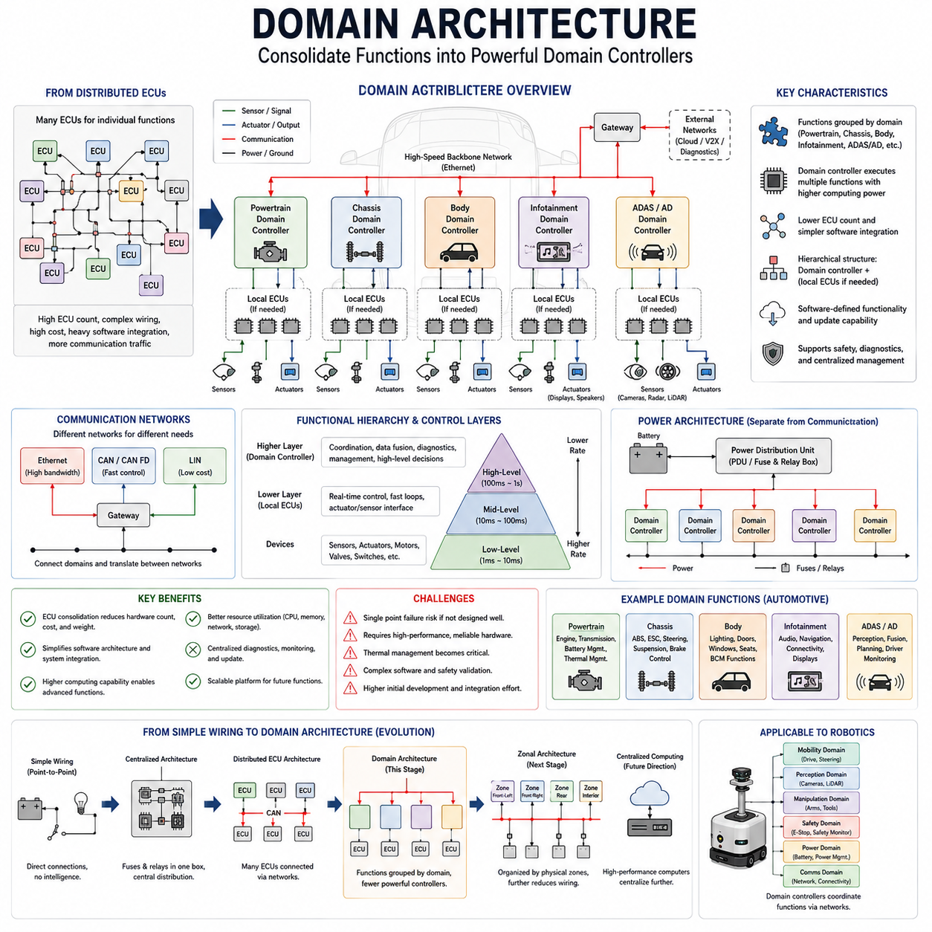
Domain architecture emerged as a response to the rapid growth of distributed Electronic Control Units across vehicles and increasingly complex machines. Distributed ECU systems provided local intelligence and modularity, but adding separate controllers for individual functions increased hardware count, wiring, software dependencies, network traffic, and integration effort. Domain architecture addressed this problem by consolidating related functions around more powerful domain controllers.
A domain represents a logical group of functions that share similar system responsibilities. In automotive applications, common domains may include powertrain, chassis, body, infotainment, and advanced driver assistance or autonomous driving. Instead of assigning every individual function to a completely independent ECU, multiple related functions can be coordinated by a domain controller with greater computing capability and broader responsibility.
The domain controller therefore becomes a major architectural node. It may execute software previously distributed across several smaller ECUs, coordinate local devices, process information from multiple sensors, and communicate with other domain controllers. Depending on implementation, some local ECUs may remain for specialized real-time control, while higher-level processing and coordination are consolidated within the domain controller.
This architecture does not simply replace many small controllers with a few large computers. It introduces functional hierarchy. Low-level controllers can remain close to motors, actuators, sensors, or safety devices where deterministic response is required, while domain controllers handle subsystem coordination, data processing, diagnostics, and higher-level decision logic. Different computing layers therefore perform tasks appropriate to their timing and functional requirements.
Communication networks become increasingly important because domain controllers must exchange information across functional boundaries. CAN, CAN FD, LIN, and automotive Ethernet may coexist within the architecture depending on bandwidth, latency, cost, and determinism requirements. Gateways can connect different networks, translate communication where necessary, and control the flow of information between domains.
The introduction of high-bandwidth communication is particularly important for domains containing cameras, radar, LiDAR, displays, or high-performance computing. Traditional control networks are highly effective for many command and status signals, but sensor-rich applications can generate substantially larger data volumes. Ethernet-based communication therefore becomes increasingly important as electrical architecture evolves toward perception, autonomy, and software-defined functionality.
Power distribution remains structurally different from information communication even when computing becomes consolidated. Domain controllers, local ECUs, sensors, communication devices, and actuators still require suitable voltage rails, grounding, circuit protection, connectors, and wiring. Domain architecture therefore changes the organization of control and information without eliminating the fundamental electrical engineering requirements of the physical system.
One major benefit of domain architecture is ECU consolidation. Functions that previously required multiple independent controllers can potentially share computing resources, memory, communication interfaces, diagnostics, and software infrastructure. This can reduce controller proliferation and simplify some aspects of packaging, although the resulting domain controllers become more powerful, complex, thermally demanding, and critical to overall system operation.
Software architecture becomes increasingly important under this model. A powerful domain controller may execute multiple software applications and services that previously belonged to separate physical ECUs. Hardware and software functions therefore become less tightly coupled. This creates opportunities for software reuse, centralized updates, coordinated diagnostics, and more flexible functional deployment across available computing resources.
The shift also supports software-defined systems. When functionality is implemented primarily through software running on capable computing platforms, system behavior can be modified or expanded without redesigning every physical circuit. Software updates, configuration changes, calibration, and new algorithms can extend system capabilities, provided that the underlying hardware, interfaces, safety requirements, and computing resources support them.
However, consolidation creates new reliability challenges. When several functions depend on one domain controller, failure of that controller can affect a larger portion of the system than failure of a single dedicated ECU. Engineers must therefore consider fault containment, redundancy, watchdog mechanisms, degraded operating modes, power independence, communication availability, and appropriate safety architectures for critical functions.
Functional safety consequently becomes closely connected to domain design. Safety-related functions cannot simply be consolidated based on computing efficiency. Their failure modes, independence requirements, timing guarantees, diagnostic coverage, and fallback strategies must be considered. Some safety-critical low-level control may remain distributed even when higher-level coordination is centralized within a domain controller.
Timing remains another important consideration. Motor current control or actuator stabilization may operate at very fast rates, while domain-level coordination can operate at slower rates. Perception and planning may have still different computational cycles. A well-designed domain architecture therefore separates time-critical local control from computationally intensive higher-level processing rather than attempting to execute every task at the same rate.
For robotics, the domain concept can be applied beyond conventional automotive categories. A mobile robot might organize functionality into mobility, perception, safety, manipulation, energy, and communication domains. A mobility domain could coordinate steering and wheel control, while a perception domain could process cameras and LiDAR. A safety domain could independently supervise emergency stops, safety sensors, and motion permissions.
In such a robot, local motor controllers can maintain rapid current, velocity, and position loops while a mobility domain controller coordinates vehicle motion. A perception computer can process high-bandwidth sensor information, while a higher-level computing platform performs localization, planning, navigation, or AI reasoning. Domain architecture therefore provides a useful bridge between distributed embedded control and increasingly powerful centralized computing.
Diagnostics also become more hierarchical. Local devices can detect component-level faults, while domain controllers aggregate diagnostic information and evaluate subsystem health. Higher-level systems can then combine information across domains to determine overall system status. This layered diagnostic structure supports maintenance, fault localization, software monitoring, and increasingly sophisticated health-management strategies.
Despite its advantages, domain architecture still organizes systems primarily according to function rather than physical location. Components belonging to one domain may be distributed throughout the vehicle or robot, requiring wiring to connect distant sensors and actuators back to their corresponding domain controller. Consequently, domain consolidation can reduce ECU count without necessarily eliminating long harness routes or physical wiring complexity.
This limitation became increasingly significant as electrical content, sensors, and computing resources continued to grow. Designers began considering architectures organized around physical zones rather than only functional domains. A zonal controller can collect local power and signal connections from nearby devices and communicate with centralized computing resources through high-speed backbone networks, reducing long point-to-point harness connections.
Domain architecture therefore occupies an important position in the historical sequence defined for electrical architecture: simple wiring evolved toward centralized architecture, distributed ECU architecture, domain architecture, and then zonal architecture. Each transition addressed limitations created by increasing functionality, wiring complexity, computing demand, communication requirements, and software integration.
The significance of domain architecture extends beyond reducing the number of ECUs. It represents a transition from hardware dedicated to individual functions toward consolidated computing platforms responsible for groups of related capabilities. This changes electrical architecture into a coordinated design problem involving power, networking, computing, software, safety, thermal management, diagnostics, and physical integration.
For modern robotics and Physical AI, this architectural principle remains highly relevant. Intelligent machines require fast local actuator control, reliable safety functions, high-bandwidth perception, substantial computing resources, and higher-level AI reasoning. Domain-oriented organization provides a structured way to separate these responsibilities while allowing them to exchange information through a common system architecture.
Ultimately, domain architecture marks an important step toward centralized high-performance computing and software-defined machines. It reduces the fragmentation created by large populations of independent ECUs while preserving distributed control where necessary. Its remaining dependence on function-oriented wiring, however, motivates the next architectural transition toward zonal organization and increasingly centralized computing.

01.05. Zonal Architecture
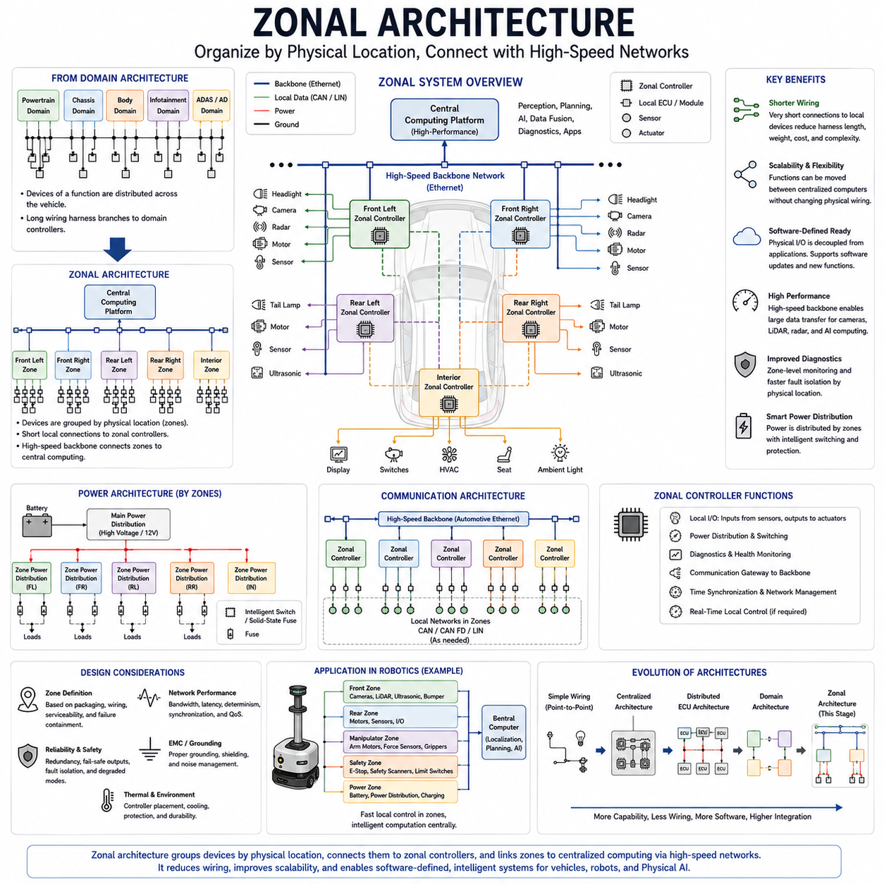
Zonal architecture represents a major transition from organizing electrical and electronic systems primarily by function toward organizing them by physical location. In a domain architecture, sensors and actuators belonging to one function may be distributed across the machine but connected to the same domain controller. Zonal architecture instead groups nearby electrical devices around local zonal controllers, reducing the need for long function-specific wiring paths.
A zone is a defined physical region of a vehicle, robot, or machine. Depending on system size and geometry, zones may represent front-left, front-right, rear-left, rear-right, interior, upper, lower, or other practical installation areas. Sensors, actuators, switches, lighting devices, and other electrical components within each region can connect to the nearest zonal controller rather than directly to a distant functional controller.
The zonal controller acts as a local electrical and communication aggregation point. It can provide input and output interfaces for nearby devices, collect sensor signals, command local actuators, distribute or switch electrical power, perform diagnostics, and exchange data with centralized computing platforms. This combines physical connectivity management with electronic control and network communication at strategically selected locations.
This approach fundamentally changes wire harness topology. Traditional distributed or domain-oriented systems may contain long harness branches connecting devices to function-specific ECUs located elsewhere. In a zonal system, local devices generally require only relatively short connections to their nearest zone. Zonal controllers are then interconnected through a much smaller number of high-capacity backbone communication and power connections.
Harness reduction is therefore one of the strongest motivations for zonal architecture. Shorter local branches can reduce total conductor length, harness mass, connector complexity, routing congestion, and installation effort. These advantages become increasingly important as modern systems incorporate large numbers of sensors, actuators, electronic modules, cameras, lighting devices, and intelligent peripherals.
Zonal architecture also separates physical connectivity from functional software organization. A camera and a lighting module located in the same physical zone may connect to the same zonal controller even though they belong to completely different functional applications. Their data can then be transported through the backbone network to whichever computing platform executes the relevant perception, body-control, safety, or diagnostic software.
This separation supports greater flexibility in software-defined systems. Functions no longer need to correspond directly to the physical location of a dedicated ECU. High-performance computers can execute applications centrally while zonal controllers provide standardized interfaces to the physical world. Electrical architecture consequently begins to resemble a distributed input-output infrastructure connected to centralized computing resources.
High-speed communication networks are essential to this model. Automotive Ethernet and related Ethernet-based technologies are particularly suitable for backbone communication because centralized computers may need to exchange large volumes of information with multiple zones. CAN, CAN FD, LIN, or other networks may still be used locally where their bandwidth, determinism, robustness, and cost characteristics are appropriate.
The backbone network must provide more than raw bandwidth. Communication latency, determinism, synchronization, quality of service, redundancy, fault isolation, and network management become important system-level considerations. Safety-related commands may have different timing and reliability requirements from diagnostic information or high-bandwidth sensor data, requiring careful communication architecture and traffic engineering.
Power distribution can also become more closely associated with physical zones. Instead of routing separate power circuits from one central fuse box to every distant load, power can be delivered through major distribution paths toward zonal locations and then distributed locally. Intelligent power switching and electronic protection may allow zonal controllers or associated power modules to monitor and control individual local branches.
This creates opportunities for smarter electrical protection. Traditional fuses primarily interrupt excessive current, while intelligent solid-state switching can potentially measure current, identify abnormal loads, disconnect individual circuits, report diagnostic information, and restore selected functions under controlled conditions. Zonal architecture can therefore integrate power distribution, protection, communication, and diagnostics more closely than earlier architectures.
Grounding remains critical despite the architectural simplification. High-current actuators, sensitive sensors, communication interfaces, and computing equipment may share nearby physical regions while having very different electrical characteristics. Engineers must carefully manage ground paths, voltage offsets, return currents, electromagnetic interference, shielding, and connector design to maintain both power integrity and signal integrity.
The zonal controller itself becomes a critical engineering component. It may require multiple communication interfaces, numerous local input and output channels, power switching capability, processing resources, diagnostic functions, environmental protection, and real-time behavior. Because it aggregates many local connections, its reliability, thermal design, connector capacity, software architecture, and fault containment strategy require careful consideration.
Functional safety also influences the design. A failure of one zonal controller could potentially affect several physically nearby devices belonging to different functions. Designers must therefore prevent physical grouping from creating unacceptable common-cause failures. Redundant power paths, communication links, independent safety channels, fail-safe outputs, monitoring mechanisms, and degraded operating modes may be necessary for critical systems.
Zonal architecture should therefore not be interpreted as complete centralization. Fast local control can remain close to actuators where necessary. A motor drive, servo controller, battery management controller, or safety controller may still execute dedicated real-time functions. The zonal layer primarily reorganizes physical connectivity and provides efficient access between these devices and higher-level computing systems.
This distinction is particularly important in robotics. A robot may contain wheel motor controllers operating fast current and velocity loops, while an edge computer performs localization, perception, planning, and AI inference at slower rates. Zonal controllers can connect nearby sensors, actuators, safety interfaces, and auxiliary devices while Ethernet or another backbone connects these physical zones to the main computing platform.
A mobile robot could, for example, contain front, rear, left, right, sensor-mast, or manipulator zones depending on its physical design. The exact zoning strategy should follow packaging, wiring, serviceability, power demand, communication requirements, and failure containment rather than arbitrary geometric symmetry. Zonal boundaries are therefore an engineering optimization problem rather than merely a physical partition.
Diagnostics can benefit significantly from this organization. A zonal controller can monitor local supply voltage, current consumption, communication status, connector interfaces, and attached devices. Fault information can then be transmitted through the backbone to centralized diagnostic software. This provides hierarchical visibility from individual physical connections through zones to the complete machine.
Serviceability can also improve because electrical faults can be associated with specific physical regions. Harness branches become shorter and potentially easier to replace, while centralized diagnostic software can identify the zone containing an abnormal device or circuit. However, these benefits depend on disciplined connector design, labeling, network diagnostics, software configuration, and physical accessibility.
The transition to zonal architecture also supports centralized high-performance computing. Once physical input and output connections are aggregated through zones, many functional applications can migrate away from dedicated ECUs toward centralized computers. This enables greater computing-resource sharing and provides an architectural foundation for software-defined vehicles, advanced robotics, autonomous systems, and Physical AI.
For Physical AI systems, this organization is particularly valuable because perception and intelligent decision-making may require substantial centralized GPU or accelerator resources while physical control remains distributed. Cameras, LiDAR, radar, IMUs, safety devices, motors, and other hardware can connect through appropriate local interfaces, while high-bandwidth networks deliver selected information between physical zones and AI computing platforms.
The historical progression therefore reflects a gradual separation of physical wiring, functional control, and computing. Simple wiring connected functions directly, centralized architecture concentrated electrical distribution, distributed ECU architecture placed intelligence around individual functions, and domain architecture consolidated related functions. Zonal architecture reorganizes connectivity according to physical location while allowing computing to become increasingly centralized.
Zonal architecture is consequently more than a method for reducing wires. It represents a structural foundation for future electrical and electronic systems in which local physical interfaces, high-speed networking, centralized computing, software-defined functions, and intelligent power distribution operate together. For robotics and Physical AI, it provides an important bridge between the physical machine and the increasingly centralized intelligence that perceives, reasons, plans, and coordinates its behavior.

01.06. Robotics EE Evolution
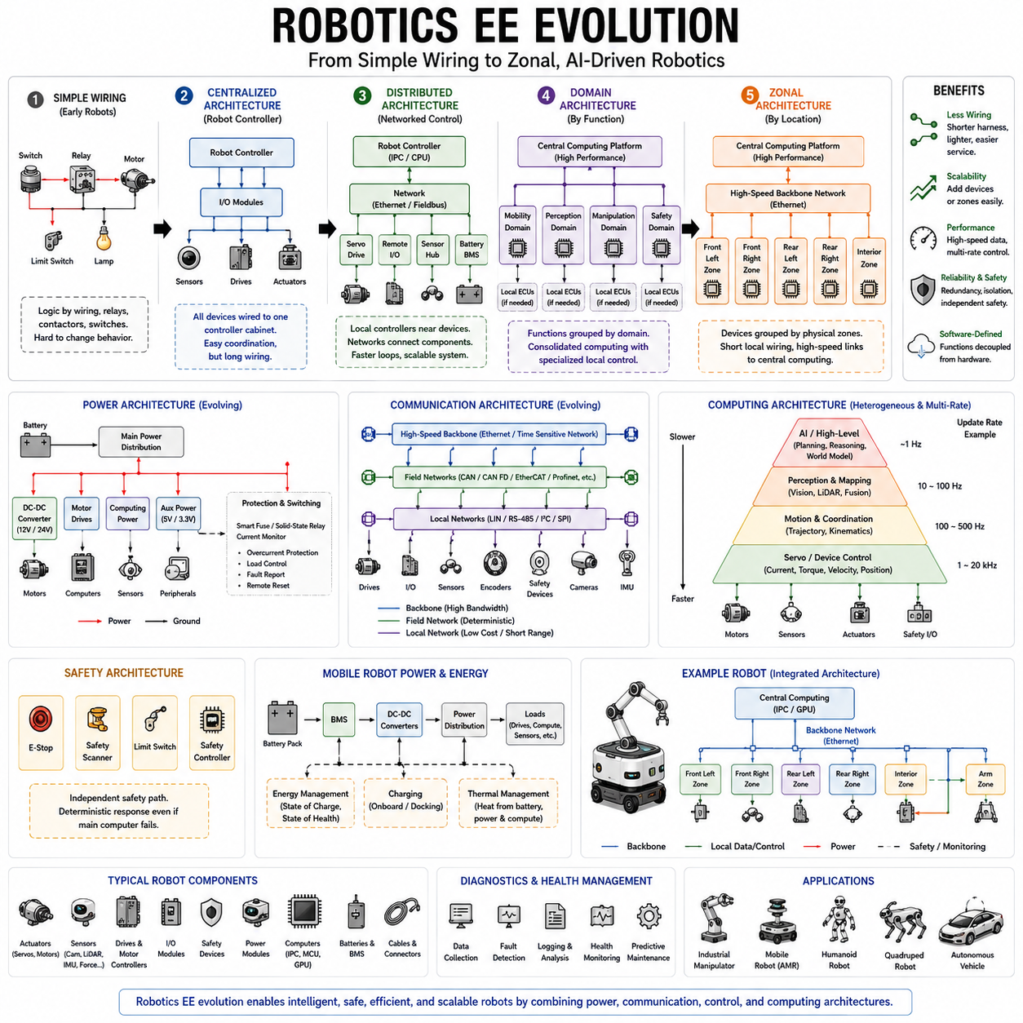
Robotics electrical and electronic architecture evolved from relatively simple machines built around direct wiring, relays, switches, motors, and basic sensors into highly interconnected systems combining distributed control, communication networks, high-performance computing, and intelligent software. This evolution follows the broader progression from simple wiring through centralized, distributed, domain, and zonal architectural concepts.
Early robotic machines relied heavily on direct electrical relationships between commands and physical actions. Switches, relays, contactors, limit switches, and motor circuits implemented much of the control logic. Electrical design was therefore closely tied to physical wiring, and modifying robot behavior often required changes to circuits, components, or mechanical switching arrangements rather than changes to software.
The introduction of electronic controllers fundamentally changed this relationship. Dedicated control electronics could receive sensor inputs, execute control algorithms, and generate actuator commands without requiring every logical relationship to be implemented through wiring. Motor control, position regulation, sequence control, interlocking, and machine supervision increasingly became electronic functions, establishing the foundation for programmable robotic systems.
Centralized robot controllers subsequently became common because they provided one location for computation, program execution, motion coordination, and machine interfaces. Sensors and actuators were connected to a central controller through input and output interfaces, while servo amplifiers supplied controlled electrical power to motors. This architecture simplified functional coordination but could require substantial wiring between the controller cabinet and the physical robot.
As robots gained more joints, sensors, safety devices, and auxiliary equipment, distributed control became increasingly attractive. Local motor drives, remote I/O modules, sensor interfaces, battery controllers, and dedicated embedded controllers could be placed closer to the devices they managed. Communication networks then connected these distributed components to the primary robot controller or industrial computer.
This change separated physical control loops from higher-level coordination. A servo drive could regulate motor current, torque, velocity, or position locally at high update rates, while the main robot controller generated motion trajectories and coordinated multiple axes at a different rate. The architecture therefore became naturally hierarchical, with different computing devices responsible for different control time scales.
Industrial communication technologies accelerated this transition. Instead of providing dedicated control wires for every signal, networked devices could exchange commands, measurements, status information, and diagnostics over shared communication links. Fieldbus systems and later industrial Ethernet enabled increasingly deterministic communication among controllers, drives, remote I/O, sensors, and other automation equipment.
Robot electrical architecture consequently evolved into an integration of power and information networks. High-current electrical paths supplied motors, drives, computers, and auxiliary equipment, while communication networks transported control and status information. These two infrastructures served different purposes but had to be engineered together because communication reliability ultimately depended on stable power, grounding, connectors, shielding, and electromagnetic compatibility.
Mobile robotics introduced additional architectural requirements. Unlike fixed industrial robots supplied continuously from facility power, autonomous mobile robots depend heavily on onboard batteries, power conversion, charging interfaces, and energy management. Electrical architecture therefore had to coordinate propulsion, computing, sensing, communication, safety, and auxiliary loads within a limited onboard energy budget.
Battery management systems, DC-DC converters, motor drives, power distribution units, circuit protection, and emergency disconnect devices became major components of mobile robot architecture. Different subsystems could require different voltage levels, while transient motor loads and computing loads created dynamic power demands. Electrical design therefore expanded beyond connectivity toward complete energy generation, conversion, distribution, protection, and monitoring.
The rapid expansion of perception systems created another major transition. Modern robots may contain cameras, LiDAR, radar, IMUs, encoders, force sensors, proximity sensors, and other sensing devices. These sensors produce information with very different bandwidth, latency, synchronization, and power requirements, requiring the electrical architecture to support both traditional real-time control traffic and high-volume perception data.
Computing architecture evolved accordingly. Microcontrollers and embedded controllers remain effective for deterministic low-level functions, while CPUs, GPUs, and specialized accelerators provide the computational resources required for localization, mapping, computer vision, planning, and AI inference. Modern robotic systems therefore use heterogeneous computing rather than expecting one type of processor to efficiently execute every task.
This creates a multi-rate architecture. Motor current control may execute extremely rapidly, motion control at another rate, sensor processing at tens or hundreds of updates per second, and higher-level planning or AI reasoning at slower rates. The electrical and communication architecture must allow these layers to cooperate without requiring the entire robot to operate according to one common processing cycle.
Safety architecture evolved in parallel with functional control. Emergency stops, safety scanners, limit switches, safe motor control, protective devices, and safety controllers cannot simply depend on high-level AI software. Safety-related electrical paths often require independent monitoring and deterministic responses so that hazardous motion can be stopped even when the primary computing or perception system fails.
The emergence of ROS and later ROS 2 further emphasized the importance of software and communication architecture in robotics. Robot functionality could be organized into software components exchanging structured data rather than being permanently associated with specific electrical circuits. Nevertheless, the software layer remained dependent on physical networks, computing hardware, timing behavior, power availability, and reliable interfaces to sensors and actuators.
As robotic systems become larger and more capable, concepts similar to automotive domain architecture can also be applied. Mobility, perception, manipulation, safety, energy, and communication can be treated as functional domains. Powerful computers can coordinate each domain while specialized local controllers continue handling deterministic device-level tasks, providing a practical balance between consolidation and distributed real-time control.
Zonal concepts provide another evolutionary direction. Instead of routing every physical device toward a controller selected only by function, nearby sensors, actuators, and I/O can connect through local zones. High-speed backbone networks then connect these zones to central computing resources. This approach can reduce harness length and improve physical integration in large mobile robots, manipulators, quadrupeds, humanoids, and autonomous vehicles.
The evolution toward Physical AI further increases the importance of this layered structure. AI computing may perform perception, world modeling, semantic reasoning, planning, or learned decision-making, but actuator-level control must still satisfy strict timing and stability requirements. The architecture therefore needs to connect comparatively slower intelligent decision layers with much faster deterministic control loops operating close to physical hardware.
A modern intelligent robot can consequently be understood as several interacting electrical and computational layers. Power systems provide energy, embedded controllers maintain fast physical control, communication networks exchange state and commands, edge computers process perception and planning, and AI systems generate increasingly sophisticated interpretations and decisions. Safety mechanisms supervise these layers and constrain physical action when necessary.
Diagnostics have evolved alongside this architecture. Early robots were diagnosed mainly through electrical measurements and circuit inspection, whereas modern systems can report controller faults, communication errors, sensor status, power conditions, thermal states, software events, and actuator health. Diagnostic information can be aggregated from individual devices toward subsystem and system-level monitoring functions.
Serviceability and modularity have consequently become architectural requirements rather than secondary considerations. Robots containing many sensors, drives, computing modules, and harness branches must allow components to be isolated, replaced, configured, and tested efficiently. Standardized interfaces and modular electrical boundaries can reduce maintenance effort while supporting upgrades as sensing and computing technologies evolve.
The broader robotics electrical engineering structure reflects this increasing specialization. Separate engineering areas are required for wire harnesses, connectors, protection devices, grounding and EMC, communication, calibration, batteries, safety, perception hardware, computing platforms, mobile robots, manipulators, autonomous vehicles, quadrupeds, and humanoids. Modern robot EE architecture therefore acts as the integration framework connecting these disciplines.
Robotics EE evolution can ultimately be viewed as a transition from wiring-centered machines toward power-and-information platforms for intelligent physical systems. Direct circuits evolved into programmable controllers, controllers became distributed and networked, computing became hierarchical and increasingly centralized, and physical connectivity moved toward modular and zonal organization. Each stage enabled greater functionality while introducing new requirements for integration, timing, reliability, safety, and software.
For Physical AI, this historical evolution establishes a fundamental architectural principle: intelligence cannot be separated from the electrical system that connects computation to the physical world. AI may determine what a robot should perceive, predict, or attempt, but electrical architecture provides the power, communication, sensing interfaces, deterministic control, protection, and actuator pathways through which those decisions become reliable physical behavior.

