Volume 01. Electrical Architecture Fundamentals

Chapter 08. Redundancy Design

08.01. Power Redundancy
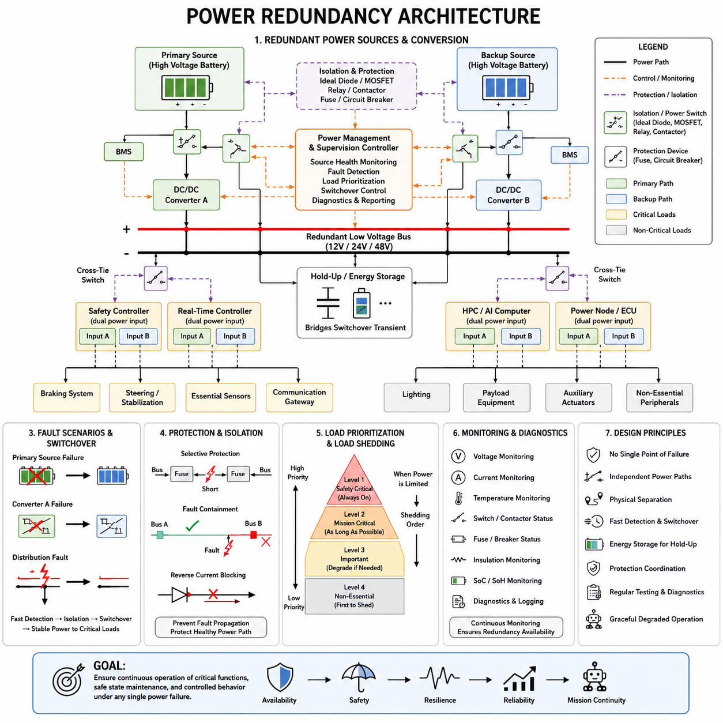
Power redundancy is the architectural practice of maintaining essential electrical functions when a primary power source, conversion stage, distribution path, or switching device becomes unavailable. In robotics and Physical AI systems, redundancy must protect more than continuous operation. It must preserve controlled behavior, safe stopping, communication, sensing, and diagnostic capability during electrical faults.
A redundant power architecture begins by identifying which loads are mission critical and which loads may be disconnected during degraded operation. Safety controllers, braking circuits, steering or stabilization systems, essential sensors, communication gateways, and supervisory computers often require higher availability than auxiliary lighting, payload equipment, or nonessential computing. This classification determines where independent power paths are justified.
The simplest redundancy concept uses a primary source and a backup source connected through controlled power-selection circuitry. The backup may be another battery, an auxiliary low-voltage battery, a supercapacitor system, or an independent DC power supply. The architecture must prevent one failed source from pulling down the healthy source, so isolation devices such as diodes, ideal-diode controllers, MOSFET switches, relays, or contactors are commonly introduced.
True redundancy requires more than installing two batteries. If both sources share the same fuse, connector, bus bar, DC/DC converter, ground path, or power distribution unit, that shared element can become a single point of failure. The architecture must therefore be evaluated from source to load. Independent branches should remain electrically separated far enough downstream that a fault in one branch does not disable the redundant branch.
Power redundancy can be organized as active-active or active-standby operation. In an active-active architecture, multiple sources or converters simultaneously support the electrical bus and may share the load. In an active-standby architecture, one path normally supplies the load while another remains available for takeover. Active-active operation can provide smoother transitions, while standby designs can simplify load control and fault isolation.
Redundant DC/DC conversion is especially important when high-voltage batteries supply low-voltage electronics. Two converters may feed a common protected low-voltage bus, or each converter may supply an independent distribution branch. Their control strategy must address current sharing, reverse-current blocking, output-voltage tolerance, startup sequencing, and fault containment so that failure of one converter does not propagate through the common electrical network.
Distribution redundancy may use dual buses, segmented buses, or cross-connected power domains. A dual-bus architecture can assign critical loads to both Bus A and Bus B through isolated inputs, while less critical loads remain connected to only one bus. Cross-tie switches may allow one healthy source to support another bus after a failure, but cross-ties must be carefully controlled because they can also connect a faulted domain to a healthy domain.
Redundant loads should preferably support independent power inputs when continuous operation is required. A safety controller, communication gateway, or high-performance computer may contain dual power-entry circuits that internally select between separate feeds. When equipment provides only one power input, external redundancy modules can perform source selection, but the external selector itself must be analyzed because it can become another common failure point.
Fault detection is fundamental to successful redundancy. Voltage, current, temperature, contactor state, fuse state, insulation condition, and converter health can be monitored continuously. A supervisory controller can compare these signals against operating limits and determine whether a power path remains trustworthy. Detection must be sufficiently fast to prevent critical rail collapse, but it must also reject temporary disturbances that do not require switching.
Switchover behavior depends strongly on the energy storage available near critical loads. Even a fast electronic switch requires finite detection and transition time, while relays and contactors may require substantially longer mechanical operation. Local capacitors, hold-up circuits, or dedicated energy-storage modules can bridge this interruption. Their stored energy must be calculated against load power and the maximum permitted voltage drop during transfer.
Redundancy should also consider transient conditions rather than only complete power loss. Motors, servo drives, pumps, heaters, GPUs, and other dynamic loads can produce large current changes that temporarily depress the bus voltage. A backup path should not activate unnecessarily whenever a legitimate transient occurs. Thresholds, filtering, hysteresis, timing logic, and load-state information help distinguish actual source failure from normal dynamic behavior.
Power-path isolation is closely related to protection coordination. A short circuit in one redundant branch should cause its local fuse, electronic protection device, or circuit breaker to operate before the fault disturbs the alternate branch. Protection devices therefore require coordinated current ratings and trip characteristics. Redundancy without selective protection can fail because one downstream short circuit may collapse both nominally independent sources.
Ground architecture must be included in redundancy analysis because duplicated positive supply paths do not automatically create independent electrical channels. Shared ground conductors, chassis connections, return connectors, and grounding junctions may introduce common failure mechanisms. Critical circuits may require separately routed returns or carefully engineered grounding structures, while still maintaining EMC, shielding, equipotential bonding, and electrical safety requirements.
Physical separation improves the effectiveness of redundant channels. Two electrical paths routed through the same connector, harness bundle, enclosure, or high-temperature region may be simultaneously damaged by mechanical impact, water ingress, overheating, abrasion, or fire. Where the risk justifies it, redundant feeds should use separated connectors, routing paths, protection devices, and distribution zones to reduce common-cause failures.
Battery redundancy introduces additional control requirements because batteries can differ in state of charge, voltage, temperature, internal resistance, and health. Directly paralleling mismatched battery packs can create uncontrolled equalization currents. Battery management systems and power-path controllers must therefore coordinate connection, precharge, isolation, charging, fault detection, and permissible current while preventing one degraded battery from compromising the healthy source.
In mobile robots, redundancy does not necessarily mean that every actuator must continue operating at full performance. A power failure may instead initiate a degraded operating mode. The system can disconnect payloads, reduce acceleration, limit compute power, disable nonessential sensors, and reserve remaining energy for steering, braking, localization, communication, or controlled return. Redundancy is therefore closely connected with load shedding and energy management.
Physical AI platforms make this prioritization particularly important because AI computing can consume substantial and highly dynamic power. GPU or accelerator workloads may be reduced before power is removed from safety-related control functions. The electrical architecture should ensure that perception and AI degradation does not unintentionally interrupt deterministic low-level control. Power domains can therefore reflect the functional hierarchy between AI computation, real-time control, and safety execution.
A practical redundant architecture also needs power-state coordination with software. The electrical system should communicate source health, remaining backup capacity, converter faults, and degraded operating states to higher-level controllers. Software can then modify mission behavior according to available electrical capability. Conversely, the electrical controller may enforce hardware-level protection independently when software commands could threaten the remaining power reserve.
Startup and shutdown sequences require redundancy-aware design. Multiple sources and converters can create unexpected backfeeding when different rails rise or fall at different times. Controllers, communication interfaces, sensors, and power switches should therefore tolerate defined sequencing states. Controlled discharge and isolation are also important so that a supposedly disabled branch does not remain energized through another module or communication interface.
Diagnostic coverage determines whether redundancy remains effective throughout the product lifetime. A backup source that is never tested can fail silently and remain undetected until the primary source also fails. Periodic self-tests can verify battery condition, converter output, switching devices, sensing circuits, and communication paths. Maintenance information should expose latent faults so that redundancy can be restored before another independent failure occurs.
Redundancy design must distinguish independent failures from common-cause failures. Two identical converters located together may both be vulnerable to the same temperature excursion, manufacturing defect, software error, or overvoltage event. Diversity in component type, control method, routing, physical location, or power source can reduce some common-cause risks, although additional diversity also increases engineering, validation, maintenance, and configuration complexity.
The required redundancy level should therefore follow system risk rather than a universal rule. Noncritical auxiliary functions may use a single protected supply, while safety-critical or mission-critical functions may require dual sources, dual converters, independent distribution paths, protected switching, and continuous diagnostics. Excessive duplication increases mass, cost, wiring, thermal load, and failure opportunities, so redundancy must be targeted where loss of power creates unacceptable consequences.
Verification of a redundant power architecture should include intentional fault insertion. Engineers can disconnect sources, open fuses, short protected branches, disable converters, introduce undervoltage, and simulate switching-device failures while observing system behavior. Testing should confirm fault containment, transfer time, voltage stability, diagnostic reporting, load shedding, degraded operation, and recovery rather than merely proving that a backup battery is electrically connected.
Power redundancy ultimately combines availability, fault containment, protection coordination, energy storage, diagnostics, and system-level control. A robust architecture ensures that a single electrical failure does not immediately become a complete robot failure. More importantly, it provides sufficient electrical capability for the machine to maintain essential functions, transition into a defined degraded state, or reach a controlled and safe condition.

08.02. Communication Redundancy
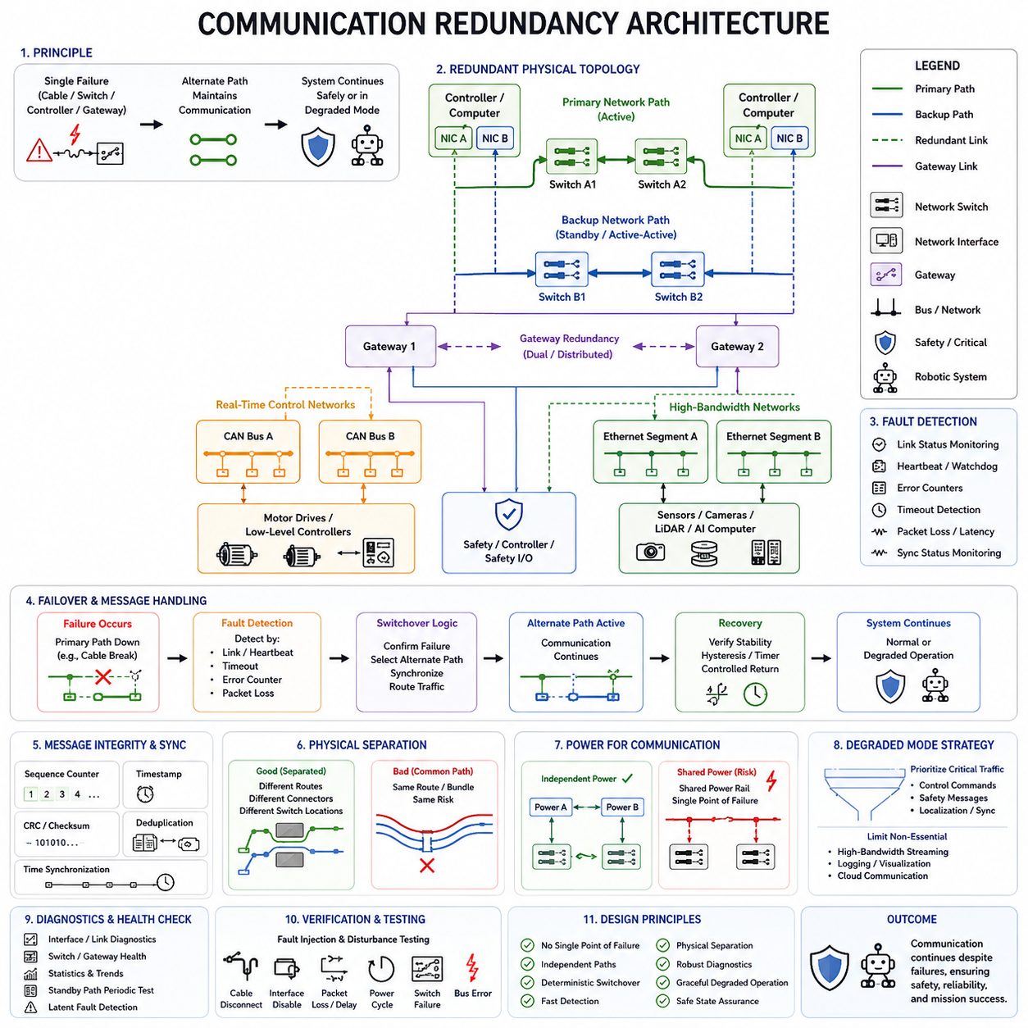
Communication redundancy is the architectural practice of maintaining essential data exchange when a network link, communication controller, switch, gateway, cable, connector, or protocol path becomes unavailable. In robotics and Physical AI systems, communication availability directly affects sensing, control, coordination, diagnostics, and safety, so network failures must be contained without immediately causing complete system failure.
A redundant communication architecture begins by identifying which messages and interfaces are essential to safe and mission-critical operation. Emergency commands, actuator control, safety status, localization information, synchronization data, and critical sensor messages normally require greater availability than maintenance logs or nonessential telemetry. This classification determines where duplicated links, interfaces, switches, gateways, or networks are justified.
Physical redundancy provides multiple independent transmission paths between important nodes. A controller may connect to two Ethernet switches, two CAN channels, or two independent communication backbones. If one path becomes unavailable because of cable damage, connector failure, transceiver malfunction, or switch failure, the alternate path can preserve communication. The paths should avoid unnecessary shared components that could create a single point of failure.
Redundant networks can operate in active-active or active-standby configurations. Active-active communication allows multiple paths to carry traffic simultaneously, potentially providing load distribution and rapid fault tolerance. Active-standby communication normally uses one primary path while maintaining another for takeover. The appropriate configuration depends on bandwidth requirements, deterministic behavior, switching time, network complexity, and required availability.
Communication redundancy must consider the entire end-to-end path rather than only duplicating cables. Two network cables connected to the same failed switch or communication controller do not provide complete independence. Effective redundancy may require separate transceivers, connectors, switches, gateways, power supplies, software interfaces, and routing paths. Independence should be maintained sufficiently far through the architecture to prevent common failures from disabling both channels.
CAN-based systems can provide redundancy by implementing independent CAN buses for critical control functions. A controller may contain two CAN interfaces connected to separate physical networks, allowing important messages to remain available after one channel fails. CAN redundancy must address message duplication, bus-off conditions, arbitration behavior, error handling, gateway dependencies, and the logic used to determine which communication channel remains trustworthy.
Industrial robotic systems can similarly apply redundancy to CANopen, EtherCAT, PROFINET, EtherNet/IP, or other industrial networks depending on system requirements. The redundancy mechanism differs between protocols and implementations, but the architectural objective remains consistent: communication failure in one channel should not eliminate the ability to maintain essential control, monitoring, or safe-state transitions through another available path.
Ethernet-based robotics architectures provide additional redundancy possibilities through duplicated switches, network interface controllers, links, and routing paths. Edge computers, AI computers, real-time controllers, and sensor-processing units can use multiple Ethernet interfaces connected through independent network segments. Redundant Ethernet design must consider switching behavior, address management, multicast traffic, congestion, time synchronization, and recovery after topology changes.
Robotics communication often spans multiple network technologies rather than a single bus. A Physical AI platform may use CAN or CANopen between low-level controllers and motor drives while Ethernet connects real-time controllers, edge computers, sensors, and AI computing platforms. Redundancy must therefore be considered across network boundaries, particularly where gateways translate or forward information between deterministic control networks and high-bandwidth computing networks.
Gateway redundancy becomes important when communication domains depend on a central gateway. A single gateway connecting CAN, industrial Ethernet, conventional Ethernet, or other networks can become a critical single point of failure. Dual gateways or distributed routing functions can improve availability, but they require coordination to prevent duplicated commands, routing loops, conflicting states, or inconsistent forwarding behavior during normal and degraded operation.
Sensor communication redundancy should distinguish between redundant sensors and redundant communication paths. Two sensors connected through the same switch or cable trunk may both become unavailable after a single network failure. Conversely, one sensor with two independent interfaces may survive a link failure but cannot tolerate failure of the sensing element itself. Robust architecture therefore evaluates sensing redundancy and communication redundancy as related but separate mechanisms.
Communication redundancy also requires reliable fault detection. Controllers can monitor link state, message counters, communication timeouts, cyclic redundancy check errors, heartbeat messages, bus error counters, packet loss, latency, and synchronization status. These indicators help determine whether a channel is healthy, degraded, intermittent, or completely unavailable. Fault detection thresholds must avoid both delayed response and unnecessary switching caused by temporary disturbances.
Heartbeat and watchdog mechanisms are particularly useful for distributed robotic controllers. Nodes periodically transmit status information so that other controllers can verify their continued presence and communication health. Missing or delayed messages can initiate diagnostic actions or failover. However, a missing heartbeat does not always identify whether the controller, communication link, switch, gateway, or power supply has failed, so additional diagnostic information may be required.
Switchover logic determines how the system transitions from a failed communication path to an alternate path. The transition may be controlled by hardware, network infrastructure, communication middleware, or application software. Critical systems require deterministic rules defining detection time, confirmation criteria, path selection, message synchronization, and recovery behavior. The objective is to prevent communication interruption from producing uncontrolled actuator commands or inconsistent system states.
Message duplication is one approach to reducing switchover delay. Critical information can be transmitted through two independent channels, allowing the receiver to accept the first valid message or compare both copies. Sequence counters, timestamps, source identifiers, and integrity checks can prevent duplicate execution. This approach can provide rapid fault tolerance but increases bandwidth consumption and requires careful handling of delayed or reordered messages.
Time synchronization must remain available during network faults because modern robotic systems frequently depend on synchronized sensor and control data. Cameras, LiDAR, IMUs, controllers, and distributed computers may require a common time reference for sensor fusion and coordinated execution. If the primary synchronization path fails, a redundant clock source, alternate synchronization path, or controlled holdover mechanism can preserve acceptable timing accuracy.
Physical separation is important because logically redundant networks may still share the same environmental risks. Two cables routed through the same harness bundle, connector, cable chain, or vulnerable mechanical area can be damaged simultaneously. Where communication availability is critical, redundant channels should use appropriately separated routing, connectors, switch locations, and power domains to reduce common-cause failures caused by impact, abrasion, heat, water, or electromagnetic disturbances.
Power and communication redundancy are strongly interconnected. Two redundant network switches connected to the same unprotected power rail may fail together when that rail is lost. Similarly, duplicated communication controllers may share a common DC/DC converter or fuse. Communication redundancy analysis should therefore include the power sources supplying switches, gateways, transceivers, controllers, and sensors so that network independence is not defeated by a shared electrical failure.
Electromagnetic compatibility must also be considered when redundant communication paths are installed. Motor drives, inverters, switching power converters, high-current cables, and rapidly switching actuators can disturb communication networks. Redundant channels routed together may experience the same electromagnetic interference. Appropriate separation, shielding, grounding, termination, filtering, cable selection, and network diagnostics help prevent a common disturbance from affecting both communication paths.
A communication failure does not always require immediate system shutdown. The system may enter a degraded communication mode in which bandwidth-intensive or nonessential traffic is reduced while critical control and safety messages receive priority. High-resolution sensor streaming, logging, remote visualization, or cloud communication may be limited so that available network capacity can support localization, motion control, safety status, and essential supervisory commands.
Physical AI systems particularly benefit from this hierarchical approach because AI workloads and deterministic control have different communication characteristics. Cameras and LiDAR may generate high-bandwidth data for perception, while motor controllers exchange smaller but timing-sensitive control messages. Failure of an AI-oriented Ethernet path should not automatically eliminate low-level motion control if an independent real-time communication channel remains healthy and can execute a defined safe or degraded behavior.
Diagnostics should continuously verify that redundant channels remain operational even when they are not actively carrying primary traffic. A standby network that is never tested can develop a latent fault that remains unnoticed until failover is required. Periodic link checks, test messages, interface diagnostics, switch monitoring, gateway health reporting, and communication statistics can reveal such latent failures before another independent failure occurs.
Recovery after communication restoration requires controlled behavior. Automatically returning to the preferred primary network immediately after a link reappears can cause repeated switching when an intermittent fault exists. Hysteresis, stability timers, health verification, and controlled reintegration can prevent network oscillation. Some systems may remain on the healthy backup path until a maintenance cycle or predefined recovery condition is completed.
Communication redundancy should be verified through intentional fault injection and network disturbance testing. Engineers can disconnect cables, disable interfaces, power down switches, block gateway paths, introduce packet loss, create latency, interrupt synchronization, or force bus errors while observing system behavior. Validation should confirm fault detection, isolation, switchover timing, message continuity, degraded operation, diagnostics, recovery, and safe-state behavior.
The required level of redundancy depends on the consequences of communication loss. Noncritical telemetry may tolerate temporary interruption, while braking, steering, stabilization, safety sensing, or coordinated actuator control may require independent communication channels and deterministic failover. Excessive duplication increases wiring, interfaces, software complexity, network management effort, and validation cost, so redundancy should be targeted according to functional risk and availability requirements.
Communication redundancy ultimately combines independent network paths, fault detection, deterministic switchover, message integrity, synchronization, physical separation, diagnostics, and degraded-operation strategies. A robust architecture ensures that one communication failure does not immediately isolate critical controllers or remove control authority. Instead, the system preserves essential information flow long enough to continue safely, reduce functionality in a controlled manner, or transition to a defined safe state.

08.03. Sensor Redundancy
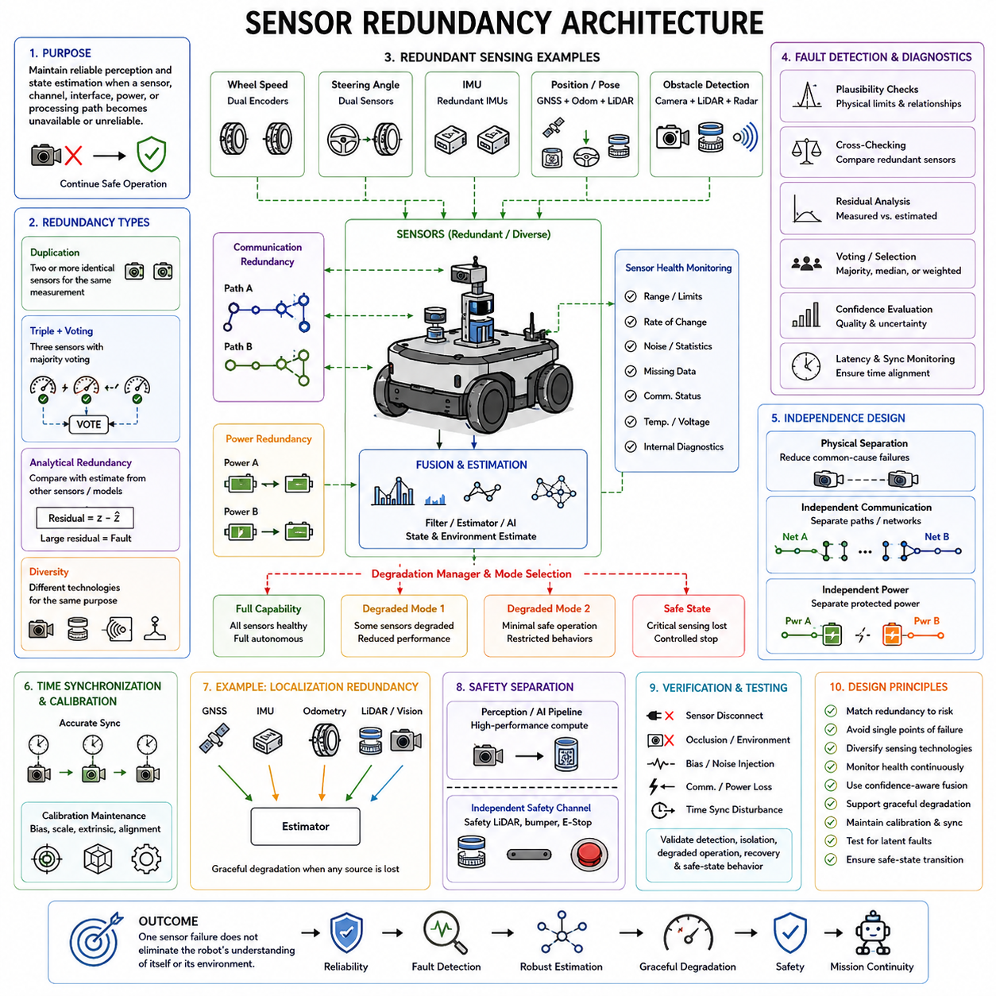
Sensor redundancy is the architectural practice of maintaining reliable perception and state estimation when an individual sensor, sensing channel, interface, power supply, or processing path becomes unavailable or unreliable. In robotics and Physical AI systems, sensors form the connection between the physical environment and computational intelligence, so sensor failures must be detected and managed before they create unsafe or uncontrolled behavior.
A redundant sensor architecture begins by identifying which physical quantities are essential for control, localization, perception, and safety. Position, velocity, acceleration, orientation, obstacle distance, wheel speed, joint position, force, temperature, and environmental information may have different criticality levels. The required redundancy therefore depends on the consequence of losing each measurement rather than simply duplicating every sensor.
The simplest form of redundancy uses two sensors measuring the same physical quantity. Dual wheel encoders, dual steering-angle sensors, redundant position sensors, or duplicated IMUs can provide continued measurement after one channel fails. However, identical sensors exposed to the same environment may share common failure mechanisms, so duplication alone does not guarantee complete fault tolerance or independent measurement capability.
Triple redundancy can provide additional diagnostic capability through majority voting. When three independent sensors measure the same quantity, the system can compare their outputs and identify a channel that significantly disagrees with the other two. This approach is useful when continued operation is required after one sensor failure, but it increases hardware, wiring, calibration, computation, packaging, and validation complexity.
Analytical redundancy provides another approach without necessarily duplicating identical hardware. A measured value can be compared with an estimate derived from other sensors, system dynamics, or mathematical models. For example, wheel speed may be compared with estimated vehicle velocity, while an IMU measurement may be checked against encoder, steering, or localization information. Large residuals can indicate a sensor fault or abnormal operating condition.
Diverse redundancy uses different sensing technologies to observe related properties of the same environment. Cameras, LiDAR, radar, ultrasonic sensors, GNSS, IMUs, and wheel odometry have different strengths and failure modes. Combining different modalities can reduce dependence on a single physical sensing principle and improve robustness against darkness, glare, dust, rain, texture loss, occlusion, multipath effects, or temporary signal blockage.
Sensor redundancy and sensor fusion are related but not identical concepts. Sensor fusion combines complementary measurements to produce a better estimate of the system or environment, while redundancy specifically addresses continued trustworthy operation after faults or degradation. A fused system may still contain a single point of failure if one indispensable sensor is required for the estimator to operate correctly.
Redundant sensing must include independent communication paths where the required availability justifies them. Two sensors connected through the same communication switch, CAN bus, Ethernet segment, connector, or gateway may become unavailable after a single communication failure. Critical sensors may therefore require separate network interfaces, independent buses, redundant switches, or alternative communication paths to prevent network failures from defeating sensing redundancy.
Power independence is equally important. Two redundant sensors connected to the same fuse, DC/DC converter, power distribution branch, or connector can fail simultaneously after one electrical fault. Critical sensing channels may require independent protected power feeds or separate power domains. Sensor redundancy must therefore be coordinated with power redundancy and communication redundancy rather than designed as an isolated function.
Physical placement strongly influences redundancy effectiveness. Sensors mounted next to each other may experience the same contamination, impact, vibration, thermal condition, electromagnetic interference, or field-of-view obstruction. Appropriate spatial separation can reduce common-cause failures, although excessive separation may cause the sensors to observe different physical conditions and complicate comparison, synchronization, calibration, and fusion.
Sensor health monitoring provides the information required to determine whether measurements remain trustworthy. Monitoring can include signal range checks, rate-of-change limits, noise statistics, missing-data detection, communication status, internal diagnostic flags, temperature, supply voltage, and consistency with other measurements. Health evaluation should distinguish complete sensor loss from gradual degradation, bias, drift, intermittent faults, and environmental disturbance.
Plausibility checking compares sensor measurements with physically reasonable limits or relationships. A steering sensor should not report impossible angular changes, an encoder should remain consistent with expected motion, and an IMU should produce measurements compatible with vehicle dynamics within known uncertainty. These checks can identify corrupted data even when the sensor continues transmitting apparently valid messages.
Cross-checking between redundant sensors provides another layer of fault detection. Measurements representing the same or related physical states can be compared continuously, with thresholds defined according to expected sensor accuracy and operating conditions. A disagreement does not automatically reveal which sensor is wrong, so the system may require additional channels, analytical estimates, confidence measures, or historical behavior to isolate the faulty source.
Voting logic can select reliable information when several equivalent sensing channels are available. Majority voting works well when three or more comparable sensors provide independent measurements, while median selection can reduce sensitivity to a single extreme value. Weighted voting can incorporate sensor accuracy, health, environmental suitability, and confidence. The voting mechanism itself must avoid converting temporary measurement differences into unnecessary sensor rejection.
Sensor degradation is often more difficult to manage than complete failure. A camera may remain operational while becoming partially obscured, an IMU may develop bias, an encoder may intermittently lose counts, and LiDAR performance may deteriorate because of contamination or weather. Redundancy management must therefore evaluate measurement quality rather than relying only on binary healthy-or-failed status information.
Confidence-aware sensing allows the perception or control system to adjust how strongly it trusts each measurement. Sensor confidence can be estimated from diagnostics, environmental conditions, residual errors, signal quality, or estimator uncertainty. When confidence decreases, the fusion algorithm can reduce the influence of that channel while increasing reliance on healthier sensors, rather than immediately removing the degraded sensor completely.
Time synchronization is critical when redundant measurements are compared or fused. Two accurate sensors can appear inconsistent if their timestamps refer to different physical moments. Cameras, LiDAR, radar, IMUs, encoders, and distributed controllers should therefore use sufficiently accurate synchronization mechanisms. Timestamp quality and synchronization health should themselves be monitored because timing faults can resemble sensor faults.
Calibration must also be maintained across redundant sensing channels. Bias, scale factor, mounting position, orientation, intrinsic parameters, and extrinsic relationships can change over time because of vibration, mechanical service, temperature, or component replacement. A redundant architecture should distinguish true sensor faults from calibration errors, and diagnostic processes should identify when recalibration is necessary before measurement disagreement becomes operationally significant.
Localization systems illustrate the value of heterogeneous sensor redundancy. GNSS may provide global position outdoors but become unavailable indoors or near structures. Wheel odometry can provide short-term motion information but accumulates drift, while IMUs provide high-rate inertial information with their own bias characteristics. Cameras and LiDAR can provide environmental references. Combining these sources allows localization to degrade gracefully when one modality becomes unreliable.
Obstacle perception similarly benefits from diverse sensing. A camera can provide rich semantic information, LiDAR can provide accurate geometric structure, and radar can offer useful range and velocity measurements under conditions where optical sensing becomes difficult. A robust robot should understand the operational limitations of each modality and modify perception confidence or behavior when environmental conditions reduce the effectiveness of particular sensors.
Safety sensing may require separation from the main AI perception pipeline. A high-performance perception system can combine cameras and LiDAR for navigation, while an independent safety LiDAR, bumper, emergency switch, or protective sensor provides a separate safety channel. This prevents failure of the AI computer, perception software, or primary sensor network from eliminating every mechanism capable of detecting hazardous conditions.
Physical AI architectures should therefore separate high-level perception availability from deterministic safety requirements. Loss of a camera or AI sensor stream may reduce semantic understanding or autonomous performance without necessarily requiring immediate uncontrolled shutdown. The system can reduce speed, restrict maneuvers, disable autonomous functions, or transition to a safe state according to the remaining sensing capability and associated uncertainty.
Graceful degradation is a central objective of sensor redundancy. Instead of treating every sensor fault as a complete system failure, the robot can define operating modes corresponding to available sensing capability. Full autonomous operation may require all major modalities, while reduced-speed navigation may remain possible with fewer sensors. Severe loss of safety-critical sensing should ultimately trigger a controlled stop or another defined safe behavior.
Sensor redundancy also requires management of latent faults. A backup sensor that is ignored during normal operation can fail without detection and remain unavailable when it is eventually needed. Standby channels should therefore be periodically exercised or continuously monitored. Diagnostics should verify measurement validity, communication, power, synchronization, calibration, and processing so that redundant capability remains available throughout operation.
Fault recovery should be controlled when a sensor begins operating normally again. Immediately reinserting a previously faulty channel into a fusion or control system may cause instability if the fault is intermittent. Stability timers, repeated health checks, calibration validation, confidence recovery, and hysteresis can ensure that a sensor is genuinely reliable before it regains full influence in the estimation or control process.
Verification of sensor redundancy should include realistic fault injection. Tests can disconnect sensors, block fields of view, introduce bias or noise, interrupt communication, disturb synchronization, remove power, corrupt measurements, or simulate environmental degradation. Validation should confirm detection, isolation, reconfiguration, fusion behavior, degraded operation, diagnostic reporting, recovery, and safe-state transition under representative operating conditions.
The appropriate redundancy level depends on functional risk and required availability. Noncritical environmental sensors may tolerate temporary loss, while sensors supporting braking, steering, stabilization, collision avoidance, or safe human interaction may require independent channels and stronger diagnostic coverage. Excessive sensor duplication increases cost, power consumption, bandwidth, computation, calibration effort, packaging requirements, and system complexity.
Sensor redundancy ultimately combines duplicated and diverse sensing, analytical estimation, fault detection, plausibility checking, voting, confidence management, independent power and communication, synchronization, calibration, and graceful degradation. A robust architecture ensures that one sensor failure does not immediately remove the robot's understanding of itself or its environment, allowing essential functions to continue or transition safely to a controlled state.

08.04. Computing Redundancy
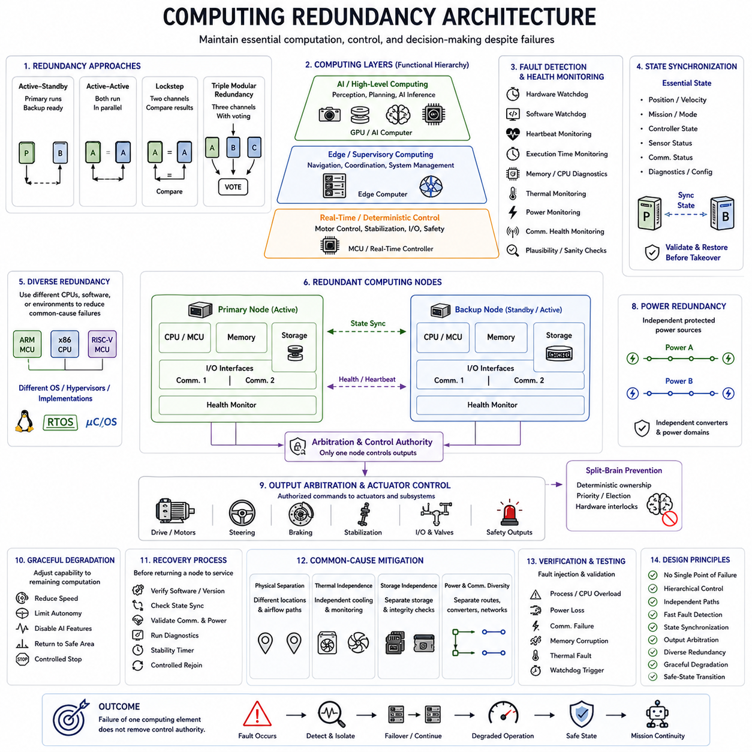
Computing redundancy is the architectural practice of maintaining essential computation, control, and decision-making when a processor, controller, computer, memory subsystem, operating environment, or processing path becomes unavailable or unreliable. In robotics and Physical AI systems, computing failures can affect perception, planning, motion control, communication, and safety simultaneously, making fault containment and controlled recovery essential.
A redundant computing architecture begins by identifying which computational functions are safety critical, mission critical, or performance related. Low-level actuator control, emergency handling, stabilization, localization, communication supervision, perception, planning, and AI inference have different timing and availability requirements. Redundancy should therefore be allocated according to the consequence of losing each computational function.
The simplest computing redundancy uses two processing units capable of performing the same essential function. A primary controller executes normal operation while a backup controller remains ready to assume control after a detected failure. This active-standby arrangement can improve availability, but the standby processor must receive sufficient state information and remain healthy enough to take over within the permitted interruption time.
Active-active computing uses multiple processors simultaneously rather than keeping one unit idle. Both computers may execute identical functions, divide workloads, or independently process the same inputs for comparison. Active-active operation can reduce switchover delay and expose computational disagreements quickly, but it requires synchronization, arbitration, output management, and mechanisms that prevent conflicting commands from reaching actuators.
Lockstep processing is a stronger form of computational comparison in which two processing channels execute equivalent operations and their results are continuously compared. A mismatch can indicate hardware, memory, timing, or execution faults. Lockstep architectures can provide rapid fault detection, but two identical processors may still be vulnerable to common design errors, software defects, power failures, or environmental disturbances.
Triple modular redundancy uses three computational channels and voting logic to tolerate a single incorrect result. When one processor disagrees with the other two, majority voting can select the consistent output and identify the abnormal channel. This architecture can support continued operation after one failure, although it significantly increases hardware, power consumption, thermal load, communication, synchronization, packaging, and validation complexity.
Computing redundancy does not require every redundant channel to use identical hardware. Diverse redundancy can combine different processors, microcontrollers, operating environments, or software implementations to reduce common-cause failures. Diversity is particularly valuable when identical platforms could share the same silicon defect, driver problem, operating-system failure, or software error, although diverse systems are more difficult to develop and verify.
Robotic computing architectures often contain multiple computational layers rather than one central computer. A microcontroller or real-time controller may execute fast deterministic motor control, an edge computer may perform navigation and system coordination, and a GPU-based computer may execute perception and AI models. Redundancy should preserve this functional hierarchy instead of assuming that one backup computer can replace every computational layer.
Low-level control redundancy is particularly important because actuator loops may operate much faster than high-level AI decision cycles. Motor current, velocity, steering, braking, stabilization, or joint control may continue locally even if an edge AI computer becomes unavailable. Separating deterministic control from high-level intelligence prevents failure of computationally intensive AI workloads from immediately removing basic control authority.
Physical AI systems can therefore use graceful computational degradation. Loss of a GPU, accelerator, or AI process may disable advanced perception, semantic reasoning, or complex planning while lower-level controllers continue maintaining stable motion or execute a predefined safe response. The system can reduce speed, restrict autonomy, stop accepting new missions, return to a safe area, or perform a controlled stop according to remaining computing capability.
State synchronization is essential when a standby processor must assume control. The backup computer may require current position, velocity, mission state, controller state, sensor status, communication status, and diagnostic information. If synchronization is incomplete or delayed, the backup may start from an inconsistent state. Redundant systems therefore need defined mechanisms for transferring, replicating, validating, and restoring operational state.
Not every internal state should necessarily be duplicated. Safety-related controllers may require only a limited set of deterministic states, while complex AI systems can contain large neural-network contexts, maps, buffers, or perception histories. The architecture should determine which information is essential for immediate takeover and which information can be reconstructed after failover, balancing recovery speed against communication and storage overhead.
Failure detection can combine hardware watchdogs, software watchdogs, heartbeat messages, execution-time monitoring, memory checks, processor diagnostics, thermal monitoring, power monitoring, communication status, and application-level plausibility checks. A processor that remains electrically powered may still be computationally unhealthy because of deadlock, timing violation, corrupted memory, runaway software, or degraded performance.
Watchdog supervision is especially important for embedded and real-time controllers. An independent watchdog can verify that critical software executes within expected timing boundaries and reset or isolate a processor that stops responding correctly. For stronger fault containment, the watchdog or supervisory function should not depend entirely on the same processor, software stack, or power domain that it is intended to monitor.
Computing redundancy must include output arbitration because multiple processors may be capable of issuing commands to the same actuator or subsystem. The architecture must ensure that only an authorized computational channel controls the output at a given time. Hardware gates, safety controllers, communication ownership rules, voting logic, or command-validity mechanisms can prevent conflicting commands during normal operation, failover, and recovery.
Split-brain behavior is a major risk in redundant computing systems. If two controllers both believe they are the active master after a communication or synchronization failure, they may issue contradictory commands. Arbitration mechanisms should establish unambiguous ownership through hardware interlocks, deterministic election rules, independent supervision, or predefined priority so that loss of communication does not create multiple uncontrolled authorities.
Communication redundancy is closely connected to computing redundancy. Two computers cannot provide effective failover if both depend on the same network switch, gateway, cable, or communication interface. Redundant processors may therefore require independent communication paths for sensor inputs, actuator commands, state synchronization, and health monitoring. Shared communication infrastructure must be evaluated as a potential common failure point.
Power redundancy is equally important because duplicated computers connected to one power rail can fail simultaneously. Critical processors may require independent protected feeds, separate DC/DC converters, isolated power domains, or local hold-up energy. Computing, communication, and power redundancy should therefore be designed together so that duplication at one architectural layer is not defeated by a single failure in another layer.
Thermal design can also create common-cause failures. Two redundant computers installed in the same enclosure may both lose functionality if a shared fan, cooling loop, air path, or thermal environment fails. High-performance AI computers and GPUs can generate substantial heat, making thermal independence and temperature monitoring relevant to availability. Redundancy analysis should therefore include cooling as part of the supporting infrastructure.
Memory and storage can become hidden single points of failure. Redundant processors that boot from the same storage device, share one configuration database, or depend on one filesystem may fail together when that resource becomes unavailable or corrupted. Critical software, configuration, calibration, and recovery information may require protected local copies, integrity checking, version control, or redundant storage appropriate to the system risk.
Software redundancy must distinguish hardware failure from systematic software failure. Running the same defective software on two identical computers does not protect against a shared algorithmic or implementation error. Independent monitoring, simplified fallback software, diverse implementations, safety kernels, or separately developed safety functions can provide additional protection where the consequence of common software failure justifies the added complexity.
Safety computing should often remain independent from the main AI computing environment. A GPU computer may perform perception, world modeling, planning, or learned inference, while a smaller safety controller independently monitors emergency inputs, speed limits, communication health, actuator state, and protective sensors. This separation allows the system to enforce safe behavior even if the high-performance computing platform becomes unstable or unavailable.
Failover timing must match the dynamics of the controlled system. A supervisory computer may tolerate hundreds of milliseconds of interruption, while stabilization or actuator control loops may require much faster continuity. Local controllers, buffered commands, hold-last-value strategies, predefined fallback trajectories, or immediate safe outputs can bridge short computing interruptions while redundant processing authority is being established.
Recovery should be treated separately from failover. After a failed processor restarts, it should not automatically regain control simply because it is responding again. Software version, configuration, synchronized state, communication health, sensor inputs, timing behavior, and diagnostic status should be verified first. Stability timers and controlled reintegration prevent intermittent failures from causing repeated transfers of computational authority.
Diagnostics should continuously verify standby computing resources. A backup computer that remains powered but unused can contain latent hardware, software, storage, communication, or configuration faults. Periodic self-tests, heartbeat processing, memory diagnostics, communication checks, workload tests, and controlled role exchanges can provide evidence that the redundant channel remains capable of assuming its intended function.
Computing redundancy should be validated through intentional fault injection. Engineers can stop processes, overload CPUs, disable network interfaces, corrupt communication, remove processor power, trigger watchdogs, disturb synchronization, simulate storage failures, or introduce thermal faults. Testing should confirm fault detection, isolation, output arbitration, state transfer, failover timing, degraded operation, diagnostic reporting, recovery, and safe-state transition.
The required redundancy level depends on functional risk, availability objectives, and acceptable degraded behavior. Noncritical user interfaces or logging functions may tolerate restart or temporary loss, while braking, stabilization, steering, safety supervision, or critical motion control may require independent processing channels. Excessive duplication increases cost, power, cooling, software complexity, integration effort, and verification burden.
Computing redundancy ultimately combines independent processors, hierarchical control, fault detection, state synchronization, output arbitration, diverse fallback mechanisms, independent power and communication, diagnostics, and graceful degradation. A robust architecture ensures that failure of one computing element does not immediately eliminate control authority, allowing the robot to preserve essential functions, reduce capability predictably, or transition to a controlled safe state.

08.05. Redundancy Switchover Logic
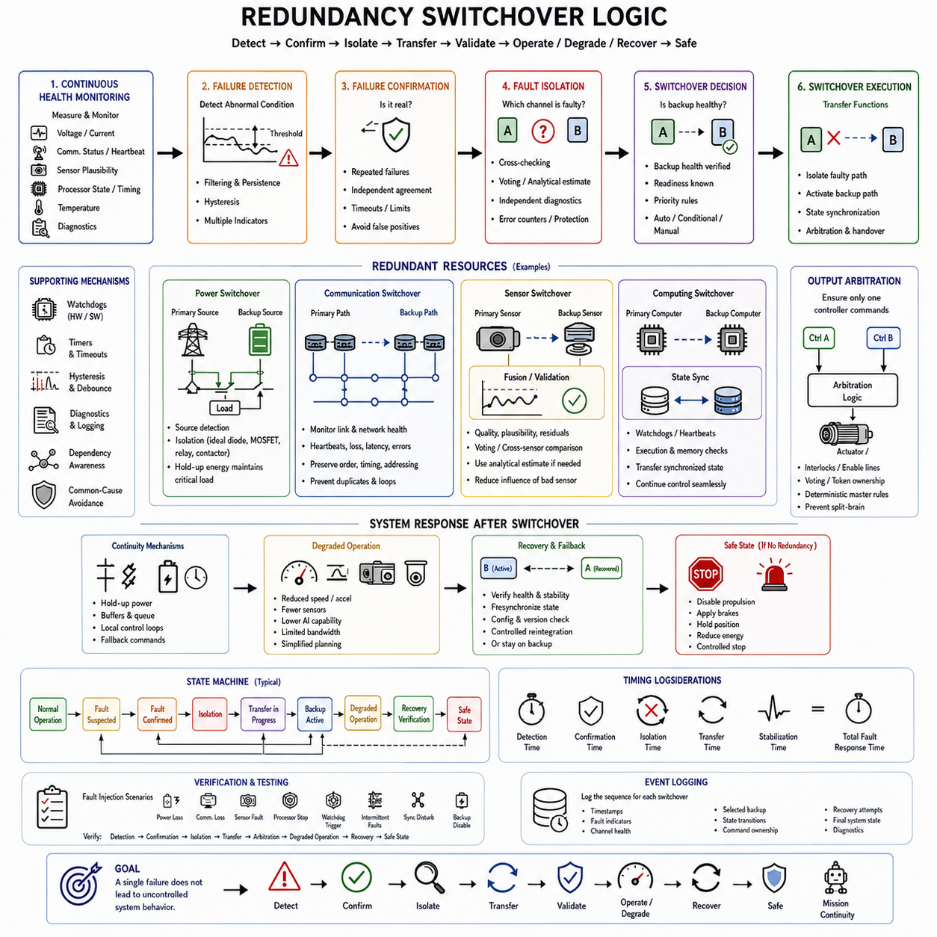
Redundancy switchover logic is the coordinated mechanism that detects a failure, determines whether the affected channel can still be trusted, isolates the faulty path, and transfers essential functions to an available redundant resource. In robotics and Physical AI systems, switchover may involve power, communication, sensors, or computing, so the logic must preserve control continuity while preventing the failure from propagating across architectural domains.
A switchover process begins with continuous health monitoring of the primary and redundant channels. Voltage, current, communication status, heartbeat signals, sensor plausibility, processor execution state, temperature, timing, and diagnostic information can provide evidence of system health. The monitoring mechanism must detect both complete failures and gradual degradation without reacting unnecessarily to normal transient conditions.
Failure detection thresholds must reflect the dynamics of the monitored function. A brief voltage dip, delayed network packet, temporary sensor disagreement, or short computational overload should not automatically trigger a major architectural transition. Filtering, persistence timers, hysteresis, statistical evaluation, and multiple diagnostic indicators can distinguish temporary disturbances from failures that require isolation and switchover.
Once an abnormal condition is detected, failure confirmation determines whether the event is sufficiently credible to justify switching. Confirmation may require repeated diagnostic failures, agreement between independent monitors, timeout expiration, or violation of a safety limit. This stage prevents false-positive detection from causing unnecessary transitions that could themselves disturb control, communication, perception, or power stability.
Fault isolation identifies the channel or component responsible for the abnormal condition. Detecting that two redundant signals disagree is not sufficient if the system cannot determine which one is incorrect. Cross-checking, voting, analytical estimates, independent diagnostics, electrical protection status, communication error counters, or supervisory monitoring can help identify the faulty source before control authority is transferred.
The switchover decision should consider not only whether the primary channel has failed but also whether the backup channel is healthy. Transferring control to an unverified backup can convert a manageable single failure into complete functional loss. Redundant resources should therefore be continuously monitored or periodically tested so that their readiness is known before they are selected for active operation.
Switchover architectures can use automatic, conditional, or manually supervised transitions depending on functional requirements. Safety-critical functions generally require automatic responses when human reaction would be too slow. Less critical functions may allow supervisory confirmation. The decision mechanism should define exactly which faults trigger immediate transfer, degraded operation, controlled shutdown, or maintenance intervention.
Priority rules are necessary when several redundant resources are available. The system may select a preferred backup according to health, remaining energy, computational capacity, communication quality, sensor confidence, thermal condition, or predefined architectural priority. Deterministic selection rules reduce ambiguity and ensure that different controllers do not independently choose conflicting recovery paths.
Power switchover logic must coordinate source detection, isolation, switching devices, and load behavior. When a primary source or converter fails, the faulty path should be disconnected before it destabilizes the healthy source. Ideal-diode circuits, MOSFET switches, relays, contactors, or cross-tie devices can perform the transfer, while hold-up capacitors or local energy storage maintain critical voltage during the transition.
Communication switchover logic selects an alternate network path when a link, switch, gateway, interface, or communication domain becomes unavailable. Link status, heartbeat timeouts, packet loss, latency, error counters, and synchronization quality can contribute to the decision. The transition should preserve message ordering, integrity, addressing, timing, and command ownership while preventing duplicated commands or routing loops.
Sensor switchover logic must account for measurement quality rather than only complete sensor loss. A degraded sensor may continue transmitting data while developing bias, noise, drift, obstruction, or intermittent errors. Plausibility checks, residual analysis, confidence estimates, voting, and cross-sensor comparison can reduce the influence of an unreliable channel or replace it with a healthier sensor or analytical estimate.
Computing switchover logic transfers computational authority when a processor, controller, software process, or computing node becomes unreliable. Hardware watchdogs, software watchdogs, heartbeat monitoring, execution-time checks, memory diagnostics, and application-level plausibility tests can initiate failover. The backup processor should receive the essential synchronized state required to continue operation without creating an uncontrolled discontinuity.
State synchronization is particularly important before computing or supervisory authority is transferred. Position, velocity, mission state, control mode, actuator state, sensor status, communication status, and diagnostic information may need to be replicated between channels. The switchover logic should verify that the backup possesses a sufficiently recent and valid state before granting it control authority.
Output arbitration ensures that only one authorized channel controls a shared actuator or subsystem after switchover. Without arbitration, both primary and backup controllers may issue commands simultaneously, creating split-brain behavior. Hardware interlocks, enable lines, safety controllers, voting mechanisms, token ownership, or deterministic master-selection rules can establish exclusive and unambiguous command authority.
Switchover timing must be matched to the function being protected. High-level mission planning may tolerate relatively long recovery intervals, while steering, braking, stabilization, motor control, or safety functions can require much faster responses. Detection time, confirmation time, isolation time, transfer time, and stabilization time should therefore be considered together as the total fault-response interval.
Continuity mechanisms can bridge the interval between failure detection and establishment of the backup channel. Electrical hold-up energy can maintain power, communication buffers can preserve messages, local controllers can maintain actuator loops, and predefined fallback commands can preserve stable behavior. These mechanisms prevent a short switchover interval from becoming an uncontrolled interruption at the physical system level.
Switchover logic should support graceful degradation when full functionality cannot be restored. A robot may continue operating with reduced speed, limited acceleration, fewer sensors, reduced AI capability, restricted communication bandwidth, or simplified planning. The available redundancy determines which functions remain trustworthy, while supervisory logic maps the remaining capability to an appropriate degraded operating mode.
Cross-domain coordination is essential because a failure in one domain can affect several others. Loss of a power rail may disable a network switch, sensor, and computer simultaneously, while a communication failure may make a healthy controller appear unavailable. The supervisory architecture should understand these dependencies so that multiple symptoms of one underlying fault are not incorrectly treated as unrelated failures.
Common-cause failures must also be considered before selecting a redundant path. Two channels that share the same power supply, network switch, cooling system, connector, software implementation, or physical routing may not be truly independent. Switchover logic should use architectural knowledge and diagnostic information to avoid transferring functionality to a backup resource that is exposed to the same failure mechanism.
Hysteresis is important when fault conditions occur near switching thresholds. Without hysteresis, a fluctuating voltage, intermittent communication link, unstable sensor signal, or recovering processor can repeatedly move the system between primary and backup states. Separate entry and exit criteria, stability timers, and minimum residence times can prevent rapid oscillation and improve predictable system behavior.
Failback should be treated differently from failover. Failover often requires rapid action to preserve safety or availability, whereas returning to the preferred primary channel can usually occur more cautiously. The recovered resource should pass health checks, synchronization, configuration verification, and stability monitoring before reintegration. Some architectures may deliberately remain on the backup channel until maintenance or restart.
A redundancy manager can coordinate switchover decisions across multiple subsystems. Instead of allowing every component to react independently, a supervisory function can collect health information, evaluate dependencies, determine system capability, and command appropriate transitions. However, the redundancy manager itself must not become an uncontrolled single point of failure and may require independent supervision or distributed fallback behavior.
Switchover logic should use clearly defined operational states. Typical states can include normal operation, fault suspected, fault confirmed, isolation, transfer in progress, backup active, degraded operation, recovery verification, and safe state. Explicit state transitions improve determinism, diagnostics, verification, and software maintainability while preventing ambiguous behavior during complex combinations of faults.
A safe state is required when no trustworthy redundant resource remains available. The appropriate response depends on the machine and operating environment and may include disabling propulsion, applying brakes, holding a manipulator position, reducing actuator energy, activating warning devices, or executing a controlled stop. Switchover logic therefore ultimately requires a defined path from normal operation to safe behavior even when redundancy is exhausted.
Diagnostics and event logging should record the sequence leading to each switchover. Fault indicators, timestamps, channel health, selected backup resources, state transitions, command ownership, recovery attempts, and final system state provide valuable information for maintenance and validation. Accurate records also help distinguish genuine component failures from wiring problems, software defects, environmental disturbances, or incorrect thresholds.
Redundancy switchover logic must be verified through intentional fault injection. Engineers can remove power, disconnect communication links, corrupt sensor signals, stop processors, trigger watchdogs, disturb synchronization, create intermittent faults, or disable backup resources. Testing should confirm detection, confirmation, isolation, transfer, arbitration, degraded operation, recovery, and safe-state behavior under realistic timing conditions.
Verification should also examine combinations and sequences of failures rather than only isolated single faults. A backup resource may already contain a latent fault when the primary channel fails, or a second failure may occur during degraded operation. Testing these conditions demonstrates whether the architecture can correctly determine remaining capability and transition to a safe state when redundancy has been partially or completely exhausted.
Redundancy switchover logic ultimately connects power redundancy, communication redundancy, sensor redundancy, and computing redundancy into one coordinated fault-response architecture. Effective switchover is not merely changing from channel A to channel B. It is the controlled sequence of detecting, confirming, isolating, transferring, validating, degrading, recovering, or safely stopping so that a single failure does not become uncontrolled system behavior.

